

Ethiopian Institute of Architecture, Building Construction, and City Development

The Relationship between Urban Spatial Structure and Travel Behavior of Residents in Addis Ababa

By Yididya Yoseph

August, 2023
Addis Ababa

Ethiopian Institute of Architecture, Building Construction, and City Development

The Relationship between Urban Spatial Structure and Travel Behavior of Residents in Addis Ababa

By Yididya Yoseph

A Thesis Submitted to the School of Graduate Studies of Addis Ababa University, Ethiopian Institute of Architecture, Building Construction and City Development (EiABC), in Partial Fulfillment for a Master’s Degree in Urban Planning

Advisor:
Berhanu Woldetensae (Associate Professor, Dr.Dipl-lng)

August, 2023
Addis Ababa, Ethiopia

Statement of Declaration
Yididya Yoseph declares that this thesis is prepared for the partial fulfillment of the requirements for the Master’s Degree in Urban Planning. The title of the thesis is “The Relationship between the spatial structure and travel behavior of Residents in Addis Ababa.” The research is my original work and has not been presented in another university/ institution and all sources are referenced and acknowledged.

Name: Yididya Yoseph

Signature

Approval
As a member of the Examiners board of the final Master's thesis open defense of Yididya Yoseph, we have read and evaluated the Thesis prepared by Yididya Yoseph entitled “The Relationship Between the Urban Spatial Structure and Travel Behavior of Residents in Addis Ababa” and recommended to Ethiopian Institute of Architecture, Building Construction and City Development, Addis Ababa University to accept the Thesis for the Fulfillment of Requirements for the award of Degree of Masters of Science in Urban Planning.

Approved by the Board of Examiners
Berhanu Woldetensae (Associate Professor, Dr.Dipl-lng)
Advisor Signature Date
Birhanu Girma (PhD)
Internal examiner Signature Date
Dagnachew Adugna (PhD) External Examiner Signature Date
Dagnachew Adugna (PhD)
Chair Person Signature Date
Dagnachew Adugna (PhD)
Graduate Program Director Signature Date

Acknowledgment
Initially, I would like to give thanks to the almighty who has helped me begin and finish all my work.
Then I would like to thank my Advisor Dr. Berhanu Woldetensae who has deeply supported and inspired my work from the very beginning. some of the fundamental approaches of this thesis developed from his support, as well as to Dr. Birhanu Girma for all the advice he has given us throughout the years. Third, I would like to give my heartfelt gratitude to all the employees of the organizations I have gone to collect the required data for the study for their willingness and cooperation through the provision of data as well as in answering all my questions. I would also very much like to thank all the people who were willing to participate in the survey as well as in the collection of the data. Lastly, I would like to thank Addis Ababa University for supporting me and giving me the chance to conduct this thesis.

Abstract
One of the pressing issues Addis Ababa currently facing is transportation and associated challenges. Different solutions such as the provision of LRT, public transportation, and widening of streets have been applied to minimize the challenges related to transport by the concerned sectors. However, these strategies were only able to bring temporary solutions. Therefore, understanding the relationship between activity densities and individual travel behavior is essential. Concerning this the paper aims to provide evidence on the relationship between the spatial structure and travel behavior in Addis Ababa in order to bring a more sustainable and resilient solution to the transportation and associated challenges. The study applies a mixed research design that combines both qualitative and quantitative data analysis. To increase the accuracy of data both primary and secondary data have been acquired, the primary data were collected through questionnaires and household surveys, While the secondary data were from relevant offices and websites. The collected data for spatial structure study are encoded on GIS and analyzed using GIS tools and Microsoft Excel spreadsheet while travel behavior data are analyzed using descriptive statistical methods. The findings initially identified the type of spatial structure Addis Ababa city has which is a mono-centric structure then calculated job-housing balance to select areas for travel behavior study which are from areas with high job-low housing, balanced job-housing, and low job-high housing ratios. Then from each area, we selected 128 participants a total of 384 using the purposive random sampling method. Finally, the research proved that spatial structure and travel behavior are related and areas that have a balanced job and housing ratio have a positive impact on travel behavior through the encouragement of sustainable modes of transportation, decreasing transportation expense as well as commuting time and its associated externalities. While areas with a low job–high housing have a more negative impact on travel behavior through their dependency on motorized vehicles, increased transportation expense, and a higher commuting time as well as increased VMT, CO2 emission, and energy consumption. Therefore, the balancing of jobs to housing should be a priority in the planning and design of cities along with the provision of affordable, quality, and mixed-income housing in different areas of a city.

Keywords: Spatial Structure, Job - Housing balance, Travel Behavior, Transportation,

Table of Contents
Statement of Declaration i
Acknowledgment iii
Abstract iv
List of Tables x
List of Figures xii
Acronyms xv
Chapter One: Introduction 1
1. Background of the study 1
1.1. Statement of the problem 3
1.2. The objective of the research 4
1.2.1. The general objective of the research 4
1.2.2. Specific Objective 4
1.3. Research question 4
1.4. Significance of the study 5
1.5. Scope of the study 5
1.6. Limitations of the Study 5
1.7. Structure of the Thesis 6
Chapter Two: Literature Review 7
2. Literature review 7
2.1. Conceptual and theoretical definitions 7
2.1.1. Urbanization 7
2.1.2. Cities 7
2.1.3. Transportation 9
2.1.4. Sustainable Transportation 10
2.1.5. Sustainable Urban Expansion and Transportation 10
2.1.6. Accessibility 11
2.1.7. Urban form and spatial structure 14
2.1.8. Approach to the spatial structure of the city 15
2.1.8.1. Ecological approach 15
2.1.8.2. Economic approach 16
2.1.8.3. Urban Morphological Approach 16
2.1.8.3.1. Density 16
2.1.8.3.2. Land use 17
2.1.9. Types of Spatial Structures 18
2.1.9.1. The Mono-centric 18
2.1.9.2. Sectorial urban growth 19
2.1.9.3. Urban Multi Nucleation (polycentric) 19
2.1.9.4. Suburbanization 20
2.1.10. Urban Spatial Structure and Commuting Patterns 21
2.1.11. The impact of spatial structure on travel behavior 22
2.2. Empirical study 25
2.2.1. Measuring spatial structure 25
2.2.2. Job housing imbalance and longer commuting time 27
2.3. Summary of literature 29
2.4. Research gap 30
Chapter Three: Methodology 32
3. Research Methodology 32
3.1. Contextual Background of the Study Area 32
3.2. Research design 33
3.3. Sources of data 36
3.4. Method of sampling 37
3.5. Methods of data collection 39
3.6. Methods of Data Analysis 39
3.6.1. Measuring spatial structure 39
3.6.1.1. City shape measure 40
3.6.1.2. Population distribution 40
3.6.1.3. Employment distribution 40
3.6.1.4. Job-housing imbalance 40
3.6.2. Measuring Travel behavior 41
3.6.2.1. Measuring Transport associated challenges 41
3.7. Method of data presentation 42
3.8. Validity of Methods and Materials 42
3.9. Ethical consideration 43
Chapter Four: Background on the study area 44
4. Background on the study area 44
4.1. Historical development of Addis Ababa 44
4.2. Spatio - Temporal Growth Trend of the City and its Drivers 45
4.3. Change in population 49
4.4. Addis Ababa city's existing population 50
4.5. Transportation in Addis Ababa 51
Chapter five: Result and Discussion 54
5. Result 54
5.1. The Spatial Structure of Addis Ababa 54
5.1.1. City Shape 54
5.1.2. Population Centrality 55
5.1.4. Job housing Balance 58
5.2. Selected Areas 60
5.2.1. Areas with High Job – Low Housing ratio 60
5.2.2. Areas With a Balanced Job – Housing ratio 61
5.2.3. Areas with Low Job – High Housing ratio 61
5.3. Data Presentation, analysis, and Interpretation of travel behavior study 62
5.3.1. Demographic characteristics of Participants from the household survey 63
5.3.1.1. Gender status 63
5.3.1.2. Age Group 64
5.3.1.3. Education level and awareness 65
5.3.1.4. Family size 66
5.3.1.5. Employment condition 68
5.3.1.6. Ownership title 69
5.3.1.7. Income status 70
5.3.2. Finding and analysis 71
5.3.2.1. Frequency of using transport mode within a week 72
5.3.2.2. Travelers' Mode Choice Attitude 74
5.3.2.2.1. Why do People use Private cars when commuting to work? 74
5.3.2.2.2. Why walk or Cycle when commuting to work? 75
5.3.2.2.3. Why Public Transportation (Taxi Mini-bus) when commuting to work? 77
5.3.2.2.4. Why Public Transportation (Autobus, Higer, and LRT) when commuting to work? 78
5.3.2.3. Access to transportation at peak hours 80
5.3.2.4. Average daily transportation expense of Participants 81
5.3.2.5. Average Cost of fuel of participants for daily commuting 82
5.3.2.6. Average transport waiting time 84
5.3.2.7. Commuting time at peak hours 85
5.3.2.8. Residential location choice 87
5.3.2.9. Total CO2 emission and energy consumption 92
5.4. Interpretation of results 95
5.4.1. The spatial structure of Addis Ababa 95
5.4.1.1. City Shape Measure 95
5.4.1.2. Population distribution 95
5.4.1.3. Job distribution 96
5.4.1.4. Job vs Population distribution 96
5.4.1.5. Job-housing balance in Addis Ababa 97
5.4.2. The relationship between spatial structure and travel behavior in Addis Ababa city 98
5.4.2.1. Mode choice and spatial structure 98
5.4.2.2. Access to transportation and spatial structure 100
5.4.2.3. Cost of transportation Vs. Spatial structure 101
5.4.2.4. Commuting time Vs. Spatial structure 101
5.4.2.5. Residential location choice vs. spatial structure 102
5.4.2.6. Total Co2 emission and energy consumption Vs. Spatial structure 102
5.4.3. The impact of spatial structure characteristics on travel behavior 104
5.4.3.1. High job-low housing areas 104
5.4.3.2. Balanced job-housing areas 105
5.4.3.3. Low job-high housing areas 105
Chapter Six: Conclusion and Recommendation 107
6. Conclusion and Recommendation 107
6.1. Conclusion 107
6.2. Recommendation 108
Reference 110
Annex I 120
Annex II 140
Annex III 157
Annex IV 160
Annex V 163
Annex VI 166

List of Tables
Table 2.1: Typology of differences between high and low levels of neighborhood accessibility
Table 2.2: Density Indicators and their meaning
Table 2.3: Summary of the literature review
Table 3.1: Research design table
Table 3.2: The specific energy consumption and CO₂ emissions factor for motorized travel modes
Table 3.3: Sources of data from organizations
Table 3.4: Sampling size from each selected neighborhood
Table 4.1: Addis Ababa city population in each sub-city
Table 5.1: Population distribution percentage at 2 km radius gap in Addis Ababa city
Table 5.2: Employment distribution percentage at 2 km radius gap in Addis Ababa city
Table 5.3: Job-housing balance at each radius in Addis Ababa City
Table 5.4: Participants' Gender Status
Table 5.5: Participants' Age Group
Table 5.6: Education Level and Awareness of Participants
Table 5.7: Average family size in each selected neighborhood
Table 5.8: Participants' employment conditions
Table 5.9: Ownership title of participants
Table 5.10: Participants' monthly income status
Table 5.11: Frequency of using transport modes within a week
Table 5.12: Private car mode choice attitude for commuting
Table 5.13: Walk or Cycle mode choice attitude for commuting
Table 5.14: Public Transportation (Taxi Mini-bus) mode choice attitude for commuting
Table 5.15: Public Transportation (Autobus, Higer, and LRT) mode choice attitude for commuting
Table 5.16: Access to transportation at peak hours
Table 5.17: Average daily transportation expense of participants for work or school-related travel purposes
Table 5.18: Average Cost of fuel of participants for daily commuting
Table 5.19: Average transport waiting time at peak hours
Table 5.20: Average commuting time at peak hours
Table 5.21: Average residential location choice
Table 5.22: Total Co2 emission per Vehicle Technology
Table 5.23: Total Energy Use per Vehicle Technology

List of Figures
Figure 2.1: Types of areas within a city
Figure 2.2: The difference between urban form and spatial structure
Figure 2.3: The Mono-centric type spatial structure model
Figure 2.4: The sectorial type spatial structure model
Figure 2.5: The polycentric type spatial structure model
Figure 2.6: The suburbanization-type spatial structure model
Figure 2.7: Travel Patterns in Different Urban Spatial Structures
Figure 2.8: Factors affecting travel behavior
Figure 3.1: Location map of Addis Ababa city
Figure 3.2: Schematic diagram showing the research design
Figure 4.1: Tayitu’s spatial plan for Addis Ababa city
Figure 4.2: Expansion trend of Addis Ababa city from (1886 – 2013)
Figure 4.3: Addis Ababa population (1887-2022)
Figure 4.4: Addis Ababa city population growth rate (1968 – 2022)
Figure 4.5: Sheger Public Bus in Addis Ababa
Figure 4.6: Mini-Bus Taxi in Addis Ababa
Figure 4.7: Anbessa Public Bus in Addis Ababa
Figure 4.8: Mini-Bus Taxi in Addis Ababa
Figure 4.9: LRT in Addis Ababa
Figure 4.10: Bajaj/ 3-wheel rickshaw in Addis Ababa
Figure 5.1: Old and New Addis Ababa City Boundary
Figure 5.2: Population distribution in Addis Ababa city at each radius
Figure 5.3: Employment distribution in Addis Ababa city at each radius
Figure 5.4: Employment distribution vs Population distribution in Addis Ababa city
Figure 5.5: Job - housing balance in Addis Ababa City
Figure 5.6: Areas within 2km radius of the CBD
Figure 5.7: Areas at 6Km area from the CBD
Figure 5.8: Areas within 18 Km radius of the CBD
Figure 5.9: Percentage of gender status of participants in each selected neighborhood
Figure 5.10: Percentage of participants' age group in each selected neighborhood
Figure 5.11: Percentage of educational level and awareness of participants in each site
Figure 5.12: Family size of each participant in areas with a high job–low housing ratio
Figure 5.13: Family size of each participant in areas with a balanced job-housing ratio
Figure 5.14: Family size of each participant in areas with high housing – low job ratio
Figure 5.15: Participants' employment conditions in each selected neighborhood
Figure 5.16: Ownership title of participants in each selected neighborhood
Figure 5.17: Participants' monthly income status in each neighborhood
Figure 5.18: Frequency of using transport modes within a week in each neighborhood
Figure 5.19: Private car mode choice attitude for commuting in each neighborhood
Figure 5.20: Walk or Cycle mode choice attitude for commuting
Figure 5.21: Public Transportation (Taxi Mini-bus) mode choice attitude for commuting
Figure 5.22: Public Transportation (Autobus, Higer, and LRT) mode choice attitude for commuting in each neighborhood
Figure 5.23: Access to transportation at peak hours in each neighborhood
Figure 5.24: Daily transportation expense on the dwellers for work or school-related travel purposes at each selected neighborhood
Figure 5.25: Cost of fuel of participants for daily commuting in each neighborhood
Figure 5.26: Transportation waiting time at peak hours in each neighborhood
Figure 5.27: Commuting time at peak hours in each neighborhood
Figure 5.28: Residential location factors for high job-low housing areas
Figure 5.29: Residential location factors for balanced job–housing areas
Figure 5.30: Residential location factors for low job–high housing areas

Acronyms
AAHDPO - Addis Ababa Housing Development Project Office
AAMPRO- Addis Ababa master planning revision office
BRT – Bus Rapid Transit
CBD- Central business district
CO2- Carbon dioxide
CSA - Central Statics Authority
FUA - functional urban area
GIS Geographic Information System
EC – European Commission
LAU - Local administrative units
LRT – Light rail transit
MRT – Mass Rapid Transit
MWUD - Ministry of Works and Urban Development
NA- Neighborhood Accessibility
NUTS - Nomenclature of Territorial Units for Statistics level 3
NGO- Nongovernmental organization
Stdev - Standard deviation
UNDESA – United Nations Department of Economic and Social Affairs
UN-HABITAT - United Nations Human Settlements Program
VMT – Vehicle Miles Traveled
VHT – Vehicle Hours Traveled

Chapter One: Introduction

Background of the study
In the global development discourse, urbanization is both a significant trend and a key concern of the 20th and 21st C (Dorosh & Thurlow, 2013). According to recent estimates, more than 50% of the world's population already resides in cities, and by the year 2050, that percentage is predicted to rise to 75%. (UNDESA, 2019). The predicted rapid urbanization is expected to be concentrated in the nations of the Global South mostly in the sub-Saharan countries. Despite having the least amount of urbanization, the sub-Saharan African countries have the fastest urban growth rate showing up to a 4.1 % annual increase (World Bank, 2019). Ethiopia is ranked among the top nations in this group. However, the urban growth in Ethiopia is concentrated in its capital city Addis Ababa alone which covers above 25% of the total country's population.
Even though, urbanization has been associated with significant economic and social transformations linked with higher levels of literacy and education, better health, lower fertility and a longer life expectancy, greater access to social services, and enhanced opportunities for cultural and political participation (UNDESA, 2014). It also has disadvantages caused by rapid and unplanned urban growth resulting in traffic congestion, inadequate infrastructure, housing, transportation, and services, as well as vulnerability to climate change, and environmental pollution.
Among the major contributors to urbanization-associated problems and environmental pollution in urban areas is the transportation system. Besides their significant socioeconomic benefits, transportation systems have environmental externalities associated with the depletion of natural resources, land consumption, and the emissions from the combustion of fossil-derived fuels contributing to degraded air quality, as well as a changing climate. In this, sustainable urban development that is integrated with the transportation sector is required.
Understanding the importance of sustainable urban development in lowering greenhouse gas emissions and energy consumption in the transportation sector requires an understanding of the relationship between urban form/ spatial structure and travel behavior. Numerous recent studies have discovered that factors related to urban form and spatial structure, such as density, land use diversity, street design, destination accessibility, and proximity to transit, have a significant impact on travel behavior, including mode selection, trip frequency, trip distance, and ultimately vehicle miles traveled (VMT). These factors are now viewed as the guiding principles for land use policies that support more environmentally friendly transportation (Krehl et al., 2016).
Similarly, Addis Ababa city is characterized by transportation challenges such as air pollution from vehicle emissions, inadequate transportation, high traffic congestion, and commuting time in all directions of the city, however, the city has a lower motorization level compared to other countries which signify these issues in long term will be very critical and requires a large amount of attention. Different solutions such as the provision of LRT, public transportation, and widening of streets have been applied to minimize the challenges related to transport by the concerned sector, however, these strategies were only able to bring temporary solutions. Therefore, the understanding of the relationship between the built density and corresponding activity densities (such as population or job densities), on the one hand, and individual mobility behavior, on the other hand, is essential.
To provide evidence concerning this relationship, the research attempted to identify the existing urban spatial structure of Addis Ababa city and then selected areas with different jobs, population concentrations, and job-housing balance to study mobility characters in each neighborhood by adopting indicators such as the amount of commuting time, mode choice, and availability of transportation as well as mobility externalities such as the amount of CO2 emission and energy consumption due to transportation in each neighborhood.
The selected areas for travel behavior studies are high job-low housing areas located 2km from the CBD, balanced job-housing areas located 6 km from the CBD, and low job-high housing areas located 18km from the CBD. The findings suggest that there is a relationship between spatial structure and travel behavior, with spatial structure characteristics having both negative and positive impacts on travel behavior as well as its associated externalities. Areas with a balanced job-housing ratio encourage sustainable modes of transportation and decrease transportation expense as well as commuting time and its associated externalities such as CO2 emission and energy consumption on the other hand, low job-high housing areas increase dependency on a motorized vehicle, transportation expense and commuting time as well as transportation externalities such as CO2 emission and energy consumption due to the increase in distance between work and residential place. Areas with high job-low housing ratios have a moderate positive impact on travel behavior, however, since the work trip distance in these areas is shorter as well as there are more public transport users the amount of CO2 emission and energy consumption is low compared to areas with low job-high housing ratios.

Statement of the problem
The city of Addis Ababa is experiencing rapid urban expansion and development. While the current population is estimated at 5.4 million people, some forecasts expect it to grow to 10 million by 2040. Car ownership is increasing; reflecting the increasing economic development and wealth, but this is also leading to severe traffic congestion, pollution, and resulting problems related to safety, health, and productivity (Ildikó, 2021).
The transportation sector has made a lot of effort to solve these issues through the expansion and improvement of existing streets for both vehicles and pedestrians as well as the provision of a variety of transportation such as the MRT and LRT. In addition, the transportation sector is preparing a Bus Rapid Transit (BRT) line to be constructed from Jemo to Winget together with some intermodal hubs.
Nevertheless, despite the effort to provide sustainable and efficient transport infrastructure the problem continues to exacerbate and the city is characterized by transportation challenges in all directions. According to a study (Ildikó, 2021), there is currently a small window of opportunity to plan and gradually implement a more sustainable transport system for Addis given the high rate of increase of both the population and the number of private automobiles in the city. It will get more difficult and costly to reverse the trends of high-intensity car usage, congestion and pollution, disconnected areas, dangerous roads, and separated inhabitants if the opportunity is lost over the upcoming years. A key challenge related to transportation in Addis Ababa metropolitan is claimed to be the fact that there is no coordinated planning between the different sectors of development such as housing and land use with transportation.
Therefore, transportation planning that is not integrated with different sectors of planning will not bring sustainable and resilient city development.

The objective of the research

The general objective of the research
The general objective of the research is to assess the existing relationship between the urban spatial structure of Addis Ababa and travel behavior of its residents to identify spatial structure characteristics that impact travel behavior and its externalities.

Specific Objective
- To assess the existing spatial structure characteristics of Addis Ababa.
- To investigate the existing relationship between the urban spatial structure and residents travel behavior in Addis Ababa city.
- To identify the urban spatial structure characteristics of Addis Ababa that have impact on resident’s travel behavior.

Research question
- What are the existing spatial structure characteristics of Addis Ababa?
- What is the relationship between the existing spatial structure of Addis Ababa and resident’s travel behavior?
- What are the urban spatial structure characteristics of Addis Ababa that have impact on resident’s travel behavior and its externalities?

Significance of the study
The purpose of the thesis is to provide evidence on the relationship between the urban spatial structure characteristics of Addis Ababa city and personal travel behavior of its residents as well as to indicate the impact of spatial structure characteristics on travel behaviors.
The findings of the research are expected to give academic knowledge and interest for further studies on the subject. The study can also serve as a source of information for development practitioners and agents. The governmental bureaus and concerned bodies can use it as a source to support their work related to the subject as well as take it as a lesson for future development.

Scope of the study
The thematic scope of the research is on the relationship between the urban spatial structure of Addis Ababa and resident’s travel behavior. It focuses on the economic approach of the urban spatial structure such as population and employment concentration and balance, to identify its impact on individual mobility behavior as well as to measure its indirect impacts.
The geographical scope of the study is bounded to areas in Addis Ababa city with high Job- low housing areas located within 2km from the CBD including (Piazza, 4 killo, Lideta, Mexico, and Kazanchiz), balanced job–housing areas located 6 km from the CBD including (Megenagna, 22, shola, Gerji and Gofa) and areas with low job – high housing located 18 km from the CBD including (Lower Koye Fitche, Lower Akaki, Tulu Dimtu and Arabsa) so as to compare the relationship with travel behavior between each selected site and identify their positive and negative impacts on travel behavior.

Limitations of the Study
The study has a few limitations. The first is the time given to conduct the research which was too short to do a deeper analysis. Considering the time required to collect, encode, analyze, and interpret the data. Thus, due to the short time provided to undertake the study, the research is limited to a smaller number of indicators as well as analysis levels. Second, among the company employees used to study the spatial structure of the city, companies who haven’t provided their employee data to the concerned sectors will be left out, although, the majority is expected to be included.

Structure of the Thesis
The research is organized into five chapters the first chapter begins with a brief on the background of the study and provides a brief explanation of the research, states the objective of the study and its significance then sets the theoretical and geographical scope of the study as well as the limitations faced while conducting the research.
The second chapter presents related literature on the subject including conceptual, theoretical, and empirical evidence from different published sources. The focus of the literature review is on topics related to urbanization, transportation, sustainable development, and transportation, the meaning of spatial structure, the types of spatial structures as well as approaches to spatial structure, and their relationship with travel behavior are some of the important theoretical and conceptual reviews. For empirical evidence, the focus was on the link between spatial structure daily mobility, and job housing balance.
The third chapter describes the background of the study area, and the methodologies applied to collect and analyze data required for the study. As well as the method of sampling applied and the number of samplings taken for the study.
The fourth chapter presents the background to the study area to provide insight and discuss factors related to the study. The fifth chapter is the results and discussion section where the findings of the study were interpreted and presented to answer the research questions. The final chapter is the conclusion and recommendation where the findings of the study are summarized and possible solutions are recommended to solve the identified challenges by the study.

Chapter Two: Literature Review

Literature review
This chapter clarifies important concepts and terminologies related to the research in order to provide a key understanding and insight into the overall subject the research study is concerned with. It provides both conceptual and theoretical definitions as well as empirical research regarding the topic from different literatures. Topics under review start from a broader topic such as urbanization, then define relevant topics such as transportation, sustainable development, accessibility, and spatial structure and its approaches as well as its characteristics and relationship with travel behavior and commuting patterns. Finally, the review is summarized and concluded along with an explanation of the research gap in the area.

Conceptual and theoretical definitions
The following section presents the conceptual and theoretical definitions for selected relevant topics with regard to the study.

Urbanization
Urbanization involves a complex set of economic, demographic, social, cultural, technological, and environmental processes that result in an increase in the proportion of the population of a territory that lives in towns and cities, an increased concentration of population in the larger settlements of the territory, and an increasing density of population within urban settlements (P. Knox, 2009).
Urbanization can occur as the result of both natural populations increase and rural-urban migration, but it also gets facilitated by the horizontal expansion of cities (Hyun Bang, 2015).
Urbanization is a pervasive and recent phenomenon. In the present global atmosphere, all nations undergo the challenges of the environment, social, transportation, and economy in their respective cities as a result of urbanization. These issues commonly occur in developing countries due to the difference in development in cities and villages (Latif Fauzi, 2007).

Cities
There are numerous concepts to define the meaning of a city. About one-third of countries use the concept of 'urban agglomeration' to estimate their city data and another 12% only for their capital cities. As much as 39% of countries use the concept of 'city proper, about 6% use the concept of "metropolitan area" and about half of countries combine various definitions to estimate city and population data in their urban areas (UNDESA, 2018).
The UN-Habitat in partnership with New York University has prepared a definition for a city using two components such as "urban extent" and "urbanized open space". Urban extent represents the total built-up area, which is itself defined as the contiguous area occupied by buildings and other impervious surfaces. Urbanized open space, on the other hand, refers to unbuilt-up areas that are encompassed within the built-up areas or their immediate vicinity, and include parks, cleared land, and forests among others (UN-Habitat, 2016).
On the other hand, according to The European Commission definition, a city is much more than a physical imprint on a map. It is an organic entity with its own identity and capacity to respond to the demands and needs of its inhabitants, as well as influence its surrounding territory. Nevertheless, to ensure significant and consistent figures on urban trends, phenomena, and challenges, the commission provides a definition based on population density per area (EC, ND). Similarly, the Ethiopian Ministry of Works and Urban Development (MWUD defines cities based on population size. This specifies that for an urban center to be defined as a city it has to have a minimum of 100,000 populations.
Nevertheless, in recent years, many international organizations have pushed to adopt harmonized city definitions. According to the specific needs of each topic, the following definitions (EC, ND) are used:
- The New Degree of Urbanization identifies three types of areas: (1) cities (equivalent to the global definition); (2) towns and suburbs (municipalities where 50% of the population lives in urban clusters and it is not a city); and (3) rural areas. Urban areas are defined as cities plus towns and suburbs.
- Metro regions are Nomenclature of Territorial Units for Statistics level 3 (NUTS-3) regions or groupings of NUTS-3 regions representing all functional urban areas of more than 250 000 inhabitants. The typology distinguishes three types of metro regions: capital city regions, second-tier metro regions, and smaller metro regions. The capital city region is the metro region which includes the national capital. Second-tier metro regions are the group of largest cities in the country excluding the capital.
- Local administrative units (LAUs) or municipalities comprise a system for dividing up the European Union’s economic territory for the purpose of statistics at the local level. They are compatible with NUTS regions.
- A functional urban area (FUA) combines the city with its commuting zone. A commuting zone includes a city’s surrounding travel-to-work areas where at least 15 % of employed residents are working in a city.
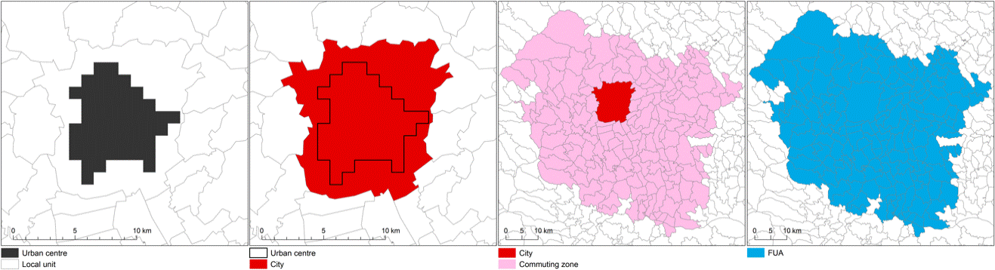Figure 2.1: Types of areas within a city (Source: Global human settlement)

Transportation
(David Boyce, 1999) Defines transportation system as a three-part system for moving people or commodities. These components consist of the vehicle, the guideway, and the operation strategy. According to his article, the vehicle is what moves the traffic or items (people, goods) while the guideway is where the vehicle travels along. The network of the guideway is made up of links and nodes. A sequence of these links is called a route. A terminal is a node where traffic is switched between different vehicles. On the other hand, the operation plan is the set of procedures by which traffic and vehicles are moved over the guideway, including schedules or timetables, crew assignments, and control systems.
He also identified another mode of transport called the urban transit system that is more public in their vehicle, guideway, and operation plan. This mode serves as an example of the urban vs. interregional mode contrast. Various transit options connect numerous urban areas into an interregional network, while others only serve one urban area. A comparison of an interregional bus network with an urban bus system serves as an example.
A larger economic, social, and physical environment affects how each transportation system functions. Each system thus produces certain externalities, also known as external effects, on its surroundings. Emissions, noise, and damage to the system's users and nearby residents' property are a few of these. The majority of emissions that impact the air, water, and land come from vehicles because of their exhaust and hazardous substance spills. Within hearing distance, society is affected by vehicle noise. Accidents cause injuries or fatalities to passengers and bystanders, and they also cause damage to or the destruction of property (David Boyce, 1999). On the other hand, the guideway has externalities through the consumption of land creating loss of green areas and expanding impervious surface which as a result decreases groundwater infiltration, Increases and accelerates stormwater runoff resulting in downstream flooding as well as Creates the urban heat Iceland. Therefore, the provision of sustainable transportation is critical for the protection of our well-being and the environment.

Sustainable Transportation
An environmentally sustainable transport system is one that does not endanger public health or ecosystems and meets needs for access consistent with the use of renewable resources at below their rates of regeneration and the use of non-renewable resources at below the rates of development of renewable substitutes (Gilbert, 2005).
However, the definition of sustainable transport adopted by the Ministers of Transport of the 15 European Union countries provides a concrete and comprehensive definition that is reviewed by political mechanisms and received general political acceptance” (Rand Europe, 2003). The definition referred to is as follows:
A sustainable transport system is defined as one that:
- Allows the basic access and development needs of individuals, companies, and societies to be met safely and in a manner consistent with human and ecosystem health, and promotes equity within and between successive generations;
- Is affordable, operates fairly and efficiently, offers a choice of transport mode, and supports a competitive economy, as well as balanced regional development;
- Limits emissions and waste within the planet's ability to absorb them uses renewable resources at or below their rates of generation, and, uses nonrenewable resources at or below the rates of development of renewable substitutes while minimizing the impact on the use of land and the generation of noise.

Sustainable Urban Expansion and Transportation
As mentioned above, Sustainable transportation is a type of transportation that does not endanger public health or ecosystems, as it meets the mobility needs consistent with the use of renewable resources below their rates of regeneration and the use of non-renewable resources below their rates of development of renewable substitutes. The concept of sustainable transportation includes at least four aspects: a high level of accessibility (shorter travel distance or duration), environmentally efficient transport modes (use of renewable energy and low emissions), public transportation, and social equity (Nicolas et al., 2003). In terms of (Zhao, 2010), Sustainable transportation involves complex environmental, economic social, and behavioral issues which are directly connected to the physical pattern of land use, financial arrangements, and a mobility management system.
(Zhao, 2010) As his study mentioned, the findings of previous studies suggest that urban growth management, facilitating urban form, should have the potential to contribute to the mitigation of environmental problems caused by transport. (Banister, 2008) further explained that growth management in land development can affect transportation patterns in many ways through increasing densities and concentration, through mixed-use development, through housing location, through the design of buildings, space, and route layouts, through public transport-oriented development and transport development areas, through car-free development and through establishing size thresholds for the availability of services and facilities. Furthermore, (Stead, 2001) workers' travel patterns are also influenced by Socioeconomic factors. Household attitudes and preferences regarding residential location also have a significant impact on travel distance and travel mode choice (Bohte et al., 2009).
Therefore, (Kombe, 2005) suggested that If there is ineffective growth management in developing and transformational countries, it can lead to urban expansion having negative effects on sustainable transportation. Many studies have already shown that in developing countries land development management at the State or municipal level is facing great challenges, stemming from uncertainties concerning local government-controlled development on the urban fringe Africa is a good example of countries facing these challenges. Thus, an integrated development between transportation and other sectors should be a priority to minimize and avoid these issues.

Accessibility
Accessibility, as generally defined, consists of two parts: a transportation element or resistance factor and an activity element or motivation factor (L. Burns, 1979; J.G. Koenig, 1980). (Suzan, 1993) claims that the transportation aspect reflects how simple it is to move between geographically distinct sites based on the nature and quality of the services offered by the transportation system and as determined by trip distance, time, or cost. The geographical component depicts how various activities—such as homes, workplaces, shops, offices, and so forth—are distributed. The quantity and placement of various activity kinds both contribute to this distribution's characteristics. A different name for the spatial component is the "attractiveness" of a specific location as a travel destination.
There is thus substitutability between the transportation system and the distribution of activities in determining the level of accessibility (Morris, 1979). With the same level of accessibility, a location may be relatively close to multiple small activity centers or rather far from a few large activity centers. However, the effects on travel habits could be extremely different. Therefore, it's crucial to distinguish between various types of accessibility, particularly between regional accessibility and local accessibility (Suzan, 1993).
(Suzan, 1993) further stated that regional accessibility depends on effective transit links to significant, regionally oriented concentrations of activity, whereas local accessibility depends on proximity to locally oriented centers of activity. To distinguish between local and regional accessibility, the researcher used three connected criteria. Differentiating depending on the scope and location of the commercial concentration is the first strategy. For instance, local accessibility is influenced by activities that are located nearby, but regional accessibility is influenced by activities that are placed further away. Small activity concentrations are probably present in the first scenario, but massive activity concentrations are the only ones that matter in the second. Differentiating based on the type of activity is a second strategy. For instance, a grocery store contributes to accessibility on a local level, whereas a department store contributes to accessibility on a regional level. According to the research on shopping and travel behavior (Holton, 1958; D.L. Huff, 1963), the two approaches are related in that an individual's willingness to travel a specific distance depends on both the type of activity and the volume of activity at the destination.
On the other hand, the definition put forth almost a decade ago by (Tri-Met, 1993) posits those areas with high neighborhood accessibility:
(1) Increase concentrations of population and employment in corridors and nodes of good transit service,
(2) Encourage a mix of appropriate land uses, and
(3) Design development and public right-of-way improvements to be pedestrian-oriented.
A complicated idea is condensed into three principles in this definition. These are the "3Ds" -- density, diversity, and design.
Another research (Kevin, 2003) defined the characteristics of neighborhoods with high and low levels of neighborhood accessibility (NA). The researcher referred that Residential neighborhoods exhibiting features characteristic of high NA are characterized by being located near commercial uses, narrow streets, on-street parking, sidewalks, and relatively higher density. While Residential neighborhoods exhibiting features characteristic of low levels of NA are characterized by curvilinear streets, driveways, lack of sidewalks, and relatively low density. See the table below.

Table 2.1: Typology of differences between high and low levels of neighborhood accessibility
Levels of Neighborhood Accessibility

Density | • Relatively higher residential densities  • Small home lots | • Relatively lower residential densities  • Large home lots
Land use mix | • Mixed land uses and proximity of land uses  • Convenient access to parks, recreation  • Distinct neighborhood centers | • Segregated, clustered land uses  • Access to a limited number of highly desirable land uses
Circulation framework/ urban design | • Interconnected, street patterns with small block size  • Separate paths for pedestrians and bicycles  • Narrow streets  • On-street parking  • Sidewalks, green spaces, and tree lining  • Variation in housing design and size  • Shallow setbacks  • Front porches and detached garages | • Circuitous, meandering streets  • Strict attention to hierarchical street patterns (highways, arterials, collectors)  • Wide streets without on-street parking  • Missing or non-shaded sidewalks  • Homogeneous housing design  • Relatively large setbacks  • Dominating
(Source: Kevin, 2003)
The 3Ds influence travel behaviors, according to (Ewing & Cervero, 2010) measures of accessibility to destinations have the strongest correlation with VMT, followed by factors linked to the design of the street network and density. The number of destinations within walking distance, intersection density, and indicators of land use diversity have the closest connections with walking. While the usage of buses and trains is similarly correlated with street network design factors, proximity to transit, and factors affecting land use diversity. Therefore, destination accessibility is the fourth-factor affecting accessibility and travel behavior (Ewing & Cervero, 2001)
In conclusion, the above literature highlights that our cities' physical layout matters, and that the integration of land use with transportation systems and non-motorized forms of movement is particularly important. Communities should be constructed in areas, with urban forms, and at densities that facilitate the supply of transit and encourage sustainable modes of transportation such as walking, biking, and public transportation. These modes of transportation provide mobility and independence for residents of all ages, which also promote social interaction and increased levels of physical activity (Ellen & Hart, 2014).

Urban form and spatial structure
Infrastructures for transportation, such as highways, transit systems, or even simple footpaths, have shaped urbanization throughout history. There is a broad variety of urban forms, spatial structures, and connected urban transportation networks since each city has a unique temporal process of accumulation and growth of transport infrastructures (Jean-Paul, 2020).
What constitutes urban form and what constitutes spatial structure are not universally agreed upon. As (Dempsey et al., 2010), for example, consider that the spatial structure is one of the dimensions of the urban form, and (Krehl et al., 2016) consider density as one of the dimensions of the spatial structure. This study will also apply the same definition as (Dempsey et al., 2010) and (Krehl et al., 2016). However, according to (Jean-Paul et al., 2009) Urban form refers to the spatial imprint of an urban transport system as well as the adjacent physical infrastructures. Jointly, they confer a level of spatial arrangement to cities. on the other hand, urban spatial structure refers to the set of links that result from the urban form and its underlying passenger and freight mobility.
Figure 2.2: The difference between urban form and spatial structure
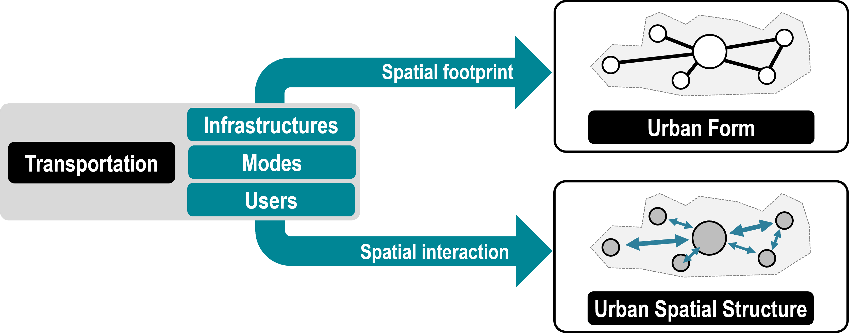
(Source: Jean-Paul, 2020)
There are two types of spatial concentrations these are: Centralization refers to how activities are situated concerning the entire urban environment. While a dispersed city does this to a lesser extent, a centralized city conducts a substantial portion of its operations within a clearly defined center. And Clustering is used to describe how activities are situated concerning a particular metropolitan region. A centralized and clustered setting denotes that the majority of value-added activities are concentrated in and around a city's center and are also close to one another (Jean-Paul, 2020). When measuring the spatial structure of a metropolitan the degree of centralization and clustering is quantified to identify its spatial structure characteristics. While a centralized city depicts a mono-centric spatial structure, a decentralized spatial structure shows a city having more than one center which is poly-centric.

Approach to the spatial structure of the city
Approaches to the spatial structure of the city are significant because they affect how urban space is planned. In this situation, urban spatial planning can be viewed as an intervention in the form of structural changes, and spatial usage patterns develop organically from the trends. As a result, the knowledge about the form and the structure of the city will enable to utilization and structure of urban spaces in the desired manner (Roosmayri, ND). Some of the Instruments that shape urban spatial structures are market forces interacting with regulations, primary infrastructure investments, and taxes (Bertaud, 2002).
Urban spatial structures can be defined by using several indicators related to average land consumption, the spatial distribution of population as shown by census data, and the pattern of daily trips (Bertaud, 2002) as well as the distribution of human activities within a metropolitan area. Therefore, the population's spatial distribution is a static depiction of the city when its residents are at home, and the pattern of travel is a schematic portrayal of the complicated paths that these same individuals will take when they are away from home (Roosmayri, ND).
Furthermore, Population density, job-housing ratio, and proximity to the Central Business District (CBD) and sub-centers are all factors that (Muñiz & Sánchez, 2018) examined while defining "Urban Spatial Structure" (quoted by Abouelhamd, 2021). Similar to the above definitions, this paper uses population and employment distribution as well as job-housing balance to represent the spatial structure of the city. Urban analysts have used different approaches to study spatial structures, these approaches are presented below.

Ecological approach
Examining the city as a research subject reveals that it has a complex society and that there have been interactions between people and their surroundings (Roosmayri, ND). Since more compact growth results in less development on farmland and natural habitat, ecologists frequently concentrate on the aggregate population density, or compactness (Knnap, Lewis, & Schindewolf, 2014). Three key theories—the Concentric theory, Sector Theory, and plural Center theory—are used in this method (Roosmayri, ND).

Economic approach
The economic approach to the city's spatial configuration is predicated on the knowledge that land use patterns are closely related to land value, rent, and cost (Roosmayri, ND). Gradients in employment and population density are the approaches used. Typically, gradients with a more gradual drop in density are seen as indicators of the center city's declining economic appeal (Knnap et al., 2014). The Theory of Land Rent and Land Value Theory can, according to this method, explain the variations in the pattern of land use (Roosmayri, ND).

Urban Morphological Approach
The morphological approach sees urban structure as a combination of numerous physical characteristics of urban configurations, such as land use mix, city size, density, the types of building blocks, the "townscape," the extent of urban sprawl, the layout of the city's roads and spatial clustering. It relates to how public and private places are organized, as well as their connectivity, and accessibility levels (Boarnet & Wang, 2019 quoted by Abouelhamd, 2021).

Density
Density has a lot of interconnected dimensions and is a deceptively difficult notion. The number of people (dwelling) in a certain area may be measured objectively and spatially, but it is also evaluated subjectively; it is a social interpretation based on individual characteristics and may vary from resident to resident (Churchman, 1999).
In addition, land use and access to services are strongly correlated with density; for example, a service or facility must serve a certain size population to be financially viable. On the one hand, density can be viewed as the result of the competition between land uses within a specific urban transportation system and its corresponding accessibility pattern. Therefore, density has been used as a tool to assess the viability of public transportation systems and other service delivery, as well as the viability of specific land uses, particularly commercial and service, in urban planning and development (Dempsey et al., 2009).
On the other hand, the measurement of built density represents the relation of objects (which can include residents, buildings, dwellings, or jobs, among others) and a reference area upon which these objects are placed. Mathematically density is denoted by using a fraction in which the number and size of objects are the numerators and the size of the reference area is the denominator. Built densities and activity densities can generally be distinguished from one another: built densities relate to the proportion of built structures to a reference area (such as the number of buildings, floor space, or dwelling units), whereas activity densities express the intensity of human use on built-up areas. Since built structures change extremely slowly, at least in a more expansive spatial context, the former is comparatively static. Activity densities, on the other hand, are always fluctuating because they are supported by dynamic, frequently discontinuous demographic and socioeconomic processes (Krehl et al., 2016)
Built density can be determined in numerous methods (Krehl et al., 2016) has presented density indicators and their meaning which is presented in Table 2.3
Table 2.2: Density Indicators and their meaning
Indicator | Scale | Meaning/Measurement | Included Land Resources
Metropolitan density | Region | People, jobs, or dwelling units per land area unit | Administrative area
Urban (residential) density | City, city district | People, jobs, or dwelling units per land area unit | Urbanized area
Gross residential density | Neighborhood, urban block | People or dwelling units per land area unit | Residential area (including streets, pavements, local community services, and public open spaces)
Net residential density | Neighborhood, urban block | Dwelling units per land area unit; floor area per land area unit | Residential area (not including streets, local community services public open spaces)
Site density | Plot, property | People or dwelling units per land area unit | The single-plot, property
Occupation density | Dwelling unit | People per dwelling unit | Single dwelling unit
(Source: Krehl et al., 2016)

Land use
The phrase "land use" is generally used to refer to the various environmental functions. Although residential is frequently the predominant land use in an urban setting, infrastructure, retail, offices, and other uses are also necessary for a viable urban environment. The debates regarding a city's effectiveness and possible "sustainable" urban forms in affecting urban travel patterns and the quality of life depend heavily on the spatial (micro) pattern of land uses (Dempsey et al., 2009).

Types of Spatial Structures
Throughout the 20th century, many spatial structures have been put forward by different professionals for this study the main ones are discussed below.

The Mono-centric
Mono-centric cities were a natural starting point for modeling early cities, in which most business activities occurred around a single center. (Alonso, 1964) developed the mono-centric city model as an adaptation of (von Thunen's, 1826) theory of agricultural land rent and land use to the urban situation. It was nearly soon expanded to cover production, transportation, and housing. The mono-centric model has shown to be an excellent conceptual tool for considering urban economies, notably the significance of commuting costs. It makes it easier to account for general equilibrium effects and seems to pinpoint certain significant urban structure drivers (Roosmayri, ND). Example: Chicago in the 1920s, Hamburg, and Munich.
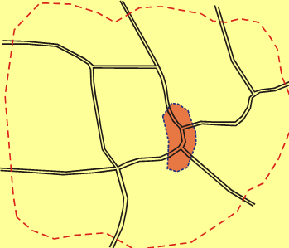
Figure 2.3: The mono-centric type spatial structure model (Source: Roosmayri, ND)
Concerning transportation, (Kutter et al’s, 1998) study of several German cities suggests a greater distance for trips in a mono-centric city (Hamburg, Munich) than in a polycentric city (Stuttgart, Frankfurt). It suggests that this model of development may only be sustainable at the cost of significant investments in the transit system, which makes possible the pooling of the energy consumption per kilometer. On the other hand, (Bertaud, 2001) explains trip distance is lower in Mono-centric cities since there is one center closer to all areas within a city. Therefore, these arguments may differ from city to city.

Sectorial urban growth
Homer Hoyt first put forth this theory in 1939. Instead of growing in rings, the sector model suggested that cities grow in sectors. Whether by happenstance or due to the geography and environment, certain parts of a city are more desirable for particular activities. These activities thrive and spread outward as the city develops, doing so in a wedge-shaped pattern that eventually turns them into a city sector (Roosmayri, ND). This sector results from the effect of communication lines such as railroads, highways, and other transportation routes. High-rent districts are primarily found on the city's outskirts away from polluted manufacturing areas and are the most accessible along major transportation corridors, while low-rent areas span from the city's center to its outskirts and are less accessible by transportation (Selma, 2011). Islamabad, Karachi, and Amsterdam are some examples of the sectorial model.
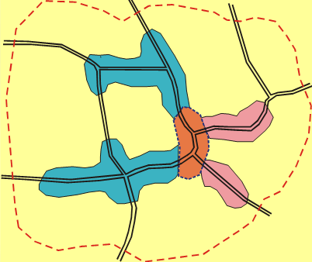
Figure 2.4: The sectorial type spatial structure model (Source: Roosmayri, ND)

Urban Multi Nucleation (polycentric)
Following the dispersion of economic and business activity across the metropolitan areas of mid-20th century cities, and the emergence of major and minor business hubs the multi-nuclei model was created in 1945 by the geographers D. Patel and E. L. Ullman. According to (Hoyt H., 1939) this model assumes that a city has multiple centers around which activity is centered. For optimal profit, different activities situate themselves in attractive, preferred, and financially feasible areas, and similar activities are located around mini-centers inside the main city. It takes into account the growing suburbanization and the consequent outmigration of people, businesses, and commercial hubs (Yeates, 1998). While doing so, it illustrates how comparable socioeconomic and cultural groups prefer to cluster together (Shearmur & Charron, 2004).
Localized activities serve a particular purpose for a sizable area, and this concentration keeps growing until high labor costs and traffic congestion balance the concentrating factors. In comparison to a mono-centric metropolis, these districts' spatial distribution is, therefore, more complicated (Yanbing, 2007). Los Angeles and Bahawalpur in Pakistan are some examples.
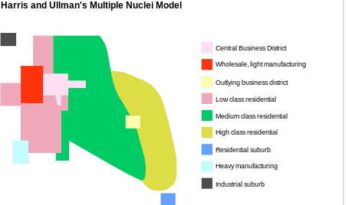
Figure 2.5: The polycentric type spatial structure model (Source: Roosmayri, ND)

Suburbanization
After the Second World War, cities saw spectacular population increase, economic expansion, and physical growth, as well as fiscal and social problems of post-war cities, such as crime, congestion, low environmental quality, high taxes, low quality of government services, and public schools, pushed the higher income households to move out first as they were able to afford initially expensive means of transportation, a personal automobile (Selma, 2011). This strong tendency toward the expansion of areas outside of cities is known as sub-urbanization. It is one of the numerous factors contributing to the expansion of urban sprawl. Following these phenomena, many people who live in metropolitan areas commute to work by car or public transportation and choose to live in suburban satellite towns where they work (Roosmayri, ND). Example: Cities in the United States and South-East Asian Cities.
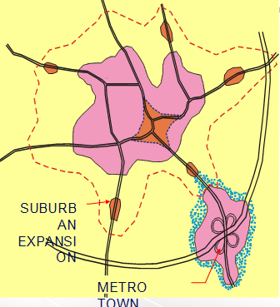
Figure 2.6: The suburbanization-type spatial structure model (Source: Roosmayri, ND)

Urban Spatial Structure and Commuting Patterns
Every day, people in a city travel from their homes to other parts of the city, such as their workplaces, shopping centers, and cultural and social amenities, which are referred to in this paper as "activity places." The proximity of residences and activity centers inside the metropolitan region will thus affect a trip pattern. In a city with a single center of activity, the majority of these locations are in a central area. Due to the fact that these persons typically reside in suburbs, there would be large commuter flows on radial routes into the city because the urban commute would have numerous origins for work trips but fewer destinations (Bertaud, 2001).
In a polycentric city, the majority of the activity places are distributed in clusters around the metropolitan areas. The number of clusters could range from 3 or 4 to several hundred (Bertaud, 2001). In reality, a polycentric city operates similarly to a monocentric city. Jobs draw individuals from every part of the city, regardless of where they are, yet the travel pattern varies. Each sub-center in a polycentric metropolis generates trips from all around the built-up area of the city; these trips frequently have a broad dispersion of origin and destination and seem to occur at random. A polycentric city typically has longer trips than a monocentric city (Bertaud, 2002).
There are many different types of polycentrism, and each has its distinctive transport characteristics. There are many different types of polycentrism, and each has its distinctive transport characteristics (Aguilera, 2005). It is proposed by (Aguilera, 2005) that polycentric cities can be divided into three main types when classified in terms of commuting patterns The three different types of poly-centric societies are decentralized, with the majority of commuters—including those from the center of the city—moving to the suburbs. In the second, cross-commuting, the central and suburban labor markets are distinctly different, which means that the majority of people who live in the central city also work in the central city, whereas the majority of people who live in the suburbs have a job in the suburbs. In the third category, known as exchange commuting, a sizable share of residents of the central city work in the suburbs and vice versa.
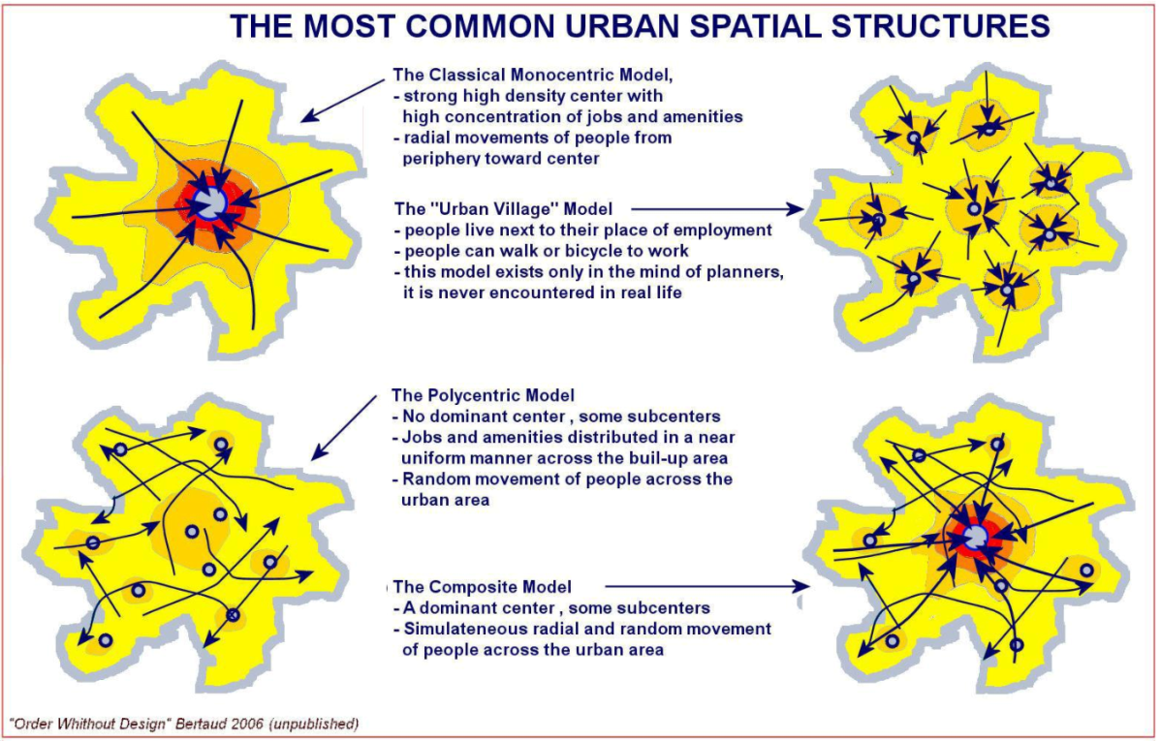
Figure 2.7: Travel Patterns in Different Urban Spatial Structures (Source: Bertaud, 2002)

The impact of spatial structure on travel behavior
Travel behavior is the process of making complex decisions about a trip, such as the destination, mode of transportation, route, and departure time (Li et al., 2019 quoted by Kay, 2007). From a behavioral perspective, urban travel includes a wide range of factors, such as trip purpose and frequency, origins, and destinations, the preferred mode of transportation, route choice, trip distance, travel duration, and transportation expenses (Acheampong, 2019).
According to theories of transport geography and transport economics, the travel between different destinations is influenced by the attractiveness of the locations and the friction of distance. The concept of friction of distance refers to the impediment that occurs because places, objects, or people are spatially separate: movement involves a cost (Lloyd & Dicken, 1977). The urban structure assembles a set of incentives that encourage some types of travel behavior while discouraging other types of travel behavior by establishing proximity or distance between activities and by facilitating various modes of travel (Petter, 2006). In addition, various other factors also affect travel behavior which is presented in Figure 2.8.
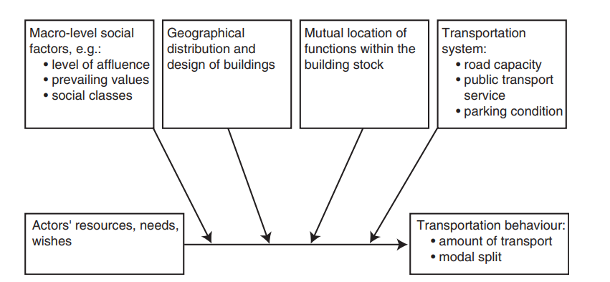
Figure 2.8: Factors affecting travel behavior (Source: Petter, 2006)
Depending on how fixed or flexible they are in terms of time and space, according to (Vilhelmson, 1999: 181), trips can be divided into four categories. ‘Bounded’ are trips to reach activities where both the time and geographical location are fixed and cannot easily be deviated from. Journeys to work or school, as well as travel to drop off or pick up kids from kindergarten or school, are common examples. ‘Non-bounded’ trips are travels where the time of the activity is flexible and the place may vary. Many leisure activities fall under this category, including hanging out with friends, jogging, and excursions.
Trips where the activity's time is fixed but the location is flexible and trips where the activity's time is set but the location is flexible make up an intermediary group. The former can be exemplified by commutes made by people who work at several locations (such as service mechanics), whilst the latter can be exemplified by trips to one's parents. The "semi-bounded" also include trips with a variety of purposes, where the destination may change and the trip frequency is not rigidly fixed but where the trips with the purpose in question must still be taken regularly. Grocery shopping is a common illustration.
Urban structures may be expected to have a stronger and more direct impact on travel behavior for "bounded" trips compared to "non-bounded" trips because some of the destinations of the latter trips, like recreational forests or relatives in other states, are outside of urban areas. while the ‘bounded’ trips are to a considerably higher extent directed toward destinations reflecting the spatial distribution of facilities within the urban area.
Urban spatial structure affects mode choice through the distance between residential and activity destinations. According to (Petter, 2006) the requirement for people to acquire private motor cars may, from a temporal viewpoint, be influenced by where they live. If you chose to walk, cycle, or take public transportation when you live far from the destinations of the "bounded" visits, traveling will take up a significant amount of your time budget. The time spent on the daily commute can then easily substitute your time to spend on other more desirable pursuits. Thus, to free up more time for other daily activities an automobile (or two cars) can be purchased to increase the speed of travel time.
In contrast, the high concentration of workplaces, stores, and other facilities that are customarily located in the historical urban centers can be used to explain the shorter travel lengths and lower proportion of car travel among inner-city people that have been discovered in many empirical research. The frequent travel mode in the inner city is non-motorized transport. Non-motorized transportation is quicker than using public transportation because so many of the destinations of inner-city residents are located close by. When traveling short distances by public transportation instead of non-motorized transportation, the time spent walking to and from the transit stops and waiting for the bus or train to arrive will frequently be longer than the time saved during the transit ride itself.
On the other hand, car ownership is influenced by socioeconomic factors such as income, gender, age group, and employment status. Increased use of car ownership is observed among higher income and educated men while old age and female gender are with lower car use instead female use public transportation, biking, and walking which is mainly related to the fact that men earn more income than women (Van A. & Frank, 2009). Additionally, since individuals’ privacy and comfort are not met in public transportation, as well as dissatisfied with inferior quality of public transit service higher income households and individuals choose to commute to work in their own cars (Acheampong, 2019).
In conclusion, many factors such as geographic, socio-economic, and personal choice affect travel behavior, among these the spatial structure elements such as distance between residential and activity centers have a significant impact on travel behavior such as trip frequency, mode choice, and time taken to reach a destination more on the bounded trips. Thus, spatial structure can be used to decrease trip distance, to promote a sustainable transportation mode and travel behavior that minimizes transport externalities.

Empirical study
Empirical reviews related to the subject are presented in order to provide valid evidence for the theories discussed in the above sections through scientific research and findings. As well as to identify research that is similar to this study and therefore can provide a lesson and guide to the research.

Measuring spatial structure
Urban spatial structure can be quantitatively measured from various disciplines such as from the ecological, economic, morphological, and transport planning perspective. The measurements vary by discipline, as are the questions being posed, the audience that is being addressed, and the data sources. (Selma, 2011).
At the metropolitan scale, the frequently asked questions are the size of the city, density, the degree of equal distribution, the degree of clustering, location and number of centers, and estimating how these centers affect employment and population densities around them (Tsai, 2004).
Among these, the simplest spatial structure measure is the size of metropolitan populations, size of metropolitan areas, and population density (Clifton & Ewing, 2008). In these, the classic measure has been the population density gradient (Selma, 2011). The density gradient measures the change in density in an urban area from the center to the periphery. Density gradients can be expressed using the following equation:
D(x) = D0e ^{-ruε}
where D0 is density in the urban center; u is distance from the city center; r is an exponential decay parameter; and e is an error term.
Furthermore, numerous density-based measurements have been established, such as maximum tract density and percentile-based density, however, empirical research has shown that these measurements have a significant correlation with density.
The population density gradient is the more restrictive compared to the other measurements since the traditional negative exponential gradient presupposes that density decreases monotonically with distance from the CBD it is limited to fit into many cities (Malpezzi, 1999 quoted by Antonio et al., 2003. For instance, (Marshall, 2007) stated that the model theoretically implies that the population density is highest in the city center, but in practice overstates this figure because the city center is typically filled by commercial land uses. Thus, we applied the population centrality approach which is a more fitted approach.
On the other hand, there are about 50 indexes that describe unequal distribution (or inequality), the most well-known of which is probably the Gini coefficient. The Gini coefficient is applied to measure inequality of population or employment distribution by spatial units in a metropolitan area. Higher Gini coefficients (i.e., close to 1) mean that population or employment density is extremely high in fewer sub-areas. A Gini coefficient close to zero means that the population or employment is evenly distributed in a metropolitan area (Tsai, 2004). The Gini coefficient can be calculated as:
Gini = 0.5 $\sum_{i=1}^{N}{/Xi-Yi/}$
where N is the number of sub-areas; Xi is the proportion of land area in sub-area i; and Yi is the proportion of population or employment in sub-area i.
Another simple measure of spatial structure is the identification of the number of centers and how these affect employment and population densities around them which also assists to distinguish between monocentric, polycentric, and decentralized urban forms. In terms of characterizing unclarity (or poly-centric form), various methods have been developed to identify employment centers, including density, size, contiguity of development, and the employment–population ratio (Tsai, 2004). Among these, the employment housing ratio is our particular interest for this study.
A job-housing balance has both quantitative and qualitative meanings, the quantitative balance is attained when the number of jobs is matched with the number of housing units whereas the qualitative is when the available job opportunities match the skill requirement and when workers who want to live in the area have access to houses at reasonable rates, sizes, and locations (Huihui et al., 2021; Jerry, 2003). It is expressed as the ratio of the number of jobs/employment to the number of housing/residents in an area.
JHRi = Ji
Hi
Where JHRi denotes the job-housing ratio for radius i, Ji denotes the total number of jobs/employees for radius i, and Hi denotes the total number of housing/residents for radius i.
Other spatial auto-correlation measures such as the Global Moran I coefficient have been applied by (Florent, 2012; Tsai, 2004) to distinguish between mono-centricity and poly-centricity.
In summary, various quantitative methods have been employed by different professionals to depict the spatial structure of a city at different levels. However, (McDonald & Bowman, 1976 quoted by Selma, 2011), concluded that no single functional form is optimal for uniform application across urban areas since urban areas differ in the age of housing stock, transportation modes, and geographical restrictions.

Job housing imbalance and longer commuting time
A significant contributor to traffic congestion, energy consumption for traveling and air pollution is commuting (Selima, 2002). (Cervero, 1989) proposed establishing a balance between jobs and housing as a means of lowering air pollution and congestion. Researchers argue that the growing job-housing imbalance in many urban regions across the country may be responsible for the reasons why commuting times have continued to increase and traffic conditions have significantly deteriorated (Cervero, 1989; Giuliano & Small, 1993)
A Job housing imbalance occurs when the number of workers residing in an area differs substantially from the number of jobs there. When residential and employment distributions are roughly equal, a community is said to be balanced. (Cervero, 1989). The idea implicitly presupposes that residents select employment that is as close to their houses as possible (or that workers select residences that are as close to their workplaces as possible). If there are significantly more employed people than there are jobs in a given area, employees must be brought in from other places; similarly, if there are many more employed people than there are jobs available, the employed must look for jobs in farther-off locations, increasing commute times.
Another instance of a job housing imbalance is when a location's housing stock is inadequate for the local workforce due to cost or other factors. Therefore, if the mix of employment and housing costs is unbalanced, longer commutes may occur when the number of jobs and housing units is roughly equal. As a result, the commute will be shorter the more balanced the area (Frank & Pivot, 1994).
(Selima, 2002) pointed out that to determine whether an area has an imbalance in jobs or housing, the ratio of jobs-to-housing units (J/H ratio) is calculated. A J/H ratio is the total number of jobs divided by the total housing units (total employment/total housing units) in an area. the researcher relied on (Cervero's, 1989) approach that if the ratio for an area lies within the range of 0.75 to 1.50, the area is considered balanced for local employment to study the job housing imbalance in the Atlanta metropolitan area. A J/H ratio above 1.50 suggests that there is an insufficient supply of available housing to meet the needs of the local workforce (job-rich), and a J/H ratio below 0.75 suggests that the area has an insufficient supply of jobs for locally employed residents (housing-rich).
(Cervero, 1989; Bourne, 1989; Guiliano & Small, 1993) The widening disparity between the locations of work and housing is seen to be one of the main causes of the deteriorating traffic congestion in dispersed urban regions. Work journeys become longer in part due to the concentration of new residential development outside of the conventional urban core and the clustering of job centers rather than their dispersion in suburban areas. In some urban regions, there is more employment than there are homes available, and vice versa. Only a small number of places offer about equal numbers of people housing and jobs.
Similar to this, (Bourne, 1989) asserted, based on studies in Canadian cities, that there is a rising imbalance between the supply and demand of labor as a result of increasing residence-workplace separation. A few significant analytical challenges arise when contrasting viable residential sites with potential work locations. The simple ratio of total jobs to total residents is not an adequate indicator of an imbalanced neighborhood. In terms of (Cervero, 1996) The affordability of housing costs may be one of the key factors influencing the imbalance in job housing, which may compel middle- and low-income workers to commute more in order to find home that fits within their budgets.
Additionally, a worker's socioeconomic level and race may significantly affect the quantity and kinds of occupations that they are qualified to hold. According to researchers, low-status professions with fewer educational qualifications have moved out of central cities and into the suburbs (Cervero, 1989). (Selima, 2002) Further noted low-status workers with insufficient education do not typically have access to affordable homes in the suburbs. As a result, there are housing and employment inequalities, and reverse commuting has increased. Compared to a decade ago when jobs were concentrated in the inner city, nowadays more workers live further away from their place of employment.
In conclusion, balancing housing and employment could have a greater impact on enhancing local mobility than any combination of traffic control or roadway building programs. Planners must seize the chance to use land development as a tool for improving mobility. Additionally, regional planning organizations must take special steps to ensure that there is enough affordable housing near job centers and that exclusionary zoning practices are eliminated. Future mobility levels and metropolitan quality may very well rely on it (Cervero, 1989).

Summary of literature
The reviewed literature in the above chapter is summarized in this section in a table format. The table includes the author, published year, the purpose of the review, the source of the journal/book as well as summary of the main points.
Table 2.3: Summary of literature
Author and published year | Purpose of the review | Source | Summary points
David Boyce, (1999) | To conceptualize a transportation system | Journal of Transportation | There are three components in a Transportation system, despite their relevance for urban and rural areas each has externalities on the environment through their emission, noise, accidents, and land consumption.
Kevin, (2003) | To identify factors affecting the accessibility of an area | Journal of Planning Education and Research | The accessibility of an area for both transportation and activities is influenced by the 3Ds (density, diversity, and design)
Jean-Paul, (2020) | To conceptualize the urban spatial structure and urban form | Routledge, New York | Urban form is the physical characteristics of built-up areas while urban spatial structure refers to the set of links that result from the urban form and its underlying passenger and freight mobility.
Bertaud, (2002) | To conceptualize the urban spatial structure and its indicators | University of California at Berkeley | Spatial structure can be defined using indicators such as average land consumption, spatial population distribution, and the pattern of daily trips.
Roosmayri, (ND) | To identify the approaches to studying the urban spatial structure | Urban Studies | Urban analysts have used approaches such as ecological, economic, and morphological to study urban spatial structure.
Roosmayri, (ND) | To identify the types of spatial structure theories | Urban Studies | Different professionals have put forward 4 main types of spatial structure theories these are the mono-centric, the sectorial, the poly-centric, and the sub-urbanization theory.
Bertaud, (2001) | To identify the type of travel pattern in different spatial structures | Journal of Urban Economics | In a mono-centric city, there is only one center thus, trips are attracted by areas from all over the city to the center. Whereas, in a poly-centric city there are broad dispersion of origin and destination since there is more than one center. Therefore, trip distance is longer in poly-centric cities than mono-centric because the existence of one center area is closer to all the places throughout the city.
Petter, (2006) | To identify the relationship between spatial structure and travel behavior | Routledge, New York | Spatial structure elements such as distance between residential and activity centers have a significant impact on travel behavior such as trip frequency, mode choice, and time taken to reach a destination, especially on bounded trips.
Cervero, (1989) | To identify the relationship between job-housing balance and the transportation system | American Planning Association Journal | The primary cause of traffic congestion and air pollution is the growing imbalance between jobs and housing which as a result increases commuting time. Therefore, creating a job-housing balance can improve the existing transportation problems and their externalities.
(Source: Table generated based on reviewed Literature)

Research gap
A study on the relationship between spatial structure and travel behavior in the western nation has been studied extensively by different professionals such as (Cervero, 1989; Petter, 2006; Bertaud, 2001; Selima, 2002; Antonio et al., 2003), recently Asian countries have also been concerned with the subject. Therefore, many studies have been conducted related to the subject. Although the impact of each job-housing balance measure on travel behavior has been left out indicating a theoretical gap related to the subject.
However, with regard to Sub-Saharan countries especially in Ethiopia, less attention is given to the subject therefore; there is an area-based research gap. Professionals in the country also focus on the transportation aspect alone when attempting to solve the challenges related to mobility and overlook the potential of spatial structure arrangement in bringing a resilient solution. concerning these various studies have been conducted by (Dereje, 2020; Admasu, Frehaileab et al., 2019; Mulu, 2015; Tilahun, 2014; Zeleke, 2011; Ashenafi, 2018) however the studies only focus on transportation and infrastructures aspects alone when attempting to solve the challenges related to mobility and overlook the potential of spatial structure arrangement in bringing a resilient solution.
In sub-Saharan countries, there is research by (Acheampong, 2019) which studied the relationship between spatial structure, intra-urban commuting patterns, and travel mode choice. The researcher applied the morphological approach to study spatial structure using land use data and observation to select based on urban zone definitions such as historical-core, inner-suburban, and outer-suburban and among the selected areas based on population distribution at the settlement level in each zone whereas, these research selects areas based on an actual calculation employment-housing ratio to study travel behaviors. On the other hand, the study by (Acheampong, 2019) concentrates on travel mode choice, their attitude, work start and end hour, origin-destination, and transport expense alone. Therefore, this research contributes to the research title by including travel behavior indicators such as transportation availability, average commuting time, and transportation externalities such as CO2 emission and energy consumption which are the main concerning issues regarding existing transportation challenges in Addis Ababa city.
In the case of Addis Ababa, a study by (Anteneh, 2007) assessed the possibilities of integrating land use and transport policies to assure sustainable development of the city focusing on the policy aspects alone. On the other hand, a research by (Ashenafi, 2018) studied the Effects of Land Use Forms and Patterns on the Demand for Public transport. The researcher identified land use pattern indicators such as population density, centeredness, and land use mix to measure their effects on public transport demand. The methodology applied was observation and traffic count on selected corridors, thus, the perception of users hasn’t been considered. Therefore, this research will contribute to the study by covering more areas as well as more transportation modes to identify how spatial structure elements such as employment and population distribution will impact mode choice as well as other travel behaviors by including participants’ perceptions and attitudes.
Lastly, the research aims to provide a new dimension and solution for transport-associated challenges in Addis Ababa city by providing empirical evidence on the relationship between the urban spatial structure and travel behavior as well as to provide a lesson for new emerging cities. This research will also present typical travel behavior in neighborhoods with high job-low housing, balanced job-housing, and low job-high housing areas that will strengthen the argument put forward by different professionals discussed in the above sections as well as fill the theoretical and area gap of the impact of different job-housing balance measures on travel behavior.

Chapter Three: Methodology

Research Methodology
This chapter provides a detailed description of the study area followed by the methodologies applied to conduct the study to answer the research questions, the different data sources and analysis methods applied as well as how sampling was taken. Finally, the ethical considerations taken to conduct the study are described.

Contextual Background of the Study Area
Addis Ababa city is the political capital and the most important financial, cultural, and administrative center of Ethiopia (Abinet et al., 2020), located 9º2´ North of the equator and at 38º34´ East of the Greenwich line, nearly at the geographic center of the country surrounded by the special zone of Oromia now known as the Sheger city. Addis Ababa city is part of the so-called Shewa plateau of Ethiopia’s central highlands situated a few kilometers west of the Great Rift Valley (Ashenafi, 2001).
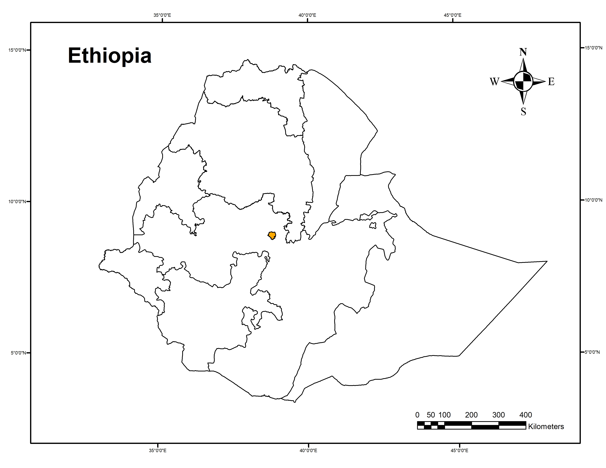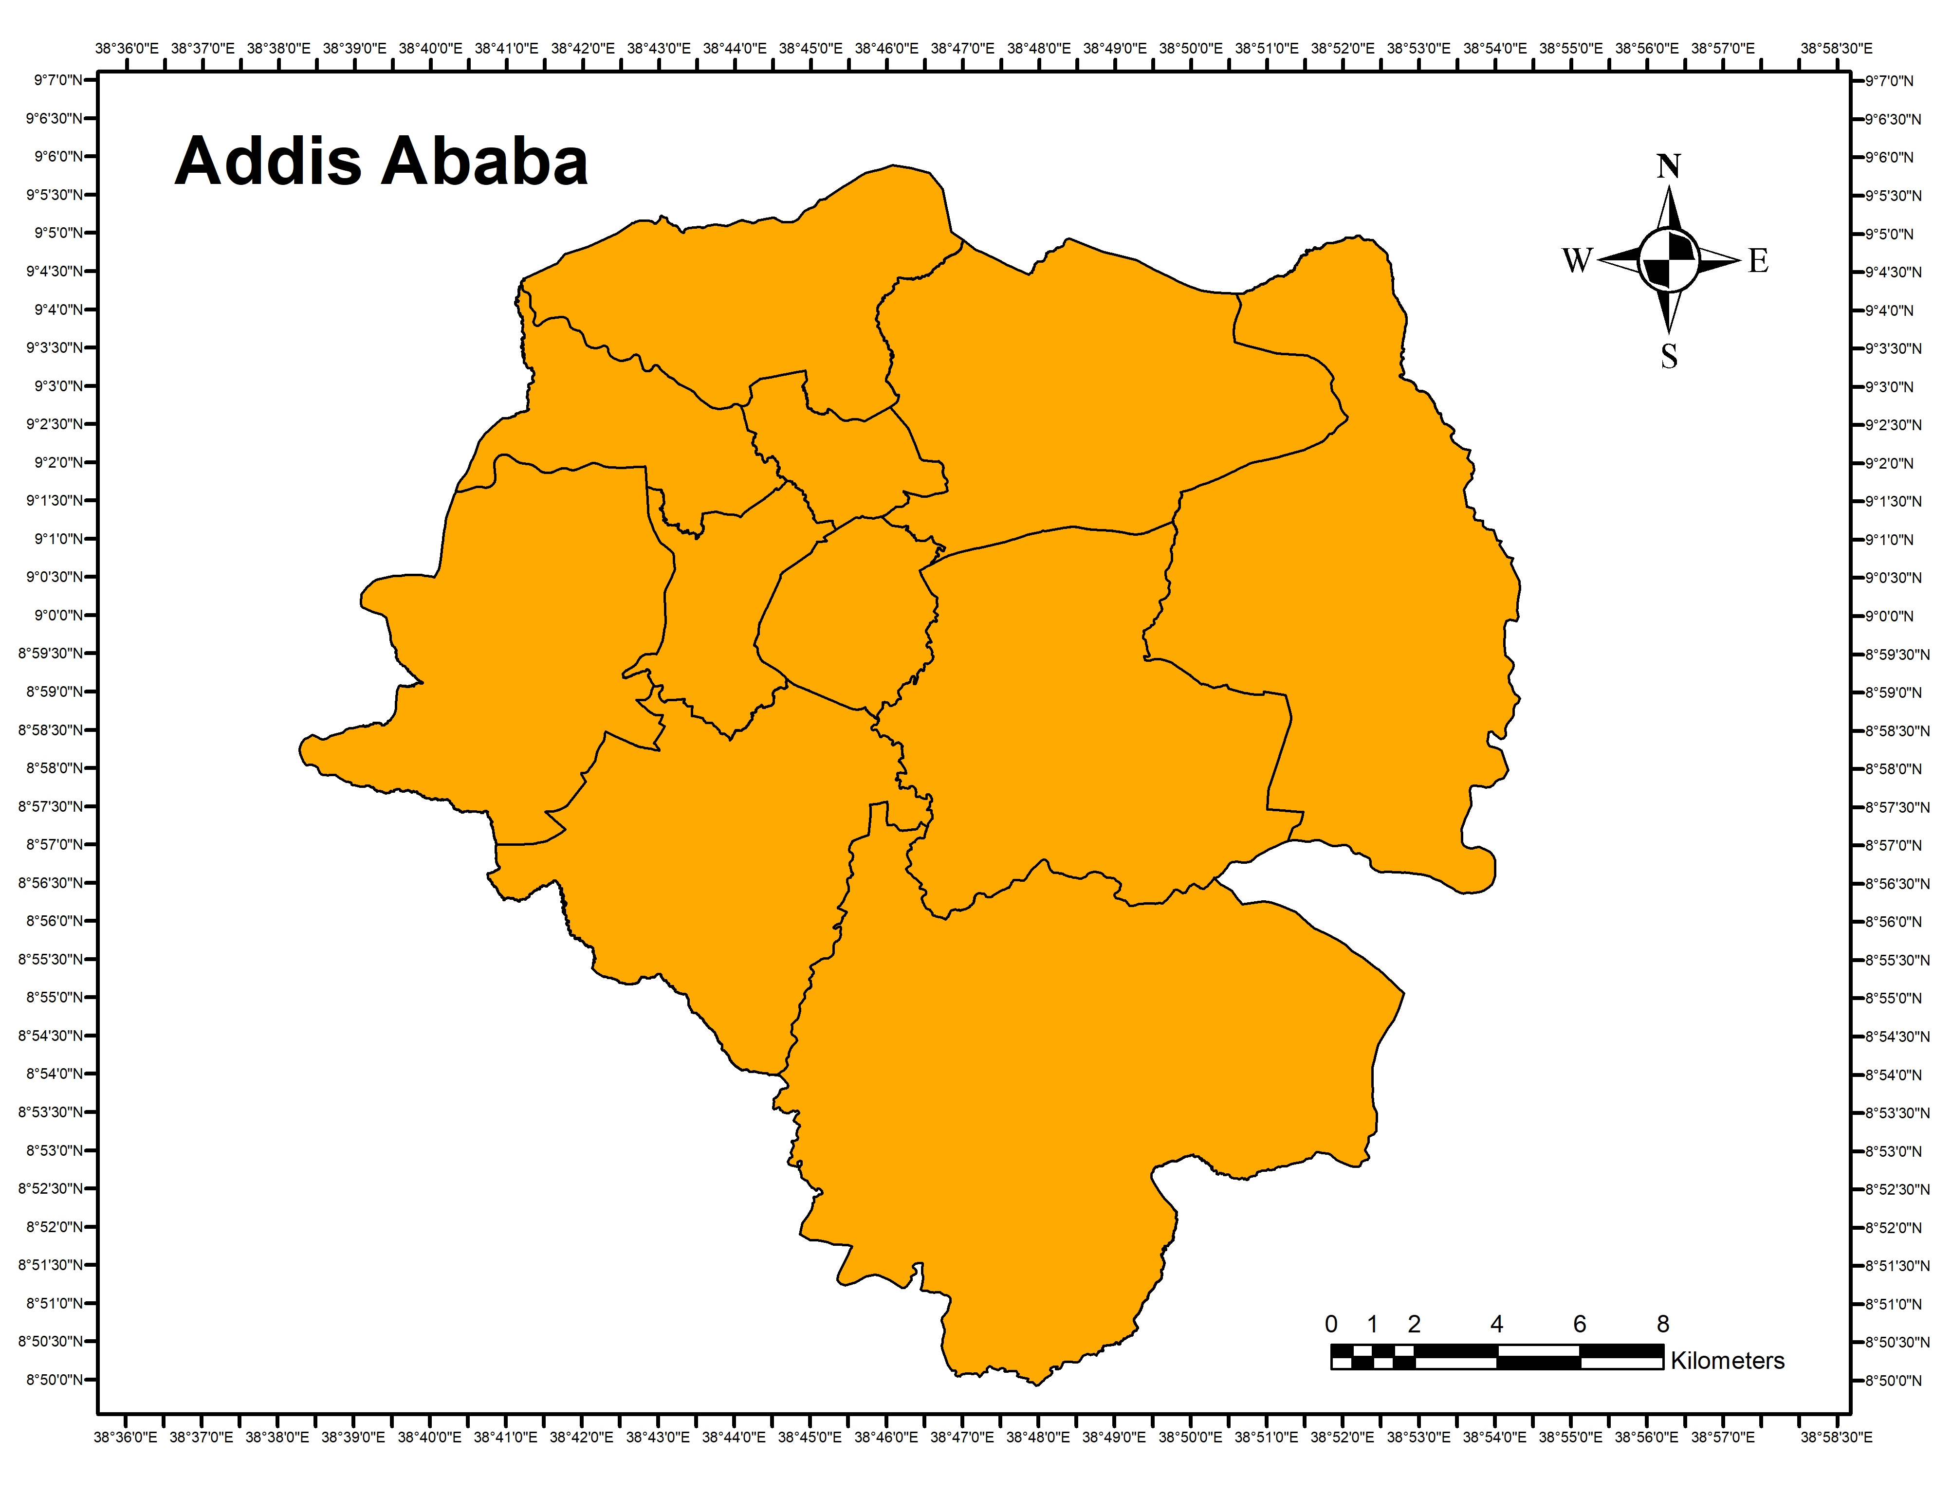
Figure 3.1: Location map of Addis Ababa city (source: Own preparation using Arc GIS 10.7 analysis, 2023)
The majority of the urbanized area in the city falls between 2,200 and 2,500 meters above sea level with a total area average altitude of 2,400 meters and a highest elevation of 3,200 meters above sea level at Entoto mountain which makes Addis Ababa one of the High-altitude cities of the world (Abnet et al., 2020).
The climate in Addis Ababa is subtropical highland, with precipitation varying substantially by month. The main rainy seasons are from June to early October and have an annual average rainfall of 1,200 mm where the majority is from the rainy season alone. Similarly, the temperature varies depending on the elevation, month, and the prevailing winds. The average minimum temperature is 7º in December and the average maximum temperature is 30.6 º in February (meteo climate, retrieved 2023).
Mountains and rivers are significant natural features that have shaped and led to the development of the city's structure and form. Entoto Hills to the north, Mount Wechacha, Repi, and Furi to the west and southwest, and Yerer Mountain and other volcanic cones to the east and south, encircle Addis Abeba. Even though not large four major streams, Qabana, Kachene, Qurtume, and Akaki, which originate in the Entoto highlands pass throughout the city (Ashenafi, 2001).
The total area covered by the city is 540 km sq. According to the CSA, the estimated population of the city is about 3.8 million urban dwellers with an average density of 7324.6 persons per kilometer and a yearly population growth rate of 2.1.
Addis Ababa is one of the two self-administered cities along with Diredawa that are accountable to the federal government. The city is divided into 11 sub-cities and 120 woredas for administrative purposes.

Research design
The study applied a mixed research design to answer the research questions. A mixed research design is a combination or integration of qualitative and quantitative research data in a research study (John, 2014). The purpose of the study fits into the correlational study. The main emphasis of a correlational study is to discover or establish the existence of a relationship /association /interdependence between two or more aspects of a situation (Ranjit, 2011).
Table 3.1: Research design table
Research Questions | Required  data | Data collection methods | Data  analysis  technique
What are the existing spatial structure characteristics of Addis Ababa city? | City shape,  Existing Land use map, The total number of the existing urban population, number of employees in each job sector in Addis Ababa city | Secondary data from the Addis Ababa City Public Service Bureau, Ethiopian Civil Service Commission, Federal private organizations employees’ social security administration, Ethiopian Central Statistics Agency, and Addis Ababa Plan and Development Commission | Measurements on GIS data, Population centrality, Employment centrality,  Job-housing balance measure,  Descriptive analysis
What is the relationship between the existing spatial structure of Addis Ababa city and travel behavior? | Job-housing balance measure,  socioeconomic and demographic characteristics of respondents,  Average time spent waiting for public transportation, Average commuting time in selected areas, commuting mode choice, and their attitude | Questioner, household survey | Descriptive analysis
What are the urban spatial structure characteristics of Addis Ababa city that have a negative and positive impact on travel behavior? | The relationship between the existing spatial structure of Addis Ababa city and travel behavior, the amount of CO2 emissions per distance traveled in each selected site, and energy consumption per distance traveled in each selected site. | Questioner, household survey | Descriptive analysis

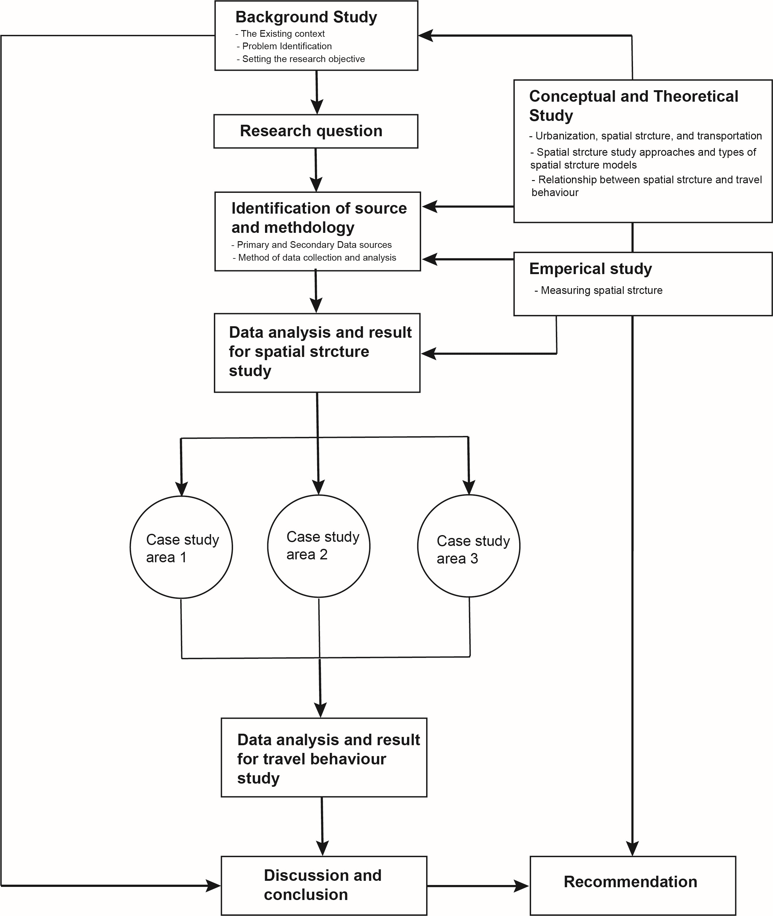
Figure 3.2: Schematic diagram showing the research process

Sources of data
To enhance the quality of data both primary and secondary sources of data have been obtained in this research. The primary sources of data were from the household survey, while the secondary data sources were obtained from published documents, different research, and websites on the topic.
In addition, Population data for Addis Ababa city for the year 2014 EC (2022 GC) were obtained from the Ethiopian Central Statistics Agency. While employment data for each sector for the year 2014 EC (2022 GC) were obtained from Addis Ababa City Public Service Bureau, Ethiopian Civil Service Commission, Federal private organizations employees’ social security administration, Ethiopian industry Minister, Addis Ababa City government organizations employees’ social security administration and missing branch employee data has been obtained from each company head offices. All the data with regard to employees includes the name of the company, the number of workers, and the location of the companies including the sub-city and woreda. On the other hand, up-to-date spatial data have been collected from the Addis Ababa Plan and Development Commission.
Table 3.2: Sources of data from organizations
No | Name of the organization where data has been collected from | Provided Data
1 | Central statistics agency | Population projection estimates for 2014 in Addis Ababa city and each sub-cities
2 | Ethiopian Civil Service Commission | Federal-level organizations' employees' data for the year 2014
3 | Addis Ababa Public service | Employee data for organizations under Addis Ababa City administration for the year 2014
4 | Federal government organizations employees’ social security administration | Federal-level development organizations' employee data for the year 2014
5 | Federal private organizations employees’ social security administration | Private companies' employee data for the year 2014
6 | Addis Ababa city government organizations employees’ social security administration | Employee data for development organizations under Addis Ababa city Administration for the year 2014
7 | Ethiopian industry minister | Employee data for industries in Addis Ababa city for the year 2014
8 | Labor, enterprise & industry development bureau | Small-scale manufacturing employee data for the year 2014
(Source: Own computation, 2023)
Data has been taken from different organizations for the purpose of data triangulation so as to increase the accuracy of the collected data.

Method of sampling
According to (Franklin, 2021) sample size in research refers to the number of people who are included in a study that accurately reflects the population under study which is the most important factor in the statical analysis. Thus, for this study, we have adopted the formula put forward by (Franklin, 2021) called the Andrew Fishers formula presented below.
Sample size = (Z-score)² x stdev x (1-stdev)
(Confidence interval)²
In this formula Z- score is calculated through the conversion of the confidence level selected for the study, confidence level is the proportion of probability, or certainty, that the confidence interval would include the true population parameter when a random sample is drawn numerous times, it is represented in percentage. Stdev represents the standard deviation which calculates the distribution of a set of data from its mean. For sample size determination it can be used to predict how widely the responses will vary from one another and from the mean value. It can also be used to approximate the standard deviation of a population. Lastly, the confidence interval analyzes the level of uncertainty or certainty associated with a sampling technique and the level of uncertainty associated with any given statistic.
The selected confidence level for this study is 95% where the z-score will be calculated to 1.96, the stdev is 0.5% which is recommended to make the sample size large enough (Franklin, 2021) when the actual sample population is not known, in our case our target population are people taking a bounded trip (for both work and education purpose) within the selected area radius.
= ((1.96)² x .5(.5)) / (.05)²
= (3.8416 x .25) / .0025
= 9604 / .0025
= 384.16
Therefore, we took total representatives of 384 participants for the household survey to study travel behaviors in the three selected sites with high job–low housing, low job–high housing, and balanced job-housing areas identified after the spatial structure study, we took 128 participants using a purposive random survey from each area to compare travel behaviors and identify its relationship with the spatial structure of the city. The factors that were taken into consideration to select the sample include income, neighborhood area characteristics, density, and location. A study by (Urban Task Force, 2022) identified up to seven types of housing in Addis Ababa these are the informal houses (the inner-city and periphery informal houses), the incremental houses, the planned formal houses, condominiums (20/80 and 40/60), the apartments, and the mixed commercial, a sample from each typology were also considered according to their availabilities in the selected sites.
Table 3.4: Sampling size from each selected neighborhood
No | Job-housing characteristics | Radius from the CBD | Selected sites | Number of Participants
1 | High job- low housing area | 2km from the CBD | Piazza, Kazanchiz, Lideta, 4 Killo, and Mexico | 128
2 | Closest Job-housing balance | 6km from the CBD | Megenagna, Gerji, 22, Shola, Gofa, and Bole | 128
3 | Low job-high housing areas | 18 km from the CBD | Akaki Kality below Akaki Adventist, Tulu Dimtu, lower Koye Fitche condominium, and Bole Arabse | 128
(Source: Own competition)

Methods of data collection
For this study, the researcher employed different data collection methods. Primary data was collected through structured questionnaires and household surveys. Secondary data was obtained from reports, related websites, and documents. The questionnaires were handed out after being translated into Amharic so that everyone could understand and provide their views. In addition, the questions were prepared with both an open-ended and close-ended question format and enough spaces have been provided for participants to express their views freely.
Three key issues that were pertinent to the study were covered by the survey questionnaire. The first section contains questions on participants’ demographic data including gender, age, education level, marital status, number of household members, employment status, and monthly income were included. The second section includes questions on housing status including, housing ownership, type of dwelling, and location of the neighborhood. Finally, the third section includes questions on travel behavior indicators and factors influencing travel behavior such as working place location, the distance between work place and dwelling place, working hour start and end time, frequency of mode choice and their attitude, availability of transportation, transportation expense, and residential location choice as well as participants opinion on solutions related to transportation challenges in Addis Ababa city.
Among the questioners sent 384 questioners were relevant to the study, participants were surveyed in public spaces around their neighborhood as well as in their homes, a face-to-face interaction and random interception approach were undertaken, and data collectors also provided support in explaining the purpose of the survey, clarifying the questions as well as provided more support in filling the questioner. The term participant is also used throughout the paper instead of respondents in order to make participants part of the research rather than to be researched on. Thus, participants are contributors to the research through the provision of the data, identification of the problems, and providing creative solutions to challenges identified as well as benefiting from the solutions.

Methods of Data Analysis
To analyze the data collected from primary and secondary sources various methods were applied. The methods are presented in the following section:

Measuring spatial structure
Four methods were adopted to measure the urban spatial structure of Addis Ababa city. These are the city shape measure, the pattern of residential land use measure using the population centrality approach, employment distribution measure, and lastly employment measure. We employed Microsoft Excel spreadsheet and ArcGIS tools to analyze the collected data. Each methodology is discussed below.

City shape measure
Identifying the city's shape is the initial stage in measuring the spatial structure of a city which will assist in determining the method required to measure the city’s spatial structure. We used the same method applied by (Antonio et al., 2003) to measure city shape which is to encircle the city with an ellipse whose major and minor axes are equivalent in size to the urbanized area of the city to calculate how much the urbanized area deviates from a circular city using Gis tools.

Population distribution
We used the population centrality approach to measure the percentage of the population living within a 2km distance from the CBD to the edge of the city’s boundary. Finally, the collected data were encoded on GIS and the data was analyzed using GIS tools and a Microsoft Excel spreadsheet. Higher population centrality values suggest that a bigger proportion of the population lives in the area.

Employment distribution
Similar to population distribution we applied the population centrality approach to measure employment area distribution using a 2 km radius starting from the CBD to the edge of the city’s boundary. The collected data was encoded on GIS and we used GIS tools and a Microsoft Excel spreadsheet to analyze the data.

Job-housing imbalance
Initially, to select areas for travel behavior study we calculated the job/housing ratio for each 2km radius starting from the CBD to the edge of the city boundary and selected areas with the highest job-low housing area, balanced job-housing area, and lowest job-high housing areas. Then to measure how evenly jobs are distributed relative to the population in the overall city area, we plotted the cumulative percent of jobs (y-axis) against the cumulative percent of the population (x-axis) to obtain a Lorenz curve. The 45-degree line represents an even distribution of jobs vs. population. Our imbalance measure (Massey and Denton's Gini coefficient) is the area between the Lorenz curve and the 45-degree line, expressed as a proportion of the area under the 45-degree line. Larger values of this measure imply a less-even distribution of jobs vs. housing (Antonio et al., 2003).

Measuring Travel behavior
The data for socioeconomic and demographic characteristics of respondents, as well as travel behavior indicators such as average time spent waiting for public transportation, Average commuting time in selected areas, commuting mode choice, and their attitude, was analyzed using a descriptive statistical method of analysis such as frequencies, percentages, averages, charts, etc so as to compare travel behavior in each neighborhood and to identify the impact of the spatial structure on travel behavior. Finally, the finding of the research was compared, interpreted, and used to draw conclusions and recommendations.

Measuring Transport associated challenges
The major transport-associated challenges are CO2 emission and non-renewable energy consumption. To calculate the average Co2 emission trip distance has been used similar to the approach suggested by previous studies (Wenyue et al., 2018). The formula for each trip is as follows
TCi = MTDi × EFm,
where TCi denotes the CO2 emissions for trip i, TDi denotes the total trip distance for residents that travel from O point to D point during trip i, MTDi is the motorized trip distance for trip i, EFm is the emissions factor for the motorized travel mode m in the related trip.
On the other hand, the energy consumption on a typical working day was calculated using the information in Table 3.3 below.
Table 3.3: The specific energy consumption and CO₂ emissions factor for motorized travel modes
Motorized Travel Modes | Final Energy Consumption (l/100 km, KWh/km) | Average Capacity (Persons) | Primary Energy Consumption (MJ/Pkm) | CO₂ (g/Pkm) | Source
Passenger car | 11.0 | 1.3 | 0.84 | 233.1 | (Wenyue, Shaojian, & Xiaoming, 2018).
Urban bus | 35.0 | 40 | 0.35 | 26 | (Wenyue, Shaojian, and Xiaoming, 2018).
Mini-bus Taxi | 13 | 12 | 0.29 | 18.4 | (Car emissions, 2023)
LRT | 1.96 | 143 | 0.3 | 19 | (ETSAP, 2011)  (Nkurunziza, Nizeyimana, & Turabimana, 2021).  (Carbon independent.org, 2007)
Bajaj/ 3-wheel Rickshaw | 2.5 | 3 | 0.36 | 19.19 | (Majumdar & Jash, 2015)
(Source: own organization from the above-mentioned sources)
Finally, the calculated results using the above formula for each trip are analyzed using a Microsoft Excel spreadsheet.

Method of data presentation
The findings from both the spatial structure and travel behavior study were presented using text formats, tables, and charts in a simple way to effectively communicate with the reader. For this study, two types of charts were used to represent the data these are bar charts and line charts.

Validity of Methods and Materials
To validate the method and approaches employed by the research and the results, a variety of measures were taken. First, both qualitative and qualitative data analysis methods were used to increase the accuracy and the result of the calculated data. The second is data triangulation variety of data sources and collection methods were also been taken using both primary and secondary data sources such as household surveys, questionnaires for concerned sectors, and document reviews, the questionnaires were also prepared with both open-ended and close-ended questions in order for the community to provide their opinion regarding the identification of problems as well as in suggesting the required measures to solve the identified challenges.
Different theories and concepts put forward by different professionals from around the world which are also discussed within the literature review and discussion sections are taken into consideration to validate all the methodologies applied as well as the results. Furthermore, deep discussions regarding the methodologies were held with a professional such as the advisor.
Sampling size is also an important consideration for accuracy assessment and sufficient numbers of samples were taken using a valid formula that can represent the population in concern. The data were also taken to include all parts of the community taking into consideration a variety of factors such as income, age, gender, education, housing typology, and location.

Ethical consideration
In a research process, ethics refers to a researcher's obligations and behavior to safeguard the target populations who are involved in the study process and the research area. It is crucial to follow ethical guidelines when conducting research because they promote the goals of the research such as knowledge, truth, and error prevention, and promote the principles of collaboration—trust, accountability, mutual respect, and fairness making the public feel safe to participate. They also help to ensure that researchers can be held accountable to the public and encourage public support for research (David, 2020)
Different ethical principles have been applied in this research when collecting data starting from asking about the willingness of participants to take part in the survey and providing a detailed description of the purpose and the benefit of the research as well as the data required. We have also made sure participants didn’t provide personal data that will make them personally identifiable, however for data from different organizations we have anonymized personally identifiable data so it can’t be linked to other data by anyone else.
Further, other than during the data collection ethics has been followed in every part of the research so as to provide honest, accurate, reliable, and transparent information and have carefully given recognition to other authors.

Chapter Four: Background on the study area

Background on the study area
The chapter presents a more depth overview of the study area beginning from its historical foundation and its development up to its existing situation. These factors are some of the significant factors that shaped the present-day spatial structure of the city thus it is essential to discuss them.

Historical development of Addis Ababa
Addis Ababa was established as the permanent capital of Ethiopia by Menilik II (1844–1913) in 1886. Like most urban centers in Ethiopia the city developed without any intentional planning efforts, the form and structure were formed as the houses and streets were constructed because of this the inner-city townscape has organic characteristics to it today.
The reason behind selecting Addis Ababa as its capital was its strategic location, availability of elevated cooler ground for residential purposes, ample supply of water, availability of woods, and most of all the thermal spring water (Ashenafi, 2001).
The original settlement pattern of the city, according to research by (Asfaw, 1998), started to allocate land among the military, the church, and the nobles. The recipients of land grants constructed homes, palaces, and military and religious institutions on elevated or strategically situated places. A number of sefers (neighborhoods) of various sizes and forms developed as each grantee, in turn, offered their dependents use rights to property close to their home or church, and as more and more newcomers formed attachments to one of these encampments. During this period the palace, the churches, and the compounds of the noblemen and military leaders served as important nodes where their dependents clustered around in a concentric settlement pattern (Johnson, 1974 quoted by Abnet et al., 2020).
This denoted the beginning of the city's earliest land use pattern, which is actually best described as its first batch of old unplanned neighborhoods (Ashenafi, 2001). Without any planning intervention, the historical footprint of the city and its social and spatial pattern has still remained throughout the years in today’s mixed-income characteristics of the old neighborhoods (Abnet et al., 2020).
In terms of (Ashenafi, 2001), this is due to the fact that Addis Ababa's expansion has been largely uncontrolled during the course of its history. Particularly since the 1974 revolution, Ethiopia's deteriorating economic conditions, scarce resources, ineffective planning processes, and ineffective institutions have made it difficult to control the pace and pattern of urban development, provide adequate services to citizens and businesses, or create a relatively autonomous institution to manage urban growth.
However, other historical events have also played a part in shaping the social and spatial structure of the city. Among these is the five-year occupation by the Italians had a long-lasting effect. During the Italian occupation, two master plans were prepared that aimed to make Addis Ababa the center of colonized countries in East Africa following this plan many have been displaced so as to create social segregation where the western part like Addis Ketema was for locals and the eastern like Kazanchize were for the Italians and the era has left its legacy on the city’s spatial structure, architectural styles of buildings, and some neighborhood characteristics (Ezana, 2021). Some examples include: Several roads mainly the grid patterns around Mercato and arching bridges, arcade shops in Merkato, and brick and wood residential villas mostly in Kazanchize were constructed
After independence three master plans were prepared but due to a shortage of financial, technical, and socio-economic capacity, the implementation of the plans was much more hindered (Ezana, 2021). Although during this period the city has expanded along major transportation routes, as well as on old and new nodes but mainly in an informal manner (Abnet et al., 2020). The following section below provides an in-depth narrative on the special expansion of Addis Ababa city chronologically since its foundation.

Spatio - Temporal Growth Trend of the City and its Drivers
Addis Ababa City has been expanding both formally and informally since its foundation. The first spatial development scheme for the city was Empress Taitu’s which created several localities known as ‘Sefers’ around the houses of the novelty. These organically growing settlements start on high grounds and sloppy areas and gradually spread around their respective focal points. The extended area was between Gulale and Yeka West to East and Entoto and Bekulo Bet North to South. In this period, the total built-up area was 1863.1 ha (AAMPRO, 2002) quoted by (Kenate T, 2012).
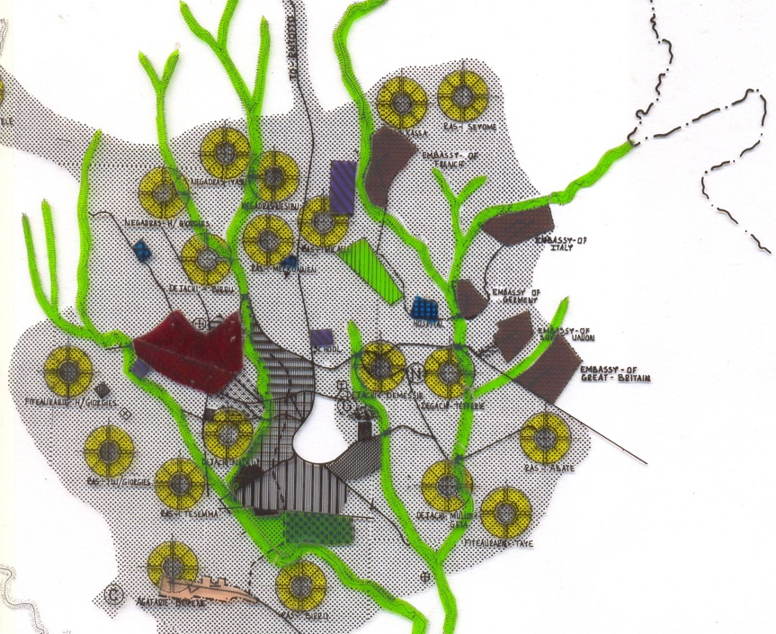
Figure 4.1: Tayitu’s spatial plan for Addis Ababa city
During the Italian occupation from 1935-1941, the land-use change and spatial pattern were influenced by planning policy, where the expansion was undertaken following the preparation of a master plan. Post-colonization up to the 1975 period was characterized by a compact type of development with an infill and green field type of development. The expansion was held to the west and largely to the south areas including Akaki, Kaliti, Nefas-Silk, Makkanisa, Alert, Burayu, and Bole Kotebe the expansion was for the purpose of Residential and industrial development with a total area increase of 6050 ha (Kenate T, 2012).
From 1974 to 1991 the socialist regime of the Dergue era seized urban land and extra dwellings and set a maximum threshold for private capital accumulation. As a result of this Investments have been hindered. During this period there was a rapid expansion of settlement covering an additional 4,788 hectares reaching a total area of 10,838 hectares this is due to radical political and economic changes that took place in the country and the increased demand for housing. Bole, Kotebe, Makkanisa, Gulale, part of Kolfe, Alert to Rephi, and Nifas-Silk, which includes the Akaki and Kalitii neighborhood, are some of the significant locations included in the city's built-up area (Kenate T, 2012).
Due to the transition of government from 1986 to 1995, squatter settlements increased and contributed to the expansion of the city. The city expanded to include Ayar Tena, Kolfe Keraniyo, and Asko in the west; Makkanisa and Kalitti in the south; Kotebe, Bole, Garji, and Bole Yerer in the east; and the French Embassy in the north. During this period the total built-up area of the city has reached 13,763.3 hectares with an overall increase of 2,925.3 hectares (Kenate T, 2012). The main reason behind this expansion along the macro reasons was economic factors where the outcome was competition for accessibility, social factors, and policy change where a robust private sector has been allowed to emerge.
The physical built-up area of Addis Ababa increased by 909.4 hectares during the physical expansion period between 1996 and 2000, totaling 14,672.7 hectares. The city's growth at this time was characterized by dispersed and fragmented settlements in the outskirts, which included both legal residents and squatters. According to estimates squatter settlements made up a total of 13.6 percent of the built-up area. The Kotebe area in the east (for residences and industries), the Kalitti and Makkanisa area in the south (predominantly designed for both residences and industries), the road to Jimma and Keraniyo in the west (primarily housing both formal and informal), and the road to Ambo (mainly formal housing in the Asco area) were the areas that underwent expansion (Kenate T, 2012). Thus, the city’s boundary reached a total of 52700 ha during this time.
Between 2005-2015 the expansion trend of the city is characterized by low and high-density residential developments on the periphery of the city one of the contributors to these trends is the AAHDPO which has developed a variety of high-density residential on periphery areas mainly to the west, east and southern parts of the city. Such as Summit, Bole Ayat, Bole Bulbula, Meri, Mikily land, Jemmo, Gelan, Bole Arabsa, Koyefiche, Tafo, and Yeka Abado are some of the developments in expansion areas.
Large infrastructure investments in road construction have accelerated the process of change. Condominium housing in more than a hundred sites in the city, large residential housing construction by private real estate companies, and the booming of the construction of commercial high-rise buildings all have been influential in reshaping the spatial organization and productivity of economic activities. The main reason behind the expansion of the city was the pressing need for housing due to macro factors, the need for quiet neighborhoods away from noise and pollution, and inner-city redevelopment. Due to this, the total density has decreased from 182 persons per hectare to 96 persons per hectare in 2015 specifying sprawl and sub-urbanization (Ezana, 2021).
More significant is the effect of the Addis Ababa City Development Plan (2002-2010), which developed a strategic Structure Plan to facilitate development in the city. The settlement pattern changed to a mixed vibrant environment but with diminishing functional hierarchies. However, this is also a period where most open spaces, agricultural land, and green zones changed into built-up. Including the mountains where Deforestation, land degradation, and proliferation of unplanned (informal) settlements have affected the structure and function of the mountain landscape. Parts of the upper catchments of Addis Ababa are increasingly being occupied by residential buildings and industries. A recent study from the Environmental Protection Authority has shown that 12,486 residents live in the upper catchment of Ankorcha, 16,519 in Kotebe, 8,981 in Entoto, and 2,470 in Sansusi.
Overall, the most important process of the change in the land use and the expansion of Addis Ababa city that has shaped the spatial structure over decades and currently are the historical urbanization of the city, macro factors such as the increasing population, planning policy, social, and economic factors including economic growth of the city, computation for accessibility to service, infrastructure, transportation, and employment opportunity. In addition, planning policy changes over the changing governance has also impacted the size and type of development that occurred around different areas of the city.
The historical physical expansion of cities, which is frequently typified by lateral growth, sprawl, and dispersed spatial development, has been one of the major effects of historical urbanization in shaping the existing spatial structure of cities. By increasing the distance between different land use activities, such as the location of housing and the place of employment, the resulting spatial patterns in turn affect commute flows (Acheampong, 2019). As discussed above this is also one of the cases for Addis Ababa city.
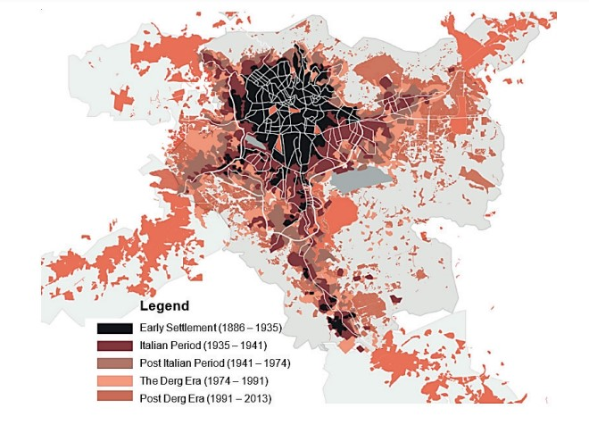
Figure 4.2: Expansion trend of Addis Ababa city from (1886 – 2013) (Source: Abinet et al., 2020).

Change in population
Ethiopia is one of the fastest urbanizing nations in Africa with an annual rate of population growth of 4.2%. Among these Addis Ababa holds 25% of Ethiopia’s population making it the largest city in the country, having almost 8 times bigger population than the second city Dire Dawa (MWUD, 2007).
Similar to its spatial expansion, the population of Addis Ababa city has been increasing at an alarming rate since its foundation in 1887 when the total population was only 15,000. In a few years at the beginning of the 1910’s the population reached 65,000, then by the 1940s the population reached 300,000, and by the 1990’s it reached 2.6 million. This shows that within 50 years, the city’s population has increased by 40%.
The last population census for Addis Ababa city was undertaken in 1984, 1995 and 2007 the result of the census shows that the population during this time was 1,423,111, 2,112,273, and 2,738,248 respectively. According to CSA, the majority of the population growth in the city is due to a high number of rural-urban migrants attracted by employment and better education. For the years past 2007, the population data is from projections. Many projections have been put forward for the city but according to the CSA, Addis Ababa will have a population of 3.8 million people by the year 2022 and a population growth rate of 2.1%. The population doubling time based on CSA estimation is 33 years. On the other hand, the United Nations population projection estimates in 2022 Addis Ababa will have a 5.8 million population and an annual growth rate of 4.46% with a population doubling year of 10.

Figure 4.3: Addis Ababa population (1887-2022) (Source: Central Statistics Agency, 2022)

Figure 4.4: Addis Ababa city population growth rate (1968 – 2022) (Source: Central Statistics Agency, 2022)
While the population has grown since the foundation of the city, the growth rate has declined starting from 1968 when the growth rate was 6.9 to 2.1 in 2012. This is estimated to be because of urbanization and economic development in other regions as well as the decline in the birth rate (AAPDC, 2021).

Addis Ababa city's existing population
According to Ethiopian central statics data in 2022 using the old city boundary (Before 2023) there was a total of 3,859,999 populations residing in Addis Ababa city. Among these, the highest population is observed in Kolfe Keranio sub-city with a population of 604,226 people covering 15.65% of the total population followed by Yeka and Nifas silk sub-city having a population of 488,537 and 445,683, and partaking 12.66% and 11.55% of the total population respectively, while the lowest is observed in Lideta and Akaki Kality sub-city which is a total of 284,208 and 255,348 covering only 7.36 and 6.6% respectively.
However, the population density varies greatly with the inner-city areas having the highest people per km residing in Addis Ketema sub-city, Lideta, and Arada taking the lead where up to 48547.23 pers/km, 30,959.5 pers/km, 30,075.1 pers/km dwell respectively while the lowest is Akaki Kality, bole and Yeka with 2,162.5 pers/km, 3,566.7 pers/km and 5,682 pers/km.

Table 4.1: Addis Ababa city Share of population in each sub-city
No | Sub-city | Number of population | Percentage (%) | Area covered (sq. km) | Density (per/km)
1 | Akaki Kaliti-Sub City | 255,348 | 6.61 | 118.08 | 2,162.5
2 | Nefas Silk-Lafto-Sub City | 445,683 | 11.55 | 68.3 | 6,525.37
3 | Kolfe Keraniyo-Sub City | 604,226 | 15.65 | 61.25 | 9,864.91
4 | Gulele-Sub City | 377,032 | 9.77 | 30.18 | 12,492.77
5 | Lideta-Sub City | 284,208 | 7.36 | 9.18 | 30,959.47
6 | Kirkos-Sub City | 311,765 | 8.08 | 14.62 | 21,324.55
7 | Arada-Sub City | 298,044 | 7.72 | 9.91 | 30,075.07
8 | Addis Ketema-Sub City | 359,735 | 9.32 | 7.41 | 48,547.23
9 | Yeka-Sub City | 488,537 | 12.66 | 85.98 | 5,681.98
10 | Bole-Sub City | 435,421 | 11.28 | 122.08 | 3,566.68
11 | Addis Ababa city | 3,859,999 | 100 | 526.99 | 7,324.61
(Source: CSA, 2022)

Transportation in Addis Ababa
The main transportation in Addis Ababa include cars, busses, taxi, LRT, and Bajaj. The dominant public transportation modes are city buses and taxis. The buses in the city are publicly owned with a variation from Anbessa, Sheger, Higer to other supporting public busses. Their carrying capacity ranges from 25 to 30-seat carry with a possibility of carrying up to 100 passengers at crowded times. There are two types of taxis. These are the mid-bus taxis which have a carrying capacity of 12 up to 15 passengers and the other ones are small contract or ride taxis that have a carrying capacity of up to 5 passengers.
The LRT in Addis Ababa is the first light transit in East Africa and in the sub-Saharan countries. There are two lines, the east-west line extends from Ayat to Torhailoch covering 17.4 Km while the north-south line extends from Piazza to Akaki covering 16.9 Km. It was initially intended to carry up to 286 passengers (Railway Gazette International, 2015).
Figure 4.8: Mini-Bus Taxi in Addis Ababa (Source: Addis Fortune, retrieved 2023)
Figure 4.7: Anbessa Public Bus in Addis Ababa (Source: Hisens.com, retrieved 2023)
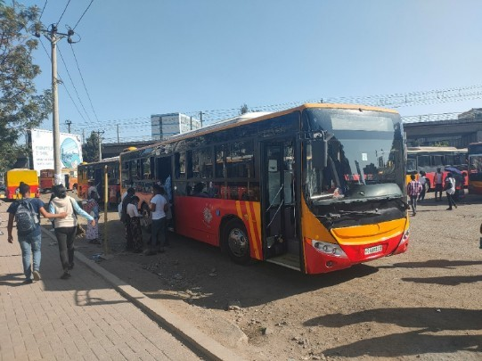
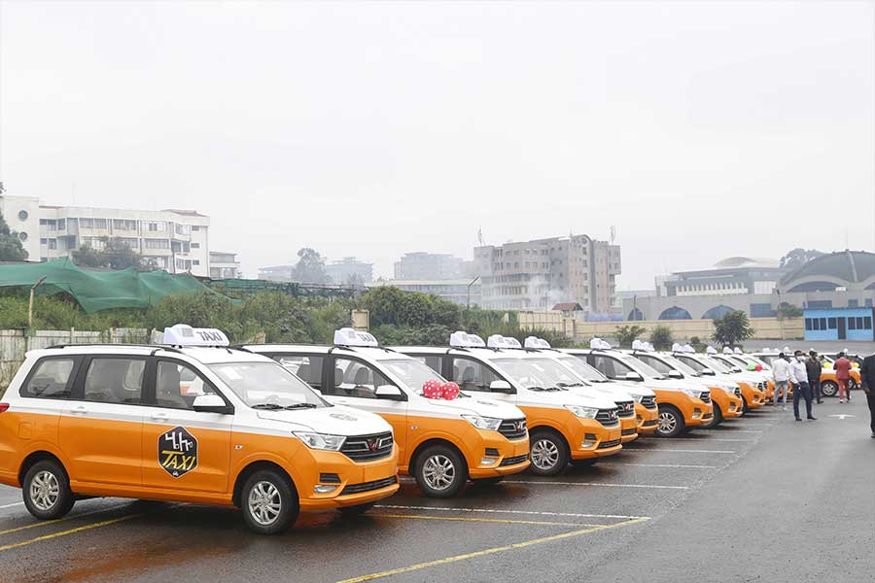
Figure 4.6: Mini-Bus Taxi in Addis Ababa (Source: Ezega.com, retrieved 2023)
Figure 4.5: Sheger Public Bus in Addis Ababa (Source: A.Savin, WikiCommons, 2018)
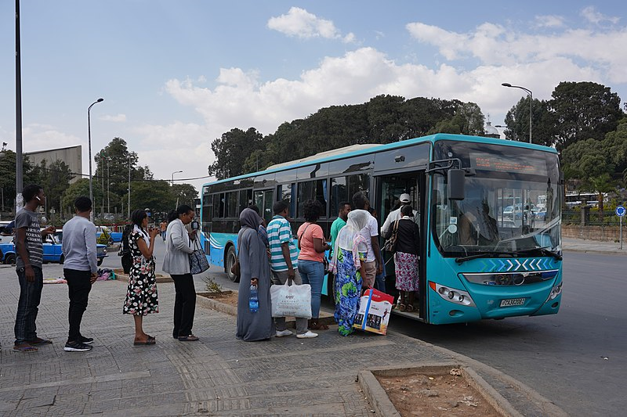
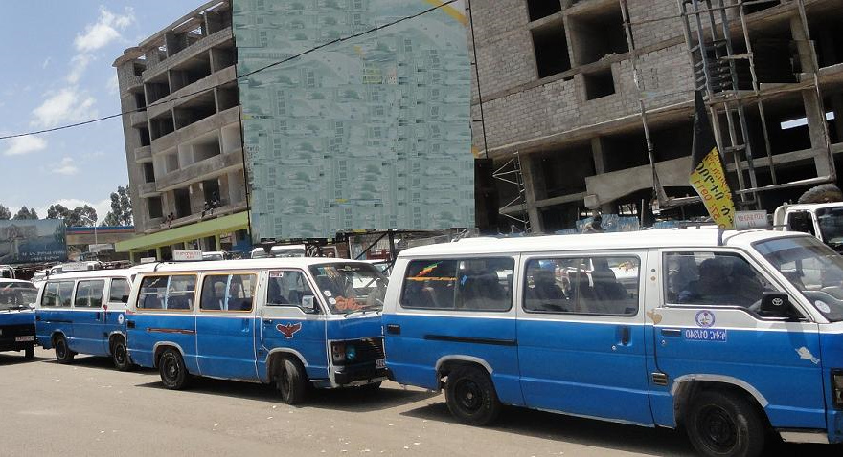
The last of the public transports are the Bajaj or the 3-wheel Rickshaws, these provide transport services for short length trips as well as provide contract services, it has a carrying capacity of 3 people with an exception of 5 people.
Figure 4.10: Bajaj/ 3-wheel rickshaw in Addis Ababa (Source: The reporter, 2023)
Figure 4.9: LRT in Addis Ababa (Source: Turtlewong, retrieved 2023)
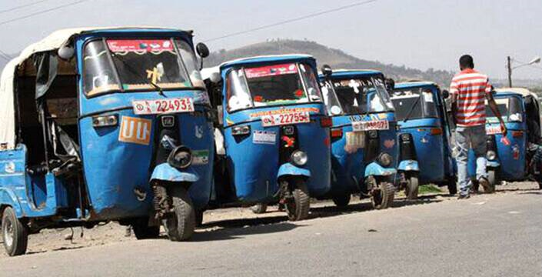
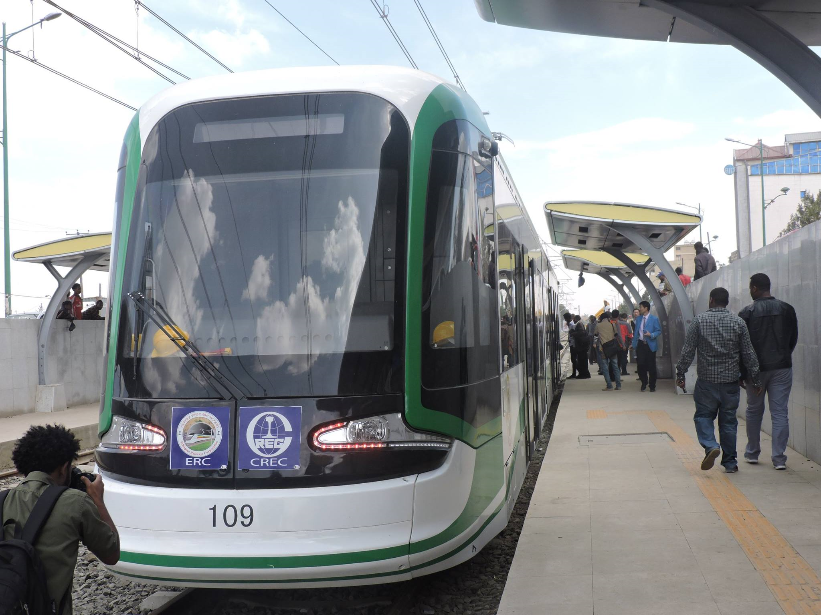
Compared to the rest of the world private car ownership is really low in the city. however, it is claimed to be rising at a rapid rate despite the increased tax rate. Similarly, the use of bicycles in the city is very low, although inner-city areas and newly constructed roads are providing separate bicycle lanes recently to encourage the use of bicycles. According to (Ashenafi, 2018) for many locals, walking is their primary mode of transportation.

Chapter five: Result and Discussion

Result
The main findings and results from the analysis are presented in this chapter. As explained in the above sections the research focuses on the relationship between the existing spatial structure of the city and individual travel behavior. Therefore, the findings for the spatial structure study are first presented, and then data for the travel behavior study including participants' demographic condition is presented analyzed, and interpreted to show its relationship with the city’s spatial structure as well as its positive and negative impacts.

The Spatial Structure of Addis Ababa
The following section presents the findings from the spatial structure study and provides an interpretation of the results. First, it provides details on how the methodology is selected for the spatial structure study then provides the findings for population and employment distribution measure as well as calculates the job-housing balance so as to select three areas for travel behavior study.

City Shape
Addis Ababa city has been going through reform since 2022, the city’s boundary as well as the sub-city and woreda has changed. However, to measure the city shape we have used both the previous and the new city boundaries where both results show a number closer to 1 with 0.99 and 0.97 major and minor axis ratios respectively.
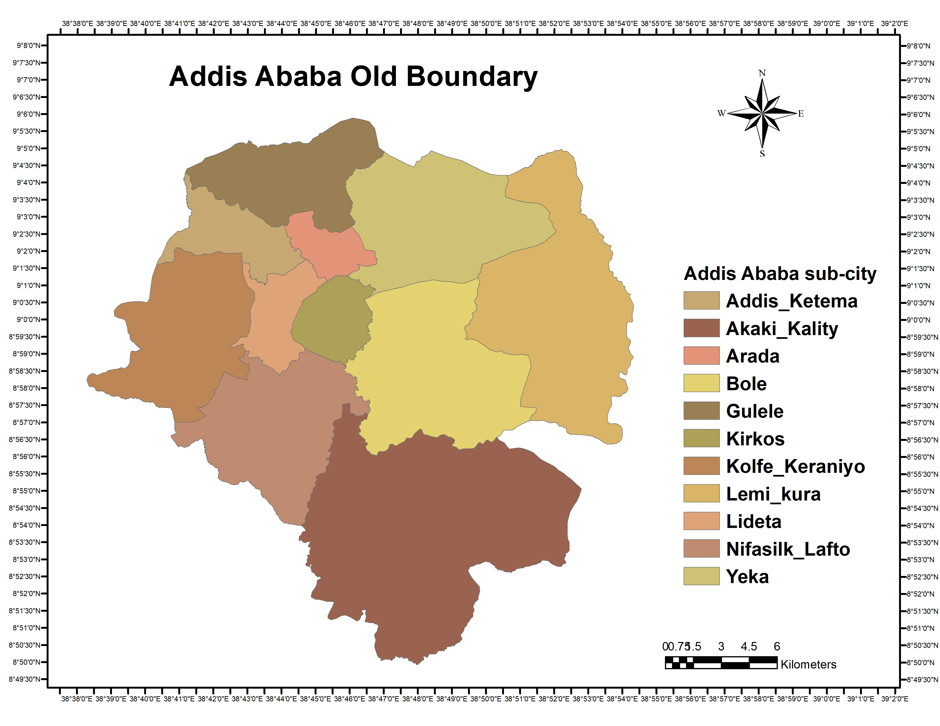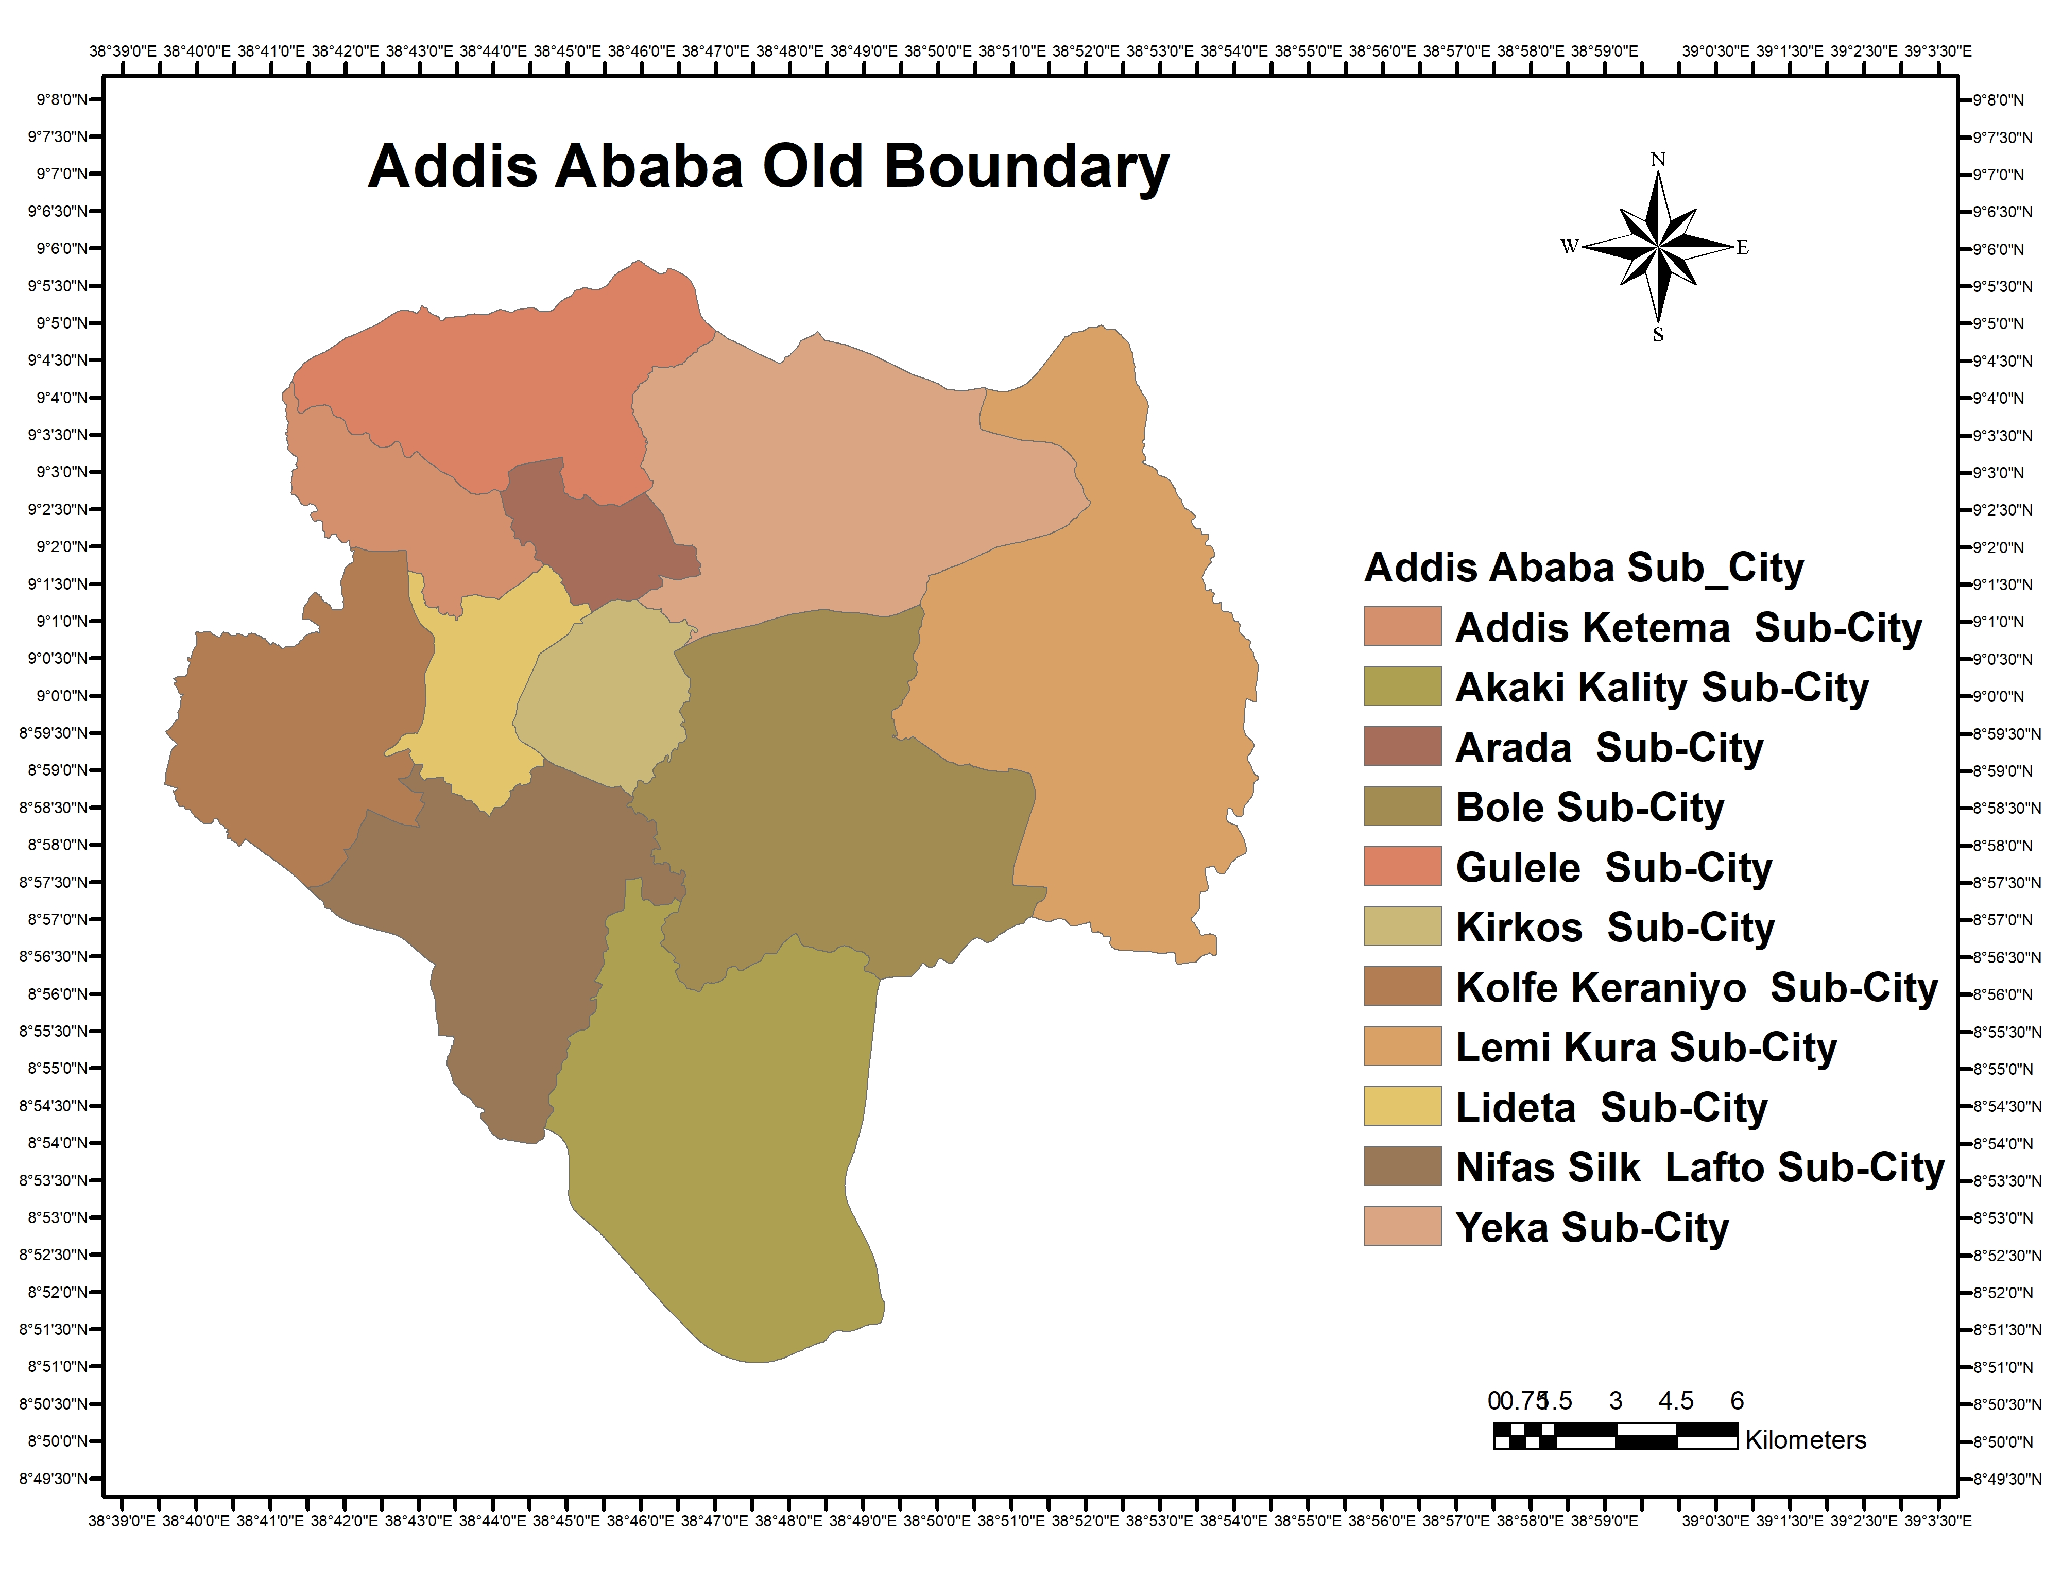
Figure 5.1: Old and New Addis Ababa City Boundary (Source: Own preparation using Arc GIS 10.7 analysis, 2023)

Population Centrality
Following the result from the city shape measurement and the appropriateness of the methodology for the research, we have applied the population centrality approach to measure the population distribution within Addis Ababa city. However, unlike the city shape measure we have used the previous city boundary alone to study the population distribution within the city because there are no existing separate population data for the new city boundary.
Using the population data from CSA for the year 2014 the population distribution at night when people are at their home were measured using the CBD as a starting point. The boundary for the CBD has been taken from the revised structure plan of 2002 and 2017. According to the 2017 Addis Ababa city structure plan the CBD covers 1km starting from Leghar at the start of Churchill Avenue including three important nodes such as Merkato, Arada, and Arat Killo. The result of the Population centrality measure is presented in the following graph below:

Figure 5.2: Population distribution in Addis Ababa city at each radius (Source: Own computation, 2023)

Table 5.1: Population distribution percentage at 2 km radius gap in Addis Ababa city
Distance from the CBD | 2 km | 4km | 6km | 8 km | 10Km | 12km | 14km | 16km | 18km | 20km
Population Percentage | 9.38 | 25.49 | 22.6 | 14.17 | 11.87 | 4.42 | 3.88 | 5.75 | 2.1 | 0.34
(Source: Own computation, 2023)
The result shows that the highest concentration of population resides within 4 km of the CBD where up to 25.49% of the total population within Addis Ababa city dwells while the lowest is located 20km from the CBD with only 0.34% of the population showing a huge difference with the highest concentration of 25.15% range value. The mean of the data is 9.98, the median is 7.56 and the standard deviation is 8.13.
    - Job Distribution
Similar to population distribution job distribution is measured using the population centrality approach of employees working with 5km, 10km, etc. from the CBD. All type of jobs within Addis Ababa city that has more than 15 workers has been included in the study except foreign embassies and self-employed jobs. The employment distribution in Addis Ababa is presented in the figure below.

Figure 5.3: Employment distribution in Addis Ababa city in each radius (Source: Own computation, 2023)
Table 5.2: Employment distribution percentage at 2 km radius gap in Addis Ababa city
Distance from the CBD | 2 km | 4km | 6km | 8 km | 10Km | 12km | 14km | 16km | 18km | 20km
Employment Percentage | 17.99 | 27.87 | 22.28 | 11.03 | 6.04 | 4.25 | 7.25 | 2.41 | 0.64 | 0.24
(Source: Own computation, 2023)
The highest employment percentage similar to the population distribution is within 4km of the CBD containing 27.87% of the total employees within the city while the lowest percentage is observed within 20km from the CBD having 0.24% of employees working in the areas. The range between the highest and the lowest values is 27.63%. The mean of the data is 10, the median is 6.64 which is around 10 km of the CBD while the standard deviation is 9.12.

Figure 5.4: Employment distribution vs. Population distribution in Addis Ababa city (Source: Own computation, 2023)
While the population decreases at a slower rate as one move away from the CBD the job distribution shows a sudden decrease as one moves away from the CBD and increases again at 14 km.

Job housing Balance
The job housing measure is the ratio of jobs to housing within a particular area. In this study case, the job is the number of employees at a certain distance from the CBD and the housing is the number of people.
The job-housing balance for Addis Ababa city has been calculated using this methodology for areas located by a 2km gap from the CBD. The measure is presented below
Table 5.3: Job-housing balance at each radius in Addis Ababa City
Distance from the CBD | Employment Percentage | Population Percentage | Job – Housing Ratio | Status
2 km | 17.99 | 9.38 | 1.91 | Imbalanced
4 km | 27.87 | 25.49 | 1.09 | Balanced
6 km | 22.28 | 22.6 | 0.98 | Balanced
8 km | 11.03 | 14.17 | 0.77 | Balanced
10 km | 6.04 | 11.87 | 0.5 | Imbalanced
12 km | 4.25 | 4.42 | 0.96 | Balanced
14 km | 7.25 | 3.88 | 1.8 | Imbalanced
16 km | 2.41 | 5.75 | 0.41 | Imbalanced
18 km | 0.64 | 2.1 | 0.3 | Imbalanced
20 km | 0.24 | 0.34 | 0.7 | Imbalanced
(Source: own computation, 2023)
The total result indicates among all areas in the city areas located at 4 km, 6 km, 8 km, and 12 km have a balanced job-housing ratio measure while the rest of the areas including located at 2 km, 10 km, 14 km, 16 km, 18 km and 20 km have imbalanced job-housing ratio.
The highest job-housing imbalances are observed around 2 km from the CBD with a higher ratio of employee concentration to Housing of 1.91 and at 18 Km from the CBD with a very high concentration of people (dwelling) to a job (employees) of 0.3.
The closest balanced area is observed at a 6 km radius with a 0.98 job/housing ratio these areas include Megenagna, 22, Gerji, Bole, Gofa, Mekannisa, and Nifas silk areas. Another closest job housing balance is at 12 km with a 0.96 job/housing ratio which includes areas such as Kality, Summit, and Kotebe area.
Finally, to identify the overall job–housing balance status of the city the cumulative percentage of jobs to housing is presented by the Lorenzo curve. The imbalance is the area between the Lorenzo curve and the 45º line of equality, the Gini coefficient, on the other hand, describes how the ratio deviates from perfect equality.

Figure 5.5: Job - housing balance in Addis Ababa City (Source: Own computation, 2023)
The graph represents the cumulative percentage of the population (noted on X) versus the cumulated percent of employees (noted on Y) to show the job-housing balance throughout the city. Thus, the Gini coefficient for this curve is 0.8.
After calculating the job housing balance at each radius, we have selected areas with high job–low housing, balanced job–housing, and low job–high housing areas to study the relationship between the spatial structures and travel behavior at each radius the following sections present households travel behavior at each selected area.

Selected Areas
To study travel behavior we have selected different sites based on population and job distribution and the result from the job–housing balance measurement.

Areas with High Job – Low Housing ratio
Among Areas with high job–low housing areas, we have selected different neighborhoods including Piazza, Kazanchiz, 4 Killo, Lideta, and Mexico. These areas are located in different sub-cities. While Piazza and 4 Killo are located in the Arada sub-city, Mexico and Kazanchiz are located in Kirkos sub-city and Lideta is located in Lideta sub-city. These areas are selected because they are located within 2 km radius of the CBD where there is a high number of jobs and a low number of housing ratio.
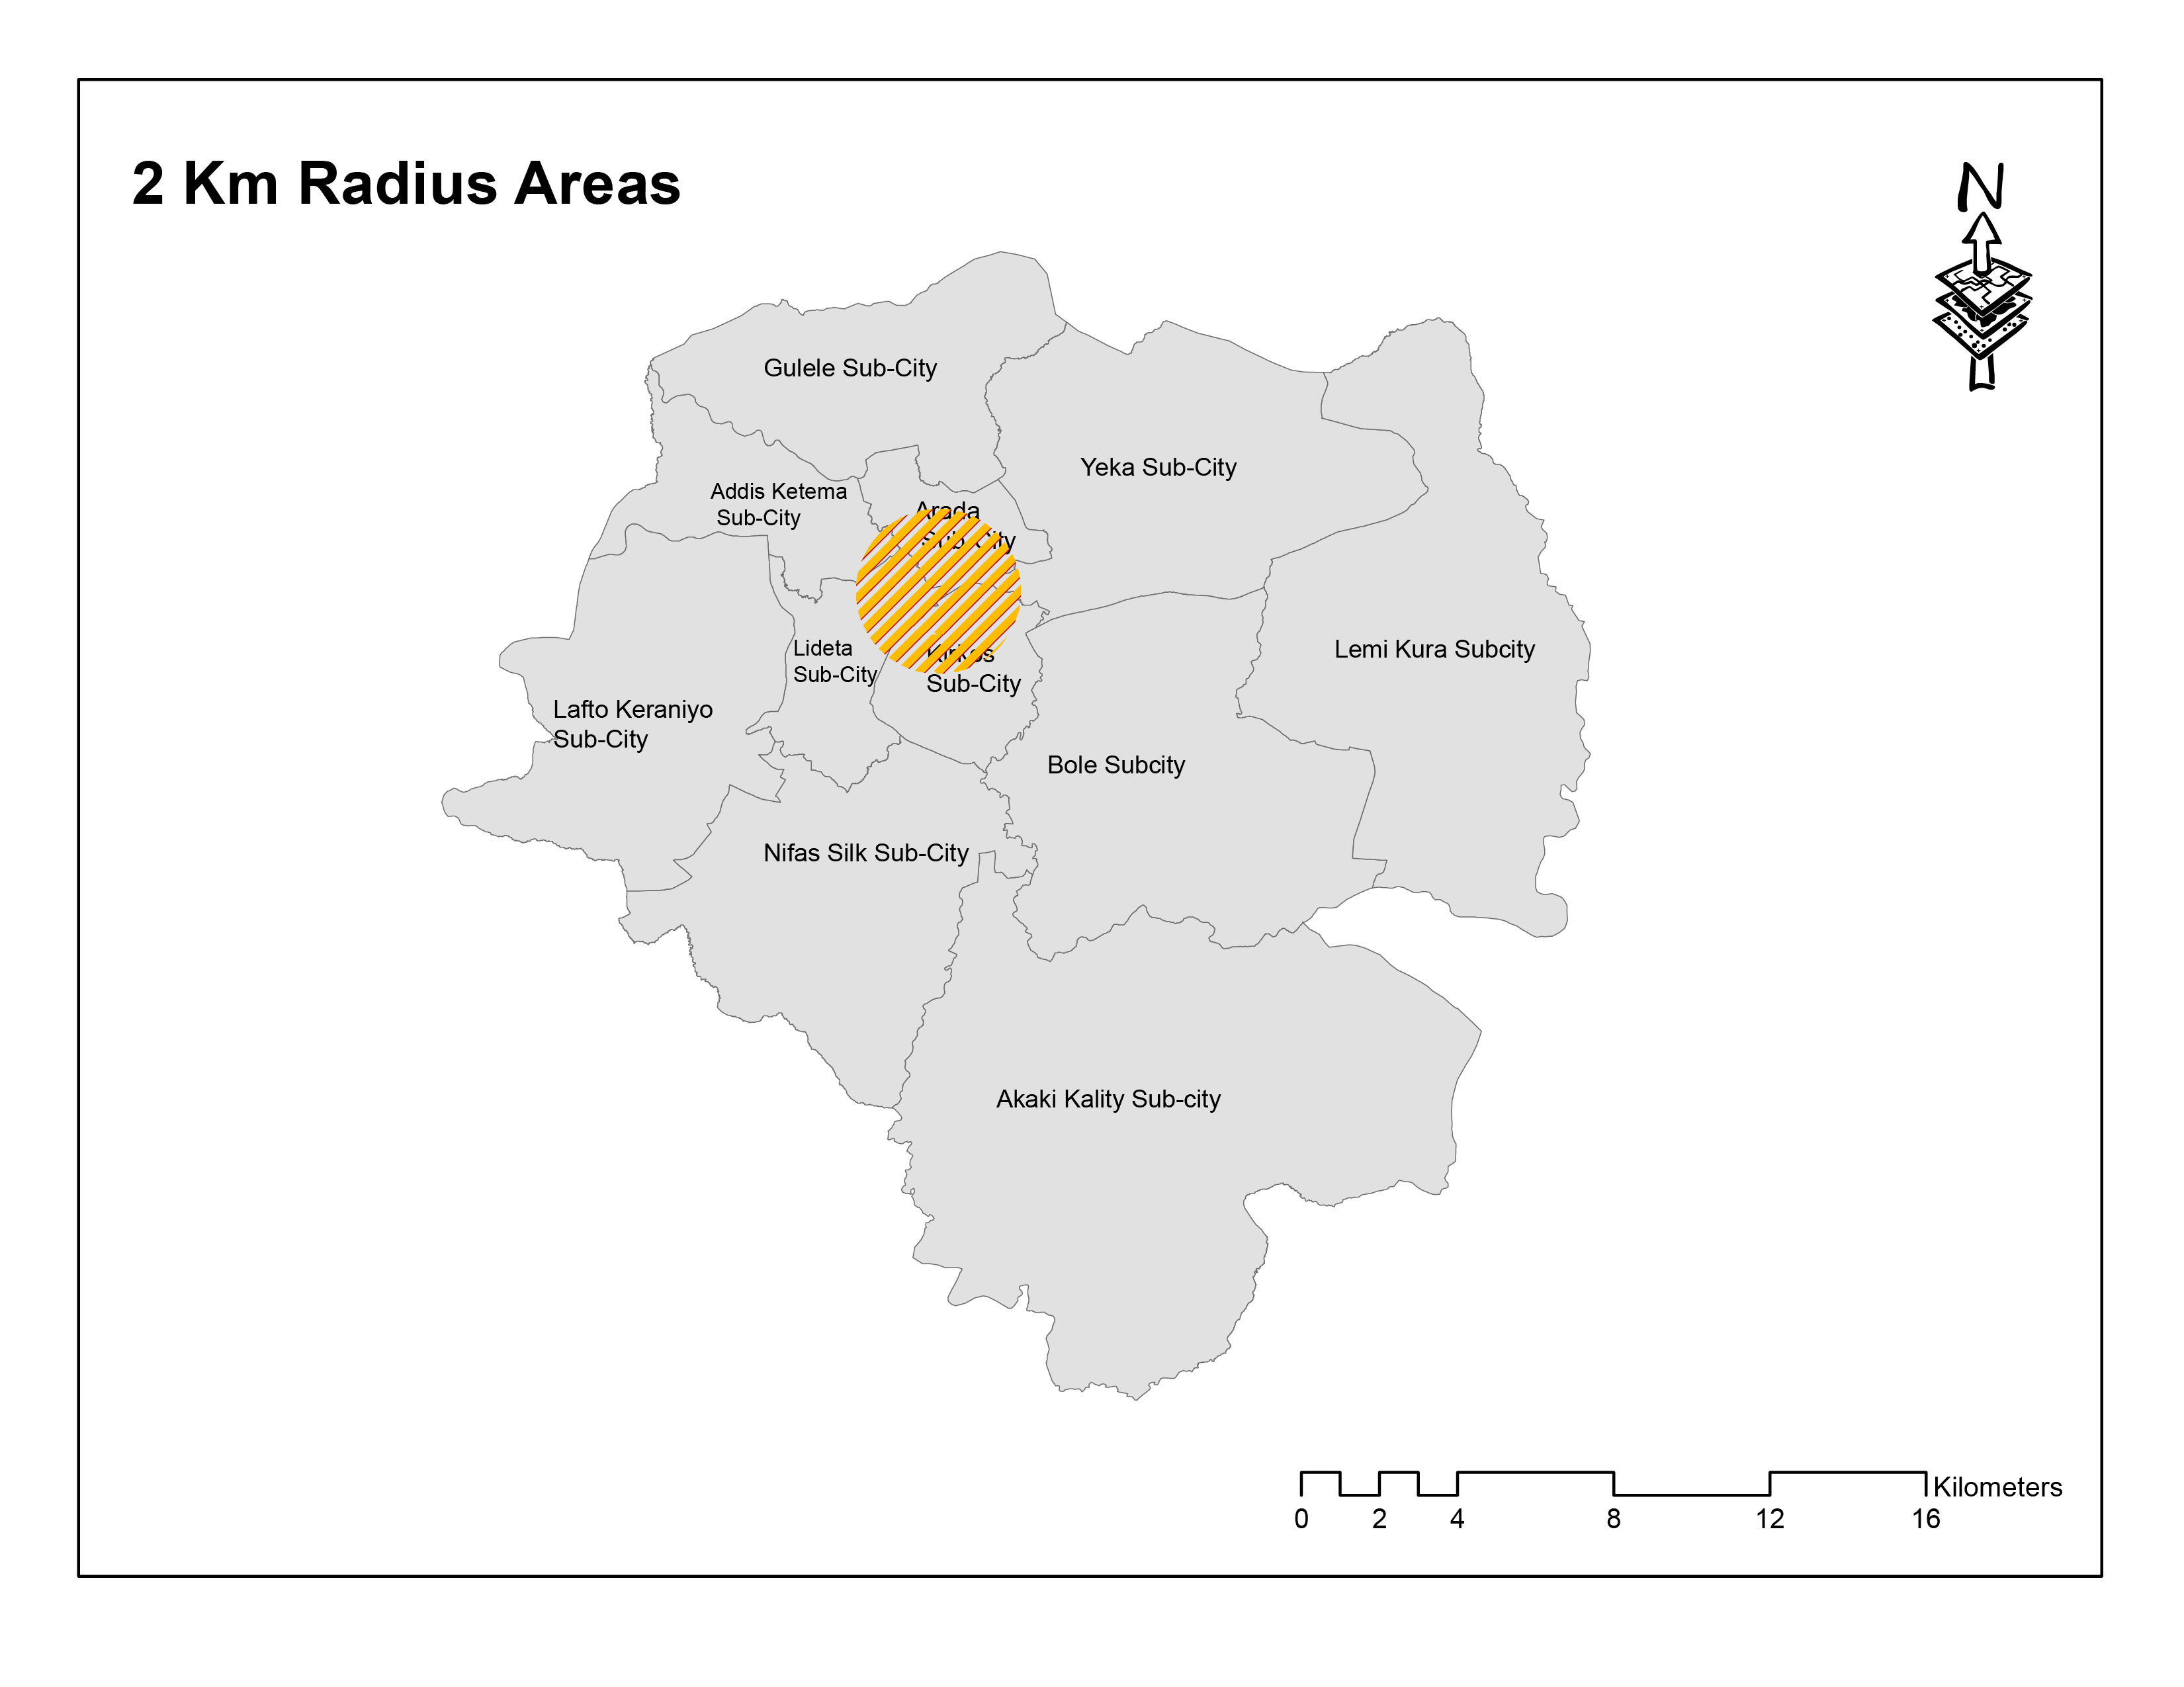Figure 5.6: Job - housing balance in Addis Ababa City (Source: Own preparation using Arc GIS 10.7 analysis, 2023)

Areas With a Balanced Job – Housing ratio
For areas with a balanced job-housing ratio, we have selected neighborhoods located within 6 km of the CBD. The selected areas are Bole, Gerji, Megenagna, 22, Shola, and Gofa these areas among other areas in this radius, are selected because the concentration of jobs and housing at a balanced ratio is concentrated over these neighborhoods. While Bole, Gerji, and 22 are located in Bole sub-city, Megenagna, and Shola are located in Yeka sub-city and Gofa is Located in Kirkos sub-city.
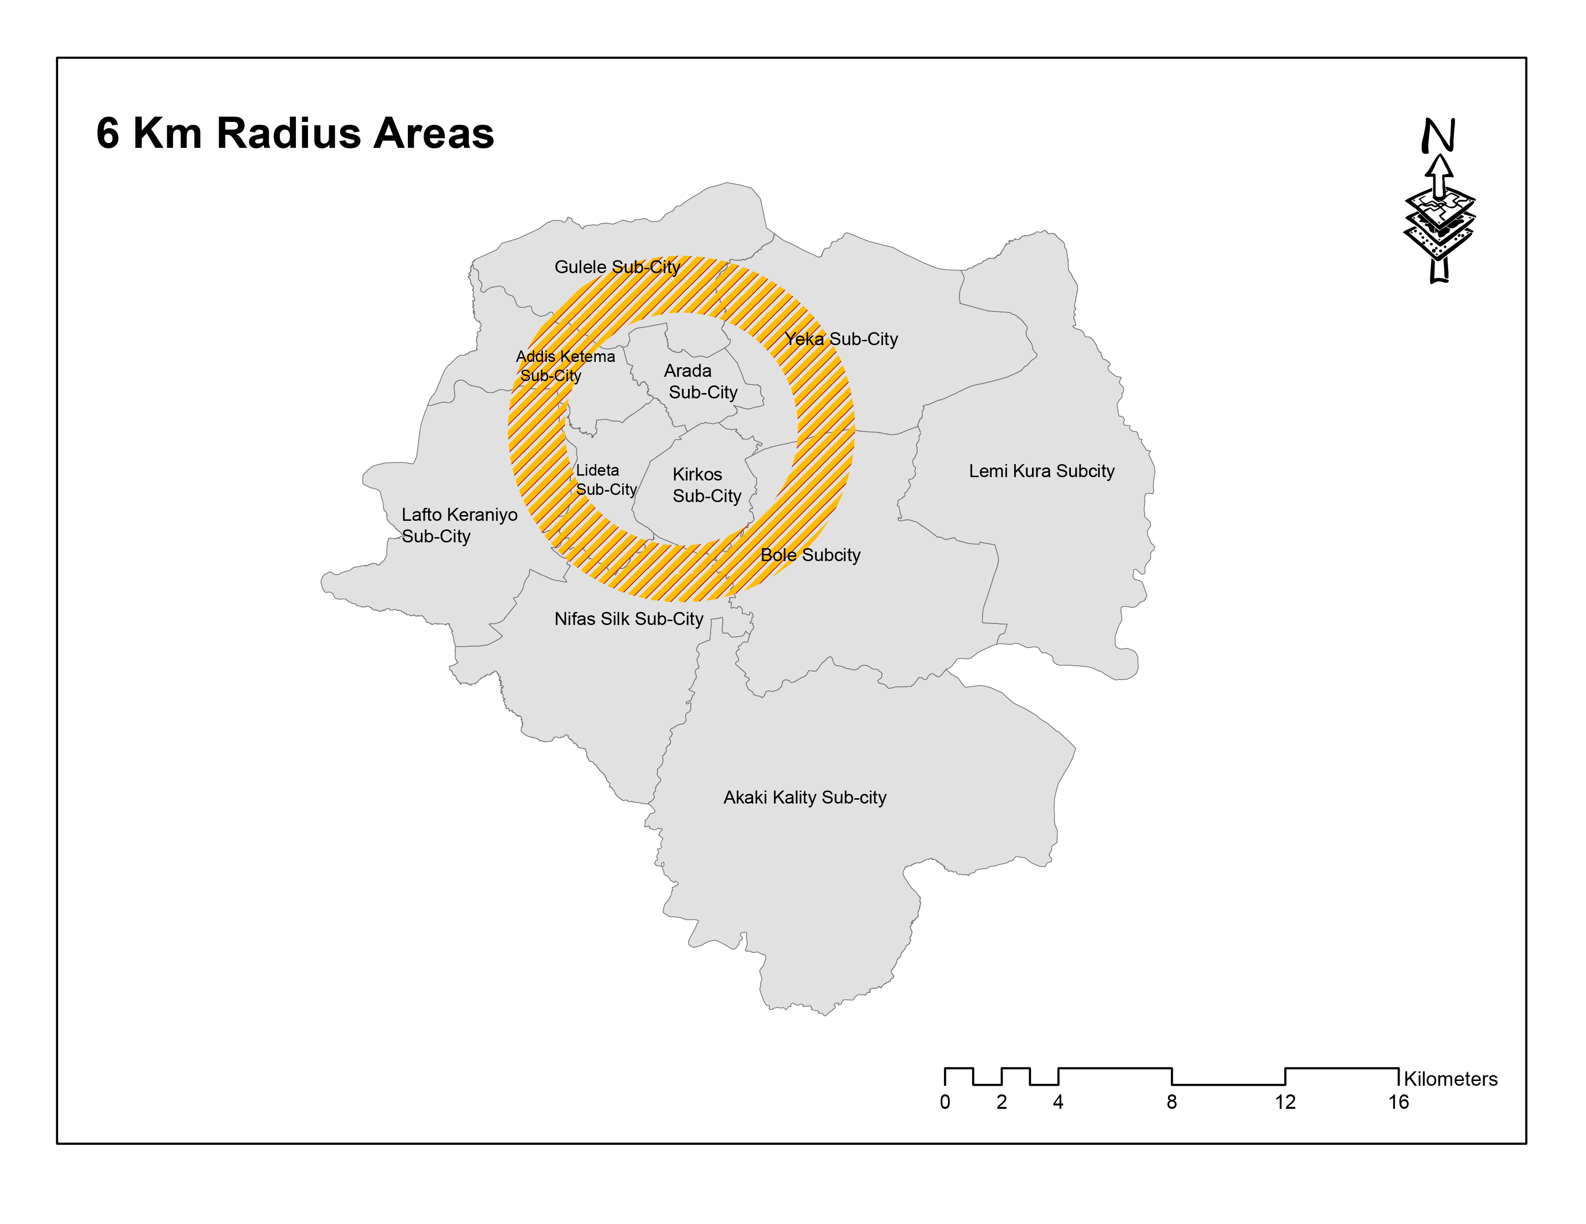Figure 5.7: Areas at 6Km area from the CBD (Source: Own preparation using Arc GIS 10.7 analysis, 2023)

Areas with Low Job – High Housing ratio
The lowest job-to-housing areas are located 18 km from the CBD; these areas include lower Koye Fitche, Lower Akaki, Tulu Dimtu, and Arabsa area. On the old city boundary Koye Fitche, Lower Akaki, Tulu Dimtu were all under Akaki Kality sub-city however currently Koye Fitche and Tulu Dimtu are under the Sheger city, but they are part of this study as part of Addis Ababa city because they are included in the available population data and there is no separate population data for the newly designated city boundary. On the other hand, Arabsa is located in the Lemi-Kura sub-city.
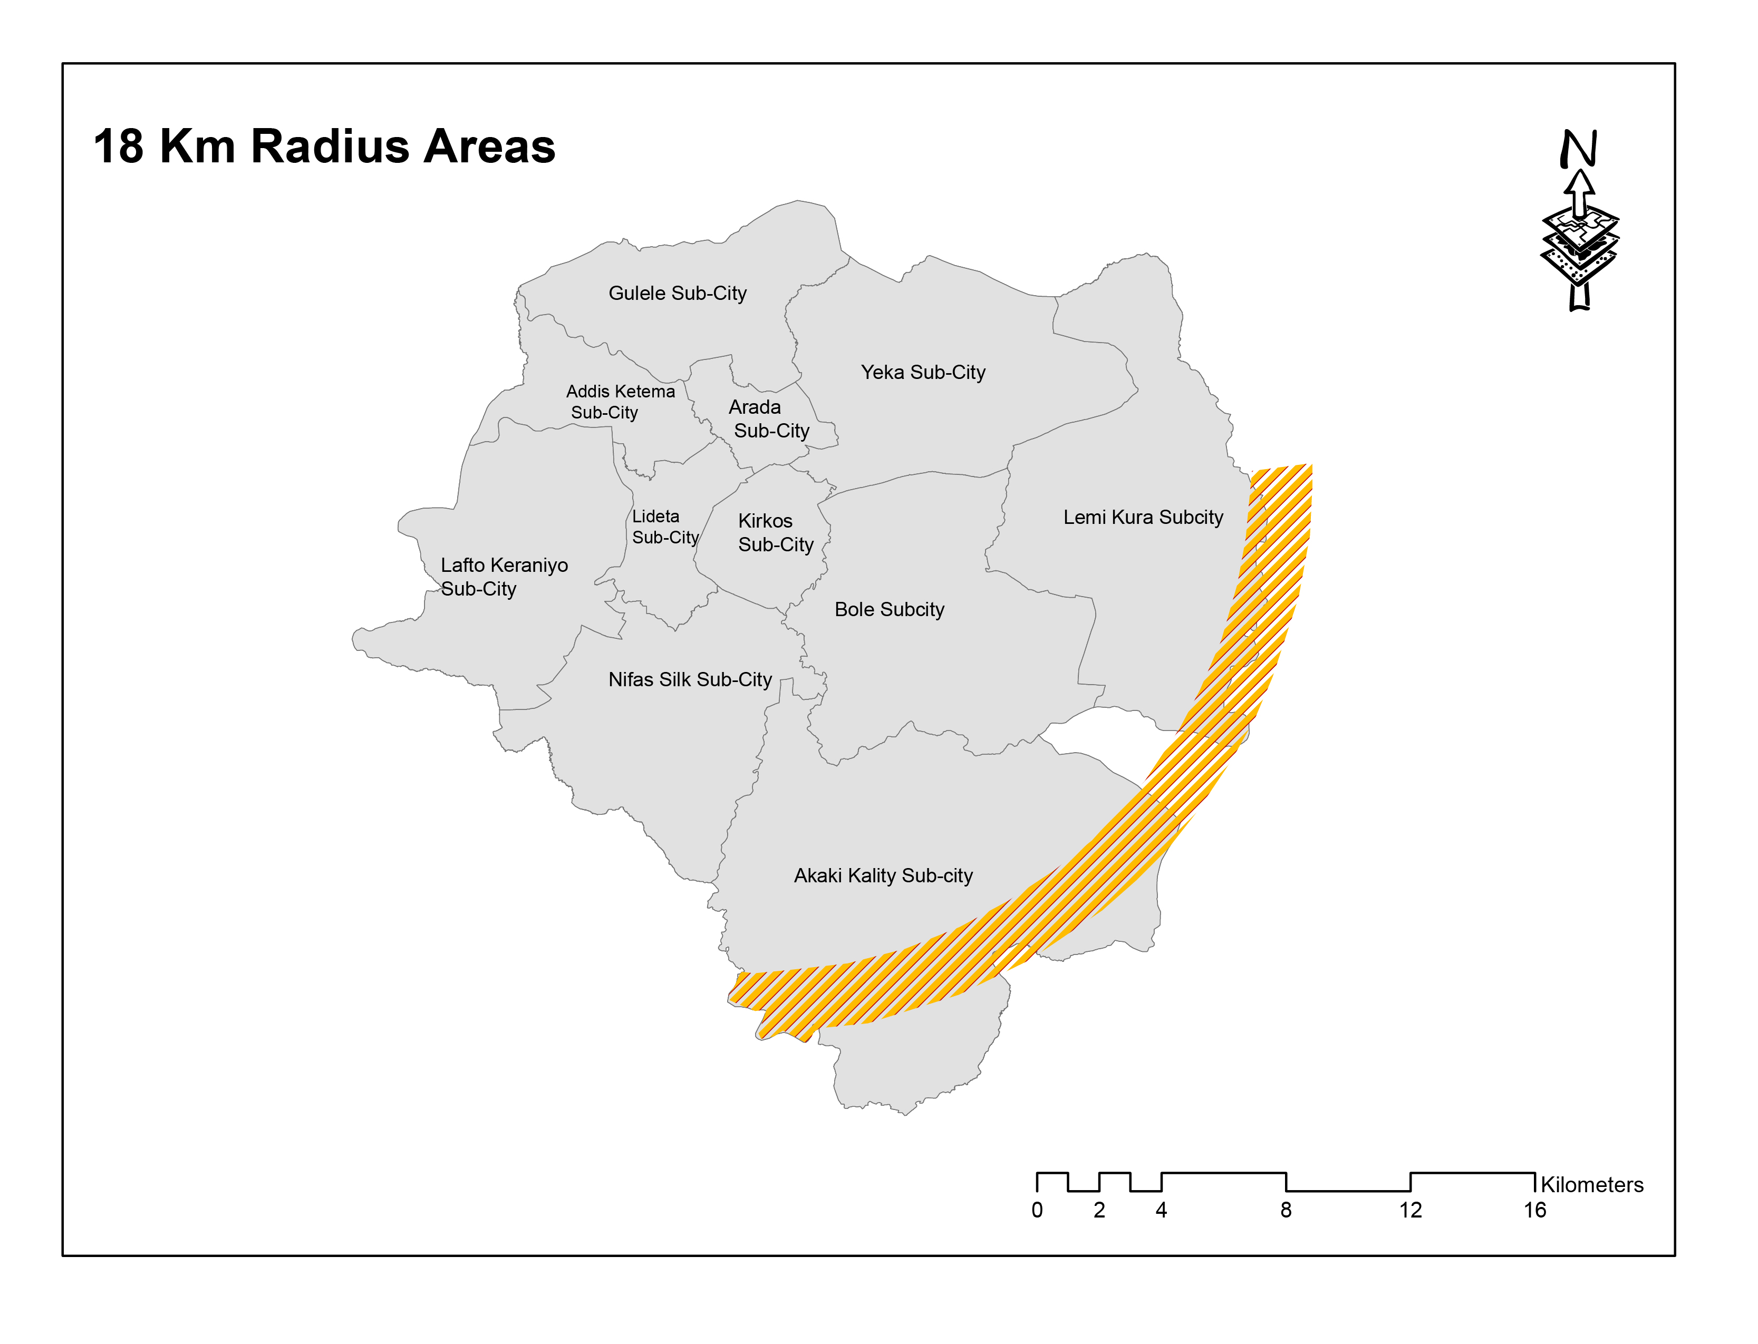Figure 5.8: Areas within 18 Km radius of the CBD (Source: Own preparation using Arc GIS 10.7 analysis, 2023)

Data Presentation, analysis, and Interpretation of travel behavior study
This chapter presents data presentation, analysis, and interpretation from the result of the household survey regarding travel behavior in selected areas.
For the study 384 participants were involved in a household survey, the questionnaires were handed out so as to gain insight regarding the travel behaviors of participants that dwell in each selected neighborhood for the study so as to compare and evaluate each characteristic and relate it with its spatial structure conditions. The questions presented vary from demographic information up to travel behaviors such as mode choice and frequency, attitude regarding mode choice, transportation expense, and average transportation waiting and commuting time. The findings of the study are presented as follows:

Demographic characteristics of Participants from the household survey
Individuals' mobility behavior is dependent on demographic characteristics such as age, income, education, and roles and tasks within the household. Therefore, studying demographic characteristics is essential in travel behavior study. The purpose of a demographic characteristic study is to understand the sample population and to assess whether they have relevant information to the study or not. The following section presents the demographic characteristics of participants in each selected neighborhood.

Gender status
Both female and male participants from different ages have been randomly selected although the number of male participants is higher in all the selected neighborhoods. This could be related to the fact that there is a higher number of male workers than females in the city.

Figure 5.9: Percentage of gender status of participants in each selected neighborhood (Source: own computation, 2023)

Table 5.4: Participants' gender status
Job - Housing ratio | High job- low housing area |  | Balanced job-housing areas |  | Low job- High housing areas |  | Average
Unit | Frequency | % | Frequency | % | Frequency | % | Frequency | %
Male | 82 | 64.1% | 70 | 54.7% | 80 | 62.5% | 77 | 60.2%
Female | 46 | 35.9% | 58 | 45.3% | 48 | 37.5% | 51 | 39.8%
(Source: Own computation, 2023)
Similarly, the average of participants show there are more male accounting for 60.2% than female which accounts for 39.8% of the total participants.

Age Group
The consideration for the age group was aiming to participate in all parts of the working age group. In each neighborhood, the number of participants in each age group differs.

Figure 5.10: Percentage of participants' age group in each selected neighborhood (Source: own computation, 2023)

Table 5.5: Participants' Age Group
Job - Housing ratio | High job- low housing area |  | Balanced job-housing areas |  | Low job- High housing areas |  | Average
Unit | Frequency | % | Frequency | % | Frequency | % | Frequency | %
Below 30 years old | 63 | 49.2% | 50 | 39.1% | 45 | 35.2% | 53 | 41.4%
Between 30–45 years old | 46 | 35.9% | 53 | 41.4% | 60 | 46.9% | 53 | 41.4%
Between 45-65 years old | 15 | 11.7% | 20 | 15.6% | 23 | 18% | 19 | 14.8%
Above 65 years old | 4 | 3.1% | 5 | 3.9% | 0 | 0 | 3 | 2.3%
(Source: own computation, 2023)
Among all the participants the highest proportion of the age group falls on the active working group which is less than 30 years old and between 35-45 years old which covers 82.8% of the total participants, followed by the age group between 45-65 years old covering 14.8%. lastly age group above 65 years covers 2.3% since this is mostly the retirement age for Ethiopia it covers the lowest proportion.

Education level and awareness
The findings regarding educational level were divided into seven categories these are elementary level, high school level, preparatory, TVET Diploma, degree, and second degree and above.

Figure 5.11: Percentage of educational level of participants in each selected neighborhood (Source: Own computation, 2023)
Table 5.6: Education Level and Awareness of Participants
Job - Housing ratio | High job- low housing area |  | Balanced job-housing areas |  | Low job- High housing areas |  | Average
Unit | Frequency | % | Frequency | % | Frequency | % | Frequency | %
Under elementary | 4 | 3.1% | 0 | 0 | 8 | 6.3% | 6 | 2.3%
Up to high school | 6 | 4.7% | 12 | 9.4% | 22 | 17.2% | 13 | 5.1%
Preparatory | 21 | 16.4% | 17 | 13.3% | 18 | 14.1% | 19 | 7.4%
TVET | 8 | 6.3% | 14 | 10.9% | 4 | 3.1% | 26 | 10.2%
Diploma | 23 | 18.0% | 15 | 11.7% | 24 | 18.8% | 21 | 8.2%
First Degree | 58 | 45.3% | 63 | 49.2% | 42 | 32.8% | 163 | 63.7%
Second Degree and Above | 8 | 6.3% | 7 | 5.5% | 10 | 7.8% | 8 | 3.1%
(Source: own computation, 2023)
From the total household survey participants 2.3% have accomplished their education up to elementary, 5.1% up to High school, 7.4% up to preparatory, 10.2% up to TVET, 8.2% have a diploma and the rest 63.7% and 3.1% have a first degree and second degree and above respectively.

Family size
The household survey participants' family size was calculated in each neighborhood. The result is presented below.

Figure 5.12: The family size of each participant in areas with a high job–low housing ratio (Source: Own computation, 2023)

Figure 5.13: Family size of each participant in areas with a balanced job-housing ratio (Source: Own computation, 2023)

Figure 5.14: The family size of each participant in areas with high housing – low job ratio (Source: Own computation, 2023)

Table 5.7: Average family size in each selected neighborhood
Job - Housing ratio | High job- low housing area | Balanced job-housing areas | Low job- High housing areas | Average
Average family size | 5.2 | 5.18 | 5 | 5.12
(Source: Own Computation, 2023)
The above table shows that the average family size in each neighborhood is relatively similar with the high job-low job housing areas having the largest family size of 5.2 and Low job – high housing areas having the lowest family size of 5.

Employment condition

Figure 5.15: Participants' employment conditions in each selected neighborhood (Source: Own computation, 2023)
Table 5.8: Participants' employment conditions
Job - Housing ratio | High Job- low housing area |  | Balanced Job-housing areas |  | Low Job- High housing areas |  | Average
Unit | Frequency | % | Frequency | % | Frequency | % | Frequency | %
Government employee | 45 | 35.2% | 27 | 21.1% | 23 | 18.0% | 32 | 22.9%
Private employee | 61 | 47.7% | 63 | 49.2% | 48 | 37.5% | 57 | 40.7%
NGO | 0 | 0 | 0 | 0 | 1 | 0.8% | 1 | 0.7%
Own business | 18 | 14.1% | 30 | 23.4% | 51 | 39.8% | 33 | 23.6%
Daily labor | 0 | 0 | 0 | 0 | 1 | 0.8% | 1 | 0.7%
Student | 4 | 3.1% | 8 | 6.3% | 4 | 3.1% | 16 | 11.4%
(Source: own computation, 2023)
Since the research is concerned with bounded trips alone the participants for the survey were either employed or students with 22.9% being government employees, 40.7% private employees, 0.7% NGO employees, 23.6% running their own business, 1% daily labor, and 11.4% students.

Ownership title
In Addis Ababa city variety kinds of Ownership titles exist for this research, we have included participants who own their house, who are renters, who dwell in Kebele housing, who are debale as well as who live in government-owned residences. The result for the ownership title is presented in the following manner.

Figure 5.16: Ownership title of participants in each selected neighborhood (Source: Own computation, 2023)

Table 5.9: Ownership title of participants
Job - Housing ratio | High job- low housing area |  | Balanced job-housing areas |  | Low job- High housing areas |  | Average
Unit | Frequency | % | Frequency | % | Frequency | % | Frequency | %
Owner | 55 | 43.0% | 56 | 43.8% | 43 | 33.6% | 51 | 36.4%
Renter | 47 | 36.7% | 52 | 40.6% | 85 | 66.4% | 61 | 43.6%
Government | 7 | 5.5% | 0 | 0 | 0 | 0 | 7 | 5.0%
Kebele | 16 | 12.5% | 20 | 15.6% | 0 | 0 | 18 | 12.9%
Debale | 3 | 2.3% | 0 | 0 | 0 | 0 | 3 | 2.1%
(Source: own computation, 2023)
The result shows that 36.4% of the total participants dwell in their own homes while 43.6% are renters, 5% dwell in Government housing, and 12.9% and 2.1% dwell in Kebele and Debale houses. The Kebele and Debale houses are located only up to 6 km radius which are the inner-city informal houses located in the old neighborhoods. Therefore, Debale and kebele houses do not exist in the new neighborhoods such as Arabsa, Tulu Dimtu, and Koye Fitche which are located within an 18 km radius of the CBD. In terms of renting, the highest number of renters exist in the low job-high housing areas which are 18 km far from the CBD this is because as one moves away from the CBD rent decreases without a decrease in the quality of housing unlike the inner city areas, which provide lower rents but the houses are also lower quality along with the price. Therefore, people are attracted to these areas for the quality cheap housing located far from the CBD.

Income status
The findings regarding income status were classified into 4 categories which are those earning less than 1000 birr a month, those earning between 1000 – 5000 birr, those earning 5000 – 10,000 birr, and those earning more than 10,000 birr a month. The findings show that the lowest income groups reside within 2km of the CBD which are the inner-city areas while the upper incomes reside in a job – housing-balanced areas such as Bole, Megenagna, 22, Gerji, Gofa, and Shola however these areas still have a mixed-income characteristic having all kinds of income societies.

Figure 5.17: Participants' monthly income status in each neighborhood (Source: Own computation, 2023)
Table 5.10: Participants' monthly income status in each neighborhood
Job - Housing ratio | High job- low housing area |  | Balanced job-housing areas |  | Low job- High housing areas |  | Average
Unit | Frequency | % | Frequency | % | Frequency | % | Frequency | %
Less than 1,000 | 4 | 3.1% | 3 | 2.3% | 0 | 0 | 3 | 2.4%
1000 – 5000 | 32 | 25.0% | 19 | 14.8% | 31 | 24.2% | 27 | 21.3%
5,000 – 10,000 | 55 | 43.0% | 39 | 30.5% | 43 | 33.6% | 45 | 35.4%
Above 10,000 | 37 | 28.9% | 67 | 52.3% | 54 | 42.2% | 52 | 40.9%
(Source: own computation, 2023)
From the total number of participants, 2.4% earn less than 1000 birr a month, while 21.3% earn between 1000 – 5000 birr, 35.4% earn between 5000 – 10,000 birr, and 40.9% which is the highest percentage earn above 10,000 birr a month.

Finding and analysis
After discussing the socio-demographic characteristics of participants for the study, in the above section this chapter presents the finding, analysis, and interpretation of results from the survey data with regard to participants' travel characteristics in each selected neighborhood. The findings are presented using charts, tables, and text.

Frequency of using transport mode within a week
There are varieties of transportation modes within Addis Ababa City for this research all available transportation usage has been observed and the result is presented below.

Figure 5.18: Frequency of using transport modes within a week in each neighborhood (Source: Own computation, 2023)
Table 5.11: Frequency of using transport modes within a week
Job - Housing ratio | High Job- low housing area |  | Balanced Job-housing areas |  | Low Job- High housing areas |  | Average
Unit | Frequency | % | Frequency | % | Frequency | % | Frequency | %
Private car | 28 | 3.6% | 122 | 15.9% | 57 | 7.4% | 69 | 8.9%
Bicycle | 11 | 1.4% | 0 | 0 | 5 | 0.7% | 8 | 1.0%
Walk | 32 | 4.2% | 149 | 19.4% | 67 | 8.7% | 83 | 10.8%
Autobus | 175 | 22.8% | 79 | 10.3% | 171 | 22.3% | 142 | 18.4%
Taxi | 395 | 51.4% | 329 | 42.8% | 279 | 36.3% | 334 | 43.3%
Contract taxi/ Ride | 26 | 3.4% | 7 | 0.9% | 23 | 3.0% | 19 | 2.5%
LRT | 21 | 2.7% | 0 | 0 | 0 | 0 | 7 | 0.9%
Bajaj | 13 | 1.7% | 0 | 0 | 83 | 10.8% | 32 | 4.2%
Service Minibus | 63 | 8.2% | 55 | 7.2% | 51 | 6.6% | 56 | 7.3%
Service Bus | 4 | 0.5% | 27 | 3.5% | 32 | 4.2% | 21 | 2.7%
(Source: own computation, 2023)
According to the findings, the highest number of private car usage is observed within the job-housing balanced area covering 15.9% of total transportation mode choice frequency within a week while 3.6% and 7.4% of the participants use Private cars to commute to work in areas with high job–low housing areas and low job–high housing areas respectively, however this is because in Addis Ababa city mostly Private car is associated with higher income society which is located at the job–housing balanced neighborhoods at a higher level than the other neighborhoods, in addition the use of private car for work purpose has increased recently.
Similarly, the highest number of participants who walk to work is observed in these areas covering 19.4% of the total travel modes while 4.2% in high job–low housing areas and 7.4% in low job– high housing areas walk to work. In terms of the survey results this is mostly because as the place of job is closer to home people choose to walk than commute by car or public transportation.
On the other hand, the use of Autobus is the highest in the high job – low housing area covering 22.8% of the total travel followed by the low job – high housing areas covering 22.3%, and the lowest is observed in the balanced job – housing Neighborhoods with 10.3% share. Autobus is the second highest frequently used mode of transportation which covers a total average of 18.4% share.
Taxi is the most frequently used mode of transportation in each area with 51.4%, 42.8%, and 36.3% in the high job – low housing, balanced job–housing, and low job–high housing areas respectively, and an average of 43.3% usage. While the lowest share of transportation mode is LRT covering 0.9% of the total participants' mode choice. This is because the LRT is highly congested once it has passed its starting Terminal point which only exists around Piazza among the selected neighborhoods.
The rest 2.5%, 4.2%, 7.3%, and 2.7% are covered by ride/ contract taxi, bajaj and service minibuses, and service buses respectively.

Travelers' Mode Choice Attitude
To identify the attitude of participants with regard to mode choice we have provided a questionnaire where participants can choose more than one choice as well as a space where they can add their views in regard to the transportation mode they use each day to commute to work. Thus, we have presented the findings in the following section.

Why do People use Private cars when commuting to work?
The usage of Private cars in Addis Ababa city is mostly related to socio-economic status, according to the survey many people are interested in using Private cars, however, the research also proves that despite the traffic and related challenges in Addis Ababa the city has a lower level of private car share which is from the total of 384 participants only 9% own a car among this 3% bought a private car for work purposes such as ride and fright.

Figure 5.19: Private car mode choice attitude for commuting to work in each neighborhood (Source: Own computation, 2023)

Table 5.12: Private car mode choice attitude for commuting to work
Job - Housing ratio | High Job- low housing area |  | Balanced Job-housing areas |  | Low Job- High housing areas |  | Average
Unit | Frequency | % | Frequency | % | Frequency | % | Frequency | %
Time efficient | 2 | 33.3% | 8 | 19.0% | 2 | 22.2% | 4 | 20%
To move at anytime | 1 | 16.7% | 12 | 28.6% | 4 | 44.4% | 6 | 30%
Free of stress | 0 | 0 | 7 | 16.7% | 2 | 22.2% | 3 | 15%
Job is far | 2 | 33.3% | 0 | 0 | 1 | 22.2% | 1 | 5%
Convenience | 1 | 16.7% | 4 | 9.5% | 0 | 0 | 2 | 10%
Reliable | 0 | 0 | 6 | 14.3% | 0 | 0 | 2 | 10%
For work purpose | 0 | 0 | 4 | 9.5% | 0 | 0 | 1 | 5%
For health | 0 | 0 | 1 | 2.4% | 0 | 0 | 1 | 5%
(Source: own computation, 2023)
Among the participants the frequently selected choice as to why people use a private car was because it provides the freedom to move anywhere at any time 30% of participants' choice, followed by time efficiency with 20%, then because it is free of stress chosen by 15% and the rest choose to commute by car because it was Reliable, Convenience, because their work is far, for work purpose and health reasons selected by the 10%, 10%, 5%, 5%, and 5% of the participants respectively.

Why walk or Cycle when commuting to work?
Walking and cycling are one of the most energy-efficient and sustainable modes of transportation with zero damage to the environment. Thus, should be promoted, the attitude of each participant as to why they choose to commute by walking and cycling in each neighborhood has been calculated and presented in the following manner.

Figure 5.20: Walk or Cycle mode choice attitude for commuting to work (Source: Own computation, 2023)
Table 5.13: Walk or Cycle mode choice attitude for commuting to work
Job - Housing ratio | High Job- low housing area |  | Balanced Job-housing areas |  | Low Job- High housing areas |  | Average
Unit | Frequency | % | Frequency | % | Frequency | % | Frequency | %
Time efficient | 5 | 23.8% | 3 | 6.7% | 2 | 16.7% | 3 | 11.5%
To move at anytime | 3 | 14.3% | 2 | 4.4% | 1 | 8.3% | 2 | 7.7%
Free of stress | 0 | 0 | 6 | 13.3% | 0 | 0 | 2 | 7.7%
Job is Close | 5 | 23.8% | 18 | 40.0% | 7 | 58.3% | 10 | 38.5%
Reliable | 2 | 9.5% | 2 | 4.4% | 1 | 8.3% | 2 | 7.7%
Cheaper | 4 | 19.0% | 8 | 17.8% | 0 | 0 | 4 | 15.4%
Health benefits | 2 | 9.5% | 4 | 8.9% | 1 | 8.3% | 2 | 7.7%
Decrease air pollution | 0 | 0 | 2 | 4.4% | 0 | 0 | 1 | 3.8%
(Source: own computation, 2023)
Participants claimed that among all the others choices to commute by walking and cycling because their job is closer to their residence areas with 38.5% of participants choosing which is the highest. The second highest reason was that it saves money with 15.4%, and third because it was time efficient with 11.5% responses. The rest 7.7% each choose walking because it gives them the freedom to move anywhere at any time, because it is free of stress, reliable, and has health benefits. Finally, 3.8% of participants choose to walk and cycle because it is a means to decrease air pollution with the lowest response among others. This is because there is lower awareness among the society of the benefit of walking and cycling in decreasing air pollution and protecting the environment.

Why Public Transportation (Taxi Mini-bus) when commuting to work?
Minibus Taxi is among the public transportation that serves Addis Ababa city and is regionally frequently used by many users. The mode carries up to 12 people for a trip, the attitude of selecting mini-bus taxis for commuting was surveyed in each neighborhood and the findings are presented below.

Figure 5.21: Public Transportation (Taxi Mini-bus) mode choice attitude for commuting to work (Source: Own computation, 2023)

Table 5.14: Public Transportation (Taxi Mini-bus) mode choice attitude for commuting to work
Job - Housing ratio | High Job- low housing area |  | Balanced Job-housing areas |  | Low Job- High housing areas |  | Average
Unit | Frequency | % | Frequency | % | Frequency | % | Frequency | %
Time efficient | 27 | 25.0% | 23 | 35.9% | 12 | 33.3% | 21 | 29.6%
To move at anytime | 24 | 22.2% | 11 | 5.5% | 6 | 17.4% | 14 | 19.7%
Free of stress | 2 | 1.9% | 4 | 5.5% | 0 | 0 | 2 | 2.8%
Job is far | 13 | 12.0% | 6 | 10.2% | 7 | 21.7% | 9 | 12.7%
Convenience | 5 | 4.6% | 1 | 1.6% | 1 | 2.9% | 2 | 2.8%
Reliable | 6 | 5.6% | 2 | 3.1% | 0 | 0 | 3 | 4.2%
Cheaper | 22 | 20.4% | 9 | 13.3% | 0 | 0 | 10 | 14.1%
Job is close | 6 | 5.6% | 8 | 12.5% | 0 | 0 | 5 | 7.0%
To decrease air pollution | 2 | 1.9% | 0 | 0 | 0 | 0 | 1 | 1.4%
For work | 0 | 0 | 1 | 0.8% | 0 | 0 | 0 | 0.0%
No other choice/ not enough bus | 1 | 0.9% | 1 | 0.8% | 9 | 24.6% | 4 | 5.6%
(Source: own computation, 2023)
The majority of the participants use a taxi because it is time efficient with 29.6% of responses choice, followed by its ability to provide service at any time by 19.7% of the responses. The third highest choice was because it is cheaper than other transport modes selected by 14.1%. 7% choose to commute by taxi because their job is closer to their residence, 5.6% choose taxi because there is no other choice and because the available buses are not sufficient to provide service. 4.2% choose it because it is Reliable for them. And 2.8% select it because it is Convenience and finally 1.4% chooses it so as to decrease air pollution by using public transport than private cars.

Why Public Transportation (Autobus, Higer, and LRT) when commuting to work?
Autobus, Higer, and Train are also sustainable public transport that should be promoted so as to protect the environment from pollution. Why participants choose to commute to work and school by this public transportation are also surveyed in each neighborhood and the findings are presented in the following manner.

Figure 5.22: Public Transportation (Autobus, Higer, and LRT) mode choice attitude for commuting to work in each neighborhood (Source: Own computation, 2023)
Table 5.15: Public Transportation (Autobus, Higer, and LRT) mode choice attitude for commuting to work
Job - Housing ratio | High Job- low housing area |  | Balanced Job-housing areas |  | Low Job- High housing areas |  | Average
Unit | Frequency | % | Frequency | % | Frequency | % | Frequency | %
Time efficient | 14 | 21.9% | 12 | 48% | 9 | 27.1% | 12 | 28.6%
To move at anytime | 8 | 12.5% | 0 | 0 | 3 | 8.6% | 4 | 9.5%
Free of stress | 0 | 0 | 0 | 0 | 1 | 2.9% | 0 | 0.0%
Job is far | 8 | 12.5% | 3 | 12% | 5 | 15.7% | 5 | 11.9%
Job is close | 2 | 3.1% | 0 | 0 | 0 | 0 | 1 | 2.4%
Reliable | 8 | 12.5% | 2 | 8% | 1 | 2.9% | 4 | 9.5%
Cheaper | 24 | 37.5% | 8 | 32% | 15 | 42.9% | 16 | 38.1%
(Source: own computation, 2023)
The majority of participants choose to commute by (Autobus, Higer, and LRT) because it is cheaper compared to other modes of transportation with 38.1% of participants’ choice. Second, because it is time efficient selected by 28.6% of the participants. Third, because the job of participants is far from their place of residence selected by 11.9% of participants. 9.5% each select this transportation mode because it is reliable and provides service to move at any time participants desire to and finally 2.4%‘s choice was because their job is closer to their home.

Access to transportation at peak hours
Access to transportation at peak hours in each radius with different job-housing ratios varies. The chart below indicates that areas with a balanced job-housing ratio have sufficient access to transportation with 66% agreeing to the availability of transportation compared to the others. While areas with low job–high housing areas have the least access to transportation with 69.% disagreeing with the availability of sufficient transportation. On the other hand, areas with high job–low housing ratios have a balanced response with 50.8% agreeing and 49.2% disagreeing.

Figure 5.33: Access to transportation at peak hours in each neighborhood (Source: Own computation, 2023)
Table 5.16: Access to transportation at peak hours
Job - Housing ratio | High job- low housing area |  | Balanced job-housing areas |  | Low job- High housing areas |  | Average
Unit | Frequency | % | Frequency | % | Frequency | % | Frequency | %
Yes | 63 | 50.8% | 66 | 66% | 34 | 30.4% | 54 | 48.2%
Not Sufficient | 61 | 49.2% | 34 | 34% | 78 | 69.6% | 58 | 51.8%
(Source: own computation, 2023)
Overall, from the total number of participants, 48.2% agreed to the availability of enough transportation, while 51.8% disagreed to the availability of sufficient public transportation.

Average daily transportation expense of Participants
The findings related to daily transportation expenses for work and school purpose travel indicate that the highest expense is for a low job – high housing areas with spending up to 200 birrs a day covering 4.5%, while the least amount of expense for travel in these areas is up to 20 birrs with only 5.4% of the participants, which are those who work closer to their homes.
On the other hand, for the overall participants, the least amount of transport expense is up to 10 birrs in balanced job-housing areas having 63% of participants paying less than 20 birr per day. The highest amount of expense observed in a balanced job–housing area is 80 birr with only 4% of participants' expenses. This indicates that dwellers in a balanced job–housing areas have fewer daily transportation expenses for commuting purposes compared to dwellers in low job – high housing areas.

Figure 5.24: Daily transportation expense on the dwellers for work or school-related travel purposes at each selected neighborhood (Source: Own computation, 2023)

Table 5.17: Average daily transportation expense of participants for work or school-related travel purposes
Job - Housing ratio | High job- low housing area |  | Balanced job-housing areas |  | Low job- High housing areas |  | Average
Unit | Frequency | % | Frequency | % | Frequency | % | Frequency | %
Up to 20 birr | 40 | 32.3% | 63 | 63% | 6 | 5.4% | 36 | 31.9%
Up to 40 birr | 46 | 37.1% | 26 | 26% | 26 | 23.2% | 33 | 29.2%
Up to 60 birr | 8 | 6.5% | 7 | 7% | 24 | 21.4% | 13 | 11.5%
Up to 80 birr | 5 | 4.0% | 4 | 4% | 23 | 20.5% | 11 | 9.7%
Up to 100 birr | 22 | 17.7% | 0 | 0 | 28 | 25.0% | 17 | 15.0%
Up to 150 birr | 3 | 2.4% | 0 | 0 | 0 | 0 | 1 | 0.9%
Up to 200 birr | 0 | 0 | 0 | 0 | 5 | 4.5% | 2 | 1.8%
(Source: Own computation, 2023)
The average daily transportation expense for the total participants shows that 31.9% pay up to 20 birrs, 29.2% pay up to 40 birrs, 11.5% pay up to 60 birrs, 9.7% pay up to 80 birrs, 15% pay up to 100 birrs. The rest 0.9% and 1.8% pay up to 150 and 200 birrs respectively.

Average Cost of fuel of participants for daily commuting
Similar to the travel expense for transportation, the fuel cost per day for participants has been calculated. However, because of the small number of participants who own a private car, the number of participants for this computation is smaller. In addition, the computation for the cost of fuel excludes participants who use their vehicle for work purposes such as for a ride, public transportation, and frights. It only includes vehicles for the purpose of commuting.

Figure 5.25: Cost of fuel of participants for daily commuting in each neighborhood (Source: Own computation, 2023)
The result indicates that the highest amount of fuel cost is observed in the Balanced job – housing area as having to pay up to 900 birrs a day accounting for 5.6% of participants, as well as the lowest fuel cost is observed in these areas with an expense of up to 100 birrs per day accounting for 22.2% of the survey. These also indicate that fuel cost is related to VMT where people who work far from their home pay less for fuel while people who work at a distance from their home will pay a higher price; fuel cost is also related to socioeconomic status.
Table 5.18: Average Cost of fuel of participants for daily commuting
Job - Housing ratio | High job- low housing area |  | Balanced job-housing areas |  | Low job- High housing areas |  | Average
Unit | Frequency | % | Frequency | % | Frequency | % | Frequency | %
Up to 100 birrs | 0 | 0 | 4 | 22.2% | 0 | 0 | 1 | 11.1%
Up to 200 birrs | 1 | 25% | 7 | 38.9% | 2 | 25% | 3 | 33.3%
Up to 300 birrs | 0 | 0 | 2 | 11.1% | 4 | 50% | 2 | 22.2%
Up to 400 birrs | 0 | 0 | 2 | 11.1% | 0 | 0 | 1 | 11.1%
Up to 600 birrs | 2 | 50% | 2 | 11.1% | 2 | 25% | 2 | 22.2%
Up to 800 birrs | 1 | 25% | 0 | 0 | 0 | 0 | 0 | 0
Up to 900 birrs | 0 | 0 | 1 | 5.6% | 0 | 0 | 0 | 0
(Source: Own computation, 2023)

Average transport waiting time
The finding related to average transport waiting time shows that the highest transportation waiting time is up to 3 hours in areas with high job–low housing areas and with low job – high housing areas covering 2.4% and 5.5% respectively with the highest frequency observed in low job – high housing areas. on the other hand, the lowest transportation waiting time is observed in areas with high job–low housing areas and balanced job–housing areas with a 5-minute or less waiting time having a share of 4.0% and 24% respectively indicating balanced job–housing areas to have the smallest transport waiting time. The highest waiting time in these areas is also lower compared to the other two areas with 1 hour waiting time being the highest which covers a total of 18%.
The smallest waiting time for areas with low job – high housing areas is 30 minutes with 8.2% of the total participant's response. These depict those dwellers in areas with a balanced job–housing waits for transportation at fewer hours than dwellers at a high job–low housing areas and at low job–high housing areas.

Figure 5.26: Transportation waiting time at peak hours in each neighborhood (Source: Own computation, 2023)

Table 5.19: Average transport waiting time at peak hours
Job - Housing ratio | High job- low housing area |  | Balanced job-housing areas |  | Low job- High housing areas |  | Average
Unit | Frequency | % | Frequency | % | Frequency | % | Frequency | %
5 minutes or less | 5 | 4.0% | 24 | 24% | 0 | 0 | 10 | 8.8%
Up to 10 minutes | 9 | 7.3% | 14 | 14% | 0 | 0 | 8 | 7.1%
Up to 15 minutes | 13 | 10.5% | 4 | 4% | 0 | 0 | 6 | 5.3%
Up to 30 minutes | 27 | 21.8% | 34 | 34% | 9 | 8.2% | 23 | 20.4%
Up to 45 minutes | 39 | 31.5% | 6 | 6% | 10 | 9.1% | 18 | 15.9%
Up to 1 hour | 15 | 12.1% | 18 | 18% | 29 | 26.4% | 21 | 18.6%
Up to 1 hour and 30 minutes | 8 | 6.5% | 0 | 0 | 27 | 24.5% | 12 | 10.6%
Up to 2 hours | 5 | 4.0% | 0 | 0 | 29 | 26.4% | 12 | 10.6%
Up to 3 hours | 3 | 2.4% | 0 | 0 | 6 | 5.5% | 3 | 2.7%
(Source: Own computation, 2023)
The findings show that among the total number of participants, the highest transport waiting timeshare is up to 30 minutes covering 20.4% of the responses, and the lowest share is 3 hours with 2.7% response, while those who wait up to 1 hour holds 18.6%, those who wait up to 45-minute hold 15.9%, and those who wait up to 1 hour and 30 minutes and Up to 2 hours holds 10.6% each. And the smallest amount of waiting time which is 5 minutes or less holds 8.8% followed by 10-minute and 15-minute waiting times holding 7.1% and 5.3% respectively.

Commuting time at peak hours
Commuting time in a transport survey is a very significant topic since it has an impact on both environmental pollution and energy consumption. To identify the area with less commuting time we have studied commuting time in each neighborhood. The result shows that the highest commuting times are 2 hours, 2 hours and 30 minutes, and 3 hours which are observed at the highest proportion in areas with low job–high housing areas holding 35.5%, 9.1%, and 4.5% respectively. While the lowest commuting time is observed in a balanced job–housing areas where 2.9% claimed that there is no congestion and 1.9% claimed that their commuting time is up to 10 minutes. The highest commuting time in these areas is also very low compared to the others which are 1 hour and 30 minutes covered by 10.7% of the participants.
Areas with a high job–low housing ratio in contrast has a lower commuting time of up to 10 minutes covering 1.6% and a higher commuting time of up to 3 hours covering 0.8% of the total response. However, the rest of the data shows these areas have less commuting time.
Therefore, commuting time is higher in areas with a low job–high housing area, and relatively good in areas with a high job-low housing area, on the other hand, areas with a balanced job–housing ratio has a lower commuting time.

Figure 5.27: Commuting time at peak hours in each neighborhood (Source: Own computation, 2023)
Table 5.20: Average commuting time at peak hours
Job - Housing ratio | High job- low housing area |  | Balanced job-housing areas |  | Low job- High housing areas |  | Average
Unit | Frequency | % | Frequency | % | Frequency | % | Frequency | %
Up to 10 min | 2 | 1.6% | 2 | 1.9% | 0 | 0 | 1 | 0.4%
Up to 15 minutes | 21 | 17.1% | 3 | 2.9% | 1 | 0.9% | 25 | 10.1%
Up to 30 minutes | 24 | 19.5% | 40 | 38.8% | 5 | 4.5% | 23 | 9.3%
Up to 45 minutes | 27 | 22.0% | 26 | 25.2% | 8 | 7.3% | 20 | 8.1%
Up to 1 hour | 24 | 19.5% | 18 | 17.5% | 34 | 30.9% | 25 | 10.1%
Up to 1 hour and 30 minutes | 21 | 17.1% | 11 | 10.7% | 8 | 7.3% | 134 | 54.0%
Up to 2 hours | 3 | 2.4% | 0 | 0 | 39 | 35.5% | 14 | 5.6%
Up to 2 hours and 30 minutes | 0 | 0 | 0 | 0 | 10 | 9.1% | 3 | 1.2%
Up to 3 hours | 1 | 0.8% | 0 | 0 | 5 | 4.5% | 2 | 0.8%
No congestion | 0 | 0 | 3 | 2.9% | 0 | 0 | 1 | 0.4%
(Source: Own computation, 2023)
According to the average commuting time result the highest frequency for waiting time is 1 hour and 30 minutes holding a total of 54%, followed by 15 minutes and up to 1 hour commuting time covering 10.1% each, then up to 30 minutes cover 9.3% of the responses, while up to 45 minutes and 2 hours commuting time covers 8.1% and 5.6% respectively. The lowest frequencies for average commuting time are up to 2 hours and 30 minutes covering 1.2%, up to 3 hours covering 0.8% as well as up to 10 minutes and no congestion times holding 0.4% each.

Residential location choice
Residential location choice varies from person to person and from one neighborhood to another, the research has collected a survey in each selected area so as to identify the attractive factor regarding each area. The result is presented below.

Figure 5.28: Residential location factors for a high job – low housing areas (Source: Own computation, 2023)
According to the findings people are attracted to these areas mostly to be closer to their place of work and school, which covers 20.0% of the total responses, the second most attractive characteristics were the easy access to transportation covering 13.1%, third people are attracted to this area because there is available cheap rents as well as the fact that the area is a city center area which holds 10.3% of the responses each. Then access to service and attachment to the area holds 9% of the responses each. The least frequencies selected are the availability of houses for rent covering 5.5%, condominium house lottery which accounts for 4.1%, to be closer to family accounting for 2.1% and finally, safety holds 1.4%.
Therefore, people choose to reside in areas with high jobs – low housing areas so as to be closer to their workplace and school, to gain easy access to transportation, and for the availability of cheap rents.

Figure 5.29: Residential location factors for balanced job–housing areas (Source: Own computation, 2023)
Similar to the high job – low housing areas people are mostly attracted to these areas so as to be closer to their place of work and school which accounts for 31.8% of the total responses, second people reside in these places because it is their family home which accounts for 13.2%, third because they are attached to this place since they are born and lived in the area for a long time as well as it is a convenient place for residence purpose which accounts for 9.3% each, fourth to be closer to a family which holds 8.5%, fifth to save energy, time and cost of transportation which holds 7% of the total responses followed by its accessibility to Service and market which holds 6.2%. The least selected responses are accessibility to transportation which holds 3.9%, relatively cheap rent, city center area, and clean air which holds 2.3% each safety and availability of house for rent account 1.6% and 0.8% respectively.
Therefore, according to the survey results people are attracted to living in these areas so as to be closer to their workplace and school, because it is convenient for residents and to be closer to their families.

Figure 5.30: Residential location factors for low job – high housing areas (Source: Own computation, 2023)
The main attractive factor for areas with low job – high housing areas is the availability of cheap rent compared to other areas which accounts for 38.5% of the responses. The second factor is the condominium lottery which accounts for 18.2% of the responses, the third factor is the existence of clean air away from pollution accounting for 16.1%, the fourth is to be closer to the workplace and school followed by the family home, attachment to the area and to be closer to a family which accounts for 7%, 4.2%, and 1.4% respectively.
Therefore, the findings indicate that people choose to reside in areas with low jobs – high housing areas mainly because of the availability of cheap rent in these areas away from the center, two because of the condominium lottery, and third in need of clean and peaceful environment away from pollution.
Table 5.21: Average residential location choice
Job - Housing ratio | High job- low housing area |  | Balanced job-housing areas |  | Low job- High housing areas |  | Average
Unit | Frequency | % | Frequency | % | Frequency | % | Frequency | %
Relatively cheap rent | 15 | 10.3% | 3 | 2.3% | 55 | 38.5% | 24 | 17.5%
Condominium lottery | 6 | 4.1% | 2 | 1.6% | 26 | 18.2% | 11 | 8.0%
Family home | 19 | 13.1% | 17 | 13.2% | 10 | 7.0% | 15 | 10.9%
To be closer to family | 3 | 2.1% | 11 | 8.5% | 2 | 1.4% | 5 | 3.6%
Clean air | 0 | 0 | 3 | 2.3% | 23 | 16.1% | 9 | 6.6%
Attachment to the Area | 13 | 9.0% | 12 | 9.3% | 6 | 4.2% | 10 | 7.3%
Closer to a place of work and school | 29 | 20.0% | 41 | 31.8% | 21 | 14.7% | 30 | 21.9%
Access to transportation | 19 | 13.1% | 5 | 3.9% | 0 | 0 | 8 | 5.8%
Access to Service and market | 13 | 9.0% | 8 | 6.2% | 0 | 0 | 7 | 5.1%
City Center Area | 15 | 10.3% | 3 | 2.3% | 0 | 0 | 6 | 4.4%
Convenient for residence purposes | 3 | 2.1% | 12 | 9.3% | 0 | 0 | 5 | 3.6%
Safety | 2 | 1.4% | 2 | 1.6% | 0 | 0 | 1 | 0.7%
Available house for rent | 8 | 5.5% | 1 | 0.8% | 0 | 0 | 3 | 2.2%
To save energy, time, and cost of transportation | 0 | 0 | 9 | 7.0% | 0 | 0 | 3 | 2.2%
(Source: Own computation, 2023)
The finding regarding the average attitude toward residential location indicates that the majority of the participants are attracted to their place of dwelling location because it is closer to their place of work and school which accounts for 21.9% of the total response, the second is the availability of cheap rent which accounts for 17.5%, the third choice is because they are living in their family houses which accounts for 10.9%, followed by condominium lottery and attachment to the area which holds 8.0% and 7.3%. Then clean air holds 6.6%, while access to transportation, access to service, and city center area hold 5.8%, 5.1%, and 4.4% respectively. Finally, the least selected factors are being closer to family and convenient for residence purposes which hold 3.6% each, while available houses for rent and to save energy, time, and cost of transportation accounts for 2.2% each, and Safety accounts for 0.7% of the average responses.

Total CO2 emission and energy consumption
To calculate the total CO2 emission and energy consumption for each selected area trip distance of both going to and coming from work has been considered then using the formula presented in the methodology section the CO2 emissions and energy consumption per vehicle technology have been calculated and presented below.
According to the result, total CO2 emission is the highest in the low job – high housing areas in all modes of transportation covering 58% of the total emission from the three neighborhoods, this is because trip distance for commuting is the highest in these areas which is 3,822.34 km, as a result, CO2 emission is the highest even though private car ownership is lower in these areas.
On the other hand, the high job–low housing areas have the smallest CO2 emissions this is because the majority of the participants in these neighborhoods are public transportation users including LRT and Bajaj, unlike the balanced job-housing areas where private car ownership is a bit higher, as a result, the total CO2 emission is 9,370.27 g/pkm higher than the high job – low housing areas. Although vehicle miles traveled is the lowest in the balanced job-housing area with a total distance traveled for bounded trips measured to 1222.4 km holding 18.8% of the total distance traveled in each neighborhood.

Figure 5.31: Total Co2 emission per vehicle in each neighborhood (Source: Own computation, 2023)

Table 5.22: Total Co2 emission per Vehicle technology
Job - Housing ratio | High job- low housing area |  | Balanced job-housing areas |  | Low job- High housing areas |  | Average
Unit | TD | TC | TD | TC | TD | TC | TD | TC | %
Passenger car | 135 | 31,468.5 | 256.2 | 46,992.9 | 439.04 | 102,330.9 | 276.7 | 64,506.5 | 43.9
Urban Bus | 382 | 9,932 | 358.1 | 9,312.16 | 1,451.6 | 37,741.6 | 730.5 | 18,995.2 | 12.9
Taxi/ Van | 908.8 | 16,722.2 | 608 | 11,187.9 | 1,915.2 | 35,239.6 | 1,144 | 63,149.9 | 42.9
LRT | 37.5 | 783.75 | 0 | 0 | 0 | 0 | 12.5 | 261.25 | 0.2
Bajaj | 6 | 119.4 | 0 | 0 | 16.5 | 328.35 | 7.5 | 149.25 | 0.1
Total | 1,469.3 | 58,122.78 | 1222.4 | 67,493.05 | 3,822.34 | 175,640.53 | 2,171.3 | 147,062.18 | 100
Percentage | 22.6% | 19.3% | 18.8% | 22.4% | 58.7% | 58.3% | - | - | -
(Source: Own computation, 2023) (TC denotes total CO2 consumption, TD denotes trip distance)
The average total CO2 emission result shows that among all the transportation modes private car emits the highest CO2 despite the lower number of private car owner participants in the study covering 43.9% of the total emission, the second is Taxi which accounts for 42.9% of the total emission this is because taxi is the most frequently used transportation in all neighborhoods that covers 43.3% of the total modal share, followed by bus which accounts for 12.9%, lastly, Bajaj and LRT have the lowest frequency of use as well as emission accounting for 0.2% and 0.1% each.
The result of the energy consumption is also much more similar, with low job-high housing areas accounting for the highest energy consumption of 368.79 MJ/pkm accounting for 51.5% which is twice that of the other two selected areas while the lowest energy consumption is in the balanced job-housing areas that account for 22.7% of the total energy consumption among the selected neighborhoods with a total 471.02 MJ/pkm energy for a bounded trip this is because CO2 emission for private cars is higher compared to energy consumption. On the other hand, areas with a high job-low housing ratio consume a total of 534.06 MJ/pkm for bounded trips which holds 25.7% which is moderate compared to areas with low – job-high housing areas.

Figure 5.32: Energy consumption in each selected site (Source: Own computation, 2023)
Table 5.23: Total Energy Use per Vehicle Technology
Job - Housing ratio | High job- low housing area |  | Balanced job-housing areas |  | Low job- High housing areas |  | Average
Unit | TD | EC | TD | EC | TD | EC | TD | EC | %
Passenger car | 135 | 113.4 | 256.2 | 169.34 | 439.04 | 368.79 | 276.74 | 348.69 | 37%
Urban Bus | 382 | 133.7 | 358.16 | 125.35 | 1,451.60 | 507.85 | 730.58 | 255.63 | 27.1%
Taxi/ Minibus | 908.82 | 263.55 | 608.04 | 176.33 | 1,915.20 | 555.4 | 1,144 | 331.76 | 35.2%
LRT | 37.5 | 11.25 | 0 | 0 | 0 | 0 | 12.5 | 3.75 | 0.4%
Bajaj | 6 | 2.16 | 0 | 0 | 16.5 | 5.94 | 7.5 | 2.7 | 0.3%
Total | 1,469.3 | 534.06 | 1222.4 | 471.02 | 3,822.34 | 1069.19 | 2,171.3 | 2,074.27 | 100
Percentage | 22.6% | 25.7% | 18.8% | 22.7% | 58.7% | 51.5% | - | - | -
(Source: Own computation, 2023) (TC denotes total CO2 consumption, TD denotes trip distance)
The result with regard to energy consumption indicates that similar to CO2 passenger cars consume the highest energy accounting for 37%, followed by Taxi which accounts for 53.2%, then bus covers 27.1% of the total energy. The smallest energy requirement is for LRT 0.4% and Bajaj 0.3% which are the smallest modal share among all the participants.

Interpretation of results
The collected and analyzed data are categorized and summarized in these sections in order to answer the research questions. All the relevant topics from the findings are discussed in detail and a conclusion has been drawn.

The spatial structure of Addis Ababa

City Shape Measure
According to research by (Antonio et al., 2003) the measure of a circumscribed city boundary within an ellipse has a result of 1 if the city has a circular shape, similarly, the research explains that based on theories a city with a circular shape and a radial street network should have less trip length compared to a city with a long narrow city. This methodology is applied when measuring a city’s road network but also it can be used to determine the methodology required to be applied when measuring the urban spatial structure of the city.
Therefore, the result shows that Addis Ababa city fits into a city with a circular shape overall. Nevertheless, the new boundary has more narrow characteristics around the southern part of the city. Still, the range of the ratio between the major and minor axis is very close to 1, implying a circular-shaped city.

Population distribution
The graph shows that as one moves from the CBD to the outer edges of the city population distribution starts low around the CBD because these areas are more occupied by commercial and retail activities than residential, then increases up to a 4 km radius then decreases with a little increment at 16km this on the other hand, is due to the existence of high-density bulk condominium housing development at 16km radius such as Yeka Abado, Koye Fitche, Bole Arabsa, and Ayat moving on the population percentage decreases having the lowest population concentration.
overall, the highest number of population concentrations is within an 8km radius containing a total of 71.64% of the total population in the city, this is due to the following reasons. The first is the fact that the areas around the CBD are old neighborhoods with mixed-use and lower standard housing with slum characteristics, which is associated with lower rent and crowded living conditions thus people of low and middle income are attracted to these areas for living. The second is the proximity to employment, service, market, and transportation. Compared to areas located at a distance from the CBD areas closer to the CBD have much accessibility to activity centers. Thus, the majority of the population chooses to dwell in these areas.
In conclusion, areas within the inner city have a moderate population concentration since these areas have more concentration of commercial and retail activities than residential, however, areas closer to the CBD have the highest concentration of population concentration because these areas have lower rent, and favorable access to transportation, service as well as employment. On the other hand, areas located the farthest from the CBD have the lowest concentration of population because these areas have the lowest access to transportation, service, and employment.

Job distribution
The findings regarding job distribution indicate that as one moves from the CBD to the outer edge of the city employment decreases showing a mono-centric employment structure where the influence of the CBD extends up to 4 km. However, the areas within a 6km radius according to the structure plan is where a major sub-center area such as Megenagna is located these areas have the second highest concentration of employment overpassing the CBD these could be related to the fact that the inner-city areas are using large areas of lands for park and recreational area development. The first highest employment percentage similar to the population distribution is within 4km of the CBD containing 27.87% of the total employees within the city. These areas are neighborhoods located at a closer distance to the CBD such as Merkato, 6 Killo, Kebena, Torhailoch, Kera, parts of Addisu Gebeya, and parts of Bole included which have the characteristics of center Area and activity nodes.
According to (Glaser, 1998) firms select a particular location due to four main reasons these are land costs, access to ideas, access to workers, and transport costs for goods, for people, and for ideas. These can be explained by the fact that the highest number of employees containing 79.17% of the total employees in the city are found within 8 km from the CBD closer to the city’s primary market, airport, transportation provision, and availability of workers.

Job vs Population distribution
The result of the comparison between job and population also proves that firms are attracted by the number of available workers as both job and housing distribution are the highest within 8km from the CBD and decrease as one moves from the center. However, other factors also have an influence on the type of firm's location choice.
In addition to these in the case of Addis Ababa city, the historical foundation, development, and expansion of the city also have an influence on how firms select their location. An example is the existence of warehouses and manufacturing around Gerji and Gurd shola which is due to the fact that these areas were expansion sites between 1986-1995 where manufacturing was located which influenced the existing characteristics of the area to have mixed manufacturing, business, and residential uses.
While the population decreases at a slower rate as one move away from the CBD the job distribution shows a sudden decrease as one moves away from the CBD and increases again at 14 km, which is due to the agglomeration of large-scale manufacturing and industrial parks at this distance mostly at Kality, and Bole Lemi area. Two areas delineated as major sub-center by the structural are also located at this radius which is the Kality and Ayer tena areas.
In conclusion, the influence of Addis Ababa’s CBD extends up to 4 km from the CBD which overpasses the old CBD in terms of both population and employment concentration, newly created sub-center areas also have more population and employment concentration than the CBD such as areas located 6 km from the CBD such as Megenagna, 22, Gerji and Bole. Therefore, the spatial structure of Addis Ababa city has a mono-centric characteristic.

Job-housing balance in Addis Ababa
There are various types of job housing imbalances. According to the results, the highest job-housing imbalances are observed around 2 km from the CBD with a higher ratio of employee concentration to Housing of 1.91 and at 18 Km from the CBD with a very high concentration of people (dwelling) to a job (employees) of 0.3. As explained above the high concentration of jobs closer to the CBD is because, these areas are inner city center areas where there is a higher number of commercial and retail activities than residential, among others this is due to the historical development of the city, which has shaped the existing spatial structure as well as the benefit of agglomeration. In terms of available housing, these areas have high job-low housing for high-wage workers compared to the other two selected areas of study, therefore, workers have to be drawn from other areas looking for jobs. The areas that fall within this radius are 4 Killo, Piazza, Kazanchiz, Mexico, Lideta, Meskel Adebabaye, and Merkato.
On the other hand, the lower number of jobs to housing at 18 km indicates suburbanization and the existence of bulk condominium houses at this distance which resulted in the imbalance, the jobs at this radius are limited to basic service provision and recreational purposes like schools, clinics, and cafes as well as shops and supermarkets. in terms of available hosing these areas have lower housing options for the low income having a low job-high housing for high wage workers. These areas include Arabsa, lower Koye Fitche, lower Akaki, and Tulu Dimtu area which is now part of the Sheger City.
The closest balanced area is observed at a 6 km radius with a 0.98 job/housing ratio these areas include Megenagna, 22, Gerji, Bole, Gofa, Mekannisa, and Nifas silk areas. These areas have both quantitative and qualitative job-housing areas offering a variety of housing options for both high-wage and low-wage workers. Another closest job housing balance is at 12 km with a 0.96 job/housing ratio which includes areas such as Kality, Summit, and Kotebe area which have both housing and employment characteristics with industrial agglomeration specifically in the Kality area.
The overall job-housing balance measure result for Addis Ababa shows a Gini coefficient of 0.8. A Gini coefficient that is 0 is absolute equality and 1 is absolute inequality. This indicates the job housing balance throughout the city is more imbalanced

The relationship between spatial structure and travel behavior in Addis Ababa city
The spatial structure has both negative and positive impacts on individual travel behavior and its associated problems. Therefore, travel behavior in each neighborhood varies. The relationship between spatial structure and the findings of travel behavior study in each neighborhood is discussed in detail in the following sections.

Mode choice and spatial structure
For this study up to 10 mode choices have been mentioned to be used by participants for commuting to work. Among these the most sustainable are walking, cycling, and public transportation. According to the results walking and cycling are associated with the closeness of a job place where 38.5% of the participants choose to walk or cycle because their working area is closer to their place of residence. (Acheampong, 2019) also stated that for people whose place of employment is close to their home, walking or cycling is the quickest and most practical form of transportation. in addition (Knnap, Lewis, & Schindewolf, 2014) mentioned short distances between concentrations of activity facilitate carpooling, greater use of public transportation, biking, and walking. As a result, walking is the highest share of transportation mode in a job–housing balanced areas compared to the others.
Similarly, in other areas also people choose to walk mainly because of the closeness of their workplace to their residence, this has also been mentioned by participants in residential location choice claiming that many people choose to live in a certain area because it is close to their place of work thus it will decrease their transportation cost and will encourage them to walk. However, as one’s job area is located far from a residential place the use and dependency on vehicles to commute will increase. Therefore, the closeness of job and housing areas has a positive impact on encouraging sustainable transportation modes such as walking and cycling which as a result can decrease pollution, energy consumption as well as traffic congestion. A study by (Manaugh, 2010; Petter, 2006) also suggested that the likelihood of using a motor vehicle increases as the distance between activity areas increases. On the contrary, inner-city areas tend to use sustainable modes of transportation such as walking, cycling, and public transportation since activity areas are closer and travel distance is shorter.
On the other hand, the use of private cars for commuting in Addis Ababa city is related to socio–economic status of participants and their status at work in this case vehicles could be provided by the organization they work in. Thus, areas with a higher income society own a private car whereas areas in a lower and middle-income status have a very lower chance of owning a private car despite their interest thus they will commute by public transportation. (Ewing & Cervero, 2001) stated the probability of travel mode choice greatly depends on socio-economic factors. Additionally, since individuals’ privacy and comfort are not met in public transportation, as well as dissatisfied with inferior quality of public transit service higher income households and individuals choose to commute to work in their own cars (Acheampong, 2019). Further (Acheampong, 2019) the likelihood of owning and using a car increases with higher household income. Compared to low-income families, high-income households had 29 times the probability of owning and using a private vehicle for commuting to work. Nevertheless, some people who own a private car choose to walk occasionally when their job is closer to their home than those whose work areas are far away.
The highest mode of transportation according to the study is the use of public transportation such as minibus taxis, Autobus, and LRT alone which covers 62.6% of the total modal share for commuting. This proves the lower numbers of private car ownership in the city and the importance of the public transportation sector for daily life in Addis Ababa city. Thus, it is the highest modal choice in all neighborhoods with the highest use of public transportation observed in the high job–low housing areas where 77% of the participants use it for daily commuting, second is in the balance job–housing areas where up to 53% uses public transportation, lastly in the lower job – housing areas 48.6% uses public transportation. This signifies that the use of public transportation for commuting is the highest in city center areas compared to periphery areas.
The main reason for the high number of using public transportation for commuting is that it is a time-efficient and cheaper means of transportation that can enable people to move anywhere they desire at any time.
In conclusion, areas with a balanced job–housing ratio encourage sustainable transportation modes such as walking because as the place of work is closer to their place of residence people will choose to walk rather than use a vehicle which as a result can decrease transportation problems and its associated externalities. Public transportation is also a very important sector in Addis Ababa city. Thus, it requires more attention.

Access to transportation and spatial structure
Access to transportation is one of the indicators selected to study travel behavior and its relationship with spatial structure. Two indicators have been selected to measure access to transportation the availability of transportation and average transportation waiting time. In terms of availability of transportation, the highest shortage is in areas with low jobs – high housing areas with 70% of participants disagreeing with the availability of sufficient transportation. On the other hand, participants dwelling in areas with a balanced job–housing ratio agreed to the availability of sufficient transportation service with 66% agreement. Areas with high job–low housing ratios claimed an equal response to the availability of sufficient and insufficient transportation.
Similarly, transportation waiting time is very high in the low job–high housing areas with up to 3 hours of waiting time and the lowest waiting time of 30 minutes. On the contrary balanced job housing areas has less than 5 minutes waiting time up to no waiting time for transportation with 24% of the participant response, while the high job–low housing areas have a waiting time from less than 5 minutes to 3 hours signifying a fluctuating public transport waiting time.
Therefore, areas with low job–high housing ratios have more transportation access challenges than areas with balanced and high job–low housing areas this is due to the high concentration of residential houses concentrated in one area while the jobs are concentrated away from the housing units, which will increase vehicle miles traveled for a trip, dependency on using transportation as well as the availability of transportation to serve the existing population. While the least problems are in job – housing-balanced areas where VMT can be decreased as well as sufficient modes such as walking and cycling can be encouraged.
In conclusion, areas with balanced job housing areas have lower challenges associated with access to transportation compared to areas with high job – low housing areas and low job – high housing areas. Furthermore, balanced job–housing areas decrease transportation access problems as well as encourage sustainable transportation while areas with low job – high housing areas will increase transportation access challenges.

Cost of transportation Vs. Spatial structure
The cost of transportation also varies as the ratio of job–housing varies. Areas with a lower job–high housing ratio have the highest transportation fees of up to 200 birr per day. This is because as the distance between the place of work and place of residence increases VMT will increase which in turn will increase the cost of transportation. The lowest transportation costs in these areas are also for participants whose workplaces are closer to their place of residence.
Again, areas with balanced job–housing ratios have the lowest transportation expense of up to 10 birr per day and a maximum expense of 80 birr per day with 63% of the participants paying less than 20 birr per day for transportation which indicates a very big difference in transportation expense between the other neighborhoods understudy. Areas with a higher job–lower housing ratio also have lower transport expenses compared to the lower job–higher housing areas but slightly higher expenses than balanced job–housing areas.
The lowest fuel cost for private car owners is also in areas with a balanced job-housing ratio where people only spend 100 per day for fuel when commuting to work and school, although since the sampling frame for private car owners is small and private car ownership is mostly related to socio–economic activities and the type of work participants do, it is hard to conclude on the results based on the finding. Thus, the conclusion will exclude private car owners for transportation costs.
Therefore, the conclusion is that public transportation expenses will be lowered if areas have a balanced job-housing ratio, while transportation expenses increase when jobs are at a lower ratio than housing because as VMT for jobs increases travel costs will increase.

Commuting time Vs. Spatial structure
Traffic congestion is one of the severe challenges throughout the city associated with transportation, many solutions have been proposed to solve this problem however the challenges still persist. The highest traffic challenges among the three neighborhoods are in areas with low jobs–high housing areas with people commuting for up to 3 hours at peak hour time and 50% commute from 2 hours and more, only people who work closer to their house commute less than 3 minutes.
Areas with a high job–low housing ratio have also a much lower commuting time with only 20.5% commuting for more than 1 hour and 30 minutes the rest 79.5% commute for 1 hour and less at peak hours.
Nevertheless, the least amount of commuting time is in areas with a balanced job–housing ratio, despite the area having the largest number of private car owners compared to the other two areas it has the lowest congestion time. The highest commuting time in these areas is 1 hour and 30 minutes with 10.7%, while the rest 89.3% commute for 1 hour and less, with the largest proportion which is 38.8% of participants commuting for only 30 minutes. A study by (Cervero, 1989) also confirms that in his study explaining that areas with balanced job housing have shorter commuting times and proposed creating a balance between jobs and housing as a strategy for reducing traffic congestion and air pollution.
In conclusion, as the distance between the working area and living area increases commuting time increases, on the contrary, if an area has a balance between job and housing commuting time will decrease as a result the amount of carbon emission as well as energy consumption will decrease.

Residential location choice vs. spatial structure
Each selected area for this study has its own attraction factors for residential purposes. Example areas with a high job–low housing and balanced job–housing are selected by people for their closer distance to the workplace, their access to transportation, and access to service and market as well as the availability of cheap rent around slum areas
While areas with low jobs–high housing are selected for the availability of cheap rent prices and better-quality homes than the inner city informal and incremental houses as well as the fact that these neighborhoods have clean air and a silent environment away from pollution. However, even if these areas have cheap rents the price for transportation is the highest but most people don’t take this into consideration. Although the average result generally indicates that people, in general, want to live closer to their workplace rather than commute a long distance for work and education.
In conclusion, as the distance from the CBD increases rent price as well as, access to working areas, services, and transportation decreases. Similarly, according to (Alain, 2002) the value of land decreases with the distance from the CBD and increases as one approaches the CBD also according to the bid-rent theory as the distance from the CBD increases rent price decreases (Alonso, 1964).

Total Co2 emission and energy consumption Vs. Spatial structure
Total Co2 emission and energy consumption are directly related to distance traveled and mode choice. Among areas selected for this study, the highest CO2 emission and energy consumption is observed in areas with low job-high housing ratio, these are because trip distance for work purpose travel is the longest in these areas which is more than three times that of the balanced job-housing areas and more than twice that of the high job-low housing areas which are 3,822.34 km total distance including the night and morning trip for work purpose, the reason behind the longest trip distance among these neighborhoods is the fact these areas are located far from the city center areas where jobs are accumulated at, as a result, dwellers have to travel a long distance to reach their workplace which will contribute to an increased amount of CO2 emission and energy consumption.
In the case of modal share, the highest emission is from the private car users, this is because the occupancy rate of a private car is 1.5 unlike the other modes that have a larger number of occupancies, and thus, their CO2 emission is higher. Due to these areas with a balanced job-housing ratio emit a bit higher CO2 than that of the high job-low housing areas since the highest number of private car shares among the participants is at these neighborhoods. Nevertheless, considering the larger number of private car owners compared to the other areas the CO2 emission is lower. These areas also have the lowest distance traveled for work purpose trips which is 1,222.4km as well as energy consumption, since energy consumption for a private car is smaller. Supporting these (Marlon, 2014) in his study mentioned that Job-Housing balance can reduce VMT resulting in a decrease in GHG emission.
On the other hand, areas with high job-low housing have the lowest CO2 emission which is due to the higher number of public transport users than the entire modal share; the energy consumption in these areas is also moderate.
In conclusion, areas with a lower job-high housing ratio will have increased trip distance for work purposes, and increased CO2 emission as well as energy consumption; while areas with a balanced job-housing ratio have a smaller trip distance for bounded travel, as a result, will decrease the CO2 emission and energy consumption. However, CO2 emission is also related to the use of private cars, thus areas with a higher number of private car users may have an increased amount of CO2 emission. On the contrary, areas with a higher number of public transportation users will have a lower amount of CO2 emission an example of these are areas with a higher job-low housing, these areas also have a lower CO2 emission as well as energy consumption since work trip is also shorter in these areas. Finally, among all transportation modes for this study, the most energy-efficient is the urban bus, LRT, and Bajaj.

The impact of spatial structure characteristics on travel behavior
For this study the spatial structure characteristics selected are job-housing balance measures, therefore the section below presents, the impact of each job-housing balance measure on travel behavior.

High job-low housing areas
Areas having high job-low housing measures are mostly located within the inner-city areas, therefore in terms of mode choice, these areas have the highest public transport users and a lower private car usage indicating a positive impact on mode choice. Since activities within the inner city are close to each other the use of cars may be much more insignificant. However, since these areas have a lower housing ratio compared to employment workers have to be drawn from other areas nearby or far thus the use of public transport is high.
Even though, these areas encourage public transportation and decrease the use of private cars, transportation challenges within these areas are not totally absent but have both good and negative impacts. According to the results, transport access has a 50/50 chance of being available and sufficient to provide service while daily transport expense is lower compared to low j0b-high housing areas but is a bit higher compared to balanced job housing areas.
Similarly, both the lowest and highest transport waiting time has been observed with 45 minutes covering the largest share but compared to low job-high housing areas these areas have lower waiting time. On the other hand, commuting is the major contributor to transport-associated challenges (Selima, 2002). These areas have a moderated impact on congestion at peak hours with more than 95% having to commute less than 1 hour, these could also be related to the fact that these areas have smaller trip distances for commuting. In terms, of energy consumption and CO2 emission, the frequent use of public transport has lowered their impacts with these areas having the lowest results.
The most attractive factors of high job-low housing areas for residential purposes according to the results is the fact that these areas provide close access to employment, education, and transportation as well as the availability of cheap housing for rent.
In conclusion, areas with a spatial structure characteristic of high job-low housing have both positive and negative impacts on travel behavior and transport-associated challenges.

Balanced job-housing areas
Areas with balanced job housing are whose job-to-housing ratio lies between 0.75 to 1.50 according to (Cervero, 1989). Travel behavior and transport-associated analysis in these areas indicate that since the highest proportion of high-income respondents reside in these areas private car usage is the highest which as a result will increase CO2 emission and energy consumption. However, since these areas have a balance between job and housing ratio trip distance for bounded trips is the smallest having a positive impact on other travel behaviors compared to the other areas. These areas have sufficient access to transportation with 66% agreeing to the availability of transportation as well as have the lowest transportation expenses with 63% paying less than 20 birr per day and 26% paying less than 40 birr per day which is the lowest transportation expense compared to both high job-low housing and low job-high housing areas. Similarly, the lowest public transport waiting time is also observed in these areas with more than 75% waiting less than 30 minutes for public transportation which is also the lowest time compared to the other two areas.
The lowest commuting times at peak hours are also observed in these areas with 85% having to commute for less than 1 hour which as a result will decrease Co2 emission and energy consumption. In terms of residential location choice, the most attractive factor of these areas similar to high job-low housing areas is the close access to employment and education areas.
Overall, compared to high job-low housing areas and low job-high housing areas balanced job-housing areas have a positive impact on both travel behavior and transport-associated challenges.

Low job-high housing areas
Areas with low job-high housing are whose number of housings is very high compared to jobs therefore people have to commute long distances to reach employment destinations which as a result will encourage dependency on motorized transport. Although since the number of private car owners is lower in these particular areas the majority of the respondents use public transportation however the high number of people who will want to travel to their work and education place will exacerbate transport-associated challenges as a result these areas have the highest challenges related to access to transport with 70% agreeing to insufficiency of transportation for bounded trips as well as spend more money on transportation and fuel compared to the other areas.
Furthermore, the lowest public transportation waiting time is 30 minutes which is considered the highest in the other two areas, with the highest being up to 3 hours and with more than 80% of the respondents claiming to wait for more than an hour for public transportation. The highest commuting time is also observed in this area with more than 85% having to commute for more than 1 hour up to 3 hours as a result these areas have the highest Co2 emission and energy consumption for bounded trips.
Despite transport and related challenges many still choose to reside in these areas, the major factor for these are the availability of cheap rent quality housing, condominium lottery, and clean and quiet neighborhoods away from both air and noise pollution. Therefore, these are the quality factors that should be taken into consideration in housing development.
In conclusion, since the distance and density between job and housing areas increase in low-job-high housing areas they have a negative impact on both travel and transportation-associated challenges.

Chapter Six: Conclusion and Recommendation

Conclusion and Recommendation
This chapter presents a summary of the whole paper, draws a conclusion as well as provides recommendations where the concerned sectors can take a lesson in order to solve the challenges raised by the study.

Conclusion
The population and employment distribution in Addis Ababa both increase up to 4 km then decrease as one moves away from the CBD to the peripheries, while the job distribution shows a sudden increase and decrease showing the existence of sub-center areas, the population distribution has a gradual decrease as one approaches the periphery. The highest concentration is at 4 km showing that the inner-city areas are losing their primacy by the expansion of the CBD as well as newly created major sub-center areas around Megenagna and its surroundings these could be related to the fact that the inner-city areas are changing into recreational areas with a large area park, and cultural buildings development. Overall, the city has a mono-centric urban spatial structure with the old CBD influence expanding up to 4 km. On the other hand, the job–housing ratio in the city has a Ginni- coefficient of 0.8 indicating a more imbalanced structure throughout the city compared to the line of equality which is 0, and the line of inequality which is at 1.
In terms of the relationship between the spatial structure of the city and travel behavior, the distance between workplace and residential places affects travel behaviors such as mode choice, access to transportation, transportation expense, and average commuting time. Therefore, areas with balanced job–housing ratios encourage sustainable transportation, decrease transportation access challenges, and decrease transportation expense as well as commuting time for work and school, which as a result will decrease transportation externalities such as carbon emission and energy consumption.
On the other hand, areas with lower job–high housing ratios have more negative impacts on travel behavior. since the distance between workplace and residential areas increases in these areas they encourage dependency on motorized vehicles, the higher concentration of population than jobs exacerbate transportation shortage and increases expense for transportation as well as commuting time as a result carbon emission and energy use for transportation will increase. Nevertheless, areas with high job–low housing ratios have both a positive and negative influence in terms of mode choice these areas have the highest number of public transport users and lower number of private car users, although this is mainly related to socio-economic status. Access to transportation has a fluctuating result where transportation is both sufficient and insufficient, transportation expense, on the other hand, is fair, although commuting time is relatively good. In terms of trip distance, these areas have a shorter work-related trip distance which as a result decreased the amount of CO2 emission and energy use.
In general, areas with balanced job housing have a positive impact on travel behavior while areas with low job–high housing areas have a more negative impact on travel behavior, Lastly, areas with high job–low housing has a moderate positive impact on travel behavior.

Recommendation
Many suggestions can be recommended to decrease transportation challenges such as road expansion in areas with high traffic congestion, the provision of alternative streets on areas with high congestion patterns, and provision of more public transport choices including LRT, and the distribution and provision of sufficient public transport in all areas that consider the number of populations. Moreover, this sector should get special attention not only because it is sustainable in terms of lowering energy consumption and CO2 consumption, but also because it is the most frequently used mode of transport in Addis Ababa city and the majority of the population depends on it. Further suggestions can include road traffic management as well as the changing of working hours for employees and students to decrease traffic at peak hours, etc.
However, a more sustainable and resilient solution is the balancing of job to housing which outstands all, because as the distance between working and living areas decreases VMT for commuting also decreases as a result sustainable transportation will be adopted, which will decrease traffic congestion, Co2 emission, and energy consumption.
Therefore, integrated and collaborative work between transportation, land use planning, and housing development as well as other concerned sectors in the policy-making, planning, and execution is highly recommended to decrease transport-related challenges.
Planners also should avoid discriminatory zoning and make the balancing of jobs and housing their priority in land use planning and structural plan preparation, the calculation of jobs and housing in an area should also be part of the initial existing situation study in plan preparation so as to enable the development of a more balanced job–housing areas that will decrease the existing transport-related challenges and bring more sustainable development. In addition, the provision of mixed-income housing at different sizes, prices, typologies, quality, and locations should also be taken into consideration since it has an impact on mobility patterns as well as job-housing balance.
At the city level important institutions, organizations, and job sectors should be decentralized and distributed throughout the city at least on major roads so as to bring more sustainable transportation that encourages walking and cycling.
Awareness creation in society should also be considered in terms of using more sustainable modes of transportation such as walking, cycling, public transportation and carpooling as well as other zero carbon transport such as electric rickshaws, electric cars, and electric scooters should be encouraged in order to decrease the negative impacts of transportation.
This paper has applied the job housing balance and population and employment distribution within the city to depict the spatial structure of the city, however other approaches such as the morphological methods of using land use and density, economic approaches including affordability of housing can also be applied for further studies on the subject as well as its relationship with travel behavior. A similar study can also be applied at different levels including metropolitan and neighborhood levels.
For this paper travel behavior study is conducted for bounded trip purposes alone, therefore to make the study more comprehensive further studies can include non-bounded trips and semi-bounded trips to study their relationship with the city’s spatial structure as well as further travel behaviors studies can be included.

Reference
Abinet Gezahegn, Dawit Benti, Imam Mahmoud, Tsion Lemma, Yonas Alemayeh. (2020). City Profile Addis Ababa, EIABC
Abouelhamd Islam. (2021). The Relationship between urban spatial structure and commuting patterns: Literature Review. JES. Journal of Engineering Sciences. 49. 662-678. 10.21608/jesaun.2021.57245.1026.
Acheampong, R. A. (2019). Spatial structure, intra-urban commuting patterns and travel mode choice: Analyses of relationships in the Kumasi Metropolis, Ghana. Cities, 96, [102432]. https://doi.org/10.1016/j.cities.2019.102432
Addis Ababa Plan and Development Commission. (2021). Addis Ababa population (for 2014- 2020)
Admasu, Frehaileab & Szpytko, Janusz. (2019). Reliability Assessment of the Transport System, Addis Ababa Case Study. Journal of KONBiN. 49. 27-36. 10.2478/jok-2019-0073.
Aguiléra, Anne. (2005). Growth in Commuting Distances in French Polycentric Metropolitan Areas: Paris, Lyon, and Marseille. Urban Studies. 42. 10.1080/00420980500185389.
Alonso, W. (1964). Location and Land Use: Toward a General Theory of Land Rent. Harvard University Press: Cambridge, MA
Anteneh Getnet. (2007). Integrating transport and land use policies for sustainable development; Theory and Practice A study of suburbs of Addis Ababa, Ethiopia
Antonio M. Bento, Maureen L. Cropper, Ahmed Mushfiq Mobarak, Katja Vinha. (2003). The Impact of Urban Spatial Structure on Travel Demand in the United States
Asfaw, M., (1998) “A review of Urban Planning Practices in Addis Ababa with Particular Emphasis on the 1984-1986 Master Plan” in Serbarro, Z. & Zewdie, Z. (eds.) The proceedings of the workshop on ‘Urban fields Development in Ethiopia and other Related Issues’, May 26-27, 1997, MWUD, Addis Ababa.
Ashenafi Daba Abdi. (2018). Effects of Land Use Forms and Pattern on the Demand for Public transport (The case of Addis Ababa, Asko – Merkato- Piassa Corridor)
Ashenafi Gossaye. (2001). Inner city renewal in Addis Ababa. Trondheim
Banister, David. (2008). The sustainable mobility paradigm. Transport Policy. 15. 73-80. 10.1016/j.tranpol.2007.10.005.
Bertaud, Alain. (2001). Metropolis: A Measure of the Spatial Organization of 7 Large Cities.
Bertaud, Alain. (2002). The Spatial Organization of Cities: Deliberate Outcome or Unforeseen Consequence? World Development Report 2003 Dynamic Development in a Sustainable World Background Paper
Boarnet, M. G. & Wang, X. (2019). ‘Urban spatial structure and the potential for vehicle miles traveled reduction: The effects of accessibility to jobs within and beyond employment sub-centers, The Annals of Regional Science, vol. 122
Bohte, Wendy & Maat, Kees & Wee, Bert. (2009). Measuring Attitudes in Research on Residential Self‐Selection and Travel Behaviour: A Review of Theories and Empirical Research. Transport Reviews - TRANSP REV. 29. 325-357. 10.1080/01441640902808441.
Bourne L. S. (1989). “Are New Urban Forms Emerging? Empirical Tests for Canadian Urban Areas”, The Canadian Geographer, vol 33, n°4, pp. 312-328.
Carbon independent.org. (2007). Emissions from Bus travel
Cervero Robert. (1986). Jobs-Housing Imbalances as a Transportation Problem. Research Report no. 86-9. Berkeley, CA’. Institute of Transportation Studies, University of California.
Cervero Robert. (1989). Jobs-Housing balance and Regional Mobility, American Planning Association Journal, 55
Clifton, Kelly & Ewing, Reid. (2008). Quantitative Analysis of Urban Form: A Multidisciplinary Review. Journal of Urbanism: International Research on Placemaking and Urban Sustainability. 1. 17-45. 10.1080/17549170801903496.
Churchman, Arza. (1999). Disentangling the Concept of Density. Journal of Planning Literature. 13. 389-411. 10.1177/08854129922092478.
CSA (Central Statistical Agency) (2022). National Population Abstracts projection for July 2022, Addis Ababa.
David Boyce. (1999). Transportation engineering and planning – Vol. I - Transportation Systems
David B. Rensik. (2020). What is ethics in research and why is it important?
https://www.niehs.nih.gov/research/resources/bioethics/whatis/index.cfm#:~:text=When%20conducting%20research%20on%20human,and%20burdens%20of%20research%20fairly.
David L. Huff. (1963). "A Probabilistic Analysis of Shopping Center Trade Areas," Land Economics, University of Wisconsin Press, vol. 39(1), pages 81-90.
Dempsey, Nicola & Brown, Caroline & Raman, Shibu & Porta, Sergio & Jenks, Mike & Jones, Colin & Bramley, Glen. (2009). Elements of Urban Form. 10.1007/978-1-4020-8647-2_2.
Dempsey N. (2010). “Revisiting the Compact City?”, Built Environnement vol. 1, pp. 5-8
10.2148/benv.36.1.5
Dereje Assefa. (2020). Assessment of Public Transportation problem: The case of Addis Ababa city
Dinesh Mohan and Geetam Tiwari, (1999), Sustainable Transport Systems: Linkages Between Environmental Issues, Public Transport, Non-Motorized Transport, and Safety
Dorosh, P.; Thurlow, J. (2013). Agriculture and small towns in Africa. Agric. Econ.
Ellen M. Bassett. (2014). Designing the healthy neighborhood: Deriving principles from the evidence base (the University of Virginia in collaboration with Hart Howerton).
Eshete, Mulu. (2015) Public Transportation System: The Case of Addis Ababa, Addis Ababa University http://etd.aau.edu.et/handle/123456789/5724
Energy technology systems analysis program. (2011). Public Transport, www.etsap.org
European Environment Agency. (2006). “Urban Sprawl in Europe – The ignored challenge”, European Commission Joint Research Center.
Ewing, Reid & Cervero, Robert. (2001). Travel and the Built Environment: A Synthesis. Transportation Research Record. 1780. 10.3141/1780-10.
Ewing, Reid and Cervero, Robert. (2010). 'Travel and the Built Environment', Journal of the American Planning Association
Ezana Haddis Woldegebriel. (2001). Addis Ababa: City Scoping Study, African Cities Research Consortium
Frank, L., Pivo,G. (1994). Impacts of Mixed use and density on utilization of three modes of travel; single-occupant vehivle, transit, walking. Transportation Research Record 1446, 44-52
Franklin Kibuacha. (2021). How to determine sampling size for a research study
https://www.geopoll.com/blog/sample-size-research/
Gerrit-Jan Knnap, Rebecca Lewis, and Jamie Schindewolf. (2014) The Spatial structure of cities in the United States
Giuliano, Genevieve and Small, Kenneth A. (1993). "Is the Journey to Work Explained by Urban Structure?" Urban Studies, Nov. 1993, 30(9), pp. 1485-500
Glaeser, Edward. (1998) “Are cities Dying?” Journal of Economic Perspectives Spring Vol. 12 Number 2, 139-160
Glaeser, E. and M. Kahn (2001). “Decentralized Employment and the Transformation of the American City." Brookings-Wharton Papers on Urban Affairs 2
Holton, R. (1958), "The Distinction Between Convenience, Shopping, and Specialty Goods," Journal of Marketing, 23 (July), 53-56.
Hoyt, H. (1939). The structure and growth of residential neighborhoods in American cities. Washington, DC: Federal Housing Administration. Progress in Human Geography - PROG HUM GEOGR. 29. 321-325. 10.1191/0309132505ph552xx.
Hyun Bang Shin. (2015). International Encyclopedia of the Social & Behavioral Sciences (Second Edition).
Ildikó Szabó. (2021). Planning and Implementing Sustainable Transport in Addis Ababa
Ivan Muñiz, Carolina Rojas. (2019). Urban form and spatial structure as determinants of per capita greenhouse gas emissions considering possible endogeneity and compensation behaviors
Jerry Weitz (2003). Job – Housing balance Planning. Advisory Service Report No. 516. Chicago: American Planning Association.
Jean-Paul Rodrigue., Comtois, C. & Slack, B. (2009). The Geography of Transport Systems. Second Ed. New York: Routledge.
Jean-Paul Rodrigue. (2020). The Geography of Transport Systems, Fifth Edition. New York: Routledge, 456 pages. ISBN 978-0-367-36463-2 doi.org/10.4324/9780429346323
J.M. Morris, P.L. Dumble, M.R. Wigan. (1979). Accessibility indicators for transport planning,
Transportation Research Part A: General, Volume 13, Issue 2, Pages 91-109, ISSN 0191-2607, https://doi.org/10.1016/0191-2607(79)90012-8.
John W. Creswell. (2014). Research design: qualitative, quantitative, and mixed methods approach. 4th Ed
Johansson, B., Klaesson, J. and Olsson, M. (2003). Commuters’ non-linear response to time distances. Journal of Geographical Systems, 5 (3), 315-329.
Johnson, M. E. (1974). The Evolution of the Morphology of Addis Ababa, Ethiopia. University of California, Los Angeles.
Kenate Tabor (2012) The regional context: Finfine (Addis Ababa) regional metropolitan system
Kevin J. Krizek. (2003). Operationalizing Neighborhood Accessibility for Land Use–Travel Behavior Research and Regional Modeling.
Koenig, J.G. (1980). Indicators of urban accessibility: Theory and application. Transportation 9, 145–172. https://doi.org/10.1007/BF00167128
Kombe, Wilbard. (2005). Land use dynamics in peri-urban areas and their implications on the urban growth and form: The case of Dar es Salaam, Tanzania. Habitat International - HABITAT INT. 29. 113-135. 10.1016/S0197-3975(03)00076-6.
Krehl A, Siedentop S, Taubenböck H and Wurm M. (2016). A Comprehensive View on Urban Spatial Structure: Urban Density Patterns of German City Regions. ISPRS International Journal of GeoInformation.
Lawrence D. Burns. (1979) Transportation, Temporal and spatial components of Accessibility
Li, Meng & Zou, Mingqiao & Li, Huiping. (2019). Urban travel behavior study based on data fusion model.
Lin, J.-J., & Yang, A.-T. (2009) “Structural Analysis of How Urban Form Impacts Travel Demand: Evidence from Taipei”, Urban Studies, vol. 46, 1951-1967.
DOI : 10.1177/0042098009106017
Majumdar, Deepanjan & Jash, Tushar. (2015). Merits and Challenges of E-Rickshaw as An Alternative form of Public Road Transport System: A Case Study in the State of West Bengal in India. Energy Procedia. 79. 307-314. 10.1016/j.egypro.2015.11.492
Marlon G. Boarnet. (2014). Impact of Jobs-Housing Balance on Passenger Vehicle Use and Greenhouse Gas Emissions University of Southern California
Malpezzi, Stephen. (1999). Estimates of the measurement and Determinants of Urban Sprawl in U.S. Metropolitian Areas, Mimeo, University of Wiscosin.
Manaugh, Kevin & Miranda-Moreno, Luis & El-Geneidy, Ahmed. (2010). The Effect of Neighbourhood Characteristics, Accessibility, Home-work Location, and Demographics on Commuting Distances. Transportation. 37. 627-646. 10.1007/s11116-010-9275-z.
Marshall, J. (2007). Urban Land Area and Population Growth: A New Scaling Relationship for Metropolitan Expansion. Urban Studies, Vol. 44, No. 10, 1889-1904.
McDonald, J.F. and Bowman, H. (1976). Some tests of alternative urban population density functions. Journal of Urban Economics, 3, 241-252.
Muñiz, I. & Sánchez, V. (2018). ‘Urban Spatial Form and Structure and Greenhouse-gas Emissions from Commuting in the Metropolitan Zone of Mexico Valley’, Ecological Economics, vol. 147, pp. 353–364
Nicolas, J. -P. & Pochet, P. & Poimboeuf, H. (2003). "Towards sustainable mobility indicators: application to the Lyons conurbation," Transport Policy, Elsevier, vol. 10(3), pages 197-208, July.
Norhazlin Mohd Shariff and Muhammad Zaly Shah. (2008). Factors influencing travel behavior and their potential solution: A review of current Literature
Nkurunziza, Jean & Nizeyimana, Jean D'Amour & Turabimana, Pacifique. (2021). Quantitative Estimation of Railway Vehicle Regenerative Energy Saving: “A Case of Addis Ababa Light Rail Transit (AALRT)”. International Journal of Engineering Technologies IJET. 7. 9-19.
P. Knox. (2009). in International Encyclopedia of Human Geography,
Peter E.Lioyd & Peter Dicken. (1977). Location in Space
Petter Naess. (2006). Urban Structure Matters: Residential Location, Car Dependence, and Travel Behavior
Railway Gazette International. (2015). Addis Ababa Railway opens
http://www.railwaygazette.com/news/urban/single-view/view/addis-ababa-light-rail-opens.html
Ranjit Kumar. (2011). Research Methodology a step-by-step guide for beginners
Reinseth, L., Kjeken, I., Uhlig, T., & Espnes G. (2012). Participation in committed and discretionary activities and quality of life in women with rheumatoid arthritis. British Journal of Occupational Therapy,75(7), 313–320
Richard Gilbert. (2005). Defining sustainable transportation. Prepared for Transport Canada
Rand Europe. (2003). Setting the Context for Defining Sustainable Transport and Mobility.
Roosmayri Lovina (ND). Urban Spatial Structure -Theory and Phenomenon
See: https://www.academia.edu/35493875/Urban_Spatial_Structure_Theory_and_Phenomenon? email_work_card=view-paper
Rob (2020). Urban forms: https://www.coolgeography.co.uk/advanced/Urban_forms.php
Selima Sultana. (2002). Job/Housing Imbalance and commuting time in the Atlanta metropolitan area: an exploration of causes of longer commuting time.
Selma Hepp (2011). Metropolitan Spatial Structure: Measuring the Change
Shearmur, R. and Charron, M. (2004). From Chicago to L.A. and back again: A Chicagoinspired quantitative analysis of income distribution in Montreal. The Professional Geographer. 56(1): 109-126.
Station Addis Ababa, meteo climate, retrieved May (2023).
http://meteo-climat-bzh.dyndns.org/index.php?page=stati&id=1837
Stead, Dominic and Marshall, Stephen. (2001). The relationships between urban form and travel patterns: an international review and evaluation. European Journal of Transport and Infrastructure Research, 1 (2). pp. 113-141. ISSN 15677141. 1. 10.18757/ejtir.2001.1.2.3497.
Suzan Handy, (1993). Regional versus local accessibility: Implication for non-work travel, Transportation Research Record 1400
The European Commission (EC). Obtained (2023). what are the criteria used to define cities
https://urban.jrc.ec.europa.eu/thefutureofcities/what-is-a-city
Tilahun Meshesha. (2014). Demands for urban public transportation in Addis Ababa, Journal of Intelligent Transportation and Urban Planning, Vol. 2 Iss. 3, PP. 121-128- 121 -
Tri-Met (1993). Planning and design for transit: Tri-country metropolitan District of Oregon
Tsai, Yu-Hsin. (2005). Quantifying Urban Form: Compactness versus 'Sprawl'. Urban Studies. 42. 10.1080/0042098042000309748.
Tumwesigye, S.; Vanmaercke, M.; Hemerijckx, L.-M.; Opio, A.; Poesen, J.; Twongyirwe, R.; Van Rompaey. (2021). A. Spatial patterns of urbanization in Sub-Saharan Africa: A case study of Uganda. Dev. S. Afr.
UN-Habitat. (2016). What is a city
https://unhabitat.org/sites/default/files/2020/06/city_definition_what_is_a_city.pdf
United Nations, Department of Economic and Social Affairs, Population Division (UNDESA). (2014). World Urbanization Prospects: Highlights (ST/ESA/SER.A/421).
United Nations, Department of Economic and Social Affairs, Population Division, (UNDESA), (2019). World Urbanization Prospects: The Revision, Methodology. Working Paper No. ESA/P/WP.252. New York: United Nations
United Nations, Department of Economic and Social Affairs, Population Division (UNDESA). (2018). World Urbanization Prospects: Highlights (ST/ESA/SER.A/421).
Available online: https://population.un.org/wup/Publications/Files/WUP2018-Highlights.pdf
United Nations General Assembly. (1987). Report of the world commission on Environment and Development: Our Common Future. Oslo, Norway: United Nations General Assembly, Development and International Co-operation: Environment.
Urban Age Task Force, Addis Ababa. (2022). Addis Ababa Spatial Compendium: Mapping and spatial analytics for Ethiopia’s capital.
Veronique Van Acker and Frank Witlox. (2009). Why land use patterns affect travel behaviour (or not)
Vilhelmson, B. (1999) ‘Daily mobility and the use of time for different activities. The case of Sweden’, GeoJournal, 48: 177–185, 1999.
V.V. Aleschenko, О.А. Aleschenko, V.A. Dobryakova, I.R. Idrisov, Е.V. Rudoy. (2021). Geoinformation mapping to analyze the spatiotemporal data of agricultural production in Siberian regions.
Wang, Huihui; Zeng, Weihua; Cao, Ruoxin. (2021) Simulation of the Urban Jobs–Housing Location Selection and Spatial Relationship Using a Multi-Agent Approach. ISPRS Int. J. Geo-Inf. 2021, 10, 16. https://doi.org/ 10.3390/ ijgi10010016
Wenyue Yang, Shaojian Wang, and Xiaoming Zhao. (2018). Measuring the Direct and Indirect Effects of Neighborhood-Built Environments on Travel-related CO2 Emissions: A Structural Equation Modeling Approach
World Bank. (2014). Addis Ababa Urban and Metropolitan Transport and Land Use Linkages Strategy Review https://doi.org/10.1596/26080
World Bank. (2019). Which way to livable and productive cities? A road map for sub-saharan Africa. The World Bank Washington, DC
Yanbing Tang. (2007). An integrated GIS-SPATIAL Analysis of Atlanta’s urban structure and urban space
Yeates, M. (1998). The North American City. New York: HarperCollins.
Zeleke Lerango. (2011). Sustainable Transport System: Mobility and Accessibility in Addis Ababa
Zihao An, Eva Heinen, & David Watling. (2023). The level and determinants of multimodal travel behavior: Does trip purpose make a difference? International journal of sustainable transportation, Vol. 17, pp. 103–117 https://doi.org/10.1080/15568318.2021.1985195
Zhao, Pengjun. (2010). Sustainable urban expansion and transportation in a growing megacity: Consequences of urban sprawl for mobility on the urban fringe of Beijing. Habitat International - HABITAT INT. 34. 236-243. 10.1016/j.habitatint.2009.09.008.

Annex I
Publishable Manuscript 1
The Relationship between Urban Spatial Structure and Travel Behavior in Addis Ababa City
Abstract
The research provides evidence of the relationship between the existing spatial structure of Addis Ababa and travel behavior using data on population and employment distribution for the year 2022. The population and employment distribution in each radius is measured using the population centrality approach so as to identify areas with high job-low housing, balanced job-housing, and low job-high housing ratio in order to study travel behavior in each area and identify a sustainable spatial structure. The result indicated that areas with a balanced job-housing ratio encourages sustainable modes of transportation, and decreases transportation expense as well as commuting time and its associated externalities such as CO2 emission and energy consumption on the other hand low job-high housing areas increase dependency on a motorized vehicle, transportation expense and commuting time as well as transportation externalities such as CO2 emission and energy consumption due to the increase in distance between work and residential place.

Keywords: Spatial Structure, Job - Housing balance, Travel Behavior, Transportation,
- Introduction
In the global development discourse, urbanization is both a significant trend and a key concern of the 20th and 21st C (Dorosh and Thurlow, 2013). According to recent estimates, more than 50% of the world's population already resides in cities, and by the year 2050, that percentage is predicted to rise to 75% (UNDESA, 2019). The predicted rapid urbanization is expected to be concentrated in the nations of the Global South mostly in the sub-Saharan countries. Despite having the least amount of urbanization, the sub-Saharan African countries have the fastest urban growth rate showing up to a 4.1 % annual increase (World Bank, 2019). Ethiopia is ranked among the top nations in this group. However, the urban growth in Ethiopia is concentrated in its capital city Addis Ababa alone which covers above 25% of the total country's population.
Even though, urbanization has been associated with significant economic and social transformations linked with higher levels of literacy and education, better health, lower fertility, a longer life expectancy, greater access to social services, and enhanced opportunities for cultural and political participation (UNDESA, 2014). It also has disadvantages caused by rapid and unplanned urban growth resulting in traffic congestion, inadequate infrastructure, housing, transportation, and services, as well as vulnerability to climate change, and environmental pollution.
Among the major contributor to urbanization-associated problems and environmental pollution in urban areas is the transportation system. Besides their significant socioeconomic benefits, transportation systems have environmental externalities associated with the depletion of natural resources, land consumption, and the emissions from the combustion of fossil-derived fuels contributing to degraded air quality, as well as a changing climate. In this, sustainable urban development that is integrated with the transportation sector is required.
Understanding the importance of sustainable urban development in lowering greenhouse gas emissions and energy consumption in the transportation sector requires an understanding of the relationship between urban form/ spatial structure and travel behavior. Numerous recent studies have discovered that factors related to urban form and spatial structure, such as density, land use diversity, street design, destination accessibility, and proximity to transit, have a significant impact on travel behavior, including mode selection, trip frequency, trip distance, and ultimately vehicle miles traveled (VMT). These factors are now viewed as the guiding principles for land use policies that support more environmentally friendly transportation (Krehl et al., 2016).
Similarly, Addis Ababa city is characterized by transportation challenges such as air pollution from vehicle emissions, inadequate transportation, high traffic congestion, and commuting time in all directions of the city, however, the city has a lower motorization level compared to other countries which signify these issues in long term will be very critical and requires a large amount of attention. Different solutions such as the provision of LRT, public transportation, and widening of streets have been applied to minimize the challenges related to transport by the concerned sector, however, these strategies were only able to bring temporary solutions. Therefore, the understanding of the relationship between the built density and corresponding activity densities (such as population or job densities), on the one hand, and individual mobility behavior, on the other hand, is essential.
To provide evidence concerning this relationship, the research attempted to identify the existing urban spatial structure of Addis Ababa city and then selected areas with different jobs, population concentrations, and job-housing balance to study mobility characters in each neighborhood by adopting indicators such as the amount of commuting time, mode choice, and availability of transportation as well as mobility externalities such as the amount of CO2 emission and energy consumption due to transportation in each neighborhood.
The selected areas for travel behavior studies are high job-low housing areas located 2km from the CBD, balanced job-housing areas located 6 km from the CBD, and low job-high housing areas locates 18km from the CBD. The findings suggest that there is a relationship between spatial structure and travel behavior, with spatial structure characteristics having both negative and positive impacts on travel behavior as well as its associated externalities. Areas with a balanced job-housing ratio encourage sustainable modes of transportation and decrease transportation expense as well as commuting time and its associated externalities such as CO2 emission and energy consumption on the other hand, low job-high housing areas increase dependency on a motorized vehicle, transportation expense and commuting time as well as transportation externalities such as CO2 emission and energy consumption due to the increase in distance between work and residential place. Areas with high job-low housing ratios have a moderate positive impact on travel behavior, however, since the work trip distance in these areas is shorter as well as there are more public transport users the amount of CO2 emission and energy consumption is low compared to areas with low job-high housing ratios.
The article is organized into 5 sections, this section provides a brief on the background of the study and an overview of the whole article, the 2nd section discusses and summarizes related literature concerning spatial structure, travel behavior, and their relationship followed by section 3 where the methodologies applied to collect and analyze data as well as their sources are discussed, the results and major findings are presented in section 4, whereas, section five concludes the main points as well as provides recommendations for future improvement in the field of study.
- Literature review
Different literatures related to the research topic are reviewed in this section for the purpose of providing key understanding and insight into the overall subject the research study is concerned with. It provides both conceptual and theoretical definitions to important terminologies. Starting from the spatial structure of a city to its relationship with travel behavior.
  - Spatial structure of a city
Urban spatial structures can be defined by using several indicators related to average land consumption, the spatial distribution of population as shown by census data, and the pattern of daily trips (Bertaud, 2002) as well as the distribution of human activities within a metropolitan area. In terms of the definition related to land consumption, what constitutes urban form and what constitutes spatial structure are not universally agreed upon. As (Dempsey et al., 2010), for example, consider that the spatial structure is one of the dimensions of the urban form, and (Krehl et al., 2016) consider density as one of the dimensions of the spatial structure.
Nevertheless, according (Rob, 2020; Jean-Paul et al., 2009) urban form refers to the physical characteristics of built-up areas, including the shape, size, density, and arrangement of settlements as well as the urban transportation system while urban spatial structure refers to the set of links that result from the urban form and its underlying passenger and freight mobility.
On the other hand, the population's spatial distribution is a static depiction of the city when its residents are at home, and the pattern of travel is a schematic portrayal of the complicated paths that these same individuals will take when they are away from home (Roosmayri, ND).
Furthermore, Population density, job-housing ratio, and proximity to the Central Business District (CBD) and sub-centers are all factors that (Muniz & Sánchez, 2018) examined while defining "Urban Spatial Structure" (quoted by Abouelhamd, 2021). Similar to the above definitions, this paper uses population and employment distribution as well as job-housing balance to represent the spatial structure of the city.
Urban analysts have used different approaches to study spatial structures. The ecological approach tends to focus on the interaction between people and their surroundings since the increase in built-up areas has a negative impact on the natural habitat and farmland. The methodology frequently applied in this approach considers aggregate population density or compactness. The economic approach predicts spatial configuration using employment and population density, land value, rent, and price. Spatial structure measures such as gradients are used to identify areas with strong and weak economic activities from the CBD (Knnap et al., 2014; Roosmayri, ND). The morphological approach sees urban structure as a combination of numerous physical characteristics of urban configurations, such as land use mix, city size, density, the types of building blocks, the "townscape," the extent of urban sprawl, the layout of the city's roads and spatial clustering. It relates to how public and private places are organized, as well as their connectivity, and accessibility levels (Boarnet and Wang, 2019 quoted by Abouelhamd, 2021).
  - The impact of spatial structure on travel behavior
Travel behavior is the process of making complex decisions about a trip, such as the destination, mode of transportation, route, and departure time (Li et al., 2019). Travel characteristics depend on the factors that affect the trip (Norhazlin & Muhammad, 2008). These could range from the attractiveness of a destination for a trip, the transportation system, socio-demographic and socio-demographic factors, time, cost, etc. (Petter, 2006) summarizes different factors in the following figure below:
Figure 2.1: Factors affecting travel behavior (Source: Petter, 2006)
As (Vilhelmson, 1999) depending on how fixed or flexible they are in terms of time and space trips can be divided into four categories. These are bounded, non-bounded, intermediary, and semi-bounded trips. Bounded is a trip to reach activities where both the time and geographical location are fixed and cannot easily be deviated from. Journeys to work or school are common examples. When it comes to trip purpose, journey to work is one of the most prevalent reasons why people commute to work every day in metropolitan settings (Acheampong, 2019).
Whereas, “non-bounded" trips refer to journeys where the time of the activity is flexible and the place may vary these include activities for leisure. Trips where the activity's time is fixed but the location is flexible and trips where the activity's time is set but the location is flexible make up an intermediary group. The former can be exemplified by commutes made by people who work at several locations, whilst the latter can be exemplified by trips to visit relatives. Lastly, the "semi-bounded” include trips with a variety of purposes, where the destination may change and the trip frequency is not rigidly fixed but where the trips with the purpose in question must still be taken regularly. Trip distance also constrains these activities less likely (Zihao et al., 2023). Activities in semi-bounded trips represent those that are bound to others through promises, such as household responsibilities (Reinseth, 2012).
Among all the types of trips discussed above spatial structure have a strong impact on bounded trips, since the destination for these trips is fixed and mostly located in urban areas. Therefore, this research focuses on bounded trips to study their relationship with travel behavior. The travel behavior that is affected is mode choice through the distance between residential and activity destiny. According to (Johansson et al., 2003), time and distance influence travel behavior in a non-linear way since people tend to feel tired and bored during long-distance daily travel.
On the other hand, the requirement for people to acquire private motor cars may, from a temporal viewpoint, be influenced by where they live. If you chose to walk, cycle, or take public transportation when you live far from the destinations of the "bounded" visits, traveling will take up a significant amount of your time budget. The time spent on the daily commute can then easily substitute your time to spend on other more desirable pursuits. Thus, to free up more time for other daily activities an automobile can be purchased to increase the speed of travel time. In contrast, the high concentration of workplaces, stores, and other facilities that are located in the urban centers can be used to explain the shorter travel lengths and lower proportion of car travel among inner-city people. The frequent travel mode in the inner city is non-motorized transport. Non-motorized transportation is quicker than using public transportation because so many of the destinations of inner-city residents are located close by. When traveling short distances by public transportation instead of non-motorized transportation, the time spent walking to and from the transit stops and waiting for the bus or train to arrive will frequently be longer than the time saved during the transit ride itself (Peter, 2006).
In conclusion, many factors such as geographic, socio-economic, and personal choice affect travel behavior, among these the spatial structure elements such as distance between residential and activity centers have a significant impact on travel behavior such as mode choice, and time taken to reach a destination more on the bounded trips. Thus, spatial structure can be used to decrease trip distance, to promote a sustainable transportation mode and travel behavior.
A study on the relationship between spatial structure and travel behavior in the western nation has been studied by different professionals such as (Cervero, 1989, 1996; Giuliano & Small, 1993; Clark & Kuijpers, 1994; Selima, 2002), recently Asian countries have also been concerned with the subject. Therefore, many studies have been conducted related to the subject. However, in Sub-Saharan countries especially in Ethiopia, less attention is given to the subject. Professionals also focus on the transportation aspect alone when attempting to solve the challenges related to mobility and overlook the potential of spatial structure arrangement in bringing a resilient solution.
Thus, the research aims to provide a new dimension and solution for transport-associated challenges in Addis Ababa city by providing empirical evidence on the relationship between the urban spatial structure and travel behavior as well as to provide a lesson for new emerging cities. The methodology applied to conduct the study is discussed in the following section.
- Research Methodology
When conducting a research variety of data are collected and analyzed to answer a research’s question. In this section the different methods of data collection, their sources and analysis as well as methods of sampling are presented starting from a background introduction on the study area.
  - Contextual Background of the Study Area
Addis Ababa is the capital city of Ethiopia and the largest urbanized area containing 25% of the country’s population almost 8 times bigger population than the second city Dire Dawa (MWUD, 2007). The city is located at the geographic center of the country covering 540 km sq. area in the previous boundary and 432.8 km sq. area in the newly designated city boundary. It is one of the high-altitude cities of the world having the highest elevation of 3,200m at the northern part of Entoto Mountain and the lowest elevation of 2,048m at the southern gates of the city. According to CSA’s population estimation, there are currently 3.8 million people residing in the city with 2.1 yearly population growth rates and an average density of 7,324.6 persons per kilometer. For administrative purposes, the city is divided into 11 sub-cities and 120 woredas which is the smallest administrative unit.
Figure 3.1: Location map of Addis Ababa city (source: Own preparation using Arc GIS 10.7 analysis, 2023)

  - Research design and sampling techniques
The study applies a qualitative research design to answer the research questions. Qualitative data analysis can be described as the process of making sense from research participant’s views and opinions of situations, corresponding patterns, themes, categories and regular similarities (Cohen et al., 2007). The purpose of the study fits into a descriptive research design Descriptive research provides an accurate account of characteristics of a particular individual, event or a group in real life situations (Saunders & Lewis, 2007). Three areas in Addis Ababa city with different job-housing balances have been selected so as to study travel behaviors in each selected area and to identify spatial characteristics that have a positive and negative impact on sustainable transportation. The selected areas are from high job-low housing; balanced job-housing and low job-high housing areas. To participate residents from the selected areas we have employed a (Franklin, 2021) sampling formula called the Andrew Fishers formula the minimum sampling required for the study was 384. Therefore, we took 128 participants from each neighborhood a total of 384. Our target groups were people who are exposed to the bounded trips whether as a student or workers in their daily life. The data was collected using questioner with both open-ended and close-ended questions.
Table 3.1: Sampling size from each selected neighborhood
No | Job-housing characteristics | Radius from the CBD | Selected neighborhoods in Addis Ababa city | Number of Participants
1 | High job- low housing area | 2km from the CBD | Piazza, Kazanchiz, Lideta, 4 Killo, and Mexico | 128
2 | Closest Job-housing balance | 6km from the CBD | Megenagna, Gerji, 22, Shola, Gofa, and Bole | 128
3 | Low job-high housing areas | 18 km from the CBD | Akaki Kality below Akaki Adventist, Tulu Dimtu, lower Koye Fitche condominium, and Bole Arabse | 128
(Source: Own competition, 2023)

  - Travel behavior indicators
The research was limited by time, therefore a few mobility indicators were selected, these are, socio-economic and demographic characteristics of respondents, average time spent waiting for public transportation, average commuting time in selected areas, transportation expense for work-related trips, commuting mode choice and their attitude for selecting each mode of transport, as well as transportation externalities such as the amount of CO2 emissions per distance traveled, and energy consumption per distance traveled in each selected site. These indicators are selected mainly because they are the most pressing issues in the city considering all modes of transportation users.
The data for socioeconomic and demographic characteristics of respondents and travel behaviors were analyzed using a descriptive statistical method of analysis such as frequencies, percentages, averages, charts, etc so as to compare travel behavior in each neighborhood and identify the positive and negative impact of the spatial structure on travel behavior. Finally, the finding of the research was compared, interpreted, and used to draw conclusions and recommendations.
  - The amount of CO2 emissions and energy consumption
To calculate the average Co2 emission trip distance has been used similar to the approach suggested by previous studies (Wenyue, Shaojian, and Xiaoming, 2018). The formula for each trip is as follows
TCi = MTDi × EFm,
where TCi denotes the CO2 emissions for trip i, TDi denotes the total trip distance for residents that travel from O point to D point during the trip i, MTDi is the motorized trip distance for trip i, EFm is the emissions factor for the motorized travel mode m in the related trip. On the other hand, the energy consumption on a typical working day was calculated using the information in Table 3.2 below.
Table 3.2: The specific energy consumption and CO₂ emissions factor for motorized travel modes
Motorized Travel Modes | Final Energy Consumption (l/100 km, KWh/km) | Average Capacity (Persons) | Primary Energy Consumption (MJ/Pkm) | CO₂ (g/Pkm) | Source
Passenger car | 11.0 | 1.3 | 0.84 | 233.1 | (Wenyue, Shaojian, and Xiaoming, 2018).
Urban bus | 35.0 | 40 | 0.35 | 26 | (Wenyue, Shaojian, and Xiaoming, 2018).
Mini-bus Taxi | 13 | 12 | 0.29 | 18.4 | (Car emissions, 2023)
LRT | 1.96 | 143 | 0.3 | 19 | (ETSAP, 2011)  (Nkurunziza, Nizeyimana, and Turabimana, 2021).  (Carbon independent.org 2007)
Bajaj/ 3 wheel Rickshaw | 2.5 | 3 | 0.36 | 19.19 | (Majumdar and Jash, 2015)
(Source: Different authors from the above sources)
- Result and discussion
The findings from the collected data are presented using descriptive statics analysis such as percentages in this section. Initially socio demographic data of participants will be presented followed by the major findings related to travel behavior, then the findings will be interpreted, compared and conclusion will be drawn from the findings.
  - Socio-demographic characteristics of respondents
Among the total respondents from the survey, 60.2% were male whereas 39.8% were female this could be due to the higher number of male workers than female. In terms, of age group, the highest share was held by the active working which is below 30 years old and between 35-45 years covering 41% each while 14.8% was held by the age group from 45-64 years old followed by above 65 years old covering 2.3%. the education level and awareness results show that 2.3% have accomplished their education up to elementary, 5.1% up to High school, 7.4% up to preparatory, 10.2% up to TVET, 8.2% have a diploma, and the rest 63.7% and 3.1% have a first degree and second degree and above respectively. The average family size in each neighborhood is similar with 5.12 people per household which is also at the city level. Respondents working status indicate the majority is private employees holding 40.7%, followed by 23.6% running their own business, 22.9% government employees, 11.4% students, 1% daily labor, and 0.7% NGO employees.
In Addis Ababa city variety kinds of housing ownership titles exist for this research, we have included 36.4% of participants who own their house, 43.6% who are renters, 12.9% who dwell in Kebele housing, 2.1% who are debale as well as 5% who live in government-owned residences. And concerning income status 2.4% earn less than 1000 birr a month, while 21.3% earn between 1000 – 5000 birr, 35.4% earn between 5000 – 10,000 birr, and 40.9% which is the highest percentage earn above 10,000 birr a month.
  - Descriptive statistics
Each of the above specified travel indicators were calculated using descriptive satirical methods the result for each neighborhood was different.
    - Frequency of using transport mode within a week
There are varieties of transportation modes within Addis Ababa City for this study all available transportation usage has been observed. According to the findings, the highest number of private car usage is observed within the job-housing balanced area covering 15.9% of total transportation mode choice frequency within a week while 3.6% and 7.4% of the participants use Private cars to commute to work in areas with high job–low housing areas and low job–high housing areas respectively, however this is because in Addis Ababa city mostly Private car is associated with higher income society which is located at the job–housing balanced neighborhoods at a higher level than the other neighborhoods, in addition the use of private car for work purpose such as ride has increased recently.
Similarly, the highest number of participants who walk to work is observed in these areas covering 19.4% of the total travel modes while 4.2% in high job–low housing areas and 7.4% in low job– high housing areas walk to work. In terms of the survey results this is mostly because as the place of job is closer to home people choose to walk than commute by car or public transportation.
On the other hand, the use of Autobus is the highest in the high job – low housing area covering 22.8% of the total travel followed by the low job – high housing areas covering 22.3%, and the lowest is observed in the balanced job – housing Neighborhoods with 10.3% share. Autobus is the second highest frequently used mode of transportation which covers a total average of 18.4% share.
Minibus taxi is the most frequently used mode of transportation in each area with 51.4%, 42.8%, and 36.3% in the high job – low housing, balanced job–housing, and low job–high housing areas respectively, and an average of 43.3% usage. While the lowest share of transportation mode is LRT covering 0.9% of the total participants' mode choice. This is because the LRT is highly congested once it has passed its starting Terminal point which only exists around Piazza among the selected neighborhoods. The rest 2.5%, 4.2%, 7.3%, and 2.7% are covered by ride/ contract taxi, Bajaj and service minibuses, and service buses respectively.

Figure 4.1: Frequency of using transport modes within a week in each neighborhood (Source: Own computation, 2023)
    - Average daily transportation expense of Participants
The findings related to daily transportation expenses for work and school purpose travel indicate that the highest expense is for a low job–high housing areas with spending up to 200 birrs a day covering 4.5%, while the least amount of expense for travel in these areas is up to 20 birrs with only 5.4% of the participants, which are those who work closer to their homes.
On the other hand, for the overall participants, the least amount of transport expense is up to 10 birr in balanced job-housing areas having 63% of participants paying less than 20 birr per day. The highest amount of expense observed in a balanced job–housing area is 80 birr with only 4% of participants' expenses. This indicates that dwellers in balanced job–housing areas have less daily transportation expenses for commuting purposes compared to dwellers in low job–high housing and high job-low housing areas.

Figure 4.2: Daily transportation expense on the dwellers for work or school-related travel purposes at each selected neighborhood (Source: Own computation, 2023)
    - Commuting time at peak hours
Commuting time in a transport survey is a very significant topic since it has an impact on both environmental pollution and energy consumption. To identify the area with less commuting time we have studied commuting time in each neighborhood. The result shows that the highest commuting times are 2 hours, 2 hours and 30 minutes, and 3 hours which are observed at the highest proportion in areas with low job–high housing areas holding 35.5%, 9.1%, and 4.5% respectively. While the lowest commuting time is observed in balanced job–housing areas where 2.9% claimed that there is no congestion and 1.9% claimed that their commuting time is up to 10 minutes. The highest commuting time in these areas is also very low compared to the others which are 1 hour and 30 minutes covered by 10.7% of the participants.
Areas with a high job–low housing ratio in contrast has a lower commuting time of up to 10 minutes covering 1.6% and a higher commuting time of up to 3 hours covering 0.8% of the total response. However, the rest of the data shows these areas have less commuting time.
Therefore, commuting time is higher in areas with a low job–high housing area, and relatively good in areas with a high job-low housing area, on the other hand, areas with a balanced job–housing ratio has a lower commuting time.

Figure 4.3: Commuting time at peak hours in each neighborhood (Source: Own computation, 2023)
    - Total CO2 emission and energy consumption
To calculate the total CO2 emission and energy consumption for each selected area trip distance of both going to and coming from work has been considered then using the formula presented in the methodology section the CO2 emissions and energy consumption per vehicle technology have been calculated and presented below.
According to the result, total CO2 emission is the highest in a low job – high housing areas in all modes of transportation covering 58% of the total emission from the three neighborhoods, this is because trip distance for commuting is the highest in these areas which is 3,822.34 km, as a result, CO2 emission is the highest even though private car ownership is lower in these areas.
On the other hand, the high job–low housing areas have the smallest CO2 emission this is because the majority of the participants in these neighborhoods are public transportation users including LRT and Bajaj, unlike the balanced job-housing areas where private car ownership is a bit higher as a result the total CO2 emission is 9,370.27 g/pkm higher than the high job – low housing areas. Although vehicle miles traveled is the lowest in a balanced job-housing area with a total distance traveled for a bounded trip measured to 1222.4 km holding 18.8% of the total distance traveled in each neighborhood.

Figure 4.4: Total Co2 emission per vehicle in each neighborhood (Source: Own computation, 2023)
The average total Co2 emission result shows that among all the transportation modes private car emits the highest CO2 despite the lower number of private car owner participants in the study covering 43.9% of the total emission, the second is Taxi which accounts for 42.9% of the total emission this is because taxi is the most frequently used transportation in all neighborhoods that covers 43.3% of the total modal share, followed by bus which accounts for 12.9%, lastly, Bajaj and LRT have the lowest frequency of use as well as emission accounting for 0.2% and 0.1% each.
The result of the energy consumption is also much more similar, with low job-high housing areas accounting for the highest energy consumption of 368.79 MJ/pkm accounting for 51.5% which is twice that of the other two selected areas while the lowest energy consumption is in the balanced job-housing areas that account for 22.7% of the total energy consumption among the selected neighborhoods with a total 471.02 MJ/pkm energy for a bounded trip this is because CO2 emission for private cars is higher compared to energy consumption. On the other hand, areas with a high job-low housing ratio consume a total of 534.06 MJ/pkm for bounded trips which holds 25.7% which is moderate compared to areas with low job-high housing areas.

Figure 4.5: Energy consumption in each selected site (Source: Own computation, 2023)
The result with regard to energy consumption indicates that similar to CO2 passenger cars consume the highest energy accounting for 37%, followed by Taxi which accounts for 53.2%, then bus covers 27.1% of the total energy. The smallest energy requirement is for LRT 0.4% and Bajaj 0.3% which are the smallest modal share among all the participants.
- Conclusion
Spatial structure characteristics of a city including the distance between workplace and residential places affect travel behaviors such as mode choice, access to transportation, transportation expense, and average commuting time as well as CO2 emission and energy consumption. While, areas with balanced job–housing ratios encourage sustainable transportation, decrease transportation access challenges, and decrease transportation expense as well as commuting time for work and school, which as a result will decrease transportation externalities such as carbon emission and energy consumption.
On the other hand, areas with lower job–high housing ratios have more negative impacts on travel behavior. Since the distance between workplace and residential areas increases in these areas they encourage dependency on motorized vehicles, the higher concentration of population than jobs exacerbate transportation shortage and increases expense for transportation as well as commuting time as a result carbon emission and energy use for transportation increases.
Nevertheless, areas with high job–low housing ratios have both a positive and negative influence in terms of mode choice these areas have the highest number of public transport users and lower number of private car users, although this is mainly related to socio-economic status as well as the fact CBD areas increase the use of public transportation these could also be related to accessibility to terminals since these areas have the highest accessibility to public transportation. Although access to transportation has a fluctuating result where transportation is both sufficient and insufficient, transportation expense, on the other hand, is fair, although commuting time is relatively good. In terms of trip distance, these areas have a shorter work-related trip distance which as a result decreased the amount of CO2 emission and energy use.
In general, areas with balanced job housing have a positive impact on travel behavior while areas with low job–high housing areas have a more negative impact on travel behavior, overall, areas with high job–low housing has a moderate positive impact on travel behavior.
Therefore, the balancing job is critical to solve transportation related challenges. Integrated and collaborative work between transportation, land use planning, and housing development as well as other concerned sectors is highly recommended.
Planners also should avoid discriminatory zoning and make the balancing of jobs and housing their priority in land use planning and structural plan preparation, the calculation of jobs and housing in an area should also be part of the initial existing situation study in plan preparation so as to enable the development of a more balanced job–housing areas that will decrease the existing transport-related challenges and bring more sustainable development.
At the city level important institutions, organizations, and job sectors should be decentralized and distributed throughout the city at least on major roads so as to bring more sustainable transportation that encourages walking and cycling.
Reference
Abouelhamd Islam. (2021). The Relationship between urban spatial structure and commuting patterns: Literature Review. JES. Journal of Engineering Sciences. 49. 662-678. 10.21608/jesaun.2021.57245.1026.
Acheampong, R. A. (2019). Spatial structure, intra-urban commuting patterns and travel mode choice: Analyses of relationships in the Kumasi Metropolis, Ghana. Cities, 96, [102432]. https://doi.org/10.1016/j.cities.2019.102432
Angelika Krehl, Stefan Siedentop, Hannes Taubenböck, and Michael Wurm. (2016). A Comprehensive View on Urban Spatial Structure: Urban Density Patterns of German City Regions
Boarnet, M. G. & Wang, X. (2019). ‘Urban spatial structure and the potential for vehicle miles traveled reduction: The effects of accessibility to jobs within and beyond employment sub-centers, The Annals of Regional Science, vol. 122

Bertaud, Alain. (2002). The Spatial Organization of Cities: Deliberate Outcome or Unforeseen Consequence?. World Development Report 2003 Dynamic Development in a Sustainable World Background Paper
Bertaud, Alain. (2004). The Spatial Organization of Cities: Deliberate Outcome or Unforeseen Consequence?. University of California at Berkeley
Carbon independent.org. (2007). Emissions from Bus travel
Cohen, L., Manion, L., & Morrison, K. (2007). Research Methods in Education (6th ed.). Routledge. https://doi.org/10.4324/9780203029053
Dempsey, Nicola & Brown, Caroline & Raman, Shibu & Porta, Sergio & Jenks, Mike & Jones, Colin & Bramley, Glen. (2009). Elements of Urban Form. 10.1007/978-1-4020-8647-2_2.
Dorosh, P.; Thurlow, J. (2013). Agriculture and small towns in Africa. Agric. Econ.
Franklin Kibuacha. (2021). How to determine sampling size for a research study
https://www.geopoll.com/blog/sample-size-research/
Jean-Paul Rodrigue., Comtois, C. & Slack, B. (2009). The Geography of Transport Systems. Second Ed. New York: Routledge.
Jean-Paul Rodrigue. (2020). The Geography of Transport Systems, Fifth Edition. New York: Routledge, 456 pages. ISBN 978-0-367-36463-2 doi.org/10.4324/9780429346323
Johansson, B., Klaesson, J. and Olsson, M. (2003). Commuters’ non-linear response to time distances. Journal of Geographical Systems, 5 (3), 315-329.
John W. Creswell. (2014). Research design: qualitative, quantitative, and mixed methods approach. 4th Ed
Majumdar, Deepanjan & Jash, Tushar. (2015). Merits and Challenges of E-Rickshaw as An Alternative form of Public Road Transport System: A Case Study in the State of West Bengal in India. Energy Procedia. 79. 307-314. 10.1016/j.egypro.2015.11.492
Muñiz, I. & Sánchez, V. (2018). ‘Urban Spatial Form and Structure and Greenhouse-gas Emissions from Commuting in the Metropolitan Zone of Mexico Valley’, Ecological Economics, vol. 147, pp. 353–364
Norhazlin Mohd Shariff and Muhammad Zaly Shah (2008). Factors influencing travel behavior and their potential solution: A review of current Literature
Nkurunziza, Jean & Nizeyimana, Jean D'Amour & Turabimana, Pacifique. (2021). Quantitative Estimation of Railway Vehicle Regenerative Energy Saving: “A Case of Addis Ababa Light Rail Transit (AALRT)”. International Journal of Engineering Technologies IJET. 7. 9-19. 10.19072/ijet.839666.
Petter Naess. (2006). Urban Structure Matters: Residential Location, Car Dependence, and Travel Behavior
Reinseth, L., Kjeken, I., Uhlig, T., & EspnesG.. (2012). Participation in committed and discretionary activities and quality of life in women with rheumatoid arthritis. British Journal of Occupational Therapy,75(7), 313–320
Rob (2020). Urban forms
https://www.coolgeography.co.uk/advanced/Urban_forms.php
Roosmayri Lovina (ND). Urban Spatial Structure -Theory and Phenomenon
Saunders, M., Philip Lewis, P., and Thornhill A. (2007). Research Methods for Business Students
Selima Sultana. (2002). Job/Housing Imbalance and commuting time in the Atlanta metropolitan area: an exploration of causes of longer commuting time.
United Nations, Department of Economic and Social Affairs, Population Division, (UNDESA), (2019). World Urbanization Prospects: The Revision, Methodology. Working Paper No. ESA/P/WP.252. New York: United Nations
United Nations, Department of Economic and Social Affairs, Population Division (UNDESA). (2014). World Urbanization Prospects: Highlights (ST/ESA/SER.A/421).

Vilhelmson, B. (1999) ‘Daily mobility and the use of time for different activities. The case of Sweden’, GeoJournal, 48: 177–185, 1999.
Wenyue Yang, Shaojian Wang, and Xiaoming Zhao. (2018). Measuring the Direct and Indirect Effects of Neighborhood-Built Environments on Travel-related CO2 Emissions: A Structural Equation Modeling Approach
World Bank. (2019). Which way to livable and productive cities? A road map for sub-saharan Africa. The World Bank Washington, DC
Zihao An, Eva Heinen, & David Watling. (2023). The level and determinants of multimodal travel behavior: Does trip purpose make a difference?, International journal of sustainable transportation, Vol. 17, pp. 103–117 https://doi.org/10.1080/15568318.2021.1985195

Annex II
Publishable Manuscript 2
The spatial structure of Addis Ababa
By Yididya Yoseph, Dr. Berhanu Woldetinsae
Abstract
The paper examines the urban spatial structure of Addis Ababa city using population and employment distribution percentages to examine the existing spatial structure pattern using urban geography models and to measure the job-housing balance within the city. The findings indicate that Addis Ababa city has a mono-centric spatial structure model with both population and employment starting moderately at the CBD and increasing up to 4Km which is the highest concentration then declines as one approaches the peripheries with employment showing a very small increment at 14km showing the emergence of an industrial development then declines. On the other hand, the job-housing ratio depicts that overall the city has a more imbalance ratio between job and housing with a Ginny coefficient of 0.8 which is closer to 1 meaning an absolute imbalance.

Keywords: Urban spatial structure, Job-housing balance, Addis Ababa
- Background
Addis Ababa city is a newly founded capital city of Ethiopia attaining only around 130 years. Since its foundation the city has developed both formally and informally reaching its political boundary and its newly designated boundary recently, therefore it is the right time to examine and depict its urban spatial structure. Furthermore, transportation inadequacy issues, increased commuting time, segregated working and living areas, security issues and increased environmental pollution have also been exacerbated lately, which are mainly related to the spatial arrangement of the city such as density, land use pattern, and job-housing balance.
Studies throughout the 20th century using different approaches have proved that the spatial structure of a city has a significant impact on the natural environment, mobility pattern, individual daily life, social equity, economic growth, and sustainable development. Thus, the current global and national challenges can be managed and mitigated using spatial structure arrangement strategies and policies.
Nevertheless, the concept has received little attention in the sub-Saharan countries especially in Ethiopia, as a result, there are few researches done regarding the subject. Recently a study by (Urban Task Force, 2022) applied the morphological approach using density to depict the population density, residential floor area density, and workplace area density in Addis Ababa city. The finding shows all population, residential area, and workplace area density starts high at the center and decreases at a high rate as one approach the peripheries.
On the other hand, this paper aims to examine the urban spatial structure of Addis Ababa city using population and employment distribution percentages to examine the existing spatial structure pattern using urban geography models and to measure the job-housing balance within the city. According to the findings Addis Ababa city has a mono-centric spatial structure model with both population and employment starting smaller at the CBD compared to the highest percentage and increases up to 4Km which is the highest concentration then declines as one approaches the peripheries with employment showing a very small increment at 14km indicating the emergence of an industrial development then declines up to reaching the boundary which is at 20km. In addition, the job-housing ratio depicts that overall the city has a more imbalance ratio between job and housing with a Ginny coefficient of 0.8 which is closer to 1 meaning an absolute imbalance. Therefore, the city requires developing strategies to decrease these gaps which as a result can decrease the existing transportation, environmental pollution, and security issues.
The article is organized into five chapters with the first chapter beginning with an introduction to the paper, the second chapter reviews relevant topics related to the paper including the definition of spatial structure, the approaches used to measure the spatial structure of a metropolitan and the type of urban geography models put forward by professionals throughout the 20thc as well as the concept of job-housing balance, then the third chapter presents the methodologies applied to conduct the research including a description of the study area, sources of data as well as the methodologies applied to analyze the collected data, while the fourth chapter discusses the result of the paper, finally the fifth chapter provides a conclusion for the overall findings.
- Literature review
This chapter reviews different concepts related to the study to define relevant terminologies as well as to provide insight regarding the area of study the paper is concerned with.

  - Spatial structure of a city
Urban spatial structures can be defined by using several indicators related to average land consumption, the spatial distribution of population as shown by census data, and the pattern of daily trips (Bertaud, 2002) as well as the distribution of human activities within a metropolitan area. In terms of the definition related to land consumption, what constitutes urban form and what constitutes spatial structure are not universally agreed upon. As (Dempsey et al., 2010), for example, consider that the spatial structure is one of the dimensions of the urban form, and (Krehl et al., 2016) consider density as one of the dimensions of the spatial structure (quoted by Muñiz & Rojas, 2019).
Nevertheless, according (Rob, 2020; Jean-Paul et al., 2009) urban form refers to the physical characteristics of built-up areas, including the shape, size, density, and arrangement of settlements as well as the urban transportation system while urban spatial structure refers to the set of links that result from the urban form and its underlying passenger and freight mobility.
On the other hand, the population's spatial distribution is a static depiction of the city when its residents are at home, and the pattern of travel is a schematic portrayal of the complicated paths that these same individuals will take when they are away from home (Roosmayri, ND).
Furthermore, Population density, job-housing ratio, and proximity to the Central Business District (CBD) and sub-centers are all factors that (Muñiz & Sánchez, 2018) examined while defining "Urban Spatial Structure" (quoted by Abouelhamd, 2021). Similar to the above definitions, this paper uses population and employment distribution as well as job-housing balance to represent the spatial structure of the city.
Urban analysts have used different approaches to study spatial structures. The ecological approach tends to focus on the interaction between people and their surroundings since the increase in built-up areas has a negative impact on the natural habitat and farmland. The methodology frequently applied in this approach considers aggregate population density or compactness. The economic approach predicts spatial configuration using employment and population density, land value, rent, and price. Spatial structure measures such as gradients are used to identify areas with strong and weak economic activities from the CBD (Knnap et al., 2014; Roosmayri, ND). The morphological approach sees urban structure as a combination of numerous physical characteristics of urban configurations, such as land use mix, city size, density, the types of building blocks, the "townscape," the extent of urban sprawl, the layout of the city's roads and spatial clustering. It relates to how public and private places are organized, as well as their connectivity, and accessibility levels (Boarnet & Wang, 2019 quoted by Abouelhamd, 2021).
  - Types of spatial structures
Throughout the 20th century, many types of spatial structures have been put forward by different professionals. The first theoretical explanation for the spatial structure was (von Thünen‘s, 1826) theory of agricultural land use. The concept employed economic rent as its foundation to explain how competition for land use among various agricultural enterprises results in the spatial organization (Selma, 2011). Following his theory many have developed different spatial models. Among these is the mono-centric model by (Alonso, 1964). The model was an adaptation of (von Thünen‘s, 1826) theory of agricultural land rent and land use to the urban situation although Alonso modified the theory to include production, transportation, and housing. The mono-centric is a model in which most business activities occur around a single center.
On the contrary, Homer Hoyt’s 1939 sector model suggested that instead of growing in rings cities grow in sectors. Whether by happenstance or due to the geography and environment, certain parts of a city are more desirable for particular activities. These activities thrive and spread outward as the city develops, doing so in a wedge-shaped pattern that eventually turns them into a city sector (Roosmayri, ND)
In later years in 1945, following the dispersion of economic and business activity across the metropolitan areas of mid-20th century cities, and the emergence of major and minor business hubs the multi-nuclei model was developed by the geographers D. Patel and E. L. Ullman. This model assumes that a city has multiple centers around which activity is centered. The agglomeration of activities is due to the profitability of an area as well as the socioeconomic and cultural group’s similarity (Shearmur & Charron, 2004). In comparison to a mono-centric metropolis, these districts' spatial distribution is, therefore, more complicated (Yanbing, 2007).
After the Second World War, cities saw spectacular population increase, economic expansion, and physical growth, as well as fiscal and social problems of post-war cities, such as crime, congestion, low environmental quality, high taxes, low quality of government services, and public schools, pushed the higher income households to move out first as they were able to afford initially expensive means of transportation, a personal automobile (Selma, 2011). This strong tendency toward the expansion of areas outside of cities is known as sub-urbanization. It is one of the numerous factors contributing to the expansion of urban sprawl. Following these phenomena, many people who live in metropolitan areas commute to work by car or public transportation and choose to live in suburban satellite towns (Roosmayri, obtained 2023).
  - Job-housing balance
A job-housing balance has both quantitative and qualitative meanings, the quantitative balance is attained when the number of jobs is matched with the number of housing units whereas the qualitative is when the available job opportunities match the skill requirement and when workers who want to live in the area have access to houses at reasonable rates, sizes, and locations (Huihui et al., 2021; Jerry, 2003). It is expressed as the ratio of the number of jobs/employment to the number of housing/residents in an area.
According to (Jerry, 2003) there are four types of job-housing imbalance these are when the area has high- jobs but low housing for the low-wage workers, second when the area is high- jobs but low housing for the high-wage workers, third is when the area is low-job but is high in housing for the low wage workers and lastly when the area has low-job but is high in housing for the highly skilled workers. As a result, there will be segregation between the living and working areas of workers resulting in longer commuting time and increased CO2 emission.
Therefore, the balancing of jobs to housing is a very significant factor in decreasing VMT and environmental pollution; however, the provision of a mixed-income neighborhood with both affordable and quality housing is as important as balancing job housing at different locations within a city.

- Methodology
This chapter presents the methodologies applied to undertake the study, starting from a detailed description of the study area, following the different sources of data and applied data analysis methods are presented.
  - Description of the study area
Addis Ababa city is the political capital and the most important financial, cultural, and administrative center of Ethiopia (Abinet et al., 2020), located 9º2´ North of the equator and at 38º34´ East of the Greenwich line, nearly at the geographic center of the country surrounded by the special zone of Oromia now known as the Sheger city. Addis Ababa city is part of the so-called Shewa plateau of Ethiopia’s central highlands situated a few kilometers west of the Great Rift Valley (Ashenafi, 2001).
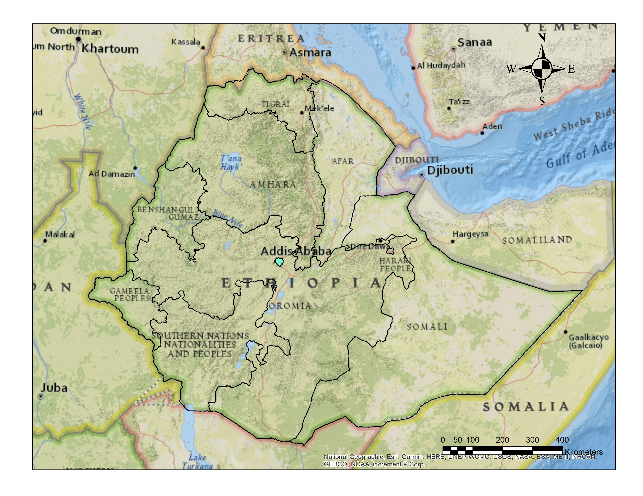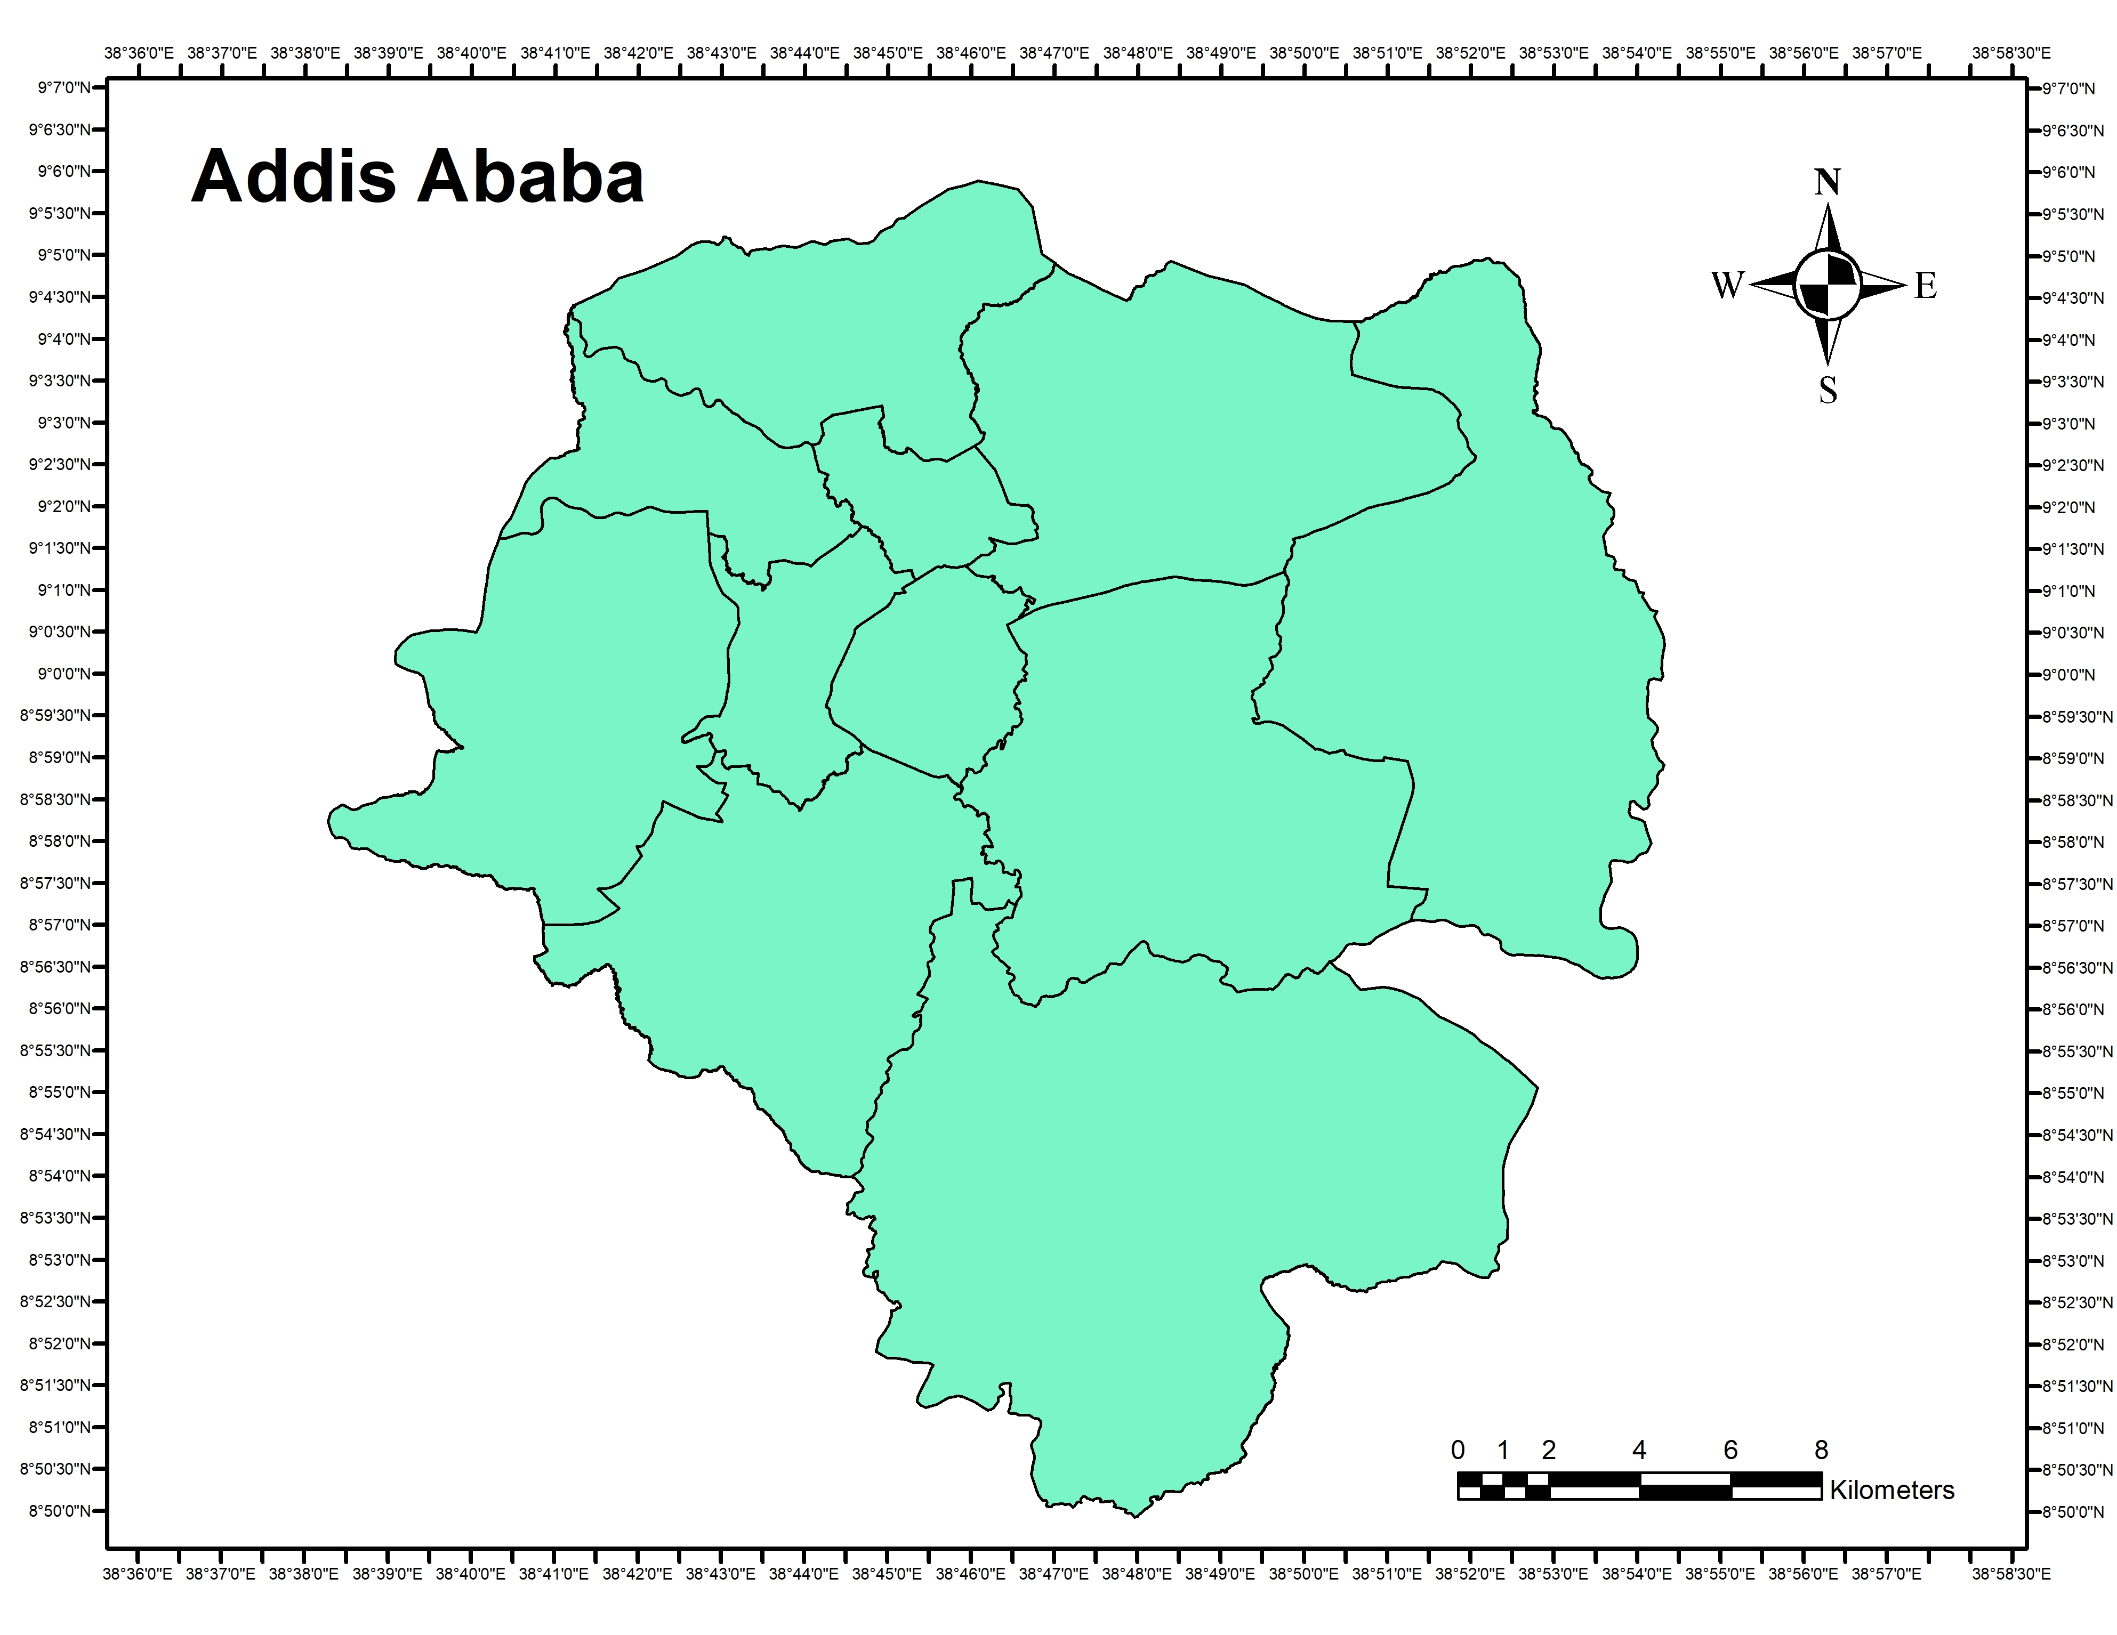
Figure 3.1: Location map of Addis Ababa city (source: Own preparation using Arc GIS 10.7 analysis, 2023)
The majority of the urbanized area in the city falls between 2,200 and 2,500 meters above sea level with a total area average altitude of 2,400 meters and a highest elevation of 3,200 meters above sea level at Entoto mountain which makes Addis Ababa one of the High-altitude cities of the world (Abnet et al., 2020).
The climate in Addis Ababa is subtropical highland, with precipitation varying substantially by month. The main rainy seasons are from June to early October and have an annual average rainfall of 1,200 mm where the majority is from the rainy season alone. Similarly, the temperature varies depending on the elevation, month, and the prevailing winds. The average minimum temperature is 7º in December and the average maximum temperature is 30.6 º in February (Meteo climate, retrieved 2023).
Mountains and rivers are significant natural features that have shaped and led to the development of the city's structure and form. Entoto Hills to the north, Mount Wechacha, Repi, and Furi to the west and southwest, and Yerer Mountain and other volcanic cones to the east and south, encircle Addis Abeba. Even though not large four major streams, Qabana, Kachene, Qurtume, and Akaki, which originate in the Entoto highlands pass throughout the city (Ashenafi, 2001).
The total area covered by the city is 540 km sq. According to the CSA, the estimated population of the city is about 3.8 million urban dwellers with an average density of 7324.6 persons per kilometer and a yearly population growth rate of 2.1.
Addis Ababa is one of the two self-administered cities along with Dire Dawa that are accountable to the federal government. The city is divided into 11 sub-cities and 120 woredas for administrative purposes.
  - Sources of Data
Population data for Addis Ababa city in the year 2014 were obtained from the Ethiopian Central Statistics Agency. While employment data for each sector for the year 2014 were obtained from Addis Ababa City Public Service Bureau, the Ethiopian Civil Service Commission, Federal private organizations employees’ social security administration, Ethiopian industry minister, Addis Ababa City government organizations employees’ social security administration and missing branch employee data has been obtained from each company head offices. All the data concerning employees includes the name of the company, the number of workers, and the location of the companies including the sub-city and woreda. On the other hand, up-to-date spatial data have been collected from the Addis Ababa Plan and Development Commission.
Table 3.1: Sources of data from organizations
No | Name of the organization where data has been collected from | Provided Data
1 | Central Statistics Agency (CSA) | Population projection estimates for 2014 in Addis Ababa city and each sub-cities
2 | Ethiopian Civil Service Commission | Federal-level organizations' employees' data for the year 2014
3 | Addis Ababa Public service | Employee data for organizations under Addis Ababa City administration for the year 2014
4 | Federal government organizations employees’ social security administration | Federal-level development organizations' employee data for the year 2014
5 | Federal private organizations employees’ social security administration | Private companies' employee data for the year 2014
6 | Addis Ababa city government organizations employees’ social security administration | Employee data for development organizations under Addis Ababa city Administration for the year 2014
7 | Ethiopian Industry Minister | Employee data for industries in Addis Ababa city for the year 2014
8 | Labor, Enterprise & Industry Development Bureau | Small-scale manufacturing employee data for the year 2014
(Source: Own computation, 2023)
Data has been taken from different organizations for the purpose of data triangulation so as to increase the accuracy of the collected data.
  - Data analysis
The frequently applied methods of measuring residential and employment patterns are the density gradient and the population centrality. Density gradients measure how much population density decreases as the proximity to the city center increases (Selma, 2011). While population centrality measures the percentage of the population and employees living or working at various distances from the Central Business District (CBD) to the edge of the urbanized area (Glaeser & Kahn, 2001). According to (Malpezzi, 1999 quoted by (Antonio et al., 2003) the population density gradient is the more restrictive of the two measurements since the traditional negative exponential gradient presupposes that density decreases monotonically with distance from the CBD. As a result, the population centrality approach is applied to measure both the population and employment distribution within the city a higher population centrality value suggests that a bigger proportion of the population lives in the area. The methodology is also new to be applied to Addis Ababa city.
On the other hand, the job housing balance is calculated as a ratio of the number of jobs to housing (number of employees to people). Based on (Cereavo, 1989) if an area lies with a ratio between 0.75 and 1.5 it has a balanced job and housing, if it lies less than 0.75 the area has fewer jobs than housing then the area is imbalanced. Similarly, if an area has a ratio above 1.5 there is no sufficient housing in the area showing people live far away.
JHRi = Ji/Hi
Where JHRi denotes the job-housing ratio for radius i, Ji denotes the total number of jobs or employees for radius i, and Hi denotes the total number of housing or residents for radius i.
Finally, to measure how evenly jobs are distributed relative to the population in the overall city area, the cumulative percentage of (Y-axis) representing jobs/employees against the cumulative percentage of (X-axis) representing housing/residents is plotted to obtain the Lorenzo curve. The 45-degree line represents an even distribution of jobs vs. population. The imbalance measure (Massey and Denton's Gini coefficient) is the area between the Lorenz curve and the 45-degree line, expressed as a proportion of the area under the 45-degree line. Larger values of this measure imply a less even distribution of jobs vs. housing (Antonio et al., 2003).

- Result
The overall findings of the paper are presented in this chapter. Initially, the data from the analysis in each category will be presented then the findings are interpreted and compared to draw conclusions.
  - Population distribution
Using the population data from CSA for the year 2014 the population distribution at night when people are at their home were measured using the CBD as a starting point. The boundary for the CBD has been taken from the revised structure plan of 2002 and 2017. According to the structure plan the CBD covers 1km starting from Leghar at the start of Churchill Avenue including three important nodes such as Merkato, Arada, and Arat Killo. The result of the Population centrality measure is presented in the following graph below:

Figure 4.1: Population distribution in Addis Ababa city at each radius (Source: Own computation, 2023)
Table 4.1: Population distribution percentage at 2 km radius gap in Addis Ababa city
Distance from the CBD | 2 km | 4km | 6km | 8 km | 10Km | 12km | 14km | 16km | 18km | 20km
Population Percentage | 9.38 | 25.49 | 22.6 | 14.17 | 11.87 | 4.42 | 3.88 | 5.75 | 2.1 | 0.34
(Source: Own computation, 2023)
The result shows that the highest concentration of population resides within 4 km of the CBD where up to 25.5% of the total population within Addis Ababa city dwells while the lowest is located 20km from the CBD with only 0.34% of the population residing in the area showing a huge gap with the highest concentration of 25.16%. Thus, the graph shows that as one moves from the CBD to the outer edges of the city population distribution starts low around the CBD because these areas are more occupied by commercial and retail activities than residential, then increases up to a 4 km radius then decreases gradually with a little increment at 16km this on the other hand, is due to the existence of high-density bulk condominium housing development at 16km radius such as Yeka Abado, Koye Fitche, Bole Arabsa, and Ayat.
Similarly, the highest number of population concentrations within an 8km radius is due to the following reasons. The first is the fact that the areas around the CBD are old neighborhoods with mixed-use and low-standard housing with slum characteristics, which is associated with lower rent and crowded living conditions thus people of low and middle income are attracted to these areas for living. The second is the proximity to employment, service, market, and transportation. Compared to areas located at a distance from the CBD areas closer to the CBD have much accessibility to activity centers. Thus, the majority of the population chooses to dwell in these areas.
  - Job Distribution
Similar to population distribution job distribution is measured using the population centrality approach of employees working with 5km, 10km, etc. from the CBD. All type of jobs within Addis Ababa city that has more than 15 workers has been included in the study except foreign embassies and self-employed jobs. The employment distribution in Addis Ababa is presented in the figure below.

Figure 4.2: Employment distribution in Addis Ababa city in each radius (Source: Own computation, 2023)
Table 4.2: Employment distribution percentage at 2 km radius gap in Addis Ababa city
Distance from the CBD | 2 km | 4km | 6km | 8 km | 10Km | 12km | 14km | 16km | 18km | 20km
Employment Percentage | 17.99 | 27.87 | 22.28 | 11.03 | 6.04 | 4.25 | 7.25 | 2.41 | 0.64 | 0.24
(Source: Own computation, 2023)
The finding indicates that as one moves from the CBD to the outer edge of the city employment decreases showing a mono-centric employment structure where the influence of the CBD extends up to 4 km. However, the areas within a 6km radius according to the structure plan is where a major sub-center area such as Megenagna is located, The highest employment percentage similar to the population distribution is within 4km of the CBD containing 27.87% of the total employees within the city while the lowest percentage is observed within 20km from the CBD having 0.24% of employees working in the areas. The range between the highest and the lowest values is 27.63% which shows there is an enormous gap between the two areas.
Areas located within a 4km radius are neighborhoods located at a closer distance to the CBD such as Merkato, 6 Killo, Kebena, Torhailoch, Kera, parts of Addisu Gebeya, and parts of Bole included these are also areas with the highest population distribution which has characteristics of center Area and activity nodes including the largest open market in Africa Merkato.
According to (Glaser, 1998) firms select a particular location due to four main reasons these are land costs, access to ideas, access to workers, and transport costs for goods, for people, and for ideas. These can be explained by the fact that the highest number of employees containing 79.17% of the total employees are found within 8 km from the CBD closer to the city’s primary market, airport, transportation provision, and availability of workers.

Figure 4.3: Employment distribution vs. Population distribution in Addis Ababa city (Source: Own computation, 2023)
The above figure also proves that firms are attracted by the number of available workers as both job and housing distribution are higher within 8km from the CBD and decreases as one moves from the center. However, other factors also have an influence on the type of firm's location choice.
In addition to these in the case of Addis Ababa city, the historical foundation, development, and expansion of the city also have an influence on how firms select their location. An example is the existence of warehouses and manufacturing around Gerji and Gurd shola which is due to the fact that these areas were expansion sites between 1986 and 1995 where manufacturing was located which influenced the existing characteristics of the area to have mixed manufacturing, business, and residential uses.
While the population decreases at a slower rate as one moves away from the CBD the job distribution shows a sudden decrease as one moves away from the CBD and increases again at 14 km, which is due to the agglomeration of large-scale manufacturing and industrial parks at this distance mostly at Kality, and Bole Lemi area. Two areas delineated as major sub-center by the structural are also located at this radius which is the Kality and Ayer tena areas.
In conclusion, the influence of Addis Ababa’s CBD extends up to 4 km from the CBD which overpasses the old CBD in terms of both population and employment concentration; newly created sub-center areas also have more population and employment concentration than the CBD such as areas located 6 km from the CBD such as Megenagna. However, the influences of sub-center areas are local and located at a closer distance to the main CBD having the probability to be engulfed by the expansion of the CBD in the future. Therefore, the spatial structure of Addis Ababa city has a mono-cetric characteristic.
  - Job housing Balance
The job housing measure is the ratio of jobs to housing within a particular area. In this case, the job is the number of employees at a certain distance from the CBD and the housing is the number of populations residing within an area. The job housing balance is calculated as a ratio of the number of jobs to housing (number of employees to people). The job-housing balance for Addis Ababa city has been calculated using this methodology for areas located by a 2km gap from the CBD. The result is presented below:
Table 4.3: Job-housing balance at each radius in Addis Ababa City
Distance from the CBD | Employment Percentage | Population Percentage | Job – Housing Ratio | Status
2 km | 17.99 | 9.38 | 1.91 | Imbalanced
4 km | 27.87 | 25.49 | 1.09 | Balanced
6 km | 22.28 | 22.6 | 0.98 | Balanced
8 km | 11.03 | 14.17 | 0.77 | Balanced
10 km | 6.04 | 11.87 | 0.5 | Imbalanced
12 km | 4.25 | 4.42 | 0.96 | Balanced
14 km | 7.25 | 3.88 | 1.8 | Imbalanced
16 km | 2.41 | 5.75 | 0.41 | Imbalanced
18 km | 0.64 | 2.1 | 0.3 | Imbalanced
20 km | 0.24 | 0.34 | 0.7 | Imbalanced
(Source: own computation, 2023)
The highest job-housing imbalances are observed around 2 km from the CBD with a higher ratio of employee concentration to Housing of 1.91 and at 18 Km from the CBD with a very high concentration of people (dwelling) to a job (employees) of 0.3. As explained above the high concentration of jobs closer to the CBD is because, these areas are inner city center areas where there are a higher number of commercial and retail activities than residential, among others this is due to the historical development of the city, which has shaped the existing spatial structure as well as the benefit of agglomeration. The areas that fall within this radius are 4 Killo, Piazza, Kazanchiz, Mexico, Lideta, Meskel Adebabaye, and parts of Merkato. On the other hand, the lower number of jobs to housing at 18 km indicates suburbanization and the existence of bulk condominium houses at this distance which resulted in the imbalance, the jobs at this radius are limited to basic service provision and recreational purposes like schools, clinics, and cafes as well as shops and supermarkets. These areas include Arabsa, lower Koye Fitche, lower Akaki, and Tulu Dimtu area which is now part of the Sheger City.
The closest job-housing balanced area is observed at a 6 km radius with a 0.98 job/housing ratio these areas include Megenagna, 22, Gerji, Bole, Gofa, Mekannisa, and Nifas silk areas. Another closest job housing balance is at 12 km with a 0.96 job/housing ratio which includes areas such as Kality, Summit, and Kotebe area which have both housing and employment characteristics with industrial agglomeration specifically in the Kality area. Finally, to identify the overall job–housing balance status of the city the cumulative percentage of jobs to housing is presented by the Lorenzo curve. The imbalance is the area between the Lorenzo curve and the 45º line of equality, the Gini coefficient, on the other hand, describes how the ratio deviates from perfect equality.

Figure 4.4: Job - housing balance in Addis Ababa City (Source: Own computation, 2023)
The graph represents the cumulative percentage of the population (noted on X) versus the cumulated percent of employees (noted on Y) to show the job-housing balance throughout the city. Thus, the Gini coefficient for this curve is 0.8. A Gini coefficient that is 0 is absolute equality and 1 is absolute inequality. This indicates the job housing balance throughout the city is more imbalanced.
- Conclusion
The population and employment distribution in Addis Ababa both increase up to 4 km then decrease as one moves away from the CBD to the peripheries, while the job distribution shows a sudden increase and decrease showing the existence of sub-center areas, the population distribution has a gradual decrease as one approaches the periphery. The highest concentration is at 4 km showing that the inner-city areas are losing their primacy by the expansion of the CBD as well as newly created major sub-center areas around Megenagna and its surroundings these could be related to the fact that the inner-city areas are changing into recreational areas with a large area park, and cultural buildings development. Overall, the city has a mono-centric urban spatial structure with the old CBD influence expanding up to 4 km. On the other hand, the job–housing ratio in the city has a Ginni- coefficient of 0.8 indicating a more imbalanced structure throughout the city compared to the line of equality which is 0, and the line of inequality which is at 1. Therefore, the concerned bodies should develop strategies to match available jobs in a community with the labor force skills and to provide housing at different prices, sizes, and locations suited to workers who wish to live in the area

Reference
Abnet Gezahegn, Dawit Benti, Imam Mahmoud, Tsion Lemma, Yonas Alemayeh. (2020). City Profile Addis Ababa, EIABC
Abouelhamd Islam. (2021). THE RELATIONSHIP BETWEEN URBAN SPATIAL STRUCTURE & COMMUTING PATTERNS: LITERATURE REVIEW. JES. Journal of Engineering Sciences. 49. 662-678. 10.21608/jesaun.2021.57245.1026.
Addis Ababa Urban Age Task Force. (2022). Addis Ababa Spatial Compendium: Mapping and spatial analytics for Ethiopia’s capital.
Alonso, W. (1964). Location and Land Use: Toward a General Theory of Land Rent. Harvard University Press: Cambridge, MA

Antonio M. Bento, Maureen L. Cropper, Ahmed Mushfiq Mobarak, Katja Vinha. (2003). The Impact of Urban Spatial Structure on Travel Demand in the United States

Ashenafi Gossaye. (2001). Inner city renewal in Addis Ababa. Trondheim
Boarnet, M. G. and Wang, X. (2019) ‘Urban spatial structure and the potential for vehicle miles traveled reduction: The effects of accessibility to jobs within and beyond employment sub centers’, The Annals of Regional Science, vol. 122, p. 775.

Cervero Robert. (1989). Jobs-Housing balance and Regional Mobility, American Planning Association Journal, 55

Dempsey, Nicola & Brown, Caroline & Raman, Shibu & Porta, Sergio & Jenks, Mike & Jones, Colin & Bramley, Glen. (2009). Elements of Urban Form. 10.1007/978-1-4020-8647-2_2.
Gerrit-Jan Knnap, Rebecca Lewis, and Jamie Schindewolf. (2014) The Spatial structure of cities in the United States
Glaeser, Edward L. (1998). "Are Cities Dying?" Journal of Economic Perspectives, 12 (2): 139-160.DOI: 10.1257/jep.12.2.139
Glaeser, E. and M. Kahn (2001). “Decentralized Employment and the Transformation of the American City." Brookings-Wharton Papers on Urban Affairs 2
Jerry Weitz. (2003). Job – Housing balance Planning. Advisory Service Report No. 516. Chicago: American Planning Association.
Jean-Paul Rodrigue. (2020). The Geography of Transport Systems, Fifth Edition. New York: Routledge, 456 pages. ISBN 978-0-367-36463-2 doi.org/10.4324/9780429346323
Krehl A, Siedentop S, Taubenböck H and Wurm M. (2016). A Comprehensive View on Urban Spatial Structure: Urban Density Patterns of German City Regions. ISPRS International Journal of GeoInformation.

Malpezzi, Stephen. (1999). estimates of the measurement and Determinants of Urban Sprawl in U.S. Metropolitian Areas, Mimeo, University of Wiscosin.

Muñiz, I. & Sánchez, V. (2018) ‘Urban Spatial Form and Structure and Greenhouse-gas Emissions from Commuting in the Metropolitan Zone of Mexico Valley’, Ecological Economics, vol. 147, pp. 353–364

Muñiz, I. & Rojas, C. (2019). Urban form and Spatial Structure as Determinants of per capital greenhouse gas emissions considering possible endogeneity and compensation behaviors, Environmental Impact Assessment Review, Vol.76, pp. 79-87

Rob (2020) Urban forms
https://www.coolgeography.co.uk/advanced/Urban_forms.php

Roosmayri Lovina obtained (2023). Urban Spatial Structure -Theory and Phenomenon

Selma Hepp (2011) Metropolitan Spatial Structure: Measuring the Change

Shearmur, R. and Charron, M. (2004). From Chicago to L.A. and back again: A Chicagoinspired quantitative analysis of income distribution in Montreal. The Professional Geographer. 56(1): 109-126.
Station Addis Ababa, meteo climate, retrieved May (2023).
http://meteo-climat-bzh.dyndns.org/index.php?page=stati&id=1837

von Thünen JH. (1826). Der Isolierte Staat in Beziehung auf Landwirtschaft und Nationalekonomie. Hamburg, Germany
Wang, H.; Zeng, W.; Cao, R. (2021) Simulation of the Urban Jobs–Housing Location Selection and Spatial Relationship Using a Multi-Agent Approach. ISPRS Int. J. Geo-Inf. 2021, 10, 16. https://doi.org/ 10.3390/ ijgi10010016
Yanbing Tang. (2007). An integrated GIS-SPATIAL Analysis of Atlanta’s urban structure and urban space, University of Georgia.

Annex III
Questioner
- Participants Demographic Background
- Gender:
- Age:
- Your education background:
A. Less than Grade 8 B. Grade 9 -10 C. Grade 11-12 D. TVET (Level I-V)
E. Diploma F. First Degree G. Second Degree & above
- Marital status:
A. Single B. Married C. Divorced D. Widowed E. Separated
- Number of family:
- What is your occupation status?
A. Government employee B. Private employee C. Own Business
D. Daily labor E. Unemployed F. Retired
G. Other:
8. How much is your monthly salary?
A. less than 1000 B. 3000 – 1000 C. 5000 – 3000
D. 10,000 – 5,000 E. Above 10,000
- Housing condition
- Ownership Status A. owner B. renter
C. Kebele D. AARH E. Government
- House type A. Condominium B. Apartment C. Villa D. Service
E. Other:
- Where is the location of your place of residence:

- Questions related to travel behavior
- Where is the location of your place of work?

- At what time do you start work?

- At what time do you finish work?

- What kind of transportation do you use when commuting for work/ school purposes each day? Show your mode choice by Using (X) mark on the following table

Transportation mode choice | Monday | Tuesday | Wednesday | Thursday | Friday | Saturday
Private car
Bicycle
Walking
Motor cycle
Autobus
Taxi
Contract taxi/ Ride
LRT
Bajaj
Service mini-bus
Service Bus
Others

- Why did you choose to use this transportation?

It is Cheaper

It is Time Efficient

Reliable

Available to move anywhere at any time

Convenience and safe

To decrease air pollution from emission and to save energy

Because it is healthy

Job is closer to home

Job is far away from home

Free from stress

Others

- Is there sufficient transportation at the time you are going and coming from work/ school? If not which ones are missing/ insufficient?
Yes Not Sufficient
- How much do you spend on transportation per day when going to and coming from work?

- How much time on average do you wait for transportation at the time of leaving and coming from work?

- How is the traffic condition in your neighborhood? How much time do you spend on the road due to traffic congestion?

- Why do you choose this area as your place of residence?

- What do you believe should be done to solve transportation-related challenges?

Thank you

Annex IV: An example of a properly attempted survey questionnaire from a balanced job housing area



Annex V: An example of a properly attempted survey questionnaire from a balanced high job- low housing area




Annex VI: An example of a properly attempted survey questionnaire from Low job- high housing area





