

PASSENGERS’ PERCEPTION TOWARDS SERVICE QUALITY AND SOCIOECONOMIC BENEFITS OF THE ADDIS ABABA LIGHT RAIL TRANSIT SERVICE

BY
ADANE OBSIE BIFA

JUNE, 2019
ADDIS ABABA, ETHIOPIA



PASSENGERS’ PERCEPTION TOWARDS SERVICE QUALITY AND SOCIOECONOMIC BENEFITS OF THE ADDIS ABABA LIGHT RAIL TRANSIT SERVICE

A thesis submitted to the school of graduate studies of Addis Ababa University, Ethiopian Institute of Architecture, Building Construction and City Development (EiABC), in partial fulfilment for master’s degree in Urban Planning
Author:
Adane Obsie Bifa

Advisor: Professor Mintesnot G. Woldeamanuel (PhD)
Co-advisor: Dr. Dipl.Eng. Berhanu Woldetensae
Ethiopian Institute of Architecture, Building Construction and City Development (EiABC)
Addis Ababa University
June, 2019
Addis Ababa, Ethiopia

This thesis is submitted to Ethiopian Institute of Architecture, Building Construction and City Development (EiABC) and to school of graduate studies of Addis Ababa University in partial fulfillment of the requirements for the degree of Masters of Science in Urban Planning.
Title of Thesis: Passengers’ Perception towards Service Quality and Socioeconomic Benefits of the Addis Ababa Light Rail Transit Service

Author: Adane Obsie
ID NO: GSR/9723/10
Date: June, 2019

Approved by board of examiners
Professor Mintesnot G. Woldeamanuel (PhD)
Advisor: Signature Date
Dr. Berhanu Woldetensae
Co-Advisor: Signature Date
Dr. Kassa Mogas
External Examiner: Signature Date
Dr. Dagnachew Adugna
Internal examiner: Signature Date
Dr. Berhanu Woldetensae
Chairman: Signature Date
Dr. Fisseha Wegayehu
Graduate Program Director: Signature Date

Declarations
I, the undersigned declare that, this thesis is my own work and original work that does not presented for a degree or diploma in any other institutions or university. All the sources of material used for the thesis have been duty acknowledged following the scientific guidelines of the institute.

Addis Ababa
June, 2019
Author: Adane Obsie
Id No: GSR/9723/10

Signature

Confirmation
I state that Adane Obsie Bifa has carried out this research work on the topic “Passengers’ Perception towards Service Quality and Socioeconomic Benefits of the Addis Ababa Light Rail Transit Service” under my supervisions and it is sufficient for the partial fulfillment for award master’s degree of in urban planning.
Professor Mintesnot G. Woldeamanuel (PhD)
Advisor: Signature Date

Acknowledgement
I would like to express my appreciation to my advisor Professor Mintesnot G. Woldeamanuel for his unconditional support, intellectual guidance, prompt responses, directions and insight that provided me with an excellent academic foundation to move forward through this study. Also, I would like to express my appreciation to my co-Advisor Dr. Dipl. Eng. Berhanu Woldetensae for his intellectual guidance, directions and insight that provided me through this thesis work.
In addition, I would like to thank Mrs. Birke Yami for financial support and special advice also Mrs. Tsion Lema, Mr. Zewudu Tesfaye and Mr. Solomon Benti for their special guidance and advice. Last but not least my thanks goes to my family, first year MSc urban planning students and all of my class MSc. Classmate who have been supporting me in moral spiritual and physical support.

Abstract
Evaluation of public transportation service quality and benefits based on users ‘perception is important to improve the systems' performance, especially for cities practicing the service. Addis Ababa, Ethiopia had launched the new light rail transit service and practicing the service to overcome problems of the transportation system in the city. When implemented the light rail transit, it was expected to serve the residents with potential benefits and criteria of reduced cost, safety, reliability, comfort, environmental friendliness, efficiency and attractiveness for residents. However, unlike these expectations currently, the light rail transit service is characterized by long waiting times, crowdedness, a dissatisfying ticketing system, and travel information. This study was conducted to identify the perception of the passengers' toward the service quality and socioeconomic benefits of this new light rail transit service. The survey method containing closed-ended and open-ended questionnaires were used. Factor and ordered logit model analysis employed to identify influencing factors on satisfaction level and socioeconomic characteristics of passengers' that influence perceptions toward the services' satisfaction and the benefits of light rail transit service. The results showed that safety and security, ticketing system and travel information, crowdedness and frequency, and cleanness and comfort are the influencing factors on the satisfaction of the light rail transit service. The influence and perceptions of these factors depend on the socioeconomic characteristics of the passengers’. It also indicates that the light rail transit service is providing benefits related to reducing travel distance, travel cost, and traffic problems, and these benefits also depend on the socioeconomic characteristics of the passengers'. The finding indicated that some satisfaction level and socioeconomic benefits of the passengers’ can be improved and maximized in short term while others can be improved in long term of planning and working on the system’s performance.

Keywords: passengers’ perception, service quality, socioeconomic benefits, light rail transit

Tables of the Contents
Approved by board of examiners iii
Declarations iv
Acknowledgement v
Abstract vi
Tables of the Contents vii
List of Figures xi
List of Tables xi
List of Annexes xiv
Acronyms and Abbreviations xv
CHAPTER ONE: INTRODUCTION 1
1.1. Background 1
1.2. Statement of the Problems 4
1.3. Objective of the Study 6
1.3.1. General Objective 6
1.3.2. The Specific Objectives 6
1.4. Research Questions 7
1.5. Significance of the Study 7
1.6. The Scope of the Study 8
1.7. Organization of the Paper 8
CHAPTER TWO: REVIEW OF LITERATURES 10
2.1. Introduction 10
2.2. The definition of Public Transport 10
2.3. The Definition and Type of Light Rail Transit 11
2.4. Characters of Good Light Rail Transit 11
2.5. The Benefits of Light Rail Transit 12
2.5.1. Social Benefits of Light Rail Transit 13
2.5.2. Economic Benefit of Light Rail Transit 15
2.5.3. Benefits of LRT and other Mass Transits to Users’ of Different Socioeconomic Characteristics 17
2.6. Passengers’ Perception and Satisfaction toward LRT and other Mass Transit Services 20
2.7. Factors Affecting Satisfaction and Perception of the users’ 22
2.8. LRT and Public Transport of Addis Ababa 25
2.9. The Summary of the Literatures and Identified Research Gaps 26
2.9.1. Summary of Literatures 26

2.9.2. The Research Gaps 30
CHAPTER THREE: RESEARCH MATERIALS AND METHODS 32
3.1. Description of the study LRT Lines 32
3.1.1. The Need of the Light Rail Transit Service 32
3.1.2. The Structure and Facilities of the AALRTS 33
3.1.3. The Phases of Addis Ababa’s LRTS and the Future Porject of LRT Lines 35
3.2. Research Methodology 38
3.3. Research Design 38
3.4. Research Methods 40
3.5. Justification for the Method 41
3.6. Data Sources 42
3.7. The study’s Variables 42
3.8. Types of Variables and Measuring Techniques 44
3.9. Populations of the study 46
3.10. Samples Size and Techniques 46
3.10.1. Total Passengers and the Sample Size of Both LRT Lines 47
3.10.2. Selection of the LRT Stations 48
3.10.3. Making the Proportion of Sampling Size to Selected Stations’ Passengers’ Percentage ........................................................................................................................................51
3.11. Data Collection Methods 52
3.11.1. Secondary Data Collection 52
3.11.2. Primary Data Collection 52
3.12. Data Analysis Methods 54
3.12.1. Descriptive Analysis 54
3.12.2. Factor Analysis 54
3.12.3. Ordered Logit Model Analysis 55
3.13. Qualitative Data Analysis 57
CHAPTER FOUR: RESULT AND DISCUSSION 58
4.1. Description of the Respondents 58
4.1.1. Socioeconomic Characters Data 58
4.1.2. LRTS Use Level of the Sampled Passengers 62
4.1.3. Trips Purpose and Mode data 63
4.1.4. Satisfaction Parameters Data 64
4.1.5. The Socioeconomic Benefits of LRTS Data 65
4.1.6. The Qualitative Data 66
4.2. Perceptions of Riders toward Service Quality of AALRTS 67
4.2.1. Descriptive Analysis of the Perceptions 67
4.2.2. Factor Analysis Result of the Perceptions toward service Quality of AALRTS 70
4.2.2.1. Factor Related Safety and Security of Passengers’ 71
4.2.2.2. Factors Related to Ticketing system and Information 72
4.2.2.3. Factor Related Crowdedness and frequency 74
4.2.2.4. Factor Related to Cleanness and Comfort 77
4.3. Relationships of Riders’ Perceptions with their Socioeconomic Characters toward the service quality of AALRTS 78
4.3.1. Safety and Security 79
4.3.2. Ticketing System and Information 84
4.3.3. Crowdedness and Train Frequency 88
4.3.4. Passengers’ Perception Result toward Service Quality of AALRTS by Ordered Logit Model Analysis 94
4.3.4.1. Safety and Security Model 95
4.3.4.2. Ticketing and Travel Information Model 97
4.3.4.3. Crowdedness and Train Frequency Model 98
4.3.4.4. Cleanness and Comfort Model 100
4.4. Perceptions of Riders toward Socioeconomic Benefit of AALRTS 101
4.4.1. Descriptive Analysis of Socioeconomic Benefits 101
4.5. The Relationships of the Passengers Perception With their Socioeconomic Characters toward Socioeconomic Benefits of AALRTS 104
4.5.1. Benefits of AALRTS toward Reducing the Cost, Distance and Traffic Congestion 105
4.5.2. Benefit of AALRTS toward Create New Jobs, Enable Clean Air, Connect to Relative and Ease Shopping 109
4.5.3. Riders Perception toward the LRT Value for City Attractiveness 113
4.5.4. Passengers’ Perception Result toward socioeconomic Benefits of AALRTS by Ordered Logit Model Analysis 117
4.5.4.1. LRT’s Benefits in Reducing Distance Model 119
4.5.4.2. The LRT’s Benefits in Reduced Transport Cost 120
4.5.4.3. The LRT’s Benefit in Reducing Traffic Congestion 121
4.5.4.4. The LRT’s Benefit in Creating Jobs, Connecting Relative, Ease Shopping and Enable Clean Air 121
4.5.4.5. The LRT's Contribution to the City Attractiveness 123
4.6. Discussion of the Result 124
4.6.1. Consistence of the Sample Characters 124
4.6.2. Passengers’ Perception toward Service Quality and Factors Influencing the Overall service satisfaction of AALRTS 126
4.6.3. Relationships of Passengers Perception with their Socioeconomic Characteristics toward the service quality of AALRTS 128
4.6.4. Passengers’ Perception toward Socioeconomic Benefits of AALRTS 129
4.6.5. Relationships of Passengers Perception with their Socioeconomic Characteristics toward socioeconomic Benefits of AALRTS 130
CHAPTER FIVE: CONCLUSIONS AND RECOMMENDATION 131
5.1. Conclusions 131
5.2. Recommendation 133
6. References 136
ANNEXES 151

List of Figures

Figure1. 1: Showing AALRTS train inside crowdedness (B), station crowdedness (A) and not enough station seat (C) 5
Figure 3. 1: Research design diagram for this study……………………………………….………….39
Figure 3. 2: Map of sampled Addis LRTS Stations 50
Figure 3. 1: Map of implemented phase one of AALRTS and the future expansions lines 37
Figure 4. 1: Showing age group of riders ……………………………………………………………..59
Figure 4. 2: Marital status of the sampled passengers 59
Figure 4. 3: Family size of the samples 60
Figure 4. 4: Occupation characters of the samples 60
Figure 4. 5: Education level of the sampled passengers 61
Figure 4. 6: Income of the house hold of the sampled passengers 61
Figure 4. 7: Riders’ use level of LRT (A) and Use time in the week (B) 62
Figure 4. 8: Travel distance of the sampled passengers 63
Figure 4. 9: Use time in the day to home and from home trips 63
Figure 4. 10: Mostly used mode and trips purpose 64
Figure 4. 11: Showing satisfactions parameters 65
Figure 4. 12: Socioeconomic benefits of LRT 66
Figure 4. 13: Graph showing relations of safety and security with riders’ age group (B) and gender (A) 80
Figure 4. 14: Graph showing relations of safety and security with riders’ education level (B) and marital status (A) 80
Figure 4. 15: Graph showing relations of safety and security with passengers’ occupations (B) and house hold income (A) 81
Figure 4. 16: Relations of safety and security with passengers’ use level of LRT (B) and use time in the week (A) 82
Figure 4. 17: Relations of safety and security with passengers’ travel distance (B) and time to home (A) 83
Figure 4. 18: Relations of safety and security with Passengers’ mostly used mode 83
Figure 4. 19: Relations of ticketing system and information with Passengers’ gender (B) and age group (A) 84
Figure 4. 20: Relations of ticketing system and information with riders’ marital status (B) and education level (A) 85
Figure 4. 21: Graph showing relations of ticketing system and information with riders’ occupation (B) and house hold income (A) 86
Figure 4. 22: Graph showing relations of ticketing system and information with 87
Figure 4. 23: Relations of ticketing system and information with passengers’ travel distance (B) and use time to home (A) 88
Figure 4. 24: Relations of crowdedness and train frequency with riders’ age groups (B) and gender (A) 90
Figure 4. 25: Relations of crowdedness and train frequency with riders’ marital status (B) and education level (A) 90
Figure 4. 26: Graph showing relations of crowdedness and train frequency with passengers’ occupation (B) and household income (A) 92
Figure 4. 27: Relations of crowdedness and train frequency with passengers’ use level of LRT (B) and use days in the week (A) 92
Figure 4. 28: Relations of crowdedness and train frequency with riders’ travel distance (B) and time to home (A) 93
Figure 4. 29: Relations of crowdedness and train frequency with riders’ mode to school (B) and mode to work (A) 93
Figure 4. 30: Graph showing model result for safety and security 96
Figure 4. 31: Graph showing model result for crowdedness and train frequency 100
Figure 4. 32: Relations of LRT’s cost, distance and congestion reduction perception with gender (B) and age groups (A) 105
Figure 4. 33: Relations of LRT’s cost, distance and congestion reduction perception with marital status (B) and education level (A) 106
Figure 4. 34: Relations of LRT’s cost, distance and congestion reduction perception with passengers’ occupation (B) and house hold income (A) 107
Figure 4. 35: Relations of LRT’s cost, distance and congestion reduction perception with passengers use level of LRT (B) and use days in the week (A) 108
Figure 4. 36: Relations of LRT’s cost, distance and congestion reduction perception with passengers travel distance (B) and time from home (A) 108
Figure 4. 37: Relations of LRT’s cost, distance and congestion reduction perception with riders mostly used mode to work 109
Figure 4. 38: LRT’s benefits of creating new jobs, connecting to relatives, ease shopping and enable clean air with passengers gender (B) and age groups (A) 110
Figure 4. 39: LRT’s benefits of creating new jobs, connecting to relatives, ease shopping and enable clean air with passengers’ marital status (B) and education level (A) 110
Figure 4. 40: LRT’s benefits of creating new jobs, connecting to relatives, ease shopping and enable clean air with passengers’ occupation (B) and household income (A) 111
Figure 4. 41: LRT’s benefits of creating new jobs, connecting to relatives, ease shopping and enable clean air with passengers’ travel distance (B) and time to home (A) 112
Figure 4. 42: LRT’s benefits of creating new jobs, connecting to relatives, ease shopping and enable clean air with passengers’ use level of LRT (B) and use days in the week (A) 113
Figure 4. 43: LRT’s contribution for city’s aesthetics with passengers’ gender (B) and age groups (A) 114
Figure 4. 44: LRT’s contribution for city’s aesthetics with passengers’ marital status (B) and education level (A) 114
Figure 4. 45: LRT’s contribution for city’s aesthetics with passengers’ occupations B) and household income (A) 115
Figure 4. 46: LRT’s contribution for city’s aesthetics with riders’ use level of LRT B) and use time of LRT during the week (A) 115
Figure 4. 47: LRT’s contribution for city’s aesthetics with passengers’ travel distance B) and time from home (A) 116
Figure 4. 48: LRT’s contribution for city’s aesthetics with passengers’ mostly used mode to work 116

List of Tables

Table 2. 1: Summary of the benefits of public transportation 27
Table 2. 2: Summary of studies and methods, table generated from Literatures 29
Table 3. 1: Description of the study Variables……………………...…………………………………45
Table 3. 2: Average total passengers per day on both lines, and total sample size per each line……..48
Table 3. 3: Average total passengers per day at N_S line’s stations and proportion sample size at stations………………………….……………………………………………..…………………51
Table 3. 4: Average total passengers per day at E-W line's stations and proportion sample size at each station……………………………..………………………………………………...………..…..51
Table 4. 1: Showing descriptive analysis result of the 18 satisfaction parameters……………………68
Table 4. 2: Showing factors reduction result of the 18 service quality parameters…………………...70
Table 4. 3: showing ordered logit model result for the riders’ satisfaction level toward service quality of AALRTS………………………………………………………………………………………95
Table 4. 4: Showing descriptive analysis result of the socioeconomic benefits……………………..102
Table 4. 5: Ordered Logit model analysis result for socioeconomic benefits parameters…………...118

List of Annexes

Annex 1. Survey Questionnaires 151
Annex 2. Photos while giving orientation (a) and prepared survey questionnaires (b) 154
Annex 3.Example of properly attempted all the survey questionnaire 155

Acronyms and Abbreviations
AA: Addis Ababa
AALRTS: Addis Ababa Light Rail Transit service
LRTS: Light Rail Transit Service
AALRTP: Addis Ababa Light Rail Transit Project
AATA: Addis Ababa Transport Authority
CSS: Customers satisfaction Survey
AACPC: Addis Ababa City Plan Commission
BRT: Bus Rapid Transit
CCTV: Closed Circuit Television
CSA: Central Statistical Agency
EiABC: Ethiopian institute of Architecture and City Development
ERC: Ethiopian Railway Corporation
ETB: Ethiopian Birr
FDRE: Federal Democratic Republic of Ethiopia
HIT: Hellenic Institute of Transport in Greece
LRT: Light Rail Transit
OCCD: Operation Control Center Division of AALRTS office
PT: Public transport
SQ: Service quality
USA: United States of America
USD: United States dollar
WHO: World Healthy Organizations
UITP: International Association of Public Transport

CHAPTER ONE: INTRODUCTION
  - Background
In the current context of our world, the economic, social and environmental benefits of light rail transit (LRT) has drawn the attention of countries (Agarana, Anake & Okagbue, 2016; Litman, 2004). According to, Yan, Delmelle and Duncan (2012) LRT has advantages in reducing pollution, congestion, lower energy consumption and can also provide more compact economic development along a corridor. Also, Wubet (2018) indicated in his study, the introduction of a rail transit investment brings benefits to the transportation system and accessibility of the population to employment, retail and recreational activities. In addition, urban rail transit can also offer higher land value for the region than other infrastructures (Sun, Chen, Cheng, Wang & Ning, 2017). Because of these, most major European cities have been investing in the development of LRT as an alternative mode of transportations to reduce personal reliance on the automobile and address the social, environmental issues (Yan, et al., 2012). In general, the LRT has been advertised as an effective way to promote economic development (Ko, et al., 2013).
However, the question is, how these all the above benefits of LRT can be maximized? Studies indicated that paying attention to users’ priority will help to improve the service quality of public transportations (Eboli & Mazzulla, 2012; Shaaban & Khalil, 2013). According to, de Oña, et al. (2013) and Shaaban and Khalil (2013) understanding passenger priorities based on measuring their perception will help decision-makers, planners, and operators in order to design appropriate strategies and provide high- performance transit services. Also measuring, service quality will help managers of public transportation to determine funding decisions. These strategies and funding will help for more level of satisfaction with public transportation and which also increase the willingness of peoples to use the services (Gebeyehu, & Takano, 2011).
Many authors have studied service quality (SQ) in the Public transport (PT) sector from different perspectives, using a range of varied methodologies in recent years. The variety of existing approaches could be justified by the complexity of the SQ concept; the number of attributes used to evaluate it; the imprecision and subjectivity of the data used to analyze it, typically it based on customer satisfaction surveys (CSS); and the heterogeneity of passenger perceptions (De Oña and De Oña, 2014).
Service quality can be understood by conducting performance measurement of PT based on riders’ experience (Dziekan, 2008). Service quality and customer satisfaction are directly related. Service qualities are perceptions judgement that customers have for that particular service while customers' satisfaction are emotional judgment that can be explained through liking and disliking, agreeing and disagreeing (Dabholkar, et al., 2000; de Oña & R. de Oña, 2014; Jen, et al., 2011).
For better understanding toward satisfaction level of riders based on their perception experience; it is better to investigate their usage frequency and socioeconomic character. The usage frequency of riders can be seen as frequent users, occasional users and non-users while the socioeconomic character is segregating passengers into gender, age groups, income, marital status, education level, travel purpose, car availability (modal split), job type and travel distance (Dziekan, 2008). These will contribute more to the effective and healthy public transit system services, hence can also attract the new riders’ to the system (Imaz, et al., 2015).
Therefore, for this particular study, scientifically exploring the perception of riders based on their experience toward public transportations performance service is even more important to achieve the benefit and good service quality of PT; especially for the country which practicing the LRT system like as Ethiopia.
Ethiopia is one of Sab-Saharan (expect South Africa) country that launched the first urban rail transit service in 2015, in Addis Ababa. Like as, to any other developing country Addis Ababa is being challenged by the increase in population number because of migration, unemployment, horizontal expansion, congestion, and poor infrastructures (Mammo, 2010). The transportation system of the city is public transport mode mainly of bus and taxi (Wubet M., 2018). In the same way, Gebeyehu, and Takano (2007) explained in their study that, the transportation modes of the city is mainly public transport characterized by low quality, poor management, and bad behavior of drivers. Also, economically the majority of passengers' in the city are low and middle - income generator groups, which depends mainly on public transport (Abadi, 2014).
In response to these transportations problems, the city administration launched its first LRT system in the city. The project has a total length of 31 km with a train speed of 20–70 km/h. It stated that it has a capacity of 60,000–80,000 passengers per day, in four directions (Aklilu, & Necha, 2018). The LRT system has 39 stations including 5 communal stations. Which means that both East-West and North-South has 17 stations each, without including the 5 communal stations.
However, as AATA (2016) assessment study report indicated, the LRT started with 41 trains and transport average 120,000 passengers per day, despite the assumed 60,000-80,000 passengers per day explained above. In addition, as the data from AALRTS shows, the LRT system is using 17 train vehicles on both lines. This means the North-South line has 9 train vehicles and a 15-minute average waiting time while the E-W line has 8 train vehicles and a 12-minute average waiting time. This shows a large variation in the number of trains at current than when it started the function which may lead to lower quality services for the passengers. These may have impacts on passenger comfortability with service which have a negative influence on the public to commute to their offices or from or for leisure, using the urban rail transit system (Nordin, et.al.2016).
There are researches and literatures gaps related to passengers’ perception on LRT and in general to PT services in Addis Ababa. However, according to the study of Private Sector Development Hub (2009), passengers’ satisfaction for the public transport in Addis Ababa city affected by road accidents, inadequate road infrastructure, poor vehicle conditions and poor infrastructure for non-motorized modes. Gebeyehu & Takano (2011) also indicated in their study, Addis Ababa’s residents have a negative view of the regular buses and mini-bus-taxi services. In the same way for AALRTS, if the service quality components are good and there are real socioeconomic benefits, then the rating by passengers will be high.
  - Statement of the Problems
The transportation system of Addis Ababa are characterized by chaotic movement, unacceptable emission, unsafe, hazardous to life and property, weak traffic management system, congestion, and aged fleet (Jemere, 2012; Bogale, 2018).
In response to these transportation problems, the city administration launched the first phase of LRT system in 2015. When started operations, it was expected to serve the resident with a train speed of 20–70 km/h and with a capacity of 60,000–80,000 passengers per day by using 41 trains (Aklilu, & Necha, 2018). However, according to the data from Operation and Control Center (OCC) division of AALRTS currently, the LRT system is transporting 103,006 average passengers per day by using 17 train vehicles on both lines. This indicates the demand is high despite the fact that the supply is getting down (e. g. the number of LRT vehicles reduced by half while the number of passengers all most double of the expected capacity). It also indicated by AATA (2016) report that, currently the LRT transports an average of 120,000 passengers per day. Furthermore, the report explained the number of problems related to LRT service system such as; un-comfortability of passengers, limited numbers of train, crowdedness and ticketing system.
In addition, currently, the LRT service is characterized by the crowdedness during peak hours both in the train and stations, long waiting times, safety, no station media, inaccessible ticketing office are seems problems for the users (Figure 1.1). Also, Abadi (2014) indicated that resident of Addis Ababa’s who are low income were mostly depends on the bus and taxis public transportation service of the city. They are also dissatisfied and have a negative attitude toward this service. However, still after the launching of LRTS low incomes residents of the city are challenging by crowdedness and a long waiting time which might be make them dissatisfied with service like as buses and taxies services. Unlike the bus and taxies there is a knowledge gaps related to socioeconomic characters of the users of AALRTS and also which groups of socio economic characteristic are benefited from the service.
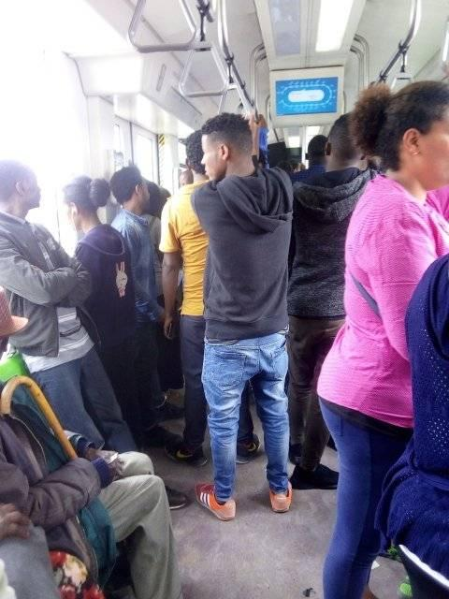
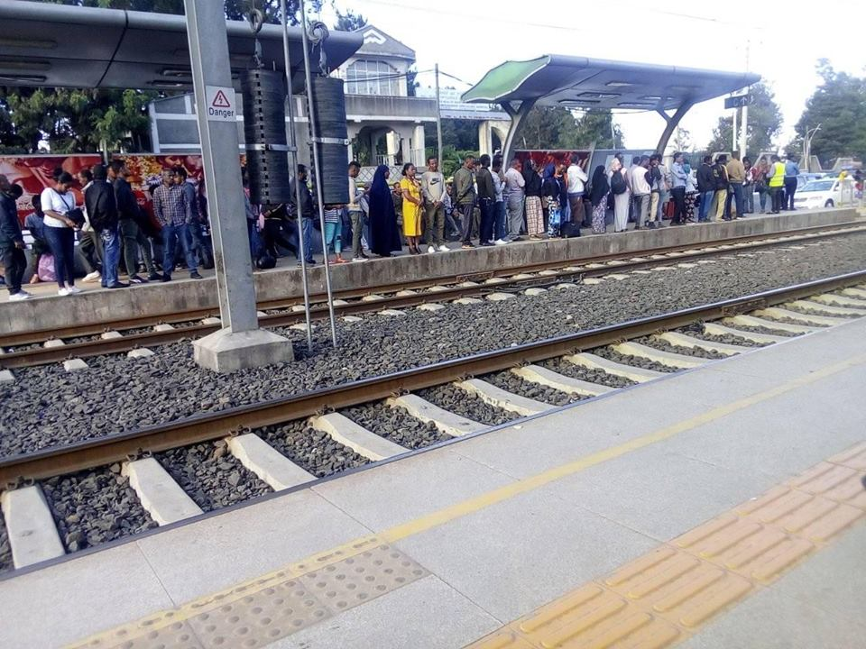

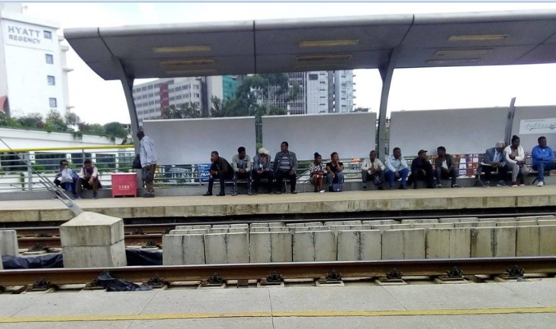
A
B
C

Source: Photos taken in April, 2019 by Author
Figure1. 1: Showing AALRTS train inside crowdedness (B), station crowdedness (A) and not enough station seat (C)
On the other hand, the project has also brought significant changes to the lines' corridors visual landscape and morphological layout. In some places of the corridors,' it totally separated the neighborhood by the fence and characterized by less accessible. Despite, only stating the problems, there is still a knowledge gap related to which the service is more dissatisfying and satisfying, and which passengers' characters are more dissatisfied and satisfied.
Even though there are problems, the system has been praised as it helped a lot in the alleviation of the acute transportation problems in the two corridors since its operationalization (Aklilu, & Necha, 2018). However, which type of benefits and who more benefited is still a question. Which indicates that there is a knowledge gap related to the benefits of AALRTS in terms of passengers' socioeconomic characters and types of benefits.
Generally, the city of Addis Ababa is striving to bridge the gap between the transport demand and supply by building different transportation infrastructures. Among these projects, the expansion of LRT is the main project. Hence, this study is believed to scientifically contribute an inputs and insight for both the future expansion projects of LRTS and also for the improvement of the service quality of the current LRTS by giving insight to the services satisfaction level and the benefits with characteristics of the users.
  - Objective of the Study
    - General Objective
The general objective of this study was to identify the perceptions of passengers’ to the performance and socioeconomic benefits of AALRTS and then analysis with the socioeconomic characters of the passengers’ to forward ways of improvement.
    - The Specific Objectives
The study was based on the following four specific objectives:
- To identify the perception of the users’ and factors influencing perceptions toward the service quality of AALRTS.
- To analyze the relationships of socioeconomic characters of the passengers; with their perceptions toward the service quality of AALRTS.
- To identify the perception of the passengers’ toward the socioeconomic benefits of AALRTS.
- To analyze the relationships of socioeconomic characters of the passengers; with their perceptions toward the benefits of AALRTS.
  - Research Questions
The study had focused on the following research questions:
- What are the views and experiences that users’ have on the service qualities of AALRTS?
- What are the relationships of users’ socioeconomic characteristics with their views and perception toward the service quality of Addis Ababa’s Light Rail Transit?
- What are the views and experiences that users’ have on the socioeconomic benefits of AALRTS?
- What are the relationships of users’ socioeconomic characteristics with their views and perception toward the benefits of Addis Ababa’s Light Rail Transit?
  - Significance of the Study
The researcher hopes that this study has a contribution for different purposes. Since the study was conducted on perception study of the Addis light rail transit which is a very young project in the city, it has significant input for the improvement of the performance service of LRTS, by filling the gaps of knowledge related to users’ socioeconomic characters and satisfaction levels of the services. In addition, it fills the knowledge gap related to the socioeconomic benefits of AALRTS and the literature gaps in the area. The researcher also believes the study has indicated policy implication on how to improve the service quality of LRTS and how to maximize the socioeconomic benefits of passengers'. Finally, this study can serve as a starting point for the other researchers, students, AALRTS offices and other practitioners.
  - The Scope of the Study
The study based on identifying users' perceptions toward service quality and socioeconomic benefits of AALRTS. Hence the scope of this study was limited to only identifying and measuring socioeconomic benefits of AALRTS based on 8 parameters and service quality of AALRTS based on 18 satisfaction parameters by surveying users’ the perception. To attain these purposes the study was based on both East-West and North-South line by purposively selecting 14 stations.
Limitation of the Study
The main limitation faced during working with this study was time and budget limitations. Related to the time, some of time planned for data collection were taken by bureaucracy of research budget permission and to wait for permission from AALRTS office to survey passengers on the selected stations. Related to the budget, the limited budget bye itself challenged during data collection because some of passengers start the questionnaire survey but did not finalize it. Hence, in order to replace these questionnaire papers it had taken more budget to recollect these data for paper duplication and to pay for data collectors.
  - Organization of the Paper
The paper is divided into six chapters. The first chapter gives the background information on the public transportation and LRT, related to the benefits, method and why to evaluating public transportation, methods and how to maximizing the benefits, overview of riders perception and satisfaction to public transportation and overview of the background information related AALRTS. Also, the section contains statement of the problems, research objective, research question, significance of the study and limitation to the study.
The second chapter is the reviews of academics discourses that were important for this study. The review were related to general definition of PT and LRT, the benefit of LRT and PT in terms of environmental, economic and social, satisfaction and factors affecting satisfaction, perception and factors affecting perception, relationships of socio economic character and public transportation, public transportation in case of Addis Ababa and summary of literatures were discussed. The chapter three is about research methods and materials used for this study. The chapter discusses issues like method and justification for the methods, type of data, study variables, sample size and techniques, methods of data collection and analysis.
The fourth chapter is about the background information’s of the study area i.e. background information of AALRTS. It discuss the issues related to AALRTS, like as why the LRT needed for the city, process of implementation and finance, the relation of pre implementation service assumption and post-implementation, the current service condition and it impact on city form and the future expansion phase are discussed.
The fifth chapter is about result and discussion of the study. The chapter discussed the results and discussion in respect to the research questions. Under the result section description of data, variables relationships analysis, factor analysis, ordered logit model analysis and qualitative analysis were discussed. While for the discussion all the result in respective of the research question related to the finding of other studies. The six chapter which is about conclusion and recommendation. The paper’s finding is summarized in respective to research question. The recommendation is based on the findings of the study, for policy improvement related the service quality and the benefits of AALRTS.

CHAPTER TWO: REVIEW OF LITERATURES
  - Introduction
This section is started by defining the concept and definition of some terminologies such as; public transportation, perceptions, LRT, and satisfaction in general to give some insight. The review also assess in detail the benefits of the LRT which is also the same for others public transportation. With this regard the benefit of LRT and public transport to different socio economic character such as to gender, different age groups, income groups has also reviewed and discussed. Furthermore, the section also reviewed different literatures on the area of perception, factors affecting perception, and extensively satisfaction and factors affecting satisfaction on public transport in general and specifically the LRT. Finally, the section summarized the reviewed ideas and pointed out the gaps on selected study area and how it is possible to fill the gaps.
  - The definition of Public Transport
The term ‘public transport’ is typically associated with scheduled conventional forms of mass transportation including LRTS. However, the term also refers other passengers’ transportation like taxis and shuttles which also share some of the key characteristics of public transport services.
However, in general public transport is transportations services that shared some common characteristics such as subsidized from government or other institutions, have passive users, hire and reward, shared transport and open to the public or all the citizens (Richard, 2016).The typical examples of these transports are LRT or tram, BRT, metro rail transit, public buses and others.

  - The Definition and Type of Light Rail Transit
As, Arndt, et al. (2009) explained, rail transit projects are typically classified into three broad categories these are; heavy rail, light rail, and commuter rail. But, for this particular study, this review is only focus on the light rail transit. According to, Knutton, M. (2005) discussed, LRT is an electric rail form of transport for urban centers that range from a conventional on-street tramway to segregated rapid transit systems. Light rail system is one of the typical public transportation modes uses for mass transit in the city. Light rail systems bridge the gap between conventional bus services and urban heavy rail or underground metro railways.
  - Characters of Good Light Rail Transit
The provision of good public transport in general enables cities to thrive and fulfil their economic, environmental and social aspirations. Different studies shows that, transit provide basic mobility to a rider who has no other means of transportation available; it provides location efficiency through easy access to employment or other community resources; and as congestion mitigation during peak hours (Small, K., 2013 ; Tang & Lo, 2010 ). Good LRT and also others public transport is vital to successful urban areas, enabling people to access jobs and services, employers to access labor markets and businesses to reach the customers for their services. In addition, to better public transport especially LRT which operated by electric is clean, carbon efficient and enhances the attractiveness of city centers and the health of the citizens (UITP, 2007a). The affordable access provided by public transport is fundamental in the drive to creating a more inclusive society (UITP, 2007b). Furthermore, UITP explained that, no other modes can come close to the ability of public transport to safely and efficiently provide urban mobility to large numbers of people.
Without continuing to invest in and improve public transport, there may be limited hope of the transport sector successfully tackling the challenges the world faces (UITP, 2009).
In order to attain a good public transport service, it helps for transport sector to conduct cost-benefits analysis. There are wide literatures on how to conduct transportation cost-benefit analyses. A common approach multiplies users’ predicted time savings by their values of time and sums the results to estimate user benefits (Banister, & Berechman, 2003). For transit, measuring and valuing, time savings is found to more important. Also others such as; service reliability, cleanliness, schedule frequency, access and egress times, and transfers play significant roles in how people value transit (Wardman, 2001).
  - The Benefits of Light Rail Transit
Light Rail is considerably the best way to deliver movement of large number of people. It facilitates fast, safe and comfortable transportation between city centers, or places (Agarana, et al., 2016). In the same Kim, et al. (2007) indicated that, LRT has gained its popularity because of its safety record, efficiency, high capacity and overall the environment benefits.
Public transport schemes, particularly large rail infrastructure projects adds capacity to constrained networks, contributes wider economic benefits to be exploited. This plays significant roles in development of national GDPs. The quantification of these economic benefits adds more to the justification of large-scale public transport development (UITP, 2009).
Studies has indicated that, the specific benefits of light rail are many, among these ,for instance in Australia “LRT has attained, 41% less energy use per passenger/km than bus cities; 18% less automobile passenger kilometers per capita; 23% lower transport emissions per capital; 38% fewer transport deaths” (Sheehan, et al., 2009; p.7). In the same way, LRT is simple engineered, and can operate on steeper slope, easily operate on curves than heavy rail trains, ability to carry up to three times more passengers than buses, operate at higher speeds than buses, have significant impact in modal switch from cars, and able to reduce road traffic volumes and congestion (Grengs, 2004; Hass-Klau et al., 2004; Knowles, 1992, 1996; Knowles & Abrantes, 2008; National Audit Office, 2004; Gleave, 2005). Furthermore, Mackett and Edwards (1998) conducted an international survey study and reasoned out why to develop light rail transit. Accordingly, they argued that urban rail can improve public transport, reducing traffic congestion, serving the city center better, improving the environment, and stimulating development. Among these reasons reducing traffic congestion is the major common reason for each survey area to build new transit systems.
In addition, Castelazo and Garrett (2004) discussed the difference of opponents and proponents on LRT’s benefits. Accordingly, proponents of light rail argue that rail transit has more contribution than any other public transport in community well-being by creating jobs, bringing development to the area and property values, and also by reducing pollution and congestion, being alternative to the automobile. These has also significant impact on economic development of individual and country, when it dominated the automobile. Opponents argued that, light-rail transit meet little of these advantages to citizens, even if some benefits are realized, the costs still outweigh any potential benefits to society.
Generally, light rail transit has four major common perceived benefits. These are; reducing traffic congestion, reducing pollution, increasing property values by bringing economic development, and providing a means of transportation for the poor (Weng, Tzu-Chun ,2016). However, Litman (2004) generalized, the benefits of LRT to economic, social and environmental system but for this study case only social and economic benefits of the LRT are focused.
    - Social Benefits of Light Rail Transit
One of LRT’s major positive side is, it’s more specific social advantages. As argued that, LRT can meet social benefits in the process of economic development. It offers the potential to unlock wider community benefits, promoting new lifestyle opportunities for cities and towns. It is also recognized as catalyst for urban improvement through design (redevelopment, or upgrading), which can reflect the character and lifestyle of an area, and can support a higher intensity of land use and activity (Knowles & Ferbrache, 2014). In addition, according to Knowles & Ferbrache numbers of cities have benefited from the higher property values and increased commercial and community activity occurred within walking distance of new light rail stops and stations.
The other important social benefits of LRT is its ability of social healthy. It provide better air quality is not just good only for people; it's also for every living thing which brought better health. Better health means reduced health care costs; hence has both social and economic benefit. Better air quality is not just good for people; it's good for every living thing (Gratton, et al., 2012). In addition to, Litman also indicated that, public transport has broader co-benefits for health, efficiency, economic development, and equity (Litman, 2013). Likewise, UITP (2009) also summarized the general benefits of LRT and other public transport as it consider the preservation of aesthetics and visual or physical attraction of landscape, townscape, historic heritage and water environment which are important social dimensions of the benefits. In addition, Gershon (2005) also explained as the mass transit helps to make cities more livable by providing the potential adverse health effects.
A high quality urban realm is important to citizens’ quality of life and to businesses deciding where to locate. Public transport has a huge impact on the quality of the urban realm, most significantly by reducing the volume of car traffic on cities roads, and hence the noise, congestion, danger and waste of space caused by such vehicles. The efficiency of public transport provides the capacity for people to access city centers, whilst also allowing valuable public space to be used for walking, cycling, relaxing and enjoying our cities. Transport bodies are increasingly promoting walking and cycling as important modes of transport (Gratton, et al., 2012; Sheehan, et al., 2009).
Perhaps the greatest impact of LRT and also others mass transit, is on the community members that depend on it as their source of transportation, such as the elderly, disabled, low income, young adults, and others. Mass transit hence not only provides for transport resources for those potentially disadvantaged, but also supports the inclusion and community participation of all urban dwellers in the life of the city, thus enhancing its vitality. Mass transit further supports the economic viability of a city by supporting visitors and tourists, which further encourages and supports cultural and social activities within a city (Gershon, 2005).
    - Economic Benefit of Light Rail Transit
The economic advantage of LRT’s persuade politician and public at large to support the system for implementation. As Castelazo & Garrett (2004) argued that, the economic issue is the main justification for expenditures on light-rail systems. They stated that, it provide transportation to thousands of low-income individuals who have no other option for their mobility.

Transport connectivity in general and in particular LRT play, a key role in encouraging higher employment rates, by providing access to centers of employment, to higher productivity centers, and improve the attractiveness of an area for investment. This can be attained through improving access to markets, to higher productivity urban locations, and also by creating user-friendly and joined-up transport network (Department of Transport, 2019; Knowles & Ferbrache, 2014).
Many studies have also focused on the economic benefit of LRT and other mass transits, because of its affordability and accessibility, it also provides a wide range of other less obvious benefits as well. For instance, at the labor level, mass transit provides employees with a means to get to work, at the employer level, it provides for workforce accessibility, and at the state level, it reduces the reliance on unemployment assistance, as workers are more likely to stay employed if they have easy and affordable means of getting to work (U.S. Department of Transportation Federal Transit Administration, 2003). There is spillover directly to the community itself as well, because mass transit results in the need for fewer cars for transport, which results in less property earmarked for parking. This in turn provides for higher economic returns per square mile, higher property values, and more taxes paid (Lewis & Williams, 1999).
Likewise, Medda (2012) identified, it improve accessibility, usually increase land and property values and thus enable developer. Since accessibility is one of mechanisms that can increase land value, the successful implementation of LRT has even more positive impact on land value.
However, investing only on light rail transit development alone is not only sufficient catalyst for economic change without additional supportive policies (Knowles, & Ferbrache, 2016). Furthermore, Knowles and Ferbrache explained that light rail transit can created accessibility to unreachable areas, those ripe for development on reclaimed land, but also in terms of eliminating existing transport constraints. This can stimulate economic growth and hence, encouraging inward investment, triggering fresh growth, widening labor market catchment areas, and influencing property prices.
In addition, LRT make passengers to save their time and to travel longer distance with lower cost. The peak hour congestion is alarming problems of urban transportations challenges, However, LRT enables riders to cut through these busy traffic. As well, it also eliminates surface, pedestrian and cycling traffic, and also reduce weather-related delays for a frequently snowbound city. LRT passengers who travel across the downtown experienced the more time savings from their daily commute. Hence, LRT’s benefit like as speed, comfort, low cost and reliability with ability to save more time by cutting through busy traffic congestion combined up and encouraged more people to use public transit (Gratton, et al., 2012).
However, light rail is more costly for cities than investment in bus systems and this has influenced the investment on LRT to only focus on cities in more developed countries, and in terms of specific routes within cities (Grengs, 2004). In the same, Mackett and Edwards (1998) explained that, biggest challenges of LRT is, its ridership and associated cost justification since significant underestimation of costs and overestimation of ridership have often plagued LRT projects.
    - Benefits of LRT and other Mass Transits to Users’ of Different Socioeconomic Characteristics
Despite, the advantages of public transport to environmental, economic and social; different studies shows that it has also specific benefits to different socio-demographical and economical users. Hence, the benefits of LRT and other mass transit in general, is different to different age groups of the riders and in the same way to different income groups, genders, travel distance influence and employment characters. For instance, studies shows that ,women using transit service are identified to benefited from or their concern are more relate to safety and security, comfort and staff helpfulness ,integrated tickets and range of fares and reliability of transit (Daraio, et al.,2016). When compared to men and mode choices, women’s choices are walk more often and travel more by public transport. But women make less daily trips and however, when travelling in a personal vehicle, older women are more often than men passengers (Li et al., 2012). More than men, women have load or factor that affect their mobility character. According to, Siren, et al. (2013) women’s travel characterized by different factors that limited women’s mobility activities like as mobility in smaller geographical areas and social factors.
Women’s transportation problems are significantly related to income and income-satisfaction, while this is not the case for men (Dubuis, et al., 2007). Thus missing financial resources are more likely a restricting factor in older women’s mobility than in men’s (Siren & Hakamies-Blomqvist, 2004).
Gender differences pertain especially to the involvement in the labor market, household work and responsibility for children and elderly relatives. And these differences have an impact on men and women's everyday travel activities and use of transport modes. In general, women reported more unmet travel needs than men, which means that especially parts of their leisure activities remain unrealized (Hjorthol, 2013; Siren & Hakamies-Blomqvist, 2004). Women also report more difficulties with all transport modes than men (Li, et al. 2012).
Likewise to the gender, public transportation has also impact on age groups. Studies shows that age has significant influences on the mobility. Older peoples are less mobile and tend to use public transportation while young peoples are more mobile and use public transportation (Follmer, et al., 2008). In the same ways, Wong, et al. (2018) conducted survey of 613 and observation of 2452 on factors that affect elderly use of public transport in Honk Kong. Their study show that, public transport modes of light rail and bus are more preferred by elder then taxes and light bus because of theirs service fees, frequent stops and arriving time than taxis .In addition, travel fare, walking and wait times, seat availability, and numerous socio-economic factors (like gender, work or availability of income and level of education) are identified as key factors that influence travel decisions among the elderly.
CONSOL WP1 (2013) reported that, different age categories have different character in terms of mobility, travel time, distance and number of trips per day in different European countries. Accordingly, in Germany peoples with age categories of 18-59 have mobility of more than 90 percentages, while 60- 74 and above age categories have less mobility which is to mean the mobility decrease as the age increases, and they need specific satisfaction from the public transport. Adedayo, et al. 2014 conducted a multistage method study in Nigeria Legos by including commuter survey at the three BRT terminals Mile 12, Moshalashi and CMS and household survey target at those living around the BRT corridor; where the BRT services have its sphere of influence. Their results implies that “economically active age group are the most benefited of the BRT services and have more access than those aged and young ones who are vulnerable and are often in need of transport assistance” (p. 8).
In addition, the mobility of older people strongly dependent on the provision and quality of public transport services, which needs taking into account the heterogeneity of the target group. Access to public transport can help older people to avail themselves of goods, services, employment and other activities (Follmer, et al., 2009).
Hence, public transport is important to older people’s quality of life, to their sense of freedom and independence. Overall travel costs become more important than travel time with growing age; since older people have more time and often less money; they tend to choose alternatives that are cheaper but with longer travel times ( CONSOL WP1, 2013; Wong, et al., 2018 ; Adedayo, et al., 2014).
In the same way, income is the most influential as studies justified. It is one of the factor that tend people prefer to use public transport. Low incomers always tend to use public transport while higher income groups use private transport. Daraio, et al. (2016) indicated in their study using survey methods by homogenies clustering of socioeconomic character; low incomers tend to focus on the benefit of public transport like low cost services issues, comfort, convenience, service operations punctuality, reliability at off peak times, reliability of services, range of fares offered, ticketing and other ticket purchasing process. Likewise, Adedayo, et al. (2014) concluded that based on the estimate of the Nigeria Bureau of Statistics (NBS) 2007, which states people with monthly income below N11, 132 are categorized as low income, those with monthly income above N22, 058. 2 are classified as high income group that their study show that majority of the BRT commuters were persons with low income group in all the study terminals when compared to Nigeria Bureau of Statistics (NBS) 2007 income categories.
  - Passengers’ Perception and Satisfaction toward LRT and other Mass Transit Services
Satisfaction is experience based construct that is determined by market expectations and performance perceptions in any given period. It is also measured or compared to the past satisfaction from period to period (Johnson, et al., 1995). Customer’s satisfaction level is measured by customers’ response to a product or service (Yi, 1990). These makes a CSS a key intermediary objective in service operations as evaluation of organizational performance (Ranaweera & Prabhu, 2003); in order for business to be successful and profitable (Shin & Elliot, 2001). Whereas, service quality is evaluated with expectations of customers. Which means if the customers expectation is conforming to service, then a firm is delivering quality service (Joewono & Kubota, 2007; Lai & Chen, 2011). Service quality is measured by surveying customers’ perception, expectation, satisfaction, and attitude to toward the intended services (Sachdev & Verma, 2004; Nandan, 2010).
In the same way, evaluation of any transport system’s service quality from passengers’ point of view is a key component in healthy functioning of system. Since the passengers are the users of the system, they can be judge well, whether the service meets their expectations or not (Berry, et al., 1990; Eboli, & Mazzulla, 2011). Likewise, according to de Oña and de Oña (2014) the main aims of identifying service quality (SQ) in public transport (PT) is to increase the attractiveness and improving its use, by substituting as a sustainable alternative to private vehicle. The SQ in mass transits could be evaluated in two ways; the first is measured by service operators based on efficiency and effectiveness of that PT, while the second is based on passengers’ perception, expectation and attitude. These can be done by using methods of customer satisfaction surveys (CSS).
Perception of passengers toward public transport can be negative or positive. Both view may be perceived because of overall service quality or single service attribute. Marteache, et al. (2015) identified that, negative perceptions about the safety; that can increase passenger tension like because of crowding, worsening on-time performance of a commuter rail system can act as a barrier to using public transportation. Passengers expect not only a reliable, clean, and comfortable environment, but also a safe one. Experiencing or witnessing an altercation while riding on a train is an upsetting event that contaminates the onboard climate and affects passenger impressions of that specific trip, and of the system as a whole. Hence, these lead riders concerned more about their safety and may retreat to other option. In the same way, other studies on perceptions of safety in public transportation identified that, the incidents that generate perceptions of unsafety such as fear of crime, if occur once, then it make the riders to feel more fearful (Feltes, 2003; Currie, et al., 2013; Collins, et al., 2013). Likewise, Eboli, et al. (2016) explored that, comfort is a main crucial concern for transit passengers. The comfort may be both the physical comfort of the vehicles and the comfort concerning ambient states at transit points like station and on board. While Vuchic, (2005) states that, the single most determinant of comfort perceived by the passengers is seat availability. Also according to, Karlsson, and Larsson (2010) described that, the relation of trip time and seat availability. They explained that, is the trip time is seen to be longer when there is no seat, or when the passengers have to stand during the journey. These negative perception toward public transportation may lead to look for other mode of transport by changing personal attitudes (Wojuade, et al., 2016; Domarchi, et al., 2008).
However, the positive perception toward LRT is mainly because of it avoid the congestion (relative high speed), comfort, parking problems during the peak hours, active accessibility to and convenience for the users are the main reasons of LRT as the mode choice amongst the available public transportation systems (Shaharudin, et al., 2018). Generally, the more comfortability of rail transit service, the more passengers it will be attracted. Hence, if the service frequency is punctual and as expected, then the rating will be high but if it is not, then it will be considered as poor or not trustworthy (Salin, et al., 2014; bin Mohd Masirin, et al., 2015 ; Nordin, et al., 2016).
  - Factors Affecting Satisfaction and Perception of the users’
Studies has indicated that different factors that directly and indirectly related to the service of mass transit determine service quality of that mass transit and level of satisfaction of the users.
Accordingly, Nandan (2010) studied Indian railway platform by using survey methods with convenience sampling of 700 passengers. They used 16 variables related to service quality of railway to measure customer perception experience by using a five- point Likert scale ranging from least satisfied to most satisfy. Their study indicated that, the availability and quality of refreshments, effectiveness of information systems, behavior of railway staff, basic amenities provided on platforms, and safety and security were the main determinant of passenger satisfaction factor. In the same way, Vanniarajan and Stephen (2008) as also cited by Nandan (2010) also identified the rail way service quality factors. They indicated reliability, assurance, empathy, tangibles, and responsiveness are the main factor that also affect service attribute like as the availability of transit service, service monitoring, travel time, safety and security, maintenance and construction which also affect the riders satisfaction level.
Other study on Malaysia LRT by Peng, et al. (2008) by using KANO model found that, passengers’ were ranged on a satisfactory level with facility, comfort, information delivery and prices of the service provision, while efficiency, services of staff and safety were dissatisfying service of the LRT. In the same way, the study of Nandan, S. (2010) observed that, passenger satisfaction at the railway transit service influenced by safety, information system, security, availability, time schedule, and cleaning.
Also, study of Irfan, et al. (2012) examined passengers’ perspective toward rail transport using a modified SERVQUAL instrument by including eight service quality attributes such as; empathy, assurance, tangibles, timeliness, responsiveness, information system, food, safety, and security to measure the passengers’ perceptions. Then, the study identified satisfaction level based on descending order like responsiveness, catering, tangibility, assurance, safety, information and punctuality as the main determinants that influence commuter satisfaction to the train. In the same way also, effects of service quality on riders satisfaction is found to satisfied with employee interest in solving the problems of passengers, the employees’ tendency toward helping out passengers and modest treatment of employees toward passenger.in addition to employees’ help passengers also suggested area of improvements in SQ attribute like related to waiting area, escalator, quality and quantity of seats in the train, comfort and convenience of parking (Esmaeili, et al., 2013).
In addition, Khalid, et al.(2014) also used punctuality (time arriving), ticketing systems, delays time, frequency of train, safety elements, convenience and space to study passengers’ perception towards the utilization of the KTM Komuter rail services based on their personal experiences and direct interaction with system. Marinov, et al. (2014) used the same to the above service attributes to identify how to integrate the modes of transport, by synchronizing timetables between light rail, buses and trains, how to defining a single ticket for both light rail and bus, or light rail and train, which could reduce the costs for passengers and could attract customers for the light rail Metro Sul do Tejo. Their study showed that, the integration or improving the connections between modes of public transport by using ticketing system, mode interchange providing more information to customers could increase passenger awareness, satisfaction and consequently, could bring benefits not only for passengers but also for the transport operators. Furthermore, Zhen, et al. (2018) also studied perception of high speed rail (HSR) passengers along the Shanghai-Nanjing corridor by surveying 4,237 passengers, using regression analysis method. They used 17 service attribute such as; frequent HSR service, safety, and carriage cleanliness, staff attitudes, adequate power outlets, staff responses to passengers’ demand , cell phone signal, staff professional ability, passengers’ manner, toilet sanitation, operating speed ,ease of access trips ,ease of egress trips ,HSR fare ,HSR inside temperature ,seat comfort ,convenience of ticket purchase. Their studies shows that HSR should maintain the performance of high operating speed and frequently service, staff attitudes, convenience of ticket purchase, ease of access trips, and carriage cleanliness have to keep up the good work and founded as the most service attributes influencing HSR satisfaction. But, toilet sanitation, seat comfort and power outlets, and cell phone signal have sub-standard performance found to be prioritized for additional improvement.
However, in different way from the above stated studies, Kamaruddin, et al. (2017) examined benefits and service quality concern on mass transit services. Their finding shown a positive significant relationship between satisfaction and the benefits. The positive relationship showed that, the public transport will assist in the move toward a sustainable transport system by changing mode of transport to save the environment. Similarly, Diez-Mesa, F.(2016) conducted two different cluster analysis (CA),based on only socioeconomic attributes, and the socioeconomic with SQ attributes by using 3,198 samples from Line 1 of Metro of Seville (Spain) riders, to identifies why the passenger use the metro system. Cluster analysis CA was used for identified different profiles of users that have more homogeneous opinions about the service. Hence, his study showed, the lack of parking, traffic congestion and less frequently the unavailability of their vehicle as the main reasons to use the metro system.
In conclusion, service quality is not only matters to passengers, but also to operators and politicians, because identification of passenger perceptions toward the service quality is directly translate towards the success of a transit system (Anderson, et al., 2008; de Oña, et al., 2016). Therefore identifying the passengers’ perception toward PT is very important, because people use public transportation services only when systems perceived to be safe and run efficiently (Marteache, et al., 2015).
  - LRT and Public Transport of Addis Ababa
However, related to Ethiopia there is few informing literature in the area of this study. Most of this study are conducted in Addis Ababa on other public transport, but related to AALRTS there is only few unpublished student thesis. Public transportation mode of city is mainly of bus and taxi (Wubet, 2018). But the service of these public transport characterized by a low quality, poor management, and bad behavior of drivers (Gebeyo, & Shin-ei, 2007). Also, economically the majorities of passengers’ in the city are low and middle - income generator groups, which depends mainly on public transport (Abadi, 2014). Also studies conducted related to ACBSE (Anbassa City Bus Service Enterprise) in Addis Ababa , indicated that, the ACBSE service is constrained by capacity limitation, the quality of the service is poor and it is below the basic quality of service indicators devised by World Bank ( Mammo, 2010).
Related to the LRT, AATA (2016) assessment study report indicated, number of problems related to LRT service system. The majors are un-comfortability of passengers, limited numbers of train on both lines, crowdedness and ticketing system in both lines are listed. Likewise, Andualem &Takele (2018) argued also since the operationalization, the system has been praised as it helped a lot in the alleviation of the serious transportation problems in the two corridors, but still there are customer dissatisfactions report. In the same way, Gebeyehu H. (2018) his unpublished thesis stated that, passenger are satisfied with the staff behavior, affordability, and ticket payment system but less satisfied with reliability, comfort, safety and security, accessibility and availability. While Mohammed, A. (2017), also in his unpublished thesis paper indicated that, the timesaving, air pollution reduction are the main benefit of AALRTS.
  - The Summary of the Literatures and Identified Research Gaps
    - Summary of Literatures
The various reviewed literatures are summarized in the Table 2.1 as followed. This study dependents on this summary to find out the gaps and how to fill the gaps for this particular study.
Table 2. 1: Summary of the benefits, factors affecting perceptions and satisfactions
Summary of the Benefits of LRT and other mass transit
Authors and Studied or Published year | Authors ideas on benefit of public transport
Small, 2013 and Tang, S., & Lo, H. K. 2010 | -provide basic mobility to a rider who has no options , it provide easy access to employment , other community resources; and congestion mitigation
UITP, 2007a | -Good PT is enabling access to jobs, a services, access to labor markets and businesses to reach the customers. In addition, enhances the attractiveness of city centers
Knowles & Ferbrache, 2014). | LRT provide wider community benefits, promoting new lifestyle opportunities for cities and towns, catalyst for urban improvement through design and support a higher intensity of land use and activity. It encourage higher employment rates, providing access to centers of employment, to higher productivity centers.
Castelazo & Garrett, 2004 | it provide transportation to thousands of low-income
Medda , 2012 | increase land value and property values, and thus enable developer
UITP, 2007b | It is only way to tackle the future challenges of urban growth , mobility and climate change
Wardman, M. 2001 | Time savings is very important. Also service reliability, cleanliness, schedule frequency, access and egress times
Litman, 2013 | Mass transit has broader co-benefits for health, efficiency, economic development, and equity.
UITP (International Association of Public Transport), 2009 | Mass transit consider preservation, aesthetics and attraction of landscape, townscape, historic heritage and water environment.
Gershon (2005) | Mass transit reduce automobile congestion and the potential adverse health effects.
(U.S. Department of Transportation Federal Transit Administration, 2003) | PT provide, at the labor level employees with a means to get to work, at the employer level, it provides accessibility, and at the state level, it reduces reliance on unemployment assistance.
Gershon, 2005 | PT helps more elderly, disabled, low income, young adults, and for those potentially disadvantaged, the inclusion and community participation, support visitors and tourists, encourages cultural and social activities within a city
Gratton, et al., 2012). | LRT enable to save time and to travel longer distance with lower cost through peak hour congestion.
Agarana, et al., 2016 | It facilitates fast, safe and comfortable transportation
Kim, et al., 2007 | LRT gained safety record, efficiency, high capacity
Benefits of mass transit for Different Socio-Economic Characteristics of the users
Daraio, et al., 2016 | women benefited relate more to safety and security, comfort and staff helpfulness ,integrated tickets and range of fares and reliability of transit
Siren & Hakamies Blomqvist, 2004 | financial problem is restricting factor in older women’s mobility
Wong, et al., 2018 | Elderly preferred light rail and bus are more than taxes in Honk Kong, because of theirs service fees, frequent stops and arriving time than taxis .In addition, travel fare, walking and wait times, seat availability, and numerous socio-economic factors
Daraio, et al. (2016) | Low incomers needs benefit of mass transit like low cost services, comfort, convenience, service operations punctuality, reliability, range of fares offered, ticketing and other ticket purchasing process.

Summary of Perception and Satisfaction toward LRT and other mass transits
Author and year | Country | Methods | Used SQ variables | Result
Nandan (2010) | Studied Indian railway platform | Used survey with convenience sampling of 700 passengers. | They used 16 variables to measure customer perception experience by using a five- point Likert scale | Indicated that, the availability and quality of refreshments, effectiveness of information systems, and behavior of railway staff, basic amenities provided on platforms, safety and security were the main determinant of passenger satisfaction factor.
Irfan, et al., 2012 |  | using a modified SERVQUAL instrument | Included eight service quality attributes such as; empathy, assurance, tangibles, timeliness, responsiveness, information system, food, safety, and security to measure the passengers’ perceptions. | Then, identified satisfaction level based on descending order like responsiveness, catering, tangibility, assurance, safety, information and punctuality as the main influence of satisfaction
Diez-Mesa, F.(2016) | Line 1 of Metro of Seville (Spain) | Used cluster analysis of 3,198 samples, to study why the rider use the metro system. | - | His study showed, the lack of parking, traffic congestion are the main reasons to use the metro system.
Kamaruddin, et al. (2017) | Studied customer perception in Klang Valley(Malaysia) | Examined riders’ perception issues of environmental benefits and service quality of PT services. | Used accessibility, reliability, fares, communication while for environment benefit used attribute such as; reduce pollution, save energy, reduce congestion and reduce accident. | Their finding shown a positive significant relationship between satisfaction and environment. concluded that, there is possibility of mode change from private to PT
(Source: Table generated based on reviewed Literatures)
Table 2. 2: Summary of studies and methods, table generated from Literatures
    - The Research Gaps
In Ethiopia there is very limited research related to public transport benefit, practice and performance particularly related to passengers’ perception and satisfaction. Few research paper related to public transport unlike LRT has conducted in Addis Ababa. In general, speaking there is a reference gap related to Addis Ababa light rail transit. However, there is a few unpublished student thesis that have done in the area of Addis Ababa Light rail transit. For instance Gebeyehu (2018), prepared his thesis study on Addis Ababa LRT which titled as “Analyze factors influencing passengers’ satisfaction in Addis Ababa city light rail transit service”. His study used 384 sample units from both North-South line and East –West line stations by using a five point Likert scale categorized from highly dissatisfied to highly satisfy. However, his studies only considered six service variable attribute such as: affordability, safety and security, comfort, accessibility and availability, ticket payment system, reliability and staff behavior. On the other hand, Mohammed (2017), also used survey and interview to study benefits of AALRTS ,using indicators prioritization by the light rail experts like; urban planners , railway administrators (directors and head of departments ), economists and environmentalist working in LRT area. Each indicators scored separately by experts based on economic benefit (reduction of travel, employment generation, transport fare affordability); social benefit (increase in the use of mass transport, proximity settlements of station, urban regeneration, safety improvements); and environmental benefit (air pollution affecting air quality, greenhouse effect, noise).
However, this study is different and fill the gaps that did not attained both by Gebeyehu (2018) and Mohammed (2017). Gebeyehu (2018) only covered six service variable attribute of AALRT in his thesis paper as explained above while this paper included 18 service variable attribute of AALRTS and samples survey of 1020 passengers. Hence, this study has more insight in detail than Gebeyehu’s study in one hand and on the other hand it considers socio economic character of passengers and the benefit of AALRTS, not done before.
In addition, Mohammed (2017) studied in his paper, the benefit of AALRTS from expert views which are working in the AALRTS office who might not use the LRT, so it is believed measuring the benefit of AALRTS from passengers’ perception needs more informant than from experts’ views because the passengers are the users of the system, they can judge well, whether the service meets their expectations or not (Berry, et al., 1990; Eboli, & Mazzulla, 2011).
Therefore, this study has filled these gaps by using eighteen (18) service variable or attributes of AALRTS and eight (8) LRT benefits service variables or attribute along with socioeconomic characteristics of the passengers.

CHAPTER THREE: RESEARCH MATERIALS AND METHODS
  - Description of the study LRT Lines
    - The Need of the Light Rail Transit Service
Addis Ababa is the capital city of Ethiopia, founded in 1887. The city is located in the geographical coordinate of 90 1’ 48’’N and 380 44’ 24’’ E with an average altitude of 2500 meters above sea level (Teshome, 2012). Now, it has an area of 54,000 hectares, and it is among the ten largest cities in Sub – Saharan Africa. The city has 4.6 million population size estimated in 2016 with an annual growth rate of above 3.8% (UN-habitat, 2017). About 80% of the total county’s fleet (i.e. all transportation) are in the city, and it is also serving as a transport hub of the nation (Bogale, H., 2018).
However, currently, the city is being challenged by problems of housing, slum, un-managed sprawl, unemployment, poor transportation, and infrastructures. Transportation has been the major problem among those, which is mainly characterized by chaotic movement, unacceptable emission, unsafe, hazardous to life and property, weak traffic management system, congestion, and aged fleet (Jemere, Y., 2012; Bogale, H., 2018). Particularly, the center, East-West corridor and North-South corridor of the city are, the area mostly familiarized by these problems (China Railway Group Limited, 2009). Accordingly, the center of the city is the main commercial hub has been serving the whole country, while the East-West corridor is connecting the main mass house area of the city to the commercial center and North-South is also the area of industrial center where more than half of the industry in the city is accumulated.
To effectively solve these challenges of transportation problems, the government decides to build an urban light rail system in the city. First, the Government of Ethiopian (FDRE) formed Ethiopian Railways Corporation to build and managed urban rail and national railway network in November 2007 for fright & passenger transport service. The main focus of the ERC (Ethiopian railway corporation) was to build a railway academy (for training and research), to develop a modern and electric railway infrastructure that integrates local development centers and links the nation with neighboring countries and to expand modern transport services all over the country (Demdime, 2012).
Hence, as per its main focus, the ERC signed a contract in September 2009, to start the building of AALRT project and then by signing a loan agreement in June, 2011with the Export-Import Bank of China. The project began on January 31, 2012, by China Railway Group Limited with a project cost of 475 million USD to complete the construction in 2015, after three years. The finance of the project mainly depended on the foreign loan of 85% and 15% on equity financing, also with consideration of future income expectation revenue from tickets, advertisement, carbon credit and potential income from the development around LRT station. The project was focused on the potential benefit and criteria such as capacity, cost, impact, safety, reliability, comfort, environmental friendliness, efficiency, attractiveness, and accessibility to the physically challenged (Jemere, 2012; Bogale, 2018).
    - The Structure and Facilities of the AALRTS
According to, Aklilu and Necha (2018) after three years of construction, the city of Addis Ababa launched its first LRT system on September 20, 2015, with the strong hope of minimizing the transportation problems in the city. Accordingly, the project was the first of its kind in sub-Saharan Africa. It has two lines known as East-West and North-South routes with a total length of 31 km and 2.7 km shared distance. Also, it has a train speed of 20–80 km/h with a capacity of 60,000–80,000 passengers per day in four directions. The construction of the LRT had included the physical layout of at grade, elevated and underground with a high capacity of 39 stations, and with 41 light rail vehicles deployed at the initial stage. Out of the 39 stations, 5 are common for both lines, and physically 30 are on the surface while the rest 9 are above the surface and one is underground.
According to, data from Operation Control Center Division of AALRT Transport Management Center (2019) the line has shared common distance of 2.7 and the maximum distance between stations on North-South lines is 1.972km while the minimum distance is 0.435 km but the average distance between stations for this line is 0.773 km. In the same way, as Aklilu and Necha (2018) explained in their study, for East-West line the maximum distance between stations is 2.362 km while the minimum is 0.412 km and the average distance of consecutive station is 0.798 km.
Furthermore, according to China Railway Group (2009), the project adopts the modern tramcar from China and it has rated power ability of 1500V, power supply system design of 1500V and overhead contact power line provision system. The tramcar has a capacity of rated passengers of 286 persons in one tramcar with 64 seats and 6 standing persons per meter square. In addition, they explained the project provided with a communication system consists of the digital transmission network, telephone, CCTV, wireless communication and the relevant affiliated facilities with the mainline station interlocking system for the proper interlocking and the route control between the switch track section, signal, and the switches. Also a computer interlocking system for route control of the depot and the crossing signal control system used by giving priority for tramcars and matching the urban transportation signal system. The vehicles have 6-axle double-articulated 70% low-floor light rail tramcar, and with four doors along the carriage. The doors are electric sliding doors and adopt high-strength aluminum alloy materials with maintaining abilities and advantages of high strength, high stiffness, and low weight, good thermal and sound insulation.
In general, the project had changed the city’s physical views and form; especially the two corridors’ physical views the layout of the road infrastructures, the pedestrians, the crossing of vehicles and pedestrians and building arrangement are completely changed. Both lines are totally fenced, and it had brought the new urban landscape to these corridors and to the overall city center image.
However, according to AATA (2016) report explains that, despite the assumed 60,000-80,000 transport of passengers per day on design, currently the LRT transports an average of 120,000 passengers per day. Furthermore, the report explained that number of problems related to LRT service system such as; un-comfortability of passengers, limited numbers of train, crowdedness and ticketing system in both lines are listed. In addition, the data from Operation Control Center Division of AALRT Transport Management Center (2019) indicated in their monthly report of February that, the LRT system has carried 103,006 average passengers per day with 17 train vehicles on both lines. Accordingly, the North-South line has 9 train vehicles and a 15-minute average waiting time while the E-W line has 8 train vehicles and a 12-minute average waiting time. In general, the demand is getting high despite the fact that the supply is getting down e.g. the numbers train vehicles of reduced by half. Even though there are still problems, the system has been praised as it helped a lot in the alleviation of the acute transportation problems in the two corridors since its operationalization (Aklilu, & Necha, 2018).
    - The Phases of Addis Ababa’s LRTS and the Future Porject of LRT Lines
Generally, the city of Addis Ababa is striving to bridge the gap between the transport demand and supply. In response to this, the government already implemented phase one of the LRT lines from the planned LRT phase’s system in the city (Figure 3.1). The lefts lines will be expected to be implemented continuously (Figure 3.1) also including other large scale road projects (like BRT) to improve the quality and capacity of the existing road transport infrastructure and the service provision (Demdime, 2012). According to, Jemere (2012) and Mohapatra (2015) the expansion line will be expected to be continued in all four directions. Accordingly, the East-West lines will expand to Laga Tafo from the current Ayat station toward the North-Eastern direction of the city while from Tohorhylochi to Labu area toward South-Western direction of the city, and then to connect with the Nation railway network that takes to Djibouti. The North-South lines also will be expected to extend on South direction to Akaki and to connect with the national railway network, while in the Northern direction, it will extend from Minilik II square to Shiro Meda on Northern direction (Figure 3.1).
In general, therefore, it is believed that scientific contribution based on passenger perception for the AALRTS will improve the overall system for the new LRT phases which are to be built and also to improve the service quality of the existing LRT service.

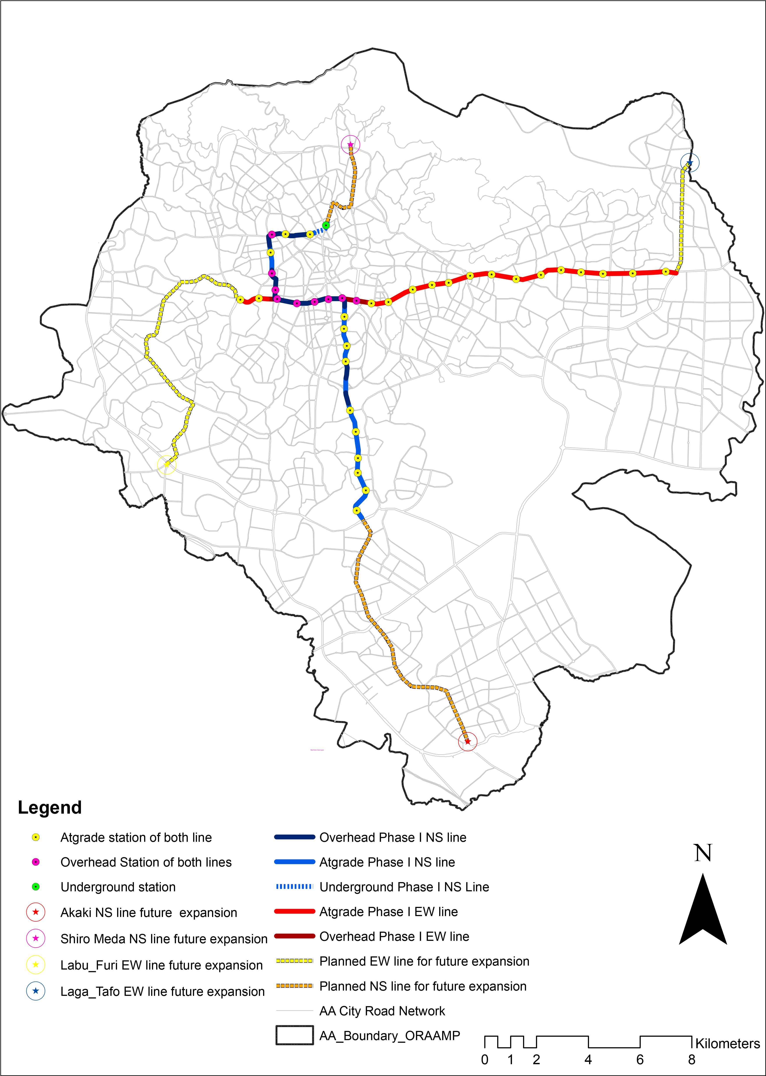
(Source: Re-organized and edited in April, 2019 by author based on data from AACPC)

Source: Re-organized and edited in April, 2019 by author based on data from AACPC
Figure 3. 1: Map of implemented phase one of AALRTS and the future expansions lines

  - Research Methodology
To appropriately address the research question of this study, first literature had been assessed in order to come up with a sound methodology. Based on these reviews research methods had developed for this study. These methods were discussed in detail in this chapter by making into subsections such as; survey process, formulation of the questionnaire, the sample size, methods of sampling and steps, description of variables, data collection processes, and techniques, analysis methods.
  - Research Design
The researcher had been used survey method that contains close-ended and open-ended questionnaires to get information from 14 purposely sampled stations of both East-West and North-South LRT lines. In this regard, the questionnaire distributed for passengers of AALRTS that waiting for train at selected station. The passengers or users rated the service quality and socioeconomic benefits of AALRTS based on the provided five point Likert scale while for open ended questionnaire the passengers listed any comments they have related to the service quality and the benefits of AALRTS. Thus, the method of data collection were based on survey of the passengers’ perceptions. After the collection of the necessary information, data processing had been performed with SPSS 20 and Excel software. The data were organized and analyzed using descriptive and inferential statistical methods and techniques i.e. mean, mode, skewness and Standard deviation for descriptive while factor reduction (principal component analysis) method for 18service quality parameters and ordered logit model analysis for the relationships analysis. The organized data presented in tables, graphs and descriptive and exploratory analysis.

Stated problems of statement on AALRTS
Research Question

Reviews of Literature related to:
Variables selection
Methods of samplings
Methods of data collection
Methods of data analysis

Readjusting and formulating
Research Methodology for this study

Formulating survey questionnaire related to AALRTS satisfaction, Benefits, most often used mode, use time of LRT, travel distance, and time along with socioeconomic characters of the riders

Pretesting the survey questionnaire
Collecting the data/conducting survey

Analyzing the data, by using
Descriptive, factor analysis and ordered logit model

Finding and conclusion
Recommendation for the improvement of services and benefits
Determining Sample design and size at both AALRTs lines and selected stations

(Organized by the author, (2019))

Figure 3. 1: Research process diagram
  - Research Methods
The survey method was adopted for this study in order to catch the perception of passengers on the service quality of AALRTS. The survey was better for the perception data collection on the satisfaction level of service quality since it follows principles of customer satisfaction survey (CSS) (Lai & Chen, 2011). In addition, the survey is a systematic method for gathering information from a sample of the larger population and to describe the basic characteristics or experiences of large populations (Groves, et al., 20011). Hence, this study also based on the perception of the larger population (i.e. passengers of AALRTS) the survey research design is appropriate.
Accordingly, this study was based on the 17 survey questionnaire. The questionnaire has 46 variables which included the socioeconomic character of the passengers, their use time and level of LRT, mostly used mode for different trips, their satisfaction level, the benefit of LRT to them and one open-ended question. The questionnaires were self-administered close-ended questionnaire type while open-ended questionnaire was included into the survey in order to let the passengers to list any unlisted their concern on the service and benefits of LRTS. Also, it believed that, the open-ended question helps to compare the answer of close-ended question. To measure the perception of passengers for the service quality attribute related to satisfaction, five scales Likert scale measurement from very satisfied to very dissatisfy used while for measurement of benefit also five Likert scales of strongly agree to strongly disagree were used. Because since the data collected was based on personal perception which may varied accordingly based on the attitude toward the service and the benefits it is better to use Likert scale to grasp the perception level or satisfaction level of passengers.

  - Justification for the Method
In general, the survey method was adopted for this study for two reasons as also explained below. The first was since this study was based on customers/passengers/perception, it follows customers satisfaction survey (CSS) of market principles and can perfectly grasp the intended data from passengers. Also, it will help for healthy functioning of AALTS, which can be input for the future LRT line expansion because since the passengers can judge the service more accurate than the operators. The second was because of the larger passengers’ or users, surveying was the best method to grasp the perception or attitude of these larger populations through samplings (Groves, et al., 2011).
Also, many literatures indicated that, context of public transport, satisfaction is a customer’s overall experience with a service compared to his or her pre-defined expectations. These expectations and satisfaction levels are different among the passengers (Morfoulaki, et al., 2010). However, according to, de Oña and de Oña (2014) the service quality (SQ) of public transport (PT) could be evaluated in two ways; the first method is from the view of operators based on efficiency and effectiveness of that PT, while the second method is based on passengers' perception which is known as methods of customer satisfaction surveys (CSS). CSS can be used for one specific component of the overall transport service, a combination of components, or the overall service to measure the service quality (SQ) (Lai & Chen, 2011; Van Lierop & El-Geneidy, 2016).
In addition, different literatures justified that, CSS method is better than the evaluation of operators to public transportation. For instance, Parasuraman and Berry (1990) and Eboli and Mazzulla (2011) argued that evaluation of a transport system’s service quality from the passengers’ point of view (surveying passengers’ perception) is a key component method for healthy functioning of the system. Because passengers are the users of the system, hence they can judge it well.
  - Data Sources
Both primary and secondary data were collected for this study. Secondary data that was for sample determination. The number of passengers at each station for both the North-South line and East-West line of AALRTS, the total passengers per day was collected. While the other was the review of the literature on methods of data collection, analysis and a general understanding of the socioeconomic character and the perception relationship toward PT, the benefit of PT and LRT, factors affecting perception and satisfaction of riders toward of service quality of public transport(PT).
The primary data source was the heart of this study and the collection was based on the survey of the users of AALRTS. It focused on attributes of the socioeconomic characters of the passengers, mostly used mode and trips, use time and use level of AALRTS, service quality and benefits indicators of AALRTS.
  - The study’s Variables
Different studies had developed and also wide literature had been experienced variables to evaluate the service quality of public transport based on the perception of passengers. Some of these variables were related to socioeconomic characters of passengers while some of them were related to the service quality attribute of public transport. For instance, Katrin Dziekan (2008) discussed that to understand the perception of a passenger toward service quality of PT, it's better to study them by segregating in into their frequency of use like as; frequent users, occasional users, and non-users and in their socioeconomic character.
In the same way, based on this for this, study both variables of use frequency and socio-economic characters are adopted with some adjustment in context to the AALRTS. In order to determine the use frequency of AALRTS's passengers, use level variable which, measured by using the Likert scale was used. Also, the use time per week, use time per day (to identify the users of the peak hours or off-peak hours) and mostly used mode along with trip purpose were used in the survey questionnaire for this study. While for the socioeconomic character of AALRTS passengers’, variable such as; gender, age, family size, marital status, occupation, and places work, family sized, levels of educations and income variables were included in the survey questionnaire.
On the other hand, the variable used for service quality attribute and benefit of AALRTS for this study were also depend on the numbers of studies like as, Tyrinopoulos and Aifadopoulou (2008) conducted a study titled as “A complete methodology for the quality control of passenger services in public transport business” and summarized the different methodologies developed by the Hellenic Institute of Transport (HIT) in Greece. Accordingly, this methodology contains 39 service quality indicators of public transport with seven major categories. These seven classifications are; ‘(safety, comfort and cleanliness’), ‘(information and communication)’, ‘(accessibility)’, ‘(terminals and stop points performance)’, ‘(lines performance)’, ‘(the fare and ticketing system)’, and ‘(compound indicators which based on others above indicators)’. Also, all of the seven PT quality indicators have their own sub-quality indicators or variable which becomes 39 when added up.
While to measure the benefit of public transport (PT), Eboli and Mazzulla (2008) used variables such as; less accidents, reduced air pollution and noise, and saving travel time. While Kamaruddin, et al. (2017) used benefit attributes such as; reduce pollution, save energy consumption (fuel), reduce congestion and reduce accidents to measure the perception of passengers toward environmental benefits.
This study used both variables of service quality attributes and benefits of PT which adopted from these above literature with some modification in a way fit able for AALRTS.
Accordingly, 18 variables related to service quality attributes of AALRTS are selected. These are; station seat and shelter, station cleanliness, station crowdedness, stations' elevators, stations' stair, stations' sense of safety, train inside cleanliness, train seat comfort, waiting time, passengers behavior, ticket checkers behavior, crowdedness in the train, travel sense of safety, speed ,price, ticketing, boarding and alighting and travel information. In the same way for benefits of AALRTS eight (8) variables related to benefits were selected, these are; the LRT reduced commuting distance, the LRT reduced out of pocket transportation cost, the LRT gave access to new jobs, the LRT made to breath clean air, the LRT helped to cut through the busy traffic, the LRT made connected to more to friends and/or relatives, the LRT make shopping experience easy and the LRT increased visual attractiveness of the city.
  - Types of Variables and Measuring Techniques
All types of variables used for this study along with their analysis and measurement techniques are presented in the Table 3.1.

Table 3. 1: Description of the study Variables
Variables | Categories of variables in this study | Analysis and descriptions of the variables | Variables relationships analysis methods
Gender, age, family size, marital status, occupation, and places work, family size, levels of educations and income | Independent | descriptive statistics and graphs were used | Relationships analysis by using a graph and ordered logit model
Use level, use time per week, use time per day to/from home, travel time and distance | Independent | descriptive statistics were used with graphs
Mostly used mode for different trips | Independent | descriptive statistics were used and graphs
station seat and shelter, station cleanliness, station crowdedness, stations’ elevators, stations’ stair, stations’ sense of safety, train inside cleanliness, train seat comfort, waiting time, ticket checkers’ behavior, passengers behavior, crowdedness in the train, travel sense of safety, speed, price, ticketing, boarding and alighting and travel information | Dependent | Variables with ranked data by Likert scale of five points which is from very satisfied to very dissatisfied were used and descriptive statistics, also to reduce them factor analysis was used.
the LRT reduced commuting distance, pocket transport cost, gave access to new jobs, able to breath clean air, helped to cut busy traffic, connected more to friends/ relatives, make shopping easy and increased the visual attractiveness of the city. | Dependent | Ranked data by using Likert scales of five points which is from strongly agree to strongly disagree and descriptive statistics were used to describe their results
(Source: Organized by the author, 2019)
  - Populations of the study
The population of this study was riders or passengers of AALRTS. To select the sample from total passengers, the passengers’ data per month and days were collected from AALRTS office. Based on these data total samples of passengers decided for both lines, then it distributed for each selected station for the survey or data collection. The distribution of the samples to each selected station was based on the average passengers per day at each selected station for both lines of AALRTS as also explained in the next section.
  - Samples Size and Techniques
In the process of the sample size selection, simple random and purposively selection (for the station) had used. Accordingly, the first Step was, calculating the sample size of the total population of LRT users and also proportion it for both lines to calculate the sample size at each selected station. The Cochran formula was used to determine the minimum sample size. Accordingly, the minimum sample sized for a larger population greater than 100,000 at 95% confidence interval, with 0.5 (50%) degree of variability and ±5% precision is 384.
Based on data of four months ( i.e. from September 2018 –December 2018) from operation control and center division, and passengers and ticketing division of AALRTS office, the average passengers per day calculated is 105, 760.
Depending on this figure the author decided to conduct a survey of 700-1400 passengers (Table 3.2) even though 384 sample size is possible by using Cochran formula calculation. Simple random samples were used to survey passengers’ perception that was waiting for the train at the selected station. The sample size for each selected station was based on the percentage share of the riders’ number per day at that station.
The second step was to identify where the survey of the passenger takes place by using a covenant selection of stations of both lines from the total 39 available stations. Accordingly, from both lines, 14 stations or 7 stations from the East-West line and seven (7) stations from the North-South line were planned to conduct a survey there. Hence, the systematical selection was used to select these 14 stations by including the end stations, all land use types, communal stations, high traffic and interchange character were used as criteria of selection on both lines (figure 3.2).
The third step was working on the proportion of sample size and passenger number at each selected station. Since there is a variation of passengers at each station; as the data collected from Operation and Control Center division, and passengers and ticking division of AALRT office shown, the researcher shared the sample size of total passengers according to the percentage share of passengers’ numbers at each selected station.
    - Total Passengers and the Sample Size of Both LRT Lines
To identify the total population (riders) numbers that were used LRTS, and also to decide the sample size based on it, the researcher had collected data from Operation and Control Center (OCC) division and ticketing and passenger division of AALRTS offices (Table 3.2). Accordingly, for both LRT lines the data of the passengers per each month (from September 2018 to December 2018), and for stations per day and months had used (Table 3.2, 3.3 & 3.4).
To come up with a sound representative population (passengers) average per day, total passengers at each line taken on average from September 1, 2018, to December 30, 2018, and computed. Accordingly, the overall average was become 105.760 for both lines, while 43,496 for the N-S line and 62,264 for the E-W line (Table 3.2). Therefore, the sample survey was based on these figures and decided to survey between 700- 1400 samples of passengers for more convenience and sound conclusions of the study.

Table 3. 2: Average total passengers per day on both lines, and total sample size per each line
Passengers numbers/  Month or day | N-S line average passengers /day | E-W line average passengers /day | Average total passengers /day for both lines
2018/12(December) | 49029.5 | 66739.5 | 115769
2018/11(November) | 46911.93 | 63023.33 | 109935.3
2018/10(October) | 42728.67 | 67969.5 | 110698.2
2018/9(September) | 35314.6 | 51326.57 | 86641.17
Overall Average passengers per LRT Lines per day | 43,496 | 62,264 | 105,760
Sample size per LRT Line | 387-868 | 308-533 | 700-1400
(Source: AALRT office, 2019)
The number of passengers on East-West lines was greater than the passengers of North-south lines of LRT system. However, since crossing station had more percentages of riders it shifted the percentage of a sample size to NS because most a number of communal station selected included under NS selected stations (Table 3.3). Hence, accordingly, in order to make homogenous, the researcher proportionally distributed the total 700-1400 samples size of passengers into 387-868 sample size for the North-South line and 308-533 for east-west line based on their total average percentages of passenger numbers per day (Table 3.3 & 3.4).
    - Selection of the LRT Stations
Addis Ababa's light rail transit has a total of 39 stations with 5 common stations overlapping on both Lines. The overlapping stations are Lideta, Tegbared, Mexico, Legar, and Stadium station. These stations are found in the city center and characterized by larger numbers of passengers when compared to other stations (Table 3.3 & 3.4). Both lines have nearly the same distance and equal numbers of stations i.e. the E-W corridor covers 17.5km distance and has 22 stations, including the 5 communal stations. The line connects residential areas of the eastern city of Addis Ababa to the center, while the N-S corridor covers 16.9 km distance and has 22 stations also including the 5 communal stations. This line connects the residential and industrial area on the south to the commercial center of the city's center (China Railway Group Limited, 2009; Aklilu, & Necha, 2018).
Hence, from the 39 stations of the Addis Ababa light rail transit, 14 stations were selected for the purpose of this study, which was 36 % of the total station. The selection was based on the end stations, all land use types, communal station, areas which characterized by high traffic on both lines (Figure 3.2). The selection process followed systematic techniques of selection from both lines i.e., 7 stations from east-west and also 7 stations from north-south lines of LRT system (Figure 3.2). To select these station systematic interval of... 2, 3, 2, 3, 2.…were used by including the end stations of both lines, communal stations, in ways making the samples size 7 on each line and represent all characters of land uses along the corridors.

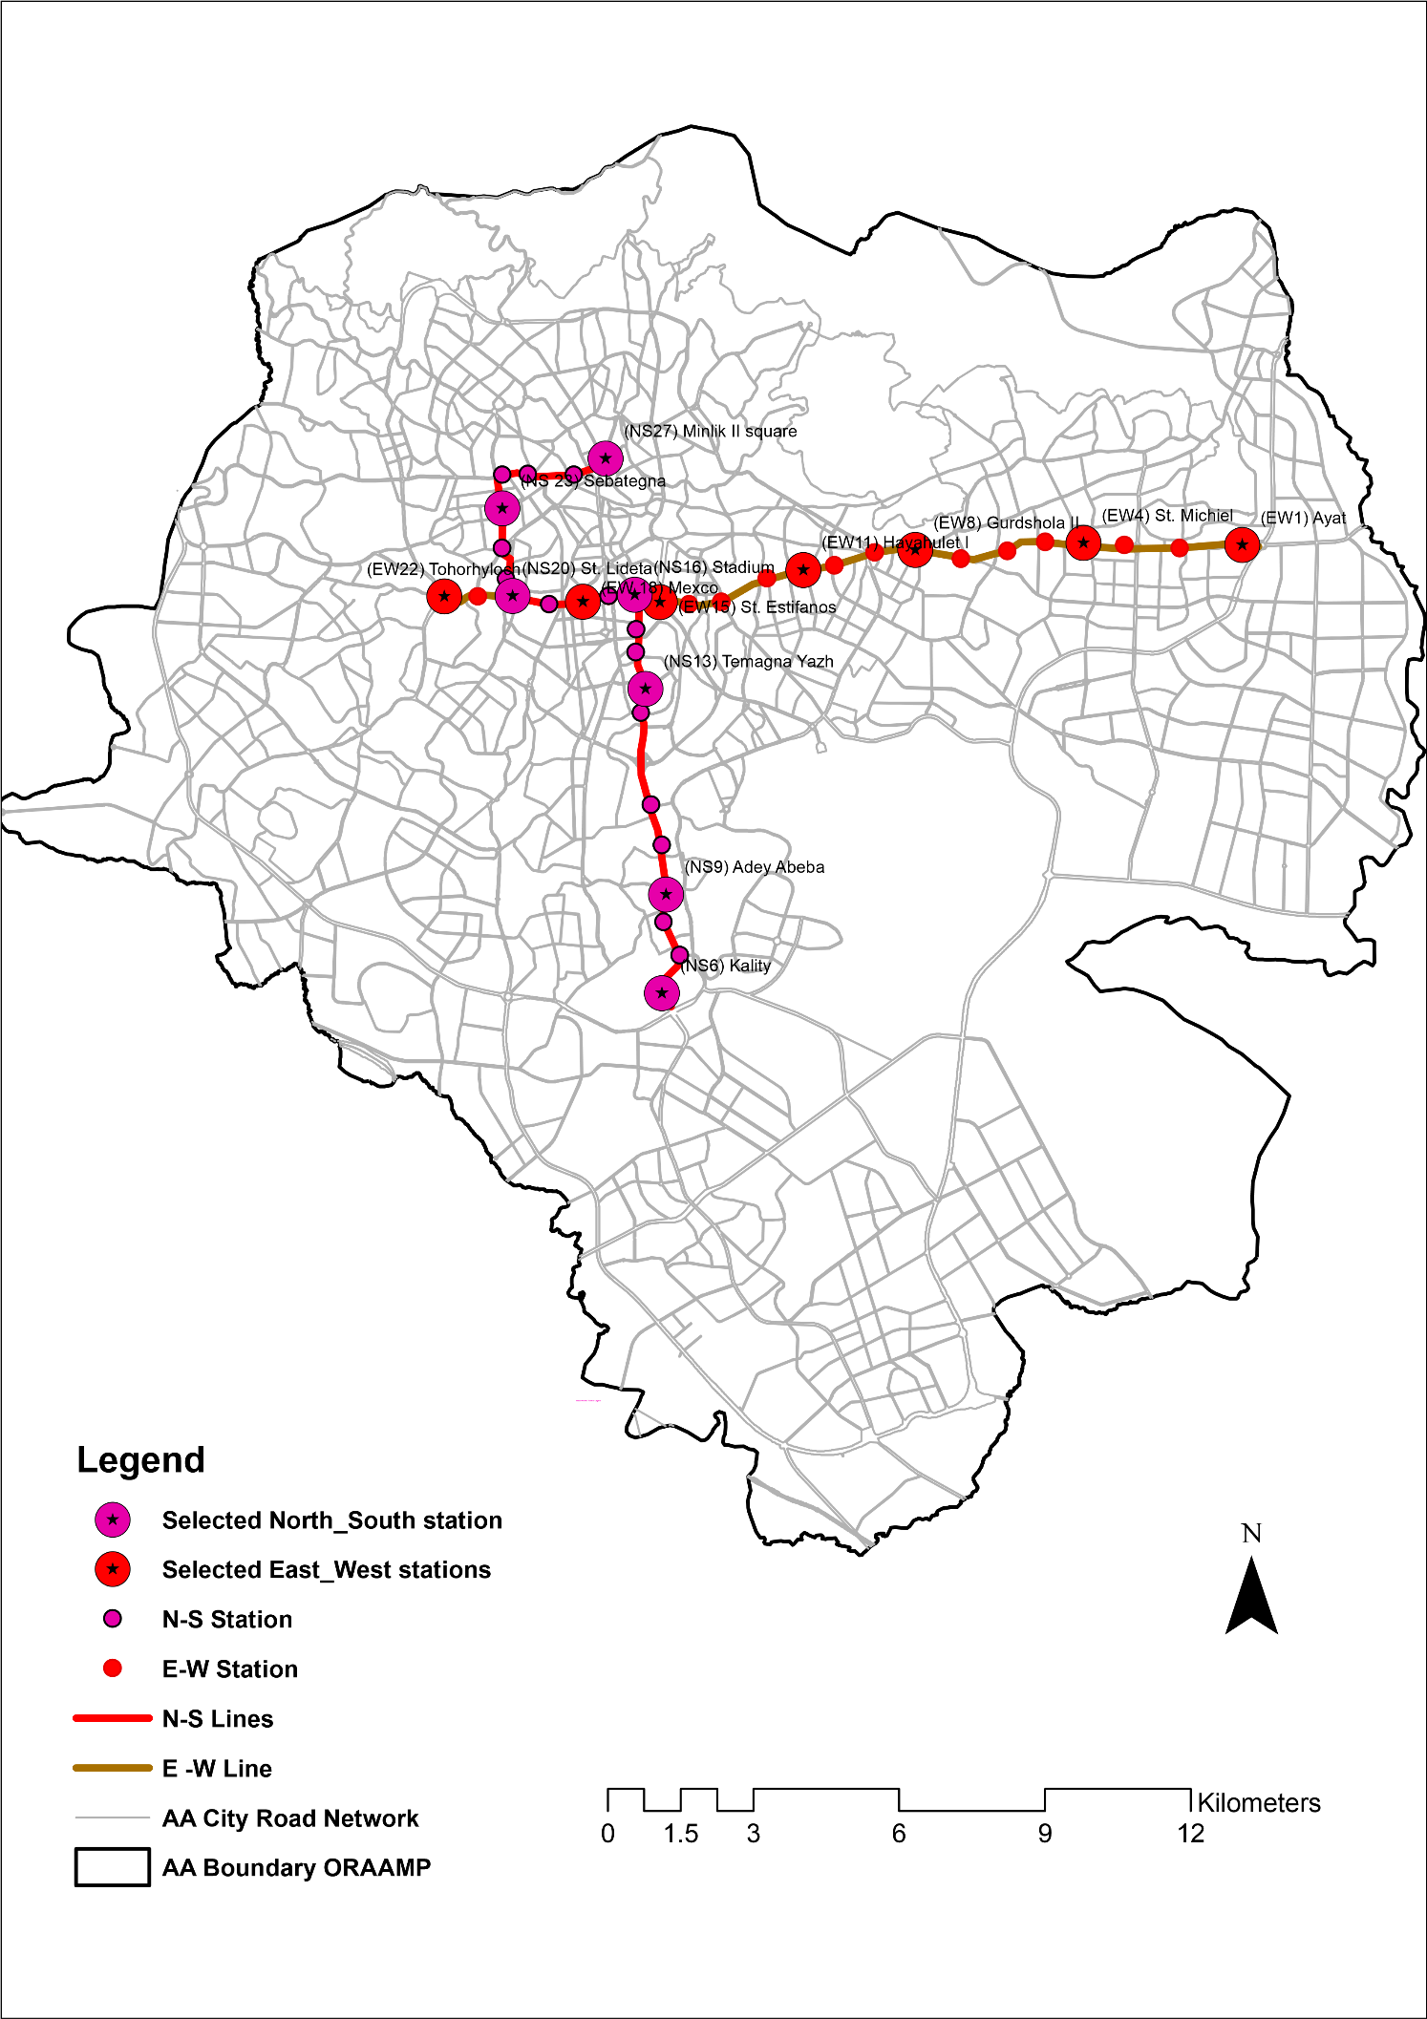
North-South stations
East-West stations
North-South Line of LRT
East-West Line of LRT
AA city roads networks
AA city boundary ORAAMP
Selected North-South stations
Selected East-South stations

(Source: Based on data from AACPC)
Figure 3. 2: Map of selected Addis LRTS Stations
    - Making the Proportion of Sampling Size to Selected Stations’ Passengers’ Percentage
Like as the number of the users on both lines differ there was also a difference in each selected station. For instance, on the North-South line, the smallest was 113 passengers per day at the station NS9 (Adeyabebe station) while the biggest was at the overlapping stations NS16 and NS 20. In the same way, the east-west had also the same variations. Hence, to make homogenous and to reduce inconvenient representations, the sample size made proportion based on their share of passenger number per day (Table 3.3 & 3.4).
Table 3. 3: Average total passengers per day at N_S line’s stations and proportion sample size at stations
Selected NS stations | Average passengers per station per day | Planned sample size at each selected stations | The actual surveyed sample size on the NS line
NS-6 | 154 | 40- 112 | 63
NS-9 | 113 | 28-82 | 46
NS-13 | 137 | 34-100 | 56
NS-16 | 2091(crossing station ) | 100-200 | 158
NS-20 | 1599(crossing station ) | 90-160 | 130
NS-23 | 253 | 63-185 | 85
NS-27 | 128 | 32-94 | 52
Total | 4475 | 387-868 | 575

Selected EW  stations | Average passengers per station per day | Planned sample size at each selected station | Actual surveyed sample size  On EW line
EW-1 | 107 | 40- 77 | 72
EW-4 | 43 | 28-31 | 27
EW-8 | 20 | 10-15 | 15
EW-11 | 66 | 30-50 | 40
EW-15 | 19 | 10-20 | 20
EW-18 | 2246(communal station ) | 100-200 | 150
EW-22 | 321 | 90-140 | 122
Total | 2822 | 308-533 | 446
Table 3. 4: Average total passengers per day at E-W line's stations and proportion sample size at each station
(Source: AALRTS office, 2019)
At selected stations simple random sample was used to collect data based on the proportion of gender and age group of passengers waiting for the train.
Accordingly, to maintain the quality of data and sound representation of samples, the gender available at that station counted or estimated by surveyors or data collectors. Then they distribute randomly the questionnaire survey based on the proportion of males and females passengers available. For instance, if there are 20 females and 10 males available at that station, then the surveyor distributes a questionnaire survey double of males for females and half of the female for males. In the same way, they distribute questionnaire paper for age groups available at that station based on the proportion of groups by categorizing into less than 30 years old, between 30 and 60 years old and above 60 years old with subjective judgment. Then the questionnaires had distributed randomly based on the proportion of these age groups.
  - Data Collection Methods
    - Secondary Data Collection
The data collection process was conducted from January 2019 to March 24, 2019. Before the collection of primary data, secondary data were collected. These secondary data were passengers' numbers from AALRTS office for the purpose of calculating the sample size.
    - Primary Data Collection
The collections of primary data were during the first three weeks of March 2019. Before starting the survey or collection of data, the survey questionnaire was prepared and tested as also explained in the research design part. As soon as the questionnaire readjusted based on the test, then became ready for data collection.
Based on the sample size determined at each station, the questionnaire multiplied and packed with the numbers of the sample size at each station. Then 26 data collectors were selected from EiABC students of masters and some undergraduate students. Out of the 26, 20 of them fully engaged in data collection by organizing them in pairs into 10 groups. After the date of starting the collection of data had fixed with data collectors, the author gave them a two-hour orientation on how to collect the data. In addition, they also practiced at the station before they start the collection. Then the collectors choose their station by using lottery drown station name and sent to 7 stations of 22 stations of East-West line (i.e.EW-1, EW-4, EW-8, EW-11, EW-15, EW-18 and to EW-22) of AALRTS in the first week of March 2019. And in the 3rd week of March 2019, they sent to north-south LRT line’s station (i.e. NS-6, NS-9, NS-13, NS-16, NS-20, NS-23 and to NS-27).
While the collection, these data collectors were performed two activities before they distribute the survey questionnaire for the passengers waiting for the train at each station selected. The first activity is to estimate the numbers of gender and then proportionally distributed the survey paper like e.g. if there are 10 male and 5 female passengers waiting for the train at that station, then they distribute 2 survey paper for males and one for females, it may be for all but in proportional. In the same way, the second activity is, they had been also proportionally distributed by considering different age categories found at that station to include and grasp the perception, attitude, and opinion of different age groups and normalize data from skewing to one gender or age groups. Accordingly, the age categories were defined into three groups, i.e. less 30 years, between 30 and 60 years and above 60 years. The data collectors subjectively judged these age groups of passengers and distributed proportionally according to the available numbers of passengers at that station along with gender numbers.
The other was the time of data collection at each station was deliberately varied based on pre-observation of AALRTS, passengers' data during the day from AALRTS office, and pilot survey. It shows that there is a difference in service during peak hours and off-peak. During peak hours the service of LRT is characterized by crowdedness both in the train and at the station and long waiting. However, during off-peak hours less such characters are experienced by LRT service. Hence, to catch up both time passengers, 50 % of the data was collected during peak hours while 50 % of the survey is collected at off-peak hours at each selected station.
  - Data Analysis Methods
Since this study to explore the relation between the quality of public transport service and customers’ satisfaction which is very interesting and useful for the transit operators and for policy recommendation based statistical power. In such a case of analysis Tyrinopoulos and Aifadopoulou (2008) recommended two statistical methods that could be used i.e. factor analysis and ordered logit modeling. However, for the purpose of this study, both descriptive and inferential methods of analysis were used as explained in the next section.
    - Descriptive Analysis
Descriptive analysis i.e. measurement of central tendency was used to describe the study’s variables in general and in specific to indicate the characters of data, and its level of relevance for the rest of the analysis. In addition, this method also used to attain objective number one and number three of the study’s or research question number one and threes by describing both 18 variables of service quality and eight variables of socioeconomic benefits of the AALRTS.
    - Factor Analysis
Factor analysis was adopted for this study in order to screen out the 18 variables of satisfaction/service quality of AALRTS studied. The 18 service parameters were run by using principal component analysis (PCA) with varimax rotation method and Kaiser Normalization at Eigenvalue greater than one. Then to use the most influencing or factor variables identified for analysis of relationships with socioeconomic characters of users. The results of this analysis was used to answers or helps to attain objective number one and three which enabled to conduct relationship analysis with service quality variables(depends) and the socioeconomic variables (the independents).
    - Ordered Logit Model Analysis
The ordered logit model was adapted to identify and examine the influencing factors affecting passengers’ perceptions on LRTS service conditions and benefits. Some multinomial choice variables are in ordered ways of rank hence the outcome is discrete. Since the multinomial logit or probit models not effective for the ordinal nature of the dependent variable, an ordered logit model is able to treat variables with a ranking order (Green, 2000). Modeling passengers’ perceptions on the service of AALTS was based on the ranked responses of a survey with 18 parameters for service quality and 8 parameters for the socioeconomic benefits of AALRTS. The rating was based on five Likert scales i.e. from very dissatisfied to very satisfied for service quality while from strongly disagree to strongly agreed for socioeconomic benefits. Accordingly, the threshold valued of Y was an ordering of items these rank by supposing ‘Y ‘as an item to represent these values. For example, let Yi be the outcome of a service quality and socioeconomic parameters test of the observation i for the 18 and 8 evaluation parameters, coded like respectively.
0: very dissatisfied for 18 service quality parameters or strongly disagree for the 8 socioeconomic benefits
1: Dissatisfied for 18 service quality parameters or disagree for the 8 socioeconomic benefits
2: Neutral for 18 service quality parameters or neutral for the 8 socioeconomic benefits
3: Satisfied for 18 service quality parameters or agree for the 8 socioeconomic benefits
4: Very satisfied for 18 service quality parameters or strongly agree for the 8 socioeconomic benefits
Yi=

In this case, Y is not a quantity but a ranking, nevertheless a larger value of Y means more, or better. In this case, there exist a known natural number m such that,
Yi ∈ {0, 1, 2... m} = 1
This type of data is usually modeled via a latent (unobserved) variable model:
Yi = α +βi Xi + ε
Where: Yi equals a latent (unobserved) measure of AALRTS service quality and socioeconomic benefits faced by the respondent.
X is a vector of explanatory variables describing the age, gender, marital status, level of education, occupation, travel distance and time, use level of LRT and time, and mostly used mode.
α +β represents a vector of parameters to be estimated.
ε denotes a random error term (assumed to follow a standard normal distribution for logistic distribution for logit model).
In this study, the logistic distribution is followed. The observed and coded discrete LRT service quality and socioeconomic benefits variables, i.e. Yi is determined from the model (or the likelihood threshold of the satisfaction or attitude to the benefits LRTS) as follows for both satisfaction and attitude to the benefits.
Where: μi represent thresholds to be estimated along with the parameter vector.
0 very dissatisfied or strongly disagree if Yi ≤ 0
1 Dissatisfied or disagree if 0≤ Yi ≥ μ1
2 Neutral if μ1 ≤ Yi ≥ μ2
3 Satisfied or agree if μ2 ≤ Yi ≥ μ3
4 Very satisfied or strongly agree if μ3 ≤ Yi
Yi=

  - Qualitative Data Analysis

The final portion of the survey provided open-ended questions for respondents to express their concerns, or comments which were not included in the survey related to service quality and socioeconomic benefits of AALRTS. Accordingly, the questionnaire were distributed randomly for all the samples proportion at each selected station along with close-ended questionnaires.
On the other hand, it was also believed that, it helps to triangulate passengers' response provided by close-ended question concerned to service quality of AALRTS and socio-economic benefits with their responses of open-ended question.
For the analysis of these data, the response was grouped and coded according to their concern into major themes with subthemes for each of the major theme. These themes identified were also analyzed along with the result of close –ended questionnaires based on the relationships of their concern to specific service variable and socioeconomic benefits variables of AALRTS.

CHAPTER FOUR: RESULT AND DISCUSSION
Out of the planned 700-1400 samples of passengers, 1021 passengers were surveyed face to face at the 14 selected stations. While data collection the researcher had made a strong effort to normalize data quality based on the proportion of gender and age groups available at the selected station. Because it is believed that it will normalize data from skewness to one gender and age group by maintaining the quality.
However, among the 1021 passengers sampled 931 of them attempted all the close-ended survey questionnaires properly, and 230 of them also attempted the open-ended question (i.e. qualitative data) of the survey. Hence, in the next section of the analysis, the number of the samples (N) will be varied between 931 and 1021 depending on the variables of concern and response.
  - Description of the Respondents
    - Socioeconomic Characters Data
To determine the passengers’ socioeconomic character, the variables of economic and demographic character such as; gender, age, marriage status, family size, occupations, level of education, income per house hold and their trips characters were included in the survey questionnaire and conducted the survey at each selected station.
Accordingly, the results show among the sampled 1021 of passengers 38.1% of them are females and while 61.9 % of them are males. Concerned to the ages of the respondents, it varies from lower group of 0.4% for the age group above 70 years followed by the below 15 years age groups which is 1.1% to 45.8% for the 21-30 age groups. It indicates about the half of the sampled passengers are young in the age groups of 21-30, followed by the age group 31-40 which is 21.3% (Figure 4.1).
Concerned to the marital character of the samples, out of 1021 passengers, 55.8% of them or more than half are singles, while 40% of them are married. Widowed is characterized for the age groups above 51, while divorced is significantly between 31-40 age group (Figure 4.2).
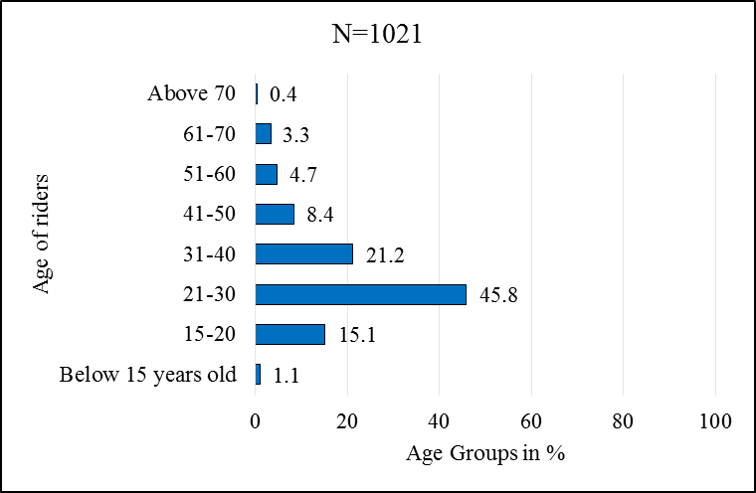

Figure 4. 1: Showing age group of passengers
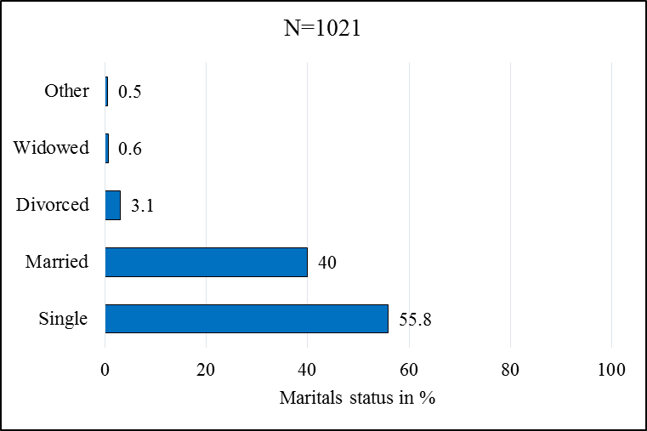

Figure 4. 2: Marital status of the sampled passengers
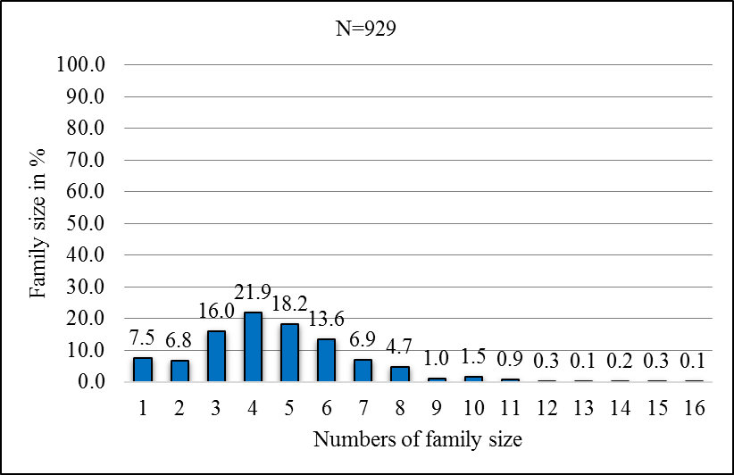
Related to family size of the passengers, it distributed from 1-15 with 4.8 average family size (Figure 4.3). Accordingly, the lowest family size is one sharing 7.5% of the samples while the largest size is 15 sharing 0.1 % of the total. However, most of sampled passengers have family size between 3-6 of which 4 is the most frequent that shared 21.9% and 3, 5 and 6 are shared 16%, 18.2% and 13.6% respectively (Figure 4.3). When the samples described by their occupation, it is found that most of them are confined in full time employment ,followed by students (19.5%) and part time employment(10%)(Figure 4.4).

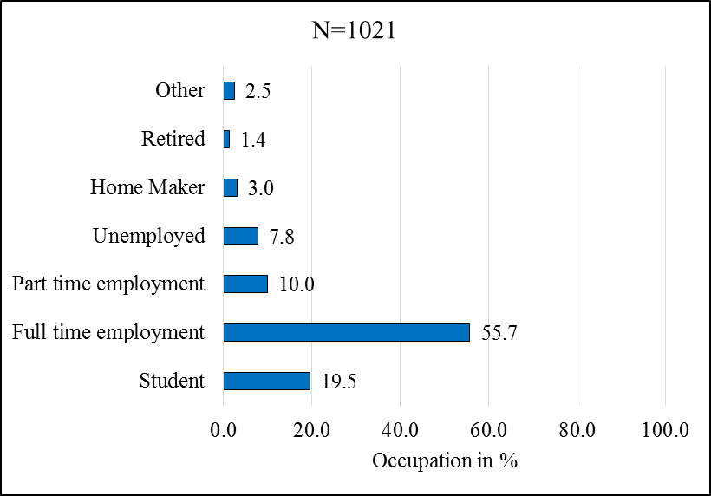
Figure 4. 3: Family size of the samples

Figure 5. 0-1: Shows Family size

Figure 5. 0-2: Shows Family size

Figure 5. 0-3: Shows Family size

Figure 5. 0-4: Shows Family size

Figure 5. 0-5: Shows Family size

Figure 5. 0-6: Shows Family size

Figure 5. 0-7: Shows Family size

Figure 5. 0-8: Shows Family size

Figure 5. 0-9: Shows Family size

Figure 5. 0-10: Shows Family size

Figure 5. 0-11: Shows Family size

Figure 5. 0-12: Shows Family size

Figure 5. 0-13: Shows Family size

Figure 5. 0-14: Shows Family size

Figure 5. 0-15: Shows Family size

Figure 5. 0-16: Shows Family size

Figure 5. 0-17: Shows Family size

Figure 5. 0-18: Shows Family size

Figure 5. 0-19: Shows Family size

Figure 5. 0-20: Shows Family size

Figure 5. 0-21: Shows Family size

Figure 5. 0-22: Shows Family size

Figure 5. 0-23: Shows Family size

Figure 5. 0-24: Shows Family size

Figure 5. 0-25: Shows Family size

Figure 5. 0-26: Shows Family size

Figure 5. 0-27: Shows Family size

Figure 5. 0-28: Shows Family size

Figure 5. 0-29: Shows Family size

Figure 5. 0-30: Shows Family size

Figure 5. 0-31: Shows Family size

Figure 5. 0-32: Shows Family size

Figure 4. 4: Occupation characters of the samples
Most of the samples attended first degree program (30.6%) followed by higher educational diploma (16.9%) and by who attended secondary and preparatory school by making 29.3% together (Figure 4.5). Furthermore, the samples are found that they are from household of different income that ranged from less than 500 ETB (or about 17.87 $ i.e. 1 USD is about 28 ETB) to more than 10000 ETB. However, more numbers of the passengers found to have income between 2000-4000, while the left income of the house hold of samples are more or less distributed in the same proportion percentage (Figure 4.6).
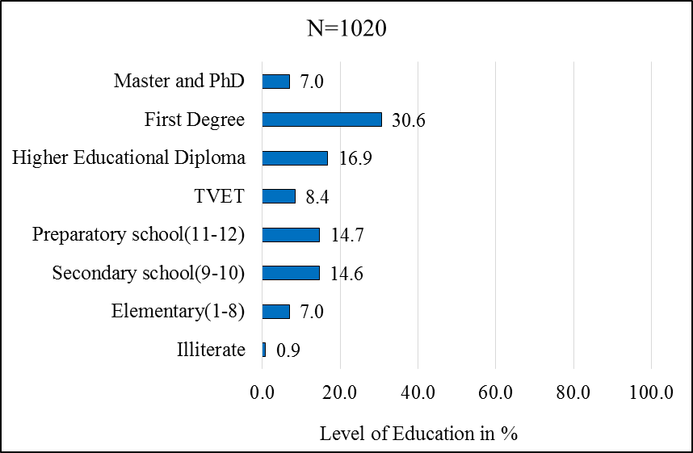

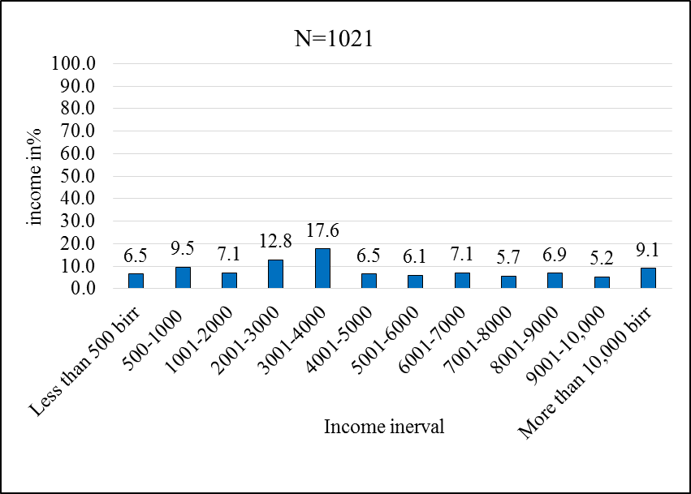
Figure 4. 5: Education level of the sampled passengers

Figure 4. 6: Income of the house hold of the sampled passengers
    - LRTS Use Level of the Sampled Passengers
In order to catch, how often the passengers use the LRT, a survey questionnaire that can indicate it was introduced with four point Likert scale (Figure 4.7). It found that, more than half of the respondents (58%) use very often and always while 41.6% of them use sometimes (Figure 4.7A). In line with this, which days in the week the passengers use LRT also asked and indicated that,58.7% of them use LRT during working days (week days), followed by 28.9% which use LRT both weekend and week days(see also Figure 4.7B).
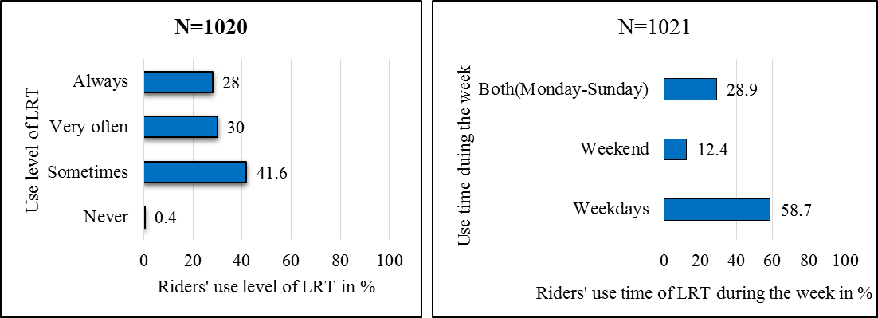

Figure 4. 7: Passengers’ use level of LRT (A) and Use time in the week (B)

On the other hand, in order to understand the perception on the service quality of LRT between those who travel longer distance and shorter distance variable of travel distance included into the survey. Likewise, to understand the perception difference between those who use LRT at peak hours and off peak hours use time as to home and from home included in the survey. It shown that, most of sampled passengers (80.7%) characterized by travel distance between 1-15 kilometers (see also Figure 4.8) and they use LRT service at peak hours. Most of passengers’ (55.9%) trips purpose from home is during morning peak hours (12:00-3:00 AM) and in the same manners trips to home (47%) is at afternoon peak hour (10:00-1:00 PM). It is the large trips when considered to others of the off-peak hour trips in the days (Figure 4.9).

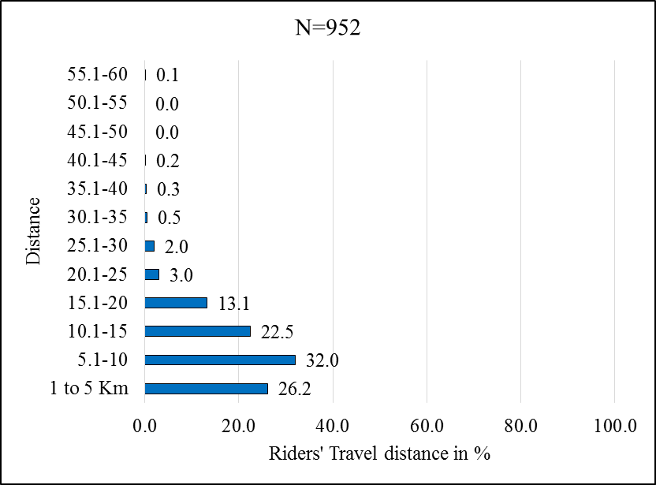

Figure 4. 8: Travel distance of the sampled passengers
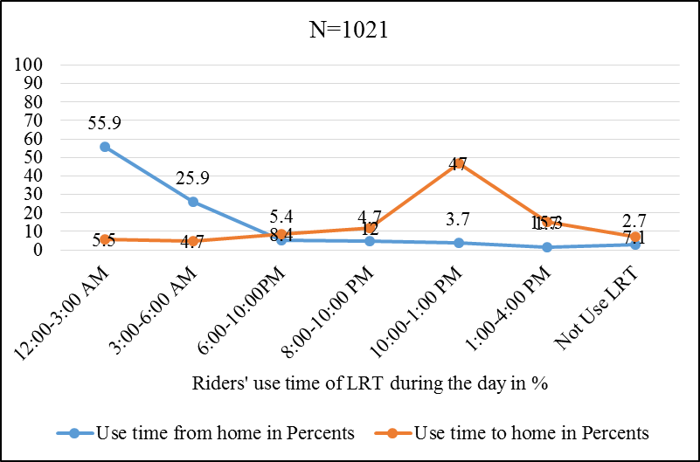

Figure 4. 9: Use time in the day to home and from home trips
    - Trips Purpose and Mode data
Trips purpose and possible mode available in Addis Ababa was included in the survey questionnaire in order to understand more trips purpose and mode mostly used by the passengers. Accordingly, the surveyed data shown that, more than half of the passengers that making their trips to work (58.8%) are using train followed by taxi (minibus) (31.1%). The train usage for all trips purpose constitute about 33% followed by trips to relative and school which make 20% and 18% respectively. However, taxi is the mode mostly used for all trips purpose except for work in this sample followed by train and bus respectively. Walking and private car are used for recreation purpose, when compared to other trips purpose, by making 43% of walking and 38% of private car for recreation(Figure 4.10).
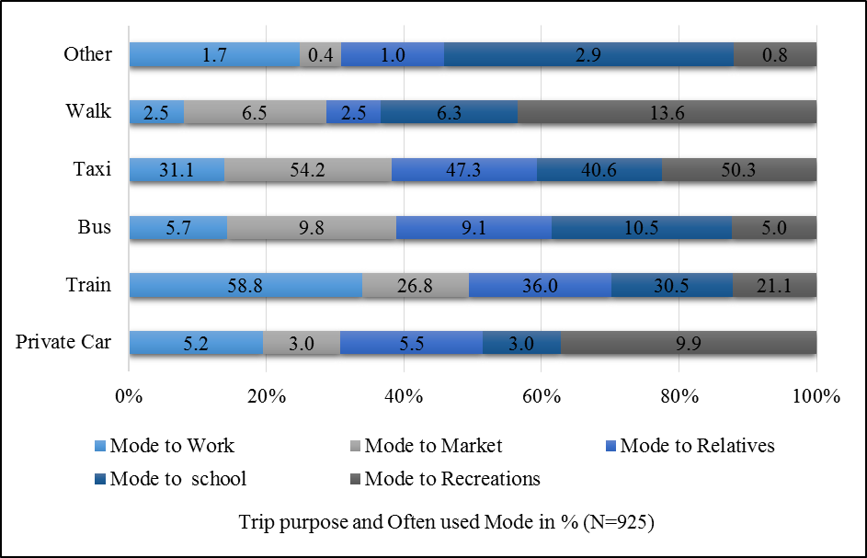

Figure 4. 10: Mostly used mode and trips purpose
    - Satisfaction Parameters Data
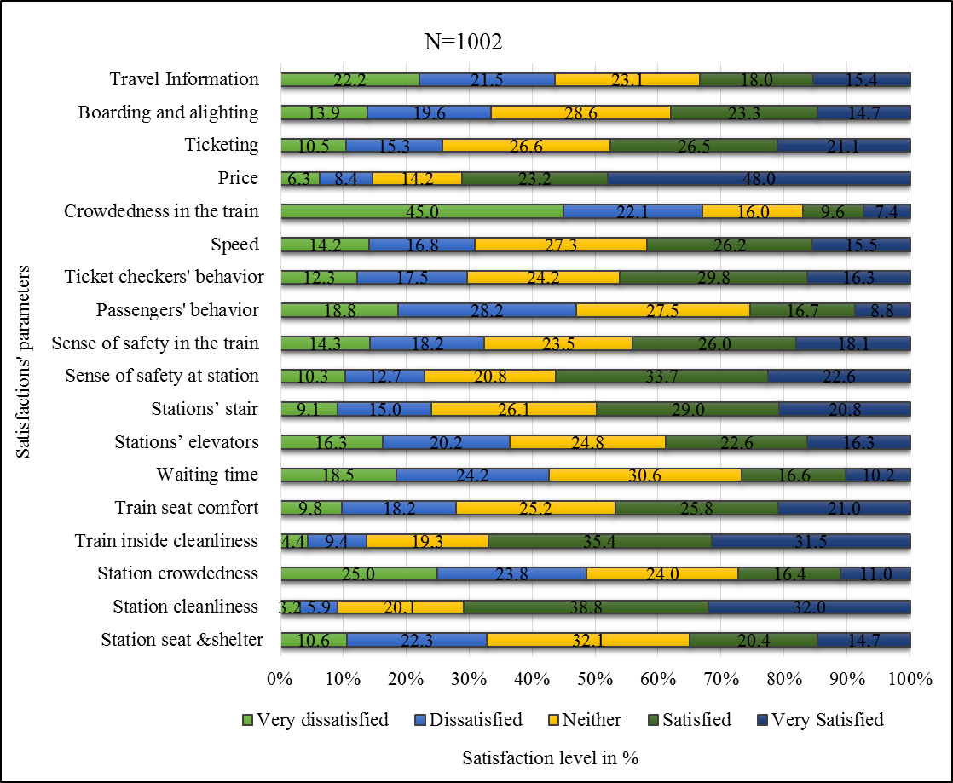
In order to measure the perception and attitude of passengers on service quality of AALRTS, 18 service quality parameters were included in the survey questionnaire using five point Likert scale measurement. The survey result shown that most of the respondent were satisfied by service quality parameters such as price, station cleanness ,train inside cleanness and sense of safety at station by 71.1 %, 70.8%, 66.9% and 56.3% respectively. While the service quality parameters such as crowdedness in the train, crowdedness at the station, passengers behaviors, travel information and waiting time are considerably the most dissatisfying attribute that rated as 67.1%, 48.8%, 47%, 43.7% and 42.7% by sampled passengers respectively (see also Figure 4.11).

Figure 4. 11: Showing satisfactions parameters
    - The Socioeconomic Benefits of LRTS Data
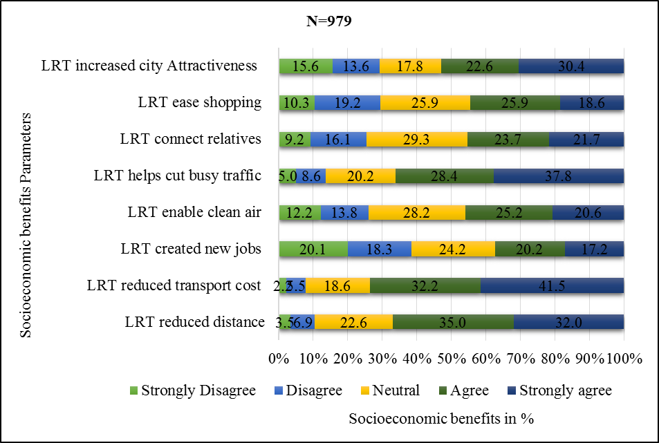
In the same way, as measured perceptions on service quality also the perceptions of passengers’ related to the socioeconomic benefit of AALRTS are also measured by using five point Likert scale measurement. To measure these perceptions eight benefit indicators variable or parameters were used (Figure 4.12). Accordingly, more than half of sampled agreed with listed benefits of LRT such as; LRT reduce transport cost (73.7%), LRT reduced distance (65%), LRT help to cut busy traffic (66.2%) and the LRT increased city attractiveness(53) while considerably less than half of the passengers are agreed (i.e. more than half not agreed) to the benefit such as the LRT created new jobs(37.4%), LRT enabled to breath clean air (45.8%), LRT connects more to relatives (45.4%) (Figure 4.12).

Figure 4. 12: Socioeconomic benefits of LRT
    - The Qualitative Data
The final portion of the survey provided open-ended questions for respondents to express unlisted concerns, or comments, in their own words. On the other hand, it is also believed to see the relationships of passengers' responses by close-ended questions concerned to service quality of AALRTS and socio-economic benefits with open-ended questions.
Accordingly, from 1021 surveys there were 230 responses to the open-ended question. Each response was coded and categorized into 9 major themes such as: crowdedness with 32 responses and has four subthemes, safety and security with 22 response and has four subthemes, frequency and power supply with 105 responses and has five categories (subthemes), city attractiveness and accessibility with 17 responses and has four subthemes, ticketing system with 18 responses and has four sub categories, information with four response but no has subcategories, comfort and service related with 11 responses and has two subcategories, future development and advice with 21 responses and has three subcategories. Each of these subthemes have its own entries responses share from its major theme. In addition, also there are some responses that are related to two majors themes and more than two themes while some of them also indicate the benefits of AALRTS. All of them were discussed in respective or related sections of analyses and specifics objectives in the following.
  - Perceptions of passengers toward Service Quality of AALRTS
    - Descriptive Analysis of the Perceptions
To measure the perception of Addis Ababa passengers toward the service quality level of AALRTS 18 (eighteen) service quality indicators (parameters) were used. Accordingly, to analysis and measure these perception descriptive analysis, factor analysis and ordered logit model where used as follows. To describe and analyses the characteristics of perceptions distribution, a measure of central tendency were focused as follows (Table 4.1). These result in the table are indicated based on Likert scales measurement from 0-4 values, whereas very dissatisfied (0), dissatisfied (1) neutral (2), satisfied (3) and very satisfied (4). The result of this table analysis based on these values for interpretation as follows.

Table 4. 1: Showing descriptive analysis result of the 18 satisfaction parameters
Descriptive Statistics
 | N | Mean | Mode | Median | Std. Deviation | Variance | Skewness  Statistic
Station seat and shelter | 1002 | 2.06** | 2 | 2 | 1.197 | 1.434 | .022
Station cleanliness | 1002 | 2.91*** | 3 | 3 | 1.018 | 1.036 | -.876
Station crowdedness | 1002 | 1.65* | 0 | 2 | 1.310 | 1.715 | .299
Train inside cleanliness | 1002 | 2.80*** | 3 | 3 | 1.114 | 1.241 | -.780
Train seat comfort | 1002 | 2.30** | 3 | 2 | 1.257 | 1.581 | -.242
Waiting time | 1002 | 1.76* | 2 | 2 | 1.223 | 1.496 | .196
Stations’ elevators | 1002 | 2.02** | 2 | 2 | 1.315 | 1.730 | -.044
Stations’ stair | 1002 | 2.37** | 3 | 2 | 1.223 | 1.495 | -.359
sense of safety at Station | 1002 | 2.46** | 3 | 3 | 1.253 | 1.571 | -.535
sense of safety in the train | 1002 | 2.15** | 3 | 2 | 1.309 | 1.713 | -.186
Passengers' behavior | 1002 | 1.68* | 1 | 2 | 1.205 | 1.453 | .281
Ticket checkers' behavior | 1002 | 2.20** | 3 | 2 | 1.255 | 1.575 | -.267
Speed | 1002 | 2.12** | 2 | 2 | 1.266 | 1.603 | -.189
Crowdedness in the train | 1002 | 1.12* | 0 | 1 | 1.282 | 1.644 | .886
Price | 1002 | 2.98*** | 4 | 3 | 1.235 | 1.524 | -1.038
Ticketing | 1002 | 2.32** | 2 | 2 | 1.255 | 1.576 | -.308
Boarding and alighting | 1002 | 2.05** | 2 | 2 | 1.252 | 1.569 | -.076
Travel Information | 1002 | 1.83* | 2 | 2 | 1.367 | 1.868 | .150
*average less satisfying, ** average neutral, *** average satisfying parameters

Accordingly, most of the variables have perception value around neutral rather than toward very dissatisfied or very satisfied (Table 4.1). However, there also perceptions distributed toward very satisfied and very dissatisfied below and above the average perceived value which is neutral.
Some service quality variables such as stations' crowdedness, waiting time, passenger's behaviors, crowdedness in the trains and travel information are service parameters that most passengers perceive dissatisfying. The crowdedness in the train, station crowdedness and passengers' behaviors are service parameters the most dissatisfying the riders where most of the passengers frequently rated as very dissatisfied with. For the crowdedness at the station and in the train, most of the passengers perceived and rated as dissatisfying as the deviation from average (mean) values shown with a close standard deviation around the main. While there are also some peoples perceived both crowdedness at stations and in the train rated as satisfying which skewed with 0.299 and 0.886 respectively toward the satisfying than dissatisfying (Table 4.1). Also ‘passengers' behavior' is third parameters that most of the passengers frequently rated as dissatisfying while some passengers perceived as satisfying which also skewed the average perception of riders toward above the average rated value.
Parameters such as; station seat and shelter, station elevations, sense of safety at stations and in the train, ticket checkers behaviors, speed, train seat comfort, and boarding alighting are perceived on average as neutral. However, when compared based on the frequencies of riders rated value, these parameters have different perceived value. For instance parameters such as station seat and shelter, station elevators, speed and boarding alighting are service parameters highly rated as neutral with some negative perception distributions for station elevators, speed and boarding and alighting while positive perception distribution toward very satisfying for station seat and shelter parameters.
Service attributes such as stations' cleanness, train inside cleanness and price are nearly satisfying relative to the other services. For the stations' cleanness and train inside cleanness, most of the passengers frequently rated as satisfying. Also, for ‘price' most of the passengers satisfied with it and rated as a very satisfying service attribute, but there are some dispersed negative perceptions toward very dissatisfaction.

    - Factor Analysis Result of the Perceptions toward service Quality of AALRTS
Factors analysis was used in order to reduce 18 service quality variables into smaller numbers of factors. Also, it helps to identify more influencing variables that affect the service quality and perceptions of passengers. On the other hand, to use the identified influencing variable/factor for further variable relationship analyses between the independent socio-economic variables and the influence factors (dependent) and as well as to use it for ordered logit model which helps to identify the perception threshold of the riders for implying recommendations.
Accordingly, all of the 18 service parameters used in the survey are run for factor analysis by using principal component analysis with varimax rotation method and Kaiser Normalization at Eigenvalue greater than one. The result showed that four important variables that influencing the overall perceptions of riders are identified and discussed as follows one by one based on table 4.2 result and qualitative response data also.
Factors (component) | Loaded variables | Factors Loading | Eigenvalue of factor | Percent of Variance
Safety and security | Sense of safety in the train | 0.786 | 5.781 | 32.119
Safety and security | Sense of safety at the station | 0.771 | 5.781 | 32.119
Safety and security | Passengers' behavior | 0.608 | 5.781 | 32.119
Safety and security | Stations’ stair | 0.555 | 5.781 | 32.119
Ticketing system and information | Ticketing | 0.745 | 1.491 | 8.283
Ticketing system and information | Boarding and alighting | 0.714 | 1.491 | 8.283
Ticketing system and information | Price | 0.663 | 1.491 | 8.283
Ticketing system and information | Travel information | 0.568 | 1.491 | 8.283
Crowdedness and frequency | Station crowdedness | 0.732 | 1.313 | 7.297
Crowdedness and frequency | Crowdedness in the train | 0.669 | 1.313 | 7.297
Crowdedness and frequency | Station seat and shelter | 0.586 | 1.313 | 7.297
Crowdedness and frequency | Waiting time | 0.551 | 1.313 | 7.297
Cleanness and Comfort | Train inside cleanliness | 0.753 | 1.145 | 6.359
Cleanness and Comfort | Station cleanliness | 0.730 | 1.145 | 6.359
Cleanness and Comfort | Train seat comfort | 0.606 | 1.145 | 6.359
 | Speed **
 | Ticket checkers' behavior **
 | Stations’ elevators **
Table 4. 2: Showing factors reduction result of the 18 service quality parameters
N=1002; ** are variable did not include in any of the identified factors

      - Factor Related to Safety and Security of Passengers’
Factor one composed from service parameters related to safety, passengers behaviors, and station stairs. All of the variables highly load on to this component are related to safety issues. Hence, factor one can be interpreted and named as the perception related to safety and security (Table 4.2). This factor one (safety and security) has four highly loaded variables than on other factors. These are the sense of safety in the train, which is very important and influencing variable with loading score of 0.786 followed by the sense of safety at stations with loading score 0.771, passengers behaviors with loading score of 0.603 and the final is stations' stairs with loading score of 0.555. This factor is more influencing factor identified relative to other factors with a bigger Eigenvalue of 5.781 and overall potential influencing of 32.12% of the passenger's perception toward service quality of AALRTS (see the following Table 4.2).
Also, result of qualitative responses of the passengers related to safety and security indicates the same implications. Accordingly, the safety and security related responses were the third theme by more numbers of responses with 22 entry responses out of 230 total responses. And has also four subthemes such as; fear of thieves and passengers behaviors, safety related to sun and rain, healthy problems and recommendations comments to safety problems. The first subthemes are passengers' fear of thieves in the train with 10 entry response. It indicates most of the riders' fears for their property to be stolen and for their general security because of varied passengers' behaviors. Accordingly, it is more difficult for female and elders than others as most of the responses indicated. For instance one of the respondents indicated that "crowdedness in the train will lead to theft, generally not comfortable and difficult for elders and peoples with healthy problems" while another indicated in general that, "crowdedness in the train will lead to theft because there are many thieves in the trains".
The second subthemes for safety are safety related to sun and rain with three entry responses, indicating problems related to station facility and design like " stations safety from sun, rain, and seats is not enough" as commented by most of the passengers in this entry shows. Whereas healthy risk subtheme has four entry responses. It shows that passengers have also feared concerned about some health risk disease that can be easily transmitted to them because of more crowdedness in the train. As one of the respondents indicated "safety in the train is too risky during peak hour, even to get breathing in the train is difficult, this creates a good condition for transmission of some disease during peak hour, hence limit numbers of passengers".
The fourth subtheme related safety and security, which is passengers' recommendation comments to safety problems with four entry response. The response indicates that riders have more become familiar with problems and also they had been thinking about the possible solution. However, the concern to safety and security is directly connected with crowdedness as also the commented solution here is more or less the same as that of crowdedness discussed below. For instance one of respondent stated that, "increasing speed is increasing safety during peak hour which minimize crowdedness", while another respondent which seems different from this indicated that "checking for security have to be strictly to improve the passengers safety and security” showing his/her fear toward thieve and passengers behaviors during travels.
      - Factors Related to Ticketing system and Information
The second factor also importantly influences the service quality with the second greater Eigenvalue and 8.3% variance of influence. It is composed from four highly loaded variable such as ticketing system which is importantly loaded with higher loading score than other variables followed by boarding and alighting, price and travel information (Table 4.2). The variables of this component factor are related to the ticketing system and information such as ticking office location, travel information which can be interpreted and named as a factor related to the ticketing system and information.
In the same way, the result of open-ended question indicated that ticketing systems and travel information was influencing the overall satisfaction toward the service quality of AALRTS. Accordingly, ticketing systems and travel information is the third major theme with 22 response entry that passengers’ comments concerned with. For this theme related to travel information which has four responses, the comments are related to station media, maximum waiting time and train arrival information are the majors. While some of them also commented, as even station workers have no information related to trains arrival time. For instance, comments among stated which indicating that "station workers have no information about the train" while other response touched all the problem like as "the system has not well-organized working system, not have standardized digitally supported information, these make us leave the station after waiting for a long time during peak hours to find for other modes".
Likewise to travel information, the ticketing system has 18 entry response and two subthemes such as ticketing accessibility and ticket sellers' behaviors. Ticketing and accessibility have also eight entry response, discussing distances of ticketing places from the station, accessibility of this place visually and safety of crossing area from traffic are among the listed comments. Example comments such as "to get the ticket we walk long distance", "ticketing places are too far away and its better if on the station and checking for tickets have to be strict", "ticketing systems including place, visually accessibility, checking system and safety of crossing have to be improved", and "generally ticketing systems is the worst service, the location and distance is not accessible" are some of comments listed.
When ticket sellers' behaviors and checking system is concerned, also has six entry response, the comments are related to ticket sellers and ticket checking system like as "ticket sellers do not give changes and they always make us to delay and also driver sometimes discriminate us". While for checking system passengers also showed that "prepare two peoples that work in the train to check the tickets, and bring the tickets to the station. Identify those passengers entering and leaving whether they hold tickets because some passengers are using the LRT without having the tickets".
      - Factor Related to Crowdedness and frequency
The third factor is related to the cause of demand to rise in the service of AALRTS. These are indicated by parameters such as; crowdedness at stations, crowdedness in the train, stations' seats and shelters from sun and rain and waiting time (frequency of the trains). These variables are related to the increase in numbers of passengers which made crowded both the station and in the train. Because the demand does not conform to the estimated and designed capacity of the trains as well as the capacity of the stations. Variable listed above are highly loaded on this component for instance, station crowdedness is highly loaded than the other parameters. Hence this factor interpreted and named as ‘crowdedness and frequency' which is the third important factor with 7.3% influencing others service quality of the ridership.
Similarly, result of open-ended questionnaire implies the same result that crowdedness and frequency are the most concern of passengers where 137 responses were revolved around. Accordingly, crowdedness is the second major theme with 32 entry responses. It has also four subgroups such as station crowdedness, the train leaving and entering problems, crowdedness impact, and recommendations to crowdedness problems. Station crowdedness is a subgroup with five entry of which two of them explaining the relations of station crowdedness with the safety issues. The response indicated that, station crowdedness makes passengers uncomfortable with the service of LRTS. It makes them feels unsafe and unsecured from sun and rain as compared to existing available station seat and shelter more crowded passengers at the stations. For instance, one response calls out a few of these issues as "there are congestions around the stations, it is totally not safe and difficult to access the train during train boarding and alighting as well to leave the train".
The second subgroup is the train's leaving and entering problems, also with five entry responses. It indicates that because of crowdedness sometime the passengers pass their leaving station while the other could not able to enter the train and forced to wait for another term. Especially the situation is difficult for females and elders. For instance one of the respondents explained that "during leaving and entering the train, passengers block the doors because there is no space for them. These situations are very difficult for elders and females, also there is high safety risk at peak hours. Please improve these problems". All most, all of the responses related to crowdedness issues are also attached to the safety and security of riders directly.
The third and fourth subthemes are crowdedness impact and recommendations to crowdedness problems with 13 entry and 9 respectively. For the crowdedness impact subthemes, the responses are more general to the overall crowdedness problems of ALRTS , like as "too many passengers have problems because it makes crowdedness", "decrease crowdedness", "crowdedness is the major's problems for us" are among the comments related to the crowdedness impact. Also, the passengers provided the recommended solution for the problems of the crowdedness to improve the service. Their recommendation is more related to the increasing number of trains, avoiding a single train, increasing frequency and defining the numbers of passengers for both single and double trains. For instance, these riders commented that "decrease peak hour crowdedness by increasing train vehicles, minimizing waiting time, define numbers of passengers per single and double train", "define the number of passengers per train to minimize crowdedness" are among the comments. Train frequency and power supply are the third theme with 110 entry responses with have five subgroups such as: waiting time, speeds, train numbers, trains' sudden stopping and power problems, and drivers' problems. Out of 110 entry responses to these majors theme, 26 of entry related to directly with crowdedness, 10 with more than three majors themes and 6 directly with safety and security.
When waiting time subtheme is concerned, it has 30 entry responses of which 7 responses are related waiting time problems because of crowdedness. For instance response like "if the time of the trains arrive is fixed, then crowdedness problems will be decreased. Also, I feared that crowdedness will lead us to sudden accidents". Whereas other responses also stated as "waiting time of peak hours have to be carefully worked on" indicating that waiting time of peak hours is too long than the off-peak hours. The other comments that related to waiting time are also indicated other themes issues in addition to waiting time. For instance, as "the train delays more during peak hours because of crowdedness sometimes it suddenly stopped and didn't open the doors protecting us to out. In addition, the train had become center of thieving, generally, it is not serving us as I expected". This indicates that he/she concerned with crowdedness, safety, frequency, power supply problems and overall service of AALRTS.
The second and third subthemes are speeds and train numbers with 16 and 48 entry responses respectively. Related to speeds 16 passengers noted by focusing on increasing of train's speed to overcome crowdedness, increase safety and security of ridership. Some of the comments are related to speed and crowdedness like "increase arriving frequencies by increasing speed and limit number of passengers per train". While other comments connect both speed and waiting time like as "think about improvement of speed and waiting time".
In the same way, to speeds, 48 riders response related increasing numbers of trains i.e. for them an increasing number of trains will solve the ridership service of AALRTS. Their comments are mostly related to crowdedness, safety and security, decreasing waiting and increasing frequency of trains. For instance responses like "increase the numbers of trains in general, during peak hour and encourage double train vehicles", "increase numbers of train-vehicles at peak hour, decrease waiting time to overcome crowdedness" are related to trains' numbers and crowdedness. Also, it shows that still crowdedness and safety issues are the most affecting the passengers' satisfaction toward the LRT service. Whereas riders' responses like "increase safety by increasing number of trains, speed and extending the lines of LRT" and "increase the numbers of trains and make strict following for safety of the passengers" are an example of responses that related to safety and number of the trains.
The last subthemes are the trains' sudden stopping (power problems) and drivers' problems with 11 and three entry responses respectively. The passengers have also experienced problems related to sudden stopping or power problems which makes them unsafe and delaying from work. For instance among 11 response one response state that "sudden stopping is affecting our working time along with ticketing system also" indicating that the ticketing system is also taking their time as sudden stopping because of power. Whereas other responses explain that "if the power is off, then the train's doors and other everything also stopped. It also sometimes suddenly stopped at the center of the line, why not a solution?" When drivers' problems theme is concerned, it is also perceived as affecting riders' satisfaction as indicated by riders' comments. For instance "some drivers are good while are not and the speed is also according to their behavior. Some of them pass the station hence, it is better if there is a time table or station media for arriving of the train" showing that some passengers perceived as drivers' problems.
      - Factor Related to Cleanness and Comfort
The fourth factor is related to the cleanness and comfort service of AALRTS, with a loading score of variables between 0.75 -0.60. These variables are station cleanness, train inside cleanness and train seat comfort. The variations influence of this factor is also close to the second and third factor with 6.36% variance to other service quality of the LRT.
In the same way, to other factors the some response of passengers by open-ended ware revolving around comfort and service related. Accordingly, comfort and service related has 11 response entries and two sub-categories such as a prohibited item in the train i.e. eating and drinking waters and other services inside the train such as air conditioner (AC), music, fire extinguisher, train inside seats. Concerned with eating and drinking water in the train one respondent said that "it is better if eating and drinking water is allowed because there might be sick peoples in the train that need water". While for the other services with eight entry responses, numbers of responses listed as "absence of music during travel even worsen the crowdedness problems", by indicating crowdedness problems and mean of forgetting it i.e. using music. Whereas other response added that "there is no fire extinguisher in train and it is not accessible hence, it is difficult for us if there might be an accident". And another added that "imagine how it is difficult crowdedness with the absence of air conditioner (AC)”.
  - Relationships of passengers’ Perceptions with their Socioeconomic Characters toward the service quality of AALRTS
Based on the result of factor analysis by reducing 18 service quality variables into four important variables, the relationships of the passengers' perception of the service quality and socioeconomic characters are analyzed. The first three parameters identified by factors analysis, i.e. ‘safety and security', 'ticketing system-information' and crowdedness- frequency' are used for this analysis as dependent variables of satisfaction. While for independents variables; demographic, economic and travel mode, distance and time are used as independents variables in order to analyze the relationships. Travel time and distance were included in the survey because the researcher believed that the perception and satisfaction of the passengers who travel a short distance and long distance are different. In the same way for the time, the travel time of AALRTS during working days and also morning and afternoon peak hours are different. Because these times are characterized by crowdedness and long waiting which also believed that the perceptions of passengers who use the system during this time are different from the others time. Hence, based on these the satisfaction level relationships analysis conducted between the three factors identified which are dependent with socioeconomic and travel characteristic variables which are independent by using graphs for each of the first three factors as follows.
    - Safety and Security
The safety and security account for 32.12% of a variance on the other service satisfaction (Table 4.2). To conduct the analysis of this relationship with safety and security, the average rated Likert scale score of the four parameters i.e. the sense of safety at stations and in the trains, passengers' behaviors and stations' stair are highly loaded on this factor are taken and processed for the analysis of this relationship.
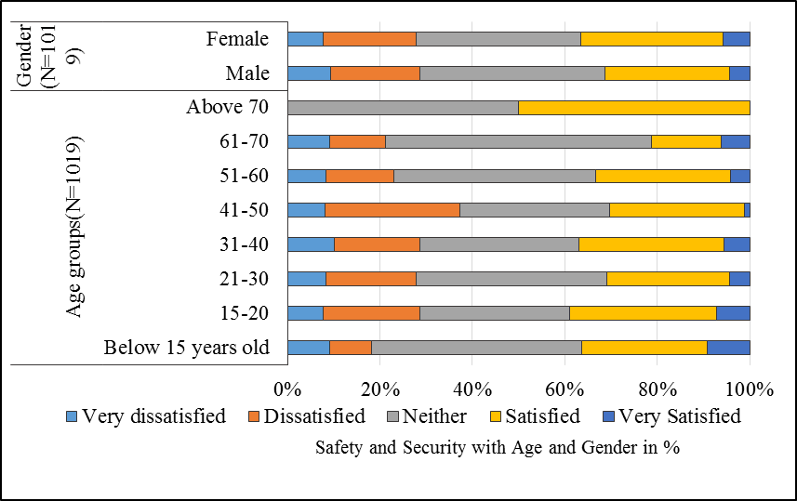
Accordingly, the safety-security for gender and age groups which sense of safety related to stations and train inside or on travel, passengers' behaviors and stations' stairs, shows a variation among the different age groups and the gender (Figure 4.13 B). On average more than 30% of riders in each age group from 15-20 to 41-50 are dissatisfied with the sense of safety and security while about 30% of riders within each of these age groups are satisfied and very satisfied. For the age group above 50 years old, more than 22% of them are dissatisfied and equally more than 22% of each age group above 50% are satisfied with the sense of safety and security. However, perception related sense of safety and security seems to decrease with increases of age from below 15 years old to 41-50 years old. For the above 50 age group, neutral perception increases unlike dissatisfaction or satisfaction on safety and security issues. In the same way for gender, males are more concerned about showing less safe than females (Figure 4.13 A). In addition, peoples which are attended preparatory school, higher education diploma, and masters and above are relatively more dissatisfied with safety and security than peoples who attended secondary school, TVET and first degrees. More than 44% of the illiterate groups' shows very satisfied more than other groups' with some skewed distribution to very dissatisfaction. In terms of marital status more than 50% of divorced and widowed riders are more satisfied than married and single riders (Figure 4.14A and B).
B
A

Figure 4. 13: Graph showing relations of safety and security with riders’ age group (B) and gender (A)
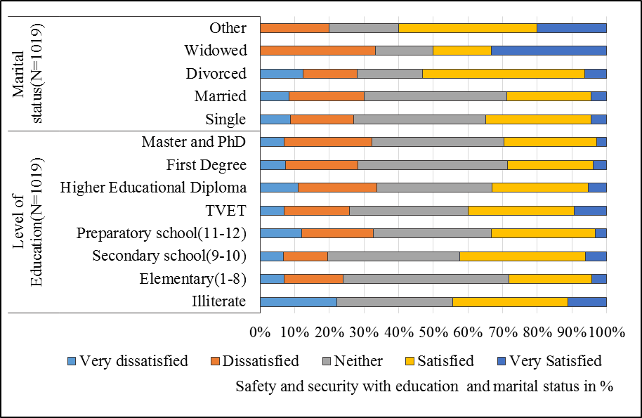
A
B

Figure 4. 14: Graph showing relations of safety and security with riders’ education level (B) and marital status (A)

In terms of economic characters of the passengers and their perception related to safety and security, their satisfaction level tended to decrease with the increase of household income. Riders those with income less than 2000 ETB are less concern with safety and security issues than the other income groups. The concern for safety and security level shows change from 20% of disaffection for income group less than 2000ETB to 39% for income groups 6001-8000 ETB income, showing a significant increase in fear for safety and security as the income increases (Figure 4.15A). In the same way, unemployed perceived more unsafe than the others. While 42% of the homemaker which 95% of them are women have less fear related to safety and security. In general, the concern for safety and security increases from student to unemployment (Figure 4.15 B) than retired peoples who perceived as neutral.
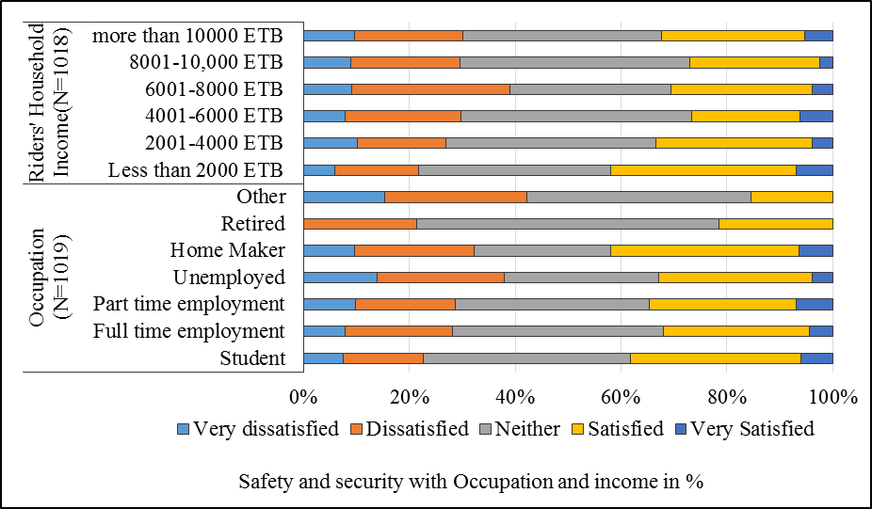
A
B

Figure 4. 15: Graph showing relations of safety and security with passengers’ occupations (B) and house hold income (A)

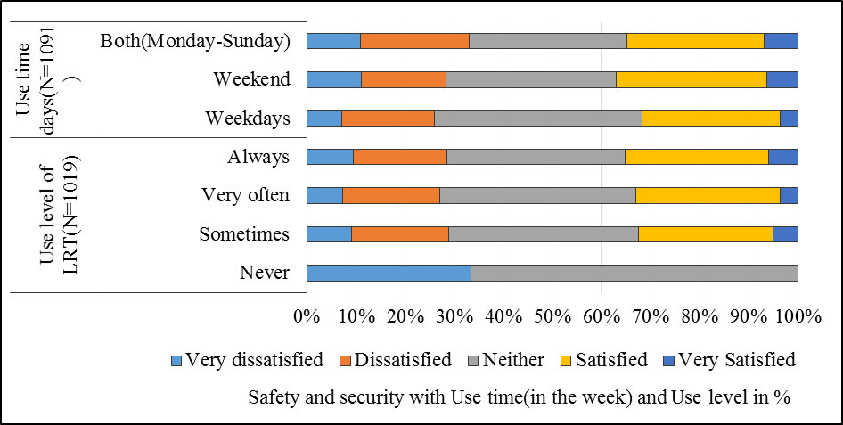
A
B

Figure 4. 16: Relations of safety and security with passengers’ use level of LRT (B) and use time in the week (A)
Unlike the income as the experience of using LRT increases the fear for safety and security tended to decrease than less users experience (Figure 4.16 B). Passengers who use the LRT service sometimes are more concerned about their safety and security i.e. 35% of them are very dissatisfied with safety issues. Whereas from never users to always users and from weekend users to all the weekdays' users the concern of safety and security decrease relatively show significant changes (Figure 4.16 A).
On the other hand, passengers who use the LRT during the night from 1:00-4: 00 PM perceived more fear for their safety and security than the others time user. The fears of safety and security perception of riders are high relatively for those use during morning and night peak hours than off-peak hour's users. For the passengers who travel longer distance, their negative perception for safety and security is lower as the distance increase with a slight increase in their satisfaction from 30% for users with distance 1-5 kilometers to 34% satisfaction for users of 20.1-30
Kilometer while their satisfaction fall from 30% to 25% respectively, showing slight change on fear for their safety and security (Figure 4.17 A and B).
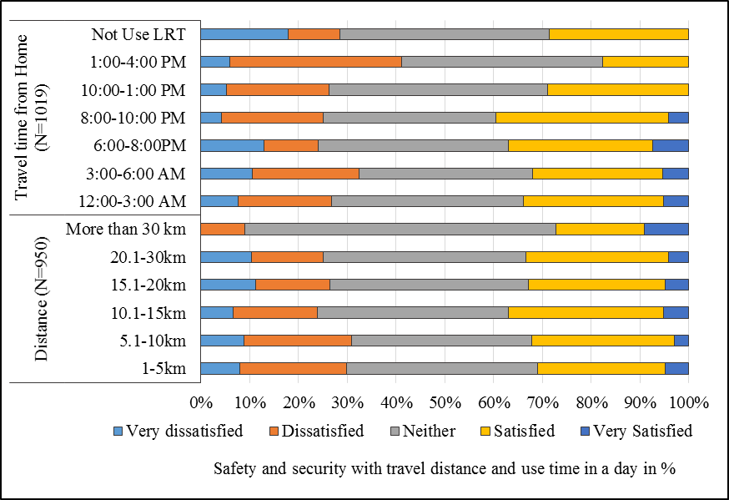
A
B

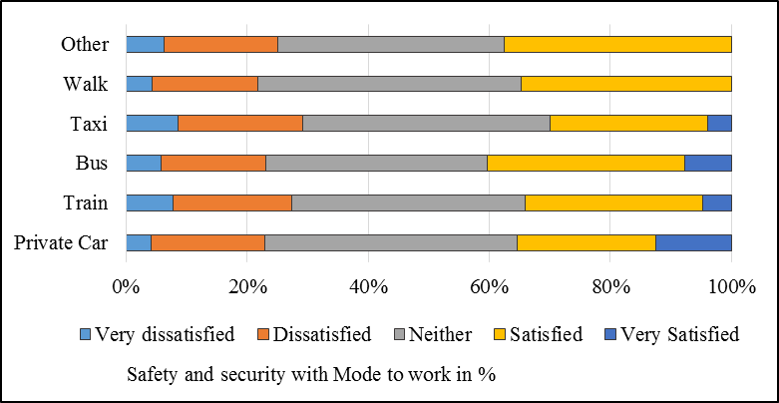
Figure 4. 17: Relations of safety and security with passengers’ travel distance (B) and time to home (A)

Figure 4. 18: Relations of safety and security with Passengers’ mostly used mode

    - Ticketing System and Information
The ticketing system and information is the second importantly influencing identified factors with the influencing variance of 8.3% on the overall service quality of the passengers. This factor is used as dependent variables consisted the average valued scored by using a Likert scale for parameters such as price, boarding, and alighting, travel information and ticketing system. The average scored valued of these variables had computed and used for further relationship analysis with demographic, economic and travel characters of the passengers as follows.
Accordingly, the perceptions of riders to the ticketing systems and information analysis in terms of riders' gender, males tended more dissatisfied than females. Dependent age groups which are 15-20 and above 61 years old are shown more satisfied than the other groups. More than 75% of age groups above 70 years old are satisfied with the price, ticketing system and travel information (Figure 4.19 A and B).
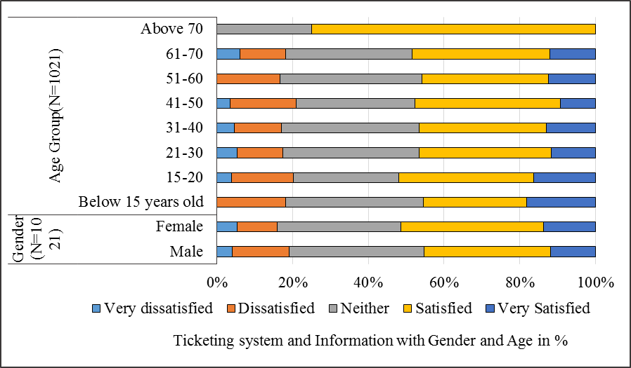
A
B

Figure 4. 19: Relations of ticketing system and information with Passengers’ gender (B) and age group (A)

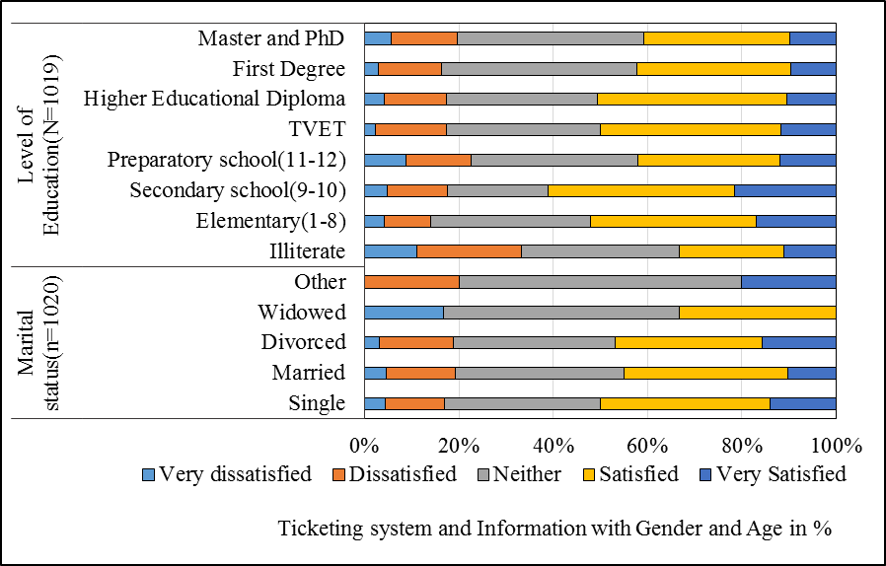
A
B

Figure 4. 20: Relations of ticketing system and information with passengers’ marital status (B) and education level (A)

On the other hand, when the relationship between ticketing and travel information of AALRTS is seen with the marital status of passengers, 49% of the singles passengers are happy with this service followed by divorced, married and widowed riders. The satisfaction character is decreasing from single riders to widowed groups sequentially from 49% to 20 % (Figure 4.20 B).
For the level of education as the status of educations increases from illiterate passengers to secondary school, the positive perception toward the ticketing system and information increases dynamically from 32% to 61%. However, from secondary school as the level of education increase, the perception of passengers toward ticketing and information is getting negative. Showing that secondary school passengers which most of them are single and students are more satisfied followed by elementary, TVET and higher educational diploma (Figure 4.20 A).
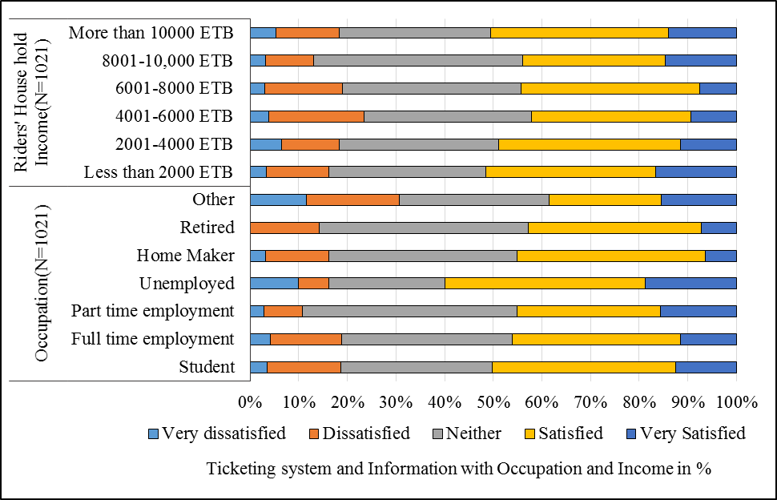
Likewise to educational level, as the income of house hold of passengers’ increases their satisfaction getting decrease from 51% for household with less than 2000ETB income to 44% for house hold with 8001-10000 ETB. However, 50% of the passengers with a household with income more 10,000 ETB are happier toward ticketing system, price and travel information preceded by household income group less than 2000 ETB. In the same pattern, for occupations, the perception toward ticketing and travel information also decreases from 50% from students to 38% retired except for unemployed riders which 60% of them are satisfied. The dissatisfaction also slightly decreasing from student to retired peoples with some increase of neutral perception (Figure 4.21 A and B).
A
B

Figure 4. 21: Graph showing relations of ticketing system and information with passengers’ occupation (B) and house hold income (A)

However, when perception of passengers compared in terms of their frequency of using LRT, toward the ticketing system and travel information; passengers who use LRT always are relatively satisfied more than those who use sometime and never. Most of always and very often are full time employment and uses LRT service during working days or week days which also satisfied with ticketing and travel information more than those using during week days(Figure 4.22 A and B).
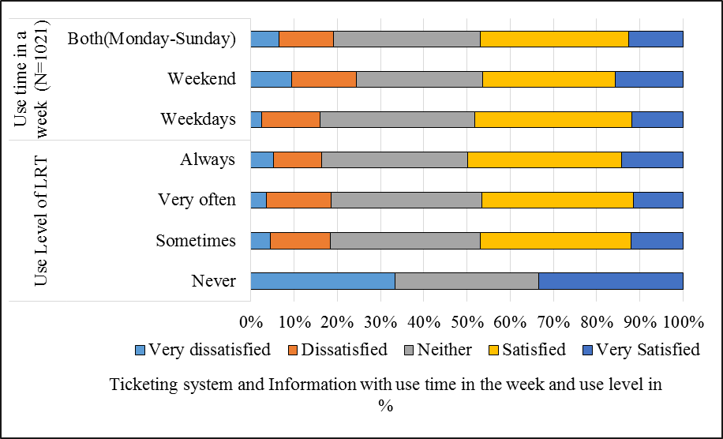
Riders’ perceptions is changing to negative as their travel distance increase from 50% for 1-5 kilometer to 38% for riders travel distances between 20-30 kilometers (Figure 5.23 B). In the same way, peak hour passengers are also dissatisfied more than those passengers who use the LRT during off peak hours (Figure 5.23 A).
A
B

Figure 4. 22: Graph showing relations of ticketing system and information with
Passengers’ Use level of LRT (B) and use time during the week (A)

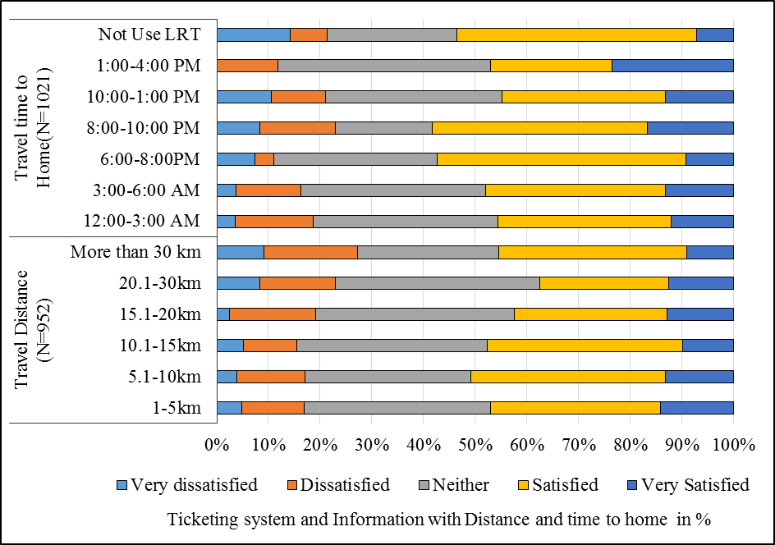
A
B

Figure 4. 23: Relations of ticketing system and information with passengers’ travel distance (B) and use time to home (A)

    - Crowdedness and Train Frequency
Crowdedness and frequency are third identified factors with 7.3% of variance over the satisfaction of the passengers. Crowdedness and long waiting times of train are found as the most dissatisfying parameter of the LRT service. In the same way, safety- security and ticketing system- information, crowdedness and frequency is based on the average value of variables such as stations crowdedness, train inside crowdedness, stations' seat and shelter and waiting time, parameters which highly loaded on this factors to analysis the relationship with socioeconomic variables.
The result showed that perceptions are different relative to the different socioeconomic character. For instance, passengers with different age groups have shown the variation of perceptions within the age group related to the crowdedness and frequency of the train. Most of the passengers have negative perceptions toward crowdedness and frequency which is crowdedness at the stations and in the trains, stations' seat, and shelter and waiting time than positive perceptions. For the age group below 15 years old are less dissatisfied and crowdedness is not much of their concern than the other age groups. While 75% of elders' above 70 years old are dissatisfied than all the other age groups showing that, crowdedness and frequency is their main concern. In general, as the age increase from below 15 years old to above 70 years old their dissatisfaction toward crowdedness and frequency is increase while satisfaction is decreasing (Figure 4.24 A). On the other hand, males are more concerned with crowdedness than females showing that they are more dissatisfied with crowdedness and train frequency (Figure 4.24 B).
Likewise, evaluating crowdedness and frequency with the level of education and marital status shows that, 56% of illiterate passengers are dissatisfied more than other levels. In general, as the level of education increase, the negatively perceived percent also increases from 39% for the elementary attendant to 50% master and PhD attendant while it is opposite for positive satisfactions(Figure 4.25A). Related to marital status and crowdedness-frequency relationships, about 66% of widowed passengers are more dissatisfied followed by 43% of married and 40% of single marital status (Figure 4.25 B).

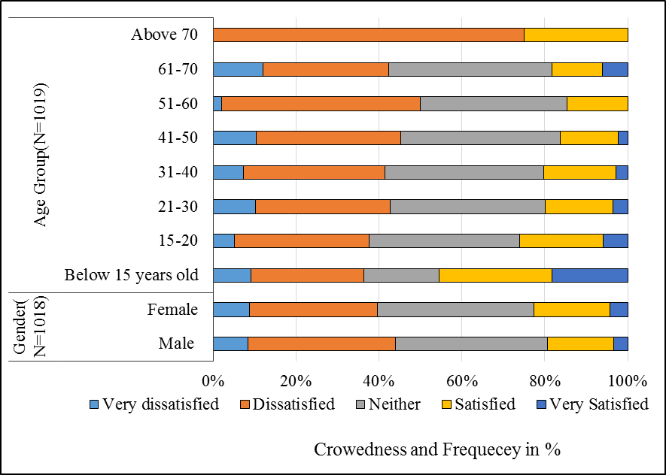
A
B

Figure 4. 24: Relations of crowdedness and train frequency with riders’ age groups (B) and gender (A)

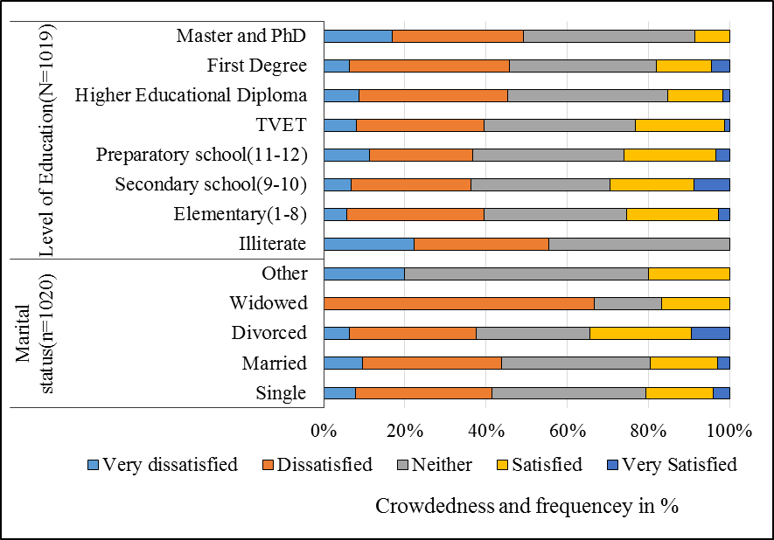
A
B

Figure 4. 25: Relations of crowdedness and train frequency with passengers’ marital status (B) and education level (A)
In the same way, educational level and age, the negatively perceived percentages of riders increase with the incensement of household income. Accordingly, riders with less household income are less dissatisfied and more satisfied. It shows that the dissatisfactions level increases from 35% of riders with household income less than 2000 ETB to 48% of riders household income with 10,000 ETB while their satisfaction level decrease from 28% to 15% respectively (Figure 4.26 A).
For occupation character, even though, there is no uniform pattern there are differences in perceptions among each occupations characters toward crowdedness and frequency. Accordingly, 50% of retired are dissatisfied relatively more than others and followed by 49% of full-time employment, 40% of students and unemployment group (Figure 4.26 B).
When the perception of riders analyzed in terms of their LRT using frequency and use time, riders who use the LRT always and during working days or weekdays are more dissatisfied than those riders who use the LRT service sometimes and during weekends. Indicating that riders who have more experience of using LRT service are tended to dissatisfied more with the crowdedness and frequency of trains. On the other meaning, during off-peak hour and weekend, the numbers of passengers using the LRT are lower than during peak hour working days which is characterized by crowdedness (Figure 4.27 A and B).
However, as the travel distance increases, the negatively perceived parentage of riders decrease slightly from 42% to 19% except for distance intervals 15.1-20 kilometers where about 50% of this interval riders are not satisfied with crowdedness and train frequency. In addition, 45% of the riders who ride the LRT during peak hours are more dissatisfied than those who ride during off-peak hours with crowdedness and frequency of LRT (Figure 4.28 A and B).

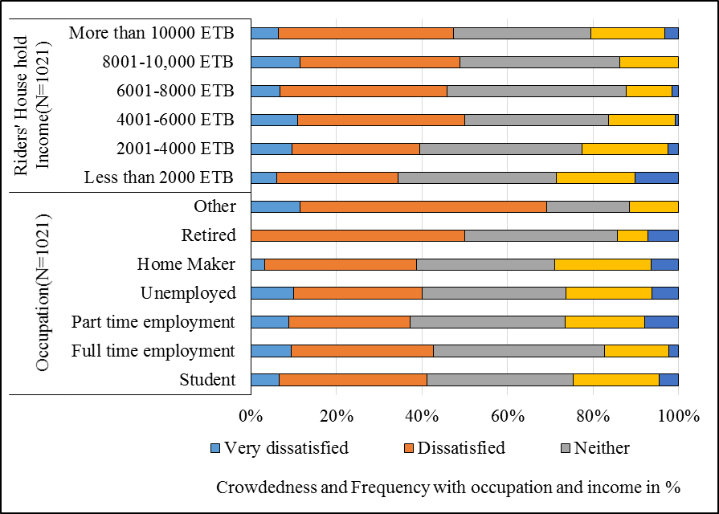
A
B

Figure 4. 26: Graph showing relations of crowdedness and train frequency with passengers’ occupation (B) and household income (A)

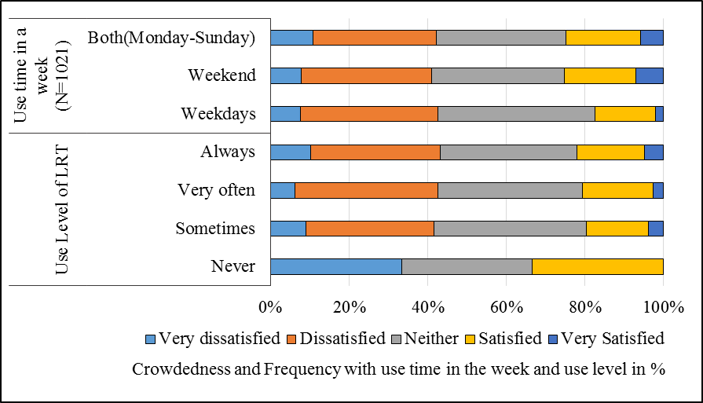
A
B

Figure 4. 27: Relations of crowdedness and train frequency with passengers’ use level of LRT (B) and use days in the week (A)
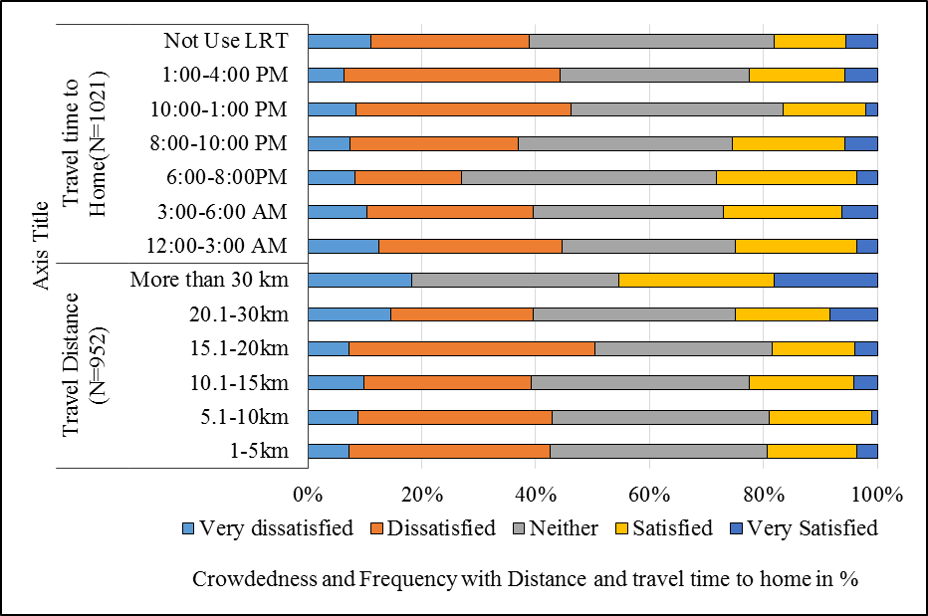
In terms of mode frequently used to work and school, riders perceptions are varied in respective to their most often use of mode. For instance, about 35% users of most often mode to work of bus, walk and private car think that train is crowd. Also about 44% of the users of taxi as mode to work also perceived train is crowd. In the same way about 43% of mostly using train as mode to work confirmed trains is crowd and dissatisfied with crowdedness and frequency of the LRT service. Likewise, among the most often riders of taxi and walking as mode to school are also thinking that train is more crowded than bus and private car (Figure 4.29 A and B).
A
B

Figure 4. 28: Relations of crowdedness and train frequency with riders’ travel distance (B) and time to home (A)
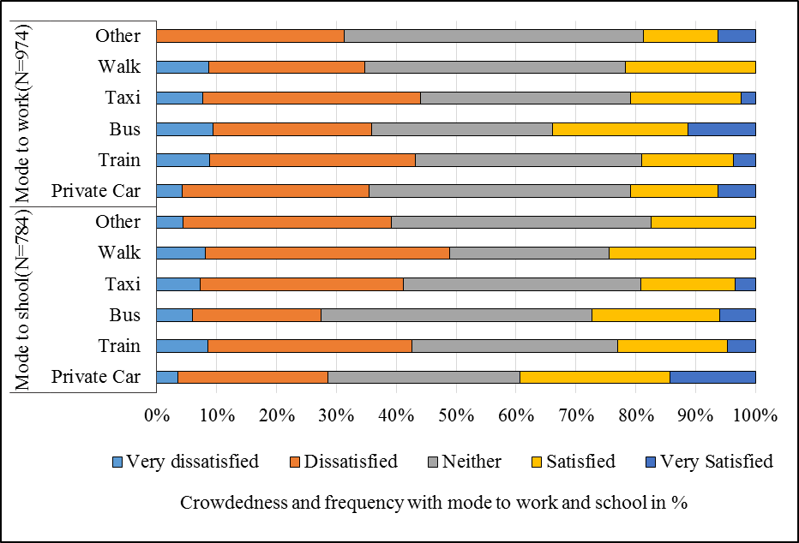
A
B

Figure 4. 29: Relations of crowdedness and train frequency with riders’ mode to school (B) and mode to work (A)

    - Passengers’ Perception Result toward Service Quality of AALRTS by Ordered Logit Model Analysis
Ordered logit model was adopted to analyze, ranked satisfaction and benefit variables in order to identify the influence and likelihood direction of the predictors of the socioeconomic character of riders. Also, in order to examine the influencing factors affecting riders' perceptions toward service conditions of AALRTS.
This model is based on the four explanatory satisfaction variables identified by factor reduction analysis explained above. For this model analysis, twenty-two (22) predictors' i.e. a degree of freedom related variables of demographic, economic and travel time, distance, mode and use level of LRT's riders are used.
The interpretations of the results were based on degree of freedom and t-value to consider the result's statistical significance level. Hence, since t-value for a degree of freedom 22 with a significance level of p < 0.05 is 2.080, all the results with Wald value ≥ 2.080 are statistically significant and considered for the model analysis (see Table 4.3).
Accordingly, the result table showed that most of the important parameters are statistically significant for t-value ≥ 1.721 with a significance level of p < 0.1and t-value with a significance level of p < 0.05. For each of the four dependent variables the interpretation analyses are described as follows.

Table 4. 3: showing ordered logit model result for the riders’ satisfaction level toward service quality of AALRTS
Independents variables |  | Safety and security |  | Ticketing system and information |  | Crowdedness and frequency |  | Cleanness and Comfort
 |  | Estimate | Wald | Estimate | Wald | Estimate | Wald | Estimate | Wald
Threshold | [Y1 = 0] | -5.621 | 29.915 | -3.832 | 14.042 | -4.502 | 19.471 | -4.960 | 22.735
Threshold | [Y2 = 1] | -4.568 | 20.311 | -3.040 | 9.058 | -2.912 | 8.382 | -4.124 | 16.234
Threshold | [Y3 = 2] | -3.006 | 8.914 | -1.336 | 1.778 | -.819 | .669 | -1.918 | 3.593
Threshold | [Y4 = 3] | -1.200 | 1.431 | .478 | .228 | .961 | .921 | .586 | .337
Threshold | [Y5= 4] | 1.801 | 3.132 | 2.778 | 7.582 | 3.793 | 12.860 | 1.183 | 1.368
Locations | Level of Education | -.046 | 1.743* | -.073 | 4.388** | -.042 | 1.477 | -.031 | .789
Locations | Distance | .027 | 8.246** | -.004 | .170 | .018 | 3.620** | .005 | .238
Locations | Use level of LRT | .018 | .054 | .043 | .295 | -.023 | .087 | .116 | 2.127**
Locations | Use time days | .020 | .081 | -.041 | .347 | .099 | 2.003* | -.021 | .087
Locations | Travel duration | -.012 | 13.032** | -.005 | 1.793* | -.009 | 6.867** | -.008 | 5.976**
Locations | LRT use time to home | -.080 | 3.379** | -.095 | 4.708** | -.102 | 5.457** | -.029 | .443
Locations | Household income | -.038 | 3.827** | .007 | .144 | -.069 | 12.446** | -.013 | .416
Locations | [Gender1= Male] | -.148 | 1.262 | -.257 | 3.796** | -.083 | .396 | -.262 | 3.909**
Locations | [Gender1=Female] | 0ª |  | 0ª |  | 0ª |  | 0ª
Locations | [Marital status=Single] | -1.303 | 2.699** | 1.011 | 1.637 | -.420 | .283 | -.887 | 1.227
Locations | [Marital status=Married] | -1.594 | 4.010** | .669 | .711 | -.420 | .281 | -.934 | 1.353
Locations | [Marital status=widowed] | .094 | .007 | .196 | .030 | -.727 | .411 | -1.833 | 2.576**
Locations | [Marital status= others] | 0ª |  | 0ª |  | 0ª |  | 0ª
Locations | [Occupations=Student] | .880 | 4.184** | .073 | .029 | .975 | 5.120** | .546 | 1.607
Locations | [Occupations= Full time employment] | .592 | 2.171** | .183 | .209 | .836 | 4.305** | .584 | 2.102**
Locations | [Occupations=Part time ] | .607 | 1.916* | .294 | .450 | 1.061 | 5.831** | .434 | .975
Locations | [Occupations=Unemployment] | .308 | .452 | .681 | 2.215** | .953 | 4.318** | .627 | 1.868*
Locations | [Occupations=Home maker] | .197 | .130 | -.306 | .315 | .806 | 2.178** | -.083 | .023
Locations | [Occupations=Retired] | .579 | .781 | -.310 | .224 | 1.026 | 2.444** | .206 | .098
Locations | [Occupations=Other] | 0ª |  | 0ª |  | 0ª |  | 0ª
*statistically significant at 90% confidence interval, ** statistically significant at 95% confidence interval

      - Safety and Security Model
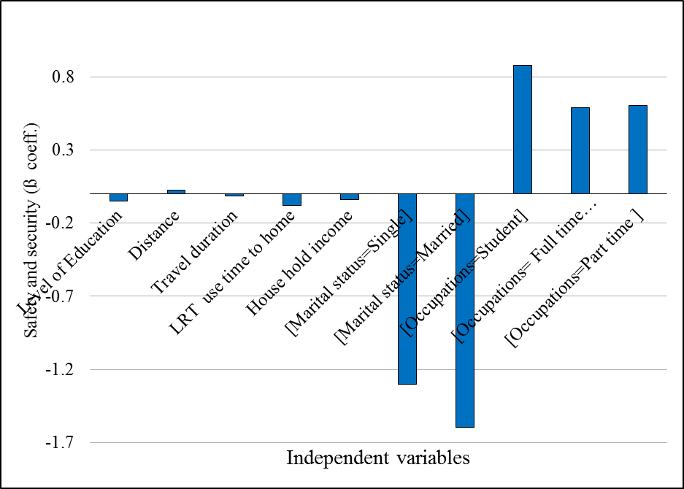
Accordingly, the result in Table 4.3 shows that the education level variable is statistically important with a t-value>1.721 for 90% confidence interval with the negatively attached beta coefficient. It indicated that more educated riders or as the education level of riders increase perception (feeling) of satisfaction toward safety and security of AALRTS likely decreases than those less educated riders. Travel distance and duration are also important parameters with t-value> 2.080 at 95% confidence interval showing that riders travel a longer distance and long duration have different perceptions toward the safety and security of LRT service. As indicated by positive beta that riders with longer distances tended to feel riding LRT is more save while riders who travel long duration feel likely in opposite that LRT is less safe. This is maybe because of chained trips and congestion problems of the city and long waiting times for different modes. These take more time for riders who travel long duration that might influence their perceptions toward safety and security in the opposite to the longer distance riders. In the same way, travel time to work/school/ (from home) and to home is found to be important and affects the perception of riders with Wald-value 3.379 at 95% confidence interval with negative attached beta value. It indicated that riding the LRT during night peak hours to home is more likely unsafe than during off-peak hours (also refer to Figure 4.30).

Figure 4. 30: Graph showing model result for safety and security

Furthermore, riders' occupation and income are also statistically important with greater than accepted t-value at a 95% confidence interval for income, student and full-time employment but at a 90% confidence interval for part-time employment. Indicating that high-income house-hold riders more likely to feel less safe and secured while using AALRTS than low-income household riders justified by negative beta. While students, full-time employment, and part-time employment who use the LRT always perceived the LRT as safe and secured. However, the positive relative high beta attached to the student and part-time employment indicating that there is a high likelihood of feeling safe and secure for the students while using LRT than full-time employment. Related to safety and security marital status of riders also importantly characterizing perceptions of riders with t- value greater than acceptable t-value at p<0.05. It indicated that married and single riders have more fears toward safety and security. Hence, there are more likely to be less satisfied with safety and security. The lower negative beta coefficient for married than single riders indicated married riders have more odds of less satisfaction toward the safety and security of AALRTS than singles riders(also refer Table 4.3).
      - Ticketing and Travel Information Model
Ticketing and travel information is also the second important factor identified that influencing satisfaction by 8.23% of the variance. The ordered logit model analysis result for this explanatory variable shows statistically significant in affecting the over satisfaction. Accordingly, the result indicated that still education level of riders' important variables for the ticketing system and travel information with Wald value greater than acceptable t-value at 95% confidence level. It indicates that high educated riders are not happy with the service of the ticketing system and travel information i.e. as the level of education increase there is more likely negative perception toward the ticketing and travel information. This may be because they more influenced by ticketing place, accessible of ticketing office, and boarding alighting system than price.
Likewise, for safety and security travel duration also statistically significant with Wald-value greater than accepted t-value at a 90% confidence interval. It shows that, as the travel duration increase more, there is more likely to be less satisfied with the ticketing system and travel information. In the same way, ticketing and travel information travel time to home is important and affects the perception of riders with Wald-value greater than accepted t-value at a 95% confidence interval. The negative attached beta value indicating that riding the LRT during night peak hours to home time is more likely dissatisfying than during off-peak hours.
Other explanatory parameters that do not important for safety and security but found to be important for the ticketing system and travel information are gender and unemployment. It indicates that male riders of AALRTS are more dissatisfied with the ticketing system and travel information than female riders. Whereas for unemployed riders', with high positive beta indicating that unemployed riders are more likely satisfied with the ticketing system and travel information service of the LRT. This may be because since unemployed peoples have less income and more time, they may not experience the ticketing office's distance from the station which takes time to get it and also maybe the price makes them to satisfied more (refer to Table 4.3).
      - Crowdedness and Train Frequency Model
Third important satisfaction variable that, influencing the satisfaction perceptions of riders is crowdedness and train frequency as explained under factor analysis. Here also the ordered logit model analysis result indicated most of the predictors' variables are statistically significant with accepted t-value at a 95% confidence interval than the other three dependent parameters (Table 4.3). Likewise, to the previous here also travel distance and duration are statistically acceptable with a 95% confidence interval but in opposite satisfaction perception toward the crowdedness and train frequency. It means that passengers from a long distance are more likely positive toward the crowdedness and frequency than from a shorter distance. While passengers those travel long time are less likely satisfied by crowdedness and train frequency indicated by negative beta attached. This may be because of the long waiting time of the train, train insider and station crowdedness, absence of enough station seats and shelter might influence their perception of the satisfaction of AALRTS.
In addition, predictors like use time during the week and use time to home are also important and influence crowdedness and frequency's satisfaction level. Use the time of LRT is significant at 95% confidence intervals while use time during the week is significant at a 90% confidence interval. Accordingly, passengers who use the LRT during working days and all weekdays are tended to more likely satisfy with crowdedness and frequency as shown with positive beta value. Since most of these riders use the LRT during working days are full-time employment, as the more experienced with the service they tended to more satisfied with service. However, in terms of use time in the day i.e. from work/school to home, it is opposite to that of during weekdays. It indicates that, as the time to home is to afternoon peak hour more it is likely to dissatisfy with the crowdedness and frequency of LRT.
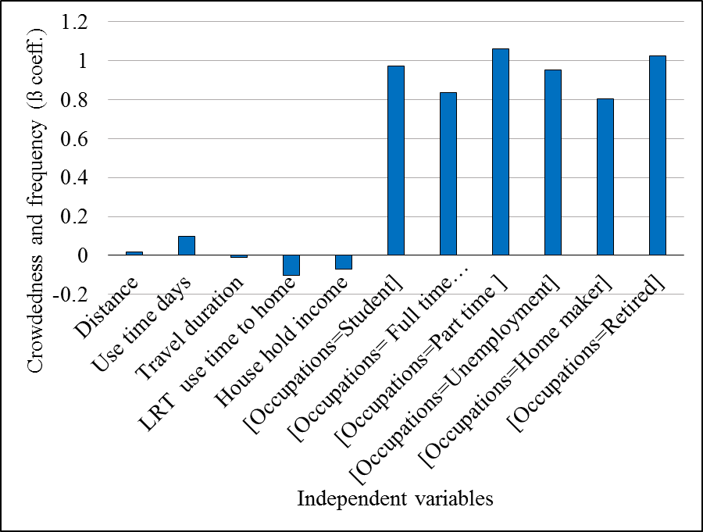
In the same ways, riders’ household income and occupation are also important variables that statistically significant with Wald-value greater than accepted t-value at p<0.05 or 95% confidence interval. Riders with high income have negative perception toward crowdedness and frequency of the LRT. The negative beta value is indicating that as the income of riders’ increases there is more likelihood of dissatisfaction with long waiting of the train, and station and train inside crowdedness. However, for the occupation character of riders, the perception is opposite to that of income i.e. riders which are students, full-time employment, part-time employment, homemaker (housewives i.e. with no work) and retired are tended to satisfy with crowdedness and frequency of AALRTS as indicated by positive attached beta. The varied beta value for each of them indicates, retired and part-time employment have more likelihood satisfaction than students and unemployed which have also more likelihood satisfaction than homemakers and full-time employment riders. This may be because since homemaker (housewives with no work), retired, students and unemployed riders are economically dependent the LRT service might more cheap and satisfying for them than other modes. Full-time employment is the riders who are low income as also explained already, low-income riders are more likely satisfied with crowdedness and frequency than higher income(also refer to Figure 4.31).

Figure 4. 31: Graph showing model result for crowdedness and train frequency

      - Cleanness and Comfort Model
The fourth important variable of satisfaction identified by factor analysis and also influence the satisfaction level is the cleanness and comfort of AALRTS. Accordingly, important predictors such as user level of LRT, genders, travel durations, widowed marital status, full-time employment are important variables (predictors) with statistically accepted t-value at p<0.05 while also unemployment is statistically important at 90% confidence interval.
Riders with more use level or those who use the LRT always are more satisfied with station cleanness, train inside cleanness and train seat comfort than occasionally (sometimes) users. Also, most of the full-time employment and unemployed are riders, those who use the LRT always have positive perceptions like as always users toward cleanness and comfort of the LRT. Unemployed riders have high beta with more likelihood satisfaction than the second high beta of full-time employment which has more likelihood satisfaction than the use level of LRT toward cleanness and comfort of AALRTS.
Whereas riders those travel long time have still negative perception toward cleanness and comfort of AALRTS. Also, male riders have a negative perception toward cleanness and comfort than the females with more likelihood of dissatisfaction than the riders who travel a long time as indicated by negative beta value. Also, widowed riders are important variables that have less likelihood of satisfaction with cleanness and comfort of the LRT associated with negative beta value.
  - Perceptions of Riders toward Socioeconomic Benefit of AALRTS
    - Descriptive Analysis of Socioeconomic Benefits
In line with the study of perception on service quality also the perceptions toward the socio-economic benefits of AALRTS are studied. To grasp the perception of riders toward the benefits of AALRTS eight (8) parameters of socio-economic which indicate benefit were included in the survey. In order to measure and identify the attitude of riders toward these benefits; descriptive analysis and ordered logit model was used. Accordingly, the result is shown in Table 4.4, the average attitude of 979 surveys and the most rated frequency of each eight variables. These results are interpreted based on Likert scales rates of these benefits variables by riders, where the value of the scales are from 0-4 i.e. strongly disagree (0), disagree(1), neutral (2), agree(3) and strongly agree(4). Based on these scales the modes, mean and distributions of perception interpreted as follows.

Table 4. 4: Showing descriptive analysis result of the socioeconomic benefits
Socioeconomic Benefits parameters | N | Mean | Mode | Std. Deviation | Variance | Skewness
LRT reduced distance | 979 | 2.85** | 3 | 1.056 | 1.115 | -.765
LRT reduced transport cost | 979 | 3.05** | 4 | 1.011 | 1.022 | -.947
LRT created new jobs | 979 | 1.96* | 2 | 1.370 | 1.877 | .003
LRT enable clean air | 979 | 2.28* | 2 | 1.274 | 1.623 | -.297
LRT helps cut busy traffic | 979 | 2.85** | 4 | 1.164 | 1.354 | -.806
LRT connect relatives | 979 | 2.32* | 2 | 1.236 | 1.528 | -.239
LRT ease shopping | 979 | 2.23* | 2a | 1.247 | 1.555 | -.191
LRT increased city attractiveness | 979 | 2.39* | 4 | 1.434 | 2.057 | -.395
*nether negative nor positive attitude with a value around two or neutral average perception, **positive attitude with a value around three which as agree to the benefits

Socioeconomic benefic indicators parameters such as, 'the LRT reduced distance', ‘reduced transport cost' and ‘helps to cut busy traffic' are the variables which riders agreed with benefit with an average score of between 2.85-305. However, when compared in terms of riders rating frequency for each of this variable, ‘the LRT reduced transport cost' and ‘helps to cut busy traffic' are parameters that have the most frequently riders rated as strongly agreed with. While for 'the LRT reduced distance' has rated as agreed which the most frequently rated value by riders. These benefits indicators, relatively have good riders' attitudes on average when compared to others. There is also some riders attitude distributed toward strongly disagree part as the average rated value is less than the most frequently rated value shows (Table 4.4).
On the other hand parameters such as; the LRT created new jobs, enabled clean air, connected more to relatives and ease shopping are the socioeconomic benefits where more than half of riders have a negative attitude with them. But when seen the average attitude perceived by riders all of these benefits indicators are perceived as neutral with average score 1.96-2.32 mean (Table 4.4). In the same way, when compared in terms of the most frequently rated value by riders, the scored value is still neutral for each of these parameters with confined valued attitude distribution around the average neutral perception.
When the aesthetic value of AALRTS for the city is concerned the average perceived value is two which is neutral i.e. mean value of 2.39 with the most frequently rated value of ‘strongly agree'(4 mode value). However, since some riders perceived the aesthetic value of AALRTS for the city by rating as ‘strongly disagree' it makes the average value less the most frequently rated value by skewing the attitude of riders toward the ‘strongly disagreed' part (Table 4.4).
Also, the response of open-ended question indicated the same implication for city attractiveness of AALRTS. City attractiveness relate response has 17 entry responses and has four subthemes such as LRT increased city attractiveness, the LRT decreased city attractiveness, accessibility to stations and design related of AALRTS response of the passengers. When increased city attractiveness related response is concerned numbers of riders commented that the project had increased city attractiveness. However, some of the comment shows even though it increased city attractiveness still it is difficult for elders and disabled. For instance, one respondent indicated that "yeah! It increased the city's attractiveness but still difficult for disables and elders".
Whereas for decreased attractiveness responses like "the LRT makes the city unattractive" stated in general among the comments. While related to the third subtheme which is design problems response like as, "the design is making me angry because it separated the city, plus there is no safe crossing and connection between crossings. Why not the simplest methods is not used?" In addition also "the design has problems because it did not consider the speed, and the aesthetics or attractiveness of the city" are among the comments that indicated the LRT has design problems.
Accessibility is the fifth subthemes with nine (9) entry respondents with a general comment of riders' concerned to the accessibility of station in terms of a separate pedestrian crossing, the traffic problems, and the safety of the crossing. For instance responses likes "stair is safe for elder, but elevators are not visible, the design has problems not good for traffic movements hence, remove this LRT and make it underground or on the ground", while the others comment like, "crossing places are not good and safe, the LRT makes crossing places too far away and exposed us for sudden traffic accidents, improve them!"
  - The Relationships of the Passengers Perception With their Socioeconomic Characteristics toward Socioeconomic Benefits of AALRTS
To measure and identify the relationship of socioeconomic benefit with socioeconomic characters of riders, the eight benefits parameters are grouped in three dependent variables based on the average perceived value by riders. Accordingly, parameters such as the LRT reduced distance, transport cost and helps to cut busy traffic have the same average perceived value, hence grouped and taken as one dependent variable for further relationship analyses with socioeconomic characters of riders. Also, variables such as the LRT created new jobs, enabled clean air, connected more to relatives and ease shopping have the same average perceived value hence also grouped as one dependent variable by taking the average rated valued of each of them. Finally since the average perceived value for the parameter, ‘the LRT increased city attractiveness' is 2.4 and the most frequently rated value is four (i.e. mode is 4) which makes this variable different from the others in both scored value. Hence, the researcher believed to consider as it is, rather than grouping with other variables for the relationship analysis with independent variables. Therefore, based on these three grouped dependent variables the relationship analysis is presented by using graphs as follows.

    - Benefits of AALRTS toward Reducing the Cost, Distance and Traffic Congestion
In order to, run these relationships analysis, first the rated average valued of surveyed 979 samples for these three grouped variables calculated and analyzed with each independent parameter. Accordingly, the result of the analysis with each independent parameter shows, more than half of the sampled riders are significantly benefited from the reduced cost, travel distance and traffic congestion in general.
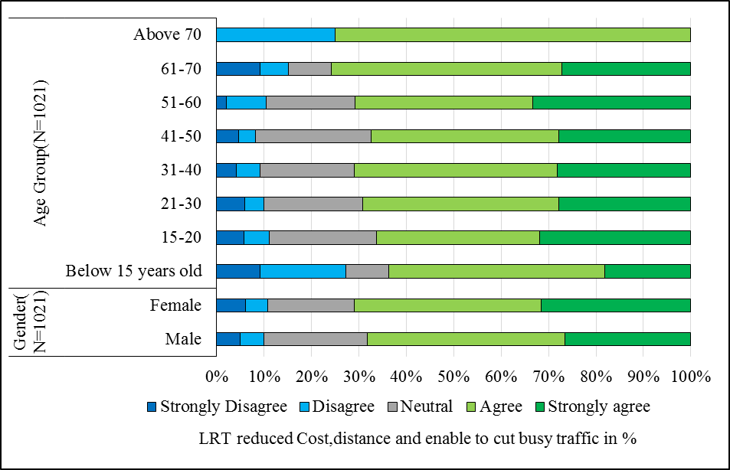
In terms of age groups, 75% of elders with above 61 years old are more benefit from the cost, distance, and in terms of overcoming busy traffic than the other age groups. In general, as the age increase, the percentages of benefited riders with these services are also increasing from 62% for the age group below 15 to 75% for age groups above 70 years old. However, for age below 15 years old and above 70% years old there are also riders who do not agree with these benefits. In addition, the reduction of cost, distance, and traffic congestion problem helped females than males riders' (Figure 4.32 A and B).
A
B

Figure 4. 32: Relations of LRT’s cost, distance and congestion reduction perception with gender (B) and age groups (A)

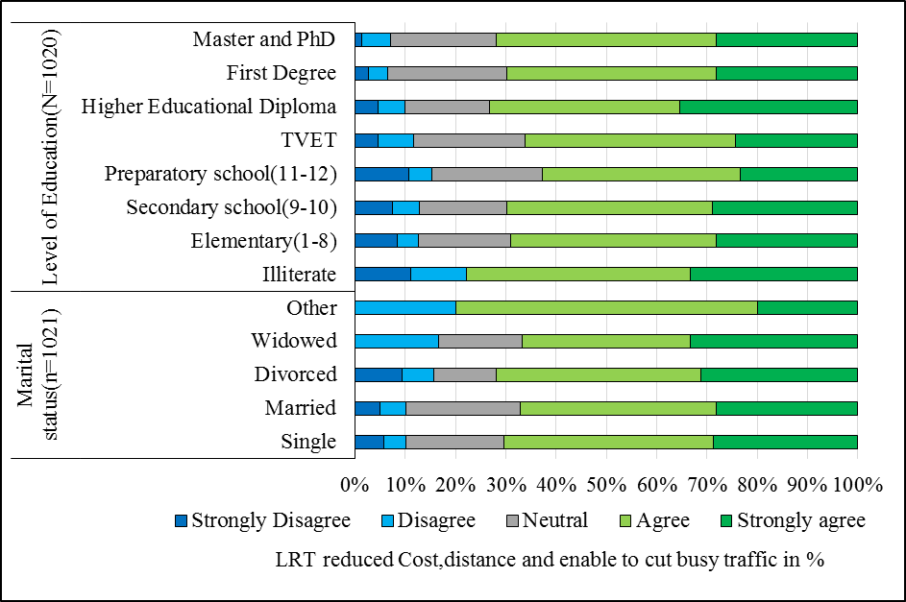
A
B

Figure 4. 33: Relations of LRT’s cost, distance and congestion reduction perception with marital status (B) and education level (A)

Likewise too, age characters in terms of the level of education 80% of illiterate are agreed with the benefits while preparatory attendants are relatively less than the others. In general, from illiterate levels to preparatory school attendants, the percentage of riders agreed with benefit decrease from 78% to 62% and then increases from 72% of preparatory to master and above. Also, the in terms of the marital status of the riders 71% of divorced riders and 70% of single are relatively more benefited than the others. In the same way, more than 65% of riders with each income categories are benefited from the LRT reduction of cost, distance and traffic problems (Figure 4.33 A and B).
While related to occupations, unemployed and homemakers riders attitudes toward the benefit are less relative to the others. But from student to part-time employed riders, the percentage of agreed riders slightly increases (Figure 4.34 A and B).
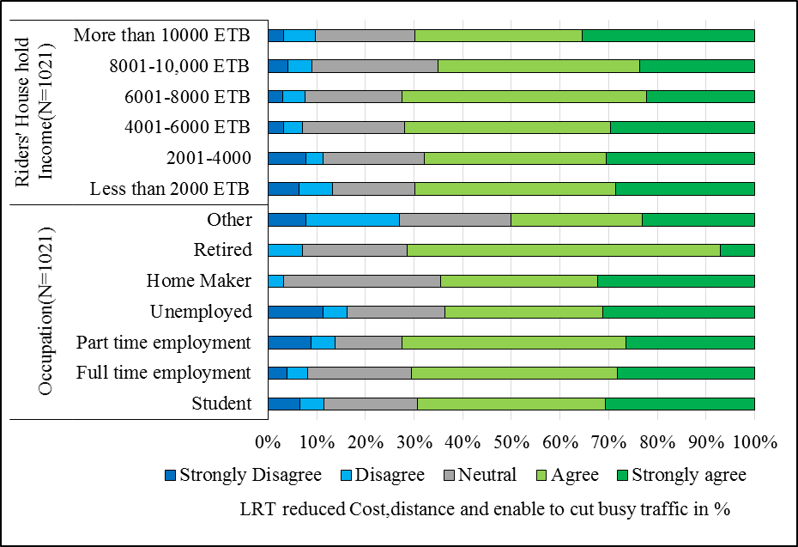
A
B

Figure 4. 34: Relations of LRT’s cost, distance and congestion reduction perception with passengers’ occupation (B) and house hold income (A)

When the attitude of the riders compared in terms of their LRT using time and level, riders those who use the LRT during weekdays and always, benefit more from reduced cost, distance and traffic congestion problems than the users of the weekend and sometimes(Figure 4.35 A and B). However, as the distance increase, the attitude toward these benefits decreases significantly from 72% of 1-5 kilometer to 60% of 20.1-30% kilometers because of the increase in percentages of riders with a neutral attitude. But for riders who use the LRT during peak hour time the reduction of cost, distance and time helped them more than the off-peak hour riders (Figure 4.36 A and B). Whereas those riders who use the private car to work assume that LRT saves more time, cost and distance. It is also the same for the riders who use the train to work than riders who use taxi and walking for mode-to work (Figure 4.37 A and B).

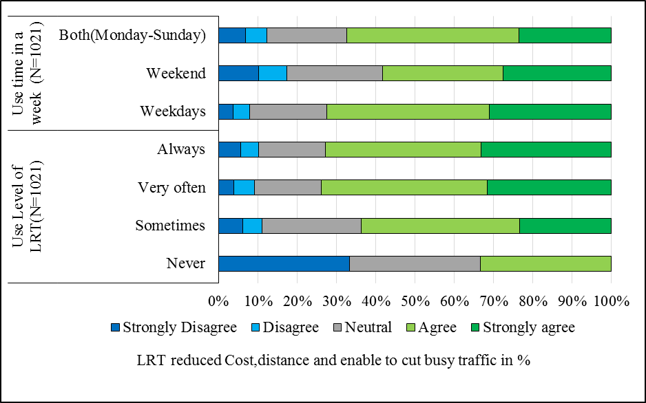
A
B

Figure 4. 35: Relations of LRT’s cost, distance and congestion reduction perception with passengers use level of LRT (B) and use days in the week (A)
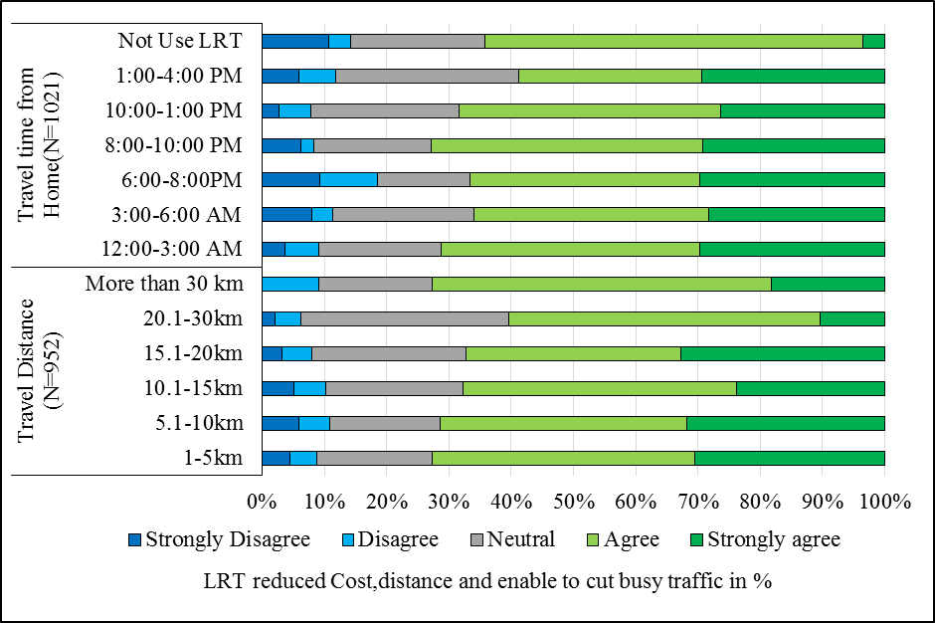
A
B

Figure 4. 36: Relations of LRT’s cost, distance and congestion reduction perception with passengers travel distance (B) and time from home (A)

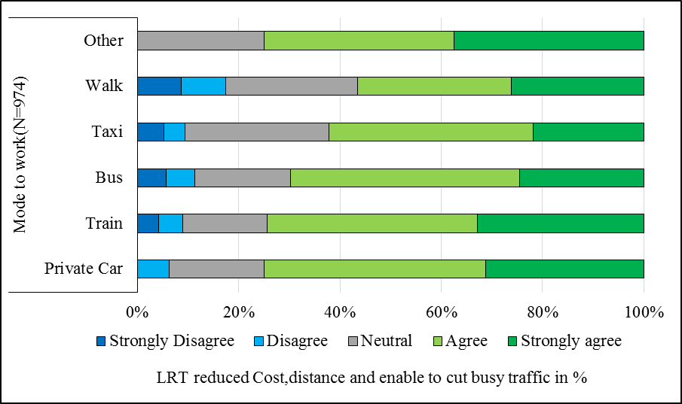

Figure 4. 37: Relations of LRT’s cost, distance and congestion reduction perception with riders mostly used mode to work

    - Benefit of AALRTS toward Create New Jobs, Enable Clean Air, Connect to Relative and Ease Shopping
Based on the average scored value(mean) of the parameters such as the LRT created new jobs, enabled to breath clean air, make connected to relatives and ease shopping are grouped as one dependent variable. Based on this value and independent socioeconomic variables, the relationship analyzed following the same process to previous sections.
Accordingly, the result of these grouped benefit parameters and with age groups shows that as the age increases both negative and positive attitudes of the riders decrease. For negative perceptions, it decreases from 28% to 15% from the age group below 15 years old to 61-70 age groups while positively perceived percentages decrease from 54% to 32% for the same age groups. However, the percentages of neutral attitude toward these benefits increase with increasing of the age. In terms of genders, females are relatively benefited more than males (Figure 4.38 A and B).

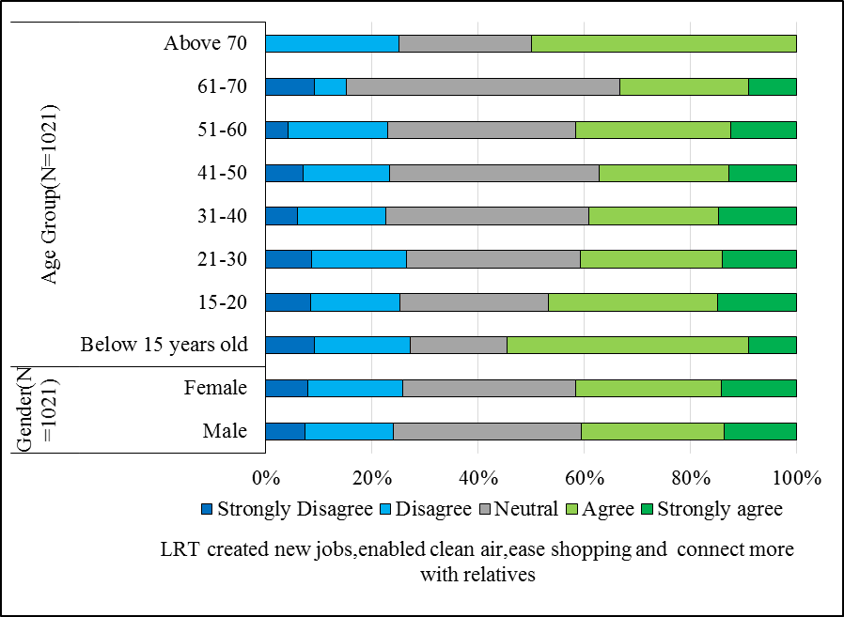
A
B

Figure 4. 38: LRT’s benefits of creating new jobs, connecting to relatives, ease shopping and enable clean air with passengers gender (B) and age groups (A)
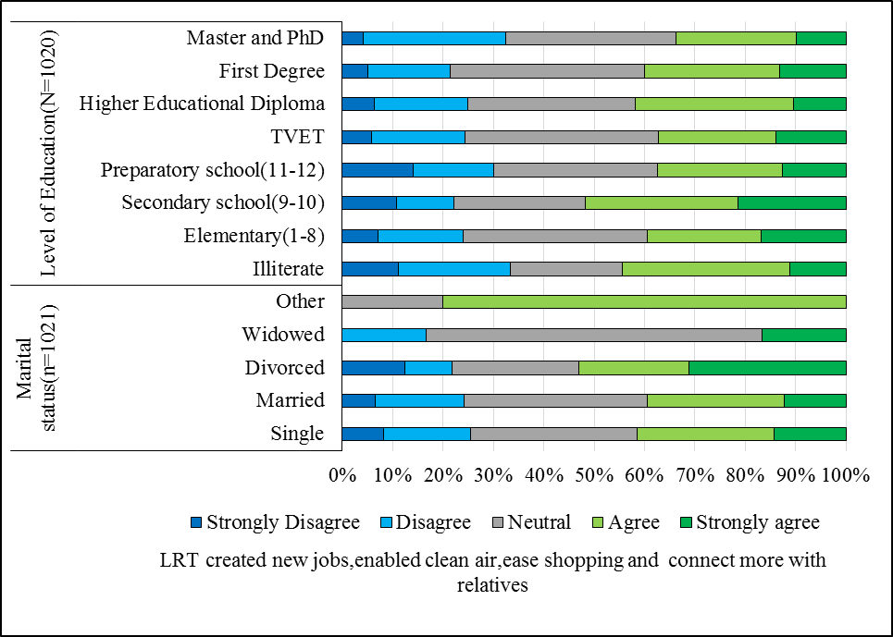
B
A

Figure 4. 39: LRT’s benefits of creating new jobs, connecting to relatives, ease shopping and enable clean air with passengers’ marital status (B) and education level (A)
In the same way, as the level of education increase the percentages of passengers with neutral perception toward these benefit increase while negative and positive attitude slightly decreases with the increases of education level. In the same manners, divorced riders agreed with these benefit than the other marital status. However, from single to widowed the percentages of passengers with neutral perception increase from 35% to 60% with the slightly decreasing of negative and positive attitude(Figure 4.39 A and B).
Riders with low income household are more agreed relatively to higher income toward LRT benefits of new jobs opportunity, provide clean air, connect more to relative and ease shopping. While more than 70% of retried passengers are neither benefited nor do not with the service but more than 45% of home makers and 40% of full time employment are agreed and relatively benefited more than the others with service of AALRTS (Figure 4.40 A and B).
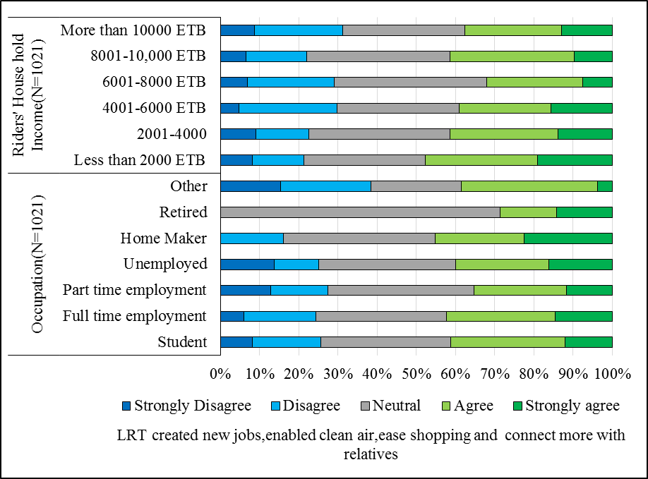
B
A

Figure 4. 40: LRT’s benefits of creating new jobs, connecting to relatives, ease shopping and enable clean air with passengers’ occupation (B) and household income (A)
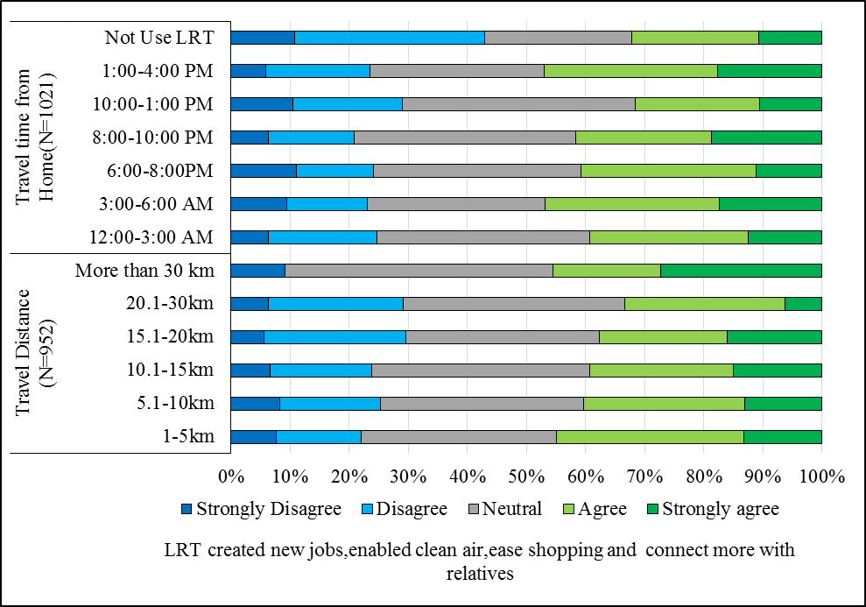
Riders those using the LRT during all the week days and very often showed more benefited with these benefit service of AALRTS than those using the LRT during weekend and sometimes(Figure 4.42 A and B). However, when compared in terms of their travel distance characters as the distance increase the positive perception of passengers toward the service benefit is getting lower from 40% to 30% while the negative attitude is slightly increase with their travel distance from 22% to 30%. However, passengers which are low income and fulltime employment, those who uses the LRT during morning peak hours have more negative attitude toward these service than off peak hours (Figure 4.41 A and B).
B
A

Figure 4. 41: LRT’s benefits of creating new jobs, connecting to relatives, ease shopping and enable clean air with passengers’ travel distance (B) and time to home (A)

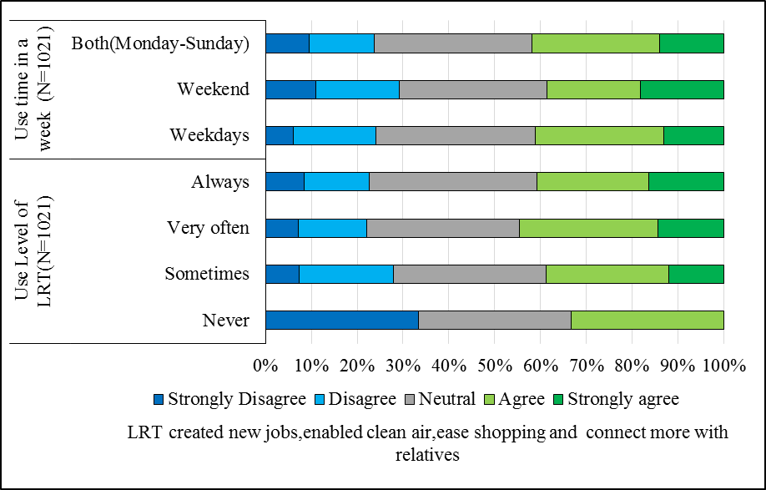
B
A

Figure 4. 42: LRT’s benefits of creating new jobs, connecting to relatives, ease shopping and enable clean air with passengers’ use level of LRT (B) and use days in the week (A)

    - Passengers Perception toward the LRT Value for City Attractiveness
The analysis result shown the percentage of passengers agreed with benefit of AALRT for city beauty and do not agreed are more or less close to each other but with slightly domination of those passengers which believed the LRT lines are increased the city attractiveness. However, the result of relations with socioeconomic characters shows, the variation of attitude more toward strongly disagree than to ward disagree for negative perception. In the same manners, for the positive attitude the percentage of toward strongly agreed are greater than agreed passengers. For instance in terms of age characters of the passengers the percentages of strongly disagreed is more than 20% while disagreed is 10% for each age groups while 25% of each group strongly agreed,20% agreed which follows the same pattern for others socio economic characters of the passengers.
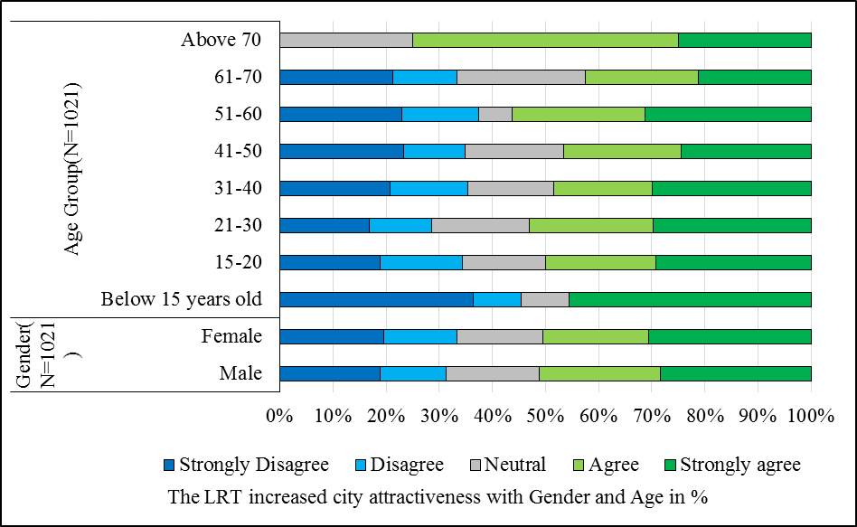
However, elders with age 51-60 and above 70 years old believe the LRT project increased the city’s attractiveness more than others age group. Likewise, also males believed it has increased the city attractiveness than females (Figure 4.43 A and B). Whereas 68% of widowed and 45% of illiterate passengers do not agreed that the LRT has increase the city attractiveness. However, more than 50% of the passengers with education level of higher diploma, first degree, and singles, divorced marital are believed that project has brought more attractiveness for the city(Figure 4.44 A and B).
B
A

Figure 4. 43: LRT’s contribution for city’s aesthetics with passengers’ gender (B) and age groups (A)
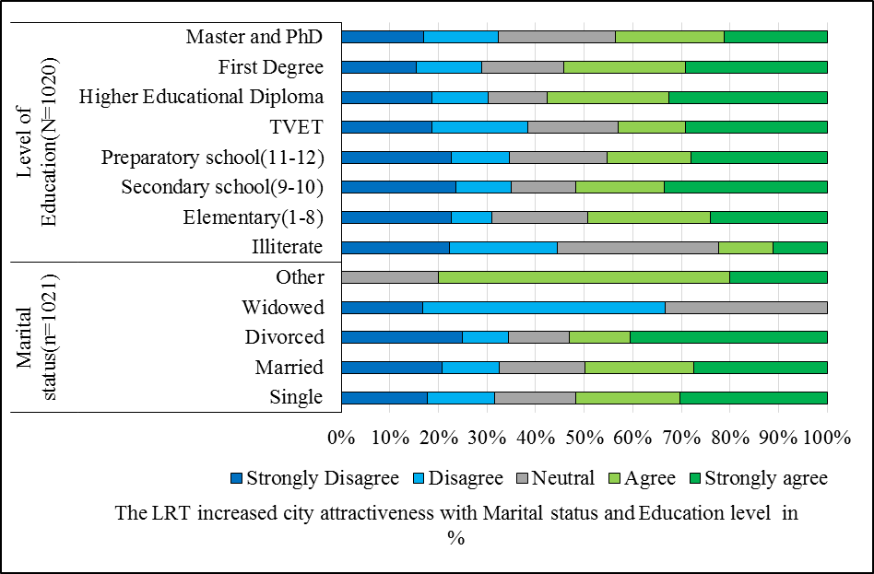
B
A

Figure 4. 44: LRT’s contribution for city’s aesthetics with passengers’ marital status (B) and education level (A)

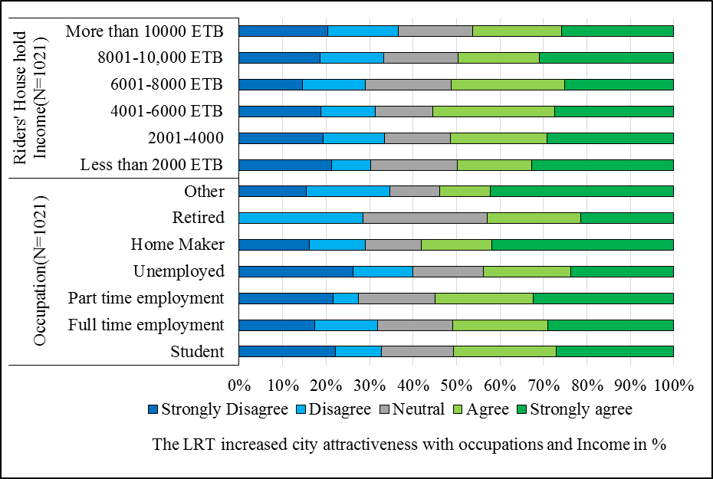
In the same way, more than half of each passengers’ house hold income groups are agreed with the contribution of the LRT for the city’s beauty while more than 42% of retired and unemployed, and more than half of other occupation character are believed that the LRT increased the beauty of the city. However, more than 30 % of passengers with each income groups and more than 28% of the passengers with each occupations characters do not believe that the LRT has increased the city’s beauty( Figure 4.45 A and B).
B
A

Figure 4. 45: LRT’s contribution for city’s aesthetics with passengers’ occupations B) and household income (A)
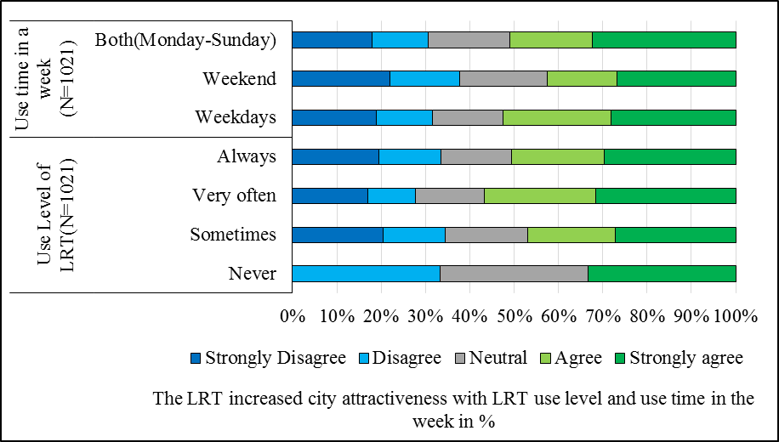
B
A

Figure 4. 46: LRT’s contribution for city’s aesthetics with riders’ use level of LRT B) and use time of LRT during the week (A)

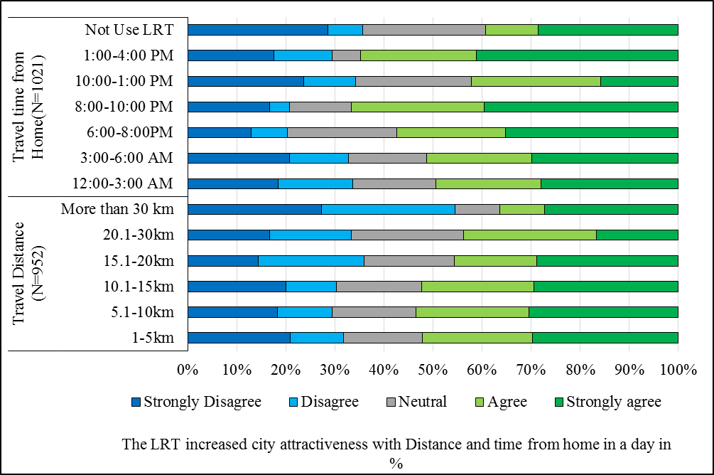
Whereas more than half of the passengers those who use the LRT always, sometimes and during working days think as the city’s beauty is improved by the AALRTS (Figure 4.46 A and B). In addition, more than 34% of passengers which use LRT sometimes and during weekend are not agreed. On the other hand passengers from longer distance, peak hour users and private car users have lower perception toward the LRT’s value for the city’s beauty relative to the others (Figure 4.47,48 A and B).
B
A

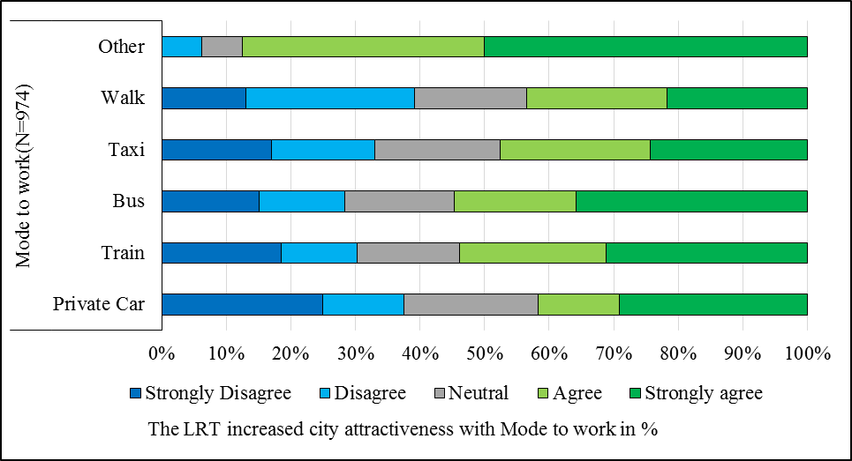
Figure 4. 47: LRT’s contribution for city’s aesthetics with passengers’ travel distance B) and time from home (A)

Figure 4. 48: LRT’s contribution for city’s aesthetics with passengers’ mostly used mode to work

    - Passengers’ Perception Result toward socioeconomic Benefits of AALRTS by Ordered Logit Model Analysis
Likewise to ordered logit model analysis for passengers’ satisfaction, also for the socio-economic benefits, it is applied in order to identify passengers’ perception likelihood or threshold. To run this model twenty one (21) independent variables or degree of freedom were used. The interpretations of the result are based on this degree of freedom and t-value to consider the result’s statistical significance level. Hence, since t-value for the degree of freedom 20 with a significance level of p < 0.05 is 2.086, all the result with Wald value ≥ 2.086 are statistically significant and considered for the model analysis (see Table 5.5) as follows.

Table 4. 5: Ordered Logit model analysis result for socioeconomic benefits parameters
 |  | LRT Reduce distance |  | LRT Reduces Transport cost |  | LTR create New Job |  | LRT enables clear air |  | LRT helps to cut busy traffic |  | LRT connect relative |  | LRT Ease shopping |  | LRT Increased city attractiveness
 |  | Coefficient | Wald | Coefficient | Wald | Coefficient | Wald | Coefficient | Wald | Estimate | Wald | Estimate | Wald | Estimate | Wald | Estimate | Wald
Threshold | [Yi = 0] | -4.855 | 20.132 | -3.524 | 10.589 | -2.367 | 5.283 | -3.961 | 13.809 | -3.387 | 9.106 | -3.705 | 12.074 | -3.707 | 12.412 | -3.149 | 8.931
Threshold | [Yi = 1] | -3.640 | 11.579 | -2.109 | 3.960 | -1.412 | 1.888 | -3.014 | 8.042 | -2.270 | 4.149 | -2.453 | 5.338 | -2.314 | 4.880 | -2.332 | 4.923
Threshold | [Yi = 2] | -2.211 | 4.314 | -.575 | .297 | -.438 | .182 | -1.761 | 2.761 | -.984 | .783 | -1.161 | 1.202 | -1.177 | 1.268 | -1.525 | 2.111
Threshold | [Yi = 3] | -.677 | .406 | .878 | .693 | .665 | .419 | -.501 | .224 | .221 | .040 | -.014 | .000 | .098 | .009 | -.509 | .236
Location | Age | -.077 | 1.289 | .110 | 2.489** | -.115 | 2.996** | .042 | .391 | .161 | 5.501** | -.014 | .047 | -.001 | .000 | -.060 | .817
Location | Level of Education | -.048 | 1.651 | .033 | .774 | -.058 | 2.565** | -.037 | 1.045 | .035 | .904 | -.006 | .028 | .029 | .652 | .031 | .716
Location | Distance | -.017 | 3.524** | -.026 | 8.200** | -.002 | .031 | -.009 | 1.134 | -.014 | 2.369** | -.013 | 2.323** | -.006 | .441 | -.015 | 3.137**
Location | House hold income | -.011 | .278 | -.009 | .191 | -.029 | 2.057* | -.034 | 2.786** | -.027 | 1.634 | -.056 | 7.494** | -.063 | 9.607** | -.028 | 1.827*
Location | Mode to work | -.140 | 5.170** | -.131 | 4.400** | -.079 | 1.724* | -.048 | .622 | -.039 | .402 | -.082 | 1.828* | -.152 | 6.340** | .031 | .266
Location | Use time to home | -.114 | 5.786** | -.085 | 3.135** | -.082 | 3.229** | -.085 | 3.458** | -.058 | 1.514 | -.014 | .091 | -.093 | 4.101** | -.048 | 1.078
Location | Use level of LRT | .129 | 2.339** | .087 | 1.035 | .091 | 1.238 | -.073 | .789 | .158 | 3.477** | .031 | .141 | .012 | .021 | .118 | 2.025**
Location | [Gender= male] | .010 | .005 | -.175 | 1.500 | .220 | 2.611** | .029 | .046 | -.223 | 2.518** | .032 | .054 | -.012 | .008 | .035 | .064
Location | [Gender= female] | 0ª |  | 0ª |  | 0ª |  | 0ª |  | 0ª |  | 0ª |  | 0ª |  | 0ª
Location | [Marital status=Single] | .109 | .017 | .691 | .700 | -.431 | .285 | -1.108 | 1.715** | -.647 | .516 | -1.128 | 1.779* | -.872 | 1.107 | -.150 | .033
Location | [Marital status= married] | -.070 | .007 | .611 | .545 | -.304 | .141 | -1.333 | 2.468** | -1.004 | 1.237 | -1.057 | 1.553 | -.956 | 1.320 | -.348 | .177
Location | [Marital status=Widowed] | .079 | .004 | -.249 | .044 | -1.456 | 1.537 | -1.216 | 1.048 | -.266 | .044 | -1.337 | 1.270 | -.487 | .172 | -1.976 | 2.814**
Location | [Marital status=Other] | 0ª |  | 0ª |  | 0ª |  | 0ª |  | 0ª |  | 0ª |  | 0ª |  | 0ª
Location | [Occupations= student] | -.064 | .019 | .386 | .692 | .311 | .475 | .181 | .160 | .529 | 1.316 | .501 | 1.229 | .799 | 3.129** | -1.100 | 5.395**
Location | [Occupations=full time employment] | .162 | .142 | .402 | .862 | .416 | .968 | .194 | .211 | .336 | .610 | .341 | .653 | .635 | 2.258** | -.964 | 4.695**
Location | [Occupations=part time employment] | .172 | .135 | .814 | 2.938** | .311 | .457 | -.043 | .009 | .051 | .012 | .243 | .278 | .489 | 1.133 | -.635 | 1.738**
Location | [Occupations= Unemployment] | .204 | .172 | .602 | 1.473 | .537 | 1.251 | -.007 | .000 | -.127 | .068 | -.043 | .008 | .535 | 1.241 | -1.437 | 8.209**
Location | [Occupations=home maker] | -.131 | .051 | -.117 | .041 | .717 | 1.604 | .398 | .493 | .164 | .079 | -.101 | .032 | .097 | .029 | -.460 | .616
Location | [Occupations=retired] | .141 | .041 | -.660 | .910 | .924 | 1.857* | -.270 | .159 | -.666 | .934 | .347 | .261 | .925 | 1.847* | -.610 | .777
Location | [Occupations=others] | 0ª |  | 0ª |  | 0ª |  | 0ª |  | 0ª |  | 0ª |  | 0ª |  | 0ª
*statistically significant at 90% confidence interval, ** statistically significant at 95% confidence interval Source: Based on survey result

      - LRT’s Benefits in Reducing Distance Model
The AALRTS benefit in the reduction of travel distance is one of the benefits that more than 67% of passengers agreed with as explained under the description of the data section. Here also it is one of the explanatory variables that determined by predictors of passengers' character that affect the perception and attitude toward the benefits of the LRTS. The result in Table 4.5 shows that, for the benefits of LRT's reducing distance, four variables are found to be statistically significant with Wald-value greater than the accepted t-value (t-value >2.086) at 95% confidence interval or p<0.05.
Riders' travel distance is among statistically important predictors indicating that passengers from a long distance have a negative attitude toward LRT reduction of travel distance. They less likely agreed to the benefits as indicated by the negative attached beta coefficient. This may be because since the LRT is serving on the two corridors i.e. east-west and north-south corridor only passengers who work or live around the corridor may be benefited. But the riders with chained trips may not perceive the benefit in terms of distance reduction.
In the same way, passengers that use other modes to work and those use LRT to travel to home during afternoon peak hours do not think that LRT reduced distance for them, indicated by negative beta coefficient with a less likely feeling of the LRT reduce distance. The riders who use other modes to work have a more likely negative attitude as indicated by high beta than riders' uses the LRT during afternoon peak hours. It might be because of less using experience of LRT make riders use others mode to work to have a negative attitude. This is because as indicated by the positive coefficient of use level of LRT variable which is the opposite attitude with that of mode to work. It states that passengers who use the LRT always think that, the LRT has reduced travel distance for them than sometimes users or with less using experience.

      - The LRT’s Benefits in Reduced Transport Cost
The LRT's benefit reduced transport cost is one of socioeconomic benefits variable where more than 73% of sampled passengers are agreed with as explained under the description of the data section. Five variables which statistically significant are also identified for LRT's benefit in reducing transport costs. Accordingly, age is one of the important predictors' variable with Wald-value greater than the accepted t-value at a 95% confidence interval. It indicates that elders are more likely benefited from the LRT's reducing transport costs. Hence, with the increase of age, there are more likely positive perceptions toward the transport cost reduction of AALRTS. Also, passengers travel distance, passengers' mode to work and passengers' LRT use time to home are statistically important variables with t-value greater than the accepted value at 95% confidence interval (p<0.05).
Riders who travel long distances do not feel that LRT's reduce transport costs for them. It shows that as the travel distance increase there is a likelihood of negative attitude increase toward the perception of transport cost, especially it may be for riders who use different modes and have chained trips. Riders who use other modes to work and those who use the LRT during afternoon peak hour to home have a negative attitude with LRT's transport cost benefit. Their negative attached beta coefficient indicated that passengers who use LRT during peak hours and other modes are less likely benefited from transport cost-benefit of AALRTS. It might be because of crowdedness and long waiting time during peak hours and less use experience of LRT make passengers to be less benefited since it has indicated that always users of LRT have a positive attitude.
In terms of occupation character of passengers the high positive beta coefficient attached to part-time employment indicated that part-time employees are more likely benefited from the transport cost of AALRTS.
      - The LRT’s Benefit in Reducing Traffic Congestion
As explained above the LRT's benefit in reducing traffic congestion is found as the parameters where most or 65.4% of the surveyed passengers agreed with. Also, the ordered logit model analysis result of this variable is statistically important which can influence the perception and attitude of passengers'. Among the four statistically significant identified predictors variables age is one. Age is statistically important with a t-value greater than the accepted value at a 95% confidence interval indicating that elders are more likely to benefits with LRT's traffic congestion reduction. The passengers' use level of LRT is also statistically significant variable attached by positive beta coefficient stating that passengers with more experience of using AALRTS have positive perception toward traffic congestion minimizing the benefit of AALRTS than sometime user of the service.
In terms of travel distance and gender character i.e. statistically significant with p<0.05 when perception toward this benefit is considered, males have a negative attitude toward the LRT's benefits in terms of reducing traffic congestion than females. Likewise, passengers with longer distance have negative attitude than shorter distance passengers.
      - The LRT’s Benefit in Creating Jobs, Connecting Relative, Ease Shopping and Enable Clean Air
Explanatory variables that indicate the socioeconomic benefit such as the LRT enable to breathe clean air, make connected more to relatives, ease shopping and created new job are variables that have a relatively less positive attitude as rated by surveyed riders. Also, model analysis result shows most of the predictors variable are statistically important for each of these socioeconomic benefits of AALRTS. The age character of riders is statistically significant with Wald-value 2.996 with a negative beta coefficient indicating that elders have less likely agreed with LRT's new job creation than young riders. Likewise too, more educated passengers are likely less agreed with LRT's job creation than less educated riders. Riders travel distance is an important variable with Wald-value 2.323 with negative beta showing that passengers those travel longer distance less likely agreed with the LRT make connected to relatives.
Riders' household income is statistically important variables that influence all the four the variable with Wald-value greater accepted t-values at 95% confidence interval but for variables, LRT created new jobs significant at p<0.1. It indicated that passengers with high-income household have a negative attitude toward this socioeconomic benefit of AALRTS. The negative beta shows as the income of passengers increase there is more likelihood of negative perception toward these socioeconomic benefits of LRTS.
Also mode to work is statistically significant with a 90% confidence interval for benefits variables LRT created new jobs and makes connected to relative. But for ease shopping significant at 95% confidence intervals. It shows passengers those using others mode to work has less likely agreed with these benefits. Use time to home is also statistically important with P<0.05 indicating that passengers using LRT during afternoon peak hours have more likely negative perceptions toward the ease of shopping, created new jobs and enable to breathes clean air benefits of AALRTS than those using off-peak hours as shown by negative beta to each variable.
When the demographic character of riders is concerned, gender is statistically important variables for the explanatory variables of LRT create new jobs with P<0.05. As indicated by the attached positive beta, male passengers have more likely positive toward the LRT's creation of new jobs than females' passengers. While single marital status passengers which are statistically significant at 90% are less likely agreed with LRT's benefit connect more to the relative. Whereas married passengers are less likely agreed with the benefits of LRT enabled to breathe clean air which statistically significant at p<0.05.
In terms of riders' occupations, student and full-time employment are found to statistically important predictors with t-value greater than the accepted value at 95% confidence interval and for retired at 90% confidence interval. Students and full-time employment riders are more likely agreed with LRT ease of shopping as indicated by positive beta coefficient. The high beta coefficient for students indicates that students have more likelihood of positive perception to the benefits of LRT ease shopping than full-time employment. In the same way, retired passengers have a positive attitude toward the LRT's creation of new jobs and ease of shopping as shown by positive attached beta.
      - The LRT's Contribution to the City Attractiveness
Concerned to the LRT's increase city attractiveness variable, as explained under the section of description of data 52.4% of the sampled passengers are agreed that the LRTS has increased the city attractiveness. The ordered logit model analysis result for this variable shows eight predictors are found to statistically significant. Accordingly, travel distance and use level of LRT are statistically important with accepted t-value at a 95 % confidence interval. It indicates that passengers with longer distance are less likely agreed with the LRT had increase city attractiveness whereas passengers those use the LRT always are more likely agreed as shown by positive beta coefficient.
In terms of passengers demographic characters, widowed riders are also important variables having Wald-value greater than accepted t-value with p<0.05. As indicated by negative beta widowed have negative perceptions toward the LRT's value for the city's visual aesthetics. Also, passengers with the high-income household which significant with 90% confidence interval, are negatively perceived the LRT's increased city attractiveness. It shows that high incomes have less likelihood a positive attitude than low-incomes passengers.
When occupation characters are concerned, variables such as student, full-time employment and unemployment are statistically significant with Wald-value greater than accepted t-value at a 95% confidence interval. All of them have a negative beta coefficient indicating that they have a negative attitude and perception toward AALRTS in improving city attractiveness and aesthetics. Also, the high beta attached to the student and unemployment indicated that there is more likelihood of negative attitudes toward the LRT increase city attractiveness for student and unemployed passengers than full-time employment relatively.
In addition, part-time employment is a significant variable at a 90% confidence interval with the attached negative beta coefficient. It shows part-time employment had also less likely happy with LRT's contribution to the city's attractiveness. This may be because of the general design layout, location or infrastructure of LRT that makes them have a negative attitude toward the AALRTS for city attractiveness contributions.
  - Discussion of the Result
    - Consistence of the Sample Characters
For this study, out of 1021 sampled passengers, 38.1% of them were females and 61.9 % of them were males. Concerned to the ages of respondents most of them were young (45.8%) aged 21-30 followed by age group between 31-40 which was 21.3%.While 55.8% of them were single and 40% of them were married. Most of the sampled passengers had a family size between3-6 of which 4 was the most frequent that shared 21.9% and 3, 5 and 6 were shared 16%, 18.2%, and 13.6% respectively with an average family size of 4.8. These results were also consistent with the socioeconomic characters of the city as stated by CSA. Which stated that 27.1% and 16.8 % of residents were between the age group of 21-30 and 31-40 the most first and third large age group respectively. Most of the family size of the dwellers were between 3-6 taking 63.4 % of the family size of the city population. Where households with family sizes four and five were the most frequent which is also consistent with this study's finding (CSA, 2011; 2016). Most of the surveyed passengers attended first-degree program and secondary and preparatory school where most of them confined in full-time employment (55.7%) status followed by the student. In addition, most of the passengers had a household income less than 5000 ETB i.e. about 178.6$ USD per month or less than $ 6 per day indicating that most of them were low incomes passengers as stated by world poverty lines and indicators (Kochhar, R., 2015).
More than half of the respondents (58%) used LRT very often and always which 58.7% of them were using LRT during working days (weekdays), followed by 28.9% which use LRT both weekend and weekdays. Also most of the sampled passengers (80.7%) characterized by travel distance between 1-15 kilometers with an average distance of 11.1 kilometers and 36-minute travel duration. They had use LRT service at peak hours i.e. 55.9% of trips purpose from home was during morning peak hours (12:00-3:00 AM) and while 47% of trips were in afternoon peak hour (10:00-1:00 PM).
The surveyed data showed that, more than half of the passengers that made their trips to work (58.8%) used train followed by taxi (minibus) (31.1%). The train usage for all trips purposes constitutes about 33% followed by trips to relative and school which make 20% and 18% respectively. However, taxi was the most used mode of transport for all trips purpose except for work in this sample. Walking and private cars were used for recreation purposes, by making 43% of walking and 38% of private cars for recreation.
As the distance increased the percentage of full-time employment were also showed increment. Most of the peak hour users were passengers who travel over long distances. Also, long-distance traveler i.e. full-time employment and students who used the LRT frequently as their daily mode to work. These passengers were low income constituting more than 55% of income groups 2000-4000 ETB and more than 66% of income groups 4001-6000 where the majority of them were low income from longer distances. This finding is in line with the review Starkey and Hine (2014) in Karachi (Pakistan) indicated the survey result, 65% of respondents were low income spent more than two hours and characterized by long distance traveling. Also the study conducted by Oviedo and Davila (2013) found that typical travel distances were between 17 and 24 km (travel time of 79 minutes) for low incomes use public transport.
    - Passengers’ Perception toward Service Quality and Factors Influencing the Overall service satisfaction of AALRTS
The finding related service quality of LRTS indicated, most of the respondents (more than 56.7%) were satisfied by service quality parameters such as price, station cleanness, train inside cleanness and sense of safety at station. These findings were related to the study of Eboli, et al. (2016) explored that, comfort and cleanness are a main crucial concern for transit passengers. The comfort and cleanness might be both the physical comfort and cleanness of the vehicles and the comfort concerning ambient states at transit points like station and on board whereas also the station cleanness and trains inside cleanness for the AALRTS case were perceived as good performance.
On the other hand most of the passengers were less satisfied with service quality parameters such as crowdedness in the train, crowdedness at the station, passengers' behaviors, travel information and waiting time in the present study. Waiting time was the most influencing factor so far have been identified as a factor influencing public transportations service so far identified. The long waiting time character of AALRTS along with high demand lead to more crowdedness then the crowdedness plus influence of passengers’ behaviors created more concerned for safety and security, resulted in fear for passengers. Therefore, as waiting time increased there were passengers incensement at the stations made crowdedness the stations and in the train. This lead more to a concern for safety security in the trains as Marteache, et al. (2015) identified that, negative perceptions about the safety; that can increase passenger tension like because of crowding, worsening on-time performance of a commuter rail system can act as a barrier to using public transportation. For AALRTS if waiting time was decreased from 15 minutes to six or five minutes then the crowdedness would be decreased three times and safety and security increased, as well as the socioeconomic benefits of the passengers, also would be increases.
The finding of this study indicated that, four major factors affecting the satisfaction toward service quality of LRT such as safety and security, ticketing system and information, crowdedness and frequency' and cleanness and comfort were identified. Safety and security was the main influencing factor related to the satisfaction level of sense of safety in the train, sense of safety at stations, passengers' behaviors and stations' stair. Ticketing system and information' was the second factors that influence the perceptions of passengers toward the service such as; ticketing system, boarding, and alighting, price and travel information. While crowdedness and frequency were affecting satisfaction related to the cause of demand rise in the service of AALRTS. These were indicated by parameters such as; crowdedness at stations, crowdedness in the train, stations' seats and shelters from sun and rain, and waiting time (frequency of the trains). Cleanness and comfort was also the fourth affecting the perception of the passengers which is related to the satisfaction of station cleanness, train inside cleanness and train seat comfort.
The finding of the present study is consistent with the finding of Marinov, et al. (2014) study of customer satisfaction factors for light rail transit. They identified satisfaction factors like the cleanliness of trains and stations, costumer-focus staff, ticketing service, information provision, safety and security, price, journey time which affects the over satisfactions. Also, these factors are related to the factors that affect sampled passengers for this study.
As also the qualitative result of this study indicated that crowdedness, safety, and train frequency were the main concern for passengers where most of their responses entered. It indicated that all of these were related to long waiting times or train frequency where out of 230 response of this study, 105 of the response revolved to waiting time. These findings were also the same for different scholars' findings. For instance Fan, et al. (2016) indicated waiting is often perceived negatively and it is significant obstacles to mode shifts to transit. More waiting time will make passengers more crowdedness. This has an influence on perceptions of safety in public transportation, resulted in fear of crime (Currie, et al., 2013). In the same way, other studies on perceptions of safety in public transportation identified that, the incidents that generate perceptions of unsafety such as fear of crime, if occur once, then it make the passengers to feel more fearful (Feltes, 2003; Currie, et al., 2013; Collins, et al., 2013).
    - Relationships of Passengers Perception with their Socioeconomic Characteristics toward the service quality of AALRTS
Furthermore, the finding of this study shows passengers such as; more educated, those who travelled to home at afternoon peak hours, those had long travel duration, high income, married and single and male gender have negative perception toward the safety and security, ticketing system and information, crowdedness and train frequency of AALRTS .While those passengers had longer travel distance, and occupation character of student, full time employment, and part time employment, use time during the week (i.e. always and working days users of LRT) had positive perception toward these overall satisfaction influencing factors. Also some studies have shown that, customer satisfaction was influenced by income, gender and perceived quality (Oghojafor, et al., 2014).
The passengers who travelled during afternoon peak hour and those had long travel duration were less likely satisfied. It might because of crowdedness and unavailability of seat which was consistent with study of Karlsson, and Larsson (2010) described that, the relation of trip time and seat availability. They explained that, the trip time is seen to be longer and perceived negative when there is no seat, or when the passengers have to stand during the journey. In addition, travel time (duration) is influencing factors that influence mode choice and the influence also based personal socio-demographics and travel characters (Frank, et al., 2008). However, these negative perception toward public transportation may lead to look for other mode of transport by changing personal attitude (Wojuade, et al., 2016; Domarchi, et al., 2008).
    - Passengers’ Perception toward Socioeconomic Benefits of AALRTS
In terms of socioeconomic benefits of AALRTS, parameters such as; LRT reduced transport cost, distance, and help to cut busy traffic were important benefits rated by more than 65% of riders. Whereas considerably less than half of the riders were not agreed with benefit created new jobs, enabled to breathe clean air, connected more to relatives and ease shopping. Which was consistent with study of Mohammed, A. (2017), which indicated that, the timesaving, air pollution reduction are the main benefit of AALRTS. These were also consistent with the benefit of the public transportation system that recognized as the benefits in terms of reduces traffic congestion, providing affordable service, and increases public transit (Marteache, et al., 2015). Also, consistent with study of Kamaruddin, et al. (2017) that examined passengers’ perception toward the benefits of public transport services indicated that reduce pollution, reduce congestion and reduce accident were the benefits. These positive will assist in move toward a sustainable transport system by changing mode to mass transport. However, studies concluded that, the positive perception toward LRT is mainly because of it avoid the congestion (relative high speed), comfort, parking problems during the peak hours, active accessibility to and convenience for the users were the main reasons of LRT as the mode choice amongst the available public transportation systems (Shaharudin, et al., 2018). Generally, the more comfortability of rail transit service, the more passengers it will be attracted.
    - Relationships of Passengers Perception with their Socioeconomic Characteristics toward socioeconomic Benefits of AALRTS
The relationships analysis result showed that, benefits of these service of LRT was depends on the socioeconomic and travel characteristics of the passengers.
The ordered logit model analysis result for these socioeconomic benefits of riders indicate that male riders were happy than females with benefits of LRT’s create new jobs and less than females for LRTs help to cut busy traffic. Whereas single marital status passengers had a negative attitude to the benefits of LRT’s enable clean air and connect to relatives and also married passengers had a negative perceptions toward this i.e. enable clean air. Elder passengers had a positive attitude to the benefits of LRT’s reduce transport costs and help to cut busy traffic but negative for created new jobs. These finding was consistent with Wong, et al. (2018) study that indicate that, older peoples have more time than the younger people and their more concern is more convenience and less cost than younger age groups.
Long distance traveling passengers, who used LRT during afternoon peak and those were using other modes to work had a negative attitude with LRT’s benefits like LRT reduced distance, transport cost and connect to relative than short distance travelers and the LRT users. Riders with high-income households had negative perception toward the benefits LRT’s created new jobs, enabled clean air, ease shopping, connected more to relatives and created city attractiveness than low-income passengers. However, always user of LRT, students, and full-time employment had positive perceptions toward LRT’s reduce distance, helps to cut busy traffic, but students and full-time employment had a negative attitude toward increased city attractiveness.

CHAPTER FIVE: CONCLUSIONS AND RECOMMENDATION
  - Conclusions
The study was conducted to analyze passengers’ experience toward the performance and socioeconomic benefits of AALRTS to provide ways of improvement of the service quality and benefits. The summary of the finding of this study are presented as per specific objective of the study.
The study’s finding indicated that, more than 56% of the samples were satisfied with parameters such as; stations' cleanness, train inside cleanness and price. While some service quality variables such as; stations' crowdedness, waiting time, passengers’ behaviors, crowdedness in the trains and travel information were parameters that most passengers perceived dissatisfying. Parameters such as; station seat and shelter, station elevations, sense of safety at stations and in the train, ticket checkers behaviors, speed, train seat comfort, and boarding alighting were perceived as neither satisfying nor dissatisfying. The factor analysis results showed that, safety and security, ticketing system and information, ‘crowdedness and frequency', and cleanness and comfort were influencing factors on the overall satisfaction of the passengers.
The relationships analysis result with these factors and socioeconomic characteristics of riders’ showed that, the satisfaction level of riders were depends on their socioeconomic characteristics. In addition, the result of ordered logit models of socioeconomic characteristics with their satisfaction perception indicated that, married and single, more educated and high-income household passengers had a negative attitude toward safety and security. Also, the same for riders with a long duration of travel and those who used LRT during afternoon peak hour. Male riders, more educated and long duration of travel riders, those who use LRT during afternoon peak hours were dissatisfied with ticketing systems and information. Riders with high-income households, with long duration of travel and those who used LRT during afternoon peak hour were also dissatisfied with crowdedness and frequency while male, with long duration of travel and widowed riders had a negative perception for cleanness and comfort. However, riders with long travel distance and occupations’ characters such as; students, full-time employment and part-time employment were satisfied with safety and security, and crowdedness and frequency, hence had less likely fear of safety and security concern.
Riders perception, toward the socioeconomic benefits, showed that, more than 65 % of sampled had benefited from the listed benefits of LRT such as; LRT reduced transport cost, travel distance, help to cut busy traffic and 53% of them benefited from the LRT increased city attractiveness. While considerably more than 55% of the sampled passengers had a negative attitude toward the benefit of LRT such as LRT created new jobs, enabled to breathe clean air, connect more to relatives and ease shopping.
The relationships analysis result showed that, benefits of these service of LRT depends on the socioeconomic and travel characteristics of the riders. The relationships result by ordered logit model for these socioeconomic benefits of passengers indicated that, male passengers were happy than females with benefits of LRT’s create new jobs and less than females for LRTs help to cut busy traffic. Whereas single marital status riders had a negative attitude to the benefits of LRT’s enable clean air and connect to relatives and also married passengers had a negative perceptions toward this i.e. enable clean air. Elder passengers had a positive attitude to the benefits of LRT’s reduce transport costs and help to cut busy traffic but a negative perceived for created new jobs. Long distance traveling passengers, who used LRT during afternoon peak and those had using other modes to work had a negative attitude with LRT’s benefits like LRT reduced distance, transport cost and connect to relative than short distance travelers and the less users of LRT. Riders with high-income households had a negative perception toward the benefits LRT’s created new jobs, enables clean air, ease shopping, connect more to relatives and created city attractiveness than low-income passengers. However, always user of LRT, students, and full-time employment had a positive perceptions toward LRT’s reduce distance, helps to cut busy traffic, but students and full-time employment had a negative attitude toward increased city attractiveness.
Therefore, service quality components like stations' cleanness, train inside cleanness and price were good quality services while LRT reduce transport cost, travel distance and help to cut busy traffic real socioeconomic benefits that rated high by the riders. While service quality components such as stations' crowdedness, waiting time, passengers’ behaviors, crowdedness in the trains and travel information and socioeconomic benefits such as LRT created new jobs, enabled to clean air, connect more to relatives and ease shopping were not good relatively hence, rated as poor services. These benefited and satisfaction levels were depend on the socioeconomic characteristics, travel distance, time and train usage frequency of the riders.
  - Recommendation
The finding of the study indicated some of the quality service and socioeconomic benefits can be improved in short term planning while some of them can be attained in long term planning. The following recommendations were presented by providing issues that can be attained in short term work and issues that can be attained in the long term of working to improve service quality, hence, to attain improved socioeconomic benefits for the users.
Note: for this case, the short term are improvement activities that can be attained in one year while the long term are improvement activities that can be attained in more than two years.
Improvements that can be attained in short terms: key areas of the services improvement for this cases were advised as follows.
Work to ensure the safety and security of the riders. This can be approached in number of ways. The first and main thing is by working on waiting time and by increasing the frequency of the trains. To decrease waiting time increase numbers of trains and staff not by increasing the speed because the speed is already limited by design 20km/hr-70km/hr.
In addition, different techniques should be applied in order to increase safety and security sense by decreasing crowdedness and waiting time, like as the following examples.
- Increase the number of double trains in line with minimizing waiting time.
- Defining numbers of passengers per train in line with making short waiting times and increasing numbers of trains if there is crowdedness.
- Provide entering and leaving doors hence, passengers can easily leave and enter the train and feel more safe and secured.
If these techniques are applied and practiced the LRT will attract more passengers different characteristics which are dissatisfied and have a negative attitude to LRT service like long duration travel passengers, high income and more educated, peak hours users and elders to use LRT whereas increase the benefits for those use LRT always like full-time employment.

Related to ticketing system, the following activities should be done in a short time to increase both service quality and socioeconomic benefits of the LRT service.
- Bring the ticket office onto the stations and provide a small box/container for ticketing at the stations.
- Provide ticket checking and selling at these box/container, it should be on both sides of the station because it increases more safety and saves time for passengers.
- Provide ticket checkers in the trains.
Related to the travel information, the system should provide stations media. It has to be implemented and installed to improve the travel information's related to low-quality service. Also, recreation services during travel like television screen, music and air conditioners should be provided and strictly follow their functionality. In addition, work on increasing coverage of stations’ shelter and increasing numbers of stations seats.
Improvement that can be attained in the long term i.e. more than two years. Key areas of the services improvement for this cases are also advised as follows.
Change the ticketing system by digital system, in ways that can improve the satisfaction of all passengers’ characters and in an understandable way by all kinds of passengers.
Crossing areas and pedestrians to the station should be free from traffic accidents and should be safe for passengers that getting into or out of the station. Therefore, strictly working on the crossing areas to stations or ticketing place in ways that increase the safety and security of passengers.
Conduct a study on how the existing LRT lines can contribute to the visual aesthetic of the city and stations and areas have to be more attractive.
For the future expansion of LRT lines contributions to the city's attractiveness have to be one of the criteria before going to build. Because visual aesthetic is one of the service quality and hence, can attract more passengers which will shift mode use to transit in the long term for the city’s residents. This can be attained by conducting series participation of the city's resident which 45% of samples are not happy with the current physical layout of the LRT.
The city transport authority has to focus on multi-model transit services that balance the demands of the transportation on the current LRT which intern attract all kinds of passengers i.e. passengers with different socioeconomic characters.
When the new LRT lines expansions are designed flexibility in speeds is better if considered. The structure of the new LRT lines should be simple and attractive, in ways that can encourage active urban corridors.

References
Abadi. T. (2014). Design of effective railway time table Generation in Ethiopia.
Addis Ababa Transport Authority (2016). Public transport demand and supply integration assessment study. Addis Ababa, Ethiopia.
Adedayo, V., Amure, K., Adeaga, O., & Omenai, J. (2014). Access to intra-urban public transport across varied socio-economic groups: A case of Lagos bus rapid transit (BRT). Asian J. Hum. Soc. Sci. (AJHSS), 2, 1-9.
Agarana, M. C., Anake, T. A., & Okagbue, H. I. (2016). Optimization of Urban Rail Transportation in Emerging Countries Using Operational Research Techniques. Applied Mathematics, 7, 1116-1123.
Aklilu, A., & Necha, T. (2018). Analysis of the spatial accessibility of Addis Ababa’s light rail transit: The case of East–West corridor. Urban rail transit, 4(1), 35-48.
Anderson, S., Pearo, L. K., & Widener, S. K. (2008). Drivers of service satisfaction: linking customer satisfaction to the service concept and customer characteristics. Journal of Service Research, 10(4), 365-381.
Arndt, J. C., Morgan, C., Overman, J. H., Clower, T. L., Weinstein, B. L., & Seman, M. (2009). Transportation, social and financial impacts of light and commuter rail (No. FHWA/TX-10/0-5652-1). Texas Transportation Institute.
Banister, D., & Berechman, J. (2003). Transport investment and economic development. Routledge.
Ben-Akiva, M. & Lerman, S. R. (1985). Discrete choice analysis. MIT Press, Cambridge, MA.
Berry, L. L., Zeithaml, V. A., & Parasuraman, A. (1990). Five imperatives for improving service quality. MIT Sloan Management Review, 31(4), 29.
bin Mohd Masirin, M. I., Johari, N. F., Nordin, N. H., Abdullah, A. H., & Azis, M. I. (2015). A Field Study on Urban Rail Transits In City Of Kuala Lumpur: Passenger Views On Train Noise And Vibration. In Applied Mechanics and Materials (Vol. 773, pp. 839-844). Trans Tech Publications.
Bogale, H. (2018). Challenge faced during the development of Addis Ababa light railway. Project with limited budget, land and time constraint in the city of Addis Ababa, Ethiopia. Ethiopian Railways Corporation (ERC).
Castelazo, M. D., & Garrett, T. A. (2004). Light rail: boon or boondoggle?. The Regional Economist, (Jul), 12-13.
China Railway Group (2009). Addis Ababa LRT project North-South line. Ethiopia: ERC.
China Railway Group Limited (CREC) (2009). Addis Ababa LRT project East-West line: Project study report.
Collins, C., Hasan, S., & Ukkusuri, S. V. (2013). A novel transit rider satisfaction metric: Rider sentiments measured from online social media data. Journal of Public Transportation, 16(2), 2.
CONSOL (2013) .Demographic change and transport work package 1.
CSA (2012). Central Statistical Agency. Addis Ababa, Ethiopia.
CSA (2016). Central Statistical Agency. Addis Ababa, Ethiopia.
Currie, G., Delbosc, A., & Mahmoud, S. (2013). Factors influencing young peoples’ perceptions of personal safety on public transport. Journal of public transportation, 16(1), 1.
Dabholkar, P. A., Shepherd, C. D., & Thorpe, D. I. (2000). A comprehensive framework for service quality: an investigation of critical conceptual and measurement issues through a longitudinal study. Journal of retailing, 76(2), 139-173.
Daraio, C., Diana, M., Di Costa, F., Leporelli, C., Matteucci, G., & Nastasi, A. (2016). Efficiency and effectiveness in the urban public transport sector: A critical review with directions for future research. European Journal of Operational Research, 248(1), 1-20.
De Oña J, De Oña R, Calvo FJ. (2012). A classification tree approach to identify key factors of transit service quality. Expert Systems with Applications, 39, 11164–11171.
De Oña, J, de Oña, R, Eboli, L, Mazzulla, G. (2013). Perceived service quality in bus transit service: A structural equation approach. Transport Policy 29, 219-226.
De Oña, J., & de Oña, R. (2014). Quality of service in public transport based on customer satisfaction surveys: A review and assessment of methodological approaches. Transportation Science, 49(3), 605-622.
De Oña, J., de Oña, R., Eboli, L., Forciniti, C., & Mazzulla, G. (2016). Transit passengers’ behavioural intentions: the influence of service quality and customer satisfaction. Transportmetrica A: Transport Science, 12(5), 385-412.
Demdime, F. T. (2012). Integrating public transport networks and built environment: The case of Addis Ababa and experiences from Stockholm. Unpublished thesis. Available at: http://kth.diva-portal.org/smash/get/diva2:549677/FULLTEXT01.pdf.
Department of Transport (2019). Light rail (and other rapid transit solutions). A Call for evidence on the opportunities available to introduce new light rail systems or other rapid transit solutions into towns and cities in England.
Diez-Mesa, F., de Oña, R., & de Oña, J. (2016). The effect of service attributes’ hierarchy on passengers’ segmentation. A light rail transit service case study. Transportation research procedia, 18, 234-241.
Dittmar, H., & Ohland, G. (Eds.). (2012). The new transit town: best practices in transit-oriented development. Island Press.
Domarchi, C., Tudela, A., & González, A. (2008). Effect of attitudes, habit and affective appraisal on mode choice: An application to university workers. Transportation, 35(5), 585–599.
Dubuis, J., Weiss, D.R., & Wolfson, C. (2007). Gender and transportation access among community-dwelling seniors. Canadian Journal on Aging, 26, 149–158.
Dziekan, K. (2008). Ease-of-use in public transportation: A user perspective on information and orientation aspects (Doctoral dissertation, KTH).
Eboli L, Mazzulla G. (2007). Service quality attributes affecting customer satisfaction for bus transit. Journal of Public Transportation, 10(3), 21-34.
Eboli L, Mazzulla G. (2008). A Stated Preference Experiment for Measuring Service Quality in Public Transport. Transportation Planning and Technology, 31(5), 509-523.
Eboli L, Mazzulla G. (2009). A new customer satisfaction index for evaluating transit service quality. Journal of Public Transportation, 12(3), 21-37.
Eboli L, Mazzulla G. (2010). How to capture the passengers’ point of view on a transit service through rating and choice options. Transport Review, 30(4), 435-450.
Eboli, L., & Mazzulla, G. (2011). A methodology for evaluating transit service quality based on subjective and objective measures from the passenger’s point of view. Transport Policy, 18(1), 172-181.
Eboli, L., & Mazzulla, G. (2012). Performance indicators for an objective measure of public transport service quality.
Eboli, L., Mazzulla, G., & Pungillo, G. (2016). Measuring bus comfort levels by using acceleration instantaneous values. Transportation Research Procedia, 18(June), 27–34.
Esmaeili, A. A., Manesh, B. A., & Golshan, E. (2013). Service quality, customer satisfaction and customer loyalty in RAJA rail transportation company. International research Journal of applied and basic Sciences, 4(12), 4248-4253.
Fan, Y., Guthrie, A., & Levinson, D. (2016). Waiting time perceptions at transit stops and stations: Effects of basic amenities, gender, and security. Transportation Research Part A: Policy and Practice, 88, 251-264.
Feltes, T. (2003). Public safety and public spaces: The citizen's fear of strangers. Vandalism, Terrorism and Security in Urban Public Transport, Round Table, 123.
Follmer, R., Gruschwitz, D., Jesske, B., Quandt, S., Lenz, B., Nobis, C., ... & Mehlin, M. (2010). Mobility in Germany 2008: Report on structure-related emissions trends. Federal Ministry for Transport, Building and Urban Development: Berlin, Germany.
Fornell, C., Johnson, M. D., Anderson, E. W., Cha, J., & Bryant, B. E. (1996). The American customer satisfaction index: nature, purpose, and findings. Journal of marketing, 60(4), 7-18.
Frank, L., Bradley, M., Kavage, S., Chapman, J., & Lawton, T. K. (2008). Urban form, travel time, and cost relationships with tour complexity and mode choice. Transportation, 35(1), 37-54.
Friman, M. & Fellesson, M. (2009). Service supply and customer satisfaction in public transportation: The quality paradox. Journal of Public Transportation, Vol. 12, No. 4, 57-69.
Gebeyehu H. (2018).Analyze factors influencing passengers’ satisfaction in Addis Ababa city light rail transit service. Unpublished thesis, available at: http://etd.aau.edu.et/bitstream/handle/123456789/13506/Habtamu%20Gebeyehu.pdf?sequence=1&isAllowed=y
Gebeyehu, M., & Takano, S. E. (2007). Diagnostic evaluation of public transportation mode choice in Addis Ababa. Journal of Public Transportation, 10(4), 2.
Gebeyehu, M., & Takano, S. E. (2011). Modeling the relationship between travelers' level of satisfaction and their mode choice behavior using ordinal models. In Journal of the Transportation Research Forum .47, 2.
Gershon, R. R. (2005). Public transportation: advantages and challenges. Journal of Urban Health, 82(1), 7-9.
Gleave, S. D. (2005). What light rail can do for cities: A review of the evidence. Passenger Transport Executive Group.
Gratton, D., Watson, L., Guèvremont, L., & Eljaji, H. (2012). Light Rail as the Catalyst for Ottawa’s Transit-Oriented Development. Sustaining the Metropolis, 279.
Greene, William H. (2000). Econometric analysis, 4th ed. Prentice-Hall, Inc.
Grengs, J. (2004). The abandoned social goals of public transit in the neoliberal city of the USA. City 9 (1), 51–66.
Groves, R. M., Fowler Jr, F. J., Couper, M. P., Lepkowski, J. M., Singer, E., & Tourangeau, R. (2011). Survey methodology (Vol. 561). John Wiley & Sons.
Hass-Klau, C., Crampton, G., Biereth, C., & Deutsch, V. (2004). Bus or light rail-making the right choice-a financial, operational and demand comparison of light rail, guided buses, busways and bus lanes.
Hjorthol, R. (2013). Transport resources, mobility and unmet transport needs in old age. Ageing & Society, 33(7), 1190-1211.
(http://r4d.dfid.gov.uk/pdf/outputs/ESRC_DFID/60726_WCTR_Davila_Oviedo.pdf).
Imaz, A., Habib, K., Shalaby, A., & Idris, A. (2015). Investigating the factors affecting transit user loyalty. Public Transport, 7(1), 39–60.
Irfan, S. M., Kee, D. M. H., & Shahbaz, S. (2012). Service quality and rail transport in Pakistan: A passenger perspective. World Applied Sciences Journal, 18(3), 361-369.
Jemere, Y. (2012). Addis Ababa light rail transit project. Ethiopian Railways Corporation (ERC).
Jen, W., Tu, R., & Lu, T. (2011). Managing passenger behavioral intention: an integrated framework for service quality, satisfaction, perceived value, and switching barriers. Transportation, 38(2), 321-342.
Joewono, T. B., & Kubota, H. (2007). User satisfaction with paratransit in competition with motorization in Indonesia: anticipation of future implications. Transportation, 34(3), 337-354.
Johnson, M. D., Anderson, E. W., & Fornell, C. (1995). Rational and adaptive performance expectations in a customer satisfaction framework. Journal of consumer research, 21(4), 695-707.
Kamaruddin, R., Osman, I., & Pei, C. A. C. (2017). Customer expectations and its relationship towards public transport in Klang Valley. Journal of ASIAN Behavioural Studies, 2(4), 29-39.
Karlsson, J., & Larsson, E. (2010). Passengers’ valuation of quality in public transport with focus on comfort. A study of local and regional buses in the city of Gothenburg. Unpublished thesis. Retrieved from http://publications.lib.chalmers.se/records/fulltext/126949.pdf
Khalid, U. A., Bachok, S., Osman, M. M., & Ibrahim, M. (2014). User perceptions of rail public transport services in Kuala Lumpur, Malaysia: KTM Komuter. Procedia-Social and Behavioral Sciences, 153, 566-573.
Kim, S., Ulfarsson, G. F., & Hennessy, J. T. (2007). Analysis of light rail rider travel behavior: impacts of individual, built environment, and crime characteristics on transit access. Transportation Research Part A: Policy and Practice, 41(6), 511-522.
Knowles, R. D. (1996). Transport impacts of Greater Manchester's Metrolink light rail system. Journal of Transport Geography, 4(1), 1-14.
Knowles, R. D., & Ferbrache, F. (2016). Evaluation of wider economic impacts of light rail investment on cities. Journal of Transport Geography, 54, 430-439.
Knowles, R.D. (1992). Light rail transport. In: Whitelegg, J. (Ed.), Traffic Congestion: Is There a Way Out? Leading Edge Press, Hawes, pp. 107–133.
Knowles, R.D., Abrantes, P. (2008). Buses and light rail: stalled en route? In: Docherty, I., Shaw, J. (Eds.), Traffic Jam: Ten Years of Sustainable Transport in the UK. Policy Press, Bristol, pp. 97–116.
Knutton, M. (2005). LRT Is Changing The Face Of French Cities. International Railway Journal, 45(3).
Ko, K., & Cao, X. J. (2013). The Impact of Hiawatha Light Rail on Commercial and Industrial Property Values.
Kochhar, R. (2015). A global middle class is more promise than reality (No. 641). LIS Working Paper Series.
Kothari, C. R. (2004). Research methodology: Methods and techniques. New Age International.
Lai, W. T., & Chen, C. F. (2011). Behavioral intentions of public transit passengers—The roles of service quality, perceived value, satisfaction and involvement. Transport policy, 18(2), 318-325.
Leipziger, D., & Lefevre, B. (2013). Private Investment in Public Transport. Success Stories from Brazilian Cities. World Resources Institute.
Lewis, D., & Williams, F. L. (1999). Policy and planning as public choice: Mass transit in the United States. Routledge.
Li, H., Raeside, R., Chen, T., & McQuaid R. W. (2012). Population ageing, gender and the transportation system. Research in Transportation Economics, 34, 39–47.
Litman, T. (2004). Rail Transit in America: A Comprehensive Evaluation of Benefits. Victoria Transport Policy Institute, Victoria. British Columbia, Canada.
Litman, T. (2013). Evaluating public transit benefits and costs: Best practices guidebook. Victoria transport policy institute. Available at: http://www.vtpi.org/tranben.pdf.
Mackett, R. L., & Edwards, M. (1998). The impact of new urban public transport systems: will the expectations be met?. Transportation Research Part A: Policy and Practice, 32(4), 231-245.
Maizlish, N. (2011). Health co-benefits and transport-related reductions in greenhouse gas emissions in the bay area: technical report. CDPH. Available at: http://www.cdph.ca.gov/programs CCDPHP/Documents/ITHIM_Technical_Report11-21-11.pdf.
Mammo, Mokenin. (2010). Assessment of customer satisfaction in transportation service delivery: The case of three terminals of Anbassa City Bus service enterprise. Ethiopian Journal of Business and Economics (The), 1(2), 29-69.
Marinov, M., Agajere, O., Bigotte, M., Proietti, D., & Gerenska, I. (2014). Customer satisfaction factors for light rail: what can we learn from a successful case?. Transport Problems, 9.
Marteache, N., Bichler, G., & Enriquez, J. (2015). Mind the gap: perceptions of passenger aggression and train car supervision in a commuter rail system. Journal of Public Transportation, 18(2), 5.
Medda, F. (2012). Land value capture finance for transport accessibility: a review. Journal of Transport Geography, 25, 154-161.
Mohammed, A. (2017). Assessment of Addis Ababa’s Light Rail Transit (LRT) Based on Sustainability Variables. Unpublished thesis document, available at: http://etd.aau.edu.et/bitstream/handle/123456789/8986/Abdlemalik%20Mohammed%20.pdf?sequence=1&isAllowed=y
Mohapatra, D. (2015). An Economic Analysis of Light Rail Transit in Addis Ababa Ethiopia. European Academic Research, 3(3), 3114-3144.
Morfoulaki, M., Tyrinopoulos, Y., & Aifadopoulou, G. (2010). Estimation of satisfied customers in public transport systems: a new methodological approach. In Journal of the Transportation Research Forum 46, 1.
Nandan, S. (2010). Determinants of customer satisfaction on service quality: A study of railway platforms in India. Journal of public transportation, 13(1), 6.
National Audit Office (2004). Improving public transport in England through light rail. Report by the Comptroller and Auditor General House of Commons HC518 Session 2003–2004. The Stationery Office, London.
Nordin, N. H., Masirin, M. I. M., Ghazali, M. I., & Azis, M. I. (2016). Passenger rail service comfortability in Kuala Lumpur urban transit system. In MATEC Web of Conferences (Vol. 47, p. 03011). EDP Sciences.
Oghojafor, B. E. A., Ladipo, K. A. P., Ighomereho, O. S., & Odunewu, A. V. (2014). Determinants of customer satisfaction and loyalty in the Nigerian telecommunications industry.
Operation Control Center Division of AALRT Transport Management Center (OCCD/AALRT/TMC) (2019). February operation status report.
Oviedo D and Davila J, (2013). Transport, urban development and the peripheral poor in Colombia: placing splintering
Parasuraman, A., & Berry, L. L. (1990). Delivering quality service: Balancing customer perceptions and expectations. Free Press.
Peng, N. Y., Ismail, W. R., Suradi, N. R., Mustafa, Z., Ali, Z. M., Mohammad, R., & Ahmad, F. (2008). Customer Satisfaction of Light Rail Transit (LRT). New Aspects of Urban Planning and Transportation.
Ponrahono, Z., Bachok, S., Osman, M. M., Ibrahim, M., Abdullah, M. F., & Abdullah, A. (2015). Assessing the urban and rural stage bus services disparities in Peninsula Malaysia. Planning Malaysia Journal, 13(5).
Ranaweera, C. and Prabu, J. (2003). The influence of satisfaction, trust and switching barriers on customer retention in a continuous purchasing setting. International Journal of Service Industry Management. Vol. 14, No. 4, pp. 374-395.
Richard Cross (2016). PT2045 definitions and frameworks. New Zeland Government/ Minstry of Transport.
Rugg, G.& Petre, M. (2006). A gentle guide to research methods. McGraw-Hill Education (UK).
Sachdev, S. B., & Verma, H. V. (2004). Relative importance of service quality dimensions: A multisectoral study. Journal of services research, 4(1).
Salin, A. B. M., Masirin, M. I. M., bin Azis, M. I., & Zainorabidin, A. (2014). Appraisal on Malaysian Rural Rail Transit Operation & Management System: Issues & Solution In Integration.
Shaaban, K., & Khalil, R. F. (2013). Investigating the customer satisfaction of the bus service in Qatar. Procedia-Social and Behavioral Sciences, 104, 865-874.
Shaharudin,M. R., Zainoddin, A.I., Akbar,J, Abdullah, D., Saifullah, N.H.(2018). Determinants of the Passengers' Light Rail Transit Usage in the Klang Valley Malaysia. International Journal of Supply Chain Management, 7; 6, 231-241
Sheehan, P., Rasmussen, B., Symons, J., Jolley, A., & Parker, S. (2009). Transforming rail: a key element in Australia's low pollution future (No. R1. 106).
Shin,D., & Elliot, K.M. (2001). Measuring customers’ overall satisfaction: A multi-attributes assessment. Services Marketing Quarterly, 22 (1), 3-19.
Siren, A., & Hakamies-Blomqvist, L. (2004). Private car as the grand equaliser? Demographic factors and mobility in Finnish men and women aged 65+. Transportation Research Part F: Traffic Psychology and Behaviour, 7, 107–118.
Siren, A., Haustein, S., Meng, A., Bell, D., Pokriefke, E., Lang, B., ... & Strnadova, Z. (2013). Driver licensing legislation. Report of the EU project CONSOL. CONSOL Project. Available online at http://consolproject. eu/attachments/article/ CONSOL% Report_WP1].
Small, K. (2013). Urban transportation economics. Taylor & Francis.
Starkey, P., & Hine, J. (2014). Poverty and sustainable transport: How transport affects poor people with policy implications for poverty reduction. A literature review. UN-Habitat, and the Overseas Development Institute (ODI).
Sun, J., Chen, T., Cheng, Z., Wang, C. C., & Ning, X. (2017). A financing mode of Urban Rail transit based on land value capture: A case study in Wuhan City. Transport Policy, 57, 59-67.
Tang, S., & Lo, H. K. (2010). Assessment of public private partnership models for mass rail transit—an influence diagram approach. Public Transport, 2(1-2), 111-134.
Transportation Research Board (1999). A Handbook for measuring customer satisfaction and service quality, TRCP Report 47.
Tyrinopoulos, Y., & Aifadopoulou, G. (2008). A complete methodology for the quality control of passenger services in the public transport business. European Transport, 38(38), 1-16.
U.S. Department of Transportation Federal Transit Administration (2003). Public transit pays large dividends. Available at: http://www.fta.dot.gov/library/policy/pppc/pr.htm.
UITP (International Association of Public Transport) (2007 b). Tackling social inclusion – the role of public transport, focus paper.
UITP (International Association of Public Transport) (2007a). A low-carbon future with public transport available at: http://www.uitp.org/low-carbon-future-public-transport.
UITP (International Association of Public Transport) (2009). Assessing the benefits of public transport, focus paper.
Un-Habitat. (2017). The state of Addis Ababa, ISBN Number (Series): 978-92-1-133397-8, ISBN Number (Volume): 978-92-1-132745-8.
Van Lierop, D., & El-Geneidy, A. (2016). Enjoying loyalty: The relationship between service quality, customer satisfaction, and behavioral intentions in public transit. Research in Transportation Economics, 59, 50-59.
Vanniarajan, T., & Stephen, A. (2008). Railqual and passengers satisfaction: An empirical study in Southern railways. Asia pacific business review, 4(1), 64-75.
Vuchic, V. (2005). Urban transit: operations, planning and economics. Hoboken: John Wiley & Sons, Inc.
Wardman, M. (2001). A review of British evidence on time and service quality valuations. Transportation Research Part E: Logistics and Transportation Review, 37(2-3), 107-128.
Washington, S. P., Karlaftis, M. G. and Mannering, F. L. (2003). Statistical and econometric methods for transportation data analysis. Chapman & Hall/CRC.
Weng, Tzu-Chun, (2016).Analyzing Benefits of Urban Development and City Tourism with Light Rail Transit in Kaohsiung. Journal of Business and Management, 18, I.11. Ver. I .PP 64-71.
Wojuade, C. A. (2016). Potentials of Light Rail Transit in Nigeria. International Journal of Management Sciences and Business Research, 5(12), 271–277.
Wong, R. C. P., Szeto, W. Y., Yang, L., Li, Y. C., & Wong, S. C. (2018). Public transport policy measures for improving elderly mobility. Transport policy, 63, 73-79.
World Health Organization. (2012). Health in the green economy: health co-benefits of climate change mitigation-transport sector. World Health Organization.
Wubet, M. (2018).The impact of Addis Ababa light rail transit on commercial property value: The case of Addis Ababa Light rail transit. Unpublished thesis document.
Yan, S., Delmelle, E., & Duncan, M. (2012). The impact of a new light rail system on single-family property values in Charlotte, North Carolina. Journal of Transport and Land Use, 5(2), 60-67.
Yi, Y. (1990). A critical review of consumer satisfaction. Review of marketing, 4(1), 68-123.
Zhen, F., Cao, J., & Tang, J. (2018). Exploring correlates of passenger satisfaction and service improvement priorities of the Shanghai-Nanjing High Speed Rail. Journal of Transport and Land Use, 11(1).

ANNEXES
Annex 1. Survey Questionnaires
We appreciate providing your perspective on Addis Ababa Rail Transit System
Survey date___________ Survey place/station_______ who collected the survey____________

- Gender፡ Male (1) female (2)
- Age፡ below 15 years old (1) 15-20 (2) 21-30 (3) 31-40 (4) 41-50 (5) 51-60 (6) 61-70 (7) above 70 (8)


- Marital status Single (1) married (2) divorced (3) widowed (4) other_____________ (5)
- Level of educations illiterate (1) Elementary (1-8)(2) secondary school (9-10)(3) preparatory school (11-12) (4) TVET(5) higher educational diploma (6) first Degree (7) masters /PhD(8)
- Including you, how many people live in your household (family size)? __________
- Occupation፡ Student (1) full time (2) part time (3) unemployed (4) home maker (5) retired (6) other ___________________________ (7)
- Approximately, how far is from your home to work/shopping፡_____________________kilometer
- How often do you use LRT?
Always (5) very often (4) Sometimes (3) Rarely (2) Never (1)
- If you use LRT always and very often when do you use LRT?
Weekday (1) weekend (2) both (3) Neither (4)
- What time of the day you usually use LRT from home to work/shopping?
12:00-3:00(1) AM 3:00- 6:00AM (2) 6:00 -8:00 PM (3) 8:00 -10:00 PM (4) 10:00-1:00 PM (5) 1:00 -3:00 PM (6)
- What time of the day you usually use LRT from work/shopping to home?
12:00-3:00(1) AM 3:00- 6:00AM (2) 6:00 -8:00 PM (3) 8:00 -10:00 PM (4) 10:00-1:00 PM (5) 1:00 -3:00 PM (6)
- Approximately, how long does it take from your home to work/shopping while using LRT? _____ minutes
- Household monthly income፡ less than 500birr(1) 500-1000(2) 1001-2000(3) 2001-3000(4) 3001-4000(5) 4001-5000(6) 5001-6000(7) 6001-7000(8) 7001-8000(9) 8001-9000(10) 9001-10000(11) more than 10000 birr (12)
- What is your main mode of transportation for the following trip purposes?

 | Private car (1) | Train (2) | Bus (3) | Taxi (4) | Walk (5) | Other (6)
Work
Shopping
Visit relatives
School
Recreation facilities

- How satisfied are you with the following components of the light rail transit?

 | Very satisfied (4) | satisfied (3) | Neither (2) | Dissatisfied  (1) | Very dissatisfied  (0)
Station seat and shelter
Station cleanliness
Stations’ crowdedness
Stations’ elevators
Stations’ stair
Stations’ sense of safety
Train inside cleanliness
Train seat comfort
Waiting time
Passengers behavior
Crowdedness in the train
Travel sense of safety
Speed
Price
Ticketing
Boarding and alighting convenience
Information/map/audio notice

- Do you agree or disagree with the following social, economic and environmental benefits of the light rail transit?
 | Strongly agree  (4) | Agree  (3) | Neutral  (2) | Disagree  (1) | Strongly disagree  (0)
The LRT reduce my commuting distance
The LRT reduce my out of pocket transportation cost
The LRT gave me access to new jobs
The LRT made me breath clean air
The LRT helped me cut through the busy traffic
The LRT made me connect more to my friends and/or relatives
The LRT make my shopping experience easy
The LRT increased visual attractiveness of the city

- Do you have any comments or recommendation on the light train system?
_______________________________________________________________________________________________________________________________________________________________________________________________________________________________________________________________________________________________________________________________________

Annex 2. Photos while giving orientation (a) and prepared survey questionnaires (b)
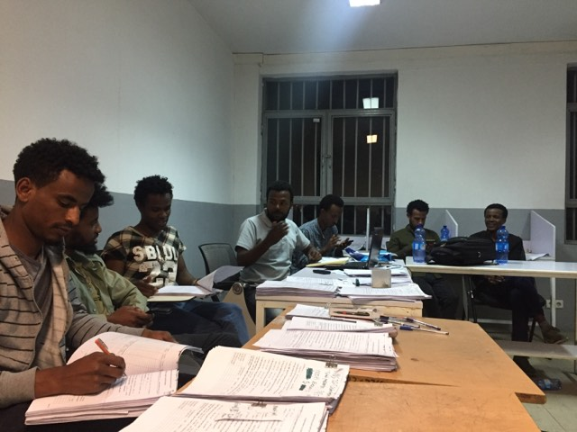
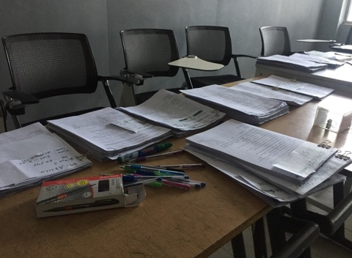
a
b

Annex 3.Example of properly attempted all the survey questionnaire
