ADDIS ABABA UNIVERSITY
College of Natural and Computational Science
Department of Zoological Science



Impacts of urbanization on productive farmlands: the case of farmland between Goro and Tulu Dimtu in Special Zone of Oromia Regional National State

By
Jeba Shubise

MSC Thesis

Addis Ababa, Ethiopia

ADDIS ABABA UNIVERSITY
College of Natural and Computational Science
Department of Zoological Science

Impacts of urbanization on productive farmlands: the case of farmland between Goro and Tulu Dimtu in Special Zone of Oromia Regional National State
By
Jeba Shubise

MSCE Thesis
Submitted to the Department of Zoological Science in partial fulfillment for the requirement of the Degree of Masters of Sciences in Biology

Advisor: Dr.Sutuma Edessa Addis Ababa, Ethiopia

Declaration
This is to clarify that the thesis prepared by Jeba Shubise, entitled: Impacts of urbanization on productive farmland and submitted in fulfilment of the requirement for the Degree of Master of Science in Biology complies with the regulation of the university and meets the accepted standard with respect to originality and quality.
Signed by Examining Committee:
Examiner____________ Signature_______ Date_________
Examiner____________ Signature_________Date_________
Advisor____________ Signature_________Date_________
Advisor____________ Signature_________Date_________

Table of content Page
List of figure v
List of Graph vi
Acronyms used in the text vii
Abstract viii
Chapter one 1
1. Introduction 1
1.1 Background of the study 1
1.2 Statement of the problem 4
1.3. Objectives of the study 5
1.3.1. General objective 5
1.3.2. Specific objectives 5
1.4 Research question 6
1.5 Delimitation of the study 6
1.6. Significance of the study 6
1.7. Limitation of the study 7
Chapter two 8
2. Review of related literatures 8
2.1The history of the urbanization process 8
2.3. World Urbanization trends 9
2.4.Causes of Urbanization 12
2.4.1 Immigration influx from rural areas 12
2.5 Impacts of Urbanization 14
2.5.1 Positive effects of urbanization 14
2.5.2 Housing problems 15
2.5.3 Overcrowding 15
2.5.4 Unemployment 15
2.5.5 Development of slums 15
2.5.6 Water and sanitation problems 15
2.5.7 Poor health and spread of diseases 16
2.5.8 Traffic congestion 16
2.5.9 Urban crime 16
2.3. Urbanization impacts on biodiversity 16
2.4 Urbanization process in Ethiopia 19
Chapter three 21
3. Methods of study 21
3.1 The study site 21
3.2 Research design and methods 21
3.3 Data collection instruments 22
3.3.1 Observation 22
3.3.2 Interview 22
3.4 Validity and reliability 23
3.5 Sampling techniques and Sample size 23
Chapter Four 24
4. Data Presentation and Evaluation 24
4.1 Data display 24
4.2 Data analysis 25
4.3 Data evaluation and interpretation 30
4.3.1 Impacts of urban extension on economy of farmers 31
4.3.2 Loss of (soil) land productivity 33
4.3.3 Challenges of urban expansion on social life of the community 33
4.3.4 Land grabbing without compensation 34
4.3.5 Impacts of urbanization on natural resource 34
4.3.6. Results 36
5. Summary, conclusion and recommendations 37
5.2 Summaries 37
5.2 Conclusion 37
5.3. Recommendations 38
Acknowledgement ...................................................................................................................... 1 38
6. References 40
Appendix 1 44
Appendix 2 45

List of table
Table 1 View of data sampling ................................................................................................... 23
Table 2 Background of the respondents...................................................................................... 24
Table 3 Land ownership of respondents .......................................................................................24
Table 4 Annual income of farmers before and after urban expansion .........................................24
Table 5 Responses on farmland loss with/without compensation ............................................... 25
Table 6 Compassion paid for farmers ......................................................................................... 25

List of figure

Figure 1 The study site .................................................................................................................21
Figure 2 View of station 1 data collection center .........................................................................26
Figure 3 View of station 2 data collection center ........................................................................ 27
Figure 4 View of station 3 data collection center ........................................................................ 28
Figure 5 View of station 4 data collection center ........................................................................ 29
Figure 6 view of station 5 data collection center ..........................................................................30

List of Graph

Graph 1 Livestock resources of the farmers before displacement ..............................................33

Acronyms used in the text

KM | Kilometers
FDI | Foreign direct investment
PAS | Protected areas
IDP | Internally displaced people
UNCHS | United Nations center of human settlements
UN | United Nations

Abstract
Recently, urban expansion is becoming problems in the sub-Saharan African countries as they are expanding without well planned urbanization. The aim of this study was to assess the impacts of urbanization on farmland in the study area. In the study area most of agricultural land has been converted to urban use and this has various implication on the farmers. Survey method of data collection through informant interviews and personal field observation was used to identify the challenges of urbanization on the farmers. Purposive sampling techniques were used. Both qualitative and qualitative method of data analysis was carried out. The finding of study indicated that before reclassification of their land the majority of the dwellers were use their land for agricultural activity. Generate high source of income from crops, fruit and vegetables. Urban expansion causes in declining of economic, social and physiological situations in the study area. Many of the farmers are not satisfied with compensation paid for them from concerned body. They are inadequate to replace their resource. Finally, the farmers have been victimized since they lost their fundamental pattern of life. Although it is impossible to stop urbanization it has to be ensured that the government should make careful planning prior to displacement.
Key words: Urbanization, urban sprawl, rural community, compensation

Chapter one

1. Introduction

1.1 Background of the study
Urbanization is the dynamic set of changes of landscapes from its original scenery to the required forms for the purpose of fulfilling ofsettlements or sedimentary plan. It is usually occupying new areas farm, range or forest land that are mostly useful for growing crops and other plant productions. Productive soils (Farm lands) are the same as grains in storages from the view of agriculture. Productive farm lands produce all cultivated crops that are the bases for grains to be consumed for food security.
In view of this forest lands, farm lands, range lands and other ecosystems may be changed to the new forms of settlements where building, houses roads and other infrastructures are occupying the lands and thus that area is no more used for farming. When farmlands are occupied by construction and houses, they put negative impacts on the bio-environment of landscapes and its original sceneries in many ways. When farmlands is ceased by urbanization, uses that farmers gain from the land is completely stopped and that lands no more produce grains, vegetables, fruits and other plants. Animals and plant species previously live in the area must disappear or die out. This means, that ecosystem loses all species and also have negative impacts on the local as well global environment.
As we begin to recognize the scope of human influence on biosphere it is important to understand how the specific forms of human induced land transformation affects the dynamics of the earth biological ecosystem. Human activities , rather than natural forces are the major sources of the contemporary changes in the state and flow of the biosphere .land transformation due to human activities have taken many forms , starting with the fire management, herding practices , development of agriculture and culminating with urbanization including industrial expansion. Land transformation is one of the most important fields of human induced environmental transformation. Land transformation did not decreased but rather accelerated and diversified with the onset of industrial revolution and globalization of the world economy and the expansion of population. Past studies of the biosphere estimate that about one /third to one /half of the earth‘s land surface has been transformed by human activities. Recent studies have shown that urban development is taking place on the most fertile and productive land. We need to understand what has urbanization underpinned in the past and it is bringing changes in the future. While their numerous issues that could be addressed concerning urban influences on the biosphere ranging from the conversion of land itself to a broader context of the ecosystem services required for the recycling urban metabolic by products . The food security and the loss in the agricultural products is the most distinct impact of the wide spread expansion of urbanization.
Urban expansion inevitably covers some agricultural land while changes in land values and land markets around cities often result in land left vacant as the owners anticipate the gains they will make from selling it or using it for non-agricultural uses. In most urban areas in low- and middle income nations, the absence of any land-use plan or strategic planning framework to guide land use changes means that urban areas expand haphazardly. This expansion is determined by where different households, enterprises and public sector activities locate and build, legally or illegally. In most instances, there is little effective control over land-use conversions from agriculture to non-agricultural uses. There may be regulations that are meant to limit this but these are often avoided by politicians and real estate interests (Hardoy , etal 2001). This unregulated physical expansion brings many serious consequences. These include the segregation of low-income groups in illegal settlements on the worst-located and the most hazardous sites (they would not be permitted to settle on better-located and safer sites) and a patchwork of high- and low-density land uses to which it is both expensive and difficult to provide infrastructure and services. Urban centers often expand over their nation's most productive agricultural land since most urban centers grew there precisely because of highly fertile soils. Most of the world's major cities today have been important cities for several hundred years, so they became important cities before the development of motorized transport (and later refrigeration) that reduced cities' dependence on their surroundings for food and other agricultural products. Of course fore prosperous cities, the demand for agricultural commodities has long-since gone far beyond what is or could be produced in their surroundings. They draw on large and complex global supply chains and have large ecological footprints, drawing on distant elsewhere‘for food, fuel and carbon sinks (Rees 1992). The dependence of many very large concentrations of urban populations on long international supply chains for food, fuels and most intermediate and final goods makes them vulnerable to disasters in locations that supply these or buy their products, and also to rising fuel prices.
However, the loss of agricultural land to the spatial expansion of urban areas is often exaggerated; one recent study suggested that only West Europe among the world's regions has more than 1 per cent of its land area as urban (Schneider et al. 2009). In addition, a declining proportion of land used for agriculture around a city may be accompanied by more intensive production for land that remains in agriculture (see Bentinck 2000) or intensive urban agriculture on land not classified as agricultural. In most locations, governments could and should restrict the loss of agricultural land to urban expansion. But this can also bring serious social consequences if it pushes up land and house prices and reduces still further the proportion of households that can afford a legal housing plot with infrastructure.
Approximately 25 per cent of the world's terrestrial surface is occupied by cultivated land (Cass man et al, 2005). Urban growth is more likely to reduce arable land availability if it takes place in this zone. But an analysis of the percentage of urban and rural population in the cultivated zones in each region found no evidence of urban populations concentrated in cultivated zones (Balk et al, 2008).
Of course, the expansion of urban land uses is not just the result of urbanization but also (in most cities) of natural increase and of declining urban densities (Angel et al, 2005). Since urbanization entails fewer rural people as well as more urban people, it may reduce rural building and so, in part, counteract the effects of urbanization expanding over cultivated land. Urbanization, the urban expansion may involve both horizontal and vertical expansion of the physical structures of urban areas. It result in loss of natural beauties, farmlands and sceneries (Melese, 2004).According to the world urbanization prospects reported by United Nation(UN,2012) from 1965 to 210,the global population increased from 3.3 billion to 6.9 billion and the total population expected 9.3 billion by 2050.Along with population growth, more and more people close to live urban areas. The percentage of world population residing in urban areas increased from35.5% in 1965 to51.6 % in 2010 and this number reach at 67% in 2017(UN,2015).
Although the level of urbanization in developing counties is low, its rate of expansion is the fastest in the world. Approximately 25% of African population lived in towns and cities 1975.In 2000, 38% of the continents population lived in urban areas and the proportion is expected to increase to 49% by 2017 and to be double by 2050 (Thou, 2010).Many studies revealed that urban expansion is becoming a big challenges in sub-Saharan African countries as they are expanded without well planned urbanization. The urban population in Ethiopia is increasing rapidly. If they are managed proactively, urban population growth presents a huge opportunity to shift the structure and location of economic activity from rural agriculture to the larger and more diversified urban industrial and service sectors. If not managed proactively, urban expansion may pose a demographic challenge as cities struggle to provide jobs, infrastructure, services, housing and others. The major effects contributing for the rapid urban expansion in Ethiopia are higher population growth, rural to urban migration and horizontal urban development (Fekadu, 2015).
This expansion has its own negative impacts on productive farm lands in various ways. Koyye facce is one of rapidly expanding area in the Oromia special zone due to urbanization practice. The economic bases of the people live in these areas are rain fed farming and free range livestock rearing. Using farmlands are the main livelihood activity. Urban expansion has been its own challenge on the livelihood of the surrounding productive soils. Thus, the aim of the study is to investigate the impacts of urbanization on productive farm lands; by taking Koyye facce as a case study, Oromia Reginald National State in Ethiopia.

1.2 Statement of the problem
Urban expansion is a continuous process that leads to spontaneous growth by displacing indigenous farming community. Even planned displacement has its own negative effects on the original people in the area.
Urbanization is rapidly increasing in developing country due to rapid growth rate of population and changes in human settlement preferences. It is accelerated by the influx migration of unemployed or income less people to cities, particularly to Addis Ababa as a capital. Emigrants to the capital from different direction come to settle in the center and again move to the suburb or outskirt for search for work or employment opportunities. They reside or start works as daily works and thinking that they need their own home where to reside and establish the so-called
Chereka houses built at night in the absence of day light using branches, bushes and mainly tent like plastic covered shelters on farmlands owned by the aborigine Oromo people..
In view of urbanization program coined to the so-called master plan, new condominium houses are continuously in construction for decades to accommodate the population growth of the capital, which is increasing in an alarming rate.
The expansion of the capital to the surrounding areas called Oromia special zone is continuously at an alarming speed the fertile farm land of the area are shrinking and as a result the owner of the farmlands were displaced (dismantled) from homesteads.
Among outskirt areas of Oromia Special Zone, the new road from Goro square to Tullu Dimtu (about 20 km) crosses newly established condominium houses and fragments of dismantled farmlands and some remaining of house hold homesteads standing still.
Obviously, along the road sides, it is a mosaic of landscape showing small grass covered farmers houses, variety building structures, farmlands, and grass lands, rangelands with cattle grazing, crops and residues of farm harvests. Among the road lines from Goro square to Tullu Dimtu, Koyye Facce area is where protests against the expansion urban on farm land was the issue requiring investigations.
According to (Samuel 2006), the Ethiopian urban centers are expanding in unexpected rate resulting to peasant displacement with concominated loss of agricultural lands, loss of agricultural production and change of livelihood.
Conversion of agricultural land to nonagricultural lands is the big issues in the study area. Such trend is very tangible in study site and it was not rigorously investigated. Urban sprawl increases land transformation in to urban uses for different purposes. This reduced the farm lands, exposes original community in to insecure livelihood and leaves farmers landless.
Therefore land dispossession and eviction are the main challenges of urbanization process in the study area anddetail of these impacts were not specifically studied in this area. So this study was conducted to address this gap.

1.3. Objectives of the study

1.3.1. General objective
The general objectives of the study are to investigate impacts of urbanization on productive farm lands areas and recommend solutions.

1.3.2. Specific objectives
The specific objectives of the study are to:
- Identify impacts of urbanization on productive farmlands in the study Area.
- Assess the major impacts of urbanization on productive farmlands in Study site.
- Indicate the serous impacts of urban process on farmlands and natural resource.
- Explore challenges of urbanization on economic and social life of the community live in the study area.
- Evaluate impacts of urbanization led to land dispossession on the local community.
- Describe impacts of urbanization on the consecutive life of people in study area.

1.4 Research question
The following research questions were set to lead the research.
- What are the basic principles of urbanization plan on farmlands?
- Is the roadside from Goro to Tullu Dimtu in the cadastral plan for urbanization?
- Was displacement of farmer compensated and ensured in the destined resettlements?
- What are the impacts of urbanizations on farm land and farmers?
- What are the possible solutions?

1.5 Delimitation of the study
This study was limited geographically, thematically and methodologically. Geographically, this study emphasis on the study of rural farmers found surrounding Koyye facce who are affected by urban expansion.
They areas have been expanding due to urban process. The scope of this study is limited to assess impacts of urbanization on indigenous farmers especially on economy, natural environment, social, infrastructures and their farmlands. To make it agreement to hold that the study in time and coverage it focused on people lived in the area. The study used the survey method in the collection of data were interview questionnaires and field observation are mostly used.

1.6. Significance of the study
In developing country like Ethiopia urban process, is one of the big issues to be addressed. That is why currently scholars, partners and other stakeholders have given due attention on the theme. The study area is undergoing the fast urban expansion day-today. This has been not studied significantly by many researchers. Therefore, this study attempts to fill this gap by assessing the impacts of urbanization on farmlands.
Generally, this study is expected have the following significance:

- Provide possible recommendations for solutions in the study area.
- Helps to forward some result to surrounding peasant who are affected directly or indirectly urban process in the area.
- Provides information for those who will like to conduct detail studies on impacts urbanization on agricultural lands.

1.7. Limitation of the study
Shortage of time and limited network connection to down load useful image are some challenges that are facing the researcher throughout the course of study. Another limitation of this study was the reactance of respondent to give reliable information about interview questionnaires the asked and absence of well documented file of the study area from located town.

Definition of technical terms
Urbanization: Refers to the population shift from rural areas to urban areas, the gradual increase in the proportion of people living in urban areas and the ways in which each society adopt to this change. It is predominantly the process by which towns and cities are formed and become larger as more people begin living and working in central areas.
Urban: Are areas characterized by denser population settlement per unit of lands, higher heterogeneity in habitats and organizational complexity as well as higher formal social control.
Livelihood: A Set of activities performed to live for a given lifespan.
Urban sprawl: The extension of the attentiveness of people of urban settlement to the sounding area whose function are nonagricultural.
Indigenous community: Are ethnic group who are original settlers in a given region, in contrast to group they have settled, occupied or colonized the area more recently.
Compensation: Is a means of payment for the property that is expropriated by the respective executing body of government both either in cash or kid.
Peripheral farming community: Is the agricultural community in rural settlement pattern to which urban set elements expands.
Rural settlement: A sparsely populated community that exists in the country, away from densely populated urban center.

Chapter two

2. Review of related literatures

2.1The history of the urbanization process
In the early Neolithic days settlement towns were associated with improvements in agricultural productivity, in particular the introduction of hard grains which not only produced higher yields than the available traditional crops but also had the advantage of long storage life. Thus fewer farmers were able to feed more people. The population evolved from hamlet living towards higher population densities, to more city oriented living. City growth was limited by the capacity of the surrounding agricultural land to produce food, and an adequate water supply (Mumford, 1956).
Modern urbanization is mainly based on higher productivity which comes from industrial and service sector activity. The pull factor’ such as, higher job or income opportunity motivate people to move from rural to urban areas. However, even if a country is highly urbanized and produces good amount of urban production, a good amount of its labor force has to remain in rural areas unless agriculture can provide the necessary productivity gains to feed the urban population (Tolley and Kripalani, 1974).
The lack of transport for mass produce movement over long distances meant that the most intensive and productive agriculture took place just outside city walls, fertilized by urban waste. Urban growth could be seen as balanced with the surrounding agricultural community. At the dawn of the twentieth century large portions of the fruits, vegetables and other perishable commodities consumed portions in New York and Paris were near on soils fertilized by urban refuse (Kropotkin, 1899).
The second stage of urbanization occurred with the development of river and sea transport and the building of roads. This enabled cities to expand beyond the agricultural capacity of the hinterland, and set up a pattern of trade and specialization in agricultural products between more distant areas. While the first stage of urbanization was marked by balance with the surrounding rural community, urban areas could now become more dominant as centers of trade. A more exploitative relationship of the local resource base was underway. Rural areas were seen as a source of both natural resources and labor.

2.3. World Urbanization trends
Half of the world's 6.7 billion people are expected to live in urban areas by the end of 2008. The world population is expected to increase by 2.5 billion by 2050, to 9.2 billion. By that time, urban population will be expected to rise from nearly 3.4 billion in 2008 to 6.4 billion in 2050. The urban regions thus will absorb most of the world's population increase in the next four decades while drawing on some of the rural population as well. There will be 600 million fewer inhabitants in rural areas by 2050.
As with the general population growth, most of urban increases will take place in developing and less developed countries as opposed to developed nations, in which 74 % of population already live in big cities and towns. (Revision of 2007 World Urbanization Prospects report, UN). Urban population globally grew 90% between 1975 and 2000 and is projected to grow at 73% 20002025. The declining growth rate reflects both a decline in overall population growth rates and that the base to which growth in 2000 was applied was already very large. However the magnitude of the urbanization challenge in the developing countries is surely as much about the sheer magnitude of numbers as the growth rate. Urban population in developing countries increased 1.2 billion between1975 and 2000 and is projected to increase by 2.0 billion in 20002025, doubling the developing country urban population in just 25 years. (The 1996 Revision of the Urbanization prospects, UN)
The report also indicated that in mid-1995, 2.6 billion people, or 46% of the world‘s population were urban dwellers. This sector of the population is growing at a rate three times higher than the rural population such that just after the turn of the millennium over 50% of the world‘s population will be urbanized. By 2025 this proportion will have increased to 60%.
As the world population becomes increasingly urban, the balance of rural and urban populations between the developed and developing world is shifting. In 1950 just 20% of the population in less developed regions resided in urban areas compared to more than 50% of the developed world. In 2000, these proportions increased to more than 40% urbanized for the developing world and about 76% for the developed. By 2025 it is projected that about 57% of the developing world‘s population will live in urban areas compared to around 84% of the developed world. By this point almost all new urban dwellers added to the world‘s population will come from developing countries. These show that the underlying rate of urbanization is now faster in the developing world than the developed.

Urbanization process in Africa
The average urbanization rate for Africa is 4.87% compared to 2.57% for the whole world. (Mwaura, 2002). The population is growing rapidly-almost twice as fast as the other regions of the world. Although African fertility has started to fall, the total population of the region will continue to increase: from 794 million in 2000 to 1.489 billion by 2030. Approximately, 70 percent of this growth will take place in African cities and towns. By 2025, African society will become predominantly urban. Africa‘s urban population is projected to more than double, from 295 million in 2000 to 748 million by 2030 so that within 25 years, Africa‘s urban population will be larger than that in North America, Europe, or Latin America. (UNCHS (Habitat)‘s ‗The State of the World‘s Cities: 2001)
It is expected that by 2025 more than half of the world‘s population will be urban. In addition, the urban population is expected to be growing at almost 2 times the general population in the next 50 years.
Due to the explosive population growth in developing countries, the majority of them face tremendous challenges to provide a decent living standard for all. Countries in the Sub Saharan Africa for example, are witnessing world's fastest increase in population. Kenya for instance, needs only 17 years to double its population. Kenya's major cities are even growing faster with a typical yearly increase of 10%. Nairobi city has about 5 million inhabitants.
Natural increase is estimated to be a more dominant factor in the increase in urban populations in many African countries compared to migration (Pott D, 201200). Urbanization projection indicate a slowing rate in Africa from the 1990s high rates of up to 8% down to a range of 1.9%−2.2% from 2020−2050, with significant variation across its countries (African Economic outlook, 2016). The total population in the continent is projected to reach almost 2.5 billion people by 2050 with population resided in urban areas in 1950. Most of the increase in urban population is taking place in small- and medium-sized cities in mid-latitudinal Africa. The negative impacts of urbanization are evidenced in the expanding haloes of deforestation around cities and transportation routes (Abernethy etal., 2016). Such exploitation of natural resources in expanding waves, progressively from the most highly valued to less, is observed both in large cities and around smaller settlements (Mayaux etal, 2013). Pre-urban agriculture, though important for food security in many Sub-Saharan African countries, can also contribute to loss and degradation of habitats around cities. Environmental degradation spreading out from an urban center can be significantly enhanced in both speed and intensity depending on the state of the transportation network (RudetTket et al, 2013). In the near future, the regions that may experience such degradation most rapidly and extensively are eastern and southern Democratic Republic of Congo and southern Cameroon, due to their high rural population densities and high foreign demand for their agricultural lands (Abernethy etal, 2016).
Ethnic conflicts and civil wars, some of which have been going on for decades, also influence urbanization in several parts of the continent. Such conflicts, as an underlying driver of urbanization, have arguably the most prominent influence on the biodiversity in central African countries (Abernethy etal, 2016). The challenges faced by habitats in pre-urban areas around major cities can be intensified to the extent that refugees and internally displaced people (IDP) settle in informal settlements around the peripheries of these cities (McDonald, 2016). In particular, in East Africa and the Horn of Africa, an increasing number of refugees and IDP are living in cities (Statics of Botswana, 2017). All these add to the challenges faced by the governments of these cities. Furthermore, what has started as a temporary camp for refugees and IDP may morph into urban areas over time whose demand for natural resources such as fuel wood, building materials, fresh water, and wild foods can be immense and result in significant local environmental degradation (UNHCR, 20012).Influences external to the continent too play significant roles in shaping the impact of the urbanization on the biodiversity and ecosystems. Some of these are financed by FDI from countries outside Africa, i.e. increasingly from China, India, Malaysia, and Brazil in addition to Europe and the USA that have been historical sources of FDI to the continent (McGranahanG etal, 2009). In recent years, investment from another rapidly urbanizing country, China, has been an important source of funding for infrastructure projects in the continent. How to ensure that such investments facilitate industrial diversification and urban development on the continent without accelerating the decimation of Africa's ecosystems is an outstanding challenge (McGranahanGetal, 2004). Demand for animal parts as food, as ornament, or medicine has also been on the rise with the increasing levels of income and integration with global markets in those countries where such demand originates. These influences interact with those internal to the continent to shape patterns of, not only urbanization, but also, habitat degradation, loss, and fragmentation (Andersonetal, 2013)

2.4. Causes of Urbanization

2.4.1 Immigration influx from rural areas
Rural-urban migration is the movement of people from rural areas to urban centers in search of employment and better living conditions among others. Rural-urban migration is prevalent in developing countries with its degree varying from country to country. Rural-urban migration influences urban growth with expansion of cities and towns covering greater land. As a result of rural-urban migration there is urbanization referring to increase in proportion of people‘s living in cities and towns. Rural-urban migration is facilitated by pull and push factors that forces people influx from countryside to cities. Push factors may include drought, famine, natural disaster, poor living conditions like housing, healthcare and education, agricultural change, unemployment, war and conflict. Pull factors include employment, higher incomes, better healthcare and education, urban facilities and way of life and protection from war and conflict (Goldscheider, 2005).
Cause of Rural-Urban Migration Costs of rural-urban migration outweighs benefits resulting in expansion of cities and towns thus excessive urbanization. Urban planners and decision makers are more concerned with causes and consequences of rural-urban migration and their relationship with economic growth and urbanization. Although rural urban migration is an integral part of development it is significant for people to understand its causes and consequence for formulation and implementation of effective policies to encourage economic growth. Issues faced in rural areas trigger people‘s migration to urban areas. Those people living in rural areas are willingly and unwillingly part of the economic system. Movement of people from rural areas to urban center is triggered by voluntary and involuntary forces. Involuntary are the factors that force people to migrate with no choice but to move this are the push factors. Voluntary forces covers all people‘s migration by will, this are the pull factors (McCatty, 2009). Migration Forces People may involuntary move from rural to urban areas as a result of family disagreements, wars, conflicts, draught, famine and political strife. This factors forces people to seek refuge in urban areas where they can have access to security, food and far from political strife. Voluntary factors such as better employment opportunities force people to move to urban areas. The quality of employment in urban areas is better than in rural. In rural areas people have little education and their payment is low. Those who have migrated to urban areas have gained incentives through better and well-paying jobs. Housing conditions in rural areas is worse compared with urban areas; people may voluntarily decide to move to urban areas to have access to better living conditions such as better healthcare, better education and housing (McCatty, 2009).
Rural land tenure and pattern of inheritance is another factor resulting in voluntary rural urban migration. This cause problem if land tenure is communal whereby you find that land is owned by group of people thus individual having no authority to protect or own the land. This cause conflict during land sharing forcing many people to be landless thus opting to move to urban centers. Rural social structure and cultural values may cause conflict among rural population forcing some people to move to urban areas. Different ethnic communities have different cultural values and social structures which may differ resulting to cultural conflicts thus people‘s migration to urban areas where they can‘t experience cultural conflicts. Rural people when offered with better options of earning living which are not demanding like rural farming and which is more financially rewarding, they are likely to accept. Depending on the country, farming gives seasonal employment with no enough income to sustain rural people thus being forced to move to urban areas in search for better and well-paying jobs (McCatty, 2009).Issues faced in rural areas change in educational system as a result of what is being taught in school vary from their traditional norms. In rural areas, cultural values and norms undergo changes due to influence from foreign entities and missionaries. In rural areas people experience low and high global economy due to drop of prices thus their sustainability being influenced. During economic recession they are the first people to be affected. This triggers their movement from rural to urban for search of better opportunities. People in rural areas are exposed to films, radio programs and recent television series from cities. When exposed to this urban life, their living conditions decline due to exploitation of resource in need of living like those in urban areas. Many people are not able to cope with this situation in rural areas and they opt for urban areas where they can have better life with access to all these facilities. Living condition for most rural people have changed for better with improved medical care, improved health and longevity which has contributed to increase in population in rural areas thus pressure on the limited resources. These forces some people especially young incase the land ownership in the rural was communal they move to urban centers where they can be accommodate without congestion.
Influence by outside developed world on people‘s culture and way of life contributes to people‘s movement to urban areas. Media influence has made people recognize their state of poverty. This has made people think of change and they think the only option to move to urban center for white collar jobs and better living conditions. People perception of better life changes their success in rural areas; people have changed their notions about educations and holding higher positions. This has facilitated people movement from rural area to urban in search of better education which can lead to higher incomes thus increasing their future income. Increase in income increases people‘s consumption. People believe that by having firsthand accounts their living conditions will be improved in urban areas .Poverty is experienced globally in third world nations especially by rural population. Developmental policies in various countries are more concerned with poverty alleviation resulting to economic growth. Most people in developing nation live under poverty with urban poverty being constant with majority living in rural areas. In those countries with agricultural based economy, those residents who are poor lack access to resources thus high level of inequitable and inequality distribution of resources. Most people living in rural areas are women and children who practices subsistence farming. Poverty contributes to people’s movement from rural to urban areas in search of better and well-paying jobs to alleviate poverty .In addition to this urbanization in study area are grasping the land of the farmers and expose them to limited economic sources. Urban Informal Sector Unlike the formal counterpart of urban informal sector, there are activities of all kind which are unregulated and small scale in nature. Most people in urban areas create their own employments, start their businesses and even work as a small-scale family enterprise. These jobs includes, street vending, hustling, sharpening of knife, drug trafficking, maize roasting and even prostitution. Government policies to some extent cause rural urban migration. Those policies supporting disproportionate increase employment opportunities and in wage rate in urban centers leads to imbalances in rural urban landscape. Rural urban migration contributes to increased rate of unemployment in urban areas.

2.5 Impacts of Urbanization

2.5.1 Positive effects of urbanization
Urbanization yields several positive effects if it happens within the appropriate limits. Some of the positive implications of urbanization therefore include creation of employment opportunities, technological and infrastructural advancements, improved transportation and communication, quality educational and medical facilities, and improved standards of living. However, extensive urbanization mostly results in adverse effects. Below listed points are few of them.

2.5.2 Housing problems
Urbanization attracts people to cities and towns which lead to high population increase. With the increase in the number of people living in urban centers, there is continued scarcity of houses. This is due to insufficient expansion space for housing and public utilities, poverty, unemployment, and costly building materials which can only be afforded by few individuals.

2.5.3 Overcrowding
Overcrowding is a situation whereby a huge number of people live in a small space. This form of congestion in urban areas is consistent because of overpopulation and it is an aspect that increases day by day as more people and immigrants move into cities and towns in search of better life. Most people from rural or undeveloped areas always have the urge of migrating into the city that normally leads to congestion of people within a small area.

2.5.4 Unemployment
The problem of joblessness is highest in urban areas and it is even higher among the educated people. It is estimated that more than half of unemployed youths around the globe live in metropolitan cities. And, as much as income in urban areas is high, the costs of living make the incomes to seem horribly low. The increasing relocation of people from rural or developing areas to urban areas is the leading cause of urban unemployment.

2.5.5 Development of slums
The cost of living in urban areas is very high. When this is combined with random and unexpected growth as well as unemployment, there is the spread of unlawful resident settlements represented by slums and squatters. The growth of slums and squatters in urban areas is even further exacerbated by fast-paced industrialization, lack of developed land for housing, large influx of rural immigrants to the cities in search of better life, and the elevated prices of land beyond the reach of the urban poor.

2.5.6 Water and sanitation problems
Because of overpopulation and rapid population increase in most urban centers, it is common to find there are inadequate sewage facilities. Municipalities and local governments are faced with serious resource crisis in the management of sewage facilities. As a result, sanitation becomes poor and sewages flow chaotically, and they are drained into neighboring streams, rivers, lakes, or seas. Eventually, communicable diseases such as typhoid, dysentery, plague, and diarrhea spread very fast leading to suffering and even deaths. Overcrowding also highly contributes to water scarcity as supply falls short of

2.5.7 Poor health and spread of diseases
The social, economic and living conditions in congested urban areas affects access and utilization of public health care services. Slum areas in particular experience poor sanitation and insufficient water supply which generally make slum populations susceptible to communicable diseases. The environmental problems such as urban pollution also cause many health problems namely allergies, asthma, infertility, food poisoning, cancer and even premature deaths.

2.5.8 Traffic congestion
When more people move to towns and cities, one of the major challenges posed is in the transport system. More people means increased number of vehicles which leads to traffic congestion and vehicular pollution. Many people in urban areas drive to work and this creates a severe traffic problem, especially during the rush hours. Also as the cities grow in dimension, people will move to shop and access other social needs/wants which often cause traffic congestion and blockage.

2.5.9 Urban crime
Issues of lack of resources, overcrowding, unemployment, poverty, and lack of social services and education habitually leads to many social problems including violence, drug abuse, and crime. Most of the crimes such as murder, rape, kidnapping, riots, assault, theft, robbery, and hijacking are reported to be more prominent in the urban vicinities. Besides, poverty related crimes are the highest in fast-growing urban regions. These acts of urban crime normally upset the peace and tranquility of cities/town.

2.3. Urbanization impacts on biodiversity
Africa has several regions with exceptional biodiversity (Mittermeir etal, 2004) and is dotted with protected areas (PAs) with varying levels of protection status. The PAs cover an area of about 4.5 million km2 across the continent (BrooksTM etal, 2016). As recently as 2000, Africa was sparsely urbanized with only about 500 km2 of urban land within the boundaries. In contrast, by 2030, total urban extent within 50 km of PAs on the continent is expected to reach more than 140 000 km2. In mid-latitudinal Africa, the nearly 20 fold increase in urban extent, the largest forecasted proportional increase in the vicinity of PAs across the world (GuneralB and Setoke,2013), will pose especially acute challenges for governance and management of PAs and the surrounding lands in this region.
While large urban centers such as Nairobi, Kenya and Ibadan, Nigeria dominate the continent's urban expansion patterns, the ecological impacts of the smaller cities and towns across Africa are also considerable. This is even the case for smaller cities such as Gaborone and Windhoek, the capitals of, respectively, Botswana and Namibia. Both cities are located in resource-poor areas and experience recurrent severe shortages of water (NU2014). Gaborone, with a population of 232 000 in 2011 (Static of Botswana, 2017) relies, in part on water supplied from the Letsibogo
Dam on the Motloutse River, via a 400 km long pipeline. An extension of this North–South Water Carrier is planned that will bring waters from the Zambezi River—about 500 km from Gaborone—to the relatively small but growing city. Such long-distance water transfers are likely to become more widespread as growing cities in Africa will seek new sources to meet their increasing demand for water (ShowerKB, 2002).
It is often assumed that migration from rural to urban areas and the resulting concentration of populations in cities would ease the pressure on natural habitats. In many parts of Sub-Saharan Africa, the migration and subsequent concentration of people in urban areas has indeed reduced rural populations, thus leading to reduced rates of deforestation (RudelTK, 2013). However, land speculation by wealthy urban residents has also driven abetted by lack of land-use planning and control loss and fragmentation of rangelands close to cities and towns in Ethiopia, Kenya, and Uganda (FlintanF, 3011). In Western Africa, the increased demand for food in the cities has incentivized farmers to convert forests to agricultural fields to meet this demand (Andersonpletal, 2013). These examples suggest that any relief from pressure on habitats from rural–urban migration may be overtaken by the increased demand for food and other natural resources from rapidly growing African cities. Furthermore, there are many instances of increasing deforestation in spite of a rise in a country's urbanization level as more complex outcomes of rural–dynamics—often involving long-distance actors start to play more prominent roles (MolinaG etal, 2015). Importantly, there has been significant foreign direct investment (FDI) aimed at land purchases in the continent to help secure food production for urban residents in other parts of the world (WauterseFetal, 2011). Therefore, conclusive evidence on ecological urban migration on the continent is yet to materialize (Andersonpletal,2013).
Urbanization and economic development also drive expansion of the transportation network, which in turn often fragment habitats. Of particular concern in the context of biodiversity conservation are the road and railroad infrastructure. Across Africa, there are 33 major development corridors, either proposed or already under construction (Laurence, etal2015). If and when constructed, the road and railroad infrastructure in current plans would cut through over 400 PAs and could degrade about 2000 more. Moreover, large-scale changes in transportation networks such as the one proposed around the Serengeti may significantly influence future urban expansion patterns potentially increasing the vulnerability of the PAs in that region (DobsonAP,etal 2010).
Another example for the far and wide-reaching impact of urban residents is the bush meat trade (ZieglerWF,etal 2016). Demand for bush meat, a traditional source of animal protein for humans in much of Sub-Saharan Africa is on the rise fueled by dietary preferences of urban residents that are shaped by a combination of urbanization and increased-income effects (BrasharesJS,etal 2011). It is shown that the high levels of human density, characteristic of urban and pre-urban areas, are negatively correlated with bush meat from ungulates and primates sold in markets. However, the bush meat trade is also linked to rural livelihoods (ACET, 2014). Therefore, measures such as blanket bans are likely to be an ineffective approach to address this complex issue; a more balanced approach that safeguards sensitive species as well as the livelihoods of people that rely on bush meat trade, and one that recognizes the role of bush meat in providing nutrition to millions of people along the urban-rural spectrum is needed.
The conversion of earth‘s land surface to urban uses is one of the most irreversible human impacts on the global biosphere. It hastens the loss of highly productive farmland, affects energy demand, alters the climate, modifies hydrologic and biogeochemical cycles, fragments habitats, and reduces biodiversity (Seto, etal2011) we see these effects on multiple levels. Future urbanization will, for example, pose direct threats to high-value ecosystems: the highest rates of land conversion over the next few decades will likely take place in biodiversity hotspots that were relatively undisturbed by urban development in 2000 (Seto, etal2012). Within cities, the nature of urban growth is also an important determinant of urban dwellers‘vulnerability to environmental stress (Güneralp and Seto, 2008).
The environmental impacts of urban expansion reach far beyond urban areas themselves. In rapidly urbanizing areas, agriculture intensifies on remaining undeveloped land and is likely to expand to new areas, putting pressure on land resources (Jiang et al, 2013). Furthermore, urban areas change precipitation patterns at scales of hundreds of square kilometers (Kaufman et al, 2007). Urban expansion will affect global climate as well. Direct loss in vegetation biomass from areas with high probability of urban expansion is predicted to contribute about 5% of total emissions from tropical deforestation and land-use change (Seto etal, 2012).
The scope and scale of these impacts is yet to be fully researched. Although many studies have described how urbanization affects CO2 emissions and heat budgets, effects on the circulation of water, aerosols, and nitrogen in the climate system are only beginning to be Understood (Seto & Shepherd, 2009).

2.4 Urbanization process in Ethiopia
The history of urbanization in Ethiopia goes to back the Axum civilization. During this time there were a number of towns, commerce had flourished countries. Later, this urban culture began to shift Labella and Gondar, However, the development was also facing the some rate of urbanization of expand (UN, 1969). Pattern and trend of urban growth in Ethiopia, being the third popular country in Africa is one of the least urbanized. Its urban population constitutes 15% like most developing countries. Ethiopia, urban population is concentrated in one primate city of Addis Ababa representing 28.4% of the total urban population (Fessusu and Detachew, 2002). At national level, the level and trends of urbanization indicates significant regional variation. For example Addis Ababa (28.4%) Amhara 17.32%) Oromia 17%, SNNPR 15.2%, Tigray 15.2% and Gambela 9.62% respectively. Addis Ababa at 100% of urbanization is most urbanized and urban population in a country and Gambela has the lowest urban population the average mean of 9.6% (CSA, 2008). Ethiopia is currently of the least urbanized countries in the world even Africa. Less than one person in five is city or town dweller. However, the rate of at which the countries urban areas the growing are among the highest in Africa. Many social, economic and environment problems have accomplined urbanization in Ethiopia and have been ignored for too long (Girma, 2004). The people residing in urban areas also increasing from 4-3 million in 1987 to 7-4 million in 1994, which is estimated to have already reached 10-6 million in the year 2003 and projected to reach 20 million by the year 2020 (NUPI, 200).
Changes that are considered as opportunities include employment creation, access to urban infrastructures and social services, and urban-rural linkages or trickledown effect of development.
However, in Ethiopia urban expansion programs are neither participatory nor supportive to farmers in periphery and thus have negative impact on people livelihood where women and youth are the major victims (Fayera, 2005). Rural communities around the city faced the problems of socio-cultural, economic challenges, environmental deterioration and land tenure insecurity. Moreover, the non-farm based economic sector was not developed to absorb displaced farming communities (World Bank, 1993).
Therefore, the non-integrative type of urban expansion or development induced displacement has negatively affects those marginalized rural communities and forces them to live in poverty, food insecure and hopelessness.

Chapter three

3. Methods of study

3.1 The study site
The study was conducted along the new roadside from Goro to Tulu Dimtu on 20 km distance between the points across the farmlands and newly built condominium houses found in Galan District of Oromia Regional National State.

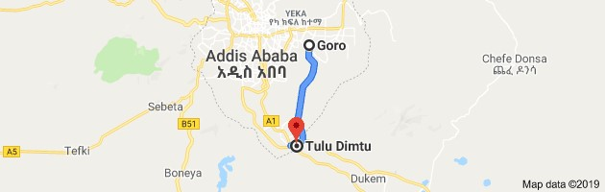

Figure 1 The study site
The aborigine dominant people found in the study area are the Oromo people whose main occupation is farming in order to live. The area is at present occupied by condominium houses and other infrastructure buildings as a result of extension of urbanization in connection to the capital city. This conditioned that the aborigine Oromo farmers are suffering from land grabbing and lost all so that the issue derived the researcher to select the area as a study site.

3.2 Research design and methods
Both quantitative and qualitative methods of data evaluations were used. A total population of 20 householders (farmland owner farmers) was purposely selected from five stations along the road side between Goro and Tulu Dimtu assuming that each data collection station represents the distance interval of 4 kilometers
Survey and observation methods were administered to collect information from selected stations.
It was designed collect evidence through observation of newly built housing condominiums and infrastructure constructions as well as industries on farm lands and the living conditions of dismantled and some remaining farmers, their situation in income generation, food sources and means of survivals.
Interview was conducted to gather information from household farmers and newly settled individuals primarily from sampled household correspondingly.
It means for all data collection tools, doubled data were collected (1) from selected 5 householder farmers residing along the roadsides and (2) from 10 informants who have been displaced to other places that the researcher reached their new placement area and collected data.

3.3 Data collection instruments
In order to collect data of the study, observation and interviews were used. Observation checklists were prepared and used to conduct field survey in all five stations systematically and supported through pictures (pictorial evidences).
Interview questionnaires were prepared for selected sample in English language and then translated in to Afaan Oromo for the purpose of asking. Ground truth data‘s on the field were collected by direct observation on the selected areas for the study. The study on challenges of urbanization on farmland were conducted from April to June 2019.Data were collected through structured interview and personal field observation. During this field notes and the pictures of each station are designed.

3.3.1 Observation
Ground truth data on the field were collected by direct observation on the selected areas for the study. The researcher observed and collected the necessary information though cameras from each stations of urban expansion. To get accurate data the researcher were observed the study area in details and used field notes to register each point. Observation checklist was used to conduct field survey systematically.

3.3.2 Interview
The structured interviews were designed and the respondents should be informed about study in details and their ethical consideration was ensured. Interviews were addressed issues regarding the overall impacts of urbanization on farm land in the study area. Questionnaires are prepared and verbally administered questionnaires are asked for each sample selected in the stations. The productive interviews are conducted according to suitable for participant and respondents. The researcher was used different skills and techniques to collect effective data from respondents. Field notes were used to register ideas about the interview at each stations selected for the study. At the end of the interview the investigator gives thank to respondents for their positive interaction, time consuming and giving guanine response.

3.4 Validity and reliability
The validity and reliability outcomes of this study report were ensured as much as possible by taking the following precautions. To increase the strength of conclusion qualitative data were used. Consulting knowledgeable person on issues that require expertise and cross checking information was obtaining through interviewing with information gathered from local community and published materials.

3.5 Sampling techniques and Sample size
In the realization of this study, a purposive sampling technique was used to assure selected samples of targeted group. To gather depth information and more reliable evidence about impacts of urbanization on farmland specific people within population are selected by investigator.

Table 1 View of data sampling
Goro | Station | Station | Station | Station | Station | T. Dimtu
 | 1 | 2 | 3 | 4 | 5
 | 4  Householder | 4  Householder | 4  Householder | 4  Householder | 4  Householder

Chapter Four

4. Data Presentation and Evaluation

4.1 Data display

Table 2 Background of the respondents

Family size | Frequency | Percentage
0-4 | 6 | 30
5-8 | 8 | 40
9 and above | 6 | 30
Total | 20 | 100

Table 3 Land ownership of respondents

Land ownership | Respondents | Percentage
Yes | 20 | 100
No | 0 | 0
Total | 20 | 100

Table 4 Annual income of farmers before and after urban expansion
Before urban  Grains/Q. | Respondents | Percentage | After urban grain/Q | Respondents | Percentage
Below 5 | 4 | 20 | Below 5 | 10 | 50
6-11 | 6 | 30 | 6-11 | 5 | 25
12-17 | 9 | 45 | 12-17 | 5 | 25
18-23 | 1 | 5 | 18-23 | 0 | 0
Above | 0 | 0 | Above | 0 | 0
Total | 20 | 100 | Total | 20 | 100

Table 5 Responses on farmland loss with/without compensation

Land loss or not | Respondents | Percentage
Yes | 14 | 70
No | 6 | 30
Total | 20 | 100

Table 6 Compassion paid for farmers

Compassion paid for farmers | Number respondent | of | Percent
Yes (money) | 8 |  | 40
No (home land) | 5 |  | 25
Missing system | 7 |  | 30
Total | 20 |  | 100

4.2 Data analysis
In (table 2) shows that the sample of household respondents indicates 30% of farms was range between 5-8 family sizes in the study area. From this we understand that, the majority the farmer
who‘s their lands has been affected by urbanization were low source of income. According to (table 3) all respondents have their own land before urban expansion.
As indicated on (table 4) from interviewed respondent 45% house hold earns the annual income of quintals 12-17 quintals before urban process on their lands.50% household earns annual income of quintals below 5 after urban expansion on their farmlands. This showed that annual income of the farmers is decreased after urbanization. That means they produce less amount of quintals after urban extension.
According to (table 5) 70% 0f respondents loss their home lands. From this we can understand that urban expansion effects on farmlands. As respondent tolled to researcher and field observation revealed that the lands of the farmers were highly affected by urbanization. As shown on (table 6) 8(40%) of respondents were compassion paid in money, 5(25%) were land plots and 7(35%) were paid in missing system. According to interviewed land dwellers and filed observation indicated that the majority of the farmers were not satisfied with the compassion given for them.

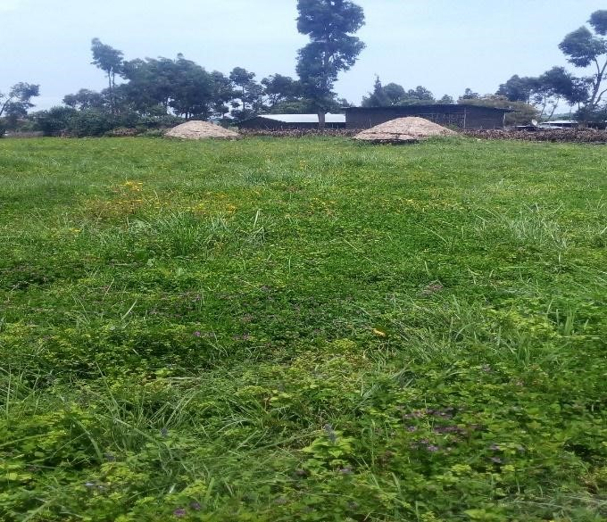

Figure 2 View of station 1 data collection center
Source: photo by Jeba Shubise (2019)
As this pictures revealed, the community uses their land for various purpose. Before urban their land were reached in a very beautiful natural resource. The economic foundation of the farming community was predominantly agricultural. The farming community used to extract resource from agriculture to meet their livelihood requirement. This livelihood was totally depends on the land which are the main source of livelihood of the farming community. However, when the land was alienated the livelihood of the community may be disrupted. In addition to this, it is clearly seen from (figure 2) the area were reach in biodiversity found in this area were highly affected land fragmentation were formed due to the road passed through land of the farmers. This increases the displacement of the farmers from their land and also affects agricultural productivity of the farmers. The range land used for livestock becomes limited.

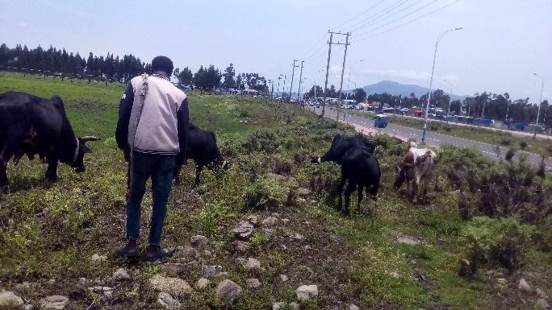

Figure 3 View of station 2 data collection center
Source: Photo by JebaShubise (2019)
According to (Figure) urbanization were occupied the farming land of the community. The landowners found in this area were highly affected due to land fragmentation were formed due to the road passed through land of the farmers. This increases the displacement of the farmers from their land and also affects agricultural productivity of the farmers. The range land used for livestock becomes limited. This reflects that the range land used for livestock and agricultural productivity of the farmers get from their land become decline. Since agriculture was the main source of income for farming community in the study area. They also revealed that the overall economy of the farmers were limited, social interaction and psychology of the land owners are highly detoreriated.
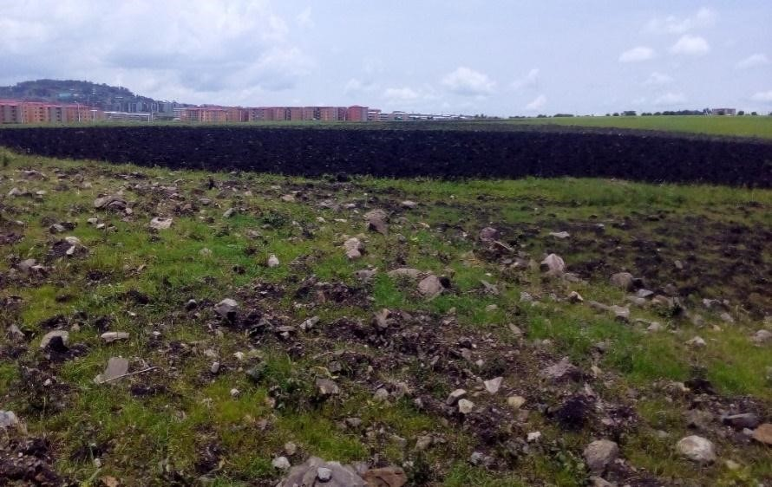

Figure 4 View of station 3 data collection center
Source: Photo by Jeba Shubise (2019)

As it is shown on (figure 4) new condominium has been surrounded the land of the farmers. They are clearly showed that urban extensions include the land of the farming community. The aborigine people in the area has been displaced and agricultural output they harvest from their land has been limited. This results in economic crisis of the aborigine community in the study area. The main factors responsible for this economic deterioration are land dispossession of the farmers. The land plays a great role in wellbeing of the people. It is the main source of assets and treasures. This demonstrates that shrinking of their agricultural land as extent of urbanization process results in economical degradation of the farmers.
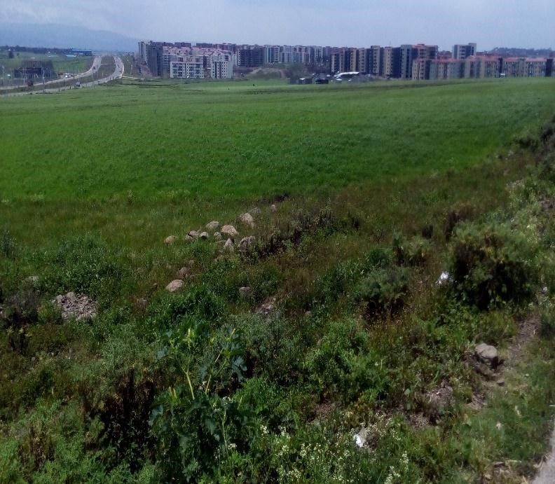

Figure 5 View of station 4 data collection center
Source: Photo by Jeba Shubise (2019)
As it is shown on the (figure 5) such fertile productive soil has been occupied by urbanization. The picture reflects that teff and wheat are cultivated on the land. It is the main source income for the farmers in the study area. However, pictorial evidence revealed that the land size of the community has been decline. The agricultural productivity they consume from their land has been decreased. This results in happening of food insecurity, daily labor increase and the whole economy of the landowner‘s detoreriated.
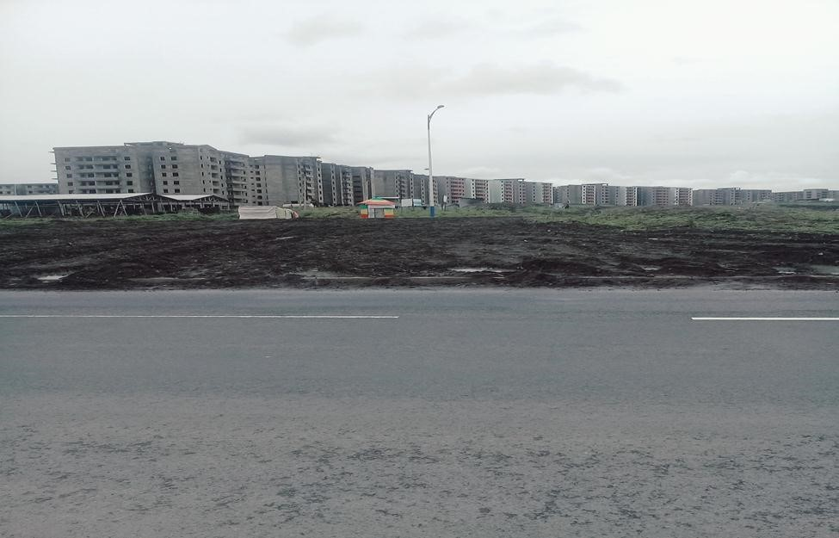

Figure 6 view of station 5 data collection center
Source: Jeba Shubise (2019)
According to (figure 6) new condominium has been surrounded the land of the farmers. They are clearly showed that urban extension occupied the land of the farming community. The aborigine people in the area has been displaced and agricultural output, they harvest from their land has been limited. This results in economic crisis of the aborigine community in the study area. The main factors responsible for this economic deterioration are land dispossession of the farmers. The land plays a great role in wellbeing of the people. It is the main source of assets and treasures. This demonstrates that shrinking of their agricultural land as extent of urbanization process results in economical degradation of the farmers.

4.3 Data evaluation and interpretation
This chapter reflects the main finding of the study on impacts of urbanization on productive farmlands. The result presented in this part is seek to achieve the goals of study, which is to investigate the impacts of urbanization on productive farmlands in the study area. It also indicates the presentation and analyzing of information gathered/collected from interviewed person and field observation with full description.
In (table 2), the data shows that the sample household respondents 30% houses hold family size of respondents. From this we understand that, the majority of respondents were 5-6 family size in the study area. This reflects that the farmers whose their lands has been affected by urbanization were low source of income. Field observation from study site also confirms the greater challenges of urban expansion on the farmers. From (table 3) we can understand that all respondents have their own farm land before urban expansion. According to (pie chart) farmers using their lands for various purpose.50% of their land were used for crop productions. This revealed that majority of the farmers using their lands for crops purpose. As evidence from informants, farmers are continuously producing subsistence crops with in small plot of land that left after land grapping. It is difficult to those farmers meet their own family consumption from limited land and supply for market. It implies that losing of land due to urban directly impacts on living condition of farmers. Because, land is the most pillar livelihood and means of survival for household farmers. The investigator also confirms this situation during field observation. According to pie chart farmers using their lands for various purposes. 50% land owners were used their land for crop productions.

50
%

30
%

10
%

10
%

Crops
Fruit and vegetable
Crops and grazing
Pie chart 1 Land uses of the farmers before urban

4.3.1 Impacts of urban extension on economy of farmers
As indicated on (table 4) from interviewed respondent 45% house hold earns the annual income of 12-17quantals before urban process on their lands.50% of household earns annual income of below 5 quintals after urban expansion on their farmlands. This showed that annual income of the farmers is decreased after urbanization. That means they produce less amount of quintals after urban extension. The data revealed majority of respondents were affected after urban process. This implies that before reclassification of their lands majority of the respondents were used their lands for agricultural activity. So urban extension affects the annual production of the farmers. This cross ponds to the study by (Dayong, 2004) as displacing farmers cause to reduce the amount of production. It is obvious that the majority of farmers were depends on agricultural way of life style in the study area. Although, due to land of the farmers were shrinked the annual income was decreased as respondent reported and filed observation indicated. This in turn harms economy of the farming community since lands play a vital for the community. According to (Seto, et al 2011) urban expansion hastens the loss of highly productive farmland, affects energy demand, alters the climate, modifies hydrologic and biogeochemical cycles, fragments habitats, and reduces biodiversity. In line with this (figure 2) revealed that land fragmentation were formed due to the road passed through land of the farmers. This increases the displacement of the farmers from their land; reduce biodiversity and affects agricultural productivity of the farmers. The economic foundation of the aborigine people was predominantly agricultural. The farming community used to extract resource from agriculture to meet their livelihood requirement. This livelihood was totally depends on the land which are the main source of income generation for landowners. The residents that are live near to the urban setting has been land dispossessed so that more likely to expose to economic crisis (Efa and Gutama, 2017).This implies that urbanization harms the economic status of farmers and result in economic degradation, food insecurity outbreak, unemployment increase, health conditions of farmers interrupted and number of poor increase. In additions to this, the finding of the study indicates that due to land size of the farmers highly reduced the numbers of domestic animals they have become decline.
This results in overall economic deterioration of the community in the study area.


75

25

0
10
20
30
40
50
60
70
80
Before Urban expansion
After Urban expansion
Graph 1 Livestock resources of the farmers before displacement

4.3.2 Loss of (soil) land productivity
According to (table 5)14 (70%) of respondents loss their home lands, whereas 6 (30%) of respondents were partially loss their farming lands. From this we can understand that urban expansion effects on farmlands. As respondent tolled to researcher and field observation revealed that the lands of the farmers were affected by urbanization. This reflects that land loss of farming community directly harms economic, social, environmental deterioration and physiological situation of the farmers. The rural community living around city were faced the above stated challenges (World Bank, 1993).According to (Samuel,2006) as land holding decline food production and farm income also decline, indicating that extremely small-sized farms cannot be made productive even with improved technology. Finding of the study revealed that the farmers lived in this area were exposed to different problems like food insecurity, lack of well standard living, unhealthy conditions and the numbers of domestic animals they has highly decreased due to narrowing of their lands. According to (figure 6) new condominium has been surrounded the land of the farmers. They are clearly showed that urban extension occupied the land of the farming community. The aborigine people in the area has been displaced and agricultural output, they harvest from their land has been reduced. This results in economic crisis of the aborigine community in the study area. The main factors responsible for this economic deterioration are land dispossession of the farmers. The land plays a vital role in wellbeing of the people. It is the main source of assets and treasures. Similar to this result, study Mendere et al. (2010) showed that the economic status of the community affected by urban expansion become decline because of shrinking of their agricultural land. This demonstrates that the economic status of the farmers has been decrease as extent of urbanization increase. This implies that urbanization harms overall livelihood of the farmers. Unless the situation intervened, food insecurity more likely outbreak. Thus uncontrolled urbanization process deserves action to be taken to mitigate its impacts on sustainable development of the community and ecosystem surrounding.

4.3.3 Challenges of urban expansion on social life of the community
From the theoretical point of view urban expansion causes displacement, dislocation and segregation of the community that result in the disorder of the social fabric. The finding of the study revealed from community informants and field observation has been showed that the social interaction usually manifested through social institutions like Dabo which brings them to work together, contribution for security in case of death of domestic animals and horse race ceremony during festival were reduced. Social grouping among kin in the rural life such as coffee ceremony were also limited to a few household due to dispersion of kin in different locations. Unless the condition intervened, social interaction more decreases. Generally, we can deduce that urban expansion has a negative impact on social interaction of the aborigine people living in the study area.

4.3.4 Land grabbing without compensation
As shown on (table 6) 8 (40%) of respondents were compassion paid in money, 5 (25%) were land plots and 7(35%) were paid in missing system.
This indicates that majority of the community in the study area get compassion of their vacated lands. According to interviewed land dwellers and field observation revealed that the majority of the farmers were not satisfied with the compassion given for them. Because it is not enough to re-establish their economy, which is land. If this situation continuous in this way, a serious food security problem will happen against the community members who earn income from agriculture. Furthermore, the low and inadequate compassion aggravates economic livelihood impoverishment of the farmers. In line with this result, Dejene (2011) reported that peasant farmers living around urban expansion area were lost their fertile agricultural land with minimum appropriation of compensation packages. This leads to economic impoverishment. For this reason the necessary measures should be taken just to secure the livelihood of the farmers who may get dispossessed of their farm land. For instance, adequate and reasonable amount of compensation should be given for the farmers with required skill and any other training that helps them to lead their normal life. Moreover the displaced people should be given the necessary follow up and special treatment because of their rurality background and logical claim for suffice protection and care.

4.3.5 Impacts of urbanization on natural resource
It is often assumed that migration from rural to urban areas and the resulting concentration of populations in cities would ease the pressure on natural habitats. In many parts of Sub-Saharan Africa, the migration and subsequent concentration of people in urban areas has indeed reduced rural populations, thus leading to reduced rates of deforestation (RudelTK, 2013). However, land speculation by wealthy urban residents has also driven abetted by lack of land-use planning and control loss and fragmentation of rangelands close to cities and towns in Ethiopia, Kenya and Uganda (FlintanF, 3011).According to (figure from station 1-5) revealed that urban expansion affects a wide range of ecological species that are naturally found in their habitat. Since the study area has been included by urban extension, many of natural biota exist in the area were disappeared. It is obviously known that urbanization creates habitat fragmentation that affects the normal living organisms survive in the area. Similarly, according to (Anderson, et al 2013) the demands of animal and plant parts as a food, as ornaments or medicine become decrease due to urban engulf the land. In line with this, the study result also agrees with these challenges. This directly harms the economy of the farmers. From environmental prospective, urban fringe areas face two main challenges and the relationship between the two seems to be a key point for the design of strategic environmental planning and management that benefits the poor and enhances their quality of life for sustainable development of the area. The first set of challenges is related to the environmental conditions of the urban fringe as the living and working environment of a large number of people. Although heterogeneous in its composition, the area constitutes the habitat of lower income communities, which are particularly vulnerable to negative externalities of nearby rural and urban systems. This includes risks to health, life and physical hazards related to the occupation of unsuitability, lack of access to basic infrastructure and poor housing conditions. The second challenges are linked to the sustainability of the regional extraction patterns of renewable and non-renewable resources of urban fringe ecosystems, and to the minimization of the transfer of environmental costs from rural to urban systems. Most of these changes are driven by the proximity of urban areas which means land conversion, new developments and flows of people. Nevertheless the sustainability of the natural resource base and quality of life in the fringe area also affected by the linkages these areas maintain with their rural hinterland and in general with the use and appropriation of natural resources and environmental services. Consequently, they area has been adversely affected due to resources are lost or degraded by influxes of people from expanding urban area. This implies that plant and animal species that are natural found in the area has been highly reduced because of urban extension. The fast urbanization and related anthropogenic activities has been devouring the adjacent natural resources leading to a greater decline of the complex ecosystem. This in turn leads to loss of habitat and decline in species associated with this ecosystem. The resulting loss is not only a burden on the environment but acts as an economic and social burden among the public whose lives are directly dependent on the natural resources. Therefore regular monitoring of the depletion of natural resources is a forefront task.
According to data from newly settled community indicated that the landowners were affected due to urban extension program. As information revealed that the farmers found in study area were economically challenged because source of their income has been reduced due to their agricultural productivity were decreased. This implies that the community has been victimized.
Their ways of social interaction and psychological situation of the farmers were also limited.

4.3.6. Results
Urbanization has been a greater challenge on the natural resources, which was leading to a decline of the complex ecosystem.
The human population living in urban areas consumes a lot of resource and energy and exhibit a net to drain the natural resources of ecosystem.
This in turn leads to loss of habitat and decline in species (plants and animals) associated with ecosystem destruction.
Many species of animals and plants disappeared and the rest fragmented bio-corridors are jeopardized due to the limitations of interbreeding systems.
From the view of natural resource degradations, the environment has lost its vital services for all living organisms on the earth.
Urbanization deals with construction of buildings that damage the natural resources like the loss of farmland, minerals, water resources, fertile soils, range lands and expose the landscape to wind and rain erosion or soli movements.
The loss of zoological habitats and species living in the soil barrier at the underneath of buildings is numberless. The land is continuously becoming fragmented, the previous farmers have lost their basic income generation like from selling eucalyptus trees, sandy soils, stones, breed animals and mainly farm land which their generation long wealth.
In view of this, due to the impacts of urbanization on the ecosystems, farmlands are shrined, converted to bare or building areas, natural resources disappeared and resulted in decreasing and disappearing of the species.
The natural resources were depleted and disappeared and displaced community remained without compensation, the natural wealth of the country is destroyed lawlessly.

Chapter five

5. Summary, conclusion and recommendations

5.2 Summaries
Urbanization has been underpinned by the rapid growth in the proportion of gross world product. It symbolizes the movement of people from rural to urban. As socio-economic dynamic, urbanization under goes different phases in Ethiopian history, where the current rate is highly increasing. On this top of fact the urbanization in the study areas were increasing. It is the way by which a given society shaped and reshaped with better livelihood strategies. Conversely, it has negative impacts on the community. Accordingly, this study was conducted to assess the impacts of urbanization on farmlands by taking the case of Koyye Facce which is found in Oromia regional state. By using survey method, the researcher gathered data based on purposively selected respondents who know depth information about area. Critical field observation and other sources were tools of data collection. The collected data were qualitatively analyzed.

5.2 Conclusion
Urbanization is developing rapidly in the world, which seriously changes the habitat of organisms and has clearly a negative impact on biodiversity. Preservation of biodiversity is crucial in urban planning and management, which is an important symbol for the beauty of an environment. However, coexistence of nature and modernization, as well the coordination of of economic development and biodiversity are goals that people are seeking. This study was under taken on impacts of urbanization on farmlands of Koyye face area where large number of dwellers are farmers with rural back ground. The objectives of the study were to investigate the impacts of urbanization on farmland and natural resource of the study area.
Accordingly, in the areas urban expansion was increasing over surrounding areas that were previously agricultural land. This expansion marginalized the farmers who depend on their livelihood basically on agricultural. Their prime agricultural land was converted in to nonagricultural land and values they consume from agricultural were declining. For instance about 50%of their land was used for crops production. After urban expansion the decline to 25%.This shows farmers livelihood mainly on agricultural. So the average land holding of the community is the lowest to sustain their livelihood after urban program. Before the urban expansion considered in the study, an average production of house hold was varying from 5 quintals to 23 quintals, where the yield of the majority was in the range of 12-17.However, after urban expansion the study scanned that the yield of majority fell below 5quintals.The livestock of the farmers are also declining because of the land size of the farmers were limited. Even though, compassion was paid for farmers in different level they are not satisfied with compassion given for them. Because it is inadequate to replace their resource. Majority of them 40% get money as compassion and 25% land plots. Urban expansion carried out in this manner has been a significant impact on community living in the study area. The land dwellers almost lacked the ways of diversification in generating income since land engulfing has been devastated.

5.3. Recommendations
In the conclusion part, several issues related to impacts of urbanization on farmland were clearly addressed. Based on impacts assessed in this study the following recommendation has been forwarded
- Urbanization and extension of any cities required basic studies of land use systems to identify farmlands from other lands and decide and make needed facilitation for urbanization.
- Urbanization program should be carefully planned for mobilization, placements of resettlement areas and means of survival of those displaced individuals.
- For those who displaced for the purpose of development, ideal compensation of land resources and related income generation means are due to planned ahead for evicted community.
- Forceful displacement for land grabbing and lowliness acts against displaced individuals need solution by the intervention of legal activities.
- Instead of horizontal expansion of urbanization planning vertical development buildings that could accommodate thousands of families on a small area of non-fertile land may solve the problematic issues.

Acknowledgement
First and for most, I would like to thank the Almighty God for giving me grace, provision of knowledge, wisdom and diligence required for the successful completion of master program in Biology. Next I would like to express my sincere and deepest gratefulness to my advisor Dr.Engineer Sutuma Edessa for his intellectual advice, guidance, encouragement and regular discussion were very valuable and inspiring in the process of proposal writing, research undertaking and this thesis writing. Without his support and endless understanding, this paper would not have had its present shape. I also extend thank to Addis Ababa Education Bureau for the financial support of my study. At last but not least I am thankful to my organization for full printing of this paper.

1

Declaration
I declare that this thesis is my original work, has been never presented for a degree in this or any other university and all sources of the materials used for this thesis has been fully acknowledged.
Declare name Jeba Shubise Signature____________Date_________
Advisor name Dr. Sutuma Edessa Signature_________Date________

1

6. References

Abernethy K, Maisels F and White L. (2016). Environmental issues in Central Africa Environmental Resource.
Anderson P L, Okereke C, Rudd A and Parnell S. (2013). Urbanization, Biodiversity and Ecosystem Services: Challenges and Opportunities Regional assessment of Africa.
Brooks T M. (2016). Analyzing biodiversity and conservation knowledge products to support regional environmental assessments.
Cass man.(2003).expansion of agriculture into natural ecosystems and marginal areas that cannot sustain crop production and provide critical habitat for protecting biodiversity. Dayong, N. (2004).Several acute Issues in China Urban Planning.
Efa Tadesse, Gutema Imana. (2017).Prospects and challenges of urbanization on the livelihood farming community surrounding Finfine.
Fekadu, T (2005). Urban expansion and its Effects on Peripheral farming Community. Hosanna, Ethiopia.
FlintanF F. (2011). Causes, Processes and Impacts of Land Fragmentation in the Rangelands of Ethiopia, Kenya and Uganda (Nairobi: Regional Learning and Advocacy Program me.
LynnBrown and Alex F. McCalla. (2001). Global Urbanization Trends of the State world‘s Cities: Implications for Food System Security (UNCHS Habitat report)
Mayaux P. (2013). State and evolution of the African rainforests between 1990 and 2010 Phil.
Mc GranahaG, Satter ThwaitD.D and Tacolic. (2004).Urban-Rural Change, boundary problems and Environmental burdens, International Institute for Environment and Development.
McDonald K, Bosshard P and Brewer N. (2009). Exporting dams: China‘s hydropower industry goes global Environmental Management.

McGranahan G, Mitlin D, Satterthwaite D, Tacoli C and Turok I. (2009). Africa‘s Urban Transition and the Role of Regional Collaboration (London: International Institute for Environment and Development.
Melese. M. (2004).City expansion, squatter settlements and policy implications in Addis Ababa: The case of Kolfe Keranio sub-city.
Mittermeier R A, Robles-Gil P, Hoffmann M, Pilgrim J D, Brooks T B, Mittermeier C G,
Lamoreux J L and Fonseca G A B .(2004). Hotspots Revisited: Earth‘s biologically Richest and Most Endangered Eco regions Mexico City.
Molinario G, Hansen M C and Potapov P V (2015). Forest cover dynamics of shifting cultivation in the Democratic Republic of Congo: a remote sensing-based assessment for 2000–2010 Environment.
Potts D. (2012). Challenging the myths of urban dynamics in Sub-Saharan Africa: the evidence from Nigeria World development.
Rees, W.E. (1992) Ecological Footprint and Appropriated Carrying Capacity What Urban Economics Leaves out. Environment and Urbanization, 4, 121-130.
Rudel T K.(2013). The national determinants of deforestation in sub-Saharan Africa.
Samuel Gebreselassie. (2006).Land, Land policy and small holder Agriculture in Ethiopia:
Option and scenarios.
Schneider. (2009). A new map of global urban extent from MODIS satellite data.
SeeBentinck. (2000). Urbanization on Delhi's fringe: changing patterns of land use and livelihood.
Seto K C, Güneralp B and Hutyra L R (2012). Global forecasts of urban expansion to 2030 and direct impacts on biodiversity and carbon pools.
Statistics Botswana (2016). Population and Housing Census of Botswana: Central Statistics Office of Botswana (Accessed: 20 March 2017) www.statsbots.org.bw/
Thuo, T. (2010).Community response to land use transformation in Nairobi rural- urban fringe, Kenya, University of Waikato.
UN-HABITAT. (2012). Urban Patterns for a Green Economy: Leveraging Density Nairobi: United Nations Human Settlements program me
Wouterse F. (2011). Foreign Direct Investment in Land in West Africa: the Status Quo,
Lessons from Other Regions, Implications for Research International Food Policy Research Institute
Ziegler S, Fa J E, Wohlfart C, Streit B, Jacob S and Wegmann M.(2016). Mapping bush meat hunting pressure in Central Africa Biotropica.

Appendix 1
Addis Ababa University
College of natural and computational science

Department of zoological science
Interview questions for respondents
Dear respondent: the main aim of this questionnaires is to collect data as in put the study titled impacts of urbanization on productive farm land. You are expected to provide genuine, accurate and balanced with respect of challenges of urbanization process. Your information is highly valuable and determines the successful of the study.
Thank you!!
- How many family size do you have?
- Do you have farming land and how many hectare m2 of land do you have?
- For what purpose you have been using your land?
- What are crops you produced on your lands before and now?
- How many hectares of farming land did you lose and do you get any compensation of land from authority with fulfilled infrastructures?
- What was the bases your livelihood before the coming reclassification of your Land into urban expansion?
- Before and after urban expansion how many quintals you produced and know what are impacts on your consecutive life?

- If you lose your original land, what are the social and economic challenges you faced on your life?
- Why your land is taken from you and what are impacts on your livelihood?
- If you do not get any compensation of lands from concerned body what is your future hope? 1O. what is your views about negative impacts of urban expansion on social life condition of the farmers?
11. What are the impacts of urbanization on natural resource in this area?

Appendix 2

Station 1

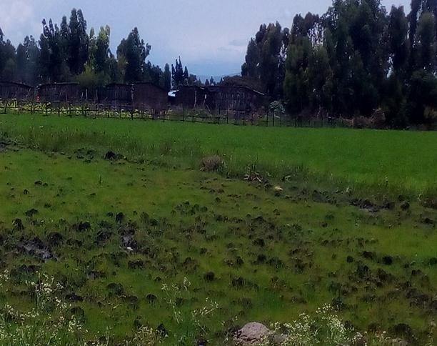

Station 2

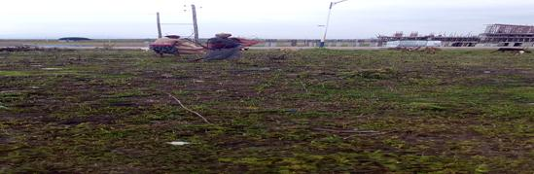

Station 3

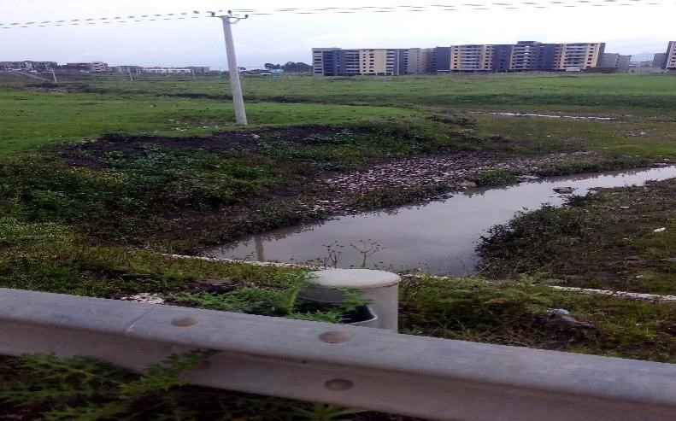

Station 4

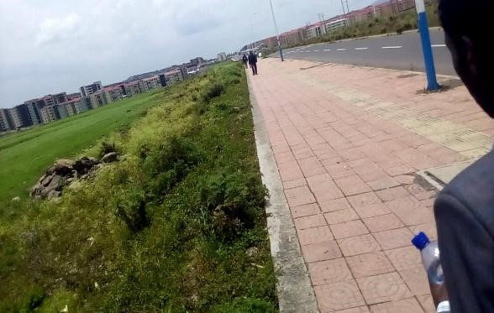
Station 5
