Addis-Ababa University


College of Natural and Computational Sciences
Department of Zoological Science

Assessment of Challenges and Opportunities of Small Scale Irrigation Utilization: (The Case of Tahtay Maychew Woreda, Central Zone, Tigray, Ethiopia

By:
Mawch Assefa Fetene
A Thesis Submitted to Department of Zoological Science presented Partial Fulfillment of The Requirements for the Degree of Master of Science in Biology.

Sep. 2019 G.C
Addis Ababa University Ethiopia
Addis Ababa University
College of Computational and Natural Science
Department of Zoological Science

Declaration
I,Mawcha Assefa declare that this thesis entitled Challenges and Opportunities of Small-Scale Irrigation utilization: Survey of Tahtay Maychw Woreda, Central Zone, Tigray, Ethiopia” submitted by Mawcha Assefa in Partial Fulfillment of the requirement for the award of the degree of Master of Science in Biology in Addis Ababa University, is my original and it has not been presented for the award of any other degree, diploma, partnership or other similar titles of any other universities or institutions.

Name of Mawcha Assefa Candidate Signature____________ Date ________

Acknowlegements
First of all I would like to praise Almighty God for giving me strength and power to pass all uncertainties during the study of my Thesis work.
Special thanks and heart-felt appreciation goes to my advisor Dr.Bikila Warkineh for his constructive comments, valuable advices, excellent cooperation and unreserved support from the inception of research thesis to the write up of the final work.
Next, I would like to extend gratefully acknowledged to the Department of Zoological Science for all cooperation’s and arrangements of the program on time and in assigning advisor at Addis Ababa University to achieve the work of my thesis on time.
I would like to extend my especial gratitude to my parents and relatives who support me economically and morally throughout my study. I am grateful thanks to my friends Hadush Mawcha ,Teklue G/micheal , and for their moral support.
Finally, I am greatly value the support that I have got from the Woreda Development Agents and Woreda agricultural and rural development office of Woreda Tahty May chew and kebele administrators during data collection period in the study site. Without their support in selecting study kebeles, this research thesis has not reached this stage. In addition, I would like to thank all of my enumerators, key informants interview, group discussion participants and respondent.
I am grateful to my beloved Alem Arefaine and my daughter Meseret Mawcha who have given me moral support, strength and encouragement in completing my thesis on time.

Assessment of Challenges and Opportunities of Small Scale Irrigation Utilization in Woreda Tahtay Maychew Woreda, Central zone, Tigray, Ethiopia
Name:Mawcha Assefa Fetene
Addis Ababa University September 2019

Abstract
Irrigation has the potential to stabilize agricultural production and ease the negative impacts of variable or insufficient rainfall in Ethiopia. This study was designed to assess challenges and opportunities of utilization of small-scale irrigation. The objectives of the study is to assess the opportunities to use irrigation, factors that influence Irrigation Utilization by small-scale farmers, the role of the extension workers towards confirming the desirable Utilization of Irrigation by the farmers and weigh up existing infrastructure of the SSI and its accessibility. It adopts quantitative and qualitative research approach. To serve these objectives, data was collected from 169 sample respondent farmers from four purposively selected Kebeles by distributing questionnaire by collectors and this was also supplemented by semi-structured interview and focus group discussion and field observations. Descriptive type of research like, participants answer questions administered through interviews or questionnaires and field observation to analyze the data. From the sampled respondents, FGDs (22) that is 4 females and 18 males and 10 key informant interviews, different challenges and opportunities were forwarded. The result of the research indicates that there was potential for the development of small-scale irrigation specially availability of favorable agro-ecology, availability of labor, and supportive of government policies and reserve underground water. The research result also identified that the challenge of small scale as Shortage of water that relates with shortage of ponds and diversion shortage of agricultural inputs specially improved seed and pesticides, high cost of irrigation, shortage of water pump technologies, spare parts, technical problems such as maintenance of motor pumps, presences of diseases and pests, insufficient market information and market networks, infrastructure specially road, weakness of local FTCs and low of price of products. In conclusion, to alleviate these constraints and utilize the opportunities towards SSI, the concerned bodies should attempt to minimize those factors that hinder productivity of irrigation in the study area. If SSI schemes are to play their role, an integrated effort of all development partners such as government (specifically BOARD), cooperative promoters, private sector and the society at large is crucial to address the problems faced. Additionally, farmers should establish viable and strong linkages with development /extension agents and other cooperative societies in the areas of irrigation, finance, marketing and technology adoption
Key Words: Farm land, Schemes Tahtay My chew woreda

Table of Contents
Declaration i
Acknowlegements ii
Abstract iii
Table of Contents iii
List of figure vii
List of Tables viii
List of Acronym viii
Chapter One: 1
1 Introduction 1
1.1 Statement of the problem 2
1.2 Objectives of the study 5
1.2.1 General Objective 5
1.2.2 Specific Objectives 5
1.3 Research questions 5
1.4 Significance of the study 5
1.5 Scope of the study 5
1.6 Limitations of the study 6
1.7 Ethical considerations 6
1.8 Organization of the Paper 6
Chapter Two 8
2 Related of Review Litrature 8
2.1 Concept and Definition 8
2.2 History of Irrigation Development in the World 9
2.2.1 The development of small scale Irrigation in Ethiopia 10
2.3 Empirical Review 11
2.3.1 Opportunities of small scale Irrigation utilization 11
2.3.2 Challenges of small scale Irrigation utilization 13
2.3.3 The role of Extension service 14
2.4 Infrastructure 15
2.5 Conceptual Framework Of The Study 17
Chapter three 18
3 Materials and Methods 18
3.1 Description of the study area 18
3.1.1 Location 18
3.1.2 Climate 18
3.1.3 Land use types 18
3.1.4 Farming systems 19
3.2 Research Approach and Design 20
3.3 Target population and Sample Design 21
3.3.1 Target population 21
3.3.2 Sampling Techniques 21
3.3.3. Sample size determination 21
3.4 Type and Data Source 23
3.5 Data Collection Methods and tools 24
3.5.1 Questionnaire 24
3.5.2 Focused group discussion 25
3.5.3 Key informant Interview 25
3.5.4 Field observations 25
3.6 Methods of data analysis and interpretation 26
4 Chapter Four: Results 27
4.1 Demographic Characteristics Of The Respondents 27
4.2 Opportunities in utilizing small scale Irrigation 28
4.2.1 Agro –ecological zone 28
4.2.2 Labor 28
4.2.3 Related with government support 29
4.2.4 Respondents related with land security 29
4.3 Challenges in utilizing small scale irrigation 31
4.3.1 Respondents related to spare parts 38
4.3.2 Price of irrigation products 40
4.4 Follow up of Experts for the Utilization of Irrigation 40
4.4.1 Training on Operation and Maintenance 41
4.5 Irrigation Practice and access to Infrastructure 42
4.5.1 Electric availability 43
Capter Five: 44
5 Discussion, Conclusion and Recommendations 44
5.1.1 Opportunities in utilizing small scale Irrigation 45
5.1.2 Challenges in utilizing small Scale irrigation 47
5.1.3 Follow up of Experts for the Utilization of Irrigation 53
5.1.4 Irrigation Practice and access to Infrastructure 57
5.2 Conclusion 60
5.3 Recommendation 61
Reference 63
AppendixI 69
APPENDIX II 71
APPENDIX III 77

List of figure
Figure 1 Conceptual framework 17
Figure 2 Map of Ethiopia,Tigray woreda and Selected kebeles (developed by Samson Negasi (2019) 20
Figure 3. Composition of sample of respondents from four kebeles 23
Figure 4. The Photo “A” shows participation of family in irrigations and “B” shows participation of employee in irrigation activates 29
Figure 5 show that the role of government in irrigation practice 29
Figure 6: Coverage of crop in the selected study area 32
Figure 7.This picture shows Planted onion has wilted, due to lack of irrigation water. 34
Figure 8 Summarized information related to utilization of irrigation inputs. 35
Figure 9. Picture taken by researcher shows a Woman watering her irrigation field by fetching water from wells. 37
Figure 10.This pie chart shows the number of irrigation utilizing farmers who participate in maintaining their irrigation Technology. 37
Figure 11 Shows the number of respondents on the source of spare parts to maintain their irrigation technologies. 38
Figure 12 pictures A and B illustrates the community pond that contains limited amount of water and irrigation land that did not fully utilize because of shortage of water in the study area 39
Figure 13 the pie chart shows the number of respondents which involved on operational and maintenance training. 41
Figure 14 The picture illustrates the farmers Training center in the study area. 41

List of Tables
Table 1.irrigation users of selected kebeles 23
Table 2 Demographic character tics of respondents 27
Table 3 Respondents on Agro ecological zones of the study area 28
Table 4 Respondents related with labor 28
Table 5 Coverage of irrigation farm land (ha) of the four selected kebeles. 30
Table 6 Respondents related with irrigation planning 31
Table 7 Respondents related with farm land productivity 32
Table 8 Problem of crop failure 33
Table 10 The water sources and uses of irrigation technologies among the local community in the study area. 36
Table 11 Respondents related with access to water 38
Table 12.Major challenges of small scale irrigation 39
Table 13 Regarding the follow up of extension 40
Table 14 Related with infrastructure 42
Table 15 Respondents related credit access service 43

List of Acronym
ARDO Agriculture and rural development Office
BoARD Bureau of Agriculture and Rural Development
DA Development Agent
DoARD District office of Agriculture and Rural development
DoFED District office of Finance and Economic development
FAO Food and Agriculture Organization
FGD Focus Group Discussion
FTCs Farmers Training Centers
GTP Growth and Transformation Plan
MOA Ministry of Agriculture
SSI Small Scale Irrigation
SSIS Small-scale irrigation schemes
TRPFB Tigray Region Plan and Finance Bureau
WB World Bank
WUA Water Users’ Association

Chapter One:

Introduction
Growing population and changing food consumption patterns are expected to require a doubling of food production in the developing countries by 2050. Eighty percent of this increase would need to come from higher crop yields and greater crop intensity given limited scope for agricultural land expansion. Expanding the use of efficient irrigation and agricultural water management technologies is a key part of the solution to increasing yields in a sustainable manner currently only five percent of land in Africa for example is cultivated using irrigation (IFC, 2014).
Most African countries highly depend on rain fed farming which has been a major cause of low food productivity, food shortages, undernourishment and famine in the region (FAO, 2012).Nations in Africa use small-scale irrigation agriculture as a means of guarantee for food security as well as improving the standard of living of the rural people for many years Hillel, (as cited in Gebrehiwot et al., 2015).
Ethiopia as a country is characterized by widespread poverty and a low standard of living; drought conditions are frequent, and farming is often small scale/subsistence, traditional and rainfall dependent, with limited access to the various irrigation technologies and institutional support services. As a result, with the majority of farmers depending on rain-fed agriculture, the country's agricultural economy is extremely weak and exposed to the impacts of weather and climatic unpredictability, which often leads to partial or total crop failure, resulting in food shortages (Seleshi Bekele et al., 2007).
Abebaw Abiyu and Tebeje (2016), stated that Irrigation is one method of agricultural growth and plays dominant role in increasing agricultural productivity. In the recent time, it is obvious that, small-scale irrigation is one of area of emphasis by policy makers and planners in Ethiopia. The smallholders have significant importance to raise production and productivity to achieve food self-sufficiency and ensure food security at household level in particular and the country at large.
Irrigation has the potential to stabilize agricultural production and mitigate the negative impacts of variable or insufficient rainfall in Ethiopia. In some areas of the country delayed entrance of rainy seasons, early withdrawal and mal-distribution of rain were challenges from which great lessons have been drawn to seriously look into expansion of small, medium and large scale irrigation in perspective (Abebaw Abiyu and Mesfin Tebeje 2016).
Tigray Region is one of the most land-degraded regions of Ethiopia. Indeed, the pace of population growth and crop production in the region are not matched, mainly due to environmental degradation, repeated droughts, the limited use of irrigation technologies and institutional support services. In response to this severe environmental degradation and population-resource imbalance, the Tigray Regional Government has initiated a major rural production-enhancing mechanism, e.g. construction of several small-scale dams and supplying various water-saving technologies, but farmers are not fully using the technologies (Kinfe Asayehegn 2012).
.Governments, NGOs and other concerned bodies, therefore, recognize that the utilization of small scale irrigation is a fundamental line of attack towards ensuring food security and thereby reducing poverty; it is important then, to study the real challenges which can affect the utilization of small scale irrigation. Accordingly, this study is intended to assess the realistic opportunities, and challenges to, small scale irrigation usage in Tahtay maychaw Woreda in the Central Zone of Tigray National Regional State.

Statement of the problem
Irrigation plays a fundamental role in world food provision but, until recent years, it has performed below expectations in Sub-Saharan Africa (FAO, 2015). In Ethiopia, despite the rapid population growth and food demand, the production of agricultural outputs using modern technology at smallholder level is at its minimal stage. The traditional system of production and rain-fed agriculture alone could not guarantee to feed this rapidly increasing population and it needs supplementation from irrigated agriculture (FAO, 2015).
The Ethiopian government considers water as crucial thing for development and it uses as an essential policy instrument to stimulate economic growth, rural development and ensuring food security. The Ethiopia government has chosen Irrigation schemes as essential policy options to eradicate poverty and food security and it has a great impact on the livelihood of rural community where agriculture is the basis of their life (Belay Meherit and Woldeamlak Bewket, 2013).The agricultural practice in the country in general and in the study area in particular is rain-fed agriculture and seasonal. While the country has high potential to irrigate its agriculture, about 97 percent of Ethiopia’s food crops are produced by rain-fed agriculture, whereas only three percent is from irrigated agriculture (FAO, 2015). There is a big difference between the potential and the level of irrigation practiced in the country due to technical, physical and economic challenges (ATA, 2016).
Seleshi Bekele (2010) and MoARD (2O11),indicated that Ethiopia has abundant water resources, land, irrigation potential and diversified agro-ecological which is suitable for growing of various crops; however, its agricultural systems do not yet benefit fully from the technologies of water management and irrigation because of limited access to agricultural technology, limited possibilities to diversify agricultural production - given underdeveloped rural infrastructure and little access to agricultural markets and technological innovations
According to Tesfaw Mengesha (2018), the country has been a series of challenges even during good rain seasons and natural failure due to different factors such as pests, unpredictable rainfall and other environmental constraints. Ethiopia could try to face those challenges in terms of food security is accompanying with in adequate food production to sustain rural communities.
According to Seleshi Bekele (2010), the majority of rural dwellers in Ethiopia are among the poorest in the country, with limited access to agricultural technology, limited possibilities to diversify agricultural production given underdeveloped rural infrastructure, and little to no access to agricultural markets and to technological innovations. These issues, combined with increasing degradation of the natural resource base, especially in the highlands, aggravate the incidence of poverty and food insecurity in rural areas.
According to the report of water development office (2017/8) Tahtay Maychaw is the potential area whereby small scale irrigation activities are undertaken by farming communities. In this Woreda, lot of conservation activities have been undertaken in the previous years and small-scale irrigation is practiced using micro dams, shallow wells, private ponds, community pond, check dams and diversions. Intensification is believed to be a necessary pre-condition for the development of the agricultural sector of Ethiopia. To this end, various governmental and NGOs initiated small-scale irrigation schemes throughout the country, including the Tigray region. Despite these efforts, the smallholder farmers, particularly in the study area, are found to be challenged in utilizing small-scale irrigation schemes. For instance, the mid-term report (2018) of the district shows that from 1643 ha area of potential only 1017 ha area is developed. This indicates that further study is needed to investigate challenges hindering full utilization of the irrigation potential.
Some researchers have conducted studies related to the utilization of small-scale irrigation both in Tigray and other parts of Ethiopia. Among the researches closest to my research topic is that of Abebaw Abiyu and Mesfin Tebeje (2016), who studied challenges and prospect of small-scale irrigation utilization in the Rift Valley basin. On top of the fact that the research was conduct in a geographical area radically different from my area of study, a challenge related with government intervention is omitted. Similarly, researchers Nata Tadesse and Bheema, (2010) also studied prospects and constraints of household irrigation practices, but have focused only on constraints in relation with ground water suitability for irrigation, and soil quality. Thus, the scope of the study is limited than this research.
As Sisay Belay and Fekadu Beyene (2013) as well as Abraham et al., (2015), their studies focus on small-scale irrigation and its effect on household income. Even if the studies targeted upon small-scale irrigation, they did not address the challenges and opportunities because most researches had been conducted only on potential area. To fill these gaps in research, further study and empirical evidence are needed. However, this study mainly focuses towards pointing out challenges and opportunities of utilizing small-scale irrigation in relation with government intervention at grass root level.

Objectives of the study

General Objective
The general objective of this study is to assess the challenges or constraints, which influence utilization of small-scale irrigation and the opportunities that promote Small-scale irrigation utilization in Tahtay Maychaw district.

Specific Objectives
- To assess the opportunities in utilizing small scale irrigation in the study area.
- To identify the challenges that influences small-scale irrigation utilization in the study area.
- To evaluate the role of extension service towards ensuring the efficient and effective use of Irrigation by small holder farmers in the Study Area.
- To assess the existing infrastructure of the small-scale irrigation and its accessibility to input-output markets in the study area.

Research questions
- What are the opportunities in utilizing small scale Irrigation in the Study Area?
- What are the challenges and constraints in utilizing small scale irrigation in the study Area?
- What is the role of extension service towards ensuring the efficient and effective use of Irrigation by small holder farmers in the Study area?
- Does sufficient infrastructure exist to enable small scale farmer’s access input-output markets?

Significance of the study
The result of the investigation will give useful information for researchers, development practitioners, policy makers, farmers, government, and non-government development organization for better intervention in the area. In addition, the study will be used for the community of the district to understand the challenges and opportunities of the irrigation utilization. For those who are interested in conducting similar studies, this study will serve a base for further study on challenges and opportunities of Small-scale irrigation utilization.

Scope of the study
The study is delimited in terms of geographical, conceptual and methodological aspects to achieve the objective of the study within the time and budget framework. The research is delimited in Tahtay Machew district only in terms of geographical delimitation. Conceptually it is restricted only on challenge and opportunities of Small-scale irrigation utilization. Methodologically, the research design for this study is proposed to be descriptive. Again from the four clusters (each with four Kebeles) exist in the study district one cluster was selected purposefully by the researcher. The woerda has 16 rural kebeles and classified in to four clusters administratively.

Limitations of the study
As the research is restricted to the subject matter of challenges and prospects of small-scale irrigation with the help of data collected from four Kebeles, it is bound to have certain limitations.
Among others, the research was not conceptually cover issues of causes for the challenges that will be identified. In addition, the fact that the study is conducted in a single Woreda the findings may not necessarily reflect the reality in the region.

Ethical considerations
All the research participants included in this study were appropriately informed about the purpose of the research and their willingness and consent was secured before the beginning of distributing questionnaire and asking interview questions. Before starting interviewing, the researcher was introduced himself and explains the purpose of the study to the person who interviewed. Even though the researcher was carry out the data collection process without interrupting their work time. During and after analysis secrets of respondents were respected (confidentiality).

Organization of the Paper
The research report is organized in the following approach. This study organized in to five chapters. Chapter one deals with Introduction. In this chapter the back ground, problem statement, research objective, research questions, scope and limitation of the study, significance of the study are included. Review of literature, theoretical and empirical, related to the study was discussed in chapter two. Chapter three provides research methodology (data type, source, collection, processing, and analysis methods, sampling design, research strategy and design and research area), employed in the study. The data analysis and results of the study were discussed in chapter four. Finally, chapter five deals with conclusions and recommendations of the study.

Chapter Two

Related of Review Litrature

Concept and Definition
Irrigation:
Irrigation is “the supply of water to agricultural crops by artificial means, designed to permit farming in arid regions and to offset the effect of drought in semi-arid region” (FAO, 2003).
Mutsvangwa,T. and Doranalli,K. (2006) ,defined irrigation as the cultivation of land through the artificial application of water to ensure double cropping as well as steady supply of water in areas where rainfall is unreliable.
Irrigation is one of the sub sectors included in the Ethiopian water resources Management Policy (EWRMP). According to Seleshi Bekele et al. (2007) the overall objective of the irrigation policy is to develop the massive land irrigated potential to make available food crops and raw materials needed for agro-industries at irrigation schemes level.
Small scale irrigation scheme:
- it is the artificial application of water to land for the purpose of agricultural production
- it is to increase crop production and grow crops in areas where such an activity would normally be impossible due to lack of water(Chenje etal.,1998)
- conventionally are those with the discharge that can water up to 200 ha of the land
- It contributes to poverty alleviation by enhancing productivity which leads to an increase in income and promoting economic growth and employment (Garcia Bolanos et al., 2011).
As Fanadzo and Ncube (2018), defined Small scale irrigation as the management of the supply of water to crops, which is initiated, organized and controlled by the small holders. Irrigation is categorized as small-scale, medium and large-scale depending on the area irrigated, scale of operation and type of control or management. But the criteria for this category may vary from country to country. For example, in India the irrigation scheme of 10,000 ha is classified as small while in Ghana the largest irrigation scheme is 300 ha. This is due the difficultness of putting SSIS a single or uniform definition criterion worldwide. In terms of command area, in Ethiopia, SSIS are generally considered to command areas of about 200 ha or less (Tesgazabe Gebremariam and Ghosal,S. 2016); (Desta Dawit, 2015).
SSIS is irrigation that usually practiced on small plots where smallholder farmers have the majority controlling influence, using a level of technologies which they can operate and maintain effectively (Desta Dawit ,2015). According to Tesgazabe Gebremariam and Ghosal (2016), the preference for SSIS is based on the perceived easily adaptability of the system to local environmental and socio-economic conditions. There are two major classifications of SSIS, the modern scheme and the traditional scheme. As Hagos Fistum et al.(2010) described the traditional small-scale schemes ranges up to 100 ha and modern communal schemes range up to 200 ha in Ethiopia.
According to Taffa Tulu (2005), Small-scale schemes are defined as schemes as the controlled and managed by the users themselves. The main advantages of small-scale irrigation are: much lower investment costs, and in a majority of cases these costs are borne by the community, do not involve dams or storage reservoirs, hence no population displacement is involved ,less demanding in terms of management, operation and maintenance, no land tenure or resettlement implications, no serious adverse environmental impact, allow a wider diffusion of irrigation benefits and, permit farmers to learn irrigation techniques at their own pace and in their own way.

History of Irrigation Development in the World
According to FAO (2003), the history of Irrigation goes back over 5,000 years ago. Due to the scarce of natural rainfall to produce crops Mesopotamia and Egypt started irrigation practice around 6th millennium BCE, according to Archaeological investigation .Beside to that, the earliest record of irrigation in the New World were found in the 'Zana' Valley of the Andes Mountains in Peru, the remains of three canals radiocarbon old from the 3rd, 4th millennium BCE, and the 9th century were found by archaeologists. Civilization of Indus Valley in Pakistan and North India (from 2600 BCE) additionally had an early canal irrigation system.
Generally, through the experience that they got from former civilizations the new comers were started to practice sophisticated irrigation in many area of the world (L. Shanan, 1987). Some of the irrigation method inherited and still using in some world such as in Asia, the Middle East and North Africa, this is mainly the Qantas, developed in antediluvian Persia in about 800 BCE, which is the oldest kenned irrigation methods. This method holds a kind of network of vertical wells and gently sloping tunnels driven into the sides of cliffs and steep hills to tap groundwater (FAO, 2003).
According Shanan,L. (1987), after wards mainly in around 1441 CE, Korea found the world’s first di hydrogen monoxide gauge (woo ryanggyae) by the inventor who was called Jang Young Sil, a Korean engineer of the Cho son Dynasty, under the active direction of the King, Se Jong. It was installed in irrigation tanks as a component of a nationwide system to quantify and amass rainfall for agricultural applications. With this instrument, planners and farmers could make more preponderant utilization of the information amassed in the survey (L. Shanan, 1987). Accordingly, it is said to be History is the greatest teacher of the mankind. Study of the history of irrigation, development of irrigation technology, sustainability of the old irrigation systems provides an insight into the factors that have sustained the outcomes over the generations (ICID, 2013). In general, irrigation in some countries is an old art - as old as civilization - but for many nations of the world, it is a modern science, the science of survival. Even if irrigation is one of the oldest identified agricultural techniques, improvements are still being made in irrigation methods and practices (FOA, 1997/98/99:1) cited in (Eliyas Assefa, 2011).

The development of small scale Irrigation in Ethiopia
In Ethiopia, traditional irrigation was practiced before centuries (Seleshi Bekele et al., 2012). Moreover, in the highlands of Ethiopia, irrigation practices have long been in use since ancient times for producing subsistence food crops Seleshi Bekele et al.,(2007). As Seleshi Bekele et al.( 2005) and Hagos Fitsum et al.(2010), stated that the development of modern SSIS started since the mid 1980s. SSIS constructed by either the government or NGOs with permanent scheme structure and improved water controlling system. The traditional ones are constructed by the local community, commonly diverting water from rivers using local materials. In traditional scheme, reconstruction of the site is needed at every year after the end of the rainy season, but it is sustainable in the modern water management system for a longer period of time. Both traditional and modern SSIS are farmer-managed irrigation systems with their own local leadership of water users’ associations or irrigation cooperatives, assisted by public extension systems. (Seleshi Bekele et al., 2005)
Traditional water management institutions established with their own initiatives based on their local experience and indigenous knowledge, and perform better than modern water management institutions, such as the Water Users’ Association (WUA) and irrigation users’ cooperatives (IUCs) which established through government initiatives. There is involvement of farmers in various aspects of management of small scale irrigation systems, particularly, in water distribution and operations to improve the performance of irrigated agriculture (Ibid).

Empirical Review

Opportunities of small scale Irrigation utilization
Small-scale irrigation creates employment opportunities, human development, and favorable agro-ecology, promote food availability and reduce poverty. Nata Tadesse et al. (2016) in their study shows that small scale irrigation has made significant contribution towards increased incomes, employment generation, enhance food security and improve nutritional status of households. Farmers who engage in irrigation farming are able to supplement their household food requirements, generate income to pay their children school fees, and acquire physical assets.
Small-scale irrigation can increase agricultural productivity and production, thus contributing to economic growth in rural areas and increased well-being among small holder farmers. Its potential to increase and stabilize food supply is especially important in light of the ongoing food crisis, and especially in Africa (Josef and Maren 2008).
Rural irrigation schemes create a multiplier effect due to increased incomes. Shops, grocers and small bakeries are opened to service farmers as noted by the research. Demand for better housing and other facilities that were constructed also created employment opportunities in the construction industry and the earlier mentioned sectors. Irrigation schemes also create entrepreneurial opportunities for non-farmers such as petty traders for green irrigation produce Josef and Maren (2008). Dereje Mengistie and Desale Kidane (2016), stated that Small-scale irrigation (SSI), both directly and in-directly, has a great impact on improving farmers’ livelihood through different dimensions, such as diversification of crops grown, as well as increased agricultural production, household income through market-oriented production system and creating employment opportunity.
According to the Ministry of Agriculture (2011), Small scale householders are the main units for development agricultural production in Ethiopia.
All the irrigation development partners work for the betterment of these households. The Ethiopian Agricultural Development Led Industrialization (ADLI) policies and its driven strategies make use of favorable conditions for the irrigation development. Most of the irrigation partners are from national level up to local communities that have significant contributions towards food security and poverty reduction at household and national level. Belay Meherit,.and Woldeamlak, Bewket (2013), explained that as small scale irrigation recently received significant focus from local governments to enable farmers to cultivate crops twice or more per year.
As Gebremedhin Gebremeskel and Asfaw Kebede (2015) stated the major opportunistic consideration regarding irrigation development in Ethiopia: emphasis and priorities are given to irrigation in the growth and transformation plan of the country, indigenous knowledge and introduction of promising household water harvesting and micro- irrigation technologies, Government’s strong political commitment and encouragement to private sector and public enterprises involvement in irrigation development, abundant water resources, climate and land suitability, availability of inexpensive labor, availability of suitable lands for irrigation development especially at arid areas of the country. According to the geological map of Tigray, Alamata and its surroundings Mokoni corridor, Mekelle, Mai-Kadra, Bereket, Rawyan, Turky, Shigeli, Rubas, from Adebay up to Adigeshu,Tekeze areas and Sheraro are sites which have rich ground water. In Badime and its surroundings, Waldiba, Ramma Axum-Shire line, Guya, Haiki-Meshal, Wukro-Tsigereda, there are 44 sites which have reasonable with ground water source. The ground water in the region is natural asset that can be used for irrigation and potable water production as the Tigray Region Plan and Finance Bureau, (2010/11-2014/15)
Generally Gebremedhin Gebremeskel (2015), forwarded the basic opportunistic considerations regarding irrigation developments in Ethiopia are
- Emphasis and priorities are given to irrigation in the growth and transformation plan of the country,
- indigenous knowledge and introduction of promising household water harvesting and micro-irrigation technologies,
- (Government’s strong political commitment and encouragement to private sector and public enterprise involvement in irrigation development,
- abundant water resources, climate and land suitability,
- availability of inexpensive labor,
- Availability of suitable lands for irrigation developments especially at arid areas of the country.

Challenges of small scale Irrigation utilization
According to Ekobi, (2014) in this study of Taung scheme in South Africa find out, small scale farmers are plagued with major challenges on the scheme which has hindered food security and livelihoods in. These challenges include; lack of market, institutional structure (organization and management), lack of capital, water pricing, and lack of transport and theft of crops. High presence of European contracts farmers on the scheme, low level of education among extension officers, lack of ownership of land by small scale farmers and lack of proper sanitation (clean water, sewerage and toilets) to farm houses.
The core focus of the government on repairing irrigation infrastructure while neglecting the soft components relating to capacity building has partly been blamed for the failure of SIS in South Africa. Capacity building is one of the missing links in smallholder irrigation development and many failures have been attributed to lack of adequately trained farmers and extension staff, particularly in irrigation water management (Fanadzo and Ncube 2018).
Nata Tadesse et al. (2016), studies small scale irrigation in Ghana. His findings show that small scale irrigation schemes have made strides in poverty reduction through the creation of employment, improve household income sources, improve household nutritional status and reduce out-migration. However, lack of storage and processing facilities hamper the production of perishable products.The major problems of the small scale irrigation in Zambia are poor infrastructure, poor crop yield, poor access to inputs and inappropriate access to credit by farmers. Other constraints include a weak institutional human resource base and inadequate access to knowledge and information. Land pressure and the inadequate provision of extension not only constrain production but also contribute to soil degradation.
According to MoA (2011), the major constraints regarding the development of irrigation systems in Ethiopia are predominantly the primitive nature of the overall existing production system, shortage of adequate agricultural inputs, limited improved irrigation technologies, limited trained human power, inadequate extension services and heavy capital requirement. In addition as Dereje Mengistie and Desale Kidane (2016) find out, the major problems that seen in small scale irrigation seems to be inappropriate irrigation water utilization, lack of improved seeds, crop disease, weeding problems, increment of input costs, water logging, and absence/low support from DAs.
As well as Seleshi Bekele (2007) point out that limited technology utilization in small-scale irrigation related with a number of issues such as, limited capacity of farmers, institutional instability, defective project design and lack of adequate community consultation during planning. In most cases farmers built the traditional small-scale schemes on their own initiative, with limited technical and material support. Due to this, the diversion sites of these traditional small-scale irrigation schemes faced to destruction problem as a result the farmers are forced to rebuild the structures after every flood season (MoA, 2011).
Nata Tadesse and Bheema (2010), in their study of Hayelom watershed, discovered that the majority of farmers are not market oriented; As a result, they face market problems. Also, according to Mintesinot et al. (2004), cited in Nata Tadess and Bheema (2010), creating better access to markets, especially for perishable and high value crops, might encourage farmers to cultivate more crops, and a greater variety, to increase their income. Apart from marketing factors, water scarcity is a major. A study conducted by Shimelis Dejene et al.(2006) also indicated that in the Gibe Lemu irrigation scheme the main problems that constrained the supply of adequate irrigation water in the command area were turn abuses, water scarcity, and poor coordination of water distribution Limitation in the area. A study conducted by Oruonye (2011), inaccessibility to irrigation farmland, Lack of farm inputs, fertilizer and chemicals, lack adequate startup capital and lack of sufficient water are the greatest challenges to sustainable small scale irrigation in the study area.

The role of Extension service
According to World Bank, (2003), Extension service is defined as a service of information, knowledge and skill development to enhance adoption of improved agricultural technologies and facilitation of linkages with other institutional support services (input supply, output marketing and credit).A study conducted by (Lawal et al. (2015), attempts to evaluate the extension service delivery to irrigation farmers in Katsina State. The finding of the study indicates that irrigation farmer’s needs scientific and technical information. Furthermore, there are little information disseminated to the farmers but more needs to be delivered and the extension worker also inadequate.
According to world Bank, (2003), There are five main goals which extension system should encompass, those are chiefly Transferring knowledge from researchers to farmers, Advising farmers in their decision making, Educating farmers to be able to make similar decisions in the future and Enabling farmers to clarify their own goals and possibilities while the last one is Stimulating desirable agricultural development. In the world wide , there are many problems which is affecting the agricultural extension service in many ways, those are chiefly; complexities involved in the service; the critical role of other institutional support services such as input supply, credit and agricultural marketing; lack of political support and commitment; and insufficient appropriate and relevant technologies; as the effectiveness and efficiency of extension service is contingent upon those overall policy environment for agricultural development (world bank, 2003).
To enhance the extension service it is not only the mandate of governments rather NGOs should have their role in providing extension services to farmers, mostly in more drought prone and food insecure areas. Some of the extension services provided by the NGOs use innovative extension approaches (IFPRI, 2010).Farmers training centers (FTCs) have a critical role Currently Ethiopia. Accordingly the Ethiopian government is focusing in the Future extension services in the country are planned to center on the use of farmer training center’s Belay Meherit (2007). Taffa Tulu (2015), Participation of stakeholders is fundamental in the planning process of small-scale irrigation. Planning involves deciding which irrigation method and water management strategy to pursue from among a number of possible options. This decision will not only be made at the beginning of a project but throughout its lifetime in response to monitoring and evaluation of project progress and changes in the environmental system

Infrastructure
According to Josef and Maren (2008), Access to financial services can enable smallholders to invest in irrigation technology. In Africa, however, less than 10 percent of the population currently enjoys access to financial services and few financial products are available to finance small-scale irrigation. Poor infrastructure is continual to hindrance irrigation activities in Ethiopia. Infrastructural constraints such as inaccessibility to roads, absence of irrigation facilities, absence of rural credit, inadequate extension services, poor storage facilities, low price of agricultural output, are reflected on household’s food insecurity (Degefa Tolosa,2002).
Smallholder farming households and community irrigation schemes in higher potential rural areas are the principal client groups with whom financial institutions may expand lending and related services. These areas are where financial services are most likely to succeed in helping farmers to acquire small-scale irrigation infrastructure. Farmers here typically produce cash crops, hold title to their land, and have access to credit as members of marketing cooperatives (Lawal et al., 2015). Nata Tadesse and Bheema (2010), in their study of Hayelom watershed, revealed that the beneficiaries of hand-dug wells produce various vegetables, both for household consumption and (mainly) for sale. The dominant vegetable produced for market is onion, followed by green pepper and tomato, and farmers in the area can only sell their product in the local market or in the nearby towns, example. Hawzien. Their product is transported by human or animals, and, after travelling long distances, their products realize very little in the market. Degfa Tolosa (2002) indicate that underdeveloped rural roads and other key physical infrastructure have led to high transport costs for agricultural products to the market as well as of farm inputs and reducing farmers competitiveness. As a result of poor road network, smallholder farmers depend on inefficient forms of transportation including use of animals. Lack of storage and processing facilities constrains marketability of perishable goods such as vegetables. in addition due to poor condition of market facilities the smallholder farmers has not access to input and output markets for agricultural production. There are many challenges or constraints in Ethiopia, most of the gap related with knowledge and finances. Tesfay Mengesha (2018) the main challenges of irrigation development are listed and explained in the following ways
- Shortage of basic technical knowledge of using modern irrigation systems such as drip, Sprinkler ,and spate irrigation systems
- Insufficient awareness about how to manage irrigation water with in the field and irrigation scheduling.
- Inadequate knowledge of an improved and diversified irrigation agro economic practices
- During Small-scale irrigation development the structure depends on scheme based approach rather than area catchment based
- Lack of involvement in design, construction, operation and maintenance of the irrigation projects.
- Inadequate community involvement and consultation in scheme planning, construction and implementation of irrigation development
- Users poor economic back ground

Conceptual Framework Of The Study

As clearly discussed in literature review and revealed below, that utilization of small scale irrigation can be challenged by different factors. The conceptual frame work shows that the linkage between small scale irrigation utilization and variables assumed that can be challenged small scale irrigation in study area.
Opportunities of small scale irrigation
- Abundant natural resources
- Government policies
- Suitable agro-ecologies
- Labor access

Utilization of small scale irrigation

Challenges of small scale irrigation
- Technologies
- Irrigation inputs
- Water access
- Skill man power

Role of extension service
Infrastructure access
- Access to market
- Access to credit
- Access to rural road

Figure 1 Conceptual framework
Source: Adopted from Hagos Fitsum. (2014) with some medication
The conceptual frame work included the overall the concept of the research that assessing the challenges and opportunities of small scale irrigation utilization.

Chapter three

Materials and Methods

Description of the study area

Location
The study was conducted in Tahtay Maychew which is one of the Woreda administration units in the central zone of Tigray, Ethiopia. It is situated at distance of 227 km from Mekelle and a road that passes from Mekelle through Adigrat to Shire crosses the capital town of the Woreda.
Tahtay Maychew is bounded by Laelay Maychew in the east, Medbyzanain the west, Nadir adyet in the South, Merebleke in the North. It located between 444725-466075 meter east and 1535974-1577093 meters North UTM. Wukro Maray is the capital for the District and. Data from the Woreda agriculture and rural development office (2018/19) indicates that there are 17 administrative units (Kebeles) with 67 sub divisions (kushets).

Climate
The study area falls under both kolas (lowland) 47 percent of the total land area and Woyna dega (midland) covers 52.94 percent of the study area. An altitude of 1473 m to 2493 meter above sea level and includes the upper catchments of several important rivers. The mean annual rain fall of the area lies between 650-750 mm/year. It has uni-modal distribution pattern. The main rainy season is last June to August. The annual temperature ranges 16 to 26 ⁰c

Land use types
The total area coverage of the District is 49885 ha, of which 27,251.8 ha cultivated land, 2,655.5 ha natural forest, 6009 ha grazing land, and river and mountain 8009.4 ha and homestead 1073.177 ha (DoFED, 2018). It is estimated that about 1643 ha irrigation potential. According to the data from finance and economic development office the total populations of the Woreda estimated around 106,811, of which 53299(49.9%) are females and 53512(50.1%) males and about 20873 families are found in the Woreda. The majority of the population of the district is rural dwellers and the two major agricultural activities are crop production and animal husbandry. And the major crops cultivated in the Woreda include barley, wheat, maize, sorghum and teff, with silt, clay and sand soil character. Currently about 8210 households use irrigation agriculture so as to supplement their main rain fed agriculture).

Farming systems
The farming system of the study area is largely based on dry land cultivation and livestock production (mixed farming) system. Crop production the major economic activity of the study area like other rural areas of Ethiopia is agriculture, particularly mixed farming (rearing of animals and growing of crops). The most widely cultivated crops in the study area include coffee, maize, teff, sorghum, millet, barley, oil seeds (Niger seed, sunflower), pulses(beans, peas). Similar to many parts of Ethiopia, the study area is gifted with significant number of domestic animals such as cattle, sheep, goats, mules, horses, donkeys and poultry and the total population of livestock population in the Woreda is 473137(DoFED,2018).

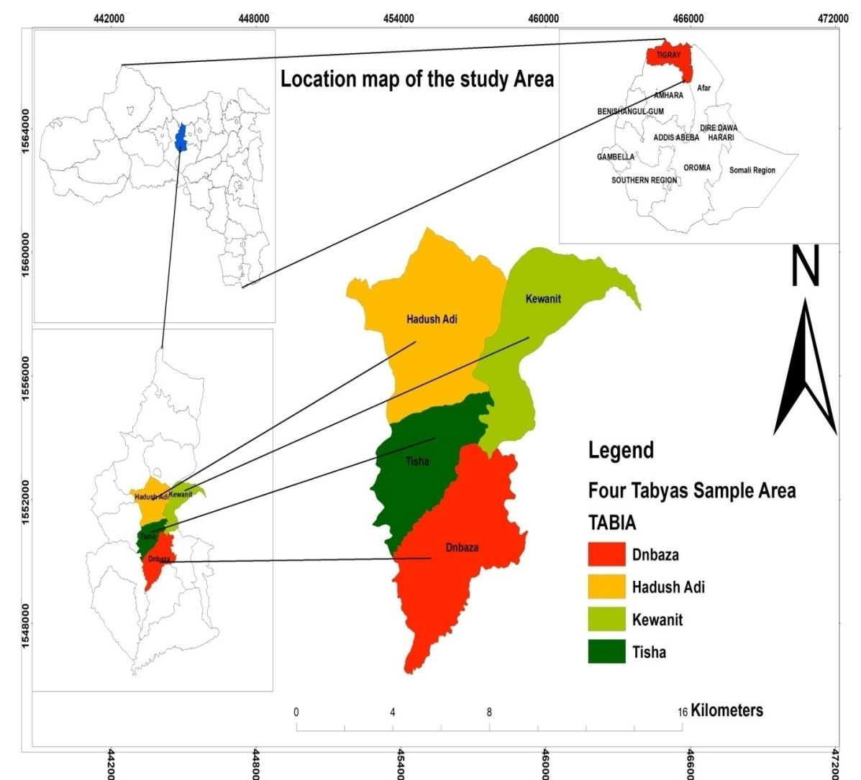
Figure 2 Map of Ethiopia, Showing Tigray Region and woreda with Selected kebeles (developed by Samson Negasi (2019)

Research Approach and Design
Since the primary concern of this study was to assess the Challenges and opportunities of small -scale irrigation utilization, both qualitative and quantitative approaches had been employed. The combination of qualitative and quantitative techniques can help the researcher to cross-check/triangulate and complement relevance and accuracy of the data and it allowed for, provision of different perspectives in answering various specific questions within a broad area. Both approaches had been employed towards meeting all research objectives. It was a very important method, as data was gathered from the sample of respondents, and the researcher described the concepts regarding the challenges and opportunities of utilizing small scale irrigation in the selected Kebeles of the Woreda. The study utilized descriptive research design as it gives there a possibility to observe the phenomenon in a completely natural and unchanged natural environment. Furthermore the study was utilized cross-sectional in the sense that all relevant data was collected at a single point in time.

Target population and Sample Design

Target population
The target population of the study was households who engaged in small scale irrigation from Tisha cluster (Tisha 280, Kewanet 316, Dnbaza 216, HddishAdi 352 total 1164) out of these four clusters in Tahtay Maychew district. In addition to this, the researcher used ten key informants from Woreda administrative (1), water development experts(4), extension personnel and irrigation expert(4) as well as 1 Head of Agricultural and .development office of the woreda

Sampling Techniques

Tahtay MychewWoreda has 17Kebeles out of these 16 kebeles are rural area which are grouped into four clusters administratively. In this study such division is important to make survey study, and aimed to select purposefully one cluster out of the four which was support to the objective of the study. According to Agriculture office of the Woreda the selected kebeles have a weak performance in the irrigation schemes. The sampling frame being the total number of Irrigation users in four Kebles, the respondents were selected using Simple Random Sampling (Lottery) method from four Kebeles in order to give equal chance for all in the Sampling Frame. Four enumerators were engaged in administering questionnaires and they were trained for one day before they start. After that, on the basis of the results obtained, the questionnaire was managed in the selected Kebeles at the convenience of respondents. The researcher himself was involved, as supervisor, throughout the questionnaire administration process.

Sample size determination
Identifying and determining the sample size from the total target population is a main task in research design. Kothari’s, (2014) provides an easy formula for determining sample sizes, and this researcher had prioritized Kothari’s formula.
n= $\frac{z2.p.q.N}{e2\left(N-1\right)+z2.p.q}$
N=population size
P=sample proportions of successes
n= sample size
q=1-p
z=the value of the standard deviation at a given confidence level
e=acceptable error (the precision) thus, N=1164 p=0.02 z=2.005 e=0.02. Therefore
n= $\frac{\left(2.005\right)2\left(0.02\right)\left(1-0.02\right)(1164)}{\left(0.02\right)2\left(1164-1\right)+\left(2.005\right)2\left(0.2\right)(1-0..2}$
n=$\frac{(4.020025)(0.02)(0.98)(1164)}{\left(0.0004\right)\left(1163\right)+\left(4.020025\right)\left(0.02\right)(0.98)}$
n=$\frac{91.71447}{0.4652+0.07879249}$

n=$\frac{91.71447}{0.54399249 }$ =168.59 =169
The researcher believes it is necessary to use an independent sample for each kebele to ensure equal representation. However, the selected kebeles has different numbers of Irrigation users; therefore, the sample size for each kebele’s was calculated proportionately. The researcher was used proportionate sample allocation in an attempt to make each stratum sample identical with proportion of population. Therefore, the proportional sample size from each stratum was calculated by using the following formula:
ni = nxNi/N
Where: ni= sample size for individual kebeles
Ni= the total number of SSIUs in each kebeles
N=the total number sample size
n= the total sample size for selected kebeles
In view of that, the table below shows the proportionate sampling for each kebeles based on the formula.

Table 1.irrigation users of selected kebeles
No. | name of kebele | Total no. of irrigation users
1 | Kewanet | 316
2 | Tisha | 280
3 | Denbaza | 216
4 | HddishAdi | 352
 | Total | 1164
Sources:from the Woreda (ARDO)

Figure 3. Composition of sample of respondents from four kebeles
By taking the above figure into consideration, the researcher was determined to work on 169 sample size for the survey. There are about 169 questionnaires prepared and distributed to these respondents who are selected by using simple random techniques from each Kebele.

Type and Data Source
In this study, both qualitative and quantitative data were collected to attain the stated objectives from primary and secondary data sources Primary data source were collected with the help of a standard questionnaire designed to obtain information from selected sample households. Qualitative method was used to capture data pertaining to local perception and opinions on the effect of irrigation on household food security. This was done by using one focused group discussion in each of the four selected Kebeles and through key informant interviews. Furthermore, the researcher was discussing with key informants and focus groups. The leading question prepared to guide the discussions with the focus group and key informants was put emphasis on major challenges and opportunities of utilizing irrigation. Information was gathered both from primary and secondary sources. The primary sources were farmers, key informants from Woreda administration and extension personnel as well as focus group. While documents, international publications about utilization of irrigation were serve as secondary sources for the secondary data source.

Data Collection Methods and tools
Data was collected from the sample group through questionnaires, interviews, focus group discussions and field observations. To supplement and enhance the information presented, Secondary data was accessed from published and unpublished documents obtained from different sources. These included policy statements of the country, strategies regulations, reports and past case study papers on small scale irrigation practices and published articles. The main sources of information was gathered through the questionnaire, from the farmers of four Kebeles, key informants and focus group discussions from Woreda administrative body, ADCS, extension personnel and farmers.

Questionnaire
To generate quantitative information at household level, household survey was undertaken by developing questionnaires. So as to gather primary information the survey was conducted on the selected 169 sample irrigation users that apply irrigation in their farming occupation was privilege to fill the questionnaires.
Questions were formulated in both open ended and close ended forms and administered through face to face contact with smallholder households. The questionnaire was first prepared in English and later translated into the local language (Tigrigna). Respondents can easily understand the questions. Four enumerators, one for each Kebele, were employed based on their ability of local language and culture, and experiences in data collection. Training was provided to the enumerators on the procedure to follow while conducting interview with respondents and deep discussion was also held to make the questionnaire clear.

Focus group discussion
FGD, which is the common data gathering method in qualitative research, is preferable when the aim of a research is to discover what people believe and feel by actually asking their opinion in a group setting (Miller and Brewer, 2003). Focused group discussion were also undertaken to gather primary information from respondent households in study area. Focused group discussion was conducted in all four Kebeles with 22 selected farmers (4 females and 18 males). From Hadushadi Kebele 6 farmers (two were the so called model farmers‟), from Tisha Kebele 5 farmers (two were the so called „model farmers‟) .from Kewanit Kebele 5 farmers (Three were the so called „model farmers‟) and 6 farmers from Denbaza kebele. The model farmers were purposely selected, while the others were selected randomly. The interviewer introduced a list of topics and encouraged the participants to discuss issues and forward their opinions. The output of the discussion was used as a guide the design of household questionnaire and to get additional supporting qualitative evidence of the on current situation of farmers and challenges that farmers have been faced irrigation activity.

Key informant Interview
An interview guide was design to obtain in depth information from key respondents and it helps to test for areas hard to investigate by the use of questionnaire approach. To make the study more comprehensive and reliable interviews of a semi-structured type was carried out by the researcher himself, with key informants chosen based on knowledge of the problems in the study area and 8 key informant interviews carried out to irrigation experts in four Kebeles, water development expert’s, and the head of Woreda Agriculture Office, Woreda heads of Water Resources, and the Woreda department of irrigation.

Field observations
During the field survey, much time was committed to observation of ground water irrigation, communal wells river diversions schemes and to visiting governmental organizations which are dealing with water resources development and management in Worda Tahtay Maychew Development and Agricultural project office of the Woreda and four kebeles Administration and development agents and the researcher gathered a lot of information

Methods of data analysis and interpretation
After careful collection of data, both from primary and secondary sources, it was checked for reliability. Data collected from respondent farmers through questionnaires, are analyzed and interpreted so as to arrive at meaningful findings. SPSS Version 20 was used to code and analyze the collected responses from questionnaires. After proper editing, data were coded; entered to the Excel software and then they were made ready for analysis. Descriptive statistical techniques are adopted for analysis of data collected from questionnaire respondents. In so doing frequency tables and percentages were used. This helped the researcher thoroughly analyze and interpret the questions one by one in order to reach meaningful results. Data collected from interview and focus group discussion was also incorporated in the data discussion and interpretation part of the study. Hence, the results are easily interpreted to assess challenges and opportunities of small scale irrigation. Conclusions were drawn based on the data analysis and interpretation.

Chapter Four: Results

Demographic Characteristics Of The Respondents
Table 2 Demographic character tics of respondents
 |  |  | Frequency |  | Percent | Valid Percent |  | Cumulative Percent
Sex of Respondents | M |  | 121 |  | 71.6 |  | 71.6 | 71.6
Sex of Respondents | F |  | 48 |  | 28.4 |  | 28.4 | 100
Sex of Respondents | Total |  | 169 |  | 100 |  | 100
Age group of Respondents
18-29 |  |  | 10 |  | 5.9 |  | 5.9 | 5.9
30-39 |  |  | 44 |  | 26.0 |  | 26.0 | 32.0
40-49 |  |  | 47 |  | 27.8 |  | 27.8 | 59.8
50-59 |  |  | 42 |  | 24.9 |  | 24.9 | 84.6
60 and above |  |  | 26 |  | 15.4 |  | 15.4 | 100.0
Total |  |  | 169 |  | 100.0 |  | 100.0
Marital status of the respondent
Married |  | 141 |  | 83.4 |  |  | 83.4 | 83.4
Divorce |  | 17 |  | 10.1 |  |  | 10.1 | 93.5
Single |  | 11 |  | 6.5 |  |  | 6.5 | 100.0
Total |  | 169 |  | 100.0 |  |  | 100.0
Educational level of the respondent
Illiterate |  | 65 |  | 38.5 |  |  | 38.5 | 38.5
Read and write only |  | 47 |  | 27.8 |  |  | 27.8 | 66.3
Elementary |  | 41 |  | 24.3 |  |  | 24.3 | 90.5
High school |  | 16 |  | 9.5 |  |  | 9.5 | 100.0
Total |  | 169 |  | 100.0 |  |  | 100.0
Source; field survey; 2018/9
The survey of the study shows that the total households participated in the study were 169. Out of these sample, 48(28.4%) of them were females and the remaining 121 (71.6%) were male (Table.2).

Opportunities in utilizing small scale Irrigation
In the study area, even though there are many challenges to introduction and utilization of small scale irrigation as will be considered in the next section, there are some encouraging aspects, as well in this part, the major opportunities towards the increased irrigation utilization in the study area where the respondent farmers have identified will be discussed.
The first opportunity singled out by respondents relates to the suitability of agro-ecological condition in the study area, as provided in the subsequent table.

Agro –ecological zone
Table 3 Respondents on Agro ecological zones of the study area
Do you think that your agro ecological zone is conducive to produce different products? |  | Frequency | Percent | Valid Percent | Cumulative Percent
 | Yes | 157 | 92.9 | 92.9 | 92.9
 | No | 12 | 7.1 | 7.1 | 100.0
 | Total | 169 | 100.0 | 100.0
Source; field survey; 2019
92.9% of the respondents reported that their Agro ecological zones are favorable for varieties of crop to grow. (Table 3 )

Labor
Table 4 Respondents related with labor
Do you have labor shortage in operating your irrigation farm? |  | Frequency | Percent | Valid Percent | Cumulative Percent
 | Yes | 43 | 25.4 | 25.4 | 25.4
 | No | 126 | 74.6 | 74.6 | 100.0
 | Total | 169 | 100.0 | 100.0
Source; field survey; 2019

Figure 4. The Photo “A” shows participation of families in irrigations and “B” shows participation of employees in irrigation activates Photo credit December 2019 by Mawcha Assefa

Related with government support

Figure 5 show that the role of government in irrigation practice
Government is an essential agent to encourage infrastructures of irrigation and to enhance Agricultural product. In this study about (66.9%) respondents are satisfied with the support of government. However, 30.8% of the respondents were dissatisfied by the support of the government.

Respondents related with land security
As the survey result indicates that 83.3% of the respondent farmers reported that the land belongs to them. In addition to, during the FGD, farmers of the irrigation users explain that they feel secured that the land belongs to them because they are issued with land certificate. This was also confirmed by the land administration office expert in the Woreda that was I interviewed.
Table 5 The coverage of irrigation farm land in (ha) of the four selected kebeles.
Name of kebles | Potential to be irrigated (ha) | Irrigated (ha) | %
Hadush-Adi | 150.6 | 101.25 | 67.23
Kewanit | 148.5 | 91 | 61.28
Tisha | 82.8 | 56.5 | 68.24
Dembaza | 28.4 | 14.2 | 50.00
Total | 403 | 262.9 | 65.25
Source from report of DoARD 2017/8
The total irrigation farm land of the Worde is 1643 ha which is available for irrigation from this 403 ha is found in the selected study area. This is a big opportunity. However, the total area covered by small scale irrigation scheme was only 262.9 ha. This shows that the irrigation activities were reduced in all the selected kebeles. As per discussions with Woreda irrigation experts the major problems of reduction of irrigations are shortage of water and dependency syndrome on government and non-governmental organizations and in some farmers’ lack of interest.

Challenges in utilizing small scale irrigation
In the preceding section, we have considered the major opportunities, which can encourage the engagement in and positively affect the utilization of small scale irrigation in the study area based on the survey results. This also part of the study, and discusses the main challenges hindering the utilization of small scale irrigation in the study area.
Table 6 Respondents related with irrigation planning
Do you plan your irrigation activities?
 | Frequency | Percent | Valid Percent | Cumulative Percent
Yes | 125 | 74.0 | 74.0 | 74.0
No | 44 | 26.0 | 26.0 | 100.0
Total | 169 | 100.0 | 100.0
If yes, what criteria you used to decide the type of irrigated crops
Price of the crop | 47 | 27.8 | 37.6 | 37.6
Cost of production | 6 | 3.6 | 4.8 | 42.4
Size of the water | 72 | 42.6 | 57.6 | 100.0
Total | 125 | 74.0 | 100.0
Source: field survey; 2019
Planning is important to bit the goals of its target. The majority of respondents (74%) responded that they have irrigation planning. However, most of the respondents with (42%) plan their irrigation based on the size of the water available to them at a certain time. We can say that planning for irrigation can be taken as a good practice. Though, as production of crops through irrigation highly depends on the size of water they have, it would limit production and productivity of irrigation system, as farmers are restricted to produce only crops that require small amount of water. As will be discussed below, there is a general limited amount of water that farmers can use for irrigation in the study area. This, in turn, means that farmers are less likely to produce market oriented crops, which could have generated higher profits. This further will mean that limited types of crops are to be produced in the study area, which would in turn negatively affect the market value to the disadvantage of the farmers.
Table 7 Respondents related with farm land productivity
How do you view the quality of your farm land?
 | Frequency | Percent | Valid Percent | Cumulative Percent
Very poor | 11 | 6.5 | 6.5 | 6.5
Poor | 104 | 61.5 | 61.5 | 68.0
Medium | 48 | 28.4 | 28.4 | 96.4
Good | 6 | 3.6 | 3.6 | 100.0
Very good | 0 | 0
Total | 169 | 100.0 | 100.0
If your response is poor or very poor, indicate factors that contributed to it
Soil erosion | 43 | 25.4 | 37.1 | 37.1
No using of irrigation technologies | 10 | 6.5 | 9.5 | 46.6
Continuous grazing | 52 | 30.8 | 44.8 | 91.4
Little or not using fertility inputs | 10 | 5.9 | 8.6 | 100.0
Total | 115 | 68.6 | 100.0
Source; field survey; 2019
The farmland of the study area farmers classified as poor (61.5) and medium (28.4) (Table.7)

Figure 6: Coverage of crop in the selected study area
Source: Report of ARDO 2018/9
The irrigated areas of the study were 91.2%, 8.4% and 0.4% covered by vegetables, Fruits and corps respectively.
Table 8 Problem of crop failure
Have you ever faced a problem of crop failure while using irrigation?
 | Frequency | Percent | Valid Percent | Cumulative Percent
Yes | 120 | 71.0 | 71.0 | 71.0
No | 49 | 29.0 | 29.0 | 100.0
Total | 169 | 100.0 | 100.0
If your answer is yes, what were the possible causes for this problem of crop failure?
Water shortage | 42 | 24.9 | 35.0 | 35.0
Damaged by disease | 73 | 43.2 | 60.8 | 95.8
Poor adaptation of varieties used | 2 | 1.2 | 1.7 | 97.5
Poor administration of water distribution | 3 | 1.8 | 2.5 | 100.0
Total | 120 | 71.0 | 100.0
Source; field survey; 2019
The survey result indicates that 71% of the respondents faced problem of crop failure (Table.8). From this sampled respondents, while 43.2% of them reported that this problem of crop failure resulted from diseases, 24.9% of respondents reported that crop failure is associated with water shortage .During the FGD, some of the participants explained that on average estimation, they lose about quarter of their production to diseases and pests. The problem is worst, as it affects the products mostly at a time of the crops start to produce. Thus, after farmers spend their time, labor and material costs, the diseases and pests result in great harm to them, let alone for them to have a profit. Therefore, it is the major headache for the users of agriculture in general and small scale irrigation in particular.
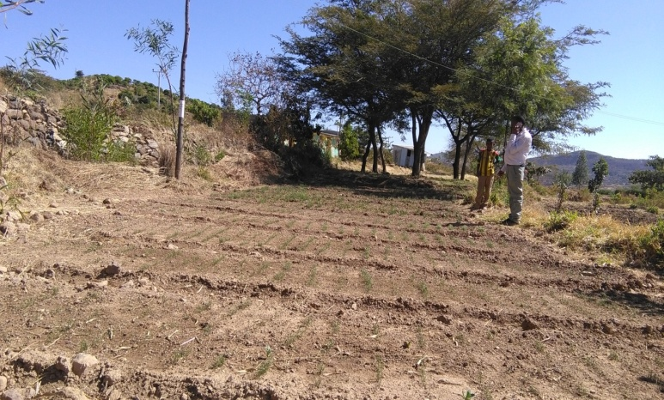

Figure 7. This picture t shows that the planted onion has wilted, due to lack of irrigation water.
Source: own Filed survey 2018 Photo Credit December 2018.by Hadush Mawcha

Table 9 Summarized information related to utilizing of irrigation inputs.
Have you used irrigation inputs on your farmland?

 | Frequency | Percent | Valid Percent | Cumulative Percent
Yes | 122 | 72.2 | 72.2 | 72.2
No | 47 | 27.8 | 27.8 | 100.0
Total | 169 | 100.0 | 100.0
Which type of irrigation inputs do you use for your farmland?

 | Frequency | Percent | Valid Percent | Cumulative Percent
Chemical fertilizer | 101 | 59.8 | 59.8 | 59.8
Organic fertilizer | 28 | 16.6 | 16.6 | 76.4
Improved seed | 57 | 33.7 | 33.7 | 110.1
Insecticides’ and pesticides | 88 | 52.1 | 52.1 | 162.2
Total | 274 | 162.2 | 162.2
Do you apply farm inputs on your farmland as per the recommendation of agricultural experts?
 | Frequency | Percent | Valid Percent | Cumulative Percent
Yes | 13 | 7.7 | 7.7 | 7.7
NO | 156 | 92.3 | 92.3 | 100.0
Total | 169 | 100.0 | 100.0
what are the factors that hinder you from using inputs for the irrigation land

 | Frequency | Percent | Valid Percent | Cumulative Percent
lack of income to purchase | 19 | 11.2 | 15.6 | 15.6
High cost of the input | 64 | 37.9 | 52.5 | 68.0
Limited accessibility | 39 | 23.1 | 32.0 | 100.0
Total | 122 | 72.2 | 100.0
Source; field survey; 2019
From the above Table 8 72.2% of the sampled respondents used irrigation inputs on their farmland while 27.8% were not used agricultural inputs on their irrigational practice. As shown in the above table the proportion of chemical fertilizer is 59.8%, pesticides 52.1% and improved seeds 33.7% respectively (Table 9). The proportion of chemical fertilizer (application is higher as compared to organic fertilizer and improved seeds.
Table 10 The water sources and uses of irrigation technologies among the local community in the study area.
What is the main source of your irrigation water?
 | Frequency | Percent | Valid Percent | Cumulative Percent
Ponds | 79 | 46.7 | 46.7 | 46.7
River | 32 | 18.9 | 18.9 | 65.7
Check dam | 54 | 32.0 | 32.0 | 97.6
Diversion | 4 | 2.4 | 2.4 | 100.0
Total | 169 | 100.0 | 100.0
What type of irrigation technologies do you use?
 | Frequency | Percent | Valid Percent | Cumulative Percent
Treadle pump | 32 | 18.9 | 18.9 | 18.9
Motor pump | 137 | 81.1 | 81.1 | 100.0
Drip pump | 0 | 0 | 0
Row pump | 0 | 0 | 0
Total | 169 | 100.0 | 100.0
Source; field survey; 2019
The survey result indicated that 46.7% of the respondents use ponds while 32%, 18.9% and 2.4% of the respondents get water for their irrigation activities from check dam, rivers/ spring, and diversions respectively (Table 10).
.
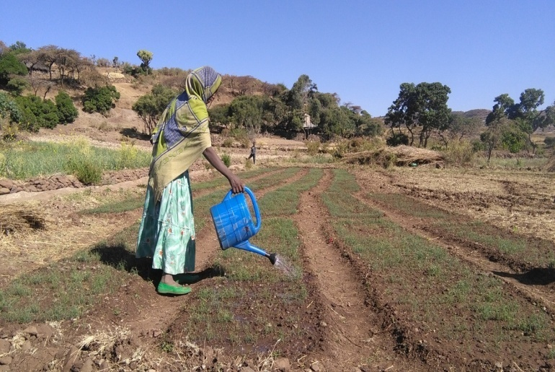
Figure 9. Picture taken by researcher shows a Woman watering her irrigation field by fetching water from wells. Photo credit :December 2019 by Mawcha Assefa

Figure 10.This pie chart shows the number of irrigation utilizing farmers who participate in maintaining their irrigation Technology.
Source Own survey 2019
As indicted (Figure.10), 97.6% of respondents Farmers confirmed that the new technologies they use are not easy to maintain, but the only small number of the respondent farmers revealed that the technology which they owned is simple to maintain. In addition to the majority of respondents reply above, the focus group attendants from sampled Kebeles demonstrated that even if they accept the new irrigation technologies they have difficulty in preserving it; because most of new irrigation technologies such as motor pump and treadle pump are complicated to maintain during the broken time/when it becomes non-functional and as lack of knowledge and skills. Standing from the above inspection, majority of the farmers in the study area have a difficulty to maintain new irrigation technologies due to its complexity and poor know how and skill

Respondents related to spare parts

Figure 11 Shows the number of respondents on the availability of spare parts to maintain their irrigation technologies.
Table 11 Respondents related with to water access
Have you cultivated your irrigable plot in full scale
 | Frequency | Percent | Valid Percent | Cumulative Percent
Yes | 41 | 24.3 | 24.3 | 24.3
No | 128 | 75.7 | 75.7 | 100.0
Total | 169 | 100.0 | 100.0
What was the most important inhibiting factors that hinder full scale irrigation utilization
 | Frequency | Percent | Valid Percent | Cumulative Percent
Shortage of water | 95 | 56.2 | 74.2 | 74.2
Shortage of input | 5 | 3.0 | 3.9 | 78.1
Credit access | 1 | .6 | .8 | 78.9
Market | 27 | 16.0 | 21.1 | 100.0
Total | 128 | 75.7 | 100.0
Source; field survey; 2019
The majority numbers of respondents (75.7%) reported that they did not use irrigation in full scale (Table 9) and the major reason cited for this is 74.2% of them responded the existence of shortage of water. As mentioned above, the small-scale irrigation practices in the kebeles covered depend on check dams and small ponds for their water sources.
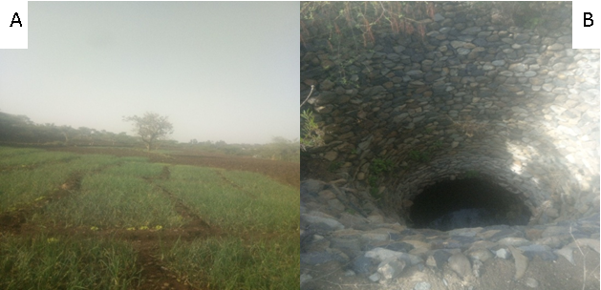
Figure 12 pictures A and B illustrates the community pond that contains limited amount of water and irrigation land that did not fully utilize because of shortage of water in the study area
Table 12.Major challenges of small scale irrigation
What are the major challenges in irrigation utilization in your area? |  | Frequency | Percent | Valid Percent | Cumulative Percent
Valid | Distance from water source to farm land | 6 | 3.6 | 3.6 | 3.6
Valid | Lack of effective marketing system | 108 | 63.9 | 63.9 | 67.5
Valid | Lack of input supply and irrigation facilities | 15 | 8.9 | 8.9 | .3
Valid | Presence of pests and diseases | 37 | 21.9 | 21.9 | 98.2
Valid | Lake of improved seed | 3 | 1.8 | 1.8 | 100.0
Valid | Total | 169 | 100.0 | 100.0
Source; field survey; 2019
The main challenges which were forwarded by the respondents are lack of effective marketing system (63.9%), Presence of pests and diseases (21.9%) and lack of input supply and irrigation facilities (8.9) (Table 12).

Price of irrigation products
According the worker of market promotion office the Worda, the price of most vegetables was very low during November, December and January. As field observations all of the irrigation users produced the same product at same time. As per discussion with the key informants, during these months the farmers compute to sale their products as the result price of vegetables becomes low. This due to, vegetables (onion and tomatoes) are easily spoiled when they take time. So the farmers tried to force to sale their products with low prices. This can influence irrigation direct or indirectly.

Follow up of Experts for the Utilization of Irrigation
Table 13 Regarding the follow up of extension
Have you ever visited by an extension agent
 | Frequency | Percent | Valid Percent
Yes | 138 | 81.7 | 81.7
No | 31 | 18.3 | 18.3
Total | 169 | 100.0 | 100.0
How frequently do you contact with them?
every month | 69 | 40.8 | 50.0
once every three month | 39 | 23.1 | 28.3
once every six month | 21 | 12.4 | 15.2
once a year | 9 | 5.3 | 6.5
Total | 138 | 81.7 | 100.0
Source: Field survey; 2019
. The majority of respondent farmers (81.7%) were visited by extension agents and 40.8% of respondent farmers were visited every month by extension personnel and this shows that farmers have no great problem with extension contact (Table 11).

Training for Operation and Maintenance

Figure 13 the pie chart shows the number of respondents which involved in operational and maintenance training.
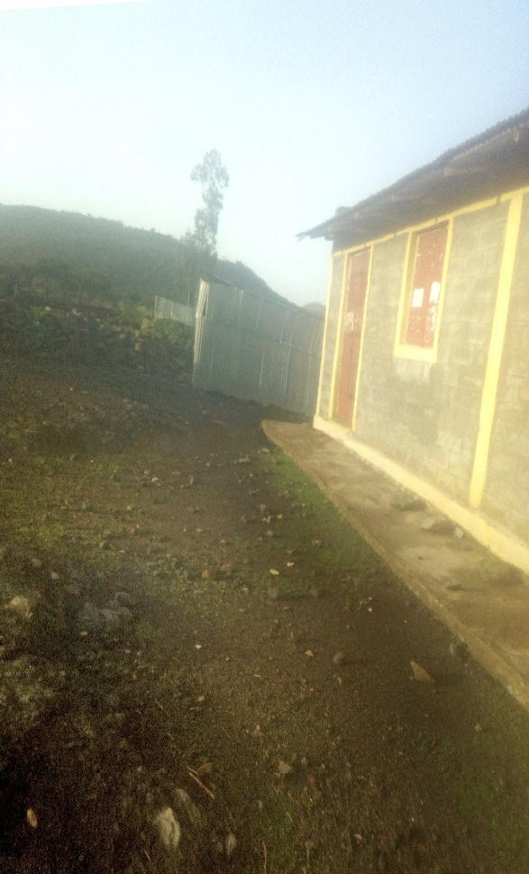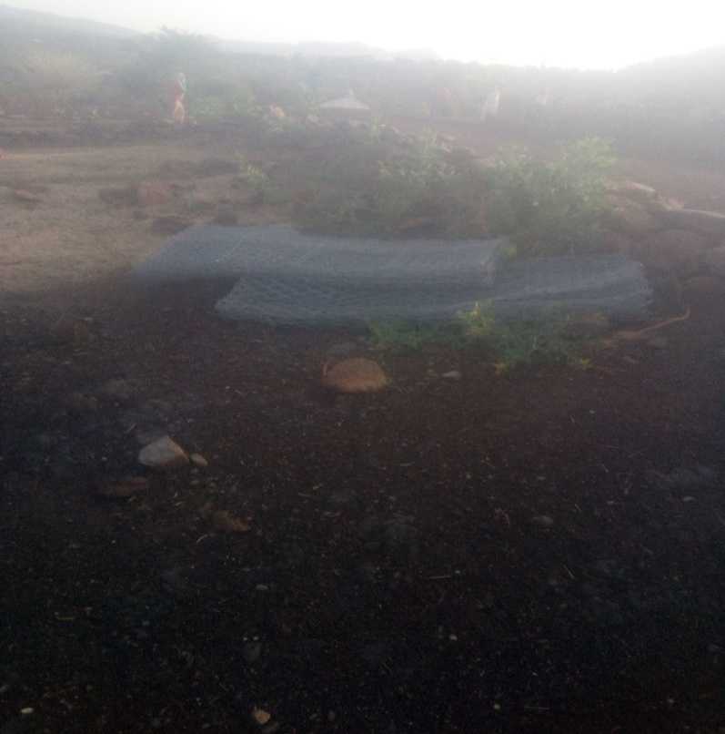
Figure 14 The picture illustrates the farmers Training center in the study area.
Source: Photo taken during field survey, January 2019
The picture illustrates the farmers Training center in the study area with no material which is important to give training for those who used small scale irrigation.

Irrigation Practice and access to Infrastructure
Table 14 Respondents related to infrastructure
Is there any feeder road that connects your kebele to the nearest market area
 | Frequency |  | Percent | Valid Percent | Cumulative Percent
Yes | 169 |  | 100.0 | 100.0 | 100.0
Road comfortable
 |  | Frequency | Percent | Valid Percent | Cumulative Percent
very poor |  | 11 | 6.5 | 6.5 | 6.5
Poor |  | 101 | 59.8 | 59.8 | 66.3
Good |  | 57 | 33.7 | 33.7 | 100.0
Total |  | 169 | 100.0 | 100.0
What are the types of transportation for agricultural products you use to go to the nearest town?
Animal |  | 98 | 58.0 | 58.0 | 58.0
on foot |  | 27 | 16.0 | 16.0 | 74.0
Car |  | 44 | 26.0 | 26.0 | 100.0
Total |  | 169 | 100.0 | 100.0
Do you have access to convenient markets for your irrigation outputs and inputs?
 |  | Frequency | Percent | Valid Percent | Cumulative Percent
Yes |  | 9 | 5.3 | 5.3 | 5.3
NO |  | 160 | 94.7 | 94.7 | 100.0
Total |  | 169 | 100.0 | 100.0
Source: Field survey; 2019
The irrigation users their products transported to market by animals back (58%), Car (26.%) and on foot(16%) (Table).The 94.7% of the respondents reported that there are no convenient markets for their irrigation output and inputs.

Table 15 Respondents related to credit access service
Do you have access to credit services that facilitate your irrigation practices such as getting a loan?
 | Frequency | Percent | Valid Percent |  | Cumulative Percent
Yes | 136 | 80.5 | 80.5 |  | 80.5
No | 33 | 19.5 | 19.5 |  | 100.0
Total | 169 | 100.0 | 100.0
How do you finance the expenses for irrigation related inputs?
Personal saving | 56 | 33.1 | 33.1 |  | 33.1
From relatives | 63 | 37.3 | 37.3 |  | 70.4
Cooperatives | 35 | 20.7 | 20.7 |  | 91.1
Microfinance | 15 | 8.9 | 8.9 |  | 100.0
Total | 169 | 100.0 | 100.0
What are the constraints to access credit from the formal institutions?
High interest rate | 89 | 52.7 |  | 52.7 | 52.7
Collateral | 65 | 38.5 |  | 38.5 | 91.1
Unfavorable repayment period | 15 | 8.9 |  | 8.9 | 100.0
Total | 169 | 100.0 |  | 100.0
Source: Field survey; 2019
80.5% of the irrigation users they got credit access service. Most of the credits they got from their relatives (37.3%) (Table.15).

Electric availability
During the survey, the research was identified non functional two ground water well through field observations in the study area had been dug since in 2011 .These ground water found in kwenit and Hadush adi kebeles . According BoARD administration and exports of water and mining reports these water bodies are non functional due to lack of energy supply and new technology. According developmental agents, these water bodies can be irrigating from 8 to 15 hectares still now they did not functional yet.

Chapter Five:

Discussion, Conclusion and Recommendations
5.1 Discussions
As can be seen in Table 2 males were dominant in the activities of irrigation (71.6%)(Table2). During the focus group discussion that female and male household leaders did not participate equally in irrigation farming activities. This finding is similar with Dereje Mengistie (2016) who reported that males predominate in irrigation activities than women. It is to be noted that age of farmers is one of the main and distinct factors that can influence modern irrigation utilization, either positively or negatively. Table 2, in this regard, shows that the majority of respondents belong to the age group of 40-49 years (27.8%) and 30-39 years (26%). According to the Ethiopian age group classification, these age groups are considered to be the working labor forces. Therefore, we can understand that the age group to which the majority of respondents belong is the age which is ideal for the utilization of irrigation, as these farmers would normally have the required energy to fully practice in irrigation. Age can influence the production and productivity of irrigated crop production and might create production difference among the irrigation areas (Lijalem Abebaw, 2013).
Data regarding the educational levels of participants in the study area was also considered. Accordingly, the data obtained from survey shows that 38.5% were illiterates; 27.8% could only write and read; whereas 24.3% are formally educated (Table 2). Farmers’ education increases their possibilities to access external sources of information that helps them, among other things, to learn and adopt new technologies, which are helpful to their work and better inputs. Education also helps farmers have a more effective communication with agricultural extension agents as well as making better choices when it comes to gaining economic benefits from their produce. It is known that Famers possesses immense indigenous knowledge that has developed over many years regarding farming and irrigation. Yet, given the evolving nature of technological advances and inputs that result from years of research and development, traditional knowledge is less likely to equate with formal education when it comes to adopting and using these technologies. This finding is similar with Feder et al.(1985) According Feder et al. (1985) farmers with more education have been shown to adapt modern agricultural technology sooner.
9.5% of the respondents completed high school and they have knowledge how to use varieties of input of irrigation and technologies Similar study conducted by Tizita Damtew (2017), literate farmers are more likely to adopt the use of farm inputs and fare better in using agricultural information delivered from extension agents than those who are illiterate though the quantity of farm input such as fertilizer demand does not depend upon literacy. Literate farmers are more likely to increase the agricultural outputs and better in accessing market information for agricultural outputs and inputs than illiterate farmers

Opportunities in utilizing small scale Irrigation
In the study area, even though there are many challenges to introduce and utilization of small scale irrigation as will be considered in the next section, there are some encouraging aspects, as well in this part, the major opportunities towards the increased irrigation utilization in the study area where the respondent farmers have identified will be discussed.
The first opportunity singled out by respondents relates to the suitability of agro-ecological condition in the study area, as provided in the subsequent table.

Agro –ecological zone
According the study of the respondents, 129 (76.33%) felt that their Agro-ecological zone is very favorable to produce different products whereas fewer respondents displayed that their Agro-ecological zone is not favorable to produce products Pertaining to this issue, the attendants of focus group discussions and key informant interview notified that there are favorable conditions in the study, area such as climatic condition, water resources and land for irrigation (Table3). Also there is a good climatic condition which is mostly Dega and W/Dega in nature. Based on the information gathered from respondents and attendants of focus group discussions, we can deduce that the agro ecology zone of the study area is conducive enough to produce different crops and vegetables via the use of irrigation technologies. This can be seen as the opportunities for utilization of irrigation in the study area. Similar to the survey study, the (MoA , 2011),revealed that the existence of a favorable natural environment and suitable agro-ecologies had been identified as major contributors and the country is endowed with a wide range of natural resources, such as land, irrigation potential and agro ecological diversities favorable for the growing of various crops

Respondents related with Labor
Labor force is important to facilitate agricultural activities especially in irrigation. The majority of respondents (74.6%) have enough labor force to effectively carryout their irrigation (Table 4). As per FGD with farmers, they further highlighted why labor force is not an issue. Accordingly, the majority of the participants pointed out that they do not have labor shortage, as their family size is large enough to manage their irrigable plots, which are small. From this, we can infer that those participating in small scale irrigation in the study area have no difficulties managing their irrigation. This, is a big an opportunity, a conducive circumstance to engage in irrigational activities. At this juncture, it should be added that many family members, including students, do participate in the endeavors. In a way, it is a family activity. Besides, the fact that many of the participants are married means that there are more people to engage in the irrigational activity. That said, however, and as the participants in the study repeatedly mentioned, the small size of the irrigable land also partly explains why families do not consider labor as a problem in conducting their irrigation related activities. Similar to the survey study result that (Nata Tadsse and Bheema, 2010) conducted, irrigation is considered as a job opportunity by households. As a result, the members of the households involve full time/part time in the irrigation activities as laborers. And irrigation and rain-fed agriculture requires a diverse labor force both in quantity and technical quality (Haile Tesfay, 2008). According Holder (200) irrigation farming is extremely labor intensive.

Respondent related with government support
Government is an essential agent to encourage infrastructures of irrigation and to enhance Agricultural product. In this study about (66.9%) respondents are satisfied with the support of government (Figure 5). However, 30.8% of the respondents were dissatisfied by the support of the government. Similarly, during the focus group discussions, many farmers said that, even though there are many problems concerning irrigation utilization which will be seen in next part of this study, the efforts of the government are inspiring them to focus on the strategies and to effectively utilize irrigation that they possess. Concerning this issue, a key informant from the office of agriculture and rural development felt that, our government is striving to enhance agriculture the leading sector in our country’s economy. In doing so, promoting new irrigation technology utilization have a vital role. Accordingly, the local government (Woreda) is practicing many alternative ways, example. mobilization of farmers by means of organizing them into unions, expansion of the practice of extracting ground water for irrigation purposes, and deployment of irrigation experts to help farmers, towards spreading and increasing the impact of irrigation. So from this discussion of respondents the support of government in the study area was identified as the luxurious opportunity that is inspiring farmers to utilize irrigation effectively.

Respondents related to land security
As the survey result indicates that 83.3% of the respondent farmers reported that the land belongs to them. In addition to, during the FGD, farmers of the irrigation users explain that they feel secure the land belongs to them because they are issued with land certificate. This was also confirmed by the land administration office expert in the Woreda that was I interviewed. Accordingly, land certifications of the farmers in the Woreda have been completed. This indicates that land certification can increase the farmers’ sense of ownership and level of confidence to utilize their land for a long period of time. This can contribute to the production and productivity of irrigation because farmers are motivated to develop their land without threat and it can be seen as a great opportunity. For instance, a land certification would encourage farmers to choose the type of crop or trees that they would like to grow, without fear of eviction. This is in line with a finding by Kluas, D (2008), stated that land certification increases security of farmers and empowers them in deciding how best to make use of their land

Challenges in utilizing small Scale irrigation

Respondents related to productivity Farm land
According to survey results obtained From the sampled irrigation farmers classify their farmland fertility situation as 61.5% poor, 28.4 % medium respectively (Table 7). The sampled farmers of the district have sensed that farmland productivity of their farm lands is declining from time to time. Farmers have understood/perceived because of the fertility decline, it is not possible to produce crops without fertilizers. According to survey results obtained the main factors constraining irrigation practice and causing decline farm land fertility of the study area are mainly related to continuous grazing (30.8%) and soil erosion (25.5%) .This constraining factors result in decline irrigation production and productivity thereby reduce crop production which in turn, would, lead household to Food security problem in the study area. (Table7)
A similar study conducted by Abraham Gebrehiwot, et al (2015), describes intensively cultivating with the same crops for long periods of time leads to the loss of productivity and fertility, this cultivation strategy facilitates crop disease like root rot and cut worm.
As per interview discussion with agricultural experts of the district indicate that the problems among the sampled kebele farmers are mainly attached with traditional farming method that prevailed for a long period of time and producing crop on the same agricultural land with poor application of modern irrigation technologies. In line with this agricultural offices of the Woreda point out that in order to reduce the problem of runoff, soil erosion and to maintain and replenish farmlands fertility and thereby enhance farm production a number of farmland management practices are being introduced recently into the Woreda. The two main activities undertaken to reduce runoff and soil erosion and protect the fertility of soil were known tracing and bench tracing. The tracing is normally a soil/stone Bund constructed with the aim of reducing soil loss. The tracing were mainly constructed on the elevated areas that took soil to the bottom, whereas, bench tracing were constructed in every flat area water is highly accumulated. The main purpose of bench tracing is to remove accumulated water and it enables the water to go to downstream. The construction of both was made by traditional way through digging by hand. The above work is done by mobilizing community members.
A similar study was conducted by Seleshi Bekele (2010) indicates Ethiopia’s soil is estimated to be moderated to severely degraded, which decreases the productivity of land. Irrigation and watershed management can reverse this degradation by conserving soil and water, reducing flooding, and increasing recharge and base flow.
The researcher tried to seek information from the respondents, key informative and field observations about agricultural coverage in 2018/19 through small scale irrigation. In this regard, the agricultural products are classified into three categories. Namely vegetables (onion, tomato, potato and others), fruits (avocado, mango, orange, banana) and cereal crops (maize, wheat, sorghum, teff) which are common agricultural products in the area. The total area covered by small scale irrigation scheme in the study area is 262.95 ha. From this total amount about 239.85 ha (91.2%) is covered by vegetables in addition, the total area covered with fruits is 22.1 ha (8.4%) The total area covered by crops is also 1 ha (0.4) (Figure 6). The present study shows that most the irrigators land is covered by vegetables (especially by onions a) and It has uniform coverage of crops .As the result the price of these vegetables low because there is high computation among irrigators So low price of irrigator’s product can affect the small irrigation practices

Summarization information related to utilization of irrigation inputs
According to the FGDs the farmers describe that this is mainly due to government’s intervention to supply chemical fertilizer and necessarily used by each smallholder farmers who has land for irrigation. In addition, they also said farmers prefer to use inorganic fertilizer than organic fertilizer, due to the most important negative impacts or limitation of organic fertilizer as perceived by the smallholder farmers point of view that it fails to practice since it is time taking and laborious to prepare, transport and address several farm plots. Mainly the raw materials, particularly animal manure are not easily available for those smallholder famers who have no and small number livestock/cattle.
The 92.3% of the respondents were not applying irrigation inputs on their irrigation according to the recommendation of agricultural experts (Table.9). Only 7.7% of the respondents were applying irrigation inputs on their farmland, according to the recommendation of agricultural experts. This indicates the smallholder farmers mainly used chemical fertilizer Thus, only a small amount of chemical fertilizer is utilized on smallholder farmers farmland without the recommendation of agricultural experts that limits the amount of vegetables produced per unit of land area. According to agricultural experts on the study area, even though the trend of using inputs is increased from time to time, but inappropriate use of improved irrigation inputs was the main problem. Farmer of the district is characterized by the inappropriate utilization of irrigation inputs.
As indicated by Mengistu Asefa (2008), Proper utilization of modern inputs such as improved seeds, chemical fertilizers, pesticides and fungicides is basic and essential to any farm enterprise especially in the production of high value horticultural crops. Almost the entire sample population used chemical fertilizer for irrigated production. However, this does not mean that they used a sufficient amount of fertilizer. In appropriate utilization of farm inputs by the smallholder farmers in the study area also reasonable to cause several problems mainly, from the above table 39.9% of the respondents reported that high cost of fertilizer as the main constraints that hinder sampled smallholder farmers from purchasing agricultural inputs. Similarly, during the focus group discussions, many farmers said that the cost of chemical fertilizer is very high to purchase for instance, 100kg of DAP/UREA were sold in 1800 birr which is difficult for all farmers to purchase taking in to consideration the economic back ground of all farmers. Lack of income was also constrained sampled smallholder farmer to purchase the farm inputs. Accordingly, 11.2% of respondents reported that lack of income were constrained the sampled respondents to purchase agricultural inputs during irrigation practice.(Table9)
Improved seeds are another important input that contributes to high output, but access in the study area is very low. As indicated (Table.9), 23.1% of respondents reported there is limited access of irrigation inputs.
During the FGDs farmers faced shortage of improved seed varieties specially (vegetables) to fill this problem farmers were searching from places and they are suffering by the high price of seeds in private shops. There is no government institution responsible for multiplication and distribution of vegetable seeds in the Woreda. Therefore, farmers use seeds from private shops.
Based on these findings, the researcher conclude that there is a problem in the availability of better quality and sufficient seed supply when required by farmers determines the quality and quantity of the products produced. As concluded by different researchers, seed multiplication and the distribution of improved genetics is a critical element of the drive for improved productivity. In the study area, there was a problem of supply of better quality seeds at the right time. Access to irrigation inputs are crucial for farmers to increase their irrigation productivity an extent to which the smallholder farmers utilize irrigation inputs determine the irrigation productivity of the households in study area
According of MoA (2011) there is a problem of technology generation, manufacturing and multiplication. As a result, very often many input products are not available. It is very rare to observe an organized input distribution system or estimation of input requirement, e.g. fertilizers, seeds, spare parts for pumps and irrigation systems etc. Farmers usually buy only what is available. Similar findings were mentioned by Getinet Kebede (2011).The sources of seeds are private shops, individual seed producers and local open markets. Due to the high price of seeds in private shops as compared to open markets and individual seed producers most of the farmers buy seeds from local open markets and local seed producers. The quality of seeds from local open markets is often low which affects yield negativel
During the focus group discussion the government intervention (investment) in the construction of ponds and check dames was good but the constructed community ponds have not yet by low and use regulation in order to administer the irrigation scheme. The amount of water in the reservoir is not measured and calculated to estimate the number of users and irrigable command area this practice imitated use conflict. As seen in the (Table 10 ), many respondent farmers (81.1%) used motor pump and 18.8% of the respondents used treadle pump irrigation technology but miserably no respondent adopt a row pump and drip irrigation technology. This indicates that new irrigation technologies enable the farmer to make use of limited amounts of water and fertilizer, which can be applied together with the irrigation water to grow high value crop and this have an advantage to reduce the water shortage but farmers in the study area did not use this irrigation technology, even if they have the problem of water shortage so this can be shown as farmers did not clearly understand about the importance of the technology. During the focus group discussions, the general feeling of farmers was with their access to ground water, the preferred technology was that using motor pumps. Since motor pumps are conducive for the areas which have no surface water and mainly depend on ground water. In general, the leading irrigation technology, which is adopted by the farmers in the study area is motor pump. However, according to the explanation of Woreda irrigation experts, most of the respondents don’t purchase pumps, but they are using pumps by renting for cash or crops arrangements.
As per the interview with Woreda irrigation experts the major problems of the irrigation are shortage of motorized pumps, insufficient diversion infrastructure and ponds this is because of lake of budget to fulfill these problems. To solve this problem we tried to mobilize the farmers to construct additional ponds but the dependency syndrome on government and on donors (farmers want construction of diversion and water harvesting technologies from the government and donor) rather than introducing such irrigation schemes and technologies. Similar findings were mentioned by Abebaw Abiyu, and Mesfin Tebeje, (2016), conflict arising from water allocation and distribution was rampant within groups and between groups. It was also expressed that lack of enforcement of bylaws has been one of the most important source for conflict than mere water scarcity. Illegal abstraction through pumped uptake has also been among the prime factors for water disputes

Respondents related to spare parts
Motor pumps are work with engine and different spare parts. In the study area, there is no reserve material for motor pumps .About the 95.8 % of the respondents responded that there was a lack of spare parts in the study area (Figure.11) So, farmers may have the will and interest to produce crops, but their irrigation equipment often lies idle due to lack of spare parts and the knowledge and skills to carry out the necessary repairs. Concerning to this issue it emerged in the group discussions that the necessary parts are not available even in the regional capital city, Mekelle hence the farmers forced to put at home. Thus, lack of extra parts available nearby is identified as a main challenge hindering development of advanced irrigation technologies. Accordingly, we can conclude recognizing that all technology breaks down sooner or later; access to spare parts is an important variable. This can positively or negatively affect the utilization of new irrigation technologies, and the farmer lacks knowledge, skills and/or access to the spare parts which may be required to carry out repairs. In essence, the broken or damaged material lies idle. This finding is consistent with Nata Tadesse and Bheema, (2010) that found maintenance and checking of the nonfunctional pumps is a serious problem as the technical support is available only in the towns which are bit away from the watershed

Respondents related to water access
The majority of the respondents (75.7%) reported that they did not use irrigation in full scale (Table 11) and the major reason cited for this is 74.2% of the responded the existence of shortage of water.(Table 11) However; the water source is way short of enabling farmers involved to irrigate all irrigable land. Further, the water available is diminishing from year to year, as the numbers of ponds are not increasing in tandem with the number of people and size of irrigation that is being added yearly. It was also noted during the FGD discussions that the critical shortage of water is becoming a source of conflict between neighboring farmers that struggle to have access to the ponds and dams. The farmers, therefore, request with the government to increase the ponds and construct more check dams. The government experts from the Woreda Office of Water Resources, Mines and Energy that undertakes the constructions claim that the government is doing its best to expand the water sources, but budgetary constraints are making it challenging to keep the pace with the demand.
A study conducted by Shimelis Dejene (2006) also indicated that in the Gibe Lemu irrigation scheme the main problems that constrained the supply of adequate irrigation water in the command area were turn abuses, water scarcity, and poor coordination of water distribution.
In addition Mahendra.,S.(2012), stated that Water is the leading input in agriculture. Development of irrigation and water management are crucial for raising levels of living in rural areas. Agriculture has to compete for water with urbanization, drinking water and industrialization. Small holding agriculture depend more on ground water compared to large farmers who has more access on canal water. Ground water is depleted in many areas of India

Major challenges of small scale irrigation
About 63.9% of the respondents were reported that lack of effective marketing system was a major constraint for irrigation use (Table .12). Farmers would be discouraged to produced much as they are not getting rational prices for their product that. Prices go down with high supply as result Farmers couldn’t store to sell latter because has no storage facilities. When the researcher discussed with the FGD at market, farmers face low and unpredictable prices for their products because they lack the necessary infrastructure and information to access high value markets. Most produce in small quantities and have no affordable means of transport, which restricts them to local markets where buyers act monopolistically to set prices. The presences of pests and diseases were the other constraints of irrigation for 21.9% respondent in the study area. (Table 12) In relation to this lack of input supply and irrigation facilities also affects to solve the problem of pests and diseases in the study area. Poor marketing is a problem of irrigators (Dereje Mengistie and Diesel Kidane, 2016).

Follow up of Experts for the Utilization of Irrigation
The majority of respondent farmers (81.7%) were visited by extension agents and 40.8% of respondent farmers were visited every month by extension personnel and this shows that farmers have no great problem with extension contact (Table 13). But, as raised in focus group discussions, the problem is not in quantity of visits, but quality; most of the time the aim of visiting extension agents seemed to be more about promoting fertilizer use, access to credit and participation in political committees than educating farmers about modern irrigation technologies. The extension personnel also complain that they have no clear job description; even though they are assigned as irrigation experts, they are allocated other duties, example farm input distribution, collection of loans and taxes, and the promotion among farmers of the benefits of participation in various administrative and political committees.
However, the majority of respondents visited by an extension agent often, yet farmers are not receiving the necessary information and training on irrigation technologies due to unclear job descriptions of agricultural extension personnel. It is clear that farmers require clear and updated information and know-how about new irrigation technologies in order to utilize them effectively. To this end, the situation concerning extension personnel is importance in development of small irrigation. Similarly a study conducted by Dereje Mengistie .and Desale Kidane (2016) indicate extension agents were reportedly engaged in administrative activities rather than their real profession. This shows weak extension administrative arrangements on the behalf of WBoARD. In addition Mengistu Asefa (2008) describes the absence of DAs and little experience of farmers with horticultural crop production hamper improvement. The limited numbers of DAs are assigned with a lot of work (administration and political committees, tax collection, aid distribution, etc.) in addition to extension services

Training on operation and Maintenance
Of all the respondents (131) 77.5% reported that they get training as planned by the government. (Figure.13). This means that concerned public bodies decide the modality and the timing of the ‘training’. It is clear that the communities needing training regarding on how to use new irrigation inputs and technologies are not getting it when they most need it. According to farmers per FGD, even though the government at times partnering try to give training on how to implement new irrigation technologies, it is not done in such a way that it helps farmers. According to the information the researcher gathered during the FGD, what happens is that the respective kebele administrations would gather the farmers after harvest and encourage them to quickly begin the irrigation. The government experts consider this as a major intervention. This in itself is commendable. However, it can hardly qualify as training, as the latter is supposed to be practical and available when the farmers need it most. It is further complained that the relevant government organs would usually pick and gather farmers that are dubbed as ‘model farmers’ in the Woreda and give them some trainings. The hope was that they would then help others farmers in their locality. However, this never happens, according to the participants in the FGD. Instead, the researcher gathered that it is becoming rather a divisive issue, as it discriminates between farmers and favors those that are in a relatively better position. The explanation given by the kebeles experts interviewed is that the selection is undertaken as of necessity, as the government is not in a position to train all farmers. Yet, they also share the challenge that the system is not helping ordinary farmers that usually need such handy trainings the most. For the survey, we can therefore say that there is a low level of capacity building in terms of training and exchange visits and this is likely contributing to the inefficiency of irrigation-using farmers. Accordingly, Abebaw Abiyu and Mesfin Tebeje (2016) discussed that availability of extension service inevitably plays a crucial role in terms of creating knowledge and skill in using improved agricultural inputs. It also increases awareness among farmers about new farm activities through demonstrations, trials and discussions. Furthermore, the study suggests that extension personnel would give technical advice and supply all other necessary inputs and services

Farmers training center
The survey study indicated that 169(100 %) respondents revealed that there is a nearby FTC in the study area.During the FGD, the participating farmers were also asked about the effectiveness and efficiency of local FTCs, and most felt that little had been done at these centers by way of demonstration of the use and success of modern irrigation technologies. The researcher have also personally observed that the physical building is standing without a trace of water or anything needed to serve the purpose of training farmers on multiple levels through demonstrations (Figure 14). This is true in all four kebeles that are covered under the study. The selection of the places on which the structure is standing also shows that it was not a well thought-out plan, as they are situated in areas that are not convenient to do anything related to irrigation. The farmers also confirmed that they have never had a chance to practically learn how to effectively sow or plant their grains, for instance. They added that the building is only serving as a meeting place. The only exception in this regard is that towards the summer, the agricultural experts would show the farmers, with the help of a projector some basic techniques of sowing. This is not by any stretch related to irrigation works. In conclusion, while an FTC should be ideally a model for farmers by providing necessary services, including relevant information, advice, demonstration, and helpful trainings in a timely fashion to meet farmers’ needs, it has failed to do so in the study area. Training and technical advice is an important factor to enhance the knowledge and skills of farmers. According to Abebaw Abiyu, and Mesfin Tebeje (2016), the more training and technical advice is provided to the farmers, the higher is the probability that farmers adopt the technologies like small scale irrigation to improve their production system. Most rural people lack knowledge about the advantages of new technologies; hence, there is high demand for training and technical advice especially while adopting new technologies.
FTCs are identified as a critical resource needed to enable extension delivery in Ethiopia currently. It is designed as local-level central points for farmers to receive information, training, demonstrations, and advice, and included demonstration fields. Therefore the FTCs are expected to form an important joint between extension and farmers in the agricultural sector (Derbew Kefyalw, 2009).

Irrigation Practice and access to Infrastructure
According the above table 12, 100% of respondents reported that there is feeder road that connects the Kebele with the wereda but according to the respondents 101(59%) of them reported that the quality of road network in the study area is in poor conditions of roads, which are often blocked during the rainy season, have an adverse effect on the transportation of irrigation products.(Table 14) The 58% of respondent’s farmers in the study areas used animal back and 16% of the respondents walking on foot to go to town to sell their products.(Table 14) Especially agricultural products are transported to and from rural are by the help of donkey back. The result indicates that using animal for the transportation purpose is not efficient and effective relative to the modern modes of transportation system. Access to markets is a key constraint to the farmer’s irrigation practice in the study area. The results of the survey study 94.6 % of the respondents have lack of convenient market. The problems of market accessibility in the study area mainly attached with poor rural infrastructure such rural roads that connect the sampled Kebele with the market areas the market access are very limited for irrigation products and farm inputs. The availability of different types of infrastructures in a given area play an important role in improving the irrigation practice of smallholder farmers as well as rural agricultural productivity and access to market but this limited accessibility affects the irrigators to produce surplus production in the study area.
Similar with this finding the Ministry of Agriculture (2011) indicates that lack of access to market in close proximity has greatly reduced the income that farmers could have gained otherwise. Price information is haphazard, some farmers get it from neighbors or friends visiting the markets and some do not get it at all. The SSI users do not have market structure for their productions. Prices are fixed by traders while farmers have little or no power to bargain on.

Respondents related credit access service
The majority of the respondents (80.5%) thought that there is access to credit in the Woreda (Table.13). The fact that there is a microfinance office in the Woreda and that extension workers are hired at every kebele to propagate the idea of using credit service by farmers, coupled with the fact that there are farmers associations and credit cooperatives at the kebele level would explain why many of the respondents feel that the issue of access is well met. However, it should also be noted that a meaningful number of respondents (19.5) hold a different opinion regarding the accessibility of credit service in the Woreda. One of the potential reasons I can think of for this divergence of views has to do with varying understanding of what accessibility of these services means to different people. They might, for instance, see accessibility not from the mere existence of the facilities and offices, as such, but rather from a deeper viewpoint of being able to benefit from the services.
Such a reading is also supported by the answers a good deal of respondents provided for the subsequent questions. More than 70% of the respondents use either from their own savings or from relatives to obtain irrigation related inputs. The formal sources of credit that comes from the microfinance and cooperatives only account for less than 30%. Indeed, the fact that borrowing money between and among relatives is common in the area, as is the case in many parts of the country. It is also indicated that some use their own savings to buy the necessary inputs. However, reading the results of the next question and juxtaposing it with the results of other related questions discussed above, it is less likely that people are able and content with finance that they can raise from family or own saving. To begin with, we are speaking of farmers who live on subsistence farming, as is the case in the wider region. Besides and as provided above, many of the respondents need but could not get as much finance to be able to acquire some important tools to carry out their irrigation works like pumping motors. It is, therefore, more likely that they rely on those ways as they could not access the formal credit system due to various challenges and concerns.
Among the constraints they raised, the high interest rate stands out as the single most important factor. For instance, Dedebit Microfinance charges a staggering 17% compounded interest rate, as the farmers complained during the FGD. This is prohibitive rate for farmers. Moreover, for the farmers to be able to access credit from the formal institutions, they need organize themselves in groups of three to five people. On this, first, the hassle involved in organizing is to be noted. Further, the group members stand as guarantors to one another to pay the debt. In a way, there is a joint and several liabilities in case of default. The respondents also mentioned that they sometimes face arrest in case one of their members defaults and they are not able to pay. Thus, the collateral system that does not allow people to individually seek credit and this legally questionable procedure of arresting people for defaulting is extremely inhibitive of accessing the formal credit sources. Lastly, the fact that repayment period is not necessarily aligned with harvest time, for instance, is adding to the challenges. In the absence of a well-functioning agricultural insurance also means that farmers need to pay in time even in times, where harvest is bad for various reasons. This hinders the actual enjoyment of the financial arrangements and this in effect affects real accessibility

Conclusion
The objective of the study was to assess the opportunities and challenges that influence small-scale irrigation in promoting irrigation production. With regard to the opportunities of effective utilization of irrigation in the study area, the result of the survey has shown that availability of conducive agro-ecology zone to produce different crops, availability of enough labor, the support of the government and land security are encouraging the local community to actively participate in implementation of irrigation the strategies and to effectively utilize irrigation facilities available. This can be seen as the opportunities for utilization of small scale irrigation in the study area. While the shared view is positive, the farmers continue to point out the challenges.
Based on these findings, the most serious challenge that was indicated in the study area by the focus group discussion as well as by the farmers interviewed was the problems of distance of farmland from source of water lack of water land productivity caused by continuous grazing, soil erosion and insufficient using of fertility inputs, shortage of irrigation inputs specially improved seed and pesticides, high cost of irrigation inputs, and lack of water pump technologies, spare parts, poor linkage between. Farmers and extension workers, false report lack of knowing how farmers about technology and lack of energy supply. In addition the study pointed out those farmers is faced problem of crop failure because pests and diseases are the most common challenges in using small scale irrigation. The respondents said that conflicts in water and use right, pests and disease are headache for us because, they spoils out our efforts usually at every time of production. But it doesn’t found attention by the government as much as other inputs of irrigation in particular and agriculture in general.
According to survey results the majority of respondents reported that they did not use irrigation in full scale and the major reason for this is shortage of water. The small-scale irrigation practices in the Kebeles covered depend on check dams and small ponds for their water sources. Further, the water available is diminishing from year to year, as the numbers of ponds are not increasing in tandem with the number of people and size of irrigation that is being added yearly. It is obvious that farmers should have access to clear and updated information and know-how about new irrigation technologies in order to utilize it effectively. To this end, extension personnel have a major role. Accordingly, the study tried to assess the situation on follow-up and visits by extension agents, and found that farmers have no problem with the frequency of contact with the extension personnel but farmers are not receiving the necessary information and training on irrigation technologies Therefore say that there is a low level of capacity building in terms of training and exchange visits and this is likely contributing to the inefficiency of irrigation-using farmers. Another aspect of the extension service which concerns farmers is the Farmers Training Centers (FTCs). It is obvious that the local FTC should be a model for farmers, a demonstration area, a source of information, advice and training, where all aspects of agriculture in the area receive due attention; but, from our study, this is mostly not the case. Furthermore, the selection of the places on which the structure is standing also shows that it was not well thought-out plan, as they are situated in areas that are not convenient to do anything related to irrigation. The farmers also confirmed that they have never had a chance to practically learn how to effectively sow or plant their grains, for instance.
According to survey results the problems of market accessibility in the study area mainly attached with poor rural infrastructure such rural roads that connect rural kebeles with the market areas, transportation facilities and convenient market place for the irrigation users. According to the study result the majority of irrigation users in the study area finance the expenses their irrigation related inputs from informal sources mainly from friends/relatives, and personal savings because formal financial institutions were attached with high interest rate and collateral.

Recommendation
According to the findings of the study the following issues are forwarded as recommendation to improve the irrigation practice of smallholder farmers of the study area.
- During this thesis work, we obtained information about two ground water well dug in 2011 with an aim to provide much needed irrigation water to the community. However, these wells are not operation and it is highly recommended that either the regional government or federal government give due attention and make these wells functional and thus solve water scarcity problem in the area.
- It is recommended that both the government and private citizens introduce modern irrigation technology such as drip irrigation and spryer irrigation.
- Diseases and pests are found to be common problems in the irrigation schemes of the area due to lack of provisioning of pesticides and other agro-chemicals. Therefore, it is important the government private sectors and other responsible bodies actively provide these vital inputs.
- The Woreda administration and BoARD must be give training programs focused on technology introduction, uses of agrochemicals and hand-on practice for the farmers needs to be encouraged and provided to the farmer. Also, the farmers should get sufficient training on installation, repair and maintenance of irrigation technologies, e.g. Treadle pump and motor pumps, by developing institutional relationships with the trainers and service providers, in a manner that can enhance the utilization of new irrigation technologies.
- The Woreda administration, strengthening technical support such as timely supervision to farmers through the extension service must be encouraged and creation of marketing linkage and provision of market information to small-scale irrigation farmers must be improved by all responsible bodies.
- Infrastructure has a direct and strong relationship with farmer’s irrigation production and productivity thereby promoting agricultural growth. For instance, Road and transportation facilities need to be developed in the study area to make the appropriate linkages with market areas. These must be facilitated by the word transport office and regional government
- If small-scale irrigation schemes are to play their role, an integrated effort of all development partners such as the government, specifically Bureau of Agriculture and Rural Development, Woreda Office of Agriculture and Rural Development, government and donor agencies, cooperative promoters, private sector and the society at large is crucial to address the aforementioned problems. Moreover, farmers should establish viable and strong linkages with development /extension agents in the areas of irrigation, marketing and technology adoption.
- The Introduction of improved varieties, resistance and disease tolerant crops, and vegetables resistant to disease are highly recommended to the department of agricultural extension office and Unions of the Woreda

References
Abebaw Abiyu and Mesfin Tebeje (2016). Challenges and Opportunities of Small-Scale Irrigation Utilization in Rift Valley Basin, Humbo Woreda, Ethiopia. Journal of Economics and Sustainable Development. Vol.7 No.1.
Abraham Geberehiwot and Mesfin Tilahun (2015). The Impact of Small-Scale Irrigation on Income of Rural, Farm Households: Evidence from Ahferom Woreda in Tigray, Ethiopia. International Journal of Business and Economics Research. Vol. 4, No. 4, 2015, doi: 10.11648/j. ijber. 20150404.14
ARDO (2018) midterm report of agricultural and rural development 2018.(unpublished).
Bekele Yeshitela ,Nata Tadesse and Bheemaling Warakonka (2012). Preliminary study on impact of Water Quality and Irrigation practices on soil Salinity and crop production .Gergera Watershed, Atsbi-Wonberta,Tigray,Northern Ethiopia,MEJS,Volume4(1):29-46
Belay Meherit and Woldeamlak Bewket (2013). Traditional Irrigation and Water Management Practices in Highland, Annual Report, Addis Ababa, Ethiopia.Ethiopia: Case Study in DangilaWoreda. Irrigation and Drainage, 62: 435– 448
BoARD(2017) Annual report of agricultural and rural development 2018.(unpublished)
Chang, M., Solar, C., Manzungu, E. (1998). The State of the Environment in Zimbabwe, Harare, MMET.
Degefa Tolosa (2002). Household Seasonal Food Insecurity in Oromiya Zone, Ethiopia: Causes, Social Science Research Report Series, No.26, OSSREA, Ethiopia, and Addis Ababa.
Derbew Kefyalw (2009). Small-scale Irrigation and Rural Livelihood Diversification in North-Eastern Ethiopia. A case study of Alawuha Irrigation Scheme in Gubalafto Woreda, North Wollo.pp66
Desta Dawit (2015). Review on Impact of Small Scale Irrigations in Household Food Security in Ethiopia. J. Econ. Sustain. Dev.6.
Dereje Mengistie and Diesel Kidane (2016). Assessment of the Impact of Small-Scale Irrigation on Household Livelihood Improvement at Gubalafto District, North Wollo, Ethiopia
Elias Assefa (2011). Sustainability of Small Scale Irrigation Schemes: A Case Study of NedhiGelanSedi Small Scale Irrigation in DederWoreda, Eastern Oromia. Addis Ababa, 2011.
FAO (2003). Preliminary Review of the Impact of Irrigation on Poverty with Special Emphasis on Asia. Land and Water Development Division, Water Resources, Development and Management Service Rome, Italy
Fanadzo,M.and Ncube,B (2018). Challenges and opportunities for revitalizing smallholder irrigation schemes in South Africa; Review Water SA Vol. 44 No. 3
Feder, G., Richard, E. Just, and David, Z. (1985). Adoption of agricultural innovations in developing countries: A survey. Economic Development and Cultural Change 33 (2): 255-98.
Food and Agricultural Organization (2015). Ethiopia Country Highlights on Irrigation Market Brief. Rome, Italy.
Food and Agricultural Organization and International finance corporation (2015). Ethiopia IrrigationmarketbriefReportNo.Rome,:investmentcentre@fao.org.www.fao.org/investment/en, 2015.
Gabriel Ekobi and Lovelyne Mboh (2018). An exploratory study in to the benefits and challenges facing small-scale farmers in the Taung irrigation scheme, north west province, South Africa. Asian Journal of Agriculture and Rural Development, 8(1), 28-39.
Garcia-Bolanos, M., Borgia, C., Poblador, N., Dia, M., Seyid, O.M.V. and Mateos, L., 2011. Performance assessment of small irrigation schemes along the Mauritanian banks of the Senegal River. Agricultural water management, 98(7):1141-1152.
Gebremedhin Gebremeskel Haile and Asfaw Kebede Kasa. (2015).Irrigation in Ethiopia A review. Acad. J. Agric. Res. 3(10)
Getinet kebede (2011). Linking Small-Scale irrigation and Household Food Security in Drought Prone area of North East Ethiopia: a Case Study of Alawuha Irrigation Scheme in Gubalafto Woreda, North Wollo Zone.
Haile Tesfay (2008). Impact of Irrigation Development on Poverty Reduction in Northern Ethiopia, a PhD unpublished Thesis, Department of Food Business and Development, National University of Ireland, Cork.
International commission on irrigation and drainage (ICID, 2013). Water for food and rural development. Accessed 16 NOV, 2013 from. http://www.icid.org/res_irrigation.html

International Finance Corporation. (2014). Impact of Efficient Irrigation Technology on Small Farmers
International food policy research institute (IFPRI, 2010). In-Depth Assessment of the Public Agricultural Extension System of Ethiopia and Recommendations for Improvement. Eastern and Southern Africa Regional Office.
James, N., Seidu, A., and Daniel,A.(2016). Small scale irrigation and rural poverty reduction in the upper east region Ghana .African Journal of Science and Research, 2016,(5)2:38-42
Josef,G.,and Maren,R. (2008).Financial services for developing Small-Scale Irrigation in Sub-Saharan Africa. Journal of agricultural and rural development vol.41.
Kassa Belay (2007) Agricultural research and extension linkages in Ethiopia: a historical survey, Haramaya University. Drainage. 62.
Kinfe Asayehegn (2012). Negative impact of small-scale irrigation schemes. A case Study of CentralTigray Regional State, Ethiopia, School of Environment, Gender and Development Studies Hawassa University, Ethiopia, 2012.
Kluas, D (2008). Implementing Low-Cost Rural Land Certification: the Case of Ethiopia (Agricultural and Rural Development Notes, No. 34, World Bank, Washington)
Kothari, R. (2014). Research Methodology – Methods and Techniques: 2nd Revised Edition. New Age International (P) Limited publishers. New Delhi.
Lawal, I., Oladokun, O., and Kalusopa, T. (2015).The role of extension workers in Akis based irrigation farming in Katsina state. International Journal of Library Science 2015, 4(2): 28-34
Lijalem Abebaw (2013). Challenges and opportunities of irrigated crop production in Gedeb river catchment: Machakel Woreda, East Gojjam ZoneVol(5)8,178-188,septenber 2013
Mahendra,S. (2012).Small Farmers in India: Challenges and Opportunities Indira Gandhi Institute of Development Research, Mumbai June 2012
Mengistu Assefa (2008) Socio-economic assessment of two small-scale irrigation schemes in Adami Tullu Jido Kombolcha Woreda, Central Rift Valley of Ethiopia.
Mesay Kasa. (2008).Gender, Household Food Security and Coping Strategy: The Case of MeskanWoreda of the Gurage Zone. MA Thesis, Addis Ababa University.
Ministry of Agriculture. (2011a). Natural Resources Management Directorates, Small-Scale Irrigation Situation Analysis and Capacity Needs Assessment, Addis Ababa, Ethiopia.
Ministry of Agriculture Natural Resource Sector (2011). Small-Scale Irrigation Capacity Building Strategy for Ethiopia. Published by Natural Resources Management Directorate, Natural Resource Sector and the Ministry of Agriculture, Ethiopia.
Miller, R., and Brewer, J. (2003). The - z of social research: A dictionary of key social science research concepts. London: SAGE
Mutsvangwa,T.and Doranalli, K. (2006) Agriculture and Sustainable Development, Netherlands, The Hague University Press.
Nahusenay Teamer Gebrehiwot., Mesfin, KA.,and Nyssen, J. (2015). Small-scale Irrigation: The Driver for Promoting Agricultural Production and Food Security (The Case of Tigray Regional State, Northern Ethiopia). Irrigate Drainage Sys Eng 4: 141. doi:10.4172/2168
NataTadesseandBheemalinges,W.(2010).ProspectsandonstraintsofHouseholdIrrigationPractices,Hayelom Watershed. Department of Earth Science, College of Natural and Computational Sciences, Mekelle University. Ethiopia.
Oruonye,E. (2011). An assessment of Fadama dry season farming through small scale irrigation system in Jalingo LGA, Taraba State. International Research Journal of Agricultural Science, 1(1): 014
Savita, K., Dominic, P., and Ramayah, T. (2016). An insight on survey questionnaire design for Green SCM:Using cognitive interviewing method. 2016 3rd International Conference on Computer and InformationSciences
Seleshi Bekele., Merrey, D. J., Kamara, A. B., Van Koppen, B., Penning de Vries, F., Boelee, E. and Makombe, G. (2005). Experiences and opportunities for promoting small–scale/micro irrigation and rainwater harvesting for foodsecurity in Ethiopia (Working Paper No. 98). Addis Ababa: International Water Management Institute.
Seleshi Bekele, Yilma, A. D., Loulseged, M., Loiskandl, W., Ayana, M. and Alamirew, T.( 2007).Water resourcesand irrigation development in Ethiopia (Working Paper No. 123). Colombo, Sri Lanka: International WaterManagement Institute.
Seleshi Bekele (2010). Irrigation potential in Ethiopia .Constraints and opportunities for enhancing the system. International Water Management Institute.
Shanan,L. (1987) The impact of irrigation. in M.G. Wolman and F.G.A. Fourier (eds.) Land Transformation in Agriculture. SCOPE 32, John Wiley and Sons, New York, pp. 115–131.
Shimelis Derege, Woldeab Teshome,Goodswill,M. and Seleshi Bekele (2006).Institutions, Management Practices and Challenges of Small-Scale Irrigation Systems in Ethiopia: A Case Study of Two Modern Smallholders Irrigation Systems in Western Oromia, Ethiopia, Jima University,AAU,IWMI-NBEA.
Sissy Belay, Fekadu Beyene (2013) and Abraham et al., (2015 Small-scale irrigation and household income linkage: Evidence from Deder district, Ethiopia. African Journal of Agricultural Research, 8 (34); 4441-4451
Tofu Tulu (2005). Small-scale irrigation development in the wetlands of South-West Ethiopia, Ambo College of Agriculture, Ambo, Ethiopia.
Tesfaw Mengesha (2018) Small Scale Irrigation Development. Irrigate Drainage Sys Eng 7: 206. DOI: 10.4172/2168-9768.1000206
TigrayNationalRegionalStateBureau of Planning and Finance. (2013).Growth and Transformation plan report
Tizita Damtew (2017). The Effect of Small Scale Irrigation on Household food security in Bona-ZuriaWoreda, Sidama Zone, Southern Ethiopia Thesis Submitted to the School of Environment, Gender and Development Studies Hawassa University College of Agriculture.
Tsegazeab Gebremariam and Surajit Ghosal (2016). The Impact of Small Scale Irrigation on Household Income in Bambasi Woreda, Benishangul-Gumuz Region, Ethiopia. Int. J. Sci. Res. Publ. 6(6)

AppendixI

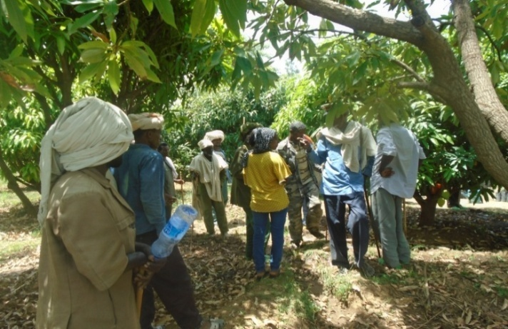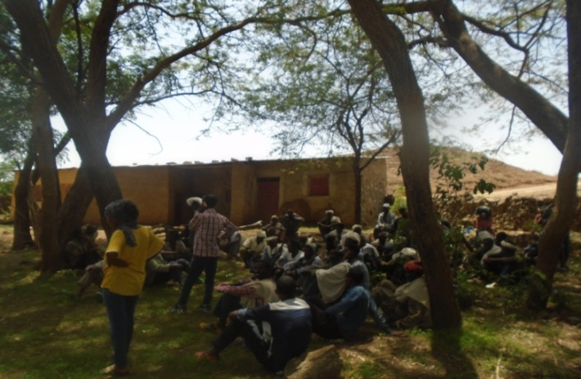
Figure 1.Disscustion with model farmers Figure2.Farmers training about irrigation
Photo credit: by Mawcha Assefa January 2019

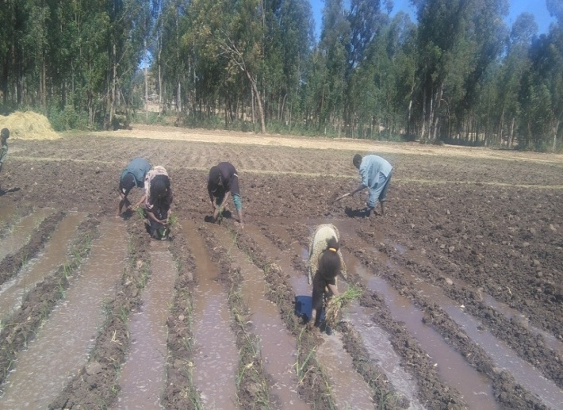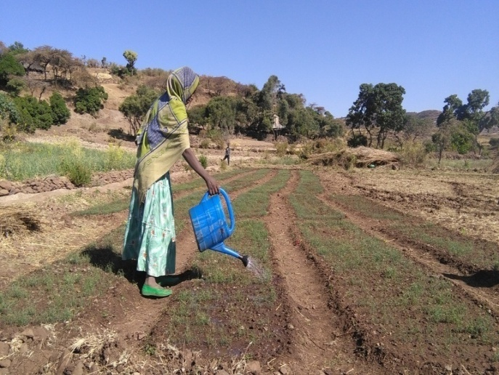

Figure3 participation of households in irrigation activity Figure 4 Researcher interviewed by model woman

Photo credit: by Mawcha Assefa December 2018

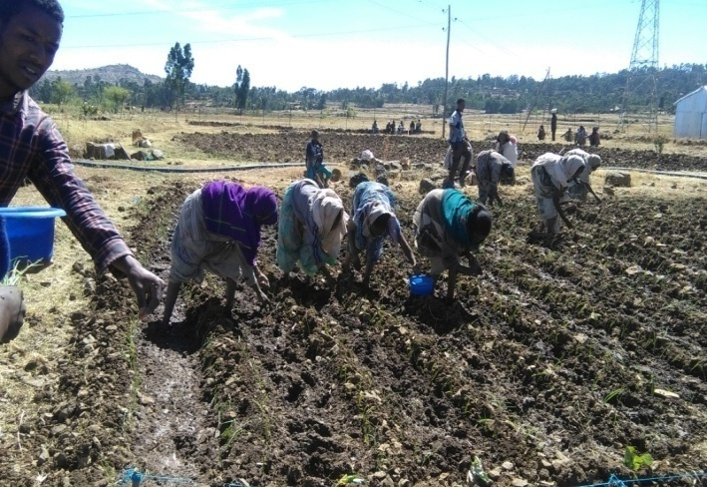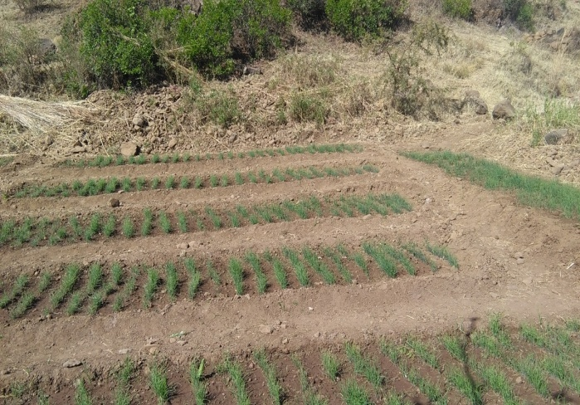
Figure 5 planting of potatoes Figure 6 Planted onions
Photo credit: by Mawcha Assefa December 2018

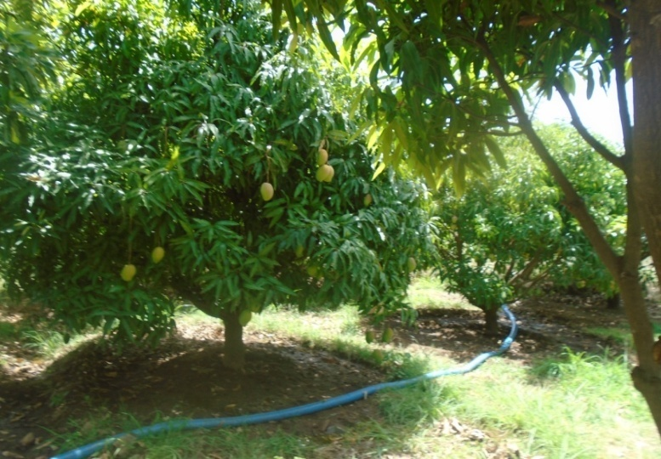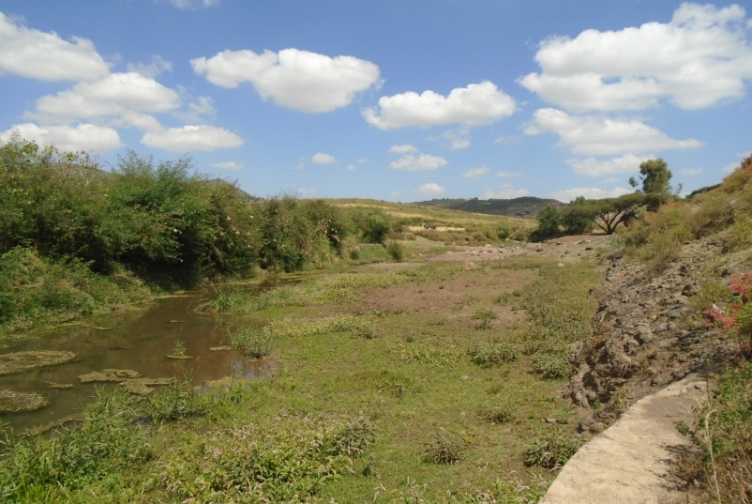
Figure7 During fetching of fruits by motor pump Figure 8 River diversion

Photo credit by: Mawcha Assefa January 2019

APPENDIX II
ADDIS-ABABA UNIVERSITY
College of computational and Natural Sciences
Department Zoological Sciences
Assessment of Challenges and Opportunities of Small Scale Irrigation Utilization: (The Case of Tahtay Maychew Woreda, Central Zone, Tigray, Ethiopia
This questionnaire is prepared by Mawcha assefa postgraduate student in the Department of Zoological science of Addis ababa University. It is prepared to gather primary data about Challenges and opportunities of small scale irrigation Utilization in Tahtay machaw Woreda. The data will be used for academic purpose only. I assure you that, all your responses will be kept in absolute confidence and you will not be held responsible for any of outcomes followed by the study. Therefore, your genuine and timely responses are vital to determine the success of this study. Hence; I kindly request your collaboration in filling the questionnaire honestly and responsibly. Thank you in advance for your willingness to give me information sacrificing your precious time.
General instructions
1. No need of writing your name
2. Please put your answer as circle in each case
3. Use the blank space for open-ended questions
4. Please attempt all parts accurately as possible and at your earliest time.
General Information
1. Agro-ecology: Dega _______________Woina Dega_________kolla__________
2. Zone: _____________ Woreda ___________ Tabia Name__________________
3. Date of interview: __________
Part one: Household Demographic Characteristics
1. Sex of the respondent;
1. Male: _______ 2. Female: ____
2 Age group of the respondent.
1. 18-29 2. 30-39
3. 40-493.5-59 4. More than 65
3. Educational level of the respondent
1. Illiterate 2. Read and write only 3. Elementary
4. High school completed 5. Diploma and above
4. Marital status of the respondent
1. Married 2. Widowed 3. Divorced 4. Single
PART two. Opportunities in utilizing small scale Irrigation
2.1 Explain the agro ecological zone of your area?
1= Dega 2= Woina Dega 3= kola
2.2. Do you think that your agro-ecological zone is conducive to produce different products?
1) Yes 2) No
2.3. Patterns of rainfall in your area for the last five years?
1) Decrease 2) No difference 3) Increase
2.4. Do you have a labored shortage in operating your irrigation farm?
1) Yes 2) No
2.5. How do you evaluate the support of government to practice your irrigation?
1) Very poor 2) unsatisfactory 3) satisfactory 4) very satisfactory
2.6 Do you feel secure that the land belongs to you?
1= yes 2= No
2.7If no why__________________________________________________________
___________________________________________________________________________________________________________________________________________________________
2.8 What types of opportunity do you have in your area to fully utilize irrigation?
___________________________________________________________________________________________________________________________________________________________
Part Three: The Challenges that influence small scale irrigation
3.1 Have you used irrigation planning?
1) Yes 2) No
3.2 If yes, what criteria you used to decide when and type of irrigated crops?
1) Price of the crop 2) cost of production 3) size of the water
3.3 How do you view the productivity of your farm land?
1) Very poor 2) poor 3) medium 4) good 5) very good
3.4 If your response is poor or very poor, indicate factors that contributed to it (you can choose more than one).
1=Soil erosion 2= no using of irrigation technologies
3= continuous cropping/grazing 4. Little or not using fertility inputs
5= others (specify) -------------------------------
3.5. Have you ever faced a problem of crop failure while you are using irrigation? 1. Yes 2. No
3.6. If your answer for question number 3.5, is yes, what were the possible causes for this problem of crop failure?
1. Water shortage 2. Damaged by disease 3.Poor adaptation of varieties used
4. Poor administration of water distribution 5.Others, specify
3.7. Have you used inputs on your irrigation land?
A) Yes B) No
  - If your answer for question no 3.5 is yes, which one do you use?
No | Type of inputs | Yes | No
1 | Chemical fertilizer
2 | Organic fertilizer
3 | Improved seeds
4 | Herbicides, insecticides and pesticides
5 | Others

3.9. If your answer for question 3. 6 is „No‟ what are the factors that hinder you from using inputs for the irrigation land?
1) Lack of income to purchase 2) High cost of the inputs 3) Limited accessibility
5) Other, specify__________________________
3.10 Do you apply farm inputs on your farmland as per the recommendation of agricultural experts?
A) Yes B) No
3.11. Do you have access to irrigation water?
1) Yes 2) No
3.12 If yes, what is the main source of your irrigation water?
1) Ponds. 2) River 3) Lake 4) check dam 5), diversions
3.13Have you used new irrigation technologies on your irrigation land?
1, yes 2, NO
3.14 What type of irrigation technologies do you have/ (you can choose more than one).
1) Drip 2) treadle pump 3) motor pump
4) row pump 5) Others (specify)………………………
3.15. Is the irrigation technology you use is simple to maintain?
1. Yes 2. No
3.16 Do you get the spare parts simply to maintain your irrigation technologies in nearby area?
1, yes 2, No if no from where do you get?
3.17 Have you cultivated your irrigable plot in full scale? 1) Yes 2) No
3.18. If your answer for question number 3.3 is no write the most important inhibiting factors in the following table:
Factor | 1 | 2 | 3 | 4
Shortage of Water
Shortage of input
Low productivity
Market
3.19. What are the major challenges in using irrigation in your area?
1. Water shortage 2.Lack of effective marketing system 3.Lack of input supply and irrigation facilities 4.Presence of pests and diseases 5.Lack of irrigable land
6. Others/specify__________
Part Four: Role of extension agent in limiting the constraints that hinder small scale irrigation
4.1. Have you ever visited by an extension agent?
1) Yes 2) No
4.2. If your answer for question no 4.2 is yes how frequently do you contact with them?
1) Once a week 2). Every month 3) Once every six month
4) Once a year 5) if other, specify
4.3. If you are visited do you simply understand the information from DAs or extension services?
1, Yes 2, No
4.5 .If your answer question No 4.5 is no. why?
1._______________________________________________________________________
2.________________________________________________________________________
3.______________________________________________________________________
4.________________________________________________________________________
4.4. Did you ever take training on irrigation practice and maintenance of the irrigation technologies?
1) Yes 2) No
4.5. If your answer is yes for Q. 4.5 how many times?
1 .Once per irrigation season 2) as planned by the Government 3) once per year 4. As required by the community
4.6. Is there any nearby farmer’s training center?
1) Yes 2) No
4.7. If your answer for question number 4.8 is yes, what are the supports you get from the farmers Training center?
1.________________________________________________________________________
2._________________________________________________________________________
3.____________________________________________________________________________
4.__________________________________________________________________________
4.8. Expressing the support that you need for extension workers concerning irrigation practice_________________________________________________________________________________________________________________________________________________________________________________________________________________________________
Part Five: Existing infrastructure for irrigation practice
5.1 Is there any feeder road that connects your Kebele to the nearest market area?
1) Yes 2) No
5.2 If yes, how good it is?
1) Very Poor 2) Poor 3) Good 4) Very good
5.3 Do you have access to transport service?
1) Yes 2) No
5.4 What are the types of transportation for the agricultural products you use to go to the nearest town? 1) Animal 2) On foot 3) Car
5.5 .Do you have access to convenient markets for your irrigation outputs and inputs?
1) Yes 2) No
5.6 If your response for question No.2.14 is no please specify the reasons?
_________________________________________________________________________________________________________________________________________________________
5.7. Do you have access to credit services that facilitate your irrigation practice such as gating a loan? 1) Yes 2) No
5.8 How do you finance the expenses for irrigation related inputs? (You can choose more than one). 1) Privet lenders 2) through relatives 3) Friends 4) cooperatives
5) Microfinance
5.9. What are the constraints to access credit from the formal institutions?
1) High interest rate 2) collateral 3) unfavorable repayment period 4) other, specify
Interview guide for key informants
1. What opportunities do you have in your area to use small scale irrigation?
2. What looks like the support of government and non-governmental organizations for development of utilization of irrigation?
3. How do you view the strength and weaknesses of the irrigation systems?
4. What are the existing policies in relation to agriculture in general and irrigation in Particular and how do you view them?
5. What are the main challenges that hinder the utilization of small scale irrigation?
6. What do you think the main solutions for those challenges?
7) What is the biological important of irrigation? and What do you feel if farm land covers by varieties of crops?
Guiding questions for focus group discussions
1. What are the major opportunities in your local area to utilize small-scale irrigation?
2. What are the main challenges you face during utilization of small-scale irrigation in your local area?
3. How can you address those problems?
4. How can you see the follow up and support of government for the mounting of irrigation use?
5. What is your recommendation to improve the practice of small scale irrigation?
6. Do you have access to transport service?

APPENDIX III
ኣዲስ ኣበባ ዩንቨርስቲ
ኮለጅ ተፍጥሮ ሳይንስ
ኣብ መስኖ ተጠቐምቲ ብዝኮኑ ሓረሰቶት ክምላእ ዝተዳለወ ፅሑፋዊ መሕትት
እዚ ኣብ ወረዳ ታሕታይ ማይጨው ይካየድ ንዘሎ "ኣብ ኣነእሽቱ ናይ መስኖ ስራሕቲ ዘጋጥሙ ዘለው ፀገማትን ዘለው ዕድላትን "ንምፍታሽ ዓሊሙ ንዝካየድ መፅናዕቲ ዝውዕል ፅሑፋዊ መሐተት እዩ።ዋና ዕላማ እዚ መፅናዕቲ ኣብ ኣዲስ ኣበባ ዩንቨርስቲ ብሻፈሻዊስነሂወት መፅናዕታዊ ፅሑፍ ንምድላው እንትኮውን ካብ ተሳተፍቲ ዝርከብ ሓበሬታ ንትምህረቲ ዕላማ ጥራሕ ዝውዕል ምካኑ ክሕብር ይፈቱ ።ካብ ተሳተፍቲ ዝርከብ ሓበሬታ ሚስጥራዊነቱ ዝሓለወ ካብ ምኻኑ ንላዕሊ እዚ መሕተት ኣብዚ ከባቢ ንዝሳለጡ ስራሕቲ መስኖ ንምጥንካር ዘክእሉ ሃነፅቲ ሓበሬታታት ብምምዕባል ንዝምለከቶ ኣካል ንምጥቓም ሰለዘክእል ትክክለኛ ሓበሬታ ብምሃብ ይተሓባበሩ። ግዜኩም መስዋእቲ ጌርኩም ንእትገብሩለይ ምትሕብባር ኣዝየ የመስግን።
ሓፈሻዊ መምርሕታት
- ሽምኩም ምፅሓፍ ኣየድልን
- ነቶም ብመልክዕ መረፃ ዝተቀመጡ ሕቶታት መልሲ ንምቅማጥ ኣብ ልዕሊ እቲ ትክክለኛ መልሲ ብምክባብ ይጠቀሙ/ማ
- ንኩሎም ሕቶታት ንክተበፅሕዎም ብትሕትና ይሓትት።
አዚ መሕትት ዘተመለአሉ ቦታ
ዞባ-----------------
ወረዳ---------------
ጣብያ ---------------
ክፍሊ ሓደ: ሓፈሻዊ ሕቶታት
1.ፆታ ሀ.ተባዕታይ ለ.ኣነሰታይ
2.ዕድመ
ሀ.18-29 ሐ.40-49
ለ.30-39 መ.50-59 ረ.60ንላዕሊ
3. ትምህርቲ ደረጃ
ሀ.ዘይተምሃሩ ሐ.2ይ ብርኪዝወደአ
ለ.ምፅሓፍን ምንባብን ጥራሕ መ.ኢለመንተሪ ረ.ዲፕሎማን ልዕሊኡን
4.ኩነታት ሓዳር
ሀ.ባዓል ሓዳር ለ.ዝተፋተሐ ሐ. ካብ ሓዳሩ ሪሒቁ ዝነብር /እትነብር መ.ዘይተመርዐወ
ክፍሊ ክልተ: መስኖ ንምጥቃም ዘለው ዕድላት ብዝምልከት ዝተዳለወ ሕቶታት
2.1 ናይ ከባቢኩም ስነ ምህዳር እንታይ ምካኑ ግለፁ?
1.ደጉዓ 2.ወይና ደጉዓ 3. ቆላ
2.2 እዚ ናይ ከባቢኩም ስነ ምህዳር ዝተፈላለዩ ዓይነት ዝራእቲ ንምፍራይ ምችውናት ኣለዎ ኢልኩም ዶ ትኣምኑ?
1. እወ 2. ኣይፋል
2.3 ኣብ ናይ መስኖ ስራሕትኩም ሕፅረት ስራሕተኛታት የጋጥመኩም ዶ?
1.እወ 2. ኣይፋል
2.4.ኣብ ናይ መስኖ ስራሕትኩም ናይ መንግስቲ ኣካላት ድጋፍ እንታይ ይመስል?
ሀ.ብጣዕሚ ድኩም ለ.ድኩም ሐ.ኣዕጋቢ መ.ብጣዕሚ ፅቡቅ
25 እቲ እትጥቀምሉ ናይ መስኖ መሬት ንምልማዕ ነተይነት ይስመዐኩምዶ?
ሀ. እወ ለ.ኣይፋል
2.6 ናይ ቁፅሪ 2.5 መልስኩም ኣይፋል እንተኮይኑ እቲ ዋና ምክንያት እንታይ እዩ?
ንምንታይ ? 1._____________________________
2._____________________________
3. ______________________________
2.7 ኣብዚ ተከታታሊ ሓሙሽተ ዓመታት መጠን ዝርገሐ ዝናብ እንታይ ይመስል?
ሀ.እናቀነሰ መፂኡ ለ.ኣፈላላይ የብሉን ሐ እናወሰከ መፂኡ
2.8.ኣብ ከባቢኩም መስኖ ብምሉእነት ንምጥቃም እንታይ ዕድላት ኣለው?
1._____________________________________________
2._______________________________________________
3.________________________________________________
ክፍሊ ሰለስተ: ኣብ መስኖ ኣጠቃቅማ ዘጋጥሙ ቀንዲ ማሕንቆታት ብዝምልከት ዝተዳለወ ሕቶታት
3.1.ናይ መስኖ ኣጠቃቅማ ትልሚ ኣለኩም ዶ?
ሀ. እወ ለ.ኣይፋል
3.2. ናይ ቁፅሪ 3.1 መልስኩም እወ እንተኮይኑ መዓዝን እንታይ ዓይነት ምህርትን ከም እተምርቱ ብከመይ ትውስኑ?
ሀ.ዕዳጋ መሰረት ብምግባር
ለ. ዘሎ ናይ ማይ መጠን መሰረት ምግባር
ሐ.ወፃኢታት መሰረት ብምግባር
መ.ናይቲ ከባቢ ዝራእቲ መሰረት ብምግባር
3.3 ልሙዑነት ናይቲ ብመስኖ ዝለምዕ መሬት እንታይ ይመስል?
ሀ. ብጣዕሚ ድኩም ለ.ድኩም ሐ. ማእከላይ መ. ልሙዕ ረ.ብጣዕሚ ልሙዕ
3.4 ናይ ቁፅሪ3.3 መልስኩም ብጣዕሚ ድኩም /ድኩምእንተኮይኑናይዚ ፀገም መን ቀሊእንታይ እዩ? (ካብ ሓደ ብላዕሊ ምምላስ ይከኣል እዩ)
ሀ.ምጉሕጋሕ መሬት ሐ. ስዲ ጋህፂ ለ.ቴክኖሎጀታት መስኖ ዘይምጥቃም መ.ንልሙዕነት መሬት ዝጠቅሙ እታወታት ዘይምጥቃም
3.5. መስኖ ኣብ እትጥቀምሉ ግዜ ኪሳራ ኣጋጢሙኩም ይፈልጥዶ?
ሀ.እወ ለ. ኣይፋል
3.6 ናይ ቁፅሪ 3.5 መልስኩም እወ እንተኮይኑ ናይዚ ክሳራ ቀንዲ ምክንያት እንታይ እዩ
ሀ.ናይ ማይ ሕፅረት ሐ. ዕዳጋ ምስኣን
ለ.ብባልዕ ምጥፍኡ መ.ፍትሓዊ ናይ ማይ ክፍፍል ዘይምህላው
ረ. ካሊእ እንተሃልዩ ዘርዝሩ ________________
3.7. ብመስኖ ክለምዕ ዝግበኦ መሬትኩም ብሙሉእነት ተልሙዑ ዶ? ሀ.እወ ለ. ኣይፋል
3.8 ናይ ቁፅሪ 3.7 መልስኩም ኣይፋል እንተኮይኑ እቲ ቀንዲ ማሕንቆ ኣየናይ ምካኑ ኣብ ታሕቲ ካብ ዘሎ ሰደቃ መልሰኩም ኣቀምጡ
ተ.ቁ | መሕንቆታት | ደረጃ
1 | ሕፅረት ማይ
2 | ስእነት ሰራሕተኛ
3 | ሕፅረት እታወታት
4 | ናይ ልቃሕ ሕፅረት
5 | ናይ ዕዳጋ ፀገም
3.9 ንመስኖ ጠቀምቲ ዝኾኑ እታወታት ትጥቀሙ ዶ?
3.10. ናይ ቁፅሪ 3.9 መልስኩም እወ እንተኮይኑ ኣየናይ እታወታት ትጥቀሙ?
ሀ.መዳበርያ ለ.ድኩዒ ሐ.ሙሩፅ ዘርኢ መ.ፀረ ባልዕ መድሓኒታት ረ.ካልእ እንተሃልዩ ይዘርዝሩ__________________
3.11 ናይቁፅሪ 3.10 መልስኩም ኣይፋል እንተኮይኑ ናይ መስኖ እታወታት ንከይትጥቀሙ ቀንዲ መሓንቅ እንታይ እዩ።
ሀ.ሕፅረት ገንዘብ ለ.ናይ እታወታት ዋጋ ምንሃር ሐ.ቀረብ እታወታት ምንኣስ
መ.ካሊእ እንተሃልዩ ዘርዝሩ -_____________________
4.12 መስኖ ንምጥቃም ዝከውን ቀረብ ማይ ኣሎዶ? ሀ. እወ ለ.ኣይፋል
4.13 ናይ ቁፅሪ 4.12 መልስኩም እወ እንድሕር ኮይኑ ምንጪ ናይ እትጥቀምሉ ማይ ካበይ እዩ?
ሀ. ዒላ ሐ. ዳይቨርሽን ለ. ወሓዚ ሩባ
መ.ቃላይ ረ.ካሊእ እንተሃልዩ ግለፁ_____________
4.14 ኣብ ናይ መስኖ ስራሕትኩም እንታይ ዓይነት ናይ መስኖ ቴክኖሎጂ ትጥቀሙ?
ሀ.ጠብጠብታ ለ.እስቲሂና ሐ.ሞተር መ.ረውፓምፕ
4.15 ነይተን ናይ መስኖ ቴክኖሎጅታት መለዋወጢ ኣቁሑት ብቀረባ ትረክቡ ዶ?
ሀ. እወ ለ. ኣይፋል
4.16 እተን እትጥቀሙለን ናይ መስኖ ቴክኖሎጅታት ንምጥቃመንን እንትበላሸዋ ንምስትክካለንን ቀለልትን ምችዋትን ድየን ?
ሀ. እወ ለ. ኣይፋል እንተዘይ ኮይነን ብከመይ ትጥቀሙ?
3.17.ኣብ ከባቢኩም መስኖ ንምጥቃም ዘጋጥሙ ቀንዲ መሓንቅ እንታይ እዩ?
ሀ.ናይ ማይ ርሕቀት ሐ. ባላዓትን ሕማማትን ምህላው
ለ.ብቁዕን ስሉጥን ናይ ዕዳጋ ምትእስሳር ዘይምህላው መ.ናይ መስኖ መሬት ምንኣስ
ረ.ናይ እታወታት ሕፅረት
ክፍሊ ኣርባዕተ :ግደ ናይ ሕርሻ ሰብ ሞያ ኣብ ምቅናስ ፀገማት መስኖ
4.1.ብናይ ሕርሻ ሰብ ሞያ ድጋፍን ክትትልን ይግበረልኩም ዶ?
ሀ.እወ ለ.ኣይፋል
4.2. ናይ ቁፅሪ 4.1 መልስኩም እወ እንተኮይኑ ክንደይ ግዜ ክትትል ይገብሩ?
ሀ.ኣብ ሰሙን ሓደ ግዜ ለ.በቢወረሒ ሐ.ኣብ ሽድሽተ ወርሒ ሓደ ግዜ መ.ኣብ ዓመት ሓደ ግዜ
4.3 ናይ መስኖ እታወታት ንምጥቃም ብናይ ሰብ ሞያ ሕርሻ ምክሪ መሰረት ትጥቀሙ ዶ? ሀ. እወ ለ. ኣይፋል
4.4.ናይ ቁፅሪ 4.3 መልስኩም ኣይፋል እንተኮይኑ እቲ ምክንያት እንታይ ምካኑዘርዝሩ
1_______________________________________________
2______________________________________________
3______________________________________________________
4.5 ብናይ መስኖ ሰብ ሞያ ዝወሃበኩም ትምህርቲ ብኣግባቡ ትርድእዎዶ?
ሀ. እወ ለ. ኣይፋል
4.6. ናይ ቁፅሪ 4.5 መልስኩም ኣይፋል እንተኮይኑ ንምንታይ ምኾኑ ዘርዝሩ
1._________________________________________
2._______________________________________________
3._______________________________________________
4.7. ካብ ናይ መስኖ ሰብ ሞያ ዝርከብ ትምህርቲ ናቲ ኣብ ባይታ ዘሎ ስራሕ ይምጥን ዶ ትብሉ?
ሀ. መጣኒ ኣይኮነን ለ.ብውሱን ይምጥን ሐ.መጣኒ እዩ መ.ብጣዕሚ ይምጥን
4.8.ኣብ ከባቢኩም መሰልጠኒ ሓረስቶት ኣሎዶ?
ሀ.እወ ለ.ኣይፋል
4.9.ናይ ቁፅሪ 4.8 መልስኩም እወ እንተኮይኑ ካብዚ መሰልጠኒ ሓረስቶት እንታይ ዓይነት ድጋፍ ትረክቡ?
1._____________________________________
2.__________________________________________
3._________________________________________
4._______________________________________________
4.10.ካብ ናይ መስኖ ኪኢላታት ክትረክብዎ እትደልዩ ድጋፍ ብዝርዝር ፀሓፉ
1.________________________________________
2.___________________________________________
3._______________________________________________
4.________________________________________________
ክፍሊ ሓሙሕተ: መሰረተ ልምዓት ዝምልከት ዝተሓተቱ ሕቶታት
5.1ጣብያኩም ምስ ዕዳጋ ንምርካብ ዝተሰርሐ መንገዲ ፅርግያ ኣሎዶ?
ሀ.እወ ለ. ኣይፋል
5.2 ናይ ቁፅሪ 5.1 መልስኩም እወ እንተኮይኑ ፅሬት ናይቲ መንገዲ እንታይ ይመስል?
ሀ.ብጣዕሚ ድኩም ለ.ድኩም ሐ.ፅቡቅ መ. ብጣዕሚ ፅቡቅ
5.3 ኣብ ጣብያኩም ናይ መጋዓዝያ ቐረብ ኣሎ ዶ?
ሀ.እወ ለ.ኣይፍል
5.4 ናይ መስኖ ምህርትኩም ናብ ዕዳጋ ንምቅራብ እትጥቀምሉ ዓይነት መጋዓዝያ ብምንታይ እዩ?
ሀ.ብእንስሳ ለ.ብዝባንና ሐ.ብመኪና
5.5. ናይ መስኖ ውፅኢታት ንምሻጥን እታወታት መስኖ ንምግዛእን ምቹው ናይ ዕዳጋ ኩነታት ትረክቡዶ?
ሀ. እወ ለ.ኣይፋል
5.6 ናይ ቁፅሪ 5.5 መልስኩም ኣይፋል እንተኮይኑ ምክንያቱ ብዝርዝር ኣቀምጡ
1._____________________________________
2._______________________________________
3.________________________________________
5.7.ናይ መስኖ ስራሕትኩም ንምስላጥ ብቀረባ ልቃሕ ወሃብቲ ትካላት ኣለውዶ?
ሀ.እወ ለ.ኣይፋል
5. 8 እታወታት መስኖ ንምጥቃም ምንጪ እትጥቀምሉ እቶት ካበይ እዩ?
ሀ.ናይ ግሊ መለቃሕቲ ለ.ካብ ቤተሰብን ፈተውትን
ሐ. ሕብረት ስራሕ ማሕበራት መ. ማይክሮ ፋይናንስ
5.9 ካብ ሕጋዊ ዝኮኑ ትካላት ልቃሕ ንምውሳድ እቲ ቀንዲ ማሓንቅ እንታይ እዩ?
ሀ.ዝለዓለ ናይ ወለድ መጠን ምህላው
ለ.ናይ ትሕጃ ፀገም
ሐ. ናይ ምምላስ ግዜ ምችው ዘይምኻን
መ.ካልእ እንተሃልዩ ዘርዝሩ _____________________
ሕቶታት ጉጀለኣዊ ምይይጥ
1.ኣብ ከባቢኩም መስኖ ንምጥቃም እንታይ ስፊሕ ዕድል ኣለዎ?
2.ኣብ ከባቢኩም ዝተፈላለዩ ዓይነት ዝራእቲ ንምፍራይ ትክእሉ ዶ?
3.ናይ መንግስታውን ዘይምንግስታዊን ኣካላት ድጋፍን ክትትልን እንታይ ይምስል?
4.ኣብ ከባቢኩም መስኖንምጥቃም ዘጋጥመኩም ቀንዲ ቀንዲ ማሓንቃት እንታይ እዮም?
5.እዞም ፀገማት ከመይ ንምፍታሕ ትሙኩሩ?
6. ከባቢኩም እኩል መሰረተ ልምዓት ኣለዎ ዶ ትብሉ ?
7.ድጋፍን ክትትል ናይ ሰብ ሞያ ሕርሻ እንታይ ይመስል?
8.ናይ መስኖ ስራሕቲ ንምምሕያሽ እንታይ ክግበር ኣለዎ ትብሉ?
ምስ ዝምልከቶም ኣካላት ንዝግበር ናይቃል መሕትት ኣመልኪቱ ዝተዳለወ ሕቶታት
- ኣብ ከባቢኩም መስኖ ንምጥቃም እንታይ ስፊሕ ዕድል ኣለዎ ?
- ናይ መስኖ ስራሕቲ ንምስፋሕ ድጋፍ መንግስታዊን ዘይመንግስታዊ ኣካለት እንታይ ይምስል ?
- ኣብ ናይ መስኖ ስራሕቲ ዘለው ጥንካረን ድክመትን እንታይ ይመስል?
- ኣብ ሕርሻ ብፍላይ ከኣ መስኖ ንምስፋሕ ዘሎ ናይ መንግስቲ ፖሊሲ ከመይ ትሪእዎ?
- ኣብዚ ወረዳ ይኩን ኣብዘል ጣብያታት ኣብ ስራሕቲ መስኖ ንዝሳተፉ ሓረስቶትዘጋጥምዎም ቀንዲ ማሓንቃት እንታይ እዮም ?
- ነዞም መሓንቃት ንምፍታሕ እንታይ መፍትሕታት ተወሲዶምን ክውሰዱ ኣለዎምን ትብሉ?
- መስኖ ኣብ ስነ ሂወት እንታይ ጥቅሚ ኣለዎ?ከባቢ ብዝተፈላለየ ኣዝርእቲ ምሽፋን እንታይ ስሚዒት ይፈጥረልኩም

