

THE AURAL PRIVACY OF MIXED-USE RESIDENTIAL BUILDINGS IN ADDIS ABABA: THE EFFECT OF COMMERCIAL UNITS ON AURAL PRIVACY OF RESIDENTS OF GOTERA CONDOMINIUM

BY

TILAHUN URGESA SEIFU

Master’s Thesis
MASTER OF SCIENCE IN HOUSING AND SUSTAINABLE DEVELOPMENT
(HASD)

ETHIOPIAN INSTITUTE OF ARCHITECTURE, BUILDING CONSTRUCTION AND CITY DEVELOPMENT, ADDIS ABABA UNIVERSITY

JUNE, 2019
ADDIS ABABA, ETHIOPIA

THE AURAL PRIVACY OF MIXED-USE RESIDENTIAL BUILDINGS IN ADDIS ABABA: The Effect of Commercial Units on Aural Privacy of Residents of Gotera Condominium

MASTER’S THESIS

A thesis submitted to the Ethiopian Institute of Architecture, Building Construction, and City Development (EiABC) Postgraduate Program Office in partial fulfilment of all requirements for the Degree of Master of Science in Housing and Sustainable Development.

BY

TILAHUN URGESA SEIFU

ADVISOR
IMAM MAHMOUD HASSEN

JUNE, 2019
ADDIS ABABA, ETHIOPIA

This thesis is submitted to the Graduate Programs Director of the Ethiopian Institute of Architecture, Building Construction and City Development (EIABC), Addis Ababa University, in partial fulfillment of the requirements for the Masters of Science degree in Housing and Sustainable Development.

Title of Thesis: The Aural Privacy of Mixed-Use Residential Buildings in Addis Ababa: The Effect of Commercial Units on Aural Privacy of Residents of Gotera Condominium

By: Tilahun Urgesa Seifu

Date: June, 2019

Approved by Board of Examiners:

Imam Mahmoud (MSc) _________________ _________________
Advisor Signature Date

Nebyou Yonas (PhD) _________________ ________________

External Examiner Signature Date

Yonas Alemayehu (MSc) _________________ ________________

Internal Examiner Signature Date

Fisseha Wogayehu (PhD) ________________ ________________

Chair Person Signature Date

Declaration

I declare that, this thesis prepared for the partial fulfilment of the requirements for the degree of Masters of Science in Housing and Sustainable Development entitled “The Aural Privacy of Mixed-Use Residential Buildings in Addis Ababa: The Effect of Commercial Units on Aural Privacy of Residents of Gotera Condominium” is my original research work prepared independently by my own effort with the close advice and guidance of my adviser. I also declare that this thesis has not been presented in any university and all sources that I have used or quoted have been indicated and acknowledged by means of complete references.

Tilahun Urgesa Seifu

Signature ________________ Date ________/_________/___________

Confirmation

The thesis can be submitted for examination with my approval as an institute’s advisor.

Imam Mahmoud Hassen

Signature ________________ Date ________/_________/___________

I

ABSTRACT

Condominium housing project is started to accommodate the housing problem in Addis Ababa. Mass housing development approach has different problem on resident quality of life as compared to other development approach due to mixed land use development and one of the sole indicators in housing quality is that of privacy or “privateness”.

The objective of this study is to explore the level of aural privacy in mixed residential building of condominium neighborhood. Therefore, the oldest phase of Integrated Housing Development Program (IHDP); Gotera condominiums is selected for this study. To have desired information from respondents about the impact commercial unit on their aural privacy survey method were used. Structured, semi structured interview and measurement is conducted to get quantitative data, and beside this the qualitative data was collected through physical and spatial analysis of the selected site. in addition to this; Standards, documents, research papers, books, maps, reports, proclamations are used by the researcher as a secondary source. Research questions are designed to find out how and to what extent commercial units affect resident aural privacy in terms of unit characteristics. In addition to this coping mechanism by residents and management component by different officials towards aural privacy is the focus of this study.

The results show that, residents of mixed residential buildings are highly affected by noise pollution from specific commercial units specially during sleeping time. The level of aural privacy of the residents are different based on spatial, physical, socio-economic and demographic characteristics. High level of noise pollution from commercial units has its own impact on resident’s health and day to day activity. To control high noise pollution from specific commercial units, vulnerable residents use different coping mechanisms, while noise pollution management by concerning bodies is weak due to lack of knowledge among officials, corruption, servility, ignorance, unorganized working structure.

The study recommends four strategies to ease the residents from sound pollution in mixed residential buildings. Zoning within neighborhood design, typology design, clear management towards the noise pollution and finally further study toward this area are essential to increase the aural privacy of residents.
Keywords: CONDOMINIUM HOUSING, MIXED RESIDENTIAL BUILDING, AND AURAL PRIVACY
II

ACKNOWLEDGMENT

First and for most I would like to give my deepest gratitude to my advisor Imam Mahmoud Hassen for his guidance, comments, and useful suggestions throughout my research study. I am grateful to my mother Aberash Bedada, my father Urgesa Seifu, my brother and sisters who have given me strength and encouragement in accomplishment of my research paper.

My sincere gratitude also goes to all respondents, officials of Federal, City, Sub city and Woreda level environmental protection offices, officials of housing owner association of Gotera Condominium site, and Addis Ababa housing project who support me in providing the necessary information and documents. The least but not last, I am grateful to my classmates and friends for their valuable views and ideas towards my research.

Above all I commend the Almighty God for his help in achieving my research.

Tilahun Urgesa Seifu
June, 2019

III
TABLE OF CONTENTS

Declaration ………………………………………………………………………...…………I
ABSTRACT II
ACKNOWLEDGMENT III
CHAPTER ONE 1
INTRODUCTION 1
1.1 Background of the study 1
1.2 Justification 2
1.3 Problem Statement 2
1.4 Objective of the study 3
1.4.1 General Objective 3
1.4.2 Specific Objective 3
1.5 Research Question 4
1.6 Significance of the study 4
1.7 Scope and limitations of the study 4
1.8 Organization of the paper 6
CHAPTER TWO 7
LITERATURE REVIEW 7
2.1 Introduction 7
2.2 Mixed-use Development 8
2.3 The Meaning of a Housing and Qualities of a Home 8
2.4 Theory development 9
2.4.1 Living and housing theory 9
2.4.2 Housing theory and society 10
2.5 Housing Privacy 10
2.5.1 Definition and Concept of Privacy 10
2.5.2 Types of Housing Privacy 11
2.5.3 Functions of privacy 12
2.6 Aural privacy 13
2.7 Important factors regarding aural privacy 15
2.8 People and privacy 17
2.9 Resident Perceptions of Comfort 18
2.10 Privacy Regulation Mechanism 19
2.11 Measurement of Aural privacy 21
2.11.1 Subjective measurement of Aural privacy 21
2.11.2 Objective measurement of Aural Privacy 22
2.12 Noise emission standards 23
2.13 Health effects of low-level aural privacy on human beings 24
2.14 Coping Mechanism 25
2.14.1 Definition of coping 25
2.14.2 Individual coping strategies 25
CHAPTER THREE 27
RESEARCH METHODOLOGY 27
3.1 Methodology Selection 27
3.2 Case selection (Why Gotera Condominium) 28
3.3 Source of Data 28
3.4 Data collection techniques 29
3.5 Sample of the population 31
3.6 Sampling techniques 33
3.7 Data Analysis 35
3.8 Research design diagram 36
CHAPTER FOUR 38
CONTEXTUAL REVIEW 38
4.1 Introduction to Addis Ababa City 38
4.2 Integrated Housing Development Program in Addis Ababa 39
4.3 Success and Challenges of Integrated Housing Development Program 40
4.4 Mixed Land use development in Ethiopia 40
4.5 Environmental Issues and Its Legal Frameworks in Ethiopia 41
4.6 Noise emission standards in Ethiopia 42
4.7 Addis Ababa and undesired sound 43
4.8 Status and trends of the undesired sound in Kirkos sub-city 44
4.9 Condominium housing and its difficulties in Kirkos sub city 45
4.10 Rule and Regulation of Sound usage in Condominium Housing 45
CHAPTER FIVE 46
DATA ANALYSIS AND FINDINGS 46
5.1 Introduction 46
5.2 Description of the case area, ‘Gotera Condominium’ 46
5.3 Mixed residential buildings in Gotera condominium 47
5.4 Respondents overall characteristics 50
5.5 Characteristics of commercial units 52
5.6 Characteristics of Dwelling Units 55
5.7 Respondents preferred area of living in residential area 60
5.8 Respondent response towards level of noise disturbance 61
5.9 The Degree of aural privacy related to the most influential noise pollutant commercial unit type in different time interval 64
5.10 Source of noise pollution rather than loudspeaker 67
5.11 Faced problem from noise pollution of commercial units 69
5.12 Building units characteristics vs Aural privacy 76
5.13 Perception towards adopting noise pollution 80
5.14 Achieved privacy Vs desired privacy 81
5.15 The Level of noise pollution by Sound level meter 82
5.16 Perspective of respondents towards commercial unit existence in condominium environment 88
5.17 Percpective of owners and tenant towards changing the current block due to low aural privacy 90
5.18 Coping Mechanism towards aural privacy 91
5.19 Noise pollution management 92
CHAPTER SIX 97
SUMMARY OF FINDINGS 97
6.1 Demographic characteristics of respondent’s vs Aural Privacy 97
6.2 Units characteristics and aural privacy 98
6.2.1 Commercial unit and its impact on Aural Privacy 98
6.2.2 Dwelling Unit and its impact on aural Privacy regarding commercial unit 99
6.3 Human health problem due to high noise pollution from commercial units 101
6.4 Coping mechanism 101
6.5 The extent of management component and aural privacy 103
6.6 Subjective and Objective Measurement Result towards Aural privacy 103
6.7 Comparison of the result of this study to the previous studies 104
CHAPTER SEVEN 106
RECOMMENDATION 106
7.1 Management context 106
7.2 Zoning within nieghborhood 107
7.3 Typology design 108
7.4 Further study 109
REFERENCE 110
ANNEX………………………………………………………………………….…………117

LIST OF FIGURES

Figure 1: Scope of the study 5
Figure 2: Positive privacy gradients maintain and respect the public/ private distinction 15
Figure 3: Privacy regulation theory 20
Figure 4: Sound level meters (DB) and Sound meter smart phone 23
Figure 5: Actual Sound level meter and mobile phone used by the researcher for measuring noise level 30
Figure 6: General overview of data collection techniques 31
Figure 7: Schematic representation of research design 36
Figure 8: Location map of Addis Ababa and sub-cities 38
Figure 9: Location of Gotera Condominium. 47
Figure 10: The location of mixed residential building in Gotera condominium 48
Figure 11: Types of commercial building in Gotera condominium site 52
Figure 12: Default commercial unit size and its extension for block type one 54
Figure 13: Default commercial unit size and its extension for block type three 55
Figure 14: Typology one (T-18) of selected block 56
Figure 15: Typology one (T-16) of selected block 56
Figure 16: Typology two (M-1) of selected block 56
Figure 17: Typology three(M2) of selected block 57
Figure 18: Floor plan of room arrangement for typology one towards street 58
Figure 19: Sectional view of room arrangement for typology one towards street 58
Figure 20: Floor plan and sectional view of room arrangement for typology two towards street 59
Figure 21: Floor plan and sectional view of room arrangement for typology three towards street 59
Figure 22: Building material type for each building element of Gotera condominium 60
Figure 23: The effect noise pollution from other area of the site to the above floor of silent area 77
Figure 24: Location effect versus floor level in higher noise pollution area in site 78
Figure 25: Location effect versus floor level in higher noise pollution area in site 78
Figure 26: Pin point (place of measurement for sound intensity level) 82
Figure 27: Level of noise disturbance from different commercial unit type 86
Figure 28: Total level of noise pollution in different area the condominium site 87
Figure 29: Location name in Gotera condominium site based on level of noise 99

LIST OF TABLES

Table 1: Noise emission standards of WHO and some countries (Leq: dBA) 24
Table 2: Bed room type stratification 33
Table 3: Block type stratification 35
Table 4: Overall research design diagram 37
Table 5: Ethiopian noise emission standard 43
Table 6: The number and percentage of dwelling and commercial unit in Gotera condominium site 49
Table 7: Number of commercial units in each parcel of Gotera condominium site 49
Table 8: Frequency of the respondent’s tenure type 50
Table 9: Respondents duration of stay in the study area 50
Table 10: Previous address of respondents 51
Table 11: Way of getting the Condominium/Residence by respondents 51
Table 13: Faced problem due to low aural privacy on family head 70
Table 14: Faced problem due to low aural privacy on spouse of family member 70
Table 15: Faced problem due to low aural privacy on male children of Family member 71
Table 16: Faced problem due to low aural privacy on female children of Family member 71
Table 17: faced problem due to low aural privacy on house maid family member 72
Table 18: Attitude towards changing the block due to aural privacy (for owner) 90
Table 19: Preferred location of the block that the owners wants to change the currunt place due to aural privacy 90
Table 20: Reason behind no interest to change the current place for owners 91
Table 21 Reason towards not to change the current site for tenant 91
Table 22: Coping Mechanism towards low aural privacy or high noise pollution by respondents 92
Table 23: Resident action towards complaining noise pollution to concerned body 93
Table 24: The frequency of place of complaint by residents 94
Table 25: Respondent satisfaction level towards action taken by responsible body 94

LIST OF CHARTS

Chart 1: Resident preferred area for living (Source: Survey result) 61
Chart 2: Respondent response of level of noise disturbance 63
Chart 3: The Degree of aural privacy related to the most influential noise pollutant commercial unit type in different time interval 66
Chart 4: Respondent perception of source of noise pollution 67
Chart 5: Perception towards level of noise pollution rather 68
Chart 6: Number of respondent’s Vs Age towards sleep disturbance 73
Chart 7: Age Versus Sleep Disturbance 74
Chart 8: Number of respondent’s vs Time of stay at home 75
Chart 9: Time of stay at home Versus Sleep Disturbance 76
Chart 10: Perception of Adopting towards the Existing Noise Pollution 80
Chart 11: Desired privacy and Achieved privacy 81
Chart 12 Average noise level of selected commercial units in different days and times 84
Chart 13: Attitude towards Commercial Unit Allowance (Neutral) 89

ABBREVIATIONS

AM After Midday
DB Decibel
EIABC Ethiopian institute of Architecture, Building construction and city planning
ETC. Et cetera
EPA Environmental Protection Authority
FDRE Federal Democratic Republic of Ethiopia
FEPA Fair Employment Practices Agencies
HASD Housing and sustainable Development
HOA House Owner Association
IGAD Intergovernmental Authority on Development
IHDP Integrated housing development program
ISO International Organization for Standardization
LAeq.T A-weighted equivalent continuous sound level in decibels measurement
LAeq.r Equivalent Continuous Level
PM Before Midday
SEL Sound Exposure Level
Sq. m Meter Square
UNIDO United Nations Industrial Development Organization
WHO World Health Organization

LOCAL TERMS

Chechenia: A name given to overcrowded place
Digaf ena Kititle: Section in one’s organization who follow up activities
DS Tv House: A place for watching international football game
Gedam: A name given to decent place
Sefer: A small place were some communities exist
Wereda: The fourth, from top to bottom, hierarchical administrative unit in Ethiopia

GENERAL NOTES

All calendar is based on Gregorian
All measurements in this study uses metric system

IV

CHAPTER ONE

INTRODUCTION

  - Background of the study

To solve housing problem of Addis Ababa city, in 2005 Integrated Housing Development Program (IHDP) has announced. In this program low cost condominium housing is provided by the government for home seeker. This form of housing tenure has individual housing units which contains communal areas and elevator in some sites, playing area, commercial units and other facilities in common. In condominium site there is no individual ownership over plots of land i.e. the land is owned by all member of household or house owner (UN-HABITAT, 2011). That’s why in terms of ownership, condominium homeowner differs from individual parcel homeowners. In addition to this most of the condominiums have residential units and commercial units together.

Condominium site has ten percent commercial units, and those commercial units are located at ground level and in some place, they are located at first floor. These commercial units are sold, not rented, and the plots of land for commercial use are leased (UN-HABITAT, 2011). Those commercial units have limited size or small size are not appropriate for large-scale industrial enterprises and therefore can only accommodate small businesses which do not require special spaces or service provision. The type of commercial units listed in IHDP are small shops, restaurants, pharmacies, salons and music shops. According to the development program there are no restrictions on commercial types and activities and this may have its own impact on the day to day activities of residents of the site (UN-HABITAT, 2011).

Mixed land use development has its own impact on day to day activity of residents. One of the major impacts of mixed land use development is lack of aural privacy therefore this study looks in to “aural privacy" of the residents who live in mixed residential building of Gotera condominium which is located in Kirkos sub-city Addis Ababa, Ethiopia.

  - Justification

On housing in the city of Addis Ababa most researches have been focus on the quantity and cost aspect (Adane and T/Giorgis, 2012; UN Habitat, 2011). It is obvious that housing quality is a critical influential factor in housing satisfaction (Cook and Bruin, 1994; Ilesanmi, 2012; Mohit et al., 2010). It is mandatory to give special emphasis on housing quality in addition to the quantity to assess the dwellers housing satisfaction and its impact in their quality of life. Therefore, privacy in this context aural privacy is one part of housing satisfaction indicator which need more emphasis.

  - Problem Statement

Development approach in Ethiopian housing policy and strategy are categorized in to mass housing, cooperative housing, real estate, self-help housing development at individual household level, and the public - private partnership (Belay, 2017). In terms of housing aural privacy all the above development approach has different aspect. When we come to specific mass housing development it is most likely to have a greater problem of aural privacy as compared to other development approach due to mixed land use development.

The character of mass housing neighborhood is different from other development approach in terms of existence of high number of populations per specific area, mixed services (residence and commerce), resident way of life and so on. This variation will have different impact on the dwellers/resident quality of life as compared to the other development approach. One of the measurements for the quality of residential neighborhood is that of resident’s privacy since the objective of this development approach is that of creating safe, attractive, livable environment in addition to provision of affordable housing. A residential area is a land used in which housing predominates, as opposed to industrial and commercial areas. In this case due to the strategy of government, residential and commercial units are mixed together for ease of accessibility of facilities in the neighborhood. This mixed land use development has its own advantage, but prohibited activities and some spatial characteristics of the commercial units have negative impact on resident’s day to day activity as well as on the neighborhood quality. Therefore, the problem statement of this research is analyzing the impact of noise disturbance emanated from certain commercial units on Gotara condominium dwellers aural privacy, specifically residents who live in mixed buildings.

  - Objective of the study

    - General Objective

The general objective of this study is to explore the level of aural privacy in mixed building of condominium neighborhood with resident’s perception of how well is their condominium dwelling related to the external commercial unit.

    - Specific Objective

In view of the above general objective, the study has the following specific objectives:

- Exploring the spatial arrangement, settlement pattern, type and size of commercial units
- Assessing the effect of dwelling units’ location of rooms, building material, openings, facing direction as well as resident’s demography towards the level of aural privacy from commercial units
- Explore the impact of commercial unit’s on resident’s aural privacy
- Exploring coping mechanism for aural privacy by residents and management component of housing state

  - Research Question

- To what extent is the spatial arrangement, settlement pattern, type and size of commercial units affect resident’s aural privacy?
- What is the effect of dwelling units’ location of rooms, building material, openings, facing direction as well as resident’s demography towards the level of aural privacy from commercial units?
- What is the impact of commercial unit on resident aural privacy?
- What mechanism is done to ensure good aural privacy?
- Residents coping mechanism towards noise pollution from commercial units
- Management components of the housing state

  - Significance of the study

Beside provision of housing any government bodies as well as private developers should consider different parameter of residential quality. One measurement of resident’s satisfaction on housing quality is privacy requirement. After the study of aural privacy of mixed residential building the recommendation part helps the dwellers to get suitable residential environment.

The finding of this research study will be significant for government bodies, professionals, developers, and different stakeholders in developing more effective mixed land uses. This study will be a witness to show the level of aural privacy in a mixed residential condominium neighborhood residential settlement and the output of this research study helps as an information for future studies on this topic area. The study will bring different strategy and solution in regulating and improvement of resident aural privacy

  - Scope and limitations of the study

This research is limited to the study of the level of aural privacy of the residents against incompatible building (commercial unit) in mixed residential building of Gotera condominium site. Therefore, thematic scope of this study is measuring the level of resident aural privacy in mixed residential building and the spatial scope will be mixed residential buildings of Gotera Condominium. Resident perception towards commercial units’ level of disturbance, measurement of the level of noise pollution by means of sound level meter, spatial analysis of both commercial, and residential unit is the scope of this study to get the level of aural privacy in such neighborhoods.

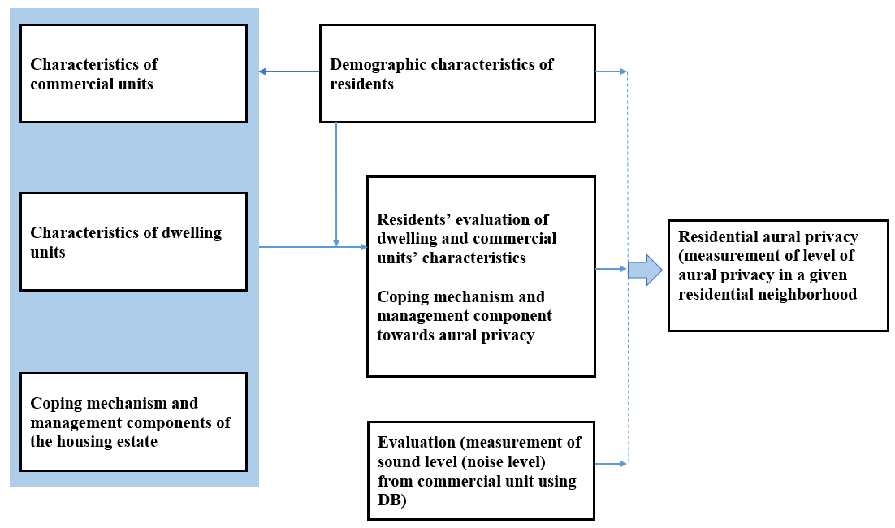
Figure 1: Scope of the study

During the study there was some limitation. Particularly, during interview some of the residents were no interest in giving accurate information due to bored of giving information for different studies in previous time for no solution. During survey time, some respondent households were not at home; few others were refused to answer the questions. Some respondents respond to the research question negligently by thinking some researches have political backing and fear of commercial unit owners for their own safety. The other limitation by researcher in this study were fear of commercial unit owners in measuring sound level during night time because most of the commercial unit receive notification and warning from responsible authority. Therefore, the above limitation might have some influence on the validity and reliability of some of the data generated from sensitive questions in the study. But In order to minimize this problem, the researcher uses different mechanism such as giving identity card to interviewee, meeting the respondents frequently, using service of commercial units’ products and using housing owner association of the site who are familiar with them to collect data.

  - Organization of the paper

This study has seven chapters. The first chapter deals with introduction of the research that contains background of the study, statement of the problem, research questions, objective of the study, significance, scope of the study, limitation, and organization of the paper. The second chapter contains review of related literature and describes the views and various aspects of aural privacy by different scholars. The third chapter deals with methodology of the research, data collection technique, sample of the population, and justifies in what criteria the study site is chosen and the reason why the researcher selects the specific methodology and chapter four deals with contextual review related to study area. In chapter five collected data is analyzed with graphs, texts and maps. The sixth chapter contains the summery of finding from chapter five and the final chapter recommend some solution based on the analysis and reviewed literature.

CHAPTER TWO

LITERATURE REVIEW
  - Introduction

To be fully aware of the problem being studied in this research study in a brief way the following reviews and summaries are very essential. Therefore, in this chapter summery of literatures and discussions are described for frame work and to know the variables which must be consider in the study of resident’s privacy specifically on aural privacy.

Different activities are set together in a residential environment and those activities have their own subsystem. According to Rapoport (1990) one example of this subsystem is that of dwelling and its forms. In residential environment such sub set of activities vary in different individuals. The variation may be in terms of factors such as age, marital status, economy, educational level and so on. It is obvious that the preferred area of home environment for most people is that of a place of safety or sanctuary. As we compare to other areas in this world, we spent our much time in our home. We can categorize our built residential environment in to internal and external. Internal built residential environment are the internal man-made components of dwelling units. On the other hand, the second category covers the built surrounding of dwelling units which are accessible for all human activities. The external built environment is a scale up to large-scale civic surroundings and it may range from parcel to neighborhood.

One of a significant factor in the study of predictors of housing preference is privacy. Rather than other factors for most dwelling buyers and dwellers, their evaluation and satisfaction towards the built environment is based on privacy respectively Xiaolong G. Jian Z. (2019) Moreover, privacy is the outcome of the influence of various parties and involvers in a given environment. According to Daneshpour, Embi, & Torabi (2012) privacy needs to be defined, it should be identified and analyzed by its influential parties and involvers. Therefore, in this research study I am going to assess the resident’s aural privacy of mixed residential building. In this case the influential parties are commercial units.
  - Mixed-use Development

Mixed-use is defined as a type of development that mixes several lands uses together and it has some similarity with multiple-use (Herndon, 2011). But further examinations on the concept of mixed-use reveals, it has different meaning to that of multiple use. According to Levitt and Schwanke (2003), multiple-use development doesn’t consider integration, density and compatibility of land uses as compared to mixed use development.

Different writers have different suggestion about the unity of uses in mixed use development. Levitt and Schwanke (2003) in his paper suggest that, integration of at least three substantial revenue- producing uses should have to be integrated in mixed-use. However, according to (e.g. Hoppenbrouwer and Louw (2005)) having two compatible uses within a mixed-use neighborhood is already adequate. Different thought about mixed use development tells as it is a complex urban development concept which integrates multiple dimensions and aspects. According to Jill (2007) having this complex urban development in a given area have its own positive and negative impact on the occupants or users. He mentioned, economic vitality, social equity, and environmental quality are the advantage whereas cultural and economic forces are the drawbacks. The advantage of mixed use in one’s country maybe it’s the main problem in another country, therefore Jills finding may vary from country to country.

  - The Meaning of a Housing and Qualities of a Home

A house is a meeting place for a wider family and it is also a source of identity and status or both to the outside world (Ahsen and Gulcin, 2005). Beside the function of living they describe house as a place where different business activities take places for the provision of basic necessity of life. That why, most of the time we say a house is more than just a dwelling.
It was clear that provision of shelter is passive and primary function of housing while its secondary function is the creation of an environment that is best suited to the way of life of a people - in other words a social unit of space. This study assesses privacy and it will be the secondary function of housing that must be seen beside first function of housing. Housing symbolizes the social status of the family. Therefore, both quality and quantity of housing stock are significant factors while measuring technology, culture, civilization level of any nation. “It contributes to the general wellbeing of a people, race or community” (Burnette, 1986).

Gracia, Uzzel, Real and Romay (2005) identifies certain attribute for relevant dimensions of a house for it to transform into a home.

- Home is a haven that surrounds us with privacy, security, refuge, and protection from outside world.
- Home is strongly related to our sense of continuity
- It is central to our identity.
- There is warmth in a home, this is like that of a hearth but is symbolic and interpersonal.
- Home helps us to feel connected to certain people, to the place, to the past, and to the future and that why we say home means connectivity.
- Home is physically suitable it means the form and structure of the house matches our social and psychological needs.
According to Gracia, Uzzel, Real and Romay(2005) the absence of the above components in a house will lead to diverse behavioral responses to reach a point of satisfaction with the dwelling.

  - Theory development

    - Living and housing theory

Czech statesman, writer and former dissident, Havel (1957) wrote about the right of each individual by describing every person in this world should enjoy good living condition which is not limited by several housing characteristics (housing size, housing privacy, housing facility etc.), economy and law.

Living and housing theory is a theory that represent the fact that human’s living condition is highly related to their housing characteristics (e.g. overcrowding, privacy and facility) in urban areas (Liu Wen Tao, 2016). In addition to this he states that, their living condition is linked to their economic and law as well. If the economy was good could housing characteristics are also good; and if housing law is good it helps the people to carry out the fair housing characteristics. When we compare the Havels thought towards individual right with that of living and housing theory, the theory was developed during the period when Havel had given more attention to the study of municipal housing. Therefore, we can conclude that the theory is more applicable in urban areas than in rural areas. Most of the time many researchers of housing use the housing theory as a base for their studies.

    - Housing theory and society

In recent time, good quality of life is related to the good quality of different factors such as good housing characteristics (housing privacy, housing facility etc.) and good housing policy (James, G., David M., Alan M., Pete R., 2016). The influence of house on our happiness, opportunity, and success is high. Housing characteristics such as housing privacy, housing facility and housing policy highly influenced human’s living condition (Havel,1957). The living and housing theory pay attention to the housing characteristics such as overcrowding, privacy and facility, and this theory also indicated who pays attention to these housing characteristics (Liu Wen Tao, 2016). Therefore, this housing theory could strongly support the researcher to undertake this research and to place emphasis on the housing characteristics specifically for housing privacy.

  - Housing Privacy

    - Definition and Concept of Privacy

Altman (1975, p10) defined privacy as “an interpersonal boundary‐control process, which paces and regulates interaction with others”. He expresses to aspect of privacy: the first aspect is desired privacy and the second aspect is achieved privacy. The social exchange amount in a given area or privacy one desires is called desired privacy, while achieved privacy refers to the actual social exchange amount or privacy one has at that moment. Privacy and social exchange set in to different corner of continuum i.e. the more privacy is the less social exchange, while the more social exchange is the less privacy. In day to day activity privacy is an important phenomenon that each individual wants. Regarding individual privacy there are many laws that have been established, to mention two of them the right to privacy and allowing individuals to have their own level of privacy (Sharp, 2013).

Demirbas and Demirkan (2000), differentiate the definition of privacy in different characteristics, i.e. individual characteristics have their own meaning to define privacy. Such us
- Personal characteristics,
- Cultural backgrounds,
- Gender,
- Age,
- Economical,
- Educational, and
- Social backgrounds

The idea of Demirbas and Demirkan to define privacy is related to subjectivity of individual behavior and these is also used to define the level of privacy. On the other hand, Gritzalis (2009) state that privacy as the right "to be left alone", these represent the possibility of remaining separate from others, anonymous and unobserved. Therefore, it is clearly revealing that privacy refers to the way individuals’ control or regulate another individuals' access to themselves. However, Pederson (1999), says privacy does not necessary mean withdrawing from people, instead it involves controlling the amount and type of contact one has with others.

    - Types of Housing Privacy

Different writers discussed about the existence different types of privacy with different context related to man environment relationship. Among them i try to review the most important types that helps in this study. According to Nancy (1972) in her article of privacy and environment, she subdivides privacy type in to sight, sound, touch and smell. In addition to these most writers define and type privacy within the home and the immediate neighborhood in terms of freedoms and protection in four main areas such as sound, space, sight, and security. Specifically, privacy related to sound can be divided into not overheard and protected from outside noise. Therefore, this research mainly focused on the type of sound privacy which is protected from outside noise.

From the book of ‘’Public Places Urban Spaces, the Dimension of Urban Design’’ Carmona, Tiesdell, Carmona, & Heath, (2012) are attain privacy in different number of ways, including behavioral/management mechanisms and strategies involving physical distance or the use of visual or sonic 'screens'. In functional terms, privacy can usefully be discussed in terms of visual and 'aural privacy.

    - Functions of privacy

Beside provision of housing obtaining peoples need in this context privacy is one of the major issues in housing environment. According to Altman (1975), privacy have two function: social comparison and self‐identity. Social comparison allows people to compare themselves with others and evaluate themselves without others present and according to Westin (1967), he calls this function self‐evaluation. The second function is Self‐identity, allows one to reflect on one’s own identity when others are not present.

Note, that the functions discussed are not a complete overview of all privacy functions. For instance, studying or being together with friends or family (e.g. intimacy, Pedersen (1997) are also privacy functions. These functions allow people to obtain a degree of privacy, but also to build and maintain relationships with others.

Regulation of the types of privacy, is a function of both personal and situational factors. “Personal factors are individual's need for privacy, personal attractiveness, interpersonal skills, personality variables and ability to utilize privacy control mechanisms” (Pederson, 1999). The second is situational factors and it may be social or physical. Social factors are presence, willingness and personal characteristics of others who have the potential for social interaction. Physical factors according are barriers, location, layout and distances. Privacy supports social interaction which, in turn, affects our competence to deal with our world, which affects our self-definition (Altman, 1975). Therefore, the benefits of privacy arise from achieving its functions.

Privacy also have its own role in supporting health functions by providing opportunities to escape from the stresses of daily life, to relax, to manage bodily and sexual functions, to emotionally vent, and to cope with loss, shock, and sorrow. Keenan (2005) identifies different other categories that privacy gives to the people.

- Natural and psychological benefits: privacy provides physical, psychological and spiritual benefits to individuals. Individuals have certain needs, such as security and connectedness, that they want to satisfy, but invasion of privacy destroys one's sense of connectedness;
- Creative benefits: many people see privacy as conductive to creativity. Individuals have the need to have their own rooms where they are away from other people and regulate their privacy;
- Protective benefits: this refers to physical invasion of individuals' sense of being safe and secure such as, the protection of one's home from burglary;
- Social benefits: individuals have the ability to regulate their own invasion of privacy and allow people they know or do not know to invade that privacy on a social basis;
- Democratic benefits: privacy is self-determining each individual has the "right to be left alone".
The achievement of a self-identity and the management of interactions between oneself and the social environment are function of privacy mention by Arkkelin (1995). In literature home is often described as a haven or refuge. The category to describe home on those two ways are based on several related ideas like the distinction between public and private, and the inside and outside world (Altman and Werner, 1985). The inside is a limited space and represents a comfortable, secure and safe space and also the outside however is more diffused and seen as a dangerous space.

  - Aural privacy

Aural privacy is one major type of privacy and the concern of this study. Undesired sounds - usually termed 'noise' – can disturb and invade privacy and activities. Although noise can be considered to be ' unwanted' sound, and it raises the issues of unwanted by whom: one person's music is another's 'unwanted sound'. According to Lang (1994, p. 226) aural privacy have another name of 'sonic comfort'. This sonic comfort depends not only on the decibel level of sound, but also on its pitch, source, and perceptions of the degree to which hearers have control over it. While people can adapt to extraordinarily noisy environments, noise pollution is an increasing concern.

Noise disturbance also has a temporal dimension: a given type and level of sound is more acceptable at some times of the day or week than at others. Glass and Singer (1972), from Krupat, (1985, p. 1 1 4) found that, rather than the physical characteristics of noise, it was the social and cognitive contexts in which it occurred that determined whether it interrupt or not. Research, for example, has indicated that continual exposure to background noise such as that found in relatively noisy neighborhoods, can lead to raised blood pressure, heart rates and stress in children, reducing maturation and leading to 'learned helplessness syndrome' (Evans 2001).

Design strategies can combat noise nuisance. A broad distinction can be made between noise generating activities (cafes, bars, night-clubs, traffic, amplified music, etc.) and noise-sensitive uses such as housing. Measures can be taken to prevent or reduce the 'breakout' of noise, and/or separate it from noise-sensitive uses, by physical distance, sound insulation, or the use of screens and barriers (Matthew C., Tim H., Taner O., Steve T., 2003).

Zoning is one mechanism in structuring privacy level. Within buildings, noise-sensitive uses can be located away from noise sources, for example. As change may be unpredictable and impossible to control, a necessary advanced principle should be to ensure that appropriate insulation is provided for noise-sensitive uses from the start (Matthew C., Tim H., Taner O., Steve T., 2003). As physical distance from the noise source is often impractical, the other main means to obstruct the sound path is by solid screening (i.e. solid fencing) or earth bunds (trees and tree belts have very little effect). In domestic space, privacy levels typically structure the position of rooms, grading from the most accessible public spaces such as the entrance hall, to the least accessible and most private spaces (e.g. bedrooms and bathrooms) an ordering which relates to the position of outdoor public space and access to the dwelling
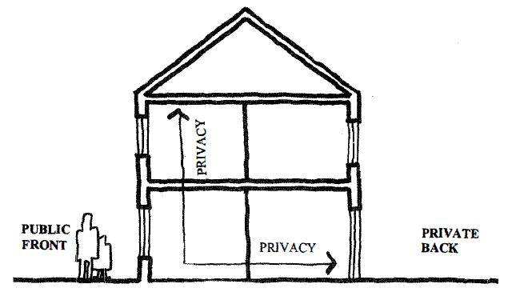
Figure 2: Positive privacy gradients maintain and respect the public/ private distinction (source: Bentley, 1999)

  - Important factors regarding aural privacy

In different societies the degree of privacy is has been dynamic, political, economic, socio-cultural, and demographic and are the most important factors for the variation (Steven, 2010). It’s a recent phenomenon for privacy of the individual and the recognition of a moral claim to private personality is a relatively recent phenomenon. Different scholars have discussed about the attitude of privacy from time to time. I.e. the circumstance of privacy changed from group life of people to more life of individuals because of different reasons. In such processes a close association has been noted between changes in privacy norms and modification of architectural design.

Rather than the physical setting, cultural norms and customs, family culture and background, family structure and family size, status and role relationships within the family, life cycle stage, age, sex and privacy-orientation of family members, time structuring, etc., are the most important factors that influence the degree or level of privacy.
Different scholars have the same attitude about factor that influence degree of privacy among them, Rapoport (1969) explained theoretical or empirical factors are factors that relate to privacy needs. He describes the definition privacy will vary from culture to culture. Willis' (1963), also studies on privacy, and she illustrate the requirement of privacy may vary within a culture or a group according to socio-economic grouping, lifestyle, family background and values, etc. up on this she pointed out that individual members of a community have its own role and relation in the concept of privacy beside groups of people. Sex and age, age-related experiences (life stage, family life cycle), past (history of the person) and present (living situation) experiences or circumstances, personality variables (introversion-extroversion), and mental health are factors related to individual’s privacy requirement.

Willis (1963) write about complex aspects related to privacy concern rather than the above context. those privacy concerns are Privacy from, or between, neighbors. For most people privacy in relation to neighbors involved the establishment of the right relationship with them. In her study the relationships have different range that varies from no involvement and high control over the relationship to varying degrees of involvement and intimacy with neighbors. The second aspect of privacy concern written by Willis is that of privacy between neighbors, and this social dimension of privacy from neighbors differed from, though it may have related to, its physical dimension, such as distance between dwellings. She listed ten factors affecting privacy between neighbors, and those are physical setting and social relationships, the individual, social factors, physical Variables, space arrangement of entrance doors, Street Form, proximity, neighborhood satisfaction, neighborhood interaction, Habitat selection. Therefore, the importance of the physical setting affecting the attainment of certain interaction outcomes and social ends should not be ignored or understated. Generally, some general aspects of design significant to internal privacy in housing include; allocation of adequate space per person (provision of territories), allocation of adequate space for different functions and activities, space arrangement, hierarchy of spaces, and home size. The above aspect may have a little solid evidence about signs of the impact of the internal layout of dwellings on processes of interpersonal interactions and relationships between, and privacy of, household members, and on family life. The main focus area of this study is that of Privacy from outside the dwelling. This is the privacy of individuals and families related to the surrounding environment. Visual privacy and aural privacy are the main components of this category.
Aural privacy and Architecture
Noise transmit in different ways, and those are through building fabric (building envelop), air, in vertical way from floor to floor, horizontally through walls and openings, (Saint-Gobain 2014). According to Saint Gobain. Acoustic transmission and absorption are the two main characteristics of Acoustic comfort in one’s building.
Saint Gobain (2014) identifies variety of external and architectural factors in the design of acoustic comfort such as:
- The types of noise to be managed
- The spectrum of noise to be managed (low or high frequencies)
- The construction system and materials
  - People and privacy

For the purpose of desired degree of interaction with others; individuals use a series of mechanisms in different pattern and at different times. Sometimes the outcome or the achieved privacy level was equal to the desired privacy and we call it this successful achieved. But if the level of contact was not optimal, it leads to crowding and violation of privacy i.e. when achieved privacy was less than desired privacy. If behavioral mechanisms of personal space, territory, and verbal and non-verbal behavior was not used in a successful way to protect a person or group from undesired interaction we call it crowding or privacy violation occurred. Rather than the above category if a person or group received less contact than was desired, sociologists says this "social isolation" (Daneshpour 2011).

According to Rapoport (1976), "rules" (manners, avoidance, hierarchies, etc.), "psychological means" (internal withdrawal, dreaming, drugs, depersonalization etc.), "behavioral cues", structuring activities in "time" (so that particular individuals and groups do not meet), "spatial separation", and "physical devices" (walls, courts, doors, curtains, locks-architectural mechanisms which selectively control) are way of controlling unwanted interaction. More than one mechanism to control unwanted interaction are practiced by the individuals and family members.

In another paper Rapoport (1976), gives important point about privacy which is similar to Altman point of view and he says that openness and closeness are way for boundaries of a person's privacy. He related this point to the above privacy definition, by explaining that "each of these mechanisms and forms of interaction are related to different sense modalities, which operated in two directions.
- One did not want to disturb or be disturbed, see or be seen, to smell or be smelled, etc. ".
- They were also related to the context so that the same amount of aural information, for example, may be acceptable in one context in a given culture but not in another (in the same culture).

Lang (1994) in his article also mention different sense of modality about aural privacy and he states noise can be considered to be ' unwanted' sound, and this feeling may vary from individual to individual as well as from family to family. Therefore, all of the above contexts which explained by Rapoport, Altman and Lang had clear implications for the study of man-environment interactions, analyzing environments or designing them, relating them to lifestyle and to specific contexts.

In the paper called "The Environment as an Enculturation Medium", Rapoport (1978) gave a more precise definition of privacy. He defined privacy as" a set of mechanisms for controlling interaction". This definition generalizes all the above written literature about privacy by different scholars. Up on this Rapoport listed all the variables that defined privacy violation; which is the main area for this study are the space, the relationship between the disturbed and disturber, the behavior that had been disturbed, the time or occasion, and the agreement on the roles controlling privacy.

  - Resident Perceptions of Comfort

Residents’ comfort is situated on a spectrum where their physiological and psychological needs are met (Lee, J.; Je, H.; Byun, J., 2011). Comfort parameters comprise both quantifiable factors, (for example, sonic comfort, thermal comfort, air quality and illumination) and qualitative considerations (for example, perceptions of privacy and personal control over the comfort of one’s private space). All elements interact and influence the way occupants use a dwelling and a building, and consequently their appreciation for how the overall design functions or is best modulated (Gann, D.; Salter, A.; Whyte, J., 2003). For example, in Singapore, a tropical city, residents on lower floors of MSAB were concerned about noise from passersby and street traffic, as well as view obstructions, lack of privacy, and odors from garbage, while dwellings on higher floors were has less noise, more privacy and better views (Yuen, B., 2011).

Various studies have identified noise in the urban residential environment as the greatest source of annoyance to residents (Cho, S.H.; Lee, T.K., 2011). Aural comfort or aural privacy is high if the sound levels are acceptable for the common spatial-temporal conditions, including perceptions of acoustic privacy, and the absent of loud noises.
A well-designed dwelling is one which provides a different range of conditions that enables individuals to meet their personal requirements when and where desired, for example noise at night in bedrooms is not desirable, but well-ventilated bedrooms are recommended for sleep health. one environment is said to be good if individual or groups have the authority and strength to control the other social as well as cultural influence (Moezzi, M., 2009).

  - Privacy Regulation Mechanism

As described by Altman (1975) Privacy regulation refers a control mechanism over access to the self or to one's group. People have a desired and an actual or achieved level of privacy. To reach the desired level of privacy people can carry out in all kinds of privacy regulatory behaviors to obtain their desired level of privacy. More importantly, Margulis (2003) says that failing in regulating privacy leads to lacking the profit from the functions that privacy provides. For instance, if dwellers living in Mixed use building would fail in regulating their privacy, this would give them insufficient opportunity to think about past actions, make plans for future behavior and compare themselves with other people. Eventually, this could prevent the development of their own identity.

Altman (1975) and Bonnes et al (1995) explains about personal space and territorial behavior are used for individuals primarily to regulate privacy and to maintain their openness/closeness towards others at optimal levels. Harris et al (1996) suggest that verbal and nonverbal behaviors, cognitive, environmental, temporal and cultural mechanisms are privacy regulation mechanism when individuals are confronted with negative privacy experiences.

Altman (1975) further suggests that the effectiveness and ease of implementing privacy regulation mechanisms may vary considerably across individuals and across social, physical and temporal context. Therefore, by combining the above mechanisms individuals can efficiently express their needed level of privacy to others in order to attain the optimal level of privacy. Altman (1975) developed a framework for understanding the mechanisms of privacy regulation and this framework can be used as a summary of all of the above-mentioned aspects of privacy. This figure indicates that privacy is a central concept that links the different phenomenon of environmental psychology (personal space, territoriality and crowding) with privacy regulation mechanisms.
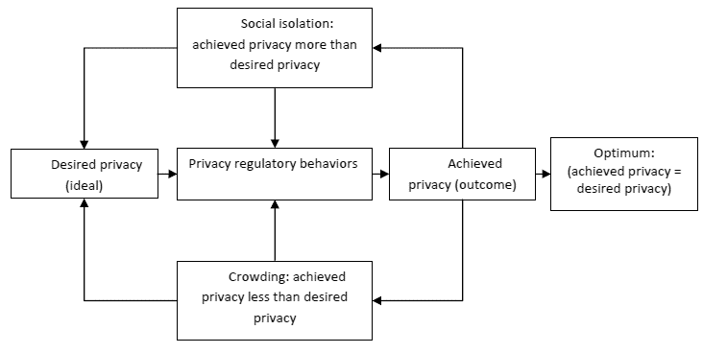
Figure 3: Privacy regulation theory (adapted from Altman, 1975)
  - Measurement of Aural privacy

    - Subjective measurement of Aural privacy

Preference, behavior, need and expectation of each individual are the way used to measuring privacy (Gifford, 1997). This idea is more or less related to the idea of Demirbas and Demirkan but the way to select those measuring techniques by Gifford is the difficulty of assessing privacy because of its complexity in nature. Cassidy (1997) pointed out that not everyone will react in the same way with regard to privacy and these is due to individual perception of the environment.

Different scholars mentioned different ways for measuring level of privacy. For instance, Kaya and Weber (2003) stayed close to Altman’s (1975) privacy regulation theory by measuring the amount of privacy someone has and subtracting this from the amount of privacy someone desires. The difference between these two scores resulted in a score indicating the extent to which someone deviates from their ideal level of privacy. For this type privacy measurement technique individual self-examinations essential for different type of privacy.

Another method to assess the level of privacy is by assessing behavioral measures. For instance, Weinstein (1982) measured privacy by installing privacy booths a table in a restaurant or bar surrounded by two high-backed benches in a children’s classroom. Children were allowed go into one of four booths when they wanted to use one. But this method has as a disadvantage that only one single behavior is measured. In addition, motivations other than seeking privacy are possible (e.g. children can choose to sit in a booth, just because it is fun). Also, based on a single behavior, we cannot conclude that a person needs more privacy (Greeve, 2001).

Haans et al. (2007) in his book develops two scales: a need for privacy and a need for socialization. Each scale consists of a range of behaviors people can use to obtain either privacy or social interaction. these scales were based on the theory of goal directed behavior and this theory of goal directed behavior assumes that if someone wants to achieve a goal (e.g. more privacy), he will take actions to achieve this goal, for instance, by closing the door to one’s room or hanging up a do not disturb sign. If someone has a high need for privacy (and is therefore highly motivated to take action), it is likely he engages in behaviors that cost more effort. For instance, asking a neighbor to be quiet might be a more difficult behavior to engage in than closing one’s own door.

Generally subjective measurements of privacy are more focused on the individual perception and engagement towards the problem. In this study the researcher combines the idea of Demirbas and Demirkan, Cassidy, Kaya and Weber and Altman to measure the level of Aural privacy of residents of mixed residential building. All authors relate the level of privacy towards individual characteristics or perception. The idea of Demirbas and Demirkan is similar to Cassidy and they illustrate the level of privacy is depending on individual or group such as personal characteristics, cultural backgrounds, gender, age, economy, education, and social backgrounds. In addition to this Kaya and Weber with Altman are define the measurement of level of privacy in terms of what you want and what you got and those need of privacy is directly related to the above individual characteristics.

    - Objective measurement of Aural Privacy

Rather than the subjective measurement as mentioned above objective measurement for level of privacy is essential.

Sound Level Meters

The basic unit of measurement for environmental noise, as recommended by ISO 1996/1, is the dB(A), It can be measured with a simple Sound Level Meter having an A-weighting filter to simulate the subjective response of the human ear. The DB(A) level is used to report ambient noise and noise intrusions, it is also used in computing LAeq.T and LAN.T (Meters et al., n.d.).

Most environmental noise investigations begin with measurements using a Sound Level Meter. The scope of the measurements will usually decide what type of instrument should be used and with which standards it must comply. A wide variety of Sound Level Meters is available covering requirements for simple noise surveys, where only DB(A) levels need to be measured, to elaborate measurements where Equivalent Continuous Levels (LAeq.r), Sound Exposure Levels (SEL), maximum, minimum, impulse and peak levels are required. Furthermore, there are Sound Level Meters available for national standards which differ from international standards.
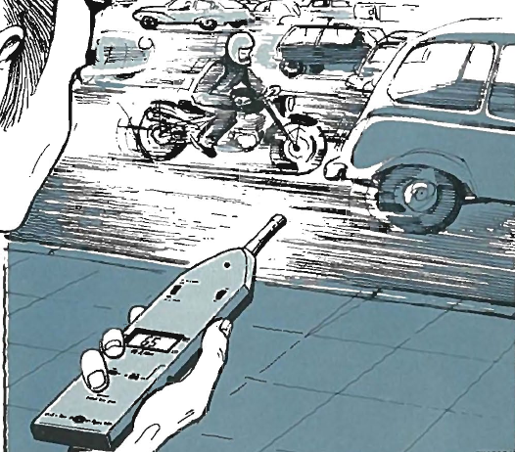
- B)
Figure 4: A) Sound Level Meters (DB). Source, Bruel and Kjaaer. Environmental noise measurement, 2014 B) Sound Meter Smart Phone. Source, Dana Doda. An Assessment of Noise Pollution in Addis Ababa, 2017
In addition to sound level meter know a day’s most experts use sound meter smart phone during inspection. Before inspection both instruments need to be calibrated to get the actual measurement of noise pollution.

  - Noise emission standards

Different countries in this world have their own standard on noise emission. the following table illustrate some countries noise emission standards. The table shows different countries have different standard towards emission standard.

Category of Area | ETHIOPIA |  | IRAN |  | WHO | SAUDI ARABIA |  | INDIA
Category of Area | Day | Night | Day | Night | Day | Day | Night | Day | Night
Residential | 55 | 45 | 50 | 30 | 55a | 55 | 45 | 55 | 45
Industrial | 75 | 70 | 75 | 65 | 70b | 75 | 65 | 75 | 70
Commercial | 65 | 55 | 65 | 55 | 70b | 65 | 55 | 65 | 55
Comm – Res. | - | - | 60 | 50 | - | 60 | 50 | - | -
Indus – Res. | - |  | 70 | 60 | - | 70 | 60 | - | -
Silent zone | ** | ** |  |  | ** | - | - | 50 | 40
World Health Organization-WHO (WHO, 1999)
a: The standard above which may happen serious day time and evening annoyance
b: The standard above which may happen hearing impairment
** means as low as possible to protect sensitive areas; The standard for traffic areas = 70dB(A)
Time base = 16 hours for residential areas and 24 hours for commercial, industrial and traffic areas

Ethiopia: Day=6.00AM-9.00PM; Night = 9.00PM-6.AM (FEPA and UNIDO, 2003)
** means as low as possible to protect sensitive areas

India: Day = 6A.M-9P.M; Night = 9P.M-6A.M (Indian Central Pollution Control Board, 1986)

Saudi Arabia: Day= 0007-0022; Night = 022-0007 (Hassall and Zaveri, 1988)

Iran: Day=7A.M-10P.M; Night=10P.M-7A.M, 30 minutes measured dBA to be compared with the standard (Maleki et al, 2010)

Table 1: Noise emission standards of WHO and some countries (Leq: dBA), Source, Aberra B. Status of Mixed-Commercial Zone Day-Time Ambient Noise Pollution in Addis Ababa-Case Study of the Yeka Sub-city, 2012

  - Health effects of low-level aural privacy on human beings

The World Health Organization has documented seven categories of adverse health effects of noise Pollution on humans (WHO, 2001, Hagler, 1998).

- Hearing Impairment
- Interference with Spoken Communication
- Sleep Disturbances
- Cardiovascular Disturbances
- Disturbances in Mental Health
- Impaired Task Performance
- Negative Social Behavior and Annoyance Reactions
  - Coping Mechanism

    - Definition of coping

Coping has different meaning and in different concepts. Erica Frydenberg and Ramon Lewis(1991a), in the book of journal of adolescent, describe "coping" has a variety of meanings and we can use coping as similarly with the meaning of mastery, defense and adaptation. According to Lazarus and Launier (1978) "Coping consists of efforts, both action oriented and intra psychic, to manage (i.e. master, tolerate, reduce, minimize) environmental and internal demands and conflicts. "Lazarus also define coping in his book with some other collogue early 1974, Lazarus, Averill and Opton (1974) as: "... the problem-solving efforts made by an individual when the demands he faces are highly relevant to his welfare (that is a situation of considerable jeopardy or promise), and when these demands tax his adaptive resources." The first definition of coping illustrates both the stressful aspects of emotion and the possibility of potential fulfillment or satisfaction. They also recognize that the adaptive outcome is uncertain or changeable.

    - Individual coping strategies

Frydenberg and Lewis (1991) in their book of journal of adolescent they describe 66 coping checklists for adolescent for measurement. Frydenberg and Lewis reduce those check list in to 18 adolescent coping such as enlist social support for management of the problem, focus on solving the problem by learning systematically about it, hard work and achievement of ambitions, worry about the future and its personal implications, Invest in intimate relationships and close friend Seek and improve relationships with others (with sensitivity to their opinion), wishful thinking, hoping for positive outcomes, not coping with the problem (including development of psychosomatic symptoms), tension reduction through various forms of release, stimulating and organizing collective social action, consciously ignoring the problem, accepting that there is no way of dealing with it, self-blame, accepting responsibility for the problem, withdrawal from others, ensuring they are unaware of the problem, reliance on spiritual support, including prayer and spiritual advice, focus on the positive, seek professional help, seek relaxing diversions and cultivate leisure activities, physical recreation and sport. On the basis of a further factor analysis, the Frydenberg and Lewis (1991c) identify three styles of coping that group the above and it is essential for other study purpose and for different age group. The three-style coping are
- Self-help activity towards the problem without any other support
- Use of others as a resource (and support), usually within a problem-focused orientation
- Using emotion focused strategy and it is associated with the filling of not coping. The three-category listed above are a way in which any person or groups tries to regulate, control or cop any problem around them. This gives the way in asking respondents regarding their coping mechanism in their dwelling units. Generally, according to Frydenberg and Lewis (1991c) ‘‘coping can be best conceptualized not by referring to problem-focused and emotion-focused components (palliative and instrumental) but rather in terms of a focus on dealing with the problem, reference to others and non-productive coping and Each of these clearly represent both functional (effective) and dysfunctional (non-productive) coping responses.

CHAPTER THREE

RESEARCH METHODOLOGY

  - Methodology Selection

According to Irny and Rose (2005) methodology is the systematic, theoretical analysis of the methods applied to a field of study. It comprises the theoretical analysis of the body of methods and principles associated with a branch of knowledge. Typically, it encompasses concepts such as paradigm, theoretical model, phases and quantitative or qualitative techniques (Irny and Rose, 2005). A methodology does not set out to provide solutions - it is, therefore, not the same thing as a method. Instead, it offers the theoretical underpinning for understanding which method, set of methods or best practices which can be applied to specific case, for example, to calculate a specific result.

This research has the objective of studying the level of aural privacy in mixed-use of condominium neighborhood with resident’s perception of how well is their condominium dwelling related to the external commercial unit. All mixed residential neighborhood in this case condominium site has different context. The variation comes in different reason such as period or time of the development, location of the development, area of the development etc. in order to understand the impact commercial unit on resident’s privacy the use of survey method is very essential.

Psychologists and sociologists often use survey research to analyze behavior, and it consists of a predetermined set of questions that is given to a sample (Syed Muhammad, 2016). Surveys provide a means of measuring a population’s characteristics, self-reported and observed behavior, awareness of programs, attitudes or opinions, and needs (Syed Muhammad, 2016). In this research study, the research question was more focused on attitude or opinion, and needs of the respondent therefore survey method was very essential as compared to case study method.

Both quantitative and qualitative research methods have been applied in this study. Since the form data collection method open- ended responses, interviews, and reflections of residents’ subjective evaluation of aural privacy up on commercial units, therefore the research method that applied for this topic is qualitative. In addition to this, the research question for this study leads to evaluation of measurement of sound level (Noise level) from commercial unit using DB and the result is quantitative.

  - Case selection (Why Gotera Condominium)
The main reason to select the site is first, the neighborhood is highly developed when we compare to other condominium site therefore the output of this study will help for new (undeveloped) site as a case. Secondly, Gotera condominium site have more problems related to privacy, safety, and security towards residents in related to mixed uses as compared to other sites (Ayele,2015). Finally, the condominium has a unique physical and spatial character such as fenced, highly vibrant and active, therefore this characteristic makes it different comparably.

  - Source of Data
    - Primary data Source

The Primary data was collected through interview and informal discussion with residents, Kirkos sub city Woreda 4 environmental protection officials, Kirkos sub city environmental protection officials, Addis Ababa environmental protection officials, federal environmental protection officials, study area condominium owner association officials. In addition to this primary data were collected through sound level with the help of Decibel and Personal Observation of the Built environment including sketching, mapping, taking photographs to understand the spatial characteristics of commercial unit.
    - Secondary data Source
The secondary data were collected from books, published journals articles, official reports of concerning government bodies, published and unpublished research papers are used to understand the theoretical background, review international experience and study the contextual background.
  - Data collection techniques

There are a number of research data collection for research design and these include: focus group discussions, questionnaires, interviews (structured, unstructured and semi-structured), record reviews (including literature) and observations (Denscombe, 2007). A major determinant of the data-collection technique is the nature and type of the enquiry and the information required about a particular setting or context (Naoum, 2007).
The fundamental rationale for collecting data is to allow the researcher to gather enough evidence and, consequently, draw the inferences required to make important decisions about the findings (Tashakkori and Teddlie, 2010). Different data-collection techniques may be suitable to different research methodologies and enquiries (Pope et al., 2002). However, deciding on the types of data-collection technique to adopt will depend largely on the research methodology and the overall objectives of the study (Fellows and Liu, 2003).
To assess aural privacy of mixed residential building; case of Gotera condominium site semi structured and structured interview have been applied to collect data from the respondents in order to get unlimited information and to get deeper understanding of the issue.
In addition to this, personal observation, mapping, sketching, direct measurement data collection technique has been applied to assess the situation were questionnaires and interviews are impossible or inappropriate to use, to access peoples in real life situation, for good explanation of the context and also for strength of the context on the validity and in-depth understanding.
The interview for the research title” Aural privacy of mixed residential building in Gotera” have different content based on research question, and this content derived from interview conducted with residents of Gotera condominium specifically residents nearer to commercial area as well as different stakeholder.

The questionnaire has six sections:
- Section “1”, is on personal data of the respondents; ·
- Section “2”, is on residential unit characteristics;
- Section “3”, is on commercial unit characteristics;
- Section “4” questions contains perception and direct measurement of aural privacy by respondents and instrument respectively; ·
- Section “5”, is related to residents coping mechanism towards aural privacy regarding commercial units,
- Section “6”, is a question related to management of resident’s privacy by different stakeholder’s such as home owner association condominium, Woreda, Sub city, City and Federal level environmental protection office.
The instrument for the perception aural privacy was structured in five -point Likert scale ranging from None to Very High. Likert scale is the way that used to employ questionnaires in research. This research study mainly depends on the survey of respondent’s perception therefore this Likert scale is essential instrument. Subjects were then instructed to respond to their degree of agreement with the statements contained in the instrument. The sound level in other direction is measured by calibrated mobile phone from calibrated sound level meter taken from Kirkos sub city (See Fig. 3). The accuracy of mobile phone is checked by the researcher each day with that of sound level meter before data collection during day and night time, weekend and holyday due to scarcity of the instrument. Environment protection experts in different level also use sound level meter of mobile application during inspection in different place of the city.
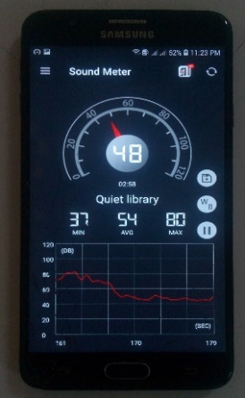
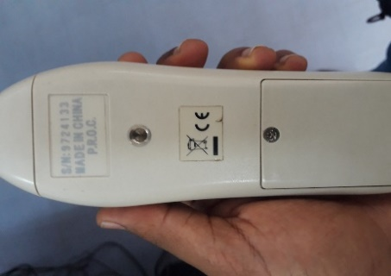
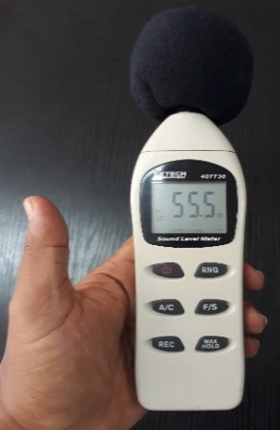

Figure 5: Actual Sound level meter and mobile phone used by the researcher for measuring noise level. Source: sound level meter from Kirkos Sub City environmental protection office and direct capture of private smart phone
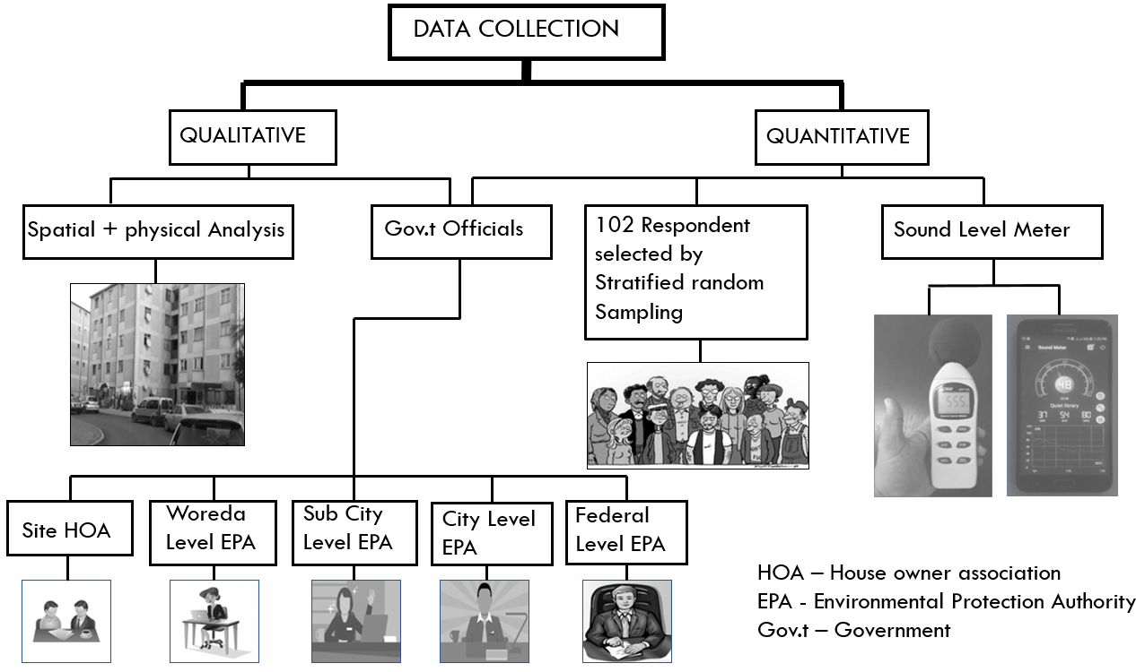
Figure 6: General overview of data collection techniques

  - Sample of the population

For some studies, the population may be small enough to warrant the inclusion of all of them in the study. But a study may entail a large population which cannot all be studied. That portion of the population that is studied is called a smaller of elements drawn through a definite procedure from an accessible population. According to Addis Ababa housing development project office the total number of households Gotera Condominium site is 2261 within seventy-eight (78) blocks and the number of mixed residential unit (residential unit with commercial unit) is 1536 units within 53 blocks. However according to home owner association of Gotera condominium site and site survey analysis by the researcher the existing blocks which have commercial unit in use are 42 blocks. Up on these the number of buildings typologies which exist on those mixed residential units are three. Therefore, to assess the level of aural privacy of the residents all 42 blocks will be implemented. Based on type commercial units, tenure type of respondents, bed room type, and floor level stratification from 42 blocks 24 of them are selected for this research study.
The sample size of this study is determined by precision level 9%. The level of precision is the range in which the true value of the population is estimated. Therefore, the sample size calculated by 91% confidence level and precision level of ±9%.
According to Yemane (1967) the formula to determine and calculate the sample size
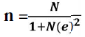
Where; n = sample size, N = the total survey area population, e = level of precision. Total survey area household population of mixed residence is 948 and level of precision is 0.09. n = 948/1+948(0.09) ^2 = 109. The household number is calculated in terms of the existence of commercial unit on the building. Before calculating the sample size, the researcher analyzes existing number and place of commercial unit in this residential environment, and after that the household number or population number is calculated from all residential units of the existing analyzed mixed residential units. Up on the above formula the sample size (n) is 109 but based on the above stratification technique the number of units for this research study were 102 units.
Some portion of this research study assess individual perception of all family member (head, spouse, children, house maid and other family) from one dwelling unit or household therefore the number of sample size were greater than the specified sample size 102.

  - Sampling techniques

In this study a stratified random sampling procedure was used for selecting the participants. Since the variance of sample mean not only depends on the sample size and sampling fraction but also on the population variance. The case to select this sampling procedure is to ensure a fairly equal representation of the different variables for the study. The stratification was based on the type commercial units, tenure type of respondents, bed room type, and floor level. Up on the above stratification the percentage for commercial unit type must be 50 percent for high disturbance and at least 25 percent for medium disturbance level area and 25 percent low level disturbance area. The proportionate stratification was based on the fact that there was low aural privacy of residents near bar and restaurant than other commercial types. According to home owner association of Gotera condominium site 90 to 95 percent of population are tenant, but to know the exact perception of aural privacy in different tenure type at least 15 percent home owner is mandatory. The other stratification is based on floor level. Since one of the areas of these study is to know level of aural privacy, in different floor level therefore each floor level must be studied. The final one is bed room type stratification and these stratification gives as different information. Therefore, equal proportion of the existing bed room type must be studied to assess the level of aural privacy in different room size, number of households and on other contexts. The number of bed room is selected based on the distribution proportion for bed room of the whole condominium site. From the total building unit of the site 20%, 45%, 21% and 14% are studio, one bed room, two bed room and three bed room respectively. By using the above percentage for selected area (mixed residence) the bed room type for research study will be:
Bed Room Type |  | Frequency
 | Studio | 19
 | One bed room | 44
 | Two bed room | 26
 | Three bed room | 13
 | Total | 102

Table 2: bed room type stratification

The selection of respondents in each floor were selected by systematic sampling. This was achieved by starting and selecting respondents from the left of the condominium entrance (stair) in each floor of mixed building. This technique will continue until the required number is obtained with replacement.
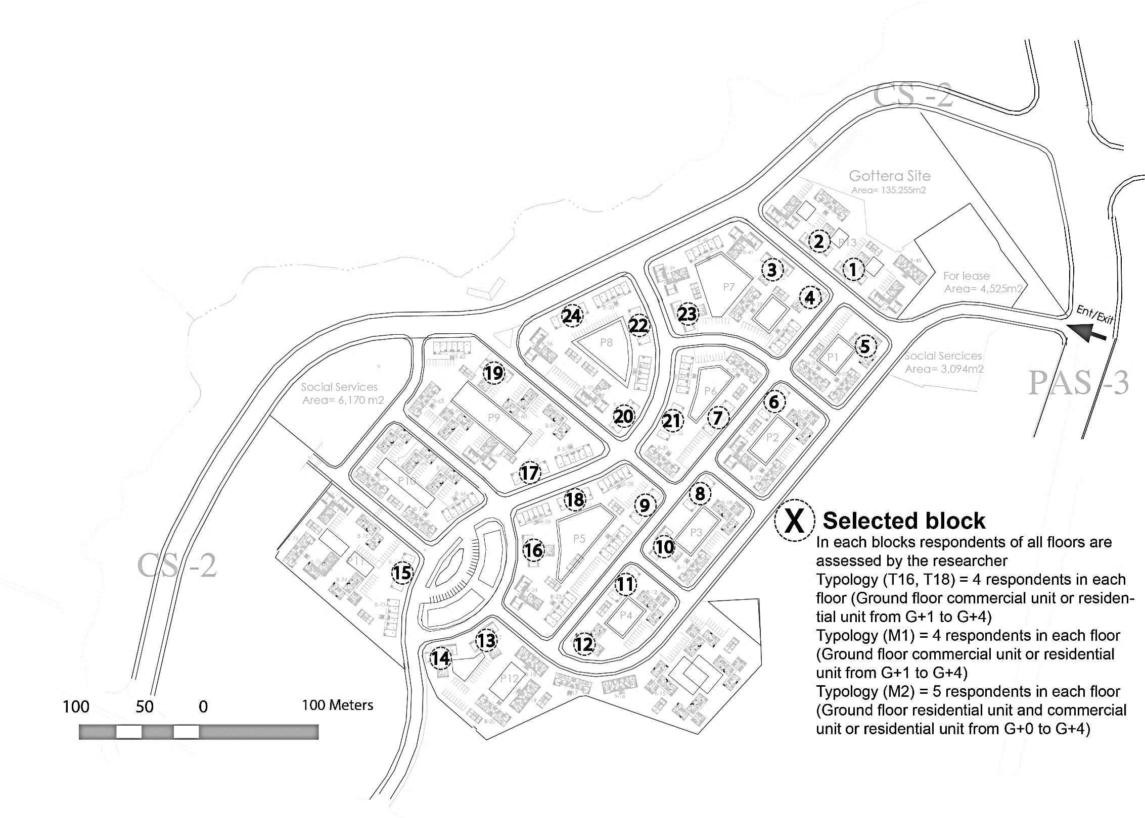
That is, researcher applied sampling with replacement. Stratified random sampling technique was employed to select 102 respondents of mixed buildings in Gotera condominium.
There are three different block type in these condominium site. Within stratified area i.e. block which have both residence and commercial unit all the three-block type are there, but the number of block type two in selected area is only one due to existence of commercial units below it. Residential units are started from 1st floor in typology (T16,18, M1) but they start from ground floor for typology (M2). Therefore, in typology (T16, T18, and M1) and M2 the number of respondents will be 4 and 5 respectively.

Block type |  | Number of respondents
 | 1(T16, T18) | 48 (12*4)
 | 2(M1) | 4 (4*1)
 | 3(M2) | 50(10*5)
 | Total | 102

Table 3: Block type stratification

  - Data Analysis

Primarily, data analysis of the selected study was applied to the fundamental data acquired through personal interviews with the participants in the study, from documents, from maps, from measurement and observations made. Since both qualitative and quantitative have been applied in this research, the analysis differs in different cases.
Based on the research question the findings qualitative data were analyzed and measured against different variables and standards that gathered from different literatures. Regarding quantitative data descriptive statistic will be conducted for attempting and collecting quantifiable information to be used for statistical analysis of the population sample using graphs, table and percentage. On the other hand, maps are analyzed by means of GIS software and personal observation.

  - Research design diagram

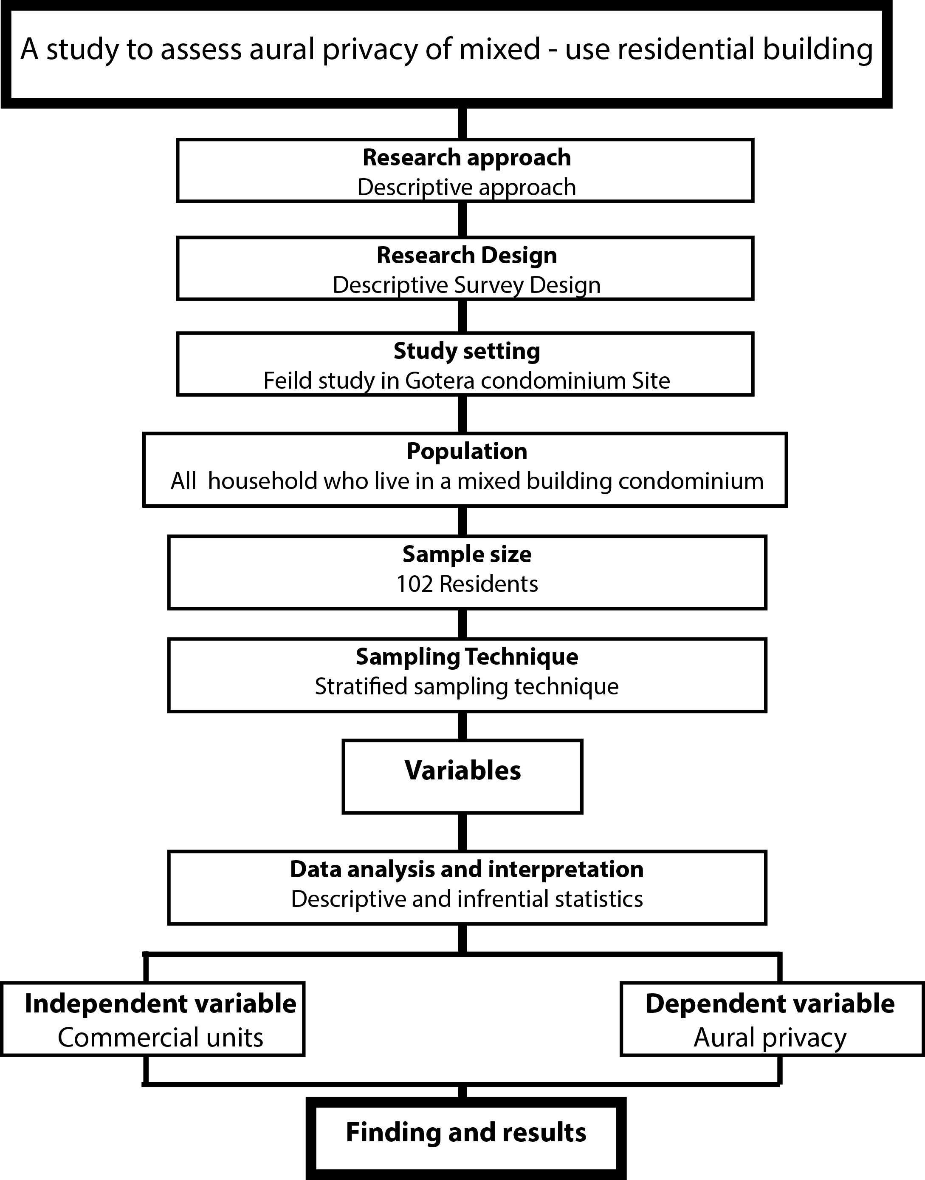
Figure 7: Schematic representation of research design

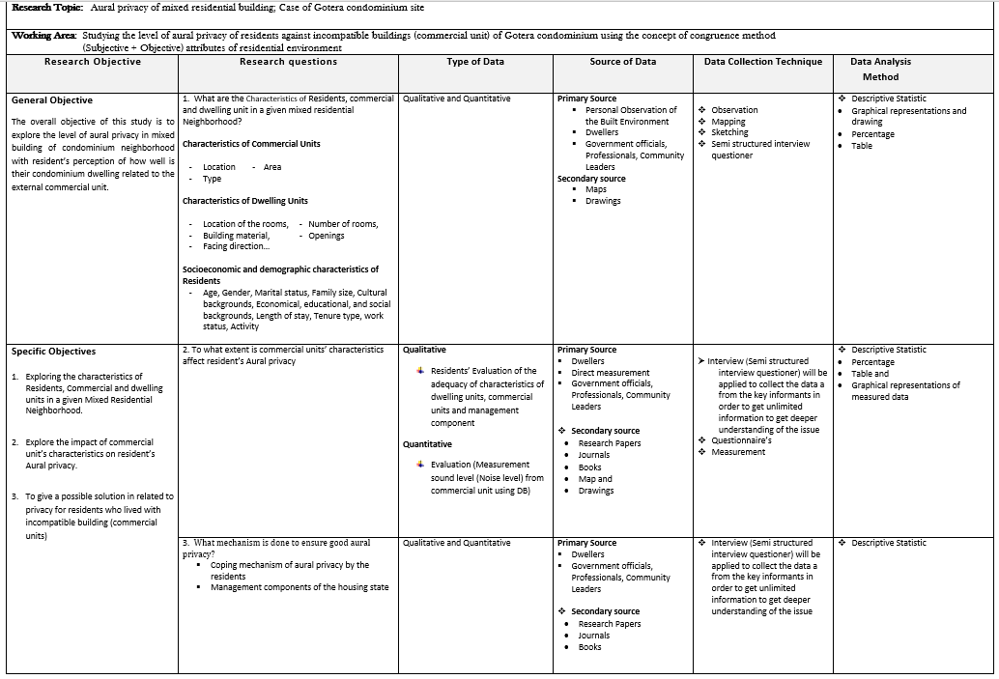
Table 4: Overall research design diagram

CHAPTER FOUR

CONTEXTUAL REVIEW

  - Introduction to Addis Ababa City

From the total of urban population in Ethiopia, Addis Ababa covers 25% of them and she is one of the fastest growing cities in Africa. Addis Ababa’s economy is growing annually by 14%. Currently Addis Ababa contributes approximately 50% towards the national GDP, highlighting its strategic role within the overall economic development of the country (World Bank Group, 2015).

Addis Ababa city administration is divided into ten Kifle-Ketemas (sub-cities) and the Sub-cities are again sub-divided in to 99 Woredas (localities), which are the lowest administration levels of the city. Executing routine municipal activities like solid waste management, tax collection, registration of vital statistics, issuance of identity cards, social court service and sub-city & neighborhood level development works which include construction of local roads and drainage networks are among the major responsibilities which are recently decentralized to Sub-cities and Woredas (Keffa, 2016).
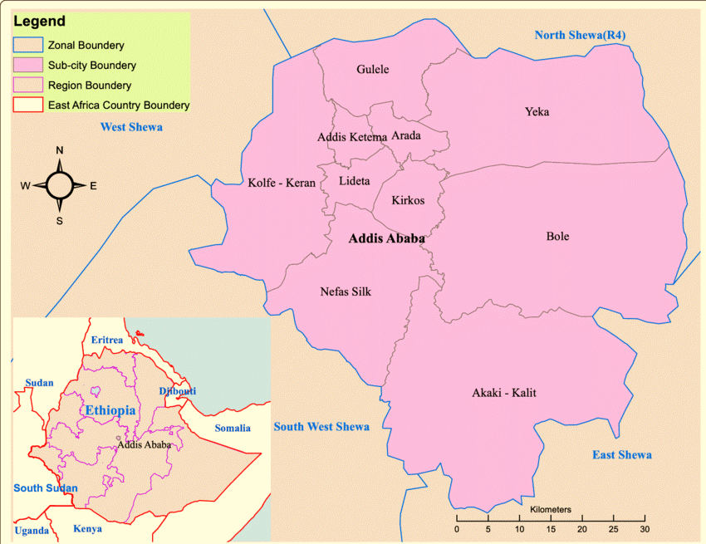
Figure 8: Location map of Addis Ababa and sub-cities. Source: Shapefile from Ethiopian karta agency
The city administration is limited itself to city level policy making, city level tax collection, city level development works, capacity building, and supervision activities among others. (UN-HABITAT, 2011)

The role of urban centers in the economic development of the country has neither recognized nor given the due attention until recent time (Keffa, 2016). This type of situation left urban centers around the country, including Addis Ababa, with complex and deep rooted social and economic problems. Urban development issues such as housing problem, slum areas, social and physical Infrastructures problem, environmental pollution, high level of urban poverty are the character of Addis Ababa before the IHDP.

  - Integrated Housing Development Program in Addis Ababa

Integrated Housing Development Program Launched in 2005 with a target to build 50,000 condominium units/ year (UN-Habitat, 2011). Taking in account the extent of the problem, launching a massive housing development program is taken as one of the major intervention sectors to reduce the poverty level of the city (Keffa, 2016). This housing development program is not meant only to supply housing, rather it envisaged to alleviate the rampant urban poverty through:

- Creating massive job opportunities,
- Improving slum areas,
- Providing basic infrastructure facilities
- Recognizing and strengthening the informal sector,
- Introducing well targeted subsidy to women and disable residents,
- Promoting economic usage of the scarce urban land,
- Facilitating access to mortgage and affordable payment modalities,
- Promoting saving culture among the residents,
- Promoting new construction techniques which can reduce cost, wastage, and time,

  - Success and Challenges of Integrated Housing Development Program

The ability to maintain the livelihood of the poor in the city center where their day-to-day activity is strongly attached is the success of this program. “The fact that almost all the housing projects take place in the city center has created them the opportunity to remain there and benefit from the redevelopment activities and other assets of the city center “(Melaku, 2009, pp40). But rather than success this program has faced many challenges and encountered many failures. The fact that the problems are vast and sophisticated, practical skills on the construction technology are limited, financial, human and physical resources are inadequate and efficient professional and institutional management capacities are imperfect have resulted in the following failures which need further investigation and improvement. (Yewoinshet, 2007:35- 40) such as, construction cost efficiency has overtaken the advantage on the quality and durability of the building, most selected sites are very small in size and fragmented creating difficulties in management, absence of orientation and minimal awareness creation on how to live in such environment, on the type and size of rooms etc. has resulted misunderstanding and mis use of places, the program is not successful in addressing the very low income groups which usually had big family size and require larger rooms.

  - Mixed Land use development in Ethiopia

Due to increasing number of populations in urban areas the need for shelter increases through time. Since 2005 Addis Ababa housing Development Program construct over 136,000 housing units to overcome housing problem of low- and middle-income people. Beside the provision of those housing the country government introduce mixed land use development in each condominium site for the purpose of accessibility of service without difficulty. In addition to dwelling unit the provision commercial unit is one example in mixed land use development. Each condominium site has ten percent commercial units, and those commercial units are located at ground level and in some place, they are located at first floor. In addition, this they’re also a plot of land for commercial use. The commercial units are sold, not rented, and the plots of land for commercial use are leased (UN-HABITAT, 2011).

According to integrated housing development program the type of commercial units are small shops, restaurants, pharmacies, salons and music shops and there are no restrictions on commercial types and activities and this may have its own impact on the day to day activities of residents of the site (UN-HABITAT, 2011). Those commercial units have limited size or small size are not appropriate for large-scale industrial enterprises and therefore can only accommodate small businesses which do not require special spaces or service provision. Rather than its negative impact the provision of commercial units aims to ensure mixed use occupation of condominium sites, which have several benefits over purely residential developments. Among the them it offering the convenience for residents to shop locally, reducing travel distances to obtain their shopping, for instance foodstuffs and related weekly necessities. Another key reason for the inclusion of commercial units was their ability to encourage activity on site at all times of the day and night, and therefore increase security and decrease the chances of unsociable activity, such as burglary, as people are continuously moving around buildings.

  - Environmental Issues and Its Legal Frameworks in Ethiopia

In 1997 comprehensive environmental policy is established by the Government of the Federal Democratic Republic of Ethiopia (FDRE). The major objective of this policy to enhance and improve citizen’s health and quality of life. The federal constitution (1995) also has article up on environmental issues. Proclaim 92 and article 44 of 1995 constitution states that all citizens shall have to live in clean and healthy environment and government and citizens shall have a duty to protect the environment. On the other hand, Environmental impact assessment is a policy 299/1995 which test environmental impact of one’s project. It is a way of illustrating positive and negative impact of one’s project or governmental document before implementation. Therefore, it has its own positive side in reducing environmental impact.

On the other hand, 22 articles which has six parts are listed under Ethiopian Environmental Pollution Control Proclamation No.300/2002, and this proclamation focused on noise and its legal aspect. Noise is one of harmful thing that should be prohibited. According to Regulations No.25/2007, noise pollution is prohibited unequivocally under these regulations. Article 14 of Addis Ababa City Government Environmental Protection Authority Pollution Control regulations; emphasis that a special permit is required to release pollutants to the environment that exceed the set standards. In addition to this article 8 of the regulation states that, noise exceeding the limited standard is not allowed to release to community.

The 2005 federal Democratic Republic of Ethiopia criminal code under the article 815 sub article one and two states that whoever disturbs the work, rest or tranquility of others, in particular by brawls and wranglers, shouts, songs, vociferations or uproars, signals, calls or the ringing of bells, or by the abuse of noisy instruments, apparatus, machines or other noisy producing articles will be punished in money terms. Article 2 of 2005 FDRE criminal code, illustrate if the noise or disturbance is caused at night as defined in the police regulations or by custom, or is willfully caused in the vicinity of hospitals, schools or similar institutions, if it is caused in deliberately mischievous manner, the court may impose fine arrest not exceeding one month.
In the case of Addis Ababa, City administration authority also has license and prohibit the use of loudspeakers at the open-air gatherings for entertainment and set a limit to the level of noise that could be released. The use of large amplifiers by vehicles that drive all over the city disturbing the peace of residents, schools, businesses and health facilities, should be restricted. Furthermore, vehicles selling perishable foods in residential areas using loudspeakers should also face limits regarding the level of noise they discharge. In addition to this commercial area near residential area should have to release sound that doesn’t affect the resident’s day to day activity and quality of life. This and other regulation related to aural privacy or noise also should have to be implemented in recently constructed mixed residential condominium neighborhood.

  - Noise emission standards in Ethiopia

The Federal Environmental Protection Authority (EPA), as a government body with the power to formulate policies, strategies and standards, has specified maximum tolerable noise levels based on the general requirements set by WHO. Accordingly, the EPA has set 75 decibels (dB) for industrial areas, 65 and 55 dB for commercial zones and for residential districts respectively during day time, whereas 70, 55, and 45 dB respectively for industrial, commercial and residential areas is the limit during night time. Since countries take the settlement patterns of their people, their advancement of technology and the burden of industry into account, noise standards vary from one place to another. Nevertheless, the EPA’s effectiveness in bringing its own standards down to earth and enforcing them accordingly is far from satisfactory.
Category of Area | Upper limit of Permissible Noise in dB
 | Day time (6.00AM -9.00PM) | Night time (9.00PM-6.AM)
Industrial | 75 | 70
Commercial | 65 | 55
Residential | 55 | 45
Table 5: Ethiopian noise emission standard; Source, Environmental Protection Authority (EPA) and United Nations Industrial Development Organization (UNIDO), 2003
  - Addis Ababa and undesired sound

Addis Ababa Environmental Protection Authority is the responsible body for the study of undesired sounds in Addis Ababa, major sources and public reactions. Undesired sound is any unwanted sound from stationary and moving sources with numerous adverse impacts. Investigation indicates that the source of those undesired sound are vehicles, religious institutions and dogs are the top high-and-above noise pollution sources in the city during day as well as night (Birhanu,2011). In addition to this, commercial activities and music-video shops and sporting activities, night-clubs and airplanes are also among the top five high and above sources of undesired sound. Statistically significant time (day night) and space (peripheral-central) based differences were found on noise pollution sources.

In Addis Ababa air pollution and undesired sound so called noise pollution are the most influential environmental problems complaints to environmental office. Condominium housing association committee, Woreda law enforcement offices, different office in sub-city are the main destination areas for complaints which came from different area the neighborhood of the city. The complaints on undesired sound is different in different areas, for instance commercial units are the source in condominium areas specially in developed sites. Other than these religious institutions were the major source of noise complaints lodged to Woreda law enforcement offices followed by music-video shops/rentals. Generally undesired sound is a serious problem in Addis Ababa with numerous sources and ever-increasing public reactions/complaints. Study findings by Birhanu (2011) indicated that regular inspection of high noise sources, education, better land use and law enforcement, effective inter-sectoral links and participatory noise mitigation approach are crucial to manage the problem.

  - Status and trends of the undesired sound in Kirkos sub-city

Kirkos sub-city administration has one of the inner sub-cities in Addis Ababa. Due to this reason different social services and residential households are exists in mixed manner. As a sub-city administration has a center, different investments are takes place in the area. Moreover, commercial services like bar and restaurant are the dominant one and also various religious institutions are found in the area (Birhanu 2011). According to Birhanu there are different types of environmental prevailing problems are surveyed during the inspection among the identified environmental problems; noise pollution which emitted from bar and restaurant as well as religious institutions in the mid-night and poor household solid waste management are a frequent environmental problem differentiated by the institutions. Of these prevailing environmental problems noise pollution which emitted from bar and restaurant, various religious institutions as a result of highly unmanageable loud speakers’ sounds are a critical issue of environmental problems in this sub-city which affects the health of the dwellers.
Besides, in the sub -city there is the increments of bar and restaurant time to time, the noise pollution also increasing. In the sub-city the monitoring and evaluation of the concerned governmental organization has lag behind and also lack of knowledge, use of sound prof technologies and skilled man power, even there is proclamation of environmental protection, unclear implementation of directives in the area of the noise pollution.

  - Condominium housing and its difficulties in Kirkos sub city

In Kirkos sub-city in recent years 4298 condominium houses for dwelling and commercial purpose are constructed and transferred in 6 Woredas and 17 sites. However, beside the existence of condominium committee association who has legal license in all sites there is a problem of Safety and security, Privacy, beautiful and comfortable environment (Digaf ena Kititl Report from Kirkos Sub City,2010)
All condominium housing units in Kirkos sub-city have their own housing association. Legehare, Temeneja Yazh, B Meda, Meskel Flower, 01/19, Kirkos 04, Libe Fana A, Libe Fana B, Kirkos 2, Dandiboru, Ras Mesfin Meda, Amalgamated, 34 Meda, Kirkos 1, Bulgaria, Gotera are condominium site located in Kirkos sub-city. Neighborhood Security problem, sound pollution from commercial units, the problem of open space development, illegal construction and others are problems related each condominium sites specifically Gotera condominium site.
  - Rule and Regulation of Sound usage in Condominium Housing

Article nine (9) of condominium housing resident’s association rule and regulation illustrate some regulation about sound usage and such regulation helps life quality of each resident in their day to day activity, but the question is in doing those regulations applied in each condominium site. Some rule and regulation of condominium housing resident’s association are; Every resident who live in condominium houses should have to reduce the use of loud slipper shoes, radio, tape and television after 10PM, if a person or organization use Radio, Tape and Television above recommend regulation will be punishable by rule and regulation of condominium housing residents association.

CHAPTER FIVE

DATA ANALYSIS AND FINDINGS

  - Introduction

This chapter presents the description of the study area, the survey results and the accompanying discussion. In addition to this background information about respondent demography and spatial data were presented.

  - Description of the case area, ‘Gotera Condominium’

Gotera Condominium is located in Kirkos sub-city near to the center of the city having situated in the North of "Nifas Silk and Lafto', south of 'Arada', west of 'Yeka and Bole', and east of 'Lideta'
sub-cities.

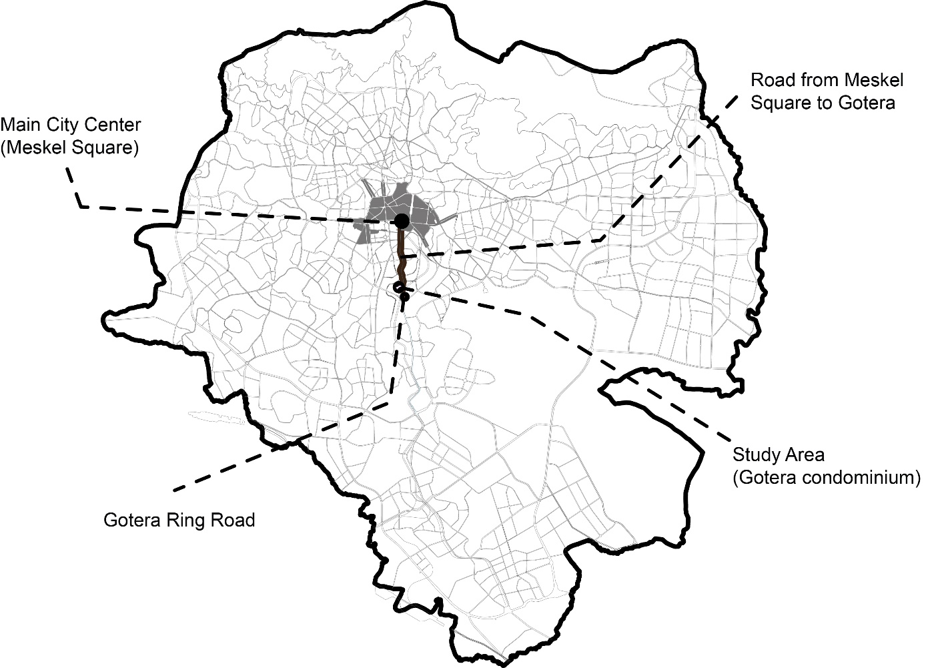a) Location of the Study Area towards City Center
Gotera condominium site has an old name of kebele 05,06,07 and now the name is changed in to Woreda four. it is one of the oldest sites of integrated housing development program. The number of population and blocks in this condominium houses are 2433 household and 78 respectively.

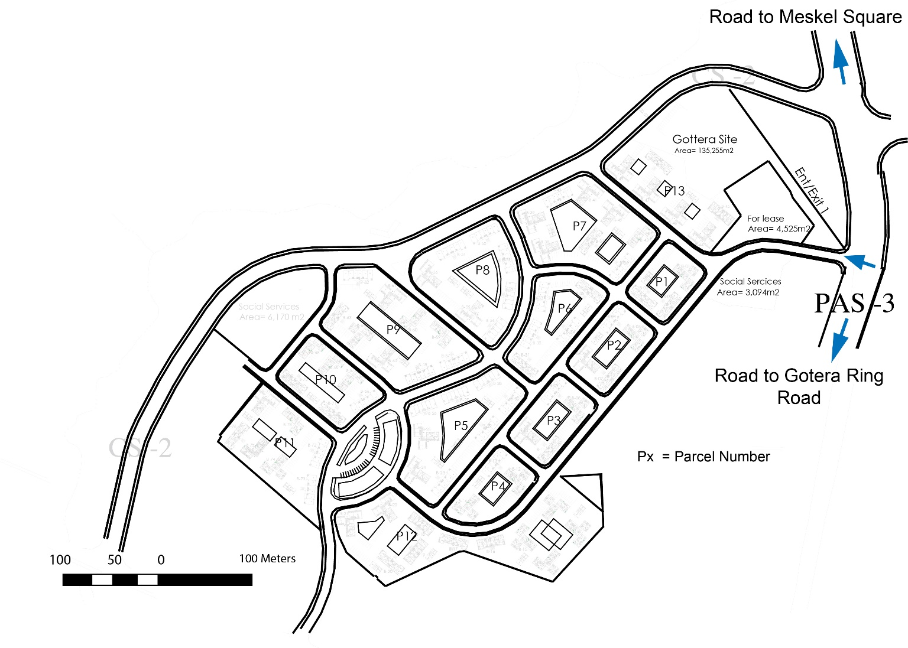
b) Location of Study Area

Figure 9: Location of Gotera Condominium, Addis Ababa Kirkos sub-city, woreda 4 Source: Kirkos Sub-city ILIC and Addis Ababa housing development project office.

  - Mixed residential buildings in Gotera condominium

The focus of this study is to assess aural privacy of mixed residential building of Gotera condominium, which is one criterion for good quality housing. The survey was undertaken in Gotera condominium which is located in the inner-city Addis Ababa. It is appropriate to assess the aural privacy in these sites with the intention of considering dwellers needs and expectation in the future condominium development. IHDP provide a total of 53 mixed building in this site. More than 60% of the blocks in Gotera Condominium site are mixed residential building but according to survey result more than 40% of commercial units are closed.

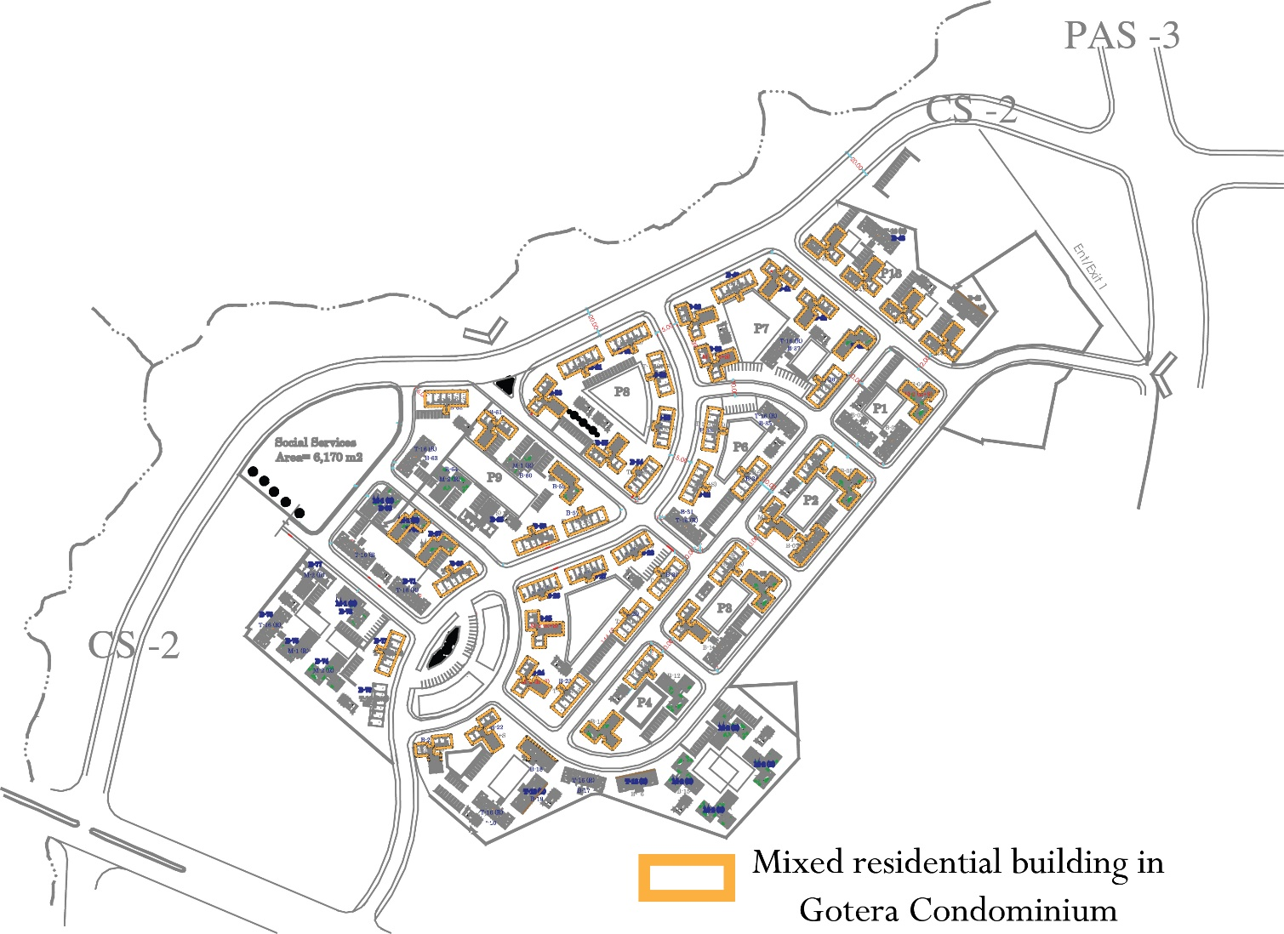

Figure 10: The location of mixed residential building in Gotera condominium (residence with commercial unit). (Source: Addis Ababa housing development project office)

The number of commercial units, studio, one bed room, two bed room, and three bed room in Gotera condominium are 294, 440, 983, 468 and 291 respectively. Table 4, shows that 11.87% the units in this condominium site are provided for commercial purpose.

No | Housing type | Number of units | Percentage of units
1 | Commercial unit | 294 | 11.87%
2 | Studio | 440 | 17.77%
3 | One bed room | 983 | 39.70%
4 | Two bed room | 468 | 18.90%
5 | Three bed room | 291 | 11.75%

Table 6: the number and percentage of dwelling and commercial unit in Gotera condominium site (Source: House owner association of Gotera condominium site, 2019)

This Condominium neighborhood is divided in to 13 parcel and in each parcel the number of commercial units are vary.
No. | Parcel Number | Number of Commercial Unit | Block Number
1 | 13 | 27 | 44 – 49
2 | 1 | 5 | 1 – 3
3 | 2 | 16 | 4 – 7
4 | 3 | 13 | 8 – 10
5 | 4 | 6 | 11 – 13
6 | 12 | 21 | 14 – 22
7 | 5 | 46 | 23 – 30
8 | 6 | 18 | 31 – 35
9 | 7 | 38 | 36 – 43
10 | 8 | 40 | 50 – 56
11 | 9 | 34 | 57 – 65
12 | 10 | 18 | 66 – 71
13 | 11 | 12 | 72 – 78

Table 7: Number of commercial units in each parcel of Gotera condominium site (Source: House owner association of Gotera condominium site,2019)

  - Respondents overall characteristics

- Tenure Type

Table 6 shows tenure type of respondents and it implies that from the total of 102 respondents 63.7% of them are tenant. This indicates the site is dominated by tenants as compared to owner and others.

Tenure Type |  | Frequency | Percent
 | Owner | 36 | 35.3
 | Tenant | 65 | 63.7
 | Care taker | 1 | 1.0
 | Total | 102 | 100.0

Table 8: Frequency of the respondent’s tenure type (Source: Survey result)
- Duration of stay in the site
Duration of stay in this site is directly related to tenure type of the respondents. From 36 owner respondents, 35 of them stayed in this site for more than 5 years. During survey analysis of selected households, it is noticed that households who stays for long period of time in this case for more than five years expe1rienced more problem related to noise disturbance when compared with those who stayed for short period of time in this site.

Duration of stay in the site |  | Frequency | Percent
 | Recently | 12 | 11.8
 | 1 year ago, | 16 | 15.7
 | 2 years ago, | 19 | 18.6
 | 3 years ago, | 13 | 12.7
 | 4 years ago, | 7 | 6.9
 | 5 years and above | 35 | 34.3
 | Total | 102 | 100.0

Table 9: Respondents duration of stay in the study area (Source: Survey result)

- Previous address of respondent

Previously respondents of this condominium sites were lived in different part of the city. The study shows, from the total of 102 households in this site, 71 of them are from the center of Addis Ababa, 8 of them from the periphery of Addis Ababa, 22 of them are from the city of regional country of Ethiopia and from neighbor Ethiopia (Eritrea, South Sudan, Djibouti, Somalia and china) and the remaining one is from rural area of the country.

 |  | Frequency | Percent
 | From Addis Ababa city center | 71 | 69.6
 | From Addis Ababa periphery | 8 | 7.8
 | From the city of outside Addis Ababa | 22 | 21.6
From rural area of outside Addis Ababa |  | 1 | 1.0
Total |  | 102 | 100%

Table 10: Previous address of respondents (Source: Survey result)

- Way of getting the Condominium/Residence

Most of the respondents in this condominium site are tenant. From the total of 102 respondents 62 of them gets the dwelling unit by means of renting.
Way |  | Frequency | Percent
 | Family | 5 | 4.9
 | Lottery | 29 | 28.4
 | Rent | 62 | 60.8
 | Purchase/Bought it | 6 | 5.9
 | Total | 102 | 100.0

Table 11: Way of getting the Condominium/Residence by respondents (Source: Survey result)

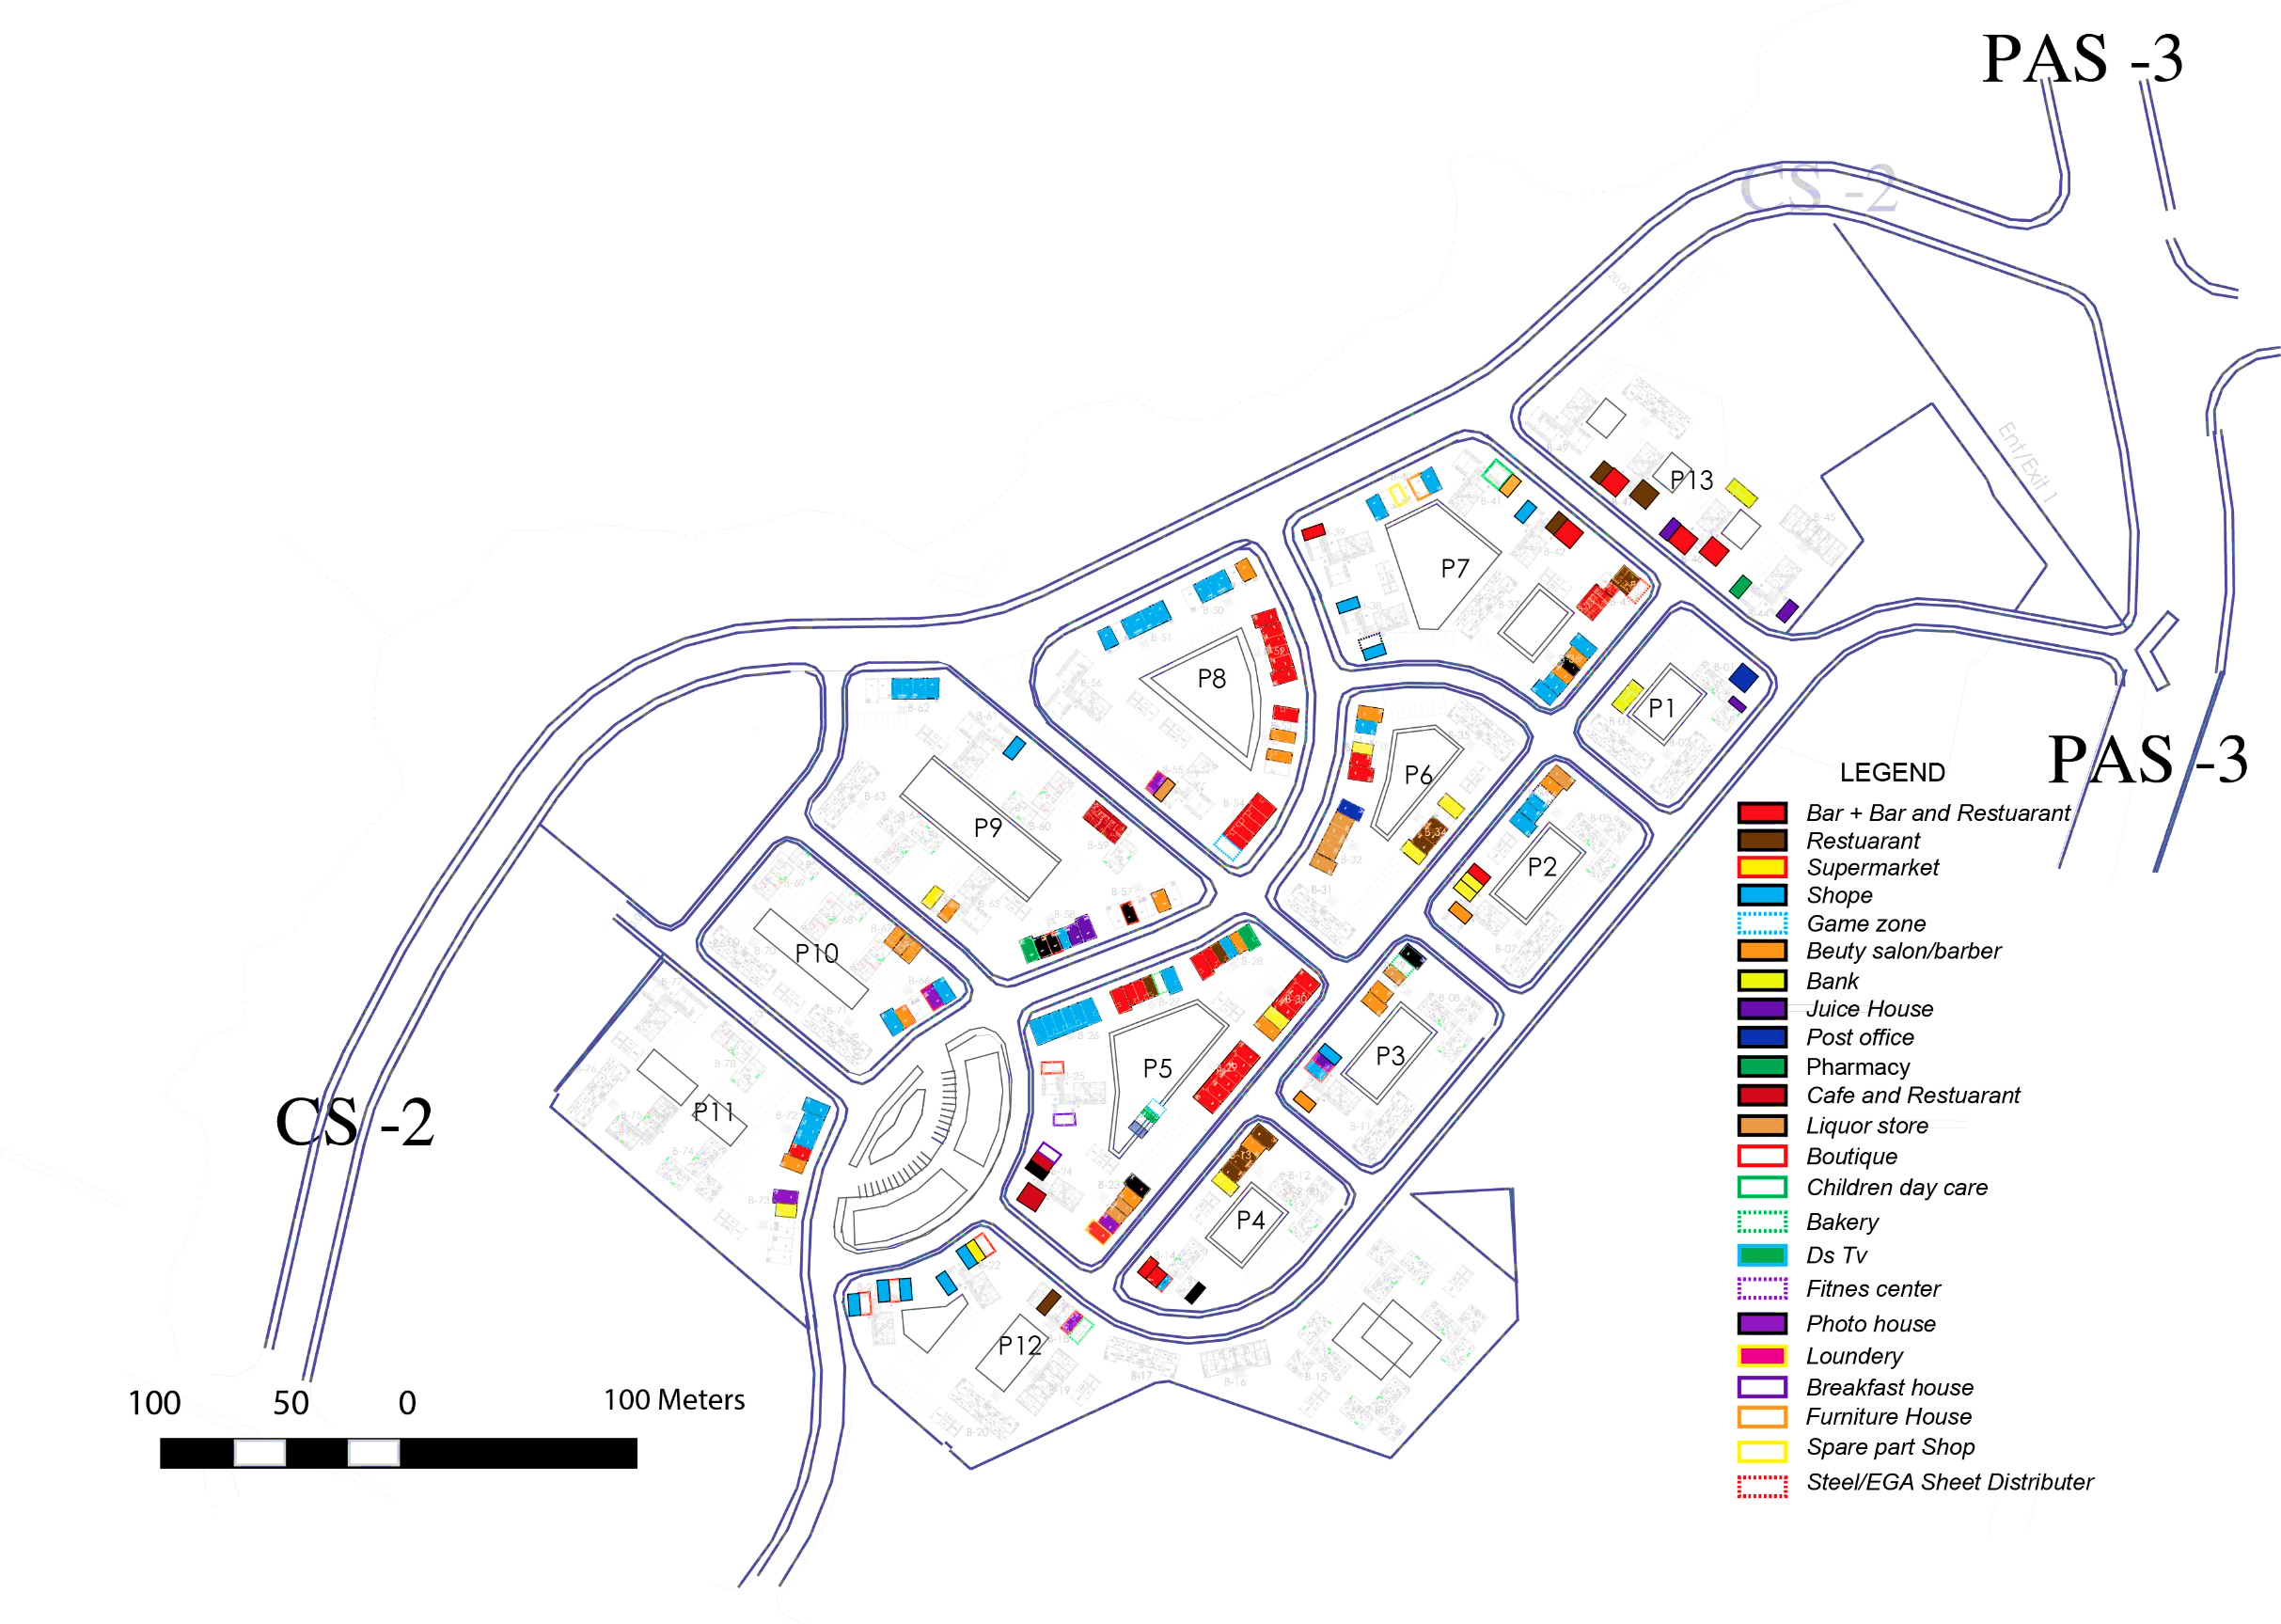
  - Characteristics of commercial units

- Types of Commercial building in Gotera condominium site(existing)

Figure 11: Types of commercial building in Gotera condominium site (Source: Survey result)

Before interview made with selected respondents the researcher assessed the type of commercial units which exist in this condominium site in February 23,2019. Commercial unit type may change from time to time in a specific area due to different reasons and that’s why the researcher write the data collection time. Restaurants, bars, supermarkets, shops, bar and restaurants, “Ds Tv house”,bank, beauty salon/barber, “Game zone”, juice house, post office, pharmacy, café and restaurant, liquor store, boutique, Children day care, bakery, fitness center, photo house(photo studio), laundry, breakfast house, furniture house, spare part shop, EGA sheet and steel distribution shop are the type of commercial unit which exist in this site during specified time. Among all commercial unit types bar and restaurants, shops, bars, and super markets/minimarkets highly dominate the site. Commercial units such as bar and bar and restaurants are located in the middle and at the entrance the site but they are they are not existed in the rear side of the site. In other direction shops, supermarket/mini market which has low noise disturbance are located all over the site. All communal buildings are changed into commercial purpose such as bar and restaurants, fitness center, Ds Tv house, game zone.

- Size of commercial unit
The size of commercial units varies based on the unit type. Commercial units such as Bar, Bar and Restaurant, Restaurant, Café and Restaurant and Ds Tv house have larger size than the other commercial units. The larger size is due to extension from default size of commercial units which provided by IHDP. The extension of those commercial units’ ranges from 20sq. meter for smaller commercial units up to 166sq.meter for larger commercial units. The default (Normal) size of commercial units range from 16m2 to 44sq. meter which used for supermarket, Shop, supermarket, post office, beauty salon, game zone, Juice house, pharmacy, boutique, small factory (steel distributer), children day care, bakery, fitness center, photo house, breakfast house and Laundry. Those commercial units have some form of extension ranging from 6 sq. meter up to 10 sq. meter for the purpose of utility storage, and to get enough space for merchandise. According to housing owner association of Gotera condominium the small extension for the purpose of shading is permitted but large extension which practiced by owner of commercial units is illegal and there is a problem in managing it.
- Block Type One (Default unit size and Default unit size with extension)
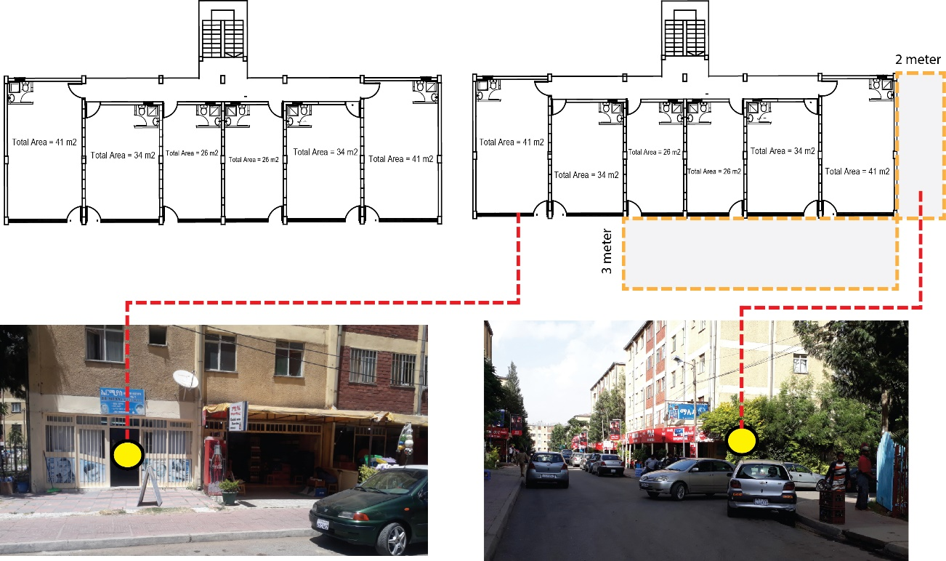
Figure 12: Default commercial unit size and its extension for block type one (T16, T18) (Source: Survey result)

- Block Type Two (Default unit size and Default unit size with extension) 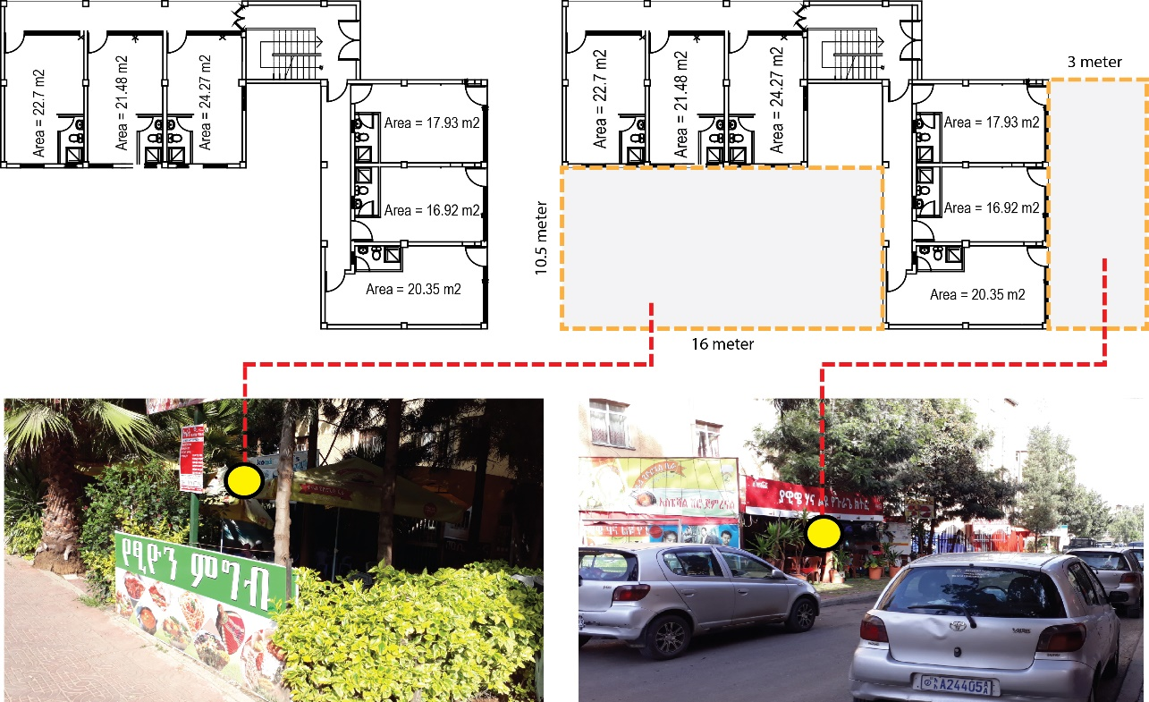
Figure 12: Default commercial unit size and its extension for block type two (M1) (Source: Survey result)
- Block Type Three (Default unit size and Default unit size with extension)

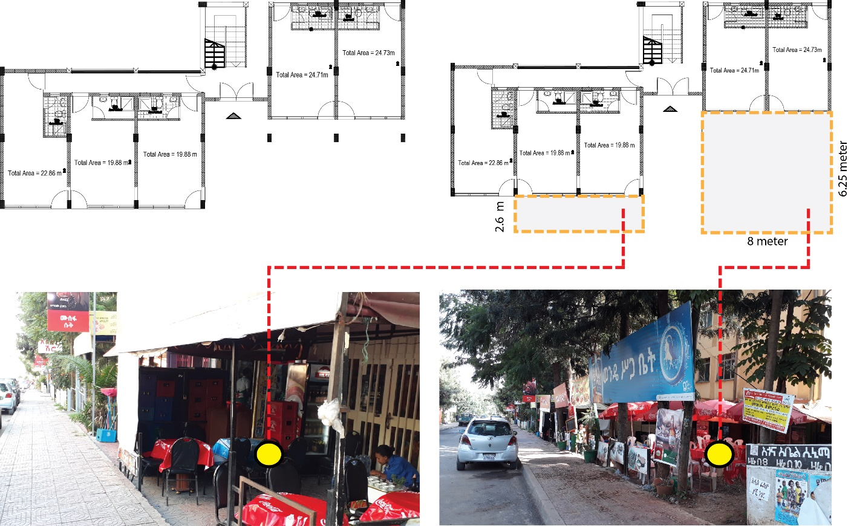

Figure 13: Default commercial unit size and its extension for block type three (M2) (Source: Survey result)

  - Characteristics of Dwelling Units

- Typology
- Typology One (T-16 and T18)

Typology one has two building block type which contains commercial unit in the ground floor and typical residential unit starting from first floor up to fourth floor. The residential unit contains 2 two bed room type and 4 one bed room type for typology one(T-18) and 2 three bed room type, 2 studios and 2 one bed room type for typology one(T-16) in each floor.

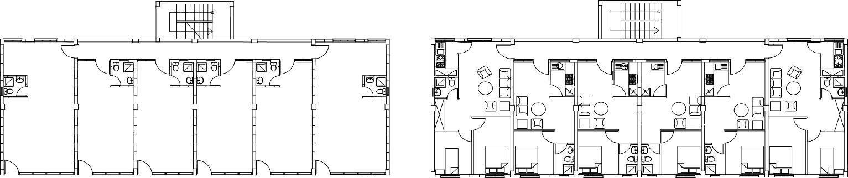
- Ground floor for commerce b. From 1st floor - 4th floor for residence
Figure 14: Typology one (T-18) of selected block

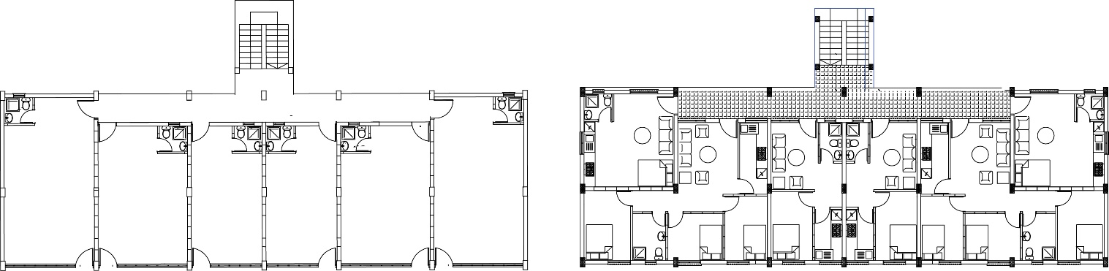

- Ground floor for commerce b. From 1st floor - 4th floor for residence
Figure 15: Typology one (T-16) of selected block

- Typology Two (M-1)

This Building block contains commercial unit in the ground floor and typical residential unit above commercial units similar to typology one. The types Bed room in this block type are studio, one bed room and two bed room type each contains one, two and two respectively in each floor.
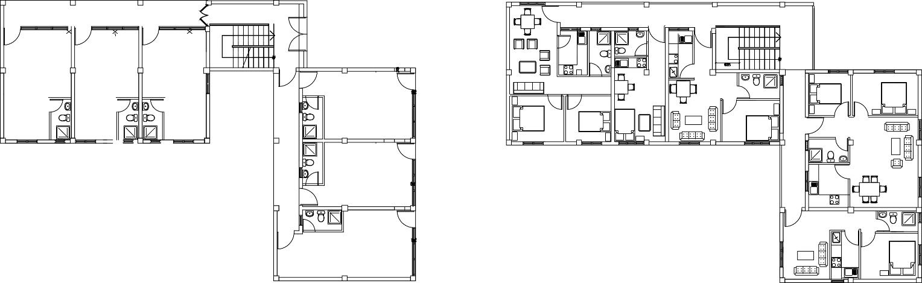
- Ground floor for commerce b. From 1st floor - 4th floor for residence
Figure 16: Typology two (M-1) of selected block
- Typology Three (M2)

The third typology is different from the above two typologies in terms of placement of residential units. The ground floor of this typology has both commercial and residential units. 2 two bed room type residential units are located in the ground floor with commercial unit. The above four floors are residential units, each contains studio, one bed room and two bed room having the number of one, four and two respectively.

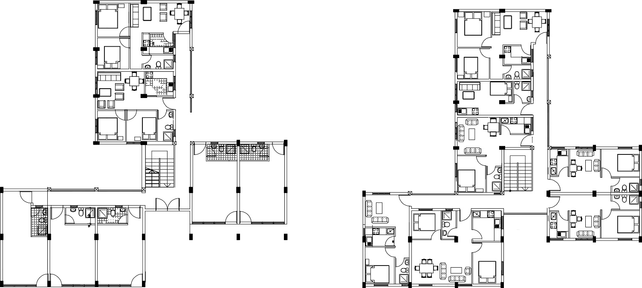
- Ground floor for commerce + residence b. From 1st floor - 4th floor) for residence

Figure 17: Typology three(M2) of selected block

- Room Arrangement

Block type one of typology one is characterized by bed room and bath room facing towards the street side as well as living room and kitchen arranged to the back face. In other hand block type, one is characterized by all bed rooms facing toward the street side for one and three bed room type residential units but the studios are located in the back face of the block. In general room which need silence (bed room) arranged towards street and commercial units.
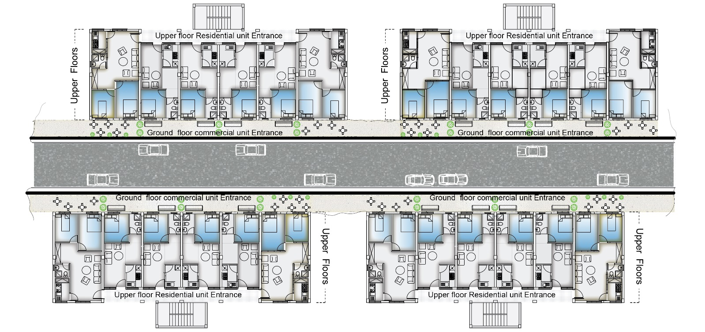
Figure 18: Floor plan of room arrangement for typology one towards street

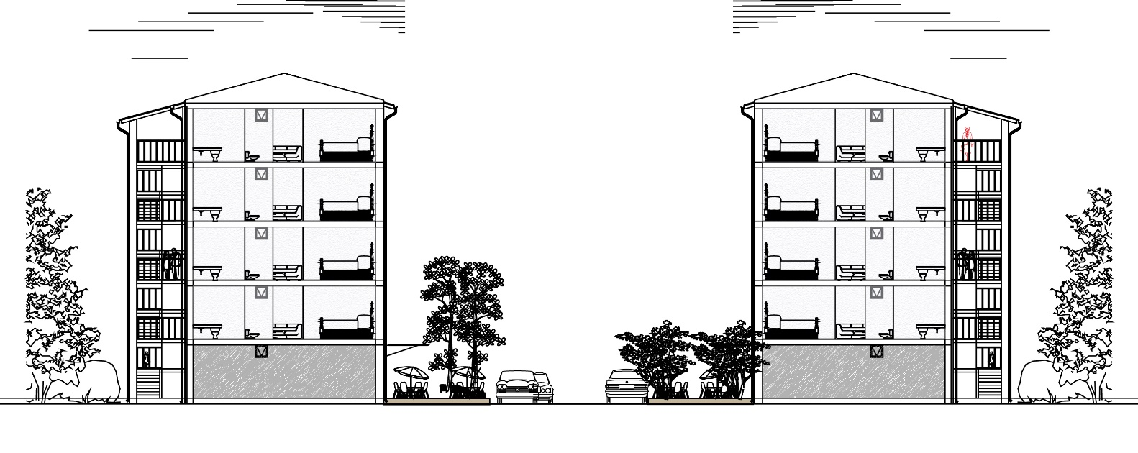
Figure 19: Sectional view of room arrangement for typology one towards street

Unlike typology one, all rooms in typology two were arranged both in street and back facing, i.e. all functional rooms are dispersed in both directions due to the shape of the block.
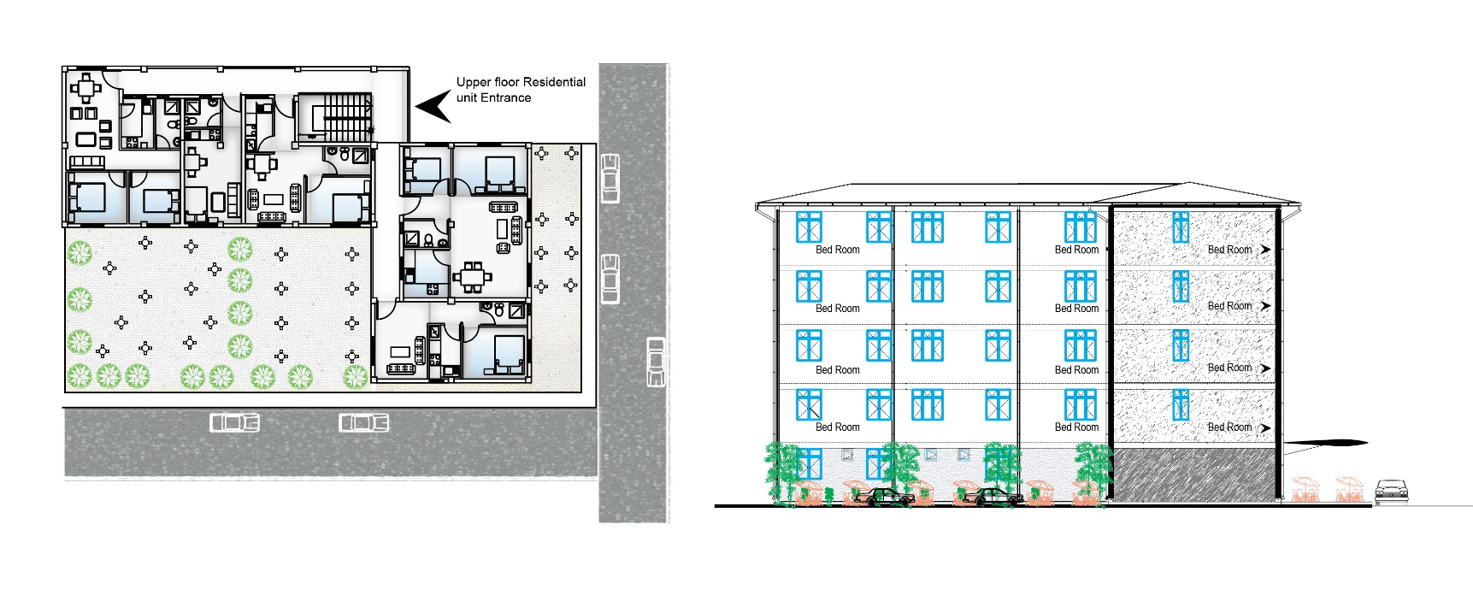
Figure 20: Floor plan and sectional view of room arrangement for typology two towards street
Room arrangement towards street and commercial units for typology three differs from the above two typologies due to shape of the block. As compared to typology one the rear side residential units which starts from first floor have no contact with street, but residential unit in the ground floor has strong physical contact with commercial unit. All residential room spaces in this typology was arranged towards commercial units.
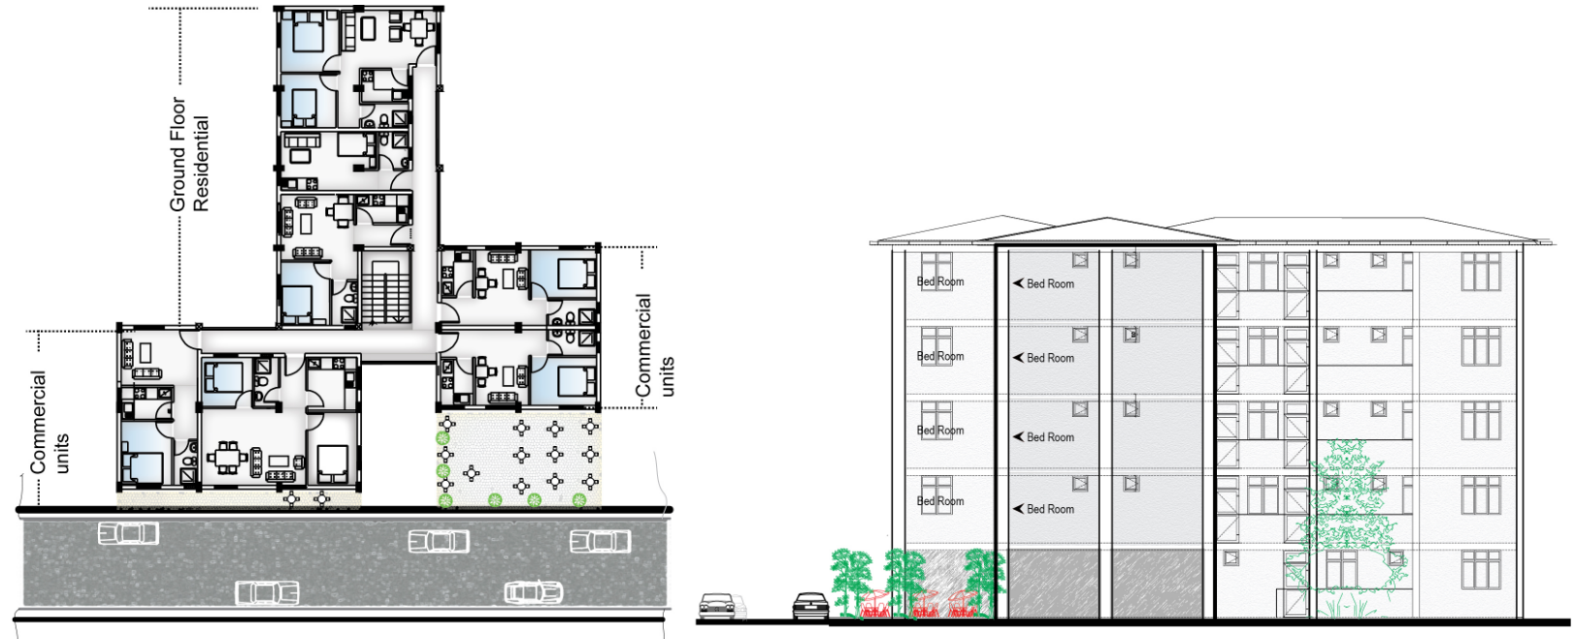
Figure 21: Floor plan and sectional view of room arrangement for typology three towards street

- Building material

The condominium blocks are constructed from a frame of reinforced concrete with masonry infill walls, plastered both inside and out (A). Floor are constructed by skim concrete to reduce building costs. Windows and doors are made from metal frames with single glazing (B). Hand rail of balcony in some blocks are constructed from bricks (C).

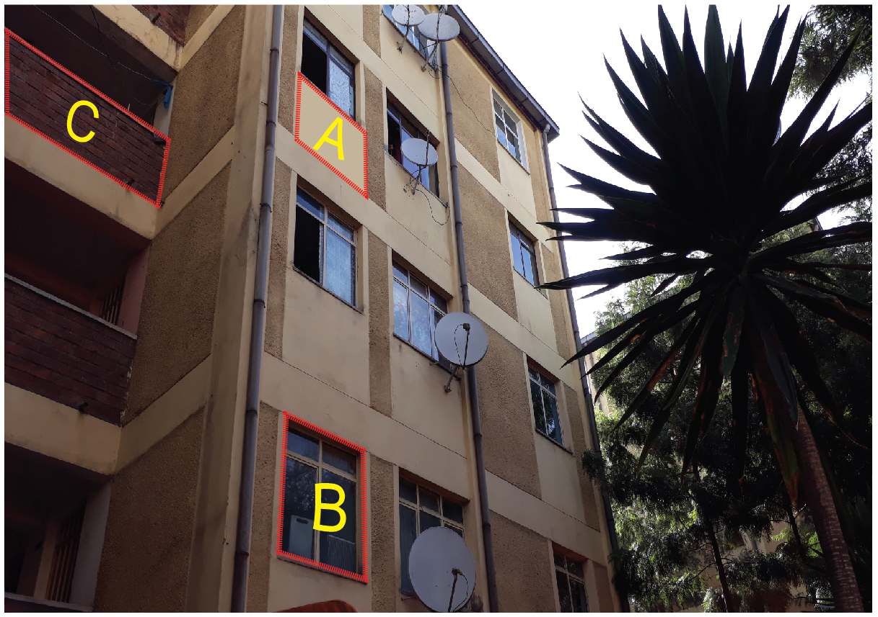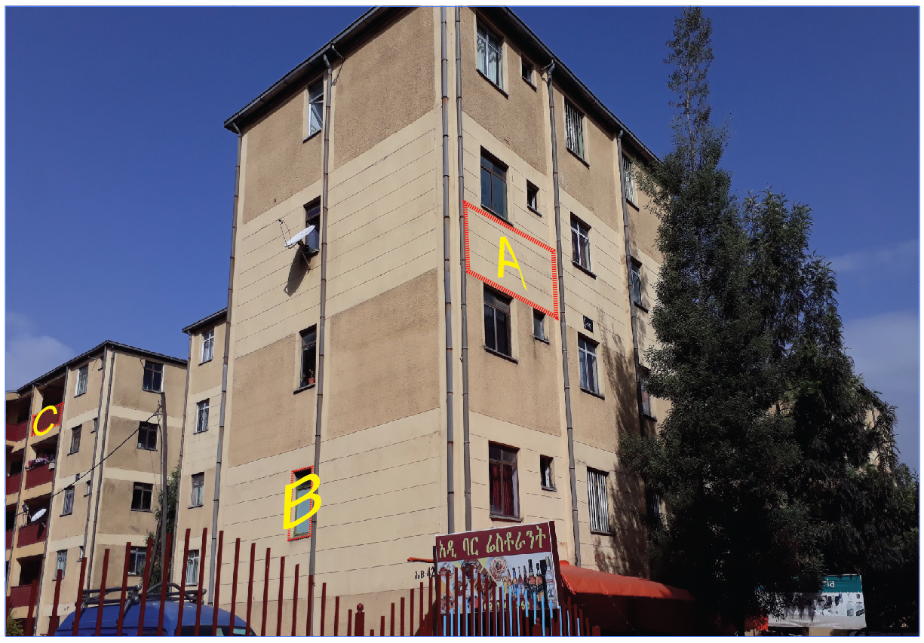
Figure 22: Building material type for each building element of Gotera condominium

  - Respondents preferred area of living in residential area

From the total of 102 respondents 89 of them wants to live in silent area and the remaining 13 respondent wants to live in moderate sound level area. The study shows that any of them have no interests to live in high and very noise pollution area. The survey result shows tenure type, and previous location of respondents has no significant difference in selecting preferred area for their residential area.

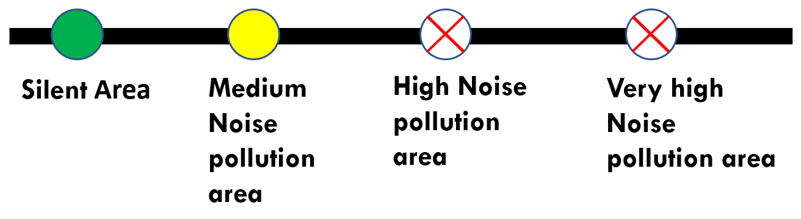
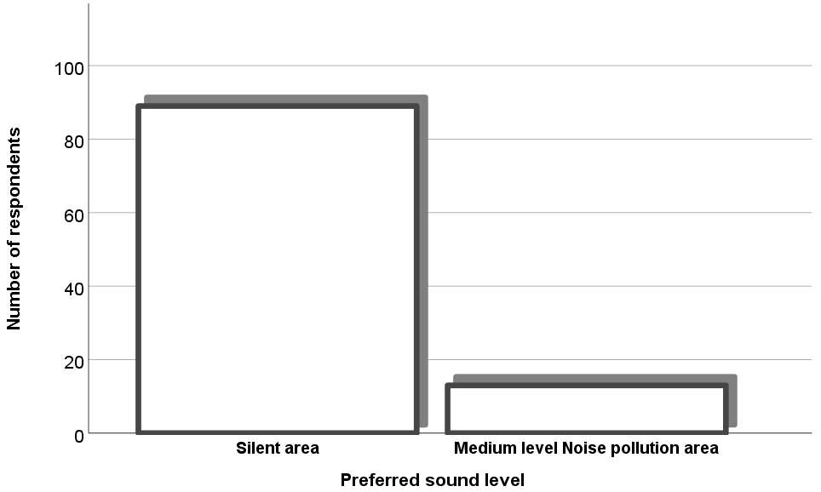
Chart 1: Resident preferred area for living (Source: Survey result)

  - Respondent Response Regarding the Level of Noise Disturbance for Different Commercial Unit Type

According to survey result, respondent’s perception towards the level of disturbance of different commercial units varies from None to Very high by using Likert scale. Respondent perception about the commercial units has been taken related to nearby existence of any commercial units to the respondents. Therefore, the following table shows the valid and missing number of respondents related to the perception of commercial units’ level of disturbance.

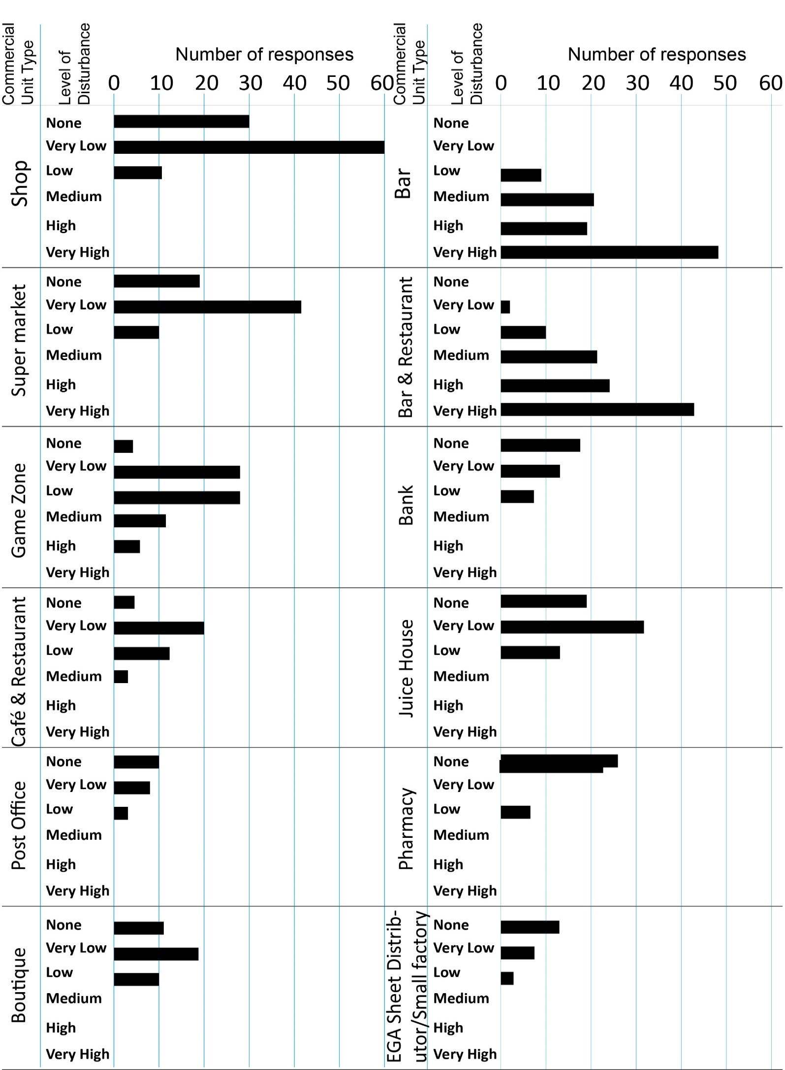
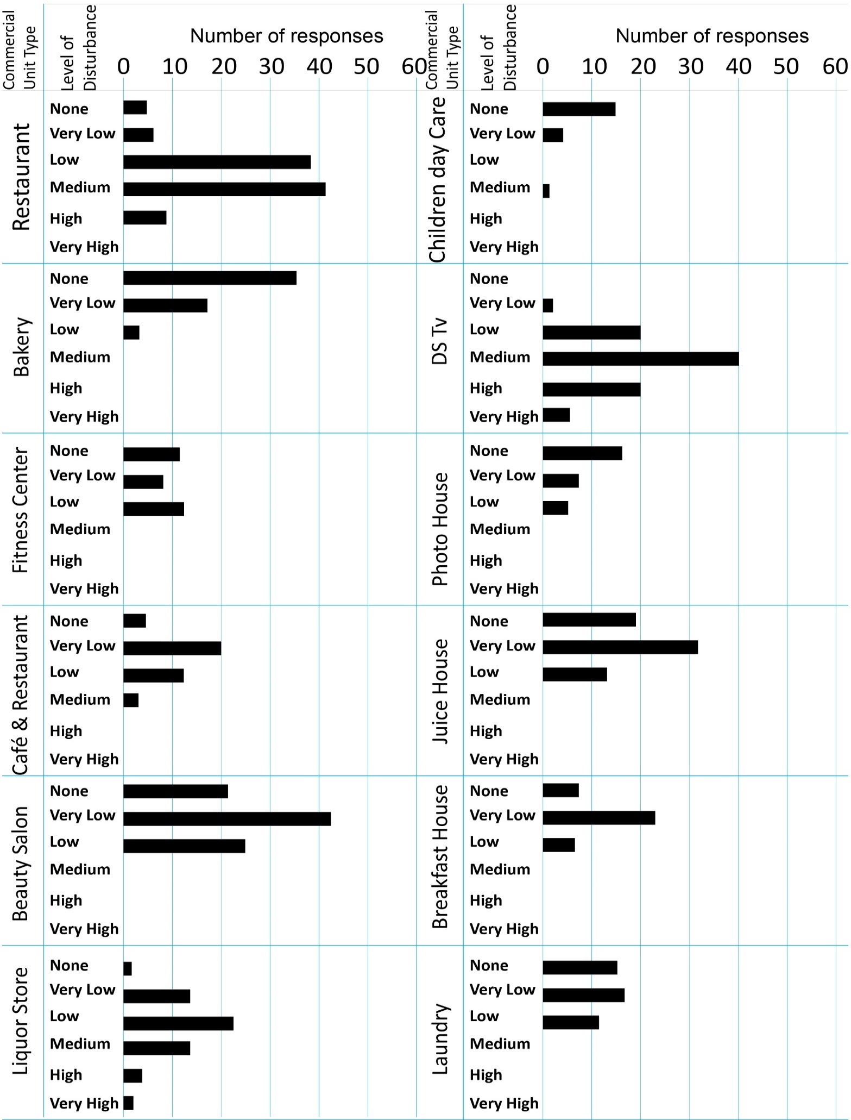
Chart 2: Respondent response of level of noise disturbance for commercial unit type (Source: Survey result)
- Commercial units with low level of noise disturbance

According to respondents perception the level of noise pollution for commercial units such as Shop, supermarket, bank, post office, beauty salon, game zone, café and restaurant, Juice house, pharmacy, boutique, small factory (steel distributer), restaurant, children day care, bakery, fitness center, photo house, breakfast house and Laundry is low. Low level of noise disturbance in this context refers to Likert scale which range from none up to low level of disturbance.

- Commercial units with medium level of noise disturbance

Chart 2 shows that Restaurant and Ds Tv houses has medium level of noise disturbance in this condominium site. Ds Tv houses are part of most bar as well as bar and restaurant i.e. they are located almost inside the two commercial units mentioned above. Ds tv house also located separately in the previous communal buildings and in mixed building. Residents most of the time uses Ds Tv houses during weekend and sometimes at mid-week. When goal scored during watching football game, sport fans makes a sound and this disturb the residence during sleeping time specially at mid-week.

- Commercial units with High level of noise disturbance
The commercial units which has high level of noise pollution in this condominium site are bars and bar restaurant. From the total of 102 respondents 70 of them are Said bars emit high noise pollution. In addition to these 65 respondents out of 102 states that bar and restaurant emit high noise pollution. High noise pollution in this case implies Likert scale which ranges from high noise pollution to very high noise pollution.

  - The Degree of aural privacy related to the most influential noise pollutant commercial unit type in different time interval

The main purpose of these portion of the study is to explore subjective measurement of resident’s aural privacy in different time of the day related to the most influential noise pollutant commercial unit. The study shows that during day time the aural privacy of residents is very high, but its low at night(sleeping) time. Chart 3 shows that the level/degree of aural privacy in different time interval. To rank disturbance level of the residents, Likert scale which range from None to Very high are used.

- Time for Very Low Aural Privacy
According to 47 respondents from the total of 102 which is 46.1 % says very high noise pollution emitted in weekday, weekend as well as holyday in the time interval between 6PM up to 6AM. Chart 3 shows the time of very high noise pollution which is low aural privacy in weekdays, weekend and holydays. Residents said that there is high noise pollution specifically in Friday, weekdays, holyday eve and holydays.

- Time Interval of Low Aural Privacy
There is an indication of high noise pollution during night time. From the total of 102 respondents 59 of them tells that there is high noise during the time interval between 6pm and 6am in week days, weekend and holydays.

- Time Interval of Medium Aural Privacy
The level of noise pollution is medium in the time interval between 6PM and 9PM in weekdays, weekend and holydays.

- Time Interval of High Aural Privacy
Aural privacy of residents increases during day time as compared to night time. From the total of 102 respondents 94 of them told me that there is high aural privacy during the time of 6AM to 6PM in week day, weekend and holyday which means during day time.

- Time Interval of Very High Aural Privacy
According to four respondents from the total of 102 there is very high aural privacy during the day time of week day and weekend. In addition to this, one respondent from the total of 102 said that there less noise pollution in weekdays, weekend and holydays before mid-days

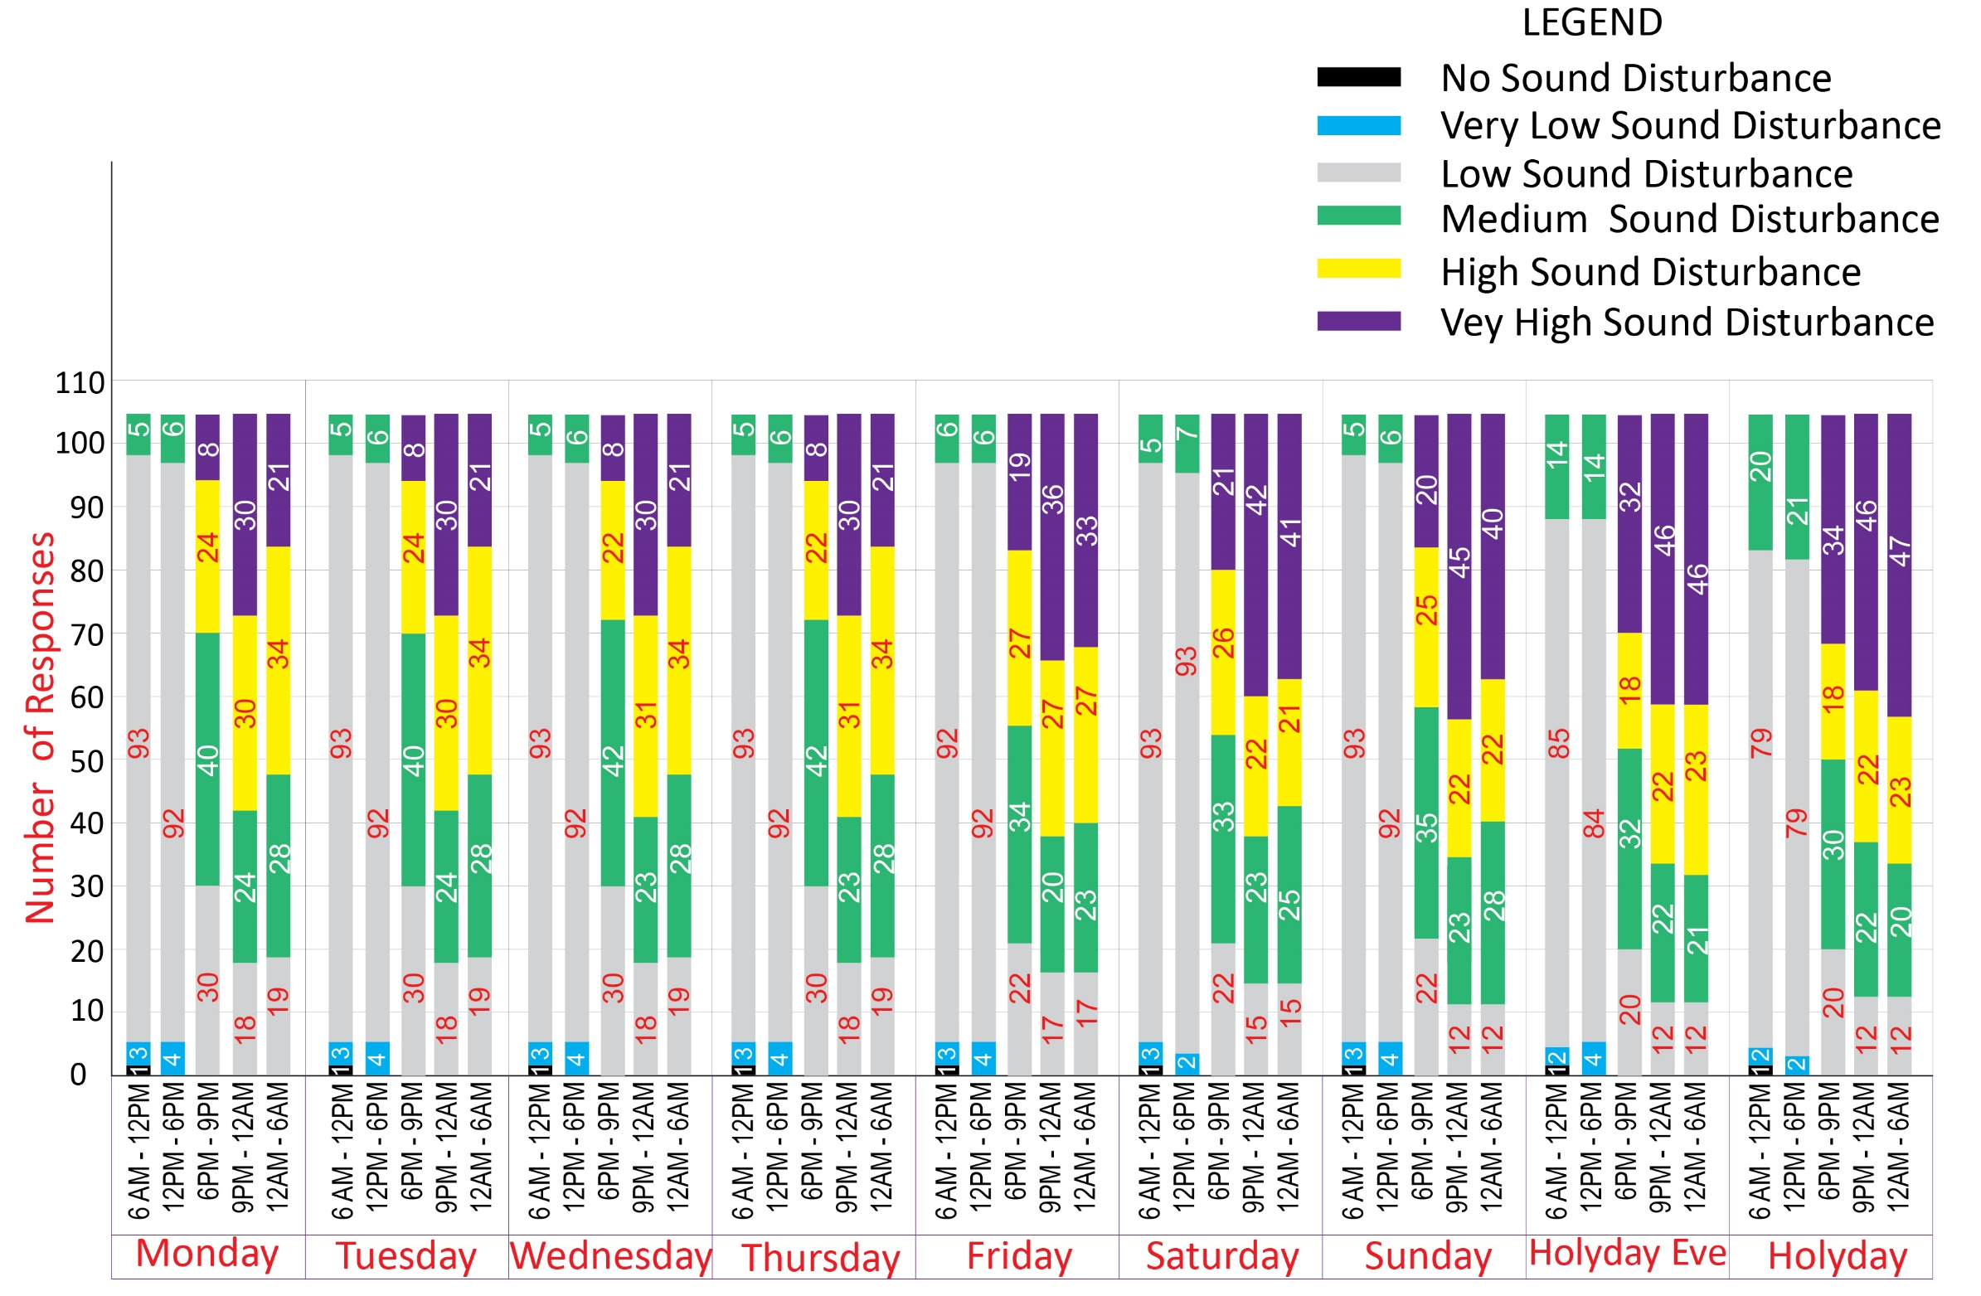
Chart 3: The Degree of aural privacy related to the most influential noise pollutant commercial unit type in different time interval (Source: Survey result)
  - Source of noise pollution rather than loudspeaker

Beside loudspeaker there are five source of noise pollution emanate from noise pollutant commercial units. Those sources of noise pollution affect resident’s aural privacy specially for residents who live near to commercial units such as bars, Ds Tv house and bar and restaurant. Generator, people speech, utility sound, drank people fighting and user’s vehicle are the four main source of sound which affect resident’s aural privacy rather than loudspeaker. More than 50% of the respondents agreed that noise pollution from people speech and drank people fighting near and inside those specified commercials is greater than loudspeaker. The loudspeaker may stop at the mid night but noise pollution from people speech and drank people fighting continues after mid night in side those commercial units. From 83 of 102 representative respondents 36.57% said that there is sound source which generated from drank people fighting. In addition to this 32.41% of them says noise pollution from people speech rather than loudspeaker affect resident aural privacy. Rather than the two major sources of pollution there is also generator sound and utility sound, and from users of commercial units’ vehicles.
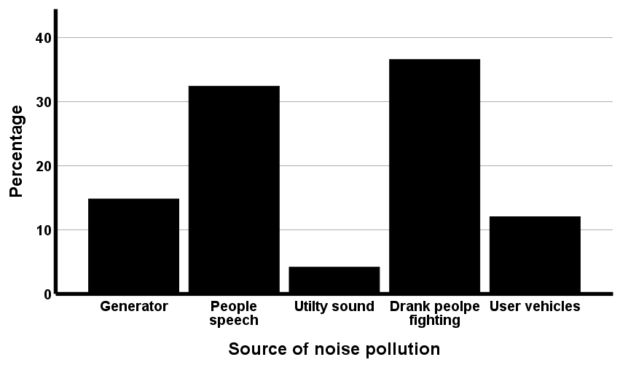

Chart 4: Respondent perception of source of noise pollution rather than loudspeaker (Source: Survey result)

Level of disturbance for source of noise rather than loudspeaker

According to the survey result which taken from respondents the level of disturbance of drank people fighting and people speech from and near commercial units have higher impact on the aural privacy of residents. As I mentioned before, based on site observation as well as the evidence I got from respondents’ perception towards noise pollution, the level of disturbance from drank people fighting and people speech is greater than loudspeaker for residents who live nearer to those commercial units. From the total of 152 respondent 63 and 68 respondents tells that the noise pollution from people speech and drank people fighting is high. Note that the number of respondents or household is greater than the sample size 102 due to one respondent may choose both source of noise pollution in a given area. The level of disturbance from generator, utility sound and commercial units’ users is low as compared to the above two source of noise pollution. Chart 5 shows that respondent perception towards high level of noise pollution regarding the source of noise.
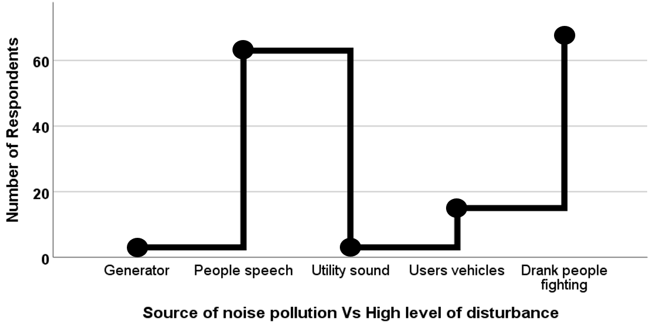

Chart 5: Perception towards high level of noise pollution rather than loudspeaker, (Source: Survey result)

  - Faced problem from noise pollution of commercial units

Concerning the impact of high noise pollution on the resident’s day to day activity the researcher asks each and every individual family member with the limitation of age above 10 years due the ability to tell their feelings to others. The World Health Organization has documented seven categories of adverse health effects of noise Pollution on humans WHO (2001), Hagler (1998), such as Hearing Impairment, Interference with Spoken Communication, Sleep Disturbances, Cardiovascular Disturbances, Disturbances in Mental Health, Impaired Task Performance and Negative Social Behavior and Annoyance Reactions. In addition to the researcher adds some problem which affect health and other residents’ day to day activity. Those problem which listed by researcher directly as well as indirectly affect living condition.

Family member such as head, spouse, son, daughter, head families, spouse families, house maids and other members were asked by the researcher with related the faced problem from high noise emitter commercial units. The result shows that there is a significant difference between each family member on the perception of level of disturbance. The most frequent faced problem on the residents who lives in mixed condominium units’ due noise pollution are headache, sleep disturbance, reading problem, hearing unwanted conversation or sound, instability and impaired task performance. Other than problems which listed above, residents who lived in the street side or near to commercial units has other problems such as depression, hearing damage/ impairment, concentration/ Mood loses, heart problem, Impatience, negative social behavior, Intrigue.

- Family head vs faced problem

Table 13 shows list of problems related to noise pollution with significant percentage for 77 family head out of 102 respondents. The study shows that most of heads in this area suffers a problem of sleep disturbance due noise pollution from commercial units. Note that the number response is greater than the total number of head respondents (77), the reason behind this is one house member may affect by more than one noise pollution problem. This situation also happens in other family member.

Faced problem |  | ` Responses
 |  | Number | Percent
 | No problem | 23 | 18.5%
 | Headache | 8 | 6.5
 | Concentration or mood lose | 5 | 4.0%
 | Sleeping disturbance | 54 | 43.5%
 | Reading problem | 6 | 4.8%
 | Hearing unwanted conversation | 5 | 4.0%
 | Impatience | 3 | 2.4%
 | Instability | 5 | 4.0%
 | Impaired task performance | 8 | 6.5%
 | Other | 7 | 5.8%
Total |  | 124 | 100.0%
Table 12: Faced problem due to low aural privacy on family head (Source: Survey result)

- Spouse vs Faced problem

The study shows that; similar to house head; spouses are subjected to sleep disturbance, but they are more subjected to headache problem as compared to heads family member. Formal interview with family member (heads & spouses) implies that spouses have no work as compared to heads and stays at their home all the day and night without work. Therefore, staying at home without work and noise pollution gets the spouses more subjected to headache problem as compared to heads.
Faced problem |  | Responses
 |  | Number | Percent
 | No problem | 19 | 13.5%`
 | Headache | 21 | 14.9%
 | Depression | 5 | 3.5%
 | Sleeping disturbance | 58 | 41.1%
 | Hearing unwanted | 9 | 6.4%
 | Instability | 11 | 7.8%
 | Impaired task performance | 9 | 6.4%
 | Other | 9 | 6.4%
Total |  | 141 | 100.0%

Table 13: Faced problem due to low aural privacy on spouse of family member (Source: Survey result)
- Male Children (Son) vs Faced problem
To conduct the study up on faced aural privacy problem on male and female children the researcher asks all individual children inside the house. The research question is conducted one to one discussion with the children if their age is more than 14 years and with the help of their family if they are in between 0 up to 10 years. From the total of 34 male children 23.5 percent of them says there is no problem related noise pollution and the remaining 41.2% and 17.6% have a problem of sleep disturbance and problem related to educational activity (reading problem) respectively. According to the study and researcher observation, most of children who says no problem with noise pollution are age between 10 to 14 years.

Faced problem |  | Responses
 |  | Number | Percent
 | No problem | 7 | 20.6%
 | Sleeping disturbance | 14 | 41.2%
 | Reading problem | 6 | 17.6%
 | Other | 7 | 20.6%
Total |  | 34 | 100.0%

Table 14: Faced problem due to low aural privacy on male children of Family member (Source: Survey result)

- Female Children (Daughter) Vs Faced problem
Similar to all the above family member female children’s also have the problem of sleep disturbance. Both female and male children’s shares reading problem in common. The proportion of reading problem with that of no problem is equal in both female and male children. female children are subjected to headache, concentration lose, hearing unwanted conversation, instability, impaired task performance with the remaining 25%.
Faced problem |  | Responses
 |  | Number | Percent
 | No problem | 10 | 19.2%
 | Sleeping disturbance | 19 | 36.5%
 | Reading problem | 11 | 19.3%
 | Other | 12 | 25%
 | Total | 52 | 100%

Table 15: Faced problem due to low aural privacy on female children of Family member (Source: Survey result)

- House Maid vs Faced problem
Similar to the above house member sleeping disturbance is one of the most difficulty which faces house maid of residents, but most of the house maids were work in side home all day time as well as until midnight and get tired therefore at sleeping time they didn’t consider, hear the noise pollution.
Faced problem |  | Responses
 |  | Number | Percent
 | No problem | 11 | 30.6%
 | Headache | 6 | 16.7%
 | Sleeping disturbance | 15 | 41.7%
 | Hearing unwanted conversation | 3 | 8.3%
 | Impaired task performance | 1 | 2.8%
Total |  | 36 | 100.0%
Table 16: faced problem due to low aural privacy on house maid family member (Source: Survey result)

In general, the above table shows that most residents who lived in mixed residential units have a problem of sleeping disturbance and children’s also have the problem associated with educational activity. The researcher also conducts informal discussion with residents of these condominium site, most of the owners who gets condominium in this site through lottery sold their house due to noise pollution which affect their children educational activity. As I mentioned before other than the above family, I investigate the problem of low aural privacy with both heads and spouse families, friends, relatives. And the result shows that most of them have the problem of sleeping.

- Age Versus Sleep Disturbance

The main reason to select sleeping disturbance problem from the other problem is due to its percentage of impact on respondent. To conduct faced problem variation between family member in terms of age group the researcher focuses on heads, spouse, son, daughter, heads/spouse families and house maid. This portion of study shows that most of the respondents for this research are age between 31 to 59.
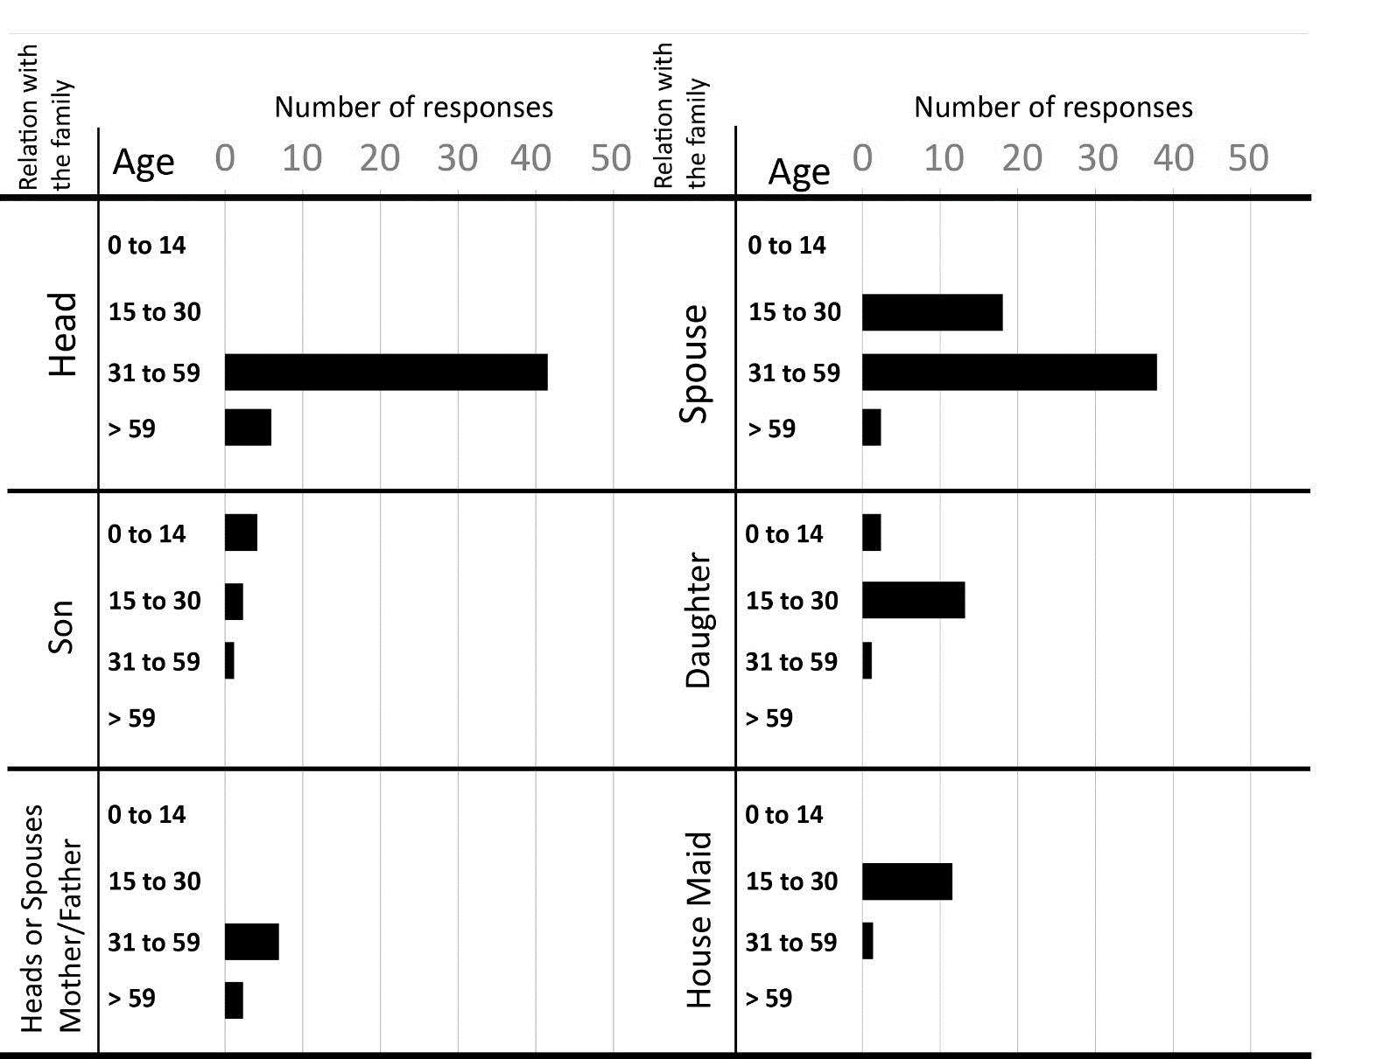
Chart 6: Number of respondent’s Vs Age towards sleep disturbance (Source: Survey result)

Sleep disturbance has a significant difference on different age group. One to one interview with family member in a house hold gives different perception toward faced problem. The main purpose of this data was to know, if there is any difference between different age group or to aware which groups of the society are most vulnerable or highly affected by less aural privacy or high noise pollution. The chart shows that from the total of 10 respondents who are age greater than 59; all of them have the problem of sleep disturbance. The data shows that sleep disturbance will increase as the age increase and decrease as the age decrease. According to parents, if a very young children(infant) disturbed by noise from commercial unit at their sleeping time sometimes they woke up and disturb the whole family. Rather than this most children age in between 0 – 10 have no problem with sleep disturbance as compared to the higher age group.

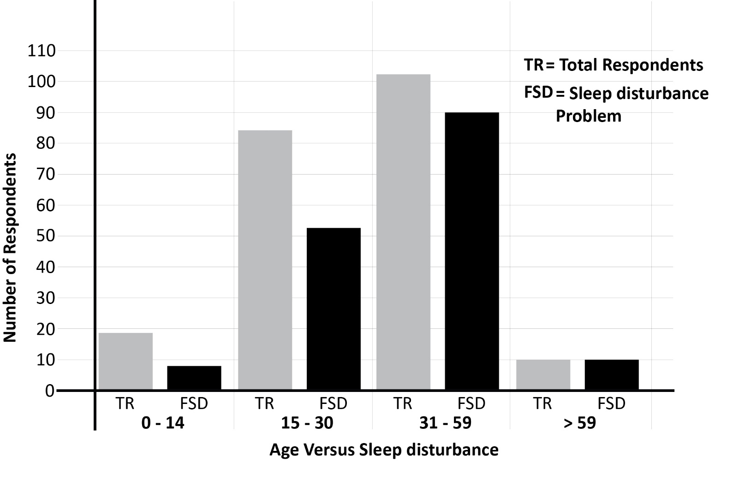Chart 7: Age Versus Sleep Disturbance (Source: Survey result)

- Time of stay at home Versus sleep disturbance

Other than the age group of the respondents, duration of stay at home has its own factor on sleep disturbance. From the total of 79 head family member 61 of them are stays at home at night time and weekend only and from 61 respondents 37 of them have faced sleep disturbance. The number of spouse respondents who stay the whole day at their home is greater than the number of head respondents, therfore spouses are more subjected to sleep disturbance than head family member. As i meantioned above the main resean of spouses are subjected to sleep disturbance is that of time of stay at home and unemployement. They stays the whole day at home with no work by waching television, and taking care of kids while the house heads are in work place out side the home.
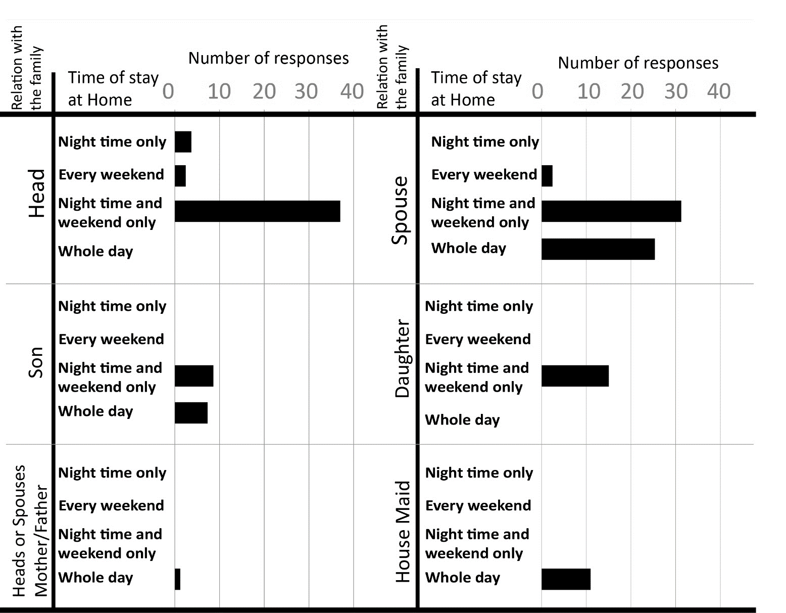
Chart 8: Number of respondent’s vs Time of stay at home (Source: Survey result)

The above graph shows that all hause maid respondents stays at their home the whole day and night but they are subjected to sleep disturbance in similar way with the other family member. Due to work load during day time and night 50% of them have no problem with sleeping.

Informal discussion with respondents shows that the more you stay at home is the more you adopt the sound from your neighbor but It is difficult conclude that time of stay at home has strong relation with faced problem for example from the total of 25 House maid who stay at home the whole day and night 11 of them have sleep disturbance and 10 of them tell that they have no problem with the noise pollution and 6 of them has the problem of headache. When we see the percentage of sleep disturbance with no problem it is almost equal. The graph shows that residents who stay at their home in night time only, every weekend, night time and every weekend and the whole day and night have equal proportion of sleep disturbance problem. The more the respondents the more sleep disturbance problem in the different category of time of stay.

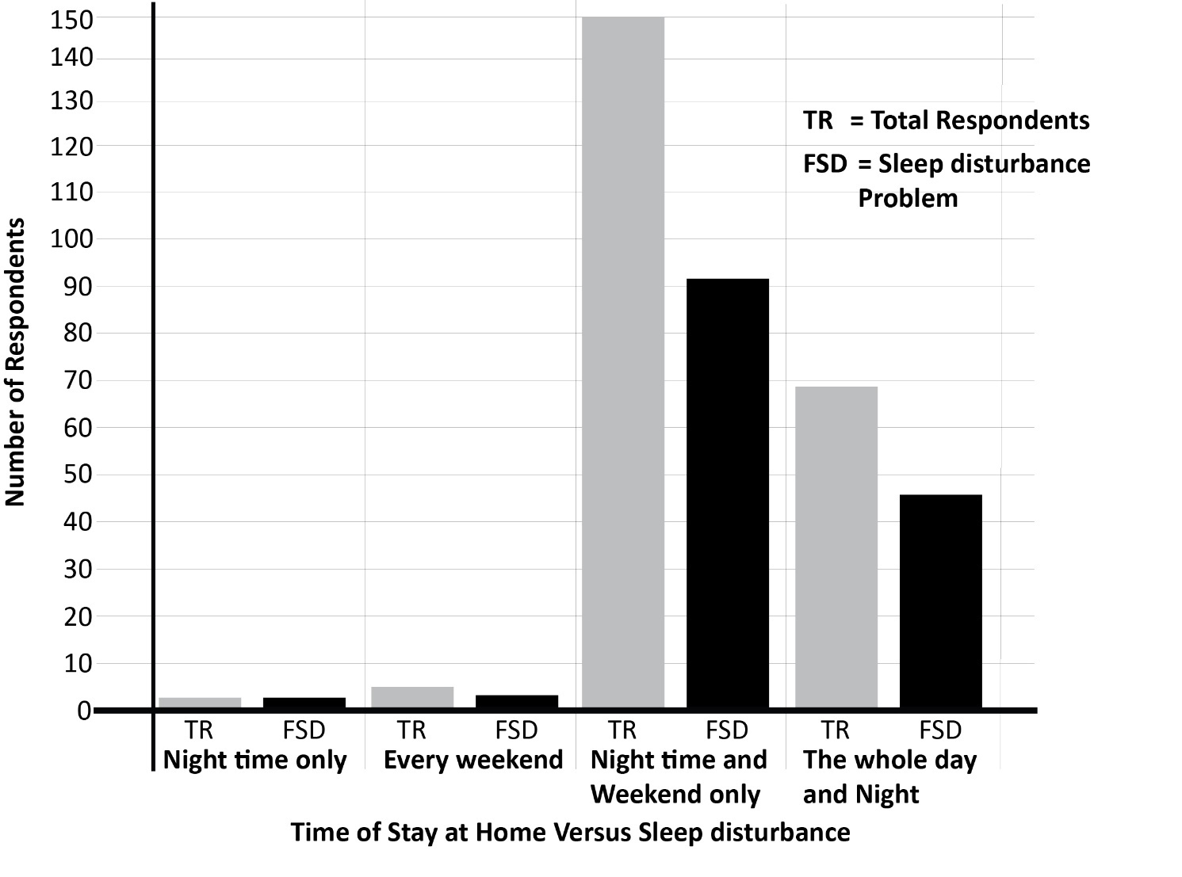
Chart 9: Time of stay at home Versus Sleep Disturbance (Source: Survey result).

  - Building units’ characteristics vs Aural privacy

- Floor level versus Level of disturbance

Level of disturbance regarding floor level varies by two different aspects. Based on respondents of block 22 and 23 in parcel number 12, the last floors (3rd and 4th floor) are more affected than the lower floors. This area already has the name “Gedam sefer” due to less noise disturbance, and a smaller number of sound pollutant commercial units. Informal discussion with residents who lived in all floors of block 21 and 22 indicates that, respondents of the above floor are affected by noise pollution from another parcel within this compound.

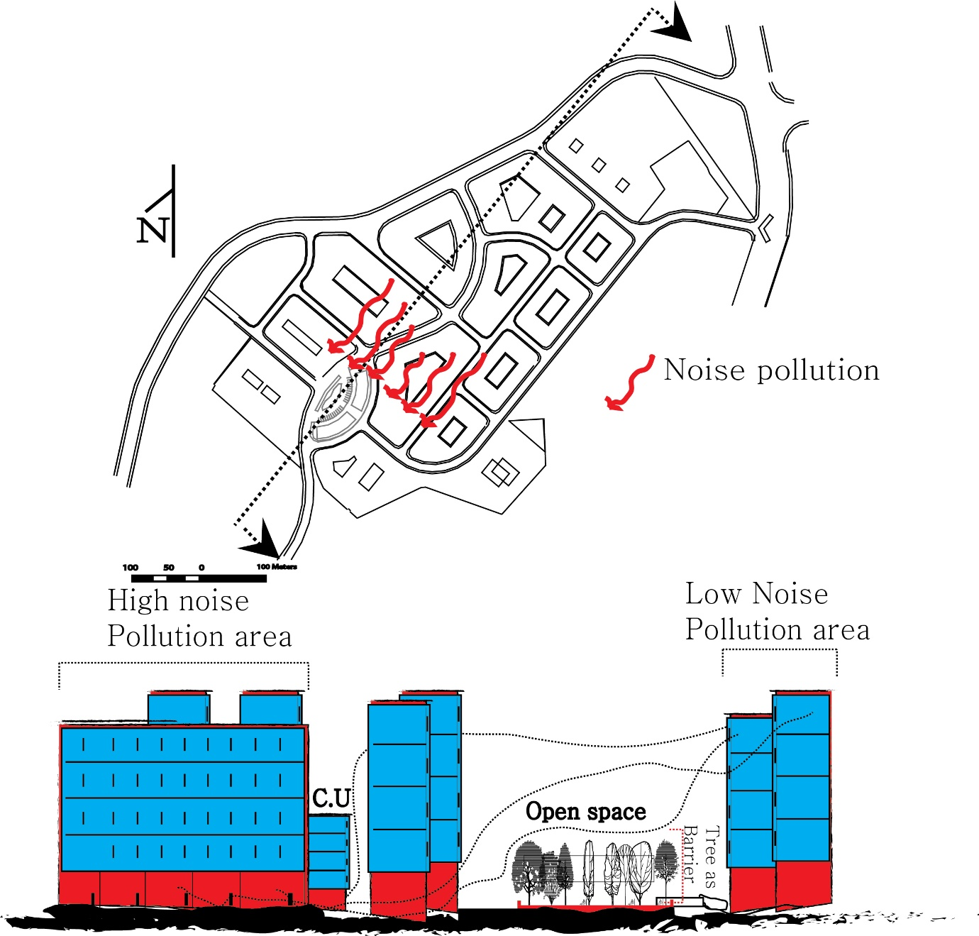
Figure 23: The effect noise pollution from other area of the site to the above floor of silent area

In other direction respondents of residential units which are located in high noise pollution area has two distinct features up on disturbance. The lower floors specially ground floor of typology three and first floor of the other two typologies are highly affected by noise pollution from commercial units below and near to them on the same building as compared to the above floors. In other direction if the commercial units are located parallel to residential unit the disturbance level in each floor is the same. This indicates that the lower condominium units are affected by commercial units which exist below and parallel to them through aggressive use of loudspeaker, and other source of sound. In addition to this vibration is another problem which affect resident’s aural privacy to the residence who located at first floor above commercial units.
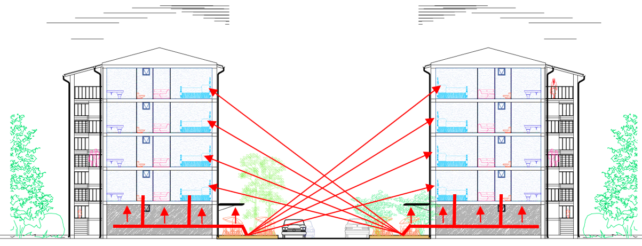
Figure 24: Location effect versus floor level in higher noise pollution area in site

The level of disturbance on each floor of rare side of typology three also has significance difference. The difference also categorized in two ways.

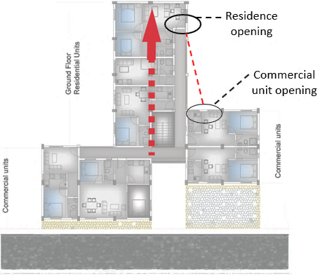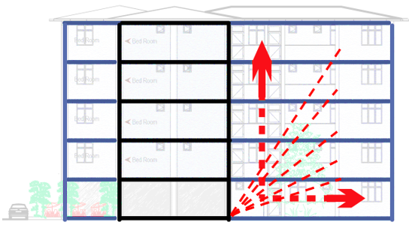
Figure 25: Location effect versus floor level in higher noise pollution area in site

If there is a bar or bar and restaurant in the ground floor residents of ground floors are more affected by noise pollution. The disturbance level decrease as we go to the above floors. Beside these residents who lives in residence entrance which are located perpendicular to the back-side door of commercial units also more affected than the other residents.

Generally, floor level has its own factor in perceiving noise pollution from the surrounding. Residents who live higher floor of moderately silent zone are affected by noise pollution from other parcel or area in the site but as compared the higher floor residents of lower floor in this area have high aural privacy. Unlike this in the area of high noise pollution, residents who lives in lower floor are more affected by noise pollution as compared to the above floors.

- Size of commercial unit Vs Level of disturbance

The size of different commercial units are varies based on their type. The researcher observes that commercial units such as Bar, Bar and Restaurant, Restaurant, Café and Restaurant and Ds Tv house have larger size than the other commercial units. As I mentioned before the larger size is due to extension from the default size of commercial units. The extension of those commercial units’ ranges from 20m2 for smaller bar and restaurant to 166m2 for larger bar and restaurant. The default (Normal) size of commercial units range from 16m2 to 44m2 which used for supermarket, Shop, supermarket, bank, post office, beauty salon, game zone, Juice house, pharmacy, boutique, small factory (steel distributer), children day care, bakery, fitness center, photo house, breakfast house and Laundry. Those commercial units have some extension ranging from 6 m2 up to 10 m2 for utility storage.

Block type two in this condominium site in parcel number seven has the largest extension and this block type allows much extension easily. Other than block type two block type three has more extension in this site. When we see the extension in terms of location front side of parcel number 7 and 13 which located in the entrance of the site has more extension.

. Based on researcher observation commercial unit which have large extension area also have much seating area outside the unit. Up on these commercial units such as Bar and Bar and restaurant with extension allows seating area and speaker (Montarbo) outside the unit. Commercial units without extension emit an average noise at night time 40DB to 55DB whereas, commercial units with extension emit an average noise range from 70DB to 75DB. Therefore, extension has its own impact in the aural privacy of resident. The survey shows that there are different sources of sound which affect resident aural privacy rather than loudspeaker such as Generator, People speech from commercial units, drank people fighting near and inside commercial unit and utility sound. According to respondent’s perception sound from people speech and drank people fighting affect resident’s aural privacy more than loudspeaker due the extension of the units.

  - Perception towards adopting noise pollution

While facing problems from commercial unit’s noise pollution, from the total of 81 household respondents who influenced by noise pollution by noise pollutant commercial units, 61.7% of them adopt the pollution, but 35.8% of them are challenged by noise pollution and the remaining 2.5% adopt partially. Respondent who says no are tenant who stayed in this site for short period of time. According respondent’s perception adoption the pollution doesn’t mean they are not affected by the problem, but it is the matter of no choice.
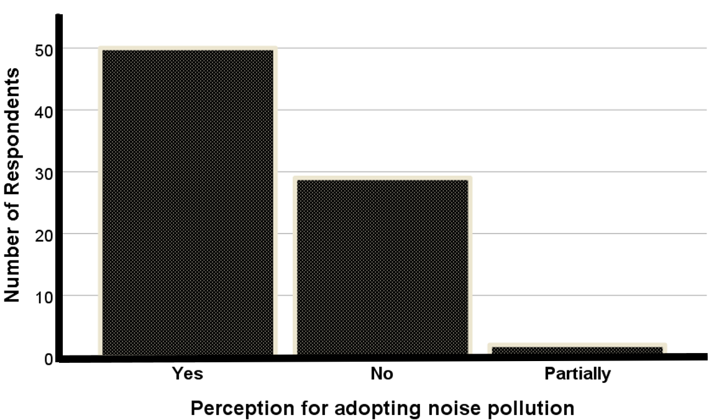
Chart 10: Perception of Adopting towards the Existing Noise Pollution
  - Achieved privacy Vs desired privacy

As described by (Altman 1975), Privacy regulation refers to selective control over access to the self or to one's group. People have a desired and an actual or achieved level of privacy. As mentioned in the figure Resident preferred area for livening in residential area from the total of 102 respondents 89 of them wants to live in silent area and the remaining 13 wants to live in moderate sound level area. One way of knowing the level of aural privacy in one’s residential environment by comparing and contrast the achieved which is actual level of privacy with that of desired privacy.
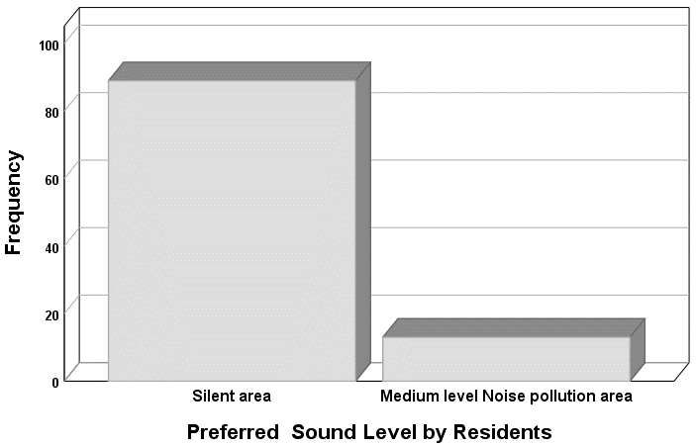

Desired privacy

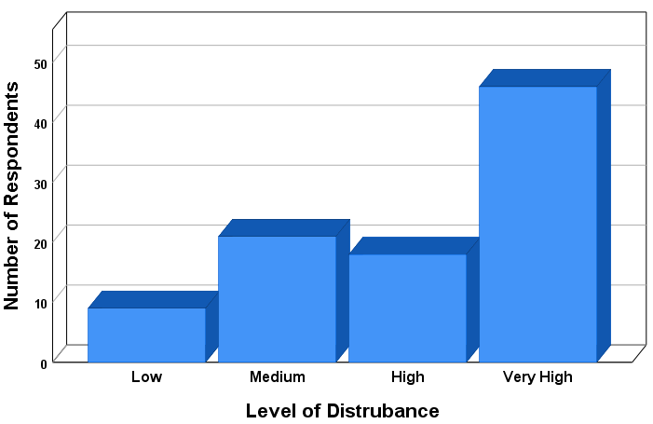

Achieved privacy

Chart 11: Desired privacy and Achieved privacy (Source: Survey result)
The above two graphs show that residents’ preference to sound level and the existing sound level which is achieved has too much difference. In privacy regulatory behavior if the achieved privacy is less than desired privacy it is said to be crowding. The optimum privacy level is when achieved privacy and desired privacy is equal. But in this case the achieved privacy Is much less than that of preferred or desired privacy. Chart 12 shows that the relationship between achieved privacy and desired privacy in mixed residential unit of Gotera condominium site.

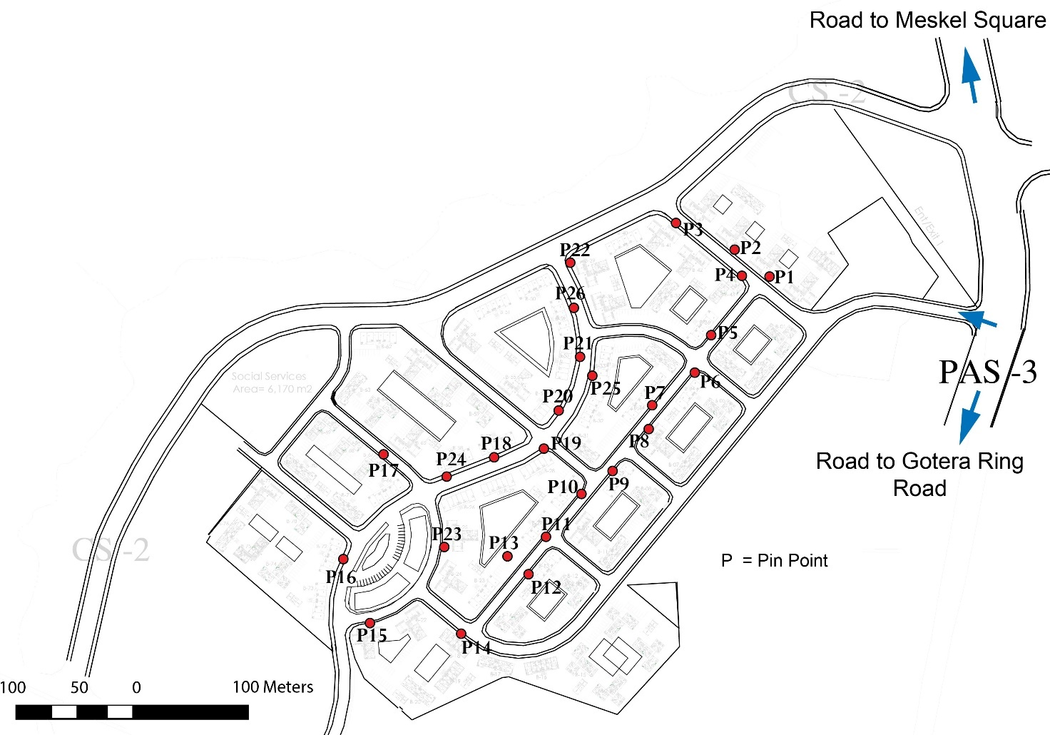
  - The Level of noise pollution by Sound level meter
Figure 26: Pin point (place of measurement for sound intensity level)
The level of noise disturbance from different source are vary in different time of the day. The reason for variation for level of disturbance is due to the function of the commercial unit. Except some functions most of commercial units are closed after 10PM. Each measurement is taken from 1 meter in front of each commercial units. See annex 2 for detail measured data. The data contains commercial unit type, minimum, average and maximum noise level and time of measurement.

P = Pin point
P1 = Bar and restaurant, P2 = Restaurant, P3 = Children day care, P4 = Restaurant, P5 = Barber P6 = Super market, P7 = Restaurant, P8 = Liquor house, P9 = Shop, P10 = Bar and restaurant, P11 = Bar and restaurant, P12 = Super market, P13 = Bar and restaurant, P14 = Laundry, P15 = Shops, P16 = Boutique, P17 = Liquor store, P18 = Game Zone, P19 = Pharmacy, P20 = Bar and restaurant, P21 = Bar and restaurant, P22 = Bar, P23 = Boutique, P24 = Game zone, P25 = Shops, P26 = Bar

Average noise level of selected commercial units

In this study recording were taken from 26 commercial units of Gotera Condominium and p1, p4, p6, p9, p22 and p24 which represent Bar and restaurant, children daycare, restaurant, barber, supermarket, shop, laundry, boutique, pharmacy, bar and game zone respectively are selected for this analysis.

- Average noise level of selected commercial units during weekday

During morning time (6AM to 12 PM) most of the commercial unit’s noise level is similar. Except bar, game zone and bar and restaurant the other commercial units have noise pollution which ranges from 40DB to 55DB. The average noise measured from bar and restaurant, bar and game zone during morning time are 64 DB, 55 DB and 78 DB. The average level of noise from 12 PM to 6PM are more or less similar to the average noise level from 6 AM to 12 PM I.e. commercial units such as children day care, restaurant, barber, supermarket, shop, laundry, boutique pharmacy has average noise level ranges from 40DB to 55DB. Rather than this bar and restaurant, bar and game zone has 65DB, 63DB and 75DB. Figure 29 shows that Average noise level is very high during the time of 6PM to 6AM from bar, bar and restaurant. Their activities increase during the time of 9 PM to 6 AM when the other commercial units are closed. Some restaurants are also open after 9PM in this condominium site beside bar and bar and restaurant. The highest average noise level in weekday is 83DB from bar in the time interval between 9PM to 6AM and the minimum is average noise level is 40DB from laundry in the time interval of 12 PM to 6PM.
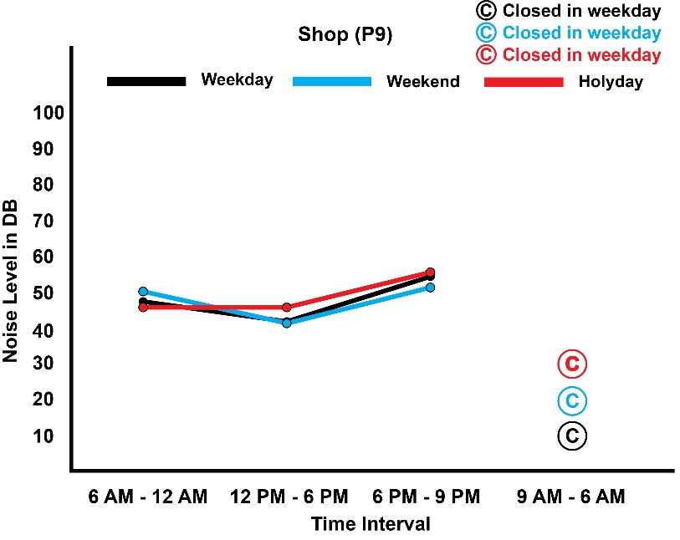
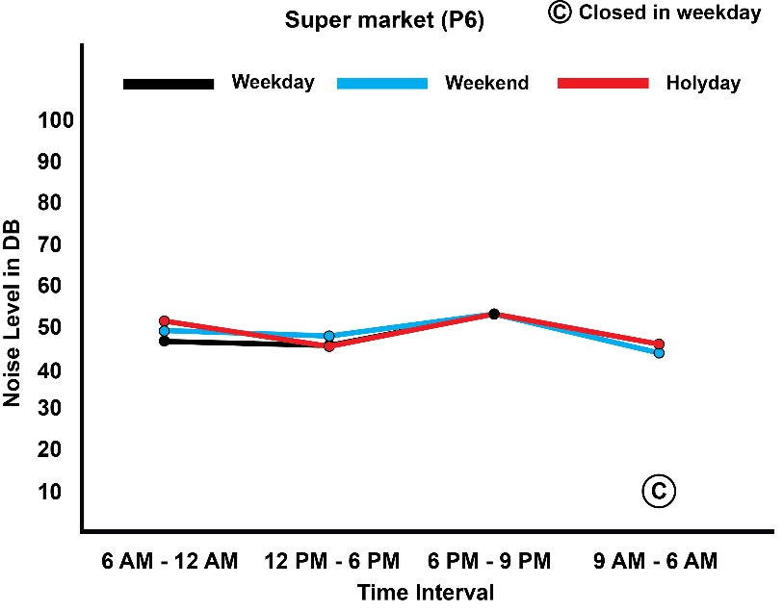
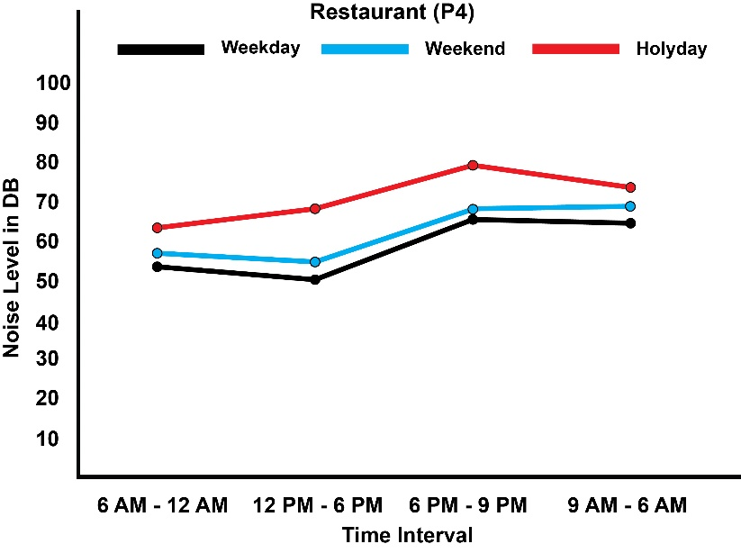
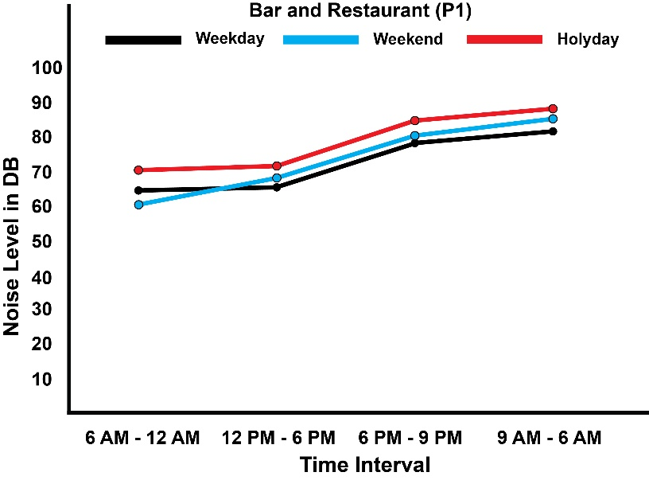
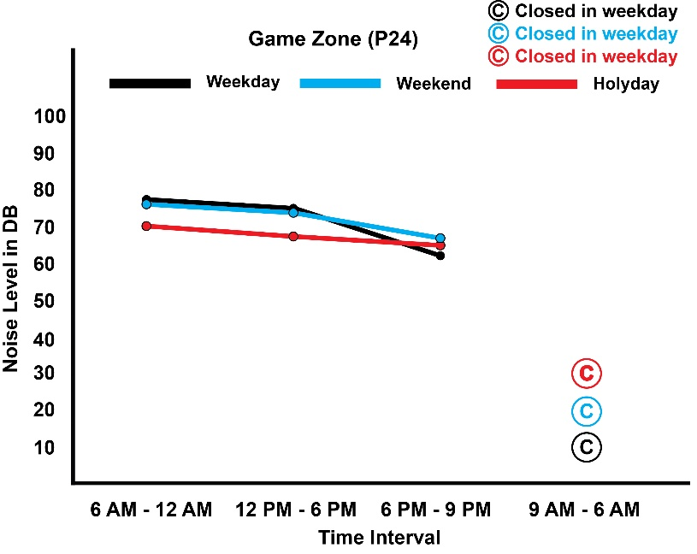
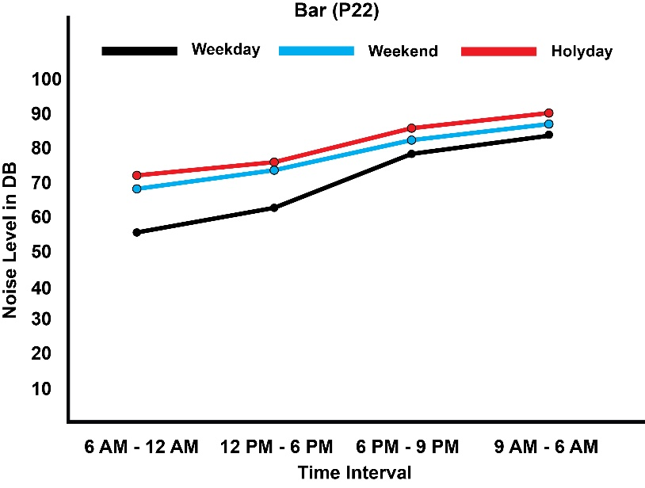
Chart 12: Average noise level of selected commercial units in different days and times (Source: Survey area Decibel measurement)
- Average noise level of selected commercial units during weekend

The result shows that the peak noise levels were recorded near to bar as well as bar and restaurant. The peak noise levels were 68DB in the time interval between 6AM to 12PM, 73DB from 12PM to 6 PM 82 DB from 6PM to 9PM and 86 DB from 9PM to 6AM for bar and also 60DB from 6AM to 12PM, 67DB from 12PM to 6PM, 80DB from 6PM to 9PM and 84DB from 9pm to 6AM for bar and restaurant. in addition to this the average noise level of game zone is also high during day time similar to weekday. Children daycare(O/C) is open at Saturday and closed Sunday. Children daycare is open from Monday to Saturday. Except the above listed commercial units and restaurants, average noise level of the other commercial unit ranges from 40DB to 56DB.

- Average noise level of selected commercial units during holyday

As compared to weekday and weekend average noise level, there is high noise pollution in holyday. The maximum average noise of bar during night time in weekday, weekend and holyday is 83,86 and 89 respectively and the maximum average noise of bar and restaurant during night time in weekday, weekend and holyday is 81,84 and 87 respectively.

The hierarchy of level of noise disturbance is based on the survey record of sound level meter at night time which is 9PM to 6AM. Overall description of sound intensity level of different commercial units at different time interval is listed in Annex 2. The level of sound intensity is taken from outside of each commercial unit and the distance between the commercial unit and the instrument is 1 meter.

Figure 28 describe the level of noise pollution of commercial unit types in different place of this condominium site based on average of the above 26 pin points with the use of sound level meter specifically during sleeping time for all day types.

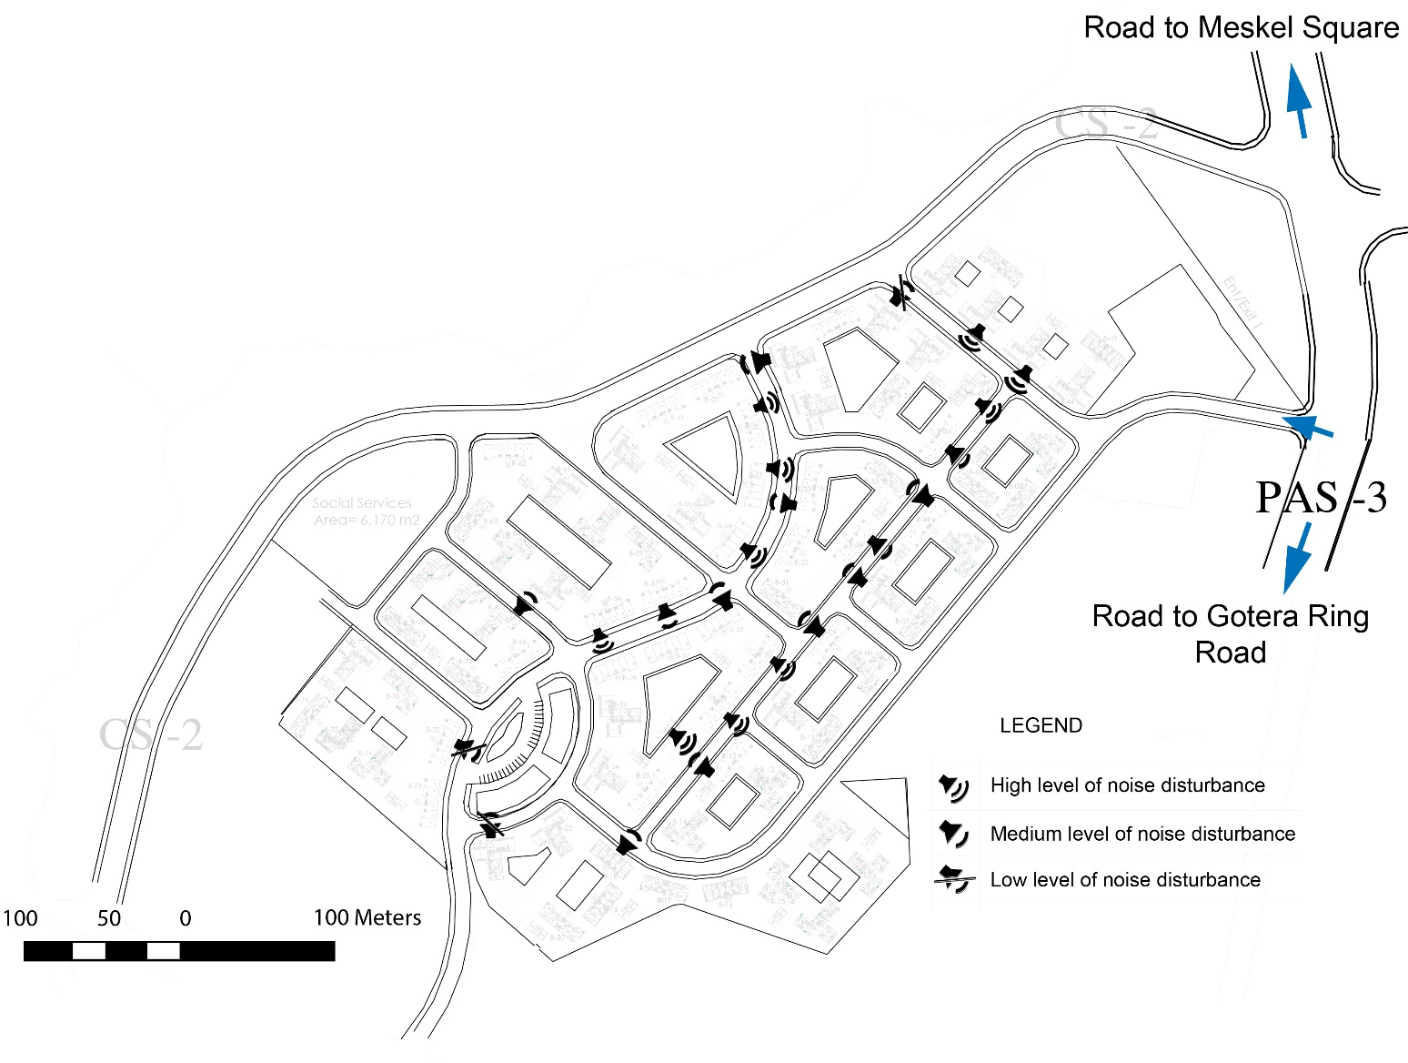
Figure 27: Level of noise disturbance from different commercial unit type

Bar, Bar and restaurant and Night club perform their activity starting from morning up to mid night and above. Other commercial units such as supermarket, shop, children day care and other which are listed on the above commercial unit type ends their activity up to 9 PM or sometimes until 10 PM.

In other direction the level of noise pollution varies in different place of these condominium site. These noise pollution level dispersed all over the site, but in some cases, the level varies based on different reasons. High noise pollution area and low noise pollution are located in opposite direction. The highest noise pollution area is characterized by location at the entrance of the site, dominated by Bars and Bar and restaurant commercial unit type and have got the name “Chechenia Sefer”.

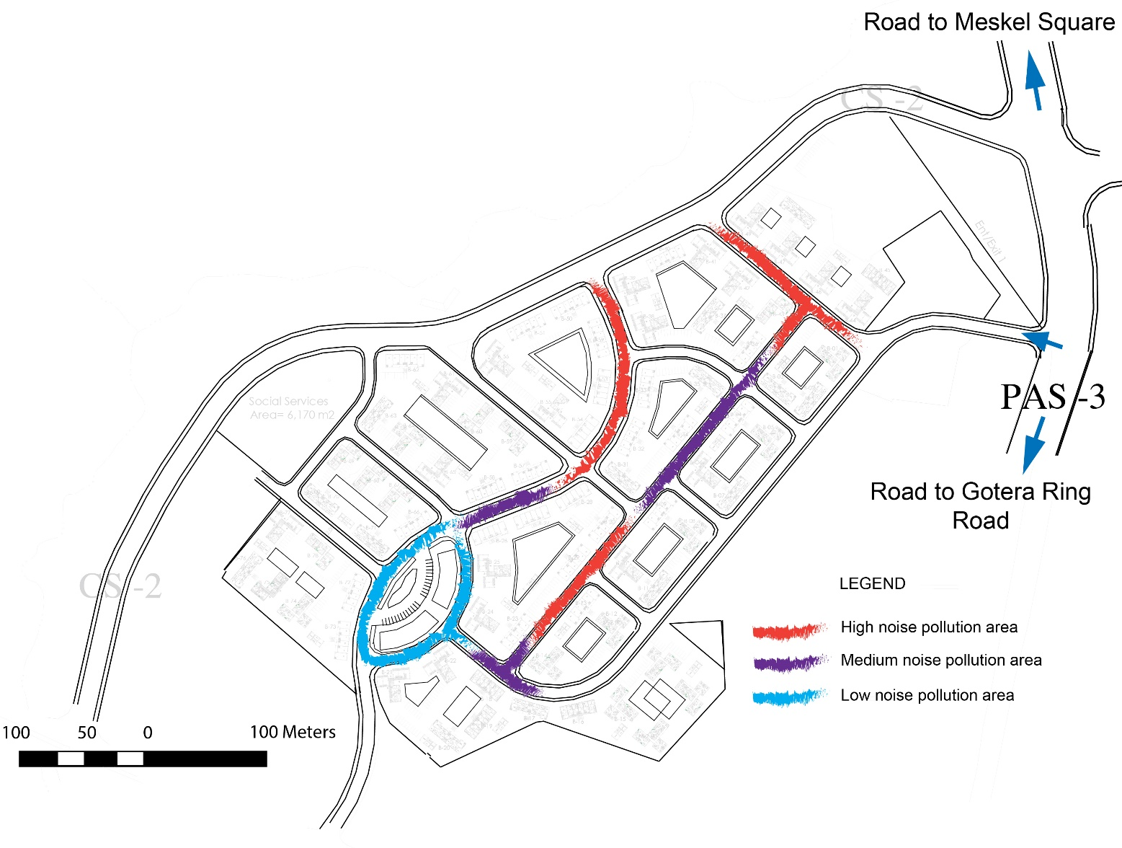

Figure 28: Total level of noise pollution in different area the condominium site

In other way the lowest noise pollution area is characterized by location at the rear side of the site, dominated by commercial unit types such as shops, boutique, Laundry and existence of open space or green area which used as barrier and reduce the possibility affected by noise pollution from other side of blocks. The name of lowest noise pollution area which is given by the resident is Gedam Sefer.

Apart from the two side the middle of these condominium site is dominated by high and medium noise pollution. High noise pollution area is directly related to commercial unit type. The more bar, and bar and restaurant the higher noise pollution area.

  - Perspective of respondents towards commercial unit existence in condominium environment

Asking such like questions helps the research during recommendation. Using Likert scale the researcher ask each respondent about the existence of different commercial unit types.

- Strongly Disagree
The data collected during the site survey shows that more than 60% of respondents in this mixed residential compound are strongly disagreeing with the allowance of Bar as well as Bar and Restaurant commercial units. Chart 15 shows the perception respondents from the total of 102 regarding the allowance of commercial units in residential environment.

- Disagree
In this category similar to the above commercial unit type such as Bar, Bar and Restaurant, Game Zone, Small factory, DS Tv and liquor store are included.

- Agree
Commercial unit types which listed under strongly disagree and agree category are less in number under this category.

- Strongly Agree

One respondent for each bar and bar and restaurant are strongly agreeing with the allowance. When we see the above allowance category with the following category (strongly agree) commercial units such as supermarket, shop, café and restaurant, bank, juice house, post office, pharmacy, boutique, restaurant, children day care, bakery, fitness center, beauty salon breakfast house and laundry has higher degree of allowance based on their level of noise pollution to the surrounding. The remaining respondent’s number out all the above category is under neutral or undecided.
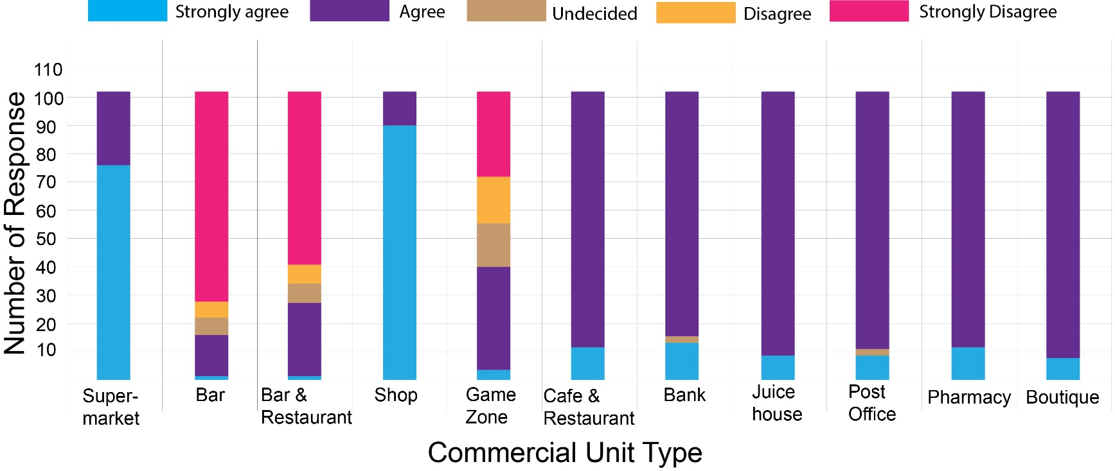

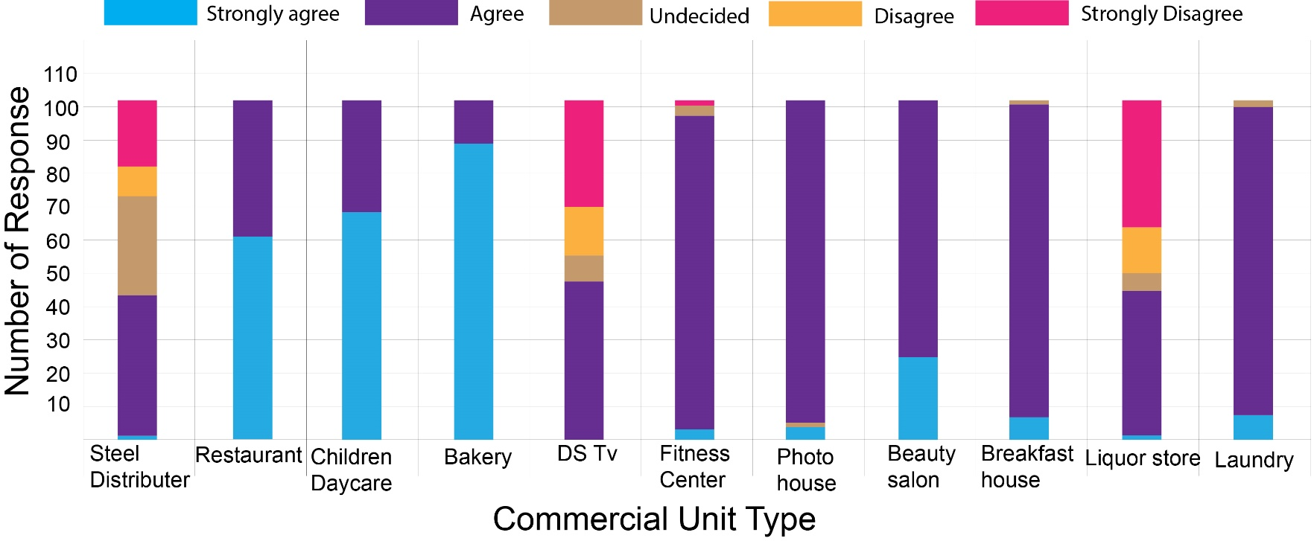
Chart 13: Attitude towards Commercial Unit Allowance (Neutral), (Source: Survey result)
  - Percpective of owners and tenant towards changing the current block due to low aural privacy

- Attitude towards changing the block due to aural privacy (for owner)

The researcher asks owners who lived in mixed residential building about their attitude towards changing the current block due to faced aural privacy problem if there is possibility. From the total owners 78.8% wants to change the current place and the remaining 21.2 have no interest.
 |  | Frequency | Percent
 | Yes | 26 | 78.8
 | No | 7 | 21.2
 | Total | 33 | 100

Table 17: Attitude towards changing the block due to aural privacy (for owner)

The Location of the block/residence that the owners wants to change

After getting their perspective towards change of the current home place the researcher wants to know the perception of owner residents by asking, do you want to change your current block to another block in this compound or to another condominium in inner city due to aural privacy. From the total of respondents who says ‘’yes’’ 61.5 % wants to live to pure residence which is away from street side in the same compound and 34.6% wants to live to the least sound polluted condominium site in the city.
 |  | Frequency | Percent
 | To pure residence/away from street side | 16 | 61.5
 | To the least sound polluted condo. site in the city | 9 | 34.6
 | Other | 1 | 3.8
 | Total | 26 | 100
Table 18: Preferred location of the block that the owners wants to change the currunt place due to aural privacy( Source: Survey result)
In other direction some respondents have no interest to change the current home for different reason. The following table shows six respondents’ perception, why they won’t to change the current home to other area or place. Hoping of the noise pollution may decrease at the future is the higher percentage in this category.

 |  | Frequency | Percent
 | Wanting to live on the street side | 1 | 16.7
 | Hoping the sound level will decrease in the future | 4 | 66.7
 | Other | 1 | 16.7
 | Total | 6 | 100.0

Table 19: Reason behind no interest to change the current place for owners (Source: Survey result)

- Perspective of tenant towards not to change the current site

Most of the tenant in this site rent the condominium for the reason of easy access of work area and transportation. From the total of 65 tenant 47 of them are highly vulnerable noise pollution. The researcher asks tenants, if you know there is a continuous problem of aural privacy, why don’t you change your house to another location on the site. Most of them prefer the site due to ease accessibility to work place, and gives more priority to accessibility to work place than sound pollution.
 |  | Frequency | Percent
 | Its affordable | 3 | 2.9
 | Its active and vibrant | 1 | 1.0
 | Closeness to work place | 33 | 32.4
 | Other | 10 | 9.8
 | Total | 47 | 46.1

Table 20 Reason towards not to change the current site for tenant (Source: Survey result)

  - Coping Mechanism towards aural privacy

Due to high noise pollution from commercial units’ street side residents of Gotera condominium were forced to some strategies to overcome the impact. Closing openings and filling the void with cloths and other materials, raising the volume of television until sleeping time, sleeping in living room instead of bed room, walking inside as well as outside the site until sleeping time are coping mechanism towards noise pollution from the neighbor commercial unit. According to respondent’s perception all the above coping mechanisms are not the interest of them they are forced strategies and those strategies has their own impact on day to day activity of the respondents. For example, closing opening to reduce the noise pollution decreases air circulation inside the home, therefore it is impossible to open door and windows if ventilation is needed. Raising the volume of television also disturb students while reading, infants while sleeping. The survey shows that from the total respondents (86) who have the problem of noise pollution 57.6% of them closes their opening to reduce the noise pollution, 30.6% of them also uses the same coping mechanism but they say there is no change and 12.9% of them use other mechanism which are listed above.
 |  | Responses
 |  | Number | Percent
 | Coping mechanism: closing opening and it reduce partially | 49 | 57.0%
 | Coping mechanism: closing opening and no change | 26 | 30.2%
 | Coping mechanism other | 11 | 12.8%
Total |  | 86 | 100.0%

 |  | Responses
 |  | Number | Percent
 | Closing opening and it reduce partially | 49 | 81.7%
 | Other Coping mechanism | 11 | 18.3%
Total |  | 60 | 100.0%

Table 21: Coping Mechanism towards low aural privacy or high noise pollution by respondents (Source: Survey result)

  - Noise pollution management

Beside the study of the level of aural privacy in Gotera Condominium, the researcher examines its management component. In Gotera and other condominium site there exist concerning body to manage resident’s day to day activity. Gotera condominium house owner association, Gotera condominium site police station, Woreda 4 environmental pollution monitoring and control office, Kirkos sub city environmental pollution monitoring and control office, Addis Ababa city administration environmental protection and green area development commission office, and Ethiopian environmental protection office are concerning bodies to manage problem related to noise pollution. Those responsible bodies are tries to control noise pollution through different mechanism such as awareness creation, law enforcement, complaint management, regular noise inspection at condominium neighborhood level. On the other hand, at city and federal level concerned bodies are works on different research studies, proper zoning, regular inspection towards the polluters, awareness creation to the polluters, regular complaint management, and consideration of environmental impact assessment before any building is constructed especially for high rise buildings. However, despite the management technique which are listed above in different level of organization there is a problem of noise pollution in this condominium.

- Resident Complaint to concerned body

From the total of 80 respondents who says there is a problem of noise pollution 63.78 percent of them complained to condominium house owner association, police station, owners of commercial units and Woreda 4 environmental pollution monitoring and control office.
Response |  |  | Frequency | Percent
 | Yes | 51 |  | 63.78
 | No | 29 |  | 36.22
 | Total | 80 |  | 100

Table 22: Resident action towards complaining noise pollution to concerned body (Source: Survey result)

Table 23 shows the frequency of 80 respondents concerning place of compliant to concerned body. According to the study, housing owner association is the main complaining area by the residents who have problem of aural privacy. Some respondents who complain to HAO also complain to other concerning bodies therefore the number of responses is greater than the number of respondents.

Responsible body |  | Responses
 |  | Number |  |  | Percent
 | To HOA of the site |  | 48 | 52.7%
 | To Kirkos sub city Woreda 4 |  | 10 | 11.0%
 | To Existing police station |  | 11 | 12.1%
 | To commercial unit owner/worker |  | 22 | 24.2%
Total |  | 91 |  |  | 100.0%

Table 23: The frequency of place of complaint by residents (Source: Survey result)

The other point of discussion is with regard to action taken by responsible authority to solve the appeal from residents in reducing noise pollution. The perception towards action which taken by concerning body indicates that 71.12 % respondents which have the problem of aural privacy are not satisfied.
 |  | Frequency | Percent
 | Satisfied | 3 | 3.75
 | Moderately satisfied | 19 | 23.13
 | Not satisfied | 58 | 71.12
 | Total | 80 | 100

Table 24: Respondent satisfaction level towards action taken by responsible body (Source: Survey result)

- Response of responsible authorities concerning management of noise pollution commercial unit in Gotera condominium

Informal discussion and interview with different officers of house owner association of Gotera condominium, Kirkos sub city Woreda 4 environmental protection office and Kirkos sub city environmental protection office shows that residents of Gotera Condominium appeal to them in different period of time.

Actual scientific data of respondent’s place of complain shows that high percentage of them complains to the House owner association office in their compound. Based on the information I got from HOA office leader, resident who are affected by noise pollution from commercial unit appeal to them most of the time. After complaints, first of all HOA notify and warn to the owners of commercial unit who use loudspeaker and if there is no change 200 Ethiopian birr punishment will be the second stage after that final warning is given to polluters. If the problem continues housing owner association reports to Woreda 4 environmental protection office. But beside this the leader of HOA told me that, servility and fear of commercial unit owners are the major drawback to take action on commercial units which have high level noise pollution.

Regarding Woreda level, according to environmental protection expert from Kirkos sub city Woreda 4 they receive many complaints from residents of Gotera condominium site since 2009 in formal and informal way. Officially, Woreda four receive complaint letter which have signature of the residents and also from house owner association of Gotera Condominium site. Different residents of this site personally complain to this office frequently in informal way. After receiving the complaint from the resident’s, team of environmental protection experts will move to the site and measure the noise level by using calibrated sound level meter instrument called Decibel. According to the expert, noise level of commercial units in Gotera condominium site vary from medium to high at night time in the context of standard guidelines of the level of sound emission in Ethiopia. But the measurement has some difficulties, during inspection, the commercial units those have high level of noise disturbance reduce the sound by getting information from the neighbor as well as from a person which work in environmental protection office of Woreda 4. Therefore, these unethical work ethics makes the inspection difficult.

Up on taking action on those commercial units which emit high level of noise pollution, the Woreda environmental protection office in collaboration with different concerned body such as Kirkos sub city environmental office, Woreda 4 heath regulatory office, culture and tourism office and trade office have full of right to manage the problem. According to Tofik Yamal who is environmental protection expert in Woreda 4, Weak joint venture between the above responsible bodies or unorganized working structure between responsible bodies, lack of rule and regulation on the action to be taken on polluters makes the decision hard to implement. But unlike the information which I get from the expert in May 21,2019 there is regulation which implemented by Addis Ababa city administration environmental protection and greenery development commission office starting from January 31, 2019.

Other than the two responsible bodies the researcher looks the activity of sub city, city and federal environmental protection office up on noise pollution in commercial units of condominium area. The duty of sub city, the city and the federal environmental protection office in protecting noise pollution is the same with that of woreda level. The difference is working structure and the scope of management. The federal environmental protection office manages at federal level, the city at city level and the sub city at sub city level.

According to the contextual review and the information which I got from different stakeholder and concerned body their exist different policies, strategies, standard and regulations up on noise pollution management in Ethiopia but there is huge gap in implementing.

CHAPTER 6

SUMMARY OF FINDINGS

This research study explores the level of aural privacy in mixed building of Gotera condominium neighborhood by different categories. This summarize anticipated and unanticipated issues related to resident’s aural privacy. Researcher observation, respondent’s subjective perception, sound level meter, and responsible bodies are an instrument that used as a base to the findings.

  - Demographic characteristics of respondent’s vs Aural Privacy

This condominium site was built in 2005 to house about 9500 low- and middle-income household. The government transfer all housing units to each resident by means of lottery.

- Perception towards noise pollution varies among one’s family member. If one family member affected by noise pollution the other family member may not affected by it. There is different reason behind this variation and such variations are relation with the family, gender, age, marital status, education level, occupation, time of stay at home. Therefore, demography is the most significant factors in perception of level of aural privacy.

- After all the government transfer the housing units to the residents by means of lottery the number of owners expected to be high but there is a practice of renting and selling residential units due to different factors. From the total of 102 household respondents 35.3% are owners, and the rest 63.7% and 1% are occupied by tenants and care taker respectively. According to respondent’s interpretation, some of the reason to rent out their residential units are due to high noise pollution, need of renting money, bad social practice in the compound which affect children’s and young population group such as prostitution, Shisha, drugs from commercial units and other source which are not acceptable in residential place.

  - Units characteristics and aural privacy

    - Commercial unit characteristic and its impact on Aural Privacy

- According to respondent’s perception as well as measurement the most influential commercial unit type that affect resident’s aural privacy are Bar/Bar and restaurants by releasing average of 65dB in day time and 80dB at night time which is above the standard permissible noise emission. Each commercial unit contains Ds Tv and this unit type also has noise pollution problem.

- The most noise pollutant commercial units such as bar and bar and restaurant are distributed all over the site except the rear side of condominium site. high noise pollutant commercial units are located in specific area and this cause the more they locate in specific area the highest noise pollution. Based on this, parcel or areas get their own name based on the level of noise pollution in the site. The figure below shows that two distinct names of area in the site which given by the residents. The letter “A” stands for the name “Chechenia Sefer” and “B” Gedam Sefer. Chechenia sefer is characterized by high noise pollution area or low aural privacy place and located at the entrance of the site and in the other direction Gedam Sefer is characterized by a place of low noise pollution or high aural privacy and it is located at the rear side of the site which has commercial units except the above high pollutant commercial types. If the number bar and bar and restaurant increase in specific place it increases the number of users and vehicles, therefore this causes high level noise pollution from the user speech, vehicle sound and loudspeaker. The two main difference between Gedam sefer and Chechenia are the existence of the most influential commercial units’ types and distance to entrance of the site. Chechenia is located at the entrance of the site whereas Gedam Sefer is located far from the entrance.
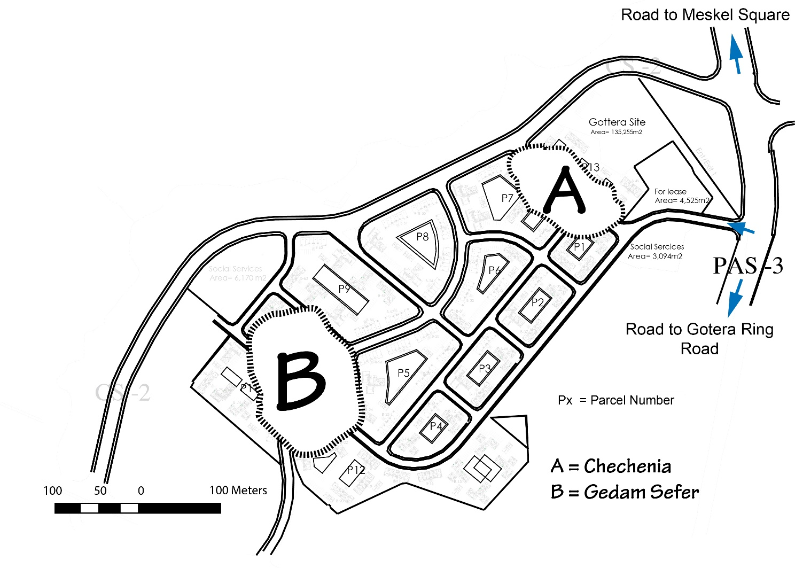
Figure 29: Location name in Gotera condominium site based on level of noise

- The most influential commercial units which has large extension have high noise pollution because this extension allows the users to seat outside the units therefore this causes high noise pollution from people speech, drank people fighting, loudspeaker. The above source of sound from commercial units directly affects street side residents.
    - Characteristics of Dwelling Unit and its impact on aural Privacy regarding commercial unit

- Bed room arrangement also directly related disturbance from commercial units. Residents of T16 and T18 which are typology one is more affected by noise pollution than M1 (typology two) and M2 (typology three). All Bed rooms in T16 and T18 are arranged toward the street and their opening faces to all commercial units and the other rooms are arranged to the rear side.

Other than this, resident who lived T16 which have studio has no problem with noise pollution, because the studio is located behind other residential units. Except some of them, Bed rooms of M1 (typology two) faces the street in two directions, in the left direction restaurants in front side Bar, bar and restaurants and restaurants. The proportion of living room arrangement related to bed rooms to street facing is equal. This typology also has the highest extension of commercial units. According to resident’s perception and observation residents of typology M1 faces less noise disturbance than typology T16 and T18 residents. Finally bed room some bed rooms in typology M2(typology three) are arranged at the back side of the street and commercial units. Most of residents in this residential unit of typology M2 are not affected by noise pollution and this is due to facing direction of the bed room. Generally, room arrangement in this case bed room arrangement towards commercial units and street is directly related to the impact of noise pollution problem.

- Informal discussion as well as formal interview with respondents indicates that, if noise pollution from commercial units gets high most of respondents who lived in more than two bed rooms has the opportunity to change the location of sleeping area from bed room to bed room as well as to living room.

- Walls are constructed from reinforced concrete with masonry infill, and plastered both inside and outside. Mass and rigidity property are the two factors that make a material to be highly noise resistant. Reinforced concrete with masonry infill walls performs appreciably in noise resistance. Units are handed to beneficiaries with skim concrete floors and in some place rather than noise pollution vibration affects resident’s aural privacy but it performs appreciably in general. The main entrance of unwanted sound to the resident is through windows and doors. Windows are made from metal frames with single glazing and thus materials has low sound resistance.

- Level of disturbance in different floor level can be categorized in to two portions.

- Noise disturbance from commercial units of other area of within the site
- Noise disturbance from commercial units located in the ground floor within a building and from parallel commercial units. Generally, disturbance level in different floor level varies from floor to floor and from area to area.

  - Human health problem due to high noise pollution from commercial units

- While age increases vulnerability to health problem goes higher. Family member responses against sleep disturbance indicates response number and sleep disturbance gets closer as the age increase. In addition to sleep disturbance the higher age group faces heart problem, Impatience, Instability, headache, raise of blood pressure.

- Survey study indicates that reading problem is the problem of lower age group as compared to higher age group.
 |  | Responses
 |  | Number | Percent
 | Head | 6 | 20.0%
 | Spouse | 3 | 10.0%
 | Children | 17 | 56.7%
 | Other | 4 | 13.3%
Total |  | 30 | 100.0%

The number of children respondent are less in number as compared to head and spouse respondents for this study but the number of respondents which affected by noise pollution in terms of reading problem is higher for children than the other respondents. From the total of 30 respondents which faces reading problem 56.7% of them are children problem.

  - Coping mechanism

Since coping is a way of mastering, tolerating, reducing and minimizing environmental as well as internal demand and incompatibility, residents of Gotera condominium mixed residential building undergo different strategies to cop up noise pollution from commercial units. Based on informal, formal discussion and interview the researcher find out some scale of coping by respondents towards noise pollution from commercial units.
- Most owners leave the site by selling their own home
- Closing doors and windows during day time as well as night time reduce noise pollution partially and this coping mechanism has another negative impact on residents. When openings are closed there is less air circulation in all room, therefore rooms lack ventilation. Therefore, if openings are open unwanted sound inters into the room on the other direction if openings are closed rooms lacks ventilation when its needed.
- Closing openings has its own advantage in reducing unwanted sound to the room partially, but in some area especially residential units which are near to commercial units closing opening does not have a significant difference in reducing noise pollution.
- Changing sleeping area from bed room to living room during sleeping time. according to respondents, when the noise pollution is high, they are forced to change sleeping area from bed room to living room. most of the respondent who change their room are residents of typology one (T16 and 18), because almost all bed rooms face towards street and commercial units.
- Walking inside as well as outside the compound at night time until sleeping time is another coping mechanism of respondents. Specifically, this coping mechanism is used by male family member which is head and young(single) respondents.
- Raising the volume of electronic medias such as radio and television until sleeping time. This coping mechanism shows the sound from commercial units is unwanted or its noise. According to Lang (1 994, p. 226) aural privacy has similar meaning with sonic comfort. Noise can be considered to be ' unwanted' sound, it raises issues of unwanted by whom: one person's music is another's 'unwanted sound'. Therefore, the sound from commercial units specially from bar and restaurants in Gotera condominium is unwanted by residents according to their coping mechanism.

All the above coping mechanism are similar with the three Frydenberg and Lewis coping factor analysis such as removal of the problem through personal endeavor or effort with a minimal use of others(self-help), use of others as a resource (and support), usually within a problem-focused orientation, use of a range of emotion-focused strategies associated with a feeling of not coping (although it permits accommodation to the problem).
  - The extent of management component and aural privacy

- The major finding in this category is the noise pollution from commercial units such as Bar and Bar and restaurants at night time greater than day time. The highest noise level in night time in this mixed residential neighborhood is 85 DB see annex 2. When we compare to upper limits permissible noise standard at night time 85 DB is much higher. The Survey data noise level in DB indicates that bar and bar and restaurant emit high level of unwanted sound during sleeping time or night time from 9 PM to 6 AM. Noise emission level of other commercial unit types are less than the standard emission level at night time because most of them are closed before 9PM. Most of bar and bar and restaurant have Ds tv house, this also increase the noise level in some days specially Tuesday and Wednesday evening when there is a soccer.

Beside the existence of policies, regulation, standard in country level there is a problem of noise pollution or aural privacy in this condominium site. the reason behind week management on noise pollution is lack of knowledge among officials, corruption, servility, ignorance, unorganized working structure.

  - Subjective and Objective Measurement Result towards Aural privacy

According to Altman, (1975) description of privacy there are two categories that define the level of aural privacy in a given environment. The two categories are achieved and desire privacy. The first one is the actual social exchange amount or privacy one has at that moment and the second one is social exchange amount in a given area or privacy one desires. The result shows achieved privacy is less than desired privacy. Therefore, we can conclude the level of privacy in this site is low.
- Achieved privacy > desired privacy = Social isolation
- Achieved privacy < desired privacy = crowding
- Achieved privacy < desired privacy = optimum
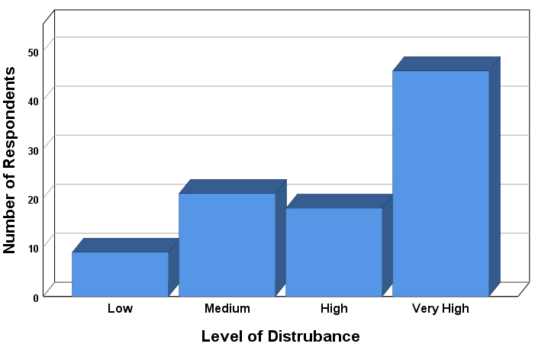
The above graph shows that very high level of disturbance was existed despite silent area preference by residents. Therefore, based on the idea of Demirbas and Demirkan, Cassidy, Kaya and Weber and Altman “The aural privacy of residents in mixed-use building is LOW”. In addition to subjective measurement of aural privacy, the objective measurement shows most influential commercial units such as bar/bar and restaurant release high level of noise pollution. Generally, both subjective and objective measurement shows “The aural privacy of respondents in mixed residential building is LOW”.

  - Comparison of the result of this study to the previous studies and perceptions

The following summary of findings shows comparison of three different studies including this research which is done in Ethiopia regarding noise pollution. Therefore, to compare the finding of this study to others in the same topic area the finding of Dana Doda (2017) and Zerihun, Mamo, Sitotaw, Mengisu (2017) were selected.

- According to Dana Doda (2017) commercial units such as night clubs, bars and restaurants situated in the community residential area release minimum average 64dB and maximum average accounts 84dB. In this research study commercial units such as bar/bar and restaurant release an average of 65dB in day time and 80dB at night time. The permissible noise emission standard in residential area in Ethiopia at day time was 55dB and 45dB at night time. In both research studies noise from commercial units were above permissible limit.

- Based on individual perception of level of disturbance this research also has similarity with other study. According to Zerihun, Mamo, Sitotaw, Mengisu (2017), people perception of noise pollution does not depend on only the intensity level of sound, but it mainly depends on the people interest for that sound. In this study, perception of respondent towards noise pollution varies based on their demography. In both cases results have similarity with Singer (1972), from Krupat, (1985, p. 1 1 4). They found that, rather than the physical characteristics of noise, it was the social and cognitive contexts in which it occurred that determined whether it disruptive or not.

- Physiological adaptation towards noise pollution are also another finding which is similar to other research studies. In this study from the total of 81 respondents 61.7% (which is higher percentage) of them adopt noise pollution. The percentage is more related to time of stay at the site, i.e. most owners adopt but newcomers (tenant) were challenged by noise pollution. Similar to this Zerihun, Mamo, Sitotaw, Mengisu (2017) also states people who have lived for a long time around one type of noise source, that noise was not considered as noise pollution, but it was considered as noise pollution for newcomers.

- This study and other studies in Ethiopia also found the impact of noise pollution on human health and other problems. The study of Dana Doda (2017) and Zerihun, Mamo, Sitotaw, Mengisu (2017) shows noise pollution from different source cases sleep disturbance, interruption in teaching-learning process, cardiovascular and physiological effect, hearing impairment and etc. therefore those studies emphasis noise pollution from different source causes a series health problem issue.

- The result of this study and Dana Doda (2017) shows that residents has negative perspective towards existences of bars in residential areas.

- Weak organization structure in Ethiopia towards noise pollution management was the other finding which similar to other study in this area.
In general, the above three research studies show similar findings in terms of level noise disturbance, perception towards noise pollution, management, impact of noise pollution on human health. Therefore, Aural privacy or noise pollution problem is the most critical issue in Ethiopia which need effective solution.

CHAPTER 7

RECOMMENDATION

The following recommendations are provided by the researcher to overcome the problem related to aural privacy in mixed residential neighborhood. The recommendation has four categories and such categories are zoning within neighborhood design, typology Design context, management context and further study.

  - Management context

    - Working structure of responsible bodies

Regarding management, responsible environmental protection bodies in federal, city, sub city and Woreda level needs to have organized working structure. Joint venture between different stakeholder in all working level such as different organization of Environmental pollution authorities, culture and tourism office, health regulators’, communication affair office, women and children affairs office, police stations, trade licensing office, housing development office, Law bodies must be strong. Therefore:

- Before allowing trade license the issue of noise pollutions should deeply analyzed by concerning bodies.

- Addis Ababa Environmental Protection Authority (EPA) should have to work strongly in educating, and creating awareness regarding permissible noise standard in residential area.

- All EPA offices have the duty to handle noise pollution starting from upper top to down grass root level plus within lateral relationship manner.

    - Policy, Standard, rule and regulation

In addition to the above recommendation permissible noise emission standard must be respected in day as well as night time. The execution of the measurement of noise pollution needs the control and enforcement of the permissible noise standards, strong priority in Ethiopian building code standard and on other planning activities. In addition to this exercising strong regular inspection is very essential. Since the overall policy goal of environmental policy of Ethiopia is “to improve and enhance the health and quality of life of all Ethiopians and to promote sustainable social and economic development through the sound management and use of natural, human-made and cultural resources and the environment as a whole so as to meet the needs of the present generation without compromising the ability of future generations to meet their own needs”.

- The existing rules and regulations to reduce noise levels in the residential area needs strong enforcement and implementation by Addis Ababa Environmental Protection Authority (EPA).

- Specifically, there should be enforcing mechanism in neighborhood design for example design manual and procedure which consider aural privacy or noise pollution.

  - Zoning within Neighborhood Design

Zoning is one mechanism in structuring privacy level. In the case of aural privacy noise-sensitive uses should be located away from noise sources, for example. According to respondent perception more than 50% of the residents have no interest in the existence of bar and bar and restaurant in the condominium site therefore based on their preference and housing quality dimension those commercial unit types needs to be away from residential environment.

During neighborhood design there should be proper zoning for different incompatible uses. According to this site different uses (residence and commerce) are dispersed throughout the site and these cases the problem of aural privacy. Professionals must consider zoning within neighborhood for different incompatible uses. Up on the above recommendation bar/ bar and restaurant, Ds Tv houses and game zone which release noise pollution needs to be away from residential blocks and should have to give building block some distance far from residential units. Based on their usage, low level of sound disturbance and service time in the compound super markets, shop, café and restaurants, bank, Juice house, post offices, pharmacy, boutique, restaurants, children day care, bakery, fitness center, photo house, beauty salon, breakfast house, liquor store, laundry needs to be open.

  - Typology Design

    - Spatial Arrangement

There should be a special consideration on room arrangement of dwelling units towards street and commercial units. In this condominium neighborhood, room which need silence specifically bed room is feces towards commercial units and street and therefore this affect aural privacy. Therefore, during typology and neighborhood design professionals should have to consider spatial arrangement of typologies in different design stage. In addition to this each commercial unit must have space extension limitation. The building block for those commercial unit types such as bar, bar and restaurant, DS Tv house, Game zone must consider

- Orientation of buildings
- The floor level of commercial unit
- Slope
- Wind direction.

Noise pollutant commercial unit types should have to be located to the lower slope; must consider wind direction, their placement should have to be in the lower floor of the block or if there is an opportunity basement is recommended, and in addition to this if the units have extension they must use some barriers in front of extension like trees.

    - Material Design

It is impossible to control changeable noise pollution in one’s location therefore it is mandatory to use appropriate insulations for noise-sensitive uses. Human’s living condition is highly related to their housing characteristics and one of the housing characteristics is privacy, therefore for effective resident’s aural privacy on the permitted commercial units in this recommendation such as shops, supermarket, barber and other which located near as well as for those separated commercial unit from residential units must use sound proof material.

In generally the aim of this recommendation part is to decrease unwanted sound pollution from different types of commercial units which affect resident aural privacy. Rather than commercial units in residential unit some engineering modification must be applied. Single glazed windows have low sound resistance therefore adding an extra layer of acrylic over the window and seal all the gaps are the temporary recommendation urged by the researcher. In other direction replacing single glazed window with double pane windows for only mixed residential building is permanent recommendation if the management recommendation is too hard to implement in short period of time because double pane windows reduce the amount of noise significantly by up to 60 %.

  - Further study

Different research studies in different area of the country should have to be conducted by different stakeholder for increasing awareness of society towards controlling noise pollution levels and the finding of thus research study must have appropriate response. In general, the quality of life is subjected to the privacy of individuals and other factors therefore every responsible bodies must tackle any problems that pause factors that enhance quality of life.

REFERENCE

Adane, B., & T/Giorgis, M. (2012). Cost Effective Condominium Construction Project in Addis Ababa, (February).

Ahsen, O. & Gulcin, P.G. (2005). Space use, dwelling layout and housing quality: an example of low-cost housing in Istanbul. England. Ashgate publishing Limited.

Allan, G. and Crow, G. (1989). Home and family: Creating the domestic sphere, Basingstoke, UK. Palgrave Macmillan, 200pp.

Altman, L. (1975). The environment and social behavior: privacy, personal space, territory, crowding. Monterey, Ca: brooks/Cole.

Altman, L., Werner, CM. (1985). Home Environments: human behavior and environment, Volume 8

Altman, L., Vinsel, A., Brown, B. (1981). Dialectic conceptions in social psychology: An application to social penetration and privacy regulation. Advances in experimental social psychology, 14, 107‐159. Academic press.

Amerigo, M. (2002). A psychological approach to the study of residential satisfaction, in: J. L. Aragon´es, G. Francescato &Tt. Garling (eds), Residential environments: choice, satisfaction, and behavior (westport: bergin & garvey), pp. 81–99.

Amerigo, M. (1992a). A model of residential satisfaction. In M. Aristides and K. Karaletsou, eds, socio environmental metamorphoses: Built scape, Landscape, Ethnos cape. Salonica: Aristotle university of Thessaloniki, vol. V, pp. 411–417.

Angotti, T., Hanhardt, E, (2001). Problems and prospects for healthy mixed-use communities in New York city. Plan. Pract. Res. 16, 145–154. Doi:10.1080/02697450120077352

Arkkelin, D. (1995). Environmental Psychology: An Interdisciplinary Perspective

Ayele, T. (2015). Condominium dwellers’ housing quality perception and satisfaction in Addis Ababa. (Enschede, The Netherlands).

Belay, F (2017). Housing Development Program in Ethiopia

Bentley, L. (1999). Urban transformations: power, people and urban design, Routledge, London.

Birhanu, A. (2011). An assessment of noise pollution in Addis Ababa, the case of Bole Michael community area.

Birhanu, A. (2012). Status of mixed commercial zone day time ambient noise pollution in Addis Ababa case study of Yeka Sub City

Bonnes, M. (1995). Analysis of theories in environmental psychology

Bruel and Kjaaer (2014). Environmental noise measurement

Buchanan, P. (1988). What city? A plea for place in the public realm. Archit. Rev. 184, 31–41.

Campell, A., Converse, P. E. & Rodgers, W. L. (1976). The quality of American life (New York: Russell sage foundation).

Carmona, M., Tiesdell, S., Carmona, M., & Heath, T. (2012). ’Public Places Urban Spaces, the Dimension of Urban Design, (2nd edition).

Chappells, H. (2011). Comfort, Well-being and the socio-technical dynamics of everyday life, P. 286-298

Chermayeff, S., Alexander, C. (1963). Community and privacy; toward a new architecture of humanism publisher anchor books Doubleday. Isbn: 0385034768

Cho, S.H., Lee, T.K. (2011). A study on building sustainable communities in high-rise and high-density

Cook, C. C., & Bruin, M. J. (1994). Determinants of housing quality: A comparison of white, African-American, and Hispanic single-parent women. Journal of Family and Economic Issues, 15(4), 329–347. doi:10.1007/BF02353809

Coupland, A., (1996). Reclaiming the city: mixed use development. Taylor & Francis.

Croome, D.J. (2008). Noise, buildings, and people, international series in heating, ventilation, and circulation

Dana Doda (2017). An Assessment of Noise Pollution in Addis Ababa: The Case of Bole Michael Community Area. A Thesis submitted to Department of Public Administration and Development Management

Daneshpour, A. (2011). Concept of privacy in housing design based on Islamic teachings. Paper presented at the first Iranian students scientific conference, Malaysia, 9-10 April 2011

Daneshpour, A., Embi R and Torabi M., (2012). Privacy in housing: Effective Variables, 2nd international conference- workshop on sustainable architecture and urban design, university Sains Malaysia, Malaysia, Mar. 2012

Demirbas, OO., Demirkan, H. (2000). Universal product design involving elderly users: a participatory design model

Denscombe, M. (2007). The Good Research Guide: for small-scale social research projects (3rd edition) Maidenhead: Open University Press

Dey, L. (1993). Qualitative data analysis: a user-friendly guide for social scientists. London, United Kingdom: Routledge.

Digaf ena Kititl (2010). Unpublished annual reports

EPA and UNIDO (2003). Ethiopian noise emission standard

Frydenberg, E., Lewis, R. (1991). Adolescent coping: the different ways in which boys and girls cope. Journal of Adolescence, 14, pp. 119-133

Evans, G. (2001). Environmental stress and health. In A. Barum, T. Revenson & J. Singer (Eds.), Handbook of Health Psychology, Mahwah, N.J.: Lawrence Earlbaum Associates

Ewing, R., Cervero, R., (2010). Travel and the built environment. J. Am. Plann. Assoc. 76, 265–294. Doi:10.1080/01944361003766766

Ewing, R., Handy, S.l., (2009). Measuring the unmeasurable: urban design qualities related to walkability. J. Urban des. 14, 65–84. Doi:10.1080/13574800802451155

Fellows, R and Liu, A. (2003). Research Method for construction students (2nd edn). Oxford UK: Blackwell.

Foddy, W. H. (1984). A critical evaluation of Altman’s definition of privacy as a dialectical process. Journal for the theory of social behavior, 14, 297‐307.

Francescato, G. (1997). Residential satisfaction, Encyclopedia of housing (Casage, Monterey).

Frydenberg, E., Lewis, R. (1991). Adolescent coping: the different ways in which boys and girls cope

Fung, Y.W.; Lee, W.l. (2011). Identifying a common parameter for assessing the impact of traffic induced noise and air pollutions on residential premises in Hong Kong. Habitat int, Page 35, 231–237.

Gann, D., Salter, A., Whyte, J. (2003). Design quality indicator as a tool for thinking. Build. Res. Inf.

Georgiou, M. (2006). Architectural privacy: a topological approach to relational design problems, thesis

Gifford, R. (1997). Environmental psychology: principles and practice

Gold, J. R. (1980). An introduction to behavioral geography (oxford, UK: university press).

Gracia, Uzzel, Real & Romay. (2005). Housing, space and quality of life

Grant, J. (2002). Mixed use in theory and practice: Canadian experience with implementing a planning principle. J. Am. Plan. Assoc. 68, 71–84. Doi:10.1080/01944360208977192

Greeve, W. (2001). Traps and gaps in action explanation: theoretical problems of a psychology of human action. Psychological review, 108(2), 435‐451.

Gritzalis S. (2009). Emerging Challenges for Security, Privacy and Trust, International Information Security Conference, SEC 2009, Pafos, Cyprus, May 18-20, 2009, Proceedings
Haans, A. (2007). Privacy need in office environment: Development of two behavior-based scales.

Havel, V., (1957). The right of individuals

Herndon, J.D. (2011). Mixed-use development in theory and practice: learning from Atlanta’s mixed experiences [www document]. Url https://smartech.gatech.edu/handle/1853/40790 (accessed 2.14.15).

Hoppenbrouwer, E., Louw, E. (2005). Mixed-use Development: Theory and Practice in Amsterdam's Eastern Docklands

Housing, T I., & Programme, D. (2011). Condominium housing in ethiopia : the integrated housing development programme.

IGAD. (2016). Assessment of the environment pollution and its impact on economic cooperation and integration initiatives of the IGAD region national environment pollution report.

Ilesanmi, A. O. (2012). Housing, Neighbourhood Quality of Life in Public Housing in Lagos,Nigeria, 36(4), 231–240. Retrieved from http://www.housingscience.org/html/publications/pdf/36-4-6.pdf

Irny, S.I. and Rose, A.A. (2005) “Designing a Strategic Information Systems Planning Methodology for Malaysian Institutes of Higher Learning (isp- ipta), Issues in Information System, Volume VI, No. 1, 2005.

James, G., David M., Alan M., Pete R., (2016). Housing and the good society: policy futures report for webb memorial trust.

Jacobs, J., (1961). The death and life of great American cities. Vintage books.

Jill, G., (2007). Mixed Use in Theory and Practice: Canadian Experience with Implementing a Planning Principle. Pages 71-84

Kaiser, F. G., & Wilson, M. (2004). Goal‐directed conservation behavior: the specific composition of a general performance. Personality and individual differences, 36, 1531‐1544.

Kaya, N., Weber, M. J. (2003). Cross‐cultural differences in the perception of crowding and privacy regulation: American and Turkish students. Journal of environmental psychology, 23, 301‐ 309.

Keenan, M. (2005). Invasion of privacy

Keffa, S., (2016). Integrated Housing Development Program (IHDP) as Instrument to Alleviate Urban Poverty: The case of Addis Ababa

Kirkos Sub city (2010). Digaf ena kititl report

Kothari, Cr. (1990). Research methodology, methods and techniques, 2nd ed. New Delhi

Krupat, E. (1985). People in cities: the urban environment and its effects, Cambridge, Cambridge university press.

Lang, J. T. (1994), Urban design: The American experience, van Nostrand Reinhold, New York.

Lazarus, R.S., Averill, J.R., and Opton, E.M., Jr. (1974). The psychology of coping: Issues of research and assessment. In G.V. Coelho, D.A. Hamburg, and J.F. Adams (Eds.), Coping and adaptation. New York: Basic Books, pp. 249 - 315.

Lazarus, R S and Launier, R, (1978). Stress-related transactions between person and environment. In L A Pervin and M Lewis (Eds), Perspectives in Interactional Psychology (pp. 287–327). New York, Plenum.

Lee, J.; Je, H.; Byun, J. (2011). Well-being index of super tall residential buildings in Korea. Build.

Levitt, R.l., Shwanke, D., (2003). Mixed-use development handbook. Urban land institute, Washington, D.C

Liu Wen Tao (2016). Survey of the critical issue of the public housing privacy to influence on residents’ living condition in Hong Kong

Marans, R.W.& Rodgers, S.W. (1975). Toward an understanding of community satisfaction, in: a. Hawley & V. Rock (eds), Metropolitan America in contemporary perspective (New York: Hallstead press), pp. 299–352.

Margulis, S. T. (2003). Privacy as a social issue and behavioral concept. Journal of social issues, 59, 243‐261.

Matthew C., Tim H., Taner O., Steve T., (2003). public places - urban spaces: The Dimensions of Urban Design

Mcindoe, G., Chapman, R., Mcdonald, C., Holden, G., Howden-Chapman, P., Sharpin, A.B., (2005). The value of urban design: the economic, environmental and social benefits of urban design. Ministry for the environment, wellington, n.z.
Melaku, H., (2009). The economic and socio-cultural consequences of Condominium Housing in Addis Ababa: A case study of Kirkos sub-city

Miles, M. B. And a. M. Huberman (1994). Qualitative data analysis: an expanded sourcebook. Thousand oaks, sage publications.

Moezzi, M. (2009). Are comfort expectations of building occupants too high? Build. Res. Inf. 37,

Mohit, M. A., Ibrahim, M., & Rashid, Y. R. (2010). Assessment of residential satisfaction in newly designed public low-cost housing in Kuala Lumpur, Malaysia. Habitat International, 34(1), 18–27. doi: 10.1016/j.habitatint.2009.04.002

Montgomery, J., (1998). Making a city: urbanity, vitality and urban design. J. Urban des. 3, 93–116. Doi:10.1080/13574809808724418

Muhammad, S. (2016). Methods of data collection. (Curtin University).

Nancy, J. (1972). Privacy and environment, Human ecology, vol. 1, no. 2

No, P. (2003). Perceptions of privacy and density in housing report on research findings prepared for the popular housing group contents. (august).

Naoum, S. G. (2007). Dissertation Research and Writing for Construction Students, Butterworth-Heinemann

Pedersen, D. M. (1997). Psychological functions of privacy. Journal of environmental psychology, 17, 147‐156.

Pederson, D. M. (1999). Model for types of privacy by privacy functions

Pope et al. (2002). Lung cancer, cardiopulmonary mortality, and long-term exposure to fine particulate air pollution. J. Am.Med. Assoc. 287:1132–1141.

Proshansky, H. M., Fabian, A. K., & Kaminoff, R. (1983). Place-identity: physical world socialization of the self. Journal of environmental psychology,3(1), 57-83.

Rapoport, A. (1976). The Mutual Interaction of People and Their Built Environment: A Cross-cultural Perspective. The Hague, Paris: Moulton Publishers.

Rapoport, A. (1977). Human aspects of urban form. Oxford: Pergammon press.

Rapoport, A. (1990a). Science and the failure of architecture. In I. Altman and K. Christensen (Eds.), Environment and behavior studies—emergence of intellectual traditions (Vol.11 of Human behavior and environment) (pp. 79–109). New York: Plenum.

Rowley, A., (1996). Mixed-use development: ambiguous concept, simplistic analysis and wishful thinking? Plan. Pract. Res. 11, 85–98. Doi:10.1080/02697459650036477

Saint. G., (2014). Acoustic comfort, Multi comfort

Sharp. T., (2013). Right to Privacy: Constitutional Rights & Privacy Laws

Steven M. (2010). The Role of Human Factors in Home Health Care: Impact of Cultural, Social, and Community Environments on Home Care. (Pp. 247)

Taro, T. (1967). Statistics, an introductory analysis, 2nd ed. New York.

Tashakkori, A. & Teddlie, C. (2010). SAGE Handbook of Mixed Methods in Social & Behavioral Research, 2nd Edition

UN-HABITAT, (2011). Condominium housing in Ethiopia: The Integrated Housing Development Programme. United Nations Human Settlements Programme: Nairobi.

Van den Hoek, J.W., (2008). The mxi (mixed-use index) as tool for urban planning and analysis (corporations and cities), corporations and cities.

Vinsel, A., Brown, B. B., Altman, L., & Foss, C. (1980). Privacy regulation, territorial displays, and effectiveness of individual functioning. Journal of personality and social psychology, 39, 1104‐1115.

Yemane,Taro(1967). Statistics, An introductory analysis, 2nd Ed. New York,
Yuen, B. (2011). In the march of High-rise

Weidemannn, S.& Anderson, J. (1985). A conceptual framework for residential satisfaction. In: I. Altmann, & c. Werner (eds) home environments, pp. 153–182 (New York: plenum press).

Weinstein, C. S. (1982). Privacy‐seeking behavior in an elementary classroom. Journal of environmental psychology, 2, 23 – 35.

Westin, A. W. (1967). Privacy and freedom. Atheneum books, New York.

Wiesenfeld, E. (1992). Public housing evaluation in Venezuela: a case study, journal of environmental psychology, 12, pp. 213–223.

Wills, M. (1963). Overlooking, The Architects' Journal, No. 23

World bank group (2015). The city strength diagnostic: Addis Ababa, Ethiopia enhancing urban resilience

Xiaolong G. Jian Z. (2019). Exploring the determinants of residential satisfaction in public rental housing in China: a case study of Chongqing

Yuen, B. (2016). Livability of tall residential buildings. In high-rise living in Asian cities.

Yuen, B. (2004). Romancing the high-rise in Singapore. Cities, Page 22, 3–.

Zerihun, S., Mamo, H., Sitotaw, B., E. Mengistu E., (2017). Evaluation of the people perception on major noise source and its impact on health at Dire Dawa city, Ethiopia, Department of Biology, Dire Dawa University, Ethiopia

ANNEXE 1 Research Interview Questionaries’
Data collection date _____________ Kirkos Sub City _Gotera Condominium Site

If the interviewee is not interested to answer the specific question use ‘’999’’ in front of the question and use ‘’222’’ if the question not appropriate to the interviewee.

Dear respondents:

Aim of this study is to conduct a research on “Aural privacy of mixed residential building on the residents of Gotera Condominium for the partial fulfillment of the requirement of a Master’s Degree in Housing and sustainable development. Hence, the quality of this research highly depends on your duly and positive response, the researcher would like to thank you in advance for your full co-operation. To conduct the level of resident’s aural privacy personal characteristics, cultural backgrounds, gender, age, educational, and social backgrounds of individuals are very essential point. Therefore, the following interview question elaborate and define the level of aural privacy and problems related to low level of aural privacy regarding the above individual characteristics. In addition to these the questions focuses on coping mechanism of residents and management component by responsible body against aural privacy.
Name of researcher_ Tilahun Urgesa Seifu _ ID No. GSR/3251/10

PART ONE: PERSONAL PROFILE and DWELLING UNIT CHARACTERISTICS
- Parcel number: __________
- Number of households: __________ Male __________ Female __________
- Block number: __________
- House number: __________
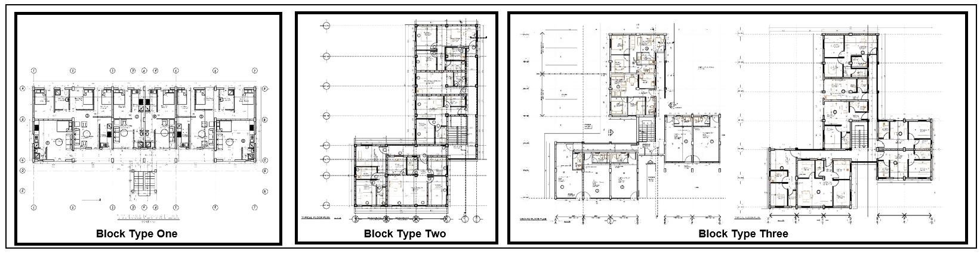
- Block Type: ☐ 1. Block type one ☐ 2. Block type two ☐ 3. Block type three
- Floor level of residential unit: ☐ 1. Ground floor ☐ 2. First floor
☐ 3. Second floor ☐ 4. Third floor ☐ 5. Fourth floor
- Number of bed room/Typology: ☐ 1. Studio ☐ 2. One bed room
☐ 3. Two bed room ☐ 4. Three Bed room
- Tenure type: ☐ 1. Owner ☐ 2. Tenant ☐ 3. Other
- When did you start to live here? ☐ 1. Recently ☐ 2. 1 year ago, ☐ 3. 2 years ago, ☐ 4. 3 years ago, ☐ 5. 4 years ago, ☐ 6. 5 years and above
- From which location of Addis Ababa, you came from ___________ ☐ 1. From city center ☐ 2. From the Periphery
- If the answer for question number ten is outside Addis Ababa, from which area ________________ ☐ 1. From city ☐ 2. From rural area
- The reason to came to this site ☐ 1. Family ☐ 2. For easily access to work place ☐ 3. Lottery ☐ 4. Purchase ☐ 5. Other ____________________
- Number of Children ☐ 1. None ☐ 2. One ☐ 3. Two ☐ 4. Three ☐ 5. Four ☐ 6. Five and above
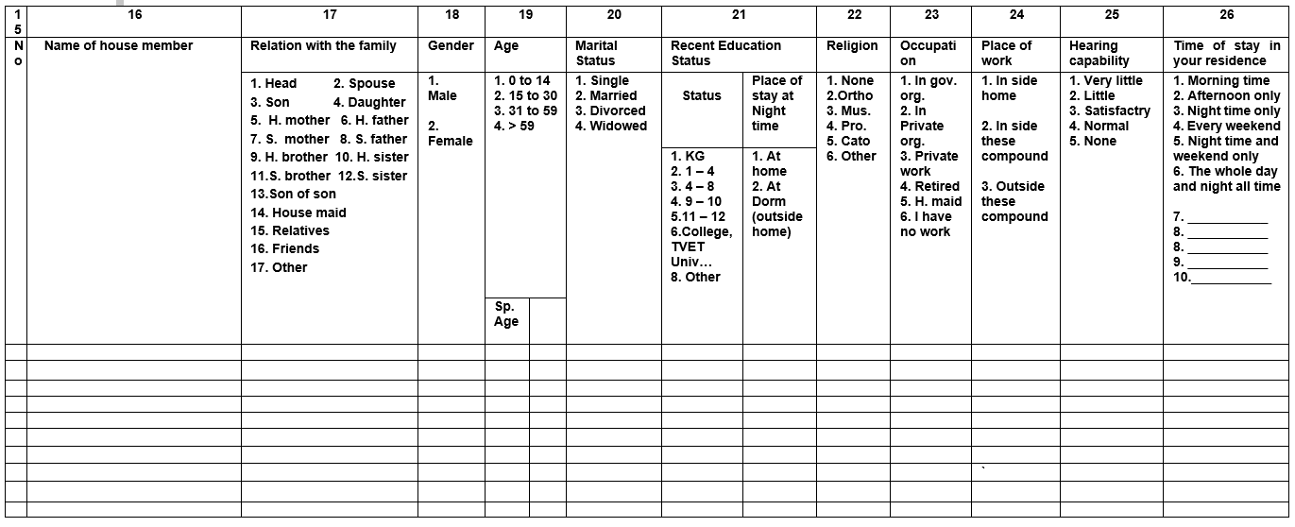
- The location and general overview of the residential unit related to street with map, section drawing, photographs. Photograph number _____
PART TWO: QUESTIONERY FOR AURAL PRIVACY ASSESSMENT
- What type of area do you want to prefer to live in residential area/condominium area ☐ 1. Silent area ☐ 2. Medium Noise pollution area ☐ 3. High Noise pollution area ☐ 4. Very high Noise pollution area ☐ 5. Undecided
- Please rate the level of noise disturbance for the given commercial unit type in these condominium site.
- None 1. very low 2. Low 3. Medium 4. high 5. very high
Super market ___Bar ___Bar and restaurant ___Shop ____Game zone ___Café and restaurant ____Bank ____Juice house ___ Post office ___ Pharmacy _____Boutique ____ Small factory ____ Restaurant ____ Children day care ____ Bakery ____ DS Tv ____ Fitness center _____ Photo house ___ Beauty salon ____ Breakfast house ____ Liquor store ____ Laundry ___

- The Degree of aural privacy related to the most influential problem of commercial unit type in your residence in different time interval. Use the following rate
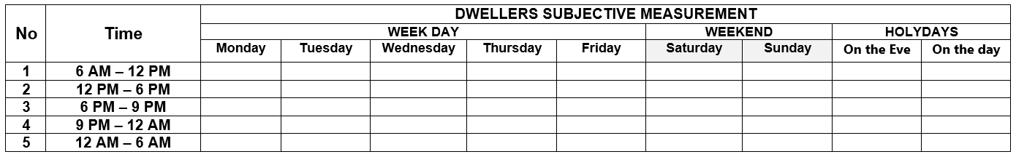
0. None 1. Very low 2. Low 3. Medium 4. High 5. Very high
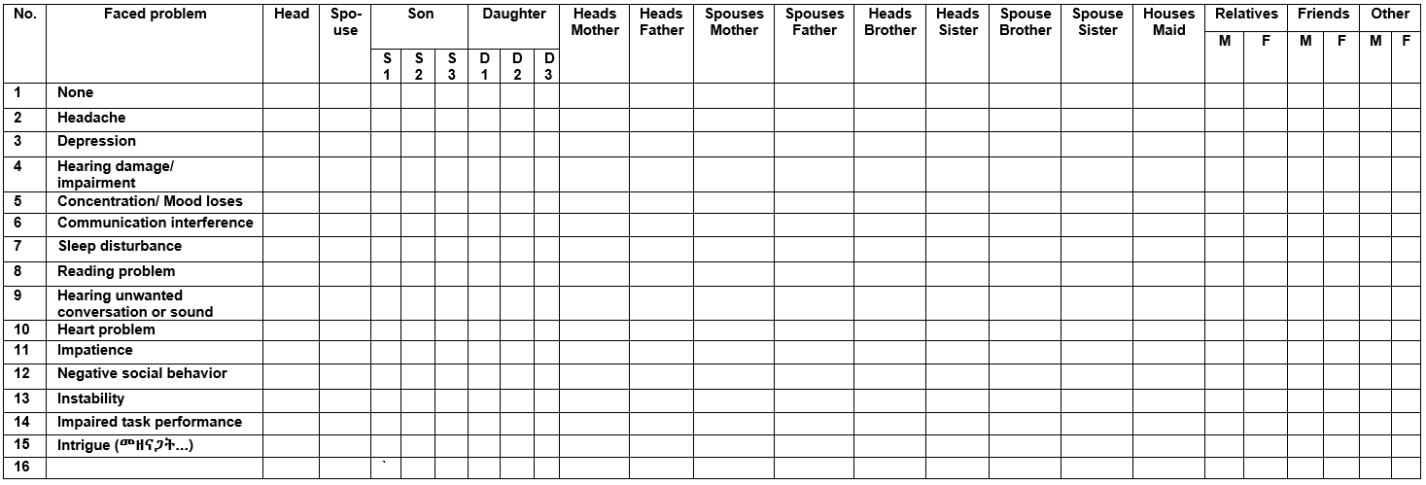
- What impacts your family face due to the existing commercial units noise disturbance? (More than one answer is possible)
- Is there any source of sound that affect your aural privacy rather than loudspeaker related to commercial units? ☐ 1. Yes ☐ 2. No ☐ 3. I have no idea
- Is there any source of sound that affect your aural privacy rather than loudspeaker related to commercial units? ☐ 1. Yes ☐ 2. No ☐ 3. I have no idea
- If the answer is ‘Yes’ for question number 29, what are they?
☐ 1. Generator ☐ 2. Peoples speech from the C. units ☐ 3. Utility sound during washing ☐ 4. N. from drank people fighting ☐ 5. Other -------
- Please rate the level of noise disturbance for the given source of sound from commercial units in these condominium site.
0. None 1. very low 2. Low 3. Medium 4. high 5. very high
Generator _____Peoples speech inside and near commercial units ______Utility sound during washing from commercial units _____Noise from drank people fighting inside and near commercial units _____
- If there is a problem of noise pollution, which side of your residence is more affected
☐ 1. Street facing ☐ 2. Back facing ☐ 3. Street and back facing ☐ 4. Both face to some extent ☐ 5. Right side ☐ 6. Left side ☐ 7. None of it
- What kind of commercial units do you think should be and shouldn’t be allowed under condominium site?
1. Strongly agree 2. Agree 3. Undecided 4. Disagree 5. Strongly disagree
Super market _____ Bar _____ Bar and restaurant _____ Shop _____ Game zone _____ Café and restaurant _____ Bank _____ Juice house _____ Post office _____ Pharmacy _____ Boutique _____ Small factory _____ Restaurant _____ Children day care _____ Bakery _____ DS Tv _____ Fitness center _____ Photo house _____ Beauty salon ____ Breakfast house _____ Liquor store _____ Laundry _____
- What is your attitude towards an increasingly aggressive use of loudspeaker by commercial units in your sleeping time?
☐ 1. The noise level needs to be reduced ☐ 2. Neutral ☐ 3. The noise level has to be continued ☐ 4. It has to be closed
- If there is sound pollution from commercial units, how students in these house/your children perform educational activity?
☐ 1. Studying and doing homework at school ☐ 2. Studying and doing homework after school immediately at home ☐ 3. Studying and doing homework at night time after noise level decreased ☐ 4. Have no choice studying and doing homework with high noise pollution situation ☐ 5. Other, specify _____________________________
- Do you adopt the noise pollution which come out of commercial units in your residence? ☐ 1. Yes ☐ 2. No ☐ 3. I have no idea
- If you get a chance, do you want to change your current block to another block in this compound or to another place due to aural privacy (for owner)
☐ 1. Yes ☐ 2. No ☐ 3. I have no idea
- If the answer for question number 37 is “Yes” Where? ☐ 1. Away from street side/pure residence in this compound ☐ 2. To the least sound polluted condo. site in the city center ☐ 3. On the above floors of the street side ☐ 4. Other, least ___________________
- If the answer for question number 37 is “No” Why ☐ 1. Wanting to live on the street side ☐ 2. Preferring sound rather than silent area ☐ 3. Hoping the sound pollution will decrease in the future ☐ 4. Other, specify ________
- If you know that there is a continuous problem of aural privacy, why don’t you change the house to another place (for tenant). Because it is ☐ 1. Its affordable ☐ 2. It is active and vibrant site ☐ 3. Closeness to work place and need for condo. ☐ 4. Other, specify________________________________
- Do you know the existence of pollution control legal instruments at the national level and complain if violated? ☐ 1. Yes ☐ 2. No ☐ 3. I have no idea
- Do you know who is the responsible control body on noise pollution?
☐ 1. Yes ☐ 2. No ☐ 3. I have no idea
- If the answer for question number 42 is ‘No’ why not ☐ 1. Lack of knowledge ☐ 2. Carelessness ☐ 3. Busyness ☐ 4. Other, __________
- If the answer for question number 42 is ‘Yes’ have you ever complained to a concerned body up on aural privacy in your residence concerning commercial unit? ☐ 1. Yes ☐ 2. No ☐ 3. I have no idea
- If the answer is ‘’Yes’’ for question number 42, to whom have you complained?
☐ 1. To the existing house owner association of the condominium ☐ 2. To Worda 4 of Kirkos sub city E. protection office ☐ 3. To Kirkos sub city E. protection office ☐ 4. To Addis Ababa E. protection office site ☐ 5. To existing police station ☐ 6. Other, specify _____________
- What action had been taken from the responsible authority to solve your appeal in reducing noise pollution?
☐ 1. No action ☐ 2. Notification and warning ☐ 3. Penalty
☐ 4. Closing ☐ 5. I have no idea
- If the answer for question number 46 is ‘No action’ what is the reason behind that? ☐ 1. Corruption ☐ 3. Ignorance (chelitegninet) ☐ 5. Lack of knowledge among officials ☐ 2. Servility (Ader bayinet) ☐ 4. Unorganized working structure ☐ 6. Other
- What is your level of satisfaction with the efforts that has been done by the responsible organ in increasing aural privacy of your residence?
☐ 1. Highly satisfied ☐ 2. Satisfied ☐ 3. Moderately satisfied ☐ 4. Not satisfied at all

PART THREE: COPING MECHANISM
- What coping mechanism used in your dwelling units to increase your aural privacy related to commercial units? More than one answer is possible.
☒ 1. Closing openings and filling the void by cloths and other material and it reduce the sound partially ☐ 2. By installing sound proof materials on the building elements
☐ 3. Changing the default building material which provided by government by sound proof building material ☐ 4. Closing openings and filling the void by cloths and other material but no change ☐ 5. Other, specify ---------------------
- What measures do you propose to control your aural privacy in your condominium housing? (indicate all you think are appropriate ☐ 1. Proper zoning ☐ 2. Awareness creation ☐ 3. Legal actions/law enforcement ☐ 4. Technological solutions ☐ 5. Complaint management
☐ 6. Regular inspection ☐ 7. If any specify -----------------

PART FIVE:
Over all characteristics of and condition of commercial unit with drawing and photographs.
- The type of commercial unit in the compound
- The location of commercial unit up on their type
- The size for commercial unit
- General overview of the above commercial unit type with maps and photographs
PART SIX:
Interview questionaries’
- House owner association of Gotera condominiums site
- Worda 4 of Kirkos sub city
- Kirkos sub city environmental office
- Addis Ababa environmental office
- Federal environmental protection office

- Have you ever received any complaint from the residents of Gotera condominium about aural privacy? (To 1,2,3,4)
- If the answer for the above question yes how frequent it is? (To 1,2,3,4)
- How did you measure if there is a problem sound pollution? (To 1,2,3,4)
- How did you handle and what solution is given to the resident’s anger? (To 1,2,3,4)
- Do you have complaint handling section or officer that visits and investigates the problem? (To 1,2,3,4)
- What is the duty of this body to protect the community’s aural privacy that comes out from commercial units’ loudspeakers and loud speech? (To 1,2,3,4,5)
- What is the major drawback’s in protecting resident’s aural privacy Gotera Condominium? (To 1,2,3,4,5)
- Are there any standard guidelines related to aural privacy or sound pollution for residential areas specifically in mixed residential environment? (To 1,2,3,4)
- Is there awareness at the authority level in condominium areas, loudspeakers and amplifiers that comes from commercial units that highly disturbs the privacy of the residents? (To 1,2,3,4,5)

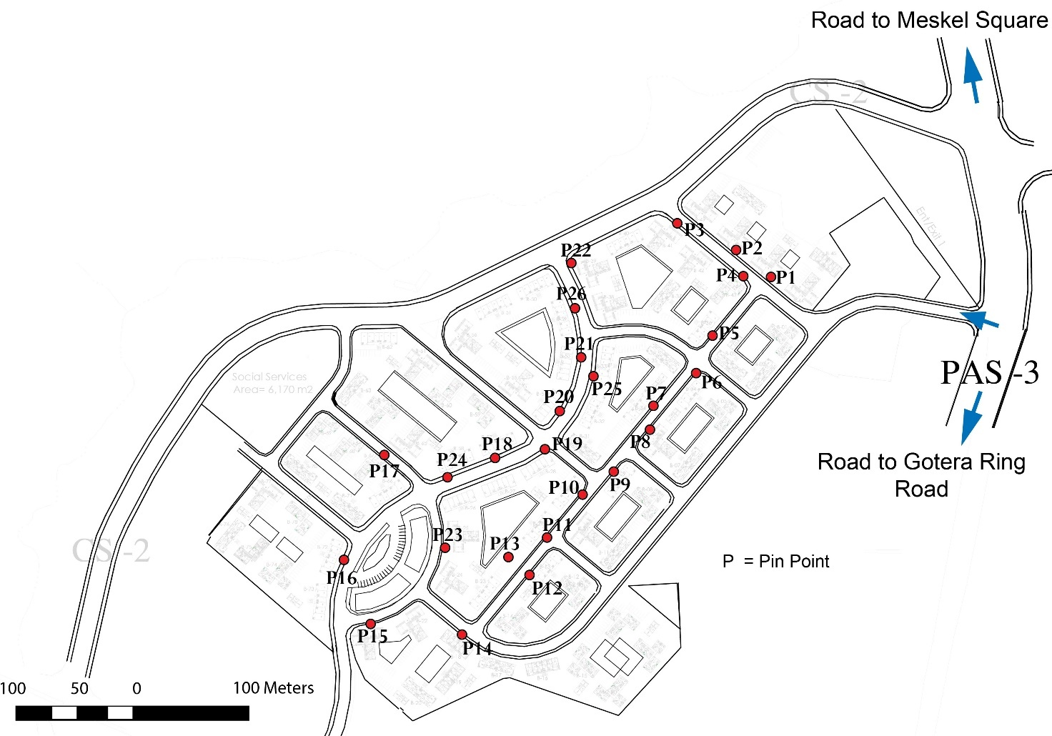
ANNEXE 2

Measured level of noise pollution from commercial unit types by using
Sound level meter/Smart phone

P = PIN POINT (In front of all commercial unit types with the distance of 1 meter)

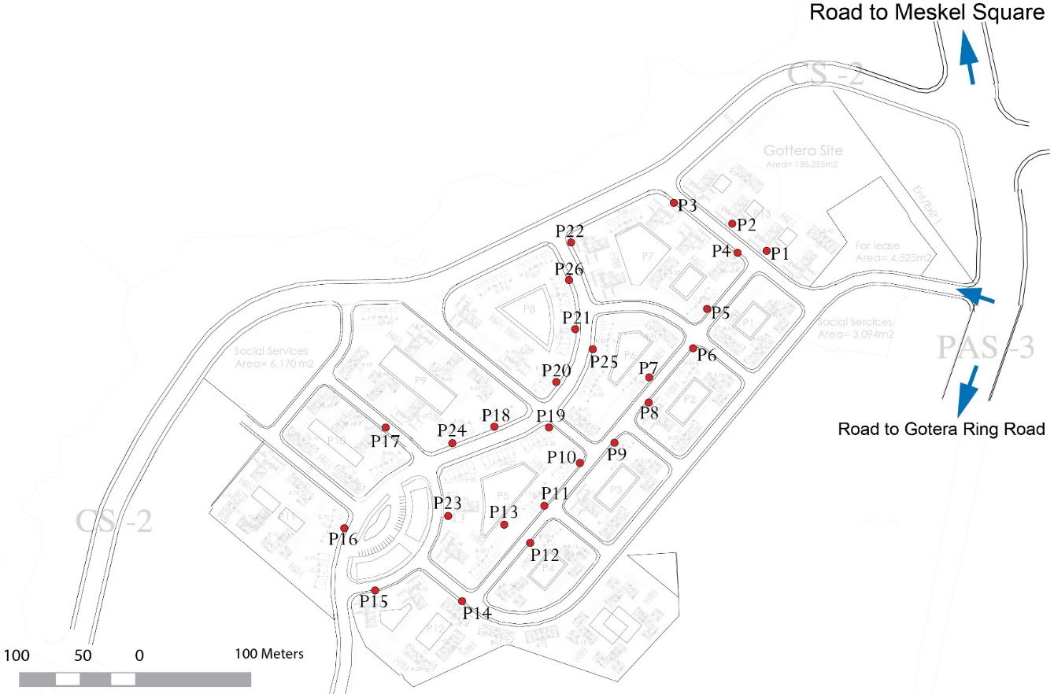
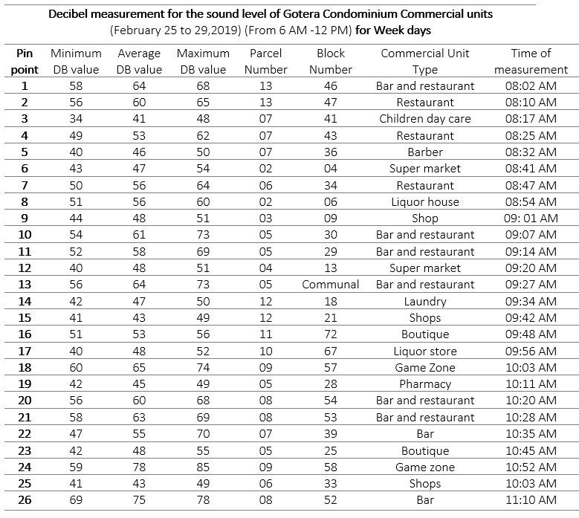
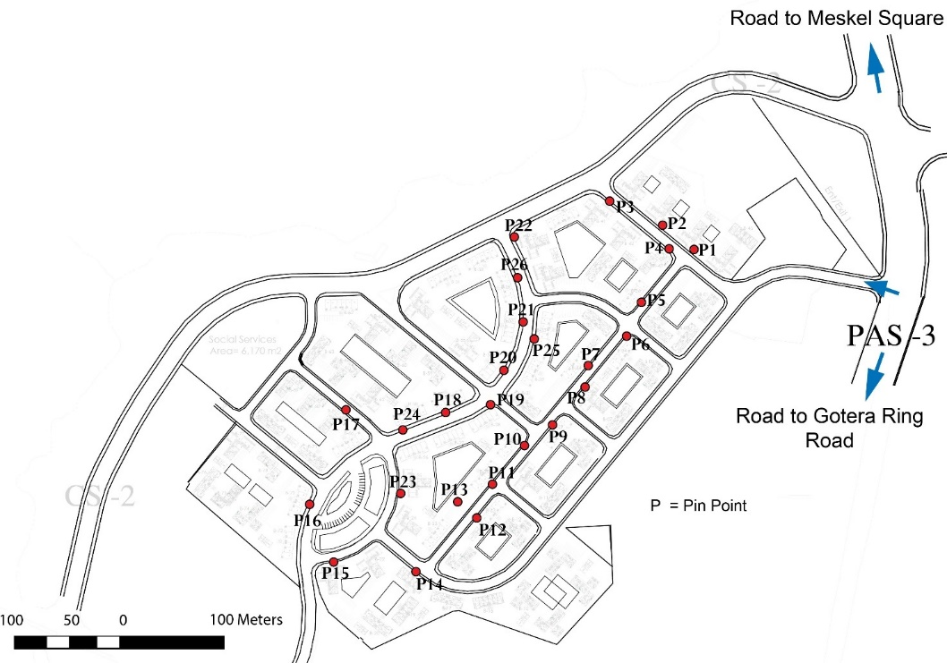

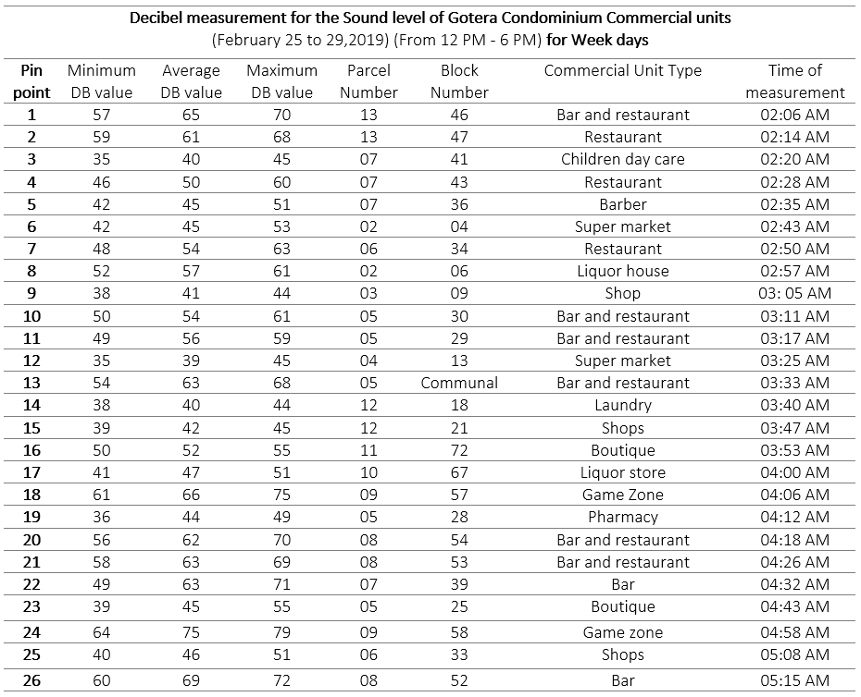
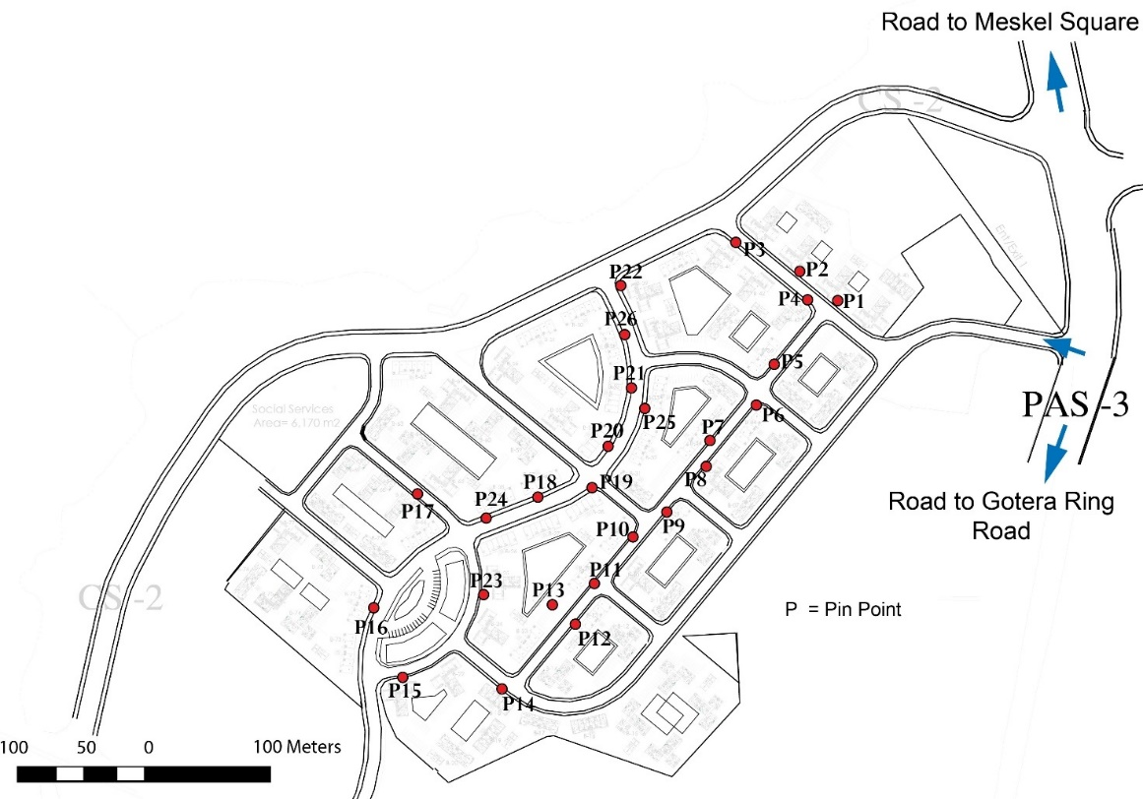
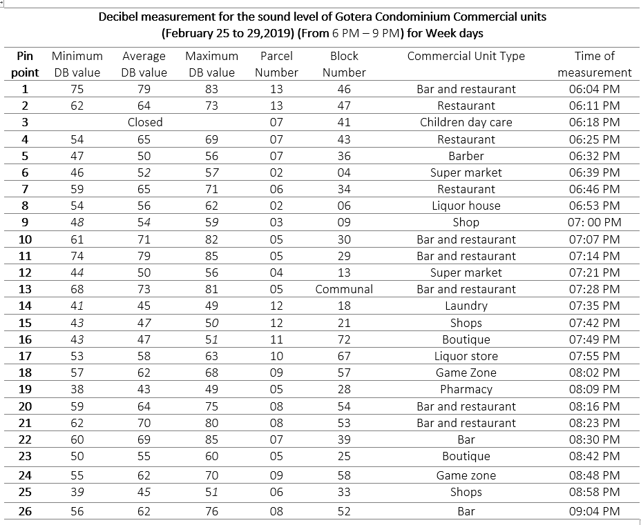
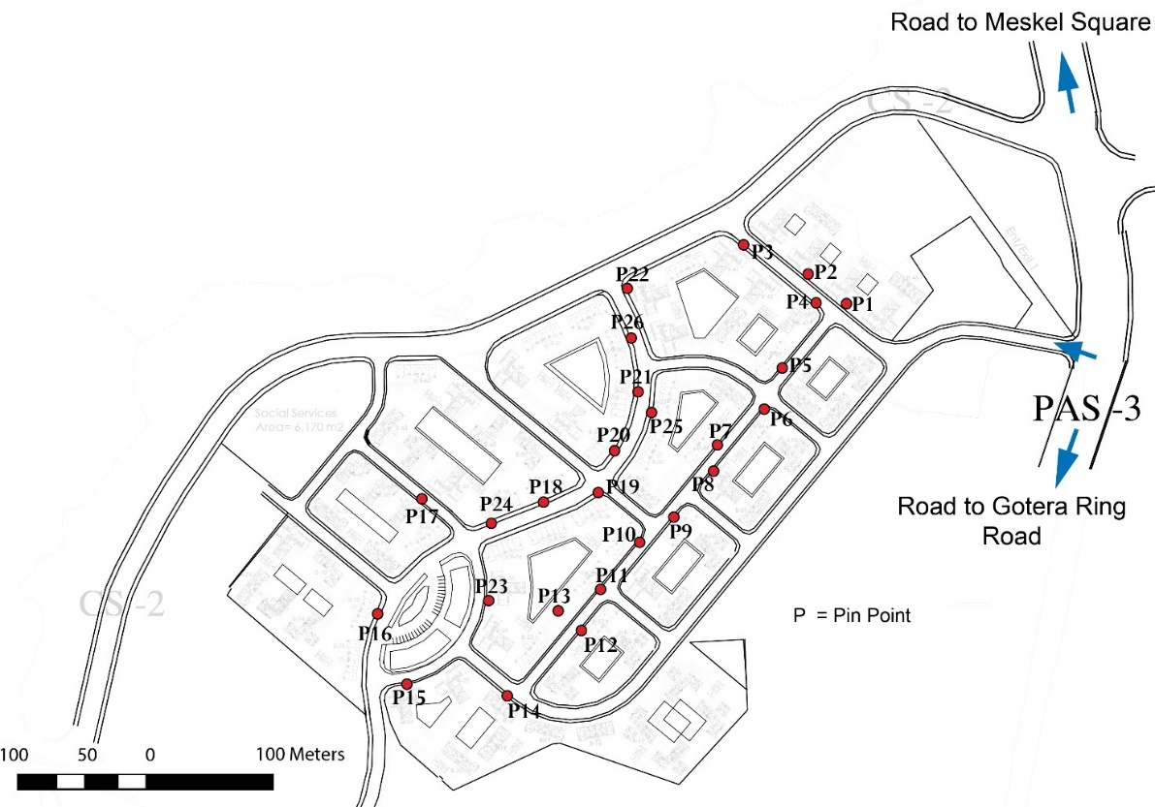
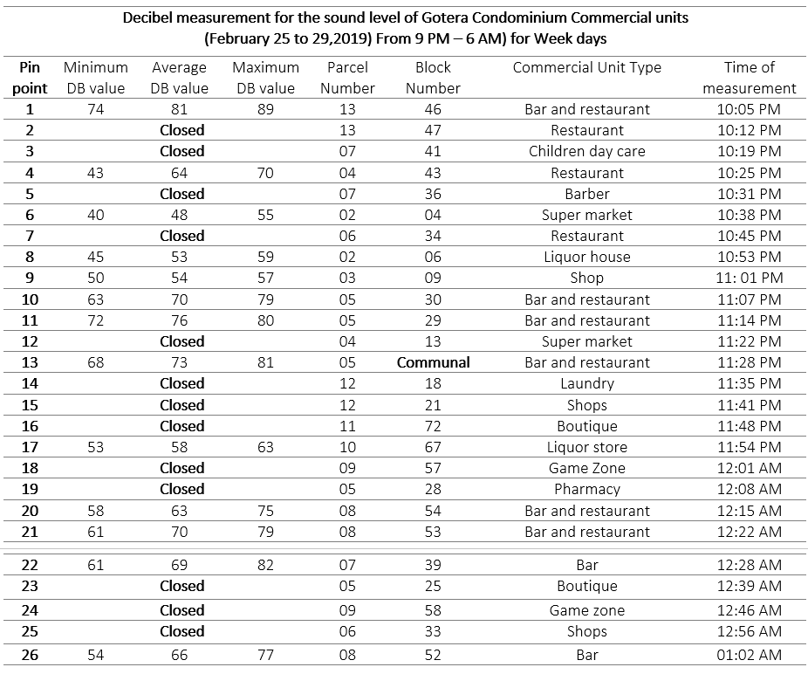
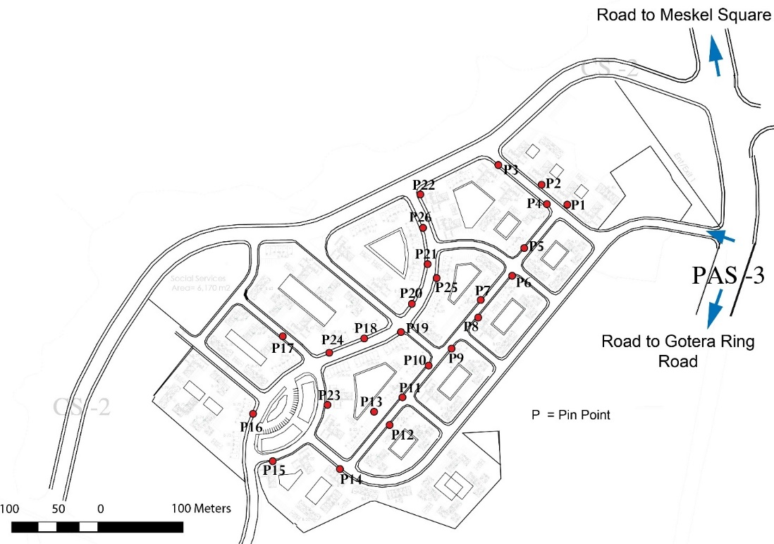
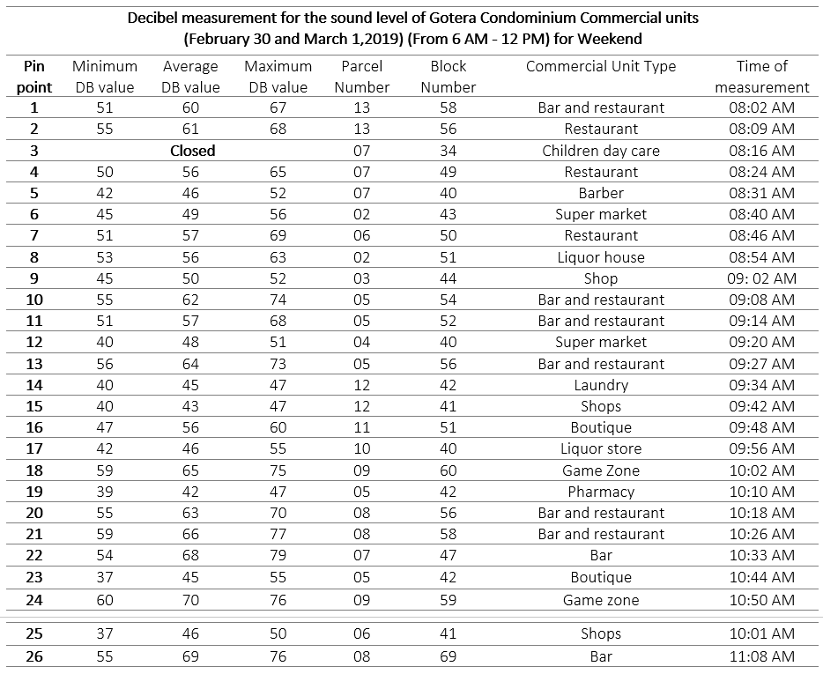
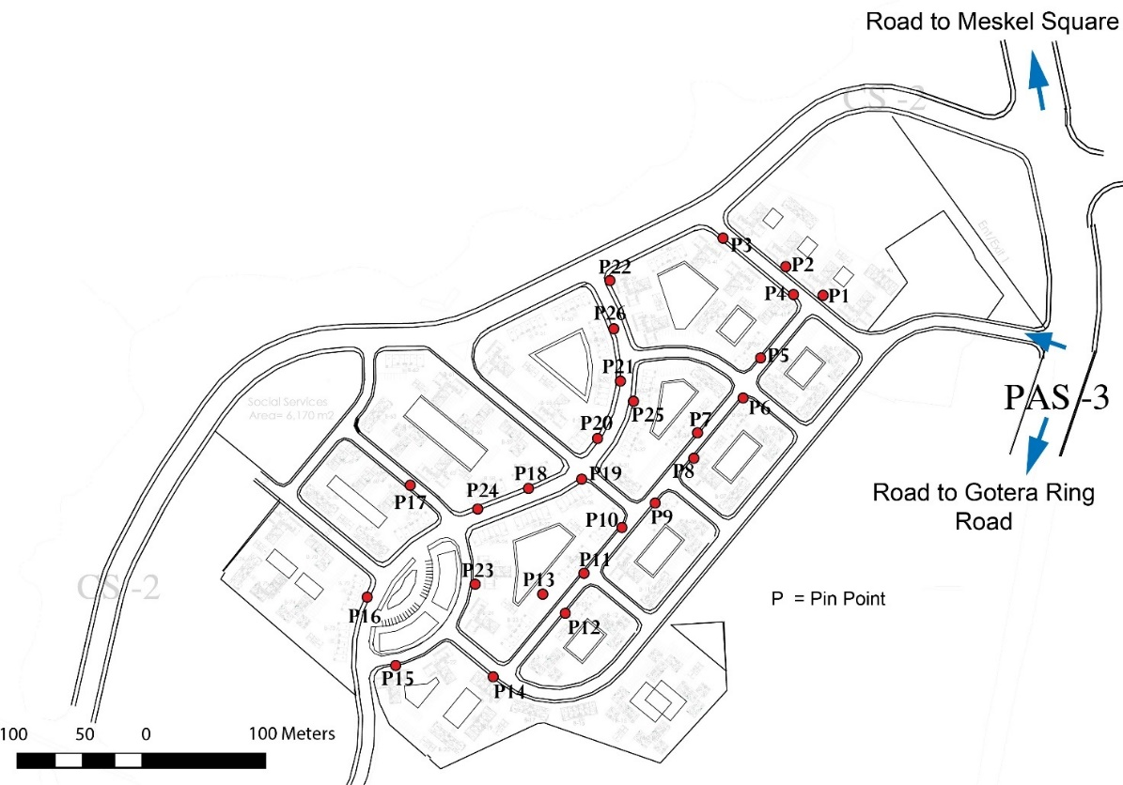
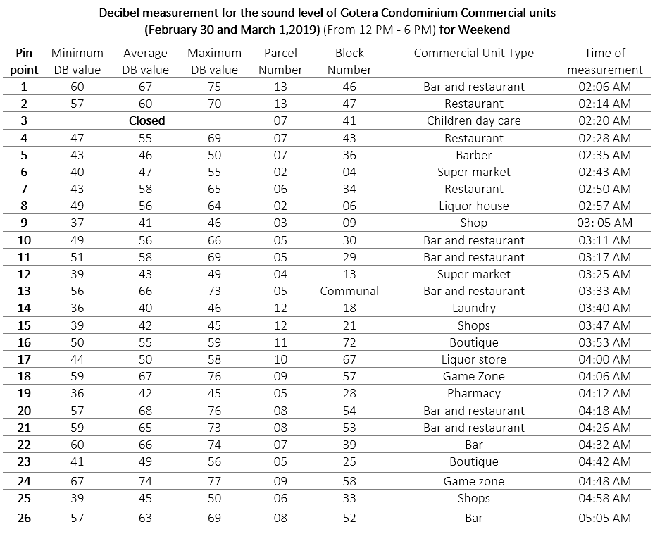
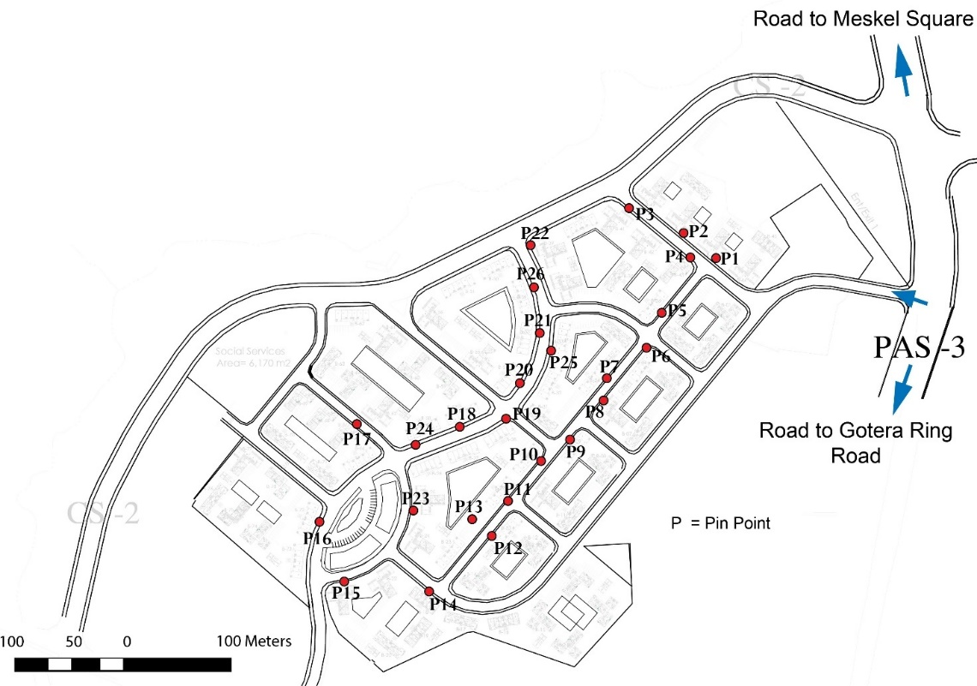
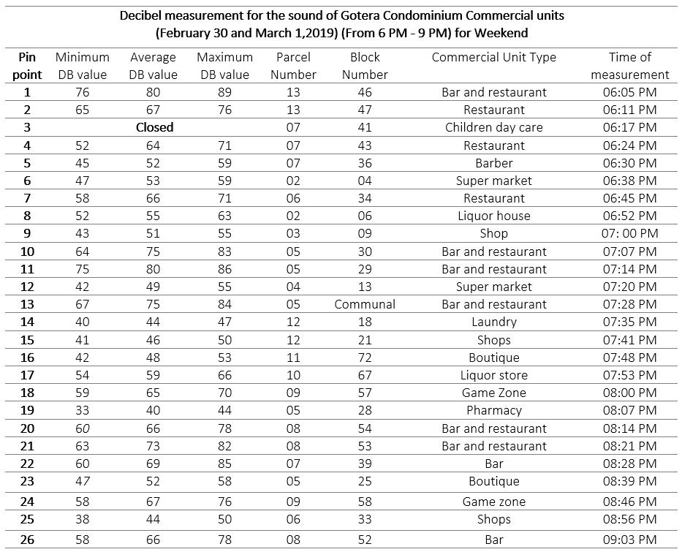
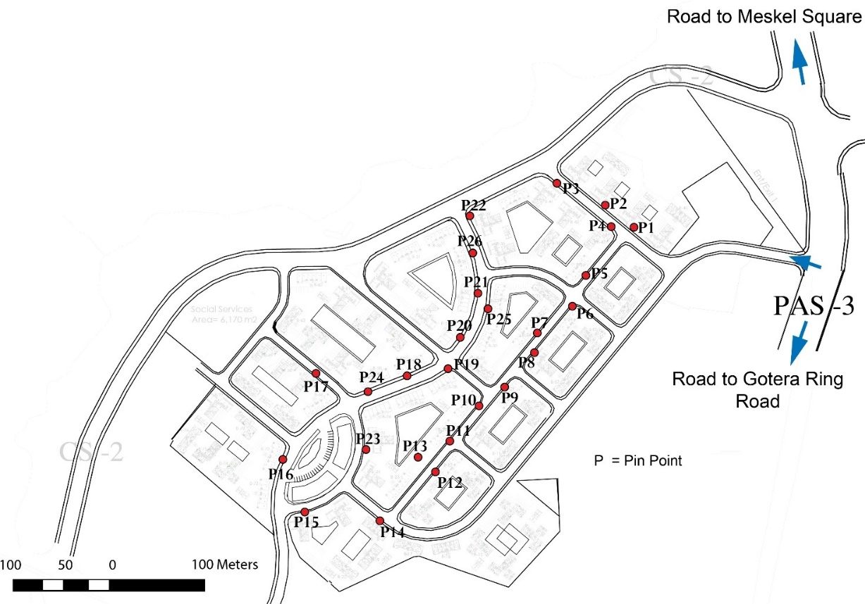
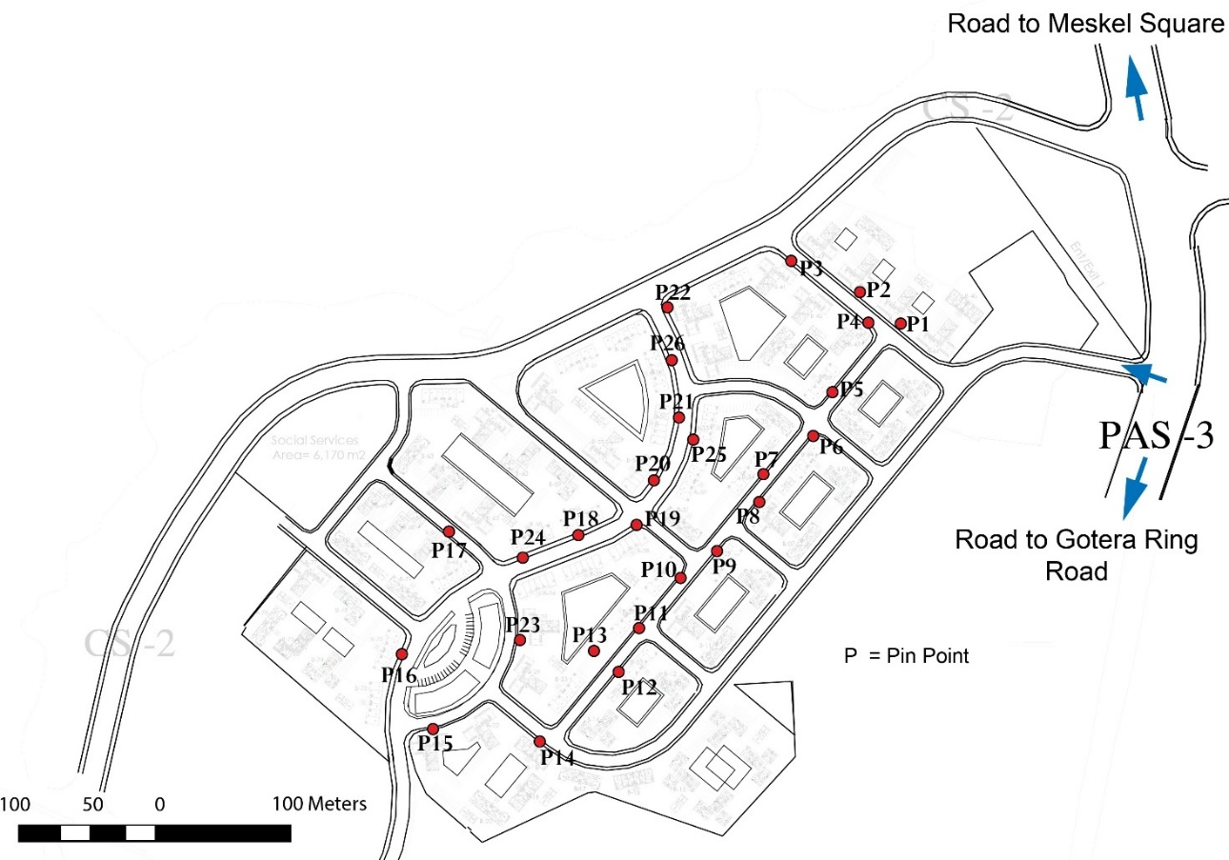
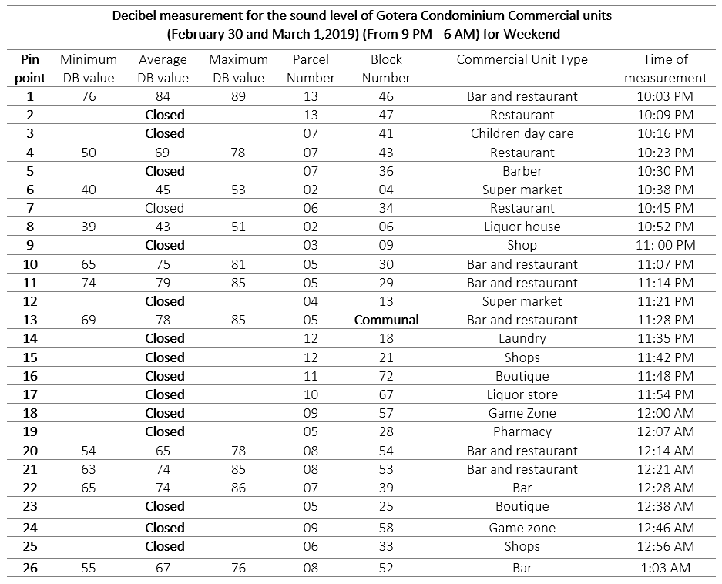

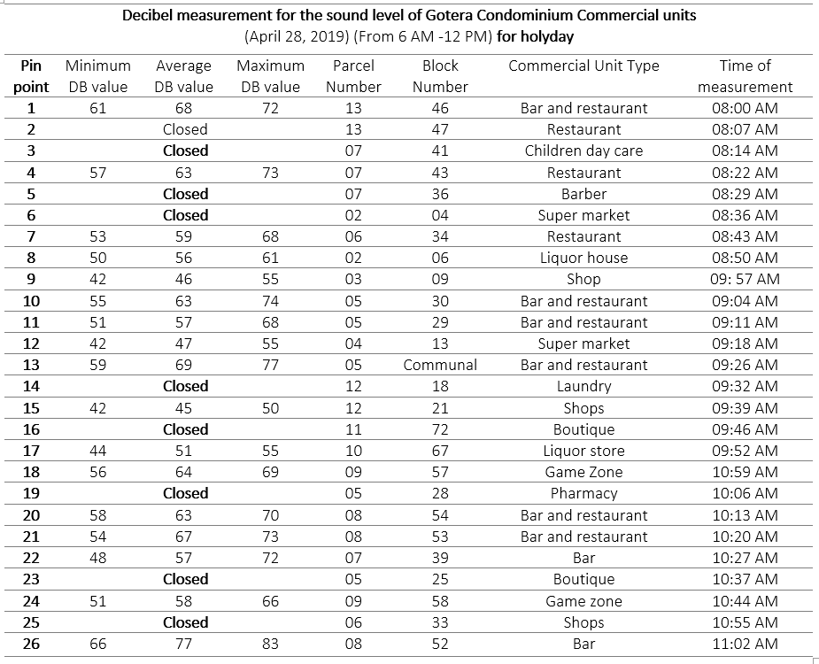
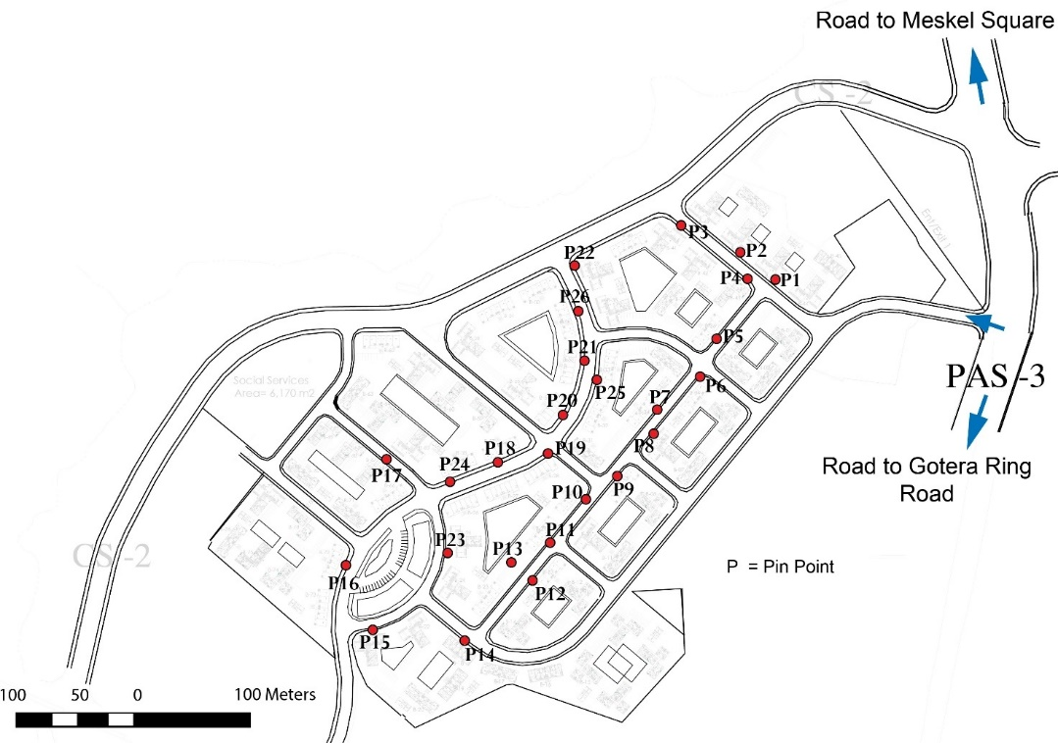
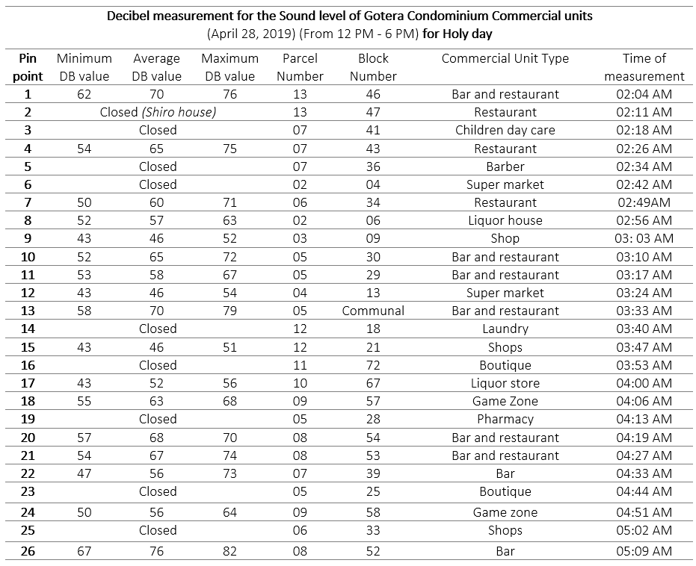
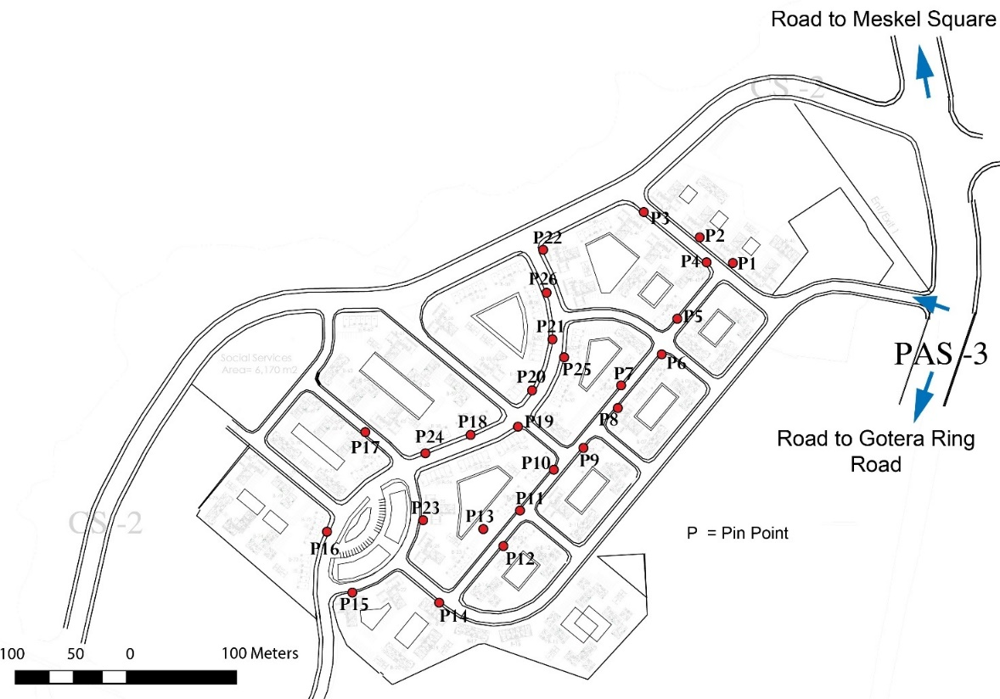
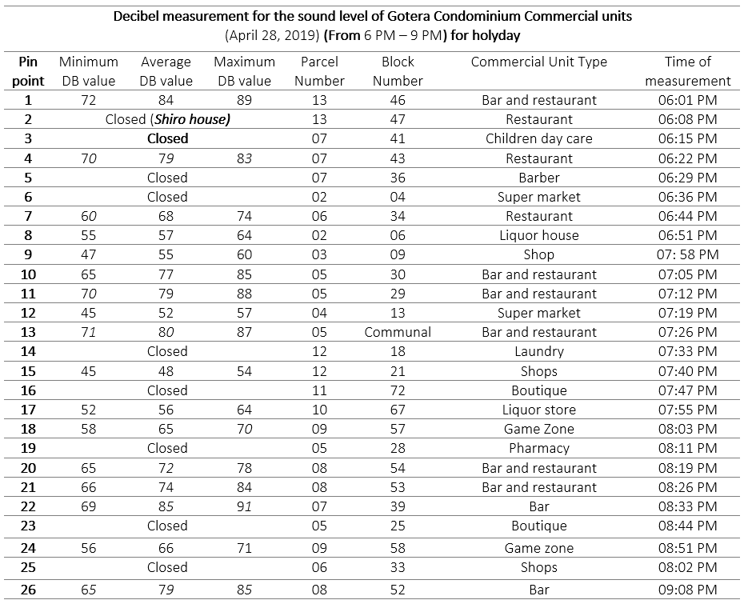
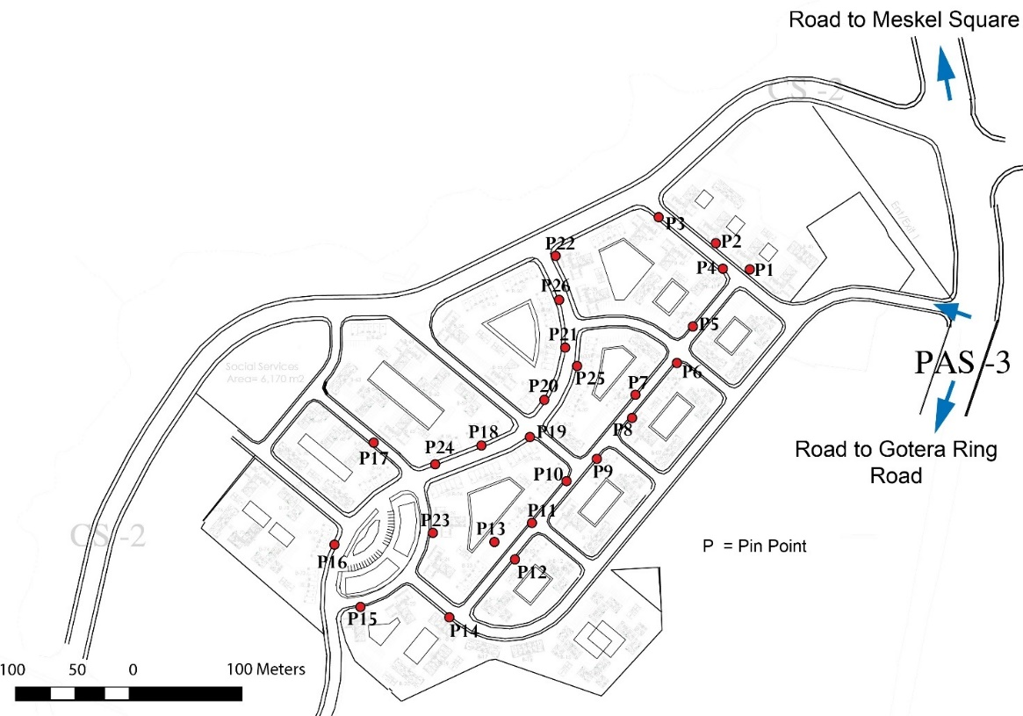
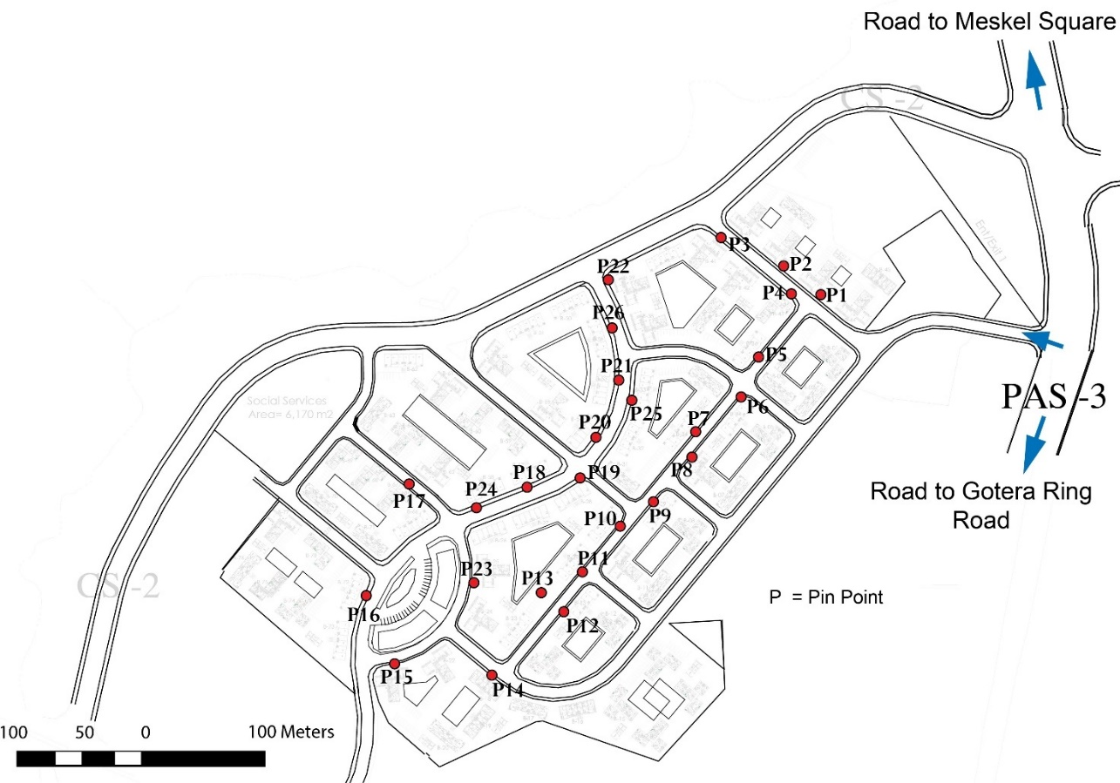
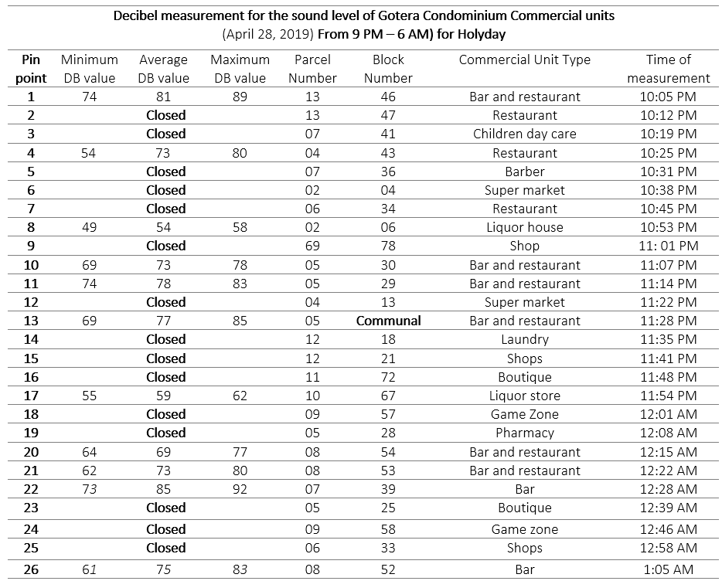

ANNEXE 3

“Digaf ena Kititl” Report Letter from Kirkos sub city regarding problems in condominium area


ANNEXE 4

Notification letter from HOA to Kirkos Sub city Woreda 4 regarding Noise pollution



ANNEXE 5

Report letter from Woreda 4 of Kirkos sub city regarding level of noise pollution by using sound level meter after notification from HOA

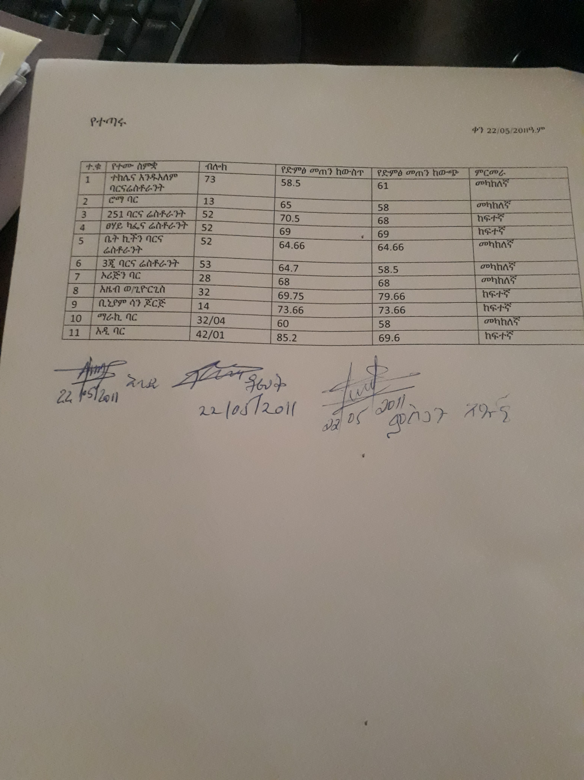
ANNEXE 6
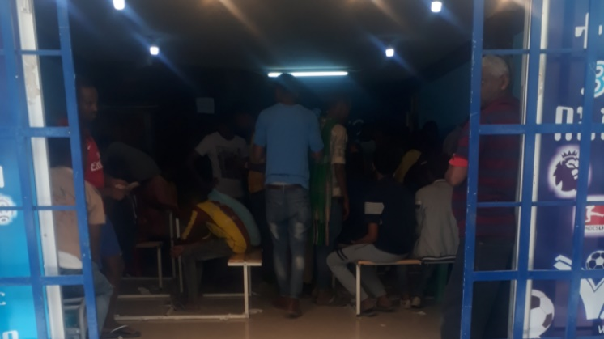
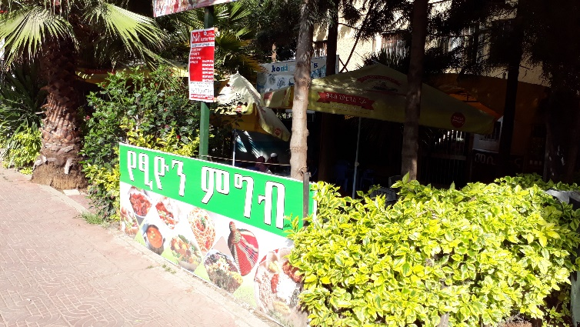
Important pictures during data collection

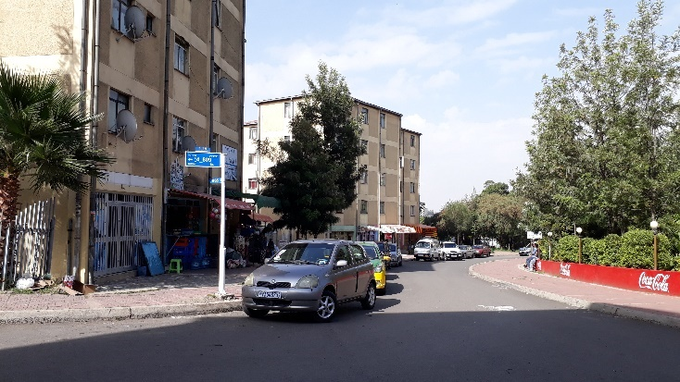
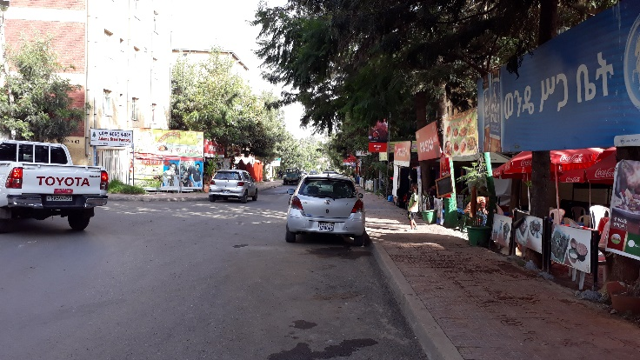
Restaurant with large extension Gambling with football match in Game zone

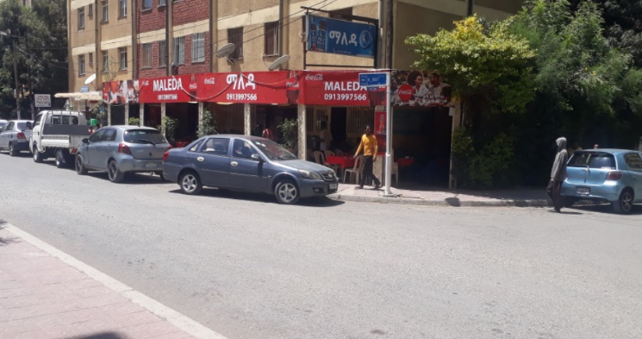
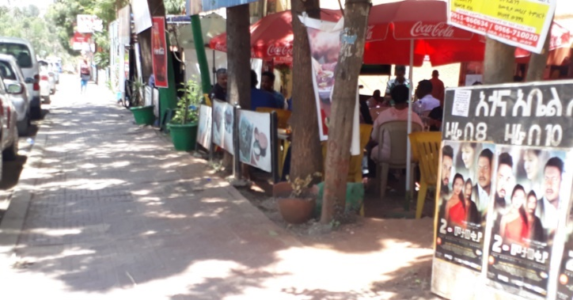
Rear side the site around “Gedam Sefer” Entrance of the site “Chechenia Sefer”

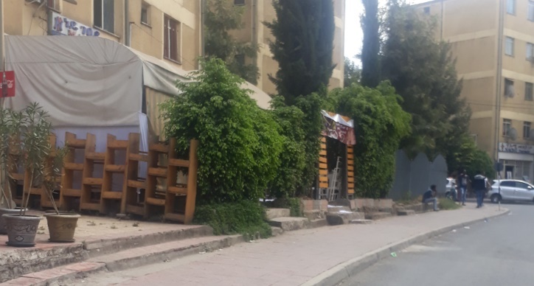
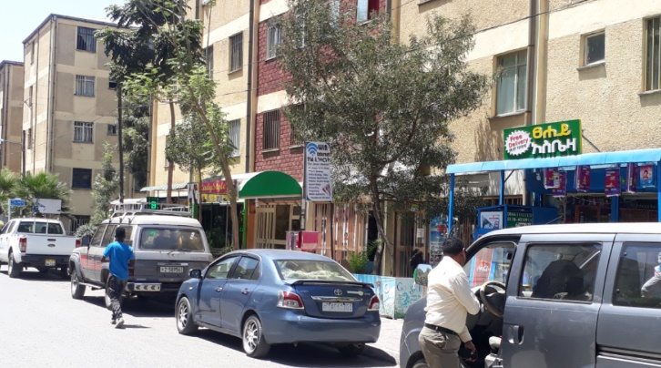
Bar and restaurant with two side extension Users seating at extended area of Bar & Res.

Shops, beauty salon, and mini market Bar and restaurant
ANNEXE 7

Support letter for data collection from EIABC (HASD chair)

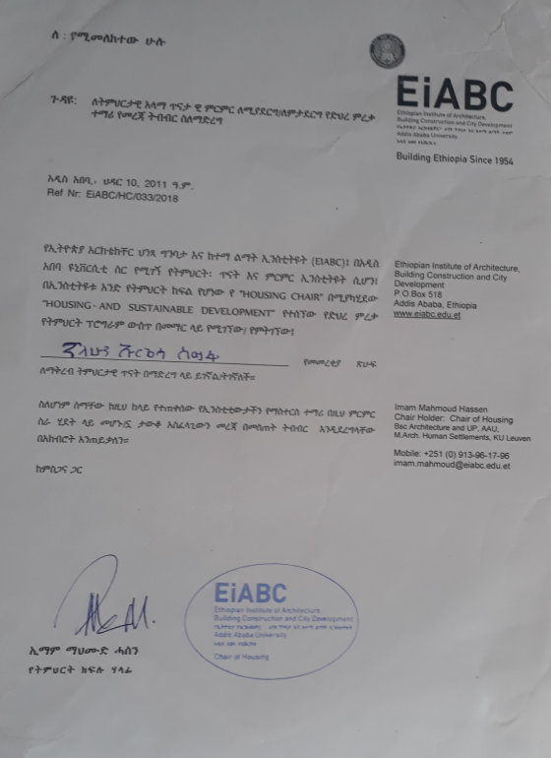

Privatness in this context implies the quality of being secluded from the disturbance of others
aural privacy is one major type of privacy related to or characterized by sound or pertaining to hearing
Ds Tv house implies a place of entertainment for watching football game such as Barclays premier league, Spanish La Liga, Germany Bundesliga, Italian seria and others.
Game zone implies a place of entertainment which contains play stations, pool
Gedam sefer implies a decent place
Chechenia Sefer implies a crowded place

