Molecular Characterization and Systematics of Korarima [Aframomum corrorima (Braun) P.C.M. Jansen] from Ethiopia

A Dissertation Submitted to
The Department of Microbial, Cellular and Molecular Biology

Presented in partial fulfillment of the requirements for the Degree of Doctor of Philosophy in Biology (Applied Genetics)
By
Dagmawit Chombe

Advisor: Professor Endashaw Bekele
Addis Ababa University
School of Graduate Studies
Addis Ababa, Ethiopia
May, 2017

Addis Ababa University
School of Graduate Studies

This is to certify that the thesis prepared by Dagmawit Chombe, entitled: “Molecular Characterization and Systematics of korarima [Aframomum corrorima (Braun) P.C.M. Jansen] from Ethiopia” and submitted in fulfillment for the requirements for the Degree of Doctor of Philosophy in Biology (Applied Genetics) complies with the regulations of the University and meets the accepted standards with respect to the originality and quality.

Approved by Examining Board:-

Prof. Endashaw Bekele (Principal Supervisor) ______________________
(External Examiner) _______________________
(Internal Examiner) _______________________
Dr. Gurja Belay (Chairman) ______________________

Dedication

I dedicate this thesis to MY FAMILY for nursing me with affection love and for their committed partnership in the achievement of my life

Declaration

I declare that the thesis hereby submitted by me for the Degree Doctor of Philosophy (PhD) in Biology (Applied Genetics) to the School of Graduate Studies of Addis Ababa University is my own independent work and has not previously been submitted by me or anybody else at another university. The materials obtained from other sources have been duly acknowledged in the thesis.

Signed on May 2017, The School of Graduate Studies, Faculty of Life Sciences, Addis Ababa University, Arat Kilo.

PhD Candidate ____________________________
Dagmawit Chombe

Abstract

Molecular Characterization and Systematics of Korarima [Aframomum corrorima (Braun) P.C.M. Jansen] from Ethiopia
Dagmawit Chombe (PhD candidate)
Addis Ababa University, 2017
Korarima [Aframomum corrorima (Braun) P.C.M. Jansen] is a perennial aromatic herb plant species native to Ethiopia. Morphologically it is classified in the genus Aframomum and family Zingebraceae. It is widely grown in Southwestern part for its fine flavor as a spice in various Ethiopian traditional dishes. A few molecular studies have been performed on this species and no molecular evidence for its taxonomy is present up to date. This study was conducted (1) to determine the magnitude of genetic diversity in cultivated korarima using inter simple sequence repeats, (2) to characterize the population genetic structure and relationships between cultivated and wild korarima using microsatellites, (3) to compare genetic diversity of cultivated korrarima for inter simple sequence repeats and microsatellites markers; and (4) to investigate the phylogenetic relationships in the genus Aframomum including A. corrarima based upon DNA sequences from plastid regions and the internal transcribed spacer region of nuclear ribosomal DNA. High levels of genetic diversity were detected in cultivated A. corrarima (Percentage of polymorphic band = 97.67 %, Gene Diversity = 0.35, Shannon information index = 0.52) when analyzed using seven inter simple sequence repeats. Analysis of molecular variance showed that 27.47% of the variation is attributed to the variation among population and 72.53% to the variation within population. The Fst (0.28) value showed a significant (p < 0.0001) genetic differentiation among populations. This was supported by the high coefficient of gene differentiation (Gst = 0.32) and low gene flow (Nm = 1.08) estimated. A neighbor-joining dendrogram, two and three dimentional PCoA clusters did not reveal clear pattern of clustering of populations based on their respective collection sites which may be because of human-mediated genetic material transfer between different localities. A total of 195 individuals representing 63 wild and 132 cultivated korarima were analyzed using newely developed eleven polymorphic microsatellite markers. Sequencing of these microsatellite regions of A. corrorima showed that most of the loci possess dinucleotide repetitive sequences. A total of 53 alleles were observed across all loci and individuals, with 32 different alleles being detected in cultivated korarima populations and 49 alleles in the wild korarima populations. Higher genetic variation was found in wild korarima than in the cultivated counterpart. Analysis of molecular variance and pair wise fixation index showed low divergence between cultivated and wild korarima populations also supported by neighbor-joining dendrogram and STRUCTURE analyses which failed to group cultivated and wild populations into two distinct clusters. The close genetic proximity between cultivated and wild korarima could be explained by historical and contemporary gene flow between the two gene pools. Comparison between inter simple sequence repeat and microsatellite markers were made in analyzing the genetic diversity of 129 korarima landraces. Ten Simple Sequence Repeats (SSR) and 7 Inter Simple Sequence Repeats (ISSR) markers were used separately. The percentage of polymorphic loci and the average Shannon diversity index among population were higher for SSR as compared to ISSR markers. These results indicated that SSRs revealed more genetic diversity than ISSR markers, although both ISSR and SSR methods provided useful genetic information. Higher variation was found within groups in the AMOVA analysis for both markers (104.30 % and 72.53 % for SSR and ISSR, respectively). Cluster analysis of ISSR and SSR using unweighted pair group method with arithmetic mean classified all the populations into two clusters, although SSR and ISSR markers led to dendrograms with different topologies. Thirtynine different taxa of Aframomum maintained in the gene bank plus six new genotypes of A. corrarima from Ethiopia were analyzed to investigate the phylogenetic relationships in the genus Aframomum. DNA sequence from chloroplast (trnL-trn-F) and nuclear ribosomal DNA (ITS) regions were used. The two molecular datasets and the combined data of the evolutionary relationships of the genus Aframomum resulted in generally congruent and compatible trees. However, disagreement was seen from combination of the three taxa of the genus Alpinia with the in-groups in trnL-trn-F region analysis. This showed the relatedness of the species within the two genera. The maximum parsimony analysis based on ITS and combined data strongly supported the monophyly of Aframomum. In addition the phylogenetic analysis suggested that A. corrorima is sister to the rest of the members of Aframomum. The present study revealed relatively higher level of genetic diversity in population of A. corrorima from southwestern part of Ethiopia using both inter simple sequence repeat and microsatellite markers. These findings should be taken into account when conservation action management policy for the species and site identification for in situ and ex situ conservation strategies are developed. Mizan Teferi II population in the ISSR analysis showed the highest genetic diversity. On the other hand Mizan-Teferi_ C2 and Masha_C2 displayed the highest genetic diversity in the ISSR analysis. Therefore, these populations should be considered as the key site in designing conservation strategies for this crop.
Key words:
Aframomum corrorima, Conservation, cpDNA, Gene Flow, Genetic diversity, Genetic Structure, ISSR, ITS, Korarima, Molecular phylogeny, SSRs

Acknowledgments
First and foremost, I thank God who does things in His will and time

It is a great time and opportunity to acknowledge all who had a part in this work. I honorably give credit and appreciation to my advisor Professor Endashaw Bekele for his unremitting guidance during my graduate career. I would like to thank him for providing me necessary research facilities and for allowing me to stay in his laboratory with suitable environment for undertaking my study. He provided me with valuable comments, suggestions and corrections from the inception of the proposal up to the final step. Without his expert advice and encouragement, it would have been unattainable to accomplish this study.

This work wouldn’t have been successful without the generous support of Prof. Tomas Bryngelsson and Dr. Mulatu Geleta allowing me to work in their Laboratory at Swedish University of Agricultural Science, Alnarp, Sweden. I would like to thank Prof. Tomas Bryngelsson for offering me a chance to stay in his laboratory. I would like to thank him for his immediate response to my questions and for his valuable comments in the write up process. I would like to thank Dr. Mulatu Geleta. He has been the best mentor during my tenure at Sweden. I admire his work ethic and enthusiasm with which he approach his research work and deeply appreciate him for being approachable. I am extremely thankful for his guidance, great words of encouragement and warmth which contributed greatly to my improvement as a scientist and also as a person. For that, I will be grateful. Many thanks to Dr. Abel Teshome for being there to listen whenever I needed him even while he was preparing himself for his PhD defense, helping me with troubleshooting experiments, providing technical insight, and teaching me the techniques used in my thesis research.

I do give credit to the staff members of plant breeding department, Swedish university of Agricultural science, in general, and to Dr. Helen Lindgren and Dr. Annelie Ahlman who helped me ordering all the materials I needed. I am indebted to thank Dr. Helle for her technical support. Special thanks to Betty, Tibebe, Wubaddis, Esayas, Kibrom, Karina and Evelyne for their kind advice and encouragement during my stay in Sweden.

My appreciation also goes to Jimma University for giving me study leave and providing me with laptop computer. The School of Graduate Studies, Addis Ababa University is acknowledged for giving me the chance to study and for financial support it provided for the research work. Due thank is also forwarded to the Department of Microbial, Cellular and Molecular Biology for facilitating my work. Special consideration is given to Dr. Kifle Dagne, Dr. Gurja Belay, Dr. Derege Beyene and Dr. Kasahun Tesfaye for their encouragement and assistance. I would like to extend my heartfelt gratitude to Ethiopian Institute of Biodiversity conservation (IBC) for allowing plant material transfer to Swedish University of agricultural Science, Alnarp, Sweden following the standard material transfer agreement.

I would like to show my gratitude to my husband Shihunegn Terefe for his numerous support and encouragement during the past years. This work would not be possible without his contribution to our family and I admire him for tolerating the hardships during my absence. I would like to thank my kids, Abel and Saron, for accompanying me throughout this journey and the tremendous joy they bring to my life.

Though it is what should have to be between brothers and sisters, I am very proud to consider and speak out my feelings to my younger Sister Girum Chombe who was dedicated to do all she can to place me on the track of success. I also appreciate my Brother Fisum Chombe for his support. I will never forget the ambition of my father, Mr. Chombe Tobiaw that paved my way to school and made me look for the highest thing that can be achieved in school. I didn’t forget the impression I had when he took me to graduate ceremony of Haramaya University every year when I was little. It was for the love and care of my mother Mrs. Zenebech Maseresha who used to give me special attention during exam periods when I was in elementary school, which made me enjoy examinations. So, all this achievement was possible due to my family care and support which I always appreciate.

Special thanks must go to Siniku Terefe who gave his one hundred percent effort during my data collection. It is my pleasure to express sincere thanks to Melese Terefe for helping me in constructing the map of the collection site and for his constant encouragement. I am also indebted to extend my sincere appreciation to my friends and colleagues: Genet G/yohanes, Meseret Solomon, Tsega Berehane, Bekele Serbesa, Fikadu Gadissa, Eddosa Fikiru and Dr.Zerihun Belay who had helped me in one way or another.
Dagmawit Chombe

May, 2017

Table of content
Contents Page
Abstract iii
Acknowledgments vi
Table of content ix
List of tables xi
List of Figures xiii
List of Appendices xvii
List of Abbreviations and Acronomys xviii
Chapter 1 Introduction 1
1.1. General Introduction 1
1.2. Objectives of the Study 5
1.2.1. General Objectives 5
1.2.2. Specific Objectives 5
1.3. Literature Review 6
1.3.1. Korarima (A. corrorima) taxonomy 6
1.3.2. Morphological and developmental description of korarima 7
1.3.3. Ecological distribution and reproductive biology of korarima 8
1.3.4. Seed composition 10
1.3.5. Importance of korarima 11
1.3.6. Uses of korarima essential oils 12
1.3.7. Factors that endangered korarima germplasm 13
1.3.8. Genetic diversity and species conservation 14
1.3.9. Morphological markers 16
1.3.10. Biochemical (enzyme) markers 17
1.3.11. Molecular markers 18
1.3.11.1. Inter simple sequence repeat (ISSR) 21
1.3.11.2. Simple sequence repeats (SSR) 22
1.3.12. Utilization of nuclear ribosomal internal transcribed spacer (ITs) and chloroplast trnL-trnF sequence for phylogenetic Studies 24
1.3.12.1. Internal transcribed spacer (ITS) 25
1.3.12.2. Chloroplast trnL-trnF region 26
Chapter 2 Genetic Diversity Analysis of Cultivated Korarima [Aframomum corrorima (Braun) P.C.M. Jansen] Populations from South Western Ethiopia Using Inter Simple Sequence Repeats (ISSR) Marker 29
2.1. Introduction 29
2.2. Materials and methods 30
2.2.1. Plant materials 30
2.2.2. DNA extraction 30
2.2.3. PCR Amplification and gel electrophoresis 31
2.2.4. ISSR data scoring and analysis 32
2.3. Result 35
2.4. Discussion 45
2.4.1. Genetic diversity 45
2.4.2. Genetic structure and gene flow 46
2.4.3. Genetic distance and cluster Analysis 47
2.5. Conclusions 49
Chapter 3 Genetic structure and relationships within and between cultivated and wild korarima [Aframomum corrorima (Braun) P.C.M. Jansen] in Ethiopia as revealed by simple sequence repeat (SSR) markers 50
3.1. Introduction 50
3.2. Material and methods 51
3.2.1. Plant material 51
3.2.2. DNA extraction 51
3.2.3. DNA database searches and development of Genomic-SSR markers 53
3.2.4. SSR PCR amplification 54
3.2.5. Gel electrophoresis and genotyping 55
3.2.6. Confirmation of SSRs using DNA sequencing and analysis 55
3.2.7. Data analysis 56
3.3. Results 58
3.4. Discussion 75
3.4.1. Genomic-SSR markers for A. corrorima 75
3.4.2. Genetic diversity 76
3.4.3. Genetic structure and gene flow 78
3.5. Conclusion 81
Chapter 4 Comparison of ISSR and SSR markers in assessing genetic diversity among cultivated korarima (Aframomum corrorima) from southwestern Ethiopia 83
4.1. Introduction 83
4.2. Materials and methods 84
4.3. Results 85
4.4. Discussion 92
4.5. Conclusion 95
Chapter 5 Phylogeny of Aframomum (Zingebraceae) based on nuclear ribosomal internal transcribed spacer (ITs) and chloroplast trnL-trnF sequence, focusing on the inclusion of a species native to Ethiopia 96
5.1. Introduction 96
5.2. Materials and methods 99
5.2.1. Plant materials and DNA extraction 99
5.2.2. Out-group selection 99
5.2.3. PCR amplification and DNA sequencing 101
5.2.4. Sequence editing and alignment 102
5.2.5. Phylogenetic analyses 102
5.2.6. Partition homogeneity test 103
5.3. Result 104
5.3.1. Nuclear DNA dataset analysis 104
5.3.2. Chloroplast DNA dataset analysis 109
5.3.3. Combined dataset analysis 111
5.4. Discussion 114
5.4.1. Phylogenetic information of the ITS and trnL-tmF sequences 114
5.4.2. Phylogeny of Aframomum 115
5.5. Conclusion 118
6. Overall Summary and Recommendations 119
7. Refference 122
8. Appendices 152

List of tables
Page
Table 1 Comparison and summary of the most commonly used molecular marker systems in cereals (adapted from FAO, 2003)…………………………………………………...….21
Table 2 Description of Aframomum corrorima samples collected from different sites in Ethiopia..…………………………………………………………………………………34
Table 3 List of primers, Repeat motifs, annealing temperature and amplification patternused for PCR optimization………………………………………………………………………...36
Table 4 Characteristics of 7 inter simple sequence repeat (ISSR) primers selected for use in this study……………………………………………………………………….……………..37
Table 5 Gene diversity estimators for populations of Aframomum corrorima from southwestern part of Ethiopia based on results of seven inter simple sequence repeat (ISSR) primers…………………………………………………………………………………...39
Table 6 Nei's original measures of genetic identity and genetic distance in 13 populations of Ethiopian A. corrorima……………………………………………………………..……40
Table 7 Analysis of molecular variance (AMOVA) of Aframomum corrorima populations based on seven ISSR primers…………………………………………………………………...42
Table 8 Passport data of A. corrorima samples collected from different sites in Ethiopia……...56
Table 9 List of primer-pairs developed and used to amplify the SSR loci in this study………...62
Table 10 Estimates of different genetic diversity parameters and gene flow for A. corrorima at each polymorphic microsatellite loci…………………………………………………….66
Table 11 Percentage of polymorphic loci (PPL), Shannon’s diversity index (I),observed heterozygosity (Ho) and expected heterozygosity (He) for Ethiopian cultivated and wild populations of Aframomum corrorima…………………………………………….….…68
Table 12 SSR-based analysis of molecular variance (AMOVA) for the cultivated and wild korarima populations………………………………………………………………….....69
Table 13 F_{ST} based genetic differentiation of the korarima gene pool at various levels………...70
Table 14 Nei’s standard genetic distance and pair-wise F_{ST} significance between the 21 pairs of korarima populations…………………………………………………………………….71
Table 15 Genetic diversity estimates of ten microsatellite loci for 13 cultivated populations of A. corrarima…………………………………………………………….…...………….…..88
Table 16 Percent polymorphic Loci (PPL) and Shannon diversity index (I) of 13 populations of korarima (A. corrarima) from South western Ethiopia using SSR and ISSR marker…………………………………………………………………………….……...90
Table 17 Nei’s genetic distance (below diagonal) and genetic identity (above diagonal) between the 13 pairs of korarima populations (A) using SSR markers and (B) Using ISSR markers…………………………………………………………. ……………………….91
Table 18 Analysis of Molecular variance for 13 populations of cultivated korarima using SSR and ISSR markers……………………………………………………………………......92
Table 19 List of taxa and gene bank accession numbers for nuclear and chloroplast DNA sequence in species of Aframomum and out-group…………………………………......103
Table 20 Comparison of the variation in the nuclear ribosomal region, the chloroplast non-coding regions, and the combined data set…………………………………………......108

List of Figures
Page
Figure 1 ISSR profile from amplification of genomic DNA of 38 individuals of A. corrorima with primers UBC-825 (A) and UBC-834 (B). (M = A 100-bp ladder)……………………........36
Figure 2 Neighbor-joining clustering of 129 individuals of Aframomum corrorima based on ISSR data generated from seven primers. The algorithm is based on Jaccard’s coefficients of similarity ......................................................................................................................41
Figure 3 Dendrogram of the 13 populations of Aframomum corrorima from Ethiopia generated from ISSR data using un-weighted pair group method of arithmetic means (UPGMA). The algorithm is based on Jaccard’s coefficients of similarity ……………………….....42
Figure 4 Two dimensional representation (2D) of principal coordinate analysis of genetic relationships among 129 individuals of Aframomum corrorima from Southwestern part of Ethiopia……………………………………………………………………………..........43
Figure 5 Three dimensional representation (3D) of principal coordinate analysis of genetic relationships among 129 individuals of Aframomum corrorima from Southwestern part of Ethiopia……………………………………………………………………………..........44
Figure 6 Regional map of Ethiopia showing the wild and cultivated korarima collection sites, SNNPR in the key corresponds to Southern Nations, Nationalities, and People’s Region ……………………………………………………………………………........................52
Figure 7 Short segments of the alignment of microsatellite containing sequences of Aframomum corrorima and Alpinia oxyphyla species for 10 of the 11 SSR loci used in the present study. The locus names are given to the right of each aligned sequences. The SSR region for each locus is shown by curly bracket. Note: sequencing of Afco_2 failed and hence is not included here…………………………………………………………...60
Figure 8 List of private alleles unique to one of the four populations shown on the right and its frequencies at six SSR loci ……………………………………………………………...61
Figure 9 Neighbor-joining tree based on pair-wise simple matching dissimilarity index showing the genetic relationships among 101 individuals randomly re sampled from cultivated and wild korarima populations (five individuals from 19 population and three individuals from two populations). Blue color indicates individuals from cultivated populations whereas red represents individuals from wild population…………….…….70
Figure 10 UPGMA dendrogram based on pair wise simple matching dissimilarity index showing the genetic relationships among 21 Ethiopian cultivated and wild korarima populations using SSR markers. Korarima populations were grouped in to two: group I comprising 13 cultivated and 2 wild populations and group II comprising 5 wild and 1 cultivated populations…..…………………………………………………………..……….…..…..74
Figure 11 NJ dendrogram based on pair wise simple matching dissimilarity index showing the genetic relationships among Ethiopian cultivated and wild korarima populations using SSR markers………………………………………………………………..………….…72
Figure 12 A biplot detected the maximum peak at K=2 (the optimum number of clusters) based on Evanno et al. (2005) prediction……………………………………………………....73
Figure (13A) Estimated population structure at K = 2 for the 195 individual korarima genotypes ordered by type and membership fraction (qi). Same colors in different individuals indicate that they belong to the same cluster. Different colors for the same individual indicate the percentage of the alleles that it shared with each cluster.(13B) STRUCTURE bar graphs of the entire korarima gene pool in 21 pre-determined populations (x-axis) at K=2. The text above the figure refers to korarima types; the text below the figure refers to the different populations………………………………………………………………74

Figure 14 Dendrogram of the 13 populations of Aframomum corrorima from Ethiopia generated from SSR data using un-weighted pair group method of arithmetic means. The algorithm is based on pair-wise simple matching dissimilarity index………………………….......91
Figure 15 One tree of 488 equally most parsimonious trees showing branch lengths. The in-group shows very short branch lengths reflecting the homogenous sequences………...107
Figure 16 Maximum-parsimony bootstrap consensus tree generated from a phylogenetic analysis of DNA sequence data from the internal transcribed spacers of the nrDNA of Aframomum species and eleven out-group species. Bootstrap values of >50 % are indicated above the branches. The arrow indicates the node that collapses in the strict consensus trees.The vertical bars show the out-group species and putative groups I, II and III were indicated within braces………………………………………………...………108
Figure 17 Maximum-parsimony bootstrap consensus tree generated from a phylogenetic analysis of DNA sequence data from trnL/F of the cpDNA of Aframomum species and eleven out-group species. Bootstrap values of >50 % are indicated above the branches. The vertical bars show the out-group species and putative groups were indicated within braces………………………………………………………………...…………………110
Figure 18 One tree of 170 equally most parsimonious trees generated from combined data matrix…………………………………………………………………………………...112
Figure 19 Maximum-parsimony bootstrap consensus tree generated from a phylogenetic analysis of combined DNA sequence data from the internal transcribed spacers of the nrDNA and trnL-trnF of the cpDNA of Aframomum species and eleven out-group species. Bootstrap values of >50 % are indicated above the branches. The vertical bars show the out-group species and putative group was indicated within braces……………………………......113

List of Appendices
Page
Appendix 1: Characteristics of 23 microsatellite primers developed for Aframomum corrorima (The bold one are used for genetic diversity analysis)……………………………...….151
Appendix 2 Elecropherogram image revealed by capillary gel electrophoresis which represent heterozygous and homozygous forms of alleles for the microsatellite loci studied, the horizontal axis represent the peak size in base pair and the vertical axis correspond to the relative fluorescence unit (RFU). The sample code is written on the top of the figure..............................................................................................................................152
Appendix 3 Graphical representation of mean likelihood L(K) and variance per K values generated by STRUCTURE on data set containing 548 individuals across 12 polymorphic EST-SSR loci…..………………………………………………………..162
Appendix 4 a and b Agarose gel electrophoresis picture for applified products of ITS and cpDNA region ………………………………………………………………………………….168

List of Abbreviations and Acronomys

AFLP =Amplified Fragment Length Polymorphism
AMOVA =Analysis of Molecular Variance
Bp = Base Pair
CTAB = Cetyl Trimethyl Ammonium Bromide
ddH2O = Double distilled water
DNA = Deoxyribo Nucleic Acid
dNTPs = Deoxynucleoside triphosphate
EST = Expressed Sequence Tags
FAO = Food and Agriculture Organization
GD = Genetic diversity
IBC = Institute of Biodiversity Conservation
ISSR = Inter Simple sequence repeats
mM = Mili Morlar
NCBI = National Centre for Biotechnology Information
NJ = Neighbor Joining
NPB = Number of Polymorphic Band
NTSYpc = Numerical Taxonomy and Multivariate Analysis System
PCO = Principal Coordinate Analysis
PCR = Polymerase Chain Reaction
PPB = Percentage Polymorphic Band
Pmol = Pico Molar
RAPD = Random Amplified Polymorphic DNA
RFLP = Restriction Fragment Length Polymorphism
SNNPR = Southern Nations, Nationalities, and Peoples' Region
SSR = Simple Sequence Repeats
SW = Southwestern
TBE = Tris Boric acetic EDTA
UBC = University of British Colombia
UPGMA = Unweighted Pair Group Methed with Arithmetic average
UV = Ultraviolet light
V = Volt
µl = Micro Litter

Chapter 1 Introduction

General Introduction

Korarima (Aframomum corrorima (Braun) P.C.M. Jansen) is a spice and medicinal plant in the family zingiberaceae (Jansen, 1981; Hymete et al., 2006) known to be indigenous to Ethiopia (Jansen, 2002; Eyob et al., 2007). It is a perennial aromatic herb with fleshy, tuberous or non-tuberous rhizomes, often with tuber-bearing roots of usually strong fibrous subterranean scaly rhizomes and with leafy false stems (capacity of 1m to 2m height) created by leaf-sheath (Hymete et al., 2006). It is a close relative of the widely known Indian cardamom (Elettaria cardamomum Maton) (Jansen, 1981; Wondyfiraw, 2004). A. corrorima grows in various parts of the country; Kaffa, Jimma, East and West Wollega, Sidama, Bale, South and North Omo, Illubabour, East and West Gojam, Gamu Gofa, etc. (Jansen, 1981; Edossa, 1998). The economic and commercial products of korarima are capsules or seeds (Edossa, 1998; Wondyfiraw, 2004; Girma et al., 2008). They are collected simply from naturally occurring herbs mostly grown as under-storey plants in association with other commercially useful shrub species such as coffee (Coffea Arabica L.) and Ethiopian long pepper (Piper capense L.) (Zenebe, 2004).

The history of spice use in Ethiopia is an ancient one and spices have always been and remain as basic food items in the diets of most Ethiopian people. Spices are an important additive to Ethiopian meals. A. corrorima has a very widespread utilization in Ethiopian and Eritrean cuisines. The spice is obtained from the plant's seeds. It has been part of most Ethiopian daily dish in preparation of curry powder for culinary purposes. The seeds are used to flavor all kinds of sauces locally for which they are ground and usually mixed with other spices (Jansen, 2002; and Eyob, 2009). Korarima is used as traditional medicine for human and animal ailments caused by unknown agents; and particularly used to treat any part of the animal body upon swelling (Eyob et al., 2008). Korarima is also important plant for soil conservation as the rhizomes and leaves spread on the ground covering and protecting the soil from erosion in hilly areas all the year around (Eyob et al., 2008). Dried A. corrorima capsule has highly significant economic importance for local market and as export commodity in addition to various uses. Previously, Ethiopia was well-known for its considerable exports of A. corrorima capsules to the world market, mainly as a substitute for the Indian cardamom (Wondyfiraw and Wannakrairo, 2004; Eyob, 2009). Currently, there is also a growing new demand wave for organic spices in Europe, USA Japan, etc. in which Ethiopia has a comparative advantage (NTFPs, 2004). In the major consumer countries, it is used as an aromatic for flavoring liquors, processed foods and in confectionery, cosmetics and pharmaceuticals (Zenebe, 2004). These clearly indicate that there are a massive domestic and international market opportunities for korarima production and marketing. Despite availability of the diverse agro-ecologies of the country to produce many kinds of spices having high demand at local and international markets, the spices sector can be characterized as under developed, unorganized and small-scale in Ethiopia (Dessalegn, 2015).

Though korarima is native and important cash crop having a good domestic and export potential, it has been one of the most under exployted crops with a less research attention given. A very few authors have addressed some issues on korariam plant; indigenous practices and farm based biodiversity (Eyob et al., 2009), micro propagation methods (Teffera and Wannakrairoj, 2004, 2006; Eyob, 2009); and antioxidant and antimicrobial activities (Eyob et al., 2008). The essential oil yield and compositions from leaves, rhizomes, pods and seeds of korarima was done by Eyob et al. (2007 and 2008). However, nothing has been reported concerning the genetic diversity of korarima and there have been no report on molecular evidence for taxonomic position of A. corrorima.

A. corrorima is being cultivated in farmer’s field, but majority of them are wild in nature. Thus, this species is being depleted from nature due to extensive collection and habitat destruction due to introduction of a large number of relief farm settlements and agricultural investments right in the heart of korarima-based forests. Strategic management and planning for their conservation is still far away from reality. The knowledge of genetic diversity is a pre requisite to study the evolutionary history of a species, as well as for other studies like intraspecific variation and genetic resource conservation (Islam et al., 2007). Determining genetic diversity can be based on morphological, biochemical, and molecular types of information (Sudre et al., 2007; Goncalves et al., 2009). However, molecular markers have advantages over other kinds, where they show genetic differences on a more detailed level without interferences from environmental factors, and where they involve techniques that provide fast results detailing genetic diversity. Moreover, the discovery of high throughput platforms increases number of data per run and reducing the cost of the data and increasing map resolution. Hence, genetic diversity and gene differentiation through molecular marker analysis are essential for their conservation and sustainable utilization (Goncalves et al., 2009; Souza et al., 2008).

Molecular data are a powerful source of information in studies of plant phylogeny and hybridization, especially in morphologically diverse groups (Baldwin et al., 1995). Among the available nuclear sequences, internal transcribed spacer (ITS) sequences have been used successfully in studying phylogenetic and genomic relationships of plants at lower taxonomic levels (Baldwin et al., 1995; Zhang et al., 2002; Hao et al., 2004). The chloroplast DNA (cpDNA) sequences, particularly the noncoding regions such as the intron of trnL (UAA) and the intergenic spacer of trnL (UAA)–trnF (GAA) are also valuable source of markers for identifying the maternal donors with additional capacity to reveal phylogenetic relationships of related species (Sang et al., 1997; Xu and Ban, 2004). Several authors have used molecular data to explore the phylogenetic relationships within the family Zingiberaceae (Searle and Hedderson, 2000; Wood et al., 2000; Kress et al., 2002; Pedersen, 2004) as well as within several genera (Hedychium: Wood et al., 2000; Alpinia: Rangsiruji, et al., 2000a, b; Roscoea: Ngamriabsakul et al., 2000; Globba: Williams et al., 2004; Amomum: Xia et al., 2004). These analyses have succeeded in clarifying the patterns of evolutionary relationships to varying degrees, but in general have been limited in breadth of taxon sampling as well as resolution. A few reports addressed the phylogenetic relationships among the genus Aframomum. Examples include the phylogenetic analysis of 28 species Aframomum based on internal transcribed spacer (ITS) nrDNA sequences (Harris et al., 2000) and the phylogeny analysis based on molecular data (ITs and trnL–trnF sequences) including 30% of all species, which suggested a recent diversification of the Aframomum (Auvray et al., 2010). However, these two phlogenetic analysis didn’t include the Ethiopian species A. corrorima. Reconstruction of phlogenetic trees of the genus Aframomum including A. corrorima is important to have a molecular evidence for the taxonomic position of the species.

Objectives of the Study

General Objectives

- To evaluate and assess the extent and pattern of genetic diversity in korarima (A. corrorima) populations from Southwestern Ethiopia based on molecular data
- To undertake further investigation of phylogenetic relationships within Aframomum by combining the data sets of previous studies with an additional ITS and trnL-trnF sequences from A. corrorima native to Ethiopia.

Specific Objectives

- To study the amount of genetic diversity among and within cultivated A. corrorima populations from Southwestern Ethiopia using ISSR marker
- To evaluate the genetic structure and relationships of wild and cultivated korarima genotypes from Southwestern Ethiopia using SSR marker
- To characterize the efficiency of molecular marker system (SSRs or ISSR) for assessing the genetic diversity in korarima landraces
- To include an Ethiopian species (A. corrorima) in the analysis of phylogenetic relationships within Aframomum and provide molecular evidence for the taxonomic position of A. corrorima (korarima) in the context of the entire genus.

Literature Review

Korarima (A. corrorima) taxonomy

Korarima (A. corrorima), a rhizomatous monocotyledon, was first described by Schumann (1904). Korarima belongs to the family Zingiberaceae, in the order Zingiberales. The currently accepted classification of the Zingiberaceae (Schumann, 1904; Holttum, 1950; Burtt and Smith, 1972; Larsen et al., 1998) includes four tribes each with different genera (Hedychieae: 22 genera, Alpinieae: 25 genera, Zingibereae: one genus, and Globbeae: four genera). The classification is based on both vegetative and floral characteristics. Although a number of morphological features have been used to distinguish the four tribes, in most cases the defining characters are either not unique to any one tribe or are not universal for all taxa within any tribe (Kresset al., 2002).

The family Zingiberaceae consists of over 50 genera and about 1400 species (Purseglove et al., 1981), which are mostly aromatic. The economically important species which have established themselves as aromatic spices are the genus Zingiber (ginger), Curcuma (turmeric), Alpinia (galanga); and Kaempferia, all representing rhizomatous spices. And Elettaria (small cardamom), Amomum and Aframomum (large cardamoms) representing seed spices (Madhusoodanan and Saideswara Rao, 2001). The genus Aframomum comprises about 50 species and is widely distributed in the wetter parts of tropical Africa. It is closely related to Amomum that is originated in tropical Asia, which was formerly grouped together. A. corrorima and A. meleguta (grains of paradias) are the well known commercial species under this genus, found growing in the Eastern and Western parts of Africa, respectively. A. zambesiacum (Baker) K.Schum occurs in similar habitats as that of A. corrorima in Ethiopia, but its seeds are not used in Ethiopia and it is commonly known in keffa province as “sheti-ofjo’ (monkey’s korarima) (Jansen, 1981). The people distinguish this species from the real korarima by the smell of the leaves; the leaves of the real korarima being more aromatic. However, leaves of A. zambesiacum are less aromatic upon crushing, and its inflorescences bear 25–50 flowers, as compared to about 5 flowers of the real korarima (Jansen, 1981). A. zambesiacum is also distinguished by pubescent leaves parts on the margins and on the midrib below (Lock 1978).
Korarima has a diploid chromosome number of 2n = 2x = 48 (Wannakrairoj and Wondyfiraw, 2013). There are different synonymous botanical names for korarima such as Amomum corrorima Braun (1848), Amomum korarima J. Pereira (1850), Aframomum corrorima (J. Pereira) K. Schum. ex Engl. (1908), Aframomum usambarense Lock (1976). Jansen (2002) had also summerized the various vernacular names of korarima, including Ethiopian cardamom, false cardamom (English) and korarima, cardamome d'Ethiopie, poivre d'Ethiopie (France) and Abyssinischen Kardamon (German). Locally, the plant is also known by different local names in different parts of the country, like ogihio in Oromifa, Offio or Otiyo in Kaffigna and korarima in Amharic and Tigrigna. In Arab korarima is nown by the name: heil, habhal-habashi (Jansen, 1981).

Morphological and developmental description of korarima

Korarima is a perennial, monoeceious and aromatic herb, consisting of an underground rhizome, a pseudostem, and several broad leaves and morphologically resembles Elettaria species. It grows usually with strong fibrous subterranean scaly rhizomes and with leafy stems reaching 1–2 m high (Eyob et al., 2009). The stem is unbranched and formed by the leaf sheathes subterete up to 1 cm in diameter but at the base it is thickened and reaches to 3 cm in diameter. The leaves are arranged in alternative form shield to each other. Korarima has a bisexual type of flowering, bearing flowers either terminally on aerial leaf shoots or from ground level (Eyob et al., 2009). Its inflorescence is a shortly stalked head arising from the rhizome near the base of a leafy stem sometimes situated at the end of a rhizomatous runner, up to 5-flowered and peduncle up to 7 cm long. The plant flowers are white to pale violet in color (Hymete et al., 2006). The flowers are covered by imbricate, purplish-brown, subovate scales of 2.5 cm × 1.5 cm and each flower is surrounded by a scarious, suboblong bract up to 6 cm × 2 cm, bidentate, ciliate. It sets seed after 3-5 years of planting depending on the planting materials used and it continue to bear seeds for a number of decades (Eyob, 2009). The fruit is an indehiscent and subconical berry up to 6 cm × 3.5 cm in size usually it shows 3 longitudinal furrows, with three cells containing 45–65 seeds for each. Seeds are subglobose in outline but usually somewhat angular from 2–5 mm in diameter. The seed testa is finely lined, glossy brown and its hilum is circular, whitish, aril thin and a bit fleshy (Jansen, 1981). Korarima rhizomes are subterete, profusely branched, red-brown in color, covered with thin, subovate scales of about 6×4 cm size, and bearing thin, fibrous, pale brown roots. Korarima flowers and red ripe fruits can be found at the same time in the field, due to the irregularity of flowering, which is so common like in that of Elitteria cardamom. At the early stage, the color of korarima capsules is green, which turns bright red upon maturity (Girma et al., 2008). Harvesting is done when the fruits turn red. They are then dried in the sun and become dark brown in their color.

Ecological distribution and reproductive biology of korarima

A. corrorima is widely distributed in Ethiopia, Sudan (south-western, Aloma Plateau), Uganda (western), Tanzania (Usambara Mountains) and Erteria (Jansen, 2002). The use of korarima is known widely in Ethiopia starting from Kefa, Gamu Gofa, Sidama, Illubabor, Bale, Welega to East and West Gojam (Edossa, 1998). Cultivation of the plant has been reported not only in places where it grows wild, but also in the Lake Tana and Gelemso areas (Harerge) (Goettsch, 1991).

In Ethiopia, korarima grows naturally at 1350–2000 m altitude in moderately shaded, more or less open sites in higher altitude rain forest. The crop can grow well in areas with mean annual rainfall of 1,300 mm to more than 2,000 mm, but with no distinct dry season. However, the crop thrives well where the main rainy season lies in the months of June to August, where 50–60% of the total rainfall is availed to the plant. The annual average temperature for successful growth and development of korarima is reported to be 20°C (Girma et al., 2008). In Ethiopia, korarima grows in almost the same habitats as wild coffee species (Jansen, 2002). The commercial fruits (known as capsules) are collected simply from naturally occurring herbs mostly grown as under-storey plants in association with other commercially useful shrub species such as coffee which themselves are mostly grown as under-storey plants and Ethiopian long pepper (Piper capense L.) (Zenebe, 2004).

In Ethiopia, korarima flowers between January and September. Fruits mature about 2–3 months after flowering. In Kefa Province of Ethiopia, however the main flowering period is June–July, with fruiting in September–October. Most probably the flowers are open for only a short time. The position of the stigma in the flower, below or against the base of the thecae of the anthers, hints at self-pollination, but there is neither observational nor experimental evidence. The presence of large nectaries at the top of the ovary makes insect visits probable (Jansen, 2002). Usually bees are the pollinators (Ravindran et al., 2002). In many other Aframomum species, the stigma is situated at the top of the anther thecae and cross-pollination caused by insects is the rule, although the plants are self-fertile too. Animals such as monkeys eat the aril around the seeds and certainly contribute to natural dispersal of the seeds (Jansen, 2002). Therefore, korarima is propagated both by seeds and rhizome parts (Ravindran et al., 2002). Korarima plants are propagated through asexual and sexual means and complete their juvenile phase and reach maturity after three to five years of planting to first harvest and have more than seven years of economical life. The crop is mainly found as undergrowth within the natural forest canopy in the Southwestern parts of Ethiopia, but it is also grown in small scale farms as cultivated crop or in natural habitat/forest (FAO, 2007).

Seed composition

Korarima seed has a mild, sweet flavor and is less peppery or pungent than seed of A. melegueta K.Schum (Grain of paradise) (Baser and Kurkcuoglu, 2001). The seeds contain an essential oil which has a typical odor and is sometimes called ‘nutmeg-cardamom’. After distillation of dried comminuted fruits, 3–3.5% of a pale yellow volatile oil with a flat cineolic odor can be obtained, in which the following compounds have been found (all monoterpenes, approximate amount of the major ones): 1,8-cineol 32–35%, limonene 7–14%, β-pinene 4–7%, sabinene 7–9%, terpinen-4-ol 3–5%, geraniol 5%, P-cymene 4%, α-pinene, α-terpineol and γ-terpinene 3% each. Sesquiterpenes were identified in another analysis; the total was dominated by about 75% monoterpenes including 1, 8-cineol (38%) and terpinyl acetate (11%), and 17% sesquiterpenes including nerolidol (11–14%), β-caryophyllene (2%) and caryophyllene oxide (1%) (Jansen, 2002). The seeds also contain hydroxy phenyl alkanones such as (6) paradol, (7) paradol and (7) gingerol. The pungency of the grains is due to the presence of paradol (Ravindran et al., 2002). Escoubas et al. (1995) reported the existence of gingerdione in addition to the above compounds. According to Sebesebe (1993), korarima oil has a similar chemical composition to that of the Indian cardamom (E. cardamomum), except for its reduced content of α-terpinyl acetate, which is the major component in the latter (Sebesebe, 1993).

Importance of korarima

Korarima (A. corrorima) is an economically very important indigenous cash crop both in the local and export trade (Zenebe, 2004). Korarima, ‘‘false cardamom’’, has been part of daily dishes of most Ethiopians in preparation of curry powder used for culinary purposes. Earlier it was mainly harvested from wildly grown plants in the forests. The dried pods are sold in almost every Ethiopian market and are quite expensive compared to other spices. The seeds are used to flavor coffee, special kinds of bread, butter and all kinds of sauces. They are ground and often mixed with other spices (Eyob et al., 2009).
Korarima is used as traditional medicine for human and animal ailments caused by unknown agents; and particularly used to treat any part of the animal body upon swelling (Eyob et al., 2008). Ethno-botanical surveys were conducted in Gamo Gofa, Debub Omo and Kaffa; which are the three major korarima growing regions of Southern part of Ethiopia. Accordingly, plant parts used as a source of medicine against different aliments were documented. About 83% of the interviewed key informants had asserted the seeds of korarima to be the most widely used parts in the traditional medicine, followed by leaves (75%) and rhizomes (72%). The remedies are prepared from freshly collected plant materials and are mostly taken orally (Eyob et al., 2007). In addition to its major uses, korarima is valued as a source of cash in most of the cases (Molla et al., 1994; Eyob et al., 2007).
Besides the large domestic consumption of korarima, Ethiopia was well-known for its considerable exports of korarima capsules to Sudan, Egypt, Soudi Arabia, Iran, India and the Scandinavian markets, mainly as a substitute for the Indian cardamom. However, the supply has greatly fluctuated during the past few decades (Eyob et al., 2007). The economic returns obtained from korarima (yields per ha) were much higher than food cereals grown in the major korarima growing administrative zones as reported by Ethiopian Agricultural Research Organization (EARO, 2000).

In the past, the use of korarima is only known in Ethiopia and Eritrea, but currently other countries have started using korarima for different purposes. In the major consumer countries, korarima was used as an aromatic for flavoring liquors, processed foods and in confectionery, cosmetics and pharmaceuticals (Zenebe, 2004). Strings of fruits are sometimes used as an ornament, or as rosaries (by the Arabs), and in the past the fruits have been used as money in the form of bartering system in Ethiopia (Jansen, 2002).

Uses of korarima essential oils

The seeds of korarima contain different types of essential oils of 1-2% having typical odor which are traditionally used as tonic, carminative and purgative drug (Eyob et al., 2007). There are reports on the leaf oils which have high activity against selected microorganisms (antioxidants and antiradical activities). Theye are also used to condiment/seasoning, as a source of vitamins and minerals (Jansen, 1981; Sebesebe, 1993; Eyob et al., 2008). The essential oils of the leaves, rhizomes, pods and seeds of korarima cultivated in the highlands of Southern Ethiopia, accession/cultivar called ‘Mume’ is obtained by hydrodistillation. The fresh samples have average moisture contents of 80.53% in leaves, 90.30% in rhizomes, 88.00% in pods and 14.19% in seeds. Likewise freshsamples have essential oil yields of 0.46% in leaves, 0.69% in rhizomes, 0.83% in pods and 4.30% in seeds on a w/w dry basis (Baser and Kurkcuoglu, 2001). The antioxidant ability of different plant parts and seed oils extracts showed the highest anti-fungal activity. However, the inhibitory effect of leaf and rhizome is lower and has no activity towards tested organisms at the lowest concentrations. The study on antimicrobial (antifungal) properties in korarima partly supports the use of this medicinal plant as traditional remedies for different aliments (Eyob et al., 2008). Galal (1996) reported the antimicrobial activity of 6-paradol and related-compounds present in korarima. These compounds were active against Mycobacterium chelonei, M. intracellulare, M. smegonatis and M. xenopi with minimum inhibitory concentration (MIC) values of 10–15 µs/ml. The desmethyl derivative of 6-paradol was more active against Candida albicans (Ravindran et al., 2002). Escoubas et al. (1995) also reported that extract of seeds exhibited antifeedent activity against termites.
Generally, the use of essential oils of korarima is not yet exhaustively determined for each specific essential oil as in cardamom, but there are a few reports on antioxidant and antimicrobial activities of korarima essential oils (Eyob et al., 2008).

Factors that endangered korarima germplasm

Among other spices, korarima has some superior qualities compared to cardamom: it has a relatively wider adaptation and higher productivity (ca. 5.5 fold), a factor that could have attracted producer’s interest to expand its production (Wondyfiraw and Wannakrairo, 2004). The great potential of this plant has, however, encountered different production problems. In the last few decades’, yields, areas of production and biodiversity have declined both from farmers’ field and natural forests of southern Ethiopia (Eyob et al., 2009). This situation could mainly be ascribed to the ever-increasing destruction of the natural habitat, which is even threatening the mere existence of the crop in the country (Wondyfiraw and Wannakrairo, 2004). A case in point is the strategically inappropriate development interventions such as the introduction of a large number of relief farm settlements and establishment of the Gumero and Wush-Wush Tea Plantation Projects right in the hearts of korarima-based forests. More recently, additional large-scale agricultural investments such as the East African Agribusiness and Ethio-Coffee Plantation and Marketing Pvt. Ltd (tea and coffee plantation companies respectively), are established in similar forests aggravating the threat of major korarima habitats and subsequent excessive genetic erosion (Zenebe, 2004). There is no serious disease or insect pests known for korarima except the natural enemies like ape, monkey and mice, but there is a report that the rust Puccinia aframomi has been observed on korarima leaves in Ethiopia (Jansen, 2008). In addition destruction of the plant’s natural habitat for expansion of arable and grazing land, new settlement and forest fire have resulted in low supply and high demand of korarima in local and export markets (Eyob et al., 2009). Eventhough large germplasm collection should have been available for such economicaly important cash crops, the Institute of Biodiversity Conservation (IBC) in Ethiopia holds only 32 accessions of korarima and very little is known about the diversity and other properties of these potentially endangered species.

Genetic diversity and species conservation

One of the major factors responsible for the endangering and subsequent extinction of plants is the small numbers of populations and low numbers of individuals within populations (Gemmill et al., 19998). Although detailed demographic data are known to be very important in designing conservation management programme for the short-term survival of endangered taxa (Lande, 1998), poorly planned reintroduction programmes based on demographic data can sometimes introduce population bottlenecks, with further reduced effective population size compared to the founding population. Such populations may be misleading for conservation purposes and potentially increase the threat of extinction by inbreeding (Friar, et al., 2000).
For these reasons, genetic variation within a taxon is thought to be critical for the long term survival and continued evolution of a population or species (Huenneke, 1991). Holsinger et al. (1999) stated that loss of genetic diversity threatens the ability of populations to respond adaptively to future environmental change, and it may even threaten the short-term persistence of populations if the expressed effects of inbreeding depression are sufficiently severe. Low genetic diversity has often been taken as evidence that a population has experienced a bottleneck or is vulnerable to future extinction (Spencer et al., 2000). Therefore, an understanding of genetic structure, especially genetic diversity, is very important for endangered species, by providing useful data for planning action such as reinforcement of populations on the verge of extinction, re-introduction, or ex situ culture or seed collections (Gaudeul et al., 2000).
Plant characteristics can be divided into four arbitrary groups: agronomic characters, morphological characters (used to distinguish between varieties), biochemical characters, and molecular (DNA) markers (Schut et al., 1997). Divergences between genotypes with regard to any of these characteristics are either indirect or direct representations of differences at the DNA level and are therefore expected to provide information about genetic relationships.

Morphological markers

Use of markers as an assisting tool to select the plants with desired traits had started in breeding long time ago. During the early history of plant breeding, the markers used mainly included visible traits such as leaf shape, flower color, pubescence color, pod color, seed color, seed shape, hilum color, awn type and length, fruit shape, rind (exocarp) color and stripe, flesh color, stem length, etc. These morphological markers generally represent genetic polymorphisms which are easily identified and manipulated. Therefore, they are usually used in construction of linkage maps by classical two- and/or three-point tests. Some of these markers are linked with other agronomic traits and thus can be used as indirect selection criteria in practical breeding (Jiang, 2013). For example, in the green revolution, selection of semi-dwarfism in rice and wheat was one of the critical factors that contributed to the success of high-yielding cultivars (Liu, 1991).
Morphological data are important in the comprehension of life cycles, geographical and ecological distributions, evolution, conservation status and species delimitation (Kaplan, 2001). However, morphological markers available are limited, and many of these markers are not associated with important economic traits (e.g. yield and quality) and some have even undesirable effects on the development and growth of plants. Diversity based on phenotypic and morphological characters, usually varies with environments and evaluation of traits requires growing the plants to full maturity prior to identification. In addition, a given morphological marker can affect other morphological markers or traits of interest in breeding programs because of genetic linkage and Pleotrophic gene action. The usefulness of morphological markers is restricted by their limited number. Consequently, complete genome assays, as required for quantitative trait locus (QTL) analyses, for example, are not feasible for morphological markers (Poehlman and Sleper, 1995).

Biochemical (enzyme) markers

Protein markers may also be categorized into molecular markers though the latter are more referred to DNA markers. Isozymes are alternative forms or structural variants of an enzyme that have different molecular weights and electrophoretic mobility but have the same catalytic activity or function. Isozymes reflect the products of different alleles rather than different genes because the difference in electrophoretic mobility is caused by point mutation as a result of amino acid substitution (Xu, 2010) which cause changes in net charge, or the spatial structure (conformation) of the enzyme molecules and, therefore, their electrophoretic mobility. After specific staining the isozyme profile of individual samples can be observed (Soltis and Soltis, 1989).

Allozymes are allelic variants of enzymes encoded by structural genes. Enzymes are proteins consisting of amino acids, some of which are electrically charged. As a result, enzymes have a net electric charge, depending on the stretch of amino acids comprising the protein. When a mutation in the DNA results in an amino acid being replaced, the net electric charge of the protein may be modified, and the overall shape (conformation) of the molecule can change. Because of changes in electric charge and conformation can affect the migration rate of proteins in an electric field, allelic variation can be detected by gel electrophoresis and subsequent enzyme-specific stains that contain substrate for the enzyme, cofactors and an oxidized salt (e.g. nitro-blue tetrazolium). Usually two, or sometimes even more loci can be distinguished for an enzyme and these are termed isoloci. Therefore, allozyme variation is often also referred to as isozyme variation (May, 1992). Isozymes have been proven to be reliable genetic markers in breeding and genetic studies of plant species (Heinz, 1987), due to their consistency in their expression, irrespective of environmental factors. Therefore, isozyme markers can be genetically mapped onto chromosomes and then used as genetic markers to map other genes. They are also used in seed purity test and occasionally in plant breeding. There are only a small number of isozymes in most crop species and some of them can be identified only with a specific strain. Therefore, the use of enzyme markers is limited (Jiang, 2013).

Molecular markers

To avoid problems specific to morphological and biochemical markers, the DNA-based markers have been developed (Tanksley et al., 1995). Molecular markers are based on naturally occurring polymorphisms in DNA sequences (i.e: base pair deletions, substitutions, additions or patterns) (Gupta et al., 2004). The greater utility of molecular markers arises from the following inherent properties that distinguish them from morphological markers (Powell et al., 1994): moderately to highly polymorphic, co dominant inheritance (which allows the discrimination of homo- and hetro- zygous states in diploid organisms), unambiguous assignment of alleles, frequent occurrence in the genome, even distribution throughout the genome, selectively neutral behavior, easy access, easy and fast assay, high reproducibility, easy exchange of data between laboratories and low cost for both marker development and assay.
Molecular markers are important tools for breeding selection, genotype identification, and studying the organization and evolution of plant genomes. Genome mapping is one of the most important applications of molecular markers. The advent of DNA-based markers has dramatically facilitated the mapping of several plant genomes in the last decade (Tanksley et al., 1995).
Numerous markers have been mapped to different chromosomes in several crops including rice, wheat, maize, soybean and several others (Tanksley et al., 1995). Those markers have been used in diversity analysis, parentage detection, DNA fingerprinting and prediction of hybrid performance. Molecular markers are useful in indirect selection processes, enabling manual selection of individuals for further propagation (Kumar et al., 2009).
Molecular markers have provided a powerful tool for breeders to search for new sources of genetic diversity of the plants and to investigate genetic factors controlling quantitatively inherited traits. Many types of dominant or codominant molecular markers such as Random Amplified Polymorphic DNAs (RAPD), Inter Simple Sequence Repeats (ISSR), Restriction Fragment Length Polymorphisms (RFLP), Amplified Fragement Length Polymorphisms (AFLP), Single Nucleotide Polymorphisms (SNPs), Microsattelites and others (Kumar et al., 2009) have been used. The comparison and discription of these markers are summarized in Table 1.

Table 1 Comparison and summary of the most commonly used molecular marker systems (adapted from Korzun, 2003).
Features | RFLP | AFLP | RAPD | Microsatellite | SNP
Detection method | Hybridization | PCR | PCR | PCR | PCR
Type of probe/primer used | g DNA/  cDNA sequence of structural genes | Sequence specific primers | Arbitrarily design primer | Sequence specific primers | Sequence specific primers
Requirement of radioactivity | Yes | No/Yes | No/Yes | No/Yes | No/Yes
Extent of genomic coverage | Limited | Limited | Extensive | Extensive | Extensive
Degree of polymorphisms | Low | High | Medium to High | High | High
Phenotype expression | Co dominant | Dominant | Dominant | Codominant | Codominant
Possibility of automation | No | Yes | Yes | Yes | Yes
DNA required (µg) | 10 | 0.5-1.0 | 0.02 | 0.05 | 0.05
DNA quality | high | moderate | high | moderate | high

Inter simple sequence repeat (ISSR)

The Inter-simple sequence repeats (ISSR) are semi arbitrary markers amplified by polymerase chain reaction (PCR). ISSR PCR is a fast, inexpensive genotyping technique based on variation in the regions between microsatellites (Zietkiewicz et al., 1994). It does not require genome sequence information; it leads to multilocus, highly polymorphic patterns and produces dominant markers (Mishra et al., 2003). ISSR is a technique that is gaining wide acceptance in the area of plant improvement by plant breeding, makes use of the fact that certain DNA markers are closely linked to important agronomic traits. Thus it has been widely used to identify markers associated with different qualities in crop plants such as disease tolerance and seed size (Zietkiewicz et al., 1994). In addition, this method has a wide range of uses, including the characterization of genetic relatedness among populations, genetic fingerprinting, gene tagging, detection of clonal variation, cultivar identification, phylogenetic analysis, detection of genomic instability and assessment of hybridization (Brenner, 2011).
ISSR marker system relies on the abundance of simple sequence repeats (SSRs) or microsatellites in the eukaryotic genomes (Lagercrantz et al., 1993). The method involves PCR amplification of regions between two adjacent and inversely oriented microsatellites using a single, usually 16-25 base pair long (Reddy et al., 2002). SSR-containing primers are anchored at the 3’or 5’end by two to four arbitrary, often degenerate, nucleotides. The primer can be based on any of the SSR motifs (di-, tri-, tetera- or penta-nucleotides) found at microsatellite loci. The technique combines the advantages of AFLP and microsatellite (SSR) analysis to the taxonomic universality of RAPD. Unlike SSR analysis, it does not require prior sequence information for primer design but like SSR it is reproducible, and it can overcome some of the technical limitations of RFLP and RAPD (Zietkiewicz et al., 1994).

Simple sequence repeats (SSR)

Simple sequence repeat (SSR) markers are repeats of short nucleotide sequences that vary in number (Reddy et al., 2002). SSR are becoming the most important molecular markers in both animals and plants. They are also called microsatellites. SSR are stretches of 1 to 6 nucleotide units repeated in tandem and randomly spread in eukaryotic genomes. SSR are very polymorphic due to the high mutation rate affecting the number of repeat units. Such length-polymorphisms can be easily detected on high resolution gels (e. g. sequencing gels). It is suggested that the variation or polymorphism of SSRs are the result of polymerase slippage during DNA replication or unequal crossing over (Levinson and Gutman, 1987). SSRs are not only very common, also are hypervariable for numbers of repetitive DNA motifs in the genomes of eukaryotes (Rallo et al., 2000). SSR have several advantages over other molecular markers. For example, (i) microsatellites allow the identification of many alleles at a single locus, (ii) they are evenly distributed all over the genome, (iii) microsatellites can offer more detailed population genetic insight than maternally inherited mitochondrial DNA (mtDNA) because of the high mutation rate and bi-parental inheritance, (iv) so inexpensive and easy to run, (v) need a small amount of medium quality DNA, (vi) the analysis can be semi automated and performed without the need of radioactivity (Guilford et al., 1997), (vii) with the advance of DNA isolation technology, it was possible to identify loci in highly degraded ancient DNA (aDNA), where traditional enrichment procedures have been unsuccessful; and (ix) with the development of high-throughput sequencing platforms, such as the GS-FLX (Roche, Branford, CT, USA) SSR has recently become fast and efficient (Allentoft et al., 2009). SSRs are typically codominant and multiallelic, with expected heterozygosity frequently greater than 0.7, allowing precise discrimination even of closely related individuals. However, since genomic sequencing is needed to design specific primers, it is not very cost effective and also requires much discovery and optimization for each species before use (Reddy et al., 2002).
For the past two decades, microsatellites have been the markers of choice in a wide range of forensic profiling, population genetics and wildlife-related research. Searches of EST databases for microsatellite containing sequences have been useful for a number of species including humans (Haddad et al., 1997), catfish (Serapion et al., 2004), rice (Cho et al., 2000) and barley (Thiel et al., 2003). In Rainbow trout, cDNAs and expressed sequence tags (ESTs) available in public databases offer an in silico approach to marker development at virtually no cost. In natural plant populations, microsatellites have great potential for helping to understand what determines patterns of genetic variation. Their utility has been demonstrated in studies of genetic diversity (Zeid et al., 2003), mating systems (Durand et al., 2000), pollination biology (White et al., 2002) and seedling establishment (Dow and Ashley, 1996). However, few studies have been carried out using microsatellites in analysis of population structure of polyploid species because the polyploidy complicates the results of the SSR. This is likely due to the problems in analysing polyploid data as well as difficulties in amplifying loci, possibly because of differences in the parental genomes of polyploids (Roder et al., 1995). A number of studies have demonstrated that microsatellite alleles of the same size can arise from mutation events which either interrupt repeat units or occur in the regions flanking the repeat region. This has been shown to occur both within and among populations (Viard et al., 1998) and closely related species (van Oppen et al., 2000). One approach to minimizing the risk of misinterpretation of genetic information is to characterize different electromorphs by sequencing, particularly in cases in which other genetic data (e.g. chloroplast or mitochondrial sequences) suggest strong levels of genetic structuring that is not being detected by microsatellite analysis (Zeid et al., 2003).

Utilization of nuclear ribosomal internal transcribed spacer (ITs) and chloroplast trnL-trnF sequence for phylogenetic Studies

The establishment of a robust organismal phylogeny is important so that we can understand 'how organisms, their traits, and interactions between species evolve' (Wiens, 2000). Phylogeny is beneficial for plant breeders and breeding programs, molecular geneticists, pest and pathogen management, endangered species studies, and studies of systematics and biogeography. Understanding of phylogenetic relationships may lead to wild taxa that contain sources of novel genes and assist in conservation of germplasm (Kellogg et al., 1996). Furthermore, some authors have developed algorithms to evaluate the conservation priority of taxa using branch lengths of molecular phylogenies (Moritz, 1998). Topology of phylogeny can be used to estimate population trends.
Molecular data are a powerful source of information in studies of plant phylogeny and hybridization, especially in morphologically diverse groups (Baldwin et al., 1995). Among the available nuclear sequences, internal transcribed spacer (ITS) sequences have been used successfully in studying phylogenetic and genomic relationships of plants at lower taxonomic levels (Baldwin et al., 1995; Zhang et al., 2002; Hao et al., 2004). The chloroplast DNA (cpDNA) sequences, particularly the noncoding regions such as the intron of trnL (UAA) and the intergenic spacer of trnL (UAA)–trnF (GAA) are also valuable source of markers for identifying the maternal donors with additional capacity to reveal phylogenetic relationships of related species (Sang et al., 1997; Xu and Ban, 2004).

Internal transcribed spacer (ITS)

Eukaryotic ribosomal RNA genes (known as ribosomal DNA or rDNA) are parts of repeat units that are arranged in tandem arrays. They are located at the chromosomal sites known as nucleolar organizing regions (NORs). Nuclear ribosomal DNA has 2 internal transcribed spacers: ITS-1 that is located between the small subunit (16s-18s) and 5.8S rRNA cistronic and the ITS-2 which is located between the 5.8S and large subunit (23S-28S) rRNA cistronic regions. The 2 spacers and the 5.8S subunit are collectively known as the internal transcribed spacer (ITS) region. The ITS regions of rDNA (600-700 bp) repeats are believed to be fast evolving and therefore may vary in length and sequences. The regions flanking the ITS are highly conserved and was used to design universal PCR primers to enable easy amplification of ITS region. Although the biological role of the ITS spacers is not well understood, the utilization of yeast models has definitely shown their importance for production of the mature rRNA. The number of copies of rDNA repeats is up to 30000 per cell (Dubouzet and Shinoda, 1999). This makes the ITS region an interesting subject for evolutionary and phylogenetic investigations (Baldwin et al., 1995) as well as biogeographic investigations (Baldwin, 1993). Generally, the ITS has become an important nuclear locus for systematic molecular investigations of closely related taxa. This is because the ITS region is highly conserved intraspecifically, but variable between different species (Bruns et al., 1991). Furthermore, the ITS region evolves much more rapidly than other conserved regions of rDNA (Baldwin et al., 1995). Thus, phylogenetic studies based on nrDNA, ITS sequences have provided novel insights into plant evolution and hybridization in various plant species (Semerikov and Lascoux, 2003). The ITS region and trnL intron are the most widely used markers in phylogenetic analyses of the Brassicaceae (Koch et al., 2003a; Koch et al., 2003b). The ITS sequences is one of the most successfully used nuclear genome in studying phylogenetic and genomic relationships of plants at lower taxonomic levels (Baldwin et al., 1995).
Although ITS is widely used in phylogenetic studies, there is a reported case for the genus Corylus in which the ITS region failed to explain the genetic relationship between species (Erdogan and Mehlenbacher, 2000). Moreover, Concerted evolution of ribosomal DNA repeats (including the ITS region) may be a problem if there are instances of allopolyploid speciation within the group (Wendel et al., 1995). Despite this potential problem, ITS is generally considered to be of great utility for phylogenetic analysis among closely related species (Baldwin et al., 1995).

Chloroplast trnL-trnF region

Transfer RNAs (tRNAs) are ancient macromolecules that have evolved under various environmental pressures as adaptors in translation in all forms of life but also towards alternative structures and functions (Muller-Putz et al., 2010). In other words, the tRNA world presents a large diversity in terms of function (which includes cell wall synthesis, porphyrin biosynthesis for heme and chlorophyll, N-terminal modification of proteins, initiation of reverse transcription in retroviruses, and lipid remodelling in addition to ribosome-dependent protein synthesis) as well as in terms of structure (Roy and Ibba, 2009). Another feature of this region is that it has highly conserved nature which allows structural changes, in the form of indels and repeat sequences, as well as base substitutions to be considered phylogenetically informative (Raubson and Jansen 2005). Low base pair substitution rates within the chloroplast genome has lead to the use of indels in population level studies, with small structural changes (< 10 bp) being useful for increasing phylogenetic resolution and increasing the ability to discriminate within species variation (Mitchell-Olds et al., 2005).
The trnT–trnF region is located in the large single copy region of the chloroplast (cp) genome. The plant trnL-trnF intergenic spacer is less than 500-bp long. From the conserved region, two primers designed (Taberlet et al., 1991) can be used to amplify this spacer in various plant species. In addition, there is generally a high degree of polymorphism exists in the spacer between species. For example, spacer sequences of Acer pseudoplatanus and A. platamoides, two closely related species, are different (Taberlet et al., 1991). Therefore, the existence of the two universal primers and the high degree of polymorphism in the trnL-trnF inergenic spacer makes it a good marker for paternal analysis in many plant species studies (Chen et al., 2002). The noncoding regions of the intron of trnL (UAA) and the intergenic spacer of trnL (UAA)– trnF (GAA) was also extensively utilized for evolutionary analysis in plants and for developing markers for identifying the maternal donors of polyploids with additional capacity to reveal phylogenetic relationships of related species (Xu and Ban, 2004). Chloroplast genome is more stable since larger structural changes, and complex structural rearrangements, such as inversions, translocations, loss of repeats and gene duplications are not common. However, there are occasional reports suggesting structural changes in the chloroplast genome (such as pseudogene which are non functioning duplications of functional genes formation) (Ingvarsson et al., 2003).
The phylogenetic studies using ITS and trnT–trnF region can be used by direct sequencing of the region from different individuals followed by tree construction based on sequence comparison. Harris et al., (2000) carried out a molecular systematic study on the largest of the African genera, Aframomum K. Schum. Kress et al. (2002) were able to sample widely across the Zingiberaceae, providing sequences of the ITS and matK (chloroplast DNA) genes for 104 species in 41 genera.Theerakulpisut et al. (2012) used DNA sequence of nuclear internal transcribed spacer (ITS) regions of ribosomal RNA genes to elucidate the classification of members of the genus Zingiber. Several papers have also used molecular data to explore the phylogenetic relationships within the family Zingiberaceae (Searle and Hedderson, 2000; Wood et al., 2000) as well as within several genera (Hedychium: Wood et al., 2000; Alpinia: Rangsiruji et al., 2000a, b; Roscoea: Ngamriabsakul et al., 2000; Aulotandra: Harris et al., 2006; Amomum: Xia et al., 2004). These analyses have succeeded in clarifying the patterns of evolutionary relationships to varying degrees, but in general have been limited in breadth of taxon sampling as well as resolution.

Chapter 2 Genetic Diversity Analysis of Cultivated Korarima [Aframomum corrorima (Braun) P.C.M. Jansen] Populations from South Western Ethiopia Using Inter Simple Sequence Repeats (ISSR) Marker

2.1. Introduction

Korarima (Aframomum corrorima (Braun) P.C.M. Jansen) is herbaceous, perennial and aromatic species classified in the monocotyledonous family Zingiberaceae (Jansen, 2002). Korarima is a spice and medicinal plant of economic importance, an indigenous and endangered species of Ethiopia (Sebesebe, 1993). The moist montane forest of the southwestern part of Ethiopia is dominated by forests that harbor several categories of genetic resources. Every household has its own forest land with big trees used to hang traditional bee hives, to provide shade for different herb plants like korarima, coffee and to supply fruits, firewood and timber. This cultural practice helps the farmers to conserve the natural forest. However, the forests are mostly fragmented mainly due to clearing forest for expansion of agricultural fields which are currently being used for cereal production such as Teff, maize, wheat and barley and perennial crops like Enset ventricosum. Expansion of settlements, both urban and rural, and cultivation are creating “Vegetation Islands” everywhere.

Korarima is one of the species in which genetic erosion is a real danger since its natural habitat, the humid mountain forests of southwestern Ethiopia, is being decimated at an increasing rate (Engels and Hawkes, 1991). To minimize the loss of korarima genetic resources, collecting germplasms from different geographic locations and conserving at in situ and ex situ conservation sites is the best strategy for conservation and sustainable utilization. To design conservation strategy, analyzing the genetic diversity using different marker systems is needed.
Inter simples sequence repeats (ISSR) is the marker choice for most studies. Therefore, the aim of this study was to evaluate and assess the extent and patterns of distributions of the existing genetic diversity of cultivated A. corrorima populations in southwestern Ethiopia using ISSR marker.

2.2. Materials and methods

2.2.1. Plant materials

One hundred twenty nine (129) individuals, which corresponded to 13 populations (Table 2), were sampled across five zones Illubabour, Jimma, Sheka, Kefa and Bench Maji in Southwestern part of Ethiopia. A sampling requirement was stipulated that the distance between sample plants within each populations was at least 20 m, in order to increase the likelihood of sampling inter individual variation. Individuals of A. corrorima were randomly chosen for sampling from each of the thirteen cultivated populations. Two very young healthy leaves were collected from each plant and sealed within plastic bags containing Silica gel. The samples were returned to the laboratory and stored at room temperature until used for DNA extraction.

2.2.2. DNA extraction

Total genomic DNA were isolated from about 1.0 g of pulverized leaf sample following a modified CTAB method employing triple extractions to yield optimal amounts of DNA (Borsch et al., 2003). Genomic DNA was loaded on an agarose gel of 0.83% and electrophoresed at a constant voltage of 80V for about 45 minutes. Then the gel was stained with 50μl of ethidium bromide for about 30 minutes in 450ml of distilled water and distained for 30 minutes in 450ml of distilled water using shaker. Gel picture was taken under UV trans-illuminator by Biodoc Analyse 2.0 with digital cannon camera to check the quality of sample DNA. Out of the three extractions, the one with high band intensity and lesser smear were selected from the picture for subsequent PCR analysis.

2.2.3. PCR Amplification and gel electrophoresis

The polymerase chain reaction was conducted by using Biometra 2000 T3 Thermo cycler. PCR amplification was carried out in a 25μl reaction mixture containing 1μl template DNA, 13.2μl ddH₂O, 5.6μl dNTP (12.5mM), 2.6μl taq buffer (10X Thermopol reaction buffer), 2.0μl MgCl₂ (25mM), 0.4μl primer (20 pmol/μl) and 0.2μl Taq polymerase (5u/μl). The amplification program was 4 minutes pre heating and initial denaturation at 94 ⁰C, followed by 40 cycles of 15 seconds at 94 ⁰C, specific the annealing temperature for each primer for 1 min, 1 minute and 30 second extensions at 72 ⁰C. The lid temperature was held at 105 ⁰C. The final extension for 7 minutes at 72 ⁰C followed. The PCR products were stored at 4 ⁰C until loaded on gel for electrophoresis.
The amplified products were separated by electrophoresis using 1.67% agarose gels in 100 ml 1xTBE. 100bp DNA marker was used to estimate molecular weight and size of each PCR product. Electrophoreses was carried for 2 hours at constant voltage of 100V. The gels were stained with ethidium bromide and observed under a UV light and photographed using gel documentation system.

Table 2 Description of Aframomum corrorima samples collected from different sites in Ethiopia
Zone | Specific location | Population name and code | No of samples | Latitude | Longitude | Altitude
Illubabour Zone | Sege- Tageta | Gore_C1 (G_C1) | 10 | 0890940 | 36 P 0777788 | 1924
Illubabour Zone | Adele Bise | Metu_C1 (M_C1) | 10 | 0922384 | 36 P 0771124 | 1655
Jimma Zone | Sebeka Dibiya 1 | Jimma_C1 (J_C1) | 10 | 0832213 | 37 N 0227907 | 1956
Jimma Zone | Sebeka Dibiya 3 | Jimma_C2 (J_C2) | 10 | 0833176 | 37 N 0229713 | 2045
Jimma Zone | Sebeka Dibiya 2 | Jimma_C3 (J_C3) | 10 | 0833176 | 37 N 0229713 | 2045
Bench Magi Zone | Fanika-1 | Mizan Teferi_C1 (MT_C1) | 9 | 0768932 | 36 N 0776019 | 1336
Bench Magi Zone | Fanika-2 | Mizan Teferi_C2 (MT_C2) | 10 | 0768822 | 36 N 0776059 | 1348
Sheka zone | Beta | Masha_C2 (Ma_C2) | 10 | 0858605 | 36 N 0774026 | 2172
Sheka zone | Kubito-1 | Tepi_C1 (T_C1) | 10 | 0809399 | 36 N 0763150 | 1885
Sheka zone | Kubito-2 | Tepi_C2 (T_C2) | 10 | 0809737 | 36 N 0762409 | 1904
Kefa Zone | 01 kebele | Bonga_C1 (B_C1) | 10 | 0806576 | 37 N 0193583 | 1657
Kefa Zone | Beha | Bonga_C2 (B_C2) | 10 | 0803604 | 37 N 0195838 | 1701
Kefa Zone | Around College | Bonga_C3 (B_C3) | 10 | 0793460 | 37 N 0193220 | 1847
Kebele: is the smallest administrative unit of Ethiopia similar to a ward, a neighborhoods or a localized and delimited group of people.
Woreda: composed of a number of wards (kebele) or neighborhood associations.
Zone: a collection of woredas together.

2.2.4. ISSR data scoring and analysis

Since ISSR markers are dominant, and A. corrorima is a diploid with chromosome number (2n = 48) (Wannakrairoj and Wondyfiraw, 2013), it is assumed that each band represents the phenotype at a single biallelic locus. Unambiguously reproducible amplified fragments were scored manually for presence (1) or absence (0) of co migrating bands after photographing the gel with the Biodoc Analyzer. Strong, reproducible and clearly distinguished bands were used in the analysis. The resulting binary data matrix of the ISSR phenotypes was analyzed using POPGENE version 1.31 (Yeh and Boyle, 1997), to estimate various genetic diversity parameters: the percentage of polymorphic band (PPB), genetic diversity index (GD) (Nei, 1973), Shannon’s information index (I), gene differentiation coefficient (G_{ST}) and the level of gene flow (N_{m}) from G_{st} according to McDermott and McDonald (1993) where N_{m} = 0.5 (1 _ G_{ST})/G_{ST}). Nei’s unbiased genetic identity (I) (Nei, 1978) and genetic distance (D) between populations were also computed using this program.

The hierarchical analysis of molecular variance (AMOVA) was used to calculate variance components within and among populations. Partitioning the total variation to different hierarchical level was done using Arlequin-version 3.0b software (Excoffier et al., 2005). The un-weighted pair group method with arithmetic mean (UPGMA) (Sneath and Sokal, 1973) was used to analyze and compare the individual genotypes as well as populations and generates phenogram using NTSYS-PC-version 2.1 software (Rohlf, 2000). The neighbor-joining (NJ) method (Saitou and Nei, 1987; Studier and Keppler, 1988) was used to compare individual genotypes and evaluate patterns of genotype clustering using Free Tree 0.9.1.50 software (Pavlicek et al., 1999).

The pattern of variation among individual samples was further examined by Principal Coordinated Analysis (PCO) which was performed based on Jaccard’s coefficient of similarity (Jaccard, 1908). The calculation of Jaccard’s coefficient of similarity was made with PAST-version 1.18 software. A few of the first axes were later used to plot with STATISTICA-version 6 software (Hammer et al., 2001).

Table 3 List of primers, repeat motifs, annealing temperature and amplification pattern used for PCR optimization
Primer | Repeat motifs | Annealing Temperature (⁰C) | Amplification Pattern
UBC-810 | (CA)₈T | 45 | No Band
UBC-811 | (CA)₈RC | 48 | Very Good
UBC-813 | (GATA)₈ | 45 | Fair
UBC-814 | (AT)₈YC | 45 | No Band
UBC-815 | (GA)₈YT | 48 | Fair
UBC-817 | (GT)₈YA | 45 | Fair
UBC-822 | (GT)₈YC | 45 | No band
UBC-825 | (CT)₈T | 45 | Very good
UBC-831 | (AT)₈YA | 48 | No band
UBC-834 | (AG)₈YT | 45 | Excellent
UBC-835 | (AG)₈YC | 48 | Excellent
UBC-841 | (GA)₈YC | 48 | Excellent
UBC-843 | (CT)₈RA | 45 | Fair
UBC-846 | (CA)₈RT | 48 | No band
UBC-849 | (GT)₈YA | 45 | No band
UBC-850 | (GT)₈YC | 48 | Fair
UBC-853 | (TC)₈RT | 48 | Good
UBC-857 | (AC)₈YG | 45 | Very Good

2.3. Result
Out of the eighteen primers tested initially (Table 3); seven primers (all di-nucleotide) gave clear banding pattern and were selected and used in this study (Table 4). The molecular weight of the bands amplified using the primers were in the range of 100 to 3000 bp (Figure 1). A total of 86 clear bands were scored, from 129 A. corrarima. Out of the total 86 ISSR fragments 84 (97.67 %) were found to be polymorphic. The total number of bands varied from 5 (UBC-853) to 18 (UBC-841), with an average of 12.29 fragments per primer (Table 4). The Shannon diversity index (I) per locus ranged from 0.42 (UBC-853) to 0.62 (UBC-835). The highest genetic diversity (GD) was reported from UBC-835 (0.43), whereas the least was from UBC-853 (0.27) (Table 4).
Table 4 Characteristics of 7 inter simple sequence repeat primers selected for use in this study
Primer | Parameters
Primer | NSB | NPL | PP (%) | GD | Size range of the bands (bp) | I
UBC-811 | 11 | 11 | 100 | 0.32 | 800-1500 | 0.47
UBC-825 | 13 | 12 | 92.31 | 0.36 | 500-2000 | 0.52
UBC-834 | 15 | 15 | 100 | 0.38 | 100-2000 | 0.55
UBC-835 | 11 | 11 | 100 | 0.43 | 300-2000 | 0.62
UBC-341 | 18 | 18 | 100 | 0.33 | 100-3000 | 0.51
UBC-853 | 6 | 5 | 83.33 | 0.27 | 1000-3000 | 0.42
UBC-857 | 12 | 12 | 100 | 0.31 | 150-1500 | 0.48
Mean | 12.29 | 11.29 | 96.52 | 0.34 |  | 0.51

NSB = number of scorable bands, NPL = number of polymorphic loci, PP = percent polymorphism, GD = genetic diversity; and I Shanon index.
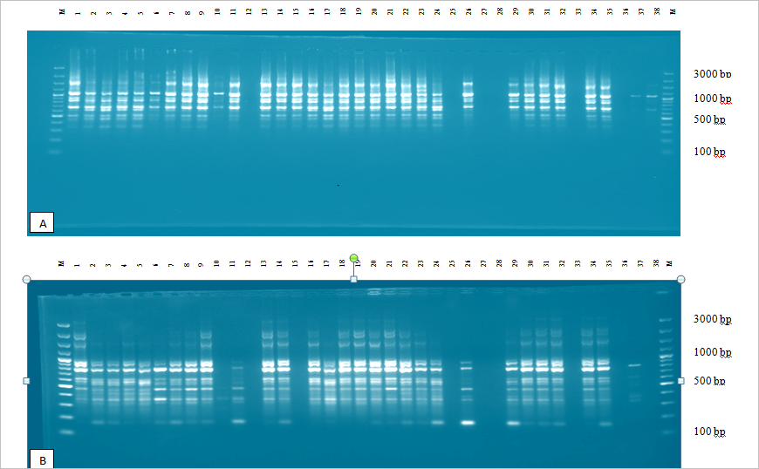
Figure 1 ISSR profile from amplification of genomic DNA of 38 Ethiopian A. corrorima with primers UBC-825 (A) and UBC-834 (B). (M = 100-bp ladder)

The percentage of polymorphic bands (PPB) ranged from 31.40 % in Jimma_C1 population to 81.40% in Mizan Teferi_C2 population. Similarly, the highest Shannon diversity index and Nei’s gene diversity for cultivated korarima population was recorded for Mizan Teferi_C2 (GD: 0.29 and I: 0.43) and lowest for Jimma_C1 (GD: 0.13 and I: 0.19). The average genetic diversity index values for the total cultivated population of korarima were found to be 0.34 (Table 5).

The genetic differentiation among populations (G_{ST}) estimated by Nei’s method was 0.32 (Table 5), which indicated that 32% of the total genetic diversity was distributed among populations, whereas 68% occurred within populations. Furthermore, the level of gene flow (N_{m}) was estimated to be 1.08 individuals per generation between populations (Table 5), suggesting that genetic exchange between populations was high.

Table 5 Gene diversity estimators for populations of A. corrorima from south western part of Ethiopia based on results of seven inter simple sequence repeat (ISSR) primers
Population | Parameters
Population | NPL | PPB | GD | I | G_{ST} | N_{m}
Gore_C1 | 59 | 68.60 % | 0.28 | 0.40
Mizan Teferi_C1 | 59 | 68.60 % | 0.26 | 0.38
Mizan Teferi_C2 | 70 | 81.40 % | 0.29 | 0.43
Metu_C1 | 38 | 44.19 % | 0.20 | 0.29
Jimma_C3 | 59 | 68.60 % | 0.27 | 0.39
Bonga_C3 | 44 | 51.16 % | 0.20 | 0.29
Bonga_C1 | 51 | 59.30 % | 0.24 | 0.35
Bonga_C2 | 56 | 65.12 % | 0.29 | 0.41
Masha_C2 | 49 | 56.98 % | 0.23 | 0.34
Jimma_C1 | 27 | 31.40 % | 0.13 | 0.19
Tepi_C1 | 56 | 65.12 % | 0.25 | 0.36
Tepi_C2 | 56 | 65.12 % | 0.25 | 0.36
Jimma_C2 | 30 | 34.88 % | 0.15 | 0.22
Over all | 84 | 97.67 % | 0.35 | 0.52 | 0.32 | 1.08

NPL = Number of polymorphic loci, PPB = percent polymorphic band, GD = genetic diversity, I = Shannon index, GST = estimate of genetic differentiation, and Nm = estimate of gene flow
Inter-population genetic distance ranged from 0.06 to 0.41 for the total 13 population (Table 6). Among the pair wise population comparisons made within southwestern Ethiopian cultivated korarima population the highest genetic distance was observed between Jimma_C2 and Bonga_C3 populations (J_C2 vs B_C3: 0.41) and the least genetic distance was observed between Bonga_C1 and Bonga_C3 population (B_C1 vs B_C3: 0.06) (Table 6). The pair-wise measures of Nei’s genetic identity showed a high value between all pairs of populations.
Table 6 Nei's original measures of genetic identity (above diagonal) and genetic distance (below diagonal) in 13 populations of Ethiopian A. corrorima using seven ISSR markers
Populations | G_C1 | MT_C1 | MT_C2 | M_C1 | J_C3 | B_C3 | B_C1 | B_C2 | Ma_C2 | J_C1 | T_C1 | T_C2 | J_C2
G_C1 | **** | 0.89 | 0.88 | 0.80 | 0.87 | 0.88 | 0.90 | 0.89 | 0.90 | 0.78 | 0.80 | 0.84 | 0.76
MT_C1 | 0.12 | **** | 0.89 | 0.83 | 0.92 | 0.86 | 0.90 | 0.90 | 0.86 | 0.77 | 0.81 | 0.79 | 0.75
MT_C2 | 0.13 | 0.12 | **** | 0.78 | 0.92 | 0.83 | 0.88 | 0.88 | 0.84 | 0.77 | 0.85 | 0.84 | 0.71
M_C1 | 0.22 | 0.18 | 0.25 | **** | 0.83 | 0.84 | 0.85 | 0.82 | 0.79 | 0.69 | 0.72 | 0.73 | 0.82
J_C3 | 0.14 | 0.08 | 0.09 | 0.19 | **** | 0.86 | 0.91 | 0.91 | 0.84 | 0.76 | 0.82 | 0.81 | 0.73
B_C3 | 0.12 | 0.15 | 0.19 | 0.18 | 0.15 | **** | 0.94 | 0.85 | 0.86 | 0.76 | 0.75 | 0.73 | 0.66
B_C1 | 0.10 | 0.11 | 0.13 | 0.16 | 0.10 | 0.06 | **** | 0.91 | 0.87 | 0.77 | 0.79 | 0.78 | 0.72
B_C2 | 0.12 | 0.10 | 0.13 | 0.20 | 0.10 | 0.16 | 0.10 | **** | 0.88 | 0.77 | 0.83 | 0.80 | 0.74
Ma_C2 | 0.11 | 0.15 | 0.17 | 0.24 | 0.17 | 0.15 | 0.13 | 0.12 | **** | 0.82 | 0.84 | 0.79 | 0.72
J_C1 | 0.24 | 0.26 | 0.27 | 0.36 | 0.28 | 0.28 | 0.26 | 0.27 | 0.20 | **** | 0.89 | 0.86 | 0.76
T_C1 | 0.22 | 0.21 | 0.16 | 0.33 | 0.20 | 0.28 | 0.24 | 0.19 | 0.17 | 0.11 | **** | 0.91 | 0.79
T_C2 | 0.18 | 0.24 | 0.18 | 0.32 | 0.21 | 0.31 | 0.25 | 0.22 | 0.24 | 0.15 | 0.09 | **** | 0.83
J_C2 | 0.27 | 0.29 | 0.34 | 0.20 | 0.32 | 0.41 | 0.33 | 0.30 | 0.33 | 0.27 | 0.23 | 0.18 | ****
G_C1 = Gore_C1; MT_C1 =Mizan-Teferi_C1; MT-C2 = Mizan-Teferi_C2; M_C1 = Metu_C1; J_C3 = Jimma_C3; B_C3 = Bonga_C3; B_C1 = Bonga_C1; B_C2 = Bonga_C2; Ma_C2 = Masha_C2; J_C1 = Jimma_C1; T_C1 = Tepi_C1; T_C2 = Tepi_C2; J_C2 = Jimma_C2;

Analysis of molecular variance (AMOVA) was carried out on the overall ISSR data score of cultivated korarima populations (Table 7). First AMOVA was carried out without grouping the population then with grouping the populations based on region and zone. AMOVA without grouping revealed that higher percentage of variation (72.53%) was attributed to the within population variation while the remaining variation is due to the among population variation (27.47%). The genetic differentiation between the populations was high (F_{ST}: 0.28) and found to be highly significant (P<0.0001).

Analysis of molecular variance (AMOVA) result obtained from grouping the population into regions showed very low percentage of variation (-3.19%) between Oromia and SNNPR, compared to 73.64% that was partitioned to the variation within the two regions. The variation is very low and non significant (F_{CT} = -0.03; P >0.05) (Table 7). On the other hand AMOVA result obtained by grouping the populations into zones showed 9.15% of the total genetic diversity was partitioned to the variation between the five zones, compared to 71.58% that was partitioned to the variation within the zones. The genetic differentiation was moderate but non significant (F_{CT} = 0.09; P >0.05) (Table 7).

Table 7 Analysis of molecular variance (AMOVA) of Aframomum corrorima populations based on seven ISSR primers. (A) Without grouping the populations, (B) by grouping the population based on region and (C) by grouping the populations according to zones of origin
Groups | Source of Variation | d.f | Sum of squares | Variance Components | % of Variation | Fixation index | P value
(A) Without grouping the populations | AP  WP  Total | 12  109  121 | 241.70  482.27  723.97 | 1.68Va  4.43 Vb  6.10 | 27.47  72.53 | F_{ST} : 0.28 | Va and F_{ST} = 0.00
(B) Populations grouped by region | AR  APWR  WR  Total | 1  11  109  121 | 10.22 231.48  482.27 723.97 | -0.19Va 1.78Vb  4.42Vc 6.01 | -3.19  29.55  73.64 | F_{ST} : 0.26  F_{SC} : 0.29  F_{CT} : -0.03 | Vc and F_{ST} = 0.00  Vb and F_{SC} = 0.00  Va and F_{CT} = 0.80
(C) Populations grouped by zones of origin | AZ  APWZ  WZ  Total | 4  8  109  121 | 117.19  124.51  482.27  723.98 | 0.57Va 1.19Vb 4.42Vc 6.18 | 9.15  19.27  71.58 | F_{ST} : 0.28  F_{SC} : 0.21  F_{CT} : 0.09 | Vc and F_{ST} = 0.00  Vb and F_{SC} = 0.00  Va and F_{CT} = 0.07
AP = Among population, WP = Within population, AR = Among Region, APWR = Among population within region, WR = Within region, AZ = Among zone, APWZ = Among population within zone, WZ = Within zone, FST = the variance among subpopulations relative to the total variance, FSC = the variance among subpopulations within groups, FCT = the variance among groups relative to the total variance
The dendrogram derived from neighbor-joining analysis of the whole ISSR data set that includes 129 Ethiopian korarima genotypes showed three major clusters (Figure 2). Cluster I and II consisted a mixture of individuals from at least ten populations. Cluster III comprise individuals from four populations (Tepi I, Jimma II, Tepi II, Jimma I). These show that there are admixtures of individuals in all clusters.
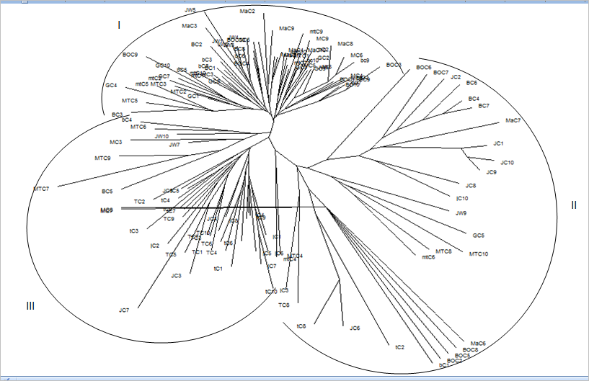
Figure 2 Neighbor-joining clustering of 129 individuals of A. corrorima based on ISSR data generated from seven primers based on Jaccard’s coefficients of similarity obtained after pair-wise comparison of the presence-absence fingerpring
The phenogram produced by UPGMA for all 13 populations is presented in Figure 3. Two major clusters (I and II) can be observed from the phenogram. The first major cluster I form two sub- clusters (A and B). Sub-cluster A consisted of seven populations (Gore_C1, Metu_C1, Bonga_C3, Jimma_C3, Bonga_C1, Bonga_C2 and Masha_C2) and subcluster B was formed by a combination of two populations (Mizan Teferi_C1 and Mizan Teferi_C2). The second cluster consisted of four populations (Jimma_C1, Jimma_C2, Tepi_C1 and Tepi_C2) from Jimma and Tepi.
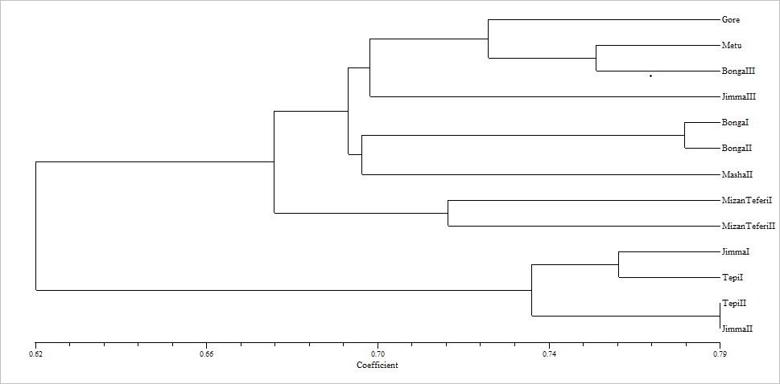
Figure 3 Phenogram of the 13 populations of Aframomum corrorima from Ethiopia generated from ISSR data using un-weighted pair group method of arithmetic means (UPGMA) based on Jaccard’s coefficients of similarity obtained after pair-wise comparison of the presence-absence fingerprint

All the data obtained using seven ISSR primers were used in PCoA analysis using Jaccard's coefficient of similarity. The first three coordinates of the PCoA with Eigen-values of 19.8, 8.1 and 5.5 with variance of 26.4%, 10.8% and 7.4%, respectively used to show the grouping of individuals using two and three dimensional coordinates. Two dimensional (2D) coordinate analyses partitioned 129 individuals of A. corrorima into three clusters (Figure 4). However, the thirteen populations failed to form separate cluster according to their respective collection origin and most of the individuals from more than three populations were observed together in the three clusters. Similarly, in the three dimensional representation (3D) of PCoA analysis the 129 individuals of A. corrorima grouped into three clusters and they did not form any group according to their population origin (Figure 5).
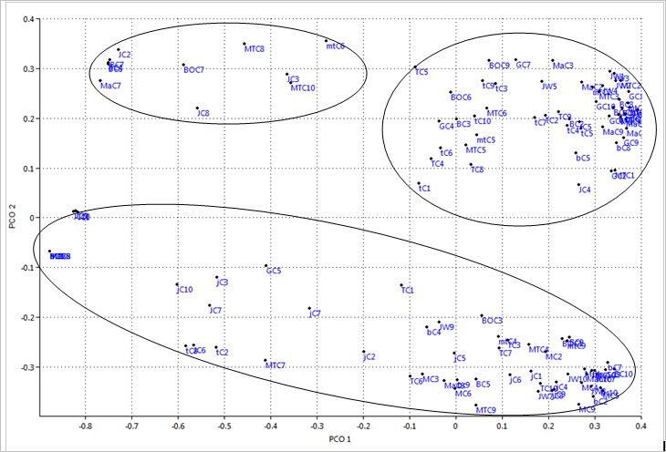
Figure 4 Two dimensional (2D) representations of principal coordinate analysis of genetic relationships among 129 individuals of A.corrorima from southwestern part of Ethiopia
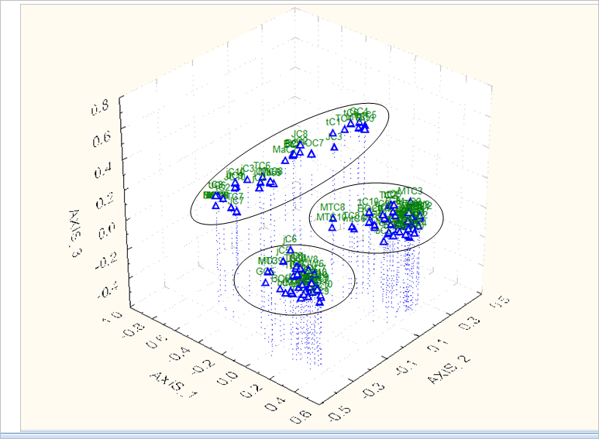
Figure 5 Three dimensional (3D) representations of principal coordinate analysis of genetic relationships among 129 individuals of A. corarima from southwestern part of Ethiopia

2.4. Discussion

2.4.1. Genetic diversity

The present study reports genetic diversity parameters for cultivated Ethiopian A. corrarima populations for the first time. The extent and pattern of genetic diversity among 129 cultivated individuals of korarima were estimated using seven di-nucleotide ISSR markers. Based on the observed results the application of ISSR DNA finger printing technique was efficient and successful for revealing the diversity between individuals and populations of A. corrorima, scoring a range from 5 to 18 polymorphic bands. From all populations, 86 discernible ISSR fragments were generated among which 79 were polymorphic. The overall percentage of polymorphism (94.48 %) revealed by this study suggests that genetic diversity of the studied individuals and populations is generally high. Numerous long-lived perennials with mixed mating systems have higher gene diversity compare to plants that are annuals or short-lived perennials (Hamrick and Godt, 1996, Nybom and Bartish, 2000; and Nybom, 2004). The high diversity observed in A. corrorima might be due to long life span. The mean Nei’s (GD) and Shannon information index (I) for all primers were 0.34 and 0.51 respectively, indicating an immense genetic diversity at species level. This result is in accordance with the result obtained in other perennial plants like Coccinia abyssinica (GD: 0.28; I: 0.43) (Bekele et al., 2014) and in spice plant like black cumin (Nigella sativa L.) (GD: 0.42; I: 0.54) (Kapital et al., 2015) from Ethiopia, that have been recently studied with ISSR markers. However, the high diversity observed in the present study is contrary with the farm based biodiversity studies of A. corrarima in southern Ethiopia by Eyob et al. (2009). The Shannon-Weaver and Simpson diversity indices calculated indicated that the biodiversity of korarima landraces is lower when compared with other native plants of Ethiopia (enset, tef and sorghum) in all administrative zones studied (Eyob et al., 2009).
The success of a crop-improvement program largely depends on the availability and knowledge of the genetic resources in a germplasm collection. Since areas of high genetic diversity mostly contribute more accessions than those with a low diversity for further and future collection, breeding and conservation activities should be based in areas with high genetic diversity. Among the 13 populations from south western Ethiopia studied, all diversity parameters showed higher genetic diversity in Mizan Teferi_C2 population (Table 5). This populations could be used as a parental line in feature breeding program. In addition, this population should be the main focuses for future follow up of collection and population conservation as compared to areas which possesses lowest genetic diversity estimates such as Jimma I (31.40%, 0.13 and 0.19) and Jimma II (34.38%, 0.15 and 0.22), On the other hand, though Jimma III population was found in the same zone with Jimma I and Jimma II populations, highest genetic diversity estimates were recorded. The highest genetic diversity in Jimma III might be attributed to selection by local farmers. The lowest genetic diversity in Jimma I and Jimma II might be explained by the existence of uniformity possibly due to vegetative way of propagation prevailed in the area and due to single or few seed sources during its introduction to these areas.

2.4.2. Genetic structure and gene flow

Analyses of the ISSR markers using various statistics (Nei’s genetic diversity analysis, Shannon’s diversity measure and AMOVA) revealed similar patterns of genetic structure of populations of A. corrarima. The overall degree of genetic differentiation of A. corrarima, as estimated by G_{ST} (0.32) (Table 5), is much higher than the average of G_{ST} = 0.19 for perennial plants and is equal to the average of G_{ST} = 0.32 for dicotyledons (Nybom and Bartish, 2000; Nybom, 2004). Breeding systems of plants greatly affect genetic differentiation, and selfing can result in low genetic diversity within populations (Hamrick and Godt, 1996). In line with this higher and significant Fst was obtained, indicating high genetic differentiation between populations of the self pollenating A. corrorima. AMOVA results revealed that of the total variation, 23.9% was attributed to among-population differences and 76.1% was attributed to the variation within populations (Table 6). Similarly the G_{st} (0.32) value also confirmed higher genetic differentiation between populations. AMOVA analysis based on further grouping of the population into regions and zones resulted in non significant variation. The absence of genetic divergence among regions and zones could be attributed to widespread practice of exchanging seeds and planting material between relatives and migrants from one location to the other during trade exchange.
Gene flow through a movement of individuals on a geographic scale (Joseph and Bruce, 1993) in conjunction with other evolutionary forces can result in the spread of single genes (or DNA sequences). When the value of N_{m} is smaller than two, it results substantial opportunity for genetic population divergence (Hartl and Clark, 2007). The level of gene flow (N_{m}) was estimated to be 1.08 individuals per generation between populations (Table 4), suggesting that gene exchange between populations was low. This result is in accordance with the AMOVA result and Gst (0.32) value which shows high variation among populations.

2.4.3. Genetic distance and cluster Analysis

In this study, inter-population genetic distance for the whole population (D) ranged from 0.06 to 0.41(Table 6). The maximum genetic distance was observed between Jimma_C2 and Bonga_C3 populations. The development of crosses between these genetically distant parents may produce varieties with better genetic recombination and broad genetic base (Chahal and Gosal, 2002). Bonga_C1 and Bonga_C3 populations found to be more related with each other showing low genetic distance (0.06). The similarity between these two populations may be due to their occurrence in the same zone that is Keffa. Both NJ tree (Figure 2) and the UPGMA phenogram (Figure 3) also revealed these two populations to be closely related as they are found in the same cluster. Farm based biodiversity study conducted by Eyob et al. (2009) also confirmed similar result in that collections from pairs of sites in Keffa zone measured by Sørenson’s similarity index was found to be uniform, indicating homogenous korarima landraces in the various household farms in Keffa zone. This is because all households grew a few korarima landraces which share similar genetic backgrounds.

The present study did not reveal clear pattern of clustering of populations according to their zonal origin. UPGMA tree topology allowed the identification of two major groups (Figure 4), cluster I was formed by 9 populations from four zones, while the second cluster was formed by populations from two zones. The first cluster formed two sub clusters from which one of them constituted populations from Bench magi zone without mixing any other population. This can support the moderate degree of genetic differentiation (G_{ST} = 0.32) obtained in this study. No clear grouping of individuals from the same population is observed in the NJ dendrogram (Figure 3). In the NJ dendrogram three clusters were formed in which individuals from one population were clustered with individuals from different populations. These results also became apparent from both the 2D (Figure 4) and 3D (Figure 5) PCoA analysis. The failure of most korarima (A. corrarima) populations and individuals to cluster on the basis of their respective zones of origins of the populations could be due to the presence of gene flow between local populations and between adjacent zones mainly in the form of planting materials. This may also be due to the close geographical proximity of sampled plants contributing to their genetic similarity. In addition wild animals such as monkeys which have the ability to move a long distance also play a significant role in korarima plant gene flow. They can transfer korarima plant by eating the capsules at one place and releasing the seeds through their digestive tract in another place, which can germinate and give rise to a new korarima plant in a new site.

2.5. Conclusions

In the present study, seven ISSR markers have been used to study the genetic diversity of A. corrarima populations from southwestern Ethiopia. The degree of genetic diversity to a certain extent reflects the capacity of species to adapt to the external environment. It not only restricts the capacity of individual and species to adapt to the environmental changes but also provides very important information for the realization and protection of species (Hogbin and Peakall 1999). The high genetic diversity observed in this study have shown that A. corrarima is endangered not because of the degree of genetic diversity rather it is due to the difficulty to recover in the presence of habitat distraction and fragmentation caused by human activity. The results obtained in this study, validate that ISSR are useful markers in genetic diversity studies, due to the very high polymorphism level detected by the primers. This result implies the potential of the Ethiopian korarima (A. corrorima) gene pool for further improvement through breeding. Therefore, an effective protection procedure such as in situ and ex situ conservation strategies should be developed to alleviate the endangered situation.

Chapter 3 Genetic structure and relationships within and between cultivated and wild korarima [Aframomum corrorima (Braun) P.C.M. Jansen] in Ethiopia as revealed by simple sequence repeat (SSR) markers

3.1. Introduction
Korarima (A.corrarima) could be developed into an important commodity if necessary attention is given to its research and genetic improvement. The beneficial characteristics of the species can be further enhanced through plant breeding. However, data on genetic characterization of this species is scarce and hence considered necessary before any breeding work can commence.
Genetic diversity based on molecular data can potentially facilitate conservation and can be employed as a tool for mining germplasm collections for genomic regions associated with adaptive or agronomically important traits (Casa et al., 2005). Microsatellites or simple sequences repeats (SSRs) are tandemly repeated motifs of two to six nucleotides found in all prokaryotic and eukaryotic genomes (Goldstein and Pollock, 1997). Microsatellites are co-dominantly inherited, highly abundant, polymorphic, multi-allelic and reproducible. Hence they have become one of the most desirable molecular markers for use in genetic studies (Zheng et al., 2008). Interestingly, SSR has been the marker of choice for assessment of genetic diversity in many plant species such as field pea (Teshome et al., 2015), Sorghum bicolor (Adugna et al., 2013), Arabica Coffee (Geleta et al., 2012) and chickpea (Keneni et al., 2012). SSR markers were also used for analysis of phylogenetic relationships (Biswas et al., 2011), marker assisted selection (Ashkani et al., 2012), construction of genetic linkage (Hong et al., 2010) and quantitative trait loci (Zhang et al., 2010).
The genus Aframomum lacks molecular markers that can be used for assessment of its genetic diversity and for other applications. It was, therefore, essential to develop new molecular markers such as microsatellites for A. corrorima. Microsatellites can be identified by screening DNA sequence databases for target or closely related species. In the present study, eleven new SSR markers were developedand utilized (1) to evaluate the genetic diversity of wild and cultivated korarima populations in southwestern Ethiopia (2) to determine the presence of indirect evidence for crop-wild hybridization by testing for admixture of SSR alleles in cultivated and wild korarima populations from the same regions (3) and to determine potential factors shaping the population genetic structure of cultivated and wild korarima in Ethiopia.

3.2. Material and methods

3.2.1. Plant material

For this study, 195 individuals from 21 korarima populations (14 cultivated and 7 wild) were sampled across five zones (Illubabour, Jimma, Sheka, Kefa and Bench-Maji) in the southwestern part of Ethiopia (Figure6). The plant materials used here are the same with plant material used for ISSR analysis (chapter 3) except for one additional cultivated and seven wild korarima populations (Table 8). The distance between sampled plants with in each population and the method of sample collection was also similar (chapter 3).

3.2.2. DNA extraction

The DNA extraction method followed is the same to the DNA extraction method followed in section 2.2.2 of the ISSR study. However, in this section QIAamp® 96 DNA QIAcube® HT Kit was used to extract DNA from samples that we failed to isolate in desired quality and quantity using the CTAB method. The quality and quantity of genomic DNA isolated was re checked using a Nano Drop® ND-1000 spectrophotometer (Saveen Werner, Sweden).

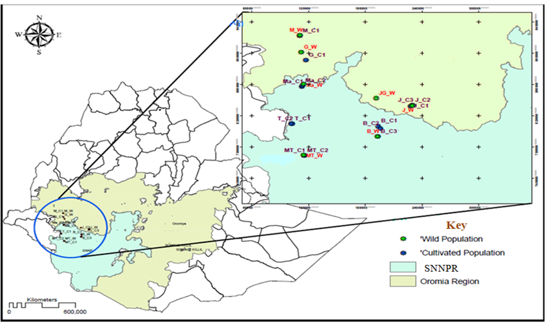
Figure 6 Regional map of Ethiopia showing the wild and cultivated korarima collection sites, SNNPR in the key corresponds to Southern Nations, Nationalities, and People’s Region

Table 8 Passport data of A. corrorima samples collected from different sites in Ethiopia
Zone | Specific location | Population name and code | No of samples | Latitude | Longitude | Altitude
Illubabourª | Sege Tageta | Gore_C1 (GC1-10) | 10 | 0890940 | 36 P 0777788 | 1924
Illubabourª | Adele Bise | Metu_C1 (MC1-10) | 10 | 0922384 | 36 P 0771124 | 1655
Jimmaª | SebekaDibiya 1 | Jimma_C1 (JC1-10) | 10 | 0832213 | 37 N 0227907 | 1956
Jimmaª | Sebeka Dibiya 3 | Jimma_C2 (jc1-10) | 10 | 0833176 | 37 N 0229713 | 2045
Jimmaª | Sebeka Dibiya 2 | Jimma_C3 (JW1-10) | 10 | 0833173 | 37 N 0229730 | 2039
Bench-Majiª | Fanika-1 | Mizan-Teferi_C1 (mtc1-10) | 9 | 0768932 | 36 N 0776019 | 1336
Bench-Majiª | Fanika-2 | Mizan-Teferi_C2 (MTC1-10) | 10 | 0768822 | 36 N 0776059 | 1348
Shekaª | - | Masha_C1 (mac1-3) | 3 | 0856964 | 36 N 0773450 | 2221
Shekaª | Beta | Masha_C2 (MaC1-10) | 10 | 0858605 | 36 N 0774026 | 2172
Shekaª | Kubito-1 | Tepi_C1 (TC1-10) | 10 | 0809399 | 36 N 0763150 | 1885
Shekaª | Kubito-2 | Tepi_C2 (tc1-10) | 10 | 0809737 | 36 N 0762409 | 1904
Kefaª | 01 kebele | Bonga_C1 (BC1-10) | 10 | 0806576 | 37 N 0193583 | 1657
Kefaª | Beha | Bonga_C2 (BoC1-10) | 10 | 0803604 | 37 N 0195838 | 1701
Kefaª | Around College | Bonga_C3 (bC1-10) | 10 | 0793460 | 37 N 0193220 | 1847
Totalª |  |  | 132
Illubabour^{b} | Adele Bise | Metu_W (mw1-3) | 3 | 0922920 | 36 P 0771391 | 1643
Illubabour^{b} | Gumero | Gumero_W (GW1-10 | 10 | 0901233 | 36 P 0772847 | 1684
Jimma^{b} | Sebeka Dibiya | Jimma_W (jw1-10) | 10 | 0832961 | 37 N 0229689 | 2057
Jimma^{b} | AfaloNaso | Jimma-Gera_W (jgw 1-10) | 10 | 0842462 | 37 N 0191504 | 1649
Bench-Maji^{b} | Fanika | Mizan-Teferi_W (mtw1-10) | 10 | 0769786 | 36 N 0775205 | 1272
Sheka^{b} | BettoKebele | Masha_W (maw1-10) | 10 | 0860535 | 36 N 0775176 | 1841
Kefa^{b} | AermoKeb | Bonga_W (bw1-10) | 10 | 0793119 | 37 N 0192835 | 1880
Total^{b} |  |  | 63
ª = represent cultivated populations, ^{b} = represents wild populations

3.2.3. DNA database searches and development of Genomic-SSR markers

Since there are no microsatellite containing DNA sequences of Aframomum in NCBI nucleotide database, we used DNA sequences of Alpinia in the GenBank to develop genomic SSR markers for Aframomum. Alpinia was used as it was the most closely related genus to Aframomum within the Zingiberaceae family (Kress et al., 2002) that has genomic resources at NCBI. We used 1498 DNA sequences of various Alpinia species in NCBI for mining SSRs. DNA sequences that contain SSR with two to six nucleotide repeat motifwere identified using WebSat web-based software (Martins et al., 2009). The analysis revealed that only 1.5% of these sequences contain SSRs and they all were from Alpinia oxyphylla. After evaluating the suitability of these sequences for designing primers, 23 SSR primer-pairs were designed using the Primer3 primer designing program (Rozen and Skaletsky, 1999).

3.2.4. SSR PCR amplification

The twenty-three SSR primer-pairs were initially tested for successful amplification of target site and capacity to detect polymorphism among genotypes (Appendix_1). Among these primers, twelve failed to amplify the target loci in A.corrorima cultivated and wild populations. The remaining eleven primer-pairs successfully amplified their target loci in A. corrorima populations and hence used for genetic diversity analysis (Table 9). The forward primers of these primer-pairs were labeled at the 5'-end with either 6-FAM™ or HEX™ fluorescent dyes. In order to avert Taq DNA polymerase tendency to add non-templated nucleotide to the PCR product as described in Ballard et al. (2002), thereverse primers were PIG-tailed with “GCTTCT”.
A total volume of 25μl containing 25 ng genomic DNA, 1×PCR buffer (10mM Tris-HCl, pH 8.3 and 50mM KCl), 0.3mM dNTPs, 0.3 μM forward and reverse primers, 1.5mM MgCl₂ and 1U Dream Taq DNA polymerase (Sigma, Germany) was used for PCR reactions. The reactions were performed using a GeneAMP PCR system 9700 thermo cycler (Applied Biosystems Inc. USA) in 96-well plates. PCR amplification reaction consisted of 3min preliminary denaturation at 95°C, 30 sec touchdown denaturation at 94°C for nine cycle, 30 sec annealing at 58°C (in every cycle annealing temperature was decreased by −1°C) and elongation for 45 sec at 72°C, afterward 29 cycles of denaturation at 94°C for 30 sec, annealing at 48°C for 30 sec, and elongation at 72°C for 45 sec. Following completion of the 29 cycles, a 20 min final elongation at 72°C was included to allow completion of the reactions. Quality check on the PCR products were conducted with gel electrophoresis and PCR products were stored at 4°C until further use.

3.2.5. Gel electrophoresis and genotyping

For each locus, amplification and quality was confirmed by running 7μl of the PCR products mixed with 2μl of 6x loading dye on ethidium bromide containing 1.5% agarose gels.Negative controls were included with sterile millipore water replacing DNA, as a quality control measure. A DNA ladder with the size of 50 bp (GeneRuler™ Fermentas Life Sciences) was used as fragment size marker. The PCR products were multiplexed into three panels where markers with different fluorescent dyes and sizes placed together. ABI Prism 3730 DNA Analyzer (Applied Biosystems) was used for subsequent analysis of the multiplexed PCR products at Swedish University of Agricultural Sciences, Alnarp, Sweden.

3.2.6. Confirmation of SSRs using DNA sequencing and analysis

To confirm that the amplified products are the target microsatellite loci, the PCR products of two individualsof A. corrorima (one cultivated and one wild) amplified by the 11 primer-pairs were sequenced. Before the PCR products were sent for sequencing to Eurofins Genomics (Germany), they were purified using the Qiaquick PCR purification kit. Then, each purified PCR product was mixed with corresponding forward primer, which was used as sequencing primer. The final edited sequences were searched in NCBI through Basic Local Alignment Search Tool (BLAST) to find out if it hits with the original SSR containing microsatellite sequence or any other similar sequence in the database. Similar sequences were aligned using ClustalXversion2.1 software (Larkin et al., 2007), and then sequences were edited using BIOEDIT version 7.0.5 (Hall, 2005).

3.2.7. Data analysis

GeneMarker® V2.2.0 software (Soft Genetics, LLS, State College, Pennsylvania) was used for peak identification and fragment sizing. The size of the PCR products was determined based on the Genescan-500 LIZ internal size standard. In all cases, default settings in GeneMarkerwere applied for detection of peaks with the recommended threshold intensity of 200, but peaks were accepted for scoring after they were visually inspected. Elecropherogram image which represents heterozygous and homozygous forms of alleles for the microsatellite loci studied were presented in Appendix 2.

Genetic diversity was analyzed using two or more software programs in order to verify consistency of the results. For estimating observed heterozygosity, expected heterozygosity and allele frequency based genetic distance analyses, POPGENE software version 1.31 (Yehet al., 1999) was used. GenAlEx 6.5 software V3.25 (Peakall and Smouse, 2012) was used to compute private alleles by population and locus and to calculate pair-wise F_{ST}.

Analysis of molecular variance (AMOVA) was conducted using Arlequin 3.0 according to Excoffier et al. (2005). A neighbor-joining (NJ) and UPGMA (unweighted pair group method using arithmetic average) dendrogram was constructed based on pair-wise simple matching dissimilarity index using DARwin6 software (Perrier and Jacquemoud- Collet, 2006). In the NJ tree construction, a random re-sampling of five individuals from 19 population and three individuals from two populations [(5x19) + (3x2) = 101] were done in order to obtain a better structured clusters due to reduced number of samples.
The pattern of population structure and detection of probable introgression was visualized using a Bayesian model based clustering method implemented in STRUCTURE software version 2.2 (Pritchard et al., 2000). The analysis was done by assigning the site of collection as the putative population origin for each individual. For this, the admixture model with correlated allele frequencies was used. A burn-in period of 10,000 was used followed by 100,000 Markov Chain Monte Carlo (MCMC) replications for data collection for K = 1 to K = 21 groups. For each K value, five replicates were run. This procedure clusters individuals into populations and estimates the proportion of membership in each population for each individual (Falush et al., 2003). Moreover, the model does not assume a particular mutation process (Pritchard et al., 2000). The optimum number of clusters was predicted between K = 1 and K = 21 following the simulation method of Evanno et al. (2005) using the web based software STRUCTURE HARVESTER v0.6.8 (Earl and von Holdt, 2016). CLUMPP software (Jakobsson and Rosenberg, 2007) was used to align the clusters across the replicates whereas the population clusters were depicted using the DISTRUCT software (Rosenberg, 2004).

3.3. Results

The list of the 11 genomic-SSR loci developed in this study is given in Table 9 along with their source sequence accession numbers, forward and reverse primers, annealing temperatures, repeatmotifs, expected fragment size and observed fragment size range. All of these SSR loci have dinucleotide repeat motifs and were amplified in all populations of korarima. At loci Afco_8 and Afco_14, only one allele was detected within cultivated populations (across the 132 individuals) and within wild populations (across 63 individuals) whereas the remaining nine loci were polymorphic within both groups of populations. Therefore, only the 10 polymorphic loci within each group were used to compute genetic diversity parameters when cultivated and wild populations were analyzed separately.

The sequences of amplified products matched the original A. oxyphylla sequences used for designing the SSR primer-pairs except in the case of Afco_2. The sequencing of the PCR product amplified by Afco_2 failed. All sequences that matched the original A. oxyphylla sequences contained the target microsatellites except in the case of Afco_8 which had poor sequence quality in the microsatellite containing region and hence trimmed off (Figure 7).

Table 9 List of primer-pairs developed and used to amplify the SSR loci in this study: primer sequences, annealing temperature (T_{a}), repeat motifs, expected and observed fragment size
Locus | SSAN | Primer sequence (5’-3’) |  | T_{a} | Repeat motifs | Expected size | Observed repeat  motifs | Allele size rangeª
Afco_2 | JX422069.1 | F | TTGACTTGGGTATGGCAAAA | 63 | (AG)₁₃ | 230 | - | 212-242
Afco_2 | JX422069.1 | R | AAGGTCGAGCAGGAGTAGCA
Afco_3 | JX422068.1 | F | GAATTCATGTTCTTGAGAAAAGTTTG | 63 | (AG)₇ | 198 | (GA)₂ | 191-200
Afco_3 | JX422068.1 | R | GCCAAATGAACGGACAGATT
Afco_5 | JX422066.1 | F | TGACTCCAAACTTGCAGGAG | 64 | (CT)₈ | 160 | (CT)₁₂ | 160-171
Afco_5 | JX422066.1 | R | AGCAGATCAATGCACGTGAG
Afco_6 | JX422065.1 | F | TCGACATGAAATCCCTACGAGA | 65 | (AG)₁₅ | 243 | (AG)₁₂ | 230-253
Afco_6 | JX422065.1 | R | GAGCTGTGAAGTGAAAGGGC
Afco_8 | JX422063.1 | F | GCTAACTTGTCTTTCCTATTTCTCC | 62 | (CT)₁₃ | 239 | * | 229-245
Afco_8 | JX422063.1 | R | TGGAAGCTGCATTCACTGAG
Afco_11 | JX422060.1 | F | AATGCTTCTAGCTGGTTCGAC | 62 | (GT)₇ | 241 | (GT)₆ | 240-260
Afco_11 | JX422060.1 | R | CCTTGAATTTTATATTTCTTCCAGATG
Afco_14 | JX422057.1 | F | CCTTCCACGGTGTCTCATTT | 64 | (GA)₁₉ | 281 | (GA)₁₀ | 280-285
Afco_14 | JX422057.1 | R | TCATCCAAAACTTCAATCATGG
Afco_15 | JX422056.1 | F | ATCGATGGGATCGCCTTAC | 64 | (GA)₁₉ | 292 | (GA)₉ | 256-262
Afco_15 | JX422056.1 | R | GACGTCACGAATGTTGGTTG
Afco_19 | JX422052.1 | F | CAGACGAGAGGAGGGAGATG | 64 | (GA)₁₇ | 373 | (GA)₉ | 356-364
Afco_19 | JX422052.1 | R | CTCTGTGAGCCGTTCAATCC
Afco_21 | JX422050.1 | F | CGACAAGGAGGAGAAGAGGT | 62 | (GA)₁₄ | 250 | (GA)₆ GAAAGG (GA)₇ | 250-260
Afco_21 | JX422050.1 | R | CCAACAGCCCTTCTTTTTGA
Afco_22 | JX422049.1 | F | GAAGAAGCGTTGGTGAGAGG | 65 | (TC)₂₀ | 468 | (TC)₉ | 449-455
Afco_22 | JX422049.1 | R | CTGTGTCGTCCAGCCGTATT
ª = refers to allele size across all individuals included in the study; SSAN = source sequence accession number; * = The SSR are located in the trimmed (low quality) part of the sequence and hence the length of the repeat motif could not be determined; - = sequencing failed.

Figure 7 Short segments of the alignment of microsatellite containing sequences of Aframomum corrorima and Alpinia oxyphyla species for 10 of the 11 SSR loci used in the present study. The locus names are given to the right of each aligned sequences. The SSR region for each locus is shown by curly bracket. Note: sequencing of Afco_2 failed and hence is not included here.

Loci like Afco_6, Afco_8, Afco_11, Afco_15, Afco_19 and Afco_22 produced private allele(s) that are unique to a single population. In the case of the cultivated populations, only one population (Mizan-Teferi_C1) produced a private allele, which was at locus Afco_11 (allele frequency = 6.3%), whereas private alleles were detected in three wild populations (Jimma-Gera_W, Metu_W and Mizan-Teferi_W). The highest number of private alleles (9) was detected in the Mizan-Teferi wild population across six loci but with a low frequency ranging from 6.3% to 33.3%. Seven private alleles were detected in the Metu wild population with a frequency ranging from 50% to 100% (Figure 8).

Figure 8 List of private alleles unique to one of the four populations shown on the right and its frequencies at six SSR loci

In total, 32 alleles were detected in the 14 cultivated populations, whereas 49 alleles were detected in the seven wild populations across the 10 loci. The observed number of alleles (na) per locus ranged from two to five in cultivated populations and from four to eight in wild populations. The effective number of alleles (ne) per locus varied from 1.02 (Afco-19) to 2.39 (Afco_11) for cultivated populations and from 1.42 (Afco_8) to 4.87 (Afco_2) for wild populations. The Shannon diversity index (I) per locus ranged from 0.06 (Afco_19) to1.02 (Afco_2 and Afco_11) for cultivated populations and from 0.63 (Afco_8) to 1.72 (Afco_2) for wild populations. The average Shannon diversity index for all loci was 0.76 and 1.06 for cultivated and wild populations, respectively. Observed heterozygosity (Ho) ranged from zero at locus Afco-19 to 0.88 at locus Afco-11 in cultivated populations and from zero at locus Afco-19 to 0.86 at locus Afco-11in wild populations. The average observed heterozygosity across all loci was 0.63 and 0.48 for cultivated and wild populations, respectively. Expected heterozygosity (He) ranged from 0.02 at locus Afco-19 to 0.58at locus Afco-11 in cultivated populations and from 0.30 at locus Afco-8 to 0.80 at locus Afco-2 in wild populations. The average expected heterozygosity for all loci was 0.48 and 0.57 for cultivated and wild populations, respectively (Table 10).

Table 10 Estimates of different genetic diversity parameters and gene flow for A. corrorima at each polymorphic microsatellite loci based on (A) all populations, (B) only cultivated populations, and (C) only wild populations
Locus | Sample size | na | ne | I | Ho | He | Av.Het | Nm
(A) All Populations
Afco_2 | 270 | 8 | 3.16 | 1.38 | 0.66 | 0.69 | 0.53 | 0.87
Afco_3 | 322 | 5 | 2.42 | 1.07 | 0.59 | 0.59 | 0.50 | 1.60
Afco-5 | 284 | 5 | 2.58 | 1.10 | 0.66 | 0.61 | 0.55 | 1.50
Afco-6 | 272 | 5 | 1.94 | 0.78 | 0.71 | 0.49 | 0.43 | 2.10
Afco-8 | 284 | 4 | 1.09 | 0.22 | 0.02 | 0.08 | 0.06 | 0.19
Afco-11 | 300 | 8 | 2.45 | 1.10 | 0.87 | 0.59 | 0.55 | 3.02
Afco-14 | 58 | 2 | 1.62 | 0.57 | 0.10 | 0.39 | 0.14 | 0.08
Afco-15 | 274 | 4 | 2.09 | 0.80 | 0.84 | 0.52 | 0.46 | 1.45
Afco-19 | 228 | 4 | 1.13 | 0.30 | 0.00 | 0.12 | 0.05 | 0.13
Afco-21 | 296 | 4 | 2.64 | 1.06 | 0.75 | 0.62 | 0.54 | 1.32
Afco-22 | 260 | 4 | 1.91 | 0.75 | 0.68 | 0.48 | 0.40 | 1.25
Mean | 259 | 4.82 | 2.09 | 0.83 | 0.54 | 0.47 | 0.38 | 0.94
St. Dev |  | 1.78 | 0.64 | 0.36 | 0.33 | 0.20 | 0.20
(B) Cultivated Populations
Afco-2 | 188 | 5 | 2.28 | 1.02 | 0.68 | 0.56 | 0.47 | 1.91
Afco-3 | 224 | 5 | 2.27 | 1.00 | 0.71 | 0.56 | 0.52 | 3.73
Afco-5 | 196 | 4 | 2.17 | 0.88 | 0.71 | 0.54 | 0.51 | 3.20
Afco-6 | 208 | 2 | 1.91 | 0.67 | 0.76 | 0.48 | 0.47 | 9.48
Afco-11 | 228 | 5 | 2.39 | 1.02 | 0.88 | 0.58 | 0.55 | 6.54
Afco-14 | 38 | 2 | 1.92 | 0.67 | 0.16 | 0.49 | 0.21 | 0.14
Afco-15 | 208 | 2 | 1.99 | 0.69 | 0.87 | 0.50 | 0.49 | 11.36
Afco-19 | 170 | 2 | 1.02 | 0.06 | 0.00 | 0.02 | 0.02 | 1.62
Afco-21 | 218 | 3 | 2.33 | 0.92 | 0.79 | 0.57 | 0.53 | 3.80
Afco-22 | 210 | 2 | 1.87 | 0.66 | 0.73 | 0.47 | 0.46 | 9.63
Mean | 189 | 3.2 | 2.01 | 0.76 | 0.63 | 0.48 | 0.42 | 1.94
St. Dev |  | 1.40 | 0.39 | 0.29 | 0.29 | 0.17 | 0.17
(C) Wild Populations
Afco-2 | 82 | 8 | 4.87 | 1.72 | 0.61 | 0.80 | 0.67 | 1.21
Afco-3 | 98 | 4 | 2.24 | 0.95 | 0.31 | 0.56 | 0.47 | 1.68
Afco-5 | 88 | 5 | 3.40 | 1.34 | 0.55 | 0.71 | 0.62 | 1.28
Afco-6 | 64 | 5 | 1.93 | 0.94 | 0.56 | 0.49 | 0.36 | 1.18
Afco-8 | 72 | 4 | 1.42 | 0.63 | 0.08 | 0.30 | 0.18 | 0.23
Afco-11 | 72 | 7 | 2.64 | 1.21 | 0.86 | 0.63 | 0.54 | 1.53
Afco-15 | 66 | 4 | 2.40 | 0.99 | 0.76 | 0.59 | 0.42 | 0.54
Afco-19 | 58 | 4 | 1.55 | 0.72 | 0.00 | 0.36 | 0.13 | 0.12
Afco-21 | 78 | 4 | 3.29 | 1.24 | 0.64 | 0.71 | 0.57 | 0.97
Afco-22 | 50 | 4 | 1.96 | 0.92 | 0.44 | 0.50 | 0.29 | 0.38
Mean | 73 | 4.90 | 2.57 | 1.06 | 0.48 | 0.57 | 0.42 | 0.74
St. Dev |  | 1.44 | 1.04 | 0.32 | 0.28 | 0.15 | 0.18
Note: Afco-8 and Afco-14 were monomorphic within cultivated and wild populations, respectively, and hence were not included when the data for the cultivated and wild populations were analyzed separately. na = observed number of alleles; ne = effective number of alleles; I = Shannon information index; Ho = observed heterozygosity; He = expected heterozygosity; Av. He = average heterozygosity; Nm = gene flow estimated from Fst = 0.25(1 - Fst)/Fst.
Percentage of polymorphic loci (PPL), Shannon diversity index, observed and expected heterozygosity was calculated for each population. The highest PPL per population was 100%, which was recorded in the Mizan-Teferi_W from the Bench-Maji Zone, while the lowest was 60% for Masha_W (Sheka zone), both of which are wild populations. In the cultivated populations, the highest PPL was 90% which was recorded in seven of the fourteen populations (Gore_C1, Jimma_C1, Mizan-Teferi_C1, Masha_C2, Tepi_C1, Tepi_C2 and Bonga_C1) and the least was 70% for the Masha_C1 population.When the average PPL per cultivated population was compared across zones, the highest PPL (85%) was recorded in three zones (Illubabor, Bench-Maji and Sheka). On the other hand, the highest average Shannon diversity index was recorded in populations from Illubabour zone (0.73) whereas the least was for populations from Jimma zone (0.58) (Table 11).

Among the wild populations, the highest Shannon diversity index was recorded for Mizan-Teferi_W (I = 1.03) and the lowest for Masha_W (I = 0.52), whereas in the cultivated populations, the highest was for Masha_C2 (I = 0.82) and the lowest for Masha_C1 (I = 0.52). The highest and lowest observed heterozygosity was scored for Bonga_C1 (Ho = 0.78) and Tepi_C2 (Ho = 0.50) in the cultivated populations, and Metu_W (Ho = 0.73) and Masha_W (Ho =0.30) in the wild populations. The expected heterozygosity in Masha_C2 (He = 0.56) was the highest and the lowest was 0.40 (for Jimma_C3) among the cultivated populations. Among the wild populations, the highest and the lowest expected heterozygosity was recorded in Mizan-Teferi_W (He = 0.64) and Masha_W (He = 0.38), respectively (Table 11).

Table 11 Percentage of polymorphic loci (PPL), Shannon’s diversity index (I), observed heterozygosity (Ho) and expected heterozygosity (He) for cultivated and wild populations of Aframomum corrorima
Zone | Population | PPL | I | Ho | He
Cultivated
populations
Illubabour | Gore_ C1 | 90 | 0.75 | 0.58 | 0.54
 | Metu _C1 | 80 | 0.71 | 0.57 | 0.47
Average |  | 85 | 0.73 | 0.58 | 0.51
Jimma | Jimma_ C1 | 90 | 0.56 | 0.54 | 0.43
 | Jimma_C2 | 80 | 0.61 | 0.69 | 0.45
 | Jimma_C3 | 80 | 0.56 | 0.55 | 0.40
Average |  | 83.33 | 0.58 | 0.59 | 0.43
Bench-Maji | Mizan-Teferi_C1 | 90 | 0.66 | 0.73 | 0.49
Bench-Maji | Mizan-Teferi_C2 | 80 | 0.63 | 0.55 | 0.43
Average |  | 85 | 0.65 | 0.64 | 0.46
Sheka | Masha_C1 | 70 | 0.52 | 0.72 | 0.50
Sheka | Masha_C2 | 90 | 0.82 | 0.62 | 0.56
Sheka | Tepi_C1 | 90 | 0.68 | 0.60 | 0.47
Sheka | Tepi_C2 | 90 | 0.69 | 0.50 | 0.48
Average |  | 85 | 0.68 | 0.61 | 0.50
Kefa | Bonga_C1 | 90 | 0.66 | 0.78 | 0.53
Kefa | Bonga_C2 | 80 | 0.66 | 0.65 | 0.47
Kefa | Bonga_C3 | 80 | 0.58 | 0.74 | 0.43
Average |  | 83.33 | 0.68 | 0.72 | 0.48
Wild
Populations
Illubabour | Metu_W | 80 | 0.56 | 0.73 | 0.48
Illubabour | Gumero_W | 80 | 0.65 | 0.51 | 0.43
Average |  | 80 | 0.61 | 0.62 | 0.46
Jimma | Jimma-Gera_W | 90 | 0.73 | 0.38 | 0.50
Jimma | Jimma_W | 80 | 0.56 | 0.42 | 0.43
Average |  | 85 | 0.65 | 0.40 | 0.47
Bench-Maji | Mizan-Teferi_W | 100 | 1.03 | 0.52 | 0.64
Sheka | Masha_W | 60 | 0.52 | 0.30 | 0.38
Kefa | Bonga_W | 80 | 0.71 | 0.45 | 0.46

Two complementary approaches were used to explore the genetic diversity structure: analysisof molecular variance (AMOVA) and pair-wise fixation index (F_{ST}). In the case of AMOVA, the total genetic variation was partitioned into three hierarchical levels: among groups (cultivated vs wild), within groups among populations and within populations. Pair-wise F_{ST} was estimated for all populations as well as for cultivated and wild populations, separately.

Table 12 SSR-based analysis of molecular variance (AMOVA) for the cultivated and wild korarima populations

Source of variation | d.f. | Sum of squares | Variance components | %age of variation |  | P-value
AG | 1 | 13.555 | 0.08193 V_{a} | 5.74 |  | Vc and F_{ST} = 0.000
APWG | 19 | 16.850 | -0.02892 V_{b} | -2.03 |  | Vb and F_{SC} = 0.069
WP | 335 | 460.267 | 1.37393 V_{c} | 96.29 |  | Va and F_{CT} = 0.000
Total | 355 | 490.671 | 1.42694
Fixation Index | F_{ST} = 0.04
AG = among groups of populations (cultivated vs wild); APWG = among populations within groups (cultivated and wild); WP = within populations

AMOVA revealed highly significant (P < 0.001) but low level ofgenetic differentiation (F_{ST}= 0.04) between the wild and cultivated populations.Of the total genetic variation, 5.74% was attributable to the variation between cultivated and wild korarima. The analysis revealed absence of differentiation among the cultivated populations as well as wild populations. The vast majority of the total variation resides within populations (Table 12). This result is in agreement with the high value of gene flow (Nm = 0.94) estimated (Table 10).
Both cultivated and wild populations were further divided into smaller groups separately and AMOVA analysis was conducted. First, both cultivated and wild populations were grouped into two: Oromia and SNNP based on their region of origin. Then, the populations were grouped into five groups based on their zones of origin. In cultivated korarima, no genetic differentiation was obtained among populations, regions and zones (F_{ST} = -0.05; P<0.001). However, in the case of wild populations significant differentiation was obtained at population (F_{ST} = 0.07; P < 0.001), region (F_{ST} = 0.06; P < 0.001) and zone (F_{ST} = 0.09; P < 0.001) levels (Table 13).
Table 13 F_{ST} based estimates of genetic differentiation of cultivated and wild korarima populations at various levels
Populations | Differentiation at | Mean F_{ST} | P-value
Cultivated | Population level | -0.05 | 0.000
Cultivated | Region level | -0.05 | 0.000
Cultivated | Zone level | -0.05 | 0.000
Wild | Population level | 0.07 | 0.000
Wild | Region level | 0.06 | 0.000
Wild | Zone level | 0.09 | 0.000
The Nei’s standard genetic distance between cultivated and wild korarima populations ranged from 0.06 (T_C1vs G_W) to 1.56 (B_C1 vsM_W). The genetic distance within cultivated populations ranged from 0.01 (MT_C2vs M_C1) to 0.19 (B_C3 vs M_C1). The genetic distance within wild populations ranged from 0.04 (Ma_W vs B_W and Ma_W vs JG_W) to 1.64 (M_W vs Ma_W) (Table 14).The Metu wild population (M_W) is distantly related to the rest of the wild populations and cultivated korarima with an observed genetic distance of greater than 1.30 (Table 14).

Table 14 Nei’s standard genetic distance (above diagonal) and pair wise F_{ST} significance (below diagonal) between the 21 korarima populations
 | G_C1 | MT_C1 | MT_C2 | Ma_C1 | Ma_C2 | B_C1 | B_C2 | B_C3 | M_C1 | T_C1 | T_C2 | J_C1 | J_C2 | J_C3 | B_W | JG_W | G_W | J_W | Ma_W | M_W | MT_W
G_C1 | **** | 0.06 | 0.11 | 0.15 | 0.03 | 0.04 | 0.10 | 0.09 | 0.11 | 0.09 | 0.07 | 0.09 | 0.11 | 0.08 | 0.10 | 0.17 | 0.13 | 0.18 | 0.16 | 1.52 | 0.14
MT_C1 | - | **** | 0.08 | 0.11 | 0.03 | 0.04 | 0.07 | 0.07 | 0.08 | 0.06 | 0.04 | 0.04 | 0.08 | 0.07 | 0.12 | 0.18 | 0.12 | 0.16 | 0.18 | 1.44 | 0.12
MT_C2 | - | - | **** | 0.11 | 0.08 | 0.06 | 0.04 | 0.18 | 0.01 | 0.03 | 0.10 | 0.09 | 0.11 | 0.03 | 0.10 | 0.19 | 0.10 | 0.16 | 0.18 | 1.46 | 0.18
Ma_C1 | - | - | - | **** | 0.12 | 0.10 | 0.13 | 0.13 | 0.12 | 0.13 | 0.08 | 0.06 | 0.02 | 0.14 | 0.27 | 0.36 | 0.22 | 0.27 | 0.35 | 1.36 | 0.14
Ma_C2 | - | - | - | - | **** | 0.02 | 0.06 | 0.06 | 0.07 | 0.07 | 0.05 | 0.07 | 0.09 | 0.06 | 0.10 | 0.18 | 0.11 | 0.17 | 0.17 | 1.45 | 0.15
B_C1 | - | - | - | - | - | **** | 0.05 | 0.04 | 0.07 | 0.06 | 0.05 | 0.06 | 0.08 | 0.06 | 0.14 | 0.22 | 0.14 | 0.23 | 0.22 | 1.56 | 0.14
B_C2 | - | - | - | - | - | - | **** | 0.18 | 0.04 | 0.02 | 0.11 | 0.09 | 0.12 | 0.03 | 0.10 | 0.16 | 0.07 | 0.13 | 0.16 | 1.48 | 0.20
B_C3 | - | + | - | - | - | - | - | **** | 0.19 | 0.18 | 0.06 | 0.09 | 0.11 | 0.17 | 0.28 | 0.39 | 0.28 | 0.36 | 0.37 | 1.48 | 0.18
M_C1 | - | - | - | - | - | + | - | - | **** | 0.03 | 0.11 | 0.10 | 0.12 | 0.05 | 0.08 | 0.17 | 0.09 | 0.12 | 0.16 | 1.53 | 0.18
T_C1 | - | - | - | - | - | - | - | - | - | **** | 0.09 | 0.08 | 0.10 | 0.02 | 0.08 | 0.12 | 0.06 | 0.14 | 0.14 | 1.40 | 0.17
T_C2 | - | - | - | - | - | - | - | - | - | - | **** | 0.04 | 0.08 | 0.09 | 0.16 | 0.21 | 0.15 | 0.19 | 0.19 | 1.50 | 0.13
J_C1 | + | - | + | - | + | + | - | + | + | - | - | **** | 0.05 | 0.08 | 0.19 | 0.25 | 0.16 | 0.21 | 0.26 | 1.51 | 0.17
J_C2 | _ | - | - | - | - | - | - | - | - | - | - | - | **** | 0.11 | 0.21 | 0.29 | 0.18 | 0.25 | 0.30 | 1.34 | 0.11
J_C3 | - | - | - | - | - | - | - | - | - | - | - | - | - | **** | 0.08 | 0.15 | 0.1 | 0.15 | 0.14 | 1.55 | 0.17
B_W | - | - | + | - | - | + | - | + | - | - | - | + | - | + | **** | 0.06 | 0.07 | 0.09 | 0.04 | 1.57 | 0.19
JG_W | - | - | + | - | - | + | + | + |  | - | - | + | - | + | - | **** | 0.08 | 0.12 | 0.04 | 1.47 | 0.23
G_W | - | + | + | - | - | + | - | + |  | - | - | + | - | + | - | - | **** | 0.12 | 0.10 | 1.31 | 0.22
J_W | - | - | + | - | - | + | + | + | - | - | - | + | - | + | - | - | - | **** | 0.07 | 1.50 | 0.29
Ma_W | - | - | - | - | - | - | - | - | - | - | - | - | - | + | - | - | - | - | **** | 1.64 | 0.22
M_W | + | + | + | + | + | + | + | + | + | + | + | + | + | + | + | + | + | + | + | **** | 1.37
MT_W | - | - | - | - | - | - | - | - | - | - | - | - | - | - | - | - | - | - | - | + | ****

+: Significant differentiation between the pair of populations (P < 0.05).
−: No significant differentiation between the pair of populations (P > 0.05).
Area shaded with gray color represents pair-wise comparison b/n cultivated population, the one shaded with red color represents pair-wise comparison b/n wild populations. The un shaded region is b/n cultivated and wild population. G_C1 = Gore_C1; MT_C1 =Mizan-Teferi_C1; MT-C2 = Mizan-Teferi_C2; Ma_C1 = Masha_C1; Ma_C2 = Masha_C2; B_C1 = Bonga_C1; B_C2 = Bonga_C2; B_C3 = Bonga_C3; M_C1 = Metu_C1; T_C1 = Tepi_C1; T_C2 = Tepi_C2; J_C1 = Jimma_C1; J_C2 = Jimma_C2; J_C3 = Jimma_C3; B_W = Bonga_W; Jg_W = Jimma-Gera_W; G_W = Gumero_W; J_W = Jimma_W; Ma_W = Masha_W; M_W = Metu_W; MT_W = Mizan-Teferi_W

The comparison of the extent of genetic differentiation within and between cultivated and wild korarima populations (pair-wise F_{ST}) is presented in Table 14. Among pairs of cultivated populations, only eight of the 91 pairs (8.8%) were significantly differentiated whereas six of the 21 pairs of wild populations (28.6%) were significantly differentiated from each other. On the other hand, 38 of the 98 cultivated-wild pairs (38.8%) were significantly differentiated from each other. Among cultivated korarima, the most differentiated population is J_C1 which is significantly differentiated from six cultivated populations (G_C1, MT_C1, Ma_C2, B_C1, B_C3 and M_C1). Populations B_C1 and B_C3 were significantly differentiated from two cultivated populations (M_C1 and J_C1). Among wild korarima, the most differentiated population was Metu wild (M_W) population. Pair-wise F_{ST} showed that M_W was significantly differentiated from all other wild populations as well as from all cultivated populations.

A neighbor-joining (NJ) tree was constructed based on pair-wise simple matching dissimilarity index for 101 individuals. The NJ cluster analysis revealedthat individuals from the same populations did not form a distinct group. A number of individuals from the cultivated populations were shown to be closely related to the individuals from wild populations (Figure 9). Neighbour-joining cluster analyses of the 21 studied populations revealed that the cultivated populations were not clearly separated from the wild populations (Figure 11).

Figure 9 Neighbor-joining tree based on pair-wise simple matching dissimilarity index showing the genetic relationships among 101 individuals randomly re sampled from cultivated and wild korarima populations (five individuals from 19 population and three individuals from two populations). Blue color indicates individuals from cultivated populations whereas red represents individuals from wild populations.

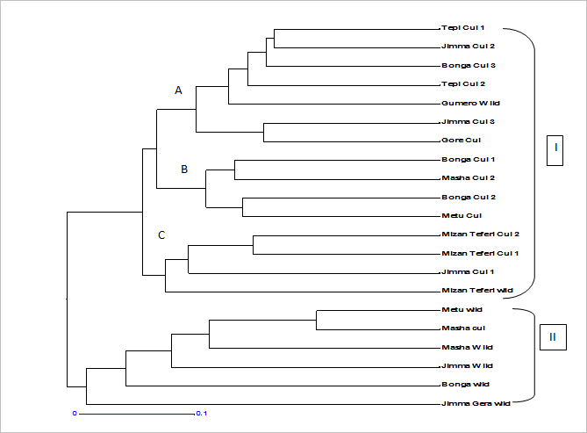
Figure 10 UPGMA phenogram based on pair wise simple matching dissimilarity index showing the genetic relationships among 21 Ethiopian cultivated and wild korarima populations using SSR markers. Korarima populations were grouped into two: group I comprising 13 cultivated and 2 wild populations and group II comprising 5 wild and 1 cultivated populations.
Figure 11 NJ dendrogram based on pair wise simple matching dissimilarity index showing the genetic relationships among Ethiopian cultivated and wild korarima populations using SSR markers

Analysis with STRUCTURE HARVERSTER demonstrated that the K value had the highest peak at K=2 (Figure 12), inferring that two populations can incorporate all individuals included in the present study with the highest likelihood. A graphic representation of estimated membership coefficients of each individual at K=2 is shown in Figure 13 (A and B). Each color represents the proportion of membership of each individual, represented by a vertical line, to the two clusters. Bayesian model-based cluster analysis at K = 2 did not produce distinct differentiation among cultivated and wild individuals (Figure 16A). In this analysis, we can observe some individuals from both cultivated and wild population jointly assigned to two clusters, following the assumption that an individual was only exclusively assigned to a particular genetic cluster if at least 85% of its genome (i.e. qi >0.85) is found in it. In Figure 16B there is no distinct structure among populations which shows an admixture of populations.

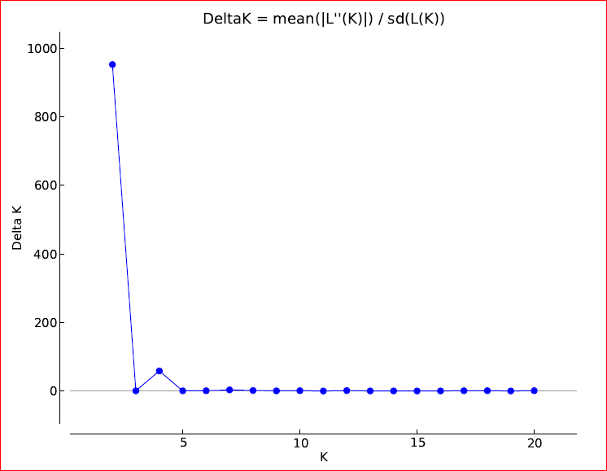
Figure 12 A biplot detected the maximum peak at K=2 (the optimum number of clusters) based on Evanno et al. (2005) prediction.

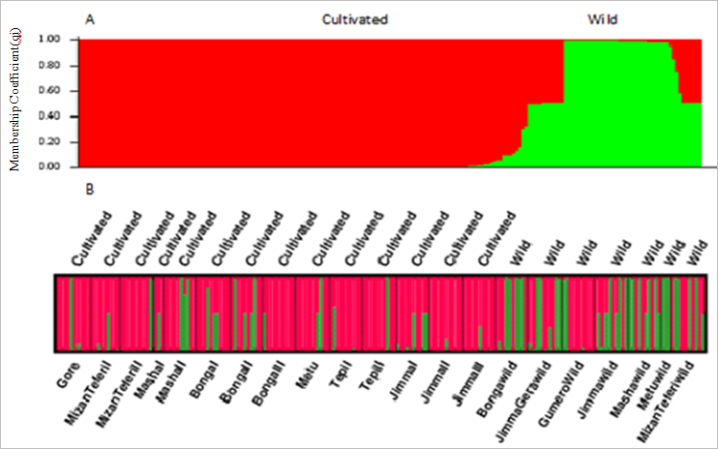
Figures 13 A and B. Estimated population structure at K = 2 for the 195 individuals ordered by type and membership fraction (A) and STRUCTURE bar graphs of the entire korarima samples in 21 pre-determined populations (x-axis) at K=2 (B). The text above the figure refers to korarima types; the text below the figure refers to the different populations. Same colors in different individuals indicate that they belong to the same cluster. Different colors for the same individual indicate the percentage of the alleles that placed it in each cluster.

3.4. Discussion

3.4.1. Genomic-SSR markers for A. corrorima

Microsatellite markers derived from genomic DNA regions have been chosen in many studies for their high levels of allelic variability compared to microsatellites derived from expressed sequence tags (EST-SSRs) (Chistiakov et al., 2006). We used publicly available microsatellite containing genomic sequences of Alpinia oxyphylla to develop eleven new SSRs for Aframomum corrorima. All of these microsatellites are dinucleotide repeats, which are the most common types of SSRs developed based on genomic DNA sequences (Goldstein and Pollock, 1997). All of these loci were polymorphic when the whole populations studied were considered. However, the numbers of polymorphic loci was reduced by one when the loci were considered either for cultivated or wild populations.

The sequence alignment analysis showed that there was variation in the repeat length of the dinucleotide motifs between the two species, A. corrorima and Alpinia oxyphylla (Figure 7), which suggests a clear differentiation of these two species at these SSR loci. However, the sequences that cover the SSR containing part of the PCR products were not obtained for Afco_2 and Afco_8, as sequencing failed for Afco_2, and the SSR containing part of Afco_8 had poor sequence quality, which is attributed to the fact that the SSR is located close to the left primer annealing site.

3.4.2. Genetic diversity

Six of the loci studied produced alleles unique to a single population (private alleles).The self-pollinating nature of korarima (Jansen, 2002) could be one of the major reasons behind the detection of private alleles in most of the loci studied facilitating the possibility of new mutations to remain in the original population due to reduced gene-flow among populations. Among cultivated populations, only one (Mizan Teferi_C1) produced a private allele (frequency = 6.25 %; Figure 8). Differences in agricultural practices in order to strengthen their adaptation to local agro-ecological conditions may have contributed to the genetic distinctiveness of this population. Most of the private alleles were found in three wild populations: Jimma Gera_W, Metu_W and MizanTeferi_W having 1, 7 and 9 private alleles, respectively (Figure 8). The presences of these private alleles have important implications because they may be in linkage disequilibrium with genes coding for desirable traits. Thus they could be useful in indicating a particular type of genotype for breeding purposes (Park et al., 2008).
When genetic analysis was done for all populations, a total of 53 alleles, which averaged to 4.82 alleles per locus, were detected across 11 loci. The average number of alleles per locus obtained in the present study may be comparable to a 4.3 alleles/locus that was reported for ginger (Zingiber officinale) accessions genotyped with eight SSR markers (Lee et al., 2007). However, it is lower than 5.7 alleles/locus reported for Curcuma longa (Sijuet al., 2010) and 5.8 alleles/locus for Piper nigrum (Menezes et al., 2009) based on data from eighteen and nine microsatellite loci, respectively. The relatively lower number observed in A. corrorima and Z. officinale could be attributed to their diploid chromosome number, as C. longa and P. nigrumare triploid and tetraploid, respectively. In the present study, Afco-2 and Afco-11 were the most polymorphic loci both containing eight alleles. Comparable number of alleles per locus were reported in Z. officinale (seven alleles; Lee et al., 2007), C. longa (nine alleles; Siju et al., 2010) and P. nigrum (ten alleles; Menezes et al., 2009). Based on 23 polymorphic microsatellites, Zouet al. (2013) reported up to 13 alleles per locus in Alpinia oxyphylla which is higher than that obtained in the present study.

The average observed heterozygosity (H_{O}) obtained in this study was 0.54 (Table 10). This result is lower than that reported in P. nigrum (0.62, Menezes et al., 2009) and in A. oxyphylla, (0.64, Zou et al., 2013). Likewise, the expected heterozygosity (He) reported in this study was lower than that reported in P. nigrum (0.72; Menezes et al., 2009) and in A. oxyphylla (0.62; Zou et al., 2013). The relatively lower genetic diversity observed in this study can be partly explained by combinations of fewer populations and loci studied.

Our study showed higher levels of diversity in wild populations compared to cultivated populations in terms of average number of alleles/locus, Shannon diversity indexand expected heterozygosity. The average number of alleles/locus and Shannon diversity index of wild korarima were higher than that of cultivated korarima, 4.9vs. 3.2 and 1.06 vs 0.76, respectively. The expected heterozygosity (He) showed similar trend with 0.57 and 0.48 for wild and cultivated korarima, respectively (Table 10). The high genetic diversity recorded in the wild populations may suggest the possibility of finding novel alleles contributing to the improvement of cultivated korarima and has to be given special attention for conservation and utilization.

Among wild populations, the highest Shannon diversity index, the highest percentage of polymorphic loci and the highest expected heterozygosity was recorded in Mizan-Teferi_W, a population from the Bench-Maji zone and lowest in Masha_W, a population from the Sheka Zone. The genetic diversity of most cultivated populations is relatively high with all of the populations having a percentage of polymorphic loci higher than or equal to 70% and a Shannon diversity index of more than 0.50. High genetic diversity was observed in Masha_C2 population (Sheka zone) possessing high percentage of polymorphic loci and high Shannon diversity index compared to other cultivated populations. This may indicate that farmers in this area grow a mixture of landraces of korarima or have their own unique culture based conservation. The lowest diversity found in the other two Masha populations (Masha_C1 and Masha_W) in the Sheka zone, which are cultivated and wild in that order, was rather unexpected. The decreased genetic diversity in cultivated Masha_C1 could be due to strong genetic drift which results in a rapid decline of population size. The reduction of genetic diversity in the wild population could be the result of korarima’s habitat destructions in this population caused by human activities such as digging the rhizomes for planting and traditional purpose or improper management of the plant during harvesting of the capsule. These would result in decline of population size. There is a real risk that if the trend towards a decline in population size is left unchecked, genetic consequences associated with small isolated populations, including genetic drift and inbreeding, will reduce most of the genetic diversity in the Masha wild population. Thus, there is an urgent need to assess the distribution and size of A. corrorima populations in this zone and to adopt appropriate in-situ conservation strategies and collect germplasm for ex- situ conservation.

3.4.3. Genetic structure and gene flow

Our analysis did not show distinct divergence between wild and cultivated korarima. Based on the AMOVA analyses, we found a significant but a relatively low level genetic differentiation among populations of cultivated and wild korarima (F_{ST} = 0.04; P < 0.001) (Table 12). Pair-wise F_{ST} also showed the presence of low level of crop-wild genetic divergence with each wild population showing a significant differentiation from only less than half of the cultivated population (Table 14). Several factors can be included in attempts to account for the observed genetic structure in cultivated and wild korarima. The present-day cultivated A.corrorima may have been directly introduced to cultivation from wild progenitors inhabiting the same localities and thus may have maintained most of their initial genetic diversity. In Southwest Ethiopia, the cultivation area of A. corrorima overlaps with the distribution of natural habitats of wild populations. Because of the sympatric distribution pattern of the wild and cultivated populations, migration from wild to cultivated populations by natural or artificial means may be an ongoing process. Therefore, subsequent gene flow from wild ancestors into cultivated populations may also contribute to the maintenance of a relatively high genetic variation in cultivated A.corrorima.

Crop cultivation impacts not only the amount of genetic variation contained in cultivated populations but also the structure of this variation (Miller and Schall 2006). Hamrick and Godt (1997) reported that the mean value of genetic differentiation among populations of crop species ishigher than that of non-crop species. However, our results run contrary to this report. The cultivated (crop) A.corrorima populations did not show genetic differentiation among populations (F_{ST} = -0.05; P < 0.001) whereas wild (non-crop) populations showed significant population differentiation (F_{ST} = 0.07, P < 0.001) (Table 13). The absence of clear differentiation among cultivated populations can be explained by the movement of genetic material between growers within and among the major production areas, which result in a higher degree of gene flow among cultivated populations and diminish their genetic differences. For wild populations, dispersal of seeds and natural migration between populations is limited, especially when habitats are isolated by geographic barriers such as mountains, rivers or distance. As a result, wild populations are expected to display a relatively greater proportion of variance among populations.

The main evolutionary forces that shape genetic structure in plant populations are gene flow, selection associated with environmental heterogeneity and/or farmer preferences and random genetic drift (Hartl and Clark 1997). For cultivated korarima, there is no differentiation among populations both at the level of regions and zones (Table 13). The absence of genetic divergence among regions and zones could be attributed to geographical proximity of the regions and zones where korarima is currently cultivated, resulting in high gene flow in the form of exchanges of germplasm among farmers. The overall population differentiation among regions and among administrative zones for wild korarima was significant (P<0.0001) with F_{ST} value of 0.06 and 0.09, respectively (Table 13). Natural barriers and geographic distance between regions limits the level of gene flow among wild populations and should therefore contribute significantly to the contemporary genetic structure. In addition, the moderate level of differentiation among administrative zones is expected because different altitudes within a geographical zone would provide different degrees of selection pressure and could accelerate population differentiation rather than gene flow (Lopez-Gartner et al., 2009).
STRUCTURE analysis following Evanno’s adhoc ΔK method suggested that the 21 populations included in the present study most likely form two clusters (K = 2) (Figure 12). Similar to the result obtained from AMOVA and pair-wise F_{ST} analysis, divergence between the two types of korarima was not clear at K = 2. The mixed clustering pattern of individuals of the cultivated and wild populations was highlighted in the STRUCTURE software-based population structure showing all populations having individual genotypes that show partial membership to both clusters (Figure 13 A and B). In addition, the NJ tree revealed two clusters, each comprising individuals from cultivated and wild populations (Figure 9). Moreover, the UPGMA dendrogram, based on pair-wise simple matching dissimilarity index among the 21 cultivated and wild populations, showed two clusters with two wild and one cultivated populations as outliers (Figure 10). Isolation from cultivars is generally considered to be beneficial from the stand point of preserving the integrity and diversity of wild gene pools. The fact that two wild populations grouped very closely with cultivars suggests that there may be ongoing gene flow between them via hybridization and/or cultivars becoming naturalized as free-living populations. Therefore, the overall result obtained in this study suggests that there is gene flow among the two korarima types (cultivated and wild) due to their relative geographical proximity to each other.

3.5. Conclusion

This study provides a first detailed analysis and estimation of genetic diversity in Ethiopian populations of korarima using eleven genomic SSR markers newly developed based on genomic resources of Alpinia oxyphylla. These SSR markers were highly polymorphic within Ethiopian A. corrorima used in this study and could be employed to examine genetic diversity and population structure of korarima in other areas as well as other Aframomum species. Some of the alleles identified across the 11 SSR loci may be linked to important agronomic traits and have to be further evaluated through their use in korarima mapping populations. Overall, Ethiopian korarima needs broader characterization at both molecular and agro-morphological levelsin order to use it in future korarima improvement. The data also shows the power of SSR markers to define how korarima genetic diversity is structured in Ethiopia. This can lead to a better management of the populations in-situ and ex-situ and promote the use of these populations in further breeding programs. Among the five zones in southwestern Ethiopia considered in this study, both Bench-Maji and Sheka harbor populations with high genetic variation and could be used as a starting in-situ conservation sites. We expect that more extensive sampling of korarima in other regions of Ethiopia followed by molecular characterization would reveal additional target sites for in-situ conservation, for development of core collection sites for long-term ex-situ conservation, as well as possible evidence of crop–wild gene flow. The present finding is a timely contribution, considering korarima’s high economic and endogenous value, and current challenges in korarima biodiversity management and conservation.

Chapter 4 Comparison of ISSR and SSR markers in assessing genetic diversity among cultivated korarima (Aframomum corrorima) from southwestern Ethiopia

4.1. Introduction

Korarima (Aframomum corrorima (Braun) P.C.M. Jansen) is a spice crop in the family Zingiberaceae. This family has provided important spices which are mostly aromatic, 40 genera and 900 species being recognized. The economically important species which have established them selves as aromatic spices are the genus Zingiber (ginger), Curcuma (turmeric), Alpinia (galanga), Kaempferia, all representing rhizomatous spices, and Elettaria (small cardamom), Amomum and Aframomum (large cardamoms) representing seed spices (Anon, 1977).

The natural habitat of korarima in south-western part of Ethiopia is being decimated at an increasing rate (Engels and Hawkes, 1991). In order to overcome these problems the range of diversity must be known as a precondition for concentrated cultivation and sustainable utilization of korarima. Estimation of genetic diversity to identify groups with similar genotypes is important for conserving, evaluating and utilizing genetic resources and also for studying the diversity of different germplasm as possible sources of genes that can improve the performance of cultivars (Subudhi et al., 2002).

In the past, plant breeders made selections of breeding material on the basis of morphological characteristics that were readily observable and that were co-inherited with the desired trait. Although these methods remain effective, morphological comparisons have limitations, including the influence of environment or management practices (Gepts, 1993). Subjectivity in the character evaluation is also linked to developmental stage (Morell et al., 1995). Studies with molecular markers have made significant contributions to our understanding of genetic diversity; when compared with other types of markers, they present a greater number of polymorphic loci, which allows distinguishing between accessions that may have similar morphological and agronomical traits (Goncalves et al., 2008). Different types of molecular markers are being studied for a wide range of applications including mapping specific genes, selecting genotypes in breeding programs using marker-assisted selection and in establishing genetic resources.

A comparison of the different marker systems used to estimate crop genetic diversity is important in order to assess their usefulness in germplasm conservation and as plant breeding tools. Here, the use of ISSR and SSR marker technique for studying genetic diversity among cultivated korarima was reported for the first time in Ethiopian korarima genotypes. This study was designed to: (1) verify the level of genetic diversity maintained by farmers in these regions of Ethiopia; (2) determine the potential of ISSR and SSR marker technique to generate polymorphic markers in korarima; (3) determine the most suitable molecular marker system (SSRs or ISSR) for assessing the genetic diversity in korarima landraces and (4) examine the genetic variability among various genotypes.

4.2. Materials and methods

Plant materials, DNA extraction and quantification, amplification of SSR and ISSR, data analysis were the same as presented in chapter 2 and 3. The data gathered and scored in the two sections was compared based on various genetic diversity estimates generated.

4.3. Results

Out of the eighteen ISSR primers tested initially; seven primers (all di-nucleotide) gave clear banding pattern and were selected and used (Table 3). On the other hand, out of the twenty three SSR primers tested, ten primers (all di-nucleotide) were used for genetic diversity analysis. The molecular weight of the bands amplified using the ISSR primers were in the range of 100 to 3000 bp (Table 4).The molecular weight of the bands amplified using the SSR primers were in the range of 160 to 455 bp (Table 9). The average Shannon diversity index for all loci in SSR analysis is 0.76 (Table 15), whereas, the average Shannon diversity index for all loci in ISSR analysis is 0.51(Table 4).
Table 15 Genetic diversity estimates of ten microsatellite loci for 13 cultivated populations of A. corrarima
Locus | n_{a} | Ne | I | F_{ST} | Nm
Afco-2 | 5 | 2.29 | 1.02 | 0.07 | 3.12
Afco-3 | 5 | 2.28 | 1.00 | 0.06 | 3.91
Afco-5 | 4 | 2.17 | 0.88 | 0.06 | 3.68
Afco-6 | 2 | 1.90 | 0.67 | 0.02 | 10.68
Afco-11 | 5 | 2.40 | 1.02 | 0.09 | 2.66
Afco-14 | 2 | 1.92 | 0.67 | 0.13 | 1.63
Afco-15 | 2 | 1.99 | 0.69 | 0.02 | 10.97
Afco-19 | 2 | 1.02 | 0.07 | 0.04 | 6.43
Afco-21 | 3 | 2.33 | 0.93 | 0.58 | 0.18
Afco-22 | 2 | 1.86 | 0.66 | 0.02 | 10.10
Mean | 3.2 | 2.02 | 0.76 | 0.10 | 2.17

Nm = Gene flow estimated from F_{ST} = 0.25(1 - F_{ST})/F_{ST}.

Genetic differentiation is an important index in order to evaluate the population genetic structure of a species. Global genetic differentiation across all loci for SSR markers was estimated with F_{ST}. Gene differentiation coefficients (F_{ST}: 0.10) suggested as 10% of the variation attributed to among populations and 90% of the variation is within the population and the estimated gene flow (N_{m}) using SSR marker was 2.17 (Table 15).For ISSR markers, the inter-population coefficient (G_{ST}) of 0.32 indicated genetic differentiation among populations. Thirty two percent of the total genetic diversity was attributed to among-population differentiation. The estimated gene flow (N_{m}) was 1.08 (Table 5).
Genetic diversity parameters (percentage of polymorphic loci: PPL and Shannon diversity index: I) were analyzed using the ISSR and SSR markers separately for 13 populations of A. corrarima and were listed in Table 16. Generally the Percentage of polymorphic loci for all population in the SSR markers showed higher value than in the ISSR marker and results for both the ISSR and SSR markers revealed different trends of genetic diversity among the populations. Where seven populations (Gore_C1, Mizan Teferi_C1, Tepi_C2, Masha_C2, Jimma_C1, Tepi_C1, and Bonga_C1) showed the highest PPL of 90% in the SSR analysis and three populations (Gore_C1, Mizan Teferi_C1, and Jimma_C3) revealed the highest PPL of 68 % in the ISSR analysis. The mean PPL values for SSR and ISSR marker were 85.38% and 58.50 %, respectively. The Shannon diversity index obtained from SSR data indicated that the Masha_C2 population showed greater genetic diversity (0.82) followed by Gore_C1 (0.75) and Metu_C1 population (0.71). Different results were obtained for ISSR data, Mizan Teferi_C2 (0.43) population showing the highest Shannon diversity index followed by Bonga_C2 (0.41) and Gore_C1 (0.40). The overall Shannon diversity index values for SSR and ISSR marker were 0.61 and 0.34, respectively (Table 16).
Table 16 Percent polymorphic loci (PPL) and Shannon diversity index (I) of 13 populations of korarima (A. corrarima) from southwestern Ethiopia using SSR and ISSR marker
Population | SSR |  | ISSR
 | PPL | I | PPL | I
Gore_C1 | 90.00 % | 0.75 | 68.60 % | 0.40
Mizan Teferi_C1 | 90.00 % | 0.66 | 68.60 % | 0.38
Mizan Teferi_C2 | 80.00 % | 0.63 | 81.40 % | 0.43
Metu_C1 | 80.00 % | 0.71 | 44.19 % | 0.29
Jimma_C3 | 80.00 % | 0.56 | 68.60 % | 0.39
Bonga_C3 | 80.00 % | 0.58 | 51.16 % | 0.29
Bonga_C1 | 90.00 % | 0.66 | 59.30 % | 0.35
Bonga_C2 | 80.00 % | 0.66 | 65.12 % | 0.41
Masha_C2 | 90.00 % | 0.82 | 56.98 % | 0.34
Jimma_C1 | 90.00 % | 0.56 | 31.40 % | 0.19
Tepi_C1 | 90.00 % | 0.68 | 65.12 % | 0.36
Tepi_C2 | 90.00 % | 0.69 | 65.12 % | 0.36
Jimma_C2 | 80.00 % | 0.61 | 34.88 % | 0.22
Over all | 85.38% | 0.61 | 58.50 % | 0.34

To elucidate further gene differentiation among populations, Nei’s (1978) unbiased genetic distances were evaluated. Nei’s distances ranged from 0.01 to 0.22 based on the SSR analysis with an average of 0.09. The largest genetic difference (0.22) occurred between Metu_C1 (M_C1) and Bonga_C3 (B_C3) populations and the least (0.01) between Metu_C1 (M_C1) and Mizan Teferi_C2 (MT_C2) populations (Table 17). Whereas, the Nei’s genetic distance for ISSR marker was highest (0.41) between J_C2 and B_C3 populations and it was lowest (0.06) between B_C1 and B_C3 populations (Table 6). The overall mean genetic distance for ISSR marker was 0.2.

Table 17 Nei’s genetic distance (below diagonal) and genetic identity (above diagonal) between the 13 pairs of korarima populations using SSR markers
Populations | G_C1 | MT_C1 | MT_C2 | Ma_C2 | B_C1 | B_C2 | B-C3 | M_C1 | T_C1 | T_C2 | J_C1 | J_C2 | J_C3
G_C1 | 0.00 | 0.94 | 0.88 | 0.97 | 0.95 | 0.89 | 0.90 | 0.88 | 0.90 | 0.92 | 0.90 | 0.88 | 0.91
MT_C1 | 0.07 | 0.00 | 0.91 | 0.96 | 0.96 | 0.92 | 0.92 | 0.91 | 0.93 | 0.96 | 0.95 | 0.91 | 0.92
MT_C2 | 0.13 | 0.10 | 0.00 | 0.91 | 0.93 | 0.96 | 0.81 | 0.99 | 0.97 | 0.89 | 0.90 | 0.87 | 0.96
Ma_C2 | 0.04 | 0.04 | 0.09 | 0.00 | 0.97 | 0.93 | 0.93 | 0.92 | 0.92 | 0.95 | 0.93 | 0.90 | 0.93
B_C1 | 0.05 | 0.04 | 0.08 | 0.03 | 0.00 | 0.94 | 0.95 | 0.92 | 0.93 | 0.95 | 0.93 | 0.91 | 0.94
B_C2 | 0.12 | 0.08 | 0.04 | 0.07 | 0.06 | 0.00 | 0.81 | 0.96 | 0.97 | 0.88 | 0.90 | 0.87 | 0.96
B-C3 | 0.10 | 0.08 | 0.21 | 0.07 | 0.05 | 0.21 | 0.00 | 0.80 | 0.81 | 0.94 | 0.90 | 0.88 | 0.82
M_C1 | 0.13 | 0.09 | 0.01 | 0.09 | 0.09 | 0.04 | 0.22 | 0.00 | 0.97 | 0.88 | 0.89 | 0.87 | 0.95
T_C1 | 0.11 | 0.07 | 0.03 | 0.08 | 0.07 | 0.03 | 0.21 | 0.03 | 0.00 | 0.89 | 0.91 | 0.88 | 0.97
T_C2 | 0.08 | 0.04 | 0.12 | 0.06 | 0.06 | 0.13 | 0.07 | 0.13 | 0.11 | 0.00 | 0.96 | 0.91 | 0.89
J_C1 | 0.11 | 0.05 | 0.11 | 0.08 | 0.07 | 0.11 | 0.10 | 0.11 | 0.10 | 0.04 | 0.00 | 0.94 | 0.91
J_C2 | 0.13 | 0.09 | 0.13 | 0.10 | 0.10 | 0.14 | 0.13 | 0.14 | 0.12 | 0.09 | 0.06 | 0.00 | 0.88
J_C3 | 0.09 | 0.08 | 0.04 | 0.07 | 0.06 | 0.04 | 0.20 | 0.05 | 0.03 | 0.11 | 0.10 | 0.13 | 0.00

G_C1 = Gore_C1; MT_C1 =Mizan-Teferi_C1; MT-C2 = Mizan-Teferi_C2; Ma_C2 = Masha_C2; B_C1 = Bonga_C1; B_C2 = Bonga_C2; B_C3 = Bonga_C3; M_C1 = Metu_C1; T_C1 = Tepi_C1; T_C2 = Tepi_C2; J_C1 = Jimma_C1; J_C2 = Jimma_C2; J_C3 = Jimma_C3

Based on AMOVA of the ISSR data set, there were highly significant (p < 0.001) genetic differences among the thirteen A. corrorima populations. About 27.47% of the total genetic diversity was attributed to among population differentiation and 72.53% to the variation within populations. Thus, AMOVA (F_{ST} = 0.28, Table 18) also supports the results of G_{ST}: 0.32 (Table 5), indicating genetic differentiation among populations. The AMOVA of the SSR data set produced congruent results (significant F_{ST} statistics, p < 0.001). Genetic variation was greater withinthan between populations. However, significantly lower genetic differentiation was identified between populations for SSR data (F_{ST} = -0.04; p < 0.001) as compared to significantly higher genetic differentiation recorded from the ISSR data (F_{ST} = 0. 28; p < 0.001) (Table 18).

Table 18 Analysis of Molecular variance for 13 populations of cultivated korarima using SSR and ISSR markers.
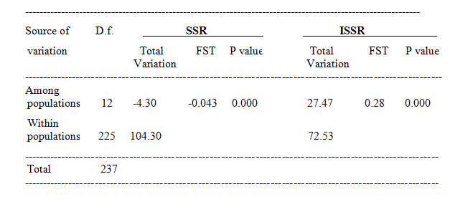
The UPGMA cluster analysis of SSR markers separated the korarima populations into two distinct clusters. The first cluster included twelve populations while the second cluster included only Jimma_C1 population. The first cluster was further divided into two sub-clusters. The first sub cluster had Tepi_C1, Jimma_C2, Bonga_C2, Tepi_C2, Jimma_C3, Gore_C1, Mizan Teferi_C1 and Mizan Teferi_C2 populations and the second sub-cluster contained Bonga_C1, Masha_C2, Bonga_C2 and Metu_C2 populations (Figure 14). The UPGMA cluster analysis based on the ISSR data also revealed a structure of two clusters. The first cluster included nine populations and the second cluster included Jimma_C1, Jimma_C2, Tepi_C1 and Tepi_C2 populations. Again the first sub cluster was further divided into two sub cluster. The first sub cluster had Gore_C1, Metu_C1, Bonga_C3, Jimma_C3, Bonga_C1, Bonga_C2 and Masha_C2 populations and second sub cluster contained Mizan Teferi_C1 and Mizan Teferi_C2 populations (Figure 3).

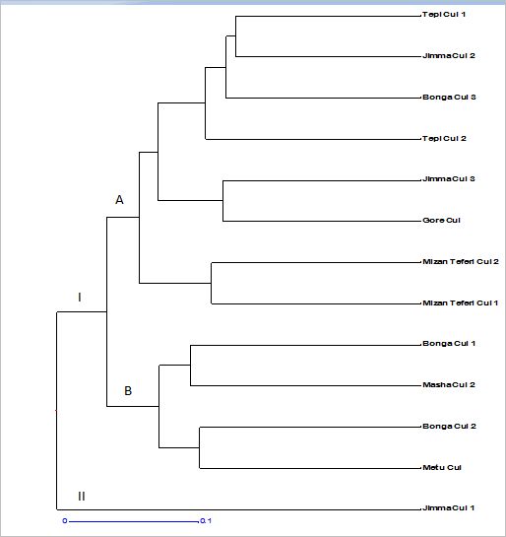
Figure 14 Phenogram of the 13 populations of Aframomum corrorima from Ethiopia generated from SSR data using un-weighted pair group method of arithmetic means (UPGMA). The algorithm is based on pair-wise simple matching dissimilarity index.

4.4. Discussion

In this study, two PCR-based markers were employed to assess genetic diversity among thirteen korarima populations. Each technique not only differed in principle, but also in the type and extent of polymorphism detected. The genetic diversity of all 13 of the populations was analyzed using 10 SSR and 7 ISSR markers. The SSR results showed the number of polymorphic alleles to be 32, whereas the ISSR results showed as the number of polymorphic bands was 84. The levels of polymorphism based on average Shannon diversity index (I) among the two techniques varied widely, SSRs (I: 0.76) showed higher values than that of ISSRs (I: 0.51). The higher level of polymorphism detected in korarima genotypes by SSR markers than with ISSRs highlights the discriminating capacity of the former. The hyper variability observed at SSR loci was expected because of the unique mechanism by which this variation is generated: replication slippage is thought to occur more frequently than single nucleotide mutations and insertion/deletion events, which generate the polymorphisms detectable by ISSR analyses (Powell et al., 1996; Milbourne et al., 1997).

Considering the genetic differences among the genotypes grown in the studied locations, the Percentage of polymorphic loci (PPL) for all population in the SSR markers showed higher value than in the ISSR marker. The overall PPL value (85.38%) for SSR was higher than the overall PPL value (58.50 %) for ISSR data (Table 16). These results imply that SSRs were revealed as more efficient for korarima diversity evaluation compared with ISSRs. In general, the average value of Shannon diversity index present in populations of A. corrarima was 0.61 and 0.34, for SSR and ISSR data, respectively. These indices are greater than the values found for perennial herbs (H’ = 0.17) and to those species with wide geographic distribution (H’ = 0.20) with allozyme markers (Hamrick and Godt, 1989). However, studies by Nayak et al. (2005) with varieties of cultivars of ginger using cytological and molecular markers, showed Shannon’s information index of 0.33, a relatively high value and inferior to that obtained for A. corrarima in this study. It is noteworthy that several factors influence the level of genetic diversity of a species, such as: the geographic distribution, life cycle, reproductive system, dispersal patterns and population size (Hamrick et al., 1991; Zhou et al., 2008).

The maintenance of genetic variation is a major objective for conservation (Hamrick and Godt 1996) and knowledge of variation within and among populations provides essential information in the formulation of appropriate conservation strategies (Francisco- Ortega et al., 2000). In this study, the AMOVA analysis revealed differences in partitioning variation within and among populations; most of the genetic variability was observed within populations (104.30 % and 72.53 % for SSR and ISSR, respectively). The AMOVA analysis showed highly significant (p < 0.001) genetic differences among populations and within populations (Table 18). Even though, a high estimate of genetic differentiation between populations of inbred species like A. corrarima is expected, this may not be a general truth if there is high gene flow represented by seed movement through human involvement. Moreover, the proportion of genetic variation is also dependent on the type of pollination that the species undergoes. Pollen movement which may be facilitated by animals like monkey could also have a role for the observed genetic structure in A. corarrima. This result is consistent with the high value of Nm: 2.17 and 1.21 obtained in the SSR and ISSR data, respectively.
SSRs provided higher within-population genetic diversity and lower genetic differentiation among populations than ISSRs, probably due to the higher polymorphism of the former (Gaudeul et al., 2004) and due to the potential underestimation of ISSR heterozygosity (Tang et al., 2008). As expected, higher estimates of the relative differentiation among populations was recorded for ISSRs than SSRs. The F_{ST} value obtained from the SSR marker in korarima population is 0.10 (Table 15), whereas with ISSR marker, the mean G_{ST} was 0.32, a rather high value that evidences the high differentiation between populations (Table 5). Similarly, AMOVA results indicated that most of the variation was partitioned within populations. Among-population variation was highly significant and reached 28% with ISSR analysis, but below zero with SSR markers (Table 18). The lower differentiation observed in the SSRs analysis may reflect higher SSR mutation rates (Hedrick 1999; and Tang et al., 2008) or homoplasy (Gaudeul et al., 2004).

Cluster analysis was carried out on the binary scores of the two sets of markers that is SSR and ISSR. The results based on the two DNA marker profiles broadly grouped the 13 populations into two clusters. However, the populations of A. corrarima did not show region specific groupings in the phenogram and, therefore, they are geographically and genetically independent. The UPGMA (unweighted pair group method with arthemethic mean) phenogram constructed from both the ISSR and SSR data showed a relatively indistinct grouping model among the different populations (Fig. 6 and Fig.17). However, a few prominent groupings were discerned. Lowest genetic distance was revealed between Bonga_C1 and Bonga_C3 with the SSR (Table 17) and Metu_C1 and Mizan Teferi_C2 with the ISSR (Table 6). These populations were clustered jointly in the UPGMA phenogram showing that they are closely related to each other. The highest genetic distances were found between Metu_C1 and Bonga_C3 in SSR (Table17) and Jimma_C2 and Bonga_C3 with ISSR scores (Table 6). This result is evident in the UPGMA phenogram as these genotypes are separated in different clusters, suggesting that they are genetically diverse.

4.5. Conclusion

The present study demonstrated that both SSR and ISSR methods obtain concordant results that genetic variation of within population is higher than among population. However, polymorphism obtained using ISSR marker is far lower than that obtained using SSRs. Therefore, SSR is more informative and powerful in terms of the assessment of genetic variability, although both ISSR and SSR methods provide useful genetic information on korarima. As pointed out by Milbourne et al. (1997), SSR polymorphism is due to a particular mechanism, namely slippage. This mechanism occurs more frequently than point mutation or insertion-deletion events that are responsible for the polymorphism of ISSRs. This explains why a higher level of polymorphism associated with SSR was evident in many other studies related to a variety of plant species (Davierwala et al., 2000; Palombi and Damiano, 2002; Belaj et al., 2003; Zhou et al., 2003). In essence, SSRs offer a better marker system with more powerful discrimination capacity than ISSR, especially in plants where the level of diversity is affected by various habitat destruction factors and bottleneck effects.

Chapter 5 Phylogeny of Aframomum (Zingebraceae) based on nuclear ribosomal internal transcribed spacer (ITs) and chloroplast trnL-trnF sequence, focusing on the inclusion of a species native to Ethiopia

5.1. Introduction

The zingiberaceae constitute a family of terrestrial rhizomal herbs with over 1400 species distributed in over 50 genera. The genus Aframomum comprises an estimated 80 species of giant herbs endemic to Africa, where it is the largest genus of Zingiberaceae and is in many places a key ecological component of the forest understory. The genus Aframomum was first described by Schumann (1904) to accommodate the African species of Amomum. Further taxonomic works (Lock and Hall, 1975; Lock, 1980; Lock, 1985) provided an initial framework and indicated that the taxonomy of Aframomum is notoriously difficult. Aframomum is the most diverse genus distributed from Senegal to Ethiopia in the north and Angola to Madagascar in the south (Larsen et al., 1998, Auvray et al., 2010). It is also found on the Gulf of Guinea Islands, Sao Tome and Principe. Some species, however, are more ecologically specialized; for example, A. longilgulatum is known only from forests in Cameroon. Another species, A. pseudostipulare, occurs only in seasonally flooded forest in the Congo River basin. One species is found in savanna (A. alboviolaccum). The genus characteristically occurs in light gaps and forest margins and is common along roads and in old fields. They are perennials and aromatics when any part of the plant is crushed (Harris et al., 2000).
Aframomum is well known in African forests because the bright red, fleshy fruit of several species contain a sweet juicy pulp which provides “welcome refreshment”. The fruit of these species are dispersed by primates and other mammals. They also posses highly colored flowers and the peduncles are covered with sterile overlapping bracts (Fankam et al., 2011). Floral morphology is variable with three main distinct flower types which appear to represent different pollination syndromes for birds, bees and butterflies, although direct observations are extremely limited. Most of the variation in flower color (white, purple, red and yellow) is correlated with the different flower types (Harris et al., 2000). These varieties of species are mostly used as laxatives, anthelmintics, toothache, antidiarrhoea, fever management, stomach ache, inflammatory conditions, postpartum haemorrhage and a tonic for sexual stimulation (Duke 2002).

Molecular data are a powerful source of information in studies of plant phylogeny and hybridization, especially in morphologically diverse groups (Baldwin et al., 1995). The trnL-trnF region includes the trnL intron and trnL-trnF intergenic spacer, both of which are noncoding. This region is readily amplified using universal primers developed by Taberlet et al. (1991). Sequence data from this region have shown potential for investigating interspecific relationships in angiosperms (Harris and Ingram, 1991; Small et al., 1998). The nrDNA ITS region consists of two transcriptional regions (ITS-1 and ITS-2) for which universal primers also exist (White et al., 1990). This region is part of the ribosomal multigene family that includes hundreds to thousands of copies at one or more chromosomal loci (Baldwin, 1992; Baldwin et al., 1995; Widmer and Baltisberger, 1999). ITS is the most widely used nuclear DNA region in plant systematic studies and is phylogenetically informative at low taxonomic levels (Baldwin et al., 1995).

The phylogenetic relationships within the family Zingiberaceae was addressed by several papers (Xia et al., 2004). There are two papers to date addressing the phylogenetic relationships among the genus Aframomum. The first is a study by Harris et al. (2000) who used internal transcribed spacer (ITS) nrDNA sequences of 42 accessions (representing 28 species) of Aframomum to provide phylogenetically informative data and suggested a recent radiation of the genus in Africa. The second paper available is a phylogeny based on ITS and trnL-trnF sequence data suggesting a recent diversification of the genus (Auvray et al., 2010). However, these two papers didn’t include the Ethiopian species (A. corrorima) in their phylogenetic analysis. Therefore, the present study aimed to re-analyze the phylogenetic relationship between various Aframomum species based on sequence data from ITS region of nuclear ribosomal DNA and the trnL intron and trnL-trnF intergenic spacers of chloroplast DNA and there by: (1) obtain a better understanding of the pylogenetic relationship of the species taxonomically placed in the genus Aframomum, (2) further test the monophylly of the genus, (3) provide molecular evidence for the taxonomic status of A. corrorima, and (4) construct a new phylogenetic classification of the genus.

5.2. Materials and methods

5.2.1. Plant materials and DNA extraction

Six individual plants of korarima (A. corrorima) which were not included in the previous phylogenetic study were selected and used in the present study. The DNA extraction and quantification methods are described in chapter 2 and 3.

In addition to the six new taxa (A. corrorima) from Ethiopia, ITS and trnL-trnF sequences from forty (40) different taxa belonging to the genus Aframomum, maintained in taxonomy database of National Centre for Biotechnology Information (NCBI), were taken as an additional source for the analysis. The species used in this study and GenBank accession numbers are listed in Table.

5.2.2. Out-group selection

Based on previous analyses (Harris et al, 2000; Kress et al., 2002, 2005; Auvray et al., 2010), Aframomum is monophyletic with three potential sister groups; the Alpinia fax clade (Alpinia fax and A. abundiflora), the Renealmia clade, and the Elattariopsis/Amomum clade. Based on these, three species of each genus were selected as an out-group.

Table 19 List of taxa and gene bank accession numbers for nuclear and chloroplast DNA sequence in species of Aframomum and out-group.
Name of species (Species with more than one accession have the number of the accession in bracket) | Gene bank accession number
 | ITS | trnL-trnF intergenic spacer
Aframomum corrorima I | - | -
Aframomum corrorima II | - | -
Aframomum corrorima III | - | -
Aframomum corrorima IV | - | -
Aframomum corrorima V | - | -
Aframomum corrorima VI | - | -
A. alpinum (Gagnep.) K.Schum | FJ883015.1 | -
A. alboviolaceum (Ridl.) K.Schum | FJ848613.1 | FJ848658.1
A. angustifolium (Sonn.) K.Schum (1) | FJ848587.1 | FJ848632.1
A. angustifolium (Sonn.) K.Schum (2) | FJ848620.1 | FJ848665.1
A. corrorima (A.Braun) P.C.M.Jansen | KU215150.1 | KU215241.1
Aframomum chlamydanthum | FJ848595.1 | FJ848640.1
A.daniellii (Hook.f.) K.Schum. | KU215148.1 | KU215239.1
A. flavum Lock | FJ848601.1 | FJ848646.1
A. laxiflorum Loes. ex Lock | AY769835.1 | AY769798.1
A. leptolepis (K.Schum.) K.Schum. | FJ848585.1 | FJ848630.1
A. letestuanum Gagnep (1) | FJ848593.1 | FJ848638.1
A. letestuanum Gagnep (2) | FJ848591.1 | FJ848636.1
A. limbatum (Oliv. & D.Hanb.) K.Schum (1) | FJ848618.1 | FJ848663.1
A. limbatum (Oliv. & D.Hanb.) K.Schum (2) | FJ848584.1 | FJ848628.1
A. limbatum (Oliv. & D.Hanb.) K.Schum (3) | FJ848583.1 | FJ848627.1
A. limbatum (Oliv. & D.Hanb.) K.Schum (4) | FJ848582.1 | FJ848623.1
A. limbatum (Oliv. & D.Hanb.) K.Schum (5) | FJ848578.1 | FJ848629.1
A. longiligulatum Koechlin (1) | AY769836.1 | AY769799.1
A. longiligulatum Koechlin (2) | FJ848594.1 | FJ848625.1
A. longiligulatum Koechlin (3) | FJ848580.1 | FJ848639.1
Aframomum longipetiolatum | FJ848606.1 | FJ848651.1
A. luteoalbum (K.Schum.) K.Schum (1) | FJ848619.1 | FJ848635.1
A. luteoalbum (K.Schum.) K.Schum (2) | FJ848590.1 | FJ848664.1
A. mala (K.Schum. ex Engl.) K.Schum. | FJ848581.1 | FJ848626.1
A. melegueta K.Schum. | FJ848610.1 | FJ848655.1
A. pilosum (Oliv. & D.Hanb.) K.Schum. | FJ848607.1 | FJ848652.1
A. polyanthum (K.Schum.) K.Schum. | FJ848612.1 | FJ848657.1
Aframomum sceptrum (1) | FJ848609.1 | FJ848654.1
Aframomum sceptrum (2) | FJ848576.1 | FJ848621.1
A. spiroligulatum A.D.Poulsen & Lock | FJ848592.1 | FJ848637.1
A. subsericeum (Oliv. & D.Hanb.) K.Schum (1) | FJ848608.1 | FJ848653.1
A. subsericeum (Oliv. & D.Hanb.) K.Schum (2) | FJ848602.1 | FJ848634.1
A. subsericeum (Oliv. & D.Hanb.) K.Schum (3) | FJ848589.1 | FJ848633.1
A. subsericeum (Oliv. & D.Hanb.) K.Schum (4) | FJ848588.1 | FJ848647.1
A. thonneri De Wild (1) | KU215149.1 | FJ848648.1
A. thonneri De Wild (2) | FJ848603.1 | KU215240.1
A. uniflorum A.D.Poulsen & Lock | FJ848598.1 | FJ848643.1
A. verrucosum Lock (1) | FJ848616.1 | FJ848661.1
A. verrucosum Lock (2) | FJ848615.1 | FJ848660.1
Alpinia abundiflora | AY742334.1 | KJ609032.1
Alpinia galangal | AF478715.1 | AY424775.1
Alpinia purpurata | KU215126.1 | KU215221.1
Renealmia thyrsoidea | DQ427003.1 | DQ444496.1
Renealmia alpinia | DQ426999.1 | DQ444511.1
Renealmia battenbergiana | AY769839.1 | AY769802.1
Amomum longipetiolatum | AF478722.1 | AY769788.1
Amomum uliginosum | AY769827.1 | AY769790.1
Amomum pierreanum | AY769829.1 | AY769792.1
Elettariopsis unifolia | AY769832.1 | AY769795.1
Elettariopsis triloba | AY769831.1 | AY769794.1

5.2.3. PCR amplification and DNA sequencing

The trnL-trnF region including the trnL intron, the 30 trnL (UAA) exon, and the intergenic spacer between trnL (UAA) and trnF (GAA), were amplified and sequenced together. The universal primers trnL-c, forward, and trnL-f, reverse (Taberlet et al., 1991) were used to amplify the trnL-F region (Appendix 4b). The nrDNA ITS region consists of two transcriptional regions (ITS-1 and ITS-2). The entire ITS region was amplified using the ITS 4 and ITS 5 primers (White et al., 1990) (Appendix 4a). Target DNA was directly amplified using 10ng of genomic DNA in a total volume of 25 ul, containing: 18. 6ul ddH₂O, 2.5ul 1x PCR buffer (10mM Tris-HCl, pH 8.3 and 50mM KCl), 0.4 uM each of the forward and reverse primers, 200 uM of each dNTP, 1.5 mM MgCl₂ and 1U Dream Taq polymerase (Sigma, Germany). PCR was performed in a GeneAMP PCR system 9700 thermocycler with the following temperature profiles: initial 3 min denaturing at 94ºC and final 7 min extension at 72ºC with 30 intervening cycles of 1 min denaturing at 94ºC, 1 min primer annealing at 48ºC and 2 min primer extension at 72ºC and then maintained at 4ºC.
PCR products were purified using the Qiaquick PCR purification kit and sent for sequencing. The purified fragment was mixed with the forward primers according to the requirements of Eurofins Genomics sequencing company, Germany. Each of 1.5 ml eppendorf tube was labeled by prepaid barcodes and 15 µl of purified DNA samples were mixed with 2 µl of primer with a concentration of 10 pmol/µl. Forward and reverse sequences of the fragments were obtained separately.

5.2.4. Sequence editing and alignment

DNA sequences were manually edited and aligned visually using the program BIOEDIT version 7.0.5 (Hall 2005). Sequences were aligned using clustalx 2.1 software (Larkinet al., 2007), followed by manual adjustment. Boundaries of the coding and spacer sequences were determined by comparison with published sequences in NCBI database.

5.2.5. Phylogenetic analyses

The nuclear (ITS) and chloroplast (trnL-trnF) sequence data of Aframomum species were evaluated for length, GC content, nucleotide site variation and parsimony-informative sites. The trnL-trnF and ITS sequence data were analyzed both individually and in combination using the program PAUP* 4.0a150 (Swofford, 2003). The default PAUP settings were used except as noted. Gaps were scored as missing data. Character states were specified as unordered and unweighted. Maximum parsimony analysis were conducted using heuristic searches with 1000 random sequence addition replicates and TBR branch swapping with one tree held per replicate, steepest descent option not in effect, Multrees in effect, no more than two trees of score (length) greater than or equal to 5 was saved in each replicate and collapse branches if maximum length is zero. Sets of equally parsimonious trees were summarized using both strict and majority rule (50%) consensus. Support for the nodes resolved in the strict consensus of the most parsimonious trees was evaluated with bootstrap analyses (Felsenstein, 1985) using heuristic searches of 10 random sequence addition replicates, TBR branch swapping and 1000 bootstrap replicates and (or) by 1000 replicates of jackknifing (50% character deletion), preserving nodes present in at least 50% of replicates. Bootstrap support was categorized according to Kress et al. (2002) criteria, i.e., strong (85%), moderate (70–85%), weak (50–70%), or poor (50%) support. Tree length, Consistency Index (CI), and Retention Index (RI), were also calculated. ACCTRAN (accelerated transformation) character-state optimization was used for all trees illustrated. Trees were rooted on the out-group taxa (in the genera Elleptropsis, Amomum Renealmia and Alpinia).

5.2.6. Partition homogeneity test

Prior to combining the data sets, conflict between data partitions was explored. Incongruence between the ITS and trnF data sets was assessed using the incongruence length difference (ILD) test (Farris et al., 1995). The test was done as implemented in PAUP using one thousand heuristic partition homogeneity replicates, each with 10 random addition sequence replicates, TBR branch swapping, MulTrees off, gaps treated as missing data, and constant characters included.

5.3. Result

5.3.1. Nuclear DNA dataset analysis

The ITS data matrix included 45 in-group taxa and 11 out-group’s. Multiple sequence alignment of ITS region of Aframomum and other closely related taxa used as an out group resulted in a data matrix of 752 characters. Of the 752 positions constituting the aligned ITS sequences, 130 (17.29%) were variable and 121 (16.09%) were parsimony-informative. Mean GC content in ITS region is 57%. The phylogenetic analysis of this sequence data (unweighted characters; without excluding any region) using a tree-bisection-reconnection (TBR) branch swapping algorithm resulted in 488 equally parsimonious trees of 368 steps [consistency index (C_{I}) = 0.77; homoplasy index (H_{I}) = 0.23; retention index (R_{I}) = 0.74] (Table 20).

From one of 488 equally parsimonious trees, a clear difference can be observed between the branch length of the out-group and in-group taxa (Figure 15). From the figure, Aframomum represents a highly homogenous group and this may probably indicate monophyly of the genus.

Table 20 Comparison of the variation in the nuclear ribosomal region, the chloroplast non-coding regions and the combined data set
Statistics | ITS | trnL-trnF | Combined
Number of taxa | 56 | 55 | 55
Aligned length | 752 | 1016 | 1700
Number of variable sites | 130 | 99 | 600
Number of constant sites | 501 | 723 | 811
Number of parsimony informative Characters | 121 | 194 | 289
Number of most parsimonious trees | 488 | 94 | 170
Maximum Parsimony (MP) tree length | 368 | 437 | 1273
% mean G+C content | 0.57 | 0.33 | 0.43
Consistency index | 0.77 | 0.81 | 0.81
Retention index | 0.74 | 0.91 | 0.76
Homoplasy index (H_{I}) | 0.23 | 0.19 | 0.19
Rescaled consistency index (R_{C}) | 0.57 | 0.74 | 0.61

55 taxa was used for trnL-trnF and combined data analysis since A. alpinum has no trnL-trnF sequence available in the gene bank

The bootstrap consensus tree presented in Figure 16 was similar to the strict consensus tree constructed for 488 equally parsimonious trees. However some nodes were collapsed in the former as indicated in the Figure 16 with arrow. The taxa were organized into different groups as follows: the out-group was separated from in-groups taxa in all trees, and the species of the genus Aframomum. Bootstrapping showed that the major branch which separates in-groups from out-group were weak (62 %). Within the in-groups, three putative grouping are observed. The first group consists of five taxon of three species: A. angustifolium 1 and 2, A. luteoalbum 1 & 2, Aframomum thonneri 2 (bt = 74 %). The second group consists of two taxon of A. verrucosum 1&2 (bt= 89%). The third group consists of A. chlamydanthum and A. polyanthum (bt= 72%). Within the out-group the genus Renelmia is the only group which forms a monophyly.
Out-group
In-group
Figure 15 One tree of 488 equally most parsimonious trees showing branch lengths. The in-group shows very short branch lengths reflecting the homogenous sequences.
III
II
I
Figure 16 Maximum-parsimony bootstrap consensus tree generated from a phylogenetic analysis of DNA sequence data from the internal transcribed spacers of the nrDNA of Aframomum species and eleven out-group species. Bootstrap values of >50 % are indicated above the branches. The arrow indicates the node that collapses in the strict consensus trees. The vertical bars show the out-group species and putative groups I, II and III were indicated within braces.

5.3.2. Chloroplast DNA dataset analysis

The trnL–F data matrix included 44 ingroup taxa. The trnL–trnF data matrix is smaller than the ITS data matrix because one taxa (A. alpinum) which had ITS sequence in GenBank has not been sequenced for trnL–F (or the sequences are not yet available). Similar number of out groups (11) as for the ITs analysis were used. The trnL–F alignment resulted in a data matrix of 1016 characters among which 99 sites were variable and 194 sites were parsimony-informative. Mean GC content in trnL–trnF region is 33%. Phylogenetic analyses using maximum parsimony as the optimality criterion resulted in 94 most-parsimonious trees of 437 steps (consistency index [C_{I}] 0.81, homoplasy index [H_{I}] 0.19 and retention index [R_{I}] 0.91) (Table 20).
-
The topology of the bootstrap consensus tree generated from trnL–trnF cpDNA region (Figure 17) was basically the same with the one generated from ITs of the nrDNA but, some differences were observed. Most of the out groups were separated from the in-groups. Bootstrapping showed that the major branch which separates in-groups from out-group’s were strong (91%). Three out-group species from Alpina genus form a clade with the in-group taxa, even though; it separated in the subsequent clade with a high bootstrap support (87%). Two taxa from the in-groups separated from the rest of the taxa, even if the bootstrap support was weak. The other interesting result obtained from the bootstrap consensus tree generated from trnL–trnF region was that all of the Ethiopian taxon forms a single putative grouping within the in-groups. This result shows the relationships within individuals from the same species were well supported

Figure 17 Maximum-parsimony bootstrap consensus tree generated from a phylogenetic analysis of DNA sequence data from trnL/F of the cpDNA of Aframomum species and eleven out-group species. Bootstrap values of >50 % are indicated above the branches. The vertical bars show the out-group species and putative groups were indicated within braces.
.

5.3.3. Combined dataset analysis

The result of the ILD test for the nrDNA and cpDNA showed incongruence between the two datasets (P = 0.01). However, the support of branches increased in the combined tree and the incongruence might disappear with more data (Farris et al., 1995). So we included the combined dataset in our analysis. The combined dataset of the two markers (ITS and trnL–trnF) had 1700 aligned characters, of which 600 (16.08%) were variable and 289 (18.17%) were parsimony informative. Mean GC content in the combined dataset is 43%. The analysis found 170 most parsimonious trees with a length of 1273 steps, consistency index (C_{I}) = 0.81, homoplasy index (H_{I}) = 0.19 and retention index (R_{I}) = 0.76 (Table 20).

One of 170 equally parsimonious tree from the combined MP analysis is shown in Figure 18. It showed a similar topology to the ITS DNA tree showing a clear separation between out-group’s and in-groups. In addition, the topology of Aframomum and related out-group’s in the combined bootstrap consensus tree was congruent with the ITs analysis. All trees based on combined data like the ITS place the Aframomum species in the same group separating them from the out-group with a bootstrap value of 53% (Figure 19). However a different putative grouping is formed here. Six Ethiopian taxon of A. corrorima form a separate clade together with other ten Aframomum species namely A. angustifolium, A. mala, A. sceptrum 2, A. veerrucosum 1&2, A. daniellii, A. thonneri, A. corrorima 0, A. luteoalbum, and A. chlamydanthum. This grouping was supported by a weak bootstrap. The out-group nodes in the topology of the combined analysis received higher bootstrap support (Figure 19) than those in the separate analyses of either nuclear or chloroplast DNA region (Figure 16 and Figure 17).
Figure 18 One tree of 170 equally most parsimonious trees generated from combined data matrix.

Figure 19 Maximum-parsimony bootstrap consensus tree generated from a phylogenetic analysis of combined DNA sequence data from the internal transcribed spacers of the nrDNA and trnL-trnF of the cpDNA of Aframomum species and eleven out-group species. Bootstrap values of >50 % are indicated above the branches. The vertical bars show the out-group species and putative group was indicated within braces.

5.4. Discussion

Recently, molecular approaches using chloroplast DNA and nuclear ribosomal DNA (nrDNA) sequences have been applied to understand the evolutionary processes and taxonomic relations within the genus Aframomum. A first approach to structuring the genus by molecular markers was published by Harris et al., 2000. The resulting phenogram based on an integration of morphological methods largely confirmed the monophyly of the genus and robustly separated the in-groups from the out-group species. Later molecular studies focused on the classification and phylogeny of ginger (Kress et al., 2002). And then Auvrey et al. (2010) constructed the phylogeny of Aframomum based on ribosomal DNA ITS and plastid trnL-trnF DNA sequences. In both analyses, the genus Aframomum proved to be monophyletic. Further understanding of Aframomum phylogeny will be achieved only through continued phylogenetic studies, especially by including A. corrarima that is native to Ethiopia and have often been excluded from previous analyses.

5.4.1. Phylogenetic information of the ITS and trnL-tmF sequences

Maximum parsimony length of the ITS region (368) in the present study is slightly greater than those of previously reported Aframomum ITS sequences length of 217 steps (Harris et al., 2000). However, it is smaller than the ITS sequence length of related genera: 593 of Amomum (Xia et al., 2004), 1461 of Alpinia (Kress et al., 2005) and 1603 of Ginger (Kress et al., 2002). ITS region sequences in many angiosperms have a high GC content, normally ranging from 50% in several groups to 75% in Poaceae (Baldwin et al., 1995). Mean GC content of ITS in Aframomum is 57% which was within the range mentioned above. Mean GC content in ITS was higher than the mean GC content obtained from trnL-trnF (33%) and combined data set (43%) in the present study. Baldwin et al. (1995) reported difficulties in ITS region sequencing in the presence of high GC content due to the formation of ITS secondary structures. However, Eurofins Genomics Company makes this easier by providing high quality sequencing of a purified PCR product length up to 3000bp using a single primer.

In Aframomum, the trnL-trn F region has more parsimony-informative characters than the ITS. The outcome that trnL-trnF ccontain more parsimony site than ITS in Aframomum is not consistent with results in other phylogenetic studies in tribe Zingibereae which had less parsimony character in the trnL-trnF region (Ngamriabsakul et al., 2004). However, compared to the ITS region sequences with 130 variable sites, the trnL-trnF region sequences are substantially less variable containing only 99 variable sites. Variable nucleotide positions and parsimony-informative sites of ITS in Aframomum are slightly lower than in Alpinia (Kress et al., 2005) and Ammomum (Xia et al., 2004).

The ITS data (Homoplasy index (HI): 0.23) show much higher levels of homoplasy than the trnL-trnF data (Homoplasy index (HI): 0.19. This shows as there is little homoplasy supported by high consistency index. This result is consistent with data from Harris et al. (2000) and might be responsible for the overall lack of resolution and low support values in the ITS phylogeny.

5.4.2. Phylogeny of Aframomum

In their investigation of the relationships among the genus Aframomum using molecular data set, Harris et al. (2000), Kress et al. (2002) and Auvrey et al. (2010) demonstrated, with limited species sampling, that Aframomum is monophyletic. Our study also confirms this result by using internal transcribed spacer (ITS) region of nrDNA and chloroplast trnL-trnF region. We find strong support for the monophyly of Aframomum in all analyses, regardless of analytical method. This is consistent with previous analyses based on floral morphological characters (Ley and Harris 2014) as well. In addition our phylogenetic analysis suggests that Aframomum corrorima is sister to the rest of the members of Aframomum. The overall results from the separate ITS and cpDNA analyses were basically the same as those found in the combined analysis. Differences seen in topologies across analyses and datasets were never supported by bootstrap values greater than 50%.

The ITS nrDNA data are useful in assessing relationships among Aframomum. Based on these data, monophyly of Aframomum is well supported being consistent with the classification of Harris et al (2000). The four clades of Aframomum recognized by Harris et al. (2000) correspond closely to the three major clades defined in our analysis using ITS region (Figure 16). Group 1 and 2 of Harris et al. (2000) corresponds to the putative group I of the present study and group 4 of the former with group III of this study. Our increased taxon sampling including A. corrorima have provided stronger bootstrap support for each of these clades.

The phylogenetic analysis of the trnL-trnF region resulted in stronger bootstrap support (91%) than the ITS region (62%) or the combined data (53%) analysis for separation of out-group’s from among the taxon in the genus Aframomum. Our most surprising result concerns a pyhlogram of Aframomum with trnL- trnF region data which appears to be paraphyletic, with the genus Alpina nested within it (Figure 17), even though, all species of Alpina are separated from the rest of the in-groups with high bootstrap value in subsequent clade. This data provide some evidence that Aframomum is more closely related to Alpinia than it is to the rest of the genera used as out-group in the present study. This is consistent with the evidence that the ploidy level of the species counted so far in these two genera is the same, Aframomum 2n = 48 (Poulsen and Lock, 1997, Wannakrairoj and Wondyfiraw, 2013) and Alpinia 2n = 48 (Beltran and Kiew, 1984). However, paraphyly of Aframomum based on trnF-trnL data shows disagreement with all traditional classifications.

The ILD test was conducted on the combined data matrix of ITS and trnF-trnL region and was significant (ILD probability value = 0.01), indicating that the two data sets are heterogeneous. The ITS and trnF-trnL trees placed some species in contradictory positions, which may reflect reticulate events in the evolutionary history of these species, the potential mechanism of which is beyond the scope of the present study. However, the combined tree was better resolved than any of the separate ITS and trnF-trnL, and trees derived from the combined dataset were mostly consistent with respect to their major groupings; we therefore describe the combined tree here. These results corroborated the irrelevance of the significant ILD values in terms of combinability, as proposed or confirmed by previous authors. The ILD test is useful as a tool for exploring heterogeneity in data sets, but probably should not be used as an arbiter of whether data sets should be combined (Yoder et al., 2001; Barker and Lutzoni, 2002). The combined data sets produced a more fully resolved tree with strong support for the out-group nodes (Figure 19).

5.5. Conclusion

Sequences of nuclear ITS and trnL-trn-F region have been obtained from 46 and 45 taxon of Aframomum, respectively, and from eleven out-group’s. Maximum parsimony trees from the two partitions were generally congruent; however, conflict was seen that derived from three taxa of Alpinia merging with the in-groups in trnL-trn-F analysis. Our phylogenetic tree based on ITS shows that Aframomum can be divided into three major clades and shows a clear separation between the out-group’s and in-groups. The monophyly of Aframomum and the three groups formed in the ITS analysis in the present study corresponds the result of Harris et al. (2000). Analyses combining the two partitions (ITS and trnL-trn-F) were generally most similar to ITS analyzed separately, though only two putative grouping formed in the combined data.

6. Overall Summary and Recommendations

This thesis project had two main goals. The first was characterizing the genetic diversity of korarima (A. corrorima) populations from southwestern part of Ethiopia. The second was to provide molecular evidence for taxonomic position of A. corrarima. To achive the first goal, first the genetic diversity analysis of cultivated korarima was conducted using inter simple sequence repeats. Then additional wild samples were included to the cultivated population to analyze the genetic diversity and structure using microsatellite markers. Finaly comparison was made between the two marker types using cultivated korarima populations. Information on the extent and pattern of genetic diversity present in the population using various marker systems is essential for further improvement of the crop. In order to achive the second goal phylogenetic analysis of the genus Aframomum was made based on DNA sequence region from nuclear ribosomal DNA and chloroplast region using maximum parsimony.
High levels of genetic diversity were detected in cultivated A. corrarima when analyzed using seven inter simple sequence repeats. Cultivated populations were not grouped according to their respective collection sites which could be attributable to the high gene flow (Nm= 1.08) between populations. Further analyses of genetic diversity were undertaken using microsatellite (SSR) markers to provide information for conservation strategies as well as evidence of possible gene flow between the different gene pools. The extent of SSR variation in korarima was investigated in 14 cultivated and 7 wild populations. Higher genetic diversity was found in wild korarima than in the cultivated counterpart. Closer genetic proximity between cultivated and wild korarima was detected that could be explained by historical and contemporary gene flow between the two gene pools. Comparison between the two molecular marker systems was made in analyzing the genetic diversity of 129 korarima landraces. Higher genetic diversity was revealed in the SSR marker than ISSR. This implies that the former was more efficient for korarima diversity evaluation than the later; however, both ISSR and SSR methods provide useful genetic information. DNA sequence from chloroplast (trnL-trn-F) and nuclear ribosomal DNA (ITS) regions were used to analyze the phylogenetic relationships of species in the genus Aframomum including A. corrarima. The maximum parsimony analysis based on ITS and combined data strongly supports the monophyly of Aframomum.This suggests A. corrarima is sister to the rest of the members of Aframomum. However, analysis based on trnL-trn-F region merges the genus Alpinia with the in-groups in Aframomum genus. This could be an indication of the relatedness of the two genera.

Based on the series of results described here the following recommendation was forwared for further research in the future:
- The ISSR markers used in the present study were effective in detecting high level of genetic diversity in cultivated A. corarima populations. Knowledge of the genetic relationships among population is important information for the efficient use and conservation of this species.
- The SSR markers developed in this study were highly polymorphic within Ethiopian A. corrorima and could be validated and employed to examine genetic diversity and population structure of korarima in other areas as well as other Aframomum species.
- The SSR markers may be linked to important agronomic traits and have to be further evaluated through their use in korarima mapping populations.
- The present data shows the power of ISSR and SSR markers to define how korarima genetic diversity is structured in Ethiopia. This can lead to a better management of the populations in-situ and ex-situ and promote the use of these populations in further breeding programs.
- In addition to the present study, Ethiopian korarima deserves further broader characterization at both molecular and agro-morphological levels in order to use it in future korarima improvement.
- We expect that more extensive sampling of korarima in other regions of Ethiopia would reveal additional target populations for germplasm conservation, as well as possible evidence of crop–wild gene flow.
- The lack of genetic divergence within Aframomum in all data sets (ITS, cpDNA and combined) suggests that it is a young taxon despite its wide geographic and morphological range. Efforts are needed to assess species boundaries and population relationships within this taxon.
- The relationship and status of Aframomum suggested by the present molecular data indicate that it is monophyletic and is closely related to the genus Alpinia. We recommend that more species sampling from both genus and related genera throughout their ranges be added for future molecular analyses.
- The results presented in this paper also highlight the continuing need to pursue additional data sets beyond the commonly employed tools of cpDNA and ITS sequences for phylogenetic studies at low taxonomic levels.

- More collection is needed to increase the number of korarima (A. corrorima) germplasm in the gene bank.

7. Refference
Adugna, A., Snow, A.A., Sweeney, P.M., Bekele, E.; and Mutegi, E. (2013). Population genetic structure of in situ wild Sorghum bicolor in its Ethiopian center of origin based on SSR markers. Genet Resour Crop Evol. 60: 1313–1328.
Allentoft, M.E., Schuster, S., Holdaway, R.N., Hale, M.L.; and McLay, E. (2009).Identification of microsatellites from an extinct moa species using highthroughput (454) sequence data. Biotechniques. 46: 195–200.
Anon. (1977). Zingiberaceae. In: Encyclopaedia Britannica Macropaedia, 15th edn, 19, 1150.
Ashkani, S., Rafii, M.Y., Rusli, I., Sariah, M., Abdullah, S.N.A., Abdul Rahim, H.; and Latif, M. (2012). SSRs for marker-assisted selection for blast resistance in rice (Oryza sativa L.). Plant Mol. Biol Rep. 30: 79–86.
Auvray, G., Harris, D.J., Richardson, J.E., Newman, M.F.; and Särkinen, T.E. (2010).Phylogeny and dating of Aframomum (Zingiberaceae). In: Barfod, A., Davis, J.I., Petersen, G., Seberg, O. (eds) Diversity, Phylogeny, and Evolution in the Monocotyledons: 287–305. Aarhus, Aarhus University Press.
Babu, K.N., Jayakumar, V.N., Divakaran, M., Venugopal, M.N., Sudarshan, M.R., Radhakrishnan, V.V., Backiyarani, S., Narayanaswami, M.M., Peter, K.V., and Parthasarathy, V.A. (2012). Genetic diversity and phylogenetic relationships among small cardamom (Elettaria cardamomum Maton.) cultivars and related genera using DNA markers. Int. J. Innovative Horticulture. 1(1): 47-56.
Baldwin, B. G. (1992). Phylogenetic utility of the internal transcribed spacer of nuclear ribosomal DNA in plants: An example from the Compositae. Mol. Phylogenet. Evol. 1: 3-16.
Baldwin, B.G. (1993). Molecular phylogenetics of Calcydenia (Compositae) based on ITS sequences of nuclear ribosomal DNA: Chromosomal and morphological evolution reexamined. Am. J. Bot. 80: 222-238.
Baldwin, B. G., Sanderson, M. J. Porter, J. M. Wojciechowski, M. F. Cambell, C. S.; and Donoghue, M. J. (1995). The ITS region of nuclear ribosomal DNA: A valuable source of evidence on angiosperm phylogeny. Ann. Missouri Bot. Gard. 82: 247-277.
Ballard, L.W., Adams, P. S.; and Bao, Y. (2002).“Strategies for genotyping: effectiveness of tailing primers to increase accuracy in short tandem repeat determinations,” J Biomol.Tech. 13(1): 20–29.
Barker, F.K.; and Lutzoni, F.M. (2002).The utility of the Incongruence Length Difference test. Syst. Biol. 51: 625–637.
Baser, K.H.; and Kurkcuoglu, M. (2001).The essential oils of Aframomum corrorima (Braun) Jansen and A. angustifolium K.Schum from Africa. J. Essential Oil Res. 13: 208–209.
Belaj, A., Satovic, Z., Gripriani, G., Baldoni, L., Testolin, R., Rallo, L., and Trujillo, I. (2003).Comparative study of the discriminating capacity of RAPD, AFLP and SSR markers and of their effectiveness in establishing genetic relationships in olive. Theor. Appl. Genet. 107: 736–744.
Bekele, A., Feyissa, T.; and Tesfaye, K. (2014). Genetic diversity of anchote (Coccinia abyssinica (Lam.) Cogn.) from Ethiopia as revealed by ISSR markers. Genet. Resour. Crop Evol. 61: 707–719.
Beltran, I. C.; and Kiew, K. Y. (1984). Cytotaxonomic studies in the Zingiberaceae. Notes Roy. Bot. Gard. Edinb.41: 541–559.
Biswas, M.K., Chai, L., Mayer, C., Xu, Q., Guo, W.; and Deng, X. (2011). Exploiting BAC-end sequences for the mining, characterization and utility of new short sequences repeat (SSR) markers in Citrus. Mol. Biol. Rep. 1–14.
Borsch, T., Hilu, K.W., Quandt, D., Wilde, V., Neinhuis, C.; and Barthlott, W. (2003). Non-coding plastid trnT-trnF sequences reveal a well resolved phylogeny of basal angiosperms. J. Evol. Biol. 16: 558-576.
Brenner, J.C., Ateeq, B., Li, Y., Yocum, A.K., Cao, Q., Asangani, I.A., Patel, S., Wang, X., Liang, H., Yu, J., Palanisamy, N., Siddiqui, J., Yan, W., Cao, X., Mehra, R., Sabolch, A., Basrur, V., Lonigro, R.J., Yang, J., Tomlins, S.A., Maher, C.A., Elenitoba-Johnson, K.S., Hussain, M., Navone, N.M., Pienta, K.J., Varambally, S., Feng, F.Y.; and Chinnaiyan, A.M. (2011). Mechanistic rationale for inhibition of poly (ADP-ribose) polymerase in ETS gene fusion-positive prostate cancer. Cancer Cell. 19(5): 664-78.
Bruns, T.D., White, T.J.; and Taylor, J.W. (1991).Fungal molecular systematics. Annu. Rev. Ecol. Syst. 22: 525-564.
Burtt, B. L.; and Smith R. M. (1986). Etlingera: the inclusive name for Achasma, Geanthus and Nicolaia (Zingiberaceae). Notes from the Royal Botanic Garden Edinburgh. 43: 235-241.
Casa, A.M., Mitchell, S.E., Hamblin, M.T., Sun, H., Bowers, J.E., Paterson, A.H., Aquadro, C.F.; and Kresovich, S. (2005) Diversity and selection in sorghum: simultaneous analyses using simple sequence repeats. Theor. Appl. Genet. 111: 23–30.
Chahal, G.S.; and Gosal, S.S. (2002). Principles and procedures of plant breeding: biotechnological and conventional approaches. Narosa, New Delhi
Chen, J., Tauer, C.G.; and Huang, Y. (2002). Paternal chloroplast inheritance patterns in pine hybrids detected with trnL-trnF intergenic region polymorphism. Theor. Appl. Genet. 104: 1307-1311.
Chistiakov, D.A., Hellemans, B.; and Volckaert, F.A.M. (2006). Microsatellites and their genomic distribution, evolution, function and applications: a review with special reference to fish genetics. Aquaculture. 255: 1–29.
Cho, Y.G., Shii, T., Temnyk, S., Chen, X., Lipovich, L., McCouch, S.R., Park, W.D., Ayres, N.; and Cartinhour, S. (2000). Diversity of microsatellites derived from genomic libraries and GenBank sequences in rice (Oryza sativa L.). Theor. Appl. Genet. 100: 713–22.
Davierwala, A. P., Chowdari, K. V., Kumar, S., Reddy, A. P. K., Ranjekar, P. K., and Gupta, V. S. (2000). Use of three different marker systems to estimate genetic diversity of Indian elite rice varieties. Genetica. 108: 269–284.
Dessalegn, G. N. (2015). Analysis of factors determining the supply of Ethiopian cardamom Spice (Aframomum corrorima): A Case from Bench Maji Zone of SNNPR, Ethiopia. Eur. J. Bus. Manag. 7(1): 56-64.
Dow, B.D.; and Ashley, M.V. (1996).Microsatellite analysis of seed dispersal and parentage of saplings in bur oak, Quercus macrocarpa. Mol. Ecol. 5: 615-627.
Dubouzet, J.G.; and Shinoda, K. (1999). Relationships among old and new world Alliums according to ITS DNA sequence analysis. Theor. Appl. Genet. 98: 422-433.
Duke, J. A. (2002). Handbook of Medicinal Spices. pp896. CRC press, LLC, Florida, USA.
Durand, J., Garnier, L., Dajoz, I., Mousset, S.; and Veuille, M. (2000). Gene flow in a facultative apomictic Poacea, the savanna grass Hyparrhenia diplandra. Genet. 156: 823– 831.
Earl, D.A.; and von Holdt, B.M. (2016) STRUCTURE HARVESTER v0.6.8. http://taylor0.biology.ucla.edu/struct_harvest). January 2016.
EARO (Ethiopian Agricultural Research Organization), 2000).National research strategy for spices, medicinal and other essential oil bearing plants.EARO, Addis Ababa, Ethiopia.
Edossa, E. 1998. Spices research achievements and experiences, Research report No. 33. Institute of Agricultural Research, Addis Ababa, Ethiopia.
Engels, J. M.; and Hawkes (1991).The Ethiopian gene centre and its genetic diversity. In: plant genetic resources of Ethiopia. Engels, J.M.M., Hawkes, J.G.; and Worede, M. (editors). . Pp: 23-41. Cambridge University Press, Combridge.
Erdogan, V.; and Mehlenbacher, S.A. (2000). Phylogenetic relationships of Corylus species (Betulaceae) based on Nuclear Ribosomal DNA ITS region and Chloroplast matK gene sequences. Syst. Bot. 25: 727-737.
Escoubas, P., Lajide, L.; and Mizutani, J (1995) Termite antifedent activity in Aframomum melegueta. Pytochem. 40: 1097-1099.
Evanno, S., Regnaut, S.; and Goudet, J. (2005).Detecting the number of clusters of individuals using the software STRUCTURE: a simulation study. Mol. Ecol. 14: 2611–2620.
Excoffier, L., Laval, G.; and Schneider, S. (2005). Arlequin ver. 3.0: An integrated software package for population genetics data analysis. Evol. Bioinform. Onl. 1: 47-50.
Eyob, S. (2009). Promotion of seed germination, subsequent seedling growth and in vitro propagation of korarima (Aframomum corrorima (Braun) P. C. M. Jansen). J Med. Plants Res. 3(9): 652-659.
Eyob S, Tsegaye A, Appelgren EM (2009) Analysis of korarima (Aframomum corrorima (Braun) P.C.M. Jansen) indigenous production practices and farm based biodiversity in southern Ethiopia. Genet. Resour. Crop. Evol. 56: 573–585.
Eyob, S., Martinsen, B. K., Tsegaye, A., Appelgren, M.; and Skrede, G. (2008). Antioxidant and antimicrobial activities of extract and essential oil of korarima (Aframomum corrorima (Braun) P.C.M. Jansen). A. J. Biotech. 7 (15): 2585-2592.
Eyob, S., Appelgren, M., Rohloff, J., Tsegaye, A.; .and Messele, G. (2007). Traditional medicinal uses and essential oil composition of leaves and rhizomes of korarima (Aframomum corrorima (Braun) P.C.M. Jansen) from Southern Ethiopia. S. Afr. J. Bot. 74: 181-185.
Eyob, S., Appelgren, M., Rohloff, J.Tsegaye, A.; and Messele, G. (2007). Chemical composition of essential oils from fresh plant parts of korarima (A. corrorima) cultivated in the highland of southern Ethiopia. J. Ess. Oil Res. 19(4): 372-375.
Falush, D., Stephens, M.; and Pritchard, J.K. (2003). Inference of population structure using multilocus genotype data: linked loci and correlated allele frequencies. Genet. 164: 1567–1587.
Fankam, A., Kuete, V., Voukeng, K.I., Kuiate, J.R.; and Pages, J.M. (2011). Antibacterial activities of selected Cameroonian spices and their synergistic effects with antibiotics against multidrug-resistant phenotypes. BMC Complement Altern. Med. 11:104.
FAO: Food and Agriculture Organization (2007). Eco crop of Food and Agriculture Organization of the United Nations.
Farris, J. S., Källersjö, M. Kluge, A. G.; and Bult, C. (1995).Constructing a significance test for incongruence. Syst. Biol. 44: 570–572.
Felsenstein, J. (1985). Confidence Limits on Phylogenies: An Approach Using the Bootstrap Source. Evol. 39 (4): 783-791.
Francisco-Ortega, J., Santos-Guerra, A., Kim, S.C.; and Crawford, D.J., (2000). Plant genetic diversity in the Canary Islands: a conservation perspective. Am. J. Bot. 87: 909-919.
Friar, E.A.., Ladoux, T., Roalson, E.H.; and Robichaux, R.H. (2000). Microsatellite analysis of a population crash and botteleneck in the Mauna kea silversword, Argyroxiphium spp. Sanwicense (Asterraceae), and its implication for reintroduction. Mol. Ecol. 9(12): 2077-2034.
Galal, A.M. (1996). Antimicrobial activity of 6-paradol and related components. Intern. J. Pharmacol. 34: 64–69.
Gaudeul, M; and Till-Bottraud, I. (2004).Reproductive ecology of an endangered Alpine plant, Eryngium alpinum L. (Apiaceae): phenology, gene dispersal and reproductive success. Ann. Bot. 93: 711–721.
Gaudeul, M., Taberlet, P.; and Till-Bottraud, I. (2000). Genetic diversity in an endangered alpine plant, Eryngium alpinum L. (Alpiaceae), inferred from amplified fragment length polymorphism markers. Mol. Ecol. 9: 1625-1637.
Geleta, M., Herrera, I., Monz, A.; and Bryngelsson, T. (2012). Genetic diversity of arabica coffee (Coffea arabica L.) in Nicaragua as estimated by simple sequence repeat markers. The Sci. W. J. Article ID 939820, 11 pages.
Gemmill, C.E.C., Ranker, T.A., Ragone, D., Perlman, S.P.; and Wood, K.R. (1998).Conservation genetics of the endangered endemic Hawaiian genus Brighamia (Campanulaceae). Am. J. Bot. 85 (4): 528-539.
George, K.J., Varma, R.S., Ganga, G., Utpala, P., Sasikumar, B., Saji, K.V.; and Parthasarathy, V.A. (2006).ISSR markers for genetic diversity analysis in spices - An appraisal. Indian J. Hort. 63(3): 302-304.
Gepts, P. (1993). The use of molecular and biochemical markers in crop evolution studies. Evol. Biol. 27: 51–94.
Girma, H., Digafe, T. Edossa, E. Belay, Y.B.; and Weyessa, G. (2008). Spices research achievements. Ethiopian Institute of Agricultural Research.Revised edition, Addis Ababa, Ethiopia.
Goettsch, E. (1991). Spice germplasm in Ethiopia. In: Plant genetic resources of Ethiopia, Engels, J. M. M., Hawkes, J. G.; and Melaku, W. (eds), Pp.123-130, Cambridge University Press, Cambridge.
Goldstein, D.B..; and Pollock, D.D. (1997) Launching microsatellites: a review of mutation processes and methods of phylogenetic inference. J. Hered. 88: 335–342.
Goncalves, L.S., Rodrigues, R., do Amaral. Junior, A.T.; and Karasawa, M. (2009). Heirloom tomato gene bank: Assessing genetic divergence based on morphological, agronomic and molecular data using a Ward-modified location model. Genet. Mol. Res. 8: 364-374.
Goncalves, L. S. A., Rodrigues, R., Amaral Juntor, A. T., Karasawa, M.; and Sudre, C. P. (2008). Comparison of multivariate statistical algorithms to cluster tomato heirloom accessions. Genet. Mol. Res. 7(4): 1289-1297.
Guilford, K., Prakash, S., Zhu, J., Gardiner, S., Bassettte, H.; and Forster, R. (1997). Microsatellites in Malus x domestica (apple), abundance, polymorphism and cultivar identification. Theor. Appl. Genet. 94: 249-254.
Gupta, P.K.; and Rustgi, S. (2004). Molecular markers from the transcribed/expressed region of the genome in higher plants.Funct.Integr. Genomics. 4: 139–162.
Haddad, L.A., Fuzikawa, A.K.; and Pena, S.D. (1997). Simultaneous detection of size and sequence polymorphisms in the transcribed trinucleotide repeats D2S196E (EST00493). Hum. Genet. 99: 796–80.
Hall, T. (2005). BioEdit v. 7.0.5.Biological sequence alignment editor for Windows.Ibis Therapeutics a division of Isis pharmaceuticals. http://www.mbio.ncsu.edu/BioEdit/bioedit.html. Accessed 06 Feb 2016.
Hammer, O., Harper, D.A.T.; and Ryan, P.D. (2001). PAST: Paleontological statistics software package for education and data analysis. Palaeonto. Electro. 4: 9.
Hamrick, J.L.; and Godt, M.J.W. (1997). Allozyme diversity in cultivated crops. Cro. Sci. 37: 26–30.
Hamrick, J.L.; and Godt, M.J.W. (1996). Effects of life history traits on genetic diversity in plant species. Philos. T. Roy. Soc. B. 351: 1291–1298.
Hamrick, J.L., Godt, M.J., Murawski, D.A.; and Loveless, M.D. (1991). Correlations between species and allozyme diversity: Implications for conservation biology. In: Falk, D.A.; and Holsinger, K.E. (eds) Genetics and conservation of rare plants. Oxford University Press, New York, pp 75–86.
Hamrick, J.L.; and Godt, M.J.W. (1989). Allozyme diversity in plant species. In: Brown, A.H.D., Clegg, M.T., Kahler, A.L.; and Weir, B.S. (eds) Plant population genetics, breeding and genetic resources. Sinauer Associates, Massachusetts, pp 43–46.
Hao, G., Yuan, Y.M., Hu, C.M., Ge, X.J.; and Zhao, N.X. (2004). Molecular phylogeny of Lysimachia (Myrsinaceae) based on chloroplast trnL-F and nuclear ribosomal ITS sequences. Mol. Phylogenet. Evol. 31: 323–339.
Harris, D. J., Newman, M. F., Hollingsworth, M. L., Moller, M.; and Clark, A. (2006). The phylogenetic position of Aulotandra (Zingiberaceae). Nord. J. Bot. 23: 725- 734.
Harris, D.J., Poulsen, A. D., Frimodt-Moller, C., Preston, J.; and Cronk, Q. C. B. (2000). Rapid radiation in Aframomum (Zingiberaceae): Evidence from nuclear ribosomal DNA internal transcribed spacer (ITS) sequences. Edinb. J. Bot. 57 (3): 377–395.
Harris, S. A.; and Ingram, R. (1991). Chloroplast DNA and biosystematics: the effects of intraspecific diversity and plastid transmission. Taxon. 40: 393-412.
Hartl, D.L.; and Clark, G. (1997).Principles of population genetics. Sinauer Associates Inc, Sunderland, 4th edition, pp546.
Hedrick, P. (1999). Highly variable loci and their interpretation in evolution and conservation. Evol. 53: 313–318.
Heinz, D.J. (1987). Sugarcane improvement through breeding, Elsevier, Amsterdam.
Hogbin, P.M.; and Peakall, R. (1999).Evaluation of the contribution of genetic research to the management of the endangered plant Zieria prostrate. Conser. Biol. 13(3): 514– 522.
Holisinger, K.E., Mason-Gamer, R.J.; and Whitton, J. (1999).Genes, demes, and plant conservation.In: Genetics and the extinction of species. Landweber, L. F. and Dobson (eds). Princeton University Press, New Jersey. Pp. 23-46.
Holttum, R. E. (1950). The Zingiberaceae of the Malay Peninsula. Gardener's Bull. Singa. 13: 1-249.
Huenneke, L.F. (1991). Ecological implication of genetic variation in plant populations. In: Genetics and conservation of rare plants. Falk, D. A.; and Holsinger K.E. (eds). Oxford University Press, New York. Pp.33-44.
Hymete, A., Rohloff, J.; and Iversen, T. (2006).Essential oil from seeds and husks of Aframomum corrorima from Ethiopia. Flavour Fragr. J. 21: 642–644.
Ingvarsson, P.K., Ribstein, S.; and Taylor, D.R. (2003). Molecular evolution of insertions and deletion in the chloroplast genome of silene. Mol. Biol. Evol. 20: 1737-1740.
Islam, M.A., Meister, A., Schubert, V., Kloppstech, K.; and Esch, E. (2007). Genetic diversity and cytogenetic analyses in Curcumazedoaria (Christm.) Roscoe.from Bangladesh. Genet. Res. Crop Evol. 54: 149– 156.
Jaccard P. (1908). Nouvelles rescherches Sur la distribution florale.Bull. Soc. Vaud. Sci. Nat.44: 223-270.
Jakobsson, M.; and Rosenberg, N.A. (2007). CLUMPP: A cluster matching and permutation program for dealing with label switching and multimodality in analysis of population structure. Bioinformatics. 23: 1801–1806.
Jansen PCM (1981). Spices, condiments and medicinal plants in Ethiopia.Their taxonomy and agricultural significance.PhD thesis, Agricultural Research Reports 906. Center for Agricultural Publishing and Documentation, Wageningen, The Netherlands, pp 10–20
Jansen PCM (2002). Aframomum corrorima (Braun) P.C.M. Jansen.Record from protabase. In: Oyen LPA, Lemmens RHMJ (eds) PROTA (Plant Resources of Tropical Africa/ Resources végétales de l’Afriquetropicale). Wageningen, The Netherlands
Jiang, G.L. (2013). Molecular markers and marker-assisted breeding in plants. In: Plant breeding from laboratories to fields, Andersen, S.B. (ed). CCBY 3.0 License. InTeckOpen. ISBN 978-953-51-1090-3.
Joseph, M.M.; and Bruce, A.M. (1993). Gene flow in plant pathosystems. Annu. Rev. Phytopathol. 31: 353-73.
Kapital, B., Feyissa, T., Petros, Y.; and Mohammed, S. (2015). Molecular diversity study of black cumin (Nigella sativa L.) from Ethiopia as revealed by inter simple sequence repeat (ISSR) markers. Afr. J. Biotech.. 14(18): 1543-1551.

Kaplan, D.R. (2001). The science of plant morphology: definition, history, and role in modern biology. Am. J. Bot. 88: 1711–1741.
Karp, A., Issac, P.G, and Ingram, D.S. (1998). Molecular tools for screening Biodiversity. Chapman and Hall, London.
Kellogg, E. A., Appels, R.; and Manson-Gamer, R. J. (1996).When genes tell different stories: the diploid genera of Triticeae (Gramineae). Syst. Bot. 21: 321-347.
Keneni, G., Bekele, E., Imtiaz, M., Dagne, K., Getu, E.; and Assef, F. (2012).Genetic diversity and population structure of Ethiopian chickpea (Cicerarietinum L.) germplasm accessions from different geographical origins as revealed by microsatellite markers. Plant Mol. Biol. Rep. 30: 654–665.
Koch, M., Dobea, C., Bernhardt, K.G.; and Kochjarova, J. (2003a).Cochlearia macrorrhiza: A bridging species between Cochlearia taxa from the Eastern Alps and the Carpathians. Plant. Syst. Evol. 242: 137-147.
Koch, M., Dobea, C.; and Mitchell-Olds, T. (2003b). Multiple hybrid formation in natural populations: Concerted evolution of the internal transcribed spacer of nuclear ribosomal DNA (ITS) in North American Arabis divaricarpa (Brassicaceae). Mol. Biol. Evol. 20: 338-350.
Korzun, V. (2003).Molecular markers and their applications in cereals breeding. A paper presented during the FAO international workshop on “Marker assisted selection: A fast track to increase genetic gain in plant and animal breeding?”, Turin, Italy.
Kress, W.J., Liu, A., Newman, M.; and LI, Q., (2005). The molecular phylogeny of Alpinia (Zingiberaceae): A complex and polyphletic genus of Gingers. Am. J. Bot. 92(1): 167–178.
Kress, W. J., Prince, L. M.; and Williams, K. J. (2002). The phylogeny and a new classification of the gingers (Zingiberaceae): evidence from molecular data. Am. J. Bot. 89: 1682–1696.
Kumar, L.S. (1999). DNA markers in plant improvement: An overview. Biotech. Adv. 17:143-82.
Kumar, P., Gupta, V.K., Misra, A.K., Modi, D. R.; and Pandey, B. K. (2009).Potential of Molecular Markers in Plant Biotechnology. Plant Omics Journal. 2(4):141-162.
Lagercrantz, U., Ellegren, H.; and Andersson L. (1993).The abundance of various polymorphic microsatellite motifs differs between plants and vertebrates. Nucleic. Acids Res. 21: 1111–1115.
Lande, R. (1998). Genetics and demography in biological conservation. Science. 241: 1455-1460.
Larkin, M.A., Blackshields, G., Brown, N.P., Chenna. R., McGettigan, P.A., McWilliam, H., Valentin, F., Wallace, I.M., Wilm, A., Lopez, R., Thompson, J.D., Gibson, T.J.; and Higgins,D.G. (2007). Clustal W and Clustal X version 2.0. Bioinformatics. 23: 2947-2948.
Larsen, K., Lock, J.M., Maas, H.; and Maas, P.J.M. (1998).Zingiberaceae.In: The families and genera of vascular plants, Kubitzki, K. (ed.), Pp.474–495. Berlin, Springer-Verlag.
Lee, S., Fai, W.K., Zakaria, M. Ibrahim, H.Othman, R.Y., Gwang, J., Rao V.R; and Park, Y. (2007). Characterization of polymorphic microsatellite markers, isolated from ginger (Zingiber officinale Rosc.). Mol. Ecol. Notes. 7: 1009–1011.
Levinson, G.; and Gutman, G.A. (1987). Slipped-strand mispairing: A major mechanism for DNA sequence evolution. Mol. Biol. Evol. 4: 203−221.
Ley, A.C.; and Harris, D.J. (2014). Flower morphological diversity in Aframomum (Zingiberaceae) from Africa – the importance of distinct floral types with presumably specific pollinator associations, differential habitat adaptations and allopatry in speciation and species maintenance. P. Ecol. Evol. 147 (1): 33–48.
Liu, B.H. (1991). Development and prospects of dwarf male-sterile wheat. Chinese. Sci. Bull. 36(4): 306.
Lock, J. M. (1978). Notes on the genus Aframomum (Zingiberaceae). The species related to A. polyanthum (K. Schum.) K. Schum. Bull. Jard. Bot. Nat. Belg. 48: 129-134.
Lock, J.M. (1976). Notes of some East African species of Aframomum (Zingiberaceae). Kew Bull. 31: 263–271.
Lock, J.M. (1980). Notes on Aframomum (Zingiberaceae) in West Africa, with a new key to the species. Kew Bull. 35: 299 – 313.
Lock, J.M. (1985). Zingiberaceae. Flora of Tropical East Africa. 1–40.
Lock, J.M. and Hall, J.B. (1975). Taxonomic studies in the genus Aframomum (Zingiberaceae). Boissiera. 24: 225–231.
López-Gartner, G., Cortina, H., Mccouch, S.R.; and Moncada, M del P. (2009).Analysis of genetic structure in a sample of coffee (Coffea arabica L.) using fluorescent SSR markers. Tree Genet. Genomes. 5(3): 435-446.
Madhusoodanan K. J.; and Saideswara Rao, Y. (2001) Cardamom (large). In: handbook of herbs and spices. Peter, K.V. (ed.), Elsevier, Technology and Engineering, Pp-336.
Martins, W.S., Lucas, D.S., Souza Neves, K.F.; and Bertioli, D.J. (2009). WebSat‐ A web software for microsatellite marker development. Bioinformation. 3(6): 282–283.
May, B. (1992). Starch gel electrophoresis of allozymes. In: Molecular genetic analysis of populations: a practical approach, Hoelzel, AR. (ed.). Oxford University Press, Oxford, UK.pp. 1– 27.
McDermott, J.M.; and McDonald, B.A. (1993). Gene flow in plant pathosystems. Ann. Rev. Phytopatho. 31: 353-373.
Menezes, I. C., Cidade, F. W., Souza, A. P.; and Sampaio, I. C. (2009). Isolation and characterization of microsatellite loci in the black pepper, Piper nigrum L. (piperaceae). Cons. Genet. Resour. 1: 209–212.
Milbourne, D., Meyer, R., Bradshaw, J.E., Baird, E., Bonar, N., Provan, J., Powell, W.; and Waugh, R. (1997). Comparison of PCR-based marker systems for the analysis of genetic relationships in cultivated potato. Mol. Breed. 3: 127–136.
Miller, A.J.; and Schaal, B.A. (2006). Domestication and the distribution of genetic variation in wild and cultivated populations of the Mesoamerican fruit tree Spondias purpurea L. (Anacardiaceae). Mol. Ecol. 15:1467–1480.
Mishra, K.P., Singh, V.K., Rani, R., Yadav, V.S., Chandran, V., Srivastava, S.P.; and Seth, P.K.. (2003). Effect of lead exposure on the immune response of some occupationally exposed individuals. Toxicology. 188: 251-9.
Mitchell-Olds, T.; Al-Shehbaz, I., Koch, M.; and Sharbel, T. (2005). Crucifer evolution in the postgenomic era. In: Plant diversity and evolution: genotypic and phenotypic variation in higher plants; Henry, R.J., (ed), CABI Publishing: Cambridge, MA, USA, pp. 119-136.
Molla, B.A., Asfaw, N.; and Lwande, W. (1994). Chemical constituents of the essential oil of Aframomum corrorima from Ethiopia. Sinet: Eth. J. Sci. 17:145–148.
Morell, M.K., Peakall, R., Appels, R., Preston, L.R.; and Lloyd, H.L. (1995). DNA profiling techniques for plant variety identification. Aust. J. Exp. Agric. 35: 807–819.
Moritz, C. (1998). Uses of Molecular Phylogenies for Conservation.In: New uses for new phylogenies Harvey, P. H., Brown, A. J. L., Smith, J. M.; and Nee, S. (eds), Pp. 203-214. Oxford University Press, Oxford.
Muller-Putz, G. R., Kaiser V., Solis-Escalante, T.; and Pfurtscheller G. (2010). Fast set-up asynchronous brain-switch based on detection of foot motor imagery in 1-channel EEG. Med. Biol. Eng. Comput. 48: 229–233.
Nayak, S., Naik, P.K., Acharya, L.K., Mukherjee, A.K., Panda, P.C.; and Das, P. (2005).Assessment of genetic diversity among 16 promising cultivars of ginger using cytological and molecular markers.Z Natur.Forsch.. 60: 485–492.
Nei, M. (1973). Analysis of gene diversity in subdivided populations. Proc. Natl. Acad. Sci. USA. 70: 3321–3323.
Nei, M. (1978).Estimation of average hetrozygosity and genetic distance from a small number of individuals. Genet. 89: 583–590.
Ngamriabsakul, C., Newman, M. F.; and Cronk Q. C. B. (2004). The Phylogeny of tribe Zingibereae (Zingiberaceae) based on ITS (nrDNA) and trnL-trnF (cpDNA) sequences. Edinb. J. Bot. 60 (3): 483–507.
Ngamriabsakul, C., Newman, M. F.; and Cronk, Q. C. B. (2000). Phylogeny and disjunction in Rosoea (Zingiberaceae). Edinb. J. Bot. 57 (1): 39–61.
NTFP: Non-timber forest products (2004). Training materials in roduction, processing and post harvest handling of selected spices (pepper, korarima, cardamom and long pepper).
Nybom, H. (2004). Comparison of different nuclear DNA markers for estimating intraspecific genetic diversity in plants. Mol. Ecol. 13: 1143–1155.
Nybom, H.; and Bartish, I.V. (2000). Effects of life history traits and sampling strategies on genetic diversity estimates obtained with RAPD markers in plants. Persp Plant Ecol. Evol. Syst. 3: 93–114.
Palombi, M. A.; and Damiano, C. (2002).Comparison between RAPD and SSR molecular markers in detecting genetic variation in kiwifruit (Actinidia deliciosa A. Chev). Plant Cell Rep. 20: 1061–1066.
Park, Y., Dixit, A. Ma, K., Lee, J., Lee, M., Chung, C., Nitta, M., Okuno, K., Kim, T., Cho, E.; and Rao, V.R. (2008). Evaluation of genetic diversity and relationships within an on-farm collection of Perillafrutescens (L.) Britt. Using microsatellite markers. Genet. Resour. Crop Evol. 55: 523–535.
Pavlicek, A., Hrda, S.; and Flegr, J. (1999). Free-Tree--freeware program for construction of phylogenetic trees on the basis of distance data and bootstrap/jackknife analysis of the tree robustness: Application in the RAPD analysis of genus Frenkelia. Folia Biologica (Praha), 45: 97-99.
Peakall, R.; and Smouse P.E. (2012). GenAlEx 6.5: genetic analysis in Excel. Population genetic software for teaching and research – an update. Bioinformatics. 28: 2537-2539.
Pedersen, L. B. (2004). Phylogenetic analysis of the subfamily Alpinioideae (Zingiberaceae) with special emphasis on Etlingera Giseke, based on nuclear and plastid DNA. Plant Syst. Evol. 245: 239-258.
Perrier, X.; and Jacquemoud-Collet J.P. (2006).DARwin software http://darwin.cirad.fr/.
Poehlman, J.M.; and Sleper, D.A. (1995).Breeding field crops.5th edition, pp432, Iowa State University Press, USA.
Poulsen, A. D.; and Lock, J. M. (1997).New species and new records of Zingiberaceae and Costaceae from tropical East Africa. Kew Bull. 52: 601–616.
Powell, W., Bonar, W. N., Baird, E., Russall, J.; and Waugh, R. (1994). Adventitious regeneration and genetic variability: molecular marker techniques for genome analysis of strawberry. Acta. Hortic. 392: 107–114.
Powell, W., Morgante, M., Andre, C., Hanafey, M., Vogel, J., Tingey, S.; and Rafalski, A. (1996). The comparison of RFLP, RAPD, AFLP and SSR (microsatellite) markers for germplasm analysis. Mol. Breed. 2: 225–238.
Pritchard, J.K., Stephens, M.; and Donnelly, P. (2000).Inference of population structure using multilocus genotype data. Genet. 155: 945–959.
Rallo, P., Dorado, G.; and Martin, A. (2000). Development of simple sequence repeats (SSRs) in olive tree (Olea europaea L.). Theor. Appl. Genet. 101: 984−989.
Rangstruji, A., Newman, M. F.; and Cronk, Q. C. B. (2000a). Origin and relationships of Alpinia galanga (Zingiberaceae) based on molecular data. Edinb. J. Bot. 57: 9–37.
Rangsiruji, A. M. F., Newman, Q. C. B.; and Cronk, Q. C. B. (2000b). A study of the infrageneric classification of Alpina (Zingiberaceae) based on the ITS region of nuclear rDNA and the trnL-F spacer of chloroplast DNA. In: Monocots—systematics and evolution, Wilson, K. L.; and Morrison, D. A. (eds.), 695–709. CSIRO Publishing, Collingwood, Australia.
Raubson, L.A.; and Jansen, R.K. (2005). Chloroplast genomes of plants. In: Plant diversity and evolution: Genotypic and phenotypic variation in higher plants; Henry, R.J. (ed), CABI Publishing: Cambridge, MA, USA, pp. 45-68.
Ravindran, P.N., Shylaja, M.; and Babu, N.K. (2002).False cardamoms.In: Ravindran, P.N.; and Madhusoodanan, K.J. (eds). Cardamom: The Genus Ellettaria. CRC Press, Kerala, India. pp. 330-340.
Reddy, M.P., Sarla, N.; and Reddy, E.A. (2002). Inter simple sequence repeat (ISSR) polymorphism and application plant breeding. Euphy. 128: 9–17.
Roder, M.S., Plashke, J.; and Konig, S.U. (1995).Abundance, variability, and chromosomal location of microsatellites in wheat. Mol. Gen. Genet. 246: 327– 333.
Rohlf, F.J. (2000). NTSYS-PC, Numerical taxonomy and multivariate analysis system, Version 2.11. Exeter Software, New York.
Rosenberg, N.A. (2004). DISTRUCT: a program for the graphical display of population structure. Mol. Ecol. Notes. 4:137–138.
Roy, H.; and Ibba, M. (2009).Broad range amino acid specificity of RNA dependent lipid remodeling by multiple peptide resistance factors. J. Biol. Chem. 284: 29677–29683.
Rozen, S.; and Skaletsky, H. (1999).Primer3 on the WWW for general users and for biologist programmers. In: Misener, S. and Krawetz, S., editors. Bioinfo. Meth. Prot. 132: 365–386.
Saitou, N.; and Nei, M. (1987). The neighbor-joining method: a new method for reconstructing phylogenetic trees. Mol. Biol. Evol. 4: 406–425.
Sang, T., Crawford, D.J.; and Stuessy, T. (1997). Chloroplast DNA phylogeny, reticulate evolution, and biogeography of Paeonia (Paeoniaceae). Am. J. Bot. 84: 1120–1136.
Scariot, V., De keyser, E., Handa, T.; and De Riek, J. (2007). Comparative study of the discriminating capacity and effectiveness of AFLP, STMS and EST markers in assessing genetic relationships among evergreen Azaleas. Plant Breed. 126: 207-212.
Schumann, K. (1904) Zingiberaceae. In: Engler, A. (ed.), Das Pflanzenreich. Wilhelm Engelmann, Leipzig, pp. 201–221.
Schut, J. W.; and Qi a, X., Stam P. (1997).Association between relationship measures based on AFLP markers, pedigree data and morphological traits in barley. Theor. Appl. Genet. 95: 1161-1168.
Searle, R. J.; and Hedderson, T. A. (2000). A preliminary phylogeny of the Hedychieae tribe (Zingiberaceae) based on ITS sequences of the nuclear rRNA cistron. In: Wilson, K. L.; and Morrison, D. A. (eds), International Conference on the Comparative Biology of the Monocotyledons. 1: 710–718.
Sebsebe, D. (1993). A description of some essential oil bearing plants in Ethiopia and their indigenous uses. J Essent Oil Res. 5: 465–479.
Semerikov, L.V.; and Lascoux, M. (2003).Nuclear and cytoplasmic variation within and between Eurasian Larix species. Am. J. Bot. 90: 1113-1123.
Serapion, J., Kucuktas, H., Feng, J.; and Liu, Z. (2004). Bioinformatic mining of type I microsatellites from expressed sequence tags of channel catfish (Ictalurus punctatus). Marine Biotech. 6: 364–377.
Siju, S., Dhanya, K., Syamkumar, S., Sheeja, T.E., Sasikumar, B., Bhat, A.I.; and Parthasarathy, V.A. (2010). Development, characterization and utilization of genomic microsatellite markers in turmeric (Curcuma longa L.). Biochem. System. Ecol. 38: 641–646.
Slatkin, M. (1981).Estimating levels of gene flow in natural populations. Genet. 99: 323-335.
Small, R. L., Ryburn, J. A., Cronn, R. C., Seelanan, T.; and Wendel. J. F. (1998). The tortoise and the hair: Choosing between non-coding plastome and nuclear ADH sequences for phylogeny reconstruction in a recently diverged plant group. Am. J. Bot. 85: 1301-1315.
Sneath, P.H.A.; and Sokal, R.R. (1973).Numerical taxonomy.WH Freeman and Company, San Francisco, California, USA.
Soltis, D.E.; and Soltis, P.S. (1989).Isozymes in plant biology.Dioscorides Press, Portland, Oregon, USA.
Souza, S.G.H., Carpentieri-Pípolo, V., Ruas, C.F.; and Carvalho, V.P. (2008). Comparative analysis of genetic diversity among the maize inbred lines (Zea mays L.) obtained by studying genetic relationships in Lactuca spp. Theor. Appl. Genet. 93: 1202–1210.
Spencer, C. C., Neigel, J.E.; and Leberg, P.L. (2000).Experimental evaluation of the usefulness of microsatellite DNA for detecting demographic bottlenecks. Mol. Eco. 12: 1339-1348.
Studier, J.A.; and Keppler, K.J. (1988).A note on the neighbor-joining algorithm of Saitou and Nei. Mol. Bol. Evol. 5: 729-731.
Subudhi, P.K., Nguyen, H.T., Gilbert, M.L.; and Rosenow, D.T. (2002). Sorghum improvement: past achievements and future prospects. In: Kang M.S. (ed), Crop improvement: Challenges in the Twenty-First Century. The Haworth Press, Binghamton, New York, pp. 109–159.
Sudre, C.P., Leonardecz, E., Rodrigues, R.; and Amaral Júnior, A.T. (2007). Genetic resources of vegetable crops: a survey in the Brazilian germplasm collections pictured through papers published in the journals of the Brazilian Society for Horticultural Science. Hortic. Bras. 25: 496-503.
Swofford, D.L. (2003). PAUP*.Phylogenetic analysis using parsimony (*and other methods).Version 4.0a150.Sinauer Associates, Sunderland, Massachusetts.
Taberlet, P., Gielly, L., Pautou, G.; and Bouvet, J. (1991).Universal primers for amplification of three non-coding regions of chloroplast DNA. P. Mol. Biol. 17: 1105-1109.
Tang, S., Dai, W., Li. M., Zhang, Y., Geng, Y., Wang, L.; and Zhong, Y. (2008). Genetic diversity of relictual and endangered plant Abies ziyuanensis (Pinaceae) revealed by AFLP and SSR markers. Genetica. 133: 21–30.
Tanksley, S.D., Ganal, M.W.; and Martin, G.B. (1995). Chromosome landing: A paradigm for map-based cloning in plant species with large genomes. Trends Genet. 11: 63-68.
Teshome, A., Bryngelsson, T., Dagne, K.; and Geleta, M. (2015). Assessment of genetic diversity in Ethiopian field pea (Pisum sativum L.) accessions with newly developed EST-SSR markers. BMC Genet.16:102.
Theerakulpisut, P., Triboun, P., Mahakham, W., Maensiri, D., Khampila, J.; and Chantaranothai, P. (2012). Phylogeny of the genus Zingiber (Zingiberaceae) based on nuclear ITS sequence data. Kew Bull.67 (3): 389–395.
Thiel, T., Michalek, W., Varshney, R.K.; and Graner, A. (2003).Exploiting EST databases for the development and characterization of genederived SSR-markers in barley (Hordeum vulgare L.).Theor. Appl. Genet. 106: 414–22.
Van Oppen, M.J.H., Rico, C., Turner, G.F.; and Hewitt, G.M. (2000). Extensive homoplasy, nonstepwise mutations, and shared ancestral polymorphism at a complex microsatellite locus in lake Malawi cichlids. Mol. Biol. Evol. 17: 489–498.
Viard, F., Franck, P., Dubois, M-P., Estoup, A.; and Jarne, P. (1998).Variation of microsatellite size homoplasy across electromorphs, loci, and populations in three invertebrate species.J. Mol. Evol. 47: 42–51.
Wannakrairoj, S.; and Wondyfiraw, T. (2013). In Vitro chromosome doubling in korarima [A. corrorima (Braun) PCM Jansen] using colchicine and oryzalin. Kasetsart J Nat Sci. 47: 684 – 694.
Waples, R.S. (1987). A multispecies approach to the analysis of gene flow in marine shore fishes. Evol. 41: 385-400.
Wendel, J.F., Schnabel, A.; and Seelanan, T. (1995).Bi-directional interlocus concerted evolution following allopolyploid speciation in cotton (Gossypium). Proc. Natl. Acad. Sci. U.S.A. 92: 280-284.
White, G.M., Boshier, D.H.; and Powell, W. (2002). Increased pollen flow counteracts fragmentation in a tropical dry forest: an example from Swietenia humilis Zuccarini. Proc. Natl. Acad. Sci. U.S.A. 99: 2038–2042.
White, T. J., Bruns, T., Lee, S.; and Taylor, J. (1990).Amplification and direct sequencing of fungal ribosomal RNA genes for phylogenetics.In: PCR protocols: a guide to methods and applications,Innis, D. G. M., Sninsky, J.; and White, T. (eds), Pp. 315- 322. Academic Press, San Diago, CA.
Widmer, A.; and Baltisberger, M. (1999). Molecular evidence for allopolyploid speciation and a single origin of the narrow endemic Draba ladina (Brassicaceae). Am. J. Bot. 86: 1282-1289.
Wiens, J. J. (2000). Phylogenetic analysis of morphological data.Smithsonian Institution Press, Washington, D.C.
Williams, K. J., Kress, W. J.; and Manos, P. S. (2004). The phylogeny, evolution, and classification of the genus Globba and tribe Globbeae (Zingiberaceae): appendages do matter. Am. J. Bot. 91: 100-114.
Wood, T. H., Whitten, W. M.; and Williams, N. H. (2000). Phylogeny of Hedychium and related genera (Zingiberaceae) based on ITS sequence data. Edinb. J. Bot. 57: 261–270.
Wondyfiraw, W. (2004). In vitro propagation and polyploidy induction of Korarima (Aframomum corrorima (BRAUN) JANSEN) and krawan (Amomum krervanh PIERRE). Dissertation for Doctor of Philosophy. Kasetsart University, Thailand.
Wondyfiraw, T.; and Wannakrairoj, S (2004). A Micro propagation Method for Korarima (Aframomum corrorima (Braun) Jansen). Sci. Asia. 30: 1-7.
Xia, J., Kress, W.J.; and Prince, L.M. (2004). Phylogenetic analyses of Amomum (Alpinioideae: Zingiberaceae) using ITS and matK DNA sequence data. Syst. Bot. 29(2): 334–344.
Xu, D.H.; and Ban, T. (2004). Phylogenetic and evolutionary relationships between Elymus humidus and other Elymus species based on sequencing of non-coding regions of cpDNA and AFLP of nuclear DNA. Theor. Appl. Genet. 108: 1443–1448.
Xu, Y. (2010). Molecular plant breeding.Field Crops Res. 123(2): 183–184 ·
Yeh F, Yang R.; and Boyle T. (1999). Popgene version 1.31.
Yeh, F.C.; and Boyle T.J.B. (1997). Population genetic analysis of co-dominant markers and qualitative traits. Belgian J. Bot. 129:157.
Yoder, A.D., Irwin, J.A.; and Payseur, B.A. (2001).Failure of the ILD to determine data combinability for Slow Loris phylogeny. Syst. Biol. 50: 408–424.
Zeid, M., Schon, C.; and Link, W. (2003). Genetic diversity in recent elite faba bean lines using AFLP markers. Theor. Appl. Genet. 107: 1304-1314.
Zenebe, W. (2004). Korarima cardamom: unrecognized and endangered non-timber forest resource. An abstract presented on a national conference on forest resources of Ethiopia. Institute of biodiversity conservation, Addis Ababa, Ethiopia.
Zhang, M., Zhang, R., Yang, J.; and Luo, P. (2010). Identification of a new QTL for Fusarium head blight resistance in the wheat genotype ‘‘Wang shui-bai’’. Mol. Biol. Rep. 37: 1031–1035.
Zhang, W., Qu, L.J., Gu, H, Gao, W., Liu, M., Chen, J.; and Chen, Z. (2002). Studies on the origin and evolution of tetraploid wheats based on the internal transcribed spacer (ITS) sequences of nuclear ribosomal DNA. Theor. Appl. Genet. 104: 1099–1106.
Zheng, Y., Zhang G, Lin F, Wang Z, Jin G, Yang L, Wang Y, Chen X, Xu Z, Zhao X (2008) Development of microsatellite markers and construction of genetic map in rice blast pathogen Magnaporthegrisea. Fungal Genet. Biol. 45:1340–1347.
Zhou, H. F., Xie, Z. W.; and Ge, S. (2003). Microsatellite analysis of genetic diversity and population genetic structure of a wild rice (Oryza rufipogon Griff.) in China. Theor. Appl. Genet. 107: 332– 339.
Zhou, Y., Zhou, C., Yao, H., Liu, Y.; and Tu, R. (2008).Amplification of ISSR markers in detection of genetic variation among Chinese yam (Dioscorea opposita Thunb.) cultivars. Life Sci. J. 5: 6–12.
Zietkiewicz, E., Rafalski, A.; and Labuda, D. (1994).Genome fingerprinting by simple sequence repeat (SSR)-anchored polymerase chain reaction amplification. Genomics. 20: 176–183.
Zou, Y., Zou, P., Liu, H.; and Liao, J. (2013). Development and characterization of microsatellite markers for Alpinia oxyphlla (Zingiberaceae). Appl. Plan. Sci. 1(4): 1200457.

8. Appendices
Locus | Primer sequences (5 ′ –3 ′ ) |  | Ta (°C) | Product size | GenBank accession no.
Afco_1 | F | TCTGAACCAGGGAATCCAAA | 64 | 157 | JX422070.1
Afco_1 | R | AACTCACTTGGAGGCCAACTT | 64 | 157 | JX422070.1
Afco_2 | F | TTGACTTGGGTATGGCAAAA | 63 | 230 | JX422069.1
Afco_2 | R | AAGGTCGAGCAGGAGTAGCA | 63 | 230 | JX422069.1
Afco_3 | F | GAATTCATGTTCTTGAGAAAAGTTTG | 63 | 198 | JX422068.1
Afco_3 | R | GCCAAATGAACGGACAGATT | 63 | 198 | JX422068.1
Afco_4 | F | GCGAAACCCTCTCATCCTTA | 63 | 177 | JX422067.1
Afco_4 | R | CCATCTCCTCGTCCTTTTCA | 63 | 177 | JX422067.1
Afco_5 | F | TGACTCCAAACTTGCAGGAG | 64 | 160 | JX422066.1
Afco_5 | R | AGCAGATCAATGCACGTGAG | 64 | 160 | JX422066.1
Afco_6 | F | TCGACATGAAATCCCTACGAGA | 64 | 243 | JX422065.1
Afco_6 | R | GAGCTGTGAAGTGAAAGGGC | 64 | 243 | JX422065.1
Afco_7 | F | AAAATTTCCAAACGGAAGATGA | 63 | 249 | JX422064.1
Afco_7 | R | TTGATTCTGCCTCCCATTTC | 63 | 249 | JX422064.1
Afco_8 | F | GCTAACTTGTCTTTCCTATTTCTCC | 62 | 239 | JX422063.1
Afco_8 | R | TGGAAGCTGCATTCACTGAG | 62 | 239 | JX422063.1
Afco_9 | F | TGTCCAAGGATTACTTATGAACGA | 62 | 202 | JX422062.1
Afco_9 | R | CGAATTGGAAAGTAATTATATGACC | 62 | 202 | JX422062.1
Afco_10 | F | GCTATAGCCAAGGCAATTCG | 62 | 195 | JX422061.1
Afco_10 | R | TTCGATGTGTTTGCTAAGAAGA | 62 | 195 | JX422061.1
Afco_11 | F | AATGCTTCTAGCTGGTTCGAC | 62 | 241 | JX422060.1
Afco_11 | R | CCTTGAATTTTATATTTCTTCCAGATG | 62 | 241 | JX422060.1
Afco_12 | F | CAGATCGCAGTCGGATTCT | 63 | 247 | JX422059.1
Afco_12 | R | TCCGTTATTCACCGTTCGAT | 63 | 247 | JX422059.1
Afco_13 | F | CTAGGGGATCGAACTGTGGA | 64 | 300 | JX422058.1
Afco_13 | R | CGCGTTTCTTCCCAATAAAA | 64 | 300 | JX422058.1
Afco_14 | F | CCTTCCACGGTGTCTCATTT | 63 | 281 | JX422057.1
Afco_14 | R | TCATCCAAAACTTCAATCATGG | 63 | 281 | JX422057.1
Afco_15 | F | ATCGATGGGATCGCCTTAC | 64 | 292 | JX422056.1
Afco_15 | R | GACGTCACGAATGTTGGTTG | 64 | 292 | JX422056.1
Afco_16 | F | CTGCGTGCGAATTATCGAG | 64 | 393 | JX422055.1
Afco_16 | R | CTGAGGAGGACGAGAAGCTC | 64 | 393 | JX422055.1
Afco_17 | F | TTTTTCATCGTTGTCCCTACG | 64 | 250 | JX422054.1
Afco_17 | R | GTCATCCAAAATGGCGACAC | 64 | 250 | JX422054.1
Afco_18 | F | GGGAAAAGATTTCGACCTACA | 62 | 300 | JX422053.1
Afco_18 | R | GCACAAACTTCAGTAAGGATAATCA | 62 | 300 | JX422053.1
Afco_19 | F | CAGACGAGAGGAGGGAGATG | 64 | 373 | JX422052.1
Afco_19 | R | CTCTGTGAGCCGTTCAATCC | 64 | 373 | JX422052.1
Afco_20 | F | TCCACTGCGTATACCGCTAC | 65 | 245 | JX422051.1
Afco_20 | R | CTGGGCTATAGTGCCCATCG | 65 | 245 | JX422051.1
Afco_21 | F | CGACAAGGAGGAGAAGAGGT | 63 | 250 | JX422050.1
Afco_21 | R | CCAACAGCCCTTCTTTTTGA | 63 | 250 | JX422050.1
Afco_22 | F | GAAGAAGCGTTGGTGAGAGG | 64 | 468 | JX422049.1
Afco_22 | R | CTGTGTCGTCCAGCCGTATT | 64 | 468 | JX422049.1
Afco_23 | F | AGAAGGATGTGCCCAAACC | 64 | 300 | JX422048.1
Afco_23 | R | CTCGCGATTTCAGGTCACTT | 64 | 300 | JX422048.1
Appendix 1: characteristics of 23 microsatellite primers developed fro A. corrarima (The bold one are used for genetic diversity analysis)

Appendix 2: Elecropherogram image revealed by capillary gel electrophoresis which represent heterozygous and homozygous forms of alleles for the microsatellite loci studied, the horizontal axis represent the peak size in base pair and the vertical axis correspond to the relative fluorescence unit (RFU). The sample code is written on the top of the figure.
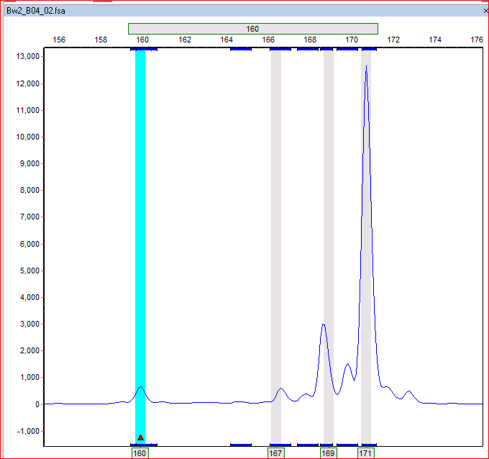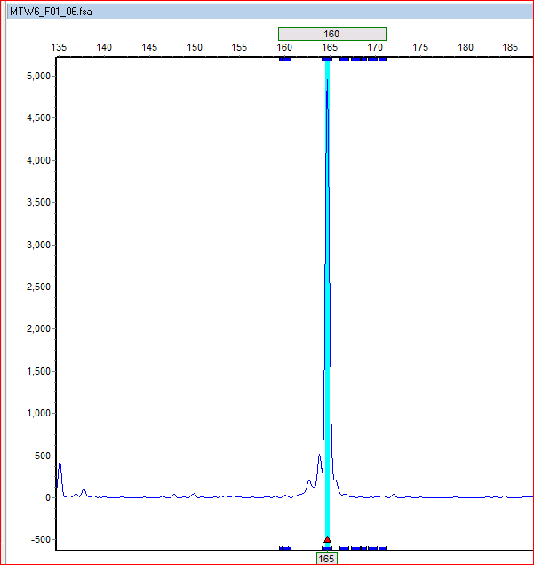
Figure Afco_5 with expected product size of 160 and florecently labeled with 6-Fam

Appendix 2 continued
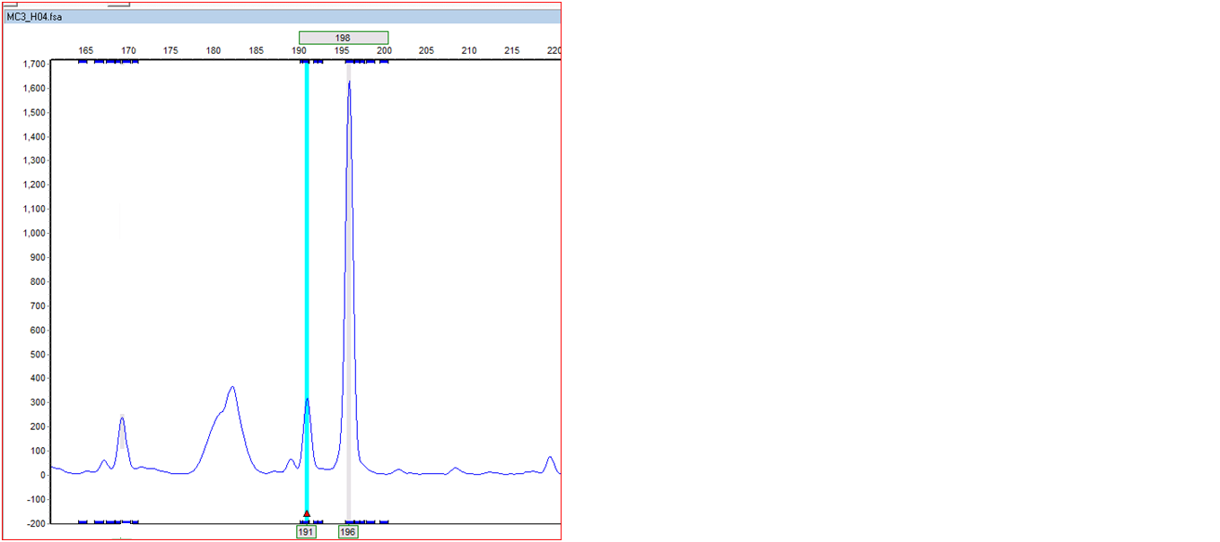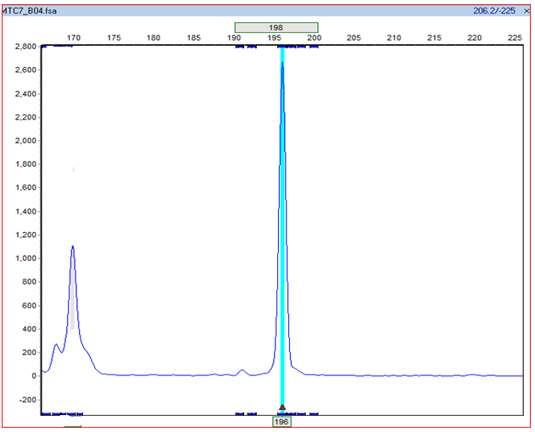
Figure Afco_3with expected product size of198 and florecently labeled with 6-Fam

Appendix 2 continued
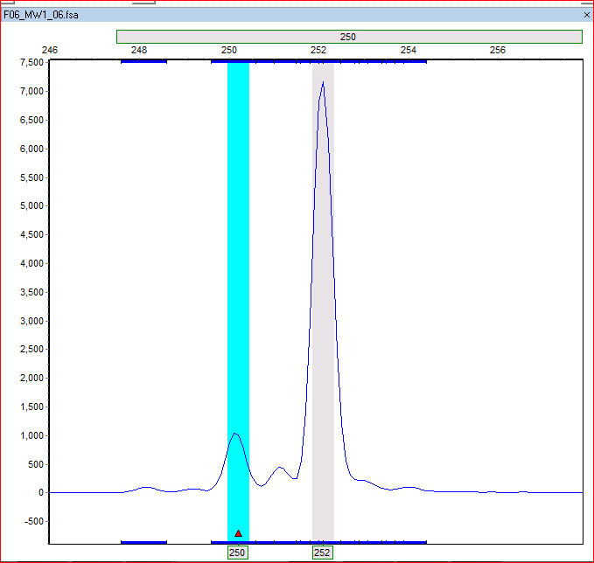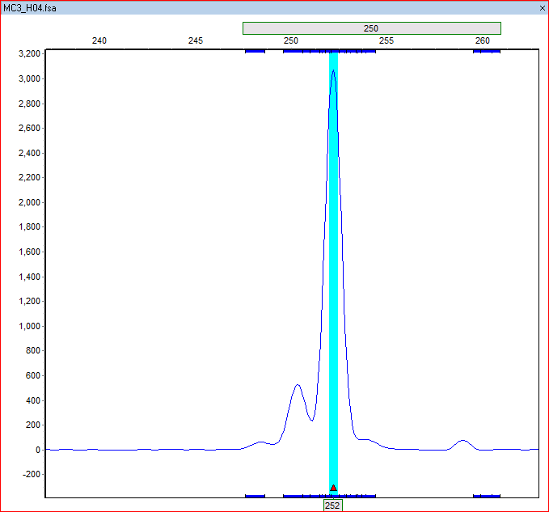
Figure Afco_21 with expected product size of250 and florecently labeled with 6-Fam

Appendix 2 continued
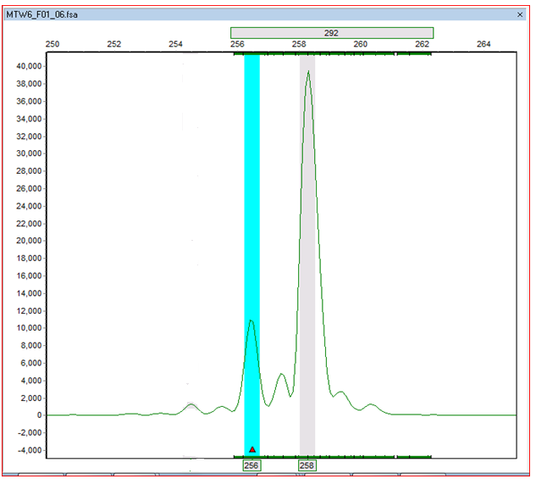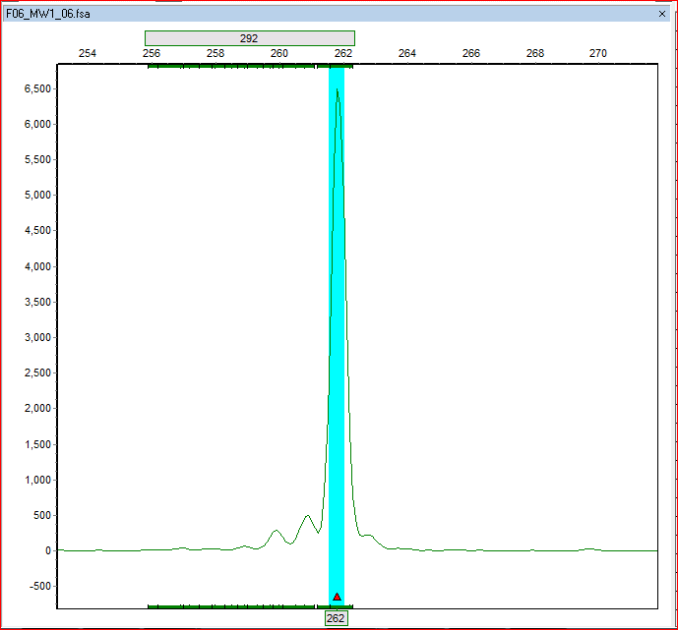
Figure Afco_15 with expected product size of292 and florecently labeled with Hex

Appendix 2 continued
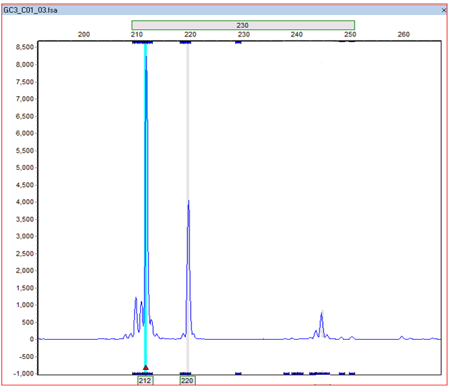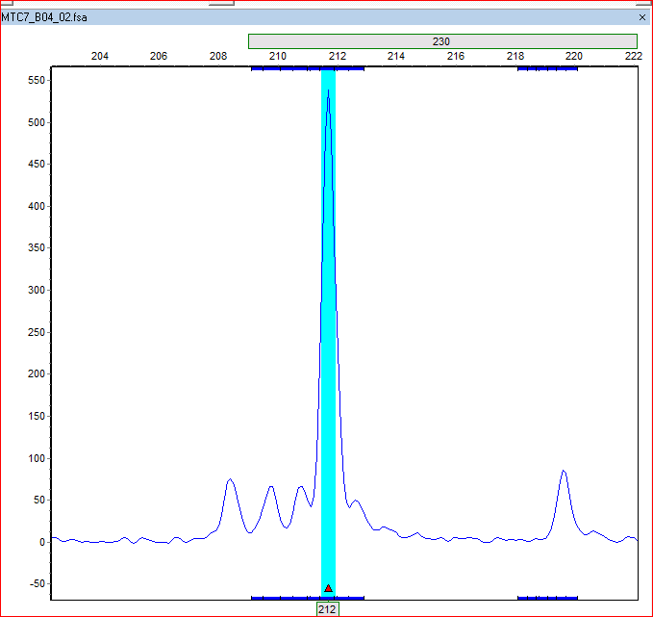
Figure Afco_2 with expected product size of230 and florecently labeled with 6-fam

Appendix 2 continued
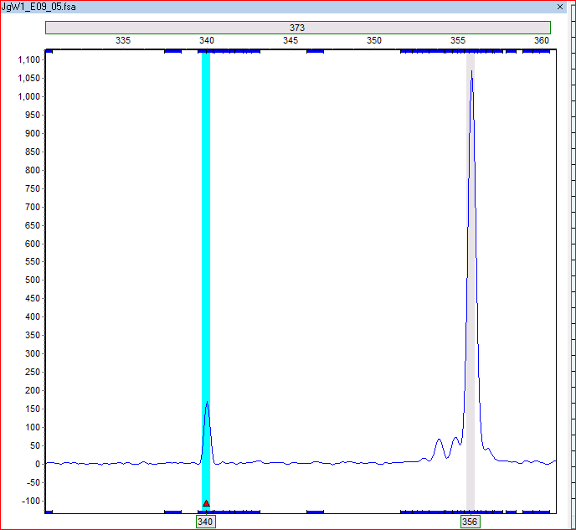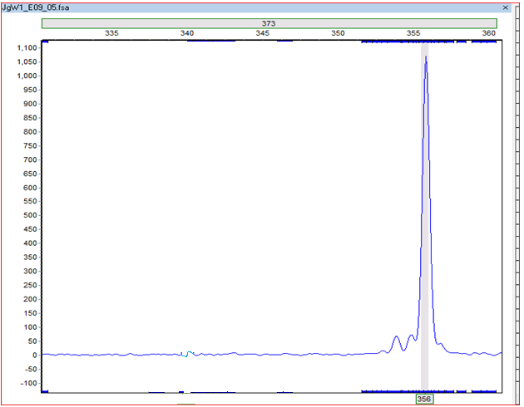
Figure Afco_19 with expected product size of373 and florecently labeled with 6-fam

Appendix 2 continued
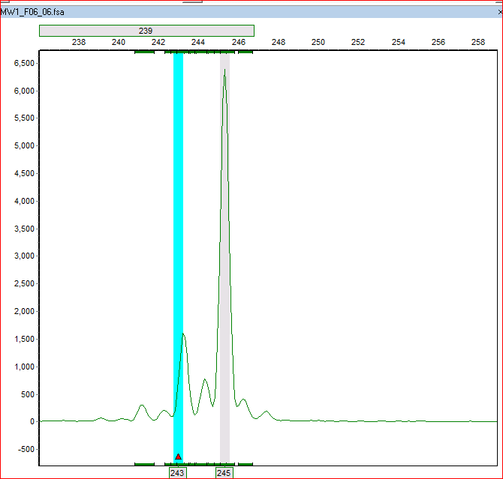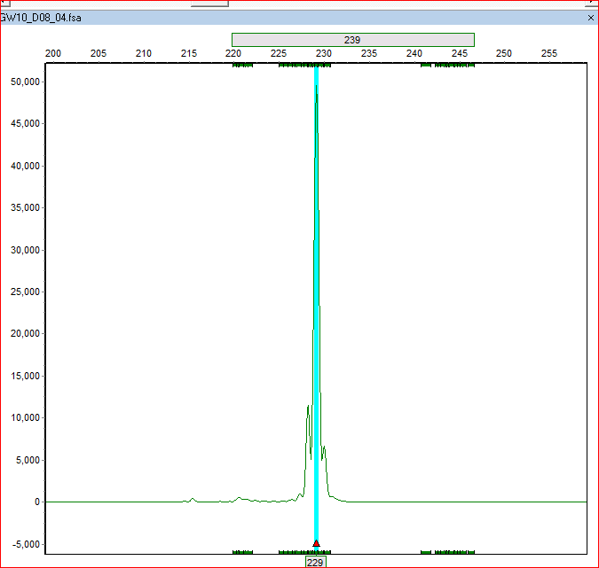
Figure Afco_8 with expected product size of239 and florecently labeled with Hex

Appendix 2 continued
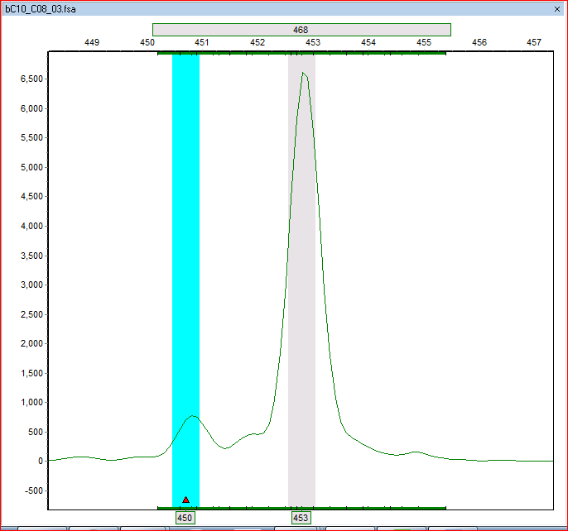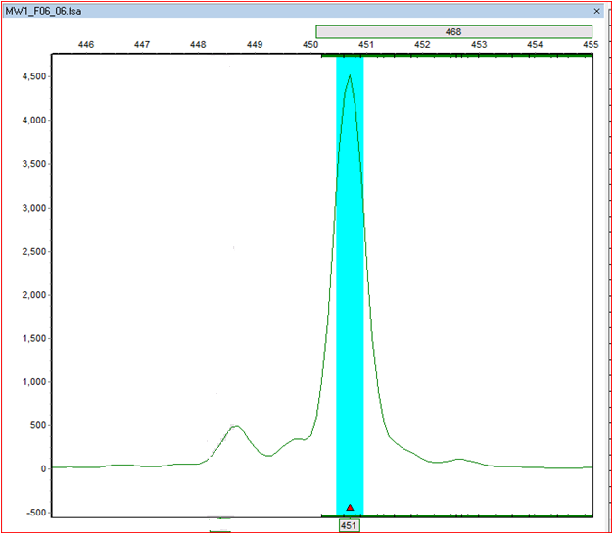
Figure Afco_22 with expected product size of468 and florecently labeled with Hex
Appendix 2 continued
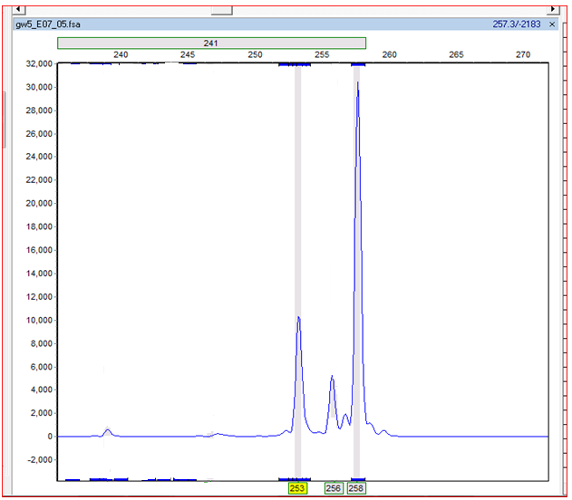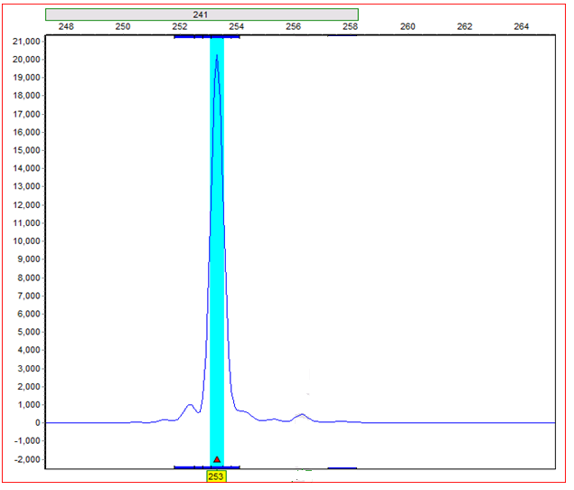
Figure Afco_11 with expected product size of241 and florecently labeled with 6-fam

Appendix 2 continued
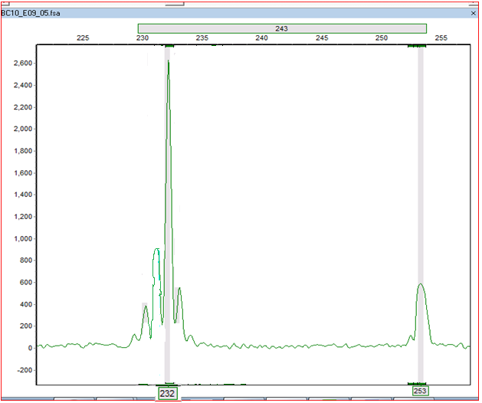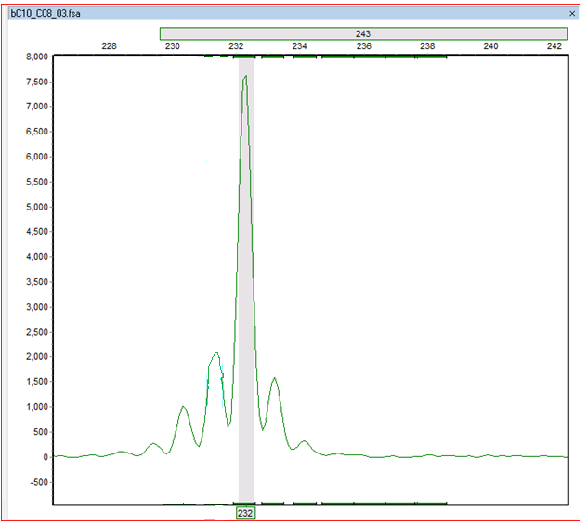
Figure Afco_6 with expected product size of243 and florecently labeled with Hex

Appendix 3 Representation of mean likelihood L(K)and variance per K values generated by STRUCTURE on datasetcontaining 548 individuals across 12 polymorphic EST-SSR loci.
K | Est. Ln prob. of data | Mean value of Ln likelihood | Variance of Ln likelihood
5 | -1846.5 | -1756.8 | 179.4
5 | -1849.5 | -1756.3 | 186.4
5 | -1833.4 | -1735.2 | 196.4
5 | -1934.3 | -1744.9 | 378.9
5 | -1856.2 | -1738.4 | 235.7
5 | -1843.2 | -1755.8 | 174.8
5 | -1849.4 | -1755.5 | 187.7
5 | -1846.6 | -1756.7 | 179.8
5 | -1848.8 | -1756.1 | 185.5
6 | -1852.8 | -1724.6 | 256.5
6 | -1901.4 | -1730.1 | 342.6
6 | -1897.8 | -1730.6 | 334.4
6 | -1844 | -1724.3 | 239.6
6 | -1875.1 | -1726.6 | 297
6 | -1903 | -1733.3 | 339.5
6 | -1904.2 | -1731.1 | 346.3
6 | -1877.3 | -1728.3 | 297.9
6 | -1841.2 | -1723.8 | 234.8
6 | -1919.2 | -1732.6 | 373
7 | -1888.7 | -1694 | 389.4
7 | -1863.7 | -1693.6 | 340.1
7 | -1873.4 | -1720.5 | 305.7
7 | -1881.3 | -1719.6 | 323.4
7 | -1862.5 | -1719.5 | 286
7 | -1862.7 | -1720.3 | 284.9
7 | -1881.2 | -1717.5 | 327.5
7 | -1876.8 | -1721.2 | 311.1
7 | -1861.8 | -1721 | 281.6
7 | -1881.8 | -1721 | 321.5
8 | -1874.4 | -1687.5 | 373.8
8 | -1906.5 | -1720.1 | 372.8
8 | -1919.5 | -1719.6 | 399.8
8 | -1867.2 | -1687.4 | 359.6

Appendix 3 Continued
K | Est. Ln prob. of data | Mean value of Ln likelihood | Variance of Ln likelihood
5 | -1846.5 | -1756.8 | 179.4
5 | -1849.5 | -1756.3 | 186.4
5 | -1833.4 | -1735.2 | 196.4
5 | -1934.3 | -1744.9 | 378.9
5 | -1856.2 | -1738.4 | 235.7
5 | -1843.2 | -1755.8 | 174.8
5 | -1849.4 | -1755.5 | 187.7
5 | -1846.6 | -1756.7 | 179.8
5 | -1848.8 | -1756.1 | 185.5
6 | -1852.8 | -1724.6 | 256.5
6 | -1901.4 | -1730.1 | 342.6
6 | -1897.8 | -1730.6 | 334.4
6 | -1844 | -1724.3 | 239.6
6 | -1875.1 | -1726.6 | 297
6 | -1903 | -1733.3 | 339.5
6 | -1904.2 | -1731.1 | 346.3
6 | -1877.3 | -1728.3 | 297.9
6 | -1841.2 | -1723.8 | 234.8
6 | -1919.2 | -1732.6 | 373
7 | -1888.7 | -1694 | 389.4
7 | -1863.7 | -1693.6 | 340.1
7 | -1873.4 | -1720.5 | 305.7
7 | -1881.3 | -1719.6 | 323.4
7 | -1862.5 | -1719.5 | 286
7 | -1862.7 | -1720.3 | 284.9
7 | -1881.2 | -1717.5 | 327.5
7 | -1876.8 | -1721.2 | 311.1
7 | -1861.8 | -1721 | 281.6
7 | -1881.8 | -1721 | 321.5
8 | -1874.4 | -1687.5 | 373.8
8 | -1906.5 | -1720.1 | 372.8
8 | -1919.5 | -1719.6 | 399.8
8 | -1867.2 | -1687.4 | 359.6
8 | -1865.5 | -1686.2 | 358.5
8 | -1920.2 | -1719.1 | 402.2
8 | -1859.4 | -1684.1 | 350.6
8 | -1911.8 | -1718.7 | 386.3
Appendix 3 Continued
K | Est. Ln prob. of data | Mean value of Ln likelihood | Variance of Ln likelihood
8 | -1924.6 | -1720.6 | 407.9
8 | -1865.5 | -1686.2 | 358.5
8 | -1920.2 | -1719.1 | 402.2
8 | -1859.4 | -1684.1 | 350.6
8 | -1911.8 | -1718.7 | 386.3
8 | -1924.6 | -1720.6 | 407.9
8 | -1924.6 | -1721 | 407.3
9 | -1956.4 | -1731.4 | 450
9 | -1967.2 | -1729.6 | 475.2
9 | -1908.9 | -1685.4 | 447
9 | -2095.9 | -1725.9 | 740
9 | -1951.2 | -1730.7 | 441.1
9 | -1908.4 | -1686.4 | 444
9 | -1958.5 | -1728.4 | 460.3
9 | -1952.2 | -1727.8 | 448.8
9 | -1989.2 | -1729.6 | 519
9 | -1952.6 | -1730.6 | 444.2
10 | -2093.3 | -1755 | 676.6
10 | -1970.1 | -1696 | 548.1
10 | -2041.3 | -1751.4 | 579.9
10 | -2032.5 | -1749.8 | 565.4
10 | -2059.3 | -1752.7 | 613.3
10 | -2216.5 | -1780.9 | 871.3
10 | -2067 | -1751.8 | 630.4
10 | -1956.2 | -1695.5 | 521.3
10 | -2059.6 | -1753.8 | 611.7
10 | -2054.3 | -1750.3 | 607.9
11 | -2075.2 | -1728 | 694.4
11 | -2182.1 | -1814 | 736.2
11 | -2017.4 | -1714.6 | 605.7
11 | -2107.8 | -1723.9 | 767.9
11 | -2139.3 | -1780.8 | 717.1
11 | -2068.7 | -1718.9 | 699.6
11 | -2099 | -1770.5 | 657
11 | -2033.5 | -1718.8 | 629.5
11 | -2020.5 | -1713.1 | 614.8
11 | -2097 | -1776.7 | 640.6
Appendix 3 Continued
K | Est. Ln prob. of data | Mean value of Ln likelihood | Variance of Ln likelihood
12 | -2080.9 | -1797 | 567.8
12 | -2122.4 | -1791 | 662.9
12 | -2165 | -1746.3 | 837.4
12 | -2167.3 | -1747.2 | 840.2
12 | -2087.8 | -1739.6 | 696.4
12 | -2118.9 | -1742.2 | 753.3
12 | -2185.4 | -1816.9 | 737.1
12 | -2084.1 | -1812.4 | 543.4
12 | -2043.3 | -1805.5 | 475.7
12 | -2090.2 | -1811.2 | 557.9
13 | -2041.3 | -1801 | 480.7
13 | -2137.2 | -1773.1 | 728.2
13 | -2103.3 | -1766.3 | 674
13 | -2061 | -1809.5 | 503
13 | -2071.9 | -1816.3 | 511.1
13 | -2044.5 | -1807.9 | 473.1
13 | -2044.3 | -1811 | 466.5
13 | -2107.3 | -1766.2 | 682.1
13 | -2231.1 | -1770 | 922.2
13 | -2042.1 | -1807.6 | 469.1
14 | -2057.9 | -1814.5 | 486.9
14 | -2057.3 | -1819.8 | 475
14 | -2108.6 | -1784.7 | 647.8
14 | -2072.9 | -1778.9 | 588
14 | -2088.5 | -1777.6 | 621.8
14 | -2062 | -1813.6 | 496.8
14 | -2072.8 | -1821.5 | 502.6
14 | -2094.1 | -1778.1 | 632
14 | -2020.7 | -1809.4 | 422.5
14 | -2112.6 | -1780.8 | 663.6
15 | -2046.4 | -1820 | 452.8
15 | -2012 | -1815.4 | 393
15 | -2084 | -1821.4 | 525.1
15 | -2031.9 | -1817.3 | 429.2
15 | -2085.5 | -1789.4 | 592.3
15 | -2040.3 | -1813.2 | 454.1
15 | -2120.6 | -1793.6 | 653.8
Appendix 3 Continued
K | Est. Ln prob. of data | Mean value of Ln likelihood | Variance of Ln likelihood
15 | -2029.1 | -1782.6 | 493
15 | -2061.5 | -1822.4 | 478.2
15 | -2033.6 | -1784.2 | 498.9
16 | -2055 | -1787.4 | 535.3
16 | -2018.5 | -1816 | 405
16 | -2069.1 | -1821.7 | 494.8
16 | -2045 | -1821.9 | 446.2
16 | -2024.6 | -1790.6 | 468
16 | -2016.9 | -1786.7 | 460.3
16 | -2050.1 | -1786.2 | 527.9
16 | -2050.4 | -1789.9 | 521
16 | -2023.2 | -1784.4 | 477.6
16 | -2022.8 | -1815.3 | 415
17 | -2016.6 | -1785.9 | 461.4
17 | -2025.6 | -1822.1 | 407
17 | -2001.6 | -1824.7 | 353.8
17 | -2025.9 | -1826.7 | 398.4
17 | -1991.9 | -1821.8 | 340.1
17 | -2027.1 | -1794.1 | 466.1
17 | -2024.1 | -1822.4 | 403.3
17 | -2051.1 | -1792.7 | 516.8
17 | -2007 | -1823.2 | 367.6
17 | -2068.2 | -1796.3 | 543.8
18 | -2001.7 | -1793.3 | 416.9
18 | -2029.2 | -1826.6 | 405.1
18 | -2028.2 | -1828 | 400.4
18 | -2028.3 | -1823 | 410.5
18 | -2032.1 | -1826.7 | 410.8
18 | -2018.2 | -1790.4 | 455.6
18 | -2039.2 | -1795.5 | 487.4
18 | -2048 | -1795.6 | 504.7
18 | -2008.4 | -1820.6 | 375.7
18 | -2047.9 | -1826.5 | 442.7
19 | -2034.2 | -1794 | 480.5
19 | -2007.6 | -1794.2 | 426.8
19 | -2017.4 | -1796.7 | 441.4
19 | -2017.2 | -1830.3 | 373.8
Appendix 3 Continued
K | Est. Ln prob. of data | Mean value of Ln likelihood | Variance of Ln likelihood
19 | -2028.1 | -1825.7 | 404.9
19 | -2033.6 | -1797.3 | 472.6
19 | -2043.5 | -1796.6 | 493.7
19 | -1985.9 | -1828.4 | 314.9
19 | -2003.9 | -1828.2 | 351.5
19 | -2010.6 | -1825.7 | 369.7
20 | -1998.1 | -1825.8 | 344.8
20 | -2023.8 | -1799.9 | 447.7
20 | -2045 | -1799.6 | 490.9
20 | -1991.3 | -1797.6 | 387.5
20 | -1993.4 | -1795.2 | 396.5
20 | -2028.5 | -1796.1 | 464.8
20 | -2024.5 | -1797.6 | 453.7
20 | -2009.5 | -1829.2 | 360.6
20 | -1995.9 | -1798.1 | 395.7
20 | -1996.6 | -1827.2 | 338.9
21 | -1995.3 | -1796.9 | 396.9
21 | -2002.5 | -1828.6 | 347.9
21 | -2032.4 | -1828.3 | 408.2
21 | -2022.9 | -1799.3 | 447.1
21 | -2023.8 | -1831.4 | 385
21 | -2023.3 | -1828.3 | 390
21 | -2027.2 | -1798.8 | 456.7
21 | -2028.5 | -1802.2 | 452.6
21 | -2035.9 | -1830.7 | 410.4
21 | -2003.3 | -1829.1 | 348.5

Appendix 4a amplification of ITS region with primer ITS4 and ITS5, M -1Kb is the DNA ladder used as a marker –lane 1 to 6 represented samples tested
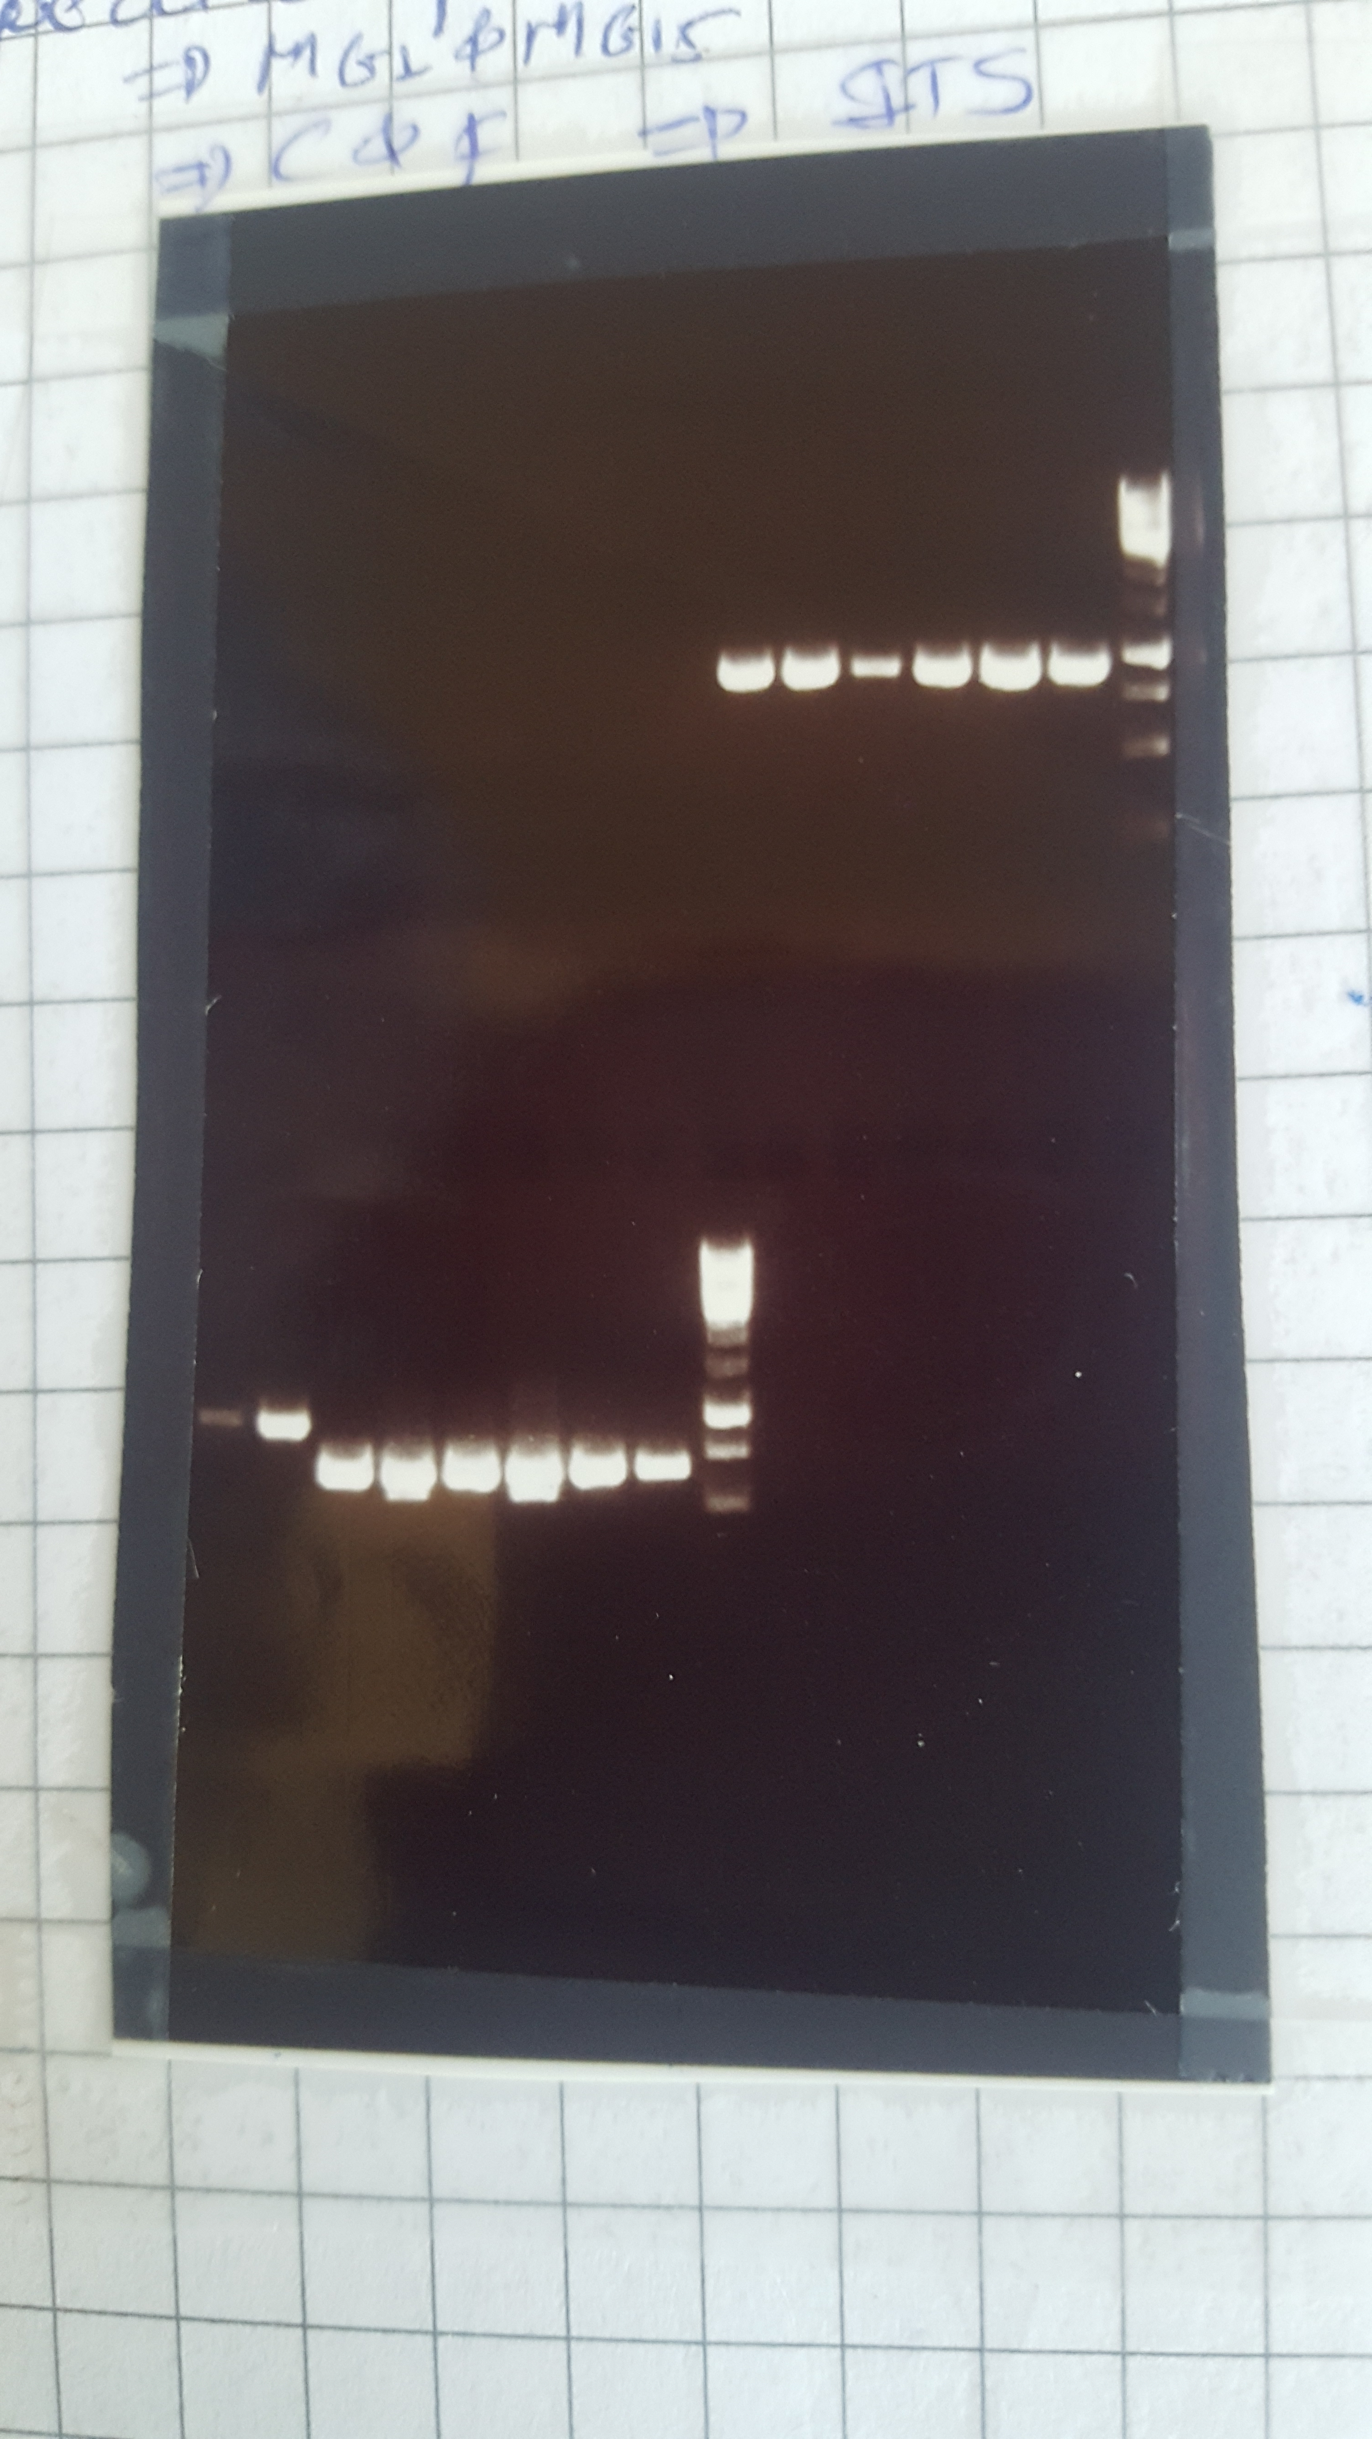
1 2 3 4 5 6 M

Appendix 4b amplification of trnF-trnL region with primer C and F respectively, M -1Kb is the DNA ladder used as a marker -lane1to 6 represented samples tested.

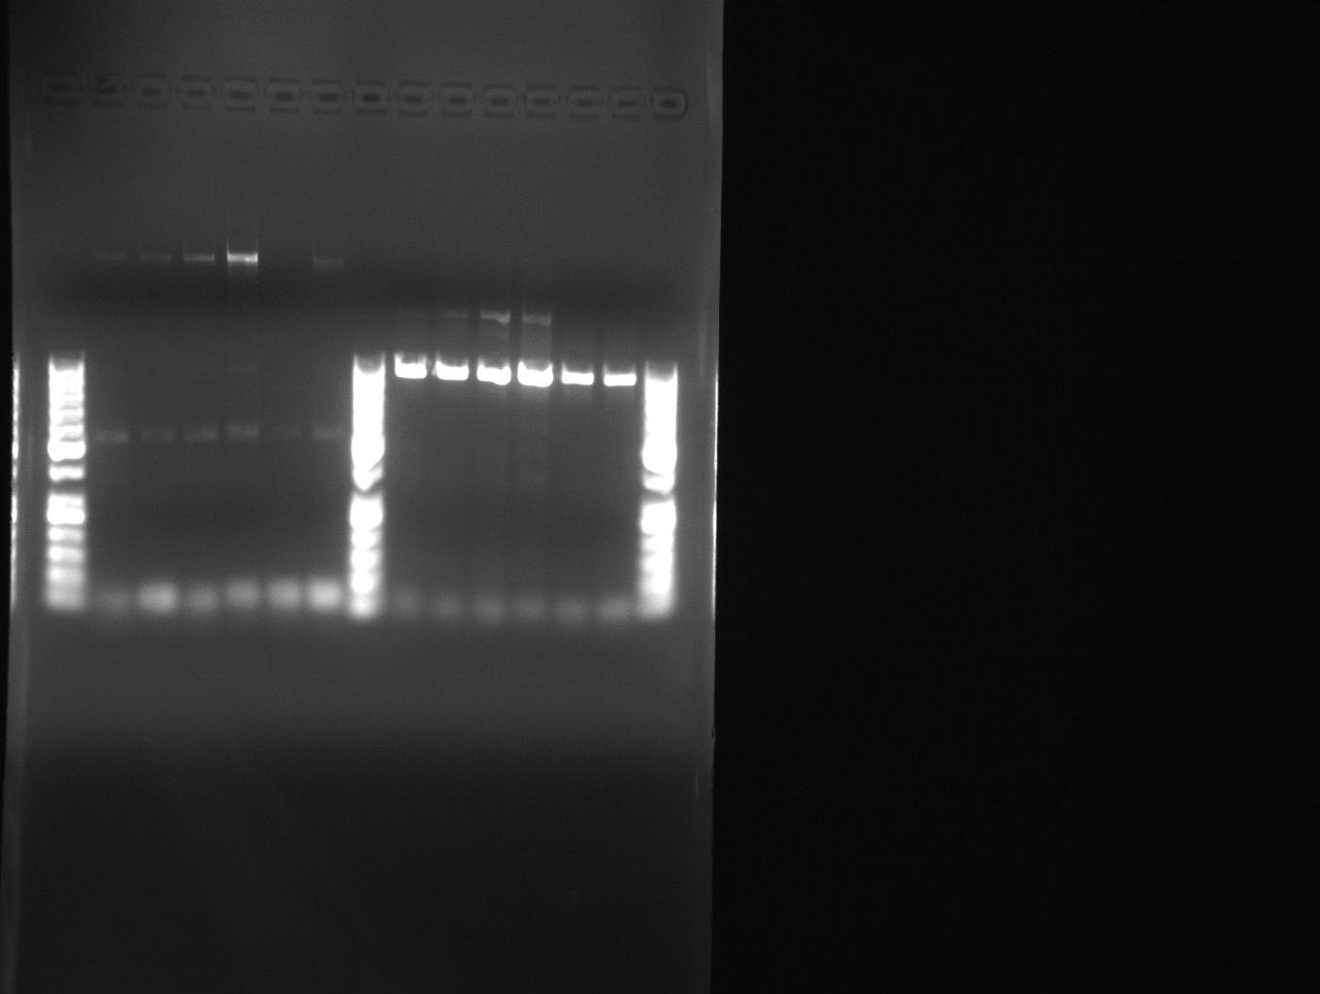
M 1 2 3 4 5 6 M

