Addis Ababa University
ETHIOPIAN iNSTITUTE OF ARCHITECTURE, BUILDING CONSTRUCTION AND CITY DEVELOPMENT



Potential of Ecological Water Treatment Elements to Reduce Pollution of River Water for Urban Agriculture: The case of Mekanisa-Gofa–Lafto Cooperative Farm
A Thesis in Landscape Architecture

Author: Terusaw Solomon

A Thesis Submitted in Partial Fulfillment of the Requirements for the Degree of Masters of Science in Landscape Architecture

15th July 2019
Addis Ababa, Ethiopia
Addis Ababa University
ETHIOPIAN iNSTITUTE OF ARCHITECTURE, BUILDING CONSTRUCTION AND CITY DEVELOPMENT

Potential of Ecological Water Treatment Elements to Reduce Pollution of River Water for Urban Agriculture: The case of Mekanisa-Gofa–Lafto Cooperative Farm
A Thesis in Landscape Architecture

By Terusaw Solomon

Advisor
Dr. Kumelachew Yeshitela (Ph.D.)

A Thesis Submitted in Partial Fulfillment of the Requirements for the Degree of Masters of Science in Landscape Architecture

15th July 2019
Addis Ababa, Ethiopia

CERTIFICATION
The undersigned have examined the thesis entitled ‘Potential of Ecological Water Treatment Elements to Reduce Pollution of River Water for Urban Agriculture: The case of Mekanisa-Gofa–Lafto Cooperative Farm’ presented by Terusaw Solomon, a candidate for the Degree of Masters of Science in Landscape Architecture and here by certify that it is worthy of acceptance.

Dr. Kumelachew Yeshitela (Ph.D.)
Advisor | Signature | Date
Alazar Assefa
Internal Examiner | Signature | Date
Dr. Dagnachew Adugna (Ph.D.)
External Examiner | Signature | Date
Dr. Fisseha Wegayehu (Ph.D.)
Chair person | Signature | Date

UNDERTAKING
I certify that research work titled “Potential of Ecological Water Treatment Elements to Reduce Pollution of River Water for Urban Agriculture: The case of Mekanisa-Gofa–Lafto Cooperative Farm” is my own work. The work has not been presented elsewhere for assessment. Where material has been used from other sources it has been properly acknowledged / referred.

Signature _______________
Terusaw Solomon

ABSTRACT
Cities in the developing countries are facing enormous challenges in the provision of employment opportunities and basic services such as drinking water, sanitation and proper wastewater disposal for the rapidly increasing urban population. They are characterized by relatively high demand for food and clean water and generation of large volume of urban wastes, being discharged into natural water bodies, contaminating rivers, lakes and other freshwater bodies used for urban agriculture. Addis Ababa, being one of the fast-growing cities in Africa is not an exception to this situation. Significant segment of human population and land resource are involved in urban agriculture with the use of urban rivers which are proven to be highly polluted with its high health risk. The general objective of this thesis was to identify the type and the extent of pollutants of agricultural concern in the water used for irrigation at Mekanisa-Gofa–Lafto Cooperative Farm, aimed at selecting an appropriate ecological water treatment elements for contextualized landscape design that can reduce the pollution level of the water for irrigation. Water samples were taken and analyzed for 9 parameters including BOD, COD, pH, EC, TSS, Na, TH, and Cl & Zn). As part of selecting an appropriate ecological water treatment elements, field test was also carried out to study the potential of floating treatment wetland in reducing the pollutants in the study site. The irrigation water were treated with floating treatment wetland with Vetiver grass for total of 7 days. The results showed that the floating treatment wetland was able to reduce the BOD (73.68%), COD (73.92%), pH (0.39%), Cl- (43.12 %), TH (66.56%) and TSS (96.21%) values, approaching the recommended irrigation water quality guideline values within 3 days. On the contrary, there was an increase in EC (22.2%) and Na (15.2%) concentration the values of which exceeded the recommended values, attributed to evapotranspiration or the introduction of the surrounding soil into the irrigation water of Mekanisa-Gofa-Lafto Co-operative farm.

KEYWORDS: Constructed wetland, Grass swale, Landscape, Pollutants, Irrigation water, Water treatment

ACKNOWLEDGEMENT
This thesis work would have not been realized without the guidance and support of my advisor, Dr. Kumelachew Yeshitela. His office door was always open whenever I had a question about my research or writing.
I would also like to thank Addis Ababa City Government Environmental Protection Authority, environmental laboratory staff’s for their technical and financial support. I am also grateful to everyone who have participated in my data collection process and who have shared their precious time and energy.
I would also like to express my very profound gratitude to my parents for providing me with unfailing support and continuous encouragement throughout my years of study and through the process of researching and writing this thesis. This accomplishment would not have been possible without them. Thank you.
Last but not least, I would like to praise the highest for everything that happen and didn’t happen. Furthermore

CONTENTS
CERTIFICATION i
UNDERTAKING ii
ABSTRACT iii
ACKNOWLEDGEMENT iv
LIST OF TABLES vii
LIST OF FIGURES viii
ACRONYMS & ABBREVIATIONS x
CHAPTER 1: INTRODUCTION 1
1.1 Background 1
1.2 Problem statement 2
1.3 General objective 3
1.4 Specific objectives 4
1.5 Research questions 4
1.6 Significance of the study 4
1.7 Scope and limitation of the study 5
CHAPTER 2: LITERATURE REVIEW 6
2.1. Urban agriculture 6
2.2. Important agricultural water quality parameters 7
2.3 The reuse of wastewater for urban agriculture 9
2.4. Guidelines and Standards for Using Wastewater for Agriculture 10
2.5 Ecological water treatment elements 11
CHAPTER 3: RESEARCH METHODOLOGY 22
3.1 Description of the Study Area 22
3.2 Research approach 24
3.3 Research Method 24
3.4 Data type 24
3.4.1 Primary data 24
3.4.2 Secondary data 25
3.5 Data Collection methods 25
3.5.1 Questionnaires 25
3.5.2 Observation 26
3.5.3 Laboratory test 26
3.5.4. Field test 27
3.6 Data analysis 32
CHAPTER 4: RESULTS AND DISCUSSION 34
4.1 Description of respondents 34
4.2 Existing irrigation practice and channel 35
4.3 Type and extent of pollutants of agricultural concern 39
4.4 Appropriate ecological water treatment elements for Mekanisa-Gofa–Lafto Cooperative Farm 41
CHAPTER 5: CONCLUSION AND RECOMMENDATION 55
5.1 Conclusion 55
5.2 Recommendations 56
5.2.1 General recommendation 56
5.2.2 Design Recommendations 57
REFERENCES 63
APPENDIX 68

LIST OF TABLES
Table 1: Important agriculture water Quality 9
Table 2: FAO guidelines for interpretation of water quality for irrigation 10
Table 4: Selected agricultural water quality parameter analyzed in this study 26
Table 5: Selected parameters and water quality guidelines values used for evaluating the laboratory results 27
Table 6: Summary of the research methodology 33
Table 7: Characteristics of the respondents 34
Table 10: Types of vegetables grown and frequency of irrigation at “Mekanisa-Gofa-Lafto Co-operative farm. 36
Table 8: Results of Laboratory test of irrigation water of Mekanisa-Gofa–Lafto Cooperative Farms 39
Table 9: Comparison of the result of laboratory test with quality standard guidelines 40
Table 11: Results of the Laboratory test of Mekanisa-Gofa-Lafto Co-operative farm irrigation water 42
Table 12: Comparison of the BOD concentration from the hole treated with Vetiver. zizanioides, L. (H2) with water quality guidelines for irrigation water. 44
Table 13: Comparison of the COD concentration from the hole treated with Vetiver. zizanioides, L. (H2) with water quality guidelines for irrigation water. 46
Table 14: Comparison of the TSS concentration from the hole treated with Vetiver. zizanioides, L. (H2) with water quality guidelines for irrigation water. 47
Table 15: Comparison of the pH concentration from the hole treated with Vetiver. zizanioides, L. (H2) with water quality guidelines for irrigation water. 49
Table 16: Comparison of the EC concentration from the hole treated with Vetiver. zizanioides, L. (H2) with water quality guidelines for irrigation water. 50
Table 17: Calculated SAR 52
Table 18: Comparison of the SAR concentration from the hole treated with Vetiver. zizanioides, L. (H2) with water quality guidelines for irrigation water. 52
Table 19: Comparison of the average laboratory result with water quality guidelines for irrigation water 54

LIST OF FIGURES
Figure 1: Status of the irrigation channel at Mekanisa-Gofa-Lafto co-operative Farm 3
Figure 2: Vegetated Swale (Adapted from http://www.portlandonline.com) 13
Figure 3: Grass swale (Left), Dry swale (Middle) and Wet swale (Right) 13
Figure 4: Grass swale 14
Figure 5: Free surface flow constructed a wetland 15
Figure 6: At the top horizontal SF CW and at the bottom vertical SF CW 16
Figure 7: At the top Floating treatment wetland and at the bottom Floating treatment wetland from The Mill Creek Valley 18
Figure 8: Floating treatment wetland with Vetiver grass in Chile 19
Figure 9: Set-up in the screen house with C, zizanioides (image to the left) and C. nigritana (image to the right) under effluent from Fertilizer Company. 20
Figure 10: Application process of Vetiver system at Umatac-Merizo Drainage Treatment Plant 21
Figure 11: Location map of the study area 23
Figure 12: Specific study site map 23
Figure 13: Location of the field test 28
Figure 14: The Construction of the Floating Treatment Wetland 29
Figure 15: Construction of two floating panel 29
Figure 16: Planted vetiver grass after 6 months. 30
Figure 17: Photo showing the field test site 31
Figure 18: Photo showing sample taking at the site 32
Figure 19: Existing statute of the irrigation water 37
Figure 20: Frequently encountered pollutants of the irrigation water by respondents 38
Figure 21: The discharge of domestic waste into the open channel 39
Figure 22: Day 3 and 7, BOD reduction percentage. 43
Figure 23: Day 3 and 7, COD reduction percentage. 45
Figure 24: Day 3 and 7, TSS reduction percentage 47
Figure 25: Level of reduction in percentage acidity on 3rd and 7th days 48
Figure 26: Day 3 and 7, EC reduction percentage 49
Figure 27: Day 3 and 7, Na reduction percentage 51
Figure 28: Day 3 and 7, Total Hardness reduction percentage 51
Figure 29: Reduction percentage of Cl on Day 3 and 7 53
Figure 30: Site plan 58
Figure 31: Zoomed in plans and sections 59
Figure 32: Zoomed in plans and sections 60
Figure 33: Details 61
Figure 34: Planting plan 62

ACRONYMS & ABBREVIATIONS
AACGEPA | Addis Ababa City Government Environmental Protection Authority
Al | Aluminum
As | Arsenic
B | Boron
Be | Beryllium
BOD | Biochemical Oxygen Demand
C | Vanadium
Ca | Calcium
Cd | Cadmium
Cl | Chloride
Co | Cobalt
COD | Chemical Oxygen Demand
Cr | Chromium
Cu | Copper
EC | Electric conductivity
ECD&SWC | Ethiopian Construction Design & Supervision Works Corporations
F | Fluoride
FAO | Food and Agriculture Organization
Fe | Iron
FSF CW | Free Surface Flow Constructed Wetland
FTW | Floating Treatment Wetland
H1 | Hole One
H2 | Hole Two
HCO₃ | Bicarbonates
Hg | Mercury
HSF | Horizontal Subsurface Flow
IWQT | Irrigation Water Quality Tool
Li | Lithium
Mg | Magnesium
Mg/l | Milgram per liter
Mn | Manganese
Mo | Molybdenum
Na | Sodium
Ni | Nickel
NO₃- N | Nitrate - Nitrogen
Pb | Lead
PO₄ – P | Phosphate - Phosphorus
PVC | Polyvinyl Chloride
SAR | Sodium Absorption Rate
Se | Selenium
SF CWs | Subsurface Flow Constructed Wetland
Sn | Tin
TDS | Total Dissolved Solid
Ti | Titanium
TN | Total Nitrogen
TP | Total Phosphorus
TSS | Total Suspended Solid
UNESCAP | United Nations Economic & Social Commission for Asia & the Pacific
US EPA | United States Environmental Protection Agency
USA | United States of America
USDA-NRCS | United States Department of Agriculture– Natural Resource Conservation Service
V | Vanadium
VSF | Vertical Subsurface Flow
W | Tungsten
WHO | World Health Organization
Zn | Zinc

CHAPTER 1: INTRODUCTION

1.1 Background
At present, more than half of the world’s population (54%) is living in urban areas, as compared to that of 30% reported in 1950 (United Nation, 2011). Moreover, relatively rapid rate of urbanization is predicted to occur in the coming decades. According to UN-DESA (2014) about 66% of the world’s population is expected to live in urban areas by the year 2050, mainly attributed to high rate of population growth and rural to urban migration, both of which are currently more pronounced in developing countries (Orsini et al., 2013). Cities in the developing countries are facing enormous challenges in the provision of employment opportunities and basic services such as drinking water, sanitation and proper wastewater disposal for the rapidly increasing urban population (FAO, 2007). According to Drechsel et al (2006), the cities of developing countries are characterized by relatively high demand for food and clean water and generation of large volume of urban wastes, being discharged into natural water bodies, contaminating rivers, lakes and other freshwater bodies used for urban agriculture.
It has been suggested that urban wastewater could be a potential and reliable source of nutrient and irrigation water for urban agriculture. However, concern for the public health has been the most important constraint for the use of urban waste water as source of irrigation water (Veenhuizen, 2007). The use of untreated polluted water for urban agriculture could be hazardous to human health and cause water-related diseases (Ashraf et al., 2010). Urban waste water could also have the risk of transferring chemical & biological contaminants to crop. It increases the heavy metal concentration in the soil and enhance the microbiological contamination of surface and ground water (Raschid-sally and Jayakody, 2008).
Addis Ababa, is one of the fast-growing cities in Africa which is not an exception to this situation. According to the local Urban Agriculture Office (2009), an estimated 1,574 Addis Ababa city dwellers are involved in urban agricultural practices involving a total land area of 400ha with the use of irrigation water from rivers known as “ Little and Great Akaki rivers” (Gebre and Rooijen, 2009). Both of these rivers (Fig 1) are polluted by chemical, physical and bacteriological pollutants and found to be unfit for household and agricultural uses (Mekonnen, 2007). Despite their foul odor and potential toxicity both rivers are currently being used as source of irrigation water without any treatment, posing high risk of public health significant (Melaku, 2005; Melaku et al., 2007; Mohammed, 2007; Gebre and Rooijen, 2009; Van Rooijen and Taddesse, 2009; Eshetu, 2012).

1.2 Problem statement
Significant segment of human population and land resource are involved in urban agriculture with the use of polluted water as source of irrigation in the city of Addis Ababa (Gebre and Rooijen, 2009). In fact, the use of polluted water for agriculture is a common practice worldwide (Ashraf et al., 2010), since polluted urban water has the potential in providing reliable water and nutrient resource for urban farming. This water if not treated and well managed it would seriously affect human health (Raschid-sally and Jayakody, 2008). The use of untreated polluted water in crop production could results in the buildup of chemical pollutants and heavy metals in the soil and the vegetation. It also contaminates groundwater with nitrates, create habitats of disease carrying and transmitting vectors and enhance excessive growth of algae (Mekonnen, 2007). On the contrary, farmers in and in the vicinity of Addis Ababa city use irrigation water diverted from Little and Great Akaki rivers, both of which were reported to have been highly polluted (Melaku, 2005; Melaku et al., 2007; Mohammed, 2007; Gebre and Rooijen, 2009; Van Rooijen and Taddesse, 2009; Eshetu, 2012). There have been constructions of a series of open irrigation channel on both Little and Great Akaki Rivers carrying untreated polluted water to the vegetable plots as indicated in Figure 1. The visual appearance of the irrigation system shows that the irrigation channels are filled with sediments of both solid and liquid municipality wastes. The color of the water is black with unpleasant odor indicating high level of contamination.

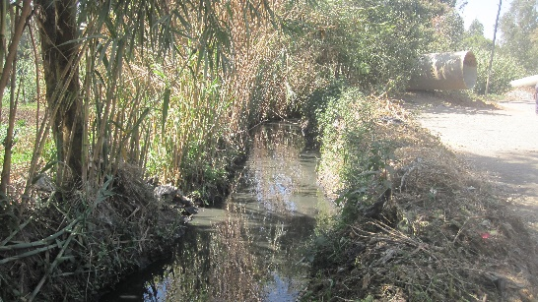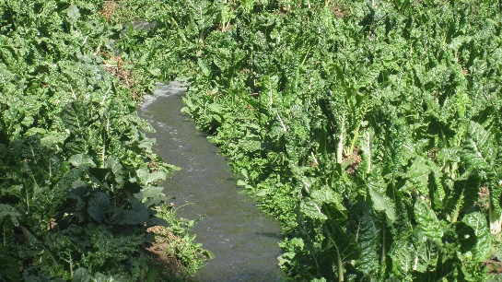
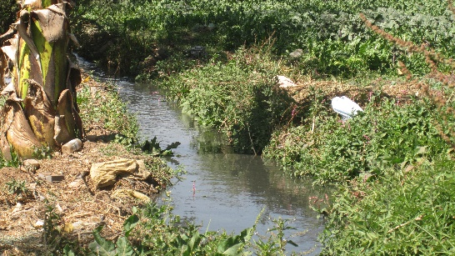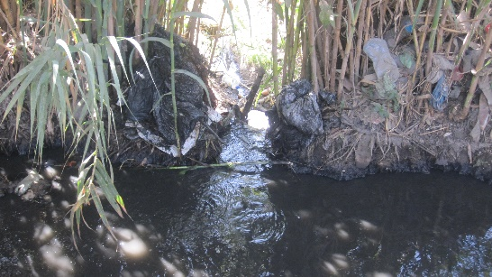
Figure 1: Status of the irrigation channel at Mekanisa-Gofa-Lafto co-operative Farm
(Photo by: Terusaw Solomon)
It was reported that, the farming community attempted hand picking and removing of solid waste from the polluted water, before irrigating their respective vegetable plots. The farmers and people living in the vicinity are directly exposed to the polluted water and the corresponding high public health risk. The consumption of vegetables grown with the use of such a highly polluted irrigation water could further put people at greater health risk (Jemal, 2002; Mekonnen, 2007; Gebre and Rooijen, 2009).
Several ecological water treatment elements methods have been developed and confirmed to be an effective and low-cost methods of removing water pollutants (Schueler, 1989; Jurries, 2003; Zhang et al., 2014; Winans et al., 2015). This research project dealt with the identification of the type and extents of the pollutants of agricultural concern in the Little Akaki river irrigation water aimed at selecting an appropriate ecological water treatment elements that could be implemented at the farmers plot level to reduce the pollution level of the irrigation water.

1.3 General objective
The general objective of this thesis was to identify the type and the extent of pollutants of agricultural concern in the water used for irrigation at Mekanisa-Gofa–Lafto Cooperative Farm, aimed at selecting an appropriate ecological water treatment elements for contextualized landscape design that can reduce the pollution level of the water for irrigation.

1.4 Specific objectives
The specific objectives of this research work were:
- Assess the existing irrigation practice and channel system used by Mekanisa-Gofa–Lafto Cooperative Farming community.
- Identify the types and extent of pollutants of agricultural concern in the irrigation water used by Mekanisa-Gofa–Lafto Cooperative Farming community.
- Select appropriate ecological water treatment elements that can reduce the pollution level of the irrigation water used by Mekanisa-Gofa–Lafto Cooperative Farming community.

1.5 Research questions
- What is the existing irrigation practice and channel system used by Mekanisa-Gofa–Lafto Cooperative Farming community?
- What are the types and extent of pollutants of agricultural concern in the irrigation water?
- What are the appropriate ecological water treatment elements that can be applied at Mekanisa-Gofa–Lafto Cooperative Farm to reduce the pollution level of the irrigation water?

1.6 Significance of the study
- The use of highly polluted water for urban agriculture is causing health problems both for farmers and farm product consumers in and in the vicinity of Addis Ababa (Jemal, 2002). Consequently, it seemed to be very urgent to come up with a solution to minimize the pollution level of the irrigation water resource. These appeared to have both human nutrition and public health significant.
- There is a continued and gradual diminish of agricultural land in the vicinity of Addis Ababa city attributed to high rate of urbanization. (Gittleman, 2009). The use of irrigation and intensification of agricultural production without damaging the soil and land resource is appealing. On the contrary, the use of polluted urban river as source of irrigation water is reported to have increased the concentration of heavy metals in the soil (Mekonnen, 2007). Thus, it was suggested to come up with a solution to overcome the problem before the concentration of the pollutants approaches the detrimental and irreversible level.
- If the polluted rivers continued to be used as source of irrigation water without treatment, there will be un interrupted contamination of groundwater, causing a wide range of environmental hazard in the future (Yohannes and Elias, 2017). Therefore, research study into the feasibility of reduction of the pollutant aimed at appropriate technological intervention seemed to have economic and environmental implications.

1.7 Scope and limitation of the study
The problem of using a polluted water source for urban agriculture is a city-wide problem. However, the scope of the current study was limited to the “Mekanisa-Gofa-Lafto co-operative farm” and the study was focused on technical aspects and attempts of addressing site specific societal problem with practical solution. The major limitation of the study was the limited finance and the lack of data and documentation on urban agricultural practice and the existing irrigation channel system. An effort was made to deal with the lack of documentation by collecting some primary data with the use of questioners and site observation. Moreover, since the use of polluted water for urban agriculture is a sensitive topic the data collection process from the farmers and farmer cooperation were also challenging.

CHAPTER 2: LITERATURE REVIEW

2.1. Urban agriculture
Different authors gave a diverse definition for urban agriculture. For the purpose of this research the definition given by Mougeot (2000) seems to be relatively complete. According to Mougeot, “Urban agriculture is an industry located within or on the fringe of a town, city or metropolis, which grows, processes and distributes food and non-food products.” The definition of Mougeot (2000) also includes the use of human and material resources, products, and services found in and around the urban area, which in turn supply human and material resources and products and services largely to the urban areas concerned. It is estimated that about 800 million people are engaged in urban agriculture at the global level (UN-Habitat, 2001). Urban agriculture is often considered as a response of the urban poor and unemployed people to urban poverty and food insecurity or malnutrition (Veenhuizen, 2007). Urban agriculture is mostly informal with little (if any) institutional, governmental and other related supports (Mougeot, 2000).
Urban agriculture has social, economic and environmental benefit for the urban population and contributes to the health, nutritional, food security and overall well-being of the urban community (Orsini et al., 2013). It reduces the negative impacts of urbanization on natural environment and helps in the improvement of the urban environment by enriching biodiversity, modification of microclimate such as reducing temperatures, increasing humidity and improving air quality (Smit (et al., 2001).
Despite all its economic, social and environmental benefit: urban agriculture is facing pressure from rapid urbanization and lack of supportive policies and policy enforcement (Gebremichael et al., 2014). According to Gebremichael (2014) inadequate cultivable land, loss of agricultural lands, shortage of irrigation water, environmental pollution, climate change, and contamination of water and soil are some of the challenges urban agriculture is currently facing.

2.2. Important agricultural water quality parameters
Important agricultural water quality parameters include several specific properties of water that are relevant in terms of yield and quality of crops, maintenance of soil productivity and protection of the environment (Pescod, 1992). The important agricultural water quality parameters could be categorized in to agronomic, hygiene & health, and management quality indicators (Bortolini et al., 2018a).
Agronomic quality indicators: are parameters causing toxicity effects on crops and/or degradation on soil fertility in the medium-long term utilization of polluted water. The agronomic water quality indicators could be expressed or measured in terms of pH, Electric conductivity (EC) and sodium adsorption ratio (SAR).
Hygiene & health quality indicators: are parameters without effect on crops yield but reported to have dangerous effects on human health attributed to pathogens transmission, particularly when low-quality water or polluted water is used to irrigate fresh vegetables.
Management quality indicators: are parameters causing negative effect on the irrigation systems (especially clogging) resulting in a low distribution and uniformity. The management quality indicators could be expressed in terms of concentration of Total Suspended Solids (TSS), Bicarbonates (HCO3), Sulphides, Manganese (Mn), and Iron (Fe).
Some of the other important agricultural water quality parameters are discussed in detail below.
Organic Matter: Biochemical Oxygen Demand (BOD) and Chemical Oxygen Demand (COD) are the two water quality parameters used as an indicator for existence of organic matters in water. BOD is a measure of the amount of oxygen consumed by bacteria during the processes of decomposition of organic matter under aerobic conditions. COD is a measure of the total quantity of oxygen required to oxidize all organic material into carbon dioxide and water (Northeast Georgia Regional Development Center, 2001). The existence of organic matter in the water act as nutrients for the microbes and bring various adverse effects, through negatively affecting the odor and color of the water (US EPA, 2012).
Total Salt Concentration: Total salt concentration is one of the most important agricultural water quality measurement parameters. Total salt concentration measures the accumulation of salts in the soil, which in turn is directly affected by the salinity of the irrigation water (Pescod, 1992). Accordingly, plant growth, crop yield, and quality of produce are affected by the total dissolved salt concentration of the irrigation water.
Electrical Conductivity: Electric conductivity is widely used to indicate the total ionized constituents of water. It is directly related to the sum of the cations (or anions), as determined chemically and is closely correlated, with the total salt concentration (Pescod, 1992). The use water with high EC value for irrigation over long period is reported to be dangerous for both soil properties and crops production (Bortolini et al., 2018a).
Sodium Adsorption Ratio (SAR): SAR expresses the toxicity effect on crops and degradation effects on soil fertility (Bortolini, Maucieri and Borin, 2018a). SAR is defined and measured by the formula $SAR= \frac{Na}{\sqrt{(Ca}+Mg (total harness))÷2 }$ . Sodium present in the soil in an exchangeable form, causes adverse physicochemical changes in the soil, particularly to soil structure resulting in reduction of infiltration rate of water and air into the soil which in turn affects germination and seedling (Pescod, 1992).
Total Suspended Solids (TSS): TSS value influences the operation of the irrigation systems. The use of irrigation water with high TSS values over a long period of time could result in clogging issues in the irrigation systems and in the reduction of crop production quality due to its deposition on leaf and/or fruits which in turn could be attributed to microbial pollution (Bortolini et al., 2018a).
Toxic Ions: Toxic ions normally results in impaired growth, reduced yield, changes in the morphology of the plant and even in death of the plant when the toxic ions are present in the soil and irrigation water in large amount (Pescod, 1992). Although the degree of damage depends on the crop, its stage of growth, the concentration of the toxic ion, climate and soil conditions, the most common phytotoxic ions that may be present in municipal sewage are Boron (B), Chloride (Cl⁻) and Sodium (Na) (Pescod, 1992).
pH: pH is an indicator of the acidity or basicity of water and is seldom a problem by itself. The normal pH range for irrigation water is from 6.5 to 8.4. The pH values outside of this range are an indicator that the water is abnormal in quality (Pescod, 1992). Normally, pH is a routine measurement in irrigation water quality assessment since deviation from the normal pH range in irrigation water indicate the presence of organic and/or inorganic pollutants (Bortolini, Maucieri and Borin, 2018a).
Table 1: Important agriculture water Quality
Parameters |  | Symbol | Unit
Physical
 | Total dissolved solid | TDS | mg/L
 | Electrical conductivity | EC | dS/m¹
 | Temperature | T | ^{O}C
 | Color / Turbidity |  | NTU/JTU²
 | Hardness |  | Mg equiv. CaCo₃/L
 | Sediments |  | g/L
Chemical
 | Acidity/Basicity | pH
 | Type and concentration of anions & cations
 | Calcium | Ca⁺⁺ | me/L³
 | Magnesium | Mg⁺⁺ | me/L
 | Sodium | Na ⁺ | me/L
 | Carbonate | HCO₃⁻ | me/L
 | Chloride | Cl⁻ | me/L
 | Sulphate | SO₄⁻⁻ | me/L
 | Sodium absorption ratio | SAR
 | Boron | B | mg/L⁴
 | Trace metals |  | mg/L
 | Heavy metals |  | mg/L
 | Nitrate- Nitrogen | NO₃- N | mg/L
 | Phosphate - Phosphorus | PO₄ - P | mg/L
 | Potassium | K | mg/L
(Source: FAO (1985))

2.3 The reuse of wastewater for urban agriculture
The reuse of wastewater is a common practice around the world and is considered as an alternative water resource in the changing agricultural environment (Jeong, Kim and Jang, 2016). It is estimated that more than 50 countries of the world with an area of 20 million hectares are treated or partly treated polluted water (United Nation, 2003). In developing countries with drier climates, farmers often use wastewater from drains and sewers as the only available source of water. On the contrary, developing countries even with adequate water resource are continuously discharging urban waste into water bodies used for urban agriculture (Drechsel et al., 2006). The use of wastewater for irrigation has the potential of providing reliable water and nutrient source for urban farming. The use of untreated polluted water could have negative impact on human health (Raschid-sally and Jayakody, 2008). Moreover, polluted water bodies could also build up chemical pollutants, particularly heavy metals in the soil and vegetation’s, contaminate groundwater mainly with nitrates, create habitats of disease vectors and enhance excessive growth of algae (Mekonnen, 2007).

2.4. Guidelines and Standards for Using Wastewater for Agriculture
Water quality guidelines and standards, are set of management target or recommendations based on the water quality parameters resulting from scientific examination for the sustainability and safety of using wastewater in agricultural production (Jeong et al., 2016). Organizations of the United Nations ( WHO, FAO & US EPA) and countries like Cyprus, France, Greece, Israel, Italy, Portugal, Spain & South Korea have modified recommendation on water quality guidelines for safe use of wastewater in agricultural production (Jeong et al., 2016). Among the existing different water quality classifications (guidelines and standards) the frequently and widely used for interpretation of water quality for irrigation is the FAO guidelines by Ayers and Westcot (Bortolini et al., 2018a).
According to FAO (1992), irrigation water can be classified into four groups depending on its salinity, sodicity (high concentration of Sodium), toxicity, and miscellaneous hazards. This classification is applicable to evaluate the quality of wastewater for irrigation purposes in terms of their chemical constituents (dissolved salts, relative sodium content and toxic ions). The following table shows the FAO guidelines for interpretation of water quality for irrigation.
Table 2: FAO guidelines for interpretation of water quality for irrigation
Potential irrigation problems | Units | Degree of restriction on use
Potential irrigation problems | Units | None | Slight to moderate |  | Sever
Salinity
EC | dS/m | < 0.7 | 0.7 – 3.0 | >3.0
TDS | mg/L | < 450 | 450 – 2000 | > 2000
Infiltration
SAR²= 0-3 & EC |  | > 0.7 | 0.7 – 0.2 | < 0.2
3-6 |  | > 1.2 | 1.2 – 0.3 | < 0.3
6-12 |  | > 1.9 | 1.9 – 0.5 | < 0.5
12-20 |  | > 2.9 | 2.9 – 1.3 | < 1.3
20-40 |  | > 5.0 | 5.0 – 2.9 | < 2.9
Specific ion toxicity
Sodium (Na)
Surface irrigation | SAR | < 3 | 3 - 9 | > 9
Sprinkler irrigation | me/L | < 3 | > 3
Chloride (Cl)
Surface irrigation | me/L | < 4 | 4 - 10 | > 10
Sprinkler irrigation | m³/L | < 3 | > 3
Boron | mg/L | < 0.7 | 0.7 – 3.0 | > 3.0
Miscellaneous
Nitrogen (NO₃- N) ³ | mg/L | < 5 | 5 – 30 | > 30
Bicarbonate (HCO₃) | me/L | < 1.5 | 1.5 – 8.5 | > 8.5
pH | Normal range 6.5 - 8
Zinc (Zn) | 2.0
(Source: FAO (1992))

2.5 Ecological water treatment elements
Different Ecological water treatment elements or methods are currently being used in landscape design in different parts of the world. These elements were initially employed as stormwater management method aimed at controlling runoff. They are now being used for pollutant removal, stream restoration, and groundwater recharge infiltration (US EPA, 2002). Some of these elements like bioswales and constructed wetland, had been confirmed to be an effective and low-cost methods for removing water pollutants (Jurries, 2003). Based on the geometric property, US EPA (2014) classified ecological water treatment elements as point, linear and area.
Point elements are used to capture water at a specific location and may use a combination of detention, infiltration, evaporation, settling, and transformation, to manage flow and removal of pollutants. Structures like constructed wetland, infiltration basin, bioretention, sand filter (surface), rain barrel, cistern, wet pond, and dry pond are categorized as point elements.
Linear elements are narrow linear shaped structures that provide filtration and nutrient uptake to manage flow and removal of pollutants. Example of linear elements includes grassed swale, infiltration trench, vegetated filter strip, sand filters (non-surface), vegetated swales etc.
Area elements are land-based management practices that affect an impervious area, land cover, and pollutant input. Structures like a green roof and porous pavement are included in this category. When selecting appropriate landscape-based elements for a specific site, important factors like the effectiveness of the methods to remove pollutants should be considered (US EPA, 2002).

2.5.1 Vegetated swale/ Bioswale
Vegetated swale (Figure 2) is linear, flow-based element designed to convey runoff with the provision of limited pollutant removal through sedimentation and horizontal filtration by vegetation (Dorman et al., 2013). Because of its limited capacity to remove dissolved pollutants, a vegetated swale element design is considered as pretreatment of concentrated flows, before discharge to other landscape-based water treatment systems (City of Portland, 2010). A vegetated swale can be used in conjunction with check dams perpendicular to the water flow to increase pollutant removal efficiency (Iowa State University, 2008). Check dams can be constructed using earth, riprap, gabions, railroad ties, or pressure-treated wood logs. A vegetated swale is cost-effective, aesthetical appealing, improve water quality by filtration, proved wildlife habitat and reduce water volume, flow rate and temperature (Charles River Watershed Association, 2008). Well-designed and properly maintained swale system could be expected to remove 70% of TSS, 30% of total phosphorus (TP), 25% of total nitrogen (TN), and 50-90% of trace metals (Iowa State University, 2008).
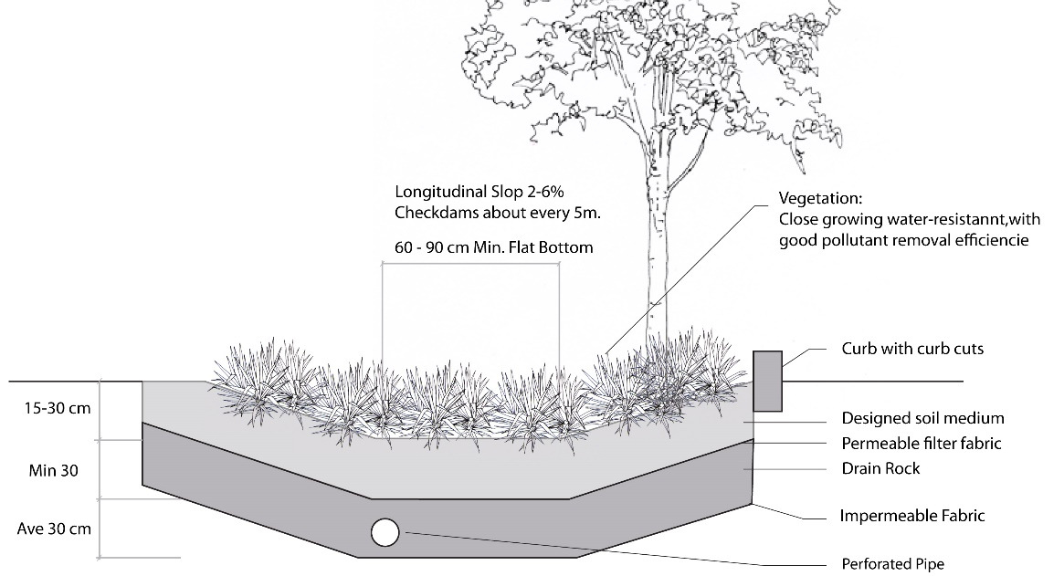
Figure 2: Vegetated Swale (Adapted from http://www.portlandonline.com)
According to Iowa state university (2008), there are three types of vegetated swale i.e. grass swales, dry swale with filter media and wet swales. Grass swale (Figure 3, Left) is a broad and shallow earthen channel vegetated with erosion-resistant and flood-tolerant grasses. It is used as a pre-treatment conveyance for other water quality ecological water treatment elements. Dry swale (Figure 3, Middle) consists of an open channel that has been modified to enhance its water quality treatment capability by adding a filtering medium consisting of a soil bed with an underdrain system. The wet swale (Figure 3, Right) also consists of a broad open channel capable of temporarily storing the water but lacks an underlying filtering bed. The wet swale has water quality treatment mechanisms like stormwater wetlands, which rely primarily on the settling of suspended solids, adsorption, and uptake of pollutants by vegetative root systems.
Figure 3: Grass swale (Left), Dry swale (Middle) and Wet swale (Right)
(Source: Iowa state university, 2008)

2.5.1.1 Grass swale
Grassed-lined and flat-bottomed channel, grass swale is one of effective element used to improve stormwater quality for many years (Davis et al., 2012). Grass swale is cheap to construct, easy to maintain (Schueler, 1989). Grass swale could improve water quality through infiltration, sedimentation (due to the low velocity induced by the vegetation), filtration by the grass blades, and likely through some biological processes (Davis et al., 2012). Several field studies have proven the effectiveness of grass swales in removal of water pollutants. A study done in Florida , showed that grass swale have removal rate of 98% of TSS, 64% of organic carbon, 45-48% of nitrogen,18% of phosphorus and 50-70% of metal (Schueler, 1989). Kabir et al. 2014 (cited in Leroy et al.2016) explained briefly how grassed swales showed a good potential of reducing TSS ( 44-98%) and metals such as Cu, Zn, Pd and Cd ( 17%-99%). Sedimentation along the swale length is the most important process in removing water pollutants. Installation of check dams, increasing swale length & channel roughness and decreasing the slope are reported to have improved treatment efficiency through increasing the retention time of the water promoting sedimentation and infiltration (Davis et al., 2012).
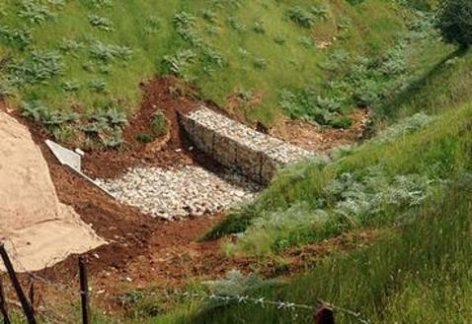
Figure 4: Grass swale
(Source: Iowa state university, 2008 & https://www.gabionsupply.com/check-dams.html)

2.5.2. Constructed wetland
Constructed wetlands are man-made systems that imitate the structural and functional aspect of natural wetlands for removing water pollutants from wastewater through the use of aquatic plants and microorganisms (Shafiq et al., 2017). Constructed wetlands is considered a holistic approach, integrating wastewater treatment, flood protection and stormwater management (ElZein et al., 2016). It removes physical, biological and chemical contaminants from wastewater through the use of different process including sedimentation (settling of solids), chemical adsorption (fixation), plants uptake and bacterial degradation (Winans et al., 2015). Compared to the conventional water treatment processes, constructed wetlands are effective, environmentally friendly and economical viable alternative of wastewater treatment technology (Dong, 2012). It has become an increasingly popular option for wastewater treatment because of high removal efficiency, low cost, simplicity in operation and high in potential of water and nutrient reuse (Zhang et al., 2014).
Although many scholars generally classify constructed wetlands into three (free surface flow, subsurface flow, and hybrid system), floating treatment wetlands are also being used widely as wastewater treatment recently. Thus, floating treatment wetland was considered as one of the study area in this research undertaking.

Free surface flow constructed wetland (FSF CW)
Free surface flow constructed wetland is the oldest type of artificial wetland characterized by water flow above the ground and plants rooted in the sediment layer or floated on the water surface (Dong, 2012). Kadlec and his co-workers (2000) as cited by Zhang et al. (2014) explained that free surface flow constructed wetland is effective in the removal of organic matters through microbial degradation and removal of suspended solids through filtration & sedimentation. It has been reported that Free surface flow constructed wetland could attain removal efficiency rate 70% and above of Total suspended solids (TSS), chemical oxygen demand (COD), biological oxygen demand (BOD) and pathogens.
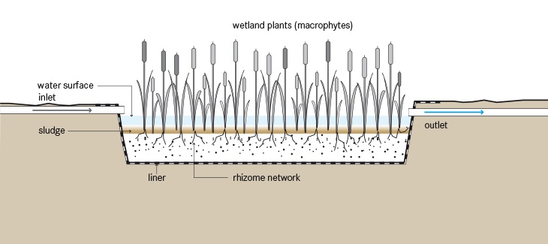
Figure 5: Free surface flow constructed a wetland
(Source: http://ecompendium.sswm.info/sanitation-technologies/free-water-surface-constructed-wetland)

Subsurface flow constructed wetland (SF CWs)
Subsurface flow constructed wetland is a system designed with horizontal or vertical surface flow through a permeable medium like sand, gravel or crushed rock (Zhang et al., 2014). In the case of subsurface flow constructed wetland, the water level is designed to remain below the top substrate (USDA-NRCS & US-EPA, 2000). Wastewater flows by gravity, horizontally or vertically, through the bed substrate containing a mixture of microbes and plant roots (Kadlec et al., 2000). There are two basic types of subsurface flow constructed wetland : horizontal subsurface flow (HSF) and vertical subsurface flow (VSF) (Dong, 2012). Current studies showed that it is possible to archive removal efficiency of 75.10% in case of HSF and 89.29% in case of VSF for BOD, and 66.02% in case of HSF and 64.41% in case of VSF for COD. It was also reported to attain removal rate of 51.97% in the case of HSF and 50.55% in the case of VSF for TN and 65.96% in the case of HSF and 59.61% in the case of VSF for TP (Zhang et al., 2014).
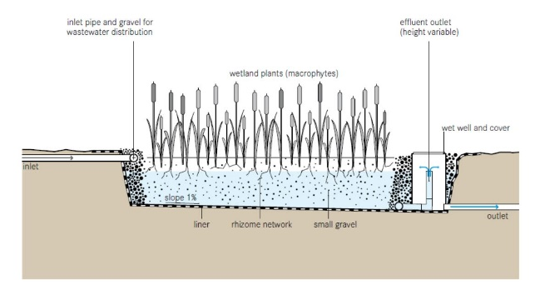
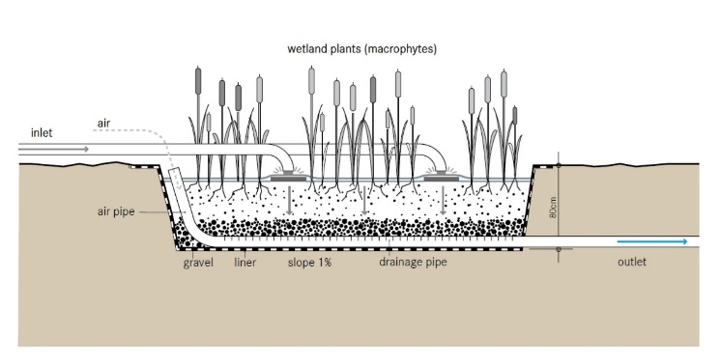
Figure 6: At the top horizontal SF CW and at the bottom vertical SF CW
(Source: http://ecompendium.sswm.info/sanitation-technologies/free-water-surface-constructed-wetland)

Hybrid system
It was agreed that it is difficult to treat many characters of wastewaters using a single system, indicating the necessity of introducing hybrid system (Zhang et al., 2014). Hybrid system is a system comprising of various type of constructed wetlands ( FSF, VSF and HSF etc.) combined aimed at achieving relatively higher treatment effect (Vymazal, 2005). The VSF constructed wetlands is intended to remove organics and suspended solids with provision of nitrification, whereas denitrification and further removal of organics and suspended solids occur in HSF constructed wetland (Zhang et al., 2014). According to Zhang et al (2014), removal efficiency of 93.82% for TSS, 84.06% for BOD₅, 85.65% for COD and 54.75% for TP and 66.88% for TN were attained with the use of hybrid system.

Floating treatment wetland (FTW)
Floating treatment wetland (also called artificial floating wetland, floating plant bed system, integrated floating system, integrated ecological floating bed) is soilless planting structure constructed with floating material such as hydroponic plants (floating plants), sediment-rooted emergent wetland plants and related ecological communities of algae and small invertebrates (Yeh et al., 2015). The upper part of the hydroponic plant grows and remains above the water, develop an extensive root system below the water and perform direct nutrient uptake from the polluted/wastewater (Pavlineri et al., 2017). Previous studies have shown FTW has a better removal efficiency of BOD (79.31%), COD (55.20%), TN (62.45%) and TP (49.58%) when compared to the other constructed wetlands (Zhang et al., 2014).
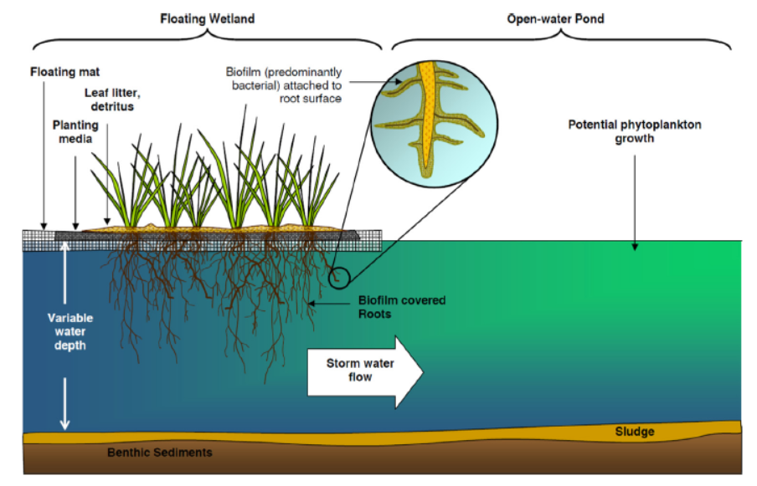
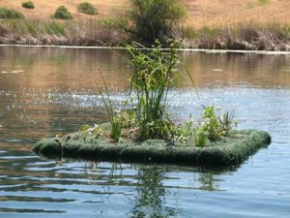
Figure 7: At the top Floating treatment wetland and at the bottom Floating treatment wetland from The Mill Creek Valley
(Source: Yeh et al., 2015 (Left) https://fuelcincinnati.org/blog/2014/02/mill-creek-floating-wetlands/ (Right))
For selecting a plant to be used in constructed wetland, the plant’s tolerance and removal capacity of pollutants are the most important criteria (Zhang et al., 2015). Although several plant species have been used in floating treatment wetlands, research in over 100 countries including Australia, China, Vietnam, and Thailand, has demonstrated that Vetiver. zizanioides L. has high tolerance and removal capacity to a wide range of pollutants including salinity, sodicity, aluminum, manganese, arsenic, cadmium, chromium, nickel, copper, mercury, lead, selenium and zinc (Golabi and Duguies, 2013). In the current research undertaking, emphasis of literature review was placed on studies conducted on pollutant removal capacity of Vetiver. Zizanioides L. in developing countries with comparable context to that of Ethiopia.
In Chile floating treatment wetland with vetiver grass were used as water treatment method for decontaminating irrigation water (Figure 8). The grass was able to extract a number of contaminants such as heavy metals, pesticides hydrocarbons and radioactive compounds (Regions et al., 2014). The results of those study showed that the grass was able to reduce Boron from 13.35 to 7.1 mg/l and Arsenic from 0.33 to 0.06 mg/l in five days duration, and reduction of Manganese from 1 to 0.24 mg/l and Lead from 2 to 0 mg/l in 15 days duration.
Figure 8: Floating treatment wetland with Vetiver grass in Chile
(Source: Regions et al., 2014)
A series of experimental study were conducted in Nigeria to assess the potential of the native African vetiver grass (Chrysopogon nigritana) species in addressing the challenges of wastewater management (Figure 9). Native African vetiver grass species (Chrysopogon nigritana) and South Indian species (Chrysopogon zizanioides) were introduced as a means of controlling and treating effluents from a fertilizer blending company, quarry industry and leachate from a public refuse dumpsite. Vetiver plants were raised hydroponically as described by Truong and Hart (2001) in plastic buckets of 40 cm diameter and 60 cm height. The treated wastewater was collected at 2, 4, and 6 days intervals for post-treatment laboratory analysis. The levels of contaminants after treatment were compared with allowable international levels reported (FAO 1985; WHO 1993 and WHO/FAO, 2007). The result showed that both C. zizanioides and C. nigritana were effective in improving the pH and removing contaminants such as BOD and COD, nitrate, phosphate, cyanide, lead, zinc, iron, cobalt, cadmium, Arsenic and manganese (Oku et al., 2015).
Figure 9: Set-up in the screen house with C, zizanioides (image to the left) and C. nigritana (image to the right) under effluent from Fertilizer Company.
(Source: Oku et al., 2015)
Guam island economy relays mainly on tourism which in turn depends upon healthy marine and water resources. Regular storm water run-off and non-treated or semi-treated wastewater were reported to have caused adverse impacts to the marine water quality, fish habitats, and aesthetics. Due to lack of appropriate infrastructure, the island was badly in need of low-cost water treatment system. Vetiver grass was applied to Umatac-Merizo Drainage and Inarajan sewage wastewater treatment plant -pond to remove the nutrients (i.e. phosphorus and nitrogen) as well as some of the heavy metals from the lagoon before the treated water is released to the percolating field and eventually to the ocean (Figure 10).
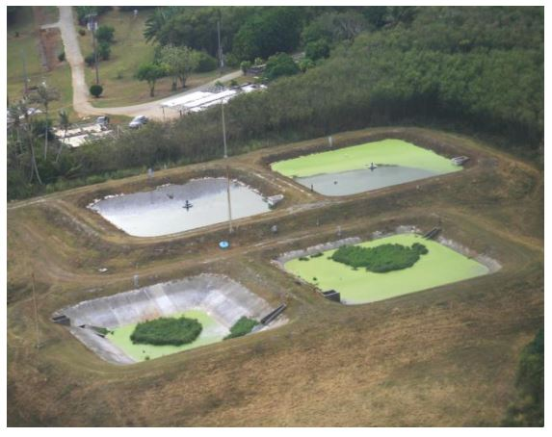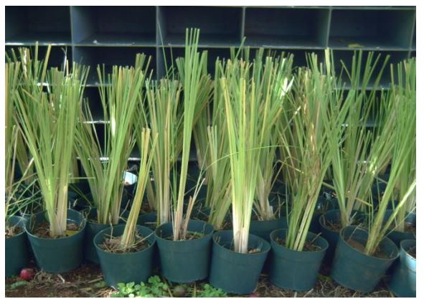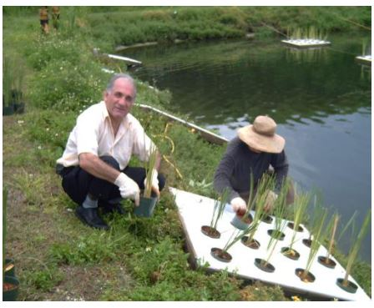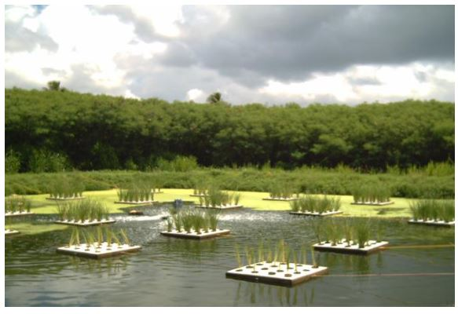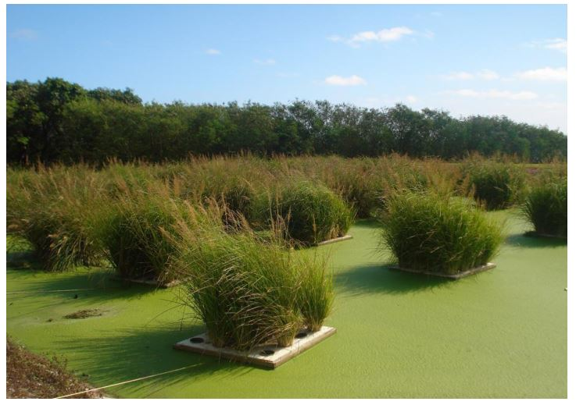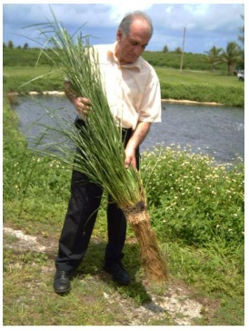
Figure 10: Application process of Vetiver system at Umatac-Merizo Drainage Treatment Plant
(Source: Golabi and Duguies, 2013)
The initial condition of the pond was monitored weekly before the application of vetiver grass grown in floating panels with each panel consisting of 20 holes. After the installation, water samples were taken and tested at weekly interval. Despite unsteady conditions like wind, rain, sunshine, cloud cover and duckweeds the results obtained indicated that vetiver grass was effective in removing pollutant including heavy metals (Golabi and Duguies, 2013).

CHAPTER 3: RESEARCH METHODOLOGY

3.1 Description of the Study Area
Addis Ababa home to 25% of Ethiopian urban population (The World Bank Group, 2015) is located at the center of the country, bounded by the two Akaki river catchment namely Great and Little Akaki. Among the two rivers, Little Akaki is the most extensively used river for irrigating urban farms in Addis Ababa (Kebbede, 2011). The river originates from small streams that pass through the western-central part of the city to join Aba Samuel Lake at the south. As the river crosses through densely populated residential, commercial and industrial areas, it is polluted by both municipal and industrial waste (Gebre and Rooijen, 2009).
Among the Addis Ababa urban farming initiatives, the “Mekanisa-Gofa-Lafto Co-operative” (Figure 12) is the oldest and largest irrigation farming site located along Little Akaki River valley (Kebbede, 2011). The site stretches from Mekanisa in the north to Lafto hill in the south covering about an area of 3-5 kilometer in length (Kebbede, 2011). According to Kebbede (2011) two-third of the “Mekanisa-Gofa-Lafto Co-operative” farmers had settled in the area between 1930 & 1975, migrated from different parts of the Gurageland. However the current holdings are the result of 1975 land distribution by the military regime that ruled Ethiopia from (1930-1991). The government at that time required the farmers to work the land in corporation; the “Mekanisa-Gofa-Lafto Co-operative” was establish in 1975 (Kebbede, 2011). The co-operative currently operates 7 irrigation dams diverted mainly from Kera and Zenebeworke stream. Kera Stream is intensively used as a receptacle of all kinds of wastes. It highly polluted tributaries of the Little Akaki River (Melaku, 2005). Consequently, the irrigation dam diverted from Kera stream located at Nifas-Silk-Lafto woreda 4 (N 8º 58ʹ 31ʺ, E 38º 44ʹ 03.25ʺ) was selected as the specific site for this research.
As been located at the Akaki basin the specific site experience Afro-Alpine climate. According to (Eshetu, 2012) the climate of Akaki catchment is characterized by two distinct seasonal weather pattern namely wet seasons (July-September & February-April) and Dry season (October-January & March-June). Most of the farm plots are located on gentle slopes while a few are on flat terrain near the river with mostly a vertisol and alluvium soil type.

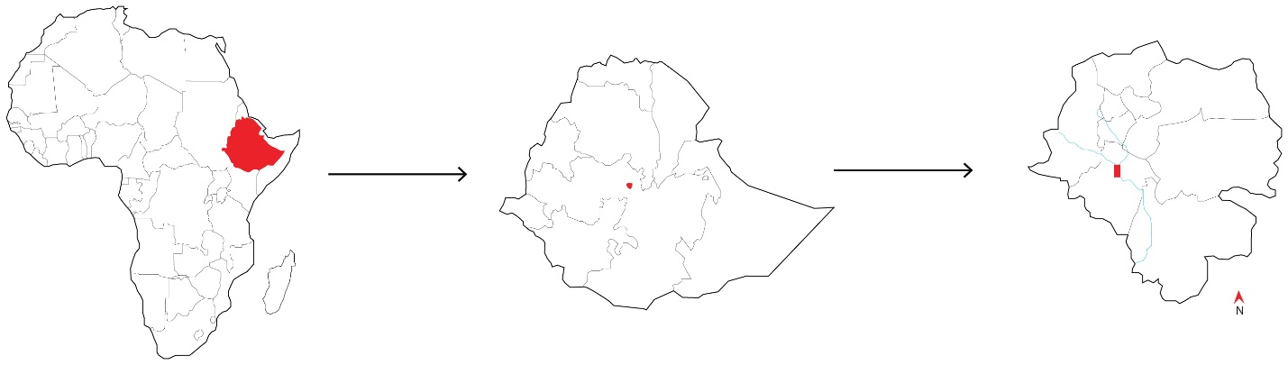
Figure 11: Location map of the study area

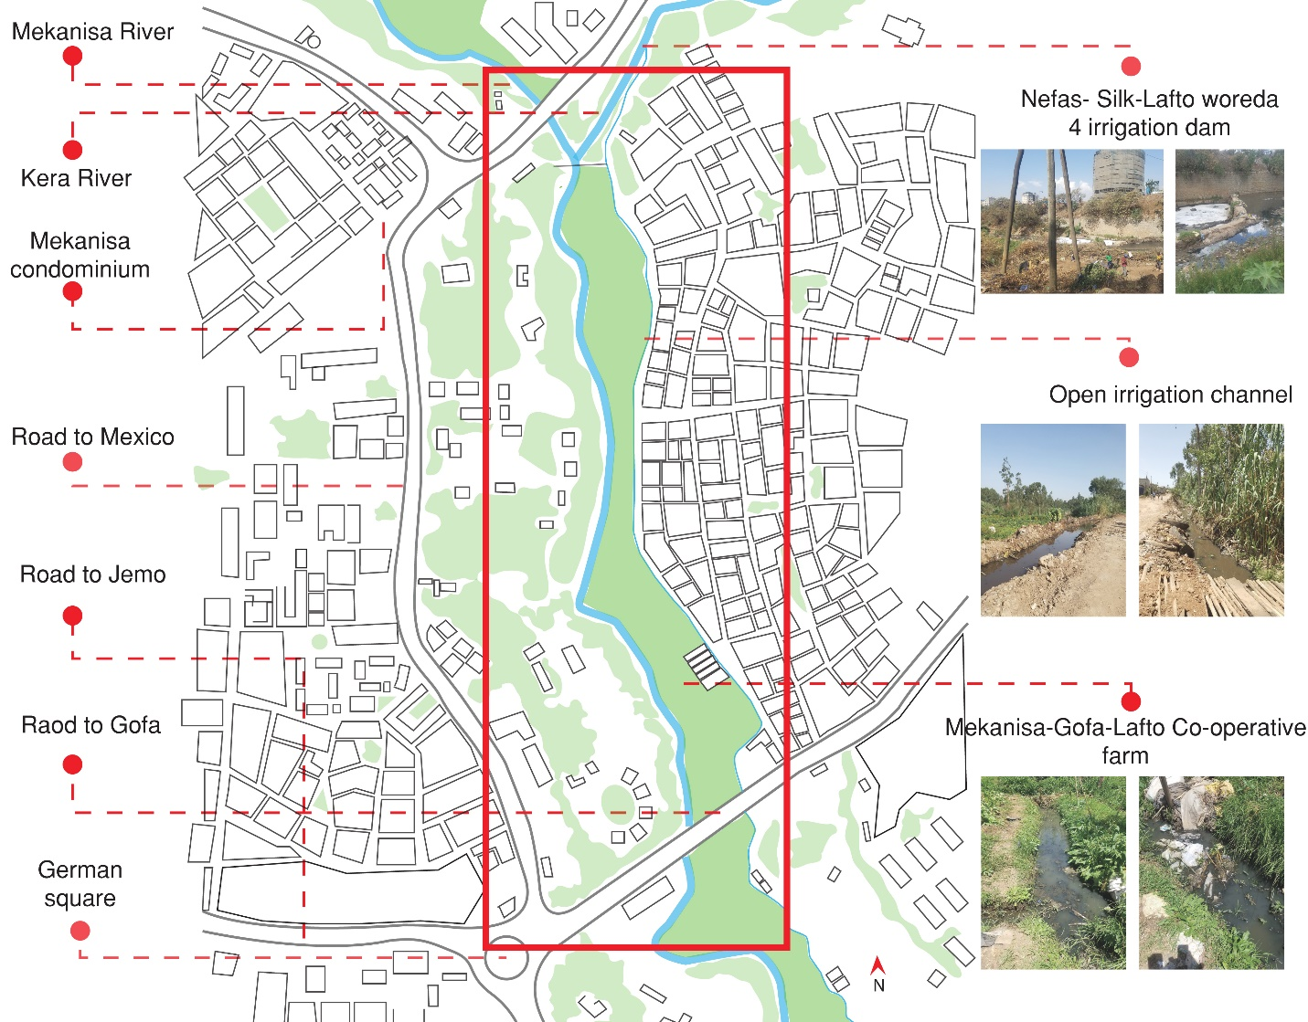
Figure 12: Specific study site map

3.2 Research approach
A mixed methodology that combined both qualitative and quantitative data collection was used in this study. Mixed methodology is an approach that combines both quantitative and qualitative data collection to provide a more complete understanding of a research problem than either qualitative or qualitative data alone (Creswell, 2014). This methodology was used because the study required both open-ended (qualitative) and close ended (qualitative) data to develop stronger understanding of the type and the extent of pollutants of agricultural concern in the irrigation water in general and the existing irrigation practice and channel system, techniques farmers are currently using to reduce pollution. In this study, appropriate ecological water treatment elements were selected by comprehensive literature review and was field tested at Mekanisa-Gofa–Lafto Cooperative Farm to assess its potential in reducing the pollution level of the irrigation water. Both qualitative and quantitative data collected were triangulated with each other to come up with validity research findings.

3.3 Research Method
Case study method was used in this study, in which the data collected from few sources are applied for holistic and in-depth investigation of complex issues (Zainal, 2007). Since it was required to have accurate and in-depth data to understand the problem and answer the research questions, case study method was chosen as research method. Different data collection methods including questionnaires, observation, field test and laboratory test were used to collect both primary and secondary data.

3.4 Data type

3.4.1 Primary data
The primary data are data collected directly from the first source, and thus, happen to be original in character (Kothari, 2004). Primary data about the extent of pollutants of agricultural concern in the irrigation water and the existing irrigation practice and channel system were collected with the use of questionnaires, observation, and laboratory test. The data was then triangulated to the secondary data collected by comprehensive literature review to come up with valid findings to answer the research questions.

3.4.2 Secondary data
Secondary data are those data which have already been collected by someone else and have already been passed through the statistical process (Kothari, 2004). Different scholarly publications such as manuals, standards and guidelines, books, journals, and articles etc. were reviewed with proper citation. Secondary data were collected by comprehensive literature review about the type of pollutants of agricultural concern, amount of pollutant concentration allowed in irrigation water and appropriate ecological water treatment elements that can be applied at Mekanisa-Gofa–Lafto Cooperative Farm to reduce the pollution level of the irrigation water.

3.5 Data Collection methods

3.5.1 Questionnaires
Structured and pre-tested questionnaires were distributed to individual farmers at the field to collect primary data about the existing irrigation practice and channel. The data collected from the questioners were later used as starting point (preliminary assessment) to carry out the laboratory and field test. The questions included in questionnaires can be categorized into three general parts. Question-related to research respondent character, water pollution status and existing irrigation practice.
To determine the sample size of the participating respondent to the questionnaires, simplified formula of determination of proportions suggested by Taro Yamane (1967) and modified by Ajay and Micah, (2014) was used. There were a total of 80 farmers involved in the farming practice at Nifas- Silk-Lafto woreda 4 irrigation dam. Each farmer has 1 - 4 individual farms located at the site.
$$n=\frac{N}{1+{Ne}^{2}}$$
Where,
n - Sample size number
N - Number of populations
e - mergion of error if confidence level 95%, error 5% = 0.05
$$n=\frac{80}{1+{80(0.05)}^{2}}=67$$
Accordingly, a total of 67 participates were randomly selected to participate in the study.

3.5.2 Observation
Several site visits were carried out to conduct observations and discussion intended at collecting primary data and information on the existing irrigation practice and status of channel system. Photos and written memos were taken as means of recording data. The data collected by observation were used to triangulate the data collected by questionnaires for validity.

3.5.3 Laboratory test
For the identification of the type and the extent of pollutants of agricultural concern in the irrigation water of the study area, laboratory test was carried out based on the data collected by the questionnaires and observation as starting point (preliminary assessment). Although there are several important agricultural water quality parameters that are useful and needed for water use for irrigation, the analysis of many parameters are expensive & difficult to conduct. Thus, because of time and finance constraints, 9 parameters were selected for laboratory analysis in this study. The method used for analyzing each parameters are indicated on Table 4.
Table 3: Selected agricultural water quality parameter analyzed in this study
Parameters | Symbols | Unit
Acidity/Basicity | pH
Electrical conductivity | EC | ds/mL
Total suspended solid | TSS | mg/L
Total hardness (amount of Ca & Mg) | TH | mg/L
Sodium | Na | SAR
Chloride | Cl⁻ | mg/L
Biochemical oxygen demand | BOD | mg/L
Chemical oxygen demand | COD | mg/L
Zinc | Zn | mg/L

Representative 4 water samples were collected using 2-liter capacity plastics bottles on two different days (26th of October, 2018 and 5th of December 2018). The 4 water samples were taken near the start point of the open channel (N 8º 58ʹ 31ʺ, E 38º 44ʹ 03.25ʺ) and taken to Addis Ababa City Government Environmental Protection Authority, environmental laboratory and Ethiopian construction design and supervision works corporation laboratory for analysis. The resulting laboratory analytical data were evaluated against FAO water quality guidelines and standards set for safe and maximum crop production as reported by Pescod (1992). For water quality parameters missing in FAO safety standard e.g. BOD, COD and TSS values UNESCAP 2000 wastewater management policies and practices used in Asia and the Pacific (Oku et al., 2015) were used including that of irrigation water quality tool (IWQT) developed for Jordan, Tunisia, and Lebanon (Bortolini et al., 2018a) as indicated in Table 5.
Table 4: Selected parameters and water quality guidelines values used for evaluating the laboratory results
Selected Parameters | Unit | Water quality guidelines for irrigation |  |  | Source
Selected Parameters | Unit | Degree of restriction |  |  | Source
Selected Parameters | Unit | None | Slight to Moderate | Sever | Source
EC | dS/m | < 0.7 | 0.7-3.0 | >3.0 | ª
TSS | mg/L | <200 | 200-400 | >400 | ^{b}
Cl | mg/L | < 140 | 140 - 350 | >350 | ª
Na | SAR | <3 | 3-9 | >9 | ª
Zn | mg/L | 2 (Recommended maximum concentration) |  |  | ª
pH |  | 6.5 – 8 (Normal rage) |  |  | ª
BOD | mg/L | 80 |  |  | ^{c}
COD | mg/L | 150 |  |  | ^{c}
ª Adopted from FAO water quality guidelines for maximum crop production (Pescod, 1992)
^{b} Adopted from irrigation water quality tool (IWQT) developed for Jordan, Tunisia, and Lebanon (Bortolini, Maucieri and Borin, 2018a)
^{c} Adopted from UNESCAP 2000 wastewater management policies and practices in Asia and the Pacific (Oku et al., 2015).

3.5.4. Field test
After selection of appropriate ecological water treatment elements, field test was carried out as part of studying the potential of ecological water treatment elements in reducing the pollutant in the study site. Due to time and financial constraints only, floating treatment wetland was tested on “Mekanisa-Gofa-Lafto Co-operative farm” study site.
3.5.4.1 Location of the field test
The field test was located in (N 8º 58ʹ 06.65ʺ, E 38º 44ʹ 03.21ʺ) at “Mekanisa-Gofa-Lafto Co-operative” farm. It is located at the middle of the farm which has been irrigated for years with Kera stream (intensively used as a receptacle of all kinds of wastes). The environmental variables such as wind, sunshine, and cloud cover were not controlled during the field test.
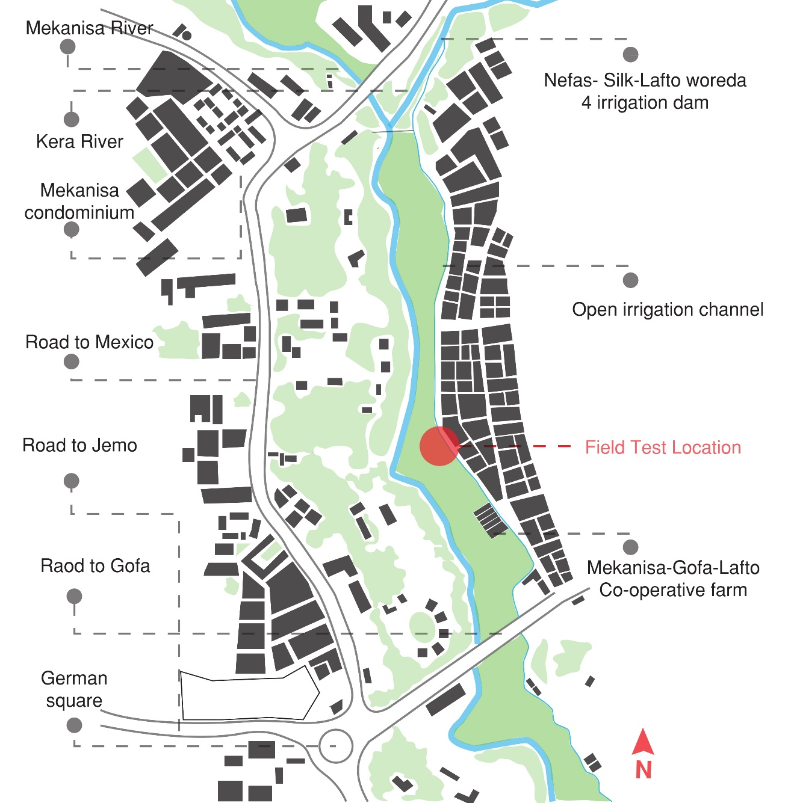
Figure 13: Location of the field test

3.5.4.2 Construction of the floating treatment wetland
On 14th of May 2018, two square holes with a size of 80x80x40 cm were prepared and covered by a plastic sheet to avoid water leakage. The two holes were filled with the irrigation water that was diverted and transported from Kera stream.
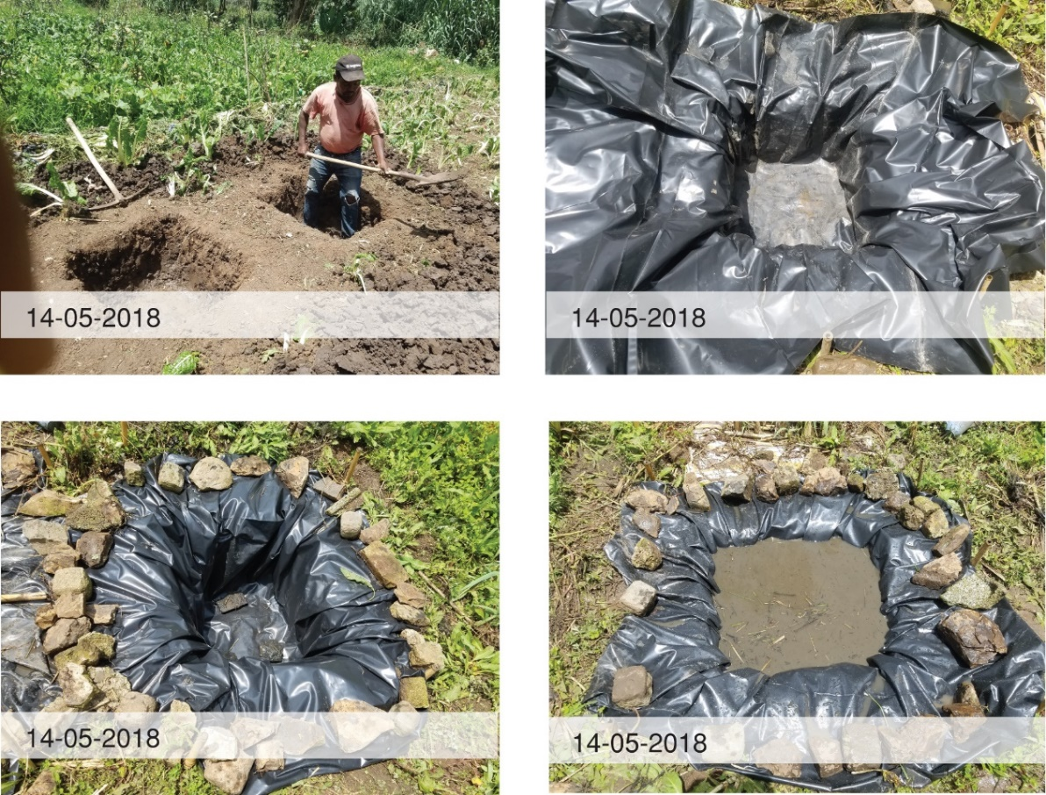
Figure 14: The Construction of the Floating Treatment Wetland
(Photo by: Terusaw Solomon)
On the 15th of May 2018, two floating panels with a size of 60x60 cm were constructed from PVC pipes and plastic net.
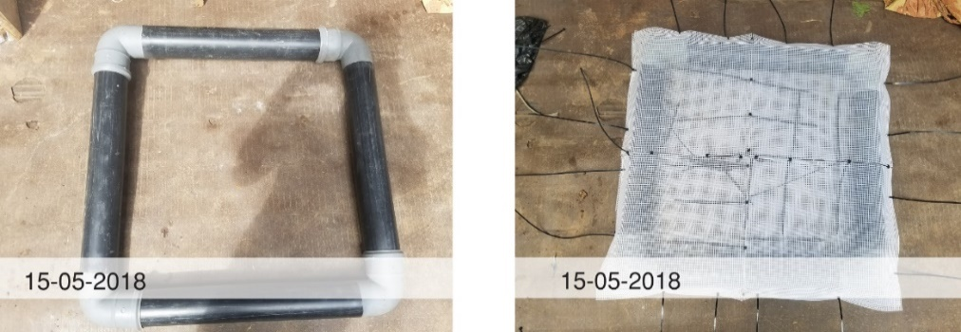
Figure 15: Construction of two floating panel
(Photo by: Terusaw Solomon)
Vetiver. zizanioides L. tiller which were brought from Jimma University College of Agriculture and Veterinary Medicine (JUCAVM) were planted on each floating panel. The two floating panels were placed on top of the holes filled with the irrigation water and left to develop hydroponically for six months.
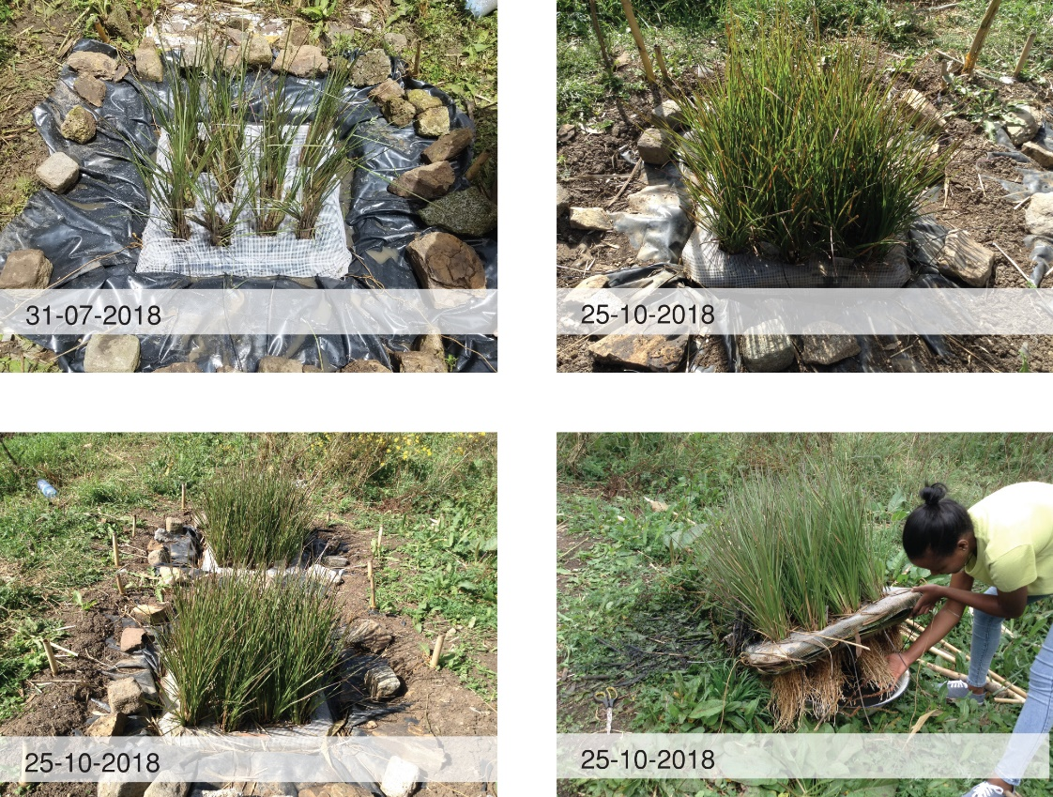
Figure 16: Planted vetiver grass after 6 months.
(Photo by: Terusaw Solomon)
On day 1 (23th of November, 2018) new irrigation water was refilled to the two 80x80x40 cm capacity holes and water samples were collected from both holes and taken to AACGEPA environmental laboratory and ECD&SWC laboratory to analyze the initial status of the 9 selected water parameters of agricultural concern. After samples were collected, the water in one of the holes (H1, see on Figure 17) was kept untreated as control while the six-month-old vetiver glass stem were harvested and applied to the other hole (H2, see on Figure 17). On day 3 (26th of November, 2018) and day 7 (30th of November, 2018) water sample were again collected from both holes and taken to the laboratory for analysis (Figure 17).

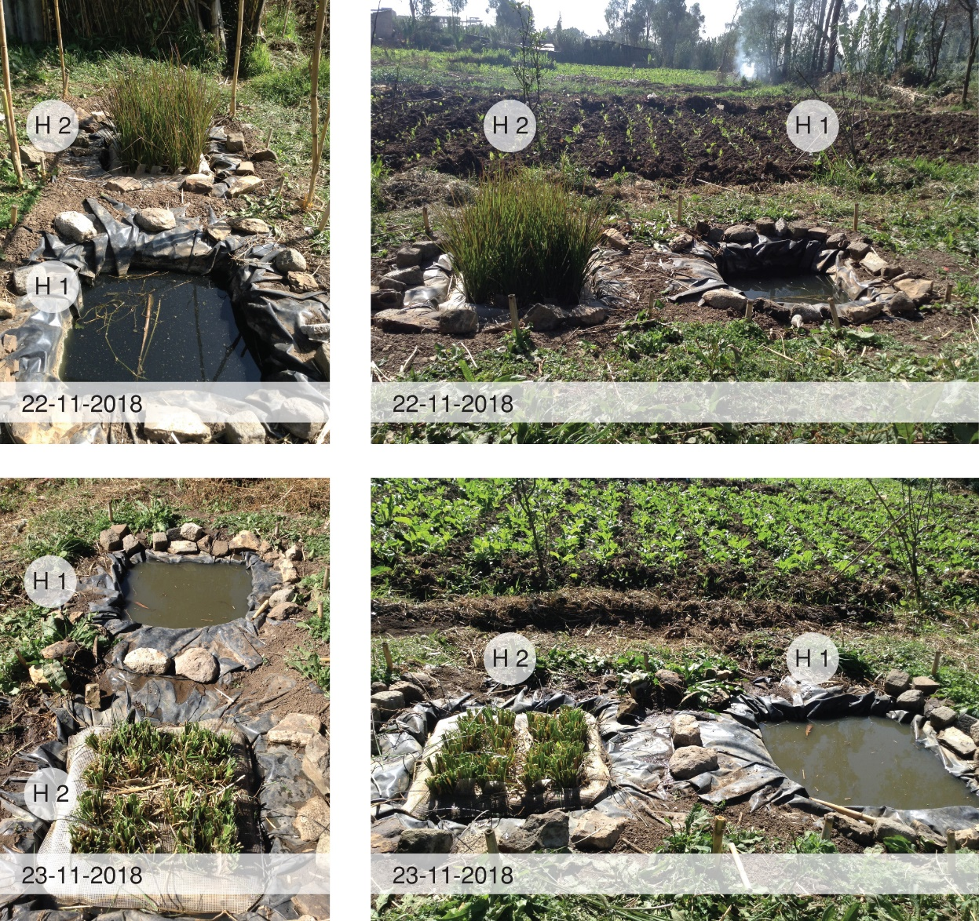
Figure 17: Photo showing the field test site
(Photo by: Terusaw Solomon)
3.5.4.3 Water sampling
2-liter capacity water plastic bottles were used to collect water sample from the holes. The water samples were taken in November 2018 (dry month) to avoid dilution of the field test water by rain water. It was tried to follow all necessary steps including labeling and taking information about the samples at the site (Figure 18). Considering the fact that farmers at the site water their farms at interval of 3-7 days depending on the vegetable type and the lack of available land to store the water more than one cycle, it was decided to test the capacity of floating treatment wetland in reducing the pollution level of water on the 3rd and 7th days.
Representative samples were taken from the holes on day 1 (23-11-2018), day 3 (26-11-2018) and day 7 (30-11-2018) and transported to the laboratory for analysis. Because of very lower detection of Zn in the two-irrigation water sample taken prior to the field test, the analysis of Zn was excluded from the parameter selected for laboratory analytical test.
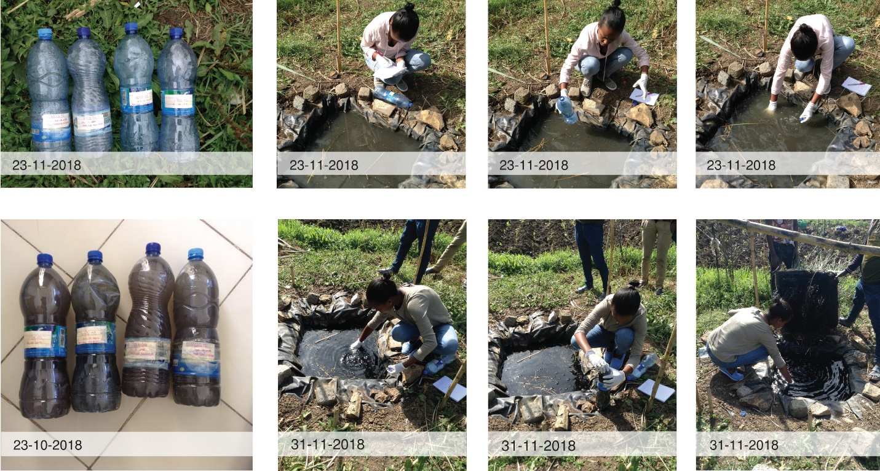
Figure 18: Photo showing sample taking at the site
(Photo by: Terusaw Solomon)

3.6 Data analysis
According to their significance, each finding is analyzed and presented by descriptive writing, tables, photos, essays, maps, illustrations, and graphs. The data collected from the questionnaires were explored and analyzed by SPSS data analysis software and presented by graphs, tables, and descriptive writing in chapter 4.
The content of the water sample for the BOD, COB, pH, TH, TSS, EC, Cl-, and Zn, were analyzed at the AACGEPA environmental laboratory. While the content of the water for Na were analyzed at ECD&SWC laboratory. Standard methods for the examination of wastewater have been applied to conduct the tests of each parameters as outlined below.
- pH/EC/TDS Meter method for analyzing the pH, EC & TSS
- Gravimetric (using pressure sensor) for analyzing the BOD
- Rector Digestion for analyzing the COD
- Titration for analyzing TH
- Flame Photometric for analyzing Na
- Mohr’s/ Titration for analyzing Cl⁻
- Graphite furnace for analyzing Zn
For further analysis the results obtained from the laboratory were compared to the irrigation water guidelines developed from reviewed literatures to identifying the extent of pollutants of agricultural concern in the irrigation water at the specific site. The findings are organized in a table and discussed in detail by descriptive writing in chapter 4.
The laboratory result from the field test were also analyzed at the AACGEPA environmental laboratory and ECD&SWC laboratory following the same standard methods discussed above. Then the reduction percentage of each parameters was calculated and presented in graphs and discussed. The results were also compared to the irrigation water guidelines developed from reviewed literatures. For further discussion the results are also compared with other similar studies published recently (2014 – 2017) in chapter 4.
Table 5: Summary of the research methodology
Research questions | Method |  | Data collection instruments | Type of analysis
  Data type and source
What are the types and extent of pollutants of agricultural concern in the irrigation water? | Case study method | A water sample was taken from Mekanisa-Gofa-Saris Co-operative Farm.  Survey (Collected from Farmers) | Laboratory Test  Questionnaire  Observation | Both: Qualitative  & quantitative
What is the existing irrigation practice and channel system used by Mekanisa-Gofa–Lafto Cooperative Farming community? | Case study method | Survey (Collected from Farmers and site visits) | Questionnaire  Observation | Both: Qualitative  & quantitative
What are the appropriate ecological water treatment elements that can be applied at Mekanisa-Gofa–Lafto Cooperative Farm to reduce the pollution level of the irrigation water? | Case study Method | Comprehensive literature review  Survey (Collected from Farmers and site visits)  Field test | Questionnaire  Observations  Laboratory test | Both: Qualitative  & quantitative

CHAPTER 4: RESULTS AND DISCUSSION

4.1 Description of respondents
A total of 67 household participants, 84% of the individuals involved in agricultural activity on Mekanisa-Gofa–Lafto Cooperative Farms were communicated for the purpose of data collection about the existing irrigation practice and channel. The characteristics of the respondents are presented in Table 7. The results obtained showed that about 81% of the respondents were male indicating that the majority of the farming community of Mekanisa-Gofa–Lafto Cooperative Farms were males. About 19% of the respondents were reported to be female household heads. The results obtained also indicated that 54 and 46% of the respondents was reported to be owner of the farms and hired employee on daily laborer basis respectively.
Table 6: Characteristics of the respondents
Research respondent character
Character | Category | Number | Percentage | Year
Age | 15 – 30 | 21 | 31.3% | -
Age | 31 – 64 | 44 | 65.7% | -
Age | 65 & Above | 2 | 3% | -
Gender | Female | 13 | 19.4% | -
Gender | Male | 54 | 80.6% | -
Education | None | 20 | 29.9% | -
Education | Elementary school | 34 | 50.7% | -
Education | Secondary school | 13 | 19.4% | -
Education | University & above | 0 | 0% | -
Ownership | Owner | 36 | 53.7% | -
Ownership | Employ | 31 | 46.3% | -
Work Experience | Maximum | - | - | 50
Work Experience | Minimum | - | - | 4
Total No. of Participants | 67
About 31.3% of the respondents were reported to be between 15 and 30 years of age whereas; about 66% of the respondents were reported to be between 31 and 64 years of age. Similarly about 97% of the respondents were between 15 and 64 years of age indicating that the majority of the respondents involved in farming activity at Mekanisa-Gofa–Lafto Cooperative Farms were within potentially productive age. According to the results of the current study about 30% of the respondents do not read and write and may be depended on daily labour as means of livelihood. About 51 and 19% of the respondents reported to have attended elementary and secondary school education respectively indicating that about 70% of the respondents might be capable of responding to the environmental and human health implication of using polluted irrigation water for agricultural production. All the respondents (100%) reported to have no other means of income generation and involved in farming at Mekanisa-Gofa–Lafto Cooperative Farms as means of livelihood. The work experience of the respondents were reported to range between 4 and 50 years.
When asked to explain their understanding of water pollution and status of pollution, about 15% of the respondents were reluctant to answer the questions. About 58% of the respondents, reported to have the concept and concern of water pollution. The remaining 27% of the respondents seriously complained about the current status of pollution of river used as source of irrigation water at Mekanisa-Gofa–Lafto Cooperative Farms. These categories of the respondents were reported to be between 27 and 45 years of age and attended either elementary or high school education. Some of them explained water pollution as result of climate change and the discharge of industrial waste to water bodies.

4.2 Existing irrigation practice and channel
In order to have deeper understanding of the existing irrigation practice and channel, primary data were collected through the use of both questionnaires and observations. The participating respondents were asked questions related to the existing irrigation practice including;
- The kind of vegetable cultivated
- Person responsible for watering the farm
- Interval od irrigation (frequency of watering)
- Frequently encountered pollutants
- Method they use to measure the pollution statues

The results of the vegetables grown and the interval of irrigation are presented in Table 10. It was found out that farmers at “Mekanisa-Gofa-Lafto Co-operative” farm cultivate different kinds of vegetable i.e. Cucumber, Lettuce, Spinach, Ethiopian Cabbage, Cabbage, Parsley, Celery, Coriander, Broccoli, Swiss chard and Pumpkin depending on market demand. Both the farm owners and employees reported to have involved in watering of the cultivated vegetation. The watering schedule/frequency depends on the type and amount of vegetable to be irrigated. It was reported that 3-7 day irrigation interval is commonly used to water the vegetables (Table 10).
Table 7: Types of vegetables grown and frequency of irrigation at “Mekanisa-Gofa-Lafto Co-operative farm.
Picture | Vegetable Name | Local name in Amharic | Watering day interval
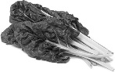 | Swiss chard | ቆስጣ | 7
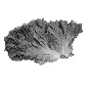 | Lettuce | ሰላጣ | 3
 | Ethiopian Cabbage | ሀበሻ ጎመን | 5
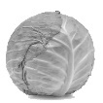 | Cabbage | ጥቅል ጎመን | 6
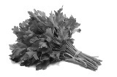 | Parsley | ሾርባ ቅጠል | 3
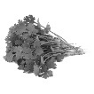 | Coriander | ድንብላል | 3
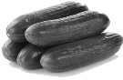 | Cucumber | ዝኩኒ | 7
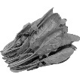 | Spinach | እስፒናች | 3
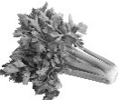 | Celery | ሰለሪ | 4
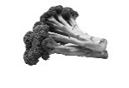 | Broccoli | ብሮክሊ | 7
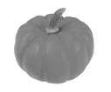 | Pumpkin | ዱባ | 4
About 64.2% of the respondents reported to have no method of measuring the pollution status of the water they are using as source of irrigation on their agricultural plots. On the contrary, about 35.8% of the respondents reported to have used observations and visual appraisals to estimate the pollution status of the water they are using as source of irrigation on their agricultural plots. When asked if the water they are currently using is polluted, about 74.6% of the respondent said no while about 25.4% of the respondents were reluctant to answer the question. On the contrary to the reactions of the respondents (74.6%), close observations made clearly indicated that the irrigation channel was filled (Figure 19) with both solid and liquid municipality wastes. The color of the water was black with unpleasant odor indicating serious level of contamination.
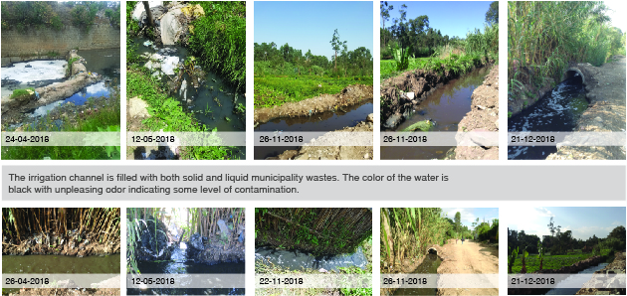
Figure 19: Existing statute of the irrigation water
(Photo by: Terusaw Solomon)
The participating respondents reported to have commonly identified plastic bottle, plastic sheets and shopping bags, animal wastes, dead animal, broken glass, diaper and human excreta’s as some of the frequently encountered pollutants of the irrigation water used at Mekanisa-Gofa–Lafto Cooperative Farms.
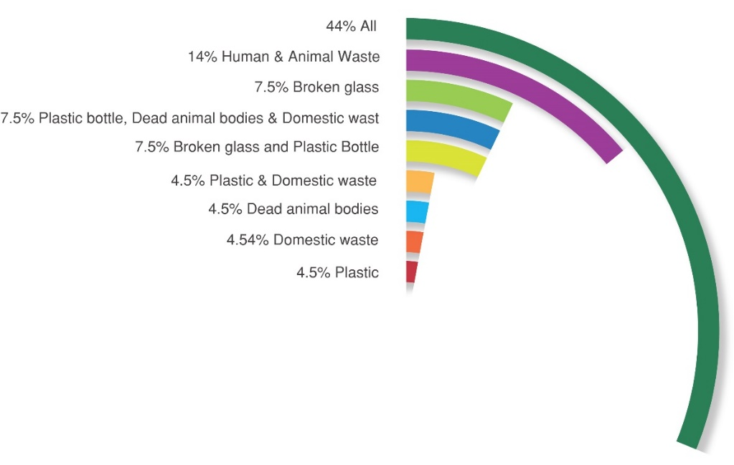
Figure 20: Frequently encountered pollutants of the irrigation water by respondents
All the participating respondents (100%) indicated that the irrigation channels are open and the irrigation water is totally exposed to wide range of pollutants discharged from the surroundings. About 70% of the participated respondents suggested the need of covering currently open irrigation channel to avoid or significantly reduce the present level of waste discharged into the irrigation water of “Mekanisa-Gofa-Lafto Co-operative farm”. About 30% of the respondents called upon the government to formulate rules and regulations against discharging of waste directly into irrigation channels or irrigation water resource without pre-treatment. People directly discharging household waste into irrigation channel(s) were frequently encountered during the conduct of this research undertaking (Figure 21).
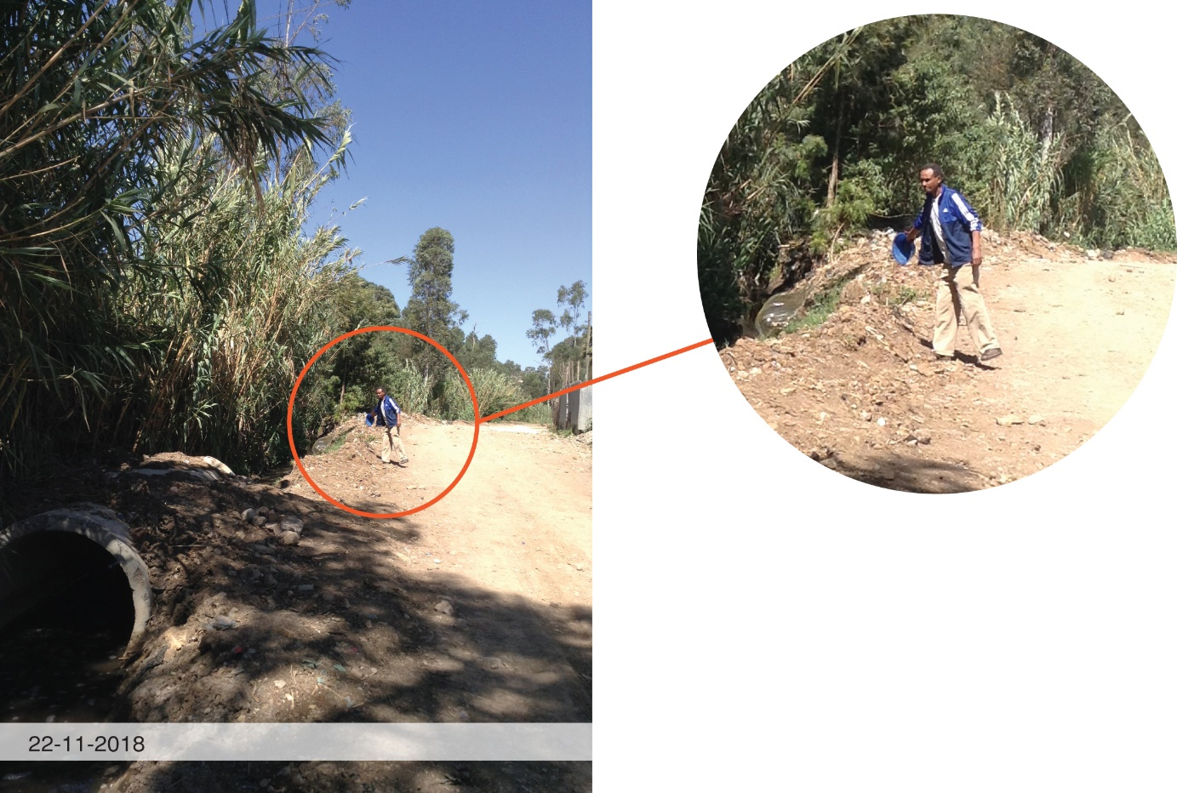
Figure 21: The discharge of domestic waste into the open channel
(Photo by: Terusaw Solomon)

4.3 Type and extent of pollutants of agricultural concern
Attempts were made to accurately identify and quantify the pollutants of agricultural concern in the irrigation water through laboratory test of water samples. The results of the laboratory test are presented in Table 8 and Table 9.
Table 8: Results of Laboratory test of irrigation water of Mekanisa-Gofa–Lafto Cooperative Farms
Parameter | Unit | S1  26-10-2018 | S2  26-10-2018 | S1  5-12-2018 | S2  5-12-2018 | Average | Method
BOD | mg/l | 174 | 156 | 528 | 358 | 304 | Gravimetric (using pressure sensor) measuring principle
COD | mg/l | 218 | 222 | 1235 | 750 | 606 | Rector Digestion
pH |  | 7.85 | 7.81 | 7.32 | 7.46 | 7.61 | pH/EC/TDS Meter
EC | dS/m | 2.78 | 2.78 | 2.67 | 2.67 | 2.725 | pH/EC/TDS Meter
TSS | mg/l | 321 | 307 | 787.5 | 416 | 457.9 | pH/EC/TDS Meter
Cl⁻ | mg/l | 350 | 250 | 225 | 275 | 275 | Mohr’s / Titration
Total Hardness | mg/l | 355 | 350 | 365 | 325 | 348.8 | Titration
Sodium | mg/l | 215 | 152.50 | 166 | 164 | 174.4 | Flame photometric
Zinc | µg/l | 1.072 | 0.143 | - | - | 0.6075 | Graphite furnace method
Table 9: Comparison of the result of laboratory test with quality standard guidelines
Selected  Paraments | Average | Unit | Water quality guidelines for irrigation |  |  | Source
Selected  Paraments | Average | Unit | Degree of restriction |  |  | Source
Selected  Paraments | Average | Unit | None | Slight to Moderate | Sever
BOD | 304 | mg/l | < 80 |  |  | ^{c}
COD | 606 | mg/l | < 150 |  |  | ^{c}
pH | 7.61 |  | 6.5 – 8 (Normal rage) |  |  | ª
EC | 2.725 | dS/m | < 0.7 | 0.7-3.0 | >3.0 | ª
Na | 13.21 | SAR | <3 | 3-9 | >9 | ª
Cl ⁻ | 275 | mg/l | < 140 | 140 - 350 | > 350 | ª
TSS | 457.9 | mg/l | <200 | 200-400 | >400 | ^{b}
Zn | 0.6075 | mg/l | 2 (Recommended maximum concentration) |  |  | ª
ª Adopted from FAO water quality guidelines for maximum crop production (Pescod, 1992)
^{b} Adopted from irrigation water quality tool (IWQT) developed for Jordan, Tunisia, and Lebanon (Bortolini, Maucieri and Borin, 2018a)
^{c} Adopted from UNESCAP 2000 wastewater management policies and practices in Asia and the Pacific (Oku et al., 2015)
As shown in Table 9, the BOD and COD of the irrigation water of Mekanisa-Gofa–Lafto Cooperative Farms exceeds the recommended value for irrigation water indicating the availability of high amount of organic matter and dissolved oxygen in the water for irrigation. High amount of organic matter in water negatively affects the odor, color and also acts as nutrients for microbes (US EPA, 2012). On the contrary, the agronomic quality indicators, the pH values fall within normal concentration range of recommended for irrigation water. The SAR, EC, and Cl falls within sever and slight to moderate degree of restriction respectively. High amount of SAR in irrigation water causes reduction of infiltration rate of water and air into the soil which in turn affects germination capacity and seedling survival (Pescod, 1992). According to Table 9, the management quality indicator, i.e. TSS values of Mekanisa-Gofa–Lafto Cooperative Farms irrigation water also exceeds the recommended values and fall within sever degree of restriction. High amount of TSS in irrigation water results in clogging issues in the irrigation system & affects the crop production quality and irrigation system operation (Bortolini et al., 2018a). The results of the current test showed that the Zinc content of water for irrigation in the study area contains excessive concentration that exceeded the recommended maximum concentration level.

4.4 Appropriate ecological water treatment elements for Mekanisa-Gofa–Lafto Cooperative Farm
After diversion of the Kera River, the irrigation water travels a minimum of 200 meters within an open linear irrigation channel before it is used to irrigate the individual vegetable plots. Considering this as an opportunity and other parameters (i.e. degree of irrigation water pollutants of agricultural concerns, cost and land availability, and comprehensive review of literature on ecological water treatment elements), attempts were made to identify and select appropriate design elements suitable for integration into the existing open irrigation channel system of “Mekanisa-Gofa-Lafto Co-operative farm”.
A combination of grassed swale (liner, flow-based element) with stone check dam and floating treatment wetland (point element) appeared to be appropriate for “Mekanisa-Gofa-Saris Co-operative farm”. Linear grass swale ecological water treatment elements is selected to be applied on the open irrigation channel as pretreatment of the irrigation water before storage followed by floating treatment wetland (point) as main treatment at the farm.
In the current research undertaking, due to time and financial constraints only floating treatment wetland was tested on “Mekanisa-Gofa-Lafto Co-operative farm” study site. Vetiver. zizanioides, L. was selected as wetland plant because several studies conducted in more than 100 countries proved that, the grass is tolerant to wide range of adverse conditions and high removal capacity of a wide range of pollutants including salinity, sodicity, heavy metals (Golabi and Duguies, 2013) pH, BOD, COD, nitrate, and phosphate in short period of time (Oku et al., 2015). The grass is widely available in Ethiopia since 1971 (Kebede and Yaekob, 2009) and found to perform well in altitude ranges of 1200- 3200m (Webshet, 1991).
The results of laboratory test of the irrigation water of “Mekanisa-Gofa-Lafto Co-operative farm” are presented in Table 11. It is noted that the holes dug for the field test were located at the farm site surrounded by the soil that had been irrigated with Kera river water (receptacle of all kinds of wastes) for years. The environmental variables such as sunshine, wind and cloud cover were not controlled during the field test. To find out the pollutant reduction capacity of the floating treatment wetland (reduction percentage of each parameter), the water samples were collected for analysis from both holes on the 1st, 3rd and 7th days of the installation of floating treatment wetland design element.
Table 10: Results of the Laboratory test of Mekanisa-Gofa-Lafto Co-operative farm irrigation water
Selected  Permanents | Hole 1  23-11-2018  (Day 01) | Hole 2  23-11-2018  (Day 01) | Hole 1  26-11-2018  (Day 03) | Hole 2  26-11-2018  (Day 03) | Hole 1  30-11-2018  (Day 07) | Hole 2  30-11-2018  (Day 07)
Selected  Permanents | Control | With Vetiver. Zizanioides | Control | With Vetiver. Zizanioides | Control | With Vetiver. Zizanioides
BOD | 164 | 228 | 74 | 78 | 96 | 60
COD | 336 | 418 | 149 | 143 | 218 | 109
pH | 8.02 | 7.64 | 8.23 | 7.58 | 9.25 | 7.61
EC | 2.59 | 2.52 | 2.69 | 2.64 | 2.72 | 3.079
TSS | 730 | 845 | 86 | 75 | 233 | 32
Cl | 270 | 250 | 130.4 | 136.2 | 141.2 | 142.2
Total Hardness | 965 | 945 | 287.8 | 310 | 292 | 316
Sodium | 117 | 125 | 134 | 130 | 142 | 144

To find out the pollutant reduction capacity of the floating treatment wetland, reduction percentage of each parameter for both holes on day 3 and day 7 were analyzed. The result is presented in chart and are discussed in comparison to water quality guidelines for irrigation. For further discussion the results are also compared with other similar studies published recently (2014 – 2017).
Biochemical oxygen demand (BOD)
BOD is the amount of Dissolved Oxygen (DO) used by microbial activity for the biochemical degradation of organic matter in water in a given time (usually 5 days) at a certain temperature (20∘C) in the dark (Truong et al., 2014) . As shown in Figure 22, BOD reduction of 54.88 and 65.79% was recorded from the control (H1) and treated hole with Vetiver. zizanioides, L (H2) respectively on the 3rd day of the trial, indicating treatment with Vetiver. zizanioides, L brought BOD reduction of 10.81% over the control hole. The results obtained also showed that BOD reduction of 41.46 and 73.68% was recorded from the control and treated hole with Vetiver. zizanioides, L respectively on the 7th day of the trial, showing that treatment with Vetiver. zizanioides, L brought BOD reduction of 32% over the control hole. This clear showed that the floating treatment wetland with Vetiver. zizanioides, L. have better and persistent performance in reducing the BOD concentration in the irrigation water of Mekanisa-Gofa-Lafto Co-operative farm.
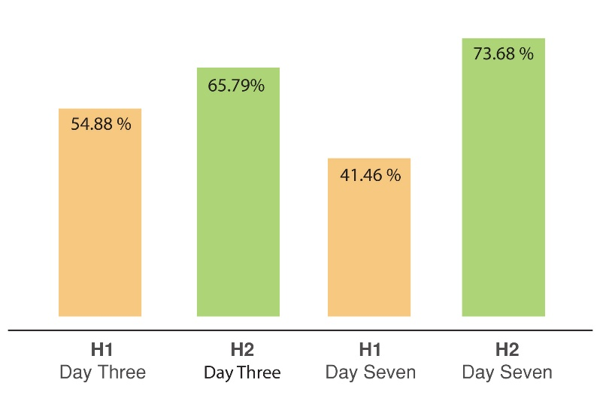
Figure 22: Day 3 and 7, BOD reduction percentage.
The result of BOD concentration obtained from holes treated with Vetiver. zizanioides, L. (H2) on the 7th day of the trial in the current study comply with the UNESCAP (2000) Guideline of acceptable BOD limit for irrigation water as shown in Table 12.
Table 11: Comparison of the BOD concentration from the hole treated with Vetiver. zizanioides, L. (H2) with water quality guidelines for irrigation water.
Selected  Parameters | H2  (Day 1)  Pre-treatment | H2  (Day 3) | H2  (Day 7) | Unit | Water quality guidelines for irrigation
 |  |  |  |  | Degree of restriction
BOD | 228 | 78 | 60 | mg/L | < 80 ^{c}
^{c} Adopted from UNESCAP 2000 wastewater management policies and practices in Asia and the Pacific (Oku et al., 2015)
According to the results of the current study, the irrigation water treated with floating Vetiver. zizanioides, L. (H2) showed relatively good performance on the 7th day of the trial in reducing BOD (73.68%) concentration of Mekanisa-Gofa-Lafto Co-operative farm irrigation water. This result was higher than that obtained from the study conducted in Nigeria to assess the pollutant removal potential from 3 different wastewater sources by native African vetiver grass species in comparison with Indian Vetiver species. The initial BOD concentration of the wastewater from the Public refuse dumpsite, Fertilizer Company and Quarry Site Effluent was 152.95, 41.57 & 124.29 respectively. On the 6th days of treatment with African Vetiver species reduction in BOD concentration of 65, 68.1 and 57.52% was recorded for public refuse dumpsite, Fertilizer Company and Quarry Site Effluent respectively (Oku et al., 2015). The BOD concentration of the current study (65.79 & 73.68%) were comparable to that of Indian Vetiver grass species which showed BOD removal efficiency of 67.34, 72.9% & 59.4% for public refuse dumpsite, Fertilizer Company and Quarry Site Effluent respectively within 6 days of the trial (Oku et al., 2015).
The study conducted in Malaysia on wastewater collected from Palm oil extraction factory with high and low pollutant concentration was treated with Vetiver grass. The initial BOD concentration of the wastewater were reported to range between 350 and 400 mg/L. Within two weeks of the treatment period , BOD concentration reduction of 90% and 60% was achieved for sample of low and high pollutant concentration respectively (Truong et al., 2014). Mean BOD removal efficiency of a floating treatment wetland of 70.73% was reported for tropical and sub-tropical countries like India, Sir Lanka, and Thailand (Zhang et al., 2015).
Chemical oxygen demand (COD)
COD is a measure of the total quantity of oxygen required to oxidize all the available organic materials into carbon dioxide and water (Northeast Georgia Regional Development Center, 2001). The results of COD of the current study are shown in Figure 23. As shown in Figure 23, COD reduction of 65.79 and 73.92% was achieved from the holes treated with Vetiver. zizanioides, L. (H2) on the 3rd and 7th day respectively. On the contrary, COD reduction of 55.6 and 16.36% was recorded from the control hole (without Vetiver. zizanioides, L) on the 3rd and 7th day of the trial respectively, indicating that the floating treatment wetland have better and persistent performance in reducing the COD concentration of the irrigation water of Mekanisa-Gofa-Lafto Co-operative farm.
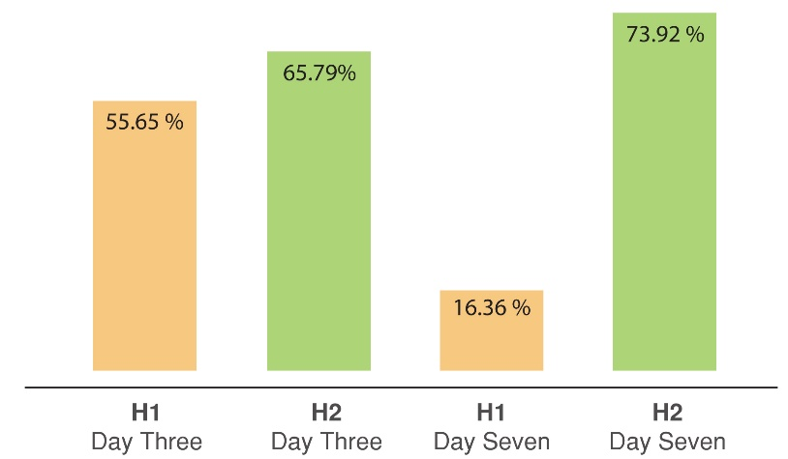
Figure 23: Day 3 and 7, COD reduction percentage.
The result of COD concentration obtained from holes treated with Vetiver. zizanioides, L. (H2) on the 7th day of the trial in the current study comply with the UNESCAP (2000) Guideline of acceptable COD limit for irrigation water as shown in Table 13.

Table 12: Comparison of the COD concentration from the hole treated with Vetiver. zizanioides, L. (H2) with water quality guidelines for irrigation water.
Selected  Parameters | H2  (Day 1)  Pre-treatment | H2  (Day 3) | H2  (Day 7) | Unit | Water quality guidelines for irrigation
 |  |  |  |  | Degree of restriction
COD | 418 | 143 | 109 | mg/L | <150 ^{c}
^{c} Adopted from UNESCAP 2000 wastewater management policies and practices in Asia and the Pacific (Oku et al., 2015)
The COD results obtained in the current study was slightly higher and showed better performance than that obtained from the study conducted in Nigeria. The initial COD concentration of the wastewater studied in Nigerian were 151.78,29 & 119.8 mg/L. The results obtained showed that reduction of COD by 66.68, 57.41 and 56.20% for Public refuse dumpsite, Fertilizer Company and Quarry Site Effluences respectively within 6 days of treatment with native African Vetiver grass (Oku et al., 2015). COD reduction value of 68.65, 63.45 and 57.59% was reported for Public refuse dumpsite, Fertilizer Company and Quarry Site Effluences respectively within 6 days of treatment with Indian Vetiver grass (Oku et al., 2015).
In the study conducted in Malaysia wastewater generated from Palm oil extraction factory with initial COD concentration of ranging between 790 and 810 mg/L, COD reduction rate ranging between 39 and 94% was reported with the use of Vetiver grass (Truong et al., 2014). Zhang et al (2015) reported average COD removal efficiency of a floating treatment wetland of 55.2% in tropical and sub-tropical countries like Uganda & China (D. Zhang et al., 2015). The better reduction percentage performance of the COD obtained in the current study could be due to variation of initial pollutant concentration, hydraulic retention time (HRT) and temperature.
Total suspended solid (TSS)
The Total Suspended Solids (TSS) value influences the production quality and irrigation systems operation (Bortolini et al., 2018b). The results of TSS obtained in the current study are shown in Figure 24. As shown in Figure 24, TSS reduction rate of 68.08 and 96.21% was achieved with the treatment of Vetiver. zizanioides, L. on the 3rd and 7th day of the trial respectively. The results presented in Figure 24 also showed that the control hole (without Vetiver. zizanioides, L.) achieved good reduction performance.
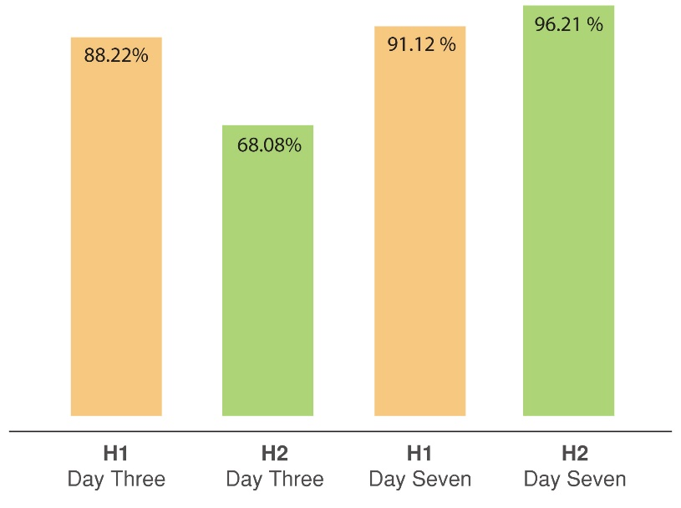
Figure 24: Day 3 and 7, TSS reduction percentage
Both holes gradually reduced the TSS of the water, complying with the Guideline values of irrigation water quality tool (IWQT) developed for Jordan, Tunisia, and Lebanon as shown in Table 14.
Table 13: Comparison of the TSS concentration from the hole treated with Vetiver. zizanioides, L. (H2) with water quality guidelines for irrigation water.
Selected  Parameters | H2  (Day 1)  Pre-treatment | H2  (Day 3) | H2  (Day 7) | Unit | Water quality guidelines for irrigation
 |  |  |  |  | Degree of restriction
 |  |  |  |  | None | Slight to Moderate | Sever
TSS | 845 | 75 | 32 | mg/L | <200 ^{b} | 200-400 ^{b} | >400 ^{b}
^{b} Adopted from irrigation water quality tool (IWQT) developed for Jordan, Tunisia, and Lebanon (Bortolini, Maucieri and Borin, 2018a)
The result of the current study showed better performans (68-92% on the 3rd and 7th day of the trial) compared with the results of Zhang et al (2015), who reported average TSS value of 46% for treatment efficiency of floating treatment wetland in tropical and subtropical regions. The better reduction percentage performance of the TSS obtained in the current study could be due to variation of initial pollutant concentration and hydraulic retention time (HRT).
Acidity/Basicity (pH)
Acidity/Basicity or pH value indicates the intensity of acidity or alkalinity of any solution (Maharjan and Pradhanang, 2017). Water with pH greater than 8 or less than 6.5 are regarded as polluted (Pescod, 1992). The acidity/basicity reduction results achieved in the current study are shown in Figure 25. The intial pH of the sample of irrigation water taken from both holes didn’t execed the normal rage of 6.5 – 8, recommended by FAO. The pH recorded from the hole treated with Vetiver. zizanioides, L. (H2) showed reduction of 0.79 and 0.39% on the 3rd and 7th day of the trial respectively, the values of which are still in norman pH rage recommended for irrigation water (Figure 25). On the contrary the pH recorded for control hole (H1) showed an increase in acidity by 2.62 and 15% on day 3 and 7 repactivly, the values of which execed that of (6.5-8) FOA recommendations (Figure 25). The result obtained showed that the water treated with Vetiver. zizanioides, L. have better and persistent performance in reducing and keeping the pH of the water within the recommended normal pH range (Table 15).
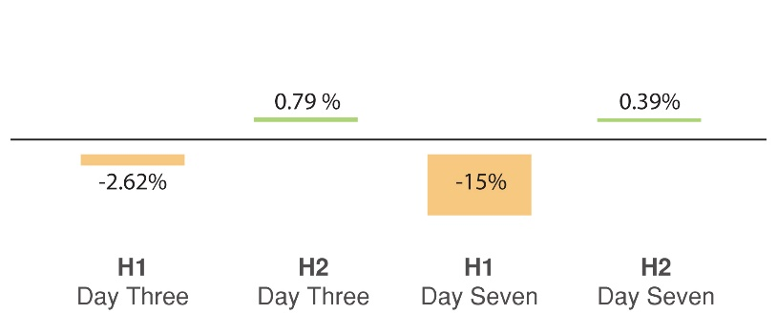
Figure 25: Level of reduction in percentage acidity on 3rd and 7th days
Table 14: Comparison of the pH concentration from the hole treated with Vetiver. zizanioides, L. (H2) with water quality guidelines for irrigation water.
Selected  Parameter | H2  (Day 1)  Pre-treatment | H2  (Day 3) | H2  (Day 7) | Water quality guidelines for irrigation
 |  |  |  | Degree of restriction
pH | 7.64 | 7.58 | 7.61 | 6.5 – 8 (Normal rage) ª
ª Adopted from FAO water quality guidelines for maximum crop production (Pescod, 1992)
The study conducted in Nigeria, on wastewater generated from Public refuse dumpsite, Fertilizer Company and Quarry site with their respective innitial pH level of 5.8,6.30 & 12.8 were treated with both the African and Indian Vetiver grass species. In agreement with the result of the current study, the result of the study reported that the pH of the wastewater was brought close to the WHO recommanded levels of 7. 25 with in 6 days of the study period (Oku et al., 2015). Similar and consistance result was also reported from the study conducted in Nepal in 2017, in which water from polluted urban river was treated with Vetiver grass for study period of 30 days. The result obtained indicated that pH values of the water sample tested during the experment were reported to be within the acceptable limit of 6.5 – 8 (Maharjan and Pradhanang, 2017).
Electrical Conductivity (EC)
The result of Electrical Conductivity (EC) obtained in the current study are presented in Figure 26. The results obtained indicated an increase in concentration of EC in both holes, both on the 3rd and 7th day of the trial.
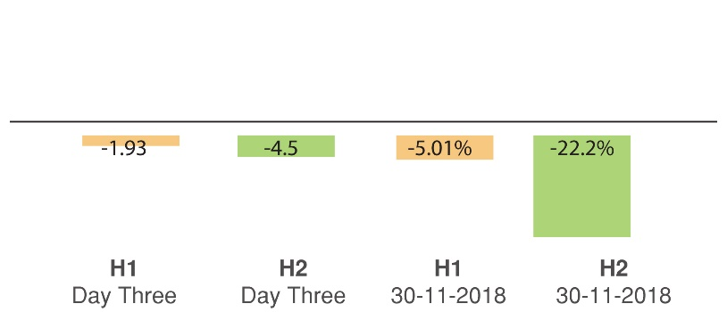
Figure 26: Day 3 and 7, EC reduction percentage
Electrical Conducivity ( EC) is closely correlated, with the total salt concentration of water (Pescod, 1992). As shown in Figure 26, the relatively increased values of EC concentration recorded in the current study, from both holes might be related to evapotranspiration effect on the irrigation water. Evapotranspiration is a complex process including atmospheric moisture losses from a wetland that occur as a result of direct evaporation from water and soil, and the moisture that passes through vascular system of plants to the atmosphere via transpiration (Headley et al., 2011). Water losses through evapotranspiration indirectly affects the EC by increasing the salinity of water due to the decreasing water volume (Green et al., 2006). The initial EC of the water from the hole treated with Vetiver. zizanioides, L was within slight to moderate degree of restriction, but gradually exceeded the maximum recommended value slightly as show in Table 16.
Table 15: Comparison of the EC concentration from the hole treated with Vetiver. zizanioides, L. (H2) with water quality guidelines for irrigation water.
Selected  Parameters | H2  (Day 1)  Pre-treatment | H2  (Day 3) | H2  (Day 7) | Unit | Water quality guidelines for irrigation
 |  |  |  |  | Degree of restriction
 |  |  |  |  | None | Slight to Moderate | Sever
EC | 2.52 | 2.64 | 3.079 | dS/m | < 0.7 ª | 0.7-3.0 ª | >3.0 ª
ª Adopted from FAO water quality guidelines for maximum crop production (Pescod, 1992)
The results of the study conducted in Nepal on the treatment of polluted urban river with Vetiver grass reported reduction of EC (46.52%) within study period of 30 days. The observed differences between the results of the Nepal and the current study in reduction efficiencies of EC could be due the variation in location of the treatment site or hydraulic retention time (HRT). The study in Nepal was carried out ex-situ for 30 days while the current study carried out in-situ on open space for only seven days.
Sodium adsorption ratio (SAR)
SAR expresses the toxicity effect of polluted water on crops and degradation effects on soil fertility and measured by the formula $SAR= \frac{Na}{\sqrt{(Ca}+Mg (total harness))÷2 }$ (Bortolini, Maucieri and Borin, 2018a) . As shown in the formula the SAR depends on the concentrations of Sodium (Na) and Total hardness of the water. The result of Na and Total hardness reduction percentage recorded in the current study are presented in Figure 27 and 28. The result showed that the Na concentration of the water from both holes increased on both the 3rd and 7th day of the trial as shown in Figure 27. This result might be explained by the evapotranspiration effect since both holes were located on an open space exposed to the sun. Evapotranspiration causes increase in the concentration of dissolved compounds in water due to the decrease of water volume (Białowiec, Albuquerque and Randerson, 2014).
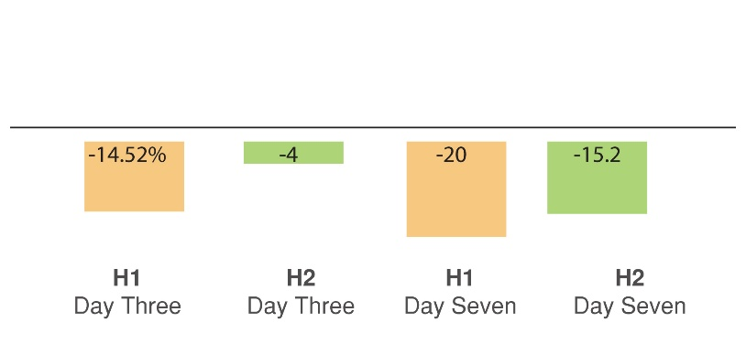
Figure 27: Day 3 and 7, Na reduction percentage
The result obtained indicates that there is an increase in concentration of Na in both untreated and treated holes. But hole treated with Vetiver. zizanioides, L showed relatively small increase in concentration of Na compared to the untreated control hole. This might be due to the water in the hole treated with Vetiver. zizanioides, L was not fully exposed to the sun attributed to the floating panel applied for treatment.
Total hardness is a measure of the sum of Calcium and Magnesium concentration in water. The results of Total Hardness obtained in the current study are presented in Figure 28. According to Figure 28, both holes showed relatively good reduction performance in total hardness.
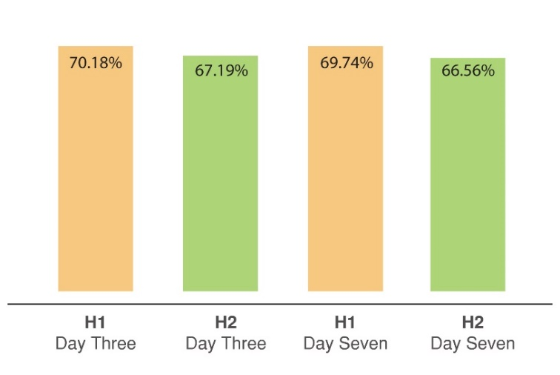
Figure 28: Day 3 and 7, Total Hardness reduction percentage
Based on the concentration of Na and Total hardness of the irrigation water obtained from both holes, SAR value were calculated and presented in Table 17.
Table 16: Calculated SAR
Selected  Parameters | Hole 1  23-11-2018  (Pre-treatment) | Hole 2  23-11-2018  (Pre-treatment) | Hole 1  26-11-2018  (Day 3) | Hole 2  26-11-2018  (Day 3) | Hole 1  30-11-2018  (Day 7) | Hole 2  30-11-2018  (Day 7)
Total Hardness | 965 | 945 | 287.8 | 310 | 292 | 316
Sodium | 117 | 125 | 134 | 130 | 142 | 144
SAR | 5.32 | 5.75 | 11.17 | 10.44 | 11.75 | 11.46
The SAR value is dependent on both Na and Total hardness. The result of the current study showed increase in the concentration of Na and decrease in Total hardness. The result showed that the SAR of both holes increased both on the 3rd and 7th days of the trial. The results of the SAR values obtained are compared to the FAO water quality guidelines for maximum crop production as shown in the Table 18. According to Table 18, the SAR value increased gradually and execeded the maximum recomanded value for irrigation water following under sever degree of restriction. This indicates the floating treatment wetland performance in reducing the SAR is higly affcted by the evapotransparation due to the exposure of the water to the sun.
Table 17: Comparison of the SAR concentration from the hole treated with Vetiver. zizanioides, L. (H2) with water quality guidelines for irrigation water.
Selected  Parameters | H2  (Day 1)  Pre-treatment | H2  (Day 3) | H2  (Day 7) | Unit | Water quality guidelines for irrigation
 |  |  |  |  | Degree of restriction
 |  |  |  |  | None | Slight to Moderate | Sever
Na | 5.75 | 10.44 | 11.46 | SAR | <3 ª | 3-9 ª | >9 ª

ª Adopted from FAO water quality guidelines for maximum crop production (Pescod, 1992)

Chloride (Cl⁻)
The reduction percentage of chloride concentration recorded from the samples of irrigation water of Mekanisa-Gofa-Lafto Co-operative farm is shown in Figure 29. Similar inconsistency reduction in Cl⁻ concentration that could be explained by evapotranspiration was obtained for both holes. The results of reduction in the concentration of Cl⁻ in both holes are presented in Figure 29.
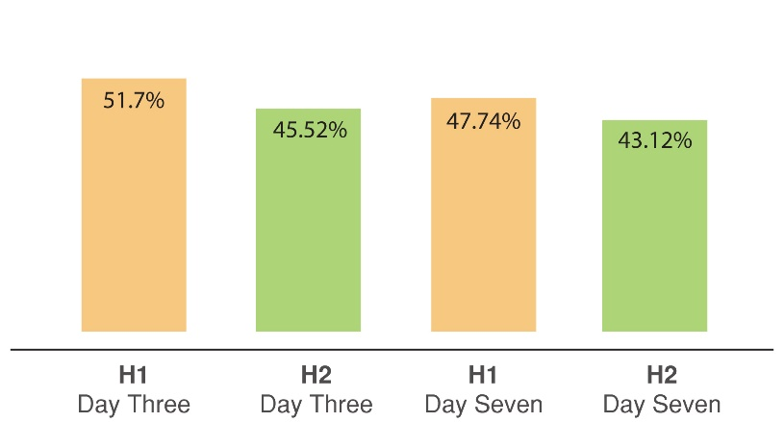
Figure 29: Reduction percentage of Cl on Day 3 and 7
The results of Cl⁻ reduction performance obtained from both untreated and treated with Vetiver. zizanioides L in the current study were higher than the results of similar study reported from the study conducted in Nepal (Maharjan and Pradhanang, 2017). According to Maharjan and Pradhanang, (2017) Cl⁻ reduction performance of 27.93% was obtained during study period of 30 days. This difference might be due to the variation of initial pollutant concentration, hydraulic retention time (HRT) temperature. The results of the laboratory analysis of the hole treated with Vetiver. zizanioides L. during both the 3 and 7 days of study were compared to water quality guidelines for irrigation water developed as shown in Table 19.

Table 18: Comparison of the average laboratory result with water quality guidelines for irrigation water
Selected  Parameters | H2  (Day 1)  Pre-treatment | H2  (Day 3) | H2  (Day 7) | Unit | Water quality guidelines for irrigation
 |  |  |  |  | Degree of restriction
 |  |  |  |  | None | Slight to Moderate | Sever
Cl | 250 | 136.2 | 142.2 | mg/L | < 140 ª | 140 - 350 ª | > 350 ª

^{b} Adopted from irrigation water quality tool (IWQT) developed for Jordan, Tunisia, and Lebanon (Bortolini, Maucieri and Borin, 2018a)
In summary the results of the current study showed that there were reduction in BOD, COD, pH, Cl⁻ and TSS values, approaching the recommended irrigation water quality guideline values as a result of treating with Vetiver. zizanioides L during the 3 days of the study period. On the contrary, there was increase in EC and Na concentration the values of which exceeded the recommended values, attributed to evapotranspiration or the introduction of the surrounding soil into the irrigation water of Mekanisa-Gofa-Lafto Co-operative farm.

CHAPTER 5: CONCLUSION AND RECOMMENDATION

5.1 Conclusion
The discharge of industrial and municipality wastewater into rivers used for urban agriculture has become a common practice in Addis Ababa for years. The use of wastewater for urban agriculture has potential of providing reliable water and nutrient source. However, if not monitored and treated properly, it could negatively affect human health, crops production and soil fertility. It could also results in buildup of pollutants in the soil, vegetation and environment and contaminate ground water resource. The results of the laboratory analysis of the current study demonstrate that the organic matter (BOD and COD), negatively affected the odor and color of the irrigation water and enhanced microbial multiplication, are relatively higher compared to the UNESCAP 2000.
From the agronomic quality indicators, the pH value fall within the recommended normal range of FAO. On the contrary EC, SAR, & Cl⁻ contents exceeded the none degree of restriction values, indicating high degree of pollution. Moreover, TSS value recorded (the management quality indicator) exceeded the recommended value for irrigation water as measured by Irrigation Water Quality Tool (IWQT) developed for Jordan, Tunisia, and Lebanon. Such a situation is likely to cause problems of production quality and irrigation system operation gradually with time. On the other hand, the laboratory test result indicated that Zn, showed no indication of excessive concentration compared to FAO recommended maximum concentration level.
In general, it can be understood that the irrigation water used currently at the “Mekanisa-Gofa-Lafto Co-operative” is not safe for vegetables production from the point of view of human health. This situation warrants the urgent need for appropriate and contextualized landscape design aimed at reducing the pollution level of the irrigation water. Combination of grassed swale (liner, flow-based method) with floating treatment wetland (point method) seems to be appealing in Mekanisa-Gofa-Lafto Co-operative farm. The field test confirmed the floating treatment wetland is effective in improving the BOD, COD, TSS and pH of the irrigation water. But it was also observed evapotranspiration highly affects the performance of the floating treatment wetland in improving the EC and the concentration of Na which in return affected the SAR of the irrigation water.

5.2 Recommendations

5.2.1 General recommendation
- According to the 2009 Local Urban Agriculture Office report, an area of 400 ha is being cultivated using Little and Great Akaki Rivers as a source of irrigation water. About 60% of the total vegetable supply of Addis Ababa city is reported to have been produced with the use of these rivers as source of irrigation water. There are studies done on the extent of pollution of the Little Akaki River and its impact on the soil and cultivated vegetable crops. However, the associated public health risks have not yet been studied, indicating that further research is appealing the results of which should be made available to the public and scholars.
- In the current study, only 9 important water quality parameters of agricultural concern were selected for the laboratory analysis mainly due to financial and time constraints. Thus further investigation of the statues of the river need to be studied on additional irrigation water quality parameters.
- The inconsistency of answer given by the respondents might be due to a concern associated with fear of losing their urban agricultural practice and/or employment opportunity, which is their only source of their livelihood, There is an urgent need of working closely with the farmers to come up with practical solutions aimed at monitoring and treating irrigation water before use.
- Significant knowledge gap seems to exist, in using treated and properly monitored wastewater as safe and reliable source of irrigation water in urban agriculture. Consultative and collaborative course of action of all the stakeholder including the government and local and international organizations are urgently required. There is also an urgent need to develop strategies and guidelines of exploiting the potential of wastewater for urban agriculture through addressing the associated health and environmental risks.
- According to the results of the current study, there was no buffer or pre-treatment of the irrigation water between the farm and the river, indicating the need for in depth study and development of appropriate treatment practices or technologies.

5.2.2 Design Recommendations
In general, from this study it can be understood that the irrigation water used currently at the “Mekanisa-Gofa-Lafto Co-operative” is not suitable for irrigating vegetables when compared to irrigation water quality guidelines adapted from other countries and international organizations. At present there are different organizations and projects working on both rivers. There is a need to coordinate all these efforts. In the meantime, appropriate and contextualized landscape design that integrate ecological water treatment elements could be operated by the farmer themselves to minimize the associated health and environmental risk. According to a compressive literature review made, a combination of grassed swale with stone check dam (pre-treatment) and floating treatment wetland (main treatment) are appropriate ecological water treatment elements for “Mekanisa-Gofa-Saris Co-operative” farm. The effectiveness of the floating treatment wetland is also proved by the laboratory test.
How a combination of grassed swale with stone check dam (pre-treatment) and floating treatment wetland (main treatment) can be implemented in landscape design is shown on site plan on Figure 30. Figure 30 shows the layout of the irrigation system including where each floating treatment wetland will be located. The grassed swale with stone check dam which will function as pre-treatment is implemented on the existing open irrigation channel located at the east side of the farms. The water that is diverted from the river will pass through the grass swale while being filtered with the grass and stone check dams installed in the grass swale. After pre-treated the water will be store in the floating treatment wetlands located at each individual farmer plots as shown on Figure 31 and 32 with zoomed in plan and section. Then after the water is treated with floating treatment wetland with Vetiver grass for 3 to 7 day the water will be discharged to the farm through 30cm wide swale for irrigating the vegetables. The details of the grassed swale and floating treatment wetland is presented on Figure 33. Purposeful plant specification and zoning were implemented as shown on Figure 34. Pollutants absorbent and fast growing plants were intentionally selected (Figure 34). Terrace walls with selected plantation is also implemented at the bank of the river to protect the river from the pollutants from the farms.

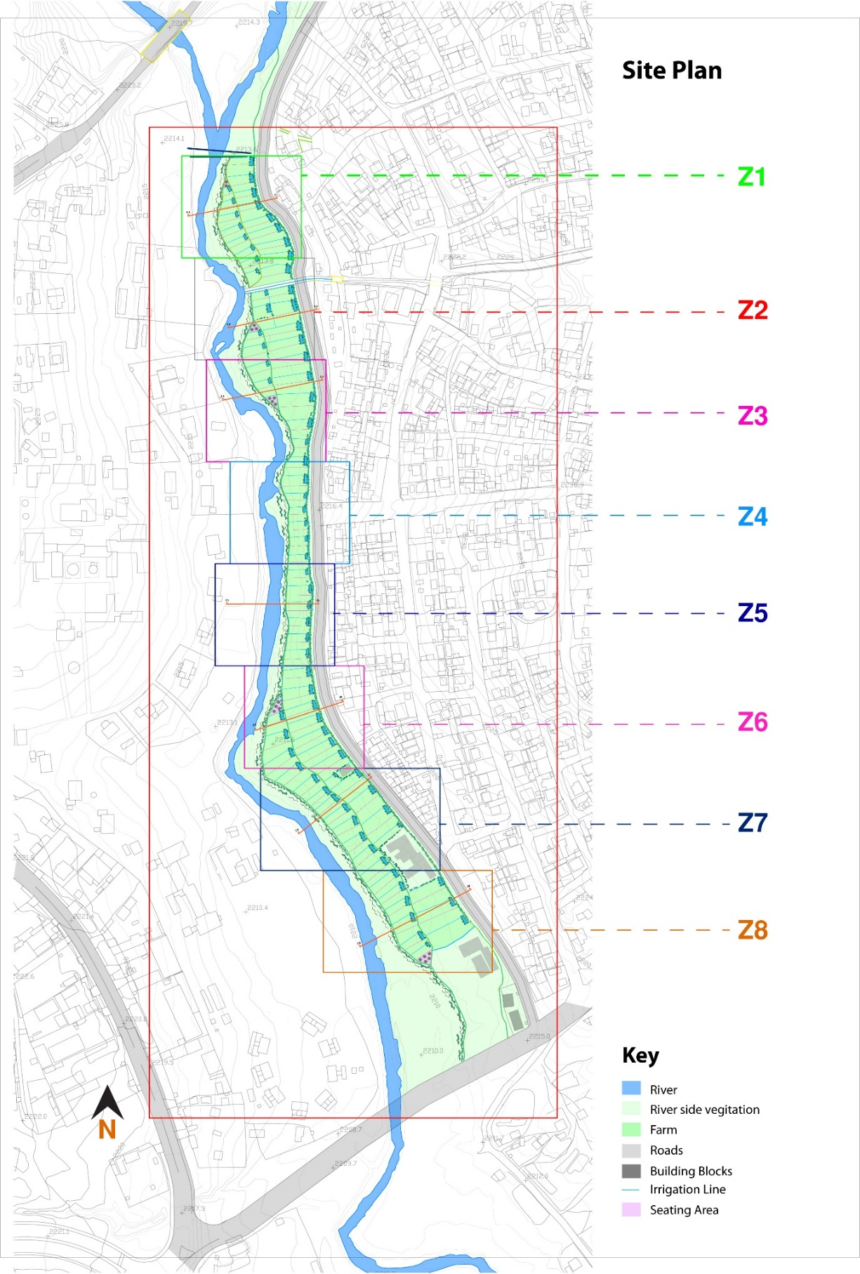
Figure 30: Site plan
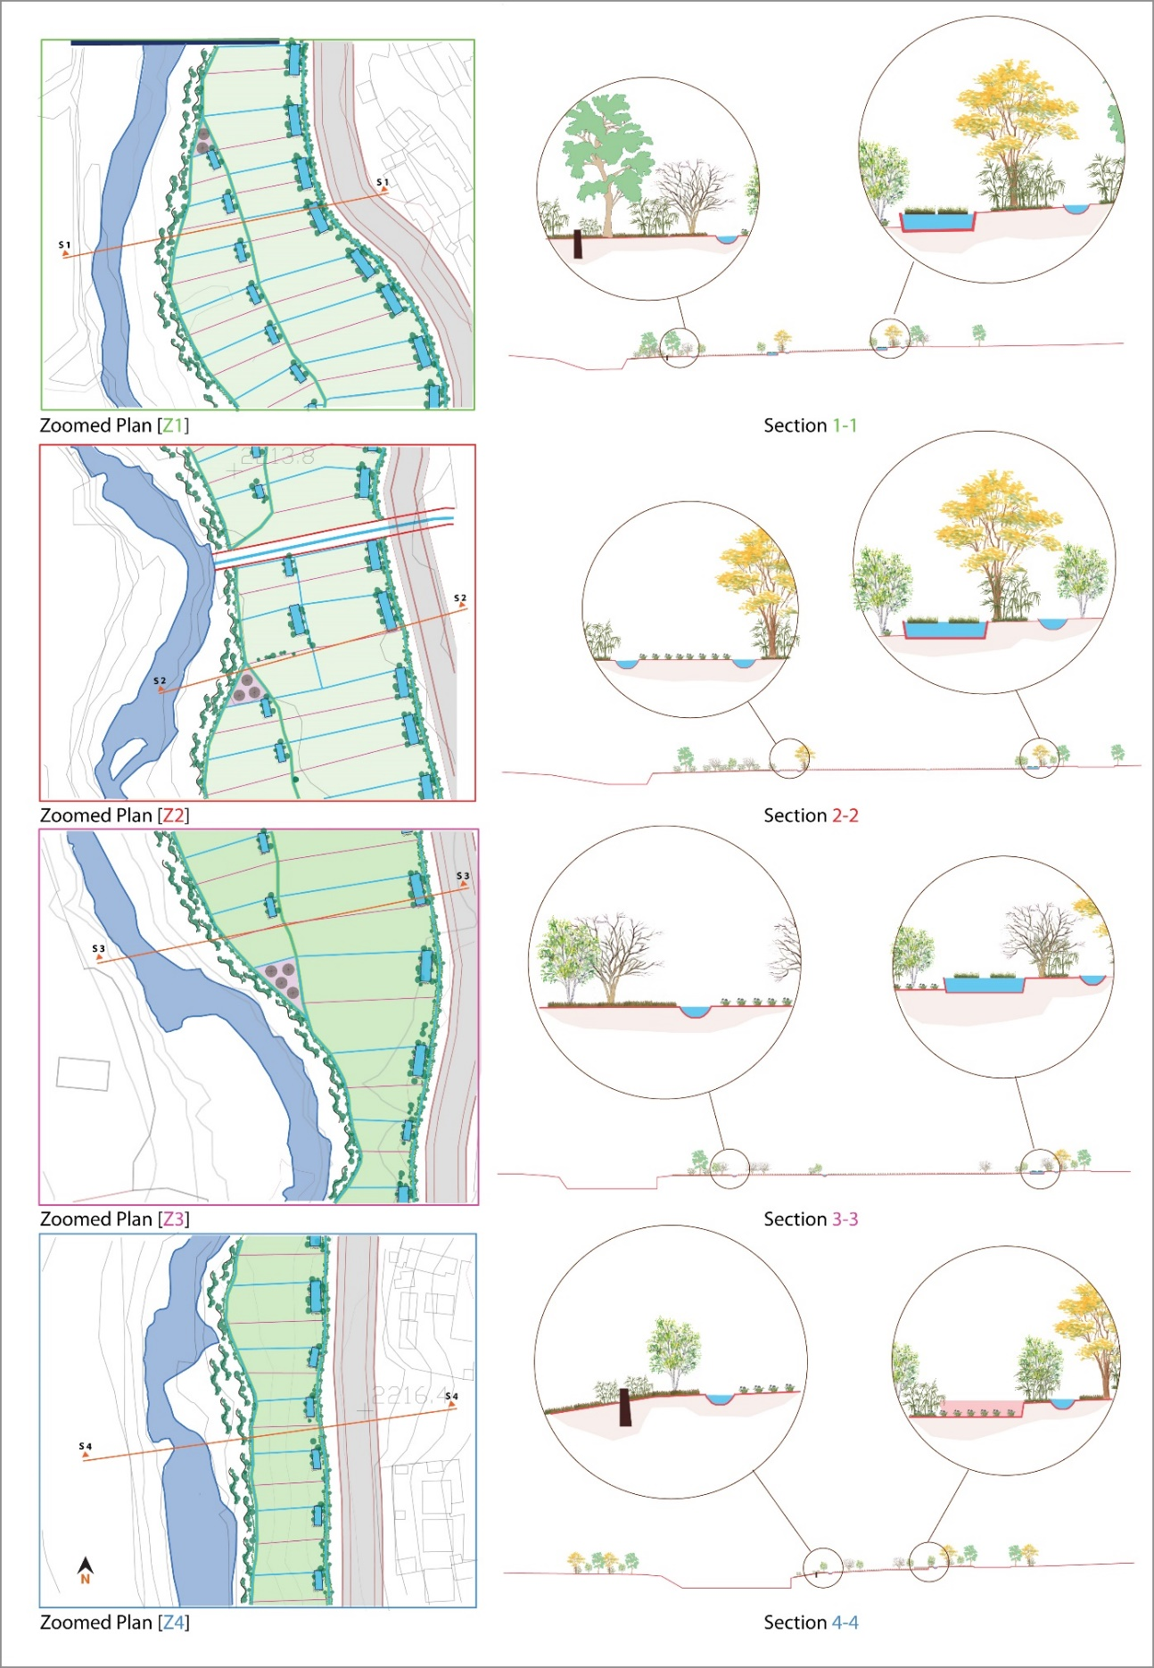
Figure 31: Zoomed in plans and sections
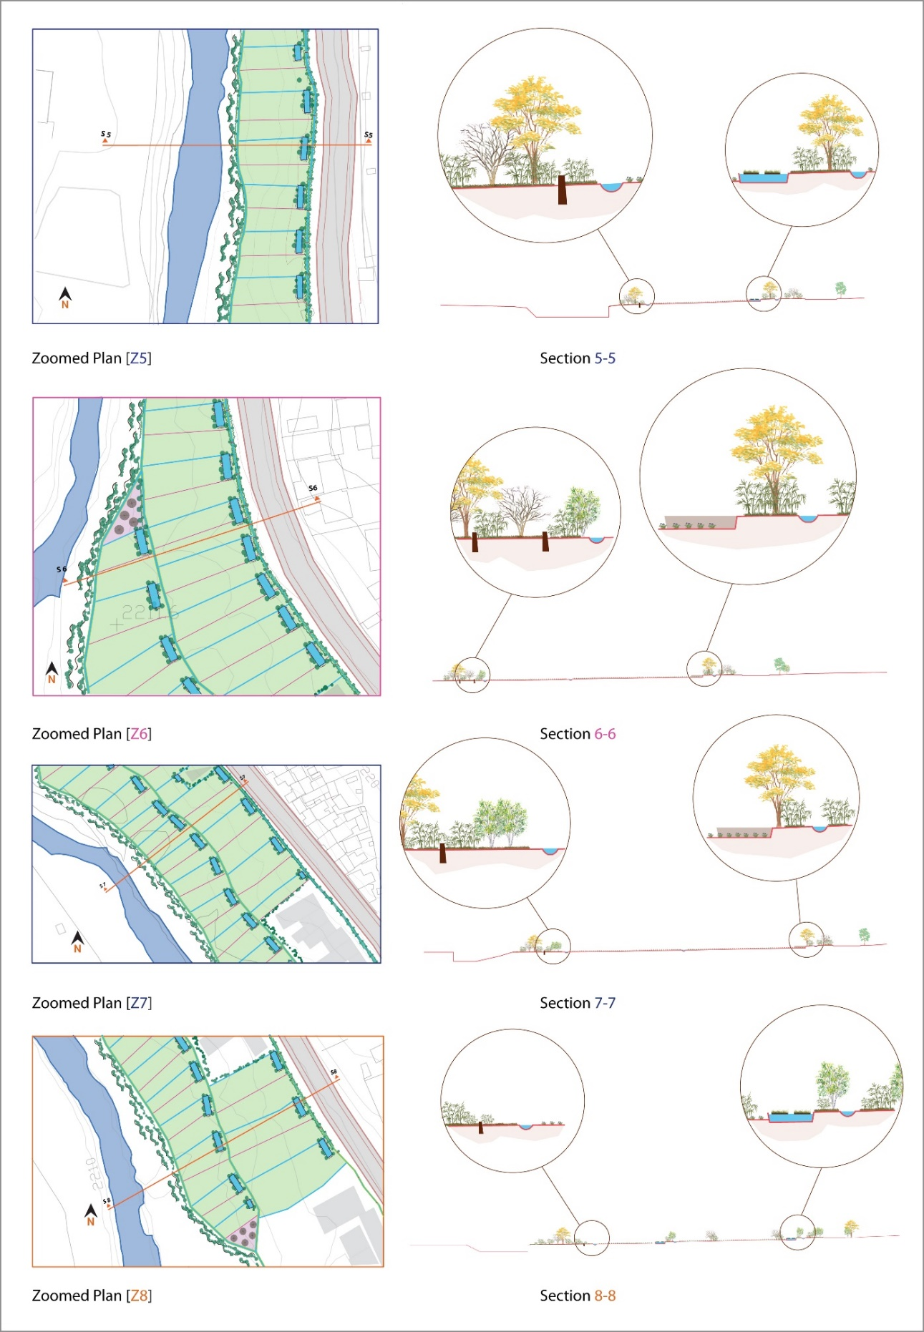
Figure 32: Zoomed in plans and sections
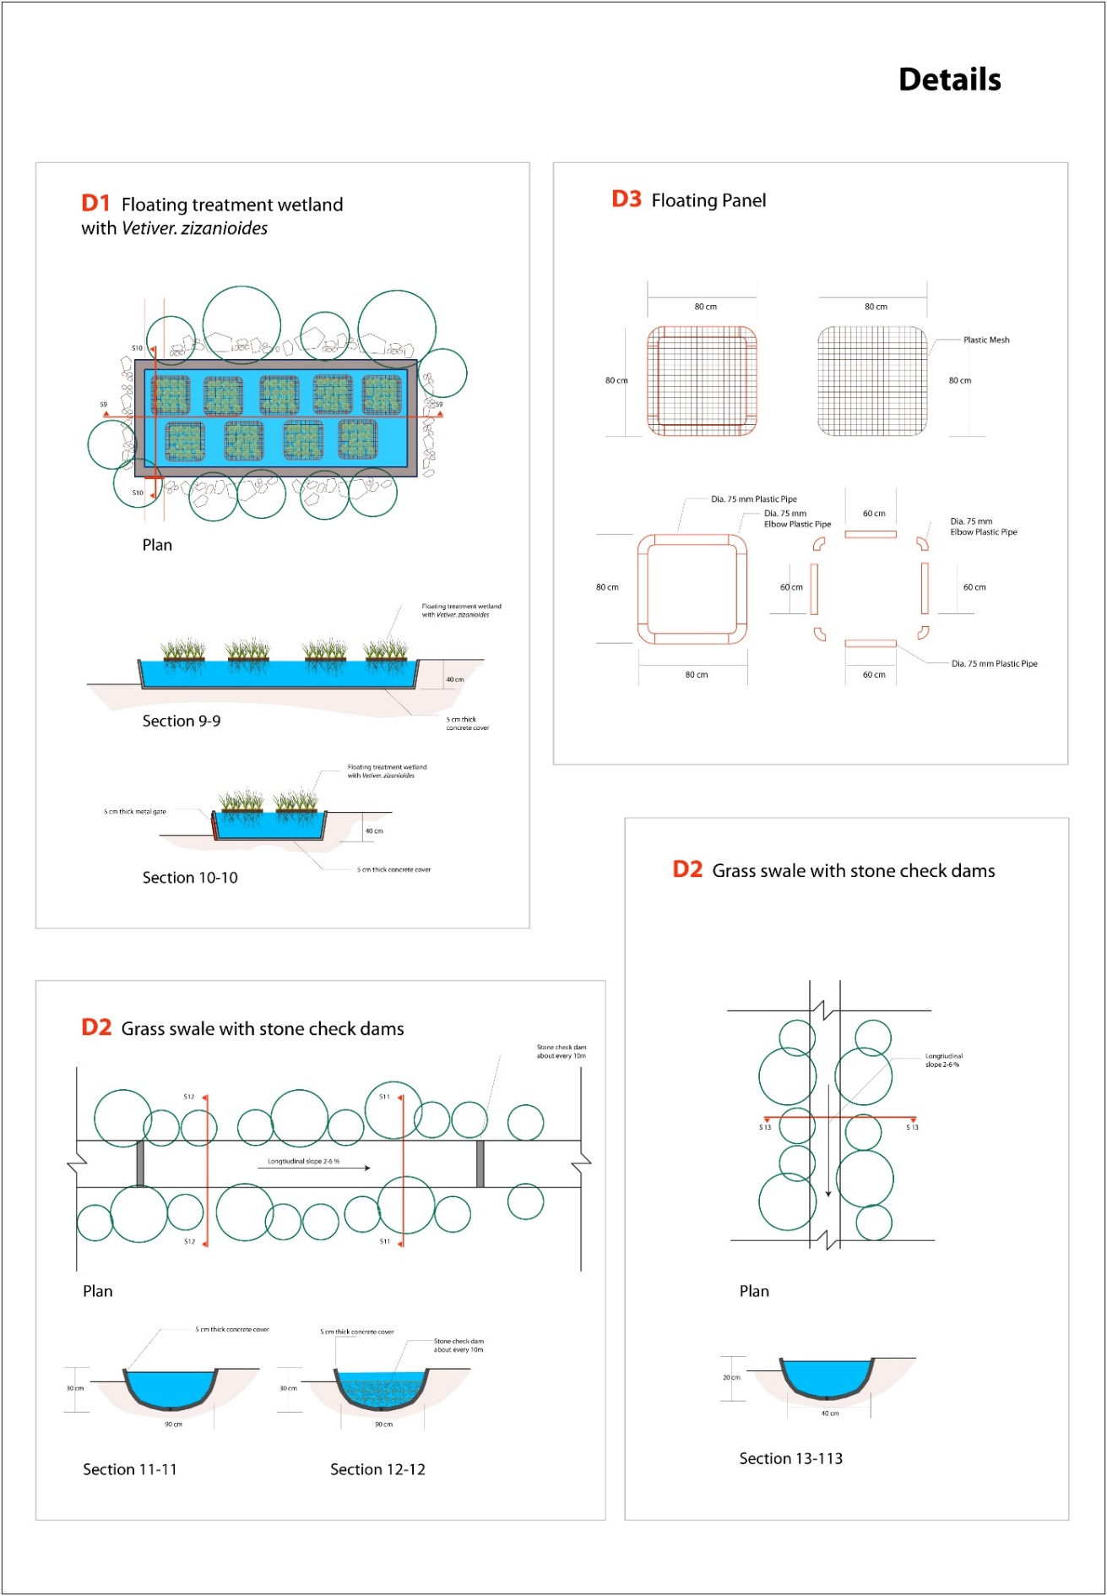
Figure 33: Details
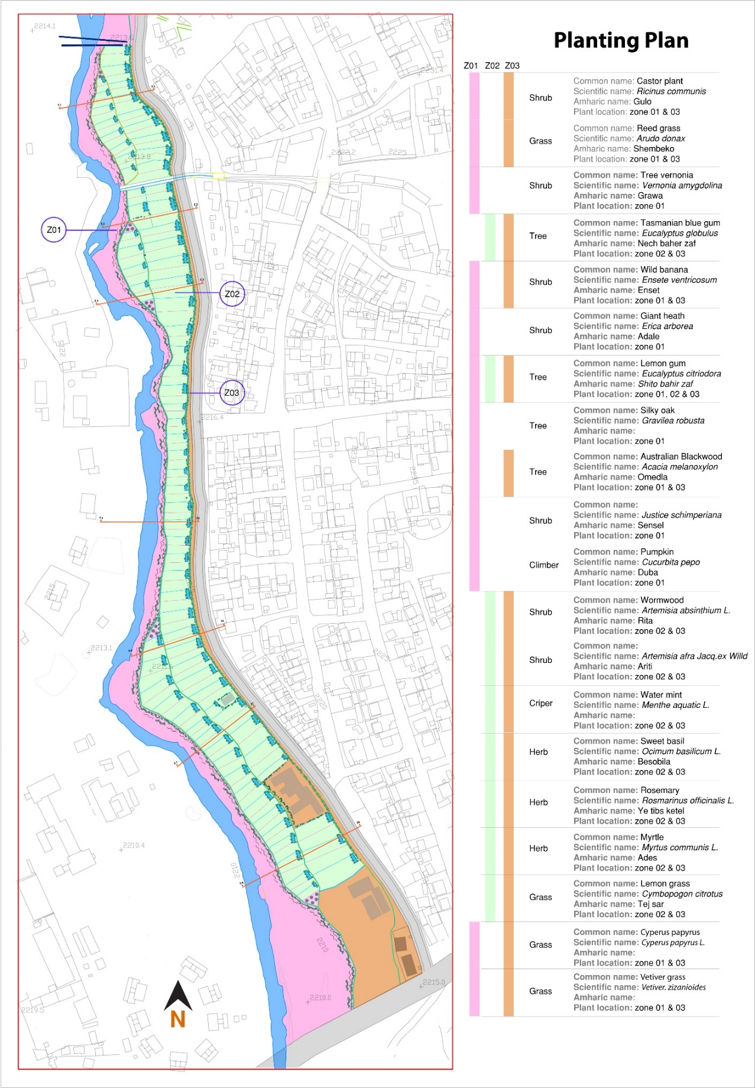
Figure 34: Planting plan

REFERENCES
Ayers, R. S. and Westcot, D. W. (1985) Water quality for agriculture, FAO of the UNITED NATIONS,Rome,italy. doi: ISBN 92-5-102263-1.
Białowiec, A., Albuquerque, A. and Randerson, P. F. (2014) ‘The influence of evapotranspiration on vertical flow subsurface constructed wetland performance’, Ecological Engineering. Elsevier B.V., 67, pp. 89–94. doi: 10.1016/j.ecoleng.2014.03.032.
Bortolini, L., Maucieri, C. and Borin, M. (2018a) ‘A Tool for the evaluation of irrigation water quality in the arid and semi-arid regions’, Agronomy, 8(23), pp. 1–15. doi: 10.3390/agronomy8020023.
Bortolini, L., Maucieri, C. and Borin, M. (2018b) ‘A Tool for the Evaluation of Irrigation Water Quality in the Arid and Semi-Arid Regions’, pp. 1–15. doi: 10.3390/agronomy8020023.
Charles River Watershed Association (2008) Vegetated swale. Available at: http://www.crwa.org/hs-fs/hub/311892/file-634306344-pdf/Our_Work_/Blue_Cities_Initiative/Resources/Stormwater_BMPs/CRWA_Vegetated_Swale.pdf.
City of Portland (2010) ‘Vegetated Swales’, in BMPs technical design manual.
Creswell, J. W. (2014) Research Design: Qualitative, and mixed methods approches. 4th edn. Edited by V. Knight. SAGE Publications India Pvt. Ltd.
Davis, A. P. et al. (2012) ‘Performance of grass swales for improving water quality from highway runoff’, Water Research. Elsevier Ltd, 46(20), pp. 6731–6742. doi: 10.1016/j.watres.2012.02.037.
Dong, Y. (2012) The application of integrated constructed wetlands for contaminant treatment and diffusion. The University of Edinburgh.
Dorman, T. et al. (2013) San Antonio River Basin Low Impact Development Technical Design Guidance Manual, v1. San Antonio,TX: San Antonio River Authority.
ElZein, Z., Abdou, A. and ElGawad.I., A. (2016) ‘Constructed wetlands as a sustainable wastewater treatment method in communities’, 34, pp. 605–617. doi: 10.1016/j.proenv.2016.04.053.
Gebremichael, D. et al. (2014) Building urban resilience: Assessing urban & peri-urban agriculture in Addis Ababa, Ethiopia. Nairobi, Kenya: United Nations Environment Programme (UNEP).
Gittleman, M. (2009) ‘Urban expansion in Addis Ababa: Effects of the decline of urban agriculture on livelihood and food security’, in A paper presented at the United Nations 17th Commission on Sustainable Development. NewYork, USA, p. 16.
Golabi, M. H. and Duguies, M. (2013) ‘Application of the vetiver system for wastewater treatment: An innovative nutrient removal technology for sewage water treatment in Southern Guam’, Pacific Rim Vetiver Network, 2013/1, p. 12.
Green, M. et al. (2006) ‘Minimizing land requirement and evaporation in small wastewater treatment systems’, Ecological Engineering, 26, pp. 266–271. doi: 10.1016/j.ecoleng.2005.10.007.
Headley, T. R. et al. (2011) ‘Evapotranspiration from subsurface horizontal flow wetlands planted with Phragmites australis in sub-tropical Australia’, Water Research, 6. doi: 10.1016/j.watres.2011.10.042.
Iowa State University (2008) ‘Vegetated swale system’, in Iowa storm water management manual, p. 23.
Jemal, M. (2002) Urban agriculture initiatives in Addis Ababa with practical evidences from selected vegetable producting cooperatives and households in the city, Addis Ababa University. Addis Ababa.
Jeong, H., Kim, H. and Jang, T. (2016) ‘Irrigation water quality standards for indirect wastewater reuse in agriculture : A contribution toward sustainable wastewater reuse in South Korea’, Water, 8, p. 18. doi: 10.3390/w8040169.
Jurries, D. (2003) Biofilters (Bioswales, Vegetative Buffers, & Constructed Wetlands) for storm water discharge pollution removal, Quality, S. o. OD o. E.(Ed.). Kidd, R., y N. Colletta.(1980). Tradition for Development: Indigenous Structures and Folk Media in Non-Formal Education. Bonn: German Foundation for International Development. Available at: http://scholar.google.com/scholar?hl=en&btnG=Search&q=intitle:Biofilters+(Bioswales,+Vegetative+Buffers,+&+Constructed+Wetlands)+for+Storm+Water+Discharge+Pollution+Removal#0.
Kadlec, R. H. et al. (2000) Constructed wetlands for pollution control:Processes,performance,Design and operation. IWA Publishing in its Scientific and Technical Report series. Available at: https://www.iwapublishing.com/sites/default/files/ebooks/9781900222051.pdf.
Kebede, T. and Yaekob, T. (2009) ‘Research and development of vetiver grass (Vetiver. zizanioides,L.) in Ethiopia’, Review Literature And Arts Of The Americas, pp. 1–11.
Kothari, C. R. (2004) Research methodology: methods& techniques. New Age International(P) Limited, Publishers.
Leroy, M. et al. (2016) ‘Performance of vegetated swales for improving road runoff quality in a moderate trffic urban area’, Science of the Total Environment, The. Elsevier B.V., 566–567, pp. 113–121. doi: 10.1016/j.scitotenv.2016.05.027.
Maharjan, A. and Pradhanang, S. (2017) ‘Potential of Vetiver Grass for Wastewater Treatment’, Enviroment and Ecology Research, 5(7), pp. 489–494. doi: 10.13189/eer.2017.050704.
Mekonnen, A. (2007) Suitability assessment of the little Akaki River for irrigation, Addis Ababa University Technology Faculty, Department of Chemical Engineering, Environmental Engineering program. Addis Ababa.
Mougeot, L. J. A. (2000) Urban agriculture: Definition, presence, potentials and risks, and policy challenges. Available at: https://idl-bnc-idrc.dspacedirect.org/bitstream/handle/10625/26429/117785.pdf?sequence=12.
Northeast Georgia Regional Development Center (2001) ‘Descripition of commonly considered water quality consitituents’, in Watershed protection plan development guidebook, pp. 1–11.
Oku, E. et al. (2015) Using native African species to solve African wastewater challenges: An in-depth study of two vetiver grass species. Accra, Ghana.
Orsini, F. et al. (2013) ‘Urban agriculture in the developing world: A review’, Agronomy for Sustainable Development, 33(4), pp. 695–720. doi: 10.1007/s13593-013-0143-z.
Pavlineri, N., Skoulikidis, N. T. and Tsihrintzis, V. A. (2017) ‘Constructed Floating Wetlands: A review of research, design, operation and management aspects, and data meta-analysis’, Chemical Engineering Journal, 308(September), pp. 1120–1132. doi: 10.1016/j.cej.2016.09.140.
Pescod, M. B. (1992) Wastewater treatment and use in agriculture - FAO irrigation and drainage, Food and Agriculture Organazation of the United Nations. Rome. doi: M-56.
Regions, P., Bas, F. and Goykovic, V. (2014) Chile, perform first crop irrigation with purified water through the Vetiver System.
Schueler, T. (1989) ‘Performance of grassed swales along east coast hightways: The practice of watershade protection’, Center for Watershad Protection, 1(3), pp. 122–123.
Shafiq, M. et al. (2017) ‘Nutrients and pollutants removal in small-scale constructed wetland in Frangipani Resort Langkawi , Malaysia’, An Internation Quarterly Scientific Journal, 16, pp. 569–577.
Singh, A. and Masuku, M. (2014) ‘Sampling techniques & determination of sample size in applied statistics research: An overview’, International Journal of Economics, Commerce and Management, II(11), pp. 1–22.
Smit, J., Nasr, J. and Ratta, A. (2001) Urban agriculture food, jobs and sustainable cities. 2001st edn, The Urban Agriculture Network, Inc. A Non-Profit, 501 (c)(3) Organization With. 2001st edn. The Urban Agriculture Network Inc. doi: 10.1016/S0022-3182(97)70254-1.
Truong, P. et al. (2014) ‘Phytoremediation Potential of Vetiver System Technology for Improving the Quality of Palm Oil Mill Effluent’, (December). doi: 10.1155/2014/683579.
US EPA (2002) Considerations in the design of treatment best management practices (BMPs) to improve water quality, Environmental Protection. Cincinnati: U.S. Environmental Protection Agency.
US EPA (2012) Guidelines for water reuse. Washington, D.C.: U.S. Agency for International Development.
US EPA, O. (2014) Best Management Practices (BMPs) Siting Tool. Available at: https://www.epa.gov/water-research/best-management-practices-bmps-siting-tool (Accessed: 9 July 2018).
USDA-NRCS & US-EPA (2000) A handbook of constructed wetlands, Wetlands. Available at: http://citeseerx.ist.psu.edu/viewdoc/download?doi=10.1.1.169.7471&amp;rep=rep1&amp;type=pdf.
Veenhuizen, R. van (2007) Productive use of urban water for urban agriculture, ETC- Urban Agriculture, RUAF.
Vymazal, J. (2005) ‘Horizontal sub-surface flow and hybrid constructed wetlands systems for wastewater treatment’, Ecological Engineering, 25(5), pp. 478–490. doi: 10.1016/j.ecoleng.2005.07.010.
Webshet, H. (1991) Vetiver and its system for community development in Ethiopia.
Winans, K. et al. (2015) Small-scale natural wastewater treatment systems : Principles and regulatory framework 1. Florida.
Yeh, N., Yeh, P. and Chang, Y. H. (2015) ‘Artificial floating islands for environmental improvement’, Renewable and Sustainable Energy Reviews, 47, pp. 616–622. doi: 10.1016/j.rser.2015.03.090.
Yohannes, H. and Elias, E. (2017) ‘Contamination of rivers and water reservoirs in and around Addis Ababa city and actions to combat it’, Environment Pollution and Climate Change, 01(02), pp. 1–12. doi: 10.4172/2753-458X.1000116.
Zainal, Z. (2007) Case study as a research method. Universiti Teknologi Malaysia.
Zhang, D. et al. (2015) ‘Application of constructed wetlands for wastewater treatment in tropical and subtropical regions ( 2000 – 2013 )’, JES. Elsevier B.V., 30, pp. 30–46. doi: 10.1016/j.jes.2014.10.013.
Zhang, D. Q. et al. (2014) ‘Application of constructed wetlands for wastewater treatment in developing countries - A review of recent developments (2000-2013)’, Journal of Environmental Management. Elsevier Ltd, 141, pp. 116–131. doi: 10.1016/j.jenvman.2014.03.015.
Zhang, J. et al. (2015) ‘A review on the sustainability of constructed wetlands for wastewater treatment: Design and operation’, Bioresource Technology. Elsevier Ltd, 175, pp. 594–601. doi: 10.1016/j.biortech.2014.10.068.

APPENDIX
A. Questionnaire
የኢትዮጵያ የስነ ህንፃ፣ የህንፃ ኮንስትራክሽን እና የከተማ ልማት ተቋም፤

የአዲስ አበባ ዩኒቨርሲቲ

በመካኒሳ-ጎፋ-ሳሪስ የገበሬ ማህበር አባላት የሚሞላ የሁለተኛ ዲግሪ ዳሰሳ ጥናት መጠይቅ

በ ጥሩሰው ሰለሞን

የእዚህ መጠይቅ ዋና ዓላማ በመካኒሳ-ጎፋ-ሳሪስ የገበሬ ማህበር አባላት ለግብርና ስራ ስለሚጠቀሙት የመስኖ ውሃ ብክለት መጠን እና አይነት ለማወቅ እና ለወደፊቱ የመስኖ ውሃን ጥራት ለማሻሻል ምን መደረግ እንዳለበት ለማየት ነው። በዚህ በጣም አስፈላጊ የዳሰሳ ጥናት ለመሳተፍ በመስማማትዎ አመሰግናለሁ።

ይህ መጠይቅ በአጠቃላይ ሁለት ክፍሎች አሉት። የመጀመሪያው ስለ መላሽ መረጃ የሚመለከት ሲሆን ሁለተኛው ክፍል መጠይቁ ነው። ሁሉም መልሶችዎ በሚስጢር እንደሚጠበቁ በትትና አሳውቃለሁ።
፩. የመላሽ መረጃ
ዕድሜ ________ ጾታ _________ የትምህርት ደረጃ ___________
ባለቤት ________ ተቀጣሪዎች ________
፪.መጠይቅ
1. ለምን ያህል ጊዜ በግብርና ስራ ላይ ቆይተዋል?
____________________________________________________________________________________________________________________________
2. ከግብርና ውጭ ሌላ ሥራ ወይም የገቢ ምንጭ አለዎት?
አለኝ የለኝም
3. ምን አይነት አትክልት ያመርታሉ?
____________________________________________________________________________________________________________________________
4. አትክልቶቹን ውሃ ለማጠጣት ኃላፊነት የሚወስደው ማን ነው?
____________________________________________________________________________________________________________________________
5. ዕፅዋቱ በምን ያህል ጊዜ ወሃ ይጠጣሉ?
በ 4 ቀን አንዴ በ 5 ቀን አንዴ በ 6 ቀን አንዴ በ 7 ቀን አንዴ
6. የውሃ ብክለትን እንዴት ይረዱታል?
____________________________________________________________________________________________________________________________
7. ለመስኖ ጥቅም ላይ ያዋሉት ውሃ የተበከለ ነው ብለው ያምናሉ?
አምናለሁ አላምንም __
8. የመስኖ ውሃ ብክለቱን / ቆሻሻውን ለመለካት የሚጠቀሙባቸው ዘዴዎች አሉ? ካለ ስልቱ ምንድነው?
አሉ የሉም _______________________________________________________________________________________
9. ለመስኖ ጥቅም ላይ በሚውለው ውኃ ውስጥ ምን ዓይነት ብክለቶች አይተው ያቃሉ?
___________________________________________________________________________________________________________________________
10. አሁን ያለው የመስኖ ውሃ ብክለት ከአምስት ዓመት በፊት ካለው ጋር ሲነጻጸር በእርሶ እይታ ምን ይመስሎታል?
ጨምሮል ቀንስዋል
11. በመስኖ ውሃው ብክለት ምክንያት በአፈሩ ወይንም በአትክልት ምርት ላይ ያዩት ለውጥ አለ? አለ ከሆነ መልሰዎ ምን አይንት ለውጥ አይተዋል?
አለ የለም ________________________________________________________________________________________________
12. የመስኖ ውኃ ጋር ባሎት ቀጥታ ግንኙነት (ንክኪ) ምክንያት የጤና ችግር አጋጥሞዎት ያውቃል? መልሰዎ አው ከሆነ እባክዎን ያጋጠሞትን የጤና ችግር ይጥቀሱ ።
ያውቃል አያውቅም _________________________________________________________________________________________
13. በመስኖ ውኃ የተመረቱትን አትክልት በመውሰዶ (በመብላትዎ) ምክንያት ያጋጠሞት የጤና ችግር አለ? መልሰዎ አዎ ከሆነ እባክዎን ያጋጠሞትን የጤና ችግር ይጥቀሱ ።
ያውቃል አያውቅም ___ ______________________________________________________________________________________
14. በመስኖ ውኃ ጥራት ላይ ከህብረተሰቡ ወይም ከመንግስት ቅሬታ ደርሶት ያውቃል? መልሰዎ አው ከሆነ እባክዎን ቅሬታዎቹ ከማን እንደደረስዎ ይጥቀሱ።
ያውቃል አያውቅም _______________________________________________________________________________________
15. አሁን ላለው የመስኖ ቦይ (መስመሮቹ) መንከባከብ ኃላፊነቱን የሚወስደው ማነው?
___________________________________________________________________________________________________________________________________
17. አሁን ያለው የመስኖ ቦይ (መስመሮቹ) ችግር ምንድነው ብለው ያሰባሉ?
___________________________________________________________________________________________________________________________________
18. ውኃውን ለመስኖ ከመጠቀምዎ በፊት የውኃ ብክለት ደረጃ ለመቀነስ የሚጠቀሙበት ዘዴ አለ? መልስዎ አዎ ከሆነ, የትኛውን ዘዴ ይጠቀማሉ?
አለ የለም ______________________________________________________________________________________

