

BUSINESS PROPERTIES PARTIAL TAKING EXPROPRIATION FOR ROAD PROJECTS AND VALUATION FOR COMPENSATION: THE CASE OF TWO ROAD CORRIDORS IN ADDIS ABABA ETHIOPIA

Thesis submitted to School of Graduate Studies of Addis Ababa University in the partial fulfillment of the requirements for the degree of Master of Art in Urban Land and Property Valuation.

Author: Haymanot Dewisha

Advisor: Eyasu Kumera

____,_____,_______
Addis Ababa, Ethiopia

This thesis is submitted to the Ethiopian Institute of Architecture, Building Construction and City Development (EiABC) and to the School of Graduate Studies of Addis Ababa University in the partial fulfillment of the requirements for the degree of MASTER OF ART IN URBAN LAND AND PROPERTY VALUATION STUDIES.

Title of Thesis: Business Properties Partial Taking Expropriation for Road Projects and Valuation for Compensation; The case of two road corridors in Addis Ababa Ethiopia.

By: Haymanot Dewisha

Approval of Board of Examination

___________________________ _________________ _______________

Chairman, Department committee Signature Date

___________________________ ________________ ________________

Advisor Signature Date

___________________________ ________________ ________________

Internal Examiner Signature Date

___________________________ ________________ ________________

External Examiner Signature Date

DECLARATION
I confirm that this research work entitled “Business Properties Partial Taking Expropriation for Road Projects and Valuation for Compensation: The Case of Two Road Corridors in Addis Ababa Ethiopia” is my original work. The work has not been presented elsewhere for assessment and award of any degree or diploma. I also verify that all sources used have been properly acknowledged.

Haymanot Dewisha ________________ ________________

Name Signature Date

Confirmation by Advisor

_____________________ ________________ ________________

Name Signature Date

Table of Contents
List of Figures, Tables and Pictures v
Acknowledgment vi
Abstract ……………………………………………………………………………………………………………………………………………vii
CHAPTER ONE: INTRODUCTION 1
1.1. Background of the Study 1
1.2. Statement of the Problem 3
1.3. Objectives 4
1.3.1. Main objectives 4
1.3.2. Specific objectives 4
1.4. Research question 5
1.4.1. Main research question 5
1.4.2. Specific research questions 5
1.5. Scope of the study 5
1.6. Methodology 5
1.6.1. Site selection criteria 5
1.6.2. Designing Interview Questions 7
1.6.2.1. Approaches for Designing Interview Questions 7
1.6.2.2. Interview Questions Structure 7
1.6.3. Preparation for Data Collection and Approaches 8
1.6.4. Data Collection Methods 8
1.6.4.1. Data Processing 9
1.6.5. Methods of Data Analysis and Assessment 9
1.6.5.1. Analytical framework for the study 10
1.7. Significance 11
1.8. Limitations 11
1.9. Thesis Structure 12
CHAPTER TWO: LITERATURE REVIEW 13
2.1. Definitions and concepts 13
2.1.1. Partial Taking Expropriation 15
2.1.1.1. Just compensation 17
2.1.1.2. Fair market value 17
2.1.2. Valuation principles 19
2.1.3. Basis of compensation 20
2.1.4. Before and after method 21
2.1.4.1. Highest and Best Use 22
2.1.4.2. The Larger Parcel 24
2.1.4.3. Damages 26
2.1.4.4. Benefits 33
2.1.5. Taking and Damages Appraisals 36
2.1.6. The Appraisal Process 36
2.1.6.1. The valuation Approaches 37
2.1.6.1.1. Sales Comparison Approach 37
2.1.6.1.2. Cost Approach 38
2.1.6.1.3. Income Capitalization Approach 39
2.2. Contextual Background 41
2.1.7. Introduction 41
2.2.2 Compensation for partial land acquisition in Ethiopia 42
2.2.3. Valuation for partial land acquisition in Ethiopia 43
CHAPTER THREE: FINDINGS AND DISCUSSION OF THE RESULTS 45
3.1. Discussion on the findings of Partial taking expropriation 45
3.2. Methods adopted on Valuation and Compensation for partial taking expropriation 46
3.2.1. Determining highest and best use 49
3.2.2. Determining Larger parcel 54
3.2.3. Damages 56
3.2.4. Benefits 67
3.2.5. The choice and application of valuation method 76
CHAPTER FOUR: CONCLUSION AND RECOMMENDATION 91
4.1. Conclusion 91
4.2. Recommendation 93
References 96
Annex 101
Full before and after analysis 101
Observation Checklist (by Appraiser) 110
Questionnaire for Government appraisal practitioners in land acquisition 111
A Questionnaire for Income capitalization 113

List of Figures, Tables and Pictures
List of Tables
Table 1- compensable and non-compensable damages 27
Table 2 special and general benefits 35
Table 3 percentage of land taken 50
Table 4 - subject property 1 extent of damage 58
Table 5 subject property 2 extent of damage 59
Table 6 subject property 7 extent of damage 63
Table 7 subject property 7 extent of damage 64
Table 8- subject property 9 extent of damage 65
Table 9- subject property 10 extent of damage 66
Table 10 subject 1 extent of benefit 68
Table 11- subject two extent of benefit 69
Table 12- subject 5 extent of benefit 71
Table 13- subject 6 extent of benefit 72
Table 14- subject 7 extent of benefit 73
Table 15- subject 8 extent of benefit 74
Table 16- subject 9 extent of benefit 75
Table 17- subject 10 extent of benefit 76
Table 18- the process of before and after analysis 78
Table 19- the process of before and after analysis 94

List of Figures
Figure 1property uses of case area 6
Figure 2 the case partly taken properties 6
Figure 3- analytical framework 10
Figure 4legal parcel of subject properties with part taken area 51
Figure 5 slope analysis 52
Figure 6- suitability model for meskel flower to esrael garage road 52
Figure 7- suitability for urael to golagol road 52
Figure 8- suitability for meskel flower 53
Figure 9- suitability for urael to golagol road 53
Figure 10- centrality map 54
Figure 11- ownership map Figure 12- legal boundaries of subject properties 55
Figure 13- subject 1 legal parcel with after taking photo 79
Figure 14- subject 2 legal parcel with after taking photo 80
Figure 15- subject 3&4 legal parcel with after taking photo 81
Figure 16- subject 5&6 legal parcel with after taking photo 83
Figure 17- subject 9 legal parcel with after taking photo 87
Figure 18- subject 10 legal parcel with after taking photo 88

Acknowledgment
First of all, I would like to thank almighty God and mother of Christ for giving me the courage and strength to finish this study successfully.
I am deeply indebted to my parents and family, who have been the one to inspire me to start this master program and their enthusiasm, guidance and support throughout my whole life. They have gone beyond their duties to share my concerns, worries and anxieties. Words cannot express my gratitude for all of their accomplishments in my entire life.
Next my deepest gratitude goes to my thesis advisor Ato Eyasu Kumera, for his advices, enthusiasm, encouragement, and support. I also would like to thank Ato Sisay Zenebe and my academic staff members who contributed in one way or another to the success of the study. I am also very much grateful for valuation experts of Yeka, Kirkos and Addis Ketema sub city for their help and reception during the process.
Finally, in making this study, it would have been really hard to pass through without ones help. Thus, I would like to take this opportunity to express my deeply felt appreciation to individuals and friends who in one way or another contributed to the accomplishment of this paper.

Abstract
Urban upgrading and renewal programs require demolishing and reconstructing existing areas. Typically, these interventions require the public acquisition of assets and land with payment of compensation. Usually such acquisition of land involves two types of acquisition, partial and total acquisition of land. Each type of acquisition involves different principles and legislative provisions in assessing compensation.
Similarly, in Ethiopia Land is presently being expropriated for roads, real estate development and other massive infrastructure developments. In this regard though different principles and methods are involved in assessing compensation with in partial and total land acquisition, sufficient researches are not carried out considering partial takings as a single entity. Studies generally focus on legal and administrative aspects than calculation of the compensation quantum of partial takings. Therefore, the aim of the study is to examine valuation and compensation practices in partial land acquisition of business properties for road projects.
For this purpose, two case study areas are selected purposively. Primary and secondary data collection method used by using interviews, observation and document reviews as a tool. Qualitative and quantitative data analysis has been used to analyze this research and descriptive method of analysis has been used. The findings reveal that, for valuing properties for partial taking there are two different methods of valuation which are before and after and taking plus damage method of valuation. From which the appraisal problem for partial acquisitions is essentially a before and after process using either the "Federal Rule" or "State Rule". Then study adopts the before and after method using the income approach in analyzing the data obtained. And recommended the state rule to minimize claims and fairly compensate what has been taken from the owner.

Key terms: Partial taking Expropriation, Business properties, Road project, valuation and compensation

CHAPTER ONE: INTRODUCTION

Background of the Study
Urban upgrading and renewal programs require demolishing and reconstructing existing areas. Typically, these interventions require the public acquisition of assets and land. This process under the authority of various levels of government is known by a variety of names depending on a country’s legal system (Jonathan Mills Lindsay, 2012). These are (Eminent domain, compulsory purchase, resumption, resumption/compulsory acquisition, or expropriation). Here, these terms will be used interchangeably.
As reviews indicate the most common uses of property taken by eminent domain are for public utilities, Highways and railroads. According to (Carol Lansing and Mark Savin, 2009 )Condemnation for transportation projects is increasingly utilized for the expansion and improvement of existing highway systems within developed urban and metropolitan areas. In most countries, roads are considered as strategic public assets that facilitate access to households, goods and services within cities, regions and across nations (Sally Burningham and Natalya Stankevich, 2005). The pattern of road network somewhat influences ease of movements and provides accessibility to various land uses which compete for available spaces along the arterial roads. As (Oni, 2010) signified Commercial properties tend to cluster along such roads to take relative advantages of agglomeration.
Although opening up of new roads usually lead to increased economic activities and higher land values among others, expanding an existing road always affect traders who have located their business premise along the route (Mary AJAYI, 2013). Therefore roads are agents of change, and can be responsible for both benefits and damage to the existing balance between people and their environment (Koji Tsunokawa and Christopher Itoban, 1997). Thus, business properties, attracted by highway improvements are often the first ones to be affected by land expropriation.
Expropriation can be total (acquisition of the whole property) or partial when only a portion of land is taken or damaged by the authorities. Based on (Koji Tsunokawa and Christopher Itoban, 1997), Partial takings cases present far more complex issues than total takings, because the property owner not only experiences a loss of a portion of his or her property but also suffers damage to the portion not taken. Continuing he mentioned that in some cases, the remaining portion may even benefit from the project undertaken on the condemned land. Therefore, the focus of this study will be on the effects of partial taking of land caused by roadways.
In Ethiopia, large tracts of land are presently being expropriated for roads, streets, irrigation works, private mechanized farming, horticulture investment, real estate development and other massive infrastructure developments. The entire city of Addis Ababa and a handful of other major cities have been undergoing massive works including roads, underground cables, bridges, and water and sewage systems. From the data gained from plan institute of Addis Ababa, in Addis Ababa Starting from 2006 E.C to 2010 E.C 100 Roads has been in proposal. From which 53 of them are constructed, 28 under construction and 19 are in progress. These projects, often lead to the closure of businesses situated in the vicinity of the construction but, generally they do not offer any compensations to the owners (Ambaye D. w., 2014).
In this regard, concerning partial takings the Ethiopian law (Council of Ministers Regulation No 135/2007) says that Compensation shall be paid only for the demolished part of a building where the owner prefers to use the unwanted part of the land. However, such preference shall be acceptable only where the condition of the partly demolished building conforms to the requirements of the appropriate city plan. Which as explained by (Ambaye D. w., 2014), in Ethiopia there is no “severance” or “injurious affection” compensation, compensation payable for the depreciation in value of a retained land caused a loss of a part of the land. In addition there is no as such compensation for depreciation of property or lost income resulting from project works, such as road constructions.
Therefore, it is considered vital to examine valuation and compensation practices of partial land acquisition of business properties for road projects in Ethiopia. Because most of the existing researches on expropriation concentrate on legal and administrative aspects but less work seems to have been devoted to the calculation of compensation quantum.
Here, specifically, the focus will be on the current practice of partial expropriation of business properties in two recent cases of road developments in Addis Ababa.

Statement of the Problem
Land acquisition is required in every country for public services; infrastructure and superstructure investments and different methods are used in land acquisition (ALİEFENDİOĞLU, 2017).The acquisition of land and the extent of the acquisition are primarily determined by the requirements of an acquiring authority (Mangioni, Just Terms Compensation And the Compulsory Acquisition Of Land). Further he explained that an acquiring authority is not compelled to acquire any more land than is required for the public purpose. For this reason, the compulsory acquisition of land entails two broad types of acquisition, partial and total acquisition of land. Within each type of acquisition, different principles and legislative provisions have evolved in assessing compensation across the various jurisdictions (Mangioni, Just Terms Compensation And the Compulsory Acquisition Of Land).
Frequently, based on (Matkins) the government only takes a portion of ones’ property. For example, the government may take a strip of land needed for a drainage channel, a utility line, or a street widening. The federal rule applicable in USA which is also known as “the before and after rule” applies in all appraisals involving partial acquisitions. Under this procedure, as it has been put by (The Appraisal Foundation, 2016), the appraiser develops opinions of both the market value before the acquisition and the market value after the acquisition. The result is a figure that includes the value of the property acquired as well as any compensable damages and/or direct (special) benefits to the remainder property.
As referenced by (UN-Habitat, 2013) ‘Many countries’ constitutions and laws require that the powers of expropriation or eminent domain of states need to be restrained by a mandatory “public purpose” and just compensation clauses (Dias, 2009: 183)’. Further it is mentioned that, the flexible valuation power of some states has been reduced, with more stringent expropriation procedures to be followed. This is, however, not the case in the majority of cities of the developing world where forced evictions take place every day (UN-Habitat, 2013). Which on the other hand as explained by (Muriithi, 2013), the main problem for developing countries has been how to adapt systems of expropriation with the aim of provision of collective goods without destroying private property rights. In addition, he referenced that the two main challenges of the compulsory acquisition systems are the creation of procedures to expropriate private property that ensure that fundamental human rights, and the provision of adequate and prompt compensation for those whose property has to be expropriated so that they are not made worse off by the process (Grover et al, 2007).
Similarly, Ethiopia is one of the developing countries where the process of providing facilities and infrastructure require the acquisition of appropriate land. As it been referenced by (Masresha, 2013), the development of clear procedures for the management of land acquisition processes such as valuation and payment of fair compensation are important aspects to be considered. By principle, “the Ethiopian law sanctions the third valuation approach, which is cost replacement approach, as the only technique to be employed in the determination of compensations of buildings, the most important type of assets” (Ambaye D. w., 2014). Particularly on partial takings (Council of Ministers Regulation No 135/2007, 2007) says compensation shall be paid only for the demolished part of a building where the 'owner prefers to use the unwanted part of the land’ if condition of the partly demolished building conforms to the requirements of the appropriate city plan. In this regard it has been noticed that there is no further explanation about partial takings independently of total takings. Studies generally focus on legal and administrative aspects than calculation of the compensation quantum of partial takings.
Therefore, though different principles and methods are involved in assessing compensation with in partial and total land acquisition, sufficient researches are not carried out considering partial takings as a single entity. As a result, this thesis aims to add to the Ethiopian body of knowledge by examining the practice of compensation in partial taking expropriation different from total takings in road widening projects with the case study of two roads in the city of Addis Ababa.

Objectives

Main objectives
The general objective of the study is to examine valuation and compensation practices in partial land acquisition of business properties for road projects and make recommendations.

Specific objectives
- To identify the issues that needs to be addressed in partial taking of business properties for road projects.
- To assess procedures, compensation mechanisms and valuation techniques used in the partial taking of business properties and make recommendations.

Research question

Main research question
- What valuation and compensation mechanisms are in practice to bring fair compensation in partial taking expropriation of business properties for road projects?

Specific research questions
- What issues have to be identified and addressed in partial taking expropriation of business properties for road projects?
- How the amount of compensation is assessed in partial taking of business properties for road projects?

Scope of the study
As it is being tried to explain above the research will use a purposive sampling technique to conduct interviews and the questionnaires. For this sampling method, the only reason is access to accurate information. Here as a case area two selection criteria will be used. One is identifying the major business area of Addis Ababa currently conducting commercial activity agglomerating along road and whose land has been taken partially for the purpose of road project. So spatially the study is going to be conducted on Kirkos Sub city ‘Meskel flower to Israel Garage’ Road and Yeka sub city ‘Urael to Golagol’ road. Thematically focus on examining the valuation and compensation practice of partial land acquisition for road projects.

Methodology
The paper presents the practice of compensation in partial taking expropriation different from total takings in road widening projects with the case study of two roads in the city of Addis Ababa.

Site selection criteria
Currently the city Addis Ababa has 10 sub cities. From which the case study roads are purposively picked from Kirkos (Woreda 02&03) and Yeka (Woreda 07) Sub cities. Namely Kirkos ‘Meskel flower to Israel Garage’ Road (1.3km) and Yeka sub city ‘Urael to Golagol’ road (0.8km). Access to data and the extent of project implementation are the main reasons for the selection of these case areas. Because all the land acquisition and compensation works have been completed recently.
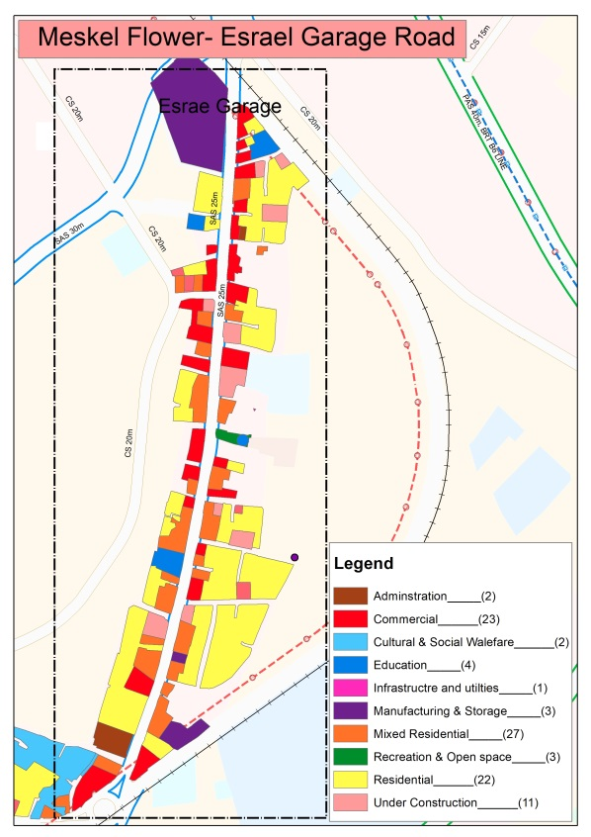
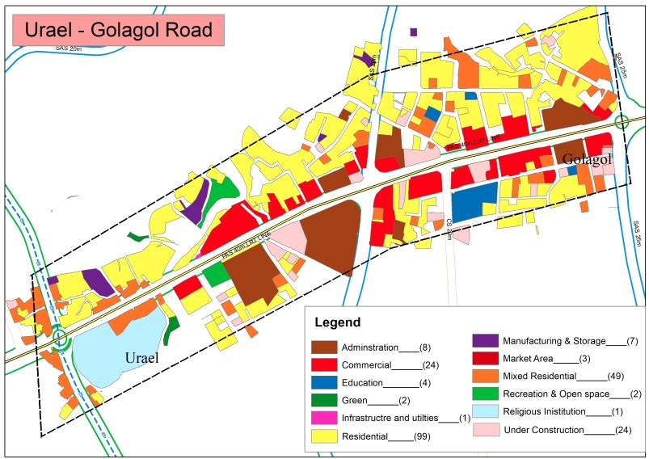

Figure 1property uses of case area
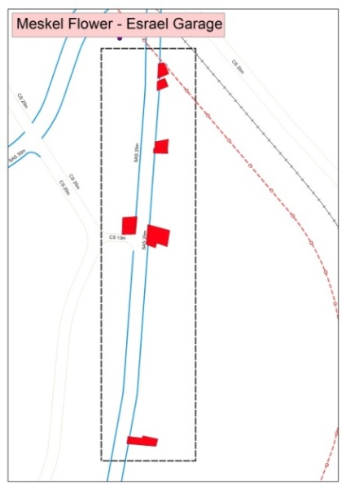
On these two case study areas there were 47 commercial properties, from which 40 of them are affected by the road projects. For the purpose of this study out of 40 affected properties, 10 subject properties are purposively selected based on the extent of the effect the road imposed on them. Specifically, From Kirkos sub city 9 sample subject properties are taken and from Yeka 1 sample subject property is taken. Because, In Kirkos case the probability of getting ownership and legal description data was high. This is basic to determine the larger parcel during the valuation process. On the other hand, the sample taken subject property from Yeka is very crucial to clearly show the before and after method of valuation because of the extent of lose the property encountered, during partial taking expropriation.
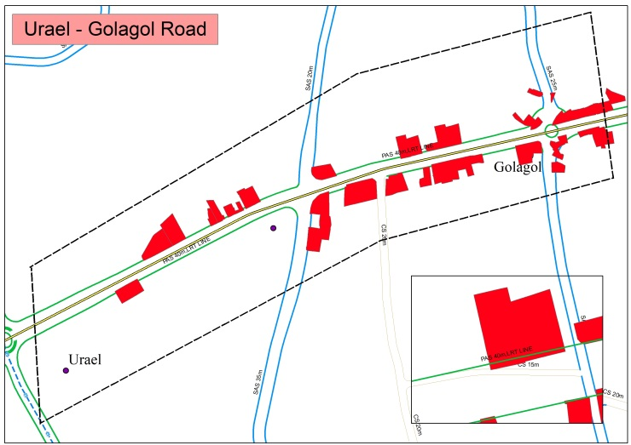

Figure 2 the case partly taken properties

Designing Interview Questions

Approaches for Designing Interview Questions
Most of the existing researches on expropriation concentrate on legal and administrative aspects less work seems to have been devoted to the calculation of compensation quantum. Therefore, the area of the research concentrates on the calculation of compensation for partial takings. To address the research problem, the study needs to achieve its objectives by collecting the relevant data from different sources to know the general practice of partial taking in different countries and how it can be adopted to road project implementation in case of Addis Ababa in the specific sample area.
Therefore, the designing of the interview questions was based on the literature review. The interview questions were designed to be used as a tool to collect data from business property owners, organizations and other relevant sources. This helped to collect different information regarding the situation existed before and after partial land acquisition. The interview questions were based on the research objectives to make it possible to answer the main and specific research questions. Before designing the interview questions, the relevant review on the practices of other countries for the purpose of partial land acquisition had been made. So they were developed based the general aspects taken from the reviews in the way possible to find data from the field.

Interview Questions Structure
Interview Questions for business property owners: the aim of this interview question is to obtain data regarding the general aspects existed on the sample study area before and after the implementation of the road widening project. This questionnaire is prepared to get the data in the before condition because, there is problem of documentation in the administration offices, regarding the data in the before condition. The other questionnaire prepared for the owners is income capitalization. This interview questions were prepared in one layout consisting both closed and open ended response questions. To make clear the intention of the study, the interview question has introductory explanations about the purpose of the study.
Interview Questions for valuation practitioners: The valuation practitioners to be interviewed are government administrative officials. The purpose of this interview questionnaire for these practitioners is to obtain knowledge, experience, activity, and information on land acquisition processes and procedures, compensation and project impacts during and after road project implementation. It includes general introduction and consisted of both open and close ended interview questions.

Preparation for Data Collection and Approaches
The data needed for the study was identified as the first stage of the field work preparation. The data collection methods were defined before starting the fieldwork. For all interview questions checklists were prepared and refined.

Data Collection Methods
This section present the methods used for the collection of primary and secondary data.

Primary Data Collection Method
Data Collection from Business properties: The main objective of collecting data from business properties is to get the relevant information regarding the partial taking of their property for the purpose of compensation. Therefore, purposive sampling technique was used since the study was intended to interview only those who were along the road on which the partial taking land acquisition project is implemented. Here the interview was conducted on those business properties that lost their property as a result of road widening project.
Therefore, as it’s been found from the data prepared on the pre field work study, from the two sample areas presented above on the site description there are 40 business properties whose land and property is partially affected by road project implementation. The practices of valuation indicate that valuation has to be conducted on case by case bases on each individual property. For this reason, For the purpose of the study from these 40 business properties a sample of 25% is taken. This is because the minimum standard sample size for analysis purpose is 25%. So from 40% partly taken commercial properties 10 properties are taken considering the availability of data as one criterion. On the other hand, using 1988 and 1997-line map it has been tried to identify the level of effect the road has on the properties. Therefore, the extent of effect on the properties is the other criteria considered.
Interviews to valuation practitioners: Interview to valuation practitioners was carried out to collect information, opinion, knowledge and practices on the aspects of compensation in partial taking for the purpose of road project implementation. Interviews were collected from the Kirkos and Yeka sub city land redevelopment office officials. Open and closed questioned were asked. A total of nine interviews were taken during the field work.
Field Observation: the aim of field observation was to observe the effects of partial taking for road project implementation on the business properties along the road. This includes the quality of utilities, parking, topography, drainage etc., after partial land acquisition for road widening project implementation. Using this method information was collected by taking photographs and marking on a printed map showing the study area.

Secondary Data Collection
For the purpose of this study, different relevant documents have been collected during field work. These includes different land administration manuals, the design of the road implemented on the study area, legal maps and photos that shows the study area before and after partial land acquisition were collected. Therefore, the land administration manuals relevant for this study were collected from the Yeka sub city land redevelopment office. From the same office information on the valuation of compensation techniques used by the city administration were collected. Administration Addis Ababa land administration plan institute, sub city land redevelopment and Addis Ababa city road authority.
Other documents such as the current demand on commercial properties and aerial photos showing the before partial land acquisition were collected from the web. Spatial data were also collected from plan institute used for identifying and visualizing the ownership of properties existing on the study. From the same source Auto cad drawings of the Addis Ababa town existing and proposed land use, and road design alignments were collected.

Data Processing
This process is begun by data organization and arrangement to the extent the study requires. The quantitative data collected from the business property owners are processed using MS Excel. Qualitative data which collected from the manuals, interview questions and field observation processed manually and noted down on MS Word. The collected spatial data were processed using Arc GIS.

Methods of Data Analysis and Assessment
For this study the methods were based on the literature review, the experiences of partial taking expropriation in other developed countries mainly (USA and Canada). The Uniform Appraisal Standards for Federal Land Acquisition by the appraisal foundation of USA has been used as the main reference for the development of the analytical framework. Qualitative and quantitative data analysis has been used to analyze this research and descriptive method of analysis has been used. As a tool for data analysis Excel and GIS are used since Graphics help the reviewer identify the location and boundaries of the partial taking in relation to the subject property and improvements as well as the location, boundaries, and configuration of the remainder and its relationship to any improvements.
Before going to the field work it’s been tried to determine the valuation methods used for partial taking expropriation from other countries based on the literature review. Through this process it’s been found out that two basic method of valuation are in practice for partial taking. Therefore, before and after appraisal and taking plus damage appraisal methods found to be the two methods that are being practiced for the purpose of partial taking. These two methods considered for the assessment and analysis.

Analytical framework for the study
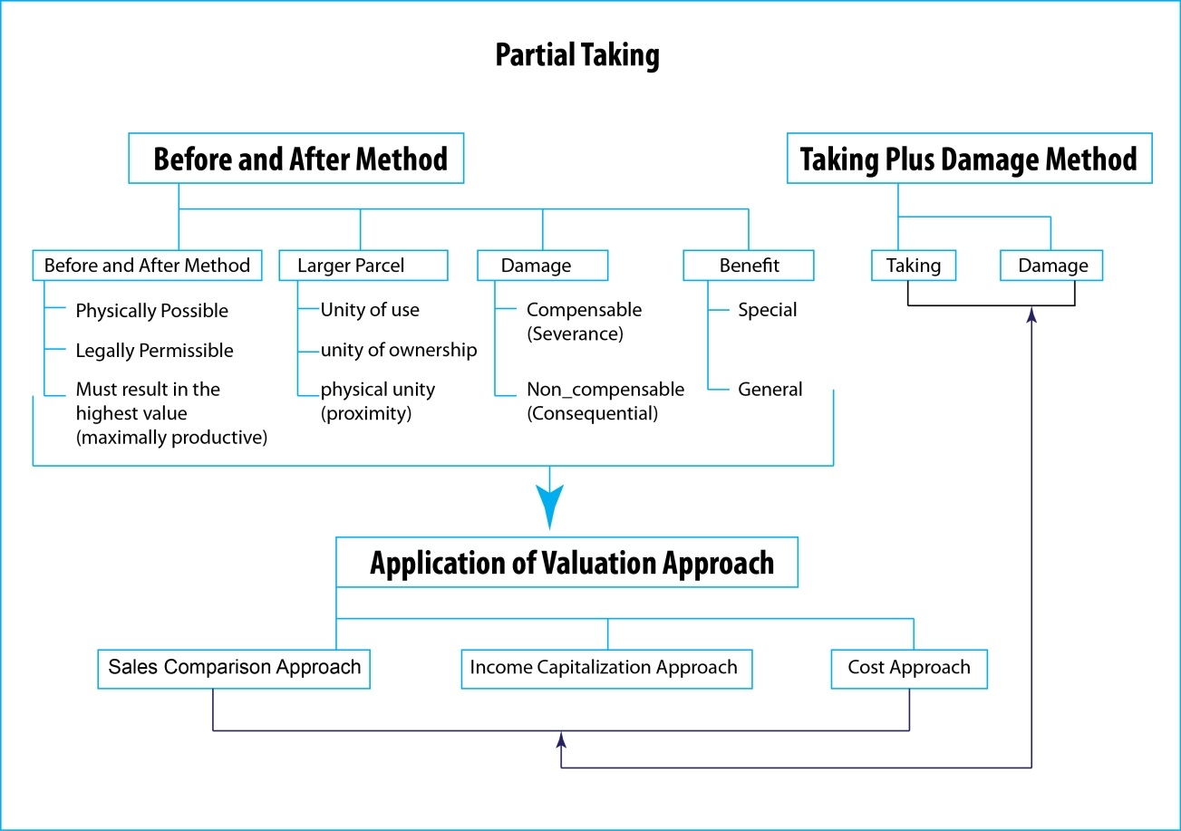
The analytical framework to be used for the study is derived from the literature reviewed. The relevant issues included within the framework are clearly described in the chapter two of the study under the theoretical background. Under the frame work the relevant issues to be assessed and analyzed for partial land acquisition purposes in road widening project are indicated. Therefore, the developed analytical framework related to this study is indicated in figure below.

Figure 3- analytical framework

Significance
As in different literatures described compensation is a form of payment for the property expropriated in the aim of minimizing social and political consequences and to avoid property insecurity among people. So here there is always doubt in achieving these aims. Concerning this the study can provide better information about valuation of business properties in partial takings for compensation purposes which can be used as reference for further studies. In partial takings the responsible organization making the value can get ideas on how and where to improve its methods of valuation in order to achieve the aim of compensation and minimize conflicts.

Limitations
In general, from the field work it’s been found out that the data management system in the study area was poor, it was difficult to collect secondary data at the required extent of the study. The extent of finding data that shows the required before and after data both from the business property owners and the sub city administration offices was very limited. So to support these photos from the web showing the area in the before condition, the city’s legal documents (1988 GIS and 1997-line map) showing the legal boundaries of the properties has been used. On the other hand, the property owners were not that much cooperative in telling the income they get from the property. It was mandatory to go frequently to them until they understand the aim of the study and become cooperative. Therefore, it was difficult to obtain the full information that the interview question requires and to finish the data collection at the required time and quality. To overcome this challenge, it’s been tried to contact brokers as a real person who is looking for a property for rent. In this way it’s been tried to fulfill some gap that has been created during the field work.

Thesis Structure
Chapter one: Introduction
This chapter consists of the general overview background of the research, the research problem, the research objectives and the research questions, the overview of the case study area, designing interview questions, approaches and methods used for data collection and processing, scope, significance and limitations of the study.
Chapter two: literature review
This chapter is about the literature review of partial land acquisition both in the theoretical aspects and the contextual. The review looks at the concepts, processes, procedures and approaches of partial taking. At the same time, contextually this chapter describes the practice of expropriation in Ethiopia which includes the partial land acquisition procedures, compensation and valuation techniques and legal frameworks.
Chapter three: findings and discussion of the results
This chapter presents the analyzed results of both primary and secondary data based on the approaches on the selected aspects of the study. The results will be described in both qualitatively and quantitatively. Some of the findings will be illustrated in graphical representation. Finally, the main findings and discussion of the results of the study will be presented based on the procedures and approaches of the selected aspects of the study.
Chapter four: conclusion and recommendation
This chapter concludes and recommends on the findings of the results based on the research objectives and questions.

CHAPTER TWO: LITERATURE REVIEW

Definitions and concepts
On the topic, we have different key terms on which the concept of the paper will focus on. These are Expropriation, Valuation, Compensation and Public purpose. Hence the concerns of this paper will revolve around these key terms, first it is necessary to define their concept. The term Expropriation, as defined by (Gordon E. Macnair, 2010), is the taking of private property or rights by government for public purposes, and is subject to compensation. The term "expropriation" is practically synonymous with the term "eminent domain”.As defined by the same source, eminent domain is the power to take private property for public use by the state, municipalities, and private persons or corporations authorized to exercise functions of public character. According to (Lindsay, 2012), this power is known by a variety of names depending on a country’s legal traditions including eminent domain, expropriation, takings and compulsory purchase.
On the other hand, as explained by (Muriithi, 2013), the right of governments to use the power of compulsory land acquisition can therefore be described as the concept of expropriation, which is based on a sovereign's power of eminent (ultimate) domain. Eminent Domain is the right by which a sovereign government, or some person acting in its name and under its authority, may acquire private property for public or quasi-public use upon payment of reasonable compensation, but without consent of the owner.In this regard, (Henry Campbell Black, 1990)mentioned that, the process of exercising the power of eminent domain is commonly referred to as "condemnation", or "expropriation". Therefore, expropriation depending on a country’s legal system can be the ultimate power of government or the process of exercising the power of compulsory land acquisition of private property or right by government for public purpose upon payment of reasonable compensation.
In discussing the issue of expropriation, the concepts of compensation, valuation and public purpose needed to be addressed. According to (Henry Campbell Black, 1990) compensation is Indemnification, payment of damages, making amends, making whole, giving an equivalent or substitute of equal value. According to the same source the direct meaning of compensation regarding eminent domain is Payment to owners of lands taken or injured by the exercise of the power of eminent domain. The award of compensation is, therefore, one of the conditions for any expropriation to be considered lawful under international law.
On the other hand, Valuation is the act of ascertaining the worth of a thing.It is also defined as “a procedure aimed at determining the value of a property”.The word “valuation” can be used to refer to the estimated value (the valuation conclusion) or to refer to the preparation of the estimated value (the act of valuing). In this regard we can understand that Valuation is all about the act or the process of determining or estimating the value of property how much it worth. Purposes for which a valuation may be required include sale or purchase, rent to be paid or demanded, the amount of mortgage which could be advanced on a security, calculation of compensation payable or receivable, assessment of taxation or rating and the advisability of investment. Therefore, as the focus area of the study, here the purpose of valuation is for calculation of compensation payable or receivable.
When we come to the other concept in expropriation, a “public purpose” means any purpose for which land may by law be acquired by compulsory process under the Land Acquisition (Just Terms) Compensation Act 1991."Public purpose" that will justify expenditure of public money generally means such an activity as will serve as benefit to community as a body and which at same timed is directly related function of government. According to (Lindsay, 2012) National constitutions and laws typically refer to compulsory acquisition being used for “public purposes”, for “public uses” and/or in the “public interest.” He also mentioned that in some jurisdictions, these terms have distinct meanings and in other cases, these distinctions are blurred or non-existent.
Seeing them one by one as defined by (Henry Campbell Black, 1990), "public use" is one which confers some benefit or advantage to the public and it is not confined to actual use by public. It is measured in terms of right of public to use proposed facilities for which condemnation is sought. As long as public has right of use, whether exercised by one or many members of public, a "public advantage" or "public benefit" accrues sufficient to constitute a public use. On the other hand, “public interest” is something in which the public, the community at large, has some pecuniary interest or some interest by which their legal rights or liabilities are affected. Therefore, based on this context it can be understood that the general idea of public purpose, pubic use and public interest directly indicate the benefit and advantage of the community. But public interest somehow indicates the process is based on the interest of the public, which can be said it is a participatory process.
A broad survey of both developed and developing countries reveals the following among the commonly accepted purposes for compulsory acquisition: Transportation uses including roads, canals, highways, railways, bridges wharves and airports; Public buildings including schools, libraries, hospitals, factories, religious institutions and public housing; Public utilities for water, sewage, electricity, gas, communication, irrigation and drainage, dams and reservoirs; Public parks, playgrounds, gardens, sports facilities and cemeteries; Defense purposes.Therefore, based on the studies’ context the focus area will be on compulsory acquisition of business properties for transportation use which is road.

Partial Taking Expropriation
The compulsory acquisition of land entails two broad types of acquisition, partial and total acquisition of land. Supporting this (Ursula Melinz, 2013) mentioned that an expropriation may take all of a property, part of a property or it may take only a partial interest in a property. Which as explained by (David Russell SC et.al. , 2014), Land which is identified for acquisition may be the whole of an existing parcel of land (total acquisition), a part of an existing parcel of land or an interest in land (an easement or some other such right over land). In the case of a partial taking, only a portion of the whole is acquired by the authority. The acquisition of land and the type of acquisition is primarily determined by the requirements of an acquiring authority which is dictated by the purpose and extent of the acquisition.
The term partial acquisition refers to a partial requirement for the 1) fee simple ownership; 2) easement or covenant and 3) an easement for a specified period (temporary easement) of a property (PICKETT, Highest and Best use and Partial Aquisitions, 2006). It can also refer to any combination of the three items listed. In the same source it is mentioned that a partial acquisition appraisal must identify all interest in the land such as a lease. Because if the property being appraised has a leased interest that is affected by the acquisition, then the portion of the lease affected is compensable. As its been tried to review Fee Simple In land ownership means complete interest in a property, subject only to governmental powers such as eminent domain, and Fee simple title indicates ownership that is absolute and subject to no limitation other than eminent domain, police power, escheat, and taxation. An easement as defined by (Henry Campbell Black, 1990) a right of use over the property of another. In the case of a partial taking, such as an easement to lay a pipeline, the condemner does not take the entire parcel. Instead, the right to use the property is taken, while the owner retains title.Therefore, in partial acquisitions the Appraiser begins by explaining what property and rights are to be acquired.
Linear projects such as construction of roads or widening of existing roads, railways, pipelines or irrigation channels can require the acquisition of only part of a land plot. further as its been reviewed, it is quite common on projects for the right of way or easement line to pass partially through a structure leaving part of the structure outside of the land areas to be acquired.Generally, such a situation will predominate more in improvements that involve streets or highways.In the case of a roadway, all of the ownership rights in a strip of land are usually taken.
At the ratification of the U.S. Constitution, the power of eminent domain is limited by the Fifth Amendment Takings Clause, which states that “property shall not be taken for public use, without ‘just compensation’.” In the case of a partial taking ‘Just Compensation’ is the difference in the fair market value of the impacted property immediately before and immediately after the taking, taking into account the contributory value of the part taken as improved, any severance damage or loss in value to the remainder, and/or any special benefits or increases in value to the remainder.The peculiar aspect of the partial taking relates to that portion which is not taken. It has long been held that damages and benefits to the remaining portion are relevant to compensation for the tract taken (GLAvEst, 1963). Generally, under federal law, in a case of partial expropriation, Calculation of the value after expropriation must take into account any decrease or increase in value as a result of the expropriation.According to (Harrison G. A., 2015)the guideline for estimating damages is the difference in the value of the whole property before and after the taking.

Just compensation
As we can observe from the above statements, the term ‘just compensation’ comes along with the power of eminent domain. The most referenced constitution regarding eminent domain and just compensation is Fifth Amendment of the United States Constitution. So, according to this constitution private property may never be taken without providing ‘just compensation’ in return.This as interpreted by (Mayer, 1968) eminent domain allows for a government entity to take private property for the public good, as long as ‘just compensation’ is provided to the landowner. Concerning this the terms ‘just compensation’ needs to be addressed considering the scope of the study.
As defined by (Henry Campbell Black, 1990), ‘Just compensation’ which is fair to both the owner and the public when property is taken for public use through condemnation (eminent domain). In the same source, it is mentioned that ‘just compensation’ means the full monetary equivalent of the property taken. Related to this the term just compensation is mentioned with the concept of adequate compensation. That is just value of property taken under power of eminent domain payable in money. So, from this it can be taken that just and adequate compensation can be used interchangeably. On the other hand, according to (Chang, 2008) saying, ‘just compensation’ means compensating condemned with fair market value of properties, which is the amount a willing buyer offers and a willing seller accepts, for “the highest and best use” of the property at the time of condemnation. Here the idea of fair market value comes along with ‘just compensation’.

Fair market value
By definition fair market value is the amount at which property would change hands between a willing buyer and a willing seller. Neither being under any compulsion to buy or sell and both having reasonable knowledge of the relevant facts, (Henry Campbell Black, 1990). This according to (Schreiber, 2014) review, “fair market value” defined as the “price which would be agreed to by an informed seller who is willing but not obligated to sell, and an informed buyer who is willing but not obligated to buy” if there is a relevant market. If there is no relevant market, fair market value may be determined by “any method of valuation that is just and equitable.” Added to this as referenced by (Mas, 2014), the fair market value standard for compensation ensures that the property owner is made whole such that his economic position prior to the taking equals his status thereafter.
Therefore, “Just compensation and fair market value” are the two inevitable concepts that come with the power of eminent domain. In this regard, just compensation has to be determined in terms of fair market value which in return has to be specified in monetary terms. Generally, according to the review of (Harrison B. , 2015), In partial taking Just compensation is ‘the difference between the fair market value of the entire tract immediately prior to said taking and the fair market value of the remainder immediately after said taking with consideration being given to any special or general benefits resulting from the utilization of the part taken for highway purposes’.
Fair market value of property may be demonstrated in three ways: (1) by evidence of sales of property comparable to the property taken, (2) by evidence of income produced by the property, or (3) by evidence of replacement or reproduction costs of structures on the realty adjusted for depreciation and obsolescence (where such reproduction or replacement would be reasonable). When and how to use these different methods of property valuation in the determination of "just compensation" for property condemned are often quite difficult. The market value of a leasehold interest is generally the difference between contract and economic rent at the expropriation date (“rental advantage”).
The USA Constitution guarantees "just compensation” for property "taken or damaged." Broadly speaking "taken” means appropriated, and “Damaged" means not physically taken, but injured, depreciated in value, and essentially the taking of rights and uses from property. Property is damaged by being reduced in area and by change in grade in all forms, as impairment of access, cutting off of access, or the removal of lateral support. The damaging of property gave rise to the terms “consequential damages” and "proximate damages. ‘The language of the federal' and several state constitutional provisions guaranteeing just compensation and due process of law is substantially identical. Just compensation is comprehensive of all elements of value as of the time the owner is deprived of his property. It is the full and fair equivalent of the property taken, and that value is measured by what the owner has lost. It includes the value of the land taken and the depreciated value of the remainder.

Valuation principles
Many recognized principles are applied in valuing real estate. They are highest and best use, substitution, supply and demand, conformity, anticipation, progression and regression, contribution, competition, change and other (International Valuation Standard Committee, 2003). Common to all these principles have their direct or indirect effect on the degree of utility and productivity of a property. According to (Gordon E. Macnair, 2010) there are three principles to consider in partial taking cases. These are highest and best use, conformity (consistent use) and contribution.
Highest and best use: according to (Gordon E. Macnair, 2010) since partial taking expropriation have a potential impact on the land use, which implies the highest and best use of a property can also be affected. In some instances, the partial taking could result in a change of highest and best use. The purpose of the highest and best use analysis is to provide a basis for evaluating real property. It into account factors such as physically possible, legally permissible, financially feasible, and maximally productive.
Based on (Gordon E. Macnair, 2010)s’ explanation another important principle to consider with partial takings is the principle of consistent use. Continuing he mentioned that, the idea with this principle is that, when improved land is in a state of transition to another highest and best use, it cannot be appraised with one use allocated to the land and another to the building or improvements. According to him this is an important principle that will be addressed in more detail under the injurious affection section with respect to ‘double recovery’.
Further on the same source it is mentioned that the other principle that need to be considered in a partial taking is the principle of contribution. The principle of contribution is based on the value of a particular component being measured by its contributory value to the property, or by the amount its absence detracts from the whole. Since this principle applies to the two main ingredients that make up the value of real property. For instance, land and improvements, the utility of either component could be affected by a partial taking. Therefore, for partial taking purpose principle of Highest and best use, Consistent use and contribution are the basic valuation principles that needs to be considered during valuation.

Basis of compensation
All compensation is based on the market value of the property on either a whole or partial acquisition basis. As (STANDARDS OF PRACTICE, 1998)indicate within each type of acquisition, different principles and legislative provisions have evolved in assessing compensation across the various jurisdictions. In partial acquisition, Compensation will be both for the part taken and for any loss of value affecting the remainder. Because partial acquisitions involve the acquisition of only a portion of a larger tract, leaving a remainder, the estimate of market value is generally a more complex assignment than is valuing an entire acquisition.The standard procedure for partial acquisitions is to appraise on a before-and-after basis. After the land and improvements within the acquisition area have been valued, the appraiser must determine the value of the remainder after the acquisition. To determine the value of the remainder the appraiser shall:
- Assume the project has been completed according to plan.
- Recognize the highest and best use for the remaining property.
- Show by sales data or other applicable techniques, the market value of the remaining property based upon its highest and best use.
Courts primarily enlist one of two calculation methods to measure just compensation. The “before and after” method awards the landowner the difference between the market value of the property before the taking and the market value of the remainder parcel after the taking. Alternatively, compensation under the “value plus damages” approach awards the value of the part taken plus net damages to the remainder parcel.
On the other hand As (Lewis) tried to explain the appraisal problem for partial acquisitions is essentially a before and after process using either the "Federal Rule" or "State Rule," depending on the individual State where the subject property is located. Further explaining he mentioned that Under the State Rule benefits can only be used to deduct damages. This is a significant difference between the Federal and State Rules. Under the Federal Rule if the remainder is greater in value in the after condition compared to the before condition, the owner is considered compensated. No money is offered. Under the State Rule the agency will pay for the part taken. For instance according to (Sevelka, 2003) In Canada and in most U.S. states, special benefits may be set off only against injurious affection or severance damage to the lands remaining, thus ensuring that the landowner always receives at least the market value of the lands taken.
Generally as (Harrison G. A., 2015) signified, the question in partial acquisition, “all things” considered, what is the fair market value of the property before versus after the road or power line goes through?. So, based on the above statement, the question of fair market value can be answered by the two just compensation calculation methods that needs to be addressed here.

Before and after method
The before and after valuation method is the most commonly used method to determine value in partial acquisitions. The advantage of this method is that it captures the impact of severance and any increase or decrease in the value of adjoining land as well as the market value of the acquired land.
According to the (Uniform Appraisal Standards for Federal Land Aquisition, 2016), this method requires to calculate a reasonable measure of compensation by deducting the remainder or after value from the larger parcels before value. The result is a figure that includes the value of the property acquired as well as any compensable damages and/or direct (special) benefits to the remainder property.This indicates that there are two distinct appraisals in the same assignment which are the “before value” and “after value”. Based on (U.S. Department of Transportation , 2005)The “Before Value” is the pre-project value of the real property disregarding any project influence. The “After Value” is the appraised value of the remaining real property without the acquired part or rights and subject project impacts.
Which as further explained by (Oregon Department of Transportation, 2006), in this method a partial acquisition requires the appraiser to first value the entire larger parcel as it exists prior to the acquisition and the value of the part to be acquired, as a part of the larger parcel, is calculated. The next step is to appraise the remainder property as it will be after the project is completed.Any difference between the value of the entire property, less the value of the acquisition, and the value of the remainder after the taking, indicates the project has caused damages or benefits to the remainder. The value of the part acquired, as a part of the larger parcel, plus damages offset by special benefits, if any, would be the appraiser’s estimate of market value..
As it is stated by (Supplemental Appraisal and Appraisal Review Guidlines, 2012)
- For a partial acquisition, a before and after appraisal valuation must be considered. The appraiser is responsible for identifying the larger parcel, and the analysis of how the larger parcel was defined.
- The before and after method of valuation shall be used on partial acquisitions, except where it is obvious there is no damage or benefit to the remaining land or improvements. In these cases, the appraiser may appraise the land only and show values for the part taken.
- A before and after appraisal is not required when any of the following conditions exist:
- The acquisition will not change the current use and utility of the remaining ownership;
- The proposed acquisition will not adversely affect the market value of the remainder.
- When conducting a full before and after appraisal, any enhancement or diminution of the value of the property is captured in the appraisal process and does not need to be calculated separately. Therefore, there is no independent calculation of severance damages.
Based on (WestTerra, 2008) when a partial taking occur valuation for eminent domain purposes is unique in that it requires consideration of damages and/or benefits to the residue after take. In the same source, it is also mentioned that more data concerning the larger parcel determination is in the highest and best use analysis. From the above statements, one can understand that the process of valuation requires determination of the larger parcel through highest best use analysis. Emphasizing this on (Supplemental Appraisal and Appraisal Review Guidlines, 2012) it is stated that, determining the Larger Parcel is a part of every appraisal and a sub-process of determining the Highest and Best Use. It is also reviewed that what makes the appraisal of Partial Takings difficult is, determination of highest and best use and larger parcel. So, the appraisal process requires being familiar with the concept of Larger Parcel and Highest and Best Use.

Highest and Best Use
The Highest and Best Use analysis is one of the prerequisites of the before and after method in partial takings. Considering the highest and best use of a property took as one of the determining factor of fair market value. As its been tried to explain in the above statement in appraising for partial acquisition, determining Highest and Best use is one of the common challenges of the appraiser. Therefore, as it has been indicated by (Henry Campbell Black, 1990) this method of valuation requires expert to determine what condemned property's fair market value would realistically be if owner were hypothetically allowed to adapt his property to its most advantageous and valuable use. In this regard, it is necessary to clearly understand the concept of highest and best use in real estate appraisal.
From what it has been stated by (Oregon Department of Transportation, 2006), Highest and best use is that reasonable and probable use of the properties at the date of valuation, which is most likely to produce the greatest net return to the land and improvements. The ( IAAO, 2013),defines Highest and Best Use as a principle of appraisal and assessment requiring that each property be appraised as though it were being put to its most profitable use (highest possible present net worth), given probable legal, physical, and financial constraints. The principle entails first identifying the most appropriate market, and, second, the most profitable use within that market. On the other hand, as signified by (Henry Campbell Black, 1990), highest and best use in real estate valuation is the use of land or buildings which will bring the greatest economic return over a given time. So, from the above definitions highest and best use in general indicates the reasonable and probable use of a property in terms of producing the greatest net return or profit. Supporting this (STOWE, 2011) conclusively mentioned that The HBU of a property is not necessarily the highest price it could sell for, but the sale price that achieves the greatest profit for the property today.
Based on (Oregon Department of Transportation, 2006), Elements to be considered in determining the highest and best use include, among others: comprehensive plan, zoning and building restrictions, size of the land and its suitability for development, supply and demand, and neighborhood trends. Determining highest and best use includes assessing potential buyers’ motives, the existing use of the property, potential benefits of ownership, the market’s behavior, community or environmental factors, and special conditions or situations which come to bear on appraisal conclusions of value.To determine a property’s highest and best use, the appraiser must answer these four questions in order to determine whether a use is reasonably probable.

  - Physically possible—suited to the size, shape, and terrain of the parcel?
  - Legally permissible—conforming to zoning, building codes, private restrictions, environmental regulations, and other governmental controls (e.g. leases)?
  - Financially feasible—resulting in a positive net return to the property?
  - Maximally productive—producing the highest rate of return or highest value for the property?
In explaining the highest and best use analysis (PICKETT, 2006) indicated that, the two criteria’s, financially feasible and maximally productive are very similar in that they analyze the economic determinants of highest and best use. Additionally, in his explanation (PICKETT, 2006) mentioned that, when estimating the market value of a property for a partial acquisition, as part of HBU analysis, an appraiser will have to determine which is the larger parcel and possibly if there is more than one zone (band) of value. Basically, zones of value refer to the amount of value that each individual portion contributes to the overall value of the property. Related to this if there is more than one zone of value, what could be the highest and best use might be a question the needs to be answered. So, as it is clearly stated on (Oregon Department of Transportation, 2006) manual, if multiple uses are possible, the use providing the greatest net return to the property owner is the highest and best use.
In partial acquisitions, the highest and best use needs to be considered twice, before and after the acquisition. Because a change in the highest and best use of the remainder area, due to the acquisition might result in a finding of damages or benefits to the remainder area. On the same source regarding the elements of a property remarked that, it is important in the highest and best use consideration not to value the land for one use and the improvements for another use and combine the two elements into a value for the entire property.

The Larger Parcel
According to many reviews there is a little literature that discusses the larger parcel in much detail and no clear definition for the word larger parcel except few appraisal dictionaries. In partial taking cases determining the larger parcel considered to be essential in dealing with the value of a part taken and an assessment of damages. From what it’s been found, though determining the larger parcel is essential in both partial and total takings, understanding the determination of larger parcel become essential in its application to the valuation of non-marketable partial takings in expropriation cases. This means for instance in most cases road projects take a strip of land from the total parcel. In this case there is no price on the market for that specific strip of land taken from the total. Therefore, determining the value of the strip from the market value of the total parcel became essential. Which as mentioned by (Orell Anderson, 2016) The government may be acquiring an awkwardly shaped strip of land for the widening of a highway, a pipeline easement or a transmission line corridor and this would likely never trade on the market, so to determine the market value, the appraiser has to consider the taken land as part of a larger parcel.
In this regard for the purpose of determining the larger parcel it is relevant to define the term. Therefore as stated on (Guidlines for Appraisers, 2004), the word "larger" is not synonymous with "bigger" Rather; it refers to "scope of consideration". Having this, as defined by (Henry Campbell Black, 1990) A term used in eminent domain proceedings, signifying that the parcel taken is not a complete parcel but part of a "larger parcel"; the owner, therefore is entitled to damages from the severance as well as the value of the parcel taken. On the other hand, based on (Uniform Appraisal Standards for Federal Land Aquisition, 2016), the larger parcel, is defined as that tract, or those tracts, of land which possess a unity of ownership and have the same, or an integrated, highest and best use. So as signified by (NDOT, 2016) it is always necessary for the appraiser to determine which parcel constitutes the larger parcel to be valued.
In determining the larger parcel there are three foundational requirements established by the courts in defining the larger parcel, (Sevelka, 2003). These are Unity of ownership, Unity of contiguity and Unity of use (highest and best use). Although federal courts and some states do not require contiguity or proximity where there is a strong unity of use. Which as stated by (Sevelka, 2003), they need not be simultaneously present as of the date of valuation. In the same source, it is also stated that Sometimes the larger parcel can be defined as covering less than the extent of the boundaries of legal ownership or extending beyond the legal boundaries of ownership through beneficial owner-ship.
Consequently (Sevelka, 2003)in his further explanation of the larger parcel stated that, an example of properties that qualify as a larger parcel while not at once meeting the three unities of contiguity, ownership, and use (highest and best use), are:
- Contiguous legal lots each held under separate and unrelated ownership, but subject to a joint development agreement or long-term ground lease. Because, in major urban centers it is not uncommon for the lands under major shopping centers and office towers to be in the ownership of a number of unrelated property owners, subject to a common development agreement and ground lease for the improvements.
- Non-contiguous legal lots, held under common ownership, involving complementary land uses and economic linkages. For example, a hotel or office tower on a separate legal lot with parking on another separate, noncontiguous legal lot would have an integrated highest and best use.
- Two contiguous farms, one owned in fee simple and the other held under lease, but both operated as an integrated economic unit.
Therefore, as it is being tried to review it is necessary to appraisers to use the three tests in determining the larger parcel. But it is not mandatory for a certain property to fulfill all the three-test to be determined as the larger parcel. Which as clearly put by (Orell Anderson, 2016), each of these tests must be considered carefully, and not all the tests must be present in all cases. Contiguity and unity of title are dominated by unity of use. Generally, in partial acquisitions when only part of a larger parcel is acquired, the value of the part acquired is not the sole measure of compensation; the “injury or benefit to the part not taken is also to be considered.” We are all of the opinion that the only method of arriving at the fair market value was to take a fair market value of the whole of each parcel and then attribute the per acre value to the acreage taken.

Damages
As it has been tried to explain above consideration of damages is one of the reasons that makes Valuation for eminent domain purposes unique in partial taking cases. Damages can only result from a partial acquisition. At the same time, as compensating Damages is part of just compensation, there are conditions some damages affect a property but no compensation can be allowed. Therefore, in appraising partial acquisitions, it is crucial to understand the concept and related issues that come along with damages as a result of expropriation. According to (Henry Campbell Black, 1990), by damage we understand every loss or diminution of what is a man's own, occasioned by the fault of another. Damage is the mathematical difference between the value of the remainder after the acquisition and the value of the remainder as a part of the whole prior to the acquisition if no benefits are found to exist, (Acquisition, 2016).
According to the uniform appraisal standard (The Appraisal Foundation, 2016), under the federal law, damage to a property’s market value is either compensable and must be considered, or non-compensable and must be disregarded. The term severance damages for compensable and consequential damages for non- compensable used. Severance damage includes any increased costs, reduced revenue as a result of the property being severed, or in other words, divided into more than one parcel. In some jurisdictions the term injurious affection and severance damage can be used to describe a loss in value to the remainder property as a result of a partial taking.
Damages to the remainder are divided into two classifications: compensable and non-compensable.
Table 1- compensable and non-compensable damages
Damages
NO. | Compensable | Non-compensable
1 | Dividing a property into two or more parts. This includes dividing buildings or other improvements on the property. | Remote and speculative damages  - Any aesthetic or sentimental losses perceived by the owner.  - Any damages caused by the acquisition and construction on the lands of others. The damages must be a result of an acquisition from the damaged property.  - Annoyances or inconveniences suffered by the public generally, such as an increase in noise, dust and fumes, or circuitry of travel.
2 | Reducing the remainder area into small parcels no longer having economic utility. | Damages to business.  The following factors generally cause increased cost to businesses but cannot be compensated for in the appraisal process:  - Business losses during construction.  - Loss of good will.  - Expenses incurred in moving personal property to a replacement site.  - Loss of trade, business, or future profits.  - Increased costs in operating the business, except as it affect the market value of the real property.  - Costs of plans and specifications for proposed improvements now obsolete due to the acquisition; also, loss of prospective use of the property based upon those plans.  - Damages arising out of an owner’s inability to relocate into an acceptable substitute location.  - Loss of profit from the sale of vacant land if it were subdivided. The appraiser cannot find higher damages by asserting the vacant land would be more valuable if subdivided, since it is speculative as to when and for how much the lots would be sold. The highest and best use of the larger parcel would consider the aggregate of the lots and not at the value of the sum of the components.  - Inconvenience and expenses incident to the surrender of possession.
3 | Creating oddly shaped remainder areas having diminished value. | Police powers. A loss in value to the subject property is non-compensable if, by the proper exercise of police powers, it is caused by:  - Zoning regulations.  - Changes in traffic patterns, such as the creation of one way streets; installing median barriers; establishing traffic lanes and restricting on-street parking; increasing or decreasing traffic volumes and regulating speeds; limiting left-turns, U-turns and crossovers; temporary and permanent diversions and rerouting of traffic, including the inconveniences resulting from circuitry of travel.
4 | Creating a landlocked remainder. | Access restrictions.  A loss in value due to restriction of access is non-compensable if it is caused by or relates to:  - Disallowing access directly to a newly located limited access highway.  - Not having access to a widened highway if there was no prior access.  - Access restrictions if access to the highway system is reasonable, including if access is provided by means of a frontage road.  - A loss of access if access is not allowed at each and every point along the highway, so long as reasonable access is provided.
5 | The loss of reasonable access to the highway system.
6 | Proximity of the highway to buildings in the after situation.
7 | Change of grade or loss of view if the loss results in a decrease in market value.
8 | The loss of off-street parking.
9 | A loss in value because of a change in highest and best use.
If there is no loss in value, then no damage has occurred. Any loss in value must be supported and documented by market evidence in the appraisal. In the (The Appraisal Foundation, 2016), it is articulated that the extent to which the utility of a property has been impacted by the acquisition must be established by factual information and analysis, and must never be assumed or based on speculation. Continuing the standard stated that, the fundamental basis for a claim of compensable damages is a diminution in the market value of the remainder.
The measure of damages in a partial taking is either the difference in the property’s value before and after the taking or, the value of land taken plus the diminution of value to the remainder land, either method may be employed, (Lutzky, 2014).in some situations damages to a remainder may be cured using a corrective action which is generally called the cost to cure and is a proper measure of damage only when it is no greater in amount than the decrease in the market value of the remainder if left as it stood. On the other hand, (Guidlines for Appraisers, 2004) states that Depending on the type of acquisition and the availability of data, the appraiser may pursue the estimate of damages “directly” or “indirectly”.
“Direct” measurement of damages can be accomplished through analysis of “matched pair” sales, capitalization of rent loss, or cost-to-cure analysis to include administrative charges.The “indirect” measurement of damage is a complete “before” and complete “after” appraisal of the property. Damage is estimated by deducting compensation for the proposed acquisition (land, easements, and improvements) from the difference in the before and after value.

Cost to cure
In support of the above statement (Gordon E. Macnair, 2010) defined the cost to cure as method that can be used to offset damages. Further in the same source it is mentioned that Cost to cure can be used to offset damages and is defined as the cost to restore an item of physical depreciation or functional depreciation to near new or new condition. Based on (State of Tennessee Department of Transportation Right-of-Way Division(TDOT) , 2004) guidelines, in no event can the cost-to-cure measure of damage are applied if the cost to cure exceeds the reduction in value that would result if such a cure were not undertaken. However, if the cost to cure is less than the reduction in the value of the remainder, the cost to cure measure of damage must be used. Which as stated on (ODOT, 2012) (GUIDE TO COMPENSABILITY, 2012), the appraiser must do the following when considering a cost to cure:
- The appraiser is required to value the larger parcel before the taking.
- The appraiser is required to value the residue property as if no cure has been considered. This is known as the residue uncured.
- The appraiser is to estimate damages based on the residue being uncured. This damage estimate is known as “the diminution in value to the uncured residue”, or, “total damages, if uncured”.
Value of the Property before the Taking
(-) Value of the Residue Uncured
Difference
(-) The Part Taken
Total Damages, If Uncured
- The appraiser is to document the cost of the cure and determine if the cure is feasible. A cost to cure is feasible when it is less than the total damages, if uncured. If the cost to cure is feasible, the appraiser moves on to No. 5 below.
Cost to Cure ≤ the Total Damages, If Uncured
If the cost to cure is not feasible, the analysis stops at this point and compensation is estimated based on No. 3 above.
Cost to Cure ≥ the Total Damages, If Uncured
- The appraiser then values the residue property as if cured.
- The appraiser then determines if any uncured damages remain after the residue is cured. To determine if uncured damages remain, the appraiser does the following analysis:
Value of the Residue Cured
(-) Value of the Residue Uncured
Value of the Cure
Total Damages, If Uncured
(-) Value of the Cure
Remaining Damages Not Cured
- The appraiser then determines if any items cured have already been paid for in the part taken to avoid over compensation. This analysis is done as follows:
The Cost to Cure
(-) Items Cured, but Paid for in the Part Taken
Net Cost to Cure
- The appraiser then estimates compensation by considering the following:
The Part Taken
+ The Cost to Cure, or, Net Cost to Cure
+ Uncured Damages
+ Temporary Easements
Total Compensation Estimate
As put by (Oregon Department of Transportation, 2006)Examples of situations in which costs-to-cure might be employed include:
- Fencing is severed, jeopardizing its security function. Security can mean to restrain livestock, for example, or it can mean to protect inventory or avoid liability.
- A building is severed.
- Access to property or buildings is eliminated but can be restored by relocating the access.
- An improvement can be moved to mitigate damages to the remainder. It is not proper to
- Consider relocation of structures to decrease proximity to the project.
- A water supply or sewage system is acquired and can be replaced in some fashion.
- A drain line can be installed to prevent flooding on the remainder
Even though a cost to cure method of estimating the diminution of value may be appropriate, it must be remembered that the remainder property is still to be valued in its uncured condition, (The Appraisal Foundation, 2016). Therefore, in a partial acquisition the remainder property may be unusable or its usability might be minimized. This means there is a chance of improving the problem through modification on the remainder property. For this reason, the decision to utilize a cost-to-cure to estimate damages to a remainder should be based on the reasonableness of performing the cost-to-cure and Damages must be estimated prior to determining the cost-to-cure, (Oregon Department of Transportation, 2006). Generally according to (Uniform Appraisal Standards for Federal Land Aquisition, 2016)Just compensation is measured by the owner’s loss, not the government’s gain.

Benefits
Benefits like damages, relate only to partial acquisitions.Emphasizing this (The Appraisal Foundation, 2016) (Uniform Appraisal Standards for Federal Land Aquisition, 2016) states that, Appraisers should give the same consideration to benefits as they do to damages in developing an opinion of the market value of remainder properties. If the owner’s remainder property increases in value as a result of the project, the owner has been benefited and compensation may be modified by offsetting the benefits against any damages previously determined by the appraiser.The same source remarked that, not all benefits can be used to offset damages. Specifying this (Henry Campbell Black, 1990) signified that, in eminent domain, it is a rule that, in assessing damages for private property taken or injured for public use, “special benefits” may be set of against the amount of damage found, but not “general benefits”.
In general, Benefits are defined as “the advantageous factors that arise from a public improvement for which private property has been acquired in eminent domain.In addition as defined by, (Lewis)Benefits are items that enhance value such as a positive change to the highest and best use or improved marketability. There are two types of benefits, general and special: General benefits are defined as the benefits that accrue to the community at large, to the area adjacent to the improvement, or to other property similarly situated. General benefits may not be used to offset damages. Special benefits are those benefits that accrue directly and solely to the advantage of the property remaining after a partial acquisition and may be used to offset damages.
On the other hand, (WSDOT Right of Way Manual, Chapter 4, Appraisal, 2016) states that there are three concepts where value may be created by a pending highway improvement. It is necessary to differentiate between these concepts and understand them in order to properly treat them in right of way acquisition. The three concepts are defined as follows:
  - Enhancement– Increases in real estate values in advance of right of way acquisition created by knowledge of a pending highway improvement.
  - Special Benefits – Value accruing to the remainder of a property by reason of acquisition and use by the state of a portion of such property where such value is special to said remainder and not enjoyed by the general public. Benefits may be special although other owners on the facility receive similar benefits.
  - General Benefits– Washington law does not clearly define general benefits. Because of this we have only attempted to explain special benefits and will assume that any benefits that are not “special” may be properly considered to be “general” benefits.
Under federal law (The Appraisal Foundation, 2016), compensation for a partial acquisition must reflect any direct and special benefits to the remainder due to the government project. Indirect and general benefits, on the other hand, are not considered because they are enjoyed by the public as a whole rather than arising from an acquisition’s particular impact on a specific property. According to this standard just compensation is answered based on what the owner lost rather than what the taker has gained. An upward shift in the remainder property’s highest and best use is often an indication of special and direct benefits.
(W.stoker, 1988) In his research report identified benefits that can be considered both as a special and general which presented below in a table format.
Table 2 special and general benefits
No | Typical Benefits | Special | General
1 | Improved Drainage | √ | √
2 | Improved road gravel to hard surface | √ | √
3 | Proximity to new highway | √
4 | Increased vehicular traffic | √ | √
5 | Increased convenience (street widened) | √ | √
6 | New access (improved road) | √ | √
7 | Increased frontage | √ | √
8 | Fencing public maintained and built | √
9 | Improved available advertising space | √
10 | Construction of sanitary sewer, storm sewer and water main | √
11 | Availability of electricity | √
12 | Corner lot creation | √
13 | Reduced circuitous route | √
14 | Improved highest and best use | √
15 | Improved drainage | √ | √

(W.stoker, 1988) Research result indicates that in United States many states use the rule of offsetting special benefits against damages to remainder, but not against the value of the land taken. Generally, on (Uniform Appraisal Standards for Federal Land Aquisition, 2016)it is stated that, to take into account any special benefits from the project, appraisers apply the before and after rule of valuation, developing opinions of the market value of the larger parcel (the entire tract) Before acquisition excluding any enhancement or diminution from the project, and the market value of the remainder after acquisition including any special benefit or diminution due to the government project.

Taking and Damages Appraisals
As illustrated by (The Appraisal Foundation, 2016)there may be rare situations in federal acquisitions that before and after rule will create costly and/or difficult burdens on the appraiser. Examples of such situations are minor fee or easement acquisitions (for flowage, wetland or habitat protection, roads, and pipelines) from large parcels. Which as practiced by (Oregon Department of Transportation, 2006), When damages are minimal and can be accurately measured in and of themselves (and there are no special benefits) certain right of way acquisitions do not merit the before and after approach. Therefore, in those rare situations a taking plus damages procedure may be allowed, which sometimes called the state rule.Instances when the taking and damages format is appropriate include:
- When the effect of an acquisition is minimal in comparison with the larger parcel.
- The highest and best use of the property will not change.
- A Before and after appraisal will not add significant additional clarity to the report.
Under this procedure, the appraiser must still determine the larger parcel and develop an opinion of the value of the part taken as it contributes to the larger parcel. Minor damages are added to the opinion of value of the part taken to provide an estimate of the compensation to be paid by the client agency.

The Appraisal Process
As the before and after rule is the mostly used appraisal method for federal partial acquisition, it follows two distinct appraisals the before and after appraisal. So, the first step is appraising in the before condition by starting from the determination of Larger Parcel and the Highest and Best use. In appraising the before condition, once the Larger Parcel and the Highest and Best Use have been determined, the appraisal process follows the normal routes. Whichever of the three approaches are applicable are used and the appraiser precedes to the value the Larger Parcel.The same source indicates that, if necessary the appraisal should include all approaches used in final value determination. At the same time, appraising the after condition follows the same rule. Finally, it is stated that, After the Before and after values of the Larger Parcel have been determined, the Value of the Taking is calculated by simply subtracting the After Value from the Before Value.

The valuation Approaches
As described by (Real Estate Appraisal, 2016) there are three Standard Approaches which are called cost, sales and income. When appropriate, all three of the standard or traditional appraisal approaches, Cost, Sales Comparison, and Income are to be used in a fee simple appraisal. The Three Approaches to Value for purposes of just compensation, market value must be determined “with an approach which seeks with the aid of all relevant data to find an amount representing value to any normally situated owner or purchaser of the interests taken”
One or more approaches to value may be appropriate, even necessary, to derive a reliable estimate of market value in a given appraisal problem. Not every approach to value is appropriate for every valuation assignment: in determining market value in federal acquisitions, appraisers must not use an approach that “though perhaps making it easier to reach some solution only makes the proper solution more difficult.”
Where just compensation is concerned, a reliable valuation process is necessary to ensure a just result, “and it is the duty of the state, in the conduct of the inquest by which the compensation is ascertained, to see that it is just, not merely to the individual whose property is taken, but to the public which is to pay for it.” Generally, based on (Uniform Appraisal Standards for Federal Land Aquisition, 2016) the three approaches are explained as followed.

Sales Comparison Approach
The process of forming an opinion of a property’s market value through comparison with such comparable sales is known as the sales comparison approach to value. The sales comparison approach is normally preferred in federal acquisitions as the best evidence of value, but not to the exclusion of other relevant evidence of value based on market data. The essence of the sales comparison approach to value is the comparison of sales transactions to the property being appraised. “Generally, the more comparable a sale is, the more probative it will be of the fair market value” of the property being appraised.
As it is been pointed out on (The Appraisal Foundation, 2016), a sale’s comparability is largely a function of three variables: characteristics of the properties, their geographic proximity to one another, and the time differential. Which as explained, On the point of similarity in character and locality, obviously if part of an allotment is condemned, should be of lots either within the immediate vicinity or very close. Though, this might not always be true when large areas of open country are involved.
Through the process of sales comparison approach the other adjustments considered to be the other requirements of determining the fair market value. As it is referenced on (The Appraisal Foundation, 2016) depending on the property involved and the relevant market, the appraiser may need to adjust each comparable sale through quantitative and/or qualitative analysis to derive an indication of the market value of the subject property involving such factors as time of sale, size of parcel, location, topography, and other such variables. Quantitative adjustment is appropriate when there are adequate market data to reliably quantify the effect of a sale characteristic in terms of a percentage or dollar amount. Qualitative adjustment may also be appropriate and necessary where market data does not support a quantitative adjustment. Qualitative analysis can be particularly useful in evaluating considerations such as development restrictions, particular land use restrictions, allowable density, the presence of environmental lands, and the impact of easements or encumbrances.

Cost Approach
Cost approach is the other valuation approach as indicated by the standard. From what it’s been reviewed cost approach can be employed where it is appropriate in valuing property with existing physical improvements. In this approach, the reproduction or replacement cost of the improvements, less appropriate depreciation, is added to the estimated market value of the land as if vacant to derive an indication of the market value of the property as a whole.
Value of land as if vacant is estimated by analysis of comparable sales by application of the sales comparison approach. This doesn’t disregard actual physical conditions that a reasonably careful buyer would consider. Coming to reproduction cost and replacement cost the standard mentioned that many courts use the terms interchangeably though they must be distinguished. Reproduction cost is the present cost of reproducing the improvement with an exact replica using the same physical materials; replacement cost is the present cost of replacing the improvement with one of equal utility. The estimate of the reproduction or replacement cost of the improvements must be based on current local market cost of labor and materials for construction of improvements. On the other hand, Depreciation includes all appropriate forms of depreciation, including physical deterioration, functional obsolescence, and economic obsolescence, must be derived from market data and deducted from the estimated reproduction or replacement cost.
Explaining this in the standard stated that cost approach can yield an indication of market value but not the fair market value. Cost of land and cost of improvements taken separately and added are not to be equalized with fair market value. Rather, the elements are considered under the cost approach in developing an opinion of the market value of the property as a whole.
As a result, while cost approach has often been misused, most courts identify it as the least reliable indicator of market value for the purpose of measuring just compensation. Therefore, rather than using the cost approach as a standalone indicator of value for acquisitions, it is employed to test the financial feasibility of a potential highest and best use or to “check” or test the reasonableness of estimates of value indicated by other approaches. It may be appropriate in the valuation of properties with highly specialized improvements that have no known comparable sales in the area. Generally, as put by the standard valuations derived from the cost approach and any other approach to value must follow the unit rule. This requires property to be valued as a whole.
Critically indicated as” In using the cost approach, it is therefore critical to distinguish between calculating the cost of improvements and estimating the market value of the property as a whole, considering the contributory value of improvements”. As it is clearly stated that, some assignments may require separate allocation of the contributory value of improvements that will be removed or adversely affected due to the government project but if applicable, the appraiser should clearly state that any such allocations do not indicate the appraisal method (s) employed.

Income Capitalization Approach
According to the (Uniform Appraisal Standards for Federal Land Aquisition, 2016), Income capitalization approach is the third recognized approach to value in USA federal acquisitions. This approach involves capitalizing a property’s anticipated net income to derive an indication of its present market value. When properly applied, the income approach can indicate what a buyer would pay at the present time for the anticipated future benefits, discounted for risk and other variables, of owning a property. In most cases this approach is relevant only in certain circumstances namely, in the valuation of income producing property with no available comparable sales.
Since it might result exaggerated result, in using this approach great care is required. Therefore, as put by the standard, this approach to be accepted by federal courts for just compensation purpose it must be supported by evidence.
Proper application of the income capitalization approach requires a distinction between income generated by the property itself (such as rental or royalty income), which can be considered, and income generated by a business conducted on the property, which must be disregarded. As a result, in determining the market value of the property, the income to be considered is only income generated by the real estate itself, typically rental or royalty income. Its application is recognized as a valid and reliable approach to value in certain cases, when there are no comparable sales and market value must be estimated. The income capitalization approach may refer to either direct capitalization or yield capitalization techniques:
- Direct capitalization techniques are used to determine the market value of a stabilized income-producing property by applying an overall capitalization rate to a property’s single-year net income.
- Yield capitalization techniques are used to determine the market value of an income-producing property with varying forecasted income or expenses, typically using discounted cash-flow (DCF) analysis. Forecasts of net income, expenses, cash flow and other factors over a holding or projection period are required.
Basically for conformity purpose in using a reliable data, it is stated that regardless of the technique used, there must be sufficient market data to ensure a reliable indication of value for the specific property being appraised. So this approach being becomes invalid when the future use or demand for the use is speculative. Additionally, it is stated that physically adaptable is not enough reason to use the capitalization method. The land owner must show that “an income producing market existed at the date of the taking or will exist in the reasonably near future.” If there is no currently operating business, it would be ‘improper to value the property as if it were actually being used for the more valuable purpose.
Similar to other valuation approaches the unit rule applies in income capitalization approach. As its put on the standard “The subsidiary interests in a fee cannot add to its market value and compensation for these interests must be paid out of the amount awarded for the whole.” if using the income capitalization approach to value, appraisers must value the property being acquired as if in single ownership not by “computing separately the value of the various constituent legal interests” (such as lessor/lessee or operator/owner) in the property.

Contextual Background

Introduction
Expropriation as a means of land acquisition is a recent phenomenon in the Ethiopian legal history (Ambaye D. W., 2013). As it’s explained in the same source, in Ethiopia the power to take land for public purpose did not become a matter of great concern until the early twentieth century. So according to (Ambaye D. W., 2013)conclusion it’s the establishment of modern urbanization that induced expropriation in Ethiopia. For the first time expropriation was formally introduced by Emperor Menelik II when he enacted a land charter of the newly established city of Addis Ababa. Further (Ambaye D. W., 2013) explained, the main reasons for land expropriation in the city is urban renewal/redevelopment, construction of condominium housing, and road construction.
Considering road construction land expropriation as a major focus area of the study, Ethiopia witnessed considerable amount of road construction after Emperor Menelik II came to the throne in 1889. The same source also signified that many roads were constructed in the city of Addis Ababa during his reign including rail road. From what has been explained by (Ambaye D. W., 2013) the 1960 Ethiopian civil code recognizes “alignment” and “expropriation” as the two methods of land acquisition modalities. Expropriation is used for the “creation of new roads and streets” while alignment proceeding serves to “widen or straighten existing roads or streets.” In this regard contextually the area of this study focus on alignment proceedings as a part of expropriation that implies road widening since the study is on partial taking of land by road projects.
On the other hand, as it has been stated on (Ethiopia MDGs Report, 2012), Ethiopia’s economy is undergoing a rapid growth and transformation. Significant progress has been seen in both economic and social development as well as in building necessary physical infrastructure. The expansion of the service sector has mainly been attributed to the increase in government spending on public service delivery, public infrastructural development (education, heath, and roads) and enhancing the capacity of the public service to deliver social services.From what it’s been recorded on (Access Capital, 2010) report one of the driving factors that increase the scope and scale of real estate activity is the expansion of city roads and infrastructure. Such as the construction of the Addis Ababa Ring Road and other major roadways, the improvement of numerous neighborhood roads and the wider reach of electricity and water services to the edges of the city.
As stated on Ethiopian (Resettlement/Rehabilitation Policy Framework, 2007), in Ethiopia Urban inhabitants along the roads are mainly engaged in the trade of various natures while others are employed in private, governmental and non -governmental institutions. In addition to increasing the real estate activity roads also have their own contribution on increasing the value of property. Which as directly stated by (Ambaye D. W., 2013), roads and streets increase the value of adjacent properties.
From what it has been reported on (Access Capital, 2010), Data on building permits granted by the City Administration between 2005 and early 2009 G.C indicate that, out of the two major real estate categories, commercial buildings have been granted the largest share (40 percent) of building permits issued during this period. In terms of the distribution of commercial building permits issued by the Addis Ababa City Administration, Bole Sub-City held the leading position with 29 percent of the total, followed by NefasSilk Lafto (21 percent), and Kirkos (19 percent).Generally, in the city of Addis Ababa road projects are a driving factor for real estate activity mostly for commercial activities.

Compensation for partial land acquisition in Ethiopia
According to Ethiopian (Proclamation No. 455 , 2005) ‘"compensation" means, payment to be made in cash or in kind or in both to a person for his property situated on his expropriated landholding’. Which as referenced by (Ambaye D. W., Land rights and Expropriation in Ethiopia, 2013), While property situated on the land refers to building, structure or plants of any kind that have value, improvement to the land refers to any work made on the land that increases the value, productivity, or fertility of the land. Which implies in Ethiopia compensation is only made to the improvement on the land. Regarding the compensation to be paid, on Ethiopian 1995 constitution, Article 40(8), mentioned that the government should pay, in advance, compensation “commensurate to the value of the property” expropriated. Though there is no further explanation on the constitution about the term commensurate compensation, (Ambaye D. W., 2009) explained that the common dictionary meaning of this word is “equal”, “appropriate” or “adequate.” So, according to (Ambaye D. w., 2014)the subject of commensurate compensation is the private property, property Situated on the land and improvement to the land, but not the land.
Regarding partial taking of land for public purpose like road, the (Council Of Ministers Regulation No 135/2007, 2007) states that Compensation shall be paid only for the demolished part of a building where the 'owner prefers to use the unwanted part of the' land. But according to this regulation, the owners’ preference will be accepted if the condition of the partly demolished building conforms to the requirements of the appropriate city plan. From what it has been tried to review, a great emphasis is given to the valuation of partly taken properties for public purposes. According to this reviews in partial land acquisition cases there is always a great concern about the remaining property. Which means, as it has been tried to review, in other countries during calculation of value for compensation purposes there is always a practice of considering the part taken and the remaining part interdependently.
On the other hand, Ethiopian compensation principle doesn’t seem to give a particular concern about partial taking different from total taking. The regulation applicable to compensation for partly taken properties concerned only for the part taken, if and only if the partly demolished building conforms to the requirements of the appropriate city plan. Which as explained by (Ambaye D. w., 2014) on his comparative analysis, If, however, the owner prefers to keep the remaining part, compensation will be paid only for the demolished portion (Art. 3.4). In other words, there is no “severance” or “injurious affection” compensation, compensation payable for the depreciation in value of a retained land caused as a result of a loss of a part of the land.
On the other hand, as its been tried to mention in the theoretical background, other countries practices indicate that compensation payable for land acquisition is based on the highest and best use of land. Which means the compensation to be paid is based on the future potential of the land. Concerning this the contextual reviews indicate that the Ethiopian compensation principle follows that the compensation paid doesn’t consider the future potential of the land. As this is clearly indicated by the findings of (Ambaye D. w., 2014), the compensation paid must consider the original purpose of use of the land rather than its futuristic potential.

Valuation for partial land acquisition in Ethiopia
As valuation is preprocess of compensation for land acquisition purposes, different countries use their own methods and approaches. Basically, worldwide the three valuation approaches, sales comparison, income capitalization and cost approach are the most applicable ones. In Ethiopia as stated on (Proclamation No. 455 , 2005) the amount of compensation for property situated on the expropriated land shall be determined on the basis of replacement cost of the property. So, from the three well known valuation approaches the Ethiopian law regulates to use the cost approach.
Practically as references indicate that using one or more approaches to value has to be considered necessary to get a reliable estimate of market value in a given appraisal problem. Each and every valuation assignment requires its own appropriate valuation approach to determine market value. From what it has been referenced, as indicated by different reviews In Ethiopia, there is neither an independent and developed valuation system, nor are there available professionals in the field. The Ethiopian Road Authority’s right-of-way agents calculate the compensation rate such as value per quintal of crops, value per big tree, value per medium tree, value per seedlings, value per m² of houses, etc. in concert with the local government (Woreda or urban administration) valuation committee. This as explained by (Ambaye D. W., 2009)in Ethiopia, in both the urban and rural land regulations, the valuation of property is to be carried out by a committee of people.
Practically from what it has been tried to review, concerning partial land acquisitions compensation to be said just, the valuation process has to be undergone two times for both the whole property, in the before condition, and the remaining property. For this purpose, there are two known valuation methods, before and after method and taking plus damage method. The idea is that in partial land acquisitions there is always a remaining property having new characteristics. So it is believed that partial land acquisitions needed to be treated in a different way from total takings. Having this, in Ethiopia regarding the valuation of partial land acquisition there is no different form of valuing partly taken properties. This implies there is no particular concern about the valuation of partly taken property, though the country experiencing the partial taking expropriation in undergoing road projects.

CHAPTER THREE: FINDINGS AND DISCUSSION OF THE RESULTS

Discussion on the findings of Partial taking expropriation
From the review of documents and the interview of staffs based on the case areas, the general approaches and concepts adopted for both partial and total takings are almost the same. There is no distinct understanding or meaning given to partial and total taking as indicated in the practices that has been tried to illustrate on the reviews of this study. According to the reviews, the remainder property after the partial taking is always a concern.
When we come to contextual practices from what it has been tried to assess on the case areas, the only concern basically given is for the part taken. Every assessment about the factual data is much focus on the part that is going to be taken. As the assessments indicate each effects on the remainder, like change in utility or desirability of what is left after the taking, change in size or shape, improved highest and best use, improved drainage, reduced/improved accessibility and road frontage etc., are also the experience of the case areas during land acquisition for road project. From the data assessed it has been found out that the change in size or shape of properties during partial acquisition happen more frequently. But the frequency of experiencing land locked remainder, change of grade or loss of view is very limited.
the document reviews and interviews indicates that the main objective is to avoid or reduce to a minimum the detrimental effects of road operations on the livelihood of the people intended to be served by the roads (Ethopian Road Authority, 2007).The results of the assessment also reveal this situation. Though pre problem mitigation program is the objective of the responsible organ, the consequences of road projects go with the project implementation process. This implies there are different mechanisms to minimize the impacts of road projects before they are being implemented. But after implementation the consequences of partial taking are not the concerns of the formal expropriation procedure. This means the factors affecting the values of the remainder described in the above statements are not included as a specific issue on the given legal compensation entitlements.
Similarly on (Resettlement/Rehabilitation Policy Framework, 2007), it is clearly stated that compensation entitlement for partially taken properties is to rebuild the affected parts in a similar structure and appearance or better one. This implies that the emphasis is given to the part taken. Conclusively the generally accepted concept about the effects of partial taking on the property is mostly benefit. In most cases it is assumed that the result of a project is going to be positive for the properties along the road. Basically other than considering differences on the items listed for compensation like cost of material, transportation fee, costs of labor and contractor fee etc., there is no given ideal concept that can differentiate partial taking from the total taking in terms using its own methods and procedures. According to the findings the damages are going to be taken in to consideration with a special case. Mostly if the owner has a chance of staying on the remaining part and if the owner wants to stay there with his own whatever reasons and improving the damage is an inevitable issue. For instance, if the property has an access issue the assigned responsible organ will try to mitigate this problem by providing access.

Methods adopted on Valuation and Compensation for partial taking expropriation
Reviews show that partial taking by itself is independent issue that has its own methods and procedures. As it has been reviewed, for valuing properties for partial taking there are two different methods of valuation which are before and after, and taking plus damage method of valuation. The process of this method includes determining Highest and best use, Larger Parcel, Damage and Benefit. This indicates that during partial takings there are two distinct appraisals in the same assignment which are the “before value” and “after value”. As a result, in partial taking covering these aspects considered to be essential. Therefore, it is after determining these aspects the three approaches of valuation going to be applied. Therefore, the results and the assessments are presented based on this.
When it comes to the case areas, it was found that the procedure for both total and partial taking is similar. The process starts from the establishment of compensation committees. Then assess the replacement values of identified assets from the field and then they establish the compensation rate for all assets to be expropriated. The role of compensation committees begins by conducting the registration of affected properties. In this regard, there is no distinct procedure to follow for the before condition and the after condition. Registration is only made to determine value for the part that is going to be taken. Additionally, document records are made just to show what has been there in the before condition just for comparison purposes.
In addition, the reviews and interviews of staff indicates that partially affected business properties, properties affected below 25% will receive partial compensation considering the factual data of the property affected assessed from the field. Compensation payments may also include inconvenience costs and other transactions to rebuild a similar or better residence in the remaining plot. Which indicate the data requirement of both total and partial land acquisition is the same. Therefore, the results of the assessments indicate, unlike the practices mentioned on this study, it is the extent of the taking that determines the amount of compensation.
From the reviews, it has been found out that in partial acquisition, Compensation will be both for the part taken and for any loss of value affecting the remainder (STANDARDS OF PRACTICE, 1998). Therefore, based on the compensable damages and Benefits from the reviews, it has been tried to assess the effects of road project on the sample Meskel flower to Esrael Garage Road and Urael to Golagol road. In this regard the effects of partial taking on the remainder property have been clearly revealed.
Based on the standard factual data assessment tool (The Appraisal Foundation, 2016), utilities are considered as one element that might be affected by partial taking in road project. So it has to be assessed in the before and after condition whether or not the taking diminish or enhance this. In this regard, from the interviews with the property owners along the road, it has been tried to get data about the condition of utilities in the before and after situation. Based on this, the data indicate that there is no difference. Everything that was there in the before condition, doesn’t altered by the taking.
The availability of parking, in the before and after condition, is the other factor that need to be checked for the purpose of compensation. As the data indicate the taking affected one property by diminishing some part of the parking. This has to be considered as damage during valuation for compensation purpose. But the findings of the interview indicate that the government only compensates the improvement on the parking area. That means the compensation is for the pavement of the parking area.
Topography is the other factor that can be affected by partial taking expropriation. During expropriation the level of the elevation might become above, below or it may stay as it is. This change will have an impact on the remainder property in terms of changing its functionality or accessibility. In this regard as the findings indicate there are properties affected by the taking. Some properties have become above the road surface level and some become below. Based on this the findings indicate the compensation include only value to fix the problem by calculating the cost of the damage independently.
Similar to the other factors, assessing drainage condition in the before and after situation consider necessary for compensation purpose. The results of the assessment indicate there is improvement. According to the findings of interviews with appraisers it has been found out that compensation will be calculated independently if there is damage.
Accessibility and road frontage is the other factor that needs to be addressed during field work in partial taking cases because the property might be altered by the taking in the after condition. In this regard if the problem is severe for instance, if the slope difference is very high and there is loss of access the compensation procedure will consider the problem to reinstate the situation as it was before. But if it is the extent of accessibility in the before and after condition it is affected, the compensation procedure doesn’t consider it. For instance, when we see one of the subject properties taken from Urael to Golagol Road, which is found along the rail road, in the before condition the access was two ways but now the accessibility diminished by the rail way project.
Quality of construction is the other issue that needs to be addressed during field work. The taking might alter the quality in terms of architecture or material. Concerning this, the findings indicate since the value of the remainder is not going to be considered for compensation purpose, the effects of the taking on the type and quality of construction is not included in the compensation.
Landscaping is the other factor that needs to be considered for compensation purpose. The findings of the study indicate there are changes in the sample taken subject properties in the before and after condition. In this regard it has been found out that compensation is only for trees and landscaping elements because, compensation is only for improvements on land.
Therefore, as the results of the data assessment on the two sample case areas indicate, road projects have made their own contribution on the properties nearby and along the road. In addition, the assessment indicated that, the project has its own contribution for the improvement or diminution of value. Some of the factors are also considered for compensation, but the damages and benefits are not calculated as the practice indicated in the reviews. The practice indicates capturing any enhancement or diminution of the value of the property in the appraisal process when conducting full before and after appraisal is necessary and they should not be calculated separately. In this regard though some of the effects considered during compensation there is a gap with the standard practice.
On the other hand, document reviews and assessments indicate compensation for partial taking is to relocate/ rebuild business premises within the remaining plot and it will be inclusive of additional payments for disruption periods. This means the compensation is the amount that make the owner rebuild (replace) the business in the remaining plot if possible.
From the reviews it has been found out that the two methods for partial taking are before and after, and Taking plus damage. In using these methods, the first step is determination of Larger Parcel, and the Highest and Best use. On the other hand, concerning valuation Addis Ababa city government uses the replacement cost approach. In using this approach, the factual data they collect from the field include purpose of the property, ownership, construction material (wall, roof and floor), dimension of the part to be taken and condition of the property. This implies though before using any valuation approach, the highest and best use, and larger parcel has to be determined. But the findings of this study shows this is not considered as a procedure. But according to the practice it is the larger parcel, and the highest and best use that determine the valuation approach to be used. Therefore, for the purpose of this study the highest and best use, and the larger parcel has to be determined to value the properties in the case study area.

Determining highest and best use
In order to determine the highest and best use, as it has been referenced from (Oregon Department of Transportation, 2006), Elements to be considered in determining the highest and best use include comprehensive plan, zoning and building restrictions, size of the land and its suitability for development, supply and demand, and neighborhood trends. Determining highest and best use includes assessing potential buyers’ motives, the existing use of the property, potential benefits of ownership, the market’s behavior, community or environmental factors, and special conditions or situations which come to bear on appraisal conclusions of value.
In this regard from what it has been found out from the field assessments the concerned body in city administration of Addis Ababa do not consider the highest and best use of land during valuation. It is not stated by regulation because of market data limitations. But for the purpose of allowing the property owner to stay on the remaining place the land administration office checks the comprehensive plan (which is the structural plan), zoning and building restrictions and size of the land. Because the law says if the owner prefers to use the unwanted part of the' land, he/she is allowed to stay there if condition of the partly demolished building confirms to the requirements of the appropriate city plan. Therefore, it is for the purpose of deciding and allowing the property owner to stay on the remaining area they check the relevant city administration regulations.
On the other hand, according to Addis Ababa city urban development and renewal office manual and Addis Ababa Road Authority, the land acquisition to be said partial the part acquired must be less than 25% from the total area of the property. Therefore, using the standard documents reviewed and the Addis Ababa city administration regulation, it has been tried to check the selected sample subject properties. As a result, based on this it is confirmed that the sample taken subject properties fall with in this range. This is one aspect this study used to make the standards reviewed go with the context. The table below indicates the percentage of land taken from the total. That is what makes the expropriated sample subject properties in the case study area to be said partial taking in Ethiopian context.
Subject property | Total area the land (before the taking)(m²) | Area of part taken land (m²) | Area of the remainder (m²) | Total floor area before the taking (FAR) (m²) | Total floor area of the part taken(FAR) (m²) | Floor area of the remainder (FAR) (m²) | percentage (%) of utility lost | Total land taken (%)
1 | 382 | 77 | 305 | 364 | 39 | 325 | 11% | 20%
2 | 291 | 63 | 228 | 260 | 63 | 197 | 24% | 22%
3 | 345 | 9 | 336 | 283 | 9 | 274 | 3% | 3%
4 | 221 | 21 | 200 | 135 | 20 | 115 | 15% | 10%
5 | 448 | 46 | 402 | 269 | 16 | 253 | 6% | 10%
6 | 328 | 66 | 262 | 329 | 66 | 263 | 20% | 20%
7 | 1107 | 85 | 1022 | 1374 | - | 1374 | - | 8%
8 | 149 | 21 | 128 | 187 | 42 | 145 | 22% | 14%
9 | 745 | 31 | 708 | 773 | - | 773 | - | 4%
10 | 2936 | 182 | 2754 | 8820 | 258 | 8562 | 3% | 6%
Table 3 percentage of land taken
Therefore, after checking the expropriation is partial taking based on the context the study tried to determine the highest and best use of the subject properties in the case areas. To determine the highest and best use of a property one has to check the physical possibility, the legal permissibility and the financial feasibility of the property.

  - Physically possible—suited to the size, shape, and terrain of the parcel?
One of the criteria to determine highest and best use is checking the physical possibility of land in terms of size, shape and terrain. Considering this as it has been tried to refer the Addis Ababa land administration standard plot size for commercial and business related uses the minimum standard plot size allowed is 150m². So when we see the size of the plots based on this standard 9 of the sample taken subject properties confirms with the standard after taking. But one subject property doesn’t fulfill these criteria. Before the taking it was 149m² which was approximate to the standard but after taking it become 128. Therefore, the highest and best use of this property is changed. This land according to the city land administration standard can only serve for residential purpose.
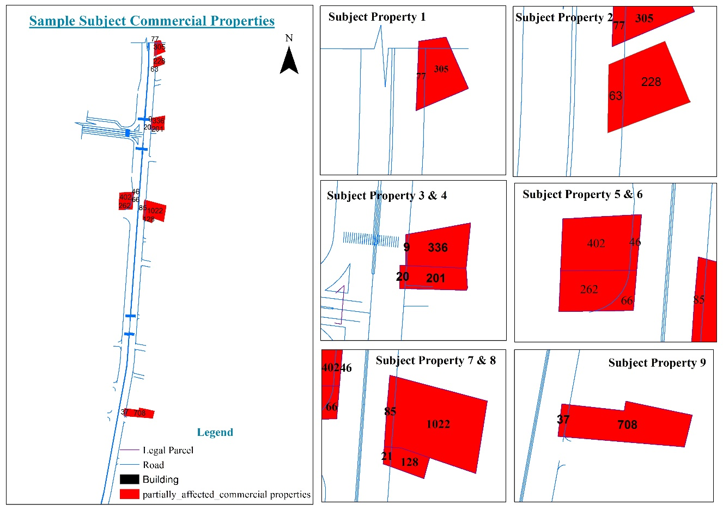

Figure 4legal parcel of subject properties with part taken area
On the other hand, it has been tried to check the terrain of the parcel using GIS slope analysis and suitability analysis. For this purpose, standards have been used to conduct suitability analysis for commercial or business development. In this regard the criteria used are as followed.
- Suitable slope usually under 2-8%.
- Corridors with in 50m depth from the road.
- Close to two major arterials, near centers of traffic and as far as along the road sides, peak flow of traffic and pedestrians were retail, professional, financial and related services can be conveniently accommodated and made easily accessible.
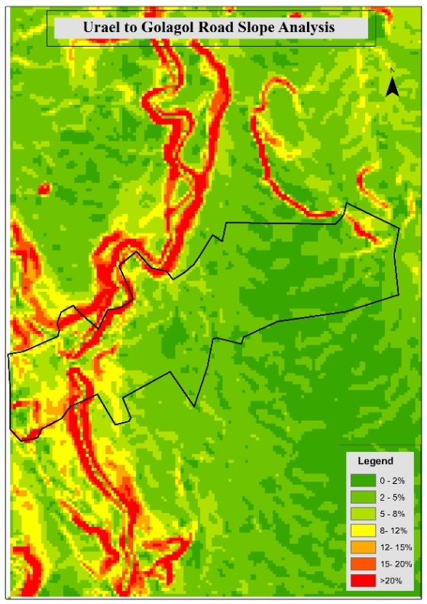
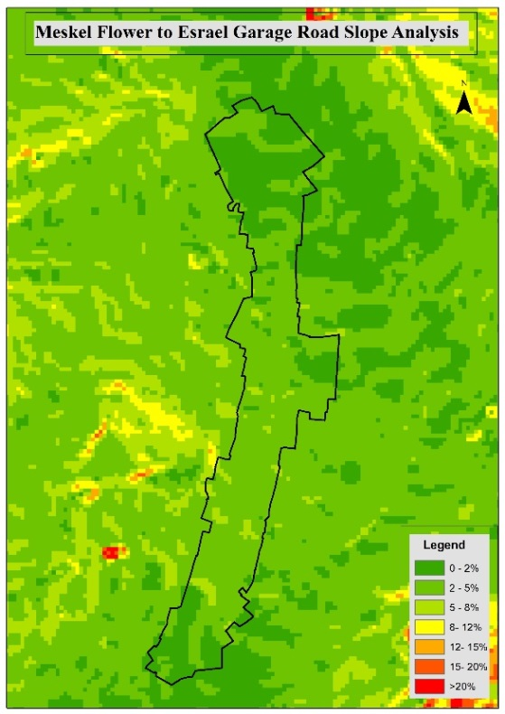
In this process the first step was to make the slope analysis. So first the slope analysis had been made using GIS. Then with the same software tool called raster calculator the slope within the range of 2-8% had been identified. Similarly, with same procedure the area within 50m has been identified and overlaid on the slope identified as 2-8%. Finally, after analyzing the criteria’s independently and overlaid the physical possibility of the case areas has been confirmed. The procedure is illustrated using GIS Model builder on figure 6 & 7.

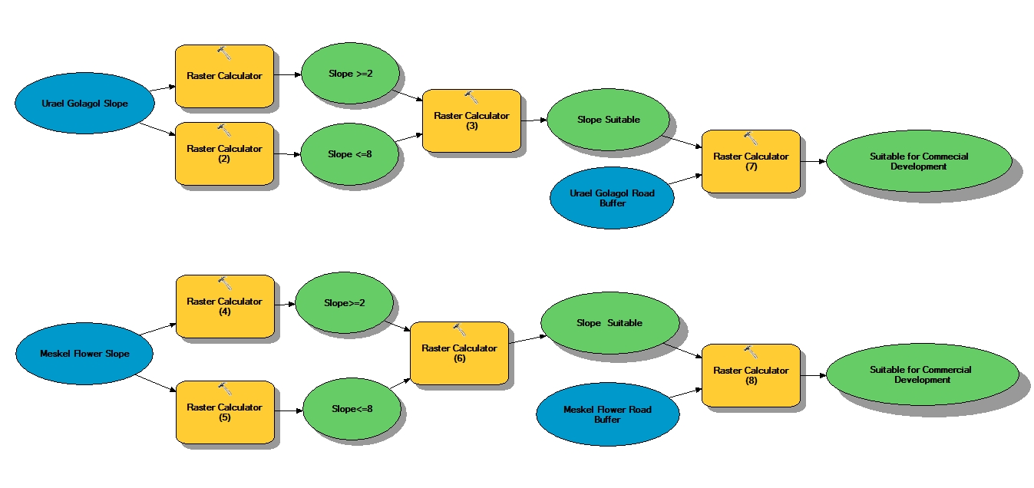
Figure 5 slope analysis

Figure 6- suitability model for meskel flower to esrael garage road

Figure 7- suitability for urael to golagol road
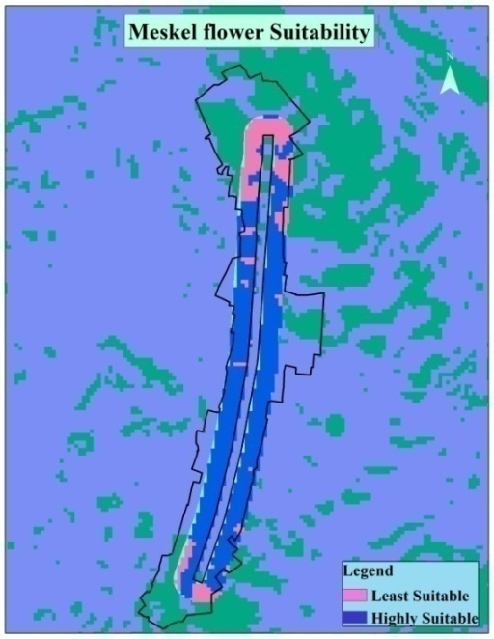
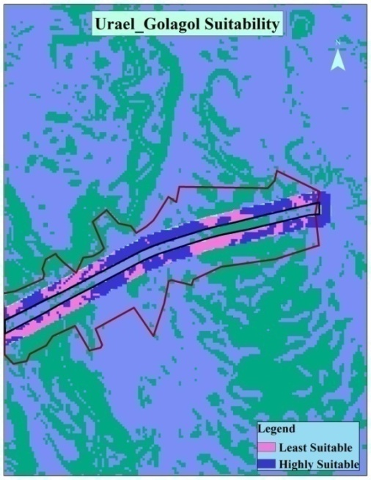

Figure 8- suitability for meskel flower
to esrael garage road
Figure 9- suitability for urael to golagol road

Therefore, from the analysis the study found out that the subject area is suitable for commercial/ business development. Specifically, from the 10 subject properties it is 9 of the subject properties that are physically possible in the before and after condition. Because as it has been tried to explain above the size of one subject property is not suitable for commercial development.
  - Legally permissible—conforming to zoning, building codes, private restrictions, environmental regulations, and other governmental controls (e.g. leases)?
To see this, it has been tried to review the Addis Ababa structural plan 2002 GC, since it was the active plan at the time of the taking. Therefore, based on this the general land use assigned for the study area was existing mixed residence. This implies according to the plan business activities that are compatible with residential development are allowed on this area. Other than one subject property that doesn’t full fill the minimum requirement for commerce and related development based on the above illustration, the other 9 subject properties have no restrictions. Therefore, commercial development on 9 of the subject properties is legally permissible.
Economic/financial Feasibility: For the purpose of analyzing the Economic/financial feasibility of the subject properties it was difficult to find the required data as the procedure needs. But as a criterion for determining the highest and best use of a property it is said that one can consider the existing use of the property, potential benefits of ownership, the market’s behavior, community or environmental factors, and special conditions or situations. Based on this when we see the general characteristics of the sample area indicates that different business activities like hotels, office complex, Bank and Insurance, café & restaurant, whole and retail activities.
At the same time the case areas are near to the CBD of the city. As its been tried to assess, according to the classification of previous structural plan the city of Addis Ababa has been assumed to have three categories of centers which are city main center, Major sub center and Minor sub center. In this case the sample case study areas are found near to the main city center. Since both areas are found along the main road, makes it directly accessible to the main city center and develop rapidly creating a vibrant environment.
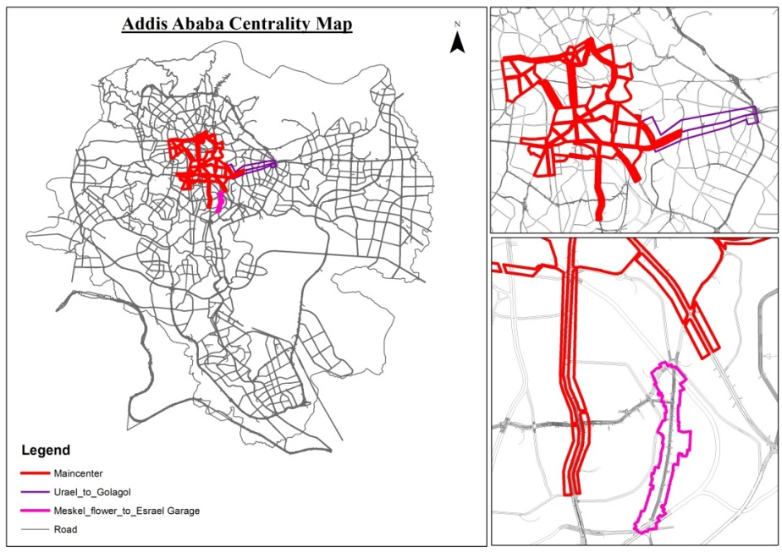

Figure 10- centrality map

On the other hand, the area is characterized by new emerging buildings for rental purpose. This as stated by (Access Capital, 2010) report Kirkos sub city is one of the leading sub city on issuance of building permit for commercial purposes. Therefore, though it is not a strong prove it can be concluding that the selected commercial properties are economically feasible.

Determining Larger parcel
As the findings of the reviews indicate determining the larger parcel is the basic procedure to follow in determining value for part taken. In determining the larger parcel there are three foundational requirements established by the courts in defining the larger parcel, (Sevelka, 2003). These are Unity of ownership, Unity of contiguity and Unity of use (highest and best use). Based on these criteria it has been tried to determine the larger parcel of the subject properties. Therefore, determining the value of the strip from the market value of the total parcel became essential because, there is no price on the market for that specific strip of land taken from the total.
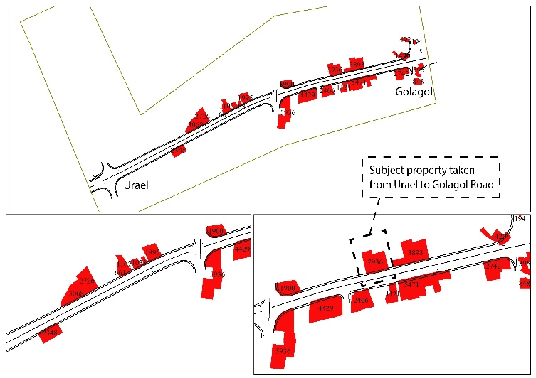
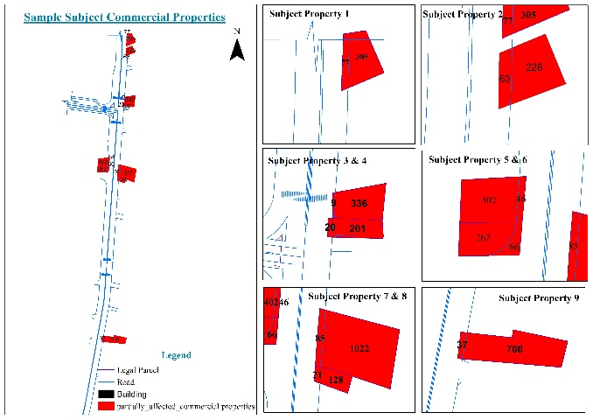
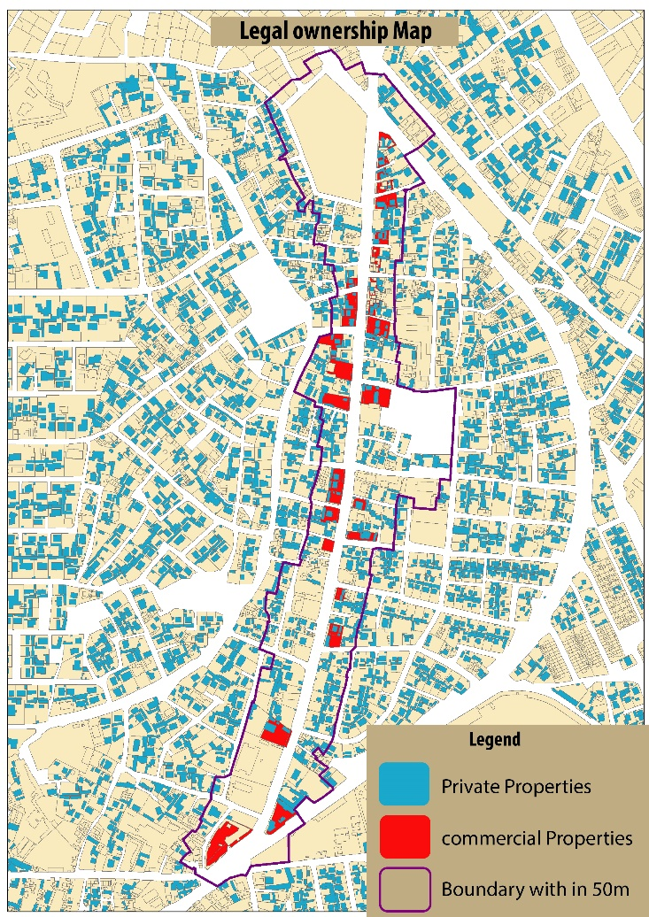
When we interpret this to the context, in Addis Ababa it is 1988 and 1997 satellite taken maps that considered legal to determine the legal boundaries of ownership by the city land administration. Therefore, for the purpose of this study in determining the larger parcel, ownership and the legal 1988 and 1997 satellite maps are used.

Figure 11- ownership map Figure 12- legal boundaries of subject properties
One criterion for determining the larger parcel is to determine the legal boundary of a property. As the findings indicate for Addis Ababa’s context the possibility of using this procedure as formal standard procedure is high. Because as it has been tried to mention above the appraisal procedure can use the legal parcel to determine the larger parcel. At the same time people are also dividing and amalgamating their plots because of their own reasons. This is also based on the 1988 satellite map. The 1988 satellite map as the administrators call it 1988 GIS, a legal document that can indicate clearly the legal boundaries of one’s property. Therefore, whether people divide or merge parcels they use the 1988-line map. Through time the requirement of determining larger parcel for both partial and total taking going to be an inevitable procedure to follow. As an example we can take Axum hotel which is one of the subject properties taken for this study purpose. This subject property legally using four parcels together. So based on the standard valuation method the larger parcel of this subject property considered to be the four of them together. But during interviews with one of the experts in the sub city urban development and renewal office it is only the property on one of the parcels considered to determine value for the part taken. Which is wrong based on the partial taking valuation standard procedure.
Therefore, for this study purpose all of the three criteria’s of determining the larger parcel are used; unity of use, proximity and ownership are used. For unity of use it is checked that all properties individually are being functioning for the same use. That is for business related function. On the other hand, in considering proximity as it has been tried to mention above legally different parcels functioning for the same use and owned by a single owner has been considered as legal parcel. One of the subject properties taken from Urael Golagol road, which is Axum Hotel, indicates this situation. Legally four parcels area merged together for same function. The last criterion to check to determine the larger parcel is Ownership. So it is confirmed that all the sample case subject properties are privately owned, because compensation is only given for privately owned properties.

Damages
by damage we understand every loss or diminution of what is a man's own, occasioned by the fault of another (Henry Campbell Black, 1990). On the other hand, (Guidlines for Appraisers, 2004) States that Depending on the type of acquisition and the availability of data, the appraiser may pursue the estimate of damages “directly” or “indirectly”. “Direct” measurement of damages can be accomplished through analysis of “matched pair” sales, capitalization of rent loss, or cost-to-cure analysis to include administrative charges.The “indirect” measurement of damage is a complete “before” and complete “after” appraisal of the property. For this study purpose it has been tried to select out the compensable damages selected out from (Uniform Appraisal Standards for Federal Land Aquisition, 2016) and tried to assess the subject properties based on these criteria.
Basically based on the above appraisal standard there are elements that have an effect on the value of a property. These are availability of utilities, parking, topography, accessibility and road frontage, type and quality of construction and landscaping. To determine damage, the change of this elements in the before and after condition, has been considered. Though there were data limitations, to find the data in the before condition, it has been tried to fulfill the data by asking the people/users, property owners and brokers who were there in the before and after condition. For additional information it has been tried to use website photos that show the before condition. Similarly, For analysis purpose, because of data limitations, to show the extent of damages and quantify it, subjective or indirect method has been used by giving weight for each affecting elements mentioned above. This procedure is used by banks for the purpose of calculating depreciation. Therefore by using elements from (Uniform Appraisal Standards for Federal Land Aquisition, 2016) it has been tried to collect factual data regarding each subject property.
On the other hand, to Determine the damage qualitatively in percentage form each element identified has been given wait based on the contribution this element have considering the owners think worthy. The property owner’s opinion used for giving weight is perceived indirectly from the discussions during filing the questionnaire and observations. For instance, parking can be taken. From the 10 case subject properties 8 of them didn’t prepared space for parking. Even if there is space for parking it not as much us the property use requires. Which indicate that though by principle parking considered basic for commerce and business related properties those property owners on the case areas didn’t consider it beneficial. But in developed countries with available market data they use different means to determine the damage on parking.
Based on an article entitled (Parking Study; an outline, 1990) there are factors that can be analyzed to measure the loss in value because of parking loss during partial taking. These factors are Rental Rates, Vacancy Rates, Tenant Mix, and Highest and best use changes and Sales and Resale of competitive properties. Therefore, since the issue of parking by itself it an independent issue recommended further study, for this study purpose it is preferred to give weight as it has been tried to reason out above. Considering this the study analyzed the damage as illustrated bellow one by one.
On the other hand, as the Ethiopian law sanctions compensation only for improvements on land, for this study purpose the functional utility lost only take in to consideration of the built space (structure) on the land that explained below as a floor area.

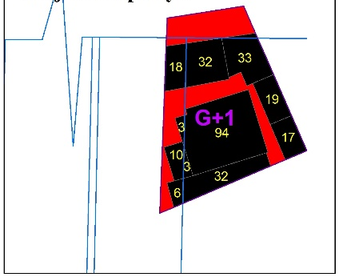
Subject one According to the factual data from the field in the before condition subject property ones’ utilities were fully available and it had no parking. Its topography was even with the road with a fair drainage. It had good accessibility and road frontage. Its type and quality of construction was fair with poor landscaping
Then After the taking subject property, one’s utilities, topography, parking and accessibility and road frontage had no change. But its type and quality of construction, and Landscaping had been altered. In addition, the functional utility of improvement diminished by 11%. Which means the remaining utility is 89%. Because in the before condition total floor area was 364 then after it become 325.
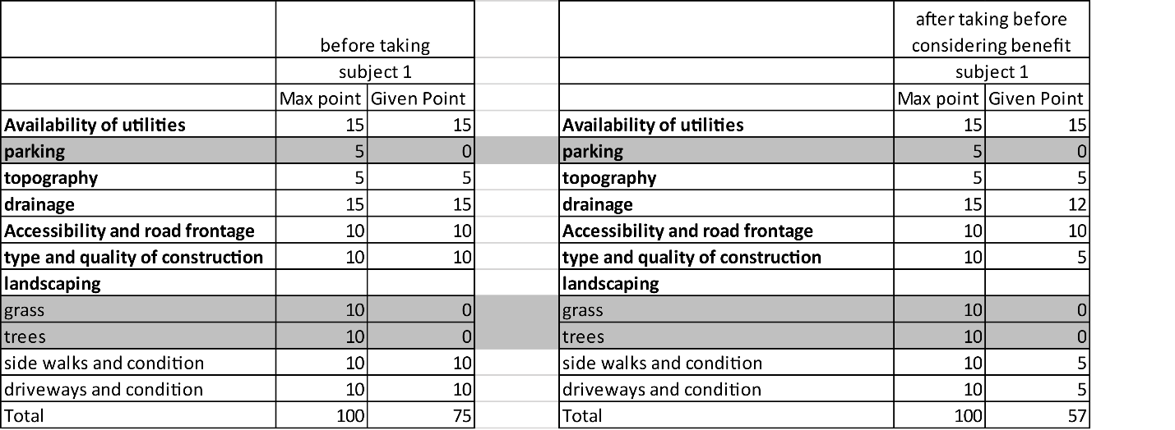

Table 4 - subject property 1 extent of damage
As it has been tried to explain in the above explanation subject one has no parking and landscaping (trees and grass). Which means during calculation for damage these factors remains constant. Therefore, subject one is evaluated from 75 from the given weight for the elements to measure damage. Because the factor that didn’t exist in the before condition never expected to be there in the after condition. So from the factors that was there to consider in the before condition the drainage, the type and quality of construction, sidewalk and driveway condition has been altered at the time of the taking. Based on this, giving weight for these loss it is concluded that from 75 in the before condition subject one got 57 in the after condition. Based on this when we convert this to 100%, 75 in the before condition means the factors were there 100%. In the after condition it become 57 means the remaining utility become 76%.
Having this, in the above statements it has been said that in the after condition 11% of the floor area of the property has been lost permanently. Which means the remaining functional utility of the property is 89%. Therefore, the total remaining utility considering the above factors and the permanently lost functional utility is ((76%+86%)/2). As a result, the remaining utility considering only damage becomes 83%.
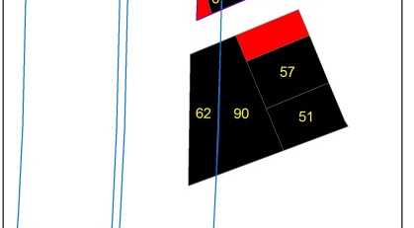
Subject two: Subject twos’ factual data is almost the same with subject one except the diminution in functional utility in the after condition. So in the before condition subject property two utilities were fully available and it had no parking. Its topography was even with the road with a fair drainage. It had good accessibility and road frontage. Its type and quality of construction was fair with poor landscaping.
Then After the taking subject property Twos’ utilities, topography, parking and accessibility and road frontage had no change. But its type and quality of construction, and Landscaping had been altered. In addition, the functional utility of improvement diminished by 24%. Which means the remaining utility is 76%. Because in the before condition total floor area was 260 then after it become 197.

Table 5 subject property 2 extent of damage
Similar to subject one, subject two had no parking and landscaping (trees and grass). Which means during calculation for damage these factors remains constant. Therefore, as it has been tried to reason out for subject one, subject two is evaluated from 75 from the given weight for the elements to measure damage. So from the factors that was there to consider in the before condition that are drainage, the type and quality of construction, and sidewalk and driveway condition has been altered at the time of the taking. Based on this, giving weight for these loss it is concluded that from 75 in the before condition subject two got 57 in the after condition. Converting this to a percentage of 100%, 75 in the before condition means the factors were there 100%. In the after condition it become 57 means the remaining utility become 76%.
Having this, in the above statements it has been said that in the after condition 24% of the floor area of the property has been lost permanently. Which means the remaining functional utility of the property is 76%. Therefore, the total remaining utility considering the above factors and the permanently lost functional utility is ((76%+76%)/2). As a result, the remaining utility considering only damage becomes 76%.
As the factual data indicate these elements used to measure the extent of damage before considering benefit are in a similar situation in most of the case subject properties. But it’s the extent of the taking which is the functional utility that brings variation in the damage. Therefore, it’s necessary to take in to consideration of this situation for this analysis.
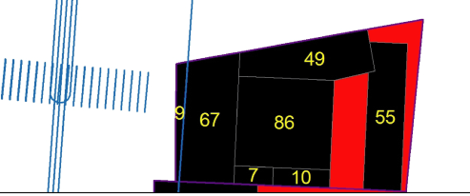
Subject three: for this subject property too, utilities were fully available and it had no parking. Its topography was even with the road with a fair drainage. It had good accessibility and road frontage. Its type and quality of construction was fair with poor landscaping.
Then After the taking subject property, three’s utilities, topography, parking and accessibility and road frontage had no change. But its type and quality of construction, and Landscaping had been altered. In addition, the functional utility of improvement diminished by 3%. Which means the remaining utility is 97%. Because in the before condition total floor area was 283 then after it become 274.
As it is explained above subject three has no parking and landscaping (trees and grass). Which means during calculation for damage these factors remain constant. Therefore, subject three is evaluated from 75 from the given weight for the elements to measure damage. So the factors that were there to consider in the before condition, are the drainage, the type and quality of construction, sidewalk and driveway condition has been altered at the time of the taking. Based on this, giving weight for these loss it is concluded that from 75 in the before condition subject three got 57 in the after condition. Converting this to a percentage of 100%, 75 in the before condition means the factors were 100% there. In the after condition it become 57 means the remaining utility become 76%.
Having this, in the above statements it has been said that in the after condition 3% of the floor area of the property has been lost permanently. Which means the remaining functional utility of the property is 97%. Therefore, the total remaining utility considering the above factors and the permanently lost functional utility is ((76%+97%)/2). As a result, the remaining utility considering only damage becomes 87%.
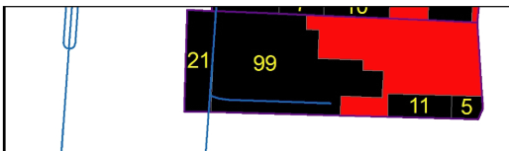
Subject four: for this property too utilities were fully available and it had no parking. Its topography was even with the road with a fair drainage. It had good accessibility and road frontage. Its type and quality of construction was fair with poor landscaping
Then After the taking subject property, fours’ utilities, topography, parking and accessibility and road frontage had no change. But its type and quality of construction, and Landscaping had been altered. In addition, the functional utility of improvement diminished by 15%. Which means the remaining utility is 85%. Because in the before condition total floor area was 135 then after it become 115.
The factors that were there to consider in the before condition, that area the drainage, the type and quality of construction, sidewalk and driveway condition has been altered at the time of the taking. Based on this, giving weight for these loss it is concluded that from 75 in the before condition subject four got 57 in the after condition. Based on this when we convert this to 100%, 75 in the before condition means the factors were there 100%. In the after condition it become 57 means the remaining utility become 76%.
Above it has been said that in the after condition 15% of the floor area of the property has been lost permanently. Which means the remaining functional utility of the property is 85%. Therefore, the total remaining utility considering the above factors and the permanently lost functional utility is ((76%+85%)/2). As a result, the remaining utility considering only damage becomes 81%.
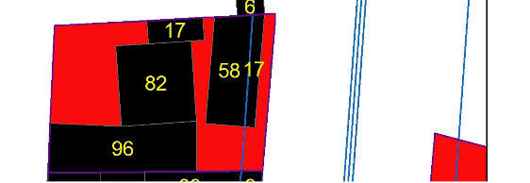
Subject five for this subject property also utilities were fully available and it had no parking. Its topography was even with the road with a fair drainage. It had good accessibility and road frontage. Its type and quality of construction was fair with poor landscaping.
Then After the taking subject property, fives’ utilities, topography, parking and accessibility, and road frontage had no change. But its type and quality of construction, and Landscaping had been altered. In addition, the functional utility of improvement diminished by 6%. Which means the remaining utility is 94%. Because in the before condition total floor area was 269 then after it become 253.
From the factors that were there to consider in the before condition, the drainage, the type and quality of construction, sidewalk and driveway condition has been altered at the time of the taking. Based on this, giving weight for these loss it is concluded that from 75 in the before condition subject five got 57 in the after condition. Based on this when we convert this to 100%, 75 in the before condition means the factors were there 100%. In the after condition it become 57 means the remaining utility become 76%.
As indicated above in the after condition 6% of the floor area of the property has been lost permanently. Meaning the remaining functional utility of the property is 94%. Therefore, the total remaining utility considering the above factors and the permanently lost functional utility is ((76%+94%)/2). As a result, the remaining utility considering only damage becomes 85%.
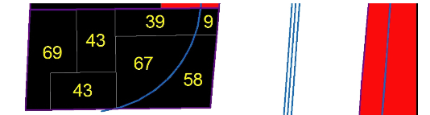
Subject six in the before condition its utilities were fully available and it had no parking. Its topography was even with the road with a fair drainage. It had good accessibility and road frontage. Its type and quality of construction was fair with poor landscaping.
Then After the taking subject property, sixs’ utilities, topography, parking and accessibility and road frontage had no change. But its type and quality of construction, and Landscaping had been altered. In addition, the functional utility of improvement diminished by 20%. Which means the remaining utility is 80%. Because in the before condition total floor area was 329 then after it become 263.
Therefore, the factors that were considered normal in the before condition, the drainage, the type and quality of construction, sidewalk and driveway condition has been altered at the time of the taking. Based on this, giving weight for these loss, it is concluded that from 75 in the before condition subject six got 57 in the after condition. Based on this when we convert this to 100%, 75 in the before condition means the factors were there 100%. In the after condition it become 57 means the remaining utility become 76% from 100%.
As indicated above in the after condition 20% of the floor area of the property has been lost permanently. Which means the remaining functional utility of the property is 80%. Therefore, the total remaining utility considering the above factors and the permanently lost functional utility is ((76%+80%)/2). As a result, the remaining utility considering only damage becomes 78%.

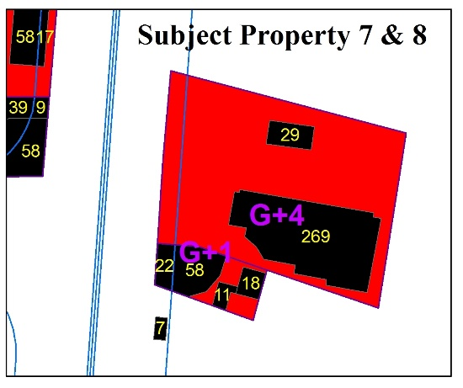
Subject seven different from the above properties the factual data of subject seven indicate that the seven elements, utilities, parking, topography, Drainage, accessibility and road frontage, type and quality of construction, and landscaping has to be considered. Therefore, in analyzing the before condition all of them are considered.
Then after the taking from all the elements considered subject property sevens’ Drainage, sidewalk and Driveway condition was altered. But the functional utility of improvement is not affected. As it has been explained in the above statements in Ethiopian context as compensation is for properties on the land, this study considered only the built space as functional utility. Which means the remaining utility is 100%. Because in the before condition total floor area was 1374 and after nothing has taking from it.
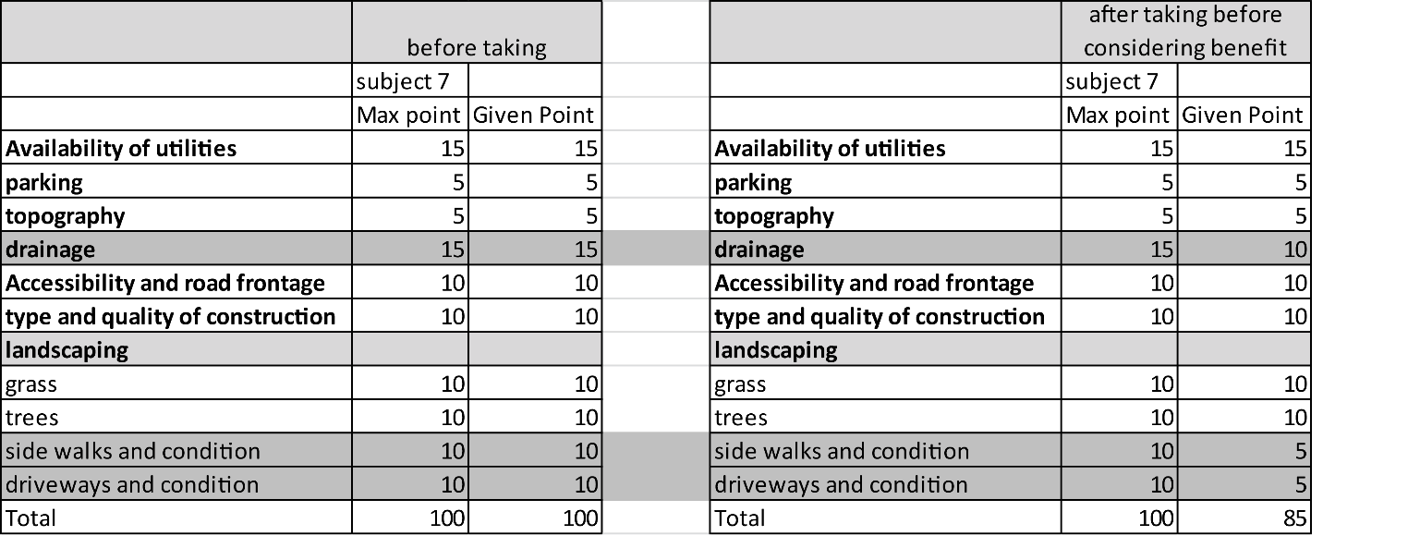
Table 6 subject property 7 extent of damage
As it is explained above for subject 7 all the elements are taken in to consideration. Therefore, subject one is evaluated from 100% from the given weight for the elements to measure damage. So after the taking from all the elements considered, subject property sevens’ Drainage, sidewalk and Driveway condition was altered. Based on this, giving weight for these loss it is concluded that from 100% in the before condition subject seven got 85% in the after condition.
Having this, in the above statements it has been said that in the after condition subject seven lost none of its built property permanently. Which means the remaining functional utility of the property is 100%. Therefore, the total remaining utility considering the above factors and the permanently lost functional utility is ((76%+100%)/2). As a result, the remaining utility considering only damage becomes 93%.
Subject eight the factual data of subject eight indicate that the six elements, utilities, topography, Drainage, accessibility and road frontage, type and quality of construction, and landscaping (sidewalk and driveway condition) has to be considered. Therefore, in analyzing the before condition all of these are considered.
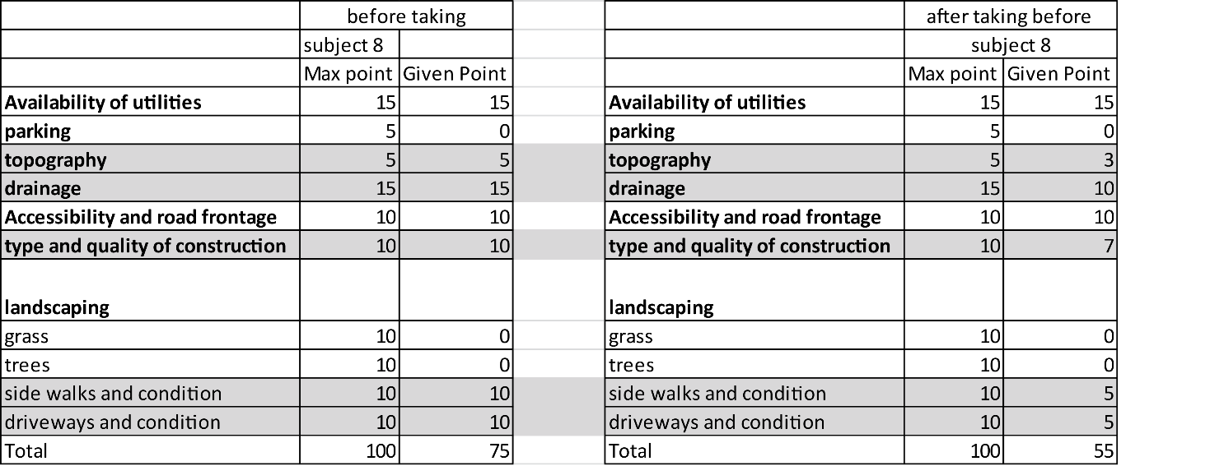
Then after the taking from all the elements considered subject property eights’ topography, Drainage, Type and quality of construction, and Landscaping (sidewalk and Driveway condition) was altered. In addition, the functional utility of improvement diminished by 22%. Which means the remaining utility is 78%. Because in the before condition total floor area was 187 then after it become 145.

Table 7 subject property 7 extent of damage
Therefore, the factors that were considered normal in the before condition, the topography drainage, the type and quality of construction and Landscaping (sidewalk and driveway condition), has been altered at the time of the taking. Based on this, giving weight for these loss, it is concluded that from 75 in the before condition subject eight got 55 in the after condition. Converting this to 100%, 75 in the before condition means the factors were there 100%. In the after condition it become 55 means the remaining utility become 73%.
As indicated above in the after condition 22% of the floor area of the property has been lost permanently. Which means the remaining functional utility of the property is 78%. Therefore, the total remaining utility considering the above factors and the permanently lost functional utility is ((73%+78%)/2). As a result, the remaining utility considering only damage becomes 76%.

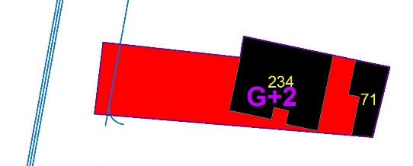
Subject nine: this is the other property similar with subject seven except that in subject property nine from the seven elements six of them are considered since it has no parking before the taking. Therefore, utilities, topography, Drainage, accessibility and road frontage, type and quality of construction and landscaping (only trees, sidewalk and driveway condition) are considered.
Then after the taking from all the elements considered subject property nines’ Drainage, sidewalk and Driveway condition was altered. But the functional utility of improvement is not affected. Similar to subject seven in Ethiopian context as compensation is for properties on the land, this study considered only the built space as functional utility. Which means the remaining utility is 100%. Because in the before condition total floor area was 773 and after nothing has taking from it.
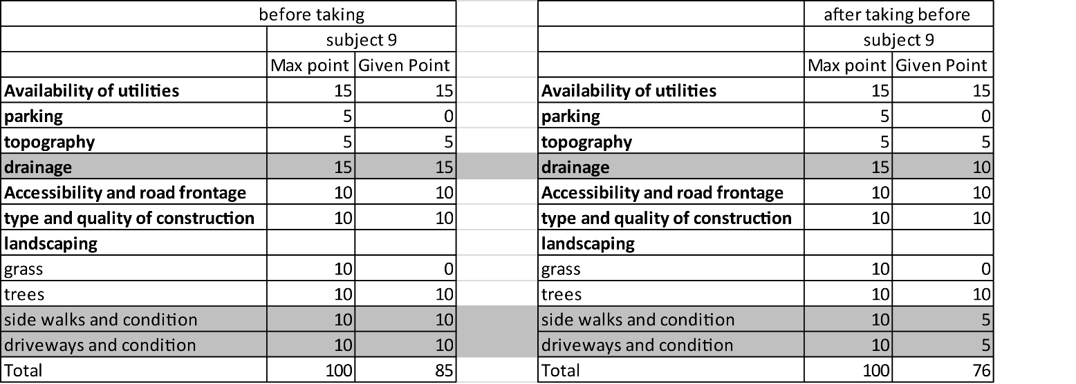
Table 8- subject property 9 extent of damage
As it is explained above for subject nine only 6 elements are taken in to consideration. Therefore, subject one is evaluated from 85 from the given weight for the elements to measure damage. Because the factor that didn’t exist in the before condition never expected to be there in the after condition. So from the factors that was there to consider in the before condition the drainage, sidewalk and driveway condition has been altered at the time of the taking. Based on this, giving weight for these loss it is concluded that from 85 in the before condition subject nine got 76 in the after condition. Based on this when we convert this to 100%, 85 in the before condition means the factors were there 100%. In the after condition it become 76 means the remaining utility become 89%.
Having this, in the above statements it has been said that in the after condition subject nine lost none of its built property permanently. Which means the remaining functional utility of the property is 100%. Therefore, the total remaining utility considering the above factors and the permanently lost functional utility is ((89%+100%)/2). As a result, the remaining utility considering only damage becomes 95%.
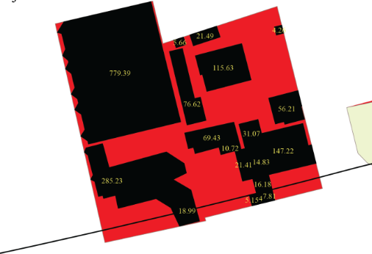
Subject ten similar to the above factual data of subject seven, the seven elements; utilities, parking, topography, Drainage, accessibility and road frontage, type and quality of construction, and landscaping are considered in analyzing subject ten.
Then after the taking from all the elements considered subject property tens’ Drainage, Accessibility and road frontage, type and quality of construction and Landscaping (Grass, Trees, sidewalk and Driveway condition) was altered. In addition, the functional utility of improvement diminished by 3%. Which means the remaining utility is 97%. Because in the before condition total floor area was 8820 then after it become 8562.
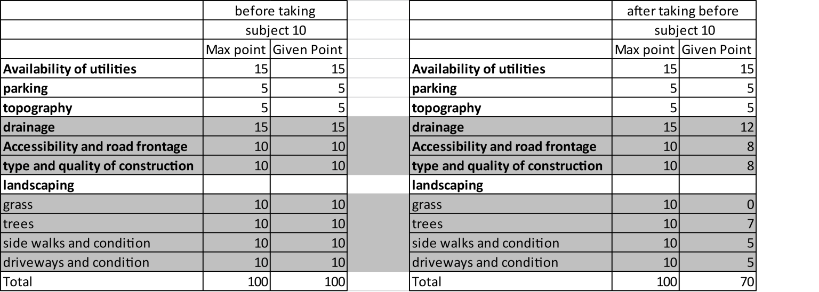
Table 9- subject property 10 extent of damage
Since all the elements are taken in to consideration, subject one is evaluated from 100% from the given weight for the elements to measure damage. So after the taking from all the elements considered; Drainage, Accessibility and road frontage, type and quality of construction and Landscaping (Grass, Trees, sidewalk and Driveway condition) was altered. Based on this, giving weight for these loss it is concluded that from 100% in the before condition subject seven got 70% in the after condition. In addition, it has been said that in the after condition subject ten has lost 3% of its functional utility permanently. Which means the remaining functional utility of the property is 97%. Therefore, the total remaining utility considering the above factors and the permanently lost functional utility is ((70%+97%)/2). As a result, the remaining utility considering only damage becomes 84%.

Benefits
As the findings of the reviews indicate, if the owners’ remainder property increases in value as a result of the project, the owner has been benefited and compensation may be modified by offsetting the benefits against any damages previously determined by the appraiser. So considering benefits as a part of partial land acquisition the study has tried to assess the special benefits that the subject properties has got from the road project. Similar to the process used for determining damages, subjective or indirect method has been used by giving weight for each factors affecting value. Here to identify the difference a method of increasing value for the factors that changed after acquisition and leaving the unchanged factors as they were before is used. Therefore, based on this remaining utility considering benefit is determined for each subject property.
Considering only the seven elements/factors affecting value, four of subject case properties reveal the same result. But since the extent of the taking on these four properties is different, the remaining functional utility brings variation on their final result of remaining benefit. Therefore, the percentage of the calculated remaining benefit will be used to analyze the benefit in the before and after analysis

Subject one
During the taking subject ones’ Drainage, type and quality of construction, and Landscaping had been altered. But after the taking and the completion of the project these damages were improved partially and full. That means the drainage, and the type and quality of construction are somehow improved. But the landscaping considering the sidewalk and drive way condition is much more improved from the before condition. The table below indicates the weight given for the improvement.
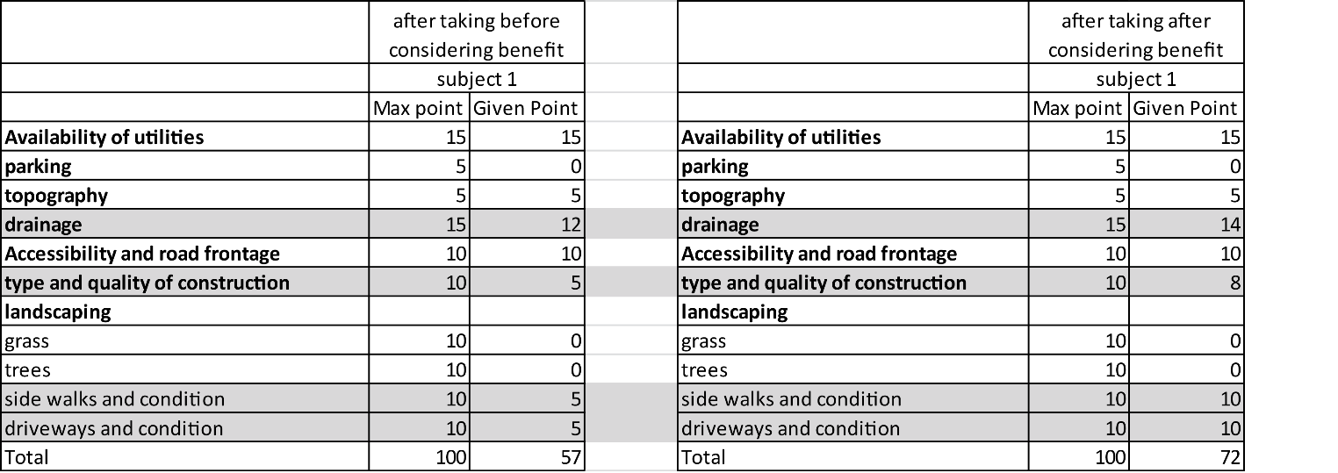

Table 10 subject 1 extent of benefit
As the table indicates the Drainage, type and quality of construction, and Landscaping (sidewalk and driveway condition) has been improved. Which means from 57 as indicated on the damage analysis part it become 72 out of 75% values. When we convert this to 100%, 57% in the before condition means, the remaining utility based on the elements considered is 76% out of 100% and the value given 72 out of 75 becomes 96% out of 100.
On the other hand, as the increased value for the factors that changed after acquisition was considered to calculate benefit, the permanently lost functional utility also taken in to consideration. So as indicated in the damage analysis in the after condition 11% of the floor area of the property has been lost permanently. Which means the remaining functional utility of the property is 89%. Therefore, the total remaining utility considering benefit is and the permanently lost functional utility is ((96%+89%)/2). As a result, the remaining utility considering benefit becomes 93%.

Subject two
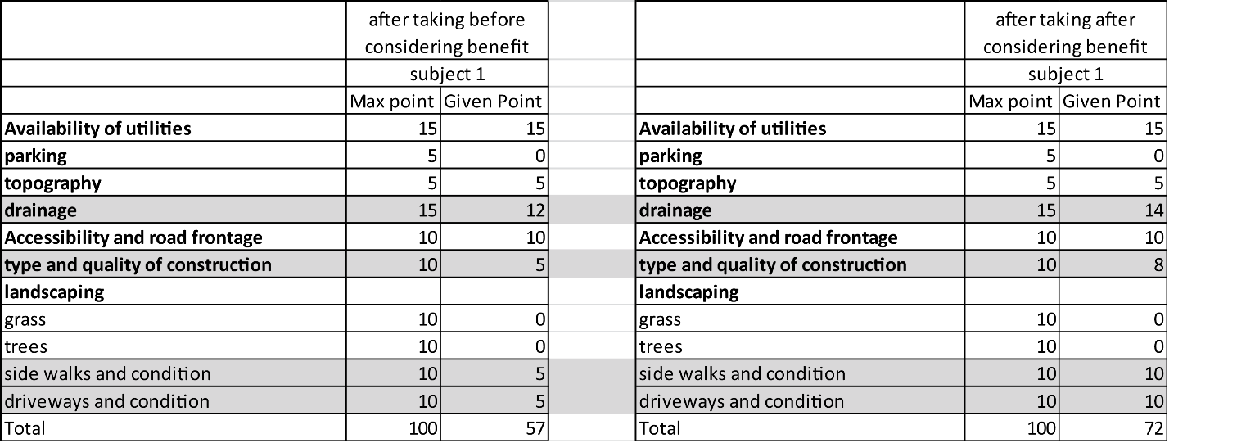
Similar to subject one, during the taking subject twos’ Drainage, type and quality of construction, and Landscaping had been altered and after the taking and the completion of the project, these damages were improved partially and full. That means the drainage, and the type and quality of construction are improved. But the landscaping considering the sidewalk and drive way condition is much more improved from the before condition. The table below indicates the weight given for the improvement.

Table 11- subject two extent of benefit
As the table indicates the Drainage, type and quality of construction, and Landscaping (sidewalk and driveway condition) has been improved. Which means from 57 as indicated on the damage analysis part it become 72 out of 75% values. When we convert this to 100%, 57% in the before condition means, the remaining utility based on the elements considered is 76% out of 100% and the value given 72 out of 75 becomes 96% out of 100.
As mentioned above to calculate the remaining utility considering benefit, as it is necessary to consider the improvements in the before and after condition, the permanent loss also need to be determined. So as indicated in the damage analysis in the after condition subject two lost 24% permanently from its floor area. Which means the remaining functional utility of the property is 76%. Therefore, the total remaining utility considering benefit is and the permanently lost functional utility is ((96%+76%)/2). As a result, the remaining utility considering benefit becomes 86%.

Subject three
Similarly, subject threes’ Drainage, type and quality of construction, and Landscaping had been altered during the taking. But after the taking and the completion of the project these damages were improved. For this improvement weight has given which is similar to the table indicated above for subject two above. In the after condition the weight given increased from 57 to 72, out of 75% values. Then this result out of 75 converted to 100% to bring consistency with the other properties evaluated from 100%. So 57% is 76% out of 100% and the value given 72 out of 75 becomes 96% out of 100%.
So as the explanation above, as the increased value for the factors that changed after acquisition has been considered to calculate benefit, the permanently lost functional utility also taken in to consideration. So as indicated in the damage analysis in the after condition 3% of the floor area of the property has been lost permanently. Which means the remaining functional utility of the property is 97%. Therefore, the total remaining utility considering benefit and the permanently lost functional utility is ((96%+97%)/2). As a result, the remaining utility considering benefit becomes 97%.
Subject four
Before getting in to the benefit analysis it is mentioned that the factors that are taken to measure the damage and benefit has the same effect for subject one to four. But the extent of the taking is different for all of them. Because of these reason and avoid redundancy here only the change in value going to be mentioned. Therefore, similar to subject one to three the remaining utility considering only damage 76%. But after the taking considering benefit it becomes 96%.
But since the permanently lost functional utility is different from the other three subject properties, subject fours’ permanently lost functional utility is taken independently. So as indicated in the damage analysis in the after condition 15% of the floor area of the property has been lost permanently. Which means the remaining functional utility of the property is 85%. Therefore, the total remaining utility considering benefit and the permanently lost functional utility is ((96%+85%)/2). As a result, the remaining utility considering benefit becomes 91%.

Subject five
In the before condition from the seven factors to be considered subject fives’ topography, drainage, type and quality of construction and landscaping (sidewalk and driveway condition) been altered. But after the taking and the completion of the project, the altered topography and type and quality of construction didn’t improve because, the project made the topography to remain below the street grade. On the other hand, its drainage and landscaping (sidewalk and driveway condition) is improved. The table below indicates the weight given for the improvement.
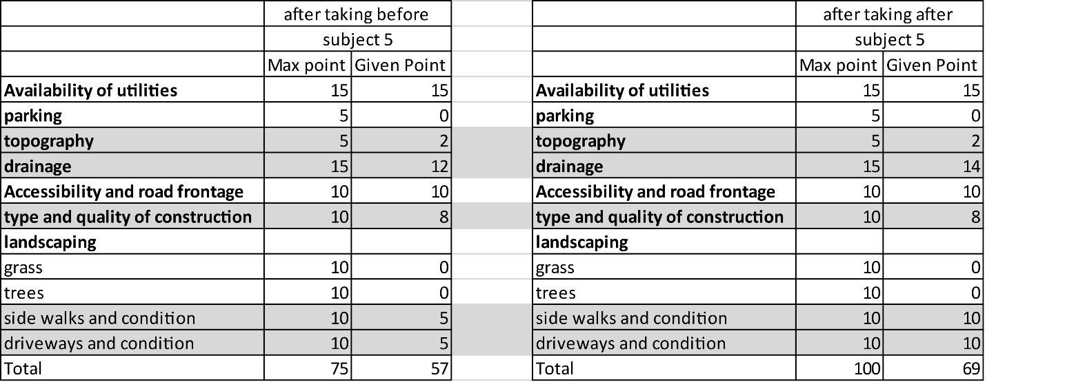

Table 12- subject 5 extent of benefit
As the table indicates, subject fives’ drainage and Landscaping (sidewalk and driveway condition) is improved. Because of this the result is improved from 57 out of 75 (76% out of 100%) to 69 out of 75 (92% out of 100).
When we come to the permanently lost utility, as indicated in the damage analysis in the after condition 6% of the floor area of the property has been lost permanently. Which means the remaining functional utility of the property is 94%. Therefore, the total remaining utility considering benefit is and the permanently lost functional utility is ((92%+94%)/2). As a result, the remaining utility considering benefit becomes 93%.
Subject six
Subject property sixes’ general situation is similar with subject five. Its topography, drainage, type and quality of construction and landscaping (sidewalk and driveway condition) been altered. But after the taking and the completion of the project, the altered topography and type and quality of construction didn’t improve because, the project made the topography to remain below the street grade. On the other hand, its drainage and landscaping (sidewalk and driveway condition) is improved. The table below indicates the weight given for the improvement.

Table 13- subject 6 extent of benefit
As the table indicates, subject sixes’ drainage and Landscaping (sidewalk and driveway condition) has been improved after the taking. Because of this the result is improved from 57 out of 75 (76% out of 100%) to 69 out of 75 (92% out of 100).
When we come to the permanently lost utility, as indicated in the damage analysis in the after condition 20% of the floor area of the property has been lost permanently. Which means the remaining functional utility of the property is 80%. Therefore, the total remaining utility considering benefit is and the permanently lost functional utility is ((92%+80%)/2). As a result, the remaining utility considering benefit becomes 86%.

Subject seven
In the before condition from the seven factors to be considered, drainage and landscaping (sidewalk and driveway condition) has been altered. After the taking and the completion of the project, the altered drainage and landscaping (sidewalk and driveway condition) has been improved. The table below indicates the weight given for the improvement.
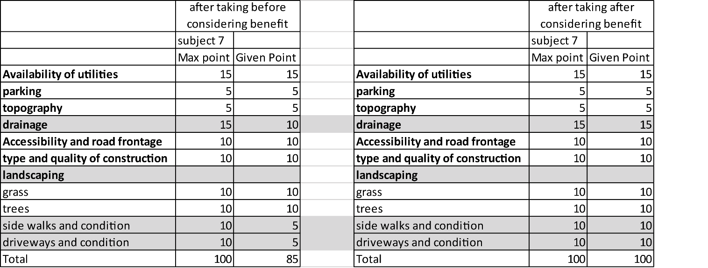
Table 14- subject 7 extent of benefit
As the table indicates, subject sevens’ drainage and Landscaping (sidewalk and driveway condition) is improved. So the result is improved from 85% out of 100% to 100% out of 100%. This implies the elements that were affected in the before condition is replaced to the condition they were before.
When we come to the permanently lost utility, as indicated in the damage analysis subject seven has lost noting permanently. Which means the remaining functional utility of the property is 100%. Therefore, the total remaining utility considering benefit is and the permanently lost functional utility is ((100%+100%)/2). As a result, the remaining utility considering benefit becomes 100%.

Subject Eight
In the before condition from the seven factors to be considered, subject property eights’ topography, Drainage, Type and quality of construction, and Landscaping (sidewalk and Driveway condition) has been altered. After the taking and the completion of the project, the altered drainage and landscaping (sidewalk and driveway condition) has been improved. But the topography, and type and quality of construction remained the same. The table below indicates the weight given for the improvement.
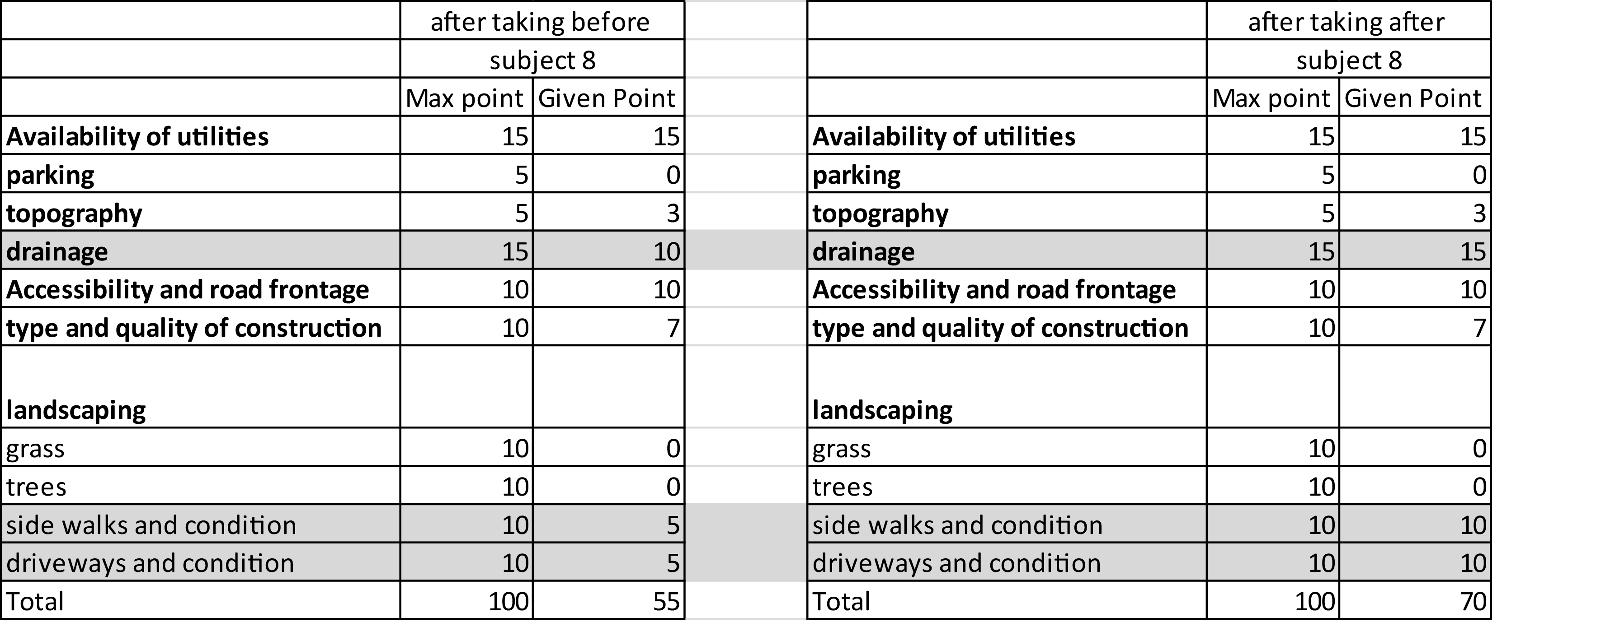
Table 15- subject 8 extent of benefit
As the table indicates, subject eights’ drainage and Landscaping (sidewalk and driveway condition) is improved. So the result is improved from 55% out of 75% (73% out of 100%) to 70% out of 75% (93% out of 100%). This implies half of the elements that were affected in the before condition was replaced to the condition they were before.
When we come to the permanently lost utility, as indicated in the damage analysis in the after condition 22% of the floor area of the property has been lost permanently. Which means the remaining functional utility of the property is 78%. Therefore, the total remaining utility considering benefit is and the permanently lost functional utility is ((93%+78%)/2). As a result, the remaining utility considering benefit becomes 86%.
Subject nine
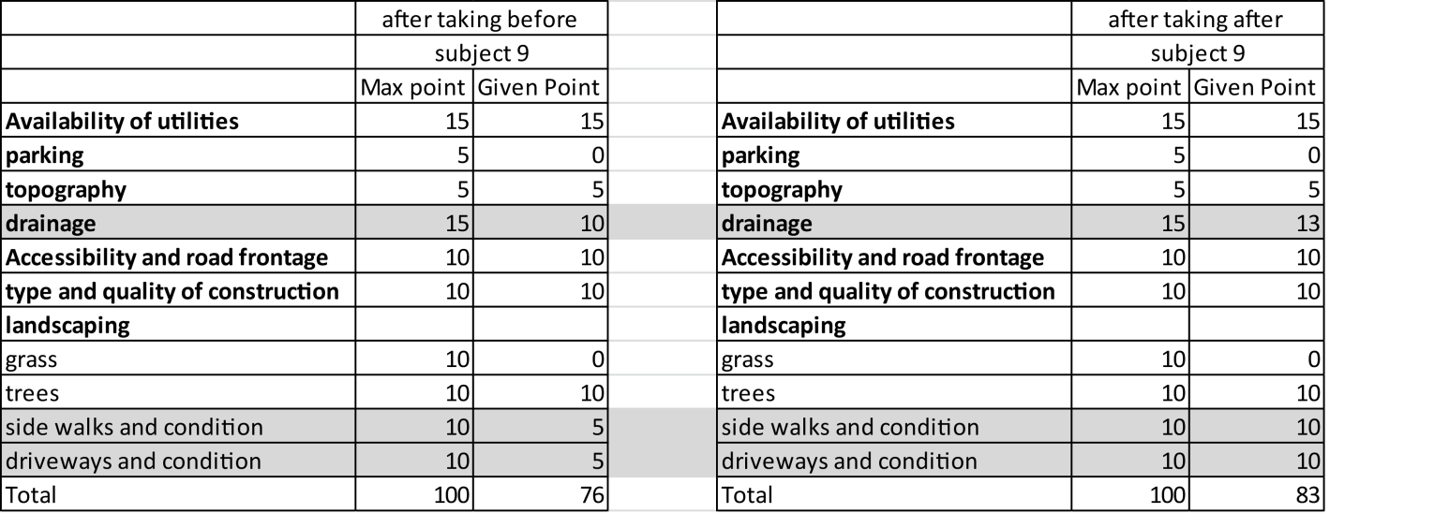
When it comes to subject nine, from the 6 factors to be considered subject nines’ drainage and landscaping (sidewalk and driveway condition) has been altered. But after the taking and the completion of the project, both of them have shown improvement. The table below indicates the weight given for the improvement.

Table 16- subject 9 extent of benefit
As the table indicates, subject nines’ drainage and landscaping (sidewalk and driveway condition) is improved. Because of this the result is improved from 76 out of 85 (89% out of 100%) to 83 out of 85 (98% out of 100).
When we come to the permanently lost utility, as indicated in the damage analysis subject seven has lost noting permanently. Which means the remaining functional utility of the property is 100%. Therefore, the total remaining utility considering benefit and the permanently lost functional utility is ((98%+100%)/2). As a result, the remaining utility considering benefit becomes 99%.

Subject ten
In the before condition from the seven factors to be considered subject tens’ drainage, Accessibility and road frontage, type and quality of construction, and landscaping (trees, sidewalk and driveway condition) has been altered. After the taking and the completion of the project, drainage and landscaping (sidewalk and driveway condition) are improved. But the altered Accessibility and road frontage, type and quality of construction, and landscaping (trees) affected permanently. The table below indicates the weight given for the improvement.
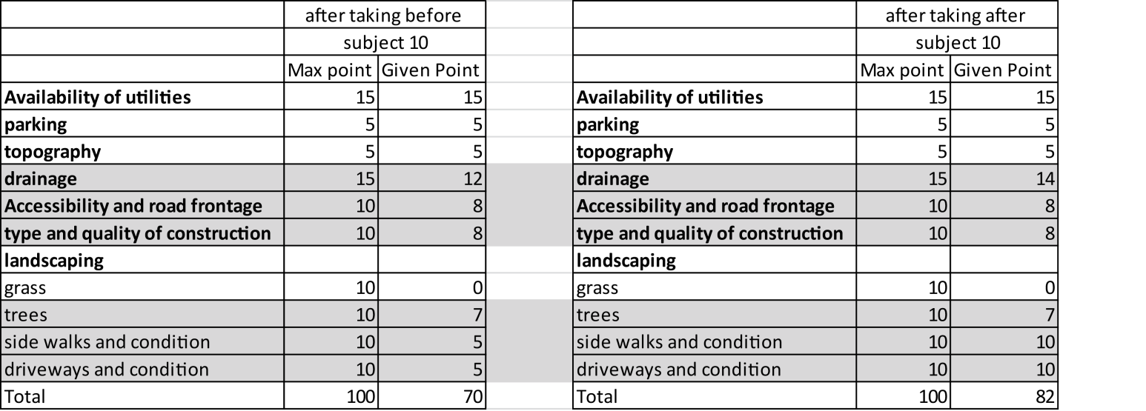
Table 17- subject 10 extent of benefit
As the table indicates, subject fives’ drainage and Landscaping (sidewalk and driveway condition) is improved. Because of this the result is 70% out of 100% to 82% out of 100.
When we come to the permanently lost utility, in the after condition 3% of the floor area of the property has been lost permanently. Which means the remaining functional utility of the property is 97%. Therefore, the total remaining utility considering benefit and the permanently lost functional utility is ((82%+97%)/2). As a result, the remaining utility considering benefit becomes 90%.

The choice and application of valuation method
On the reviews it is indicated that one or more approaches to value may be appropriate. It might even be necessary to the purpose of estimating a reliable market value. It is also stated that not every approach to value is appropriate for every valuation assignment. In the first place if there is an available comparable sale the most preferred valuation approach is sales comparison approach. If not with all efforts, it is appropriate to use one of the three valuation approaches available. As the findings of the interviews indicated that in Addis Ababa case whatever the use is, the standard valuation method used for compensation purpose is cost replacement approach.
In this regard since it is difficult to get comparable sales and the focus area of the study is on business properties for this study purpose income capitalization approach is used. As the reviews indicate in most cases this approach is relevant only in certain circumstances namely, in the valuation of income producing property with no available comparable sales. In using this approach 12% and 16% capitalization rate is applied based on the analysis made by Ethiopian banks association and bank manual. 16% cap rate is used for hotel subject property which is one of the sample subject properties taken. For the other 9 subject properties 12% cap rate is applied.
On the other hand, it also has been found out that for compensation purpose this valuation approach has to consider only income generated by the property itself (such as rental or royalty income). This rule is also applied for the purpose of this study. Only income which is gained from the subject properties is considered during valuation. Taking this in to consideration the study used direct capitalization techniques since it has been difficult to find three years’ incomes of properties.
On the other hand, for partial taking expropriation there are valuation principles to consider during valuation process. In this regard as it has been tried to review there are three valuation principles. These are principle of highest and best use, principle of consistent use and principle of contribution. Therefore, based on the analysis made above the highest and best use of the 9 of the properties is commerce both in the before and after condition. But since 1 of the property is not legally possible, its size is less than 150m², its highest and best use is banned for commercial and related uses.
On the other hand, on this study it has been tried to apply the principle of consistent use by valuing the property as a whole by Income Capitalization approach without detracting the land from the improvement on the land. This is because the right procedure indicated is when improved land is appraised, it cannot be appraised with one use allocated to the land and another to the building or improvements. But according to the legal frame work of Ethiopia land is owned by the public so it is not compensable. Compensation is only for the improvements on the land. But in whole taking cases a replacement land will be given. But when we come to the specific subject properties the rental price collected from the field indicate that the price is set for both the land and the improvement on the land. Therefore, Appling this principle was an unavoidable situation.
The other important principle to be considered in valuation of partial takings is the principle of contribution. The principle of contribution is based on the value of a particular component being measured by its contributory value to the property, or by the amount its absence detracts from the whole. This implies the value of the part taken is calculated by valuing the whole property and applying the unit value to the part taken. In this regard the findings of the assessments indicate that the valuation process doesn’t consider the contribution the part taken has for the whole property. But as it has been tried to review and analyze the Ethiopian system of compensation is based on the principle of substitution since it applies cost replacement approach. In general, in Ethiopia these three principles of valuation are not taken in to consideration during valuation of partial taking expropriation. On the other hand, the study followed the appraisal methods, principles and approaches to value the sample taken subject properties. This is illustrated bellow as it has been tried to explain by (Lewis) before and after analysis.
Table 18- the process of before and after analysis
1 | Value of the whole Before Acquisition | VBA
2 | Value of the part acquired as part of the whole | VPAW |  | VPAW=Part taken area *value per m2 (as a part of the whole)
3 | Value of the remainder as part of the whole | VR |  | VR=VBA-VPAW
4 | Value of the remainder after the acquisition and Before considering Benefit | VRAA(BB) |  | VRAA(BB)=the remainder area*value per m2 (before)*the remaining utility in % (considering only damage)
5 | Severance Damages | SD |  | SD=VR-VRAA(BB)
6 | Value of the remainder after the acquisition and after Considering Benefits | VRAA(AB) |  | VRAA(AB)=the remainder area *value per m2 (after)*the remaining utility in % (considering benefit)
7 | Benefits | B |  | B=VRAA(AB)-VRAA(BB)
 |  |  |  | NET DAMAGE=SD-B
Therefore, the study applied this analysis procedure on the selected subject properties. This illustrated below by taking subject property 1 to 10.
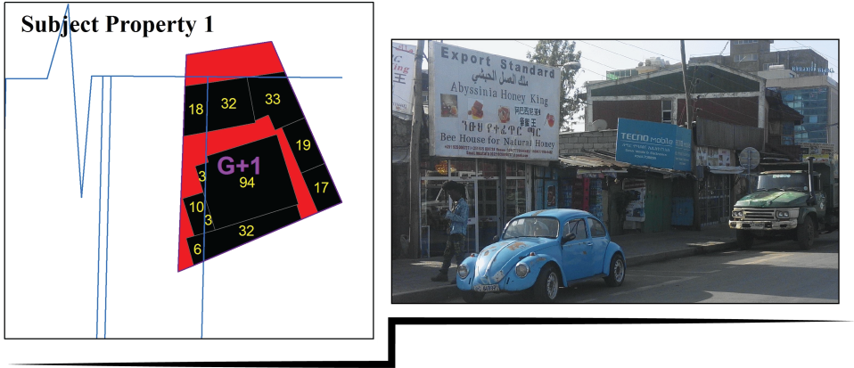
Subject 1

Figure 13- subject 1 legal parcel with after taking photo
- Total floor Area- 364m²  - Part Taken area- 81 m²  - Remainder area- 305 m²  - Rent/month (Before)-45000 birr  - Rent/month (After)-54000 birr  The remaining utility considering only damage – 83%  The remaining utility considering benefit – 93% | BEFORE AND AFTER ANALYSIS
1 | Value of the whole Before Acquisition | VBA | NOI/CAP.R=540000/12%=4,500,000
2 | Value of the part acquired as part of the whole | VPAW | VPAW=Part taken area * value per m2 (as a part of the whole)= 81m² * 12362.64=1,001,373.63
3 | Value of the remainder as part of the whole | VR | VR=VBA-VPAW=4,500,000-1,001,373.63=3,498,626.37
4 | Value of the remainder after the acquisition and Before considering Benefit | VRAA(BB) | VRAA(BB)=the remainder area*value per m2 (before)*the remaining utility in % (considering only damage) = 305*12,362.64*83%=3,129,601.65
5 | Severance Damages | SD | SD=VR-VRAA(BB)= 3,498,626.37-3,129,601.65= 369,024.73
6 | Value of the remainder after the acquisition and after Considering Benefits | VRAA(AB) | VRAA(AB)=the remainder area *value per m2 (after)*the remaining utility in % (considering benefit)= 305*17,704.92*93%=5,022,000
7 | Benefits | B | B=VRAA(AB)-VRAA(BB)= 5,022,000-3,129,601.65= 1,892,398.35
 |  |  | NET DAMAGE=SD-B= 369,024.73-1,892,398.35= -1,523,373.63

Subject 2
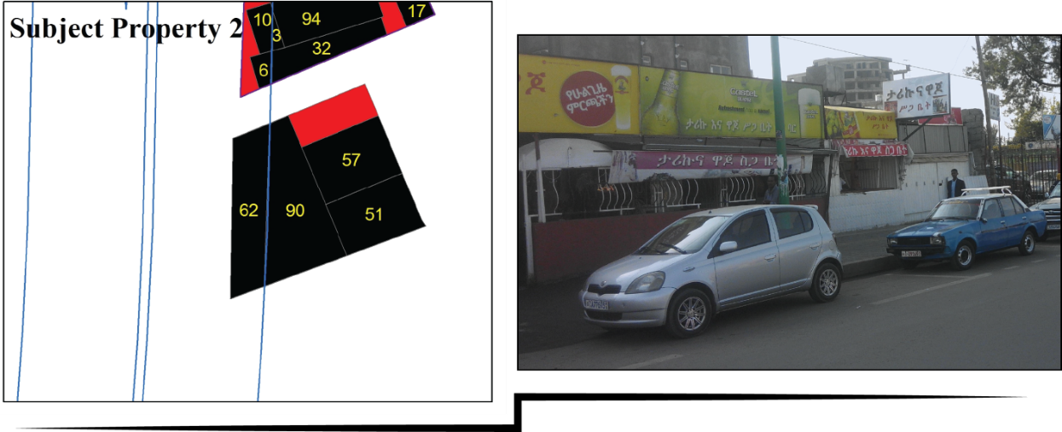

Figure 14- subject 2 legal parcel with after taking photo
- Total floor Area- 291m²
- Part Taken area- 63 m²
- Remainder area- 228 m²
- Rent/month (Before)-40000 birr
- Rent/month (After)- 40000 birr

The remaining utility considering only damage – 76%
The remaining utility considering benefit – 86%

 | BEFORE AND AFTER ANALYSIS
1 | Value of the whole Before Acquisition | VBA | NOI/CAP.R=480,000/12%=4,000,000
2 | Value of the part acquired as part of the whole | VPAW | VPAW=Part taken area * value per m2 (as a part of the whole)= 63m² * 13,745=865,979.38
3 | Value of the remainder as part of the whole | VR | VR=VBA-VPAW=4,000,000-865,979.38=3,134,020.62
4 | Value of the remainder after the acquisition and Before considering Benefit | VRAA(BB) | VRAA(BB)=the remainder area*value per m2 (before)*the remaining utility in % (considering only damage) = 228*13,745*76%=2,381,855.67
5 | Severance Damages | SD | SD=VR-VRAA(BB)= 3,134,020.62-2,381,855.67= 752,164.95
6 | Value of the remainder after the acquisition and after Considering Benefits | VRAA(AB) | VRAA(AB)=the remainder area *value per m2 (after)*the remaining utility in % (considering benefit)= 228*17,543.86*86%=3,440,000
7 | Benefits | B | B=VRAA(AB)-VRAA(BB)= 3,440,000-2,381,855.67= 1,058,144.33
 |  |  | NET DAMAGE=SD-B= 752,164.95-1,058,144.33= -305,979.38

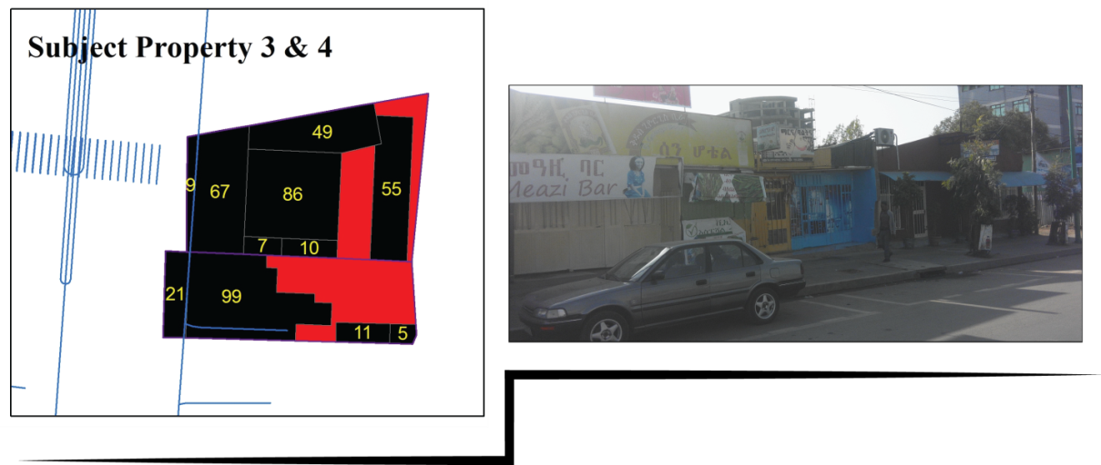
Subject 3 and 4

Figure 15- subject 3&4 legal parcel with after taking photo
Subject 3
- Total floor Area- 345m² 364m²
- Part Taken area- 9m² 81 m²
- Remainder area- 336m² 305 m²
- Rent/month (Before)-40000 birr
- Rent/month (After)-45000 birr

The remaining utility considering only damage – 87%
The remaining utility considering benefit – 97%

BEFORE AND AFTER ANALYSIS
 | SUBJECT 3
1 | Value of the whole Before Acquisition | VBA | NOI/CAP.R=480,000/12%=4,000,000
2 | Value of the part acquired as part of the whole | VPAW | VPAW=Part taken area * value per m2 (as a part of the whole)= 9m² * 11594.20=89,040.00
3 | Value of the remainder as part of the whole | VR | VR=VBA-VPAW=4,000,000 - 89,040.00=3,910, 960
4 | Value of the remainder after the acquisition and Before considering Benefit | VRAA(BB) | VRAA(BB)=the remainder area*value per m2 (before)*the remaining utility in % (considering only damage) = 336*11,594.20 * 87%=3,389,217.39
5 | Severance Damages | SD | SD=VR-VRAA(BB)= 3,910, 960 - 3,389,217.39= 521,742.61
6 | Value of the remainder after the acquisition and after Considering Benefits | VRAA(AB) | VRAA(AB)=the remainder area *value per m2 (after)*the remaining utility in % (considering benefit)= 336 *13,392.86*97%=4,365,000.00
7 | Benefits | B | B=VRAA(AB)-VRAA(BB)= 4,365,000.00 - 3,389,217.39= 975,782.61
 |  |  | NET DAMAGE=SD-B= 521,742.61- 975,782.61= - 454,040
Subject 4
The remaining utility considering only damage – 81%
The remaining utility considering benefit – 91%
- Total floor Area- 221m²
- Part Taken area- 21 m²
- Remainder area- 200 m²
- Rent/month (Before)-35000 birr
- Rent/month (After)-35000 birr

SUBJECT 4
1 | Value of the whole Before Acquisition | VBA | NOI/CAP.R=420000/12%=3,500,000
2 | Value of the part acquired as part of the whole | VPAW | VPAW=Part taken area * value per m2 (as a part of the whole)= 21m² * 15,837.10=332,579.19
3 | Value of the remainder as part of the whole | VR | VR=VBA-VPAW=3,500,000 - 332,579.19 = 3,167,420.81
4 | Value of the remainder after the acquisition and Before considering Benefit | VRAA(BB) | VRAA(BB)=the remainder area*value per m2 (before)*the remaining utility in % (considering only damage) = 20*15,873.10*81%=2,565,610.86
5 | Severance Damages | SD | SD=VR-VRAA(BB)= 3,167,420.81 - 2,565,610.86= 601,389.14
6 | Value of the remainder after the acquisition and after Considering Benefits | VRAA(AB) | VRAA(AB)=the remainder area *value per m2 (after)*the remaining utility in % (considering benefit)= 200*17,500*91%=3,185,000
7 | Benefits | B | B=VRAA(AB)-VRAA(BB)= 3,185,000 - 2,565,610.86= 619,389.14
 |  |  | NET DAMAGE=SD-B=601,389.14 -619,389.14= -17,579.19

BEFORE AND AFTER ANALYSIS
SUBJECT 5
- Total floor Area-448 m² 364m²
- Part Taken area-46 m² 81 m²
- Remainder area-402 m² 305 m²
- Rent/month (Before)-45000 birr
- Rent/month (After)-54000 birr

The remaining utility considering only damage – 85%
The remaining utility considering benefit – 93%
1 |  | Value of the whole Before Acquisition | VBA | NOI/CAP.R=720,000/12%=6,000,000.00
2 |  | Value of the part acquired as part of the whole | VPAW | VPAW=Part taken area * value per m2 (as a part of the whole)= 46m² * 13,392.86=616,071.43
3 |  | Value of the remainder as part of the whole | VR | VR=VBA-VPAW=6,000,000 - 616,071.43=5,383,928.57
4 |  | Value of the remainder after the acquisition and Before considering Benefit | VRAA(BB) | VRAA(BB)=the remainder area*value per m2 (before)*the remaining utility in % (considering only damage) = 402*13,392.86*85%=4,576,339.29
5 |  | Severance Damages | SD | SD=VR-VRAA(BB)= 5,383,928.57- 4,576,339.29= 807,589.29
6 |  | Value of the remainder after the acquisition and after Considering Benefits | VRAA(AB) | VRAA(AB)=the remainder area *value per m2 (after)*the remaining utility in % (considering benefit)= 402 *17,412.94*93% = 6,510,000
7 |  | Benefits | B | B=VRAA(AB)-VRAA(BB)= 6,510,000 -4,576,339.29 = 1,933,660
 |  |  |  | NET DAMAGE=SD-B=807,589.29 - 1,933,660 = -1,126,071.43
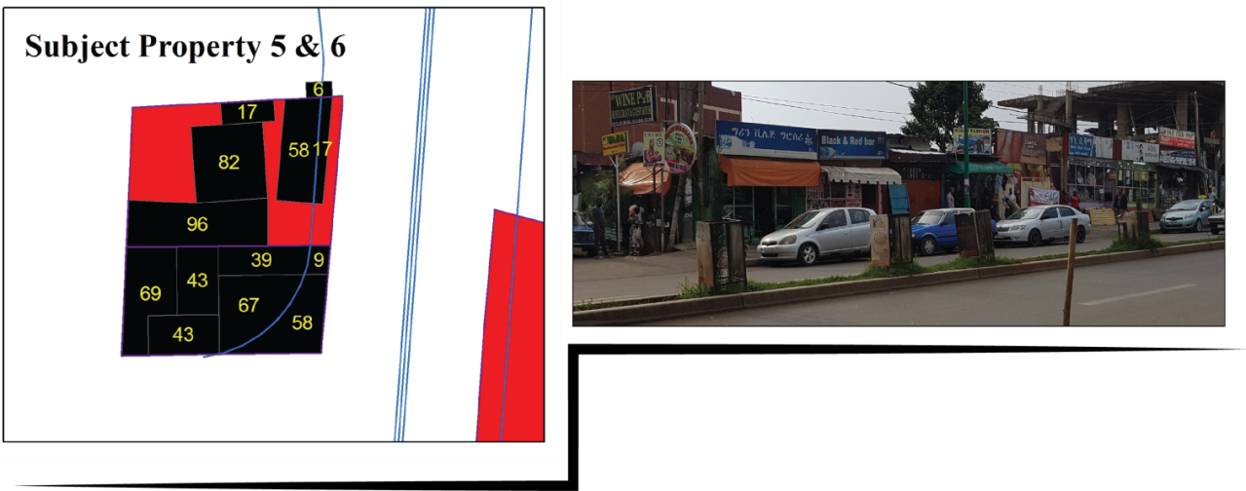
Subject 5 and 6
Figure 16- subject 5&6 legal parcel with after taking photo

- Total floor Area-328 m² 364m²
- Part Taken area-66 m² 81 m²
- Remainder area-262 m² 305 m²
- Rent/month (Before)-40000 birr
- Rent/month (After)- 40000 birr

SUBJECT 6
The remaining utility considering only damage – 78%
The remaining utility considering benefit – 86%
1 | Value of the whole Before Acquisition | VBA | NOI/CAP.R=480000/12%=4,000,000
2 | Value of the part acquired as part of the whole | VPAW | VPAW=Part taken area * value per m2 (as a part of the whole)= 66m² * 12,195.12 = 804,878.05
3 | Value of the remainder as part of the whole | VR | VR=VBA-VPAW=4,000,000-804,878.05=3,195,121.95
4 | Value of the remainder after the acquisition and Before considering Benefit | VRAA(BB) | VRAA(BB)=the remainder area*value per m2 (before)*the remaining utility in % (considering only damage) = 262*12,195.12*78%=2,492,195.12
5 | Severance Damages | SD | SD=VR-VRAA(BB)= 3,195,121.95 - 2,492,195.12= 702,926.83
6 | Value of the remainder after the acquisition and after Considering Benefits | VRAA(AB) | VRAA(AB)=the remainder area *value per m2 (after)*the remaining utility in % (considering benefit)= 262*15,267.182*86%=3,440,000
7 | Benefits | B | B=VRAA(AB)-VRAA(BB)= 3,440,000 - 2,492,195.12= 947,804.05
 |  |  | NET DAMAGE=SD-B= 702,926.83 - 947,804.05= -244,878.05

Subject 7 and 8
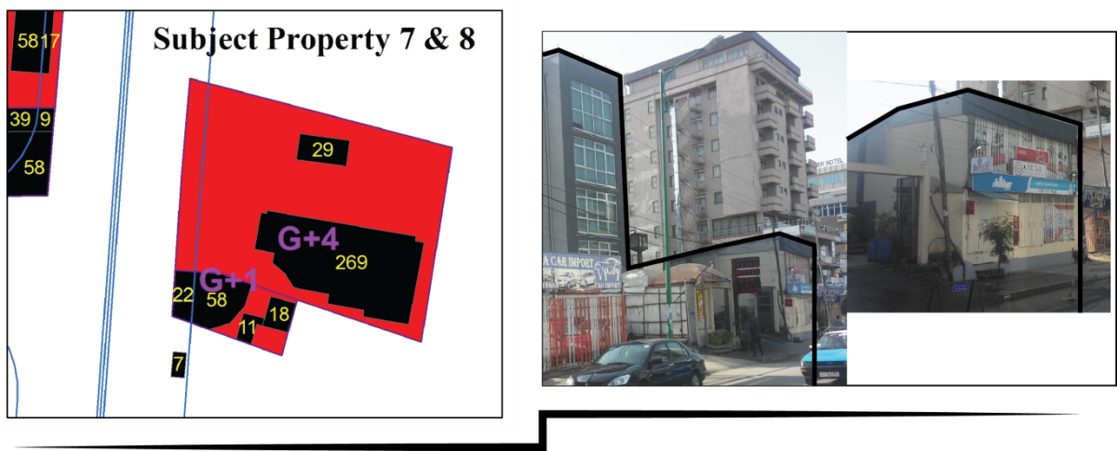

The remaining utility considering benefit – 100%
The remaining utility considering only damage – 93%
Subject 7
- Total floor Area-1107 364m²
- Part Taken area- 85 81 m²
- Remainder area- 1022 305 m²
- Rent/month (Before)-200,000 birr
- Rent/month (After)-200,000 birr

BEFORE AND AFTER ANALYSIS
SUBJECT 7
1 | Value of the whole Before Acquisition | VBA | NOI/CAP.R=2,400,000/12%=20,000,000
2 | Value of the part acquired as part of the whole | VPAW | VPAW=Part taken area * value per m2 (as a part of the whole)= 85m² * 18,066.85=1,535,682.02
3 | Value of the remainder as part of the whole | VR | VR=VBA-VPAW=20,000,000-1,535,682.02=18,464,317.98
4 | Value of the remainder after the acquisition and Before considering Benefit | VRAA(BB) | VRAA(BB)=the remainder area*value per m2 (before)*the remaining utility in % (considering only damage) = 1022*18,066.85*93%=17,171,815.72
5 | Severance Damages | SD | SD=VR-VRAA(BB)= 18,464,317.98 - 17,171,815.72= 1,292,502.26
6 | Value of the remainder after the acquisition and after Considering Benefits | VRAA(AB) | VRAA(AB)=the remainder area *value per m2 (after)*the remaining utility in % (considering benefit)= 1022 * 19,569.47*100%=20,000,000
7 | Benefits | B | B=VRAA(AB)-VRAA(BB)= 20,000,000 - 17,171,815.72= 2,828,184.28
 |  |  | NET DAMAGE=SD-B= 1,292,502.26 -2,828,184.28= -1,535,682.02
Subject 8

The remaining utility considering benefit – 86%
- Total floor Area-149 m² 364m²
- Part Taken area-42 m² 81 m²
- Remainder area-107 m² 305 m²
- Rent/month (Before)-35000 birr
- Rent/month (After)-35000 birr

The remaining utility considering only damage – 76%

As explained in the above statements, according to Addis Ababa land administration standard the minimum standard plot size for commercial and business related uses is 150m². So when we see the size of subject 8 it doesn’t fulfill these criteria. Before the taking its total area was 149m² which was approximate to the standard but after taking it became 128. As a result, the highest and best use of this property is changed because it’s not legally permissible. According to the city land administration standard the land can only serve for residential purpose. On the other hand, the scope of the study focuses on commercial properties. So subject 8 is banned from this study because of highest and best use change. This is where the choice of valuation approach comes.

1 | Value of the whole Before Acquisition | VBA | NOI/CAP.R=1,680,000/12%=14,000,000
2 | Value of the part acquired as part of the whole | VPAW | VPAW=Part taken area * value per m2 (as a part of the whole)= 31m² * 18,791.98=582,550.34
3 | Value of the remainder as part of the whole | VR | VR=VBA-VPAW=14,000,000 - 582,550.34=13,417,449.66
4 | Value of the remainder after the acquisition and Before considering Benefit | VRAA(BB) | VRAA(BB)=the remainder area*value per m2 (before)*the remaining utility in % (considering only damage) = 714*18,791.98*95%=12,746,577.18
5 | Severance Damages | SD | SD=VR-VRAA(BB)=13,417,449.66 - 12,746,577.18= 670,872.48
6 | Value of the remainder after the acquisition and after Considering Benefits | VRAA(AB) | VRAA(AB)=the remainder area *value per m2 (after)*the remaining utility in % (considering benefit)= 714*19,607.84 * 96%=13,440,000
7 | Benefits | B | B=VRAA(AB)-VRAA(BB)=13,440,000 - 12,746,577.18 = 693,422.82
 |  |  | NET DAMAGE=SD-B= 670,872.48 - 693,422.82= -22,550.34
Subject 9
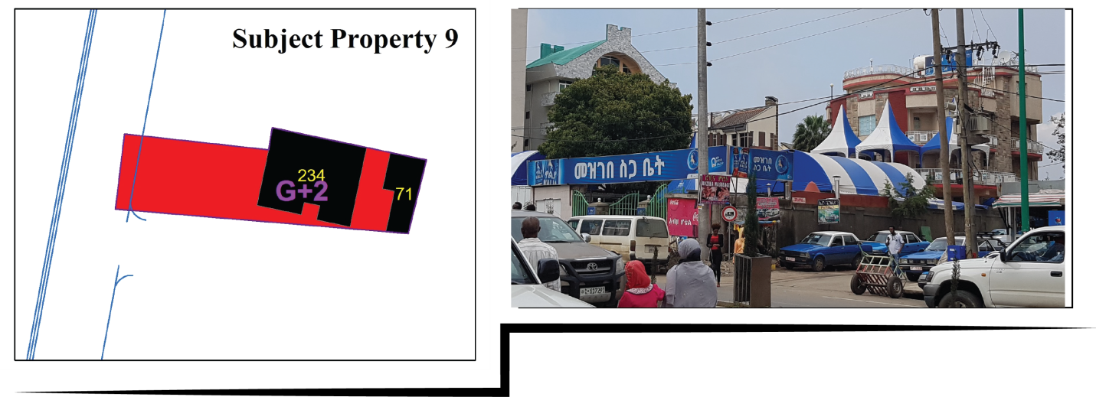
Figure 17- subject 9 legal parcel with after taking photo
The remaining utility considering benefit – 99%
The remaining utility considering only damage – 95%
- Total floor Area-745 m² 364m²
- Part Taken area-31 m² 81 m²
- Remainder area-714 m² 305 m²
- Rent/month (Before)-140000 birr
- Rent/month (After)-140000 birr

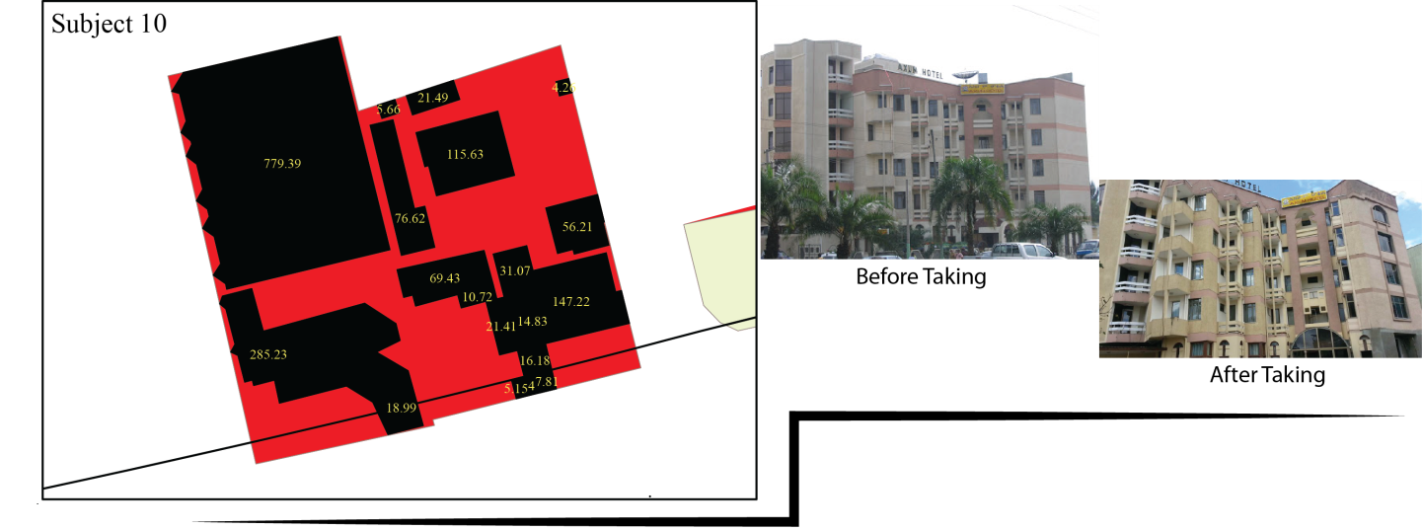 | Subject 10
 | Figure 18- subject 10 legal parcel with after taking photo  - Total floor Area-8820 m² 364m²  - Part Taken area-258 m² 81 m²  - Remainder area-8562 m² 305 m²  - PGI Before (Only from property income)-18,323,000 birr  - PGI (After)-17,447,000 birr  SUBJECT 10 |  | The remaining utility considering benefit – 90%  The remaining utility considering only damage – 84%
1 | Value of the whole Before Acquisition | VBA | NOI/CAP.R=9,583,515.63/12%=59,896,972.66
2 | Value of the part acquired as part of the whole | VPAW | VPAW=Part taken area * value per m2 (as a part of the whole)= 258m² * 6,791.04=1,752,088.32
3 | Value of the remainder as part of the whole | VR | VR=VBA-VPAW=59,896,972.66 - 1,752,088.32=58,144,884.34
4 | Value of the remainder after the acquisition and Before considering Benefit | VRAA(BB) | VRAA(BB)=the remainder area*value per m2 (before)*the remaining utility in % (considering only damage) = 8562*6,791.04*84%=48,841,702.85
5 | Severance Damages | SD | SD=VR-VRAA(BB)= 58,144,884.34 - 48,841,702.85= 9,303,181.49
6 | Value of the remainder after the acquisition and after Considering Benefits | VRAA(AB) | VRAA(AB)=the remainder area *value per m2 (after)*the remaining utility in % (considering benefit)= 8562 *6,339.85 * 90%=48,853,593.75
7 | Benefits | B | B=VRAA(AB)-VRAA(BB)= 48,853,593.75 - 48,841,702.85= 11,890.90
 |  |  | NET DAMAGE=SD-B= 9,303,181.49 - 11,890.90= 9,291,290.59

From what it has been reviewed it has been found out that the appraisal problem for partial acquisitions is essentially a before and after process using either the "Federal Rule" or "State Rule". Under the Federal Rule if the remainder is greater in value in the after condition compared to the before condition, the owner is considered compensated and No money is offered. Under the State Rule the agency will pay for the part taken. So states encourage ensuring the landowner always receives at least the market value of the lands taken. When we come to the results of the analysis if we consider the federal rule for compensation, except subject 10 with a complete before and after appraisal all of the taken subject properties receive no money. But as many U.S. states and Canada these study recommends the state rule to minimize claims and what has been taken from the owner have to be compensated.
Remark on cost to cure
The cost to cure method is one method that is considered in partial takings applied to offset damage. In this method as the stated by (The Appraisal Foundation, 2016) the remainder property has to be valued in its uncured condition. Cost to cure could have been applied on subject 7 and 9 since, it was their fence affected by the taking. But there is no data that can show the uncured condition of these properties. Because, according to the review cost to cure is cost to restore an item of physical depreciation to bring it to its new condition. Therefore, if the condition uncured has to be documented to calculate the cost to cure and after this the procedure followed above will be undergone. As the practice indicates the first step in the cost to cure procedure is to estimate the damage. Then comparing the cost to cure to the damage, which is the method that is use in illustrating subject property one and ten. That is;

VRAA (BB) – the remainder uncured = the remainder area * value per m² (before) * the remaining utility in % (considering only damage)

Severance damage SD= Value of the remainder (VR) - value of the remainder before considering benefit VRAA (BB), remainder uncured.
After estimating the damage this is going to be compared with the cost to cure.
Cost to cure ≤ The Total Damages, If Uncured the cost to cure is feasible another procedure will follow.
But if the cost to cure is not feasible, the analysis stops at this point and compensation is estimated based on above and use severance damage (total damage uncured) for compensation.
Cost to cure ≤ The Total Damages, If Uncured the cost to cure is feasible another procedure will follow. That is
VALUE OF CURE = VRC – VRUC which based on this study’s analysis
Value of the cure= VRAA (AB) - VRAA (BB) Result value of the cure
Remaining damage not cured= total damage-value of the cure, which based on the above before and after analysis
REMAININNG DAMAGE, UNCURED= SD-VALUE OF CURE

The final step is determining any items cured that have already been paid for in the part taken to avoid over compensation. This analysis is done as follows:
Net Cost to Cure= The Cost to Cure – Items Cured, but paid for in the part taken; which based on this study
Net Cost to Cure= the Cost to Cure - Benefit
Finally, compensation= Net Cost to Cure+ Uncured Damages (Net Damage)
N.B this step follows if and only if the Cost to cure ≥ The Total Damages (Severance Damage), If Uncured.

CHAPTER FOUR: CONCLUSION AND RECOMMENDATION

Conclusion
In the introduction chapter as the main research problem of this study state that, though different principles and methods are involved in assessing compensation with in partial and total land acquisition, sufficient researches are not carried out considering partial takings as a single entity. As a result, this thesis aims to add to the Ethiopian body of knowledge by examining the practice of compensation in partial taking expropriation different from total takings in road widening projects with the case study of two roads in the city of Addis Ababa. Therefore, the general objective of the study is to examine valuation and compensation practices in partial land acquisition of business properties for road projects. Specifically, the issues that needs to be addressed in partial taking of business properties for road projects has been identified and procedures, compensation mechanisms and valuation techniques used in the partial taking of business properties has been assessed.
As it has been found out from the reviews, what makes partial takings different from total taking is the portion which is not taken. Damages and benefits to the remaining portion are relevant to compensation for the part taken. Which means calculation of the value must take in to account any decrease or increase in value as a result of the partial taking expropriation. Related to this it is stated that it is basic to identify the compensable damages and benefits. In addition to this there are valuation principles that need to be considered in partial taking cases. These are principle of highest and best use, principle of consistent use and principle of contribution.
In this regard the compensable damages identified are dividing a property in to two or more parts, reducing the remainder area in to small parcels no longer having economic utility, creating a land locked remainder, the loss of reasonable access to the highway system, proximity of the highway to buildings in the after situation, change of grade or loss of view if the loss results in a decrease in market value, the loss of off-street parking and a loss of value b/c of change in highest and best use. On the other hand, as the literatures indicate the compensable benefits can be proximity to new highway, fencing public maintained and built, construction of sanitary sewer, storm sewer and water main, availability of electricity, corner lot creation, reduced circuitous route, improved highest and best use, etc.
These damages and benefits have to be identified before and after the taking based on the context. At the time of the taking these relevant information indicating the whole condition of the property must be recorded. Again after the taking before the cure the data about the remainder property has to be assessed to measure the amount of damage. Finally, after the cure the condition of the remainder property has to be documented. Therefore, in partial taking cases data has to be recorded in three phases.
On the other hand, for the purpose of analyzing the factual data about partial taking it has been found out that, there are two distinct methods. These are ‘Before and after’, and ‘Taking plus damage’ methods of valuation. “The before and after rule” applies in all appraisals involving partial acquisitions. With this method under this procedure, the appraiser develops opinions of both the market value before the acquisition and the market value after the acquisition will be developed. The result is a figure that includes the value of the property acquired as well as any compensable damages and/or direct (special) benefits to the remainder property. On the other hand, taking plus damage rule is applied when damages are minimal and a before and after appraisal will not add significant additional clarity to the report.
Though, before and after appraisal method is more of create costly and difficult burdens on the appraiser than taking plus damage, as the reviews indicate it is the most acceptable method in courts that the taking plus damage. Because it is believed that sometimes taking plus damage double counts figures. On the other hand, before and after appraisal is also inclusive of the taking plus damage method indirectly. Therefore, it has been found out that before and after appraisal method is the most acceptable method in partial taking cases.
In addition, it has been found out that before starting valuation for the purpose of any appraisal problem, the highest and best use, and the larger parcel has to be determined. To determine the highest and best use of a property the legal possibility, physical possibility and economic feasibility of the subject properties has to be determined. To determine the larger parcel Unity of ownership, Unity of contiguity and Unity of use has to be considered.
Based on these findings this study addressed the issue of before and after appraisal by preparing questionnaire that can help to assess the before and after condition based on a standard valuation factual data assessment format. Then the issues are tried to address by asking the property owners/users, brokers and valuators from administrating offices. This is then adjusted qualitatively since the study is conducted on a complete project were there is no quantitative document that clearly show the before condition and the remainder uncured.
for the purpose of determining the highest and best use physical possibility, suitability analysis is used, for the legal possibility the legal documents like structural plan of the city, building permit manual and 1988 GIS map showing legal boundaries has been used. To check the economic feasibility, the general centrality map showing the main business areas, a report document sowing the commercial real estate activity on the city and the existing development activity of the case area has been checked. On the other hand, to determine the larger parcel the legal 1988 GIS map and 1997 map are used since they are the two legally permitted documents used by Addis Ababa city administration. Therefore, using this method though it may not result perfect output as the method requires, it is possible to apply this method of determining larger parcel and highest and best use.
Generally, it has been found out that if the appropriate data at the time of taking, after the taking before the cure and after the cure is documented, the specific issues raised in discussing the practice of compensation procedures for partial takings are more of possible to apply them to the Ethiopian context. What is understood in applying the before and after method for Ethiopian context, it’s not about the approaches of valuation that matters. What matters is the data assessed in the three phases. So if the appropriate data is captured at the time of the taking, it is possible to address these issues and determine value in partial taking expropriation cases with the available possible valuation approach. In addition, considering the valuation principles during valuation for compensation purpose has to be considered a basic need to bring fair compensation as promised by the Ethiopian low. Therefore, this study has many contributions for the purpose of valuing partial taking expropriation.

Recommendation
In this study it has been found out that there is a big gap in the area of knowledge regarding the difference of impact in partial takings and total takings on the property. In this case it is recommended to differentiate the level of impact partial takings and total taking expropriation has on properties. This is the issue that leads to the idea of what to be compensated and in what way has to be compensated. Therefore, the legal documents and other related documents has to start by addressing this issues in considering total takings and partial taking expropriation.
(Council of Ministers Regulation No 135/2007, 2007) Says compensation shall be paid only for the demolished part of a building where the 'owner prefers to use the unwanted part of the land' if condition of the partly demolished building conforms to the requirements of the appropriate city plan. Here there is one issue that mediates between leaving the place and Take a replacement land on other place, and staying there and take the compensation given only for the part taken of improvements on the land. That is the issue of staying on the remaining land and be compensated what is taken from him.
This means if the property has diminishing in utility but he only got the value for the part taken not the damage, he must have the right to claim compensation for the permanent damage he/she encountered because of the taking. The case of subject 10 is similar with this. Therefore, the study recommends there has to be a regulation with appropriate method of valuation that addresses the issue of such claims. This will minimize investment insecurities. Before and after appraisal method has a strong purpose in this regard. Therefore, this study recommends to use the before and after appraisal method with the ‘state rule’ in partial taking cases as indicated below in table 17.
Table 19- the process of before and after analysis
1 | Value of the whole Before Acquisition | VBA
2 | Value of the part acquired as part of the whole | VPAW |  | VPAW=Part taken area *value per m2 (as a part of the whole)
3 | Value of the remainder as part of the whole | VR |  | VR=VBA-VPAW
4 | Value of the remainder after the acquisition and Before considering Benefit | VRAA(BB) |  | VRAA(BB)=the remainder area*value per m2 (before)*the remaining utility in % (considering only damage)
5 | Severance Damages | SD |  | SD=VR-VRAA(BB)
6 | Value of the remainder after the acquisition and after Considering Benefits | VRAA(AB) |  | VRAA(AB)=the remainder area *value per m2 (after)*the remaining utility in % (considering benefit)
7 | Benefits | B |  | B=VRAA(AB)-VRAA(BB)
 |  |  |  | NET DAMAGE=SD-B

Fair compensation is the right given by the low. In this regard as the findings indicate to bring “just compensation” in partial takings, the value of the part taken must be determine by first determining the value of the whole property. Then the unit value of the whole larger parcel will be applied to the value of the part taken. Therefore, this study recommends to apply the rule of applying value of the whole to determine the value of the part taken. That is principle of contribution to clearly address the factors affecting value, address the problem of double recovery and clearly indicate the contributory value of the part taken to the value of the property.
Finally, it has been found out that whatever valuation approach (cost, income or sales) going to be applied, the before and after appraisal method only require appropriate data inspection in the before, during and after acquisition. If appropriate data is documented, it is possible to apply this method of valuation. Therefore, for the purpose of bringing fair compensation appropriated data has to be well documented that show the before, during (the uncured level of the remainder) and after (reminder cured) and apply the before and after method with the appropriate valuation approach with the country context.

References
IAAO. (2013). Glossary for Property Appraisal and Assessment. INTERNATIONAL ASSOCIATION ofASSESSING OFFICERS.
Access Capital. (2010). Access Capital research on Investing in Ethiopia, Sector Report_Real estate.
(2016). Acquisition. In WSDOT Right of Way Manual.
Alemu, B. Y. (2012). Expropriation, Valuation and Compensation Practice in Amhara National Regional State (ANRS) – The Case of Two Cities (Bahir-Dar and Gonder). Nordic Journal of Surveying and Real Estate Research.
Alemu, B. Y. (2013). Expropriation, valuation and compensation practice in Ethiopia:The case of Bahir Dar city and surrounding. Emerald Insight.
ALİEFENDİOĞLU, H. T. (2017). PRINCIPLES OF LAND ACQUISITION, EXPROPRIATION, AND COMPENSATION CALCULATION FOR INFRASTRUCTURE PROJECTS IN TURKEY AND AN ANALYSIS OF KEY ISSUES. responsible land governance: towards an evidence based approach. Washington,DC.
Ambaye, D. W. (2009). Land Valuation for Expropriation inEthiopia: Valuation Methods and Adequacy of Compensation. Compulsory Purchase and Land Acquisition II.
Ambaye, D. W. (2013). Land rights and Expropriation in Ethiopia. Academic Dissertation for the Degree of Doctor of Philosophy. Stockholm, Sweden.
Ambaye, D. W. (2013). The History of Expropriation in Ethiopian Law Ethiopian Law . 7.
Ambaye, D. w. (2014). compensation for expropriation in Ethiopia and the UK: a comparative analysis. FIG Congress. Kualal Lumpur.
Blackledge, M. (2009). Introducing Property Valuation.
Carol Lansing and Mark Savin. (2009 ). Assessing and Mitigating the Zoning Im pacts of a Partial Taking. Condemnation, Zoning, and Land Use, Annual Review.
Chan, N. (2003). Land Acquisition Compensation in China –Problems & Answers . INTERNATIONAL REAL ESTATE REVIEW.
Chang, Y.-c. (2008). An Empirical Study Of Compensation P aid in Eminent Domain Settlements: New York City. NELLCO Legal Scholarship Repository.
Coen, C. J. (1967). Chapter 19: Eminent Domain: Damages. Annual Survey of Massachusetts Law.
David Russell SC et.al. . (2014). Review of the NSW Land Acquisition (Just terms) Compensation Act 1991 and Housing Acquisition Review.
Department of Natural Resources Division of Lands and Minerals Appraisal Management Unit. (2012, April 2). Supplemental Appraisal and Appraisal Review Guidlines. DNR SUPPLEMENTAL GUIDELINES.
DEPARTMENT OF THE ARMY U.S. Army Corps of Engineers. (2016, January 29). Real Estate Appraisal. Regulation No 405-1-04. Washington, DC 20314-1000.
DIVISION OF HIGHWAYS WEST VIRGINIA DEPARTMENT OF TRANSPORTATION(WVDOT). (n.d.). A GUIDE FOR PROPERTY OWNERS. RIGHT OF WAY PAMPHLET.
Ethopian Road Authority. (2007). Resettlement/Rehabilitation Policy Framework. Road Sector Development Program Support Project.
European Bank for Reconstruction and Developement (EBRD). (2014). Resettlement Guidance and Good Practice.
Federal democratic republic of Ethiopia. (2005). Proclamation No. 455 . Federal NegaritGazeta( Expropriation of Landholdings for Public Purposes and Payment of Compensation).
Federal democratic republic of Ethiopia. (2007). Council of Ministers Regulation No 135/2007. payment of compensation for property situated on landholding expropriated for public purposes.
Federal democratic republic of Ethiopia. (2007). Council Of Ministers Regulation No 135/2007. Payment of compensation for property situated on landholding expropriated for public purposes council of minstrares regulations.
Fraser, J. D. (2008). Real Estate — Special Topics Expropriation from the Property Owner’s Perspective. Lawson Lundell LLP.
friends, T. a. (2014). EBA Real Property Valuation Manual.
GLAvEst, D. W. (1963). DATE OF VALUATION IN EMINENT DOMAIN: IRREVERENCE FOR UNCONSTITUTIONAL PRACTICE*. THE UNIVERSITY OF CHICAGO LAW REVIEW .
Gordon E. Macnair. (2010). Expropriation and the Partial Taking Appraisal Taking Appraisal.
Harrison, B. (2015). THE COMPENSATION CONUNDRUM IN PARTIAL TAKINGS CASES AND THE CONSEQUENCES OF BOROUGH OF HARVEY CEDARS. CARDOZO LAW REVIEW.
Harrison, G. A. (2015). Eminent Domain and Condemnation: The T aking of Private Property for Public U se in I ndiana. Historical Documents of the Purdue Cooperative Extension Service.
Henry Campbell Black, M. A. (1990). BLACK'S LAW DICTIONARY Definitions of the Terms and Phrases of American and English Jurisprudence Ancient and Modern. WEST PUBLISHING.
Hugh Thompson. (2015). Right of way manual. North Carolina Department of Transportation Division Of Highways Right of way .
INTERNATIONAL ASSOCIATION ofASSESSING OFFICERS (IAAO). (2013). Glossary for Property Appraisal and Assessment.
International Valuation Standard Committee. (2003). International Valuation Concepts and Principles. International Valuation Standard Sixth Edition.
International Valuation Standards Council. (2011). International Valuation Standards. Page Bros.
Jonathan Mills Lindsay. (2012, Auguest). Compulsory Acquisition of Land and Compensation in Infrastructure Projects. PPP INSIGHTS An explanator y note on issues relevant to public-private partnerships.
Koji Tsunokawa and Christopher Itoban. (1997). Roads and the environment. Washington, D.C.: World Bank.
Kummerow, M. (n.d.). Theory for Real Estate Valuation: An Alternative Way to Teach Real Estate Price Estimation Methods.
Lewis, D. R. (n.d.). Partial Acquisition Appraisals for Public Projects . American Society of appraisers, providing value world wide.
Lindsay, J. M. (2012). Compulsory Acquisition of Land and Compensation in Infrastructure Projects. PPP INSIGHTS ANexplANATORy NOTe ON IssUes RelevANT TOpUblIC-pRIvATe pARTNeRshIps.
Lutzky, A. B. (2014). IN PURSUIT OF JUST COMPENSATION IN TEXAS: ASSESSING DAMAGES IN TAKINGS CASES USING THE PROPERTY’S TAX-APPRAISED VALUE. Comment.
Mangioni, V. (2015). Refining Principles of Compensation for Traditional and Non-traditional Public Purposes in Land Acquisition. State of Australian Cities Conference 2015.
Mangioni, V. (n.d.). Just Terms Compensation And the Compulsory Acquisition Of Land. Refereed Paper.
Mary AJAYI, B. O. (2013). Impact of road expansion projects on the informal sector in Akure, Ondo State, Nigeria. Environment for Sustainability. Abuja, Nigeria.
Mas, A. (2014). EMINENT DOMAIN LAW AND “JUST” COMPENSATION FOR DIMINUTION OF ACCESS. “J UST” COMPENSATION, CARDOZO LAW REVIEW.
Masresha, A. (2013). Land Acquisition for Capital Project Implementation in Ethiopia: An Assessment for the Case of Dilla Town. Thesis submitted to the Faculty of Geo-Information Science and Earth .
MATHEWOS Consult Architectural, Engineering, Urban Planning, Urban Development and Urban Management Consultants. (2006, September). URBAN UPGRADING AND RENEWAL MANUAL. MINISTRY OF WORKS AND URBAN DEVELOPMENT Federal Urban Planning Institute. Addis Ababa.
Matkins, A. (n.d.). THE GOVERNMENT WANTS YOUR PROPERTY…NOW WHAT? THE BASICS OF EMINENT DOMAIN FOR PROPERTY AND BUSINESS OWNERS.
Mayer, H. R. (1968). Eminent Domain - Consequential Damages - Noise Element - Dennison v . State, 239 N .E. 2d 708. William & Mar y Law Review, 10(3).
Ministry of Finance and Economic Development Federal Democratic Republic of Ethiopia. (2012). Assessing progress towards the Mellenium Development Goals ETHIOPIA MDGs REPORT.
Muriithi, J. M. (2013). A research project on land acquisition for selected road projects in Kenya. SUBMITTED IN PARTIAL FULFILLMENT OF THE REQUIREMENTS FOR THE AWARD OF MASTERS OF ARTS DEGREE IN VALUATION AND PROPERTY MANAGEMENT.
NDOT. (2016). RIGHT-OF-WAY MANUAL. NEVADA DEPARTMENT OF TRANSPORTATION RIGHT-OF-WAY MANUAL.
Nikièma, S. H. (2013). Compensation for Expropriation. Best Practice Series.
ODOT, O. D. (2012). GUIDE TO COMPENSABILITY. ODOT’s Real Estate Manual.
Office of the Valuer General. (2014). Compensation following compulsory acquisition. Valuer General’s Policy.
Oni, A. O. (2010). Arterial Road Network and Commercial Property Values: Case Study of Ikeja, Nigeria. Paper Presented at the Business Luncheon/MCPD Organized by RICS Nigeria Group.
OREA’s Enforcement Division. (n.d.). www.google.com. Retrieved from www.orea.ca.gov.
Oregon Department of Transportation. (2006). Guide to Appraising Real Property Appraisal Chapter of the Right of Way Manual. In Oregon Department of Transportation RIGHT OF WAY MANUAL.
Orell Anderson, J. W. (2016). Addressing the larger parcel one of the vexing problems facing condemnation appraisals today. Right of Way.
Origon Department of Revenue. (2003). Appraisal Methods Basic information and procedures for setting up a mass appraisal program.
PICKETT, T. (2006). HIGHEST AND BEST USE AND PARTIAL ACQUISITIONS. Right of Way.
PICKETT, T. (2006). Highest and Best use and Partial Aquisitions. Right of Way.
(2015). PROPERTY VALUATION. In MAINE RIGHT-OF-WAY MANUAL.
Russo, L. M. (2014). From Railroads to Sand Dunes: An Examination of the Offsetting Doctrine in P artial T akings. Fordham Law Review, 83(3).
Sally Burningham and Natalya Stankevich. (2005, June). Why road maintenance is important and how to get it done. (W. D. THE WORLD BANK, Ed.) TRANSPORT NOTES OPERATIONAL GUIDANCE.
Schreiber, B. K. (2014). PROPER TY L A W—Strong Armed at Arm’s Length: The Role of Comparable Easements in Condemnation P roceedings under W yoming’s Amended Eminent Domain Laws; Barlow Ranch, LP v . Greencore Pipeline Co., 2013 WY 34, 301 P .3d 75 (W yo . 2013). Wyoming Law Review, 14(1).
SERECON VALUATIONS INC. (2011). APPRAISAL REPORT OF THE MARKET VALUE AND DAMAGES IN THE TAKING OF A PORTION OF NE X-71-10-W6 & SW X-72-10-W6. EDMONTON, ALBERTA.
Sevelka, T. (2003). Expropriation and Condemnation: The Larger Parcel. The Appraisal Jornal.
Simon Keith. (2008). Compulsory Acquisition Of Land and Compensation. FAO LAND TENURE STUDIES 10.
STANDARDS OF PRACTICE. (1998).
State of Tennessee Department of Transportation Right-of-Way Division(TDOT) . (2004). Guidlines for Appraisers.
Steiner, J. .. (1941). Eminent Domain Damages. Missouri Law Review, 6(2).
STOWE, T. P. (2011). HIGHEST AND BEST USE. Right of Way.
Strauss, G. a. (n.d.). Property Valuation in condemnation Law.
The Appraisal Foundation. (2016). Uniform Appraisal Standards for Federal Land Aquisition.
The Appraisal Foundation. (2016). UNIFORM APPRAISAL STANDARDS FOR FEDERAL LAND AQUISITIONS.
The History of Expropriation in Ethiopian Law. (2013). MIZAN LAW REVIEW, 7 .
Transport roads and maritime services. (2014). Roads and Maritime Services Land Aquisition information guide.
Trojanek, M. (2010). THE APPLICATION OF INCOME APPROACH IN PROPERTY VALUATION IN POLAND.
U.S. Department of Transportation . (2005). LAND ACQUISITION AND RELOCATION ASSISTANCE FOR AIRPORT IMPROVEMENT PROGRAM (AIP) ASSISTED PROJECTS. Advisory Circular.
UN-Habitat. (2013, February). Evictions, Acquisition, Expropriation and Compensation: Practices and selected case studies. Working Paper I,. UNON, Publishing Services Section, Nairobi, ISO 14001:2004-certified.
Uniform Appraisal Standards for Federal Land Acquisitions. (2000). WASHINGTON, D.C.: the Appraisal Institute 875 North Michigan Ave., Suite 2400, Chicago, IL 60611-1980 in cooperation with the U.S. Department of Justice.
Ursula Melinz. (2013). Expropriation Law: A Brief Introduction. 2013 East Region Solicitors' Conference. Montebello: Soloway Wright LLP.
W.David Hohman, e. (1990). Parking Study; an outline. Right of Way.
W.stoker, E. J. (1988). factors affecting appraisal values in highway land acquisition cases. Increased land accessibility due to highway project, research report 489-2F.
WestTerra. (2008). EMINENT DOMAIN – REAL PROPERTY APPRAISAL REPORT SUMMARY APPRAISAL REPORT PARTIAL TAKE REPORT FORMAT. Denver, Colorado.
Wikipedia, the free encyclopedia. (n.d.). Eminent domain. Retrieved from https://en.wikipedia.org/wiki/Eminent_domain.
(2016). WSDOT Right of Way Manual, Chapter 4, Appraisal. In The Washington State Department of Transportation (WSDOT) Appraisal Guide.

Annex

Full before and after analysis
Subject 1
factual data on before condition |  |  |  |  |  | factual data on After condition
Rent per month | 45,000.00 |  |  |  |  | Total rent Including tax | 54,000.00
Rent/year | 540,000.00 |  |  |  |  | Rent/year | 648,000.00
CAP.R | 12.00% |  | VBA | 4,500,000.00 |  | CAP.R | 12.00%
Vacancy | 0% |  | VTAW | 1,001,373.63 |  | Vacancy | 0%
OE | - |  | VR | 3,498,626.37
 |  |  | VRAA (BB) | 3129601.65 |  | OE | -
 |  |  | SD | 369,024.73 |  | After value
Before value |  |  | VRAA (AB) | 5,022,000.00 |  | PGI | 648,000.00
PGI | 540,000.00 |  | Benefit | 1,892,398.35 |  | VACANCY | -
VACANCY | - |  | Net Damage | (1,523,373.63) |  | EGI | 648,000.00
EGI | 540,000.00 |  |  |  |  | OE | -
OE | - |  |  |  |  | NOI | 648,000.00
NOI | 540,000.00 |  | VBA | 4,500,000.00 |  | CAP RAT | 12%
CAP RAT | 12.00% |  | quality of improvement as a whole | 100% |  | A.VALUE | 5,400,000.00
B.VALUE | 4,500,000.00 |  | Value of property as a whole before considering damage | 4,500,000.00 |  | Total Area | 305
Total Area | 364 |  | unit area value | 12,362.64 |  | value per m² | 17,704.92
value per m² | 12,362.64
remainder
Remainder Area | 305 |  | Area of the remainder | 305
Unit Area value | 12,362.64 |  | Total taken area | 81
Part Taken Area | 81 |  | quality of improvement as a whole | 100%
Value of the part taken | 1,001,373.63 |  | quality of improvement after taking before considering benefit | 83%
 |  |  | quality of improvement after taking After considering benefit | 93%
 |  |  | VRBB | 3,129,601.65
 |  |  | SD | 369,024.73
 |  |  | VRAB | 5,022,000.00
Subject 2
factual data on before condition |  |  |  |  |  | factual data on After condition
Rent per month | 40,000.00 |  |  |  |  | Total rent Including tax | 40,000.00
Rent/year | 480,000.00 |  |  |  |  | Rent/year | 480,000.00
CAP.R | 12.00% |  | VBA | 4,000,000.00 |  | CAP.R | 12.00%
Vacancy | 0% |  | VTAW | 865,979.38 |  | Vacancy | 0%
OE | - |  | VR | 3,134,020.62
 |  |  | VRAA (BB) | 2,381,855.67 |  | OE | -
 |  |  | SD | 752,164.95 |  | After value
Before value |  |  | VRAA (AB) | 3,440,000.00 |  | PGI | 480,000.00
PGI | 480,000.00 |  | Benefit | 1,058,144.33 |  | VACANCY | -
VACANCY | - |  | Net Damage | (305,979.38) |  | EGI | 480,000.00
EGI | 480,000.00 |  |  |  |  | OE | -
OE | - |  |  |  |  | NOI | 480,000.00
NOI | 480,000.00 |  | VBA | 4,000,000.00 |  | CAP RAT | 12%
CAP RAT | 12.00% |  | quality of improvement as a whole | 100% |  | A.VALUE | 4,000,000.00
B.VALUE | 4,000,000.00 |  | Value of property as a whole before considering damage | 4,000,000.00 |  | Total Area | 228
Total Area | 291 |  | unit area value | 13,745.70 |  | value per m² | 17,543.86
value per m² | 13,745.70
remainder
Remainder Area | 228 |  | Area of the remainder | 228
Unit Area value | 13,745.70 |  | Total taken area | 63
Part Taken Area | 63 |  | quality of improvement as a whole | 100%
Value of the Part taken | 865,979.38 |  | quality of improvement after taking before considering benefit | 76%
 |  |  | quality of improvement after taking After considering benefit | 86%
 |  |  | VRBB | 2,381,855.67
 |  |  | SD | 752,164.95
 |  |  | VRAB | 3,440,000.00
Subject 3
factual data on before condition |  |  |  |  |  | factual data on After condition
Rent per month | 40,000.00 |  |  |  |  | Total rent Including tax | 45,000.00
Rent/year | 480,000.00 |  |  |  |  | Rent/year | 540,000.00
CAP.R | 12.00% |  | VBA | 4,000,000.00 |  | CAP.R | 12.00%
Vacancy | 0% |  | VTAW | 89,040.00 |  | Vacancy | 0%
OE | - |  | VR | 3,910,960.00
 |  |  | VRAA (BB) | 3,389,217.39 |  | OE | -
 |  |  | SD | 521,742.61 |  | After value
Before value |  |  | VRAA (AB) | 4,365,000.00 |  | PGI | 540,000.00
PGI | 480,000.00 |  | Benefit | 975,782.61 |  | VACANCY | -
VACANCY | - |  | Net Damage | (454,040.00) |  | EGI | 540,000.00
EGI | 480,000.00 |  |  |  |  | OE | -
OE | - |  |  |  |  | NOI | 540,000.00
NOI | 480,000.00 |  | VBA | 4,000,000.00 |  | CAP RAT | 12%
CAP RAT | 12.00% |  | quality of improvement as a whole | 85% |  | A.VALUE | 4,500,000.00
B.VALUE | 4,000,000.00 |  | Value of property as a whole before considering damage | 3,413,200.00 |  | Total Area | 336
Total Area | 345 |  | unit area value | 9,893.33 |  | value per m² | 13,392.86
value per m² | 11,594.20
remainder
Remainder Area | 336 |  | Area of the remainder | 336
Unit Area value | 11,594.20 |  | Total taken area | 9
Part Taken Area | 9 |  | quality of improvement as a whole | 100%
Value of the Part taken | 104,347.83 |  | quality of improvement after taking before considering benefit | 87%
 |  |  | quality of improvement after taking After considering benefit | 97%
 |  |  | VRBB | 3,389,217.39
 |  |  | SD | 521,742.61
 |  |  | VRAB | 4,365,000.00
Subject4
factual data on before condition |  |  |  |  |  | factual data on After condition
Rent per month | 35,000.00 |  |  |  |  | Total rent Including tax | 35,000.00
Rent/year | 420,000.00 |  |  |  |  | Rent/year | 420,000.00
CAP.R | 12.00% |  | VBA | 3,500,000.00 |  | CAP.R | 12.00%
Vacancy | 0% |  | VTAW | 332,579.19 |  | Vacancy | 0%
OE | - |  | VR | 3,167,420.81
 |  |  | VRAA (BB) | 2,565,610.86 |  | OE | -
 |  |  | SD | 601,809.95 |  | After value
Before value |  |  | VRAA (AB) | 3,185,000.00 |  | PGI | 420,000.00
PGI | 420,000.00 |  | Benefit | 619,389.14 |  | VACANCY | -
VACANCY | - |  | Net Damage | (17,579.19) |  | EGI | 420,000.00
EGI | 420,000.00 |  |  |  |  | OE | -
OE | - |  |  |  |  | NOI | 420,000.00
NOI | 420,000.00 |  | VBA | 3,500,000.00 |  | CAP RAT | 12%
CAP RAT | 12.00% |  | quality of improvement as a whole | 100% |  | A.VALUE | 3,500,000.00
B.VALUE | 3,500,000.00 |  | Value of property as a whole before considering damage | 3,500,000.00 |  | Total Area | 200
Total Area | 221 |  | unit area value | 15,837.10 |  | value per m² | 17,500.00
value per m² | 15,837.10
remainder
Remainder Area | 200 |  | Area of the remainder | 200
Unit Area value | 15,837.10 |  | Total taken area | 21
Part Taken Area | 21 |  | quality of improvement as a whole | 100%
Value of the Part taken | 332,579.19 |  | quality of improvement after taking before considering benefit | 81%
 |  |  | quality of improvement after taking After considering benefit | 91%
 |  |  | VRBB | 2,565,610.86
 |  |  | SD | 601,809.95
 |  |  | VRAB | 3,185,000.00
factual data on before condition  Subject 5 |  |  |  |  |  | factual data on After condition
Rent per month | 60,000.00 |  |  |  |  | Total rent Including tax | 70,000.00
Rent/year | 720,000.00 |  |  |  |  | Rent/year | 840,000.00
CAP.R | 12.00% |  | VBA | 6,000,000.00 |  | CAP.R | 12.00%
Vacancy | 0% |  | VTAW | 616,071.43 |  | Vacancy | 0%
OE | - |  | VR | 5,383,928.57
 |  |  | VRAA (BB) | 4,576,339.29 |  | OE | -
 |  |  | SD | 807,589.29 |  | After value
Before value |  |  | VRAA (AB) | 6,510,000.00 |  | PGI | 840,000.00
PGI | 720,000.00 |  | Benefit | 1,933,660.71 |  | VACANCY | -
VACANCY | - |  | Net Damage | (1,126,071.43) |  | EGI | 840,000.00
EGI | 720,000.00 |  |  |  |  | OE | -
OE | - |  |  |  |  | NOI | 840,000.00
NOI | 720,000.00 |  | VBA | 6,000,000.00 |  | CAP RAT | 12%
CAP RAT | 12.00% |  | quality of improvement as a whole | 100% |  | A.VALUE | 7,000,000.00
B.VALUE | 6,000,000.00 |  | Value of property as a whole before considering damage | 6,000,000.00 |  | Total Area | 402
Total Area | 448 |  | unit area value | 13,392.86 |  | value per m² | 17,412.94
value per m² | 13,392.86
remainder
Remainder Area | 402 |  | Area of the remainder | 402
Unit Area value | 13,392.86 |  | Total taken area | 46
Part Taken Area | 46 |  | quality of improvement as a whole | 100%
Value of the Part taken | 616,071.43 |  | quality of improvement after taking before considering benefit | 85%
 |  |  | quality of improvement after taking After considering benefit | 93%
 |  |  | VRBB | 4,576,339.29
 |  |  | SD | 807,589.29
 |  |  | VRAB | 6,510,000.00
Subject 6

factual data on before condition |  |  |  |  |  | factual data on After condition
Rent per month | 40,000.00 |  |  |  |  | Total rent Including tax | 40,000.00
Rent/year | 480,000.00 |  |  |  |  | Rent/year | 480,000.00
CAP.R | 12.00% |  | VBA | 4,000,000.00 |  | CAP.R | 12.00%
Vacancy | 0% |  | VTAW | 804,878.05 |  | Vacancy | 0%
OE | - |  | VR | 3,195,121.95
 |  |  | VRAA (BB) | 2,492,195.12 |  | OE | -
 |  |  | SD | 702,926.83 |  | After value
Before value |  |  | VRAA (AB) | 3,440,000.00 |  | PGI | 480,000.00
PGI | 480,000.00 |  | Benefit | 947,804.88 |  | VACANCY | -
VACANCY | - |  | Net Damage | (244,878.05) |  | EGI | 480,000.00
EGI | 480,000.00 |  |  |  |  | OE | -
OE | - |  |  |  |  | NOI | 480,000.00
NOI | 480,000.00 |  | VBA | 4,000,000.00 |  | CAP RAT | 12%
CAP RAT | 12.00% |  | quality of improvement as a whole | 100% |  | A.VALUE | 4,000,000.00
B.VALUE | 4,000,000.00 |  | Value of property as a whole before considering damage | 4,000,000.00 |  | Total Area | 262
Total Area | 328 |  | unit area value | 12,195.12 |  | value per m² | 15,267.18
value per m² | 12,195.12
remainder
Remainder Area | 262 |  | Area of the remainder | 262
Unit Area value | 12,195.12 |  | Total taken area | 66
Part Taken Area | 66 |  | quality of improvement as a whole | 100%
Value of the Part taken | 804,878.05 |  | quality of improvement after taking before considering benefit | 78%
 |  |  | quality of improvement after taking After considering benefit | 86%
 |  |  | VRBB | 2,492,195.12
 |  |  | SD | 702,926.83
 |  |  | VRAB | 3,440,000.00
factual data on before condition  Subject 7 |  |  |  |  |  | factual data on After condition
Rent per month | 200,000.00 |  |  |  |  | Total rent Including tax | 200,000.00
Rent/year | 2,400,000.00 |  |  |  |  | Rent/year | 2,400,000.00
CAP.R | 12.00% |  | VBA | 20,000,000.00 |  | CAP.R | 12.00%
Vacancy | 0% |  | VTAW | 1,535,682.02 |  | Vacancy | 0%
OE | - |  | VR | 18,464,317.98
 |  |  | VRAA (BB) | 17,171,815.72 |  | OE | -
 |  |  | SD | 1,292,502.26 |  | After value
Before value |  |  | VRAA (AB) | 20,000,000.00 |  | PGI | 2,400,000.00
PGI | 2,400,000.00 |  | Benefit | 2,828,184.28 |  | VACANCY | -
VACANCY | - |  | Net Damage | (1,535,682.02) |  | EGI | 2,400,000.00
EGI | 2,400,000.00 |  |  |  |  | OE | -
OE | - |  |  |  |  | NOI | 2,400,000.00
NOI | 2,400,000.00 |  | VBA | 20,000,000.00 |  | CAP RAT | 12%
CAP RAT | 12.00% |  | quality of improvement as a whole | 100% |  | A.VALUE | 20,000,000.00
B.VALUE | 20,000,000.00 |  | Value of property as a whole before considering damage | 20,000,000.00 |  | Total Area | 1022
Total Area | 1107 |  | unit area value | 18,066.85 |  | value per m² | 19,569.47
value per m² | 18,066.85
remainder
Remainder Area | 1022 |  | Area of the remainder | 1022
Unit Area value | 18,066.85 |  | Total taken area | 85
Part Taken Area | 85 |  | quality of improvement as a whole | 100%
Value of the Part taken | 1,535,682.02 |  | quality of improvement after taking before considering benefit | 93%
 |  |  | quality of improvement after taking After considering benefit | 100%
 |  |  | VRBB | 17,171,815.72
 |  |  | SD | 1,292,502.26
 |  |  | VRAB | 20,000,000.00

Subject 9

factual data on before condition |  |  |  |  |  | factual data on After condition
Rent per month | 140,000.00 |  |  |  |  | Total rent Including tax | 140,000.00
Rent/year | 1,680,000.00 |  |  |  |  | Rent/year | 1,680,000.00
CAP.R | 12.00% |  | VBA | 14,000,000.00 |  | CAP.R | 12.00%
Vacancy | 0% |  | VTAW | 582,550.34 |  | Vacancy | 0%
OE | - |  | VR | 13,417,449.66
 |  |  | VRAA (BB) | 12,746,577.18 |  | OE | -
 |  |  | SD | 670,872.48 |  | After value
Before value |  |  | VRAA (AB) | 13,440,000.00 |  | PGI | 1,680,000.00
PGI | 1,680,000.00 |  | Benefit | 693,422.82 |  | VACANCY | -
VACANCY | - |  | Net Damage | (22,550.34) |  | EGI | 1,680,000.00
EGI | 1,680,000.00 |  |  |  |  | OE | -
OE | - |  |  |  |  | NOI | 1,680,000.00
NOI | 1,680,000.00 |  | VBA | 14,000,000.00 |  | CAP RAT | 12%
CAP RAT | 12.00% |  | quality of improvement as a whole | 100% |  | A.VALUE | 14,000,000.00
B.VALUE | 14,000,000.00 |  | Value of property as a whole before considering damage | 14,000,000.00 |  | Total Area | 714
Total Area | 745 |  | unit area value | 18,791.95 |  | value per m² | 19,607.84
value per m² | 18,791.95
remainder
Remainder Area | 714 |  | Area of the remainder | 714
Unit Area value | 18,791.95 |  | Total taken area | 31
Part Taken Area | 31 |  | quality of improvement as a whole | 100%
Value of the Part taken | 582,550.34 |  | quality of improvement after taking before considering benefit | 95%
 |  |  | quality of improvement after taking After considering benefit | 96%
 |  |  | VRBB | 12,746,577.18
 |  |  | SD | 670,872.48
Subject 10

factual data on before condition |  |  |  |  |  | factual data on after condition
No of rooms | 64 |  |  |  |  | No of rooms | 60
revenue from room/day | 50200 |  |  |  |  | revenue from room/day | 47800
revenue/year | 18,323,000.00 |  | VBA | 59,896,972.66 |  | revenue/year | 17,447,000.00
Revenue from service | 10,560,000.00 |  | VTAW | 1,752,088.32 |  | Revenue from service | 10,560,000.00
total revenue | 28,883,000.00 |  | VR | 58,144,884.34 |  | total revenue | 28,007,000.00
vacancy | 8% |  | VRAA (BB) | 48,841,702.85 |  | vacancy | 8%
room lost | 4.00 |  | SD | 9,303,181.49 |  | room lost | 4.00
loss from the total | 6% |  | VRAA (AB) | 48,853,593.75 |  | loss from the total | 7%
OE | 7,308,000.00 |  | Benefit | 11,890.90 |  | OE | 7,308,000.00
CAP.R | 16% |  | Net Damage | 9,291,290.59 |  | CAP.R | 16%
 |  |  |  |  |  | OE | -
Before value |  |  | VBA | 59,896,972.66 |  | After value
PGI | 18,323,000.00 |  | quality of improvement as a whole | 100% |  | PGI | 17,447,000.00
VACANCY | 1,431,484.38 |  | Value of property as a whole before considering damage | 59,896,972.66 |  | VACANCY | 1,453,916.67
EGI | 16,891,515.63 |  | unit area value | 6,791.04 |  | EGI | 15,993,083.33
OE | 7,308,000.00 |  |  |  |  | OE | 7,308,000.00
NOI | 9,583,515.63 |  |  |  |  | NOI | 8,685,083.33
CAP RAT | 16.00% |  |  |  |  | CAP RAT | 16%
B.VALUE | 59,896,972.66 |  |  |  |  | A.VALUE | 54,281,770.83
Total Area | 8820 |  | Area of the remainder | 8562 |  | Total Area | 8562
value per m² | 6,791.04 |  | Total taken area | 258 |  | value per m² | 6,339.85
remainder |  |  | quality of improvement as a whole | 100%
 |  |  | quality of improvement after taking before considering benefit | 84%
Remainder Area | 8562 |  | quality of improvement after taking After considering benefit | 90%
Unit Area value | 6,791.04 |  | VRBB | 48,841,702.85
Part Taken Area | 258 |  | SD | 9,303,181.49
Value of the Part taken | 1,752,088.32 |  | VRAB | 48,853,593.75

Observation Checklist (by Appraiser)
Applicable for before partial taking
- Lot Dimensions
Width _______________ Depth_______
Area _______________
Shape _______________
Comments _______________
- Utilities
Electricity 1) Yes 2) No Sewers 1) Yes 2) No
Water 1) Yes 2) No curb 1) Yes 2) No
Telephone 1) Yes 2) No
Sidewalks 1) Yes 2) No
Street surface 1) Yes 2) No
- parking 1) Yes 2) No
- Topography
Lot in relation to street grade 1. Even ______ 2. above _____ 3. Below _____
- Drainage 1. Good ______ 2.Fair _______ 3. Poor _______
- accessibility and road frontage 1.good _______ 2.Fair ______ 3.Poor_______
- Type and quality of construction 1.good _______ 2.Fair ______ 3.Poor_______
- Landscaping
Grass 1) Yes 2) No
Trees 1) Yes 2) No
Retaining walls 1) Yes 2) No
Sidewalks and condition 1) Good ______2) Fair _______3) Poor _______
Driveways and condition 1) Good ______2) Fair _______3) Poor _______
- Zoning _______________________________________________________________________
- Easements or encroachments ______________________________________________________
Observation Checklist (by Appraiser)
Applicable for after partial taking
- Lot Dimensions
Width _______________ Depth_______
Area _______________
Shape _______________
Comments _______________
- Utilities
Electricity 1) Yes 2) No Sewers 1) Yes 2) No
Water 1) Yes 2) No curb 1) Yes 2) No
Telephone 1) Yes 2) No
Sidewalks 1) Yes 2) No
Street surface 1) Yes 2) No
- Functional utility of improvements 1) the same 2) totally lost 3) diminished
- Parking 1) the same 2) totally lost 3) diminished
- Topography
Lot in relation to street grade 1. Even ______ 2. above _____ 3. Below _____
- Drainage 1. Good ______ 2.Fair _______ 3. Poor _______
- accessibility and road frontage 1.good _______ 2.Fair ______ 3.Poor_______
- Type and quality of construction 1.good _______ 2.Fair ______ 3.Poor_______
- Landscaping
Grass 1) Yes 2) No
Trees 1) Yes 2) No
Retaining walls 1) Yes 2) No
Sidewalks and condition 1) Good ______2) Fair _______3) Poor _______
Driveways and condition 1) Good ______2) Fair _______3) Poor _______
- Zoning _______________________________________________________________________
- Easements or encroachments ______________________________________________________

Questionnaire for Government appraisal practitioners in land acquisition

- Is the valuation procedure for partial land acquisition similar with the total acquisition?
- Yes_______ b. no_______
- If yes, do you think it’s appropriate?
- Yes_______ 2. no_______
- Do you think both partial and total land acquisition have the same effects on the taken property?
- Yes_______ 3. no_______
- Please indicate the approximate frequency in which you have experienced the following damages on properties in partial acquisition.
- Reducing the remainder area into small parcels
Never ________ rarely ________ sometimes ______ often__________
- Creating oddly shaped remainder areas
Never ________ rarely ________ sometimes ______ often__________
- Creating a landlocked remainder.
Never ________ rarely ________ sometimes ______ often__________
- The loss of reasonable access to the highway system.
Never ________ rarely ________ sometimes ______ often__________
- Proximity of the highway to buildings in the after situation.
Never ________ rarely ________ sometimes ______ often__________
- Change of grade or loss of view
Never ________ rarely ________ sometimes ______ often__________
- The loss of off-street parking.
Never ________ rarely ________ sometimes ______ often__________
- Knowing this, do you consider these effects during compensation?
- Yes_________ no_________
- As in many countries lows indicate the compensation must ensure that the property owners’ economic position prior to the taking equals his status thereafter, do you agree?
- Yes________ no________
Either way put your reason,
_______________________________________________________________________

- As stated by the Ethiopian constitution for partial acquisition, in what way do you check the reminder property conforms to the requirements of the appropriate city plan?
________________________________________________________________________________________________________________________________________________________________________________________________________________________________________________________________________
- Remark
________________________________________________________________________________________________________________________________________________________________________________________________________________________________________________________________________

A Questionnaire for Income capitalization

The general objective of this research is examine the practice of partial land acquisition and develop general guidelines for use by appraisers to measure quantitatively the factors that have an effect on the value of the remainder business property in partial taking for road projects. The results of this interview will only be used as an input for the study. The identity of the interviewee and the data is confidential.
Thank you for your cooperation!!

- Location and Address___________________________________________________________
Sub-city ___________ Woreda _________ House no_________
- Interests in property life estate________ lease________
- Ownership: 1) Sole proprietorship 2) P.L.C. 3) Cooperatives/S.C. 4)Public 5)Others
- present use of property
1) wholesale/retail trade 2) manufacturing/storage 3) service 4) office 5) other
- Building height G+______________
- Built-up area (m2) ___________________
- Total floor area (m2) ___________________
- Year of construction ___________________
- Construction cost (ETB) ___________________
- Land acquisition cost (total price or price per m2)________________________
- Sales price/value of the property at current market price _______________________________
- Income
- Amount of monthly rental per square meter (yours or in your area by floor level) or Total monthly rental price __________________________

Floor level | fee /square meter
Basement
Ground
1st floor
2nd floor
3rd floor
4th floor
5th& above

- Estimated annual vacancy (loss) in percent ______________________

20. Expenses ____________________________________
Expenses | Paid by |  | Year Before the partial taking | Year after the partial taking
 | Owner | Renter
Variable expenses
- utilities
- Water
- Electricity
- Telephone
- Garbage
- Material input
- (sanitation and cleaning workers uniform)
- Administrative and general overheads (postage, telephone, tele fax and internet browsing, stationary and office suppliers, audit fee)

- Salary and wages
- Advertising
- Repair and maintenance
- Miscellaneous (legal fees, etc)
Fixed Expenses
- Insurance
- License
- Land lease expenses
- Replacement reserves (roof, carpet, etc)
Total

(Wikipedia, the free encyclopedia) Eminent domain (United States, the Philippines), Compulsory Purchase (United Kingdom, New Zealand, Ireland), Resumption (Hong Kong), Resumption/Compulsory Acquisition (Australia), or Expropriation (France, Mexico, South Africa, Canada, Brazil, Portugal, Spain).
(Ambaye D. w., 2014)
(Federal democratic republic of Ethiopia, 2007)
(Ambaye D. w., 2014)
(Henry Campbell Black, 1990)
(INTERNATIONAL ASSOCIATION ofASSESSING OFFICERS (IAAO), 2013)
(Nikièma, 2013)
(Henry Campbell Black, 1990)
(Trojanek, 2010)
(International Valuation Standards Council, 2011)
(Blackledge, 2009)
(Office of the Valuer General, 2014)
(Henry Campbell Black, 1990)
(Simon Keith, 2008)
(Mangioni, Refining Principles of Compensation for Traditional and Non-traditional Public Purposes in Land Acquisition, 2015)
(Chan, 2003)
(Mangioni, Refining Principles of Compensation for Traditional and Non-traditional Public Purposes in Land Acquisition, 2015)
(PICKETT, Highest and Best use and Partial Aquisitions, 2006)
(INTERNATIONAL ASSOCIATION ofASSESSING OFFICERS (IAAO), 2013)
(Schreiber, 2014)
(WSDOT Right of Way Manual, Chapter 4, Appraisal, 2016)
(European Bank for Reconstruction and Developement (EBRD), 2014)
(Right of way manual, 2015)
(GLAvEst, 1963)
(Harrison G. A., 2015)
(Russo, 2014)
(PROPERTY VALUATION, 2015)
(STANDARDS OF PRACTICE, 1998)
(Schreiber, 2014)
(Coen, 1967)
(Fraser, 2008)
(Steiner, 1941)
(Steiner, 1941)
(International Valuation Standard Committee, 2003)
(Gordon E. Macnair, 2010)
(Oregon Department of Transportation, 2006)
(Harrison B. , 2015)
(Office of the Valuer General, 2014)
(The Appraisal Foundation, 2016)
(U.S. Department of Transportation , 2005)
(Oregon Department of Transportation, 2006)
(Oregon Department of Transportation, 2006)
(Oregon Department of Transportation, 2006)
( IAAO, 2013)
(OREA’s Enforcement Division)
(Origon Department of Revenue, 2003)
(Oregon Department of Transportation, 2006)
(State of Tennessee Department of Transportation Right-of-Way Division(TDOT) , 2004)
(Sevelka, 2003)
(The Appraisal Foundation, 2016)
(Sevelka, 2003)
(State of Tennessee Department of Transportation Right-of-Way Division(TDOT) , 2004)
(SERECON VALUATIONS INC., 2011)
(Oregon Department of Transportation, 2006)
(Oregon Department of Transportation, 2006)
(The Appraisal Foundation, 2016)
(State of Tennessee Department of Transportation Right-of-Way Division(TDOT) , 2004)
ibid
(State of Tennessee Department of Transportation Right-of-Way Division(TDOT) , 2004)
(Oregon Department of Transportation, 2006)
(State of Tennessee Department of Transportation Right-of-Way Division(TDOT) , 2004)
(NDOT, 2016)
(NDOT, 2016)
(The Appraisal Foundation, 2016)
ibid
(Oregon Department of Transportation, 2006)
(The Appraisal Foundation, 2016)
(The Appraisal Foundation, 2016)
(Department of Natural Resources Division of Lands and Minerals Appraisal Management Unit, 2012)
ibid
(The Appraisal Foundation, 2016)
(Ambaye D. W., Land rights and Expropriation in Ethiopia, 2013)
(Ambaye D. W., The History of Expropriation in Ethiopian Law Ethiopian Law , 2013)
ibid
(Ethiopia MDGs Report, 2012)
(Access Capital, 2010)
ibid
(Alemu, Expropriation, valuation and compensation practice in Ethiopia:The case of Bahir Dar city and surrounding, 2013)
(Ambaye D. W., Land Valuation for Expropriation inEthiopia: Valuation Methods and Adequacy of Compensation, 2009)
(Alemu, Expropriation, Valuation and Compensation Practice in Amhara National Regional State (ANRS) – The Case of Two Cities (Bahir-Dar and Gonder), 2012)
(OREA’s Enforcement Division)
(State of Tennessee Department of Transportation Right-of-Way Division(TDOT) , 2004)
(Oregon Department of Transportation, 2006)
(Gordon E. Macnair, 2010)

