
Urban Green Infrastructure Development and Management System for the Emerging Towns of Oromia Special Zone Surrounding Finfinne

Yared Girma

A dissertation submitted to the Ethiopian Institute of Architecture, Building Construction and City Development (EiABC), Addis Ababa University in Fulfillment of the Requirements for the Degree of Doctor of Philosophy in Environmental Planning

Addis Ababa University
Addis Ababa, Ethiopia
June 2019
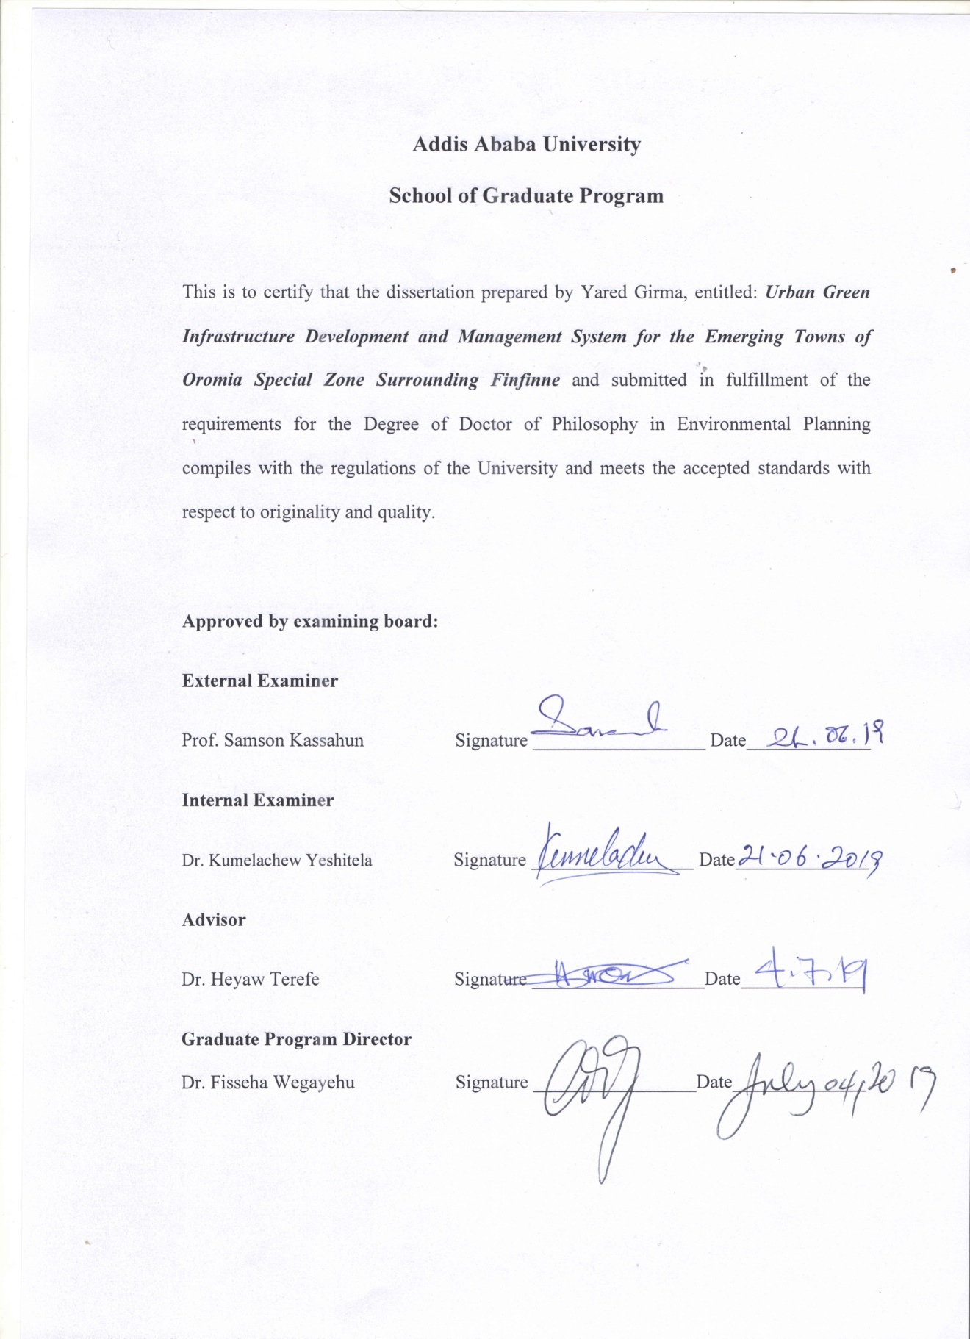

ABSTRACT
Urban Green Infrastructure Development and Management System for the Emerging Towns of Oromia Special Zone Surrounding Finfinne
Yared Girma Addis Ababa University, 2019
Urban green infrastructure components have gradually become an integral part of urban development strategies due to their important role in providing space for multiple ecosystem services for human well-being. Even though they have multiple benefits, they are under strong pressure particularly in rapidly developing cities of sub-Saharan Africa where relatively little is known about their development and management system. Therefore, this study attempts to evaluate the planning, implementation and management challenges of urban green infrastructure components and to provide recommendations that can address the challenges in the emerging towns of Oromia special zone surrounding Finfinne. The study used a mixture of quantitative and qualitative research approaches and techniques to achieve the intended objectives. The finding of the study shows that an average per capita urban green infrastructure component in Sululta, Sebeta and Legetafo towns is found to be 2.66 m², 0.9 m² and 2.17 m² per person, respectively. Results also indicated that 71.9%, 67.9% and 73.7% of respondents in Legetafo, Sebeta and Sululta towns, respectively, do not have any urban green infrastructure component in their neighborhood while very few respondents mentioned playgrounds and sport fields. The LULC change result revealed that urban green infrastructure component has decreased by 51.8%, 31.9%, and 37.5% between the year 2003-2016 in Sebeta, Sululta and Legetafo towns, respectively. The drivers for the change were physical expansion of the built-up area, high land value, laxity in the enforcement of planning regulations, corruption, lack of coordination and limited awareness of the community about the benefits of green infrastructure components. Regarding the evaluation of the planning documents, this study identified that the principles of urban green infrastructure planning are slightly presented in the documents. At the same time, the result revealed that the existing green infrastructure components provide mono-functional services and their integration with grey structure is limited. Furthermore, result shows that issues related to connectivity of green infrastructure components are not recognized in planning documents and practices. Lack of awareness, financial constraints, insufficient professional knowledge, inadequate legal framework, absence of collaboration and poor public involvement are the most influential factors hindering the integration of urban green infrastructure planning principles into urban development. Overall, the management systems of the urban green infrastructure components have also been challenged by the above-mentioned constraints. Therefore, advanced development in budget allocation, capacity building, legal framework, awareness creation and stakeholder’s involvement are needed to promote sustainable urban green infrastructure development and management system.
Keywords: Green infrastructure, component, planning, implementation, multi-functionality, participation, connectivity
Acknowledgments
First and foremost, I would like to thank the Almighty God for His generosity throughout my work to complete the study successfully. Next, I would like to express my sincere and deepest gratitude to my supervisor Dr. Heyaw Terefe for his unreserved support, evaluation, comments, encouragement, and guidance at various stages of the study. I really appreciate his patience and candid dedication towards the betterment of this research paper.

My deepest gratitude also goes to Professor Dr. Stephan Pauleit for his invitation letter and mentorship role during my three month stay in Technical University of Munich, Germany. Also, I would like to extend my gratitude to Dr. Mengistie Kindu for his warm reception, advice and support during my stay in Munich.

I am also grateful to Professor. Hailu Worku, Dr. Kumelachew Yeshitela, Dr. Fisseha Wegayeh, Dr. Ephrem Gebremariam, Dr. Hayal Desta and other EiABC staffs for their unreserved support throughout my study. I would like to extend my tanks to my classmates Sitotaw Haile, Abebe Tufa, Getinet Feyisa, Asfaw Mohammed, Dr.Mesfin Sahle, Solomon Benti, and others for their guidance and technical support during my study.

I gratefully acknowledge the financial support provided by Addis Ababa University. I am especially indebted to Professor Hailu Worku, the principal investigator of thematic area research fund, for his role, time and energy in facilitating the approval of thematic area research fund. I would also like to thank Sululta Town Administration for their permission to pursue my PhD.

My special appreciation also goes to all of my respondents from Ministry of Urban Development and Housing, Oromia Urban Planning Institute, Sululta, Sebeta and Legetafo towns’ administration and other institutions for providing me data and information for this study. I am indeed thankful to the data collectors at the three towns too.
I have no words to express my heartfelt gratitude to my family for their uninhibited encouragement and support during this study period. I would also like to reserve a special thanks to my lovely wife Eyerusalem Tamiru for her relentless support throughout this study period and all the time.

Table of Contents
Table of Contents iv
List of Figures ix
List of Tables xi
Acronyms xiii
Chapter One: Introduction 1
1.1. Background 2
1.2. Statement of the problem 7
1.3. Objective of the study 9
1.3.1. General objective 9
1.3.2. Specific objectives 10
1.4. Research questions 10
1.5. Scope of the research 10
1.6. Significance of the research 12
1.7. Description of the study area 13
1.7.1. Geographic location 13
1.7.2. Bio-physical characters 14
1.7.2.1. Topography and Climate 14
1.7.2.2. Soil and vegetation cover 15
1.7.3. Socio-economic characteristics 17
1.7.3.1. Population 17
1.7.3.2. Land use/land cover 17
1.7.3.3. Economic situation 18
Chapter Two:-Review of Related Literature 19
2.1. Introduction 19
2.2. Concept and definition of urban GI 19
2.3. Significance of urban GI 25
2.3.1. Social significance 25
2.3.2. Economic significance 26
2.3.3. Environmental significances 27
2.4. Provision of urban GI components worldwide 28
2.5. Urban GI as a planning concept 32
2.5.1. Urban GI in planning efforts around developed countries 39
2.5.2. Urban GI in planning efforts around developing countries 41
2.6. Challenges facing the development of urban GI 42
2. 7. Summary of ideas on various issues of urban GI development and management system 44
2. 8. Urban GI components in Ethiopia 47
2. 8.1. Problems of urban GI development in Ethiopia 49
Chapter Three: Research Methodology 51
3.1. Research strategy 51
3.2. Methods and techniques 52
3.2.1. Analyzing the planning challenges of GI components 52
3.2.1.1. Identifying planned and existing urban GI components 52
3.2.1.2. Assessing the accessibility of urban GI components 53
3.2.1.3. Comparing per capita of urban GI component with international standards 58
3.2.2 Analyzing the implementation challenges of GI components 59
3.2.2.1. Urban GI components plan violation 59
3.2.2.2. Change analysis of urban GI component 60
3.2.2.3. Assessing the driving forces for the loss and degradation of urban GI components 64
3.2.2.4. Assessing the utilization pattern of urban GI components 67
3.2.3. Assessing the actual status and constraints of GI management system 71
3.2.4. Evaluating the integration of urban GI planning principles in the current urban green space planning practices 72
Chapter Four: Results and Discussion 77
4.1. Planning challenges of urban GI components 77
4.1.1. Proposed and existing urban GI components 77
4.1.2. Accessibility of urban GI components 80
4.1.3. Urban GI components and international planning standards 86
4.2. Implementation challenges of urban GI components 90
4.2.1. Plan violation regarding GI components 90
4.2.2. Changes in urban GI components 96
4.2.3. Driving forces for the loss and degradation of urban GI components 105
4.2.3.1. Physical expansion of the built up area and densification of the inner towns 106
4.2.3. 2. Land value 107
4.2.3. 3. Laxity to enforce plans, policies, proclamations and regulations 109
4.2.3. 4. Low esteem of the community towards the protection of urban GI components 111
4.2.3.5. Enforcement of urban development by higher level authorities 112
4.2.3. 6. Private interest 113
4.2.3. 7. Illegal development 115
4.2.3. 8. Absence of plan monitoring, evaluation and updating system 115
4.2.4. Assessing the use pattern of urban GI components 116
4.3. Actual status and constraints of urban GI component management system 127
4.3.1. Policy and legal frameworks 127
4.3.2. Institutional framework 130
4.3.3. Capacity of human resource 133
4.3.4. Financial capacity 138
4.4. Integration of the main principles of urban GI planning in the current green space planning practices 140
4.4.1. Multi-functionality aspects of current green space planning practices 140
4.4.2. Green-grey integration in current green space planning practice 144
4.4.3. Social inclusiveness of current urban green spaces planning practices 146
4.4.4. Connectivity aspect of current green spaces planning practices 150
Chapter Five: Conclusion, Recommendations and Further Research 152
5.1. Conclusion 152
5.2. Recommendations 156
5.2. 1. Developing urban GI policy 156
5.2.2. Improving provisioning standards for urban GI components 157
5.2.3. Develop a strong institutional framework 160
5.2.4. Amend urban GI financing policy and practice 162
5.2.5. Enhancing participation in planning policy 164
5.3. Contribution and further research 165
References 167
Appendices 201

List of Figures
Figure 1 Map of the study area 14
Figure 2 Existing urban GI components in the study towns 79
Figure 3 Service area of urban GI components 82
Figure 4 GI components per capita of the study towns compared with international standards 89
Figure 5 Change of urban GI components into manufacturing and residential development 91
Figure 6 (A).Structural plan of the town in Furi area and (B).Existing land use condition of Furi area 92
Figure 7 Urban GI components changed into residential and administration uses 94
Figure 8 Urban GI changed into residential development 95
Figure 9 Land use/land cover map of Sebeta town from 2003 to 2016 96
Figure 10 Land use/land cover map of Sululta town from 2003 to 2016 97
Figure 11 Land use/land cover map of Legetafo town from 2003 to 2016 97
Figure 12 The graphical representation of the LULC proportion for 2003, 2010 and 2016 for Sebeta town 99
Figure 13 The graphical representation of the LULC proportion for 2003, 2010 and 2016 for Sululta town 100
Figure 14 The graphical representation of the LULC proportion for 2003, 2010 and 2016 for Legetafo town 100
Figure 15 Solid waste and construction material dumped on urban GI components 112
Figure 16 Type of urban GI components found in the neighborhood 118
Figure 17 Frequency of GI components visit 120
Figure 18 Factors influencing urban GI components visits 121
Figure 19 Organizational structure of the Department of Greenery and Beautification 131
Figure 20 Planned urban GI components in the structural plan 151

List of Tables
Table 1 Description of the study area 13
Table 2 Climate condition of the study towns 15
Table 3 LULC of the study area 17
Table 4 Definitions of GI 22
Table 5 Principles of urban GI planning 34
Table 6 The data used to assess the service area of GI components 56
Table 7 Satellite image data description 61
Table 8 List of data and their original sources 61
Table 9 Description of LULC classification schemes used in the study 62
Table 10 Sample size for the households 69
Table 11 Planning documents reviewed and analyzed 73
Table 12 Main principles of urban GI planning (adopted from Davies et al., 2015) 74
Table 13 Proposed urban GI components on the structural plan 77
Table 14 Number of the population that access urban GI component within different walking distances 83
Table 15 Per capita urban GI components provision 87
Table 16 LULC changes in Sebeta, Sululta and Legetafo towns 102
Table 17 Change detection matrix of LULC types between 2003 and 2016 105
Table 18 Land auction price of towns found in 1st grade lease towns categories of Oromia region 108
Table 19 Availability of urban GI components 116
Table 20 Types of urban GI components mostly visited 118
Table 21 Purpose of visiting GI components 122
Table 22 Average time it takes to reach to GI components 124
Table 23 Facilities found in urban GI components 125
Table 24 Human resources for the Department of Greenery and Beautification 137
Table 25 Planned and allocated budget for the department of greenery 139

Acronyms
AHP: Analytical Hierarch Process
ANGSt: Accessible Natural Green space Standards
CABE: Commission for Architecture and the Built Environment
CI: Consistency Index
CIWEM: Chartered Institution of Water and Environmental Management
CR: Consistency Ration
CSA: Central Statistical Agency
DEM: Digital Elevation Model
EEA: European Environment Agency
EEAC: European Environment and Sustainable Development Advisory Councils
ETM: Enhanced Thematic Mapper
EU: European Union
GI: Green Infrastructure
GIS: Geographic Information System
GPS: Global Positioning System
ILAM: Institute of Leisure and Amenity Management
LULC: Land Use/Land Cover
NASA: National Aeronautics and Space Administration
OLI: Operational Land Imager
OUPI: Oromia Urban Planning Institute
OWWDSE: Oromia Water Works Design and Supervision Enterprise
PDR: Purchase of Development Rights
PPSC: Planning Policy Statement Consultation
RI: Random Index
SRTM: Shuttle Radar Topography Mission
TM: Thematic Mapper
UDP: Unitary Development Plan
UN: United Nation
UTM: Universal Transverse Mercator
USGS: United States Geological survey
WHO: World Health Organization
WLC: Weighted Linear Combination
WGS: World Geodetic system

Chapter One: Introduction
This dissertation is written for a study that has been conducted in the emerging towns of Oromia special zone surrounding Finfinne, for fulfillment of the requirements for the Degree of Doctor of Philosophy in Environmental Planning at Ethiopian Institute of Architecture, Building Construction and City Development (EiABC), Addis Ababa University. The study aimed at evaluating the planning, implementation and management challenges of urban green infrastructure (GI) components and providing recommendations that overcome the challenges. Urban GI components are an essential element of the urban environment and are also vital to human well-being. While the multiple functions of urban GI components are reasonably understood worldwide, they are still not receiving full attention in sub-Saharan Africa in general and in the emerging towns of Oromia special zone surrounding Finfinne of Ethiopia in particular, and are consequently under threat from urban development and human activates. As an urban management expert and a resident of one of the town found in the Oromia special zone surrounding Finfinne, the author was aware of several aspects of this general situation. Therefore, these things motivate the author to better understand the existing situation of urban GI components and suggest solutions to overcome the threats.

To this effect, this chapter provides the background of the study, statement of the problem, objectives of the study, research questions, scope of the study, significance of the study and description of the study area.

1.1. Background
Throughout the world, urban areas have been increased in size over recent decades (Sandstrom, 2002; Cohen, 2006). The United Nation report indicates that currently more people of the world (54 %) are living in urban centers and by 2050 urban environment will need to accommodate an additional 2.6 billion people, pushing urbanization to 86% in the developed world and 64% in the developing countries (United Nation, 2014). This rapid urban expansion and population growth across the globe is followed by degradation of local environments such as air pollution, intensification of the heat island, loss of urban green spaces, biodiversity and the ecosystem services (Zipperer et al., 1997; Mng’ong’o, 2005; Vesely, 2007; Young, 2010; Sudha et al., 2012; McDonald et al., 2013). Overall, population growth and urban expansion induces high pressure on natural resources and threats to compromise the quality of life within urban environment (Mazza & Rydin, 1997; Liu, 2008).

Currently, urban GI is identified as an alternative nature-based and cost-effective remedy to some of these negative consequences (Benedict & McMahon, 2006; Ahern, 2007; Pauleit et al., 2011; Pakzad & Osmond, 2016) and it is increasingly recognized by researchers, professionals and practitioners as playing an essential role in strengthening the resilience of urban environments and communities (Pitman et al., 2015).

Urban GI as a concept emerged in the 1990s (Firehock, 2010; Pauleit et al., 2017). However, it is not a new notion and has roots in green spaces planning and conservation efforts that started a hundred and fifty years ago (Benedict & McMahon, 2002; CIWEM, 2010). It commonly refers to the strategically planned interconnected network of high quality natural and semi-natural areas with other environmental features, which is developed and managed to provide multifunctional benefits and protect biodiversity in both rural and urban areas (Benedict & McMahon, 2006; Gill et al., 2007; Mell, 2008; Kato, 2011; European Commission, 2013). Therefore, in urban regions, GI includes a wide range of green spaces elements such as parks, open spaces, playing grounds, pocket spaces, small incidental green space and neighborhood gardens that are linked by tree-lined streets and waterways, around and between urban areas (Said & Mansor, 2011).

Several studies have demonstrated that urban GI elements can provide crucial ecosystem services for ecologically degraded urban environments by regulating climate (Konijnendijk et al., 2013), minimizing air pollution (Nowak et al., 2006; Jim & Chen 2008), aiding water purification (Shepherd, 2006), and providing habitats for wildlife (Dallimer et al., 2014; Li et al., 2017). In addition, they offers benefits relating to health and wellbeing such as relaxation (Chiesura, 2004), recreational opportunities (Madureira et al., 2018), and a connection to nature (Cohen et al., 2008). Furthermore, studies have revealed important benefits associated with cultural services provided by urban GI elements such as landscape aesthetics, outdoor recreation, and cultural values (Chiesura, 2004; Sanesi & Chiarello, 2006).

Well-planned and managed urban GI needs to be considered as an integral part of the city, since it is indispensable for the functioning of the city in a sustainable manner (Sandstrom, 2002). In recent times, GI has been identified as a specific strategy to support resilience in cities (Ahern, 2007). The integration and strategic planning and delivery of networks of connected green space described as GI has become a major discourse in urban greening and is increasingly accepted as a policy and planning approach (Lennon, 2014; Davies et al., 2015). Thus, to successfully plan and implement a high-performing urban GI capable of delivering multiple benefits, adoption of a set of principles in planning becomes necessary (Pauleit et al., 2017). These principles relate to the content as well as the process of planning (Benedict & McMahon, 2006; Kambites & Owen, 2006; Ahern, 2007; Mell, 2008; Pauleit et al., 2011; Lafortezza et al., 2013).

The role of GI planning as a strategic approach has been emphasized based on principles of connectivity, multi-functionality, integration of grey and green elements and social inclusion (Benedict & McMahon 2006; Ahern 2007; Kambites & Owen, 2006; Li 2008; Pauleit et al., 2011, Davies et al., 2015, Hansen, et al., 2016). Moreover, Pauleit et al. (2017) stated that strategic planning, interdisciplinary and trans-disciplinary partnerships, and multi-scale planning are also important additional principles to be considered. Therefore, adoption of these principles can help to maintain and enhance the quality of life in unplanned and intensified compact cities (Lafortezza et al., 2013).

Previous studies also show that processes of urban GI planning are based on long-term spatial visions supplemented by actions that are usually led by the public sector, NGOs, community groups, individuals and various sectors. The process also aims at enhancing linkages between disciplines, science, policy and practice through integrating knowledge and demands from different disciplines such as landscape ecology, urban and regional planning, and landscape architecture (Albrechts, 2006; Davies et al., 2015). Therefore, developing governance arrangements that enable such process will be a key for strategic urban GI development and management system all over the world (Pauleit et al., 2017).

In parts of Europe, North America and Asia, GI planning and management have been receiving more attention and GI is considered as essential urban infrastructure (Lafortezza et al., 2013). For instance, in the United States the integration of green and grey infrastructures has become an important solution for storm water management. While this is one approach to implement urban GI, the experience of New York City shows how this may be expanded to tackle wider challenges of climate change by preparing plan that combined engineering structures with urban GI (Pauleit et al., 2017). In Europe, cities such as Barcelona are now noted for equally ambitious strategies that put emphasis on increasing connectivity of green spaces (Pauleit et al., 2017). Moreover, the Berlin Landscape Program emphasizes a well-connected green structure that should serve as a habitat network, moderate the urban climate and create corridors for human uses (Hansen et al., 2016). Review of current planning and good practice in European and North American urban centers indicates that developed countries have established a fertile ground for application of urban GI planning principles and for further stretching to exploit the benefits of GI (Davies et al., 2015; Hansen et al., 2016). Furthermore, the review shows how the researchers, policy makers and practitioners in Europe and North America have recognized the potential of GI development and management to tackle current and future challenges for urban environment (Lafortezza et al., 2013).

On the contrary, developing countries have remained with a huge assignment regarding the development and management of urban GI components. Urban GI components in developing countries have excessively been destroyed (Wright & Nebel, 2002; Mpofu, 2013; Douglas, 2016). For instance, studies in different sub-Saharan African cities, such as Nairobi, Kisumu, Freetown, Accra, Lagos and Kumasi (Fuwape & Onyekwelu, 2011; Makworo & Mireri, 2011; Oduwaye, 2013; Mensah, 2014) found massive depletion of urban GI components with the resultant effect being very low coverage of green spaces in the landmass of many African cities. Consequently, urban GI components resulted in many deficiencies both in demand and in supply (Tuzin et al., 2002) and they are not properly utilized by the urban dwellers (Chishaleshale, 2012).

In sub-Saharan Africa, the provision of high quality urban GI components in cities is rarely recognized (Djibril et al., 2012; Olaleye et al., 2013). Moreover, the important role of urban GI elements in Africa urban regions is still hardly recognized in policymaking (Roberts et al., 2012). There is also lack of appropriate GI approach that well integrates into the planning and governance system of the cities (Herslund et al., 2017).

Similar problems were also observed in Ethiopia, which is one of the most rapidly urbanizing countries in sub-Saharan Africa (Lamson-Hall et al., 2018). The share of the population living in cities has increased from an estimated 7.1% in 1994 (Lamson-Hall et al., 2018) to 16% in 2016 and is expected to reach 60% by 2040 at the current annual growth rate of 3.5% (United Nations, 2014; Lamson-Hall et al., 2018). Due to rapid urbanization, the consequences on the development of urban GI components are alarming (Ministry of Urban Development and Housing, 2015).

1.2. Statement of the problem
Urban GI components are of utmost significance for sustainable urban development. However, they are being seriously threatened by the negative externalities of unplanned urban growth. As in many other African countries, in Ethiopia urban GI components are continuously converting to other urban land uses (Mpofu, 2013; Herslund et al., 2017), and the urban centers have faced problems such as allocation of GI components which is not based on standards. Other problems include low levels of publicly accessible green spaces, and lack of connectivity between different GI components (Ministry of Urban Development and Construction, 2013; Mpofu, 2013; Tassew & Nair, 2014).

In Ethiopia, most of the urban centers are unable to meet the minimum standard proposed by WHO, World Health Organization for urban GI component per capita which is 9m² (Ministry of Urban Development and Housing, 2015). For instance, Adama, Shashemene, Dese, Jijiga, Dire Dawa and Bahir Dar had 2.1 m², 1.9 m², 3.1 m², 3.8 m², 5.6 m² and 8.2 m² urban GI components per person, respectively (Ministry of Urban Development and Housing, 2015). Moreover, urban GI components are poorly accessible (Gondo, 2012), they are not well developed and they lack basic facilities discouraging urban dwellers to utilize them (Yeshewazerf, 2017).

The situation also applies to the emerging towns found in Oromia special zone surrounding Finfinne. The urban GI components in these towns have been consumed by industrial, commercial, residential and infrastructural developments, as well as by spontaneous and illegal settlements along mountain slopes and river valleys (Mpofu, 2013). Moreover, they are not welcoming, safe, pleasant and suitable. As a result, both quality and quantity of urban GI components are being negatively affected and failing to deliver what the towns expect from the components.

Nowadays, few studies have been conducted in Ethiopia relating to urban GI components. They are mainly focused on: the effects of urban development on green space (Abebe & Megento, 2016; Gashu & Gebre-Egziabher, 2018; Abo El Wafa et al., 2018), adaptation to climate change (Lindley et al., 2015), establishing a functional GI (Herslund et al., 2017), ecosystem service (Woldegerima et al., 2017) and utilization pattern (Yeshewazerf, 2017; Molla et al., 2017). However, there is lack of adequate understanding of the ways in which the urban GI are planned and the factors that enhance or inhibit their implementation and management systems.

Similarly, studies on the development and management of urban GI components in the emerging towns of Oromia special zone surrounding Finfinne are very limited. One study undertaken by Oromia Water Works Design and Supervision Enterprise (OWWDSE) in (2011) shows how the absence of integrated GI components and lack of proper spatial planning leads to disparities between the capability and suitability of the existing land with the proposed parks and urban agriculture. The study further revealed that the established parks are changed to industrial area for unknown reasons. Moreover, the study showed that proposed park and forest developments are also in conflict with the existing commercial areas. Another study conducted by Gondo (2012), revealed that most GI components in the study area are less attractive and difficult to access. As a result, urban dwellers are forced to travel long distances to access such facilities. As Gondo (2012), noted the problems have resulted from absence of a land use (re)mixing strategy, weak development controls and absence of facilities in existing GI components.

In total the above two studies show that the emerging towns lack proper GI planning which is based on appropriate planning principles, process and approaches. They also show that in some cases lack of implementation capacity of officials and professionals has hindered the development of GI components. However, they do not adequately identify the challenges related to planning and implementation of urban GI components and management aspects. This has created a knowledge gap on the major challenges behind the poor planning, development and management of urban GI components in the emerging towns. Beside, the studies do not recommend strategies and approaches for addressing the problems. This has made it difficult for much attention to be focused on taking necessary actions to address the challenges and enhances sustainable urban GI development and management system. Therefore, this study is intended to contribute to filling these knowledge gaps.

1.3. Objective of the study

1.3.1. General objective
The general objective of the study is to contribute to the process and understanding of the development of appropriate urban GI and management systems for urban centers of Ethiopia by investigating the urban GI development and management system of the emerging towns of Oromia special zone surrounding Finfinne.

1.3.2. Specific objectives
The specific objectives of the study are to:
- Analyze the planning, implementation and management challenges of urban GI components in the emerging towns;
- Evaluate the integration of urban GI planning principles in the current urban green space planning practice in the study towns;
- suggest alternative strategies that promote sustainable urban GI development and management system

1.4. Research questions
In light of the above problem statement and objectives, the study has the following questions.
- What are the urban GI components planning, implementation and management challenges in the study towns?
- To what extent the principles of urban GI planning integrated into the current urban green space planning practice in study towns?
- What are the strategic approaches that can promote sustainable urban GI development and management system?

1.5. Scope of the research
Spatially, this study takes into consideration the emerging towns of Oromia special zone surrounding Finfinne. The special zone consists of eight emerging towns namely Sebeta, Gelan, Dukam, Legetafo, Burayu, Holeta, Sululta and Sendafa. Among the eight towns, Sebeta, Sululta and Legetafo towns were selected purposively for this study. The towns were selected for two major reasons. First, they have the potential for being absorbed by the capital city, thereby housing millions of people and affecting their life quality. Secondly, they are particularly fast growing in terms of population, infrastructures and physical size again because of pressures from the capital. Relative to other towns in the zone, the development patterns of the three selected towns are highly influenced by a combination of factors including the availability of land in the towns that attracts investments and very close proximity to Addis Ababa city (Nigusie, 2015). Moreover, easy access to infrastructures such as roads and electricity has played an important role in the attraction of private investment in and around the towns resulting in faster development of the three towns than other towns in the zone (OWWDSE, 2011). The three towns have similar characteristics with other emerging towns found in the Oromia special zone surrounding Finfinne in terms of problems related to urban GI components planning and management.

The components of urban green infrastructure is quite wide and it is based on land use or purpose (e.g. park, greenway,), scale (e.g. city-region, city, parcel) and location, accessibility, biotope/plant communities, surface characteristics (e.g. degree of permeability or of vegetated surfaces), or vegetation structure (e.g. parks, grassland, woodland, waterside zones) (Burgess, 2015; Hansen, 2018). In the emerging towns of Oromia special zone surrounding Finfinne playground, sport field, parks and garden and green along river have been identified as the most common components of urban green infrastructure in the structural plan of the towns. Moreover, according to the data obtained from the field observation, gardens, street tree and urban forest have been also identified as the most common established components of urban green infrastructure in the emerging towns of Oromaia special zone surrounding Finfinne. Therefore, since the objective of this study is to assess the challenges of the planned and existing components for the purpose of this study the components identified both on the structural plan of the towns and from the field survey was used. Thematically, the study was conducted to assess urban GI planning, implementation and management challenges. Urban GI in the context of this study is areas covered with the soft landscape elements such as grass, shrub, bush and tree established outside urban plans, proposed in urban plans, and established as a result of the implementation of urban plans which includes mix of street trees, parks, playground, green corridors, and sport field.

1.6. Significance of the research
Urban GI is very important for sustainable urban development and human well-being. It requires adequate development and management system in order to develop properly. However, the development process of the system in developing countries like Ethiopia suffers from lack of research and contextualized knowledge inputs in addition to other inputs. Therefore, the study provide scientific knowledge by filling literature gaps for developing an effective GI planning, implementation and management strategy for small towns of Ethiopia. Moreover, it helps as a pertinent literature and input for policy makers in formulating policies and strategies along with the issue. Furthermore, the study may used as baseline information for further investigation to enrich the research findings in this area.

1.7. Description of the study area

1.7.1. Geographic location
Oromia special zone surrounding Finfinne is one of the zones of the Oromia region in Ethiopia. It was established in 2008 by Regulation No. 115/2008. The special zone comprises a surface area of 4,300 Km². This zone is surrounding the capital of Ethiopia, Addis Ababa, which is called Finfinne in the regional language. It is located between 8⁰ 34’ 25” and 9⁰ 34’ 41’’ N latitude and 38⁰ 25’ 50” and 39⁰ 7’ 53” E longitude. The zone consists of six weredas; namely, Akaki, Berek, Mulo, Sebeta Hawas, Sultulta and Welmera and eight major towns such as Sebeta, Gelan, Dukam, Legetafo, Burayu, Holeta, Sululta and Sendafa (OWWDSE, 2011). Among the eight towns, Sebeta, Sululta and Legetafo towns were selected for this study (Fig. 1 and Table 1).

Table 1 Description of the study area
Study towns | Astronomical location | Administrative area | Distance from the capital city | Sources
Sululta | 9⁰ 30' 00" to 9⁰ 12'15"N latitude and 38⁰ 42' 0" to 38⁰ 46’ 45’’ E longitude | 44.71 sq.km | 24km | OUPI, 2006
Sebeta | 8⁰ 53’38’’to 8⁰59’58’’N latitude and 38⁰ 35’11’’ to 38⁰ 39’ 33’’E longitude | 99 sq.km | 24km | OWWDSE, 2011
Legetafo | 9⁰ 01' 29" to 9⁰ 06' N latitude and 38⁰ 53' 42" to 38⁰ 55' 30" E longitude | 24.3 sq.km | 21km | OUPI, 2007
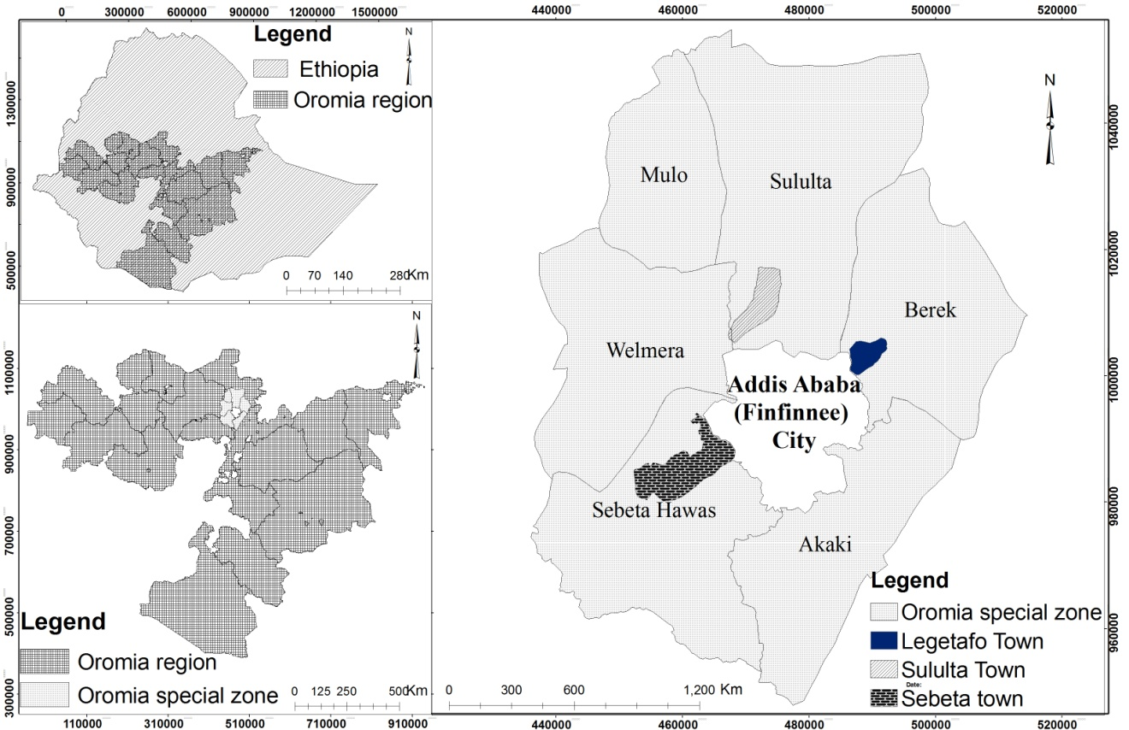
Figure 1 Map of the study area

1.7.2. Bio-physical characters

1.7.2.1. Topography and Climate
The topography of Sululta town varies from 2550m to 2813m above sea level while the average elevation of the town is 2600m above sea level. The lowest point is at the northern fringe of the town, which is 2550m above sea level, and the highest is at Entoto, a ridge which is 2800m above sea level. Sululta town has the same general climatological characteristics as that of the capital city. Globally, it is part of the tropical humid climatic region, which is characterized by warm temperature and high rainfall.

Legetafo town is characterized by dissected high plateaus and mountains associated with hills, valleys and gorges. Its altitude extends from 2387m to 2519m above sea level (Oromia Urban Planning Institute OUPI, 2007). The climate condition of Legetafo towns is characterized by sub-tropical/ ‘weyina dega’ and ‘dega’ agro-climatic conditions.

The third town is Sebeta; its elevation varies from 2066m to 2646m above sea level and Wochecha mountain is the highest elevation in the town. Climatically, Sebeta town is classified under humid (Weyina dega) agro-climatic zone that has the same general climatologic characteristics as that of the capital city.

Table 2 Climate condition of the study towns
Study towns | Average annual rainfall | Mean annual temperature | Sources
Sululta | 1119 mm | 11⁰-16⁰c | OWWDSE, 2011
Sebeta | 1073 mm | 15⁰-20⁰c | OWWDSE, 2011
Legetafo | 1078 mm | 10⁰-25⁰c | OWWDSE, 2011

1.7.2.2. Soil and vegetation cover
Sululta town’s soil is derived from Mesozoic sedimentary and volcanic rocks. The major soil type of the town’s area is Chromic Luvisols. It is categorized under basic parent material category. Basic (rich in bases) rocks are dark colored or black and have less than 55 percent silica. Basaltic rocks basic Andesites, basic Tuffs and Agglomerate, Basalti ashlbeds and Ancient basic rocks are the main parent materials in this basic category (OWWDSE, 2011).
Information obtained from OWWDSE shows that similar to Sululta town soil, Sebeta town soil is basically derived from Mesozoic sedimentary and volcanic rocks. The major soil types found in the area are Chromic and Orthic Luvisols (23.9 %) and Chromic and Pellic Vertisols (76.1%). As Oromia urban planning institute report (2007) shows larger portions of the eastern and central portions of the Legetafo town lies under Vertisols, Lithosols and Cambisols soil types. Similarly, Aerosols, Luvisols, Nitosols and rocks cover portions of the Legetafo town.
The vegetation cover of Sululta town is mostly concentrated in the mountainsides of Entoto where dense Eucalyptus tree is associated with few Acacia abyssinica together with scattered bushes and minor other kinds of plants. Its northern plain part is mainly covered with grass (pastureland) and alternating crops with few scattered trees (OWWDSE, 2011). According to OWWDSE (2011), Eucalyptus trees are found in mountain and open spaces and within homesteads of Sebeta town, whereas shrub and bush and other plantation forests are slightly available in the town. High forests, woodland, bush and shrubland, grassland and plantation trees are available in the Legetafo town, which is dominated by Eucalyptus trees, dominantly owned by individuals. Eucalyptus trees are found in all parts of the town and its hinterland. Juniperus procera (Yabesha Tsid) is the second dominant trees found in the town and its hinterland (OUPI, 2007).

1.7.3. Socio-economic characteristics

1.7.3.1. Population
The population of Sululta town was 12,452 inhabitants in 2007, (Central Statistical Authority CSA, 2008). Currently, the total population of the town is estimated at 37988 inhabitants (OUPI, 2018). According to the 1994 national census, Sebeta town had a population of 14,100, which had risen to 62,704 by 2007 (CSA, 2008). Currently, the total population of the town is estimated at 179,897 inhabitants. According to the 2007 national census, Legetafo town had a population of 10,750 (CSA, 2008). Currently, the total population of the town is estimated at 30,149 inhabitants (OUPI, 2018).

1.7.3.2. Land use/land cover
Land use/land cover (LULC) is an important aspect for modeling and understanding the earth as a system and is a key input for planning and management activities. The LULC of the towns under study constitutes settlement, bush land, cultivated land, flower farm, open grassland, plantation forest and woodland. The components of the LULC of the three towns under study are summarized in the Table (3) below.
Table 3 LULC of the study area
No | Study towns | Types of LULC (ha)
No | Study towns | Settlement | Grass land | Plantation land | Cultivated land | Woodlot | Bush land | Flower farm
1 | Sululta | 1339.7 | 1604.1 | 105.7 | 1181.2 | 180.4 | 49.5 | 15.6
2 | Sebeta | 3209.3 | 354.7 | 73.6 | 5100.6 | 13.8 | 29.5 | 61.1
3 | Legetafo | 1020.4 | 109.9 | 134.5 | 877.7 | 66 | 13.98 | -
Source: - OWWDSE, (2011)

1.7.3.3. Economic situation
Basically from its foundation, the study towns’ administrations were established from agricultural kebeles. Thus, agrarian societies are practicing their agriculture, cattle and traditional pottery. Currently, as the towns’ administration expands and the number of population increased, they are exhibiting different customs and work behavior. The economy enlarges from small-scale trade to national and international level investments. In the past one decade, more specifically in the past five or six years, the trend of investment in the towns is enormous. A number of manufacturing plants and associated service and related plants are establishing. Tens of thousands of people get jobs in such investment activities from daily laborer to professional jobs. A number of peoples’ lives have been changed as a result. In the towns, where the majority of the inhabitants are involved in non-agricultural economic activities, small and medium scale industries involve the majority of the populace. Moreover, small-scale commerce activities can be regarded as the major sources of income for the urbanites. In most households, due to many opportunities to increase ones’ income; communities in the urban areas engaged in more than one source of income. Own business, family support, remittance and other unspecified sources are the major secondary sources of income. Particularly, those working in governmental organizations and NGOs engage in such secondary sources.

Chapter Two:-Review of Related Literature

2.1. Introduction
In this chapter, concepts related to urban GI, definition, typologies and significance will be critically reviewed. In addition, urban GI components planning, implementation and management issues and the Ethiopian urban centers’ experience on urban GI components development and management system will be assessed.

2.2. Concept and definition of urban GI
The concept of urban GI emerged in the US in the 1990s, triggered by growing concern of uncontrolled urban sprawl (Benedict & McMahon, 2002; Walmsley, 2006; Hansen, 2018). The exemplar designs of Frederick Law Olmsted and Ebenezer Howard were fundamental to the development of GI thinking (Davies et al., 2006). Little (1990), Williamson (2003), and Fabos (2004) claim that the ideas of linking the ecological capacity and social opportunities of an area have now been taken as a given in landscape planning but the work of Olmsted and Howard was some of the first to explore this relationship. More recently the Commission for Architecture and the Built Environment’s (CABE) (2003) discuss both the work of Olmsted and Howard as good practice examples of GI providing diverse and multi-functional benefits within and across the urban and urban-fringe interface (Davies et al., 2006).
In some academic perspectives, the concept of GI is also considered to have drawn from the green belt thinking (Amati & Taylor, 2010). The green belt model was thought of as an effective way of managing the protection and development of urban fringe areas (Thomas & Littlewood, 2010). Previous studies have also stated that, GI has also embraced the ideas of greenways planning to promote multi-functional ecological and recreational routes (Little, 1990, Ahern, 1995; Benedict & MCMahon, 2002; Fabos, 2004). Moreover, based on Farina, (2006), Forman, (1995) and Weber & Wolf, (2000) the concepts of GI has also been influenced by complementary principles identified in the landscape ecology and conservation research.
The application of urban GI concept has significantly increased over the past decade (Wright, 2011). However, the origin of the term remains debatable (Allen, 2012; Roe and Mell, 2013; Rouse & Bunster-Ossa, 2013), and there are a variety of interpretations as to what it entails (Sylwester, 2009; Casperson & Olafsson, 2010; Ellis, 2012). It has been described as a contested term (Davies et al., 2006), aligned with various meanings ranging from a planning approach for large-scale green space networks to ecosystem-based storm water management.
Previous studies show that the definition used by practitioners or researchers are directly related to the focus of their own GI research contexts (Tzoulas et al., 2007; Mell, 2008; Madureira & Andresen, 2013). For example, conservationists may strongly emphasize the ecological and biodiversity components (Ahern, 2007), whereas urban planners may view the concept in terms of policy implementation (Benedict & McMahon, 2002; Mell, 2010), and recreational, greenway and GI specialists may focus on the benefits gained through development (CABE, 2003). Even though, the definitions vary from professional to professional, most stakeholders agree on the following;

“GI is a network of multi-functional open and green space in and around towns and cities; the gardens, trees, rivers, woodland, parkland, nature reserves and urban wild space, and the access to and through them, which support wildlife and biodiversity, provide recreation, access and leisure opportunities and create a sense of place” (McDonald et al., 2005).

In addition, there are common themes which various authors use (Mell, 2010). Thus, the Countryside Agency (2006) gives one definition which provides an insight into the complexity of the GI concept by noting the roles of connectivity, multi-functionality and the development of better ecological, economic and social places across a number of scales as prominent elements of the concept (Benedict & McMahon, 2002; Mell, 2010). According to definition of Countryside Agency (2006):-
“GI comprises the provision of planned networks of linked multifunctional green spaces that contribute to protecting natural habitats and biodiversity, enable response to climate change and other biosphere changes, enable more sustainable and healthy lifestyles, enhance urban livability and wellbeing, improve the accessibility of key recreational and green assets, support the urban and rural economy and assist in the better long-term planning and management of green spaces and corridors.”

The definition shows that GI is or should be, part of a wider ecological network linking different ecological features. However, there is no single explanation that can act as a principal definition of what urban GI is all about. The following table (4) illustrates the various definitions of GI that are provided by different authors at different time.

Table 4 Definitions of GI
No | Authors (references) | Definitions
1 | Ahern, (2007) | GI is a concept that is principally structured by a hybrid hydrological/drainage network, complementing and linking relict green areas with built infrastructure that provides ecological functions. It is the principles of landscape ecology applied to urban environments
2 | Benedict & McMahon, (2002) | GI is a strategic approach to land conservation, a smart conservation that addresses the ecological and social impacts of sprawl and the accelerated consumption and fragmentation of open land.
3 | Benedict & McMahon, (2006) | An interconnected network of natural areas and other open spaces that conserves natural ecosystem values and functions, sustains clean air and water, and provides a wide array of benefits to people and wildlife.
5 | CABE, (2010) | GI is the network of natural places and systems in, around and beyond urban areas. It includes trees, parks, gardens, allotments, cemeteries, woodlands, green corridors, rivers and wetlands.
4 | City of Melbourne, (2012) | GI is the network of natural landscape assets which underpin the economic, socio-cultural and environmental functionality of our cities and towns i.e. the green spaces, water systems and built environment landscapes which intersperse and increase connectivity, multi-functionality and landscape performance in urban environments
6 | Davis et al.(2012) | GI is parts of urban area with a mix of street trees, parks, cultivated land, wetlands, lakes, and streams.
7 | EEAC, (2009) | GI is the actions to build connectivity nature protection networks as well as the actions to incorporate multifunctional green spaces in urban environment
8 | Epsom & Ewell, (2013) | GI is a term used to refer to the living network of green spaces, water and other environmental features in both urban and rural areas. It is often used in an urban context to cover benefits provided by wildlife, trees, parks, gardens, road verges, allotments, cemeteries, woodlands, rivers and wetlands.
9 | European Union, (2013) | GI can be broadly defined as a strategically planned network of high quality natural and semi-natural areas with other environmental features, which is designed and managed to deliver a wide range of ecosystem services and protect biodiversity in both rural and urban settings.
10 | Landscape Institute, (2009) | GI is an approach to land use, underpinned by the concept of ecosystem services. Green assets such as parks, coastlines or embankments have generally been thought of in terms of their single functions the approach that recognizes their vast range of functions and their interconnectivity is called GI.
11 | Lewis, (2007) | GI is an interconnected network of greenways and natural lands that include wildlife habitat, waterways, native species and preservation or protection of ecological processes.
12 | Natural England, (2011) | GI is a strategically planned and delivered network of high-quality green spaces and other environmental features. It should be designed and managed as a multifunctional resource capable of delivering a wide range of environmental and quality-of-life benefits for local communities. GI includes parks, open spaces, playing fields, woodlands, allotments and private gardens.

The definitions of GI appear to draw on a myriad of complex ideas that reflect different needs, priorities and situations of the organizations and communities concerned. However, a clear definition is now needed in order to describe and delineate the theme of research to be pursued here. This study will therefore use the term urban GI ‟as areas covered with the soft landscape elements such as grass, shrub, bush and tree established outside urban plans, proposed in urban plans, and established as a result of the implementation of urban plans which includes mix of street trees, parks, playground, green corridors, and sport field’’ a definition more likely similar to that of Davis et al. (2012). This working definition is intended to be as comprehensive and inclusive as possible: it allows the inclusion of parks, gardens, green corridors, playground, sport fields and derelict or vacant land that is vegetated. The working definition used in this study has take into account only the components indicated on the structural plan of the towns and identified from the field survey. The structural plans of the towns has put the farmlands as urban agriculture and it did not included in the urban GI components, therefore this study has also excluded farmland from the urban GI components..

As the above definitions, there are different components that actually constitute urban GI. However, many authors agree on urban forest, public green spaces, gardens, playing grounds, right-of-way along streams and roads, community gardens, urban wetlands, and constructed features such as green roofs, green walls, permeable vegetated surfaces, green swales and rain gardens as the main components that are constitute urban GI (CABE, 2010; Natural England, 2010; Davis et al., 2012; Serra-Liobet & Hermida, 2016). Therefore, in line with this agreement this study is mainly focused on urban GI components such as parks, playgrounds, gardens, sport fields, and green corridors.

2.3. Significance of urban GI
Many studies have revealed that a well developed and managed urban GI has an essential contribution to urban sustainability because of generating significant benefits in all the three sphere of concerns: social, economic and environmental (Schneekloth, 2003; Harnik, 2004; Fam et al., 2008; Forest research, 2010; Ernstson, 2012; Konijnendijk et al., 2013). Therefore, an extensive review of all the three spheres are provided here to give the current study a more theoretical background on the significance of urban GI to the urban and built environment.

2.3.1. Social significance
Urban GI components can serve as providers of passive and active recreation and help to meet the leisure needs of a community (Reeves, 2000; Grose, 2009) through furnishing places for play, sport, recreation, special events and other leisure activities in both developed and developing countries. Study undertaken in China by Xi-Zhang (2009) and Jim and Chen (2006) revealed that many urban dwellers use GI components for recreational activities such as relaxing, playing, walking, exploring and observing wildlife. Haq (2011) has also found that GI components such as playgrounds and parks are major resources for recreational activities in UK, Finland and Mexico

In the area of improving the health condition of urban dwellers, several studies have found that GI components have a positive influence on psychological and mental health, reducing stress, inducing feelings of control and reducing frustration and irritation (Kuo et al., 1998; Conway, 2000; Woo et al., 2009; Ernstson, 2012). Hutchison (1987), More (1988), Loukaitou-Sideries (1995) and CABE (2004), claim that urban GI components such as parks and playgrounds provide a meeting ground for social interaction of urban dwellers. Concurrently, according to Swanwick et al. (2003), urban GI contributes significantly to social inclusion due to the fact that it is free and accessible to all.

Urban GI components such as parks, gardens and urban forest can also be seen as second classrooms for children. Exposure to the urban GI components creates a sense of diversity and stimulates ingenuity and imagination (Chen & Jim, 2008), which promotes performance of students in their classes. Urban GI components also improve self-discipline, lower the rate of truancy and allow for even better scholar achievement (Taylor et al., 2001; Taylor et al., 2002). Moreover, it is an important site for scientific studies, including ecology, vegetation, and animal science (Conner, 2005).

2.3.2. Economic significance
One of the main economic benefits that can be directly monetized and compared is the increase of property value in relation to proximity to GI component in urban areas (Luttik, 2000; Crompton, 2001; Morancho, 2003; Jim & Chen, 2006; Kong et al., 2007). The findings from a study in 8 towns in Netherlands revealed that proximity to GI components such as parks and playgrounds increased the value of houses prices by about 28% (Luttik, 2000). A similar picture emerges from research in Dallas (CABE, 2004), where many residents cited public green spaces at the rear of their houses as a major factor in their decision to move to the area. Nearly two thirds of these residents believed that the presence of the green spaces have elevated the value of their homes by at least 15%. In Berlin in 2000, proximity to playgrounds in residential areas was found to increase land values by up to 16% (CABE, 2004).
Urban GI components have also been observed in saving energy. A fascinating study undertaken by Nowak and Dwyer, (2007) reveled that urban trees can reduce building heating and cooling energy needs, as well as consequent emissions of air pollutants and CO² by power plants, by shading buildings and reducing air temperatures in the summer, and by blocking winds in winter. Similarly, a study undertaken by Luttik, (2000) shows that trees around buildings can reduce cooling costs by 30%, and heating costs by 20-50% reducing the fuel costs associated with heating and cooling.

2.3.3. Environmental significances
Several studies provide evidence that urban GI components such as parks and urban forest have contain significant amount of biodiversity and perform an important role in conserving habitats, ecological value and biodiversity (Niemela, 1999; Jorgensen et al., 2002; Smith et al., 2005; Barbosa et al. 2007; Forest Research, 2010). A study undertaken by the Institute of Leisure and Amenity Management (ILAM), (1995) shows that, urban GI components can help to conserve natural eco-systems and their associated species within the urban environment. A study of Cornelis & Hermy (2004) in Flanders, Belgium, reported that GI components mainly urban parks may be considered as important “hotspots‟ for biodiversity in cities.

Urban GI components have also observed to contribute positively in stabilizing the microclimate and moderating the extremes of urban climate (Kottmeier et al., 2007; Fam et al., 2008; Konijnendijk et al., 2013). Flores et al. (1998) and Gomez-Munoz et al. (2010) claimed that the vegetation in urban GI components play an important role through its cooling effect as it provides shade and thus reduces heat from solar radiation. A study undertaken by Alexandri & Jones (2008) also revealed that urban GI components help to mitigate urban high temperatures and lower the effect of urban heat islands.

Urban vegetation can purify air and water as well as reduce noise (Conway, 2000; Ong, 2003; Chiesura, 2004). A study undertaken by Nowak et al. (2006) shows the availability of many urban trees has been observed to enhance urban air quality by helping to remove some pollutants such as carbon monoxide, nitrogen oxide and sulphur dioxide from the atmosphere. Similarly, Bolund & Sven (1999) claim that vegetation is much better in filtering the air compared to water or open space.

Urban GI components could also moderate the flow of surface run-off, which can cause erosion and help to control storm water run-off in cities (Roy et al., 2000). According to a study done by Shepherd (2006) in Ohio, US, trees can also modify the way water moves through urban catchments.

In general, the above discussions strongly emphasize on significance the urban GI components have to human well-being and sustainable development of the urban environment. This significance can fully be realized when urban GI components are adequately provided. The next section therefore gives attention to the provision of urban GI components in cities all over the world.

2.4. Provision of urban GI components worldwide

Previous studies confirmed that the provision of a sufficient amount of urban GI components represents a key aspect for adequate living conditions and a healthy environment in urban centers (Cornelis & Hermy, 2004; Nowak & Heisler, 2010; Krekel et al., 2016). The significance of urban GI components for human well-being and sustainable development of urban environment has led to the development of standards for urban GI components provision both in developed and developing cities. The standard approach for urban GI components such as parks provision dates back to the early 20th century when park reformers sought to establish minimum acceptable park allocations for urban dwellers (Wilkinson, 1985; Taylor, 1999). For instances, the firm responsible for designing American parks (Olmstead, Bartholomew and Associates) specified that no resident should be further than 400 meters from a park (Byrne & Sipe 2010). Currently, the national standard for the provision of urban GI components in the USA ranges from 2.5 to 4.2 hectare per 1,000 populations (National Parks and Recreation Association, 2000).

Similar trends occurred in the United Kingdom. In the 1920s, the National Playing Fields Association adopted a standard of 2.4 hectares per 1,000 populations and following the Second World War, a national standard emerged of 1.6 hectares of green space per 1,000 residents, with no resident living more than 800 meter from a park (Hindley, 2007). These ideas were modified over time, and Accessible Natural Green Space Standards (ANGSt) recommends a provision of 2 hectares accessible green space per 1,000 population, and that no person should live more than 300 meters from the nearest green space, which is about 5 minutes walking distance (Handley et al., 2003; Comber et al., 2008). The European Environment Agency (EEA) also recommends that people should live within a 15-minute walking distance of their place of residence, which is approximately 900 to 1000m (Chiesura, 2004). The Netherlands target a minimum urban GI components provision of 60 m² per capita within a 500m radius around household (Roo et al., 2011) while in the Copenhagen (Denmark) city authorities have adopted a green space standard of providing green spaces within 400 meters for at least 90 percent of residents (Schipperijn et al., 2010). Similarly, Magalhaes (1992) considers a minimum distance for children and elderly people of 100m and considers 400 m² as the minimum area for a public green space in Portugal.

Internationally, WHO and the Food and Agricultural Organization (FAO) suggest ensuring at least a minimum availability of 9 m² urban GI components per urban dweller (Kuchelmeister, 1998). Yet the developed countries have raised their standard beyond the minimum limit up to 20 m² urban GI components per city dweller (Wang, 2009). For instance, Ljubljana, Vienna, Stockholm, Amsterdam, Copenhagen, Rotterdam and London have 560 m², 120 m², 87.5 m², 45.5 m², 42.4 m², 28.3 m² and 27 m² urban GI components per capita, respectively (Vazques, 2011; Comertler, 2017).

Developing countries have also established similar quantitative standards for the provision of urban GI components. For instances, the Bangkok Metropolitan Administration in Thailand has a standard of 10 m² urban green spaces per capita to enhance the provision of urban GI components in Bangkok (Fraser, 2002). In India (Delhi) average urban GI components cover is about 20% of geographical area and about 21m² per residents (Singh et al., 2010). According to Mensah (2014), cities such as Cape Town (South Africa), Maputo (Mozambique), and Dar es Salaam (Tanzania) had high scores on the coverage of urban GI components, which were 289.5 m², 114.9 m², and 64.1 m² per capita, respectively while values below 1 m² per capita have also been reported for Alexandria, Cairo, and Luanda (Mensah, 2014). In Ethiopia, Addis Ababa city master plan has also proposed recreational park standards based on park size. Accordingly, city park should have 10 ha and above size, sub-city park should have 1-10 ha size, wored park should have 0.3 to 1ha size and neighborhood park should have 0.1 to 0.3 ha size. Moreover, the National Urban Green Infrastructure standard of Ethiopia also proposed 15m² public green open spaces per capital within the city boundaries and every resident to live within 500 meter from a public green open space of a size of at least 0.3 hectare (MUDH, 2015). However, even though, the standard has proposed they never been implemented accordingly in the city.
Even though the quantitative standards serve as a benchmark to guide the provision of urban GI components, they have received increasing criticism for failing to deliver the quality of urban GI components (Pauleit et al., 2003) and for producing bland urban GI components that people do not use (Wilkinson, 1985). Studies have also found that the standards only specify a gross amount of urban GI components, they are silent about how urban GI components is distributed within built environments, meaning that some urban areas end up ‘park poor’, creating environmental justice problems (Sister et al., 2009).

Accordingly, it is difficult to rely only on quantitative standards for providing sufficient urban GI components, but also a qualitative standard is needed. Studies pointed out that easy access, naturalness (wildlife, vegetation etc.), comfort (toilet, seats and shelter), cleanliness, aesthetics and facilities as well as the quality of their maintenance are important characteristics that an ideal urban GI components should have both in developed and developing countries (Chiesura, 2004; Kaczynski et al., 2009; Schipperijn et al., 2010; Fischer et al., 2018). Harnik, (2004) also stated that equitable access and safety have also observed as some of the key characteristics that urban GI components in good condition should possess. At this point, the study takes a closer look at the quantity and quality aspect of the urban green infrastructure components found in the emerging towns of Oromia special zone surrounding Finfinne to fill the knowledge gaps related to the issue.

2.5. Urban GI as a planning concept
The GI concept is being adopted within some countries in the plan making at local and regional levels (European Environment Agency, 2011). At the regional and local level, GI has often been related to a fine-scale application where hybrid infrastructures of green spaces and built systems are planned and designed to support multiple ecosystem services (Pauleit et al., 2011). More recently, there has been much focus on how GI can be used as a tool for integrated spatial planning and governance to deal with urban challenges, from climate change adaptation and biodiversity loss to enhancing human health and well-being, social cohesion and economic sustainability (Gill et al., 2007; Colding, 2011).

According to the European Union’s Directorate General Environment Biodiversity Unit (European Union, 2010), GI promotes integrated spatial planning by identifying multifunctional zones and by incorporating habitat restoration measures and other connectivity elements into various land use plans and policies (e.g. linking urban and peri-urban areas, Lafortezza et al., 2013). More recently, urban GI planning has emerged as a distinct subset of GI aimed at creating and managing networks of green space in urbanized environments through the application of certain planning processes, approaches and policy themes (Ahern, 2007; Mell, 2009; Pauleit et al., 2011; Davies et al., 2015). It is distinguished from other green space planning approaches by being based on a specific set of principles that relate to the content as well as the process of planning. (Benedict & McMahon, 2006; Kambites & Owen, 2006; Ahern, 2007; Mell, 2008; Pauleit et al., 2011; European Commission, 2013; Lafortezza et al., 2013).

When GI is understood as a planning concept, again a large variety of defining features are mentioned in the literature (Kambites & Owen, 2006; Pauleit et al., 2011; Roe & Mell, 2013). However, there is general agreement on some underlying principles: the idea that GI is to be developed as a network, and is supposed to be planned or managed to ensure multi-functionality and provision of multiple ecosystems services (Madureira & Andresen, 2013; Liquete et al., 2015)

From different urban GI initiatives underway across the world, a common set of principles have emerged as being critical to success. These principles provide a strategic approach to and a framework for conservation that can advance sustainable use of land while benefiting people and nature, and providing an interconnected system of green spaces that benefit people, wildlife and the economy. The principles can be used as a benchmark for incorporating GI approaches into existing and future plans and policies as well as future land conservation and land development projects (Bendict & MacMahon, 2002). Table (5) shows different principles of GI planning identified by Lennon & Scott (2014), Kambites & Owen (2006), and Hansen & Pauleit (2014). From the presented principles, only four key principles i.e. multi-functionality, connectivity, green-grey integration, and social inclusiveness and adoption of a communicative approach have been further explored in this study.

Table 5 Principles of urban GI planning
S/N | Principles | Authors
1 | Connectivity | Lennon & Scott (2014), Hansen & Pauleit (2014)
2 | Multi-functionality | Lennon & Scott (2014), Hansen & Pauleit (2014)
3 | Green-grey Integration | Hansen & Pauleit (2014)
4 | Strategic approach | Kambites & Owen (2006), Hansen & Pauleit (2014)
5 | Social inclusion | Kambites & Owen (2006), Hansen & Pauleit (2014)
6 | Multi-scale approach | Hansen & Pauleit (2014)
7 | Interdisciplinary and trans-disciplinary | Lennon & Scott (2014), Hansen & Pauleit (2014)
8 | Multi-object approach | Hansen & Pauleit (2014)

The first core attribute of the GI planning principle is multi-functionality. With the overall concept of sustainability at its roots, urban GI planning views urban green areas as being part of a multifunctional structure (Thoren, 2000). According to Hansen and Pauleit (2014), GI planning considers and seeks to combine ecological, social and economic/abiotic, biotic and cultural functions of green spaces. Similarly, Lennon and Scott (2014) understand GI planning as a way to enhance multiple ecosystems services. Based on the idea of the authors, multi-functionality refers to the ability of urban green spaces to provide several functions and provide several benefits on the same spatial area (Pauleit et al, 2017). These functions can be environmental, such as conserving biodiversity, adapting to climate change and carbon reduction and sequestration, social such as access to urban green spaces, healthy living, improved aesthetics, increased recreational space, and a connection to the natural environment and economic, such as supplying jobs, energy saving and raising property prices (Molla, 2015). Planning for multi-functionality needs to build on an understanding of different human demands, and it should strive for universal access to multiple green-space services, regardless of socioeconomic status. Groups and individuals will have different preferences, and multi-functionality is one way of making sure that these needs are met (Pauleit et al., 2017). Different countries often consider the multiple ecological and social benefits that urban GI provides (Hansen et al., 2016). However, enhancing multi-functionality has so far received less explicit attention: in different part of the world, there seems to be uncertainty about how to actively plan and design for multifunctional green infrastructure. A more proactive approach to multi-functionality is likely to be needed in light of trends such as climate change and urbanization, both of which are increasing the pressure on urban GI (Davies et al., 2015).

The second principle of GI planning is its integration to other types of infrastructure. Advocates of an urban GI planning contend that urban GI should be seen in an integrative way, together with other urban structures (Armann et al., 2017). Hansen & Pauleit (2014) describe that GI planning must be integrated and coordinated with other urban infrastructures, creating physical and functional links (e.g. to the built-up structure, transport infrastructure, and water management system). Lennon & Scott (2014) go even further by arguing that as fundamental infrastructure, GI should be prioritized by planning and considered before development. Green-grey integration often leads to a better expression of the multiple functions of each structure (Liu, 2008). Different studies pointed out that green-grey integration in urban GI planning is most prominently related to storm water management (Keeley et al., 2013; Chini et al., 2017; Christman et al., 2018). However, it can also apply to other kinds of infrastructure, for instance, bike paths and greenways along power line right-of-ways, green corridors for natural ventilation, green as a noise buffer, or green roofs for cooling (Hansen et al., 2017). The need to shift towards more efficient and integrated system incorporating urban GI has been globally recognized and in some cases translated into legislation, (e.g., the US Environmental Protection Agency’s Clean Water Act or the EU Water Directive). The challenge is to translate these high-level agendas to the local level and into concrete measures. Barriers to implementation exist in many cities, including lack of funding, lack of access to land, low levels of citizen engagement, and administrative fragmentation (Davies et al., 2015).

Third, GI planning emphasizes connectivity as central to promoting holistic planning approaches. Connectivity is described as a key principle of GI planning by Lennon & Scott (2014) as well as by Hansen & Pauleit (2014). A review of GI practice in the United Kingdom by Kambites & Owen (2006) concluded that connectivity is a pervasive and desirable characteristic of both GI itself and the process of GI planning. It should be noted that the understandings of connectivity vary between the authors. A narrow interpretation is put forward by Hansen & Pauleit (2014) who describe that connectivity is used to improve connections between different green spaces at different scales in order to enhance social connectivity (for better accessibility, recreation), and ecological connectivity (dispersal of plants and animal) or abiotic connectivity (regulating water flow or climate functions) (Hansen et al., 2016). In contrast, Lennon & Scott (2014,) understand connectivity to be both a characteristic of GI on the ground and of the GI planning process, differentiating between spatial, scalar and institutional connectivity. While spatial connectivity refers to the physical connection of GI elements across the landscape, scalar connectivity highlights the need for coordination and consistency across spatial and administrative scales, encouraging strategic thinking about GI; Rather than piecemeal interventions at the local level, individual measures should be embedded in a larger scale and long-term strategic plans. Finally, institutional connectivity implies that partnerships and cooperation between different administrative organizations should be established, as joined-up approaches and integrated governance are considered essential to GI planning (Lennon & Scott, 2014). The spatial planning undertakes in European cities has widely recognized the value of linking green spaces. However, the level of understanding of connectivity’s objectives and benefits differs from between cites (Davies et al., 2015).

The fourth core attribute of GI planning principle is social inclusiveness. Social inclusion is understood as a process by which efforts are made to ensure equal opportunities for all, regardless of their background, so that they can achieve their full potential in life. It is a multi-dimensional process aimed at creating conditions which enable full and active participation of every member of the society in all aspects of life, including civic, social, economic, and political activities, as well as participation in decision-making processes (Silver, 2015). Lack of socially inclusive planning may result in an urban GI that does not meet the requirements of the different sectors of urban society well, thus intensifying social inequalities rather than promoting social cohesion (Pauleit et al., 2017). Socially inclusive urban GI planning can help to foster social cohesion and also to take questions of equal access to urban green infrastructure and user needs into account (Hansen et al., 2016).

In sum, GI planning is generally understood as a process targeted at strengthening connectivity between individual GI elements, while recognizing and supporting their multiple functions and benefits. Simultaneously, urban GI planning is recognized as a contributor for promoting social cohesion. Furthermore, the necessity to integrate GI planning with spatial and infrastructure planning processes is highlighted by the authors. Cities across the developed world seem to be starting to pay more attention to various aspects of the GI principles. In the US the focus of GI planning is often on stormwater management, in the UK and Ireland the GI principles have been adopted to overcome limitations of green belt planning (Thomas & Littlewood, 2010; Lennon, 2014; Lafortezza, et al., 2017). The study undertaken by Lafortezza et al. (2017) reveals that most of the European cities preserve and develop green networks, such as historic green ring or belt structures, habitats, or other ecological networks and/or systems of recreational corridors and paths. Moreover, northern and western Europe were already more open to experimenting with participatory approaches toward planning (Buijs et al., 2016).

2.5.1. Urban GI in planning efforts around developed countries
There has been a successful effort for applying the concept of GI and GI planning in different part of the developed countries. Study by the European Union (2012) shows that significant interest in GI planning is currently underway in the EU with primary interests in biodiversity protection and climate change mitigation/adaptation. In addition, the study undertaken by the European Union (2012) revealed that, with respect to biodiversity concerns, various agreements have been reached by the member nations to complete GI works. These include: a) a habitat directive to include a minimum of twenty percent of the land base to be protected for unique Natura 2000 ecological sites; b) a water quality and protection framework directive; and c) a protection of endangered birds and animals’ habitats directive. Moreover, the EU has implemented various GI efforts that strategically address issues facing its constituent countries through its Environment and LIFE Programmes. Specifically, through specific GI mechanisms, the EU is attempting to combat habitat loss, land fragmentation and degradation, and the negative effects of large scale agricultural and forestry production (European Union, 2010).
Currently, urban GI is embedded in the planning system, with national statutory designations in the United Kingdom (CIWEM, 2010). The Planning Policy Statement Consultation (PPSC) (DCLG, 2010) stated that planning could make a significant contribution to mitigating and adapting to climate change, through the provision of well-planned GI within and between developments. In their view, GI should help to address the changing climate through planning action. Natural England (2011) also argues that the government should establish GI partnership to support the development of GI in England. The concept of GI permeates planning policy from the highest level of government down to local municipal plans with various implementation mechanisms. The UK GI planning use example is illustrative of how the EU strategic planning framework for GI is being implemented (Mell, 2008).
In Sweden, the national launch of the GI concept is performed on a regional level, where urban planning is very superficially considered, and GI is therefore discussed as ecological core areas in the countryside and its effects on forestry (Lindholm, 2017). The City of Melbourne, a well-regarded green city in the world today (Forman, 2008) has acknowledged the notion of the GI term in its most recent comprehensive plan for the municipality (City of Melbourne, 2012).

In USA, various states including Florida, Oregon, Washington, New Jersey, Virginia, Massachusetts, Delaware, and Maryland have integrated the concepts of GI planning into local efforts but may not use the term GI to define such efforts or have only completed assessments on a county or regional scale but not statewide (Youngquist, 2009). While interpretations of GI in the USA vary in focus from ecological conservation (Marcucci & Jordan, 2013), to recreation space provision (Erickson, 2006) and aesthetic enhancement (Pincetl, 2013), they most frequently show concern for storm water management (Brown and Caldwell et al., 2011). The city of Seattle, Washington, is a leader in the implementation of innovative GI in the United States, primarily in the area of urban storm water management (Pauleit et al., 2011).

2.5.2. Urban GI in planning efforts around developing countries
Few countries in Latin America have introduced urban green infrastructure planning principles at the policy level (Quintero, 2012). Three notable examples are Ecuador, Brazil and Colombia (Quintero, 2012; Serra-Llobet, & Hermida, 2017). The Brazilian experience with biodiversity offsets illustrates that biodiversity offsets not only constitute an excellent financial instrument for consolidation of protected areas but also address the full impact of infrastructure projects on biodiversity at the landscape scale (Quintero, 2012). City of Cuenca in Ecuador has attempted to expand riparian corridors to improve ecological connectivity, increase flood capacity, filter runoff before reaching river channels, and providing parkland. Moreover, connecting between linear parks to improve biological connectivity and human accessibility has also attempted. Furthermore, green areas in the city center can be connected to peri-urban green space, especially along streams in the peripheral zone, to create an integrated system of green corridors at a local and regional level (Serra-Llobet & Hermida, 2017).

Even though the green agenda is gaining importance within the African planning context, in comparison to international trends, Africa is still slow to plan for, and successfully implement GI as part of broader spatial planning approaches (Cilliers, 2019). In African countres, urban green infrastructure is not (yet) successfully implemented in practice due to various reasons of which the misconceptions relating to the important role and value of green infrastructure in terms of the economic, social, and environmental benefits are probably the core denominator (Cohen, 2006). In the context of sub-Saharan African and the study area in particular, the application of the urban GI planning principles in the urban planning practices and its implementation is not often well known and hence serve as a relatively new research approach. This is one of the research gaps that the study intends to fill. At this point, the study takes a closer look at the integration of the main principles of urban GI planning into the current urban planning practices of the emerging towns and evaluates the success or failure of plans and its implementation.

2.6. Challenges facing the development of urban GI
Despite its promises as a cost-effective, multi-beneficial strategy for delivering valuable ecosystem service to society and efficiently contributing to a range of goals, urban GI component development and management system has challenges (Alliance, 2011; Tayouga & Gagne, 2016; ODonnell, et al., 2017; Thorne, et al., 2018). Several authors have addressed different factors that negatively influence the development and management system of urban GI (Sandstrom et al., 2005; Young, 2010; Alliance, 2011; Mensah, 2014; Tayouga, & Gagne, 2016). For the purposes of clarity and easy understanding, these barriers are broadly categorized under four main themes in this study. These include community & institutional, budgeting & financing, policy & governance and technical & information barriers.
Researchers in the area claim that community and institutional barriers are a considerable constraints on the development and management system of urban GI components such as playgrounds, parks and sport field in many urban centers of both developed and developing countries (Mensah, 2014; Biernacka & Kronenberg, 2018, Thorne et al., 2018). The characteristics and values of a community significantly influence the acceptance of GI and may represent a critical barrier to its implementation (Kimmel et al., 2013). As Kimmel et al. (2013) and Mensah (2014) state, these barriers include public knowledge and perception, landowner preferences, development plans, resistance to change and a lack of political commitment and leadership. Moreover, according to Alliance (2011), community barriers can involve private properties, public outreach, public perception, the education of builders and developers, equitable distribution, equitable representation, and neighborhood issues while institutional barriers included lack of interagency coordination, resistance to change, diffuse jurisdictional power, shared commitment and lack of political leadership. In general, according to Thorne, et al. (2018) barriers in this category include:
  - insufficient and inaccessible information about GI and its benefits for political leaders, administrators, agency staff, developers, builders, landscapers, and others, including the public,
  - a lack of integration of GI in local rules and regulations,
  - a lack of understanding concerning the interconnectedness of resources, and
  - resistance by developers to integrate and use GI.
Direct and indirect financial incentives are other influential factors that hinder the development and management of GI components such as parks, playground and sport fields (Tayouga, & Gagne, 2016). The study undertaken by Kimmel et al. (2013) highlights that the availability of financial resources to plan, design, implement and maintain GI is a fundamental challenge to communities, cities and regions found in both developed and developing countries.
Laws and policies play a significant role in the adoption of GI because they mandate the inclusion of GI in urban planning and design (Tayouga & Gagne, 2016). As Kimmel et al. (2013) highlight rules and regulations at all level of government can present barriers to pursuing GI strategies. At the local level, zoning, building, road, and even health codes and ordinances can restrict the ways in which GI can be designed and installed on the landscape. The duration of the permit process for green solutions (rather than grey) has also been cited as a barrier. States policies and laws can also present confines on how GI is realized. For example, strict technical requirements or design standards for particular solutions may preclude the use of GI solutions. Lack of inter-agency coordination and integration can result in conflicting guidance. In addition, water and land use and access policies can impede the implementation of green GI strategies, as well as their maintenance (Kimmel et al., 2013). Lastly, research in the area also shows that insufficient information about the performance, short and long-term costs, benefits and management strategies for GI elements and systems are a fundamental barrier to its widespread adoption and implementation (Tayouga & Gagne, 2016; ODonnell et al., 2017).

2. 7. Summary of ideas on various issues of urban GI development and management system
The concepts of GI are drawn from landscape ecology, green belt thinking, greenways planning and the Garden Cities movement, as well as the literature on water-centric development; all of which have provided advocates with a wide-ranging set of principles to frame its use. While there are numerous definitions of GI since its emergence, for the purpose of this study, it is considered as a part of urban area with a mix of street trees, parks, garden, green corridors, and sport field established outside urban plans, proposed in urban plans, and established as a result of the implementation of urban plans.

In both developed and developing countries, urban GI are conceptualized to commonly comprises elements such as parks, gardens, urban agriculture, cemeteries, playground, sport field, constructed features such as green roofs and green walls, river and creek corridors, cycleways and routes along major transport corridors. These components contribute positively in diverse ways to enhance the development and sustainability of urban areas. Their contributions are broadly reflected in the social, economic and environmental dimensions of urban areas. Even though most of the contributions are highly evident in the developed world, since the conservation of the urban natural environment such as urban GI is now encouraged by many international bodies and national governments across the world, the contributions now also provide good lessons for the developing world. In Africa for example, the contributions of urban GI can help to address several environmental and health problems affecting the region.

The relevance of the components can fully be realized when urban GI is adequately provided and considered in the planning discourse at different level. Currently, urban GI planning has dominates the planning discourse on strategic urban greening. Urban GI planning is a strategic planning approach that aims to develop networks of green and blue spaces in urban areas, designed and managed to deliver a wide range of ecosystem services and other benefits at all spatial scales. Due to its integrative, multifunctional approach, urban GI planning is capable of addressing a broad range of urban challenges, such as conserving biodiversity, adapting to climate change, supporting the green economy and improving social cohesion. The reviewed literature argued that urban GI planning should build on several principles to unlock its full potential. Green-gray integration, multi-functionality, connectivity, and socially inclusive are the main planning principles that play a key role to provide support for the planning and management of urban GI.
The reviewed literature revealed that globally there has been significant growth in the development and application of the principles of urban GI planning to different degrees. Evidence from the UK, Europe and the USA, highlights a growing consensus between locations (and stakeholders) of the value of the concept. This has embedded into policy at an international, national and sub-national scale supporting the formation of GI policy, and its subsequent implementation. However, the concept of GI is not often developed in the policy agenda of sub-Saharan African and how the principles of urban GI planning ingrates into urban planning system of sub-Saharan African are not often known.

The overall development and management of urban GI all over the world has found to be affected negatively or positively by resource base of institutions responsible for urban GI development and management, priority to urban GI, sufficient information, political commitment, legal and institutional framework and stakeholders involvement. The literature revealed that when the resource base (manpower, finance and logistics) of institutions responsible for urban GI development and management is adequate and high priority is given to urban GI by the government, it highly promotes the sustainable development and management of urban GI. Moreover, strong stakeholders’ involvement, sufficient information about the benefit of GI and adequate policy and legal frameworks enhance the sustainability of urban GI development and management system. On the contrary, insufficient stakeholder involvement, inadequate budget, unskilled manpower, limited information and poor institutional and legal frameworks will result in bad outcomes such as poor quantity and quality of urban GI and rapid loss of GI components to other land-uses leading to poor development and management system of urban green infrastructure.

2. 8. Urban GI components in Ethiopia
In Ethiopia, the development and management of GI components have not been uniform and there is a great deal of variation among urban centers. Furthermore, the development and management of urban GI components across the urban centers in the country have not been standardized and the urban dwelling communities in the country have not been receiving the goods and services that well planned and well-developed urban green infrastructure components are supposed to provide (Ministry of Urban Development and Housing, 2015). Recently, however, the government of Ethiopia has recognized the benefits of properly developed and well-managed urban GI components such as playgrounds, parks and sport fields to the urban dwellers as well as to the nation at large. Accordingly, it is currently making efforts to make significant changes in the urban greenery sub-sector. Positive steps in this direction include the development of relevant policies, guidelines, proclamations, regulation and standards related to GI components. These includes, the Ethiopian constitution of 1995, the Ethiopian environmental policy of 1997, the Ethiopian urban development policy of 2006, urban plan strategy of 2013, urban planning proclamations of 2008, urban greenery strategy of 2014 and urban GI standards of 2015.

The Ethiopian constitution provides general principles that give all peoples the right to live in a clean and healthy environment. The concept of sustainable development and environmental rights are also enshrined in Article 43, 44 and 92 of the constitution.

The environmental policy of Ethiopia has recognized the importance of planning and creating green spaces within urban areas. This creates an opportunity for various stakeholders to develop and manage urban forests, street trees, etc as elements of urban GI. Likewise, the environmental policy of Ethiopia outlines the environmental importance of planning of green spaces within urban areas.

The Ethiopian urban development policy of 2005 is concerned with incorporating green areas in urban development, considerations of the compatibility of various land use activities, incorporation of generalized environmental objectives, and identification of hazardous areas. It also emphasizes delineation of green areas within the framework of the urban plan, at the town and kebele levels (the lowest level of town or city administration) and considering environmental protection issues in the overall urban development activities.
Urban planning proclamation No574/2008 makes urban administrations one of the institutional areas for environmental protections in Ethiopia. It also prohibits any kind of urban development projects that cannot consider their impacts on the urban environment in general and urban greens in particular.

The urban planning strategy of Ethiopia allocates 30% of the land for roads and infrastructure, 30% for green areas and 40% for building construction (Ministry of Urban Development and Housing, 2015). The green areas include open spaces and environmentally sensitive areas (parks, urban agriculture, recreation, mineral resources). All these are very important steps in advancing the efforts of urban GI development and management in the country.

2. 8.1. Problems of urban GI development in Ethiopia
Researches in the area show that Ethiopian urban centers suffer from lack of well-developed and managed GI components such as parks, playgrounds, sport fields and forestland (Lindley et al., 2015; Herslund et al, 2017). The development of GI components such as playgrounds, parks and sport fields has been given little attention by the government as well as the urban population itself due to different factors (Ministry of Urban Development and Housing, 2015). The factors that contributed to the improper development and management of the GI component and to the excessive misuse of these components has been discussed below briefly.
As Wondimu, (2007) stated, plan implementation problem is one of the major factor for improper development and management of GI components such as parks, playgrounds and sport fields in urban centers of Ethiopia. Even though a sound plan is prepared, ground interpretation of the plan is not seen through the coordinated effort of the concerned stakeholders. For instance, the Addis Ababa master plan prepared in 2002 proposes 41% of the city to be covered with GI components but it was not realized hitherto (Berhanu, n.d). Moreover, as Berhanu (n.d) state, failure to enact policies to undertake corrective measures on those who violate plans and regulations are responsible for the limited implementation of the plans.

Many studies claim that GI component needs high development and management investment (Wong et al., 2003; Yang et al., 2008; Tayouga & Gagne, 2016). Even though budget constraint is common in all sectors, urban environmental activities have been primarily affected by this issue in Ethiopia. As Derese (2008) demonstrates, there is no adequate budget for planning and managing GI components such as parks and gardens in urban centers of Ethiopia such as Addis Ababa. In times of fiscal constraints, as Forsyth (2003) argues budgets for GI components are often one of the first to be cut in Ethiopia. Therefore, shortage of budget for development and maintenance of urban GI components is a key factor in urban centers of Ethiopia in spite of their multifunctional benefits for the urban environment in particular and their contribution to divert the current problems related to global warming in general.
A study undertaken by Mpofu (2013) states that institutional constraints are also responsible for poor development and management of GI components in urban centers of Ethiopia. The study found that in Addis Ababa city, the agency, which is responsible for the development of green space, was experiencing delays in land delivery from the Land Administration Authority. According to the Addis Ababa Master Plan, about 405 hectares of land was reserved for green space and park development purposes. However, the agency had, at the time of the study, been given jurisdiction over only 89 hectares or 22% of the total (Mpofu, 2013).

Chapter Three: Research Methodology
This chapter presents research methods and techniques applied for gathering and analyzing data in order to answer the research questions developed in Chapter 1. The chapter covers the research strategy and the methods and techniques used for data collection and analysis for each objective.

3.1. Research strategy

The practice of urban GI components planning, implementation and management is multi-faceted and dynamic. It must be understood, analyzed and presented within its real-life context. According to the aims of this study and specific research questions, the case study method is considered suitable as the main strategy for this study. The case study design or strategy is well noted for serving as a robust means through which detailed and rich data from a variety of sources can be collected and analyzed to give an in-depth explanation of a phenomenon (Stake, 1995; Zucker, 2009; Mensah, 2014). The case study approach has become an increasingly preferred strategy in urban planning research, and Werquin et al. (2005), Greensco, (2007), Liu, (2008) and Mensah, (2014) has been confirmed its strength. The case study strategy facilitates understanding of complex social phenomena (Zaidah, 2007). It allows investigators to retain the holistic and meaningful characteristics of real-life events. Moreover, it deals with a full variety of evidence including documents, artifacts, interviews, and observations (Yin, 2003), which all fall under the nature and needs of urban planning studies.

Depending on the case study design, a combination of explanatory and descriptive forms of case study was used in the study (Yin, 2003; Hancock & Algozzine, 2006; Mensah, 2014). The explanatory case study establishes the cause-and-effect relationships of a phenomenon with the ultimate goal of determining how events occur and which ones may influence particular outcomes; whilst descriptive case study provides an absolute description of a phenomenon within its real context (Hancock & Algozzine, 2006). These forms of case study were employed to enable the study to comprehensively describe the exact condition and challenges of urban GI component planning, implementation and management system of study towns, give possible explanations on how the main principles of urban GI planning integrated into urban planning practices of the study area and suggest possible measures to overcome the challenges.

3.2. Methods and techniques

3.2.1. Analyzing the planning challenges of GI components
To assess the planning challenges of urban GI components in the emerging towns of the study zone, different variables were identified and different methodologies have been applied based on the variables. These include:

3.2.1.1. Identifying planned and existing urban GI components
In order to identify planned and existing GI components in the study towns, both primary and secondary data sources were used. Existing land use and structural plan of the towns were used as a data type. The structural plans were collected from Oromia Urban Planning Institute and municipalities of the towns. The structural plan (land use plan) were reviewed and analyzed to identify different urban GI components that had been planned in the towns under study.

Field survey was also made in the study towns to identify the existing GI component by using GPS. After the field survey was undertaken, the collected GPS data were imported into the GIS environment and overlaid with the existing land use plan to identify the accurate area.

3.2.1.2. Assessing the accessibility of urban GI components
Accessibility to urban GI components such as playgrounds, parks and sport fields can be evaluated through the service area analysis for a base measure indicating the GI component available for residents with a specific distance (Boone et al., 2009; Wendel et al., 2012). The literature suggested four major methods widely used in accessibility measurement: the statistical indicator method, the travel distance or expense method, the minimum distance method and gravity model method (Yin et al., 2008; Xiaoma & Changfu, 2009; Nicholls & Shafer, 2011). The minimum distance approach is employed for this study due to the fact that it is easy to comprehend and it is based simply on the shortest distance to the nearest GI component (Hass, 2009). The rational for selecting the minimum distance approach is that it is possible to produce visualizations to show urban GI components accessibility and equity, who can access the components and where is the greatest need for new components. The other three methods are based counting the number of facilities within an accessible distance, rather that calculating the distance from each origin to the nearest destination and they are based on satisfaction of the uses to measure accessibility (Talen & Anselin, 1998) and hence, it is difficult to show who can access the facilities within different distances. Therefore, for the purposes of this study minimum distance approach is more appropriate to measures accessibility. The objective of the minimum distance measure is to calculate the distance from each origin (residential block) to the nearest destination (GI components such as playgrounds, sport fields, and parks) and produce an accessibility index (Hass, 2009). The following formula (Eq.1) applied by Omer, (2006) was used in this study to measure the accessibility of urban GI component using the minimum distance approach.

D_{i}=min d_{ij}---------------------------------------------------------------------------------- (Eq.1)

Where D_{i} is the minimum distance between the geometric centroid of residential blocks i and the nearest GI components j

In different countries, accessibility is measured based on different standards developed by different scholars and researchers. For instances, English Nature (now part of Natural England) recommends that people living in towns and cities should have access to GI components within 300 meters of their home (Davies et al., 2006; Barbosa et al., 2007; The Environment Partnership, 2007; Natural England, 2012). Sheffield City Council has promoted a distance of 400 meters in the Unitary Development Plan (UDP) and the Site Categorization Strategy. Van Herzele and Wiedemann (2003) also recommend that people should access GI components that have 1ha size within 150m walking distances. However, there is no consensus on the maximum walking distance to use GI components; distances used in the literature range from 1600 meter to 400 meters (Boone et al., 2009, Kaczynski, 2014). Therefore, in this study, four levels of walking distances were considered which include: 300, 500, 700 and 1000 meters of threshold to measure pedestrian access to GI components neighborhood facilities such as playgrounds, parks and sport fields.

Euclidean and network analysis are the two common measurement techniques that are used to assess accessibility. Most researchers use Euclidean distance, also called straight line distance, to measure accessibility (Coutts et al., 2010; Moseleya et al., 2013), but this technique over-simplifies the real world because it does not account for barriers to movement across city space. In contrast, network analysis is based on the actual roads and their associated speeds and is much more accurate in a study of accessibility (Oh & Jeong, 2007). Therefore, this study used Network Analyst techniques, which allow computing of network distances. With this tool, areas accessible within 300m, 500m, 700m and 1000m of distance from the center of the GI components have been calculated. The technical transportation speed of a person during walking in the normal case is estimated within the range of 0.9 to 1.5 m/s (54 to 90 m/min) and appears to follow a normal distribution. The overall mean speed calculated by Daamen (2004) in Olszewski (2007) based on results from 25 studies in 12 different countries was 1.43 m/s with the standard deviation of 0.37 m/s. Therefore, based on this the walking speed of a person was taken as 1.4 m/s in this research.

In this method, the following steps were used to assess the accessibility:
- digitizing and setting access point of GI components, road network information, residential blocks and population data into GIS;
- calculating the service area and clipping the served population using network analysis tool, and
- analyzing the accessibility levels according to their respective population information in the service areas.
The primary datasets used for the network analysis to assess the accessibility of GI components is described in Table 6 below. Data for this study were obtained from the kebele administration, municipalities of the towns, Google earth high-resolution image, field survey, and CSA.
Table 6 The data used to assess the service area of GI components
S/N | Data | Types | Sources
1 | Road network | Line | Google earth high-resolution image and structural plans and municipalities
2 | Residential block | Polygon | Municipalities and field survey
3 | Population | Polygon | CSA, Municipalities of the town, kebele administration and field survey
4 | Existing green spaces | Polygon | Land inventory and Google earth high-resolution image

The road data was extracted from Google earth high-resolution image and structure plan, and transformed into a pedestrian routing network in ArcGIS using the new network dataset command. GI components (parks, playgrounds and sport fields) and residential blocks were digitized based on Google earth high-resolution image, existing land use plans and by overlaying the data collected from a fled survey using GPS with the structural plan of the towns.

To undertake the accessibility assessment, only urban GI components that have 2ha size and below have been digitized. Comber et al. (2008) also used a similar approach in determining accessibility for different green spaces. Based on 2ha and less area coverage the study digitized 67 access point of playgrounds, sport field and parks that are found in 9 kebeles of the study towns. The rational for selecting the nine kebeles (i.e. Sebeta 01, Furi, Welete and Alemgena kebeles from Sebeta town; kebele 01 and 02 from Legetafo town and Sululta 01, NonoMan Abichu and Qaso Wasarbi kebeles from Sululta) was that the established and developed urban GI components that have 2h and less area are highly found in the kebeles. The kebeles was selected with the assistances of the town’s administration officials.

The total population was obtained from kebeles of the towns, municipalities and CSA. To determine the population size of each digitized residential block, firstly, the sample population density was taken from residential blocks, which have high population density, low population density and medium population density by field survey from each kebeles. Then the average of the three-population densities was taken into account to determine the population size of each residential block based on the size of the blocks in each kebeles.

After digitizing the access points of the GI components, network analysis was performed. Since Network Analysis technique is based on distance measurement between the GI components and the residential blocks they serve (Abubakar & Aina, 2006), the Network Analyst geoprocessing tool in ArcGIS was used for the determination of service areas. A service area in a network analysis approach is a region that encompasses all accessible streets that are within a specific parameter. The service area was used to identify how many people can access the GI component.

Using the function service area from Network Analysis, 300 meters, 500 meters, 700 meters and 1000 meters service area polygons were created. Blocks that are within the polygons show the number of people that can access each of the GI components such as parks and playgrounds. To identify how many people are within the service area, service areas created by network analysis were converted to a raster and overlaid with the residential block raster.

3.2.1.3. Comparing per capita of urban GI component with international standards
To compare the availability of urban GI components such as parks, sport fields and playgrounds with international planning standards, per capita (m²) indices was used in this study. The urban GI components per capita of the towns was assessed and compared with international accepted and more applicable standards such as United Nations (30 m²) (Laghai & Bahmanpour, 2012; Khalil, 2014), European Union (26 m² per capita) (Vlad & Bratasanu, 2011), public health bureau of USA (18 m²) (Laghai & Bahmanpour; 2012; Khalil, 2014) and WHO (9 m²) (Saz & Rausell; 2008). To evaluate the availability of GI component per person, coverage at kebele level was used. Coverage was measured by the quantity of GI component area available for each keblele’s population size.

3.2.2 Analyzing the implementation challenges of GI components
To analyze the implementation challenges of GI components in the emerging towns of study zone, different variables were identified and various methodologies were applied based on the identified variables. These include:

3.2.2.1. Urban GI components plan violation
Land inventory has been used to assess possible violation of the structural plan with regard to urban GI components and to identify changes in small green space. Purposive sampling method was used to select kebeles where land inventory was undertaken. The usage of the purposive sampling technique in the study was not arbitrary, but based on its strength in helping select key kebeles from which detailed information could be obtained to have a better understanding of specific events and activities. This benefit therefore supported the primary motive of the case study design employed in the study (Powell, 1997; Leedy & Ormrod, 2001; Yin, 2003; Mills et al., 2010). Accordingly, Sebeta 01, Furi, Welete and Alemgena kebeles from Sebeta town; kebele 01 from Legetafo town and Sululta 01, NonoMan Abichu and Qaso Wasarbi kebeles from Sululta town were selected. The main criteria for selection of the kebeles were that, over the past ten years, they have experienced substantial changes in the quantity of green space because of factors such as rapid population growth and physical structure development and economic activities that are likely to lead to rapid depletion of GI components and violation of land use plans and hence needed to be saved from extinction. The selection of the kebeles was also done in consultation with experts from the Department of Land Administration and Development and the Department of Greenery and Beautification of the towns. From the eight kebeles, 80 urban GI components were selected based on the land use plans of 2007/08. The sample points were selected purposively based on their proximity to residential blocks with the thresholds of 500m radius. After the selection of the sample points, intensive fieldwork was conducted from January to April 2016 to identify the sample point on the ground using GPS. The collected GPS data were imported into the ArcGIS 10.2 and overlaid with the structure plan of the towns to assess whether the urban GI components in the structure plan of the towns had been implemented or not. Finally, the land use plans of 2007/08 were compared with the existing land use of 2016 to show how far the GI components have been implemented and to identify the land use types that had replaced the GI components.

3.2.2.2. Change analysis of urban GI component
Secondary data sources were used for analyzing GI component changes from time to time. Secondary data were collected from the structure plan of the towns, existing land use plan, satellite image and Google earth high-resolution image. Three Landsat images, acquired on January and December 2003, 2010 and 2016 covering path/row 168/54 were downloaded from the National Aeronautics and Space Administration (NASA) through their EOS Data Gateway Database (Table 7) for each town. The years were selected by taking into consideration events such as year of structural plan formulation, and quality and availability of Landsat images. To avoid seasonal variation in the vegetation pattern and distribution throughout a year, the images were acquired in the dry season, which is in December and January. The Landsat images have a medium spatial resolution of 30m. Other studies in cities of sub-Saharan Africa used this type of resolution in the context of urban expansion (Mundia & Aniya, 2005; Mohammed et al., 2015), urban vegetation distribution (Stow et al., 2013), and urban GI changes (Gashu & Gebre‑Egziabher, 2018).
Table 7 Satellite image data description
S/N | Satellite | Sensor | Path/Row | Season | Resolution | Sources
1 | Landsat 7 | ETM+ | 168/54 | Dry | 30m | NASA
2 | Landsat 5 | TM+ | 168/54 | Dry | 30m | NASA
3 | Landsat 8 | OLI | 168/54 | Dry | 30m | NASA

All data were projected to the Universal Transverse Mercator (UTM) projection system zone 37N and datum of World Geodetic System 84 (WGS 84), ensuring consistency between datasets during analysis. Garmin GPS was used for the field to verify the data generated from the satellite image on the ground. ERDAS IMAGINE 2010, ArcGIS 10.2 and EASY GPS software were used for processing images. Summary of the list of data and their sources is given in Table 8 below.
Table 8 List of data and their original sources
S/N | Types of data | Sources | Scale | Years | Remark
1 | Boundary map | Town’s municipality | 1:10000 | 2007/8 | Shape file
2 | Structural plan | Town’s municipality | 1:10000 | 2007/8 | Shape file
3 | Existing land use map | Addis Ababa and the surrounding Oromia integrated development plan project office, Google earth image and  land inventory | 1:10000 | 2016 | Shape file
4 | Landsat image | NASA | 30m resolution | 2003, 2010, 2016 | Path/raw168/54

To work out the LULC classification types of each reference year, a pixel-based supervised image classification with maximum likelihood classification algorithm (Lillesand & Kiefer, 2000) was applied. The major LULC types used in this study are built-up areas, green spaces, farmland, and open spaces. Their description is provided in Table 9 below.

Table 9 Description of LULC classification schemes used in the study
S/N | LULC class | Description
1 | Built-up | Built-up areas are areas used for residential, commercial, manufacturing, institutions, transportation, communication, and utilities
2 | Green Spaces | Areas covered with the soft landscape elements such as forest, woodland, tree, bush, shrub, and grasslands. It includes urban parks, gardens, greenways, urban forest, street trees, playgrounds and sport fields.
3 | Farmland | The area used for cultivation are grouped as farmland
4 | Open Spaces | In this study, open spaces were quarry sites, bare lands and the like.

Ground truth points collected from different sources were used during classification and accuracy assessments of each reference year. Lillesand et al. (2008) argue that a minimum of 50 samples for each map class should be collected for maps of less than 4000 km² area and fewer than 12 classes. Therefore, by considering the size of Sebeta town (99 km²), Sululta town (44km²) and Legetafo town (24km²) and four LULC classes a minimum of 50 random ground points per LULC category were used for each town. The sources for sample points for the year 2003 and 2010 were Google Earth high-resolution image, researcher’s personal experience, and local community knowledge. Field visit and Google Earth high-resolution image datasets through visual interpretation were used to collect samples for the 2016 reference year. The approach is similar to that used to study LULC changes of Munessa-shashemene Landscape of the Ethiopian highlands by Kindu et al. (2013).

It is inevitable that errors occur from any digitally generated land cover maps of remote sensing imagery. These errors may result during data acquisition or image processing. Therefore, an assessment of the classification accuracy is needed to guaranty the reliability of the result (Lillesand et al., 2008). Accuracy assessment is an essential and crucial part of studying image classification and thus land use/land cover detection in order to understand and estimate the changes accurately. It reveals the extent of association between what is on the ground and the classification results (Cheruto et al., 2016). In this study, this was done for the classified image of 2003, 2010 and 2016 by making the accuracy assessment points independent from those used as training samples. The assessment was carried out by creating error matrix, which compares information obtained by reference sites to that provided by classified image for a number of sample areas. Accordingly, overall accuracy, producer's and user's accuracies, and Kappa statistic were calculated from the error matrix for each reference year (Congalton & Green, 2008; Kindu et al., 2013; Kanniah, 2017).

Finally, urban GI components changes were quantified through analysis of land use/land cover dynamics in the periods, 2003-2010, 2010-2016 and 2003-2016 using post-classification while the percentage of land use/land cover change detection is made by using the following formula (Eq.2) (Kindu et al., 2013):
$Percentage LULC Change=\frac{\left(Area final year-Area initial year\right)}{Area initial year}×100$-------------Eq.2
In the result, positive values suggest an increase whereas negative values imply a decrease in the extent of LULC. In addition, change detection matrix of ‘from-to’ was derived to show LULC class conversion transitions during the 13-year period by overlaying the 2003 and 2016 classified maps (Demissie et al., 2017). This procedure was performed in ArcGIS 10.2 using the function called ‘Tabulate Area’.

3.2.2.3. Assessing the driving forces for the loss and degradation of urban GI components
Analysis of the major underlying factors that change urban GI components to other land uses was based on data from personal observations and experience, key informant interviews and focus group discussions. The key informants were selected purposively from the residential blocks adjacent to urban GI components selected as sample points to undertake the land inventory survey. The selection was made based on age (i.e. elderly preferred) and the number of years they lived in the area (i.e., 10 years and above). The rational for preferring the elderly (age of 45 and above) lived in the residential blocks adjacent to urban GI components included in the land inventory survey was that they potentially have better information on the developments and changes that have taken place on urban GI components over a long period. The key informants were selected with the assistance of the kebeles’ and towns’ administration officials. Regarding the number of key informants, there was no predetermined number of participants in the beginning. This is because interviews usually require a flexible and pragmatic approach (Dornyei, 2007). After initial interviews and records were made and their responses tentatively analyzed, additional participants were included. This ‘iterative process’ went on until the interview data reached a level of ‘saturation’ (Dornyei, 2007; Arthur et al., 2012). Interviews averaged approximately 20 minutes but ranged from 10 to 40 minutes. The main instrument for the key informant interview was semi-structured questions, which included open-ended questions whereby the respondents were given the chance to discuss all issues of concern. The main theme of the interviews included the drivers of loss of GI components, where, how and by whom the loss occurred, what strategy should be developed to reverse the loss, and more general questions on the implementation and management of GI components.

Semi-structured interviews were also undertaken with purposively selected experts from the Departments of Land Administration and Development and the Department of Greenery and Beautification of the towns who have adequate knowledge on the issues. The latter interviews served to obtain data such as areas where urban GI components have changed to other uses, factors that have led to the changes and possible strategies to reverse the changes. Data collection started slowly by interviewing one experts followed by the second and the third. This was followed by the analysis of the data collected. This iterative process was repeatedly employed with other experts. At a time when no more new information was added in the basket of data collected, the process of data collecting was deemed adequate and was ended.
Focus group discussion with 11 groups was also carried out in this study to triangulate the result obtained from the key informants. Eight with purposively selected heads of the households who live close to the urban GI components selected as sample points to undertake land inventory ( i.e 1 in Sebeta 01, 1 in Furi, 1 in Welete and 1 in Alemgena kebeles from Sebeta town; 1 in kebele 01 from Legetafo town and 1 in Sululta 01, 1 in NonoMan Abichu and 1 in Qaso Wasarbi kebeles from Sululta town) was undertaken. Three focus group discussions with officials from Departments of the Land Administration and Development, the Department of Greenery and Beautification and kebele administrations of the towns was also undertaken. The sizes of the groups in each focus group discussion ranged from 6 to 8 participants and most of the participants were men. The discussion with the households was undertaken in 8 different weekend day for each group while the focus group discussion with the experts was undertaken in three different working days for each group. Members of all groups were representative in terms of gender, age, religion and income level. The discussions covered specific topics such as availability of GI components, whether there have been loses, the most important factors driving the losses, and their views on how to overcome the losses. Draft maps of the land use/land cover with different reference year of the study area were used to facilitate the discussions.

3.2.2.4. Assessing the utilization pattern of urban GI components
Social survey has been widely used to assess public views on urban GI components (Payne et al., 2002; Jim & Chen, 2006; Lo & Jim, 2012). Based on this, the household survey and focus group discussion were conducted in order to assess the attitude of the local community towards use pattern of GI components in the three towns.

The towns have collectively 13 kebeles (i.e. 7 in Sebeta, 4 in Sululta and 2 in Legetafo). Since this research is structured as a case study design, six kebeles (i.e. 3 from Sebete, 2 from Sululta and 1 from Legetafo) were selected purposively in consultation with experts from the Department of Land Administration and Development and the Department of Greenery and Beautification of the towns for the study to serve as case studies to undertake the household survey. The main criteria for selection of the kebeles were that, over the past ten years, they had experienced substantial changes in the quantity of urban green infrastructure components because of factors such as rapid population growth. According to the information obtained from the experts, these rapid population growths and a high rate of urban expansion in the kebeles are likely to affect negatively the utilization pattern of urban GI components and hence needed to assess the attitude of community toward the use pattern of the components.

The sample size of the respondents was determined using a formula (Eq.3) developed by Yamane (1967).
$n=\frac{N}{1+N{(α)}^{2}}$--------------------------------------------------------------------------------------------Eq.3
Where: n= sample size of the study population
N=Number of households
α=the margin of error, and
1=constant
Thus, actual sample size will be calculated as follows:
$$n=\frac{31979}{1+31979{(0.05)}^{2}}$$
$$n=\frac{31979}{80.947}$$
$$n=395$$

Accordingly, out of 31979 households, 395 sample informants were selected for household surveys. In order to increase the accuracy of the research results, the research operated at a 95 % level of confidence with a margin of error of 5%. A proportional to size allocation method was employed to obtain a representative sample size for each kebele. In proportional to size sampling, subjects are selected in proportion to their occurrence in the population (Grove et al., 2013). This means that the sample per kebele was determined by the percentage contribution of households by each kebele to the total number of households (31,979) in the six kebeles (Table 10).

Table 10 Sample size for the households
Towns | Selected kebeles | Number of Households | Sample size used
Sululta | Sululta 01 | 3036 | 38
Sululta | QasoWasarbi | 2654 | 33
Sebeta | Sebeta 01 | 9981 | 123
Sebeta | Furi | 4593 | 57
Sebeta | Almegena | 8294 | 102
Legetafo | Legetafo 01 | 3421 | 42
Total | 31979 |  | 395

The sample households were selected using, simple random sampling method. Accordingly, households from each kebeles were selected randomly by using a table of random numbers from the registered list of households in each of the kebeles. For the implementation of random selection, a number was assigned to each household head name on the list, and then the households were selected from the registered sampling frame using random numbers table generator software. After requisite sample unit n were drawn, one mature member of the household (age,>18) were invited to respond to the questions.

For data collection, the researcher employed a questionnaire as a major tool. The questionnaires were composed of closed and open-ended questions, which were distributed to the respondents. The survey questionnaires covered issues regarding availability of GI components, purposes of visiting GI components, types of GI components used, frequency of visiting and reasons for selecting more frequently visited green infrastructure components. Furthermore, participation in the development of GI components, major problems observed on the GI components and underlying factors were also included.

To this end, six data collectors (i.e. 3 in Sebeta, 2 in Sululta and 1 in Legetafo) were used to administer the survey questions. A total of 395 questionnaires were prepared and finally engaged in conducting this survey. They were all administered in the study area; however, only 348 questionnaires representing 88.1% of the total number were returned valid for analysis. Literatures indicate different acceptable level of response rate for a face-to-face survey. For instance, Babbie (1990) suggests that a return of 50% is adequate, while Bailey, (1987) and Singleton and Straits (2005) set the adequacy bar at 75% and 85%, respectively. Schutt (1999) warns that a response rate below 60% is a disaster and argues that it is hard to justify the representativeness of the sample if more than a third failed to respond. Based on these literature 88.1% response rate is within the acceptable range for further analysis. In addition, the homogeneous trend of the response collected from the 348 (88.1%) respondents for this study indicates that the responses of the remaining 47 (11.9%) respondents is unlikely to have major effects on the results of the study.

Six focus group discussions with purposively selected heads of the households who live in kebeles selected as sample area to undertake households’ survey were also conducted. The focus group discussion was organized on six different days with different groups (i.e 23th Jan 2017 in Sululta 01, 24th Jan 2017 in Qaso Wasarbi, 25th Jan 2017 in Sebeta 01, 26th Jan 2017 in Furi, 27th Jan 2017 in Almegena and 31th Jan 2017 in Legetafo 01). The number of participants per focus group discussion was eight heads of the households. Members of all groups were representative in terms of gender, age, religion and income level. The discussions covered specific topics such as availability of GI components, attitudes of the local community toward the use of GI components, issues related to the management of urban GI components and problems related to existing GI components

The survey result was analyzed using descriptive statistics to describe the use of GI components and to summarize their responses using SPSS (Version 21). The qualitative data were analyzed through content and context analysis. In general, the analysis and discussion of quantitative and qualitative data were done by triangulating results to either supplement the result or verify qualitative responses and/or quantitative results.

3.2.3. Assessing the actual status and constraints of GI management system
To assess the actual status and constraints of urban GI management system, both secondary and primary data sources were employed in this study. Secondary data were obtained from the monthly and annual reports of the municipalities while primary data were obtained from officials of the municipalities, towns’ administrations, kebele administrations, officials of Oromia Urban Planning Institute, and the local community.

A key informant interview was conducted with purposively selected officials from Oromia Urban Planning Institute, towns’ administrations, Department of Land Administration and Development, Department of Greenery and Beautification and kebele administrations of the study towns. The key informants were selected based on the following criteria:-
- Those who have involved in different GI component management practices
- Those who have experiences and background on issues related to the management and administration of GI components

The main instrument used to interview the officials was a semi-structured interview, which contained open-ended questions whereby the respondents were given the chance to discuss all issues of concern. The interview deals with management issues such as financial capacity, stakeholder involvement, coordination between institutions, institutional and legal framework, and human resources capacities. In addition, the key informants were also asked how management issues affected the usage of the urban GI components. Interviews with the officials were conducted on January 2017 for approximately 15 minutes per individual respondent. The data were consistently organized and presented in a descriptive and narrative form.

3.2.4. Evaluating the integration of urban GI planning principles in the current urban green space planning practices
To explore the integration of the main principles of urban GI planning in current green space planning practices of the towns, this study employed planning documents review and analysis supplemented with interviews and personal observations. Both primary and secondary data sources were used to achieve the intended objective. Primary data was obtained from key informant interviews and personal observation while secondary data were obtained from reviews of different policies, strategies, regulations, standards and guidelines related to current green space planning practice.

A desktop review and analysis of documents related to national and urban plans and polices were undertaken. The review process was focused on examination of relevant documents while the analysis part was concerned with separation of relevant parts in each document. Documents related to current green space planning practices were selected from the Ministry of Urban Development and Housing, and Oromia Urban Planning Institutes by consultation with experts from different sectors. The criteria for selection were (1) representing strategies, which refer to the planning, implementation and management of green spaces on a national, regional, and city level, and (2) being put into force and still be in use. In addition, structural plans of the towns were collected from municipalities of the case study towns and reviewed. The list of documents analyzed is provided in Table 11 below.

Table 11 Planning documents reviewed and analyzed
S/N | Planning documents | Year of formulation
1 | Ethiopian Environmental Policy | 1997
2 | Urban Plan Proclamation | 2005
3 | Ethiopian National Urban GI Standards | 2015
4 | Urban Greenery and Beautification Strategy | 2015
5 | GI Based Landscape Design | 2011
6 | Growth and Transformation plan II | 2016
7 | Participatory Urban Planning Manual | 2007
8 | Public Right of Way Management and Establishment Manual | 2016

These documents were carefully reviewed and analyzed by using principles adopted from the literature on GI planning (Benedict & McMahon 2006; Ahern 2007; Kambites & Owen 2006; Li 2008; Pauleit et al., 2011, Lennon & Scott, 2014; Davies et al., 2015, Hansen, 2016; Pauleit et al., 2017) to extract information relevant to the study. The list of the principles is provided in Table 12 below.

Table 12 Main principles of urban GI planning (adopted from Davies et al., 2015)
Principles | Planning of urban GI needs to:
Multi-functionality | - Consider the combination of whole set functions and benefits of urban green spaces including ecological, social and economic on the same spatial area
Connectivity | - Consider structural and functional connections between different green spaces at different level and from different perspectives e.g. recreation, biodiversity, urban climate, storm water management, etc.
Green- Grey Integration | - Consider integrating and coordinating of urban green spaces with other urban infrastructures in terms of physical and functional relations (e.g. built-up structure, energy and communication, transport infrastructure and water system)
Social-inclusiveness | - Involve a wide range of social groups, with special emphasis to groups that are vulnerable and disadvantaged in decision-making  - Attempt to meet the needs and interests of all stakeholders

Data from document review and analysis were analyzed by using content analysis (Krippendorff, 2004; Rall et al., 2015) in which explicit references to various terms of GI planning principles were identified (e.g., using exact wording; Roe, 2006; Hansen et al., 2015) also in addition to implicit references. Implicit references means identifying related concepts, e.g. “ecological, social and economic functions on the same spatial area’ which were applied for example in 20 European cities (Davies et al., 2015), ‘landscape/ecological functions’ which were applied, for example, in Germany (von Haaren and Albert, 2011; Bastian et al., 2012; Hansen et al., 2015) and the Netherlands (De Groot, 1992; Hansen et al., 2015). To identify the explicit or/and implicit references, the planning documents were carefully read and data (i.e presence/absence of terms, consideration of concepts and related issues) were filled in a document analysis worksheet. After coding of the concepts, the study has attempted to provide brief explanation of the concepts stated in the planning documents using citation from the original documents. However, the study has not attempted to present how often each urban GI planning principle was referred to in the documents since the documents have different lengths, writing styles, and foci of interest, making a fair assessment of such quantitative findings difficult.

Professionals from Ministry of Urban Development and Housing, Oromia Urban Planning Institute, Department of Land Administration and Development of Sebeta, Sululta and Legetafo town, and from the Department of Greenery of Sebeta, Sululta and Legetafo town. were also selected for interview using a purposive sampling method to explore the integration of the main principles of urban GI planning in current green space planning practices of the towns. Key informants were selected based on their knowledge and involvement in urban planning, green spaces planning and management, and/or issues of current green space practices. The main instrument used to interview the officials was semi-structured interviews, which contained open-ended questions whereby the respondents were given the chance to discuss all issues of concern. The main topic of the semi-structured interviews was how far the concepts of multi-functionality, connectivity, green-grey integration and social inclusiveness were incorporated in current green space planning documents and practices. Moreover, the key informants were asked about barriers that hinder the adoption of GI both at planning and practice levels. The key informants were also asked to propose solutions to overcome the constraints that hinder the adoption of green infrastructure planning. In addition, non-structured interviews were undertaken with a purposively selected residents from Sebeta, Sululta and Legetafo towns to obtain data such as their participation and multi-functionality of the GI component. Data collection started slowly by interviewing one key informant followed by the second and the third. This was followed by the analysis of the data collected. This iterative process was repeatedly employed with other residents. At a time when no more new information was added in the basket of data collected, the process of data collecting was deemed adequate and was ended.

Data from the key informant interviews were analyzed using the theoretical proposition strategy recommended by Yin (2003), which requires interview data to be analyzed under key themes. Based on this strategy, the responses from key informant interviews were categorized under themes such as integration of the urban GI planning principles, and existing barriers and solutions for their effective application.

Chapter Four: Results and Discussion

4.1. Planning challenges of urban GI components
The literature review indicates that planning challenges are one of the major constraints on the development of urban GI. Data collected on this challenge is presented and analyzed below by focusing on types, components, and accessibility of urban GI.

4.1.1. Proposed and existing urban GI components
Evaluation of the structural plan of the towns has revealed that, a variety of urban GI components were proposed for the towns including, parks and gardens, sport fields, playgrounds and green along river and buffer. However, most emphasis was given to playgrounds and as the evaluation shows, the proposed components are varying in shape and size. Based on the assessment of the structural plans, the total areas allocated for the urban GI components such as parks, sport fields, and playgrounds were 272.3ha, 414.7ha and 157ha in Legetafo, Sebeta, and Sululta towns, respectively (Table 13).
Table 13 Proposed urban GI components on the structural plan
Study towns | Proposed GI components | Code | Area(hectare)
Legetafo | Playground | RE11 | 272.31
Legetafo | Sport field | RE12 | 272.31
Legetafo | Sport center | RE13 | 272.31
Legetafo | Park and Garden | RE21 | 272.31
Sebeta | Playground | RE11 | 414.7
Sebeta | Green along river | GR | 414.7
Sebeta | Park | P | 414.7
Sebeta | Stadium | St | 414.7
Sululta | Play grounds | RE11 | 157
Sululta | Sport field | RE12 | 157
Sululta | Indoor sport | RE14 | 157
Sululta | Sport Center | RE13 | 157
Sululta | Parks and garden | RE21 | 157
Source: Structural plans of the towns (2016)

Based on the evaluation of the structural plans from the total land mass of Sululta, Legatafo and Sebeta towns, only 9.01%, 11.2% and 9.6% of land mass had been proposed for the GI components, respectively. The proposed land mass is very low when compared to the practice in other countries such as United Kingdom, Italy India and Slovenia. For instance, in Leicester, Greater Manchester and Ferrol city the area dedicated to urban GI components in the plan is 25%, 17% and 46%, respectively (Comber et al., 2008; Gill et al., 2008; Fuller & Gaston, 2009). Moreover, from the total land mass of Bangalore, Vienna and Ljubljana city 57%, 51% and 43.4 % are dedicated to urban GI components in the plan, respectively (Vazques, 2011; Comertler, 2017). As the evaluation of the structural plan of the towns shows indoor sport had also proposed as urban GI components in the study towns. However, as different studies shows indoor sport in not categorized under urban GI component (Natural England, 2010; Davis et al., 2012; Serra-Liobet & Hermida, 2016).

The structural plans of the towns had given due consideration only to the components which give recreational function and aesthetic value such as playground, sport field, green corridor and parks, however, due to lack of adequate understanding about the urban green infrastructure planning theories and methods, components such as urban agriculture and wetland did not given due consideration. As a result, the role of urban green infrastructure components planning in improving the entire ecological and environmental functions is limited in the study towns.

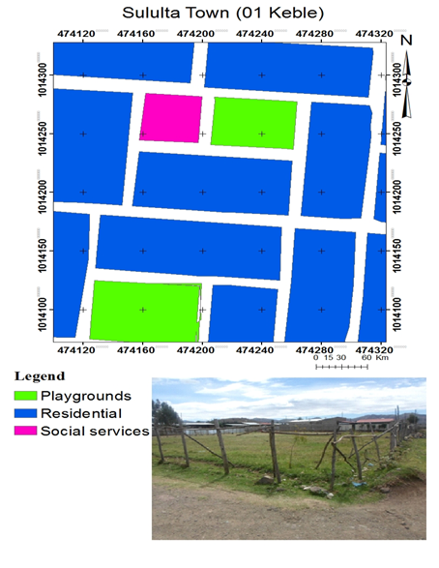
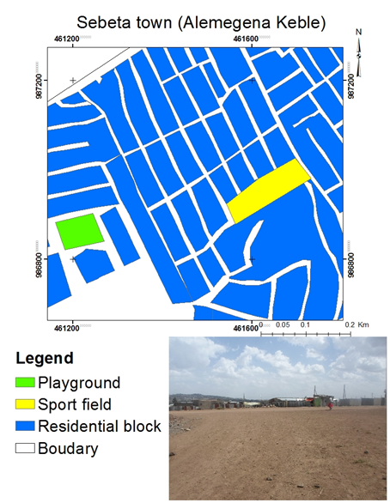
The information obtained from the field survey shows that from the total proposed urban GI components, only 6.6%, 1.36% and 2.56% have been established and developed in Sululta, Sebeta and Legetafo towns, respectively. As the field survey shows playgrounds, sport fields, and parks are notable examples of existing components in the study towns (Figure 2).

Figure 2 Existing urban GI components in the study towns
Source: Fieldwork, 2016

4.1.2. Accessibility of urban GI components
Easy access to urban GI components such as playgrounds, sport fields, and public parks is an important motivational factor for visitors to use such places in urban areas (Barbosa et al., 2007). Access to GI components in the study towns was assessed to reveal issues related to the planning challenges of urban GI components. Figure 3 shows pedestrian accessibility to existing urban GI components such as playgrounds and parks within walking distance of 300m, 500m, 700m and 1000m from the residential blocks. The service area of the urban GI components was computed through the shortest network path method and represented by yellow, red, roses and cyan color in figure (3). Yellow color presents areas having access to urban GI components such as playgrounds, parks and sport fields within 300m walking distance, while red color presents the areas having access to urban GI components within walking distance of 500m. As well, the rose color shows areas having access to urban GI components within 700m and cyan color show areas having access to urban GI components within 1000m.
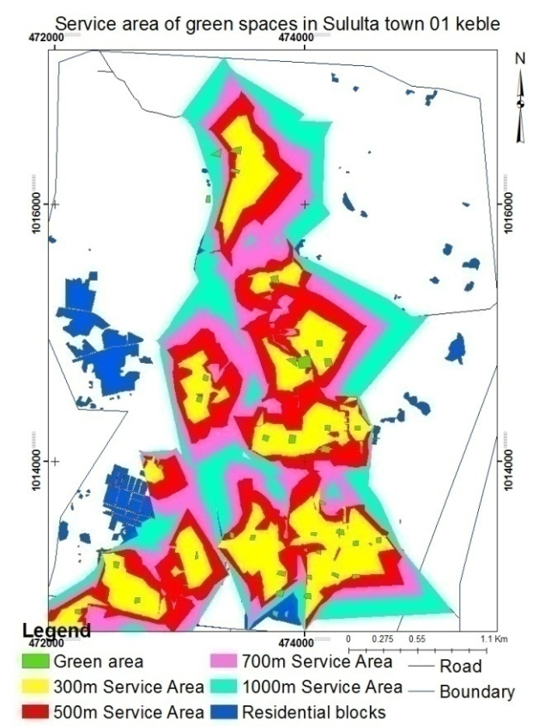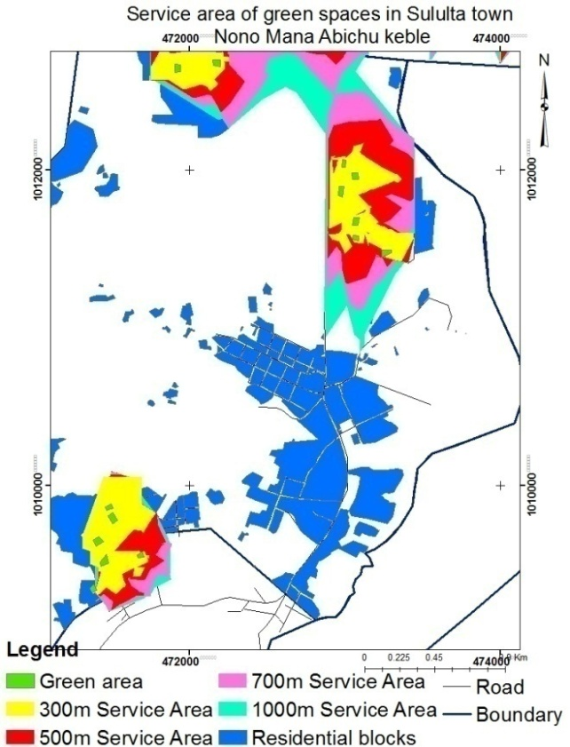
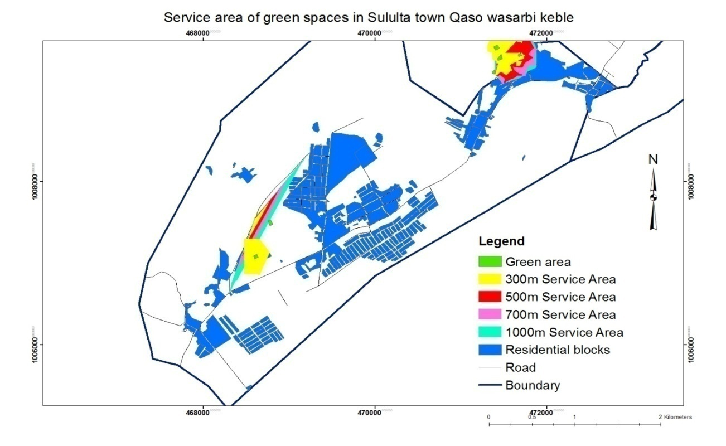
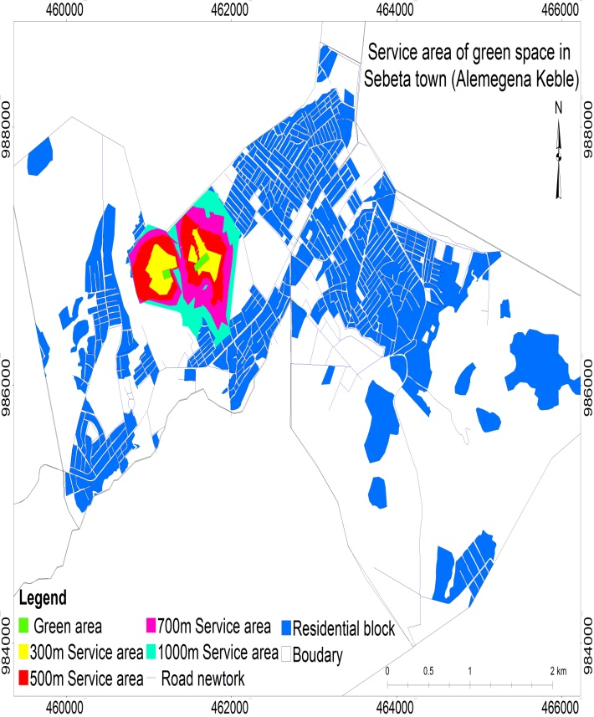
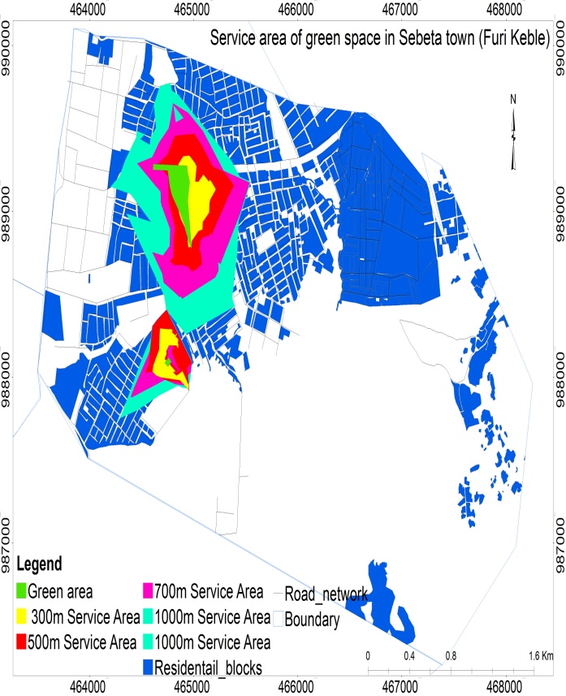
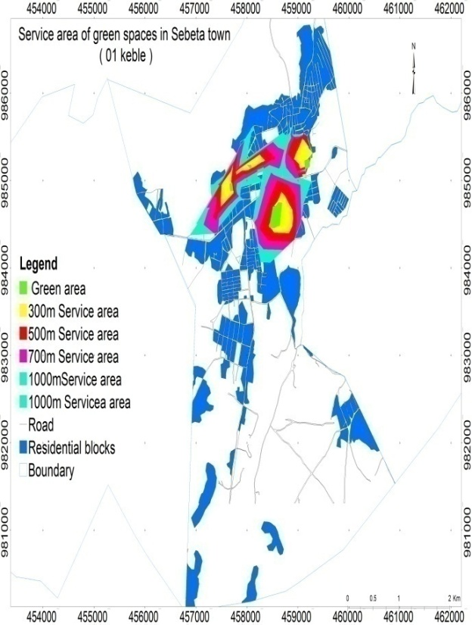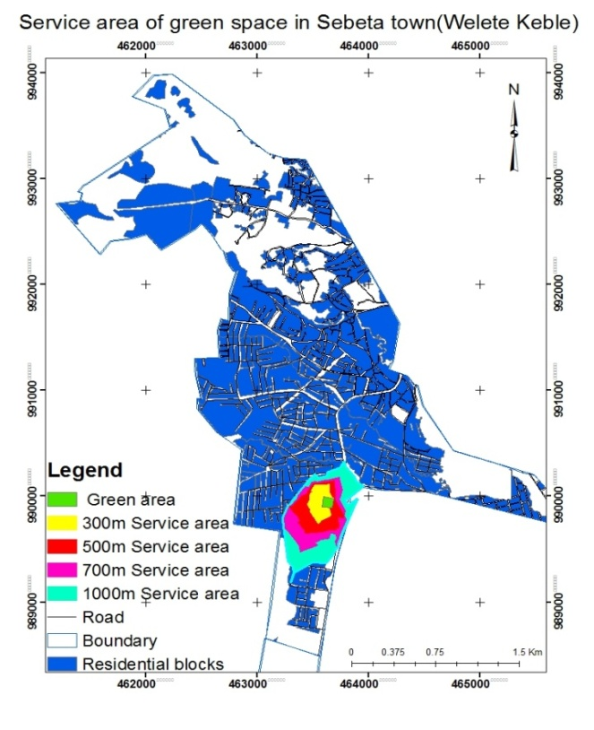
Figure 3 Service area of urban GI components
Source: Author's construct, 2016
From the above figures, it can be observed that access to urban GI components such as playgrounds and parks within 300m and 500m is very low in all the kebeles of the study towns; except in 01 kebele of Sululta town. There is better access to the components within distances of 300m to 500m in 01 kebele of Sululta town. Table 14 shows the total number of people that can access urban GI components within walking distances of 300m, 500m, 700m and 1000m in each kebeles within the towns.

Table 14 Number of the population that access urban GI component within different walking distances
Service area |  | Sululta Town
 |  | 01 kebele |  |  |  | Nono Man Abichu |  |  |  |  | Qaso wasarbi kebele
 |  | Population it serves |  |  | % | Population it serves |  |  | % |  | Population it serves |  |  | %
300m |  | 4404 |  |  | 30.2 | 1591 |  |  | 16.3 |  | 291 |  |  | 2.3
500m |  | 3648 |  |  | 25 | 715 |  |  | 7.3 |  | 117 |  |  | 0.9
700m |  | 2539 |  |  | 17.5 | 391 |  |  | 4.1 |  | 190 |  |  | 1.5
1000m |  | 1545 |  |  | 10.6 | 211 |  |  | 2.1 |  | 116 |  |  | 0.9
Out of Service area |  | 2438.2 |  |  | 16.7 | 6880.45 |  |  | 70.2 |  | 12026.51 |  |  | 94.4
Service area |  | Legetafo Town
 |  | Kebele 01 |  |  |  |  |  |  | Kebele 02
 |  | Population it serves |  |  |  |  |  | % | Population it serves |  |  |  | %
300m |  | 3590.42 |  |  |  |  |  | 17.8 | 158 |  |  |  | 2.1
500m |  | 3194.78 |  |  |  |  |  | 15.8 | 562.89 |  |  |  | 7.41
700m |  | 3532.35 |  |  |  |  |  | 17.5 | 775.64 |  |  |  | 10.22
Out of Service area |  | 9904.77 |  |  |  |  |  | 48.9 | 6091.1 |  |  |  | 80.3
Service area | Sebeta Town
Service area | Almegena Kebele |  |  | Furi Kebele |  |  |  | Welete Kebele |  |  |  | Sebeta 01 Kebele
Service area | Population it serves |  | % | Population it serves |  |  | % | Population it serves |  | % |  | Population it serves |  | %
300m | 829.37 |  | 2.1 | 488.82 |  |  | 2.2 | 406.97 |  | 1.2 |  | 1613.24 |  | 3.3
500m | 1420.86 |  | 3.6 | 1070.09 |  |  | 4.9 | 499.93 |  | 1.5 |  | 2275.25 |  | 4.8
700m | 1280.04 |  | 3.2 | 1381.22 |  |  | 6.3 | 604.11 |  | 1.7 |  | 2916.51 |  | 6.1
1000m | 1104.57 |  | 2.8 | 1898.52 |  |  | 8.6 | 745.90 |  | 2.2 |  | 3297.50 |  | 6.9
Out of Service area | 35177.16 |  | 88.3 | 17208.34 |  |  | 78 | 31797.08 |  | 93.4 |  | 37809.49 |  | 78.9
Source: Fieldwork, 2016

Based on Table 14, more than 4404, 1591 and 291 people can access urban GI components within walking distance of 300m from their residence and 3648, 715 and 117 people can access urban GI components within walking distance of 500m in 01, Nono Man Abichu and Qaso Wasarbi kebeles of Sululta town, respectively. In addition, 2539, 391 and 190 people can access the nearby urban GI components within 700m walking distances while 1545, 211 and 116 people have access to the GI components within walking distance of 1000m from their residence in 01, Nono Man Abichu and Qaso wasarbi kebeles of Sululta town, respectively. However, 2438, 6880 and 12026 of the population found in 01, Nono Man Abichu kebele and Qaso wasarbi kebeles of Sululta town, respectively have no any access to urban GI components such as parks and playgrounds within walking distance of 300m to 1000m from their residences.

As Table 14 shows, only less than 17.8 % and 2.1% of the population found in kebele 01 and kebele 02 of Legetafot town can access GI components within 300m walking distance while 15.8% and 7.4% of the population can access the components within 500m walking distance, respectively. Similarly, 17.5% and 10.2% of the population found in kebele 01 and kebele 02 of Legetafo town, respectively, can access the GI components within a walking distance of 700m from their residence. However, 9904 and 6091 people found in Legetefo town’s 01 and 02 kebele, respectively do not have access to any GI component within the walking distance of 300m to 1000m from their residential blocks.

Based on the results shown in Table 14, 829, 488, 406 and 1613 people found in Almgena, Furi, Welete and 01 kebeles of Sebeta town, respectively, can access the GI components within a walking distance of 300m from their residence. In addition, 1420, 1070, 499 and 2275 people can access GI components within a distance of 500m in Almgena, Furin, Welete and 01 kebles of Sebeta town, respectively. On top of this, 1280, 1381, 604, and 2916 of people can accesses GI components within 700m walking distances while 1104, 1898, 745 and 3297 people can access the urban GI components within a walking distance of 1000m from their residence in Almgena, Furin, Welete and 01 kebeles of Sebeta towns, respectively. On the other hand, 35177, 1720, 31797 and 37809 of the population of Almgena, Furin, Welete and 01 kebeles of Sebeta town, respectively do not have any access to GI components within walking distance of 300m to 1000m from their residences.

Overall, the availability of urban GI components such as parks and playgrounds for the urban dwellers in the study towns within the walking distances of 300m and 500m from their residences is inadequate and the urban dwellers are forced to walk more distances to use urban GI components such as parks and playgrounds. The result of this study is similar with the study undertaken by Khalil (2014) which found out that more than 70% of the population in Jeddah have to walk a distance exceeding 500m to access urban GI components. Both results are in contrast with standards of different countries of the developed world. For instance, the guidelines provided by the United Kingdom, which stated that no one should live more than 300m from their nearest area of GI components of at least 2 hectares in size (Comber et al., 2008). In addition, this study is in contrast with Van Herzele & Wiedemann (2003) proposal, which stated every person should live within 150m from the nearest urban GI components of at least 1-hectare size. Moreover, the result of this study is in contrast with the study undertaken by De Vries & Van Zoest, (2004) in Netherlands where 67% of neighborhoods had opportunities to access urban GI components within walking distance of 300m radius.

4.1.3. Urban GI components and international planning standards
To compare the availability of urban GI components of the study towns with international planning standards, per capita urban GI components provision was calculated (Table 15). Calculation of per capita urban GI components provision was done only for active urban GI components such as playgrounds, parks and sport fields rather than other urban GI components such as squares or networks of streets and forests that are not suitable, safe and reachable.

Table 15 Per capita urban GI components provision
Sample kebeles | Population | Existing GI components (m²) | GI components per capita (m²) | Town
Sululta (01 kebele) | 14576 | 74029.93 | 5.1 | Sululta town
Nono Man Abichu | 9790 | 24354.44 | 2.5 | Sululta town
Qaso Wasarbi | 12742 | 5437.4 | 0.42 | Sululta town
Total | 37108 | 103821.8 | Mena per capita 2.66 | Sululta town
Sebeta (01 kebele) | 47912 | 44857 | 0.93 | Sebeta town
Furi | 22047 | 41953 | 1.9 | Sebeta town
Welete | 34054 | 2400 | 0.07 | Sebeta town
Almegena | 39812 | 29126 | 0.7 | Sebeta town
Total | 143825 | 118336 | Mean per capita 0.9 | Sebeta town
Keble 01 | 17105 | 62937.4 | 3.7 | Legetafot
Keble 02 | 10705 | 6862.6 | 0.64 | Legetafot
Total | 27810 | 69800 | Mean per capita 2.17 | Legetafot
Source: Fieldwork, 2016

Per capita existing urban GI components (playgrounds, parks and sport fields) in Sebeta town ranges from 1.9 m² to 0.07 m² with an average of 0.9 m² (Table 15). As far as the differences of urban GI components per capita between the kebeles are concerned, the highest per capita provision was found in the Furi kebeles, which is 1.9 m² followed by 0.94 m² and 0.73 m² per person for Alemegena and Sebeta 01 kebeles, respectively. Welete kebele has the lowest value with 0.07 m² per capita GI components.

In Sululta town, per capita existing urban GI ranges from 5 m² to 0.4 m² with an average of 2.66m² (Table 15). As far as the differences of urban GI components per capita between the kebeles are concerned, the highest per capita was found in Sululta 01 kebele, which is 5m² followed by 2.48 m² for Nono Man Abichu kebele. Qaso wasrbi kebele has the lowest value with 0.42 m² per capita GI components. As Table 15 shows, 01 kebele of Legetafo town has 3.7 m² per capita GI components while 02 kebele of Legetafo town has 0.64 m² per capita urban GI components.
The mean per capita of urban GI components such as playgrounds, sport fields, and parks are 2.66 m², 0.9 m² and 2.17 m² for Sululta, Sebeta and Legetafo towns, respectively (Table 15). Sululta and Legetafo towns have almost the same average urban GI components per capita. Similar findings were reported by studies in different parts of sub-Saharan African countries (Ministry of Urban Development and Housing, 2015; Mensah, 2014; MaConnachie et al., 2008). For instance, the Ministry of Urban Development and Housing (2015) reported that cities in Ethiopia such as Adama, Shashemene, Dese, Jijiga, and Dire Dawa had only between 1.9 m² and 5.6 m² urban green spaces per capita whereas the standard set by WHO is 9 m² green space per capita (Pafi, et al., 2016). Similarly, Mensah, (2014) found out that cities such as Alexandria (Egypt), Luanda (Angola) and Cairo (Egypt) have a public green space provision below 1m² per capita. In addition, MaConnachie et al. (2008) found out that several towns in the Republic of South Africa have less than 10 percent of their total lands occupied by public green spaces. In contrast, more than two-thirds of the population living in Scandinavian countries or in Western European Union countries, such as Austria and northwestern Germany, have green spaces above the standard set by WHO (Kabisch et al., 2016). For instance, Vienna, Stockholm, Amsterdam, and London have 120 m², 87.5 m², 45.5 m² and 27 m² urban GI components per capita, respectively. According to standards proposed by the UN, WHO, EU and other international institutions per capita urban GI components provision of the three study towns is very low and do not match with any international standards (Figure 4).

Minimum requirement
Figure 4 GI components per capita of the study towns compared with international standards

4.2. Implementation challenges of urban GI components

4.2.1. Plan violation regarding GI components
The land inventory survey showed that the towns’ urban GI components plans were widely violated by various activities. Majority of the urban GI components found in the land use plan of 2007/08 were converted to built-up. For instance, as the results from the land inventory shows, in Alemgena and Welete kebeles of Sebeta town, urban GI components which were planned for parks and playgrounds in the land use plan of 2008 were reclaimed for infrastructure development, social services, residential development and manufacturing during implementation of the land use plan. In these areas, more than 25.9ha of planned and established urban GI components were converted to residential, manufacturing and social services land use from 2008 to 2016 (Fig. 5).

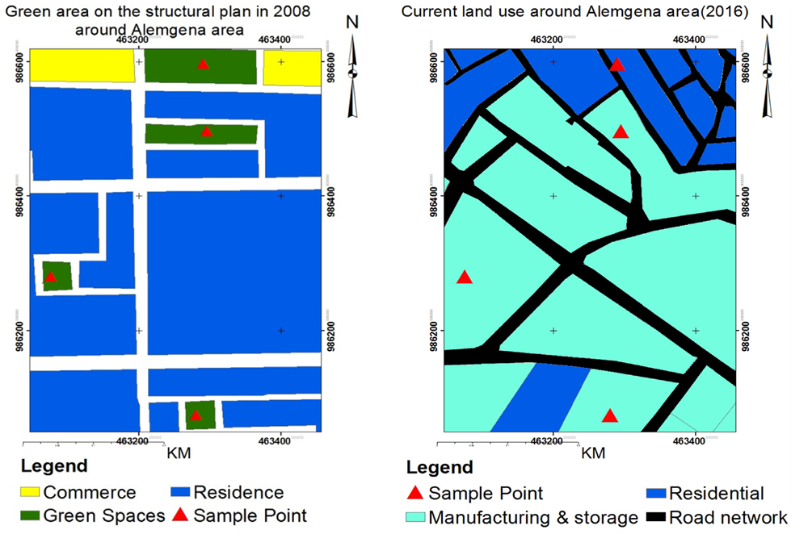

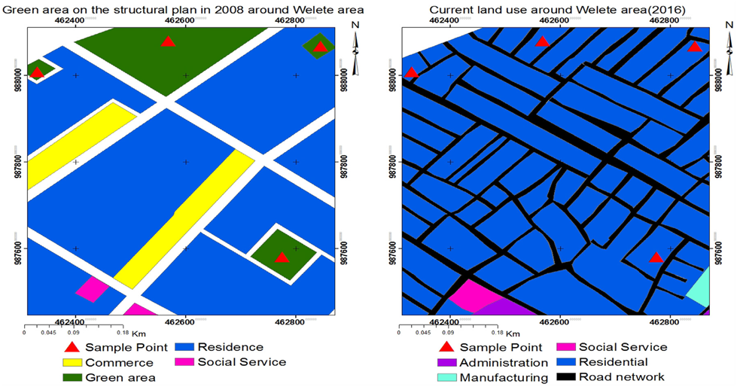
Figure 5 Change of urban GI components into manufacturing and residential development
Source: Fieldwork, 2016

At the same time, urban GI components found around Furi (04 keble) area were also converted to different land uses (Fig.6). In this area, 2.3ha of urban GI components were converted by residential development both in legal and illegal ways from 2008 to 2016. Surprisingly, more than 54 of the residential plots, which are located within the river buffer have legal title deeds.

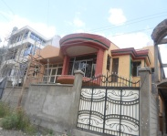
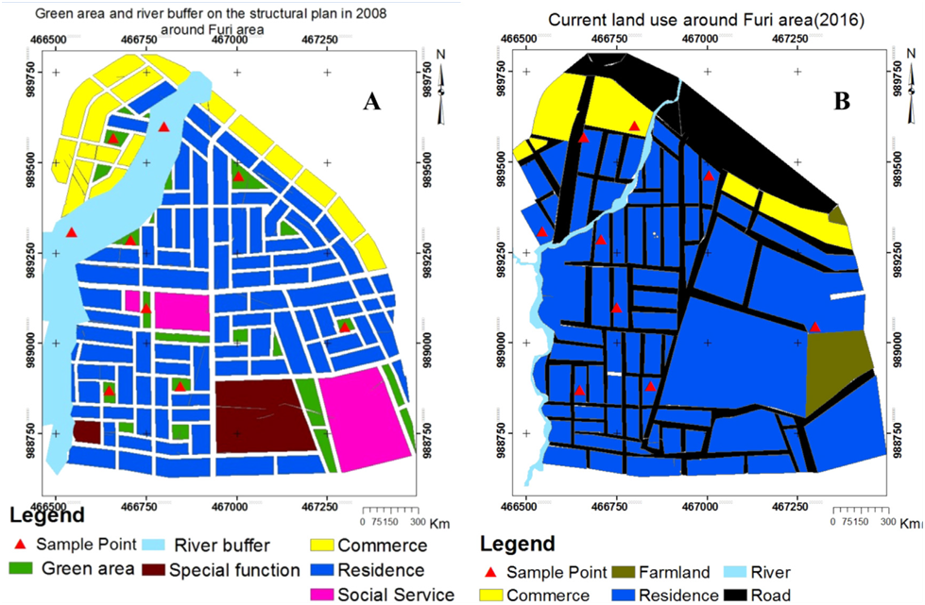
B

Figure 6 (A).Structural plan of the town in Furi area and (B).Existing land use condition of Furi area
Source: Fieldwork, 2016

Figure 6 (A) above shows the proposed urban GI components and river buffer in the structural plan of 2008. The figure shows that, urban GI components around the residential areas were clearly planned. At the same time, river buffers were proposed to restrict urban development to 30-50 meter distance from the river. Nonetheless, currently all the proposed urban GI components including river buffers were converted to residential use (Figure 6 B).
Similarly, the urban GI components found in Sululta town around 01 kebele and Qaso weserbi area were sub-divided and given to individuals for various purposes such as residential, manufacturing and commercial. Moreover, many settlers, without title deeds from the town administration, occupy the GI components found around this area. The result of land inventory shows about 38.9 hectares of urban GI components has changed to other land uses. Figure 7 (A & B) show changed urban GI components in Sululta town around Sululta 01 keble and Qaso weserbi area.

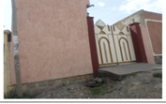
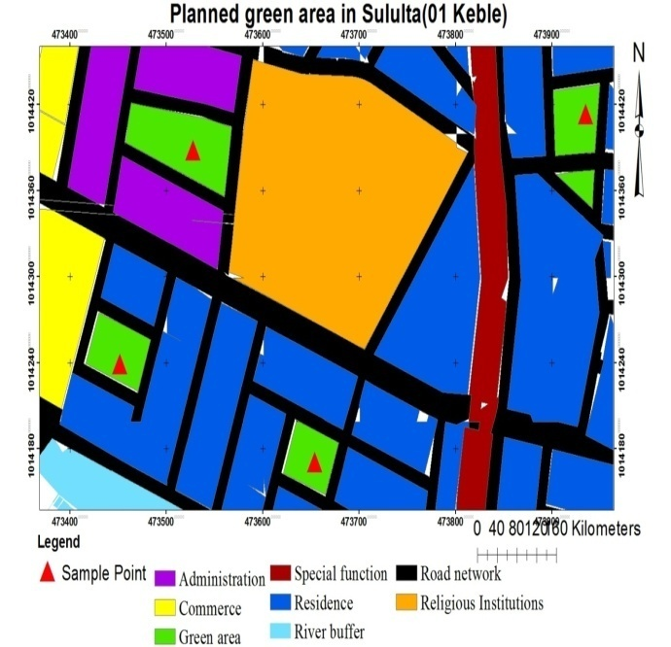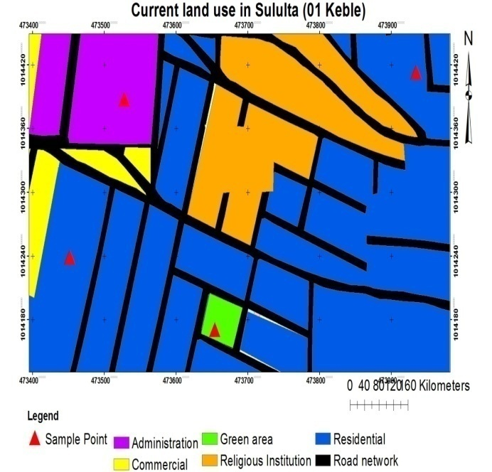
A

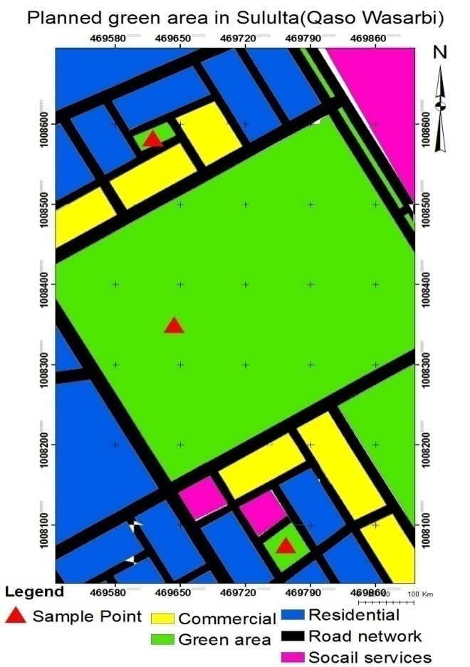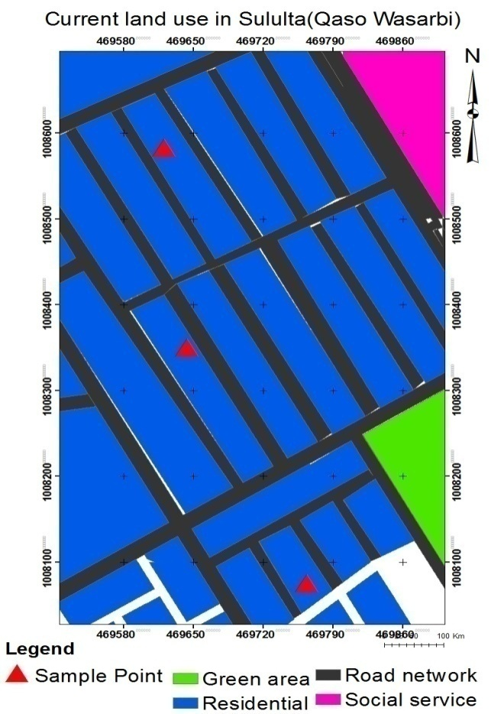
B
Figure 7 Urban GI components changed into residential and administration uses
The situation in Legetafo town is also similar. In this town, areas such as 01 and 02 kebeles, urban GI components (park and playgrounds) proposed in the structural plan in 2007 were reclaimed for infrastructure development, social services, residential and manufacturing during the implementation of the plan. In this area, more than 15.3ha of urban GI components were converted to infrastructure development residential, manufacturing and social services development during the implementation of the plan (Fig. 8).

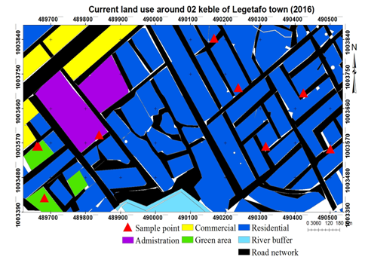
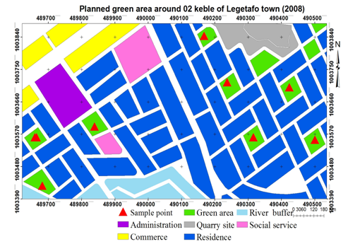

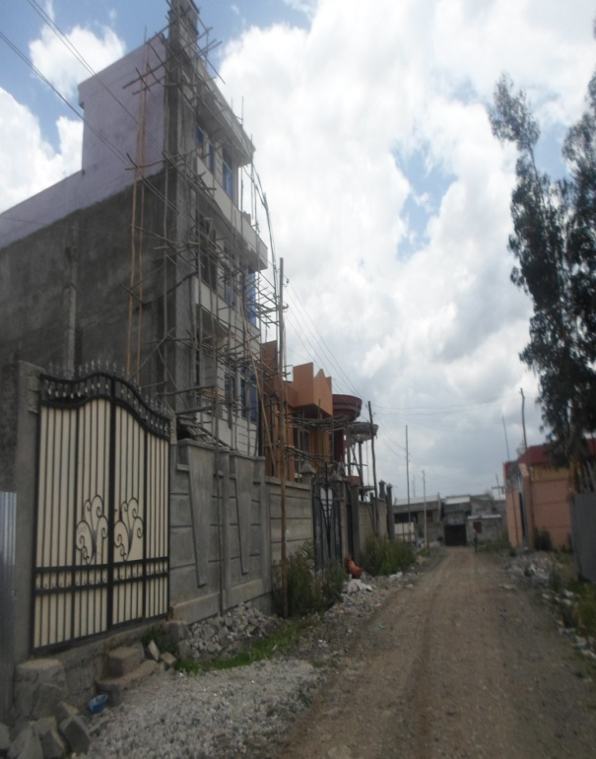
Figure 8 Urban GI changed into residential development
Source: Fieldwork, 2016

In general, based on the land inventory survey from 2007/08 to 2016, more than 82ha of proposed and established urban GI components have been changed to residential, commercial, and manufacturing uses. In the towns, loss and destruction of urban GI components is largely linked to urban sprawl and physical expansion of the towns. Pressure on land is particularly high in these towns because they are located in close proximity to the capital city, attracting people from the city and leading to high land values for residential and commercial purposes. In addition to informal settlements, most of the expansion was created by violating the land use plan with regard to urban GI components through corruption and political pressure as the in-depth interviews with the experts from the department of Land Development of the study towns revealed. This finding corroborates Ogundele et al. (2011) finding though the extent is not comparable with that of Nigeria much of the green spaces in the Festac town in Lagos, procedurally, have been destructed due to the reason that some officials give title deeds for residential purpose to individuals on lands reserved for green spaces by taking bribes.

4.2.2. Changes in urban GI components
The emerging towns found in the study zone are among the fastest growing towns in Ethiopia in terms of speed of spatial extension, development of economic activities and demography. The change analysis of the urban GI components has revealed considerable depletion of the latter and expansion of built-up area and urban sprawl (Fig. 9, 10 and 11).
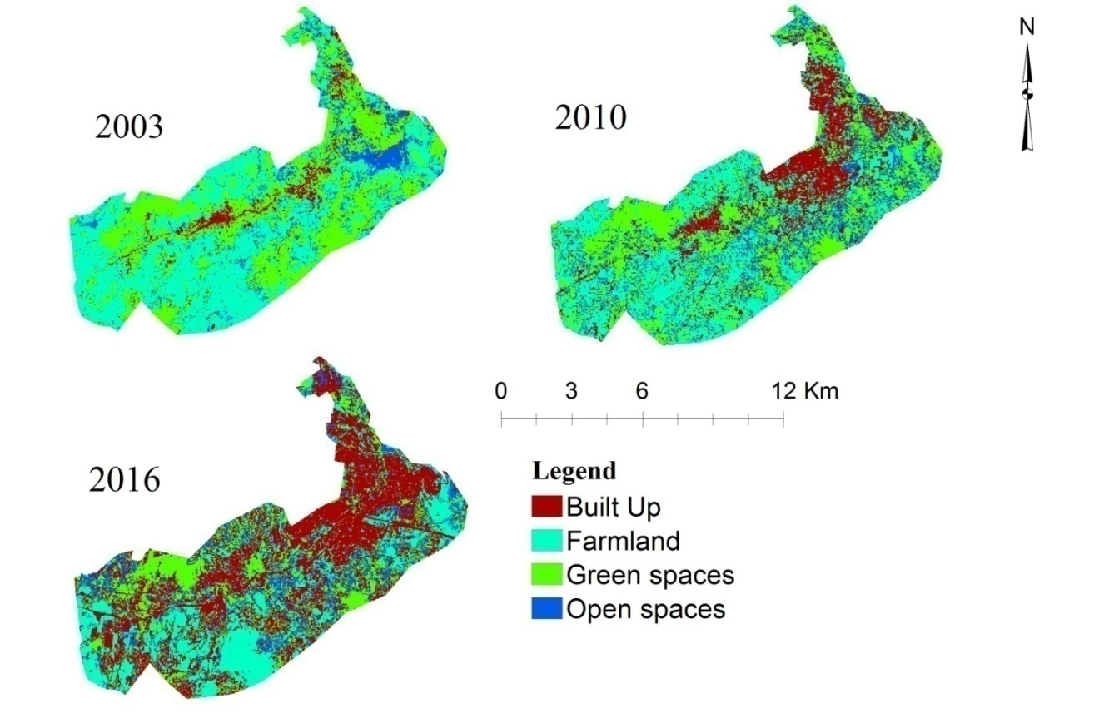
Figure 9 Land use/land cover map of Sebeta town from 2003 to 2016
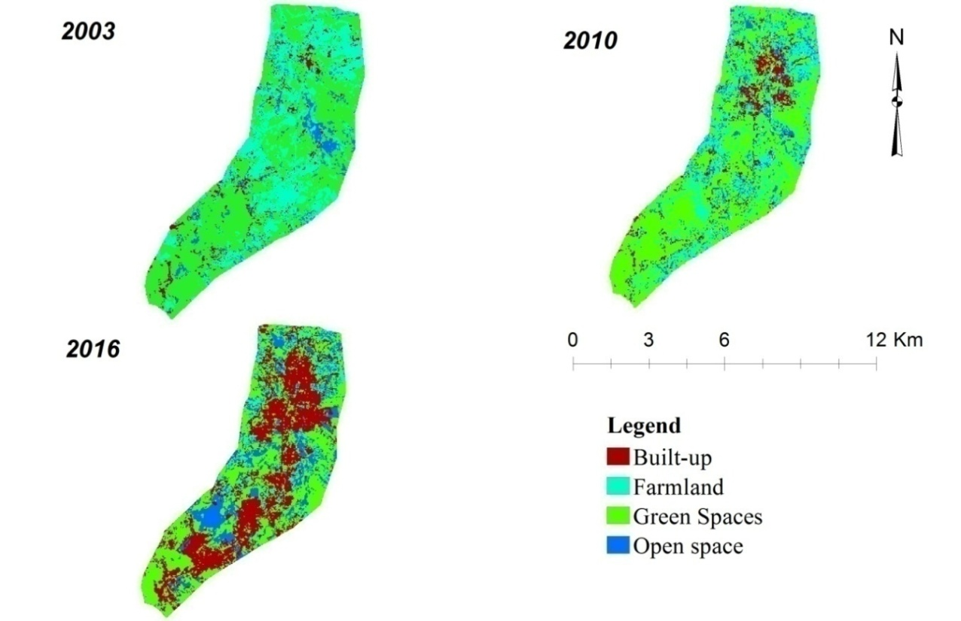Figure 10 Land use/land cover map of Sululta town from 2003 to 2016
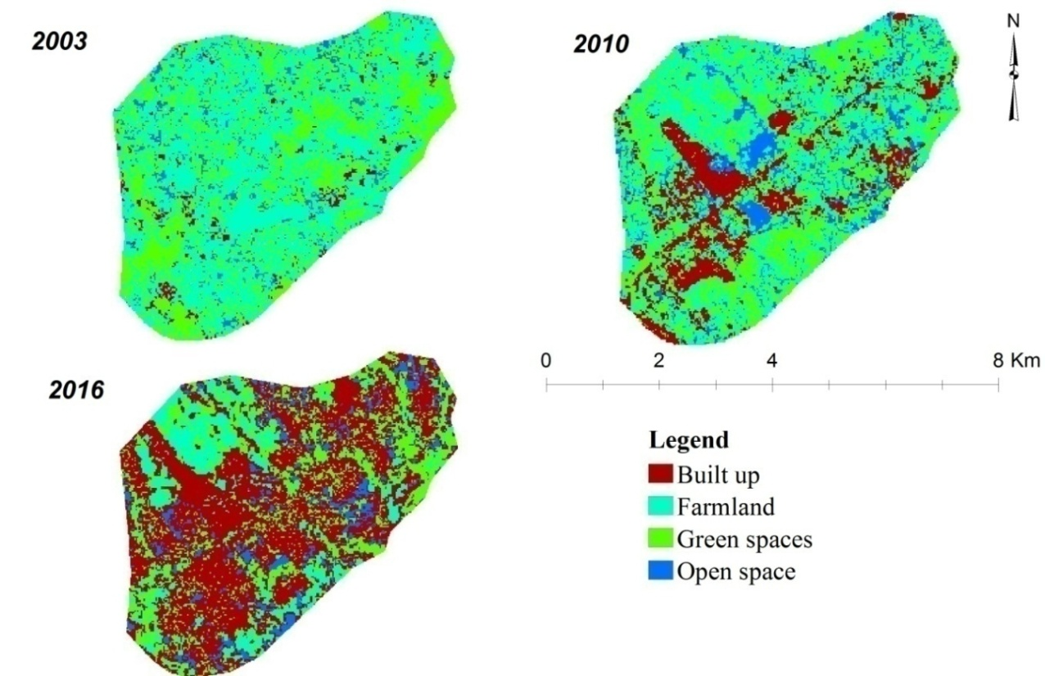
Figure 11 Land use/land cover map of Legetafo town from 2003 to 2016
In 2003, large patches of urban GI components were still well distributed over the towns and occupied 3397.5ha, 2587ha and 894.8ha of land mass in Sebeta, Sululta and Legetafo towns corresponding to 37.3%, 57.9% and 36.8% of the towns, respectively. However, considerable fragmentation and quantitative losses of urban GI components were observed during the studied period. The process of fragmentation was particularly pronounced in the inner parts of the towns, Northern parts of Sebeta and Sululta towns known as Welete and Qason Weseri kebeles, respectively and North Eastern part of Sebeta town known as Alemegena and Furi and South Eastern parts of Legetafo town. In these areas, the urban GI components were dissected into small patches. In Welete, Alemegena, Furi kebeles of Sebeta town, Qaso Weseri kebele of Sululta town and South Eastern parts of Legetafo town, there were large continuous urban GI components in 2003 but in 2016 with the exception of a few urban GI components, almost all had disappeared.

In 2010, the urban GI components in Sebeta, Sululta and Legetafo towns, in general, had decreased to only 2828.7ha (31%), 2439.3ha (54.6%), and 798.6ha (32.8%), respectively and in 2016 to 1637.3ha (18%), 1761.1ha (39.4%), and 559.6ha (23%) (Fig. 12, 13 and 14). The average rate of urban GI components cover changed into other LULC types during the period of 2003 to 2016 was found to be 135.4, 63.5 and 25.7 ha/year in Sebeta, Sululta and Legetafo towns, respectively.

In contrast, between 2003 and 2016 the built-up area has increased from 573.7ha (6.3%), 200ha (4.5%), and 65.5ha (2.7%) to 3798.5ha (41.7%), 1573ha (35.2%), and 1270.2ha (52.2%) in Sebeta, Sululta and Legetafo towns, respectively (Fig. 12, 13 and 14). The population growth rate was also quite rapid in the towns (CSA, 2008; OWWDSE, 2011; Nigusie, 2015). The average annual rate of growth of the population for the three towns was 4.11% and 4.8% between 1984 and 1994, and 1994 and 2007, respectively (CSA, 2008). This rate further increased to 5.6% during 2008 (OUPI, 2008). Accordingly, based on this rate, the population size of each town doubles itself every 12.5 years, significantly shorter than the national doubling period, which is 24 years (Nigusie, 2015). Thus, this analysis highlights that the towns are under high pressure of urbanization, as the result of high population growth. The growth of population also encouraged the emergence of urban sprawl over some communal restricted open spaces and GI components replacing them by built-up structures. The result of direct post-classification comparison identified that most of the urban GI components were converted to build up areas. Despite some variation, overall, there is consistency of findings for the three towns.

Figure 12 The graphical representation of the LULC proportion for 2003, 2010 and 2016 for Sebeta town

Figure 13 The graphical representation of the LULC proportion for 2003, 2010 and 2016 for Sululta town

Figure 14 The graphical representation of the LULC proportion for 2003, 2010 and 2016 for Legetafo town
Table 16 below shows a high degree of physical expansion of the towns, and densification of their inner parts by depleting urban GI components. In the first period (2003-2010), urban GI components were depleted by 568.8ha (16.7%), 147.7ha (5.7%) and 96.2ha (10.8%), while the farmland depleted by 1240.7ha (13.6%), 178.1ha (12.8%) and 400.3ha (31%) in Sebeta, Sululta and Legetafo towns, respectively. In contrast, urban built-up increased by 189.2%, 134.9% and 506.1%, while open spaces increased by 88.6%, 18.7% and 91.7% in Sebeta, Sululta and Legetafo towns, respectively, at the expense of urban GI components and farmlands.

In the second period (2010-2016), urban GI components decreased at higher rates, by 42.1%, 27.8% and 29.9% while urban built up has increased by 129%, 234.7% and 219.9% in Sebeta, Sululta and Legetafo towns, respectively. During the whole study period (2003-2016), urban built-up area has increased by 561.1%, 686.3% and 1839.2% while urban GI components have decreased by 51.8%, 31.9% and 37.5% in Sebeta, Sululta and Legetafo towns, respectively. Despite some variation, overall, there is consistency of these findings for the three towns.

Similar changes in LULC were reported by previous studies in different parts of the country (Lindley et al., 2015; Abebe & Megento, 2016; Teferi & Abraha, 2017). For instance, Lindley et al. (2015) report that in Addis Ababa there was a high rate of loss of green structures with particular dramatic reduction in agricultural land (loss of around one-quarter of the agricultural land area from 2006 (19,639 ha) to 2011 (14,920 ha)). Similarly, Abebe and Megento (2016) found shrinking of urban green spaces (consisting of plantations, forestland, and grassland) by 82.1%, 62.1%, and 78.8%, respectively, during the past three decades (1986-2015) whereas built-up and transport areas increased at an annual rate of 5.7% and 1.3% and consumed 419% and 47% of Addis Ababa’s total area, respectively. In addition, Teferi and Abraha (2017) pointed out that urban/built-up areas expanded dramatically in Addis Ababa, while green spaces such as forest declined.

Table 16 LULC changes in Sebeta, Sululta and Legetafo towns
Class name | Sebeta Town
Class name | 2003-2010 |  | 2010-2016 |  | 2003-2016
Class name | ha | % | ha | % | ha | %
Built up | 1085.3 | 189.2 | 2139.5 | 129.0 | 3224.8 | 562.1
Green area | -568.8 | -16.7 | -1191.4 | -42.1 | -1760.2 | -51.8
Farmland | -1240.7 | -28.7 | -771.2 | -25.0 | -2011.9 | -46.5
Open spaces | 724.2 | 88.6 | -176.9 | -11.5 | 547.3 | 66.9
Class name | Sululta Town
Class name | 2003-2010 |  | 2010-2016 |  | 2003-2016
Class name | ha | % | ha | % | ha | %
Built up | 270.0 | 134.9 | 1103.0 | 234.7 | 1373.0 | 686.3
Green area | -147.7 | -5.7 | -678.2 | -27.8 | -825.9 | -31.9
Farmland | -178.1 | -12.8 | -823.5 | -68.2 | -1001.5 | -72.3
Open spaces | 55.8 | 18.7 | 398.7 | 112.6 | 454.5 | 152.4
Class name | Legetafo Town
Class name | 2003-2010 |  | 2010-2016 |  | 2003-2016
Class name | ha | % | ha | % | ha | %
Built up | 331.5 | 506.1 | 873.2 | 219.9 | 1204.7 | 1839.2
Green area | -96.2 | -10.8 | -239.0 | -29.9 | -335.2 | -37.5
Farm land | -400.3 | -31.0 | -509.3 | -57.1 | -909.6 | -70.4
Open spaces | 165.0 | 91.7 | -124.9 | -36.2 | 40.1 | 22.3
Source: Author's construct, 2016
The change detection matrix revealed that about 1410.7ha, 779.5ha and 421.9ha of urban GI components were changed into built-up areas in Sebeta, Sululta and Legetafo towns, respectively (Table 17). Also, 404ha, 105.8ha and 144ha of urban GI components were converted into farmland and 607.7ha, 459.1ha and 80.6ha of urban GI components were converted into open spaces, in Sebeta, Sululta and Legetafo towns, respectively. Of 3798ha, total growth of urban built-up areas from 2003 to 2016 in Sebeta town, about 1599ha came from farmland and the other 1410.7ha and 428.1ha were from urban GI components and open spaces, respectively.

Similarly, in Suluta town out of 1573ha total growth of urban built-up areas from 2003 to 2016, about 779.5ha came from urban GI components and the other 565.6ha and 116.2ha were from farmland and open spaces, respectively. In the same way from 1270.2ha total growth of urban built-up areas from 2003 to 2016 in Legetafo town, about 714.8ha came from farmland and the other 421.9ha and 90.6ha were from urban GI components and open spaces, respectively. These results indicate that increases in urban built-up areas mainly came from conversion of urban GI components and farmlands during 2003–2016.

The change detection matrix further shows that 46ha, 46.2ha and 6.5ha of built-up area was converted to urban GI components from 2003 to 2016 in Sebeta, Sululta and Legetafo towns, respectively. This, however, was a result of misclassification since the field investigation shows that areas classified as urban GI components were actually built-up on the ground. These areas are found near gardens of private houses at old settlement areas that have a high vegetation canopy and near to streets with large urban tree canopies. The misclassification occurred when the Landsat satellite captured the canopies of streets and garden trees overshadowing the settlement and roads and when it recognized built-up areas and roads having large trees with wide canopies as urban green infrastructure components.
Classification errors may also be the cause of other unexpected changes. For example, between 2003 and 2016, 114.5ha of built up changed to farmland and 52.5 hectares of built-up to open spaces in Sebeta town. These changes are most likely associated with omission and commission errors in the Landsat classification change map. Registration errors and edge effects can also cause apparent errors in the determination of change vs. no change (Yuan et al., 2005).
In general, based on the change detection matrix, it can be concluded that physical expansion of the built-up area and densification in the inner towns were the main driving forces for loss of urban GI components. Similar results were reported by studies (Fazal, 2000; Yuan et al., 2005; Woldegerima et al., 2016; Teferi & Abraha 2017) where urban growth with a high density of residential development has been recognized as a major force for shaping the biosphere and known for converting green spaces into a built environment. Thus, physical expansion of built-up area and inner towns densifications can be seen as independent variables that induced or triggered changes in the urban GI components.

Table 17 Change detection matrix of LULC types between 2003 and 2016
2003 | 2016(Area in hectare) |  |  |  | Towns
2003 | BUILT_UP | FARMLAND | GREEN_AREA | OPEN_SPACE | Sebet town
BUILT_UP | 360.7 | 114.5 | 46 | 52.5 | Sebet town
FARMLAND | 1599 | 1678.6 | 503.4 | 547 | Sebet town
GREEN_AREA | 1410.7 | 404 | 975.1 | 607.7 | Sebet town
OPEN_SPACE | 428.1 | 119 | 112.8 | 157.9 | Sebet town
2003 | 2016(Area in hectare) |  |  |  | Sululta town
2003 | BUILT_UP | FARMLAND | GREEN_AREA | OPEN_SPACE | Sululta town
BUILT_UP | 111.7 | 22.0 | 46.2 | 20.1 | Sululta town
FARMLAND | 565.6 | 230.0 | 385.4 | 204.8 | Sululta town
GREEN_AREA | 779.5 | 105.8 | 1242.6 | 459.1 | Sululta town
OPEN_SPACE | 116.2 | 26.6 | 86.9 | 68.6 | Sululta town
2003 | 2016(Area in hectare) |  |  |  | Legetafo town
2003 | BUILT_UP | FARMLAND | GREEN_AREA | OPEN_SPACE | Legetafo town
BUILT_UP | 43 | 5 | 6.5 | 11.1 | Legetafo town
FARMLAND | 714.8 | 195 | 267 | 114.8 | Legetafo town
GREEN_AREA | 421.9 | 144 | 248.3 | 80.6 | Legetafo town
OPEN_SPACE | 90.6 | 38 | 37.8 | 13.6 | Legetafo town
Source: Author's construct, 2016

4.2.3. Driving forces for the loss and degradation of urban GI components
Current urban development in developing countries is taking place in the context of rapid urbanization and urban expansion. The supply and use of urban GI components first and foremost require awareness of their benefits by key actors and stakeholders followed by preparation of plans in which land is allocated for their development. Once established and developed through plan implementation, the components need management and development control in order to be protected from unauthorized changes. These indicate that the major driving forces for the depletion of urban GI components include urban expansion, land supply, awareness, plan implementation, and development control.

4.2.3.1. Physical expansion of the built up area and densification of the inner towns
Based on the result from the change detection matrix of LULC and the land inventory physical expansion of the built-up area and densification in the inner towns were observed as the main factor for the depletion of urban GI components. Based on the change detection matrix of LULC 1410.7ha, 779.5ha and 421.9ha of urban GI components have changed to built-up area between 2003 and 2016 i.e. a period of 13 years in Sebeta, Sululta and Legetafo towns, respectively. This change has mostly occurred in kebeles such as Nono Man Abichu and Qaso weserbi of Sululta town, Welete, Furi and Almgena of Sebeta town and Legetafo 01 kebele due to their proximity to the capital city and, therefore, high demand for other land uses in the kebeles. Moreover, as the result of the land inventory shows, the loss of urban GI components has also occurred in the inner part of the towns indicating that densification of existing built-up areas is another significant factor.

Similar factors were reported by studies in different part of sub-Saharan African countries (Dubbale et al, 2010; Mensah, 2014 and Fuwape & Onyekwelu, 2011). For instance, Dubbale et al. (2010) reported that in Addis Ababa, Ethiopia, most of urban green spaces have been destroyed due to rapid population growth of the city and physical expansion of built-up areas. Similarly, Mensah (2014) pointed out supplanting green spaces for the built up area as the principal factor for green spaces depletion in Addis Ababa city. Fuwape & Onyekwelu, (2011) also pointed out that urban sprawl and infrastructural developments have lead to depletion of green spaces in cities such as Lagos (Nigeria), Freetown (Sierra Leone), Abidjan (Cote D’lvoire), and Accra, (Ghana). The finding of this study is also consistent with that of Mamun et al. (2013) which indicated that unplanned physical expansion of built-up areas was largely responsible for encroachment of urban green space in Dhaka (Bangladesh). Contrary to these findings, Dobbs et al. (2013) found out that increased housing density and streets in developed countries have a positive influence on urban green spaces due to the presence of green lawns and trees in housing areas and along streets.

4.2.3. 2. Land value
Based on the information gathered from the local community and municipality officials, the loss of urban GI components in the three towns can be partially attributed to the rapid increase of the land value. In the study towns, land uses such as residential and commercial are more financially rewarding to the government, which is the landowner, than urban GI components. For instance, 1 m² of land for residential purpose was sold for 12,229.5 birr (531.7$) on average in Sebeta town which is much higher than the land price of any town found in the categories of 1st grade lease towns in Oromia National Regional State. Similarly, the land price of Legetafo and Sululta town for 1 m² is much higher than the land price of other towns found in categories of 1st grade lease towns in Oromia National Regional State except Burayu town (Table 18).

Table 18 Land auction price of towns found in 1st grade lease towns categories of Oromia region
S/N | Towns | Average land auction price (Birr/M² ) in 2015/16 for residential purposes (1$=23 Birr in 2016)
1 | Sebeta | 12,295.5
2 | Burayu | 8,850
3 | Sululta | 7,360
4 | Legetafo | 7,030.5
5 | Bishoftu | 5,586.8
9 | Adama | 5,376
6 | Dukem | 4,205.95
7 | Shashemene | 3,475
8 | Gelan | ---------
Source: - Urban Land Development and Management Bureau (2016)

Taking a land value of Birr 12,295.5 per m², the total land value for the minimum residential plot size (105 m²), is estimated at 1,297,175.25 birr (56,398.9$) in the study area. As a result, households and the towns’ administration tend to use all sorts of techniques to utilize the entire parcel of land including urban GI components for residential and commercial purposes. For instance, a key informant said:

“….people in the towns and those who emanate from other areas to live or work in the towns are willing to pay high price for residential and commercial uses. This appears to have caused both the government and the local community to undermine the importance of urban GI components and favor more residential and commercial uses at the expense of urban GI components” (Mr. J., process owner of Land Development and Administration Department, Sululta town; Key informant interview, 4/11/2016).

Similar situation has also happened in Kumasi, (Ghana). The study undertaken Addo-Fordwuor (2015) reveled that there is a strong motivation in the land lord for building more residential and educational facilities at the expense of green spaces due to the reason that these uses are more financially rewarding than green spaces to the land lords. These situation shows that the government and the local communities did not recognized about the future economic importance of protected and well-developed urban GI component. Different studies show that the property value will increase if it is near to GI component in urban areas (Luttik, 2000; Crompton, 2001; Morancho, 2003; Jim & Chen, 2006; Kong et al., 2007). For instance, the findings from a study in 8 towns in Netherlands revealed that proximity to GI components such as parks and playgrounds increased the value of houses prices by about 28% (Luttik, 2000).

4.2.3. 3. Laxity to enforce plans, policies, proclamations and regulations
Having proper planning, policy, proclamation and regulation is not enough; unless there is implementation and enforcement. Unsuccessful enforcement of land-use plans and regulation is one of the reasons for the loss of urban GI components in the towns. For instance, several types of urban GI components were included in structural plans of the towns to improve the living standard and environmental quality. However, many of these urban GI components are virtually non-existent on the ground. These observations corroborate Sarporiti’s finding that in developing countries many public parks exist only on paper (Sarporiti, 2006).
Responses by selected key informants provided much evidence on how laxity to enforce planning policies and regulations has lead to encroachment of urban GI components in the towns. For example, one of the key informants remarked as follows:
“…..Oromia Urban Planning Institute demarcates a minimum of 30m buffer from the river banks as no development area and includes it in urban GI components in the land use plan. In addition, Urban Plans Proclamation No. 574/ 2008 does not allow converting land proposed for urban GI components to other uses without approval by the regional Urban Planning Institute. However, there is a wide practice of subdividing lands earmarked for urban GI components for other purposes without the approval required by the proclamation. Similarly, the buffer itself is converted to built-up area by informal settlers” (Mr. F., process owner of Greenery and Beautification Department, Sebeta town; Key informant interview, 4/27/2016).
A similar finding was suggested by Okpala (2009), which found planning organizations or agencies in many African countries such as Nigeria, Zimbabwe, Kenya, and Ghana to be weak in enforcing planning regulations due to limited finances, logistics and labor force.

4.2.3. 4. Low esteem of the community towards the protection of urban GI components
Protection of urban GI components ranks low for the community. This was found to be the result of lack of involvement of the local community in decision making on urban GI components and poor awareness of the benefits of urban GI components. In the study towns, decisions on urban GI components are taken by towns’ administration without active involvement of the local community as one of the key informant’s reports:

“…..most of the households in the local community use urban GI components for storing construction material and waste dumping site. Moreover, they incorporate some into their compounds if the urban GI components are very close. This has occurred due to limited awareness that the community have on the benefit of urban GI components. Even sometimes, the towns’ administrations think the local communities have nothing to offer so they do not involve them in urban GI components planning and management activities. As a result, the local community thinks the development of urban GI components is solely the work of the towns’ administrations and they do not care for urban GI components found in their locality” (Community member, Legetafo town, key informant interview, 3/23/2016).

Personal observation on urban GI components in Qaso weserbi, and Nono man Abichu of Sululta town, Almegena, Wolate, and Furi of Sebeta town and Legetafo 01 kebele has also shown that the local community uses most of the urban GI components for solid waste disposal and storage of construction materials (Fig. 15). This observation is similar to the situation reported in Nairobi city (Kenya) by Makworo & Mireri (2011) and in Kumasi, (Ghana) by Menshan (2014).

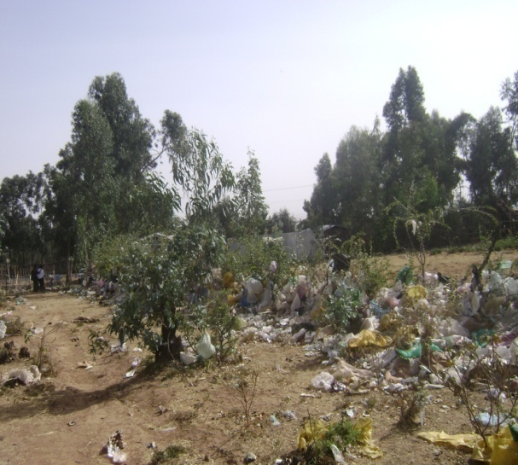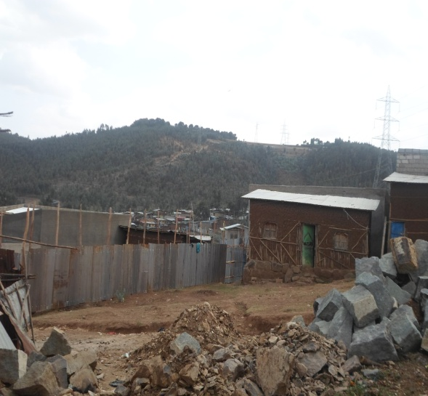
Figure 15 Solid waste and construction material dumped on urban GI components
Source: Fieldwork, 2016

4.2.3.5. Enforcement of urban development by higher level authorities
Occasionally higher officials in the regional and federal levels enforced the municipalities and the towns’ administrations to give urban GI components for another purpose such as manufacturing outside the plans. For instances, one of the key informant said:

“…a manufacturing plant found in front of Noc fuel station around Furi area was first established near to urban GI component and later the latter was allocated for its expansion under the pressure of regional investment office. During the expansion period, the Land Administration and Development department of the town had written a letter to the Investment Commission of Oromia to make them aware of the urban GI component designation. However, the regional investment commission forced the town administration to give the land to the owner of the manufacturing plants by ignoring the letter”(Mr. O., process owner of Land Administration and Development Department of Sebeta town, key informant interview: 4/27/2016).

The above comment shows how higher officials found both at the federal and regional levels influenced the development of urban GI components in the towns. As DiGaetano & Strom (2003) stressed this factor is mostly related to the clientelistic mode of governance, where politicians favor some groups of people or specific clients with the aim of getting political support or material benefit. Therefore, this condition does not allow the institutions responsible for developing and managing urban GI components to exercise their mandates confidently on the ground to prevent encroachment of the components.

4.2.3. 6. Private interest
Urban GI components, especially playgrounds and parks found around the residential area of the study towns were changed to another land use especially to residential purpose due to the private interest of the Land Administration and Development department and the towns’ administration officials, in a manner likely linked to corruption. For example, one of the key informants said:
“….officials found in the Department of Land Administration and Development of Sebeta town changed the proposed urban GI components to residential area and gave it to different persons for residential purpose by taking bribes from the individuals’’(Mr. V., Manager of Sebeta town municipality, key informant interview: 4/26/2016).

Another key informant also said:
“…playground and parks (urban GI components) which were found around the residential area of Qaso Weserbi and Nono Man Abichu kebeles of Sululta town and Almegena, Welete and Furi kebeles of Sebeta towns were parceled into different plots and sold to different persons by the officials of the Land Administration and Development and the towns administration illegally.” (Community member, Qaso Weserbi and Alemgena kebele, key informant interview: 3/24/2016, and 5/3/2017)

Though land conversion is possible under certain conditions, in the study towns it was done haphazardly without following standard procedures stated in the urban planning proclamation (Proclamation No. 574/ 2008). The proclamation states that reallocation of land shall be carried out and administered by the concerned planning authority. Procedurally, if the towns administration wants to relocate land uses, first it has to compare the overall benefits from the land before and after relocation and it is believed the advantage of relocation overweighs, the towns’ administration informs the Regional Urban Planning Institute, which has the mandate to make the decision. However, the interview responses indicate that this procedure was not observed.

4.2.3. 7. Illegal development
In the study towns, urban land is supplied by the government through a lease system, with terms reaching up to 99 years for residential purposes (Urban Land Lease Holding Proclamation No. 721/2011). Due to the monopoly of ownership, the supply is irregularly leading to skyrocketing of land prices and hindering access to land for many low and middle-income people. Currently, according to information obtained from officials of Land Administration and Development department, the highest land lease prices per square meter, reaches up to 24162.1 birr (1037 USD) in the study towns, a price very difficult to afford for middle and low-income people. As a result, building of illegal houses known as “Yechereka Bet” (moon lighthouses) in restricted areas such as urban GI components and river buffers is quite common. These houses are built not only by users but also by developers who build for business. This finding is consistent with that by UN-Habitat, (2011) which indicated that the city of Cairo has recently lost considerable urban green spaces because of unplanned and irregular urbanization on greener land and more than 80% of all informal settlement growth has taken place on the GI components.

4.2.3. 8. Absence of plan monitoring, evaluation and updating system
The study revealed that no monitoring and evaluation of the structural plan of the towns had taken place through its entire history by any responsible body, local, regional or federal. For instance, one of the key informants said:

“…manuals to undertake a comprehensive monitoring and evaluation on the implementation of principles, proposals, norms and standards of the structural plan were prepared both at the federal and regional levels. However, they are never implemented and thus lack of regular monitoring and evaluation of the implementation of the structural plan by the concerned body has been facilitating the violation of the land use plan and creating rooms to use the land proposed for GI components for other purposes.”(Miss. S., process owner of Greenery and Beautification Department, Legetafo, Key informant interview, 3/18/2016)

4.2.4. Assessing the use pattern of urban GI components
Availability of urban GI components: In order to assess the availability of urban GI components, the respondents were asked to describe whether there are urban GI components such as park, playground, sport field, urban forest and green corridors in their neighborhood (Table 19).

Table 19 Availability of urban GI components
 | Lefetafo |  | Sebeta |  | Sululta
 | Frequency | % | Frequency | % | Frequency | %
No | 23 | 71.9 | 175 | 67.6 | 42 | 73.7
Yes | 9 | 28.1 | 84 | 32.4 | 15 | 26.3
n | 32 | 100 | 259 | 100 | 57 | 100
Source: Fieldwork, 2017

According to the household survey, less than one third of the respondents in Legetafo, and Sululta towns reported the presence of urban GI components in their neighborhood. Sebeta’s case also was not very different from the two towns. The information obtained from the focus group discussion revealed that the availability of urban GI components such as parks, playgrounds and sport fields are perceived as very low. For instance, one focus group participant remarked that:
“…in our neighborhood the availability of GI components such as parks, playgrounds and sport fields are limited and even those established urban GI components by the plan have been changed to residential and commercial use. This problem has occurred due to negligence in controlling land use and the high land value of residential and commercial uses.”(Aged person, Qaso Wasarbi, kebele, Focus group discussion, 01/24/2017)
Types of urban GI components: Based on the household survey, playgrounds are the most common urban GI component types available for residents in all the three towns followed by sports fields, while other urban GI components such as green along river corridors and urban forests are rare (Fig. 16). Despite some variation, overall, there is consistency of these findings in the three towns. However, in Legetafo town only, parks and playgrounds were observed but not the other urban GI components. Street trees were only mentioned by respondents from Sebeta town. Importantly, the survey results show that more than half of the respondents in all the three towns reported a lack of any type of urban GI component in their neighborhood.

Figure 16 Type of urban GI components found in the neighborhood
Source: Fieldwork, 2017

Visited urban GI components: The respondents were also asked about the type of GI components they mostly visited. The household survey revealed that 21.9% of respondents in Legetafo town preferred to visit sports fields, followed by playgrounds (12.5%) and parks (6.3%) (Table 20).
Table 20 Types of urban GI components mostly visited
 | Legetafo |  | Sebeta |  | Sululta
 | Frequency | % | Frequency | % | Frequency | %
Playground | 4 | 12.5 | 22 | 8.5 | 3 | 5.3
Sport field | 7 | 21.9 | 12 | 4.6 | 9 | 15.8
Parks | 2 | 6.3 | 14 | 5.4 | 5 | 8.8
Urban forest | - | - | 8 | 3.1 | 1 | 1.8
other | - | - | 6 | 2.3 | - | -
Do not visited | 19 | 59.4 | 197 | 76.1 | 39 | 68.4
n | 32 | 100 | 259 | 100 | 57 | 100
Source: Fieldwork, 2017

Playground and parks are visited by only 8.5% and 5.4% of respondents in Sebeta town whereas, 4.6% and 3.1% of respondents preferred to visit sport fields and urban forest respectively (Table 20). In Sululta town, sport fields have the highest share of users (15.8%), followed by parks (8.8%), playgrounds (5.3%) and urban forests (1.8%). In the study towns, more than half of the respondents do not visit urban GI components.

To gain a better understanding, the participants of the focus group discussion were asked about the types of urban GI components mostly visited by the local community. The views reflected by most of the participants were more or less similar and can be summarized as follows:
“…the majority of the local community did not visit urban GI components due to limited awareness of their benefits, scarcity of urban GI components and poor management of the components. Few people sometimes-visited sport fields and playgrounds found near their homes for the purpose of physical exercise. But the habit of visiting urban GI components is low in our communities.”(Community member, Legetafo town, Focus group discussion, 01/31/2017)
This result is in line with the findings of Abkar et al. (2010), Mensah (2014) and Nyantakyi-Frimpong et al. (2016) where lack of available urban GI components, poor access to urban GI components and improper management were among the major factors that discouraged residents from using urban GI components. Again, these findings for sub-Saharan African cities contrast with the regular use of urban GI components in Europe. For instance, the study by CABE (2010) in England has shown that almost nine out of 10 people used parks and playgrounds.

Frequency of Visits: The survey showed little variation in the frequency of urban GI component visits between the three towns. In Legetafo, 3% of respondents would visited urban GI components more than once per week whereas 12.5%, 15.6%, and 9.5% of them visited urban GI components once a week, once a month and less than once a month, respectively. The frequency of visits is considerably lower in Sebeta and Sululta towns. About 3.9% and 5.3% of respondents visited urban GI components once a week in these towns, respectively (Fig.17).

Figure 17 Frequency of GI components visit
Source: Fieldwork, 2017

Based on the finding, the majority of the respondents visited urban GI components once a month or less. The finding is in contrast with the studies conducted by Xue & Lau, (2017) in Singapore and Madureira, et al. (2018) in Portugal where many residents visited green spaces more than once a week.
Physical factors influencing urban GI components visit: Most respondents did not indicate particular physical features influencing their visits of urban GI components (Fig. 18). For those who indicated, proximity was the most important influences in all the three towns followed by easy access. In Legetafo and Sebeta availability of various facilities was also mentioned (Fig. 18).

Figure 18 Factors influencing urban GI components visits
Source: Fieldwork, 2017

Based on the survey result, the most common reason frequenting an urban GI component was proximity. This finding is consistent with a study by Kaczynski et al. (2009) which indicated that people usually recreate in the closest urban green space. Shanahan et al. (2015) also pointed out that in Australia usually communities visited green space near to their home. In addition, many studies show that the closer to a home a green space is the more it is used (Roovers et al., 2002; Jensen & Koch, 2004; Giles-Corti et al., 2005; Nielsen & Hansen, 2006; Schipperijn et al., 2010).

Motives for visiting urban GI components: The most common motive mentioned was relaxation (18.8% and 7.3%) in Legetafo and Sebeta towns, respectively. In Sululta town, the most comment purpose for visiting was physical exercise (14%), followed by relaxation (8.8%), nature appreciation (5.3%) and finding privacy or loneliness (1.8%). The survey result also shows that 12.5 % and 6.2% of respondents in Legetafo and Sebeta towns have visited urban GI components for physical exercise purposes such as football playing, and running, respectively whereas 6.3% and 4.6% of them visited urban GI components for social contact with friends and families, respectively. Nature appreciation and finding privacy or loneliness were at the lower end of the motives for urban green infrastructure components visits (Table 21).
Table 21 Purpose of visiting GI components
 | Legetafo |  | Sebeta |  | Sululta
 | Frequency | % | Frequency | % | Frequency | %
Physical exercise | 4 | 12.5 | 16 | 6.2 | 8 | 14.0
Relaxation | 6 | 18.8 | 19 | 7.3 | 5 | 8.8
Social contact | 2 | 6.3 | 12 | 4.6 | - | -
Nature appreciation | - | - | 7 | 2.7 | 3 | 5.3
Solitude | 1 | 3.1 | - | - | 1 | 1.8
Other | - | - | 8 | 3.1 | 1 | 1.8
no response | 19 | 59.4 | 197 | 76.1 | 39 | 68.4
n | 32 | 100 | 259 | 100.0 | 57 | 100
Source: Fieldwork, 2017

Concerning the purpose of urban GI components visit, the results of the study indicated that relaxation and physical exercise followed by nature appreciation are the most common purposes. This result demonstrates some similarities with results from urban areas in other countries where physical activities such as walking and relaxing tend to predominate (Loukaitou-Sideris, 1995; Holm, 2000; Dunnet et al., 2002, Rosenberger et al., 2009, Schipperijn et al., 2010). Therefore, it seems that overall the behavior of urban GI components users in the studied towns in particular and in Ethiopian cities, in general, does not fundamentally differ from that of other countries. However, these results should be taken as preliminary due to the limited number of observations made since much more in-depth research with bigger samples is needed to establish the motivations and uses of urban green infrastructure components in Ethiopian cities with confidence.

Time it takes to reach urban GI components: Despite an overall low response rate, results showed that the share of respondents that reached urban GI components within 10 minutes or less was higher in Legetafo and Sululta than in Sebeta town (Table 22).

Table 22 Average time it takes to reach to GI components
 | Legetafo |  | Sebeta |  | Sululta
 | Frequency | % | Frequency | % | Frequency | %
Less than 5 minute | 2 | 6.3 | 3 | 1.2 | 7 | 12.3
6-10 minute | 4 | 12.5 | 23 | 8.9 | 2 | 3.5
11-20 minute | - | - | 6 | 2.3 | - | -
21-30 minute | 1 | 3.1 | 19 | 7.3 | 6 | 10.5
More than 30 minute | 6 | 18.8 | 11 | 4.2 | 3 | 5.3
no response | 19 | 59.4 | 197 | 76.1 | 39 | 68.4
n | 32 | 100 | 259 | 100 | 57 | 100
Source: Fieldwork, 2017

Studies point out that public green space should be at the center of the neighborhood and not more than five minutes walk for the residents (Haq, 2011). However, for the majority of respondents the time needed to reach the preferred urban GI components was 20 minutes and thus much longer than the five minutes that have been established in other studies as a threshold for regular urban GI components visits (e.g. Boone et al., 2009). Again, this finding points out the low provision of urban GI components in the study towns. For instance, in Brussels, Copenhagen, Glasgow, Gothenburg, Madrid, Milan and Paris, residents live within 15 minutes walk from public green spaces (Stanners & Bourdeau, 1995; Handley et al., 2003).

Facilities found in the urban GI components: Sport facilities are the most common facilities found in the GI components in all the three towns followed by children playing areas. Facilities such as toilets and cafeteria services were only mentioned by respondents from Sululta town. Importantly, the results show that nearly half of the respondents mentioned the absence of facilities in the urban GI components (Table 23).
Table 23 Facilities found in urban GI components
 | Legetafo |  | `Sululta |  | Sebeta
 | Frequency | % | Frequency | % | Frequency | %
Toilet | - | - | 1 | 1.8 | - | -
Cafeteria services | - | - | 2 | 3.5 | - | -
Children playing area | 2 | 6.3 | 2 | 3.5 | 7 | 2.7
Sport facilities | 4 | 12.5 | 6 | 10.5 | 9 | 3.5
Seat | 2 | 6.3 | 1 | 1.8 | 6 | 2.3
No Facilities | 5 | 15.6 | 10 | 17.5 | 40 | 15.4
No responses | 19 | 59.4 | 35 | 61.4 | 197 | 76.1
n | 32 | 100 | 57 | 100 | 259 | 100
Source: Fieldwork, 2017

The views of the participants of the focus group discussions on facilities in urban GI components were similar and can be summarized as follows:

“…even if there are few urban GI components in our neighborhood, they lack basic facilities such as seats, playing area and toilets. The absence of these facilities makes the urban GI components uncomfortable and deters many people from using such places.”(Community members, Furi kebele, focus group discussion, 01/26/2017)

One of the fundamental goals of creating urban GI components is to create spaces that people can rely on to enjoy and comfort themselves (Xi-Zhang, 2009). Though, for such comfort to be realized some facilities such as seats, toilet and playing facilities ought to be in place (Dunnett et al., 2002). However, based on the result of the study, lack of facilities in GI components was a critical problem in the study towns. Similar studies in Kumasi (Mensah, 2014), Nairobi (Makworo & Mireri, 2011) and Kisumu (Rabare et al., 2009) have also indicated similar problems.

Problems in using urban GI components: High level of cleanness of urban GI components is very important since it gives a good first impression to users and encourages subsequent users (Van Herzele & Wiedemann, 2003). However, 65.6%, 47.1% and 50.9%, of the respondent in Legetafo, Sululta and Sebeta, respectively stated that waste disposing in the urban GI components was a major constraint on the use the components.

According to a number of studies, residents will less likely utilize urban GI components if they are viewed as unsafe (Sanesi & Chiarello, 2006; Baycan-Levent et al., 2009; Durant et al., 2009; Cohen et al., 2010). The findings of this study support this proposition: 5.7% and 4.6% of the respondents in Sululta and Sebeta, respectively stated that they viewed some urban GI components as unsafe, hiding places for criminals and places for sexual violence.

Limited awareness of the benefits of urban GI components is also an important barrier for urban GI components use (Scott & Jackson, 1996). The result of this study supports this view: where a number of the respondents were unaware of what urban GI components had to offer. Studies conducted in Alberta, Canada (Alberta Community Development, 2000), Arizona (Virden & Yoshioka, 1992), and Texas (Scott & Kim, 1998), also found out that lack of information was a strong constraint on the use of urban green spaces. According to the nationwide sample conducted by Godbey et al. (1992), one-third of Americans said lack of information was reason why they did not visit parks.

4.3. Actual status and constraints of urban GI component management system

4.3.1. Policy and legal frameworks
In Ethiopia, there are no distinctive policy and legislation on the management of urban GI at the national and regional levels, but there are several laws including certain provisions on urban GI components.
The Environmental Policy of Ethiopia (1997) and Urban Development policy (2005) lay the foundation for urban GI components management in the country. The policies have the objective of planning and creating urban GI components within urban areas for recreational amenity. Moreover, they require the allocation of sufficient urban GI components for urban dwellers. The Urban Planning Proclamation No. 574/2008 is also another important legal instrument that provides rules, which can be applicable for the management of urban GI components. It includes principles applying to urban GI like safeguarding the community and the environment.

Moreover, the second Growth and Transformation Plan (GTP II) gives priority to environmental awareness creation and development of urban GI components. Through enhancing the awareness and participation of the community and stakeholders, it plans to increase the coverage of urban GI components in urban centers of the country.

Not least, a National Urban Green Space Strategy (2011) and an Ethiopian National Urban GI Standard (2015) have been adopted to develop and manage GI components in a sustainable way by furthering the participation of all stakeholders. According to these documents, GI should become more diverse, more equitable and accessible, by introducing innovative systems of green development.

These policy and legal frameworks are only those that can be directly and indirectly associated with urban GI components management system. However, these legal frameworks do not cover all the major issues related to urban GI components and they do not provide a mechanism for the proper management of urban GI components. The review of available policy and legal documents revealed that there were no specific quantitative guidelines and standards on the provision of different types of urban GI components such as parks, playgrounds and sport fields. Furthermore, information obtained from the review of the documents showed that there is no mechanism for participation of stakeholders and the local communities in the management of urban GI components. The absence of a structured framework on stakeholder and community participation is resulting in a poorly conceptualized public participation process characterized by confusion of stakeholders as well as their roles.

Information obtained from key informant interviews shows that issues related to cross-departmental cooperation to increase resource and gain supporters for plan/strategy objectives and to bundle resources from different departments for implementing and managing urban GI components projects is not included in the policy and legal frameworks. In addition, according to information obtained from the key informants, the legislation that is directly concerned with the development of urban GI components lacked enforcement laws. For example, in some parts of the study area, buildings were constructed in GI components without proper licensing due to a lack of enforcement laws. Moreover, when zoning laws came into existence, urban GI components were not necessarily considered. In general, as the information obtained from the key informants and review of documents shows the policy and legal frameworks lacks management tools, enforcement laws, guidelines and approaches for developing and managing urban GI components in a sustainable way.

According to Purnomohadi (2006) legislation, guidelines, policy documents and standards have an important potential to influence the provision and management of urban GI components. The study conducted by Zakka et al. (2017) found out that the weak legal and regulatory framework in Sub-Saharan Africa region remains very visible and lead to inadequate and ad hoc provision and management of urban GI components. The finding of this study confirms the above finding: policy and legal frameworks for the development and management of urban GI components were clearly inadequate to provide sufficient GI components in good quality for the rapidly growing urban population. It is, however, inconsistent with the studies undertaken by Chen et al. (2016) where many western countries have formulated a number of specific policies and guidelines that oversee urban GI planning and management.

4.3.2. Institutional framework
In order to make the management of urban GI components effective, it is clear that an appropriate legal framework is necessary. However, the presence of an appropriate legal framework alone cannot create a sustainable urban GI management system for unless it is effectively enforced. On the other hand, effective enforcement of the urban GI components’ legal framework requires, among other things, the creation of several institutions. Like an appropriate legal framework, well-functioning institutions are also important prerequisites to have an effective urban GI development and management system.
Based on information obtained from the key informant interviews, the Departments of Greenery and Beautification at the municipality level is responsible for the management of urban GI components. The Departments have a power and responsibility to develop, administer, maintain and control all the urban GI components in accordance with the plan of the towns. The diagram (Fig. 19) below shows the organizational structure of the Department

Municipality Manager

Department of good governance and public participation

Department of urban-urban linkage

Department of infrastructure

Department of plan preparation and budget

Department of social service and abattoir

Department of Greenery and Beatification

Department Human resources

Greenery and Beautification team

Urban waste disposal team

Team leader
Different officers

Figure 19 Organizational structure of the Department of Greenery and Beautification

While the administration responsible for urban GI components management is hierarchically structured, according to key informants, a lack of coordination between the institutions can be observed.

“…lack of coordination among the organization directly or indirectly responsible for the development and management of urban GI components at towns’ level is a big problem. Many environmental problems confronting these towns such as destruction of urban GI components are often left unattended because the various institutions in charge do not coordinate their activities well.”(Mr. M., official of Department of Greenery and Beautification, Legetafo town, Key informant interview, 01/09/2017)

“…in the structural plan of the towns, lands were reserved for urban GI components. However, the Land Administration and Development Department often does not want to hand over these lands immediately to the Department of Greenery and Beautification, an institution responsible for the development of urban GI components due to a weak linkage between the two departments. As a result, the capacity of Greenery Department for implementation was highly constrained by the bureaucracy of the Land Administration Department. Even when there was a handover, the specific site plan of the GI component, in most cases lacked “XY” coordinates creating difficulties in identifying the sites.” (Mr. C., process owner of Department of Greenery and Beautification, Sululta town, key informant interview, 01/13/2017)

The idea of Sorensen et al. (1997) in explaining the bottleneck factors on greening urban centers is reflected in the study areas. While stating the situation in Latin America and Caribbean, Sorensen et al. (1997) stated that one among the most common challenges that could hinder urban greening practice is lack of and/or weak coordination between various governmental sectors. Similarly, the study finding is in agreement with Mpofu (2013) who found that poor coordination between institutions have negatively affected the development of urban parks in Addis Ababa city. Moreover, Muderere, (2011) reported that poor coordination between the various planning institutions in Harare (Zimbabwe) surfaced as the main problem behind the destruction of green spaces.

4.3.3. Capacity of human resource
The environmental advantage and multi-functionality benefits of urban GI components demand skilled professionals equipped with different disciplines such as landscape ecology, urban and regional planning and landscape architecture (Pauleit et al., 2017). However, the findings of this research revealed that a few skilled professionals occupy the departments of greenery and the majority of the officers are from unrelated disciplines. Results show that the towns’ administration comprises 10 positions for the Department of Greenery and Beautification. Among the 10 positions, only 6, 5 and 5 are filled in Sululta, Sebeta and Legetafo towns, respectively (Table 24). Moreover, based on the result of the study, the human resource structure itself has a problem as some of the proposed professions such as Urban Economics, Urban Engineering and Civil Engineering did not have the specific educational background for the development and management of urban GI components. Furthermore, even the professionals who are provided; are unwilling to work in the department.

“…..the employees who were recruited for the department of greenery are not professionals. The majority of them were recruited to this department when the government fired them from higher positions such as mayor and cabinet member positions. Moreover, some of the employees come to this department when their education level does not qualify them for better positions in other sectors. Professionals feel that they were given lower status if they are assigned in the department of greenery and, therefore, are unwilling to work in the department. This is a condition that creates problems in developing and managing the GI components as needed.” (Miss. K., official of Department of Greenery and Beautification, Sebeta town, key informant interview, 01/17/2017)

“….there are few universities that educate professionals in the field of landscape architecture, landscape ecology, and horticulture which are important for the development and management of urban GI components. Moreover, there is lack of on job training on issues related to the development of GI components. This condition has created problems in getting qualified professionals for the department” (Mr., A., manager of Sululta town municipality, key informant interview, 01/13/2017).
“….there is a high turnover of workers in search of a better salary and incentives. This condition has had a negative impact on urban GI components management. Besides this, the organizational structure of the departments is not well suited to developing urban GI components as needed.”(Miss. S., process owner of Department of Greenery and Beautification, Legetafo town, key informant interview, 01/09/2017)
The above comments show that employees recruited in the department of greenery are not qualified and have no enough experiences to undertake works regarding urban GI component development and management. Moreover, the comments show how the sector is viewed as a less priority area by the government.

Similar problem has been observed in many African cities where many town planning organizations are manned by few technical and administrative staff with a host of unqualified personnel taking up most of the positions (Okpala, 2009; Menshe, 2014). A specific study in Abidjan city (Cote D’lvoire) suggests similar finding where the body in charge of Parks and Gardens was found to be crippled by poor conditions of service for staff and very limited professionals in landscape planning and design (Djibril et al., 2012).

S/N | Position | Required Qualification | Amount Required | Occupied amount and qualification
 |  |  |  | Sebeta | Sululat | Legetafo
1 | Process owner of Greenery and Beautification | Urban planning, Env’tal studies, Urban Eng, Urban mgt, urban Economics (MSc/MA/BA/BSc) | 1 | 1(Bsc in Agriculture) | 1(Bsc in Clinical Health) | 1(BA in management)
2 | Secretary | Secretarial Sc and offices Mgt, ICT | 1 | - | - | 1(level I)
3 | Team leader of Greenery and Beautification | Urban planning, urban engineering and civil engineering (MSc/BSc ) | 1 | - | 1(Bsc in Agricultural Economics | 1(MA Urban Management
4 | Urban Environmental protection expert | Urban Env’tal studies, urban environmental and climate change, Env’tal health (MSc/BSc ) | 1 | 1(Bsc in natural resource mgt | 1(Msc in urban Env’t) | 1(Bsc Agricultural Economics
5 | Urban Greenery expert | Urban forestry and greening, plan Scs, general forester, horticulture (MSc/BSc ) | 1 | 1(Bsc in plant Scs) | 1(Bsc in natural resource mgt | -
6 | Urban Greenery design expert | Urban planning, urban Eng, Urban design, Landscape architect (MSc/BSc ) | 1 | 1( MA in Env’tal studies) | 1(Bsc in Civil Engineering | 1(Dip surveying)
7 | Senior expert of urban park and recreation | Urban forestry and greening, general forestry, plant Sc. Horticulture(Bsc/Dip) | 1 | - | 1(Bsc in natural resource mgt | 1(dip in plant Sc)
8 | Gardiner | 10th grade complete | 1 | 1(level I) | - | -
9 | Nursery station expert | 10th grade complete | 1 | - | - | -
10 | Senior Expert of Nursery station | 10th grade complete | 1 | - | - | -
 | Total |  | 10 | 5 | 6 | 5
Table 24 Human resources for the Department of Greenery and Beautification

4.3.4. Financial capacity
Budget is a fundamental issue in putting any plan into action. If urban GI components development and management are to be taken forward, then the question for providing adequate funding needs to be addressed (Mohamed, 2011). Securing the funds for developing, maintaining and managing urban GI components can be a difficult task, especially in a developing country like Ethiopia. It may require funding and support from municipal, regional and national government agencies, as well as from NGOs and international agencies (Sorensen et al., 1997). In the study towns, lack of finance has been one of the most substantive factors behind the problem of poor development and management of urban GI components. Based on information obtained from the key informant interviews, it was found that the towns do not have adequate funds allocated for the development and management of urban GI components. For instance, one of the key informants said:

“...the town’s administration has collected more than 108 million birr (4,696,652$) per year and used almost all the revenue for construction of basic infrastructure and for other investments. However, the budget allocated for the Department of Greenery and Beautification is very low and it is not enough to undertake projects related to GI components. The financial hardship in the department is disrupting its activities and causing most of the tasks to remain on the drawing board.” (Official, Department of Greenery and Beautification, Sululta town, key informant interview, 01/13/2017)
Another key informant also said:
“….there is a great budget shortage in the Department of Greenery and Beautification. Even at the time of budget surplus less attention and lack of awareness about the benefits of urban green infrastructure components have affected budget allocation for urban GI components development and management. Therefore, equal to lack of finance, lack of attention for the development of urban GI components has resulted in the problem of under development of urban GI components in the towns.”(Miss. S., process owner of Department of Greenery and Beautification, Legetafo town, key informant interview, 01/09/2017)

A close examination of the 2013-2016 financial report of the towns supports the comments given by the key informants. The report shows that very little priority had been given in allocating budget to the Departments of Greenery (Table 25).
Table 25 Planned and allocated budget for the department of greenery
No | Year | Town | Planned budget by the department of greenery in USD | Allocated budget by the town administration in USD
1 | 2013/14 | Sululta | 422,360.5 | 34,922
1 | 2013/14 | Legetafo | 593,748.2 | 47,457.7
1 | 2013/14 | Sebeta | 774,814.7 | 106,521.7
2 | 2014/15 | Sululta | 510,427.1 | -------
2 | 2014/15 | Legetafo | 601,909.7 | 56,728
2 | 2014/15 | Sebeta | 751,757 | 98,834.6
3 | 2015/16 | Sululta | 533,686.4 | 48,697
3 | 2015/16 | Legetafo | 690,143.3 | 83,360.9
3 | 2015/16 | Sebeta | ------- | -----

The comments and the data from the table show that the attention of the towns’ administration has been focused on allocating of budget for construction of roads, schools, health centers, housing and other social infrastructure by virtually neglecting the development and management of urban GI components in the towns. Low priority has led to slow development of urban GI components and poor maintenance of existing ones. The situation is similar in many African countries; Djibril et al. (2012) identify lack of funds as a major problem and hindrance for proper management of green spaces in Côte d'Ivoire. (Olaleye et al., 2013) identify the same problem in Lagos, Nigeria. CABE (2006), on the other hand, indicates that the situation is the opposite in many developed countries suggesting that there is correlation between the level of priority for green spaces and the level of economic development.

4.4. Integration of the main principles of urban GI planning in the current green space planning practices

4.4.1. Multi-functionality aspects of current green space planning practices
The analysis of the planning documents revealed that four planning documents recognize multiple benefit and function of green spaces in different ways. This was confirmed by interviews held with the officials from the Ministry of Urban Development and Housing and the Oromia Urban Planning Institutes. As the officials stated, multiple benefits and functions provided by different green spaces have been taken into account during the preparation of different planning documents, which are related to green spaces. For instance:

- The Environmental Policy of Ethiopia, which was formulated in 1997, includes the objective to plan and create green spaces within urban areas that provide recreational activities, habitats for plants and animals and ameliorate urban microclimates.
- The Urban Greenery and Beautification strategy, which was formulated in 2015, has the objective to develop green spaces, which reduce environmental degradation, pollution, urban floods, and which promote environmental sustainability in the urban area.
- The Ethiopian National Urban Green Infrastructure Standard, which was formulated in 2015, has the objective to create ecologically well-functioning, aesthetically pleasing, and socially beneficial green spaces in cities and provide suitable, sufficient and ecologically viable green spaces for recreational, social, economic and environmental needs of the community.
- The GI Based Landscape Design Supporting Manual, which was developed in 2011, also proposes to develop street tree plantings for shading, mitigating the urban heat island effect, reducing runoff and sequestering carbon.
Thus, the planning documents appear to be supportive of multi-functionality and an understanding of the ability of green spaces to provide multiple functions and services was present in almost all documents. However, except in one document, the term multi-functionality was described only indirectly. Moreover, information obtained from the document analysis indicated that the objectives of policies and strategies in promoting multi-functionality varied considerably between the different documents. For instance, some planning documents focused more on providing green spaces as habitats for plants and animals and for ameliorating urban microclimates while others focused more on creating green spaces for aesthetic and social values.
Even when the planning documents support multiple functions and benefits provided by green spaces, as information obtained from key informant interviews and field visits shows, only a few functions of urban green space (e.g. recreational functions) were taken into consideration in practice. As a result, many urban GI components are mono-functional, such as recreational, sports fields and playgrounds while their contributions to storm water infiltration or mitigation of the heat island effect are rarely taken into consideration.
Personal observation of playgrounds in the case study towns also shows that they have been serving only as playing grounds while other possible functions such as storm water regulation, social interaction, and microclimate regulation have been neglected. A community member had the following to say regarding this mono-functionality of a playground near his home:

“….the playground found around my residential block is used only for playing football and it does not serve other functions such as recreational and social interaction since it lacks facilities and trees. The poor condition and lack of facilities discourages its use by people for another purpose.”(Community member, Qaso weserbi kebele, key informant interview: 12/5/2016)
Studies emphasized that playgrounds can provide opportunities for recreational activities such as relaxing, walking, admiring nature and socializing with friends and loved ones (Lafortezza et al., 2009). However, as the respondents indicated, playgrounds in the study towns were not planned to provide multifunctional benefits and, consequently, the residents hardly use playgrounds found around their locality for other activities.
The information obtained from the key informant interviews shows that limited awareness among decision-makers and planners on the concept of multi-functionality is identified as the main problem in creating multi-functional urban GI components.

‘‘….I don’t think there’s awareness on the concept of multi-functional GI planning at all among planners, and policy and decision makers. As a result, low attention has been given by these bodies to properly integrate the main principles of urban GI planning including multi-functionality in the current green space planning practice.” (Mr. Z., Official of Ministry of Urban Development and Housing, Key informant interview, 12/16/ 2016)

According to CABE (2010), the information gap on the concept of urban GI is a worldwide challenge although the challenge appears much more serious in developing courtiers like Ethiopia.

In a nutshell, the study shows that while planning documents strive to address the issues of multi-functionality, the multiple benefits of green spaces are neglected in practice. The finding is similar to a study by Liu (2008) which found that attention given to multiple functions of green areas is present more in statutory planning than in practice. In contrast, a review of urban green space planning practices in 20 European cities by Davies et al. (2015) and Hansen et al. (2016) shows that several ecological and social functions or services of urban GI components are mentioned in plans and taken into account in practice.

4.4.2. Green-grey integration in current green space planning practice
Regarding the integration of green space with other urban grey structure, the analyzed strategies, standards and guidelines, which have been related to current green spaces planning practices contained little information. For instance:
- The Urban Greenery and Beautification Strategy has an objective to protect towns and cities from flooding by integrating green spaces with grey structure through the development of permeable surface and plantation.
- The Ethiopian National Urban Green Infrastructure Standard requires improving storm water management and enhancing storm water quality through the regulation of river flow and protection of riverbanks. Moreover, the standards state how urban and regional planning should incorporate green infrastructure early in the process of designing of infrastructures like new roads, transit facilities and other projects by assuring enough space (both above ground and underground) and enough resources for green.
- The Public Right of Way Management and Establishment Manual, which was developed in 2016 by the Ministry of Urban Development and Housing, has also an objective to encourage vegetation planting along the roadsides and proper integration of both grey and green elements of the public right-of-way based on the current condition of green infrastructures in Ethiopia. These measures should reduce the urban heat island effect as well as noise and pollutants along roadways, and also improve air quality.

The information obtained from key informant interviews and personal observation from the field visit of the case study towns show that integration of green spaces and grey infrastructure has been practiced only in Sebeta town. In one of this town’s neighborhoods called Furi, the town administration and the local community have developed vegetated road buffer, which is used to improve aesthetic quality and reduce noise and air pollution.

Even though such attempts of green-grey integration have been found, their application is at an early stage in general, indicating that there is still a considerable gap of collaboration between the grey and green spaces sectors such as transport, urban planning, housing, energy and water. In particular, the study found that infrastructural integration was limited to certain functions (like storm water integration) in the document and particular networks (like road networks) in practice, whereas there is no emphasis on expanding green-gray synergies on other built-up structures such as green building, green energy and the like.

The key informants have identified the absence of collaboration among various governmental sectors as the main barrier for poor integration of green spaces with grey structure. Consequently, the majority of the grey infrastructure found in the study area has been planned and implemented independently by various departments of the local authority. For instances, one of the key informants remarked on this issue as follows:

“….large multi-story buildings are constructed without adequate green areas. This is partly due to the absence of collaboration among different sectors that are responsible for the development of buildings and green spaces” (Mr. U., Spatial Planner, Oromia Urban Planning Institute, Key informant interview, 12/19/ 2016)

4.4.3. Social inclusiveness of current urban green spaces planning practices
Studies show that social inclusiveness enhances effective management of urban GI and promotes community stewardship for GI components (Enger, 2005). This study was also aimed at assessing how the concept of social inclusiveness has been integrated into current green space planning practices. The results of the document analysis indicate that more than half of the planning documents, which relate to current green space planning practices; have considered the issue of social inclusiveness in different ways. For instance:

- The Ethiopia National Urban Green Infrastructure Standard states that urban GI shall be managed and administered in the interests of the local community and shall address its needs. The long-term collective interests of the local community shall be prioritized over the interests of any specific interest group or sector of society.
- The Growth and Transformation Plan (GTP II) which was formulated in 2016 by the National Planning Commission of the Federal Democratic Republic of Ethiopia includes increasing the coverage of GI and recreational areas in urban centers of the country. Enhancing the awareness and participation of the community and stakeholders has been identified as important measures of green space planning in the document.
- The Urban Greenery and Beautification Strategy has an objective to involve the community and stakeholders in sustainable ways during the development of urban green spaces. Moreover, the strategy states that urban greenery planning can be successful only when there is active participation of the community and the stakeholders.
- The Participatory Urban Planning Manual that was formulated in 2007 by the Ministry of Urban Development and Housing has the objective of involving disadvantaged groups into decision-making during urban plan preparation, which includes planning of green spaces. Moreover, the manual has an objective to pay attention to the priorities, needs and constraints of the city’s population, especially to low-income groups during urban plan preparation, which includes green space planning.
In general, while the above-reviewed planning documents emphasize social inclusion and community cohesion in urban areas by involving community members and other stakeholders in planning and management processes as well as fostering a sense of community, the idea of social inclusiveness is less emphasized in practice. The evidence collected through semi-structured interview shows that formal communication among different sectors (e.g. the Planning and Land Administration and Development offices) are limited at different levels of government. For instance, one of the key informant said:

“….sometimes we are not involved in decision-making on issues related to green space planning. As a result, we do not have access to major information on green spaces such as required standards and norms. This is because the formulation, preparation and approval of the plan is made at the regional level by mayors and municipality managers excluding the direct responsible experts of the sector such as land administration and greenery department. Owing to this fact, we face problems in identifying green space standards that need to be implemented.”(Mr. J., process owner of Department of Land Administration and Development, Sululta town, key informant interview, 12/09/2016)

Likewise, the key informant interviews revealed that most of the local communities did not participate in urban GI components planning (and establishment/ management) and that there is a widespread disengagement of the local community in the preservation of GI in their areas. Furthermore, the local communities were not informed about issues concerning GI planning and management by the towns’ administration.

“….I lived all my life in this village but I have never seen any resident of this village being involved in GI components planning. The towns administration does not see us as important stakeholders, they do everything on their own.’’ (Community member, Nono Mana Abaichu kebele, key informant interview: 12/14/2016)

“….there has been poor communication between the local community and the towns’ administration concerning urban GI development and management. Moreover, there has been a poor flow of information from the town's administration on issues related to development and management of GI components. In addition, the towns’ administration did not create any awareness on the benefits of GI components and as a result, the local communities are not sufficiently aware of the importance of GI components. Therefore, they have not participated in urban GI components development and management.” (Community member, 01 kebele of Legetafo town, key informant interview: 12/20/2016)

These indicate that stakeholder and community participation in planning which is an essential element of social inclusiveness and an essential process for identifying community need and interests and for matching plans with them was very week. In addition, the planning process lacked adequate accountability to the community while the plans lacked statutory status and mandatory implementation requirement making the community’s chance for influencing urban development in general very slim.

As Fuwape and Onyekwele (2011), Mensah (2014) and Zakka et al. (2017) indicate poor community participation in green space development and management is a common problem in many African cities. In contrast, partly due to long urban history, in many European cities especially cities in the United Kingdom, residents and community groups are highly involved by local city authorities in the conservation of GI components (CABE, 2010). Similarly, a study conducted by Davies et al. (2015) on 20 European cities shows that citizen participation in urban GI planning is widely implemented.

4.4.4. Connectivity aspect of current green spaces planning practices
The analysis of documents revealed that issues related to connectivity of different urban GI components were not given due consideration in any planning documents, policies and strategies related to current green space planning. None of the documents considered the ways to link urban GI components physically and/or functionally.

According to information obtained from the key informants, urban GI components planned in the study towns were not considered as parts of a large network and connectivity was not the objective in their planning process. As a result, there is a highly fragmented urban GI components system in the study towns as confirmed by key informants:

“…the idea of a network of urban GI components was not incorporated in the green space planning documents. As a result, no urban GI components found in the towns are connected to each other. In my opinion, lack of adequate knowledge at the national and local levels resulting from the newness of the concept of making green space a larger network has significantly affected the planning practices.” (Mr. X., Urban Planner, Ministry of Urban Development and Housing, key informant interview: 12/16/2016)

In addition, evaluation of the structure plans of the case study towns’ shows that urban GI components were proposed in a fragmented way and creation of a large network of urban GI components was not attempted (Fig.20).
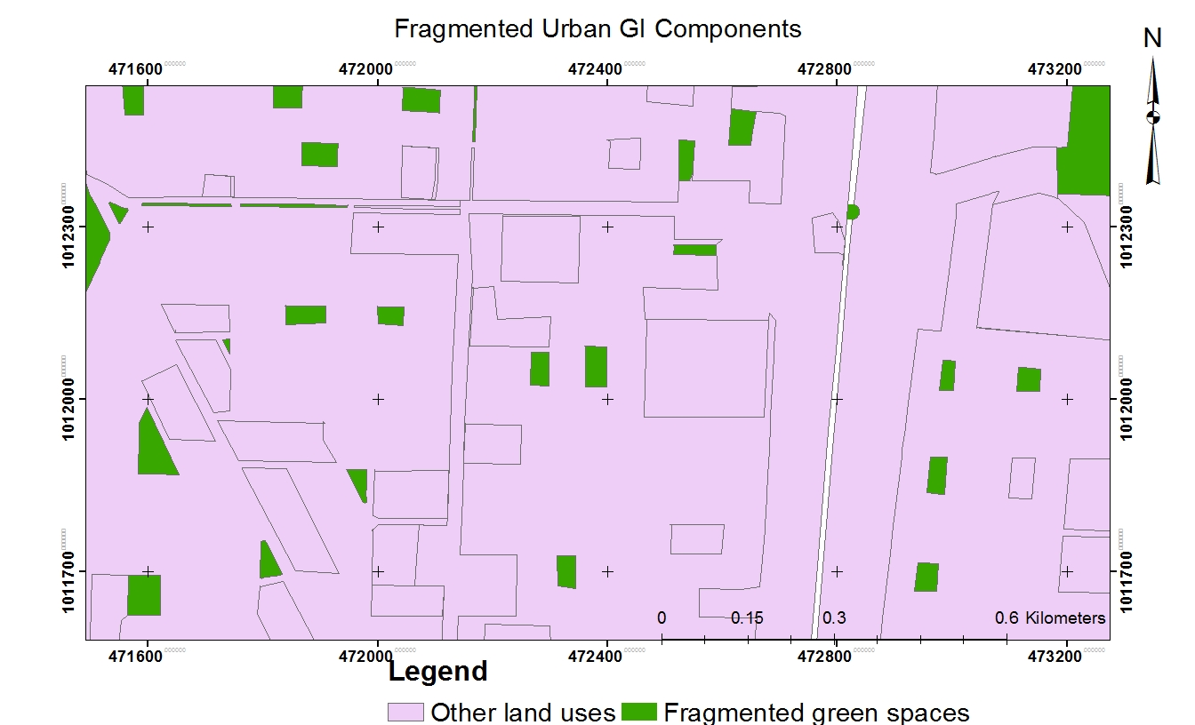
Figure 20 Planned urban GI components in the structural plan
Source: Structural plan of the study towns

Chapter Five: Conclusion, Recommendations and Further Research

5.1. Conclusion
The literature review has indicated that urban GI components supply is evaluated by the criteria of quantity, quality, location, multifunctionality and connectivity. WHO recommends a per capita green space of 9 m². Qualitatively safety, cleanness, attractiveness and availabilities of facilities such as for sanitation are needed for successful functioning of urban GI components. In addition, accessibility or short walking distance, multifunctionality such as playground, sport field, recreation, storm water management, and connectivity of the components area essential to support the latter function and biodiversity.

In similar with many sub-Saharan African cities, urban GI components in the study towns are currently in precarious conditions due to inadequate planning and implementation capacity. Urban GI components indicators (availability/ existence and per capita, accessibility/ physical access, and quality/ facilities, attractiveness, cleanness and safety) are in a poor condition. The study revealed that only 6.6%, 1.36% and 2.56% land mass of Sululta, Legatafo and Sebeta towns, respectively had been dedicated for the development of urban GI components. This has led to limited availability of established urban GI components such as parks and playgrounds within the walking distances of 300m and 500m and forcing the urban dwellers to walk more than 20minutes to access it. This is much longer than the five minutes that have been established in many studies as a threshold. Additionally, limited urban GI components in the emerging towns have resulted in having a per capita urban GI component of 2.66 m², 0.9 m² and 2.17 m² for Sululta, Sebeta and Legetafo towns, respectively. Low facilities, safety and poor sanitation conditions have also resulted in the poor state of the urban GI components. The study identified that the poor condition of urban GI components are closely linked to low user numbers and low frequency of their use in the emerging towns. In general, this study has evidenced a high scarcity of urban GI components in the emerging towns.

Excessive depletion of urban GI components and encroachment into them for different human activities has also limited the availability and accessibility of urban GI components in the emerging towns. The result of the study demonstrated that the study area has experienced a drastic loss and destruction of urban GI components during the last 13 years. Nearly 1410.7ha, 779.5ha and 421.9ha of urban GI components that were existed in 2003 were gradually converted to built-up in 2016, in Sebeta, Sululta and Legetafo towns, respectively. The immediate factors responsible for the problem are increasing physical expansion of the built-up area and densification in the inner towns, rapidly increasing land value, personal interests more likely including corruption, illegal developments, interventions from national and regional authorities and less priority given to urban GI components by the towns’ administration.
The literatures indicate that loss of urban GI components is basically a global phenomenon. In the mainstream literatures, based on situations in the developed parts of the world, the main drivers of reduction is planned conversion. This study shows in the emerging towns, the supply of urban GI components is constrained more by poor implementation of plans as a result of inadequate public participation, and financial and technical limitations. It also indicated that the implemented urban GI components of the plan were physically lost through unplanned and quasi-planned conversions and through encroachment due to poor development controls.
The literature also indicates that land supply is one of the challenges of government for urban GI supply. However, although land is owned by government in Ethiopia it does not seems to have reduced the challenges partly because local governments are often focused more on socio-economic development rather than environmental issues.
Despite wide difference in living standards, the study indicates some similarities with Western world and tropical countries regarding the overall behavior of urban GI components users: playgrounds and sport fields were the type of urban GI components commonly visited by the urban dwellers and proximity was the main reason for going to these components. Moreover, relaxation, physical exercise and social activities are the common purpose for using the urban GI components.

The overall management of urban GI components in the emerging towns of the study zone was found to be hindered by a lot of challenges. The study identified that the priorities given by the towns administration in allocating adequate funding to undertake tasks related to urban GI development was less and causing most of the tasks to remain on the drawing board. In addition, the absences of adequate legal framework and clearly defined mandates and roles among the different institutions have led to poor coordination between institutions. These problems are compounded by limited dialogue, poor sharing of information and lack of mutual understanding among the allied institutions on decisions concerning urban GI components. Moreover, developing and managing urban GI components in a sustainable way within the current human resources capacity of greenery department is very difficult.

The study also provides a picture of how urban GI planning principles has been considered into current urban planning practices. There have been efforts to integrate the principles of urban GI planning on policy documents although the term multi-functionality, connectivity, green and grey integration and social inclusion are lacking in the planning documents. Multiple functions and benefits of urban green spaces were recognized in the planning documents in different ways. Nonetheless, in practice developed urban GI components have mostly single functions. The green and grey infrastructure integration and social inclusiveness were recognized in a very limited degree in planning documents and in practice. Moreover, there is also a lack of communication and social inclusiveness in implementing different urban GI components. Decisions on urban GI components are not based on consensus of all the stakeholders, but are rather undertaken independently by the towns’ administration. This condition has resulted in limited awareness of urban GI components benefits and less sense of stewardship. The connectivity approaches were absent in any planning documents for connecting green space physically and/or functionally. As a result, urban GI components in the study area were developed in a fragmented manner. This could be due to lack of awareness and understanding of the decision makers and urban planners.

5.2. Recommendations

5.2. 1. Developing urban GI policy
Effective urban GI development and management system requires an effective policy framework that supports the process. Therefore, this study has recommended the development of urban GI policy that prioritizes urban GI development and management system at the national level.
Throughout the world, urban GI is ambiguous and essentially “a contested concept”. The concept has not been yet defined explicitly, as different practitioners and academicians attach different environmental, social and economic meanings to it. Therefore, efforts should be made on the policy to clearly put the concepts of urban GI and capture its values in the context of Ethiopia. Once the concept is well captured, there is greater opportunity to understand how it is used and what it might look like in practice. In addition, the policy has to proclaim the replacement of the narrower term “green space” to the wider concept of “GI” in all the planning documents and in practices.
The policy statement should also emphasize on urban GI planning principles such as multifunctionality, connectivity, and integration. For instance, the establishment of multifunctional and interconnected urban GI components around urban areas should be proclaimed as one of the policy objectives. The policy should identify departments/agencies that should be involved in decision making regarding urban GI development and management and the roles, codes and regulations that need to be updated to incorporate urban GI. Furthermore, there should be strict legal frameworks that enforce planning laws to prevent the encroachment of urban GI components in the policy document.
The elements of the urban GI policy should flow down from the national level to regional, urban and department level and action plans should be drawn from the policy frameworks for specific urban contexts. The overall significance of formulating and promulgating urban GI policy is to provide the direction and the basic standards for the development and management of urban GI in each urban center and avoid blind development of urban GI.

5.2.2. Improving provisioning standards for urban GI components
The analysis section has shown that per capita urban GI components are 2.66 m² for Sululta, 0.9 m² for Sebeta and 2.17 m² for Legetafo towns indicating limited availability of many urban GI components such as parks, playgrounds, sport fields and the like in the total land mass of the study towns. Surprisingly, the standards developed by OUPI in 2012 propose only 2 m² per capita green spaces for the first and second level urban centers and 1 m² per capita for the third level urban centers. These are far below the minimum green space requirement of WHO that is 9 m² per capita. Moreover, as highlighted in the same section, the existing GI components in the study towns are unattractive, mono-functional, fragmented and poorly accessible to the community. Therefore, improving the standards of quantity, quality and accessibility of urban GI components such as parks, sport fields and playgrounds is recommended in this study. In improving the standards, the concerned body should set out specific requirements for the provision of urban GI components as part of new development and make clear how much, of what type and quality and what the accessibility requirements are. The standards should be carefully tailored to the circumstances of the area and they should be developed differently for different functions such as playgrounds, parks, sport fields and the like.

To improve the standards in terms of quantity, firstly, the planning authority should determine a minimum quantitative standard based on population size. Secondly, it has to be sure that the individual urban GI component must be not only of sufficient size but also equally distributed. To provide sufficient urban GI components, the planning authority should introduce indices like the “Biotope Area Factor”, “six-acre standard” or “Accessible Natural Green Space Standard” based on the local context. Such indices will enable to improve the quantity of the urban GI components based on the population size by focusing on issues such as green space ratio, green space coverage and green space area per capita. In providing specific quantitative standards for the provision of urban GI components, the WHO standard of 9 m² per person can serve as a benchmark.

Besides improving the quantitative standards, enhancing urban GI components’ quality standard is also needed. As the analysis sections shows, lack of connectivity, integration, facilities and lack of awareness on multifunctional benefits of urban GI components have led to poor quality of the components. Therefore, quality standards should focus on the fitness of urban GI components to the intended purpose, the long-term sustainability of the components, the appropriateness of the designs, and the flexibility to the user need and requirements. The quality standard should focus on diversity and equity of urban GI components, which results from the heterogeneity and spatial distribution of the GI components. Moreover, the quality standard improvement should also target on connectivity of the components. Connectivity can be of a spatial nature, for example in the form of riparian corridors (stream, lake, riverside), urban green corridors or road network (cycling path, pedestrian zone/walkway, underpass, interchange, transport hubs).
Additionally, to improve the quality standard, attention should be given to the integration of green spaces with the grey structure. As different studies show the integration of green and grey infrastructure for stormwater management has gained much attention in the past two decades (Fletcher et al., 2014). However, other fields of application include, for instance, bike paths and greenways along power line right-of-ways, green corridors for ventilation or green roof.

Furthermore, to improve the quality standard of urban GI provision multi-functionality should be promoted. In line with this, there should be a commitment to increases multi-functional GI components and an effort to maximize the quality of the places and the contribution that they provide to local communities.

Thirdly, as the analysis section shows, the majority of the urban GI components (such as playgrounds, parks and sport field) are not accessible to the urban dwellers. Therefore, the accessibility standard should be improved based on walking time and distances. A 10 – 12 minute walk (400m-600m) is considered as a reasonable standard by many countries. International research shows that having green space within a 5-minute walk of home is a strong indicator for the quality of life (Lee et al., 2015). To improve the accessibility standard the site should be easily found and accessible by road, cycleway, footpaths and public transport including by those with disabilities and barriers should be avoided

The analysis showed that the gap between planning documents and practical application on the ground is evident in the study towns. Therefore, the standards should strictly consider this gap and be supplemented with enforced legal frameworks. The legal framework should include how the civil, criminal, and administrative measures can be taken on those who violate the standards and did not implement properly.

5.2.3. Develop a strong institutional framework
Poor coordination among institutions in charge of urban GI component development and management was identified as one of the problems with regard to the development and management system of urban GI in the studied towns. Institutions such as department of greenery, office of environmental protection, department of land administration, departments of finance and urban planning were are identified as having poor horizontal coordination among them. However, sustainable urban GI development and management system require strong coordination between these departments (Mensah, 2014). Therefore, to strengthen the coordination among institutions this study has recommended that, the urban GI policy should establish a regulatory framework, which improves and enhances coordination among institutions and which encourages working together. Additionally, the urban GI policies, strategies and legislation should clearly define the mandate and responsibilities of the different institutions that directly or indirectly responsible for urban GI development and management to avoid conflicting responsibilities. The issue of overlaps and gaps of mandate and responsibilities has to be given due attention since urban GI development and management is a multi-sectoral. Moreover, the different linkages between key institutions responsible for the development and management of urban GI should be well defined and structured in the policy and strategy frameworks. This condition will create a strong institutional network and interdependencies to effectively develop and manage urban GI components. Furthermore, to strengthen the coordination, there should be a way in which the associated institutions should communicate freely in continual manner. More to the point, the urban GI policy frameworks should promote joint projects that could be undertaken together by the responsible institutions. Specific legislative instruments are also required to make the coordination more practical on the ground.
Besides to the poor coordination, the analysis section highlighted that the department of greenery has few skilled professionals. The majority of employs were demoted individuals who were fired from higher positions such as mayor and cabinet member. Therefore, the institutions responsible for the development and management of urban GI shall be provided with sufficient and qualified staff. Additionally, the government should stop the practice of using the department as a dumping ground for demoted officials. Moreover, there should be regular capacity building strategies which helps to improve the skill and knowledge of the staff members. Furthermore, there should be a strong alliance with higher institutions to design curriculum and to launch training which is related to GI planning and implementation, environmental planning, urban horticulture, urban planning and landscape planning and design. The collaboration will help to upgrade the skills of the staff and to solve the problem of unqualified professional, which was eminent among the departments.

5.2.4. Amend urban GI financing policy and practice
The analysis has highlighted financial constraints as a major hindrance in the study towns for developing and managing urban GI components. Therefore, different funding approaches have been recommended in this study to overcome the budget shortage of urban GI development and management system.
- Prioritizing GI among top government agenda: The findings of the study show that the attention of the town administrations has been focused on the construction of roads, schools, health centers, housing and other social infrastructure. As the budget report of the towns shows, matters of GI components were often relegated to the bottom or not given much attention during the budget allocation. This is inconsistent with the importance of the GI discussed extensively in this study and shall be improved both in the urban GI policy and in practice.
- Multi-agency public sector funding: The analysis shows that the department of greenery is the only sector that allocated budget for development and management of urban GI components. However, funding can be accessed from a range of departments and agencies for the delivery of projects that meet crosscutting targets. For instance, the office of health and office of youth and sport have targets for improving public health, creating conducive environment for youth, and protecting youth from unnecessary activities. Well-developed and managed urban GI components can provide opportunities for outdoor physical activities, social contacts and relaxation, which is an important environmental determinant of the health of urban residents. Therefore, the above-mentioned benefit can solve the burden of the offices of health and office of youth and sport. In view of that, policies and strategies related to urban GI should put explicitly mechanisms on how the above offices should allocate some budget for the development and management of urban GI components.
- Income-generating opportunities: Urban GI financing policy and strategy should grant the authority and mandate to the institution directly responsible for urban GI development and management to generate its own income from various activities such as licensing and franchising, sponsorship, entry fees and fines, on-site events and concessions fees such as for cafes or specialist recreational activities. Opportunities for generating income are ways in which funding from the private sector and users of urban GI components can be sourced. The income-generating activities on Mile End Park in London offer a good example for this initiative (CABE, 2006).
- Voluntary involvement: The central role that many urban GI components play in people’s lives can lead to a high degree of voluntary involvement. Non-profit organizations and voluntary community groups can contribute time and labor, and raise funds for the development of urban GI components (CABE, 2006). Based on the experience of different countries, these are potentially viable options for creating self-sustaining urban GI components in the future.

5.2.5. Enhancing participation in planning policy
Limited community participation and stakeholder involvement was identified as one of the main problems for the development and overall management of urban GI components in the study towns. Poor social inclusion in the planning of the urban GI components has led to less sense of cohesion and resulted in urban GI components that do not meet the needs and interest of stakeholders. To overcome these challenges, the active involvement of the stakeholders and the local community in all project planning, development and management stages is mandatory (Tian et al., 2012; Jim, 2013; Haaland & van den Bosch, 2015; Kanniah, 2017). Therefore, this study has recommended that the policy frameworks and strategies related to urban GI should clearly define how stakeholders and communities collaborate with the government through effective and accountable channels of participation in the development and management of urban GI. Moreover, the features of communicative planning theory such as informing, consultation, partnership, delegation and community control should be given much attention in the policy frameworks and strategies. Healey (2007), and Innes and Booher (2004) have found these features to be vital boosters for wider community participation. Specific legislative instruments are also needed to make the features more practical on the ground.

Furthermore, the analysis showed that limited awareness on the benefits of urban GI components has hindered the community to participate actively in the development and management of urban GI and made them to view the development and management as the sole responsibility of government. Therefore, public awareness creation campaigns should be conducted through workshops, seminars and by using the mass media and materials such as posters, leaflets and brochures indicating the benefits of urban GI components, the consequences of the actions of all on the urban environment and the need for sustainable development of urban areas. This effort will help in changing the behavior of the local community towards the development and protection of urban GI components. For example in Florida (USA), a similar education campaign produced a positive result by improving environmental knowledge, attitude and behavior of the public toward the development and management of urban GI (Hostetler et al., 2008; Mensah, 2014). For a more sustainable effect, courses focused on urban GI shall be introduced into the educational curriculum at the basic education level. This will help to inculcate into schoolchildren the spirit of environmental stewardship and help them grow up to develop a love for the conservation of urban GI components.

5.3. Contribution and further research
The study has attempted to add new information to urban GI literature concerning the dynamics of urban GI components and how the urban GI planning principles have been incorporated in the current urban planning practices of a sub-Saharan African country. Three peer-reviewed papers have already been published out of the study to augment the literature on urban GI components in the region. Moreover, it has attempted to provide variety of recommendations offering a wider range of measures that can be utilized to successfully develop and manage urban GI components. Such recommendations provide a broader range of ideas that can be incorporated into development agendas and different planning strategies to support sustainable development and management of urban GI for the emerging and other towns.
Finally, the study has attempted to provide a comprehensive assessment of the planning, implementation and management challenges of urban GI components, and to suggest measures that address the challenges. However, similar researches needed to be conducted in the future on developing tools (information, decision supporting and technical) that help to transfer the concepts, principles and approaches of urban GI into practice. In addition, although the study covers a variety of urban GI components, attention was not given to cemeteries and urban agriculture, which constitute an important aspect of urban GI components. Thus, future studies should concentrate on integrating cemeteries and urban agriculture into the broad GI of urban areas. It is also suggested that there is a need for comparative case studies of towns since studies across locations are relatively rare. Such studies would significantly advance our understanding of sustainable urban GI development and management system in Ethiopia in particular and more widely in sub-Saharan Africa.

References
Abebe, M.T., & Megento, T.L. (2016). The city of Addis Ababa from ‘Forest city' to ‘Urban Heat Island' Assessment of Urban Green Space Dynamics. Journal of Urban and Environmental Engineering, 10(2), 254-262.
Abkar, M., Mustafa K.M. S., Mariapan M., Maulan S., & Sheybanic M. (2010). The role of urban green spaces in mood change. Australian Journal of Basic and Applied Sciences, 4 (10), 5352-5361.
Abo El Wafa, H., Yeshitela, K., & Pauleit, S. (2018). The use of urban spatial scenario design model as a strategic planning tool for Addis Ababa. Landscape and Urban Planning, 180, 308-318. https://doi.org/10.1016/j.landurbplan.2017.08.004
Abubakar, I., & Aina, A. (2006). GIS and Space Syntax: An analysis of accessibility to urban green areas in Doha district of Dammam metropolitan area. Saudi Arabia, 1-8.
Addo-Fordwuor, D. (2015). Green space depletion in Ghana’s urban settlements: a case of Kumasi (Doctoral dissertation).
Ahern, J. (1995). Greenways as a planning strategy. Landscape and Urban Planning, 33, 131–155.
Ahern, J. (2007). Green infrastructure for cities: the spatial dimension. In Cities of the Future: Towards Integrated Sustainable Water and Landscape Management ed. V. Novotny, 267–283. London: IWA Publications.
Ahmed, I. C., Matori, A., Umar, D. L., & Sabri, S. (2011). GIS- based Land Suitability Analysis Using AHP for Public Parks Planning in Larkana City. Modern Applied Science, 5(4), 178-184.
Alberta Community Development. (2000). Alberta Recreation Survey, Alberta, Sport and Recreation Branch. Alberta, Canada.
Alberti, M., Booth, D., Hill, K., Coburn, B., Avolio, C., Coe, S., & Spirandelli, D. (2007). The impact of urban patterns on aquatic ecosystems: An empirical analysis in Puget lowland sub-basins. Landscape and Urban Planning, 80:345-361.
Albrechts, L. (2006). Shifts in strategic spatial planning: some evidence from Europe and Australia. Environment and Planning, 38 (6), 1149-1170.
Alexandri, E., & Jones, P. (2008). Temperature decreases in an urban canyon due to green walls and green roofs in diverse climates. Building and Environment, 43, 480-493.
Allen, W. L. (2012). Advancing green infrastructure at all scales: from landscape to site. Environmental Practice, 14, 17-25.
Alliance, C. W. A. (2011). Barriers and gateways to green infrastructure. Clean Water America Alliance: Washington, DC, USA, 137.
Amati, M., & Taylor, L. (2010). From green belts to green infrastructure. Planning Practice & Research, 25(2), 143-155.
Arthur, J., Waring, M., Coe, R., & Hedges, L. V. (2012). Research Methods and Methodologies in Education. SAGE.
Awuah, K. G. B., Hammond, F. N., Block, R., Proverbs, D., Booth, C., & Lamond, J. (2010). Sub-Saharan Africa urban land use planning systems: The need for an economic appraisal. A paper presented at the Construction, Building and Real Estate Research Conference of the Royal Institution of Chartered Surveyors. Paris, September 2-3.
Abebe, M.T., & Megento, T.L. (2016). The city of Addis Ababa from ‘Forest city' to ‘Urban Heat Island' Assessment of Urban Green Space Dynamics. Journal of Urban and Environmental Engineering, 10(2), 254-262.
Abkar, M., Mustafa K.M. S., Mariapan M., Maulan S., & Sheybanic M. (2010). The role of urban green spaces in mood change. Australian Journal of Basic and Applied Sciences, 4 (10), 5352-5361.
Abo El Wafa, H., Yeshitela, K., & Pauleit, S. (2018). The use of urban spatial scenario design model as a strategic planning tool for Addis Ababa. Landscape and Urban Planning, 180, 308-318. https://doi.org/10.1016/j.landurbplan.2017.08.004
Abubakar, I., & Aina, A. (2006). GIS and Space Syntax: An analysis of accessibility to urban green areas in Doha district of Dammam metropolitan area. Saudi Arabia, 1-8.
Ahern, J. (1995). Greenways as a planning strategy. Landscape and Urban Planning, 33, 131–155.
Ahern, J. (2007). Green infrastructure for cities: the spatial dimension. In Cities of the Future: Towards Integrated Sustainable Water and Landscape Management ed. V. Novotny, 267–283. London: IWA Publications.
Ahmed, I. C., Matori, A., Umar, D. L., & Sabri, S. (2011). GIS- based Land Suitability Analysis Using AHP for Public Parks Planning in Larkana City. Modern Applied Science, 5(4), 178-184.
Alberta Community Development. (2000). Alberta Recreation Survey, Alberta, Sport and Recreation Branch. Alberta, Canada.
Albrechts, L. (2006). Shifts in strategic spatial planning: some evidence from Europe and Australia. Environment and Planning, 38 (6), 1149-1170.
Alexandri, E., & Jones, P. (2008). Temperature decreases in an urban canyon due to green walls and green roofs in diverse climates. Building and Environment, 43, 480-493.
Allen, W. L. (2012). Advancing green infrastructure at all scales: from landscape to site. Environmental Practice, 14, 17-25.
Alliance, C. W. A. (2011). Barriers and gateways to green infrastructure. Clean Water America Alliance: Washington, DC, USA, 137.
Amati, M., & Taylor, L. (2010). From green belts to green infrastructure. Planning Practice & Research, 25(2), 143-155.
Arendt, R. G. (2012). Conservation design for subdivisions: A practical guide to creating open space networks. Island Press.
Barbosa, O., Tratalos, J. A., Armsworth, P. R., Davies, R. G., Fuller, R. A., Johnson, P., & Gaston, K. J. (2007). Who benefits from access to green space? A case study from Sheffield, UK. Landscape and Urban Planning, 83(2-3), 187-195.
Bastian, O., Haase, D., & Grunewald, K. (2012). Ecosystem properties, potentials and services – The EPPS conceptual framework and an urban application example. Ecological Indicators, 21, 7-16. doi:10.1016/j.ecolind.2011.03.014
Baycan-Levent, T., & Nijkamp, P. (2009). Planning and management of urban green spaces in Europe: Comparative analysis. Journal of Urban Planning and Development, 135(1), 1-12. https://doi.org/10.1061/(ASCE)0733-9488(2009)135:1(1)
Bayon, R., Carroll, N., & Fox, J. (2012). Conservation and biodiversity banking: a guide to setting up and running biodiversity credit trading systems. Earthscan.
Benedict, M. A., & McMahon, E. T. (2006). Green infrastructure: linking landscapes and communities. Island Press.
Benedict, M.A., & McMahon, E.T. (2002). Green Infrastructure: Smart Conservation for the 21st Century. Renewable Resources Journal, 20(3), 12-17.
Bengston, D. N., Fletcher, J. O., & Nelson, K. C. (2004). Public policies for managing urban growth and protecting open space: policy instruments and lessons learned in the United States. Landscape and urban planning, 69(2-3), 271-286.
Berhanu, M. A. (n.d). Current Status and Management Practices of Urban Green Areas In Addis Ababa.
Biernacka, M., & Kronenberg, J. (2018). Classification of institutional barriers affecting the availability, accessibility and attractiveness of urban green spaces. Urban Forestry & Urban Greening, 36, 22-33.
Bolund, P., & Sven, H. (1999). Ecological Services in Urban Areas. Ecology Economy, 29, 293-301.
Bonilla, M. H. (2013). The significance and meanings of public space improvement in low-income neighborhoods ‘colonias populares’ in Xalapa-Mexico. Habitat International, 38: 34 - 46.
Boone, C.G., Buckley, G.L., Grove, J.M., & Sister, C. (2009). Parks and People: An environmental justice inquiry in Baltimore, Maryland. Annals of the Association of American Geographers, 99(4), 767-787.
Brown and Caldwell, Hntb & Tetra Tech Inc. (2011). Determining the Potential of Green Infrastructure to Reduce Overflows in Milwaukee, Milwaukee, Wisconsin, U.S.A., Milwaukee Metropolitan Sewerage District.
Buckland, J.G. (1987). The history and use of purchase of development rights in the United States. Landscape Urban Plan, 14, 237–252.
Buijs, A., Elands, B., Havik, G., Ambrose-Oji, B., Gerohazi, E., van der Jagt, A., Mattijssen, T., Moller, M. S., & Vierikko, K. (2016). Innovative governance of urban green spaces – learning from 18 innovative examples across Europe, European Union FP7 project Green Surge (ENV.2013.6.2- 5-603567), Deliverable 6.2, retrieved from http://greensurge.eu/working-packages/wp6/files/
Bunruamkaew, K., & Yuji M. (2011). Site Suitability Evaluation for Ecotourism Using GIS & AHP: A Case Study of Surat Thani Province. Thailand. Procedia Social and Behavioral Sciences, 21,269–278.doi:10.1016/j.sbspro.2011.07.024
Burgess, S., (2015). Multifunctional green infrastructure: A typology. In Sinnett, D., Smith, N., Burgess, S. (Eds.). Handbook on green infrastructure. Planning, design and implementation. Edward Elgar Publishing, Chel-tenham, UK, 227–241.
Byrne, J., & Sipe, N. (2010). Green and open space planning for urban consolidation–A review of the literature and best practice.
CABE. (2003). Planning green infrastructure. CABE Space, London
CABE. (2004). The Value of Public Space: How High Quality Parks and Public Spaces Create Economic, Social and Environmental Value? CABE Space, London.
CABE. (2006). Green space strategies: A good practice guide. London: CABE.
CABE. (2010). Research summary. Urban Green Nation: Building the evidence base. London: Commission for Architecture and the Built Environment.
Carmona, M., Magalhaes, C. D., Blum, R., & Hopkins, J. (2004). Is the Grass Greener…? Learning from international innovations in urban green space management. London: CABE Space.
Casperson, O. H., & Olafsson, A. S., 2010. Recreational Mapping and Planning for Enlargement of the Green Infrastructure in Greater Copenhagen. Urban Forestry & Urban Greening, 9, 101-112.
Central Statistical Agency (CSA). (1994). Population and Housing Census of Ethiopia: Results at a Country Level. Office of population and housing census commission, Addis Ababa, Ethiopia.
Central Statistical Agency (CSA). (2008). Population and Housing Census of Ethiopia: Statistical Report for Oromia Region. Central Statistical Agency of Ethiopia, Addis Ababa, Ethiopia.
Central Statistical Agency (CSA). (2013). Population Projection of Ethiopia for All Regions at Wereda Level from 2014 – 2017. Central Statistical Agency of Ethiopia, Addis Ababa, Ethiopia
Chen, W. Y., & Jim, C. Y. (2008). Assessment and valuation of the ecosystem services provided by urban forests. In Ecology, Planning, and Management of Urban Forests (pp. 53-83). Springer, New York, NY.
Chen, Y., Liu, T., Xie, X., & Marusic, B. G. (2016). What attracts people to visit community open spaces? A case study of the Overseas Chinese Town community in Shenzhen, China. International journal of environmental research and public health, 13(7), 644. doi:10.3390/ijerph13070644
Cheruto, M.C., Kauti, M.K., Kisangau, P.D., & Kariuki, P. (2016). Assessment of Land Use and Land Cover Change Using GIS and Remote Sensing Techniques: A Case Study of Makueni County, Kenya. Journal of Remote Sensing & GIS, 5(175). doi:10.4175/2469-4134.1000175
Chiesura, A. (2004). The role of urban parks for the sustainable city. Landscape and Urban Planning, 68, 129-138. https://doi.org/10.1016/j.landurbplan.2003.08.003
Chini, C., Canning, J., Schreiber, K., Peschel, J., & Stillwell, A. (2017). The green experiment: Cities, green storm water infrastructure, and sustainability. Sustainability, 9(1), 105.
Chishaleshale, M. (2012). Governance and management of urban trees and green spaces in South Africa: ensuring benefits to local people and the environment.
Chishaleshale, M., Shackleton, C. M., Gambiza, J., & Gumbo, D. (2015). The prevalence of planning and management frameworks for trees and green spaces in urban areas of South Africa. Urban Forestry & Urban Greening, 14(4), 817–825. http://dx.doi.org/10. 1016/j.ufug.2015.09.012.
Christman, Z., Meenar, M., Mandarano, L., & Hearing, K. (2018). Prioritizing suitable locations for green storm water infrastructure based on social factors in Philadelphia. Land, 7(4), 145.
Cilliers, E.J. (2019). Reflecting on Green Infrastructure and Spatial Planning in Africa: The Complexities, Perceptions, and Way Forward. Sustainability, 11(2), 455.
City of Melbourne. (2012). Urban forest strategy: making a great city greener 2012-2032, City of Melbourne, retrieved 26 July, 2016, <http://www.melbourne.vic.gov.au/urbanforests.
CIWEM. (2010). Multi-Functional Urban Green Infrastructure a Ciwem Briefing Report London: The Chartered Institution of Water and Environmental Management.
Cohen, B. (2006). Urbanization in developing countries: Current trends, future projections, and key challenges for sustainability. Technology in society, 28(1-2), 63-80.
Cohen, D. A., Inagami, S., & Finch, B. (2008). The built environment and collective efficacy. Health & Place, 14(2), 198-208.
Cohen, D. A., Marsh, T., Williamson, S., Derose, K. P., Martinez, H., Setodji, C., & Mckenzie, T. L. (2010). Parks and physical activity: Why are some parks used more than others?. Preventive Medicine, 50, 9-12.
Cohen, D.A., Ashwood, J.S., Scott, M.M., Overton, A., Evenson, K.R., Staten, L.K., Porter, D., Mckenzie, T.L., & Catellier, D. (2006). Public parks and physical activity among adolescent girls. Pediatrics, 118, E1381-E1389
Colding, J. (2011). The role of ecosystem services in contemporary urban planning. In: Niemelä, J., et al. (eds.) Urban Ecology: Patterns, Processes and Applications. (pp 228-237). Oxford: Oxford University Press
Comber, A., Brunsdon, C., & Green, E. (2008). Using a GIS-based network analysis to determine urban greenspace accessibility for different ethnic and religious groups. Landscape and Urban Planning, 86(1), 103-114.
Comertler, S. (2017). Greens of the European Green Capitals. In IOP Conference Series: Materials Science and Engineering, 245, 5, p. 052064. IOP Publishing.
Congalton, R.G., & Green, K. (2008). Assessing the Accuracy of Remotely Sensed Data: Principles and Practices, 2nd ed. CRC Press/Taylor & Francis: Boca Raton, FL, USA.
Conway, H. (2000). Parks and people: the social functions. The regeneration of public parks, 9-20.
Cornelis, J., & Hermy, M. (2004). Biodiversity relationships in urban and suburban parks in Flanders. Landscape and Urban Planning, 69 (4), 385 401.
Countryside Agency. (2006). Countryside in and around Towns: The Green Infrastructure of Yorkshi re and the Humber. Countryside Agency, Leeds.
Coutts, C., Horner, M., & Chapin, T. (2010). Using geographical information system to model the effects of green space accessibility on mortality in Florida. Geocarto International, 25(6), 471-484.
Crompton, J. L. (2001). Financing and acquiring park and recreational resources. Champaign, IL: Human Kinetics.
Dallimer, M., Davies, Z., Irvine, K., Maltby, L., Warren, P., Gaston, K., & Armsworth, P. (2014). What personal and environmental factors determine frequency of urban greenspace use?. International journal of environmental research and public health, 11(8), 7977-7992.
David, N. P. (2015). Factors affecting planned unit development implementation. Planning Practice & Research, 30(4), 393-409.
Davis, A. Y., Belaire, J. A., Farfan, M. A., Milz, D., Sweeney, E. R., Loss, S. R., & Minor, E. S. (2012). Green infrastructure and bird diversity across an urban socioeconomic gradient.Ecosphere, 3(11), 1-18.
Davies, C., Hansen, R., Rall, E., Pauleit, S., Lafortezza, R., De Bellis, Y., ... & Tosics, I. (2015). The status of European green space planning and implementation based on an analysis of selected European city-regions. EU FP7 project GREEN SURGE, Deliverable D, 5.
Davies, C., Macfarlane, R., & Roe, M. H. (2006). Green Infrastructure Planning Guide, 2 Volumes: Final Report and GI Planning Newcastle, England, UK, University of Northumbria, North East Community Forests, University of Newcastle, Countryside Agency. English Nature, Forestry Commission, Groundwork Trusts.
De Groot, R.S. (1992). Functions of nature: evaluation of nature in environmental planning, management and decision making. Wolters-Noordhoff BV.
De Vries, S., & Van Zoest, J. (2004). The impact of recreational shortages on urban liveability. In: Proceedings of the Open Space-People Space Conference, Edinburgh, Scotland, 27–29 October (Paper 00089).
Demissie, F., Yeshitila, K., Kindu, M., & Schneider, T. (2017). Land use/Land cover changes and their causes in Libokemkem District of South Gonder, Ethiopia. Remote Sensing Applications: Society and Environment, 8, 224-230.
Derese, G. (2008). The Tragedy of the Urban Commons. A case study of 2 public places in Addis Ababa, Addis Ababa, Ethiopia.
Djibril, K., Coulibaly, A., Wang, X., & Ousmane, D. (2012). Evaluating green space use and management in Abidjan City, Cote d'Ivoire. International Journal of Economics and Management Engineering, 2(3), 108-116.
Dornyei, Z. (2007). Research Methods in Applied Linguistics: Quantitative, Qualitative, and Mixed Methodologies. New York: Oxford University Press.
Douglas, I. (2018). The challenge of urban poverty for the use of green infrastructure on floodplains and wetlands to reduce flood impacts in intertropical Africa. Landscape and Urban Planning, 180, 262-272.
Dubbale, D.A., Tsutsumi, J., & Bendewald, M.J. (2010). Urban environmental challenges in developing cities: The case of Ethiopian capital Addis Ababa. World Academy of Science, Engineering and Technology, 4(6), 397-402.
Dunnett, N. Swanwick, C., & Woolley, H. (2002). Improving Urban Parks, Play Areas and Green Spaces. London: DLTR
Durant, N., Kerr, J., & Harris, S. (2009). Environmental and safety barriers to youth physical activity in neighborhood parks and streets: Reliability and validity. Pediatric Exercise Science, 21, 86-99. https://doi.org/10.1123/pes.21.1.86
EEAC (European Environment and Sustainable Development Advisory Councils) Biodiversity Working Group. (2009). Briefing Paper: Green infrastructure and ecological connectivity. http://www.google.co.uk/url?q=http://www.eeac-
Ellis, J. B. (2012). Sustainable surface water management and green infrastructure in UK urban catchment planning. Journal of Environmental Planning and Management, 56, 24-41.
Enger, S. C. (2005). Planning for parks, recreation, and open space in your community. Olympia, WA: Washington State Dept. of Community, Trade and Economic Development.
Erickson, D. (2006). Metro green: Connecting Open Space in North American Cities, Washington, D.C, U.S.A., Island Press.
Ernstson, H., Barthel, S., Andersson, E., & Borgstrom, S. (2012). Scale-crossing brokers and network governance of urban ecosystem services: The case of Stockholm. Ecology and Society, 15(4): 28
European Commission. (2013). Green infrastructure (GI) — Enhancing Europe’s natural capital. Communication from the Commission to the European Parliament, the Council, the European Economic and Social Committee and the Committee of the Regions, COM 249 final.
European Environment Agency. (2011). Green infrastructure and territorial cohesion. The concept of green infrastructure and its integration into policies using monitoring systems, Technical Report No. 18/2011, Copenhagen, Denmark.
European Union. (2010). Building Up Europe's Green Infrastructure: Addressing connectivity and enhancing ecosystem functions. Retrieved from http://ec.europa.eu/environment/life/publications/lifepublications/lifefocus/documents/green_infra.pdf
European Union. (2010). Making our cities attractive and sustainable How the EU contributes to improving the urban environment, ISBN 978-92-79-16298-5. Doi: 10.2779/42720.
Fabos, J. G. (2004). Greenway planning in the United States: Its origins and recent case studies. Landscape and Urban Planning, 68, 321–342.
Fam, D., Mosley, E., Lopes, A., Mathieson, L., Morison, J., & Connellan, G. (2008). Irrigation of urban green spaces: A review of the environmental, social and economic benefits. CRC for Irrigation Futures Technical Report No. 04/08.
Farina, A. (2006). Principles and methods in landscape ecology: Towards a science of the landscape. London: Springer.
Fazal, S. (2000). Urban expansion and loss of agricultural land-a GIS based study of Saharanpur City, India. Environment and Urbanization, 12(2), 133-149.
Firehock, K. (2010). A short history of the term green infrastructure and selected literature. Retrieved from http://www.gicinc.org/PDFs/GI%20History.pdf.
Flores, A., Pickett, S. T. A., Zipperer, W. C., Pouyat, R. V., & Pirani, R. (1998). Adopting a Modern Ecological View of the Metropolitan Landscape: The Case of a Green Space System for the New York Region. Landscape and Urban Planning, 39, 295-308.
Forest Research. (2010). Benefits of green infrastructure. Report to Defra and CLG. Farnham: Forest Research.
Forman, R. (1995). Land mosaics: The ecology of landscapes and regions. Cambridge: Cambridge University Press.
Forman, R. T. T. (2008). Urban Regions: Ecology and Planning Beyond the City. Cambridge, UK; New York: Cambridge University Press.
Forsyth, A. (2003). People and urban green areas: perception and use. Design Center for American Urban Landscape, 4.
Fraser, E. D. G. (2002). Urban ecology in Bangkok, Thailand: Community participation, urban agriculture and forestry. Environments, 30(1), 37-50.
Fuller, R. A., & Gaston, K. J. (2009). The scaling of green space coverage in European cities. Biology Letters, 5, 352-355.
Fuwape, J. A., & Onyekwelu, J. C. (2011). Urban forest development in West Africa: Benefits and challenges. Journal of Biodiversity and Ecological Sciences, 1(1), 78-94.
Gashu, K., & Gebre-Egziabher, T. (2018). Spatiotemporal trends of urban land use/land cover and green infrastructure change in two Ethiopian cities: Bahir Dar and Hawassa. Environmental Systems Research. 7(1), 8. https://doi.org/10.1186/s40068-018-0111-3
Geneletti, D., (2011). Reasons and options for integrating ecosystem services in strategic environmental assessment of spatial planning. Int. J. Biodivers. Sci. Ecosyst. Serv. Manag. 37–41.
Giles-Corti, B., Broomhall, M.H., Knuiman, M., Collins, C., Douglas, K., Ng, K., Lange, A., & Donovan, R.J. (2005). Increasing walking. How important is distance to, attractiveness, and size of public open space?. American Journal of Preventive Medicine, 28 (2S2), 169–176.
Gill, S.E., Handley, J.F., Ennos, A.R., & Pauleit, S. (2007). Adapting Cities for Climate Change: The Role of the Green Infrastructure. Built Environment, 33(1), 115-133.
Gill, S. E., Handley, J. F., Ennos, A. R., Pauleit, S., Theuraya, N. & Lindley, S. J. (2008). Characterizing the urban environment of UK cities and towns: A template for landscape planning. Landscape and Urban Planning, 87, 210-222.
Godbey, G., Graefe, A., & James, S. W. (1992). The Benefits of Local Recreation and ParkServices: A Nationwide Study of the Perspectives of the American Public. Washington, DC, National Recreation and Park Association.
Gomes, C. S., & Moretto, E. M. (2011). A framework of indicators to support urban green area planning: A Brazilian case study. Proceedings of the International Academy of Ecology and Environmental Sciences, 1(1):47-56.
Gomez-Munoz, V.M., Porta-Gandara, M.A., & Fernandez, J.L. (2010). Effect of tree shades in urban planning in hot-arid climatic regions. Landscape and Urban Planning. 94(3-4), 149-157.
Gondo, T. (2012). Spatial Planning and Open Spaces Integration in urban Ethiopia: A sustainable accessibility exegesis. http//www.corp.at
Greenscom (Communicating Urban Growth and Green). (2007). Retrieved November 5, 2007, from Greenscom Project Web site: http://www.greenscom.com/.
Gret-Regamey, A., Siren, E., Brunner, S.H., & Weibel, B. (2016). Review of decision support tools to operationalize the ecosystem services concept. Ecosyst. Serv. 0–1. http://dx. doi.org/10.1016/j.ecoser.2016.10.012.
Grose, M. (2009). Changing relationship in public open space and private open space in suburbs in south-western Australia. Landscape and Urban Planning. 92, 53- 63.
Haaland, C., & van den Bosch, C. Konijnendijk. (2015). Challenges and strategies for urban green-space planning in cities undergoing densification: A review. Urban forestry & urban greening, 14, 760-771. doi: 10.1016/j.ufug.2015.07.009
Hancock, D. R., & Algozzine, B. (2006). Doing case study research: A practical guide for beginning researchers. New York: Teachers College Press.
Handley J., Pauleit S., Slinn P., Barber A., Baker M., Jones C., & Lindley S. (2003). Accessible Natural Green space Standards in Towns and Cities. A review and tool-kit for their implementation. English Nature Research Reports, 526.
Hansen, R., & Pauleit, S. (2014). From multi functionality to multiple ecosystem services? A conceptual framework for multi functionality in green infrastructure planning for urban areas. Ambio, 43(4), 516-529.
Hansen, R. (2018). Multifunctionality as a Principle for Urban Green Infrastructure Planning (Doctoral dissertation, Technische Universität München).
Hansen, R., Buizer, M.,Rall, E.; DeBellis, Y., Davies, C., Elands, B., Wiersum, F., & Pauleit, S. (2015). Report of Case Study City Portraits. Appendix to GREEN SURGE study on urban green infrastructure planning and governance in 20 European case studies. Retrieved from: https://greensurge.eu/filer/GREEN_SURGE_Report_of_City_Portraits.pdf
Hansen, R., Rolf, W., Santos, A., Luz, A. C., Száraz, L., Tosics, I., ... & Pauleit, S. (2016). Advanced Urban Green Infrastructure Planning and Implementation: Innovative Approaches and Strategies from European Cities. EU FP7 project GREEN SURGE, Deliverable D, 5.2.
Hansen, R., Frantzeskaki, N., McPhearson, T., Rall, E., Kabisch, N., Kaczorowska, A., … & Pauleit, S. (2015). The uptake of the ecosystem services concept in planning discourses of European and American cities. Ecosystem Services, 12, 228-246. doi:10.1016/j.ecoser.2014.11.013
Haq, S. M. A. (2011). Urban green spaces and an integrative approach to sustainable environment. Journal of Environmental Protection, 2, 601-608.
Harnik, P. (2004). The excellent park system: What wakes it great and how to get there? San Francisco, CA: The Trust for Public Land.
Hass, K. (2009). Measuring accessibility of regional parks: a comparison of three GIS techniques. Master's Theses. Paper 3641.
Herslund, L., Backhaus, A., Fryd, O., Jørgensen, G., Jensen, M. B., Limbumba, T. M., ... & Yeshitela, K. (2018). Conditions and opportunities for green infrastructure–Aiming for green, water-resilient cities in Addis Ababa and Dar es Salaam.Landscape and Urban Planning, 180, 319-327.
Hindley, J. (2007). A park for the 21st century. Observations on the transformation of mile end park. Capitalism Nature Socialism, 18, 104-24.
Holm, S. (2000). Use and Importance of Urban Parks; Danish Centre for Forest. Landscape and Planning, 28.
Honrado, J.P., Vieira, C., Soares, C., Monteiro, M.B., Marcos, B., Pereira, H.M., & Partidario, M.R. (2013). Can we infer about ecosystem services from EIA and SEA practice? A framework for analysis and examples from Portugal. Environ. Impact Assess. Rev. 40, 14–24. http://dx.doi.org/10.1016/j.eiar.2012.12.002.
Hutchison, R. (1987). Ethnicity and urban recreation: Whites, Blacks, and Hispanics in Chicago's public parks. Journal of Leisure Research, 19(3), 205-222.
ILAM. (1995). Policy Position Statement on Urban Parks.
Jensen, F.S., & Koch, N.E. (2004). Twenty-five years of forest recreation research in Denmark and its influence on forest policy. Scandinavian Journal of Forest Research, 19, 93–102. https://doi.org/10.1080/14004080410034173
Jim, C. Y., & Chen, W. Y. (2008). Assessing the ecosystem service of air pollutant removal by urban trees in Guangzhou. Journal of Environmental Management, 88, 665–676.
Jim, C.Y. (2013). Sustainable urban greening strategies for compact cities in developing and developed economies. Urban Ecosystems, 16(4), 741-761.
Jim, C.Y., & Chen, W.Y. (2006). Perception and attitude of residents toward urban green spaces in Guangzhou (China). Environmental Management, 38, 338–349. https://doi.org/10.1007/s00267-005-0166-6
Jorgensen, A., Hitchmough, J., & Calvert, T. (2002). Woodland Spaces and edges: Their Impact on Perception of Safety and Preference. Landscape Urban and Planning, 60, 135-150.
Kabisch, N., Strohbach, M., Haase, D., & Kronenberg, J. (2016). Urban green space availability in European cities. Ecological Indicators, 70, 586-596. https://doi.org/10.1016/j.ecolind.2016.02.029
Kaczynski, A. T., Potwarka, L. R., Smale, B. J., & Havitz, M. E., 2009. Association of parkland proximity with neighborhood and park-based physical activity: variations by gender and age. Leisure Sciences, 31(2), 174-191. https://doi.org/10.1080/01490400802686045
Kaczynski, A. T., Besenyi, G. M., Stanis, S. A. W., Koohsari, M. J., Oestman, K. B., Bergstrom, R., ... & Reis, R. S. (2014). Are park proximity and park features related to park use and park-based physical activity among adults? Variations by multiple socio-demographic characteristics. International Journal of Behavioral Nutrition and Physical Activity, 11(1), 146.
Kambites, C., & Owen, S. (2006). Renewed prospects for green infrastructure planning in the UK 1. Planning Practice and Research, 21(4), 483-496. doi:10.1080/02697450601173413
Kanniah, K. D. (2017). Quantifying green cover change for sustainable urban planning: A case of Kuala Lumpur, Malaysia. Urban Forestry & Urban Greening, 27, 287-304.
Kato, S. (2011). Green infrastructure for Asian cities: the spatial concepts and planning strategies. In Journal of the 2011 International Symposium on City Planning (pp. 161-170).
Keeley, M., Koburger, A., Dolowitz, D.P., Medearis, D., Nickel, D., & Shuster, W. (2013). Perspectives on the use of green infrastructure for stormwater management in Cleveland and Milwaukee. Environmental management, 51(6), 1093-1108.
Khalil, R. (2014). Quantitative evaluation of distribution and accessibility of urban green spaces (Case study: City of Jeddah). International Journal of geometrics and geosciences, 4, (3).
Kimmel, C., Robertson, D., Hull, R. B., Mortimer, M., & Wernstedt, K. (2013). Greening the Grey: An Institutional Analysis of Green Infrastructure for Sustainable Development in the US. Center for Leadership in Global Sustainability, Virginia Tech, 6.
Kindu, M., Schneider, T., Teketay, D., & Knoke, T. (2013). Land use/land cover change analysis using object-based classification approach in Munessa-Shashemene landscape of the Ethiopian highlands. Remote Sensing, 5(5), 2411-2435.
Kong, F., Yin, H., & Nakagoshi, N. (2007). Using GIS and landscape metrics in the hedonic price modeling of the amenity value of urban green space: A case study of Jinan City, China. Landscape and Urban Planning, 79, 240-252.
Konijnendijk, C. C., Annerstedt, M., Nielson, A. B., & Maruthaveeran, S., 2013. Benefits of urban parks: A systematic review. A report to the International Federation of Parks and Recreation Administration, Copenhagen and Alnarp, January 2013.
Kottmeier, C., Biegert, C., & Corsmeier, U. (2007). Effects of urban land use on surface temperature in Berlin: Case study. Journal of Urban Planning and Development, 33, 128–137.
Krekel, C., Kolbe, J., & Wüstemann, H. (2016). The greener, the happier? The effect of urban land use on residential well-being. Ecological Economics, 121, 117-127.
Krippendorff, K. (2013). Content analysis: An introduction to its methodology. Los Angeles: SAGE.
Kuchelmeister, G. (1998). Urban Forestry: Present Situation and Prospects in the Asia and Pacific region, FAO Asia-Pacific Forestry Sector Outlook Study, FAO Working Paper No: APFSOS/WP/44, Food and Agriculture Organization of the United Nations, Rome.
Kuo, F. E., Bacaicoa, M., & Sullivan, W. C. (1998). Transforming Inner-city Landscape trees, Sense of Safety and Preference. Environment Behavior, 30(1), 28-59.
Lafortezza, R., Pauleit, S., Hansen, R., Davies, C., & Sanesi, G. 2017. Strategic green infrastructure planning and urban forestry. In: Ferrini, F., Konijnendijk van den Bosch, C.C., Fini, A. (Eds.), Handbook of Urban Forestry. Routledge Environment & Sustainability, USA, pp. 179 – 193
Lafortezza, R., Carrus, G., Sanesi, G., & Davies, C. (2009). Benefits and well-being perceived by people visiting green spaces in periods of heat stress. Urban Forestry & Urban Greening, 8(2), 97-108. doi:10.1016/j.ufug.2009.02.003
Lafortezza, R., Davies, C., Sanesi, G., & Konijnendijk, C. (2013). Green Infrastructure as a tool to support spatial planning in European urban regions. iForest – Biogeo sciences and Forestry, 6(2), 102-108. doi:10.3832/ifor0723-006
Laghai, H. A., & Bahmanpour, H. (2012). GIS application in urban green space per capita evaluation:(Case study: City of Tehran). Annals of Biological Research, 3(5), 2439-2446.
Lamson-Hall, P., Angel, S., DeGroot, D., Martin, R., & Tafesse, T. (2018). A new plan for African cities: The Ethiopia Urban Expansion Initiative. Urban Studies, 004209801875760. doi:10.1177/004209801875760
Landscape Institute. (2013). Green Infrastructure; An integrated approach to land use, Landscape Institute Position Statement
Lee, A. C., Jordan, H. C., & Horsley, J. (2015). Value of urban green spaces in promoting healthy living and wellbeing: prospects for planning. Risk management and healthcare policy, 8, 131–137. doi:10.2147/RMHP.S61654
Leedy, P. D., & Ormrod, J. E. (2001). Practical research: Planning and design (7th ed.). Upper Saddle River, NJ: Merrill Prentice Hall. Thousand Oaks: SAGE Publications.
Lennon, M. & Scott, M. (2014). Delivering ecosystems services via spatial planning: reviewing the possibilities and implications of a green infrastructure approach. Town Planning Review, 85 (5), 563–587. http://dx.doi.org/10.3828/tpr.2014.35.
Lennon, M. (2014). Green infrastructure and planning policy: a critical assessment. Local Environment, 20(8), 957-980. doi:10.1080/13549839.2014.880411
Li, F., Zhang, F., Li, X., Wang, P., Liang, J., Mei, Y., ... & Qian, Y., 2017. Spatiotemporal patterns of the use of urban green spaces and external factors contributing to their use in central Beijing. International journal of environmental research and public health. 14(3), 237. doi:10.3390/ijerph14030237
Lillesand, T.M., Kiefer, R.R.W., Chipman, J.W. (2008). Remote Sensing and Image Interpretation. 6th ed. New York: Wiley.
Lillesand, T.M., & Kiefer, R.W. (2000). Remote Sensing and Image Interpretation, 4th ed.; John Wiley & Sons: New York, NY, USA.
Lindley, S. J., Gill, S. E., Cavan, G., Yeshitela, K., Nebebe, A., Woldegerima, T., & Abo-El Wafa, H. (2015). Green infrastructure for climate adaptation in African cities.S. Pauleit, et al (Eds.), 2015 Urban Vulnerability and Climate Change in Africa, Springer International Publishing Switzerland, A Multidisciplinary Approach. Future City 4 (2015) http://link.springer.com/chapter/10.1007%2F978-3-319-03982-4_4
Liquete, C., Kleeschulte, S., Dige, G., Maes, J., Grizzetti, B., Olah, B., & Zulian, G. (2015). Mapping green infrastructure based on ecosystem services and ecological networks. A Pan-European case study. Environmental Science and Policy, 54, 268–280.
Little, C.E. (1990). Greenways for America. The John Hopkins University Press, Baltimore.
Liu, L. (2008). Status and prospects for urban green structure planning in China: Weihai city as a case study (Doctoral dissertation, Forest & Landscape, University of Copenhagen).
Lo, A. Y., & Jim, C. Y. (2012). Citizen attitude and expectation towards green space provision in compact urban milieu. Land use policy, 29 (3), 577-586. https://doi.org/10.1016/j.landusepol.2011.09.011
Loukaitou-Sideris, A. (1995). Urban Form and Social Context: Cultural Differentiation in the Use of Parks. Planning, Education and Research, 14, 89-102.
Luttik, J. (2000). The value of trees, water and open spaces as reflected by house prices in the Netherlands. Landscape and urban planning, 48, 161-167.
Madureira, H., & Andresen, T. (2013). Planning for multifunctional urban green infrastructures: Promises and challenges. URBAN DESIGN International 19 (1), 38–49.
Madureira, H., Nunes, F., Oliveira, J. V., & Madureira, T. (2018). Preferences for urban green space characteristics: A comparative study in three Portuguese cities. Environments, 5(2). https://doi.org/10.3390/environments5020023
MaConnachie, M. M., Shackleton, C. M., & McGregor, G. K. (2008). The extent of public green space and alien plant species in 10 small towns of the Sub-Tropical Thicket Biome, South Africa. Urban Forestry and Urban Greening, 7, 1-13.
Magalhaes, M.R. (1992). Urban Green Spaces; Directorate-General for Spatial Planning: Lisbon, Portugal.
Makworo, M., & Mireri C. (2011). Public open spaces in Nairobi City, Kenya, under threat. Journal of Environmental Planning and Management. 54 (8), 1107-1123. https://doi.org/10.1080/09640568.2010.549631
Mamun, A. A., Mahmood, A., & Rahman, M. (2013). Identification and monitoring the change of land use pattern using remote sensing and GIS: A case study of Dhaka City. IOSR Journal of Mechanical and Civil Engineering, 6(2), 20-28.
Marcucci, D., & Jordan, L. (2013). Benefits and Challenges of Linking Green Infrastructure and Highway Planning in the United States. Environmental Management, 51, 182-197.
Mascarenhas, A., Ramos, T.B., Haase, D., & Santos, R. (2015). Ecosystem services in spatial planning and strategic environmental assessment – a European and Portuguese profile. Land Use Policy, 48, 158–169. http://dx.doi.org/10.1016/j.landusepol.2015.05.012.
Mazza, L., & Rydin, Y. (1997). Urban Sustainability: Discourses, Networks and Policy Tools. Progress in Planning, 47(1), 1-74. doi:10.1016/s0305-9006(96)00006-2
McDonald, L., W. Allen, M. Benedict, & K. O'Connor. (2005). Green Infrastructure Plan Evaluation Frameworks. Journal of Conservation Planning, 1(1):12-4.
McDonald, R.I., Marcotullio, P.J. & Guneralp, B. (2013). Urbanization and global trends in biodiversity and ecosystem services. In Urbanization, biodiversity and ecosystem services: Challenges and opportunities (pp. 31-52). Springer, Dordrecht.
Mell, I. C. (2008). Green infrastructure: concepts and planning. In FORUM ejournal, 8(1), 69-80.
Mell, I.C. (2009). Can green infrastructure promote urban sustainability?. In Proceedings of the Institution of Civil Engineers-Engineering Sustainability, 162 (1), 23-34.
Mell, I.C. (2010). Green infrastructure: Concept, perceptions and its use in spatial planning. PhD Thesis. New Castle, UK: School of Architecture, Planning and Landscape Newcastle University.
Mensah, C. A. (2014). Urban green spaces in Africa: nature and challenges. International Journal of Ecosystem, 4(1), 1-11.
Mills, J. A., Durepos, G., & Wiebe, E. (2010). Encyclopedia of case study research (Volume 1& 2). Thousand Oaks: Sage Publications.
Ministry of Urban Development and Housing. (2015). Ethiopian National Urban Green Infrastructure Standards. Addis Ababa, Ethiopia
Ministry of Urban Devlopment and Construction. (2013). Urban Sanitation, Beatification and greenery strategy, Unpublished report in Amharic, Addis Ababa, Ethiopia.
Mng’ong’o, O.S. (2005). A Browning Process – The case of Dar es Salaam. Doctoral Thesis in Built Environment Analysis Stockholm, Sweden. Stockholm: Universities service US AB.
Mohamed, S. (2011). Green infrastructure planning in developing countries; developing green concept in Kurdistan region-Iraq (Master's thesis).
Mohammed, E.A., Alawad, H.M., Zeinelabdein, K.A.E., & Ali, A.G. (2015). Urban expansion and population growth in Omdurman city, Sudan using geospatial technologies and statistical approaches. American Journal of Earth Sciences, 2(1), 1-7.
Molla, M. B. (2015). The value of urban green infrastructure and its environmental response in urban ecosystem: A literature review. International Journal of Environmental Sciences, 4(2), 89-101.
Molla, M. B., Ikporukpo, C.O., & Olatubara, C.O., 2017. Socio-economic characteristics and utilization of urban green infrastructure in Southern Ethiopia. International Journal of Development Research, 7, (12), 18010-18020.
Morancho, A. B. (2003). A Hedonic Valuation of Urban Green Areas. Landscape and Urban Planning, 66, pp. 35-41.
More, T. A. (1988). The Positive Values of Urban Parks. Trends. 25(3), 13-17.
Moseley, D., Mariella M., Jordan C., & Kevin W. (2013). Green networks for people: Application of a functional approach to support the planning and management of green space. Landscape and Urban Planning, 116, 1-12.
Mpofu, T.P. (2013). Environmental challenges of urbanization: a case study for open green space management. Research Journal of Agricultural and Environmental Management, 2(4), 105-110.
Mundia, C.N., & Aniya, M. (2005). Analysis of land use/cover changes and urban expansion of Nairobi city using remote sensing and GIS. International journal of Remote sensing, 26 (13), 2831-2849. doi:10.1080/01431160500117865.
National Parks and Recreation Association. (2000). National Park Land Standards, 4–18. In Wolch, J., Wilson, J. P., and Fehrenbach, J., editors. Parks and Park Funding in Los Angeles: An Equity Mapping Analysis. Los Angeles, CA: University of Southern California, GIS Research Laboratory and Sustainable Cities Program.
Natural England. (2011). Natural Environment White Paper– Update for Landscape Institute Members Available: http://archive.defra.gov.uk/environment/natural/documents/newp-imp-update-111013. pdf
Natural England. (2012). Green Infrastructure: Mainstreaming the Concept Understanding and applying the principles of Green Infrastructure in South Worcestershire, Natural England Commissioned Report NECR079.
Nicholls, S., & Shafer, C. S. (2001). Measuring Accessibility and Equity in a Local Park System: The Utility of Geospatial Technologies to Park and Recreation Professionals. Journal of Park & Recreation Administration, 19(4).
Nielsen, T.S. & Hansen, K.B. (2006). Nearby nature and green areas encourage outdoor activitiesand decrease mental stress. CAB Reviews: Perspectives in Agriculture, Veterinary Science, Nutrition and Natural Resources, 1(059).
Niemela, J. (1999). Ecology and Urban Planning. Biodiversity and Conservation. 8, 119-131.
Nigusie, D. (2015). Rapid urban expansion and its implications on livelihood of farming communities in peri urban area: the case of Sebeta town. Res. J. Econ. Bus. Stud. 4 (7).
Nowak, D.J., & Dwyer, J.F. (2007). Understanding the benefits and costs of urban forest ecosystems. In Urban and community forestry in the northeast (pp. 25-46). Springer, Dordrecht.
Nowak, D., & Heisler, G. (2010). Air quality effects of urban trees and parks. Research Series Monograph. Ashburn, VA: National Recreation and Parks Association Research Series Monograph. 44 p., pp.1-44.
Nowak, D. J., Crane, D. E., & Stevens, J. C. (2006). Air pollution removal by urban trees and shrubs in the United States. Urban Forestry & Urban Greening, 4(3-4)115-23.
Nyantakyi-Frimpong H., Arku G., & Inkoom D. K. B. (2016). Urban agriculture and political ecology of health in municipal Ashaiman, Ghana. Geoforum, 72, 38-48. https://doi.org/10.1016/j.geoforum.2016.04.001
ODonnell, E. C., Lamond, J., & Thorne, C. R. (2017). Recognizing barriers to implementation of Blue-Green Infrastructure: A Newcastle case study. Urban Water Journal (NURW), 14 (9), 964-971. ISSN 1573-062X Available from: http://eprints.uwe.ac.uk/30813
Oduwaye, L. (2013). Globalization and Urban Land Use Planning: The Case of Lagos, Nigeria. Real Corp. Planning Times. 1193-1999. Retrieved on June 15, 2016 from http://www.corp.at/archive/CORP2013_7.pdf
Ogundele, F.O., Ayo, O., Odewumi, S.G., & Aigbe, G.O. (2011). Challenges and prospects of physical development control: A case study of Festac Town, Lagos, Nigeria. African journal of political science and international relations, 5(4), 174-178.
OH, K., & Jeonge, S. (2007). Assessing the spatial distribution of urban parks using GIS. Landscape and Urban Planning, 82, 25-32.
Okpala, D. (2009). Regional overview of the status of urban planning and planning practice in Anglophone (Sub-Saharan) African countries. United Nations Human Settlement Programme, Regional study for Global Report on Human Settlement, Nairobi.
Olaleye, D. O., Ayoade, O. J., & Omisore, E. O. (2013). A multivariate analysis of factors influencing green space provision in residential neighborhood of Sub-Saharan African Cities. Journal of Environment and Earth Science, 3(5), 138–146.
Omer, I. (2006). Evaluating accessibility using house-level data: A spatial equity perspective. Elsevier Sciences: Computers Environment and Urban Systems, 30,254–274
Ong, B. L. (2003). Green plot Ratio: An Ecological Measure for Architecture and Urban Planning. Landscape and Urban Planning, 63, 197-211.
Oromia Urban Planning Institute (OUPI). (2018). Socio-Economic report of the structural plan of Sululta town. Finfine. Oromia Urban Planning Institute.
Oromia Urban Planning Institute (OUPI). (2008). Socio-Economic report of the structural plan of Sebeta town. Finfine. Oromia Urban Planning Institute
Oromia Water Works Design and Supervision Enterprise (OWWDSE). (2011). Report on Socio economic survey and Analysis of Oromia special zone surrounding Finfinne. Finfinne: Oromia Water Works Design and Supervision Enterprise
Pafi, M., Siraguaa, A., Ferri, S., & Halkia, M. (2016). Measuring the Accessibility of Urban Green Areas. A comparison of the Green ESM with other datasets in four European cities. Publications Office of the European Union, Luxembourg.
Pakzad, P., & Osmond, P. (2016). Developing a Sustainability Indicator Set for Measuring Green Infrastructure Performance. Procedia - Social and Behavioral Sciences, 216, 68-79. doi:10.1016/j.sbspro.2015.12.009
Pauleit, S., Hansen R., Rall E.L., Zolch T., Andersson E., Luz A., Santos A., Szaraz L., Tosics I., & Vierikko K. (2017). Urban Landscapes and Green Infrastructure. In. Shugart H. (Ed.) Oxford Research Encyclopedia of Environmental Science. Online Publication Date: Jun 2017, https://doi.org/10.1093/acrefore/9780199389414.013.23
Pauleit, S., Slinn, P., Handley, J., & Lindley, S. (2003). Promoting the natural green structure of towns and cities: English nature's accessible natural green space standards model. Built Environment, 29(2), 157-170.
Pauleit, S., Liu, L., Ahern, J., & Kazmierczak, A. (2011). Multifunctional Green Infrastructure Planning to Promote Ecological Services in the City. Urban Ecology, 272-285. doi:10.1093/acprof:oso/9780199563562.003.0033
Payne, L.L., Mowen, A.J., & Orsega-Smith, E. (2002). An examination of park preferences and behaviors among urban residents: the role of residential location, race, and age. Leisure Sciences, 24, 181–198. https://doi.org/10.1080/01490400252900149
Pincetl, S. (2013). Urban Ecology and Natures Service Infrastuctre. Implications of the Million Trees Initiative of the City of Los Angeles. In: BOONE, C. G. & FRAGKIAS, M. (eds.) Urbanization and Sustainability. Springer Netherlands.
Pitman, S. D., Daniels, C. B., & Ely, M. E. (2015). Green infrastructure as life support: urban nature and climate change. Transactions of the Royal Society of South Australia, 139(1), 97-112.
Posner, S., Getz, C., & Ricketts, T. (2016). Evaluating the impact of ecosystem service assessments on decision-makers. Environ. Sci. Policy 64, 30–37. http://dx.doi.org/10. 1016/j.envsci.2016.06.003.
Powell, R. R. (1997). Basic research methods for librarians (3rd ed.). Greenwich, CT: Ablex.
Quintero, J. D. (2012). Principles, Practices, and Challenges for Green Infrastructure Projects in Latin America. Inter-American Development Bank.
Rabare, R.S., Okech, R., & Onyango, G.M. (2009). The role of urban parks and socio-economic development: case study of Kisumu Kenya. Theoretical and Empirical Researches in Urban Management, 4 (12), 22-36.
Reeves, N. (2000). The Condition of Public Urban Parks and Green Space in Britain. The Chartered Institute of Water and Environmental Management, 14(3), 157- 163.
Roberts, D., Boon, R., Diederichs, N., Douwes, E., Govender, N., Mcinnes, A., … & Spires, M. (2012). Exploring ecosystem-based adaptation in Durban, South Africa: “learning-by-doing” at the local government coal face. Environment and Urbanization, 24(1), 167-195. doi:10.1177/0956247811431412
Roe, M. & MelL, I. (2013). Negotiating value and priorities: evaluating the demands of green infrastructure development. Journal of Environmental Planning and Management, 56, 650-673.
Roe, E. (2006). Narrative policy analysis: Theory and practice. Durham: Duke University Press.
Roo, M., Kuypers, V.H.M., & Lenzholzer, S. (2011). The green city guidelines: techniques for a healthy liveable city. The Green City.
Roovers, P., Hermy, M., & Gulinck, H. (2002). Visitor profile, perceptions and expectations in forest from a gradient of increasing urbanization in central Belgium. Landscape Urban Plan, 59, 129–145.
Rosenberger, R.S., Bergerson, T.R., & Kline, J.D. (2009). Macro-Linkages between Health and Outdoor Recreation: The Role of Parks and Recreation Providers. J. Parks Recreation. Admin, 2009, 27, 8–20.
Rouse, D. C. & Bunster-ossa, I. F. (2013). Green Infrastructure: A Landscape Approach, Washington, D.C., U.S.A., American Planning Association.
Roy, J.W., Parkin, G.W., & Wagner-Riddle, C. (2000). Water flow in unsaturated soil below turf grass: observations and LEACHM (with EXPRES) predictions. Soil Science Society of America Journal, 64, 1, 86-93.
Said, I., & Mansor, M. (2011). Green Infrastructure in Cities and Towns in Southeast Asia Countries: Quest for Research. In Second International Seminar on Sustainable Development (Jakarta, Indonesia), http://www. medinanet. org/index. php/articles/uplanning/211-green-infrastructure-in-cities-and-towns-insoutheast-asian-countries-quest-for-research.
Sandstrom, U.G., Angelstam, P., & Khakee, A. (2005). Urban Comprehensive Planning Identifying Barriers for the Maintenance of Functional Habitat Networks. Landscape and Urban Planning, 75, 43-57.
Sandstrom, U. G. (2002). Green Infrastructure Planning in Urban Sweden. Planning Practice and Research, 17(4), 373-385. doi:10.1080/02697450216356
Sanesi, G., & Chiarello, F. (2006). Residents and urban green spaces: The case of Bari. Urban Forestry & Urban Greening, 4, 125-134. https://doi.org/10.1016/j.ufug.2005.12.001
Sarporiti, N. (2006). Managing public parks: How public-private partnership can aid conservation. Public policy for the private sector. World Bank, Washington, DC Note no. 309.
Saz, S.D., & Rausell, P. (2008). A Double-Hurdle model of urban green areas valuation: Dealing with zero responses. Landscape and Urban Planning, 84, 241–251.
Schipperijn, J., Ekholm, O., Stigsdotter, U., Toftager, M., Bentsen, O., Kamper-Jørgensen, F., & Randrup, T. B. (2010). Factors influencing the use of urban green space: Results from a Danish national representative survey. Landscape and Urban Planning, 95, 130-137. https://doi.org/10.1016/j.landurbplan.2009.12.010
Schneekloth, L. H. (2003). Urban green infrastructure. In D. W. al (Ed.), Time saver standards for urban design. New York: McGraw-Hill.
Scott, D., & Kim, C. (1998). Outdoor Recreation Participation and Barriers to Involvement. Texas Parks and Wildlife Technical Report, available at http://www.rptsweb.tamu.edu/ tpwd/scott.pef
Scott, D., & Jackson, E. (1996). Factors that limit and strategies that might encourage people's use of public parks. Journal of Parks and Recreation Administration, 14 (1), 1–17.
Serra-Liobet, A. & Hermida, M.A. (2016). Opportunity for green infrastructure under Ecuador’s new legal framework. Landscape and Urban Planning, 159, 1-4.
Shanahan, D.F., Lin, B.B., Gaston, K.J., Bush, R., & Fuller, R.A. (2015). What is the role of trees and remnant vegetation in attracting people to urban parks?. Landscape Ecology, 30(1), 153-165.
Shepherd, J.M. (2006). Evidence of urban-induced precipitation variability in arid climate regimes. Journal of Arid Environments, 67(4), 607-28.
Singh, V. S., Pandey, D. N., & Chaudhry, P. (2010). Urban Forests and Open Green Spaces: Lessons for Jaipur, Rajasthan, India. Rajasthan State Pollution Control Board, Occasional Paper No. 1/2010:1-23.
Sister, C., Wolch, J., & Wilson, J. (2010). Got green? Addressing environmental justice in park provision. Geo Journal, 75(3), 229-248.
Smith, R.M., Gaston, K.J., Warren, P.H., & Thompson, K. (2005). Urban Domestic Garden (V): Relationships between Land cover Composition, Housing and Landscape. Landscape Ecology, 20, 235-253.
Sorensen, M., Smit, J., & Barzetti, V. (1997). Good practices for urban greening. Inter-American Development Bank.
Stake, R. E. (1995). The art of case study research: Perspective in practice. London: Sage Publications.
Stow, D.A., Weeks, J.R., Toure, S., Coulter, L.L., Lippitt, C.D., & Ashcroft, E. (2013). Urban vegetation cover and vegetation change in Accra, Ghana: Connection to housing quality. The Professional Geographer, 65(3), 451-465.
Sudha, M., Ragini, M., Shabnam, A., & Mishra, I. K. (2012). Impact of urbanization on environment. Asian Journal of Environmental Science, 7(2), 235-238.
Sukop,p H., Numata, M., & Huber, A. (1995). Urban Ecology as the Basis of Urban Planning. The Hague: SPB Academic Pub., 1−218.
Swanwick, C., Dunnett, N., & Woolley, H. (2003). Nature, role and value of green space in towns and cities: An overview. Built environment, 29(2), 94-106.
Sylwester, A. (2009). Green Infrastructure: supporting connectivity, maintaining sustainability. Brussels, Belgium, European Commission.
Tassew, A., & Nair, A S. (2014). Analysis on Public Green Spaces in Kolfe Keraniyo Sub City, Addis Ababa, Ethiopia. Journal of Aquatic Biology and Fisheries, 2(2), 7 – 15.
Taylor, A.F., Kuo, F.E., & Sullivan, W.C. (2001). Coping with ADD the surprising connection to green play settings. Environment and Behavior, 33 (1), 54-77.
Taylor, A.F., Kuo, F.E., & Sullivan, W.C. (2002). Views of nature and self-discipline: Evidence from inner city children. Journal of environmental psychology, 22(1-2), 49-63.
Taylor, D.E. (1999). Central Park as a model for social control: Urban parks, social class and leisure behavior in Nineteenth-Century America. Journal of Leisure Research, 31, 420- 77.
Tayouga, S., & Gagne, S. (2016). The socio-ecological factors that influence the adoption of green infrastructure. Sustainability, 8(12), 1277.
Teferi, E., & Abraha, H. (2017). Urban Heat Island Effect of Addis Ababa City: Implications of Urban Green Spaces for Climate Change Adaptation. In Climate Change Adaptation in Africa (pp. 539-552). Springer, Cham.
The Economics of Ecosystem and Biodiversity (TEEB)., 2011. TEEB Manual for Cities: Ecosystem Services in Urban Management. Available online: http://www.teebweb.org/wp-content/uploads/Study%20and%20Reports/
Thomas, K., & Littlewood, S. (2010). From green belts to green infrastructure? The evolution of a new concept in the emerging soft governance of spatial strategies. Planning Practice & Research, 25(2), 203-222.
Thoren, K. H. (2000). The green poster: A method to evaluate the sustainability of the urban green structure. Environmental Impact Assessment Review, 20, 359-371.
Thorne, C. R., Lawson, E. C., Ozawa, C., Hamlin, S. L., & Smith, L. A. (2018). Overcoming uncertainty and barriers to adoption of Blue‐Green Infrastructure for urban flood risk management. Journal of Flood Risk Management, 11, 960-972.
Tian, Y., & Jim, C.Y. (2012). Development of potential of sky gardens in the compact city of Hong Kong. Urban Forestry & Urban Greening, 11, 223–233.
Tuzin, B., Leeuwen, L., Rodenburg, C., & Nijkamp P. (2002). Development and Management of Green Spaces in European Cities; A Comparative Analysis, http://www.isocarp.net/data/case_studies/175.pdf Accessed on 14/09/2013.
Tzoulas, K., Korpela, K., Venn, S., Yli-Pelkonen, V., Kazmierczak, A., Niemela, J., & James, P. (2007). Promoting eco-system and human health in urban areas using Green Infrastructure. A literature review. Landscape and Urban Planning, 81 (3), 167–178.
UN Habitat. (2011). Practical guide for conducting: Housing profiles. Nairobi: UN Habitat.
UN-Habitat. (2008). State of the World’s Cities 2010/2011: Bridging the Urban Divide. UK Earthscan, London,
United Nation. (2014). World Urbanization Prospects: The 2014 Revision, Highlights (ST/ESA/SER. A/352). New York.
Van Herzele, A., & Wiedemann, T. (2003). A Monitoring Tool for the Provision of Accessible and Attractive Urban Green Spaces. Landscape and Urban Planning, 63(2), 109-126.
Vazques, M. (2011). How much green space does your city have? Accessed from http://blog.sustainablecities.net/2011/07/13/how-many-metres- of- green- space-does-your-city-have/.\
Vesely, E.T. (2007). Green for green: the perceived value of a quantitative change in the urban tree estate of New Zealand. Ecological Economics, 63(2), 605-615.
Virden, R. J., & Yoshioka, C. (1992). The 1992 Arizona Outdoor Recreation Needs Survey. Arizona State Parks Board Technical Report. Tempe, Arizona State University.
Vlad, M. I., & Bratasanu, D. (2011). Quality of life assessment based on spatial and temporal analysis of the vegetation area derived from satellite images. Romanian review of regional studies, 7(2), 111-120.
Von Haaren, C., & Albert, C. (2011). Integrating ecosystem services and environmental planning: limitations and synergies. International Journal of Biodiversity Science, Ecosystem Services & Management, 7(3), 150-167. doi:10.1080/21513732.2011.616534
Walmsley, A. (2006). Greenways: multiplying and diversifying in the 21st century. Landscape and Urban Planning, 76 (1-4), 252–290.
Wang, X. J. (2009). Analysis of problems in urban green space system planning in China. Journal of Forestry Research, 20 (1), 79-82
Weber, T., & Wolf, J. (2000). Maryland’s green infrastructure—Using landscape assessment tools to identify a regional conservation strategy. Environmental Monitoring and Assessment, 63, 265–277.
Wendel, H., Zarger, R., & Mihelcic, J. (2012). Accessibility and usability: Green space preferences, perceptions, and barriers in a rapidly urbanizing city in Latin America. Landscape and Urban Planning, 107, 272-282.
Werquin, A. C. et al. (Eds.). (2005). Green structure and urban Planning: Final report of COST Action C11. Luxembourg: Office for Official Publications of the European Communities.
Wilkinson, P. (1985). The golden fleece: the search for standards. Leisure Studies, 4, 189- 203.
Williamson, K.S. (2003). Growing with Green Infrastructure. Heritage Conservancy, Doylestown, PA.
Woldegerima, T., Yeshitela, K., & Lindley, S. (2016). Characterizing the urban environment through urban morphology types (UMTs) mapping and land surface cover analysis: the case of Addis Ababa, Ethiopia. Urban Eco system, 20,245–263
Wondimu, A. (2007). Which urban livelihood without adequate breathing space? A reflection on the green areas of Addis Ababa. Green Forum Conference on Environment for Survival, Proceeding No. 1: 17–32. Addis Ababa
Wong, N.H., Tay, S.F., Wong, R., Ong, C.L., & Sia, A. (2003). Life cycle cost analysis of rooftop gardens in Singapore. Building and environment, 38(3), 499-509.
Woo, J., Tang, N., Suen, E., Leung, J., & Wong, M. (2009). Green space, psychological restoration, and telomere length. The Lancet, 373 (9660), 299-300.
Wright, H. (2011). Understanding green infrastructure: the development of a contested concept in England. Local Environment, 16, 1003–1019.
Wright, R.T., & Nebel B.J. (2002). Environmental Science: Towards A Sustainable Future. New Jersey. Pearson Education Inc.
Xiaoma, L., & Changfu, L. (2009). Accessibility and service of Shenyang’s urban parks by network analysis. Acta Ecol. Sin., 29, 1554–1562.
Xi-Zhang, S. (2009). Urban green spaces in Guangzhou (China): Attitude, preference, use pattern and assessment. A PhD thesis submitted at University of Hong Kong.
Xue, F., Gou, Z., & Lau, S. (2017). The green open space development model and associated use behaviors in dense urban settings: Lessons from Hong Kong and Singapore. Urban Design International, 22(4), 287-302. https://doi.org/10.1057/s41289-017-0049-5
Yamane, T. (1967). Statistics, An Introductory Analysis, 2nd Ed. New York: Harper and Row.
Yang, L. (2006). Urban Park and Green Space Planning. Beijing: China Forestry Publishing House, 175−177.
Yang, J., Yu, Q., & Gong, P. (2008). Quantifying air pollution removal by green roofs in Chicago. Atmospheric environment,42(31), 7266-7273.
Yeshewazerf, G. H. (2017). Recreational parks: practices and challenges in Hawassa City. Journal of Tourism and Hospitality, 6(3). doi: 10.4172/2167-0269.1000284
Yin, H., Kong, F., & Zong, Y.G. (2008). Accessibility and equity assessment on urban green space. Acta Ecologica Sinica, 28(7), 3375-3383.
Yin, R. K. (2003). Case study research: Design and methods (3rd ed.). Thousand Oaks: Sage
Young, R.F. (2010). Managing municipal green space for ecosystem services. Urban Forestry & Urban Greening. 9(4), 313-321.doi:10.1016/j.ufug.2010.06.007
Youngquist, T.D. (2009). What is green infrastructure? An evaluation of green infrastructure plans from across the United States.
Yuan, F., Sawaya, K.E., Loeffelholz, B.C., & Bauer, M.E. (2005). Land cover classification and change analysis of the Twin Cities (Minnesota) Metropolitan Area by multi temporal Landsat remote sensing. Remote sensing of Environment, 98(2-3), 317-328.
Zammit, C. (2013). Landowners and conservation markets: Social benefits from two Australian government programs. Land Use Policy, 31, 11-16.
Zaidah, Z. (2007). Case study as a research method. Jurnal Kemanusiaan, 9:1-6
Zakka, S. D., Permana, A. S., Majid, M. R., Danladi, A., & Bako, P. E. (2017). Urban Greenery a pathway to Environmental Sustainability in Sub Saharan Africa: A Case of Northern Nigeria Cities. International Journal of Built Environment and Sustainability, 4(3).
Zipperer, W.C., Sisinni, S.M., Pouyat, R.V., & Foresman, T.W., 1997. Urban tree cover: an ecological perspective. Urban Ecosystems, 1(4), 229-246.
Zucker, D. M. (2009). How to do case study research. School of Nursing Publication Series, paper 2.

Appendices
Appendix 1 Survey questionnaire for sampled households
Addis Ababa University
Ethiopian Institute of Architecture, Building construction and City Development
Addis Ababa,
Questionnaire for the local community
Questioner ID_____
I am a PhD candidate in environmental planning program in Ethiopian Institute of Architecture, Building Construction and City Development, Addis Ababa University. Currently, I am undertaking a research entitled ‘‘Urban green infrastructure components development and management system for the emerging towns of Oromia special zone surrounding Finfinne’’. The study aims to assess the overall planning, implementation and management challenges of urban green infrastructure in the emerging towns of Oromia special zone surrounding Finifnne. To this end, I am approaching and interviewing individuals who have knowhow in this area. You are one of the respondents selected to participate on the study. I would like to promise you that the whole information given by the respondent is used for academic purpose only. Hence, considering the purpose of the questioner respondents are kindly requested to cooperate with the researcher in giving the necessary information. I would like to thanks you for your cooperation.

Instruction
Please put (X) on the box for the answers you choose or fill your answer on space provided.
N.B. In this questioner urban green infrastructure components referees to playground, sport field, parks, green along river, street tress and urban forests

1. Town name
- Sululta B. Sebeta C. Legetafo
2. Is there a green infrastructure component at your residential or working area?
A. Yes [ ] B. No [ ]
3. If your answer to question no 2 is yes, what kind of green infrastructure component is it?
A. Play ground [ ] B. Sport field [ ] C. Parks [ ] D. Green along river and stream [ ] E. Street tress [ ] F. Urban forests [ ]
G. Others (Specify) _____H. No______________________________
4. If your answer to question no 2 is no, what do you think is the reason?
5. How often do you visit green infrastructure component?
A. More than once a week [ ] B. Once a week [ ] C. Once a month [ ] D. Less than once a month [ ] E. I don’t use GI components. If so, please explain reasons? ------------------------
6. Which GI component is the “most used” by you?
A. Play ground [ ] B. Sport field [ ] C. Parks and garden [ ]
D. Urban forests [ ] E. Others (Specify) ____F. Do not vist
7. What are the purposes for your visits of green infrastructure components? A. Physical Exercise [ ] B. Relaxation [ ] C. Social contact [ ] D Nature appreciation [ ] E. Solitude [ ] F. Other (specify)_____________
8. How long does it takes to you in average to reach the green infrastructure components?
A. Less than 5 minute [ ] B. 6-10 minute [ ] C.11-20 minute [ ]
D.21-30 minute [ ] E. More than 30 minute [ ]
9. Why do you choose to visit green infrastructure components?
A. Easy access [ ] B. Various facilities [ ] C. Pleasant landscape [ ]
D. Proximity [ ] F. Other (specify) ------------
10. What are the facilities found in the green infrastructure components found in residential or working?
A. Toilet [ ] B. Children play area [ ] C. Sport facilities [ ] D. Seat [ ] E. Cafeteria services F. Other (specify) ___G. No facilities________________
11. Are there any problems associated with using green infrastructure component in you working or residential area?
A. Yes [ ] B. No [ ]
12. If your answer to no 12 is yes, what are the problems? A. Physical threats to human safety [ ] B. A place for dumping solid waste [ ] C. lack of faculties [ ] D. Others (specify)
13. Do you participate in developing and managing of urban green infrastructure component? If your answer to question No 16 is yes, how?
14.Pleas give your general comment on how to improve the planning, implementation and management challenges of green infrastructure?

Appendix 2. Semi-structured interview lead questions*#
- How do you think about the awareness of employees of federal, regional and town level administration on the concept of green infrastructure planning principles?
- Which urban green infrastructure planning principles are integrated in current green space planning documents and practices?
Multi-functionality------- Green-grey integration-----
Social inclusiveness--------- Connectivity-------
- How are the concepts of multi-functionality, connectivity, green-grey integration and social inclusiveness incorporated in current green space planning documents and practices?
- What are the main gaps and limitations of current green space planning practices in integrating green infrastructure planning principles?
- To what extent are the principles of green infrastructure implemented on the ground? And what mechanisms are in place to ensure implantation of plans?
- How does your institution work for integrating green infrastructure planning principles into planning documents and practices?
- Do you think there is community participation in planning and development of green infrastructure?
- How do relevant institutions communicate during urban green infrastructure planning and development process?
- What are the funding mechanisms for developing urban green space? How do you think about if adequacy to undertake green space projects?
- How do you think the collaboration of different government sector in planning and implement of green infrastructure planning principles?
- Do you think professionals’ in your institution are adequately qualified to integrate green infrastructure planning principles in planning and manage the urban GI?
- What do you think are the main barriers to adoption of green infrastructure planning principles both at planning and practices level?
- What do you think are possible measures to overcome the barriers?
- Do you know of any urban green infrastructure component in your working or residential area that has been converted to a different land use? Where is it located and what land use has it been converted to? What do you think are the reasons that lead to conversion? Who convert it? What measures did the governments take to the people who make the conversion?
- What are factors contribute(s) to the depletion of urban green infrastructure components?
- Are there adequate legal and instructional frameworks that promote the development and management of the urban GI?
- What is the institutional arrangement in place for implementing and managing urban GI?
- How do you think about the effect of the management issues such as adequate funding, collaboration, legal framework and qualified professionals on the usage patter of urban GI components?
- What do you think are the possible measures to overcome the problems related to the planning, implementation and management of urban GI?
*Note: Additional follow-up questions were asked, as appropriate.
#Note: The semi-structured questions were used for different informants based on the each objective of the study.
Annex 3.Checklists for informants involved in the Focus Group Discussion (FGD)
- How do you see the availability of urban GI in your locality?
- What do you think about the usage of existing urban GI?
- How do you see the attitude of the local community regarding the use and management of the GI?
- What are the main problems that affect the management of urban GI?
- What are the factors that hindered the usage of the urban GI?
- What are factors contribute(s) to the depletion of urban green infrastructure components?
- In your opinion, what are the opportunities that create conducive environment to promote sustainable development and management of urban GI?
Appendix 4 Publications
- Girma, Y., Terefe, H., Pauleit, S., & Kindu, M. (2019). Urban green spaces supply in rapidly urbanizing countries: The case of Sebeta Town, Ethiopia. Remote Sensing Applications: Society and Environment, 13, 138-149. https://doi.org/10.1016/j.rsase.2018.10.019
- Girma, Y., Terefe, H., Pauleit, S., & Kindu, M. (2019). Urban green infrastructure planning in Ethiopia: The case of emerging towns of Oromia special zone surrounding Finfinne. Journal of Urban Management, 8(1), 75-88. https://doi.org/10.1016/j.jum.2018.09.004
- Girma, Y., Terefe, H., & Pauleit, S. (2019). Urban green spaces use and management in rapidly urbanizing countries:-The case of emerging towns of Oromia special zone surrounding Finfinne, Ethiopia. Urban Forestry & Urban Greening, 43, 126357. https://doi.org/10.1016/j.ufug.2019.05.019

