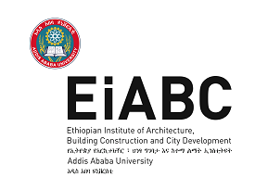
MSE - PARK MANAGEMENT SYSTEM
ADDIS ABABA
The Case of Dibab Park
By Samuel Tsegu
Ethiopian Institute of Architecture, Building Construction and City Development,
Addis Ababa University
June, 2019, Addis Ababa, Ethiopia

This thesis is submitted to the Ethiopian institute of Architecture, Building Construction and City Development (EiABC) and to the School of Graduate Studies of Addis Ababa University in the Partial fulfillment of the requirements for the degree of Masters of Science in Environmental Planning and Landscape Design
Title of Thesis: MSE Park Management System Addis Ababa
By: Samuel Tsegu
June, 2019
Approved by Board of Examiners:
Dr. Heyaw Terefe ____________ ________________
Advisor Signature Date

__________________ _____________ _______________
Internal Examiner Signature Date
_________________ ______________ _______________
External Examiner Signature Date
________________ ____________ ______________
Chair Person Signature Date

DECLARATION
I, the undersigned, declare that this thesis is my own and original work and has not been presented a degree in any other University, and that all sources of material used for the thesis has been duly acknowledged, following the scientific guidelines of the institute.
Student’s Name: Samuel Tsegu
Signature ____________
Date._________________
CONFIRMATION
This thesis has been submitted for examination with my approval as an Institute’s advisor
Advisor’s Name: Dr. Heyaw Terefe
Signature: _____________
Date: ________________

ACKNOWLEDGEMENTS
First and Foremost, I would like to thank my family and my wife for supporting me all the way during this study.
I am very grateful also for the dedication of interest of my Professors, Particularly for
Dr. Heyaw Terefe who was my advisor for the study.
Great thanks are also to my best friends whose help and feed back at the different stages of the study was valuable.
I would like to thank also all the people who helped me during the data collection.

List of Figures
Figure 1. Organization of AACG focusing on Beautification and Parks development 32
Figure 2-Location of Dibab Park 36
Figure 3 carving of the face of the Karl Marks. 37
Figure 4 Front view of Dibab Park from Algeria Avenue 38
Figure 5. Surrounding land uses of Dibab Park. 1-Addis Ababa University main campus, 2- Medhanyalem secondary school. 3-FBE. 4- Yekatit 12 senior secondary school. 5- Entoto vocational college. 6- International leadership Institute. 7- Ministry of Finance and Economy. 39
Figure 6. Container Shop built in the Park and Suspended from service 40
Figure 7. Descriptive Framework for the management of Dibab Park. 41
Figure 8. Landscapes in Dibab Park 44
Figure 9. Paved walk ways and plaza entrance area 45
Figure 10. Visitor Information and banners at different spots of the park 46
Figure 11. Different leftover spaces 48

List of Tables
Table 1. The Environmental value of urban Green Spaces 22
Table 2. The Economic value of urban Green Spaces 23
Table 3. Strength and weakness of the MSE 42
Table 4. Evaluation of the Management Practice 43
Table 5.Existing and proposed Parks of Addis Ababa, Source- Addis Ababa City Beautification, Parks and Cemetery Development and Administration Agency 56

Lists of Acronyms
AACG- Addis Ababa City Government
MSE- Micro and Small Enterprise
BPCDAA-Beautification, Parks and cemetery Development and Administration
Contents
ACKNOWLEDGEMENTS iii
List of Figures iv
List of Tables iv
Lists of Acronyms iv
Abstract viii
CHAPTER ONE 1
INTRODUCTION 1
1.1. Background of the Study 1
1.2. Statement of the problem 2
1.3. Objective of the study 3
1.3.1 Main objective 3
1.3.2 Specific objectives 3
1.4. Research Question 4
1.5. Scope and Limitation of the study 4
1.5.1 Scope of the study 4
1.5.2 Limitation of the study 4
1.6. Significance of the study 5
CHAPTER TWO 6
RESEARCH METHODOLOGY 6
2.1. Introduction 6
2.2. Criteria’s for Selecting the Case Area 6
2.3. Methods of Information Gathering 7
2.3.1. Observation technique 8
2.3.2. Key informant interview 8
2.4. Analytical Framework 8
2.4.1. Landscape Standards 9
2.4.2. Design 10
2.4.3. Visitor Information 11
2.4.4. Maintenance 12
2.4.5. Events Management 14
CHAPTER THREE 16
LITERATURE REVIEW 16
3.1. Purpose 16
3.2. The Definition of an Urban Park 16
3.3. The Value/Benefit of Urban Park 17
3.3.1. Social Value 18
3.3.2. Environmental Value 22
3.3.3. Economic Value 23
3.4. The Future of Parks and Green Area Planning ‐ Green Infrastructure for Ecosystem Services 25
3.5. Urban Park/Green Space Management 26
3.5.1. An Overview of Park Management 26
3.5.2. What is Park Management? 26
3.6. Structures and Mechanisms of Urban Green Space Management 26
Institutional frameworks 26
3.6.1. Institutional Frameworks and Service Delivery 27
3.6.2. Contracting out the parks service 27
3.6.3. Local Agenda 21 and Environmental Policy 28
3.6.4. Community Development 28
3.6.5. Area-based Responsibility 29
3.7. Developing and managing green areas in Addis Ababa 29
3.7.1. Policy Issue 33
3.7.2. What are Micro and Small Enterprises (MSEs)? 33
CHAPTER FOUR: 36
CASE STUDY-DIBAB PARK 36
4.1. Overview 36
4.2. Description of the Park and Its Surrounding Land Uses 36
4.3. The Current Management of Dibab Park 40
4.4.1. Strength and Weakness of the MSE 42
4.5. Analysis and Study Finding 44
4.6. Findings. 54
4.7. Conclusion 54
DISCUSSION AND RECOMMENDATIONS 56
5.1. Discussion 56
5.1.1. Distribution of urban parks. 56
5.1.2. Planning Issues and problems. 57
5.2. Recommendations 61
Bibliography 62

Abstract
The urbanization phenomenon in Ethiopia has been associated with environmental problems in most cities, including Addis Ababa. Among the problems are urban sprawl, solid and liquid waste management; water, air, and noise pollution; illegal settlements and the degradation of open green areas. Open green areas in particular have been placed under extreme pressure, thus threatening their ability to maintain basic ecological, social and economic functions. The objective of this study, therefore, was to evaluate the achievements and challenges of the Addis Ababa Beautification, Park and Cemetery Development and Administration Agency (BPCDAA) in managing the City’s open green spaces through Micro and Small Enterprise Scheme of Urban green space /park Management. The study utilized secondary data sources, interviews with the officials from the BPCDAA, the wereda case team manager and members of the MSE, as well as personal observations. The study found that the agency established a new scheme of park management with unique funding model for the park’s management (which is the MSE park management system). In addition to this, the study also found that this new scheme of park management system added value to the economic benefits of urban parks by creating job opportunities both for the members of the MSEs and employed support staffs. The MSE was facing some challenges such as shortage of skilled manpower, standards and guiding principles for developing, maintaining and managing the green space. Therefore, the study recommends that the city administration requires to put in place a broad policy framework, standards and principles for park planning, design and management, facilitate coordination and reduce overlaps, in addition support with adequate and qualified manpower.

CHAPTER ONE

INTRODUCTION

Background of the Study
Addis Ababa is an Amharic word which means “new flower” (Selamta, 2008). The total surface area of the city is 54,000 hectares (AACA, 2008). Addis Ababa is located at 9° 2' N, 38° 42' E (see Fig. 1). The city possesses a mix of highland climate zone. The high elevation moderates’ temperatures year-round, and the city's position near the equator means that temperatures are very constant from month to month.
Addis Ababa is a fast-growing city that is overwhelmed by problems afflicting most cities in the developing world, including extensive urban poverty, joblessness, inadequate housing, severe overcrowding and congestion and underdeveloped infrastructure. (Dubbale D., 2010).
However, the urbanization process is, among other causes, commonly associated with the movement of people from rural to urban areas. This results in high population densities relative to their surrounding areas (O’sullivan, 2007). On average, the world urban population growth rate is about 1.8% whereas that of Africa is about 4.4% (UN-Habitat, 2004/2005). Furthermore, Africa’s proportion of urban population is 39% while that of the Sub-Saharan Africa is about 29%. In Ethiopia, the urban population is about 11.7 million people or 16% of the total population of the country. The City of Addis-Ababa alone has an estimated population of more than 3 million or 25% of the total urban population, and an annual growth rate of 8% [Plan of Action for the Sustainable Development to End Poverty (PASDEP), 2006; Yewoinishet, 2007]. The rapid urbanization of Addis-Ababa aggravates the natural environment, including the deterioration of urban open green areas. To counter-act the challenges of open green space deterioration, the City established the Addis Ababa Sanitation, Beautification and Park Development Agency (the current Beautification, Parks and Cemetery Development and Administration Agency (BPCDAA)) to manage these areas. The purpose of this study, therefore, was to evaluate the achievements of this Agency through the Micro and Small Enterprise (MSE) scheme of park Management and to highlight its constraints.

Statement of the problem
The unsustainable urban growth rate of Addis Ababa has placed green areas under extreme pressure; consumed the natural and scenic beauty of the landscape; and altered the attractiveness of the City, thereby threatening the ability of green areas to perform their basic ecological, social and economic functions.
According to Edwards, Sue (ed.), (2010), the probable causes for the deterioration and degradation of green areas in Addis Ababa are:
- lack of proper planning (including scaling up), implementation, monitoring, and evaluation of the activities related to the use and conservation of green areas;
- wrong perception by decision makers in particular and the public in general about the purpose of green areas and their relation with other development spaces;
- a ‘tragedy of the commons’ situation in which a resource that belongs to everybody is nobody’s responsibility;
- illegal settlers;
- use for illegal dumping of waste and as open toilets; and
- Invasion by residential and/or commercial development activities.
Most part of the government budget for planning goes to the much more needed housing units in the city. But, the city also needs proper urban open spaces and green parks in the city. The administration should also pay the needed attention to the existing urban parks which are facing many problems at the moment. To name a few, most of the places are unplanned or left over spaces, there are no facilities in these spaces and since the general attitude towards them by the public is low, they are used as garbage disposal areas. The fact that little concern is given to the places and the idea of them being ownerless makes them inappropriate for many of the needed functions they could give to the public.
Although the BPCDAA has made some strides towards coping with the pressures of a rapidly expanding City since 2003, Addis- Ababa still faces a number of urban environmental challenges that require a closer analysis to understand their ramifications. The annual and monthly reports that are produced by the BPCDAA, while useful in their own way, do not shed much light in terms of the fundamental factors that hinder the development and management of the City’s green frame. It was due to the absence of any comprehensive evaluation of the BPCDAA performance that this study was conceived. Thus, the study was initiated as an attempt to fill this knowledge gap.

1.3. Objective of the study

1.3.1 Main objective
The main objective of the study was to evaluate the achievements of the BPCDAA under the MSE scheme of urban green space /park management, identify its challenges and recommend possible strategies for the better protection and greening of open spaces in Addis-Ababa.

1.3.2 Specific objectives
The specific objectives of this study is:
- To study the general Structures and Mechanisms for the management of urban green spaces.
- To identify the major Structures and Mechanisms for the management of urban green spaces used by the city Administration of Addis Ababa.
- To evaluate the MSE scheme of urban green space /park management of BPCDAA.
- Recommend possible strategies for the better protection and greening of open spaces in Addis-Ababa by the MSE.

1.4. Research Question
What are the challenges and opportunities of MSE park management structure in the city of Addis Ababa? Is the main research question of this study and specifically it addressed the following specific questions:
- What are the general Structures and Mechanisms for the management of urban green spaces/public parks?
- What are the main Structures and Mechanisms used by the city administration of Addis Ababa?
- What are the strength and weaknesses of MSE parks and green space management system?
- What are the recommended approaches for better management of urban green spaces by MSE?

1.5. Scope and Limitation of the study

1.5.1 Scope of the study
There are various tools and mechanisms of urban park management in this study, however, more emphasis is given for the management of urban parks by Micro and small enterprises (MSE) in the city of Addis Ababa specifically in Dibab Park.

1.5.2 Limitation of the study
Lack of literatures on urban parks in Ethiopia especially on urban recreational parks and access to other literatures; made the researcher to focus on theories of books written on the context of other countries and to collect documents by browsing internet. In addition to this, the researcher is unable to describe about urban parks in the study area due to lack of information

1.6. Significance of the study
Urban green areas are an integral part of urban land use planning and zoning. They form an important component of urban infrastructure that maintains air and ground water quality, and reduce run-off and flooding. They are essential also for purposes of complimenting urban tourism and education. For these and other reasons, it is hoped that the results of the study will contribute towards improved development and management of the open spaces of Addis Ababa City and, indeed, other cities in Africa. It is my hope, also, that this study will motivate other scholars to carryout similar research in this and other cities of Ethiopia and Africa at large.

CHAPTER TWO

RESEARCH METHODOLOGY

2.1. Introduction
In order to look in depth at the research issue, a “case study” method is chosen for this study. Case areas are selected based on appropriate criteria and critically analyzed from an urban park best management practice point of view. By taking into account the data collected in regard to the case areas, the research bases its analysis on the approaches and framework set by different theories with regard to public open spaces.
Both primary and secondary data is used for this study. Qualitative method is used to collect the necessary data and also to describe and analyze the collected data. The tools that were used under the qualitative method include: personal observations, open ended interviews with participants related to the issue, discussions, site visits and use of photographs.
Relevant documents from planning institutions in Addis Ababa like ORAAMP (office for the revision of Addis Ababa master plan) and BPCDAA (Beautification, parks and cemetery development and administration office) and also other relevant documents from the municipality of the city were used as secondary resources.

2.2. Criteria’s for Selecting the Case Area
As stated in (Improving Urban Parks, Play Areas and Green Spaces, 2002), some authorities had tried alternative managerial and departmental structures. These included contracting out the parks service; linking with Local Agenda 21 and environmental policy; adopting a community development focus; and moving to an area-based management structure. Likewise the Addis Ababa city administration is trying to implement different park management structures and mechanisms through the BPCDAA. The Agency regularly prepared technical manuals to guide the work of sub-cities and the private sector, including small-scale enterprises (MSEs) (Mpofu, 2013). Some of the manuals had to do with roadside cleaning, park development and solid waste management. These are:
- Direct management by the BPCDAA.
- Through the different organs of the city administration’s beautification and parks task force (sub-city and wereda level task forces).
- By contracting to private sector.
- By community development and
- NGOS and NPO
- Using MSE (Micro and small Enterprises)
In this research therefore, taking this structures and mechanisms of urban green space management practice and the significance of the park within the urban environment of Addis Ababa, and being the only urban green space/park which is managed by MSE, Dibab Park is selected as a case to show the strength, weakness and opportunities of this kind of new urban park management approach
It is therefore, the hope of the researcher that, the analysis based on these case area would help evaluate several issues related to the current practice of MSE park management in Addis Ababa in general and on the selected case area in particular.

2.3. Methods of Information Gathering
Collecting relevant data for analyzing MSE management practice of urban park spaces in Addis Ababa urges for using or applying different methodologies. Various scholars who conduct successful researches on related issues argue that, the best way of obtaining a data on how urban spaces operate or used is by making site visits to the areas and observe what really is going on there. I.e. Through observing the relationships between activities and spaces.
For this study, therefore, field observations on the selected case study area is used as a primary method of data collection. This was carried out by adapting several
Observational techniques and other techniques like interviews and discussion were also used in order to describe the management of the park.

2.3.1. Observation technique
Observation was made by the researcher in order to crosscheck and enhance the data obtained through other methods of data collection. This method was applied to observe services and facilities in parks under study. Thus information obtained through observation included in the research finding and pictures taken during observation time are included in the paper to show the actual conditions of the parks.

2.3.2. Key informant interview
Unstructured interview was used to collect data from park agency manager, specific park’s workers (member of the MSE), and park users. So, three different kinds of interview guiding questions were prepared for stated key informants. Open-ended questions were used (refer to the checklists for key informant interview in annex). Before conducting the interview, key informants or individuals were selected based on criteria:
- Park workers who have worked in the park for long time and member of the MSE.
- Experts and officials relatively concerned on the management and administration of parks.
- Park users.

2.4. Analytical Framework
To conduct a more systematic analysis and to arrive at a deeper understanding, of the issue under study (i.e. MSE system of urban park management in Addis Ababa) is further explored and divided in to different parts
Despite all this, several researchers, who succeeded on studying the issue, identified five topic areas of best management practice at urban parks both in national and international level. Which include: Landscape Standards, Design, Visitor Information, Maintenance and Events Management
Taking these best management practices of successful urban parks as a reference, the MSE system of park management of the selected case area for this research was analyzed according to Landscape Standards, Design, Visitor Information, Maintenance and Events Management. Parallel to this, the appropriate data collection techniques to each part was applied.

2.4.1. Landscape Standards
“The discussion of landscape standards addresses how landscape use is aligned with a park’s mission and vision, followed by a detailed discussion of how written landscape quality standards can be used for planning on both a strategic and a practical level for events and maintenance. Landscape quality standards identify desired quality outcomes and typically outline the maintenance activities required to achieve these results. Standards provide a framework for determining a specific desired quality for a landscape element (e.g., turf, trees, and flowers). Quality standards serve as a performance- based evaluation tool for maintenance; the performance of the maintenance program is evaluated against the achievement of quality standards. With these types of standards in place, parks are better able to strategically plan their maintenance programs, focusing resources in areas or zones where standards are set at higher levels.” (Jeff Bransford, et.al., 2007)
Summary of best practices:
- Align uses and standards with park mission and vision.
- Define the role for high-use activities at a strategic level and make clear links between intensity of use and the quality and conservation of park resources.
- Get public buy-in for landscape quality goals through education and engagement, since the public plays an active role in respecting landscape rehabilitation and resource conservation efforts.
- Use written landscape quality standards.
- Define management areas and subareas.
- Set specific, realistic, and measurable landscape quality standards for all areas or subareas within the park. Not all areas are equal in terms of desired or attainable landscape standards.
- Set quality expectations and guidelines for all maintenance activities and link these expectations to landscape quality standards.

2.4.2. Design
“The design section considers all types of use and outlines common practices for coordinating the identity for a place and its appearance through consistent, appealing, and appropriate site furnishings and circulation approaches. Enhancements to design reduce landscape damage (e.g., social trails) and improve the efficiency of the maintenance staff (e.g., consistent site furnishings). Additionally, visitor experience is enhanced as a result of easy access, comprehensive and clear information, and an overall level of excellence in landscape appearance.” (Jeff Bransford, et.al., 2007)
Summary of best practices:
- Establish a sense of place.
- Reinforce place character through branding use of logos and consistent site furnishings.
- Set high expectations for design quality and use of enduring materials.
- Control circulation and access.
- Control access for safety (e.g., capacities are not exceeded) and the protection of landscape elements (e.g., avoiding soil compaction and trampling of tree roots).
- Design pathways and entrances to accommodate visitors’ needs (e.g., multiuse trails, events, and protests).
- Reduce damage to the landscape through the use of fencing, social trail reduction tactics, edging, and corner treatments.
- Design to accommodate events and regular use with less impact.
- Develop specific areas to accommodate events.
- Pave areas to provide space for event infrastructure, including mobile food stands, information kiosks, stages, speaker’s corners, etc.
- Incorporate landscape elements that are robust enough for high use (e.g., turf specified for sports field or golf courses).
- Incorporate utility connections within park furniture, such as bollards or light posts.
- Design tent anchor locations to support and control the location of tents at events.
- Design for ease of maintenance.
- Standardize and limit the numbers and types of site furnishings.
- Pave under seating, trash containers, and information/interpretive signs.

2.4.3. Visitor Information
“For visitor information, approaches are discussed for improving visitor experiences through coordinated onsite orientation, way finding, educational information, and regulations. Cutting edge education and information methods are highlighted, including mobile welcome centers and downloadable self-guided tours in MP3 format. The role for strong natural resource management messaging (e.g., “Clean and Green”) is emphasized; messaging should be integrated with repair and recovery signage (e.g., a red flag system in Central Park) as well as park infrastructure (e.g., trash receptacles) and visitor services (e.g., concession stands)”. (Jeff Bransford, et.al., 2007)
Summary of best practices:
- Provide information that is identifiable, consistent, understandable, and current.
- Partner with other agencies and organizations (e.g., surrounding museums or parks) to eliminate confusion and improve visitor experiences.
- Present coordinated visitor information, orientation, interpretation signs.
- Reinforce resource protection messaging.
- Educate visitors on park programs that target resource protection challenges.
- Encourage the responsible behavior of visitors. Display positive messaging and park rules.
- Use cutting edge education and information methods.
- Use a variety of approaches for education and information, including web-based tools, traditional interpretive panels, and permanent and mobile welcome centers.

2.4.4. Maintenance
“The maintenance section provides an important perspective on dealing with impacts resulting from high use. It suggests alternative staffing structures, scheduling considerations, and practical maintenance approaches to dealing with the tension between high levels of use (both events and regular visitation) and the desire for high landscape quality. Fostering a sense of pride in employees is a critical component of a successful maintenance program and can be achieved by streamlining hiring practices and developing staff, linking day to- day operations to landscape quality standard goals, creating maintenance zones, and experimenting with scheduling programs. The use of sustainable maintenance practices by others is an emerging best practice. Study sites are using organic mulching programs and tactics for limiting the use of chemicals and mitigating damage (e.g., to reduce problems associated with runoff)”. (Jeff Bransford, et.al., 2007)
Summary of best practices:
- Use a staffing model that works for the organization.
- Assess different staffing models, including in-house staff, contract services, and private/public partnerships.
- Maintain an adequate level of expertise in specialty skills on the park staff (e.g., landscape architecture).
- Use volunteers to enhance staff and contractor efforts.
- Ensure goals, standards, and design intent are understood.
- Ensure that maintenance staff and contractors understand quality expectations.
- Monitor maintenance performance against landscape quality standards.
- Reward consistently high performance and address poor performance immediately.
- Promote respect through a zero tolerance approach toward trash on the ground or overflowing from trash receptacles, graffiti, and other forms of vandalism.
- Organize maintenance staff by zone and specialties.
- Organize staff by geographic zones to develop expertise and to instill pride in one’s work and a caring attitude toward the park.
- Manage zones to specific landscape standards.
- Develop specialty teams that work in all zones as needed.
- Ensure that maintenance staff and contractors understand quality expectations.
- Monitor maintenance performance against landscape quality standards.
- Reward consistently high performance and address poor performance immediately.
- Promote respect through zero tolerance of trash on the ground or overflowing from trash receptacles, graffiti, and other forms of vandalism.
- Develop staff.
- Hire staff based on both experience and attitude.
- Support the professional development and upward mobility of employees to boost morale and satisfaction levels.
- Ensure that managers visibly participate in day-to-day activities.
- Develop plans for regular and emergency maintenance.
- Develop creative and flexible approaches and written schedules for recurring, periodic, and seasonal maintenance activities. Develop a system to address typical emergencies and complaints.
- Respond to complaints in a timely manner; develop and maintain a system to convey that action has occurred.
- Develop a system to monitor and track park conditions.
- Use sustainable maintenance practices.
Begin to move toward organic practices and implement as possible.
Limit the use of commercial fertilizers, pesticides, and herbicides, and use chemicals responsibly when necessary.
Address soil compaction with turf closures and rotations, limited traffic, post-event treatments, engineered soils, and irrigation.

2.4.5. Events Management
“Events management looks at the many of the challenges of hosting large-scale and high-use events on vulnerable landscapes. Managers must be proactive, with comprehensive event guidelines, limitations on use (e.g., maximum duration and number of events), and regulation enforcement (e.g., weather delays). Fees and bonds should recover the cost of the events program as well as event damages. The Royal Parks charge a disruption fee depending on the scale of the event. Finally, a fully staffed team of professional events staff will boost the performance of a park’s event program”. (Jeff Bransford, et.al., 2007)
Summary of best practices:
- Manage events proactively.
- Manage use, including limiting the number, type, location, and duration of events.
- Use mitigation checklists.
- Define requirements for public safety and security.
- Enforce event regulations uniformly and consistently.
- Facilitate the permitting process.
- Create comprehensive and accessible events guidelines with graphic appeal.
- Communicate park goals to event organizers to ensure a clear understanding of the park’s purpose and significance.
- Develop strong working relationships with event organizers.
- Charge fees and recover costs for use of public areas.
- Use variable permit fee schedules based on the type and location of events, as well as level of disruption.
- Charge direct costs for staff, utilities, trash collection, removing or relocating park furniture, and repairing damage.
- Assign responsibility with performance bonds and event monitoring.
- Professionalize events staff.
- Hire staff with hands-on experience in events production.
- Co-locate maintenance and event staffs to foster collaboration, coordination, and communication.
- Consider classifying events and maintenance staffs within one division.
- Staff sufficiently to cover permitting, monitoring, and reporting needs.

CHAPTER THREE

LITERATURE REVIEW

3.1. Purpose
The purpose of the literature review is to gain an understanding of broader issues concerning to the research. In addition, it is also important to examine previous research related to the topic of this research. Lastly, the literature review provides the theoretical framework needed to further define the research scope and questions. The literature review is mainly derived from research about urban parks that has been done outside Ethiopia, because there has been little research on urban parks in Ethiopia or East Africa.
The literature review helps to define and narrow the research questions and problems. Since the objectives of the research are to examine and evaluate Addis Ababa’s Cities key urban public parks and provide a fresh perspective on the problems and opportunities that prevent these
spaces from building the iconic collection of other landmark spaces along with to developing a set of principles for creating quality Urban public parks that are iconic to the city of Addis Ababa and to explore the needs and preferred activities of the Park’s Users, the literature review is divided into the following three sections:
- A definition of “urban park”
- Urban Park Management
- The Value/Benefit of urban Parks.

3.2. The Definition of an Urban Park
Historically, urban parks have evolved from pieces of land set aside informally for grazing, into multi-purpose urban spaces for recreation, escape and social gathering. This evolution of the uses and purposes of urban parks makes an established definition of the term impossible. According to Jim Hilborn (2009), an urban park is defined as “A bounded area of public open space that is maintained in a “natural” or semi-natural (landscaped) state and set aside for a designated purpose, usually to do with recreation.
The China’s encyclopedia (construction, gardens, city planning) defines park as: park is for green space of a type, by the government or public organizations and construction business, for public recreation, ornamental, entertainment, and garden.
According to (Yuen’s 1995, as sited in Maulan S., 2002) definition of an urban park as “any public area of land set aside for aesthetic, educational, recreational or cultural use by the public amidst essentially urban surroundings”.
The most famous definition of urban park was provided by Frederick Law Olmstead who defined the urban park as “a naturalized passive retreat”. Olmsted’s definition has been widely used all over the world, particularly in the United States from the mid 1800’s to the early 1900’s.
However, Sirong Liu, 2012 defines park by a comprehensive definition: park is for the public as the main function in recreation, with certain recreational facilities and service facilities, beautifying the city, perfecting ecological disaster prevention and disaster prevention. ) is the most suitable for use in this research because it incorporates most vales of public urban parks.

3.3. The Value/Benefit of Urban Park
Many scientific studies on urban green space start with stressing the multiple benefits of parks and other green areas ((Lyytimäki and Sipilä, 2009, as sited in (Cecil C. Konijnendijk,Matilda Annerstedt,Anders Busse Nielsen,Sreetheran Maruthaveeran, 2013). There is general agreement, at least within the green space sector, that urban parks are essential for livable and sustainable cities and towns. But how much do we really know about these benefits?
This section of the literature review is intended to serve three primary purposes:
To provide a platform of evidence for all types of green space services at the local level, raising awareness of the inherently unique contribution that they make to the social, environmental and economic fabric of our towns and cities
Provide the organizations that manage parks and green spaces teams with a framework for applying this evidence to enable them to position and make the case for the contribution that the service can make to local outcomes in order for them to collaborate more effectively during this period of unprecedented financial difficulty.
Generating greater understanding of the unique contribution that community management of green spaces can make in developing a sense of ownership and community engagement.

3.3.1. Social Value

3.3.1.1. Communities
Urban parks have been viewed as an important part of urban and community development rather than just as settings for recreation and leisure. If parks and green spaces are well managed, research has shown that communities use their local spaces more, have better relationships with their local councils and take some pride in the area where they live. They provide communities with a sense of place and belonging, opportunities for recreation, health and fitness, events that reinforce social cohesion and inclusive society and offer an escape from the stresses and strains of modern urban living which can feel compounded by the built environment.
Parks can lift the quality of our lives significantly, providing reasons to get out and about and engage with our neighbors, providing part of the social “glue”, (S.Renolds, 2012). Parks are one of the quickest and most effective ways to build a sense of community and improve quality of life.
“From playgrounds to sports fields to parks benches to chessboards to swimming pools to ice skating rinks to flower gardens, parks offer opportunities for people of all ages to communicate, compete, interact, learn and grow” (The Trust for Public Land, 2010)
According to the (American planning Associatin, 2002), parks are:
One of the quickest and most effective ways to build a sense of community and improve quality of life.
Parks provide places for people to connect and interact in a shared environment.
Parks channel positive community participation by getting diverse people to work together toward a shared vision.

3.3.1.2. Volunteering and Community-Led Management
Community managed parks and green space are particularly important as they are generated directly from a need identified within the community. As they are created by local communities, for local communities, they help empower local people to take more control of their environment and give them an opportunity to become more active in their communities. Often community farms, gardens, developed allotments and newly established growing areas, are created in areas of deprivation, enabling those without easy access to formalized green space or parks, somewhere pleasant and productive to visit or volunteer. There is also much community development inherent in community managed projects.

3.3.1.3. Public Health and Well Being
The environmental and social benefits that green spaces bring in themselves create further physical and mental health benefits for individuals and communities;
Parks and green spaces contribute to all aspects of health and well-being including increasing levels of physical activity which could alleviate pressures on the NHS. Simply being outside in a green space can promote mental well-being, relieve stress, overcome isolation, improve social cohesion and alleviate physical problems so that fewer working days are lost to ill health. (CABE., 2010)
“Parks provide spaces where people can get some fresh air, go for a walk, play football, exercise or just enjoy the surroundings. Unfortunately those living in more deprived communities, who tend to have poorer health and suffer from the kind of illnesses that can be alleviated by regular exposure to green spaces, are also less likely to have good access to high quality parks and green spaces.”(“Understanding the Contribution Parks and Green Spaces…”

3.3.1.4. Families and Children
As a freely available, highly accessible local facility providing recreational opportunities for all ages, quality parks and green space can make a vital contribution to family relationship building process. All of the benefits they offer to the individual in terms of feeling part of the community and better understanding the place in which you live can be extended to the immediate and wider family group with good effect. Parks and green spaces also provide opportunities through interaction at the playground or at events for neighboring families to meet and extend their local social networks. They provide an escape from the limitations of spending too much time indoors, especially where the family‘s accommodation is less than generously proportioned, and an opportunity for the children to get out from under their parents feet.
Research by Keep Britain Tidy found that:
“Visits to green spaces with friends and extended family groups were highly valued for enabling social bonding in largely natural and frequently picturesque surroundings, while children remained one of the primary motivations for visits to green spaces for many who saw green spaces as areas in which all the family could enjoy a day out”. (Tidy, 2010).
“Play is an essential part of the physical, emotional and psychological development of any child, but in urban environments the opportunities for play are restricted. Today, the urban park is the primary outdoor environment that still remains for children to meet and play in a sociable and informal setting, where there is still scope for imagination, improvisation and innovation. Play is not grown out of quickly. There are positive benefits to indulging in play whatever your age; teenagers need to play and socially interact just as much as younger children.” (Urban Parks Forum, 2002)

3.3.1.5. Education
Schools, particularly in urban areas, have long used parks and green spaces to access the natural environment as a means of education. Parks provide the opportunity for play, exploration and the development of an awareness and understanding of risk in a dynamic, interactive, accessible and free outdoor classroom.
“Many parks teams have developed their own education programs linked to the National Curriculum to facilitate and encourage school visits. Green spaces provide the opportunity to explore a number of themes of learning from regeneration, sustainability and environmental protection to community participation, social inclusion, health and wellbeing, supporting subjects such as biology, geography and citizenship.” (Understanding the Contribution Parks and Green Spaces can make to Improving People’s Lives.)
Educational opportunities are also available formally for adults through training schemes attached to urban green space – such schemes are a common part of many current urban regeneration initiatives. Parks friends’ groups and urban parks rangers may host events and workshops that range from maintenance and horticultural skills to art activities and lecture series based around green space issues.

3.3.2. Environmental Value
Table 1. The Environmental value of urban Green Spaces
NO. | Values | Value Descriptions
1 | Ecology, Nature and Biodiversity | Within urban locations the most valuable habitats are invariably found within the diverse range of urban green space; the woodlands, urban forests, ponds, rivers and riverbanks, parks and gardens, allotments and cemeteries, providing a rich variety of habitats for mammals, birds, insect, aquatic and plant life. Maintaining this diversity of green space is essential to meeting biodiversity conservation objectives, as each space will offer different habitats for species (Understanding the Contribution Parks and Green Spaces can make to Improving People’s Lives.)
2 | Air Quality | Trees and vegetation in parks can help reduce air pollution both by directly removing pollutants and by reducing air temperatures and building energy use in and near parks (NOWAK, 2010)
3 | Air Cooling | Vegetation can be very effective as it delivers several mechanisms of cooling simultaneously and in a complementary manner. (Hutchings, 2013)  Trees also act as natural air conditioners to help keep cities cooler, mitigating the effects of concrete and glass that can turn cities into ovens under the summer sun. (Paul M. Sherer, 2006)  Cooler air temperatures provided by urban parks can have significant impacts on human health. During heat wave events, which can kill hundreds of people, park areas may provide city dwellers with some respite from high air temperatures, particularly in the evening. During hot, sunny days tree shade can greatly increase human comfort. (NOWAK, 2010)
5 | Water and Flood Management | Trees more effectively and less expensively manage the flow of storm water runoff than do concrete sewers and drainage ditches. Runoff problems occur because cities are covered with impervious surfaces such as roads, sidewalks, parking lots, and rooftops, which prevent water from soaking into the ground. Trees intercept rainfall, and unpaved areas absorb water, slowing the rate at which it reaches storm water facilities. (Paul M. Sherer, 2006)
6 | Landscape
7 | Waste
8 | Local Food
9 | Energy and Climate Change
10 | Transport

3.3.3. Economic Value
Table 2. The Economic value of urban Green Spaces
NO. |  | Value Descriptions
1 | Business Attraction and Retention
2 | Increase in Property Value and Local Taxes | “The real estate market consistently demonstrates that many people are willing to pay a larger  amount for a property located close to parks and open space areas than for a home that does  not offer this amenity,” (Paul M. Sherer, 2006)
3 | Redevelopment and Renewal
4 | Health | Lack of exercise is shown to contribute to obesity and its many effects, and experts call for a more active lifestyle. Recent research suggests that access to parks can help people increase their level of physical activity. The Parks Health Benefits Calculator measures residents’ collective economic savings through the use of parks for exercise. (Peter Harnik and Ben Welle, 2009)
5 | Recreation | For small children, playing is learning. Play has proved to be a critical element in a child’s future success. Play helps kids develop muscle strength and coordination, language, cognitive thinking, and reasoning abilities (Paul M. Sherer, 2006)
6 | Environment
7 | Tourism | A park often becomes one of a city’s signature attractions, a prime marketing tool to attract tourists, conventions, and businesses. (Paul M. Sherer, 2006)
8 | Events | A huge range of events take place in public parks and green space, from small local community-based events, through to those of national importance (Understanding the Contribution Parks and Green Spaces can make to Improving People’s Lives.)
9 | Industry/Employment Value

3.4. The Future of Parks and Green Area Planning ‐ Green Infrastructure for Ecosystem Services
Appreciation of the environmental functions of parks became blurred through much of the 20th century but with the onset of environmental concerns in the 1960s followed by the urban ecology movement and later the concept of sustainable development, this role once again came to the fore. (S.Renolds, 2012)
“Since the turn of the 21st century the term ecosystem services has been used to describe the beneficial outcomes to humans and the natural environment that result from ecosystem functions. In city‐regions ecosystems and ecosystem functions occur ‐ or have the potential to occur ‐ in their most extensive and purest form in parks and green areas including the rural hinterland. In addition to their social and economic services discussed above, their environmental services include:” (S.Renolds, 2012)
- Habitat provision, protection and enhancement for biodiversity;
- Water management including drainage and flood attenuation, run‐off filtration and pollution control;
- Nutrient cycling and soil formation;
- Air quality improvement;
- Regulation of micro‐climates (green lung) and potentially climate change adaptation.
The resources for the delivery of ecosystem services have come to be known collectively as green infrastructure (GI). There are various definitions of GI. One of the most comprehensive, and most relevant to this project, is that of Natural England (the English government’s advisor on the natural environment):
“Green Infrastructure is a strategically planned and delivered network comprising the broadest range of high-quality green spaces and other environmental features. It should be designed and managed as a multifunctional resource capable of delivering those ecological services and quality of life benefits required by the communities it serves and needed to underpin sustainability. Its design and management should also respect and enhance the character and distinctiveness of an area with regard to habitats and landscape types. (S.Renolds, 2012)
Green Infrastructure includes established green spaces and new sites and should thread through and surround the built environment and connect the urban area to its wider rural hinterland. Consequently it needs to be delivered at all spatial scales from sub‐regional to local neighborhood levels, accommodating both accessible natural green spaces within local communities and often much larger sites in the urban fringe and wider countryside.”

3.5. Urban Park/Green Space Management

3.5.1. An Overview of Park Management
The management of any green space must respond to the inevitable natural changes that it will undergo as it matures, and to changes in how people use it. A successful design will itself take account of these unpredictable factors, and will determine the levels of resources and skills needed to uphold its quality and value. Caring for a park or square means more than just managing the horticulture. In many cases this is often less demanding than managing how people use the space. A green space management plan is an important means of creating successful and inclusive places.

3.5.2. What is Park Management?
Professor Simon Bell Estonian University of Life Sciences on his lecture defined Management of an enterprise such as a city park department is about the mobilization and organization of resources to achieve the desired condition of the parks and open spaces.
However, maintaining and enhancing the function of urban green space should rely on effective public policy and institutional framework

3.6. Structures and Mechanisms of Urban Green Space Management
Institutional frameworks
It is clear that a diversification of urban green spaces, in terms of their form, content, range of users, as well as who is involved in their management and who owns them, is taking place and that the main examples of innovation and creativity are associated with this diversification. Local authority parks and open spaces services can drive these changes, in partnership with local communities and others, or they can react to them (Nigel Dunnett, Carys Swanwick and Helen Woolley, 2002). This section considers how local authorities can organize their services and operations relating to urban green space to meet these challenges.

3.6.1. Institutional Frameworks and Service Delivery
Institutional arrangement is one of the most important factors for the proper implementation of development plans.
“The majority of parks and open space departments where “merger” had occurred retained a traditional policy and operations split, with area-based operational staff, and officers taking responsibility for specialist areas, whether this be arboriculture, play, community issues, contract management, allotments and so on. This is an efficient, logical and well-tried arrangement.” (Nigel Dunnett, Carys Swanwick and Helen Woolley, 2002)
Some authorities had tried alternative managerial and departmental structures. These included;
- Contracting out the parks service;
- Linking with Local Agenda 21 and Environmental policy;
- Adopting a Community Development Focus; and
- Moving to an Area-Based Management structure.

3.6.2. Contracting out the parks service
These where a private finance initiative arrangement had resulted in a large part of the parks service being transferred to a private contractor. This involved not only grounds maintenance functions but also managerial roles. The council itself retained a policy, strategy, and contract and quality-monitoring role.

3.6.3. Local Agenda 21 and Environmental Policy
One way in which parks had received greater recognition was in the small number of authorities where Local Agenda 21 and environmental policies were well developed and the parks service sat within an Environment Directorate. In these instances, urban parks and green spaces were seen as one of the main avenues for delivering environmental policy. Landscape design, arboriculture and grounds maintenance and the operations teams were held in separate departments within the same directorate. The inclusive development of Local Agenda 21 within the parks section has resulted in a progressive parks and community engagement strategy. The department has responsibility for the development of biodiversity action plans: these are seen as key operational and policy documents with a direct link to the management and development of parks and other green spaces.

3.6.4. Community Development
- Community involvement in urban parks and green spaces can lead to increased use, enhanced quality and richness of experience and, in particular, to facilities suited to local needs; but it requires support and investment to reap the benefits.
- Both local authority officers and communities were able to list many benefits of community involvement, including: encouraging local ‘ownership; giving access to additional funding; increasing understanding of local problems and local authority constraints; providing expertise; responding to local need and contributing to long term sustainability.
- There are also costs. For local authorities they include: demands on officer time and other resources, lack of appropriate skills, conflicting demands and potential for diversion from normal activities and investment. For communities they include: undesirable levels of responsibility; over reliance on volunteers; shortage of volunteers and the need for long term commitment.
- There are two basic and different objectives for community engagement: one involves communication, information exchange and consultation, and the other takes the process forward into active collaboration in decision making, design, planning and management. The development of self-management activity on a site can be the ultimate expression of community involvement.
- It is possible to actively and strategically manage groups into the more advanced stages of partnership, and this can happen in the more deprived areas of a town or city as well as the more affluent. The importance of a group being representative of a local community varies according to the objectives of the group.
- Promoting networking and co-ordination of Friends Groups activities can help to promote good practice across a town or city.
- Increasing a local sense of ownership, accessing additional funding and promoting communication and understanding were seen as the main advantages of community involvement by both local authorities and community groups. Mechanisms may be needed to recognize (and reward) local voluntary input.
- The potential involvement of local communities in urban parks and green spaces is related to the culture of the local authority and parks service, the resources available, the type of site and local capacity. (Nigel Dunnett, Carys Swanwick and Helen Woolley, 2002)

3.6.5. Area-based Responsibility
Area or site based responsibilities, focusing on links with community groups, environmental organizations, sports clubs, Schools and children’s and youth groups.

3.7. Developing and managing green areas in Addis Ababa
In Ethiopia, urban green areas have been consumed by industrial, commercial, residential and infrastructural developments, as well as by spontaneous and illegal settlements along mountain slopes, river valleys and other open spaces. (Mpofu, 2013).
“However, following the Rio Summit held in Brazil in 1992, Ethiopia took a number of initiatives to address its environmental problems, including minimizing environmental impacts induced by the urbanization process. The country introduced a number of legal instruments to help implement Agenda 21 at local level. This included the enactment of Article 44 of the country’s Constitution (1995) which states that the people of Ethiopia have the right to live in a healthy environment. The country also established the Ethiopian Environmental Protection Authority in 1995, and went on to formulate the Ethiopian Environmental Policy in 1997.” (Mpofu, 2013)
As stated earlier, Addis Ababa is one of the cities of Ethiopia that have experienced environmental deterioration, to tackle this Phenomenon the Addis Ababa City Development Plan for 2001-2010 designated 3,000 hectares of the city’s land for developing public recreational parks, but by 2009, no evidence of this plan being put into operation could be seen. If this plan was implemented, it would increase the ratio of green area to 8 m2/person. The estimated population during the planning period was 3.8 million (Wondimu, 2007).
“Institutional arrangement is one of the most important factors for the proper implementation of development plans.” (Hayal Desta, 2011)
Currently Urban parks in Addis Ababa are managed and administered by Beautification, Parks and Cemetery Development and Administration Agency. This agency was established as one of Addis Ababa city government executive and municipal service organ by Addis Ababa city government executive and municipal service organs re-establishment proclamation number 15/2009. This agency was first established as Sanitation, Beautification and Parks Development Agency in 2002 (interview with Park Agency Manager). Before the agency was established, parks were administered and managed at work team level under different service organs of the municipality like natural resource protection office and health office. As the name indicates this agency is in charge of cemetery places, different green places in addition to recreational parks.
Some of the powers and functions of the agency includes
- Develop, administer, and control, recreation places, zoos, cemetery, and river banks under the ownership of the city government in accordance with the city plan.
- Develop closed parks, open green areas identified for park purpose, festival and plaza squares, river banks, and cemetery; contract out the administration of the above places to voluntary developing investors; follow up; control the service delivery in accordance with the contract; take back their possession on lapse of the contract period.
- Prepare regulations, consistent with the policies, strategies, programs and laws issued by Federal Government, that are related to the development of recreation centers, cemetery, residence areas and green areas on the bank rivers. In addition to this, prepare and issue directives, standards and manuals.
- Install and implement procedures of follow up and control in relation to the development, preservation, care and use of cemeteries, recreation centers, residence and green areas on the banks of rivers, and squares in cooperation with concerned bodies to improve the service delivery.
- Provide education to service beneficiaries to protect the developed places.
- Prepare design of recreation centers, cemeteries, and squares; dividing road lines; if necessary contracting out their development works; and follow up and
- Control construction works in accordance with the contract.

Figure 1. Organization of AACG focusing on Beautification and Parks development

According to Ato Getnet Admasu the Agency Beautification and parks Development process owner to fulfill the above listed functions and major responsibilities of the Agency, they are managing the green spaces at different levels, Parks with an area greater than ten hectares are managed by directly by the Agency and those with area less than ten hectares are managed by their respective sub-cities where the park or green area belongs.
He also added that some parks are contracted to private sector and some small green areas in Akaki Kaliti Sub-city and Dibab Park in Gulele Sub-city are given to Micro and small Enterprises with a contractual agreement for a period of five years, which will be the main focus of this study.

3.7.1. Policy Issue
“There is no policy issues related to urban agriculture, development and management of parks and green areas, river bank protection and the protection of important catchment areas for Addis Ababa city. There are only standard procedures for street parks development, river bank protection, catchment protection and mining.” (Hayal Desta, 2011)

3.7.2. What are Micro and Small Enterprises (MSEs)?
The European Commission Communication defines SMEs as follow:
“An enterprise is any entity engaged in an economic activity, irrespective of its legal form”. “Enterprises qualify as micro, small and medium-sized enterprises (SMEs) if they fulfil the criteria laid down in the Recommendation which are summarized in the table below. In addition to the staff headcount ceiling, an enterprise qualifies as an SME if it meets either the turnover ceiling or the balance sheet ceiling, but not necessarily both.” (Erusmus for young enterpriners, 2015)
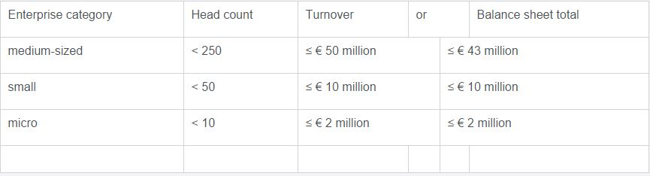
Different authors defined MSEs differently in different place at different time. But, many authors of the world concluded and use number of employees to classify and define MSEs.
Micro, small and medium-sized enterprises
“Micro, small and medium-sized enterprises are defined according to their staff headcount and turnover or annual balance-sheet total.
A medium-sized enterprise is defined as an enterprise which employs fewer than 250 persons and whose annual turnover does not exceed EUR 50 million or whose annual balance-sheet total does not exceed EUR 43 million.
A small enterprise is defined as an enterprise which employs fewer than 50 persons and whose annual turnover and/or annual balance sheet total does not exceed EUR 10 million.
A microenterprise is defined as an enterprise which employs fewer than 10 persons and whose annual turnover and/or annual balance sheet total does not exceed EUR 2 million.” (Europa, 2015)
According to the new Small & Micro Enterprises Development Strategy of Ethiopia (published 2011) the working definition of MSEs is based on capital and Labor.
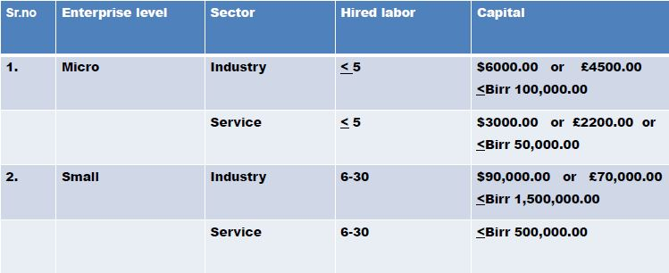
Micro and small enterprises are a pivotal resource for the development of Ethiopia, not only for the contribution that it makes to poverty alleviation and job creation but also the sector is a base for entrepreneurial endeavor and the potential for new business development. (Tadesse, 2014)

CHAPTER FOUR

CASE STUDY-DIBAB PARK

4.1. Overview
This chapter will examine the case study of a traditional public open park space called Dibab Park. It is located on the northern outskirts of the Central Business District of Addis Ababa and holds an interesting evolution in space which will be briefly be investigated. Interview, discussion and Observations will be relayed to provide an insight on the park. The principles developed will then be applied to appropriately identify the positive and negative aspects of the parks management. Areas of improvement are also appropriately identified.

4.2. Description of the Park and Its Surrounding Land Uses
Dibab Park is located to the north of the central business district of Addis Ababa, next to Yekatit 12 memorial monument and in front of the main gate of Addis Ababa University main campus, alongside of the Algerian street.
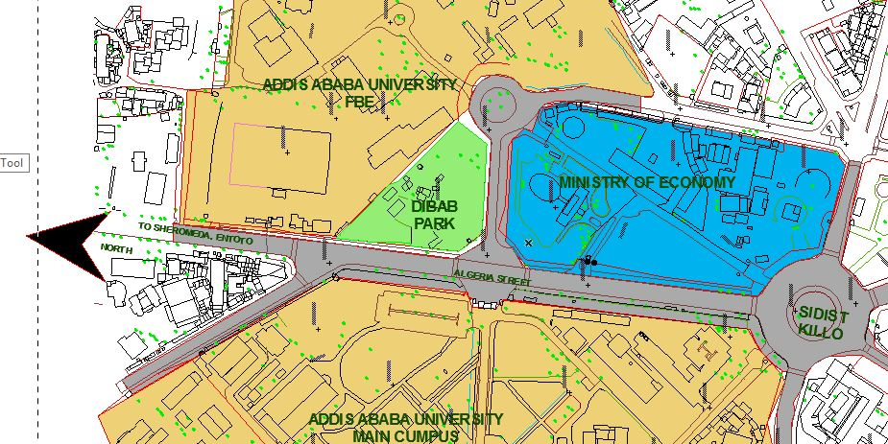
Figure 2-Location of Dibab Park
The park with a total area of approximately 8619 sq. Meter, was built in 1984 in collaboration with East Germany. The head of Marx was sculpted by Jo Jastram. (A Guide to the Green Spaces of Addis Ababa, n.d.). The park is characterized by the huge trees like Acacia Abyssinica and a large stone carving of the face of the Karl Marx.
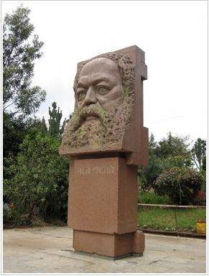
Figure 3 carving of the face of the Karl Marks.
Dibab Park is almost triangular in form being chamfered at the two corners. It is bordered by the Algeria Street which connects Sidist Killo to the market center at shiro meda and leads to the historical palace of emperor Minilik at Entoto. The other street which borders the park is the street which connects the main campus of Addis Ababa University to the Faculty of Business and Economics (FBE) and which leads to Jan Meda. The other side of the park is bordered by AAU, FBE.
The park has only one functioning entrance and exit which is in front of the main campus of Addis Ababa University. The main gate is emphasized by a tree (Acacia Abyssinica) with bigger canopy for shading, and has no designed gate as an entrance emphasis.
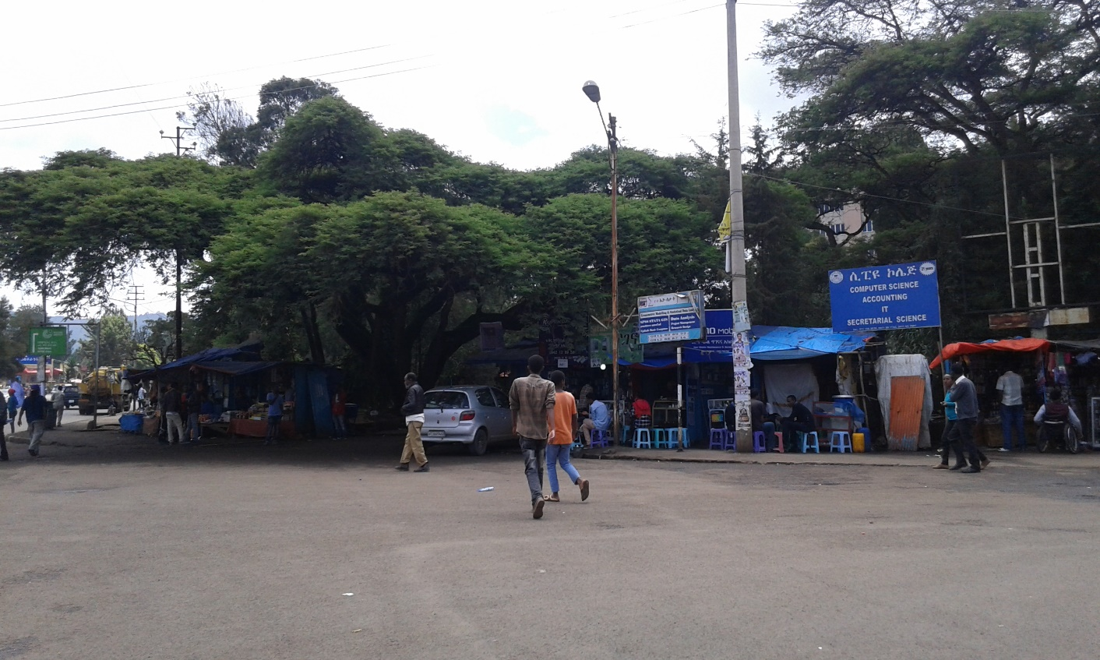
Figure 4 Front view of Dibab Park from Algeria Avenue
A distinguishing character of this Park is the name “Dibab” which means Shade, the Big trees (dominated by Acacia Abyssinica) having superior canopy for shade and a large stone carving of the face of the Karl Marx, in addition to this the ample green within the park characterize the parks uniqueness.
Dibab Park generally has great activity throughout the day providing users many opportunities to soak in the sun or enjoy the natural shade from trees. The space creates a genuine sense of place for users in its peaceful calmness. A range of users are attracted to Dibab Park ranging from Students, local residents and workers to international tourists. It is the same reason many people use the space as a place of relaxation, socializing, exercising, lunch eating etc. Dibab Park serves mainly as a passive space where users come to relax. Bench seating and passive seating opportunities exist throughout the park allowing users to sit enjoy the scenery and the shade throughout the park.
The most important element of this park is the large stone carving of the face of the Karl Marx which is located at the main entrance and emphasizes the small stone paved plaza with stone seating benches and a shade from a big Acacia tree.
In addition to the passive park activities of seating, walking, meeting with friends etc. Cafeteria, Multipurpose Hall, Internet service, Pool House, Children play area are some of the major services provided by the park.
Dibab Park is surrounded by many Educational Institutions including Addis Ababa University main campus, FBE, Yekatit 12 senior secondary school, Entoto vocational college, Medhanyalem secondary school, International Leadership Institute.
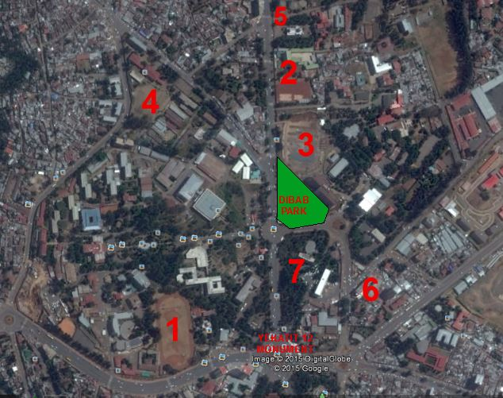
Figure 5. Surrounding land uses of Dibab Park. 1-Addis Ababa University main campus, 2- Medhanyalem secondary school. 3-FBE. 4- Yekatit 12 senior secondary school. 5- Entoto vocational college. 6- International leadership Institute. 7- Ministry of Finance and Economy.

4.3. The Current Management of Dibab Park
According to Ato Dereje Ejeta the Deputy Manager and Core Process owner of the Addis Ababa Beautification, Parks and Cemetery Development and Administration Agency, Dibab Park is managed by the MSE scheme of urban green space management under Gulele sub-city, wereda-2 beautification and Parks case team.
The Park is managed by three micro and small enterprises (Interview with W/r Hulubanchi Abera the wereda-2, beautification and park case team manager) these are:
- Dibab Migib Zigigit: The enterprise is established by 69 members in 2005 Ethiopian calendar and is responsible for the Bar and Restaurant. They provide food service, Fast Food, Cafeteria Service, Soft Drink and Beer.
- Friends Multipurpose Hall and Pool House and Children’s Play: Established by 12 members by the year 2005. This Enterprise is responsible for the 200 meter square Multipurpose Hall, Pool House, Children Play Area Services.
- MAC Internet Service – is the third Enterprise established in the same year with six members to provide internet service, Maintenance and Publication but currently not rendering Service due to space insufficiency and other space related problems.
The case team manager added there is another forth Enterprise with 13 members which built a container shop for Dry food service in the park, which was suspended since its establishment a year ago due to the reason she called “Illegal construction” and weak communication between the different organs of the Agency.
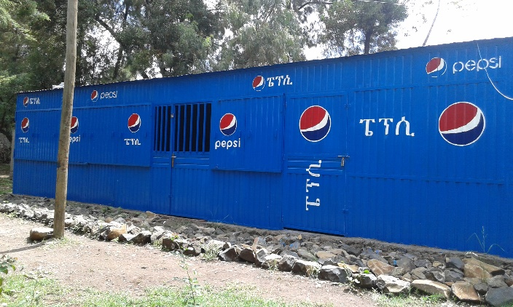
Figure 6. Container Shop built in the Park and Suspended from service
As mentioned on Article -1 of the signed agreement between the Addis Ababa Gulele Sub-City Beautification, Parks and Cemetery Development and Administration Agency and the three Micro and Small Enterprises indicates that the overall agreement is for Developing, Maintaining, Beautifying the park , park Service provision and strengthening the capacity and experience of the enterprises. These main components of the agreement are the basis for describing the current management practice within the park.
Figure 7. Descriptive Framework for the management of Dibab Park.
The Development and Beautification component of the management practice incorporates the Landscape standard and Design, the service provision also includes Visitor information and Event Management which are described as Best Management practice topics above in the Analytical framework section in addition to this capacity building is included to harmonize with the current policy of poverty reduction and job creation agenda of the government.

4.4. Evaluation of the MSE Management Practice
4.4.1. Strength and Weakness of the MSE
Table 3. Strength and weakness of the MSE
 | Strength | Weakness
 | They created job opportunity for the members of the enterprise. This contributes to the poverty reduction policy of the government | The goal of the enterprise is not set together with the green space development rather it is profit oriented expansion of the service facilities.
 | Created a job opportunity for other supporting staffs like security guards, gardeners, waiters and cleaners in the cafeteria. | No effort has been made to get a professional support from the neighboring university.
 | In creating partnership with different companies and acquired different facilities like plastic chairs and tables, big umbrellas, Tents, refrigerators, and beverage machines. | No coordination among the three MSEs within the park in developing and managing common areas resulted in some areas as trash damping and smoking spots.
 |  | No effort made in developing the existing children’s play area which has the potential in attracting families to use the park and their services.

Table 4. Evaluation of the Management Practice
Best Management Practice |  |  | Evaluation of the Case Area
Best Management Practice |  | Key points: | Positive | Efforts | Negative
Best Management Practice | Landscape Standard | - Align uses and standards with park mission and vision.
Best Management Practice | Landscape Standard | - Use written landscape quality standards.
Best Management Practice | Design | - Establish a sense of place.
Best Management Practice | Design | - Control circulation and access.
Best Management Practice | Design | - Design to accommodate events and regular use with less impact.
Best Management Practice | Design | - Design for ease of maintenance.
Best Management Practice | Visitor Information | - Provide information that is identifiable, consistent, understandable, and current.
Best Management Practice | Visitor Information | - Reinforce resource protection messaging.
Best Management Practice | Visitor Information | - Use cutting edge education and information methods
Best Management Practice | Maintenance | - Use a staffing model that works for the organization.
Best Management Practice | Maintenance | - Ensure goals, standards, and design intent are understood.
Best Management Practice | Maintenance | - Organize maintenance staff by zone and specialties.
Best Management Practice | Maintenance | - Develop staff.
Best Management Practice | Maintenance | - Develop plans for regular and emergency maintenance.
Best Management Practice | Maintenance | Use sustainable maintenance practices.
Best Management Practice | Events Management | - Manage events proactively.
Best Management Practice | Events Management | - Facilitate the permitting process.
Best Management Practice | Events Management | - Charge fees and recover costs for use of public areas.
Best Management Practice | Events Management | - Professionalize events staff.

4.5. Analysis and Study Finding
4.5.1. Landscape Standards
Create written landscape standards to align with a park’s mission and vision, and to provide park staff with specific and measurable objectives. These standards should be communicated clearly to the public.
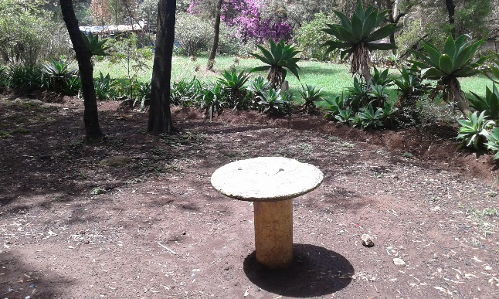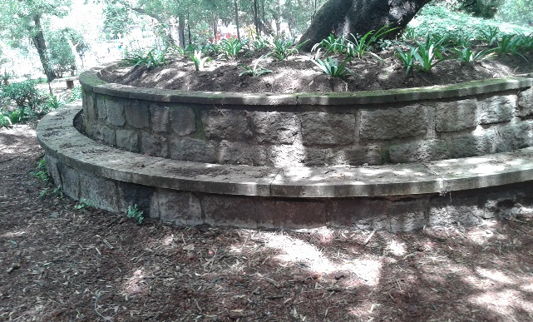
Figure 8. Landscapes in Dibab Park
Case area:
- Seating areas are not paved.
- Fixed concrete tables without benches
4.5.2. Design
Coordinate a site’s identity and landscape appearance through consistent, appealing, and appropriate site furnishings, information, and circulation, which contribute to higher quality visitor experiences. Design sites to accommodate events and regular use and to support ease of maintenance.
Case area:
Establish a sense of place
- Dibab Park’s design play a major role in creating the identity or sense of place for the surrounding community. It is designed to take advantage of natural features, provide opportunities for social interaction and community events, lively, attractive and interesting places about which the community feels a sense of pride and ownership.
- Lack of attention to the natural resources which have the potential to create/establish a sense of place.
Control circulation and access
Pathways and entrances to accommodate Visitors’ needs
- No defined path ways in many areas of the park.
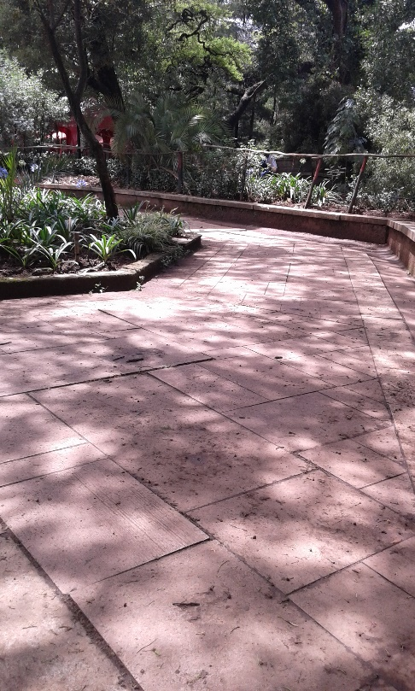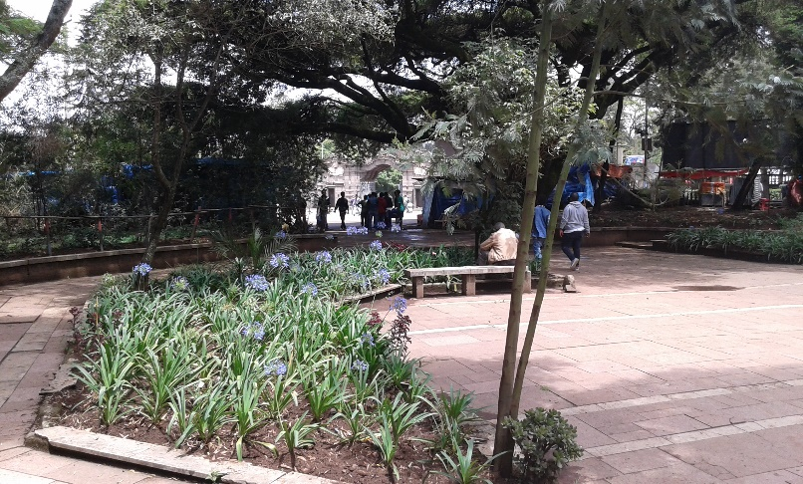
Figure 9. Paved walk ways and plaza entrance area
4.5.3. Visitor Information
Provide information to visitors to educate and orient them. Use a range of media to educate visitors on natural and cultural resource protection challenges. Orientation must be comprehensive and coordinated with a park’s surroundings.
Case Area:
- Banners are hung here and there without considering the landscape design.
- Information for facilities like internet service toilet and others are written on the walls of the structures which in turn disturb the scenic values.
- No precaution messages for reserved and sensitive areas of natural reserve.
- No information desk and written guide throughout the park.
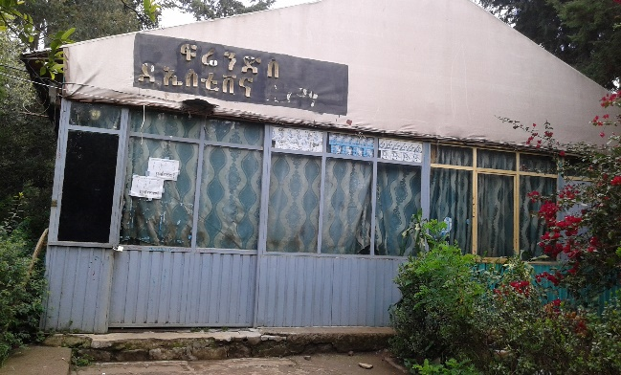
Fi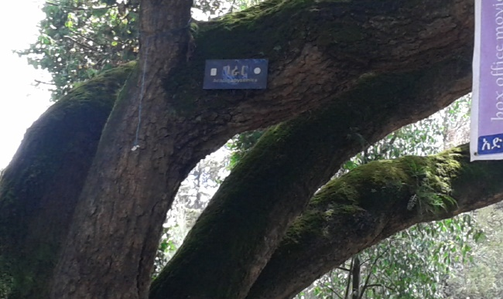
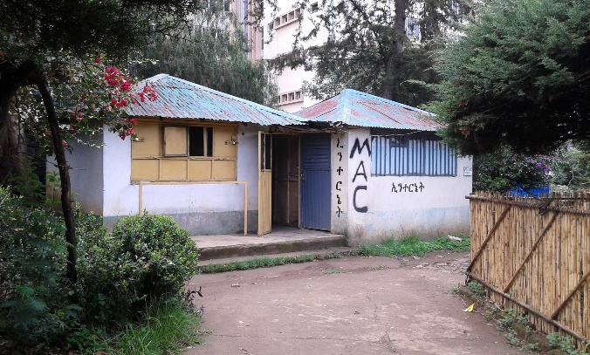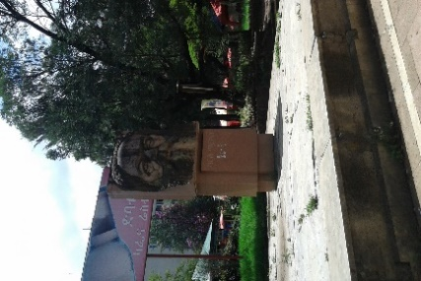
Figure 10. Visitor Information and banners at different spots of the park
4.5.4. Maintenance
Develop a landscape maintenance program that complements landscape quality standards. Structure the program to suit the park’s size and complexity, usage levels, maintenance infrastructure, and staffing and volunteer structures.
Case Area:
- Broken concrete benches are not maintained.
- Exposed electric meters with Brocken boxes
- Left over spaces around the main entrance which serve as litter damping and smoking spot.
- Supporting facilities’ like toilets are not well maintained and clean.
- Attention was not given to falling trees and tree branches in the compound.
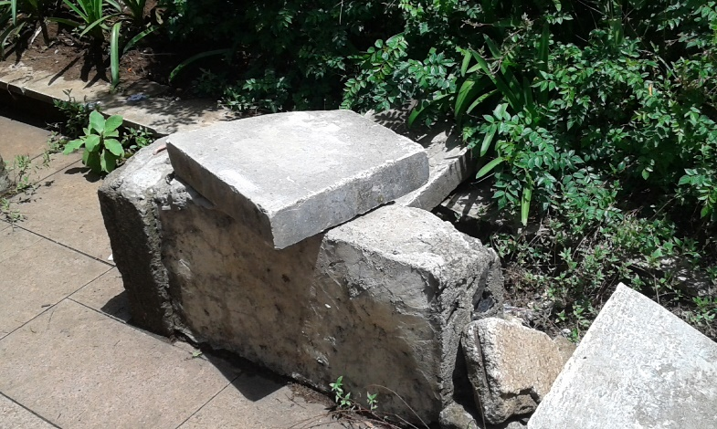
Figure 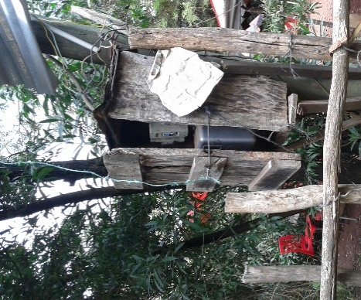
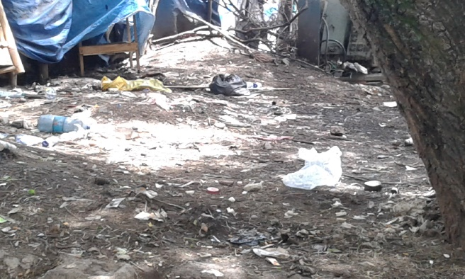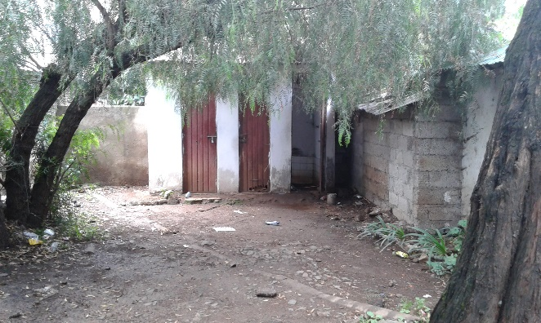
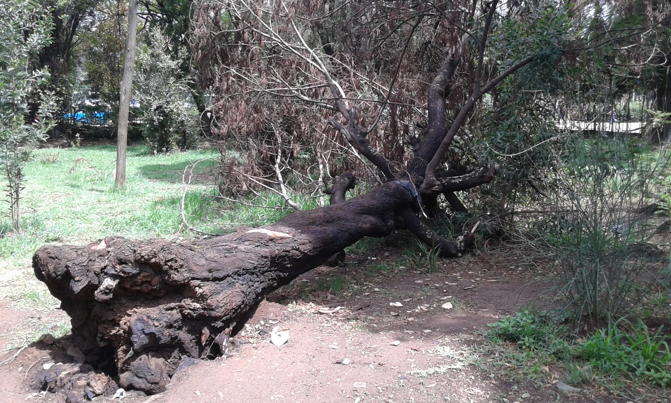
Figure 11. Different leftover spaces
4.5.5. Events Management
Develop an events program that employs strategic and proactive approaches to planning and management. A strong events program requires continuous improvement, including hiring skilled staff, coordination between events and maintenance staffs, and development and enforcement of events procedures and protocols.
Case Area:
- No efforts have been made to manage special events
- The meeting hall mostly focused in football display but it has a potential to prepare especial in door events.
- The plaza at the entrance has also the potential to prepare smaller outdoor evens but not explored yet.

4.5.6. Analysis and findings from Ecosystem service Perspective
Analysis of the study Area
- Regulatory Ecosystem Service
Parks planed for regulatory ecosystem service are supposed to provide services such as carbon sequestration, micro climate regulation through the control of temperature and rainfall patterns, hydrological services through recharging of aquifers timing and volume of surface water flows, control of erosion, flood and sedimentation etc. although some of these services require wider ecological set up (e.g. large scale carbon sequestration, timing and volume of river and rain fall pattern) Hence may not be provided by such narrow urban parks.
There for this study focused on the supply of urban micro climate regulation through small scale carbon sequestration, controlling of city temperature, erosion, sedimentation to flood control.
The trees (like the Acacia Abyssinica) having large biomass have high capacity to sequester urban carbon dioxide and then to regulate city temperature easily, secondly the presence of large leaf and canopy reduced rainfall intensity and reduced surface run off and flooding, thirdly reduced surface run off and flooding would facilitate the recharge of aquifers. Adding up to these benefit the less paved areas in the park and unpaved seating areas with only red ash has its own contribution for reducing the surface water runoff and facilitate the recharging of aquifers.
- Cultural Ecosystem Service
City parks planned for cultural ecosystem service are mainly designed for the supplying of peoples spiritual enrichment, cognitive development and Knowledge system such as scientific and educational information, opportunity for truism and recreation, aesthetic experience and values, social relations, noise reduction, etc. Most of these services are non-tangible and are mostly related with social and psychological wellbeing through reduced stress and aggressiveness as well as increasing social interaction.
From the surrounding land use study it is obvious that the city is characterized by active business and social interaction which is associated with high level of noise stress and restlessness. Since the study area is accessed with no fee it is accessible to especially for low income groups.
C. Provisioning Ecosystem Service
These parks are planned mainly for their provision of food, wood, fiber, grass for fodder, biomedical to medical plants, genetic resources, fresh water etc. however, since most urban parks have small special area, which makes the supply of all the provisioning services cumbersome. This study focused on analyzing selective services on the basis of its spatial area. Hence the supply of grass for fodder, wood for fuel etc. are not considered since such services by nature require large ecological resources and thus unlikely to get it in the urban context. Thus the analysis for this study will focus on the provision of food such as fruits, Vegetable, and plants of medical value for scientific research or traditional use, fresh water etc.
None of the above mentioned services are provided by the park to the adequate level except small amount of grass during summer season and wood for fuel from fallen trees and tree branches.
C. Supporting Ecosystem Service
Supporting services are those which include Soil formation and retention, nutrient cycling Production of biomass and atmospheric oxygen, water cycling, provisioning of habitat, pollination, Biodiversity conservation etc. These are the supporting ecosystem services provided by every park in harmony regardless of the basic ecosystem services that the bark is mainly designed. Hence services under this category are integral part of other ecosystem service component.

- Summary of park values of the study area
Environmental Values of Dibab park | Values | Description of the benefits of the study area by the current management system
Environmental Values of Dibab park | Values | Positive Impact | Negative Impact
Environmental Values of Dibab park | Ecology, Nature and Biodiversity | To preserve the ecology they plant trees every summer plantlets provided by the Agency.
Environmental Values of Dibab park | Air Quality | Maintained by the existing plantation
Environmental Values of Dibab park | Air Cooling | Provided by shading of big canopy of Acacia trees
Environmental Values of Dibab park | Water and Flood Management | In a better condition with less paved areas
Environmental Values of Dibab park | Landscape |  | The landscape is not well managed the grass is not mown to standard height. If Intensively managed or “ordinary“ lawns are mown grass surfaces used for activities, while extensively managed lawns have fewer practical uses and are more for aesthetic purposes.
Environmental Values of Dibab park | Waste |  | Garbage bins are missing throughout the park as a result of this users drop litter everywhere.
Environmental Values of Dibab park | Local Food |  | No effort to plant fruit bearing plants and vegetables
Environmental Values of Dibab park | Energy and Climate Change
Social Values of Dibab Park | Community
Social Values of Dibab Park | Public Health and Well Being |  | No space provision for passive activity like walking and Aerobic activities.
Social Values of Dibab Park | Volunteering and Community-Led Management
Social Values of Dibab Park | Families and Children |  | Since the children play area is not maintained and not functioning it hinders the attraction of families to the park
Social Values of Dibab Park | Education |  | The existence of various plant specious in the park is an attraction to experts
Economic values of Dibab park | Business Attraction and Retention | Attracted small businesses because of the activities around the park expressed by many of the shops around the fence of the park
Economic values of Dibab park | Increase in Property Value and Local Taxes |  | The location of the study area is not in an area where there is no residential or business expansion as a result it doesn’t influence the property value aspect of urban park value.
Economic values of Dibab park | Redevelopment and Renewal
Economic values of Dibab park | Health | By carbon sequestration and adding to atmospheric oxygen
Economic values of Dibab park | Recreation | Fee free accesses provided a seating and relaxation pace at any time for all income groups specially for low income groups
Economic values of Dibab park | Environment
Economic values of Dibab park | Tourism
Economic values of Dibab park | Events |  | Having the opportunity to organize small scale events the park management lost this oportunity
Economic values of Dibab park | Job creation | Created a job opportunity for member of the MSE and Others.

4.6. Findings.
In Addition to being new mechanism of urban park management system exercised in Addis Ababa with new model of funding for parks the micro and small enterprise scheme of park management system created a different Economic Value of Urban parks which is Job creation for both the members of the enterprise and employed staffs supporting the MSE management practice.

4.7. Conclusion
Addis-Ababa has a variety of open green spaces. However, their current management possess a lot of challenges including:
Lack of coordination, cooperation and strong partnerships with the private sector, NGOs, residents and private individuals were other factors hindering effective protection and greening of the parks and riversides Unless there is effective involvement of these entities in developing the newly preserved sites and re-vitalizing the non-functional parks, the BPCDAA will find it difficult to effectively implement its annual work plans, as expected
Although the BPCDAA office used the Micro and Small Enterprise as an alternative scheme for managing green spaces: The MSE faces luck of:
- Professional support on the development and management of the green space.
- Technical guide lines and standards for developing and maintaining the green and supporting infrastructure.
In addition to this the small park is divided for three MSEs with no defined boundaries and this in turn produced a sense of competition which resulted to limit the cleaning and beautification task only to their vicinity. According to the wereda case team manager this competition resulted most of the park spaces as a left over space for damping of litter and smoking spots.
She also added the MSEs are focused on their profit Based Business rather than Developing the Green Area as per the signed Agreement.
Finally from my Observation on site, my interviews and Discussions with the Agency Managers, the wereda case team manager and the members of the MSEs this theme of urban green space Management will be an alternative system to involve the community with a new funding scheme and as a value adding scheme of management.
CHAPTER FIVE

DISCUSSION AND RECOMMENDATIONS

5.1. Discussion

5.1.1. Distribution of urban parks.
There are 18 existing and 17 newly proposed parks in Addis Ababa city with a total area of 383.9 hectares. When disaggregated by existing and newly proposed, is about 201.5 and 182.3 hectares of land for existing and proposed parks respectively. Unfortunately, most of this parks are confined in the northern parts of the city especially in Gulele and Yeka sub cities. Coupled with, today it is not all the parks which render service to the public, most of the existing parks provide service to the public while a few of them ( such as Ethio-Cuba, Pyness, Africa Park and Sheger) are not rendering service due to management related problems. The distribution of urban parks both existing and newly proposed once by their spatial area and respective sub city is presented as follows:
Table 5.Existing and proposed Parks of Addis Ababa, Source- Addis Ababa City Beautification, Parks and Cemetery Development and Administration Agency
No. | Sub-city | Existing Parks |  | Newly proposed Areas for Parks
No. | Sub-city | Name of the park | Area in Sq. m | Area near to/at | Area in Sq.m
1. | Yeka | Yeka | 22081 | Sara Ampul | 147300
1. | Yeka | Ferensay | 54201 | Embassy of Italy | 100700
1. | Yeka | Kaleb | 5000 | Embassy of Italy | 100700
2. | Nifas Silk Lafto | Bihere Tsega | 142796 | St.Yosef Church | 53000
 |  |  |  | Jemmo Kentiba W/Tsadik | 82000
3. | Bole | Central Park(Peacock) | 344014
 |  | Adwa Park | 1123000
4. | Lideta | Gola Michael | 9625 | Immigration | 7000
4. | Lideta | T/Haymanot | 4371 | Embassy of Holland | 60000
4. | Lideta | Ethio-Cuba Friendship | 29803 | Festula Hospital | 40000
5. | Arada | Anbesa Gibi | 12000
 |  | Ambassador | 9393
6. | Gulele | Afinchober(Ethio-Koria) | 30209 | Entoto | 102000
6. | Gulele | Hamle-19 | 67968 | Egziabher Abe Church | 21000
6. | Gulele | Sheger | 70000 | Anbesa Garaji | 124000
 |  |  |  | St.Peters Church | 266000
7. | Kolfe | Kolfe Park | 20000 | Kolfa Keranio Sub City | 56000
8. | Kirkos | Africa Park | 45707 | Filwuha | 167884
 |  |  |  | ECA | 167900
9. | Akaki Kaliti | Millennium Park | 4284 | Worku Sefer | 150000
 |  |  |  | Adventist Clinic | 216000
 |  |  |  | Akaki Sub City | 62518
10. | Addis Ketema | Gedame Eyesus | 4128
Total |  |  | 2015784 |  | 1823302

5.1.2. Planning Issues and problems.
Literature indicate that, the first urban plan emerged during the brief period of Fascist Italy from 1936-1941 (Mikyas, 2011). At this period, public spaces were considered in the segregated parts of native and European parts of the city. But, rivers and other natural features of the city were used more for the segregation of the European city from the native city rather than for Environmental or aesthetic purposes. In 1946, during the reign of Emperor Haile Selassie, the main public spaces of the city were the open space at St. George church and Janmeda. During the military government of Derge regime, the most significant planning steps contributed was the design of Meskel square. This was a major step in the planning of the city and the introduction of open space as part of the urban design.
The 1986 master plan which was intended to serve for a period of twenty years was prepared by the Addis Ababa Master plan Project Office established through Ethio-Italian cooperation. In an attempt to have functional integration, the city was planned with a focus on the Zoning of activities. Green spaces and public open areas were proposed in this master plan. In this plan, the city green system has three levels. The local green network were open areas connected to service centers, district green network with parks and street sides, and city wide green areas which included functional green areas reserved for recreational activities like festivals, Zoos, horse race trucks, golf field wood lands or forests etc.
Currently the city has developed by the 2003 revised master plan by the office for the Revision of master plan in Addis Ababa. This master plan focuses on reorganization of the 1986 master plan with detailed studies. Urban open spaces are proposed to be located at city centers. There are also open space and green spaces proposed at other parts of the city. Public parks, zoological parks, and open areas were proposed at different parts of the city. But due to lack of proper implementation of the plan, most of these proposed areas were taken by other functions (Mikyas, 2011).
The existing planning approaches that have been practiced in Addis Ababa were generally focused on the functional zooning of the different land uses. So far, the development of urban open public spaces in the city has been taken place in the absence of urban design policies and guidelines coupled with, the existed weak implementation capacity of the municipality have resulted in the prevailing week patterns of urban spaces and weak linkage between them especially in the city’s main center (Mikyas, 2011). Although environment is one of the most important components which were considered during the revision of the 1986 development plan, Urban Park planning, development and administration were poorly implemented and have got little emphasis on the part of the city administration.
For instance the 1986 master plan acknowledges the major roles to be played by green areas, open spaces, parks and trees in providing the total images of Green city. It also explained the existing situation the city by which open spaces for recreation activities were very limited, hence different solution to improve the situation have been proposed including: protection of continuous green areas along the river, building of public gardens and parks, avenue tree planting, preserving and widening of the wood land. Most of these proposals where however, not implemented. The failure of the 1986 master plan was also indicted by the assessment of the draft regional conservation strategy. Accordingly, none out of 31 proposed park areas in the master plan had been built and developed. Of these some are still open while the remaining areas are used for various purposes.
The recent expansion of Adds Ababa has been characterized by the formation of the city metropolitan area. The area covers ten different sub cities or sub municipalities with a total area of 546.4 sq. km. the structural and/or master plan is the main tool for urban planning and development, thus it contains planning legislation, plan standards and norms, strategies for local development planning as well as other subsidiary rules and target to facilitate and improve the land use planning process.

5.1.2.1. Planning standards of Green Area
The standards and norms is the major component of Addis Ababa city structure plan, which is a framework for guiding future development activities in the city. The norms and standards are developed to be used as basic planning element in the preparation of particularly local development plans, and other detail plans, including those to be prepared for improvements and also spot interventions as well as environmental issues. This document has given some room for environmental issues. The greenery and environmental norms and standards of the development plan indicated that there must be one plot one tree for plots of area up to 150 m.sq. And one tree for every additional 100 m sq. plot area. It also states that 12-25% of a plot area should be unsealed /open (for greenery and natural open space so that rain water should percolate to the ground and helps to decrease water discharge and reduce runoff). Green areas of different standards (Neighborhood- city level) should be provided and developed according to the norms and standards social and facilities component, which states that in any case an average of 0.5-1m² /person should be reserved for green spaces.
Although the norms and standards of the structural plan is an excellent guiding document in many respects such as in providing various sets of specification to which urban land is intended for appropriate use, it generate a broad range of land uses in to single category and thus it lucks detailed specification to be applicable for precise land use type. For example plazas, squares, green corridors, urban parks, urban zoos, street greens, and open spaces etc. are generalized in to the broader category of green open space or urban greenery. In practical terms, these specific land use groups, although they all are urban environmental issues, each has possessed distinct and varied characteristics in terms of standard spatial size (area), composition of proposed plant type and species, required management system, type of user group as well as functional and service to some extent.
For example, we may use parks with excellent ecological and service facilities for scientific research, weeding ceremonies, or public gatherings purpose but not street green areas or green corridors mainly because they are either spatially to narrow or may not have the required facilities for the same purpose. At the same time a single park may require a mix of different staffs for the proper management, functioning, and rendering of services but only one or two workers may be adequate for a specific plaza or square. Due to such overlooked issues pertains to various environmental issues, detailed standards and norms of planning for all land use categories is vital which helps to appropriately address urban environmental problems and to give integrated services to the society.
The city planning process has been further assessed in line with the proposed tree planting per urban area. The greenery and environmental norms and standards of the plan has proposed one tree one plot standard for lots of area up to 150 sq. m and one tree for every additional 100m sq. plot area. It also states that 12-25% of plot area should be unsealed. However, since various land use types are grouped very generally under the wider umbrella of environment as green space, it is not clear whether this standard is for all urban environmental land use types or not. For example, with regard to the number of trees per park area, how many trees are required per sq. m of an urban park as well as which selected species of trees to be grown regardless of the prioritized ecosystem service are still unclean.

5.2. Recommendations
To achieve the goal of making Addis-Ababa a clean and green city, the city administration has to strengthen its efforts to work with different stake holders like MSE, the private sector, none profit organizations commonly called friends of park and the community.
In order to succeed with the MSE scheme of park development the agency (BPCDAA) which is the responsible body for the development and administration of urban green spaces of the city should:
- Prepare a standard guideline for creating, managing, and maintaining urban green spaces.
- Provide continuous professional support by training the members in creating managing and maintaining urban green spaces.
- Link the MSE with friends of parks like NGO’s for funding.
- Establish a regular follow-up mechanism, and evaluate their effort on the green space Development.

Bibliography
A Guide to the Green Spaces of Addis Ababa. (n.d.). A Guide to the Green Spaces of Addis Ababa. Retrieved from AddisGreenSpace.org: https://addisgreenspace.wordpress.com/category/parks-unofficial/karl-
AACA. (2008). Addis Ababa City Administration, Addis Ababa City Profile. ,<http://www.addisababacity.gov.et/index.php?option=com.
American planning Associatin. (2002). How cities use parks for community engagemen, City Parks Forum Briefing Papers. Chicago: APA.
CABE. (2010). Future Health: Sustainable places for health and well-being.
Cecil C. Konijnendijk,Matilda Annerstedt,Anders Busse Nielsen,Sreetheran Maruthaveeran. (2013). Benefits of Urban Parks,A Systematic Review, A Report for Ifpra. Copenhagen & Alnarp: Ifpra.
Dubbale D., e. a. (2010). Urban Environmental Challenges in Developing Cities: The Case of Ethiopian Capital Addis Ababa. World Academy of Science, Engineering and Technology 42.
Erusmus for young enterpriners. (2015, 6 15). Retrieved from www.erasmus-entrepreneurs.eu: http://support.erasmus-entrepreneurs.eu/Knowledgebase/Article/View/44/5/what-is-the-european-union-definition-of-micro-small-or-medium-sized-enterprise-sme
Europa. (2015, 06 15). Retrieved from http://europa.eu/legislation_summaries/enterprise/business_environment/n26026_en.htm
Hayal Desta, K. Y. (2011). Evaluation of the 2003-2010 Development pPlan of Addis Ababa city, Environmental Planning, AClean and Green Addis Ababa. Addis Ababa: Unpublished source.
Hutchings, K. D. (2013). Air temperature regulation by urban trees and green infrastructure.
Jeff Bransford, et.al. (2007). Best Management Practices Used at Urban Parks in National and International Locations, A Background Report for the National Mall Plan. Washington, D.C.: National Mall & Memorial Parks.
Mikyas, T. (2011). URBAN OPEN SPACE USE IN ADDIS ABABA:THE CASE OF MESKEL SQUARE.
Mpofu, T. P. (2013). Environmental challenges of urbanization: A case study for open green space management. Harare, Zimbabwe.
Nigel Dunnett, Carys Swanwick and Helen Woolley. (2002). Improving Urban Parks, Play Areas and Green Spaces. London: Department of Landscape, University of Sheffield,Department for Transport, Local Government and the Regions.
NOWAK, D. J. (2010). Air Quality Effects of Urban Trees and Parks. National Recreation and Park Association.
Paul M. Sherer. (2006). The Benefits of Parks: Why America Needs More City Parks and Open Space. the Trust for Public Land.
Peter Harnik and Ben Welle. (2009). Measuring the Economic Value of a City Park System. The Trust for Public Land.
S.Renolds, C. (2012). Park Atlantic Urban Parks and Green Areas Action Plan. Dublin2,Ireland.
Selamta. (2008). The City of Addis Ababa. <http://www.selamta.net/addis_ababa.htm>.
Tadesse, B. (2014). Access to Finance for Micro and Small Enterprises in Debre Markos Town Ethiopia. Global Journal of Current Research, Pp.36-46.
The Trust for Public Land. (2010). The Economic Benefits of Denver’s Park and Recreation System.
Tidy, K. B. (2010). People Places and their Green Spaces.
(n.d.). Understanding the Contribution Parks and Green Spaces can make to Improving People’s Lives.
Urban Parks Forum. (2002). Your Parks: the benefits of parks and green space.
Wondimu, A. (2007). Which urban livelihood without adequate breathing space? A reflection on the green areas of Addis Ababa.Green Forum Conference on Environment for Survival, Proceeding No. 1: 17–32. Addis Ababa. Addis Ababa.

CONFERENCE PAPER
Sirong Liu+, 2012, Research on Landscape Design of Urban Park, 2012 4th International Conference on Computer Modeling and Simulation (ICCMS 2012)
IPCSIT vol.22 (2012) © (2012) IACSIT Press, Singapore
GOVERNMENT PUBLICATIONS
Hilborn, J (2009) Dealing With Crime and Disorder in Urban Parks, Problem-Oriented Guides for Police Response Guides Series No. 9, U.S. Department of Justice Office of Community Oriented Policing Services.
INTERNET WEBSITES
Design Principle – Parks and Open Space
www.healthyplaces.org.au
THESISES
BTP Thesis 2008 “Sydney City’s Public Open Spaces” • Vi Cuong (Simon) Truong, 3131448
Maulan, S (2002) Seremban urban park, Malaysia: a preference study, Thesis Submitted to the Faculty of Virginia Polytechnic Institute & State University in partial fulfillment of the requirements for the degree of Master of Landscape Architecture in the College of Architecture and Urban Studies

