Architectural Intervention for Rural Farmer: Adoption of Alternative and Cost-Effective Construction Technology of Housing in ‘Wenago’ Wereda, Dilla, Southern Ethiopia

By: HANA ABAYNEH ZEWDU
March, 2019 GC

This thesis is submitted to the graduate Program Director of Ethiopian Institution of Architecture, Building Construction and City Development (EiABC) Addis Ababa University, in partial fulfilment of the requirements for the Masters of Science Degree in Architectural Engineering
Title of Thesis:
“Architectural Intervention for Rural Farmer: Adoption of Alternative and Cost-Effective Construction Technology of Housing in ‘Wenago’ Wereda, Dilla, Southern Ethiopia “
Author: HANA ABAYNEH ZEWDU
Date: March, 2019 GC

Approved by the Examining Board:

Fisseha Wegayehu (PHD) | ______________________ | ________________________
Advisor | Signature | Date
________________________ | ________________________ | ________________________
External Examiner | Signature | Date
________________________ | ________________________ | ________________________
Internal Examiner | Signature | Date
________________________ | ________________________ | ________________________
Chair Person | Signature | Date

Declaration

I, the undersigned, declare that this thesis is my own and is an original work and has not been presented in a degree in any other university, and that all sources of material used for the thesis have been duly acknowledged, following the scientific guidelines of the Institute.

Student`s Name: HANA ABAYNEH ZEWDU

Email: hanaabayneh2017@gmail.com

Signature: _________________________

Certification
Here with, I state that HANA ABAYNEH ZEWDU has carried out this research work on the topic
“Architectural Intervention for Rural Farmer: Adoption of Alternative and Cost-Effective Construction Technology of Housing in ‘Wenago’ Wereda, Dilla, Southern Ethiopia “
under my supervision and it is sufficient for submission for defence.

Fisseha Wegayehu (PHD)

Signature: ___________________________

Date: __________________________

ABSTRACT

This thesis, which focuses on alternative construction technology in which a new type of house to provides great advantages over current rural housing alternatives. The major aims are to contribute knowledge about what type of construction technology appropriate and how to implement in rural-housing successfully. Cost effective alternative construction technology could be an appropriate option in rural areas, where human labour is a less restricted resource compared to monetary capital, and most of the materials needed are locally available.
Data were collected by both primary and secondary methods. Detail observation, questioner and group discussion was used for gathering data from study area. The result implies the housing condition low standard and it also impact on other health related problem for the resident.
The finding indicate that study area the household did not allow its occupants to work out their basic activities (the things people do) such as preparing their food, sleeping, eating, display the family & social interaction and shelter for the family and for their domestic animal, and the ways in which these are met, and whether one is in conflict with the other, is a measure of how appropriate the housing is for the activity or activities in question. Housing provides the scenario for family life, recreation, rest, sleep and social interaction it follows that many aspects of sample housing, such as overcrowding, noise, air pollution, bad odours or dampness, give rise to considerable dissatisfaction and annoyance and perhaps contribute to poor health.
Conclusion of this thesis is that in the study area need cost effective housing, that have great potential for future rural housing in Ethiopia, to improve their living standard and reduce impact on their health status. The housing must be durable, higher-standard, low-cost housing for the rural society and contextually appropriate.
Finally, the study recommended cost-effective construction technology of housing, that is satisfies the most bottom and fundamental human needs for shelter and other needs that people aspire home including psychological, social, and aesthetic needs and ultimately, need for self-actualization. It was found that highly minimized construction cost, including material and labour cost, can be saved by using the low-cost housing construction technologies for walling, slab and roofing system.

ACKNOWLEDGEMENT
First and Foremost, I would like to give my biggest gratitude for all that was around me by helping and encouraging me in the search of wisdom all these years. I am gratefully to acknowledge my supervisor DR. FISSEHA WEGAYEHU, for his continuous assistance through the entire work as well as his advice on technical and non-technical matters is greatly appreciated. Moreover, I would like to acknowledge the financial support of the Office of Research and Graduate studies, Addis Ababa University.
I would also like to thank:
- The Almighty GOD, I would like to praise for His blessings and blissfulness, He gave me to pass all these moments and finalize the paper.
- The research study area community, for allowing me to collect and gather data freely and my family, friends, and classmates for all the support and help you had given to me.
- To my beloved and faithful Arega B. (MSc) who have been there to support me in every aspect no matter how occupied he is. He has all the love and life and also has faith in me to complete the thesis.
- To all family members had always been there to support me no matter how far or occupied they are. They had all the love and faith in me to complete my work.
- The last not but the least to all who give me their support and encouragement to complete the thesis.

Table of Contents

ABSTRACT iv
ACKNOWLEDGEMENT v
LIST OF TABLES x
LIST OF FIGURES x
LIST OF MAPS xii
LIST OF ABBREVIATION AND ACRONYMS xii
OPERATIONAL DEFINITION OF TERMS xii
CHAPTER ONE 1
INTRODUCTION 1
1.1 Background 1
1.2 Statement of the Problem 3
1.3. The Research Question 4
1.3.1. The Specific Research Question 4
1.4. Objectives 4
1.4.1. General Objective 4
1.4.2. Specific Objectives 4
1.5. Scope and Limitation of the Research 5
1.5.1. Scope of the Research 5
1.5.2. Limitation of the Research 5
1.6. Significance and Relevance of the Research 6
1.6.1. Significance of Research 6
1.6.2. Relevance of the Research 7
1.7. Organization of the thesis Report 7
CHAPTER TWO 9
LITERATURE REVIEW 9
2.1. INTRODUCTION 9
2.2. CONCEPT AND REQUIREMENTS OF HOUSING 10
2.2.1. CONCEPT 10
2.3. REQUIREMENT FOR HOUSING 14
2.3.1. Criteria for Quality Affordable Housing 14
2.3.2. Requirements of Building 15
2.3.3. Defining housing quality 17
2.4. COST-EFFECTIVE & LOW-TECH ALTERNATIVE CONSTRUCTION TECHNOLOGY OF HOUSING 18
2.4.1. DEFINITION OF IMPORTANT TERMS 18
2.4.2. ROOFING TECHNOLOGIES 18
2.4.1.1. Precast RC Plank and Joist Roofing System 18
2.4.1.2. Precast Curved Brick Arch Panel Roofing 19
2.4.1.3. Ferrocement Channel Roofing 20
2.4.1.4. Prefabricated Brick Panel Roofing System 20
2.4.1.5. Corrugated Fibre Concrete Roofing Sheets 21
2.4.1.6. Fibre and Micro Concrete Tiles (FC/MC Tiles) 22
2.4.3. WALLING TECHNOLOGIES 24
2.4.3.1. Rat Trap Bond 24
2.4.3.2. Compressed Earth Blocks 25
2.4.3.3. Stabilized Compressed Earth Blocks 26
2.4.3.4. Concrete Jacketed Rammed Earth Wall Construction 27
2.4.3.5. Wall Construction with Bamboo 28
2.4.4. SLAB TECHNOLOGY 28
2.4.4.1. RC Fller Slab with Non-Autoclaved Cellular Concrete Blocks 28
2.4.4.2. Reinforced Catalan Vaulting 29
2.4.4.3. Prefabricated Brick Panel and Joist System 30
2.4.5. Review on Partial Replacement of Cement in Concrete 31
2.4.6. Case study: Improvement of Rural Housing by Alternative Construction Technology 33
2.4.6.1. A case study of cob earth-based building technique in Matagalpa, Nicaragua.. 33
2.4.6.2. Construction of improved rural house in Dinajpur, Bangladesh 34
2.4.6.3. Housing innovations in rural Ethiopia 37
CHAPTER THREE 41
METHODOLOGY 41
3.1. Location & Description of the Study Areas 41
3.2. Methods of Data Sampling Techniques and Sample size 44
3.2.1. Sampling Frame and Units 45
3.2.2. Sample Size and Sampling Techniques 45
3.3. Sources and Methods of Data Collection 46
3.3.1. Types of Data & Materials 46
3.3.2. Data Sources and Collection Techniques 46
3.4. Research Design 48
3.5. Data Analysis and Interpretation Techniques 50
3.5.1. Presentation techniques 50
3.5.2. Outputs and reports 51
CHAPTER FOUR 52
RESULTS/FINDINGS AND ANALYSIS 52
4.1. Background Characteristics of Respondents 52
4.2. Physical Characteristics of Housing (Requirements of Housings) 55
4.2.1. Performance Requirements 55
4.2.2. User Requirements 70
4.2.3. Functional Requirement 79
4.2.4. Statutory Requirements 83
CHAPTER FIVE 85
DISCUSSION AND CONCLUSIONS 85
5.1. Introduction 85
5.2. Response to Research Question One 85
5.3. Response to Research Question Two 87
5.4. Response to Research Question Three 88
5.5. Response to Research Question Four 89
5.6. Implications for this study’s results 90
5.9. Conclusion 91
CHAPTER SIX 93
RECOMMENDATIONS AND PROPOSAL 93
6.1. Recommendations 93
6.2. Further Research 93
6.3. Design Solution for Architectural Space of Housing 94
6.3.1. Space organization 94
6.4. Building Technique………………………………………………………………….95
6.5. Detail Information about Building System 97
6.6. Comparative Analysis between Conventional Construction Method and Proposed Construction Technologies 103
REFERENCE 106

APPENDIX……………………………………………………………………………….112
I. Quesioner for Resident 112
II. Quesioner for Govermental Sector Office 115
III. Leter of Coperation and Secondary Data from Sector Govermental Office 121
IV. Central Statistical Authority (CSA) Population and Housing 1994 Census in Ethiopia Information of Gedeo Zone 142

LIST OF TABLES

Table 3.1 Distribution of sampled households by ‘Wenago wereda’ in rural ‘kebela’ (n=60) …...…45
Table 4.1 Percentage distribution of respondent of household units by selected demographic characteristics, in ‘Wenago wereda’ in three ‘kebele’, (n=60) ……………………………...……….52
Table 4.2 Percentage distribution of respondents by selected socio-economic characteristics, in ‘Wenago wereda’ in three ‘kebele’, (n=60) …………………………………………………….....…53
Table 4.3 Percentage distribution of respondents by selected work and income characteristics, in ‘Wenago wereda’ in three ‘kebele’, (n=60) ………………………………………………………….54
Table 4.4 Appearance of the house in ‘wonago wereda’, 2018…………………………………..…...57
Table 4.5 Access and Egress of the house in ‘wonago wereda’, 2018………………………………...58
Table 4.6.A Durability of the house in ‘wonago wereda’, 2018………………………………..…..…59
Table 4.6.B Durability of the house in ‘wonago wereda’, 2018………………………………..…..…60
Table 4.7.A Durability of the house in ‘wonago wereda’ 2018………………………………….……62
Table 4.7.B Durability of the house in ‘wonago wereda’, 2018…………………………………....…63
Table 4.8 Precipitation of the house in ‘wonago wereda’, 2018…………………………………….66
Table 4.9 Fire protection of the house in ‘wonago wereda’, 2018…………………………………..69
Table 4.10 Sanitation of the house in ‘wonago woreda’, 2018……………………………….….......70
Table 4.11 Task orientation of the house in ‘wonago wereda’, 2018………………………......……73
Table 4.12 Task orientation of the house in ‘wonago wereda’, 2018……………………………....…74
Table 4.13 Task orientation of the house in ‘wonago wereda’, 2018…………………………..….….75
Table 4.14 Experienced problems within the sample Household in ‘wonago wereda’, 2018……….80
Table 4.15 Satisfaction on the house in sample household, ‘wonago wereda’, 2018…………….….81
Table 5.1 Relative comparative of alternative construction technology based on literature review and context of the study area…………………………………………………………..….………………86
Table 6.1 Comparative analysis between conventional construction method and Proposed Construction Technologies………………………………………………………………….....……103

LIST OF FIGURES

Figure 2.1 Quality Affordable Housing theoretical frameworks…………………………………......14
Figure 2.2 Components of housing quality………………………………………………...…….…...17
Figure 2.3 View of brick panel……………………………………………………………...…….….21
Figure 2.4 Prefabricated brick panel and Joist system…………………………………………….…31
Figure 2.5 Cob Earth-based Building in Matagalpa, Nicaragua…………………………………34
Figure 2.6 Sustainable rural dwelling unit………………………….………………………..……….38
Figure 2.7 Plan and section of SRDU (the circular version) …………………...……………….…….40
Figure 3.1 Diagram illustrating the Research design……………………………………...………… 49
Figure 4.1.A Appearance of Huts………………………………………………………...………….56
Figure 4.1.B Appearance of rectangular House…………………………………………………...…56
Figure 4.2 Durability of the Household unit………………………………………………..………..60
Figure 4.3 Building Material Character from Dimensional Stability perspective………………..….61
Figure 4.4 Shrinkage of building material in building component………………………………..…62
Figure 4.5 Wall type and Covering method………………………………..…………..……….……64
Figure 4.6 Temperature and thermal comfort Vs way of house construction……………….………65
Figure 4.7 Types of wall and roof and their covering method………………………………………66
Figure 4.8 Types of roofs and its covering material…………………………………………………68
Figure 4.9 Attached & Semi attached housing units………………………………………………....69
Figure 4.10 Toilet type and waste disposal system from domestic animals…....................................70
Figure 4.11 Sample of room number and task orientation within the room ………………………...73
Figure 4.12 Type of room classification and arrangement of space within rectangular house…..….74
Figure 4.13 Type of room classification and arrangement of space within circular house …..….….76
Figure 4.14 Requirement of space and circulation in the household………...……………………....77
Figure 4.15 Cross-sectional view of huts and its construction……………………………..….…….79
Figure 4.16 Organization of activity and space in sample Huts house………………………………82
Figure 4.17 Organization of activity and space in sample Rectangular house……………………....82
Figure 4.18 Environmental vs. housing condition & Vegetation…………...…………………...…..83
Figure 6.1 Proposed Ground floor plan……………………………………….…………………..…95
Figure 6.2 Proposed first floor plan………………………………………………….………………95
Figure 6.3 Proposed building systems………………………………………………….……………96
Figure 6.4 Wooden Stair View…………………………………………………………….………...97
Figure 6.5 Material that used for production of corrugated fibre concrete tiles: Cement, sand, false banana fibre, banana trunk ash from right to left………………………………………………….....98
Figure 6.6 Production methods of corrugated fibre concrete tiles……………………………...……98
Figure 6.7 Construction of corrugated fibre concrete tiles roofing……………………………….....98
Figure 6.8 Bamboo waving and Timber Frame wall…………………………………..………….…99
Figure 6.9 Material that is used for production of tiles for Catalan vaulting: Clay and sawdust……99
Figure 6.10 Arrangement of Reinforced Catalan vaulting and reinforcement………………………99
Figure 6.11 Arrangement of tiles in Catalan vaulting………………………………………………100
Figure 6.12 Concrete Jacketed Rammed Earth wall prefab concrete box…………………..……101
Figure 6.13 Good soils for construction earth construction………………………..……………….101
Figure 6.14 Earthen Floor………………………………………………………...…………………102
Figure 6.15 Sectional view of proposed building………………………………………………......102

LIST OF MAPS
Map 3.1 ‘Keble’ that found in ‘Wenago wereda’ ………………………………………..….44

LIST OF ABBREVIATION AND ACRONYMS
CSA = Central Statistics Agency
GDP = Gross Domestic Product
GTP = Growth and Transformation Plan
Ha = Hectare
HCAFEDO = Hawassa City Administration Finance and Economic Development Office
MDGs = Millennium Development Goals
MUDHCo = Ministry of Urban Development, Housing & Construction
NGOs = Non-Governmental Organizations
SNNP = Southern Nation, Nationalities and Peoples
SRDU = Sustainable Rural Dwelling Unit
UN = United Nations
UN-HABITAT = United Nations Human Settlement Programme

OPERATIONAL DEFINITION OF TERMS
Enset (False banana): - the most common agricultural plant in Gedeo zone. It used to make different cultural foods.
Kocho: - is a very common and organic Gedeo zone cultural food, made from ‘enset’.

CHAPTER ONE

INTRODUCTION

1.1. Background
Amongst humanity’s basic needs shelter, or housing, ranks quite high. In literature it usually follows after water, health, and food Gaillard, (1995). As Nabi states, “to maintain a good quality of life, a household or an individual should own a good house” Nabi, Chakrabarty, Begum and Chaudhury, (1999). For a very long time however, housing has been considered as being merely consumptive rather than contributing to a national economy. Therefore, housing has pretty much been neglected by policy makers. These days especially the low-income countries suffer a huge housing problem. Supply is insufficient for the lower income families in particular, and therefore many of them live in houses of inferior quality or even in slums (where shelter is no more than some cardboard and plastic sheets and cloth). In other words, besides a huge quantitative housing need, there is also quite a qualitative housing need.
Also, Ethiopia has to cope with a huge problem in the housing situation being one of the world’s poorest and developing countries. Issues as rapid growth of its population, unequal social structures, topographic limitations, resource constraints and an unclear governmental perception of housing have all contributed to the problem.
HOUSING is one of the prime necessities of human life, next only to food and clothing. The provision of suitable and adequate shelter to live under is of vital importance to one’s life. There is acute shortage of housing in Ethiopia and this problem is aggravating as time is passing due to rapid growth in population. High and middle-income people takeover most of the low-income housing because the income of low-income group not even approximates the expenditure of housing. There is a need of cost-effective construction technology and materials. The cost of construction using conventional building materials and construction is becoming beyond the affordable limits particularly for low-income groups of population as well as, a large cross section of the middle-income groups.
Construction of a house is a dream for low income people in Ethiopia especially in rural area; whether he is a farmer, labour or private employee. Cost of construction is very high because of high labour wages and high material cost. A poor man has to spend his entire life to construct a house although it is impossible for the majority of them.
The rural populations live largely under difficult conditions dominated by poverty and lack of access to knowledge on alternative, appropriate construction technologies that can exploit local resources leading to a low-cost construction. According to the Five-Year Government’s Program for 2008-2012 (GROWTH AND TRANSFORMATION PLAN II EFY 2008‐2012 (2015/16‐2019/20), the National Government set the following objectives for the Rural Housing Development Projects and states as follow:
- To construct 1.7 million housing units in the 17,000-rural development centres during the 2nd GTP period 2015/16 to 2020/21(2008 to 2012EFY/.
- To create 4,200 micro and small enterprises that participate in the production and construction of rural housing development projects during the 2nd GTP period 2015/16 to 2020/21(2008 to 2012EFY/.
- To establish a system for 8,400 extension agents who participate and support in the rural housing development projects during the 2nd GTP period 2015/16 to 2020/21(2008 to 2012EFY/.
South Nation Nationality People (SNNP) region is the third largest populated region of Ethiopia having a population of 15 million according to CSA (Central Statistics Authority), 2007 census which has seen an increment of 44.2% from 1994 census. According to Central Statistical Agency (Ethiopian) and ICF International, (2012) SNNPR population grows by 4.9% per annum which should be taken as main problem of the region, moreover it is noted that the majority people is below poverty line.
According to Hawassa City Administration Finance and Economic Development Office, (2011) capital of Southern regional state; Hawassa city administration, classifies its population as the following income group: - high income group earning is more than Ethiopian birr 2000 (100 USD), middle income getting monthly income of 670-2000birr, and low-income residents, those getting less than birr 670. If we go further in categorizing the low-income group, 50 percent of households earn below 450 birr (22USD)/month. Relating this with expenditure items, it could be said that most of the households spend more than 50 percent of their income on food (HCAFEDO, 2011).
The houses that are found in the rural part of the country are also constructed with sub-standard materials. In relation to this, the availability of infrastructural services (i.e. water, telephone, electricity, etc.) of the rural houses are at an infant stage in comparative to the needs of the rural population. Generally, the houses that are found in the rural part of the country are built without plans and standard designs. (GROWTH AND TRANSFORMATION PLAN II EFY 2008‐2012 (2015/16‐2019/20)
The improvement of the living conditions and sanitation for the population is heavily linked with the form and adequacy of housing provision. The current housing stock in rural areas is sub-standard and thus needs to be replaced. This will raise the standard of living for rural residents. In addition to this, that will create job opportunities which in return will reduce the unplanned rural-urban migration that creates a huge burden in urban centres of the country. Specifically, the study is essential for the following reasons: -
- To select and standardize local construction materials and to modernize the construction sector.
- To create or produce skilled manpower that fits to the rural housing sector.
- To establish, create a system and strengthen the implementing entities of the rural housing projects.
- To organize the main stakeholders so that they participate in an integrated way in the project of housing.
- To establish rural development centres based on appropriate architectural design, and to adapt and implement new construction technologies.
- To create awareness on the rural housing development project.
In response to the above issues, this study recommends to investigate several options for making the housing cost-effective. This study was to carry out an all-inclusive participatory investigation of housing construction for adoption of appropriate building technology which could achieve utmost economy and speed in construction. The high cost of building are basic building materials such as steel, cement, blocks, timber and other inputs as well as cost of labour. Necessitates a research that focus and look into cost-effective construction methods either by up-gradation of traditional technologies using local resources or applying modern construction materials and techniques with efficient inputs leading to economic solutions.

1.2. Statement of the Problem
Majority of the population resides in the rural areas and suffers from poor service delivery and quality more than the urban dwellers. The census conducted by the Central Statistics Agency (CSA) in 2007 shows that about 73.14% of the rural houses are constructed out of wood and mud. The roofs of about 61.43% of the houses are made out of grass, 54.74% of rural households live in only one room, 32.03% of the rural residents use unhygienic running water from rivers as well as ponds, 75.79% do not have toilets, 53.77% do not have kitchens, 89.31% of the households use wood as their main energy source. In addition, 48.62% of the households live in a single room together with domestic animals. This clearly shows that the rural houses are uncomfortable and of a sub-standard nature for residences. Therefore, researching the contextual aspect of housings in rural area towards the existing situation of housing and proposing alternative construction technology concepts, which this research paper is aimed to address, is very important.

1.3. The research Question
In general, this research aspires to look for a type of alternative construction technology that increases the effectiveness of affordable rural farmer housing development

1.3.1. The specific Research Question
To the above effect the following specific research questions need to be looked into: -
- What are different types of cost-effective alternative construction technology of housing implemented easily?
- What are the spatial character in their housing and How to organize their architectural space in housing in ‘Wenago Wereda, Dilla’?
- What is current construction practice and building material of Housing in ‘Wenago Wereda, Dilla’?
- Which is more appropriate and cost-effective construction technology for housing of the rural farmer?

1.4. Objectives

1.4.1. General Objective
The general objective of the research is to investigate on cost-effective construction technology of housing for the development of rural farmer housing.

1.4.2. Specific Objectives
Whereas the specific objectives are as follows: -
- To review and investigate current practices of low-cost construction technology and material of housing based on literature and to evaluate/ compare regarding cost, time and quality of housing in terms of cost-effective measure.
- To study the existing architectural characteristics and construction material of rural farmer housing in ‘Wenago Wereda’.
- To propose a cost-effective construction technology that is practical and adaptive to housing for rural farmer specifically in ‘Wenago Wereda, Dilla’.

1.5. Scope and Limitation of the Research

1.5.1. Scope of the Research
The study covers identifying the challenges and potential resources of the study area ‘Wenago Wereda, Gedeo Zone,’ SNNP region in terms of economy-income, population growth, infrastructures, housing construction method and locally available building material and climatic condition. The thematic scope of this study focuses on adopts affordable or cost-effective construction technology for the rural farmer housing and this may be done by replacing locally available and cost-effective building material. The replaced locally available building material characteristic will be tasted to check related behavior in university building material and construction laboratory when it is implemented. The social scope mainly focuses on majority of medium-income and low-income group of farmers in ‘Wenago Wereda’. The spatial scope of the research is confined in ‘Dilla’ city specifically ‘Wenago Wereda’ particularly in mass building for low cost housing construction.

1.5.2. Limitation of the Research
Results of this study are subject to some limitations. First of all, this research examines by dependent ability of the respondent in the study area. The people have experience by support different NGO and by this reason they did not give exact or real information and assume data collector as NGO worker. Secondly, because of the limitation in data source, were transportation; location of the study rural ‘kebela’ and sampled household unit in far distance or in remote area, therefore challenging to move around. Language also another barrier, but to solve by using translator even though it has constraint to understand all communication and ask a question as you want.
This study assumes detail observation and discussion is the most effective means of data collection to study housing unit. For instance, this study looks at only 60 sample household unit from selected three rural ‘kebele’. There are similar characters, which do not necessarily additional units to investigate. Finally, the governmental office also another limitation because it abuses by corruption and not willing to give data or information without payment, and security (guard so called ‘minisha’ assigned by rural ‘kebele’ administer by daily payment) also challenging to investigate/collect data freely.

1.6. Significance and Relevance of the Research

1.6.1. Significance of Research
House construction is a challenge for farmer in rural area. Cost of construction is at high because of erection and high material cost. It is found that cost-effective and alternative construction technologies, which apart from reducing construction cost by the reduction of quantity of building materials through improved and innovative techniques, can play a great role in providing better housing methods and protecting the environment. It should be noted that cost-effective construction technologies do not compromise with safety and security of the buildings and mostly follow the prevailing building standard.
Housings are our personal environments, products in which we are constantly immersed. As Churchill said, “we shape our buildings and our buildings shape us.” Building materials and construction way surround us, and (unfortunately) are literally part of the air we breathe. Our relationship to building materials and construction method is thus a major influence on our economy, the natural world, and our personal and spiritual well-being. And this study could be useful not just for those involved in housings, but for anyone interested in how fundamental social change can take place. Type of building material and construction method can significantly contribute to reduction in CO₂ emission from its huge and rapidly growing construction sector. Cost-effective construction technologies can bring down the embodied energy level associated with production of building materials by lowering use of energy-consuming materials. This embodied energy is a crucial factor for sustainable construction practices and effective reduction of the same would contribute in mitigating global warming. The cost-effective construction technologies would emerge as the most acceptable case of sustainable technologies both in terms of cost and environment.
Other significance of alternative construction technology is manpower development: Shortage of skilled manpower can play a crucial role in implementing any sort of new technologies in the construction sector. To promote cost-effective technologies, skill up gradation programmes has to be organized for masons. And also have contributed building material development. Therefore, due to the aforementioned reasons, it is crucial to propose and implement the cost-effective construction technology for rural housing development in the upcoming periods.
This research paper will have its own significance as an academic input, social transformation, economic development and technological improvement. The outcome of the research depends on the facts collected from up dated resources and current situations. This in turn will add to reliability of the information gathered. Academically this paper can be used as pioneering ground to professionals and other individuals whom in the future may establish too deeply conduct further researches related to the topic.

1.6.2. Relevance of the Research
Scientific
The scientific relevance of this research is gaining more insight into the different alternative construction technology and implementation of those technology. This research focuses on the particular needs of the target group that are considered to have advantage on successful application of developed technologies.
Practical
This research is practically relevant by contributing to the achievement of the above mentioned indirect aim of this research: providing for better housing opportunities for the people of the ‘Wenago wereda’, South Ethiopia. Moreover, this research can contribute to the transfer of construction technology benefiting the more disadvantaged groups in society.

1.7. Organization of the thesis Report
The thesis report will be containing seven chapters. Description of the following chapters is listed below:
Chapter 1: Background - in section outlines the purpose of the report and the objectives to be achieved.
Chapter 2: Literature Review - This chapter will be containing a literature review including concept and requirements of housing, existing solutions (explanations) of different alternative construction technology of housing, investigations on implementation and cost-effectiveness. Those construction technologies were discussed and factors that have been determined to affect contextual appropriateness and cost-effectiveness in construction also discussed. Conceptual frameworks on housing requirements are offer for study existing futures of the study area.
Chapter 3: Methodology - different data collection technique (questionnaires, focus group discussion, observation, etc.) was used for the investigation of existing housing condition and contextual enquiry of the rural area in order to determine appropriate construction technology. Production method also practices to check appropriateness and cost effectiveness of the building material & construction method.
Chapter 4: Results (Also called Findings) - Use basic housing requirement as a framework to evaluate the existing housing condition of the study area. Results are presented and discussed, offering a final value for appropriate and cost-effective construction technology. The results of the finding are presented by text, graphs, tables or diagrams, and by way of description the local context. This chapter also addresses the idea of Professor Donath which is “What really matters is to work with the people, to listen to them, to look at their capacity, to get their advice, to learn about their culture, to know how they want to live in the future; and then just to propose something where we think they can do it by their own. This means they can build their house by their own, where they can share the capacities of their local community, their neighbourhood and their families.”
Chapter 5: Discussion and Conclusions - Discussion parts of the analysis answer(s) to the research question (s). These results are then compared to those found in the literature and reasoning for the outcomes was also offer. And any modifications to them are explained in this chapter. It brings everything together, showing how the findings respond to the brief explaining in introduction and the previous research surveyed in literature survey. These need to discuss not only what the findings show but why they show this, comparing with the evidence from previous research explanations. And also conclusions are made providing advice for desirable options within the construction technology for housing building system.
Chapter 6: Recommendations/Proposal - In this chapter the theories (statements) interrelate with findings vs. Literature and Contextual reviews of the study. And finally recommend and propose from discussion the cause of development problems in the findings and the solutions suggested by literature and contextual reviews. It is a short section with no new arguments or evidence but express a good opinion of the study.

CHAPTER TWO

LITERATURE REVIEW
The literature review and conceptual and theoretical frameworks share five functions: (a) to build a foundation, (b) to demonstrate how a study advances knowledge, (c) to conceptualize the study, (d) to assess research design and instrumentation, and (e) to provide a reference point for interpretation of findings (Merriam & Simpson, 2000). All five functions are not necessarily fulfilled by the review or framework in each manuscript. The role of the review or framework within an empirical study presenting data collected and analysed using qualitative, quantitative, or mixed methods research designs is discussed. A conceptual framework relates concepts, empirical research, and relevant theories to advance and systematize knowledge about related concepts or issues.

2.1. INTRODUCTION
There is no doubt that housing is one of the basic necessities for human beings. However, it has remained a critical problem for millions of poor people in developing countries (Bihon, 2007). Ethiopia as a developing country the provision of adequate, good or quality housing for the population has always been a major challenge and task, and the problem affect widely. Defining the criteria for quality housing and establishing the standards of quality housing particularly with respect to the parameters in the determination of quality as some of the parameters are subjective and contextual such as psychological, cultural and environmental aspects. To discuss the concept of quality housing and considered the parameters and theoretical framework, this can be used as criteria/guidelines for the planning and design of quality housing.
Therefore, the quality, the requirements and concept or definition of housing is not common universally, but housing has basic concept and requirement described by scholars. This basic concept and requirement used as conceptual framework to evaluate current housing condition of the study area, and also as guideline for recommendation or proposal.
Housing as a unit it contains different building components such as wall, roof, slab, foundation…..and to construct those components for shelter are difficult for developing countries like Ethiopia. To solve this housing problem by apply different construction technology for the components of housing in different countries. Study those construction technologies to adapt for rural farmer housing by related the context of the study area.

2.2. CONCEPT AND REQUIREMENTS OF HOUSING

2.2.1. CONCEPT
Housing is a multi-dimensional concept. It has been defined differently by different people depending on the emphasis and focus of analysis. The basic definition is housing as shelter and the provision of human needs.
Housing as shelter and Creation of Communities
The Oxford Dictionary (1987) defines a house as a building for human habitation. While housing is given the meaning of dwelling houses collectively, provision of these; shelter, or lodging. The United Nations however defined housing not simply as shelter, but also as a means of creating communities, giving great emphasis on the functions of which housing has to perform (United Nations, 1978).
According to the organization, housing is a means which should perform a double function: the interior, one of providing a place where a household of different age, sex, education, occupation, intellectual modes and values can meet in harmony; and the exterior, one of providing meeting grounds for groups of households and for the healthy and enjoyment enrichment of their lives and the life of the community.
In another report, the United Nations emphasized that housing should be considered as more than shelter, or more than the mere protection of man and his activities from the elements of nature. How much more and what the deficiencies of aspects of housing and climatic regions, by religion and ethnic groups, by available income to be spent on housing as well as by the individual’s own past history with housing and his individual preferences and attitudes (United Nations, 1977).
Quality Housing
The concept of quality housing has been discussed particularly by the United Nations through its series of seminars on the social aspects of housing through the use of different terms such as suitable, adequate, standard, or good housing. As it was impossible to have a universal definition of good or quality housing, it was generally agreed that good housing satisfies the residents’ needs at a given stage of development. It was also agreed that good housing should fulfil the various functions which housing should provide, the important ones being for shelter, family life, economic stability, family participation and access to community facilities (United Nations, 1977).
Dan Soen (1979) discussed the concept of habitable housing in relation to occupants’ needs and dwelling satisfaction. He highlighted the fact that housing quality is influenced by whole series of factors namely engineering, social, behavioural and others and that the quality of housing is not static because it varies in accordance with circumstances. As such, the quality of housing should be assessed based on a multi-dimensional perspective, particularly with respect to the function of housing in meeting human needs.
Turner (1976) highlighted the issue of the value of housing. He argued that housing problem arises as a result of the mismatch between people’s socio-economic and their cultural situations and the housing processes and products. Housing problems according to him arise when housing process, that is housing goods and service and the ways and means by which they are produced cease to be vehicles for the fulfilment of the user’ lives and hopes. In his studies he discovered that some of the poorest dwellings materially speaking were clearly the best socially and some but not all of the highest standard dwellings were the most socially oppressive. Hence, indicating the need to ensure a good match between housing and wants of people in the provision of good or quality housing.
Housing and Human Needs
The most important function of housing is to provide for human needs. In common term needs means requirements of some sort. Human needs can be in the form of objective or subjective needs. Objective needs are basic and measurable which according to Doxiadis.,C.A, (1968) are certain minimum needs which do not change over time such as the need for certain cubic meters of oxygen per hour, certain kilos of water per day or certain minimum standard of space per person. The other category of need is the ‘subjective need’ which are needs perceived by people which involves the question of which. This question however cannot be answered in a uniform way mainly because of the variability of human perception, behaviour and priorities. According to Doxiadis (1968):
“everybody has a subjective meaning of his own needs or for the needs of mankind, and that there is no accepted system of values which allows us to measure, compare and to judge these needs…. Needs vary enormously with time, locality, conditions, and that even for the same person, they change continuously’.
Quality housing is housing that fulfils human needs. The important needs of housing are need for shelter, needs that are not culturally induced such need for comfort and being, and culturally induced need such as need for recognition, identity and support for a lifestyle.

Housing and Family Needs
An important function of housing is for the fulfilment of family needs, which vary according to the stage in the life cycle of the family. (Bayer, 1965) distinguished four separate stages, each of which has a planning implication on the occupant’s needs. The stages are the young couple stage which consists of the core family with no children; the founding family stage which consists of couple with children aged below eight years old; the growing family consisting of parents and children aged between eight to eighteen years old and the contracting family which consists of a pair of aging parents some of whose children have already passed the age of eighteen. Generally, it is usual to distinguish three in the life cycle, vis-à-vis the stage of growing family, the contracting family stage and the static family stage. A good housing is one which matches the needs of the family according to the family’s life cycle.
Housing and Environment
The other important elements in housing are that it is concerned with the provision of conductive environment for a living. (Lazenby, 1977) highlighted that there are four types of environments impinging on man, firstly, the physical, the socio-cultural, the psychological and the physiological environments impinging on man, firstly, the physical, the socio-cultural, the psychological and the physiological environments. The physical environment is one which has direct influence on one’s level of comfort and wellbeing.
Secondly, there is the socio-cultural environment whereby man is often confronted with social contacts. Confrontation with too many contacts may become a problem to man. To the extent that man does not have or cannot create some form of protection for himself and his family, he is faced with a problem situation.
Then there is the psychological environment which is internal to man. A problem is generated when a preferred way of behaviour does not match actual behaviour at any point in time. It simply means that a psychological problem exist when a given psychological need is unmet. Psychologists refer to the basic needs for social interaction, affiliation with people, and the need to belong to a social group. There is also the psychological need for individuals to have a high esteem of themselves, for self-respect and for having the respect of others.
Finally, there is the physiological environment. This environment can be considered a problem when one’s homeostatic balance is disrupted, such as the need for sufficient space, clean air, water and so forth. Invariably, there a number of problem situation stemming from the various environments that man encounters which can give rise to several needs related to housing. These include the need to escape temporarily from the physical stresses of the urban environment; the need to experience nature; the need for privacy; the need security and safety for self and family; the need affiliation and belonging; the need for social recognition and status; the need for physical exercise; and the need for tension release (Lazenby, 1977).
Housing and Socio-Cultural Aspects
Housing and socio-cultural aspects are very closely interrelated. The relationship can be seen in terms of the influence one has upon the other and vice versa. The influence of socio-cultural aspects on housing can be viewed particularly in relation to settlement pattern and house form.
On the other hand, the influence of socio-cultural aspects on housing can be observed through house form. In this respect, family structure and system were found to influence most. Rapoport’s studies of some African communities for example, identified certain differences in the house form (particularly the spatial arrangements) of polygamous as against monogamous households (Rapoport, 1969). The influences of kinship and caste on house form have also been identified.
The major aspect of culture has direct relationship to housing that of the lifestyles and the norms of occupants. While lifestyle is actually the outcome of a whole series of factors including culture, socio-economic status and character of the family, norms can be defined as the standards people share and they provide guidelines for people’s activities (Blake and Davis, 1964).
Housing, Income and Affordability
Housing is directly related to income levels. This is proven by the fact that the richer a person is the more likely he or she would own a bigger and better-quality house and vice versa. As such, it is common that a rich landlord would live in a luxurious mansion while a poor person lives in poor quality shelter made of cheap quality materials with smaller space and few rooms, as the house relates very much to his affordability.
Housing affordability measures the cost of a house against the amount buyers can afford to spend on housing (Ahmed, 1997). The amount available for housing investment or rental depends on many factors; the important ones are the household expenditure pattern, recurrent housing costs, housing options and standards, sources and types of financing and household savings. In the provision of quality housing, the affordability factor should also be considered.

2.3. REQUIREMENT FOR HOUSING
‘Well building hath three conditions. Commodity (user satisfaction), Firmness (structurally sound), and Delight (aesthetically pleasing). (Sir Henry Wotton, 1624)
There is a series of layers or boundaries – shell, service, scenery and set proposed by Duffy (1990, p.17) and site, structure, skin, services, space plan and stuff proposed by Brand (1994, p.13) – which tear or shear due to different rates of change. This is again useful in emphasizing that buildings are more than just bricks and mortar.

2.3.1. Criteria for Quality Affordable Housing
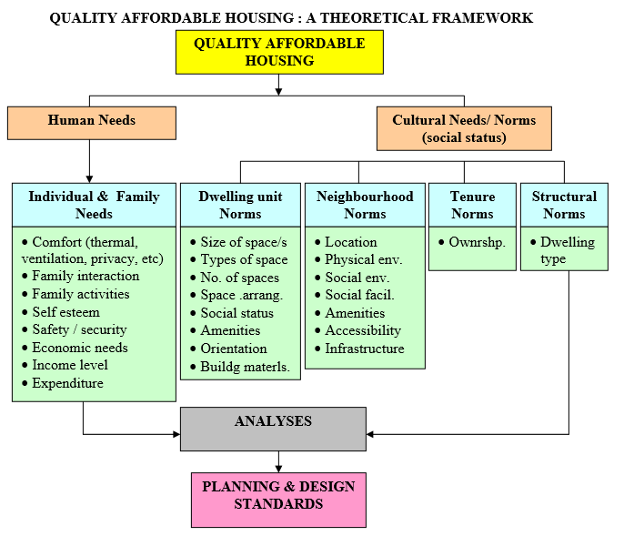
The success of a building is fulfilling its basic duties of containment and shelter depends on a series of related and interrelated issues. Based on Noor Sharipah Bt. Sultan Sidi, summarized that theoretically, quality affordable housing encompasses the provision of housing which fulfils the following needs:
Source: By Noor Sharipan Bt. Sultan Sidi, Journal of Techno-Social, Page no 9.
Figure 2.1 Quality Affordable Housing theoretical frameworks
These judgments are, however, essentially subjective in nature, and may only partly answer the question of whether a building is really ‘good’ or ‘bad’. Objectivity comes from acknowledging the various requirements of the building and assessing it against accepted criteria. These might include: fitness for purpose (e.g. needs and expectations), accessibility (e.g. abled and disabled persons), energy efficiency (e.g. thermal insulation, carbon dioxide emissions, SAP energy ratings), sustainability (e.g. resource management), condition (e.g. repair and maintenance), and performance in use (e.g. life cycle costs, levels of obsolescence). (Watt, 1999)
Whether buildings are more than the sum of their components parts, representing a synergistic relationship between building and user, is a matter for personal opinion and debate. This is not to suggest the existence of a built ‘super organism’, similar to that of James lovelock’s Gaia (Lovelock, 1995), but the concept that a building has a birth, life and death.
‘What should we ask of a new shelter? We should ask for protection from the elements, an adequate level of comfort and a pleasurable environment that enhances our life. These features should be supplied economically, simply, reliably. Shelter should not dominate our lives but rather make minimum impact upon us. Ideally, a shelter should make us aware of the beauties and delights of nature rather than remove us from them.’ (Rodale, 1982)

2.3.2. Requirements of Building
In order to be successful, the design and construction of a building has to consider a variety of issues. Or, to put this in another way, a building/housing, once it has been built, must fulfil certain criteria. These may be considered as being: Functional requirements, Performance requirements, statutory requirements and User requirements. (Watt, 1999)
Functional Requirements
Every building, regardless of its original, intermediate or ultimate use, can be expected to fulfil certain basic functional requirements. These requirements are primarily concerned with protection from the external environment, human comfort, and organization of activity and space. Other functional needs might include the creation of a particular sense of identity or place, and the control of competing or conflicting internal uses.
Performance Requirements
For a building to be successful, it must satisfy the basic functional requirements noted above. The way in which it meets these demands, both as a building and as a collection of related and interrelated parts, may be determined by how it performs in relation to a number of defined performance measures or standards.
The performance requirements of a building and its various elements may be considered: Access and egress, appearance, durability, dimensional stability, strength and stability, weather exclusion, sound control, thermal comfort, fire protection, lighting and ventilation, sanitation, security and cost. Many of this performance requirements are from the basis of statutory and non-statutory demands that need to be met, both in relation to new buildings/housing and the continued use of those already in existence.
Statutory Requirements
There are various statutory and non-statutory requirements that make demands on those who design, build, manage, repair, maintain, occupy or demolish building. In practice, many of these demands are made in relation to health, safety and well-being of such persons. (Watt, 1999)
User Requirements
According to Watt, (1999) the user of a building can expect to live or work in a space that satisfies basic human requirements and, in addition, certain needs that are specific to the activities being performed. The ways in which these are met, and whether one is in conflict with the other, is a measure of how appropriate the building is for the activity or activities in question. Fitness for purpose is thus an important measure of how a building matches the requirements of its user.
User requirement studies attempt to identify purpose in terms of activities (the things people do) and human needs (physical, psychological, physiological and social), and for a building to be fit for its purpose it must allow its occupants to carry out their activities economically and conveniently, and have a satisfactory environment to suit the user. Such a study will typically consider the following: classification of user (task orientation); analysis of activities (social interaction); requirements of space (circulation in and around buildings); environmental conditions (sensory stimulation); structural implications (compatibility) and cost (improvements).
Where buildings are designed or adapted for specific needs, these basic requirements may be replaced or supplemented by further considerations. These may be prescriptive in nature and, as such, might include requirements under specific headings (such as floor loadings or lighting levels). In such a situation, study of the particular needs of the user will assist in identifying what the buildings has to provide in order to satisfy user activities and human necessity.
The user requirements within a particular building may at times conflict with the structural, material and/or environmental needs of the building or its contents. This may be particular concern when dealing with historic buildings, where careless alterations or adaptations can cause irreparable damage both to the structure and fabric of the building, and the aesthetic qualities of its spaces. Where such conflict exists, it is important that the needs of both the building and its user(s) are clearly recognized, and the implications of bias or compromise fully understood.

2.3.3. Defining housing quality
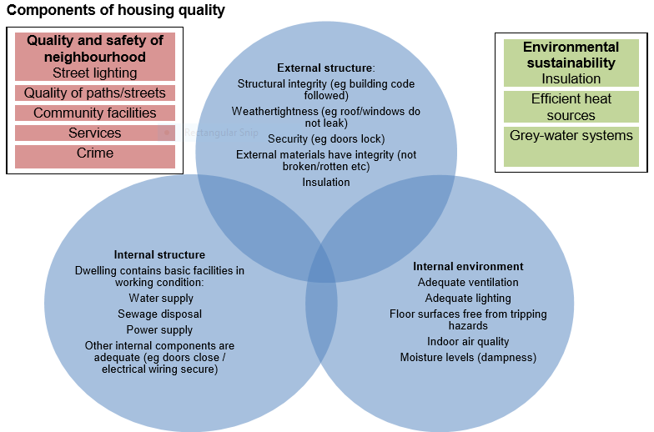
Housing quality has many elements, and can be defined in many ways. A targeted definition of housing quality concerns simply the quality of the internal and external structure of a dwelling and aspects of the internal environment. Housing quality is also referred to as Statistics New Zealand (2015), Measuring housing quality; housing condition or housing habitability. Below Figure shows some of the major components of housing quality, and some of the elements that can be included in each component.
Source: Statistics New Zealand (2015), Page no 7.
Figure 2.2 Components of Housing Quality
Clark (2009) defined adequate housing as “protection from the cold, damp, heat, rain, wind, structural hazards, disease vectors, and other threats to health”.

COST-EFFECTIVE & LOW-TECH ALTERNATIVE CONSTRUCTION TECHNOLOGY OF HOUSING

2.4.1 DEFINITION OF IMPORTANT TERMS
- Cost-effective: - is something that is a good value, where the benefits and usage are worth at least what is paid for them. Dictionary definition
- Low-Tech: - technologically simple or unsophisticated. Marriam-Webster and Wikipedia define low-tech is simple technology, often of a traditional or non-mechanical kind, such as crafts and tools that pre-date the industrial revolution. Low technology can typically be practised or fabricated with a minimum of capital investment by an individual or small group of individuals. Also, the knowledge of the practice can be completely comprehended by a single individual, free from increasing specialization and compartmentalization.
- Alternative construction Technology: - that are more environmentally friendly than the functionally equivalent technologies dominant in current practice. Wikipedia
- Conceptual framework: - is best summarized by Miles & Huberman (1994), who categorized it as a system of concepts, assumptions, and beliefs that support and guide the research plan. Specifically, the conceptual framework “lays out the key factors, constructs, or variables, and presumes relationships among them” (1994, p.440). Moreover, Camp (2001) aptly described a conceptual framework, asserting that a conceptual framework is a structure of what has been learned to best explain the natural progression of a phenomenon that is being studied.

ROOFING TECHNOLOGIES

PRECAST RC PLANK AND JOIST ROOFING SYSTEM
Principle: This is a system which uses precast concrete elements to construct a roof. The planks are supported over partially precast RC joists side by side and then joined together with in-situ concrete poured over the entire roofing area. Both elements of the roof - planks and joists can be manually produced at site using wooden moulds. Alternatively, given the context of a large-scale use such as housing project, they can be produced in a small enterprise mode using steel moulds mounted on vibrating tables. (Climate and Development Knowledge Network, 2013)
Design: The roof can also be used an intermediate floor and the building should be designed keeping in mind the modular size of the planks. (Climate and Development Knowledge Network, 2013)
Precast reinforced concrete plank and joist roofing system are sturdy and higher strength, dimensional regularity in shape and size, saving in time, energy resource, cost effective roofing option, and no shuttering required. Size of product for planks 1500*300*30 – 60mm and for joists length up to 4500mm, cross-sectional size 100*125 or 150*150 or any other sizes by uses of raw material; cement, sand, stone aggregates, steel and binding wire. This system consists of precast RC planks supported over partially precast joist. RC planks are made with thickness partly varying between 3cm and 6cm. There are haunches in the plank which are tapered. When the plank is put in between the joists, the space above 3cm thickness is filled with in-situ concrete to get tee-beam effect of the joists. A 3cm wide tapered concrete filling is also provided for strengthening the haunch portion during handling and erection. The planks have 3 numbers 6mm diameter MS main reinforcement and 6 mm diameter @ 20cm centre to centre cross bars. The planks are made in module width of 30cm with maximum length of 150cm and the maximum weight of the dry panel is 50 kg. Precast joist is rectangular in shape, 15cm wide and the precast portion is 15cm deep. The above portion is casted while lying in-situ concrete over planks. The stirrups remain projected out of the precast joist. Thus, the total depth of the joist becomes 21cm. The joist is designed as composite Tee-beam with 6 cm thick flange comprising of 3 cm precast and 3cm in-situ concrete. This section of the joist can be adopted up to a span of 400cm. For longer spans, the depth of the joist should be more and lifting would require simple chain pulley block. The completely finished slab can be used as intermediate floor for living also in residential buildings. The savings achieved in practical implementations compared with conventional RCC slab is about 25 %. (Adlakha and Puri, 2002)
Partially precast joist - It is a rectangular shaped joist 13 cm wide and 10 cm to 12.5 cm deep with stirrups projecting out so that the overall depth of joist with in-situ concrete becomes 21 cm to 23.5 cm; it is designed as composite Tee-beam with 3.5 cm thick flange. (Adlakha and Puri, 2002)

PRECAST CURVED BRICK ARCH PANEL ROOFING
Principle: The roof is constructed with pre-cast panels made with burnt clay tiles placed on pre-cast reinforced concrete beams. The arch profile imparts lateral or transverse strength to the panels for distributing the roof load through compressive forces. The panels serve as a lost formwork for the finished roof, after topping concrete has been laid over the pre-cast components. (Climate and Development Knowledge Network, 2013)
Design: Usable economically till a span of 5 meters, and recommended for areas where burnt clay products are commonly used and produced in good quality - both the semi-arid and coastal study area.
In this roofing system the panels do not have any reinforcement. A panel while casting is given a rise in the centre and thus an arching action is created. An overall economy of 30% has been achieved in single story building and 20% in two or three-story buildings. (Adlakha and Puri, 2002)

FERROCEMENT CHANNEL ROOFING
Principle: The building system uses precast Ferro cement roofing channels of a segmental arch profile which are placed adjacent to each other and spanning over two supports. After partly filling the valley between channels with concrete, the channels form an idealized T-beam and are able to carry the load of a roof / floor. (Climate and Development Knowledge Network, 2013)
For roof and intermediate floor construction as a substitute to RCC slabs particularly suitable for large spans. To increase speed of installation or no shuttering required, 30% cost saving over RCC roofing, lower dead load on wall, usable as an intermediate floor, high strength to weight ratio, elegant profile and unique size, large span up to 6.1 metres, and light weight; slender elements and shall structure. Raw material that’s used in production of Ferro cement channel are cement, sand, aggregates (10 mm and below), steel, chicken mesh and welded mesh. Produced by size of clear bay length – 750 mm, outer – outer dimension – 840 mm, rise of arch – 290 mm, shall thickness – 25mm, bottom nib dimension – 40*45 mm, and span up to 6.1 metres.

PREFABRICATED BRICK PANEL ROOFING SYSTEM
The prefabricated brick panel roofing system consists of: (a) Prefab brick panel Brick panel is made of first-class bricks reinforced with two MS bars of 6 mm diameter and joints filled with either 1:3 cement sand mortar or M-15 concrete. Panels can be made in any size but generally width is 53 cm and the length between 90 cm to120 cm, depending upon the requirement. The gap between the two panels is about 2 cm and can be increased to 5 cm depending upon the need. A panel of 90 cm length requires 16 bricks and a panel of 120 cm requires 19 bricks. (Adlakha and Puri, 2002)
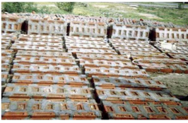

Figure 2.3 View of brick panel

For roofing as an alternative to conventional RCC slab. This roofing panel reduced economy in steel, cement, labour, time and cost, simple technology, no shuttering is required, and the same structural stability and durability as that of conventional RCC slab, and it is suitable for rural areas. Raw materials used in production brick panel are cement, bricks, sand, and aggregates. Developed by CBRI, Roorkee, (1994) used for its design, Concrete used was in high compressive zone whereas bricks were used in less compressive zone. Use of M20 grade or 1:3 grade cement mortar was done for construction. Brick Panel Rooﬁng was made up of ﬁrst class bricks reinforced with 6 mm MS bars, length was varied between 900 and 1200 mm but width was kept at 530 mm for allowing 36 - 40 mm gaps between bricks. In order to increase the length of brick panel, diameter of bars was also increased and is most suitable for rural areas. The diﬀerent advantages of using these were that they help in saving the quantity of cement, steel, labour. It also saves time and cost, concrete and concreting cost can be saved by 20–25% and 25–35% of complete slab cost respectively. If the production for ensuring availability is highlighted then in that case a factory can produce approximately 120,000 brick panels/day in an 8 h shift and 24,000 RCC joist in an annum. For all those produced the compressive strength ranges up to 150 kg/cm2. Standard size of brick panel used was of size 1200×530×75 mm and while that of RCC joist was 130× 1200×3600 mm. The numbers of skilled and unskilled labour required are 6 and 20 respectively. Brick panel weighs around 75 kg whereas RCC joist weights 15 kg/m.

CORRUGATED FIBRE CONCRETE ROOFING SHEETS
According to Ramakrishna, Sundararajan and Kothandaraman,(2011) there are not many feasible alternatives for roofing materials in many developing countries, especially in the rural areas where modern housing has to rely almost exclusively on the use of corrugated aluminium or asbestos sheets. Due to the high prices of these items, this makes roofing to be the single most expensive item in rural housing schemes. Current research shows that roofing sheets made from silk fibre reinforced concrete can provide a cheap alternative to the conventional corrugated aluminium sheets. Silk fibre reinforced concrete sheets are fire resistant and durable. They also have good thermal and sound insulating properties. Silk fibre reinforced concrete roofing sheets can be produced in small scale industries, thereby offering opportunities for improving the quality of life in rural areas.
The productions require fairly simple, locally made equipment and a very well-coordinated working team of at least two workers; no require electricity; but are difficult to handle when fresh and to cure in water tanks, because of their large size; are difficult to transport and install without breakage, and do not tolerate inaccurately constructed and flexing supporting structures; and withstand strong wind forces because they are heavy and have few overlaps.
Materials - Cement: ordinary Portland cement (10mm thick corrugated sheet of 60 x 60cm) corresponding to cement: sand ratio of 1: 1; a pozzolana (rice husk ash) can be added to improve fibre durability and reduce cement content, but causes slow setting, which necessitates a larger number of moulds and larger workspace. Sand: (5 kg per sheet) preferably with angular particles and good grain size distribution between 0.06 and 2mm, free from silt and clay. Fibre: (0.1 kg per sheet) mainly natural, such as sisal, jute, coir, or banana fibre, but also synthetic fibres, eg polypropelene or glass fibre can be used. Long fibres can be used, but require a different (more difficult) manufacturing process and result in weaker products. Short fibres, chopped to lengths of 12 to 25mm, are easy to process, provide cohesiveness to the wet mortar, permitting reshaping without cracking, and also help to prevent cracking due to drying shrinkage. Water: preferably drinkable water, just enough to make the mortar mix workable (water: cement ratio 0.5-0.65 by weight). Admixtures: such as water proofers may be used, if the sand is not well graded, and colorants, if the grey cement colour is not desired.

FIBRE AND MICRO CONCRETE TILES (FC/MC TILES)
Rajive Chaudhry, (1990) describe it is cladding for sloping roofs of different types of buildings, as a substitute to country tiles, asbestos and other corrugated sheets. It is highly cost effective, production under controlled condition, more durable and strong in different climatic conditions, no noise during rain, decentralised production makes it more energy effective, manageable tile size make the structure relatively lighter, and reduction in construction and finishing time. When the technology was first developed it was decided to make large roofing sheets similar in size and shape to the corrugated asbestos or galvanized iron sheets used on many buildings. These were reinforced with natural fibres such as sisal or coir. The fibre-cement mortar mix was simply spread out by hand on a flexible plastic sheet in a large mould. Afterwards the sides of the mould were taken away and the sheet with the mortar on top was gently pulled over onto a corrugated mould where it took its shape. Problems were experienced with decay of the fibres and cracking of the sheets after only a few years, and so the production of fibre-reinforced concrete roofing sheets has been abandoned in many countries. The next development was production of fibre-reinforced concrete roofing (FCR) tiles. With tiles (typically about 500 x 250 x 6 or 8mm) the performance of the fibre is less critical than with sheets. The fibres are added largely to control damage caused by impact during handling. Once placed on the roof, tiles are unlikely to crack if the fibres decay. In addition, FCR tiles are vibrated during their production which gives them added strength and durability. It has also been found possible to make fibre-reinforced semi-sheets (of size 600 x 600 x 8mm) by the same method without any adverse effects.
Jayasinghe, Silva, Dissanayake and Fernando, (2006) more recent development has been to make concrete tiles without any fibre at all. These are the so-called micro-concrete roofing (MCR) tiles. Greater care needs to be taken with MCR tile production compared with FCR if the number of damaged or sub-standard tiles is to be kept low. MCR tiles are also more brittle than FCR tiles, and can be damaged if dropped or handled carelessly when transporting them or fixing them to the roof. Micro-concrete tiles are developed to overcome most of the problems encountered in producing and installing corrugated FC sheets; are made most efficiently on a small vibrating table (hand powered or run by electricity, ea. a car battery), which can be operated by a single trained worker; can be made thinner (6 mm) than FC sheets (10 mm), and their cement: sand ratio (between 1: 2 and 1: 3) is less than for FC sheets (1: 1), so that the cement used for making tiles is only between 5 and 7 kg per m² of roofing; this tile are easy to handle when fresh and to cure in water tanks; do not tend to break as easily as sheets during transport and installation, and minor inaccuracies in the supporting structure have no negative effects; are easily torn off by strong wind forces, if they are not well fixed to the substructure.
Materials - Cement: same as for FC sheets, but about 0.4 kg per 6 mm thick pantile of 50 x 25 cm, corresponding to cement: sand ratio of 1: 3. Sand: same as for sheets, but 1.2 kg per tile. Fibre: same as for sheets, but 0.02 kg per tile, used in FC tiles only. Aggregate: for MC tiles aggregate is used instead of fibre. The ratio sand to aggregate is between 2:1 and 1:1. Water and admixtures: same as for sheets. Screeding machine: comprising a vibrating screeding surface and interchangeable, hinged frame (for products of different shapes and thicknesses), whereby the vibrating mechanism is either powered by a 12-volt car battery or hand-powered.

WALLING TECHNOLOGIES

RAT TRAP BOND
Rat-trap bond in wall construction: While laying bricks, the manner in which they overlap is called the bond. Nilanjan, and Souvanic, (2013) there are several types of bonds developed in different countries from time to time. They are called as stretcher bond (required to construct 125 mm thick partition walls), English bond (most widely used to construct walls of thickness 250 mm or more), Flemish bond (decorative bond, used to construct walls of thickness 250 mm or more, slightly difficult to lie) and rat-trap bond. The rat-trap bond is laid by placing the bricks on their sides having a cavity of 4″ (100 mm), with alternate course of stretchers and headers. The headers and stretchers are staggered in subsequent layers to give more strength to the walls. The main advantage of this bond is the economy in use of bricks, giving a wall of one brick thickness with fewer bricks than a solid bond. Rat-trap bond was commonly used in England for building houses of fewer than three stories up to the turn of the 20th century and is still used in India as an economical bond. The main features of rat-trap bond wall are:
Nilanjan, and Souvanic, (2013) the main features of Rat-trap bond walls are: Strength is equal to standard 250 mm thick brick wall, but savings in consumption of brick, cement and sand are 28%, 37% and 40% respectively. The overall saving on cost of materials used for construction compared to the traditional 10” wall is about 20%. The air medium created in between the brick layers helps in maintaining a good thermal comfort inside the building. This phenomenon is particularly helpful for tropical climate, as the construction is done by aligning the bricks from both sides with the plain surfaces facing outwards, plastering is not necessary except in a few places. The finished surface is aesthetically appealing from both inside and outside; Buildings up to two stories can easily be constructed with this technique. In R.C.C. framed structures, the filler walls can easily be made of rat-trap bond, due to reduced load on the base of the walls, the width of foundation is also decreased, resulting in a saving of about 8%, 8.33% and 7.7% respectively on use of bricks, cement and sand in foundation and plinth for small dwellings.
Principle: Rat-trap bond is a masonry technique in which the bricks are laid in such a manner that a cavity is formed between two faces of the wall. Typically, a 75mm cavity is formed in a 230mm thick wall by placing the bricks on edge in a modular fashion.
Design: Usable up to 2 stories of load bearing masonry, wherever burnt clay brickwork is used. Rat-trap bond used infill walls for multi-storeyed buildings. This bond well-suited to exposed brickwork because of its neat appearance.

COMPRESSED EARTH BLOCKS
Sengupta, (2008) compressed earth blocks (CEBs) are earthen bricks compressed with hand-operated or motorized hydraulic machines. Stabilizers such as cement, gypsum, lime, bitumen, etc. are used during production or on the surface of the bricks. In many areas of the world, proper materials are available for making CEBs, and thus this type of block may be a better choice than any other building material. One of the factors that affect the use of CEBs is the mental barrier of using simple earth rather than burnt clay bricks. Non-availability of skilled manpower and technical guidance to produce large quantities of CEB with proper quality is also a determinant force.
Advantages of CEB include: uniform building component sizes, which result in faster construction. & use of locally available materials and reduction of transportation (CEBs are mostly produced locally by transporting the equipment and machine at the work site). Modular elements like sheet-metal roofing, and pre-cast concrete door/window frames can be easily integrated into a CEB structure. The use of locally available materials and manpower helps in improving local economy rather than spending for procuring building materials from a distant place. The earth used is generally subsoil and thus the top agricultural soil remains intact. The reduction of transportation requirement can also make CEB more environment-friendly than other materials. CO₂ emission is practically nil in the production of CEBs. If the wet compressive strength is more than 20 kg per sq. cm, then an RCC roof can be laid and a second storey can be built. If the blocks have more than 8% cement stabilization, then a three-storey, loadbearing structure can be built. But, in such cases, expert advice is suggested. Good quality blocks having lesser water absorption can safely be used in areas with high rainfall.
The technology that has become widespread in the new system of re-invented buildings is the Compressed Earth Blocks that makes unbaked earth blocks. Unlike the native adobe block, which is a mixture of earth, water and distinct cultural additives moulded to desired shape with the hand, the compressed earth block is supplemented in very small amounts (in most cases less than 10%) with either cement or lime component in its blending process. The blend is not worked to achieve a plastic state, but simply blended until the cement/lime and earth are thoroughly mixed. Afterwards, the mixture either machine pressed or placed in a mould and compacted with a high level of pressure applied through a hand operated machine. After aeration, the CEBs gain a high compressive strength appropriate generally for three floors constructions but higher potentials can also be attained for up to five floors constructions. These blocks (CEBs) can be left un-plastered, covered with plaster or can be coated with watered earth (muddy plastic mixture), sometimes added with natural colouring. Its facades in comparison to the contemporary urban houses offer a feeling of a cooler interior and the inside temperature is lower than many cement block houses.
The use of local materials and building methods will cut costs to its barest minimum. The impact of green technology on the state of economy observed from the standpoints of cost saving/effectiveness is immense. Household revenue in terms of disposable income increases as housing expenses reduce. Maintenance cost and general bills are minimized.

STABILIZED COMPRESSED EARTH BLOCKS
Principle: (CEBs/CSEBs) are mechanically compressed block of local soil. The soil (with minimum 20% clay) is mixed with a binding material such as cement (5-10% depending upon the strength), lime, rice husks or straw.
Design: It can be used in the construction of various structures like wall masonry with arched openings, jack arches and domes for roofing. The component made of these blocks needs protection from water and tensile forces; hence walls made of these blocks should have appropriate overhangs from chajja or roof.
Nilanjan and Souvanic (2013) a soil contains four components: gravel, sand, silt and clay. In concrete, the binder of gravel and sand is cement. In a soil, the binder is silt & clay. But silt and clay are not stable in water. Thus, the aim of stabilization is to stabilize silt and clay against water, so as to give lasting properties with the minimum of maintenance. Topsoil and organic soils must not be used. Identifying the properties of a soil is essential to create, at the end, good quality products. Not every soil is suitable for earth construction and CSEB in particular. But with some knowledge and experience many soils can be used for producing CSEB.
Cost effectiveness CSEB are generally cheaper than fired bricks. This will vary from place to place and specially according to the cement cost. The cost breakdown of a 5 % stabilised block will depend on the local context. In India with manual equipment (AURAM press 3000), it is usually within these figures: Labour: 20-25 %, Soil & sand: 20-25%, Cement: 40-60 %, Equipment: 3-5 %.
Compressed Stabilised Earth Block (CSEB) is the most economic and energy-efficient building material having heat storage capacity is one of the highest and also has proven capability of control of humidity. Zami and Lee, (2008) observed that Earth construction is energy saving and economically beneficial requires simple tools and less skilled labour and it improves indoor air humidity and temperature which ensures thermal comfort, and the materials are readily available in large quantities in most regions. Maini (2005) has stated that for production of good quality CSEB, top soil and soil with organic content should be avoided. It requires expertise and knowledge to choose the right soil and stabilizer for production of CSEB as per laid down standards. Hadjri et al. (2007) have surveyed users’ perception on different type of constructions in Zambia, Africa and concluded that majority did not prefer buildings made of earth as it is a symbol of low societal status, culturally associated with poverty and there is a chance of decreased durability due to poor design and construction standards.
Advantages of CSEB - A local material ideally, production is made on the site itself or in the nearby area. Thus, it will save transportation, fuel, time and money. It is a bio-degradable material, limiting deforestation, Energy efficiency and eco friendliness, Cost efficiency, an adapted material, A transferable technology, A job creation opportunity, Market opportunity, Reducing imports, Flexible production scale, and Social acceptance.
Disadvantages of CSEB - Proper soil identification is required or lack of soil, Unawareness of the need to manage resources. Ignorance of the basics for production & use and Wide spans, high & long buildings are difficult to do. Low technical performance compared to concrete and untrained teams producing bad quality products. Also reduce its quality by over-stabilization through fear or ignorance, implying outrageous costs, or under-stabilization resulting in low quality products. It makes Low social acceptance due to counter examples (by unskilled people, or bad soil & equipment).

CONCRETE JACKETED RAMMED EARTH WALL CONSTRUCTION
Kimmie, (2010) this system uses a composite wall construction comprising concrete surfaces and a rammed earth core. The high thermal mass walls constructed using mostly of local natural materials promise efficient running costs in terms of heating/cooling energy and also provide a greatly reduced environmental impact of construction. A novel construction of compacted soil between surface layers of concrete has been developed that offers an ideal environmental solution. The finish is equal to traditional forms of construction; the thermal mass is high and the embodied energy very low – as soil is used us the bulk of material – no timber frame is required. The construction technique involves a purpose – designed formwork system that creates the concrete surface and the compacted soil core.
The wall is constructed within the formwork; a tray of dry cement-based mortar mix is positioned at each side. The formwork centre is than filled with earth from the site. Moisture content is controlled at this stage by a simple workability test. The steel trays separating the mortar mix are than removed. The soil is that compacted using an electric hammer/vibrator. The process results in the mortar mix at the top surface creating a lip that extends over the surface of the compacted soil. This lip acts to tie - in the two outer concrete walls. If desired a steel or non - metallic tie can be placed at this location to tie the inner and outer wall surfaces. The formwork is subsequently raised and the next level of wall created. The walls are inherently non - combustible and will not produce toxic gasses in case of fire, the finished wall does not pose a threat to air quality by out - gassing and minimum transport costs promise significant advantage in rural areas.

WALL CONSTRUCTION WITH BAMBOO
FROM:"THE USE OF BAMBOO AND REEDS INBUILDING CONSTRUCTION;' UN. ST /SOA /113, in Indonesia it is common method of wall construction with bamboo boards. The boards are covered on both sides with closely plaited matting on internal walls. External walls are plastered on one or both sides. Fine-weave matting does normally not receive any paint or other finish. If it should be plastered the weave is arranged open. In a wattle and daub wall construction bamboo lath is used as the base for the application of mud mixed with clay, organic fibres or cow-dung on both sides. Very often this bamboo lath is eaten away by termites and the walls easily collapse. To avoid this by mud plaster may be mixed with an anti-termite solution as protection. Another wall construction is the wattle wall in various different variations. In these entire constructions bamboo lath is used as a base for receiving mud plaster that is applied on one or both sides. The mud is mixed with clay, organic fibre or cow dung. As already mentioned, it would be advisable to include in the plaster mix a solution of Dieldrin or other anti-termite chemical.

SLAB TECHNOLOGY

RC FILLER SLAB WITH NON-AUTOCLAVED CELLULAR CONCRETE BLOCKS
M.P.Jaisingh, L.Jaisingh & B.Singh describe the floor/roof consists of a cast in-situ RC filler slab with non-autoclaved cellular concrete filler blocks. The filler blocks are 110 mm thick and 260 x 560 mm at top tapering down to 250 x 550 mm at bottom. The slab is cast with cement concrete of grade M15. Spanning in two perpendicular directions, the slab can be designed as a grid with compression taken by the deck concrete at top and tension taken by the reinforcement at the bottom in the rib portion. The cellular concrete blocks act as non-structural fillers. The technique can be adopted for floor/roof in single and multi-storeyed residential and other types of buildings. Conventional roof/floor finish could be laid above the filler slab. Ceiling plaster could be avoided in low cost constructions and also where better acoustic performance is called for. In other situations the ceiling may be plastered. It can be seen that adoption of filler slab in place of conventional RC slab will result in a saving of about 17% in cost. In addition, there is a saving of 16 to 33% in cement and about 45% in steel.
Nilanjan and Souvanic, (2013) this is a normal RCC slab where the bottom half (tension) concrete portions are replaced by filler materials such as bricks, tiles, cellular concrete blocks, etc. These filler materials are so placed as not to compromise the structural strength, result in replacing unwanted and non-functional tension concrete, thus resulting in economy. These are safe, sound and provide aesthetically pleasing pattern ceilings and also need no plaster. The main features of the filler slab are:
• Consumes less concrete and steel due to reduced weight of slab by the introduction of a less heavy, low cost filler material like two layers of burnt clay tiles. Slab thickness minimum 112.5 mm.
• Consumes less concrete and volume of concrete results in reduction of consumption of cement, sand & crushed stone chips by about 49%, whereas use of steel is reduced by about 13%, Cost saving of about 23% in comparison with normal RCC slab, produces a good aesthetic if plastering is done only on concrete surface of the ceiling.
• Enhances thermal comfort inside the building due to heat-resistant qualities of filler materials and the gap between two burnt clay tiles.
• Makes saving on cost of this slab compared to the traditional slab by about 23% and reduces use of concrete and saves cement and steel by about 40%.

REINFORCED CATALAN VAULTING
An ancient system of reinforcing tiled vaults belonging to the constructive Spanish tradition (tabicada technique or method of timbrel vaulting). This technique rests on reinforcing existing thin vaults by laying several layers (no more than four) of flat rectangular tiles or thin bricks (called rasillas) alternated with layers of mortar mainly based on gypsum.
Marco, Giulio and Antonio timbrel, (2014) vaulting differs substantially from the traditional method of arch building, which relies on gravity. It does not rely on gravity but on the adhesion of several layers of overlapping tiles which are woven together with fast-setting mortar (cohesive construction). Due to their “cohesiveness”, that is the cohesive force established between the various layers of bricks and mortar, the main structural characteristic of timbrel vaults is the ability of these structures to bear considerable traction tensile states. If just one layer of thin tiles was used, the structure would collapse, but adding two or three layers makes the resulting laminated shell almost as strong as reinforced concrete.
Materials characterization
Characterizations of masonry mortar - The arches were constructed using two types of hydraulic lime mortar. Type A has been chosen with the aim of reproducing the quality and the mechanical behaviour of rather weak mortars usually connecting the bricks in existing masonry historical structures. The mix proportions of the mortar (lime: sand: cement) are 1:2:0.15 (by volume). The water-lime ratio is in the range of 30 to 60%, depending on the required workability.
Characterizations of the bricks - Flat rectangular tiles (250×120×35 mm) were used for the construction of the masonry arches. The mechanical characteristics of the bricks were obtained by means of compression and bending tests. Uniaxial compression tests, performed in the direction of the moulding (perpendicular to bed joints), gave a mean strength and a coefficient of variation of 20.99MPa and 0.11, respectively, whereas the mean value of the bending tensile strength and its coefficient of variation were 6.75MPa and 0.27, respectively.
Characterization of the reinforcement - this reinforcement used to in the composite system made strengthen the arches included GFRP grid, and it characterized by square mesh with nominal dimensions of 66×66 mm. It is made up of AR (Alkali Resistant) glass fibre with a zirconium content equal to or greater than 16% pre-impregnated with thermosetting epoxy vinyl ester resin.

PREFABRICATED BRICK PANEL AND JOIST SYSTEM
Adlakha and Puri, (2002) the prefabricated brick panel system consists of:
- Prefab brick panel Brick panel is made of first-class bricks reinforced with two MS bars of 6 mm diameter and joints filled with either 1:3 cement sand mortar or M-15 concrete. Panels can be made in any size but generally width is 53 cm and the length between 90 cm to120 cm, depending upon the requirement. The gap between the two panels is about 2cms and can be increased to 5cms depending upon the need. A panel of 90cm length requires 16 bricks and a panel of 120 cm requires 19 bricks.

- Partially precast joist is a rectangular shaped joist 13 cm wide and 10 cm to 12.5 cm deep with stirrups projecting out so that the overall depth of joist with in-situ concrete becomes 21 cm to 23.5 cm; it is designed as composite Tee-beam with 3.5 cm thick flange.
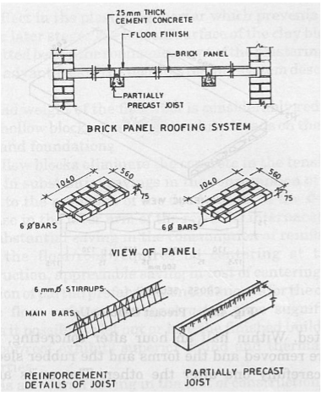

Figure 2.4 Prefabricated brick panel and Joist system

Source: Rinku Taur and Vidya Devit, 2009

Brick panel and joist system as an alternative to conventional RCC slab. This panel reduced economy in steel, cement, labour, time and cost, simple technology, no shuttering is required, and the same structural stability and durability as that of conventional RCC slab, and it is suitable for rural areas. Size of product reinforced brick panel: 1200*530*75mm and raw materials used in production are cement, bricks, sand, aggregates and steel.
Structural design - prefab brick panel for roof as well as for floor of residential buildings has two numbers 6mm diameters MS bars as reinforcement up to a span of 120cms. The partially precast RC joist is designed as simply supported Tee-beam with 3.5cm thick flange. The reinforcement in joist is provided as per design requirements depending upon the spacing and span of the joist. An overall economy of 25% has been achieved in actual practice compared to cast-in-situ RCC slab. (Adlakha and Puri, 2002)

2.4.4. REVIEW ON PARTIAL REPLACEMENT OF CEMENT IN CONCRETE
BAEZA, PAYA, GALAO, SAVAL, GARCÉS, (2014), done a research on Blending of industrial waste from different sources as partial substitution of Portland cement in pastes and mortars. He has done Binary and ternary combinations of sewage sludge ash (SSA) with marble dust (MD), fly ash (FA) and rice husk ash (RHA) as replacement in Portland cement pastes, were assessed. In this study several tests were carried out at different curing ages. In general, the compressive strength reaches or exceeds the cement strength class, and blending SSA, FA and RHA (30% cement replacement) increase of strength by 9%, compared to the control sample, was achieved.
CHAN, (2000) conducted a study on the durability of concrete made from various non-reactive waste materials, i.e. carbon black, silts and clays, and with various water contents were investigated. He has studied different types of test like compressive strength; workability, sorptivity, and water permeability of the concrete. Also a detail investigation based on the resulting change in the microstructure and cement hydration in these concrete by X-ray diffraction (XRD), scanning electron microscopy (SEM) and energy dispersive X-ray (EDX) spectroscopy. Workability can be increased by increasing the specific surface area or using super plasticizer. So in present study used silt and clay for research in varying proportion and he has found that 25 vol. % of cement replaced with silts and clay using a water/cement (w/c) ratio of 0.5 gives durable concrete. That is, the cement and water contents were less than those in OPC. Also, the cost of concrete will be lowered.
Research on plant-based natural fibre reinforced cement composite has continued to evolve as a result of the increasing demand for sustainability in raw materials usage, as well as the low cost, low density, strength and local availability of these fibres. However, as highlighted in this review article, in the past moisture absorption capacity of plant-based fibres which influence the mechanical and durability properties of reinforced cement composites negatively has remained a factor mitigating their use. There are however scenarios such as hot-weather concreting where water absorption capacity of plant-based fibres can be seen as a bonus. Inability of some of these fibres to resist a high pH cement environment also remains a concern and has discouraged their use.
Addition of Banana fibre to the conventional mix by 0.4% gives the maximum compressive strength. The concrete mix is less workable when Banana fibres are added to the mix as the slump values and compacting factor values are low when compared to conventional mix. The lower workability is supplemented by the use of super plasticizers. The mix with high per cent of banana fibre gives high tensile strength to the mix.
The use of fly ash in concrete at proportions ranging from 30% to 65% of total cement binders has been studied extensively over the last twenty years. Due to some of its drawbacks we have replaced the cement by HIGH VOLUME FLY-ASH AND LIMESTONE. These two materials reduce greenhouse gas emission proportionately and result in a more “green concrete”, through reduction of energy consumptions (energy required to produce cement) and prevent the depletion of natural resources. The aim was to achieve the target strength of M40 grade, replacing cement by high volume fly ash and lime as per the normal mix design (using 53 grade of cement). We have achieved M40 target strength by replacing cement about 75% of its mass by fly-ash and lime. In this context cost analysis of mix design and the properties of the design are also studied. As compared to original mix design reduced the cost up to 40 % by 75% replacement of cement by HIGH VOLUME FLY-ASH AND LIMESTONE and LIMESTONE.

Case study: Improvement of Rural Housing by Alternative Construction Technology

A Case study of Cob Earth-Based Building Technique in Matagalpa, Nicaragua
The cob house in this case study is a 60m² house built in Matagalpa, Nicaragua in 2012. The house was built and it’s owned by a Spanish couple who learned the technique and wanted to try it out themselves. The house is approximately 4m high at its highest point, it is on one level and it has an attic. The main floor has a bathroom, a study, a living room, a kitchen and a small area for a dining table. The attic serves as a bedroom. The floor is made of compacted earth and they only used tiles in the kitchen. The house has furniture made with cob and wood and there are niches and bookshelves carved into the walls, which are 50cm thick. The house has a 70cm deep ditch around its perimeter ensuring stability in the event of an earthquake and it has a 50cm high rock chain which is visible from the outside, and it also works as a drainage system. Therefore, during the rainy season, the water can flow without added restrictions under the ground avoiding accumulation of water under the house. The roof is made with clay tiles and a plastic sheet was added to avoid of leaks. The wooden beams supporting the ceiling have nails on the edges to increase the area and they were incorporated into the surrounding cob walls. The inner walls have a fine layer of plaster made of sand and clay to make them smooth and nicer.
As it can be seen from attributes and the fact that there is only one built house and one under construction the rate of diffusion of the cob technique is slowed down. But the other three attributes “relative advantage”, “compatibility” and “complexity” may be used to promote and encourage the use of this technique since it seems to meet the needs and capacities of the people living in Nicaragua at the same time that it gives a better alternative for housing when compared to existing options in the area. If the two slowing attributes (“trialability” and “observability”) want to be tackled then it is recommended to start with small projects like small ovens and benches in order to understand and become familiar with the techniques.
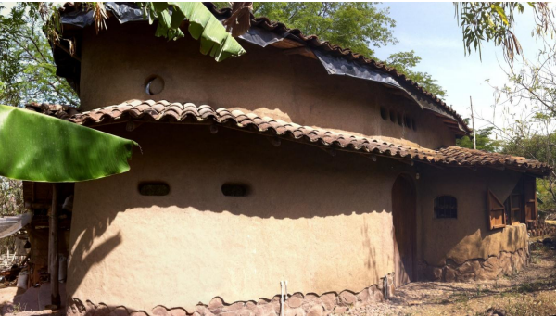
The cob technique may be a way of decoupling two aspects: citizen’s quality of life and environmental degradation. Cob enables families to build affordable and customized houses at a low price when compared to other houses, and through the extraction of materials for the cob mixture and the reclaiming and reuse of other materials extensive and intensive damage to the environment can be minimized.
Figure 2.5 Cob Earth-Based Building in Matagalpa, Nicaragua, Picture from internet
• Cob technique from Rogers rate of adoption perspective (relative advantage, compatibility, complexity, trialability and observability) has a relative advantage when compared to other building techniques on the area, is compatible with the needs and capacities of the people living in Matagalpa, Nicaragua and is a simple technique that can be implemented by anyone.
• Cob technique uses cheap materials and is labour intensive which is suitable for Nicaragua´s conditions.
• “Community-led solutions” may be an approach to improve local participation and to increase the rate of adoption among small communities and rural areas in Matagalpa, Nicaragua taking into advantage the niche used by the adobe and wattle-and-daub building techniques.

Construction of Improved Rural House in Dinajpur, Bangladesh
The house has been built with the household of Ranu and Gojen Chanda Roy near Hari para, Sundarban village, Dinajpur. The house is being built to replace the existing sleeping room which was in poor condition and too small owing to an extra family member having moved back to the house. The house comprises of 2 bedrooms and is of total dimensions 24ft by 8ft. The house is built on a mud plinth with no foundations (the existing ground being well consolidated), the structure is made from bamboo with ‘wattle and daub’ walls. The roof is of lean‐to (ekchala) construction and made with bamboo frame and corrugated iron (CI) sheet. This house included several low-cost improvements to the traditional house and these are as follows:
FOUNDATION
The plinth was compacted in layers by hand. The plinth area and lower half of the walls are
particularly at risk to damage by rain and two techniques were used to make the plinth much more resistance to water. A capping layer, 2-3" thick, of cement stabilised mud was placed on the plinth. The mud was mixed with 5% cement1,2. The plinth was finished with a cement and lime slurry (mixed in the proportions 1:1:6 lime: cement: water), and coloured with a black oxide powder available at the local market. All bamboo used in the structure was treated with a solution of borax, boric acid and water. This solution penetrates the bamboo easily, reducing the level of sap in the bamboo and
making it less likely to be damaged by insects. A Vertical Soak Diffusion technique was
employed: the bamboos are stacked vertically and the solution is poured inside from the top
end (prior to this a hole was made in each diaphragm using a long metal rod, hammered into one end; the last diaphragm being left so that water would be contained within the culm).
The culms were left for 7 days, topping up daily as required. A concentration of 4% borax,
3% boric acid and 93% water by weight was used. The borax/boric acid solution can be
reused up to 4 times so the most cost-effective approach is to treat ¼ of the total bamboo at
a time. If done in this way the total cost of the treatment is approximately 5% of the cost of
the bamboo. The soaking period of 7 days is less than sometimes advised. It was judged that a period of time longer than this would result in a total soaking time (i.e 4 batches) that was
so long as to be inappropriate for most rural households.
CONCRETE FOOTING (KAATLA) & BITUMEN To prevent the part of the bamboo culm in the ground rotting, two techniques were used. 6 no. posts were fixed to concrete footings or stumps. These form the foundation for the posts at the corner and the middle. These are the posts to which the cross bracing is fixed and are the most important for strength. The lower parts of the remaining posts were painted with bitumen.
BRACING
Cross‐bracing and plan‐bracing were used too provide strength to sideways forces from high winds. Stronger joints the bamboo joints are fixed with nylon rope or wire. Bamboo nails are used at knee joints.
The cross-bracing is fixed with 6" steel nails (rather than bamboo nail) in predrilled holes and secured with nylon rope. This is because of the shear force on the nail due to the nature of this joint. Design features the cross wall dividing the two rooms is cross‐braced. Ventilation and lighting were improved by including small windows on all walls, and a small gap around the top of the walls. The wattle and daub mud walls are places outside the bamboo frame and cross-bracing, protecting the structure from the rain. This is contrary to most local practice. Bamboo nails are used at knee joints.
WALLS
The walls are constructed with a wattle and daub technique. A bamboo ‘lattice’ is made by Weaving strips of bamboo together and fixed to the outside of the frame. The lattice is raised off the floor by standing it on a row of bricks placed on the plinth. Mud is weaving strips of bamboo together and fixed to the outside of the frame. The lattice is raised off the floor by standing it on a row of bricks placed on the plinth. Mud is then applied in layers on both sides of the wall up to approximately 2" thick, at a consistency where it can be squeezed between the lattice. Three techniques have been used to improve the performance of the mud. On the lower half of the wall, cement stabilised mud has been used. This improves resistance to water and was not deemed necessary on the upper half of the walls as they are well protected from the rain by the overhanging roof. The mud used for the upper parts of the walls was mixed with rice straw to reduce cracking and help it bind to the lattice. Lastly a slurry of cement, lime and water (1:1:6) was painted over the lower half of the walls, again to improve resistant to water.
ROOF
The roof is lean- to construction (ekchala), made with a bamboo frame and CI sheet. The CI sheets are not fixed with roofing nails with a local sapre technique which uses thin strips of bamboo, passed over and below alternate sheets, to secure them to the frame. In this way the sheets are not damaged by nails and can be easily resold. Exposed parts of the roof frame were painted with bitumen and fixings made with galvanised wire. A layer of bamboo matting has been placed directly below the CI sheet roof to provide some insulation from the heat. Due to the small overhang of this roof, extra protection is needed for the walls. On one side of the house, a veranda has been built and on the other three sides small side roofs will be constructed.

Housing Innovations in Rural Ethiopia
The first two SRDU-houses were built in Gubrie, 175 km south-west of Addis Ababa, project site no. 1. Gubrie is located 15 km from Wolkite, and 500 m from Wolkite University area. The next unit is located in Agena, project site no. 2. Another one was built by TVET on the TVET compound in Wolkite, project site no. 3. Finally, four houses are currently (March 2016) under construction in the village of Wita, 8 km north of Butajira. This is project site no. 4. It had been observed that rural housing was substandard, and the research team aimed to improve this in terms of house durability, indoor standard, water sanitation opportunity, separation between people and cattle, energy generation through biogas, local materials that will be cheap to access and impact the environment less than current housing. The problem of on-going deforestation led the architects to choose earth blocks (so called Adobe blocks) for wall construction, and bamboo for both ceiling and roof. The idea was to draw lessons from traditional vernacular architecture to design a new type of unit, with higher standard of living, and sustainable environmentally, economically, and socially, the so-called triple bottom line. Environmental sustainability ensures that the environment will not be harmed by pollution or unsustainable use of raw materials. The economic sustainability consists of making the house affordable for local people in the rural area, so that they can continue to build this type of house in a long-term perspective. The social sustainability focuses on the society aspects-that it suits the aim of the group and that the local people’s needs are fulfilled. (Yitbarek Alemayehu, 2015)
The process was to study the need in rural Guraghe and to develop a house design that would be an innovation in the geographical area. The house was to be in harmony with the ethical and social aspects of the Guraghe community. In the house design, the future of the planet was taken into account, and local resources were the basis for the building materials. This would also lead to a very economical house, which would be cheap to construct for local farmers, a part of the economical sustainability. Finally, the unit was meant to suit different income groups. (Yitbarek Alemayehu, 2015)
SRDU Compared to Current Houses
One change relative to both traditional and modern rural houses is that an SRDU has an upper floor designed for bedrooms. It also has cattle shed connected to the house, which can be reached from inside. The waste from the cattle is to be used for a biogas energy system, which is installed on the compound. An SRDU brings many changes and the most important ones are described in comparison to both traditional and modern Guraghe houses.
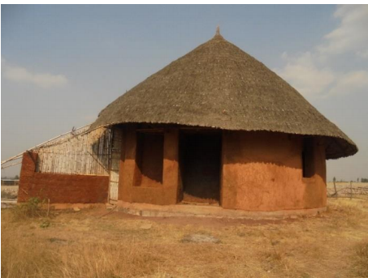

Figure 2.6 Sustainable Rural Dwelling Unit. Picture of the second unit in Gubrie 2016-02-18.
MATERIALS
Traditional house: Walls are built with wood and plastered on the interior with earth. Paint may occur but is uncommon. The roof is thatched with grass. The need for wood for traditional houses is high. The picture shows a “gojo” house under construction.
Modern house: The walls are made in the same way as for the traditional houses, but rectangular and often higher. The house front is usually painted in bright colours. The roof consists of corrugated iron sheets.
SRDU: Earth blocks from the walls and bamboo forms the outer roof and inner ceiling.
TECHNIQUES
Traditional house: Vertical wooden poles are put into the ground for the walls; sometimes the wooden elements are extended by nailing them to each other. Horizontal wood is integrated with the vertical, and the walls are plastered on the interior, and to some extent on the exterior with earth-straw mixture. Many times, the external plastering disappears with rain during rainy seasons. The roof-structure is woven in the same way as the walls, and is thatched with grass bundles.
Modern house: The walls are built with the same technique as the traditional house. Corrugated iron is bought in sheets and screwed onto the rafters. To compensate for the bad indoor climate that iron sheet roofing brings, the walls are built very tall. In the urban areas, an indoor ceiling is often used which insulates and keep the house cool during the day and warmer during the night, but this is not common in rural areas.
SRDU: The walls are made out of earth bricks according to the Adobe technique, which traditionally has not been used in the area. The roof consists of multiple layers of bamboo leaves, an alternative to the traditional thatched roof. The ceiling consists of woven bamboo, a technique that has not been used in the Guraghe zone.
The bottom of the walls (up to a half meter in height) have a surface of river stones added in the plastering, of size 10-40 mm. This will protect the Adobe blocks against rain destruction.
FOUNDATION
Traditional house: No special foundation is constructed.
Modern house: Either no special foundation is constructed, or an un-reinforced concrete foundation on stones is casted.
SRDU: The foundation is like that of the modern house with stones, and reinforcement is prepared beneath the coming walls as beam reinforcement.
FLOORS
Traditional house: Stamped earth floors. It sinks successively when cleaning it and has to be refilled. For a sleeping place, a carpet is laid out.
Modern house: The floors are covered by a thin layer of concrete, or they are stamped as in the traditional houses. Many times, the floor is covered with a plastic or a woven straw carpet.
SRDU: Concrete floors, both the bottom and the upper floor.
SPATIAL DIVISION
Traditional house: The house consists of one room, although sometimes a wall is present, from the centre pole to the outer wall, which divides the family’s sleeping place from the cows, goats and chickens on the other side. The cattle are bound to the right, the fire place is in the middle, and to the left the family sleeps at night on carpets which are laid out.
Modern house: The house is usually divided into several rooms.
SRDU: Separate dwelling areas within the house. One to two bedrooms, one kitchen, one living room, toilet and storage, all separated by walls partly or fully. The SRDU is also usually relatively larger, with its 65m of living space.
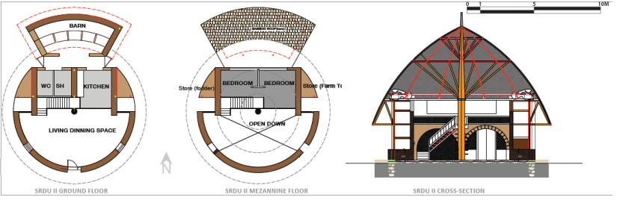
Figure 2.7 Plan and section of SRDU (the circular version). From left to right: The Bottom Floor, The Upper Floor, A Cross-Section.

CHAPTER THREE

METHODOLOGY

3.1. Location & Description of the Study Areas
Gedeo is one Zone in the Southern Nations Nationalities and People Regional State (SNNPR) of Ethiopia. Gedeo is bordered on the East, South and West by the Oromia region, and on the north by Sidama. The Zone is located in 369 km from Addis Ababa to South Addis Ababa-Moyale international road and 90 km from Hawassa (capital city of the region) in Southern Nations Nationalities and People Regional State (SNNPRS). Gedeo zone is one of the most densely populated regions in the country with an estimated population density of 617.53 people per square kilometre (Gedeo Zone Agricultural Bureau, 2010). However, regional differences within the country exist depending on several soil and climatic conditions as well as variations in their population density, with some areas having a poor population-resource balance and others having much excess capacity. For example, in the Southern Nations, Nationalities and Peoples’ Region (SNNPR), where the population density is high in most weredas, one wereda Wenago had 864 persons per square Kilometer in 1999, whereas the average population density for the country was about 56 persons per Km² (CSA, 1998a).
Wenago is one of the woreda found in Gedeo zone. This study was conducted in three kebele of Wenago Woreda (Sugale, Wotiko & Mokonisa kebeles) of Gedeo Zone, and Southern Nations, Nationalities and Peoples Regional state. Those kebele was selected based on their population size, over all land size and number of landless peoples higher than the other kebele of Wonago Wereda for the reason of densely populated kebela are more housing problem than less dense kebela. Wonago Wereda is located to the North West of the Zone and its centre of political administration is Wonago. It is bounded by Dilla Zuria Woreda in the North, and East; Yirgacheffe Wereda in the South and Oromia Regional State in the West. The wereda is geographically located 60 13’-60 26’ North latitude and 380 13’-380 24’ East longitudes. Its total area coverage is estimated to be 137Sq.km.
According to the ‘Wonago wereda’ Agricultural office, Agriculture is the base of the economy of the wereda and it provides employment for an estimated 92.2% of the population and other 9.8% was dependent on commercial and other activity.
In agricultural sector cover, 65% of their economic income obtains from coffee, 25% from ‘false banana’/ ‘enset’, 7% from breeding domestic animals and the remaining 3% obtained from other agricultural output. The zone is well known by producing high quality coffee (Yirgachefe buna) to international market. According to the ‘Wonago wereda’ Agricultural office, the ‘Woreda’ is sub- divided into 17 administrative rural ‘kebeles’ among which 13 ‘kebeles’ (81%) belongs to ‘Woina Dega’ climatic zone and the remaining 4 ‘Kebeles’ (19%) are under ‘Kola’ climatic Zone.
In general, the physical features of land forms of this ‘Wereda’ are dissected and undulating plane in which each hillside or mountain is followed by plateau and then by short or long slopping to flat lands. According to CSA (Central Statistics Authority), 2007, Summary and Statistical Report of the Population and Housing Census, Federal Democratic Republic of Ethiopia, Population Census Commission, Addis Ababa, Ethiopia, the total population of ‘Wonago’ was estimated to 147, 940 of which 70,964 are male and 76,976 are female. The total number of headed households in the 17 rural ‘kebeles’ of the ‘wereda’ was about 24,463 of which 3,981 are male headed and the rest 20,482 are female headed households. Average family size of the ‘wereda’ was five (5). In this ‘wereda’ found generally twenty-one (21) ‘kebele’, and seventeen (17) of them rural ‘kebele’ and the remaining four (4) are urban ‘kebele’. Majority of the population (91.2%) lived in rural ‘kebele’ and the remaining 9.8% the population lived in urban ‘kebele’. According to the same source, the climates of ‘Wonago Woreda’ is characterized by mean annual rainfall and temperature of 1001 mm - 1800 mm and mean monthly maximum and minimum temperature 12°C - 25°C respectively. The rainfall is bimodal and the ‘Belg’ (short rainy season) extends from March to May (60 - 90 days) accounting for 30% of the total rainfall while the main rainy season is from July to October (90 - 120 days) accounting for more than 60% of total rainfall.
Housing and Socio-Cultural Aspects
Cultural and social factors alongside geophysical characteristics, durability of building materials, climate and technology have all played a part in guiding rural, semi-urban and urban areas. The wenago Wereda culture is arguably the most prevalent across Gedio zone, with many characteristics shared by the neighbourhood Wereda and zone. The rural kebela homestead is described as a grouping of isolated rectangular and circular shelters. These independent structures perform distinct functions, typically housing the main living and sleeping space, kitchen, storage facility and animal shelter. The majority had no facility and used rivers, ponds, fields or the bushes for their sanitation needs. The periphery of the homestead is typically enclosed by vegetation, screens or walls, where possible. Privacy is a key concern despite the strong culture of hospitality and an ‘open door’.
The most respected people in the community are those who save and who effectively manage their livelihood. Management skills are highly valued. A successful farmer is one who has enough means of production, who saves from his production for the next season, and who has a locally accepted good house. A successful farmer is recognized as one who uses well what he has and not he who produces the largest amount. Saving is seen as the most important skill. Technical skill is not valued as such, what is respected is the effort made to be self-sufficient.
One can get a glimpse of Gedeo living standards from the following statistics: in 1984 the literacy rate was 33%; working age population was 44% of total population; average household income was 328 birr; only 4% of the Gedeo rural population have access to piped drinking water; only 13% of the population have access to medical facilities at nearby health clinics; and the unsanitary and crowded conditions of rural dwelling units were considered to be one of the lowest.
The source of wealth in the community is trade in agricultural products, farming, and land. The rich buy coffee and other crops to sell when the price increases. People become poor if they are not saving, if they have sold their land, or if they are not cultivating their farm properly. The richer are mostly middle-aged. Due to the population increase most of the people have a very small size of plot which is not sufficient to feed their family throughout the year and the number of landless people is increasing.
Justification for selection "Wenago wereda"
The most densely populated Wereda in Ethiopia - Wonago - with nearly a 1000 people per square kilometres, is located in SNNPR. The presence of several Weredas with densities over 500 persons per square kilometre, indicate the high level of population concentration in the region.
The crucial factor is land; they do not have enough land and are not able to sell or lease it. And also, they do not try to improve their farming methods and do not look for other opportunities. The child of a poor person can become rich if he saves and coordinates trade and farm activities. The Gedeo highly value hard work. As a result, it is possible for someone who has been poor to acquire possessions and become wealthy through hard work. On the other hand, a rich man may lose his wealth as a result of having large family to support or his wealth may be abused by his children and he may become poor as a consequence.
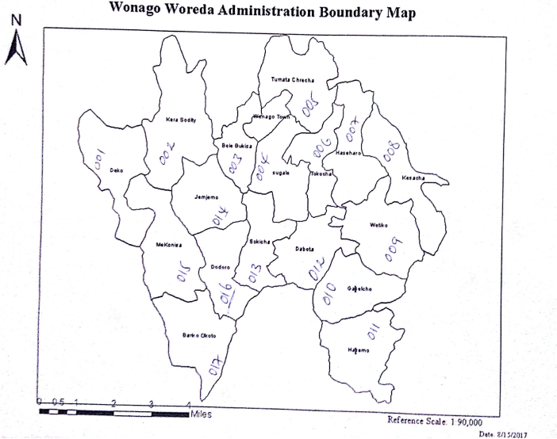Source: Wenago wereda administer office, 2017.
Map 3.1 ‘Keble’ that found in ‘Wenago wereda’
According to wereda administer office population density 1192.87 per km square and total area of the wereda is 128 km per kilometre square. Altitudes of the wereda are between 1550 up to 3000 meters.

3.2. Methods of Data Sampling Techniques and Sample size
Research Methodology is the path to find answers to a research question. It is a practical step
through which a researcher must pass in his/her research journey in order to find answers to
his/her research questions (Kumar, 2005). In rural area of ‘wenago woreda’ there is Seventeen (17) ‘kebeles’ and three (3) ‘kebeles’ (Sugale, Wotiko, and Mekonisa kebeles) of them purposely selected on the basis of similar economic status, overall size of the ‘kebele’, infrastructure system and population size and the degree of being affected by landlessness. Sixty (60) sample household unit respondents was selected from three (3) ‘kebeles’ using a systematic sampling method (using the formula: nth term = N/n). Since the numbers of farmers in each ‘kebeles’ different, sample was selected proportional to size to ensure representativeness of the sample.

Table 3.1 Distribution of sampled households by ‘Wenago wereda’ in rural ‘kebela’ (n=60)
Rural Kebela |  | Population size | No. landless people | ‘Kebele’ Land size | Selected ‘kebela’ for sampling
No. | Name of ‘kebele’
1. | Deko | 5570 | 30
2. | Karasoditi | 7596 | 37
3. | Bebala buqisa | 3929 | 25
4. | Sugale | 11587 | 59 |  | Selected for data collection
5. | Tumata chirecha | 6009 | 27
6. | Tokicha | 5292 | 27 | 520ha
7. | Hassa haro | 9750 | 39
8. | Kalecha | 9779 | 51 | 800 ha | Selected as reserve
9. | Wotiko | 11364 | 60 |  | Selected for data collection
10. | Gelelcho | 8190 | 34
11. | Halimo | 6364 | 26
12. | Dobota | 9371 | 38
13. | Sokicha | 7791 | 32 | 800ha
14. | Jemijemo | 9402 | 47 | 800ha
15. | Mokonisa | 13791 | 75 | 960ha | Selected for data collection
16. | Dodoro | 7900 | 38 | 800ha
17. | Banko akoto | 9258 | 45 | 960ha
Source: based on ‘Wenago wereda’ administrative office, ‘Wenago wereda’ agricultural office and ‘Wenago wereda’ health office

3.2.1. SAMPLING FRAME AND UNITS
The frames that were used to limit the number of samples that are taken under consideration were as follows.
1. The housing to be assessed are to be within the selected three rural kebela
2. Housing with high land value following access
3. Housing that are used for residential purpose for farmer
This framing technique helps to limit not only the number of housing that are within the selected rural kebela but also facilitates us to focus and centralize our attention on the objective the paper plans to accomplish.

3.2.2. SAMPLE SIZE AND SAMPLING TECHNIQUES
Purposive random sampling was used to select different buildings with different types. These sampling techniques were selected based on: (i) the experience gained during the selection of the study area (ii) the purpose of the study and also (iii) for the need to reach the targeted issues and I have chosen 60 households’ unit which qualify the criteria and can represent the other housing typologies.

3.3. Sources and Methods of Data Collection
Data were collected by both primary and secondary methods. The primary data were collected for this study by use field observation (to characterize and understand the housing condition and environmental features such as topography, climatic condition, available building material resource and construction practices, land uses type, infrastructure, etc…), questionnaire (structured and unstructured questionnaires was use for ‘woreda’ housing experts, traditional construction workers, finance and economy experts to collect information about the general population characteristics of the study areas, existing types of Housing and infrastructure practices), and also literature survey on the familiarisation of alternative construction methods and how the different construction methods could be applied to the development and delivery of low-cost housing was conduct among quantity surveying method and certified lab test result report. Focus group discussions with construction technology experts, professional engineers and community leaders were employing to collect data which need high elaboration and which cannot be collect by using questionnaire). Face-to-face interviews with those respondents was employed to collect household characteristics, architectural space characteristics, detailed plot level data, types construction practices and available construction material, perceptions on the problem of housing, knowledge and attitude of farmers towards adopt cost-effective construction technology and determinant factors affecting farmers’ decision to adopt alternative construction technology of housing. The secondary data were collected from related research results, books, and journals.

3.3.1. TYPES OF DATA & MATERIALS
The types of data and materials used in this research helped in figuring out what the major problems of the study area are and also in filtering the causes in hierarchical value.
PRIMARY DATA - These include the Problem, Interest and the Attitude of the residents toward their living and housing conditions which includes spatial character, construction material and method, housing related experienced problem, and living comfort.
SECONDARY DATA - These include written literature in the fields of alternative construction technology, concept and quality of housing and other collateral data that were of great help to the research.

3.3.2. DATA SOURCES AND COLLECTION TECHNIQUES
The research relied on the data collected from Related Literature Reviews, site visits and observations, sample survey. Since the concept of alternative construction technology is relatively new to our country, it was necessary to rely upon internet search on legitimate web sites.

3.3.2.1. PRIMERY DATA SOURCE AND COLLECTION TECHNIQUES
Personal observation and experiences; household occupiers and owners, the residents in the study area, concerned government officials and professionals were the main sources of the primary data. The following data collection methods were used to collect these primary data:
PHYSICAL OBSERVATION METHOD
Own direct observation is used through taking photographs of the study site aided with field notes.
CONTACT METHOD
Interview was used for gathering descriptive information from household occupiers and owners. An individual interview is a conversation between two people that has a structure and a purpose. It is designed to elicit the interviewee’s knowledge or perspective on a topic.
Individual interviews, which can include key informant interviews, are useful for exploring an individual’s beliefs, values, understandings, feelings, experiences and perspectives of an issue. Individual interviews also allow the researcher to ask into a complex issue, learning more about the contextual factors that govern individual experiences.
FOCUS GROUP DISCUSSIONS
Focus group discussions provide participants with a space to discuss a particular topic, in a context where people are allowed to agree or disagree with each other. Focus group discussions allow you to explore how a group thinks about an issue, the range of opinions and ideas, and the inconsistencies and variations that exist in a particular community in terms of beliefs and their experiences and practices.
SURVEY METHOD
Both direct and indirect approach questions were used with the aid of Structured Surveys (using predefined lists of questions in which all respondents were asked in the same way) and Unstructured Surveys (by probing the respondents and guide the interview according to their answers).

3.3.2.2. SECONDARY DATA SOURCE AND COLLECTION TECHNIQUES
The main sources used to collect the secondary data were both hard and Softcopies which include: Published books and journals; unpublished norms and standards, reports, brochures from internet, libraries and office stacks; The secondary data were collected through reading and note taking; scanning and photocopying books, journals, reports and maps; browsing and extracting through trusted websites.

3.4. Research Design
A concurrent mixed method research design was employed because both qualitative and quantitative types of data were collected at the same time during one data collection phase and have equal priority. Both quantitative and qualitative method was mainly used to get insight into details (which) to adopt or propose contextually appropriate construction technology for the rural farmer housing. The Mixed types of quantitative and qualitative approaches were used under the two structures of inquiry modes:
Structured approach: The first inquiry mode used was the structured approach in which everything that forms the research process, objectives, design, sample, and the questions planned to ask the respondents was predetermined. This approach was applied to determine the extent of a problem, issue or phenomenon by quantifying the variation.
Unstructured approach: This approach allows flexibility in all aspects of the research process. It was selected to more appropriately explore the nature of a problem, issue or phenomenon without quantifying it. The main objective was to describe the variation in a phenomenon, situation or attitude which included the description of an observed situation, an account of different opinions of different people towards an issue.

Figure 3.1 Diagram illustrating the Research design

3.5. Data Analysis and Interpretation Techniques
In this study two prominent methods: qualitative research data analysis and quantitative research data analysis used. In each method used its own data collection techniques, apply interviews and observation as forms of qualitative data, while experiments and surveys as quantitative data.
This study follows a qualitative data analysis approach was exploratory and seeks to explain ‘how’ and ‘why’ a particular phenomenon, or program, operates as it does in a particular context. As such in the study, qualitative research investigates i) local knowledge and understanding of housing condition; ii) people’s experiences, meanings and relationships and iii) social activity and contextual factors (e.g., social interaction and cultural practices) that marginalize impact a housing. Qualitative data was non-numerical, covering images, videos, text, sketch and spoken words. Qualitative data was gathered through individual interviews, detail observation and focus group discussions using semi structured or unstructured topic guides.
In quantitative data analysis collected all the data together in a spread sheet; however, need to analyses and summarizes the data to answer the research questions. Need to understand what percentage of activity or problems are involved in different question types. Statistics help turn quantitative data into useful information to help with decision making. This study used statistics to summarize collected data, describing patterns, relationships and connections. Statistics can be descriptive or inferential. Descriptive statistics help to summarize the data.
Software such as Microsoft office Word, Microsoft office Excel was used to write texts, create tables and graphs. This software is also used to analyse and present the surveyed data from questionnaires and interviews.
Percentages are calculated by multiplying the proportion by 100. Proportions and percentages can be easier to understand and interpret than examining raw frequency data and are often added into a frequency table.

3.5.1. PRESENTATION TECHNIQUES
Illustrations that were easily understood and could be translated were used to present the analysed data, results and proposals. Tables, maps, contextual photography are self-explanatory and used in such a way that they could explain a certain relationship among issues.

3.5.2. OUTPUTS AND REPORTS
This research paper contains remedial solutions for possible problems that revealed through the research process. The solutions are design modifications which are shown by illustrating the existing housing supporting with tables and photographs. This paper will be reported in both hardcopy and Soft copy for Addis Ababa University, Ethiopian institute of Architecture, Building Construction and City Development (EiABC) and EiABC Post Graduate Program Office.

CHAPTER FOUR

RESULTS/FINDINGS AND ANALYSIS

4.1. Background Characteristics of Respondents
This session consists of the overall finding of the study under physical housing characteristics in terms of construction material and method, spatial arrangement of the house (functionality), and socio-economic profile of the population. The study was conducted on sixty (60) sample household units selected from three (3) representative rural ‘kebela’. Those ‘kebela’ were selected from nineteen (19) rural kebela of wenago wereda use some criteria; these are the population size (number of family head), landless people and size of overall land size.
Demographic, socio-economic, physical and psychological factors of the households are directly or indirectly related to characteristics their housing and life style. Therefore, the demographic and socio-economic of sample respondent in the study areas are presented and discussed briefly in this section as follows:
Table 4.1 Percentage distribution of respondent of household units by selected demographic characteristics, in ‘Wenago wereda’ in three ‘kebele’, (n=60)
Household Size | Number of Household | Percentage (%) of Household
1 up to 3 | 2 | 3.34
4 up to 6 | 29 | 48.33
≥7 | 29 | 48.33
Total | 60.00 | 100
Gender of Household Member | No. of Member | Percentage (%) of Member
Female | 194.00 | 51.19
Male | 185.00 | 48.81
Total | 379.00 | 100.00
Age of household Member | No. of Member | Percentage (%) of Member
0-9 Years | 116.00 | 31.18
10-15 Years | 94.00 | 23.33
16-19 Years | 45.00 | 13.00
20-44 Years | 107.00 | 28.76
45-64 Years | 17.00 | 4.54
> 64 Years | - | -
Total | 379.00 | 100.00
Household member in the age group 15-64 | No. of Working Group Member | Percentage (%) of Working Group Member
1 up to 3 | 114.00 | 64.41
4 up to 6 | 58.00 | 32.77
>7 | 5 | 2.82
Total | 177.00 | 100.00
Source: Computed from surveyed data, 2018.
According to table 4.1, the percentage distribution of household size for family member that ranges from equal or greater than 7 and from 4 up to 6 are equal and accounts 48.33 % based on the collected data. The remaining 3.43 % household size were family member contain 1 up to 3 family members. A large family size is more than from small family size. This have impact on the standard of living and also affect their economic status.
The study conducted based on 60 sample household units selected from seventeen rural ‘kabele’ three of them in ‘Wenago Wereda’, of which 194 (51.19%) were female and the remaining 185 (48.81%) were male. Based on the above table 4.1, the percentage distribution of stay in the study area levelled that, 31.18% of the household member lived in for 0-9 years, 23.39% lived 10-15 years, 13.0% of households member lived 16-19 years, 28.76% of households member 20-44 years and the remaining 4.57% lived for longer period compare to other (45-64 years). In the study area there is no any member more than 64 years lived. The household member in the age group between 15 and 64, described as working group had distribute in each sampled household units 1 up to 3 members had 64.41%, 4 up to 6 member 32.77% and the remaining 2.82% had 7 and above member. Age of the household member less than 15 is more in number, this have a role in their living standard became poor condition.
Table 4.2 Percentage distribution of respondents by selected socio-economic characteristics, in ‘Wenago Wereda’ in three ‘kebele’, (based on 60 sample household units, n=60)
Educational status of Household Member | Number of Population | Percentage (%) of Member
Primary First Cycle (1-4 grade) | 74.00 | 51.03
Primary Second Cycle (5-8 grade) | 58.00 | 40.00
Secondary First Cycle (9-19 grade) | 11.00 | 7.59
Secondary Second Cycle (11-12 grade) | - | -
College Certificate | - | -
College Diploma | 2.00 | 1.38
College Degree | - | -
Other | - | -
Total | 145.00 | 100.00
No. of Employee member in the Household | Number of Population | Percentage (%) of Member
1 | 15.00 | 23.81
2 | 34.00 | 53.97
3 | 12.00 | 19.05
> 4 | 2.00 | 3.17
Total | 63.00 | 100.00
No. of dependent members in the Household | Number of Population | Percentage (%) of Member
1 up to 3 | 23.00 | 39.65
4 up to 6 | 31.00 | 53.45
> 7 | 4.00 | 6.90
Total | 58.00 | 100.00
Source: Computed from surveyed data, 2018.
Regarding educational status of household members (Table 4.2) presented 51.03% had joined Primary first cycle (1-4 grade). However, 40, 7.59 and 1.38% had joined primary second cycle (5-8 grade), secondary first cycle (9-10 grade), and college diploma holders respectively.
Percentage distribution of employee member in the household unit 23.81% had one member, 53.97% had two members, and 19.05% had three members. The remaining 3.17% had 4 and more employee member in the household units. In the other side household dependency was also surveyed and the result shows that 39.65% had 1 up to 3 members and 53.45% had 4 up to 6 members, whereas 6.90% of households during the survey had 7 and more dependent members. Educational status of the society is not high, rather dependent member is high in number. This also create a problem on their economic growth and way of living.
Table 4.3 Percentage distribution of respondents by selected work and income characteristics, in ‘Wenago Wereda’ in three ‘kebele’ (based on 60 sample household units, n=60)
Type of Work | Number of Worker | Percentage (%) of Worker
Commercial Activity | - | -
Farming | 60.00 | 92.31
Governmental Work | 5.00 | 7.69
Non-governmental Work | - | -
Other | - | -
Total | 65.00 | 100.00
Working area/ Distance of Working area
In your house | - | -
Near to your house | 55.00 | 85.94
Other " Kebele" | 8.00 | 12.50
In the " Wereda" | 1.00 | 1.56
Outside from the " Wereda" | - | -
Other | - | -
Total | 64.00 | 100.00
Average income of the household
500 - 1000 birr | 40.00 | 68.97
1001 - 2500 birr | 18.00 | 31.03
2501 - 3500 birr | - | -
3501 - 5000 birr | - | -
More than 5000 birrs | - | -
Total | 58.00 | 100.00
Source: Computed from surveyed data, 2018.

Regarding of type of employment based on the above table (Table 4.3) most of the household member experienced on farming that was 92.31% of the respondent. And the remaining 7.69% of the household employed on governmental work. The distance between working to their household units was summarized as near to the household 85.94%. The remaining 12.5, 1.56% was worked in other ‘kebele’ and in the ‘Wereda’ respectively.
The mean income of sampled respondents was 68.97% earn between 500-1000 birr, and 31.03% earn between 1001-2500 birr. As obstacle there was a problem to get exact income value information from the respondent. Formal and informal employment was the main source of income.

4.2. Physical Characteristics of Housing (Requirements of Housings)
A housing, once it has been built, must fulfil certain criteria. These may be considered as being: performance requirements, user requirements, functional requirements and statutory requirements. (Watt, 1999)

4.2.1. Performance Requirements
The way in which it meets these demands, both as housing and as a collection of related and interrelated parts, may be determined by how it performs in relation to a number of defined performance measures or standards. The performance requirements of a building and its various elements may be considered under the following: -
- Appearance
Appearance means the looking of buildings or houses; context and characteristics of buildings or houses. In this research study to indicate the appearance of the performance requirements of the ‘Wonago Wereda’, the researcher used the field observed data and questioners collected for analysing. According to the field observation and collected questioners data, from the total sample household 58.33% are huts and the rest 41.67% are rectangular house, and from those, 31.67% are huts its roof constructed from bamboo and covered with grass and the rest 26.67% are covered with false banana ‘Ensete’ outer leaf sheath. Out of the 31.67% huts its roof constructed from bamboo and covered with grass, 10% huts have eucalyptus wood wall covered with mud, 15% huts wall covered with waved bamboo ‘Satera’ and plastic sheets and 6.67% huts wall covered with false banana ‘Ensete’ outer leaf sheath, old clothes and some part uncovered. Likewise, out of 26.67% huts its roof constructed from bamboo and covered with false banana ‘Ensete’ outer leaf sheath, 8.33% huts have eucalyptus wood wall covered with mud, 11.67% huts wall covered with waved bamboo ‘Satera’ and plastic sheets and 6.67% huts wall most part covered with false banana ‘Ensete’ outer leaf sheath, old clothes and some part uncovered as shown below in figure 4.1.A.
Table 4.4 Shows out of the total houses, 41.67% are rectangular houses, 16.67% of houses roof constructed from eucalyptus wood rafter and purlin covered with corrugated iron sheet and the rest 25% houses roof constructed from the same materials but covered with waved bamboo ‘Satera’ and plastic sheets. And out of the 16.67% house roof constructed from eucalyptus wood rafter and purlin covered with corrugated iron sheet, 8.33% huts eucalyptus wood wall covered with mud, 5% huts wall covered with waved bamboo ‘Satera’ and plastic sheets and 3.33% huts wall covered with false banana ‘Ensete’ outer leaf sheath, old clothes and some part un covered. In same way out of 25% huts roof constructed from eucalyptus wood rafter and purlin covered with waved bamboo ‘Satera’ and plastic sheets, 8.33% huts eucalyptus wood wall covered with mud, 11.67% huts wall covered with waved bamboo ‘Satera’ and plastic sheets and 5% huts wall most part covered with false banana ‘Ensete’ outer leaf sheath, old clothes and some part uncovered, as shown below in figure 4.1.B.
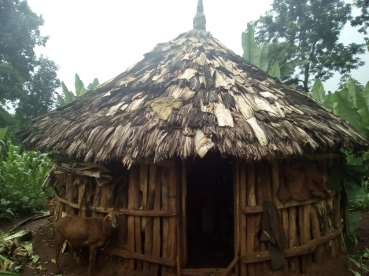
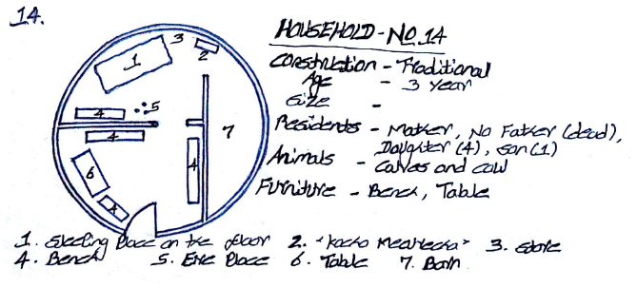
Figure 4.1.A Appearance of Huts

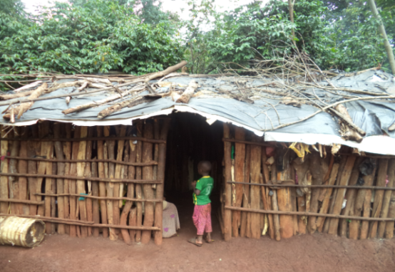
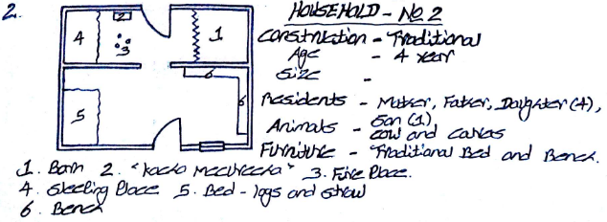
Figure 4.1.B Appearance of Rectangular House

Table 4.4 Appearance of the house in ‘Wonago Wereda’, 2018
Appearance, Performance Requirements | Number of Household | Percentage (%)
A. Huts its roof constructed from bamboo and covered with grass (Circular Huts /Home/) | 19.00 | 31.67
Eucalyptus wood wall covered with mud | 6.00 | 9.99
Eucalyptus wood wall covered with waved bamboo ‘Satera’ and plastic sheets. | 9.00 | 15.00
Eucalyptus wood wall most part covered with false banana ‘Ensete’ outer leaf sheath, old clothes and some part un covered | 4.00 | 6.67
B. Huts its roof constructed from bamboo and covered with false banana ‘Ensete’ outer leaf sheath. | 16.00 | 26.67
Eucalyptus wood wall covered with mud | 5.00 | 8.33
Eucalyptus wood wall covered with waved bamboo ‘Satera’ and plastic sheets. | 7.00 | 11.67
Eucalyptus wood wall most part covered with false banana ‘Ensete’ outer leaf sheath, old clothes and some part un covered | 4.00 | 6.67
Sub Total (A + B) | 35 | 58.34
C. Rectangular house its roof constructed from Eucalyptus wood rafter and purlin covered with corrugated iron sheet. | 10.00 | 16.67
Eucalyptus wood wall covered with mud | 5.00 | 8.33
Eucalyptus wood wall covered with waved bamboo ‘Satera’ and plastic sheets. | 3.00 | 5.00
Eucalyptus wood wall most part covered with false banana ‘Ensete’ outer leaf sheath, old clothes and some part un covered | 2.00 | 3.33
D. Rectangular house its roof constructed from Eucalyptus wood rafter and purlin covered with plastic sheet. | 15.00 | 25.00
Eucalyptus wood wall covered with mud | 5.00 | 8.33
Eucalyptus wood wall covered with waved bamboo ‘Satera’ and plastic sheets. | 7.00 | 11.67
Eucalyptus wood wall most part covered with false banana ‘Ensete’ outer leaf sheath, old clothes and some part un covered | 3.00 | 5.00
Sub Total (A + B) | 25 | 41.67
Total (A + B + C +D) | 60.00 | 100.00
Source: Computed from surveyed data, 2018.
- Access and Egress: - As shown on Table 4.4 and table 4.5, out of the total sample household in huts 26.67% have only one door, 13.33% have one window and door, 11.67% have two windows and one door, 6.67% have two windows and two doors for entry and exit or access to dwellers. With regard to the rectangular houses, 5.34% have only one door, 8.33% have one window and door, 15% have two windows and one door, 13% have two windows and two doors for entry and exit or access to dwellers.
Table 4.5 Access and Egress of the house in ‘Wonago Wereda’, 2018
Wind, Performance requirements | Number of Household | Percentage (%)
A. Huts (Circular House /Home/) | 35.00 | 58.33
With only one door | 16.00 | 26.67
With one window and one door | 8.00 | 13.33
With two windows and one door | 7.00 | 11.67
With two windows and two doors | 4.00 | 6.67
B. Rectangular house | 25.00 | 41.67
With only one door | 3.00 | 5.34
With one window and one door | 5.00 | 8.33
With two windows and one door | 9.00 | 15.00
With two windows and two doors | 8.00 | 13.00
Total | 60.00 | 100.00
Source: Computed from surveyed data, 2018.
- Durability: - A building is a sum of the parts; such parts can be replaced and hence renewed, leaving the basic structure to determine overall life expectancy. Other literature on service life discusses the effect of external and internal actions on building durability, and principally identifies location, usage and design as the main parameters. Longstone, (2011) developed on excel calculation template, a series of question gives insight into the longevity of a building according to three primary criteria: environmental context (location), occupational profile (usage) and structural integrity (design). Evaluate its robustness through subsequent different properties lab test report of the material and detail observation of construction method and material used.
Durability: - It means the quality of component materials, physical life of component materials; techniques of construction. Table 4.4 (page No. 45) shows the house durability that is related to house performance requirements. Out of the 58.33% huts, 18.33% have eucalyptus wood wall covered with mud, 26.67% wall covered with waved bamboo ‘Satera’ and plastic sheets and 13.33% wall covered with false banana ‘Ensete’ outer leaf sheath, old clothes and some part uncovered having different age ranges. Huts having age less than one year are about 10%, one to ten years accounts 30% and greater than ten years are only 1.67%, as shown below in table 4.6.A.
Based on table 4.6.B, out of 41.67% rectangular houses, 16.67% have eucalyptus wood wall covered with mud, 16.67% eucalyptus wood wall covered with waved bamboo “Satera” and plastic sheets and 8.33% eucalyptus wood wall covered with false banana “Ensete” outer leaf sheath, old clothes and some part uncovered and having different age that ranges between less than one year account 8.33%, one to ten years about 30% and greater than ten years accounts only 3.33%. From table 4.6.B, the rectangular houses with roof covered by corrugated iron sheet and plastic sheet are 16.67% and 25% respectively. And circular huts with roof covered by grass & false banana outer sheath accounts 31.67% and 26.67% respectively, the sample figures 4.2 (a, b, c) are shown below with the three age ranges; less than one year, between one to ten years and greater than ten years respectively.
Durability | Number of  House | Percentage  (%)
A. Huts its roof constructed from bamboo and covered with grass and false banana ‘Ensete’ outer leaf sheath. (Circular House /Home/) | 35.00 | 58.33
Eucalyptus wood wall covered with mud | 11.00 | 18.33
Less than one year | 1.00 | 1.67
From one up to ten years | 9.00 | 15.00
Greater than ten years | 1.0 | 1.67
Eucalyptus wood wall covered with waved bamboo ‘Satera’ and plastic sheets. | 16.00 | 26.67
Less than one year | 3.00 | 5.00
From one up to ten years | 13.00 | 5.00
Greater than ten years | 0.00 | 0.00
Eucalyptus wood wall most part covered with false banana ‘Ensete’ outer leaf sheath, old clothes and some part uncovered | 8.00 | 13.33
Less than one year | 2.00 | 3.33
From one up to ten years | 6.00 | 10.00
Greater than ten years | 0.00 | 0.00
Table 4.6.A, Durability of the house in ‘Wonago Wereda’, 2018
Source: Computed from surveyed data, 2018.

Table 4.6.B, Durability of the house in ‘Wonago Wereda’, 2018
Durability | Number of Houses | Percentage (%)
B. Rectangular house its roof constructed from Eucalyptus wood rafter and purlin covered with corrugated iron sheet and plastic sheet. | 25.00 | 41.67
Eucalyptus wood wall covered with mud | 10.00 | 16.67
Less than one year | 1.00 | 1.67
From one up to ten years | 7.00 | 11.67
Greater than ten years | 2.00 | 3.33
Eucalyptus wood wall covered with waved bamboo ‘Satera’ and plastic sheets. | 10.00 | 16.67
Less than one year | 2.00 | 3.33
From one up to ten years | 8.00 | 13.33
Greater than ten years | 0.00 | 0.00
Eucalyptus wood wall most part covered with false banana ‘Ensete’ outer leaf sheath, old clothes and some part un covered | 5.00 | 8.33
Less than one year | 2.00 | 3.33
From one up to ten years | 3.00 | 5.00
Greater than ten years | 0.00 | 0.00
Source: Computed from surveyed data, 2018.
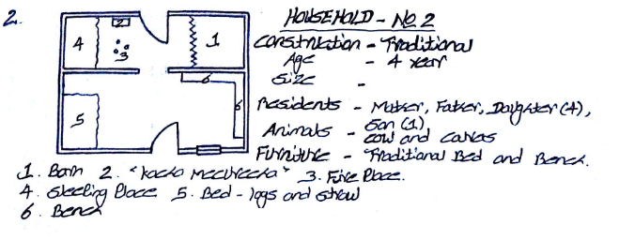
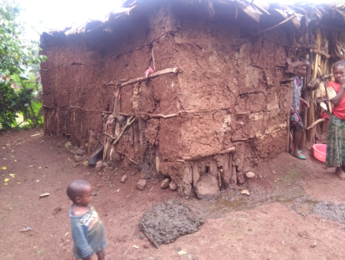
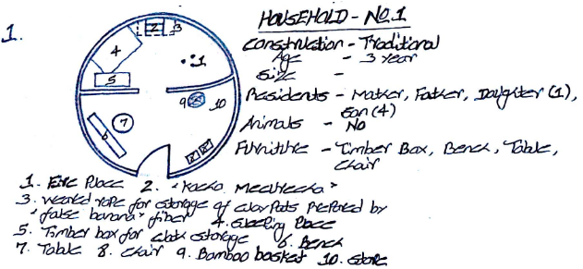
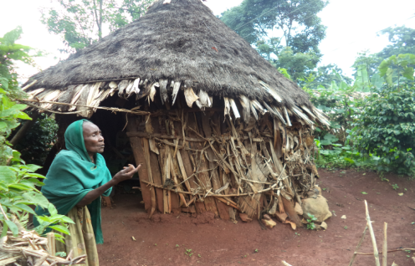
Figure 4.2 Durability of the Houses
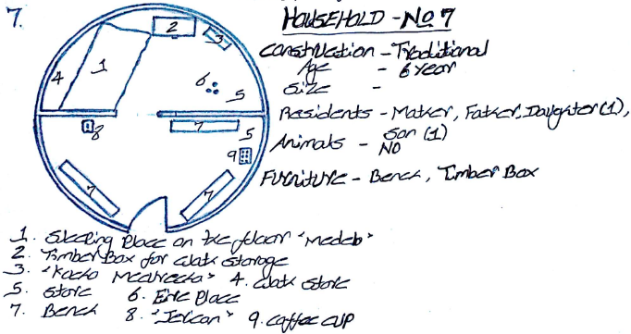
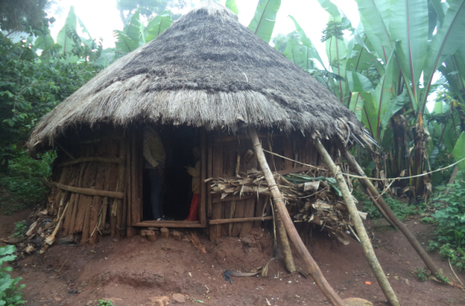
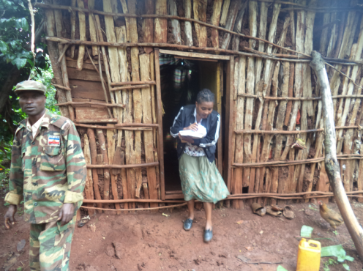
- Dimensional Stability: - It represents shrinkage and cracking. The degree to which a material maintains its original dimensions when subjected to changes in temperature and humidity (htt://en.wiktionary.org/wiki/dimensional_stability).
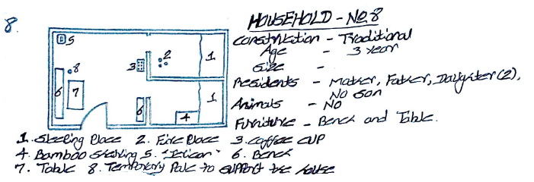
Figure 4.3 Building Material Character from Dimensional Stability perspective
According to table 4.4 (page No. 45) and table 4.6A (page No. 47), From those 58.33% huts, 18.33% have eucalyptus wood wall covered with mud, 26.67% wall covered with waved bamboo ‘Satera’ and plastic sheets and 13.33% wall covered with false banana ‘Ensete' outer leaf sheath, old clothes and some part uncovered and having different physical changes. Huts having physical change in components of material constructed or Shrinkage in components of material huts constructed (the components material lost their original dimensions) are 35% and that of not Shrinkage holds 23.33%, and below figure 4.4 shows sample huts for Shrinkage in components of constructed building material.
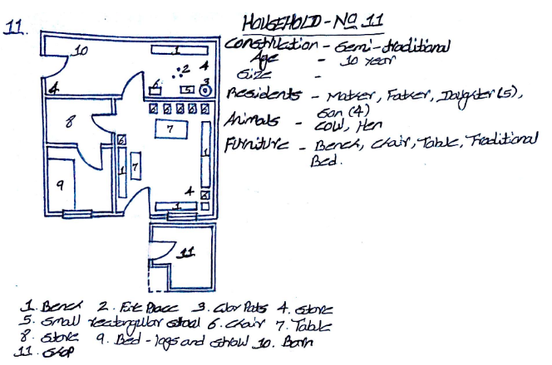
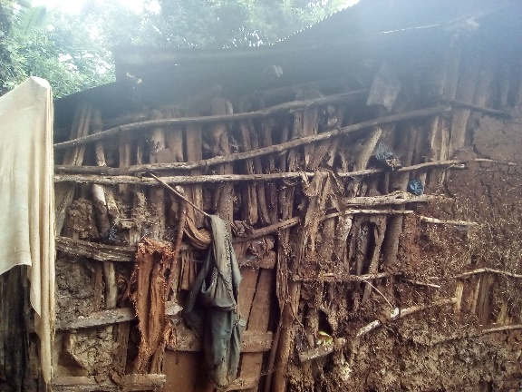
Based on table 4.4 (page No. 45) and table 4.6.B (page No. 48), shows out of the 41.67%, rectangular houses with eucalyptus wood wall covered mud are 16.67%, wall covered by waved bamboo ‘Satera’ and plastic sheets accounts 16.67 % and wall covered with false banana ‘Ensete’ outer leaf sheath, old clothes and some part uncovered are 8.33% and having different physical changes. Rectangular houses having physical change in components of constructed material or Shrinkage in components of material rectangular houses constructed are 33.33% and not Shrinkage holds 8.33%, and below figure 4.4 (a, b,) shows sample rectangular houses for Shrinkage and not Shrinkage components of constructed material respectively.

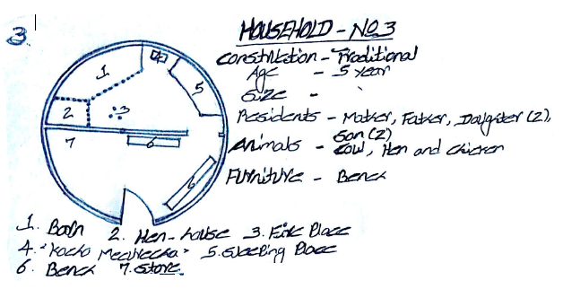
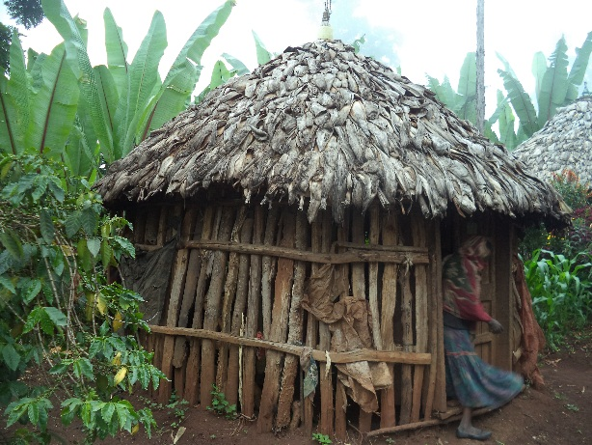
Figure 4.4 Shrinkage of building material in building component
Table 4.7.A, Durability of the house in ‘Wonago Wereda’, 2018
Durability | Number of Houses | Percentage (%)
A. Huts its roof constructed from bamboo and covered with grass and false banana ‘Ensete’ outer leaf sheath. (Circular House) | 35.00 | 58.33
Eucalyptus wood wall covered with mud | 11.00 | 18.33
Not Shrinkage and cracked | 5.00 | 8.33
Shrinkage and cracked | 6.00 | 10.00
Eucalyptus wood wall covered with waved bamboo ‘Satera’ and plastic sheets. | 16.00 | 26.67
Not Shrinkage | 8.00 | 13.33
Shrinkage | 8.00 | 13.33
Eucalyptus wood wall most part covered with false banana ‘Ensete’ outer leaf sheath, old clothes and some part un covered | 8.00 | 13.33
Not Shrinkage | 1.00 | 1.67
Shrinkage | 7.00 | 11.67
Source: Computed from surveyed data, 2018.
Table 4.7.B, Durability of the house in ‘Wonago Wereda’, 2018
Durability | Number of Houses | Percentage (%)
B. Rectangular house | 25.00 | 41.67
Eucalyptus wood wall covered with mud | 10.00 | 16.67
Not Shrinkage and cracked | 3.00 | 5.00
Shrinkage and cracked | 7.00 | 11.67
Eucalyptus wood wall covered with waved bamboo ‘Satera’ and plastic sheets | 10.00 | 16.67
Not Shrinkage | 2.00 | 3.33
Shrinkage | 8.00 | 13.33
Eucalyptus wood wall most part covered with false banana ‘Ensete’ outer leaf sheath, old clothes and some part un covered | 5.00 | 8.33
Not Shrinkage | 0.00 | 0.00
Shrinkage | 5.00 | 8.33
Source: Computed from surveyed data, 2018.
- Strength and Stability: - Ability and resistance of material, rigidity of joints; Strength: the capacity of the individual elements, which together make up a structural system, to withstand the loads that are applied to them.

Stability: - the capability of a structural system to transmit various loading safely to the ground. (web.mit.edu/4.441/1_lectures/1_lecture1/1_lecture1.html – Architectonics –the science of architecture). With regard to the strength and stability of the house, from table 4.4 (page No. 45), from the 58.33% of circular huts or houses, 18.33% have eucalyptus wood wall covered with mud, 26.67% wall covered with waved bamboo ‘Satera’ and plastic sheets and 13.33% wall covered with false banana ‘Ensete’ outer leaf sheath, old clothes and some part uncovered. According to table 4.4 (page No. 45), out of the total houses 41.67% are rectangular houses, from those rectangular houses, eucalyptus wood wall covered with mud are 16.67%, wall covered by waved bamboo ‘Satera’ and plastic sheets accounts 16.67% and wall covered with false banana ‘Ensete’ outer leaf sheath, old clothes and some part uncovered are 8.33%, as shown below in figure 4.5.

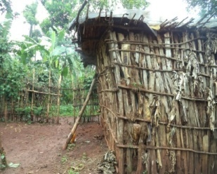
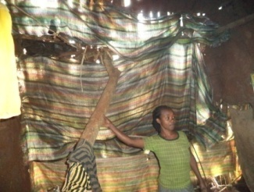
Example of wall covering: the right wall covered by sack (materials holding grains) and the left enclosed by wood with false banana ‘Ensete’ outer leaf sheath
Figure 4.5 Wall type and Covering method
- Weather Exclusion: - It means the concern of temperature, Precipitation and wind. The primary purpose of most houses and other buildings is to shelter their occupants and contents from inclement weather. Keeping warm and dry are probably the primary aims in constructing most buildings the roof and walls should keep rain (even wind-driven rain) from entering the enclosed space. They should also be reasonably resistant to heat transfer.
Temperature and Thermal Comfort
The resistance of the walls of a building to heat transfer and the capacity of the heating system will depend to a large extent on the temperature difference that must be maintained between the inside and outside of the building. According to table 4.4 (page No. 45) out of the total houses, 58.33% of circular houses or huts and the rest 41.67% are rectangular house. From those circular huts, 40% have cold weather and low temperature as compared to the house that have proper wall coverage with mud mortar, because the eucalyptus wood wall are not covered properly to keep the inside at normal room temperature, and the 18.33% have moderate room temperature as compared to the house that have proper wall coverage with mud mortar ,because the eucalyptus wood wall are covered with mud to keep the inside at normal room temperature, as shown below in figure 4.6. And out of the observed rectangular house 25% have cold weather and low temperature because the eucalyptus wood wall are not covered properly to keep the inside at normal room temperature and 16.67% have moderate room temperature since the eucalyptus wood wall are covered with mud to keep the inside at normal room temperature.

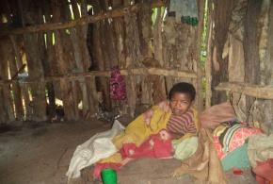
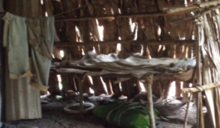
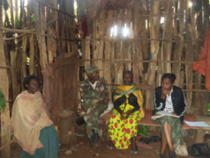
Precipitation
Figure 4.6 Temperature & thermal comfort vs way of house construction
Precipitation affects the design of housings in several different ways. One of the primary requirements for any housing is that it should keep the interior space dry. All roofs and walls must therefore shed rainwater and design requirements are the same everywhere in this respect. Walls that fail to keep moisture out under severe conditions of wind driven rain may still be considered satisfactory in areas where these conditions are rare. The rainwater collected by a sloping roof is concentrated along a line under the eaves. The capacity of the drainage system should depend on the maximum rainfall rate.
According to table 4.4 and table 4.8, from those huts, 31.67% roof constructed from bamboo and covered with grass and the rest 26.67% a roof constructed from bamboo and covered with false banana ‘Ensete’ outer leaf sheath. And out of the total observed huts 20% have moist some part of interior space during a rain shower because various part of the roof covered materials (grass or false banana outer leaf sheath) are too aged or not covered properly to shed the rain shower, so that the roof don’t satisfying the basic function of protection the home owners or the residents from rain adequately and about 40% of hut’s eucalyptus wood wall not covered with mud to keep the interior space dry by shading the rain water, and 38.33% of circular huts have dry interior space during a rain shower because the roof covered materials (grass or false banana outer leaf sheath) are not aged or covered properly to shed the rain shower, so that the roof satisfying the basic function of protection the home owners or the residents from rain adequately and about 18.33% of hut’s eucalyptus wood wall are covered with mud to keep the interior space dry by shading the rain water.
Based on table 4.4 (page No.45) and table 4.8 (page No.55), out of the observed rectangular houses 13.33% have some part of moist interior space during a rain shower because some part of the roof covered materials (corrugated iron sheet or plastic sheets) are too aged or not covered properly to shed the rain shower, so that the roof don’t satisfying the basic function of protection the home owners or the residents from rain adequately and also about 25% of rectangular house’s eucalyptus wood wall not covered with mud to keep the interior space dry by shading the rain water, and 28.33% rectangular houses have dry interior space during a rain shower because the roof covered materials (corrugated iron sheet or plastic sheets) are not aged or covered properly to shed the rain shower, so that the roof satisfying the basic function of protection the home owners or the residents from rain adequately and also about 16.67% of rectangular house’s eucalyptus wood wall are covered with mud to keep the interior space dry by shading the rain water.
Table 4.8, Precipitation of the house in ‘Wonago Wereda’, 2018
Precipitation | Number of Houses | Percentage (%)
A. Huts its roof constructed from bamboo and covered with grass (circular hut with thatched roof) | 19.00 | 31.67
Roof that satisfying the basic functional requirements | 12.00 | 20.00
Roof that don’t satisfying the basic functional requirements | 7.00 | 11.67
B. Huts its roof constructed from bamboo and covered with false banana ‘Ensete’ outer leaf sheath. | 16.00 | 26.67
Roof that satisfying the basic functional requirements | 11.00 | 18.33
Roof that don’t satisfying the basic functional requirements | 5.00 | 8.33
C. Rectangular house its roof constructed from Eucalyptus wood rafter and purlin covered with corrugated iron sheet. | 10.00 | 16.67
Roof that satisfying the basic functional requirements | 8.00 | 13.33
Roof that don’t satisfying the basic functional requirements | 2.00 | 3.33
D. Rectangular house its roof constructed from Eucalyptus wood rafter and purlin covered with plastic sheet. | 15.00 | 25.00
Roof that satisfying the basic functional requirements | 9.00 | 15.00
Roof that don’t satisfying the basic functional requirements | 6.00 | 10.00
Total | 60.00 | 100.00
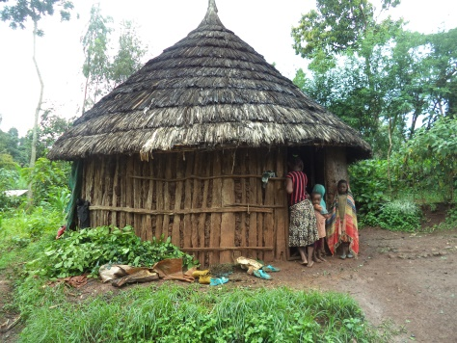
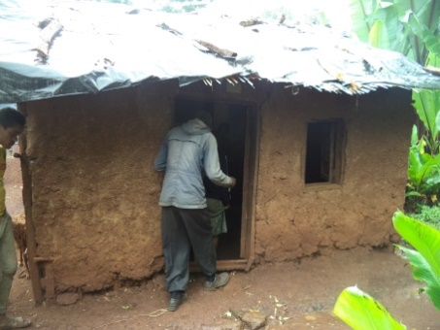
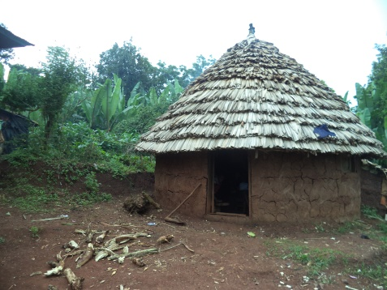
Source: Computed from surveyed data, 2018.
C
A
B
Figure 4.7 Types of wall and roof and their covering method: - A. the wall covered by eucalyptus wood with mud in both side & the roof cover with false banana ‘Ensete’ outer leaf sheath, B. wall by eucalyptus wood with mud in only internal side & roof cover grass (thatched roof), and C. wall covered by eucalyptus wood with mud in both side & roof cover with plastic sheet and ‘satera’.
Wind: - to be justified from observation and climatic /weather/ condition. The amount of warm air that escapes through cracks around doors and windows and the amount of cold air or dust that gets in to houses depends partly on the wind speed. Wind speed also affects the relationship between degree-days and the energy required for heating. The relative importance of temperature and wind, however, is largely dependent on the tightness of a building.
The most important point concerning the effects of wind on building design is that the structure must be strong enough to withstand the strongest winds that might occur. Buildings must be designed to exclude certain weather elements such as rain and extreme temperatures and to resist the loads imposed by certain others such as wind. Buildings should also be built of materials that can resist the deteriorating effects of the weather.
Table 4.4 (page No.45) and table 4.5 (page No.46), Huts its roof constructed from bamboo and covered with grass accounts 31.67% and the rest 26.67% are covered with false banana ‘Ensete’ outer leaf sheath. From the total observed huts 26.67% have only one door, 13.33% have one window and door, 11.67% have two windows and one door, 6.67% have two windows and two doors for entry and exit of air or wind and dwellers. Wind also enters in to the huts through uncovered eucalyptus wood wall with mud and it accounts 40% from the total huts. With regard the rectangular houses, 5.34% have only one door, 8.33% have one window and door, 15% have two windows and one door, 13% have two windows and two doors for entry and exit of air or wind and dwellers. Wind also enters into the houses through uncovered eucalyptus wood wall with mud and it accounts 25% per cent from the total number.
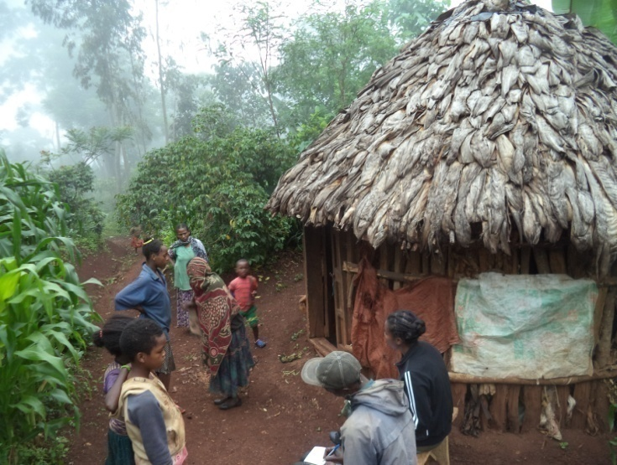
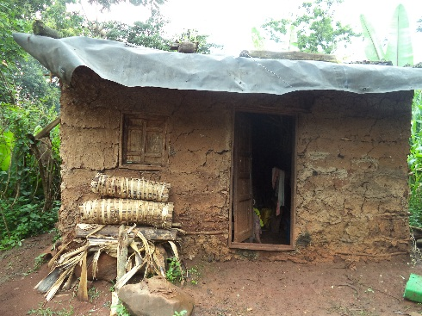
- Sound Control: - mass of the structure; break the path of vibration, cavity absorption, number of windows and doors on the side of noise, source, rain sound. As described on table 4.4 (page No.45), the Huts roofs constructed from bamboo and covered with grass accounts 31.67% and the rest 26.67% roof covered with false banana ‘Ensete’ outer leaf sheath, and the huts roof have good sound proof against rain shower because the roof materials have less capacity in transmitting sound through vibration (the roof materials breaks the path of vibration or the materials absorb sound). And out of 41.67% rectangular houses, 16.67% roof constructed from eucalyptus wood rafter and purlin covered with corrugated iron sheet and the rest 25% roof covered with waved bamboo ‘Satera’ and plastic sheets, have good capability for protect sound against rain shower because the roof cover materials have the capacity in transmitting sound through vibration. Sample roofs types are shown in figure 4.8.
The right house roof covered by bamboo wave board ‘satera’ with black plastic and the left house roof enclosed by false banana ‘Ensete’ outer leaf sheath.
Figure 4.8 Types of roofs and its covering material
8. Thermal Comfort: - it is described by natural ventilation, heating and cooling, occupancy, heat gains, proper orientation of building, proper ventilation, using shading devices, proper lighting, creation of microclimate, and preventing infiltration. From the sample huts, 40% have cold weather and low temperature because the eucalyptus wood wall are not covered properly to keep the inside at normal room temperature as a result they have no thermal comfort, and 18.33% huts have moderate room temperature because the eucalyptus wood wall are covered with mud to keep the inside at normal room temperature as a result they have relatively good thermal comfort. And out of the observed rectangular house 25% have cold weather and low temperature because the eucalyptus wood wall are not covered properly to keep the inside at normal room temperature as a result they have no thermal comfort and 16.67% house have moderate room temperature because the eucalyptus wood wall are covered with mud to keep the inside at normal room temperature as a result they have relatively good thermal comfort.
9. Fire Protection: - Material type, spread of fire within buildings, spread of fire between buildings, smoke spread. According to the field observation and collected data 31.67% huts roof constructed from bamboo and covered with grass and the rest 26.67% roof covered with false banana ‘Ensete’ outer leaf sheath. With regard to rectangular houses, 16.67% house roof constructed from eucalyptus wood rafter and purlin covered with corrugated iron sheet and the rest 25% roof covered with waved bamboo ‘Satera’ and plastic sheets. From the total number collected data 10% huts and 8.33% rectangular houses’ eucalyptus wood wall covered with mud, the rest 21.67% wall are uncovered with mud as a result they are more exposed to fire because the types of materials they were constructed are easily flammable and the fire spread rapidly within huts and houses, might they caught a fire. Based on table 4.9, out of the total observed huts and rectangular houses 51% are separated one from the other and the rest 15% are semi-separated that means at least they share a common wall, as shown below in figure 4.9.

Table 4.9 Fire protection of the house in ‘Wonago Wereda’, 2018
Source: Computed from surveyed and observed data, 2018.
Type of house | Number of Houses | Percentage (%)
Detached house one from the other | 51.00 | 85.00
Semi-detached house (shearing at least a common wall) | 9.00 | 15.00
Total | 60 | 100
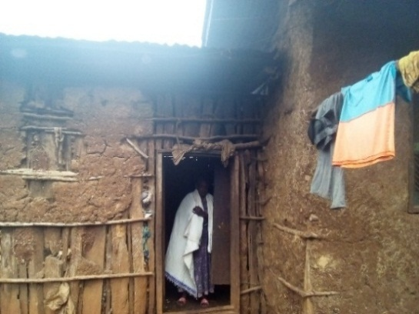
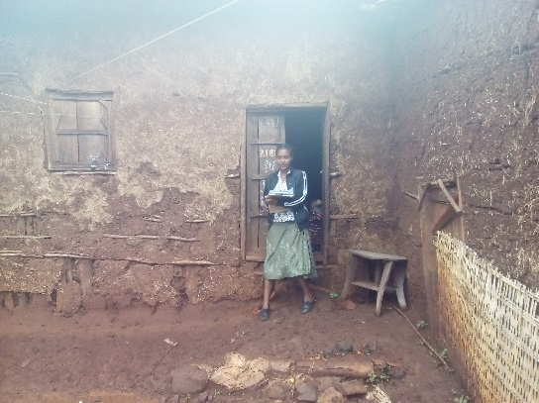
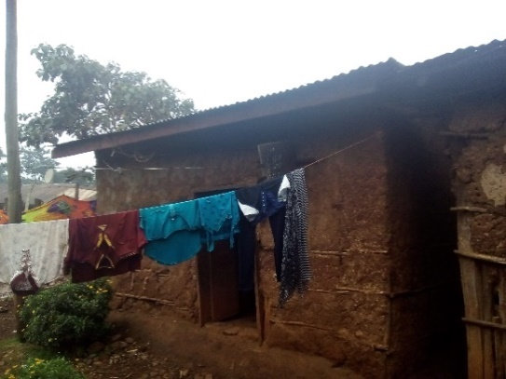
Figure 4.9 Attached & Semi attached housing units
10. Lighting and Ventilation: - ventilation rate, airflow direction, and air distribution. Table 4.4 (page No.45) and table 4.5 (page No.46), shows that Huts its roof constructed from bamboo and covered with grass accounts 31.67% and the rest 26.67% are roof covered with false banana ‘Ensete’ outer leaf sheath. Out of the total observed huts 26.67% have only one door, 13.33% have one window and door, 11.67% hut have two windows and one door, 6.67% hut have two windows and two doors for entry and exit of air or wind, light and dwellers. Light and air also enter into the huts through uncovered eucalyptus wood wall with mud and it accounts 40% from the total huts. With regard to the rectangular houses, 5.34% have only one door, 8.33% have one window and door, 15% have two windows and one door, 13% have two windows and two doors for entry and exit of air or wind, light and dwellers. Light and air also enter into the houses through uncovered eucalyptus wood wall with mud and it accounts 25% from the total number of sample house.
11. Sanitation: - sullage and solid waste. Sullage is wastewater from kitchens, bathrooms and laundries is called sullage. It can contain disease-causing organisms, particularly from soiled clothing, but its main health hazard occurs when it collects in poorly drained places and causes pools of organically polluted water that may serve as breeding places for Culex mosquitoes. This genus of mosquitoes transmit malaria do not breed in polluted water.
Solid Waste- Rats, hens, and other animals, which may be carriers (reservoirs) of disease-causing organisms are attracted to discarded food, cloth, and other components of solid waste. Small rainwater collections in solid waste may serve as the breeding places for Aedes mosquitoes, vectors of the dengue virus. According to table 4.10, from those huts within 43.33% people are not living together with domestic animals and within the rest 15% people are living together with domestic animals. In same way out of the rectangular house, within 31.67% people are not living together with domestic animals and the rest 10% rectangular houses people are living together with domestic animals.
Table 4.10 Sanitation of the house in ‘Wonago Woreda’, 2018
Sanitation | Number of houses | Percentage (%)
A. Huts (Circular huts or homes) | 35.00 | 58.33
Huts used only shelter for Human residence | 26.00 | 43.33
Huts used as shelter for Human and Domestic Animals | 9.00 | 15.00
B. Rectangular house | 25.00 | 41.67
Rectangular houses used as shelter only for Human | 19.00 | 31.67
Rectangular houses used as shelter for Human and Domestic Animals | 6.00 | 10.00
Total | 60.00 | 100.00
Source: Computed from surveyed and observed data, 2018.
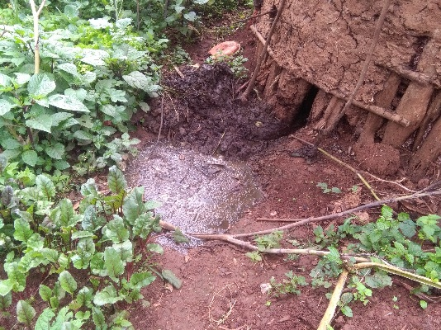
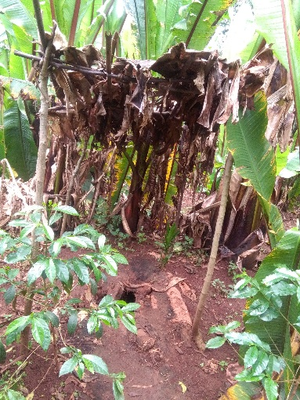
The toilet constructed simply by dig the hole and then covered by wood or timber and domestic animal waste disposal system was directly house to surface.
Figure 4.10 Toilet type and Waste disposal system from Domestic Animals

4.2.2. User Requirements
The user of a building can expects to live or work in a space that satisfies basic human requirements and, in addition, certain needs that are specific to the activities being performed. The way in which these are met, and whether one is in conflict with the other, is a measure of how appropriate the building is for the activity or activities in question. Fitness for purpose is thus an important measure of how a building matches the requirements of its user. User requirement studies attempt to identify purpose in terms of activities (the things people do) and human needs (physical, psychological, physiological and social), and for a building to be fit for its purpose it must allow its occupants to carry out their activities economically and conveniently, and have a satisfactory environment to suit the user. Such a study was typically considering the following:
Classification of User (Task Orientation): - From table 4.11 (page No.64) the total observed huts 21.67% have only one room and the rest 36.67% have two rooms for different activities. Based on tables 4.12 (page No.64) and table 4.13 (page No.65), 5% hut have separated and 15% have not separated rooms for bed room, children bed room, living room, kitchen, cattle bar and store, 16.67% huts have separated and 21.67% have not separated rooms for bed room, children bed room, living room, kitchen and store. And 36.67% huts have two rooms and the rest 21.67% have one room for bed room, children bed room, living room, kitchen, cattle bar and separated store.
With regard to the rectangular houses, out of the total observed houses 10% have only one room, 16.67% have two room, 13% have three room and the rest 1.67% have four rooms for different activities. According to table 4.12 (page No.64) and table 4.13 (page No.65), 5% rectangular houses have separated and 5% have not separated rooms for bed room, children bed room, living room, kitchen, cattle bar and store, 26.67% rectangular houses have separated and 5% have not separated rooms for bed room, children bed room, living room, kitchen and store and 16.67% rectangular houses have two rooms, 13.33% have three and 1.67% have four rooms for bed room, children bed room, living room, kitchen, cattle bar and separated store, as shown below in figure 4.11.
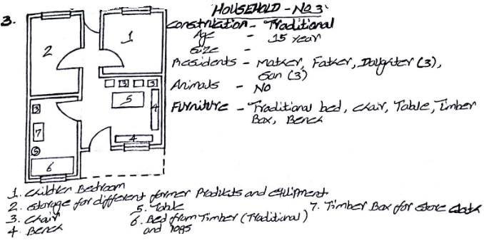

Sample of household unit it contains four rooms

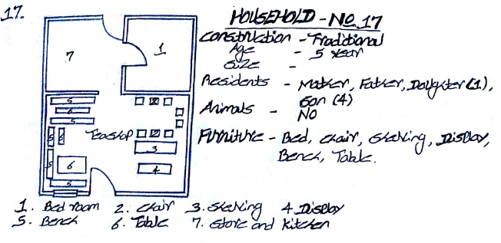
Sample of household unit it contains three rooms

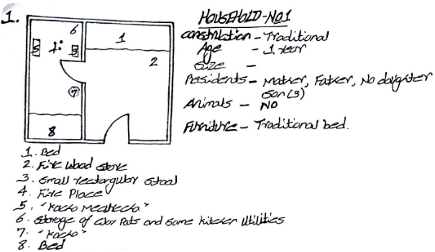

Sample of household unit it contains two rooms

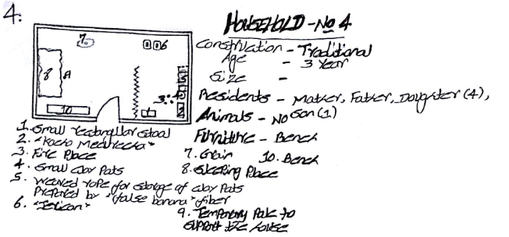

Sample of household unit it contains one room

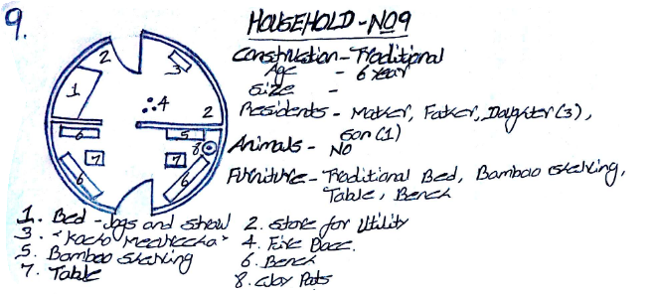

Sample of household unit (huts) it contains two rooms
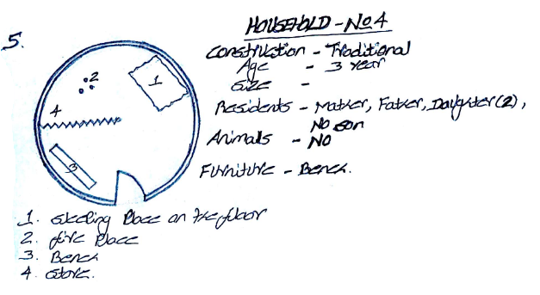

Sample of household unit (huts) it contains one room

Figure 4.11 Sample of room number and task orientation within the room

Table 4.11 Task orientation of the house in ‘Wonago Wereda’, 2018
Task orientation room activities | Number of Houses | Percentage (%)
A. Huts (Circular huts or homes) | 35.00 | 58.33
Number of rooms in huts
1 | 13.00 | 21.67
2 | 22.00 | 36.67
3 | 0.00 | 0.00
4 | 0.00 | 0.00
B. Rectangular house | 25.00 | 41.67
Number of rooms in houses
1 | 6.00 | 10.00
2 | 10.00 | 16.67
3 | 8.00 | 13.33
4 | 1.00 | 1.67
Total | 60.00 | 100.00
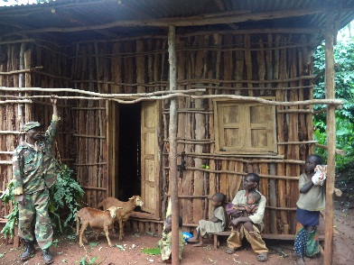
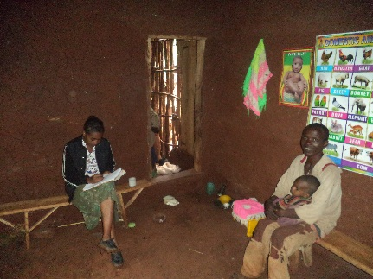
Source: Computed from surveyed and observed data, 2018.
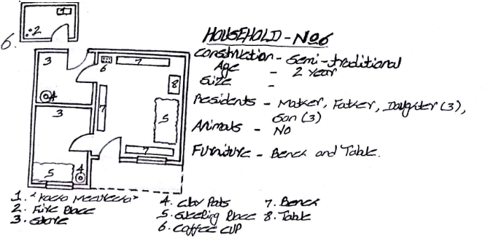

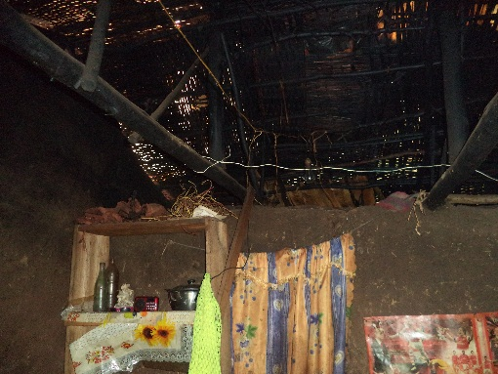
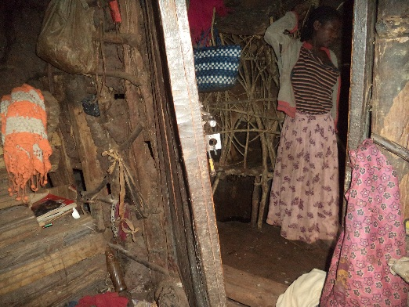
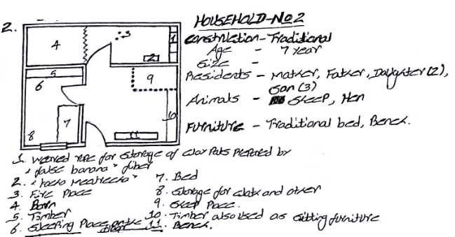
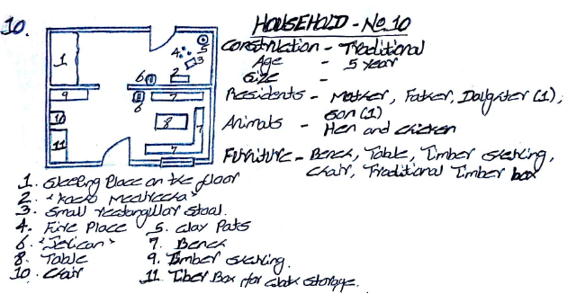
Figure 4.12 Type of room classification and arrangement space within rectangular house

Table 4.12 Task orientation of the house in ‘Wonago Wereda’, 2018
Task orientation room activities | Number of Houses | Percentage (%)
A. Huts (Circular huts or homes) | 35.00 | 58.33
Bed room, children bed room, living room, kitchen, cattle bar and store separately. | 3.00 | 5.00
Bed room, children bed room, living room, kitchen, cattle bar and store not separately. | 9.00 | 15.00
Bed room, children bed room, living room, kitchen and store separately. | 10.00 | 16.67
Bed room, children bed room, living room, kitchen and store not separately. | 13.00 | 21.67
B. Rectangular house | 25.00 | 41.67
Bed room, children bed room, living room, kitchen, cattle bar and store separately. | 3.00 | 5.00
Bed room, children bed room, living room, kitchen, cattle bar and store not separately. | 3.00 | 5.00
Bed room, children bed room, living room, and kitchen and store separately. | 16.00 | 26.67
Bed room, children bed room, living room, and kitchen and store not separately. | 3.00 | 5.00
Total | 60.00 | 100.00
Source: Computed from surveyed and observed data, 2018.
Table 4.13 Task orientation of the house in ‘Wonago Wereda’, 2018
Task orientation room activities, user requirements | Number of Houses | Percentage (%)
A. Huts (Circular huts or homes) | 35.00 | 58.33
Bed room, children bed room, living room, kitchen, cattle bar and store
Within one (1) rooms | 2.00 | 3.33
Within two (2) rooms | 10.00 | 16.67
Bed room, children bed room, living room, kitchen, and store
Within one (1) rooms | 2.00 | 3.33
Within two (2) rooms | 21.00 | 34.99
B. Rectangular house | 25.00 | 41.67
Bed room, children bed room, living room, kitchen, cattle bar and store
Within two (2) rooms | 2.00 | 3.33
Within three (3) rooms | 4.00 | 6.67
Bed room, children bed room, living room, kitchen and store
Within one (1) rooms | 2.00 | 3.33
Within two (2) rooms | 5.00 | 8.33
Within three (3) rooms | 10.00 | 16.67
Within four (4) rooms | 2.00 | 3.33
Total | 60.00 | 100.00
Source: Computed from surveyed and observed data, 2018.
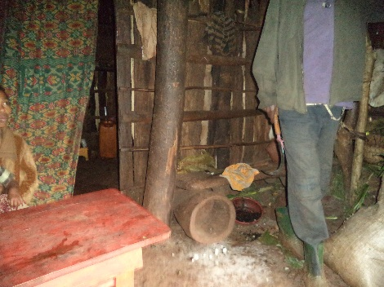

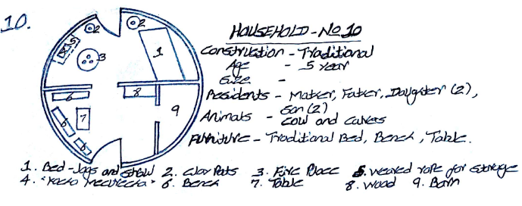
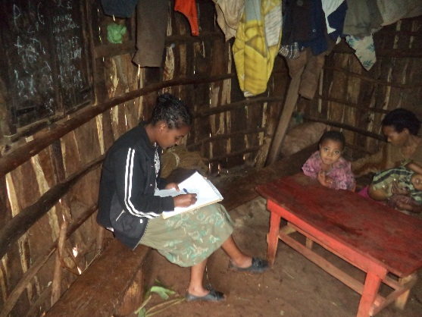
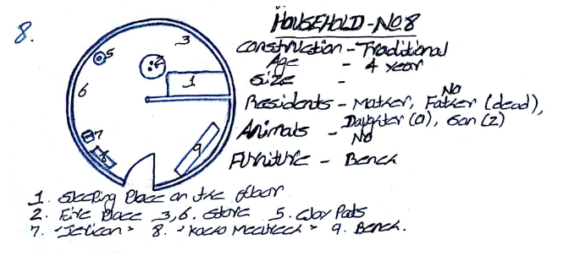
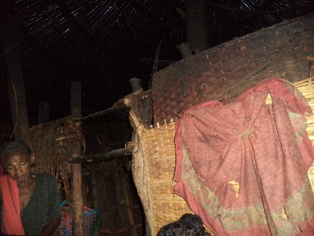
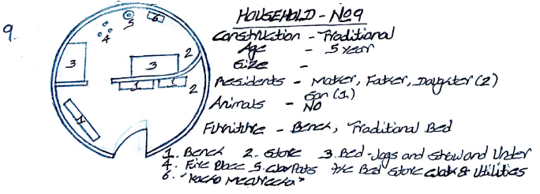
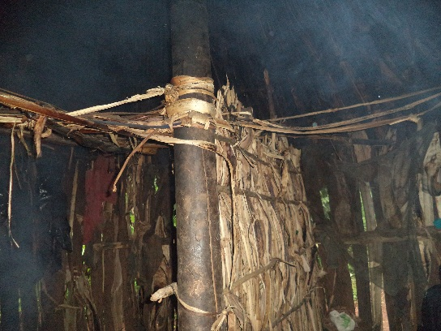
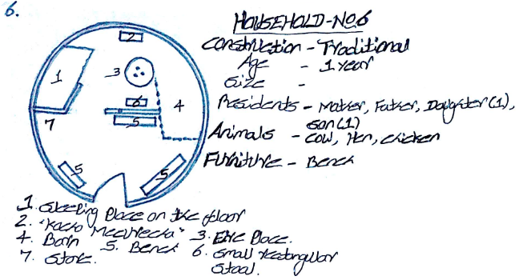
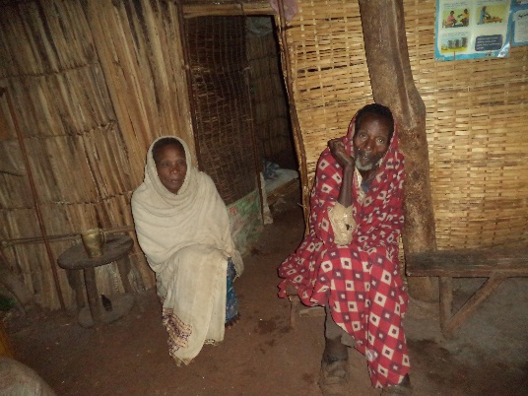
Figure 4.13 Type of room classification and arrangement space within circular house /huts/

Requirements of Space (Circulation in and around Buildings): - As shown on the sample household floor plan there is conflict between different factional activity/space within the house. And also in the house functional space are congested by different utilities and activities. In general majority of the household unit have a problem of enough functional space and way of arranging utilities as well as daily activities. The majority of the house described in above separated it allow away to access easily around housing. This freedom flow of circulation has mandatory for their daily farming activities of the residence. The farming and their domestic animals wants the people daily treatment or care. But both the weather condition (rainy season) and the access nature challenging to move especially for elders and child.
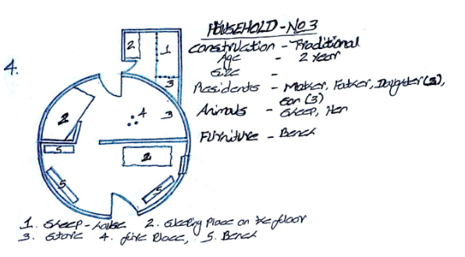
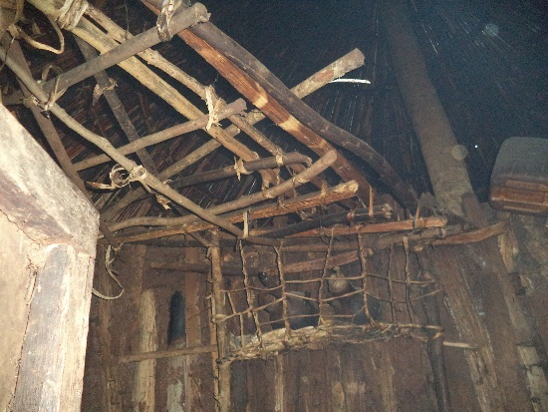

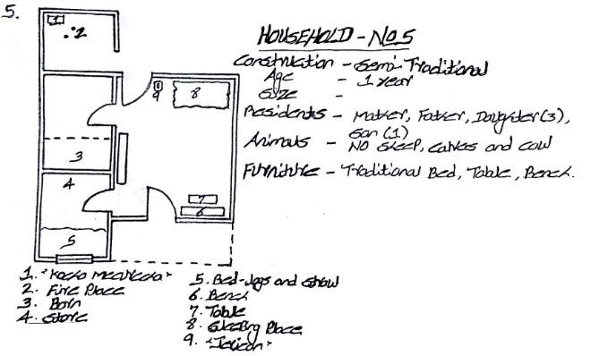
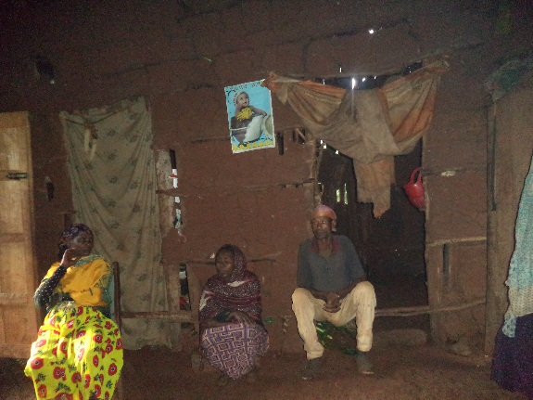

Figure 4.14 Requirement of space and circulation in the household

Analysis of Activities (Social Interaction): - Interaction between the neighbour and within the village. As shown in table 4.5 (page 45), out of the total sample data, 58.33% are huts and the rest 41.67% are rectangular house. Based on table 4.9 (page 57), 85% houses (huts and rectangular houses) are separated one from the other and the rest 15% are semi-separated that means at least they share a common wall.
Environmental Conditions (Sensory Stimulation): - Climatic condition vs. construction method and material, green space (vegetation cover). According to the surveyed data, the environment has long rainy season and covered by vegetation. But unlikely from the total sample household in table 4.5 (page 45), 58.33% are circular huts and the rest 41.67% are rectangular house, and from those, 31.67% are huts its roof constructed from bamboo and covered with grass and the rest 26.67% are covered with false banana ‘Ensete’ outer leaf sheath. Out of the 31.67% huts its roof constructed from bamboo and covered with grass, 10% huts have eucalyptus wood wall covered with mud, 15% huts wall covered with waved bamboo ‘Satera’ and plastic sheets and 6.67% huts wall covered with false banana ‘Ensete’ outer leaf sheath, old clothes and some part uncovered. Likewise, out of 26.67% huts its roof constructed from bamboo and covered with false banana ‘Ensete’ outer leaf sheath, 8.33% huts have eucalyptus wood wall covered with mud, 11.67% huts wall covered with waved bamboo ‘Satera’ and plastic sheets and 6.67% huts wall most part covered with false banana ‘Ensete’ outer leaf sheath, old clothes and some part uncovered.
Table 4.4 (page 45) shows out of 41.67% are rectangular houses, 16.67% houses roof constructed from eucalyptus wood rafter and purlin covered with corrugated iron sheet and the rest 25% houses roof constructed from the same materials but covered with waved bamboo ‘Satera’ and plastic sheets. And out of the 16.67% house roof constructed from eucalyptus wood rafter and purlin covered with corrugated iron sheet, 8.33% huts eucalyptus wood wall covered with mud, 5% huts wall covered with waved bamboo ‘Satera’ and plastic sheets and 3.33% huts wall covered with false banana ‘Ensete’ outer leaf sheath, old clothes and some part un covered. In same way out of 25% per cent huts roof constructed from eucalyptus wood rafter and purlin covered with waved bamboo ‘Satera’ and plastic sheets, 8.33% huts eucalyptus wood wall covered with mud, 11.67% huts wall covered with waved bamboo ‘Satera’ and plastic sheets and 5% huts wall most part covered with false banana ‘Ensete’ outer leaf sheath, old clothes and some part uncovered.
Structural Implications (Compatibility): - Climatic condition vs. the type of material that the house was constructed. According to the field observation and collected questioners data, from the total sample, 31.67% are huts its roof constructed from bamboo and covered with grass and the rest 26.67% are covered with false banana ‘Ensete’ outer leaf sheath. And in the huts 31.67% its roof constructed from bamboo and covered with grass, 10% huts have eucalyptus wood wall covered with mud, 15% huts wall covered with waved bamboo ‘Satera’ and plastic sheets and 6.67% huts wall covered with false banana ‘Ensete’ outer leaf sheath, old clothes and some part uncovered. Likewise, out of 26.67% huts its roof constructed from bamboo and covered with false banana ‘Ensete’ outer leaf sheath, 8.33% huts have eucalyptus wood wall covered with mud, 11.67% huts wall covered with waved bamboo ‘Satera’ and plastic sheets and 6.67% huts wall most part covered with false banana ‘Ensete’ outer leaf sheath, old clothes and some part un-covered. On the other hand, in the study area is rainy and highly covers by evergreen & other categories of vegetation.
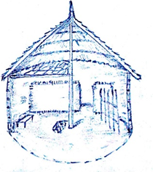
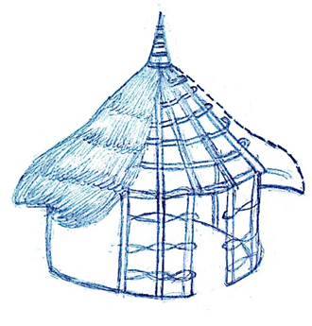
Table 4.4 (page 45) shows out of 41.67% are rectangular houses, 16.67% houses roof constructed from eucalyptus wood rafter and purlin covered with corrugated iron sheet and the rest 25% houses roof constructed from the same materials but covered with waved bamboo ‘Satera’ and plastic sheets. And out of the 16.67% house roof constructed from eucalyptus wood rafter and purlin covered with corrugated iron sheet, 8.33% huts eucalyptus wood wall covered with mud, 5% huts wall covered with waved bamboo ‘Satera’ and plastic sheets and 3.33% huts wall covered with false banana ‘Ensete’ outer leaf sheath, old clothes and some part un covered. In same way out of 25% huts roof constructed from eucalyptus wood rafter and purlin covered with waved bamboo ‘Satera’ and plastic sheets, 8.33% huts eucalyptus wood wall covered with mud, 11.67% huts wall covered with waved bamboo ‘Satera’ and plastic sheets and 5% huts wall most part covered with false banana ‘Ensete’ outer leaf sheath, old clothes and some part uncovered.
Bamboo or thin logs
Mezzanine floor for storage
The roof covered with grass or false banana ‘Ensete’ outer leaf sheath
Partition wall: the height of 1.2m – 1.6m and constructed by logs with mud, bamboo wave, or false banana ‘Ensete’ outer leaf sheath
Domestic animal barn
Vertical member: logs or traditional timber; Horizontal member: Bamboo or thin logs
Figure 4.15 Cross-sectional view of huts and its construction method

4.2.3. Functional Requirement
Housing, regardless of its original, intermediate or ultimate use, can be expected to fulfil certain basic functional requirements. These requirements are primarily concerned with: -
Protection from the external environment
The housing condition of the study area that shown on Table 4.4 (page 45), 41.67% are rectangular houses, 16.67% houses roof constructed from eucalyptus wood rafter and purlin covered with corrugated iron sheet and the rest 25% houses roof constructed from the same materials but covered with waved bamboo ‘Satera’ and plastic sheets. And out of the 16.67% house roof constructed from eucalyptus wood rafter and purlin covered with corrugated iron sheet, 8.33% huts eucalyptus wood wall covered with mud, 5% huts wall covered with waved bamboo ‘Satera’ and plastic sheets and 3.33% huts wall covered with false banana ‘Ensete’ outer leaf sheath, old clothes and some part un covered. In same way out of 25% huts roof constructed from eucalyptus wood rafter and purlin covered with waved bamboo ‘Satera’ and plastic sheets, 8.33% huts eucalyptus wood wall covered with mud, 11.67% huts wall covered with waved bamboo ‘Satera’ and plastic sheets and 5% huts wall most part covered with false banana ‘Ensete’ outer leaf sheath, old clothes and some part uncovered. Also, on table 4.14 expressed experienced problem of the sample household unit.
Table 4.14 Experienced problems within the sample Household in ‘Wonago Wereda’, 2018
Experienced problems within the House/ Protection | Number of Household | Percentage (%)
A. Roof
Roof that satisfy the basic functional requirements | 40 | 66.67
Roof that don’t satisfy the basic functional requirements | 20 | 33.33
Total | 60 | 100
B. Wall
Roof that satisfy the basic functional requirements | 21 | 35
Roof that don’t satisfy the basic functional requirements | 39 | 65
Total | 60 | 100
C. Floor
Roof that satisfy the basic functional requirements | 40 | 66.67
Roof that don’t satisfy the basic functional requirements | 20 | 33.33
Total | 60 | 100
Source: Computed from surveyed and observed data, 2018

Human comfort
Based on the sample; the household members challenged by different problem in the study area. This problem comes from the house itself and also by the environment. The housing unit did not provide the basic requirement for the resident. Some of the problem was it affect the health of the housing member (rain, wind, cold, smell & smoke in the house), space problem to workout different activity and the house not protect from weather such as wind, cold, rain. This problem illustrated on table 4.15.
Table 4.15 Satisfaction on the house in sample household, ‘Wonago Wereda’, 2018
Satisfaction on the house/Human comfort | Number of Household | Percentage (%)
Happy | 4 | 6.67
Un happy | 56 | 93.33
Total | 60 | 100
Reason for Unhappiness
Affect our health (rain, wind, cold, smell & smoke in the house) | 28 | 46.67
Space problem in the house for different activity | 24 | 39.99
Don’t Protect from weather such as wind, cold | 4 | 6.67
Total | 56 | 93.33
Source: Computed from surveyed and observed data, 2018
Organization of activity & Space
Organization of activity and space illustrated by sampled household unit floor plan was described below:
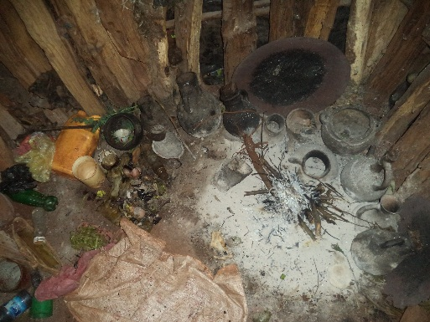
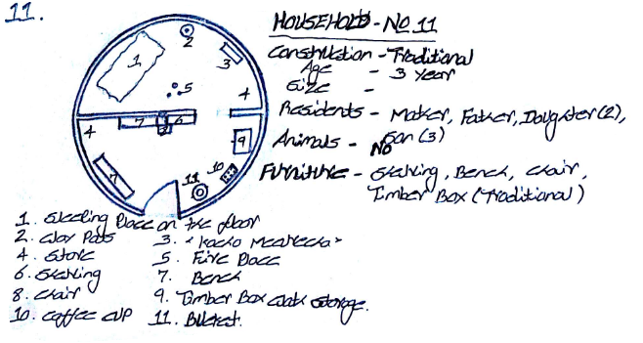
Fire place & clay pots

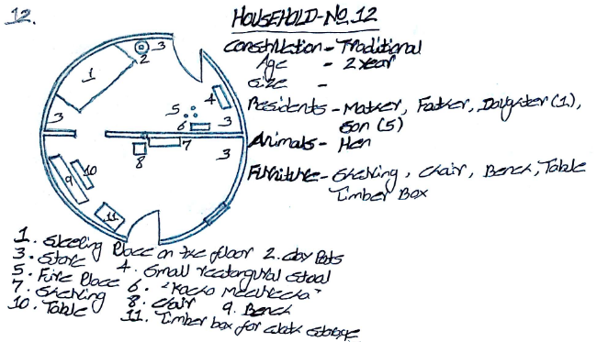

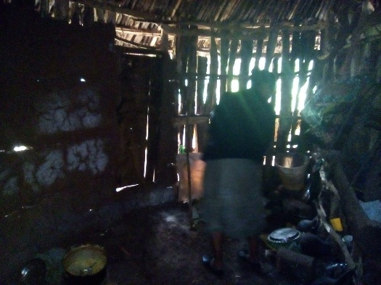
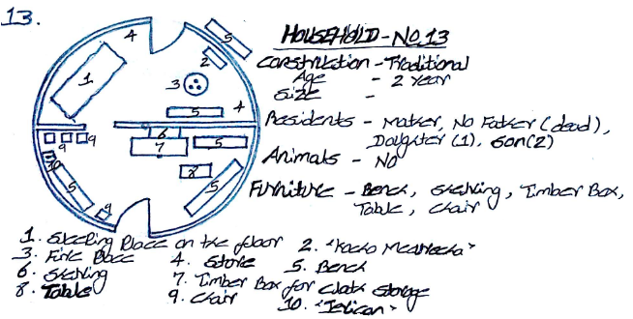
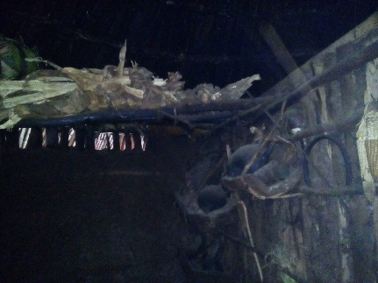
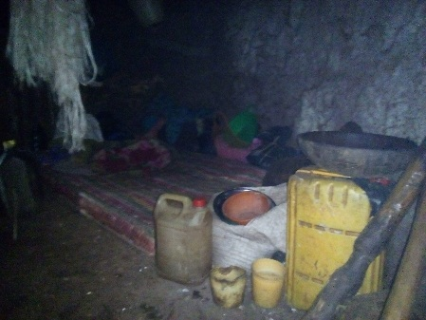
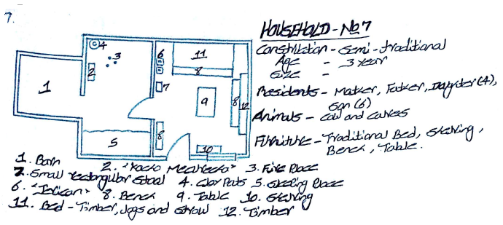
Figure 4.16 Organization of activity and space in sample Huts house
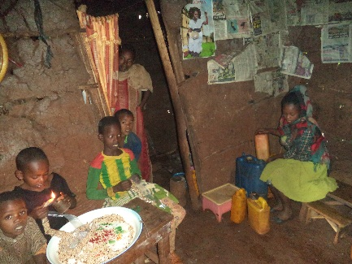
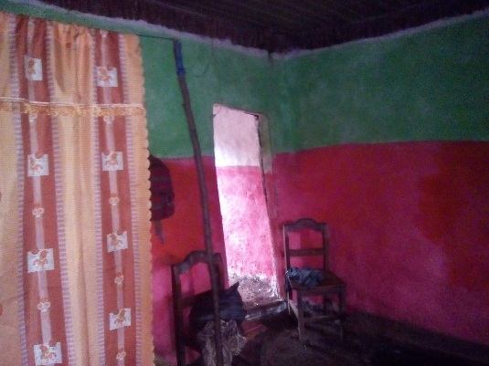
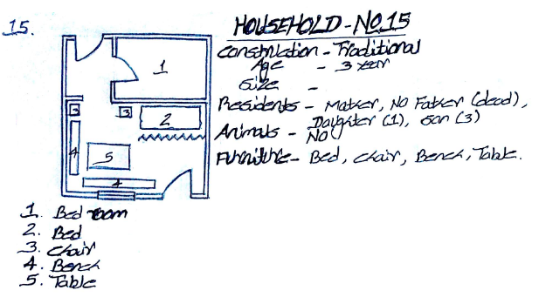
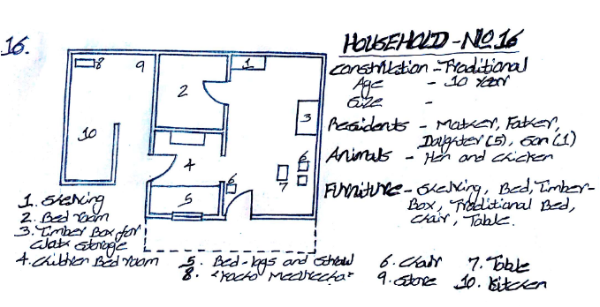

Figure 4.17 Organization of activity and space in sample Rectangular house
`The Creation of a Particular Sense of Identity or Place & the Control of Competing or Conflicting Internal Uses
In the community majority of the household unit are bounded by different type of vegetation; it used as food for the resident & domestic animal, income asset, building material and also in the community a family lived together in one area, this is because especially young man when he married get land from him family and build him house near to his families. From the above reason the study area have crowded housing unit in distributed manner with vegetation cover.
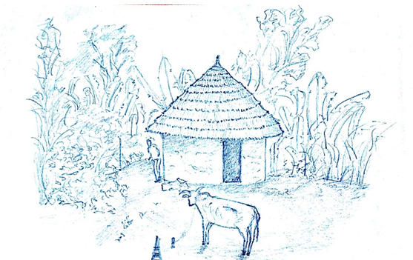
Control of competing or conflicting internal uses by creates additional space below the roofing system and also storage for clay utilities in the kitchen. To separate activity/ space such as animal barn from living room, living from sleeping, living from kitchen, sleeping from kitchen, by built simple as partition/separation system use the simple materials like old clothes, leaves, bamboo, thin wood pole, and natural rope.

Used as Utility
Fibre Extracted
Fibre Extracted
Outer leaf sheath
Used as food and medicinal value
Widely available vegetation ‘Enset’

Environmental condition of the study area
Figure 4.18 Environmental vs. housing condition & vegetation

4.2.4. Statutory Requirements
There are various statutory and non-statutory requirements that make demands on those who design, build, manage, repair, maintain, occupy or demolish housing. In practice, many of these demands are made in relation to:
- THE HEALTH: - Housing should provide a safe and healthy environment for its in habitants. Many technical, social, planning and policy factors relating to housing may affect physical and mental health and social wellbeing. These factors can be expressed in terms of basic human requirements that can accordingly be incorporated into housing standards, polices and goals of attainment relevant to an individual county’s needs, resource and priorities. No universal interpretation of healthy housing is possible, but typical requirements can form necessary basis. General healthy housing needs: - It must protect the transmission of communicable diseases (housing layout, space and density); it must fulfil with physiological needs; and its design or construction no cause injury to health, but based on the above result & healthy housing requirements there are a problem on health in the study area.

- SAFETY: - According to (Empirical evidence from Hong Kong (unpublished PHD Thesis), the university of Hong Kong; 2006) You Y. Safety performance of housing/ buildings: - consideration for structural safety, fire and life safety, human comfort, the physical condition of building elements and service systems.

- WELL-BEING: - a problem classified as:

Physical well-being - Pollution- air quality, water quality, noise & Energy (equipment, design, minimum temperature within the house) and prevention of droughts caused by uptight doors and windows, Prevention of diseases- parasites, building material, obesity, Prevention of domestic accidents- falls, means of escape from fire, prevention of death due to carbon monoxide poising, physical handicaps- disabled people, children, elderly & Natural and Technological risks- extreme temperature, floods, earthquakes.

Mental well-being - Depression & Degradation of self-esteem and rise of stress due to the immediate environment, housing quality, maintenance, Multiple occupations- definition of a maximum number of people occupying the dwelling in order to avoid lack of privacy, regulations concerning green spaces to offset high population density, Behavioural problems and violence- reduce vandalism & deterioration of common space, graffiti ….

Social well-being – includes social and economic life, transportation & social fairness, and the question of access to the dwelling.

CHAPTER FIVE

DISCUSSION AND CONCLUSIONS

5.1. Introduction
In this chapter by recapping main thesis aim outlined in chapter one. This study set out to investigate appropriate and cost-effective housing construction technology of housing for rural farmer in ‘Wonago Wereda, Dilla’. This chapter discusses results generated in previous chapter and also answer each research question addressed in this study, followed by evaluation requirement of housing in the study area. Finally, the limitations, suggestions for future research and conclusions of this study are presented or describe.

5.2. Response to Research Question One
- Research Question One: What are different types of cost-effective alternative construction technology of housing implemented easily?
Previous studies (e.g., Society for Education Village Action and Improvement, India) stated that “Low Cost Housing is a new concept which deals with effective budgeting and following of techniques which help in reducing the cost construction through the use of locally available materials along with improved skills and technology without sacrificing the strength, performance and life of the structure. Building Cost: The building construction cost can be divided into two parts namely: Building material cost: 65 to 70%. Labour cost: 35 to 30%.”
Study and select some alternative construction technology by review different literature and investigate from different country practice of low housing construction technology in terms of cost, construction time, quality, availability of materials and method of construction. Analyse by classify major housing components such as roof, wall and slab to study the appropriateness each component of housing for the study area.
Selected alternative construction material and methods are: Roofing Technology: - Precast RC plank and joist roofing, Precast curved brick arch panel roofing system, Ferrocement channel, Prefabricated Brick panel roofing system, Corrugated fibre concrete sheets and Fibre and micro concrete Tiles.
Walling Technologies: - Rattrap Bond Wall, Stabilized compressed earth blocks, compressed earth blocks, Concrete jacketed rammed earth wall and Bamboo board wall.
Slab Technologies: - RC filler slab with autoclaved cellular concrete blocks, Reinforced Catalan vaulting and prefabricated brick panel and joist system.
Amit D Chougule, Manoj H. Mota, Ushadevi S Patil, (2015) demonstrate Filler slab is much more economical than traditional slab as it saves 16%, 44%, 17% of cement, steel and cost in two-way slab and 33%, 46%, 25% in one-way slab respectively. Brick panel saves 19% per m³ in cement, 19% per m³ in sand, 19% per m³ in aggregate, and 38% per m³ in steel. Satprem Maini, (November 2010) also illustrated Soil stabilized bricks are 27.7% cheaper as compared to country fired bricks walls, they are less air pollution, energy consumption, carbon emission. Rat trap bond are much economical than convectional bricks. They reduce the usage of bricks by 25% and mortar by 40%, and reducing the load by 8% while giving same compressive strength with a saving of 57% in cement cost, 20% saving in bricks, and 61% saving in sand. Based on literature data construction technology and material, and contextual analysis of the study area summarized as follow on table 5.1:
Table 5.1 Relative comparative of alternative construction technology based on literature review and context of the study area
Construction Technologies | Cost | Time | Quality | Availability of material | Construction Technique
Roofing Technology
Precast RC plank and joist roofing | Relatively high | Short | v. Good | Less | Relatively complex
Precast curved brick arch panel roofing | Medium | Medium | Good | Less | Simple
Ferrocement channel | Medium | Short | v. Good | Less | Relatively complex
Prefabricated Brick panel roofing | Medium | Medium | Good | Available | Simple
Corrugated fiber concrete sheets | Inexpensive | Medium | Good | Relatively Good | Simple
Fiber and micro concrete Tiles. | Inexpensive | Medium | Good | Relatively Good | Simple
Walling Technologies
Rattrap Bond Wall | Medium | Medium | v. Good | Less | complex
Stabilized compressed earth blocks | Medium | Medium | Good | Relatively Good | Simple
Compressed earth blocks | Low | Medium | Good | Relatively Good | Simple
Concrete jacketed rammed earth wall | Inexpensive | Short | v. Good | Relatively Good | complex
Wall construction with Bamboo | Inexpensive | Short | Good | Available | Simple
Slab Technologies
RC filler slab with autoclaved cellular concrete blocks | Relatively high | Medium | v. Good | Less | Relatively complex
Reinforced Catalan vaulting | Medium | Medium | Good | Relatively Good | complex
Prefabricated brick panel and joist system | Relatively high | Medium | Good | Less | Relatively complex

In low cost housing, building material cost is less because the investigation makes use of the locally available materials and also the labour cost can be reduced by properly making the time schedule of the work. Cost of reduction is achieved by selection of more efficient material and construction technique or by an improved design.

5.3. Response to Research Question Two
- Research Question Two: What are the Spatial Character in their Housing and How to Organize their Architectural Space in Housing in ‘Wenago Wereda, Dilla’?
The housing can expect to live or work in a space that satisfies basic human requirements and, in addition, certain human needs (physical, psychological, physiological and social) that are specific to the activities being performed. In the study area the household allow its occupants to work out their basic activities (the things people do) such as preparing their food, sleeping, eating, display the family & social interaction and shelter for the family and for their domestic animal, and the ways in which these are met, and whether one is in conflict with the other, is a measure of how appropriate the housing is for the activity or activities in question. Fitness for purpose is thus an important measure of how housing matches the requirements of its user.
In the sample household prepare/workout different activities that are basic/necessary for the dweller to survive. Those activities are preparing food (kitchen), interaction and eating food (living & dining), living their domestic animals (barn), sleeping space for the family (master & children bed room), storage for farming equipment and other utilities. The arrangements/organization of this space are in one room, two room, three or four room. In the circular hut 58.33% of the total sample household those activities bounded in one room and two rooms, but in rectangular house 41.67% the activities performed in one room up to for rooms. In the hut 21.67% of activities executed in one room and the remaining 36.67% activities organize in two rooms. On the other hand the rectangular house the above activities performed in one room was 10%, and 16.67% in two rooms, 13.33% in three rooms and the remaining 1.67% did in four rooms.
Housing provides the scenario for family life, recreation, rest, sleep and social interaction; it follows that many aspects of sample housing. Such as overcrowding, noise, air pollution, bad odours or dampness, give rise to considerable dissatisfaction and annoyance and perhaps contribute to poor health. Housing also forms part of the wide social setting whereby communities are formed and institutionalized. In general arrangements of activities are not well organized because of space problem within the household and also conflict within different space and activities. Those problems create smell, smoke and parasites; these are highly affected for health of occupant. Type of furniture and their way of setting (on damp land and cold housing) in the house a cause for common colds and influenza for the occupier especially for child.

5.4. Response to Research Question Three
- Research Question Three: What is current construction practice and building material of Housing in ‘Wonago Wereda, Dilla’?
In the study area the construction practice almost the same in the hut and in rectangular house. The housing construction technique is start from digging a hole on the ground and put the logs in the hole. In the side the roof construction on going simultaneously to make in the ground for hut housing construction, and finally the logs are tied together by using bamboo/thin wood and rope, and put the roof structure on it. After this progress the roof is covered by grass or vegetation leaf. In the rectangular house the logs are tied together by using nail and thin wood, and above this structure the rafter and purlins constructed and covered by corrugated iron sheet or plastics and bamboo waving or vegetation leaf sheath.
According to the total sample household table 4.4 (page 45), 58.33% are huts and the rest 41.67% are rectangular house, and from those, 31.67% are huts its roof constructed from bamboo and covered with grass and the rest 26.67% are covered with false banana ‘Ensete’ outer leaf sheath. Out of the 31.67% huts its roof constructed from bamboo and covered with grass, 10% huts have eucalyptus wood wall covered with mud, 15% huts wall covered with waved bamboo ‘Satera’ and plastic sheets and 6.67% huts wall covered with false banana ‘Ensete’ outer leaf sheath, old clothes and some part uncovered. Likewise out of 26.67% huts its roof constructed from bamboo and covered with false banana ‘Ensete’ outer leaf sheath, 8.33 % huts have eucalyptus wood wall covered with mud, 11.67% huts wall covered with waved bamboo ‘Satera’ and plastic sheets and 6.67% huts wall most part covered with false banana ‘Ensete’ outer leaf sheath, old clothes and some part un-covered.
Out of 41.67% are rectangular houses, 16.67% houses roof constructed from eucalyptus wood rafter and purlin covered with corrugated iron sheet and the rest 25% houses roof constructed from the same materials but covered with waved bamboo ‘Satera’ and plastic sheets. And out of the 16.67% house roof constructed from eucalyptus wood rafter and purlin covered with corrugated iron sheet, 8.33 % huts eucalyptus wood wall covered with mud, 5% huts wall covered with waved bamboo ‘Satera’ and plastic sheets and 3.33% huts wall covered with false banana ‘Ensete’ outer leaf sheath, old clothes and some part un covered. In same way out of 25% per cent huts roof constructed from eucalyptus wood rafter and purlin covered with waved bamboo ‘Satera’ and plastic sheets, 8.33% huts eucalyptus wood wall covered with mud, 11.67% huts wall covered with waved bamboo “Satera” and plastic sheets and 5% huts wall most part covered with false banana ‘Ensete’ outer leaf sheath, old clothes and some part uncovered.
Shelter not only fails to protect against but exposes them to health risks that are for the most part preventable. Adoption of cost-effective construction technology will help communities and families to safeguard against such risks. The weather condition of the area is relatively long rainy season and covered different type of vegetation. By this reason the environment are wet and also produce moisture, but the type and properties of housing building material and construction method not compatible or not consider the weather condition of the environment. This incompatibility also affects the durability of housing, this means to make the housing not to stay long period of time. This incompatibility correspondingly produces other health and safety problem in the resident such as to generate termite and insect, to lose heat from the house, wet and slippery floor, improper lighting and cross ventilation, bad smell. The housing inside moisture and wet condition also affect the housing building material and construction method and this also reduce housing durability.

5.5. Response to Research Question Four
- Research Question Four: Which is more appropriate and cost-effective construction technology for housing of the rural farmer?
Housing should provide a safe and healthy environment for its inhabitants. Many technical, social, and planning relating to housing may affect physical and mental health and social wellbeing. These factors can be expressed in terms of basic human requirements that can accordingly be incorporated into housing standards, policies and goals of attainment relevant to an individual country’s needs, resources and priorities. No universal interpretation of healthy housing is possible, but typical requirements can form the necessary basis.
The appropriateness and cost-effectiveness of housing are measured based on architectural design, selected building material and construction method. In architectural design space are decided grounded on study data information and to include basic activities and space with proper size, with related to selected construction material and method (lab test and structural design analysis) properties and compare other based on literature review.
This paper aims to point out the various aspects of cost-effective building methodologies for low cost housing by highlighting the different production techniques, and the economic advantages achieved by its adoption. In a building the foundation, walls, slab (intermediate floor), floors and roofs are the most important components, which can be analysed individually based on the needs thus, improving the speed of construction and reducing the construction cost. The major methods of construction systems considered here are namely, prefabricated roofing components like fibre and micro concrete tiles, concrete jacketed rammed wall and bamboo walls, reinforced Catalan vaulting for slab, partial replacement of cement material in concrete are considered.

5.6. Implications for this study’s results
A number of implications may be made from this research. The general picture derived from this study also stimulates some further research.
This study shows the people live in hard burden by governmental administer, trader and NGO. The people have adapted as life philosophy “prefer live in poverty than work to grow other”, because other more beneficiary than the farmer; those are not any participation up to product time of farming, but in the production session they gain more. The farmer as a society not benefited from their skill/knowledge, efforts, or infrastructure development. This implies the majority of the people think work is not the way to improve living standard rather they depend on NGO and Governmental commissioner support as way of living or way of survive for their family.
The results show that the housing condition is bad level compared to other place of the countries. Even most urban area are actually still just getting started low-cost housing project with the residents. It seems that different organizations are promoting housing project without consider rural area people. Low-cost construction technology of housing will become increasingly important in Ethiopia because those initiatives undertaken by the government, economic organizations, and companies continue to gain momentum. The evidence shows that beside the economical deficiency, the educational level of the farmer and skill problem of the governmental sector office staff also affect to access information or knowledge and way of thinking to improve living standard as well as housing condition. This also have role in minimize age to live alive.
In summary, housing is directly or indirectly related to the health, development and satisfaction of human being but in the study area its status is still below average standard or requirement. Therefore, to improve the housing of the farmer also improves the life standards of farmer.

5.7. Conclusion
This study adds substantial evidence to the existing situation of rural farming housing. The study investigates the extent of housing problem and its related impact. This indicates many parts of the study ‘Wereda’ face a serious housing problem, which contributes to hazards to health and wellbeing. For instance, disease, accidents and fires are more prevalent in these areas, and psychological and social disturbances also are partly attributed to substandard housing. However, this research provides more evidence on lower standard housing status.
…the secret of man’s being is not only to live, but to have something to live for, without a stable conception of the object of life, man would not consent to go on living, and would rather destroy himself than remain on earth…. Fyodor Dostoevsky (1880)
“In terms of housing information about epidemiology and identification of causal factors rarely includes bio medical, psychosomatic and social pathologies. As a result, little is known about the contribution made by housing in causing stress-related diseases such as Hypertension, Migraine, depression, neurosis, alcoholism and social diseases manifested by pathological derived antisocial behaviour (e.g. Crime, violence, street mugging, vandalism, child abuse, and mental or sexual ailments). Without detailed cause and effect studies, remedial action cannot be precise, and symptomatic medical treatment is unlikely to be the only course of action available to sufferers of bad housing.” GUIDELINES FOR HEALTHY HOUSING (1988)
Good housing is a need to every human being. Everyone wants to live in good houses which are comfortable. In rural areas there are a shortage number of houses. People need houses that are attractive, having more life span, larger space area, environmental friendly and cheaper. Therefore cost effective houses and low cost houses are needed to fulfil the demand. The local available materials and technology serve a purpose for low income people. Using cost effective technology will not only save money, save time and faster production. A cost reduction of 20-30% can be achieved by using alternative methods. Particularly, this study provides evidence for the study area housing standard. Therefore necessary to propose or adopt house which is appropriate and cost effective, innovative and environment-friendly housing technologies (building material and construction method) is a most important solution for rural farmer in the study area. Using low cost housing technologies minimizes construction cost, including material and labour cost.
The study area the society give more value for cashes crop farming product and they did give attention other like education and technological knowledge but, they are hard worker and willing to accept other ideas and to corporate for works.
In this study, low cost housing technologies were studied and the potential for the materials to be used as alternative building materials was discussed, but there are no proper guidelines formulated for structural aspects of these alternate building materials. Lack of awareness is also there among builders and the society on the applicability and beneﬁts of these materials. But this research based on the above study and analysis it can be concluded that corrugated fibre concrete tiles for roofing, Timber frame with Bamboo waving wall for first floor and Concrete jacketed rammed earth wall for ground wall, reinforced Catalan vaulting Slab would be the most cost effective, appropriate and acceptable among people belonging to middle income group and below in rural area as they are satisfying all their guiding criteria and capable of providing the following advantages:
(i) Use of locally available traditional materials and can be used by local craftsperson,
(ii) Much cheaper than presently-followed type of construction of conventional buildings,
(iii) Safe as per Ethiopian Standards
Another conclusion of this thesis is that the studied project both has great potential for future rural housing in Ethiopia and is relevant for other developing countries where there is a need for durable, higher-standard, low-cost housing.

CHAPTER SIX

RECOMMENDATIONS AND PROPOSAL

6.1. RECOMMENDATIONS
Based on the literature review and findings are inclined to recommend the following:
I. Create awareness among the rural population about the technology, knowledge, system of improving farming and wealth management by governmental sector office, academic centres such as, universities and NGO.
II. Decrease the population rate of increase by adopting effective strategies to provide and promote effective family planning services by government and NGO.
III. Increase the housing standard/quality by promoting the appropriate housing design that considers the farmer land problem by researcher, universities and other concerned stakeholder.
IV. Adopt and implement cost effective construction technology of housing associated with availability and quality of construction material, and simplicity and speed of construction technique through consideration of the climatic condition.
V. Design appropriate policies to facilitate rural population growth by governmental police maker.

6.2. FURTHER RESEARCH
This study provides only the evidence on the physical characteristics housing and a problem on it. Further research is necessary to investigate effect of housing in health condition of the resident in more depth. And also, dependent ability on NGO and awareness about cost effective housing construction technology effect on housing development are need further investigation by altered data collection technique helps to know the society housing problem in detail.
Overall, this study provides only evidence on particular objectives using detail observation, discussion and questioner. Subject to the limitation of the scopes and research of this study, further researches are necessary to explore more alternative construction technology for low cost or cost-effective housing and would contribute more on its understanding and applications.

6.3. DESIGN SOLUTION FOR ARCHITECTURAL SPACE OF HOUSING

6.3.1. SPACE ORGANIZATION
Design criteria for house organization should address issues of light, ventilation, and thermal comfort. Other issues of sanitation & hygiene are related to location of sullage and animals. The obvious problem with space layout is the lack of privacy and problems of smoke and odour within the house, which are exacerbated at times with the absence of proper light and ventilation. Kitchen exhaust remains a major issue especially in houses that use firewood or coal for cooking. Most of the cooking is done on the floor using firewood/ coal in earthen stoves. Organizing windows to create draft for cross ventilation and exhaust the smoke can help, but requires flexibility in terms of placement of openings. Placing openings closer to the roof will help in ventilation by reducing smoke build up.
Poor light conditions in kitchens and living areas causes all kinds of eye problems as the rooms are not conducive to reading inside the houses or working even in the daytime. The problem is slightly overcome by removing roof tiles or keeping doors open. There is insufficient ventilation due to lack of openings and sometimes because of improper arrangement of rooms. Kitchens are not properly ventilated which causes accumulation of smoke. Flies and mosquitoes are a problem as a result of insufficient drainage and high levels of humidity inside the houses.
Water and grains are the essential things that need to be stored in large quantities. Water is scarce and has to be carried over large distances at times. Large earthen pots are used for storage which is kept in the vicinity of the kitchen for drinking, cooking and washing. Grains, too, need to be stored and protected from rats and insects. They are typically stored in large storage within the house, close to the kitchen. Other things that need storage are cooking utensils remain in the kitchen either on shelves or on the ground.
Light conditions can be improved by making more openings can be provided with some thought given to the sizes for privacy and better diffused light. Good ventilation is providing smokeless stoves and chimney in the Kitchen. Windows can be located according to the wind direction; these reduce level of humidity & light to be controlled.
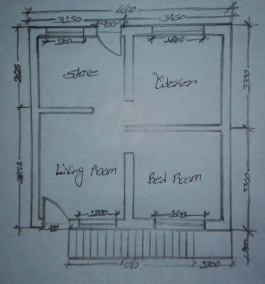

Figure 6.1 Proposed Ground Floor Plan

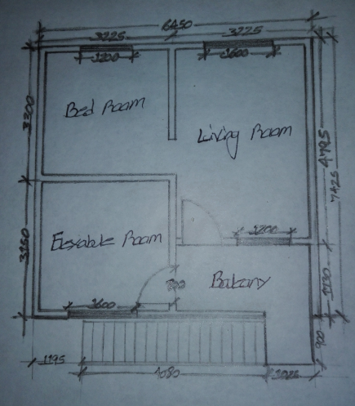

Figure 6.2 Proposed First floor plan

6.4. BUILDING TECHNIQUES
Alternative construction method such as corrugated fibre concrete tiles roofing, concrete jacketed rammed earth wall for ground floor and bamboo with timber frame wall type for the first floor. Reinforced Catalan vaulting for slab partial replacement of concrete from local available material will be suitable for appropriate low-cost housing in terms of cost, time and quality. Also must integrated appropriate and effective architectural design for the straightforwardness to implement the construction technology.
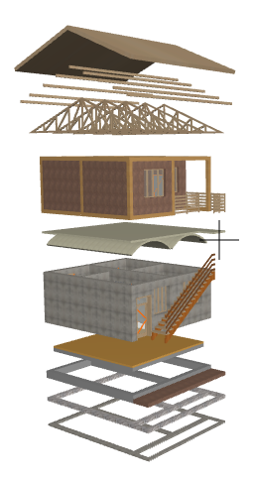
- Roof Tiles
2. Purlin

3. Truss
4. Timber frame with Bamboo wall

5. Reinforced Catalan Vaulting Slab

6. Concrete Jacketed Rammed Earth wall

7. Earthen Floor

8. 40*30cm Strip Foundation /Reinforced Beam/
9. 30cm Masonry
10. 5cm Lean Concrete

Figure 6.3 Proposed building systems
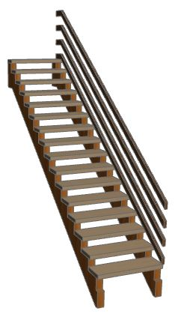

11. Wood Stair

Figure 6.4 Wooden Stair View

6.5. DETAIL INFORMATION ABOUT BUILDING SYSTEM

- Roof Tiles – Corrugated fibre concrete tiles
Production method - Composites were manufactured by manual mix of false banana fibre, ordinary Portland cement, sand and potable water in a head pan using pre-determined cement, sand and water ratios. The cement-water ratio was 1:0.5 while the cement-sand ratio was 1:1 up to 1:3. False banana fibres were added at the rate of 0.2%. Banana fibre Ash or powder (fine particle of banana fibre) was also added at the rate of 20% as partial replacement for cement (banana trunk ash or powder). The added dosages of the fibre and Banana trunk Ash or powder were based on the mass of cement. The mixtures were thoroughly mixed until homogenous slurry was formed. Produce by dimension 600x450x8 mm. The mixture was spread uniformly to a thickness of 8 mm. It was then tamped to reduce and eliminate voids in the composite produced. The slurry was carefully transferred on a corrugated mould as shown in figure below; the mixture was smoothened with the aid of a hand trowel as seen in figure and covered with polythene. It was allowed to dry for 24 hours, and then it was removed from the sheet.
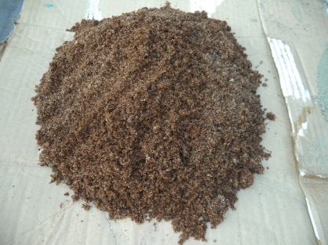
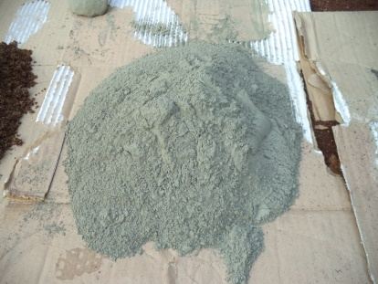

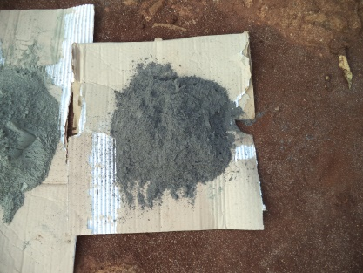
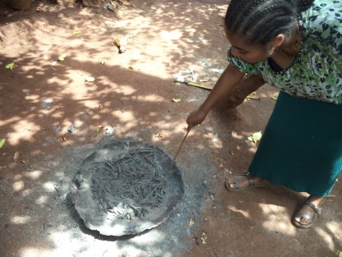
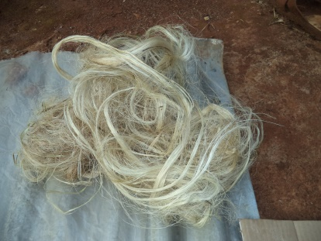

Figure 6.5 Material that used for production of corrugated fibre concrete tiles: Cement, sand, false banana fibre, banana trunk ash from right to left

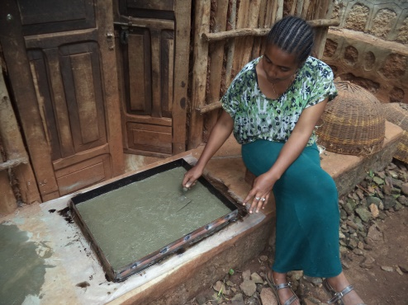
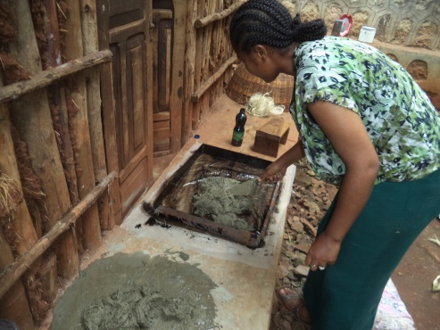

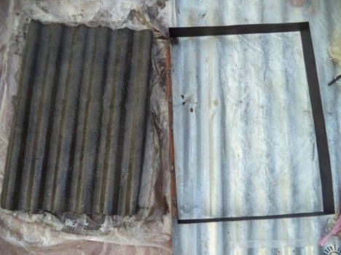
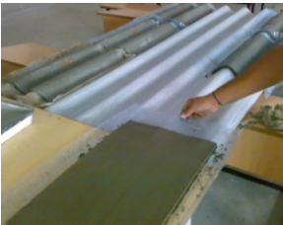

Figure 6.6 Production methods of corrugated fibre concrete tiles

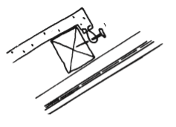
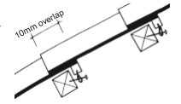

Figure 6.7 Construction of corrugated fibre concrete tiles roofing

- Purlin - Eucalyptus tree 5cm*7cm
- Truss - Zigba tree 5cm*10cm, truss spacing 1.5m, truss member spacing 1m
- Timber frame with Bamboo waving wall - in first floor construction bamboo lath wall is used as the base for the application of mud mixed with clay, organic fibres or cow-dung on both sides. Very often this bamboo lath eaten away by termites and the walls easily collapse. To avoid this mud plaster may be mixed with an anti-termite solution as protection. And Banana and plantain are cultivated a thick liquid is produced from boiling the stalks and leaves. This liquid is used as a water-proofing agent which is applied as a wash on the plastered mud walls. The presence of fibres controls the formation of cracks during drying
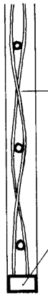
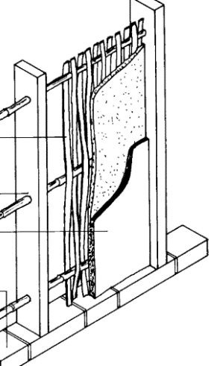
Bamboo waving
Coats of mud and plaster
Timber frame

Bamboo waving
Coats of mud and plaster

Timber base
Timber base

Figure 6.8 Bamboo waving and Timber Frame wall
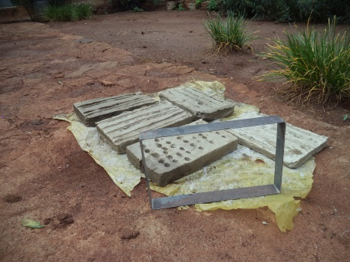
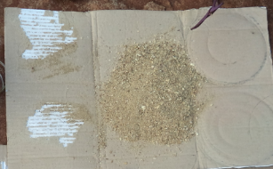
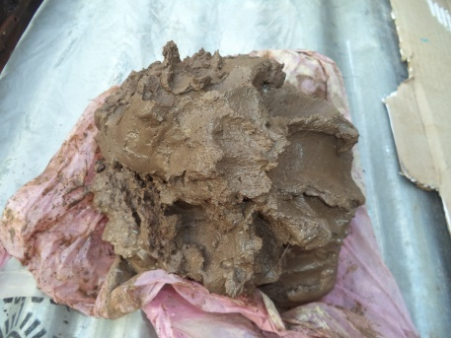
5. Reinforced Catalan Vaulting Slab - it is possible to obtain reinforced masonry vaults or arches by overlapping two layers of tiles or thin bricks and laminates, embedded within a hydraulic mortar, so that the entire assembly may act as a single structural unit.
Figure 6.9 Material that is used for production of tiles for Catalan vaulting: Clay and sawdust
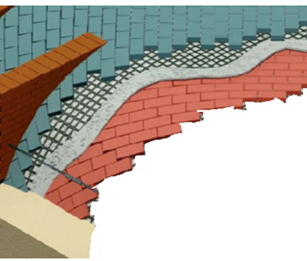
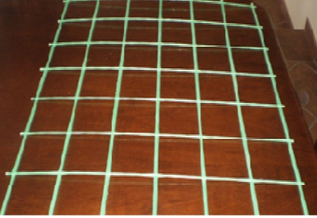
Figure 6.10 Arrangement of Reinforced Catalan vaulting and Reinforcement

Mason’s line (string) is tied to connect the guides; the first vaulted layer is set in plaster without formwork – cantilevering out into space while following the mason’s lines. The builder must understand how a single curved vault is weak (particularly when it is still only 1 layer with a 3-centimetre thickness). The following layers of masonry are set ‘oblique’ to each other (generally rotated by 45 degrees) so that the joints between each layer are ‘broken’ (meaning, so that a joint does not overlap between multiple layers). This creates a very strong ‘sandwich’ of masonry, which gives us a reasonable assumption that ‘no sliding’ will occur in the material. Once the thickness of the vault – and thus its self-weight – is increased, it is more resilient against point loads.
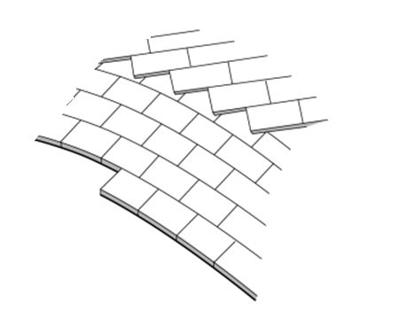

Figure 6.11 Arrangement of tiles in Catalan vaulting

Once a meter of the first and second course of masonry is laid, we may begin to build the stabilizing diaphragm walls that were described in the last post. The diaphragm walls are space 0.9 meters apart, creating regular stiffeners against asymmetrical loading. One the floor system fill has been added the diaphragms and the fill will work together to allow the load paths to travel through the floor system in the case of asymmetrical loading. The tension ties must be specified with sufficient strength steel, at the proper gauge, and spaced accurately to tie the outward thrust of the single curved masonry shell. This vault was designed so that all the load paths would be directed to the ring-beam, in the direction of the curvature of the vault.
6. Concrete Jacketed Rammed Earth wall - the technique would basically involve making the pre-cast concrete panels and marions before they are stacked up and filled with rammed earth. The pre-cast element would be identical in shape and size to practice of wall element. Pre-casting would eliminate waiting time in an in-situ technique until the concrete sets. The elements can be pre-cast by fewer people and would cost less if the owner is using paid labour. When the elements are pre-cast they can be stacked up and earth rammed directly in them reducing construction time enormously.
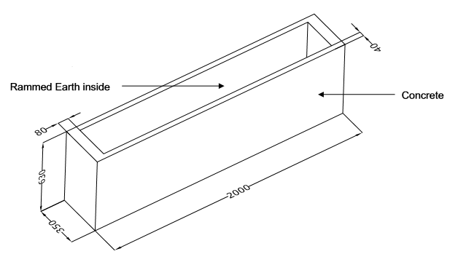

Figure 6.12 Concrete Jacketed Rammed Earth wall prefab concrete box

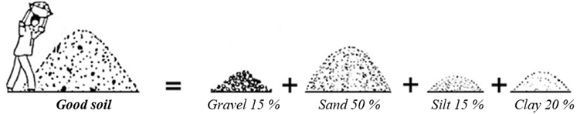
The above Figure 6.12 shows a pre-cast element that will be used in constructing the wall. Wall will be formed in such a way these pre-cast concrete panels are stacked next to each other and filled with rammed earth. When they are filled with earth and rammed the next layer of these pre-cast elements is put on top of the bottom ones and ramming process is repeated. 4 of these pre-cast elements on top of each other would form a load bearing wall of 2.52 metres height. Pre-cast elements can be cast in different dimensions to suit the particular design of the structure. Identifying the properties of a soil is essential to create, at the end, good quality products. Not every soil is suitable for earth construction. But with some knowledge and experience many soils can be used for filled in concrete.
Figure 6.13 Good soils for construction earth construction
7. Earthen Floor - Materials: Sand or crusher fines, clay, straw, polypropylene as air/moisture barrier, mineral spirits, linseed oil, alis (clay paint), Howard Feed-n-wax as a final touch and also instruments. Installing an Earthen Floor - First tamp the earth beneath the building. Then 100 - 150 mm Gravel and 6mm vapour barrier insulating properties and also acts as a capillary break from moisture of the earth. Preparing cob mixture (for first layer) 15-25% clay + 75% sand or crusher fines, (usually cheaper than sand) +chopped straw. Laid the mud base is at least 100 mm thick and Better to do it in 3 layers one by one letting to dry each. When create the cracks after first layer and Fix them in second and third coat. The final finishing layer of mud 3-4 mm + clay paint. Allow to dry the floor 100% Avoiding freezing. Seven (7) coats of warm linseed oil, Linseed, Walnut, Tung, Hemp and Perilla oils are all hardening or “drying” oils. If there are some think cracks, you can full them up with same mixture before oil covering.
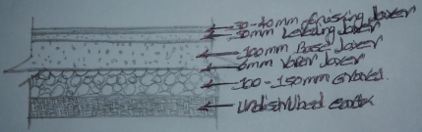
Figure 6.14 Earthen Floor
8. 40*30cm Strip Foundation /Reinforced Beam/ - to bear the weight of the structure above, transfer it into the ground, and resist the weathering that takes place where buildings meet the earth
9. 30cm Masonry - 30 cm stone gravel to prevent moisture from the earth and to support structural member and transfer load to the soil beneath it.
10. 5cm Lean Concrete – to provide the uniform surface to the foundation and to prevent the direct contact of foundation from soil
11. Wood Stair – 90 * 410cm wide straight wooden stair
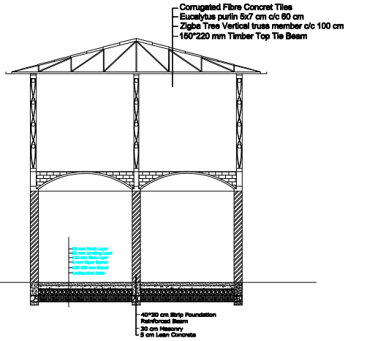

Figure 6.15 Sectional view of proposed building

6.6. Comparative Analysis between Conventional Construction Method and Proposed Construction Technologies
Conventional construction method used hollow block concrete (HCB) wall system and reinforced beam and column as building system. And proposed alternative construction used concrete jacketed rammed and timber frame with bamboo and mud wall system, Catalan vaulting slab, tile roofing system and wooden stair.
Table 6.1 Comparative analysis between conventional construction method and Proposed Construction Technologies
S.  No. | Item Description | Building material required by Conventional Method | "Proposed Construction Technologies: Reduction by Using Cost-Effective Construction Technology or Low-Cost Housing Construction Technologies (concrete jacket rammed earth wall, Catalan Vaulting  Slab)" | Material Savings of Low-Cost Housing Construction Technologies as compared to Conventional Method | Local availability of Building material of Low-Cost Housing Construction Technologies (Affordability of building materials locally)
S.  No. | A.SUB STRUCTURE
1 | Foundation | Required (Isolated) | Required (Strip Foundation)
1 | Foundation | Cement | Cement :25 % replacement by burnt fiber (banana leaf) | 25% | Locally available
1 | Foundation | Sand | sand | 0%
1 | Foundation | water | water | 0%
1 | Foundation | Reinforcement bar | Reinforcement bar | 0%
1 | Foundation | Form work | Form work | 0%
2 | Grade Beam | Required | Required
2 | Grade Beam | Cement | Cement :25 % replacement by burnt fiber (banana leaf) | 25% | Locally available
2 | Grade Beam | Sand | sand | 0%
2 | Grade Beam | water | water | 0%
2 | Grade Beam | Reinforcement bar | Reinforcement bar | 0%
2 | Grade Beam | Form work | Form work | 0%
2 | Grade Beam | aggregate (crushed stone) | aggregate (crushed stone) | 0%
3 | Masonry Work | Required | Required
3 | Masonry Work | Basaltic stone | Basaltic stone | 0%
3 | Masonry Work | Cement | Cement :25 % replacement by burnt fiber (banana leaf) | 25% | Locally available
3 | Masonry Work | Sand | Sand | 0%
3 | Masonry Work | water | water | 0%
 | B. SUPER STRUCTURE
1 | Ground floor slab | Required (Reinforced concrete) | Required (Earthen Floor) |  | Locally available
1 | Ground floor slab | Cement | Cement :25 % replacement by burnt fiber (banana leaf) | 25% | Locally available
1 | Ground floor slab | Sand | sand | 0%
1 | Ground floor slab | water | water | 0%
1 | Ground floor slab | Reinforcement bar |  | 100%
1 | Ground floor slab | Form work |  | 100%
1 | Ground floor slab | aggregate (crushed stone) | Required (Earthen Floor) | 100% | Locally available
2 | Elevation Columns (Ground Floor) | Required | Not Required
2 | Elevation Columns (Ground Floor) | Cement | Not Required | 100%
2 | Elevation Columns (Ground Floor) | Sand | Not Required | 100%
2 | Elevation Columns (Ground Floor) | water | Not Required | 100%
2 | Elevation Columns (Ground Floor) | Reinforcement bar | Not Required | 100%
2 | Elevation Columns (Ground Floor) | Form work | Not Required | 100%
2 | Elevation Columns (Ground Floor) | aggregate (crushed stone) | Not Required | 100%
3 | Wall (Ground Floor) | Required | Required
3 | Wall (Ground Floor) | Hollo concrete block (HCB) | "Concrete Jacketed Rammed Earth wall" |  | Locally available
3 | Wall (Ground Floor) | Cement | Cement :25 % replacement by burnt fiber (banana leaf) | 25% | Locally available
3 | Wall (Ground Floor) | Sand | Sand | 0%
3 | Wall (Ground Floor) | water | water | 0%
4 | Intermediate Beam | Required | Required
4 | Intermediate Beam | Cement | Cement :25 % replacement by burnt fiber (banana leaf) | 25% | Locally available
4 | Intermediate Beam | Sand | sand | 0%
4 | Intermediate Beam | water | water | 0%
4 | Intermediate Beam | Reinforcement bar | Reinforcement bar | 0%
4 | Intermediate Beam | Form work | Form work | 0%
4 | Intermediate Beam | aggregate (crushed stone) | aggregate (crushed stone) | 0%
5 | Slab | Required | Required
5 | Slab | Cement | Cement :25 % replacement by burnt fiber (banana leaf) | 25% | Locally available
5 | Slab | Sand | sand | 0%
5 | Slab | water | water | 0%
5 | Slab | Reinforcement bar | Reinforcement bar (Mesh) | As required
5 | Slab | Form work | Tiles | 0%
5 | Slab | aggregate (crushed stone) | Not required | 100%
6 | Frist Floor Columns | Required | Required (replaced by Timber frame) |  | Locally available
6 | Frist Floor Columns | Cement | Not required | 100%
6 | Frist Floor Columns | Sand | Not required | 100%
6 | Frist Floor Columns | water | Not required | 100%
6 | Frist Floor Columns | Reinforcement bar | Not required | 100%
6 | Frist Floor Columns | Form work | Not required | 100%
6 | Frist Floor Columns | aggregate (crushed stone) | Not required | 100%
7 | Wall (Frist Floor) | Required | Required
7 | Wall (Frist Floor) | Hollo concrete block (HCB) | Wall Covered with Bamboo and Mud | 100% | Locally available
7 | Wall (Frist Floor) | Cement | Not required | 100%
7 | Wall (Frist Floor) | Sand | Not required | 100%
7 | Wall (Frist Floor) | water | Not required | 100%
8 | Top tie Beam | Required | Required (Timber frame) |  | Locally available
8 | Top tie Beam | Cement | Not required | 100%
8 | Top tie Beam | Sand | Not required | 100%
8 | Top tie Beam | water | Not required | 100%
8 | Top tie Beam | Reinforcement bar | Not required | 100%
8 | Top tie Beam | Form work | Not required | 100%
8 | Top tie Beam | aggregate (crushed stone) | Not required | 100%
9 | Roofing | Required | Required
9 | Roofing | Truss (wood) | Truss (wood) | 0% | Locally available
9 | Roofing | Purlin (wood) | Purlin (wood) | 0% | Locally available
9 | Roofing | Roof cover with Corrugated iron EGA sheet | Roof cover with roof Tiles | 100% | Locally available
10 | Windows | Required | Required
10 | Windows | Metal Frame | Wood Frame | 100% | Locally available
10 | Windows | Metal Grill | Not required | 100%
10 | Windows | Glass | Not required | 100%
11 | Doors | Required | Required
11 | Doors | Wood Frame | Wood Frame | 100% | Locally available
11 | Doors | Not required | Not required | 100%
11 | Doors | Not required | Not required | 100%
12 | Staircase | Required | Required (Wood Stair) |  | Locally available
12 | Staircase | Cement | Not required | 100%
12 | Staircase | Sand | Not required | 100%
12 | Staircase | water | Not required | 100%
12 | Staircase | Reinforcement bar | Not required | 100%
12 | Staircase | Form work | Not required | 100%
12 | Staircase | aggregate (crushed stone) | Not required | 100%
12 | Staircase | Metal Hand rail | Not required | 100%

REFERENCE
Ahmed Zaki Yahya, 1997, Housing the Nation: A Definitive study, Cagamas Berhad, Kuala Lumpur
Ali Haider Jasvi & D.K. Bera, 2015, Sustainable use of low cost building materials in the rural India, IJRET: International Journal of Research in Engineering and Technology, eISSN: 2319-1163 | pISSN: 2321-7308, Volume: 04 Special Issue: 13, http://www.ijret.org
Allen, W. (1995), the pathology of modern building, Building research and information, 23 (3), 139-46
Amit D Chougule, Manoj H. Mota, Ushadevi S Patil, 2015, “To Study the Filler Slab as Alternative Construction Technology - A Review”, Journal of Information, Knowledge and Research in Civil Engineering, Volume: 3, Issue: 2
Mr. Andrew McKimmie, 2010, Rammed Earth – “The Modern Alternative”
Ar.Vidya & Ar. Radha. Alternative low-cost building materials, DSATM Bangalore, India
Bayer. (1965), Housing and Society, Macmillan, New York
Berlant, S., (1999), The Natural Builder, vol. 1: Creating architecture from earth. Montrose Colorado: The Natural Builder.
Benfratello, S., Caiozzo, G., D’Avenia, M. & Palizzolo, L., 2012, Tradition and modernity of Catalan vaults: historical and structural analysis. Meccanica dei Materiali e delle Strutture, 5 (2012) 3, 44-54
Bihon, K. (2007), Housing for the poor in Addis Ababa. Addis Ababa. Retrieved on Oct 4, 2012, http://www.lth.se/fileadmin/hdm/alumni/papers/sdd2006/sdd2006-12.pdf
Brand, S. (1994), How Buildings Learn: What happens after they’re Built, London, Viking Books
Borri, A.; Casadei, P.; Castori, G. & Hammond, J., 2009, Strengthening of brick masonry arches with externally bonded steel reinforced composites. Journal of Composites for Construction, 13 (2009) 6, 468-475.
Brian Milani, (2005): Building Materials in a Green Economy: Community-based Strategies for Dematerialization. A thesis submitted in conformity with the requirements for the degree of Doctor of Philosophy; Department of Adult Education, Community Development and Counselling Psychology, Ontario Institute for Studies in Education, and the Institute for Environmental Studies of the University of Toronto
Capozucca R., 1997, Analysis of thin composite masonry vaults. Mas. Int., 11 (1997) 1, 19-25.
C. Jayasinghe, M H P JDe. Silva, D M M P Dissanayake and C T K I Fernando, 2006, Engineering Properties of Micro Concrete Roofing Tiles, ENGINEER - Vol 39, No. 03, pp. 35-41, The Institution of Engineers, Sri Lanka
CSA (Central Statistics Authority) (2007), the 2007 Population and Housing Census of Ethiopia: Results for SNNPRS, Statistical Report on Housing Characteristics, Vol. I, Part IV, Addis Ababa
Central Statistical Agency (Ethiopian) and ICF International, 2012, Ethiopia Demographic and Health survey 2011, Addis Ababa, Ethiopia and Calverton, Maryland, USA: central statistical agency and ICF International.
Carla Bielli, Gezu Berhanu, Amare Isaias & Arianna Orasi, 2001, Population growth and environment in Ethiopia: In-depth studies from the 1994 population and housing census in Ethiopia, Italian Multi-Bi Research Project ETH/92/P01, Central Statistical Authority (CSA) Addis Ababa, Ethiopia, Institute for Population Research – National Research Council (Irp-Cnr) Roma, Italy
Canada Mortgage and Housing Corporation (CMHC), (2003), Healthy Housing and Sustainability, from http://www.cmhc-schl.gc.ca/en/imquaf/hehosu/index.cfm
Clark, EJ, (2009). The Housing Quality Questionnaire: A new self-report measure for public health assessment. ProQuest Dissertations and Theses, http://gradworks.umi.com/ (accessed December 2014)
CORRADI, MARCO, CASTORI, GIULIO and BORRI, ANTONIO, A new method for strengthening tiled vaults: “Reinforced Catalan vaulting”, 9th International Masonry Conference 2014 in Guimarães, https://www.researchgate.net/publication/289687470
Creswell, J. W. (2003). Research design: A qualitative, quantitative, and mixed method approaches (2nd ed.). Thousand Oaks, CA: Sage
David S. Watt, 1999, Building Pathology: Principles and Practice, ISBN 0-632-04875-1, Blackwell Science Ltd, United Kingdom, www.blackwell-science.com
Duffy, F. (1990), Measuring building Performance, Facilities, 8(5), 17-20
“Environment Friendly Indian Building Material Technology for Cost Eﬀective Housing”, Society for Excellence in Habitat Development, Environmental Protection & Employment Generation (SHEE)
Federal Democratic Republic of Ethiopia: ministry of urban development and housing, GTP II (2015/16- 2019/20) Pillars, Programs and Projects that support achievement of Ethiopian Cities Sustainable Prosperity Goals (ECSPGs) (2015/16 2024/2025) For Urban Development and Housing, Final Draft 17 December, 2015
European commission, 2011, office for infrastructure and logistics Brussels: Manual of standard building specification, version of 12
Jill Stewart, Iam Watson, Phil Hatcher, Sara Emanuel & Richard Hopkins, 2013, Housing, Health, Safety and Wellbeing, Occasional paper No.1, Environmental health research network (EHRNET), http://ukehrnet. wordpress.com
GUIDELINES FOR HEALTHY HOUSING, 1988, World health organization, Regional office for Europe, Copenhagen
Gut P, Ackerknecht D. (1993) Climate Responsive Building-Appropriate Building Construction in Tropical and Subtropical Regions. SKAT: 324.
Hannah Schreckenbach, 1981, Construction technology for a tropical developing country, published by German Agency for technical cooperation (GTZ) for department of Architecture, university of science and technology, Kumasi, Ghana, ISBN 3-88085-186-7
HCAFEDO (Hawassa City Administration Finance and Economic Development Office) (2010), Socio-economic profile of Hawassa City Administration, Hawassa, SNNPRS
HCAFEDO (Hawassa City Administration Finance and Economic Development Office), (2011), Bulletin by the Hawassa city administration, Vol. 2, No. 3, Hawassa, SNNPRS
Housing and health regulation in Europe, (2006), by the convention between the French ministry of health and world health organization, regional office for Europe
Ibrahim U. Haruna, Ishaq Musa, Muhammad I. Tikau, & Maksha Yerima, 2014, Improvement of thermal comfort in residential buildings, international journal of scientific & technology research volume 3, issue 3, ISSN 2277-8616, www.ijstr.org
Iwuagwu Ben Ugochukwua, Iwuagwu & Ben Chioma Mb, 2015, Local building materials: affordable strategy for housing the urban poor in Nigeria, Elsevier Ltd, doi: 10.1016/j.proeng.2015.08.402, (http://creativecommons.org/licenses/by-nc-nd/4.0/).
Kennedy, J. F. (2002). Natural Building Materials: An overview. The Art of Natural Building, Gabriola Island, BC: New Society Publishers.
K. Jain & M. C. Paliwal, 2012, Adoption of Appropriate and Cost-Effective Technologies in Housing: Indian Experience, International Scholarly and Scientific Research & Innovation 6(3) 2012, scholar.waset.org/1307-6892/1017
López López, David, Domènech Rodríguez, Marta & Palumbo Fernández, Mariana, Using a construction technique to understand it: thin-tile vaulting, 2014, SAHC2014 – 9th International Conference on Structural Analysis of Historical Constructions F. Pena & M. Chávez (eds.) Mexico City, Mexico, https://www.researchgate.net/publication/281846063
Maini S. (2005), Earthen Architecture for sustainable habitat and compressed stabilized earth block technology. Paper Presented at heritage lecture on clay architecture and building techniques by compressed earth at the meeting of India High Commission, Riyadh City
Mahesh K.P. (2013). A thesis on dissertation work “Strength of corrugated roofing elements reinforced with silk fibre and rice husk ash”, International Journal of Scientific & Engineering Research, Volume 4, Issue 8, August-2013, ISSN 2229-5518
Manjesh Srivastava and Vikas Kumar, 2017, the methods of using low cost housing techniques in India, Journal of Building Engineering 15 (2018) 102–108, Elsevier Ltd, https://doi.org/10.1016/j.jobe.2017.11.001
Marwan Mostafa and Nasim Uddin, 2015, Article, Effect of Banana fibres on the Compressive and Flexural Strength of Compressed Earth Blocks, Buildings 2015,5,282-296; doi: 10.3390/buildings5010282, www.mdpi.com/journal/buildings/
Merriam, S. B., & Simpson, E. L. (2000), a guide to research for educators and trainers of adults (Updated 2nd ed.). Malabar, FL: Krieger.
Ministry of Finance and Economic Development, Federal Democratic Republic of Ethiopia, “Growth and Transformation Plan (2010/11 – 2014/15)”, Addis Ababa, 2010
Morris, E.W and Mary Winter, (1978), Housing, Family and Society, John Wiley & Sons Inc., New York
M. P. Jaisingh, L. Jaisingh and B. Singh, A RC filler slab with non-autoclaved cellular concrete blocks for sustainable Construction, Central Building Research Institute, Roorkee, India
Narendra Verma, V.K. Gupta, N. Singh, Balbir Singh, 2011, Building Research Note − 79, CSIR – Central Building Research Institute, Roorkee
Ndubueze, O. (2007), Measuring Housing Affordability: A Composite Approach, W17 – Housing and Sustainable Urbanization in Developing Countries, Centre for Urban and Regional Studies (CURS), University of Birmingham, Rotterdam.
Nilanjan S (2008) Use of cost-effective construction technologies in India to mitigate climate change. Current Science 94: NO. 1, General articles
Nilanjan S, Souvanic R. (2013) Study of Appropriateness of Cost-Effective Building Construction Technologies in Housing Sector in India. J Archit Eng Tech 2: 113. doi:10.4172/2168-9717.1000113
Noor Sharipah bt. Sultan Sidi, Quality Affordable Housing: A Theoretical Framework For Planning and Design of Quality Housing, Universiti Tun Hussein onn Malaysia, Journal of Techno-Social
Obinna Onuaguluchi & Nemkumar Banthia, 2016, Plant-based natural ﬁbre reinforced cement composites: A review, Elsevier Ltd, http://dx.doi.org/10.1016/j.cemconcomp.2016.02.014
Oloruntoba, Kayode, Ayodele E Olusegun, 2013, “Local Building Materials: A Tool towards Effective Low - Income Housing in Nigeria”, Journal of Scientific Research, Volume: 18, Issue: 4, pp: 492 – 497.
Otto Ruskulis of ITDG’s Technical Enquiries Service, Appropriate Technology magazine Volume 23/Number 1 June 1996 ATBrief No 16, Drawings from Appropriate Building Materials, published by SKAT, http://www.researchinformation.co.uk
P. P. Bhangale & Ajay K. Mahajan, (2015), Cost Reduction through Cost Effective Construction Techniques, International Journal of Science and Research (IJSR), Volume 4 Issue 2, February 2015, www.ijsr.net
Production Guide: Fibre and Micro Concrete Roofing Tiles: FCR/MCR Toolkit Element 22, 1992, SKAT/ILO Publications, St. Gallen and Geneva

P. Vipul Naidu and Pawan Kumar Pandey, 2014, Replacement of Cement in Concrete, International Journal of Environmental Research and Development, ISSN 2249-3131 Volume 4, Number 1, pp. 91-98, Research India Publications, http://www.ripublication.com/ijerd.ht
Reddy BW (2004), Sustainable Building Technology, Current Science 87: 899-907
Regassa, B., Regassa, N.,(2015), Housing and Poverty in Southern Ethiopia: Examining Affordability of Condominium Houses in Hawassa City, Economics and Sociology, Vol. 8, No 3, pp. 155-169. DOI: 10.14254/2071-789X.2015/8-3/12
Rinku Taur and Vidya Devit, 2009, Low cost housing, ACSGE-2009, Oct 25-27, BITS Pilani, India
Roland Stulz and Kiran Mukerji, 1993, Appropriate Building Materials, SKAT, IT and GATE co publication, 3rd Edition
Satprem Maini, 2010, “Compressed Stabilized Earth Block Sand Stabilized Earth Techniques Research and Development by the Auroville Earth Institute (AVEI)”
Setegne Kifle, Bogale Teferi, Abreham Kebedom, and Abiyot Legesse, “Factors Influencing Farmers Decision on the Use of Introduced Soil and Water Conservation Practices in the Lowland’s of Wenago Woreda, Gedeo Zone, Ethiopia.” American Journal of Rural Development, vol. 4, no. 1 (2016): 24-30. doi: 10.12691/ajrd-4-1-4
Statistics New Zealand, (2015), Measuring housing quality: Potential ways to improve data collection on housing quality in New Zealand, www.stats.govt.nz
Soen. (1979). “Habitability: Occupants’ needs and dwelling satisfaction” in Ekistics, Volume 48, No. 275.
Study on Low Cost Incremental Housing for UP State.‟ BMTPCD, Adlakha and Associates. (BMTPC- Building Materials & Technology Promotion Council, Govt. of India)
Tonette S. Rocco and Maria S.Plakhotnik, 2000, Literature Reviews, Conceptual Frameworks, and Theoretical Frameworks: Terms, Functions, and Distinctions, Article in Human Resource Development Review Vol. 8, No. 1, DOI: 10.1177/1534484309332617, Published by: SAGE, http://hrd.sagepub.com/content/8/1/120.refs.html
Turner, J.F.C. (1976), Housing by People, Marion Boyars, London
U. J. Phatak, C. S. Chavan, Lalit V. Rathod, 2014, “Cost Effective House by Using Various Construction Techniques and Materials”, IJAR, Volume: 4, Issue: 4
United Nations (1977), the social impacts of Housing: Goals, Standards, Social indicators and population participation. Department of economics and social affairs, New York
United Nations (1978), the role of housing in promoting social interaction, Department of economics and social affairs, New York
Vijaya Prathima, Rajeswari Isnakula and Shaik Nadhim, 2017, Comparative Study of Conventional Concrete with Banana Fibre Modified Concrete, IJSART - Volume 3 Issue 9 –ISSN: 2395-1052, www.ijsart.com
Vivian W. Y. Tam, 2011, Cost Effectiveness of using Low Cost Housing Technologies in Construction, Procedia Engineering 14 (2011) 156–160, 1877–7058, Published by Elsevier Ltd. doi:10.1016/j.proeng.2011.07.018, www.sciencedirect.com
W. Z. Taffese, 2012, Low-Cost Eco-Friendly Building Material: A Case Study in Ethiopia, World Academy of Science, Engineering and Technology International Journal of Civil and Environmental Engineering Vol: 6, No: 2, scholar.waset.org/1307-6892/7965
Zami MS, Lee A (2008), contemporary Earth Construction in Urban housing stabilized or un-stabilized? The Crescent, Sanford, United Kingdom
Wikipedia, Rammed earth - Wikipedia, the free encyclopaedia
http://sepindia.org/ihd-sep/ceeef-technologies/filler-slab -technology/
http://arkistudentscorner.Blogspot.in/2011/05/fillerslab s.html
http://www.istudioarchitecture.com/rat-trap-bond/
http://sepindia.org/ihd-sep/ceeef-technologies/rat-trapbond-a-masonry-technique/

APPENDIX I - QUESIONER FOR RESIDENT
ለአካባቢ ነዋሪዎች የተዘጋጀ መጠይቅ
ክፍል - አንድ
ማህበራዊ እና ኢኮኖሚያዊ ሁኔታ
ይህ የጥያቄ ክፍል የሚዳስሰው አሁን ያሉበትን ማህበራዊ እና ኢኮኖሚያዊ ሁኔታ ሲሆን ይህም በዚህ ጥናት ወስጥ የሚጠቅመው የሚኖሩበትን ቤት ካሎዎት ማህበራዊ እንቅስቃሴ አንፃር እና ከኢኮኖሚያዊ አቅም ሁኔታ ለማነፃፀር ነው::
የአካባቢው (የቀበሌው) መጠሪያ
- በቤት ውስጥ የሚኖሩ የቤተሰቡ አባላት ቁጥር እና የእድሜ ደረጃ? እባክዎትን የቁጥሩን መጠን በትክክል በሠንጠረዡ ይሙሉ
 | 0-9 አመት | 10-15 አመት | 16–19 አመት | 20-44 አመት | 45-64 አመት | 65-74 አመት | 75 አመት እና ከዚህ በላይ
ሴት
ወንድ

- በቤት ውስጥ የሚኖሩ የቤተሰቡ አባላት የትምህርት ደረጃ? እባክዎትን የቁጥሩን መጠን በትክክል በሠንጠረዡ ይሙሉ
 | 0-4 ክፍል | 4-6 ክፍል | 7-8 ክፍል | 9-10 ክፍል | 11-12 ክፍል | ሙያ/ዲፕሎማ | ዲግሪ እና ከዚያ በላይ
ሴት
ወንድ

- በቤት ውስጥ የሚኖሩ በተለያዩ የስራ መስክ ላይ የተሠማሩ የቤተሰቡ አባላት ቁጥር?
ወንድ-
ሴት-
- በቤት ውስጥ የሚኖሩ በተለያዩ የስራ መስክ ላይ የተሠማሩ የቤተሰቡ አባላት የተሠማሩበት የስራ አይነት?
የንግድ ስራ
የግብርና ስራ
የመንግስት ስራ
የመንግስታዊ ያልሆነ የስራ
ከላይ ከተጠቀሠው ውጪ ከሆነ_________________________________________

- በቤት ውስጥ የሚኖሩ በተለያዩ የስራ መስክ ላይ የተሠማሩ የቤተሰቡ አባላት የስራ ቦታ?
ቁጥር
በመኖሪያ ቤትዎ ውስጥ _____________
በመኖሪያ ቤትዎ አቅራቢያ _____________
በሌላ ቀበሌ _____________
ከወረዳው ውጪ _____________
ከላይ ከተጠቀሠው ውጪ ከሆነ__________________________________________
- የቤተሰብዎ የገቢ መጠን (Household Income)
በሳምንት | በወር
እስከ ብር 150 | እስከ ብር 600
ከብር 150 እስከ 450 | ከብር 600 እስከ 1500
ከብር 450 እስከ 600 | ከብር 1500 እስከ 3000
ከብር 600 እስከ 1000 | ከብር 3000 እስከ 6000
ከብር 1000 በላይ | ከብር 6000 በላይ
የተዘረዘሩት የገቢ ሁኔታ የተለየ ካለ ________________________________________
ክፍል - ሁለት
የመኖሪያ ቤትዎ አካላዊ ባህርይ
ይህ የጥያቄ ክፍል የሚዳስሰው አሁን ያሉበትን የመኖሪያ ቤት አካላዊ ሁኔታ ማለትም የተሠራበትን ግብዐት እና የተሠራበትን የአሰራር ሁኔታ፤ የመኖሪያ ቤት የውስጥ ቦታ ክፍፍል እና የቦታ አጠቃቀም ሁኔታ ለማጥናት የሚያግዝ ነው::
- የሚኖሩበት ቤት (Ownership)
የግል
የቤተሰብ
ከግለሰብ ኪራይ
ከመንግስት ኪራይ
ሌላ ______________________________________________________________
- የሚኖሩበት የቤት አሠራር አይነት
ለብቻው የተሠራ
ተያይዞ የተሰራ
በከፊል የተራራቀ
ሌላ ______________________________________________________________
- የመኖሪያ ቤትዎ የእድሜ መጠን
ከዓመት በታች
ከአንድ እስከ ሶስት አመት
ከሶስት አመት በላይ ከአስር አመት በታች
ከአስር አመት በላይ
- በመኖሪያ ቤትዎ ለተለያዩ አገልግሎት የሚውሉ የክፍል ብዛት
1 2 3 4 5 እና ከዚያ በላይ
- ከላይ የተጠቀሰው የክፍል ብዛት የአገልግሎት ዐይነት ቢገልፁልን?
የአገልግሎት አይነት የክፍል ቁጥር
___________________ ___________
___________________ ___________
___________________ ___________
- አሁን በሚኖሩበት ቤትዎ ከፍላጎትዎ አንፃር፣ በአጠቃቀም ወይንም በተለያየ ሁኔታ የገጠምዎ ችግር ካለ __________________________________________________
_______________________________________________________________
- በመኖሪያ ቤትዎ ደስተኛ ነዎት?
አዎ
አይደለሁም
ለሰጡት መልስ ምክንያት ________________________________________________
____________________________________________________________________
- ወደፊት በቤትዎ የአሠራር ሁኔታ ወይንም በሚሰራበት ግብዐት ላይ እንዲቀየር የሚፈልጉት ነገር ካለ? _______________________________________________
__________________________________________________________________
__________________________________________________________________
- ወደፊት በቤትዎ ውስጥ እንዲካተት ወይም እንዲቀየር የሚፈልጉት መጠቀሚያ ቦታ ካለ? _____________________________________________________________
___________________________________________________________________
___________________________________________________________________
- በአዲስ የቤት አሠራር አይነት እና የግንባታ ግብዐት ለመጠቀም ወይንም ባልዎት አቅም ለመደገፍ ምን ያህል ዝግጁ ነዎት? ________________________________
__________________________________________________________________

APPENDIX II - QUESIONER FOR GOVERMENTAL SECTOR OFFICE
- Organization Profile
Region_______________________ Zone___________________________
Office/organization Name_____________________________Year___________Month________Time
- Information/Data About the Study Area
Region_______________________ Zone__________ Wereda_________________ Kebele________________________________subYear___________Month________Time____

 | Population size
S.No | Male |  | Female
S.No | Ages | Number | Ages | Number
1 | Below 18 |  | Below 18
2 | Between 18-30 |  | Between 18-30
3 | Between 31-50 |  | Between 31-50
4 | Above 51 |  | Above 51
 | Total |  | Total
Tabel-1
Family size/House hold size
 | House hold size | Number of houses
1 | Below 1
2 | Between 2-4
3 | Between 5-7
4 | Between 8-10
5 | Above 10
 | Total
Tabel-2
House hold size Below 1 /one
S.No | Land Size In Hectares | Number of house
1
2
3
4
5
6
7
8
9
Table-3
Check list for gathering information for MSC thesis: “Architectural Intervention for Rural Farmers” Adaptation of Cost-effective and Alternative Construction Technology of Housing in wonago wereda, Gedeo, Zone, Dilla.
By Hana Abayneh, 2018.
- Organization Profile
Region_______________________ Zone___________________________
Office/organization Name_____________________________Year___________Month________Time
- Information/Data About the Study Area
Region_______________________ Zone__________ Wereda_________________ Kebele________________________________subYear___________Month________Time____

House Hold Size Between 2-4
S.No | Land Size In Hectares | Number Of House
1
2
3
4
5
6
7
Tabel-4
House Hold Size Between 5-7
S.No | Land Size In Hectares | Number Of House
1
2
3
4
5
6
7
Tabel-5
House Hold Size Between 8-10
S.No | Land Size In Hectares | Number Of House
1
2
3
4
5
6
7
Tabel-6
Check list for gathering information for MSC thesis: “Architectural Intervention for Rural Farmers” Adaptation of Cost-effective and Alternative Construction Technology of Housing in wonago wereda, Gedeo, Zone, Dilla.
By Hana Abayneh, 2018.
- Organization Profile
Region_______________________ Zone___________________________
Office/organization Name_____________________________Year___________Month________Time
- Information/Data About the Study Area
Region_______________________ Zone__________ Wereda_________________ Kebele________________________________subYear___________Month________Time____

House Hold Size Above 10
S.No | Land Size In Hectares | Number Of House
1
2
3
4
5
6
7
Tabel-7

Socio -Economic Status
S.No | Male |  |  | Female
S.No | Economic Activities | Number of House | Number of Peoples | Economic Activities | Number of House | Number of Peoples
1 | Students |  |  | Students
2 | Farmers |  |  | Farmers
3 | Merchant/Traders/Private |  |  | Merchant/Traders/Private
4 | Government Employed |  |  | Government Employed
5 | Non-Government Employed |  |  | Non-Government Employed
6 | Unemployed |  |  | Unemployed
7 | Others |  |  | Others
Tabel-8

Check list for gathering information for MSC thesis: “Architectural Intervention for Rural Farmers” Adaptation of Cost-effective and Alternative Construction Technology of Housing in wonago wereda, Gedeo, Zone, Dilla.
By Hana Abayneh, 2018.
- Organization Profile
Region_______________________ Zone___________________________
Office/organization Name_____________________________Year___________Month________Time
- Information/Data About the Study Area
Region_______________________ Zone__________ Wereda_________________ Kebele________________________________subYear___________Month________Time____

Housing Characters
S.No | House Type | Number Of Rooms | Number Of Houses | Minimum Service Year
1 | Simple Shades
2 | Hut Constructed From Wood, Mud And The Roof Covered By Grass/Bamboo
3 | Hut Constructed From Wood, Grass/Enset Leave/False Banana And The Roof Covered By Grass/Bamboo
4 | House Constructed From Wood ,Mud And Roof Covered With From Grass/Bamboo
5 | House Constructed From Wood ,Mud And Roof Covered With Corrugated Iron Sheet
6 | House Constructed From HCB,Brik,Stones ,And Roof Covered With Corrugated Iron Sheet
7 | Others
Tabele-9

Check list for gathering information for MSC thesis: “Architectural Intervention for Rural Farmers” Adaptation of Cost-effective and Alternative Construction Technology of Housing in wonago wereda, Gedeo, Zone, Dilla.
By Hana Abayneh, 2018.
- Organization Profile
Region_______________________ Zone___________________________
Office/organization Name_____________________________Year___________Month________Time
- Information/Data About the Study Area
Region_______________________ Zone__________ Wereda_________________ Kebele________________________________subYear___________Month________Time____

General Information
- Description of the major housing type construction procedure/method.
____________________________________________________________________________________________________________________________________________________________________________________________________________________________________________________________________________________________________________________________________________________________________________________________________________________________________________________________________________________

- Description of the climatic condition of the area___________________________________________________________________________________________________________________________________________________________________________________________________________________________________________________________________________________________________________________________________________________________________________________________________
- Description of a bout the location of the area_______________________________________________________________________________________________________________________________________________________________________________________________________________________________________
- Description about the economic activities of the wored___________________________________________________________________________________________________________________________________________________________________________________________________________________________________________________________________________________________________________________

Check list for gathering information for MSC thesis: “Architectural Intervention for Rural Farmers” Adaptation of Cost-effective and Alternative Construction Technology of Housing in wonago wereda, Gedeo, Zone, Dilla.
By Hana Abayneh, 2018.
- Description about the income level of the population of the area___________________________________________________________________________________________________________________________________________________________________________________________________________________________________________________________________________________________________________________________________________________________________________________________________

- Total population size of the wored__________________________________________________________________
- Total land use for farm_____________________________________________________________________
- Total land use for housing_______________________________________________________________
- Total land owned by government/Administrative______________________________________
- Total Private house number________________________________________________________
- Total governmental house number____________________________________________________
- Fertility rate of the wered__________________________________________________________

Check list for gathering information for MSC thesis: “Architectural Intervention for Rural Farmers” Adaptation of Cost-effective and Alternative Construction Technology of Housing in wonago wereda, Gedeo, Zone, Dilla.
By Hana Abayneh, 2018.

APPENDIX III - LETER OF COPERATION AND SECONDARY DATA FROM SECTOR GOVERMENTAL OFFICE

APPENDIX IV - CENTRAL STATISTICAL AUTHORITY (CSA) POPULATION AND HOUSING 1994CENSUS IN ETHIOPIA INFORMATION OF GEDEO ZONE

Ethiopia is divided into nine regions and two administrative councils. The regions are further divided into zones. Zones are again divided into weredas, and the weredas into Kebeles.
There is difference between the sum of total because the study count the member in the household for the regarding issue
Up to one Kilometre distance from their housing
Domestic animals such as hens, goat, sheep, cows and other animals /cattle/

