Addis Ababa University
College of Natural Sciences
School of Earth Sciences
SLOPE STABILITY ASSESSMENT FOR MANA BEGNA-LEMLEM BEREHA ROAD,NORTHWESTERN ETHIOPIA.
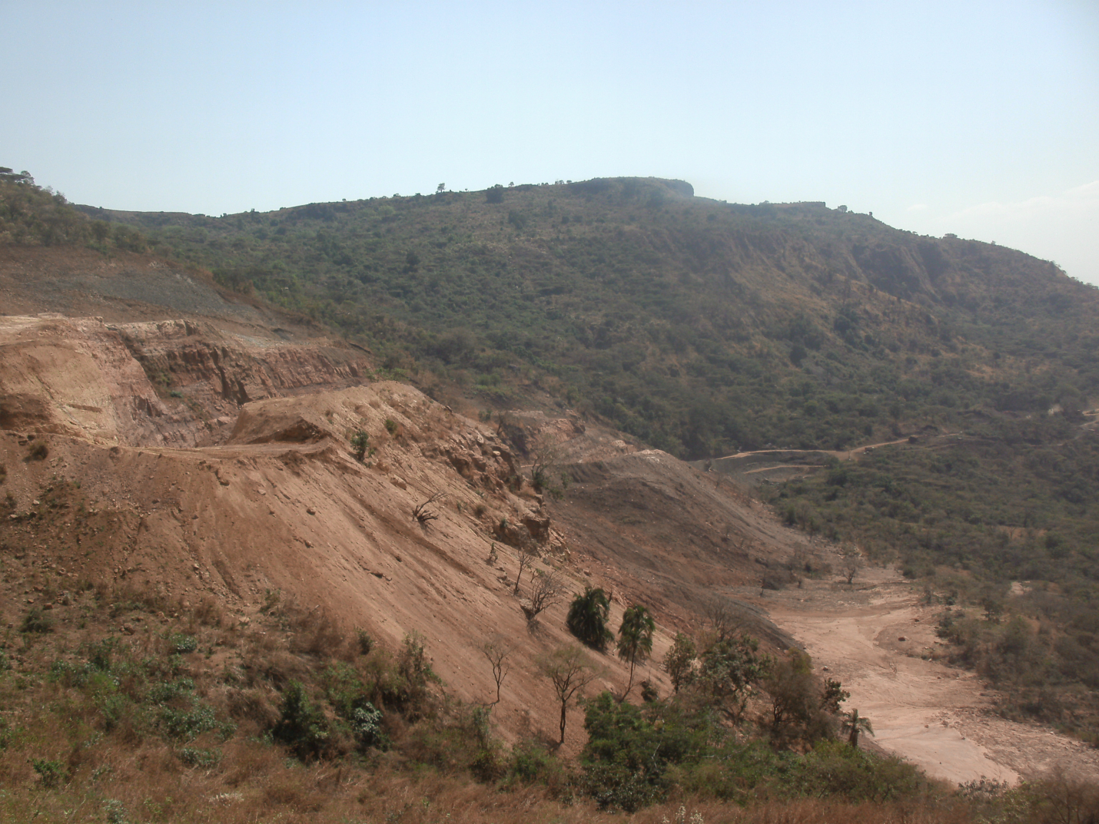
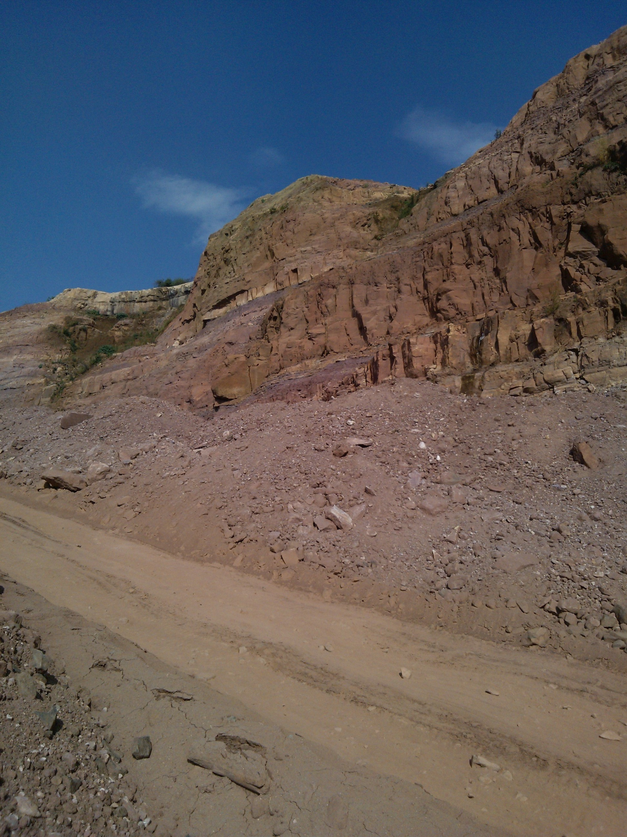

A thesis submitted to the School of Earth Sciences, Addis Ababa University in partial fulfilment of the requirement for the degree of Master of Science in Earth Sciences (Engineering Geology).

BY:
KASSAHUN MISGANA BORU

May, 2014

SLOPE STABILITY ASSESSMENT FOR MANA BEGNA-LEMLEM BEREHA ROAD,NORTHWESTERN ETHIOPIA

A thesis submitted to the school of Earth sciences, Addis Ababa University In partial fulfillment of the requirement for the degree of Master of Science in Earth sciences (Engineering Geology).

By:

KASSAHUN MISGANA BORU

ADVISORS: 1: FIKIRTE AREGA (PHD)
2: BEKELE ABEBE (PHD)
ADDIS ABABA UNIVERSITY
SCHOOL OF EARTH SCIENCES

May, 2014
Addis Ababa University
College of Natural sciences
School of Earth sciences
SLOPE STABILITY ASSESSMENT FOR MANA BEGNA-LEMLEM BEREHA ROAD, NORTHWESTERN ETHIOPIA
By
Kassahun Misgana Boru
Approved by Board of Examiners:- signiture
- Seifu Kebede (PHD) …………………..............
Chairman, school of Earth sciences
- Fikirte Arega (PHD) ……………………………..
Advisor
- Bekele Abebe (PHD) …………………………….
Advisor
- Taru K. Raghunvanshi (PHD) ….........….…………..........
Examiner
- Mulugeta Alene (PHD) …………………......................
Examiner
May,2014

Acknowledgements

I would like to express my deepest gratitude to my Advisors Dr. Fikirte Arega and Dr. Bekele Abebe for their comments on substantial parts of the manuscript and continuous encouragement to complete the thesis.

I am very thankful to Engineer Zawdu Constultant and Sur construction plc for their support during fieldwork and for providing the data.

I am also grateful to Ato Bayisa Regassa for sharing ideas and technical support during laboratory work.

My special gratitude goes to my brother Miresa Fikadu and his family for their encouragements and support during fieldwork.

Finally, my deepest gratitude goes to my family and friends for their continuous moral support, encouragements and care.

Contents
Acknowledgements i
List of figure v
List of tables vii
List of Annex viii
Abstract viii
CHAPTER 1 INTRODUCTION 9
1.1 Background of the study 9
1.2 Problem Statement 3
1.3 Objectives of the study 3
1.3.1 General Objective 3
1.3.2 Specific Objectives 3
1.4 General Methodology and Material to be used 3
1.4.1 Pre-field work 4
1.4.2 Field work and Data collection 4
1.4.3 Laboratory tests 6
1.4.4 Data analysis and interpretation 7
1.5 Significance of the study 8
1.6 Outcome of the study 9
1.7 Limitation of the study 9
1.8 Scheme of presentation 9
CHAPTER 2 LITERARUE REVIEW 10
2.1 Introduction 11
2.2 Factors that influence Slope stability 11
2.2.1 Geological Factors 12
2.2.2 Hydrological Factors 12
2.2.3 Geomorphologic Factors 13
2.2.4 Seismic Activity 14
2.2.5 Human Activity 14
2.3 Types of Slope Failure 14
2.3.1 Falls 15
2.3.2 Topple failure 15
2.3.3 Slides 15
2.3.4 Flows 16
2.3.5 Lateral spreads 16
2.4 Slope stability analysis 17
2.4.1 Analytical methods 17
2.4.2 Numerical methods 18
2.4.3 Empirical methods - rock mass classification systems 19
2.5 Slope stability related studies in Ethiopia 24
CHAPTER 3 DESCRIPTION OF THE STUDY AREA 28
3.1 Introduction 28
3.2 Location 28
3.3 Climate and Temperature 29
3.4 Rainfall distribution 30
3.5 Physiography and Drainage Pattern 31
3.6 Seismicity of the study area 32
3.7 Geological Setting 33
3.7.1 Regional Geology 33
3.7.2 Geology of Blue Nile (Abay) basin 36
3.7.3 Geology of the study area 38
3.6.3 Structural setup of the Study area 40
CHAPTER 4 MEASUREMENT AND CHARACTERIZATION OF ROCK MASS 43
4. 1 Introduction 43
4.2 Rock Cut Slope 43
4.2.1 Engineering properties of rocks 44
CHAPTER 5 RESULT AND DISCUSSION 55
5.1 Introduction 55
5.2 Rock slope stability assessment for the selected slope using SSPC-system 55
5.2.1 Slope Section one 57
5.2.2 Slope section two 64
5.2.3 Slope section three 68
5.3 Stereographic Discontinuity analysis 71
5.3.1 Kinematic Check for Possible Mode Of Failure 72
5.4 Limit Equilibrium Analysis for Slope Sections 74
5.4.1 Plane Mode of Failure Analysis 74
5.4.2 Wedge mode of failure analysis using Stereographic Method 79
5.5 Deterministic and Probabilistic Stability Analysis of Colluvium Slope Section 81
5.5.1. Deterministic Stability Analysis of Colluvium Slope Section 83
5.5. 2 Probabilistic stability analysis of Colluvium Slope section under different condition 86
CHAPTER 6 CONCLUSION AND RECOMMENDATION 93
6.1 Conclusion 93
6.2 Recommendation 95
REFERENCES 96
ANNEX 98

List of figure

Figure.2.1 Various types of mass movements (Cruden and Varnes, 1996)............................16
Figure 2.2 Flow chart shows the three step concepts, which works in the SSPC
system................................................................................................................. 22
Figure 2.3 Exposures in rock masses with various degrees of weathering, different types
of excavation, and showing the concept of the reference rock mass................. 23
Figure 2.4 Locations of landslide affected areas in the highlands of Ethiopia..................... 24
Figure 3.1 Location map of the study area.............................................................................28
Figure 3.2 Monthly mean maximum and minimum temperatures at Fincha station............30
Figure 3.3 Mean monthly rainfall of Fincha and Combolcha stations...................................31
Figure. 3.4 Topographic setting and Major drainage pattern..................................................32
Figure. 3.5 Seismic risk map’ of Ethiopia...............................................................................33
Figure 3.6 Geological map of Ethiopia..................................................................................35
Figure. 3.7 Geological map of the Blue Nile Basin................................................................36
Figure. 3.8 Basaltic unit in the study area...............................................................................38
Figure 3.9 Sandstone bedding................................................................................................39
Figure 3.10 Colluvium movement and falling of the tree.......................................................40
Figure 3.11 Fill crack and Mud-crack.....................................................................................41
Figure.3.12. Geologic Map of the Study area..........................................................................42
Figure 4.1 Schematic of the primary geometrical properties of discontinuities.....................49
Figure: 4.2 Spacing measurement between adjacent joints....................................................51
Figure:4.3 Joint roughness (Barton and Choubey, 1977)....................................................... 52
Figure 5.1 Large- scale roughness and small-scale roughness................................................57
Figure 5.2 Discontinuity spacing factors.................................................................................59
Figure 5.3 Probability of orientation independent stability.....................................................62
Figure 5.4 Slope stability Probability along each discontinuity with respect to Sliding
criterion..................................................................................................................63
Figure 5.5 Probability of orientation independent stability....................................................66
Figure 5.6 Slope stability Probability along each discontinuity with respect to
Sliding criterion....................................................................................................67
Figure 5.7. Probability of orientation independent stability.....................................................69
Figure 5.8. Slope stability Probability along each discontinuity with respect to Sliding
criterion.................................................................................................................70
Figure 5.9. Preferred orientation of discontinuity planes on three critical rock slope
sections..................................................................................................................72
Figure.5.10. Stereographic analysis of planar mode of failure................................................73
Figure. 5.11. Stereographic analysis of wedge mode of failure...............................................74
Figure 5.12 Parameters and Geometric details to be considered in Modified analytical
Plane failure.........................................................................................................77
Figure 5.13. Determination of Different Angles, used in stereographic Analysis
for wedge mode of failure...................................................................................80
Figure 5.14 Profile of colluvium slope section ......................................................................83
Figure 5.15 Deterministic factor of safety of colluvium slope section under static dry
condition .............................................................................................................84
Figure 5.16 Deterministic factor of safety colluvium slope section under static saturation
condition ..............................................................................................................85
Figure 5.17 Deterministic factor of safety of colluvium slope section under dynamic
dry condition ......................................................................................................85
Figure 5.18 Deterministic factor safety of colluvial slope section under dynamic
saturated condition..............................................................................................86
Figure 5.19 Factor of safety and probability of failure colluvium slope section under
static dry condition .............................................................................................87
Figure 5.20 Probability distributions of colluvium slope section factor of safety under
static dry condition ............................................................................................88
Figure 5.21 Factor of safety and probability of failure of colluvium slope section under
static saturation condition................................................................................... 88
Figure 5.22 Factor of safety and probability of failure colluvium slope section under
dynamic saturated condition ...............................................................................89
Figure 5.23 Factor of safety and probability of failure of colluvium slope section under
dynamic saturated condition ..............................................................................89
Figure 5.24 Factor of safety and probability of failure of colluvium slope section
under dynamic saturated condition ....................................................................90
Figure 5.25 Factor of safety and probability of failure of colluvium slope section
under dynamic saturated condition .....................................................................91
Figure 5.26 Sensitivity analysis of colluvium parameter......................................................91
Figure 5.27 Sensitivity analysis of basalt parameter ............................................................92

List of tables

Table 2.1 Types of landslides. Abbreviated version of Varnes’ classification
of slope movements...............................................................................................14
Table 2.2 Existing rock mass classification system for cut slopes.........................................18
Table 2.3 Values of adjustment factors for F₄ for method of excavation..............................21
Table 3.1 Maximum and Minimum temperature at Fincha station.........................................29
Table 3.2 Rainfall data at Fincha and Combolcha Stations ................................................30
Table 4.1 Geographic Locations of the selected Rock slope sections....................................44
Table 4.2 Summarized Test results of Schmidt hammer rebound value...............................46
Table 4.3 Rock density(Hoek and Bray, 1997)..................................................................46
Table 4.4 Uniaxial compression strength calculation result..................................................46
Table 4.5 Slake durability laboratory results..........................................................................48
Table 4.6 Classification of spacing according to ISRM (1978).............................................50
Table 4.7 Mean aperture classification according to (ISRM, 1978)......................................54
Table 5.1 Rock mass parameters collected from section one in the field..............................58
Table 5.2 Results of Discontinuity spacing (SPA) and Condition of
discontinuity(CD) ..................................................................................................60
Table 5.3 Reference rock mass parameters calculation result for slope section
One.........................................................................................................................60
Table 5.4 Parameters used in orientation independent stability..............................................62
Table 5.5 Orientation Dependent Stability for slope section one............................................63
Table 5.6 Rock mass parameters collected from section two in the field...............................64
Table 5.7 Discontinuity Spacing and condition of discontinuity results................................65
Table 5.8. Reference rock mass parameters results for section two........................................65
Table 5.9 Orientation independent stability result of section two..........................................66
Table 5.10 Orientation dependent stability of section two......................................................67
Table 5.11 Rock mass parameters collected from slope section three in the
field.......................................................................................................................68
Table 5.12 Discontinuity spacing and condition of discontinuities results...........................68
Table 5.13 Reference rock mass parameters results for section three.....................................69
Table 5.14 Results of orientation independent stability for section three..............................69
Table 5.15 Slope section three Orientation Dependent stability ..........................................70
Table 5.16 Preferred orientation of joint sets used for slope sections....................................71
Table 5.17 Preferred orientation of discontinuity planes, slope and possible
mode of failure in slope sections........................................................................73
Table 5.18 Orientation (strike and dip) of discontinuity and slope........................................78
Table 5.19 Input parameters for determination of factor of safety for J1 plane
which has plane mode of failure............................................................................79
Table 5.20 Stability condition of J1 plane having planar mode of failure..............................79
Table 5.21 Angles determined from stereographic projection................................................81
Table 5.22 Deterministic input parameter for colluvium slope section............................... 80
Table 5.23 Deterministic factor of safety result for colluvium slope section under
different conditions.............................................................................................83

List of Annex

Annex A(1) proportions of sandstone compositions obtained from sandstone
samples collected from the study area......................................................................................98
Annex A(2): Photomicrographs of sandstone samples............................................................98
Annex A(3): Photomicrographs of Basalt samples ...............................................................101
Annex (B): Rock specimens before and after slake durability test .......................................103
Annex C. Rebound values measured by Schmidt hammer in the field................................106
Annex D: Direct shear test result of colluvium slope .........................................................107
Annex E: Slope Stability Probability Classification System.................................................109

Abstract

The present study was conducted on Mana Begna -Lemlem Bereha road which located in Fincha valley at about 318km northwest of Addis Ababa. This road connects Fincha sugar factory and northwestern parts of the country with Addis Ababa. From the present field observation, the area has slope stability problems and it require detailed slope stability studies to protect failure of structures and probable loss of life because of the slope instability problems.

The main objective of the present study was to assess the stability of the slope along the section of Mana Begna-Lemlem Bereha road using Slope Stability Probability Classification (SSPC) system, Stereographic analysis, limit equilibrium analysis and SLIDE software.

For the present study, an empirical and analytical approaches for data analysis and interpretation were used. Based on the field observation, three rock and one colluvium slopes were identified for further analysis. The slope probability stability analysis of rock slopes were made by SSPC system. Later, factor of safety for the selected slope section that satisfy the kinematic condition was determined using limit equilibrium analysis. The factor of safety of the rock slopes having a planar mode of failure was analyzed by the Modified technique of plane failure analysis of Sharma et.al, (1995) and the rock slope with wedge mode of failure is analyzed by stereographic methods. For the stability analysis of colluvium slopes, SLIDE software were used that supports both deterministic and probabilistic approaches.

The results of SSPC orientation independent stability indicates that slope section one and three have greater than 95% of probability to be stable, rock slope sections two has <5% probability of stability. The result of factor of safety by stereographic methods shows that slope section one has 1.36. According to plane failure analysis, rock slope sections two has factor of safety less than one under various conditions. Therefore, slope section two is unstable under anticipated adverse conditions. The results of colluvium slope shows that colluvium slope section was more affected by water saturation conditions. Finally, the remedial measures such as removal of unstable rock, making benches for rock slope and for colluvium slope an appropriate measures such as surface drains, horizontal drainage and retaining wall with appropriate water path were recommended.

CHAPTER 1 INTRODUCTION

1.1 Background of the study

Slope instability is one of the major problems in the construction of engineering infrastructures where disasters involving loss of life and property can occur. Previous studies revealed that highway slopes are exposed to a variety of environmental and climatic conditions. Over time, the climatic conditions in combination with other factors such as geological formations, slope angle and groundwater conditions, can influence slope stability (Ahmet and Raghav, 2013). Natural slopes that have been stable for many years may suddenly fail because of changes in topography, seismicity, groundwater flows, loss of strength, stress changes and weathering (ERA, 2002). The unplanned excavations of rock slopes for construction or widening purposes may also undermine the stability of the slopes. These factors contribute in causing slope failures that are hazardous to highway structures and to the traveling public. Any kind of slope failure may lead to disruption in traffic, loss of properties and lives/injuries as well as environmental degradation (Umrao et al., 2011). Therefore, it is necessary to investigate, evaluate and analyze those factors which may influence slope stability.

In our country, many roads intersect different landscape features such as; ridges or valleys which can be prone to slope stability problems. The highlands of Ethiopia are generally characterized by highly variable topography which is a reflection of the past geological, weathering and erosion processes. The landscape includes plateaus, steep hill slopes, and deeply incised valleys and gorges. Fincha valley is a sub-basin of Abay basin, which has very steep and hilly terrains. Slope failures both in the form of landslides and rock falls affect much of the Blue Nile basin (the Abay River and its tributaries) (Ayalew and Yamagishi, 2003). Landslides in the region include deep-seated rotational slumps, massive translational slides, progressive creep movements, and debris- and mudflows. Rock falls on the other hand exist largely as discernible block topples and wedge failures all along mountains, valley walls, and road cuts.

The study area is a part of Gedo – Fincha – Lemelem Bereha proposed road construction project by ERA(Ethiopian Road Authority) which is an existing gravel road that starts at Gedo town,176 km west of Addis Ababa and proceeds in a north direction towards Fincha sugar factory found in Lemlem Bereha (Fincha Valley). The road project has a total length of 63.8km and currently it is under construction. The present study focuses on the escarpment terrain of the road section which is about 12km long. The area is dominantly covered by sandstone and basalt units. The geologic structures such as bedding, fractures and joints also cover the area. The road is encountered by slope failure mainly along the escarpment of the route. The present study is conducted to identify the causes of failure, determine the rock mass characteristics and solve the slope stability problem along the proposed road section.

1.2 Problem Statement

Slope instability along the road cuts is a common problem in Ethiopia which can cause damages to life and property. The present study is in a new site that follows the route down the valley is covered by sedimentary and volcanic rocks. Topographically, most of the road passes through rolling terrain with low hills. The segment on the escarpment falls on steep slopes. Several rock mass movements along the slope have been encountered in the area during the construction. The road is also characterized by a heavy landslide problem at the escarpment section of the route.
Due to all these problems there should be some intensive studies regarding the slope stability of the area using various methodologies. Among them the present study is an attempt to solve the problems by using SSPC system. This system is employed to assess the slope stability and probability of failure along the exposed road section. The present study also identifies the slope instability areas.

1.3 Objectives of the study

1.3.1 General Objective

The main objective of the present study is to assess the stability of the slope along the section of Mana Begna-Lemlem Bereha road construction. Different investigations were carried out in the rock cut area to determine the most influential rock mass characteristics. It is also intended to assess the most significant factors affecting the slope stability in the area.

Specific Objectives

- Determination of the Engineering geological properties of the rocks and soils
- Determining the possible causes for the failure of the slope section
- Detailed characterization of the slope section for the evaluation of the stability analysis
- To determine the stability condition of the slope sections based on appropriate method for the existing and possible worst conditions for the slope section

1.4 General Methodology and Material used

1.4.1 Pre-field work

Before the field work, various secondary data and information related to the study area were collected from various sources. These data include topographical maps, meteorological data and DEM. Besides, a thorough literature review of previous works related to landslide studies in Ethiopia was done and reviewed. Further, various slope stability analysis techniques were also reviewed. The literature review was mainly done to develop the conceptual frame work about the landslides and slope instability. This includes understanding the types of slope failure, factors responsible for landslides and various methods available for slope stability assessment.

1.4.2 Field work and Data collection

Field investigation and data collection were mainly undertaken to have all pertinent information about the past and future slope stability.

1.4.2.1 Rock slope of the study area

The rock cut slope assessment requires an understanding of the geological and mechanical behaviors of rocks. A rock having no discontinuities such as joints, foliation, bedding etc. are known as intact rock, whereas, a mass of rock interrupted by discontinuities with discrete block having intact rock properties is referred to rock mass. For the present study, based on field manifestation of actual or potential instability, a total of three rock slopes were identified. Field data from selected rocks are collected as follows:

1) Intact rock strength determination in the field

The intact rock strength was studied in terms of strength and degree of weathering in the field. The intact rock strength of a rock mass has been determined by Schmidt hammer and estimation by so-called ‘simple means’. which estimates the intact rock strength by hammer blows, crumbling by hand, etc.
During the estimation of the intact rock strength in the field using Schmidt hammer, the following key points are taken in to account:
- The representative rock surfaces those are smooth, flat, and free from crack and localized discontinuity of the rock mass.
- The orientation of the hammer. It is recommended that the hammer be used in one of the three positions: vertically upwards, horizontally or vertically downward. In the present study, the test was conducted vertically downward which is perpendicular to the rock surface.
- Any test that causes cracking or any other visible failure was rejected. Some tests on the soft sandstone rock were rejected due to test failure when the hammer vibration was applied on the rock.
- Fifteen individual tests were conducted on one rock surface and the test locations were separated approximately by the diameter of the plunger. The tests were conducted both on the weathered and unweathered rock surface.

2) Discontinuity parameters measurement in the field

In order to assess the discontinuity properties in an exposure and the behavior of rock mass, the discontinuities that are representative for the set are visually selected by incorporating the whole exposed area and the character of the discontinuity. After the selection, the properties of the selected discontinuities are measured in detail.

The best way to obtain information on the joint properties (density and other joints characteristics) of the rock mass is to perform observations in the field or on drill cores. The way such observations are carried out highly determines the quality of the geo-data used in the evaluations and calculations. According to Call (1992), there are different methods of joint data collection in the field. These are, cell mapping, scan line mapping (detail-line mapping), Oriented core mapping.

For the present study, scan line method was practiced. Scan line method is a systematic spot sampling method in which a measuring tape is stretched along the bench face or outcrop to be measured. For all the fractures along the tape, the point of intersection with the tape, orientation, length, roughness, filling type, and thickness are recorded. Scan line are normally positioned at an easily accessible location on the exposure, mostly about 1.5m above the ground (Hack, 1996). The normal scan-line is horizontal and has the inherent problem of mapping those joint sets that do not intersect that horizontal line, such as flat-dipping joint sets or sets that strike parallel to the wall orientation. The only way to map those sets is to map a vertical scan-line or a face perpendicular to the wall. Scan line surveys provide detailed information on the individual features in each set and can be subsequently statistically analyzed. Scan line method was used to determine characteristic discontinuity properties in an exposure by a form of averaging of the properties of all individual discontinuities crossing a scan line.

Scan line measurements were conducted along the three rock faces of the road. For every discontinuity that intersected the scan line, dip direction, dip, persistence along strike and dip, infill material, roughness, spacing were recorded. However, a scan line method has the following disadvantages:
- Depending on the height of the exposure only a part (and often very small part) is represented in the measurements.
- Discontinuity sets with a (very) large spacing may be missed, and
- All discontinuities with a trace (near-) parallel to the scan line are under-sampled.

Making visually an inventory of the different discontinuity sets (based on orientation, spacing and the character of the discontinuity, e.g. infill, roughness, etc.) is a more proper method (Hack, 1996). A mean orientation value for a discontinuity set can then be calculated by using only those discontinuities that belong to the discontinuity set can be oriented in order to cross a maximum number of the discontinuities of the set being measured. Alternatively, all discontinuities belonging to a set in the whole exposure or in part of the whole exposure can be measured and analyzed.

1.4.2.2 Colluviums soil slope of the study area

The accumulations of colluviums deposits at the base of slopes were identified in the field. The road crosses the rock cut slopes, and colluvium soils which are moved down to the base of a slope.

1.4.3 Laboratory tests

- Slake durability test

A rock's physical and chemical characteristics determine its durability. Rock characteristics that affect long-term stability of the slope such as the degree of weathering, potential for weathering (physical, chemical), hardness and slake durability will be considered in the assessment. The depth and degree of weathering is dependent on the rock type, the type of weathering process, the climate, the environment to which rock is subjected, the time, etc.

- Petrographic analysis

The analysis emphasis on overall intact rock mineral composition, texture(grain size, sorting, roundness), degree and/or type of cementation, susceptibility to weathering or mineral alteration, porosity and permeability, etc.

- Direct shear test
Laboratory tests on undisturbed colluvium soil samples are difficult to conduct due to their compositional heterogeneity and various properties. However, the shear strength of the colluvium/rock interface was examined by performing laboratory direct shear tests on remolded samples of the material at the expected in-situ moisture content.

1.4.4 Data analysis and interpretation

By combining the literature reviews and field data, The Slope Stability Probability Classification (SSPC) system were used for slope stability analysis. SSPC system was first developed by Hack in 1996. But, later he modified the system in 1998. The system is used as a specific tool for classifying a rock mass and assessing the slope stability and probability of failure of an exposed slope rock mass.
The SSPC system was used due to the following reasons:
- A differentiation between the rock mass in the exposures used for the classification and the rock mass in which the final slope is to be made,
- The assessment of stability by the probability of occurrence of different failure mechanisms instead of a single point rating value, and
- Unambiguous and simple procedures for collection of data in the field.

The SSPC system uses a three-step assessment and classification of a rock mass, which has been, or will be, altered or engineered into a cut slope. The SSPC scheme, like all other classification systems, classifies and assigns adjustment factors to the rock mass parameters required to classify a geotechnical rock unit.
- The rock mass in the exposure, the 'exposure rock mass' (ERM),
- The rock mass in an imaginary unweathered and undisturbed condition prior to excavation, the 'reference rock mass' (RRM), and
- The rock mass in which the existing or new slope is to be situated; the 'slope rock mass' (SRM)

For further analysis, factor of safety were determined by limit equilibrium analysis. This assessment require an understanding of possible slope failure modes and associated directions of failure and geometry. kinematic check is carried out via kinematic slope stability analysis. Kinematic analysis is purely geometric in that it examines which modes of failure are possible in a rock mass with respect to an existing or proposed rock slope. This analysis is normally conducted with the aid of a stereographic representation of the planes and/or the lines of intersect.
The Markland test is an extremely valuable tool for identifying those discontinuities that could lead to planar, wedge, or toppling failure in the rock mass and for eliminating other discontinuities from consideration. It is one of the kinematic analysis methods designated to evaluate the possibility of failure. SLIDE software was used for colluvium slope analysis.

1.5 Significance of the study

Road and highway networks play a vital role in remote areas for transportation, public network and all kind of socio-economic activities. It is obvious that slope failure is a great problem in the highlands of Ethiopia along road sections. This kind of phenomenon can affect traffic circulation even causing car accidents.

The investigation of slope stability is an important aspect in the design and construction along highways and roadways in hilly terrain. Inadequate input or considerations with respect to critical geologic features or structures associated with a particular slope, can lead to slope failure with accompanying serious consequences. Therefore, detailed investigations of slope failure causes and assessment of triggering factors should be carried out in the study area.

The Gedo – Finchaa – Lemlem Berha Road connects one of the densely populated and agriculturally productive parts of western Ethiopia. In addition, it links the Fincha Sugar Estate, which is one of the three major sugar estates presently operational in the country. As a result, this road plays an essential role for economic and social development activities of the influence region as well as the nation. Therefore, construction of a good standard and sustainable road is necessary in order to enhance socio-economic development.

The significance of study is to differentiate the possible causes of the slope failure and also to predict the future problem conditions. This study also contributes to reduce the damages caused by slope failure in the form of movements. Later, the study can provide a proper remedial measures for the stability of slopes. Moreover, the present study may be helpful to researchers, individuals or agencies/organizations, intending to carry out similar type of studies in the other parts of the country.

1.6 Outcome of the study

The expected output of the study may help in identifying the slope instability areas and determine the slope failure probability occurrence in the study area. The results of the present study may also indicate the areas that require the special design consideration due to the factors that make the slope unstable.

1.7 Limitation of the study

The thickness of colluvium slope base material along which the road was constructed is unknown. In order to identify and describe the slope material section below at depth of the road, borehole data/logging is very important. But, there is no stratigraphic log data.

The main factor of colluvium slope failure in present study is rainfall. There is heavy rain from May to September and the area obtain high annual rainfall. It is obvious that rainfall fluctuates the groundwater table, reduces the material strength, add weight to the slope material, etc. However, since the road construction is along a new route there is no local groundwater data or borehole data provided.

All efforts are being made to carry out the present study in a very systematic and organized way, well supported by the actual field data, laboratory tests and the secondary data procured from various sources. However, these efforts were made under the limitations of time, resources and the financial constraints. Thus, the quality of the results and the findings of the present study may be affected to certain degree of inaccuracy.

1.8 Scheme of presentation

The present study comprises the following chapters and is presented schematically as follows:
Chapter 1: Presents the introduction part, which includes the background of the study, problem statement, objectives, and methodologies, significance of the study and limitations of the research and finally, the scheme of presentation.

Chapter 2: The literature review comprises a brief description of previous works relevant to the present research in order to provide framework of the problem statement.
These reviews related to slope instabilities and landslide types, factors influencing slope stability, types of slope stability analysis.
Chapter3: Describes the study area about its location, topography and geomorphology, drainage pattern, regional geology, local geology, climate and seismicity of the area.
Chapter 4: This chapter mainly deals on the rock mass characteristics. This chapter describes the intact rock and discontinuity properties of the present study.
Chapter 5: Discusses about the slope stability analysis. This chapter is a main body of the study and interprets the results based on the input data and the methodologies were followed.
Chapter 6: This chapter mainly describes about the conclusion that has been drawn from the overall research work and also presents the recommendation.

CHAPTER 2 LITERARUE REVIEW

2.1 Introduction

Slope failures are significant natural hazards in many areas throughout the world. Generally, a slope failure can be defined as a downward movement soil or rock. Slope failures are also referred to as mass wasting. Slope failures can occur suddenly in one easily recognized movement, or may occur over a period of many years. Slope failures can occur without warning, but typically they give early warning signs, such as; surface cracks and tilted fence posts, poles, and trees. The rate of failure can range from very slow (over many years) to instantaneous. Failures can be isolated occurrences or they can be progressive reoccurrences. Some move short distances while others can move for many kilometers and can range in volume from small blocks to tremendous volumes (AMEC, 2009).

Slope failures in the form of landslides and other types of slope movements are among the common geo-environmental hazards in many of the hilly and mountainous terrains of both the developed and developing world. According to Terlien (1996), although a small percentage of individual landslides are catastrophic, it is essentially the high number which makes the total economic loss due to slope instability (direct damage to agricultural land and infrastructure and indirect damage to economic activity) to be higher than due to other hazardous natural phenomena (as cited in Kifle Woldearegay., 2013).

2.2 Factors that influence Slope stability

Slope failure occur when the rupturing force exceeds resisting force. It can be caused by atmospheric processes, geologic processes, man- made and natural modification of the landscape, or some interaction of all of the above (AMEC, 2009). Factors affecting slope stability can be divided into two main categories: internal latent factors and external inducements (Lee and Wang, 2013). Latent factors include: slope type, property, structure, etc. Inducements include: heavy rain falls, earthquakes, human factors, etc. Internal factors are the most fundamental causes affecting slope stability, especially on rocky slopes. Inducements, on the other hand, are direct causes of slope failures.

Improper road construction techniques, including improper selection of equipment, are a common cause of slope instabilities (Shah, 2008). One technique often used in mountainous regions is known as cut and cast, cut and fill, or side-cast construction. Side-cast fills are typically not compacted and not draining, and are over-steepened. Picture a road in a mountainous or hilly region where material has to be cut from the uphill side and cast onto the downhill side to create the road bench—the horizontal plane on which the road will be constructed.

Cruden and Varnes (1996), both classified the causal factors of slope failure, including the preconditions and triggering factors in to geological, morphological, physical and human causes.

2.2.1 Geological Factors

The geology of the soil and bedrock plays a vital role in slope stability, specifically the material’s structure and strength. Material structure influences the failure form and the location and shape of the potential failure surface. Rock slopes form part of the components in many highway or roadway constructions in hilly terrain. The stability of a particular rock slope is governed by three main engineering geologic factors, namely: lithology, structure and weathering grade (Tan, 2006). The engineering geologic investigation and assessment of cut-slope stability are pre-requisite to any stabilization measures that might be necessary to ensure the long-term stability and integrity of the rock slope.

According to Matrika Prasad koirala (2003), different rocks have diverse affect on the stability of the slope. Thus, rocky outcrops is studied in terms of texture, composition, structure, colour and thickness of layers. If the rock is covered by the thick layer (about 1m or more) colluvium or other soil types, the properties of both bed rock and soils should be noted. Measurement of the structure includes determination of attitude (direction and dip angle) of the discontinuities (bedding plane, joint, foliation, cleavage, shear zone and fault). It is important to know the relationship of the discontinuity with the slope. For this purpose, the discontinuities were plotted on a stereonet. Joints and bedding planes were studied for spacing, persistence, width, waviness and infilling material.

The weathering condition of the rock has a significant influence on the engineering properties of rock mass. The weathering process depends upon the rock type, kind of weathering process, environment of rock occurrence, time, climate etc. The degree of weathering may differ in the rock mass depending upon various factors such as size and orientation of discontinuous and ground water movement (Matrika prasad koirala, 2003). Weathering can also drastically reduce the rock strength and lead to weak foundation.

2.2.2 Hydrological Factors

Water is an important factor in mass movement because it lubricates the unconsolidated material on slopes (reduces cohesion) and adds weight to the mass (increases downhill force), thereby promoting mobility and down slope movement. Heavy rain falls, whether prolonged over many days or in a single storm, are particularly effective in triggering mass movement.

Rainfall affects slope stability by two processes: runoff and seepage. The quantity and velocity of runoff are major factors in erosion, and may result in flows and avalanches. Seepage forces, usually a result of an increased water table, may reduce the resisting forces along the failure surface or increase the driving forces acting against the material at rest (AMEC, 2009). The groundwater table for hill slopes is generally low and fluctuates with time and rainfall events. High groundwater table increases the risk of failure as the shear resistance in the potential failure plane decreases due to increased water pressure between soil particles. In addition, the ground water table on the upslope acts as additional driving forces.

2.2.3 Geomorphologic Factors

Slope morphology can probably affect the susceptibility of a slope to landslide in several ways. The shape of a slope influences the direction of and amount of surface runoff or subsurface drainage reaching a site. Concentration of subsurface drainage within a concave slope, resulting in higher pore water pressures in the axial areas than on flanks, is one possible mechanism responsible for triggering landslides (Pierson, 1980 cited in Dai and Lee, 2002).

Different types of terrain impose varying problems in the road engineering. Steep rocky slopes and cliffs pose a high hazard of rock fall, talus slides and wedge failure (Matrika prasad koirala, 2003). In the moderately sloping hills debris flow and gully erosion are common. Steep colluvium slopes are affected by debris slide. So it is important to considered geomorphologic condition at the time of construction.

The shape of the slope can be a defining factor in its stability. Natural slopes are generally concave, which is the most stable type of slope and experiences the least erosion. Many man-made slopes are linear, and research has found that in many cases a linear slope will erode until it becomes concave. Linear slopes created with benches are frequently used on larger slopes to reduce erosion potential, but modeling has found that linear slopes with contour benches tend to channel water in concentrated flow paths, causing severe gullying over time (Gyasi- Agyei et al., 1996).

2.2.4 Seismic Activity

Earthquakes, with their initial shock and aftershocks, can loosen fragments of rocks on steep slopes, overcoming the cohesion of the slope, and set the slope in motion. In many areas, more damage is caused by mass movement than by the earthquake itself.

In seismically active regions, earthquakes are a major trigger for instability of natural and man-made slopes. Therefore, seismic effects are essential design considerations for slope stability, retaining walls, bridges and other engineering structures. When an earthquake occurs, the effect of earthquake induced ground shaking is often sufficient to cause failure of slopes that were marginally stable before earthquake.

2.2.5 Human Activity

Human activities may increase the natural tendency for a slope failure to occur. They are usually the result of increasing moisture in the soil or changing the form of a slope. Development activities such as cutting and filling along roads and the removing of forest vegetation are capable of greatly altering slope form and ground water conditions (AMEC, 2009). These altered conditions may significantly increase the degree of erosion and slope failure.

2.3 Types of Slope Failure

Slopes irrespective of the thickness of overlying soil that are falling primarily from the failure of underlying rocks should be dealt with under rock slope stability (Deoja et al., 1991). The term “landslide” describes a wide variety of processes that result in the downward and outward movement of slope-forming materials including rock, soil, artificial fill, or a combination of these. Landslides are referred to be synonyms with mass movements, slope movements, slope failures, etc. The materials may move by falling, toppling, sliding, spreading, or flowing. The various types of landslides can be differentiated by the kinds of material involved and the mode of movement (John, 2004).

Table 2.1 Types of landslides. Abbreviated version of Varnes’ classification of slope movements (Varnes, 1978, Source: John, 2004).

2.3.1 Falls

Falls are the sudden failures of vertical or near-vertical slopes involving single or multiple blocks of material. Falls occur when slopes become over-steepened (typically exceeding its angle of internal friction) and are unable to withstand gravitational forces. Rock falls occur when a piece of rock on a steep slope becomes dislodged and falls down the slope. Debris falls are similar, except they involve a mixture of soil, regolith, vegetation, and rocks

2.3.2 Topple failure

A topple is the forward rotation out of a natural or cut slope of a mass of rock or soil. It involves rotation of columns or blocks of rock about some fixed base and the simple geometrical conditions governing the toppling. Toppling failures most commonly occur in rock masses that are subdivided into a series of slabs or columns formed by a set of fractures that strike approximately parallel to the slope face and dip steeply into face. It may be developed where the rock mass exhibits steeply dipping structures that results in blocks with a large height-to thickness ratio.

2.3.3 Slides

A slide is a down-slope movement of a soil or rock mass occurring on surfaces of rupture or on relatively thin zones of intense shear strain. Movement does not initially occur simultaneously over the whole of what eventually becomes the surface of rupture; the volume of displacing material enlarges from an area of local failure. The two major types of slides are rotational slides and translational slides.

Rotational Slide- This is a slide in which the surface of rupture is curved concavely upward and the slide movement is roughly rotational about an axis that is parallel to the ground surface and transverse across the slide.

Translational Slides:- In this type of slide, the landslide mass moves along a roughly planar surface with little rotation or backward tilting. A block slide is a translational slide in which the moving mass consists of a single unit or a few closely related units that move down slope as a relatively coherent mass.

2.3.4 Flows

Flows are the down-slope movement of unconsolidated material in which the material behaves like a viscous fluid. Flows can be very slow or exceedingly fast moving. Types of flows include: Earth Flows; Mud Flows; Debris Flows; Debris Avalanches; and Creep.

2.3.5 Lateral spreads

Lateral spreads are distinctive because they usually occur on very gentle slopes or flat terrain. The dominant mode of movement is lateral extension accompanied by shear or tensile fractures. The failure is caused by liquefaction, the process whereby saturated, loose, cohesion-less sediments (usually sands and silts) are transformed from a solid into a liquefied state. Failure is usually triggered by rapid ground motion, such as that experienced during an earthquake, but can also be artificially induced.

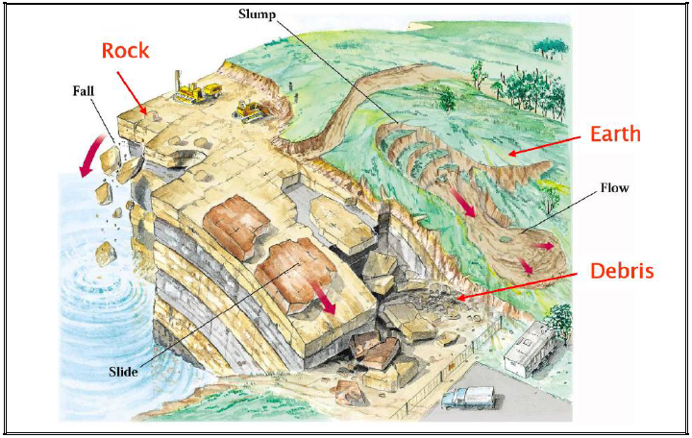
Figure.2.1 Various types of mass movements (Cruden and Varnes, 1996)

2.4 Slope stability analysis

The collection of data ideally involves rock mass characterization and the sampling of rock materials for laboratory analysis (i.e. strength and constitutive behavior determination), field observations and in situ measurements. In situ monitoring of spatial and temporal variations in pore pressures, slope displacements, stresses and subsurface rock mass deformations, provide valuable data for constraining and validating the stability analysis undertaken (Erick Eberhardt, 2004). There are different types of methods for slope stability analysis.

2.4.1 Analytical methods

Analytical methods are very useful in geo-mechanics because they provide results with very limited effort and highlight the most important variables that determine the solution of a problem. Analytical solutions, however, have often a limited application since they must be used within the range of assumptions made for their development (Antonio Bobet, 2010). Such assumptions usually include elastic behavior, homogeneous, isotropic material, time independent behavior, quasi-static loading, etc. Geo-materials such as soils and rock masses display non-linear behavior, either because this is inherent to the material or because it has been externally induced (e.g., past stress history). Rocks and soils may not be isotropic or homogeneous, and the loading may not be static, or the geometry of the problem may be complex.

Conventional methods of rock slope analysis can be generally broken down into kinematic and limit equilibrium techniques. In addition, analytical computer-based methods have been developed to analyze discrete rock block falls (commonly referred to as rock fall simulators) (Mahboubi et al., 2008). Kinematic methods concentrate on the feasibility of translational failures due to the formation of day lighting wedges or planes. As such, these methods rely on the detailed evaluation of rock mass structure and the geometry of existing discontinuity sets that may contribute to block instability. This assessment may be carried out by means of stereonet plots and/or specialized computer codes which focus on planar and wedge formation. Limit equilibrium techniques are routinely used in the analysis of landslides where translational or rotational movements occur on distinct failure surfaces. Analyses are undertaken to provide either a factor of safety or, through back-analysis, a range of shear strength parameters at failure.

2.4.2 Numerical methods

Numerical methods give only approximations to the correct or exact mathematical solution. This is so because some simplifications are made to solve the system of differential equations either inside the continuum or at the boundaries of the discretization. It has to be mentioned also that the problem that is solved is the conceptualization that is done of the actual physical problem. The conceptualization applies to the geometry of the problem, the loading process or history, and the response of the geomaterials to loading. The better the approximation to the field problem through this conceptualization process, the more accurate the solution will be with respect to the response observed in the field.

Numerical methods of analysis used for rock slope stability investigations may be divided into three approaches: continuum modelling, discontinuum modeling and hybrid modelling. Continuum modelling is best suited for the analysis of slopes that are comprised of massive, intact rock, weak rocks, and soil-like or heavily jointed rock masses. Discontinuous modeling is appropriate for slopes controlled by discontinuity behavior. Hybrid codes involve the coupling of these two techniques (i.e. continuum and discontinuum) to maximize their key advantages.

2.4.3 Empirical methods - rock mass classification systems

Rock mass classification systems were developed for underground excavations as an alternative to analytical analyses of a discontinuous rock mass in many years ago. Now a days, a division is often made between the so-called early systems such as rock load classification system, Stand-up time classification, RQD index classification, Rock Structure Rating (RSR) and recent systems such as Rock Mass Rating, Q-system, Mining Rock Mass Rating (MRMR), Size Strength Classification, Hoek-Brown failue criterion for jointed rock mass, etc (Hack, 2002).

The main difference between the two groups of classification systems is the number of parameters used in the systems. The early systems often depend on only one or two parameters and were developed for underground excavations. Recent classification systems use more parameters and primarly developed for underground use but in the last decades some extensions to surface applications (e.g. slope stability, foundations and rippability) have been published.
Table 2.2 Existing rock mass classification system for cut slopes (Source: Pantelidis, 2008)
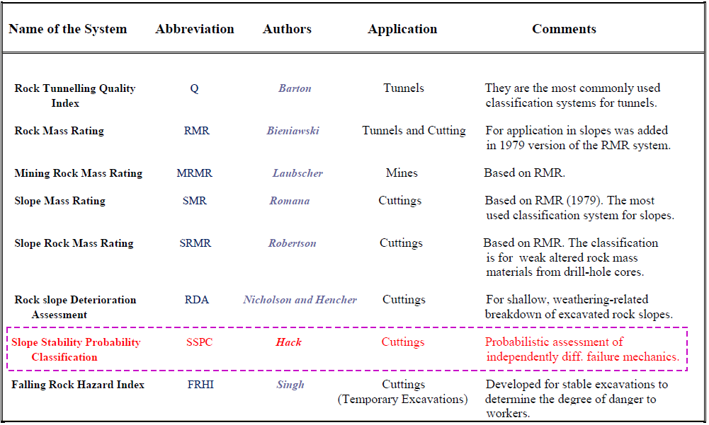

2.4.3.1 Geomechanics classification

Bieniawski (1976) published the details of a rock mass classification called the Geomechanics Classification or the Rock Mass Rating (RMR) system. Over the years, this system has been successively refined as more case records have been examined and the reader should be aware that Bieniawski has made significant changes in the ratings assigned to different parameters. The discussion which follows is based upon the 1989 version of the classification (Bieniawski, 1989).

The following six parameters are used to classify a rock mass using the RMR system:
1. Uniaxial compressive strength of rock material.
2. Rock Quality Designation (RQD).
3. Spacing of discontinuities.
4. Condition of discontinuities.
5. Groundwater conditions.
6. Orientation of discontinuities.

Bieniawski(1976, 1989) included not only recommendations for underground excavations but also for foundations and slope stability.

2.4.3.2 Rock Tunneling Quality Index, Q

On the basis of an evaluation of a large number of case histories of underground excavations, Barton et al (1974) of the Norwegian Geotechnical Institute proposed a Tunnelling Quality Index (Q) for the determination of rock mass characteristics and tunnel support requirements. The numerical value of the index Q varies on a logarithmic scale from 0.001 to a maximum of 1,000 and is defined by:

$Q= \frac{RQD}{J_{n}}x\frac{J_{r}}{J_{a}}x\frac{J_{w}}{SRF}$................................................................................................eq. 2.1
where RQD is the Rock Quality Designation
Jn is the joint set number
Jr is the joint roughness number
Ja is the joint alteration number
Jw is the joint water reduction factor
SRF is the stress reduction factor

In explaining the meaning of the parameters used to determine the value of Q, Barton et.al (1974) offer the following comments:

$\frac{RQD}{J_{n}}(Block size)$, represents the structure of the rock mass, is a crude measure of the block or particle size. Probably the largest blocks should be several times this size and the smallest fragments less than half the size. (Clay particles are of course excluded).

$\frac{J_{r}}{J_{a}} \left(Inter-block shearstrength\right)$represents the roughness and frictional characteristics ofthe joint walls or filling materials. This quotient is weighted in favour of rough, unaltered joints in direct contact. It is to be expected that such surfaces will be close to peak strength, that they will dilate strongly when sheared, and they will therefore be especially favourable to tunnel stability.

$\frac{J_{w}}{SRF}(Active Stress)$consists of two stress parameters. SRF is a measure of: 1) loosening load in the case of an excavation through shear zones and clay bearing rock, 2) rock stress in competent rock, and 3) squeezing loads in plastic incompetent rocks. It can be regarded as a total stress parameter.

The parameter Jw is a measure of water pressure, which has an adverse effect on the shear strength of joints due to a reduction in effective normal stress.

2.4.3.3 Slope Mass Rating(SMR)

For evaluating the stability of the rock slopes, Romana (1985) proposed a classification system called slope mass rating (SMR) system. For slope mass rating Romana utilized Bieniawiski’s Rock Mass System (RMR).

SMR = RMR _{basic} + (F1 * F2 * F3) + F4........................................................eq.2.2
Where; RMR_{basic} is evaluated according to Bieniawiski (1979, 1989) by adding the Parameters of five parameters. The F1, F2 and F3 are adjustment factors related to joint orientation with respect to slope orientation and F4 is the correction factor for method of excavation.
F1 – depends upon parallelism between joints and slope face strikes. (αj - αs)
where, αj is joint strike and αs is slope strike.
F2 – refers to joint dip angle (βj) or plunge of line of intersection of two wedge
formingplanes (βi).
F3 – depends upon relationship between joint dip or plunge of line of intersection
of twowedge forming planes and slope inclination. (βj - βs) or (βi - βs)
where, βs is the inclination of the slope.
F4 – Method of Excavation. It includes the natural slope, or the cut slope
excavated by pre splitting, smooth blasting, normal blasting, poor blasting
and mechanical excavation.

Table 2.3 Values of adjustment factors for F₄ for method of excavation

2.4.3.4 Slope Stability Probability Classification (SSPC) system

SSPC system is a new classification system for slope stability assessment (Hack, 1998) with as main characteristics:
- A differentiation between the rock mass in the exposures used for the classification and the rock mass in which the final slope is to be made,
- The assessment of stability by the probability of occurrence of different failure mechanisms instead of a single point rating value, and
- Unambiguous and simple procedures for collection of data in the field.

The SSPC system considers three rock masses:
- The rock mass in the exposure, the 'exposure rock mass' (ERM),
- The rock mass in an imaginary unweathered and undisturbed condition prior to excavation, the 'reference rock mass' (RRM), and
- The rock mass in which the existing or new slope is to be situated; the 'slope rock mass' (SRM).
Figure 2.2 Flow chart shows the three step concepts, which works in the SSPC system [Source: Hack, 1998]
Rock mass parameters of importance are described and characterized in an exposure resulting in the 'exposure rock mass'. Local influences on the parameters measured in the exposure such as weathering and the disturbance due to the excavation method used to make the exposure are then compensated. This converts the parameters for the 'exposure rock mass' to that of the theoretical rock mass that exists below the influence zones of weathering (thus fresh) and other disturbances: the 'reference rock mass' (RRM) (Fig. 2.3). This compensation is done with the aid of correction parameters: the exposure specific parameters. The resulting rock mass parameters are those of the 'reference rock mass'. By this technique, parameters that, in the same geotechnical unit, show different degrees of weathering and different degrees of excavation disturbance are brought back to parameters reflecting their original basic geotechnical properties.

The actual stability assessment is made in the 'slope rock mass' (SRM). This is derived from the 'reference rock mass' (RRM) by correction of the parameters of the 'reference rock mass' with the slope specific parameters. Slope specific parameters are correction parameters for the influence of future weathering within the engineering lifetime of the slope and for the influence of the method of excavation to be used. The 'exposure rock mass' and 'slope rock mass' are the same if an existing slope is examined and future weathering is not considered.
Figure 2.3 Sketch of exposures in rock masses with various degrees of weathering, different types of excavation, and showing the concept of the ‘reference rock mass’. [Source: Hack, 1998]

2.5 Slope stability related studies in Ethiopia

The hilly and mountainous terrains of the highlands of Ethiopia which are characterized by variable topographical, geological, hydrological (surface and groundwater) and land-use conditions, are frequently affected by rainfall-triggered slope failures. Earthquake triggered landslides are little reported in Ethiopia (Kifle Woldearegay, 2013). Because of its complex geomorphological, hydrological, and geological setting, the hilly terrains of the Ethiopian landmass has been frequently affected by first time as well as reactivated old landslides.

In Ethiopia, landslide-generated hazards are becoming serious concerns to the general public and to the planners and decision-makers at various levels of the government. However, so far, little efforts have been made to reduce losses from such hazards. With the on-going infrastructural development, urbanization, rural development, and with the present land management system, it is foreseeable that the frequency and magnitude of landslides and losses due to such hazards would continue to increase unless appropriate actions are taken in the Ethiopia.

Figure 2.4 Locations of landslide affected areas in the highlands of Ethiopia
(Source: Kifle Woldeearegay, 2013).

Landslide and slope stability related studies by various authors on various localities are summarized as below.

Temesgen et al.(2001) have reported on the Natural Hazard Assessment Using GIS and Remote Sensing Methods, with Particular Reference to the Landslides in the Wondogenet Area. He studied landslide occurrences and their relationships with various event controlling parameters using GIS and remote sensing techniques. Statistical relationships of these parameters with landslide occurrences were converted into risk susceptibility priority numbers. According to the authors, Morpho-dynamic activities have been coupled with frequent heavy precipitation and accelerating human impact to produce frequent landslide problems.

Lulseged Ayalew and Yamagishi (2003) have conducted study on the slope failures in the Blue Nile basin, as seen from landscape evolution perspective. The study showed that landslides and rock falls have a significant contribution to the landscape development.

Jemal Saed (2005) has conducted slope stability studies on the road section starting from Gohatsion to Dejen towns. He used limit equilibrium method to analyze the critical slope sections between the towns.

Henok Woldegiorgis (2008) studied on landslide hazard zonation mapping in Blue Nile gorge. The study was based on Landslide Hazard Evaluation Factors (LHEF) that includes Geology, Structure, Ground Water Condition, Land use and Land Cover, Relative Relief and Slope morphometry. The total estimated hazard (TEHD)of an individual facet is obtained by adding the ratings of individual causative factors obtained from the LHEF rating scheme.

Shimelies Ahmed (2009) worked on Slope Stability Analysis Using GIS and Numerical Modeling Techniquesin Dogua’s Tembien district, Tigray, Ethiopia He considered completely dry, half saturated and saturated for the deterministic modeling. In addition, 4 statistical techniques such as statistical index, weighting factor, certainty factor and landslide susceptibility methods were used. According to this study, the study area is unconditionally stable, and some areas will face instability under moderate destabilizing actions and it needs stabilization methods to control instability.

Jemal Ibrahim (2009) worked on landslide assessment and hazard zonation in Mersa and Wurgessa, North Wollo, Ethiopia. was adopted. The researcher has adopted the technique proposed by Anbalagan (1992) and modified by Raghuvanshi (2011) which includes inherent causative factors such as; slope material, slope morphometry, relative relief, landuse/ landcover and groundwater condition. In addition, he consider triggering factors such as; rainfall, seismicity and manmade activities. The study reveals that the present study area falls under very high hazard, high hazard, and moderate hazard zone.

Samuel Molla (2011) conducted study on Slope Stability Analysis on a Selected Slope Section along the Road Gohatsion – Dejen. The deterministic slope stability analysis approach was followed to perform the detailed slope stability analysis of the selected slope section. The factor of safety for the selected slope section was determined using SARC and SLOPE/W software. The results of this thesis indicate that the slope section is stable only for the dry condition under static state with a FOS of 1.28. For the other conditions, both under static and dynamic state, the slope section will be unstable with a FOS less than 1.0.

Lensa Negassa (2012) conducted study on theLandslide Hazard Zonation Using Remote Sensing and GIS Approach - A Case Study in Meta Robi Wereda, West Showa Zone, Oromiya, Ethiopia. She followed GIS based ‘Grid overlay analysis’ and GIS modeling approaches by computing Landslide susceptibility Index (LSI) for LHZ map preparation. The results revealed that study area has a Very High landslide Hazard (VHHZ), High landslide Hazard (HHZ), Medium hazard (MHZ), Low Hazard (LOHZ) and Very Low Hazard (VLH) potentials.

Mulugeta Beyene (2013) Worked on theassessment of slope stability using combined probabilistic and Deterministic approach for selected sections along Gohatsion Dejen route, Blue Nile Gorge, Central Ethiopia. He evaluate the stability condition of selected critical slope sections for a total of four critical slope sections; two from failed colluvium section and two from rock slopes were identified for further analysis.

The stability analysis of colluvium slopes were made for the existing and anticipated worst conditions by utilizing SLIDE software and for rock slope having planar mode of failure ROCPLANE software that support both deterministic and probabilistic methods for analysis. The result of this study in general indicates that the critical colluvium slope sections, investigated in the present study, would be unstable during anticipated adverse conditions and possibility of damage is unavoidable during the event of failure. The deterministic and probabilistic analysis results suggest possibility of rock block failures during anticipated worst conditions.

CHAPTER 3 DESCRIPTION OF THE STUDY AREA

3.1 Introduction

Understanding the natural environment such as the topography, geomorphology, geology and soil is essential when examining the overall issues and impacts of a major public transport infrastructure project on an area. This chapter describe the geology, drainage pattern, physiography, the location, climate, rainfall and seismicity of the study area.

3.2 Location

The study area is located in Guduru district of the Horro Guduru Wollega zonal administration, Oromia regional state. More specifically it is situated in Hababo Guduru Woreda. The study area is about 318km from northwest of Addis Ababa. This road passes through the villages of Bero Mazoria, Kenate, Dedu and Kubsa. Geographically, the study area is bounded by 1080000 to 1088000 Easting and 330000 to 338000 Northing in UTM projection or between 128 + 700 and 139 + 000 field survey.
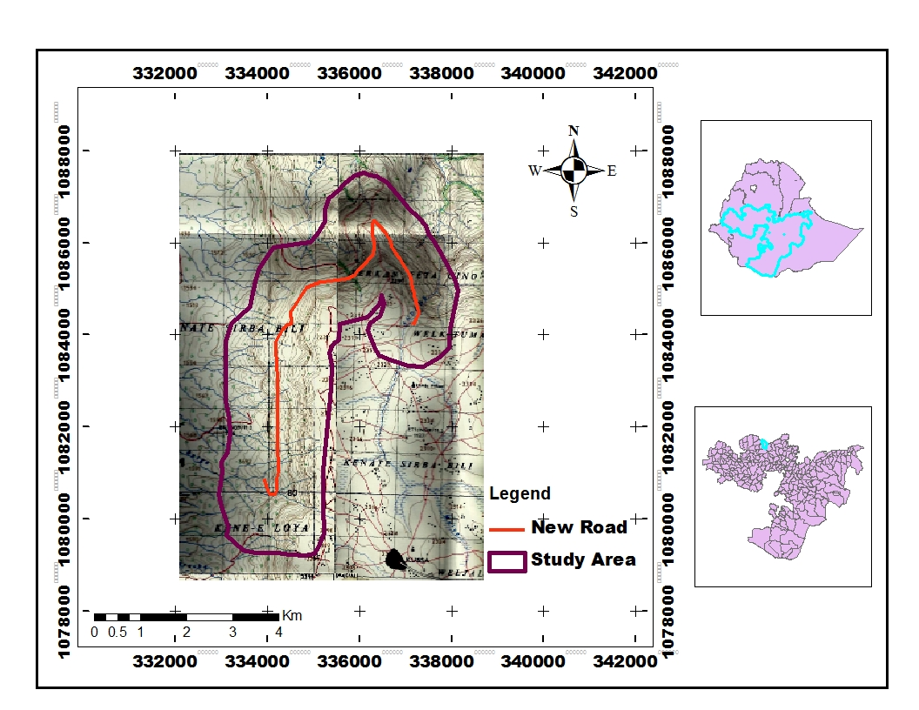
Figure 3.1. Location map of the study area.

3.3 Climate and Temperature

The climate of Ethiopia ranges from equatorial desert to hot and cool steppe, and from tropical savannah and rain forest to warm temperate, from hot lowland to cool highlands. The altitude ranges from around 120m below sea level in the Dalol depression up to 4,620 m a.s.l on the Ras Dashen on the Semien Mountains Massifs (Tamiru Alemayehu, 2006). The traditional climate classifications of the country based on altitude and temperature shows the presence of five climatic Zones namely Wurch (cold climate at more than 3000 Mts. Altitude), Dega (temperate like climate - highlands with 2500 - 3000Mts.), Woina Dega (warm 1500 - 2500), Kola (hot and arid type, less than 1500m.In altitude), and Berha (hot and hyper arid type) climates.

The climatic types prevailing over the Regional State of Oromia may be grouped into three, with their respective sub-divisions. They are dry climate (the hot arid, semi-arid, dry sub-humid climates), tropical rainy climate (the tropical humid and tropical sub-humid climates) and temperate rainy climate (the warm temperate humid, the warm temperate per humid and the cool highland climates) (Oromia National Regional State, 2011).

The study area is included in a sub-tropical (W/Dega) Climate which covers most of the Guduru and Hababo Guduru district. The climate of this area is tropical humid with a seasonal variation associated with the oscillation of the Inter Tropical Convergence Zone (ITCZ). It is a humid temperature climate without dry season and mean temperature of the coldest month is less than 18⁰C. Annual temperature range is between 10.7Cº and 33.6Cº at Fincha area.

Table 3.1. Maximum and Minimum temperature at Fincha station
Month | Jan | Feb | Mar | Apr | May | Jun | Jul | Aug | Sep | Oct | Nov | Dec
Max. Temp. (ºc) | 26 | 27 | 27 | 27 | 27 | 24 | 22 | 22 | 22 | 24 | 25 | 25
Min. Temp. (ºc) | 9 | 10 | 11 | 11 | 11 | 11 | 11 | 11 | 11 | 10 | 9 | 8
(Source: from mana begna-lemlem bereha road project report)

Figure 3.2 Monthly mean maximum and minimum temperatures at Fincha station.

3.4 Rainfall distribution

In Ethiopia, rainfall has an uneven distribution both in time and in space. This is partly due to the presence of one major and one small rainy season, in large part of the country (Tamiru Alemayehu, 2006).

Monthly and daily maximum rainfall data is available at Fincha and Kombolcha stations along the project area. The data from these stations showed that the rainfall pattern is unit model with peaks in the month of May-September. The climate of this area is tropical humid with a seasonal variation associated with the oscillation of the Inter Tropical Convergence Zone (ITCZ). Between May and September the Fincha and the area received highest rainfall of Ethiopia. Mean annual rainfall varies between 1500 - 2000mm.The rain is moderate during the months of November to April with the annual distribution. But the rainfall is seasonal varying in amount and time. The rainy season is May – September months.
Table 3.2 Rainfall data at Fincha (1989-2013) and Combolcha (1959-2013) Stations
Station | Jan. | Feb | Mar | Apr | May | June | July | Aug | Sept. | Oct. | Nov | Dec
Fincha | 10 | 9.7 | 53 | 74 | 158 | 353 | 429 | 401 | 279 | 113 | 26 | 22
Combolcha | 12 | 22 | 52 | 62 | 118.4 | 193 | 300 | 300 | 193 | 67 | 32 | 12
(Source: National Meteorological Services Agency)

Figure 3.3 Mean monthly rainfall of Fincha and Combolcha stations

3.5 Physiography and Drainage Pattern

One of the factors that affect the slope stability is the shape of the natural landscape surrounding the road. The northwestern Ethiopian highlands are considerably more extensively rugged and are further divided into northern and southern sections by the valley of the Abay (Blue Nile). The present study area belongs to the Fincha valley(southern section of Abay valley) which is bounded by Guduru highlands according to Oromia land features. This area consists of flat, undulating and escarpment terrains. It is locally rugged, full of cliffs, steep slope surfaces and some gentle slope areas.

The upper and mid hill slopes are generally gently inclined, and steep slopes are associated with shallow open gullies. These gullies receive and direct surface run-off and drainage towards the major surface water tributaries within the area. Many slabs are constructed for the summer run-off across the road. The colluvium deposits are move down to the slope base from the steep surface.

The road pass through the steep slope and the drainages are flow easily from the escarpment to the rivers in the lowlands. All the local drainages in the study area flows towards the Abay river. There is no huge water body (i.e. rivers, streams, etc) that cross the road. There is only Andode river that cross the road at entrance of the escarpment. The small scale of natural streams flows from slope sections. The discharge of most of the springs is low. The discharge of these springs as estimated during the field survey and ranges from 0.2-0.5lt/s. It is obvious to presume that the discharge amount will increase during the summer period due to rainfall.
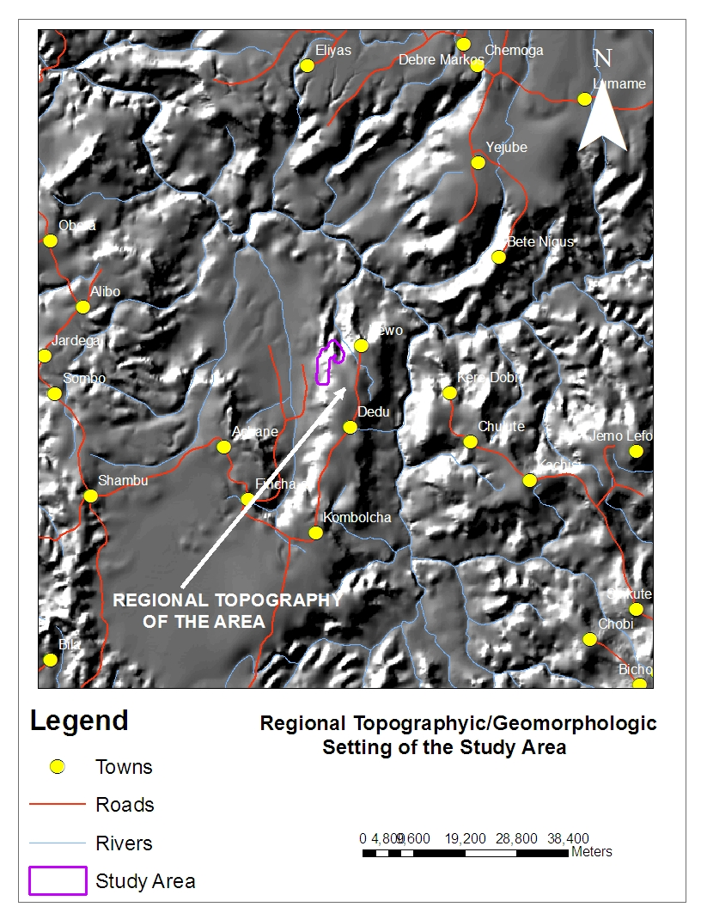
Figure. 3.4 Topographic setting and Major drainage pattern

3.6 Seismicity of the study area

The seismicity of the Ethiopia is controlled and influenced by the active Ethiopian Rift System which divides the country into two along the NE–SW direction. The structural pattern shows that the region, characterized by a complex fault pattern trending mainly around NE–SW, separates the Somalian Plate from the Nubian Plate. Based on the seismicity, geology and tectonics of the country, the seismic source zones are divided in to Afar Depression, the Escarpment and the Ethiopian Rift System seismic source zones (Tilahun Mamo, 2005).

According to the Seismic Risk Map of Ethiopia produced by LaikeMariam Asfaw(1986) for a hundred year return period and 0.99probability, the study area was found in 7MM intensity scale. Thus, it requires consideration and a systematic study to know exactly the damage an earthquake can cause to this road construction. Such study is beyond the scope of the present study.
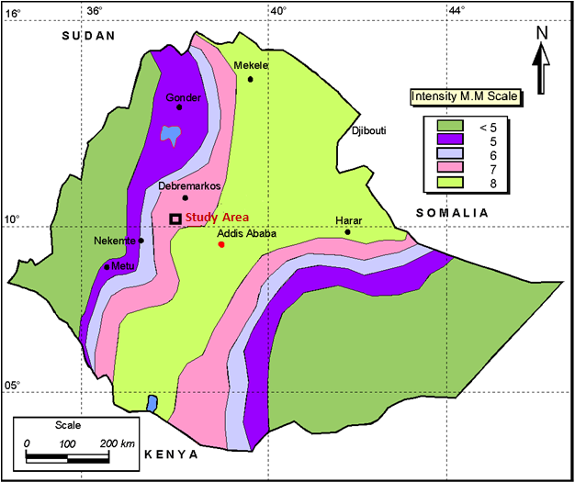
Figure 3.5 Seismic risk map’ produced by Laike Mariam Asfaw (1986) for 100 year return period and 0.99 probability.

3.7 Geological Setting

3.7.1 Regional Geology

The main stratigraphic units throughout the Ethiopia are Precambrian metamorphic basement rocks, Mesozoic sedimentary rock, Tertiary volcanic rocks (largely basalts) and Quaternary volcanic rocks, largely ignimbrites and sediments (Tamiru Alemayehu, 2006).
The basement upon which all younger lithologic formations were deposited consists of the oldest rocks in the country. The Precambrian basement rocks are exposed in all climatic regions of the country along with intrusive bodies. These rocks consist of granites, granodiorites, gabbro, gneiss, migmatites, granulites, amphibolites, schists, phyllites, etc. The Neoprotrozoic sequence lies at a critical geotectonic boundary between the Arabian- Nubian Shield (mostly Juvenile crust) to the north and Mozambique belt (mostly reworked older crust) to the southern part of Ethiopia. The main exposure areas are Northern, Eastern, Southern and south western, western parts of the country.

The Palaeozoic and Mesozoic rocks are sedimentary formations are described in details by many authors. The Palaeozoic formations are localized in the Ogaden and Tigray regions. In the eastern part of the country, Palaeozoic deposits occur in Chercher named as Waju sandstone, which is friable sandstone with frequent shale intercalation. In the northern part of Ethiopia, they are essentially constituted of Edagarbi glacial deposits and Enticho Sandstones.

Mesozoic sediments are widely deposited in Ethiopia during a continuous subsiding period of the land and migration of the sea from east, in the Ogaden towards the west and north covering the central part and northern areas of the country. Between the Ordovician and Early Mesozoic system of Northeasterly as well as northwesterly trending troughs were filled with continental sediments. Early Jurassic marine sediments filled this troughs and at Late Jurassic time, the transgressive sea was widespread over a part of Ethiopia. Regression happened at the end of the jurassic. Today, a part of these Mesozoic sediments are exposed on the Exposed on the Eastern Ogaden, central dissected plateau areas in the Blue Nile river basin and in the northern Tigray around Mekele (Kazmin,1975; Russo et al.,1994).

The general stratigraphy in the Ogaden basin are: Lower sandstone /Adgirat sandstone: mainly comprised by sandstone, Hamanley limestone, Urandab formation-Shales, Kebridar formation-limestone, Gypsum formation-contain crystalline gypsum with marly intercalation, Upper sandstone.

The Mesozoic sedimentary rocks sequence in Abay basin according to Kazmin (1975) and later modified by Russo et al (1994) are Lower sandstone /Adgirat sandstone: mainly comprised by sandstone, Gypsum and shale containing unit, Limestone, Mudstone, Upper sandstone /Ambaradam formation While in Tigray, the Antalo limestone is overlain by Agula shale and Ambaradam formation (upper sandstone).

The earliest and most extensive groups of volcanic rocks are the Trap Series, erupted from fissures during the early and middle Tertiary. The Plio-Quaternary volcanics are largely restricted in the Rift valley. Substantial shield volcanoes consisting mainly of basalt lava developed on the Ethiopian plateau during the Miocene and Pliocene (Kazmin, 1975). The Ethiopian volcanics were divided into two main Series: Trap Series (or plateau Series) and Rift volcanics.

Cenozoic sedimentary rocks and sediments are found in eastern Ogaden, Danakil Depresion, lower Omo valley, Southern Sidamo, Gambela and western Gondar areas (Tamiru Alemayehu, 2006). The main Quaternary deposits are alluvial, lacustrine, alluvial and colluvial deposits. The alluvial deposits are of two types: those spread out in alluvial plains and those strips along rivers and streams. Alluvial plains are filled up grabens and large stretches of flat land in the rift valley and along the whole length of the western boarder of the country. These are troughs in the lowlands where during the pluvial period streams deposited large amounts of sediments carried down from the highlands. The thin strips of alluvium along streams occur in most places both in the highlands and in the lowlands.
Figure 3.6. Geological map of Ethiopia (Source: Tamiru Alemayehu, 2006)

3.7.2 Geology of Blue Nile (Abay) basin

The Blue Nile Basin within the Northwestern Ethiopian Plateau are bordered by the uplifted tectonic escarpments on the western flanks of the Afar Depression and the Main Ethiopian Rift in the east and southeast, respectively, and in the west by the erosional Tana escarpment.

The Blue Nile Basin underwent various phases of tectonic activity. NW–SE, NE–NW, NNW–SSE to N–S, ENE–WSW to E–W fault systems accounted for the structural complexities of the basin. The Blue Nile Basin is interpreted as a NW–SE trending failed arm of the Karroo rift system (Russo et al., 1994).
Figure. 3.7 Geological map of the Blue Nile Basin (simplified after Kazmin, 1972)
(Source:Wolela,2008).

The typical Mesozoic succession of the Abay basin is about 1200m thick and these Mesozoic rocks sequence from bottom to top are Lower sandstone/Adgirat sandstone, Gypsum and shale containing unit(or Gohatsion formation), Limestone Unit(or antalo limestone), Shaly sandstone unit, Upper sandstone (Debre libanos sandstone) (Getaneh Assefa,1991).
- Lower Sandstone unit
The lower sandstone unit overlies the basement unconformably, but in some places it overlies unconformably the paleozoic continental sediments. The thickness of this unit ranges from about 100 to 700m. This unit outcrops on both sides of the Abay river is forming nearly vertical cliff; it consists mostly of sandstones intercalated with layers of siltstones, mudstones and rare beds of conglomerates and shales. Fining upward sequences and cross-stratification are frequent.

- Gypsum and shale containing units

The superimposed shale and gypsum unit, 350m thick, consists of interbedded siltstones and shale in its lower part, and bioturbated mudstones, coquinoid siltstones, which are very rich in small pelecypods, and chickenwire and laminated gypsum in its middle parts. The upper part consists of barren greenish, reddish clays and siltstones. The upper and lower boundaries of this unit are gradational. The environment deposition for the terrigenous clastics is interpreted as deltaic, and shallow lagoonal and supratidal for the gypsum, limestone, dolomite and associated shales.

- Limestone Units

The limestone units consists of approximately 600m of thick fossiferous carbonates interbedded with marl, shale and mudstone. The topmost part of this unit, which is oolitic, massive and cliff forming limestone. The maximum thickness of this part of the limestone unit is 170m. The rest of the formation is dominated by marl and this informally known as marly limestone. Both of this unit boundaries are transitional.

- Shaly sandstone unit

The shaly sandstone unit, 320m thick, is composed largely of alternating, fin-grained sandstone and mudstone with a few beds of siltstone and shales. its lower part consists of interbedded dolomite, gypsum, and shale. The unit is either conformably overlain by the upper sandstone unit or unconformably overlain by tertiary basalts. The environment of deposition is inferred as supratidal, grading in to a meandering river system.

- Upper sandstone Unit

The unit is unconformably overlain by tertiary basalts, is composed of sandstone with thin beds of conglomerates, mudstone and shale. It reaches a maximum thickness of 280 m. The unit is believed to have been deposited in a braided river system. The unit is correlative to the Amba Aradam formation of Tigrai.

Thick massive flood lavas, chiefly of basalt, unconformably overlay the paleozoic and mesozoic sediments. These volcanic rocks are generally post-oligocene and rich a maximum thickness of 5,500m.

3.7.3 Geology of the study area

Fincha sub basin, is one of the northwestern Abay basin which is mainly dominated by Adigrat Sandstone and Basaltic unit. There are also Alluvium and Colluvium deposits. According to Wolela (2008), the Adigrat Sandstone formation covers an extensive area in the Blue Nile Basin and forms vertical cliff exposures in Fincha area. The formation is largely composed of continental clastics (conglomerates, gravely sandstones, siltstones, mudstones and carbonaceous materials).

Fincha Valley in which the study area was found is one of the Abay sedimentary basin continuation. Therefore, the lithologic units in the study area follows the stratigraphic succession of the Abay basin. The rock units in the study area consists of sedimentary, tertiary volcanic rocks and quaternary deposits.
1) Basalt rock

The basalt occur on the sandstone units and the escarpment starts with the basalt rock. Basalt in the study area is a fine-grained and hard extrusive igneous rock. The basalt color is dark gray to black and greenish-black. There are large blocks on gentle slope and columnar basaltic units.
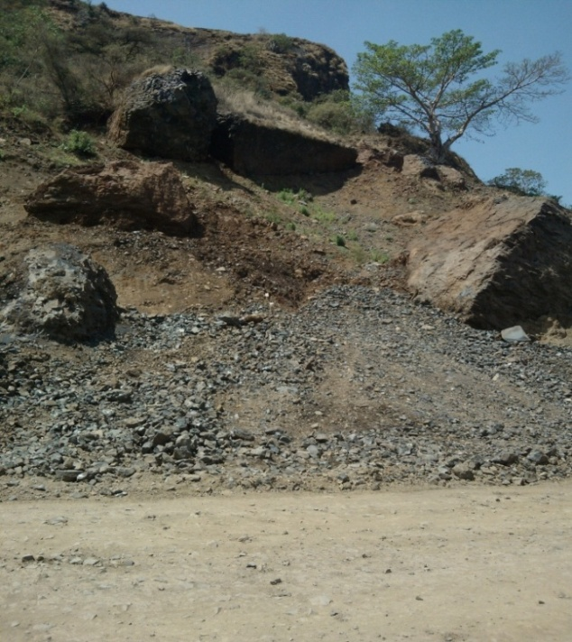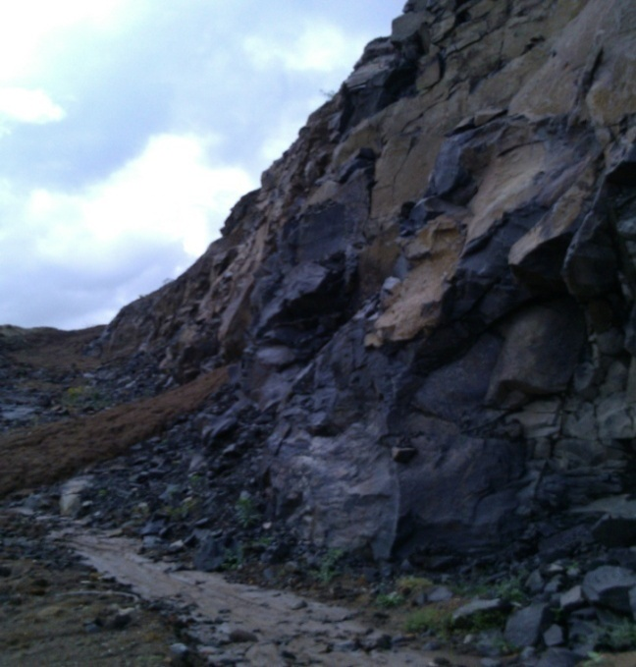

Figure. 3.8 Basaltic unit in the study area
Loose Material
2) Sandstone rocks

Sandstone is a clastic sedimentary rock that derived from pre-existing rocks (detrital fragments). Sandstone units form parallel layers separated by contact surfaces. Each layer represents a successive deposit of material. Sandstone is a medium-to-coarse grained that is composed mainly of sand-size. Sandstone varies widely in properties according to composition and cementation. The sandstones in the study area vary in colour from whitish to reddish. The sandstone become red as a result of their iron oxide content. The iron present in sediment often occurs as either ferrous iron compounds or ferric iron compounds. Ferrous iron oxide (FeO) frequently occurs in oxygen deficient environments. It is unstable and may slowly oxidize to form ferric iron oxide (Fe2O3). When oxygen is in short supply, ferric iron may be similarly reduced to ferrous iron. Ferric minerals such as hematite tend to color the rock red. It has Low-density, poorly cemented, and less durable.

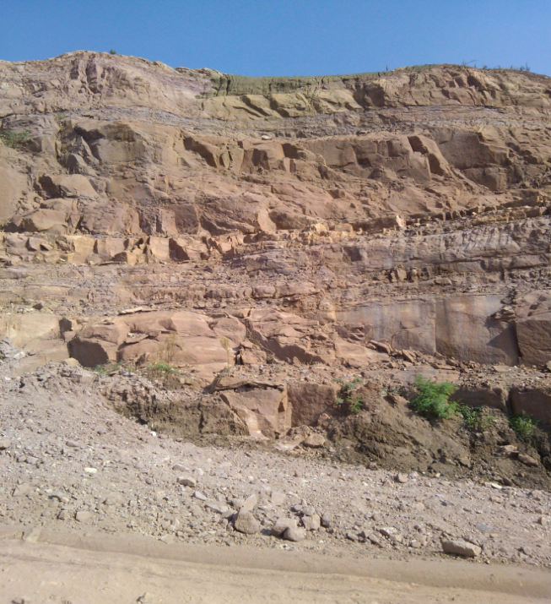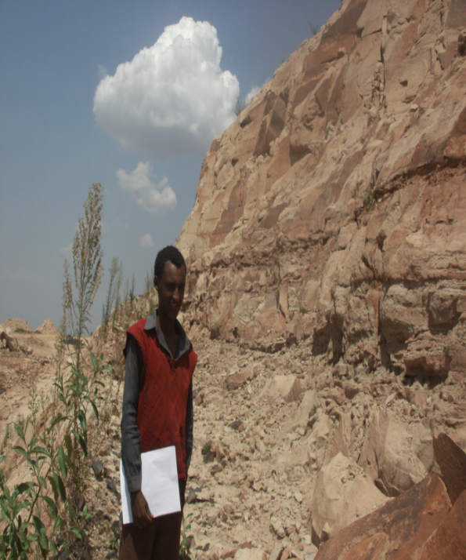
Figure 3.9. Sandstone bedding in S2 section(left) and Sandstone cut section in S₃(right)
3) Quaternary Sediments

i) Colluvium Deposit

Colluvium is a general term used to describe soil and rock material that has been transported and deposited by gravitational forces. Colluvium is typified by poorly sorted mixtures of soil and rock particles ranging in size from clay to large boulders.

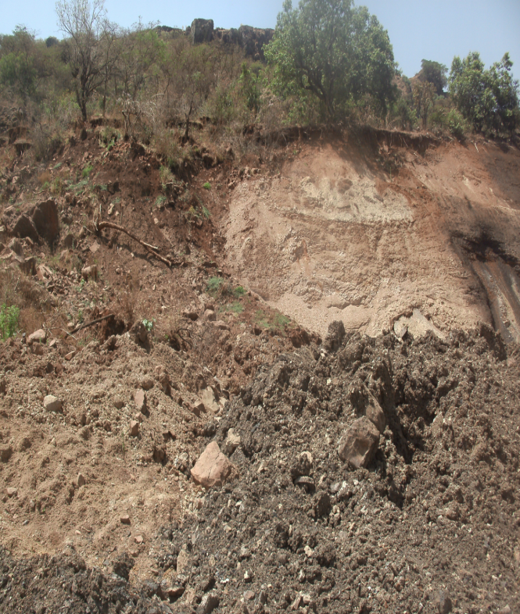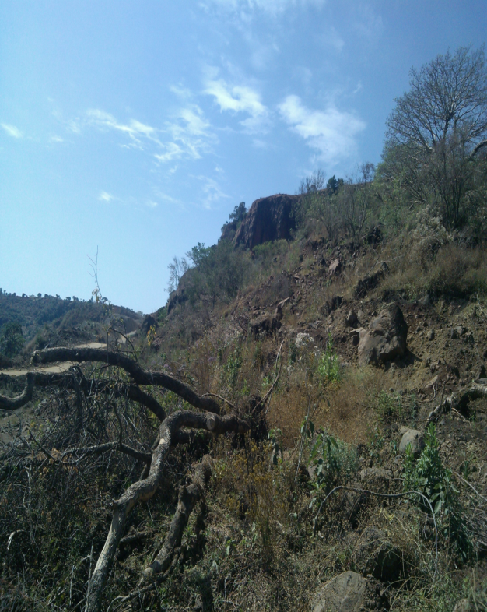
Main Scarp
Movement direction
Crown
Figure 3.10 colluvium movement (silty-clay, gravel and cobbles) and falling of the tree (Location: 129 + 500 - 130 + 000).
The colluvium deposits in the study area are collected at the foot of an upper steep slope. It is mainly composed of gravel, cobble and boulder sizes of basalts and sandstone within silty clay matrix. The mottled colour of soil colluvium with red, black, white and white colours covers the area. It is generally poorly sorted resulting in the occurrence of voids and hence the colluviums could be categorized as very loose, weak, heterogeneous and permeable unit. Most of the springs emanate from the colluvial soil which indicates the high permeability nature of the colluvium material. Trees and grasses that covers the slide areas are dried and tilted.

ii) Alluvial Deposit

Alluvial deposits are generally deposited by streams as they move from upper to lower slope. Alluvial sediments are a quaternary deposit mainly in stream channel. The alluvial sediments in the present study are vary in size from sand, pebble, cobble and boulder grain size.

3.6.3 Structural setup of the Study area

a) Lineaments
A lineament is a linear or curvilinear feature of a surface whose parts align in a straight or slightly curving relationship. The linear features in the present study are straight stream and valley that formed across the slope. The lineaments are straight and aligned both in the NW and NE directions (Figure 3.13). Straight stream valleys and aligned segments of a valley are typical geomorphological expressions of lineaments. Most lineaments are formed at the base of the slope and makes a topographic changes.

b) Bedding

The bedding in the present study has changes in sediment grain-size, colour or mineralogy/composition which indicates changes in the pattern of sedimentation. Bed boundaries are sharp, smooth, irregular and gradational.

c) Joints and Fractures

Joints are fractures along which little or no displacement has occurred and are present within all types of rocks. The joints in the present study form planar and wedge mode of failure.
d) Crack

Some tension cracks are found along the road fill. The array of micro cracks is oriented parallel to the road direction and this may be the problem of material they used. The crack is formed at the toe of colluvium movement near columnar basalt rocks. There is streams around the mudcrack. The mud crack develops the polygonal patterns of dessication joints when the fine grained sediments are shrink. The growth of these joint due to loss of water have tetragonal, pentagonal and hexagonal shapes. The size of the polygons and the depth of the cracks are small and shallow depth.

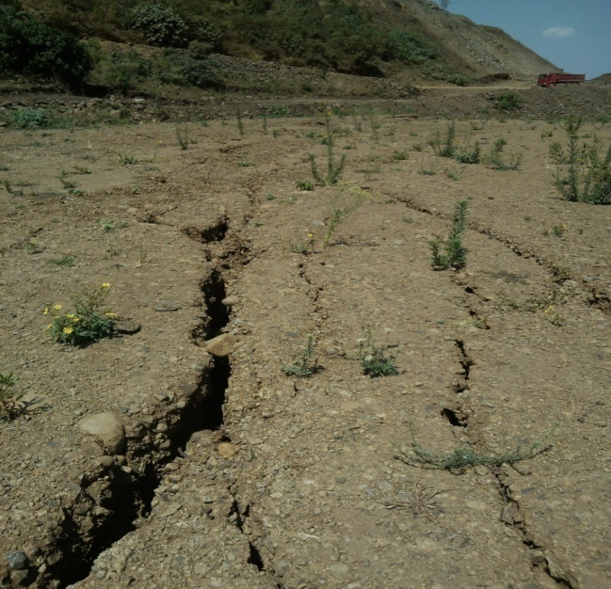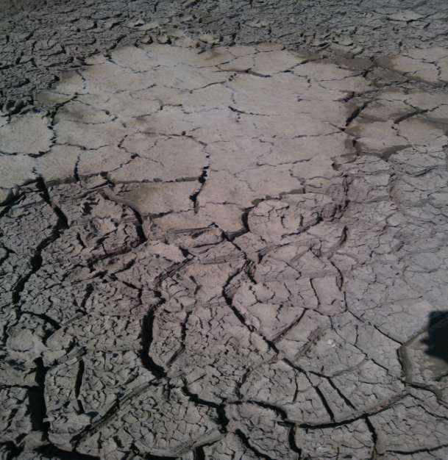Figure: 3.11. a) fill crack b)Mudcrack

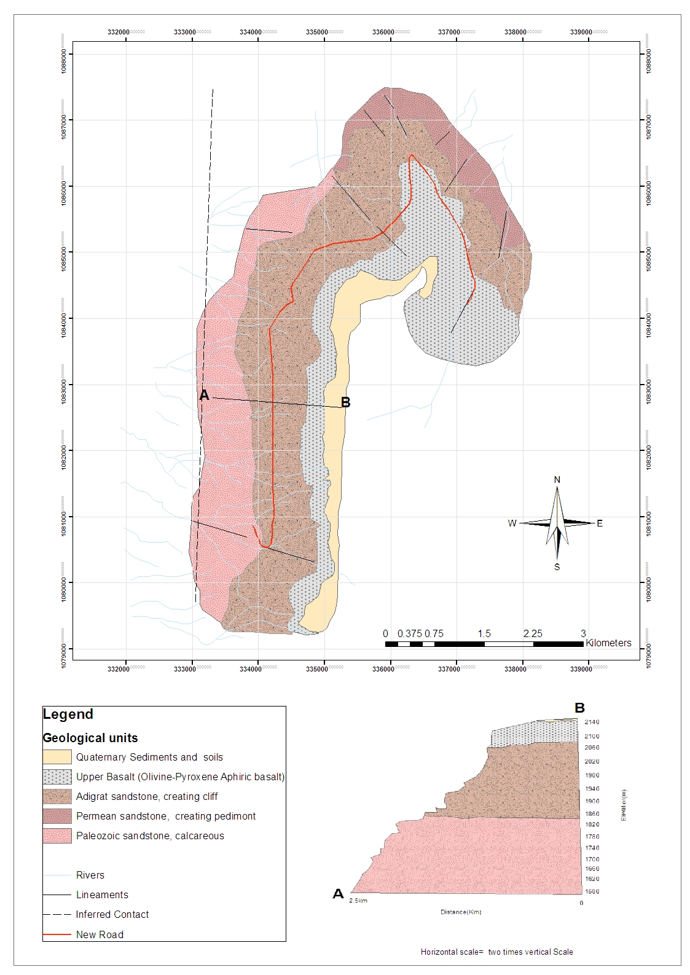
Figure.3.12. Geologic Map of the Study area(Source: Ethiopian Geological Survey, 2004)

CHAPTER 4 MEASUREMENT AND CHARACTERIZATION

OF ROCK MASS

4. 1 Introduction

When dealing with discontinuous rock masses, the properties of the discontinuities in the rock becomes of prime importance, since they will determine, to a large extent, the mechanical behavior of the rock mass (Bieniawski, 1989). These properties are classified in to geometric and non-geometric. The non-geometric properties are related to mechanical behavior of the infill material and the shear strength of the intact rock adjacent to the discontinuity while the geometric properties define the fabric of the discontinuous rock mass (Hack, 1998). The purpose of this chapter is to describe the intact rock and rock mass properties of the present study.

4.2 Rock Cut Slope

The rock slopes were selected in such a manner that they represent varied geological and slope stability conditions. The selected slopes present a variety of rock types having various degrees of weathering and joint conditions. The rocks in the present study area were categorized in to igneous and sedimentary rocks. The rock types encountered in these slopes are sandstone and basalt. The parameters of discontinuities of the studied slopes varied considerably. Joint spacing and openings also show a wide range of values. The presence or absence of filling was noted along with type of filling. The data includes slope angle, rock type, joint orientation, joint set number, joint spacing, joint condition, joint roughness, joint alteration, rock mass structure, etc.
Rocks are precisely classified using various properties which are determined by petrographic microscopes and other equipment. However, rock exposures were also described and identified in the field.

Table 4.1 Geographic Locations of the selected Rock slope sections
Section | Rock name | Locations(UTM) |  | Elevation  (m) | Slopes
Section | Rock name | Northing | Easting | Elevation  (m) | orientation |  | Height(m)
 |  |  |  |  | Dip direction | Dip
1 | Basalt | 0337046 | 1085365 | 2195 | 090 | 80 | 24
2 | Sandstone | 0336325 | 1085929 | 2083 | 293 | 75 | 30
3 | Sandstone | 0334207 | 1081659 | 1884 | 300 | 56 | 18

4.2.1 Engineering properties of rocks

Engineering properties of rock are controlled by the discontinuities within the rock mass and the properties of the intact rock. Therefore, engineering properties for rock must account for the properties of the intact rock and for the properties of the rock mass as a whole, specifically considering the discontinuities within the rock mass. Rock properties can be divided into two categories: intact rock properties and rock mass properties. The following engineering properties are important for engineering purposes such as stability of slope as well as for other engineering structure.

4.2.1.1 Intact rock

Intact rock is the term applied to rock containing no discontinuities such as joints or bedding. The properties of intact rock depend upon the physical properties of materials such as mineral composition grain size, grain interlock, kind and amount of cement etc. Geological and engineering properties are the indices that define the intact rock properties are rock type, color, grain size, texture and fabric, weathering, alternation, hardness, durability, strength, etc. For the intact rock the petrographic analysis, slake durability test and schmidt hammer testing on strength were conducted and described as below.
i) Petrographic analysis

Rocks are identified and classified based on their mineral composition and texture. Mineral composition refers to the specific minerals in the rock. Texture includes the grain size and shape, sorting, and rounding of the sediments that form the rock.
Sandstone Thin Section: From the sample collected from the field, five sandstone thin sections are done for analysis. Sandstone composition of the present study is analyzed using a petrographic microscope and thin section. Sandstones are composed of three principal components: rock fragments (lithic grains), quartz and feldspar grains. The Sandstones in the present study are classified according to the relative proportional components: Quartz(Q), Feldspar, Rock (lithic) fragments (RF), cements, matrix and pore space (gaps between/within grains) in the thin section based on Dot classification (Annex A_1).

Some grains and minerals are mechanically and chemically more stable than others. Minerals, in decreasing order of stability, are quartz, muscovite, microcline, orthoclase, plagioclase, hornblende, biotite, pyroxene and olivine (from Goldich stability series). The sandstone in the study area is compositionally matured and immatured unit. The matured sandstone includes the more stable minerals and grains such as quartz and some feldspar (i.e. S_21 and S_52 samples). The samples such as S_2, S_22 and S_51 are composed of unstable grains (rock fragments, cements, feldspars and other). Generally, the petrographic analysis indicates that the sandstone unit in the present study is compositionally unstable and more susceptible to weathering.

Basalt Thin Section: Three samples of basalt thin section were prepared and discussed. In basalt rock the olivine, plagioclase feldspars, pyroxene, amphiboles are common minerals (Annex A_3). Pyroxenes are hard, very dense, glassy to resinous minerals found chiefly in dark igneous rocks. They usually occur as well-formed short, columnar crystals that appear almost square in cross-section. Colors of green to black or brown are most common. Olivine is a very hard, dense mineral that forms yellowish green to dark olive green or brown, glassy grains or granular masses in very dark, iron-rich rocks, like basalt. Olivine weathers rapidly into iron oxides and soluble silica.

ii) Rock strength

Strength is a fundamental quantitative engineering property of a rock specimen. The strength of the rock forming the walls of discontinuities will influence the shear strength of rough surfaces. Therefore, it is adequate to estimate the uniaxial compressive (UCS) strength from the Schmidt hammer field test (Hoek & Bray, 1981). The Schmidt hammer returns a rebound number for the tested sample which is then converted to UCS using the approximated density of the material tested. Details of the test method and calculations are presented in Annex C. The Schmidt hammer test was applied to unweathered and slightly weathered basalt and sandstone rocks. An average of many reading values were recorded per rock type tested.

Table 4.2 Summarized Test results of Schmidt hammer rebound value.
Section/Rock type | Average measurement |  | maximum |  | minimum
Section/Rock type | fresh | weathered | fresh | weathered | fresh | weathered
S1(basalt) | 49 | 38.2 | 56 | 50 | 36 | 24
S2(sandstone) | 37.2 | 26.4 | 52 | 34 | 26 | 18
S3(sandstone) | 34 | 30.2 | 40 | 36 | 29 | 27

The strength can be determined by using Barton and Choubey (1977) relation;
log10 (σc) = 0.00088 γR + 1.01 ................................................................................eq.4.1

Where, ‘σc’ uniaxial compressive strength in Mpa , ‘γ’ dry rock density in kN/m3 and ‘R’ is the rebound number of Schmidt Hammer.

Table: 4.3 Rock density (Hoek and Bray, 1997)
Rock | Rock density interval | Average density(KN/m3)
Basalt | 25-30 | 27.5
Sandstone | 17-23 | 20

Table:4.4 Uniaxial compression strength calculation result
Section/Rock type | Average measurement |  | maximum |  | minimum
Section/Rock type | fresh | weathered | fresh | weathered | fresh | weathered
S1/basalt | 156.96 | 85.98 | 231.85 | 165.96 | 76.07 | 38.98
S2/sandstone | 46.21 | 29.83 | 84.18 | 40.59 | 29.35 | 21.22
S3/sandstone | 40.59 | 34.79 | 51.76 | 44.01 | 33.14 | 30.56

iii) Influence of weathering on rock mass properties

Weathering is the process of mechanical and chemical decay of rocks by various surface and sub-surface phenomena. Weathering weakens both rock material and rock mass properties. Weathering implies decay and change in state from an original condition to a new condition as a result of external processes. Weathering takes place in all environments but is most intense in hot, wet climates where weathering may be expected to extend to great depths. The weathering process depends upon the rock type, kind of weathering process, environment of rock occurrence, time, climate etc.

According to BS 5930 (1981), the basalt and sandstone rocks in the study area are slightly weathered and some discolorations on the rock surface were observed. In order to know the influence of weathering on rocks in the study area, the slake durability test was also conducted. The description of weathering in the present study includes both intact rock and condition of the discontinuities (joints, bedding planes, foliations etc.) and the condition of the material between the discontinuities.

Slake durability test

The slake durability test is used to determine the influence of weathering on rock and its disintegration. The Basalt and sandstone rocks have been collected from three slope sections in the field. The preparation of these samples for slake durability test is based on the ASTM standard. It is carried out in accordance with the standard of ASTM D4644. Seven samples, two basalt type and five sandstone rocks are prepared. These fragments are produced by breaking with a hammer and the results before and after the test were shown in Annex B.

Table 4.5 Slake durability laboratory results.
Sample No. | Weight of oven dried sample & can (g) | Weight of Can | Total Weight after oven-dried (1stcycle) | Total Weight after oven-dried (2ndcycle) | slake durability index(%)
B₁ | 540.24 | 40.19 | 535.56 | 533.79 | 98.7
B₂ | 558.33 | 41.66 | 554.14 | 552.25 | 98.8
S₂₋₁ | 730.89 | 192.8 | 487.85 | 372.24 | 33.4
S₂₋₂ | 578.59 | 61.09 | 285.62 | 197.73 | 26.4
S_{2-a} | 578.23 | 99.7 | 511.57 | 467.83 | 76.9
S_{2-b} | 577.11 | 96.16 | 560.08 | 549.53 | 94.3
S₃ | 565.32 | 54.46 | 524.55 | 497.08 | 86.6

Based on the Gambles' slake durability classification, B₁ and B₂ are very high durable rocks. samples S_{2_1} and S₂_₂ have low durability. S₂_a has medium durability whereas S₂__{b} and S₃ have medium high durability.

4.2.1.2 Rock mass Properties

Rock mass is composed of a system of rock blocks and fragments separated by discontinuities forming a material in which all elements behave in mutual dependence as a unit. The engineering properties of a rock mass depend often far more on the system of geological defects within the rock mass than of the strength of the rock itself. Thus, from an engineering point of view, a knowledge of the type and frequency of the joints and fissures are often more important than the types of rocks involved. Discontinuity is a collective term that include joints, fractures, bedding planes, rock cleavage, foliation, shear zones, faults and other contacts etc.
Joints are a particular type of geological discontinuity but the term tends to be used generally in rock mechanics and usually covers all types of structural weaknesses with the exception of faults. There is a general agreement (ISRM, 1978) regarding the scope of description required to characterize the nature of discontinuities and main attributes are orientation (mean dip and dip direction), spacing, persistence, roughness and waviness, wall strength, aperture, filling, seepage, number of sets, block size and shape.
Figure 4.1 Schematic of the primary geometrical properties of discontinuities in rock (from Hudson, 1989).
a) Discontinuity sets and Orientation: The recommended terminology for orientation are dip, dip direction and strike. Dip is the maximum inclination of a discontinuity to the horizontal. Strike is the trace of the intersection of an inclined plane with a horizontal reference plane. Dip direction or dip azimuth is the direction of the horizontal trace of the line of dip, measured clockwise from north.

Discontinuities are do not occur at completely random orientations and they occur for good mechanical reasons with some degree of 'clustering' around preferred orientations associated with the formation mechanisms. Hence, it is sometimes convenient to consider the concept of a discontinuity set (which consists of parallel or sub-parallel discontinuities), and the number of such sets that characterize a particular rock mass geometry. The orientation of both the slope and discontinuity are collected from each slope sections and analyzed on stereographic projection.

b) Spacing and frequency: spacing is the distance between adjacent discontinuity intersections with the measuring scan line. Frequency (i.e. the number per unit distance) is the reciprocal of spacing (i.e. the mean of these intersection distances).
Joint set spacing is the distance between individual joints within a joint set. The terms joint spacing and average joint spacing are often used in the description and assessments of rock masses. Where more than one set occurs, this measurement is in the case of surface observations often given as the average of the spacing for these sets.

In the present study area, the mean orientation of the discontinuity sets was taken and the normal mean spacing of each discontinuity set is measured by a scan line perpendicular to the established mean orientation of each set using measuring tape. The spacing of adjacent joints largely controls the size of individual blocks of intact rock. The joints in collumnar basalt intersect each other and determines the wedge mode of failure. Most of the joints in sandstone unit have parallel joints. Joint spacing for a particular pair of joint is the perpendicular distance between the two joints. For a joint set, is usually expressed as the mean spacing of that joint set. However, when the expose is limited, often the apparent spacing is measured.

Table 4.6 Classification of spacing according to ISRM (1978).
Slope section | Joint sets | Mean Spacing(m) of field data | ISRM Recommendation of joint spacing (m) | Description
1 | J1 | 0.1-0.3 | 0.06-0.6 | Moderate to wide spacing
1 | J2 | 0.2-0.7 | 0.2-2 | Wide to very wide spacing
2 | B1 | 0.5-3 | 0.6-6 | Very wide spacing
2 | J1 | 0.35-0.5 | 0.2-0.6 | Moderate spacing
2 | J2 | 0.1-2 | 0.06-2 | Close to wide spacing
3 | B1 | 0.23-1.5 | 0.2-2 | Wide to very wide spacing
3 | J1 | 0.2-1 | 0.2-0.2 | Moderate wide spacing
3 | J3 | 1-3 | 0.2-2 | Wide to very wide spacing

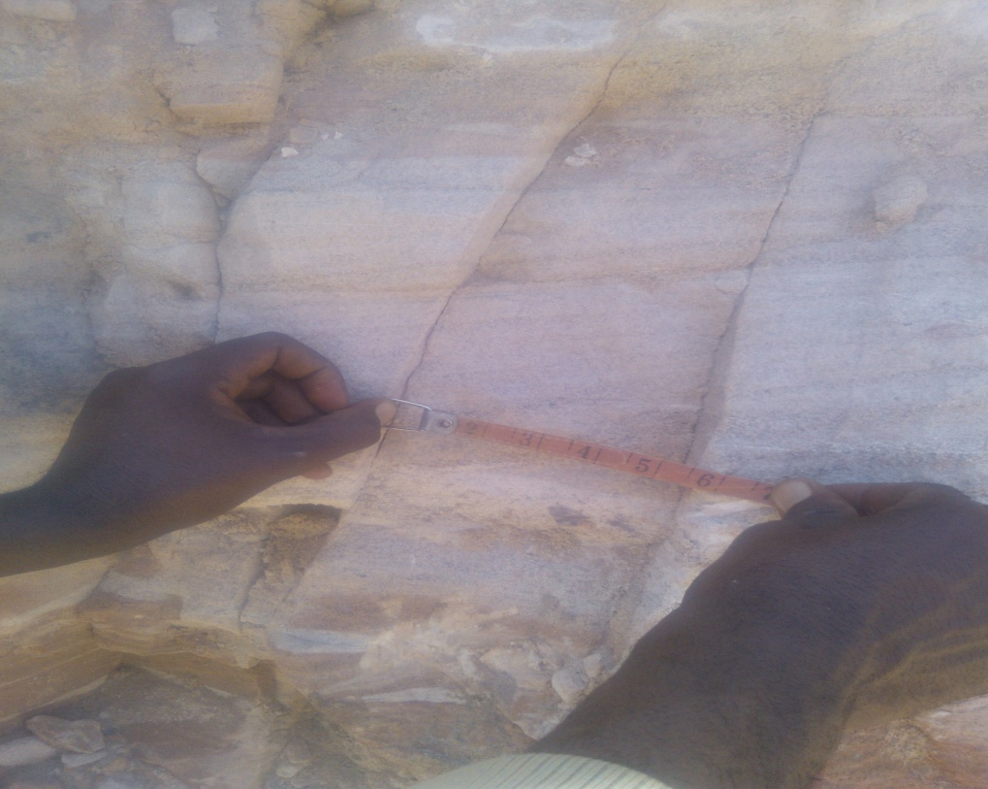
Figure: 4.2. Spacing measurement between adjacent joints.

c) Persistence, size and termination: The size and continuity of the joints often have great influence on the properties of rock masses, in particular the difference in importance between partings and normal joints upon rock mass behavior. The joint length can be crudely quantified by observing the discontinuity trace lengths on surface exposures. Frequently, rock exposures are small compared to the length of persistent discontinuities, and the real persistence can only be guessed. The size or the length of the joint is often a function of the thickness or separation of the joint, and can sometimes be evaluated from this feature. Joints are may be continuous or persistent joints that terminate against other joints or discontinuous joints that terminate in massive rock.

In the present study, continuity of the discontinuities are controlled by the bedding plane in sandstone unit. There is no visible abut or discontinuity against each other. It is difficult to determine the persistence along the dip and strike of the joints and beds. The joints wall along the dip are slightly weathered and some joints are filled by material. However, an estimation was given along dip and strike of the joints (Table 4.10).

d) Roughness: Joint roughness includes the condition of the joint wall surface both for filled and unfilled (clean) joints. Discontinuity roughness may be defined either by reference to standard charts or mathematically. A numerical characterization, the joint roughness factor, consists of the large scale undulations of the joint wall, joint waviness or planarity, and the small scale smoothness of the joint surface.

In practice, the smoothness is measured by moving the hand along the joint surface, and waviness by simple observation. Barton (1976) introduced the joint roughness coefficient (JRC), which gives a picture of the smoothness and waviness (planarity) along 0.1 m length of the joint.
Figure 4.3 Joint roughness (Barton and Choubey, 1977)

e) Block size, types and shapes: The blocks dimensions and shapes are determined by the joint set spacing, by the number of joint sets and by the amount of random joints.The types of blocks delineated by joints have in the literature been characterized in different ways and by different terms. Where relatively regular jointing exists, it may be possible to give adequate characterization of the jointing pattern according to the system presented by Dearman (1991).

The volcanic basalt in the present studyhas a columnar structure. The columnar basalt orientation and the orientation of the slope are nearly parallel. The columnar basalt has a tetragonal pattern and it has wedge mode of failure. The columnar basalts have an average of 3-10m length and 0.5-1m width. The rock is slightly weathered (discoloration of the rock surface). The basalt slope section also damaged by blasting. These weathering and excavation effects may initiate the slope instability. According to Dearman (1991), the columnar basalt in the present study is classified under columnar blocks with tetragonal block faces.

The sandstone slope sections in the study area have the same joint pattern with some difference of rock blocks, strength and random fractures. The degree of fracturing of a rock mass is controlled by the number of joint in a given dimension. The spacing of adjacent joints largely controls the size of individual blocks of intact rock. The blocks in section two is largely controlled by the bedding with two general discontinuity setting. The joint pattern in this section is not well developed and there are different small scale random fractures. Thus, the blocks are grouped under polyhedral blocks. However, the discontinuity patterns and blocks sizes of sandstones in the slope section two is well developed and regularly arranged. Therefore, the blocks in the slope sections are tabular in shape.

f) Joint Condition or Alteration: The strength of the surface of a joint is a very important component of shear strength and deformability where the surfaces are in direct rock to rock contact as in the case of unfilled (clean and coated) joints. The strength of the joint surface is determined by the following:
- The condition of the surface in clean joints,
- The type of coating on the surface in closed joints,
- The type, form and thickness of filling in joints with separation.

When weathering or alteration has taken place in the rock, it can be more pronounced along the joint wall than in the block. This results in a wall strength that can be considerably lower than in the fresher rock found in the interior of the rock blocks. The state of weathering or alteration of the joint surface is therefore essential in the characterization of the joint condition.
g) Aperture: It is perpendicular distance between the adjacent rock surfaces of the discontinuity. This will be a constant value for parallel and planar adjacent surfaces, a linearly varying value for non-parallel but planar adjacent surfaces, and completely variable for rough adjacent surfaces.

Table 4.7 Mean aperture classification according to (ISRM, 1978)
Slope section | Joint sets | Mean aperture of field data(cm) | ISRM Recommendation of joint aperture | Description
1 | J1& J2 | 0.3-2cm | 10mm-10cm | Widely Open to Very widely open
2 | B1 | 0.2-0.6cm | 0.5-10mm | Open to Widely open(gapped feature)
2 | J1 | 1- 8cm | 1-10cm | Very widely open (open feature)
2 | J2 | 0.5-5cm | 1-10cm | Very widely open(open feature)
3 | B1 | 0.3- 7cm | 2.5-100mm | Very widely open (open feature)
3 | J1 | 0.1-0.5cm | 0.5-10mm | Open to Widely open (open feature)
3 | J3 | 0.1-0.3cm | 10-30mm | Extremely widely open

CHAPTER 5 RESULT AND DISCUSSION

5.1 Introduction

For the present study, field observation and measurements were undertaken to identify critical slope sections. Based on the field manifestations, three rock slopes and one colluvium slopes were identified for stability analysis. In order to assess the discontinuity properties in an exposure, the discontinuities that are representative for the set are visually selected by incorporating the whole exposed area. After the selection, the properties of the selected discontinuities are measured and described in detail. This chapter discusses the results of field measurements and laboratory test results for slope stability analysis.

5.2 Rock slope stability assessment for the selected slope using SSPC-system

The slope stability probability classification (SSPC) system is based on the concept of distinct differentiation between the rock mass in the exposure used in the classification and the rock mass in an undisturbed slope condition (Hack 2002). In addition, the SSPC method uses a three step classification system to describe the exposure, reference and slope rock masses in a slope unit (Hack, 1996; Hack, 1998). The 'exposure rock mass' is characterized according to the rock mass properties, degree of weathering and the disturbance due to excavation methods. This helps in establishing the theoretical fresh rock mass i.e. 'reference rock mass' that exists below the zone of influence of weathering and other disturbances. The stability of the 'slope rock mass' is derived from both exposure and reference rock masses with some adjustment of rock mass and specific parameters.

The SSPC system uses the basic rock mass parameters observed on an exposed slope cut section such as Intact rock strength (IRS) and discontinuity properties like spacing condition (SPA), Condition of discontinuity (CD), Friction (φ_{RRM}) and cohesion (coh_{RRM}) of the reference rock mass for slope stability assessment along with the height of the slope (H_{slope}) and slope angle (slope _{angle}).

For the present study, the slope stability probability classification system (SSPC) were used for the slope stability analysis of the road cut slope sections. SSPC system is a field-based approach, which calculates the slope stability probability by two different approaches. These approaches are orientation dependent stability which is related to the orientation of the slope and discontinuities and orientation independent stability analysis which is related to the strength of the rock mass.
For the calculation of the slope orientation dependent stability, it is quite necessary to determine the apparent discontinuity dip (AP), which can be estimated for each discontinuity set using slope dip amount with slope orientation and the slope condition of discontinuity (STC).

AP = arctan (cosδ * tanβ) ........................................................................................eq. 5.1
δ = σ - τ....................................................................................................................eq.5.2
where, β - discontinuity dip
σ - slope dip direction
τ - discontinuity dip direction
Depending upon the orientation of the discontinuity with relation between orientation of slope and the value of slope condition of discontinuity, the probability of the slope can be determined. According to this discontinuity condition, the sliding or toppling probability for each discontinuity set can be calculated, which gives a new idea about the quantitative assessment of the slope stability probability. Since there is no toppling failure in the present study, only sliding criterion were applied.

Following the SSPC system, the rock mass properties such as intact rock strength and its degree of weathering, discontinuity parameters such as orientation, spacing, joint sets, persistence, roughness, etc were determined in the field for each selected sections. The shear strength of the slope was calculated from the discontinuity properties measured in the field and the possibility of the slope movement along the discontinuity was estimated.

Field data was collected for each discontinuity sets at different slope sections. Based on the block size and shape by visual assessment, the spacing and persistence of discontinuities were calculated. The shear strength of each discontinuity is determined with visual and roughness established by touch. The roughness in terms of large scale (Rl) was determined by visually about 1x1m² area and the small scale roughness (Rs) are determined in an area of about 20x20m² and tactile (roughness established by touch like rough, smooth and polished). The small-scale roughness like stepped, undulating, planar can be calculated with reference to the given form.
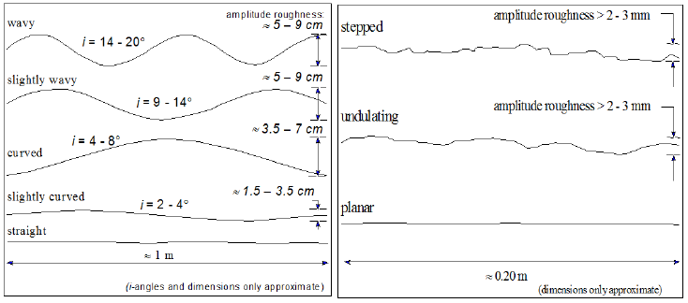
Figure 5.1 Large- scale roughness (left) and small-scale roughness (right). [Source: Hack, 1998]

5.2.1 Slope Section one

Basalt rock covers slope section one on upper part of the escarpment. In the basalt section, joints are observed to occur in sets with a directional parallelism. The polygonal columns were developed, many were four sided, and an inclined joint system formed the basal planes. Joints occur in two groups and the closeness of the several parallel and sub-parallel, are geometrically related surfaces and they have almost the same properties of a given joint system.

The joint-bounded columns display the two nonparallel joint systems appear to cross one another (x-intersection, i.e. not orthogonal) without any apparent interaction. In the field, a number of geometric features of basaltic columns and joints are measured. The widths of the column faces ranges from 10-30cm, the length of individual column ranges from 2 -10m. The columnar basalt in the study area is classified in to slightly and weakly weathered rock masses. The measurements given in table below was an average measurement of the rock mass properties used in the SSPC calculation (Annex E_1).

In the field, an exposed rock mass properties of section one were collected and summarized in table below.

Table 5.1 Rock mass parameters collected from section one in the field.
Exposure no.= 1 | Formation name = Basalt |  | Time & Date: 4:30 & 22/02/14
Methods of excavation- Pre-splitting/smooth wall blasting = 0.99
Degree of Weathering (Slightly = 0.95)
Intact rock strength= 132Mpa
Disc. Sets |  | Joints plane (J1) |  | Joints plane (J2)
Dip direction |  | 120 |  | 071
Dip |  | 68 |  | 76
Spacing (m) |  | 0.28 |  | 0.23
Roughness large scale (Rl) (1x1m²) |  | 0.95 |  | 0.95
Roughness Small scale (Rs) (20 x 20 cm²) |  | 0.75 |  | 0.75
Infill material (Im) |  | 1 |  | 1
Karsts (Ka) |  | 1 |  | 1

From data measured in the field, the condition factor of discontinuity (TC) is calculated by a simple multiplication of four factors:
TC= Rl * Rs * Im * Ka........................................................................................................eq. 5.3
The spacing parameter (SPA) which is based on the factors of Taylor (1980) was calculated. The factor of spacing is obtained based on the following graph provided (cited in Hack, 2002).
For two discontinuity sets:
SPA = factor _{maximum} * factor _{minimum} ........................................................................eq.5.4

Figure 5.2. Discontinuity spacing factors (After Taylor, 1980)

Then, the condition of discontinuities in a rock mass (CD) is based on the mean of the conditions of two discontinuity sets weighted against the spacing of the sets:

$CD=\frac{\frac{{TC}_{1}}{{DS}_{1}}+ \frac{{TC}_{2}}{{DS}_{2}}}{\frac{1}{{DS}_{1}}+ \frac{1}{{DS}_{2}}}$ ......................................................................................................................eq. 5.5
TC_{1,2,}are the conditions, and DS_{1,2,}are the spacing of the discontinuity sets 1,2.

Table 5.2: Results of Discontinuity spacing (SPA) and Condition of discontinuity(CD)
Parameters | Joints | Spacing (m) | factor | Spacing type | TC = Rl * Rs * Im * Ka
 | J₁ | 0.28 | 0.72 | maximum | 0.71
 | J₂ | 0.23 | 0.73 | minimum | 0.71
SPA= factor₁ * factor₂ = 0.5256
Condition of Discontinuities (CD) = 0.71

In reference rock mass, the parameters such as Reference rock mass condition of discontinuity (RTC), Reference rock mass Intact rock strength (RIRS) and Reference rock mass spacing (SPA) were calculated from TC, IRS and SPA measured in the Exposure rock mass corrected with influencing factor like degree of weathering in the exposure (WE) and Method of excavation (ME).

RIRS = IRS (in MPa) / WE ...............................................................................................eq.5.6
RSPA = SPA / (WE * ME) ...............................................................................................eq. 5.7
RCD = CD / WE ................................................................................................................eq.5.8

The rock mass friction angle and cohesion can be calculated by the optimizing the Mohr-Coulomb failure criterion with the intact rock strength (IRS), spacing parameter (SPA) and condition of discontinuities (CD) using the given formula (Hack, 1998).
φ _{RRM} = RIRS * 0.2417 + RSPA * 52.12 + RCD * 5.779 ..................................................eq.5.9
coh _{RRM} = RIRS * 94.27 + RSPA * 28629 + RCD * 3593 ..............................................eq. 5.10
if intact rock strength > 132Mpa → IRS = 132

Table: 5.3 Reference rock mass parameters result
Reference Rock mass Calculation
RIRS(Mpa) | RSPA | RCD | φ_{RRM}(°) | Coh_{RRM} (Kpa)
138.95 | 0.559 | 0.747 | 64.36° | 30

Table 5.3 shows that basalt slope section has an angle of friction 64.36° and a cohesion of 30Kpa.

The stability of a new slope is assessed with the new slope made in the slope rock mass. The parameters characterizing the geotechnical units in the slope rock mass are obtained by correcting the parameters characterizing the geotechnical units in the reference rock mass for the damage due to the method of excavation to be used for a new slope and are corrected for the decay of the rock mass due to future weathering. The probability of the slope to be stable is then calculated for a slope made in the slope rock mass.

For this case, a new method of excavation for new slope (SME) and degree of weathering of rock mass at the location of slope (SWE) is denoted according to the British Standard. After the incorporation of all the parameter values of the rock mass, slope orientation independent stability and slope orientation dependent stability is calculated.

a) Slope stability analysis of slope section one

The slope stability is determined by two different processes according to their relation to the orientation. These are orientation independent and dependent stability.

For the assessment of slope orientation independent stability, the slope intact rock strength (SIRS), slope spacing condition (SSPA) and slope condition of discontinuity (SCD), which is conceptually a strong approach towards the stability classification are calculated. If φ_{SRM} < slope dip; Maximum Slope Height (H _{max}) is calculated;
$H_{max}=1.6*{10}^{-4}*{coh}_{SRM}*\frac{\sin\left({dip}_{slope}\right)*cos({}_{SRM})}{1-cos({dip}_{slope}-{}_{SRM})}$...........................................................eq.5.11
$$H_{max}=1.6*{10}^{-4}*30,740.94*\frac{\sin\left(80\right)*cos(64.36)}{1-cos(80-64.36)}=56.63m$$
SIRS = RIRS * SWE ..........................................................................................................eq. 5.12
SSPA = RSPA * ME * SWE ..............................................................................................eq.5.13
SCD = RCD * SWE ............................................................................................................eq.5.14
$φ_{SRM}$ = SIRS * 0.2417 + SSPA * 52.12 + SCD * 5.779 ....................................................eq.5.15
${Coh}_{SRM}$ = SIRS * 94.27 + SSPA * 28629 + SCD * 3593 ................................................eq.5.16
Table: 5.4. Parameters used in orientation independent stability
Probability of orientation independent stability
SIRS | SSPA | SCD | $φ_{SRM}$ (°) | ${Coh}_{SRM}$ (Kpa) | H _{slope}  (m) | Slope _{dip}  (°) | H _{max}  (m) | $${φ_{SRM}}/{{slope}_{dip}}$$ | $${H_{max}}/{H_{slope}}$$ | Probability to be stable(%)
132.003 | 0.526 | 0.71 | 60.9 | 29 | 24 | 80 | 56.6 | 0.761 | 2.36 | >95%

Using the ratio of ${φ_{SRM}}/{{slope}_{dip}}$ to ${H_{max}}/{H_{slope}}$ , the probability of orientation independent stability of slope section one was obtained from graph below.
Figure 5.3. Probability of orientation independent stability
The Figure 5.3 indicates that the probability of orientation independent stability slope section one is greater than 95%.

In Orientation Dependent Stability assessment, the apparent discontinuity dip in the direction of the slope and the relation between orientation of the slope and the orientation of the discontinuity using eq.5.1 and eq.5.2.
Table 5.5 Orientation Dependent Stability
Disc. Sets | (Joints) J1 | (Joints) J2
Dip direction | 120 | 071
Dip | 68 | 76
RTC = TC/sqrt(1.452 - 1.220 * e^{(-WE)}) | 0.72 | 0.72
STC = RTC * sqrt(1.452 - 1.220 * e^{(-SWE)}) | 0.71 | 0.71
AP | 64.98 | 75.23
Probability of stable for sliding(%) | 50% | <5%
Figure 5.4. Slope stability Probability along each discontinuity with respect to Sliding criterion.

From the above calculation sheet and graph, the stability probability for sliding is <5% means that the stability is much less for sliding along the J2 with 071/76° orientation. In the field, it is confirmed that the joint plane is more steep oriented and spacing close to each other. This indicates that, the effect of J2, joint plane is high for the wedge failure in the slope section.

5.2.2 Slope section two
Section two is sandstone rock unit. The sandstone outcrop is bedded with various thickness and dipped gently. The joints and fractures in bedding sandstones have different discontinuity properties. The joint formation in section two was controlled by bedding-contained joints which terminate at the top and bottom of beds. Since joints end at layer boundaries, which are rock discontinuities, the longer joints in thicker layers need to be spaced less frequently.

Bedding-contained joints terminate at the top and bottom of stronger beds. some joints are non-systematic joints and irregularly spaced. The geometry of bedding surface is slightly curved parallel to sub-parallel structure. Some of the intersection of bedding surfaces are indistinguishable and there is no sharp contact between adjacent beds. The slope is very steep and it is valley at the toe of the slope and the upper slope surface is towards the cut slope.
Table 5.6. Rock mass parameters collected from section two in the field(Annex E_2).
Exposure no.= 2 | Formation name = sandstone |  | Time: 9:00 |  | Date: 24/02/14
Methods of excavation- Pre-splitting/smooth wall blasting = 0.99
Degree of Weathering (Slightly weathered = 0.95)
Intact rock strength (31.25Mpa)
Disc. Sets |  | (Bedding) B |  | (Joints) J1 |  | (Joints) J2
Dip direction |  | 315 |  | 300 |  | 216
Dip |  | 25 |  | 60 |  | 72
Spacing(m) |  | 0.78 |  | 1.00 |  | 0.6
Roughness large scale (Rl)(1x1m²) |  | 0.8 |  | 0.8 |  | 0.8
Roughness Small scale (Rs)(20 x 20 cm²) |  | 0.6 |  | 0.6 |  | 0.65
Infill material (Im) |  | 0.9 |  | 1.00 |  | 1.00
Karst (Ka) |  | 1.00 |  | 1.00 |  | 1.00

From the above data measured in the field on an exposure rock mass and Figure 5.2, the following parameters were calculated for three discontinuity sets.
- For three discontinuity sets:
SPA = factor _{maximum} * factor _{intermediate} * factor _{minimum} ..........................................eq.5.16
Then, the condition of discontinuities in a rock mass (CD) is based on the mean of the conditions of three discontinuity sets weighted against the spacing of the sets:
$CD=\frac{\frac{{TC}_{1}}{{DS}_{1}}+ \frac{{TC}_{2}}{{DS}_{2}}+ \frac{{TC}_{3}}{{DS}_{3}}}{\frac{1}{{DS}_{1}}+ \frac{1}{{DS}_{2}}+ \frac{1}{{DS}_{3}}}$ ................................................................................................................eq.5.17
TC_{1,2,3} are the conditions, and DS_{1,2,3} are the spacing of the discontinuity sets 1,2,3.

Table: 5.7 Discontinuity Spacing and condition of discontinuity results
Parameters | Joints | Spacing (m) | factor | Spacing type | TC = Rl * Rs * Im * Ka
Spacing factor | B | 0.78 | 0.73 | Intermediate | 0.432
Spacing factor | J₁ | 1 | 0.77 | maximum | 0.48
Spacing factor | J₂ | 0.6 | 0.76 | minimum | 0.52
SPA= factor₁ * factor₂ * factor₃ = 0.427
Condition of Discontinuities (CD) = 0.48

Using the same eq. 5.6-10, the internal friction angle (φ_{RRM}) and cohesion (coh_{RRM}) of the reference rock mass of section two was calculated (Table 5.8).
Table: 5.8 Reference rock mass parameters results for section two.
Reference Rock mass Calculation
RIRS(MPa) | RSPA | RCD | φ_{RRM}(°) | Coh_{RRM} (Kpa)
32.89 | 0.454 | 0.505 | 36.25 | 18

a) Slope stability analysis of slope section two
In SSPC system, both orientation dependent and independent slope stability can be calculated in terms of probability in percentage. Using Table 5.8 result in eq.5.11-16, the orientation independent parameters were determined.
Table 5.9 Orientation independent stability result of section two
Probability of orientation independent stability
SIRS | SSPA | SCD | φ_{SRM}  (°) | Coh_{SRM}  (Kpa) | H _{slope}  (m) | Slope _{dip}  (°) | H _{max}  (m) | φSRM/slopedip | H_{max}/H _{slope} | Probability to be stable(%)
31.24 | 0.427 | 0.48 | 34.2 | 17 | 30 | 75 | 9.22 | 0.46 | 0.3 | <5%

Figure 5.5 Probability of orientation independent stability

The probability of orientation independent stability depends on the slope height, slope angle and friction angle of discontinuity. Figure 5.5 indicates that the probability of stability for slope section two is less than 5%. Therefore, the slope parameters (height and angle of slope) and condition of the discontinuity influences the slope stability.

The orientation dependent stability in a rock slope often depend on the orientation of the slope and the discontinuities in the rock mass. Therefore, it is necessary to know which discontinuity set plays an important role for the slope failure.
Table 5.10 Orientation dependent stability of section two.
Disc. Sets | (Bedding) B1 | (Joints) J1 | (Joints) J2
Dip direction | 315 | 300 | 216
Dip | 25 | 60 | 72
RTC = TC/sqrt(1.452 - 1.220 * e^{(-WE)}) | 0.4364 | 0.485 | 0.525
STC = RTC * sqrt(1.452 - 1.220 * e^{(-SWE)}) | 0.432 | 0.48 | 0.519
AP | 23.38 | 59.8 | 47.81
Probability of stable for sliding(%) | >95 | <5% | 50

Figure 5.6. Slope stability Probability along each discontinuity with respect to Sliding criterion.
From the above calculation sheet and graph, the stability probability for sliding is <5% means that the stability is much less for sliding along the J1 with 300/60°. The probability of stability along bedding plane is high (i.e. >95% stable). The discontinuity along J1 is the major cause for the slope failure. The sliding criterion was confirmed visually in the field survey.

5.2.3 Slope section three

The slope exposure is a sandstone unit. No visible weathering, but some discoloration on the cut slope are observed. The rock unit is similar to that of section two. The data collected for section three were summarized in Annex E_3. using SSPC system data sheet.
Table 5.11 Rock mass parameters collected from slope section three in the field.
Exposure no.= 3 | Formation name = sandstone |  | Time: 6:00 | Date: 26/02/14
Methods of excavation- Pre-splitting/smooth wall blasting = 0.99
Degree of Weathering (Slightly = 0.95)
Intact rock strength (31.25Mpa)
Disc. Sets |  | (Bedding) B | (Joints) J1 | (Joints) J2
Dip direction |  | 308 | 302 | 222
Dip |  | 22 | 69 | 61
Spacing(m) |  | 0.65m | 0.70m | 1.75m
Roughness large (Rl)(1x1m²) |  | 0.80 | 0.80 | 0.80
Roughness Small(Rs)(20x20 cm²) |  | 0.75 | 0.60 | 0.60
Infill material (Im) |  | 0.90 | 0.90 | 1.00
Karst (Ka) |  | 1.00 | 1.00 | 1.00

Table 5.12 Discontinuity spacing and condition of discontinuities results.
Parameters | Joints | Spacing (m) | factor | Spacing type | TC = Rl * Rs * Im * Ka
Spacing factor | B | 0.65 | 0.78 | minimum | 0.54
Spacing factor | J₁ | 0.70 | 0.75 | Intermediate | 0.432
Spacing factor | J₂ | 1.75 | 0.84 | maximum | 0.48
SPA= factor₁ * factor₂ * factor₃ = 0.49
Condition of Discontinuities (CD) = 0.49
Using the eq. 5.6-10, the internal friction angle (φ _{RRM}) and cohesion(coh _{RRM}) of the reference rock mass of section three was calculated (Table 5.13).
Table: 5.13 Reference rock mass parameters results for section three.
Reference Rock mass Calculation
RIRS(Mpa) | RSPA | RCD | φ_{RRM} | Coh_{RRM} (KPa)
31.25 | 0.52 | 0.52 | 39.68 | 20.5

For the calculation of orientation independent slope stability, the above field results input parameters and the equations from eq. 5.11-16 were used.
Table: 5.14 Results of orientation independent stability for slope section three.
Probability of orientation independent stability
SIRS | SSPA | SCD | φ_{SRM}  (°) | Coh_{SRM}  (Kpa) | H _{slope}  (m) | Slope _{dip}  (°) | H _{max}  (m) | φSRM/slopedip | H_{max}/H _{slope} | Probability to be stable(%)
37.7 | 0.489 | 0.494 | 37.45 | 19.34 | 18 | 56 | 39 | 0.67 | 2.17 | >95%

Figure 5.7. Probability of orientation independent stability
The orientation dependent slope stability is explained based on sliding criterion.
Table 5.15 Orientation Dependent stability
Disc. Sets | (Bedding) B1 | (Joints) J1 | (Joints) J2
Dip direction | 308 | 302 | 222
Dip | 22 | 69 | 61
RTC = TC/sqrt(1.452 - 1.220 * e^{(-WE)}) | 0.55 | 0.44 | 0.48
STC = RTC * sqrt(1.452 - 1.220 * e^{(-SWE)}) | 0.54 | 0.435 | 0.475
AP | 21.8 | 68.98 | 20.56
Probability of stable for sliding(%) | >95% | <5% | >95%
Figure 5.8. Slope stability Probability along each discontinuity with respect to Sliding criterion.
From Figure 5.8, the probability of stability for sliding along B1 and J2 is greater than 95%. But, along J1 the probability of slope stability is <5%. Therefore, the probability failure is high along joint plane, J1.

5.3 Stereographic Discontinuity analysis

Discontinuity is the collective term for most types of joints, weak bedding planes, and faults or weakness zones. From an engineering point of view, acknowledge of the type and intensity of the rock defects may be much more important than of the types of rock which will be encountered. The presence or absence of discontinuities has a very important influence up on the stability of rock slopes and the detection of these geological features is the most critical part of the stability investigation (Hoek and Bray, 1981). The rock mass exposed on the critical slope sections in the study area is traversed by discontinuity planes such as joints and fractures. Structural data on preferred orientations of these discontinuity planes have been collected from the three critical slope sections. For each discontinuity plane the azimuth of the dip direction clockwise (from 0° to 360°) and amount of dip along its true dip direction of the plane have been measured. The major plane dip directions and dips were plotted by DIPS-stereonet (Rocscience software).

Table 5.16 Preferred orientation of joint sets used for slope sections

Slope Section | Mean dip direction/Mean dip
Slope Section | B1 | J1 | J2
1 | ___ | 120/68 | 071/76
2 | 315/25 | 300/60 | 216/72
3 | 308/22 | 302/69 | 222/61
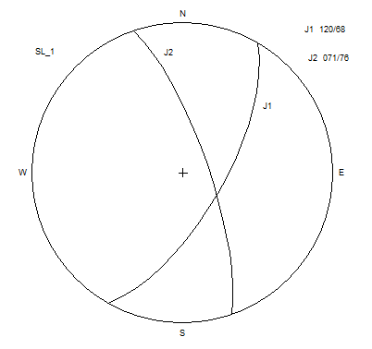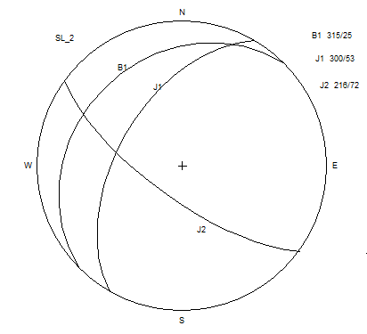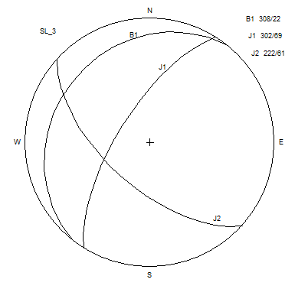
Figure 5.9. Preferred orientation of discontinuity planes on three critical rock slope sections

5.3.1 Kinematic Check for Possible Mode Of Failure

Markland test proposed a kinematic check to determine the possible mode of failure in the rock slopes. The critical slope sections, structural data along with slope inclination and a 'phi circle' corresponding to angle of friction (φ) of the rock mass has been plotted on equal area projection (Schmidt Net). The angle of friction has been estimated from SSPC data. From the three critical slope sections, Slope section one and two satisfy the markland kinematic condition (Table 5.17).

Table 5.17. Preferred orientation of discontinuity planes, slope and possible mode of failure in slope sections.
Slope section | Geometry of slope |  |  | Preferred orientation of discontinuity planes(Dip direction/dip) |  |  | Possible mode of failure
Slope section | Slope inclination | Upper slope inclination | Height (m) | B | J₁ | J₂
1 | 090/80 | 090/28 | 24 | ___ | 120/68 | 071/76 | Wedge(J1, J2)
2 | 293/75 | 293/35 | 30 | 315/25 | 300/60 | 216/72 | Planar (J1)

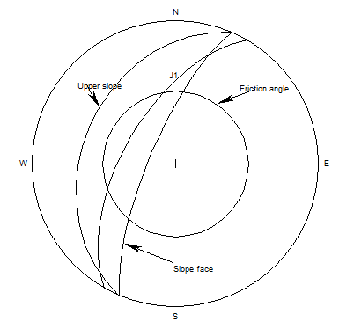
Figure.5.10. Stereographic analysis of planar mode of failure

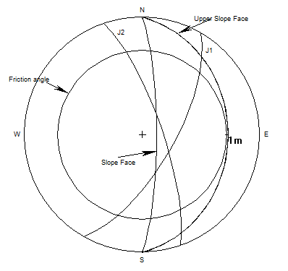
Figure. 5.11. Stereographic analysis of wedge mode of failure

5.4 Limit Equilibrium Analysis for Slope Sections

Limit equilibrium is an effective method for rock slope stability analysis. The input parameters used for limit equilibrium calculation of factor of safety are unit weight of the rock mass, cohesion and angle of friction, uplift water force acting along the discontinuity planes and tension crack (Hoek and Bray, 1981). For the present study, the factor of safety has been determined for static and dynamic conditions under various water saturation (dry, moderately and fully saturated) situations.

5.4.1 Plane Mode of Failure Analysis

Planar failure occurs when the strike of the discontinuity plane is nearly parallel to the strike of the slope and it daylights on the slope face (Sharma et al., 1995). For the present study from two critical slope sections, slope section two (S2) satisfy the Markland conditions for planar mode of failure. The plane failure analysis has been carried out by the technique of Sharma et al. (1995). The factor of safety of the failure plane has been determined under static and dynamic conditions for varying water saturation conditions.

In the modified Sharma et al. (1995) technique the following general conditions must be satisfied;
- The failure plan must strike parallel or nearly parallel (approx. + 20%) to the slope face.
- The dip of the failure plane must be smaller than the dip of the slope face (α_{p}<α_{f}).
- The angle of internal friction (φ) of the failure plane must be smaller than the dip of the
failure plan (φ<α_{p}).
- The upper slope surface and tension crack must be inclined.
- The inclination of the upper slope must be smaller than the inclination of the failure plan (α_{p}>α_{s}).
- The tension crack must be present on the upper slope surface.

Assumptions

For modified technique following assumptions were considered;

(i) For saturation conditions, the tension crack is filled with water to a vertical depth of Z_{w}. The water from the tension crack seeps along the failure surface and escape out on the slope face where the failure surface daylights on the slope face.
(ii) There is no resistance to sliding at the lateral boundaries of the sliding rock mass.
iii) For moderately saturated condition the tension crack (ZL) is half filled and the water level in the crack Zw = 0.5Z_{L}.
iv) For dry condition, the rock mass is completely dry (Zw = 0).

As per the technique of plane failure analysis (Sharma et.al, 1995) the area, weight, horizontal water forces and uplift water forces are calculated by the following equations;
Area of sliding mass

A=(h-ZI)cosecα..................................................…...................eq.5.18

Where;

$ZL=\frac{Zsinαt}{sinαt - tanαp cosαt }$...........................................................….............…..eq.5.19

ZI = ZL – IG ................................................................. ....................eq.5.20

$Z=h[\left(1-\frac{Cotαf}{Cotαs}\right)+ \sqrt{\frac{Cotαf}{Cotαp}} X \frac{Cotαp}{Cotαs}-1)]$.....................................................eq.5.21

IG$=\frac{h[\sqrt{CotαfCotαp} -Cotαf }{Cotαs}$........................................................................................eq.5.22

Weight ‘W’ of the sliding mass

$W=\frac{1}{2} γ[(h + a)X - DZ ]$ ..............................................................eq.5.23
Where, γ is the unit weight of the rock, ‘X’ and ‘D’ are the slope distance AF and GF,
respectively and ‘a’ is the height EF as shown in Fig.5.20.

X$=h(\frac{Cotαf}{Cotαs} X \frac{tanαp-tanαf }{tanαs-tanαp})$ .............................................................eq.5.24
D = $\frac{Z}{tanαpCosαs-sinαs}$..................................................................................................eq.5.25

a$=h(\frac{tanαs}{tanαf}) X (\frac{tanαp-tanαf }{tanαs-tanαp})$ ............................................................eq.5.26

Horizontal water force, V

V$= \frac{1}{2}γw {Zw }^{2}\sin^{2} αt$ ............................................................................................eq.5.27

Where, γ_{w} is the unit weight of water and Z_{w} is the water level in the tension crack.

Uplift water force, U

U$= \frac{1}{2}γw Zw sinαt (h - Zf )cosecα$p ..................................................................eq.5.28

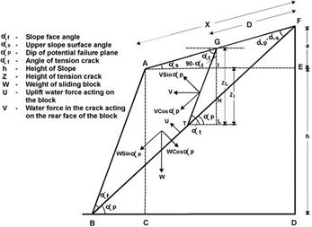
Figure 5.12 Parameters and Geometric details to be considered in Modified analytical Plane failure approach (Source: Sharma et al., 1995)

The Factor of safety for static condition as per Sharma et al. (1995) is given by eq.( )
F = $\frac{CA+(WCosαp-U-Vsinαp)tanφ}{Wsinαp +Vcosαp }$ ................................................................eq.5.29
Where; C is the cohesion,
A is the base area of the sliding mass,
W is the weight of the sliding mass,
U is the uplift water force,
V is the water force acting on the rear face of the tension crack and
φ is the angle of friction.

The Factor of safety for dynamic condition as per Sharma et al. (1995) is given by eq.( )
F = ....................................................eq.5.30

Where ‘α’ is the horizontal earthquake acceleration.
The area, weight, horizontal water forces and uplift water forces were calculated according to the technique of the plane failure analysis(Sharma et al., 1995).
a) Input Parameters for plane mode of failure

Based on the discontinuity data, the kinematic analysis is typically done using stereographic projection. In the present study, only planar and wedge mode of failure were evaluated.
Table 5.18. Orientation (strike and dip) of discontinuity and slope
Section | Joint strike/dip |  |  | Slope strike/dip
Section | B1 | J1 | J2 | Slope strike/dip
1 | __ | N57E/68SE | N 65W/76NE | N48W/80NE
2 | N60E/25NW | N24E/53NW | N66W/72SE | N30E/75NW
3 | N46E/22NW | N75E/69NW | N44E/37SE | N35E/56NW

SSPC system estimates the friction angle of the discontinuities based on back analyses of slope stability a sliding criterion was developed to easily estimate the shear strength of a discontinuity (Hack and Price 1995; Hack et al. 2002). The shear strength of the discontinuity is characterized by the discontinuity condition parameters such as large scale roughness (Rl) and small scale roughness (Rs), infill material (Im) and the presence of the karst (Ka) of the discontinuity. The different factors for the different characteristics are multiplied and divided by an empirically established factor. This results in the so-called ‘sliding angle’:

$φ_{sliding angle}=\frac{Rl*Rs*Im*Ka}{0.0113}$ .........................................................................................eq.5.31
Therefore, friction angle forJ1 is 42.48° and
There is tension crack with 305/80 orientation, which is more or less dips in the same direction with the failure plane.
The plunge or line intersection of line the two wedge forming joint planes in slope section one is 65°.
According to Laike Mariam Asfaw (1986) for a hundred year return period and 0.99 probability, the study area was found in 7 MM intensity scale. The horizontal earthquake acceleration for 7mm fall between 0.07 to 0.1g. An average value 0.08g was taken for the analysis.

Table 5.19. Input parameters for determination of factor of safety for J1 plane which has plane mode of failure.
Slope section | Height(H)(m) | Slope angle(αf)(°) | Upper slope angle(αs)(°) | plane angle(°) | Tension crack angle(αt)(°) | Cohesion(C) (Kpa) | Angle of friction(φ)(°) | Density of rock(γ) (KN/m3) | Unit weight of water(γw)(KN/m3) | Hor. seismic acceleration(α)(g)
S2 | 30 | 75 | 35 | 60 | 80 | 17.53 | 42.48 | 20 | 10 | 0.08

Table 5.20. Stability condition of J1 plane having planar mode of failure
Factor of Safety
Slope Section | Static Condition |  |  | Dynamic Condition
Slope Section | Dry | Moderately saturated | Fully saturated | Dry | Moderately saturated | Fully Saturated
S2 | 0.693 | 0.691 | 0.689 | 0.585 | 0.584 | 0.58

The factor of safety under each condition is less than one and the value is decreasing due to the effect of water saturation and earthquake. This indicates that the slope section is unstable along joint plane (J1) under different condition.

5.4.2 Wedge mode of failure analysis using Stereographic Method

When two discontinuities strikes obliquely across the slope face their line of intersection daylights in the slope face, the wedge of rock resting on these discontinuities will slide down the line of intersection, provided the plunge of line of intersection of the two wedge forming planes is greater than the angle of friction and is less than the inclination of the slope (Hoek and Bray, 1981).

Stereographic method is the simplest to analyze the stability of the slope having wedge mode of failure. The factor of safety is calculated as;
F = 3/γH (C_{A} . X + C_{B}.Y) + (A - γ_{w}/2γ . X) tanφ_{A} + (B - γ_{w}/2γ . Y) tanφ_{B} ...........................eq.5.3
where CA & CB are the cohesive strength of plane ‘A’ &‘B’, φA &φB are the angle of friction for plane ‘A’ and ‘B’. ‘γ’ is the unit weight of the rock ‘γw’ is the unit weight of the water ‘H’ is the height of the wedge X,Y,A, and B are dimensionless factors which depend upon the geometry of the wedge.
Figure 5.13. Determination of Different Angles, used in stereographic Analysis for wedge mode
$$X= \frac{sin{}_{24}}{sin{}_{45} . Cos{}_{2na}}$$
$$Y= \frac{sin{}_{13}}{sin{}_{35} . Cos{}_{1nb}}$$
$$A= \frac{cos{}_{a}- cos{}_{b} . cos{}_{na .nb}}{sin{}_{5} . \sin^{2}{}_{na. nb}}$$
$$B= \frac{cos{}_{b}- cos{}_{a} . cos{}_{na .nb}}{sin{}_{5} . \sin^{2}{}_{na. nb}}$$
where Ψa and Ψb are dips of plane ‘A’ and ‘B’ Ψ5 is the dip of line of intersection 5.
Table 5.21. Angles determined from stereographic projection
Angles of frictions | Angles counted on stereonet
φ_{2.na} | 64⁰
φ_{na.nb} | 120⁰
φ_{1.nb} | 61⁰
φ_{1.3} | 61⁰
φ_{3.5} | 27⁰
φ_{4.5} | 25⁰
φ_{2.5} | 32⁰
θ24 | φ_{4.5} + φ_{2.5} =32⁰ + 25⁰ = 57⁰
ψ5 | 51⁰

γ= 27.5 kN/m3(unit weight of basalt)
CA =CB = 30KN/m2
φA=φB = 64.36°
γw = 10KN/m3
F = 3/γH (C_{A} . X + C_{B}.Y) + (A - γ_{w}/2γ . X) tanφ_{A} + (B - γ_{w}/2γ . Y) tanφ_{B}
Cohesion and friction angle are directly taken from SSPC system calculation.
Factor of safety for the wedge mode failure for basalt is 1.36, which indicates that slope section one is stable.

5.5 Deterministic and Probabilistic Stability Analysis of Colluvium Slope Section

SLIDE software was used for deterministic and probabilistic stability analysis. The safety factors and probability of failure for circular slope failure surfaces, using a number of widely used limit equilibrium analysis approaches such as the Bishop, Janbu corrected, gle/morgenstern-price, Spencer, Ordinary/Fellenius are determined. Circular surface grid search with 20 x 20 grid interval is used to locate the slip surface (critical slip surface), which has the lowest factor of safety.

In order to carry out a Probabilistic analysis, the input parameters used in deterministic analysis are defined as a random Variable. For the present study, normal probability distribution and Monte Carlo method are used for determination of factor of safety and probability of failure. The number of Monte Carlo trials in an analysis depends on the variability of input parameters and the expected probability of failure. For these variables, many trials of Monte Carlo simulation was taken.

For the colluviums slope analysis, the length and the height of the slope sections have been taken by GPS reading. The slope is 76m high and 200m long. The slope cross section was based on the field observation due to lack of sufficient data. The cross section in Figure 5.14 has 1:2.5V and 1:3H scale

For the present study, the factor of safety has been determined for static and dynamic conditions under varying water saturation situations. Static dry and saturated, dynamic dry and saturated conditions are considered for the factor of safety determination. The Meteorological data of the area indicated that the area received the Mean annual rainfall varies between 1500 - 2000mm. Thus, for dry condition analysis, the groundwater table is considered to be at the lowest level whereas for water saturation conditions, water table were considered at the maximum level.

For stability analysis, the shear strength input parameters for basalt rock was used from Barton (1974). The input parameters used for Colluvium is taken from the direct shear test result (Annex- D)
According to LaikeMariam Asfaw (1986), the present study found in 7MM seismic intensity scale. The horizontal earthquake acceleration for 7mm fall in 0.07 to 0.1g. Therefore, an average value 0.08g was taken for the analysis.

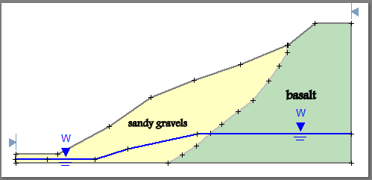

Figure 5.14 Profile of colluvium slope section.

5.5.1. Deterministic Stability Analysis of Colluvium Slope Section

The colluvium of this station is occurred at the entrance of the slope. In the field it is observed that the slope includes various soils with different grain size (from sandy to silt and gravel). The soils in the area are light (white), red and mixed in color.

Table 5.22 Deterministic input parameter for colluvium slope section
Types of material | Cohesion(Kpa) | Friction angle(deg.) | Unit weight(KN/m3)
Colluvial | 16.97 | 48.97 | 18.5
Basalt | 240 | 42 | 27.5

Using Table 5.22, the deterministic factor of safety for colluvium slope section was determined under static and dynamic conditions with varying water saturation (Table 5.25).
Table 5.23 Deterministic factor of safety result for colluvium slope section under different conditions.
Analysis methods | Static condition |  | Dynamic Condition
Analysis methods | dry | saturated | dry | saturated
Bishop | 2.82 | 1.39 | 2.51 | 1.16
Ordinary/Fellenius | 2.95 | 1.18 | 2.36 | 0.95
gle/morgenstern-price | 2.95 | 1.42 | 2.51 | 1.19
Janbu corrected | 2.95 | 1.35 | 2.49 | 1.09
Spencer | 2.95 | 1.42 | 2.51 | 1.19

i) Deterministic stability analysis of Colluvium slope section under Static-dry condition

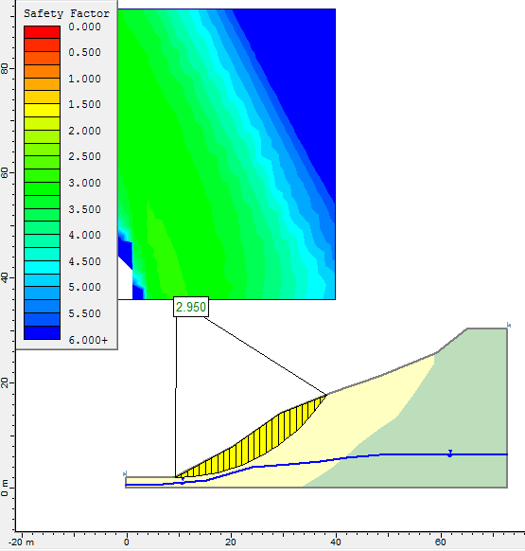
Figure 5.15 Deterministic factor of safety of colluvium slope section under static dry condition
Under the static dry condition, dry situation is considered when groundwater table is at the lowest level. without seismic load was considered. All analysis methods have a factor of safety greater than 2.8 value (Table 5.25).
ii) Deterministic analysis of colluvium slope section under static saturation condition
The factor of safety under static saturated condition is mainly governed by the pore pressure formed due to the fully saturation in the soil-profile. The minimum slip surface of slope has 1.396 factor of safety and the slope section is stable at static saturated conditions.

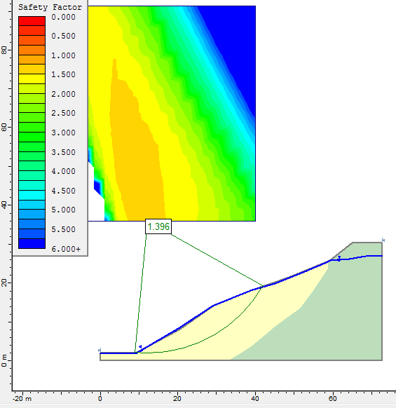
Figure 5.16 Deterministic factor of safety colluvium slope under static saturation condition

iii) Deterministic analysis of colluvium slope section under dynamic dry condition
Under the dynamic dry condition, the seismic load is considered and ground water table is at the lowest level. The minimum global surface of the colluvium slope section under dynamic dry condition is 2.513 (Table 5.25).
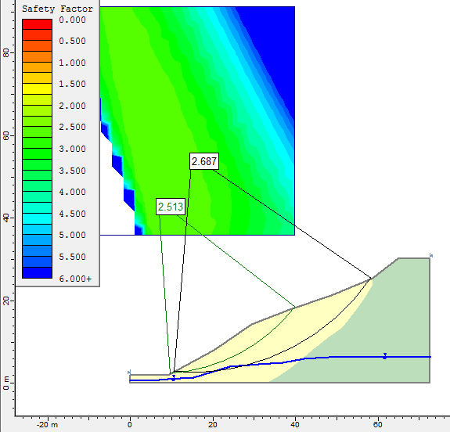
Figure 5.17 Deterministic factor of safety of colluvium slope section under dynamic dry condition

iv) Deterministic analysis of colluviums slope section under dynamic saturated condition
The seismic load and groundwater table are considered. The Ordinary/fellenius methods has 0.95 factor of safety and other analysis methods have factor of safety greater than 1 (Table 5.25).
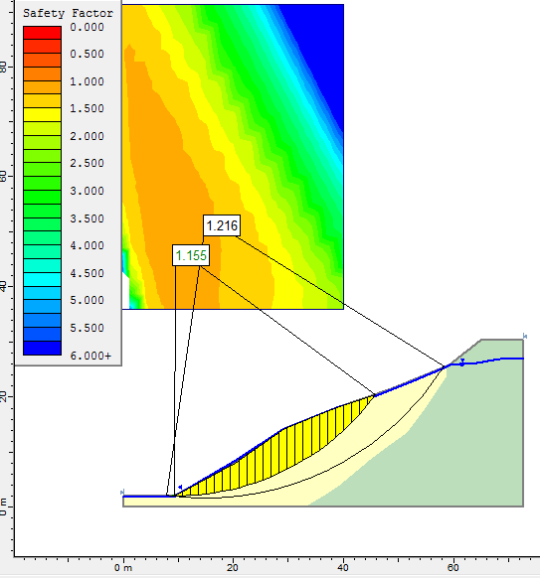
Figure 5.18 Deterministic factor safety under dynamic saturated condition

5.5. 2 Probabilistic stability analysis of Colluvium Slope section under different condition

In probabilistic analysis, the result of global minimum slip surface is described by FS (deterministic), FS (mean), probability of failure and reliability index. FS (deterministic), is calculated for the Global Minimum slip surface, from the regular (non-probabilistic) slope stability analysis and FS (mean), is the mean (average) safety factor, obtained from the Probabilistic Analysis. The FS (mean)and FS (deterministic) have close value. The Reliability Index (Normal or Lognormal distribution) is an indication of the number of standard deviations which separate the Mean Safety Factor from the critical safety factor ( = 1).

a) Probabilistic stability analysis of colluvium slope section under static dry condition
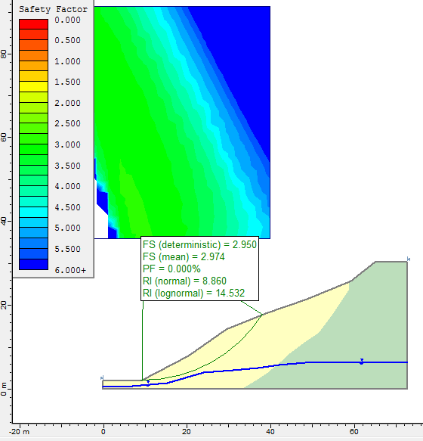
Figure 5.19 Factor of safety and probability of failure colluvium slope section under static dry condition
Under static dry condition colluviums slope section has 0.0% probability of failure and relatively higher reliability index. A Reliability Index of at least 3 is usually recommended, as a minimal assurance of a safe slope design. Since the reliability index of colluvium slope section under Static dry condition is >3, the slope is safe (Figure 5.19).
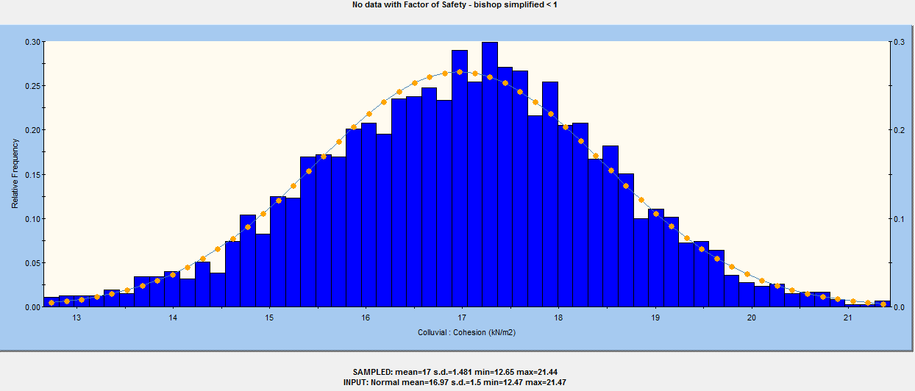
Figure 5.20 Probability distributions of colluvium slope section factor of safety under static dry condition.
b) Probabilistic stability analysis of colluvium slope section under static saturation condition
The deterministic and mean factor of safety is 1.39 and the probability of failure is 0.8%.
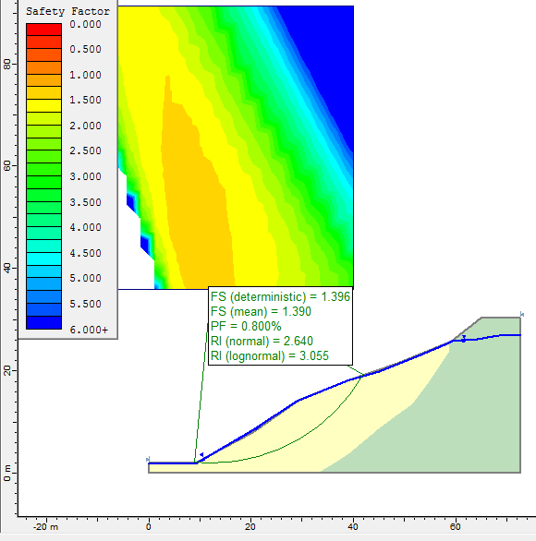
Figure 5.21 Factor of safety and probability of failure of colluvium slope section under static saturation condition
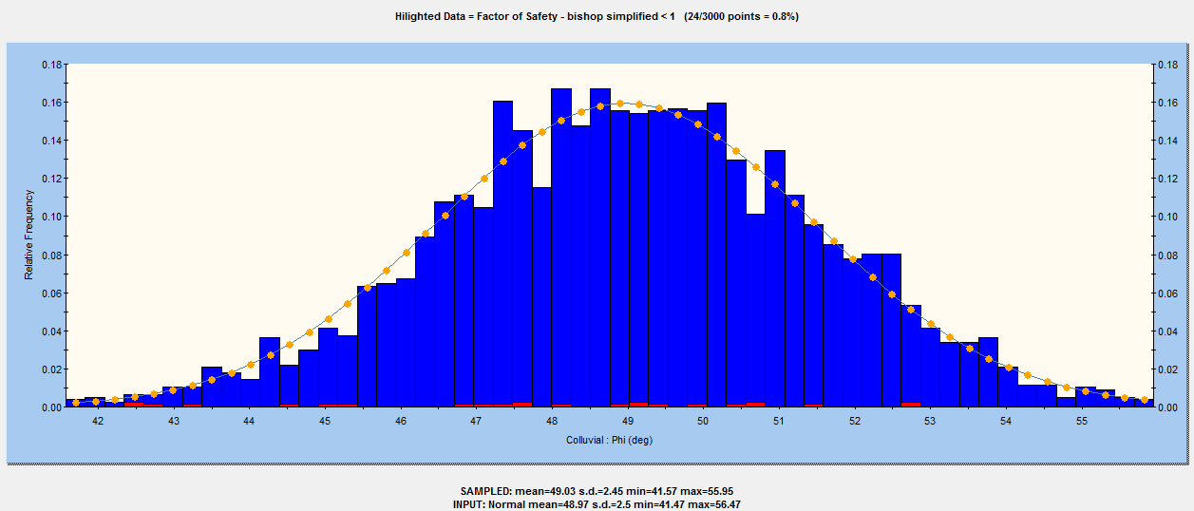
Figure 5.22 probability distributions of colluvium slope section factor of safety under static saturation condition.
c) Probabilistic stability analysis of colluvium slope section under dynamic dry condition
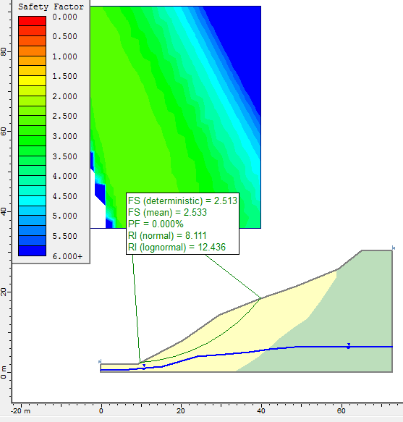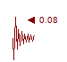
Figure 5.23 Factor of safety and probability of failure of colluvium slope section under dynamic dry condition
d) Probabilistic stability analysis of colluvium slope section under dynamic saturation condition
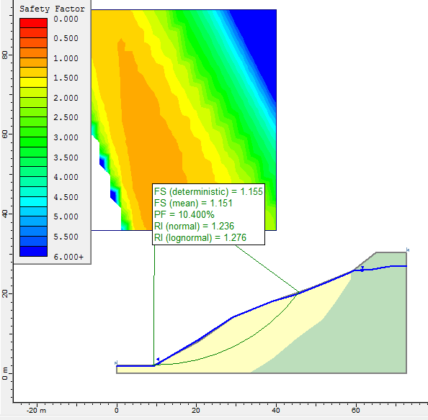
Figure 5.24 Factor of safety and probability of failure colluvium slope section under dynamic saturated condition
The deterministic factor of safety and mean safety factor have almost same value and the probability of failure is 10.4%. The reliability index of normal and lognormal are 1.236 and 1.276 respectively.

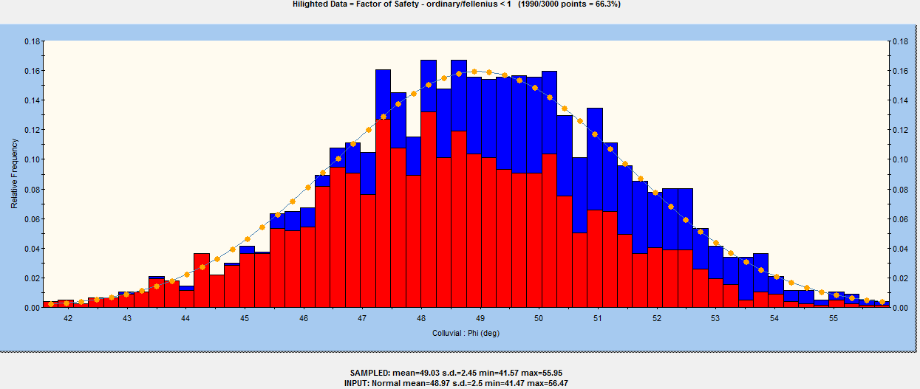
Figure 5.25 Factor of safety and probability of failure of colluvium slope section under dynamic saturated condition
The highlighted data (red bars) shows the analyses which resulted in a safety factor less than 1 under dynamic saturation condition. Therefore, the seismic load and ground water condition have a great influence for the slope stability.
5.5.3 Sensitivity Analysis

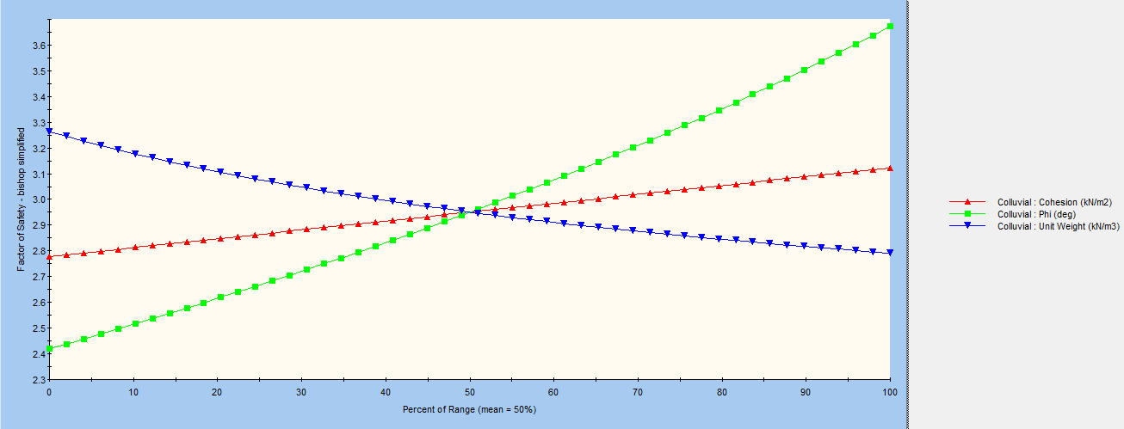
Figure 5.26 Sensitivity analysis of colluvium parameter
From the plot, the safety factor is sensitive to the friction angle and less sensitive to the cohesion. All variables intersect at Percent of Range = 50% which represents the mean value of each variable.

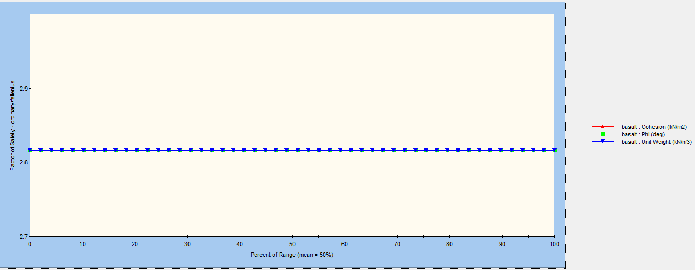
Figure 5.27 Sensitivity analysis of basalt parameters
Factor of safety has equal sensitivity to friction of angle and unit weight of basalt.

CHAPTER 6 CONCLUSION AND RECOMMENDATION

6.1 Conclusion

For the present study, a detailed slope stability analysis was carried out for a rock and colluvium critical slope sections. Three rock and one colluvium slopes were selected for analysis. The rock slopes are basalt and sandstone sections. The possibility of failure along the basalt section is wedge mode of failure and along the sandstone is planar failure. The colluvium slope section was selected based on the field observation. The colluvium slope has different geotechnical material with variation in its origin, engineering property, grain size.

For the selected rock slope sections detail field data measurement and laboratory tests were conducted. The field data related rock mass properties that includes rock material and discontinuity properties, weathering condition and other slope related data were collected. These data were analyzed by SSPC system. This system analyze the rock slope in terms of orientation dependent and independent between the slope and discontinuity.
The results of orientation dependent stability showed that the probability of stability of slope section two and three along joint plane J1 and slope section three along J2 is less than 5%. Slope section two and three have 95% probability to be stable along bedding plane (B1). Slope section one and two have 50% probability of stability along J1 and J2 respectively.
It was observed that orientation independent stability is very useful approach for assessment of the stability of each rock mass exposure. It calculates the probability of stability with respect to independent orientation of the slope. In orientation dependent stability, it is necessary to observe each discontinuity sets, the dependency of each discontinuity with slope rock mass. The probability observed from SSPC system varies from 0 to 100%. The probability of orientation independent stability of slope section one and three is greater than 95%. Whereas, slope section two has <5% probability to be stable. This means that the rock mass exposure is highly unstable and may be prone to failure in near future. Therefore, the probability of failure is high.

For further analysis, kinematic check for rock slopes were carried out. From three rock slopes, two rock slope sections satisfied the kinematic conditions. Slope section one satisfied for possible wedge mode of failure and section two satisfied the possibility of plane mode of failure. The plane failure analysis was carried out by a modified analytical approach proposed by Sharma et al. (1995) and the wedge analysis was carried out by stereographic method. The factor of safety for plane mode of failure under static and dynamic conditions with different water saturation is less than one which indicates that the slope is unstable. Factor of safety for wedge analysis is 1.36 which is relatively stable. The orientation independent stability also indicates that the probability of stability of slope section one and two are greater than 95% and less than 5% respectively.

The SLIDE software was used to perform the stability analysis of colluvium slope sections using both deterministic and probabilistic stability analysis under different seismic load and water saturation conditions. The deterministic analysis was undertaken by Bishop, Janbu corrected, Ordinary/Fellenius, morgenstern-price and Spencer limit equilibrium analysis methods. In order to carried out the probabilistic analysis, each deterministic input parameter (i.e. material properties such as; Cohesion, Friction Angle, Unit Weight) were defined as random values and quantified by 3000 Monte Carlo simulation after many trials. Then, based on the probabilistic result, the reliability index and probability of failure of slopes were discussed. Deterministic and probabilistic analysis of colluvial slopes, were concluded as follows:
- The colluvium slope section under deterministic static dry condition with factor of safety 2.9 and this value further drop to 1.4 under static saturated condition. The factor of safety under dynamic dry and dynamic saturation conditions are 2.5 and 1.15 respectively. The safety factor value is decreasing. This result indicates that slope section colluvium would be unstable under anticipated adverse conditions.

- From probabilistic analysis it is deduced that probability of failure of colluvium slope in static dry condition is 0.0% and under static saturation condition the probability of failure is 0.8%. Under dynamic dry conditions the probability of failure is 0.0% and with water saturation the probability of failure is 10.4%. Thus, the results indicate that the water saturation under static or dynamic conditions will make slope unstable.

Recommendation

- For the present study three rock slopes (section one, two and three) were identified as potentially critical slopes. However, only rock slope section two is unstable for existing and anticipated adverse conditions. But, during fieldwork it is observed that slope section one and three have minor problems such as rock fall. Therefore, removing an unstable rock , benches and wide shoulders are an appropriate measures to avoid any future rock falling or sliding particularly in slopes section two.

- The main factor of colluvium slope failure in present study is rainfall. There is heavy rain from May to September and the area obtain high annual rainfall. The heavy rain builds pore pressure and saturation in the soil. Therefore, providing surface drainage system such as horizontal drainage is an appropriate measure to reduce the water infiltration. Retaining wall with appropriate drainage path is also more suitable to resist the downward forces of the soil mass. However, for sub-surface drainage problem, groundwater condition should be investigated.

- There are local people settled at/near the upper slope and they use the escarpment for grazing, cutting trees for various purposes and making erosion channel towards the slope. These factors made the slope unstable. Therefore, awareness should be given to local people to protect the slope from landslide problem.

- There are rock and colluvium slope problems along Mana Begna - Lemlem Bereha road at different sections. However, due to constrain of time, resources and financial limitations only four most critical slope sections were selected and studied during the present study. Therefore, further studies are needed to cover the remaining slopes in order to reduce the slope instability.

REFERENCES

Ahmet, H. A. and Raghav. S. R. (2013). Slope failure investigation management system,
Maryland State Highway Administration, Glenn L. Martin Hall, Maryland.
AMEC Americas Limited, (2009). Bank stability study For the proposed Lower churchill
hydroelectric Generation project, Environmental baseline unpublished report.
Antonio Bobet. (2010). Numerical methods in geomechanics, School of Civil Engineering,
Purdue University, West Lafayette, IN, USA.
Ayalew L. and Yamagishi H. (2003). Slope failures in the Blue Nile basin, as seen from
landscape evolution perspective. Geomorphology, 1 -22
Barton, N.R., Lien, R. and Lunde, J. (1974). Engineering classification of rock masses for the
design of tunnel support. Rock Mech. 6(4), 189-239.
Barton N. (1976). The shear strength of rock and rock joints. Int. J. Rock Mech. Min. Sci. &
Geomech. Abstr., 13, No. 9, 255-279pp.
Barton, N.R. and Choubey, V., 1977, The shear strength of rock joints in theory and practice.
Rock Mechanics.,10, No. 1-2, pp 1 – 54.
Bieniawski, Z.T. (1976). Rock mass classification in rock engineering. In Exploration for rock
engineering, proc. of the symp., (Bieniawski . Z.T. (ed)) 1, 97-106. Cape Town:
Balkema.
Bieniawski, Z.T. (1989). Engineering rock mass classifications. New York: Wiley.
BS 5930 (1981). Code of Practice for Site Investigations. British Standards Institution (BSI).
London. 147pp.
Call, R.D., 1992, Slope stability, SME Mining Engineering Handbook 2nd ed. Vol. 1 ed. H.L.
Hartman. Littleton, Colorado, SME.
Cruden, D.M. & Varnes, D.J. (1996). Landslide types and processes. In Turner & Schuster(eds.),
Landslides: Investigation and Mitigation (Special Report 247). National Academy
press, Washington, D.C., 36-75
Dai, F.C and Lee, C. F. (2002). Landslide characteristics and slope instability modeling using
GIS, Lantau Island, Hong Kong. Geomorphology 42, 213– 228pp.
Dearman, W.R. (1991). Engineering geological mapping. Butterworth - Heinemann Ltd.,
Oxford.
Deoja, B., Dhital, M., Thapa, B. and Wagner, A., (1991). Mountain Risk Engineering (MRE),
Handbook Part I and II, ICIMOD, Kathmandu, 875 p.
Erick Eberhardt (2004). Rock Slope Stability Analysis-Utilization of Advanced Numerical
Techniques, Geological Engineering/Earth and Ocean Sciences, UBC, 6339 Stores
Rd., Vancouver, Bc, v6t 1z4, Canada.
ERA,(2002). Ethiopian Road Authority (ERA) Design Manual, Unpublished Report, Addis
Ababa.
Getaneh Assefa (1991). Lithostratigraphic and environment of deposition of the late jurassic-
Early cretaceous sequence of the central part of Northwestern plateau, Ethiopia. N. Jb.
Geol. paleont. Abh., 182(3), 255-284, Stuttgart.
Gyasi-Agyei, Y., F.P. de Troch, and P.A. Troch (1996). A Dynamic Hillslope Response Model
in a Geomorphology-Based Rainfall–Runoff Model, Journal of Hydrology, 178,
No. 1–4, pp. 1–18.
Hack H.R.G.K (1996). Slope Stability Probability Classification-SSPC, ITC, Kanaalweg, 3, 2628
EB Delft, The Netherlands.
Hack H.R.G.K. (1998). Slope stability probability classification, SSPC. 2nd edition. publ. ITC,
Enschede, The Netherlands. ISBN 90 6164 154 3. 258 pp.
Hack, Robert (2002). An evaluation of slope stability classification, Section Engineering
Geology, Centre for Technical Geosciences, International Institute for Geo-information
Science and Earth Observation (ITC), Delft, Netherlands.
Hoek, E. and Bray, J.W. (1981). Rock Slope Engineering (Revised Third Edition). Inst. of Mining and Metallurgy, London. pp.358.
Hudson, J. A., 1989, Rock mechanics principles in engineering practice, CIRIA/Butterworths, London, 72 pp.
ISRM., 1978, Suggested methods for quantitative description of discontinuities in rock masses. Int. J. Rock Mech. Min. Sci. & Geomech. Abstr. 15, pp 319 – 368.
John B. Ritter (2004), Landslides and Slope Stability Analysis, Computational Science Module,
Department of Geology, Wittenberg University.
Kazmin V., (1975). Explanation Of The Geological Map Of Ethiopia. Bull No.1 Eigs Addis
Ababa.
Kifle Woldearegay. (2013). Review of the occurrences and influencing factors of landslides in
the highlands of Ethiopia: With implications for infrastructural development, 5(1):3-31.
Laike Mariam Asfaw (1986). Catalogue of Ethiopian earthquakes, Earthquake Parameters, Strain
Release and Seismic Risk. In: proceedings of the SAREC-ESTC conference on
Research Development and Current Research Activities in Ethiopia, pp. 252-279.
Lee, C. and Wang, I. (2013). Analysis of Highway Slope Failure by an Application
of the Stereographic Projection.
Mahboubi, M. Aminpour and Noorzad (2008). Conventional and Advanced Numerical Methods
of Rock Slope Stability Analysis, A Comparison Study, Gotvand Dam Right Abutment
(Iran) Case Study.
Matrika prasad koirala (2003). engineering geological and geotechnical studies Of the tinpiple-
banchare dada road, Between km 0+000 and km 8+300, Central nepal, lesser himalaya,
Unpublished MSc thesis. India.
Oromia National Regional State (2011). Program of Plan on Adaptation to Climate Change,
Technical report Oromia, Ethiopia.
Pantelids (2008). Rock slope stability assessment through rock mass classification systems.
International Journal of Rock mechanics and Mining Sciences, In Press, Corrected
Proof.
Romana M. (1985). New adjustment rating for application of the Bieniawski classification to
slopes. Proc. Int. Symp. Rock Mechanics Mining Civ. Works. ISRM, Zacatecas,
Mexico. pp 59-63.
Russo, A., Assefa,G. and Atnafu.B. (1994). Sedimentary evolution of the Abay river basin,
Ethiopia. N Jb. Geol. Palaont. Mh 5:291-308.
Shah, B.H.(2008). Field Manual of Slope Stabilization, United Nations Development Program,
Pakistan.
Sharma, S., Raghuvanshi, T.K. and Anbalagan, R. (1995). Plane failure analysis in rock slopes,
Geot. and Geol. Eng. 13:105–113.
Tamiru Alemayehu.(2006). Groundwater occurrence in Ethiopia, Addis Ababa University,
Ethiopia.
Tan (2006). Engineering Geology of Rock Slopes in Highway Construction, Geology
Programme, Faculty of Science & Technology, Bangi, Malaysia.
Tilahun Mammo (2005). Site specific ground motion simulation and seismic response analysis at
the proposed bridges sites within the city of Addis Ababa. Ethiopia, Eng. Geol. 79:127 150.
Umrao, R. Singh, M. Ahmad and T. N. Singh (2011). Stability Analysis of Cut Slopes Using
Continuous Slope Mass Rating and Kinematic Analysis in Rudraprayag District,
Uttarakhand, India.
Wolela A. (2008). Contrast in clay mineralogy and their effect on reservoir properties in
sandstone formations, Petroleum Operations Department, Ministry Of Mines And
Energy, Addis Ababa, Ethiopia.

ANNEX
Annex A. Sandstone petrographic description
Annex A(1) proportions of sandstone compositions obtained from sandstone samples collected from the study area.
Sample No. | Composition(%) |  |  |  |  |  | Rock Name
Sample No. | Q | RF | Feldspar | Matrix | cements | Others
S_2 | 10-20 | ___ | 15 | 60-75 | 5 | ___ | Clastic mudrock
S_21 | 40-50 | 10-15 | ___ | ____ | 30 | 10-20 | Lithicwacke
S_22 | 80 | 15 | ___ | ___ | __ | 5 | Quartzarenite
S_51 | 30-40 | 20-30 | 1-10 | 5 | 10 | 2 | Lithicwacke
S_52 | 40-50 | 20-30 | 10 | 2 | 5 | 5 | Lithicwacke

Annex A(2): Photomicrographs of sandstone samples
Sample S₂
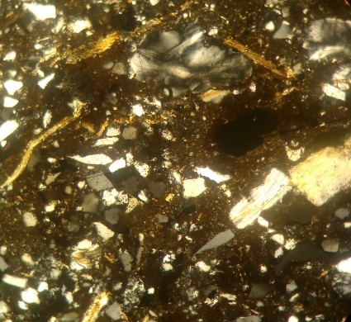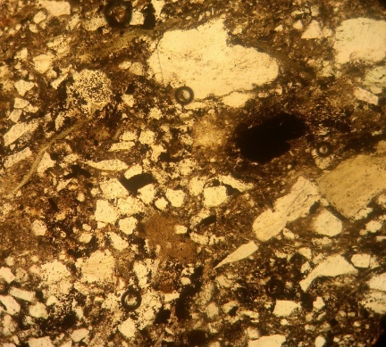
PS
F
M
B
A

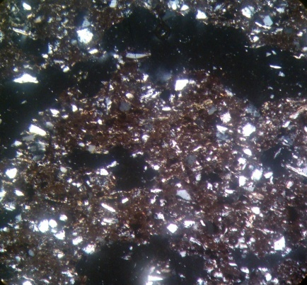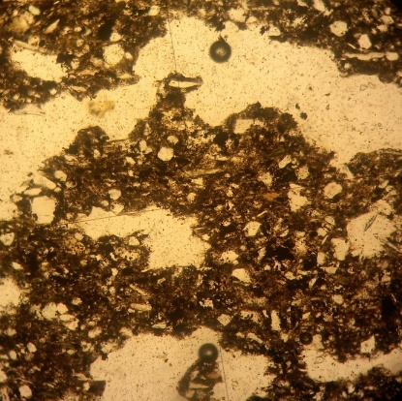
RF
PS
m
D
C
A and B) shows the photomicrographs of sample S2 with 40xmagnification under crossed Polarized Light(XPL)and Plane Polarized Light(PPL) respectively. They shows various sandstone components like feldspars (F), Muscovites(M), pore space(PS) and Cand D), also shows another view of the same sample ,S2 with 40xmagnification under XPL and PPL respectively, in which sandstone components like quartz grains (Q), the larger pore space(PS), rock fragment (RF) and darker matrix(m)

Sample S_21
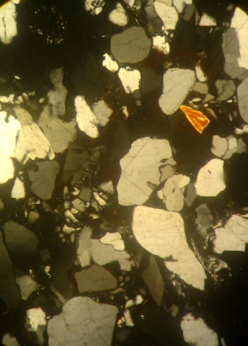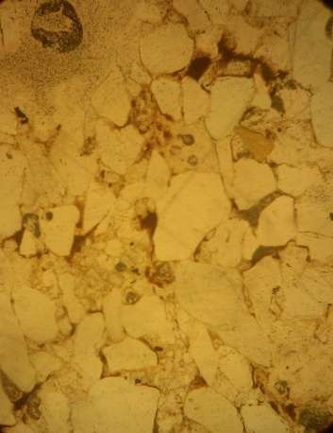
M
Q
FB
E
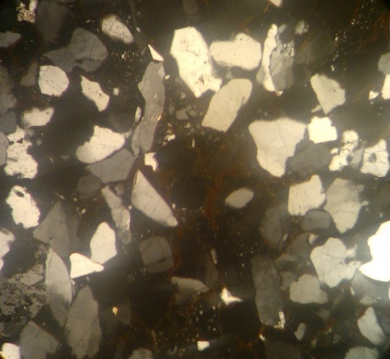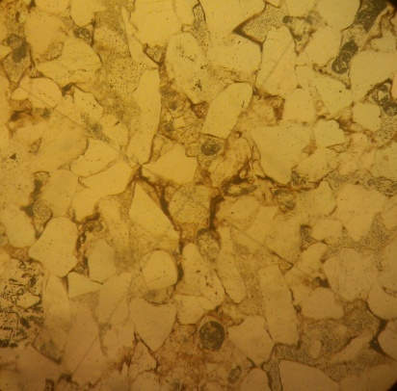
Q
RF
C
H
G
E and F) the photomicrographs of sample S-21 with 40x magnification under XPL and PPL respectively, in which sandstone components like angular to sub-rounded coarser Quartz grains(Q), Rock Fragments(RF), Cements(C), Mica(M), Pore Space(PS), Opaque(O) G and H) the photomicrographs of sample S-21 with 40x magnification under XPL and PPL respectively, in which sandstone components like Quartz(Q), Rock Fragments(RF), Cements(C), Mica(M), Pore Space(PS), Opaque(O)

Sample: S_52
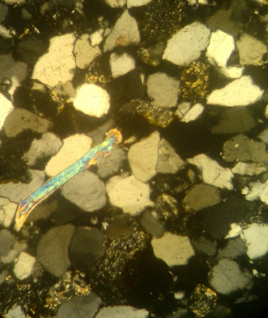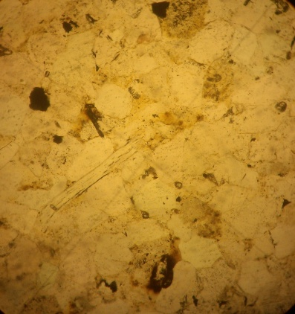
Q
J
RF
M
I
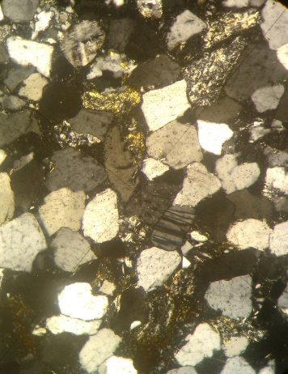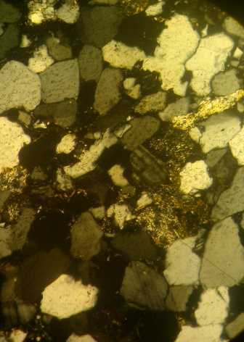
RF
F
L
K
(I and J) the photomicrographs of sample S-52 with 40x magnification under XPL and PPL respectively, in which sandstone components like elongated mica(M), Rock fragment(RF) and quartz(Q) (K and L) the photomicrographs of sample S-52 with 40x magnification under XPL and PPL respectively, in which sandstone components like twined Feldspar(F), subrounded Quartz(Q), Rock Fragments(RF)

Annex A(3): Photomicrographs of Basalt samples
Sample: S_11
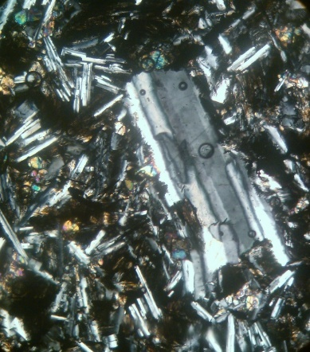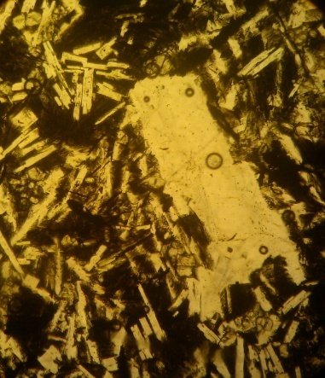
Py
2
1
Pf
Photomicrographs of sample S_11(1 and 2) includes Ferric Oxides(30%), (Pf-Plagioclase feldspar(40%), (Py-pyroxene)(20-30%), Biotite(10%) and rare Amphibolite and Olivine. Euhedral grain shape and planar alignment of grains.
Sample: S_12
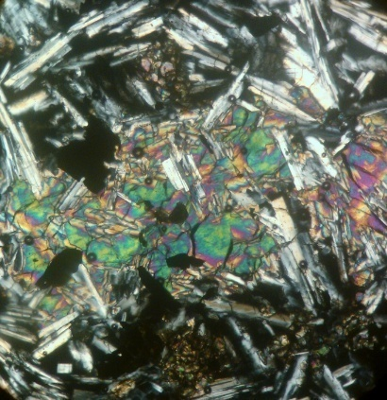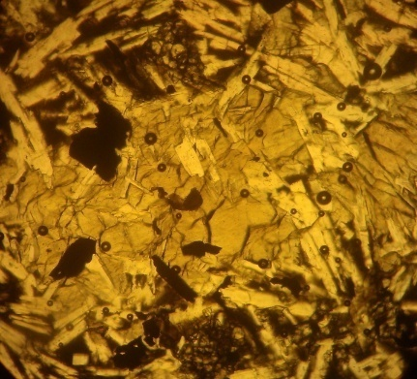
3
Py
Pf
4
Photomicrographs of sample S_12(3 and 4) includes Plagioclase feldspar(50%), Pyroxene(20), Olivine(10%), Ferric Oxide(Fe/Ti)-black color(10%), Olivine. Granular and holocrystalline texture, anhedral and subhedral shapes mainly on pyroxene and olivine.
Sample: S_13
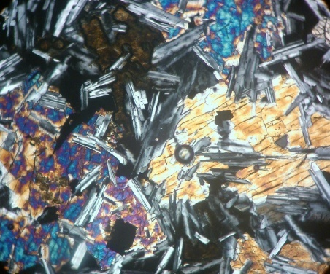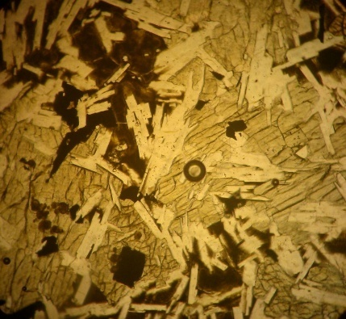
6
Ol
Py
Bi
Pf
5
Photomicrographs of sample S_13 (5 and 6) includes Pyroxene(10%), Amphiboles(30%), Olivine(10-20%), Plagioclase(30-40), Fe/Ti oxides(10%). Some intergranular textures in which pyroxene is filling the gap between anhedral shape of plagioclase.
Annex B - Rock specimens before and after slake durability test
Annex B_1 Test results description according to ASTM D4644-87
Sample no. | Type | Description
B1, B2, S2_b | I | Retained pieces remain virtually unchanged
S2-1, S2-2, S3, S2-a | II | Retained materials consist of large and small

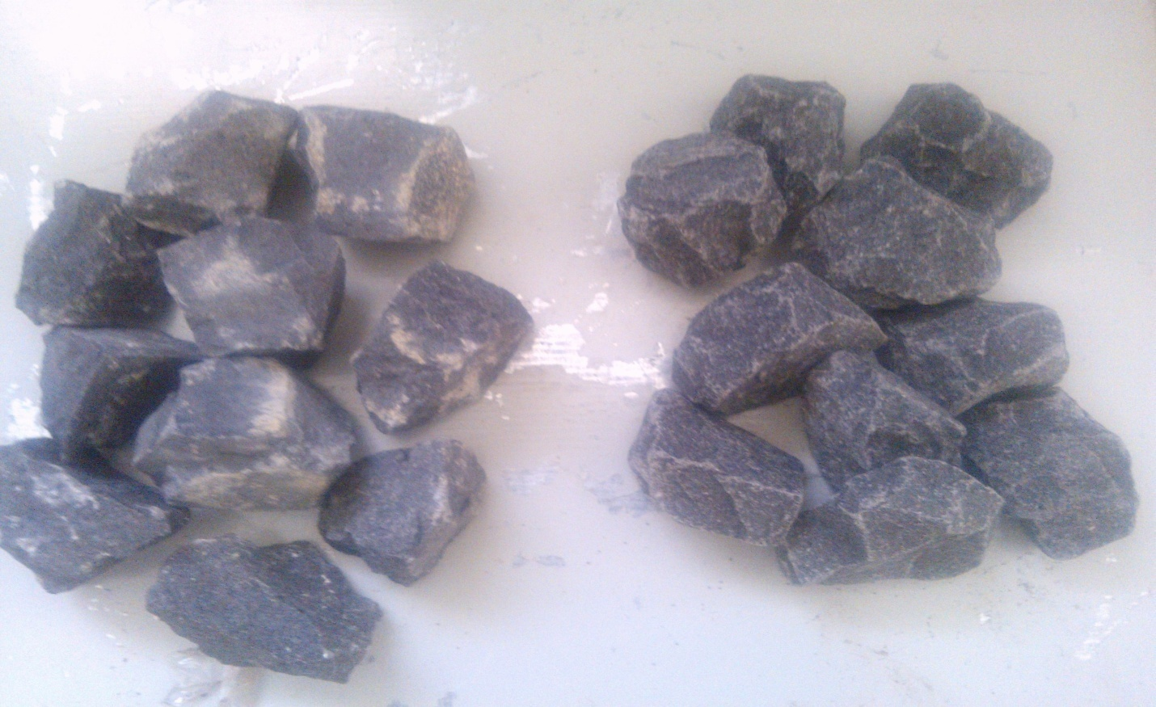
after
before
Basalt rock specimen before(left) and after (right) slake durability test from B slope section. The retained pieces remain virtually unchanged (i.e. Type I)

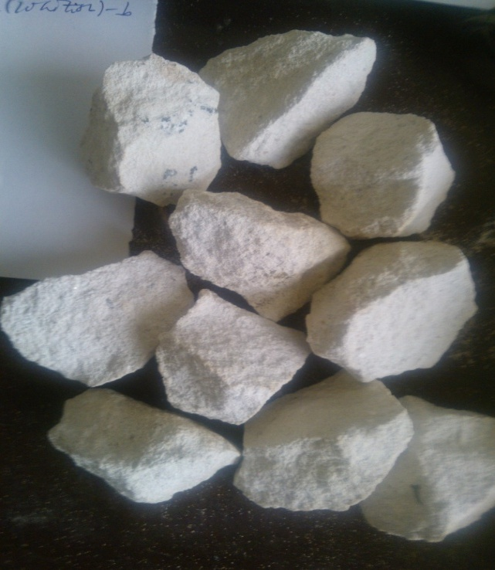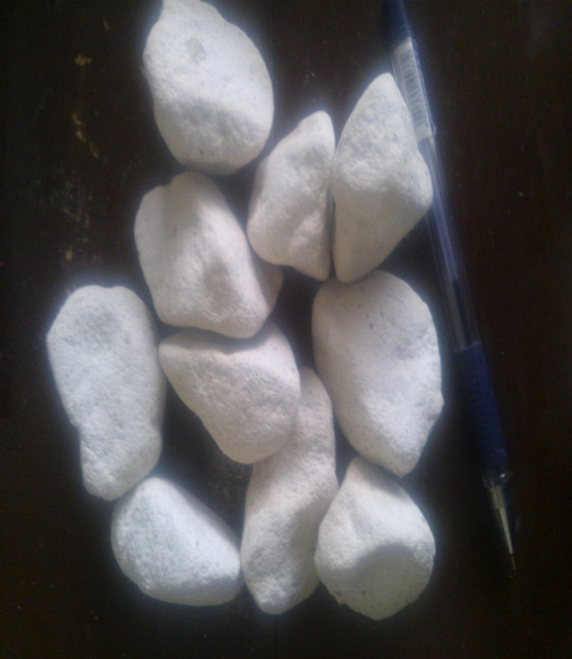
after
before
Examples of Sandstone from S₂_b section: Before and After slake durability test(Type I-retained materials virtually unchanged)

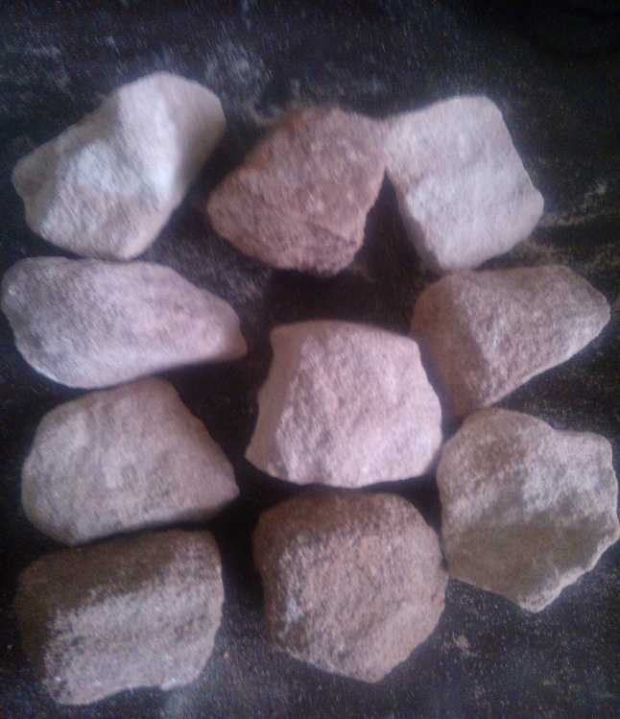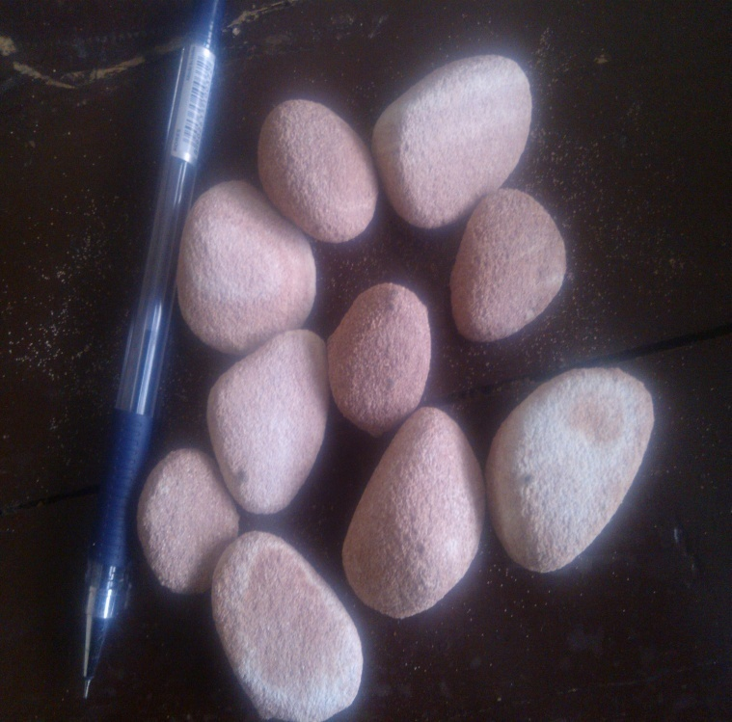
after
before
Example of Iron oxide rich Sandstone specimen from S_{2_1} slope cut section. (Type II-retained materials consist of large and small pieces)

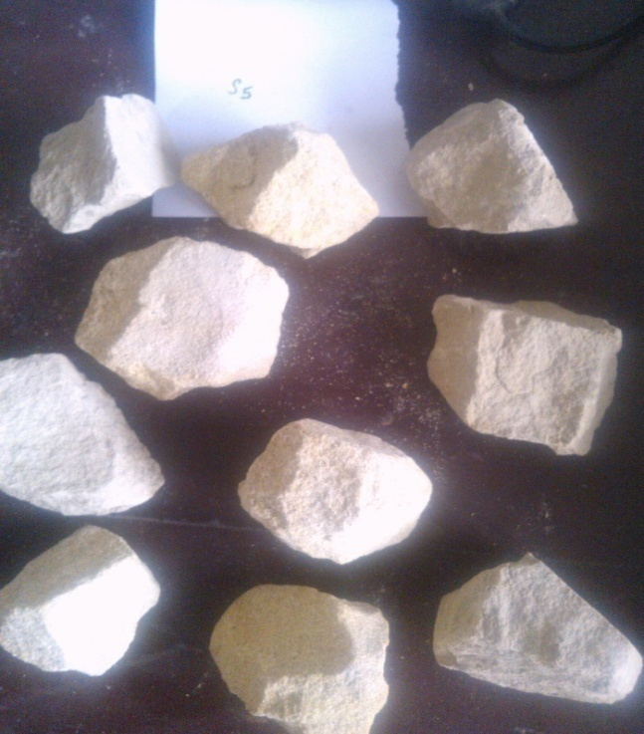
after
before
S3 sandstone unit before and after the slake durability test (Type II-retained material consists of large and small pieces)

Annex C. Rebound values measured by Schmidt hammer in the field.
Exposure No. | Date: 25/4/2014 |  | Time:4:00 |  | Condition: bright
Exposure No. | S₁(basalt) |  | S₂(sandstone) |  | S₃(sandstone)
Exposure No. | Schmidt rebound value |  | rebound value |  | Schmidt rebound value
Exposure No. | Fresh rock | Weathered | Fresh | Weathered | Fresh | weathered
1 | 60 | 40 | 52 | 24 | 34 | 34
2 | 48 | 46 | 36 | 19 | 30 | 30
3 | 47 | 38 | 26 | 26 | 36 | 27
4 | 45 | 36 | 44 | 26 | 33 | 28
5 | 50 | 50 | 42 | 30 | 38 | 35
6 | 50 | 34 | 32 | 18 | 33 | 29
7 | 54 | 44 | 42 | 22 | 34 | 28
8 | 46 | 38 | 34 | 26 | 33 | 31
9 | 48 | 39 | 35 | 34 | 39 | 31
10 | 52 | 35 | 30 | 30 | 40 | 30
11 | 49 | 37 | 42 | 28 | 34 | 34
12 | 66 | 40 | 34 | 20 | 32 | 28
13 | 48 | 44 | 44 | 30 | 29 | 36
14 | 46 | 37 | 28 | 26 | 35 | 33
15 | 62 | 30 | 39 | 28 | 37 | 29

Annex D: Direct shear test result of colluvium slope (based on ASTM D3080 testing standard ("Standard Method for Direct Shear Test on Soils under Consolidated Drained Conditions").
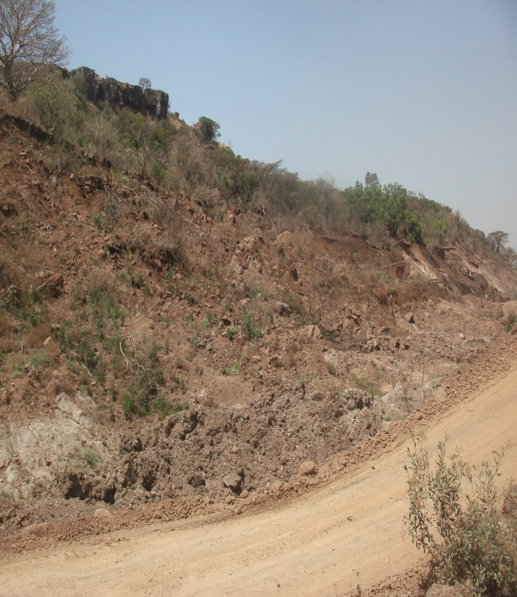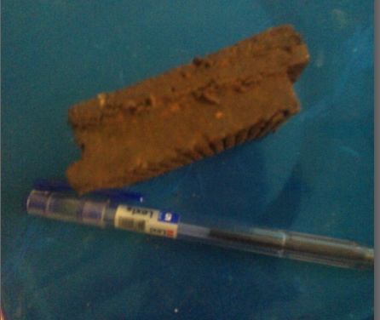
Field observation(left) and specimen that shows the sheared plane in laboratory (right)

Shear strength parameters
Cohesion = 16.97Kpa
Friction angle = 48.87°
Unit weight = 18.5KN/m2

Annex E: Slope Stability Probability Classification System
1) SSPC data from slope section one
ITC/TU ENGINEERING GEOLOGY |  |  |  |  |  |  |  |  |  |  |  |  |  |  |  |  |  |  |  |  | exposure characterization |  |  |  |  |  |  |  |  |  |  |  |  | SSPC-SYSTEM
Logged by: Kassahun M |  |  |  |  |  |  | Date: 22/02/14 |  |  |  | Time: 4:30hr |  |  |  |  |  |  |  |  |  | exposure no: |  |  |  |  |  |  |  |  |  |  |  |  | 1
Weather conditions |  |  |  |  |  |  |  |  |  |  |  |  |  | Map coordinates: |  |  |  |  |  |  |  |  |  |  |  |  |  | Map no:
Sun: |  |  | Cloudy/fair/bright |  |  |  |  |  |  |  |  |  |  |  |  |  |  |  |  |  |  |  |  |  |  |  |  | Northing |  |  |  |  |  | 337046
Rain: |  |  | dry/drizzle/slight/heavy |  |  |  |  |  |  |  |  |  |  |  |  |  |  |  |  |  |  |  |  |  |  |  |  | Easting |  |  |  |  |  | 1085365
Method of excavation(ME) |  |  |  |  |  |  |  |  |  |  |  |  |  |  |  |  |  |  |  | Dimensions/Accessibility
natural/hand-made |  |  |  |  |  |  |  |  |  | 1 |  |  |  |  |  |  |  |  |  | Size total exposure: (m) |  |  |  |  |  |  |  |  |  | l: 100 |  |  |  | h: 24 | d: 20
pneumatic hammer excavation |  |  |  |  |  |  |  |  |  | 0.76
pre-splitting/smooth wall blasting |  |  |  |  |  |  |  |  |  | 0.99
conventional blasting with result: |  |  |  |  |  |  |  |  |  |  |  |  |  |  |  |  |  |  |  | Mapped on this form: (m) |  |  |  |  |  |  |  |  |  | l: 60 |  |  |  | h:24 | d: 10
 |  |  |  | good |  |  |  |  |  | 0.77
 |  |  |  | open discontinuities |  |  |  |  |  | 0.75
 |  |  |  | dislodged blocks |  |  |  |  |  | 0.72
 |  |  |  | fractured intact rock |  |  |  |  |  | 0.67 |  |  |  |  |  |  |  |  |  | Accessibility: poor/fair/good
 |  |  |  | crushed intact rock |  |  |  |  |  | 0.62
Formation |  |  |  | Columnar basalt
Description(BS 5930: 1981)
colour |  | grain size |  |  |  | structure & texture |  |  |  |  | weathering |  |  |  |  |  | Name
Black |  | fine |  |  |  | blocky |  |  |  |  | slightly |  |  |  |  |  | Sandstone
 |  | Intact Rock Strength(IRS) |  |  |  |  |  |  |  |  |  |  |  |  |  |  | Sample number(s): |  |  |  |  |  |  | Weathering(WE)
<1.25Mpa |  | crumbles in hand |  |  |  |  |  |  |  |  |  |  |  |  |  |  |  |  |  |  |  |  |  | Unweathered 1
1.25-5Mpa |  | thin slabs break easily in hand |  |  |  |  |  |  |  |  |  |  |  |  |  |  |  |  |  |  |  |  |  | Slightly 0.95
5-12.5pa |  | thin slabs broken by heavy hand pressure |  |  |  |  |  |  |  |  |  |  |  |  |  |  |  |  |  |  |  |  |  | moderately 0.90
12.5-50Mpa |  | Lumps broken by light hammer blows |  |  |  |  |  |  |  |  |  |  |  |  |  |  |  |  |  |  |  |  |  | highly 0.62
50-100Mpa |  | Lumps broken by heavy hammer blows |  |  |  |  |  |  |  |  |  |  |  |  |  |  |  |  |  |  |  |  |  | completely 0.35
100-200Mpa |  | Lumps only chip by heavy hammer blows
>200Mpa |  | Rocks ring on hammer blows, sparks fly.
DISCONTINUITIES B=bedding, C=cleavage J=joint |  |  |  |  |  |  |  |  |  |  |  |  |  |  |  |  | J1 |  |  |  |  | J2 |  |  | 3 |  | 4 |  | 5 |  |  | Existing Slope?
Dip direction (degrees) |  |  |  |  |  |  |  |  |  |  |  |  |  |  |  |  | 120 |  |  |  |  | 71 |  |  |  |  |  |  |  |  |  | dip direction/dip
Dip (degrees) |  |  |  |  |  |  |  |  |  |  |  |  |  |  |  |  | 68 |  |  |  |  | 76 |  |  |  |  |  |  |  |  |  | 090 / 80
Spacin (m) |  |  |  |  |  |  |  |  |  |  |  |  |  |  |  |  | 0.28 |  |  |  |  | 0.23 |  |  |  |  |  |  |  |  |  | height: 24 m
Persistence | along strike (m) |  |  |  |  |  |  |  |  |  |  |  |  |  |  |  | >10 |  |  |  |  | >10
Persistence | along dip (m) |  |  |  |  |  |  |  |  |  |  |  |  |  |  |  | >0.5 |  |  |  |  | >0.5 |  |  |  |  |  |  |  |  |  | Stability(tick)
Condition of Discontinuities |  |  |  |  |  |  |  |  |  |  |  |  |  |  |  |  |  |  |  |  |  |  |  |  |  |  |  |  |  |  |  | Stable 1
Roughness large scale(Rl) |  |  |  |  | wavy |  |  |  |  |  |  |  | 1 |  |  |  |  |  | 0.95 |  |  |  | 0.95 |  |  |  |  |  |  |  | small problem in near future 2
 |  |  |  |  | slightly wavy |  |  |  |  |  |  |  | 0.9
 |  |  |  |  | slightly curved |  |  |  |  |  |  |  | 0.8 |  |  |  |  |  |  |  |  |  |  |  |  |  |  |  |  |  | Large problems in near future 3
 |  |  |  |  | straight |  |  |  |  |  |  |  | 0.75
Roughness Small scale(Rs) |  |  |  |  | rough stepped |  |  |  |  |  |  |  | 0.95 |  |  |  |  |  | 0.75 |  |  |  | 0.75 |  |  |  |  |  |  |  | small problems 4
 |  |  |  |  | smooth stepped |  |  |  |  |  |  |  | 0.9 |  |  |  |  |  |  |  |  |  |  |  |  |  |  |  |  |  | Large problems 5
 |  |  |  |  | polished stepped |  |  |  |  |  |  |  | 0.85 |  |  |  |  |  |  |  |  |  |  |  |  |  |  |  |  |  | Notes:
 |  |  |  |  | rough undulating |  |  |  |  |  |  |  | 0.8 |  |  |  |  |  |  |  |  |  |  |  |  |  |  |  |  |  | 1) For infill gouge >  irregularities and  flowing material sma  ll scale roughness = 0.55
 |  |  |  |  | smooth undulating |  |  |  |  |  |  |  | 0.75
 |  |  |  |  | polished undulating |  |  |  |  |  |  |  | 0.7
 |  |  |  |  | rough planar |  |  |  |  |  |  |  | 0.65
 |  |  |  |  | smooth planar |  |  |  |  |  |  |  | 0.6
 |  |  |  |  | polished planar |  |  |  |  |  |  |  | 0.55 |  |  |  |  |  |  |  |  |  |  |  |  |  |  |  |  |  | 2) If roughness is ani  stropic(e.g. ripple  mark, striation, etc) it should be assessed perpendicu lar & parallel to the roughness & direc tions noted on this form.
Infill material(Im) |  |  |  |  | cemented infill |  |  |  |  |  |  |  | 1.07 |  |  |  |  |  | 1 |  |  |  | 1
 |  |  |  |  | no infill |  |  |  |  |  |  |  | 1
 |  |  |  |  | non softening & sheared material |  |  | coarse 0.95
 |  |  |  |  |  |  |  | medium 0.90
 |  |  |  |  |  |  |  | fine 0.85
 |  |  |  |  | soft sheared material |  |  | coarse 0.75
 |  |  |  |  |  |  |  | Medium 0.65
 |  |  |  |  |  |  |  | fine 0.55 |  |  |  |  |  |  |  |  |  |  |  |  |  |  |  |  |  |  |  |  |  |  | 3) Non-fitting of disc
 |  |  |  |  | gouge< irregularities |  |  |  |  |  |  |  |  |  | 0.42 |  |  |  |  |  |  |  |  |  |  |  |  |  |  |  | ontinuity should be
 |  |  |  |  | gouge> irregularies |  |  |  |  |  |  |  |  |  | 0.17 |  |  |  |  |  |  |  |  |  |  |  |  |  |  |  | marked in roughnes
 |  |  |  |  | flowing material |  |  |  |  |  |  |  |  |  | 0.05
Karst(Ka) |  |  |  |  | none |  |  |  |  |  |  |  |  |  | 1 |  |  | 1 |  |  |  |  | 1
 |  |  |  |  | karst |  |  |  |  |  |  |  |  |  | 0.92
Susceptibility to weathering (Sw)
degree of weathering |  |  |  |  |  |  |  |  | date excavation |  |  |  |  |  |  | remarks |  |  |  |  |  |  |  |  |  |  |  |  |  |  |  |  | The slope is damaged by excavation
Slightly weathered |  |  |  |  |  |  |  |  | 2000 |  |  |  |  |  |  | the red sand stone is more weathered

2) SSPC data from slope section two
ITC/TU ENGINEERING GEOLOGY |  |  |  |  |  |  |  |  |  |  |  |  |  |  |  |  |  |  | exposure characterization |  |  |  |  |  |  |  |  | SSPC-SYSTEM
Logged by:  Kassahun M. |  |  |  |  |  | Date: 24/02/14 |  |  |  |  |  | Time: 9:00hr |  |  |  |  |  |  | exposure no: |  |  |  |  |  |  |  |  |  |  |  |  |  | 2
Weather conditions |  |  |  |  |  |  |  |  |  |  |  |  | Map coordinates: |  |  |  |  |  |  |  |  |  |  |  |  |  |  | Map no:
Sun: |  | Cloudy/fair/bright |  |  |  |  |  |  |  |  |  |  |  |  |  |  |  |  |  |  |  |  |  |  |  |  |  | Northing |  |  |  |  | 336325
Rain: |  | dry/drizzle/slight/heavy |  |  |  |  |  |  |  |  |  |  |  |  |  |  |  |  |  |  |  |  |  |  |  |  |  | Easting |  |  |  |  | 1085929
Method of excavation(ME) |  |  |  |  |  |  |  |  |  |  |  |  |  |  |  |  |  | Dimensions/Accessibility
natural/hand-made |  |  |  |  |  |  |  |  |  |  |  |  | 1 |  |  |  |  | Size total exposure: (m) |  |  |  |  | l: 550 |  |  |  |  |  |  |  | h:30 |  |  | d: 10
pneumatic hammer excavation |  |  |  |  |  |  |  |  |  |  |  | 0.76
pre-splitting/smooth wall blasting |  |  |  |  |  |  |  |  |  |  |  | 0.99
conventional blasting with result: |  |  |  |  |  |  |  |  |  |  |  |  |  |  |  |  |  | Mapped on this form: (m) |  |  |  |  |  | l: 540 |  |  |  |  |  |  | h:30 |  |  | d: 8
 | good |  |  |  |  |  |  |  |  | 0.77
 | open discontinuitity |  |  |  |  |  |  |  |  | 0.75
 | dislodged blocks |  |  |  |  |  |  |  |  | 0.72
 | fractured intact rock |  |  |  |  |  |  |  |  | 0.67 |  |  |  |  |  |  |  | Accessibility: poor/fair/good
 | crushed intact rock |  |  |  |  |  |  |  |  | 0.62
Formation name Sandstone
colour |  |  |  |  | grain size |  | structure & texture |  |  |  |  |  |  | weathering |  |  | Natural
Black |  |  |  |  | fine |  | Rounded |  |  |  |  |  |  | Slightly |  |  | Sandstone
 |  |  |  |  | Intact Rock Strength(IRS) |  |  |  |  |  |  |  |  |  |  |  | Sample number(s): |  |  |  |  |  | Weathering(WE)
<1.25Mpa |  |  |  |  | crumbles in hand |  |  |  |  |  |  |  |  |  |  |  |  |  |  |  |  |  | Unweathered 1
1.25-5Mpa |  |  |  |  | thin slabs break easily in hand |  |  |  |  |  |  |  |  |  |  |  |  |  |  |  |  |  | slightly 0.95
5-12.5pa |  |  |  |  | thin slabs broken by heavy hand pressure |  |  |  |  |  |  |  |  |  |  |  |  |  |  |  |  |  | moderately 0.90
12.5-50Mpa |  |  |  |  | Lumps broken by light hammer blows |  |  |  |  |  |  |  |  |  |  |  |  |  |  |  |  |  | Highly 0.62
50-100Mpa |  |  |  |  | Lumps broken by heavy hammer blows |  |  |  |  |  |  |  |  |  |  |  |  |  |  |  |  |  | completely 0.35
100-200Mpa |  |  |  |  | Lumps only chip by heavy hammer blows
>200Mpa |  |  |  |  | Rocks ring on hammer blows, sparks fly.
DISCONTINUITIES, B=bedding, C=cleavage J=joint |  |  |  |  |  |  |  |  |  |  |  |  |  |  |  |  | (B1) |  |  |  | (J1) | (J2) |  |  | 4 |  | 5 |  |  | Existing Slope
Dip direction (degrees) |  |  |  |  |  |  |  |  |  |  |  |  |  |  |  |  | 315 |  |  |  | 300 | 216 |  |  |  |  |  |  |  | dip direction/dip
Dip (degrees) |  |  |  |  |  |  |  |  |  |  |  |  |  |  |  |  | 25 |  |  |  | 60 | 72 |  |  |  |  |  |  |  | 293/75
Spacing (m) |  |  |  |  |  |  |  |  |  |  |  |  |  |  |  |  | 0.78 |  |  |  | 1 | 0.6 |  |  |  |  |  |  |  | Height=30m
Persistence |  |  |  | along strike (m) |  |  |  |  |  |  |  |  |  |  |  |  | >20 |  |  |  | >1.7 | >1.5
 |  |  |  | along dip (m) |  |  |  |  |  |  |  |  |  |  |  |  | >2 |  |  |  | >0.3 | >0.5 |  |  |  |  |  |  |  | Stability(tick)
Condition of Discontinuities |  |  |  |  |  |  |  |  |  |  |  |  |  |  |  |  |  |  |  |  |  |  |  |  | Stable 1
Roughness large scale(Rl) |  |  | wavy |  |  |  |  |  |  |  | 1 |  |  |  |  | 0.8 |  |  |  |  | 0.8 | 0.8 |  |  |  |  |  |  |  |  |  | small problem in near future 2
 |  |  | slightly wavy |  |  |  |  |  |  |  | 0.9
 |  |  | slightly curved |  |  |  |  |  |  |  | 0.8 |  |  |  |  |  |  |  |  |  |  |  |  |  |  |  |  |  |  |  |  | Large problems in near future 3
 |  |  | straight |  |  |  |  |  |  |  | 0.75
Roughness Small scale(Rs) |  |  | rough stepped |  |  |  |  |  |  |  | 0.95 |  |  |  |  | 0.6 |  |  |  |  | 0.6 | 0.65 |  |  |  |  |  |  |  |  |  | small problems 4
 |  |  | smooth stepped |  |  |  |  |  |  |  | 0.9 |  |  |  |  |  |  |  |  |  |  |  |  |  |  |  |  |  |  |  |  | Large problems 5
 |  |  | polished stepped |  |  |  |  |  |  |  | 0.85 |  |  |  |  |  |  |  |  |  |  |  |  |  |  |  |  |  |  |  |  | Notes:
 |  |  | rough undulating |  |  |  |  |  |  |  | 0.8 |  |  |  |  |  |  |  |  |  |  |  |  |  |  |  |  |  |  |  |  | 1) For infill gouge >  irregularities and flowing material small scale roughness = 0.55
 |  |  | smooth undulating |  |  |  |  |  |  |  | 0.75
 |  |  | polished undulating |  |  |  |  |  |  |  | 0.7
 |  |  | rough planar |  |  |  |  |  |  |  | 0.65
 |  |  | smooth planar |  |  |  |  |  |  |  | 0.6
 |  |  | polished planar |  |  |  |  |  |  |  | 0.55 |  |  |  |  |  |  |  |  |  |  |  |  |  |  |  |  |  |  |  |  | 2) If roughness is anistropic (e.g. ripple mark, striation, etc)  roughness should be assessed perpendicular & parallel to the  roughness and directions noted on this form.
Infill material(Im) |  |  | cemented/cemented infill |  |  |  |  |  |  |  | 1.07 |  |  |  |  | 0.9 |  |  |  |  | 1 | 1
 |  |  | no infill -surface staining |  |  |  |  |  |  |  | 1
 |  |  | non softening & sheared material |  |  |  |  |  | coarse 0.95
 |  |  |  |  |  |  |  |  | medium 0.90
 |  |  |  |  |  |  |  |  | fine 0.85
 |  |  | soft sheared material |  |  |  |  |  | coarse 0.75
 |  |  |  |  |  |  |  |  | medium 0.65
 |  |  |  |  |  |  |  |  | fine 0.55 |  |  |  |  |  |  |  |  |  |  |  |  |  |  |  |  |  |  |  |  |  |  | 3) Non-fitting of disc  ontinuity should be  marked in roughness
 |  |  | gouge< irregularities |  |  |  |  |  | 0.42
 |  |  | gouge> irregularies |  |  |  |  |  | 0.17
 |  |  | flowing material |  |  |  |  |  | 0.05
Karst(Ka) |  |  | none |  |  |  |  |  | 1 |  |  |  |  |  |  | 1 |  |  |  | 1 |  | 1
 |  |  | karst |  |  |  |  |  | 0.92
Susceptibility to weathering (Sw)
degree of weathering |  |  |  |  |  |  |  | date excavation |  |  |  |  |  |  | remarks |  |  |  |  |  |  |  |  |  |  |  |  | Steeply bedded sandstone.
Slightly weathered |  |  |  |  |  |  |  | 2000 |  |  |  |  |  |  | Red Sandstones are more weathered.
3) SSPC data from slope section three
ITC/TU ENGINEERING GEOLOGY |  |  |  |  |  |  |  |  |  |  |  |  |  |  |  |  |  |  |  | exposure characterization |  |  |  |  |  |  |  |  |  |  | SPC-SYSTEM
Logged by: Kassahun M |  |  |  |  |  | Date: 26/02/14 |  |  |  |  | Time: 6:00hr |  |  |  |  |  |  |  |  | Exposure no: |  |  |  |  |  |  |  |  |  |  | 3
Weather conditions |  |  |  |  |  |  |  |  |  |  |  |  |  | Map coordinates: |  |  |  |  |  |  |  |  |  |  |  | Map no:
Sun: |  |  |  | Cloudy/fair/bright |  |  |  |  |  |  |  |  |  |  |  |  |  |  |  |  |  |  |  |  |  | Northing |  |  |  |  | 334206
Rain: |  |  |  | dry/drizzle/slight/heavy |  |  |  |  |  |  |  |  |  |  |  |  |  |  |  |  |  |  |  |  |  | Easting |  |  |  |  | 1081659
Method of excavation(ME) |  |  |  |  |  |  |  |  |  |  |  |  |  |  |  |  |  | Dimensions/Accessibility
natural/hand-made |  |  |  |  |  |  |  |  |  |  |  |  | 1 |  |  |  |  | Size total exposure: (m) |  |  |  |  |  |  | l: 800m |  |  |  |  | h:20 |  | d: 15
pneumatic hammer excavation |  |  |  |  |  |  |  |  |  |  |  |  | 0.76
pre-splitting/smooth wall blasting |  |  |  |  |  |  |  |  |  |  |  |  | 0.99
conventional blasting with result: |  |  |  |  |  |  |  |  |  |  |  |  |  |  |  |  |  | Mapped on this form: (m) |  |  |  |  |  |  | l: 720m |  |  |  |  | h: 20 |  | d: 10
 |  | good |  |  |  |  |  |  |  |  |  | 0.77
 |  | open discontinuities |  |  |  |  |  |  |  |  |  | 0.75
 |  | dislodged blocks |  |  |  |  |  |  |  |  |  | 0.72
 |  | fractured intact rock |  |  |  |  |  |  |  |  |  | 0.67 |  |  |  |  |  | Accessibility: poor/fair/good
 |  | crushed intact rock |  |  |  |  |  |  |  |  |  | 0.62
Formation: |  | Sandstone
Description(BS 5930: 1981)
colour | grain size |  |  |  | structure & texture |  |  |  | weathering |  |  |  |  |  |  | Name
Black | fine |  |  |  | Tabular/flat |  |  |  | slightly
 | Intact Rock Strength(IRS) |  |  |  |  |  |  |  |  |  |  |  |  |  |  | Sample number(s): |  |  |  |  |  | Weathering(WE)
<1.25Mpa | crumbles in hand |  |  |  |  |  |  |  |  |  |  |  |  |  |  |  |  |  |  |  |  | Unweathered 1
1.25-5Mpa | thin slabs break easily in hand |  |  |  |  |  |  |  |  |  |  |  |  |  |  |  |  |  |  |  |  | slightly 0.95
5-12.5pa | thin slabs broken by heavy hand pressure |  |  |  |  |  |  |  |  |  |  |  |  |  |  |  |  |  |  |  |  | moderately 0.90
12.5-50Mpa | Lumps broken by light hammer blows |  |  |  |  |  |  |  |  |  |  |  |  |  |  |  |  |  |  |  |  | highly 0.62
50-100Mpa | Lumps broken by heavy hammer blows |  |  |  |  |  |  |  |  |  |  |  |  |  |  |  |  |  |  |  |  | completely 0.35
100-200Mpa | Lumps only chip by heavy hammer blows
>200Mpa | Rocks ring on hammer blows, sparks fly.
DISCONTINUITIES, B=bedding, C=cleavage J=joint |  |  |  |  |  |  |  |  |  |  |  |  |  |  |  | (B1) |  |  | (J1) |  |  | (J2) |  | 4 |  |  | 5 |  | Existing Slope?
Dip direction (degrees) |  |  |  |  |  |  |  |  |  |  |  |  |  |  |  | 308 |  |  | 302 |  |  | 222 |  |  |  |  |  |  | dip direction/dip
Dip (degrees) |  |  |  |  |  |  |  |  |  |  |  |  |  |  |  | 22 |  |  | 69 |  |  | 61 |  |  |  |  |  |  | 300/56
Spacing (m) |  |  |  |  |  |  |  |  |  |  |  |  |  |  |  | 0.65 |  |  | 0.7 |  |  | 1.75 |  |  |  |  |  |  | height: 18 m
Persistence |  | along strike (m) |  |  |  |  |  |  |  |  |  |  |  |  |  | >10 |  |  | >5 |  |  | >5
 |  | along dip (m) |  |  |  |  |  |  |  |  |  |  |  |  |  | >0.5 |  |  | >5 |  |  | >3 |  |  |  |  |  |  | Stability(tick)
Condition of Discontinuities |  |  |  |  |  |  |  |  |  |  |  |  |  |  |  |  |  |  |  |  |  |  |  |  |  |  |  |  | stable |  |  |  | 1
Roughness large scale(Rl) |  |  | wavy |  |  |  |  |  |  |  |  | 1 |  |  | 0.8 |  |  |  | 0.8 |  | 0.8 |  |  |  |  |  |  |  | small problem in near future 2
 |  |  | slightly wavy |  |  |  |  |  |  |  |  | 0.9
 |  |  | slightly curved |  |  |  |  |  |  |  |  | 0.8 |  |  |  |  |  |  |  |  |  |  |  |  |  |  |  |  | Large problems in near future 3
 |  |  | straight |  |  |  |  |  |  |  |  | 0.75
Roughness Small scale(Rs) |  |  | rough stepped |  |  |  |  |  |  |  |  | 0.95 |  |  | 0.75 |  |  |  | 0.6 |  | 0.6 |  |  |  |  |  |  |  | small problems 4
 |  |  | smooth stepped |  |  |  |  |  |  |  |  | 0.9 |  |  |  |  |  |  |  |  |  |  |  |  |  |  |  |  | Large problems 5
 |  |  | polished stepped |  |  |  |  |  |  |  |  | 0.85 |  |  |  |  |  |  |  |  |  |  |  |  |  |  |  |  | Notes:
 |  |  | rough undulating |  |  |  |  |  |  |  |  | 0.8 |  |  |  |  |  |  |  |  |  |  |  |  |  |  |  |  | 1) For infill gouge > irregularities and  flowing material small scale roughness = 0.55
 |  |  | smooth undulating |  |  |  |  |  |  |  |  | 0.75
 |  |  | polished undulating |  |  |  |  |  |  |  |  | 0.7
 |  |  | rough planar |  |  |  |  |  |  |  |  | 0.65
 |  |  | smooth planar |  |  |  |  |  |  |  |  | 0.6
 |  |  | polished planar |  |  |  |  |  |  |  |  | 0.55 |  |  |  |  |  |  |  |  |  |  |  |  |  |  |  |  | 2) If roughness is anistropic(e.g. ripple mark, striation, etc)
Infill material(Im) |  |  | cemented/cemented infill |  |  |  |  |  |  |  |  | 1.07 |  |  | 0.9 |  |  |  | 0.9 |  | 1
 |  |  | no infill -surface staining |  |  |  |  |  |  |  |  | 1
 |  |  | non softening & sheared material |  |  |  | coarse 0.95 |  |  |  |  |  |  |  |  |  |  |  |  |  |  |  |  |  |  |  |  |  | roughness should be assessed perpendicular & parallel to the  roughness and directions noted on this form.
 |  |  |  |  |  |  | medium 0.90
 |  |  |  |  |  |  | fine 0.85
 |  |  | soft sheared material |  |  |  | coarse 0.75
 |  |  |  |  |  |  | medium 0.65
 |  |  |  |  |  |  | fine 0.55 |  |  |  |  |  |  |  |  |  |  |  |  |  |  |  |  |  |  |  |  |  | 3) Non-fitting of discontinuity should be marked in roughness
 |  |  | gouge< irregularities |  |  |  |  |  |  | 0.42
 |  |  | gouge> irregularies |  |  |  |  |  |  | 0.17
 |  |  | flowing material |  |  |  |  |  |  | 0.05
Karst(Ka) |  |  | none |  |  |  |  |  |  | 1 |  |  |  |  | 1 |  |  |  | 1 |  | 1
 |  |  | karst |  |  |  |  |  |  | 0.92
Susceptibility to weathering (Sw)
degree of weathering |  |  |  |  |  |  |  | date excavation |  |  |  |  |  |  |  |  | remarks
Slightly weathered |  |  |  |  |  |  |  | 2000 |  |  |  |  |  |  |  |  | The slope is gentle

DECLARATION
I the undersigned, declare that this thesis is my original work and has been carried out by me under the supervision of Dr. Fikirte Arega and Dr. Bekele Abebe. I further declare that this work has not been submitted to any other university or institute for a degree. All sources of materials used for the thesis work have been duly acknowledged.

Kassahun Misgana

Signature:________________

Date: May 30,2014
Approved by (Advisors):-
Dr. Fikirte Arega
Signature: ____________________
Dr. Bekele Abebe
Signature:______________________

