
School of Graduate studies,
Addis Ababa University
Faculty of computer and mathematical Sciences
Department of Mathematics
A project on
COMBINATORIAL INTERPRETATIONS AND CONVOLUTIONS
OF CATALAN NUMBERS

BY KIBRU TEKA
Advisor: Dr. Seyom Getu

A project Submitted to Department of Mathematics in Partial fulfillment of the requirements for the degree of Master of Science in Mathematics.

January ,2012

Table of Content
Content Page
Section one 1
- Introduction 1
Section two 3
- Combinatorial interpretation of Catalan number 3
2.1 Enumeration of balanced parenthesis 3
2.2 Enumeration of lattice path 4
2.3 Enumeration of ordered rooted plane trees 7
2.4 Enumeration of Binary tree (full binary tree) 10
2.5 Enumeration of planar diagram 13
2.6 Enumeration of stalking manila folders 15
2.7 Enumeration of mountain range (dyck path) 17
2.8 Enumeration of increasing function 18
2.9 Enumeration of standard young tableaus 20
2.10 Triangulation of convex polygon 23
2.11 Enumeration Technique 25
Section three 33
- Convolution of Catalan number 33
3.1 Proper word and K proper word 34
3.2 Equality of sequence 36
3.3 K- proper words 37
3.4 Combinatorial interpretation of C (n,k) 38
Section four 40
- Truncated Pascal triangle 40
Summery…………………………………………………………………… 43
References 44

Acknowledgments

I would like to express my deepest gratitude to my project supervisor, Dr. Seyum Getu for all his absolute guidance, technical and moral support starting from the beginning of my study and encouragement during the entire project work and preparation of the paper.
I would also like to thanks my best friends Fikre Bogale, Tgese Birhane and Dessu Berta for their uncountable helps and advise on my entire life span.

I would like to extend my thanks to Deber Birhan University for sponsorship

All staff members of the Department of Mathematics are gratefully acknowledged for their encouragement and support.

Finally, I would like to extend my gratitude to the Department of Mathematics, AAU, for giving me the opportunity to accomplish my studies.

SECTION ONE

Introduction
Eugene Charles Catalan (born: 30 May 1814 in Bruges, Belgium - died: 14 Feb 1894 in Liege, Belgium ) defined the numbers, called today the Catalan numbers, while considering the solution of the problem of dissecting a polygon into triangles by means of non-intersecting diagonals. Catalan was not the first to solve the problem, however, since Segner had solved it in the 18 th century, although his solution was not as elegant as Catalan's. Euler had worked on simplifying the solution to the problem as did Benet at almost the same time as Catalan, around 1838.
The Catalan Numbers are a sequence of numbers which show up in many contexts. They were discovered by Leonhard Euler when he was attempting to find a general formula to express the number of ways to divide a polygon with n sides into triangles using non-intersecting diagonal.
In my case I interpreted more about enumeration technique of Catalan numbers. The Catalan numbers, ${\left\{c_{n}\right\}}_{n=0}^{∞}$ are well known for having a large variety of combinatorial interpretations. In fact Stanley has a list of 66 different interpretations. Furthermore it would seem natural that there would be a large variety of combinatorial interpretations for the convolutions of the Catalan numbers as well.

However, these interpretations are either not well known, or have not been stated explicitly. In fact, the literature either contains explicit formulas for the values of these convolutions, or contains explicit formulas for a combinatorial interpretation of the Catalan numbers. However, no reference contains a proof showing the combinatorial interpretation without using the explicit formula.

We will attempt to rectify this situation by determining a large variety of combinatorial interpretations of the higher convolutions of the Catalan numbers. We do this by considering the generating functions of both the combinatorial interpretation and of the convolutions of the Catalan numbers. Furthermore, we show that the convolutions of the Catalan numbers appear as the terminal column in a corresponding truncated Pascal’s triangle. We begin with some definitions, then show some of the combinatorial interpretations of higher convolutions of the Catalan numbers, and finally end with the occurrence of these numbers in truncated Pascal’s triangles.

SECTION TWO

2. COMBINATIONAL INTERPRETATION OF CATALAN NUMBER

2.1 Enumeration Of Balanced Parenthesis (Brackets)
A string of left and right brackets is said to be balanced if each left bracket has a matching right bracket.
How many balanced strings of n left and n right brackets are there?
For n =0, there is clearly only 1 way (of doing nothing!)
For n=1, there is 1 way ()
For n= 2, there are 2 ways: (()) and () ()
For n= 3, there are 5 ways((())) , (())(), ()(()) (()()), ()()()
For n=4 there are 14 ways
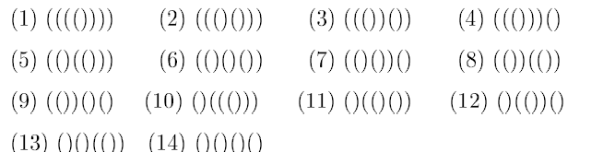
For n= 5, there are 42 ways:
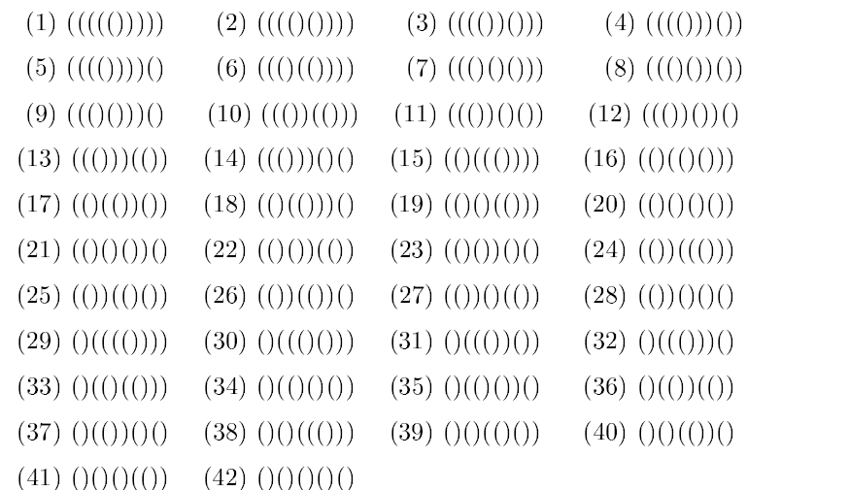
For every n it gives n Catalan numbers.

2.2 Enumeration Of Lattice paths (Balanced Paths)
Problem 1: Given the origin (0,0) and the (n,n) in R², we are going to join them by a path, allowing to move a unit to the right or a unit upwards. Such a path is called balanced if it does not go above the diagonal joining (0,0) and (n,n).For any integer n, how many balanced paths are there?
Problem 2: How many lattice paths from (0,0) to (n,n) with steps (0,1) or (1,0), never rising above the line y=x?
Problem 3 in a soccer match between Teams A and B, the final score is n-all. At no time during the match was Team B in the lead. In how many different way can the A-B scores be built up, starting at 0-0 and ending at n-n?
Problem 4: Ballot problem suppose an election is held in which there are two candidates A and B. the final number of votes is n each. Throughout the counting of votes, A stays ahead of B How many ways of counting there are?
Problem5 Find the number of increasing lattice paths from (0,0) to (n,n) that never cross but may touch the main diagonal
Problem 6: Suppose that a coin is tossed 2n times, coming up heads exactly n times and tails exactly n times, What is the number of sequences of tosses in which the cumulative number of heads is always at least as large as the cumulative number of tails?
All the six problems in above are the same and they have equal solution.
For n= 1, there is clearly 1 such balanced path and for n=2 there are 2 such balanced paths.
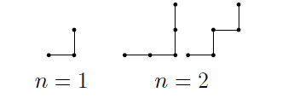
For n= 3, there are 5 such balanced paths.
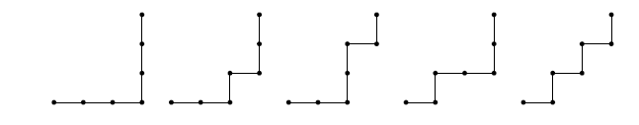
For n=4, there the 14 such balanced paths.

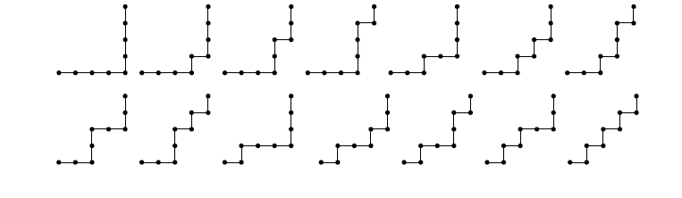
Connection with the First Bracketing Problem
Given balanced paths, we obtain a balanced string of brackets by associating a left bracket with every unit move to the right, and right bracket with every unit move upwards.
Given a balanced string of brackets, we obtain a balanced path as follows. Replace left bracket by a unit move to the right, and right bracket by a unit move upwards
- Construct balanced strings corresponding to the following balanced paths.
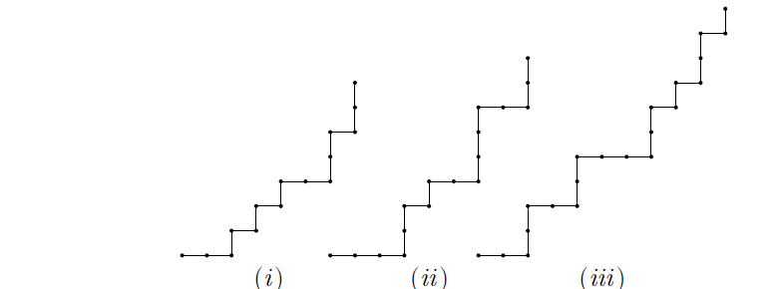
Solution the corresponding balanced strings of brackets are
(i) (()()()(())())
(ii) ((())()(()))(())
- (())(())((())()())()
- For each of the following balanced strings of brackets, construct the corresponding mountain ranges.
- (())()(()())
- (()())(())()()
- (()()())()(())(()())
Solution
The corresponding balanced paths are
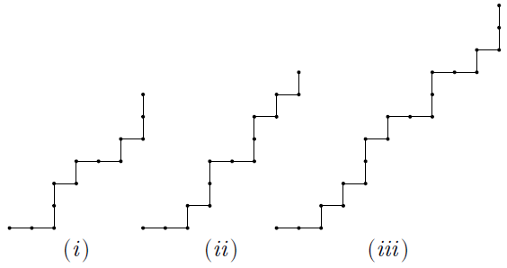

2.3 Enumeration Of Ordered The Rooted Plane Tree
Consider “trees” planted in the ground and living the two dimensions. These are called rooted plane trees or planted planar trees. The dots in the drawing below are called vertices and the lines joining the vertices are called the edges. A tree of n+ 1 vertex has n edges; there are no circuits. (here ‘plane’ means that we distinguish between left and right.)
How many rooted plane trees (or planar trees) are there with n+1 vertices and n edges?
For n=1, there is 1 such rooted plane tree: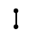
For n=2 there are 2 such rooted plane trees: 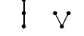

For n=3 there are 5 such rooted plane trees:
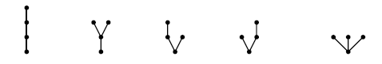
For n=4, there are 14 such rooted plane trees:
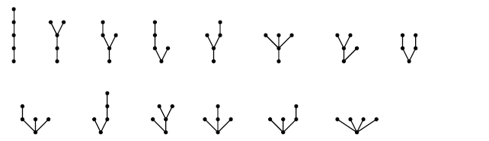
For n=5 there are 42 such rooted plane trees:
Connection with the first bracketing problem
Given a rooted plane tree, we construct a balanced string of bracket as follows.
Consider a caterpillar walking across the diagram from left to right, up and over the tree. Each time the caterpillar moves up from one vertex to the next, we write down a left bracket and each time it moves down we write a right bracket.
Given a balanced string of bracket, we obtain a rooted plane trees by reversing the above procedures.
If the tree has n+1 vertices, we get a string of n left and n right brackets in which each prefix has at least as many left brackets as right brackets. That is the number of rooted plane trees is the same as the number of balanced strings of brackets.
- Construct balanced strings of brackets corresponding to the following rooted plane trees.
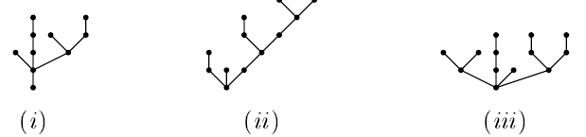
Solution
The corresponding balanced strings of brackets are:
- (()((()))(()(())))
- (())()(((())((()()))))
- (()())((()))()((())(()))

The following balanced strings of brackets are
- (())()(()())
- (()())(())()()
- (()()())()(())(()())
Solution
Have the corresponding rooted plane trees are

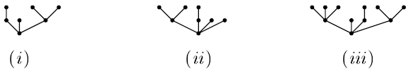

2.4 Enumerate Of full Binary Trees
Full Binary Trees
A full binary tree is a rooted tree in which each internal vertex has exactly two children. Thus, a full binary tree with n internal vertices has 2n edges. Since a tree has one more vertex than it has edges, a full binary tree with n internal vertices has 2n+1 vertices, 2n edges and n+1 leaves.
How many full binary trees are there with n internal vertices?
For n=1, there is 1 full binary tree and for n=2 there are 2 full binary trees.
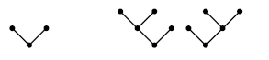
For n=3, there are 5 such full binary trees.
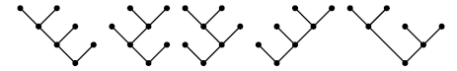
For n=4, there are 14 such full binary trees
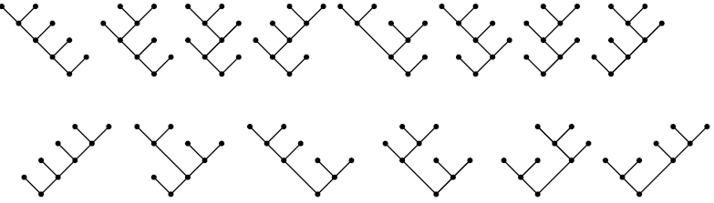

For n=5, there are 42 full binary trees,
In fact, the number of full binary trees with n internal vertices is the Catalan number Cn we will show at the end of this section.
Connection With The Second Bracketing Problem
Given a full binary tree with n internal vertices and n+1 leaves, we obtain a well parenthesized product of n+1 leavens, we obtain a well parenthesized product of n+1 number x₀,x₁,…,x_{n} as follows. We label the levels of the tree as they are encountered along a transfer with x₀,x₁,…,x_{n} . Then the tree recursively defines a well –parenthesized product of x₀,x₁,…,x_{n} by the following rule.
Labeling rule: if u is an internal vertex with left child a and right child b, having labels A and B, respectively, then label u with (AB).
The label on the root of the tree will be the well-parenthesized product.
Given a well-parenthesized product of n+1 numbers x₀, x₁,,,,,, x_{n}, we obtain a full binary tree as follows. A labeled full binary tree is labeled the root with the well-parenthesized product, then moving from the outer parentheses. The leaves of the tree will be labeled with the numbers x₀, x₁,,,,,, x_{n} in the order encountered by a transversal.
Write down the well-parenthesized products corresponding to the following full binary trees.
The well-parenthesized product can be obtained as follows:-
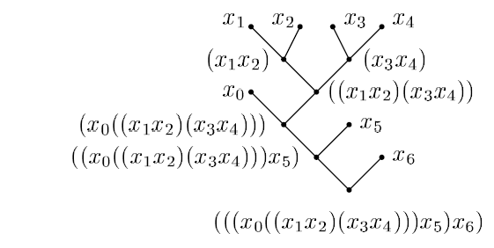
Hence the well-parenthesized product is
(((x₀((x₁x₂)x₃))x₄)(x₅(x₆)

2.5 Enumeration of planar diagram
Planar Diagrams or Smiling faces
Consider a row of 2n dots. For each pair of dots, we join them by a unique arc from below. We call such a diagram a planner diagram. How many ways can we join the dots with nonintersecting arcs? That is, how many such planer diagrams with nonintersecting curves?
Find the number of ways of connecting 2n point in the plane lying on a horizontal line by n nonintersecting arcs, each are connecting 2 of the points and lying below the points.
For n=1, there is only 1 such planar diagram
For n=2, there are two such planar diagrams 
For n=3, there are five such planar diagrams.

For n=4, there are 14 such planar diagrams.

For n=5, there are 42 ways
In fact, for 2n dots, the number of such planar diagrams is the Catalan number c_{n}
Connection with the first bracketing problem
Given a balanced string of brackets, we obtain the corresponding planar diagram as follows. Find the rightmost (remaining) L-bracket and the first, remaining R-bracket to its right. We replace this pair of brackets by two dots which we join by an arc, this procedure is repeated until no brackets remain.
Given a planar diagram with nonintersecting arcs. To obtain the balanced string of brackets, we replace the left end of a loop with an L- bracket and the right end with an R-bracket.
- construct balanced strings of brackets corresponding to the following planar diagrams.
Solution: The corresponding balanced strings of brackets are
- ((()())()) (ii) (())(()())() (iii) ((()))()(())
- For each of the following balanced strings of brackets, construct the corresponding planar diagrams.
- (())()(()())
- (()())(())()()
Solution: The corresponding planar diagrams are:

2.6 Enumeration of stacking of manila folders
Problem How many ways to stack n (identical) manila folders upright, nested, in to your carrying bag are there?
For n= 0, there is 1 way
For n= 1 there is also 1 way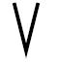
For n= 2, there are 2 way 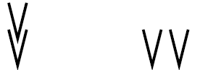

For n= 3, there are 5 way 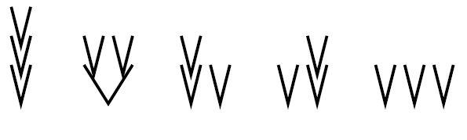
For n= 4, there are 14 way

Connecting with the first bracketing problem
Given a balanced string of left and right brackets, to obtain the corresponding string of circles, we replace a matching pair LR by a manila folder.
Given a stacking of manila folders, to obtain a balanced string of left and right brackets, we replace a folder by a matching pair LR.
- For each of the following balanced strings of letters L and R, write down the corresponding stacking of manila folders.
- LLLRLRRLRR
Solution:
The corresponding stacking of manila folders are

- For each of the following strings of manila, write down the corresponding balanced strings of brackets.


Solution
The corresponding balanced strings of brackets are
LLRLRLRRLRLLRRLLRLRR

2.7 Enumeration of mountain range (dyck path)
Mountain Ranges
A path moves a unit of north east and a unit of south east direction is said to be dyck path if it does not go below x axis.
Problem 1: How many mountain ranges can you draw with n upstrokes and n down strokes?
Problme2: A Dyck path from (0,0) to (2n,0) is lattice path with steps (1,1) and (1,-1), never falling below the x-axis. How many such Dyck paths are there?
Problem3: Consider a random walk in the plane, where the steps are from (x,y) to (x+1,y+1) or (x+1,y-1), starting at a given point. In how many ways can the random walk go from (0,0) to (2n,0) through the upper half plane without crossing the x-axis?
From n=1, there is only 1 such mountain range and for n=2 there are 2 such mountain ranges.
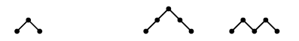
For n=3, there are 5 such mountain ranges.
For n= 4 there are 14 such mountain ranges:
This dyck path has connection to the first bracket if a unit move north east write open bracket and a unit move south west write closed bracket.

2.8 Increasing Functions on {1,2,...,n}
Problem 1. Let f: {1,2,…,n} $→$ {1,2,…,n} be a function such that
- F is increasing i.e if i$≤$j, then f(i) $≤$f(j) and
- For all i$∈N$ f(i) $≤$i.
For any integer n, how many such functions are there?
Problem 2 :How many sequences of the form 1= a₁ ,,$≤$….$≤$ a_{n} of integers are there, with a_{i} $≤$ i?
Problem3: How many n-tuple (1,a₂,,,,a_{n}) are there, with a_{i}$≤i$ for all i, and a_{i}$≤$ a_{j} whenever i$≤$j ?
When n=1, there is only one such function which is given by the sequence (1) or the arrow diagram 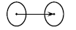
When n=2, the two such function are given by the following sequences of 2 number (1,1) and (1,2) or by the two arrow diagrams: 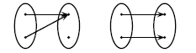
When n=3 there are five such functions which are given by the sequences
(1,1,1), (1,1,2),(1,1,3),(1,2,2), (1,2,3);
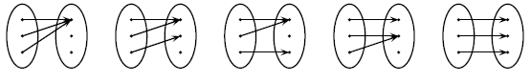
Or by the arrow diagrams
When n=4, the functions are given by the following 14 sequences;
(1,1,1,1), (1,1,1,2), (1,1,1,3), (1,1,1,4), (1,1,2,2),
(1,1,2,3), (1,1,2,4), (1,1,3,3), (1,1,3,4), (1,2,2,2),
(1,2,2,3), (1,2,2,4), (1,2,3,3), (1,2,3,4),
They are given by the following 14 arrow diagrams:
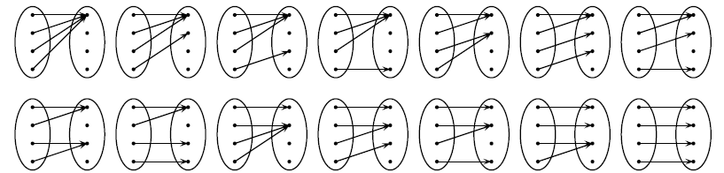
Connection with the first bracketing problem
Given a balanced string of n left and n right brackets, we can construct the necessary functions by constructing a sequence of n numbers as follows; We write number in place of the left brackets by beginning at the left with 1 and increase the number we are writing by 1 each time you pass a right bracket.
Given a sequence of n number (1, a₂, a₃, . . . ,a_{n}) with a_{i}≤ i and a_{i}≤ a_{j} for i≤j, we can construct a balanced string of brackets as follows: For each integer 1 appeared in the sequence, we draw a left bracket: and when the number increase by k, we then draw k right brackets followed by as many left brackets as the numbers of k appeared in the sequence, and so on; and finally write down the balancing right brackets.
- Construct the increasing functions corresponding to the following balanced strings of brackets:
(()())(())()()

Solution
The corresponding sequences are
(1,1,2,4,4,6,7)
- Construct balanced strings of brackets corresponding to the following increasing functions:

(1,1,1,3,3,4,4,4,5,5,6)

Solution:
The balanced strings of brackets are:
((()))(()((()(()())))))

2.9 ENUMERATION OF STANDARED young tableauX of shape (n,n)
problem 1: Given two rows of boxes with n boxes in each row:
…
…
In how many ways can you place the number 1,2 ,,,2n in the boxes so that the numbers increase from left to right and so that each number in the bottom row is larger than the number in the box above it?
Proble2: Given 2n people of different heights, in how many ways can these 2n people be lined up in increasing heights in to rows of length n each, so that everyone in the second row is taller than the corresponding person in the first row?
For n=1, there is only one such arrangement for n=2,there are 2 such arrangements:
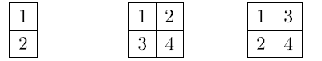
For n=3, there are 5 such arrangements:
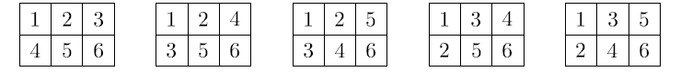
for n=4, there are 14 such arrangements: 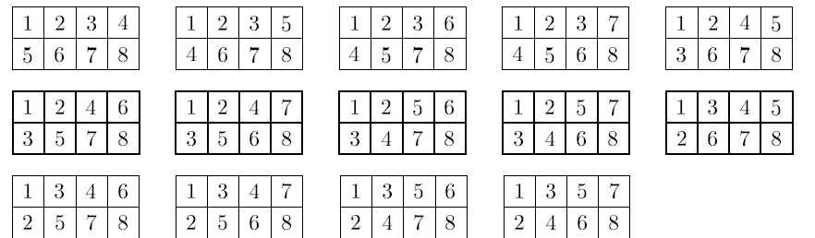
For n=5, there are 42 such arrangements:
CONNECTION WITH THE FIRST BRACKETING PROBLEM
Given an (n,n) tableau such that the numbers increase from left to right and such that each number in the bottom row is larger than the number in the box above it, we obtain a corresponding balanced string of brackets as follows: To each integer I in the top row, we associate a left bracket to the i-th position; and to each integer j in the bottom row, we associate a right bracket to the j-th position.
- Construct balanced strings of brackets corresponding to the following (n,n) tableau. 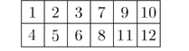
Solution:
The corresponding balanced strings of brackets are

((()))()(())
- For each of the following balanced strings of brackets, construct the corresponding (n,n) tableau.
- (()()())()(())(()())
Solution:
The corresponding (n,n) tableau are
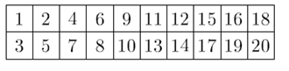

2.10 triangulations of convex polygon

Problem: in how many ways can a convex polygon with n+1 sides (labeled 0.1.2…..n) be divided into triangles by non-intersecting diagonals?
For n=2, there is only 1 such triangulation and for n=3, there are 2 such triangulations.
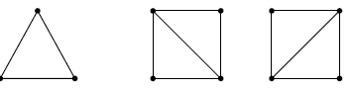
n=2 n=3
For n=4, there are 5 such triangulations.
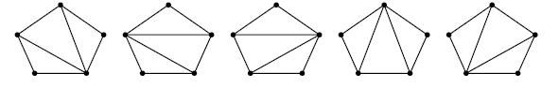
For n =5, there are 14 such triangulations.
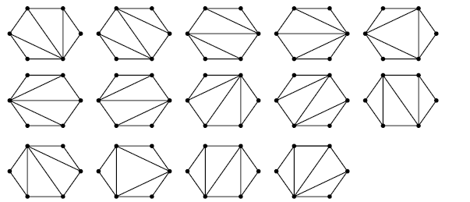
For n=6 there are 42 such triangulation in fact, for any convex polygon with n+1 sides (labeled 0,1,2,…,n), the number of ways to divide it into triangles by non-intersecting diagonals, is Cn.
Connection with the second bracketing problem
A connection with the second bracketing problem is described as follows.
for i=0,1,…,n -1, label side i with x_{i}. For each triangle, if two sides are labeled,
then label the third side with a bracket containing the product of the other two ,ides. Then we obtain a well –parenthesize product of n+1 numbers x₀, x₁,…,x_{n}.
Given a well-parenthesized product of n+1 numbers x₀,x₁,…,x_{n}, we obtain a triangulation as follows. For i=0,1,…,n label side i with x_{i}. If (x_{i}x_{i+1}) appears in the well-parenthesized product, then we join a line to make x_{i}x_{i+1} and (x_{i}x_{i+1}) into a triangle, and so on.
Write down the well-parenthesized products corresponding to the following triangulations.

Hence the well-parenthesized product can be obtained as follows:
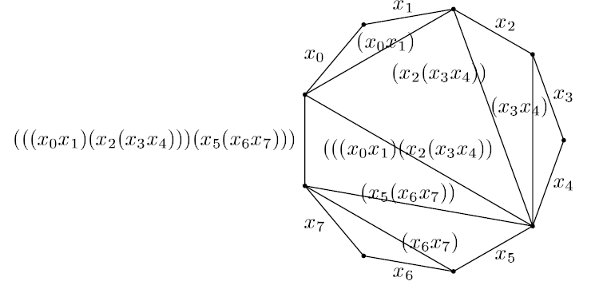
Hence the well- parenthesized product is
(((x₀x₁)(x₂(x₃x₄)))(x₅(x₆x₇)))

2.11 ENUMERATION TECHNIQUE
Enumeration of ordered trees and lattice paths
Ordered trees (often referred to as rooted plane trees or simply plane trees) are trees with a distinguished vertex called the root where the children of each internal vertex are linearly ordered. Ordered trees are drawn so that the children of each internal vertex are shown in order from left to right. Ordered trees may be defined recursively as follows:
If $t_{1}, t_{2}, …, t_{m}$ are ordered trees, $m≥0$, then If $t_{1}$,$t_{2}$, . . .,$t_{m}$ are ordered trees, $m≥0$, then
An ordered tree
The trees $t_{1}$,$t_{2}$, . . .,$t_{m}$ are sub- trees of the distinguished vertex called roots the root of connecting them. The roots of the sub-trees are children of the root of the tree. The trees are ordered in the sense that the order among sub trees (or children) is significant.
With each vertex (node) $x$ in a tree $t$ we associate two values: its degree and level. The degree of $x$ is the number of children it has, and the level of $x$ is its distance (the number of edges separating it) from the root of $t$. A vertex of degree is termed a leaf; otherwise it is called an internal vertex. The root is the only vertex at level 0. (See figure below an ordered tree with 8 edges)
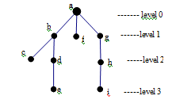
Leaves (nodes of degree 0): c, e, f, i
Internal nodes $\left\{\begin{aligned}of degree 1:d,g,h \\ of degree 2:b \\ of degree 3:a\end{aligned}\right.$

Level 0 (root): a
Level 1: b, f, g
Level 2: c, d, h
Level 3: e, i
Let $T_{n}(n≥0)$ denote the set of ordered trees with $n$ edges. As can be seen in figure 2, the sizes of these sets form a series $1, 1, 2, 5, 14, 42, …$These are the Catalan numbers${ C}_{n}$:
$\left|T_{n}\right|=C_{n}=\frac{1}{n+1}\left({2n \atop n}\right)$. The Catalan numbers on non negative integers $n$ are a set of numbers that arise in tree enumeration problems of the type,“ in how many ways can a regular $n$-gon be divided in to $n-2$ triangles if different orientations are counted separately ” (Euler’s polygon division problem.) Catalan numbers are the most frequently used numbers in combinatory other than binomial coefficients. It has more than $66$ interpretations, (Richard P. Stanely, enumerative combinatory vol.2). Catalan numbers are commonly denoted by$C_{n}$. The first few Catalan numbers for $n=1, 2, …$are $1, 2, 5, 14, 42,132, …$
The explicit formulas for $C_{n}$ include
$$C_{n}=\frac{1}{n+1}\left({2n \atop n}\right)=\frac{\left(2n\right)!}{\left(n+1\right)!n!}$$
$T_{0}$ = emplies $C_{0}$ =1
$T_{1}$ = implies $C_{1}=1.$
$T_{2}$ = implies $C_{2}=2$.

$T_{3}$ = implies $C_{3}=5$
$T_{4}=$
Implies$C_{4}=14$.
$T_{n}$ - {ordered trees with n edges}.
There are numerous one-to-one correspondences between elements of these set of ordered trees and other combinatorial objects.
Among them the correspondences between the following sets will help in their enumerations:
$T_{n}$: The set of ordered trees with $n$ edges.
$L_{n}$: The set of legal sequences of $n$ open and close parentheses. A parenthetic expression is called “legal”(balanced) if each open parenthesis has matching close parenthesis.
$P_{n}$: The set of admissible paths from the point $(0,0)$ to $(n,n)$ in an $n×n$ lattice.
$B_{n}$: The set of full binary trees with $n$ internal vertices. An ordered tree is “full binary” if all vertices are either of degree (leaves) or (have a left child and a right child).
All steps in a lattice path are either up or to the right; a path is “admissible” if it does not pass above the diagonal$y=x$.
The correspondences between these four sets are described below and illustrated in figure using a tree $t∈T_{8}$
$T_{n}↔P_{n}$: given a tree $t∈T_{n}$,traverse it in pre order (visit the root, then traverse its sub trees from left to right),writing an open parenthesis for each edge passed on the way up and a close parenthesis for each edge passed on the way down.
For the tree $t$ in figure below this yields the legal parenthetic expression $p(t)∈P_{8}$ shown in fig.
In general if $t_{1, }t_{2 ,} …,t_{m}$ are the sub trees of a tree$t$, then $p\left(t\right)=\left(p\left(t_{1}\right)\right)\left(p\left(t_{2}\right)\right)…(p(t_{m}))$.

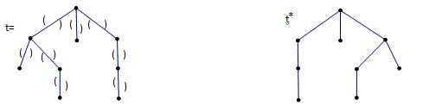

An ordered tree $t$. Its reflection$t^{*}$.
$P\left(t\right)=$ (()(()))()((()))
Alegal parenthetic expression
An admissible lattice path corresponding to $p(t)$ A full binary tree corresponding to $l(t)$
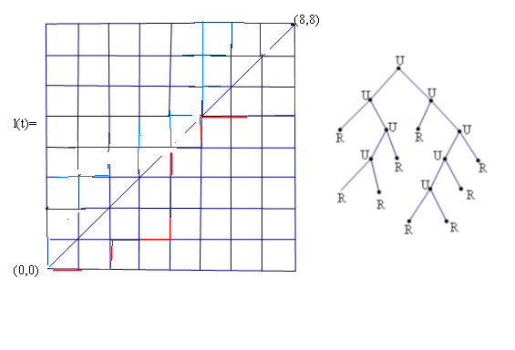
Correspondences between $T_{n},P_{n}, L_{n} andB_{n}$
$P_{n}↔L_{n}$ : Lattice paths may be easily obtained from sequences of balanced(legal) parentheses or integers. Given a legal parenthetic expression $p∈P_{n}.$ we start at $(0,0)$ and go east one coordinate by open parenthesis and up one step for each close parenthesis. This yields a path $l(t)$that remains in the upper left half of the lattice and end at$(n,n)$.
$L_{n}↔B_{n}$: Given an admissible lattice path $l∈L_{n}$ corresponding to an ordered tree$t∈T_{n}$, a unique full binary tree $l(t)∈B_{n}$ is constructed in the following manner:
Build the binary tree in the preorder, each step east on the path corresponding to an internal node and each step to the up corresponding to a leaf. a final leaf must be added.

First reflection lemma
The ordered trees $t,t^{*}∈T_{n}$ are reflection of each other, if and only if the full binary trees $b\left(t\right),b^{'}(t^{*})$ $∈B_{n}$ are reflection of each other.
For example the ordered tree $(t^{*})$ is the reflection of $t$ .
An ordered tree $t$ and its reflection $t^{*}$
Each of the above correspondence is one to one and can be used in the other section four properties follow directly from characterization formula.
The number of leaves in a (not edge less) tree $t$
=the number of ( ) patterns in $p\left(t\right)$ = the number of corners in $l(t)$
= the number of left leaves in$b(t)$ =the number of right leaves in${ b}^{'}(t)$.
The cycle lemma
A sequence $p$of open and closed parentheses is called a legal prefix if it is a prefix of a legal parenthetic expression, but neither $p$ nor any initial segment of $p$ is itself a legal parenthetic expression . In other words, a prefix consisting of $m openbrackets$and $n closed brackets,m>n$ is legal if at any point within the prefix the number of (‘s to the left is greater. For example,((()() is a legal prefix, but )((()( and ()()(( are not.
The following lemma has been rediscovered a number of times; it is a powerful tool in enumeration arguments.
Cycle lemma: for any sequence $p_{1},p_{2}, …,p_{m+n}$ of $m$ open parenthesis and $n$ close parenthesis, where $m>n$ there exist exactly $m-n$ cyclic permutations. $p_{j} p_{j+1} …p_{m+n} p_{1}… p_{j-1}$
That are a legal prefixes.
For example, of the six cyclic permutations of the sequence )((()(, only two legal prefixes ((()() and (()()(.
We can use this lemma to determine the number $f(i,j)$ of admissible lattice paths from $\left(0,0\right)to (i,j)$ the obvious recurrence for the function $f$ is :
$f\left(i,j\right)=\left\{\begin{aligned}1 if j=0 \\ 0 if i<j \\ f\left(i,j-1\right)+f\left(i-1,j\right) otherwise\end{aligned}\right.$
Each admissible path corresponds to a legal prefix of $i+1$ open parenthesis and $j$ close parentheses: just construct the corresponding parenthetic expression and prefix it with an extra open parenthesis the total number of ways to arrange the $i+j+1$ parentheses on a line is $\left({i+j+1 \atop j}\right)$ ; by the cycle lemma, exactly $\frac{i-j+1}{j+i+1}$ of these arrangements are legal . Hence, the total number of legal prefixes[3] is
$f\left(i,j\right)=\frac{i-j+1}{j+i+1} \left({i+j+1 \atop j}\right)$ =$\frac{i-j+1}{i+1}\left({i+j \atop i}\right)=\left({i+j \atop i}\right)-\left({i+j \atop i-1}\right)$
If $i=j$, then we get the Catalan numbers ${\left({2i \atop i}\right)}/{(i+1)}$ . (See fig )
The lattice function $f\left(i,j\right)$
Hence we have proven the following theorem.
Theorem (classical result) 1: The number of paths from $\left(0,0\right) to \left(n,n\right)$ with either an up step or a right step and never go below the diagonal is the $n^{th}$ Catalan numbers

j
i
i=j
0
0
0
0
0
0
0
0
0
0
0
0
0
0
0
0
0
0
0
0
0
0
0
0
42
14
42
28
14
5
14
9
5
2
1
2
3
4
5
1
1
1
1
1
0
0
0
0
1
(0,0)

SECTION THREE

3. CONVOLUTION OF CATALAN NUMBER

Definitions 4.1. We let $Z ≥0$ denote the set of non-negative integers. We begin with the general definition of the sequence of Catalan numbers, ${\left\{C_{n}\right\}}_{n=0}^{∞}$
For n $∈$ Z^{+,} the nth Catalan number, C_{n}, is defined by
C_{n} = $\frac{1}{n+1}$ $\left({2n \atop n}\right)$ = $\frac{\left(2n\right)!}{\left(n+1\right)n! n!}$

Although the above definition gives an explicit statement of C_{n,} the Catalan numbers are often defined in terms of a combinatorial problem. The particular interpretation we will use is as the number of “proper” words in a two letter alphabet.

Let W be the set of all finite words on {X, Y }. For any w $∈$ W, define |w| to be the length of w, i.e. the number of symbols that appear in w. For any 1 $≤$ i $≤$ |w|, let w_{i} represent the initial segment of w with length i. Finally, nX (w) and nY (w) will be the number of occurrences of X and Y , respectively, in w.With this, we define

3.1 Proper word and K-proper word
Definition 3. 2. A word w $∈$ W is proper if it satisfies the following two properties:
1. For some n $∈$ Z$≥0$, n_{X} (w) = n, n_{Y} (w) = n,
2. For all 1$≤$ i $≤$ 2n, n_{Y} (w_{i}) $≤$ n_{X} (w_{i}).
If W(n) is the set of proper words with length 2n, then it is well known [4] that
Proposition3.1. For n $∈$ Z⁺, C_{n} = |W(n)|.
Prove
For n=1, xy imples C₁=1
For n =2 xxyy, xyxy C₂=2
For n=3 XXX YYY, XXYXYY, XXYYXY, XYXXYY, XYXYXY = C₃=5
for n=4, XXXX YYYY, XXX YXYYY, XXXYYXYY, XXXYYYXY,
XXY XXYYY, XXYXYXYY, XXYXYYXY, XXYYXYYY,
XXYY XYXY, XYXXXYYY, XYXXYXYY, XYXXYYXY,
XYXYXYYY, XXYYYXY
$imples$ C₄= 14
Let h_{n} be the number of possible ways that writing a proper words of length 2n of nxs and nys
Assume ho=1, (initial condition).
Let H (x) = $\sum_{n≥,0}{{h_{n}x}^{n}}$ be the O GE for {h_{n}} n>0
Let i be the first index when the numbe of xs is equlal to the number of Ys which is we say (1st moment)
Assume that the 1st moment occure at i^{th} idex
Before the m0ment 1 i After moment

$\sum_{i≥1}{h_{i-1}x^{i}}$ $\sum_{n≥i}{h_{n-i}x^{n-i}}$
H (x)-1=$\sum_{i≥1}{h_{i-1}x^{i}}$ $\sum_{n≥i}{h_{n-i}x^{n-i}}$
H (x) -1 =x $\sum_{i≥1}{h_{i-1}x^{i-1}}$ $\sum_{n≥i}{h_{n-i}x^{n-i}}$
implies H (x) -1 =x H² (x)
x H² ⁽x) – H(x⁾ +1 =0 using quadratic formula H(x)=$\frac{1-\sqrt{1-4x}}{2x }$ =c(x)
which is the GF for the Catalan number
C_{n}= $\frac{1}{n+1}$ $\left({2n \atop n}\right)$ this is the same as enumeration of dyck path

We now generalize the idea of proper words to k-proper words:
Definition 3.3. Let k $∈$Z⁺. A word w $∈$ W is k-proper if it satisfies the following two properties:
1. For some n$∈$Z⁺. , nX (w) = n, n_{Y} (w) = n + k,
2. For all 1 $≤$ i $≤$ 2n + k, nY (wi) $≤$ nX (wi) + k.
For n $≥0$, let W(n, k) be the set of k-proper words with length 2n+k. A result which follows immediately from the definition is:
Proposition 3.2. W(n) = W(n, 0). This is directly from the definition

Corollary 3.1. For n $∈$ Z⁺, C_{n} = |W(n, 0)|.
Proof from definition C_{n}=$\left|w(n)\right|$
But W(n)=W(n,0) hence by transitive C_{n} = |W(n, 0)|.

We will relate the number of k-proper words to self-convolutions of the Catalan numbers. So we now define the convolution of a sequence. We choose to do this in terms of generating functions.

Definition 3.4. Given any sequence ${\left\{a_{n}\right\}}_{n=0}^{∞}$ , the generating function for the sequence, A (z), is the formal power series
A (z) = $\sum_{n=0}^{∞}{a_{n}z^{n}}$

Definition 3.5. Given a sequence ${\left\{a_{n}\right\}}_{n=0}^{∞}$ with generating function A(x), the k^{th} fold self convolution of ${\left\{a_{n}\right\}}_{n=0}^{∞}$ is the sequence which has $A^{k+1}(x)$ as a generating function. We will let
a (n, k) denote the n-th term of the k^{th}-fold self convolution of ${\left\{a_{n}\right\}}_{n=0}^{∞}$ .

We now give a few examples to illustrate the convolutions of some given sequences.
Example 3.1. Suppose ${\left\{a_{n}\right\}}_{n=0}^{∞}$ is the constant sequence of 1’s. Then the terms of the first convolution of ${\left\{a_{n}\right\}}_{n=0}^{∞}$ can be found as follows:
A² (z) = (1 + z + z² + z³ + · · ·). (1 + z + z² + z³ + · · ·)
= 1 + (z + z) + (z² + z² + z²) + (z³ + z³ + z³ + z³) + · · ·
= 1 + 2z + 3z² + 4z³ + · · ·
=$\sum_{n=0}^{∞}{\left(n+1\right)}z^{n}$.
Hence a(n,1)=n+1
Example 3.2. Suppose {${\left\{a_{n}\right\}}_{n=0}^{∞}$ is any sequence. Then the second convolution of
${\left\{a_{n}\right\}}_{n=0}^{∞}$ can be found as follows:
A³ (z) = (a₀ + a₁z + a₂z² + · · · ) (a₀ + a₁z + a₂z² + · · · ) (a₀ + a₁z + a₂z² + · · · )
= a₀a₀a₀ + (a₁a₀a₀ + a₀a₁a₀ + a₀a₀a₁) z
+ (a₂a₀a₀ + a₁a₁a₀ + a₁a₀a₁ + a₀a₂a₀ + a₀a₁a₁ + a₀a₀a₂) z² + · · ·
This implies that
a (0, 2) = a₀a₀a₀,
a (1, 2) = a₁a₀a₀ + a₀a₁a₀ + a₀a₀a₁,
a (2, 2) = a₂a₀a₀ + a₁a₁a₀ + a₁a₀a₁ + a₀a₂a₀ + a₀a₁a₁ + a₀a₀a₂.
If, in fact, we use the sequence of Catalan numbers, then
c (0, 2) = 1 · 1 · 1 = 1,=$\left|W(0,2)\right|$
c (1, 2) = 1 · 1 · 1 + 1 · 1 · 1 + 1 · 1 · 1 = 3,$\left|W(1,2)\right|$

c (2, 2) = 2 · 1 · 1 + 1 · 1 · 1 + 1 · 1 · 1 + 1 · 2 · 1 + 1 · 1 · 1 + 1 · 1 · 2 = 9.$= \left|W(2,2)\right|$

As these examples exhibit, the terms in the kth-fold self convolution of ${\left\{a_{n}\right\}}_{n=0}^{∞}$ can be computed directly by
$a(n, k) =\sum_{0≤i_{1,i_{1,}i_{2,……..,}i_{k,}i_{\begin{aligned}1k+1≤n \\ \sum_{j=1}^{k+1}{i_{j=n}}\end{aligned}}}}{a_{i_{1}}}a_{i_{2…………}}a_{i_{k}}a_{i_{k+1,}}$
where the summation is over all combinations of k + 1 subscripts which add to n.

3.2 Equality of the Sequences,

We intend to show that the sequence, ${\left\{W(n,k)\right\}}_{n=0}^{∞}$ of k-proper words and the sequence, , ${\left\{C(n,k)\right\}}_{n=0}^{∞}$ of kth-fold self convolution of the Catalan numbers are equal. We do this by showing that these two sequences have the same generating function. We consider each sequence separately.

Catalan Numbers

Let C (z) = $\sum_{n=0}^{∞}{c_{n}z^{n}}$ be generating function of ${\left\{c_{n}\right\}}_{n=0}^{∞}$ , and thus C^{k+1}(z) is the generating function of ${\left\{C(n,k)\right\}}_{n=0}^{∞}$.

It follows immediately[9] enumeration of order trees in which the left most edge counted by Z and left braches counted by C(z)and the remaining counted by C(z) if it has number of edges or 1 if it has no edges from Segner’s recurrence relation for the Catalan numbers that the following equation holds:
C (z) = zC² (z) + 1. Multiply both side by C^{k} (z). (1)
From this, we obtain the following equation involving higher powers of the Catalan generating function:
zC^{k+2}(z) = C^{k+1}(z) − C^{k} (z). (2)

3.3 k-Proper Words
We now consider the generating function for the number of k-proper words. Let W_{k}(z) denote the generating function ${\left\{W\left(n,k\right)\right\}}_{n=0}^{∞}$
Wk (z) = $\sum_{n=k}^{∞}{\{|W(n, k)|z^{n} }$.
In order to determine Wk (z) for k $≥$0, we begin with the following lemma.
Lemma 3.4. For n, k $∈$ Z$≥$"0, |W(n − 1, k + 2)| = |W(n, k + 1)| − |W(n, k)|

Proof. Let w $∈$ W with |w| $≥$ 1. One of two possibilities can occur, we consider
each separately.
Suppose w = Xw’ with w’ $∈$W. In this situation, |w’| = |w|−1 and for 1$≤$ i $≤$ |w|,
n_{X} (w _{i} +1) = n_{X} (w’_{i}) + 1 and n_{Y} (w_{i}+1) = n_{Y} (w’i). Thus, if w $∈$W(n, k + 1), then n_{X}(w) = n, nY (w) = n + k + 1, and nY (wi) $≤$ nX (wi) + k + 1. This implies that
nX(w’) = n − 1, nY (w’) = (n − 1) + k + 2, and nY (w’i) = nY (w_{i+1}) $≤$ nX(wi+1) + k + 1 = nX(w’i ) + k + 2. Thus w ’$∈$ W(n − 1, k + 2).

Now suppose w = Y w’ with w’ $∈$ W. Now, |w’| = |w| − 1 and for 1 $≤$ i $≤$ |w’|, nX(w_{i+1}) = nX(w’i ) and nY (wi+1) = nY (w’i ) + 1. Thus, if w $∈$ W(n, k + 1), then nX(w) = n, nY (w) = n + k + 1, and nY (wi) $≤$nX(wi) + k + 1. This implies that nX(w’) = n, nY (w’) = n + k, and nY (w$i) = nY (w _{i+1}) − 1 $≤$ nX (w_{i+1}) + k = nX(w’i ) + k.
Thus w’ $∈$ W(n, k).
These two cases together imply that
|W(n, k + 1)| = |W(n − 1, k + 2)| + |W(n, k)| , thus proving the lemma.

Theorem3.4. For k$∈$ Z $≥$0, zW_{k+2}(z) = W_{k+1}(z) –W_{k} (z).
Proof. Recall that |W(0, k)| = 1 for all k $≥$ 0. Thus:
z Wk+2(z) = $\sum_{n=0}^{∞}{|W(n, k + 2)| z^{n+1}=}$ $\sum_{n=0}^{∞}{|W(n-1, k+2)| z^{n}}$
= $\sum_{n=1}^{∞}{|W(n, k + 1)| {- |W(n, k)|) z}^{n}}$
= $\sum_{n=1}^{∞}{|W(n, k + 1)| z^{n}{- \sum_{n=1}^{∞}{|W(n, k)|) z}}^{n}}$
= $\sum_{n=0}^{∞}{|W(n, k + 1)| z^{n}{- \sum_{n=0}^{∞}{|W(n, k)|)z^{n} }}^{}}$
= W_{k+1}(z) –W_{k} (z).
With this, we immediately obtain the following corollary.

Corollary 3.3. For n, k $∈$ Z$≥$"0, c (n, k) = |W(n, k)|.
Proof two sequences are the same generating function then the sequence are equal.

3.5 Combinatorial Interpretations of C (n, k).
With, the equality of k-th fold convolution and k proper word w, c (n, k) = |W(n, k)|
we can now obtain a large number of combinatorial interpretations of the kth-fold self-convolution of the Catalan numbers. We begin by interpreting k-proper words as a particular subset of proper words.

Theorem 3.5. For n $≥$ 0 and k$≥$ 0, c (n, k) counts the number of proper words w $∈$ W (n + k) with w_{k} = XX · · ·X…

Proof. Consider the mapping from W (n, k) to W(n + k) which takes the word w $∈$W (n, k) to the word X^{k}w, where X^{k} denotes k copies of X. This mapping is clearly a bijection between W (n, k) and {w$∈$ W (n+k) : w_{k} = XX · · ·X}. Thus, using , c (n, k) = |W(n, k)|.
, this set has size c (n, k).

Example 4.3. We now exhibit this particular interpretation of c (n, k) by considering a few particular values of both n and k. Consider, in particular, W(4):
W(4) = {XXXXY Y Y Y,XXXY XY Y Y,XXXY Y XY Y,XXXY Y Y XY,
XXY XXY Y Y,XXY XY XY Y,XXY XY Y XY,XXY Y XXY Y,
XXY Y XY XY,XY XXXY Y Y,XY XXY XY Y,XY XXY Y XY,
XY XY XXY Y, XY XY XY XY }.

Notice, of the 14 elements of W (4), exactly 9 of them begins with at least two X’s.
W(2, 2) = {XXY Y Y Y,XY XY Y Y,XY Y XY Y,XY Y Y XY, Y XXY Y Y,
Y XY XY Y, Y XY Y XY, Y Y XXY Y, Y Y XY XY }.
This agrees with the fact that c (2, 2) = 9.
With Theorem and the standard bisections between the different combinatorial interpretations (many of which are exhibited in, we obtain the following combinatorial interpretations of c (n, k). (there are many more, one for each interpretation of the Catalan numbers.)

Note: For n $≥$ 0 and k $≥$ 0, c (n, k) counts the following:
- The number of balanced strings of n + k brackets with an initial string of at least k left brackets.
- The number of lattice paths consisting of either North or East steps, which do not pass above the line y = x, which start at (k, 0) and end at (n + k, n + k).
- The number of rooted plane trees with n + k edges whose leftmost branch has length at least k.
- The number of increasing functions f on [n + k] = {1, 2, . . . , n + k} where f(i) = 1 if 1$≤$ I $≤$ k.
- The number of full binary trees with 2(n + k) edges which have only single vertices on the left side of the first k branches.
- The number of standard Young tableaus of size (n + k, n + k) where the first term in the second row is greater than k.

Note: For n, k $∈$ Z$≥$" 0, c (n, k) $≤$c (n + k).

SECTION Four

Truncating Pascal’s Triangle

According to Young Taylor and Zwicker showed that the Catalan numbers arise in the last column when the rows of Pascal’s Triangle are truncated immediately after the central column. We show that by changing where the rows are truncated, different convolutions of the Catalan numbers appear in the last column.

As with many combinatorial number theory objects, Pascal’s Triangle can be defined in many different ways. We will use the recursive definition of Pascal’s Triangle.

Definition 4.1. Pascal’s Triangle, P, is defined by
P (n, r) =$\left\{\begin{aligned} 0 if n<0 or r>n, \\ 1 if n=r=0, \\ p(n-1, r) + P(n - 1, r - 1) otherwise.\end{aligned}\right.$
We show the terms of the first five rows of P in Figure 5.1. In Figure 5. 2, we show the values of the first six rows. We show the terms of the first six rows of P and their values in Figure 1. We also label the columns of Pascal’s triangle starting with labeling the central column 0. These column numbers are indicated in the figure.
P (0, 0)
P(1, 0) P(1, 1)
P(2, 0) P(2, 1) P(2, 2)
P(3, 0) P(3, 1) P(3, 2) P(3, 3)
P(4, 0) P(4, 1) P(4, 2) P(4, 3) P(4, 4)
P(5, 0) P(5, 1) P(5, 2) P(5, 3) P(5, 4) P(5, 5)

0 1 2 3 4 5
Figure 4.1: Pascal’s Triangle with columns labeled

1
1 1
1 2 1
1 3 3 1
1 4 6 4 1
1 5 10 10 5 1

Figure 4.2: P
Definition 4.2. For any k $∈$Z$≥$"0, the kth truncated Pascal’s Triangle, denoted Pk, is defined by the following:
$\overline{pk}(n, r)$ =$\left\{\begin{aligned} 0 if n<0 or r>\left[\frac{n}{2}\right]+ k, \\ 1 if n=r=0, \\ \overline{pk}(n-1, r) + \overline{pk}(n - 1, r - 1) otherwise.\end{aligned}\right.$

1
1 0
1 1 0
1 2 0 0
1 3 2 0 0
1 4 5 0 0 0
1 5 9 5 0 0 0
$$\overline{p_{1}}$$
1
1 1
1 2 1
1 3 3 0
1 4 6 3 0
1 5 10 9 0 0
1 6 15 19 9 0 0

Figure4. 3: P0 and P1

We use this recursive definition to build a collection of new triangles, each similar to Pascal’s Triangle.

From a procedural point of view, we have replaced elements of Pascal’s Triangle with zeros after column k and have recalculated the remaining entries of the triangle using Pascal’s Identity. Figure 3 shows P₀ and P₁.

In [10], Young, Taylor, and Zwicker showed that the nth term of column 1 (starting with n = 0), in P1 is cn+1 = c(n, 1). In fact

Theorem 4.1. Let k $∈$ Z $≥$"0, the nth term (starting with n = 0) of column k in Pk is c (n, k).
Proof. In Pascal’s Triangle, P (n, r) counts the number of paths from the point (0, 0) to the point (n, r) consisting only of moves going either southeast or southwest.
Similarly, ${\overline{P}}_{0}$ (n, r) counts the number of paths starting at (0, 0) to (n, r) consisting of moves going either southeast or southwest which do not go past column k. Since the nth term of column k in $\overline{p_{0}}$ occurs at position (m, $\left[\frac{m}{2}\right]$+k), where m = k+2n, such a path will consist of n moves southwest and n + k moves to the southeast.

Furthermore, since this path does not pass column k, the number of southeast moves never exceeds the number of southwest moves plus k. Thus, the nth term of column k (n starting at 0) in $\overline{p_{0}}$ is
|W (n, k)|. By Corollary , this is c (n, k).

Figure 4.4 shows the first rows of triangle P2, with the last column highlighted, to further show this result.
P₂
1
1 1
1 2 1
1 3 3 1
1 4 6 4 1
1 5 10 10 5 0
1 6 15 20 15 0 0

Summery
I introduced more of the combinatorial interpretations of Catalan numbers using different techniques ( interpretations) like enumeration of lattice path, ordered trees, binary trees ,etc their one to one correspondence using different theorems lemmas and rules and also an interpretations of k-th fold self convolutions of Catalan numbers by showing that they count the number of words in a symbol X and Y. Where the total number of Ys is k more than the total numbers of Xs and at no time are there more Ys than K plus the number of X’s using this we exhibit some of the wide Varity of combinatorial interpretations of self convolutions of Catalan numbers. we give anew proof of Kth- fold convolution of Catalan numbers. This is done by enumerating a certain class of polygon dissections called k in n dissections. Finally I show how these number appear as the last column in a truncated Pascal triangles.

References
- Andr´e, D., Solution directe du probl`eme r´esolu par M. Bertrand, Comptes Rendus Acad. Sci. Paris 105 (1887), 436–437.
- Catalan, E., Sur les nombres de Segner, Rend. Circ. Mat. Pal. 1 (1887), 190–201.
- Choo,KooGuan,Catalannumbers,http://www.maths.usyd.edu.au/u/kooc/catalan.html
- Hilton, P. and Pedersen, J., The ballot problem and Catalan numbers Nieuw Archeif voor Wiskunde 8 (1990), 209–216.
- Hilton, P. and Pedersen, J., Catalan numbers, their generalizations, and their uses, The Math. Intell. 13 (1991), 64–75.
- Hoggart Jr., V. E. and Bicknell, M., Pascal, Catalan, and general sequence convolution arrays in a matrix, Fibonacci Quarterly 14 (1976), 135–143
- Jani,R.G. Rieper and Melkamu Zeleke, Enumerations of $K$-trees and Applications.
- Koshy, T., Catalan Numbers with Applications, Oxford University Press, New York, 2009.
- Larcombe, P. J. and French, D. R., The Catalan number k-fold self-convolution identity: The original formulation, Journal of Combinatorial Mathematics and Combinatorial Computing 46 (2003), 191–204.
- Stanley, R. P., Enumerative Combinatorics, Volume 2, Catalan Addendum, Cambridge University Press 1999, http://www-math.mit.edu/!rstan/ec/catadd.pdf.
- Young, S., Taylor, A., and Zwicker, W., Counting quota systems: A combinatorial question from social choice theory, Mathematics Magazine 68 (1995), 331–343.

