

College of Technology and Built Environment
School of Built Environment (SBE)

Evaluating Energy Metabolism
In the case of Addis Ababa City Cement Consumption.

By
Tsadiku Zerihun Merga
A thesis submitted for graduate studies at Addis Ababa University for the Partial Fulfillment of the degree of Master of Science (MSC) in Urban Design and Development.

Addis Ababa University
Addis Ababa, Ethiopia
Date: May: 2025

Addis Ababa University
School of Graduate Studies
This is to certify that the thesis prepared by Tsadiku Zerihun Merga is titled “Evaluating Energy Metabolism In the Case of Addis Ababa City Cement Consumption.” and submitted to graduate studies of Addis Ababa University in partial fulfillment of the requirement for the degree of Master of Science in Urban Design and Development with the regulation of the University and meets the accepted standards for originality and quality.
Signed by the Examining Committee:

Advisor: Wondwosen Debebe (PhD candidate) Signature __________Date ______
External Examiner: _________________________Signature __________Date______
Internal examiner: __________________________ Signature __________Date______
Chairperson: ______________________________ Signature __________Date______

Graduate director: __________________________Signature __________Date______

Declaration
I declare that this thesis entitled “Evaluating Energy Metabolism In the Case of Addis Ababa City Cement Consumption.” Is my work and has not been submitted to any university for a similar purpose. The references used in this thesis are duly recognized by proper citation.

Tsadiku Zerihun Merga
Signature .
Date: May, 2025

Confirmation
This thesis can be submitted for examination with my approval as a university
Advisor .
Wondweson Debebe (PhD candidate)
Signature .
May, 2024

Acknowledgment
First and foremost, praises and thanks to God, the Almighty, for His blessings throughout my research work to complete the research.
I express my special thanks to Dilla University and Addis Ababa University for allowing me to study Master of Science (MSc) in urban design and development at the Ethiopian Institution of Architecture, Building, and Construction. I would like to say thanks to my friends and Dilla University colleagues.
I would like to sincerely thank my adviser, instructor Wondweson Debebe (a PhD candidate), for my MSc degree studies and research, and for his patience, encouragement, excitement, and vast expertise. His advice was beneficial to me when I was conducting my research and writing my thesis.
I am very thankful. I want to express my gratitude to my family: my mother, Bogalech Bekele, for making sacrifices to educate and prepare me for my future and providing financial and spiritual support throughout my life.
Finally, my thanks go to all those who have supported me to completing the research work, directly or indirectly.

Abstract
In the city's development, this “Evaluating Energy Metabolism” in cities is essential for the different industries and future clean energy development. The idea of "cement metabolism" looks at the movement of cement through a city, including its extraction of material with its transportation to factories, the production process of cement, and the distribution of cement to use for construction. To evaluate cement energy metabolism in urban systems, it is crucial to understand and optimize the energy flows and environmental impacts associated with material collection, cement production, and distribution. Since cement plays a major role in energy consumption and greenhouse gas (GHG) emissions, this analysis is vital for sustainable urban development. Key goals include research Quantifying Energy Consumption, Evaluating Emissions & Environmental Impact, Optimizing Resource Efficiency, and Supporting Sustainable Addis Ababa City emergy. The Emergy (spelled with a "m") analysis is an effective method for evaluating the true resource efficiency and environmental stress of cement production, as well as the sustainability of Addis Ababa city cement consumption. It offers a comprehensive view of sustainability that extends beyond traditional energy or carbon metrics by quantifying all inputs (like natural embodied material, labor, and energy like coal or electricity) in terms of their solar energy equivalents (solar Emjoules, or Sej). The last three to four decades of cement metabolism in Addis Ababa have seen a significant increase due to high demand and limited supply. Contributing factors include nonrenewable energy and fuel crises, logistics and distribution costs, rapid urbanization with elevated construction activity, minimal use of alternative materials and energy, a linear (non-cyclic) material flow, and considerable environmental stress. The cement industry, which accounts for 8% of global CO₂ emissions, faces significant challenges in adopting green energy due to technological, economic, and infrastructural barriers. On the other hand, this city must invest in sustainable alternative energy and local production to avoid future disasters.
Keywords:
Energy Metabolism, Emergy Analysis, Green Energy, Materials Flow.

Table of Contents
Acknowledgment i
Abstract ii
Table of Contents iii
List of Tables vi
List of Figures viii
List of Acronyms x
Chapter One: Introduction 1
1.1. Background of the study 1
1.2. Statement of the problem 2
1.3. Research questions 3
1.4. Objectives of the study 4
1.5. Scope of the study 4
1.6. Significance of the study 5
1.7. Validation and Reliability 5
1.8. Research limitation 5
1.9. Organization of the document 6
Chapter Two: Literature Review 7
2.1. Introduction 7
2.2. Cement Energy, Production and Transportation 8
2.3. Cement Metabolic Flow, Typology and Assessment Methods 14
2.3.1 Cement Metabolic Flow and Typology 14
2.3.2 Cement Material Flow Assessment Methods 14
2.4. Sustainability and Urbanization 16
2.5. Cement Metabolism Globally and Local Level 16
Chapter Three: Research Methodology 22
3.1. Study Area 22
3.1.1. Location map of Addis Ababa, Ethiopia 22
3.1.2. Background Addis Ababa 22
3.2. Research Design 23
3.3. Data Types and Source 24
3.4. Sampling Design 25
3.5. Method of Data Analysis (Emergy Analysis) 28
3.6. Method of Data Presentation 32
Chapter Four: Results and Discussion 33
4.1. Addis Ababa City Energy and Cement Metabolism 33
4.1.1. Introduction 33
4.1.2. National Production, consumption, and Availability of cement 33
4.1.3. Ethiopian Cement Industry Energy Consumption 34
4.1.4. Addis Ababa City Urbanization, Housing and Cement Consumption 35
4.2. Dangote Cement Ethiopia Cement Metabolism 40
4.3. Scenario A: Emergy indicator (EI) and Data analysis. 51
4.3.1. EI of Dangote cement production for A.A (2,547,063 tons of cement) 51
4.3.2. EI of Addis Ababa cement consumption (5 million ton of cement) 52
4.3.3. Sustainability A 53
4.4. Scenario B: Emergy Indicator (EI) and Data analysis. 54
4.4.1. Alternative Energy for Scenario B 54
4.4.2. EI of Dangote cement production (2,547,063 ton of cement) by Scenario B. 57
4.4.3. EI and Data analysis in the case of A.A cement Consumption (5 million tons of cement) 58
4.4.4. Sustainability B 59
4.5. The environmental influence of the study of A.A Cement Metabolism 59
4.6. Discussion 62
4.7. Main findings 66
Chapter Five 68
Conclusions and recommendations 68
5.1. Conclusion 68
5.2. Recommendations: 71
References 85
AnNex 1: Scenario A 89
A. Scenario A: Emergy of Dangote Cement Production 89
B. Scenario A: Emergy of Ababa cement consumption 91
Annex 2: Scenario B (calculations) 93
A. Scenario B: Emergy of Hydrogen production 93
B. Scenario B: Emergy of Dangote Cement Production 94
C. Scenario B: Emergy of A.A Cement Consumption 97
Appendix A 99
Appendix B 101
Unit Conversion 102

List of Tables
Table 2.1: International Electricity Market Report. (International Energy Agency, 2023) 17
Table 2.2: Coal consumption in Addis Ababa. (Source: (Worldometer, 2024)) 18
Table 2.3: Limit Values for Emissions to Air and Water of Cement Production. 19
Table 3.1: Parameters for the study 26
Table 3.2: Emergy analysis indicators, formula, and interpretation 29

Table 4.1: Cement plants in Ethiopia with >2 million (Source: FDRE Minister of Mine) 33
Table 4.2: Cement in the last 6 years and 2025 in Ethiopia (Source: FDRE Minister of Mine) 34
Table 4.3: Ethiopia's hydrocarbon gas liquid Average Energy (thousand barrels per day (TBPD) and Ethiopia’s Natural gas reserve (Trillion Cubic Feet (Tcf)). 35
Table 4.4: 40 years of Coal and coke consumption of Ethiopia. 35
Table 4.5: Addis Ababa City Urban Expansions and Agglomeration. 37
Table 4.6: Addis Ababa City cement consumption Comparison with Other Regions (source: FDRE Minister of Mine) 39
Table 4.7: Production of Dangote cement capacity and capacity utilization details 41
Table 4.8: Average Amount of PPC & OPC production of raw material 41
Table 4.9: Summary of both Electrical Energy and Thermal Energy consumption (source: Dangote cement Ethiopia) 43
Table 4.10: Dangote cement industry Electric consumption (Source: Dangote cement company and the Ethiopia Ministry of Mining and Energy) 44
Table 4.11: Embodied material need (Main Cement Materials, Corrective Material, and Adhesive Material) in tons 46
Table 4.12: Embodied material for last production need (Raw meal and Coal) in tons 46
Table 4.13: Annual average of record of Raw material consumption for Cement Production and Dispatch of cement 47
Table 4.14: (A) Raw Energy Material Transportation (Main Fuel Consumption) (B) Before production and Dispatch Material Collection to the Factory (in table 4.8) 48
Table 4.15: Transport raw material, number of trip of track and fuel transport consumption. 49
Table 4.16: Final transportation of product, both bag cement and bulk transportation from Mugar-(Adda-Berga) to Addis Ababa city construction site with Dangote cement contribution (2 million metric tons). 50
Table 4.17: Summary of energy transportation 50
Table 4.18: Emergy material amount and type for production 2,547,063.12 tons/year of Dangote cement by Scenario A. 51
Table 4.19: Emergy indicator for Dangote cement production (2,547,063 ton/year). 52
Table 4.20: EI for A.A cement consumption (5million tons/year) by Scenario A. 52
Table 4.21: EI analysis for A.A Cement consumption (5 million tons/year). 53
Table 4.22: Alternative Energy Comparison with Fossil Fuels (Source: 54
Table 4.23: Emergy for hydrogen capacity. 56
Table 4.24: Emergy indicator for hydrogen production 56
Table 4.25: Emergy material amount and type for the production (2,547,063.12 tons/year) of Dangote cement by Scenario B. 57
Table 4.26: Emergy indicator for Dangote cement production (2,547,063 ton/year). 57
Table 4.27: Emergy material amount and type for the production (5 million tons/year) of A.A cement consumption by Scenario B. 58
Table 4.28: Emergy indicator for A.A cement consumption (5 million ton). 58
Table 4.29: value that A.A cement input material and emission of green gas house gas 61
Table 4.30: Comparison with Scenario A and Scenario B (total need of Addis Ababa city cement Metabolism (5 million tons)) 65
Table Annex 1:1: Emergy material for 2,547,063.12 tons/year by Scenario A 89
Table Annex 1:2: Total Emergy Material of Dangote cement for A.A city cement metabolism. 91
Table Annex 2.1: Emergy material for hydrogen capacity. 93
Table Annex 2.2: Table 4.39: Summary of H₂ gas Emergy indicator 94
Table Annex 2.3: Emergy for 2,547,063.12 ton/year to A.A cement metabolism from Dangote Cement production (Scenario B) 94
Table Annex 2.4: Total Emergy material of Dangote cement produce (By Scenario B) for A.A 97

List of Figures
Figure 2.1: Cement manufacturing and transport process (source: Author) 12
Figure 2.2: Cement metabolism complex network (Source: Author) 13
Figure 2.3: General framework for MFA across the economy. 13
Figure 2.4: linear metabolism 14
Figure 2.5: Circular Metabolism (Source: Author) 14
Figure 2.6: Greenhouse gas emissions from cement. (Source: ((EIA), 2024) 16
Figure 2.7: Coal production in thousand tons.( Source: (Worldometer, 2019)) 18
Figure 2.8: Synhelion (Source: (synhelion, 2024)) 21
Figure 2.10: Circular City Heidelberg (Source: Microsoft Bing) 21
Figure 3.1: Location Map of the study area. 22
Figure 3.2: Research design chart 24
Figure 3.3: linear cement metabolism process. 28
Figure 3.4: Metabolism of cement for A.A. 28
Figure 3.5: Emergy method cement metabolism system (Source (Wang H. L., 2022)) 29
Figure 4.1: A.A Urban Expansion 1987-2017 (source: (Atlas of Urban Expansion - Addis Ababa., 2010)) 36
Figure 4.2: Urban Expansion 1984, 1994, 2005, 2015, and 2020 (Source: Addis Ababa’s Strategic Development Framework June 2021). 36
Figure 4.3: Location of cement factories within a radius of 90km to the west of A.A. 39
Figure 4.4: Energy flow in a Dangote cement. (Source: Dangote Cement) 42
Figure 4.5: Temperature of clinker using fuel chart (source: Dangote Cement) 43
Figure 4.6: Location, distance of different minerals, and distribution to Addis Ababa city 45
Figure 4.7: Materials Extraction with process around and in the factory 45
Figure 4.8: Chart of Emergy material of scenario A (Dangote Cement). 51
Figure 4.9: Chart of the Emergy indicator of scenario A (Dangote Cement). 52
Figure 4.10: Chart of Emergy material of scenario A (A.A Cement consumption). 53
Figure 4.11: Chart of Emergy indicator of scenario A (A.A Cement consumption). 53
Figure 4.12: Emergy analysis for hydrogen production for scenario B. 56
Figure 4.13: Chart of Emergy indicator for hydrogen production. 56
Figure 4.14 Chart of Emergy material of scenario B (Dangote Cement Production). 57
Figure 4.15: Chart of Emergy indicator of scenario B (Dangote Cement). 58
Figure 4.16: Chart of Emergy material of Scenario B (A.A Cement consumption). 58
Figure 4.17: Chart of the Emergy indicator of scenario B (A.A. Cement Consumption). 59
Figure 4.18: Environmental Emission of 1Kg Dangote cement (GHG and water) (source: ((EIA), 2024) 60
Figure 4.19: Material environmental emission of cement production and consumption of A.A. 61
Figure 4.20: Typical clinker-to-cement ratios of coal kiln and hydrogen kiln. 71
Figure 5.1: a) photographs of the first electric cement production in an electric arc furnace at the Materials Processing Institute, UK. (Source: Cement recycling method could help solve one | Eurek Alert!) b) Demolished building in Addis Ababa (source: Microsoft Bing) 73
Figure 5.2: E-highway of a transportation project in Germany (Source: New York Times, research of Germany in the cities) 74
Figure 5.3: Underground petroleum pipeline (source: Microsoft Bing) 74
Figure 5.4: Study Coverage that includes West Shewa, Sheger City, and Addis Ababa City 75
Figure 5.5: Distribution chart of PVOUT, DNI, GHI and DHI of study area 77
Figure 5.6: Solar resource map chart of PVOUT, DNI, GHI, and DHI of the study area 77
Figure 5.7: Distribution chart of GTI, OPTA, TEMP, and ELE of the study area 77
Figure 5.8: Solar resource map chart of GTI, OPTA, TEMP and ELE of study area 77
Figure 5.9: Annual Average, hourly and monthly DNI of study area. (Source: GSA) 78
Figure 5.10: Area view of wind at the surrounding cement factory and Addis Ababa city 80
Figure 5.11: (A) Mean Power Density @Height 100m and (B) Hourly vs. monthly (cross table) (Source: GWA) 80
Figure 5.12: (A) Wind Speed Variability (B) Mean wind speed and (C) Hourly Vs. monthly (Radar plot) of the selected area (Source: GWA) 81
Figure 5.13: (A) Wind rose and (B) Wind Frequency Rose (Source: GWA) 81
Figure 5.14: Horizontal Wind Turbine (Energy, 2024). 83

List of Acronyms
A.A | Addis Ababa
CPP | Captive Power Facilities
CCIDI | Chemical and Construction Inputs Development Institute
DMC | Domestic material consumption
DMI | Direct material input
DPO | Domestic Processed Outputs
ENA | Ecological Network Analysis
Ew-MFA | Economic-Wide Material Flow Analysis
EI | Emergy Indicator
GSA | Global Solar Atlas
GWA | Global Wind Atlas
IE | Industrial Ecology
LCA | Life-Cycle Assessment
MFA | Material Flow Analysis
MoTRI | Ethiopia's Ministry of Trade and Regional Integration
MRIO | Multiregional Input-Output
MSW | Municipal Solid Waste
NAS | Net Addition to stock
PTB | Physical Trade Balance
WCED | World Commission on Environment and Development
UM | Urban Metabolism
UN | United Nations
UNDG | United Nations Development Goals

Chapter One: Introduction

Background of the study
More than 70% of the world's population resided in rural areas in 1950, with the remaining population residing in metropolitan areas (the business area) (United Nations, 2019). Ethiopia had a 22.7% or 28,007,256 urban population in 2022. Ethiopia's urban population increased significantly during the past 50 years, from 9.1 to 22.7%, rising at an increasing annual rate that peaked in 2008 at 2.44% or 2,058,313 before falling to 2.20% in 2022. (Knoema, 2023). According to the Ethiopian Statistical Service demographic data of 2024, Addis Ababa city population size is 4,030,000.
In Ethiopia, a locality is considered urban if it has a minimum of 2,000 inhabitants, based on data from the Central Statistical Agency (CSA). Urban areas currently cover less than 20% of the nation, and even then, the majority is made up of tiny towns, which make up more than 85% of the urbanized regions in the nation. However, the country's rate of urbanization is rising quickly, at a pace of 4.63% yearly. (Implications of overlooked drivers in Ethiopia's urbanization: curbing the curse of spontaneous urban development for future emerging towns, 2022).
At that time, mass production and technological advancements liberated many families from farming, and employment shifted steadily towards the industrial sector (David et al., 2010). The advancement of transportation facilitated the movement of people, goods, and resources between locations (Cuddihy and colleagues, 2005). In the cement industry transportation is the main energy consumption.
Firstly, in 1883 Urban Metabolism was discussed by Karl Marx, to describe the material and energy exchanges between nature or environment and society in his critique of industrialization. Later Wolman in 1965 re-launched the urban metabolism concept in response to deteriorating air and water qualities. The artificial and highly aggregated nature of the city, as well as the metabolic flows of resources, define urban metabolic processes. The role of cities in reducing socioeconomic material and energy flows is increasingly recognized (Steinberger & Weisz, 2010).
Urban cement metabolism is a process in which cement transforms, exploits, and consumes embodied energy, and also the recycling of cement from the source to the users. Embodied energy in all regions of Ethiopia is the primary source of energy with the hardening process to produce materials for any industrial sector spatially for the construction industries. The process is applied in a single city or multiple cities in various weather and regions. This could be due to different factors like environmental, economic factors, and so on.
According to the Chemical and Construction Inputs Development Institute (CCIDI), Ethiopia's cement demand reached 12 million tons in 2019, while domestic producers supplied only 8.9 million tons, despite a nominal capacity of 20 million tons. Addis Ababa, the main hub, accounts for 30-40% of the country's total cement consumption. The Ministry of Mines indicates an annual cement demand of 4-6 million tons. However, Addis Ababa experiences an annual shortage of 1-3 million tons due to industry challenges such as a lack of spare parts, power outages, raw material shortages, security issues, and insufficient professional skills. However, the main reason of cement shortage is allocates 55% of total production costs are to energy, mainly for thermal and electrical requirements. However, reliance on grid power is unstable due to outages, compelling plants to utilize diesel generators. Addis Ababa city estimates energy needs of 400-600 KWh/year for electricity, and at 4,000–4,300 J/kg clinker, producing clinker to meet Abbas’s demand could consume 16-24 PK/year for thermal energy and the main sources of energy are coal and fossil fuels.
In this study, we referred to different sources of primary and secondary sources from the Ethiopian Energy Authority, cement factories, Ethiopia Industrial Input Development Enterprise, the Ministry of Mines and Industrial Development, and related sectors. The flow of cement is affected by the efficiency of embodied energy and the power consumption of cement production industries through its process.

Statement of the problem
Cement "metabolism (natural and human made)" refers to the entire life cycle of cement, from raw material extraction, cement production, and product distribution to construction. Addis Ababa consumes significantly more non-renewable energy to produce urban materials like cement, which has cultural and political implications as a key construction component and environmental degradation. Cities exhibiting varying levels of material and energy consumption (non-renewable energy) that challenge the sustainability of Addis Ababa and other developing cities.
The growing urban population increases the demand for resources in terms of land use for housing, infrastructure, and basic services, as well as construction materials like cement. The national geography forecast predicts that by 2050, two-thirds of the global population will reside in urban areas. In Addis Ababa, rapid urbanization and construction have resulted in greater consumption of cement than its production, attributed to defective manufacturing practices, elevated transportation costs, and management challenges in each activity. This resulting cement shortage is due to high energy costs, environmental degradation from elevated GHG emissions, socio-economic challenges like public health risks, and waste management crises. In another way, the cement consumption of this city is trapped by higher input material than output and high logistical challenges.
Urban pollution, primarily caused by human activity, refers to the contamination of air, water, and soil in densely populated areas. The cement industry is a crucial element of a nation's development and economic growth. However, it also significantly contributes to air pollution, environmental implications (climate change, health risks), and challenges for sustainability.
The main issues with Addis Ababa's cement metabolism are high emissions and energy use, which render production unsustainable. Additionally, there is a lack of construction and demolition waste management, overconsumption of cement, and insufficient integration of green energy.

Research questions
- How much consumption of resources and energy in Addis Ababa city for cement production?
- How to protect and decrease environmental stresses that are caused by cement industries?
- What is industrial circular activity for the reuse of concrete waste?
- What kinds of technology will help to develop green energy for the cement industry?

Objectives of the study

General Objective

The main objective of this analysis is to evaluate the environmental support required for cement production. It aims to assess sustainable urban development, evaluate resource use efficiency, quantify environmental impact, and integrate the principles of a circular economy.

Specific Objectives
- To analyze emergy resource efficiency in cement metabolism while optimizing and quantifying material flows.
- To assess environmental sustainability in the selected cement industry by analyzing the total energy input materials, including both renewable and nonrenewable options.
- To evaluate the potential of industrial cement circular activity and the feasibility of closed-loop recycling of concrete waste back into cement production.
- To develop green energy technology for cement metabolism in cement industries and cities.

Scope of the study
The spatial scope of this study was delimited to Addis Ababa city. The city was linked to neighboring cities through resource collections from manufacturing industries in Muger City, pumice material from Meki, and coal and biofuel production in Wellega and Kamashi. The collection of these resources involves the use of fossil fuels and other transportation technologies. This fossil fuel is imported through Djibuti ports.
The thematic scope of the study centers on cement production for the city of Addis Ababa, focusing on industrially produced materials that require substantial resource management, engineering, and control over energy infrastructure. Natural resources like limestone, clay, iron ore, and gypsum are used for consumption, while energy comes from fossil fuels, electricity, and alternative fuels. Additionally, human and economic inputs include labor and infrastructure.
The study's temporal scope is a medium-term analysis covering the last 5-20 years, but it focuses on the country's most recent, modern (last ten years), and advanced cement industry. Looking ahead to the cement industry technology in 2050, the UNDP has implemented a zero-emission program.

Significance of the study
The significance of this study Environmental and ecological assessments include ecosystem valuation, sustainability indicators, regional analysis, economic and policy applications, alternative valuation, and resource use optimization for Addis Ababa. Ecosystem valuation measures nature's contributions to resource and service generation for cement campany industry and city, while sustainability indicators such as the Emergy Yield Ratio (EYR) and environmental loading ratio (ELR) help evaluate system sustainability. Alternative valuation provides a biophysical basis for assessing goods and services beyond cement market prices, aiding policy decisions. Evaluations of industrial and building systems analyze life cycle impacts, compare technology options, and assess building sustainability, taking into account the full environmental cost of construction materials.
The rapid increase in population, urbanization, and social and economic growth are linked to the rising demand for energy and its various resources. This research aims to explore how to assist multiple construction projects, such as cement production, in achieving the economic, environmental, and social objectives of Addis Ababa by generating clean energy. It also contributes to addressing climate change by reducing air pollution (through decreased CO₂ emissions).

Validation and Reliability
Addressing the validation of this study is essential for maintaining scientific results and broadening its applications in sustainability assessment. Meanwhile, studies comparing emergy analysis and energy analysis reveal both convergences and divergences in their results and methodologies. Emergy energy analysis has a wider scope, incorporating an internal optimizing principle, and is more ambitious but also more prone to criticism. It necessitates transformation ratios to convert different energy forms to a common basis, underscoring the differences in accounting procedures between the various methods.

Research limitation
The other process will be a challenge in collecting the research data sources, depending on feedback from government offices as well as private limited company offices. These offices and factories are located at different sites due to certain political issues in the area. The contradiction of data is the hardest part of the analysis collected from secondary sources. Another significant reason that made data collection difficult was security, which is one of the limitations that challenge the collection of this research data. The production of cement necessitates precise data on material, energy, and labor inputs, which can be difficult due to intricate supply chains and calculations.

Organization of the document
The entire research document consists of five chapters. The first chapter includes a background study, a problem statement, an objective, a research question, the scope of the study, the significance of the study, research limitations, a description of the study area, and the organization of the document. The second part of the research focuses on both literature reviews and conceptual literature reviews, utilizing secondary data such as books, journals, periodicals, photos, and images. The third chapter details the research methodology, describing how the study was conducted, organized by study area, research design, data type, and research approach. In Chapter 4, present the results and discuss their relation to the objectives and questions outlined in Chapter 1. In the final fifth chapter, the researchers conclude and summarize the results from Chapter 4 while fully leveraging the recommendations.

Chapter Two: Literature Review

Introduction
    - Historical background
Urban energy metabolism, defined by Wolman in 1965, is the process of exchanging, converting, using, and discarding energy in urban settings. It reflects the structure and functionality of an urban energy system by describing the status of the energy metabolic processes based on the similarities between urban and natural systems. Inspired by this analogy, scholars have developed a range of interpretations and extensions of urban metabolic terms and adopted numerous applications of urban metabolism.
Complex system science reveals that cities are not mere accumulations of sectors; they are super-organisms, driven by complex interactions among sectors (population, industries, and other facilities), causing intricate reactions. Urbanization, population growth, and industrialization have led to increased energy consumption and waste emissions in urban areas, resulting in high metabolic throughputs and severe pollution.
The concept of urban metabolism stems from applying the metaphor of industrial ecology to urban systems; it is a metaphor that draws on nature as a source for innovative ideas to redesign urban areas or cities, making them more sustainable (Ferrão and Fernández, 2013).
    - Cement metabolism
It is a fine powder that acts as the binding agent in concrete and mortar. The most common type is made from limestone and clay heated at 1450°C, along with gypsum and additional materials such as fly ash, slag, or silica fume. The production process includes extracting raw materials like limestone, clay, sand, and iron ore, followed by kiln processing and grinding to create a fine powder. This represents that cement production consumes both embodied and cement energy inputs.
    - Urban Metabolism
To capture the process of how a city "attains resources" and "releases wastes" while providing "economic outputs and social services," the Urban Metabolism (UM) concept has inspired ideas for designing sustainable cities, despite years of being overlooked (Musango, 2017). A broad definition from Kennedy, Pincetl, and Bunje specifies UM as "the total of the technical and socio-economic processes that occur in cities, resulting in growth, the production of energy, and the elimination of waste".
Urban metabolism, crucial for urban development, faces high energy consumption and air pollution, prompting research on supply, demand, efficiency, environmental impacts, and the balance between environment and development.
The urban metabolism framework has been extensively utilized in literature to evaluate the metabolism of cities by quantifying and analyzing the flow of resources and materials within urban environments. Ecosystems are resilient, robust, and sustainable systems; observing ecological processes can provide insights to enhance the sustainability of urban areas (Ferrão and Fernández, 2013).
The urban metabolism concept provides methods, tools, and metrics to comprehend urban systems' metabolism, evaluate resource circularity, identify deficiencies, and uncover opportunities for sustainable improvement. Moreover, the urban metabolism framework offers appropriate measures of resource exploitation and consumption, along with different types of waste generation that can serve as sustainability indicators (Ferrão and Fernández, 2013).
    - Cement Emergy Metabolism
The complete energy flow (Emergy) involved in cement production, from the extraction of raw materials to the final product. Emergy measures the total energy needed to produce a product or service, expressed in solar emjoules (sej). In cement production, Emergy energy offers a comprehensive view of resource utilization, environmental impact, and sustainability. The Emergy budget of cement encompasses non-renewable resources, renewable resources, as well as labor and services.
Emergy Energy = Raw material input + Energy input + Output (Cement) + Transportation + Labor and Service……………………………………………………... (2-1)
Emergy Energy = (Non Renewable (Embodied Material) + Renewable) Energy……... (2-2)

Cement Energy, Production and Transportation
The production of cement entails a complex process that incorporates various components, including a rotary kiln, cement mill, chimney, bag house, homogenizing silo, raw mill, cyclone, electrostatic precipitator, and preheater. Each ton of product produced requires approximately 100 kWh of electrical energy, which represents over 6% of the world's annual energy consumption. More than 60% of the energy needed to reduce the size of raw materials and clinker is utilized by comminution equipment such as crushers and mills. The main energy types that are used in cement metabolism:
    - Cement Energy Type
Non-Renewable Energy Input
- Cement Raw Material Input (Embodied Energy)
Cement production necessitates a balanced combination of raw materials with distinct chemical properties essential for clinker formation and performance. This overview details the primary and supplementary raw materials, their functions, and processing methods in cement manufacturing.
Cement consists of two main raw materials: limestone, a source of calcium carbonate, and clay or shale, an argillaceous material. Limestone serves as the backbone of clinker and is the primary source of calcium carbonate. Clay or shale provides silica, alumina, and iron oxide for silicate formation during clinkerization. Additionally, marl, a natural mix of limestone and clay, is also utilized.
- Cement Energy input (Purchased Energy)
Conventional Kiln-Based energy (Thermal energy): Traditional cement production employs rotary kilns that burn fossil fuels to achieve clinkering temperatures (1,400-1,500°C). Thermal energy consumption ranges from 3.3 to 5.6 GJ/ton (60–70% of total energy), while electrical energy is about 110 kWh/ton for grinding raw materials and clinker. Some of input of thermal energy are:
- Fossil Fuels for Kilns (Clinker Production)
- Coal is a fossil fuel, a type of sedimentary rock, formed from the remains of ancient plants, and is burned for energy. It is classified as a solid hydrocarbon. As of 2016, Ethiopia consumed 539,255 tons of coal annually, with factories spending 227 million USD per year in 2020. Ethiopia's cement demand reached 2.21 million tons of coal in 2020, with total imports ranging from 0.8 to 1 million tons and a coal deposit of 250 million tons. Additionally, it accounts for 60% of global kiln energy, is an inexpensive fossil fuel with a high heat output, but it raises environmental concerns due to significant CO₂ emissions and air pollution.
- Petroleum Coke (Pet coke) possesses a higher energy density than coal; however, it is also more polluting because of its elevated sulfur content.
- Fuel oil and natural gas, which constitute about 10% of the global energy mix, provide cleaner alternatives to coal and pet coke; however, their high costs are attributed to the insufficient gas infrastructure in Africa.
- Human-Transformed Energy (labor and service)
This analysis examines the role of human labor and services in the metabolism of cement, concentrating on direct production labor such as quarry operations and clinker production, which includes kiln technicians and maintenance crews.
Renewable energy input
The cement industry can utilize renewable energy sources to reduce its dependence on fossil fuels and lower CO₂ emissions. Some examples of RE sources are:
- Alternative Fuel energy: The process entails substituting fossil fuels with waste-derived fuels such as tires, biomass, and plastics, which reduces net CO₂ emissions but may also lower kiln temperatures. Additionally Electro-Chemical Energy (ECE) is a significant shift from kiln-based systems, utilizes microalgae-cultivated limestone for biogenic cement, and employs electrolysis for carbon-negative cement production.
- Solar energy: Photovoltaic systems supply energy for grinding mills, lighting, and office operations, while concentrated solar power (CSP) delivers high-temperature heat for experimental kilns.
- Wind farm: This product is cost-effective in windy regions and can be scaled to meet large industrial demands.
- Biomass and Biofuel: Carbon-neutral and sustainably sourced agro-based economies utilized agricultural waste as kiln fuel and wood pellets as a coal substitute in pre-calciner kilns.
- Hydropower: Cement plants utilize grid electricity for stable baseload power, resulting in low CO₂ emissions.
- Geothermal energy: Direct heat is utilized for drying raw materials; however, its application is restricted to volcanic regions, offering a continuous energy supply around 24/7.
- City Waste-derived Energy: Generating electricity from urban waste is an innovative and sustainable approach to managing city refuse while generating energy. Several methods exist to convert municipal solid waste (MSW) into electricity:
- The Waste-to-Energy (WtE) Incineration (Process by burning waste)
- The Landfill Gas-to-Energy (LFGTE) (a process by decomposition of organic waste is decomposed and produces methane).
- Anaerobic digestion (a process by which bacteria decompose organic waste, generating biogas (methane + CO₂))
- The pyrolysis and gasification (processes that involve heating waste to produce syngas (a mixture of hydrogen, carbon monoxide, and methane).
- Hydrogen gas: Hydrogen (H₂) is emerging as a promising zero-carbon fuel alternative, yet obstacles persist in terms of cost, scalability, and infrastructure. The advantages of hydrogen kilns include zero CO₂ emissions, a high flame temperature (2000°C), compatibility with existing kilns, and synergy with renewable energy via electrolysis.
- Hydrogen production methods
- Blue Hydrogen (Steam Methane Reforming (SMR): is a process in which natural gas reacts with steam to generate H₂ and CO₂, while carbon capture and storage (CCS) is implemented to minimize emissions.
- Gray hydrogen (Biomass Gasification): is the thermochemical conversion of biomass, including agricultural waste, into syngas (H₂ + CO), requiring sustainable biomass sourcing and lower H₂ purity.
- Green Hydrogen (Water Electrolysis): this utilizes renewable electricity to separate water into H₂ and O₂, satisfying high electricity demand.
    - Cement Production
There are four stages to produce cement:
Stage 1: Raw material extraction: These raw materials include the extraction of limestone, sand and clay, pumice, and other materials.
Stage 2: Proportioning, Grinding, and blending: The crushed raw materials are blended with additives to produce a fine, uniform cement mixture, usually consisting of 80% limestone and 20% clay.
Stage 3: Pre-Heating Raw Material: A preheating chamber transforms raw materials into oxides.
Stage 4: The kiln phase: The core energy transformation process in cement production accounts for over 80% of the sector's energy use and 90% of CO₂ emissions in urban material flows.
- Integration into Cement Production
Hydrogen Kiln (Fuel Replacement): Replace coal or petroleum coke with hydrogen in rotary kilns at 1,450°C, necessitating burner retrofitting. Hydrogen's flame temperature, which requires 2,000°C, is adequate.
Process Emissions Mitigation: Hydrogen is utilized as a reducing agent to capture CO₂ from raw materials such as iron ore in clinker, with green hydrogen expected to dominate in the future as renewable energy expands and electrolyze costs decline.
    - Cement Transport System
Cement's stability is vital for urban construction and infrastructure, as its physical properties support the creation of exoskeletons. Significant quantities of loose cement are transported to cement brick factories, ready-mix concrete plants, and bagging operations, which transform it into concrete for foundations, slabs, load-bearing walls, and columns.
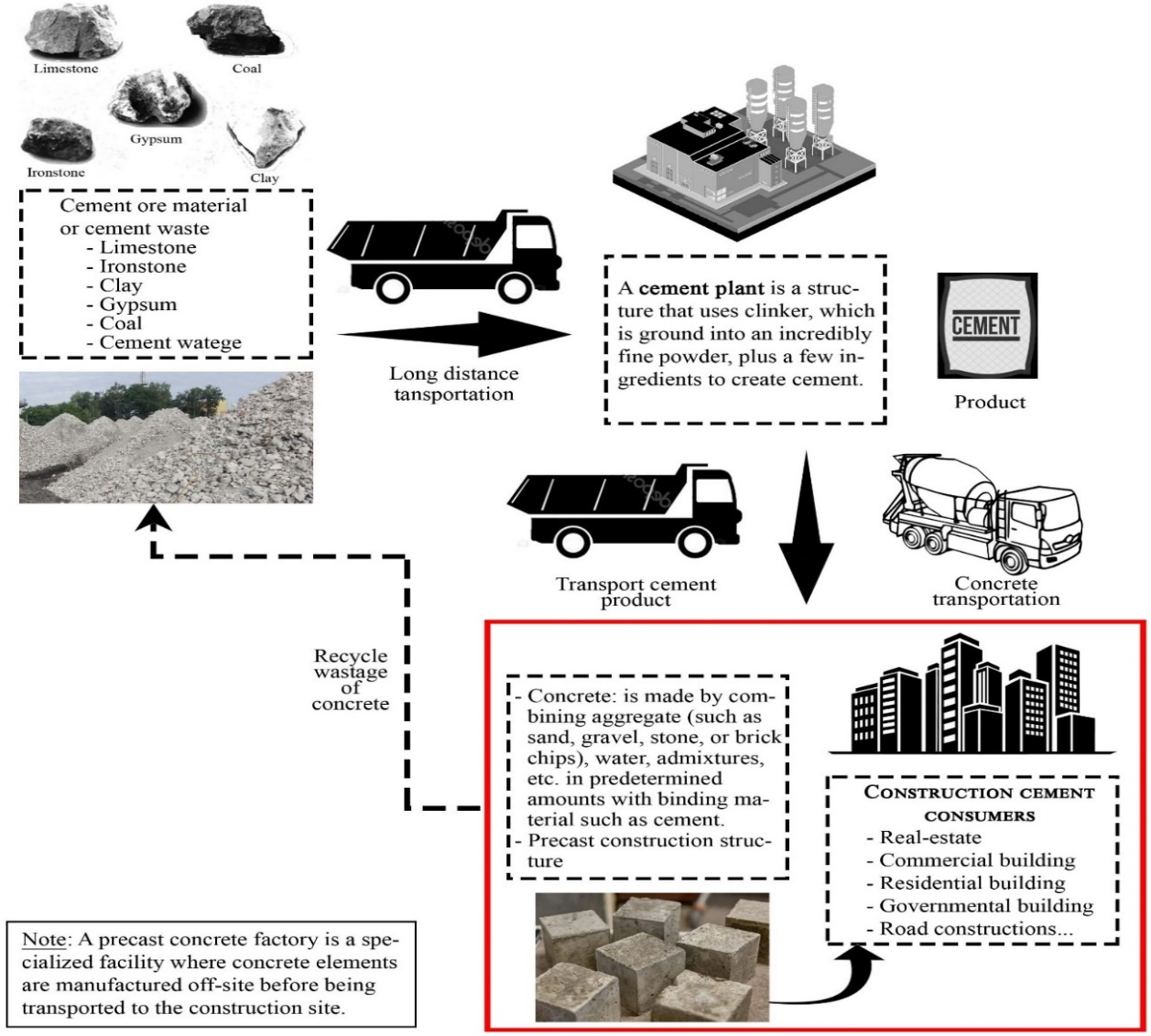
Figure 2.1: Cement manufacturing and transport process (source: Author)
Stable cement circulation requires a robust infrastructure network, efficient transportation, storage facilities, silos, and compliance with regulations and engineering standards, as well as an understanding of material properties.
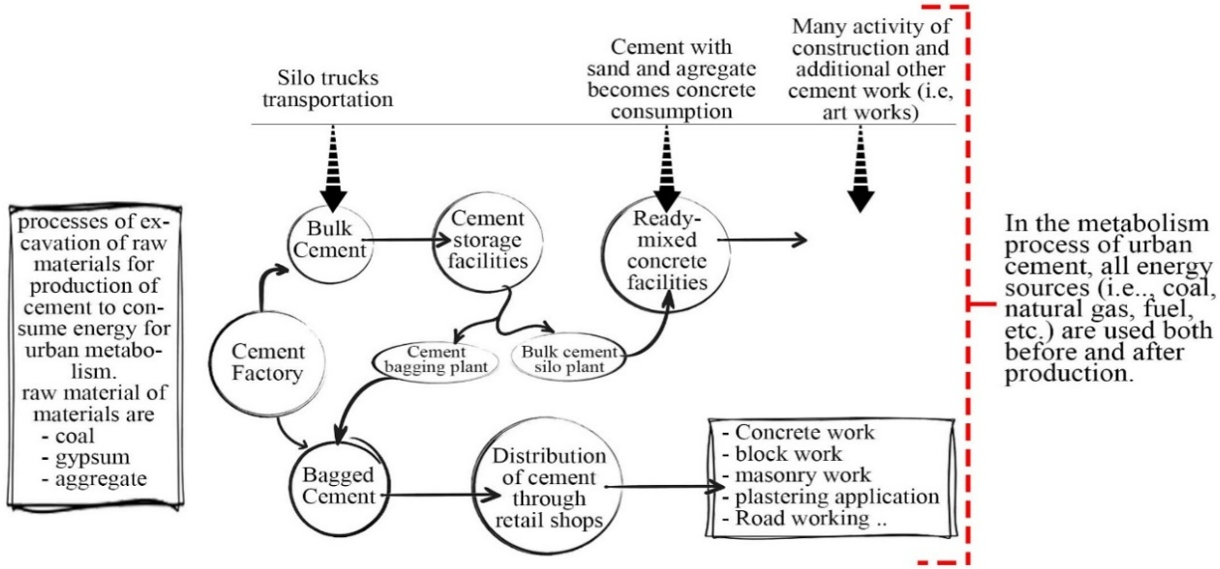
Figure 2.2: Cement metabolism complex network (Source: Author)
Generally, 1 ton of cement requires 181.437 kg of coal, 110 kWh of electrical energy (26% of total), and 60 to 130 liters of fuel or its equivalent. Non-renewable resources account for 88.6% of the total and 11.1% of sustainable indicators in the cement production industry. Ethiopia, with its renewable energy potential, has the potential to lead Africa’s green cement transition. Cement serves as both the economic and literal foundation of modern cities, shaped by complex interactions among material flows, labor dynamics, and urban development patterns. By constructing homes, businesses, and infrastructure, the cement sector contributes significantly to urban economies by promoting growth and development.
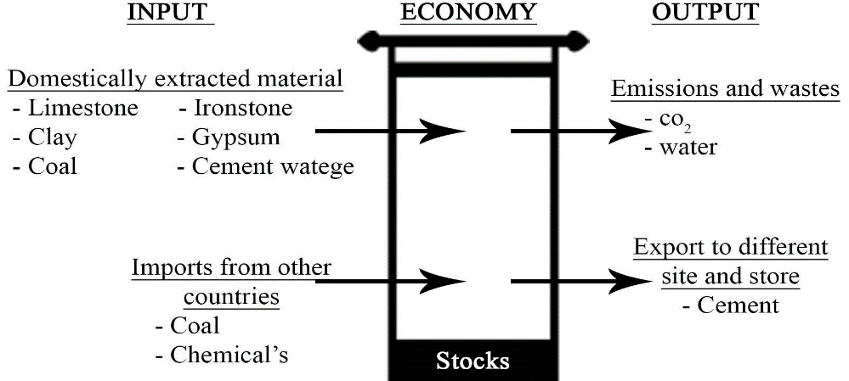
Figure 2.3: General framework for MFA across the economy. (Source: Author)

Cement Metabolic Flow, Typology and Assessment Methods

Cement Metabolic Flow and Typology
Cement metabolic flow pertains to the movement of cement materials within urban systems, encompassing production, and construction to demolition, and waste management. It is analyzed through different cement metabolic flow methods. The metabolism of cement involves the dynamic flow of cementitious materials through urban systems, influencing energy consumption and environmental impacts. It can be categorized into distinct typologies for efficiency, circularity, and sustainability.
- Linear Metabolism: The traditional cement production model, recognized for its substantial resource input, energy-intensive processing, and considerable waste output, is defined by linear metabolism.
Output (cement)
City/ Urban
Input Material
Wastage
Landfill (Disposal emits)
- Raw material
- Energy input
Figure 2.4: linear metabolism (source: Author)
- Circular Metabolism (Industrial Symbiosis & Recycling): Concentrates on closing material loops via recycling, alternative fuels, and clinker substitution.
City/Urban

Input Material

Output (cement)

Wastage

Reuse, Recycle

- Construction sector
- Infrastructure (road, pipelines…)

- Raw material
- Energy Input

Figure 2.5: Circular Metabolism (Source: Author)

Cement Material Flow Assessment Methods
The cement material flow method, which encompasses Life Cycle Analysis, Material Flow Analysis, Ecological Network Analysis, and Emergy Analysis, offers comprehensive insights into the environmental, economic, and systemic impacts of cement production. Those methods are discussed below:
- Life Cycle Analysis:
The built environment is acknowledged as a significant hotspot for resource use and environmental impacts. Life cycle assessment (LCA) has increasingly been utilized to evaluate the environmental impacts of construction products and buildings over the past 25 years. A new trend has emerged from applying LCA to larger systems such as urban islets or neighborhoods (Critical review of life cycle assessment (LCA) for the built environment at the neighborhood scale).
- Material Flow Analysis:
Material flow analysis (MFA) enables the assessment of a system's material consumption over a specific period, typically one year, while also allowing for the evaluation of trends in material consumption within the economic system through the development of time series (Smaranda, 2014). Although Industrial Ecology (IE) encompasses various perspectives and types of contributions, variants of material balances, specifically substance flow analysis and material flow analysis, provide the unifying conceptual and methodological core for IE (Duchin and Hertwich, 2003).
- Hybrid Methods
Based on the scope and boundaries of an MFA study, the raw material equivalents (cement) for traded commodities can be calculated using life-cycle assessment (LCA). This is particularly advantageous for estimating indicators determined by consumption, such as the material footprint of an economy. Multiregional input-output (MRIO) models have been most widely employed for the sectoral resolution of physical flows based on monetary inputs and outputs.
- Ecological Network Analysis:
Ecological network analysis (ENA) can tackle these challenges by representing the system as a network of nodes where flows of material or energy are exchanged (Ulanowicz, 2004) and then delving deeper into the analysis to assess the quality of the relationships (e.g., symbiotic or not).
- Emergy Analysis (Method of Data Analysis in all Energy):
This is part of a broader theory developed by Odum regarding the functioning of ecological systems. Emergy theory emerged from the understanding of how significant energy quality is and how beneficial it is to use a common denominator for different types of energy flows.

Sustainability and Urbanization
Sustainability is the “end goal” of sustainable development, while sustainable development is the road or pathways to achieve it (Hector et al., 2014). It defined sustainable development as development that meets the needs of the present without compromising the ability of future generations to meet their own needs World Commission on Environment and Development (WCED), and Brundtland, 1987, p.8). The WCED gained worldwide support for its argument that development must ensure the coexistence of the economy and the environment by comprising environmental, economic, and social pillars, however, this concept is subject to criticism on many grounds, especially for its ambiguity and the lack of tangible operationalization (Jerneck et al., 2010; Komiyama and Takeuchi, 2006).
Despite the MDGs' (Millennium Development Goals) emphasis on social, economic, and environmental dimensions, the implementation process was not as integrated as anticipated.

Cement Metabolism Globally and Local Level
This section overview of local and global cement production parameters and industry research. The four primary processes of cement production that were covered in the literature above result in the release of CO₂ from four distinct sources. The following topics tell us about cement at the international and domestic levels.
  - Cement at the Global level
Cement is the second most consumed material on Earth after water, playing a crucial role in urbanization and infrastructure. Each year, over 4 billion tons of cement are produced, accounting for 8% of global emissions—more than 2.5% from aviation and 3% from shipping. In the case of clinkers, one ton of clinker emits approximately 0.8 to 1 ton of CO₂ (60% from chemical reactions and 40% from fuel).

Figure 2.6: Greenhouse gas emissions from cement. (Source: ((EIA), 2024)

Table 2.1: International Electricity Market Report. Source (International Energy Agency, 2023)
No | Country/ Continent | Electricity/ton of cement | No | Country/ Continent | Electricity/ton of cement
 | Canada | 139 | 8. | Europe | 116
 | United States | 133 | 9. | Germany | 111
 | North America ex USA | 134 | 10. | Brazil | 108
 | Italy | 122 | 11. | Central America | 106
 | France | 119 | 12. | Japan | 106
 | CIS(states of Soviet Union) | 119 | 13. | Middle East | 103
 | United Kingdom | 116 | 14. | Africa | 103
Coal, the least expensive energy source, is expected to contribute to a portion of the fuel used in the cement industry due to environmental concerns.
  - Ethiopia and Addis Ababa Cement
- Cement Capacity and Demand
Ethiopia's demand for cement reached over 12 million metric tons in 2020. Still, despite the nominal installed capacity of nearly 20 million metric tons, local cement companies are only contributing about 8.9 million metric tons to this amount, according to the Chemical and Construction Inputs Development Institute (CCIDI). The CCIDI reported that the nation's cement capacity at this time was 17.1 million tons.
Ethiopia's cement production capacity has increased to 16.4 million tons, a tenfold rise from a decade ago, despite a low per capita consumption of 61 kilograms. The cement industry is grappling with supply shortages due to sector challenges, including a lack of raw materials, power outages, security concerns, foreign currency availability, and insufficient professional leadership, as well as truck shortages.
Addis Ababa, Ethiopia's rapidly urbanizing capital, plays a crucial role in the nation's cement demand, highlighting detailed consumption patterns, key drivers, and sustainability challenges. In Addis Ababa, cement consumption is projected to reach 4-6 million metric tons each year, representing 30-40% of Ethiopia's total consumption. Leading cement manufacturers, including Dangote Cement, Derba Midroc Cement, Mugher Cement, Messebo Cement, Habesha Cement, and National Cement. (Global , Highways, 2025)

- Cement Energy Metabolism
Ethiopia ranks 80th in the world for Coal consumption, accounting for about 0.0% (contribution to the world consumption) of the world's total consumption of 1,139,471,430 ton. (Worldometer, 2019)

Figure 2.7: Coal production in thousand tons. (Source: (Worldometer, 2019))
Addis Ababa's cement factories, such as Dangote Cement and Derba Midroc, heavily depend on imported coal for energy, with annual consumption estimated at 10,000-20,000 tons due to a construction boom from 2015 to 2019. The COVID-19 pandemic and subsequent economic challenges led to a decline in industrial activity and coal usage, prompting factories to seek alternative energy sources, including electric kilns and natural gas. Coal consumption is projected to stabilize between 15,000 to 20,000 tons annually in 2023-2024, driven by renewed construction activities and government policies encouraging local coal utilization.
Table 2.2: Coal consumption in Addis Ababa. (Source: (Worldometer, 2024))
Year | Estimated Coal consumption (tons/year) | Challenges
2020 | Approximately 10,000-12,000 | COVID-19 disruptions; industrial slowdown
2022 | “ 8,000-10,000 | Post-Tigray war economic strain; forex shortages
2024 | “ 12,000-15,000 | Partial recovery in the construction sector
Ethiopian company Yo Holding has launched the country's first coal-washing plant since 2022, eliminating the need for costly imports. In the Benishangul Gumuz region, the plant can process 1 million tons of washed coal annually.
Shortages of imported materials have prompted cement producers to source local coal supplies for manufacturing, resulting in a sharp increase in local usage from 20 percent to between 60 and 100 percent. The government has been encouraging the industry to replace coal imports with locally produced biomass.
- Cement Industry and Environment
The cement production process generates and releases waste gases such as dust, SO₂, and NO_{x}, leading to health problems like respiratory diseases and disrupted ecological conditions, impacting system sustainability. The table below presents emission limit values for effluent discharges into water and gaseous emissions from Ethiopian cement industries into the atmosphere.
Table 2.3: Limit Values for Emissions to Air and Water of Cement Production. Source: ((EIA), 2024)
 | Emissions to Air |  |  | Emissions to Water
No. | Parameter | Limit value (mg/Nm³) | No. | Parameter | Limit Value (mg/l)
 | Total particulates | 150 |  | pH | 6 – 9
 | Sulphur dioxide (SO₂) | 1000 |  | BOD5 at 20°C | 25
 | Nitrous oxide (as NO₂) | 2000 |  | COD | 150
 |  |  |  | Total phosphorus (as P) | 5
 |  |  |  | Suspended solids | 50
 |  |  |  | Mineral oils at the oil trap or interceptor | 20
- Cement Application
Cement is an essential material in construction, infrastructure projects, and flooring. It is utilized in foundations, columns, beams, slabs, and walls for residential, commercial, and industrial structures. Additionally, cement plays a key role in concrete production, mortar and plastering, flooring, waterproofing, and repair works. Its applications extend to pavement, terrazzo, industrial flooring, and repair mortars. Cement is also employed in decorative uses, such as patios and pathways, as well as in precast concrete products like pipes, poles, manholes, and railway sleepers. Furthermore, it is used for soil stabilization in road construction. Specialized applications include high-alumina cement for high-temperature resistance, white cement for decorative purposes, and rapid-hardening cement for swift repairs.
  - Case study: Heidelberg city, Germany “ Heidelberg Cement”
Heidelberg, a German city with a population of 160,000, is recognized for its leadership in sustainability, especially through Heidelberg Cement, a prominent building materials company. This study examines how Heidelberg optimizes cement metabolism. Annual (2023 data) cement demand is approximately 150,000 tons, with 50,000 tons (95% recycled) of waste produced each year, aiming for 50% recycled cement in public projects by 2025.
It is the first European city to adopt urban mining, repurposing construction and demolition waste for new projects. Cement, a manufacturer of construction materials, generated $22.15 billion in 2022. By 2030, concrete companies plan to provide circular alternatives.
Heidelberg Cement has developed TernoCem, an alternative clinker technology featuring an altered chemical composition and lower burning temperatures, leading to a 30% reduction in CO₂ output, the use of alternative raw materials, and a 15% decrease in energy consumption.
  - Circular Strategies & Innovations of Heidelberg City)
Heidelberg shows that smaller cities can lead global cement innovation through corporate Research & Development, local policies, and circular urban planning.
- Industrial Leadership
- Carbon Capture at Scale: The "mineralization" process captures 50,000 tons of CO₂ annually from cement plants and stores it in concrete.
- Alternative Raw Materials: Heidelberg's energy plant utilizes municipal waste incineration ash to substitute virgin limestone, while demolition waste recycles concrete aggregate to meet 20% of new mix demand. One of the alternative energy are:
  - Synhelion Technology (Sun-to-Liquid technology)
Synhelion converts solar energy into renewable solar fuels by converting CO₂ into high-temperature process heat. This heat is fed to a thermochemical reactor, producing syngas, which is processed into fuels like jet fuel, gasoline, or diesel. The remaining heat is stored for continuous 24/7 operation. This technology has four innovation fronts:
Mirrors (heliostats) - solar radiation onto the solar receiver.
Solar receiver - clean solar process heat at unprecedented temperatures beyond 1500°C.
Thermochemical reactor - solar heat to produce syngas (the precursor to synthetic liquid fuels),
The thermal energy storage - enables continuous 24/7 operation.
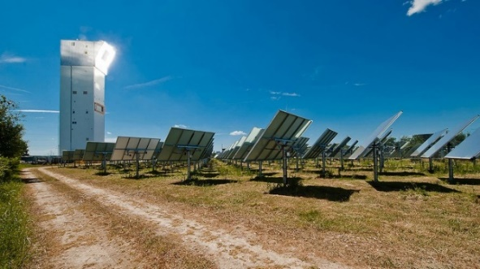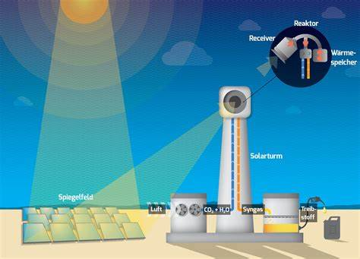
Figure 2.8: Synhelion (Source: (synhelion, 2024))
The fuel gas mixture known as "synthesis gas," or "syngas," is mostly composed of hydrogen, carbon monoxide, and occasionally some carbon dioxide. The primary byproduct of gasification, syngas, is essential to the pyrolysis process that is started on residues, biomass, and waste.
- City-Level Policies
- Green Building Code: The mandate requires 30% recycled content in municipal waste.
- Construction and Demolition: The process necessitates selective demolition to enhance material recovery. Building Material Registry for the City of Heidelberg. And aims to simplify the reuse of construction and demolition waste. In the future, the aim is to separate demolished concrete into its components and return it to the construction cycle.
- Subsidies: Grants are available to developers who use carbon-negative concrete, such as Heidelberg's "i.Cement".
- Urban Mining & Reuse
- "Baukasten" Initiative: The digital platform actively tracks the reuse of building materials, such as old sidewalks, to create new parks.
- Local Recycling Hubs: are engaged in processing demolition waste into high-purity Recycled Concrete Aggregate (RCA).
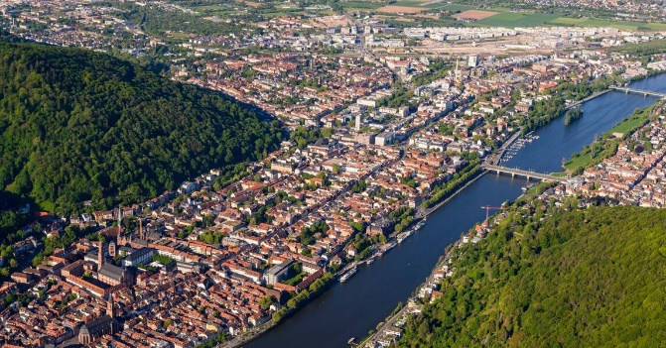
Figure 2.9: Circular City Heidelberg (Source: https://wall.alphacoders.com)

Chapter Three: Research Methodology
This study's research methodology encompasses the study area, design, target cement selection, sampling procedure, sample size, data sources, strategy, research framework, and data analysis and interpretation.

Study Area

Location map of Addis Ababa, Ethiopia
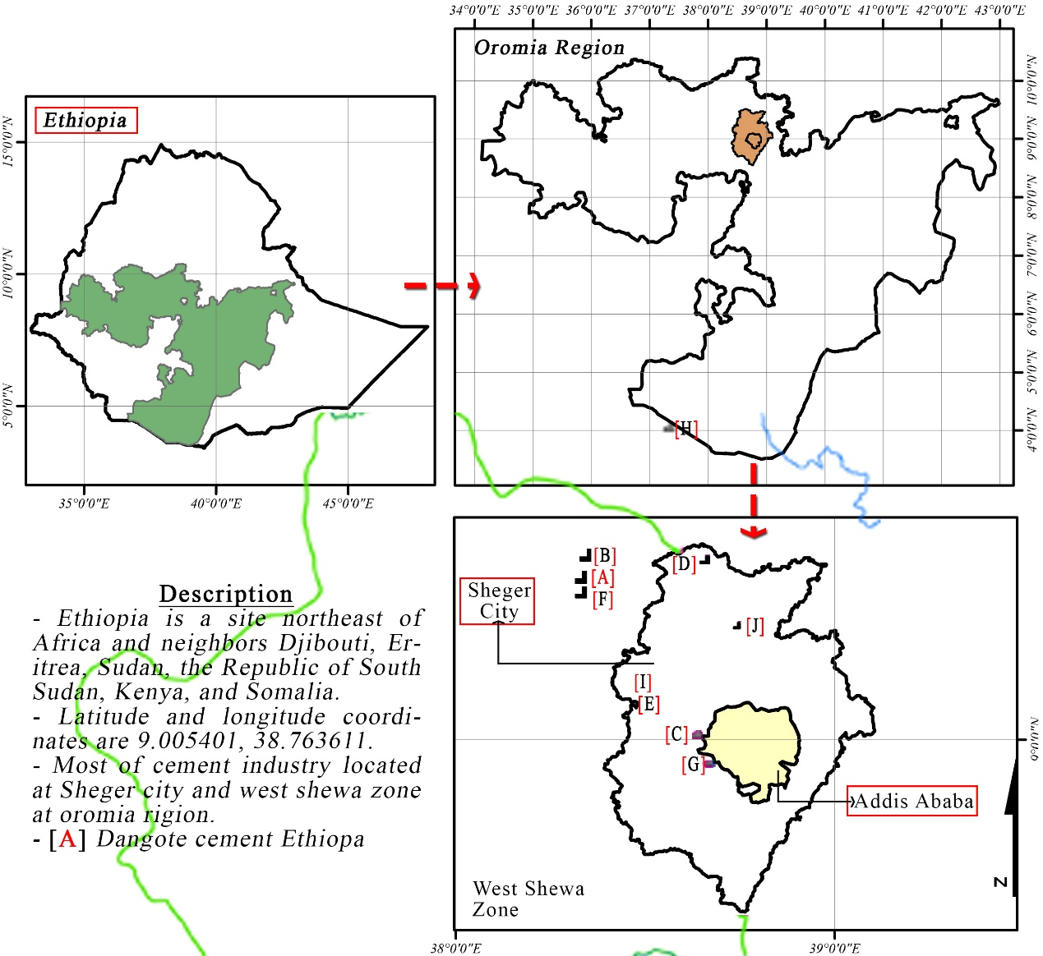
Figure 3.1: Location Map of the study area. (Source:Author)

Background Addis Ababa
Addis Ababa, the capital of Ethiopia and one of the largest cities in Africa, is home to millions of diverse individuals and serves as a crucial hub for transportation, logistics, and commerce. Founded in 1886, it is among the safest cities in Ethiopia and hosts industries such as trade, commerce, manufacturing, and civil administration. Tourism is also on the rise, thanks to an increase in shopping centers and attractions.

Research Design
The research aims to establish a flow of cement-related materials, energy, and emissions, including GHG, to draw conclusions and make recommendations.
- Resource efficiency in cement metabolism
The study quantifies the Emergy flows within Addis Ababa's cement production and consumption system, considering both renewable and non-renewable resources, as well as human labor and services, all converted to solar em-joules. The transportation of raw materials, such as limestone, silica sand, clay, and pumice, along with energy sources like electricity, fuel, and coal, is carried out using various types of trucks.
- Environmental sustainability
In the overall survey of clinker production, the grinding and transportation processes generate waste, including CO₂, fly ash, and kiln dust, while cement products are being produced. This waste is directed to the material collection site before reaching the production site, and then the final product is transported to the designated area, specifically Addis Ababa City.
- Potential of the cement industry and circular activity
After data collection, all results indicate that circular cement metabolism provides a triple-win solution, such as reducing emissions by breaking down greenhouse gas emissions, unlocking economic value, and minimizing waste. The circular activity of cement potential seeks to identify opportunities within the circular economy, including alternative fuels and waste reuse. It examines the material flow between the inputs and outputs of current and future advanced activities.
- Green energy technology
Identify alternative energy sources for sustainable cement production and consumption in cities, and develop a decision-support framework for stakeholders to prioritize sustainable interventions, aiming for net-zero emissions by 2050. Sustainable cement production incorporates alternative raw materials, carbon capture, utilization, storage, and low-energy kilns.
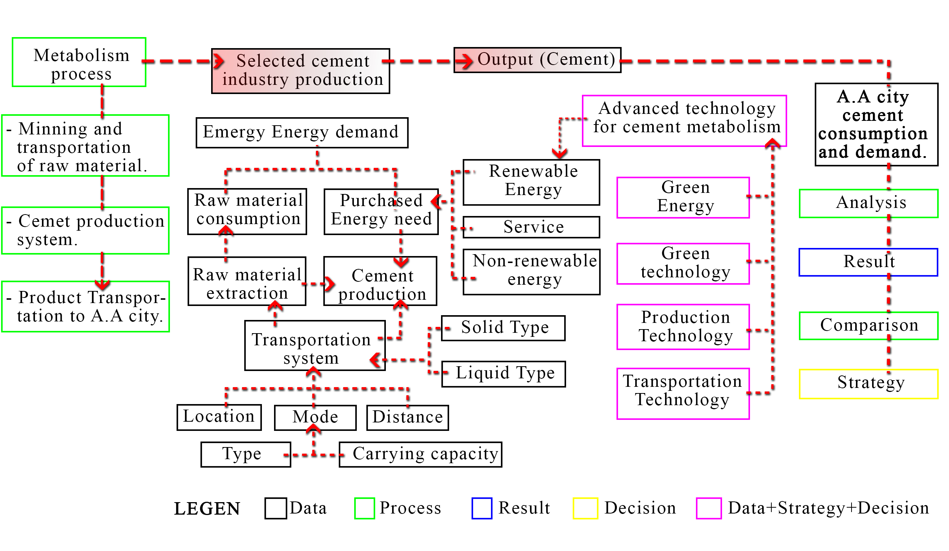
Figure 3.2: Research design chart

Data Types and Source
- Data Type
There are two ways to identify findings: first, through geographical urban cement material flows, and second, through findings that depend on local scales, such as neighborhood or construction industry scales of urban cement metabolism. This approach aids in identifying energy utilization, embodied material flows, and sustainable practices. The primary advantage lies in the systematic method of analyzing data gathered in Raw Material collection, Production Process, Byproducts amount, Logistics, and Distribution. The study conducted surveys on construction sites in Addis Ababa to analyze the patterns of cement utilization. Main data inputs and outputs in Addis Ababa cement include:
Primary data type
Data collected on resource consumption indicates that non-renewable resources such as limestone, clay, and gypsum are utilized for kiln heating, whereas renewable resources like solar, wind, and hydrogen energy are employed indirectly. This data can be collected from the cement plants industry, mining sites, the future capacity and potential of raw materials.

- Energy Flows
The data cement operates on energy; for instance, thermal energy is utilized in high-temperature kiln operations for clinker production, whereas electrical energy is employed for grinding, transportation, and plant operations.
- Emissions and Waste
To identify emissions and waste data, including CO₂ from calcination and fuel combustion, as well as SO₂, NOₓ, and wastewater. The cement industry releases emissions and waste into the air, water, and surface areas.
- Human and Economic Inputs
The human and economic inputs encompass labor, services, and procured materials such as imported coal, also calculated to identify urban cement metabolism.
- Data Source
This study employs both primary and secondary data sources. Data source includes:
- Primary Data Source
To gather Primary data sources for Addis Ababa city cement metabolism, including direct surveys at cement plants, transportation logistics (distance and fuel use), interviews with builders, contractors, and industry reports from the Ethiopian Petroleum Authority. Official websites provide global renewable energy potential analysis (including the Global Solar Atlas and Global Wind Atlas), featuring solar and wind data essential for energy planning in selected areas.
- Secondary Data Sources
Secondary data sources encompass literature-derived materials, as well as government and institutional databases, including the EFDR Minister of Mines and the Minister of Urban and Infrastructure. Data from secondary sources included academic and institutional publications, as well as reports from industry and international organizations.

Sampling Design
    - Sample Cement plant selection
There are currently over 19 cement producers in Ethiopia, reflecting a 26.67% increase since 2023. Twelve of these manufacturers are located in Oromia; however, they are spread across different regions. Addis Ababa serves as the primary distribution and administration hub for Ethiopia's cement industry, even though most large-scale factories are positioned outside the city (within 50–200 km).
The selection criteria for the cement industry focus on assessing a plant's capacity utilization, logistics costs, inventory management, production efficiency to improve profitability, inventory management, and cement production efficiency. Dangote Cement plans to expand its cement production in Ethiopia by 5 million metric tons, following the opening of its 2.5 million tons facility in the Mugher Valley in 2015. This cement industry is situated within a 100 km radius of Addis Ababa to Adda Berga, depends on Dangote's estimates, its market share to have been about 42.1% during the period, up from the 34 % of the market it controlled in 2021, and it is estimated that in 2022, it had a 42% market share.
    - Sample cement input material
Non-renewable resources: Cement manufacturing uses limestone, clay/sand, gypsum, and pumice as non-renewable raw materials. These materials are analyzed for A monthly raw material sampling schedule is implemented in the study for the quantitative data sampling related to energy and cement input material metabolism analysis, covering the collection and transportation of input, cement production, and distribution of cement.
Renewable resources: In the manufacturing of cement and sustainable energy, renewable inputs can replace conventional ingredients. The primary energy input for cement production is electricity from the national grid, which is used for grinding raw materials, powering kilns, and operating machinery. Alternative fuels consist of waste-derived fuels (such as plastics and tires) and biomass generated from agricultural waste. Data and annual consumption figures are utilized to calculate these materials.
Table 3.1: Parameters for the study
No. | Parameter | Measurement method | Unit
 | Raw material | Weighting scale | Ton
 | Energy | Reports | kwh
 | Transport distance | Supplier Records | km
 | Liquid input (fuel, water) | - | Litter
Sample Human and Economic Flows: The study assesses human carrying capacity by connecting labor productivity to the availability of renewable resources, comparing the investment in human capital with the total labor in the cement industry each year.
    - Sampling Size
The study assesses human carrying capacity by connecting labor productivity to the availability of renewable resources, comparing the investment in human capital with the total labor in the cement industry each year.
This study identifies individual cities, specific plants, and technologies related to cement production and distribution. It utilizes aggregated data from primary data by interview questionnaires, government reports, and cement plant databases. The sample size consists of over 100 measurements across all stages of the cement process, with at least 30 samples per subsystem. The data analysis examines input resource and energy input data for the kiln over a period of 6 months.
    - Sampling Technique
The methodology includes both top-down and bottom-up static or dynamic models for assessing stocks. Techniques such as geographical information systems and satellite-based imaging have facilitated various advances in measuring stocks and cement resource flows.
Study cement metabolism in urban areas, necessitating robust sampling techniques for precise data collection, representation, and sustainability assessment of cement input materials. Resource efficiency in cement metabolism data samples taken from Cement plants and construction sites demands intensive cement inflows, and we can develop an optimal cement solution for the city of Addis Ababa.
Each kilogram of cement production relies on environmental stresses like carbon dioxide and other greenhouse gas emissions, and it could be identified as a whole stress for Addis Ababa.
Information gathered from satellite data to develop Green Energy Technology to protect environmental stress and economic advantage for the cement metabolism of the city.
Stage sampling technique for Cement Flows is shown below:
- First stage: Identify key cement sources such as raw materials, energy inputs, and transportation activities to the cement plant site.
- Second stage: Sample the production of cement using input materials and energy for the output material or cement.
- Third stage: Distribute the product at the distribution site for construction activities.
Stage A: Input material and Transportation

Stage B: Output production (cement)
Stage C: Distribution to Addis Ababa

Figure 3.3: Linear cement metabolism process. (Source: Author)

Method of Data Analysis (Emergy Analysis)
Urban cement metabolism data analyses are an important tool for studying energy consumption, and urban ecological aspects. By this method, we can account for and evaluate Addis Ababa city cement material and energy flows in urban metabolic processes by taking Dangote cement industry. This research made Emergy analysis is a method employed to evaluate resource utilization in terms of energy memory, which aids in quantifying the sustainability and environmental costs associated with cement production, consumption, and waste management in Addis Ababa.
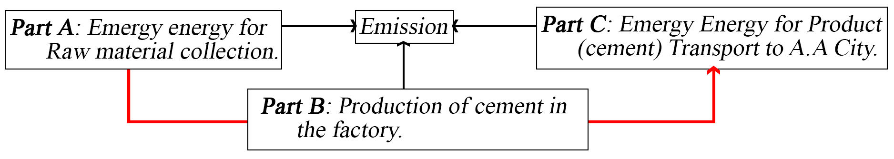
Figure 3.4: Metabolism of cement for A.A. (Source: Author)
Steps of Emergy Analysis for Cement Metabolism in Addis Ababa City are:
- Step 1: Define System Boundaries (Dangote Cement Ethiopia).
- Step 2: Identify Energy & Resource Flows in Emjoules (Sej).
- Step 3: Calculate Transformities (Emergy per Unit)
- Step 4: Compute Total Emergy Flows
- Step 5: Emergy Indicators for Sustainability

Table 3.2: Emergy indicators, formula, and interpretation. Source: www.emergy.org
Emergy Indictor | Formula | Interpretation
- Emergy Yield Ratio (EYR) - Measures efficiency | $$=\frac{Out Emergy}{ Inputs Emergy}$$ | < 1 --- Not Efficient  = 1 --- Break-even point  > 1 --- Efficient
- Environmental Loading Ratio (ELR) - Measures environmental | $$=\frac{Non-Renewable}{Renewable Inputs}$$ | < 1 --- Less Environmental Stress.  ≈ 1-3 --- Moderate Environmental Stress  > 1 --- Environmental Stress
- Emergy Sustainability Index (ESI) - Measures Sustainability | $${=EYR}/{ELR}$$ | > 1 --- Sustainable  ≈ 1-3 --- Moderate Environmental Stress  < 1 --- High Unsustainable.
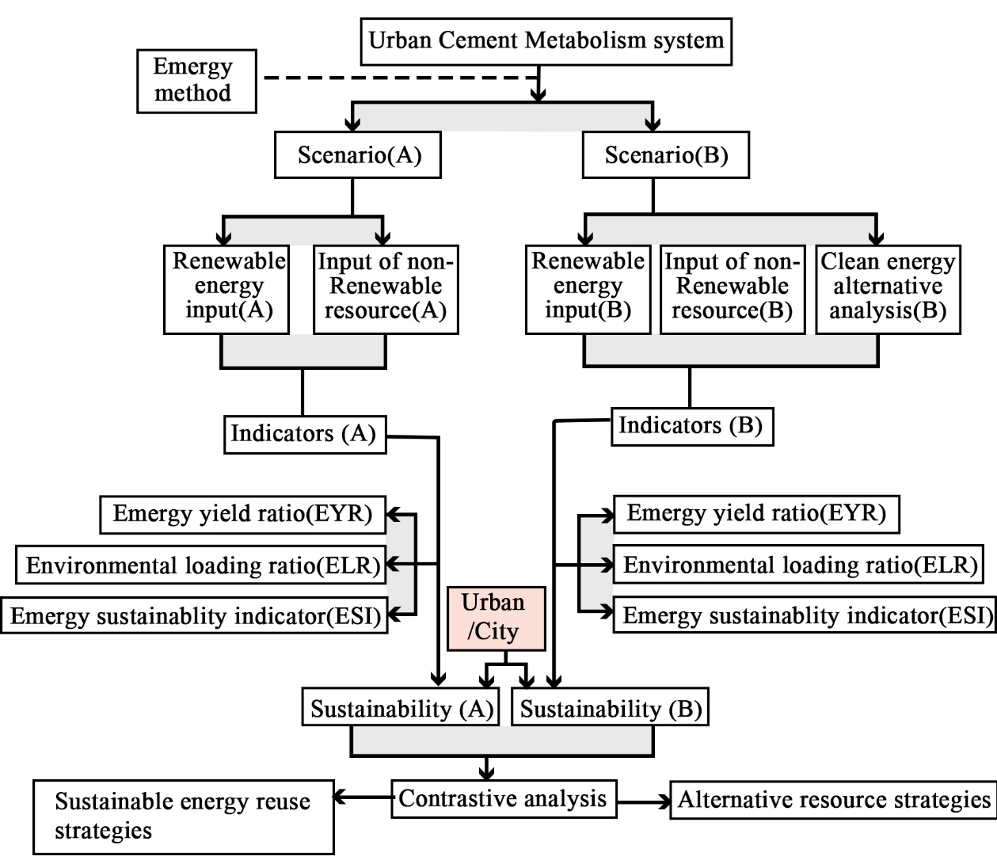
Figure 3.5: Emergy method cement metabolism system (Source (Wang H. L., 2022))
Where: Scenario (A): is the basic system, including the renewable and non-renewable resource inputs, and
Scenario (B): is a comprehensive system that integrates a clean energy subsystem, compared with Scenario (A).

Emergy method analysis in cement metabolism indicators
- Emergy Yield Ratio (EYR)
Clinker and gypsum are crushed together in a cement mill to produce cement. It is ground to a fineness determined by the requirements of the final cementitious product. Increasing the blending percentages of either slag or fly ash decreases the overall SEC of the particular grade of cement. Emergy yield ratio (EYR) given by:
$$Cement Emergy Yield Ratio \left(EYR\right) Cement= \frac{Emergy Output}{Emergy Input}………………….(31)$$
Source: www.e-education.psu.edu
The Emergy Yield Ratio (EYR) in cement production measures how efficiently a cement plant can create Emergy, including all energy utilized throughout the manufacturing process. (Pulselli, 2008)
$$Emergy Output =Cement product………………………………………………………(32)$$
$$Emergy Input=Sum of Embodied\left(Limestone+Gypsum+clay+…)+Labour and Service+Energy \left(electricity+fuel\right)\right)……….……(33)$$
Source: www.e-education.psu.edu
An increasing EYR is typically regarded as favorable since it indicates that the plant provides more value while causing less environmental harm. The unit of Emergy output and Emergy input is measured by solar Emergy joules per gram (sej/g) or per joule (sej/J). Where:
- Emergy Output refers to the total Emergy embodied in the product or service produced. and
- Emergy Input includes all the direct and indirect Emergy used in the process, such as raw materials, energy, labor, and services.
The typical Emergy Yield Ratio (EYR) for cement manufacturing might vary. In cement production, a greater Emergy Yield Ratio (EYR) is generally advantageous. It shows that the system generates more Emergy (embodied energy) than it consumes, making it more efficient and sustainable. While there is no one "best" number for EYR, a value much greater than 1 is preferable. Generally:
EYR > one, the system is efficient and has the potential for sustainability.
EYR >> 1 indicates a more efficient and sustainable system with a significant surplus of energy.
Achieving a high EYR in cement manufacturing often involves optimizing processes, utilizing renewable energy sources, and enhancing material efficiency.
In practical terms, an EYR < 1 suggests:
- High Energy Consumption: The production process is energy-intensive and not efficient.
- Unsustainability: The system is not sustainable in the long run, as it relies heavily on external energy inputs.
- Economic and Environmental Concerns: Higher costs and greater environmental impact due to the need for more energy resources.
- Environmental Loading Ratio (ELR)
The Environmental Loading Ratio (ELR) is the ratio of nonrenewable and imported energy consumption to renewable energy production. It represents the pressure a process exerts on an environment and is regarded as a measure of ecological stress.
In the context of cement production, the Environmental Loading Ratio (ELR) measures the environmental pressure exerted by the manufacturing process. This comprises the energy required to extract raw materials, create clinker (an important cement component), and manufacture the finished product. The ELR would consider the usage of nonrenewable energy sources (such as fossil fuels) and imported energy (such as nonrenewable electricity) in these processes in comparison to renewable energy sources. (Wang H. L., 2022)
$$Environmental Loading Ratio \left(ELR\right)= \frac{Nonrenewable Emergy}{Renewable Emergy}………………..(34)$$
Source: www.e-education.psu.edu
Consider a procedure in which the following Emergy inputs are used: where
- Renewable energy (solar and wind) for cement production: This is calculated by summing up all the Emergy inputs that come from renewable resources. This includes:

- Solar radiation
- Wind energy
- Hydropower
- Geothermal energy
- Biomass

- Non-renewable energy for cement production: This energy is the total sum of all fossil fuels (coal, oil, natural gas…)
Environmental Loading Ratio (ELR) readings may be classified into various levels of environmental load.

- Low values: ELR < 1.
- Moderate intensity: Approximatlly
- High environmental load (ELR > 1)

These guidelines aid in determining the sustainability of a system, with lower ELR values suggesting less environmental stress.
- Emergy Sustainability Indicator (ESI)
The Emergy Sustainability Indicator (ESI) for cement production evaluates the total sustainability of the cement manufacturing process. It is determined by dividing the Emergy Yield Ratio (EYR) by the Environmental Loading Ratio (ELR). (Wang H. L., 2022)
$$Emergy Sustainability Indicator \left(ESI\right)= \frac{Emergy Yield Ratio\left(EYR\right)}{Environmental Loading Ratio\left(ELR\right)}………………………(35)$$
Source: www.e-education.psu.edu
The meaning of ESI values includes the following:
- ESI >> 1 shows that the system is sustainable and the economy is strong.
- An ESI value of less than one suggests that non-renewable resources and products, or imported energy.

Sustainability: Energy analysis assesses the sustainability of cement production by evaluating energy efficiency, resource utilization, and environmental impacts, given that the cement industry plays a significant role in global CO₂ emissions.

Method of Data Presentation
The data is presented as tables, charts, graphs, maps, and pictures. This data will be presented by using different software like Adobe Illustrator, Microsoft Word, Microsoft Excel, etc. Other essential websites are used like Global Solar Atlas and Global Wind Atlas.

Chapter Four: Results and Discussion

Addis Ababa City Energy and Cement Metabolism

Introduction
Ethiopia is the third-largest cement producer in sub-Saharan Africa, after South Africa and Nigeria. Ethiopia has a cement capacity of approximately 16.5 million tons, with an average annual demand increase of 10%. (Limited, 2024)
Ethiopia's domestic cement industry is dominated by foreign and local firms, with 19 companies running 23 facilities. The largest operators include Dangote, Derba Midroc Cement, Mugher Cement, Messebo Cement, National Cement (a subsidiary of East African Holding), and Habesha Cement. (Ethiopian cement industry, 2023)
According to the above, over 40% of cement production facilities are located in and around Addis Ababa. Ethiopia's domestic demand was 5.5 million tons short in 2021. (Ethiopian cement industry, 2023). Ethiopia now has a 50% utilization rate for its cement-producing capacity. Although per capita cement use in Ethiopia is rising, it is still far less than the global average. However, it is assumed that per capita cement consumption will rise from 62 kg to 179 kg by 2025. (Dure Mulatu, August 2018).

National Production, consumption, and Availability of cement
There are 171,000,000 metric tons of limestone, 21,600,000 metric tons of clay, 57,400,000 metric tons of silica sand, 3,400,000 metric masses of gypsum, and several million tons of pumice in reserve in Ethiopia. (Ethiopian cement industry, 2023)
Table 4.1: Cement plants in Ethiopia with >2 million (Source: FDRE Minister of Mine)
Plant | Clinker Capacity (ton/day) | Cement production (Mt/y)
- Dangote Cement (Adda-Berga) | 4800 | 2.5
- Muger Cement Enterprise (Sheger City) | 2000 | 2.26
- Mugher Cement Expansion project (Muger city) | 3000 | -
- Messobo Cement Expansion Project (Mekele City) | 3300 | 2.26
- Derba MIDROC Main Cement Plant (Derba) | 5600 | 2.3
Other than Dangote cement Ethiopia, cement industries contribute less to Addis Ababa and its surroundings. Due to their limited capacity and distance from the city, these industries have a reduced impact on Addis Ababa and its neighboring areas. For instance, Messobo Cement Factory (located in Mekele City) and National Cement (based in Dire Dawa) are both far from Addis Ababa. In contrast, Derba Midroc serves as the main supplier for the Grand Ethiopian Renaissance Dam (GERD). From the above table, the suppliers of cement materials from top to bottom are Dangote Cement, Muger Cement, and Additionally, Habesha Cement, located in the eastern part of West Shewa from Addis Ababa.
Table 4.2: Cement in the last 6 years and 2025 in Ethiopia (Source: FDRE Minister of Mine)
Year (G.C) | Cement Capacity(Mt/y) | Cement production(Mt/y) | Domestic cement Consumption(Mt/y) | Domestic Cement Deficiency/year
2015-2016 | 13.6/15 Factories | 8.16/14 Factories | 9.0 | 0.84
2016-2017 | “ | 6.8/12 Factories | 9.9 | 3.1
2017-2018 | “ | 8.2/15 Factories | 10.89 | 2.69
2019-2020 | “ | 8.6/14 Factories | 11.98 | 3.38
2020-2021 | “ | 7.8/12 Factories | 13.18 | 5.38
2021-2022 | “ | 12.6 | 15.30 | 2.7
2025 | 25.16 | - | 16.90 | 8.26 (Surplus)
Note: Ethiopia will have a 10% average growth in annual consumption
The report shows a steady increase in domestic cement production, consumption, and deficiency over the years, with a surplus in 2025. Factories' production has been steadily increasing since 2015.

Ethiopian Cement Industry Energy Consumption
One of the primary causes of high production costs in the Ethiopian cement sector is the utilization of outdated technologies, such as vertical shaft kilns (VSK), which result in high energy expenses, high operating costs, and low-quality output.
Input of Renewable Energy: Ethiopia's cement production industry is heavily reliant on imported energy sources. This has a major effect on the industry's high production costs, and the environmental impact requires a wide area to produce energy. Currently in Ethiopia main renewable energy is produced from hydropower, but this country also has the capacity for other renewable energy.
Input of Non-renewable Resources: The main non-renewable energy import is all the liquid petroleum gas from Kuwait, Saudi Arabia, and United Arab Emirates. In the 2019 fiscal year, Ethiopia was worth a total amount of 81.8 billion Birr (approximately $2.82 billion) of fuel. Depending on Ethiopia’s Transport and Logistics Ministries data in 2025 G.C, Ethiopia is expected to increase the amount of fuel imports with a value of USD 6 billion (worth, 2019). The following table indicates that Ethiopia imported fossil fuel and the total reserve:
Table 4.3: Ethiopia's hydrocarbon gas liquid Average Energy (thousand barrels per day (TBPD) and Ethiopia’s Natural gas reserve (Trillion Cubic Feet (Tcf)).
No. | Year | 1983-1992 | 1993-2002 | 2003-2012 | 2013-2022
 | Liquefied Petroleum Gas (LPG) Consumption | 0.2 | 0.07( Only 1st 5 year) | 0.05 | 0.22
 | Natural gas reserve | 0.9 | 0.9 | 0.9 | 0.9
LPG is the main source of energy used to develop the transportation economy, including goods and public transportation, and is a significant source of environmental harm.
Table 4.4: 40 years of Coal and coke consumption of Ethiopia.
 | Value by Mt
Years | Annual Ethiopia Subbituminous consumption | Bituminous consumption, Ethiopia, Annual | Coal consumption, Ethiopia, Annual
1983-1992 | 0 | 0 | 0
1993-2002 | 0 | 0 | 0
2003-2012 | 0 | 0 | 400.7
2013-2022 | 400.7 | 377 | 5086
Liquefied petroleum gas (LPG) is used by Ethiopian cement manufacturers as an alternative fuel due to its cleaner burning properties, with an average annual consumption of 0.135, and natural gas reserves are 0.9.

Addis Ababa City Urbanization, Housing and Cement Consumption

Addis Ababa City Urbanization and Housing
- Addis Ababa city Urbanization
Ethiopia is one of the least urbanized countries in Africa. Urbanization greatly drives cement consumption, as the construction of buildings, roads, bridges, and infrastructure primarily relies on concrete. The construction sector in Ethiopia generates a significant number of jobs as a result of urbanization (Alemayehu, 2024). The rate of urbanization will double in the next 20 years. Ethiopia's urban population is expected to nearly double during the next 30 years, reaching 38.51% by 2050, from its present level of 21.1% urbanization (Worldometer, 2019).
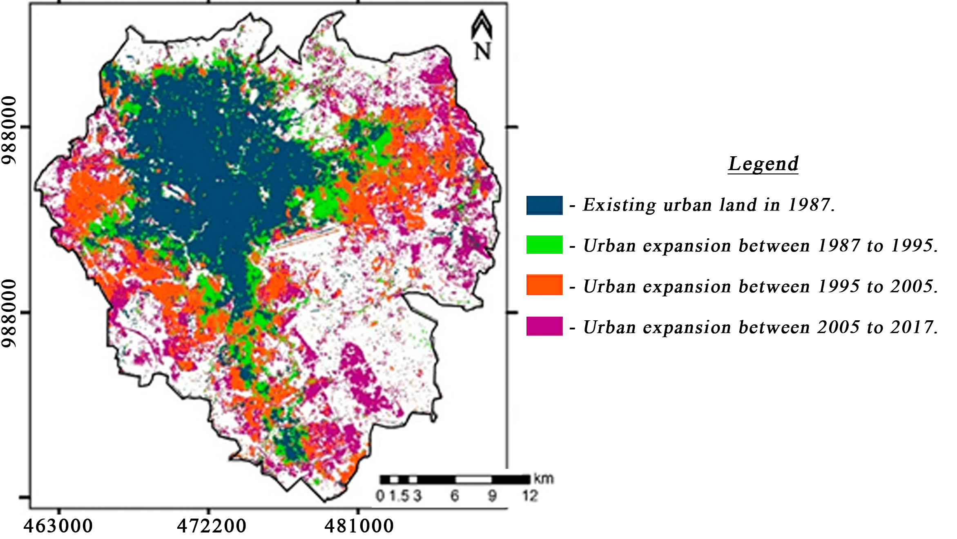
Figure 4.1: A.A Urban Expansion 1987-2017 (source: (Atlas of Urban Expansion - Addis Ababa., 2010))
Between 1987 and 2017, Addis Ababa's urban land increased from 99 km² to 283.9 km², whereas the forest area decreased proportionately from 21% in 1986 to 5% in 2015. But reforestation started in 2018 and up to now.
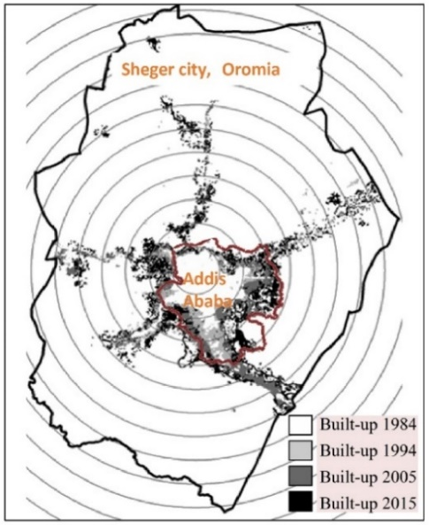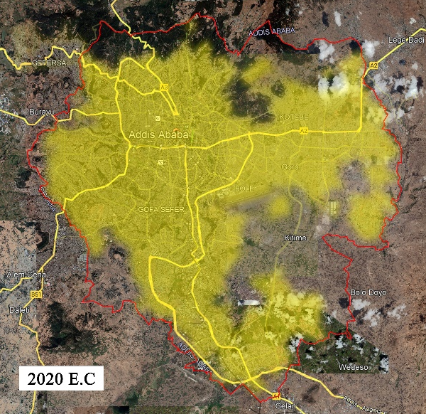
Figure 4.2: Urban Expansion 1984, 1994, 2005, 2015, and 2020 (Source: Addis Ababa’s Strategic Development Framework June 2021).
Addis Ababa's sub-cities have repurposed land for retail and corporate operations, while the surrounding six sub-cities have converted agricultural land into residential dwellings, manufacturing, and storage.

Table 4.5: Addis Ababa City Urban Expansions and Agglomeration.
Year | Administrative  boundary (in km²) | Urban  Agglomeration (in km²) | Built-up land area (in km²) | Built-up land area Difference (in km²)
Established city (1912) | 32 | - | - | -
1984 | 218 |  | 80.6 | -
1994 | 526.99 | 180 | - | -
2005 | 526.99 | 215 | 198.7 | 118.1
2015 | 526.99 | 325 | 364.5 | 165.8
2028 | - | 371+406 | - | -
Table 4.5 shows that since its founding in 1912, when its administrative boundaries were 32 km², Addis Ababa has continued to grow. By 1984, it had grown to 218 km² and now stands at around 527 km². The city's built-up area has also expanded. For instance, in 1984, the urban agglomeration built-up land area was 80.6 km² by 2028, it's expected to reach a whopping 371+406 km².
- Addis Ababa City Housing
Addis Ababa faces considerable housing challenges from rapid urbanization, population growth, and inadequate infrastructure. The Ethiopian construction sector is projected to see a real expansion of 4.7% in 2021, a notable increase from the 3.1% growth rate in 2020, and is expected to grow at an annual average rate of 8.3% between 2022 and 2025. Here’s a summary of the housing situation in the city:
Housing supply, demand and shortage: Addis Ababa is experiencing a significant housing deficit of over 1 million units, worsened by the city's growing population of more than 5 million and an annual growth rate of approximately 3.8%. Annual housing demand is approximately 150,000 units, while only about 50,000 units have been constructed (Tesema, 2025).
Government Housing Programs: The Integrated Housing Development Program (IHDP), initiated in 2005, aims to construct condominiums for low and middle-income residents but encounters challenges such as lengthy waiting lists. Over 200,000 units have been completed.
Informal Settlements: Over 80% of Addis Ababa's housing, mainly informal and substandard, is marked by dense slums, inadequate sanitation, and overcrowding, even though government relocation programs frequently lack jobs and services.

Addis Ababa Cement Consumption
According to the National Bank of Ethiopia's trading economics data, Ethiopia's GDP from construction climbed to 468.44 ETB billion in 2021, up from 446.72 billion in 2020. From 2012 to 2021, GDP from construction in Ethiopia averaged 299.27 ETB billion, with an all-time high of 468.44 ETB billion in 2021 and a record low of 114.42 ETB billion in 2013. The National Bank of Ethiopia predicts a 7.9% increase in the Ethiopian economy in the fiscal year 2023/2024, starting on July 8, 2023. Ethiopia's GDP annual growth rate averaged 5.97 percent from 1981 to 2023, with an all-time high of 13.90 percent in 1986 and a record low of -11.10 percent in 1984.
Market research predicts Ethiopia's cement business to be worth around $2.16 billion by 2023, with an annual growth rate of 3.2%. The industry is expected to continue to grow steadily, reaching around $2.46 billion by 2027. The country's cement output is predicted to expand from $2,096.7 million in 2022 to $2,459.7 million in 2027.
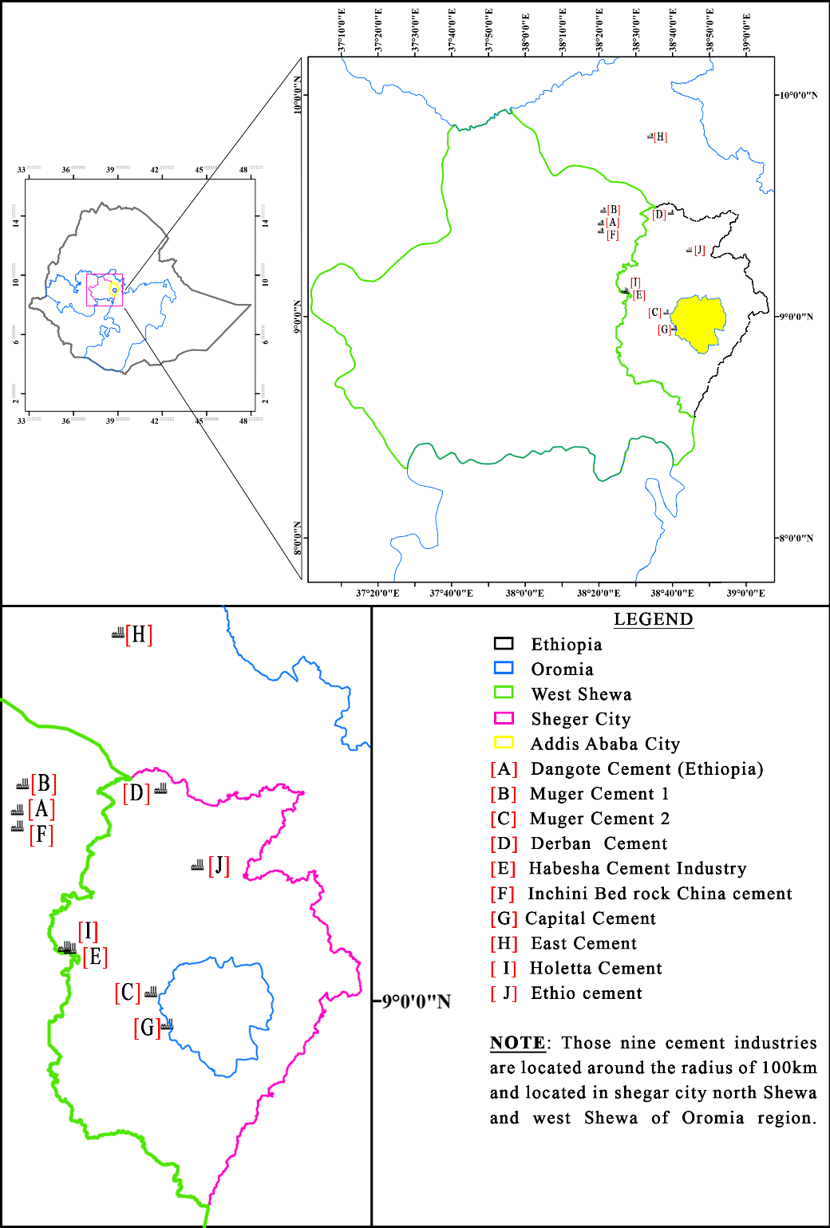
Figure 4.3: Location of cement factories within a radius of 90km to the west of A.A.
Addis Ababa consumes 4 to 6 million tons of cement annually, accounting for 30 to 40% of the national demand, with a per capita consumption of 800 to 1,000 kg, which is significantly higher than the national average in Ethiopia.
Table 4.6: Addis Ababa City cement consumption Comparison with Other Regions (source: FDRE Minister of Mine)
No. | Region | Estimated (ton/year) | % of national Demand | Avg of national  Demand (%)
 | Addis Ababa | 4-6 million | 30-40 | 35
 | Oromia | 3-4 “ | 20-30 | 25
 | Amhara | 2-3 “ | 15-20 | 17.5
 | SNNP & Others | 2-3 “ | 15-20 | 17.5
(Note: Estimates based on construction activity, cement industry reports, and urbanization rates.)
According to Dangote Cement Ethiopia data, it produces 2.5 million tons of cement annually and accounts for approximately 40% of the cement supply for national demand. The company is a significant contributor to Ethiopia's infrastructure growth, supporting essential projects in housing, commercial buildings, and industrial development.
Average cement consumption of A.A = $\frac{\left(Maximum+minimum\right)cement consumption}{2}$
=$\frac{\left(4+6\right)million }{2}=$5 million tons of cement per year
Dangote Cement Ethiopia can provide a reliable estimate based on industry insights and regional data, yet it does not provide a precise market share for Addis Ababa alone. Then More than 40% of plants are located in and around Addis Ababa, where production is centered. In light of these elements, it is conceivable that Dangote Cement meets between 30 and 40 percent of Addis Ababa's cement needs, which is consistent with the city's high level of infrastructure and its national supremacy.
- Dangote Cement for national Demand = 40% × Cement Production = 40% × 2,547,063 milli = 1.6 million tons of cement
- Dangote Cement consumption of A.A _{(Maximum)}=40%×Cement Consumption _{(Maximum)} = 40% × 6 million = 2.4 million tons of cement
- Dangote Cement consumption of A.A _{(Average)} = 40% × cement consumption _{(Average)} = 40% × 5 million = 2 million tons of cement
Note: The remaining five hundred thousand tons of the cement market share per year from Dangote Cement Ethiopia could be located near A.A City and its surrounding region.

Dangote Cement Ethiopia Cement Metabolism
Different inputs of cement manufacturing material and energy consumption, giving environmental decision-making solutions, and evaluation of the system's energy flow.
Dangote Cement Production and Capacity: Dangote Cement Industry plans to invest $650 million in a cement manufacturing facility in Mugher, Ethiopia, which is 83 km west of Addis Ababa, aiming to increase its market share from 30 to 40%. In 2015, Ethiopia's Dangote Cement Industry commissioned a 2.5 million-ton facility with a load of 6,000 tons of cement every 8 hours. This factory produce 60 million polypropylene cement bags annually for packing cement. The company operates 420 trucks, staffed by there skilled logistics team, which is essential for supporting both inbound and outbound supply chains.
The DC gives data analysis on installed capacity and actual production, which are then utilized to calculate capacity utilization. The capacity utilization for any given year and future capacity utilization are defined as the following:
$$Capacity Utilization=\frac{Actual Production in Tones}{Production Capacity in Tones}×100…………………………(4 SEQ Equation \backslash * ARABIC \backslash s 1 1)$$
- Actual production capacity of Dangote (Dispatch) _{2015/16} = 1.855 million tons
- Production capacity of Dangote= 2.5 million tons
- $Capacity Utilization of 2023 year=\left({1.855}/{2.5}\right)×100= 74.2\%$
Table 4.7: Production of Dangote cement capacity and capacity utilization details
Year | Cement Production | Dispatch (Mt) | Capacity Utilization (%)
2015/16 | 1.86 | 1.855 | 74.2
2016/17 | 2.056 | 2.042 | 81.68
2017/18 | 2.03 | 2.03 | 81.2
2018/19 | 2.034 | 2.036 | 81.44
2019/20 | 2.12 | 2.13 | 85.2
2020/21 | 2.15 | 2.13 | 85.5
Note: Dangote Cement Ethiopia produces 6000 tons of clinker per day with a capacity of 2.5 million tons of cement annually.
The Dangote cement metabolism of a cement factory involves a continuous flow of materials and energy, transforming inputs into useful products and waste. The inputs consist of limestone, clay, pumice, iron ore, and gypsum, while the energy sources include coal, natural gas, fuel, and alternative fuels. Next, we discussed the input and output material for Dangote Cement.
- Production Raw Material Consumption of Dangote Cement
Table 4.8: Average Amount of PPC & OPC production of raw material
No | Material | PPC Material | OPC Material | Location of materials
 | Clinker | 101,966 (67%) | 39,087 (95%) | Around Factory (7-10Km)
 | Pumice (Pozzolana) | 78,521 (28%) | 0 | Meki (221-230km)
 | Gypsum | 4,444 (5%) | 1,050.15 (5%) | Around Factory
 | HGL (Hydrocarbon Gas Liquids) | 0 | 3770 | Middle East through Djibouti port
Table 4.8 indicates the extraction of cement materials like clinker, pozzolana, gypsum, and HGL for the factory from Meki and the Middle East through the Djibouti port.
- Energy Flow in a Dangote Cement Plant
The figures 4.4 show the Dangote cement industry's mass balance and general energy flow. Temperature energy is expressed in MJ/kg, whereas electrical energy flow is described in kWh/ton at each sub-process.
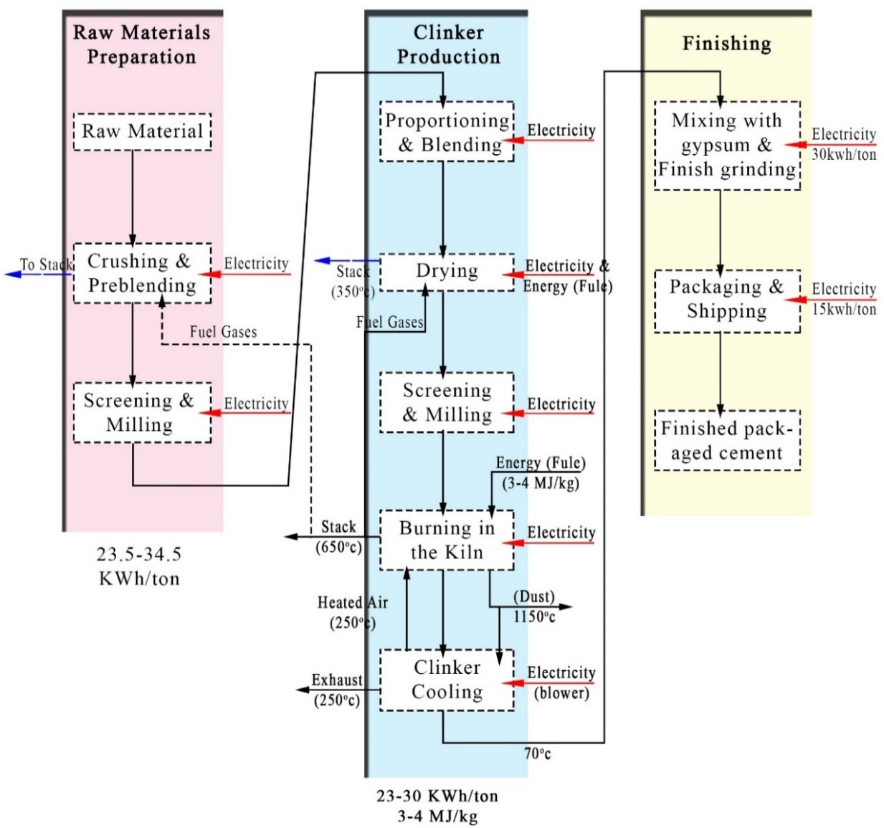
Transport-ation
Transportation
Figure 4.4: Energy flow in a Dangote cement. (Source: Dangote Cement)
In this section, we examine scenario (A), which represents the fundamental energy system of cement production, including both renewable and non-renewable resource inputs (but excluding energy-efficient ones). In Dangote Cement, energy is used to produce and distribute cement to Addis Ababa (with average of 35%).
To obtain the required calcination temperature (usually between 860°C and 950°C), the precalciner uses both the primary fuel (e.g., coal) and alternative fuels. The heat that remains comes from the kiln's exhaust gasses.

Table 4.9: Summary of both Electrical Energy and Thermal Energy consumption (source: Dangote cement Ethiopia)
No. | Sub-process | Electrical Energy consumption (KWh/t cement) | Thermal Energy Consumption (kCal/kg clinker)
 | Crusher | 0.93
 | Raw Mill | 15.91
 | Kiln & Cooler | 20.12 | 808
 | Coal Mill | 3.41
 | Cement Mill | 38.74
 | Packaging Plant | 1.59
 | Lighting & Misc. load | 3.00
 | Total | 83.71 Approximately = 90 | 808
Note: $1\text{ kcal/kg}=0.001162\text{ kWh/kg}$ or $1\text{ kWh/kg}=860.4216\text{ kcal/kg}$

Figure 4.5: Temperature of clinker using fuel chart (source: Dangote Cement)
- Type of Energy Consumption for Dangote Cement Production
- Renewable Resource Inputs
Electricity from the Grid: Dangote Factory usage involves extensive electrical energy consumption for industrial activities, lighting, housing, and auxiliary power. Some facilities rely on grid power, while others use captive power facilities (CPP), which send extra electricity to the grid. The following equation is used to convert the previously mentioned data to the relevant kCal:
$$Purchased Electricity from Grid \left(kcal\right)=Purchased units×860\frac{kcal}{kWh}…………………(4 SEQ Equation \backslash * ARABIC \backslash s 1 2)$$
Given:
- Total power received from the power grid 431,687 kWh/month.
- Total power consumption of Dangote cement factory=427,395 kWh/Month
- Total power consumption of Dangote cement factory= 56,110,598 kWh/Year
$Purchased Electricity from Grid \left(kcal\right)=431,687\left(12 year\right)×860\frac{kcal}{kWh}$= 4,455,009,840 kcal
Table 4.10: Dangote cement industry Electric consumption (Source: Dangote cement company and the Ethiopia Ministry of Mining and Energy)
Cement machine | Production | Power needed in kWh/t | Total Power needs in kWh/t | Total Power Ton/hour (tph) | Power consumption kWh/year
Crusher and conveying | 539,464 | 3.01 | 3.34 | 938.8 | 1,799,179
Total Raw Mill grinding | 629,456 | 22.20 | 22.41 | 542.4 | 14,107,387
Kiln and Cooler Total | 411,060 | 22.11 | 34.14 |  | 14,035,535
Total Coal Grinding Mill | 67,898 | 4.01 | 4 | 50.6 | 2,546,979
Total Cement Mill Section | 603,574 | 35.72 | 35.72 |  | 21,557,875
- Cement Mill-CM A |  |  |  | 140.62 | 10,123,676
- Cement Mill-CM B |  |  |  | 133.79 | 9,359,578
Cement Loading Sys(Packing) | 590,472 | 1.3 | 1.3 |  | 757,569
Utilities Total |  | 0.9 | 1.7 |  | 526,950
Lighting Total |  | 0.6 | 0.6 |  | 351,569
Colony and Miscellaneous |  | 0.2 | 0.2 |  | 122,431
Distribution Loss |  | 0.51 | 0.5 |  | 305,124
Total |  | 90.5(Avg) | 103.91 |  | 56,110,598
Power Received |  |  |  |  | 56,426,607
Limestone to Raw Mill |  | 0.88
Raw mill to clinker |  | 1.53
Coal to clinker |  | 0.15
- Non-renewable Energy input:
Embodied energy, the main material to construct buildings and urban construction is the energy for extracting, processing, transporting, and assembling materials and products. To produce cement in the Dangote cement industry needs different basic minerals like limestone, Gypsum, around the factory, local coal from the Kamashi Beneshangule-Gumuze region, and Meki. The next figure indicates the distance to the factory to different sites of mineral extraction.
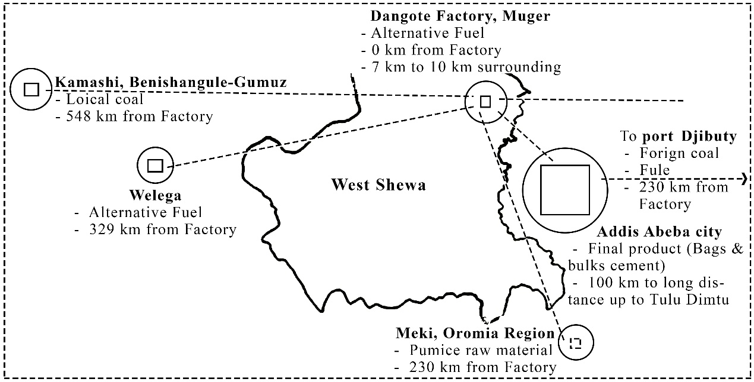
Figure 4.6: Location, distance of different minerals, and distribution to Addis Ababa city. (Source: Author)
As mentioned earlier, Dangote Cement Ethiopia can help identify and calculate renewable and non-renewable energy sources. This means that Dangote's cement contribution to Addis Ababa will also help determine the renewable or non-renewable energy source in Addis Ababa's annual cement consumption. This will help boost the GDP of the construction in the country and Addis Ababa.
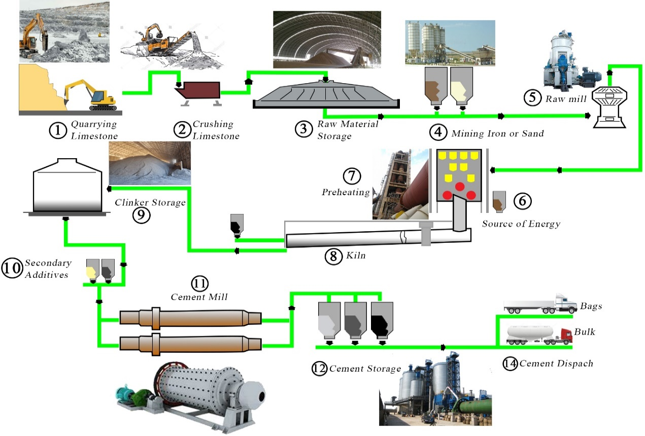
Figure 4.7: Materials Extraction with processes around and in the factory. (Source: Author)

Table 4.11: Embodied material need (Main Cement Materials, Corrective Material, and Adhesive Material) in tons
Stage A) Raw Material for Raw Mill
No. | Evaluating Cement Material | Detail Material | Total Average Consumption ton/month | Annual Total raw material for the raw mill by ton
 | Main Cement Materials | Limestone | 217,329 | 2,607,948
 | Corrective Material | Silica sand | 19,366 | 232,392
 | Corrective Material | Red clay | 11,675.63 | 140,107.56
 | Corrective Material | Iron ore | 1,156.4 | 13,876.8
 | Adhesive Material | Gypsum | 5,494.15 | 65,929.8
 | Adhesive Material | Pumice | 78,521 | 942,252
Total Embodied Material (Ton) |  |  |  | = 4,002,506.16

Table 4.12: Embodied material for last production need (Raw meal and Coal) in tons
Stage B) Raw material for Clinker Production
No. | Embodied Material | Detail Material | Total Average Consumption ton/month | Annual Total cement production material by ton
 | Raw meal | Stage A material without gypsum | 249,527.03 | 2,994,324.4
 | Coal | - Foreign coal(fuel) | 20,273.6 | 243,283.2
 | Coal | - Local coal | 9,670.9 | 116,050.8
 |  | Total coal consumption | 29,944.5 | 359,334

In Table 4.12 detailing the embodied material for clinker production, specifically focusing on raw materials, by type meal and coal consumption. This provides a breakdown of material consumption by type including average monthly and annual figures for cement production.
Table 4.13: Annual average of record of Raw material consumption for Cement Production and Dispatch of cement
No. | Cement Type | Type of Cement Raw Materials | Average total Cement production ton per month | Annual Total cement production material by ton | Dispatch type | Average total dispatch ton per month | Annual Total Dispatch by ton | Total sells to Addis Ababa (35 %)
 | PPC | Clinker | 101,966 | 1,223,592 | PPC-Bags | 147,115 | 1,765,380 | -
 | PPC | Pumice | 78,521 | 942,252 | PPC-Bulk | 23,311.5 | 279,738 | -
 | PPC | Gypsum | 4,444 | 53,328
 | OPC | Clinker | 39,087 | 469,044 | OPC-Bags | 3,760 | 45,120 | -
 | OPC | HGL | 3,770 | 45,240 | OPC-Bulk | 38,068.76 | 456,825.12 | -
 | OPC | Gypsum | 1,050.15 | 12,601.8
Note: Bulk cement = 90% &  The rest Dangote cement amount bags for A.A = 2,000,000 (40% of A.A share) -662,906.808 (90% of cement through bulk consumptions)  = 1,337,093.2 tons (66.85% of A.A city consumption from Dangote cement Ethiopia) |  |  |  |  | Total bulk | 61,380.26 | 736,563.12 | 662,906.808
 |  |  |  |  | Total bags | 150,875 | 1,810,500 | 1,337,093.2
 |  |  |  |  | Total dispatch | 212,255.26 | 2,547,063.12 | 2,000,000
Non-renewable energy in case of Transportation: Non-renewable material transportation to the Dangote cement production must account for all embodied material input and output. This study can assist in identifying and understanding total consumption. All transportation systems will employ fossil fuels to determine the amount of energy consumed.

Table 4.14: (A) Raw Energy Material Transportation (Main Fuel Consumption) (B) Before production and Dispatch Material Collection to the Factory (in table 4.8)
No. | Energy Type | Location, Destination, and Distance | Transportation Type and Loading capacity) | Amount of Material (liter or ton /year) | Number of truck trips | Transport fuel consumption (2 liters per km/Trip)
 | Fuel (LFO, HFO) | Port Djibouti (Foreign)  (855 Km) | Draw Bar Fuel Tank Trailer (50,000L) | 10,863,360 | 218 | 743,053.824
 | Diesel | Port Djibouti (foreigner)  (855 km) | Draw Bar Fuel Tank Trailer (50,000L) | 10,303,560 | 207 | 704,763.504
 | Coal | Port Djibouti (Foreign)  (548 km) | Long Truck (45-ton) | 121,641.6 | 2704 | 9,244,761.6
 | Coal | Port Djibouti (Foreign)  (548 km) | Dump Truck (25-ton) | 121,641.6 | 4866 | 14,560,499.52
 | Coal | Kamashi (local)  (345 km) | Long Truck (45-ton) | 58,025.4 | 1290 | 2,826,481.707
 | Coal | Kamashi (local)  (345 km) | Dump Truck (25-ton) | 58,025.4 | 2322 | 4,451,708.688
 | Alternative Fuel (Waste) | Welega (coffee waste or chaff ) | Dump Truck (25-ton) | 43,200 | 1728 | 2,086,560
 | Total | - | - | - | - | 34,617,828.84
Note: at the time of 2022 and 2023 Ethiopian refused to import foreign coal and formulas = $\frac{Amount of Material}{Transportation Capacity}×2 Liters ×distance in km per trip$

Table 4.15: Transport raw material, number of trip of track and fuel transport consumption.
No. | Embodied Material | Detail Material | Transportation System and Truck Capacity (ton) | Location and Distance | Amount of Material Ton/ year | Number of truck trips | Transport fuel consumption (1.75 liters per km/trip)
 | Main Cement Materials | Lime Stone | Belt Conveyor (n/a) | 7km to the crusher | 2,607,948 | n/a | n/a
 | Corrective Material | Silica sand | Dump Truck (25) | Near to the Factory (10km range) | 232,392 | 9296 | 325,348.8
 | Corrective Material | Red clay | Dump Truck (25) | Near to the Factory (10km range) | 140,107.56 | 5605 | 196,150.584
 | Corrective Material | Iron Ore | Dump Truck (25) |  | 13,876.8 | 555 | 19,427.52
 | Adhesive Material | Gypsum | Dump Truck (25) | Near to the Factory (10km range) | 65,929.8 | 2638 | 92,301.72
 | Adhesive Material | Pumice | Dump Truck (25) | Meki (230 km) | 942,252 | 37690 | 30,340,514.4
 | Cement dust trap | n/a | n/a | By the system trapped | 15% of the total cement | n/a | n/a
 | Total | - | - |  |  |  | 30,973,743.02

Table 4.16: Final transportation of product, both bag cement and bulk transportation from Mugar-(Adda-Berga) to Addis Ababa city construction site with Dangote cement contribution (2 million metric tons).
 |  | Cement Load Capacity(ton) |  | Fuel (diesel) Consumption (liters) |  | Total sells to A.A Bulk cement = 90% & bags cement= 35% | Number of truck trips |  | Annual Fuel Consumption in Liter
No. | Transportation type | Min | Max | Min | Max | Total sells to A.A Bulk cement = 90% & bags cement= 35% | Min | Max | Min | Max | Average
 | Silo truck (Bulk Transport) |  | 60 | 150 | 200 | 662,907 | - | 11,048 | 1,657,200 | 2,209,600 | 1,933,400
 | Long truck (50% Bag Cement Transport) | 40 | 45 | 150 | 200 | 668,547 | 14,857 | 16,714 | 2,228,550 | 3,342,800 | 2,785,675
 | Dump Truck (Dangote) rest | 20 | 25 | 200 | 250 | 668,547 | 26,742 | 33,427 | 5,348,400 | 8,356,750 | 6,852,575
 | Total | - | - | - | - | 2,000,000 | 50,141 | 52,647 | 9,234,150 | 13,909,150 | 11,571,650

Table 4.17: Summary of energy transportation
No. | Energy Transportation (fuel) for Material | Annual Average Fuel Consumption in Liter
 | Embodied Material (Lime Stone, Silica sand, Red clay, Iron Ore, Gypsum, and Pumice) | 30,973,743.02
 | Energy Type (Fuel (LFO, HFO), Diesel, Coal, and Alternative Fuel (Waste) without foreign coal) | 10,812,567.72
 | Product transportation | 11,571,650
 | Total | 53,357,960.74
The Dangote cement industry is increasingly utilizing non-renewable energy sources, despite the high transportation costs, in addition to coal and petroleum coke as primary fuels to produce cement.

Scenario A: Emergy indicator (EI) and Data analysis.
The study examines the total consumption of Dangote Cement's shares (2 million tons) to A.A. and the annual cement consumption of Addis Ababa city (5 million tons). Based on its actual production of 2,547,063 tons of cement, we can discuss Scenario A and Scenario B Emergy energy of the city as follows:

EI of Dangote cement production for A.A (2,547,063 tons of cement)
The table presents all Emergy energy sources derived into three sections, including raw materials and energy raw materials, along with their transportation.
Table 4.18: Emergy material amount and type for production 2,547,063.12 tons/year of Dangote cement by Scenario A.
 | Material (in trillion Sej)
 | Input | Output | Renewable | Non-Renewable
Part A: Raw material collection | 3,661.93 | 22,089.15 | 28.73 | 3,633.2
Part B: Production of cement in the factory | 22,620.4 | 437.4 | 1,123.7 | 21,500
Part C: Product (cement) Distribution to A.A | 570.79 | 437.4 | 0 | 1,008

Figure 4.8: Chart of Emergy material of scenario A (Dangote Cement).
In Table 4.18 indicates that high output raw material collection and production material in Dangote cement high non-renewable materials. In this product (cement) transportation consumes fossil fuel than renewable energy.

Table 4.19: EI for Dangote cement production (2,547,063 ton/year).
 | Emergy Yield Ratio (EYR) | Environmental Loading Ratio (ELR) | Emergy Sustainability indicator (ESI)
Part A: Raw material collection | 6.03 | 126.46 | ≈ 0.0477
Part B: Production of cement in the factory | 0.019 | 19.13 | 9.93×10⁻⁴
Part C: Product (cement) Distribution to A.A | ≈ 0.77 | ∞ | 0
This emergy analysis indicates by scenario A that raw material collection are efficient and has the potential for sustainability. But both the process of production and distribution of cement less than one and it indicates not efficient because high emergy input than output. In addition to the system of all three stages have the impact of high environmental stress.

Figure 4.9: Chart of the Emergy indicator of scenario A (Dangote Cement).

EI of Addis Ababa cement consumption (5 million ton of cement)
In the previous discussion on the cement production of Dangote cement Emergy analysis and Emergy sustainability indicators, Addis Ababa cement consumption from Dangote cement with future additional needs. This study helps us to analyze a higher Emergy Yield Ratio (EYR), Emergy Sustainability Indicator (ESI), and Sustainability.
Table 4.20: EI for A.A cement consumption (5million tons/year) by Scenario A.
 | Material (in trillion Sej)
 | Input | Output | Renewable | Non-Renewable
Part A: Raw material collection | 7,188.46 | 45,032.39 | 56.4 | 7,132.06
Part B: Production of cement in the factory | 44,299 | 858.63 | 3,769.74 | 42,201.65
Part C: Product (cement) Distribution to A.A | 1,120.48 | 858.64 | 0 | 1,120.48

Figure 4.10: Chart of Emergy material of scenario A (A.A. Cement consumption).
As table 4.18 or figure 4.8 scenario A of Dangote cement production to A.A contribution to A.A, Table 4.20 indicates that Dangote Cement's high output of raw materials and production materials results in a high use of non-renewable materials. In this product (cement) transportation consumes fossil fuel than renewable energy.
Table 4.21: EI analysis for A.A Cement consumption (5 million tons/year).
 | Emergy Yield Ratio (EYR) | Environmental Loading Ratio (ELR) | Emergy Sustainability Indicator (ESI)
Part A: Raw material collection | 6.26 | 126.45 | 0.05
Part B: Production of cement in the factory | 0.019 | 11.2 | 0.0017
Part C: Product (cement) Distribution to A.A | 9.78 | ∞ | 0

Figure 4.11: Chart of Emergy indicator of scenario A (A.A Cement consumption).

Sustainability A
The system is highly unsustainable, despite its high efficiency (high EYR). This cement industry, which lacks renewable energy, has an infinite ELR, suggesting its high environmental stress. The cement production system is unsustainable because it relies entirely on non-renewable and renewable resources, resulting in significant environmental stress and disrupting the ecological balance.

Scenario B: Emergy Indicator (EI) and Data analysis.

Alternative Energy for Scenario B
This Scenario aims to compare to Scenario A, which will be a more complete system that includes a clean energy subsystem. This sustainable energy contributes to the cement industry's overall energy efficiency. (Wang H. L., 2022)
Initially, Scenario B entails examining different clean energy sources, such as waste, wind, and solar energy production from the city of Addis Ababa.
Alternative energy sources, including renewable, low-carbon, and emissions-free options, are vital for decreasing dependence on fossil fuels, promoting sustainability in the cement industry and Addis Ababa, and are essential for attaining net-zero emissions, energy security, and climate resilience.
Table 4.22: Alternative Energy Comparison with Fossil Fuels (Source:
Factor | Alternative Energy | Fossil Fuels
Emissions | Low/zero (excluding bioenergy) | High CO₂, air pollutants
Resource Limits | Renewable (infinite) | Finite (peak oil, coal depletion)
Energy Density | Lower (except hydrogen) | Higher
Addis Ababa City Alternative Energy Resource
- Waste-to-Energy Potential
We need key data on waste composition, quantity, and the chosen conversion technology to estimate the electricity generation potential from Addis Ababa's municipal solid waste (MSW). The hydrogen-fueled cement kiln, powered by urban waste, combines waste-to-hydrogen conversion with cement production, tackling energy needs, emissions, and system adjustments compared to conventional fossil fuel kilns. The cement kiln needs about 4 GJ of energy and 29.2 kg of H₂ for each ton of clinker produced.
Current Waste Generation: According to data from the Addis Ababa City Administration in 2023, the daily waste production in Addis Ababa is approximately 4,000-5,000 metric tons, resulting in an annual generation of 1.5-1.8 million tons. The composition of this waste includes organic waste (60-65%), plastics and rubber (12-15%), paper and cardboard (8-10%), and textile and other (10-15%). The status of waste collection and disposal in informal settlements is challenging, with a collection rate of 70-80% and a recycling rate of under 5%.
- Produce Hydrogen gas for Dangote Cement Industries
Hydrogen gas (H₂) offers the advantages of being green, renewable, and having a high flame temperature (~2,000°C). It can substitute natural gas in preheating or clinker production, leading to zero CO₂ emissions. Below is a comprehensive overview of hydrogen production methods and their relevance to the cement industry.
- How much Hydrogen gas is needed and its Emergy?
The upcoming discussion will explore the potential of using hydrogen gas “Green Hydrogen (Electrolysis)” as an Emergy source to substitute coal in cement production. The clinker energy requirement is established at 3.2 GJ/ton. If 100% hydrogen is utilized in Dangote cement, 1,692,636 tons of clinker and 2,547,063.12 tons of cement, it is:
- H₂ Energy = 1×3.2 GJ = 3.2 GJ = 3,200 MJ
- Mass of H₂ = ${120MJ/kg}/{3,200MJ}$ ≈ 26.7 kg (0.0276) ton H₂ per ton clinker
- Mass of H₂ for Dangote cement = 1,692,636 tons × 0.0276 ton H₂/ton ≈ 46,716.8 ton H₂.
Emergy of “Green Hydrogen (Electrolysis)” for Dangote Cement Factory
Input Inventory for Hydrogen Production:
- If Green H₂ Plant produces 46.7K tons of waste each year and employs 12 to 35 highly automated workers.
- Electricity = 50-55 kWh/kg H₂ or 1,902.2 kWh/ton (from solar/wind)
Then: Electricity for production H₂ = (1,902.2 kWh/ton H₂ × 46,716.8 ton H₂)/1 ton
= 88,864,697 kWh ≈ 88.86 GWh (from solar/wind)
- Water = ~ 9 liters/kg H₂ or 326.1L/ton (ultrapure).
Water for production H₂ = (326.1L× 46,716.8 ton H₂)/0.0276 ton = 15,234,348.5 L
- Electrolyzer and catalyst materials = Steel, and platinum.
- Previously, the conversion rate for 100% substitution was 26.7 kg H₂ per ton of clinker, and the steel weight used was approximately 13.35 kg per ton of clinker.
Steel for production H₂ = 1,692,636 tons of clinker × 13.35 kg/ton
= 22,596,690.6 kg (22,597 tons) of steel needed
- Additionally, the cost of clinker (100% H₂) per ton is approximately 0.13-0.38 g Pt, while the annual substitution of 100% H₂ amounts to about 130-380 kg Pt per ton. The production of 46,716.8 tons of H₂ through PEM electrolysis necessitates 29.2–87.6 kg of Platinum (Pt).
Table 4.23: Emergy for hydrogen capacity.
 | Material (in trillion Sej)
 | Input | Output | Renewable | Non-Renewable
Hydrogen production | 149,720 | 1,120,000,000 | 18.053 | 149,700
By the table of 4.23, Emergy for hydrogen capacity, which details the Emergy inputs and outputs for hydrogen production. It also distinguishes between renewable and non-renewable Emergy components in the output, indicating 18.053 trillion Sej as renewable and149,700 trillion Sej as non-renewable.

Figure 4.12: Emergy analysis for hydrogen production for scenario B.
Table 4.24: Emergy indicator for hydrogen production
Emergy energy indicator | Hydrogen production
Emergy Yield Ratio (EYR) | 7,480.63
Environmental Loading Ratio (ELR) | 8,292.2
Emergy Sustainability Indicator (ESI) | 0.9
Table 4.24 indicates high efficiency of hydrogen production and sustainable process with environmental stress.

Figure 4.13: Chart of Emergy indicator for hydrogen production.

EI of Dangote cement production (2,547,063 ton of cement) by Scenario B.
The Dangote cement industry is exploring hydrogen as a clean alternative fuel to reduce CO₂ emissions from coal, evaluating its application in cement production and comparing sustainability metrics.
Table 4.25: Emergy material amount and type for the production (2,547,063.12 tons/year) of Dangote cement by Scenario B.
 | Material (in trillion Sej)
 | Input | Output | Renewable | Non-Renewable
Part A: Raw material collection | 111.9 | 12,809.15 | 978.76 | 11,942.25
Part B: Production of cement in the factory |  | 437.4 | 1,120,001,12 | 12,215.85
Part C: Product (cement) Distribution to A.A | 145.86 | 437.4 | 132.04 | 451.22

Figure 4.14 Chart of Emergy material of scenario B (Dangote Cement Production).
Table 4.26: Emergy indicator for Dangote cement production (2,547,063 ton/year).
 | Emergy Yield Ratio (EYR) | Environmental Loading Ratio (ELR) | Emergy Sustainability indicator (ESI)
Part A: Raw material collection | 114.46 | 12.2 | 9.38
Part B: Production of cement in the factory | 3.91 ×10⁻⁷ | 1.09×10⁻⁵ ≈ 0 | 3.59×10⁻¹² ≈ 0
Part C: Product (cement) Distribution to A.A | 3 | 3.42 | 0.88

Figure 4.15: Chart of Emergy indicator of scenario B (Dangote Cement).

EI and Data analysis in the case of A.A cement Consumption (5 million tons of cement)
Table 4.27: Emergy material amount and type for the production (5 million tons/year) of A.A cement consumption by Scenario B.
 | Material (in trillion Sej)
 | Input | Output | Renewable | Non-Renewable
Part A: Raw material collection | 219.49 | 25,032.02 | 191.22 | 28.27
Part B: Production of cement in the factory | 2,200,024,341 | 858.63 | 2,200,002,206 | 23,867.37
Part C: Pro duct (cement) Distribution to A.A | 286.33 | 858.63 | 259.2 | 27.13

Figure 4.16: Chart of Emergy material of Scenario B (A.A Cement consumption).
Table 4.28: Emergy indicator for A.A cement consumption (5 million ton).
 | Emergy Yield Ratio (EYR) | Environmental Loading Ratio (ELR) | Emergy Sustainability Indicator (ESI)
Part A: Raw material collection | 114.05 | 0.15 | 771.43
Part B: Production of cement in the factory | 3.9×10⁻⁷ | 1.08×10⁻⁵ | 0.036
Part C: Product (cement) Distribution to A.A | ≈3 | 0.1 | 28.65

Figure 4.17: Chart of the Emergy indicator of scenario B (A.A. Cement Consumption).
Conclusion
The efficiency of scenario B relies on a greater output of raw material compared to the input of raw material during the production and transportation processes in scenario A, as well as in product distribution to A.A. However, cement production is inefficient due to the high transformity value of hydrogen gas. This scenario exhibits a low environmental loading ratio across three stages, indicating minimal environmental stress.

Sustainability B
The sustainability indicator for scenario B shows a value of 771.43 for the extraction of raw materials and transportation using alternative energy sources, such as electricity. The production of cement in the factory has a value of 0.036, indicating moderate sustainability for A.A. cement consumption.
The Emergy Sustainability Indicator (ESI) value of 28.65 for cement material indicates a highly sustainable process in comparison to conventional production, characterized by a strong dependence on renewable and natural Emergy flows, along with low environmental pressure.

The environmental influence of the study of A.A Cement Metabolism
As previously stated, emissions from the cement manufacturing process may include greenhouse gases, which hurt the environment and raise human health problems. Starting with Scenario A (both renewable and nonrenewable energy) and Scenario B (only clean and renewable energy), both are widely adopted in the environment.
When utilized properly, electricity is a clean and relatively safe kind of energy, yet its generation and transmission have an impact on the environment. Almost all forms of electric power plants have an impact on the environment, although some have more consequences than others.
Fossil fuels (coal, oil, and gas) are the single largest contributor to global climate change, accounting for more than 75% of world's greenhouse gas emissions and almost 90% of total CO₂ emissions. The majority of these GHG emissions were caused by industrial and fossil fuel-based transportation systems.
Globally, the industrial sector contributes around 24.2% of total GHG emissions. This includes emissions from iron and steel production (7.2%), chemical and petrochemical industries (3.6%), and other manufacturing activities.
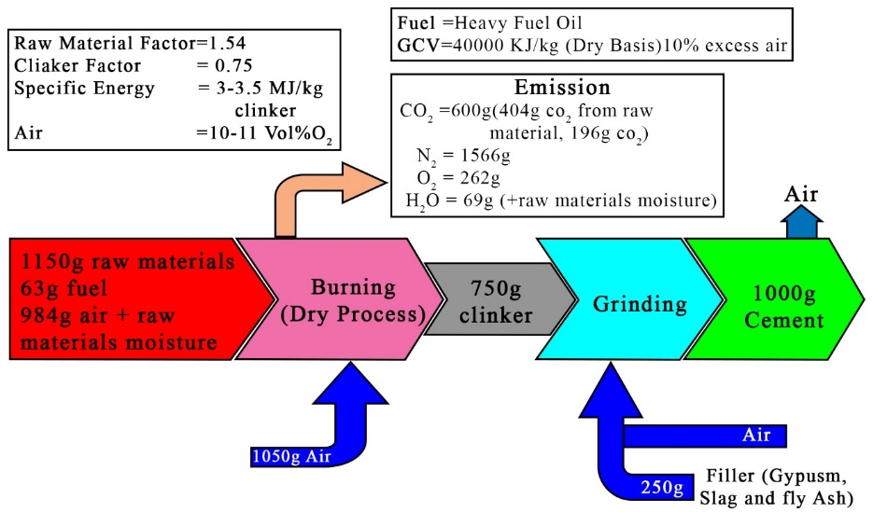
Figure 4.18: Environmental Emission of 1Kg Dangote cement (GHG and water) (source: ((EIA), 2024)
Figure 4.19 shows each input for producing 750 grams of clinker from 1150 grams of raw materials, which includes 63 grams of fuel and 984 grams of air, including raw material moisture. This component released 600 grams of CO₂, 1566 grams of nitrogen, and 69 grams of water and moisture. In general:
Input material = [(1150g raw materials + 63g fuel + 984g air & raw materials moisture) + (1050g air)]
= [(750g clinker) + (600g CO₂ + 1566g N₂ + 262g O₂ + 69g Air)]
Then: Input material = [(750g clinker) + 250 filler (Gypsum, Slag and fly ash) + (Air)]
= [(1000g cement) + (Air)]
Table 4.29: value that A.A cement input material and emission of green gas house gas
 | Value (gram) per 1000g cement production | Dangote cement produce (Ton)  2,547,063 | 2023/2024 consumption of A.A (Ton) 5 Million
Input material
Raw material | 1150 | 2,930,000 | 5,751,722.6
Fuel | 63 | 160,000 | 314,087.2
Air + Raw Material Moisture | 984 | 2,510,000 | 4,927,243.7
Filler (Gypusm, slag, | 250 | 640,000 | 1,256,349
Air | 1050 | 2,670,000 | 5,241,330.8
Semi Product
Clinker | 750 | 1,900,000 | 3,729,786
Emission
CO₂ | 600 | 1,530,000 | 3,003,459
N₂ | 1566 | 3,990,000 | 7,832,550.7
O₂ | 262 | 670,000 | 1,315,240
H₂O | 69 | 180,000 | 353,348

Figure 4.19: Material environmental emission of cement production and consumption of A.A.
High cement production significantly contributes to global greenhouse gas (GHG) emissions, accounting for around 3 million tons of total CO₂ emissions from Addis Ababa. From the table above, Dangote cement contributes 1.2 million tons of CO₂ emissions.

Discussion
Urban metabolism refers to the flow, transformation, and storage of materials within metropolitan environments. It examines how cities consume and modify resources for their operations, considering socioeconomic and environmental dimensions. Cement production, consumption, and disposal are essential components of this process, providing insight into broader urban development patterns.
The role of cement in urbanization highlights its importance in resource management and sustainability. Discussions surrounding "cement urban metabolism" reflect increasing concerns about its environmental implications in rapidly developing cities.
This thesis employs Emergy indicators to assess sustainability, efficiency, and environmental impact through a structured analytical framework.
To address this pressure, the study presents mitigation strategies, most notably the incorporation of renewable energy sources.
Urbanization and Cement Demand
Case comparisons bolster these findings. For instance, compare to A.A City of 527 km² with a higher population than Xiamen, a major city on China’s southeast coast and a designated special economic zone, covers 1,573 km² and is home to 3.81 million residents. It serves as a pertinent benchmark for analyzing resource flows and sustainability metrics.
Cement usage has surged significantly due to rapid urbanization, with Addis Ababa accounting for nearly half of Ethiopia’s urban expansion in recent decades. This growth has led to substantial infrastructure development that heavily relies on concrete. As urbanization continues to accelerate globally, cement demand is expected to rise sharply, with forecasts indicating a dramatic increase by the mid-21st century.
The production of cement begins with the processing of key raw materials in the raw mill. These include limestone (the primary ingredient), silica sand (used for correction), red clay (as a secondary material), iron ore (as an adhesive), gypsum, and pumice. According to Dangote Cement Ethiopia, the raw mill processes approximately 4,002,506.16 tons of these materials annually.
The next stage in cement production is clinker manufacturing, which utilizes raw mill inputs excluding gypsum. This process consumes 2,994,324.4 tons of material monthly and requires coal—both locally sourced and imported—with a total monthly usage of 29,944.5 tons. Currently, the industry emphasizes the use of local coal for firing the clinker kiln.
Transportation of raw materials and fuels plays a critical role in the cement production cycle. Before production, energy resources and raw materials are delivered to the factory. The transportation process consumes around 34,617,828.84 liters of fuel annually. Fuel usage depends on the volume of transported material, vehicle capacity, and the distance traveled.
In Addis Ababa, cement is distributed using silo trucks, long trucks, and dump trucks. On average, 90% of the cement is delivered in bulk and 35% in bags, with annual fuel consumption for distribution reaching 11,571,650 liters.
Additionally, the average annual fuel consumption for transporting embodied raw materials such as limestone, silica sand, red clay, iron ore, gypsum, and pumice is 30,973,743.02 liters. Of this total, 10,812,567.72 liters are derived from various energy sources, including light and heavy fuel oil (LFO and HFO), diesel, coal, and alternative fuels like industrial waste, excluding foreign coal.
Urban expansion has significantly contributed to the rise in cement demand. A report by the Chinese Academy of Sciences indicates that the urban built-up area expanded dramatically from 81.9 km² in 2000 to 281.6 km² by 2013. This growth is closely associated with an increased reliance on primary non-renewable inputs such as coal and limestone, which lead to higher Environmental Loading Ratios (ELR). Furthermore, the disposal of construction materials has intensified issues such as raw material depletion, climate change, air pollution, and solid waste generation.
Cement and Emergy indicators
The Environmental Sustainability Index (ESI) value of A.A cement consumption approximately 0.00 indicates significant environmental pressure resulting from fossil fuel usage, consistent with Scenario A, which demonstrates higher ecological stress than Scenario B. Sustainability is achieved when the Energy Sustainability Index (ESI) exceeds 1 (Scenario B), while a value below 1 (Scenario A) indicates unsustainable practices. ESI scores of 7,132.06, 42,201.65, and 1,120.48 reflect relatively high sustainability under Scenario B, although further enhancement is possible by minimizing non-renewable inputs.
In 2002 to 2012, Xiamen consumed 31.53 million tons of cement, which is equivalent to the entire 2006 production of Fujian Province. Electricity in Xiamen, primarily sourced from fossil fuels, contributes 2.21×10⁵ Sej, while only 5% of construction and demolition waste is recycled, resulting in wasted Emergy. The city exhibits moderate efficiency in Emergy yield ratio (EYR), environmental loading ratio (ELR), and environmental stress index (ESI). Xiamen's metabolic system's total Emergy rose from 2010 to 2017, reaching 2.51×10²⁴ Sej, a 1.65-times increase since 2010. The Emergy yield ratio has gradually increased from 8.30% to 15.20%, while the environmental loading ratio remains low, indicating a low load state. However, with recycling rates for construction and demolition waste below 5% and A.A city is also 0%,
The Emergy index of sustainable development in Xiamen grew from 3.67 in 2010 to 7.76 in 2017, reflecting enhanced sustainability. Xiamen's urban metabolic system is currently in the sustainable development phase under the construction of an eco-city. If A.A city also applied Scenario B, which increases sustainable construction through cement consumption.
Cement Production and Environment
Non-renewable energy sources such as coal, oil, and gas continue to be the primary contributors to global climate change. They account for over 75% of global greenhouse gas (GHG) emissions and 90% of total CO₂ emissions, with the majority arising from industrial operations and fossil fuel-dependent transportation systems. The Effects of Cement Production on the Environment About 8% of worldwide carbon dioxide emissions come from the manufacture of cement, making it a significant local contributor. Ethiopia's cement industry would be regarded as a nation if it contributed 40% of the total. The calcination of clay and limestone, which is necessary to produce clinker, the main component of cement, releases carbon dioxide into the atmosphere.
Ethiopia's energy capacity and consumption are distinguished by many energy sectors, distinguished by their substantial potential, heavy, and rising investments in renewable energy.
The study of cement metabolism in the case of Addis Ababa City will develop with the capacity of utilization of 2023 G.C. being 96.12% with a production capacity of 24.16 million tons. but Emergy is being squandered. Additionally, in 2002 to 2012, Xiamen consumed 31.53 million tons of cement, which is equivalent to the entire 2006 production of Fujian Province. Xiamen accounts for approximately 10% of China's industrial CO₂ emissions, with a high ELR reflecting a significant dependence on non-renewable resources. This suggests an unsustainable long-term system.
Clean energy (electricity) that Dangote Cement Ethiopia purchased was only 56.42 million kWh/year from the national grid. Other non-renewable energy is used, like 359,334 tons of coal, annually.
Cement plants are transitioning from traditional fossil fuels to alternative fuels like hydrogen gas, waste materials, biomass, and some are incorporating renewable energy sources like solar and wind to reduce their carbon footprint and power certain operations.
In the future, the development cement industry is shifting towards alternative fuels, including waste-derived fuels like biomass and industrial byproducts, as a way to reduce greenhouse gas emissions and replace fossil fuels. However, infrastructure issues and high costs hinder the widespread implementation of green hydrogen as a fuel.
Implications for Urban Planning
More sustainable urban environments can result from incorporating the idea of urban metabolism into planning procedures. Cities may create strategies that increase resource efficiency, decrease waste, and improve overall environmental performance by comprehending the metabolic aspects of cement use. The following two ideas:
Carbon Pricing: Cement manufacturers will be encouraged to use cleaner technology and use less energy through the implementation of carbon pricing schemes and more stringent emissions standards.
Sustainability Commitments: A lot of cement firms have established high goals for sustainability, like reaching net-zero emissions by 2050. This will encourage investment in low-carbon and energy-efficient solutions.
Comparison with Scenario A and Scenario B for A.A city cement need
Table 4.30: Comparison with Scenario A and Scenario B (total need of Addis Ababa city cement Metabolism (5 million tons))
Indicator | Scenario A: | Scenario B: | Remark
Part A: Raw material collection
EYR | 6.26 | 114.05 | Scenario B is more efficient than Scenario A
ELR | 126.45 | 0.15 | Scenario A has higher environmental stress than B
ESI | 0.05 | 771.43 | Scenario B is a more sustainable raw material collection than A
Part B: Production of cement in the factory
EYR | 0.019 | 3.9×10⁻⁷ | Because of H₂ gas input. are less Emergy output in scenario B
ELR | 11.2 | 1.08×10⁻⁵ | Scenario A has higher environmental stress than B
ESI | 0.0017 | 0.036 | Scenario B are more sustainable raw material collection than A
Part C: Product (cement) Distribution to A.A
EYR | 9.78 | 3 | Both scenarios are high EYR but scenario A are efficient than B.
ELR | ∞ | 0.1 | Scenario A High environmental stress than B (high environmental stress) cement to A.A.
ESI | 0 | 28.65 | Scenario B are more sustainable to distribute to A.A city from high EYR.
Note: Addis Ababa City Embodied Material (cement)
- Scenario (A): basic system, including the renewable and non-renewable resource inputs
- Scenario (B): a comprehensive system, that integrates a clean energy subsystem, Compared with Scenario (A)
- Dangote Cement (Total cement production) = 2,547,063.12 tons (10.09 Quadrillion Sej)
- Addis Ababa cement consumption = 5,000,000 ton (19.8 Quadrillion Sej)

Main findings
The thesis argues that cement metabolism in rapidly urbanizing cities, particularly Addis Ababa, exerts considerable environmental pressure. This pressure stems from a heavy reliance on non-renewable resources, fossil fuels, and inefficient recycling practices.
- In Addis Ababa, the existing cement consumption practices (Scenario A) are unsustainable, marked by extreme resource intensity and an Environmental Sustainability Index (ESI) nearing zero.
- Scenario B, which incorporates clean energy and alternative fuels, demonstrates significantly enhanced sustainability metrics, including a higher Emergy Yield Ratio (EYR), a lower Environmental Loading Ratio (ELR), and a substantially improved Emergy Sustainability Index (ESI).
- Transitioning to renewable energy, alternative fuels, and circular construction is essential for alleviating environmental stress and achieving sustainable cement metabolism in urban settings.
Cement metabolism in rapidly developing urban areas is presently unsustainable. However, by adopting renewable energy and circular economy principles, this system can be transformed into a sustainable model that greatly reduces environmental impact and improves emergy efficiency.

Chapter Five

Conclusions and recommendations

Conclusion
The Dangote cement industry uses a combination of renewable and nonrenewable resource inputs for its production and distribution. The industry uses electricity for industrial activities, lighting, and housing colonies. The total power consumption of the Dangote cement factory is 56,110,598 kWh/year. The total consumption of raw materials for cement production is 4,002,506.16 tons per month.
The study also examines the transportation of raw energy materials, including fuel consumption, transportation type, and loading capacity. The study also reveals the transportation of raw materials, including fuel (LFO, HFO), diesel, and coal. The total fuel consumption for the transportation of raw materials is estimated to be around 30,973,743.02 liters per km/trip.
Renewable Energy for Cement Production
- Calculated by summing all Emergy inputs from renewable resources.
- Includes solar radiation, wind energy, hydroponics, geothermal energy, and biomass.
Non-renewable energy includes the total sum of all fossil fuels.
The total embodied energy of Dangote cement is 2,547,063.12 tons per year, with energy inputs comprising electricity, labor and services, fuel (gasoline), raw materials, and alternative fuels. The total raw material amounts to 4.68 quadrillion. But Addis Ababa's cement consumption is 5 million tons/year, with energy needs from average of 35% of Ethiopia's cement production. The total energy input from Addis Ababa's cement consumption is 9,029,411.42 liters, with energy outputs of 10,080,411.42 liters for transportation.
The total Emergy input to cement production is approximately 18.79 quadrillion Sej, with a total output of approximately 10.09 quadrillion Sej.
This study evaluates the cement metabolism associated with the cement consumption in Addis Ababa. Cement metabolism refers to the continuous processes of producing, transporting, and recycling cement in the cement industry and urban systems.
The Dangote Cement Ethiopia plant has a clinker production capacity of 4,800 tons per day, alongside the Derban Midrok Cement facility, and generates 2.5 million tons from the Adda-Berga area. This research is focused on three key aspects: raw material extraction and preparation for transportation, the production process of cement, and product transportation to the target city (Addis Ababa). Those aspects of the processes are also classified into two scenarios: scenario A and scenario B.
Emergy energy in the cement industry utilizes a blend of renewable and nonrenewable resource inputs, along with output material transportation for its production and distribution to Addis Ababa city. Non-renewable energy inputs encompass the extraction, processing, transportation, and utilization of various materials and products. The industry employs renewable resources such as alternative fuel and electricity for industrial operations, lighting, and residential areas. Emergy Energy metabolism analysis primarily focuses on three components that reflect efficiency, environmental stress, and sustainability in urban cement consumption. Resource efficiency is assessed by the total ratio of Emergy output to input. Environmental pressure exerted by a process, such as cement production, is measured by comparing nonrenewable and imported energy consumption to renewable energy production.
- The total electric power consumption of the Dangote cement factory is 56,110,598 kWh/year.
- The total consumption of raw materials for cement production is 4,002,506.16 tons per month.
- . The total fuel consumption for the transportation of raw materials is estimated to be around 30,973,743.02 liters per km/trip.
- The total Emergy energy of Dangote cement is 2,547,063.12 tons of cement/year, with energy inputs including electricity, labor and service, fuel (gasoline), raw material, and alternative fuel. The total raw material is 4.68 quadrillion.
- Addis Ababa's cement consumption is 5 million tons/year, with energy needs from an average of 35% of Ethiopia's cement production. The total energy input from Addis Ababa's cement consumption is 9,029,411.42 liters, with energy outputs of 10,080,411.42 liters for transportation.
- The total Emergy input to cement production is approximately 18.79 quadrillion Sej, with a total output of approximately 10.09 quadrillion Sej.
- In scenario A, the environmental stress of cement consumption in Addis Ababa, a city that lacks renewable energy for cement metabolism (without electricity from the national grid), indicates an infinite ELR, suggesting a high level of environmental stress.
- The Dangote cement factory has an Emergy Yield Ratio of less efficiency and its Environmental Loading Ratio is high environmental stress. The Dangote cement to Addis Ababa contribution is 35% Emergy Energy, with an EYR of less environmental harms. Ethiopia's cement consumption is 19.3 million tons per year, with Addis Ababa's consumption being 30 - 40% of total dispatch cement, which is 5 million tons annually.
- In scenario B, the cement industry should prioritize sustainable energy sources such as hydrogen gas and electricity generated from solar and wind energy. This approach will help decrease reliance on fossil fuels, attain net-zero emissions, and enhance energy security and climate resilience, ultimately paving the way for a more sustainable future.
- Due to increased urbanization and construction booms, Addis Ababa, one of Africa's fastest-growing cities, faces significant challenges related to cement waste. Globally, five to ten percent of cement is lost in construction due to improper handling, overordering, and damage. In Addis Ababa, between 250,000 and 500,000 tons of cement are wasted annually (5–10% of the 4-6 million tons produced). Reports from the unregulated sector indicate that demolition debris from old structures may account for over 50,000 tons annually.
- In scenario B, the process recommends substituting non-renewable energy sources such as coal, diesel, and heavy fuel oil with renewable energy options like electricity and alternative energy.

Recommendations:
    - Develop Clinker Efficiency
Clean energy includes improving energy efficiency, switching to lower-carbon fuels, promoting material efficiency (to reduce the clinker-to-cement ratio and total demand), and advancing innovative near-zero emission production routes. This situation is also known as the net-zero scenario.
$Clinker Cement Ratio= \frac{Weight of Clinker}{Weight of Cement}$…………………........................................... (5-1)
The global average clinker-to-cement ratio is 0.81, with 81% of cement weight consisting of clinker and 19% supplementary materials like gypsum, fly ash, slag, and additives. Then we can calculate the clinker-cement ratio for Dangote Cement and Addis Ababa Cement consumption.
$Clinker Cement Ratio= \frac{Weight of Clinker}{Weight of Cement}$=$\frac{1,692,636 ton}{2,547,063 ton}$ = 0.664
The value clinker-to-cement ratio of 0.664 indicates that 66.4% of cement comprises 66.4% clinker and 33.6% is other corrective and sedimentary. A clinker-to-cement ratio closer to zero signifies that cement manufacture uses less energy and is therefore more environmentally friendly.
Table 5.1: Typical clinker-to-cement ratios of coal kiln and hydrogen kiln.
Factors | Coal kiln | Hydrogen kiln
- Clinker ratio | 0.65 - 0.75 | 0.50 - 0.65
- Supplementary Cementitious Materials (SCMs) | 35 - 50% | 45–60% (cleaner clinker allows more substitution)
Developing this method (scenario B) is more expensive, neutralizes environmental damage, and increases the advantage of negative actions in the building industry. To develop scenario B, it will require a larger budget and more advanced technology. But we can develop advanced technologies, as shown in the section on scenario B alternative energy identification and recommendations.
    - Reduce Cement Demand
- Use Alternative Binders: Alternative binders, such as Geopolymers, Limestone Calcined Clay Cement, and Magnesium-Based Cements, can help reduce cement demand while maintaining or enhancing performance.
- Optimizing structural design: this focuses on topology optimization to reduce material usage while maintaining strength, and employs prefabrication and modular construction to minimize waste.
    - Carbon Capture in Cement Plants
- Carbon Capture & Utilization (CCU): In cement plants, post-combustion capture techniques, such as amine scrubbing and oxy-fuel combustion, facilitate easier CO₂ separation.
- Mineral Carbonation: CO₂-cured concrete is an innovative technology that sequesters carbon dioxide, improves performance, and mineralizes fresh concrete instead of traditional water-based curing.
    - Urban Planning & Material Efficiency
- Adaptive Reuse of Buildings: Adaptive reuse involves repurposing old or underused buildings for new purposes, preserving structural integrity, reducing urban waste, and lowering the carbon footprint of construction.
- Urban Greening: is to shift from concrete-dominant designs to permeable pavements, green roofs, and bio-based materials.
- Local Sourcing: The aim of local sourcing is to reduce transport emissions by using sustainable materials that are available locally.
    - Enhance Circularity in Cement & Concrete
Recycle concrete waste: The project aims to improve the circularity of cement and concrete by recycling concrete waste and utilizing urban mining to recover materials from demolished buildings.
Electric arc furnaces (EAFs): are being investigated as a viable technique for producing low-emission cement. This approach entails crushing old concrete, separating the cement from the aggregate, and then heating the cement in an EAF. The technology not only recycles cement but also dramatically lowers CO₂ emissions. The main advantage of this technology is that it has the potential to generate zero-emission cement if the EAFs are driven by renewable energy.
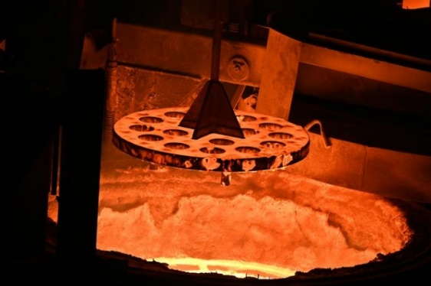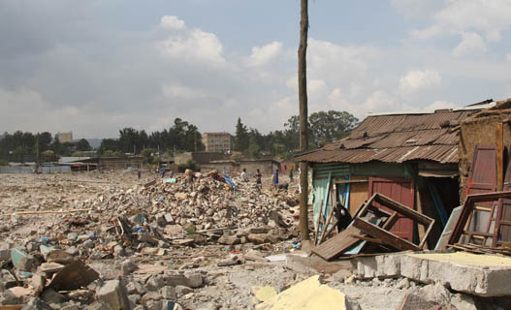
Figure 5.1: a) photographs of the first electric cement production in an electric arc furnace at the Materials Processing Institute, UK. (Source: Cement recycling method could help solve one | Eurek Alert!) b) Demolished building in Addis Ababa (source: Microsoft Bing)
    - Develop Infrastructure and Manage a Transportation System:
Transportation technology evolves quickly, delivering creative solutions that improve the efficiency, safety, and sustainability of moving and loading cement. The transportation system of cement industries is divided into two. The first one is before production, the factory needs both raw material mining and raw material transportation. The following discussion and recommendation will be listed as:
- Raw material extraction and transportation
- Mining site Cement Raw material Machinery

- Premium Productivity
- Super Long Service Life
- Super High Adaptability
- High-strength Frame

- Rechargeable transportation truck (both cement and raw material)
- Long Cruising Range
- Quick Charging Technology
- Develop Cement (product) transportation
- Built a new electric highway for a large truck (E-highway)
The project will utilize cheaper, more efficient batteries, with the final decision based on total infrastructure, vehicle, and energy costs. The truck remained a truck, but it was now powered like many trains or streetcars.
The system's direct power delivery from the electrical grid to the motors makes it energy-efficient. Because batteries are often heavy and expensive, the technology saves weight and money because a truck using overhead wires only needs a large enough battery to get from the off-ramp to its destination.
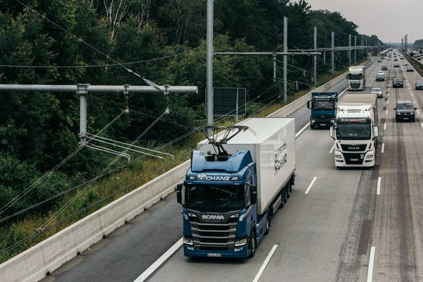
Figure 5.2: E-highway of a transportation project in Germany (Source: New York Times, research of Germany in the cities)
- Fuel tunnel pipes (Fuel Transportation)
Fuel tunnel pipes, also known as fuel pipelines, are essential for moving massive amounts of fuel across long distances. These pipes are intended to provide the safe and efficient transportation of petroleum, minimizing reliance on road and rail transit, which is more susceptible to disruptions. The following are the advantages of fuel tunnel pipelines:
- Pipeline types: including crude oil pipelines, refined product pipelines (such as gasoline and diesel), and natural gas pipelines.
- Efficiency and Cost: Pipelines are the most efficient and cost-effective way to carry petroleum. They run continuously 24/7 and are mostly submerged, making them less visible and less vulnerable to weather-related disruptions.
- Safety: Pipelines include several safety mechanisms to avoid leaks and accidents. Regular maintenance and monitoring are carried out to ensure their integrity.
- Environmental Impact: Pipelines are generally safer and more efficient than other modes of transportation, but they can still pose environmental dangers if not handled appropriately.
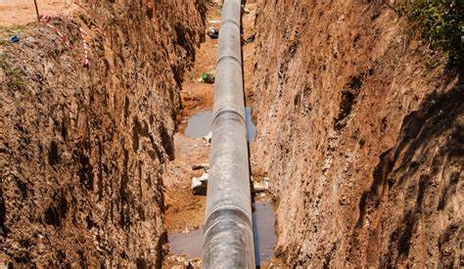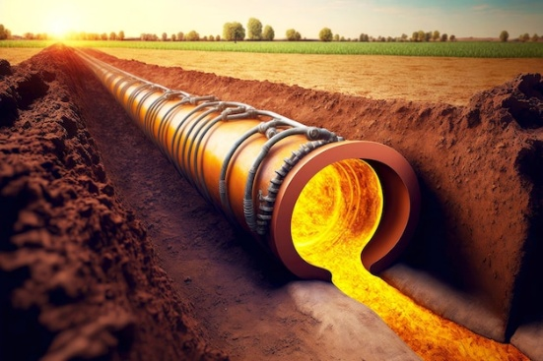
Figure 5.3: Underground petroleum pipeline (source: Microsoft Bing)
    - Develop Alternative energies
As we discussed before in scenario B, supplementary alternative energy sources (Hydrogen gas), we can develop other energies, such as wind and solar energy will be integrated with city waste to foster clean energy development. This energy sources are being explored to reduce the environmental impact of cement manufacturing in Addis Ababa, promoting long-term sustainability.
This study area of clean energy covers an area of 10,000 square kilometers with a perimeter of 100 kilometers. This study area of energy included near to Addis Ababa, and Shager City, and the zonal states of the west and north Shewa Oromia region in Ethiopia.
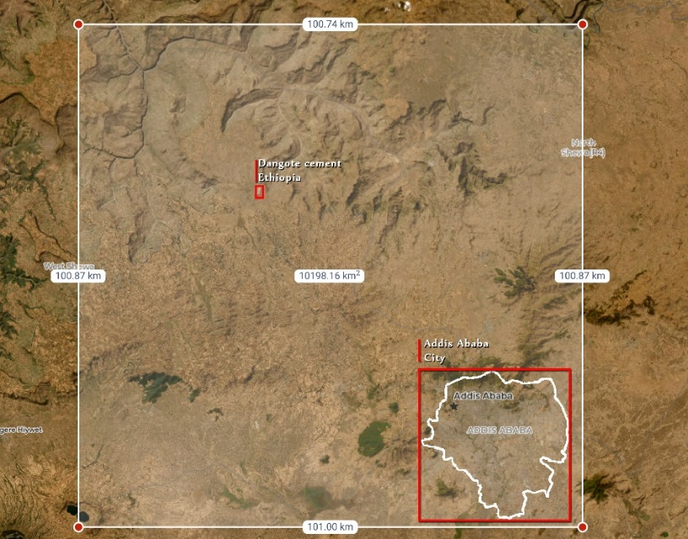
Figure 5.4: Study Coverage that includes West Shewa, Sheger City, and Addis Ababa City
      - Solar energy
Criteria for Photo-voltaic solar sitting
This study differs from other studies in that it compares the use of all the Multi-criteria decision-making (MCDM) methods.
- Three main criteria are defined for solar power plant location selection. These criteria rely on solar energy potential, feeder capacity, and surface slope.
- It is determined from the global radiation values (kWh/m²/day), sunshine duration (hours), and PV-type area energy generation (kWh/year).
- The slope of the surface where a solar power plant will be installed is usually kept below 5%. these cities, which are good in terms of the amount of sunlight,
The evaluation criteria include abundant solar irradiation (> 1100 kWh/m²/year), specific slope and aspect (5–15°), nearby transmission lines (TL with a minimum of 35 kV within 600 m), proximity to populated areas (< 2500 m), proximity to enterprises (< 2500 m), proximity to road networks (< 500 m), average air temperature (15-40°C), proximity to residential areas (> 500 m), land cover (preferably low and medium grassy vegetation), protected areas, and elevations above 1000 m and 1500 m.
Based on the data gathered and the research performed, it was discovered that more than 80% of the North Shewa regions are appropriate for solar energy generation for off-grid and grid-connected systems.
As a result, the North Shewa zone's solar potential fully meets the standards of sunshine, solar radiation, and temperature. That is, most of the areas have average solar irradiation of 4.73 kWh/m², with annual average Direct normal irradiation (DNI) 1696.5 kWh/m² per year, and daily sunshine is an average of exceeding 7 hours with a maximum energy production found in February (9.62 hours of sunshine per day and 298.29 hours/month). Other studies of solar irradiation of annual 5.74 kWh/m²/day and monthly average value January 6.41, February 6.43, March 6.04, April 5.52, May: 5.37, June 4.91, July 4.33, August 4.57, September 5.42, October 6.35, November 6.89, and December 6.63.
Table 5.2: solar energy capacity indicators of the study area. (Source: GSA)
Solar energy indicator | Value per day | Value per Year
- Specific photovoltaic power output (PVOUT) | 4.51 - 5.00 kWh/kWp | 1923.9 kWh/kWp
- Direct normal irradiation (DNI) | 4.33 - 5.37 kWh/m² | 2038.0 kWh/m2
- Global horizontal irradiation (GHI) | 5.43 - 6.10 kWh/m² | 2312.4kWh/m2
- Global tilted irradiation (GTI) | 5.58 - 6.28 kWh/m² | 2384.0 kWh/m2
- Diffuse horizontal irradiation (DHI) | 2.23 - 2.41 kWh/m² | 850.2 kWh/m2
- Optimum tilt of PV modules (OPTA) | 14 - 16 ° | 15/180
- Air temperature (TEMP) | 12.4 - 23.0 °C | 15.7 °C
- Terrain elevation (ELE) | 1359 - 3382 m | -
Detail solar analysis: According to solar energy analysis, total photovoltaic power output and Global tilted irradiation are 1.936 GWh/year and 2379.8 kWh/m2/year with the study area has the greatest sun radiation value of 2915.03 kWh/m2/year. Area Analysis: (Specific photovoltaic power output (PVOUT), Direct normal irradiation, Global horizontal irradiation, and Diffuse horizontal irradiation) discussed below in table:
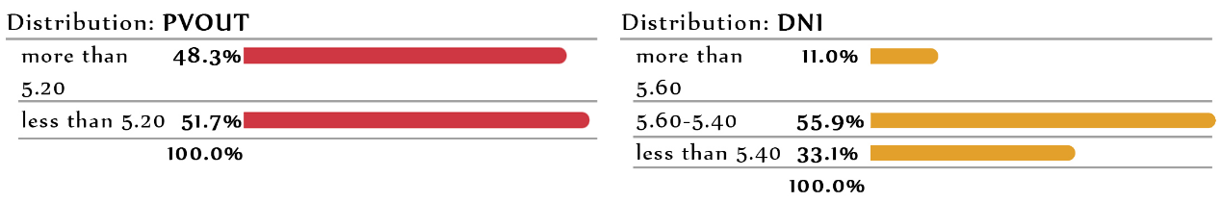
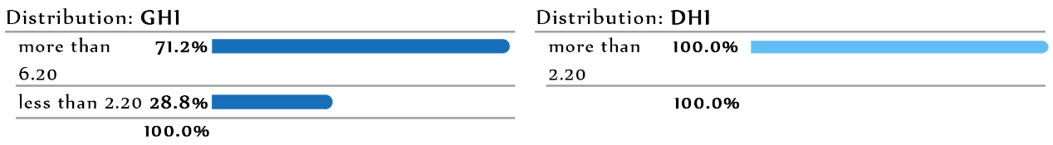
Figure 5.5: Distribution chart of PVOUT, DNI, GHI and DHI of study area
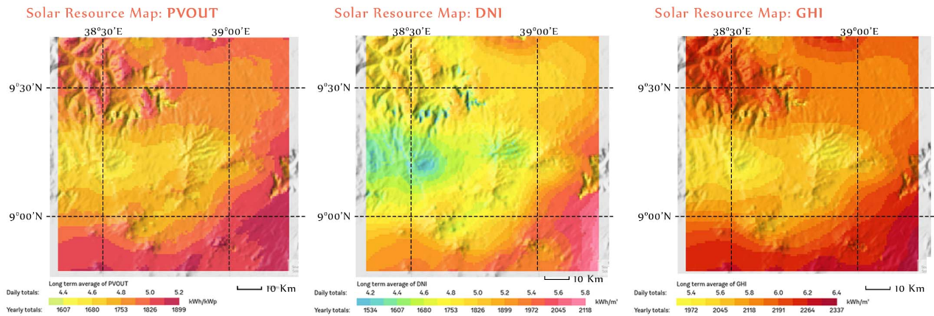
Figure 5.6: Solar resource map chart of PVOUT, DNI, GHI, and DHI of the study area
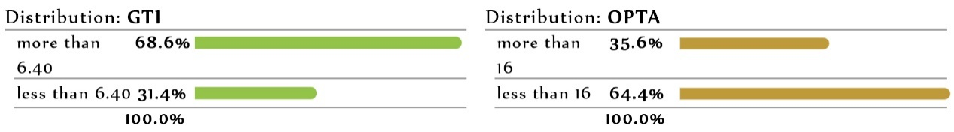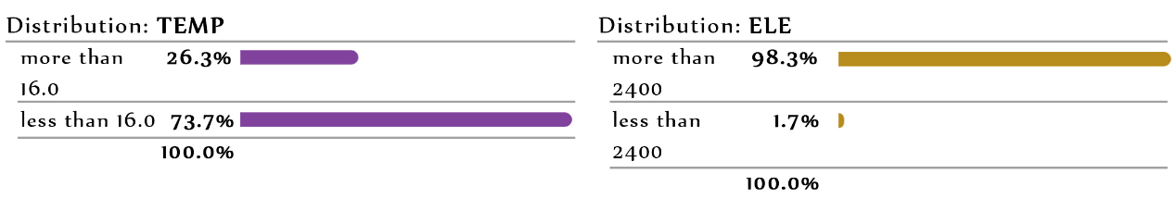
Figure 5.7: Distribution chart of GTI, OPTA, TEMP, and ELE of the study area
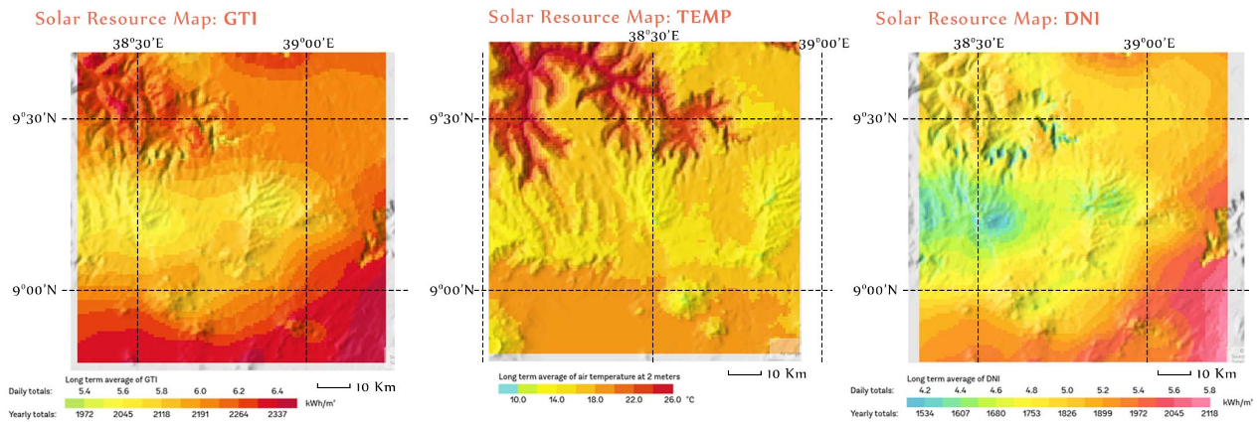
Figure 5.8: Solar resource map chart of GTI, OPTA, TEMP and ELE of study area
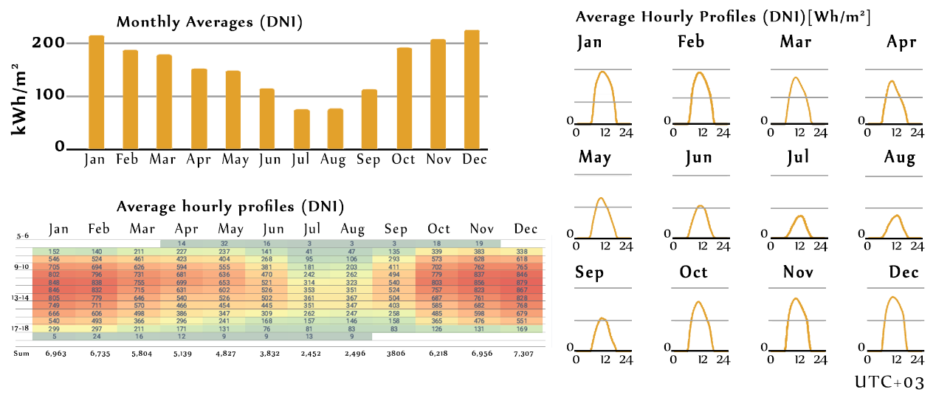
Figure 5.9: Annual Average, hourly and monthly DNI of study area. (Source: GSA)
Solar Energy Production Capacity
Solar energy production capacity is determined by solar panel capacity, sunshine, solar radiation, and temperature, converting solar energy into electrical energy. To calculate how much a solar panel generates each day, multiply the output by the peak sun hours.
We have several options to consider depending on the best commercial and industrial solar panels. Here are some of the best ones available in 2023. Below, we can list some of the best solar panels that have the best efficiency and photovoltaic energy production:
Table 5.3: Three best solar panels manufactured in 2023 depends on efficiency.
Solar panel type | Power output (in watt(W)) | Efficiency (%) | Size in LxW (cm) | Area (m²)
- Phono Solar Helios 690 W Module | 690 | 22.53 | 238.4×130.3 | 3.15
- Jinko Solar Tiger Neo 615 W | 595-515 | 21.2-22 | 176.2×113.4 | 2
- Trina Solar Vertex 670 W | 635-670 | 21.6 | 238.4×130.3 | 3.15
  - Daily Energy Production:
The previous discussion shows 5.74 kWh/m²/day solar irradiation.
- Sun irradiation = 5.74 kWh/m²/day
- A=is the total solar panel area (m²)= 3.15m² /panel
- r =is the solar panel yield or efficiency (expressed as a percentage) = 22.53
- Best Solar panel Installed capacity= 690w = 0.69 kw
- Peak Sun Hours = 7 hour
$$Daily Solar Energy\left(kWh\right)=Solar Panel Efficiency×Solar Panel Area×Suns Irradiance per day$$
$$SE\left(kWh\right)=r×A×Suns Irradiance per day$$
$SE Daily=22.53×3.15 m^{2}×5.74 kWh/m^{2}/day =$ = $407.36 kwh$
- PR= is the performance ratio
$$PR= \frac{Actual Energy Output\left(kWh\right)}{installed capaciy\left(kw\right)×Peak Sun Hours×100}=\frac{407.36 kWh}{0.69 kW×7 hour×100}$$
= $(407.36 kWh)/(483 kWh)$= $0.84$
A well-designed PV system generally has a PR of 0.75 to 0.85 (75–85%) and the system we examined has better performance with 84 percent capacity.
  - Monthly Energy Production:
$$Monthly Solar Energy(kWh)=Daily Solar Energy(kWh)×30 days$$
SE _{monthly}=407.36 kWh x 30 = 12,220.8 kWh/month/panel
  - Annual Energy Production:
Annual Solar Energy (kWh) = Monthly Solar Energy (kWh) × 12 Months
SE Annual = SE monthly × 12 months
SE _{monthly}=12,220.8 kWh x 30 = 366,624 kWh/year/panel or 366.624MWh/year/panel
  - Total number of power panels needed for Dangote Cement Factory:
- Power Purchased electricity=56,426,607 kWh/year( purchased from the grid)
- Each panel produced = 366,624 kWh/year/panel
$$Total panel number=(power purchased electricity)/(Each panel produced)$$
$Total panel number=(56, 426,607 kWh/year)/(366,624 kWh/year)$ = 154 panels
      - Wind Energy
Criteria for Wind Turbine Energy
Table 5.4: Criteria considered for wind farm power plant siting.
Restrictive criteria buffer zones
Criteria | Sub-criteria
- Structural | Distance from the electricity grid  - Power plants, Substations, Gas transmission line.  - Railway, Highway, Road, Airport.
- Topographical | - Elevation  - Slope  - Faults
- Ecological | - Environmental protected areas, Ancient, and cultural monuments.  - River, Lakes, and water bodies.  - Distance from an urban area.
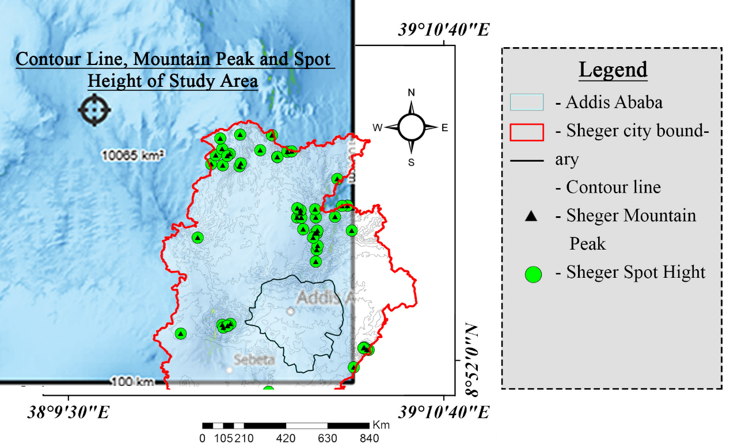
Figure 5.10: Area view of wind at the surrounding cement factory and Addis Ababa city
- Wind speed
Table 5.5: Wind-force per Day (January 1996 - December 2024). (Source: GSA)
Month | Wind speed [kph] | Data Availability [%] | Month | Wind speed [kph] | Data Availability [%]
- Jan | 14.8 | 56 | - Jul | 10.9 | 50
- Feb | 15.5 | 59 | - Aug | 10.0 | 57
- Mar | 15.4 | 57 | - Sep | 11.1 | 62
- Apr | 14.8 | 60 | - Oct | 15.2 | 62
- May | 13.5 | 53 | - Nov | 15.5 | 61
- Jun | 11.2 | 53 | - Dec | 15.2 | 56
- Wind time (Coordinated Universal Time (UTC))
Wind speed and duration vary depending on the time of day. Between 12 a.m. and 24 p.m., there is a high level of activity in specific locations. The windiest months are July, August, and September. Figure 4.29 will indicate this time.
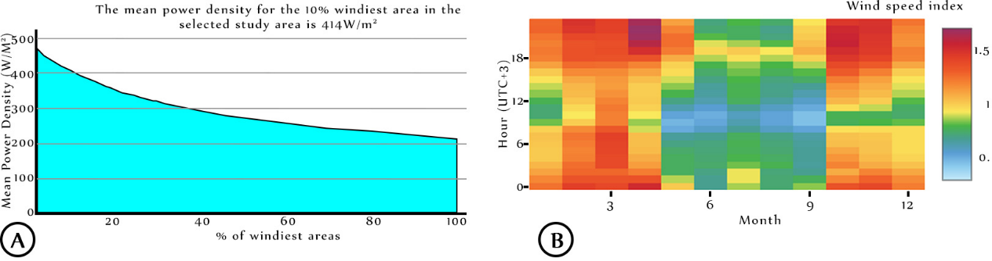
Figure 5.11: (A) Mean Power Density @Height 100m and (B) Hourly vs. monthly (cross table) (Source: GWA)
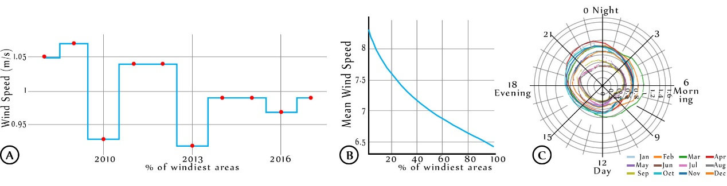
Figure 5.12: (A) Wind Speed Variability (B) Mean wind speed and (C) Hourly Vs. monthly (Radar plot) of the selected area (Source: GWA)
- Wind direction
The wind rose for Addis Ababa city, and its surroundings show how many hours the wind blows per year from the indicated direction. The diagram for Addis Ababa shows the days per month when the wind reaches a certain speed. Example SW: Wind blows from South-West (SW) to North-East (NE).
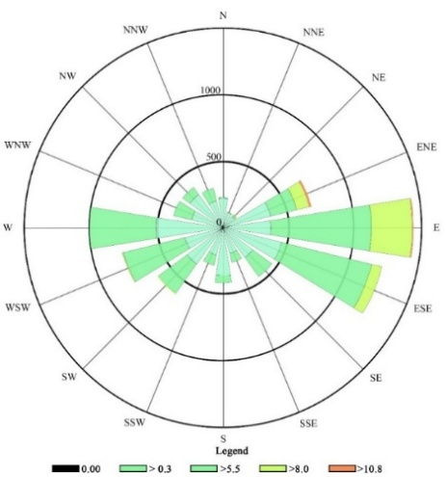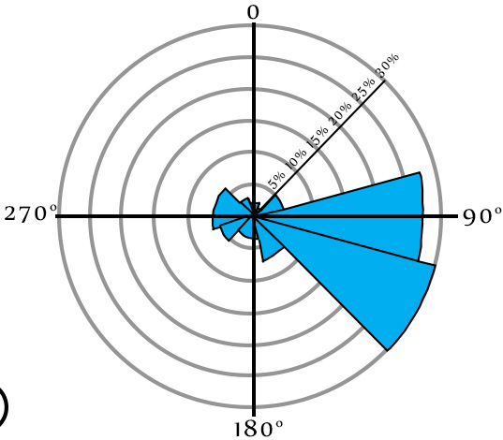
Figure 5.13: (A) Wind rose and (B) Wind Frequency Rose (Source: GWA)
- Wind Power Density (WPD):
It measures the 414 W/m2 of energy accessible from wind at a given location. It represents the average annual power available per square meter of swept area of a wind turbine as shown in Figure 4.16 (A) Mean Power.
Wind Energy Production Capacity
At the 100 km² radius of the study area (Addis Ababa City), we can calculate the capacity of wind power that can help to develop renewable and clean energy. This Wind energy study will help the efficient utilization of factories to minimize the Emergy energy of cement production and distribution of cement to the city.
The following are best industrial wind turbines are listed in the table:
Table 5.6: 2024 G.C top three brand wind turbine
Wind turbine brand | Roter Diameter (meters) | Capacity(MW) | Capacity Factor (%)
- Vestas V236 | 236 | 15 | 60
- Siemens Gamesa SG | 222 | 14 | >25
- GE Haliade-X | 220 | 14.7 | 63
To calculate wind energy, we can use the following formula: P = 0.5ρAv³ Where:
- P = power generated (in watts).
- ρ = air density by in (kg/m³) =1.225 kg/m³ at sea level.
- A = swept area turbine blades (in m²). For a circular area, A = πr²
Where (r) = radius of the blades, (π) = 3.14
- v = wind speed (in meters per second).
Therefore study area of power generated (in watts) can generate
- A = swept area turbine blades (in square meters). For a circular area, A = πr²
Where: (r) = radius of the blades, (π) = 3.14
- V = Wind speed of given location (in meters per second) = 6.14
Therefore calculate the power output of Vista V236 in study area:
- ρ =1.225 kg/m³
- A=3.14($\frac{236}{2})$²m² = 3.14×13,924m² = 43,721.36 m²
- V _{avg}= 6.14 m/s
P = 0.5ρAv³ = 0.5 × 1.225 kg/m³ × 43,721.36 m² × (6.14m/s) ³
= 6,198,760.67 W or = 6,198.76 KW = 6.2 MW
Calculate the power output of annual power energy:
$$Annual Energy (E)=Power(P) ×time(T) (hour)$$
If Power of Vista 236(P) = 6.2 MW and Time (T) = 365 day × 24 hour = 8,760 hour
E = 6.2 MW × 8,760 hours = 54,312 MWh (1 Vista 236 produces 54,312 MWh/year)
Suppose 56,426.61 MWh/year of purchased power is required for Dangote cement manufacturing, and 319,428.15 MWh/year is needed in the future. In that case, we can build clean energy (a wind farm) a set of wind turbines positioned in the same location that work together to generate electricity.
- Vista V-236 produce = 54,312 MWh/year
- Dangote electricity purchased from the grid= 56,426.61 MWh/year
- Total cement needed to A.A city's production of electricity = 319.428.15 MWh/year
Only one Vista V236 wind turbine will be farmed for Dangote Cement, and six wind turbines will be farmed for the city of Addis Ababa's total cement demand.
- Power generation (Horizontal E-wind energy turbine (Horizontal Axis Wind Turbines (HAWT))
HAWTs have blades that rotate on a horizontal axis, with the rotor shaft parallel to the ground. This design is more frequent in large-scale wind farms, and it has witnessed major technological and efficiency developments over the years. (Energy, 2024)

Figure 5.14: Horizontal Wind Turbine (Energy, 2024).
- Higher Efficiency: HAWTs typically outperform VAWTs, particularly in steady wind conditions, because of improved aerodynamics and blade design.
- Scalability: HAWTs are more easily scalable to bigger sizes, making them ideal for utility-scale wind farms with significant power output.
- Proven Technology: HAWTs are a mature technology with a well-established supply chain, resulting in lower manufacturing costs and increased reliability.
- Eco-Friendly Cements (Green cement and concrete)
Green cement: Solidia Technology cement and concrete technology, built for greener enterprises, is a comprehensive platform of modern technology that reduces emissions in cement manufacturing while mineralizing CO₂ in concrete production. Together, these technological breakthroughs cut concrete's carbon impact by up to 50%.
Green concrete: refers to concrete made from biological concrete waste. This is a crucial step towards a more sustainable building sector with a longer life cycle. It saves energy, reduces carbon dioxide emissions, and allows wastewater to be reused.
Green concrete constructions are predicted to reduce carbon dioxide emissions by at least 30%. Each year, we use over 4 billion tons of concrete. In 2016, global concrete production released 2.2 billion tons of carbon dioxide into the atmosphere, accounting for 8% of total CO₂ emissions.
During cement manufacture, heat of up to 800–1000°C is applied to the components. This procedure produces roughly 900 grams of carbon dioxide emissions. As a result, green concrete is utilized to avoid air pollution and reduce carbon dioxide emissions. To put it another way, green concrete may be recycled and reused in other projects, whereas regular concrete can remain in the environment for years. For example, it is utilized in road construction, building construction, bridge construction, sidewalks, and architecture, where concrete is the basic material.

References
Alemayehu, A. (2024, March 16). “Why should Ethiopians care about urbanization? Jobs, infrastructure, and formal land and housing”. World Bank Blogs. https://blogs.worldbank.org/en/africacan/why-should-ethiopians-care-about-urbanization-jobs-infrastructure-and-formal-land-and-hous.
Analysis Tool. Massachusetts: University of Massachusetts Amherst. https://scholarworks.umass.edu/dissertations.
Atlas of Urban Expansion. (2010). Addis Ababa. UN-Habitat. http://atlasofurbanexpansion.org/cities/view/Addis_Ababa.
Circular Ecology. (2024). "Carbon footprint, LCA, embodied energy and sustainability experts". https://www.circularecology.com/.
Dure Mulatu, L., & H.-W. (2018, August). "The cement industry in Ethiopia". South Korea: Research Gate.
Ethiopian Ministry of Mines. (2023). Ethiopian cement industry. Addis Ababa: Ethiopian Ministry of Mines.
Farzinmoghadam, M. (2016). Urban metabolism and land use modeling for urban designers and planners: A land use model for the Integrated Urban Metabolism
Global Highways. (2025). Ethiopia’s challenging cement market: consumption stimulation. World Highways. https://www.globalhighways.com/wh4/feature/ethiopias-challenging-cement-market-consumption-stimulation.
Hsi-Chuan, & Wang. (2022). Case studies of urban metabolism: What should be addressed next? Urban Studies. https://doi.org/10.1177/10780874221080145.
Implications of overlooked drivers in Ethiopia's urbanization: Curbing the curse of spontaneous urban development for future emerging towns. (2022, October 7). Heliyon. https://www.ncbi.nlm.nih.gov/pmc/articles/PMC9576904/.
International Energy Agency. (2023). Electricity market report 2023. International Energy Agency. https://iea.blob.core.windows.net/assets/255e9cba-da84-4681-8c1f458ca1a3d9ca/ElectricityMarketReport2023.pdf.
Keirstead, J., & Shah, N. (2013). Urban energy systems. Shah.
Khalifa, Y. A. (2021). Urban metabolism: An integrated approach to exploring the challenges of resource management for urban sustainability in developing countries. Keele: Keele University.
Knoema. (2023). Ethiopia urban population. Retrieved from Knoema World Data Atlas
Krausmann, F. (2013). A city and its hinterland: Vienna’s energy metabolism 1800–2006. https://www.researchgate.net.
Martínez-Martínez, S., Pérez-Villarejo, L., Eliche-Quesada, D., & Sánchez-Soto, P. J. (2023, January 13). New types and dosages for the manufacture of low-energy cement from raw material and industrial waste under the principles of circular economy and low carbon economy. Materials, 16(2), 802. https://doi.org/10.3390/ma16020802.
Mohanty, B. (2012). Sustainable urban energy: A sourcebook for Asia. Nairobi, Kenya: United Nations Human Settlements Programme (UN-HABITAT).
Moors, N. C., Chrysoulakis, N., Castro, E. A., & Moors, E. J. (2014). Understanding urban metabolism: A tool for urban planning. Routledge. https://doi.org/10.4324/9781315765846.
Musango, J. C., Currie, P., & Robinson, B. (2017). Urban metabolism for resource-efficient cities: From theory to implementation. Paris: UN Environment.
Nousiainen, K. (2021). A new urban metabolism approach: Combining satellite data and urban metabolism assessment for promoting sustainable urban development [Master’s thesis, University of Vaasa]. Osuva Institutional Repository. https://urn.fi/URN:NBN:fi-fe202102276135.
Olana, G. W. (2015). Challenges and prospects of Ethiopia’s cement industry: Strategic perspective (2015–2025). Research Gate. https://www.researchgate.net/publication/275209456.
Pernice, R. (2022). The urbanism of metabolism: Visions, scenarios and models for the mutant city of tomorrow. Routledge. https://doi.org/10.4324/9781003186540
Pulselli, R. S., Simoncini, E., Ridolfi, R., & Bastianoni, S. (2008). Specific emergy of cement and concrete: An energy-based appraisal of building materials and their transport. Siena, Italy: Emergy Society. Retrieved from Emergy Society PDF
RO Limited. (2024). Global highways. World Highways. https://www.worldhighways.com.
Slanger, D., & Lalit, R. (2023, June 6). With concrete, less is more. Rocky Mountain Institute. RMI article
Smaranda, B. (2014). Data mining for material flow analysis: Application in the territorial break-down of French regions. Modeling and Simulation. STEEP Team, INRIA Rhône-Alpes: Université Politècnica de Catalunya. INRIA HAL archive
Steinberger, J., & Weisz, H. (2010). Reducing energy and material flows in cities. Current Opinion in Environmental Sustainability, 2(3), 185–192. https://doi.org/10.1016/j.cosust.2010.05.010
Synhelion. (2024). Synhelion’s technology enables net-zero mobility. Synhelion. https://synhelion.com/technology
Tan, L. M. (2020). An ecological-thermodynamic approach to urban metabolism (Doctoral dissertation). The University of Sheffield, Faculty of Engineering, Department of Civil and Structural Engineering. https://etheses.whiterose.ac.uk/id/eprint/28086
Tesema, D. (2025). The unrelenting housing stress in Addis Ababa. Africa in Fact. https://africainfact.com/the-unrelenting-housing-stress-in-addis-ababa/
Wang, H. L. (2022). Sustainability investigation in the building cement production system based on the LCA-emergy method. MDPI. https://www.mdpi.com
Wang, H., Liu, Y., Zhang, H., Huang, L., Xu, D., Zhang, C., & Zhang, J. (2022). Sustainability investigation in the building cement production system based on the LCA-emergy method. Sustainability, 14(24), Article 16380. https://doi.org/10.3390/su142416380
Wind Cycle Energy. (2024, February 11). *Vertical Axis Wind Turbines vs. Horizontal Axis: Which Is Better?* Wind Cycle – Wind Energy for Urban Environments. https://windcycle.energy/vertical-axis-wind-turbines-vs-horizontal-axis/.
Worldometer. (2019). “Worldometer - real-time world statistics”. https://www.worldometers.info/.
Worldometer. (2024). Coal consumption by country. https://www.worldometers.info/coal/coal-consumption-by-country/#ethiopia
Worth, E. I. (2019, August). Ethiopia imports worth $2.8 billion petroleum. New Business Ethiopia. https://newbusinessethiopia.com/trade/ethiopia-imports-worth-2-8-billion-petroleum/
U.S. Energy Information Administration. (2024). U.S. Energy Information Administration (EIA). https://www.eia.gov/.
United Nations. (2019). Supporting the improvement of the development strategy and policy for Ethiopia’s technology-based chemical industry. United Nations Industrial Development Organization (UNIDO). https://downloads.unido.org/ot/14/10/14100685/Final%20Ethiopia_report_web.pdf
United Nations Human Settlements Programme (UN-HABITAT). (2008). Ethiopia: Addis Ababa urban profile. Nairobi, Kenya: UN-HABITAT. https://unhabitat.org/ethiopia-addis-ababa-urban-profile
Zhang, J., Srinivasan, R. S., & Peng, C. (2020). A systematic approach to calculate unit emergy values of cement manufacturing in China using consumption quota of dry and wet raw materials. Buildings, 10(7), 128. https://doi.org/10.3390/buildings10070128.

AnNex 1: Scenario A

Scenario A: Emergy of Dangote Cement Production
Table Annex 1:1: Emergy material for 2,547,063.12 tons/year by Scenario A
Tasks | Value | Emergy Energy (Sej)
Part A: Raw material collection
Input material
- Extraction of raw material excavator + loader (Low estimate: 5 L/ton or High estimate: 10 L/ton) | 30,018,796 litter fuel | 1,134.7 Trillion
- Coal (energy needed extract 359,334 tons) | 6,468,012 kWh | 27.94 Trillion
- Raw material transport to the factory
- Limestone (Belt Conveyor) (2,607,948 tons) | 182,556.4 kWh | 788.6 Billion
- Adhesive Material (386,376.36 tons) and Corrective Material (1,008,181.8 tons) | 30,973,743 Litter fuel | 1,170.8 Trillion
- Energy Material Transport (fuel) | 34,617,828.84 Litter | 1,308.5 Trillion
- Labor and service | ≈ 200 Employer | 19.2 Trillion
Output material
- Limestone | 2,607,948 ton | 10.05 Quadrillion
- Silica sand | 232,392 ton | 334.65 Trillion
- Red clay | 140,107.56 ton | 252.2 Trillion
- Iron ore | 13,876.8 ton | 41.63 Trillion
- Gypsum | 65,929.8 ton | 118.67 Trillion
- Pumice | 942,252 ton | 1130.7 Trillion
- Coal | 359,334 ton | 9.28 Quadrillion
- Alternative Fuel (coffee chaff Waste) | 43,200 ton | 881.3 Trillion
Part B: Production of cement in the factory
Input material
- Output material from part A | - | 22.09 Quadrillion
- Electricity | 56,110,598 kWh | 242.4 Trillion
- Labor and service | ≈ 3000 Employer | 288 Trillion
Output material
- Dangote Cement production (2,547,063 tons) | 2,547,063 tons | 437.4 Trillion
Part C: Product (cement) Distribution to A.A
Input material
- Product transport to A.A (2,547,063 tons) | 14,736,860.8 Litter | 556.97 Trillion
- Labor and Service | 144 Employer | 13.82 Trillion
Output material
- Dangote Cement product (2,547,063 tons) | 2,547,063 tons | 437.4 Trillion
- Total raw material | 4,002,506.16 tons | 22.09 Quadrillion
- Raw material transport to the factory | - | 2,345.8 Trillion
- Total Energy raw material | - | 4.66 Quadrillion
Part A: Emergy Indicator for Raw material collection
- Emergy Yield Ratio (EYR)
- Total Emergy Input = Σ [Labor and service + Extraction of raw material + Coal energy needed + Raw material transport to the factory] = 3,661.93 Trillion Sej
- Total Emergy Output = Σ [Limestone + Silica sand + Red clay + Iron ore + Gypsum + Pumice + Coal + Alternative Fuel (coffee chaff Waste)]
= 22,089.15 Trillion Sej
- Emergy Yield Ratio (EYR) = ${Emergy Output}/{Emergy Input}$
$={22,089.15 ×{10}^{12}}/{3,661.93×{10}^{12}}=$6.03
- Environmental Loading Ratio (ELR)
- Renewable Emergy = Σ [Coal (electricity energy needed to extract 359,334 tons)+Limestone (Belt Conveyor)]
= [27.94 Trillion + 0.7886 Trillion] = 28.73 Trillion Sej
- Non-Renewable Emergy = Σ [Extraction of raw material + Raw material transport to the factory without belt convey + Labor and service]
= [(19.2 + 1,134.7 + 2,479.3) Trillion] = 3,633.2 Trillion Sej
- Environmental Loading Ratio (ELR)
$$={Non Renewable Emergy}/{Renewable Emergy}$$
$={3,633.2×{10}^{12}}/{28.73×{10}^{12}}$≈ 126.46
- Emergy Sustainability indicator (ESI) $={\left(EYR\right)}/{\left(ELR\right)}={6.03 }/{126.46}$≈ 0.0477
Part B: Emergy Indicator for the Production of cement in the factory
- Emergy yield ratio (EYR)
- Total Emergy input = Σ [Labor and service + Electricity + Output material from part A]
= 22620.4 Trillion Sej
- Total Emergy Output = Dangote Cement production = 437.4 Trillion Sej
- Emergy Yield Ratio (EYR) = ${Emergy Output}/{Emergy Input}$
$={437.4 ×{10}^{12}}/{22,620.4×{10}^{12}}=$0.019
- Environmental Loading Ratio (ELR)
- Renewable Emergy = Σ [Electricity + Alternative fuel] = 1,123.7 Trillion Sej
- Non-Renewable Emergy= Σ [Labor and service + Output material from part A (Except Alternative fuel)]
= [288 Trillion+ 21.21 Quadrillion] Sej = 21,500 Trillion Sej
- Environmental Loading Ratio (ELR)
$$={Non Renewable Emergy}/{Renewable Emergy}$$
$= {21,500×{10}^{12}}/{1,123.7×{10}^{12}}=$19.13
- Emergy Sustainability indicator (ESI) $={\left(EYR\right)}/{\left(ELR\right)}={0.019}/{19.13}$≈ 9.93×10⁻⁴
Part C: Emergy Indicator for Product (cement) transport to A.A City
- Emergy yield ratio (EYR)
- Total Emergy Input = Σ [Product transport to A.A + Labor and service]
= 570.79 Trillion Sej
- Total Emergy Output = Dangote Cement production = 437.4 Trillion Sej
- Emergy Yield Ratio (EYR) = ${Emergy Output}/{Emergy Input}$
$={437.4 ×{10}^{12}}/{570.79×{10}^{12}}$ ≈ 0.77
- Environmental Loading Ratio (ELR)
- Renewable Emergy = Σ [no renewable energy for transportation of cement to A.A]
- Non-Renewable Emergy = Σ[Labor and service + Product transport to A.A + Cement]
= [(13.82 + 556.97 + 437.4) Trillion] Sej = 1,008 Trillion Sej
- Environmental Loading Ratio (ELR)
$={Non Renewable Emergy}/{Renewable Emergy}$
= 1.008 x 10¹⁵/0 = ∞ (A cement production system lacking renewable energy would exhibit an undefined or infinite ELR, signifying maximum environmental sustainability).
- Emergy Sustainability Indicator (ESI) $={\left(EYR\right)}/{\left(ELR\right)}=$ 0.77/∞ = 0 [The system is highly unsustainable, despite its high efficiency (high EYR)].
Conclusion: This cement industry, which lacks renewable energy, has an infinite ELR, suggesting its high environmental stress. The cement production system is unsustainable because it depends entirely on non-renewable and renewable resources, leading to significant environmental stress and disrupting ecological balance.

Scenario A: Emergy of Ababa cement consumption
Table Annex 1:2: Total Emergy Material of Dangote cement for A.A city cement metabolism.
Tasks | Emergy Energy(Sej) of A.A city cement consumption  (5 million Tons)
Part A: Raw material collection
Input material
- Extraction of raw material excavator + loader (Low estimate: 5 L/ton or High estimate: 10 L/ton) | 2,227.47 Trillion
- Coal (energy needed extract) | 54.85 Trillion
- Raw material transport to the factory
- Limestone (Belt Conveyor) | 1,548.06 Billion
- Adhesive Material and Corrective Material | 2,298.3 Trillion
- Energy Material Transport (fuel) | 2,568.6 Trillion
- Labor and service | 37.69 Trillion
Output material
- Limestone | 19.73 Quadrillion
- Silica sand | 656.9 Trillion
- Red clay | 495.1 Trillion
- Iron ore | 81.72 Trillion
- Gypsum | 232.95 Trillion
- Pumice | 2,219.62 Trillion
- Coal | 18.22 Quadrillion
- Alternative Fuel (coffee chaff Waste) | 3,396.1 Trillion
Part B: Production of cement in the factory
Input material
- Output material from part A | 43.36 Quadrillion
- Electricity | 373.64 Trillion
- Labor and service | 565.36 Trillion
Output material
- Dangote Cement production | 858.63 Trillion
Part C: Product (cement) Distribution to A.A
Input material
- Product transport to A.A | 1,093.36 Trillion
- Labor and Service | 27.12 Trillion
Output material
- Dangote Cement production | 858.64 Trillion
- Total raw material | 23.42 Quadrillion
- Raw material transport to the factory | 4,604.9 Trillion
- Total Energy raw material | 9.15 Quasdrillion

Annex 2: Scenario B (calculations)

Scenario B: Emergy of Hydrogen production
Table Annex 2.1: Emergy material for hydrogen capacity.
Input Emergy | Transformity (sej/unit) | Dangote cement Emergy (sej)
- Labor & service | 96×10⁹ Sej/person | 3.36 ×10¹²
- Wind electricity | 1.5×10⁵ Sej/J | 13.33×10¹²
- Water (fresh) (Treatment and river) | 3.1×10⁵ Sej/L | 47.23×10¹¹
- Steel (Electrolyzer) (by Mining, smelting, manufacturing) | 8.1×10⁸Sej/kg | 18.3×10¹⁵
- Platinum (Catalyst) (Rare metal mining and processing) | 1.5×10¹² Sej/kg | 131.4×10¹⁵
Output Emergy
- Hydrogen gas (H₂) | ~2 × 10⁵ sej/J | 1.12×10²¹
Emergy energy analysis of hydrogen gas (Dangote Cement's actual production): H₂ gas for Dangote Cement Factory (≈ 46,716.8 ton/year of H₂ for the production of 2,547,063 tons of cement) of Emergy Energy Analysis.
- Emergy Yield Ratio (EYR)
- Total Emergy Input = Σ [Wind Electricity + Labor and service + Water (fresh) + Steel (electrolyzer) + Platinum (catalyst)]
= [(3.36+13.33+4.723) Trillion + (18.3 + 131.4) Quadrillion] Sej
≈ 149.72 Quadrillion Sej
- Total Emergy Output = Product of H₂ in Dangote
= 5.606×10¹⁵J × 2×10⁵ sej/J = 1.12×10²¹ Sej
- Emergy Yield Ratio (EYR) = ${Emergy Output}/{Emergy Input}$
${=1.12 ×{10}^{21}}/{149.72 ×{10}^{15}}$ = 7,480.63
- Environmental Loading Ratio (ELR)
- Renewable Emergy = Σ [Wind Electricity + Water (fresh)]
= [13.33×10¹² + 47.23×10¹¹] Sej = 18.053 Trillion Sej
- Non Renewable Emergy = Σ[ Labor and service + Steel (Electrolyzer) + Platinum (Catalyst)]
= [3.36 ×10¹² + 18.3×10¹⁵ +131.4×10¹⁵] ≈ 149.7 Quadrillion Sej
- Environmental Loading Ratio (ELR)
$={Non Renewable Emergy}/{Renewable Emergy}$
$= {149.7×{10}^{15} }/{18.053×{10}^{12}}$ = 8,292.2
- Emergy Sustainability indicator (ESI) $={\left(EYR\right)}/{\left(ELR\right)}={7,480.63}/{8,292.2}$ = 0.9
Table Annex 2.2: Summary of H₂ gas Emergy indicator
Emergy indicator | EYR | ELR | ESI
- Dangote cement production (2,547,063 ton) | 7,480.63 | 8,292.2 | 0.9
- Dangote Cement shares to A.A (2 million ton) | “ | “ | “
- A.A city cement need (5 million) | “ | “ | “

Scenario B: Emergy of Dangote Cement Production
Table Annex 2.3: Emergy for 2,547,063.12 ton/year to A.A cement metabolism from Dangote Cement production (Scenario B)
Tasks | Value | Emergy in (Sej)
Part A: Raw material collection
Input material
- Extraction of raw material by electric excavator + loader… [Electric Excavator (0.5 kWh/ton), Electric Loader (0.5 kWh/ton), Short Haul (1.0 kWh/ton), Crushing (3.0 kWh/ton) or Total = ~5.0 kWh/ton] | 4,361,840.16 Ton  (21,809,200.8 kWh) | 94.22 Trillion
- Raw material transport to the factory (by electricity)
- Limestone (Belt Conveyor) (2,607,948 tons)(7km) | 182,556.4 kWh | 788.6 Billion
  - Adhesive Material (386,376.36 tons)[(10 km) (Avg 0.12 kWh/ton-km)]
- Gypsum | 65,929.8 tons (79,115.76 kWh) | 341.78 Billion
- Pumice (230 km) | 942,252 tons (26,006.15 kWh) | 112.35 Billion
  - Corrective Material (1,008,181.8 tons)[(10 km)(Avg 0.12 kWh/ton-km)]
- Silica sand | 232,392 tons (278,870.4 kWh) | 1.2 Trillion
- Red clay (10 km) | 140,107.56 tons (168,129.07 kWh) | 726.32 Billion
- Iron Ore | 13,876.8 tons (16,652.16 kWh) | 71.94 Billion
- Labor and service | ≈150 Employer | 14.4 Trillion
Output material
- Limestone | 2,607,948 ton | 10.05 Quadrillion
- Silica sand | 232,392 ton | 334.65 Trillion
- Red clay | 140,107.56 ton | 252.2 Trillion
- Iron ore | 13,876.8 ton | 41.63 Trillion
- Gypsum | 65,929.8 ton | 118.67 Trillion
- Pumice | 942,252 ton | 1130.7 Trillion
- Alternative Fuel (coffee chaff Waste) | 43,200 ton | 881.3 Trillion
Part B: Production of cement in the factory
Input material
- Output material from part A | - | 12.81 Quadrillion
- Electricity | 56,110,598 kWh | 242.4 Trillion
- Hydrogen gas (for coal replacement) | ≈ 46,716.8 tons | 1.12 sextillion
- Labor and service | ≈ 3000 Employer | 288 Trillion
Output material
- Dangote Cement production (2,547,063 tons) | 2,547,063 tons | 437.4 Trillion
Part C: Product (cement) Distribution to A.A
Input material
- Product transport to A.A (2,547,063 tons)(Avg 0.12 kWh/ton-km) (maximum distance 100 km) | 30,564,756 kWh | 132.04 Trillion
- Labor and Service | 144 Employer | 13.82 Trillion
Output material
- Dangote Cement product (2,547,063 tons) | 2,547,063 tons | 437.4 Trillion
- Total raw material | 4,045,706.16 tons | 12.81 Quadrillion
- Raw material transport to the factory | - | 3,241 Trillion
Part A: Emergy indicator for Raw material collection
- Emergy Yield Ratio (EYR)
- Total Emergy Input = Σ [Labor and service + Extraction of raw material + Raw material transport to the factory] = 111.9 Trillion Sej
- Total Emergy Output = Σ [Limestone + Silica sand + Red clay + Iron ore + Gypsum + Pumice + Alternative Fuel (coffee chaff Waste)]
= 12,809.15 Trillion Sej
- Emergy Yield Ratio (EYR) = ${Emergy Output}/{Emergy Input}$
$={12.809.15 ×{10}^{12}}/{111.9×{10}^{12}}=$114.46
- Environmental Loading Ratio (ELR)
- Renewable Emergy = Σ [Extraction of raw material + Raw material transport to the factory)+Alternative energy material] = 978.76 Trillion Sej
- Non-Renewable Emergy = Σ [Labor and service + Total raw material without alternative energy material]= 11,942.25 Trillion Sej
- Environmental Loading Ratio (ELR)
$$={Non Renewable Emergy}/{Renewable Emergy}$$
$= {11,942.25×{10}^{12}}/{978.76×{10}^{12}}$= 12.2
- Emergy Sustainability indicator (ESI) $={\left(EYR\right)}/{\left(ELR\right)}={114.46}/{12.2}$≈ 9.38
Part B: Emergy Indicator of Production of cement in the factory
- Emergy Yield Ratio (EYR)
- Total Emergy Input = Σ [Output material from part A + Electricity + Hydrogen gas (for coal replacement) + Labor and service]
= 1,120,013,340 Trillion Sej
- Total Emergy Output = Σ [Cement production (2,547,063 Tons per year)]
= 437.4 Trillion Sej
- Emergy Yield Ratio (EYR) = ${Emergy Output}/{Emergy Input}$
$={437.4 ×{10}^{12}}/{1,120,013,340×{10}^{12}}$≈ 3.91 ×10⁻⁷
- Environmental Loading Ratio (ELR)
- Renewable Emergy = Σ [Electricity + Alternative fuel + Hydrogen gas (for coal replacement))] = 1,120,001,124 Trillion Sej
- Non-Renewable Emergy = Σ [Labor and service + Output material from part A (Except Alternative fuel)]= 12,215.85 Trillion Sej
- Environmental Loading Ratio (ELR)
$$={Non Renewable Emergy}/{Renewable Emergy}$$
$= {12,215.85×{10}^{12}}/{1,120,001,124×{10}^{12}}$= 1.09×10⁻⁵ ≈ 0
- Emergy Sustainability indicator (ESI) $={\left(EYR\right)}/{\left(ELR\right)}$
$={3.91 ×{10}^{-7}}/{1.09 ×{10}^{-5}}$≈ 3.59×10⁻¹² ≈ 0

Part C: Emergy indicator (Product (cement) Distribution to A.A)
- Emergy Yield Ratio (EYR)
- Total Emergy input = Σ [Product transport to A.A + Labor and service]
= 145.86 Trillion Sej
- Total Emergy output = Dangote Cement production = 437.4 Trillion Sej
- Emergy Yield Ratio (EYR) = ${Emergy Output}/{Emergy Input}$
$={437.4 ×{10}^{12}}/{145.86×{10}^{12}}$ ≈ 3
- Environmental Loading Ratio (ELR)
- Renewable Emergy = Σ [Product transport to A.A] = 132.04 Trillion Sej
- Non-Renewable Emergy = Σ [Labor and service + Dangote Cement product]
= [(13.82 + 437.4) Trillion] Sej = 451.22 Trillion Sej
- Environmental Loading Ratio (ELR)
$={Non Renewable Emergy}/{Renewable Emergy}$
$= {451.22×{10}^{12}}/{132.04×{10}^{12}}$ ≈ 3.42
- Emergy Sustainability indicator (ESI)$={\left(EYR\right)}/{\left(ELR\right)}$ $={3 }/{3.42}$≈ 0.88
Table: The summary offers an overview of Dangote's cement production utilizing the Emerge energy indicator for both Scenario A and Scenario B.

Scenario B: Emergy of A.A Cement Consumption
Table Annex 2.4: Total Emergy material of Dangote cement produce (By Scenario B) for A.A
Tasks | Emergy in (Sej) of A.A city cement consumption  (5 Million Tons)
Part A: Raw material collection
Input material
- Extraction of raw material by electric excavator + loader… [Electric Excavator (0.5 kWh/ton), Electric Loader (0.5 kWh/ton), Short Haul (1.0 kWh/ton), Crushing (3.0 kWh/ton) or Total = ~5.0 kWh/ton] | 184.96 Trillion
- Raw material transport to the factory (by electricity)
- Limestone (Belt Conveyor)(7km) | 1,548.05 Billion
  - Adhesive Material [(10 km) (Avg 0.12 kWh/ton-km)]
- Gypsum | 670.93 Billion
- Pumice (230 km) | 112.35 Billion
  - Corrective Material [(10 km)(Avg 0.12 kWh/ton-km)]
- Silica sand | 2.36 Trillion
- Red clay (10 km) | 1,425.8 Billion
- Iron Ore | 141.22 Billion
- Labor and service | 28.27 Trillion
Output material
- Limestone | 19.73 Quadrillion
- Silica sand | 656.93 Trillion
- Red clay | 495.08 Trillion
- Iron ore | 81.72 Trillion
- Gypsum | 118.67 Trillion
- Pumice | 2,219.62 Trillion
- Alternative Fuel (coffee chaff Waste) | 1,730 Trillion
Part B: Production of cement in the factory
Input material
- Output material from part A | 23.3 Quadrillion
- Electricity | 475.84 Trillion
- Hydrogen gas (for coal replacement) | 2.2 sextillion
- Labor and service | 565.35 Trillion
Output material
- Dangote Cement production | 858.63 Trillion
Part C: Product (cement) Distribution to A.A
input material
- Product transport to A.A [(Avg 0.12 kWh/ton-km) (maximum distance 100 km] | 259.2 Trillion
- Labor and Service | 27.13 Trillion
Output material
- Dangote Cement product | 858.63 Trillion
- Total raw material | 25.15 Quadrillion
- Raw material transport to the factory | 6,362.23 Trillion

Appendix A
Questionaries and interview
Dear respondents, this interview question aims to conduct research for “Evaluating Urban Cement Energy Metabolism, In the case of Addis Ababa City construction cement material” Masters of Science (MSc) in urban design and development. The research focuses on cement production with the topic “Energy metabolism of the cement industry in Ethiopia, especially the highest producer industry”.
The interview was designed to collect information about the consumption of cement in Addis Ababa. The result of the study may be important in suggesting possible solutions for improving cement metabolism, the challenge of cement in the environment, cement contribution to urban development, and future development of cement industries. Therefore, your sincere cooperation in responding to the fill-the-block space and answering questions is important. They will only be used for academic purposes. Your cooperation and prompt response will be highly appreciated.
Thank you very much for your support!
Appendix A): Interview Questions
- Questionaries 1 (During production) for Drivers or related
- Truck type and capacity for transporting cement ingredient materials such as gypsum, ironstone, limestone, clay soil, etc.
- Long truck (in m³) .
- Sino truck (in m³) .
- Other truck (in m³) .
- Transporting cement production ingredient materials distance from the mining location to the cement factory. (if it is in a different location)
- Mining ingredient type limestone mining location name distance of km.
- Mining ingredient type gypsum mining location name distance of km.
- Mining ingredient type ironstone mining location name distance of km.
- Mining ingredient type clay soil mining location name distance of km.
- Other ingredient type mining location name distance of km.
- Number of transported ingredient materials trucks per day or week
- Long truck (per day) (Per week) .
- Sino truck (per day) (Per week) .
- Other truck (per day) (Per week) .
- Fuel type and consumption per trip
- Long truck (per one trip) Or (One per week) .
- Sino truck (per one trip) Or (One per week) .
- Other truck (per one trip) Or (One per week) .
- A number of transported ingredient materials by trucks per day or week
    - Limestone (per day) .
    - Gypsum (per day) .
    - Ironstone (per day) .
    - Clay soil (per day) .
- Questionaries’ 2: (After production) for Drivers or related
- The number of cement that is transported by
- Long track (Number) with the number of bag cement .
- Sino truck (Number) with the number of bag cement .
- Silo track (Number) with its each size .
- Other track (Number) with the number of bag cement .
- How many times can cement that one truck transported per week .
- Location name of depo in Addis Ababa city or around it
- .
- .
- The distance that cement is transported from Muger (production site) to (In A.A) in km.
- Fuel type and consumption per trip
- Long truck (per one trip) Or (One per week) .
- Sino truck (per one trip) Or (One per week) .
- Sino truck (per one trip) Or (One per week) .
- Other truck (per one trip) Or (One per week) .
- Questionaries 3: For management
Data that I want to analyze that
- The capacity of kilns for cement production .
- Capacity of the amount of cement production per day/ week/ year .
- Amount of energy consumption
- Fuel - Benzene (Litter per ) .
- Diesel (Litter per ) .
- Other (Litter per ) .
- Coal (Metric Ton) .
- Electricity (KWh per ) .
- Contribution of Dangote cement for Addis Ababa city. (For the last five, or ten years (more)).
- Amount of truck Transportation of cement to Addis Ababa
- How Does Dangote Cement Impact the Economy of Addis Ababa City?
- What challenges will cement industries face in the future energy?
- Questionaries 2: What amount does Real estate construction cement need and consumption?

Appendix B
Type of transportation system of material and product to the factory, to city.
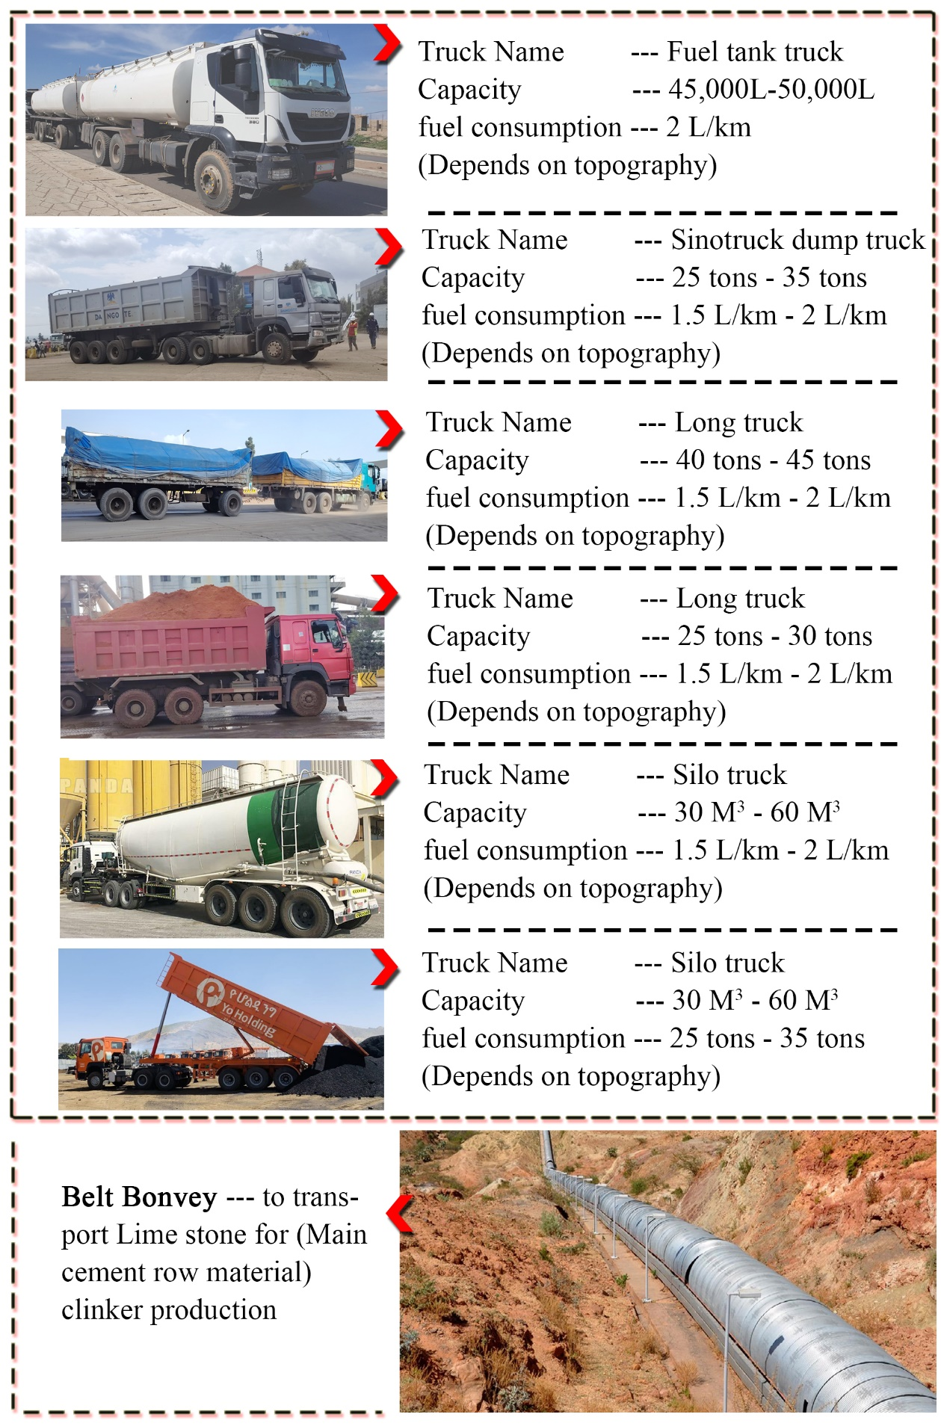

Unit Conversion
Material | Energy(joules) | Emergy Energy (solar emjoules)
1-ton of Cement | 3.3 Billion | 3.96 Billion
1-liter of fuel | 31.5 Million | 37.8 Million
1-kWh | - Million | 4.32 Million
1-ton limestone | 3.2 Billion | 3.84 Billion
1-ton silica sand | 1.2 Billion | 1.44 Billion
1-ton red clay | 1.5 Billion | 1.8 Billion
1-ton iron ore | 2.5 Billion | 3 Billion
1-ton gypsum | 1.5 Billion | 1.8 Billion
1-ton Pumice | 1- Billion | 1.2 Billion
1-ton coal | 21.5 Billion | 25.8 Billion
1-Coffee chaff | 17 Billion | 20.4 Billion
1-ton H₂ | 141 Billion
Labour and service | 80-100 Billion | 96 Billion/year
Note: 1-ton of hydrogen has nearly 6 times more energy than coal and it was different value by its production system with location, panel efficiency, and sunlight hours.
- Using the conversion factor of 1 joule other than hydrogen= 1.2 Sej
- Depending on the production method, 1 ton of H₂ ≈ 18–36 trillion seJ..
- 1 liter of gasoline contains approximately 32 mega joules (MJ) of energy.
In other units:
  - 32,000,000 joules (J)
  - ≈ 7,656 kilocalories (kcal) (since 1 kcal ≈ 4.184 kJ)
  - ≈ 8.89 kilowatt-hours (kWh) (since 1 kWh = 3.6 MJ)
Table: Transformity value of hydrogen (Sej/J)
Production Method | Transformity (seJ/J) | Avg 1-Ton H₂ (Sej) | Note
Solar-Powered Electrolysis (Green H₂) | 1-3 × 10⁵ | 282 × 10¹⁴ | High due to PV/wind infrastructure emergy
Wind-Powered Electrolysis | 0.8-2 × 10⁵ | 197.4 × 10¹⁴ | Slightly lower than solar PV

