

In Vitro Antibacterial and Antioxidant Activities of Field Collected (Jimma and Yirgacheffe) Coffee Beans and Roasted-Ground Shop Coffee from Addis Ababa

By:
TsedaleTasew

A Thesis Submitted to the Department of Microbial, Cellular and Molecular Biology; College of Natural and Computational Sciences in Partial Fulfillment of the Requirements for the Degree of Master of Science in Biology (Applied Microbiology)

May 2019
Addis Ababa
Ethiopia

DECLARATION
I, the undersigned, declare that, this is an original work and has never been presented in any other university as well as research institutes and all the source material used for this thesis have been fully acknowledged.

Tsedale Tasew Dubale
Signature ___________
Date_______________

The thesis has been submitted for examination with the approval of my University advisors.
Advisor: Hassen Mamo (Ph.D.) Signature_____________

Co-advisors: Fasil Assefa (Ph.D.) Signature_____________

Yalemtsehay Mekonnen (Prof.) Signature_____________

Date and place of Submission
Addis Ababa
Ethiopia
May 2019

ACKNOWLEDGEMENTS
First, my sincere thank goes to my advisors Dr Hassen Mamo, Prof. Yalemtsehay Mekonnen and Dr Fasil Assefa for their advice and support. Next, I would like to thank all members of the Applied Microbiology and the Institute of Biotechnology and Department of Microbial Cellular and Molecular Biology; Addis Ababa University, for their kind support in terms of supplies and equipment.

I would like to extend my gratitude to Kotebe Metropolitan University for sponsoring my study and provision of some materials. I am grateful to W/o Amelework Eyado, Ato Debebe Hailu, Ato Dejene Gutan and W/o Eyerus Mekuria the Biomedical Laboratory (Infection Biology Unit, Department of Microbial cellular and Molecular Biology) for their technical help. I am also thankful to Ato Zerihun Asefa for his assistance in statistical data analysis.

Table of Contents Pages
List of Tables iii
List of Figures v
List of Annexes vi
Abbreviations/ Acronyms vii
Abstract viii
1. INTRODUCTION 1
1.1. Statement of the problem 3
1.2. Significance of the study 4
1.3. Objectives 5
1.3.1. General objective 5
1.3.2. Specific objectives 5
1.4. Hypothesis 6
2. LITERATURE REVIEW 7
2.1. History of coffee 7
2.2. Coffee types and production in Ethiopia 8
2.3. Nutritional and medicinal values of coffee 11
2.4. Oxidation and antioxidant activity of coffee 12
2.5. Epidemiological studies on coffee consumption and health 14
2.6. Antimicrobial activities of coffee 17
2.6.1. Test bacteria (Bacterial strains) 18
3. MATERIALS AND METHODS 22
3.1. Sample collection and preparation 22
3.2. Extraction 23
3.3. Qualitative phytochemical screening tests 24
3.4. Antibacterial activity test 25
3.4.1. Extract and bacterial inoculums preparation 25
3.4.2. Antibacterial Susceptibility test 26
3.4.3. Minimum inhibitory concentration test 27
3.4.4. Minimum bactericidal concentration test 28
3.5. Antioxidant activity test 28
3.5.1. IC₅₀ percent inhibition antioxidant activity test 29
3.5.2. Measuring antioxidant content 29
4. DATA ANALYSIS 31
5. RESULTS AND DISCUSSION 32
5.1. Phytochemical test 32
5.2. Antibacterial susceptibility test 32
5.3. Minimum inhibitory and minimum bactericidal concentration 37
5.4. Antioxidant activity IC₅₀ 38
5.5. Antioxidant content measure 39
6. CONCLUSIONS AND RECOMMENDATIONS 42
7. REFERENCES 43
8. ANNEXS 51

List of Tables
Table 1: World’s top ten coffee producers, production and export during 2015 8
Table 2: Number of total and polymorphic alleles and rate of polymorphism (Rp, %) for 32 SSR markers in Arabica coffee collections. 10
Table 3: Coffee bean sample collection sites 22
Table 4: Antibacterial activities of medium roasted coffee bean sample extracts (Mean ± SD) 33
Table 5: The minimum inhibitory concentrations and minimum bactericidal concentrations of coffee samples boiled water extracts 37
Table 6: DPPH IC₅₀ antioxidant activity assay 39

List of Figures
Figure 1: Antioxidant contents of green and roasted coffee bean sample crud extracts 40

List of Annexes
Annex: 1 Roasting coffee using Ethiopian traditional coffee roaster 51
Annex: 2 Sieving and boiling coffee samples 51
Annex: 3 Shaking samples within given solvents 52
Annex: 4 Filtrating different solvent coffee extracts 52
Annex: 5 Lyophilizing water extract coffee samples 52
Annex: 6 Removing solvents from the extracts using a rotary evaporator 53
Annex: 7 Collected coffee sample extracts 53
Annex: 8 Bacterial suspension preparations 54
Annex: 9 Cold water coffee extracts with no antibacterial activity 54
Annex: 10 Instant and boiled coffee filtrates directly applied for well diffusion antibacterial susceptibility test with no activity 55
Annex: 12 Phytochemical test results for different coffee samples 55
Annex: 13 Coffee’s DPPH scavenging activity changing the purple color of DPPH into yellow 56
Annex: 14 Antibacterial susceptibility test inhibition zone 56
Annex: 15 Measuring inhibition zone diameters 56
Annex: 16 Minimum inhibitory concentration test tubes 57
Annex: 17 Minimum bactericidal concentration test plates 57
Annex: 19 Standard curve of ascorbic acid 58

Abbreviations/ Acronyms
AA | Antioxidant Activity
CFU | Colony-Forming Units
CGA | Chlorogenic Acid
CHD | Coronary Heart Disease
CLSI | Clinical Laboratory Standards Institute
CVD | Cardiovascular Disease
DPPH | 2,2-Diphenyl-1-Picrylhydrazyl Hydrates
^{IC}50 | 50% Inhibition Concentration
ICO | International Coffee Organization
MBC | Minimum Bactericidal Concentration
MHA | Mueller-Hinton Agar
MHB | Mueller-Hinton Broth
MIC | Minimum Inhibitory Concentration
PCR | Polymerase Chain Reaction
ROS | Reactive Oxygen Species
SSR | Single Stranded Ribosome
T2DM | Type 2 Diabetes Mellitus

Abstract
Coffee has long been among the first beverages consumed worldwide and most traded commodities. The coffee extract is reported to show antibacterial and antioxidant activities. Ethiopia as the land of origin of the Coffea arabica and producer and exporter of different coffee varieties has not yet developed enough studies on the health aspects of coffee. This study aimed at investigating the antibacterial and antioxidant activities of coffee bean samples collected from two coffee-growing regions of Ethiopia, Yirgacheffe and Jimma, as well as roasted ground coffee bean sample from a coffee shop in Addis Ababa. The antibacterial test was conducted on medium-roasted, boiled water extracts. Qualitative phytochemical test was conducted to assess the availability of most common secondary metabolites on roasted sample extracts. Agar well-diffusion bacterial susceptibility test, minimum inhibitory concentration test and minimum bactericidal concentration tests were determined against eight bacterial strains to assess the antimicrobial activities of the coffee samples using chloramphenicol as positive control. The antioxidant activity assessment was done following the DPPH IC₅₀ percent inhibition test and DPPH antioxidant content measure procedure on light roasted and green coffee bean samples as well as light roast shop sample methanol extracts. The susceptibility test data was analyzed using (Minitab.v17.1.0.) one-way ANOVA mean ± SD (p˂0.05). All coffee samples showed strong antibacterial and antioxidant activities. However, samples from Yirgacheffe, Jimma and the shop sample showed significant variation in both their antibacterial as well as antioxidant activities. The different coffee bean samples activity was also variable against the different test bacteria. The study highlighted the health importance of Ethiopian coffee using field samples. In-depth investigations using samples from wider agro-ecological regions and localities and testing fractionates is necessary.
Keywords: Agar well-diffusion, antibacterial activity, antioxidant activity, Coffee, DPPH IC₅₀

INTRODUCTION
Coffee is the favorite beverage consumed worldwide and has been used to be additive to many other beverages and foodstuffs. Coffee is the second most traded commodity next to oil (Davis et al., 2012). The two common species of coffee are Coffea arabica (C. arabica) and Coffea robusta. C. arabica which is the most preferable coffee type is reported to be discovered in Ethiopia and Ethiopia is recognized as the primary center of C. arabica diversity (Anthony et al., 2001). For longer time, Ethiopia is indicated to be the first African coffee producer and among the first five top-ten largest world Arabica coffee producers (Okicki, 2008).

Coffee bean is getting attention in health apart from being most preferable beverage for its stimulating properties. Coffee beans possess antibacterial properties against the different groups of pathogenic bacteria (Daglia et al., 1998). The varied factors affect the antibacterial activities of coffee (Antonio et al., 2010). Compounds isolated from roasted coffee bean showed strong antibacterial activity (Daljit et al., 2008). On the other hand, a report showed that green coffee beans did not show antibacterial activity and explained the antibacterial activity might be induced by factors like roasting process while other report showed that green coffee beans have antibacterial activity (Daglia et al., 1998).

Antioxidants are molecules that inhibit other molecule’s oxidation. Antiradicals absorb free radicals while antioxidants prevent oxidation and so the accumulation of free radicals that are known to produce oxidative stresses and lead to chronic diseases like cardiovascular disorders, cancer and premature aging due to their oxidation of the blood vessel walls, protein molecules, DNA, carbohydrates and lipids. The antioxidant activity of coffee is mostly related to the plant’s higher composition of phenolics, chlorogenic acids and other compounds (Nicoli et al., 1997). In roasted coffee, phenylalanine’s and melanoidins, strong antioxidants are reported to be synthesized (Yashin et al., 2013). The pulp of coffee is also reported to contain high antioxidant activity due to its contents of phenolics compounds (Duangjai et al., 2016).

The composition and types of secondary metabolites of coffee are responsible for the activities of coffee including the antibacterial and antioxidant activities. The factors contributed for the variation of the compositions of those secondary metabolites of coffee include coffee species as well as varieties types, agro-ecological variations, processing and storage conditions from the field to the market, roasting degree (Antonio et al., 2010) extracting solvent type and others.

Ethiopia as land of origin of the C. arabica, producing different regional origin coffee types which are of cultivars and wild (Ofcansky et al., 2004) the first nation to use coffee as beverage, place of genetic diversity of the coffee plant (Anthony et al., 2001) African largest first and worlds fifth producer of coffee ICO (2016) and specialty coffee exporter (Okicki, 2008) no work is found on the antibacterial activity of the diverse coffee types in the country. This study thus tries to assess the antibacterial and antioxidant activities of crude extracts of coffee samples from two coffee growing regions of Ethiopia and roasted ground coffee samples from a coffee shop in Addis Ababa.

Statement of the problem
Ethiopia as land origin of the coffee plant, one of the nations of the top coffee producers as well as a producer of divers’ variety of C. arabica., but has not yet conducted enough studies around the medicinal impacts and health benefits of the Ethiopian coffee. Ethiopia is having various wild coffee types, varieties and cultivars. Coffee is incriminated to show antibacterial and antioxidant activities. However, the antibacterial and antioxidant activities of the various Ethiopian coffee types are little studied in Ethiopia. The aim of the current study was, therefore, to assess the antibacterial and antioxidant activities of the crude extracts of six coffee bean samples from two coffee growing regions of Ethiopian and a roasted ground coffee sample from a coffee shop in Addis Ababa.

Significance of the study
This study showed coffee’s promising activity against common pathogenic bacteria including the well-known multidrug-resistant bacterium Pseudomonas aeruginosa. The result of this study indicated that there is significant variation in both antibacterial as well as antiradical activity among the different coffee samples from the two coffee-growing regions as well as different localities within a coffee growing region. Ethiopia owns various organic coffee varieties and cultivars including wild types distributed in diverse agro-ecological localities. Thus, there is expected variation in the composition of secondary metabolites that have significant health implications. Ethiopia being the homeland of coffee but with little previous such work, this study tries to show future in-depth studies nationwide. The selection of the most active coffee type in both antibacterial and antioxidant activities may lead to the way for development of better treatment options against multidrug resistant bacterial infections as well as chronic non-infectious diseases.

Objectives

General objective
To assess the antibacterial and antioxidant activities of crude extracts of Ethiopian coffee beans samples originating from the different regions and localities.

Specific objectives
- To evaluate the antibacterial activity of coffee bean samples from two regions of Ethiopia and a commercial source in Addis Ababa,
- To evaluate the antioxidant activities of Ethiopian coffee bean samples.

Hypothesis
It was hypothesized that the coffee samples from different locations of a coffee growing region of Ethiopia show variations in antibacterial and antioxidant activities.

LITERATURE REVIEW

History of coffee
According to legends coffee was first discovered in Ethiopia. The herdsman Kaldi who lived around AD 850 found it stimulating his goats as they feed on the plant’s berries, not sleeping during the nights (Ofcansky et al., 2004). He is known to acknowledge it for the first time. The native place where coffee tree was discovered is named Kaffa province, in the southern west highland of the early Abyssinia now Ethiopia and the coffee plant has got its name from this place (Okicki, 2008)..

Coffee consumption is also noted to begin in Ethiopia, by the local people. The first coffee house in the United States was opened in Boston in 1689. The opening of the first coffee and tea shop in San Francisco in 1966, led to the expansion of the specialty coffee industry in the United States. Cultivation of coffee was started by the Dutch East India Company in Java using seeds obtained from Mocha in Yemen in the 1690s. From there, it was taken to the Amsterdam Botanical Garden in 1706, from which a plant was reach to France in 1713; 1720, coffee made its way from France to the French colony of Martinique in the Caribbean and spread throughout the Caribbean islands: Haiti (1725), Guadeloupe (1726), Jamaica (1730), Cuba (1748) and Puerto Rico (1755) (Krishnan, 2017).

Today Ethiopia is the first African coffee producer and one of the top-ten world’s major producer and exporters of the Arabian coffee beans (Davis et al., 2012). Ethiopia has been among the main exporters of coffee. The International coffee organization 2015 report (Table 1) below also shows Ethiopia is the fifth largest coffee producer in the world. Coffea arabica, which was identified by the botanist Linnaeus in 1753, is one of the two major species used in most production and presently accounts for around 70 percent of the world’s coffee. The second common species of coffee is Coffea robusta; the indigenous distribution of this coffee species includes tropical Africa from Guinea to western Tanzania, at altitude 50-1500m (Davis et al., 2006; Davis et al., 2012).

Table 1: World’s top ten coffee producers, production and export during 2015
Country | Production (1,000 60 kg bags) | % of world production | Exports (1,000 60-kg bags) | % of world exports
Brazil | 43,235 | 30.17 | 28,478 | 30.53
Vietnam | 27,500 | 19.19 | 19,125 | 20.50
Colombia | 13,500 | 9.42 | 10,031 | 10.75
Indonesia | 12,317 | 8.60 | 4,847 | 5.20
Ethiopia | 6,700 | 4.68 | 2,514 | 2.70
India | 5,833 | 4.07 | 5,006 | 5.37
Honduras | 5,750 | 4.01 | 4,746 | 5.09
Uganda | 4,755 | 3.32 | 2,817 | 3.02
Guatemala | 3,400 | 2.37 | 2,432 | 2.61
Peru | 3,300 | 2.30 | 2,280 | 2.44
Total world production & export | 143,306 | 88.17 | 93,275 | 88.21
Source: ICO (2016)

Coffee types and production in Ethiopia
Ethiopia produces different regional origins coffee types which are of the wild and cultivars. Coffea arabica are with different aroma, test and bean shape. The variety of coffee beans is registered to be over 6,000 (Heran, 2010). Ethiopia is reported to own three heritage coffees - Harar, Sidamo, Yirgacheffe, and these coffee varieties are commonly identified and marketed with their regional names as Harar, Sidamo, Yirgacheffe, and others. Ethiopian coffee types are known worldwide for their excellence. The coffee types are with the most varied tests (Okicki, 2008). Each region's coffee tastes slightly different, according to the growing conditions and genetic variety. There are also many other Ethiopian coffee bean types, such as Tepi, Bebeka, Wollega (Nekemte), Limu and others which are known with their specific features. Ethiopia is indicated to be the center of genetic diversity of coffee. Genetic diversity assay (Table 2) below indicates Ethiopia is the principal site of the Arabica coffee genetic diversity.

Table 2: Number of total and polymorphic alleles and rate of polymorphism (Rp, %) for 32 SSR markers in Arabica coffee collections.
No | SSR Code | PCR size range ( bp) |  | Ethiopian accession | Cultivated ACCs group | Overall
 |  |  | Number of alleles |  | Number of alleles | Number of f alleles
1 | SSR124577 | 138-157 | 3 | 2 | 3 | 2 | 3 | 3
2 | SSR122850 | 132-141 | 3 | 2 | 2 | 0 | 3 | 2
3 | SSR124195 | 83-101 | 3 | 2 | 2 | 0 | 3 | 2
4 | SSR119699 | 98-110 | 3 | 2 | 4 | 4 | 4 | 4
5 | SSR129793 | 200-236 | 11 | 10 | 5 | 5 | 12 | 12
6 | SSR124161 | 161-177 | 4 | 4 | 4 | 4 | 5 | 5
7 | SSR123909 | 252-263 | 2 | 2 | 1 | 0 | 2 | 2
8 | SSR123557 | 206-270 | 4 | 4 | 2 | 2 | 4 | 4
9 | ssrCMA008 | 106-128 | 4 | 4 | 5 | 4 | 6 | 6
10 | ssrCMA055 | 82-97 | 6 | 6 | 4 | 4 | 7 | 7
11 | ssrCMA059 | 129-165 | 10 | 10 | 3 | 2 | 10 | 10
12 | ssrCMA151 | 168-177 | 4 | 4 | 3 | 2 | 4 | 4
13 | ssrCMA159 | 147-174 | 12 | 12 | 3 | 3 | 13 | 13
14 | ssrCMA198 | 195-236 | 7 | 6 | 5 | 4 | 9 | 8
15 | ssrCMA199 | 122-153 | 11 | 11 | 8 | 8 | 14 | 14
16 | ssrCMA233 | 255-270 | 5 | 4 | 4 | 3 | 6 | 5
17 | ssrCMA263 | 178-200 | 7 | 7 | 2 | 2 | 8 | 8
18 | ssrAY2434 | 178-199 | 4 | 3 | 4 | 3 | 4 | 3
19 | ssrAY2449 | 273-294 | 6 | 6 | 4 | 3 | 8 | 8
20 | ssrA8783 | 106-126 | 8 | 8 | 5 | 5 | 8 | 8
21 | ssrA8837 | 148-165 | 5 | 5 | 3 | 3 | 5 | 5
22 | ssrA8847 | 159-192 | 10 | 10 | 3 | 2 | 10 | 10
23 | ssrR105 | 187-222 | 9 | 9 | 5 | 5 | 10 | 10
24 | ssrR126 | 206-142 | 11 | 10 | 4 | 3 | 11 | 10
25 | ssrR175 | 214-217 | 3 | 3 | 2 | 2 | 4 | 4
26 | ssrR209 | 161-173 | 3 | 2 | 2 | 0 | 3 | 2
27 | ssrR268 | 131-147 | 3 | 2 | 4 | 4 | 5 | 5
28 | ssrR278 | 123-141 | 7 | 7 | 2 | 0 | 7 | 7
29 | ssrR325 | 224-262 | 10 | 10 | 6 | 6 | 10 | 10
30 | ssrR338 | 221-233 | 3 | 2 | 2 | 0 | 3 | 2
31 | ssrR339 | 215-226 | 5 | 4 | 4 | 4 | 5 | 5
32 | ssrZAP25 | 185-193 | 3 | 2 | 2 | 0 | 3 | 2
Total |  |  | 189 | 175 | 112 | 89 | 209 | 200
Rate of Polymorphism (rP, %) |  |  | 92.6 |  | 79.5 |  | 95.7
No SSRs |  |  | 32 | 32 | 32 | 32 | 32 | 32
Average |  |  | 5.9 | 5.5 | 3.5 | 2.8 | 6.5 | 6.2
Source: EJAST 1(1): 63-79 (2010)

Nutritional and medicinal values of coffee
Coffee is consumed worldwide primarily for its stimulating activity due to its composition of psychoactive substance. Even if mostly people consume coffee for the previously indicated purposes, coffee is also known to contain large number of substances. The major component of coffee is carbohydrates, followed by lipids and amino acids. Coffee also contains minerals, aliphatic and chlorogenic acids (CGA), trigonellines and many volatile aromatic compounds. CGA, which are present in high concentrations in green coffee beans (up to 14%), have a marked influence in determining coffee quality and play an important role in the formation of coffee flavor (Farah et al., 2006). CGA is a phenolics compound and second most abundant compound next to caffeine. This compound is getting greater considerations to contribute a number of health benefits including diabetes cases (Meng et al., 2014). As in Ong et al. (2013) investigation done on mice, showed that CGA lowered blood glucose, improved glucose tolerance and insulin sensitivity, reduced body weight and water intake, inhibited gluconeogenesis and fatty acid synthesis, lowered hepatic lipid accumulation and stimulated glucose uptake in skeletal muscles. Coffee consumption is related to reduction rate of diabetes (Zhang et al., 2011).

Among the alkaloids of coffee, the most studied and recognized one is caffeine followed by other purinic alkaloids (Echeverri et al., 2010). Caffeine the most abundant compound in coffee is psychoactive substance most widely consumed in the world. It is found not only in coffee but also in tea, carbonated beverages or soft drinks, chocolate and a wide variety of medications, including appetite suppressants. Thus, the general population consumes a considerable amount of caffeine per day when coffee consumption coupled with tea, chocolate and soft drinks. Adults over 25 years consume approximately 2.4mg/kg/day caffeine, while children below12 take only 0.7mg/kg/day (Saxena et al., 1994).

Compounds in coffee exhibit considerable health benefits including blood sugar lowering, liver protection and antiviral activities. Coffee is incriminated as antiparasitic (Geerts and Gryseels 2000; Ong et al., 2012; Jamila et al., 2013) and antioxidant agent. Moreover, constituents of coffee have several beneficial health properties largely explained by their potent antioxidant activity, which in turn has great impact in reducing chronic non infectious diseases like Alzheimer’s and Parkinson’s (Ross et al., 2000).

Several chronic infectious and non infectious diseases are emerging. Drug-resistance is becoming a major challenge in the management and treatment of especially infectious diseases (Dzidc et al., 2008). Using natural plant antibiotic components in combination with the existing antibiotics is being practiced as an option to treat such diseases (Gislene et al., 2000). As highly consumed beverage having complex composition of secondary metabolites, coffee is getting considerations to be considered among the common medicinal plants in addition to the daily consumption worldwide.

Oxidation and antioxidant activity of coffee
The importance of oxidation in the body and in food stuffs has been widely recognized. Oxidative metabolism is essential for the survival of cells. A side effect to this dependence is the production of free radicals and other reactive oxygen species that cause oxidative changes. There is increasing evidence for the involvement of such species in a variety of normal in vivo regulatory systems. When an excess of free radicals is formed, they can overwhelm protective enzymes such as superoxide dismutase, catalase and peroxidase and cause destructive and lethal cellular effects (e.g., apoptosis) by oxidizing membrane lipids, cellular proteins, DNA and enzymes, thus shutting down cellular respiration (Antonio et al., 2010).
The term “ROS” includes all unstable metabolites of molecular oxygen (O₂) that have higher reactivity than O₂ like superoxide radical (O₂•) and hydroxyl radical (HO•) and non radical molecules like hydrogen peroxide (H₂O₂). These ROS are generated as byproduct of normal aerobic metabolism, but their level increases under stress which proves to be a basic health hazard (Antonio et al., 2010).

Antioxidants are molecules that inhibit other molecule’s oxidation, hence prevent the accumulation of free radicals that are known to produce oxidative stresses and lead to many of the chronic disease like cardiovascular disorders, cancer and premature aging due to their oxidation of the blood vessel walls, protein molecules, DNA, carbohydrates and lipids. Prolonged oxidative stress inevitably leads to dangerous diseases such as cancer, cardiovascular diseases, or diabetes and premature aging. Oxidative stress can be reduced by antioxidant therapy by consumption of certain amounts of natural antioxidants contained in vegetables, fruits, berries, vegetable oils, honey, tea, coffee, cocoa, juices, wine, sprouted grains and other foods. However, in order to control consumption of antioxidants, it is necessary to know their content in foods and beverages (Rahal et al., 2014).

Coffee is one of the major sources of antioxidants in people’s daily diet. For this activity of coffee the main components are phenolic compounds (Menshchikova et al., 2010). Coffee is known to contain complex compounds especially caffeine, CGA, trigonelline, cafestol, kahweoletc which are being described to show strong antioxidant activity in nature and there are chemical compounds produced during roasting process of coffee beans like melanoidins which also are described to contain high antiradical activities (Nicoli et al., 1997; Abreu et al., 2005). Phenylalanines, which are of the compounds formed during the roasting process of coffee are also shown to contain antioxidant activity as do heterocyclic compounds.
Investigations explored the relationship between coffee’s antioxidant activities and roasting and described that, during the roasting process, Maillard reaction products, which are also strong antioxidants compounds, are formed. The compounds, such as CGA which contributed to the antioxidant activity of coffee and are among the largest constituents of coffee, have agro-ecological variation among the different types and origins of coffee. The coffee fruit is reported to contain higher CGA in Arabica coffee fruit planted in Mexico and India compared to the coffee fruit grew in China (Abreu et al., 2005). Differences in green coffee bean compound composition, roasting conditions and extraction procedures adopted for the coffee beverages preparation resulted in great variation of the chemical composition of the final product, which could account for differences in the biological activities of coffee brews.

Epidemiological studies on coffee consumption and health
Cardiovascular diseases (CVDs) according to the WHO the disorder of the heart and blood vessels include coronary heart disease (CHD), cerebrovascular disease, rheumatic heart disease and other conditions. CHD is one of the leading causes of mortality. Most of cases of CHD can be attributed to lifestyle factors, such as unhealthy diet. Because of the wide consumption of coffee, its effects on CHD could have considerable public health and clinical implications. Demonstration of the benefits and hazards associated with any such common exposure is important. Over the past three decades, many observational epidemiologic studies have extensively examined whether coffee consumption increases risk of CHD (Grobbee et al., 1990). However, the issue remains controversial.

For years and with most, coffee was understood to cause CVDs. There are controversial studies done on the benefits and harm full effects of coffee. There are also Potential indicated mechanisms by which tea and coffee phytochemicals can exert effects for CVD protection. Some of them include the regulation of vascular tone through effects on endothelial function, minimizes simple sugar catabolism, increased reverse cholesterol transport and inhibition of foam cell formation, inhibition of oxidative stress, immune modulation as well as effects on platelet function (adhesion and activation, aggregation and clotting). Hypertension and the healthy functioning of the heart are highly related. Investigations done on coffee’s impact concerning its hypertension reducing mechanism Zhao et al. (2011) described that green coffee extract showed reducing activity on both non-human animal models and human being hypertension and in regulating blood pressure.

The findings from a systematic review and meta-analysis, based on approximately 1,283,685 study participants and 47,779 CVD cases, including about 28,347 CHD cases, 12,030 stroke cases and 7,402 other CVD cases, demonstrated a non-linear association between coffee consumption and risk of CVD. According to the data in this meta-analysis, moderate coffee consumption (3–5 cups/day) was associated with lower CVD risk and heavy coffee consumption (≥6 cups/day) was neither associated with a higher nor a lower risk of CVD. The meta-analysis also explained the idea based on clinical information based on the findings summarized results from 36 prospective cohort studies on coffee consumption and CVD risk with 1,279,804 study participants and 36,352 CVD cases (Ding et al., 2014). The Meta analysis also revised findings showed that there was a non-linear relationship of coffee consumption with CVD risk. The phytochemical compounds in tea and coffee and the secondary metabolites produced are suggested to influence protective endogenous pathways by modulation of gene-expression (Bohn et al., 2012). The coffee components mostly raised in association with cardiovascular diseases include, caffeine and CGA.

Cancer is a major cause of morbidity and mortality worldwide. According to cancer society’s information, in 2012 there were 14.1 million new cancer cases and 8.2 million cancer deaths globally and the global burden from cancer has become significantly high. Although the strategy for cancer treatment has improved much, cancer is still the most devastating disease to overcome. Early diagnosis and treatment may provide good chance for cancer patients to improve overall prognosis. However, there is no promising survival for those who suffer from advanced cancer. Therefore, it is important to determine methods to prevent tumor occurrence. Nutrition, such as the consumption of citrus fruits, vegetables and coffee, has also been considered to play an important role in reducing cancer risk Coffee is speculated to decrease the risk of different types of cancers. Coffee as described previously is a complex mixture of complex biologically active components, including caffeine, cafestol, kahweol and CGA (Wang et al., 2016)..

Coffee intake could reduce the incidence of colon cancer, liver cancer, prostate cancer, endometrial cancer, oral, pharyngeal cancer and melanoma. There are mechanisms attempting to explain this phenomenon. Studies indicate that caffeine can prevent oxidative DNA damage, modify the apoptotic response and reverse the cell cycle checkpoint function. Moreover, studies also showed that cafestol and kahweol are anticarcinogenic (Wang et al., 2016). The previously cited study also hypothesized that CGA can clear away reactive oxygen species and confer an anti-tumor effect. There also mentioned that coffee consumption decreased the exposure of epithelial cells to carcinogens in the colon by increasing colonic motility. In addition, coffee has been reported to reduce the synthesis and secretion of bile acids, potential promoters of colon carcinogenesis. Coffee is reported to reduce the common non-infectious diseases and is advisable to be used except during pregnancy (Poole et al., 2017).

Antimicrobial activities of coffee
Infectious diseases are also becoming great health issue especially due to the emergence of drug-resistant strains among common groups of pathogenic microorganisms. Viruses which are known to be uncommonly different creatures are among the dominant problems for the human, animals as well as other group of organisms’ health. An in vivo and in vitro study of CGA, quinic acid and caffeic acid from coffee showed inhibitory action against hepatitis B virus replication (Wang et al., 2009). Another in vitro study indicated that coffee inhibited the replication of herpes simplex virus type 1 (Utsunomiya et al., 2008). According to the information in this study, the mechanisms of coffee’s activity to inhibit viral infection are a direct inactivation of the infectivity of virus particle (virucidal activity) and the inhibition of progeny infectious virus formation at the late stage of viral multiplication in the infected cells.

Parasitic helminthes such as hookworms and schistosomes are common especially among the developing nations where hygienic problems and poverty are dominant. Coffee extract killed earthworm species effectiveness varying with concentration of coffee extract, exposure time and extraction solvent used (Jamila et al., 2013).

Coffee is also indicated to show antifungal activities. Quiroz et al. (2013) reported that green coffee 5-O-caffeoyl quinic acid and its alkyl esters showed anti-Aspergillus activities. CGA is also demonstrated to exert antifungal activity by disrupting the structure of the cell membrane (Sung and Lee, 2010).

Pharmacological industries have always been making antibacterial drugs, but those pathogens are also developing various mechanisms to resist drugs and survive. Drug-resistance among the most common pathogenic bacteria is becoming serious concern globally. Bacteria developed mechanisms for acquiring resistance to various antibiotics such as modification of the target molecule, which is no longer recognized by the antibiotic, production of bacterial enzymes that modify the antibiotic molecule or decrease in antibiotic take over by reducing the permeability of bacterial cell or by emergence of active efflux systems (Manu et al., 2011).

Compounds isolated especially from roasted coffee are reported to show strong antibacterial activity (Daljit et al., 2008; Arora et al., 2009). The influence of species, roasting and decaffeination on the plants bactericidal activity was also assessed and it was found that the joint effect of active compounds of coffee bean removed by decaffeination seems to be of the constituents that contribute for the antimicrobial and other bioactivities of coffee (Antonio et al., 2010; Vignoli et al., 2014). Coffee origins of different agro-ecological regions are reported to show variations in antibacterial activity.

Test bacteria (Bacterial strains)
Pathogenic bacteria are causes of major human, animal and plants diseases. Staphylococcus aureus (S. aureus), Escherichia coli (E.coli), Pseudomonas aeruginosa (P. aeruginosa) and Salmonella typhi (S. typhi) are among the most common pathogenic bacteria affecting humans.

S. aureus is a gram-positive, round non motile and non sporulating bacterium mostly common in nose respiratory tract and skin especially on skin and lower female reproductive tract of normal flora. Staphylococci are important infection agents causing hospital and community acquired infections. The bacterium is generally common to cause skin and respiratory infections as well as food spoilage/ intoxication. It causes a wide range of infections including: bacteremia, pneumonia, meningitis, skin and soft tissue, surgical site, urinary tract, bone and joint infections and toxic shock syndrome (Abubakar and Sulaiman, 2018). Now a day’s drug resistant S. aureus strains are immerging. Increasing resistance problem in staphylococci bacteria particularly methicillin resistant S. aureus (MRSA) caused a global challenge to treat staphylococcal infections (Yilmaz and Aslantas, 2017).

Staphylococcus aureus bacteria have developed different drug resistance mechanisms. The one way by which resistance mechanisms can develop is by horizontal transfer of resistance determinants encoded by mobile genetic elements using plasmids, transposons and the staphylococcal cassette chromosome. The other way is by mutations in chromosomal genes. Horizontally acquired resistance can occur by mechanisms like enzymatic drug modification and inactivation, enzymatic modification of the drug binding site, drug efflux, bypass mechanisms involving acquisition of a novel drug-resistant target and displacement of the drug to protect the target. Acquisition of resistance by mutation can result from alteration of the drug target that prevents the inhibitor from binding, derepression of chromosomally encoded multidrug resistance efflux pumps and multiple stepwise mutations that alter the structure and composition of the cell wall and/or membrane to reduce drug access to its target (Foster, 2017).

E. coli is a gram negative, facultative anaerobe, rod shaped, coli-form bacterium. Most of the genus are harmless enteric as a part of the normal flora of the gut, but some are pathogenic and others are opportunistic in immune suppressed and some are especially known for serious food poisoning. Due to their release into the environment during the removal of fecal matter from the intestine of warm blooded animals, including the human being, the bacteria are used as an indicator of environmental contamination. Even if mostly E. coli is among the common human commensals, it is known to be opportunistic causing severe epidemic diseases. Diarrheal diseases are causes of many mortalities and morbidities worldwide. The most common E. coli strain known to causes such seviour diahric epidemic is E. coli O157:H7. The outbreaks of this bacterial strain in the different parts of the world at different occasions cause many to die in so short time (Ishii and Sadowsky, 2008). The emergence of antibiotic resistant strains is the result of mutations in chromosomal DNA (vertical evolution) or the acquisition of foreign genetic material (horizontal evolution) like most other pathogenic bacteria even if there are some differences among the different strains.

P. aeruginosa is a rod-shaped gram negative facultative anaerobe, bacterium. It can be found in soil, water, skin flora and other artificial and natural environments. This bacterium is a common pathogen among plants and animals including the human being causing lung, urinary tract and other infections. It is mostly considered to be opportunistic due to its common appearance in the immune compromised people. P. aeruginosa is known to cause nosocomial infections. The bacterium is also common to be multidrug resistant. Due to its resistance to most drugs available on the market, the bacterium is named ‘superbug’ (Breidenstein et al., 2011). P. aeruginosa has intrinsic resistance mechanisms against amino glycosides, fluoroquinolones and β lactam. The inefficient porins low permeability of the bacterium outer membrane, limiting antibiotic penetration rate is one factor to limit the antibiotic efficiency. This membrane barrier enables the secondary adaptive resistance mechanism to work with efficiency including high efflux and enzymatic antibiotic modification. The intrinsic resistance mechanisms can be enhanced by mutation affecting expression of genes encoding for resistance. The intrinsic resistance is dependent up on other intrinsic resistance mechanisms and adaptive secondary mechanisms like rapid efflux. P. aeruginosa may also develop acquired resistance due to horizontal transfer of genetic material and mutational resistance. In the horizontal transfer of genetic elements, plasmids, transposons and other genetic materials carrying genes coding for different resistance mechanisms are transferred by conjugation, transformation as well as transduction. The transfer of genetic elements can increase multidrug resistance (Breidenstein et al., 2011).

Salmonella typhi, the causative agent of typhoid fever, is a gram-negative, motile, rod shaped, facultative anaerobe. It is solely a human pathogen and there is no animal reservoir (Ugboko and De, 2014). S. typi is one of the most frequently isolated food borne pathogens. It is a major worldwide public health concern, accounting for 93.8 million food borne illnesses and 155,000 deaths per year (Eng et al., 2015). The emergence of multi-drug-resistant (MDR) Salmonella serotypes is challenging the efficiency of antibiotic treatment and an increasing prevalence of MDR strains may lead to an increase in mortality rates of the bacterial infections. An investigation done on S. typhi resistant to available antibiotic drugs showed that it has the resistance rate of 38.3% for amoxicillin, 19.1% for co- trimoxazole and 2.1% for chloramphenicol (Patel et al., 2017).

The antibiotic resistance mechanisms of S. typhi include inactivation of the antimicrobial agent, efflux or transport of the antimicrobial agent, modification of the antimicrobial target site, reduced permeability of the antimicrobial agent and genetic change in the organism, either by chromosomal mutation or the acquisition of a plasmid or transposon (Ugboko and De, 2014). The serotypes of S. typhi displaying MDR phenotype have the ability to generate various types of hybrid plasmids. The majority of the gene cassettes located within these plasmids consists of resistance genes that confer the antimicrobial resistance property (Eng et al., 2015).

MATERIALS AND METHODS

Sample collection and preparation
Six green coffee bean samples (1kg each) were kindly donated by farmers from different localities in two coffee-growing regions in the south and southwest of Ethiopia. The two regions were Yirgacheffe (Y) and Jimma (J) and samples were designated as Y1, Y2 and Y3 for those of the Yirgacheffe samples as well as J1, J2 and J3 for those from Jimma. Both regions were visited during December 2017 to March 2018 and the samples acquired from the same harvest season. The sample sites are shown in the Table 3 below. Additionally, roasted ground and packed coffee samples (250g each) were obtained from local coffee house which is among the most preferable roasted and ground coffee powder suppliers and coffee brewers in Addis Ababa. The coffee shop samples are represented by Tl for light roast and Tm for the medium roast.
Table 3: Coffee bean sample collection sites
No | Sample name | Sampling site | Region
 | Y1 | Gedeo, Yrga, Korna | Southern
 | Y2 | Gedio, Yrga, Korne | Southern
 | Y3 | Gedeo, Yrga, Chite | Southern
 | J1 | Jimma, Omafuntile | Southwestern
 | J2 | Jimma, Omafuntile | Southwestern
 | J3 | Jimma, Gome, Chochie | Southwestern
 | Tl and Tm | Local market roasted and ground
Key: J = Jimma, Y= Yirgacheffe, Tl =Light roasted shop sample, Tm = Medium roasted shop sample
The samples were collected from farmers who produce a special coffee under close supervision of local agricultural experts on purpose of exportation to international market. All of the green coffee bean samples were obtained from ripped coffee cherries and processed by sun drying. The green coffee beans samples were kept in paper bags sealed, transported and stored at the Department of Microbial, Cellular and Molecular Biology (Infection Biology Laboratory Unit), College of Natural Sciences, Addis Ababa University, under room temperature conditions until used for extraction.

Extraction
Half of the 1kg of each of the selected field samples were roasted (roughly light and medium roast) using Ethiopian traditional coffee roasting equipment “Biretmitad” (in Amharic language), ground using an electric grinder and sieved with 0.5mm particle size mesh. The other half was reserved for extraction without roasting. T samples were used for direct brewing except sieving with similar mesh.

The medium roasted and powdered coffee bean samples as well as those from Tm were boiled (25g powder in 250ml) using distilled water for 30 min in a flask covered with aluminum foil. The extracts were double-filtered with cotton followed by Watman No. 1 filter paper. The filtrates were put in deep freeze at -20c⁰ for 48 hrs and lyophilized. These lyophilized products of all samples were placed in refrigerator until used for antibacterial activity test for a week.

The green coffee samples were ground and extracted using 99% methanol. Similarly the light roasted powder was extracted with methanol after sieving. Twenty five (25g) powder of each sample was dissolved in 250ml methanol and allowed to shake for 72 hrs in a shaker (GFL, model 3020, Germany) at 27⁰C and filtered with Watman No.1 filter paper. Then the methanol was evaporated using rotary evaporator (BUCHI, Germany) at 45⁰C followed by oven drying at 45⁰C to remove the remaining solvent and kept in refrigerator until use for antioxidant test for a week.

Qualitative phytochemical screening tests
Qualitative photochemical screening test was conducted on medium roasted coffee samples crude extracts to evaluate the availability of some of the common secondary metabolites associated with antibacterial as well as antioxidant activities. The testes were done for the following compounds.

Phenol test (ferric chloride test)- five milligram of crude extract was dissolved with 3ml of distilled water and 2ml of the dissolved extract was pipetted in another test tube and it was treated with 0.5ml of 5% ferric chloride (FeCl₂) a formation of intense blue color indicates the presence of phenol (Tiwari, 2011).

Flavonoids test- few drops of 10% sodium hydroxide were added to 1ml of stock solution of the extract then an intense yellow color formed. Few drops of 2% HCl were again added to yellow color mixture and then it becomes colorless that indicated the presence of flavonoids (Hossain et al., 2013).
Tannins test- in a test tube 2ml of extract was added and then it was treated with a few drops of 1% lead acetate. Formation of yellowish or red precipitates confirmed the presence of tannins (Treare and Evans, 1985).

Steroids test- crude extract was mixed with 2ml of chloroform and concentrated H₂SO₄ was added sidewise. A red color produced in the lower chloroform layer indicated the presence of steroids (Gibbs, 1974).

Terpenoids test- a few drop of acetic acid was added in chloroform solution of the extract then 1ml of concentrated H₂SO₄ was added. Establishment of reddish brown coloration at the junction of two layers shows the presence of triterpenoids (Kumar et al., 2013).

Alkaloids test- extracts 1mg was dissolved in diluted 2% HCl and filtered. Then 1ml of the filtrate was mixed with 2ml of Wagner’s reagent. Formation of reddish brown precipitate turbidity indicates the presence of alkaloids (Kannan et al., 2015).

Saponin test (foam test) -5ml of the extract was mixed with 20ml of distilled water and shaken vigorously. Formation of foam indicated the presence of saponin (kunnan et al., 2015).

Glycoside test (Legal’s test)- the plant extract (5ml) placed in a test tube and 2ml of glacial acetic acid was added on it then it was treated with 1 drop of FeCl₃ and 5ml of concentrated H₂SO₄ was added along the side of the test tube. Brown color at the junction indicates the presence of Glycosides (Kumar et al., 2009).

Antibacterial activity test

Extract and bacterial inoculums preparation
Antibacterial agent and test bacterial inoculums preparation was conducted following standard procedure in (CLSI, 2015). 0.5gm of each lyophilized crude extract sample was dissolved in distilled sterile water to prepare three concentrations (mg/ml): 500, 250 and 125). The positive control was 1mg/ml chloramphenicol and the negative control distilled sterile water.

The standard test bacteria were the American Type Culture Collection (ATCC) E. coli (ATCC 25922), P. aeruginosa (ATCC 2785315), S. aureus (ATCC 25923) and S. typhi (ATCC 13311) and clinical isolates of the same bacterial species. These were kindly donated by the Ethiopian Public Health Institute. For each of the bacterium collected, some characterization biochemical tests were done prior to direct application to antibacterial test following technical laboratory procedures of (Cheesbrough, 2006). Each bacteria type was grown on to a selective media of a particular bacterial type (E. coli - Eosin Methylene Blue, S.yphi a –Shigella-Salmonella (SS) agar, S. aureus – Manitol Salt Agar and P. aeruginosa on Pseudomonas Agar). From the culture colonies were transferred on to nutrient agar plate (Strikplate) and incubated for 24 hrs. Muller Hinton Agar plates were prepared after sterilization of the medium solution, aseptically placed on Petri dishes of 90 mm diameters and allowed to solidify in a safety hood. Inoculums were prepared following direct colony suspension preparation method whose cell density was adjusted to a turbidity visually comparable to 0.5 McFarland standard prepared by mixing 0.5ml of 1.75% (w/v) barium chloride dihydrate (BaCl₂.2H₂O) with 99.5ml of 1% (v/v) sulfuric acid (H₂SO₄), which is equivalent to approximately 1-2×10⁸ colony forming units per ml (CFU/ml).

Antibacterial Susceptibility test
Antimicrobial activity of the coffee extracts was determined following agar well-diffusion method (NCCLS, 2005) guidelines. Accordingly, 0.5 McFarland standard bacterial suspensions were spread on each Mueller Hinton agar (MHA) plates using sterilized cotton tips and 5 wells with 6mm diameter size were made on plates using sterile cork-borer. Three wells were filled with 40µl coffee crude extract solutions with 500mg/ml, 250mg/ml and 125mg/ml concentrations and the remaining with the positive and negative controls. After incubating the plates at 37⁰C for 24 hrs inhibition zones around the colonies were measured using a ruler. The activity was done thrice and average measurement of zone of inhibition was taken.

Minimum inhibitory concentration test
Following triplicate antibacterial susceptibility tests up to the concentration of 125mg/ml for each sample type, MIC (minimum inhibitory concentration) and MBC (minimum bactericidal concentration) were determined.

0.5 McFarland comparable test bacterial suspension which is approximately 1 to 2 × 10⁸
Colony Forming Units, sterilized nutrient broth, saline solution, distilled sterilized water, sterilized screw cupped test tubes, sterilized tips and micropipettes, as well as stock dissolved sample extracts (with concentration 62.5mg/ml) were prepared.1ml of each 0.5 McFarland comparable bacterial suspension prepared was transferred to a separate 150ml of the sterile nutrient broth containing container and was well mixed (to bring 5× 10⁶ CFU/Ml). 1 ml of the bacterial suspension was transferred to each of the fold broth dilution test tubes labeled 62.25mg/ml, 31.25mg/ml, 15.625mg/ml, 7.8125mg/ml, 3.906mg/ml, 1.953mg/ml, 0.976mg/ml and a positive control containing 1ml of the bacterial suspension for each of the bacterial type. In addition to the bacterial suspension, to other one test tube 1ml of sterile broth was added as a negative control. One ml of the crude extract solution was transferred to the first test tube (the highest concentration which is 62.5mg/ml) shacked well and 1ml from the first test tube was transferred to the next lower concentration level shacked well and went on to the final two fold serial dilution tube (0.976mg/ml). The subsequent 1:2 dilution with the extracts solution brings the final inoculums to 5×10⁵ CFU/Ml. Finally from the last test tube 1ml solution was discarded to bring the volume equal. The test tubes then were incubated at 37⁰c for 24 hrs.

After incubation, the MIC test tubes, growth was observed and data was recorded. The smallest concentration on which growth is inhibited was taken as the MIC of the extract. The activity was repeated trice in three different days. The MIC and all above concentration tubes were selected for MBC test

Minimum bactericidal concentration test
The MBC was determined by transferring a loop full of bacterial suspension from the MIC and higher next concentrations of each test bacterial type onto fresh sterile nutrient agar plates by streak platting method. The plates then were incubated for 24 hrs at 37⁰C and any growth was observed. The plate with the lowest extract concentration on which no CFUs were detected was taken as the MBC of the sample against the given type of the test bacterium.

Antioxidant activity test
The green and light roasted coffee bean extracts indicated in extraction part were used to assess antioxidant activities. Two type of antioxidant activity measuring methods were done. The first was IC₅₀ DPPH percent inhibition test done only for the sample with the best antibacterial activity (Y1), while the second was DPPH antioxidant content measuring done for all the 13 sample extracts including Y1 which used in IC₅₀ test. Light roasted and green coffee bean methanol extracts of each sample type explained in the previously mentioned part are used to compare the antioxidant content of the different coffee bean samples in reference with Y1 DPPH IC₅₀ percent in inhibition test result. The main materials used in antioxidant activity test include methanol 99%, the free radical 2, 2 Diphenyl-1-Picrylhydrazyl Hydrates (DPPH) (ALDRICH) control ascorbic acid (L-Ascorbic acid LR), spectrophotometer (CHRIST, Germany).

IC₅₀ percent inhibition antioxidant activity test
The IC₅₀ antioxidant activity test was done using 2, 2 Diphenyl-1-Picrylhydrazyl Hydrates (DPPH) following IC₅₀ free radical scavenging activity procedures with some modifications (Williams et al., 1995). The green and roasted methanol extracts of the selected sample (Yg1 and Yr1) were used. Equal mass (3.333μg/1μl) of both the roasted and green sample as well as the control ascorbic acid were measured and dissolved in 99% methanol. The stock sample solutions of both the samples and the standard ascorbic acid were changed into six different concentrations (66.667μg, 133.32μg, 266.64μg, 399.96μg, 533.28μg, 666.67μg) per 1,000μl of methanol. 4,000μl DPPH (10μg DPPH/250μl methanol) was added to both of the samples and the standard. Blank was also prepared at the same time by adding 1,000μl of methanol to 4,000μl of DPPH solution. All the samples, control and the blank were incubated in dark for 30 min. After the given incubation time, absorbance of all was read on spectrophotometer at 517 nm. The activity was done three different times in triplicates.

Antioxidant activity (AA)/percent inhibition (%I) was expressed as the percentage of the DPPH radical inhibition after incubation with the test solutions with reference to the blank and calculated from the equation given below:
Equation 1$:AA (\%I=\frac{Ab-As)}{Ab}*100\%$
Where: Ab = absorbance of blank (DPPH + methanol), AS = absorbance of methanol solution of samples. The IC₅₀ value was then obtained using the equation of the graph of the percent inhibition.

Measuring antioxidant content
The antioxidant content measure was done for all the coffee samples both in roast as well as green forms to compare the antioxidant contents of the different coffee samples using standard curve of the control ascorbic acid following the method Meda et al. (2005) with some modifications. The different coffee sample extracts were dissolved in methanol each with 50µg/1000ml of methanol. DPPH 40μg/1000µl was dissolved. 4000µl of DPPH solution was added to 1ml of each of the coffee extract solutions and allowed in dark for 30 min at room temperature. Blank used 1ml of methanol added to 4ml of DPPH solution. Ascorbic acid was used as a standard. The antioxidant content was expressed using standard curve of the control ascorbic acid. The control standard ascorbic acid was dissolved (7500µg/50,000ml of methanol) and changed into six different concentrations (3µg/1000µl, 6µg/1000µll, 12µg/1000µl, 18µg/1000µl, 24µg/1000µl and 30µg/1000µl), incubated for 30 min in dark and absorbance was read using spectrophotometer at 517 nm. In the same manner after 30 min incubation of the coffee extracts with the DPPH, each absorbance was read at 517 nm.

Antioxidant content (AA) was calculated using ascorbic acid equivalent antioxidant content/50µg of coffee sample using the following equation.
Equation 2: $Antioxidant content \left(AA\right)=\frac{\left(Absorbance of sample-y intercept\right)×DF}{slope}$
Where DF = 50µl/ml
Control curve equation y = -0.130x + 0.845
R² = 0.988

DATA ANALYSIS
Data analysis was done for antibacterial susceptibility test using (Minitab.v17.1.0) one way ANOVA and mean comparison was done using post-hoc tuky test mean ± SD. It compared the antibacterial activity of each sample against all the test bacteria mean ± SD at (p <0.05).

RESULTS AND DISCUSSION

Phytochemical test
The phytochemical analysis was done on roasted coffee samples for some of the common bioactive secondary metabolites (Phenol, Flavinods, Tannins, Steroid, Terpinoid, Alkaloids, Saponin and Glycoside) associated with antibacterial as well as antioxidant activities showed that the coffee samples crude extract contained the indicated secondary metabolites. Although the data is qualitative and did not show the range of variation of the compounds among the different coffee samples, other related work quantitative tests showed variation among these secondary metabolites depending upon the condition of the coffee bean (raw, roasted), degree of roasting (light, medium or dark temperature) growth location (agro geographical factors) (Abreu et al., 2005).

Antibacterial susceptibility test
There was significant difference in antibacterial activity among the different coffee samples against the test microorganisms (p<0.05) (Table 4).

Table 4: Antibacterial activities of medium roasted coffee bean sample extracts (Mean ± SD)
Sample | E.coli c | S. aureus c | S. typhi. c | P. aeruginosa c | E.coli),. s | S. aureus s | S. typhi s | P. aeruginosa s
Y1 | 9.333±0.577^{bc} | 22.667±0.577^{ab} | 17.333±0.577^{b} | 12.667±1.528ª | 10.00±0.00^{b} | 23.333±1.528^{ab} | 18.333±1.155^{b} | 13.667±1.528ª
Y2 | 8.333±0.577^{c} | 20.667±0.577^{bc} | 17.667±0.577^{b} | 8.667±0.577^{c} | 8.333±0.577^{c} | 20.667±1.155^{bc} | 18.000±1.00^{b} | 9.000±1.000^{b}
Y3 | 10.667±0.577^{b} | 19.333±0.577^{c} | 17.667±0.577^{b} | 11.667±1,155^{ab} | 12.667±0.577ª | 20.333±1.528^{c} | 17.667±0.577^{b} | 11.667±1.528^{ab}
J1 | 8.333±0.577^{c} | 21.000±1.000bc | 17.333±0.577^{b} | 12.000±1.000^{ab} | 8.667±0.577^{bc} | 23.333±1.155^{bc} | 18.333±0.577^{b} | 13.333±1.528ª
J2 | 8.667±0.577^{c} | 20.000±1.000^{c} | 17.000±1.000^{b} | 9.667±0.577^{bc} | 9.000±1.000^{bc} | 20.00±0.00^{c} | 17.667±0.577^{b} | 9.667±0.577^{b}
J3 | 8.333±0.577^{c} | 19.333±0.577^{c} | 17.00±0.00^{b} | 11.667±1.528^{ab} | 9.000±0.000^{bc} | 21.00±1.000^{bc} | 18.00±0.00^{b} | 13.333±1.528ª
Tm | 8.667±0.577^{c} | 21.000±1.000^{c} | 16.667±0.577^{b} | 10.333±0.577^{abc} | 9.333±0.577^{bc} | 20.667±0.577^{bc} | 17.33±0.577^{b} | 11.333±0.577^{ab}
Chl | 12.333±0.577ª | 24.000±1.000ª | 23.000±1.000ª | 8.000±0.000^{c} | 13.333±0.577ª | 25.00±1.000ª | 23.667±0.577bª | 9.000±0.000^{b}
DW | 0.000±0.000^{d} | 0.000±0.000^{d} | 0.000±0.000^{c} | 0.000±0.000^{d} | 0.000±0.000^{d} | 0.000±0.000^{d} | 0.000±0.000^{c} | 0.000±0.000^{c}
Key: Statistical differences were analyzed by ANOVA (p<0.05). Different letters indicate signiﬁcant differences between groups (Tukey test pair-wise comparison). Mean diameter of inhibition zone (mm) including diameter of 6 mm well, in the bacterial type description, c stands for clinical and s stands for standard.
,J = imma, Y = Yirgacheffe, Chl. = chloramphenicol (positive control), DW = distilled water (negative control), Tm = Shop sample, SD = standard deviation

All extracts of coffee collected from different sampling sites showed variations in their inhibitory activities against the test bacterial pathogens (Table 4). They differed in their pattern of antagonistic activity ranging from higher inhibition zones against S. aureus (23.333mm), followed by Salmonella sp. (18.333mm) to the lowest on E coli (8.333mm). The extracts were diverse in their effectiveness on individual test pathogens and strains, except S. typhi, although the coffee extracts displayed wider inhibition zones, they did not show significant difference on S. typhi (Table 4).

The third sample from Yirgacheffe (Y3) showed the highest activity against both clinical E. coli (10.667mm) and the standard one (12.667mm) with significant difference from all other coffee samples. It showed that the activity of this sample against the standard bacteria is better than on the clinical one. As can be observed, the activity of the positive control as well as the coffee samples against, the clinical and standard E. coli, there seen better inhibitory activity against the standard than the clinical one and this may indicate that there is some level of resistant for the standard drug.

Y1 showed the highest activity against both standard S. aureus (22.667) and clinical S. aureus (23.333) than all the samples tested. These values were significantly higher (p<0.05) than the rest of the coffee samples. Similarly, both clinical and standard strains of S. typhi were well- inhibited by all the coffee samples. The standard drug also effectively inhibited these stains compared to all other test bacteria.

Psed.c is best inhibited by Y1 (12.667) while the least and surprising activity was noticed for the positive control, whereas all the coffee samples showed highly promising activities. In comparison with the clinical (Psed.c), the standard one was also shown to be significantly inhibited by three coffee samples, Y1, J1 and J3. Here the activity of the positive control was the list, which indicates that there is high level of chloramphenicol-resistance. In this case the significantly higher activity of the coffee samples might be signaling to look forwards the active ingredients of coffee against these bacterial strains. P. aeruginosa is becoming a major health threat due to its resistance to most antibiotics available on the market. Due to its resistance to most drugs available using varied resistance mechanisms, it is named ‘superbug’ (Breidenstein et al., 2011). A related study to this current study also demonstrated that coffee had good inhibitory activity against P. aeruginosa (Tome et al., 2 011).

Selection of the best coffee type against this bacterium and identification of the active components against it may leads to the discovery of drug at least against drug-resistant strains of this pathogen. In addition to the natural contents of the coffee’s bioactive ingredients, additional other factors like the roasting time and degree, processing as well as packaging and storage conditions may contribute for the variation of the antibacterial activities. According to the data in Antonio et al. (2010) the roasting time variation is presented to show significant variation on the antibacterial activities of coffee.

In the current study the total highest antibacterial activity among all the coffee samples was recorded by Y1, S. aureus was the most susceptible for all the samples as well as for the positive control. E. coli was the least sensitive compared to the other test bacteria to the coffee samples. When the total antibacterial activities of the coffee samples of the two regions were compared overall, those from Y had relatively higher antibacterial activity against the three bacterial groups (E. coli, S. aureus and S. typhi) while two of the Jimma samples (J1 and J3) showed significantly highest activity against the threatening resistant Psed. c. Even if there is significant difference in antibacterial activity between the samples from the three sources, the Ethiopian coffee generally showed good antibacterial activity. Previous study which compared the antibacterial activity of Ethiopian coffee sample of the Yirgacheffe origin with those from Colombia and Kenya origin demonstrated that the Ethiopian and Colombia coffee samples showed the highest antimicrobial activity (Tome et al., 2011). Unlike this study which was done using well diffusion method, the study was done using disk diffusion applying different volume of the given coffee samples (30-300µl/disk), S. aureus and P. aeruginosa were well inhibited at 30µl (23.67 and 8.00) respectively whereas E. coli, inhibition was seen at 100µl volume. Accordingly coffee showed the highest activity against S. aureus. P. aeruginosa was also seen to be well inhibited where as E. coli was less inhibited in comparison to the other two. The data (Table 4) of this current study also showed relates association.

The coffee extracts showed slightly, but not significantly higher activity between the clinical isolates and standard test organisms. The extracts displayed more inhibition on standard bacteria than the clinical isolates. The low antimicrobial activity on clinical isolate may implicate the emergence of chloramphenicol-resistant strains among the population.

A single regional origin coffee growing region contains varied coffee types and the contents of the active ingredients may also vary on the bases of the variable natural and ecological factors. The result of this study is also in agreement with the idea. Ethiopia being the home of the various cultivar coffee types and specially the home of wild coffee types is expected to obtain varied results. The previously cited study describes that a study done just on the bases of fruit and bean morphology classified the Ethiopian cultivated coffee into 13 main types as Ennarea, Kaffa, Agaro, Cioiccie, Irgalem, Dilla, Tafari Kela, Arba Gougou, Harar, Zeghie, Loulo, Wolkite and Wollam. Differently the south western Ethiopian coffee types are indicated to be base genetic line for the coffee plants of other localities and other coffee growing nations.

Minimum inhibitory and minimum bactericidal concentration
The MIC and MBC was done in two fold for all the test bacteria. The lowest MIC was recorded against S. aureus, which was 15.625mg/ml for both the standard and the clinical bacteria, while the MIC for the rest of the bacteria was 31.25mg/ml (Table 5). Both MIC and MBC triplicates were done in two folds. In similar manner the lowest MBC was recorded for S. aureus (31.25mg/ml) while for the rest of the test bacteria, it was 62.5mg/ml.

Table 5: The minimum inhibitory concentrations and minimum bactericidal concentrations of coffee samples boiled water extracts
Test bacteria | MIC | MBC
E. coli clinical | 31.25 | 62.5
E. coli standard | 31.25 | 62.5
S. aureus clinical | 15.62 | 31.25
S. aureus standard | 15.62 | 31.25
S. typhi clinical | 31.25 | 62.5
S. typhi standard | 31.25 | 62.5
P. aeruginosa clinical | 31.5 | 62.5
P. aeruginosa standard | 31.25 | 62.5
Key: MIC = minimum inhibitory concentration, MBC = minimum bactericidal concentration

The susceptibility test showed that there is significant variation in the antibacterial activities of the different coffee bean samples onto the different test bacteria selected, but the twofold MIC and MBC test does not show this variation except for S. aureus both the standard and the clinical. If the samples were fractionated into the active components and phytochemical analysis was conducted, the source of the antibacterial activity variation might be clearly seen. For this reason inability to show and compare the phytochemical analysis of each sample can be taken as one limitation.

Even if there was significant variation on antibacterial susceptibility test among the different coffee samples against a single test bacterium, the MIC and MBC of all the coffee samples was the same for a given bacterium. This might be due to the wide gap or range between each of the two folds and the exact inhibitory and bactericidal point of each of the sample against a test bacterium lies at different points between that fold. In addition to agro-ecological variations, coffee’s antibacterial and antioxidant activity can be affected by the coffee species, roasting degree, processing, packaging as well as storage conditions as in Anise and Nicoli (2003) starting from the field and even the active compounds extraction method and solvents (Daglia et al., 1998; Antonio et al., 2010). In this current study also variation was observed between the immediate processed and packed coffee samples both in the antioxidant and antibacterial activities, the previously indicated factors may contribute for this variation.

Antioxidant activity IC₅₀
In the DPPH IC₅₀ antioxidant activity test, the IC₅₀ value of green coffee (Y1g) was 167.426µg/ml where as the IC₅₀ of the roasted coffee of the same sample type (Y1r) was 294.71µg/ml. This result indicates that the green coffee sample has higher antioxidant activity compared to the roasted one. The data demonstrated that green coffee has higher antioxidant activity. Related works done on this area also reported that different coffee varieties have variable results indicating that some coffee varieties have higher antioxidant activity in roasted form while the others in the green form (Priftis, 2015). Other related work discussed in Yashin et al. (2013) which is in agreement with the current work also indicated that the green Arabica and Robusta coffee species had higher antioxidant activity as compared to the roasted one and with increasing roasting degree the antioxidant activity of both species decreased. It also demonstrated that the antioxidant activity of green Robusta coffee was higher than the activity of the green Arabica coffee, while as both of the species were roasted at different degree of roasting, the observed result was the reverse for the two species in green form. Other related work compared to the antioxidant activities of coffee at different roasting degree (light, medium and dark) roast showed that antioxidant activity decreased with increasing of the roasting degree (Abreu et al., 2005). The way the coffee brewed is also shown to have variation in antimicrobial activities (Monreal et al., 2011).

Table 6: DPPH IC₅₀ antioxidant activity assay
Conc. In μg/ml | Ic50 | I% Y1g | I% Y1r | I% A. a | IC₅₀  Y1 µg/ml | IC₅₀ Y1r µg/ml
66.667 | 50 | 35.5446 | 23.402 | 90.886
133.32 | 50 | 45.69 | 31.931 | 90.506
266.64 | 50 | 56.887 | 42.605 | 92.11 | 167.426
399.96 | 50 | 88.805 | 58.579 | 92.11 |  | 294.71
533.28 | 50 | 89.929 | 90.059 | 92.49
666.67 | 50 | 91.432 | 90.342 | 92.575
Key: I% = percent inhibition, Y1g = Yirgacheffe 1 green, Y1r = Yirgacheffe 1 roast, A. a = Ascorbic acid, Ic50 = 50% DPPH scavenging concentration

Antioxidant content measure
Using the standard curves of ascorbic acid (R²= 0.988) and all samples at the concentration of 50µg/1000µl, it was shown that higher antioxidant contents were observed in all the green coffee samples. Jg3 had with the next higher antioxidant activity above all the roasted coffee, but lowest compared to all the green coffee samples. It may indicate that the variation of active components with agro-geographic variation. This idea is in agreement with the review idea in Yashin et al. (2013).
Among the roasted samples, highest antioxidant content was shown by Yr3 where as the least antioxidant activity was recorded by Tl, which is light roasted coffee sample collected from local market. For the lowest activity of the local market roasted and ground coffee, there might be contributing factors like roasting condition, storage, time and transportation in addition to the naturally occulting factors. As in Cammerer and Email (2006) coffee brews showed changes in antioxidant action depending on time especially for roasted coffee. The article states that the content of CGA increased significantly at higher storage temperatures, probably caused by a release from polymer structures.

Key: A. a = antioxidant content, Jg = Jimma green, Jr = Jimma roast, Yg = Yirgacheffe, Yr = Yirgacheffe roast, Tl = Shop sample
Figure 1: Antioxidant contents of green and roasted coffee bean sample crud extracts

In the Ethiopian coffee ceremony, coffee seeds are roasted using the traditional roster called “Biretmitad” and immediately crushed using Mortar and Pestle, soon the coffee is made by boiling in the traditional equipment named “Jebena” and is served. In the diverse cultural society of Ethiopia, coffee making ceremony also varies with the varied cultures.

As roasting degree increased phenolics compounds are reported to decrease. Some compounds like melanoidins are created during roasting, but they do not compensate the amount of highly bioactive phenolics compounds lost during roasting, so it is recommended by investigators to get the benefits of reducing diseases caused by oxidative stresses Biswas et al. (2017) using medium and light roasted coffee would be better. Other study in other hand reported that some coffee types show high antioxidant activity in roasted form while others in green form (Priftis et al., 2015). The result of this current study showed variations in antioxidant activity among the given coffee samples which are of different locations, but all types of the green coffee samples showed significantly higher activity in comparison with all the roasted one.

The variation in activity among the different samples is indicative to the requirement of much work on the agro ecologically varied coffee types within specific coffee growing region of a nation, especially as Ethiopia, origin home land of coffee, site of coffee genetic diversity as well as top ten producer and exporter of premier quality coffee in the world. This work may just be indicative of directions for more detailed investigations dealing with each of the different coffee growing regions of Ethiopia.

CONCLUSIONS AND RECOMMENDATIONS
The data demonstrated that the coffee bean samples from two coffee growing regions have high antibacterial as well as antioxidant activities. The Yirgacheffe coffee bean sample Y1 showed the highest activity against most test bacteria. Samples of the different locations even within the same coffee-growing region showed variations (p<0.05) in both the antibacterial and antioxidant activities. All the green coffee samples showed higher antioxidant activity compared to roasted coffee samples irrespective of origin. The antibacterial activities of the different coffee samples of the same region were variable especially against the well-known drug-resistant bacteria species/strain P. aeruginosa. This variation suggests the variability of the composition of important secondary metabolites among specific coffee-samples which might be linked to factors like agro-geographical variation, among other factors. This variation in activities might be indication for the requirement of more detailed investigations within each of the coffee growing regions of Ethiopia.

Ethiopia as the mother land of the coffee plant, with diversified land escape types, nature based variations grows divers type of the species Coffea arabica. The coffee types are with different aroma test pH and other features and the nation is indicated to be the genetic base line of the coffee plant which may suggest the requirement much works in the area.
It is recommended to work extensively incorporating as much as larger possible samples from varied localities within a coffee growing region. It is also recommended to apply biochemical analysis assay of each sample type.

REFERENCES
Abreu, C.M.P., Santos, M.H. and Gouvea, C. (2005). Effect of processing and roasting on the antioxidant activity of coffee brews. Ciênc. Tecnol. Aliment., Campinas, 25(2): 387-393.
Abubakar, U. and Sulaiman, S.A.S. (2018). Prevalence, trend and antimicrobial susceptibility of Methicillin Resistant Staphylococcus aureus in Nigeria: a systematic review. J. Infect. Public Health. 11:763–770.
Anise, M. and Nicoli M.C. (2003). Antioxidant properties of ready-to-drink coffee brews. Abstract. J. Agric. Food Chem. 51(4): 942–946.
Anthony, F., Bertrand, B., Quiros, O., Wilches, A., Lashermes, P. and Charrier, A. (2001). Genetic diversity of wild coffee (L.) using molecular Markers. Euphytica, 118: 53–65.
Antonio, A.G., Moraes, R.S., Perrone, D., Maia, L.C., Santos, K.R.N., Ióri, N.L.P. and Farah, A. (2010). Species, roasting degree and decaffeination influence on the antibacterial activity of coffee against Streptococcus mutans. Food Chem. 118(3):782-788.
Arora, D.S., Kaur, G.J. and Kaur, H. (2009). Antibacterial Activity of Tea and Coffee: Their Extracts and Preparations. Int. J. food prop. 12(2): 286-294.
Biswas, S. Das, R. and Banerjee. E.R. (2017). Role of free radicals in human inflammatory diseases. A. I. M. S. Biophysics. 4(4): 596-614.
Bohn, S.K., Ward, N.C., Hodgson, J.M. and Croft, K.D. (2012). Effect of tea and coffee on cardiovascular disease risk: Abstract. Food Funct. 3(6):575-91.
Breidenstein, E. B.M., Nunez, F. C. and Hancock, R.E.W. (2011). Pseudomonas aeruginosa: all roads lead to resistance: A review. Trends Microbiol. 8: 19.
Cammerer, B. and Email, W.K. (2006). Antioxidant activity of coffee brews. Eur. food res. and technol., 223: 469-474.
Cheesbrough, M. (2006). Laboratory Practice in Tropical Countries. Part 2 Ed. 2, CUP, the Edinburgh building, Cambridge CB2 8RU, UK, 62-70.
CLSI. ( 2015) Methods for dilution antimicrobial susuptibility tests for bacteria that grow aerobically; approved standard ed. 10, CLSI-M07-A10,.
Daglia, M., Papetti, A., Dacarro, C. and Gazzani, G. (1998). Isolation of an antibacterial component from roasted coffee. J. Pharm. Biomed. Anal. 18: 219-225.
Daljit, S.A., Gurinder, J.K. and Hardeeo, K. (2008). Antibacterial activity of tea and coffee: their extracts and preparatons. Intern. J. Antimicrob. Agents, 31:380–399.
Davis, A.P., Gole, T.W., Baena, S. and Moat, J. (2012). The impact of climate change on indigenous arabica coffee (Coffea arabica): predicting future trends and identifying priorities. Plos one. 7(11): e47981.
Davis, A.P., Govaerts, R. Bridson, D.M. and Stoffelen, P. (2006). An annotated taxonomic conspectus of the genus Coffea (Rubiaceae). Bot. J. Linn. Soc. 152: 465–512.
Ding, M., Bhupathiraju, S.N., Dam, R.M. and Hu, F.B. (2014). Long term coffee consumption and risk of cardiovascular disease: A systematic review and a dose-response: Meta-Analysis of Prospective Cohort Studies. Circulation, 129: 643-659.
Duangjai, A., Suphrom, N., Wungrath, J., Ontawong, A., Nuengchamnong, N. and Yosboonruang, A. (2016). Comparison of antioxidants, antimicrobial activities and chemical profiles of three (L.) pulp aqueous extracts. Integr. Med. Res. 5: 324-331.
Dzidc, S., Suskovc, and Kos, B. (2008). Antibiotic resistance mechanisms of bacteria: Biochemical and genetic aspects. Food Technol. Biotechnol. 46(1): 11-21.
Echeverri, D., Montes, F.R., Cabrera, M., Galan, A. and Prieto, A. (2010). Caffeine’s Vascular Mechanisms of Action: Review Article. Int. J. Vasc. Med., 2.
Eng, S.K., Pusparajah, P., Mutalib, N.S., Ser, H.L., Chan, K.G. and Lee, L.H. (2015). Salmonella: A review on pathogenesis, epidemiology and antibiotic resistance. Front life sci. 8(3):284-293.
Farah, A. and Donangelo, C.M. (2006). Phenolic compounds in coffee: Minireview. Braz. J. Plant Physiol. 18(1):23-36.
Foster, T.J. (2017). Antibiotic resistance in Staphylococcus aureus current status and future prospects. F. E. M. S. Microbiology Reviews, 41:430-449.
Gaidhani, K.A., Harwalkar, M., Bhambere, D. and Nirgude, P.S. (2015). Lyophylization/freeze drying. A review: W. J. P. R. 4(8): 546-543.
Geerts, S. and Gryseels, B. (2000). Drug resistance in human helminths: current situation and lessons from livestock. Clin. Microbiol. Rev. 13(2): 207-222.
Gibbs, R.D. (1974). Chemotaxonomy of flowering plants. Mc Gill Queen’s University Press, Montreal and London, 1.
Gislene, G.F., Nascimento,1., Locatelli, J., Freitasl, P.C. and Giuliana, L. (2000). Antibacterial activity of plant extracts and phytochemicals on antibioticresistant bacteria. Braz. J. Microbiol. 31:247-256.
Grobbee, D.E., Eric, B. Rimm, B.S., Giovannucci, E., Colditz, G., Stampfer, M. and Willett W. (1990). Coffee, caffeine, and cardiovascular disease in men. N. Engl. J. Med. 15(323): 1026-1032.
Heran, S.B. (2010). Coffee, culture, and intellectual property: lessons for Africa from the Ethiopian Fine Coffee Initiative. Boston University Frederick S. Pardee Center for the Study of the Longer-Range Future. The Pardee: 1:15-18.
Hilda, E.G., Smiley, Z.N., Kopfman, M.W., Najjar, M.G., Hake, M.J. and Najjar, S.M. (2015). Chlorogenic acid/chromium supplement rescues diet-induced insulin resistance and obesity in mice. Nutr. Metab. 12(19):1-7.
Hossain, M.A., A.L.S., Raqmi, K.A., Mijizy, Z.H., Weli, A.M. and Raqmi, Q. (2013). Study of total phenol, flavoids contents and phytochemical screening of various leaves crude extractes of locally grown thymus vulgaris. Asian Pac. J. Trop. Biomed. 9:705-710.
Ishii, S. and Sadowsky, J.M. (2008). Escherichia coli in the Environment: implication for water quality and human health. Microbes environ. 2(l23):101-108.
Jamila, R. Vedamurthy, A.B., and Joy, H.H. (2013). A report on a potent anthelmintic agent -unbaked coffea arabica bean extracts. Asian J. Pharm. Clin. Res. 6(5): 119-121.
Kannan, V., Fahad, S.M., Arumugam, C.S., Vinothkumar, D. and Babu, N.G.R. (2015). Phytochemical screening of bauhinia Purpure L.: an important medicinal plant. Int. Res. J. Pharm. 6(12): 802-804.
Krishnan, S. (2017). Sustainable coffee production. Oxford research encyclopedia of environmental science, 3.
Kumar, A.R., Jayachandra, T., Decaraman, M., Aravindhan, P., Padmanaban, N. and Krishnan, M.R.V. (2009). Phytochemical investigation on a tropical plant. Pak. J. Nutri. 8:83-85.
Kumar, R.S., Venkateshwar, C., Samuel, G. and Rao, S.G. (2013). Phytochemical Screening of some compounds from plant leaf extracts of Holoptelea integrifolia (Planch.) and Celestrus emarginata (Grah.) used by Gondu tribes at Adilabad District, Andhrapradesh, India. I. J. E. S. I. 8(2): 65-70.
Manu, D., Lupan I. and Popescu, O. (2011). Mechanisms of pathogenesis and antibiotics resistance in Escherichia coli. Annals of R. S. C. B. 2: 16.
Meda, A., Lamien, C.H., Romito, M., Millogo, J. and Nacoulma, O.G. (2005). Determination of the total phenolic, ﬂavonoid and proline contents in Burkina Fasan honey, as well as their radical scavenging activity. Food Chem. 91:571–577.
Meng, S., CaoJ, Feng, Q. and Peng, J. H.Y. (2014). Roles of Chlorogenic acid on regulating glucose and lipids metabolism: a review article. eCAM. 1-9.
Menshchikova, E.B., Zenkov, N.K., Weisman, N.Y., Kandalintseva, N.V. and Prosenko, A.E. (2010). Effect of phenol inducing the antioxidant responsive element on Drosophila Melanogaster lifespan. Bull Exp. Biol. Med. 150(1):65-67.
Monente, C., Bravo, J., Vitas, A.I., Arbillaga, L., Pena, M.P. and Cid, C. (2014) Spent coffee grounds as a source of bioactive compounds. University of Navarra (Poland, Spain), Athens.
Monreal, A.M.J., Jimenez, L.G., Almel, L., Diz, L.G., Arcas, M.M. and Murcia, M.A. (2011). Assessment of antimicrobial activity of coffee brewed in three different ways from different origins. Eur. Food Res. Technol. 233:497–505.
NCLLS. (2005). Manual of antimicrobial susceptibility testing. American Society for Microbiology..
Ofcansky, T.P., and Shinn, D.H. (2004). Historical dictionary of Ethiopia. ScarecrowPress.Maryland USA, 92.
OKicki, M. (2008). Lessons Learned from Ethiopia's Trademarking and Licensing Initiative: Is the European Union's Position on Geographical Indications Really Beneficial for Developing Nations. Loy. U. Chi. Int'l L. Rev. 6(2): 312.
Ong, K. W., Hsu, A. and Tan, B.K.H. (2013). Anti-diabetic and anti-lipidemic effects of chlorogenic acid are mediated by ampk activation. Biochem. Pharmacol. 85:1341-1351.
Ong, K.W., Annie, H. and Tan, B.K.H. (2012). Chlorogenic Acid Stimulates Glucose Transport in Skeletal Muscle via AMPK Activation: A Contributor to the Beneficial Effects of Coffee on Diabetes. PLoS. One. 7(3): e32718.
Ortez, J.H. and Rankin, I.D. (2005). Manual of Antimicrobial Susceptibility Testing. Journals. Asm.Org. 39-63.
Patel, R.A., Bharti, S. Pratap, C.B. and Nath, G. (2017). Drug resistance pattern in the recent isolates of S. typhiwith special reference to Cephalosporins and Azithromycin in the Gangetic plain. J. C. D. R. 11:6.
Petit, N. (2007). “Ethiopia’s Coffee Sector: A Bitter or Better Future?” J. A. C. 7(2):225-263.
Poole, R. Kennedy, O.J., Roderick, P., Fallowfield, J.A., Parkes, J. and Hayes, P.C. (2017). Coffee consumption and health: umbrella review of meta-analyses of multiple health outcomes. B. M. J. 359.
Priftis, A., Stagos, D., Konstantinopoulos, K. Tsitsimpikou ,C. Spandidos, D.A., Tsatsakis, A.M., Tzatzarakis, M.N. and Kouretas, D. (2015). Comparison of antioxidant activity between green and roasted coffee beans using molecular methods. Mol. Med. rep. 12:7293-7302.
Quiroz, M.L.S., Campos, A.A., Alfaro, G.V., Ríos, O.G., Villeneuve, P. and Espinoza, M.C.F.(2013) Anti-Aspergillus activity of green coffee 5-O-caffeoyl quinic acid and its alkyl esters. Microb. Pathog. 61- 62.
Rahal, A., Kumar., A., Singh, V., Yadav, B., Tiwari, R., Chakraborrty, S. and Dhama, K. (2014). Oxidative stress, prooxidants, and antioxidants: The interplay. Biomed. Res. Int.
Rita, P. (1997). “The Coffee Ceremony and the History of Coffee Consumption in Ethiopia, ”Ethiopia in Broader Perspective:Papers of the 13th International Conference of Ethiopian Studies. 2: 516–539.
Ronald, L., Xianli, W. and Karen, S. (2005). Standardized methods for the determination of antioxidant capacity and phenolics in foods and dietary supplements. J. Agric. Food Chem. 53:4290-4302.
Ross, G.W., Abbott, R.D., Petrovitch, H., Morens, D.M., Grandinetti, A., Tung, K.H., Tanner, C.M., Masaki, K.H., Blanchette, P.L., Curb, J.D., Popper, J.S. and White, L.R. (2000). Association of Coffee and Caffeine Intake with the Risk of Parkinson Disease.
Saxena, G., Cutcheon, A.R., Farmer, S., Towers, G.H.N. and Hancock, R.E.W. (1994). Antimicrobial constituents of Rhus glabra. J. Ethnopharmacol. 42:95-99.
Sung, W.S. and Lee. D.G. (2010). Antifungal action of chlorogenic acid against pathogenic fungi, mediated by membrane disruption. Pure appl. chem. 1(82): 219–226.
Tiwari, P., Kumar, B., Kaur, M., Kaur,G. and Kaur, H. (2011). Phytochemical screening and Extraction. A review: International Pharmaceutica Sciencia, 1(1):98-106.
Tome, M.M., Monreal, A.M.J., Jimenez, L.G., Almela, L., Diz, L.G., Arcas, M.M. and Murcia, M.A. (2011). Assessment of antimicrobial activity of coffee brewed in three different ways from different origins. Eur. Food Res. Technol. 233:497–505.
Treare, G.E. and Evans, W.C. (1985). Pharmacogynosy 17 ed, Bahive Tinal, London, pp: 149.
Ugboko, H. and Nandita, D. (2014). Mechanisms of Antibiotic resistance in Salmonella typhi. A review article: Int. J. Curr. Microbiol. App. Sci. 3(12):461-476.
Utsunomiya, H. Ichinose, M. Uozaki, M. Tsujimoto, K. Hisashi, Y. and Koyama, A.H. (2008). Antiviral activities of coffee extracts in vitro. Food Cheml Toxicol. 46: 1919–1924.
Vignoli, J.A., Viegas, M.C., Bassoli, D.G. and Benassi, M.T. (2014). Roasting process affects differently the bioactive compounds and the antioxidant activity of arabica and robusta coffees. J.A. 61: 279–285.
Wang, A. Wang, S. Zhu, C. Huang, H. Wu, L. Wan, X. Yang, X. Zhang, H. Miao, R. He, L. Sang, X. and Zhao, H. (2016). Coffee and cancer risk: A meta-analysis of prospective observational studies. Sci. Rep. 6:33711.
Wang, G.F., Ren, Y.D., Shi, L.P., Liu, Q.F., Liu, H.F., Li, Z., Zhu. F.H., He, P.L., Wei, T. Tao, P.Z., Zhao, W.M., Zuo, J.P. and Chuan, L. (2009). Anti-hepatitis B virus activity of chlorogenic acid, quinic acid and caffeic acid in vivo and in vitro. Antivir. Res. 83: 186–190.
Williams, W.B., Cuvelier, M.E. and Berset, C. (1995). Use of a free radical method to evaluate antioxidant activity. Lebcnsm-Wiss. u.-Technol. 28:25-30.
Yashin, A., Yashin, Y., Wang, J.Y. and Nemzer, B. (2013). Antioxidant and Antiradical Activity of Coffee: Antioxidants. Rev. Antioxidants, 2: 230-245.
Yilmaz, E.S. and Aslantas, O. (2017). Antimicrobial resistance and underlying mechanisms in Staphylococcus aureus isolates. Asian Pa.c J. Trop. Med. 10(11): 1059–1064.
Zhang, Y., Lee, T. Cowan, L.D., Fabsitz, R.R. and Howard, B.V. (2011). Coffee consumption and the incidence of type 2 diabetes in men and women with normal glucose tolerance: The Strong Heart Study. N. M. C. D. 21:418-423.
Zhao, Y., Wang, J., Ballevre, O., Luo, H. and Zhang, W. (2011) Antihypertensive effects and mechanisms of chlorogenic acids. A review: Int. J. Hypertens. 1- 5.

ANNEXS
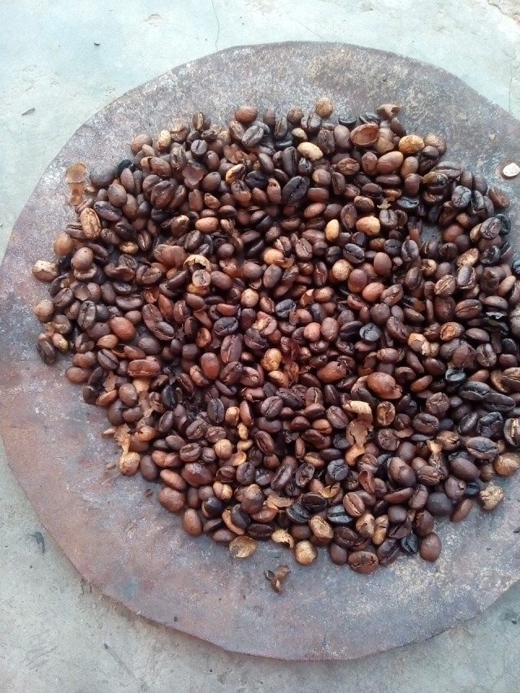
Annex: 1 Roasting coffee using Ethiopian traditional coffee roaster

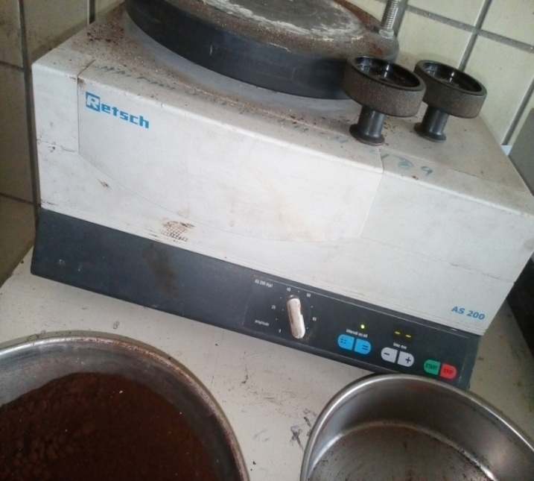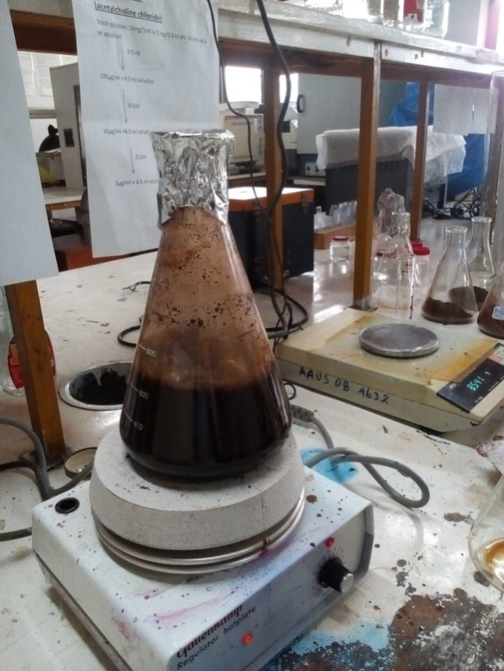
Annex: 2 Sieving and boiling coffee samples

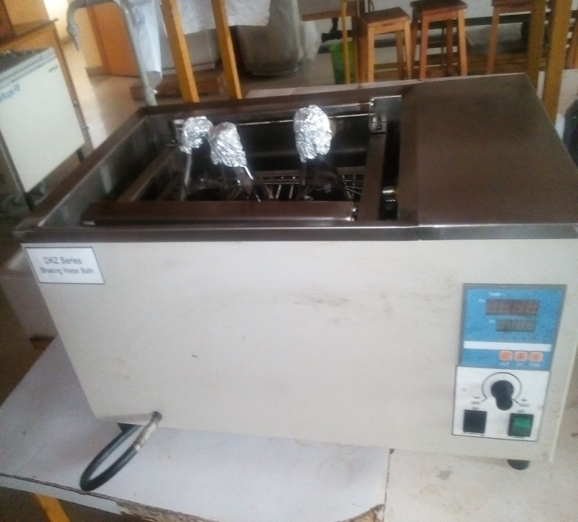
Annex: 3 Shaking samples within given solvents

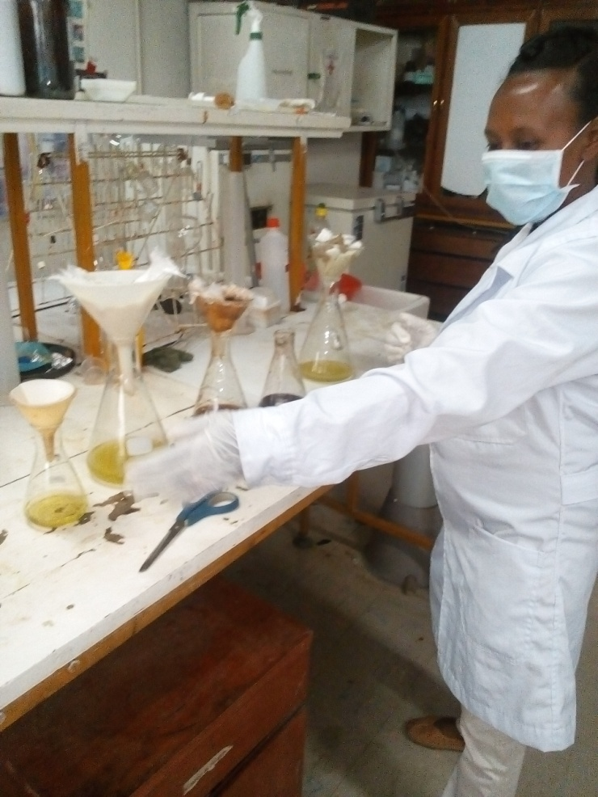
Annex: 4 Filtrating different solvent coffee extracts

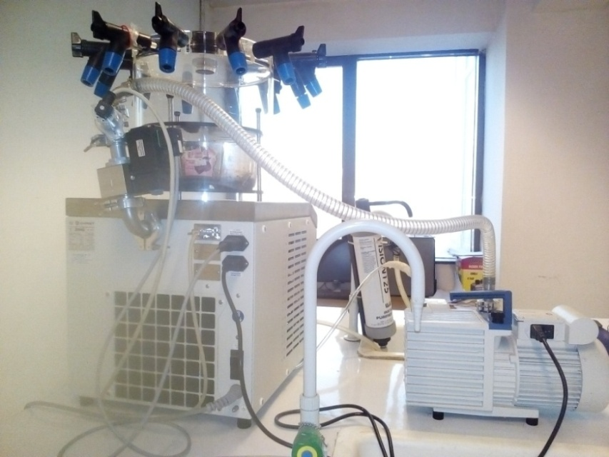
Annex: 5 Lyophilizing water extract coffee samples
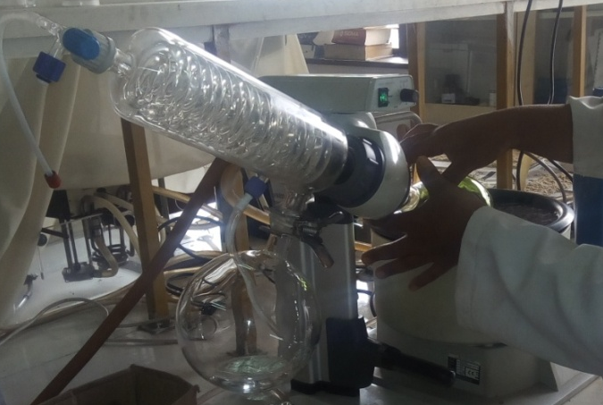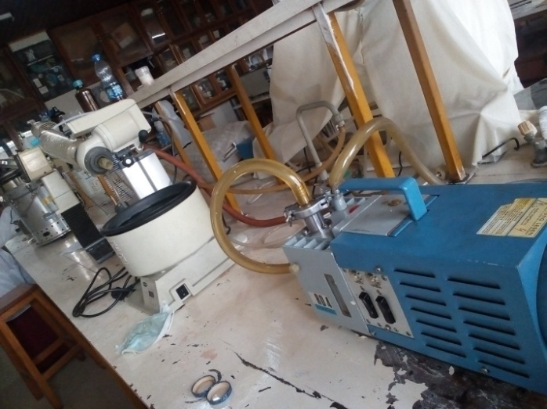
Annex: 6 Removing solvents from the extracts using a rotary evaporator
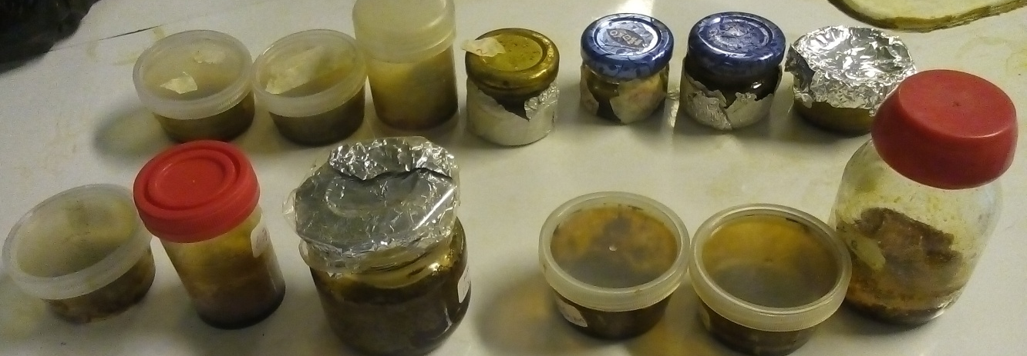

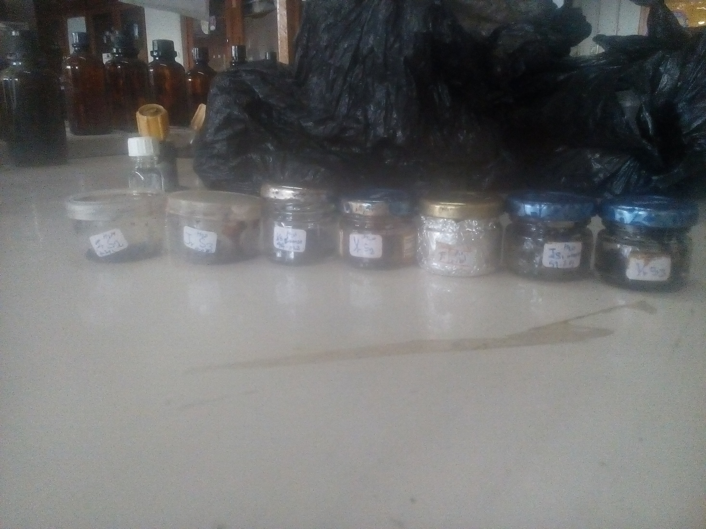
Annex: 7 Collected coffee sample extracts

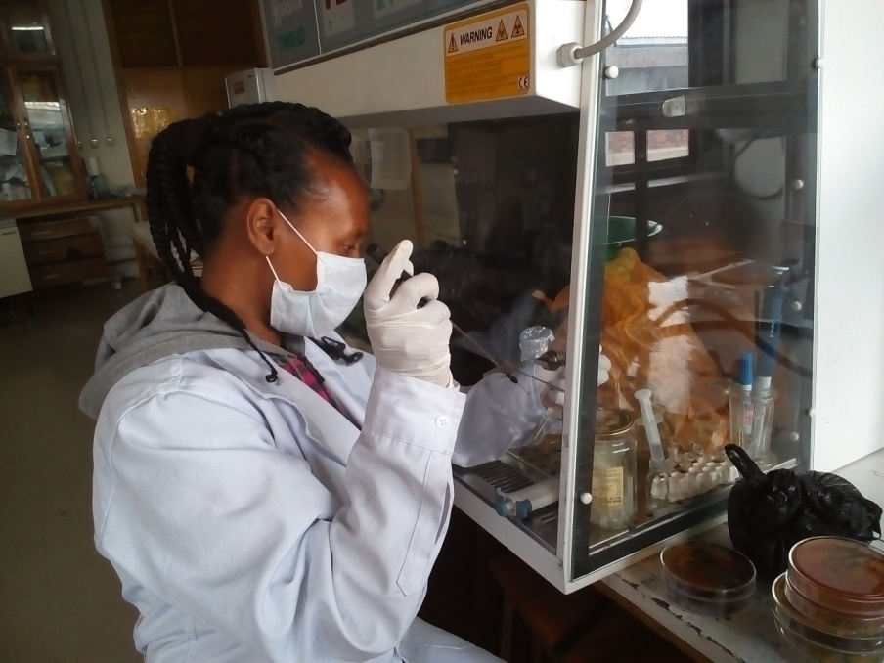
Annex: 8 Bacterial suspension preparations

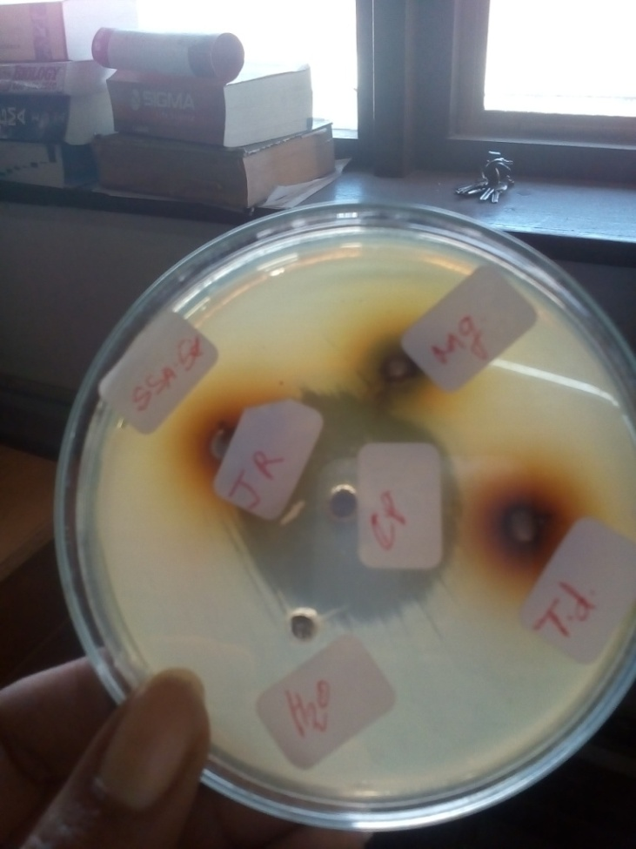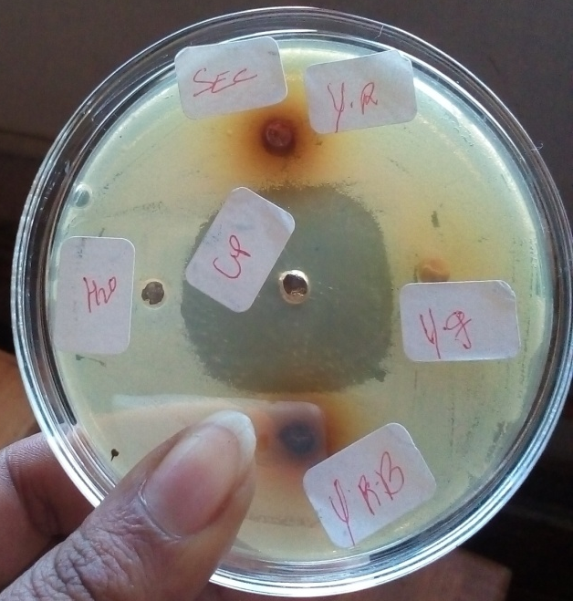
Annex: 9 Cold water coffee extracts with no antibacterial activity

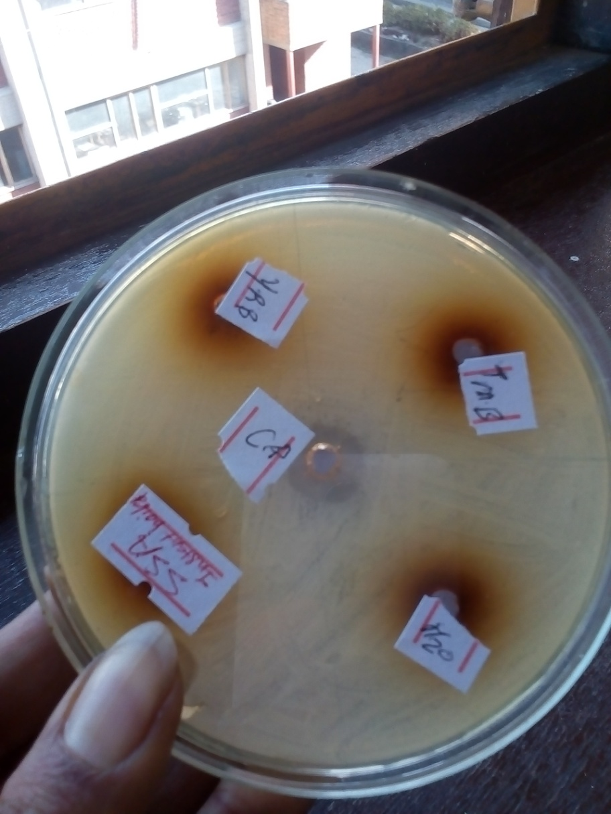
Annex: 10 Instant and boiled coffee filtrates directly applied for well diffusion antibacterial susceptibility test with no activity

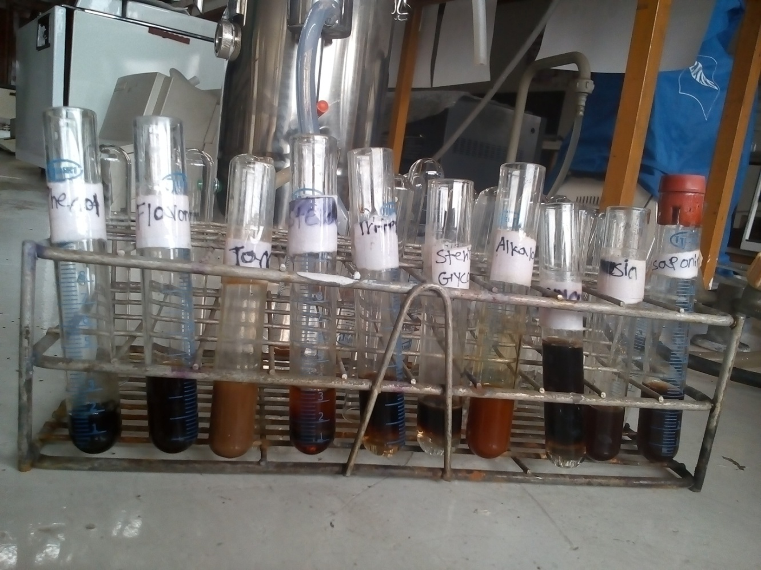
Annex: 12 Phytochemical test results for different coffee samples

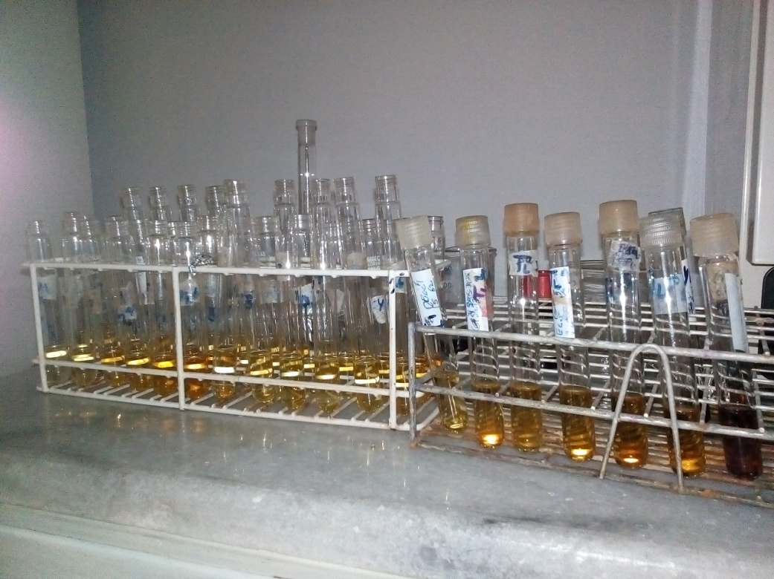
Annex: 13 Coffee’s DPPH scavenging activity changing the purple color of DPPH into yellow
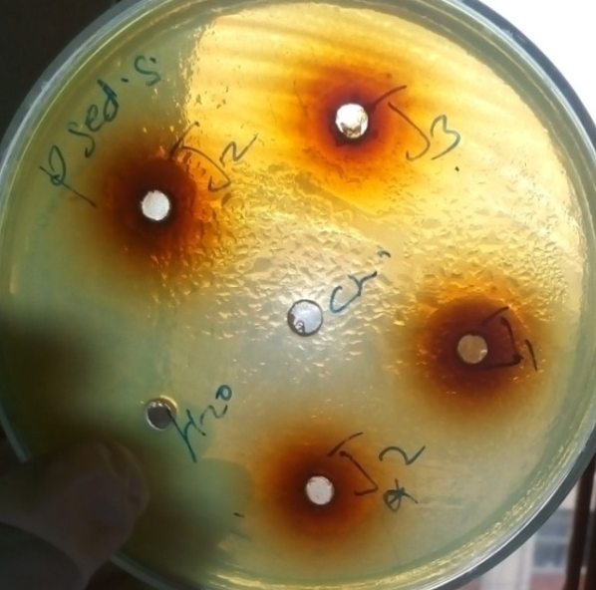

Annex: 14 Antibacterial susceptibility test inhibition zone
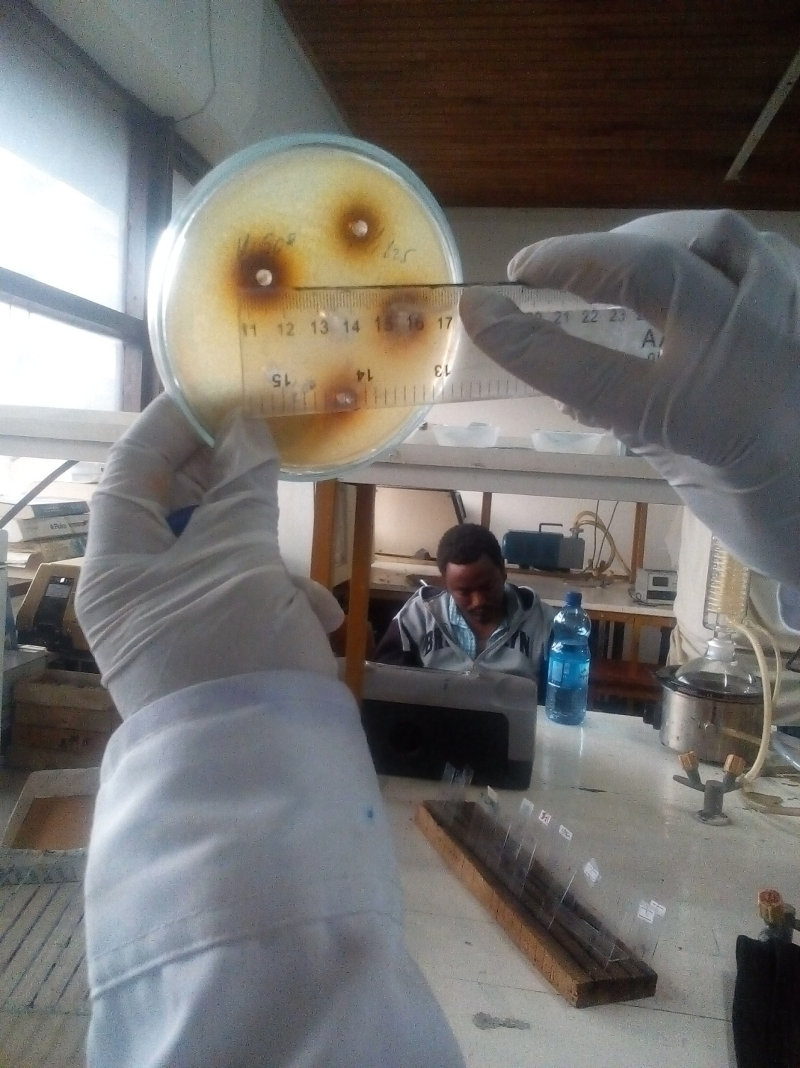
Annex: 15 Measuring inhibition zone diameters
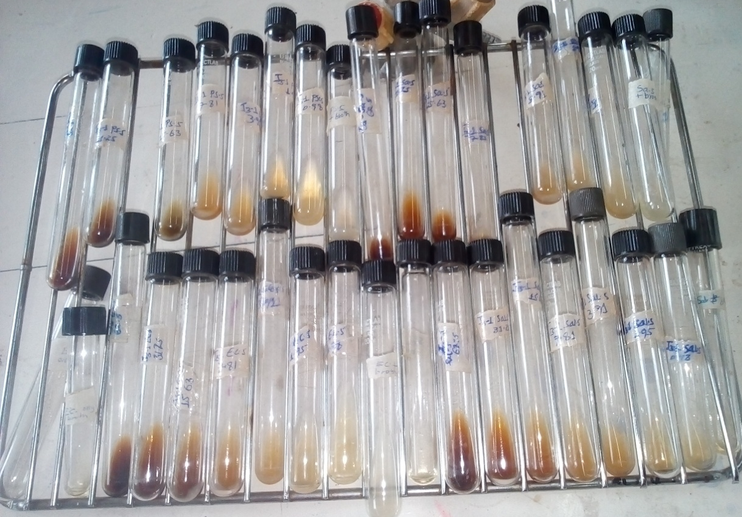
Annex: 16 Minimum inhibitory concentration test tubes

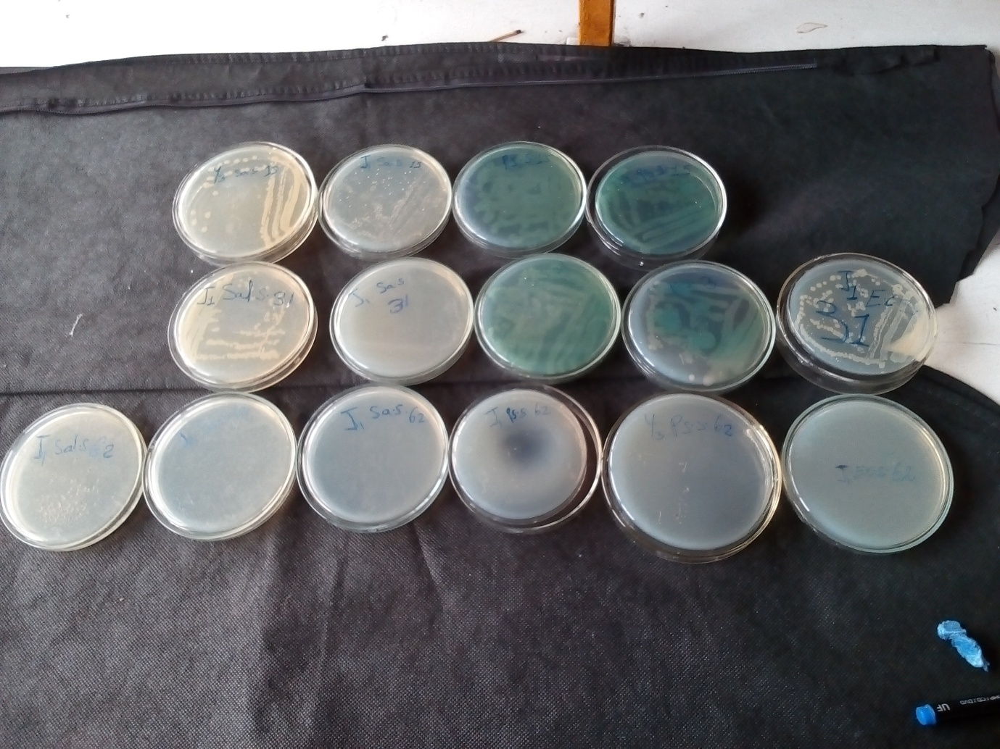
Annex: 17 Minimum bactericidal concentration test plates

Annex: 19 Standard curve of ascorbic acid

