

AIR QUALITY AT PUBLIC TRANSPORTATION STATIONS/STOPS: CONTRIBUTION OF LIGHT RAIL TRANSIT TO REDUCE AIR POLLUTION IN ADDIS ABABA

BY
ADDIS BIKIS MEQUANNIT

JUNE, 2019
ADDIS ABABA, ETHIOPIA

AIR QUALITY AT PUBLIC TRANSPORTATION STATIONS/STOPS: CONTRIBUTION OF LIGHT RAIL TRANSIT TO REDUCE AIR POLLUTION IN ADDIS ABABA
A thesis submitted to the school of graduate studies of Addis Ababa University, Ethiopian Institute of Architecture, Building Construction and City Development (EiABC), in partial fulfilment for master’s degree in Urban Planning
By
ADDIS BIKIS MEQUANNIT

Advisor: Professor Mintesnot G. Woldeamanuel
Co-advisor: Dr. Berhanu Woldetensae
Ethiopian Institute of Architecture, Building Construction and City Development
Addis Ababa University
June, 2019
Addis Ababa, Ethiopia

This thesis is submitted to Ethiopian Institute of Architecture, Building Construction and City Development (EiABC), Addis Ababa University in partial fulfillment of the requirements for the degree of Master of Science in Urban Planning.
Title of Thesis: Air Quality at Public Transportation Stations/Stops: Contribution of Light Rail Transit to Reduce Air Pollution in Addis Ababa.

Author: Addis Bikis
Date: June, 2019

Approved by Board of Examiners
Pro. Mintesnot G. Woldeamanuel(PhD)
Advisor: Signature Date
Dr. Berhanu Woldetensae
Co-advisor: Signature Date
Dr. Frew Mengistu
External Examiner: Signature Date
Dr. Sisay Seifu
Internal examiner: Signature Date
Dr. Berhanu Woldetensae
Chairman Signature Date
Dr. Fisseha Wegayehu
Graduate program Director Signature Date

Declaration
I, the undersigned, declare that this thesis is my own and original work in fulfiilment of the requirments for the degree of Master of Science in Urban Planning entiteld “Air Quality at Public Transportation Stations/Stops: Contribution of Light Rail Transit to Reduce Air Pollution in Addis Ababa”. It has not been previously submitted to this or any other institution and is the original work of the author unless otherwise stated. All sources of material used for the thesis have been properly acknowledged, following the scientific guidelines of the Institute.

Researcher’s Name: Addis Bikis

Signature:

Confirmation
The thesis can be submitted for examination with my approval as an Institute`s advisor.

Advisor`s Name: professor Mintesnot G. Woldeamanuel(PhD)

Signature:
Date:

Acknowledgement
First, above all, I thank Almighty God for always with me in all my endeavors and giving me endurance to complete my study.
Second, researcher would like to express his heartfelt gratitude to Professor Mintesnot G. Woldeamanuel(PhD) who is the advisor of this research, idea source for the title and material support (air tracking device), for his tireless and unreserved professional advice by following through each part of the researcher endeavor. The researcher also would like to thank his heartfelt gratitude to Berhanu Woldetensae(PhD) who is the co-advisor and chairholder of urban and regional planning for his support and encouragment.
The researcher third share of heartfelt gratitude goes to Ato Takele Lulie who is a deputy manager of transport in Addis Ababa road and transport bureau for his support and explanation regarding transportation air pollution and vehicles information in Addis Ababa. I would also like to thank Degualem Mekuriaw at EiABC for his unreserved professional advising. Similarly the researcher would also like to thank his heartfelt gratitude to offices of Addis Ababa environmental protection authority, Addis Ababa Light Rail Transit Service, Addis Ababa City Transport Authority and Addis Ababa Road and Transport Bureaue, for their data support and permission to measure air quality at LRT, bus and taxi stations to be this study viable.
Fourth, the researcher also would like to pass his highest admiration and heartfelt gratitude to those police, shoeshines, transport distribution coordinators and traffic police that collaborated the researcher for measuring air quality at each stations, being positive for other necessary formalities that requested by the researcher and at large fully being the participants of the study in any cases as well as data collectors for their tireless working.
Lastly but not the least researcher special admiration, appreciation with heartfelt gratitude goes to for those all participants who never aforementioned and whom participated on interviews, questionnaires to be the project viable and practical, and the researcher would like to thank everyone else who helped researcher throughout his stay.
Addis Bikis
June, 2019

Table of contents
Contents Page
Sign Approval sheet ii
Declaration iii
Acknowledgement iv
Table of contents v
List of Figures ix
List of Tables xi
List of Annex xii
List of Acronyms xv
Abstract xvi
CHAPTER ONE 1
1. INTRODUCTION 1
1.1 Background of the study 1
1.2 Problem statement 3
1.3 General Objectives of the Study 5
1.3.1 Specific objectives of the study 5
1.4 Research questions 5
1.5 Significance of the Study 6
1.6 The Scope of Study 6
1.7 Limitations of the Study 7
1.8 Organization of the Study 9
CHAPTER TWO 10
LITERATURE REVIEW 10
2.1 Definition of terms 10
2.2 Public Transportation 11
2.3 Air pollution Definition and its source 12
2.3.1 Transport as a Source of Pollution 13
2.4 Urban Transport Air Pollution Source and Effect across the World 14
2.5 Transport Policy and Development 15
2.6 Transport sector policy implementation and Air pollution control 16
2.7 Transport policy of Addis Ababa and Air pollution 17
2.7.1 Environmental Protection, bus stop shelter and Energy use 18
2.7.2 Impact of LRT on Air pollution and Greenhouse Emission Reduction 19
2.7.3 Rising particulate pollution in Addis Ababa 20
2.8 Particulate Matter and its origin 22
2.9 Particulate Matter Exposure by Mode of Travel 24
2.9.1 Particulate Matter Exposure at Bus Stops 24
2.10 Land use and Transportation Pollution 25
2.10.1 Gap in Transport and Land use Interaction 26
2.11 Particulate Matter, Air Quality Index and Health Concerns 28
2.12 Characteristics and Health effects of Transportation Air Pollution 30
2.12.1 Health Effects of Particulate Matter and Carbon Dioxide 31
CHAPTER THREE 32
THE RESEARCH METHODOLOGY AND SOURCES OF DATA 32
3.1 Methodology of the Study 32
3.1.1 Rationale for the Study 32
3. 1.2 Study Area Selection Criteria (NS-LRT) 33
3.1.3 Research Design 38
3.1.4 Structure of the Research Methodology 39
3.1.5 Target Population and Sampling Frame 40
3.1.5.1 Sample Size 40
3.1.5.2 Sampling Technique and Sampling size Selection Requirements 42
1.1.6 Method of Data Collection and Data Source 43
3.1.6.1 Primary Sources of Data 44
Four types of data collecting tools were prepared to primary data source. These are 44
3.1.6.2 Secondary Source of Data 46
3.1.7 Description of Variables 46
3.1.8 Method of Data Analysis and Presentation 47
CHAPTER FOUR 50
BACKGROUND ON THE STUDY AREA 50
4.1 Description of the Study Area 50
4.2 Historical background of AALRT 51
4.3 Transport and Air Pollution Trends in Addis Ababa 52
4.3.1 Emissions from Transportation 53
4.3.2 Age of Vehicles in Addis Ababa 53
4.4 The Environmental Impacts of Transportation 54
4.5 Respiratory Diseases and Health condition in Addis Ababa 55
CHAPTER FIVE 56
RESULTS AND DISCUSSION 56
5.1 Introduction 56
5.2 Demographic characteristics of Air quality related Health respondents 59
5.2.1 Response rate of Respondents 60
5.3 Air Quality at sampled Public Transportation Station 61
5.3.2 Particulate Matter (PM) 64
5.3.3 Air Quality Index (AQI) 65
5.3.4 Carbon dioxide (CO₂) 67
5.4 Stations Characteristics and Shelter orientation 68
5.4.1 Sampled Stations characteristics 70
2.11 Health versus Air quality and Station characteristics 72
5.6 Human exposure and health effect of transport-related air pollution 76
5.7 Air Quality versus Health 80
5.7.1 Simple regression analysis of air quality related diseases and air quality 83
5.8 Results of Qualitative Data 85
5.8.1 Observation of air quality at sampled public transportation station 85
5.8.2 Interview results 87
5.8.2.1 Factors affect more the composition of motor vehicle exhaust emissions 88
5.9 Discussion 89
CHAPTER SIX 93
CONCLUSION AND RECOMMENDATION 93
6.1 Conclusions 93
6.2 Recommendations 96
References 99
Appendix I 105
Appendix II 107
Appendix III 108
Appendix IV 109
Appendix V 110
Kality station 110
Saris station 116
Stadium station 122
Mexico station 128
Autobus Tera station 134
Minilik II square station 140
Appendix VI 146

List of Figures and Tables

List of Figures
Figure 1: Mega joules per passenger’s kilometer traveled, energy related CO₂ emissions 16
Figure 2: Rising particulate matter (PM10) levels 21
Figure 3: Rising particulate matter (PM2.5) concentration 21
Figure 4: Environmental and social dimension of transportation conceptual framework 27
Figure 5: Sample distribution by sub-city 34
Figure 6: Minilik II square sample station where air quality measurement taken 35
Figure 7: Autobus Tera sample distribution where air quality measurement taken 35
Figure 8: Mexico sample station where air quality measurement taken 36
Figure 9: Stadium sample station where air quality measurement taken 36
Figure 10: Saris sample station where air quality measurement taken 37
Figure 11: Kality sample station where air quality measurement taken 37
Figure 12: Research methodology flow chart 39
Figure 13: Sample distribution in spatial location (line 2, North-South LRT line) 42
Figure 14: Sampling procedure 43
Figure 15: Air tracing device (IQAir Visual pro). 45
Figure 16: The cause and effect relationship of dependent and independent variables 47
Figure 17: The causes and impacts of transport air pollution 53
Figure 18: Six sub city versus sampled stations North-South LRT line 57
Figure 19: Land use and sample stations distribution 58
Figure 20: Gender and age frequency of the respondents 59
Figure 21: Age versus gender of respondents 59
Figure 22: Average air quality at all sampled station. 61
Figure 23: Average air quality index at bus, taxi, LRT and mixed stations 63
Figure 24: Average carbon dioxide concentration at bus, taxi, LRT and mixed station 63
Figure 25: Average PM_{2.5} concentration at peak and off-peak hour at sampled station 64
Figure 26: Average PM₁₀ concentration at peak and off-peak hour at sampled station 64
Figure 27: Average particulate matter (PM_{2.5} and PM₁₀) at sampled stations. 65
Figure 28: Average air quality index concentration at peak and off-peak hour. 65
Figure 29: Average air quality index and CO2 at sampled station 66
Figure 30: Average CO₂ concentration at peak and off-peak hour at sampled station. 67
Figure 31: air quality at Mexico at peak hour (evening at 6:30pm). 68
Figure 32: greatest number of air quality related diseases by station type under study. 75
Figure 33: Hospitals/clinic visited for health issues in the past time. 76
Figure 34: Top ten air quality related diseases from the respondents 78
Figure 35: Incidence of air quality related diseases versus air quality 80
Figure 36: Number of incidence of air quality related health problems and AQI 83
Figure 37: Incidence of air quality related health problem and AQI at Kality and Saris station 83
Figure 38: Incidence of air quality related health problem and AQI at Stadium and Mexico 84
Figure 39: Incidence of air quality related health problem and AQI at Autobus Tera and Minilik II square station. 85

List of Tables
Table 1: Emission from Addis Ababa Road Network without construction of LRT 19
Table 2: Estimate of Pollutant from Addis Ababa Road Network after construction of LRT 20
Table 3: air quality index, description and health concern with PM2.5 and PM10 29
Table 4: Sample size selection from sampling frame 40
Table 5: Sample size distribution by type of station and Sub-city 41
Table 6: Sample distribution and interviewee persons per stations. 41
Table 7: Method of data collection, type and sources 44
Table 8: Air quality categories, standards and health messages 48
Table 9: Average measurement of air quality both and off-peak hour at sampled station. 62
Table 10: 30 minutes average air quality index at sampled stations (24) at peak hours 66
Table 11: 30 minutes average air quality index at sampled stations (24) off peak hours 66
Table 12: Station location related to intersection and shelter orientation 69
Table 13: Sampled public transportation stations characteristics 70
Table 14: Relationship between average air quality, health and stations design. 72
Table 15: Name of the station and reason to visit clinic/hospital. 74
Table 16: Station type under the study and air quality related diseases. 74
Table 17: Station type under the study and number of air quality related diseases. 75
Table 18: Age of respondents and clinics visit for health issues in the past time. 76
Table 19: Age of respondent’s and reason to visit clinic/hospital. 77
Table 20: Number of air quality related disease by type of employment 77
Table 21: Air quality index (US) and number of air quality related diseases 80
Table 22: Air quality index versus reason to visit clinics/hospitals 81
Table 23: The relationship between health and air quality 82

List of Annex
Annex 1: Air tracking device used to collect transportation air quality data at station/stops 108
Annex 2: Particulate matter at peak hour and off-peak hour Kality bus station. 110
Annex 3: Air quality index at peak hour and off-peak hour Kality bus station. 110
Annex 4: Carbon dioxide at peak hour and off-peak hour Kality bus station. 111
Annex 5: Particulate matter at peak hour and off-peak hour Kality LRT station. 111
Annex 6: Air quality index at peak hour and off-peak hour Kality LRT station. 112
Annex 7: Carbon dioxide at peak hour and off-peak hour Kality LRT station. 112
Annex 8: Particulate matter at peak hour and off-peak hour Kality mixed station. 113
Annex 9: Air quality index at peak hour and off-peak hour Kality mixed station. 113
Annex 10: Carbon dioxide at peak hour and off-peak hour Kality mixed station. 114
Annex 11: Particulate matter at peak hour and off-peak hour Kality taxi station. 114
Annex 12: Air quality index at peak hour and off-peak hour Kality taxi station. 115
Annex 13: Carbon dioxide at peak hour and off-peak hour Kality taxi station. 115
Annex 14: Particulate matter at peak hour and off-peak hour Sari bus station. 116
Annex 15: Air quality index at peak hour and off-peak hour Sari bus station. 116
Annex 16: Carbon dioxide at peak hour and off-peak hour Saris bus station. 117
Annex 17: Particulate matter at peak hour and off-peak hour Saris LRT station. 117
Annex 18: Air quality index at peak hour and off-peak hour Saris LRT station. 118
Annex 19: Carbon dioxide at peak hour and off-peak hour Saris LRT station. 118
Annex 20: Particulate matter at peak hour and off-peak hour Saris mixed station. 119
Annex 21: Air quality index at peak hour and off-peak hour Saris mixed station. 119
Annex 22: Carbon dioxide at peak hour and off-peak hour Saris mixed station. 120
Annex 23: Particulate matter at peak hour and off-peak hour Saris taxi station. 120
Annex 24: Air quality index at peak hour and off-peak hour Saris taxi station. 121
Annex 25: Carbon dioxide at peak hour and off-peak hour Saris taxi station. 121
Annex 26: Particulate matter at peak and off-peak hour Stadium bus station. 122
Annex 27: Air quality index at peak and off-peak hour Stadium bus station. 122
Annex 28: Carbon dioxide at peak and off-peak hour Stadium bus station. 123
Annex 29: Particulate matter at peak and off-peak hour Stadium mixed station. 123
Annex 30: Air quality index at peak and off-peak hour Stadium mixed station. 124
Annex 31: Carbon dioxide at peak and off-peak hour Stadium mixed station. 124
Annex 32: Particulate matter at peak and off-peak hour Stadium taxi station. 125
Annex 33: Air quality index at peak and off-peak hour Stadium taxi station. 125
Annex 34: Carbon dioxide at peak and off- peak hour Stadium taxi station. 126
Annex 35: Particulate matter (PM) at peak and off-peak hour Stadium LRT station. 126
Annex 36: Air quality index (AQI) at peak and off peak hour Stadium LRT station. 127
Annex 37: Carbon dioxide at peak and off-peak hour Stadium LRT station. 127
Annex 38: Particulate matter at peak hour and off-peak hour Mexico bus station. 128
Annex 39: Air quality index at peak hour and off-peak hour Mexico bus station. 128
Annex 40: Carbon dioxide at peak hour and off-peak hour Mexico bus station. 129
Annex 41: Particulate matter at peak hour and off-peak hour Mexico LRT station. 129
Annex 42: Air quality index at peak hour and off-peak hour Mexico LRT station. 130
Annex 43: Carbon dioxide at peak hour and off-peak hour Mexico LRT station. 130
Annex 44: Particulate matter at peak hour and off-peak hour Mexico mixed station. 131
Annex 45: Air quality index at peak hour and off-peak hour Mexico mixed station. 131
Annex 46: Carbon dioxide at peak hour and off-peak hour Mexico mixed station. 132
Annex 47: Particulate matter at peak hour and off-peak hour Mexico taxi station. 132
Annex 48: Air quality index at peak hour and off-peak hour Mexico taxi station. 133
Annex 49: Carbon dioxide at peak hour and off-peak hour Mexico taxi station. 133
Annex 50: Particulate matter at peak hour and off-peak hour Autobus Tera bus station. 134
Annex 51: Air quality index at peak hour and off-peak hour Autobus Tera bus station. 134
Annex 52: Carbon dioxide at peak hour and off-peak hour Autobus Tera bus station. 135
Annex 53: Particulate matter at peak hour and off-peak hour Autobus Tera mixed station. 135
Annex 54: Air quality index at peak hour and off-peak hour Autobus Tera mixed station. 136
Annex 55: Carbon dioxide at peak hour and off-peak hour Autobus Tera mixed station. 136
Annex 56: Particulate matter at peak hour and off-peak hour Autobus Tera LRT station. 137
Annex 57: Air quality index at peak hour and off-peak hour Autobus Tera LRT station. 137
Annex 58: Carbon dioxide at peak hour and off-peak hour Autobus Tera LRT station. 138
Annex 59: Particulate matter at peak hour and off-peak hour Autobus Tera taxi station. 138
Annex 60: Air quality index at peak hour and off-peak hour Autobus Tera taxi station. 139
Annex 61: Carbon dioxide at peak hour and off-peak hour Autobus Tera taxi station. 139
Annex 62: Particulate matter at peak hour and off-peak hour Minilik II square bus station. 140
Annex 63: Air quality index at peak hour and off-peak hour Minilik II square bus station. 140
Annex 64: Carbon dioxide at peak hour and off-peak hour Minilik II square bus station. 141
Annex 65: Particulate matter at peak and off-peak hour Minilik II square LRT station. 141
Annex 66: Air quality index at peak and off-peak hour Minilik II square LRT station. 142
Annex 67: Carbon dioxide at hour and off-peak hour Minilik II square LRT station. 142
Annex 68: Particulate matter at peak and off-peak hour Minilik II square mixed station. 143
Annex 69: Air quality index at peak and off-peak hour Minilik II square mixed station. 143
Annex 70: Carbon dioxide at peak and off-peak hour Minilik II square mixed station. 144
Annex 71: Particulate matter at peak and off-peak hour Minilik II square taxi station. 144
Annex 72: Air quality index at peak and off-peak hour Minilik II square taxi station. 145
Annex 73: Carbon dioxide at peak and off-peak hour Minilik II square taxi station. 145
Annex 74: Temporary camera shooting and reporting permit 146
Annex 75: Bus stations for sampling frame from stadium to kality 146
Annex 76: Addis Ababa Light Rail Transit service East-West and North-South line 147
Annex 77: Street design and walkways, separate lane for bus adopted from developed nations 147
Annex 78: Photos were taken at Stadium and Megenagna stations 148
Annex 79: Photos were taken at Stadium bus station and Minilik II square taxi station 148
Annex 80: Photos were taken at Mexico LRT and taxi station 149
Annex 81: Road quality and pedestrian way from Mexico to Kera road 149
Annex 82: Respondent profile at sampled stations by type of stations 150
Annex 83: Transport-related air pollution diseases at sampled stations 150

List of Acronyms
AACRTB = Addis Ababa City Road and Transport Bureau
AACTA = Addis Ababa City Transport Authority
AAC-DVLCA = Addis Ababa city divers and vehicles Licensing and Control Authority
AAEPA = Addis Ababa Environmental Protection Authority
AALRTS = Addis Ababa Light Rail Transit Service
APTA = American Public Transit Association
AQI = Air quality index
CARB = California Air Resource Board
CO₂ = Carbon Dioxide
CSA = Central Statistical Authority
ERC = Ethiopian Railways Corporation
EEA = European Environment Agency
HC = Hydro Carbon
KM = Kilo meter
LRT = Light Rail Transit
NAAQS = National Ambient Air Quality Standards
PM = Particulate Matter
PM2.5 = PM with Aerodynamic Size Less than or Equal to 2.5 Micrometer
PM10 = PM with Aerodynamic Size Less than or Equal to 10 Micrometer
TPAA = Transport Policy of Addis Ababa
μg/m³ = Microgram per Cubic Meter
UFP = Ultra-fine particle
USEPA = United States Environmental Protection Authority
WHO = World Health Organization

Abstract
This study portrayed air quality at public transportation stations/stops: contribution of Light Rail Transit to reduce air pollution in Addis Ababa. In this regard, the current transportation air pollution research documents indicates that increased risks for exposure of asthma and other respiratory diseases, and cancers populations residing close proximity to roadways. The purpose of the researcher was to know the air quality at LRT, bus, taxi and bus/taxi stations by air tracking device, and health effect at sampled public transportation stations. Air quality data include particulate matter (PM), air quality index (AQI), CO₂, humidity and temperature with 30 minutes observation by Air-Visual pro for each 24 sampled stations from North to South LRT line. The data were collected by using questionnaires, interviews and measurements at 24 purposively selected bus, LRT, taxi and bus /taxi stations at peak and off peak hours. All data obtained by primary data gathering instruments were analyzed with qualitative and quantitative method. Air quality data and health questionnaires analyzed in quantitative approach with regression, tables, graphs and percentage whereas, interviews and personal observation analyzed and interpreted in qualitative manner. The result suggested that the location and design of bus stops and shelter orientation is found to have a significant effect on the concentration of AQI, PM and CO₂. It was observed that shelters with an opening oriented towards the roadway had consistently higher concentrations inside the bus shelter than unsheltered stops. Regarding this, 30 persons questioned at each stations, 720 in total to know the health effect of persons living/working in and around the stations. The findings indicate that out of 720 respondents, 324 (45%) were exposed for air quality related diseases residing and working close proximity to the stations. Based on the findings, air quality at public transportation stations is unhealthy, above an average of 65μg/m³ PM2.5 and 150 AQI at bus and taxi stations during peak hour. LRT stations have below 25μg/m³ PM2.5 and 70 AQI. This indicates that LRT contributed 40.63μg/m³ PM2.5 and 81.88 AQI reduction of air pollution at sampled stations daily. It is hoped this study will inform stakeholders to harmonize between transportation and land-use. Institutionalizing transportation and health, transport policy should focus on High Occupancy Vehicles and expansion of Light Rail Transit in Addis Ababa.
Key words: air quality index (AQI), carbon dioxide (CO₂), particulate matter (PM_{2.5}, PM₁₀), public transportation, LRT, bus shelter, station design, health.

CHAPTER ONE
- INTRODUCTION
Now a day’s air pollution from public transportation and construction dust along major roads at public transportation stations in Addis Ababa is increasing and affecting the environment and human health. Air pollutants from cars, trucks and other motor vehicles are found in higher concentrations at public transportation stations. People who live, work or attend school near major roads appear to have an increased incidence and severity of health problems associated with air pollution. Due to this, Light rail can be reduced air pollution as an electric rail transport (carbon free transport). It can replace many low occupancy vehicles on the roadway because of speed and high capacity of passengers in a single trip. Therefore, it is necessary to conduct scientific investigation on the role of LRT is really playing to bring sustainable urban development, clean urban air quality (environmental sustainability), and impact of vehicles air pollution at public transportation stations. This is what inspired the researcher to conduct the study on this area.

1.1 Background of the study
Addis Ababa, capital city of Ethiopia, is currently facing rapid urbanization and high population growth. Overall population is expected to grow from 3.2 million to 5.5 million inhabitants by 2020 and reach double figures within the next two decades (Yorgos & Derek, 2012). Based on UN-Habitat (2017) projection indicated 4.6 million in 2016. In this regard there are public transportations shortage and traffic congestion in the city. Public transportation and Non-motorized transport, and particularly walking, still dominates the modal split for daily trips in Addis Ababa with most of total trips, whereas public transport service is not adequate to accommodate the respective demand (Abdlemalik, 2017).
Aged vehicles, traffic congestion, lack of alternative roads in peak hours degrading air quality at public transportation stations. Fuel efficient vehicles and electric trains could reduce transport emission level. Between 1990 and 2015 in Europe, the transport sector significantly reduced emissions of certain air pollutants: carbon dioxide (CO₂) and non-methane volatile organic compounds (NMVOCs) (both by around 85%), Sulphur oxides (SO_{x}) (49 %), nitrogen oxides (NO_{x}) (41 %). Since, 2000 a reduction in particulate matter emissions (42 % for PM_{2.5} and 35 % for PM₁₀) has occurred in the European air quality index (European Environment Agency, 2017). Traffic congestion increases vehicles emissions also increase and degrades ambient air quality. Recent studies have shown by Zhang and Batterman (2013), excess morbidity and mortality for drivers, commuters and individuals living near major roadways.
European Environmental Authority (EEA, 2017) report stated that, PM contributes most to premature deaths from air pollution in the EU more than 400, 000 each year. In Denmark an estimated 3,000 premature deaths occur annually from exposure to PM and NO₂.
Demand for transport has increased faster than the city can provide it and is creating health risks, producing more greenhouse gas emissions and particulate matters. The Addis Ababa 2002 - 2010 master plan highlighted increasing pressure on the city’s public transport service, due to factors including an insufficient number of buses and shelter (Transport Policy of Addis Ababa, 2011). Public transport is one of the most common transportation modes that can be accessed by the urban population where most of trips in Addis Ababa are made by walking and insufficient public transport however, there is poor air quality at public transport stations due to traffic congestion and shelter design at station/stop (Abdlemalik, 2017).
Ethiopia’s Ministry of Health (MoH) report indicated that more than 800,000 people were affected by respiratory illness in Addis Ababa two years ago due to air pollution. According to the air quality study it conducted last Ethiopian fiscal year (2018), the ministry of health confirmed that the air pollution level in the Addis Ababa has exceeded the limit set by the World Health Organization (WHO) 25μg/m³ of PM2.5. Of the total patients who sought health treatment in health institutions, 819,900 or 27.2% of them were patients affected by respiratory illness. According to WHO air quality guidelines, particulate matters pollution should not exceed 20μg/m³. However, the number exceeded more than 300μg/m³ in some parts of Addis Ababa (Ministry of Health, 2018). According to the ministry, 60 percent of the air pollution in urban areas is caused by vehicle emissions.
In many cities, urban rail transportation projects, i.e. the light rail, metro and tram systems over the years demonstrated itself as the optimal solution in providing sustainability mobility for the increasing urban population. Light rail transit is an environmentally sustainable transit option based on perceptions of its possible benefits on minimizing air pollution, energy consumption and greenhouse gas emissions. Rail transit is a fuel efficient transport mode especially in comparison to cars and trucks, because of its capability to transport more passengers or goods (in the case of freight rail systems) to destinations, which results in free from fuel use(electric system) per miles traveled and reduce carbon dioxide emissions (Marie, 2013).

1.2 Problem statement
There is often poor air quality in urban and suburban areas where traffic congestion is the worst. This has meant that residents of these areas, especially those living in close proximity to major roads or highways, confront much higher health risks due to poor air quality (Adam et al., 2012). Public transportation can reduce the need for many separate trips by private vehicles in dense urban areas, replacing many separate emissions-producing vehicles with fewer transit vehicles that generally emit less pollution on a per person basis. Most rail transit vehicles emit little or no pollution, as they are powered by electricity (Adam et al., 2012).
Many residents in Addis Ababa live in areas where urban smog, particle pollution, and CO₂ from transport and construction dust that pose serious health concerns. The study by Zachariah and Thamizh (2005) revealed that, current guidelines for the location and design of bus stops shelter do not take into account air quality or exposure considerations for waiting passengers. Therefore, the quality of the air has become a serious concern in the city. For instance, according to Gebre et al. (2010), the mass concentrations of total suspended particulate matter (PM10) in the city found that above the value of 150 μg/m³.
Addis Ababa faces a rapid increase in air pollution due to increasing number of automobiles which do not follow emission standards set by various environmental agencies. Consequently, a study shown that 53.5% vehicles were more than 20 years old, while 29.3% were more than 30 years old (Tiwari, 2011). This resulted in high tailpipe emission from the exhaust system. The major pollutants emission include, Carbon dioxide (CO₂), Particulate Matters (PM), and Sulphur dioxide (SO₂). These hazardous chemicals cause various respiratory infections and diseases in human beings. In this regard, a specific medical study of patients and their exposure to the pollution level was done. Out of the top 20 leading causes of outpatient visit in all health centers and hospitals of Addis Ababa, the occurrence of acute respiratory infection was of prime concern (Tiwari, 2011). This may be largely attributed to the toxic emissions of the vehicle transportation. Accordingly, a study depicted that acute respiratory infections were about 148,000 in 2007, which reached up to 207,000 in 2008 (Tiwari, 2011).
The rate of vehicular increase is beyond the capacity of road network that are being built. More than 62% of the country’s vehicles are found in Addis Ababa and the number is increasing at a relatively a faster rate (AARTB, 2019). For instance, a study in Addis Ababa city by Tarekegn and Gulilat (2018), portrayed that the number of vehicles are being increased by 9.88% annually, whereas the Road networks are increasing with annual growth rate of 8.22%. Accordingly, about 168 vehicles are found in a 1 km single lane asphalt road at a time.
In general, public transportation stations design, location for passengers waiting related to road intersection are not given great attention by policy makers and transport planners. Regarding this, passengers and those peoples living/working in and around the stations are exposed to dangerous pollutants caused by vehicles and traffic congestion. These pollutants include carbon dioxide (CO₂), carbon monoxide (CO), nitrogen oxides (NO_{X}), Sulphur dioxide (SO₂) and particulate matters (PM_{2.5}, PM₁₀). The design and location of public transportation stations/stops contribute for the quality of the air in and around the stations. Therefore, the purpose of this research is to measure air quality level at public transportation stations and health impacts as well as land use type at public transportation stations/stops using an air quality tracking device (Air-Visual pro).

1.3 General Objectives of the Study
The general objective of the study is to measure air quality level and health impact at different public transportation stations at LRT, bus and taxi stations/stops.

1.3.1 Specific objectives of the study
- To measure the level of air quality at bus, taxi and light rail transit stations during peak and off-peak hours by Air-Visual pro.
- To identify land use types those contribute more to poor air quality at public transport stations.
- To study the health effects of those peoples living/working in and around the public transportation stations.
- To study the relationship between air quality, health and station design of the road where the station/stop located.

1.4 Research questions
- What are the level of air quality at bus, taxi and light rail transit stations during peak and off-peak hours?
- What type of land use does it contribute more too poor air quality at public transport stations?
- What are the health effects of those peoples living/working around the public transportation stations?
- What are the relationship between air qualities, health and stations design of the road where the stations/stops located?

1.5 Significance of the Study
The primary concentration of the study was to study air quality at public transportation stations, the level of air quality index and health effect at each sampled stations. Urbanization and public transportations in Addis Ababa is an issue for city administration for various reasons. One of the reason is the need to minimize negative impacts of air pollution in economic, social and environmental impacts, to bring mutual development and symbiotic integration of the rural and urban life that foster social and economic development. Today is the time of examining at problems both logically and scientifically, therefore, these methods are becoming the vital that addresses the social, economic and environmental problems of the society.
Generally, it was expected that train stations have cleaner air than bus or taxi stations. Bus/taxi stations with shelters located away from the busy streets and bus/taxi stations located in residential locations also have lesser pollutants. This would lead to a policy recommendation that Addis Ababa city administration, transport policy of Addis Ababa and public transportation providers need to encourage the construction of light rail system, import fuel efficient vehicles and re-designing of bus or taxi stations away from the roadway that riders have less chances of being exposed to vehicles pollutants of CO₂, particulate matters and other transport-related pollutants.

1.6 The Scope of Study
This study focus is on air quality at public transportation stations, especially targeting on purposively selected sample stations (bus, taxi and LRT) to know the level of air quality. Concerning this, to effectively solve the problem of urban transportation in Addis Ababa especially that of the downtown area of the city, the government of Ethiopia decided to build a light rail in the city of Addis Ababa. Currently the project has been implemented and giving service the two lines, the East-West (EW) line and the North-South (NS) line. According to Ethiopian Railways Corporation (2014), the total length of AALRTP is 34.3 km (NS line 16.9 km from Kality to center of the city Piassa (Minilik II square) and E-W line 17.4 km) from Ayat to Torhayloch which has the capacity of transporting 60,000 passengers per hour and the design speed is 70 km per hour. Thirty nine (39) stations are placed for both EW and NS route. (22 stations for each) five stations (or 2.7 km) which are shared and elevated stations. Average interval between two adjacent stations is around 850 meters. The longest interval is around 1300 meters and the shortest interval is around 400 meters. It is also include 14 bus, 21 taxi stations and 14 both bus/taxi stations from Minilik II square to Kality principal Arterial Street.
Therefore, this study was restricted on air quality at public transportation stations on NS- LRT line in Addis Ababa. Air quality were measured by Air-Visual (March 20 until April 16, 2019). It is also included the impact of air quality on health at bus, taxi and both stops as well as the relationship of air quality, station design and health effect those people living and working in and around the stations/stops in Addis Ababa.

1.7 Limitations of the Study
The study was limited on public transportation stations/stops of LRT, bus and taxi stations and persons living/working in or around the stations or stops who are affected by vehicles air pollution from public transportation stations. To study all LRT stations, bus or taxi stations were difficult. The behavior of the subject matter, length and area of spatial coverage is very large with limited time. The air quality data CO₂, PM_{2.5}, PM₁₀, AQI, Temperature, and Humidity were collected. The air quality data were gathered at stations/stops using an air tracking device (Air-Visual pro) by sampled six representative stations/stops purposively for half hour measurement at each stations during morning peak (7:30am - 9:30am), evening peak hour(4:30pm -7:00pm) and afternoon off-peak hour (9:30am - 4:30pm). This measurement of air quality does not represent all public transportation stations or stops in Addis Ababa. Health impact focus on only those people living and working close proximity to major roads of public transportation stations as well as riders and drivers at public transportation stations.

Therefore, the selected sample persons and measured air quality at public transportation stations do not describe transportation emission only, it is an open system and affected by land-use, homebased emission, construction activity, dust, and heavy duty vehicles. The characteristics of all the stations/stops and chance of exposure for transport-related air pollution diseases are cumulative effect. They are varied in characteristics all stations/stops, it is affected by the volume of traffic flow, road pavement quality, density of population, emission level, spatial location and land use. In addition, barriers on measurement of air quality during high wind and direction for bus and taxi stations, some detail information on riders and persons living and working around the stations didn’t give full response on their health status. Coordination problems of some community to survey during measurement of air quality at LRT stations, and unwillingness to fill health questionnaires. Some problems such as, lack of awareness and experience of the research were happened in respondents. Lack of collaboration between the AALRT service office and police at stations, for facilitating the situation while the data survey and measurement taken by air tracking device. Furthermore, unavailability of up to date resources (data) to study the research deeply, especially, there is a research gap on air quality at public transportation stations in Addis Ababa it was difficult to get secondary source of data related to this issue. Insufficient time (late beginning), urban governance and complex leadership structure and financial limitation of the researcher was limited.

1.8 Organization of the Study
This research proposal work was arranged in six chapters. The first chapter deals with introductory part that assesses the entire frame work of the work of the research, statement of the problems, research questions, objectives of the study, significance of the study, scope of the study, limitations of the study and organization of the study. The second chapter is about review of related literatures which are done on different journal articles, government publication and published books regarding air quality of public transportation station, station design, vehicle types and health effects. The third chapter deals with research design (method) and methodology; it includes method of data collection and method of data analysis, sampling frame and sample size, sampling techniques and process. The fourth chapter deals with background of the study area regarding LRT, environmental quality, public transportation and health condition. The fifth chapter deals with results and discussion; analysis and interpretation of the data collected. The last and the sixth chapter deals with conclusions and recommendations have been provided by the researcher.

CHAPTER TWO

LITERATURE REVIEW

2.1 Definition of terms
Light Rail Transit (LRT): is a form of urban rail transit using rolling stock similar to a tramway, but operating at a higher capacity, and often on an exclusive right-of-way.
Station: a stopping place for trains or other land conveyances, for the transfer of passengers.
Air Pollution: occurs when harmful or excessive quantities of substances including gases, particles, and biological molecules are introduced into Earth's atmosphere. It may cause diseases, allergies and even death to humans; it may also cause harm to other living organisms such as animals and food crops, and may damage the natural or built environment. Both human activity and natural processes can generate air pollution.
Health: the general condition of the body or mind with reference to soundness and life: good health; poor health. Soundness of body or mind; freedom from disease. As defined by the World Health Organization (WHO, 2006), is "a state of complete physical, mental and social well-being and not merely the absence of disease . Health may be defined as the ability to adapt and manage physical, mental and social challenges throughout life (Knottnerus et al., 2011).
Public Transport: (public transportation or mass transit) is transport of passengers by group travel systems available for use by the general public, typically managed on a schedule, operated on established routes, and that charge a posted fee for each trip (Schofer, 2018).
Air Quality Index (AQI): The Air Quality Index is a simple, color-coded, unit-less index that is an effective way to communicate air pollution concentrations to the general public. It is used by government agencies to communicate to the public how polluted the air currently is or how polluted it is forecast to become (NWSC, 2015). As AQI increases, an increasingly large percentage of the population is likely to experience increasingly severe adverse health effects.
Particulate Matter (PM): is the sum of all solid and liquid particles suspended in air many of which are hazardous. This complex mixture includes both organic and inorganic particles, such as dust, pollen, soot, smoke, and liquid droplets. These particles vary greatly in size, composition, and origin (PM0.1, PM1, PM2.5 and PM10) ultra-fine particles, very fine particles, fine particles and course particles respectively.
Carbon Dioxide (CO₂): Carbon Dioxide or CO₂ is a greenhouse gas is a gas consisting of one part carbon and two parts oxygen that is natural and harmless in small quantities but as levels rise it can be dangerous to your health. However, CO₂ can also have negative effects. As CO₂ builds up in our atmosphere it has a warming effect that could change the earth’s climate.
Level of Service (LOS): The most commonly measure that used to assess the level of congestion. LOS measures a traffic volume of a given area qualitatively (Krishna & Mathew, 2007). Six different levels are defined (LOS A, B, C, D, E, and F) with LOS-A representing the best condition and LOS-F representing the worst condition). Many agencies defining congestion in relation with LOS value, either LOS-E or F (Corpus Christi Metropolitan Planning Organization, 2009).

2.2 Public Transportation
Public transport (also known as public transportation, public transit, or mass transit) is transport of passengers by group travel systems available for use by the general public, typically managed on a schedule, operated on established routes, and that charge a posted fee for each trip. Examples of public transport include taxi, city buses, trolleybuses, trams (or light rail) and passenger trains, rapid transit (metro/subway/underground, etc.) Public transport is a shared passenger transport service which is available for use by the general public, as distinct from modes such as taxi, carpooling or hired buses which are not shared by strangers without private arrangement (APTA, 1993).
There is no single definition given to Light Rail Transit system. However, among many of the common definitions given by different authorities and researchers, the common ones are those given by the American Public Transportation Association and Transportation Research Board.
The American Public Transportation Association (APTA) in its Glossary of Transit Terminology defines light rail as "An electric railway with a 'light volume' traffic capacity compared to heavy rail which uses shared or exclusive rights-of-way, high or low platform loading and multi-car trains or single cars." Transportation Research Board (Transportation Systems Center, 1977) on the other hand defined light rail as “a mode of urban transportation which utilizes predominantly reserved rights-of-way and having electrically propelled rail vehicles providing a wide range of passenger capabilities and performance characteristics at moderate costs.” Hence, LRT is backbone of traffic, free of pollutants and mass transport system, in addition to these, it has the characteristics of low cost/energy, travel time, energy saving and environmentally friendly.

2.3 Air pollution Definition and its source
One of the major source of pollutants in urban area is public transportations. Old vehicles, engine type and congested road vehicles emit more pollutants. In this regard, Air pollution can be defined as the presence of toxic chemicals or compounds (including those of biological origin) in the air, at levels that pose a health risk (Didier, 2018). In an even broader sense, air pollution means the presence of chemicals or compounds in the air which are usually not present and which lower the quality of the air or cause negative changes to the quality of life. From common pollutants, carbon dioxide, a greenhouse gas, is the main pollutant that is warming Earth. Though living things emit carbon dioxide when they breathe, carbon dioxide is widely considered to be a pollutant when associated with cars, planes, power plants, and other human activities that involve the burning of fossil fuels such as gasoline and natural gas (Didier, 2018).
Air pollutants are emitted from natural sources (such as volcanos, vegetation, soils and oceans) as well as from human activity-related sources, also known as 'anthropogenic' sources (from a variety of sectors across the economy). The focus of this study is on particulate matter (PM) and CO₂ at public transportation station. PM is Solid or liquid particles of varying sizes and chemical composition. Didier (2018) portrayed that primary PM is emitted directly from natural sources (sea salt, naturally suspended dust, pollen and volcanic ash) and anthropogenic sources (from combustion, heating, transport, industry, agriculture, as well as tyres and road wear). Secondary PM is formed from emissions of SO₂, NOx, NH₃ and NMVOCs, mainly from anthropogenic sources.

2.3.1 Transport as a Source of Pollution
Transport are major source of air pollution from diesel emissions is becoming an increased international concern, and though attention has been primarily focused on the automotive industry, concerns have also been raised about emissions from diesel rail vehicles (Hickman et al.,2018). Since 1970, vehicle’s exhaust pollutions have received increasing attention as a source of air pollution at both local (human health concerns) and global (global warming) scales. Today, over 90% of vehicles on the road use gasoline and diesel fuels (Lujie, 2011). The major concerns of gasoline exhaust contaminants are carbon monoxide (CO), hydrocarbon (HC), carbon dioxide (CO2) and polycyclic aromatic hydrocarbons (PAHs); the major concerns of diesel exhaust emissions contaminants are nitrogen oxides (NOX) and particulate matter (PM). The study (Lujie, 2011) results show that burning gasoline fuels will emit less PM and NOX emissions than burning diesel fuels, but it will generate about 50% more CO2 than diesel fuels, and it also emit about ten times more CO, PAHs and around five times more HC than diesel fuels; burning diesel fuels will produce less CO2 emissions than gasoline fuels, but will emit around ten times more NOX and PM than gasoline fuels (Lujie, 2011). Consequently using a gasoline car in urban areas might help to reduce the human health effects; using a diesel car on motorways or in rural areas might help to reduce the greenhouse gas (GHG) emissions and minimize the global warming effects.
The size distribution of airborne particles matter for health. The WHO places special emphasis on suspended particles smaller than 10μm in diameter (PM₁₀), also called inhalable particulate matter, and those smaller than 2.5μm (PM_{2.5}), called fine or respirable particulate matter. Emerging scientific evidence points to increasing damage with decreasing particle diameter. Particles larger than about 10μm are deposited almost exclusively in the throat, whereas particles smaller than 1μm are able to reach the lower part of the lungs.
Five principal causes of air pollution from motor vehicles that are responsible for the range of problems in Addis Ababa. These include: (a) excessive vehicle use (especially in urban areas); (b) the persistence of old and outdated technology in the vehicle fleet; (c) poor maintenance of the vehicles in use; (d) unavailability or improper use of appropriate fuels; and (e) the atmospheric, topographic and climatological aspects of metropolitan areas where pollution is concentrated (Roger, 2002). These categories imply to some degree normative judgements such as excessive, poor, too and not enough, judgements that beg the question of how the appropriate levels are determined. In practice, public opinion and consensus determine the range (upper and lower bounds) of these normative debates, with the specific line-drawing exercise being the outcome of political struggles between particular interests (Roger, 2002).

2.4 Urban Transport Air Pollution Source and Effect across the World
According to the WHO, in 2012 ambient air pollution contributed to 6.7 % of all deaths worldwide. In particular, 16% of lung cancer deaths, 11% of chronic obstructive pulmonary disease deaths, and more than 20% of ischemic heart disease and stroke are associated with ambient fine particulate matter. The economic cost of the approximate 600, 000 premature deaths and of the diseases caused by air pollution in the WHO European Region in 2010 has been estimated in Euro 1.5 trillion. In addition to these Particulate matter (PM) in the air can enter the human body, affecting the cardiovascular system as well as other major organs. Chronic exposure leads to a number of health risks.
The World Health Organization (WHO, 2011) have identified the main categories of PM in urban air in 51 different cities around the world. On average, traffic is the biggest source of air pollution, responsible for one quarter of particulate matter in the air. In order to reduce the negative health impact of air pollution, it is important to know its sources and quantity. Measurements of fine particles PM_{2.5} and PM₁₀ serve as indicators of air quality. The recently published study shows that based on the available information, traffic (25%), combustion and agriculture (22%), domestic fuel burning (20%), natural dust and salt (18%), and industrial activities (15%) are the main sources of particulate matter contributing to cities’ air pollution(WHO, 2011).

2.5 Transport Policy and Development
There are three broad types of transport policies: infrastructure investments, price instruments, and regulations. Investments entail building new transport infrastructure (for example roads, railways, or airports), upgrading existing links and technology, or improving transport services. Price incentives include subsidies or taxes to influence mode choice and transport behavior more generally for example, student fare reductions, tolls, parking fares, fuel taxes, and clean transport subsidies (Berg et al., 2017).
Regulations include rules to directly reduce emissions (such as fuel emission standards, or driving restrictions) or to organize the transport sector (for example, freight, taxis or buses) or the construction of infrastructure. Due to this, some policy interventions may affect supply, such as infrastructure investments, whereas others target demand, as do transport subsidies.

Figure 1: Mega joules per passenger’s kilometer traveled, energy related CO₂ emissions
Source: (David, 2011) sustainable transport and public policy.
It is more efficient when tends to zero and less efficient when tends to three. In an ideal world, the ranking above stands, but in the real world how we actually use transport significantly affects sustainability. For example, full buses travelling longer will be significantly more efficient in relative terms than empty buses travelling short spans.

2.6 Transport sector policy implementation and Air pollution control
The electric railroad which was completed in early 2015 was hoped to effectively replace half of the country’s need for fuel for transportation and the problems associated with the emissions. According to the data obtained from Addis Ababa City Administration, there are six hundred city buses that are currently in use in the city. These buses daily consume 35 MT of diesel. The buses daily travel about 54,000 km in the city and provide transportation services to 1.5 million residents. The recently introduced light trains and railway in Addis Ababa have already become operational. There is also a plan to introduce electric buses to be used at least on the streets in Addis Ababa in the next few years (AARTB, 2018). All these can be taken as expressions of attempts designed to put a curb on city air pollution.

2.7 Transport policy of Addis Ababa and Air pollution
In the cities of developed nations average mobility rate per person or trip/day is 2.5. According to the 2005, transport study of Addis Ababa mobility rate or average trip/day/person is 1.08. In this respect the average length of mobility covered by vehicle is 3.3 km. and that of 1.5 by foot. In developed countries the length of mobility by walking is not more than 500 meter (TPAA, 2011). Transport studies indicated that in Addis Ababa there is a big gap between public transport demand and supply. This indicates that many of pedestrians or riders waiting at station expose of road vehicles pollutions.
Subsequently, the Transport Policy adopted in 2011 promotes the expansion of mass transport systems along with non-motorized mobility to achieve a more socially inclusive, economically affordable, environmental friendly and technologically advanced transport system. The policy sets the foundations for a renewed public transport system and the improvement of traffic management practices through the introduction of Intelligent Transportation Systems (ITS). The new framework has been articulated with the master plan for urban development (2010-2015) of the city. The rationale behind the initiative is that sustainable development of Addis Ababa can be achieved if the transport sector remove old vehicles and promote LRT, high capacity buses to reduce vehicle air pollution and clean urban environment.
In the Ethiopian setting the rapid increase in the number of vehicles in Addis Ababa increase problems of congestion and air quality. Clearly, the increasing demand in the transportation sector in general has accelerated the use of small and large vehicles in the city. For example, slightly over a half (i.e., 56%) of the total 350,419 vehicles those were in use in Ethiopia. In 2010/11 were found in Addis Ababa and 62% of vehicle are found in Addis Ababa out of the total 831,265 vehicles in Ethiopia by 2018. Over one-thirds (i.e., 35%) of the vehicles in Addis Ababa has diesel engine. About 55% had already been in operation for 20 or more years at the time (Redda, 2012). Diesel engine vehicles and vehicles that have been in operation for a long period of time are likely to emit noxious gases and particulates, thus making urban air a threat to human health. The resultant air pollution is further aggravated by the deteriorating quality of road and poor management of on-road vehicles. Indications that traffic air pollution is increasing raise concerns about human exposures to pollutants emitted from diesel and petrol engines (Biagini et al., 2015). The result indicated that diesel vehicles cause more than four times the pollution than petrol cars.

2.7.1 Environmental Protection, bus stop shelter and Energy use
The effect of global climate changes has imposed negative impact on the overall urban development. Pollution emanating mainly from the transport sector is identified to be one of the major cause (TPAA, 2011). There is no integrated planning between agencies of the environmental protection and transport sector. The absence of coordination and symbiosis in implementing the laws and regulations pertinent to environment protection and transport sectors, as well as bus stop shelter design orientation, gaps in improving quality of fuel used in the transportation sector is also a main problem. The city widely suffers from high levels of traffic congestion and construction dust leading to ambient air pollution due to vehicular emissions. Air pollution in particular has a negative effect on health, pollution from vehicles is also a major problem to the city. Improve environmental protection and energy use is one of the policy issues was enacted by the Transport Policy of Addis Ababa (2011), but the issue is not fit with reality on the ground land use and transport interaction as well as modal choices.
Research has shown that drivers inside a vehicle with windows up and vents closed are exposed to significantly lower levels of pollution (Moore et al., 2012). However, public transportation users waiting at stops are not protected by the vehicle shell and exposed to significant amounts of pollution, as a result of waiting for buses near busy corridors. However, transit user exposure at bus stops has not been properly addressed.
Air quality, wind speed and direction, and traffic counts, to assess environmental impacts on the concentration of particulate matter air pollution inside and outside semi-enclosed bus stop shelters are common in urban areas and have traditionally been placed on high-ridership routes as a convenience to waiting passengers. This increased riders’ exposure to pollution.

2.7.2 Impact of LRT on Air pollution and Greenhouse Emission Reduction
The transport sector is a major consumer of energy. It is also a major emitter of the carbon dioxide that is contributing to global warming. In contrast, LRT emission much less compared to road transport and strong justification for a modal shift from road to rail. More than 400,000 passengers use LRT per day in Addis Ababa. That means LRT covers 26% traffic volume (out of 1.52 million). Hence, Fuel consumption reduction is assumed 26% from the total fuel consumption, as LRT started operation (Abdlemalik, 2017). The impact of the integrated solution, based on the decrease of road kilometers through the shift of car and bus users towards the light rail, is a reduction of 26 % in 2024 on traffic CO₂ emissions, corresponding to a level of emissions of 81,701.98 tons. As Abdlemalik found that CO₂ emissions decrease further by 26 % to reach approximately 1,016.38 tons in 2024. Similarly Particulate matter (PM) and total hydrocarbon (THC) exhaust emissions will also decrease further by a 26 % in 2024.
Table 1: Emission from Addis Ababa Road Network without construction of LRT
S. No | Source of pollutants | Carbon emissions (M Tones/Year)
S. No | Source of pollutants | 1999 | 2004 | 2009 | 2014 | 2019 | 2024
1 | CO | 1,244.00 | 1,268.88 | 1,294.26 | 1,320.14 | 1,346.55 | 1,373.48
2 | THC | 110.70 | 112.91 | 115.17 | 117.48 | 119.83 | 122.22
3 | PM10 | 40.57 | 41.38 | 42.20 | 43.05 | 43.91 | 44.79
4 | CO₂ | 100,000.00 | 102,000.00 | 104,040.00 | 106,120.80 | 108,243.22 | 110,408.08
Total |  | 101,395.27 | 103,423.17 | 105,491.63 | 107,601.47 | 109,753.50 | 111,948.57
Source: Estimated from Federal Transport Master Plan Study, Environmental Studies, November 2008, Carbon Dioxide Emissions in Ethiopia (Abdlemalik, 2017).

Table 2: Estimate of Pollutant from Addis Ababa Road Network after construction of LRT
S. No | Source of pollutants | Carbon emissions (M Tones/Year)
S. No | Source of pollutants | 1999 | 2004 | 2009 | 2014 | 2019 | 2024
1 | CO | 1,244.00 | 1,268.88 | 1,294.26 | 1,320.14 | 996.45 | 1,016.38
2 | THC | 110.7 | 112.91 | 115.17 | 117.48 | 88.67 | 90.44
3 | PM10 | 40.57 | 41.38 | 42.2 | 43.05 | 32.49 | 33.14
4 | CO₂ | 100,000.00 | 102,000.00 | 104,040.00 | 106,120.80 | 80,099.98 | 81,701.98
Total |  | 101,395.27 | 103,423.17 | 105,491.63 | 107,601.47 | 81,217.59 | 82,841.94
Source: (Abdlemalik, 2017). Estimate of Pollutant Emission from Addis Ababa Road Network after construction of LRT.
From the above table the estimated pollutants reduction of Addis Ababa road network after LRT construction, CO₂ and PM10 reduce 28,143.24 and 11.42 million tons per year respectively in 2019. The estimated reduction of CO₂ and PM10 in 2024 will be 28,706.1 and 11.65 m tons.
Total CO₂ reduction (MT) after LRT operations for 10 years between the period (2015-2024) GC = 281,432.4 MT, Total Carbon Reduction Cost in euro (€) = CER * Total CO₂ emission reduced. Certified emission reductions (CERs) = €8.23/MT of CO2, 8.23*281,432.4 is 2,316,188.652. Hence, Total Carbon dioxide reduction cost = €2,316,188.652

2.7.3 Rising particulate pollution in Addis Ababa
The only available time series data on particulate matter is from the World Bank document that has PM₁₀ data from 1991 to 2011. In a pilot air pollution monitoring study carried out by researchers from Desert Research Institute, Environmental Protection Authority of Ethiopia and Clark County Department of air quality management in Addis Ababa during 2004 dry season found 24 hourly PM₁₀ concentrations ranging from 35 to 97 μg/m³ across 12 sampling sites around the city. In another study conducted by researchers from Addis Ababa University and US based National Risk Management Research Laboratory, aerosol samples collected from February 22, 2008 to April 15, 2008 in seven urban and peri-urban areas of Addis Ababa showed concentration of total suspended particulate matter ranging from 17 (Kaliti sub-station in June 2008) to 556μg/m³, Nefas Silk Lafto Police Department (NSLP site in February 2008) and PM10 ranging from 17 Comesa Leather Technology Institute (COLTI site in July 2008) to 285μg/m³ , Kotebe Waste Water Treatment (KWWT site in March 2008).

Figure 2: Rising particulate matter (PM10) levels
Source: World Bank, Ethiopia PM10 country level (micro-gram per cubic meter),

Figure 3: Rising particulate matter (PM2.5) concentration
Source: (Zerihun, 2015) impact of vehicle emission on air pollution in Addis Ababa.
Air quality monitoring was done by (Zerihun, 2015) in different areas of Addis Ababa, such as Aduwa Square (Megenagna), Arada building, Betel, Bob Marley Square (Imperial Hotel), Bole Bridge, Bus Station (Addis Ketema), Entoto (St. Mary Church), Kaliti Road Intersection (Traffic light), La gare traffic light, Mexico Square, Taklehaimanot Square and Urael Traffic Light found PM2.5 concentrations to be higher than the WHO guideline. The PM_{2.5} levels were also found to be higher than the Ethiopian Environmental Protection Agency limit values except for areas such as Aduwa Square, Arada, Imperial Hotel and Entoto sites. The highest 24 hourly PM_{2.5} concentration was observed at Taklehaimanot Square.

2.8 Particulate Matter and its origin
Suspended particulate matter (airborne dust) consists of particles small enough to remain suspended in the air for long periods. Respirable particulate matter (PM₁₀ and PM_{2.5}) includes particulates of 10 microns or less in diameter for PM₁₀ and 2.5 microns or less for PM_{2.5} those that are small enough to be inhaled, pass through the respiratory system, and lodge in the lungs with resultant health effects. Generally speaking, PM_{2.5} sources tend to be combustion sources like vehicles, power generation, industrial processes, and wood burning, while PM10 sources include these same sources plus roads (28.8%) and farming activities (23.5%). Fugitive windblown dust and other area sources also represent a source of airborne dust in the Valley (15%) (Pisarski, 2006).
PM is one of the common air pollutants regulated by the National Ambient Air Quality Standards (NAAQS), established by the U.S. Environmental Protection Agency (EPA) as part of the 1990 Clean Air Act (NAAQS, 1990). PM is generally classified into four categories based on the aerodynamic diameter of the particles. PM₁₀ (coarse particles), PM_{2.5} (fine particles), and PM_{1.0} (very fine particles) are defined as having aerodynamic diameters less than 10μm, 2.5μm, and 1.0μm, respectively (Ballester et al., 2008).
Individuals traveling within transport microenvironments may be exposed to higher levels of pollution, thus making up a significant percentage of their daily total exposure within a short amount of time. Elevated concentrations of PM near roads in excess of ambient urban concentrations indicate a direct relationship to vehicle emissions. Motor vehicles are the primary source of fine particles and UFP along transportation corridors (Hitchins et al., 2000).
Several studies have used microscale measurements to investigate commuter exposure to PM₁₀, PM_{2.5}, and PM_{1.0} among different commuting modes, including private vehicle, bicycle, walking, and public transportation. The general consensus is that particulate exposure is greatly affected by the mode of transport (Briggs et al., 2008). Public transportation exposure studies commonly focus on diesel buses, the most common vehicle used by most transit agencies. Buses have repeatedly been singled out as significant sources of PM in urban areas (Briggs et al., 2008). A common study design involving diesel buses focuses on in-vehicle exposure of bus drivers and bus patrons. In their multimodal study, Adams et al. (2012) observed consistent mean in-cabin PM_{2.5} concentrations in the summer (39μg/m3) and the winter (38.9μg/m3).
In general Adam et al. (2012) study shows that, PM as a common air pollutant recognized by the NAAQS, is a key contributor to urban air quality concerns. This study uses a comparative approach to determine PM concentrations inside and outside bus shelters along a busy urban corridor, with particular attention paid to the orientation of the bus stop shelter. To the best of the authors’ knowledge, this is the first study that analyzes the impact of shelter orientation on transit users’ exposure at bus stops. Bus stop orientation is shown to play a statistically significant role in PM levels and, consequently, exposure. Currently, guidelines for the location and design of bus stops do not take into account air quality or exposure considerations. The results of this research strongly suggest that it is possible to reduce exposure by changing the orientation of a bus shelter.

2.9 Particulate Matter Exposure by Mode of Travel
Several studies have used micro-scale measurements of near-roadway environments to investigate commuter exposure to PM10, PM2.5 and PM1.0 among different commuting modes including private vehicle, bicycle, walking, and public transportation (Adam, 2012). In this regard another study (Kaur et al., 2005; cited by Adam, 2012) found pedestrian exposure along a major road in London, UK to average 37.7μg/m³ and 80,009 pt/cm³ for PM2.5 and UFP, respectively. PM2.5 levels in the morning were significantly higher than in the afternoon. Ultra-fine particle (UFP) levels were significantly lower when walking building side in comparison to curbside on the sidewalk, attributed to proximity from the roadway. (Gulliver & Briggs, 2004) observed average PM₁₀, PM_{2.5} and PM_{1.0} levels to be 38.18μg/m³, 15.06μg/m³ and 7.14μg/m³, respectively, while walking within a few feet of the curb along one of the main commuter routes in town.

2.9.1 Particulate Matter Exposure at Bus Stops
Most reviewed air quality study designs, particularly transit-oriented studies, fail to capture the exposure for a transit patron waiting at a bus stop. Yet, bus stop location is considered to be one of the most important aspects to transit route design, determining transit system performance, traffic flow, safety, and security (Adam, 2012).
Bus stops are located in one of three configurations, each relative to the closest intersection: near-side, far-side, and mid-block. Near-side bus stops are located immediately before an intersection in the direction of travel. Far-side bus stops are located immediately after an intersection in the direction of travel. Mid-block bus stops are located within the block. Locating the bus stop in any of these configurations comes with distinct advantages and disadvantages.
Near side advantage : Allows passengers to access bus while it is stopped at a red light, allows passengers to access buses closest to crosswalk and Intersection is available for driver to pull away from curb. Whereas the disadvantage is: Increases right-turn vehicle conflicts, Increases sight distance problems for crossing pedestrians, may obscure curbside traffic control devices and crossing pedestrians.
Far side advantage: Minimizes right-turn vehicle conflicts, Provides additional right turn capacity, easier for bus to pull away from curb during gaps in traffic flow, Encourages pedestrians to cross behind the bus and minimizes sight distance problems on approach to intersection while the disadvantage is stopping buses may queue into the intersection, Traffic may queue behind a bus into the intersection, bus may stop far side after stopping for a red light, which interferes with bus operations and all other traffic and may obscure sight distance for crossing vehicles.
Mid-block advantage: Passenger waiting areas may experience less pedestrian congestion and minimizes vehicle and pedestrian sight distance problems while the disadvantage is requires additional no-parking restrictions and Encourages jaywalking (Adam, 2012).

2.10 Land use and Transportation Pollution
The transportation sector is currently the largest emitter. Our cars, trucks, planes, trains, ships, and barges produced 1.8 billion metric tons CO₂ in 2011. Emissions of CO₂ from this sector have grown at an average rate of 0.7% since 1990 (US energy information administration, 2012).
The commercial sector which includes such sources as schools, office buildings, and shopping malls accounts for a total of 1.0 billion metric tons of energy-related CO₂ emissions, with about 77% of it coming from the power plants providing the electricity used in the buildings. Its CO₂ emissions have grown the fastest since 1990, at an average annual rate of 1.1%.
Studies have shown that in large cities with rail transit in major corridors, congestion increases at a 42% lower rate (Henry & Samuel, 2001). Absolutely, for the economy to grow, transportation options must grow. While construction will cause temporary disruption along the main transit corridors, the long-term benefits far balance the short-term inconvenience. Riding rapid transit is one way, we can help make our air cleaner and conserve natural resources. Transit emits 92% less VOC (volatile organic compounds) and 50% less NOx (nitrogen oxides) per passenger mile than a car (Kevin et al., 2012).

2.10.1 Gap in Transport and Land use Interaction
Generally, public transport and non-motorized modes require high densities and mixed uses in order to be practically and financially feasible. Compact urban development is also often associated with shorter distances and lower use of motorized transport. Therefore, land-use controls have important implications for travel behavior. In smaller cities in particular, the manipulation of urban form (shape, size, density, compactness, intensification, decentralization, land-use type and mix, building layout and type, and green and open spaces) can help to overcome city problems (Jenks & Burgess, 2000). However, there are many complexities in the relationship between transport and land-use. The desirable degree of compaction of existing settlements is far from clearly understood. The road network and land use planning doesn’t consider future growth and spatial distribution of land use(residential vs work place, recreation vs residential) in proper allocation of land use that creates commuting, longer trip, traffic congestion and lack of alternative roads. In this regard there is also transport and land use policy gap on vehicles age, engine type and integration between different sector offices (infrastructures and transport providers).
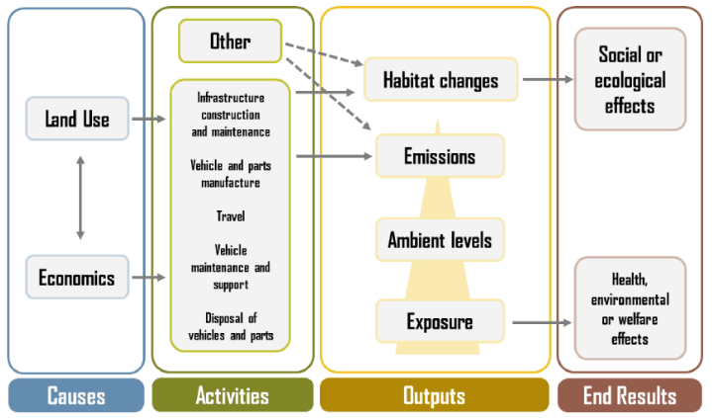
Figure 4: Environmental and social dimension of transportation conceptual framework
Source: (Rodrigue et al., 2013)
Addis Ababa Transport bureau consider the preparation and implementation of standards and legal framework to reduce the noise and air pollution in the transport sector. Expanding mass transport so as to reduce traffic congestion and air pollution is taken as an action. A priorities of measurable actions was also identified by a concerned bodies, establishment of institutional coordination and preparation of action plan; enforce high ethanol-blended fuel consumption of imported vehicles, introduce incentives, regulation formulation and implementation; ensure high biodiesel-mix consumption of imported diesel vehicles to enable biodiesel for transport service, prepare incentives for importing fully biodiesel vehicles (Tarekegn & Gulilat, 2018).
However, there is no transport related environmental protection proclamation crafted, several related legislations were emplaced to mitigate the problem. Some of them are Proclamation on Environmental Impact Assessment (Proc. No. 299/2002), Proclamation on Establishment of Environmental Protection Organs (Proc. No. 295/2002), and Proclamation on Environmental Pollution Control (Proc. No. 300/2002 and Proclamation on Public Health (Proc. No. 200/2000).

2.11 Particulate Matter, Air Quality Index and Health Concerns
The AQI is an index for reporting daily air quality. It tells you how clean or polluted your air is, and what associated health effects might be a concern for you. The AQI focuses on health affects you may experience within a few hours or days after breathing polluted air. EPA calculates the AQI for five major air pollutants regulated by the Clean Air Act: ground-level ozone, particle pollution (also known as particulate matter), carbon monoxide, sulfur dioxide, and nitrogen dioxide. For each of these pollutants, EPA has established national air quality standards to protect public health .Ground-level ozone and airborne particles are the two pollutants that pose the greatest threat to human health (US-EPA, 2011).
According to (US-EPA, 2011) AQI as a standard that runs from 0 to 500. The higher the AQI value, the greater the level of air pollution and the greater the health concern. For example, an AQI value of 50 represents good air quality with little potential to affect public health, while an AQI value over 300 represents hazardous air quality. AQI value of 100 generally corresponds to the national air quality standard for the pollutant, which is the level EPA has set to protect public health. AQI values below 100 are generally thought of as satisfactory. When AQI values are above 100, air quality is considered to be unhealthy-at first for certain sensitive groups of people, then for everyone as AQI values get higher. Values above 500 are considered beyond the AQI. The purpose of the AQI is to help you understand what local air quality means to your health. The most likely estimate of the number of people above 30 years of age who experience premature mortality in New Zealand due to exposure to emissions of PM10 particulates from vehicles is 399 per year (with a 95% confidence range of 241-566 people). This compares with 970 people above age 30 experiencing pre-mature mortality due to particulate pollution from all sources (including burning for home heating), and with 502 people dying from road accidents in all ages (Woodward, 2002).
Table 3: air quality index, description and health concern with PM2.5 and PM10
Air quality index values | Air quality descriptor | Health concerns
Air quality index values | Air quality descriptor | PM2.5 | PM10
0-50 | Good | None | None
51-100 | Moderate | None | None
101-150 | Unhealthy for Sensitive Groups | People with respiratory or heart disease, the elderly, and children should limit prolonged exertion. | People with respiratory disease, such as asthma, should limit outdoor exertion.
151-200 | Unhealthy | People with respiratory or heart disease, the elderly, and children should avoid prolonged exertion; everyone else should limit prolonged exertion. | People with respiratory disease, such as asthma, should avoid outdoor exertion; everyone else, especially the elderly and children, should limit prolonged outdoor exertion.
201-300 | Very Unhealthy | People with respiratory or heart disease, the elderly, and children should avoid any outdoor activity; everyone else should avoid prolonged exertion. | People with respiratory disease, such as asthma, should avoid any outdoor activity; everyone else, especially the elderly and children, should limit outdoor exertion.
301-500 | Hazardous | Everyone should avoid any outdoor exertion; people with respiratory or heart disease, the elderly, and children should remain indoors. | Everyone should avoid any outdoor exertion; people with respiratory disease, such as asthma, should remain indoors.
Source: (US. EPA, 2011) clean air act office of Air Quality Planning and Standards.

2.12 Characteristics and Health effects of Transportation Air Pollution
Air pollution has been one of the key points of environmental workers both at home and abroad with the development of “person is the core” (Hauptmann, 2004). From the view of human breath exposure, the human living environment can be divided into these three important parts: indoor environment, outdoor atmosphere, and transportation microenvironment.
Based on the investigation of human activities by the U.S. Environmental Protection Agency (EPA), the time of human activities spent on these three environmental parts were at rates of 85%, 7%, and 8%, respectively (US-EPA, 1989). Nowadays, the pollution of indoor air has received high attention (Baez et al., 2003; Abdel et al., 2013); in China, the pollution of indoor air has received some attention (Xu et al., 2012), but the air pollution of transportation microenvironment has not received enough attention to match with the popularization of cars, whereas the pollution of air by transportation microenvironment in foreign countries has been received high attention (Johnson et al., 2014). Nowadays, cars have gradually become part of people’s life, but together with the convenience to people’s life, the car also brings the problem of environmental pollution, especially the pollution of formaldehyde. The formaldehyde pollution in cars and other traffic microenvironment comes from different sources.
In the 1952 London air pollution episode it was estimated that 4,000 extra deaths occurred as a result of the high concentrations of Sulphur dioxide and particulate matter (Brimblecombe, 2012). According to Waller (1971) portrayed that Since the 1950s a great body of evidence has accumulated showing that air pollutants have a damaging effect on health.

2.12.1 Health Effects of Particulate Matter and Carbon Dioxide
PM has been linked to aggravation of asthma, chronic bronchitis, and decreased lung function (Vallero, 2008). Many studies have documented negative cardiovascular effects from exposure to PM10 and PM2.5 (Chuang et al., 2007) and PM1.0 and UFP have been shown to increase cardiorespiratory symptoms for elderly patients.
Both PM10 (big) and PM2.5 (small) particles can cause health problems; specifically respiratory health (that's the lungs and airway). Because the PM2.5 travels deeper into the lungs and because the PM2.5 is made up things that are more toxic (like heavy metals and cancer causing organic compounds), PM2.5 can have worse health effects than the bigger PM10 (Rolfe et al., 2000). Exposure to particulate matter leads to increased use of medication and more visits to the doctor or emergency room. According to Rolfe et al. (2000) portrayed that health effects include coughing, wheezing, shortness of breath, aggravated asthma, Lung damage (including decreased lung function and lifelong respiratory disease), and premature death in individuals with existing heart or lung diseases poisoners.

CHAPTER THREE

THE RESEARCH METHODOLOGY AND SOURCES OF DATA

3.1 Methodology of the Study
In order to make a closer investigation of air quality at public transportation stations/stops, the relationship between air quality at LRT, bus and taxi stations as well as health effects from pollutants of CO₂ and particulate matter (PM) at public transportations stations. In the line of NS-LRT line of Addis Ababa, there were air quality measurements by Air-Visual tracking device, personal observation, health questionnaires at stations of LRT, bus, taxi and both bus/taxi of NS-LRT line/route. Data were collected by measuring air quality from the stations with air tracking device (Air-Visual). Accordingly, the required data were obtained from both primary and secondary sources. The primary data were collected by both open and closed ended questionnaires, both semi-structured and structured interviews, stations survey through observation and measuring air quality at stations. Secondary data were collected and used from the relevant literature from published and unpublished researches, books and institutions report

3.1.1 Rationale for the Study
Now a day’s air pollution from public transportation and construction dust along major roads in Addis Ababa is increasing and affecting the environment and human health. Hence, to apply city administration, public transportation providers and transport policy of Addis Ababa to encourage environmental friendly transport/green transportation, that is energy efficient, enhance and encourage the construction of light rail system and re-designing of bus or taxi stations in such a way that riders have less chances of being exposed to pollutants. In addition to this, the rational to urban planning must be comprehensive and integrated land-use planning to provide alternative roads in the structure plan for walking, cycling.
Moreover, institutionalizing connections between health and transportation at multiple level. Infrastructures improvement for active transportation and integration between sector departments. The benefit is dual in reducing traffic congestion and harmonize healthy quality of life and urban environment.

3. 1.2 Study Area Selection Criteria (NS-LRT)
Public transportations air pollution in major roads is increasing and affecting the human health. The previous a few bus stop shelters are facing toward roadway on the side walk and made of metallic materials expose riders to vehicles air pollution and most of the bus/taxi stations have not shelters in the study line of NS-LRT (Kality to Menelik II square 16.9 km) with 6 sample stations (Kality, Saris, Stadium, Mexico, Autobus-Tera, Menelik II square) and 30 persons sample size for each station and 180 persons for all LRT stations. Purposive sampling was applied to select target population for health questionnaires. They were selected by age, gender and occupations who are exposed to vehicles pollution on and around the station. Air pollution from public transportations at NS-LRT line stations/stops due to lack of alternative road network, congested road traffic, old motor vehicles (over used) and no street side trees in arterial street (40 meter) of NS-LRT line were observed by the researcher. Hence the study area North-South LRT selection criteria was based land use type, major street, high traffic volume and accessed by all public transport that run from periphery Kality to the center of the city Piassa (Minilik II square). The selection criteria for sample stations were purposive, considering the characteristics of numbers of passenger’s, road junction, land use, sub-cities, and elevated, on-ground, underground and, origin and destination of LRT station.
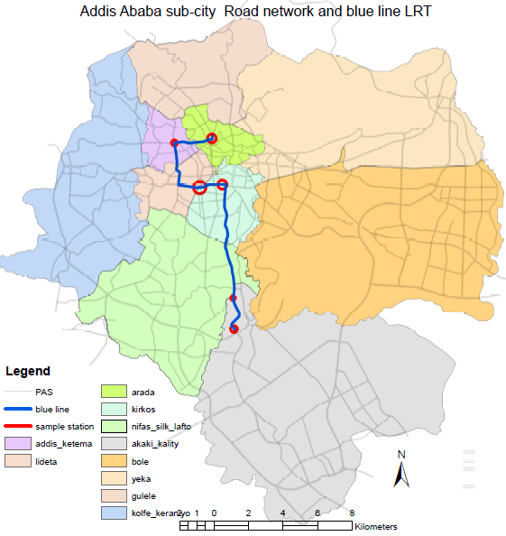
Figure 5: Sample distribution by sub-city
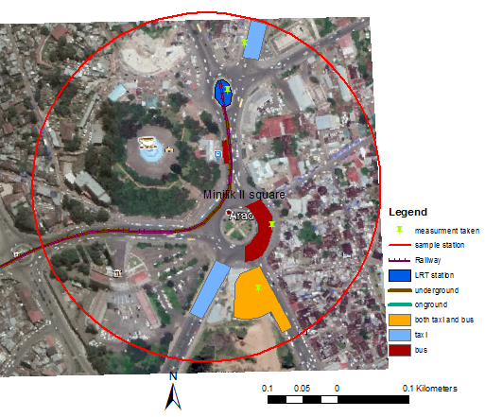
Figure 6: Minilik II square sample station where air quality measurement taken
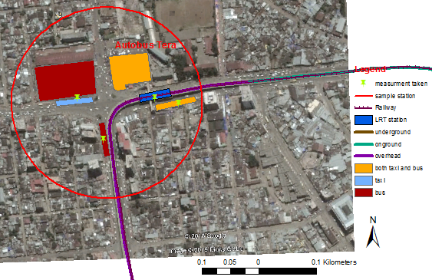
Figure 7: Autobus Tera sample distribution where air quality measurement taken
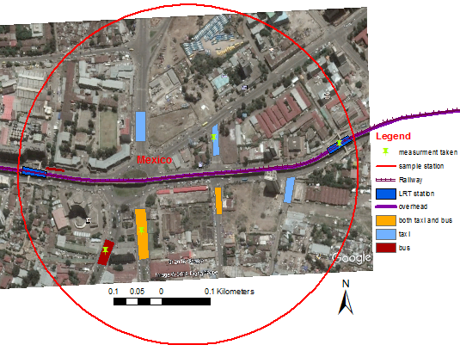
Figure 8: Mexico sample station where air quality measurement taken
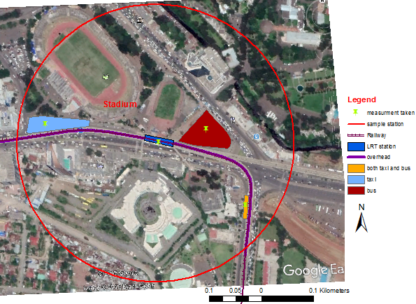
Figure 9: Stadium sample station where air quality measurement taken
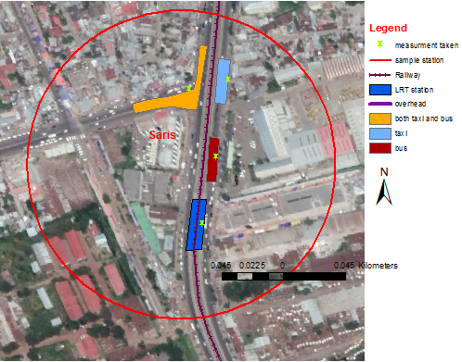
Figure 10: Saris sample station where air quality measurement taken
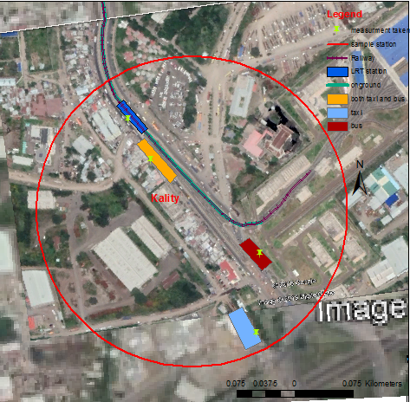
Figure 11: Kality sample station where air quality measurement taken

3.1.3 Research Design
The researcher has been used both quantitative and qualitative method (mixed approach) to get information from 24 sampled stations/stops from Kality to Piassa LRT line. In this regard, in quantitative aspect air quality measurements by air tracking device (Air-Visual) and health questionnaires were prepared for residents or workers close proximity (100 meter radius) to the stations (drivers, traffic police, shoeshines, street vendors, transport distribution controllers, street sweepers). In the qualitative (descriptive) aspect, semi-structured interviews were applied for Addis Ababa City Road and Transport Bureau, Addis Ababa Environmental Protection Authority. In addition, stations observation were applied to collect data on 24 stations of public transportations. After the collection of the necessary information, data processing had been performed with SPSS, Excel, and GIS software. The data were organized and analyzed using descriptive and inferential statistical methods and techniques (mean, count and simple regression analysis).

3.1.4 Structure of the Research Methodology
Problem statement

Research objective

Research question

Literature review

Local experience
International experience

Rationality of doing research about Air quality at public transportation stations contextual background

Method of data analysis
Method of data collection
Study area

Regression
Observation
Result & Discussion
Measuring
Tabulation
Questionnaires
Interview
Conclusion
Graph/chart frequency
Recommendation

Figure 12: Research methodology flow chart

3.1.5 Target Population and Sampling Frame
Sampling frame is the list of elements from which the sample is drawn. Thus public transportations stations or stops were purposively selected for the study from Kality to Minelik II square LRT corridor, hence, the totals are 22 LRT stations. The population is greater than 113,000 average daily passengers. Taxi, Bus and LRT stations selected for this study and located along north-south LRT line a major arterial street started from periphery located at Kality, Saris, Stadim, Mexico, Autobus-Tera and Minilik II square to the center of Addis Ababa city serve as a ridership main road for the outlying suburbs, with high arriving morning traffic volumes and high outbound evening traffic volumes. Hence, samples selected on commercial, service, mixed and industry & manufacturing land-use. There are 22 NS-LRT stations, 14 bus stops only, 21 taxi stations only and 14 are both bus and taxi stations. Thus, equal sample size selected for each stations to compare air quality and station design (road pavement material, traffic volume, quality of walkways by Likert scale).
Table 4: Sample size selection from sampling frame
No | Station | No of stations ( sampling frame) | Sample size | Percentage of sample size
1 | NS-LRT | 22 | 6 | 27.27%
2 | Bus | 14 | 6 | 42.85%
3 | Taxi | 21 | 6 | 28.57%
4 | Both bus & Taxi | 14 | 6 | 42.85%
Total |  | 71 | 24 | 33.80%

3.1.5.1 Sample Size
Sampling is the process of using a small number or part of a larger population to make conclusion about the whole population. In order to assess air quality at public transportation station 24 stations and 720 persons interview questionnaires selected (LRT, bus and taxi station) North- South LRT line, 6 stations for each are sample size for LRT, bus, taxi and both bus/taxi stations/stops hence, two stations from five total common stations and two stations that are used as both origin and destination and the rest two stations were selected purposively on-ground, underground and elevated station that serves for both taxi and bus stations. The selected two stations out of five common stations are elevated stations and diversified land use activities. The sample stations name are Kality, Saris, Stadium, Mexico, Autobus-Tera and Minilik II square. These stations were studied in detail the relationship of stations design, health and air quality for each LRT, bus, taxi and both bus/taxi (24 stations) and 30 persons sample size for each stations with a total of (24x30) =720 sampling peoples.
Table 5: Sample size distribution by type of station and Sub-city
No | Sample | Quantity | Sample station name | Sub-city
1 | On ground(LRT) | 2 | Kality, saris | Akaki- kality, Nifas-silk lafto
2 | Underground(LRT) | 1 | Menelik II square | Arada
3 | Elevated(LRT) | 3 | Stadium, Mexico, Autobus-tera | Kirkos , Addis ketema, Lideta
5 | Bus | 6 | Kality, Saris, Stadium, Mexico, Autobus tera, Georgis | Kirkos , Addis ketema, Arada, Akaki- kality, Nifas-silk lafto
6 | Taxi | 6 | Kality, Saris, Stadium, Mexico, Autobus tera, georgis | Kirkos , Addis ketema, Arada, Akaki- Kality, Nifas-silk Lafto
7 | Both taxi & bus | 6 | Kality, Saris, Stadium, Mexico, Autobus tera, Georgis | Kirkos , Addis ketema, Arada, Akaki- Kality, Nifas-silk lafto
Total |  | 24 | 24 | 6
Table 6: Sample distribution and interviewee persons per stations.
No | Type of station | Station Sample size | Sample persons per station | Total
1 | LRT | 6 | 30 | 180
2 | Bus | 6 | 30 | 180
3 | Taxi | 6 | 30 | 180
4 | Both bus and taxi | 6 | 30 | 180
Total |  | 24 | 30 | 720
At each 6 stations researcher was purposively interviewed 30 persons (6x30) =180. Train, Taxi, Bus, both Taxi and Bus hence 4 x 180=720 sample persons.

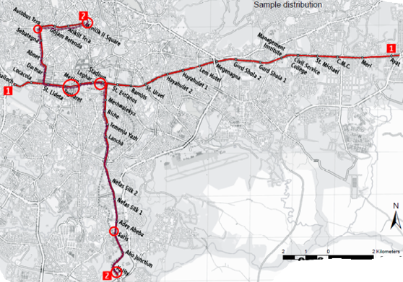
Figure 13: Sample distribution in spatial location (line 2, North-South LRT line)
Source: (AALRTS, 2016)

3.1.5.2 Sampling Technique and Sampling size Selection Requirements
Purposive sampling technique was applied to select sample population at public transportation station based on homogeneous group age, gender and occupation living and working around transportation station. They are permanently affected by vehicles pollution. Street vendors, traffic police, transport distribution coordinators, shoeshines, passengers, street sweeper, drivers and homeless are target population. A homogeneous sample is often chosen when the research questions that is being address is specific to the characteristics of the particular group of interest. Hence, the researcher applied purposive sampling. Purposive is selected to take sample from North-South LRT line, bus, taxi and both bus and taxi reasonably. The sample size stations selection were considered the characteristics of numbers of passenger’s population, land use, road junction, sub-cities, time, data and elevated, on ground, underground and, origin and destination for NS-LRT station. Sampled stations had (NS-LRT, bus, taxi and both bus and taxi) 4 x 6 totally 24. The sample size is 33.80% in purposive sampling out of total 71 stations in six sub-city (Akaki-Klity, Nifas-Silk Lafto, Kirkos, Lideta, Addis Ketema and Arada Sub-City. Hence one sample station for each sub-city. The population is greater than 113,000 average daily passengers. In most case researchers used the degree of confidence level to minimize sampling errors (i.e. health science is about 99% and social science 95%).But a rule of thumb commonly or conventionally used for smaller population less than 1000; 30% is sufficient if the populations are homogenous, if the sample sizes are large, it will bring non sampling errors. Thus, the researcher considered cost, time and target population to be studied for exposure respiratory disease related to transportation air pollution.

Diagrammatic representation of sampling procedure
Stations Vs Sample persons
Defining population
Sampling Design

Sample Size

Estimate Cost of Planning
Execute Sampling Process

Figure 14: Sampling procedure

Method of Data Collection and Data Source
All data sources were both primary and secondary type of data, accordingly four type of primary data collection were applied. The data source and methods are shown in the table below.

Table 7: Method of data collection, type and sources
Data type | Method of data collection | Data source
Primary data  (Qualitative and Quantitative data) | Questionnaires | Street vendors, shoeshines, traffic police, transport coordinator, street sweepers, passengers, drivers, homeless
Primary data  (Qualitative and Quantitative data) | Personal observation | Visiting transportation stations, photo, counting vehicles type
Primary data  (Qualitative and Quantitative data) | Measurement | Air-Visual tracking device
Primary data  (Qualitative and Quantitative data) | Interview | AACTA, AAEPA, AARTB,AALRTS,
Secondary data | Reading and reviewing different published and unpublished documents | Journal articles, books and government publications, CSA, internal records, websites

3.1.6.1 Primary Sources of Data

Four types of data collecting tools were prepared to primary data source. These are
- Questionnaires: helps to gather relevant air quality related health information for the study. The questionnaires were open and close ended types as the nature of the questions those open-ended items that has been constructed for residents/workers, traffic police, street vendors, shoeshines, street sweepers, transport coordinators and passengers regarding health surrounding the stations/stops of the study area.
- Interviews: unstructured interview schedule was prepared for the institutions (AACRTB, and AALRTS) regarding air pollution, transport and vehicles. Semi-structured interview, this method of interview has features of both unstructured and semi-structured interviews, for key informants’ road and transport authority, Addis Ababa LRT service and Addis Ababa environmental authority in addition, traffic police and transportation distribution controllers at bus/taxi station. For the structured one the researcher constructed structured items as a road map whereas, for the semi-structured one the researcher use semi-open ended questions why they visit hospitals/clinics (health institution).
- Personal observation: The researcher visited the transportation stations. 24 days were dedicated to research areas and fill questionnaires. There were made on foot and it enabled the researcher to measure air quality by device (air-visual), to experience and understand the condition of station, traffic volume, capacity and level of service, shelter type and availability and land use around public transportations station. It also enable to interview passerby and riders who was not related to the area but still gave relevant information. Besides, Personal diaries and survey documents were compiled by the researcher from different literatures for his own use.
- Measurement: measuring air quality at sampled station to know the amount of AQI, CO₂ and particulate matter (PM2.5, PM10), humidity and temperature and relationship of air quality between taxi, bus and LRT station by using air tracking device(air-visual). Measurement was taken two times peak hours and off-peak hours at each 24 stations (2 x 24) is 48 measurement for half hour (30 minute). Total measurement time of 24 hours. Measurement was taken on March 22 till April 16, 2019.
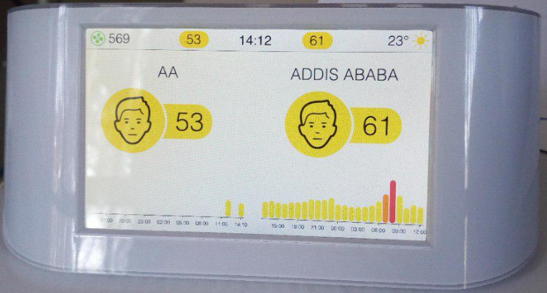
Temperature (ºC)
Carbon dioxide
Air quality index
Time

Figure 15: Air tracing device (IQAir Visual pro).
Air tracking device measures particulate matter (PM2.5, PM10), air quality index (US and China), carbon dioxide (CO₂), humidity (%RH), temperature (in ^{O}C and F).

3.1.6.2 Secondary Source of Data
Secondary data were compiled by the researcher from different literatures for his own use. The sources of secondary data were personal document such as thesis, dissertation and public document. Public documents such as books, physical mapping, records, and census reports of survey by private and public institution and various information’s published in newspapers and journal articles regarding air quality at public transportation, health impact air pollution particulate matter and air quality at public transportation station. In addition ERC, AACTA and AALRTS gave important data regarding LRT, vehicles number and vehicles pollution.
Literatures have been taken as the secondary source of data in order to underpin and consolidate the primary data sources and it is the pillar to see the delineation (a clear cut line) between what is saying those literatures and the primary data sources based on the operationalized phenomena (entities, attributes and variables) by associating or disassociating the attributes with the dependent variable of the study and the literatures were organized in the manner of their thematic form.

3.1.7 Description of Variables
The purpose of this study is to identify the relationship between health versus air quality and air quality versus station design at public transportation stations on NS-LRT line of Addis Ababa. First identify the cause and effect relationship between health, air quality and station design. Hence, the effect (dependent variable) and cause (independent variable) in the relationship between health, air quality and station design. The first relationship was health and air quality, health depend on air quality, in this case the dependent variable is health and the independent variable is air quality (AQI, CO₂ and PM2.5 value). In the other case the relationship between air quality and station design, air quality depend on station design, in this case the dependent variable is air quality and station design (at grade, shelter, land use, traffic volume) are independent variable. Researcher used two variables to know the relationship each other health versus air quality and air quality versus station design.
Variables relationship between dependent and independent variables
Land-use
Dependent variable
Independent variable
Traffic volume
Air quality
Health
Station design

Shelter
PM2.5
AQI
CO₂
Grade
Figure 16: The cause and effect relationship of dependent and independent variables
Air quality at bus, taxi and LRT has a number of factors, it is an open system and influenced by type of vehicles, fuels type, land-use (homebased emission, industry), road quality (dust and waste), shelter availability all these are cumulative effect on air quality at public transportation stations. Station design has an influence on air quality at taxi, bus and LRT waiting passengers. Most bus and LRT stations has shelters(sheds), these sheds especially on ground LRT stations and bus stop near busy road intersection has concentration of air pollution(CO₂, PM) than taxi and elevated LRT stations.

3.1.8 Method of Data Analysis and Presentation
Data analysis is the process of systematically applying statistical and/or logical techniques to describe and illustrate, summarize, and evaluate. It gives the direction for future data collection. Once the air quality data were collected two times at peak and off-peak hours for each 24 sample stations for 30 minutes. Comparison was done by taking average air quality both peak and off-peak hours. Thus, health questionnaires and air quality data were analyzed in quantitative method (relationship with air quality by simple regression analysis). Whereas, physical observation or characteristics of the stations were analyzed in qualitative method.
The analysis of the whole study was interpreted, based on the nature of the data collection methods and both qualitative and quantitative procedures had been employed. Data interpretation is important to select the proper statistical tool to make use full interpretation of data. Accordingly those data, the interviews and observations were administered and described qualitatively whereas, the data that obtained via questionnaires and air tracking device were interpreted and analyzed in a quantitative manner. As a result the organized (analyzed) data were described in the form of tabulations, count, maps, text and graphs (descriptive statistics). In the case of tabulations and graphs percentage were used to analyze the items of the health questionnaires.
The air quality data were analyzed by US-EPA air quality index color code. AQI value grouped in six category good to hazardous category (green, yellow, orange, red, purple and maroon). Particulate matter is also grouped by six level PM2.5. Therefore, the measured air quality at each sampled stations and health questionnaires were analyzed by these air quality index and those relationship between air quality, station design and health. Foot and vehicular traffic movement were analyzed and interoperated by level of service (LOS) A up to F regarding vehicular congestion speed in km/hr and foot traffic in person/minute/30.48cm.
Table 8: Air quality categories, standards and health messages
AQI value | AQI color | PM2.5 (μg/m³) | PM10 (μg/m³) | CO₂(ppm) | AQI category and health messages
0-50 | Green | 0-12.4 | 0-54 | <700 | Good
51-100 | Yellow | 12.5-35.4 | 55-154 | 701-1,000 | Moderate
101-150 | Orange | 35.5-65.4 | 155-254 | 1,001-1,500 | Unhealthy for sensitive groups
151-200 | Red | 65.5-150.4 | 255-354 | 1,501-2,500 | Unhealthy
201-300 | Purple | 150.5-250.4 | 355-424 | 2,501-5,000 | Very unhealthy
301+ | Maroon | 250.5+ | 425+ | 5001+ | Hazardous
Source: (US-EPA, 2007).
Current guideline of US-EPA for PM2.5 standard is 35μg/m³. Color is key for communication ranges from 0 to 500 (no units) provides indicator of the quality of the air and its health effects.
Furthermore, correlation and simple regression analysis were used to quantify the relationship of air quality index and health impacts at public transportation (LRT, Bus, and Taxi) stations in the study area of North-South LRT corridor in Addis Ababa.
According to Anyadike, the simple linear regression equation is used in the form:
𝑌 = 𝑎 + 𝑏𝑋
Y is dependent variable (effect) represent the magnitude of the relationship between health and air quality (CO₂, PM, AQI) 𝑎 is the constant (intercept) that scales the equation, 𝑏 represent regression coefficients of the independent variables. X represent independent variables (cause) air quality (PM, CO₂ and AQI).
Instruments (or tools) and software that researcher were used to analyze and interpret the collected data are GIS, SPSS, AutoCAD, MS Word, Excel, camera. Run the correlation and regression analysis, cause and effect relationship between air quality at public transportation station, station design and effect on health. Lastly, Interpret data in to information and knowledge.

CHAPTER FOUR

BACKGROUND ON THE STUDY AREA

4.1 Description of the Study Area
The population of Addis Ababa is 3,384,569 according to CSA census with annual growth rate of 3.8% (CSA, 2013). Based on this premises, the current total population size of Addis Ababa is more than 4.5 million which take more than 25% of the total urban population of the country of Ethiopia. In this regard, Addis Ababa’s transport problems are diverse; aged fleet, chaotic movement, unacceptable emission, unsafe, hazardous to life and property and weak traffic management system. To effectively solve the problem of urban transportation, traffic congestion especially that of the downtown area of the city, the government of Ethiopia decided to build a light rail in the city of Addis Ababa. Currently the project has implemented two lines, the east-west (E-W) line and the south-north (N-S) line. According to Ethiopian Railways Corporation (2015), the total length of AALRT is 34.25 km (N-S line 16.9 km and E-W line 17.35 km) which has the capacity of transporting 60,000 passengers per hour in both direction and reduce transportation emission and congestion (ERC, 2015).
The focus of this study is air quality at public transportation stations and relationship with station design and health impacts on NS-LRT line from the center of the city Menilik II square via Autobus Tera, Mexico, Stadium, Gotera, Saris to the intermediate Zone Kality(16.9km and 22 LRT stations), 28 Bus stations and 35 Taxi stations. Among these, 14 are common for both Bus and Taxi stations. In this regard 6 sample stations selected for each LRT, Bus, Taxi and both Bus and Taxi stations purposively. (Kality, Saris, Stadium, Mexico, Autobus-Tera and Minilik II square). These stations selection were considered the characteristics of numbers of passenger’s population, land use, road junction, sub-cities, character of station, heterogeneity of stations and elevated, on ground, underground and, origin and destination for NS-LRT stations.
Those six sampled stations have bus, LRT, taxi and mixed stops with a total of 6x4=24 stations. Each of them observed two times peaks and off peak hours by air tracking device. Hence, total measurements are 48 for thirty minutes.
Most of the stations in the study area located at the road curve and intersection. The nature and the design of the public transportation stops/stations contribute for the quality of the air in and around the stations. Many design of the stations facing the main road and taxi stations do not have shelters. Train, taxi and bus stations located at commercial and mixed land use and are not available in residential land use. There are high traffic volume on the station due to on the road curve stop, lack of transportation options and alternative road infrastructure. The quality of road pavement on and around the stations are dusts, cracked asphalt and no safe walkways and riders waiting. Long waiting at stations being exposure to transport air pollution.

4.2 Historical background of AALRT
The Ethiopian railway was built in 1917 by the French to facilitate the transport of merchandise which previously had to be carried on the backs of animals. Taking into account the natural topography of this country and the lack of proper roads it was extremely difficult to transport goods from central Ethiopia to the ports of the Red Sea, and merchants spent months travelling from Addis Ababa to Massawa, Zeila or Berbera, which put a crimp on the export of goods from Ethiopia (Groum, 2006). Not only did the Ethiopian railway contribute to bring the country out of its centuries-old isolation from the rest of the world but it also played an important role in changing the social relations between the Ethiopian nations.
Transport service provision challenge in Addis Ababa giving special attention to the issue, a great effort is made by the government to realize technology transfer in mass transport by introducing Light Rail Transit (LRT), Bus rapid Transit (BRT) and Trolley Bus transport services. Addis Ababa Light Rail Transit Service revealed that The Ethiopian government decided to address the congested roads of the capital, Addis Ababa, by commissioning a new urban metro, largely funded constructed and run by chinse institutions in December 2011. It is the first railway to be built in Sub-Saharan Africa and the first line opened in September 2015.
The Addis Ababa LRT is currently operating average capacity, serving up to 6, 610 passengers across four lines every hour and 105,760 every day (Addis Ababa LRT service, 2019). Full emissions reduction data are not yet available for the project but the cumulative emission reduction potential of the LRT system is forecasted at 1.8 million tone CO₂ emission by 2030. The LRT is at the forefront of supporting low carbon transport for the area and is powered by low-carbon electricity from hydropower from the Ethiopian grid. It uses less land than road construction, and has lower noise and air pollution levels.

4.3 Transport and Air Pollution Trends in Addis Ababa
The population of Addis Ababa is increasing from time to time. Addis Ababa city with an estimated population of 4.5 million is considered as a major metropolitan city (CSA, 2013).
The Addis Ababa Greenhouse Gas Emission Inventory greater than 4.8 million tons of carbon dioxide gas (CO₂) the city emits, transport vehicles account for 47 percent of the total emission (Molalign, 2016). Transportation is the fastest growing major contributor to global climate change. Need of transportation in Addis Ababa is increasing, parallel to the city’s population growth and economic development and increasing the diverse impacts.
Population explosion and the associated anthropogenic activities generate air pollution especially transport sector that adversely affect the physical environment. The transport services are a public sector that is being demanded by the increasing population in the city.
Similarly, emission of pollutants is increased rapidly. Respiratory diseases are incidents commonly recorded at the health care institutions like health centers, clinics and hospitals (Tarekegn & Gulilat, 2018). The driving forces, pressures, states, impacts and responses for air pollution issue related to transportation in Addis Ababa listed below.
Response
- Environmental policy
- Public health policy
- Environmental pollution control
- Sectoral policies (transport policy, regulation)
- Environmental impact assessment

Drivers
Major emission source
- Congestion
- Fuel quality
- Old vehicles
Impact
Human health
- Respiratory diseases
- Premature mortality
Ecosystem
- Damage on plant
State
Air quality
- Concentration level of CO₂, particulate matter
- Air quality index
Pressure
Emission of pollutants
- CO₂
- Particulate matter(PM)

Figure 17: The causes and impacts of transport air pollution
Source: (Tarekegn & Gulilat, 2018) diagram for air pollution in Addis Ababa

4.3.1 Emissions from Transportation
Key transport-related air quality challenges in Addis Ababa are vehicles growth, old fleet, fuel quality, old vehicles and poor maintenance. Addis Ababa Road and Transport Bureau (2018) revealed that transport is the main source of air pollutant in Addis Ababa. Rapid increase in vehicle numbers in Addis Ababa city, driven by increased urban population, economic development and urbanization. Regarding the vehicles growth, old vehicles, poor maintenance and inefficient public transport are factors driving emissions in the transport sector. Motorization rate is high, approximately 10% per year, with more than 50% of the current fleet being more than 15 years old.

4.3.2 Age of Vehicles in Addis Ababa
Addis Ababa faces a rapid increase in air pollution due to increasing number of automobiles which do not follow emission standards set by various environmental agencies. Lack of retirement policy for the vehicles worsens the problem. According to the study (Kante , 2011) indicated that the age of vehicles in Addis Ababa was that of 53.5% vehicles were more than 20 years old, while 29.3% were more than 30 years old. This indicated that more old vehicles emit more pollutant in to the environment. Therefore, Carbon free and alternative transport infrastructure is crucial to address the growing challenges pertaining to rapid urbanization including traffic congestion, aged vehicles and mitigate climate change.

4.4 The Environmental Impacts of Transportation
The issue of Transportation and the Environment is paradoxical in nature since Transportation conveys substantial socio-economic benefits, but at the same time Transportation is impacting Environmental systems. From one side, transportation activities support increasing mobility demands for passengers and freight, while on the other, transport activities are associated with growing levels of environmental externalities. Further, a study (Rodrigue, 2017) portrayed that Environmental conditions have an impact on transportation systems in terms of operating conditions and infrastructure requirements such as construction and maintenance and the growth of personal and freight mobility in recent decades have expanded the role of transportation as a source of emission of pollutants and their multiple impacts on the Environment. These impacts fall within three categories:
Direct impacts: The immediate consequence of transport activities on the environment where the cause and effect relationship is generally clear and well understood. For instance, noise and carbon monoxide emissions are known to have direct harmful effects.
Indirect impacts: The secondary (or tertiary) effects of transport activities on environmental systems. They are often of higher consequence than direct impacts, but the involved relationships are often misunderstood and more difficult to establish (Rodrigue et al., 2013). For instance, particulates which are mostly the outcome of incomplete combustion in an internal combustion engine are indirectly linked with respiratory and cardiovascular problems since they contribute among other factors to such conditions.
Cumulative impacts: The additive, multiplicative or synergetic consequences of transport activities. They take into account of the varied effects of direct and indirect impacts on an ecosystem, which are often unpredictable. According to Rodrigue (2017) portrayed that climate change, with complex causes and consequences, is the cumulative impact of several natural and anthropogenic factors, in which transportation plays a role. 15% of global CO₂ emissions are attributed to the transport sector.

4.5 Respiratory Diseases and Health condition in Addis Ababa
The rapidly increasing transport sectors together with the fast urbanization, poorly and slowly constructing road infrastructure and the type and quality of high sulfur containing fuel usage are the major derivers of Addis Ababa air quality problems.
A study by Tarekegn and Gulilat (2018), also portrayed that acute upper respiratory infection increased with annual growth rate 47.18% from incidents 4,539 in 2003 to 212,590 in 2017. The chronic obstructive pulmonary disease (COPD) and Pneumonia are being increased by annual growth rate about 53.44% and 24.89%, respectively. The quality of air is now becoming a serious issue in Addis Ababa.
Ethiopia’s Ministry of Health (MoH) report indicated that more than 800,000 people were affected by respiratory illness in Addis Ababa last year due to air pollution. According to the air quality study it conducted last Ethiopian fiscal year (2018), the ministry of health confirmed that the air pollution level in the Addis Ababa has exceeded the limit set by the World Health Organization (WHO). Of the total patients who sought health treatment in health institutions, 819,900 or 27.2% of them were patients affected by respiratory illness.
In general, the increasing trends and nature of respiratory diseases are clearly attributed to the increasing of vehicles and corresponding emissions. In addition to this, the nature and accessibility road, quality of fuel and type and quality of vehicles, age used in Addis Ababa affecting emission rate and its corresponding incidents.

Case Study: Transport and Air
Polluon Trends in Addis Ababa
The rapid and high diplomac and industrial development of
the country has aracted not only domesc and internaonal
companies, but also rural communies into the capital city.
The populaon in the city is increasing from me to me.
Addis Ababa city with an esmated populaon of 3.6 million is
considered as a major metropolitan city by any developing
country standard. Populaon explosion and the associated
anthropogenic acvies generate huge amounts of dierent
types of wastes (air, solid and gaseous) that adversely aect
the physical environment. The transport services are a public
sector that is being demanded by the increasing populaon in
the city.
Correspondingly, emission of pollutants is increased rapidly.
Respiratory diseases are incidents commonly recorded at the
health care instuons like health centers, clinics and
hospitals. The common driving forces, pressures, states,
impacts and responses for air polluon issue in Addis Ababa is
summarized in the DPSIR diagram (Figure 1), discussed below
Case Study: Transport and Air
Polluon Trends in Addis Ababa
The rapid and high diplomac and industrial development of
the country has aracted not only domesc and internaonal
companies, but also rural communies into the capital city.
The populaon in the city is increasing from me to me.
Addis Ababa city with an esmated populaon of 3.6 million is
considered as a major metropolitan city by any developing
country standard. Populaon explosion and the associated
anthropogenic acvies generate huge amounts of dierent
types of wastes (air, solid and gaseous) that adversely aect
the physical environment. The transport services are a public
sector that is being demanded by the increasing populaon in
the city.
Correspondingly, emission of pollutants is increased rapidly.
Respiratory diseases are incidents commonly recorded at the
health care instuons like health centers, clinics and
hospitals. The common driving forces, pressures, states,
impacts and responses for air polluon issue in Addis Ababa is
summarized in the DPSIR diagram (Figure 1), discussed

CHAPTER FIVE

RESULTS AND DISCUSSION

5.1 Introduction
This chapter presents all the information and the results obtained through the primary data collection techniques. Focusing on air quality, station design characteristics and air quality related health problems at 24 sampled public transportation stations on North-South LRT line of Addis Ababa.
Therefore, transportation poses a dilemma in that it is necessary for economic and social development, yet it is associated with environmental problems, especially with regard to air quality related health impacts. Its emissions include greenhouse gases, most notably CO₂, as well as particulate matter, sulfur oxides and volatile organic compounds. The most dangerous and studied pollutants are CO₂ that increase global warming, health problems and PM2.5 is also the most dangerous particles affecting human health and travel long distance on air. In this regard, station design, bus shelter orientation, and street greenery, age of vehicles and traffic congestion in Addis Ababa affect the emission level at public transportation station and long waiting passengers have been exposing to vehicles pollution. 720 sampled persons were surveyed at public transportation. These samples focused on especially peoples living/working in and around the stations. 45% of out of 720 respondents are exposed by transport related air pollution diseases. This indicates that the major victims are street vendors, street sweepers, traffic police, transport coordinators and shoeshines.
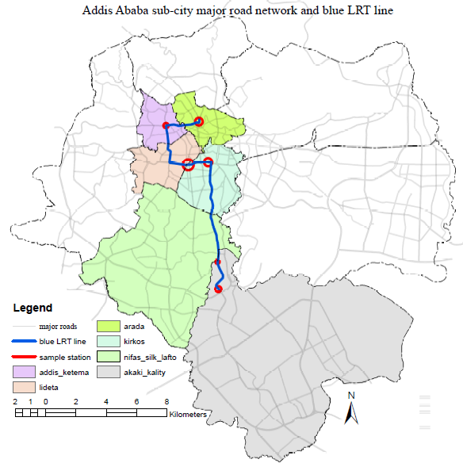
Figure 18: Six sub city versus sampled stations North-South LRT line
One sample station were taken at one sub-city (Akaki-Kality = kality, Nifas-silk Lafto = Saris, Kirkos = Stadium, Lideta = Mexico, Addis ketam = Autobus Tera and Arada = Minilik II square
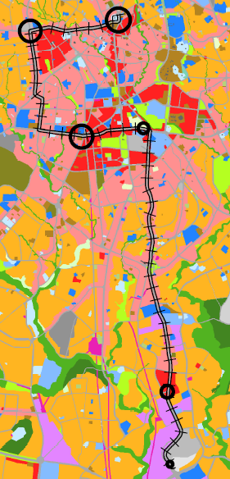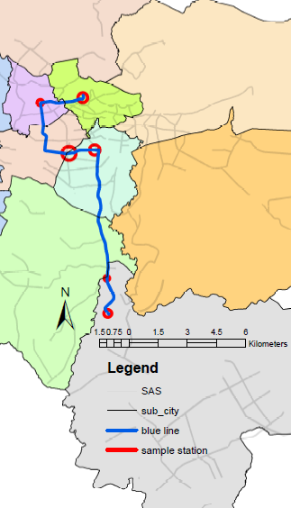
Figure 19: Land use and sample stations distribution
Source: (Addis Ababa structural plan manual, 2016)
Sample stations were taken from industrial (purple), commercial (red), mixed (light pink) and service (blue) land use. The six sample transportation stations taken from Akaki-Kality, Nifas-silk lafto, Kirkos, Lideta and Arada sub-city. There are bus, taxi, LRT and mixed (bus/taxi) at all sampled stations. 6x4 = 24 type of stations were surveyed. Air quality measurement have been taken two times (peak hours =7:30am-9:30am and 4:30pm-7:00pm and off peak hours = 9:30am-4:30pm) on March 22 up to April 16, 2019. 48 measurement of air quality have been taken at sampled stations for 30 minutes.

5.2 Demographic characteristics of Air quality related Health respondents

Figure 20: Gender and age frequency of the respondents
Males’ respondents were greater than females. Out of total (720) respondents 420 (58%) are males whereas 300 (42%) are females. Age composition of respondents categorized in to seven age structures below 15 years old, the five categories grouped by 10 years differences and the remaining one grouped above 65 years old. The higher proportion of respondents were age between 26-35 (39.0%), 15-25 (34.7%) and 36-45(17.40%) respectively. whereas the least number of respondents were above 65(1.00%), 56-65 (1.30%), 46-55(3.20%) respectively.

Figure 21: Age versus gender of respondents

5.2.1 Response rate of Respondents
According to Government accountability office (GAO) internal guidance/resource, Calculating and Reporting Survey Response Rates is important. The GAO internal guidance defined as a response rate is the percentage of the eligible sampled elements of a survey population who provide usable data for the analysis. The response rate for a sample survey calculated as follows: response rate = usable responses/eligible sampled elements where usable responses = total number of eligible respondents who provide usable data for the analysis, and eligible sampled elements = all elements drawn into the initial sample who were not later identified as out of scope (i.e., outside the survey population).
At the beginning, it was expected to get full response from 750 samples size, among these, 720 were fully responded all health questionnaires. 30(4%) respondents could not answer all questionnaires. 96% of respondents were answered all questionnaires.
Among key informants or institutions (Addis Ababa City Road and Transport Bureau, Addis Ababa city Environmental protection authority, Addis Ababa city Administration Driver and Vehicles licensing and Control Authority, Addis Ababa City Transport Authority, Addis Ababa Light Rail Transit service, Ethiopian Railways Corporation). These six institutions were shared data for the researcher but only five institutions were willing and answered the interview.
Regarding this, 83.33% response rate was obtained by interview.
The overall rate of response were the percentage health questionnaires (peoples living/working in and around public transportation stations and interview for institutions. Thus rate of respondents were 96% plus 83.33% divided by two is 89.67%. Generally speaking, it’s preferable getting the response rate (80% or higher) from a purposive sampling. In this research work the total percentage rate of the respondents were 89.67%. This percentage indicated that it is satisfactory the minimum requirement based on GAO internal guidance.

5.3 Air Quality at sampled Public Transportation Station
This study indicates that, there is unhealthy air condition at public transportation stations. Most motor vehicles are diesel engines, old and used more than 15 years i.e. mini-bus, DAF bus and lorry. Especially industrial and commercial land use affect air quality at sampled stations. Congested traffic corridors in dense urban areas are key contributors to the degradation of urban air quality. While waiting at bus stops, transit riders may be exposed to greater amounts of vehicle-based pollution CO₂, including particulate matter (PM), because of their proximity to the roadway. Most stations in the study area situated near road intersection where there are high traffic movement and nodal point. As explained in this study; bus shelter orientation and location was found to significantly affect concentration of sizes of particulate matter (PM2.5 and PM10).

Figure 22: Average air quality at all sampled station.
Average concentration of air quality at peak and off peak hour include all bus, taxi, LRT and bus/taxi stations together at Kality, Saris, Stadium, Mexico, Autobus-tera and Minilik II square.
Air quality at sampled stations were taken two times; during morning peak (7:30am - 9:30am), evening peak hour (4:30pm -7:00pm) and off-peak hour (9:30am - 4:30pm). Each measurement have taken for 30 minutes length. All sampled stations summarized as follow.
Table 9: Average measurement of air quality both and off-peak hour at sampled station.
Station name | Station type | Air quality and weather during peak hours |  |  |  |  |  | Air quality and weather during off peak hours
Station name | Station type | CO₂ | AQI | PM_{2.5} | PM₁₀ | Temp. in ⁰C | Humidity (%) | CO₂ | AQI | PM_{2.5} | PM₁₀ | Temp. in ⁰C | Humidity (%)
Kality | LRT | 414.22 | 89.97 | 30.33 | 108.36 | 26.89 | 35.27 | 416.22 | 79.92 | 25.97 | 89.73 | 29.50 | 34.72
Kality | bus | 544.89 | 152.94 | 79.24 | 205.49 | 23.81 | 36.42 | 411.88 | 117.44 | 49.36 | 163.2 | 28.09 | 39.62
Kality | Taxi | 443.00 | 120.43 | 48.81 | 111.84 | 23.20 | 38.72 | 405.84 | 123.15 | 48.94 | 195.8 | 26.93 | 39.4
Kality | Mixed | 518.30 | 126.35 | 55.26 | 152.87 | 24.13 | 38.28 | 432.55 | 110.00 | 42.52 | 161.1 | 27.67 | 36.72
Saris | LRT | 421.57 | 86.25 | 29.77 | 95.35 | 28.88 | 37.36 | 418.34 | 79.98 | 27.25 | 91.04 | 30.03 | 37.2
Saris | bus | 602.77 | 164.27 | 85.09 | 155.33 | 23.09 | 47.16 | 512.57 | 156.71 | 84.68 | 173.8 | 22.84 | 46.03
Saris | Taxi | 501.68 | 115.78 | 50.67 | 148.11 | 27.74 | 29.28 | 467.13 | 105.07 | 40.79 | 143.5 | 30.68 | 35.49
Saris | Mixed | 540.8 | 116.16 | 57.52 | 179.88 | 28.80 | 28.69 | 463.39 | 106.17 | 45.77 | 123.7 | 29.54 | 32.92
Stadium | LRT | 400.25 | 63.84 | 18.41 | 51.69 | 24.76 | 36.47 | 410.26 | 37.75 | 9.37 | 25.81 | 27.33 | 26.32
Stadium | bus | 724.03 | 127.42 | 71.94 | 257.61 | 27.23 | 27.92 | 627.22 | 112.12 | 47.74 | 149.3 | 28.27 | 36.36
Stadium | Taxi | 463.79 | 123.04 | 56.6 | 128.13 | 27.66 | 32.32 | 414.25 | 90.84 | 31.52 | 84.98 | 26.8 | 37.91
Stadium | Mixed | 730.71 | 133.29 | 57.52 | 165.29 | 29.92 | 30.01 | 438.85 | 117.64 | 45.42 | 141.7 | 28.07 | 32.57
Mexico | LRT | 431.61 | 37.85 | 9.10 | 28.13 | 25.84 | 28.77 | 426.16 | 34.39 | 8.33 | 24.32 | 29.05 | 38.79
Mexico | bus | 1039.8 | 158.31 | 87.17 | 159.06 | 30.16 | 38.19 | 979.3 | 123.93 | 49.05 | 90.77 | 29.04 | 37.09
Mexico | Taxi | 564.96 | 103.01 | 41.56 | 84.79 | 25.52 | 35.92 | 455.78 | 97.13 | 36.49 | 91.97 | 25.41 | 35.03
Mexico | Mixed | 840.05 | 151.66 | 71.84 | 134.39 | 23.24 | 44.94 | 831.32 | 96.53 | 38.51 | 72.97 | 28.24 | 37.34
Autobus  Tera | LRT | 423.37 | 86.05 | 28.53 | 64.15 | 28.44 | 32.65 | 397.59 | 63.26 | 18.12 | 44.94 | 27.07 | 30.23
Autobus  Tera | bus | 734.31 | 151.73 | 71.52 | 200.67 | 29.19 | 34.99 | 427.91 | 122.4 | 57.35 | 132.2 | 30.49 | 33.49
Autobus  Tera | Taxi | 499.76 | 144.36 | 64.88 | 102.22 | 22.60 | 62.68 | 421.16 | 101.43 | 37.5 | 92.65 | 30.21 | 28.28
Autobus  Tera | Mixed | 709.53 | 173.79 | 100.3 | 365.5 | 31.11 | 25.92 | 443.14 | 122.24 | 55.53 | 112.6 | 29.24 | 25.17
Minilik II square | LRT | 669.12 | 138.32 | 73.97 | 329.07 | 25.06 | 49.17 | 541.99 | 76.00 | 23.84 | 63.70 | 24.69 | 45.66
Minilik II square | bus | 734.47 | 158.34 | 78.01 | 174.06 | 26.80 | 34.01 | 578.18 | 142.14 | 75.25 | 133.1 | 22.79 | 52.42
Minilik II square | Taxi | 450.34 | 121.86 | 49.17 | 158.67 | 19.05 | 62.18 | 437.92 | 88.46 | 30.35 | 114.9 | 27.92 | 34.47
Minilik II square | Mixed | 1307.4 | 153.56 | 81.94 | 161.18 | 24.80 | 51.49 | 613.28 | 130.46 | 57.68 | 118.9 | 20.79 | 57.54

Figure 23: Average air quality index at bus, taxi, LRT and mixed stations
Air quality index at six sampled station as indicated in the graph above, the higher concentration appeared at bus and mixed stations particularly at Mexico and Saris. LRT stations have lower concentration than bus and taxi stations, especially elevated LRT station has good air quality index (below 90 AQI).

Figure 24: Average carbon dioxide concentration at bus, taxi, LRT and mixed station
The concentration of carbon dioxide at all stations are moderate except LRT has good carbon dioxide concentration (below 700ppm). Carbon dioxide has more concentration at underground stations and especially when heavy duty vehicles pass on the road carbon dioxide too much increase up to 1310ppm in average during vehicles congestion at peak hour.

5.3.2 Particulate Matter (PM)
Average particulate matter at all stations both peak hour and off-peak hour

Figure 25: Average PM_{2.5} concentration at peak and off-peak hour at sampled station
It is observed that bus station has great contribution for PM2.5 emission at all sampled station and LRT has the smallest amount of particulate matter compared to bus, taxi and bus/taxi station both peak hour and off peak hour.

Figure 26: Average PM₁₀ concentration at peak and off-peak hour at sampled station
The graph indicates that average concentration of 30 minutes at each sampled station. It is observed that PM10 is heavy at Autobus Tera and Minilik II square stations at peak hour. Kality and Saris has higher concentration during off peak hour due to industrial area and under construction road.

Figure 27: Average particulate matter (PM_{2.5} and PM₁₀) at sampled stations.
Average particulate matter both peak and off-peak hour (PM2.5 concentration is greater than 40μg/m³ and PM10 is greater than 85μg/m³ which is unhealthy for sensitive group under the category of orange color (35.5-65.4μg/m³ for PM2.5).

5.3.3 Air Quality Index (AQI)

Figure 28: Average air quality index concentration at peak and off-peak hour.
The average concentration of AQI at peak hour greater than off peak hour. Minilik II square and Autobus Tera indicates that there are unhealthy AQI concentration than off peak hour.
Table 10: 30 minutes average air quality index at sampled stations (24) at peak hours
station(AQI) | Bus | LRT | Taxi | Mixed
Kality | 152.94 | 89.97 | 120.43 | 126.35
Saris | 164.27 | 86.25 | 115.78 | 116.16
Stadium | 127.42 | 63.84 | 123.04 | 133.29
Mexico | 158.31 | 37.85 | 103.01 | 151.66
Autobus Tera | 151.73 | 86.05 | 144.36 | 173.79
Minilik II square | 158.34 | 138.32 | 121.86 | 153.56
Air quality index (green = 0-50, yellow = 51-100, orange = 101-150, red = 151-200, purple = 201-300 and maroon = >300). Bus and mixed stations have bad air concentrations at peak hour. LRT station relatively has moderate air quality than bus or taxi stations. The average air quality at all stations fall under green, yellow, orange and red color code.
Table 11: 30 minutes average air quality index at sampled stations (24) off peak hours
station(AQI) | Bus | LRT | Taxi | Mixed
Kality | 117.44 | 79.92 | 123.15 | 110
Saris | 156.71 | 79.98 | 105.07 | 106.17
Stadium | 112.12 | 37.75 | 90.84 | 117.64
Mexico | 123.93 | 34.39 | 97.13 | 96.53
Autobus Tera | 122.4 | 63.26 | 101.43 | 122.24
Minilik II square | 142.14 | 76 | 88.46 | 130.46
LRT station has good air quality and bus station is unhealthy for sensitive groups. The air quality indicated that AQI increase at LRT, taxi, mixed and bus station from low to high respectively.

Figure 29: Average air quality index and CO2 at sampled station
The average concentration of air quality index both peak hour and off peak hour at 6 sampled stations air quality index (AQI) and PM2.5 highest at Autobus Tera and Minilik II square, CO₂ is highest at Mexico and Minilik II square, and PM10 is highest at Minilik II square and Kality station. Stadium and Mexico have the least concentration of PM2.5 and AQI, but Stadium has greatest concentration of PM10 and CO2.

5.3.4 Carbon dioxide (CO₂)

Figure 30: Average CO₂ concentration at peak and off-peak hour at sampled station.
30 minutes average concentration of CO₂ in ppm by type of station and place of station. The highest CO₂ occurred at bus station, and lowest in LRT station at Mexico station. Bus/taxi mixed station at Minilik II square observed that the 1307ppm in average and 3500ppm at maximum from higher bus and midi-bus. CO₂ increase when there are high smoke from vehicles especially diesel engine and old vehicles. Bus station contributed the greatest concentration of CO₂ both at peak hour and off peak hour.

Air pollution caused by vehicles exhaust gases like (CO₂) and particulate matters leads to significant changes in atmospheric concentration of harmful air pollutants locally and worldwide. Climate change resulting from the actions of air born pollutants can have very serious health and environmental consequences (Shenkute, 2015).
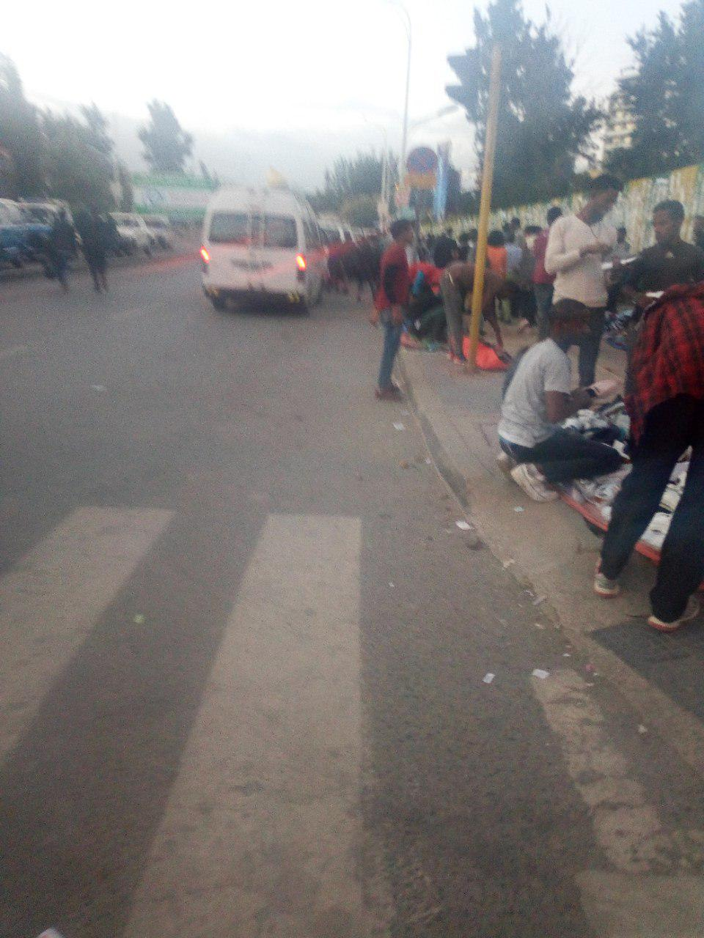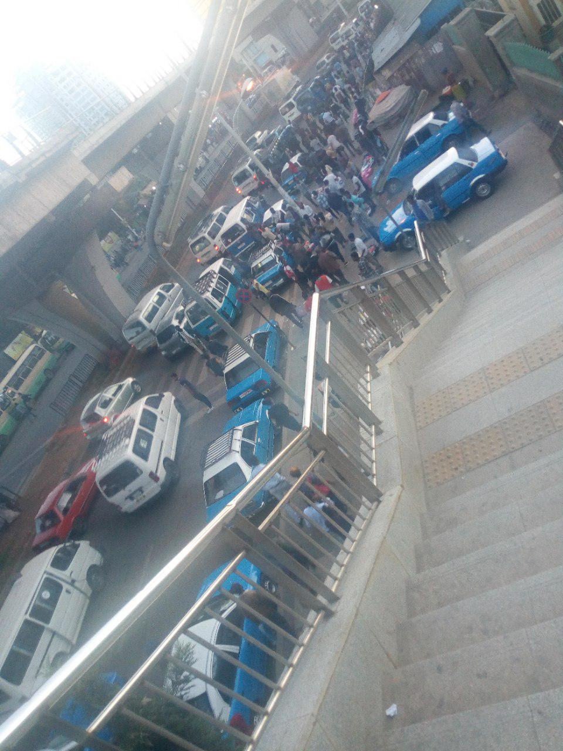
Figure 31: air quality at Mexico at peak hour (evening at 6:30pm).
This picture indicates traffic congestion, pedestrian flow and street vendors at Mexico LRT and taxi station stations. elevated LRT stations has good air quality and when traffic flow became congested movement Air visual pro increased both particulate matter and air quality index.

5.4 Stations Characteristics and Shelter orientation
Stations location related to intersection were placed in 3 ways near side, far side and mid-block. Researcher observed that near side stops are crowded and passenger’s exposure increased for pollution than far and mid-block stops. Concerning this all bus shelter faced toward roads.

Table 12: Station location related to intersection and shelter orientation
Variables |  | Station location related to intersection |  |  | Shelter orientation
Type of station | Station name | Near side block | Far side block | Mid-block | Facing toward road | Away from the road
Kality | Bus | - | Yes | - | Yes | -
Kality | Taxi | - | Yes | - | - | -
Kality | Bus and taxi | Yes | - | - | Yes | -
Kality | Train | Yes | - | - | Median | -
Saris | Bus | - | - | Yes | Yes | -
Saris | Taxi | - | - | Yes | - | -
Saris | Bus and taxi | - | Yes | - | - | -
Saris | Train | - | - | Yes | Median | -
Stadium | Bus | Yes | - | - | Yes | -
Stadium | Taxi | - | - | Yes | - | -
Stadium | Bus and taxi | - | Yes | - | Yes | -
Stadium | Train | - | - | Yes | Median | -
Mexico | Bus | - | Yes | - | Yes | -
Mexico | Taxi | Yes | - | - | - | -
Mexico | Bus and taxi | - | Yes | - | Yes | -
Mexico | Train | - | - | Yes | Median | -
Autobus Tera | Bus | - | Yes | - | Yes | -
Autobus Tera | Taxi | - | Yes | - | - | -
Autobus Tera | Bus and taxi | - | Yes | - | - | -
Autobus Tera | Train | Yes | - | - | Median | -
Minilik II square | Bus | Yes | - | - | Yes | -
Minilik II square | Taxi | Yes | - | - | - | -
Minilik II square | Bus and taxi | - | Yes |  | Yes | -
Minilik II square | Train | Yes | - | - | Under ground | -
It is expected that mid-block station location has less impact of exposure from vehicles emission than near or far side station location related to intersection. Six of them are mid-block, ten far side and eight near side station location related to intersection.

5.4.1 Sampled Stations characteristics
Table 13: Sampled public transportation stations characteristics
Name of the station | Type of the station | Station location across running way | Shelter  Availability | Foot traffic  Volume in  p/min/feet | Average Vehicular traffic  in speed  Km/hr | Number of lanes  in the road | Land use  around the station | Maximum Building height  nearby station | Availability of street tree | Road quality
Kality | Bus | By the road curve | Yes | 8-10 | 25.1-33.5 | 6 | Industrial | G+4 | No | Fair
Kality | LRT | On median of road | Yes | 8-10 | 25.1-33.5 | 8 | Industrial | G+6 | No | Good
Kality | Taxi | Separate | No | 8-10 | 33.6-43 | 8 | Industrial | G+4 | No | Fair
Kality | Mixed | By the road curve | Yes | 8-10 | 25.1-33.5 | 6 | Industrial | G+4 | No | Good
Saris | Bus | By the road curve | Yes | 11-15 | 33.6-43 | 6 | commercial | G+4 | No | Very good
Saris | LRT | On Median of road | Yes | 11-15 | 25.1-33.5 | 6 | Commercial | G+6 | No | Very good
Saris | Taxi | By the road curve | No | 11-15 | 25.1-33.5 | 6 | Commercial | G+5 | 1 within 10 meter | excellent
Saris | Mixed | By the road curve | No | 11-15 | 25.1-33.5 | 6 | commercial | G+2 | No | Very good
Stadium | Bus | Separate | No | 8-10 | 25.1-33.5 | 6 | Mixed | G+22 | No | Good
Stadium | LRT | On median of road | Yes | 11-15 | 25.1-33.5 | 8 | Commercial | G+10 | No | Very good
Stadium | Taxi | Separate | No | 11-15 | 25.1-33.5 | 8 | Commercial | G+12 | No | Very good
Stadium | Mixed | By the road curve | Yes | 8-10 | 25.1-33.5 | 6 | Mixed | G+8 | No | Very good
Mexico | Bus | By the road curve | Yes | 11-15 | 0-25 | 6 | Mixed | G+10 | 1 within 10 meter | excellent
Mexico | LRT | On median of road | Yes | 11-15 | 0-25 | 6 | Commercial | G+10 | No | Very good
Mexico | Taxi | By the road curve | No | 11-15 | 25.1-33.5 | 6 | Commercial | G+6 | No | Good
Mexico | Mixed | By the road curve | Yes | 11-15 | 25.1-33.5 | 6 | Service | G+10 | No | Good
Autobus tera | Bus | By the road curve | Yes | 11-15 | 25.1-33.5 | 6 | Commercial | G+5 | No | Good
Autobus tera | LRT | On median of the road | Yes | 11-15 | 25.1-33.5 | 8 | Commercial | G+10 | No | Good
Autobus tera | Taxi | By the road curve | No | 11-15 | 25.1-33.5 | 6 | Commercial | G+0 | No | Good
Autobus tera | Mixed | By the road curve | Yes | 11-15 | 25.1-33.5 | 8 | Commercial | G+8 | No | Good
Minilik II square | Bus | Separate | No | 8-10 | 25.1-33.5 | 6 | Service | G+4 | No | Very good
Minilik II square | LRT | On median of the road | Wall & roof | 8-10 | 33.6-43 | 6 | Service | G+8 | No | Very good
Minilik II square | Taxi | By the road curve | No | 8-10 | 25.1-33.5 | 5 | Mixed | G+8 | No | Good
Minilik II square | Mixed | Separate | Yes | 8-10 | 25.1-33.5 | 6 | Service | G+2 | No | Good
Foot traffic and vehicular traffic were analyzed by level of service (LOS). Foot traffic (very light=<6p/min/30.48cm, light = 6-7p/min/30.48cm, medium = 8-10p/min/30.48cm, heavy = 11-15p/min/30.48cm, super heavy = >16p/min/30.48cm) while vehicular traffic were analyzed by based on speed representing A up to F level of service (super light = >67km/hr, very light = 54.5-67km/hr, light = 43.1-54.4km/hr, medium = 33.6-43km/hr, heavy = 25.1-33.5km/hr and super heavy = 0-25km/hr). Road quality categorized in Likert scale (excellent = full of infrastructure, good pavement, walkway and street tree; very good = lack of street tree; good = lack of street facility and street trees; fair = cracked asphalt and bad = dust and cracked asphalt).
From the result of the above table, most bus and taxi stations located by the road curve near road intersections. Out of 24 sampled public transportation stations 22 stations do not have street trees at least one within 10 meters to filter particulate matter and carbon dioxide from vehicles emission on the roadways. 11 out of 24 stations have good road quality (do not have cleanness and street greenery), and 9 of them have very good quality, 2 of them excellent condition with street trees well paved surface design facilities and the remaining two(2) stations have fair condition of road quality(cracked asphalt, dust and improper design for waiting passengers. Most stations have heavy foot and vehicular traffic.

Health versus Air quality and Station characteristics
The relationship between health and air quality observed that when vehicles pollution became unhealthy (above 100AQI) at stations air quality related health problems also increased. Health and air quality has strong and positive correlation at station. In addition to this, land-use, shelter type and availability affect air quality. It has poor air quality and exposure for air pollution related diseases at industrial and commercial land-use. Shelter type is also affected air quality, wall and roof bus shelter at the road curve has poor air quality than unsheltered bus stops.
Table 14: Relationship between average air quality, health and stations design.
Station name | Type of station | Incidences of air quality related Health | Air quality in 30 minutes |  |  | Station characteristics
Station name | Type of station | Incidences of air quality related Health | average  PM2.5 | average  CO2 | average  AQI | land use  nearby station | Shelter availability and type | Vehicular  Traffic in speed km/hr
Kality  (88) | LRT | 19 | 28.15 | 415.22 | 84.95 | Industrial | Roof | 33.6-43.0
Kality  (88) | bus | 24 | 64.3 | 478.38 | 135.19 | Industrial | Wall &roof | 25.1-33.5
Kality  (88) | Taxi | 22 | 48.88 | 424.42 | 121.79 | Industrial | No | 33.6-43.0
Kality  (88) | Bus/taxi | 23 | 48.87 | 475.43 | 118.18 | Industrial | Wall & roof | 25.1-33.5
Saris  (40) | LRT | 8 | 28.51 | 419.96 | 83.12 | Commercial | Roof | 33.6-43.0
Saris  (40) | bus | 13 | 84.88 | 557.67 | 160.49 | Commercial | Wall &roof | 25.1-33.5
Saris  (40) | Taxi | 9 | 45.73 | 484.4 | 110.4 | Commercial | No | 25.1-33.5
Saris  (40) | Bus/taxi | 10 | 51.64 | 502.09 | 111.16 | Commercial | No | 25.1-33.5
Stadium  (51) | LRT | 11 | 13.89 | 405.26 | 50.79 | Mixed | Roof | 25.1-33.5
Stadium  (51) | bus | 14 | 59.84 | 675.62 | 119.77 | Mixed | No | 25.1-33.5
Stadium  (51) | Taxi | 13 | 44.06 | 439.02 | 106.94 | Mixed | No | 25.1-33.5
Stadium  (51) | Bus/taxi | 13 | 51.47 | 584.78 | 125.46 | Mixed | Wall & roof | 25.1-33.5
Mexico  (46) | LRT | 10 | 8.72 | 428.88 | 36.11 | Service | Roof | 25.1-33.5
Mexico  (46) | bus | 13 | 75.11 | 1009.54 | 151.12 | Service | Wall & roof | 25.1-33.5
Mexico  (46) | Taxi | 11 | 39.03 | 510.37 | 100.07 | Commercial | No | 25.1-33.5
Mexico  (46) | Bus/taxi | 12 | 55.17 | 835.68 | 134.09 | Commercial | Wall & roof | 25.1-33.5
Autobus tera(41) | LRT | 7 | 23.33 | 410.48 | 74.65 | Commercial | Roof | 25.1-33.5
Autobus tera(41) | bus | 11 | 64.43 | 581.11 | 137.06 | Commercial | Wall &roof | 25.1-33.5
Autobus tera(41) | Taxi | 10 | 51.19 | 460.46 | 122.89 | Commercial | No | 25.1-33.5
Autobus tera(41) | Bus/taxi | 13 | 77.91 | 576.33 | 148.01 | Commercial | Wall & roof | 25.1-33.5
Minilik II square (58) | LRT | 14 | 48.9 | 605.55 | 107.16 | Service | Wall & roof | 33.6-43.0
Minilik II square (58) | bus | 15 | 76.63 | 656.32 | 150.24 | Service | Wall & roof | 25.1-33.5
Minilik II square (58) | Taxi | 13 | 39.76 | 444.13 | 105.16 | Commercial | No | 25.1-33.5
Minilik II square (58) | Bus/taxi | 16 | 69.81 | 960.34 | 147.01 | Service | No | 25.1-33.5
Total |  | 324

LOS | A | B | C | D | E | F
Vehicular traffic | Super  light | Very  Light | Light | Medium | Heavy | Super  heavy
Speed(km/hr) | >67 | 54.5-67 | 43.1-54.4 | 33.6-43 | 25.1-33.5 | 0-25
Foot traffic (p/min/feet) | <6 | 6-7 | 8-10 | 11-15 | >16 | -
Foot and vehicular traffic were analyzed by level-of-service (A up to F).
Average vehicular traffic volume both off peak and peak hour are medium (33.6-43km/hr) and heavy (25.1-33.5km/hr), but most stations, 20 out of 24 sampled stations have very heavy (0-25km/hr) vehicular traffic movement. The result indicated, average foot traffic is also very heavy (>16p/min/30.48cm) at peak hour and medium (8-10p/min/30.48cm) during off peak hour based on level of service.
Land use has an impacts on air quality, researcher observed that industrial and commercial land use contributed to degrade air quality at public transportation stations. The measured air quality indicated that industrial, commercial and service has greatest particulate matter and air quality index.
Based on the outcome of measurement of air quality and health questionnaires, the relationship between air quality related health problems and air quality (PM2.5, PM10, AQI, CO₂) are strong directly relationship. The result indicated that when AQI increases then the exposure for air quality related diseases increases. From 720 the total respondents, 324 (45%) are exposed to air quality related diseases.
Station design and characteristics has an impact air quality as indicated the table above. Near and far side stations location related to roadway intersection and shelter type and availability observed that increase the air pollution than mid-block stations. All bus shelters in the study area located on the sidewalk and by the road curve. This increased passengers’ exposure to air quality related diseases. Nine out of 24 sampled stations/stops have not shelters. It is observed that Air-Visual indicated that bus stop with shelters has bad air quality than unsheltered bus stop.
Table 15: Name of the station and reason to visit clinic/hospital.
Name of station | Reason to visit clinic/hospital |  | Total | Percent of  Exposure by name of station
Name of station | non air quality related disease | air quality related disease | Total | Percent of  Exposure by name of station
Kality | 36 | 84 | 120 | 70.00%
Saris | 80 | 40 | 120 | 33.33%
Stadium | 69 | 51 | 120 | 42.50%
Mexico | 74 | 46 | 120 | 38.33%
Autobus Tera | 75 | 45 | 120 | 37.50%
Minilik II square | 62 | 58 | 120 | 48.33%
Total | 396 | 324 | 720 | 45.00%
Exposure of transportation air pollution versus name of station indicated that commercial, industrial and mixed land-use more exposed for vehicles pollution. From the table Kality, Minilik II square and Stadium stations exposed more respondents to visit clinics/hospitals by air quality related diseases respectively.
Table 16: Station type under the study and air quality related diseases.
Stations/stops type  under the study | Reason to visit clinic/hospital |  | Total | Percent of  Exposure by air pollution
Stations/stops type  under the study | non air quality related disease | air quality related disease | Total | Percent of  Exposure by air pollution
Train station- Elevated | 59 | 31 | 90 | 34.44%
Train station- On grade | 34 | 26 | 60 | 43.33%
Train station- Underground | 18 | 12 | 30 | 40.00%
Bus station | 91 | 89 | 180 | 49.44%
Taxi station | 98 | 82 | 180 | 45.56%
Both bus/taxi station | 96 | 84 | 180 | 46.67%
Total | 396 | 324 | 720 | 45.00%
Based on the table train station suited on elevated then exposure of vehicles pollutants decrease and train station suited on the middle of the road (on ground) increase exposure for pollution. Bus, taxi and bus/taxi stations have poor air quality than train station. Exposure for air quality related diseases increased at bus and bus/taxi stations 49.44% and 46.67% respectively.

Table 17: Station type under the study and number of air quality related diseases.
Stations/stops type under the study | Number of air quality related disease |  |  |  |  |  |  | Total
Stations/stops type under the study | 1 | 2 | 3 | 4 | 5 | 6 | 7 | Total
Train station- Elevated | 0 | 4 | 28 | 29 | 18 | 8 | 2 | 90
Train station- On grade | 0 | 6 | 13 | 18 | 13 | 8 | 2 | 60
Train station- Underground | 0 | 0 | 9 | 7 | 9 | 5 | 1 | 30
Bus station | 1 | 10 | 30 | 49 | 43 | 32 | 15 | 180
Taxi station | 1 | 5 | 25 | 55 | 56 | 25 | 13 | 180
Both bus/taxi station | 0 | 3 | 35 | 55 | 43 | 33 | 11 | 180
Total | 2 | 28 | 140 | 213 | 182 | 111 | 44 | 720

Train station underground has more CO₂, but less particulate matter and less exposure for air quality related disease whereas, on-ground train station has more pollution exposure for air quality related diseases due to the station suited on the median of the road and both side of vehicles road emit pollution toward the LRT station. The elevated LRT station has least amount of pollution and exposure for respiratory ailment.

Figure 32: greatest number of air quality related diseases by station type under study.
Respondents were exposed one up to seven type of air quality related diseases. Out of 720 respondents, 44 were the maximum number air pollution exposures. They were exposed by seven type of air quality related diseases. From the graph, researcher concluded that bus stations has more exposure for air pollution than taxi and Light Rail Transit (LRT) stations.

5.6 Human exposure and health effect of transport-related air pollution
Table 18: Age of respondents and clinics visit for health issues in the past time.
Age of respondents | hospital/clinic visited for health issues in the past time |  |  |  | Totals
Age of respondents | 1 time | 2 times | 3 times | 4 and more times | Totals
<15 | 16 | 8 | 1 | 0 | 25
15-25 | 125 | 90 | 28 | 7 | 250
26-35 | 83 | 103 | 60 | 35 | 281
36-45 | 14 | 40 | 37 | 34 | 125
46-55 | 3 | 6 | 4 | 10 | 23
56-65 | 2 | 1 | 1 | 5 | 9
>65 | 1 | 0 | 1 | 5 | 7
Total | 244 | 248 | 132 | 96 | 720
Clinics/hospital visit increases by respiratory disease when age increases adults and elderly than youngsters.

Figure 33: Hospitals/clinic visited for health issues in the past time.
From the graph, elderly people are visited clinics/hospitals four and more times out of the seven total respondents above age 65 (71.43%) of them were visited clinics by air quality related diseases. This indicates that when age increases the exposure for transport related air pollution also increases.

Table 19: Age of respondent’s and reason to visit clinic/hospital.
Age of respondents | Reason to visit clinic/hospital |  | Total | Percent of air quality related disease
Age of respondents | non air quality related disease | air quality related disease | Total | Percent of air quality related disease
<15 | 22 | 3 | 25 | 12%
15-25 | 177 | 73 | 250 | 29.2%
26-35 | 141 | 140 | 281 | 49.8%
36-45 | 44 | 81 | 125 | 64.8%
46-55 | 6 | 17 | 23 | 73.9%
56-65 | 3 | 6 | 9 | 66.67%
>65 | 2 | 5 | 7 | 71.43%
Total | 396 | 324 | 720 | 45.00%
The table shows that when the age increase, then their exposure for air quality related diseases also increase. 45% of respondents exposed for air quality related disease and visited clinic/hospital. 55% of respondents visited clinics for non-air quality related disease.
Table 20: Number of air quality related disease by type of employment
Type of employment | Number of air quality related disease |  |  |  |  |  |  | Total
Type of employment | 1 | 2 | 3 | 4 | 5 | 6 | 7 | Total
in office | 2 | 3 | 22 | 20 | 18 | 8 | 2 | 75
unemployed | 0 | 5 | 5 | 8 | 3 | 3 | 1 | 25
street vender | 0 | 11 | 35 | 66 | 67 | 39 | 19 | 237
traffic police | 0 | 0 | 1 | 4 | 7 | 5 | 1 | 18
coordinator of transportation | 0 | 5 | 21 | 34 | 22 | 18 | 6 | 106
drivers | 0 | 2 | 6 | 6 | 7 | 7 | 0 | 28
police | 0 | 0 | 17 | 19 | 7 | 10 | 1 | 54
shoeshines | 0 | 1 | 24 | 30 | 21 | 2 | 3 | 81
street sweepers | 0 | 1 | 8 | 19 | 19 | 12 | 9 | 68
homeless | 0 | 0 | 1 | 7 | 11 | 7 | 2 | 28
Total | 2 | 28 | 140 | 213 | 182 | 111 | 44 | 720

From the total type of employment that experience the greatest air quality related diseases 213 (29.58%) were 4 times visited clinic/hospital. Street vendors are major exposure 237 (32.92%) by air quality related diseases and visited clinics more than two times.
Among the respondents, street vendors were exposed to air pollution more than other type of employment takes placed near major road. The next exposure to transportation air pollution are Shoeshines and coordinator of transportation. Most of the respondents’ work their job near major roads are exposed to respiratory diseases (asthma, bronchitis, emphysema, pneumonia, irritation od eye, dry throat, increased fatigue, headache, shortness of breath, difficulty of breathing, wheezing, nausea, irregular heart-beat, nonfatal heart attacks, coughing).
From the table: street vendors, coordinator of transportation, and shoeshines are more exposed to air quality related diseases respectively.

Figure 34: Top ten air quality related diseases from the respondents
Out of 720 respondents 218 (30.28%) coughing, 129 (17.92%) difficulty of breathing, and 126(17.5%) of asthma are exposed by transportation air pollution.
Out of 720, 339(47.08%) exposed to coughing, asthma, difficulty of breathing and emphysema.118 (16.39%) exposed to dry throat, 85(11.8%) bronchitis, 53(7.36%) difficulty of breathing. We can understand how air quality related diseases affect human living and working in and around major roads.
Except LRT stations, all bus, taxi and bus/taxi stations had AQI greater than 100 and PM2.5 above 35ug/m3. 450 CO2 in ppm. This indicates that it violets international emission level standards. The environmental characteristics, land use, road network and quality, street greenery, vehicles type and age, station quality, and traffic congestion affect air quality in and around the stations/stops. All these factors degrading air quality and threating health. Most respiratory diseases were come from road vehicles emission at public transportations. From the respondents (>45%) that experience two or more times in air quality related diseases living near major roads. Insufficient foot path, lack of street greenery, gravel and dust station/stop, unpaved surface stations, heavy duty vehicles, private cars as well as land-use homebased emission in aggregate increase particulate matter and gaseous pollutants emission, as a result, exposure for air quality related health problems.
Healthy people can experience health impacts from polluted air including respiratory diseases, irritation of eyes or breathing difficulties during exercise or outdoor activities near roadway. The actual risk of adverse effects depends on current situation of health status, the pollutant type and concentration, and the length of exposure to the vehicles pollution. This study indicates that short and long term exposure to polluted air had permanent health effects. The measured air quality at public transportation stations shows that high air pollution level and immediate health effect. We can understand from the graph, long term exposure to polluted air: accelerate aging of lung function, asthma, bronchitis, emphysema, cancer and decrease life span.
This result is parallel with a study Tefera et al. (2016) In Ethiopia, the national estimates of the burden of diseases such as acute lower respiratory infection and chronic obstructive pulmonary diseases is high. According to the report of the MoH, 1,262,908 (5%) cases of acute upper respiratory infections and a 5% of pneumonia cases (this accounts for 7% of hospital admissions) that might be linked to air pollution occurred in 2010/11. Moreover, 2% of hospital admissions in the same year were due to tuberculosis. Put roughly, air pollution is thought to have been the cause of these hospital admissions.

5.7 Air Quality versus Health
Table 21: Air quality index (US) and number of air quality related diseases
Air quality index United states value | Number of air quality related disease |  |  |  |  |  |  | Total
Air quality index United states value | 1 | 2 | 3 | 4 | 5 | 6 | 7 | Total
0-50(green) | 0 | 1 | 13 | 9 | 6 | 1 | 0 | 30
51-100(yellow) | 0 | 9 | 28 | 38 | 25 | 15 | 5 | 120
101-150(orange) | 1 | 8 | 59 | 90 | 91 | 56 | 25 | 330
151-200(red) | 1 | 10 | 40 | 76 | 60 | 39 | 14 | 240
Total | 2 | 28 | 140 | 213 | 182 | 111 | 44 | 720
Transport related air quality diseases increase when the AQI increases. The color cod indicates the exposure level for respiratory diseases. Green (0-50) exposed 30 persons this came from other factors land use or other causes because none of is exposed by green color it is good air quality. The red color code increase exposure too much for air quality related diseases, it is unhealthy.

Figure 35: Incidence of air quality related diseases versus air quality
When air quality index being below 100 (green and yellow color code) then the exposure for air quality related diseases is very low. However, Air quality index being above 101(orange and red color code) then the exposure for air quality related diseases increase too much.

Table 22: Air quality index versus reason to visit clinics/hospitals
Air quality index (AQI) US | Reason to visit clinic/hospitals |  | Total | Percent of air quality related diseases | Percent of non-air quality related  diseases
Air quality index (AQI) US | non air quality related disease | air quality related disease | Total | Percent of air quality related diseases | Percent of non-air quality related  diseases
0-50(green) | 20 | 10 | 30 | 33.33% | 66.67%
51-100(yellow) | 69 | 51 | 120 | 42.50% | 57.50%
101-150(orange) | 176 | 154 | 330 | 46.67% | 53.33%
151-200(red) | 131 | 109 | 240 | 45.42% | 54.58%
Total | 396 | 324 | 720 | 45.00% | 55.00%

The air quality related diseases increased due to air quality index increment from the table. This indicated that most of the residents in and around public transportation station in Addis Ababa have been exposing air quality related diseases when air quality index become above 100.
Transport air pollution has more health effect when the emission level increase above PM2.5 value 65μg/m³ and 100 air quality index (AQI). 101 typically corresponds to the level that violates the national health standard. Based on measured air quality data and US-EPA standards exposure for health summarized as PM_{2.5} standards in 1997 by US-EPA NAAQS legislated 65ug/m³ daily and 15μg/m³ annually. After 9 years later, in 2006 legislated 35μg/m³ daily and 15μg/m³ annually. In the other case world health organization (WHO, 2007) guidelines enacted 25μg/m³ daily and 10μg/m³ annually. The result indicated that the emission level at public transportation stations greater than both WHO and US.EPA standards for vehicles emission.

Table 23: The relationship between health and air quality
Correlation | Age | Duration in year | Air quality related disease | No of visit hospital | Reason to visit hospital | PM2.5 | PM10 | AQI value | CO₂
Age | 1
duration in year | 0.436414 | 1
air quality related disease | 0.344163 | 0.370767 | 1
No of visit hospital | 0.727352 | 0.610587 | 0.698788 | 1
reason to visit hospital | 0.384842 | 0.459118 | 0.676965 | 0.502935 | 1
PM2.5 value | 0.043424 | -0.03658 | 0.646124 | 0.6856558 | 0.71456757 | 1
PM10 value | 0.031645 | -0.04192 | 0.596248 | 0.5249862 | 0.48149739 | 0.680907 | 1
AQI value | 0.032067 | -0.01552 | 0.677722 | 0.6948752 | 0.71343716 | 0.876389 | 0.611333 | 1
CO2(ppm) | 0.00389 | -0.10532 | 0.322518 | 0.4708134 | 0.49361493 | 0.483509 | 0.441573 | 0.574355 | 1
Correlation value is between (-1 and 1), when the relationship close to positive one then the relationship is strong and direct. When the relationships close to negative one, then it has strong and inversely relationships. However, when the relationship close to zero, then it has weak or relationship between them. The correlation between PM_{2.5}, PM₁₀, AQI, and air quality related diseases have direct and strong relationships. Visit clinic/hospitals for health issues and reason to visit clinics/hospitals have also strong and direct relationship. Whereas, long live in and around the stations has not relationship with air quality related diseases from the result in the table.

5.7.1 Simple regression analysis of air quality related diseases and air quality

Figure 36: Number of incidence of air quality related health problems and AQI
The correlation between incidences of air quality related health problems and air quality index (AQI) out of 24 stations shows that positive relationships each other’s. 10.45% causes related with average transport air pollution. The intercept is 8.209 that affected health beyond air quality. The incidence for air quality related health problems depends on location, industrial and commercial land-use.

Figure 37: Incidence of air quality related health problem and AQI at Kality and Saris station
The relationship between incidences of air quality related health problems and air quality index (AQI) at Kality and Saris station had strong positive relationship. Each station has LRT, taxi, bus/taxi and bus station indicated in the graph from the smallest to the largest respectively. Air quality related health incidence at Saris (R square = 95.47% or adjusted R² = 93.19%) larger than Kality (R square = 93.92% or adjusted R² = 90.88%). 93.19% and 90.88% respiratory diseases caused by related with transport air pollution at Saris and Kality stations. LRT stations has lowest AQI from all bus, taxi, and bus/taxi stations.

Figure 38: Incidence of air quality related health problem and AQI at Stadium and Mexico
The relationship between incidence of air quality related health problems and air quality index (AQI) has strong positive relationship at Stadium and Mexico station. Each station has LRT, taxi, bus/taxi and bus station indicated in the graph from the smallest to the largest respectively. Air quality related health incidence at Mexico (R² = 90.4%) larger than Stadium (R² = 83.7%). Or adjusted R² = 85.66% and 75.64% respiratory diseases caused by related with transport air pollution at Mexico and Stadium station respectively. This indicates that LRT has the least incidence for health problem but bus has highest incidence for air quality related health problems.

Figure 39: Incidence of air quality related health problem and AQI at Autobus Tera and Minilik II square station.
LRT stations had low exposure for quality related health problems at Autobus Ter. Bus, bus/taxi are the greatest contribute to incidence of air quality related health problems. LRT station at Minilik II square is the only underground station and has poor air quality (particulate matter and CO₂) at peak hour. The relationship between air quality and incidence of air quality related diseases has strong and direct relationship. As indicated in the graph when air quality index increases then incidence of air quality related health problem is also increased. 94.89% of adjusted R square (96.6% R²) indicates that respiratory diseases caused by transport air pollution at Autobus Tera station. The relationship between health incidence and transport related air pollution is 81.24% of R² or adjusted R² = 71.86% at Minilik II square.

5.8 Results of Qualitative Data

5.8.1 Observation of air quality at sampled public transportation station
It was observed that at sampled station if there is dust at station then, PM and AQI highly increase, CO₂ is high when the vehicles emit smoke and evaporate dust on the road. When the station is underground then CO₂ value increase than PM and AQI because there are no vehicles and wind under ground station. When the station situated elevated, AQI and PM_{2.5} value is very low and the CO₂ value increase especially when people walk in crowded condition. If there is high wind, the value of AQI, CO₂ and PM_{2.5} decrease. CO₂ value inside the train and bus increase than outside but AQI and PM_{2.5} is very low.
Detection of Air-Visual sensor decreases if there is high wind and direction of wind towards to air quality tracking device, it is green value of AQI even if, there is congestion and high emission of CO₂ and particulate matter. Sometimes there is limitation cannot be determined by peak and off peak hours. Researcher observed that old vehicles emit high CO₂ and particulate matter. Air quality tracking device indicated that when old vesicles and long vehicles pass on the roadway, air quality being worst. AQI above 150 and CO₂ greater than 800ppm. There was irritation of eye and nose, dry throat and coughing during measurement.
The measurement of air quality depended on wind speed and wind direction. High wind, low value of AQI and PM. when AQI increase above 150 then there is more increase in PM_{2.5} but when AQI being below 50 then PM_{2.5} reduce more than double. Both wind speed and direction were shown to affect particulate matter concentrations differently, depending on shelter orientation.
If there are very high smoke from long vehicles, the value of AQI go up to 1400 and PM_{2.5} being 835μg/m³. When the vehicles motor became hot and release smoke continuously the value of CO2 increase than AQI and PM_{2.5}. Especially when exist dust and no wind hence, there are high accumulation of CO₂ than particulate matter and AQI in underground station, in Piassa LRT underground station indicates that there are high CO₂ in relation to the other on ground and elevated stations.
The location and the design of bus stops do not take into account air quality or exposure considerations. Shelters with an opening oriented toward the roadway were consistently observed to have higher concentrations inside the shelter than outside the shelter. In contrast, shelters oriented away from the roadway were observed to have lower concentrations inside the shelter than outside the shelter. From the survey of Air-Visual pro indicated that, some of the bus stop shelters are more polluted than unsheltered bus stops due to shelter orientation is towards the roadway. The particulate Matter and CO₂ radiate inside the wall and roof bus shelter. The wind effect is very low inside the bus shelter, the glass wall and roof shelter protects only sun and wind but riders more expose to pollutants than unsheltered bus stops. Thus, sheltered bus stops have not more pollutants than unsheltered bus stops due to Air-Visual pro. Therefore, the bus shelters situated by the road curve affected by transport air pollution results passengers’ exposure increase to pollutants from the road vehicles while waiting at bus shelter (shed).

5.8.2 Interview results
According to deputy manager of Addis Ababa road and transport bureau, the main factor that increase air pollution in Addis Ababa regarding transportation are traffic congestion (the primary one), hotel waste management, garage oil, industry emission and construction dust, toilet, drainages and sewerage line deteriorate air quality. There is no integration of infrastructure, policy due to these there is very low awareness and responsibility.
In addition to vehicles emissions, a deputy manager of Addis Ababa road and transport bureau added disposal of solid and liquid waste around the station during night time affect passerby and residents around the station. To manage those problems there is gap between transport policy and infrastructure provision, no research regarding the implication of buying cars and health impacts due to poor policy implementation. There is not institutionalized between transportation air pollution and health. Weak integration of transport planners, environmental protection authority and transport decision makers. Transforming the current system to achieve transportation policy that helps to improve public health and safety and will require a convergence of many discipline or different sector department like public health, planning, engineering, environmental studies etc.

5.8.2.1 Factors affect more the composition of motor vehicle exhaust emissions
According to deputy manager of transport in Addis Ababa road and transport bureau explained that fuel type and quality, maintenance of vehicle, age of vehicle, type and operating condition of engine, traffic congestion. He added as a solution to minimize the impact of transport related air pollution, the car importer and petroleum importer and distributer focus on fuel efficient vehicles rather than diesel engine and minimize to import second hand vehicles. Another participant added to minimize air pollution at public transportation station, it must be done on passengers’ awareness, comfort and separate lane for high capacity buses. This minimize number of vehicles that has small capacity on the road and traffic congestion.
He explained about the number of diesel and gasoline engine vehicles. They don’t know the right number of diesel and gasoline engine but diesel engine vehicles take the higher percentage than gasoline engine. Diesel engine vehicles emit bad particulate matter and black smoke on the roadway and affect human health. Regarding this, Addis Ababa environmental protection authority doesn’t have standard limit for vehicles emission to protect human exposure.
Number of vehicles are increasing at alarming rate in Addis Ababa. Environmental pollution research and study team leader explained that EPA of Addis Ababa city government doesn’t have vehicles emission standards and controlling mechanisms. Diesel engine mainly emit hazardous particulate matter (PM) and black smoke (CO₂ emission highly increase). Particulate matter (PM_{2.5}) can be formed chemical reaction in the atmosphere that cause others pollutants such as SO₂, NO_{X} and volatile organic compound. Gasoline engine emit gaseous pollutants like SO₂, NO_{X}, CO. From the finding of the study, it is unhealthy air condition at public transportation stations. No one can be responsible for emission limit standards and increasing of vehicles pollution through time. Even, Addis Ababa city administration environmental protection authority doesn’t have the data and emission limit standards on vehicles and industry emission.

5.9 Discussion
Vehicles pollution exposure is the major transport-related health impacts. Motor vehicles produce various pollutants which can cause health problems and environmental damage.
Most imported vehicles are above 30 years old. From the result there are 29.3% of vehicles above 30 years served (AARTB). This heavily increased air pollution on the roadway. Therefore, Government should lower the age of the importing vehicles from eight to three years old from the date of manufacture. Old vehicles release toxic in to the atmosphere with sever health effects to those exposed to the pollutants in Addis Ababa especially who lives in Autobus Tera, Kality and Minilik II square cannot inhale clean air around the stations. Vehicular emission cause a rapid deterioration of ambient air quality and the environment with consequent danger to human health.
It is important to expect an increasing pattern of traffic air pollution due to the growing traffic density, vehicles growth rate and the deteriorating quality of urban road infrastructure. The growth observed in the number of vehicles and second hand aged vehicles example, an increase at a rate of 7.7% or about 5000 vehicles a year in Addis Ababa (Tefera et al., 2016). Current total vehicles populations are 586, 737 in April 2019. Therefore, need to monitor near-road ambient air quality and evaluating transportation air pollution where a large number of diesel engine vehicles can be found and vehicles population are rapidly growing.
Commercial, industrial and administration land use attract more cars and people, on this land use (Air-Visual pro indicated that, there is unclean air quality). Hence, on this attention on integrated land use with nature local adaptive tree should be planted on the median and sidewalk of the roads to filter pollutants and air pollution monitoring system.
The main problems identified in passengers’ interview were low frequency of bus and taxi services and hence long waiting times at stations exposed to vehicles emission near road curve. Long waiting time and crowding results exposure for vehicles air pollution. These problems show an acute shortage of high occupancy vehicles. Inaccessible non-motorized transport road, short LRT line that does not address all parts in Addis Ababa. Single occupancy vehicles are too much on the roadways than public transportations. This increase air pollution level and negative health impact due to congestion and aged vehicles.
This study indicated that transport-related air pollution contributes to an increased risk of health, particularly from respiratory and cardiovascular causes. It increases the risk of respiratory symptoms and diseases that are not related to allergies. Long and short term exposure to air suspended toxicants on human including respiratory and cardiovascular diseases.
Respondents were exposed for Asthma, emphysema, difficulty of breathing, pneumonia skin diseases, and long-term chronic diseases such as cancer. Several reports have revealed the direct association between exposure to the poor transport air quality and increasing rate of morbidity and mortality mostly due to cardiovascular and respiratory diseases. Transport air pollution is considered as the major environmental risk factor in the incidence and progression of some diseases such as asthma, lung cancer, emphysema, pneumonia, sore throat and nausea (Adel et al., 2016). Regarding this, the results indicated that exposure for transportation air pollution those peoples living/working on and close proximity to the public transportation stations have been increasing. Out of 720 respondents working/living close proximity to the major roads 324 (45%) were exposed for respiratory and cardiovascular diseases.
Regarding this, transportation emission is one of the main contributors to greenhouse gas (GHG) emissions in Addis Ababa transportation contributes to around 47% of Addis Ababa total emissions (AALRTS, 2016). Improvements to public transport (LRT expansion) has the potential to significantly contribute to the city’s plans for reducing GHG emissions and particulate matter(PM), as well as providing socio-economic and environmental sustainability.
Recent researches have shown that in vehicles air pollution is often worse, putting those who drive longer hours at greater risk. In addition, persons who live or work near busy, congested roadways have been shown to have higher rates of respiratory ailments. The results show that major ailments are asthma, coughing, emphysema, pneumonia, bronchitis, shortness of breath, lung cancer, difficulty of breathing, nausea. That is why out of 720 participants 324 or 45% were visited clinic/hospital by respiratory diseases. However, ownership of cars in Addis Ababa is very low when we compared to other metropolitan area. The incidence of air pollution and congestion are heavy due to poor transport policy implementation problems of transport sector, low road coverage, unintegrated land use and transport system, weak infrastructural development and lack of institutionalizing transport, environment and infrastructures integration.
A study by Shankute (2015) on the effect of diesel fueled vehicles exhaust smoke emissions on air pollution in Addis Ababa, Ethiopia indicated that the overall rate for the 436 random sample diesel engine vehicles was 76%. This means that over 76% of the total sampled vehicles registered high smoke and particulate matters from vehicles. An extrapolation of this finding suggest that over three quarters of the diesel engines fleet in Addis Ababa produce exhaust smoke emissions well above internationally accepted standards (US.EPA, 1998).
Diesel vehicles smoke or particulate matter (PM) is responsible for the black smoke traditionally associated with diesel engine vehicles. Existing medial studies suggest that PM is one of the major harmful emissions produced by diesel engines (CARB, 2011). It is a pioneer of lung cancer, respiratory and cardiovascular problems, as well as the causes of a host of environment issues. The 2012 Vehicular Smog-less Air for Ethiopia (V-SAFE) baseline report found that 50% of the Addis Ababa gasoline engine vehicles fleet produced 90% of the HC and CO emissions (Benjaminsin & Shankute, 2012). Furthermore, the same report confirmed that the concentration of PM levels in the city ambient air was at least eleven times on average higher than comparable USA and WHO standards. The 2012 V-SAFE baseline report showed a similar findings for Addis Ababa.
There are so many factors that affect air quality at public transportation stations beyond vehicles air pollution because air pollution is not closed system at stations. Land-use, especially industry, homebased emission from cooking (charcoal and firewood). This were the external or controlled variable on air quality at public transportation station, it has its own contribution to deteriorate air quality at public transportation station. From the finding of the result industrial land-use has great contribution for deteriorating air quality than commercial, mixed and social service land-use. Hence, air quality at public transportation stations located on industrial land-use is the aggregate effect of transport air pollution and emission from factory.
Station design has an influence on air quality at taxi, bus and LRT waiting passengers. Most bus and LRT stations has shelters(sheds), these sheds especially on ground LRT stations and bus stop near busy road intersection has concentration of air pollution(CO₂, PM) than taxi and elevated LRT stations.
Similarly, an extensive report by the United Nations states that Ethiopia is the fastest urbanizing country in the world and the urbanization process is especially rapid in Addis Ababa (UN-Habitaat, 2010). Generally rapid urbanization and industrialization especially countries with limited financial and technological resources, leads to deterioration of ambient air quality and the environment and consequently endangers human health. These regions are among the air pollution emerging as a key threat to human health.
Currently, Addis Ababa does not have pollution control regulation to subject exhaust smoke and PM pollution vehicles. Furthermore, the city lacks appropriate regulatory framework for importing used and new vehicles. As a result, it is timely and necessary for Addis Ababa city officials and the federal government to look at this, and other studies, to design a comprehensive long term air quality management program to ensure that tolerable pollution levels are not exceeded.

CHAPTER SIX

CONCLUSION AND RECOMMENDATION

6.1 Conclusions
Generally, this study has tried to quantify and describe air quality at public transportation stations, its health impacts and relationship between air quality, and station design in Addis Ababa. Thus, LRT, bus, taxi stations/stops and the type of land use activities as well as the nature of stations design has an overall impact on air quality in and around public transportation stations.
- Transportation is a critical factor that affects economic growth, air pollution and people’s health. Addis Ababa are facing an increasing traffic congestion resulting from increased long travel time delays in densely traffic corridors, and long waiting at public transportation stations which resulted in increasing of air pollution and pollutants concentrations. Exposure to transport-related air pollution varies, as some groups may be more exposed, depending on how long they stay in polluted areas and what they do while there. For most pollutants, exposure concentrations appear to be two to three times as high near busy roads. Commercial activities and dusts are all major contributors to the air quality measured at public transportation stations. The results also revealed that roadside locations, commercial and industrial areas have high particulate matter above (65μg/m³) PM_{2.5} concentrations.
- The result has indicated mainly people who live, work or attend school near major roads appeared to have an increased incidence and harshness of health problems. A study on Ontario, Canada show that those who lived/worked close to public transportation within 300 meters area were affected by transport air pollution. Similar to this, all sampled population was living or working between (0-250) meters radius from study public transportation stations. Associated with transport-related air pollution such health problems include higher rates of asthma aggravation, bronchitis, pneumonia, emphysema, coughing, sore throat, difficulty of breathing, lung cancer and, cardiovascular disease. This lead to increased clinics/hospitals visit in the study area of public transportation stations. In this regard, 720 sampled persons were surveyed for air quality related health problems at public transportation stations. These samples focused on especially peoples living/working in and around the stations. 45% out of 720 respondents are exposed by transport related air pollution diseases. This indicates that the major victims are street vendors, street sweepers, traffic police, transport coordinators and shoeshines.
- Based on the finding, air quality at public transportation stations is unhealthy, above an average of 65μg/m³ PM_{2.5} and 150 AQI concentration at bus and taxi stations during peak hours. There are many old vehicles in Addis Ababa which contribute greatly to the high levels of pollutants than the maximum recommended level by the World Health Organization (WHO). The concentration of particulate matter (PM_{2.5}) at public transportation stations in Addis Ababa is greater than WHO limits (25μg/m³). This results caused for respiratory and cardiovascular diseases a person who lives/works in and around the transportation stations.
- LRT stations had an average below 25μg/m³ PM_{2.5} and 70 AQI concentration at peak hours. It was also observed that air quality is good at LRT stations than bus or taxi stations. Bus shelters with an opening oriented towards the roadway had consistently higher concentrations inside the bus shelter than unsheltered stops. Bus/taxi stops located on congested roads had more pollutants than the less congested ones. Regarding this, some passengers have been exposed for air quality related diseases when waiting for long time at public transportation stations at peak hours.
- In Ethiopia, more than half of (62%) vehicles found in Addis Ababa. Most vehicles are diesel engine vehicles and causes for harmful particulate matter (PM) emissions, which is hazardous for health. The other is gasoline engine vehicles cause for emission of gaseous pollutants like CO₂, and NO_{x} is affecting the human health. Regarding this, aged secondhand vehicles, motor type and unclean fuel type increased emission and exposure for health problems.
- Based on the results of measurement of air quality and health questionnaires, the relationship between air qualities related health problems and air quality (PM_{2.5}, PM₁₀, and AQI) have strong and direct relationship. The result indicated that when AQI increases then the exposure for air quality related diseases increases. Similarly, this study depicted that there is a strong relationship between air quality and station location/design. Thus, near and far side station location related to roadway intersection, and shelter type and availability observed that increase the vehicles air pollution than mid-block stations.
- Lastly, Addis Ababa is expanding due to high population growth and migration rates. Although rapid urbanization poses several serious challenges for planning, city development and living conditions, especially environmental problems linked to transport pollutants. This pollutants include particulate matter, greenhouse gas emission (CO₂) from gasoline and diesel engine vehicles. Now a days, in Addis Ababa air pollution problem has been increasing due to traffic congestion, rapid growth of transport demand and aged vehicles. These affect health of the city residents particularly, those peoples living and working close proximity to roadways and passengers at public transportation stations.

6.2 Recommendations
The finding of this research indicated that very poor air quality happened at public transportation stations especially bus and taxi stations. Also, residents/workers on and close proximity to major roadways were exposed to air quality related health problems. It is also observed that road quality and station design affect the air quality at public transportation stations. Therefore, to minimize the cause and effect of vehicles air pollution at public transportation stations, the following recommendations have been forwarded.
- For Urban Planning and City Administration
- Green infrastructure is essential for reducing air pollution related health problems and environmental pollution. The importance is twofold in quality of life and environmental beauty. Thus, provision of street greenery, green building (institution and commercial) has an eminent role for pollution reduction. Based on the findings of this study, breathing smog and particulate pollution can cause respiratory ailments, including sore throat, lung cancer, aggravation of asthma, and even premature death. Trees, gardens, and other green infrastructures on the median and road curve can reduce particulate pollution by absorbing and filtering particulate matters (PM), CO₂ and related gaseous pollutants from motor vehicles emission. Provision of air quality monitoring to offer municipality with enough data to assess the progress of their varied strategies to lower harmful emissions. Build air purifier (smog vacuum cleaner) that can produce fresh air every day at public transportation stations.
- In order to reduce transportation air pollution on major roads of Addis Ababa city, sustainable and integrated urban land-use planning is needed to balance interaction between transport and land-use. The point is not increasing the road network, rather, it is decreasing the road congestions. Work more on supply and demand approach. Hence, Travel demand management and intelligent transportation system or redistribute this demand in space or in time. This program encompasses several tools to help with traffic congestion mitigation by offering alternatives to the single occupant vehicle. Providing travelers, regardless whether they drive alone, with travel choices, such as work location, route choice, time of travel and type of mode. For instance, carpooling and non-motorized transportation like walking, bicycling.
- This research has shown that in Addis Ababa, bus/taxi riders frequently spend 25 to 45 minutes or more each way waiting for a bus/taxi which exposes them to pollution at stations. The air quality index shows that bus stop located near side the intersection has more pollution than far side from the intersection and mid-block. Therefore, moving bus stops away from busy intersections would substantially reduce the amount of pollution and exposure during peak hours. Most bus shelters in Addis Ababa located near busy road intersection on walkways and facing towards the road. This increase exposure level. So, location and orientation should be considered, it will reduce passengers exposure if located away from the roadway and separated from the road curve. Furthermore, to reduce vehicles pollutants using active transportation (walking and cycling) and high occupancy public transportation modes by reducing low occupancy vehicles.
II. For Transport policy and providers
- Based on the result (Air-Visual), diesel engine vehicles are major pollutants that emit more particulate matters than gasoline engine in Addis Ababa. When shopping for a new car, look for fuel efficient vehicles with low greenhouse gas emissions. These cars can help the environment with potentially saving money on fuel costs at the pump. In this regard, government should reduce cost on fuel efficient vehicles and add cost on non-fuel efficient vehicles to discourage buyers and enact regulation on aged vehicles. In fact, Addis Ababa city is under-developing and need additional vehicles due to rapid urban population growth.

- Demand management strategies can reduce traffic through economic incentives, regulatory measures and modern communication technologies: access restrictions, pricing strategies, special parking tariffs for low-emission vehicles, promotion of public transport services, offer incentives to use sustainable modes, priority treatment of high-occupancy vehicles, managing parking and parking pricing. Transport bureau and Addis Ababa environmental protection authority should work together regarding vehicles growth and their pollution impact. Rules and regulation must be enacted to aged vehicles.
- Light Rail transit in Addis Ababa are serving for heavy passengers especially morning and evening peak hours. Proponents of light rail transit argued that rail transit increases community well-being by creating jobs, by boosting economic development and lower transport cost than taxi or bus, and by reducing pollution and traffic congestion. Now a day the LRT is better option for transportation to reach on time without delay and pollution reduction mainly vehicles pollution. Hence, extend LRT to uncovered main roads of Addis Ababa to reduce congestion and transport-related air pollution.
III. For Further Research
- There is a research gap related to air quality at public transportation stations in Addis Ababa, regulation and standards on air pollution emission level, health impact and poor implementation in transport sector. Therefore, additional research is needed to expand the number of case studies and better understanding of the impact of traffic congestion or transport-related air pollution on human health. As well as to warrant a stronger recommendation on alternative transportations, bus shelter location planning and design guidelines.

References
Abdel-Salam, M. M. (2013). Indoor particulate matter in urban residences of Alexandria, Egypt. Journal of the Air & Waste Management Association, 63(8), 956-962.
Abdlemalik, M. (2017). Performance Assessment of Addis Ababa’s Light Rail Transit (LRT) Based on Sustainability Variables: Master thesis. Addis Ababa University.
Adam, M., Miguel, F., Christopher, M. M. (2012). An Empirical Study of Particulate Matter Exposure for Passengers Waiting at Bus Stop Shelters in Portland, Oregon, USA. Journal of Civil and Environmental Engineering Faculty Publications and Presentations, pp. 1-20.
Adam, M., Miguel, F., & Christopher, M. M. (2012). Air Quality at Bus Stops: Empirical Analysis of Exposure to Particulate Matter at Bus Stop Shelters. Journal of the Transportation Research Board, 2770(1), 76-86.
American Public Transit Association. (1993). Transit Fact Book, Washington, D.C.
Anumita, R., Priyanka, C., & Vivek, C. (2016). Urban Air Quality Management in Ethiopia: A Guidance Framework. Centre for Science and Environment.
Anyadike, R. C. (2009). Statistical Methods for the Social and Environmental Sciences, Spectrum Books, Ibadan, Nigeria.
Baez, A., Padilla, H., Garcıia, R., Carmen Torres, M., Rosas, I., & Belmont, R. (2003). Carbonyl levels in indoor and outdoor air in Mexico City and Xalapa, Mexico. Science of the Total Environment, 302(1-3), 211-226.
Ballester, F., Medina, S., Boldo, E., Goodman, P., Neuberger, M., Iniguez, C., & Kunzli, N. (2008). Reducing ambient levels of fine particulates could substantially improve health: a mortality impact assessment for 26 European cities. Journal of Epidemiology & Community Health, 62(2), 98-105.
Banister, D. (2008) “The Sustainable Mobility Paradigm”, Transport Policy, 15 (2), pp. 73-80
Benjaminson, R., & Shenkute, D. (2012). The effect of gasoline fueled vehicles exhaust emissions on air pollution in Addis Ababa, Ethiopia.
Berg, C. N., Deichmann, U., Liu, Y., & Selod, H. (2017).Transport Policies and Development. The Journal of Development Studies, 53(4), 465-480.
Brandt, E. B., Myers, J. M. B., Acciani, T. H., Ryan, P. H., Sivaprasad, U., Ruff, B., & Hershey, G. K. K. (2015). Exposure to allergen and diesel exhaust particles potentiates secondary allergen-specific memory responses, promoting asthma susceptibility. Journal of Allergy and Clinical Immunology, 136(2), 295-303.
Briggs, D. J., de Hoogh, K., Morris, C., & Gulliver, J. (2008). Effects of travel mode on exposures to particulate air pollution. Environment international, 34(1), 12-22.
Brimblecombe, P. (2012). The Big Smoke (Routledge Revivals): A History of Air Pollution in London since Medieval Times. Routledge.
Burgess, R., & Jenks, M. (2000). Compact cities: Sustainable urban forms for developing countries. Spon press, Routledge.
California Air Resource Board (CARB). (2011). Low Emission Vehicles III PM technical support document: Appendix California air resource board.
Central Statistical Authority. (2013). National census report. Addis Ababa, Ethiopia.
Chuang, K. J., Chan, C. C., Su, T. C., Lee, C. T., & Tang, C. S. (2007). The effect of urban air pollution on inflammation, oxidative stress, coagulation, and autonomic dysfunction in young adults. American journal of respiratory and critical care medicine, 176(4), 370-376.
Corpus Christi Metropolitan Planning Organization (CCMPO). (2009). http://www.corpuschristi-mpo.org/ Accessed, March, 2019.
Daniel, R. (2012). Pilot Global Fuel Economy Initiative study in Ethiopia: Vehicle Stock Statistics Final Draft Report. Addis Ababa Institute of Technology/Federal Transport Authority.
Didier, B. (2018). Air quality pollution sources and impacts, EU legislation and international Agreements. European Parliamentary Research Service.
Ewing, R., Pendall, R., and Chen, D. (2002). Measuring Sprawl and Its Impact. Online at
<http://www.smartgrowthamerica.org/sprawlindex/sprawlreport.html>
Fisher, G., Rolfe, K. A., Kjellstrom, T., Woodward, A., Hales, S., Sturman, A. P., & King, D. (2002). Health effects due to motor vehicle air pollution in New Zealand. Wellington: Ministry of Transport, New Zealand.
Ghorani-Azam, A., Riahi-Zanjani, B., & Balali-Mood, M. (2016). Effects of air pollution on human health and practical measures for prevention in Iran. Journal of research in medical ciences: the official journal of Isfahan University of Medical Sciences, 21(5).
Gebre, G., Feleke, Z., & Sahle-Demissie, E. (2010). Mass concentrations and elemental composition of urban atmospheric aerosols in Addis Ababa, Ethiopia. Bulletin of the Chemical Society of Ethiopia, 24(3).
Groum, A. (2006). Spanish firm, Ethio-Djibouti railway signs a 2.2 million Euro contract, www. capitalethiopia.com [accessed 10 March, 2019].
Hauptmann, M., Lubin, J. H., Stewart, P. A., Hayes, R. B., & Blair, A. (2004). Mortality from solid cancers among workers in formaldehyde industries. American Journal of Epidemiology, 159(12), 1117-1130.
Hazel, M., & Achacoso, S. (2013). Environmental Sustainability of Light Rail Transit
Henry, L., & Archer, S. J. (2001). Projected Ridership for New Light Rail Starts: Issues of Accuracy and Impact on Congestion. In Rail Transit Conference American Public Transportation Association (Vol. 8).
Herbert, D. T., & Thomas, C. J. (1997). Cities in space: City as Place. David Fulton, London.
Hickman, A. L., Baker, C. J., Cai, X., Delgado-Saborit, J. M., & Thornes, J. E. (2018). Evaluation of air quality at the Birmingham New Street Railway Station. Proceedings of the Institution of Mechanical Engineers, Part F: Journal of Rail and Rapid Transit, 232(6), 1864-1878.
Hitchins, J., Morawska, L., Wolff, R., & Gilbert, D. (2000). Concentrations of sub-micrometer particles from vehicle emissions near a major road. Atmospheric environment, 34(1), 51-59. (Doctoral dissertation, The University of North Carolina at Charlotte).
Johnson, T., Capel, J., & Ollison, W. (2014). Measurement of micro-environmental ozone concentrations in Durham, North Carolina, using a 2B Technologies 205 Federal Equivalent Method monitor and an interference-free 2B Technologies 211 monitor. Journal of the Air & Waste Management Association, 64(3), 360-371.
Joseph, L. S. (2018). "Mass transit". Encyclopædia Britannica. Mass transit, or public transportation, the movement of people within urban areas using group travel technologies.
Kante, A. (2011). Urban Air Pollution Caused by Automobiles in Addis Ababa, Ethiopia and its Health Consequences.
Kaur, S., Nieuwenhuijsen, M. J., & Colvile, R. N. (2005). Pedestrian exposure to air pollution along a major road in Central London, UK. Atmospheric Environment, 39(38), 7307-7320.
Kirhna, R. K., & Mathew, T. V. (2007). Introduction to Transportation engineering. Civil Engineering and Transportation Engineering. IIT Bombay, NPTEL ONLINE, http://www. Civil Engineering. Chapter 35(1-6).
Knottnerus, J., André, G. L., Huber, M., & Horst, H. (2011). “How should we define health”?
Koshy, R. Z., & Arasan, V. T. (2005). Influence of bus stops on flow characteristics of mixed traffic. Journal of transportation engineering, 131(8), 640-643.
LU, J. (2011). Environmental effects of vehicle exhausts, global and local effects: A comparison between gasoline and diesel. Master Thesis, Halmstad University.
Michael, T. (1998). Vice-President and Past Chairman of the Light Rail Transit Association. The History of Tramways and Evolution of Light Rail. Accessed via Internet on February 20, 2019 at http://www.lrta.org/mrthistory.html.
Michaels, R. A., & Kleinman, M. T. (2000). Incidence and apparent health significance of rief airborne particle excursions. Aerosol Science & Technology, 32(2), 93-105.
Ministry of Health (MoH). (2017). Health report, Addis Ababa.
Moore, A. (2012). An Empirical Study of Particulate Matter Exposure for Transit Users at Bus Stop Shelters. Dissertations paper.
Moore, A., Figliozzi, M., & Monsere, C. M. (2012). Air quality at bus stops: empirical analysis of exposure to particulate matter at bus stop shelters. Transportation Research Record, 2270(1), 76-86.
Molalign, W. (2016). An Overview of Addis Ababa Transport System: Implication to Air Pollution. Addis Ababa University.
National Ambient Air Quality Standards (NAAQS). (1990).U.S. Environmental Protection Agency. http://www.epa.gov/air/criteria.html.
National emissions reported to the Convention on Long-range Transboundary Air Pollution (LRTAP Convention), (2017). Provided by European Environment Agency (EEA).
Physicians, (5), 362-368.
National Weather Service Corporate (NWSC) Image Web Team. "NOAA's (National Oceanic and Atmospheric Administration) National Weather Service/Environmental Bich quit listening Agency - United States Air Quality Forecast Guidance". Retrieved 20 August 2015.
Pisarski, A. (2006). Commuting in America III: The third national report on commuting patterns and trends (Vol. 550). Transportation Research Board. Washington, D.C.
Rodrigue, J. P. (2017). the Geography of Transport Systems. Chapter 3 and 4. Fourth Edition, New York: Routledge.
Rodrigue, J. P., Comtois, C., & Slack, B. (2013). Chapter eight Transport, energy and environment (pp 255-259). The Geography of Transport Systems. Third edition, New York: Routledge.
Roger, G. (2002).Air Pollution from Ground Transportation. An Assessment of Causes, Strategies and Tactics, and Proposed Actions for the International Community: united nation.
Shapiro, R. J., Hassett, K. A., & Arnold, F. S. (2002). Conserving energy and preserving the environment: The role of public transportation. American Public Transportation Association, (9), 1-39.
Shenkute, D. (2015).The effect of Diesel Fueled Vehicle exhaust Smoke Emissions on Air Pollution in Addis Ababa, Ethiopia. Baseline study.
Sok, A. H., & Christine, B. (2012). Exposure of Bicyclists to Air Pollution in Seattle.
Tarekegn, M.M., & Gulilat, T.Y. (2018). Trends of ambient air Pollution and the corresponding respiratory diseases in Addis Ababa. Journal of clinical Pharmacology & Toxicology, 2(1:5).
Tarekegn, M.M., & Gulilat, T.Y. (2018). Trends of Ambient Air Pollution and the Corresponding Respiratory Diseases in Addis Ababa. Journal of Research and Reports on Toxicology. Vol.2 No. (1: 5).
Tefera, W., Asfaw, A., Gilliland, F., Worku, A., Wondimagegn, M., Kumie, A., & Berhane, K. (2016). Indoor and outdoor air pollution-related health problem in Ethiopia: review of related literature. Ethiopian Journal of Health Development, 30(1), 5-16.
Tiwari, A. (2011).Urban Air Pollution Caused by Automobiles in Addis Ababa, Ethiopia and its Health Consequences. The IUP Journal of Environmental Sciences, 5 (3), 49-58.
Transport Policy of Addis Ababa. (2011).The Federal Democratic Republic of Ethiopia. Ministry of Transport.
US energy information administration. (2012). Monthly energy review.
Vallero, D. A. (2008). Fundamentals of Air Pollution. Academic Press, New York.
Voukas, Y., & Palmer, D. (2012). Sustainable Transportation in East Africa. The Bus Rapid Transit Evolution in Addis Ababa, Ethiopia. In CODATU XV: The role of urban mobility in (re) shaping cities CODATU.
Waller, R. (1971). Air pollution and community health, Journal of the Royal College of
Washington Hybrid Analysis Using Personal Monitoring and Land Use Regression. Transportation Research Record.(2270), 59-66.
Weng, M., & Jin, X. (2015). Study on the air pollution in typical transportation Micro-environment: Characteristics and health risks. Journal of the Air & Waste Management Association, 65(1), 59-63.
Woodward, A. (2002). Tropospheric ozone: respiratory effects and Australian air quality goals, Journal of Epidemiology and Community Health, (49), 401-407.
World Health Organization. (2005). WHO Air quality guidelines for particulate matter, ozone, nitrogen dioxide and sulphur dioxide. Global update Summary of Risk Assessment.
World Health Organization. (2006). Constitution of the World Health Organization. Basic Documents, Forty-fifth edition.
Xu, J., Zhang, X.Y., & Gao, Z. (2012). Determination of partition and diffusion coefficients of formaldehyde in selected building materials and impact of relative humidity. J. Air Waste Manage. Assoc. 62:671–679.
Zerihun, A. (2015). Impact of vehicle emission on air pollution in Addis Ababa.
Zhang, K., & Batterman, S. (2013). Air pollution and health risks due to vehicle traffic. Science of the total Environment, 450, 307-316.

Appendix I
Addis Ababa University
Ethiopian institute of Architecture, Building construction and City development (EiABC)
Master of Science (MSc) in urban planning
Air Quality at Public Transportation Station/stops: Contribution of LRT to reduce Air pollution (by observation and survey)
- Time of station observation _________
- Station/stop Location name_______________
1. At Peak hour (7:30am - 9:30am and 4:30pm – 7:00pm)
2. Off-peak hour (9:30am - 4:30pm)
- Station location (bus/taxi) across running way

  - By the road curb
  - On the sidewalk
  - Separate from the sidewalk (bus/taxi)
  - On the middle of road(LRT)
- Station location (bus/taxi) related to intersections
1. Near side 2. Far side 3. Mid-block
- Shelter type and availability

4. Wall & Roof Shelter
3. Roof Only Shelter
2. Structure Overhang
1. Natural Tree Shelter
0. No shelter

- Are there any benches for seating? 1) Yes 0) No
- Stations/stops

  - Train station- Elevated
  - Train station- On grade
  - Train station- Underground
  - Bus station
  - Taxi station
  - Both bus/taxi station

- Foot traffic average flow rate LOS in person per minute per feet(P/min/30.48cm)

5. Super heavy (16 - 23 P/min/30.48cm)
4. Heavy (11-15 P/min/30.48cm)
3. Medium (8 - 10 P/min/30.48cm)
2. Light (6 - 7 P/min/30.48cm)
1. Very Light (<=5P/min/30.48cm)
- Vehicular traffic average speed LOS on the road at public transport station

6. Super heavy (0-25km/hr
5. Heavy (25.1-33.5km/hr)
4. Medium (33.6-43km/hr)
3. Light (43.1-54.4km/hr)
2. Very light (54.5-67km/hr)
1. Super light (>67km/hr)

- Number of lanes of the nearby road width

- Land use (activity type)

  - Purely residential
  - Purely commercial
  - Purely industrial
  - Mixed
  - Service
  - Recreation

- The quality of road pavement around the station

5. Excellent condition (full infrastructure)
4. Very good condition (lack of street tree)
3. Good condition (lack of street facility)
2. Fair condition (cracked asphalt)
1. Bad condition (dust & cracked asphalt)

- The availability of street trees/shade within 10 meters around the station

3. More than 2 street trees within 10 meters
2. Two street trees within 10 meters
1. One street tree within 10 meter at
0. No street trees within 10 meters at all
- The highest building near the side of the road at station
  - G+0 2. G+2 3. G+3 4. G+4 5. G+5 6. G+6 and more
- Are there any trash bin? 1. Yes 0. No
- The majority types of vehicles on the road at station within 15 minutes observation.
- Private Cars (for one to five people)
- Mini-buses (blue Taxi, dolphin (12-15 passengers)
- Midi-buses (higer, lonchen(24-30)
- Buses (Anbesa, sheger, public service etc >48 Passengers)
- Heavy trucks (Isuzu, Sino-truck long vehicles and other)
- Mixed( bus midi-bus and taxi or private car, lorry and long vehicles)

Appendix II
Addis Ababa University
Ethiopian institute of Architecture, Building construction and City Development
Questionnaires on health for those people living and working in and around the stations/stops (particularly Traffic police, Shoeshines, Street vendors, Transport coordinator)
- Name of station
- Station type under the study: 1) LRT 2) Bus 3) Taxi 4) Both bus and taxi
- Gender: 1) Male 2) Female
- Age: 1) below 15 years old 2) 15-25 3) 26-35 4) 36-45 5) 46-55 6) 56-65 7) >65
- Location of residence: 1) inside of major road 2) near from major road 3) far from major road
- Employment: 1) in office 2) street vender 3) coordinator 4) traffic police 5) driver 6) police 7) shoeshine 8) street sweeper 9) homeless 10) unemployed 11) others
- How long have you been working/living in this location? _______________ Years

1) <1 2) 1-2 3) 3-4 4) 5-6 5) 7-8 6) 9-10 7) >10
- In the years you worked here have you experienced the following health conditions?

- Shortness of breath
- bronchitis
- asthma
- coughing
- sore throat
- Wheezing
- Difficulty breathing
- Chest pain
- Dry throat
- Headache
- Nausea
- Increased fatigue
- Irregular heart-beat
- Nonfatal heart attacks
- Irritation of the eyes and nose
- Emphysema
- Lung cancer
- Pneumonia
- Leukemia
- Others

- In the years you worked here how many times did you visit hospital/clinic for health issues?
1 time: Reason

2 times: Reason

3 times: Reason

4+ times: Reasons

Appendix III
Annex 1: Air tracking device used to collect transportation air quality data at station/stops
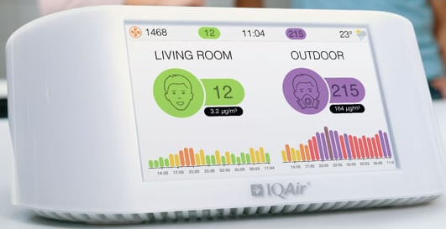
Source: (IQAir visual pro user manual air quality guide, 2019)
Continuous Mode is the recommended mode for taking measurements throughout an experiment. In this mode, the Node/Pro will take measurements every 10 seconds - making it quick to detect changes in the environment. Hence, the measurement were taken at each station for 30 minutes. Every 10 seconds air tracking device registered the air quality data in excel form in one minute 6 records with the total of (6x30) = 180 excel information for single 30 minutes Air Visual data. 24 stations were sampled and observed two times during peak and off peak hours. Therefore, (2x24) = 48 or 1440 minutes (24 hours) measurement of air quality at public transportation stations (LRT, bus, taxi and mixed) were taken with a total of (48x180) = 8,640 excel data. This device gave information about PM2.5, PM10, CO₂, humidity, temperature and air quality index (AQI).
For indoor monitoring, the coverage of an Air-Visual Node/Pro is a room (or open space) of up to 100sqm and for outdoor monitoring, the coverage of an Air-Visual sensor is usually for a 5km radius. The network of sensors become more accurate as the density of the sensors increases.

Appendix IV
Addis Ababa University
Ethiopian institute of Architecture, Building construction and City Development
Semi-structured interview items for institutions (key informants) AACRTB and AAEPA on the study topic which is entitled: air quality at public transportation stations/stops: LRT contribution to reduce air pollution in Addis Ababa.
Dear the interviewee of this study as the practitioner and the stakeholder on one hand this study and on the other hand by being the profession of different fields. The researcher kindly pronounce that the purpose of this study is only for academic orientations upon aforesaid title of the study, with the intention that, to be this study viable and fruitful the researcher demand information, you to convey and deliver so as, the situation going on, as what, the study requests. For the willingness as well as collaboration and devotion that you paid the researcher would like to express his heartfelt appreciation.
- What factors affect more emission on road motor vehicles in Addis Ababa?
- How many vehicles (diesel and gasoline engine vehicles) are there in Addis Ababa?
- What are the emission limit of AAEPA or standards for vehicles emission?
- What are the possible solutions to minimize transport related air pollution?

Appendix V

Kality station

Annex 2: Particulate matter at peak hour and off-peak hour Kality bus station.
At peak hour, PM2.5 was increasing to 560μg/m³ and changing the value continuously minimum concentration 51μg/m³. And also PM10 is increased up to 1700μg/m³ at peak hours and 970μg/m³ off peak hour at Kality bus station.

Annex 3: Air quality index at peak hour and off-peak hour Kality bus station.
AQI average concentration is 152.94 and 117.44 which is unhealthy and unhealthy for sensitive group respectively at peak hour and off peak hour.

Annex 4: Carbon dioxide at peak hour and off-peak hour Kality bus station.
CO₂ (ppm) increased heavily at peak hours between (500-710) ppm. There was traffic congestion, dust and wind during measurement. CO₂ is between (400-500) ppm, medium traffic congestion and low wind when air quality observed during off-peak hours.

Annex 5: Particulate matter at peak hour and off-peak hour Kality LRT station.
The concentration f particulate matter(PM) at peak hour is an average 30.2μg/m3 of PM2.5 and 108.36μg/m3 of PM10 off peak hour moderate air quality.

Annex 6: Air quality index at peak hour and off-peak hour Kality LRT station.
Air quality index in the graph shows that most value occur between (80-120) at peak hour, whereas (60-100) during off peak hours. Hence LRT station located the middle of the road and at grade level exposed more pollutants.

Annex 7: Carbon dioxide at peak hour and off-peak hour Kality LRT station.
CO₂ at grade(on ground) LRT station, have almost similar value during peaks and off peak hours, but in this graph off peak CO₂ increased because Low wind speed at peak hours there was wind during air quality observed at station. CO₂ concentration at LRT station has almost the same level of concentration (400ppm-450ppm).

Annex 8: Particulate matter at peak hour and off-peak hour Kality mixed station.
PM2.5 at peak hour has greater amount than off peak hour, but PM10 both peak and off peak hour has related amount of measurment. Researcher observed that there was dust particles, industy and manufacturing area in addition to this there was under construction road along the station during measurment of air quality.

Annex 9: Air quality index at peak hour and off-peak hour Kality mixed station.
Average AQI concentration is 126.35 at peak hour and 110 off-peak hour. Both of them concentration is unhealthy for sensitive group of people. It ranges from 320 to 54 at peak hour and 275 to 50 during off peak hour.

Annex 10: Carbon dioxide at peak hour and off-peak hour Kality mixed station.
CO₂ at peak hour reached at maximum 765ppm which is greater than (700ppm of good air quality) so it fall under moderate air quality(700-1000ppm). During off peak hour CO₂ ranges between 400-560ppm which is good air quality none of them affect by this CO₂ emmission.

Annex 11: Particulate matter at peak hour and off-peak hour Kality taxi station.
Only taxi station at Kality off peak hour measurment is greater than peak hours due to location of the station adjecent to industial land use and under construction road. PM2.5 have the same value but PM10 during off-peak hour value is greater than peak hour measurment.

Annex 12: Air quality index at peak hour and off-peak hour Kality taxi station.
AQI at kality taxi station a little bit similar because of the end and separate station. Peak hour and off peak hour measurment is affected by under construction road all the day, industry and manufacturing. That is why the the graph indicated related amount of AQI.

Annex 13: Carbon dioxide at peak hour and off-peak hour Kality taxi station.
Taxi station at Kality located in separate from road curve and near major round about(road junction) and under construction road. There was high particulate matter. When nearby road became crowded the concentration of CO₂ increase.

Saris station

Annex 14: Particulate matter at peak hour and off-peak hour Sari bus station.
PM2.5 ranges between 34 to 295μg/m³ at peak hour, and 23 to 398μg/m³ off peak hour. PM10 from 91 to 615μg/m³ peak hour and 38 to 1120μg/m³ off peak hour. Average concentration of PM2.5 85.09μg/m³, 84μg/m³ at peak and off peak hour respectively.

Annex 15: Air quality index at peak hour and off-peak hour Sari bus station.
AQI concentration at Saris bus station unhealthy for sensitve groups in average. the average concentration is greater than off peak hour. The maximum concentration is 355 at peak hour and 430 off peak hour

Annex 16: Carbon dioxide at peak hour and off-peak hour Saris bus station.
When vehicles being in long queue due to congestion air traking device indicated constant CO₂ in ppm when they started to move then CO₂ immediately increase too much from 500-780ppm.

Annex 17: Particulate matter at peak hour and off-peak hour Saris LRT station.
Saris LRT station located at the median of the congested roadway both sides of the LRT station affected by congestion, hence LRT passangers waiting exposed to transport related air quality problems. The graph indicated that there was higher concentration of both PM2.5 and PM10.

Annex 18: Air quality index at peak hour and off-peak hour Saris LRT station.
Saris LRT station located at the median of the congested roadway both sides of the LRT station crowded by traffic congestion, hence LRT passangers waiting exposed to transport related air quality problems.

Annex 19: Carbon dioxide at peak hour and off-peak hour Saris LRT station.
The concentration of CO₂ is good but the concentration go up and down between therage 395ppm-455ppm peak hour and 400ppm-450ppm off peak hour. The average concentration peak hour is greater than off peak hour.

Annex 20: Particulate matter at peak hour and off-peak hour Saris mixed station.
The concentration of PM heavily increase up due to heavy traffic congestion. Sometimes lower down the concentration of PM due to wind effect and traffic signal.

Annex 21: Air quality index at peak hour and off-peak hour Saris mixed station.
AQI indicated that higher concentration of bad air quality at station. The station usually congested and heavy traffic movement both peak and off peak hour.when the time tends to peak hour AQI increases. In addition to this there were old vehicles that emit black smoke and QI reached 875 which is hazardous.

Annex 22: Carbon dioxide at peak hour and off-peak hour Saris mixed station.
When the time tends to peak hour, it increase the concentration of CO₂. CO₂ has moderate concentaration at peak hour and good concentration off peak hour.

Annex 23: Particulate matter at peak hour and off-peak hour Saris taxi station.
Saris taxi station was observed that heavy particulate matter due to heavy traffic both peak hour and off peak hour.an average 50.6μg/m3 PM2.5 concentration and 148.11μg/m3 PM10 concentration at peak hour and 40.7μg/m3, 143.48μg/m3 respectvily during off peak hour.

Annex 24: Air quality index at peak hour and off-peak hour Saris taxi station.
Peak hour air quality observation was unhealthy than off-peak hour air quality index. The higher concentration of AQI was 460 which is hazardous, 180 average at peak hour and 450 maximum concentration and 130 average concentration during off-peak hour.

Annex 25: Carbon dioxide at peak hour and off-peak hour Saris taxi station.
There were great concentration change during peak and off-peak hour. It ranges between 410ppm-780ppm at peak hour and 410ppm -570ppm off peak hour.

Stadium station

Annex 26: Particulate matter at peak and off-peak hour Stadium bus station.
PM indicates at peak hour bad air quality, the station was unpaved and dust surface material when bus move the dust rise and increase particulate matter unhealthy.

Annex 27: Air quality index at peak and off-peak hour Stadium bus station.
AQI indicates at peak hour bad air quality, the station was unpaved and dust surface material when bus move the dust rise and increase bad particulate matter and AQI.

Annex 28: Carbon dioxide at peak and off-peak hour Stadium bus station.
CO₂ reached 1870ppm this is unhealthy due to black smoke and dust at station. It was not good for waiting passangers

Annex 29: Particulate matter at peak and off-peak hour Stadium mixed station.
Both PM2.5 and PM10 has unhealthy concentration of air quality. Even if less concentration of PM2.5, it is the most dangerous and hazardous one due to small size and enter easily in to lung and respiratory organ.

Annex 30: Air quality index at peak and off-peak hour Stadium mixed station.
AQI indicates unhealthy both peak hour and off peak hour. Maximum concentration 410 and average 133 at peak hour and maximum 230 and 117 average concentration during off peak hour.

Annex 31: Carbon dioxide at peak and off-peak hour Stadium mixed station.
The great concentration of CO₂ occur at peak hour, it is difficult for health, whereas CO₂ is moderate at peak hour exceptional when long vehicles pass on the road at instant time CO₂ too much increase. The maximum concentration is 1760ppm at peak hour and 950ppm during off peak hour.

Annex 32: Particulate matter at peak and off-peak hour Stadium taxi station.
PM highly increase mainly PM10 when there are black smoke and dust in and aroun the station. The average concentration of PM2.5 is 56.6μg/m³ at peak hour and 31.52μg/m³ and off peak hour respectively. The maximum cincentration of PM2.5 were 760μg/m³ which is very hazardous and minimum of 20μg/m³.

Annex 33: Air quality index at peak and off-peak hour Stadium taxi station.
Maximum AQI concentration is 620 at peak hor and 280 off peak hour. It is unhealthy for sensitive group at peak hour and little effect during off peak hour.

Annex 34: Carbon dioxide at peak and off- peak hour Stadium taxi station.
Average CO₂ concentration at peak hour is much greater than off peak hour. It is separated station from the roadway. It is moderate air quality at peak hour and good air quality during off peak measurment.

Annex 35: Particulate matter (PM) at peak and off-peak hour Stadium LRT station.
particulate matter increased when heavy track pass on the road and wind affected air quality during measurment. An average 18μg/m³ PM2.5 and 51μg/m³ PM10 at peak hour in 30 miniutes observation and 9μg/m³ PM2.5, 25μg/m³ PM10 during off peak hour.

Annex 36: Air quality index (AQI) at peak and off peak hour Stadium LRT station.
Elevated LRT station was affected by onground very heavy traffic congestion. When wind direction toward LRT station, there is bad air quality. The graph indicates that during super heavy congestion AQI increased too much and the long queue move fast. If they stopped due to traffic AQI decrease down ward.

Annex 37: Carbon dioxide at peak and off-peak hour Stadium LRT station.
Stadium LRT station is elevated and CO₂ concentration is low and has related or similar CO₂ concentration both peak hour and off peak hour.

Mexico station

Annex 38: Particulate matter at peak hour and off-peak hour Mexico bus station.
Particulate matter heavily increased at peak hour especially PM10 increased very much due to traffic congestion. There is great difference between peak hour and off peak hour measurment PM2.5 reached 200μg/m³ at peak hour while off peak hour 120μg/m³.

Annex 39: Air quality index at peak hour and off-peak hour Mexico bus station.
AQI and particulate matter increased proportionally, at instant time AQI reached 745 which is hazardous for health at station/stop at peak hour and 205 maximum concentration during off peak hour air quality observation.

Annex 40: Carbon dioxide at peak hour and off-peak hour Mexico bus station.
CO₂ vary at peak hour du to congestion when vehicles move quickly, it release high smoke as indicated from the graph. Wind affected the air quality, there was wind during measurment.

Annex 41: Particulate matter at peak hour and off-peak hour Mexico LRT station.
The particulate matter at LRT station almost similar during peak hour and off-peak hour. A little bit particulate matter increased at peak hour than off-peak hour. It falls the range between good air quality (PM2.5 = 0-12 μg/m³) and (PM10 = 0-54 μg/m³).

Annex 42: Air quality index at peak hour and off-peak hour Mexico LRT station.
LRT station has related air quality both peak hour and off peak hour observation because of elevated station, free from gasoline or diesel (electricity) and separated from road vehicles. Elevated LRT station/stop has better air quality than under ground or on ground station.

Annex 43: Carbon dioxide at peak hour and off-peak hour Mexico LRT station.

CO₂ has not heavy difference, it has an average of 450ppm both of them. It is good during peak and off peak hour, it ranges between (400-500ppm).

Annex 44: Particulate matter at peak hour and off-peak hour Mexico mixed station.
PM2.5 has maximum of 230μg/m³ at peak hour and 140μg/m³ during off peak hour. It is hazardous and very unhealthy for health at station/stop. The average concentration of PM2.5 has 71.8μg/m³ at peak hour, it is unhealthy (55.5-150.4μg/m³) and 38.5μg/m³ off peak hour it is unhealthy for sensitive group(35.5-55.4μg/m³).

Annex 45: Air quality index at peak hour and off-peak hour Mexico mixed station.
AQI is above 100 to 250 at peak hour and 50-200 off peak hour. At peak hour, it falls an average 151.6 AQI it is unhealthy(151-200). The air quality changed up and down due to wind.

Annex 46: Carbon dioxide at peak hour and off-peak hour Mexico mixed station.
Threre is heavey wind during measurment and when the the wind direction toward the air quality traking devce, CO₂ emmidiatly decrease during off peak hour. that is why CO₂ is vared by greater amount of difference in the graph. Most buses stop at station for long time at station due to congestion and without making off engine at station to load risers.

Annex 47: Particulate matter at peak hour and off-peak hour Mexico taxi station.
Particulate matter increased at peak hour, there was very heavy traffic congestion during measurment of air quality at taxi station. There was wind and dust off peak hour air quality observation. When the station being full congestion and long queue the station/stop area became hot and increase particulate matter from mini-bus and bus.

Annex 48: Air quality index at peak hour and off-peak hour Mexico taxi station.
The AQI indicates that it is very unhealthy at peak hour and unhealthy off peak hour at taxi station. Average concentration is 103 which is unhealthy for sensitive group.

Annex 49: Carbon dioxide at peak hour and off-peak hour Mexico taxi station.
The highest CO₂ concentration is 780ppm and 530ppm off peak hour. 780ppm fall under the category of AQI yellow moderate concentraation, it has less impact on health and 530ppm is under category green which is good and none impact on health.

Autobus Tera station

Annex 50: Particulate matter at peak hour and off-peak hour Autobus Tera bus station.
Peak hour is greater than off peak hour when off peak hour tends to peak period PM increase. During measurement, the maximum at 3:31pm at reached 1798μg/m³. Which is hazardous for health and the color indicates maroon based on US-AQI color code. Everyone should care of outdoor air quality.

Annex 51: Air quality index at peak hour and off-peak hour Autobus Tera bus station.
When off peak hour tend to peak hour, the value of AQI increase. Majority AQI is between 100-200 at peak hour, but 75-150 during off [eak hour. During off peak hours, AQI at 3:3pm is maximum 1358 because diesel engine vehicles emit black smoke when air is low.

Annex 52: Carbon dioxide at peak hour and off-peak hour Autobus Tera bus station.
It is clear that at peak hour CO₂ heavely incrased and up and down CO₂ in ppm due to congestion and long queue on the road. When the vehicles move quickly CO₂ increse too much and vehicles move slowly in congestion CO₂ decrease even it is being on long queue.

Annex 53: Particulate matter at peak hour and off-peak hour Autobus Tera mixed station.
It was very unhealthy particulate matter concentration maximum(830μg/m³) at peak hour and (420μg/m³) off peak hour. This is hazardous PM concentration for health.

Annex 54: Air quality index at peak hour and off-peak hour Autobus Tera mixed station.
AQI at peak hour. It ranges between 100 and 700. This is very unhealthy for everyone air related diseases. During off peak hour, it varies between 50 and 320.

Annex 55: Carbon dioxide at peak hour and off-peak hour Autobus Tera mixed station.
It was observed that during measurment of air quality at Autobustera bus/taxi station, CO₂ emitted from old vehicles and midi-bus are heavy during peak hours, more vehicles occupied on the raodway and move slowly due to congestions. When it moves fast, vehicles emit more smoke and CO₂ increase.

Annex 56: Particulate matter at peak hour and off-peak hour Autobus Tera LRT station.
Particulate matter at LRT station almost similar during peak and off-peak hour due to elevated station.

Annex 57: Air quality index at peak hour and off-peak hour Autobus Tera LRT station.
Air quality index at Autobus tera LRT station became sometimes unhealthy for sensitive groups at peak hour becuause of traffic congestion and located at KEFELHAGER AUTOBUS TERA.

Annex 58: Carbon dioxide at peak hour and off-peak hour Autobus Tera LRT station.
When the LRT stations suited at elevated, the air quality is good. CO₂ value is below 470 during peak and off peak hours. But wind speed and direction affect air quality. Low wind speed and the direction toward the station/stop then CO₂ increase and in opposite direction it decreases.

Annex 59: Particulate matter at peak hour and off-peak hour Autobus Tera taxi station.
PM2.5 at peak hour is much greater than off peak hour while PM10 at peak hours is less than off-peak measurment of air quality. PM10 increase when dust particles happened in and around the station. This indicated [researcher observed] that, there was dust particles at taxi station.

Annex 60: Air quality index at peak hour and off-peak hour Autobus Tera taxi station.
Taxi station measurment of air quality was taken near KEFLE HAGER Autobu Tera, the station has heavy traffic and fair condition of road and bad condition of pedestrian walkways. AQI indicates minimum of 100 and maximum of 270 which is unhealthy during peak hours, and unhealthy for sensitive groups during off peak hours.

Annex 61: Carbon dioxide at peak hour and off-peak hour Autobus Tera taxi station.
This clear, CO₂ is heavily increased at peak hour maximum of 752ppm. CO₂ increased when old vehicles pass and emit black smoke on the station. CO₂ is between 400-450 during off peak hour.

Minilik II square station

Annex 62: Particulate matter at peak hour and off-peak hour Minilik II square bus station.
Minilik II square has greatest amount of particulate matter at bus station, its PM2.5 concentration range between 50-210μg/m³ at peak hour and 21-200μg/m³ during off peak hour. Whereas PM10 has maximum 788μg/m³ and 900μg/m³ at peak hour and off peak hour respectively. Average concentration of PM2.5 is 78μg/m³ and PM10 is 174μg/m³ at peak hour and 75μg/m³ off peak.

Annex 63: Air quality index at peak hour and off-peak hour Minilik II square bus station.
The maximum concentration was 314 and 158 average concentration of AQI at peak hour and 810 maximum concentration and 142 average concentration of AQI during off peak hour.

Annex 64: Carbon dioxide at peak hour and off-peak hour Minilik II square bus station.
There was wind and high smoke from bus station due to congestion. When wind speed slow down the concentration of CO₂ increased up and some vehicles emit black smoke at the end of (off peak hour) measurment of air quality.

Annex 65: Particulate matter at peak and off-peak hour Minilik II square LRT station.
The great difference occurred under ground LRT station, there are high concentration of particulate matter because of dust when sweep the station under ground there is no wind effect and then increased PM. During measurment the station was sweeping and rise particulate matter(dust).

Annex 66: Air quality index at peak and off-peak hour Minilik II square LRT station.
AQI indicates that there were very high concentration under ground LRT station. If there are dust and particulate matter especially when the station sweep there is bad air quality. It ranges from 90 to 580 at peak hour and 80 to 110 off peak hour. Average concentration is 138.3 and 76 peak and off peak hour respectively.

Annex 67: Carbon dioxide at hour and off-peak hour Minilik II square LRT station.
It is obvious CO₂ under ground with high passengers increased when the passangers wait the train for long time at station and increase too much its concentration. The maximum concentration reached 800ppm at peak hour and 600ppm during off peak hour.

Annex 68: Particulate matter at peak and off-peak hour Minilik II square mixed station.
The concetration of particulate matter at Minilik II square bus/taxi station is very unhealthy due to unpaved dust stopping station. If there are dust and construction activity near the station particulate matter increase too much than CO₂.

Annex 69: Air quality index at peak and off-peak hour Minilik II square mixed station.
AQI indicates bad air quality maximum concentration reached up to 365 which is very unhealthy at peak hour and 320 off peak hour. It ranges between 85 and 355 at peak hour, and 49 to 325 off peak hour. Average concentration 153.56 and 130.46 at peak and off peak hour respectively.

Annex 70: Carbon dioxide at peak and off-peak hour Minilik II square mixed station.
There was wind during measurment and heavy-duty vehicles emit black smoke, it reached 3200ppm the maximum concentration. It was observed that, the highest CO₂ concentration from all stations at peak hour.

Annex 71: Particulate matter at peak and off-peak hour Minilik II square taxi station.
PM2.5 ranges between 35 to 200μg/m³ at peak hour, and 20 to 115μg/m³ off peak hour. PM10 from 80 to 970μg/m³ peak hour and 40 to 610μg/m³ off peak hour.

Annex 72: Air quality index at peak and off-peak hour Minilik II square taxi station.
AQI concentration of taxi station at Minilik II square is not good air quality due to station location near side of road junction and gravel paved surface stop. Gravel surface station rise dust and particulate matter.

Annex 73: Carbon dioxide at peak and off-peak hour Minilik II square taxi station.
CO₂ is high concentration at instant off peak hour when old vehicle pass on the raod way and emit black smoke. The average CO₂ concentration at peak hour is greater than off peak hour.

Appendix VI
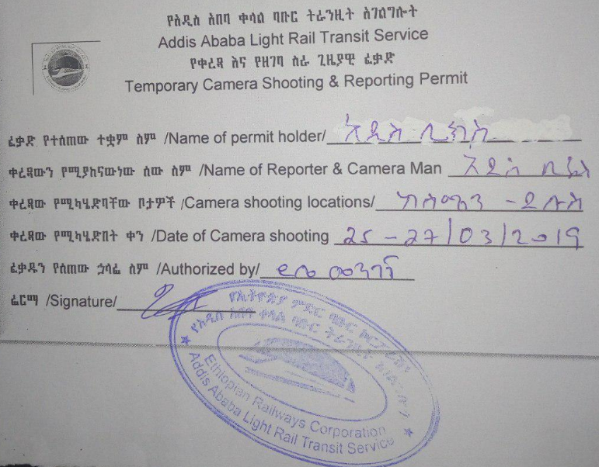
Annex 74: Temporary camera shooting and reporting permit
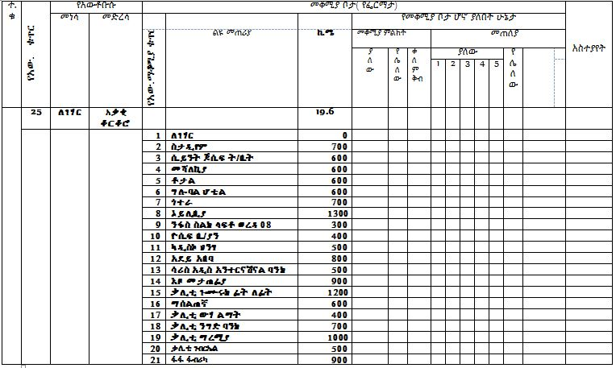
Annex 75: Bus stations for sampling frame from stadium to kality
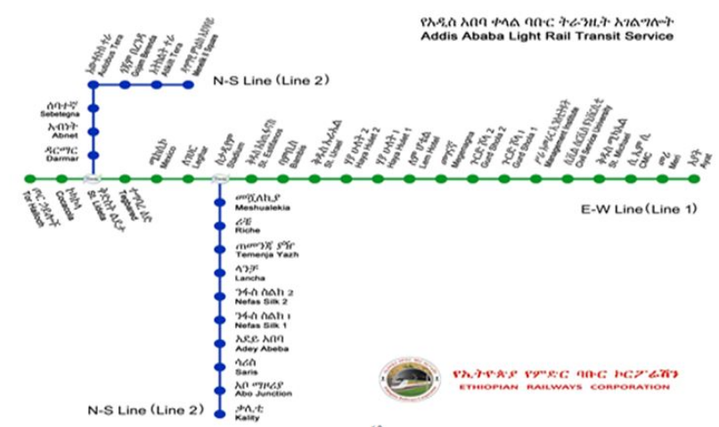
Annex 76: Addis Ababa Light Rail Transit service East-West and North-South line (2015)
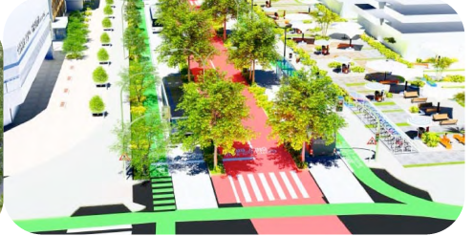
Annex 77: Street design and walkways, separate lane for bus adopted from developed nations

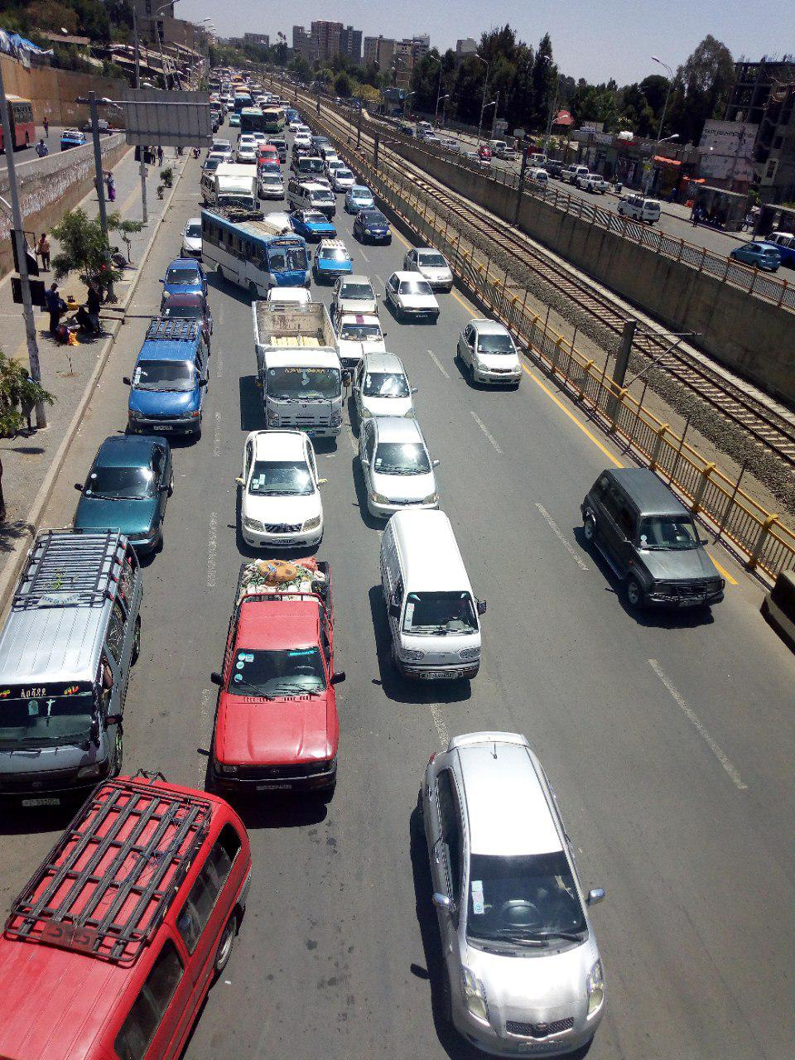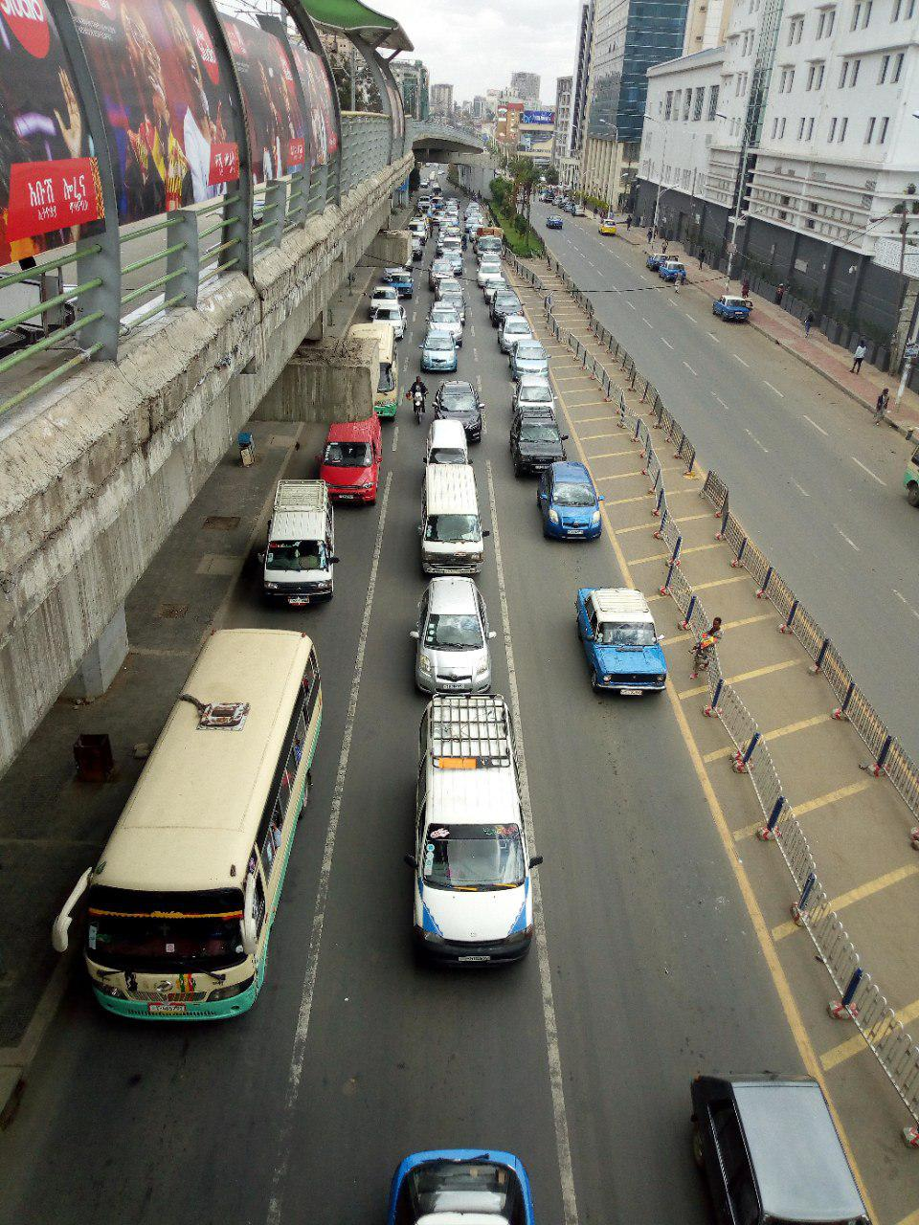
Annex 78: Photos were taken at Stadium and Megenagna stations
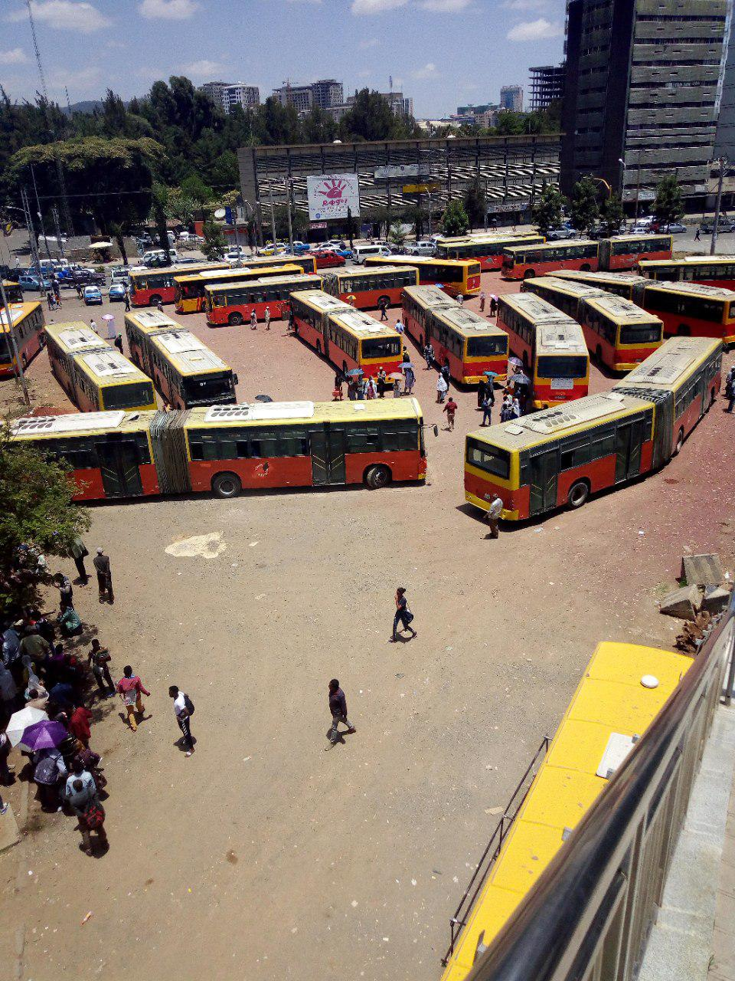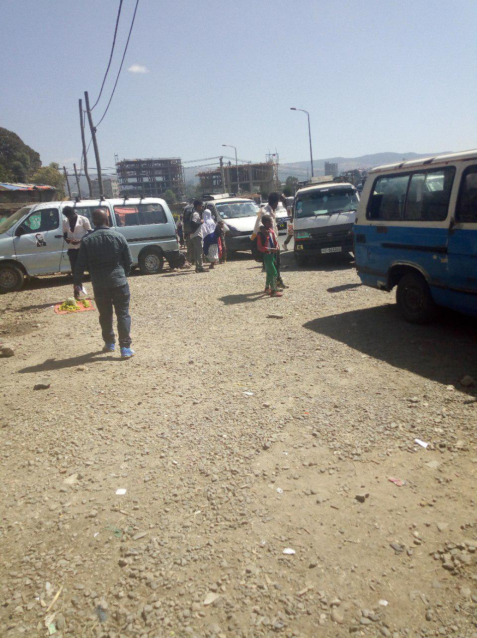
Annex 79: Photos were taken at Stadium bus station and Minilik II square taxi station
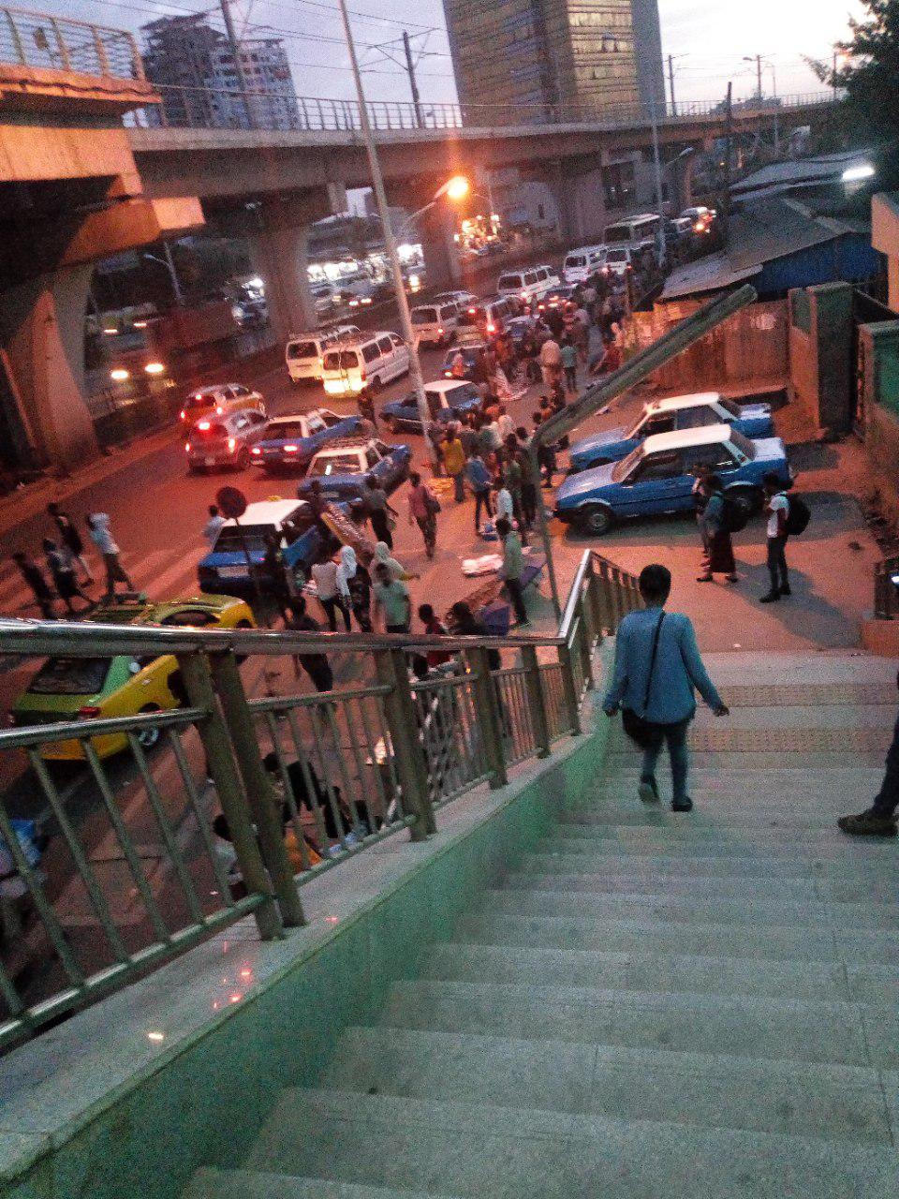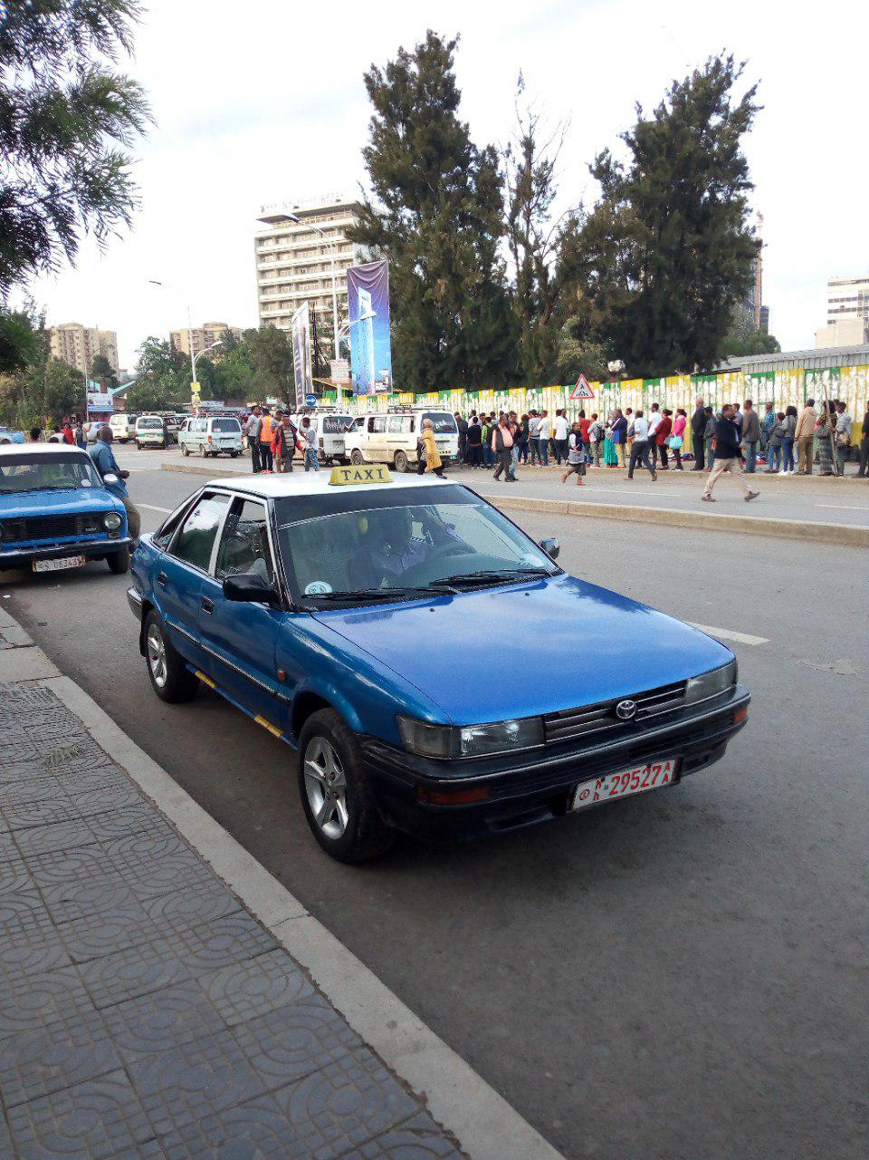
Annex 80: Photos were taken at Mexico LRT and taxi station
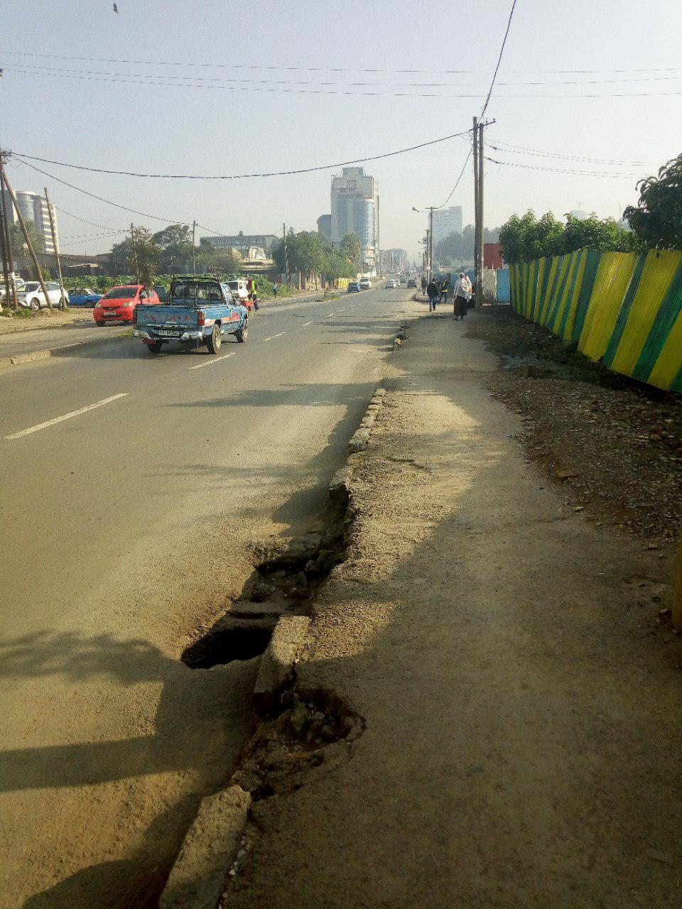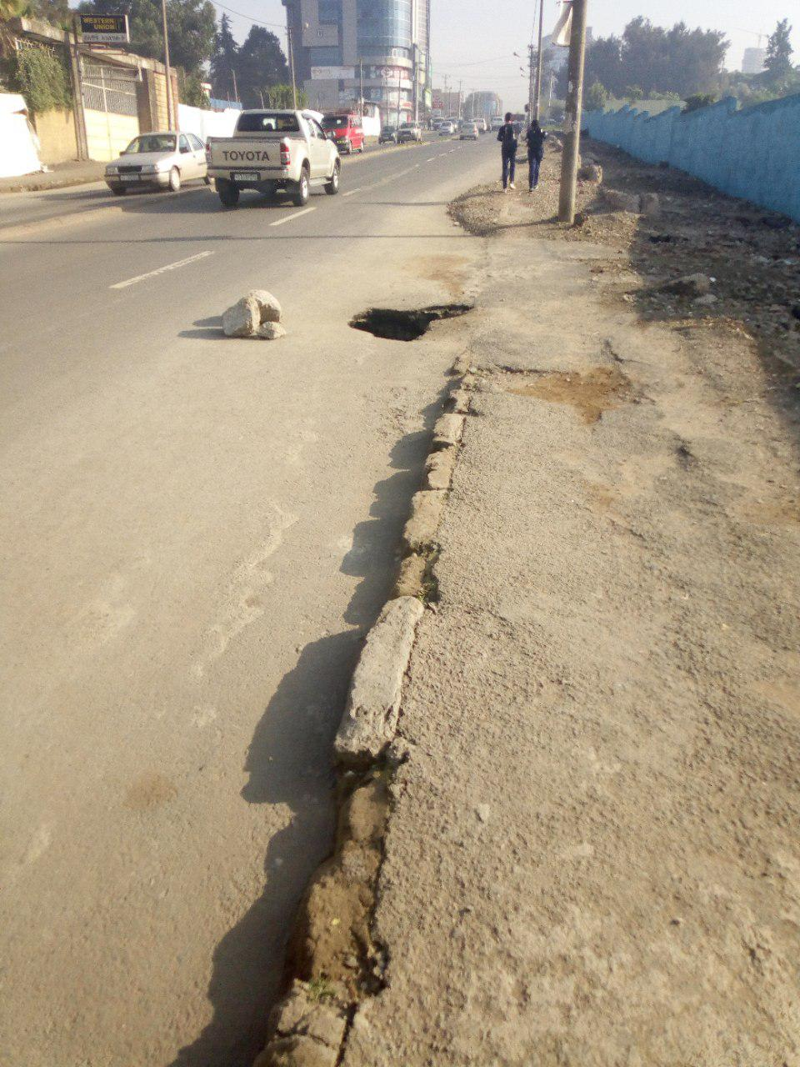
Annex 81: Road quality and pedestrian way from Mexico to Kera road

Annex 82: Respondent profile at sampled stations by type of stations
Type of employments | Type of stations/stops under the study |  |  |  |  |  | Total
Type of employments | Train station Elevated | Train station on ground | Train station Underground | Bus station | Taxi station | Both bus/taxi station | Total
Passengers(in office) | 20 | 7 | 4 | 12 | 16 | 16 | 75
unemployed | 4 | 5 | 0 | 6 | 6 | 4 | 25
street venders | 14 | 16 | 6 | 71 | 58 | 72 | 237
traffic police | 1 | 2 | 0 | 3 | 6 | 6 | 18
coordinators of transportation | 10 | 14 | 3 | 23 | 29 | 27 | 106
drivers | 0 | 4 | 1 | 8 | 7 | 8 | 28
Security police | 17 | 5 | 6 | 7 | 14 | 5 | 54
shoeshines | 5 | 1 | 2 | 31 | 21 | 21 | 81
street sweepers | 17 | 4 | 6 | 13 | 15 | 13 | 68
Homeless | 2 | 2 | 2 | 6 | 8 | 8 | 28
Total | 90 | 60 | 30 | 180 | 180 | 180 | 720
Annex 83: Transport-related air pollution diseases at sampled stations
Stations | Gender  Male Females |  | Age group in year | Duration in that location | No of air quality related diseases | No of air quality related diseases visited clinics/hospitals
Kality | 65 | 55 | 13-68 | 6 month-21 years | 2-7 | 84
Saris | 74 | 46 | 14-66 | 1-31 years | 1-7 | 40
Stadium | 74 | 46 | 14-55 | 4 months-28years | 2-7 | 51
Mexico | 64 | 56 | 14-55 | 8 months-37 years | 2-6 | 46
Autobus Tera | 71 | 49 | 14-55 | 5 months-43 years | 2-7 | 45
Minilik II square | 72 | 48 | 14-67 | 9 months-22 years | 2-7 | 58
Totals | 420 | 300 | 720 | 720 | 720 | 324

