ADDIS ABABA UNIVERSITY
SCHOOL OF GRADUATE STUDIES
COLLEGE OF NATURAL AND COMPUTATIONAL SCIENCE
DEPARTMENT OF ZOOLOGICAL SCIENCES

Diversity and Distribution of Birds at Borta Dam
and its Surrounding, Oromia Region, Western Ethiopia

A Thesis submitted to the School of Graduate Studies of Addis Ababa University in partial fulfillment of requirements for the Degree of masters of Science in Biology

By
Yaekob Gemechu
Advisor: Bezawork Afework (PhD)

August, 2019
Addis Ababa, Ethiopia

ADDIS ABABA UNIVERSITY

SCHOOL 0F GRADUATE STUDIES

Studies on Diversity and Distribution of Birds at Borta Dam

And its surrounding, Oromia Region, Western Ethiopia

APPROVAL SHEET

A Thesis submitted to the School of Graduate Studies of Addis Ababa University in Partial Fulfillment for the Requirements of the Degree of Master of Science in Biology.

Approved by the Examining board:

Research Advisor
______________________________________________________________________

Examiner
______________________________________________________________________

Acknowledgements
I thank the Almighty God for his endless help and generosity in giving me the courage and strength all through the course of my studies and writing this thesis.
I would like to express my deepest gratitude to my Advisor, Dr. Bezawork Afework, for her diligent follow up, continuous encouragement and essential guidance in completing this study. I am also grateful to the following individuals and institutions: Sayo Woreda Culture and Tourism Office, Dembidollo meterological station, Sayo Woreda Agricultural office, and Borta Dam warden, Mr. Edosa Wolde, for creating a homely working environment and his unlimited friendly support and the Borta Dam staff support during the field investigations around the Dam. Without them, the fieldwork would not have been possible. I would also like to thank Department of Zoological Sciences for providing all necessary support from the begnig to end of the study.
My heart-felt thanks also go to my family, Gemechu Kusa and Kabane Gamtessa who took all the hardship in bringing me up. I also express my sincere thanks to my wife, Diribe Bultum for her encouragement, understanding and patience and loving care and sharing all my difficulties during my stay in the School of Graduate Studies. Finally yet importantly, I would like to acknowledge all my friends with whom I shared ideas during my study.

Table of contents Page
Acknowledgement……………………………………………………………………………………….…i
Table of contents…………………………………………………………………………………………..ii
List of tables …………………………………………………………………………………….………...iv
List of figures……………………………………………………………………………………………….v
List of plate……………………………………………………………………………………...................vi
List of appendices ……………………………………vii
Abstract ….viii
1. Introduction ….1
1.1Background of the study 1
1.2 Statement of the problem…………………………………………………………………………….3
1.3 Objectives of the study 4
1.3.1 General objective 4
1.3.2. Specific objectives 4
1.4 Significance of the Study 4
2. Literature review 5
3. Study area 9
3. 1 Habitat 11
3.2. Climate 14
4. Materials and Methods 16
4.1Materials 16
4.2Methods 16
4.2.1Preliminary survey 16
4.2.2 Data collection 17
4.2.3 Data analysis 18
4.2.4 Species abundance analysis 19

5. Results 20
5.1 Species Diversity 25
5.2. Species Richness 26
5.3 Species Similarity 26
5.4 Distribution 28
5.5 Abundance 33
6. Discussion 34
7. Conclusion and Recommendations 36
7. 1. Conclusion 36
7.2 Recommendations 36
Refereances 37

List of Tables page
Table 1. Encounter rates used to give acrude ordinal scale of abundance 19
Table 2 Bird species recorded during wet and dry seasons ……………………………..................... .......21
Table 3. Bird species diversity index (H’),species richness (s) and evenness (E) 25
Table 4. Bird species similarity between habitats during the wet season………………………...... ..........27
Table 5. Seasonal species similarity (SI) …………………………………………………… …................27
Table 6. Distribution of different brid species in all habitats………………………… ……….…..29
Table7.Over all distribution of habitat types at Borta Dam and its surrounding………………… …...……32

List of Figures Page
Figure 1. Map of the study area………………………………………………………………………….10
Figure 2. Monthly mean minimum and maximum temperature ……………………………………14
Figure 3. Monthly mean minimum and maximum rainfall ……………………………………………15
Figure 4. Bird species richness in different habitat………………………………………………………..26

List of Plates Page
Plate1. Wetland habitat…………………………………………………………………………………11
Plate 2. Woodland habitat………………………………………………………………………………...12
Plate 3. Farmland habitat……………………………………………………………................................13

List of Appendices page
Appendix 1. Point count field data sheet …………………………… ………….………………..42
Appendix 2. Line transect count field data sheet……………………………… ……………………43
Appendix 3.Number of individual bird species recorded …………………………… …………..44
Appendix4. Expansion of farmland……………………………………………… ……………47
Appendix5. Some birds of the area 47
Appendix6. Views of the area…………………… ………..50

Abstract
This study was carried out to investigate bird species distribution and diversity of Borta Dam and its surrounding habitat in Western Ethiopia. It was conducted from January 2019 to June 2019 covering both dry and wet season. The study area was classified into three habitat types based on the topography and vegetation types. These are wetland, woodland, and farmland. Representative sample study area, were taken from each habitat type and line transect method was employed for wetland and farmland habitat types but point count method for woodland habitat. Data were collected in the morning (6:30 –9:30 am) and in the afternoon (2:30 –5:30 pm). During the study period, a total of 88bird species belonging to 39 families were recorded. The diversity of birds varied among the three different habitats. Wetland habitat appeared to be a choice for most of bird species (56) and woodland least (37) encountered in the study period. This habitats had the highest diversity of bird species with Shannon-Wiener Index of diversity (H’=4.02, E=0.97). The second diversified habitat was farmland with (H’ = 3.43, E=0.87) and woodland was the third diversified habitat (H’=3.11, E=0.84). Among the three habitat types, Simpson’s similarity index showed that the highest similarity was between woodland and farmland (SI=0.522) and the least similarity was between woodland and wetland (SI= 0.379) during the dry season. During the wet season also, the highest similarity between farmland and woodland (SI=0.487) and the least similarity was between wetland and woodland (SI=0.342). The highest number of families distributed in wetland (17 families) and the lowest (10 families) in woodland. There fore, it can serve as important center for tourist attraction if properly managed Controlling habitat destruction, controlling livestock grazing from the area and active community participation are essential for maintaining the habitats and birds of the area.
Key words: bird, distribution, diversity, evenness, richness

1. INTRODUCTION

Background of the study
Environmental heterogeneity in the form of spatial variation in habitat and local climate can affect species distribution (Veech and Crist, 2007). The abundance and distribution of bird species are also affected by scale-dependent hierarchical processes that disturb the links between habitat suitability and their numbers (Telleria et al., 2009). The divergent seasonality of rainfall and seasonal variation in the availability of food resources end result in seasonal changes in the species abundance of birds (Karr and Roth, 1971; Gaston et al., 2000 ). The allocation and abundance of numerous bird species are determined by the composition of the vegetation that forms a major element of their habitats. As vegetation changes along multifaceted biological and environmental gradients, a particular bird species can appear, increase or decrease in number, and vanish as the habitat changes (Lee and Rotenberry, 2005)
Ethiopia is an ecologically diverse country with extensive and unique environmental conditions and biodiversity (Yalden, 1983). This is believed to be as a result of large diversity of ecological conditions determined by a topography ranging from 110 m.b.s.l at Kobar sink in the Afar depression to a peak of 4543 m.a.s.l at Ras Dejen in the Simien Mountains National Park (Shibiru Tedla, 1995). Ethiopia harbors 918 species of birds, of which 639 are resident and 224 are regular seasonal migrants, including 176 from the Palearctic and 48 inter-African (BirdLife International, 2001; Lepage,2016). Among these 19 bird species are endemic to Ethiopia whereas 31 are globally threatened, 1 introduced species and a further 13 are shared with Eritrea (Lepage, 2016). Despite the rich bird assemblages in Ethiopia, due to enormous habitat degradation, fragmentation and loss the survival of many bird species including the endemic and globally threatened ones are endangered (Lepage, 2016) (Birdlife International (BLI), 2001). To conserve the biodiversity of the country and enhance economic growth through tourism and associated activities about 73 important bird areas (IBAs) are identified within the country (Shimelis Aynalem and EWNHS, 1996). Of these 30 sites (41% of the total) comprise wetlands, while the rest are representatives of other types of ecosystems.
Among the known wildlife area of Ethiopia Borta Dam and its surrounding is one of the area which contain the largest extent of wetland habitat. Wetlands provide a suitable habitat for innumerable organisms including birds (Shimelis Aynalem and Afework Bekele, 2008). Hence, study of diversity of such habitat with no record of avifauna study is important.

Statement of the problem

In Ethiopia many researchers have carried out on avian diversity, distribution and abundance in different ecosystems; particularly emphasize national on parks and protected areas. Afework Bekele and Shimelis Aynalem (2008) showed species composition and relative abundance of birds fauna at southern tip of Lake Tana. However, Borta Dam and its surrounding is recreational area around Dembidollo Town. The area is having higher birds Diversity, thus no research is carried out to investigate the diversity, abundance and distribution of birds. There for, this study designed to get essential information of the area.

Objectives

General objective
The general objective of this study is to assess the distribution and diversity of birds of Borta Dam and its surrounding, Western Ethiopia.

Specific objectives
- To identify bird species diversity in the study area.
- To determine the distribution of bird species in various habitats of Borta Dam and it’s surrounding.
- To determine species diversity of birds in the study area.

  - Significance of the Study
The study of diversity, abundance and distribution of birds at Borta Dam and its surrounding which is important document for the future development management plan for this area. In addition, the information collected during this study can serve as a base line for other researchers interested to carry out additional studies in the area.

- LITERATURE REVIEW
Birds are the most successful and highly diverse of all terrestrial vertebrates because they can consume almost all types of animal and plant materials (Welty, 1975). Each species has its own ecological preference. Birds have long been popular with amateurs and professionals and consequently their systematic position and distribution patterns are better known than any other comparable groups of animals, with the possible exception of large mammals (Furness and Greenwood, 1993).
Every year, more bird species are discovered. Birds are also among the most easily defined and readily recognized categories on animals, due to the presence of feather, which is unique to them. In addition to feathers, the development of forelimbs as wings, mostly for flight; feathered tail that serves for balancing, steering and lifting; toothless horny beak and skeleton exhibiting unique adaptations, mainly for flight and bipedal locomotion are characteristics of birds (Wallace and Mahan,1975; Padian and Chiappe, 1998). Birds are both visually and acoustically conspicuous organisms of most ecosystems. Because they are comparatively easy to identify, birds have received considerable attention of humans (McLay, 1974; Whelan et al., 2008).
Patterns of abundance and distribution of birds are strongly related to environmental factors, which determine their presence and activity. Birds are adapted for flight, which is an important mechanism to escape from terrestrial enemies. However, the best method of escaping from sudden attack is by concealing coloration with their habitat (Lanyon, 1963). Their skeleton, lung and heart have adaptation mechanisms for flight. Some of them can fly continuously for over 2500km or even greater distance. Some can reach speeds of more than 90km/hr (king and mcleelland, 1975).The power of flight allows them to move easily through the air and yet they are perfectly adapted to every environment that fit their requirements for successful reproduction and survival (Welty, 1975).

The class Aves includes 29 orders, 201 families, 2073 genera and 10,000 species (Lepage, 2009). Africa is home to two endemic bird Orders, ten endemic Families (with two more only reaching Madagascar or Arabia) (Sinclair and Ryan, 2003). Africa is second only to South America in terms of numbers of bird species, and offers more rewarding birding than other tropical regions. The continent supports more than 2100 of the world’s bird species, out of which almost 1400 are endemic species in a diversity of habitats (Sinclair and Ryan, 2003).
Birds fulfill many ecological functions in their habitats. For instance, they are bio indicators of healthy ecosystems (Mistry et al., (2008). In addition, insectivorous species and raptors regulate disease vectors, including mosquitoes and rodents. Scavenger birds, such as the Pied Crow (Corvus albus), contribute to biomass recycling and to some degree reduce levels of disposable wastes. Frugivorous birds play an important role in seed dispersal of fleshy fruit-producing plants (Stevenson, et al., 2002). Birds are also important in plant pollination as demonstrated by sunbirds, which participate in crossbreeding of flowering plants, especially those with bird-pollination syndrome (Judd, et al., 2008). These ecosystem services are important for many communities, and to ensure that birds can fulfill these biological roles at an appropriate level for current and future generations, there is a pressing need to study the dynamics and socio-economics. Birds also serve other purposes in nature. Fruit-eating birds help in dispersal of seeds. Birds eat and digest the pulp of berries and other fruits, but pass the seeds unaffected through their droppings. The seeds may sprout wherever the droppings fall (Clout and Hay, 1989).
Certain birds like humming birds and sunbirds pollinate certain flowers that produce nectar. As they visit flowers in search of it, they spread pollen from flower to flower. Birds are also beneficial to humans as a source of food (Pomeroy, 1992). Birds through the ages have been the source of considerable fascination and folklore, and have been used as symbols. They are the most universally celebrated form of nature, found in pictures, photographs, sculptures, word and song (Clifford and Beehler, 1998). The effective management of human activities in wildlife areas is an important conservation issue, as the footprint of human influence continues to expand and incidental impacts of human activities spread into more areas. Such expanding anthropogenic activity is widely perceived to lead to negative consequences for the wildlife beyond habitat loss alone.
There are occasions where birds get in conflict with humans due to the damage they cause. Too often the destructive influence of human activities on Klem bird populations is recognized only after substantial damage has been done. Virtually all human activities can affect bird populations either positively or negatively (Donnelly and Marzluff, 2004). This could especially be true for birds of prey, given their low densities, large home ranges, and the resulting scale at which they operate (Berry et al., 1998). Understanding how animals respond to anthropogenic activities is fundamental to resolving potential conflicts between humans and animals. There are numerous ways in which it is possible to study animal responses, but changes in an animal’s behavior are often the most obvious consequences of anthropogenic activities (Beale, 2007).
Terrestrial avian diversity increases as one move from the poles towards the equator. Habitat complexity is greater in the tropics. This provides opportunity for ecological specialization of species (Roth, 1976). Birds are among the widely studied groups, with enough information on their distribution and status (Canterbury et al., 2000). Birds are commonly distributed in different habitats including the Polar regions, the tropics, in forests and deserts, on mountains and prairie and the ocean and its islands. The distribution of any species can be influenced by many factors which are mainly categorized under abiotic and biotic factors (Loreau, 2010). Approximately 30% of the world’s species of birds are restricted to tropical forests (either for winter or year-round habitat) that they would disappear if all tropical forests were lost (Myers, 1992).
The spatial distributions of food and cover resources determine the abundance of bird species. The food and cover requirement of bird species is determined mainly by the vegetation structure and composition that is correlated with abundance and habitat use (Waterhouse et al., 2002). Expansion of agriculture, livestock encroachment, deforestation, indiscriminate fire fuel by the ever increasing human population has been often cited as the major cause of birds’ habitat degradation, fragmentation and loss in Ethiopia ultimately affecting the survival of birds (Shimelis Aynalem and Afework Bekele, 2008; Girma Mengesha et al., 2011). It has been indicated that threats to bird species of Ethiopia have been dramatically increasing in the past few decades, as it is true to other wildlife (Shimelis Aynalem and Afewerk Bekele, 2008).

Distribution, abundance, reproductive success and behavior of animals are often sensitive to habitat change caused by human activities. They are indicators and useful models for studying variety of environmental changes (Sutherland and Green, 2004; Urfil et al., 2005; Estrella, 2007). Many of them have adapted with the changes that humans have inflicted on the ecosystem. Most bird studies in Ethiopia focused on characterizing the birds’ species composition and abundance on specific regions of the country (Shimelia Aynalem and Afework Bekele, 2008; Girma Mengesha and Afework Bekele, 2008).
The different land use type had species in common and species specific to specific habitat in response to ecological factors such as altitudes, vegetation, and climate across the landscape of the area. It has been revealed in the results that birds’ abundance is affected by the availability of food and cover, which is influenced mainly by vegetation composition and structure. However, the anthropogenic activities going on in and around the remnant forest can shrink the available habitats to birds through their action in altering the vegetation composition and structure that ultimately affects birds’ abundance and survival. Hence, urgent conservation measures are inevitable to conserve the endemics and globally threatened bird species in the area. Birds are important as bio-indicators and in ecosystem functioning such as pollination, seed dispersal and insect pest controls. However, birds are threatened by threats such as habitat loss, fragmentation and degradation all over their range. Furthermore, bird species composition and their distribution is poorly understood in forest fragments like the present study area (Zerihun Girma et al., 2017).

STUDY AREA DESCREPTION
Borta Dam located in western Ethiopia, about 657 km from Addis- Ababa, with Latitude of (8°31´20´´N and Longitude 34°47´10´´E).The dam was established from Borta River in 1978E.C by the Lutheran missionary and western synod for the purpose of irrigation and fishery to help the local people and now used as the source of drinking water for Dembidollo Town. The Borta Dam and surrounding area covers a total area of about 153 ha out of which wet land covers 33 ha, woodland covers 97 and farmland covers 23 ha. Borta Dam and the surrounding area is the unexplored potential site in Western Ethiopia, the National Regional State of Oromia, where large populations of birds are known to occur. The area located at the edge of the Dembidollo town in Sayo Woreda in Kellem Wollega Zone. Most of the area falls between an altitudinal ranges of 1390 –1850m.

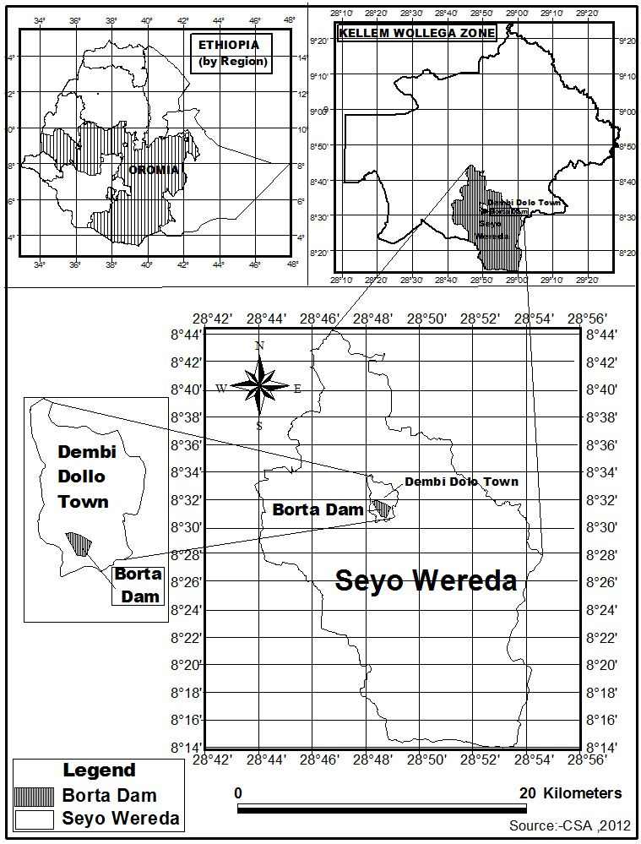

Figure 1. Map of the study area

  - Habitats
The area encompasses three different habitat types. These are wetland, woodland, and farmland.
Wetland
The wetland is composed of the Borta River and Borta Dam. It is the second largest portion of the study area which covers a total area of 33 hectors. It gives conspicuous features of the landscape in contrast with the surrounding vegetation (Shimelis Aynalem and Afework Bekele, 2008) (plate 1a and b).
a.
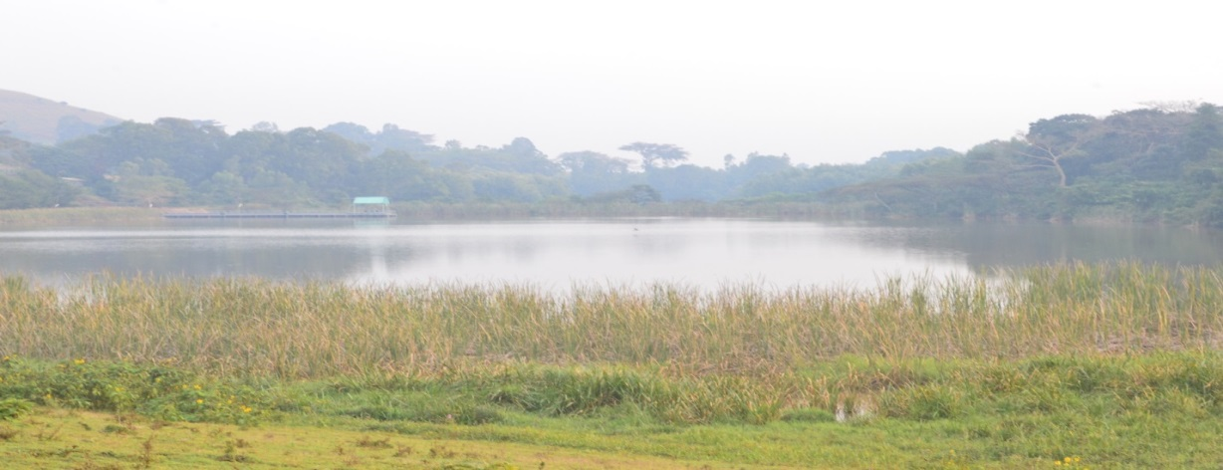
b. 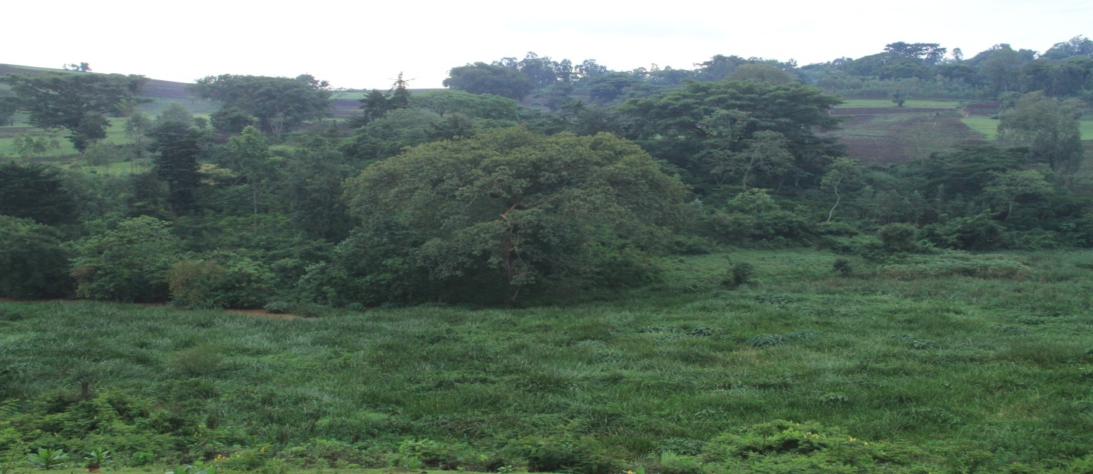 Plate1. Views of wetland a/ dry season b/ wet season
Woodland
Woodland is the largest habitat covering an area of 97 ha. It is characterized by small to moderate-sized tree species such as Acacia abyssinica, Albizia gummifera, Erythrina brucie, Croton macrostachyus, Cordia africana, Grevillea robusta, Juniperus procera and Combretum species .Based on the types of dominant species the woodland area can be characterized as mixed and Combretum woodlands. The Combretum woodland which is found at the border of the Dam is characterized by dominant species of Combretum and Terminalia species. Wild animals such as Potamochoerus porcus, Cercopthecus pygerythrus, pipo nubis, Orwcteropus afer, Crocuta crota, and Swlvicapra grimmia.
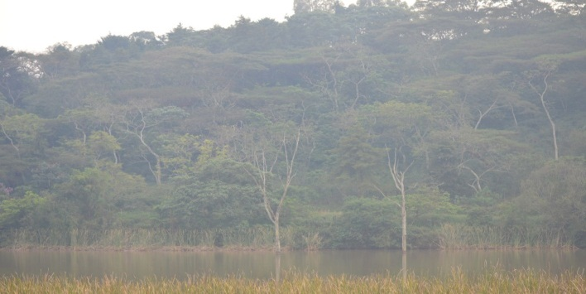
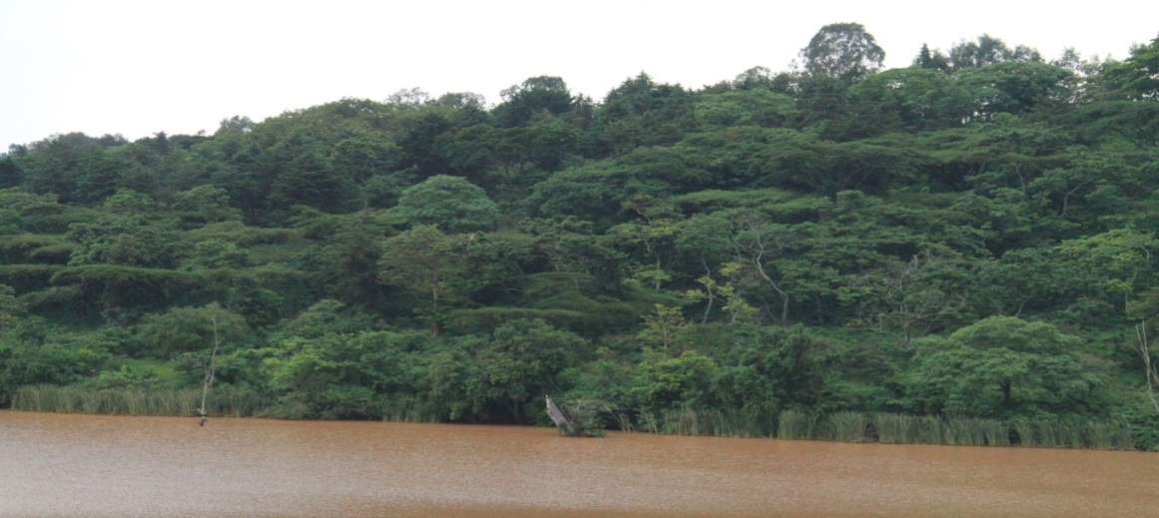
b

Plate 2. Views of woodland a/ dry season b/ wet season

Farmland
The study area is 23 ha surrounded by agricultural land. The farmers live near the forest area make threats to the forest and wild animals living there. The main agricultural productions are Coffee, Sorghum, Wheat, Sunflower, Maize, Potatoes, Tomatoes, Cabbages and also Eucalyptus cultivation. In addition to this farmers keep livestock and the forest is the source of timber, firewood and construction materials for many farmers.(plate 3, a and b)
a
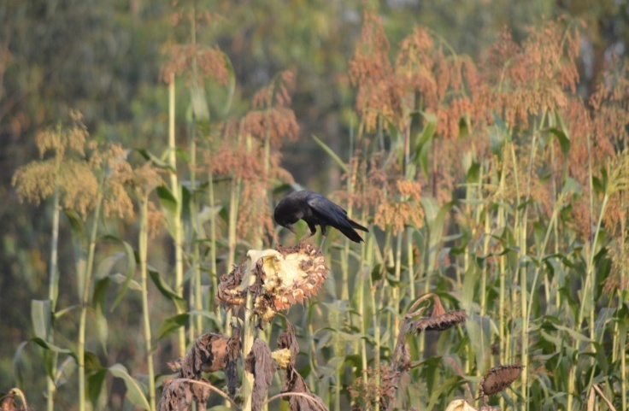
b
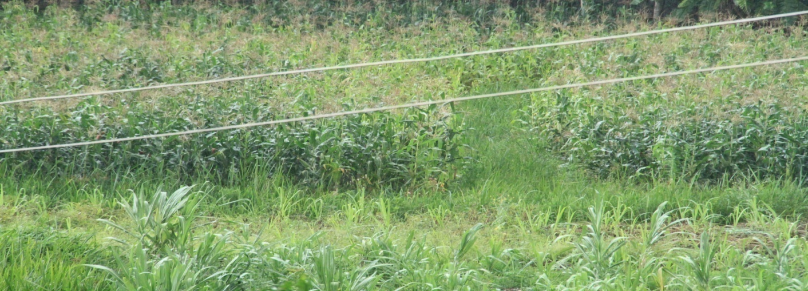 Plate 3. Views of farm land a/ dry season b/ wet season

Climate

Temperature and rainfall record within the study area are lacking. The data used for the description of the climate (temperature and rainfall data) were collected from the Seyo woreda agricultural office.
3.2.1 Temperature
The mean monthly maximum temperature of the area ranged between 26⁰ C and 28⁰C and the mean minimum temperature between 15⁰ C and17⁰C.

Figure2. Monthly mean maximum and minimum temperature of the area (2012-2018)

3.2.2 Rain fall
The rainfall distribution in this area is bimodal with one long rainy season; June to September and the short rainy season March to May. The total amount of annual rainfall in the study area varies between 600 and 1500 mm (Figure 3. ) and the mean annual rainfall of the area is 1050 mm The area receives the highest rainfall during the wet season, May to September and the lowest rainfall during the dry season, October to April.

Figure 3.Monthly mean maximum and minimum rain fall of the area (2012-2018).

- MATERIALS AND METHODS

Materials
The materials that are used during the study period include digital camera, bird field guides Kebede Tadesse handbook (2000 E.C). Geographic Positioning System (GPS), binocular, data sheet and books.

Methods

Preliminary survey
A preliminary survey was conducted in the study area from November 2018 to December 2018 for five days. During the preliminary survey, information about the study area (climatic condition, topography), and approximate size of the study area was gathered from relevant governmental authorities (Kellem Wollega Cultural and Tourism Office, Dembidollo Metrological Station, Oromia Regional State). Different habitat types and representative habitat sites were observed. Habitats of the study area were classified into wetland, woodland and farmland. During the study, each habitat type was classified into blocks. Although, 7 blocks were selected from habitat types of the study area, representative blocks were selected for actual survey among the habitat types at random to make sure that the results are generally representatives of the whole study area. There were three blocks from wetland, two blocks from woodland and two blocks from farmland.

Method of data collection
Data were collected using methods by walking through habitat blocks by using direct count and point count method. The actual field work was carried out from January 2019 to June 2019during the wet and dry seasons. A total of 24 transect lines systematically established in the present study the distance between one transect and another twenty meter for wetland, woodland and farmland. In addition to line transect method six point counts were also used for the woodland habitat. The length and width of transect varied based on the visibility of habitat and its accessibility. As the result, in the wood land habitat transects length of 60 m with a width of 30 m, in wetland habitat transects length of 45m with a width of 20 m, and in farmland habitat 30m with a width of 10m was used. During observations of birds, species name, numbers of individuals of each species observed, time, location and vegetation types were recorded. Observation of birds was made by direct observation with naked eye or aided by binoculars (7x50mm). Data were collected by observing the study area twice a day early in the morning from 6:30-9:30 A.M and late in the afternoon 2:30-5:30 P.M.when the activity of birds were prominent. To minimize disturbance during count, a waiting period of 3 to 5 minutes prior to counting was applied (Sutherland, 2000; Hosteler, 2001).
Point count sampling methods were also used in the woodland. For one of the two blocks of woodland which is at the border of the dam, a total of, six point counts places were identified. All six point count stations were surveyed four times during the study period. The point count within the sample unit was 150m far from each other, and had a radius of 25m to avoid double counting (Ralph et al. 1985)

Data analysis
The species diversity of each habitat of the seasons of the area analyzed using Shannon- Wiener diversity Index (Shannon and Wiener, 1949). Shannon-Wiener diversity Index is calculated as:
𝐻′ = - Σ [(xln ( )] where:
𝐻′ = Shannon-Wiener diversity Index
ni = number of individuals of each species (the i^{th} species) and
N = total number of individuals for the site, and
ln = the natural log of number.
Species evenness, which measures the pattern of distribution of the bird populations that present in the area, was evaluated using Shannon-Wiener evenness Index (E) as follows:
Where: E = Shannon-Wiener Evenness Index
H’ = Shannon-Wiener diversity Index
H_{max} = ln S= natural logarithm of the total number of species (S) in each site (Brown et al., 2008).
Diversity indices measure the degree of uncertainty (if the diversity is high in a given habitat, the sureness of finding a particular species is low). In reference to the composition of species, Simpson’s similarity index (SI) used to assess the similarity of species between two different habitats, and season by using the formula
(Shaheen, et al., 2001):
SI=where, SI = Simpson’s similarity index
A = Number of species that occur in site A
B = Number of species that occur in site B
C = Number of species shared by A and B

4.2.4 Species abundance analysis
The abundance of avian species were determined using encounter rates that give crude ordinal scales of abundance as abundant, common, frequent, uncommon and rare, which is calculated as follows (Bibby et al., 1998) :-
$$Encounter rate=\frac{Total number of individual bird observed}{Period of observation in Hour}x100$$
The relative abundance of avian species was determined using encounter rates that give crude ordinal scales of abundance as abundant, common, frequent, uncommon and rare (Bibby et al., 1998). Accordingly bird species with encounter rates <0.1, 1-2.0, 2.1-10.0, 10.1-40, >40 were classified as rare, uncommon, frequent, common and abundant respectively
. Table 1.Encounter rates used to give a crude ordinal scale of abundance
Abundance Category | Abundance score | Ordinal scale
Less than 0.1 | 1 | Rare
0.1–2.0 | 2 | Uncommon
2.1–10.0 | 3 | Frequent
10.1–40.0 | 4 | Common
Greater than 40.0 | 5 | Abundant

.

RESULTS
A total of 88 species of birds belonging to 39 Families were recorded from all study sites during both wet and dry seasons. Majority of bird species are found under the family Accipitridae (11 species) followed by Columbidae (10 species) and the lowest is found under the family Alaudidae (1 species), Buccrotidae (1 species), Oriontidae (1 species) and Malacontidae (1 species). Among the total number, 32 species were recorded during the dry season, 24 species during the wet season and 32 were observed during both seasons. From these; two species are endemic; namely; Abyssinian cat bird and Abyssinian long claw, and five species are near to endemic namely; White collared pigeon, White billed starling, Black-Winged Loved Bird, Wattled ibis and Thick billed raven (Table 1).

Table 2 Bird species recorded during wet and dry seasons from the study area.
No | Family |  | Bird species |  | Dry Season | Wet Season | Both Seasons
No |  |  | Common name | Scientific name | Dry Season | Wet Season | Both Seasons
1 | Bucerotidae |  | Abyssinian ground-Hornbill | Bucorvus abyssinicus |  |  | *
2 | Timaliidae |  | Abyssinian Catbird ∆ | Parophasma galinieri | *
3 | Oriolidae |  | Abyssinian long Claw ∆ | Macronyx flavicollis |  |  | *
4 | Fringillidae |  | African citril | Serinus citrinelloides |  |  | *
5 | Accipitridae |  | African fish-eagle ¥ | Haliaeetus vocifer |  | *
6 | Accipitridae |  | African goshawk | Accipiter tachiro |  | *
7 | Accipitridae |  | African Harrier-Hawk | Polyboroi destypus |  | *
8 | Columbidae |  | African collared-dove | Streptopeliaro seogrisea |  |  | *
9 | Accipitridae |  | Augur buzzard | Buteo augur | *
10 | Estrildidae |  | Black-rumped waxbill | Estrilda troglodytes | *
11 | Ardeidae |  | Black headed heron ¥ | Ardeamelano cephala |  | *
12 | Pasittacidae |  | Black-Winged love Bird♣ | Agapornis taranta | *
13 | Accipitridae |  | Black kite ® | Milvus migrans |  | *
14 | Accipitridae |  | Black sparrowhawk | Accipiter melanoleucus |  | *
15 | Nectariniidae |  | Beautiful sunbird | Cnnyris pulchellus | *
16 | Picidae |  | Bearded woodpecker | Dendropicos namaquus |  | *
17 | Cuculidae |  | Black Cuckoo | Cuculus clamosus | *
18 | Cuculidae |  | Blue-headed Coucal | Centropus monachus |  |  | *
19 | Coliidae |  | Blue-napedmousebird | Urocolius macrourus |  | *
20 | Meropidae |  | Blue-breastedBeeeater® | Merops variegates |  | *
21 | Phylloscopidae |  | Brownwoodland-warbler | Phylloscopus umbrovirens |  |  | *
22 | Columbidae |  | Cape turtle | Streptopelia capicola | *
23 | Phasionidae |  | Crested francolin | Francolinus sephaena | *
24 | Phasionidae |  | Common quail | Coturnix coturnix |  |  | *
25 | Pycnonotidae |  | Common bulbul | Pycnonotus barbatus | *
26 | Ardeidae |  | Cattle egret ® | Bubulcus ibis |  |  | *
27 | Columbidae |  | Dusky turtle-dove | Strepto pelialugens |  | *
28 | Anatidae |  | Egyptian goose ¥ | Alopochen aegyptiaca | *
29 | Alaudidae |  | Fischer’s Sparrow Lark | Eremopterix leucopareia | *
30 | Sturnidae |  | Greater blue-eared  Starling | Lamprotornis chalybaeus | *
31 | Turdidae |  | Groundscraper thrush | Psophocichla litsipsirupa |  |  | *
32 | Ardeidae |  | Grey heron ¥ | Ardae cinerea |  | *
33 | Indicatordae |  | Greater honey guide | Indicator indicator |  |  | *
34 | Acrocephalidae |  | Great reed-warbler | Acrocephalus arundinaceus |  | *
35 | Scopidae |  | Hamerkop | Scopus umbretta | *
36 | Numididae |  | Helmeted guineafowl | Numida meleagris |  |  | *
37 | Accipitridae |  | Hooded vulture | Necrosyrtes monachus |  | *
38 | Acrocephalidae |  | Icterine warbler | Hippolaisi cterina |  |  | *
39 | Accipitridae |  | Lappet-faced vulture | Torgos tracheliotus | *
40 | Accipitridae |  | Long-crested eagle | Lophaetus occipitals |  |  | *
41 | Columbidae |  | Lauphing dove | Streroptopelia senegalensis | *
42 | Laniidae |  | Lesser gray shrike | Lanius minors |  |  | *
43 | Ploceidae |  | Little weaver | Ploceus luteolus | *
44 | Motacillidae |  | Long-billed Pipit | Anthis similes | *
45 | Laniidae |  | Masked shrike | Lanius minors |  | *
46 | Columbidae |  | Mourning collared-dove | Strepto peliadecipiens |  | *
47 | Picidae |  | Nubian wood peaker | Campethera nubica |  |  | *
48 | Necctariniidae |  | Olive sunbird | Cyanomitra olivacea | *
49 | Cisticolidae |  | Pectoral-patch Cisticola | Cisticola brunnescens | *
50 | Columbidae |  | Red-eyed dove | Streptopelia semitorquata |  |  | *
51 | Campephagidae |  | Red-shouldered cuckooshrike | Campephaga phoenicea |  |  | *
52 | Muscicapidae |  | Rueppell's robin-chat | Cossyph asemirufa | *
53 | Ploceidae |  | Red-collared widowbird | Euplecte sardens | *
54 | Sturnidae |  | Ruppell’s starling | Lamprotoris purpuropterus |  |  | *
55 | Accipitridae |  | Ruppell’s vulture | Gyps rueppellii |  |  | *
56 | Columbidae |  | Speckled pigion | Columba guinea |  |  | *
57 | Muscicapidae |  | Spotted Flycatcher | Muscicapa striata |  | *
58 | Nectariniidae |  | Scarlet chested Sunbird | Chalcomitra senegalensis |  | *
59 | Nectariniidae |  | Shining Sunbird | Cinnyris habessinicus |  | *
60 | Lybiidae |  | Banded barbet | Lybius undatus | *
61 | Picidae |  | Wattled ibis♣ | Bostrychia carunculata |  |  | *
62 | Phylloscopidae |  | Wood warbler | Phylloscopus sibilatrix |  |  | *
63 | Accipitridae |  | White-backed vulture | Gyps africanus | *
64 | Alcedinidae |  | Woodland Kingfisher | Halcyon senegalensis | *
65 | Gruidae |  | Wattled crane | Bugeranus carunculatus |  |  | *
66 | Columbidae |  | White collared Pigeon♣ | Columba albitorgues | *
67 | Sturnidae |  | White billed Starling♣ | Onlychognathus albirostris |  |  | *
68 | Fringillidae |  | Yellow-fronted canary | Serinus mozambicus | *
69 | Columbidae |  | Lemon Dove | Columba larvata |  | *
70 | Turdidae |  | Olive Thrush | Turdus olivaceus |  | *
71 | Ploceidae |  | Red – headed Weaver | Anapllctes rubriceps |  | *
72 | Ploceidae |  | Red-billed Quelea ® | Quelea quelea |  |  | *
73 | Columbidae |  | Speckled pigeon | Collumba guinea |  |  | *
74 | Motacillidae |  | Yellow wagtail ® | Motacclla flava | *
75 | Paridae |  | White winged Black-Tit | Melamiparus leucomelas |  |  | *
76 | Apodidae | Spur-winged goose |  | Plectropterus gambensis | *
77 | Muscicapidae | AbyssinianSlaty-Flycatcher |  | Melaenornis variegates |  | *
78 | Estrildidae | African firefinch |  | Laagonosticta rubricata |  |  | ⃰
79 | Charadriidae | Crowned plovr |  | Vanellus coronatus | ⃰
80 | Ciconiiformes | Marabous stork | Leptoptilos crumeniferus | ⃰
81 | Anatidae | White faced duck | Dendrocygna viduuta |  |  | ⃰
82 | Turdidae | African trush | Tardus pelios | ⃰
83 | Estrildidae | Redchecked cordon blue | Eracginthus bengalus |  | ⃰
84 | Cisticolidae | Greybackedcamaroptera | Camaroptera brevicaudata |  |  | ⃰
85 | Ploceidae | Red bishop ® | Euplectes orik | ⃰
86 | Corvidae | Thick billed raven♣ | Corrus albicollis |  |  | ⃰
87 | Apodidae | Red crow | Corvus albus |  | ⃰
88 | Corvidae | Dwarf raven | Corvus edithae |  |  | ⃰

NB: ∆ =Endemic ♣ = Near to endemic ® = Migrant ¥ = Resident

Unmarked = Resident and partially Migrant

Species Diversity
Variation in the number of bird species was observed among the three habitats during the wet and dry seasons. During the wet season, the highest number of species was recorded from farmland (51) followed by wetland (49) and woodland (37). During the dry season, the highest number of bird species was recorded from wetland (56) followed farmland (44) and woodland (43). The highest diversity of bird species was recorded in the wetland (H’ =3.94) followed by farmland (H’=3.45) and the lowest diversity of species was found in the woodland (H’=3.02) during wet season. During the dry season, the wet land habitat (H’=4.10) supported the highest diversity and followed by farmland (H’=3.42). The least diversity of birds was recorded in the woodland (H’=3.21) as in the wet season. The highest and lowest evenness was observed in the wetland (E=0.95 and 0.99). The highest and the lowest evenness was observed in the wood land (E=0.865 and 0.83) and both during the dry and wet season respectively (Table 2)
Table3. Bird species diversity index (H’), species richness (S) and evenness (E) in different habitat types during wet and dry season
Habitat | Season | Species richness(S) | H’ | H _{max} | E= H’/H_{max}
Wetland | Wet | 49 | 3.94 | 3.97 | 0.99
Wetland | Dry | 56 | 4.106 | 4.32 | 0.95
Woodland | Wet | 37 | 3.02 | 3.61 | 0.83
Woodland | Dry | 43 | 3.21 | 3.76 | 0.865
Farmland | Wet | 51 | 3.45 | 3.93 | 0.87
Farmland | Dry | 44 | 3.42 | 3.78 | 0.878

H’= Shannon-Wiener Index, H’ max= ln S = ln (total number of species), H’/H’max =Evenness (E)

Species Richness
Variation in the number of species was observed among the three different habitats and between seasons in the same habitat. The highest species number was recorded in the wet land habitat (56) during dry season and followed by farm land (44). The least species number was recorded in the wood land habitat (43) during the dry season.
During the wet season highest species number recorded from farmland (51), followed by wetland (49) and least number of species were recorded from woodland (37). (Fig.5)

Figure 4.Bird species richness in different habitat

Species Similarity
Bird species similarity between different habitats showed variations between seasons. During the wet season more species similarity was seen between species of woodland and farmland (SI=0.487). Least similarity was observed between woodland and wetland (SI=0.342) (Table 3). During the dry season the highest similarity was also observed between woodland and farmland (SI=0.522) and least similarity was between wetland and woodland (SI=0.379) (Table 4).
Table4. Bird species similarity between habitats during the wet and dry seasons
Habitats |  | Wetland |  |  | Woodland |  |  | Farmland
 |  |  |  |  | wet |  | Dry | wet dry
Wetland |  | = |  |  | 0.342 | o.379 |  | 0.344 o.45
Woodland |  | = |  |  | = |  |  | 0.487 o.522

In the study area, birds showed variation in their distribution among the three habitats. Highest number of species was observed in wetland (56), followed by farmland (44) and woodland (43) during the dry season. Nine bird species were recorded in all three habitat types during this season. During the wet season, 49, 37, 51 bird species were recorded in wetland, woodland and farmland, respectively and seven bird species were recorded in all the three habitat types. Among the three habitat types, maximum value of seasonal bird species similarity was observed in the farmland (SI=0.884) followed by wetland (SI=0.81). The minimum value of bird species similarity was observed in wood land (SI=0.57.5) (Table 5).
Table2. Seasonal species similarity (SI) within the habitats type of Borta Dam and its surrounding
Habitat |  | Wet | Dry |  | No of common species during both seasons | SI |  |  | %
Wetland |  | 49 | 56 |  | 43 | 0.81 |  |  | 81
Woodland |  | 37 | 43 |  | 23 | 0.575 |  |  | 57.5
Farmland |  | 51 | 44 |  | 42 | 0.884 |  |  | 88.4

Distribution
The total number of species recorded in the study area during the wet and dry seasons was 88. Some species were restricted to a single habitat while others occupy two or more habitats. The highest number of species was recorded from the farmland habitat during the wet season while the wetland habitat had the highest number during the dry season. The lowest species number was registered from the woodland during the wet and dry season respectively (Table 6)

Table 6: Distribution of different bird species in the three habitats recorded .
 | Family | Bird species |  | Wetland |  | Woodland |  | Farmland
 | Family | Common name | Scientific name
 |  |  |  | dry | wet | dry | wet | Dry | Wet
1 | Bucerotidae | Abyssinian ground-Hornbill | Bucorvus abyssinicus | √ |  |  |  | √ | √
2 | Timaliidae | Abyssinian Catbird ∆ | Parophasma galinieri | √ | √
3 | Oriolidae | Abyssinian long Claw ∆ | Macronyx flavicollis | √ | √
4 | Fringillidae | African citril | Serinus citrinelloides | √ | √
5 | Accipitridae | African fish-eagle ¥ | Haliaeetus vocifer | √ | √ | √ | √
6 | Accipitridae | African goshawk | Accipiter tachiro |  | √ | √ | √
7 | Accipitridae | African Harrier-Hawk | Polyboroides typus |  |  | √ |  | √ | √
8 | Columbidae | African collared-dove | Streptopelia roseogrisea | √ | √ | √ | √ | √ | √
9 | Accipitridae | Augur buzzard | Buteo augur | √
10 | Estrildidae | Black-rumped waxbill | Estrilda troglodytes | √ | √
11 | Ardeidae | Black headed heron ¥ | Ardea melanocephala |  |  | √ | √
12 | Pasittacidae | Black-Winged  love Bird ♣ | Agapornis taranta |  |  | √ | √ | √ | √
13 | Accipitridae | Black kite ® | Milvus migrans | √ | √ | √ | √ | √ | √
14 | Accipitridae | Black sparrowhawk | Accipiter melanoleucus |  |  | √ | √ | √ | √
15 | Nectariniidae | Beautiful sunbird | Cnnyris pulchellus |  |  | √ |  | √ | √
16 | Picidae | Bearded woodpecker | Dendropicos namaquus |  |  | √ | √
17 | Cuculidae | Black Cuckoo | Cuculus clamosus | √ | √ | √ | √ | √ | √
18 | Cuculidae | Blue-headed Coucal | Centropus monachus |  |  |  |  | √ | √
19 | Coliidae | Blue-napedmousebird | Urocolius macrourus |  |  | √ | √
20 | Meropidae | Blue-breasted  Bee-eater ® | Merops variegates |  |  | √ | √ |  | √
21 | Phylloscopidae | Brownwood landwarbler | Phylloscopus umbrovirens |  |  | √ | √
22 | Columbidae | Cape turtle | Streptopelia capicola | √ | √ | √ | √
23 | Phasionidae | Crested francolin | Francolinus sephaena | √ | √
24 | Phasionidae | Common quail | Coturnix coturnix | √ | √ |  |  | √ | √
25 | Pycnonotidae | Common bulbul | Pycnonotus barbatus | √ | √
26 | Ardeidae | Cattle egret ® | Bubulcus ibis | √ |  |  |  | √ | √
27 | Columbidae | Dusky turtle-dove | Streptopelia lugens |  |  | √ | √ | √ | √
28 | Anatidae | Egyptian goose ¥ | Alopochen aegyptiaca | √ | √
29 | Alaudidae | Fischer’Sparrow Lark | Eremopterix leucopareia | √ | √
30 | Sturnidae | Greaterblue-eared starling | Lamprotornis chalybaeus |  |  |  |  | √ | √
31 | Turdidae | Groundscraper thrush | Psophocichla litsipsirupa |  |  | √ |  | √ | √
32 | Ardeidae | Grey heron ¥ | Ardae cinerea | √ | √
33 | Indicatordae | Greater honey guide | Indicator indicator |  |  | √ |  | √ | √
34 | Acrocephalidae | Great reed-warbler | Acrocephalus arundinaceus | √ | √ | √ | √
35 | Scopidae | Hamerkop | Scopus umbretta | √ | √
36 | Numididae | Helmeted guineafowl | Numida meleagris |  |  |  |  | √ | √
37 | Accipitridae | Hooded vulture | Necrosyrtes monachus | √ | √ | √ | √ | √ | √
38 | Acrocephalidae | Icterine warbler | Hippolais icterina | √ | √ |  |  | √ | √
39 | Accipitridae | Lappet-faced vulture | Torgos tracheliotus | √
40 | Accipitridae | Long-crested eagle | Lophaetus occipitals |  |  | √ | √ | √ | √
41 | Columbidae | Lauphing dove | Streroptopelia senegalensis |  |  | √ | √ | √ | √
42 | Laniidae | Lesser gray shrike | Lanius minors | √ | √
43 | Ploceidae | Little weaver | Ploceus luteolus | √ | √
44 | Motacillidae | Long-billed Pipit | Anthis similes | √ | √
45 | Laniidae | Masked shrike | Lanius minors |  |  | √ | √
46 | Columbidae | Mourning collared-dove | Streptopelia decipiens |  |  | √ | √ |  | √
47 | Picidae | Nubian wood peaker | Campethera nubica |  |  | √ | √ | √ | √
48 | Necctariniidae | Olive sunbird | Cyanomitra olivacea | √ | √ |  |  | √ | √
49 | Cisticolidae | Pectoral-patch Cisticola | Cisticola brunnescens | √ | √
50 | Columbidae | Red-eyed dove | Streptopelia semitorquata | √ | √
51 | Campephagidae | Red-shouldered cuckooshrike | Campephaga phoenicea | √ | √
52 | Muscicapidae | Rueppell's robin-chat | Cossypha semirufa | √ | √
53 | Ploceidae | Red-collared widowbird | Euplectes ardens | √ | √
54 | Sturnidae | Ruppell’s starling | Lamprotoris purpuropterus |  |  |  |  | √ | √
55 | Accipitridae | Ruppell’s vulture | Gyps rueppellii |  |  |  |  | √ | √
56 | Columbidae | Speckled pigion | Columba guinea |  |  |  |  | √ | √
57 | Muscicapidae | Spotted Flycatcher | Muscicapa striata |  |  | √ | √
58 | Nectariniidae | Scarlet chested Sunbird | Chalcomitra senegalensis |  |  | √ | √ | √ | √
59 | Nectariniidae | Shining Sunbird | Cinnyris habessinicus | √ |  |  |  | √ | √
60 | Lybiidae | Banded barbet | Lybius undatus |  |  |  |  | √ | √
61 | Picidae | Wattled ibis ♣ | Bostrychia carunculata | √ | √ |  |  |  | √
62 | Phylloscopidae | Wood warbler | Phylloscopus sibilatrix |  |  | √ | √ | √ | √
63 | Accipitridae | White-backed vulture | Gyps africanus | √ | √ | √ | √ | √ | √
64 | Alcedinidae | Woodland Kingfisher | Halcyon senegalensis | √
65 | Gruidae | Wattled crane | Bugeranus carunculatus | √ | √ | √ | √
66 | Columbidae | White collared Pigeon ♣ | Columba albitorgues | √ | √
67 | Sturnidae | White billed Starling ♣ | Onlychognathus albirostris | √ | √ |  |  | √ | √
68 | Fringillidae | Yellow-fronted canary | Serinus mozambicus | √ | √
69 | Columbidae | Lemon Dove | Columba larvata |  |  | √ | √ | √ | √
70 | Turdidae | Olive Thrush | Turdus olivaceus | √ | √ | √ | √ | √ | √
71 | Ploceidae | Red – headed Weaver | Anapllctes rubriceps | √ | √ | √ | √
72 | Ploceidae | Red-billed Quelea® | Quelea quelea | √ | √ | √ | √ | √ | √
73 | Columbidae | Speckled pigeon | Collumba guinea |  |  |  |  | √ | √
74 | Motacillidae | Yellow wagtail ® | Motacclla flava |  | √
75 | Paridae | White winged Black-Tit | Melamiparus leucomelas | √ | √ |  |  | √ | √
76 | Apodidae | Spur-winged goose | Plectropterus gambensis | √ | √
77 | Muscicapidae | Abyssinian slatyflycatcher | Melaenornis variegates | √ | √
78 | Estrildidae | African firefinch | Laagonostic tarubricata | √ |  |  |  | √ | √
79 | Charadriidae | Crowned plover | Vanellus coronatus | √ |  |  |  |  | √
80 | Ciconiiformes | Marabous stork | Leptoptilos crumeniferus | √ | √ | √ |  |  | √
81 | Anatidae | White faced duck | Dendrocygn aviduuta | √ | √
82 | Turdidae | African trush | Tardus pelio | √ |  | √ |  | √ | √
83 | Estrildidae | Redcheckedcordon blue | Eracginthus bengalus | √ | √ | √ | √ | √ | √
84 | Cisticolidae | Greybacked camaropte | Camaroptera brevicaudata |  |  | √ | √
85 | Ploceidae | Red bishop ® | Euplectes orik | √ | √ |  |  | √ | √
86 | Corvidae | Thick-billed raven♣ | Corrus albicollis | √ |  |  |  | √ | √
87 | Apodidae | Pied crow | Corvus albus | √ |  |  |  | √ | √
88 | Corvidae | Dwarf raven | Corvus edithae | √ |  | √ |  | √
NB: ∆= Endemic ♣= Near to endemic ® = Migrant ¥ = Resident
Unmarked = Resident and Partially Migrant
Total : 2 = endemic 5 = near to endemic 6 = migrant 4 = resident
71 = Resident and partially migrant
Over all distribution of avian species at Borta Dam and its surrounding.
The distribution of avian family showed variation among habitats. The highest number of bird families were recorded in wetland (17 families) and lowest number of families were recorded in woodland habitats (10 famies) (Table 7).
Table7. Over all distribution of habitat types at Borta Dam and it’s surrounding
Habitat type | Total number of families | Percentage (%)
Woodland | 10 | 25.64
Farmland | 12 | 30.77
Wetland | 17 | 43.59

  - Abundance
Abundance of bird species during wet and dry seasons for all habitats: during the wet season, the numbers of individuals of species recorded were 5408, 710, 96 in wetland, farmland and woodland habitats respectively. During dry season, there were 4994, 4540, 96, individuals in the wetland, woodland and farmland habitats respectively. The mean number of individuals observed was statistically significant difference between habitats (df = 2, F = 9.246, p = 0.029<0.05). This indicates that the difference in habitat had significant effect on the abundance of birds. The significance was observed between wetland and woodland, wetland and farmland, woodland, farmland.
Bird species abundance varied among the habitat types. The highest abundance was recorded in wetland habitat followed by farmland during the wet and dry seasons respectively. The least abundance was recorded in woodland habitat followed by farmland during the wet and dry seasons respectively.

DISCUSSION
A total of 88 bird species belonging to 39 families were recorded from the study area. This may not represent all the bird species present in the study area, but it gives up-to-date information on currently available bird species present in the study sites. Due to this there was difference in the diversity of birds. Differences in habitat characteristics of bird species in the study area are responsible for variation in species diversity, number of species and number of individuals of bird species among different habitats as suggested by (Smith, 1992). MacArthur (1964) stated that a large area could conceivably support many bird species in three rather different ways (vertical, horizontal and temporal). Within homogeneous habitat, the number of layers of vegetation is sufficient to account for the diversity of breeding bird species. When the area includes such major differences as those between sparse and dense vegetation, the number of layers of vegetation is no longer sufficient to account for bird species diversity. The area of the present study is not homogeneous; therefore, the diversity in bird species could be a result of vertical, horizontal and temporal variations as stated by MacArthur (1964).
Among the three habitats of the study area, the highest diversity index ($H^{'}=4.10)$and evenness (E=0.99) were recorded in the wetland habitat, followed by farmland (H’=3.45 and E=0.878) and the least woodland (H’= 3.21 and E =0.865) . This variation observed in the study area could be due to differences in feeding habits and weather condition. Species similarity between seasons was observed in the farmland (SI=0.884) followed by wetland (SI=0.81). This might be due to available source of food, and nesting in both seasons. The minimum value of bird species similarity was observed in the woodland habitat (SI=0.575).This may be due to local migration of birds to the farmland and wetland. Many bird species migrate to take advantage of differences of seasonal temperatures, thereby optimizing availability of food sources and breeding habitat.
Among the three habitat types, more similarity of birds species was obtained from woodland and farmland (SI=0.522) during the dry season and between woodland and farmland (SI=0.487) during wet season. However, less similarity was obtained between species of wetland and woodland (SI= 0.379) during the dry season and between species of wetland and woodland (SI= 0.342) during the wet season. This is due to the differences in feeding adaptation of bird communities in each habitat. In the present study, the distribution of birds showed variation among habitats. Highest number of species was observed in wetland and farmland during wet and dry seasons. This might be due to higher vegetation complexity. Least number of species was recorded in the woodland during both seasons .This may be due local migration of birds to farmland and wetland. The highest abundance was recorded in wetland followed by farmland and the least recorded in woodland followed by farmland habitat in both seasons. This is in line with Agernesh Desalegn and Subramania, C. (2015), who reported that the avian species richness and distribution influenced by vegetation structure determinant factor of avian species richness (Waterhouse et al., 2002).
Most of the birds in the study area were resident and partially migrant, others were migrant and resident. There were also endemic and near to endemic. Majority of the species of birds are common to both seasons, there was significant difference in birds abundance between two season
Expansion of agriculture, lives stock encroachment, deforestation, indiscriminate fire fuel by ever increasing human population has been often cited the major cause of bird’s habitat and fragmentation, over fishing by traditional method in the study area. The forest around the dam is shrinking in size in all direction from time to time. If these treats continue the bird species diversity in the area decline. Discussions with local and direct observation help to assess the effects of such pressures.

CONCLUSION AND RECOMMENDATIONS

Conclusion
The study area was Borta Dam and its surrounding that supports the diverse species of birds in the different habitat types. During the survey, a total of 88 species of birds belonging to 39 families were identified from the study area. The highest number of bird species was recorded from family Accipitridae followed by Columbidae. The high diversity and richness of birds in the study area indicate the importance of these sites for the conservation. Therefore, it can serve as important centre for tourist attraction if properly managed. In addition, the value of similarity index may reflect the extent to which the habitats are similar. The seasonal variation in number of individual species and their distribution in the study area are directly related to the types of habitats.

Recommendations
The Borta Dam was suitable for the survival of various types of bird species and other wild animals. Therefore, to ensure the long-term conservation of wildlife of the area, based on the present study, the following recommendations were suggested:

- To prevent drainage of swap and wetland areas to attract birds for the sources of food and water.
- Awareness creation to the local community to reduce human induced factors such as overgrazing, preventing clearing of forest, cutting forest fires, and agricultural expansion within the area of Borta Dam for the survival of bird species.
- The status of endemic birds that occur around the Borta Dam should be studied in detail. This is important to know whether the species is in danger and to take appropriate conservation measures.
- Dembi Dollo town Administrative body and lutherian missionary should give attention for the conservation this attractive area.
- Additional detailed study of long duration on the diversity and other ecological aspects of the area should be conducted to get detailed information of the area.
References
Agarnesh Desalegn and Subramania, C. (2015).Studies on avian diversity in angereb forest and adjacentfarm land with reference to rainy and post rainy seasons, northwestern Ethiopia International Journal of Pure and Applied Zoology Volume 3, Issue 3, pp: 219-225
Ash, J. and Gullic, T . (1989). The present situation regarding endemic
breeding birds of Ethiopia. Scopus. 13: 90-96.Beale, C. M. (2007).The behavioral ecology of disturbance responses. Intern. J. Compar. Psycho. 20: 111-120.
Berry, M. E., Bock, C. E. and Sandra, L. (1998). Abundance of diurnal raptors on open space grasslands in an urbanized landscape. The Condor 100: 601-608.
Bibby, C. J. (1998). Expendition Field Techniques, Bird Surveys. The Expendition Advisory
center Royal Geographical Society, London, 134 pp.
BLI (2001).Important Bird Areas in Africa and Associated Areas: Priority Sites for Conservation. Cambridge, pp. 1144.
Brown, C., Kingsolver, R. (2008). Measuring Biodiversity. Tennessee Technological University Canterbury, G., Martin, T., Petit, L. and Bradford, D. (2000).Bird communities and habitats are ecological indicators of forest condition in regional monitoring. Cons. Bio. 14:1-14.
Clifford, B., Frith, B. and Beehler, B. (1998). Birds of Paradise. Oxford University Press, Oxford. pp. 613.
Clout, M. and Hay, J. (1989). The importance of birds as browsers, pollinators and seed dispersers in New Zealand forests. New Zealand J. Ecol. 12: 27-32.
Conterburgy, G., Martin, T., Petit, L. and Bradford, D. (2000). Bird communities and habitats are ecological indicators of forest condition in regional monitoring. Cons.Bio. 14:1-14.
Donnelly, R. E. and Marzluff, J. M. (2004). Designing research to advance the management of birds in urbanizing areas. In: Proceedings of 4th International Urban Wildlife Symposium, Washington DC, pp. 114-122.
Estrella, R. R. (2007). Land use changes affect distributional patterns of desert birds in the Baja California Peninsula, Mexico. Diver. Distribu. 13: 877–889.
Furness R., and Greenwood J. (1993). Birds as Monitors of Environmental Change. Chapman and Hall, London, pp.356.
Girma Mengesha,Yoseph Mamo, and Afework Bekele. (2011). A comparison of terrestrial bird community structure in the undisturbed and disturbed areas of the AbijataShalla lakes national park, Ethiopia. International Journal of Biodiversity and Conservation, 3, 389–404.
Hosteler, M. and Martin,M. (2001). Florida Monitoring Program: Transect and Point Count Method for Surveying Birds. University of Florida, Florida, pp.37.
Judd, W. S. Campbell, C. S .and Kellogg, E. A. (2008). Stevens, P. F. and Donoghue, M. J. Plant Systematics: A Phylogenetic Approach, Sinauer Associates, Sunderland, Mass, USA, 3rd edition,
Karr, J. R. and Roth R. R. (1971). Vegetation structure and avian diversity in several New
World Areas. Amer. Natur. 105:423-451.
King, A. S.and Mcleeland(1975).Outlines of Avian Anatomy. Bailliere Tindall. London,pp.46. Klem, D. (1990). Collisions between birds and windows: mortality and prevention. J. Field Ornithol. 61:120-128.
Lee, P. and Rotenberry, J. (2005). Relationships between bird species and tree species assemblages in forested habitats of eastern North America. J. Biogeogra, 32: 1139-1150.
Lanyon, W.E. (1963). Biology 0f Birds. The Natural History Press, New York, pp.175.

Lepage, D. (2009). (a) Avi base-Bird checklists of the world. Bird life International. Downloaded from http://www.bsceoc.org/avibase.
Lepage, D. (2016).(b) Avibase -Bird Checklists of the World- Ethiopia.Retrieved from http://www.bsc- eoc.org.
Lepage, D. (2016).(c) Avibase -Bird Checklists of the World Ethiopia.Birdlife International.Retrieved from http://avibase.bsc eoc.org/checklist.jsp?region=ET.
Loreau, M. (2010). From Population to Ecosystem: Theoretical Foundations for a New Ecological Synthesis.PrincetonUniversity Press, Princeton, pp.300.
MacArthur, R. H. (1964). Environmental factors affecting bird species diversity. Am er.Natur. 98:387-397.
McLay, C.L. (1974). The species diversity of New Zealand forest birds: some possible consequences of the modification of beech forests, New Zeal. J. Zool. 2: 179-96.
Mistry,J. Berardi,A. and Simpson, M.(2008)“Birds as indicators of wetland status and change in the North Rupununi, Guyana,” Biodiversity and Conservation, vol. 17, no. 10, pp. 2383–2409.
Myers, N. (1992). The Primary Source: Tropical Forests and Our Future. Norton, New York.
Padian, K. and Chiappe, L. M. (1998). The origin and early evolution of birds.Biol.Rev.73: 1-42..
Ralph, C.J. (1985). Habitat association patterns of forest and steppe birds on northern Patagonia, Argentina. Cordon.87: 471-483.
Roth, R. (1976). Spatial heterogeneity and bird species diversity.Ecology.57:773-782.
Shaheen, H.,Mulkkhan,S.,Harper,D.M.,Ullah,Z.,andQureshi,R.A.,(2001).Species Diversity, community structure and distribution pattern inwestern Himaliya Alpine pastures of Kashmir, Pakistan. International mountain society. DOI:http://dx.doi.org/10.1659/MRD- JOURNAL-D-10-00091.1URL: http://www .bioone. Org/ doi/full/10.1659/MRD JOURNAL-D- 10- 00091.1
Shannon, C. E and Wiener, N. (1949). The mathematical theory of communication. The University of Illinois, Urbana, 117pp.
Shibru Tedla. (1995).Protected areas management crisis in Ethiopia.Walia.16: 17-30.
Shimelis Aynalem and EWNHS, (1996). Important Bird Areas of A first Inventory Report. Addis Ababa ,297pp .
Shimelis Aynalem and Afework Bekele (2008). Species composition, relative abundance and distribution of bird fauna of riverine and wetland habitats of Infranz and Yiganda at southern tip of Lake Tana, Ethiopia. Tropical Ecology, 49, 199–209
Shimelis Aynalem, Afework Bekele and Abebe Getahun (2008).Species diversity, distribution, relative abundance and habitat association of the avian fauna of modified habitat of Bahir Dar and Debre Mariam Island,Lake Tana,Ethiopia.Int.J.Ecol.Environ.Sci.34:259-267.
Sinclair, I. and Ryan, P. (2003). Birds of Africa South of the Sahara: Field Guides. Princeton University Press, Princeton, pp .759.
Smith, R. (1992). Elements of Ecology.3rd edn. Harper Collins Publishers Ltd, London.
Southwood, T. R. E. and Henderson, P. A. (2000). Ecological Methods.3rd edn. Blackwell Science Ltd., Cambridge. 575pp.
Stevenson,T. and Fanshawe,J. Field Guide to the Birds of East Africa: Kenya, Tanzania, Uganda, Rwanda, Burundi,T&ADPoyser, London, UK, 2002.
Sutherland, W.J. and Green, R.E. (2004).Habitat assessment. In: Bird Ecology and Conservation: A Handbook of Techniques, 2nd edn. Oxford University Press Inc., New York. pp. 405.
Tedla Shibru Tedla . (1995).Protected areas management crisis in Ethiopia.Walia.16: 17-30.
Urfil, A.J., Sen, M., Kalam, A. and Maganathan, T. (2005). Counting birds in India: methodologies and trends, initiatives, International Bird Strike Committee, Amsterdam. Curr. Sci. 89: 25-27.
Van Tyne, J. and Berger, A.(1959). Fundamentals of Ornithology, 2nd edn. John Wiley and Sons, Inc., New York.
Veech, J. A. and Crist, T. O. (2007). Habitat and Climate heterogeneity maintain beta diversity
of birds among land scapes within ecoregions. Glob. Ecol. Biogeogr. 16:650- 656
Waterhouse, F. L., Mather, M. H., and Seip, D. (2002).Distribution and abundance of birds relative to elevation and biogeoclimatic zones in coastal old – growth forests in southern British Columbia. Journal of Ecosystem and Management, 2, 1–13.
WCMC - World Conservation Monitoring Centre (1991). Global Biodiversity: Status of Earth’s Living Resources.Chapman Hall, London.585 pp.
Welty, J. (1975). The Life of Birds, 2nd edn.W.B.Saunders Company, Philadelphia, pp. 645 Willis, E. (1979). The composition of avian communities in reminiscent woodlots in southern Brazil. Auk90: 62-77.Cambridge, pp 575.
Whelan, C. J., Wenny, D. G. and Marquis, R. J. (2008) Ecosystem services provided by birds, Ann. N.Y. Acad. Sci. 1134: 25–60
Yalden, D.W., (1983). The extent of high ground in Ethiopia compared to the rest of Africa. SINET: Ethiopian J. Sci., 6: 35-39. 2
Zerihun Girma, Girma Mengesha, and Tsiyon Asfaw, . (2017). Diversity, relative abundance and distribution of avian fauna in and around Wondo Genet forest, South-central Ethiopia. Res. J. For., 11: 1-12.)
Zerihun Girma, Yoseph Mamo, Girma Mengesha, Verma A, Tsiyon Asfaw (2012 ). Seasonal abundance and habitat use of bird species in and around Wondo Genet Forest,

Appendices
Appendix 1.Point count field data sheet for bird survey
Habitat_____ Date_____ Starting time_____ Finishing time_____
Point of station number | Bird species(Common Name) | Local name | Number of individuals

Appendix2. Line Transect Count Field Data sheet for bird survey
Habitat_____ Date_____ Starting time_____ Finishing time______
Transect number | Bird species(Common Name) | Local name | Number of individuals

Appendix 3 .Number of individual Bird species recorded during wet and dry seasons from the study area.
S.No | Common name | Wetland |  | woodland |  | Farmland
S.No | Common name | D | W | D | W | D | W
1 | Abyssinian ground hornbill | 15 | 10 | 9 | 7 | 33 | 36
2 | Abyssinian Catbird | 22 | - | 5 | - | 11 | -
3 | Abyssinian long Claw | 28 | 14 | 6 | 8 | 8 | 5
4 | African citril | 28 | 19 | 7 | 8 | 9 | 4
5 | African fish-eagle | 36 | 27 | 8 | 5 | 3 | 3
6 | African goshawk | 30 | 27 | - | 7 | 10 | 8
7 | African Harrier-Hawk | - | 37 | - | 5 | - | 11
8 | African collared-dove | - | 39 | - | 9 | - | 7
9 | Augur buzzard | 33 | 42 | 4 | 7 | 5 | 8
10 | Black-rumped waxbill | 39 | - | 5 | - | 18 | -
11 | Black headed heron | 43 | - | 4 | - | 19 | -
12 | Black-Winged love Bird | - | 45 | - | 18 | - | 15
13 | Black kite | 41 | - | 15 | - | 40 | -
14 | Black sparrowhawk | - | 39 | - | 7 | - | 6
15 | Beautiful sunbird | - | 36 | - | 19 | - | 13
16 | Bearded woodpecker | 43 | - | 68 | - | 75 | -
17 | Black Cuckoo | - | 39 | - | 6 | - | 32
18 | Blue-headed Coucal | 52 | - | 17 | - | 18 | -
19 | Blue-napedmousebird | 36 | 32 | 12 | 23 | 12 | 13
20 | Blue-breasted Bee-eater | - | 33 | - | 12 | - | 17
21 | Brownwoodland-warbler | 30 | 32 | 43 | 32 | 18 | 16
22 | Cape turtle | 34 | - | 11 | - | 16 | -
23 | Crested francolin | 38 | - | 9 | - | 17 | -
24 | Common quail | 29 | 32 | 12 | 7 | 21 | 13
25 | Common bulbul | 46 | - | 8 | - | 12 | -
26 | Cattle egret | 32 | 36 | 11 | 9 | 62 | 68
27 | Dusky turtle-dove | - | 46 | - | 13 | - | 16
28 | Egyptian goose | 59 | - | 8 | - | 17 | -
29 | Fischer’s Sparrow Lark | 64 | - | 7 | - | 23 | -
30 | Greater blue-eared starling | 67 | - | 5 | - | 34 | -
31 | Groundscraper thrush | 66 | 68 | 18 | 19 | 23 | 29
32 | Grey heron | - | 36 | - | 6 | - | 17
33 | Greater honey guide | 38 | 34 | 5 | 6 | 26 | 29
34 | Great reed-warbler | - | 62 | - | 8 | - | 18
35 | Hamerkop | 68 | - | 6 | - | 23 | -
36 | Helmeted guineafowl | 46 | 42 | 6 | 5 | 19 | 21
37 | Hooded vulture | - | 46 | - | 7 | - | 24
38 | Icterine warbler | 34 | 32 | 8 | 7 | 33 | 35
39 | Lappet-faced vulture | 36 | - | 5 | - | 39 | -
40 | Long-crested eagle | 38 | 39 | 6 | 7 | 52 | 51
41 | Lauphing dove | 12 | - | 18 | - | 19 | -
42 | Lesser gray shrike | 33 | 36 | 14 | 18 | 12 | 18
43 | Little weaver | 61 | - | 7 | - | 23 | -
44 | Long-billed Pipit | 33 | - | 26 | - | 56 | -
45 | Masked shrike | - | 47 | - | 9 | - | 36
46 | Mourning collared-dove | - | 55 | - | 6 | - | 42
47 | Nubian wood peaker | 43 | 53 | 9 | 14 | 26 | 32
48 | Olive sunbird | 58 | - | 6 | - | 37 | -
49 | Pectoral-patch Cisticola | 61 | - | 5 | - | 42 | -
50 | Red-eyed dove | 46 | 55 | 6 | 7 | 36 | 39
51 | Red-shouldered cuckooshrike | 43 | 53 | 6 | 5 | 38 | 46
52 | Rueppell's robin-chat | 64 | - | 9 | - | 22 | -
53 | Red-collared widowbird | 68 | - | 8 | - | 36 | -
54 | Ruppell’s starling | 38 | 52 | 6 | 8 | 36 | 51
55 | Ruppell’s vulture | 42 | 38 | 4 | 9 | 73 | 79
56 | Speckled pigion | 70 | 68 | 21 | 19 | 81 | 87
57 | Spotted Flycatcher | - | 52 | - | 15 | - | 13
58 | Scarlet chested Sunbird | - | 61 | - | 11 | - | 23
59 | Shining Sunbird | - | 71 | - | 8 | - | 38
60 | Banded barbet | 82 | - | 12 | - | 46 | -
61 | Wattled ibis | 67 | 81 | 18 | 19 | 38 | 46
62 | Wood warbler | 51 | 54 | 33 | 46 | 70 | 69
63 | White-backed vulture | 26 | - | 13 | - | 41 | -
64 | Woodland Kingfisher | - | 35 | - | 40 | - | 36
65 | Wattled crane | - | - | - | - | - | 38
66 | White collared Pigeon | 46 | - | - | - | - | -
67 | White billed Starling | 54 | 51 | 12 | 11 | 29 | 30
68 | Yellow-fronted canary | 73 | - | 8 | - | 77 | -
69 | Lemon Dove | - | 52 | - | 8 | - | 59
70 | Olive Thrush | - | 61 | - | 7 | - | 78
71 | Red – headed Weaver | - | 31 | - | 76 | - | 42
72 | Red-billed Quelea | 32 | 21 | 37 | 46 | 38 | 33
73 | Speckled pigeon | 62 | 56 | 9 | 7 | 79 | 69
74 | Yellow wagtail | 60 | - | 75 | - | 62 | -
75 | White winged Black-Tit | 41 | 46 | 8 | 9 | 69 | 71
76 | Spur-winged goose | 18 | - | 9 | - | 21 | -
77 | AbyssinianSlaty-Flycatcher | - | 84 | - | 8 | - | 86
78 | African firefinch | 27 | - | - | - | 73 | 91
79 | Crowned plover | 10 | - | - | - | 14 | 9
80 | Marabous stork | 46 | 42 | - | - | 16 | 18
81 | White faced duck | 38 | 58 | - | - | - | -
82 | African trush | 17 | - | 13 | - | 76 | 84
83 | Redchecked cordon blue | 25 | 17 | 10 | 12 | 59 | 56
84 | Greybacked camaroptera | 14 | 10 | 16 | 19 | 46 | 38
85 | Red bishop | 24 | 26 | - | - | 45 | 52
86 | Thick-billed raven | 26 | 20 | - | - | 32 | 31
87 | Pred crow | 28 | 26 | - | - | 69 | 66
88 | Dwarf raven | 21 | - | 16 | - | 15 | 17

Appendix 4. Expanssion of farm land
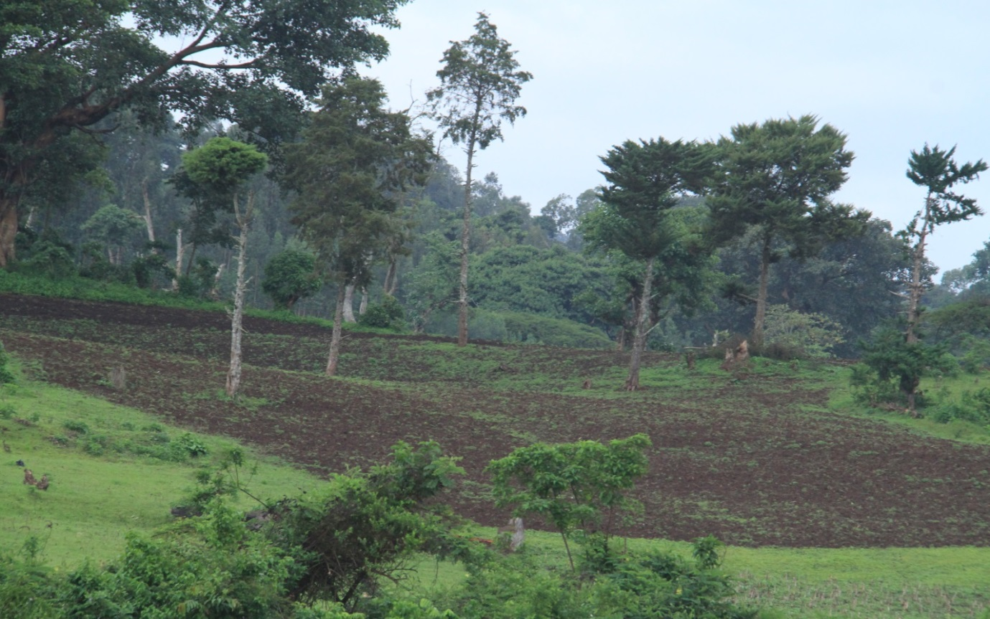

Appendix 5. Some birds of the area
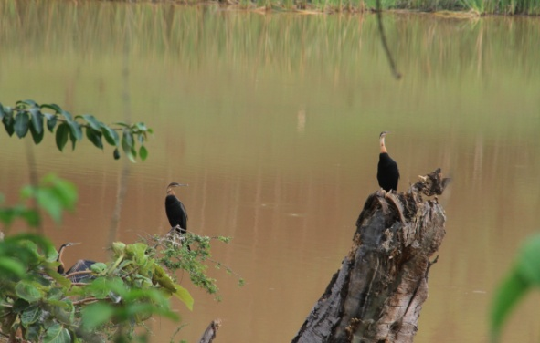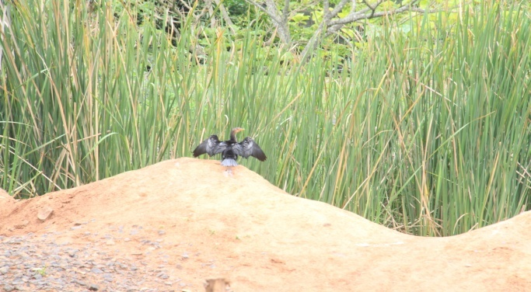
Black headed heron Spur-winged goose
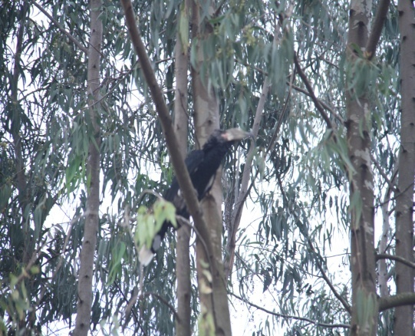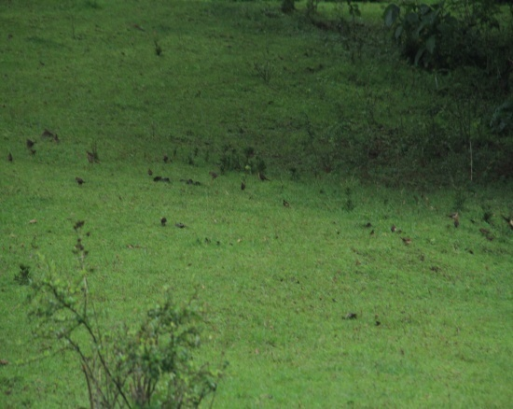Thick billed raven Grey backed camaropte

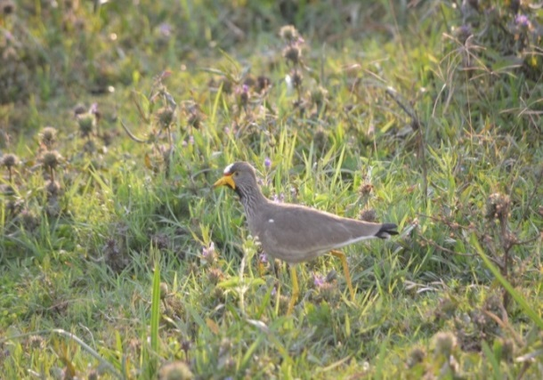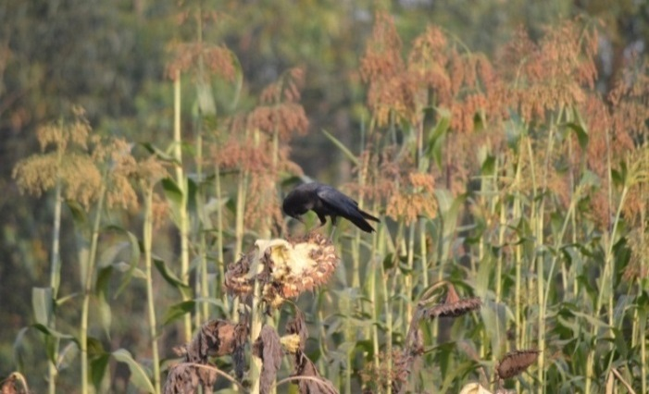
Crowned plover Dwarf raven
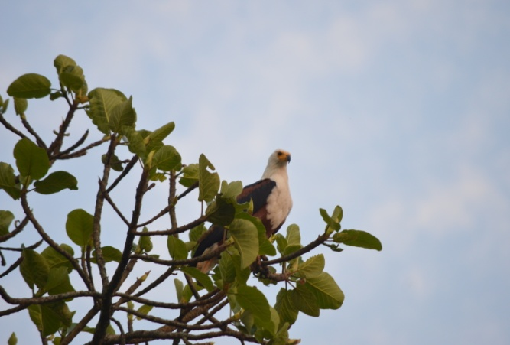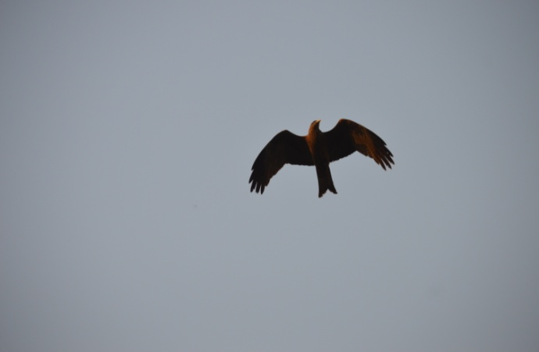
African fish eagle Black kite

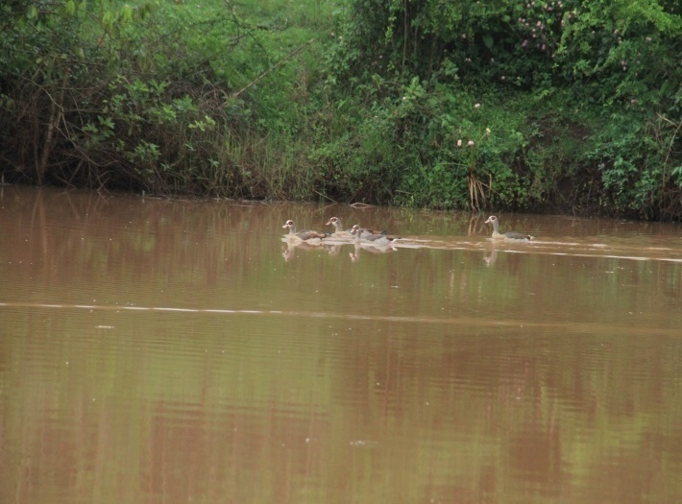
Egyptian goose

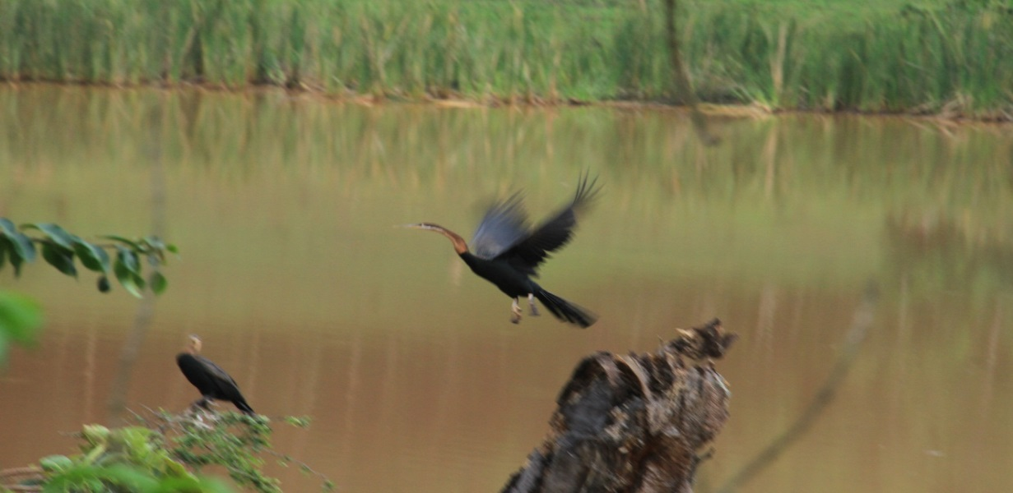
Black headed heron

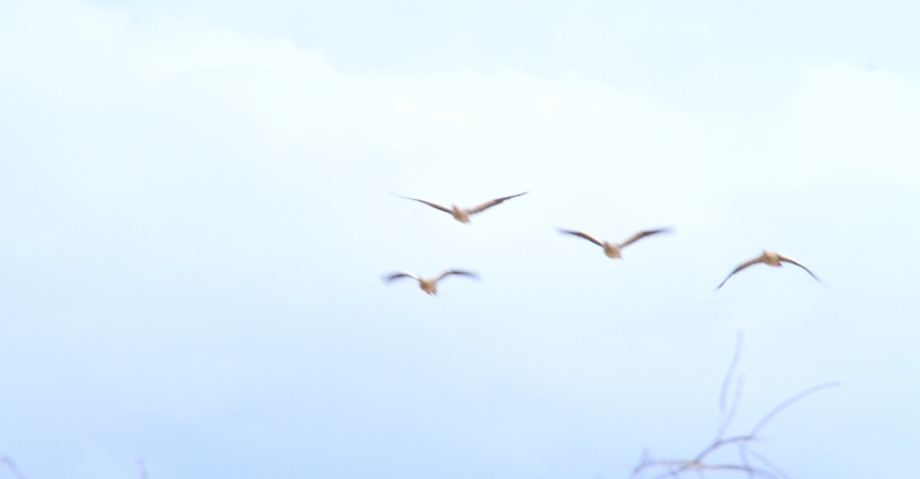
African Fish eagle

Appendix 6. View of the area
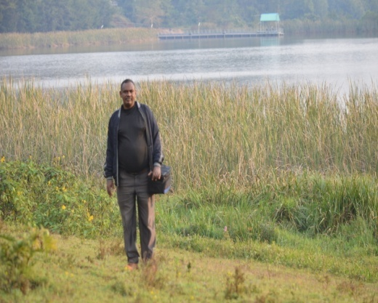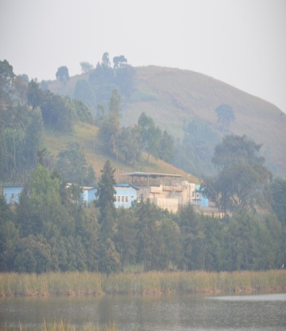
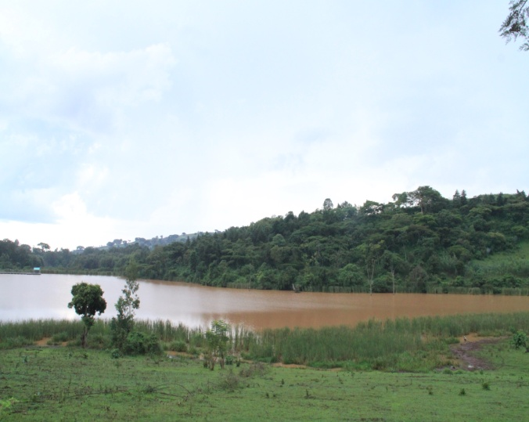

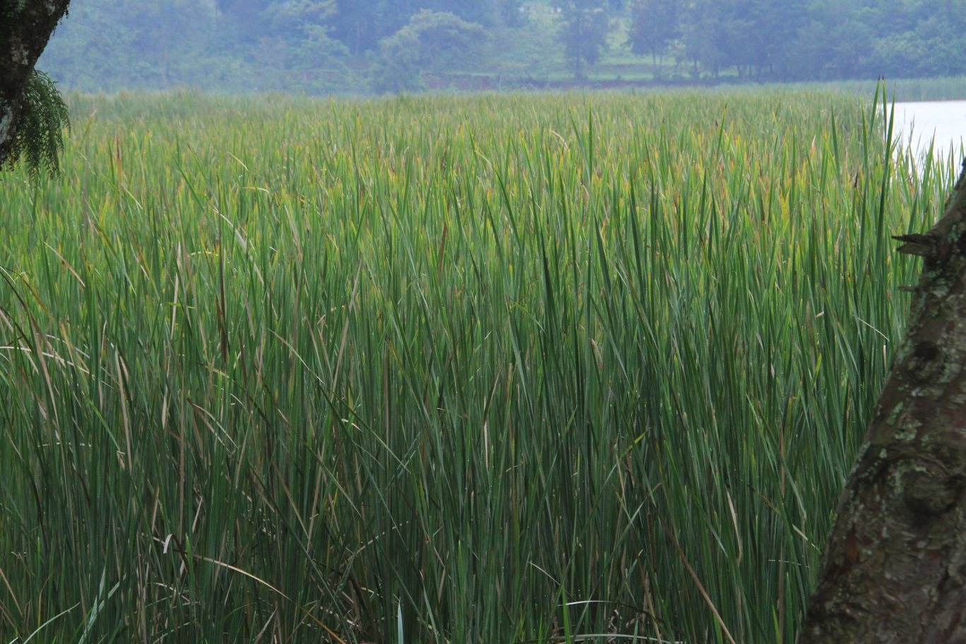 Wetland

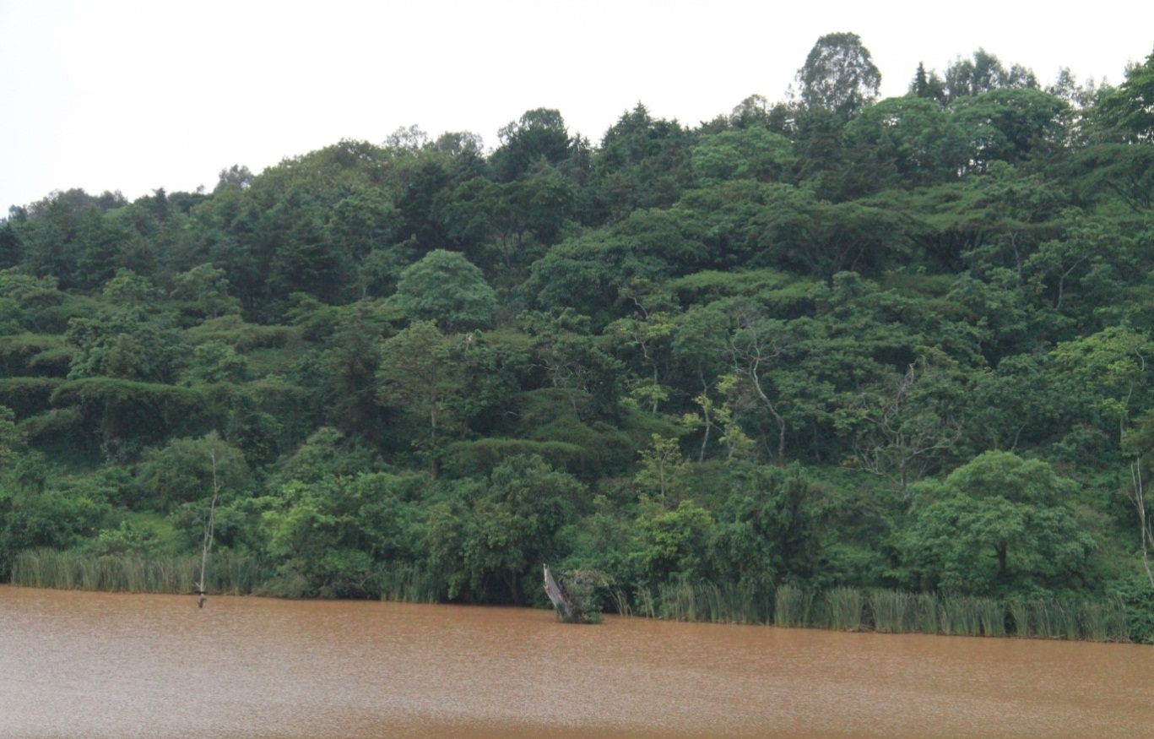

Woodland

