Hydrological and Hydrogeological Characterization of Dawa River Basin, South Central Ethiopia

Fikadu Woldemariyam Wodessa

A Thesis Submitted to
The School of Earth Sciences
Presented in Partial Fulfillment of the Requirement for the Degree of Doctor of Philosophy in Earth Sciences (Hydrogeology)

Addis Ababa University
Addis Ababa, Ethiopia
November, 2016

Addis Ababa University,
School of Graduate Studies

This is to certify that the thesis prepared by Fikadu Woldemariyam Wodessa entitled: Hydrological and Hydrogeological Characterization of Dawa River Basin, South Central Ethiopia and submitted in partial fulfilment of the degree of Doctor of Philosophy in Earth Sciences (Hydrogeology) complies with the regulations of the University and meet the accepted standard with respect to originality and quality.

Signed by the Examining Committee
Prof. Tenalem Ayenew _______________ _________ _______
Principal advisor Signature Date
Dr. Seifu Kebede _______________ _________________
Examiner (Internal) Signature Date
Prof. Dr. Kristine Walraevens _______________ _________________
Examiner (External) Signature Date
Dr. Balemwal Atnafu _______________ _________________
Chair of School Signature Date
Program coordinator

Abstract
Hydrological and Hydrogeological Characterization of Dawa river basin, South Central Ethiopia
Fikadu Woldemariyam
Addis Ababa University, 2016
In the Dawa river basin of southern Ethiopia there is a problem of locating good quantity and quality groundwater particularly in the semi-arid region. Integrated geological, hydrogeological, hydrochemical, and isotopic study together with the preliminary analysis of the river hydrograph were employed to conceptualize hydrological and hydrogeological behavior of the basin giving emphasis to understand the nature of groundwater flow system. Based on litho-structural and hydrogeological data analysis, it is identified that extensive semi-confined multilayer basaltic aquifer, unconfined discrete basement aquifer, and extensive limestone aquifer occur, respectively, in the northern, central, southeastern parts of the study area and the three aquifers do not have strong lateral hydraulic connection. Stable isotope data analysis indicates in the humid to sub-humid region in the north direct recharge occurs from modern local rainfall prior to evaporation, while in the semi-arid region in the south, southwest, and southeast indirect recharge occurs from flush flood which follows the high intensity local rainfall. In the southwest recharge occurs rapidly prior to evaporation; however, in the south and southeast evaporation prior to recharge is significant. The presence of tritium in the groundwater of the study area at amount comparable to modern local rainfall and the dominance of mixed cation-HCO₃ type waters in the volcanic and basement terrain and the sulfate type water marked with high Ca²⁺ and Mg²⁺ in the sedimentary terrain supports groundwater of local, modern recharge, and/or short residence time, implying the dominance of local flow system throughout the river basin. Low recession index of the tributary streams supports rapid groundwater circulation at least in the headwater region. There is no clear signature of geochemical evolution that would indicate the presence of regional flow system along N-S and/or NW-SE transects. This is supported by stable isotope data that in the absence of favorable physical condition for isotopic fractionation and given the general groundwater flow direction towards southeast, isotopic depletion of the groundwater in the south and southeast relative to the groundwater in the north indicates the absence of regional flow system. Measurement of electrical conductivity and preliminary analysis of river hydrograph reveal the dry period river flow is dominantly supplied by the groundwater reservoir in the volcanic terrain. Graphical plots and statistical analysis show water chemistry is highly variable in the basin, signifying the effect of various factors. It is revealed that silicate hydrolysis is the dominant geochemical process in the volcanic and in the most parts of the basement terrain. Sulfide oxidation and sulfate dissolution has an effect on the groundwater chemistry, respectively, in the sulfide rich areas and along the dry riverbeds in the basement terrain. In the sedimentary terrain, gypsum dissolution is the dominant process. Observation of high nitrate concentration in the groundwater reveals the effect of surface contamination sources on water chemistry of the study area. This study highlights the dominant effect of water-rock interaction on the groundwater chemistry and vulnerability of groundwater resources of the basin to pollution sources related to human activity. Overall, converging evidences from different techniques indicate the dominance of local groundwater flow pattern in most parts of the river basin. Due to structural and lithologic factors the traditional regional groundwater flow model which is common in most large river basins of Ethiopia does not hold true in the Dawa river basin. In the upper part of the basin the flow is dominantly topographic-driven. In the middle part structure plays a vital role. The existence of Precambrian basement complex in the middle makes the flow system discontinuous. Hence, both groundwater flow and hydrochemical signatures display extreme variability. This makes the Dawa river basin in a number of ways unique.
Key words: Dawa river basin, Ethiopia, Groundwater recharge, Groundwater flow system, Hydrochemistry, Stable isotope

This work is dedicated to my sister

Firenesh Woldemariyam Wodessa

(1974 – 2013)
Acknowledgment
I am grateful to the School of Earth Sciences, Addis Ababa University, for the support of field logistics and laboratory facilities, and to Ministry of Water Resources, Irrigation and Energy (MoWIE), Geological survey of Ethiopia (GSE), National Meteorological Agency (NMA), and Guji and Borana zone water resources offices for the provision of relevant data free of charge.
I am extremely grateful to the thesis advisor Prof. Dr. Tenalem Ayenew for his guidance, fruitful suggestions, and constructive criticism in the course of this study. I am also very grateful to Dr. Seifu Kebede, ex-head of School of Earth Sciences, for the support and his constructive comments. The members of supervisory committee are highly acknowledged for their close monitoring and constructive comments. Thanks also go to Mr. Dagmawi Shiferaw and Mr. Adane Abebe, chemists in the laboratory of chemical and isotope hydrology. I also value the support, encouragement, and comments of Dr. Gadissa Deyassa and Dr. Tilahun Azagegn, Taye Alemaehu (PhD candidate), Behailu Berhanu (PhD candidate) and his family, Mersha Alemu (PhD candidate), and Mr. Andualem Getawu.
Many thanks also go to Mr. Uraga Woldemariyam, Mr. Satana Utura, and Mr. Gumi Gedo for their contribution to the success of the field works. I am also grateful to Mr. Abdushikur, Mr. Galgalo Halake, and Mr. Desalegn Sali, who are water resources officers in the various districts in the study area, for their support during the field work in the remote areas of the basement and sedimentary terrains. I also thank full to Mr. Adan for his caring motor bike drive while I was working in the remote areas. All friends who directly or indirectly supported the study deserve special appreciation.
Special thanks goes to my beloved wife Basaku Girja Galgalo for her patience through all the hardships of raising alone our young twin kids Galalcha and Diramu. At last, not least, I must give gratitude to my sister Firenesh Woldemariyam, who passed away in 2013, for her special contribution in my life particularly when …. Dear sister, I always remember you.

Table of Contents
Abstract ii
1 Introduction 1
1.1 Background 1
1.2 Previous studies 3
1.3 Description of the study area 6
1.4 Methods 10
1.4.1 Litho-structural characterization 11
1.4.2 River discharge analysis 12
1.4.3 Estimation of groundwater recharge 17
1.4.4 Aquifer configuration and hydraulic properties 19
1.4.5 Hydrochemical and isotopic study 20
1.5 Research objective 25
1.6 Significance of the research 25
2 Geology 27
2.1 Geological history 27
2.2 Lithologic units 29
2.2.1 Precambrian basement rocks 29
2.2.2 Sedimentary sequences 31
2.2.3 Volcanic rock units 35
2.2.4 Alluvial deposits 37
2.3 Geological Structures 37
2.3.1 Faults 38
2.3.2 Lineaments 39
3 River discharge analysis 43
3.1 Introduction 43
3.2 River flow characteristics 43
3.3 Recession analysis 48
3.4 Source-aquifer for dry Period River flow 55
4 Aquifer configuration and hydraulic properties 61
4.1 Introduction 61
4.2 Data: Type, quantity, and distribution 61
4.3 Hydrostratigraphic unit 62
4.3.1 Basaltic aquifer 63
4.3.2 Basement aquifer 71
4.3.3 Limestone aquifer 78
4.3.4 Aquicludes 80
5 Hydrochemistry 83
5.1 Introduction 83
5.2 Hydrochemical characteristics 84
5.3 Factors that affect groundwater chemistry 95
5.3.1 Hydrogeochemical processes 95
5.3.2 Anthropogenic interference 105
5.4 Sources of high salinity 108
5.4.1 Factor analysis 110
6 Environmental Isotope Hydrology 113
6.1 Introduction 113
6.2 Isotopic composition of precipitation 115
6.3 Isotopic composition of surface water 117
6.4 Isotopic composition of groundwater 118
7 Groundwater recharge and flow system 122
7.1 Introduction 122
7.2 Estimation of groundwater recharge 123
7.2.1 Base flow separation method 124
7.2.2 RCD method 127
7.2.3 Chloride mass balance method (CMB) 128
7.2.4 Reliability and uncertainties in estimation of recharge rate 132
7.3 Process of recharge and groundwater flow systems 134
8 Conclusion and recommendation 145
8.1 Conclusion 145
8.2 Recommendations 150
References 152
Annexes 173

List of Figures
Figure 1 Map showing location, elevation, and drainage network of the study area 7
Figure 2 Isoheytal and elevation map of the study area 8
Figure 3 Slope map 9
Figure 4 Distribution of rainfall measuring stations and part of the basin/sub-basin influenced by particular rainfall measuring station 13
Figure 5 Graphical illustration of base flow separation using TIMEPLOT 15
Figure 6 Example period of continuous recession (red line) that RECESS might detect depending on the program user options. 17
Figure 7 Distribution of errors in ionic balance 24
Figure 8 Location of the study area with respect to East African rift system and the Ogaden basin rift system 28
Figure 9 Simplified geological map (lithology and fracture network) of the study area 30
Figure 10 The main fault systems and thickness map of sedimentary rock (above the basement rock) in the Ogaden basin 32
Figure 11 Simplified lithologic log at a El Kuran b Siminto well 33
Figure 12 Geological cross section across a sedimentary terrain in Dawa river basin and its nearby region 34
Figure 13 Geological cross-section along selected transects 36
Figure 14 Detailed fracture map in mafic-ultramafic rocks and volcanosediemtary sequences of the study area 38
Figure 15 Map of lineament density 40
Figure 16 Rose diagram for fracture orientations 41
Figure 17 Daily flow diagram of the tributary streams 45
Figure 18 Typical stream hydrograph showing recession segment 50
Figure 19 Q_{tp} variation for the a Awata Sub-basin, b Mormora sub-basin, c Digati sub-basin, d main Dawa 52
Figure 20 Range of recession indices for the major sub-basins and Dawa at Melka guba 53
Figure 21 MRCs of the head water catchments and the main Dawa 54
Figure 22 EC measuring points 57
Figure 23 River hydrograph 59
Figure 24 Hydrostratigraphic unit of the study area 62
Figure 25 Selected borehole logs showing nature of volcanic rocks of the study area 63
Figure 26 Schematic cross-sections representative of the southeastern part of the volcanic terrain showing lithologic framework and spring locations 65
Figure 28 Spatial plot of well yield along with well depth 67
Figure 27 Plot of well yield against well depth 67
Figure 29 Typical drawdown-time curves showing a multi-layer aquifer system of the volcanic terrain 68
Figure 30 Groundwater flow direction in the basaltic aquifer 70
Figure 31 Spatial relationships between fracture lines, stream lines, and productive water wells 72
Figure 32 Groundwater flow direction in the basement terrain 73
Figure 33 Box plot of well yield per major climatic regime in the basement terrain 75
Figure 34 Spatial distributions of well yield and transmissivity in the basement terrain 76
Figure 35 Plot of well yield against well depth from the limestone terrain 80
Figure 36 Groundwater flow direction in the sedimentary terrain 81
Figure 37 Location of hydrochemical data points 84
Figure 38 Box plots of major ions from volcanic (v), basement (b), and sedimentary (s) terrains 85
Figure 39 Spatial variations of a EC in µS/cm b HCO₃⁻ in mg/l 86
Figure 40 Dendogram of HCA showing associations between samples 88
Figure 41 Spatial distributions of clusters (or samples) along with elevation 89
Figure 42 Average of water quality variables from CI through CV 91
Figure 43 Piper plots of hydrochemical data 92
Figure 44 Plots of a Na⁺/Cl– versus TDS b Ca²⁺/Mg²⁺ versus TDS c and d Ca²⁺ against HCO₃– e Ca²⁺ + Mg²⁺ against HCO₃– f SI (saturation indices)_dolomite versus SI_calcite g Ca²⁺ + Mg²⁺ against HCO₃– + SO₄^{2–} h Ca²⁺ versus SO₄²⁻ 99
Figure 45 Spatial distributions of nitrate concentrations 107
Figure 46 Plots of a δ¹⁸O versus TDS and b Cl–/Br– versus TDS of selected samples 109
Figure 47 Sampling locations for stable isotope of a River and rainfall b Groundwater 114
Figure 48 sampling locations for Tritium 115
Figure 49 Scatter plots of δ²H and δ¹⁸O of local rainfall 116
Figure 50 a, b Altitude versus stable isotopes of rainfall of the study area; 117
Figure 51a, b Altitudinal variations of stable isotopes in groundwater of the study area 119
Figure 52 Plot of isotope data on δ²H versus δ¹⁸O diagram along with spatial distribution 120
Figure 53 Location of sampling point for chloride content, hydrometerological stations, and sub-basins 123
Figure 54 Recession-curve displacement method to estimate recharge in response to a recharge event 129
Figure 55 Spatial distributions of mean annual recharge estimated based on CMB approach 130
Figure 56 Chemical characteristics along selected dry riverbeds 140

List of tables
Table 1 Range of available river flow data and periods of data gap 12
Table 2 Rainfall measuring stations and range of rainfall records used in this study 14
Table 3 Mean monthly river flow 43
Table 4 Total flow, Base flow, and Base flow index for main Dawa measured at Melkaguba and major tributary rivers 44
Table 5 Equation of the best fitting liner trend line of each MRC 55
Table 6 EC of the dry period river flow of year 2014 56
Table 7 Statistical summary of TDS of groundwater of the area 56
Table 8 Type and quantity of data used 62
Table 9 Statistical summary of analysis results of well hydraulic data (representative of basaltic aquifer) 65
Table 10 Statistical summary of well hydraulic data (from basement terrain) 74
Table 11 Summary of water quality parameters 85
Table 12 Statistical summary of hydrochemical parameters of groundwater of clusters resulted from Q-mode HCA analysis 90
Table 13 Groundwater types of the study area 94
Table 14 Correlation coefficients between water quality variables 97
Table 15 Factor loadings after rotation for the maximum variance, Eigen values, percent of variance, and cumulative variance 110
Table 16 Summary of environmental isotopes of rainfall and groundwater 117
Table 17 Recharge estimate for headwater sub-basins of Dawa using base flow separation method 126

List of plates
Plate 1 Typical dry stream filled with sand 37
Plate 2 Typical quartz vein intruded into weak zones in Meta-volcanic rocks of southern Ethiopia 42
Plate 3 Exposure of columnar joints in the basaltic terrain 64
Plate 4 Typical spring at basalt-basement contact line 69
Plate 5 a, b Fractured limestone surface view c cross-section view 78

List of Annexes
A 1 Abstracts of published articles 174
A 2 Mean monthly rainfall data of the study area 176
A 3 Mean monthly discharge (m³/s) of Awata River 177
A 4 Mean monthly discharge (m³/s) of Mormora River 177
A 5 Mean monthly discharge (m³/s) of Digati River 178
A 6 Mean monthly discharge (m3/s) of main Dawa River 178
A 7 Inventory of well yield, SWL, Depth to First Water Strike (DFWS), estimated Transmissivity (T), Drawdown (DD), Specific storage (S), and Specific capacity (S_{c}) – Volcanic terrain 179
A 8 Lithologic log related data from basement terrain 180
A 9 Inventory of well depth (m), yield (l/s) and SWL (m) from sedimentary terrain 184
A 10 Values of Transmissivity based on pump test and empirical formula 185
A 11 Inventory of spring discharge 186
A 12 Typical S-shape Time-Drawdown curve 186
A 13 Potentiometeric surface and general groundwater flow direction 187
A 14 Chemical data 188
A 15 δ¹⁸O and δ²H, tritium data for groundwater 192
A 16 δ¹⁸O and δ²H, tritium data for surface water 193
A 17 Tritium data of rainwater 193
A 18 Stable isotopes data of rainfall of the southern Ethiopia 194
A 19 Calculated point recharge using CMB 195
A 20 Cl⁻/Br⁻ ratio for some of the samples in the study area 196

List of Acronyms
AAU Addis Ababa University
AAS Atomic Absorption Spectrophotometer
CMB Chloride Mass Balance
DEM Digital Elevation Model
DFWS Depth to First Water Strike
DMBR Depth to Massive Bedrock
EC Electrical Conductivity
ENVI Environment for Visualizing Image
ETM+ Enhanced Thematic Mapper Plus
FA Factor Analysis
GIS Geographic Information System
GMWL Global Meteoric Water Line
GNIP Global Network for isotopes in precipitation
GSE Geological Survey of Ethiopia
HCA Hierarchal Cluster Analysis
IAEA International Atomic Energy Agency
l/s Liters per second
LMa Types of Loose Materials
LMWL Local Meteoric Water Line
masl meters above sea level
m²/d meter square per day
m³/s meter cube per second
Ma million years
MA Main aquifer
meq/l milliequivalent per liter
mg/l milligrams per liter
mm/y millimeters per year
MRC Master Recession Curve
MoWIE Ministry of Water, Irrigation, and Energy
n number of data
NMA National Meteorological Agency
RCD Recession-Curve-Displacement
S Specific storage
SES School of Earth Sciences
SI Saturation Index
S_{y} Specific yield
T Transmissivity
TDS Total Dissolved Solids
TLM Thickness of Loose Material
TU Tritium Unit
USGS United States Geological Survey
UV/Vis Ultraviolet/Visible
V-SMOW Vienna Standard Mean Oceanic Water
WD Well Depth
WHO World Health Organization
WMO World Meteorological Organization

Introduction

Background
Ethiopia is a country with complex topography, diversified climate, and spatially variable water resources potential. The country is covered by a variety of volcanic rocks, basement complex, and sedimentary rock sequences that provide aquifer system of highly variable potential. These physical and climatic heterogeneity challenges groundwater exploitation programs in the country (Alemayehu, 2006).
The basin studied here is Dawa river basin that is located in southern Ethiopia which is part of the East African landmass that has been influenced by multiple geological events. One of the major geological events is collision between eastern and western Gondwana, also called East African Orogeny that has occurred between 870 and 550 Ma (Kusky et al, 2003; Kröner and Stern, 2004). Periodic rifting and subsequent ocean transgression of Phanerozoic eon (Guiraud et al., 2005) is another major event. The former event has emplaced basement rocks that consist of metamorphic rocks and igneous intrusions in the central parts of the study area, while the later geological processes have emplaced volcanic rocks and sedimentary sequences, respectively, at the northwestern and southeastern part of the basin. In relation to these geological events the basin is affected by faults of various ages and folding of multiple episodes.
The study area is characterized by diversified topography. The maximum and minimum elevation is 3089 meters above sea level (masl) and 169 masl, respectively. The northern and northwestern highland is characterized by ridges and associated gorges, while the southern, southwestern, and southeastern parts of the area is characterized by a leveled ground with scattered hills and low relief elongated valleys. Climatic condition is also diversified–humid condition in the highland region in the north and semiarid to arid condition in the south, southwest, and southeast. The highland region usually enjoys high amount of rainfall, while the southern half of the basin receives erratic and little amount of rainfall, even as low as 200 mm near the border with Kenya and Somalia. Large portion of the basin is usually affected by frequent drought. In general, agriculture activity is common in the highland part of the study area and in some localities in the semi-arid region where soil moisture allows. Groundwater is the major source of water for domestic use and animal watering in the rural areas and for most of the towns in the basin.
Owing to the diversified geology, physiography, and climatic condition, the basin is characterized by complex hydrogeological system which challenges locating groundwater of good quantity and quality in most parts of the river basin. In spite of hydrogeological complexity, no detailed study is available dealing with hydrogeological behavior of the river basin. The present study aims to improve hydrogeological understanding by giving emphasis to the characterization of nature of groundwater recharge and flow systems and identification of major hydrogechemical processes and factors that control groundwater quality in the research area.

Previous studies
Several geological studies have been carried out in the Dawa river basin and its surroundings thanks to the anticipated mineral and petroleum potential in the region. The basin is geologically mapped at the scale of 1:250,000 as part of the Genale-Dawa river basin master plan study (Ministry of Water, Irrigation, and Energy (MoWIE), 2007). Geology of the basement terrain of the study area is studied and mapped at the scale of 1:250,000 by Geological Survey of Ethiopia (GSE) as well (Hassen et al., 1991; Awoke and Hailu, 2007; Hussen, 2009). Individual investigators (Gilboy, 1970; Chater, 1971; Kazmin, 1972; Hamrla, 1977; Kazmin et al., 1978; Warden and Horke, 1984; Woldehaimanot and Behrmann, 1995; Worku and Schandelmeier, 1996; Yibas, 2000) have also studied geology of selected areas in the basement terrain. Many studies such as Greitzer (1970), Beltrandi and Pyre (1972), Assefa (1988), Work (1988), Habtezgi (1989), Worku and Astin (1991), Geleta (1998), and Hunegnaw et al. (1998) have dealt with geology of sedimentary sequences of the study area and its surroundings. Volcanic rocks of the study area, which is part of Ethiopian trap series volcanic, was studied by Kazmin (1972), Zanettin and Justin-Visentin (1974), Zanettin and Piccirillo (1978), and Mohr and Zanettin (1988). These geological studies have been found to be important to conceptualize geological evolution and for the compilation of the geological map of the basin.
With regard to hydrology and hydrogeology of the basin, only few regional scale studies can be mentioned. Belete et al (2000), Kiflu and Bacha (2011), Zekarias et al (2011), and Zewide and Nahusenay (2011), have studied hydrogeology of selected areas in southern Ethiopia that includes parts of the Dawa river basin. The more regional work that includes the whole parts of the study area is the Genale-Dawa integrated river basin master plan study (MoWIE, 2007). The emphasis of these works was to characterize water quality from water use point of view and to assess groundwater potential based on qualitative evaluation of rocks. Subsequently, volcanic rocks, basement complexes, and sedimentary formations of the study area have been grouped into high to moderate, low, and moderate to low groundwater potential zones, respectively. It has been also concluded that groundwater quality in semi-arid and arid parts of the study area is bad.
There are also some works at the scale of country level that contains little hydrogeological information of parts of the study area. In general, Precambrian rocks of Ethiopia, which also covers the central part of the study area, are impermeable (Kazmin, 1975) and groundwater occurs and circulates through fractures (Kazmin, 1975; Cherinet, 1993; Kebede, 2013; Deyassa et al., 2014). On the other hand, Cherinet (1993) underlined the concern that granitic masses and quartz veins emplaced along fractures may block groundwater circulation. Relatively more information is available regarding hydrogeology of volcanic rocks than the basement rocks at least in other parts of the country. Productivity of these rocks considerably varies from place to place depending on the degree of fracturing and buried river gravel. According to Alemayehu (2006), well yield varies in the range of 1 to 5.6 lit/sec.
Evaluation of the previous studies reveals the available hydrogeological knowledge of Dawa river basin is inadequate to develop a detailed hydrogeological conceptual model, particularly, to understand the nature of groundwater flow systems, process of recharge, and factors controlling groundwater quality.
In principle, groundwater flows from recharge to discharge area at local, intermediate, and/or regional scale whereby the scale of flow is determined by topography and hydraulic characteristics of underlying rocks (Tóth, 1963; Bugliosi, 1999). Regional flow is important to supply lowland aquifers (Todd and Mays, 2004; Kebede et al., 2007) and, therefore, valuable for the occurrence of good quantity groundwater particularly in semiarid and arid climatic conditions where local recharge is believed to be scant (Bisson and Lehr, 2004). In the Dawa river basin, due to the complexity in the geology of the river basin, which is expressed by diversified lithology and structural framework, the applicability of the regional groundwater flow model which is developed and/or used elsewhere by the experts in the field of hydrogeology is not clear and, hence, worth detail investigation.
From community problem point view, poor water quality, geological complexity, and topographical and climatic diversity also urge detailed hydrogeological and hydrogeochemical investigation to improve efficiency of sitting groundwater of good quality and quantity. Moreover, with expected population growth in the future, more water wells are need to be drilled and this attracts more animals and wastes to accumulate around the water points particularly in the dry areas. Besides, in recent times agricultural practice is expanding in the valley bottoms where soil moisture allows. Transformation from nomadic way of living to agriculture-based economy may increases use of agricultural fertilizers which can pollute groundwater resources of the area. These urge clear understanding of aquifer vulnerability to pollution from surface contamination sources.
On the other hand, the basin is drained solely by the Dawa River and its tributaries. The river water is a source of water for rural community and towns such as Shakisso and Adola. In the coming years, it is believed that the river water is a potential source of water supply for many other towns in the basin and surrounding areas (MoWIE 2007). Moreover, according to MoWIE (2007), there is also a plan to use the river water to irrigate the floodplain of Dawa to improve the livelihood of households residing in the arid environment. Despite the importance of the river water for the socio-economic development, no previous studies are available to explain questions like “aquifers of which terrain (volcanic, basement or sedimentary) sustains dry period flow of Dawa river?” and “how about hydrogeological behavior of this aquifer?” This information is critically important for wise water use and management in the basin.
Therefore, in the present study effort has been given to minimize knowledge gap based on converging evidences from geological, hydrogeological, hydrochemical, environmental isotopes, and river discharge data analysis.

Description of the study area
Dawa river basin is located in the Horn of Africa bounded by latitudes 3.92°–6.47° N and longitudes 38.02°–42.08° E. It covers a total area of 58,961 km² in three countries–Ethiopia, Kenya, and Somalia. The studied part of the basin covers 81% of the total area that falls within Ethiopian Territory (Fig. 1). Upstream of Melkaguba gauging station (see Fig. 3 for location on the map) surface area is 19,665 km².
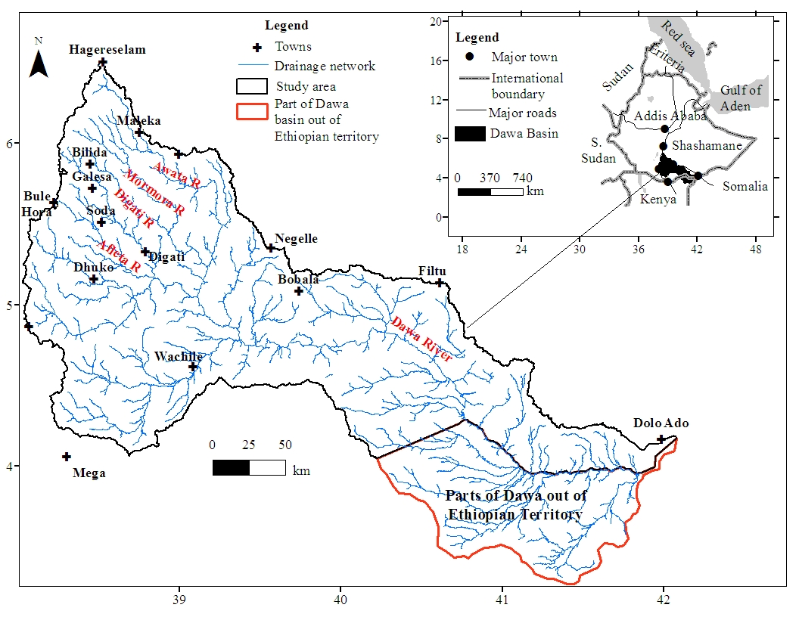Figure 1 Map showing location, elevation, and drainage network of the study area
The maximum elevation is 3089 masl at the northwestern end and the minimum elevation is 169 masl near the river outlet in southeastern end. The general surface inclination is toward southeast. The drainage map of the study area is presented in Fig. 1. Awata, Mormora, and Digati are the only perennial tributary rivers to main Dawa and covers, respectively, 1635, 1330, and 2379 km² upstream of the respective gauging stations. Many of the other streams, particularly, those located in the arid and semiarid part of the study area supply water only during extreme rainfall events as flush floods and the channels are mostly filled with alluvial deposits.
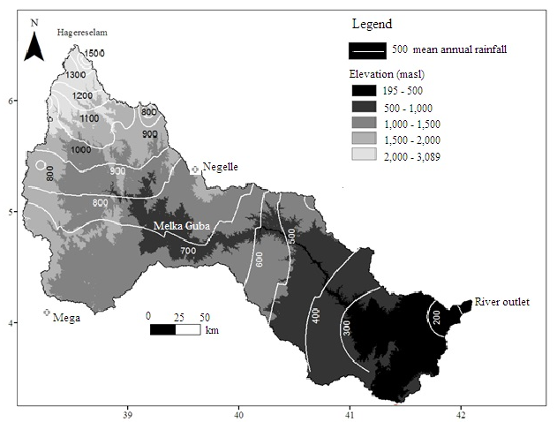
Figure 2 Isoheytal and elevation map of the study area
Northern, central, and southeastern parts of the study area are characterized by humid, semi-arid, and arid climatic condition, respectively (Gamachu, 1977). Mean annual rainfall is about 1500 mm in the Northern end and it decreases southward reaching 200 mm per annum near the river outlet (Fig. 2). Awata, Mormora, and Digati sub-basin enjoys 1223, 1027, and 926 mm of rainfall per annum, respectively. Rainfall of the area exhibits bi-modal pattern with maximum and minimum rainfall peak in May and October, respectively. The long-term annual mean temperature is 15.5 °c above 2,000 masl and 28 °c below 500 masl.
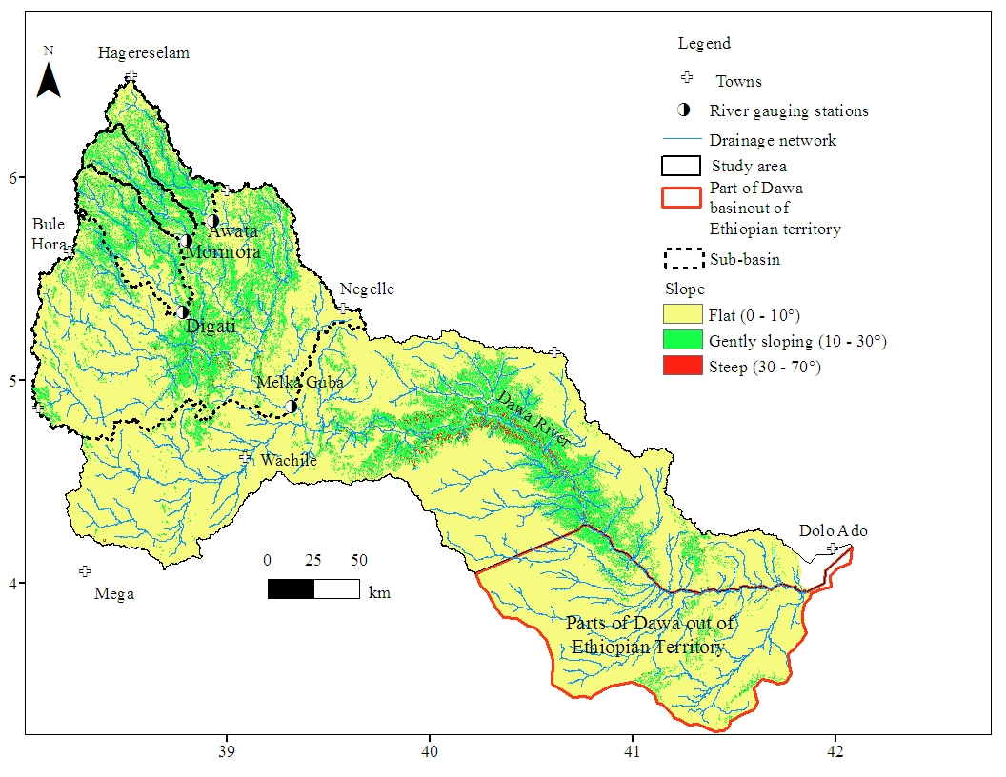
Figure 3 Slope map
Undulating ground is a typical topography in northern part of the volcanic terrain. Toward south volcanic plateau is highly dissected by major tributaries of Dawa River and, hence, marked with elongated parallel basalt-caped ridges and associated gorges (Fig. 2). The north-central part of the basin is known by the so called fold belts (Yibas, 2000) which is characterized by series of valleys and associated ridges forming very complex rugged topography. In general, ground with gentle slope, with slope in the range of 10–30°, characterizes the northern and north-central parts of the study area. Southwestern and southeastern parts of the study area are characterized by flat land, slope less than 10°, with local steep slope adjacent to the channel of main Dawa River (Fig. 3). Of the three headwater sub-basins, relatively Digati possesses extensive flat land in its southern part (Fig. 3).

Methods
Due to the complex lithological and structural setup and the limited data situation in the basin it is difficult to address the aforementioned scientific problems with a single hydrological or hydrogeological method. Therefore, existing theories and knowledge in the field of geology, hydrogeology, hydrochemistry, isotope hydrology, hydrology, and Geographic Information System (GIS) and remote sensing have been used to interpret data by converging evidences from the different methods.
Attention was given to the collection of secondary data and interpretation of satellite images during desk study. Geological and hydrogeological maps and associated reports were reviewed; borehole lithologic logs, pumping test data, water point inventory data, results of water chemical analysis, river discharge data, records of rainfall and temperature have been analyzed. Following the desk study, two major field works have been carried out during the dry period of 2013 and 2014. Informal frequent field visits have also been carried out when required. During field activities water samples were collected and geological and hydrogeolgical observation and measurement have been made. Emphasis has been given to the study of the nature of fractures, lithologic contact, spring characterization, and to the measurements of groundwater level, pH, temperature, Total Dissolved Solids (TDS), and electrical conductivity (EC).

Litho-structural characterization
Simplified lithological and structural maps were constructed based on the previous works complemented by the preliminary field observations. Review of the previous geological study has also enabled conceptualization of geological evolution and litho-structural setup of the study area. Borehole logs were analyzed to characterize stratigraphy at specific locations. Along selected transects elevation of lithological contacts between the major rock units were noted; type and physical characteristics of the rocks were described; and trends of the major fractures were measured. Records of the contact elevations and analysis of the borehole logs enabled to construct the geological cross-section along the selected transects.
In the present study, lineaments, mainly fractures, were compiled from the previous geological works. Verification was done by analyses of Landsat 7 Enhanced Thematic Mapper Plus (ETM+) image of January 2001 using Environment for Visualizing Image (ENVI) version 4.7 software. Enhanced color composite of bands were directionally filtered and overlaid on the shaded relief image which was derived from Digital Elevation Model (DEM) data in ArcGIS 10 software. The lineaments were then extracted using on-screen manual digitizing. To show orientations of the major lineaments, rose diagrams were constructed by RockWorks 16 software using shape files as input data. Furthermore, lineament density map were constructed from the shape file using ArcGIS 10 graphic software.

River discharge analysis
Data source and range of records
Long-term daily river flow records of the main Dawa and of the three major tributary rivers–Awata, Mormora, and Digati – were obtained from the database of MoWIE of Ethiopia. Location of the river flow measuring stations is shown in Figure 3. Rainfall data is obtained from National Meteorological Agency (NMA) of Ethiopia. For each sub-basin and main Dawa areal depth of rainfall is estimated by Theisson polygon method using spatial analyst tool in ArcGIS 10. The distribution of the rainfall data and the surface area influenced by a particular rainfall measuring station is shown in Figure 4. Range of records and periods of data gap for river flow and rainfall data are given in Table 1 and Table 2, respectively. The mean rainfall data and mean monthly river flow of tributary rivers and main Dawa are presented in annex A2 and A3-A6, respectively.
Table 1 Range of available river flow data and periods of data gap
S.N | station | Range (YYY) | Period of data gap  (YYY/MM/DD)
1 | Awata near Shakiso | 1986-2007 | 1991/06/21 to 1991/08/10
2 | Mormora near Megado | 1982-2003 | 1982/01/01 to 1984/03/31; 1993/05/17 to 1993/08/07; 2000/10/29 to 2000/11/23; 2001/01/01 to 2001/01/27
3 | Digati near Digati town | 1999-2007 | 2000/02/20 to 2000/04/29; 2005/06/05 to 2005/10/30; 2007/09/09 to 2007/12/31
4 | Main Dawa at Melkaguba | 1987-2007 | 1988/02/07 to 1988/04/14; 1991/01/01 to 1991/03/23; 1991/06/15 to 1991/07/31; 1992/08/10 to 1993/07/29; 2001/01/01 to 2001/03/24
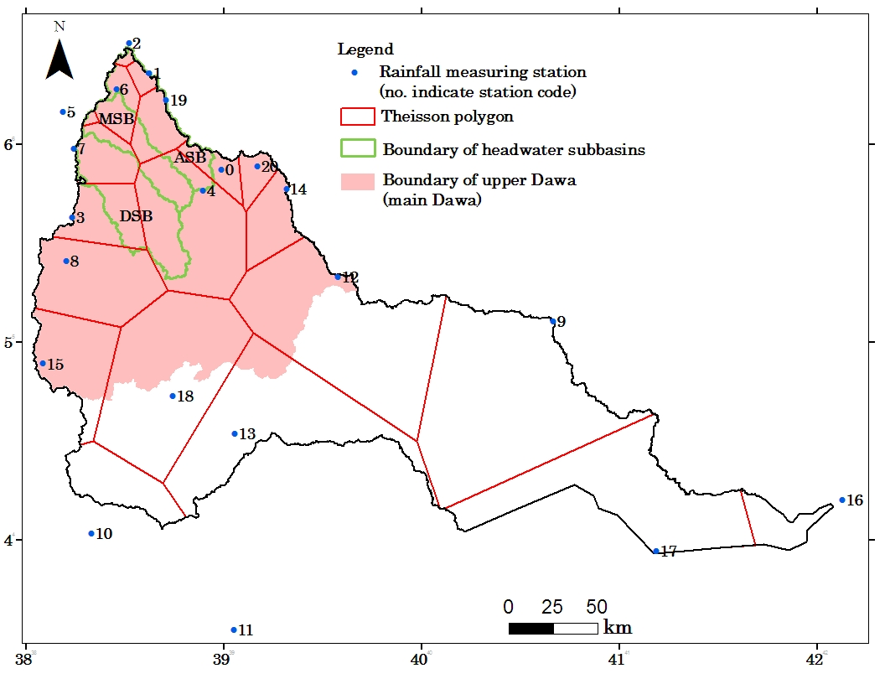
Figure 4 Distribution of rainfall measuring stations and part of the basin/sub-basin influenced by particular rainfall measuring station; (ASB Awata sub-basin, MSB Mormora sub-basin, DSB Digati sub-basin; name of each station is given in Table 2)
Base flow separation
Groundwater component of the river flow, i.e. base flow, was separated from the quick flow using TIMEPLOT excel spreadsheet developed based on a recursive digital filter, commonly used in signal analysis and processing (Lyne and Hollick, 1979). The filter is of the simple form:
$f_{k}=af_{k-1}+ \frac{(1+a)}{2} (y_{k}-y_{k-1})$ (1)
where, f_{k} is the filtered quick response at the k_{th} sampling instant, y_{k} is the orginal streamflow, and a is the filter parameter; the filtered base flow is thus defined as y_{k} - f_{k}. Use of this technique rests merely on the fact that filtering out high-frequency signals is intuitively analogues to the separation of low-frequency base flow from the high frequencies of quick flow. This filter has also been described in detail by Nathan and McMahon (1990).
Table 2 Rainfall measuring stations and range of rainfall records used in this study
Station code | Station | Longitude | Latitude | Range of Rainfall Data
0 | Adola Rede | 38.986 | 5.874 | 1987-2008, 2010-2013
1 | Bore | 38.623 | 6.363 | 2000-2013
2 | Hagerselam | 38.518 | 6.515 | 1965-4972
3 | Bule Hora | 38.229 | 5.631 | 1975-2013
4 | Shakiso | 38.895 | 5.769 | 1975-2004
5 | Yirgacheffe | 38.188 | 6.167 | 1970-2001
6 | Bule | 38.456 | 6.283 | 2003-2013
7 | Gedeb | 38.239 | 5.982 | 1981-1993,1995-2011
8 | Finchawuha | 38.202 | 5.413 | 1987-1991, 1993-2013
9 | Filtu | 40.665 | 5.108 | 1987-1999
10 | Mega | 38.326 | 4.039 | 1989-1991, 1993-2012
11 | Moyale | 39.051 | 3.551 | 1979-2000
12 | Nagele | 39.576 | 5.333 | 1964-1990, 1993-2013
13 | Wachile | 39.055 | 4.541 | 1989-1992
14 | Wadera | 39.315 | 5.779 | 1973-2009
15 | Yabelo | 38.085 | 4.894 | 1987-2013
16 | Dolo Ado | 42.126 | 4.205 | 1989-1994
17 | Sede | 41.184 | 3.945 | 2000-2013
18 | Arero | 38.743 | 4.732 | 1987-2000
19 | Yirbamouda | 38.705 | 6.227 | 1975-2008
20 | Zenbaba wuha | 39.168 | 5.892 | 1980-1997

TIMEPLOT accepts daily records of river flow of a single year and separates it into daily base and quick flow. After base flow is determined separately for each year, the mean monthly and mean annual base flow is calculated. The typical graphical illustration of TIMEPLOT is shown in the Figure 5 for the daily flow of particular year of Mormora River.
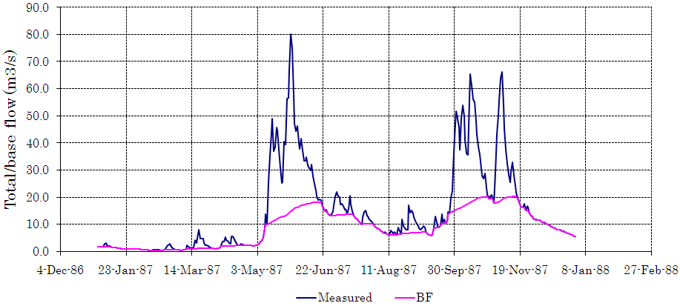
Figure 5 Graphical illustration of base flow separation using TIMEPLOT
Recession analysis
For each gauging station, recession segments of stream hydrograph were analyzed for the evaluation of basin-scale groundwater discharge-storage characteristics. Recession segments were analyzed based on the linear reservoir model of groundwater discharge on the basis of procedures presented in Bevans (1986), Nathan and McMahon (1990), Mau and Winter (1997), and Fetter (2004). In the present study, RECESS computer program was used to filter and plot recession segments and to calculate recession index.
The RECESS program is an empirical method for describing recession characteristics. The program scans the stream flow dataset and finds periods of continuous recession, such as the period defined by the red line on Figure 6. When a segment found, the program user can decide whether it should be analyzed and, if so, which parts represent near-linear conditions (on the semi-log plot) that can be used to quantify the recession index. In the Figure 6, for example, the selection might be the period indicated by the red line. Sometimes during the first few days of the recession, if the influence of direct-surface runoff or instability of the groundwater-head profile or both is suspected, this part of recession shall be ignored. After the user has selected a segment, the program will calculate a mathematical expression shown in equation (eq.) 1.
t = K₁ x LogQ + K₂ (1)
where t is times in days, LogQ is the logarithm of the flow in meter cube per second (m³/s), and K₁ and K₂ are coefficients that are determined by linear regression. This expression is used to derive the recession index (days/ log cycle), which is the absolute value of K₁. After this solution is obtained the program proceeds to the next period of continuous recession, and repeats this process until a number of segments have been analyzed.
The program has a tool to plot the identified recession segments as presented in Figure 20 (section 3.2) and produces text files that contains recession index (k) of each segment and statistical summary, such as min, max, median and mean values, of the dataset. Detail description of the program is given in Rutledge (1998). This approach of recession analysis is widely used in different geological environment (Rutledge and Mesko, 1996). Variation of k-values around median value is determined by statistica software version 8.
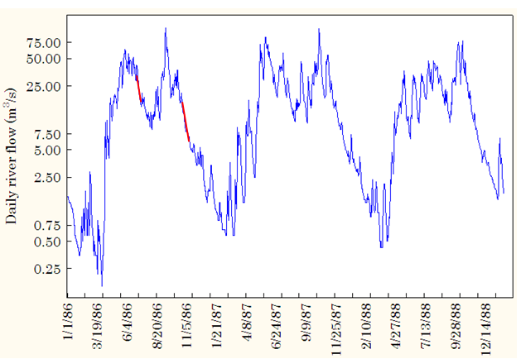
Figure 6 Example period of continuous recession (red line) that RECESS might detect depending on the program user options. (The stream flow data is Mormora flow measured near Megado)

Estimation of groundwater recharge
Methods such as base flow separation, Recession-Curve-Displacement (RCD), and Chloride Mass Balance (CMB) were employed for the estimation of groundwater recharge rate in the study area. Groundwater component of the river flow, i.e. base flow, which is derived from the hydrograph separation, was taken as an estimate of a catchment-scale minimum recharge rate with assumptions that where most streams are gaining and the water table is near the land surface, the majority of ground-water recharge ultimately discharges as stream flow (Rorabaugh, 1964; Mau and Winter, 1997; Halford and Mayer, 2000; Risser et al., 2005; Holtschlag, 1997; Daniel, 1996), with implicit losses of groundwater by pumping, evapotranspiration, underflow to deep aquifers, and in any other way, from a watershed is minimal (Risser et al., 2005).
RCD assumes one-dimensional analytical model of groundwater discharge (Mau and Winter, 1997; Fetter, 2004) to estimate groundwater recharge. It is based on calculation of recharge for each pick in stream hydrograph in order to estimate total recharge (Rutledge and Daniel, 1994; Chen and Lee, 2003). In the present study, a computer program called RORA was used to calculate the basin-scale recharge. The program scans the streamflow data and identifies periods of groundwater flow recession. The program then defines a peak as the largest streamflow between two consecutive periods of groundwater flow recession, and considers that peak to be a recharge event. The recharge is calculated for each peak by use of procedures diagrammed as shown in Figure 55 (Section 7.2.2). Detail description of the program is given in Rutledge (1998). Both the base flow separation and the RCD method yield areal estimate of groundwater recharge.
Point recharge rate was determined using CMB method for the most parts of the study area. Areal depth of mean annual rainfall and chloride concentration of both local rainfall and groundwater are the data required for the calculation of point recharge using CMB method. To minimize the error related to the estimation of chloride data, chloride concentration of the groundwater in undeveloped area was considered in the calculation. Detail description of each of the recharge estimation method used in the presented study is given in section 7.2.1, 7.2.2, and 7.2.3.

Aquifer configuration and hydraulic properties
Integration of well-hydraulics data and geological and structural knowledge of the area accompanied with field observations were used to conceptualize hydrostratigraphic framework of the river basin. Average depth to massive bedrock is estimated from borehole logs. On the other hand, depth to aquifer, aquifer type (semi-confined or unconfined), layering, and thickness were characterized by the combined analysis of depth to water-strike, lithologic logs, and pump test data. Furthermore, hydraulic properties of aquifer such as transmissivity and specific yield or specific storage were determined from the pump test data using Aquitest software version 3.5. The raw pump test data, depth to water strike, and part of the data on static water level was obtained from drilling report archived in different water sector offices in the area. At some of the wells where access is possible water level has been measured by electronic tape. Well hydraulic data and associated analysis result are presented in Annex A7-A10.
As summarized in Razack and Huntley (1990), Thomson and others (1960) solved the Dupuit-Theiem equation for transmissivity (T) as function of well specific capacity (Q/s) (eq.2):
$T=\left(\frac{Q}{s}\right)\left(\frac{1}{2π}\right)ln⁡(\frac{R}{r})$ (2)
where s = drawdown in pumping well; Q = constant discharge rate from well; T = aquifer transmissivity; R = radius of influence of the well; and r = radius of the well. This approach resulted in a linear relation between transmissivity and well specific capacity of the form of eq.3:
T = C (Q/s) (3)
where C is a constant. The constant C approximated to 1500 for unconfined aquifer and 2000 for confined aquifer for units of gpm for Q, ft for drawdown, and gpd/ft for T (Driscoll, 1986).
The transmissivity determined by using computer program is then compared with the value estimated from specific capacity data using the empirical formula discussed so far and the result is presented with error between the two values in Annex A10 and used to validate the accuracy level of the pump test data.
Basin-scale aquifer characteristics such as behavior of aquifer storage and its extension have also been evaluated semi-qualitatively by the analysis of recession curves of the stream hydrograph using RECESS computer program (explained earlier). Inventory of well yield enabled to conceptualize groundwater potential of the various aquifer units.
Groundwater contours, from which groundwater flow direction was inferred, were constructed from water level data using ArcGIS 10 software.

Hydrochemical and isotopic study
Analysis of hydrochemical and environmental isotope data were the principal methods used in to characterize processes of recharge, groundwater flow systems, and major hydrogeochemical processes and factors that influence groundwater chemistry.
A total of 100 chemical data, each contains major cations and anions and represents different water sources, has been used in the data interpretation. Eighty three of these data are primary which were collected during the present study and 17 is secondary data were compiled from the previous works, such as MoWIE (2007), Zewdie and Nahusenay (2011), and Zewdie and Sima (2011). Ninety-four chemical data (79 is primary and 15 is secondary) represents groundwater, 2 represents river water (both are secondary), and 4 represents rainwater (all are primary). Primary samples were collected in polyethylene bottles. While sampling groundwater from the wells, samples were collected after 10 minutes of pumping. The time of pumping was set to 10 minutes after estimating the volume of water stored in the borehole and approximating the time required to remove it. Rainfall samples were collected at mid of particular rainfall event. At each of the sampling points the sampling bottles were completely rinsed, at least two times, with the source waters to be sampled. EC, pH, and groundwater temperature were measured on spot using field measuring kits. Right at the field measuring site, TDS is also estimated by EC-meter based on the measured EC using empirical formula. In addition to the abovementioned chemical data for which all major cations and anions were determined, 8 rainfall samples were collected based on sampling procedure mentioned earlier for the determination of chloride concentration and at 29 groundwater points field based water quality parameters (TDS, EC, pH, and temperature) were determined. Complete list of hydrochemical data used in the present study is given in annex A14 (Source of the secondary chemical data is indicated by asterisk (*)) and spatial distribution of the data points is shown where required in the subsequent chapters.
During the present study, twenty-four groundwater samples, of which 21 samples are from boreholes, 2 samples are from springs, and 1 sample is from hand-dug well, were collected in the standard sampling bottles for the determination of tritium. Samples have also been collected for tritium analysis from rainwater (number of data (n) = 8) of March-April local rainfall and from river water (n = 1). Rainfall sampling is based on one-time sampling of particular rainfall event. Tritium data is presented in annex A15 (for groundwater), A16 (for river water), and A17 (for rainwater) and spatial distribution of the data points is shown in figures presented under respective sections.
For the analysis of δ²H and δ¹⁸O, 73 samples from groundwater sources, 6 samples from the river water, and 15 samples of rain water of local rainfall were collected. Fifty-three, 13, and 7 of the samples collected from groundwater sources are, respectively, from boreholes, hand-dug wells, and springs. In this case, the bottles were completely filled and then tightly capped and plastered around the mouth to avoid isotopic exchange with the atmosphere. Rainfall sampling is based on by means of one-time sampling of the rainfall events. Additional data of δ²H and δ¹⁸O of the local rainfall (n = 33, annex A18) and of rainfall at Addis Ababa, Ethiopia, were obtained from the Global Network for isotopes in precipitation (GNIP) data base of International Atomic Energy Agency (IAEA) (IAEA/World Meteorological Organization (WMO), 2015) for the construction of meteoric water lines. Data of stable isotopes were presented in annex A15 (for groundwater), A16 (for river water), and A18 (for rain water). Stable isotope data of Addis Ababa station is available at IAEA web site http://www.iaea.org/water.
The samples are put to cool temperature (in the refrigerator) within 5 hour of sampling until lab analysis. Except alkalinity, all other major cations and anions were analyzed in the laboratory of School of Earth Sciences (SES), Addis Ababa University (AAU). Ca²⁺, Mg²⁺, and NO₃⁻ ions were determined using Jenway 6405 Ultraviolet/Visible (UV/Vis) spectrophotometer. Na⁺ and K⁺ were determined by Atomic Absorption Spectrophotometer (AAS). SO₄²⁻ was measured partly by Jenway 6405 UV/Vis spectrophotometer and partly by ion chromatography with mutual agreement between the results of the two measurements > 98 %. Cl⁻ was determined partly by titration and partly by ion chromatography. The mutual agreement between Cl⁻ concentrations determined by the two methods was > 97 %. For the selected samples (number (n) = 19) Br⁻ was analyzed by ion chromatography. CO₃²⁻ and HCO₃⁻ were determined in the field by titration immediately after sampling. Saturation indices (SI) with respect to certain minerals were calculated by using PHREEQC in Aquachem version 4 software.
For each analysis analytical precision, expressed in standard deviation, is generally ±4 %. The errors in ionic balance of the 100 chemical data that used in hydrochemical interpretation generally fall within ±5 %. Distribution in ionic balance is shown in Figure 7 and it is revealed that distribution of the errors is not systematic.
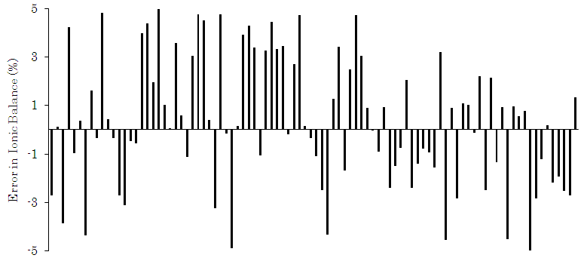
Figure 7 Distribution of errors in ionic balance
Stable isotopes (δ¹⁸O and δ²H) and Tritium (T) were determined, respectively, by Los Gatos DLT 100 LWIA and EELSS. Standard deviation was ±2 % for δ²H, ±0.2 % for δ¹⁸O, and ± 0.5σ for tritium.
Hydrochemical data were analyzed statistically and graphically. The statistical techniques used in this study are descriptive, Hierarchal Cluster Analysis (HCA) and Factor Analysis (FA). Statistica software version 8.0 was used for the statistical analysis. Hydrochemical data were plotted on the various diagrams using AquaChem software for windows version 4.0.284 and Microsoft Excel. Interpretation of isotope data was aided by plotting the data on the traditional δ¹⁸O versus δ²H graph along with the local and global meteoric water lines using Microsoft Excel. For the illustration of spatial distribution of hydrochemical and isotope data ArcGIS 10 graphic software were used.

Research objective
The main objective of the research is to develop hydrological and hydrogeological conceptual model to characterize the nature of groundwater flow systems, process of recharge, and factors that control groundwater chemistry in the basin.
Special emphasis has been given to the following hydrogeological issues:
- Characterization of litho-structural framework of the study area
- Investigating hydrogeological setup of the aquifer of the particular lithologic terrain and its relation to the aquifers of adjacent lithologic terrains.
- Investigating the nature of groundwater circulation in the particular lithologic terrain and its continuity across the terrains.
- Investigating mechanism, source, and rate of groundwater recharge
- Characterization of groundwater chemistry, controlling hydrogeochemical processes, and vulnerability of the aquifer system to near surface contamination sources
- Preliminary assessment of the source-aquifer for the dry period river flow.

Significance of the research
The study improves understanding of litho-structural and hydrostratigraphic framework of the Dawa river basin, which is marked by the typical geological characteristic that basement complex have laterally emplaced between the volcanic terrain in northwest and the sedimentary sequences in the southeast. In addition, understanding regarding aquifers interconnectivity, scale of groundwater flow, factors controlling groundwater quality, and source-aquifer for dry period river flow is also improved. Further, being this is the first study of its kind covering the whole areas of the river basin, ample data has been generated and being available as a baseline for future hydrogeological research works.
Importance of the river water to supply the large towns in the river basin and surrounding areas and to fulfill irrigation water demand in the dry areas of the river basin is ever increasing (MoWIE, 2007). On the other hand, a large number of population of the rural community and residents of small towns in the basin depends on shallow and deep groundwater resources for water supply. To sustain contribution of the water resources to socio-economic development of the area, IWRM should be applied at the basin scale. Effective application IWRM, however, requires complete understanding of the water resources system, where the output of this research contributes a lot toward this end.

Geology

Geological history
The Dawa river basin of southern Ethiopia is characterized by complex geologic setup expressed by diversified lithology and structural framework attributable to the basin’s location in the region of multiple phases of volcano-tectonic events (Woldehaimanot and Behrmann, 1995; Worku and Schandelmeier, 1996; Hunegnaw et al., 1998). During neoproterozoic (870 Ma to 550 million years (Ma)), collision between eastern and western Gondwana, commonly known as East Africa Orogeny, results in ocean closure, metamorphism, and subsequent faulting and intrusion in the present day East African region (Kusky et al, 2003; Kröner and Stern, 2004). Metamorphic complexes and associated plutonic rocks and structures of basement terrain of the study area are the result of this geological event.
A major regional rifting event was initiated in the pre Jurassic times as a consequence of initial break up of east Godwana (Bosselini, 1989). In the process of Gondwana break-up, branches of the rift basin intersect in the southern Ethiopia making Ogaden basin. One branch of this rift system, Mandera-Bodel rift, extends into the northeast Kenya across the southern Ethiopia (Bossellini, 1989) (Fig. 8). In Triassic to early Jurassic times, large scale subsidence of the entire Horn of Africa lead to extensive continental down warping and the Jurassic sea progressively encroach the entire horn of Africa. At the end of Jurassic and early Cretaceous the sea began to recede (Bossellini, 1989). The extensive sedimentary rocks of southern Ethiopia are the result of transgression and regression of the Indian Ocean (Purcell, 1981).
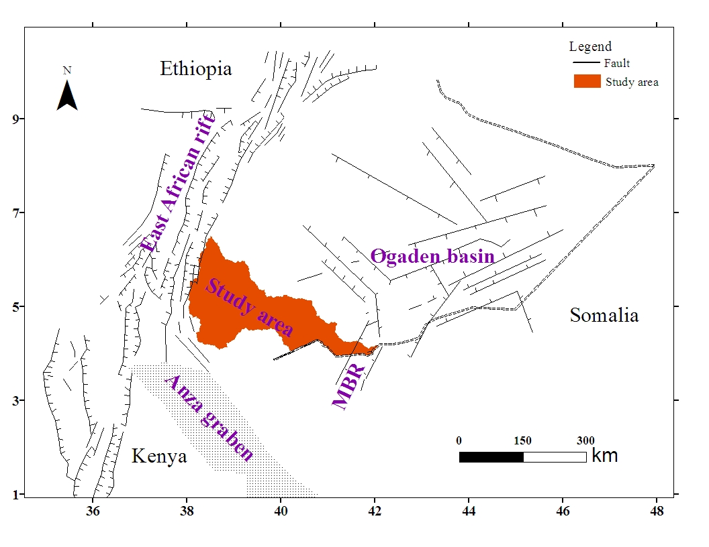
Figure 8 Location of the study area with respect to East African rift system and the Ogaden basin rift system (Complied from Davidson, 1983; Hugnegaw et al., 1998, and Ebinger et al., 1993 )
In East Africa, development of the Rift structure associated with continuous volcanic activity of upper Oligocene to recent (Fig. 8) is the other major geological event that has contributed to the present day geological framework of southern Ethiopia (Mohr, 1962). The distribution of volcanic rocks appears to be closely related to the stage of rift development, i.e., period of doming and rift development. In southeastern Ethiopian plateau, volcanic rock is a result of pre-rift late Oligocene to mid Miocen fissural eruption which is analogus to the continental flood basalts elsewhere in Ethiopian plateaus (Kazmin, 1979).
As a result of the above stated geological processes, three major lithological terrains – volcanic, Basement, and sedimentary – were outcropped in the basin. These lithologic units and associated structures are presented in the subsequent sections.

Lithologic units

Precambrian basement rocks
Precambrian basement rock is the most widespread rock unit in the central part of the Basin and it covers 32% of surface area of the Dawa river basin (Fig. 9). Basement rock of the area is thoroughly studied compared to the crystalline basement rocks in other parts of the country thanks to its economic importance as sources of precious metals or academic purpose. Gilboy (1970) and Chater (1971) classified the basement rocks of the region in to Lower, Middle, and Upper complexes based on lithological assemblage, structure, and degree of metamorphism. The lower complex consists of various types of high grade gneisses and banded migmatites; middle complex consist various moderate to high grade meta-sediments; and the upper complex constitutes thick succession of slightly metamorphosed sedimentary and volcanic rocks (Kazmin, 1972). This scheme of classification has long been in use though the validity of this classification is diminishing in the light of newly emerging geochemical, geochronological data as well as current advances in geological knowledge (Yibas, et al, 2000, and the reference cited therein).
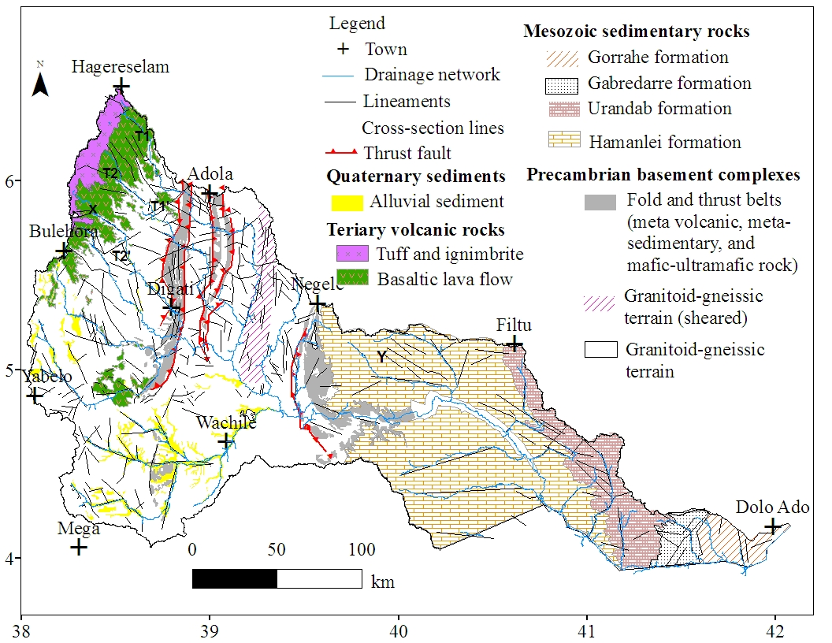
Figure 9 Simplified geological map (lithology and fracture network) of the study area
Recent geological and structural study by Worku (1996) and Yibas et al. (2000) introduced a more simplified, broad, and alternative two-fold classification of Precambrian basement rock of southern Ethiopia: (1) granite-gneiss terrain consists of dominantly quartzofeldspathic gneisses intercalated with amphibolites, schist and marbles, and deformed and metamorphosed granitoids; and (2) ophiolitic fold and thrust belts consists of low grade, mafic-ultramafic and metavolcano-sedimentary assemblages (Fig. 9). Granitoid-gnessic terrain is sheared in the eastern part (Fig. 9). Geochronological database suggests that granitoids and Ophiolites emplaced between 900 and 550 Ma, while gneisses have emplaced between about 1050 and 880 Ma (Yibas et al, 2002, and references cited therein).
The granitoid rocks vary from granitic gneisses to undeformed granites which forms an integral part of the granite-gneiss terrain in the study area. Compositionally, this rock unit varies from diorite to granite with significant amount of quartz and K-feldspar, plagioclase, amphibole, and biotite. The mafic rocks that form the bulk of ophiolitic assemblages are dominantly sub-alkaline, low-Ti tholeiites and Ca-boninites. Detailed lithology and geochemistry of the mafic-ultramafic suites from the ophiolitic belts are available in Yibas et al (2000) and comparable information can also be obtained from Gebreab (1992). Additional geochemical information of basement rocks of the study area is also available in the technical reports of Ethiopian Institutes of Geological Survey (Hassen et al, 1991; Yihunie and Tesfaye, 1998; and Awoke and Hailu, 2007).

Sedimentary sequences
The NE-SW oriented Mandera-Bodle rift, which is part of the tectonic frame work of the Ogaden basin (Hunegnaw et al., 1998), affected south-eastern end of the Dawa river basin (Fig. 10). In the Ogaden basin in general, the late Palaeozoic Karoo sediment which is composed of sandstone and shale occurs at the bottom of the sedimentary sequences (Worku and Astin, 1991). Adigrat sandstone unconformably overlies the Karoo sediment (Hunegnaw et al, 1998). Jurassic to Cretaceous sedimentary rocks overlay Adigrat sandstone and exposed in most part of the southeastern part of the study area.
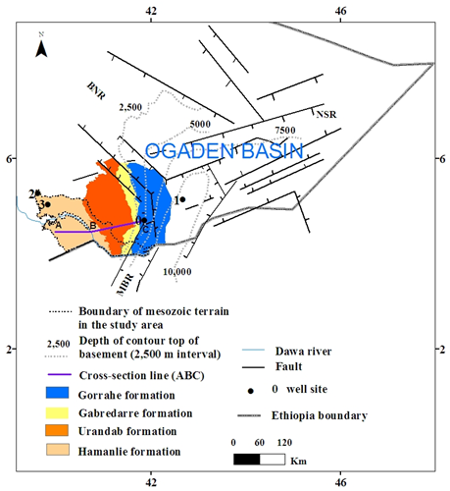
Figure 10 The main fault systems and thickness map of sedimentary rock (above the basement rock) in the Ogaden basin (modified from Hunegnaw et al, 1998) (0 = El kuran well site; 1 = Bodel well site; 2 = Siminto well site; 3 = Funnan Girri well site; MBR = Mandera-Bodel-Rift)
Stratigraphic sequence of the area, from bottom top, includes (a) Hamanlie formation (dominantly limestone with intercalation of thin gypsum and shale), (b) Urandab formation (calcareous shale with minor gypsum and limestone), (c) Gabredarre formation (dominantly marl with minor limestone), and (d) Gorrahe formation (dominantly gypsum and anhydrite with subordinate limestone, marl, and shale) (Assefa, 1988; Geleta, 1998).
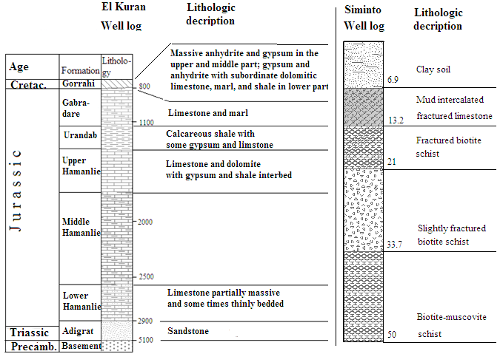
a b
Figure 11 Simplified lithologic log at a El Kuran b Siminto well
The spatial distribution of Jurassic to Cretaceous sedimentary rocks is shown in Figure 9. Beyond the study area, the northward extension of the units is shown in Figure 10. Based on seismic study and well log analysis spatial variation in the thickness of sedimentary succession of the Ogaden basin has been depicted in Hunegnaw et al. (1998).
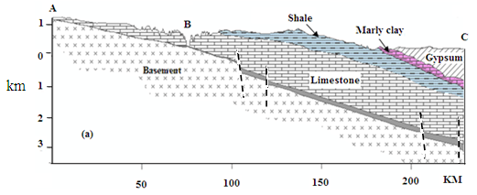a 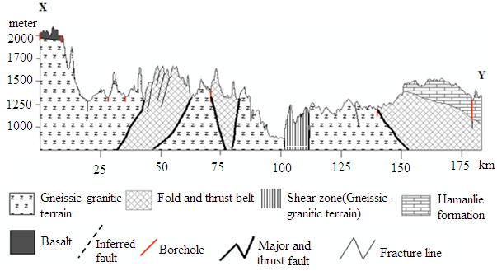b
Figure 12 Geological cross section across a sedimentary terrain in Dawa river basin and its nearby region (The position of the cross section is shown as line ABC on figure 6) b volcanic-basement-sedimentary terrain (The position of the cross section is shown on figure 5; The dip direction and dip amount is inferred from the work of Worku and Yifa, 1992)
According to this work, the maximum thickness of the sequence reaches up to 10,000 m at the centre of the Ogaden basin where the three rifts intersects. Thickness of the succession decreases in either direction away from the point of intersection. At the El Kuran well, which is located nearby the study area, sedimentary succession has a thickness of about 5,000 m (Fig. 10, 11). Taking into account geological and tectonic framework of the region, sequence and thickness of the rock units at El Kuran well (Fig. 10, 11) can reasonably be interpolated to represent sedimentary succession of south-eastern end of the study area.
As evidenced from the lithologic log of Siminto well (Labeled 2 on Fig. 10), the contact between the sedimentary sequence and the underlying basement rock occurs at depth of 13 m below the ground surface (Fig. 11). At few hundreds of meters toward northwest of the Siminto well, 2 m thick white sandstone is exposed on the surface overlying the crystalline basement complex. This sandstone is presumably correlated to the Adigrat Sandstone which occurs at deeper depth in south-eastern end of the study area.
Toward southeast, at Funnan Girri (Labeled 3 on Fig. 10), the basement rock is emplaced at depth of 200 m below the ground surface. Field observations and geological cross-section (Fig. 12) along A–B–C (Fig. 10) confirms the general tilting and thickening of the whole succession toward southeast, supporting the previous works (Geleta, 1998; Hunegaw et al, 1998). Similar setting is also illustrated with geological cross-section (Fig. 12b) along X–Y transect (Fig. 9). In general, the sequence thins toward northwest and finally pinches out near 39.5° longitude.

Volcanic rock units
Tertiary flood basalts and intercalated silicic volcanic rocks of Ethiopia (Mohr and Zanettin, 1988) cover the northwestern part of the study area. The two main rock groups are (1) Basaltic lava flows and (2) Tuff, ignimbrite, and minor basaltic agglomerate. The first group of rock unit consists of predominantly thick basaltic lava flows with subordinate flows of trachyte, rhyolite, and interbedded series of paleosol and pyroclastic materials. Field observation and lithologic log from the area confirms the Tertiary volcanic rocks overly the Precambrian crystalline basement rock. Cross-section along the selected transects reveals the surface of lithologic contact slightly tilts toward southeast (Fig. 12b and Fig. 13a, b).
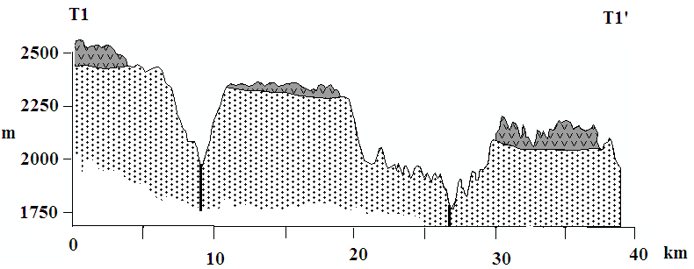a
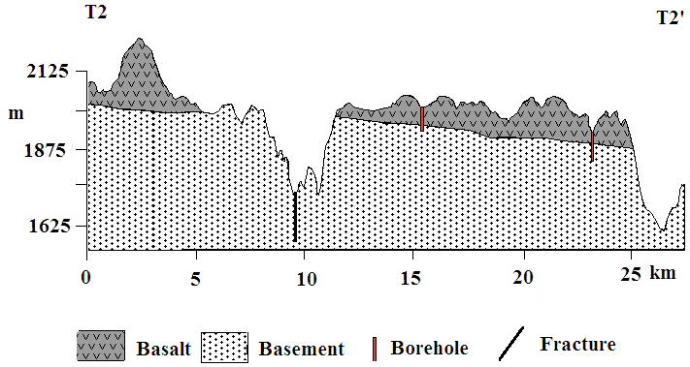b
Figure 13 Geological cross-section along selected transects (Location of the transects are indicated on Figure 5)
The second group of the rock units consists of acidic rocks such as tuff, ignimbrite, rhyolite, and trachyte interbedded with agglomerates of basaltic composition. It overlies the basaltic rock unit and has a thickness that varies between 20 and 35 m.

Alluvial deposits
Alluvial deposits mainly composed of clay, silt, and sand occurs throughout the region. These sediments have accumulated in low-lying areas and along dry riverbeds (Plate 1) which is confined within the vast areas of washed surface mainly in the semi-arid regions (Fig. 9). Field exposure reveals that the sediments are up to 20 m thick overlying gneissic bed rock.
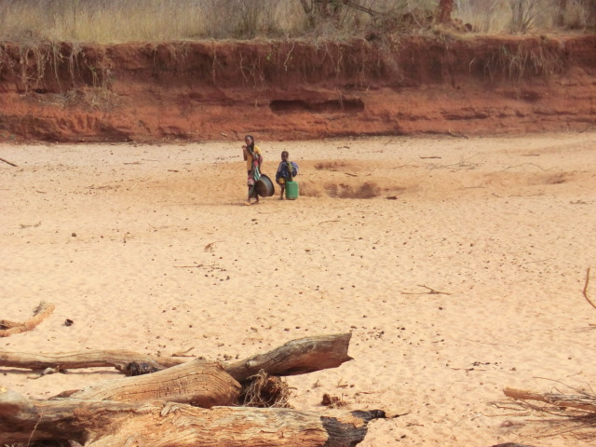
Plate 1 Typical dry stream filled with sand (photo at Dhuko, See Fig. 1 for the location)

Geological Structures
Various types of geological structures have been mapped by previous workers (Hamrla, 1977; Hassen et al., 1991, Ghebreab, 1992, Tefera et al., 1996, Yihunie and Tesfaye, 1998; Yibas, 2000; Awoke and Hailu, 2007) and verified in the present study. In the subsequent sections emphasis has been given to the discussion of those structures that have significant influence on groundwater circulation.

Faults
In the study area, the high grade granitoid-gneissic rocks form large blocks separated and surrounded by belts of mafic-ultramfic rocks and metavolcanosediementary sequences.
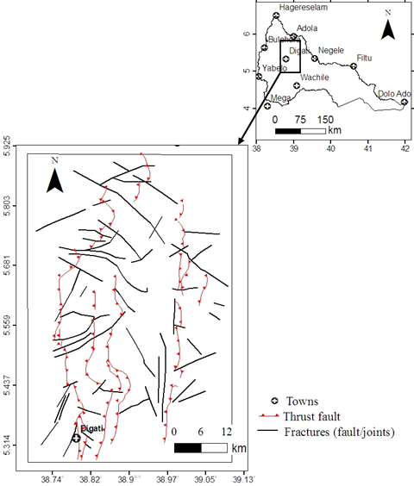
Figure 14 Detailed fracture map in mafic-ultramafic rocks and volcanosediemtary sequences of the study area (after Hamrla, 1977)
The contacts are particularly defined by N-S trending regional thrust faults that extend for distance of over 100 km (Hamrla, 1977; Kozyrev et al., 1985; Yibas, 2000). These faults are affected by secondary deformational stress (Abdelsalam and Stern, 1996; Worku, 1996). E-W strike slip or NE (50-60°) and NW (140 – 150°) trending faults cut and displace the N-S fractures (Hamrla 1977). Usually NE and NW trending faults form conjugate faults particularly in the northern end of the basement terrain (Fig. 14). Regional faults presumably normal in type were identified and inferred in sedimentary terrain (Fig. 15).

Lineaments
Lineaments of the study area (Fig. 9) are mostly fractures and density and orientation of the fractures vary from place to place across the study area (Fig 15 and Fig. 16).
In the parts of volcanic terrain that is covered by tuffs and ignimbrite, lineaments are rarely observed due to the accumulation of thick weathering product over fresh bedrock. As a result, this part of the volcanic terrain is characterized by low lineament density (0–0.1 km/sq.km) (Fig. 15). On the other hand, there are observed lineaments in the parts of the volcanic terrain covered by basaltic flows (Fig. 9). In this area, the lineaments are dominantly oriented in NW-SE directions with bearing in the range of 120–175° (Fig.16a).
The shear zone and mafic-ultramafic belts are the highly fractured and/or jointed zones in the basement terrain of the study area (Fig. 9) where the fractures and joints are dominantly oriented N-S (bearing in the range of 0–10°) (Fig. 16b,c). Furthermore, the mafic-ultramafic belts are characterized by well-defined open shcistocity which bears similar orientation of other lineaments of the area. As a result, the shear zone and the fold and thrust belts of the study area is marked by high lineament density (0.2–0.38 km/sq.km) (Fig. 15). It has also been observed that at many localities of fold and thrust belts, fractures are filled with quartz veins; and the veins are intensively fractured (Plate 2). Moreover, fractures of the area are discontinuous due to multiple phases of deformations, weathering process or cut by younger fractures (Fig. 14). In the shear zone, however, up to 20 km long lineaments were recognized occurring in echelon form.
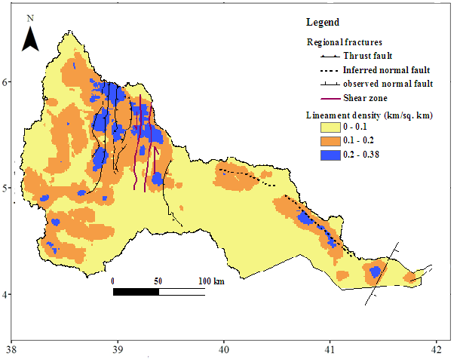
Figure 15 Map of lineament density

a b c
d e
Figure 16 Rose diagram for fracture orientations in a volcanic terrain b Ophiolitic belts c Granitoid-gneiss (in the shear zone) d gneiss-granitoid terrain (out of the shear zone) e Sedimentary terrain (N = number of data)
On the other hand, in the most part of the gneissic-granitoid terrain other than the shear zone, lineaments are dominantly oriented in NW-SE direction with bearing in the range of 120–175° (Fig. 9 and Fig. 16d). Furthermore, in this region fractures in or around intrusions are mainly circular and localized in nature. In general, lineament density is moderate (0.1 – 0.2 km/sq.km) in most parts of the gneissic- granitoid terrain (Fig. 15).
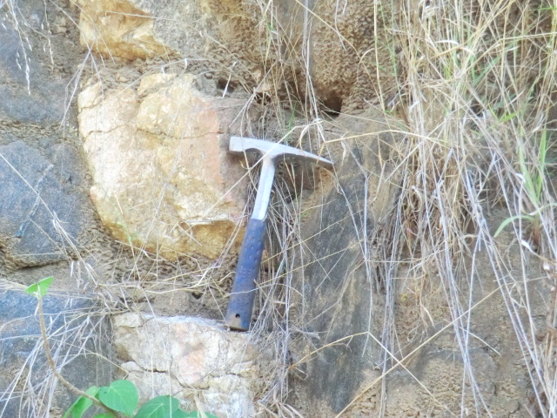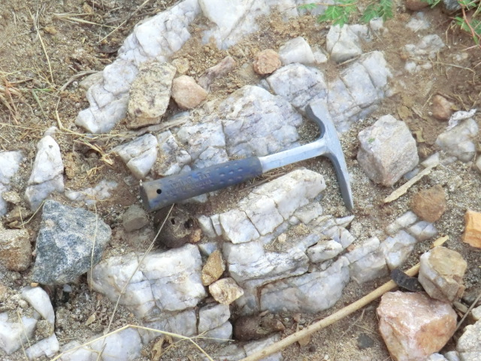
Plate 2 Typical quartz vein intruded into weak zones in Meta-volcanic rocks of southern Ethiopia (near Soda, see Fig. 1 for the location)
Much of the lineaments in Mesozoic sedimentary terrain are dominantly oriented in NW-SE direction with bearing in the range of 120–130°. Few lineaments in southeastern end of the sedimentary terrain of the study area are oriented in NE-SW and E-W direction (Fig. 16e). In most part of the sedimentary terrain, lineament density is low except near the major fracture lines (Fig. 15)

River discharge analysis

Introduction
Available river discharge data is analyzed with emphasis given to the flow characterization, base flow separation, and recession analysis. Method of base flow separation and recession analysis is illustrated in section 1.4.2. Relation of seasonal patterns of the river flow of main Dawa and its tributary rivers with the patterns of local rainfall is scrutinized by superimposing the flow hydrograph over the hyetograph. Field observations and EC measurements were conducted at selected sites to identify source-aquifer of dry period river flow. Locations of river flow measuring stations are shown in Figure 3 (above) and of EC measuring points are shown in Figure 22 below.

River flow characteristics
As explained earlier, the ranges of the available flow records at the four river flow measuring stations are variable and the data is discontinuous (Section 1.4.2). These data has been analyzed to gain a preliminary insight into the hydrology of at least the gauged upper parts of the river basin.
Table 3 Mean monthly river flow (in m³/s)
Month | Jan | Feb | Mar | Apr | May | Jun | Jul | Aug | Sep | Oct | Nov | Dec
Awata | 4.2 | 2.9 | 2.7 | 7.5 | 23 | 27.2 | 20.1 | 21.9 | 25.3 | 38 | 19.1 | 6.9
Mormora | 5 | 3.6 | 4.5 | 7.7 | 19.9 | 20.7 | 14.9 | 15.2 | 18.9 | 33.4 | 18.3 | 8.1
Digati | 2 | 1.4 | 1.3 | 4 | 11.2 | 5.7 | 4.3 | 4.7 | 3.7 | 7.4 | 10.4 | 4.3
Main Dawa | 8.2 | 7.3 | 6.5 | 21.4 | 41.7 | 33.3 | 25.7 | 29.5 | 31 | 45.1 | 39.6 | 16.6
Mean monthly flow data is presented in Table 3 and the monthly flow data is presented in Annex A3-A6. Relative to Awata and Mormora sub-basins, Digati sub-basin and main Dawa are marked with low values of specific flow and low percentage of rainfall converted to runoff (Table 4), suggesting as one moves toward semi-arid region a large portion of a rainfall cannot generate or end-up into runoff; rather it may evaporate, or infiltrate and then moves underground without being measured at the river gauge.
Table 4 Total flow, Base flow, and Base flow index for main Dawa measured at Melkaguba and major tributary rivers
 |  |  | Sub-basin/Main Dawa
 |  |  | Awata | Mormora | Digati | Main Dawa
Area | km² |  | 1635 | 1330 | 2379 | 20095
Mean annual rainfall | mm |  | 1223 | 1027 | 926 | 833
Mean annual total runoff | mm |  | 319 | 317 | 57 | 41
Mean annual Base flow | mm |  | 174 | 200 | 42 | 26
Base flow Index (BFI) |  |  | 0.54 | 0.63 | 0.74 | 0.64
% |  |  | 26 | 31 | 6 | 5
% is percent of total flow relative to rainfall.
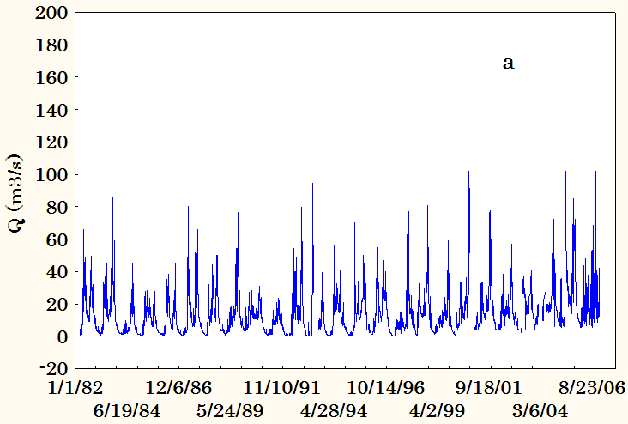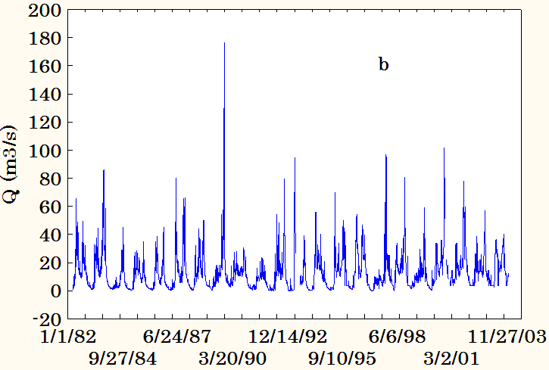
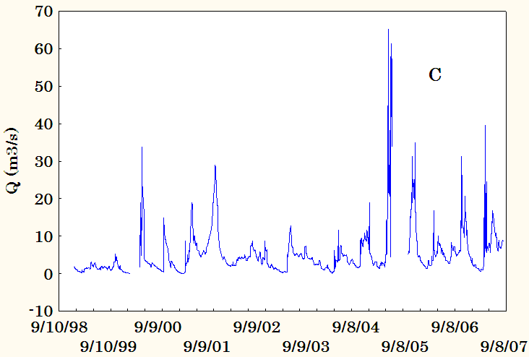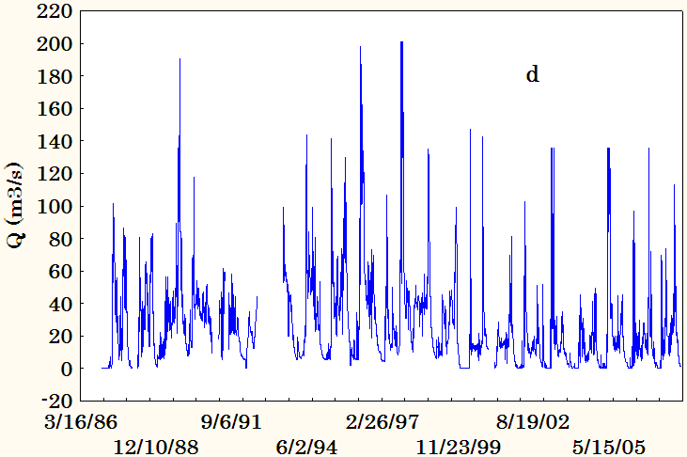
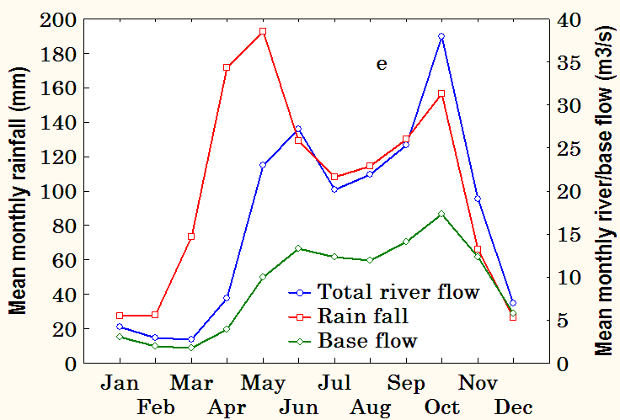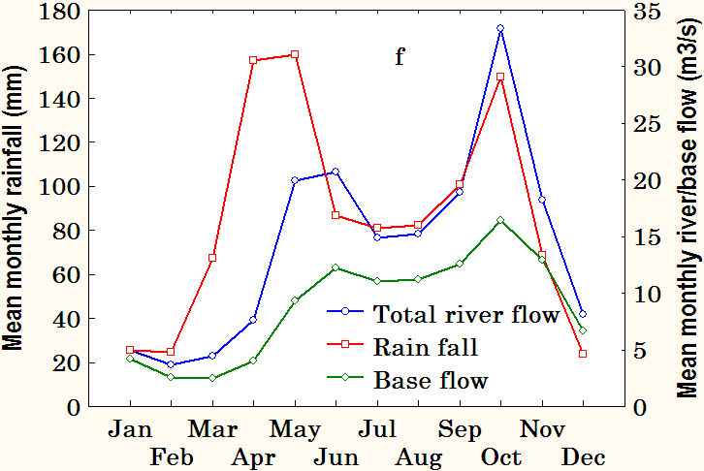

Figure 17 Daily flow diagram of the tributary streams: Mormora (a), Awata (b), and Digati (c) and the main Dawa river (d); seasonal variability of the mean monthly flow of the Awata (e), Mormora (f), Digati (g), and main Dawa (h) along with mean monthly areal rainfall of the corresponding basin/sub-basin; annual variability of the mean annual flow of Awata (I), Mormora (J), and main Dawa (K)
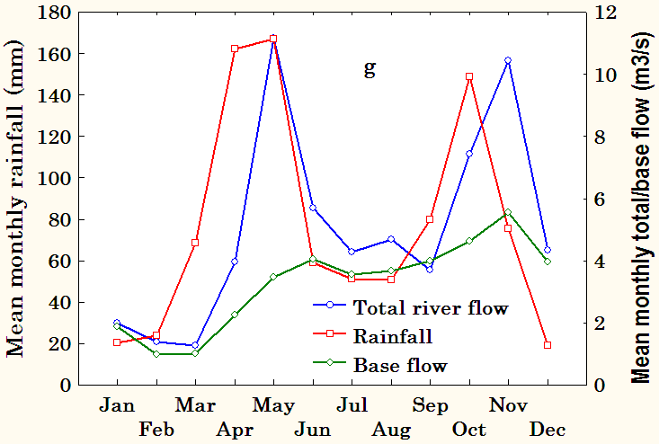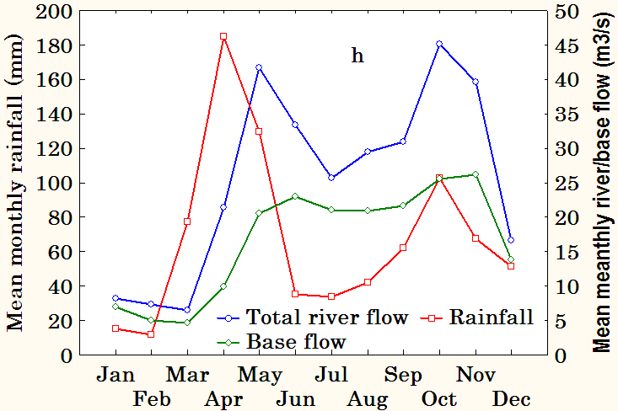
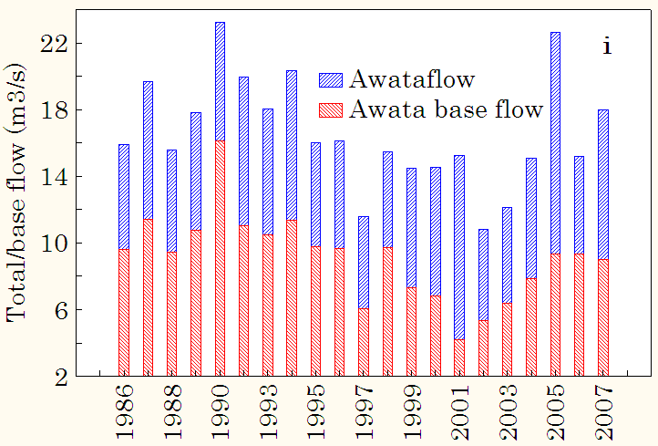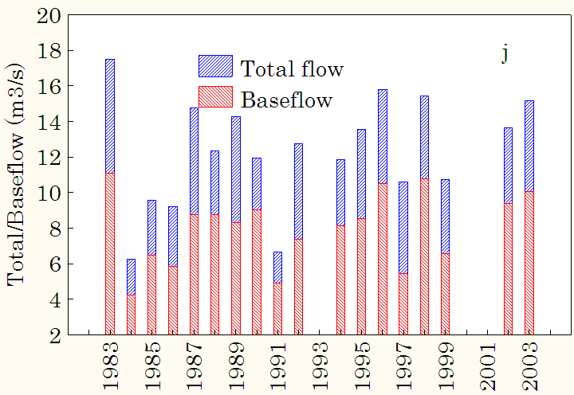
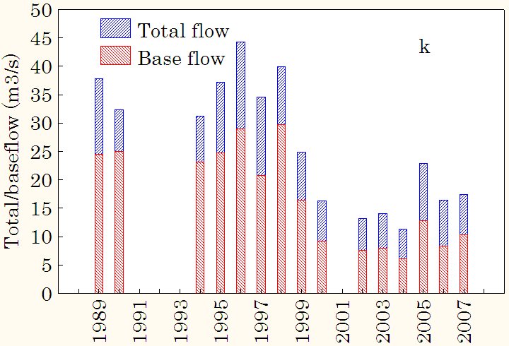
Figure 17 (cont.)
However, based on the converging evidence from litho-structural, hydrochemical, and isotopic data analysis (section 7.3 below), subsurface lose by means of regional flow is unlikely, implying the rainwater is most likely lost by evaporation. At the all flow measuring stations, Base Flow Index (BFI) – the ratio of base flow volume to total stream flow volume (BFI) – is greater than 0.50 (Table 4), indicating at annual time scale base flow makes up a larger portion of the River flow relative to its runoff complement.
The flow diagram showing the complete time series and seasonal and annual variability of the flow regime are shown in Figure 18a–j. The diagrams show high variability of the river flow based on all daily, mean monthly, and mean annual flow data. Seasonal pattern conforms the pattern of local rainfall both in the headwater region and at the middle of the basin (Fig. 18e–h), revealing river flow is directly proportional to the rainfall. For Awata and Mormora high flow is observed in the months of May–June and October (Figure 18e – h). For both Digati and main Dawa high flow is noticed in the months of May and also in November for Digati and in October for Main Dawa. Figure 18e–h also reveals that during the first rainy season, river flow responds to change in the rainfall regime after one month lag-time. However, during the second rainy season no lag-time is observed for Awata, Mormora, and main Dawa that the peaks of the rainfall and river flow occur contemporaneously; however, for Digati sub-basin there is observed a one month lag time between rainfall and river flow peaks.
Awata and Mormora sub-basins and main Dawa experience the highest peak of the total river flow in October despite the highest peak in the rainfall happens in May/June (Figure 18e, f, h). Though not significant, similar pattern is also observed in the Digati sub-basin.
The seasonal patterns of the River flow are likely related to the catchment’s physical characteristics such as surface geology and climatic variables. Large portion of the surface area of the head water sub-basins is covered by permeable volcanic bedrock overlain by the thick regolith. In this part of the River basin, the one month lag-time during the beginning of the first rainy season is associated with the fact that much of the rain water of this period ends up in satisfying soil moisture deficiency of the near surface regolith rather than generating runoff. As the soil moisture deficiency gradually gets satisfied, much portion of the subsequent rainfall ends up into the river flow; as a result, at the end of the second rainy season no lag-time is observed for Awata and Mormora sub-basins. However, for Digati sub-basin the observed lag-time during the second rainy season is likely associated with the more semi-arid climatic condition of the sub-basin, than Awata and Mormora, that the period between the two main rainy seasons receives less rainfall and experiences high evaporation (due to high temperature condition related to low elevation). These conditions increase soil moisture deficiency before the commencement of the second rainy season, which, in turn, likely the cause of the lag-time.
In the case of main Dawa, the pattern of total flow is comparable to that of Awata and Mormora sub-basins, indicating the river water at middle of the basin is generated from the tributary rivers. On the other hand, patterns of base flow more or less follow the patterns of total flow.

Recession analysis
Following a flood event, stream flow hydrograph typically diminishes quite steeply but slows over time. This part of stream hydrograph commonly called recession curve and comprise primarily of base flow, i.e. groundwater discharge from the aquifer, and continues until another runoff event occurs (Fig. 18). Shape of a recession segment follows a simple exponential decay type and represented by the relationship of eq. (4) assuming a linear reservoir model of groundwater discharge (Martin, 1973; Murphy et al., 2009).
$Q=Q_{o}e^{-∝t}$ (4)
where Q_{o} is initial stream flow; Q is stream flow after time t; $∝$ is a constant defining rate of recession; and t is the time lapse (usually in days) between Q_{o} and Q. The exponential function of eq. (4) implies that groundwater aquifer behaves like a single linear reservoir with storage linearly proportional to outflow (S = $∝$Q, where S is storage). It is important to note that sometimes k is used instead of$∝$, where k = 1/$∝$ in that case.
According to this model, if plot of logQ against time is drawn, a straight line results (hence, linear model) with slope equal to log$∝$. Thus, by simple graphical means, value of base flow recession constant can be obtained (Martin, 1973). If $∝$ is expressed in terms of k, k represents an average response time in storage. It is equal to a time (mostly in days) required for storage to decrease by one log cycle. From the fact that the retention constant k has the dimension of time, k can be interpreted as representative of residence time for water in the aquifer (Wittenberg, 1999).
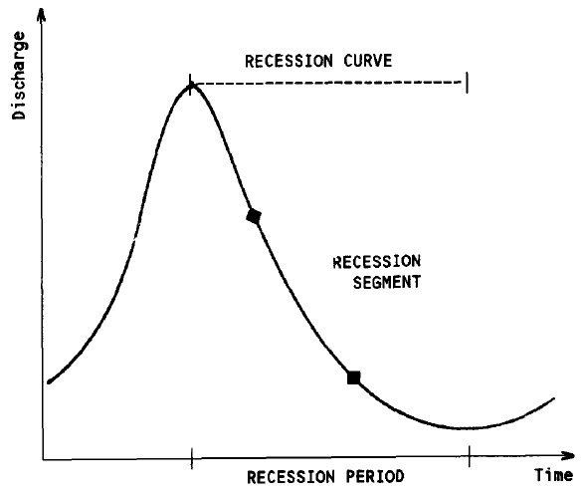
Figure 18 Typical stream hydrograph showing recession segment (after Tallaksen, 1995)
In most cases, however, semi-logarithmic plots of flow recessions of real rivers are still concave (Wittenberg, 1999), even after critical time ($t_{c}$), the time since the peak discharge event and after which the profile of water table distribution is stable (Rutledge and Mesko, 1996) and it is evident that the parameter k fitted to different discharge ranges of the recession curves in actual rivers does not remain constant but increases systematically with the decrease of stream flow (Wittenberg, 1994). Acceptability of linear model is by assuming non-linearity of recession curve is insignificant beyond a critical time (Rutledge and Mesko, 1996).
Recession analysis is a well-known tool in hydrological analysis. It is frequently applied to derive general hydrologic properties of aquifer systems (Rutledge and Mesko, 1996; Nelms et al., 1997). More specifically, recession analysis tells about aquifer storages feeding streams. Accordingly, it contains valuable information concerning storage properties and aquifer characteristics (Tallaksen, 1995). Detailed techniques of recession analysis are given in Nathan and McMahon (1990) and Tallaksen (1995). The relationship between hydrogeology and recession rate and, hence, the application of recession analysis to characterize hydrogeological behavior of a river basin is well illustrated in a number of previous works elsewhere (Bevans 1986; Rutledge and Mesko, 1996; Nelms et al., 1997; Szilagyi et al., 1998; Mendoza et al., 2003; Ruirui et al., 2010; Huang et al., 2011).
Recession segments of hydrograph of the tributary rivers and of the main Dawa are plotted using RECESS computer program according to the procedure discussed in section 1.4.2 to recognize the extent of variation in the amount of groundwater discharge on the first day of the depletion follows (Q_{tp}) (Fig. 19a-d). Q_{tp} is a potential groundwater storage which is equal to the total volume of base flow if allowed to discharge for infinite time (Fetter, 2004). It is observed that for the Mormora and Awata tributary logQ_{tp} varies between 0 and 2 m³/s (Fig. 19a, b), while for the Digati river it varies between 0 and 1.5 m³/s (Fig. 19c), showing that the maximum logQ_{tp} value of Digati river is slightly lower than that of Mormora and Awata rivers. For the main Dawa River, logQ_{tp} varies in the range comparable to that of Mormora and Awata, likely indicating the river flow of the main Dawa is majorly supplied by groundwater storage in the headwater region.
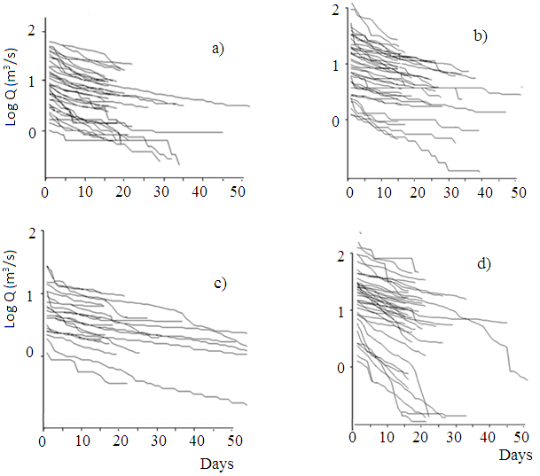
Figure 19 Q_{tp} variation for the a Awata Sub-basin, b Mormora sub-basin, c Digati sub-basin, d main Dawa
Degree of inclination of each recession curve expressed in terms of recession index (k, in days), was determined for the tributary rivers and main Dawa. The river flow is marked with the high recession slope. For the river discharge to recess by one log cycle, mean recession index (k) of 49, 63, 66, and 51 days is required for Awata, Mormora, Digati, and main Dawa river, respectively. Range of variation in the recession indices around the median value is shown in Figure 20. It is observed that the range of variation is highest for the main Dawa which is likely associated with the greatest aquifer heterogeneity relative to the individual tributary sub-basins.
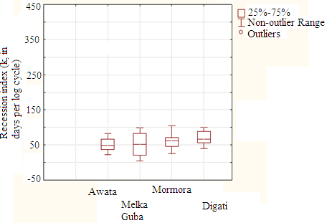
Figure 20 Range of recession indices for the major sub-basins and Dawa at Melka guba
Figure 20 also reveals that for main Dawa (at Melkaguba), the recession indices in the bottom non-outlier range is lower than that of the tributary rivers, indicating the presence of recession segments with higher slopes. Recession segments with high slope are also observed in the Figure 19. These segments likely associated with the fast groundwater flow toward the river channel, immediately following rainfall event, along the fracture lines in the basement terrain. However, the presence of the high slope segments has not changed the mean recession indices of main Dawa significantly above that of the headwater tributaries. This might be due to the fact that the low recession indices at main Dawa are balanced by some high recession indices observed in the headwater tributary rivers.
Based on procedure of Matching Strip Method (Nathan and McMahon, 1990), individual recessions are combined to provide an average recession curve, also called Master Recession Curve (MRC). MRC represents recessions of the tributary rivers and the main Dawa (Fig. 21) and provides a first glance at extent of linearity, i.e., slope and shape of recessions. In earlier discussions, it is mentioned that acceptability of a linear model is by assuming non-linearity of recession curve is insignificant beyond a critical time. In the present study, this assumption has been taken into consideration and also an attempt has been made to minimize uncertainty by removing few recession segments (one segment from Awata, two from Mormora, one from Digati, and four from main Dawa) which visually looks far from linearity using program-user options.
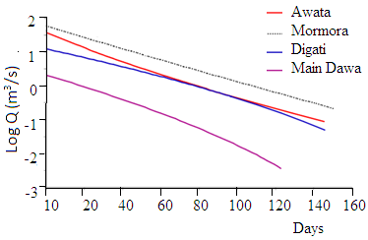
Figure 21 MRCs of the head water catchments and the main Dawa

Table 5 Equation of the best fitting liner trend line of each MRC
Basin/subbasin | Approximate linear equation  (T is days) | R² | k = 1/slope (approximate)
Mormora | Log Q = -0.016T + 1.757 | 0.999 | 63
Awata | Log Q= -0.018T + 1.503 | 0.995 | 56
Digati | Log Q = -0.015T + 1.177 | 0.991 | 67
Main Dawa | Log Q= -0.022T + 0.462 | 0.992 | 45
The average recession index (k) of each MRC is approximated from slope of the linear equations (Table 5) and the values are comparable to the corresponding median recession indices (k) shown in the Figure 20. Furthermore, as shown in Figure 19a-d, each recession curve of the tributary rivers and the main Dawa is made up of multiple line segments varying in slopes and segment lengths growing into the compound recession curve.

Source-aquifer for dry Period River flow
Electrical conductivity (EC) of the dry period river flow is measured in situ in the headwater, middle, and near the river outlet of the Dawa river basin. In the headwater region and at the middle of the basin, EC is measured three times at a site where each measurement is taken in the mid of dry months–Jan, Feb, and March – of year 2014. Near the Dawa outlet, EC is measured only once in the mid of January, 2014 for the reason that the river flow ceases in the subsequent dry months. The data is presented in Table 6. EC measuring points and the mean EC of the river flow (for measurements at headwater and middle of the basin) and EC value of the river flow near the river outlet are shown in the Figure 22.

Table 6 EC (in µS/cm) of the dry period river flow of year 2014
Site name | Mid of Jan | Mid of Feb | Mid of March | Mean value | Stdev
Kercha | 255 | 260 | 289 | 268.0 | 18.4
Kojo'a | 245 | 253 | 273 | 257.0 | 14.4
Awata | 239 | 237.5 | 248 | 241.5 | 5.7
Megado | 263 | 272 | 296 | 277.0 | 17.1
Digati | 575 | 602 | 620.3 | 599.1 | 22.8
Melkaguba | 333 | 355 | 401 | 363.0 | 34.7
Dolo Ado | 462.5 | - | - | -

Mean EC of groundwater in the volcanic (humid), highland (humid) parts of the basement, lowland (semiarid) parts of the basement, and the sedimentary terrain (semiarid and arid) is 244.6, 689.0, 2342.8, and 2383.9 µS/cm, respectively (Table 7). Complete list of EC of groundwater of the study area is given in annex A14. On the other hand, mean EC of dry period flow of Awata and Mormora rivers is 241.5 and 277.0 µS/cm, respectively (Fig. 22) where the values are comparable to the mean EC of groundwater in the volcanic terrain than that of in the basement terrain. This suggests dry period river flow of Awata and Mormora is supplied dominantly by the groundwater storage in the volcanic terrain.
Table 7 Statistical summary of TDS (in milli grams per liter (mg/l))/EC (in µS/cm) of groundwater of the area
Terrain |  | min | max | mean | stdev | median | n
Volcanic | TDS | 26.0 | 892.0 | 152.3 | 165.9 | 110.0 | 25
 | EC | 42.0 | 1487.0 | 244.6 | 277.2 | 180.0 | 25
Basement (Humid) | TDS | 82 | 1136 | 438 | 224 | 418 | 39
 | EC | 134 | 1738 | 689 | 347 | 640 | 39
Basement (Semi-arid) | TDS | 127.0 | 6474.0 | 1481.3 | 1536.2 | 914.5 | 44
 | EC | 208.0 | 9970.0 | 2342.8 | 2470.3 | 1361.5 | 44
Sedimentary | TDS | 172.6 | 4421 | 1574.82 | 1153.043 | 1296 | 15
 | EC | 287.8 | 6631 | 2383.92 | 1687.972 | 1983 | 15

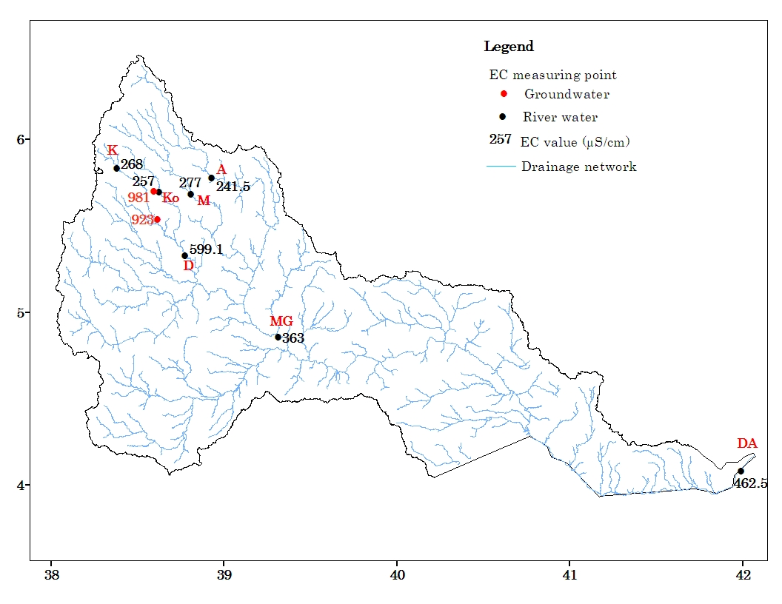
Figure 22 EC measuring points (Kercha (K); Kojo’a (Ko); Mormora (M); Awata (A); Melkaguba (MG); Dolo Ado (DA))
Mean EC of dry period flow of the Digati River is 599.1 µS/cm (Table 7) near the Digati village (see Fig. 22 for location). This value nearly doubles EC of the same river measured upstream at Kercha (see Fig. 22 for location) as the river flows through the volcanic terrain (Table 7). Given a short distance between the two measuring points, chemical evolution associated with water flow cannot explain the high EC of the river water near Digati; rather, somewhere between the two measuring points groundwater with the higher EC might be discharged from the basement aquifer in the basement terrain into the adjacent river channel and then mixed with the river water that originates from the volcanic reservoir. EC measurement reveals groundwater with higher salinity (981 µS/cm and 923 µS/cm), relative to the river water, is noticed near the river channel in the basement terrain (Fig. 22). These suggest both the volcanic and basement aquifer contributes water for the Digati River.
At Melkaguba mean EC of dry period flow of the main Dawa is 363 µS/cm (Table 7). This value is much lower than the mean EC of groundwater in the basement terrain and of the Digati River. However, the value is well comparable to the mean EC of the Awata and Mormora rivers measured upstream in the volcanic terrain or measured as the river leaves the volcanic terrain. This suggests during dry period, the main Dawa is supplied dominantly by groundwater storage in the volcanic terrain. This also illustrates a minor contribution from Digati sub-basin relative to the contribution from Awata and Mormora.
In general, EC data indicates insignificant contribution of groundwater of the basement terrain to the dry period river flow. This deduction is confirmed by the plot shown in the Figure 23. For most of the days in the year, except during period of intense rainfall, sum of flow of the tributary rivers exceeds flow of the main Dawa measured downstream beyond the point of confluence of the tributary rivers. Basically, flow of the main Dawa would have been higher than, otherwise equal to, the sum of flow of the three tributary rivers as there is extra surface area and tributary rivers (e.g. Aflata, see Fig. 1 for the location) which can contribute additional water at least during rainy period. The low flow rate of the main Dawa relative to the sum of flow of the tributary rivers indicates that in the basement terrain the river channel loses water instead of gaining. In implication, base flow contribution to the river flow is insignificant as the river flows over the basement terrain. Certain field observation also supports the losing behavior of the river channel over the basement terrain. For example, one of the un-gauged tributary rivers of Dawa, Aflata, is perennial on its upstream reach but intermittent somewhere downstream likely due to the river water is lost through fracture networks.
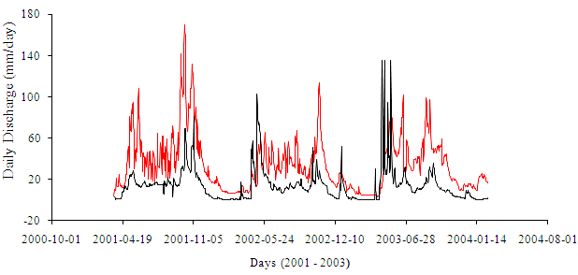
Figure 23 River hydrograph: Red line – the sum of flow of tributary rivers; Black line – the flow main Dawa at Melka Guba
Further downstream, near the Dawa outlet, the river water is marked with lower EC, 462.5 µS/cm, (Fig. 22) relative to the groundwater in the basement and sedimentary terrain, suggesting river water likely originates from the volcanic reservoir. In implication, groundwater contribution from the basement and sedimentary terrain to the dry period river flow of Dawa is insignificant. Moreover, for the two months, i.e. Feburary and March, Dawa remains dry near Dolo Ado (see Fig. 22 for the location), indicating the losing behavior of the river channel in the reach between Melkaguba and Dolo Ado.
The above discussions reveal that the dry period river flow Dawa depends on the supply from the groundwater storage in the volcanic terrain. This highlights the need for appropriate management of groundwater reservoir in the volcanic terrain to ensure the sustainability of dry period flow of Dawa River.

Aquifer configuration and hydraulic properties

Introduction
Aquifer characterization is significant to solve problems related to groundwater occurrence, quantity, flow, and quality. Characterization of an aquifer system requires accurate information on the geometry and hydraulic properties. This information is commonly obtained by drilling, geophysical methods, and description of lithologic logs and other well hydraulic data. Effective characterization of heterogeneous aquifers depends on efficient integration of information from different sources (Paillet and Reese, 2000). In the present study, information from lithologic logs, pump test, water level, and river flow records and from geological and structural knowledge of the area were used along with preliminary field observation to characterize hydrostratigraphic units of the Dawa river-basin.

Data: Type, quantity, and distribution
Well log, pump test data, records of water level, and well yield are limited in most parts of the study area, particularly, in the sedimentary terrain. Most of well hydraulic data including static water level is based on measurements and/or records made during drilling/pump test at the time of well construction. River flow record is only available for the headwater regions and, hence, used to characterize the upper parts of the river basin. Complete well hydraulic and Lithologic log related data is presented in Annex A7-A10. Summary of the selected parameters of the data is given in the Table 8 and corresponding discussion is presented in the subsequent sections.
Table 8 Type and quantity of data used
Data type | Volcanic | Basement | Mesozoic
 | Number of borehole related data
Borehole logs | 30 | 65 | 3
Pump test | 8 | 15 | -
Static water level | 38 | 53 | 18
Well yield | 23 | 52 | 15
 | Number of hand-dug well related data
Depth | 2 | 42 | 18
static water level | 2 | 39 | 18
 | Number of spring discharge data
Spring discharge | 23 | 11 | -

Hydrostratigraphic unit
The term hydrostratigraphic unit is originally defined by Maxey (1964) as bodies of rock with considerable lateral extent that compose a geologic framework of reasonably distinct hydrologic system. Integrating results of analysis of available data, various aquifers and aquiclude were identified Figure 24). Detailed discussion of each aquifer based on the available data is presented in the subsequent sections.
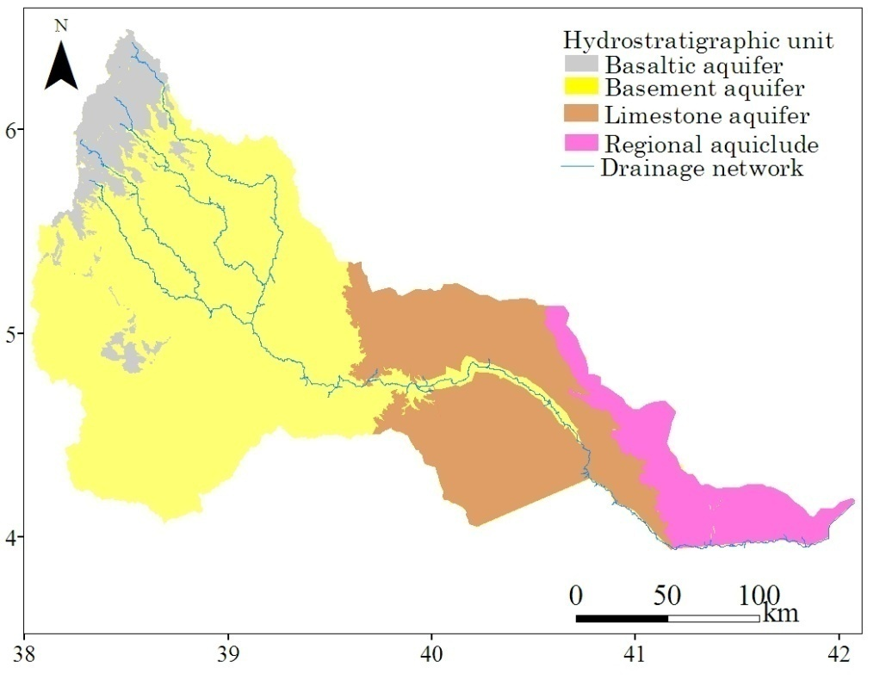
Figure 24 Hydrostratigraphic unit of the study area

Basaltic aquifer
Basaltic rocks of the Dawa river basin is composed of repeated succession of lava flows interbeded with soils, tuffs or volcanic ashes. Layering of the rocks is evidenced across steep side of escarpments of deep gorges in the area and from collected borehole logs (Fig. 25). Besides, well developed open columinar joints are observed at various localities in the study area (Plate 3). According to Todd and Mays (2004), layering and columinar joints are among the openings that contribute to permeability of basaltic aquifers.
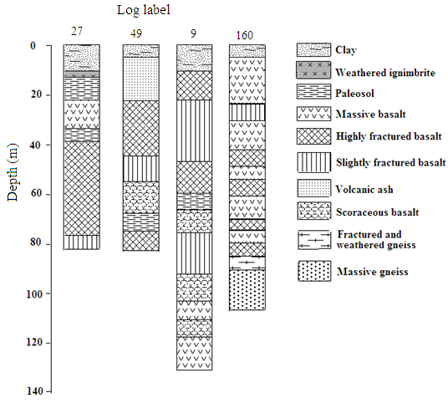
Figure 25 Selected borehole logs showing nature of volcanic rocks of the study area (Location of the borehole logs is indicated on Figure 20)
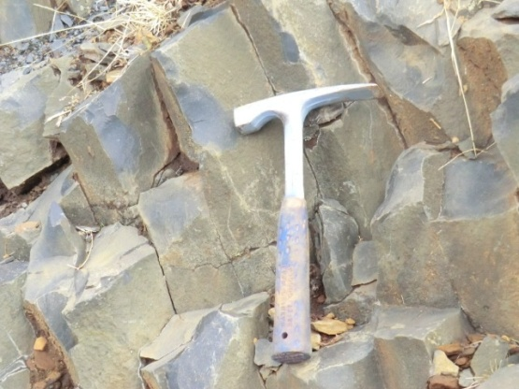a 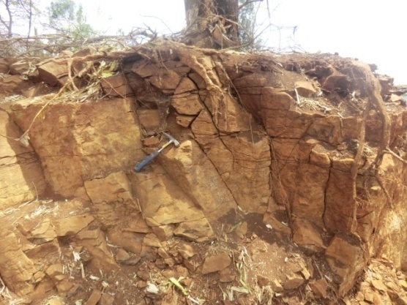 b
Plate 3 Exposure of columnar joints in the basaltic terrain near a Maleka b Galesa
In principle, top and bottom parts of each basaltic layer are more fractured and jointed than center of the flow (Whitehead, 1992; Domenico and Schwartz, 1998). This suggests the thicker the lava flow, the chunky less fractured basaltic core between the two fractured ends. On the other hand, centers of thin flows are commonly broken and vesicular like top and bottom of the flows. Therefore, it is apparent that number and nature of interflow boundary and thickness of each layer influence potential of basaltic aquifer. In the study area, the thickness of each basaltic layer is thin (Fig. 25), implying basaltic sequence of the basin constitutes a number of transmissive aquifer layers.
In the study area, basaltic rock occurs at high elevation emplaced over the basement rocks (Fig. 26). Due to its occurrence at high elevation, rugged topography of the area, and high transmissivity, basaltic aquifer is marked with low storage characteristics. The high transmissivity and the low storage behavior of basaltic aquifer of the study area are further confirmed by analysis of pump test data. The mean transmissivity (T) and specific storage (S) of the aquifer is 40.6 meter square per day (m²/d) and 0.0034, respectively (Table 9).
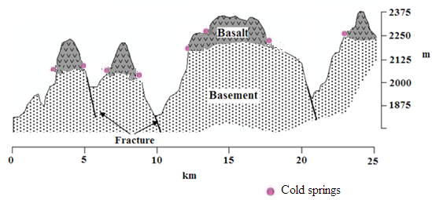
Figure 26 Schematic cross-sections representative of the southeastern part of the volcanic terrain showing lithologic framework and spring locations
Table 9 Statistical summary of analysis results of borehole well hydraulic data (representative of basaltic aquifer)
Data type | Mean | Min | Max | Stdev | n
Well depth (m) | 74.9 | 20.0 | 155.00 | 32.5 | 41
Depth to water-strike (m) | 31 | 10 | 60 | 17 | 31
Depth to SWL (m) | 21.2 | 3.75 | 100 | 19.6 | 31
Well yield (l/s) | 5.9 | 1.40 | 15.0 | 3.4 | 28
Transmissivity (m²/day) | 40.6 | 3.9 | 95.7 | 37.3 | 8
Specific storage | 0.0034 | 0.0002 | 0.0066 | 0.0021 | 8
Spring discharge | 1.12 | 0.20 | 3.00 | 0.75 | 22

The low storage behavior of the basaltic aquifer is also inferred from recession curve analysis following the deduction that the river water is dominantly emerges from the storage in the basaltic aquifer (Section 3.3). In general, high recession slopes or the low recession indices (Fig. 20, section 3.2) indicate low storing capacity of the basaltic aquifer.
Due to high rainfall in the volcanic terrain in the north (section 1.3), which is a prerequisite for groundwater recharge, and to high transmissivity of the aquifer, water wells that tap basaltic aquifer yield a large quantity of water (5.9 liters per second (l/s) in average, table 4) (Fig. 21).
In general, the well yield is directly proportional to the well depth (Fig. 27) which can be explained by increase in the number of potential aquifers along with increase in the well depth. However, the correlation is not strong (R² = 0.137) which can be explained by the effect of factors other than well depth on well yield. For example, despite of comparable depths, yield of the wells drilled entirely into the basaltic flow in the southeastern part of the volcanic terrain is greater than the yield of wells which tap the potential aquifer exploited after drilling through upto 20 m thick overlying tuff and ignmbrite formation. In the former case, the high yield is likely associated with greater number of aquifer exploited than in the later case. In the later case the contribution of the upper unit to a well is not as significant as the basaltic rocks.

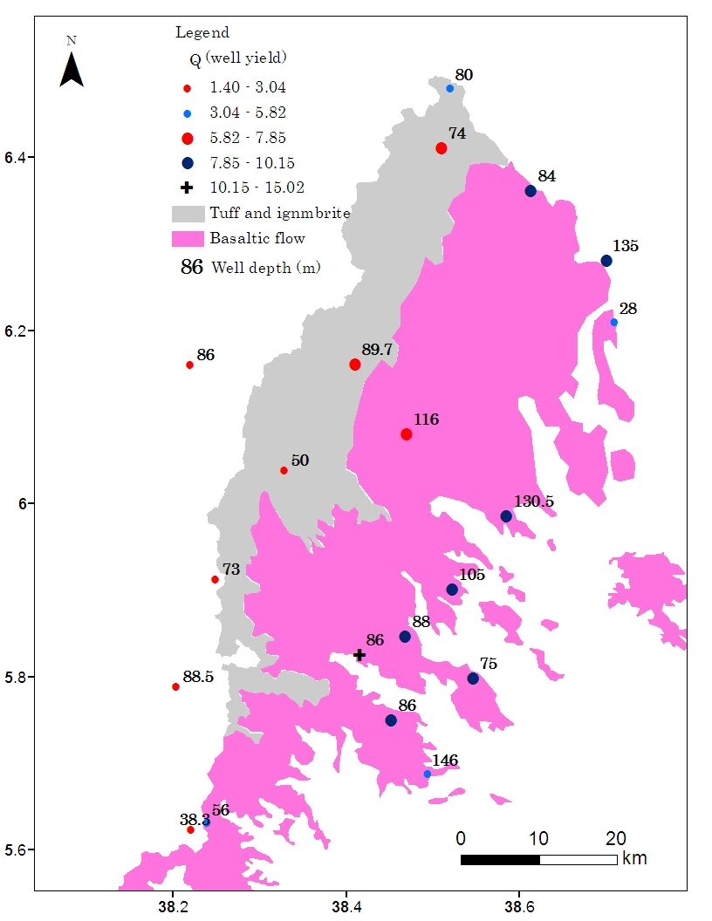
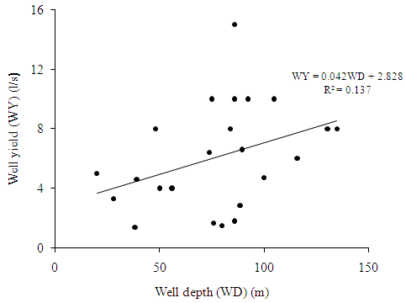
Figure 27 Plot of well yield against well depth

Figure 28 Spatial plot of well yield along with well depth
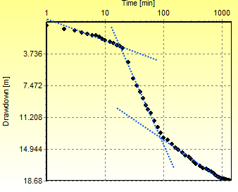a 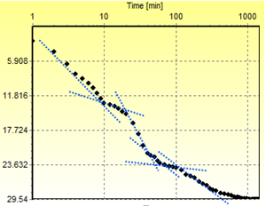 b
Figure 29 Typical drawdown-time curves showing a multi-layer aquifer system of the volcanic terrain: a well 160, b well 21 on Fig. 21 above
The above mentioned layered scheme of the basaltic aquifer is also confirmed by the time-drawdown curves of representative pump test data of the basaltic aquifer (Figure 29) and from the recession curve of the stream hydrograph (Figure 19, section 3.2). In the Figure 19 and Figure 29, the curves have breaks in slope where the slope and length of each straight-line segment of the compound curve depend on the hydraulic properties and the extent of the aquifer it represents.
In principle, in basaltic rocks vertical flow of groundwater occurs through vertical fractures and joints (Domenico and Schwartz, 1998). Inter-bedding units that are semi-pervious and include palaeosols, volcanic ash, tuff, and unfractured centers of basaltic lava flow act as a local barrier to the vertical flow. Elsewhere, studies indicated that in places where these inter-bedding units are thick and broad, spring discharges at high elevation (Dafny et al., 2006). In the study area, during field investigation such springs are commonly observed in the either side of southeast trending parallel ridge capped by volcanic rocks. It is also observed that springs emerge at the contact between the basaltic sequence and the underlying basement rocks (Fig. 26 and Plate 4). Discharge of the springs is low (mean 1.10 l/s) (Annex A11) presumably due to small recharge area and/or poor storage characteristic of the basaltic aquifer.
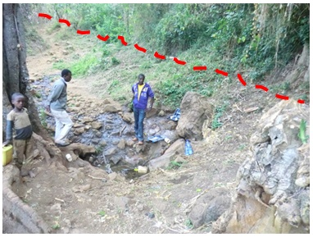
Plate 4 Typical spring at basalt-basement contact line (Red hatch = contact line) (Photo taken near Bilida, see Fig. 1 for the location)
In the basaltic aquifer groundwater generally flows toward south and southeast (Figure 30). It seems that groundwater flow direction is controlled by both topography and fractures orientation that is shown in Figure 2 and Figure 9, repectively.
On the drawdown-time curve of pump test data of the selected wells in the basaltic terrain, the change in the drawdown sharply increases during the first few minutes of pumping; however, the change slows in the later time which is, according to Krusemen and Ridder (2000), indicative of at least semi-confined aquifer system. This conclusion is normal due to the existence of the semi-pervious units on top of each fractured basaltic layer (Fig. 25). Semi-confined nature of the basaltic aquifer is further evidenced from the position of static water level relative to the depth of first-water-strike. Data shows mean static water level is at 21.2 m which is, in average, 10 m above the depth of first-water-strike (Table 10).
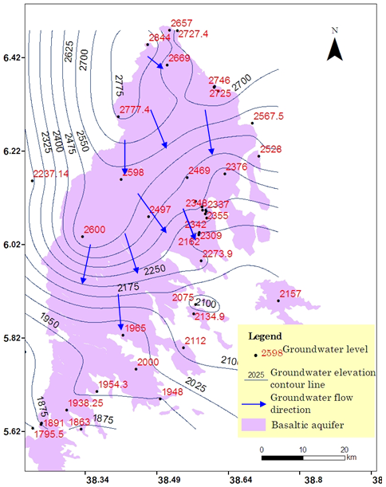
Figure 30 Groundwater flow direction in the basaltic aquifer

Basement aquifer
Plutonic igneous rocks (granites, diorites, etc.) and metamorphic rocks (gneisses, granulites, quartzites, schists and phyllites, etc.) are characterized by insignificant primary inter-granular porosity and primary permeability (Krasny, 1997); however, rock weathering and fracturing create secondary porosity and permeability to varying extent (UNESCO, 1984; Singhal, 2008). In a typical basement terrain covered by these rocks, geological sequence is characterized by (a) upper weathered zone formed by regolith, talus and/or quaternary deposits where inter-granular (or interstitial) porosity prevails, (b) middle fissured zone having thickness in some tens of meters, and (c) lower massive zone (Bhawan, 1999; Omosuyi and Oyemola, 2012). In general, the upper and the middle layer form basement aquifers where groundwater occurs and circulates (UNESCO, 1984).
In the basement terrain of the study area, water well inventory shows productive water wells are located on or near the fracture lines (Fig. 31), suggesting that groundwater occurs and circulates along fracture lines. Indeed, fracture control on groundwater occurrence and flow direction is common to many of the basement terrains elsewhere (Singhal, 2008). In chapter two above, it is disclosed that fractures are short in length and not interconnected, resulting in compartmentalized/localized aquifer system.
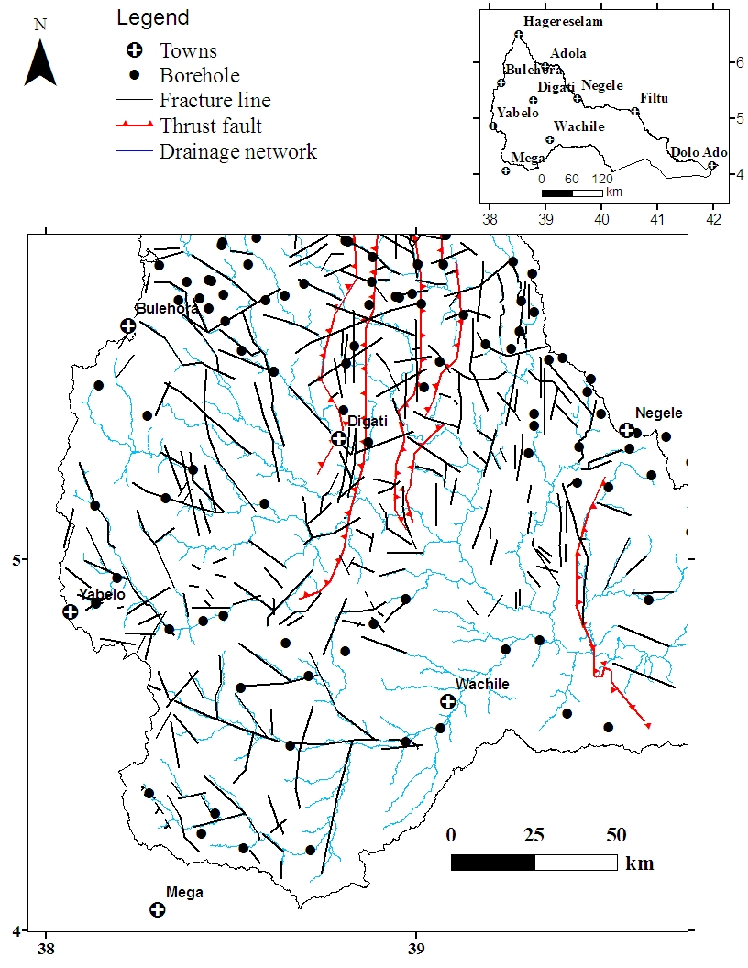
Figure 31 Spatial relationships between fracture lines, stream lines, and productive water wells
Figure 32 shows groundwater flow direction in the basement terrain. It is revealed that the flow direction is generally toward south from north and toward southeast from west dominantly conforming fracture orientation of the area. At some locations in the terrain, however, topography controls the flow direction.
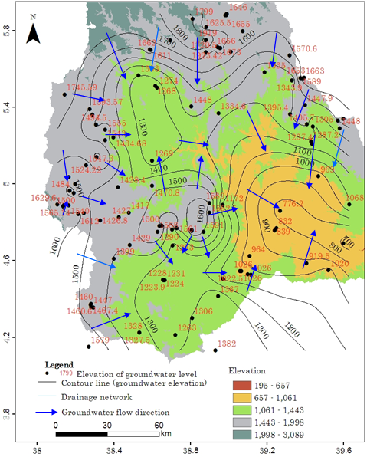
Figure 32 Groundwater flow direction in the basement terrain
Well log analysis indicates in the gneiss-granite terrain coarse sediments of sandy size occur in the depressed areas, while in the mafic-ultramafic terrain depressions are filled with relatively finer sediments. The mean thickness of near-surface loose materials, composed of clay, silt, and/or sand, is 12.6 m (Table 10). Massive bedrock occurs at an average depth of 38.9 m. Fractured and/or weathered bedrock of varying thickness occurs between the upper loose sediments and the bottom massive bedrock. On the other hand, average depth to a first water-strike is 24.5 m, which is within the range of depth of fractured and/or weathered zone. The preceding discussion signifies in the basement terrain, groundwater majorly occurs in the fractured and/or weathered zone than the overlying loose sediments and the underlying massive bedrock.
Table 10 Statistical summary of well hydraulic data (from basement terrain)
Data type | Mean | min | Max | Stdev | n
Well depth (m) | 60.7 | 22.6 | 150 | 25.27 | 116
Static water level (m below  the ground surface) | 21.4 | 0.6 | 127 | 17.79 | 35
Thickness of loose sediments (m) | 12.6 | 0 | 66 | 11.71 | 65
depth to first water-strike (m) | 24.47 | 2 | 78 | 14.99 | 35
Depth to massive bed rock (m) | 38.89 | 2 | 120 | 22.62 | 49
Well yield (l/s) | 2.27 | 0.1 | 12.5 | 2.11 | 95
Tansmissivity (m²/day) | 36.61 | 0.189 | 168 | 54.71 | 15

The mean yield of the water wells is 2.3 l/s (Table 10). In general, yield is higher in the northern half of the basement terrain (3.1 l/s in average; stdev of 2.56; n = 30) than in its southern counterparts (1.9 l/s in average; stdev of 1.77; n = 65). The distribution of well yield data around the median value is shown in Figure 33. The overall spatial variation of the well yield over the study area is also shown in Figure 34.
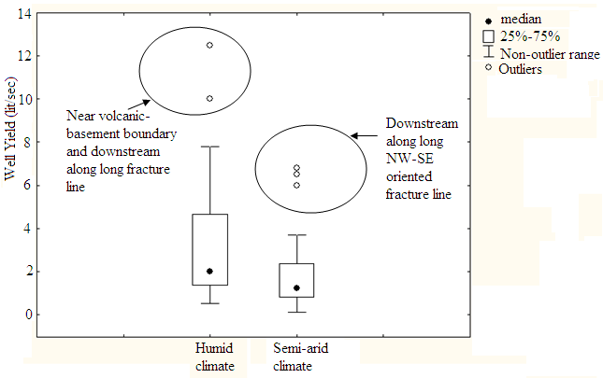
Figure 33 Box plot of well yield per major climatic regime in the basement terrain
Based on the pump test data at 15 test pump points, hydraulic characteristics such as transmissivity and specific yield of the hard rock aquifer were estimated. Spatial variation in transmissivity is shown in Figure 34. It is found that transmissivity varies between 0.42 and 168 m²/day (the mean value equal to 36.61m²/day) and specific yield varies between 0.10 and 0.002 (median value = 0.05). Spatial variation in well yield is likely explained by the disparity in climatic condition of the two regions which influences the amount of water available for recharge.
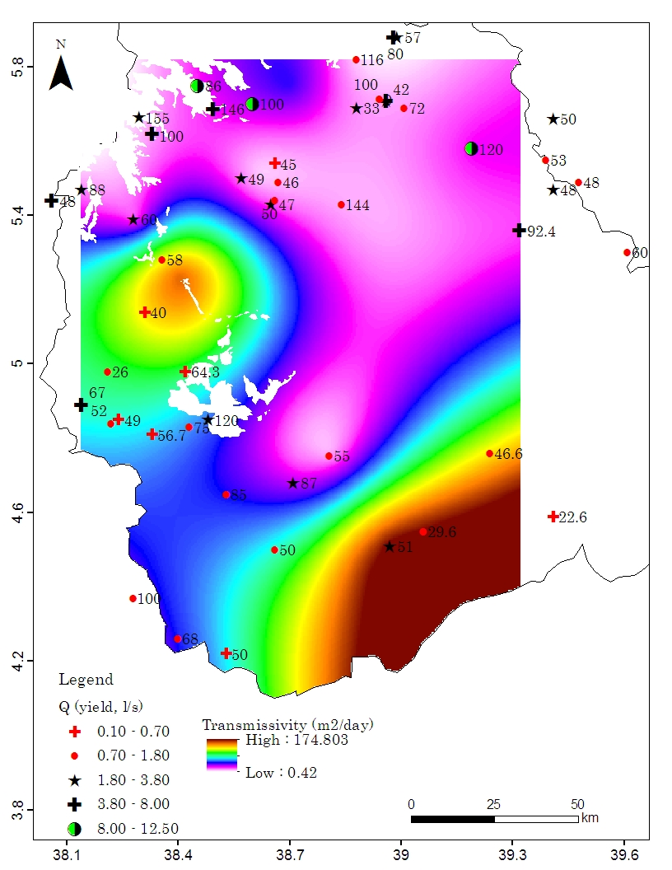
Figure 34 Spatial distributions of well yield and transmissivity in the basement terrain (number on the map indicates the data label in annex A8)
In the basement terrain of the basin, mean depth of the productive water wells is 60.7 m (Table 10). This value is close to the optimum depth of productive wells in hard rock aquifers, 50–60 m, determined elsewhere by Davis and Turk (1964). Drilling beyond the optimum depth usually does not add a significant amount of water to a well. In the view of that, the well yield data used in the present study provides a reliable image of aquifer productivity of the basement terrain.
In boreholes greater than 20 m in depth, the mean SWL is 21 m which is comparable to the mean depth of first-water-strike, 24.5 m (Table 10) and this likely indicates the unconfined aquifer system. This deduction is supported by the analysis of pump test data of water wells in the area. Time-drawdown curves of the pump test data show S-shape, from which we can recognize three distinct segments: a steep early-time segment, a flat intermediate-time segment, and a relatively steep late-time segment (Annex A12) and, according to Kruseman and de Ridder (2000) this is a typical characteristic of unconfined aquifers. The three segments of the curve are explained in the way that: a) the steep early-time segment corresponds to the early period after the start of pumping. During this time, the water that discharges out of well is released directly from the aquifer storage due to water expansion and aquifer compaction. As a result, shape of the early-time segment is steep; b) the flat intermediate-time segment represents the effect of the dewatering which is associated with the falling of the water table. In this case, increase in the drawdown slows down with time and after a minute to a few hours of pumping, the curve may close the horizontal; c) the relatively steep late-time segment represents the conditions that the flow in the aquifer is fundamentally horizontal again and the curve once again tends to be steep (Kruseman and de Ridder, 2000).
On the other hand, in the hand-dug wells, mean static water level is 5.3 m (stdev = 3.55; n = 39), indicating the occurrence of very shallow groundwater. In general, the unconfined aquifer system in the basement terrain and the near-surface SWL signify the high vulnerability of the aquifer system to anthropogenic interference. This deduction is later confirmed by hydrochemical data (Section 5.3.2).

Limestone aquifer
Field observation and previous drilling experience in the area reveals consolidated limestone is the highly fractured rock unit in the sedimentary terrain (Plate 5a-c). Overlying this fractured unit, soil cover is absent or thin and where exists it is non-compact (plate 5a, b).
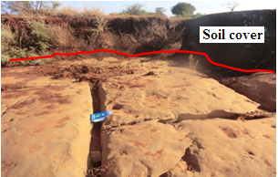a 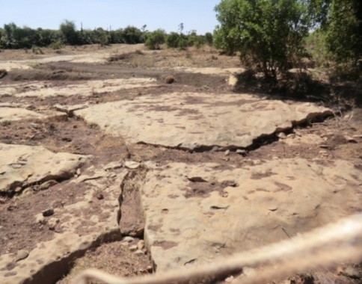b 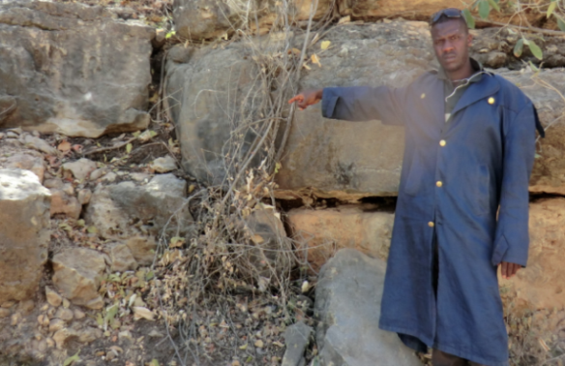c
Plate 5 a, b Fractured limestone surface view c cross-section view (Photo taken near Negelle (a, b) and Bobala (c))
In this terrain, depth of groundwater occurrence depends on the depth to the relatively impermeable layer upon which groundwater accumulates. In the northwestern end of the sedimentary terrain, drilling experience, for example, at water well sites 36, 41, 51, and 47 (see Fig. 37 for locations) shows groundwater occurs at the interface between the basement rock and the overlying limestone succession. Generally, depth to this interface increases toward southeast (Section 2.2.2) and, hence, depth to groundwater occurrence increases in the same direction. However, where the limestone unit is relatively thick, for example, at water well site 91 (see Fig. 37 for location) groundwater accumulate on impermeable units such as mudstone intercalated in the sequence.
Approximately, east of 40.5° longitude, thick impermeable units cover the fractured limestone (Fig. 24) and put this potential aquifer beyond a depth affordable for drilling for community water supply. Practically, this is the most likely explanation why drilling ends dry in the Filtu area (Figure 1 for location) and beyond toward east and southeast. In the area covered by rocks other than the fractured limestone groundwater occurs in the alluvial sediments along dry riverbeds.
There is no pump test data available to characterize transmissive and storage characteristics of this aquifer. However, preliminary inference can be made to the aquifer productivity based on few records of well yield. The well yield that considered here is the current production yield which is believed to be an optimum yield of the well for the reason that in practice in such arid to semiarid region, a well usually exploited to the maximum possible yield to address the acute water shortage in the area. Mean yield of 15 boreholes that tap the aquifer is 1.8 l/s (stdev. = 1.1), indicating moderate or low aquifer productivity relative to the basaltic aquifer. No well defined correlation is observed between well depth and well yield (Figure 35) which can be associated with the nature of groundwater occurrence, recharge condition, and well locations. Where wells tap shallow aquifers in the northwestern end of the limestone terrain rainfall is high relative to the area in the southeast. Toward southeast though well depth increases in relation to deep groundwater occurrence, rainfall is low limiting groundwater recharge.
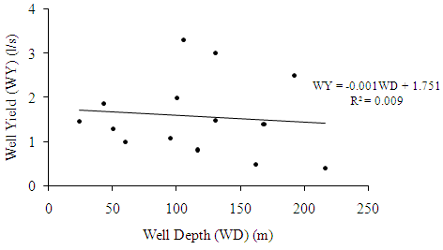
Figure 35 Plot of well yield against well depth from the limestone terrain
In general, it is observed that in the sedimentary terrain groundwater flows toward southeast (Fig. 36). Groundwater flow direction in entire regions of the study area is shown in annex 13.

Aquicludes
Tuff and ignimbrite are outcropped in the north and north western end of the study area. Well log analysis shows the thickness of these units varies between 20 and 30 m. Fracture development is not traceable due to thick and intense weathering. Custodio (2003) suggested that weathering of ash and pyroclastic volcanic rocks produce low permeability but high porosity mass. Accordingly, these units are characterized as local aquiclude that confines the underlying basaltic aquifer.
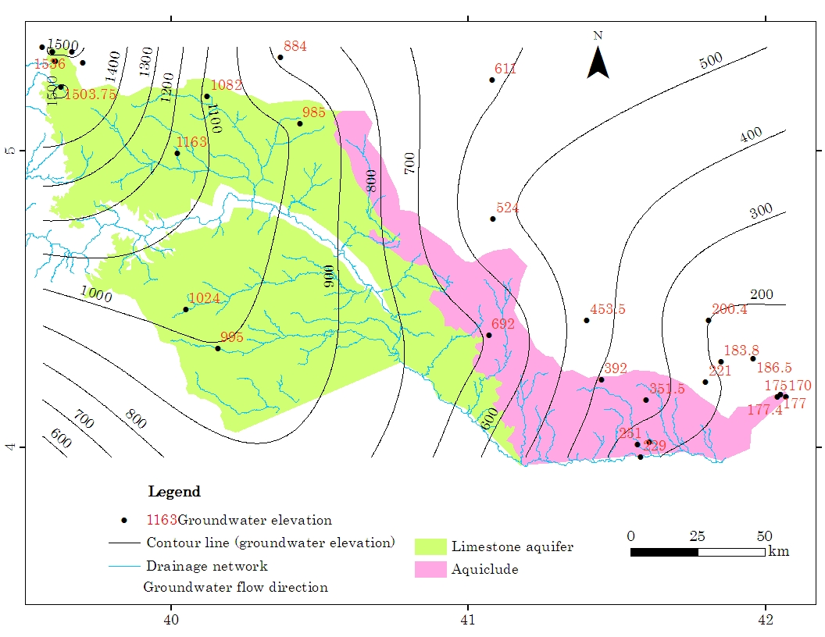
Figure 36 Groundwater flow direction in the sedimentary terrain

Shale, marl with some limestone, and gypsum units in the southeast has a cumulative thickness of up to 1000 m overlying the highly fractured limestone unit (Hunegnaw et al., 1988; Getaneh Assefa,1988). No hydraulic data is available for the detail characterization of these formations. However, field experience shows groundwater development is unsuccessful in the area as drilling usually ends dry. Elsewhere, these formations are considered as regional confining units due to its high clay proportion (Belcher et al., 2001). For the similar reason, these units are considered as regional aquiclude (Fig. 24) which inhibits vertical percolation of the rainfall toward the deep seated fractured limestone.

Hydrochemistry

Introduction
It is generally established that major cations and anions dissolved in groundwater originate either from rainwater, mineral weathering through water-rock interaction, and/or athropogenic interferences (Kim et al., 2005). Evaporation process as well influences groundwater chemistry (Hiscock, 2005; Adams et al., 2001).
Worldwide a number of hydrochemical studies have been conducted to identify geochemical processes and their relation to groundwater quality (Jalali, 2006; Jalali, 2010; Biswas et al., 2012) and to understand groundwater occurrence, recharge, and flow pattern (Kebede et al., 2005; Demlie et al., 2010). The importance of hydrochemical study to design appropriate management practices to develop and protect aquifers and undertake proper corrective actions for polluted groundwater is well illustrated (Li et al., 2013; Wu et al., 2014; Wu et al., 2015). Hydrochemical studies have also been conducted to assess groundwater suitability for domestic and agricultural uses (Sonkamble et al., 2012).
In this study hydrochemical data were analyzed using statistical analysis and various graphical plots to gain an insight into general chemical characteristics, major process that controls groundwater chemistry and nature of groundwater recharge and flow systems. Spatial distribution of hydrochemical data used in this study is shown in Figure 37.

Hydrochemical characteristics
Descriptive statistics
Table 11 shows in the volcanic terrain TDS is in the range of 26–892 mg/l, and in the basement and sedimentary terrain is 20.5–6,474 and 428–4,421 mg/l, respectively. pH values are in the range of 5.7–7.2, 4.5–8.0, and 6.4–7.8, respectively, in the volcanic, basement, and sedimentary terrain. Eighty-three and 71 % of the wells investigated in the volcanic and basement terrain, respectively, are marked with a pH < 7.0, indicating the general acidic water in these parts of the study area; while 70% of the wells investigated in the sedimentary terrain yielded a pH > 7.0, illustrating the dominance of alkaline water in this particular terrain.
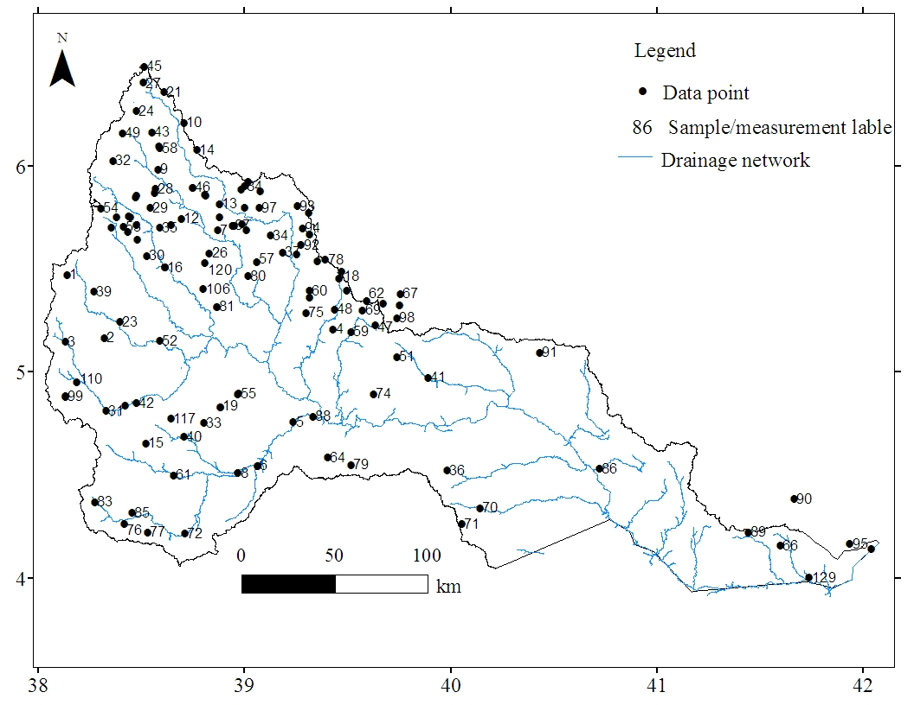
Figure 37 Location of hydrochemical data points
Table 11 Summary of water quality parameters (Units: T (Temperature) in °c; TDS in mg/l; EC in µS/cm; major ions in mg/l)
 |  | pH | T | TDS | EC | Ca²⁺ | Mg²⁺ | Na⁺ | K⁺ | HCO₃⁻ | Cl⁻ | SO₄²⁻ | NO₃⁻
Volcanic | mean | 6.6 | 20.2 | 152.3 | 244.6 | 24.6 | 4.9 | 8.7 | 2.1 | 111.6 | 4.6 | 3.2 | 0.9
Volcanic | Median | 6.7 | 19.8 | 110.0 | 180 | 23.0 | 4.6 | 7.7 | 1.9 | 110.0 | 3.6 | 1.0 | 0.7
Volcanic | Min | 5.7 | 17.1 | 26.0 | 42 | 4.2 | 1.0 | 2.0 | 0.3 | 21.5 | 1.0 | BDL | BDL
Volcanic | Max | 7.2 | 28.7 | 892.0 | 1487 | 44.0 | 12.0 | 24.0 | 4.2 | 220.0 | 18.2 | 18.3 | 2.4
Volcanic | Stdev | 0.4 | 2.5 | 165.9 | 277.2 | 11.8 | 3.0 | 5.7 | 1.0 | 54.8 | 3.9 | 4.8 | 0.7
Volcanic | n | 23 | 24 | 25 | 25 | 17 | 17 | 17 | 17 | 17 | 17 | 17 | 17
Basement | mean | 6.7 | 24.1 | 991.0 | 1566 | 122.6 | 44.2 | 172.1 | 12.5 | 397.9 | 207.7 | 224.4 | 14.7
Basement | Median | 6.8 | 24.3 | 567.0 | 887 | 83.0 | 25.5 | 63.0 | 6.0 | 334.0 | 58.0 | 71.5 | 1.8
Basement | Min | 4.5 | 19.5 | 82 | 134 | 9.0 | 2.0 | 1.9 | 0.5 | 45.0 | 2.0 | 1.0 | BDL
Basement | Max | 8.0 | 28.0 | 6474.0 | 9970 | 1002.0 | 289.0 | 1562 | 110.0 | 1120.0 | 1901.0 | 2540.0 | 433.0
Basement | Stdev | 0.6 | 2.1 | 1239 | 1986 | 142.4 | 50.9 | 290.3 | 18.5 | 232.8 | 385.5 | 440.0 | 55.4
Basement | n | 78 | 83 | 83 | 83 | 64 | 64 | 64 | 64 | 64 | 64 | 64 | 64
Sedimentary | mean | 7.2 | 27.0 | 1575 | 2384 | 259.2 | 157.7 | 235.8 | 11.2 | 372.6 | 326.9 | 1009.6 | 28.9
Sedimentary | Median | 7.2 | 27.4 | 1296 | 1983 | 239.0 | 150.0 | 72.0 | 11.0 | 340.0 | 132.0 | 1004.0 | 4.0
Sedimentary | Min | 6.4 | 21.7 | 172.6 | 287.8 | 54.0 | 54.0 | 29.0 | 3.0 | 225.0 | 12.0 | 48.0 | 0.1
Sedimentary | Max | 7.8 | 29.0 | 4421.0 | 6631 | 524.0 | 278.0 | 865.0 | 26.0 | 652.0 | 1485.0 | 2508.0 | 160.0
Sedimentary | Stdev | 0.4 | 2.0 | 1153 | 1688 | 147.3 | 68.9 | 276.4 | 6.8 | 117.2 | 462.1 | 680.7 | 52.0
Sedimentary | n | 13 | 13 | 13 | 13 | 13 | 13 | 13 | 13 | 13 | 13 | 13 | 13
BDL = 0.001 mg/l BDL below the detection limit; T temperature
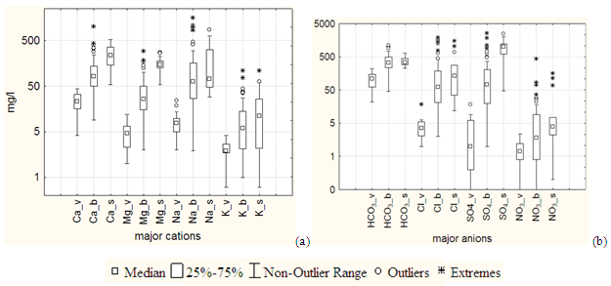
Figure 38 Box plots of major ions from volcanic (v), basement (b), and sedimentary (s) terrains
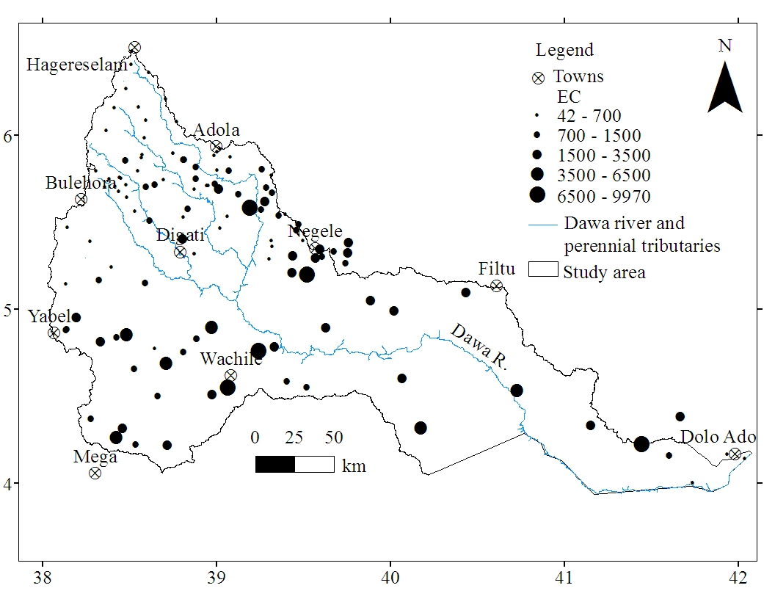a
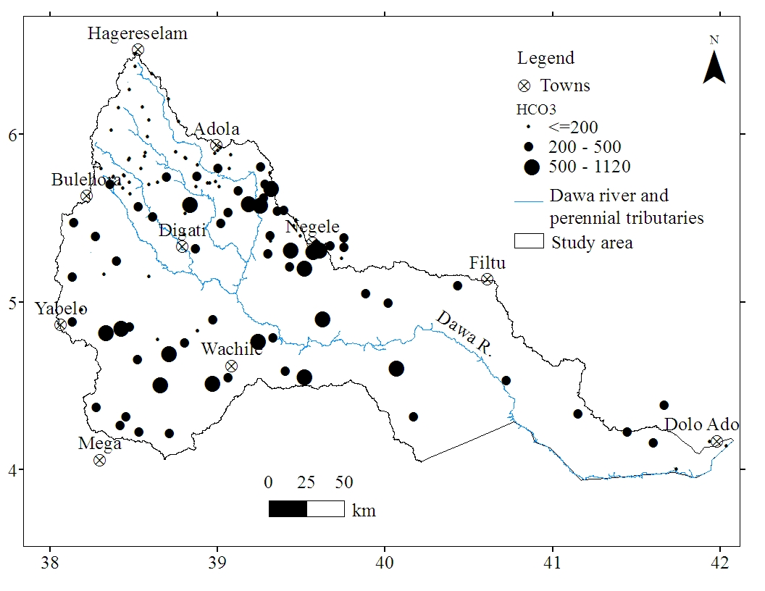b
Figure 39 Spatial variations of a EC in µS/cm b HCO₃⁻ in mg/l
In the study area, groundwater is generally cold with temperature ranging from 17.1–29.0. For each terrain, the overall statistical summary of water quality parameters is presented in Table 11. From table 11 and Figure 38, it is apparent that in each of the terrains the range between the maximum and minimum values of water quality parameters is high. It is also revealed that the range and variability of data points around the mean, expressed by standard deviation, and median values are higher in the basement and sedimentary terrains than in the volcanic terrain.
Furthermore, spatial plot of EC and HCO₃– (Fig. 39a, b) illustrates the extent of chemical variability across the study area. Chemical variability is high within a short distance between the sampling points particularly in the central part of the basin covered by metamorphic rocks.
Hierarchical Cluster Analysis
HCA was employed on the hydro-chemical data set of 94 samples. Consequently, the water samples were classified into five statistically distinct clusters (C): CI, CII, CIII, CIV, and CV. The resultant dendogram of HCA and spatial distribution of the clusters are shown in Figure 40 and Figure 41, respectively. Each of these clusters correspond typical geologic and geographic environment. Preliminary description of the clusters is given as follows based on statistical summary of water quality parameters (Table 12).

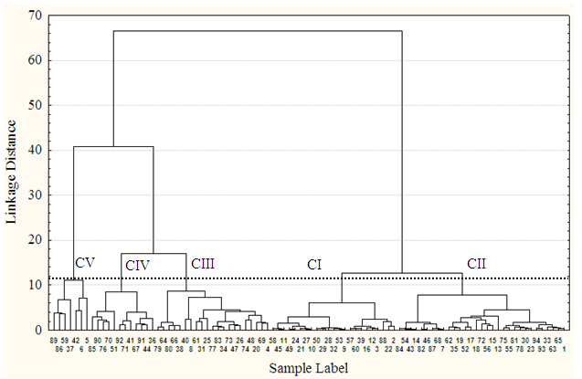
Figure 40 Dendogram of HCA showing associations between samples (line of asterisks is chosen by analyst to select number of sub-clusters)
CI is comprised of 23 samples largely collected from the highland volcanic terrain. Few samples of this cluster are associated with the relatively elevated region in the northwestern parts of the basement terrain (Fig. 41). CI is represented by a mean EC of 331.2 µS/cm (or TDS of 241.6 mg/l). CII is comprised of 31 samples many of which are collected from the northern half the basement terrain. Some of the samples of this cluster are also related to the headwater region of the dry stream channel and near the foot of the elevated area in the southern half of the basement terrain (Fig. 41). CII is characterized by mean EC equals 672.2 µS/cm (or TDS equals 437.9 mg/l) showing slightly higher salinity than CI. In both CI and CII, Ca and HCO₃– are the dominant ions with the other cations and anions existing in appreciable amount.
CIII is comprised of 21 samples where many of the samples are sited at some distance downstream of the hill-foot or away from head water of dry river bed in the semi-arid southern half of the basement terrain. Mean EC and TDS of CIII is 1523.2 µS/cm and 999.7 mg/l, respectively. As in CI and CII, HCO₃– is the most abundant anion in CIII samples; however, in CIII, Na⁺ is the most abundant cation with important amount of Ca²⁺ and Mg²⁺ (Table 12).
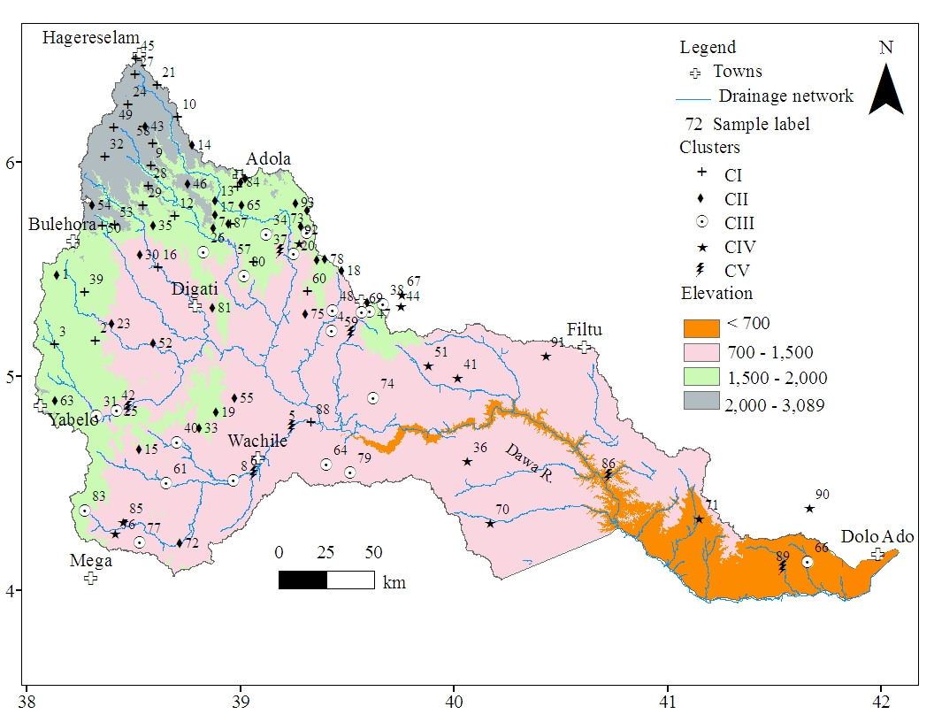
Figure 41 Spatial distributions of clusters (or samples) along with elevation

Table 12 Statistical summary of hydrochemical parameters of groundwater of clusters resulted from Q-mode HCA analysis (EC in µS/cm; cations and anions in mg/l; temperature in °c; % is percent of ions relative to the corresponding cations and anions)
Cluster | Variables | pH | Temp | TDS | EC | Ca²⁺ | Mg²⁺ | Na⁺ | K⁺ | HCO₃⁻ | Cl⁻ | SO₄²⁻ | No of  samples
 | Minimum | 6.6 | 17.1 | 60.0 | 97.0 | 10.6 | 2.0 | 5.0 | 1.4 | 55.6 | 1.8 | 0.0
I | Maximum | 7.5 | 24.9 | 682.0 | 887 | 131.9 | 25.0 | 58.0 | 9.0 | 317.2 | 32.3 | 296.0 | 22
 | Mean | 7.0 | 20.8 | 214.6 | 331.2 | 43.2 | 9.0 | 16.1 | 3.7 | 169.1 | 10.7 | 28.6
 | Std.Dev. | 0.2 | 2.1 | 149.0 | 212.0 | 29.4 | 6.3 | 12.0 | 2.1 | 79.8 | 9.3 | 64.3
 | % |  |  |  |  | 60.0 | 12.5 | 28.9 | 5.1 | 81.1 | 5.1 | 13.7
 | Minimum | 5.5 | 18.3 | 26.0 | 42.0 | 4.2 | 1.0 | 1.9 | 0.3 | 21.5 | 1.0 | 0.0
II | Maximum | 6.9 | 28.0 | 1019.0 | 1559.0 | 166.0 | 62.0 | 212.0 | 26.0 | 482.1 | 186.2 | 217.9 | 31
 | Mean | 6.5 | 23.1 | 437.9 | 676.2 | 63.7 | 18.2 | 48.8 | 4.8 | 231.6 | 56.2 | 64.3
 | Std.Dev. | 0.3 | 2.2 | 252.2 | 393.0 | 41.6 | 13.3 | 42.6 | 5.9 | 117.4 | 59.2 | 69.7
 | % |  |  |  |  | 47.0 | 13.4 | 36.0 | 3.5 | 65.8 | 16.0 | 18.3
 | Minimum | 6.3 | 21.7 | 418.0 | 640.0 | 9.0 | 8.4 | 6.0 | 0.5 | 294.0 | 6.0 | 2.0
III | Maximum | 8.0 | 28.5 | 1766.0 | 2943.0 | 285.0 | 124.0 | 420.0 | 39.0 | 1002.0 | 443.0 | 625.0 | 20
 | Mean | 7.2 | 25.5 | 999.7 | 1523.2 | 115.2 | 49.5 | 134.6 | 13.3 | 577.9 | 128.1 | 115.4
 | Std.Dev. | 0.5 | 1.7 | 430.8 | 678.6 | 70.4 | 27.3 | 105.8 | 12.6 | 164.9 | 121.9 | 153.6
 | % |  |  |  |  | 36.9 | 15.8 | 43.1 | 4.3 | 70.4 | 15.6 | 14.1
 | Minimum | 6.4 | 23.0 | 922.0 | 1536.0 | 75.0 | 80.0 | 29.0 | 1.0 | 225.0 | 16.0 | 484.0
IV | Maximum | 7.7 | 29.0 | 3172.0 | 4853.0 | 398.0 | 222.0 | 523.0 | 44.0 | 652.0 | 701.0 | 2039.0 | 12
 | Mean | 7.1 | 26.6 | 1653.1 | 2606.3 | 252.6 | 143.1 | 210.3 | 15.3 | 381.1 | 265.7 | 941.7
 | Std.Dev. | 0.4 | 1.6 | 652.6 | 1079.5 | 114.0 | 39.8 | 181.6 | 13.5 | 111.7 | 256.4 | 437.8
 | % |  |  |  |  | 40.7 | 23.0 | 33.8 | 2.5 | 24.0 | 16.7 | 59.3
 | Minimum | 6.7 | 24.9 | 3019.0 | 4647.0 | 82.0 | 82.7 | 640.0 | 5.0 | 231.0 | 752.3 | 714.5
V | Maximum | 7.8 | 28.4 | 6474.0 | 9970.0 | 1002.0 | 289.0 | 1562.0 | 110.0 | 1110.0 | 1901.0 | 2540.0 | 7
 | Mean | 7.1 | 26.8 | 4739.1 | 7526.4 | 408.1 | 201.9 | 976.7 | 36.7 | 545.6 | 1345.7 | 1552.0
 | Std.Dev. | 0.4 | 1.2 | 1277.6 | 2036.1 | 308.3 | 77.5 | 290.5 | 39.7 | 279.6 | 372.5 | 751.5
 | % |  |  |  |  | 25.1 | 12.4 | 60.2 | 2.3 | 15.8 | 39.1 | 45.1

CIV is comprised of 12 samples that have been largely collected from the sedimentary terrain. Two samples of this cluster are associated with dry stream beds in the southern half of the basement terrain. In CIV, the mean EC or TDS is high (mean EC, 2606.3 µS/cm or mean TDS, 1728.0 mg/l) and characterized by higher proportion of Ca²⁺ + Mg²⁺ over Na⁺ + K⁺. Furthermore, in CIV, SO₄²⁻ is the most abundant anion followed by HCO₃– and Cl– (Table 12).
CV is comprised of 7 samples in which all are associated with dry river beds in semi-arid and arid part of the study area. This cluster is characterized by a very high mean EC (7,526µS/cm) or TDS (4739.1 mg/l), and Na⁺ is the most abundant cation followed by Ca²⁺, Mg²⁺, and K⁺. The most abundant anion is SO₄²⁻ followed by Cl⁻ and HCO₃⁻ (Table 12). There is a general increase in mean EC and major ions from CI through CV (Table 12 and Fig. 42).
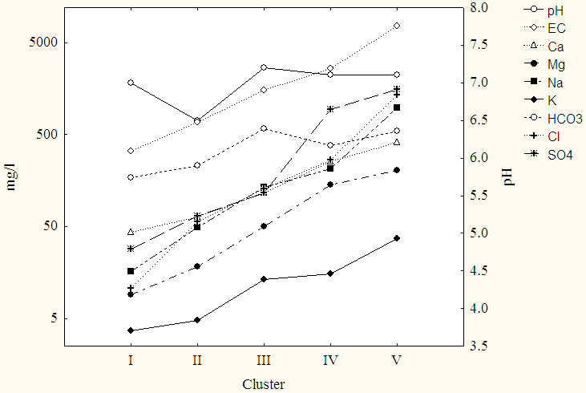
Figure 42 Average of water quality variables from CI through CV
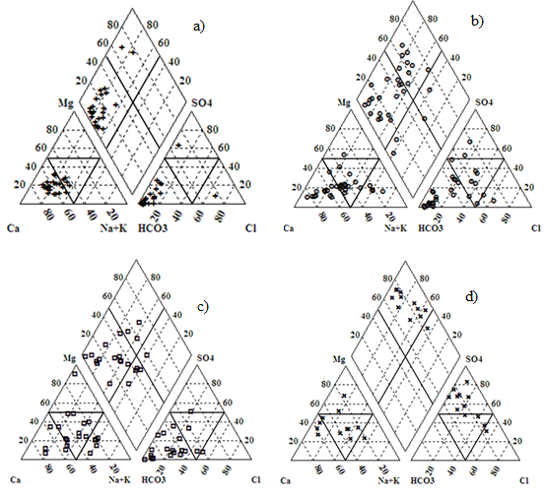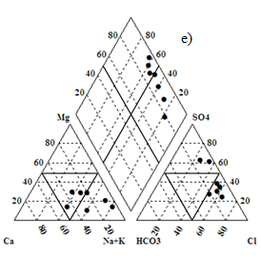
Figure 43 Piper plots of hydrochemical data: a CI, b CII, c CIII, d CIV, and e CV
Hydrochemical data were plotted on piper diagram (Piper, 1944) (Fig. 43) to make a detailed analysis of water quality in terms of hydrochemical facies. Subsequently, classification scheme of Back (1966) was used to group the water samples into different chemical types of water based on the dominant ions. This approach is widely used in many previous hydrogeological studies (Ophori and Toth, 1989; Adams et al., 2001; Güler et al., 2002; Kebede et al., 2005).
Accordingly, a wide variety of water types, represented by CI, CII, and CIII, were found in the volcanic and basement terrains of the study area (Table 13). However, mixed cation–bicarbonate, (Ca, Mg, Na)–HCO₃, water type dominantly occurs in these areas with the type of dominant cation varying from sample to sample based on the local geology. Though the water is mixed type in terms of cations, Figure 43 illustrates Ca²⁺ + Mg²⁺ is higher than Na⁺ + K⁺ in most of the samples.
In particular, 91 % of CI samples are HCO₃ type. Of these HCO₃-type samples, 74 % are Ca-HCO₃-type followed by 17 % mixed cation-HCO₃-type water. Likewise, 61 and 76 % of the samples of CII and CIII, respectively, are HCO₃-type (Table 13).
On the other hand, 67 % of the samples of CIV are sulfate type where 25, 17, and 25 % of these samples are Ca–SO₄, Mg–SO₄, and mixed–SO₄ type, respectively (Table 13). In particular, water collected from the wells that penetrate the limestone aquifer shows chemical character of sulfate type. Sulfate-type water is also observed at few locations in the fold and thrust belts of the basement terrain (e.g. at sample labeled 13 and 84).

Table 13 Groundwater types of the study area
Cluster | Cation | Anion | Water |  | Collected dominantly from
C I  (n = 23) | Ca-type (83%, n = 19)  Mixed – type (17%, n = 4) | HCO₃-type (91%, n = 21)  SO₄-type (4%, n = 1)  Cl-type (4%, n = 1) | Ca-HCO₃ (74%, n = 17);  Mixed cation-HCO₃ (17% n = 4);  Ca-SO₄ (4%, n = 1); Ca-Cl (4%, n = 1) |  | Volcanic/basalt
C II  (n = 31) | Ca-type (39%, n = 12)  Mixed-type (45%, n = 14)  Mg-type (3%, n = 1)  Na-type (13%, n = 4) | HCO₃-type (61%, n = 19)  Mixed-type (29%, n = 9)  SO₄-type(7%, n = 2)  Cl-type (3%, n =1) | Ca-HCO₃ (23%, n = 7); Mixed cation-HCO₃ (29%, n = 9); Mg-HCO₃ (3%, n = 1); Na-HCO₃ (3%, n = 1); Mixed cation-SO₄ (7%, n = 2); Na-Cl (3%, n = 1); Ca-Mixed anion (16%, n = 5); Na-Mixed anion (3%, n = 1); Mixed cation-Mixed anion (3%, n= 1) |  | Basement terrain in humid and near hill-foot in semi-arid areas
C III  (n = 21) | Ca-type (19%, n =4)  Mixed-type (52%, n = 11)  Na-type (24%, n = 5)  Mg-type (5%, n =1) | HCO₃-type (76%, n = 16)  Mixed-type (14%, n = 3)  SO₄-type (5% = 1)  Cl-type (5% = 1) | Ca-HCO₃ (19%, n = 4); Na-HCO₃ (14%, n = 3); Mixed cation-HCO₃ (38%, n = 8); Mg-HCO₃ (5%, n = 1); Na-Mixed anion (10%, n =2); Mixed cation-Mixed anion (5% , n = 1); Mixed cation-Cl (5%, n =1); Mixed cation-SO₄ (5%, n =1) |  | Basement terrain in semi-arid region (along dry river beds)
C IV  (n = 12) | Ca (25%, n = 3)  Mg (17%, n = 2);  Na (8%, n = 1)  Mixed ( 50%, n = 6) | SO₄-type (67%, n = 8)  Mixed-type (25%, n =3)  Cl-type (8%, n = 1) | Ca-SO₄ (25%, n =3); Mg-SO₄ (17%, n = 2);  Mixed cation-SO₄ (25%, n = 3)  Na-Cl (8%, n = 1); Mixed cation-mixed anion (25%, n =3) |  | Sedimentary terrain with intercalation of gypsum
C V  (n =7) | Na (43%, n = 3)  Mixed cation (57%, n = 4) | Cl-type (71%, n = 5)  SO₄-type (29%, n = 2) | Na-Cl (42%, n = 3); Mixed cation-Cl (29%, n = 2)  Mixed cation-SO₄ (29%, n = 2) |  | Alluvial deposits (at far distance downstream along dry beds in arid and semi-arid regions)

CV samples, which are dominantly Cl-type, (Fig. 43) is occasionally observed along dry stream channels or valley bottoms sited in the semi-arid region. These samples are either Na⁺ dominated or mixed cation type (Fig. 43).

Factors that affect groundwater chemistry

Hydrogeochemical processes
As explained earlier, groundwater of the study area significantly varies in concentration of water quality parameters and water types. In similar studies elsewhere, Subramani et al. (2010) associated the non-homogeneity of water chemistry with diversity in processes that control groundwater chemistry. HCA has effectively grouped groundwater samples into clusters of distinct water quality. As mentioned earlier, each cluster correspond typical geologic and geographic environment, signifying the effect of lithologic composition and climatic variability on water chemistry. Consequently, the dominant geochemical processes in each lithologic terrain are discussed as follows.
Processes in the vocanic terrain
As revealed in Table 14, TDS is strongly correlated to Ca²⁺, Mg²⁺, and HCO₃– and moderately to K⁺, Na⁺ and Cl– in groundwater of basaltic aquifer, indicating these ions are the major components of TDS.
Correlation between Na⁺ and Cl⁻ is weak, indicating halite dissolution may not be the major contributor of Na⁺ and Cl⁻ to the groundwater chemistry. This is also confirmed by the plots shown in Figure 44a. Ninety-four percent of the groundwater samples of this terrain (n = 16) are plotted above the reference line defined by Na⁺/Cl– ratio 1.5. Basically, recharge water, i.e., rainfall, is usually marked with Na⁺/Cl⁻ molar ratio varying between 0.5 and 1.5 at far distance from the coast (Thimonier et al., 2008) and with the ratio equal to sea salt, i.e., 0.86, near the coast (Keene et al., 1986). The ratio is equal to 1 if the source of Na⁺ and Cl⁻ is halite dissolution (Wu et al., 2014). In contrast, silicate hydrolysis adds Na⁺ but not Cl⁻ (Stumm and Morgan, 1995; Appelo and Postma, 2005; Lu et al., 2015) and, hence, raises Na⁺/Cl⁻ ratio above that of salt dissolution or rainfall. Therefore, plot of data above the reference line defined by the maximum possible Na⁺/Cl⁻ ratio of rainfall, 1.5, can be explained by weathering of silicate minerals. The possible influence of silicate hydrolysis on the water chemistry of the basaltic aquifer is further confirmed by plots shown in Figure 44b. Eighty-three percent of the samples (n = 14) are plotted above the reference line defined by Ca²⁺/Mg²⁺ molar ratio 2. Elsewhere, Ca²⁺/Mg²⁺ molar ratio >2 is used as indicative of silicate hydrolysis (Sonkamble et al., 2012) such as enhanced weathering of calcic plagioclase in the basalt (Aboubaker et al., 2012; Möller et al., 2005). In the other studies, such as Moral et al (2008), it is also explained that high Ca^{2+/}Mg²⁺ molar ratio could be due to dissolution of pure carbonate. However, for the reason explained below calcite and/or dolomite dissolution in the basaltic aquifer of the area is absent or insignificant, the high Ca^{2+/}Mg²⁺ molar ratio shall be explained in terms of importance of silicate weathering in the basaltic aquifer of the study area.

Table 14 Correlation coefficients between water quality variables (underlined indicates correlation is significant at 0.05 level)
 | Variable | TDS | Ca²⁺ | Mg²⁺ | Na⁺ | K⁺ | HCO₃⁻ | Cl⁻ | SO₄²⁻ | NO₃⁻
Volcanic | TDS | 1.00 | 0.94 | 0.81 | 0.63 | 0.54 | 0.94 | 0.69 | 0.42 | -0.31
Volcanic | Ca²⁺ |  | 1.00 | 0.64 | 0.54 | 0.51 | 0.92 | 0.68 | 0.42 | -0.30
Volcanic | Mg²⁺ |  |  | 1.00 | 0.47 | 0.51 | 0.75 | 0.46 | 0.19 | -0.39
Volcanic | Na⁺ |  |  |  | 1.00 | 0.20 | 0.77 | 0.20 | -0.11 | -0.14
Volcanic | K⁺ |  |  |  |  | 1.00 | 0.45 | 0.64 | 0.47 | -0.06
Volcanic | HCO₃⁻ |  |  |  |  |  | 1.00 | 0.50 | 0.15 | -0.30
Volcanic | Cl⁻ |  |  |  |  |  |  | 1.00 | 0.72 | -0.21
Volcanic | SO₄²⁻ |  |  |  |  |  |  |  | 1.00 | -0.20
Volcanic | NO₃⁻ |  |  |  |  |  |  |  |  | 1.00
Basement(Highland) | TDS | 1.00 | 0.69 | 0.81 | 0.77 | 0.27 | 0.69 | 0.70 | 0.66 | -0.04
Basement(Highland) | Ca²⁺ |  | 1.00 | 0.37 | 0.18 | 0.22 | 0.53 | 0.32 | 0.50 | -0.22
Basement(Highland) | Mg²⁺ |  |  | 1.00 | 0.55 | 0.16 | 0.57 | 0.56 | 0.55 | 0.10
Basement(Highland) | Na⁺ |  |  |  | 1.00 | 0.12 | 0.49 | 0.68 | 0.48 | 0.09
Basement(Highland) | K⁺ |  |  |  |  | 1.00 | 0.52 | -0.16 | -0.07 | -0.24
Basement(Highland) | HCO₃⁻ |  |  |  |  |  | 1.00 | 0.13 | 0.01 | -0.08
Basement(Highland) | Cl⁻ |  |  |  |  |  |  | 1.00 | 0.57 | -0.03
Basement(Highland) | SO₄²⁻ |  |  |  |  |  |  |  | 1.00 | -0.01
Basement(Highland) | NO₃⁻ |  |  |  |  |  |  |  |  | 1.00
Basement(semi-arid) | TDS | 1.00 | 0.65 | 0.84 | 0.93 | 0.48 | 0.40 | 0.91 | 0.85 | 0.38
Basement(semi-arid) | Ca²⁺ |  | 1.00 | 0.55 | 0.44 | 0.06 | 0.15 | 0.64 | 0.72 | -0.12
Basement(semi-arid) | Mg²⁺ |  |  | 1.00 | 0.75 | 0.25 | 0.33 | 0.71 | 0.90 | 0.24
Basement(semi-arid) | Na⁺ |  |  |  | 1.00 | 0.50 | 0.45 | 0.91 | 0.76 | 0.30
Basement(semi-arid) | K⁺ |  |  |  |  | 1.00 | 0.12 | 0.45 | 0.22 | 0.62
Basement(semi-arid) | HCO₃⁻ |  |  |  |  |  | 1.00 | 0.23 | 0.26 | -0.04
Basement(semi-arid) | Cl⁻ |  |  |  |  |  |  | 1.00 | 0.72 | 0.26
Basement(semi-arid) | SO₄²⁻ |  |  |  |  |  |  |  | 1.00 | 0.08
Basement(semi-arid) | NO₃⁻ |  |  |  |  |  |  |  |  | 1.00
Sedimentary | TDS | 1.00 | 0.54 | 0.71 | 0.81 | 0.18 | -0.19 | 0.89 | 0.49 | 0.20
Sedimentary | Ca²⁺ |  | 1.00 | 0.55 | 0.40 | 0.43 | 0.09 | 0.41 | 0.76 | -0.27
Sedimentary | Mg²⁺ |  |  | 1.00 | 0.82 | 0.20 | -0.29 | 0.73 | 0.80 | 0.10
Sedimentary | Na⁺ |  |  |  | 1.00 | 0.26 | -0.43 | 0.90 | 0.67 | 0.20
Sedimentary | K⁺ |  |  |  |  | 1.00 | -0.27 | 0.06 | 0.54 | -0.54
Sedimentary | HCO₃⁻ |  |  |  |  |  | 1.00 | -0.30 | -0.39 | 0.09
Sedimentary | Cl⁻ |  |  |  |  |  |  | 1.00 | 0.47 | 0.27
Sedimentary | SO₄²⁻ |  |  |  |  |  |  |  | 1.00 | -0.22
Sedimentary | NO₃⁻ |  |  |  |  |  |  |  |  | 1.00

HCO₃– is highly correlated to Ca²⁺, Mg²⁺, and Na⁺ with correlation coefficients more than 0.77, also indicating the possibility that these ions are released into the groundwater from silicate–water interaction. In principle, chemical weathering of silicate minerals releases HCO₃– and depending on the type of silicate minerals, it liberates a variety of major cations (Stumm and Morgan, 1995; Appelo and Postma, 2005; Lu et al., 2015).
The general chemical equations that represent rock-water interaction in the basaltic aquifers are given as follows (Lu et al., 2015):
CO₂ + H₂O → HCO₃– + H⁺ (R1)
Na_{x}(Ca,Mg,Fe)_{y}Si₃AlO₈ + (x + 2y + 3)H⁺ + 4H₂O → xNa⁺ + y (Ca,Mg,Fe)²⁺
+ 3H₄SiO₄ + Al³⁺ (R2)
High correlation of HCO₃– to Ca²⁺ and Mg²⁺ (Table 14) may be associated with carbonate dissolutions as well. In theory, if calcite and dolomite dissolution is the only sources of Ca²⁺ and Mg²⁺, HCO₃–:Ca²⁺ and HCO₃–:(Ca²⁺ + Mg²⁺) molar ratio should be within the range of 2–1, depending on the amount of CO₂ involved in the reactions (Wu et al., 2014). Water samples of the volcanic terrain were plotted beyond 1:2 line in Figure 44c, indicating the effect of calcite dissolution on the water chemistry is not obvious, while the samples are plotted on or very close to 1:2 line in Figure 44e, indicating dolomite dissolution might have contributed these ions to the water chemistry. However, the samples are plotted above molar ratio 1 in Figure 44b and, according to Sonkamble et al. (2012), this suggests dolomite dissolution is not significant. Moreover, the far negative values of saturation indices with respect to calcite (Si_{c}) and dolomite (Si_{d}) (Fig. 44f) indicates undersaturation of carbonates and, according to Lu et al. (2015), this suggests soluble carbonates mineral phases were absent or insignificant.
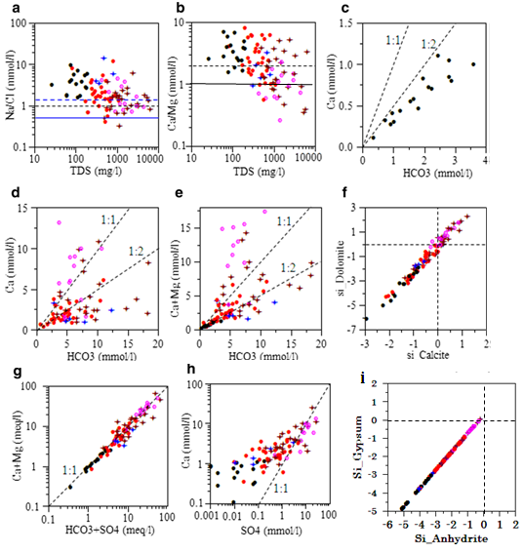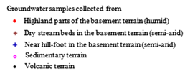
Figure 44 Plots of a Na⁺/Cl– versus TDS (blue hatch line represent ratio = 1.5, black hatch line represents ratio = 1; and Solid blue line represents ratio= 0.5) b Ca²⁺/Mg²⁺ versus TDS (black hatch line represents ratio = 2) c and d Ca²⁺ against HCO₃– e Ca²⁺ + Mg²⁺ against HCO₃– f SI_dolomite versus SI_calcite g Ca²⁺ + Mg²⁺ against HCO₃– + SO₄^{2–} h Ca²⁺ versus SO₄²⁻ I SI_gypsum versus SI_anhydrite
The preceding discussion illustrates that silicate hydrolysis is the dominant hydrogeochemical process which controls groundwater chemistry in the volcanic terrain.
Processes in the basement terrain
As explained earlier, groundwater in the basement terrain is characterized by diverse chemical character. Correlation coefficient between ions in wet highland parts of the basement terrain differs from that of semi-arid counterparts (Table 14). This may suggests a difference in underlying hydrogeochemical processes between the two regions.
In the highland region, HCO₃– is moderately correlated to Ca²⁺, Mg²⁺, Na⁺, and K⁺ with correlation coefficients in the range of 0.49–0.57; while in the semi-arid region, HCO₃– is moderately correlated only to Na⁺ with correlation coefficient of 0.45. For the reason explained earlier, statistically significant correlation between HCO₃– and major cations in the highland regions represents the effect of hydrolysis of silicates of various compositions. In the semi-arid region, however, hydrolysis of Na-bearing silicate minerals influences water chemistry. The possible effects of silicate hydrolysis on the water chemistry are confirmed by plots shown in Figure 44a, b. Majority of the samples collected from both humid and semi-arid parts of the basement terrain are plotted above the line defined by Na⁺/Cl⁻ molar ratio equal to 1.5 (Fig. 44a). Moreover, majority of the samples from humid highland and half of the samples from semi-arid parts of the terrain are plotted above the line defined by Ca²⁺/Mg²⁺ molar ratio 2 (Fig. 44b). Since, as explained below based on Figure 44d, the effect of calcite dissolution is not clear here too, the high Ca²⁺/Mg²⁺ molar ratio indicates the effect of silicate hydrolysis.
Most of the samples collected from both humid and semi-arid regions of the terrain are plotted out of the range of 1:1–1:2 lines in Figure 44d, indicating effect of calcite dissolution on the water quality is not clear. However, more samples from both regions are plotted within the range of 1:1–1:2 lines or close to 1:2 line in Figure 44e, suggesting water chemistry might be influenced by dolomite dissolution. Moreover, a few samples collected from the humid region and part of the samples from semiarid parts of the terrain are plotted below the line defined by Ca²⁺/Mg²⁺ molar ratio 2. This might be associated with the effect of dissolution of carbonates such as dolomite that contains high amount of Mg²⁺, supporting the similar conclusion that have made above based on Figure 44e.
In the basement terrain, Cl⁻ is correlated to Na⁺, while SO₄^{2–} is correlated to Ca²⁺, Mg²⁺, Na⁺, and Cl–. In both cases, strong correlation is observed in semiarid parts of the terrain (Table 14). Correlation between Na⁺ and Cl– might be associated with the effect of halite dissolution or rainfall chemistry. This is supported by plot shown in Figure 36a that some of the samples collected from different parts of the terrain are plotted within the range of the likely influence of rainfall chemistry and/or salt dissolution. However, the low values of Cl–/Br– ratio of high EC groundwater in the semi-arid parts of the study area suggests that the effect of halite dissolution is insignificant and as explained in section 5.3.3, the source of Na⁺ and Cl– are the local rainfall with evaporation builds their concentration. Similarly, some of the samples which were collected from the highland parts of the basement terrain are also plotted between 0.5 and 1.5 (Fig. 44a). Given the low TDS of highland waters, this indicates that the sources of Na⁺ and Cl– are rainwater.
Correlation of SO₄^{2–} to Ca²⁺ and Mg²⁺ is frequently associated with the effect of sulfide oxidation in silicate terrains (Jalali, 2010). The oxidation reaction of sulfide mineral, for example of pyrite, can be described as the following and these reactions bring about a considerable decrease in pH (Migaszewski et al., 2007):
FeS₂ (pyrite) + 3.5O₂ + H₂O → Fe²⁺ + 2SO₄²⁻ + 2H⁺
FeS₂ + 14Fe³⁺ + 8H₂O → 15Fe²⁺ + 2SO₄²⁻ + 16H⁺
Under acidic conditions, silicate minerals dissolve and release various types of cations depending on the mineral compositions. For example, under acidic condition, dissolution reaction of serpentine mineral releases Mg²⁺ and SO₄²⁻ into groundwater as follows (Yoo et al., 2009):
Mg₃Si₂O₅(OH)₄ + 3H₂SO₄ → 3Mg²⁺ + +3SO₄²⁻ + 2SiO₂ + 5H₂O
In the study area, occurrence of sulfide (e.g. pyrite) and serpentine minerals in the fold and thrust belts are reported in Hamrla (1977).
On the other hand, correlation of SO₄²⁻ to Ca²⁺ and Mg²⁺ is observed in groundwater of semiarid parts of the basement terrain (Table 14) and, if it is in semiarid region, this is frequently explained by dissolution of sulfate minerals (Subramani et al., 2010) such as gypsum (CaSO₄) and magnesium sulphate (MgSO₄) (Wu et al., 2015). The dissolutions of sulfate minerals could be represented in the following reactions (Wu et al., 2015):
CaSO₄ (gypsum) = Ca²⁺ + SO₄²⁻
MgSO₄ = Mg²⁺ + SO₄²⁻
Sulfate salts are commonly observed along dry river beds in semi-arid regions of the study area (Kebede, 2013).
Processes in the sedimentary terrain
Majority of the samples collected from the sedimentary terrain are plotted along 1:1 line of Ca²⁺ + Mg²⁺ versus HCO₃– + SO₄²⁺ diagram (Fig. 44g). According to Datta and Tyagi (1996), in Ca²⁺ + Mg²⁺ versus HCO₃⁻ + SO₄^{2–} diagram, in milliequivalents per liter, if a points falls along 1:1 line, it suggests these ions have resulted from dissolution of carbonates and sulphate minerals. As revealed in Table 14, however, HCO₃– is weakly correlated to major cations, suggesting that effect of carbonate dissolution and silicate hydrolysis on the water chemistry is insignificant. The insignificance of carbonate dissolution on the water chemistry is confirmed by plots shown in Figure 44c, d where the samples are plotted out of the range of 1:1–1:2 lines. Dissolution of sulphates, as explained below, might have caused the precipitation of calcite and dolomite, resulting in weak correlation between HCO₃⁻ and Ca²⁺ and Mg²⁺. The high amount of HCO³- (median value, 340 mg/l) in the groundwater of the sedimentary terrain could be derived via dissolution of CO₂ – the process that is triggered by high pH (mean value: 7.2 in the area).
However, five samples which were collected from the wells that penetrate into the basement rocks, crossing through thin overlying sedimentary formations, are marked with Na⁺/Cl– ratios >1.5 (Fig. 44a) and this indicates involvement of hydrolysis of Na-bearing silicate minerals.
On the other hand, SO₄^{2–} is strongly correlated to Ca²⁺ and Mg²⁺, while its correlation to Na⁺ and Cl– is moderate. As in semiarid parts in the basement terrain, the high correlation of SO₄^{2–} to Ca²⁺ and Mg²⁺ is plausibly associated to dissolution of sulfate minerals such as CaSO₄ and MgSO₄ based on reactions explained earlier.
Dissolution of gypsum as a source of these ions is confirmed by plots shown in Figure 36h that the samples are plotted more close to the theoretical 1:1 line of SO₄^{2–} versus Ca²⁺ diagram. The presence of gypsum layer in the limestone sequence is already discussed in geology section above. However, in Figure 44h, samples are plotted slightly below 1:1 line toward SO₄^{2–} side, indicating the influence of additional sulfate sources other than gypsum dissolution. Though it is deduced that dissolution of sulfate mineral such as gypsum is the dominant sources Ca²⁺ and SO₄²⁻, saturation indices with respect to gypsum and anhydrite are less than 0 for all of the samples collected from sedimentary terrain.
As discussed below, Cl⁻/Br⁻ ratios of groundwater samples from the sedimentary terrain are low, indicating insignificance of halite dissolution as contributor of Na⁺ and Cl–. However, strong correlation between Na⁺ and Cl– explained by the sources of these ions are from rainfall.
In the study basin, Ca^{2+/}Mg²⁺ molar ratio generally decreases toward southeast (Fig. 44b). Earlier it is illustrated that in the sedimentary terrain sulfate dissolution likely adds Ca²⁺ and Mg²⁺ and induces calcite precipitation which removes Ca²⁺ from the system. This condition lowers the Ca²⁺/Mg²⁺ molar ratio in the groundwater of sedimentary terrain.
On the other hand, as explained earlier, in the volcanic terrain enhanced weathering of calcic-plagioclase dominantly controls groundwater chemistry by adding of much amount of calcium into the groundwater and also no dolomite dissolution is observed in the groundwater. Furthermore, temperature of the terrain is low and, according to Herman and White (1985), this slows rate of dolomite dissolution more than the rate of dissolution of calcite. These are the reasons for higher Ca^{2+/}Mg²⁺ molar ratio in the groundwater of the volcanic terrain.
In the basement terrain, for example, slight influence of dolomite dissolution, which adds Mg²⁺ into the system, is observed than as in the volcanic terrain; the rate of calcite dissolution is likely lower than as in the volcanic terrain but higher than as in sedimentary terrain due to difference in temperature conditions. According to Moral et al (2008), the higher the temperature the lesser rate of calcite dissolution. As a result, in line with the spatial position of the basement terrain in the study area, Ca²⁺/Mg²⁺ molar ratio in the groundwater is intermediate.

Anthropogenic interference
As mentioned earlier, groundwater is the sole sources of water for both domestic use and livestock watering, particularly, in semiarid parts of the study area. This attracts a large number of livestock and, hence, a large volume of waste around the water points. Furthermore, agriculture is in practice in the valley bottoms where soil moisture allows. Hence, apart from the natural geochemical processes, the influence of anthropogenic activities on the water quality of the basin is not beyond expectation.
In studies elsewhere, high nitrate concentration in groundwater is frequently used to justify the effect of surface contamination sources (Jalali, 2006; Subramani et al., 2010). To verify the extent or the existence of human interference using NO₃– concentration as index, however, it requires knowledge on background nitrate concentration (Elisante and Muzuka, 2015). Such information was not documented for the study area. Field observation at and information (Oral communications, March 2013; January, 2015) obtained from the local communities at the sampling sites and surrounding areas were used to gain an insight into the current and past history of human activities in the basin. In general, at the sampling sites where NO₃– concentration is less than 5 mg/l (Fig. 45), there is no indication of current or past human activities that can have an effect on the water chemistry. Subsequently, these sites were regarded as undisturbed. The maximum nitrate concentration observed at the undisturbed sites, 5 mg/l, was used as background value above which anthropogenic interferences can be assumed. Determining background nitrate concentration from groundwater samples collected from undisturbed areas is a common practice (Panno et al., 2006) and the method is widely used by many researchers in areas that are hydrogeologically comparable to the most parts of the study area (Postma et al., 1991; Mueller et al., 1995; Leenhouts et al., 1998; Cho et al., 2000).
In Dawa river basin, nitrate concentrations vary from BDL to 433 mg/l NO₃–(Fig. 45). High nitrate concentrations mainly occur in semiarid parts of the basin. In 26% of the water samples (n = 24), nitrate concentration is above the human-affected value established for the study basin and in 6% of the samples (n = 6), NO₃– concentration is greater than the acceptable limit (50 mg/l NO₃–) for drinking water (World Health Organization (WHO), 2008).
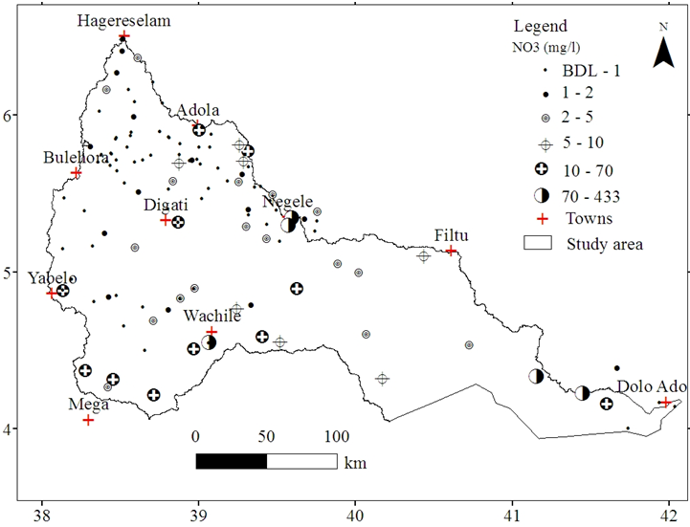
Figure 45 Spatial distributions of nitrate concentrations
The origin of nitrate in groundwater is usually related to fertilizer application and municipal wastes (Jalali, 2006; 2010; Subramani et al., 2010) or animal wastes (Hem, 1985). In the study area, agricultural fertilizer, animal wastes or both are the likely sources of high NO₃–. Water with the excessive nitrate concentration, 433 mg/l NO₃– (sample labeled 6, Fig. 41), is sited along the dry riverbed in agriculturally undeveloped area. At this particular site, the likely source of nitrate is animal wastes. This explanation is valid because of the observed accumulation of large number of animals around the water points in the area. On the other hand, sample labeled 62, Figure 41, is collected from the well sited in intensively fertilized area. In this case, the high nitrate concentration, 84 mg/l NO₃–, is plausibly attributed to drainage from agricultural fields. The high correlation between K⁺ and NO₃– in semiarid parts of the basement terrain (Table 14) confirms the effect of agricultural fertilizer (KNO₃) on the water chemistry. Similarly, in the sedimentary terrain, significant correlation between SO₄^{2–} and K⁺ (Table 14) as well likely supports the possible impact of fertilizer (K₂SO₄) application on the water quality. Frequent application of nitrate and/or sulfate fertilizer in the agricultural field in the basement and sedimentary terrain is reported by the local community. In general, chemical analysis indicates that groundwater system of the basin is vulnerable to pollution from surface contamination sources.

Sources of high salinity
Most of the samples collected from the wells sited along dry river beds in the semiarid parts of the basement terrain and few of the samples in the sedimentary terrain are plotted in the right side of the freshwater boundary line in the salinity range of brackish water of Freeze and Cherry (1979), while majority of the non-evaporated water are plotted within the freshwater range (Fig. 46a).
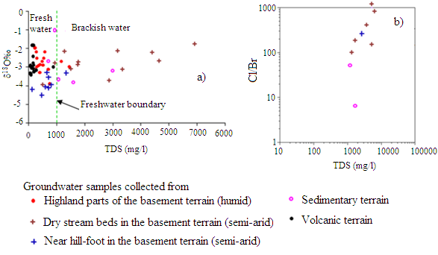
Figure 46 Plots of a δ¹⁸O versus TDS and b Cl–/Br– versus TDS of selected samples
The investigated brackish water of the study area is marked with Cl–/Br– ratio, in milligrams per liter, generally less than 357 (Fig. 46b) with the two samples plotted near the ratio of 950. Low values of Cl–/Br– ratio in groundwater is frequently explained by the absence of halite dissolution because water affected by salt dissolution will have ratio greater than 1900 and the ratio will be as high as 100,000 if pure halite dissolution is involved (Davis et al., 1998). However, the two samples, marked with the ratio nearly 950, might be influenced by dissolution of minor amounts of salt. Results of Cl–/Br– ratio may lead to the conclusion that the source of high salinity is associated with sulfate dissolution rather than halite dissolution.

Factor analysis
Factor analysis was applied to the hydrochemical data collected from the volcanic (n = 17), basement (n= 64), and sedimentary terrains (n = 13) to contribute to the extraction of factors that likely control groundwater chemistry. The number of factors to keep was determined based on the Kaiser criterion for which only the factors with Eigen values greater than 1 were extracted (Wu et al. 2014). Accordingly, for each of the terrains, three factors were retained. The total variance explained by each factor and the loading matrix of factors are shown in Table 15 (values greater than 0.50 are underlined).
Table 15 Factor loadings after rotation for the maximum variance, Eigen values, percent of variance, and cumulative variance
Variable | Volcanic |  |  |  | Basement |  |  |  | Sedimentary
Variable | F1(v) | F2(v) | F3(v) |  | F1(b) | F2(b) | F3(b) |  | F1(s) | F2(s) | F3(s)
pH | 0.26 | -0.48 | -0.85 |  | -0.68 | 0.23 | 0.84 |  | 0.10 | -0.24 | 0.92
TDS | 0.85 | 0.47 | 0.09 |  | 0.89 | 0.39 | 0.21 |  | 0.91 | 0.03 | 0.03
Ca²⁺ | 0.77 | 0.48 | 0.24 |  | 0.86 | -0.13 | 0.00 |  | 0.63 | -0.61 | -0.36
Mg²⁺ | 0.79 | 0.29 | -0.09 |  | 0.83 | 0.21 | 0.26 |  | 0.89 | -0.14 | 0.07
Na⁺ | 0.85 | -0.14 | -0.16 |  | 0.82 | 0.40 | 0.22 |  | 0.90 | 0.01 | 0.36
K⁺ | 0.33 | 0.74 | -0.31 |  | 0.33 | 0.79 | 0.22 |  | 0.14 | -0.81 | 0.35
HCO₃⁻ | 0.95 | 0.21 | 0.08 |  | 0.41 | -0.03 | 0.73 |  | -0.21 | 0.07 | -0.85
Cl⁻ | 0.34 | 0.86 | 0.08 |  | 0.86 | 0.36 | 0.10 |  | 0.91 | 0.16 | 0.20
SO₄²⁻ | -0.04 | 0.89 | 0.23 |  | 0.93 | 0.10 | 0.01 |  | 0.70 | -0.57 | 0.14
NO₃⁻ | -0.37 | -0.05 | -0.64 |  | 0.08 | 0.92 | 0.04 |  | 0.26 | 0.82 | -0.09
Eigen value | 5.08 | 1.74 | 1.27 |  | 5.73 | 1.52 | 1.04 |  | 4.76 | 2.12 | 1.63
% of total variance | 50.77 | 17.36 | 12.68 |  | 57.35 | 15.16 | 10.40 |  | 47.56 | 21.25 | 16.33
Cumulative %  of variance | 50.77 | 68.13 | 80.81 |  | 57.35 | 72.51 | 82.91 |  | 47.56 | 68.81 | 85.14
F factor; v volcanic; b basement; s sedimentary; values greater than 0.50 are underlined
In the volcanic terrain, F1(v), F2(v), and F3(v) explain 50.77, 17.36, and 12.68 % of the total variance, respectively. Accounting for most of the variance in the original dataset, F1(v) contains high loading of TDS, Ca²⁺, Mg²⁺, Na⁺, and HCO₃⁻ (Table 15), indicating these ions are important components of TDS. Loading of F1(v) with Ca²⁺, Mg²⁺, Na⁺, and HCO₃⁻ represents dissolution of silicate minerals. Given their low concentrations in the groundwater, high loadings of K⁺, Cl⁻, and SO₄²⁻ in F2(v) may represent introduction of these ions from source water, i.e., local rainfall. High loading of NO₃⁻ in F3(v) may represents groundwater pollution by animal wastes at few locations.
In the basement terrain, F1(b), F2(b), and F3(b) account 57.35, 15.16, and 10.40 % of total variance, respectively. F1(b) is loaded with TDS, Ca²⁺, Mg²⁺, Na⁺, and SO₄²⁻, indicating these ions are important components of TDS. High loading of Ca²⁺, Mg²⁺, and SO₄²⁻ may be explained by dissolution of sulfate and sulfide minerals, while high loading of Na⁺ and Cl⁻ indicates halite dissolution and/or solute enrichment by means of evaporation of infiltrating water. Furthermore, moderate loading of HCO₃⁻ on F1(b) indicates the importance of silicate hydrolysis. F2(b) contains high positive loadings of K⁺ and NO₃⁻. As NO₃⁻ has no known lithologic sources (Batayneh and Zumlot, 2012), its high loading indicates pollution of the groundwater from surface sources. The high K⁺ suggests pollution from potash fertilizers from agricultural lands. F3(b) is highly loaded with HCO₃⁻ and pH may be explained by weathering of carbonates and silicates at few locations.
In the sedimentary terrain, three factors account 85.14% of total variance. Accounting 47.56% of the total variance, F1(s) is loaded with TDS, Ca²⁺, Mg²⁺, Na⁺, Cl⁻ and SO₄²⁻, indicating these ions make up major components of TDS. High loading of Ca²⁺, Mg²⁺, and SO₄²⁻ represents dissolutions of sulfates. High loading of Na⁺ and Cl⁻ represents the presence of dissolution of halite and or enrichment of solutes by means of evaporation of infiltrating water. F2(s) is loaded with Ca²⁺, K, SO₄²⁻, and NO₃⁻, which may be explained by dissolution of gypsum (CaSO₄), fertilizers (K₂SO₄, KNO₃), and nitrate concentrations associated to animal wastes. F3(s) is loaded with pH and HCO₃⁻, indicating dissolution of carbonates at few locations.
It is important to note that, for the reason explained earlier, the role of evaporative enrichment is dominant over salt dissolution to load factors with Na⁺ and Cl– in the basement and sedimentary terrain.

Environmental Isotope Hydrology

Introduction
Isotopes of hydrogen (H) and oxygen (O), the most widely used isotopes in hydrological study, are measured as a ratio of abundance of rare isotope to abundance of abundant isotope. By comparing a sample ratio to standard value, known as Vienna Standard Mean Oceanic Water (V-SMOW), compositions are generally given as δ (delta) values in per mille ‰ (Leibundgut et al., 2009).
Craig (1961) observed that δ²H and δ¹⁸O values of global precipitation that has not been evaporated are linearly related by δ²H = 8δ¹⁸O+10 defining Global Meteoric Water Line (GMWL). At regional or local scale deviation from this global correlation exists and defines specific meteoric water line known as regional or LMWL. This line is the reference against which water samples are compared to understand hydrological process (Leibundgut et al., 2009).
In the present study, δ²H, δ¹⁸O, and tritium data were analyzed to assist characterization of recharge process and groundwater flow systems. In similar studies elsewhere, δ²H, δ¹⁸O, and tritium data have been applied effectively (Kebede et al., 2005; Kebede, 2013; Nkotagu, 1996; Bouchaou et al., 2009; Herczeg and Leaney, 2010). Spatial distribution of data points are shown in Figure 47, 48.
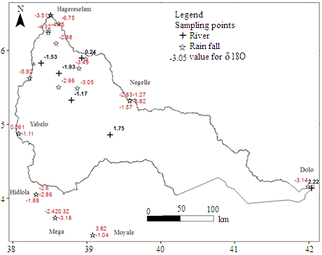a
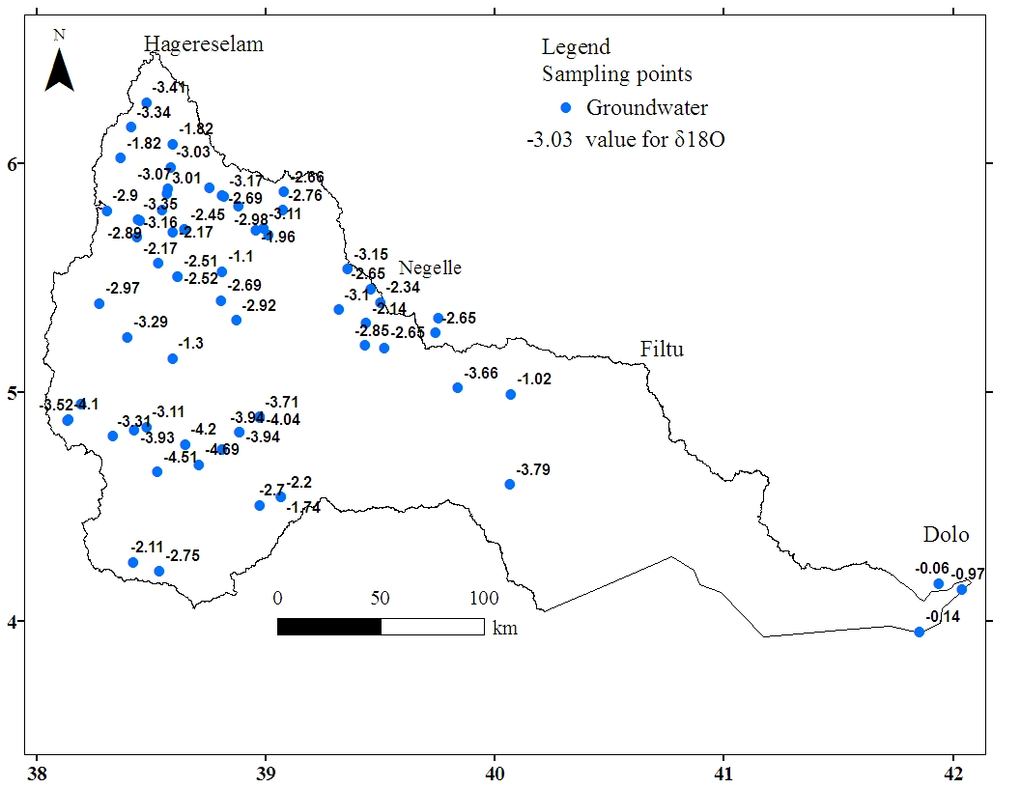b
Figure 47 Sampling locations for stable isotope of a River and rainfall b Groundwater (unit in per milli (‰))
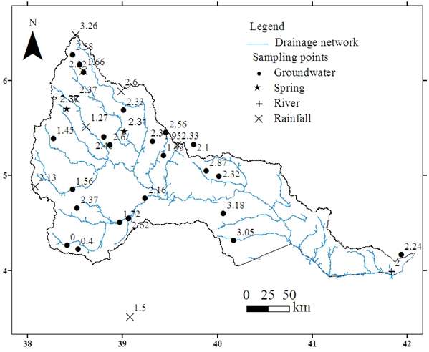
Figure 48 sampling locations for Tritium (number indicates tritium value, unit in Tritium Unit (TU))

Isotopic composition of precipitation
Using the records of stable isotopes of rainfall of the study area (number of data (n) = 48), regression analysis between δ²H and δ¹⁸O forms the LMWL for the southern Ethiopia that is expressed by equation: δ²H = 6.645δ¹⁸O + 11.69 (R² = 0.853). This LMWL is compared with the GMWL of Craig (1961) and LMWL derived from long-term isotope data (n = 289) of GNIP station at Addis Ababa (Fig. 49). Figure 49 illustrates that there is no much difference between the LMWL at Addis Ababa and southern Ethiopia. Consequently, in the present study either of the two lines can be used as LMWL without significant influence on the results of data interpretation.
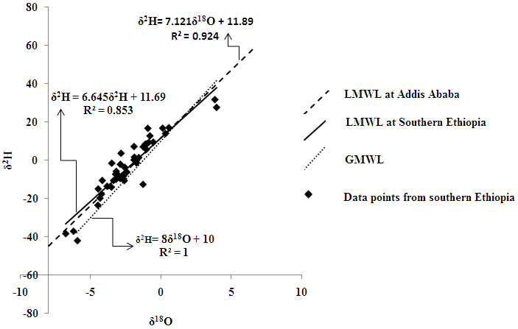
Figure 49 Scatter plots of δ²H and δ¹⁸O of local rainfall
Statistical summary of isotopic composition of rainfall of the study area and of the selected region in the basin is given in Table 16. Rainfall in the southern and southeastern lowland is isotopically enriched than that of the northern highland parts of the study area (Table 16). Depletion in isotopic composition of the local rainfall with rise in altitude is also observed in Figure 50 based on the isotopic data obtained by means of one-time sampling of local rainfall events. In general, altitudinal depletion in the isotopic composition of rainfall of the study area complies with altitude-isotope relationship of Ethiopian rainfall (Kebede, 2013).
In rainfall of the study area tritium content varies between 1.27TU and 4.10TU (Fig. 48) with the mean value equals 2.54TU (σ = 0.918).
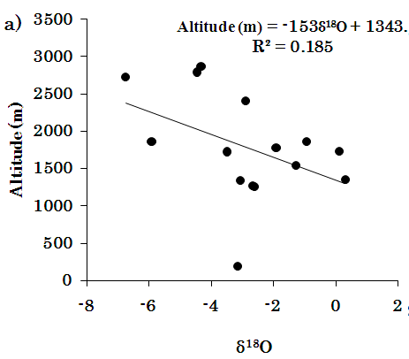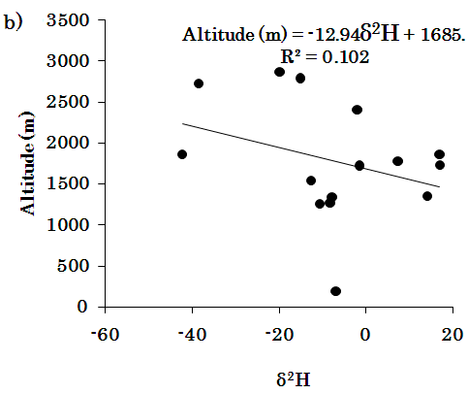
Figure 50 a, b Altitude versus stable isotopes of rainfall of the study area;
Table 16 Summary of environmental isotopes of rainfall and groundwater (stable isotopes in ‰)
 | Entire data  (δ²H, δ¹⁸O) | Northern highland  (δ²H, δ¹⁸O) | South central and southeastern region/lowland  (δ²H, δ¹⁸O)
Rainfall  Mean  Stdev  n | (-3.097, -2.230)  (15. 095,2.099)  48 | (-4.51, -2.61)  (15.65, 1.76)  23 | (-1.797,-1.873)  (15.31, 2.42  25
Groundwater  Min  Max  Median  Mean  Stdev  n | (-24.21, -4.69)  (-0.55, -1.01)  (-7.82, -2.96)  (-8.63, -2.89) (5.74, 0.75)  70* | (-15.09, 3.41)  (-0.55, -1.11)  (-4.18, -2.91)  (-5.11, -2.74)  (3.06, 0.56)  36 | (-24.21, -4.69)  (-0.96, -1.01)  (-12.88, -3.09)  (-12.37, -3.05)  (5.57,0.0.89)  34
* Three samples are not included in the statistical calculations for the reason that its isotopic composition is influenced by isotopic composition of surface water.

Isotopic composition of surface water
Based on the limited number of isotopic data (n = 6) of stream waters of the study area, δ²H and δ¹⁸O are related by the equation δ²H = 4.698δ¹⁸O + 11.29 (R² = 0.916). The similarity of d-excess of surface water with that of the local rainfall suggests the river water is supplied by the recent local rainfall. However, slope of LMWL of the surface water is lower than that of the local rainfall, suggesting surface water is evaporated than the source rainfall. Slope value, 4.698, of LMWL of stream water complies with the range of slope, 4–6, that is suggested by Payne (1988) for residual surface water after evaporation.
In general, in the headwater region, streams are depleted with δ²H and δ¹⁸O, while at far downstream in the middle stream water became enriched and even more enriched near the river out let. This shows the effect of significant evaporation of the river water as it flows in semiarid and arid parts of the study area. The river water sampled near the river outlet is marked with tritium amount which is comparable to the content in the local rainfall (Fig. 48).

Isotopic composition of groundwater
In the groundwater of the study area, δ²H varies between -24.21 ‰ and -0.55 ‰ and δ¹⁸O varies between -4.69 ‰ and -1.01 ‰ (Table 16). Sampling locations for the stable isotope data are shown in Figure 39. Unlike observations from other regions in Ethiopia where δ¹⁸O in the groundwater is depleted along with increase in altitude with average depletion rate of 0.1 ‰/100 m (Kebede et al., 2005; 2007), δ¹⁸O in the groundwater of the study area is not well correlated with altitude (Fig. 51a) and a plot of δ²H versus altitude shows groundwater is slightly enriched in δ²H along with rise in altitude (Fig. 51b).
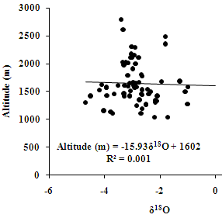 a 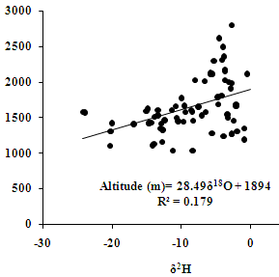 b
Figure 51a, b Altitudinal variations of stable isotopes in groundwater of the study area
The mean isotopic composition of highland groundwater is comparable to that of the highland rainfall (Table 16). On the standard δ²H versus δ¹⁸O graph, groundwater samples, which are collected from the northern highland area, are plotted around the mean isotopic composition of the local rainfall within the constricted range on or near the LMWL (2A samples, Fig. 52). Exceptionally, two groundwater samples of the highland region are plotted on the right side below the LMWL (2B samples, Figure 52).
In the semiarid southern and southeastern parts of the study area the mean isotopic composition of groundwater is equal to -12.37‰ and -3.05‰ for δ²H and δ¹⁸O, respectively (Table 16). On δ²H versus δ¹⁸O diagram, part of the groundwater samples of this parts of the study area, particularly, those collected from far distance downstream along the dry stream channels or valley bottoms, shift away from the LMWL (1A samples, Fig. 52). However, those samples collected from elevated area and near foothills are plotted on or near the LMWL (1B samples, Fig. 52).
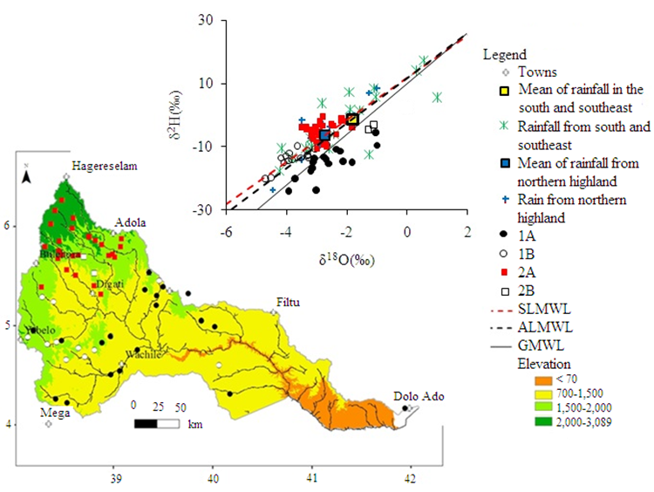Figure 52 Plot of isotope data on δ²H versus δ¹⁸O diagram along with spatial distribution (1A = evaporated southern and southeastern groundwater; 1B = non-evaporated southern and southeastern groundwater; 2A = highland non-evaporated groundwater; 2B = evaporated highland groundwater; SLMWL = LMWL of southern Ethiopia; ALMWL = LMWL at Addis Ababa)
In general, both the range, median or mean values of the stable isotopes (Table 17) and plot of the data on δ²H versus δ¹⁸O diagram along with meteoric water lines (Fig. 52) shows groundwater in the semiarid south-central and southeastern parts of the study area are isotopically depleted relative to groundwater in the northern highland. Figure 52 also reveals groundwater in the semiarid parts of the study area is plotted towards the depletion side relative to the mean isotopic composition of the local rainfall. On the other hand, appreciable amount of tritium is observed in the groundwater everywhere in the study area at amount comparable to the local rainfall (Fig. 48) with exceptional low values, 0 and 0.4 TU, observed at two sampling points in southern end of the study area.

Groundwater recharge and flow system

Introduction
Groundwater recharge is entry of water into a saturated zone (Freeze and Cherry, 1979). Generally, recharge occurs in three principal mechanisms: direct, indirect, and localized. In many locations combinations of these processes are important (de Vries and Simmers, 2002). Knowledge of natural recharge is important in groundwater studies, particularly, in a regions where water supply rely heavily on groundwater sources, in order to define safe yields of aquifer to avoid groundwater exploitation above the recharge rate (Walker et al., 2002) and to maintain quality of groundwater supplies (Jackson, 2002). Moreover, quantification of the current rate of natural groundwater recharge is a basic prerequisite for efficient groundwater resources management (Danskin, 1998).
Groundwater flows from recharge to discharge area at local, intermediate and/or regional scale, where the scale of flow is determined by topography and hydraulic characteristics of underlying rocks (Tόth, 1963; Bugliosi, 1999). Understanding groundwater flow pattern is significant in locating groundwater of optimum quality (Toth, 1984) and quantity (Furlong et al., 2011). The importance of regional flow in supplying a lowland aquifer system is underlined in Todd and Mays (2004) and Bisson and Lehar (2004). Study of hydrochemistry has been well accepted among scholars as one of the methods available to determine patterns of groundwater flow (Dalton and Upchurch, 1978; Ophori and Toth, 1989; Kebede et al., 2005).

Estimation of groundwater recharge
Different methods are available for quantifying groundwater recharge (de Vries and Simmers, 2002). However, determining which of a wide variety of the methods is likely to provide a reliable recharge estimate is often difficult (Scanlon et al., 2002). In the present study, methods such as base flow separation, RCD, and CMB were employed.
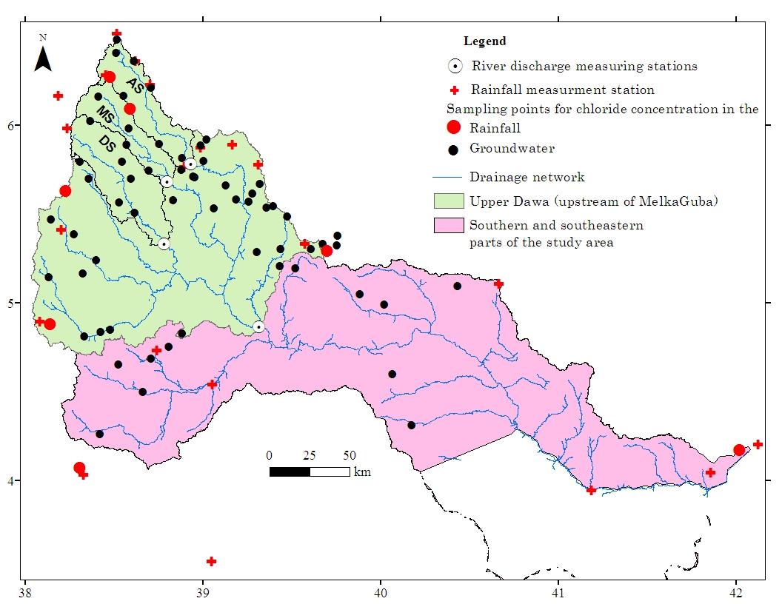Figure 53 Location of sampling point for chloride content, hydrometerological stations, and sub-basins (AS Awata sub basin, MS Mormora sub basin, DS Digati sub basin)

Base flow separation method
The base flow, derived from hydrograph separation (section 3.2), was used to estimate groundwater recharge based on assumption that where most streams are gaining and water table is near land surface, majority of groundwater recharge ultimately discharges as stream flow (Mau and Winter, 1997; Halford and Mayer, 2000), with implicit losses of groundwater by pumping, evapotranspiration, underflow to deep aquifers, and in any other way, from the watershed is minimal (Risser et al., 2005). If these conditions are met, base flow provides a reasonable estimate of groundwater recharge for long-time periods (1 year or more) with the assumption that within this long period of time there has been no change in groundwater storage (Daniel, 1996). The recharge estimate based on base flow separation method is named as effective (or residual) recharge (Daniel, 1996), base recharge (Szilagyi et al., 2003), and observable recharge (Holtschlag, 1997) to acknowledge that it probably represents some amount less than that which recharged an aquifer.
In the studied basin, 4 river flow measuring stations are available in the upper part of the river basin measuring flow of the three main tributaries (Awata, Mormora, and Digati) and main Dawa (Fig. 53). The range of records and periods of data gap of each station is presented earlier in the Table 1. The flow records from these stations were used to estimate groundwater recharge based on base flow separation approach.
Accordingly, mean annual effective recharge of 174, 200, and 42 millimeters per year (mm/y) is determined for Awata, Mormora, and Digati sub-basins, respectively. For area upstream of Melkaguba, which is largely (up to 85 %) covered by basement complex, mean annual effective recharge estimate is 26 mm/y (Table 17). The result of recharge estimation reveals the northern highland region receives a higher recharge and the recharge rate decreases towards south. The observation of high recharge in the northern highland, particularly, in Awata and Mormora sub-basins, is most likely associated with the extensive, porous, and permeable volcanic coverage and with humid climatic condition in the area. As explained earlier, the highland volcanic terrain receives high rainfall distributed over 7 to 9 months of a year and marked with low temperature condition. In implication, there exist large portion of the rainwater available for recharge. The thick near surface extensive volcanic regolith stores large volume of water which slowly released throughout the year into the underlying top basaltic aquifer. The aquifer that is placed below the upper one, with aquitard occurs in between, receives recharge from the storage in the upper aquifer through slow vertical movement across the aquitard. Moreover, where the regolith is thin or the aquifer is exposed to the surface and fractures connects the interlayered aquifers and/or at a place where the aquitard is discontinuous recharge rate is significantly high. Toward south a large part of the flat or gentle slope land, which appears reliable for recharge to occur, is covered with thin and highly compacted silty clay soil overlying less fractured bedrock. In this region, recharge is likely confined to narrow valley bottoms where thick and permeable regolith or alluvial deposit occurs. Besides, semiarid climatic condition of the area limits portion of the rainfall that available for recharge (Table 17). Overall, the climate may be the dominant limiting factor, though the role of Lithologic-framework cannot be overlooked.
Table 17 Recharge estimate for headwater sub-basins of Dawa using base flow separation method (RF = mean annual rainfall; TRF = mean annual river flow; BF(R) = Base flow (Recharge); % of BF (or R) relative to RF; BFI = base flow index; for RF, TRF, and BF (or R) unit is mm/y)
S.N | Sub-basin | RF | TRF | BF (or R) | %
1 | Awata | 1223 | 319 | 174 | 14
2 | Mormora | 1027 | 317 | 200 | 20
3 | Digati | 926 | 57 | 42 | 5
4 | Main Dawa | 833 | 41 | 26 | 3

The deduction that recharge rate is low in the semiarid area that largely covered by basement complexes is supported by the results of recession analysis. According to Fetter (2004), stream discharge at the time when recession begins (Q_{tp}) is directly proportional to the rate of groundwater recharge. Based on the limited stream flow data, the maximum Q_{tp} value of Digati sub-basin is less than that of Awata and Mormora sub-basins (Fig. 19, section 3.3), implying the Digati sub-basin, which is marked with semiarid climatic condition and its 62 % of the surface area is covered by basement complexes, receives lower recharge than Awata and Mormora sub-basins, which are relatively marked with humid to sub-humid climate and the surface is largely covered by volcanic rocks.

RCD method
This method is based on recession analysis. It assumes a one-dimensional analytical model of groundwater discharge to fully penetrating stream in an idealized, homogeneous aquifer with uniform recharge. It is applicable only for stream flow records of a catchment where regulation and diversion of flow, and evapotranspiration from groundwater by phreatophytes can be considered negligible so that all groundwater discharge is by means of base flow to streams (Mau and Winter, 1997; Fetter, 2004).
The method is based on calculations of recharge for each pick in stream hydrograph in order to estimate total recharge (Chen and Lee, 2003). The basis for this method is the next recession is displaced due to recharge event and the amount of displacement is proportional to recharge amount (Rutledge and Daniel, 1994). Rorabaugh (1964) showed that total potential groundwater discharge at critical time after a peak in stream flow is equal to approximately one-half of total volume of water that recharged a system. This finding is the basis of RCD method; thus, total recharge from the particular event is calculated as follows:
$R= \frac{2(Q_{2}-Q_{1})k}{2.3026}$ (5)
where $R$ is total volume of is recharge; $Q_{1}$is groundwater discharge at critical time, $t_{c}=0.2144k,$ as extrapolated from the stream flow recession preceding the peak; $Q_{2}$ is groundwater discharge at critical time as extrapolated from the stream flow recession following the peak (Fig. 54); and k is recession constant.
In the present study, the river flow records that were used in base flow separation method also used to estimate groundwater recharge based on RCD using a computer program RORA. Detail description of the program is given in Rutledge (1998).
Using RCD method, basin-scale recharge is estimated for the three headwater sub-basins. Accordingly, recharge value of 195, 201, and 50 mm/y is determined for Awata, Mormora, and Digati sub-basin, respectively. The result shows the recharge estimated by RCD method is comparable to the effective recharge estimated by base flow separation method. The similarity between results of the two methods indicates no or less portion of recharged water is failed to be measured at respective gauging stations which, in turn, suggests base flow separation method gives a reliable approximate of areal recharge for the investigated parts of the study area.

Chloride mass balance method (CMB)
In arid and semiarid environment, estimation of groundwater recharge using base flow separation and RCD methods is not an easy task for the reason that most surface flow system in such regions is intermittent. Elsewhere, under such circumstances many studies have been used CMB method to estimate groundwater recharge (Allison et al., 1994; Haile, 2005).
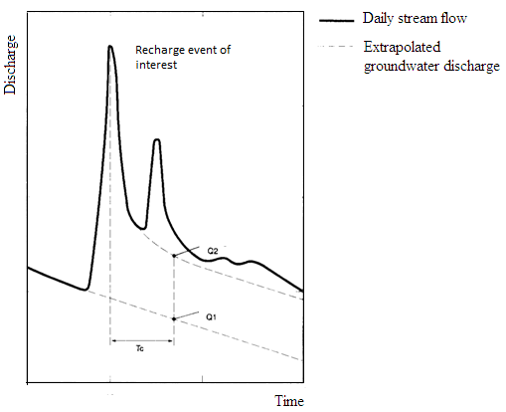
Figure 54 Recession-curve displacement method to estimate recharge in response to a recharge event (Q₁ and Q₂ is groundwater discharge at critical time as extrapolated from the stream flow recession, respectively, before and following the peak; Tc is critical time) (figure modified from Rutledge and Daniel, 1994)
CMB method is based on assumption of conservation of mass between input of atmospheric chloride and chloride flux in subsurface (Xu and Beekman, 2003). Bear and Verruijt (1987) established basic equation applicable for estimation of recharge using chloride mass balance method as:
$R_{gw}=\frac{P_{year}{Cl}_{p}}{{Cl}_{gw}}$ (6)
Where R_{gw} is the annual recharge rate (mm), P_{year} is the average annual rainfall (mm), Cl_{p} is the chloride concentrations of the rainfall (mg/l), and Cl_{gw} is chloride concentrations of groundwater (mg/l). While using this method, input parameters, i.e. P_{year} and Cl_{p}, are generally difficult to measure, highly variable (i.e. seasonal effects), prone to pollution, and poorly understood; however, groundwater chloride concentration is often assumed to stay constant during recharge studies (van Tonder and Bean, 2003).
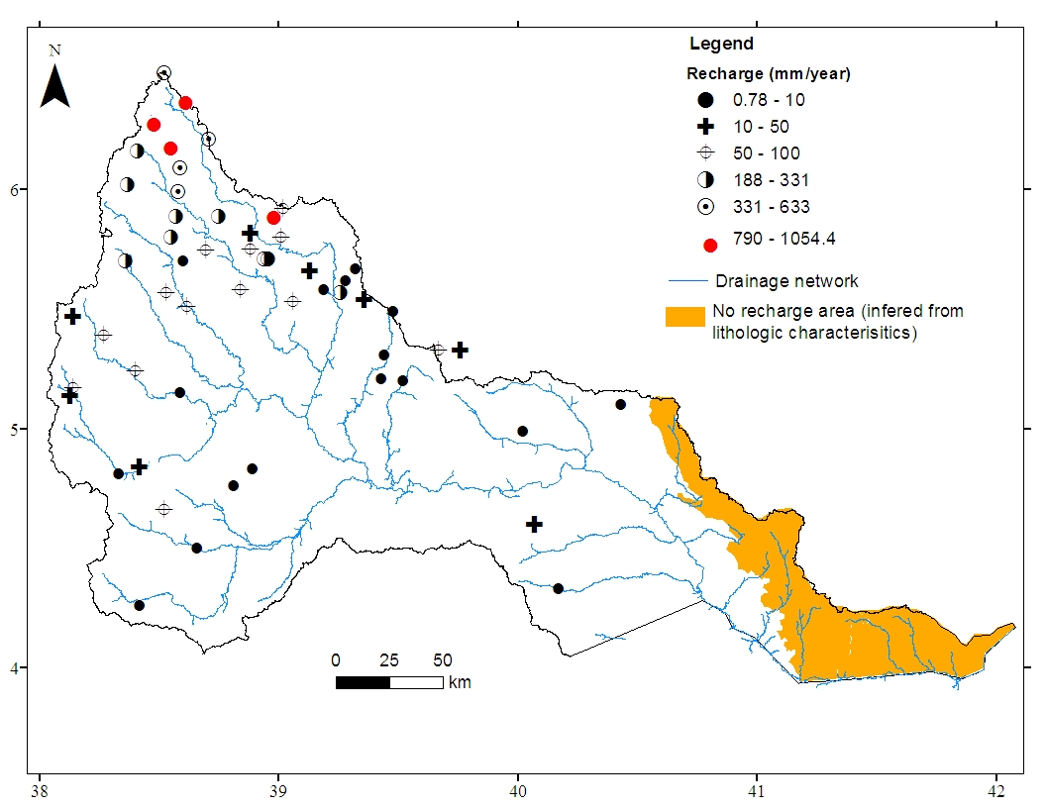
Figure 55 Spatial distributions of mean annual recharge estimated based on CMB approach
In the present study, chloride concentration of 12 rainfall samples (Annex A14) at seven points in the basin (Fig. 53) and chloride concentration of groundwater at a point which is believed to be undisturbed based on field observation (Annex A19) were used. Method of rainfall and groundwater sampling and analysis were discussed in section 1.4.5. Mean chloride concentration in the rainfall of humid highland in the north and semiarid in the south, southwest, and southeast, were determined. The mean value of each region was assigned to groundwater recharge determination points of respective region. Yearly areal rainfall depth of a nearby meteorological station (Fig. 53) was assigned to a recharge estimation point. The nearest meteorological station was determined based on the theisson polygon approach that a recharge estimate point uses the rainfall amount that represents the polygon in which the point is located. Standard deviations of chloride concentration were used to determine the uncertainties in the recharge estimate.
The point recharge estimate and associated uncertainties were presented in annex A19 and spatial distribution of the point recharge is shown in Figure 55. In line with the recharge estimate based on river discharge analysis, the result of CMB method shows high recharge, greater than 188 mm/y, in the headwater regions in the north that is largely covered by volcanic rocks. Toward south recharge rate decreases along with change in Lithologic, physiography, and climate. The elevated northern parts of the basement terrain enjoys moderate recharge rate, 50-100 mm/y, while semiarid crystalline basement terrain in the south and limestone terrain in the southeast receives little amount of recharge which is less than 10 mm/y (mean: 5.7 mm/y with stdev 3.05, number of data 18).
The recharge estimate, by using CMB method, for the semiarid parts of the study area is consistent with the work of Belete et al (2000). According to Belete et al (2000), based on the mean residence time inferred from the regional fit of experimental model, point recharge rate, which is in the range of 1.5–10 mm/y (mean 4.57 mm/y, stdev 3.20, number of data points 14), is estimated for the selected sites in the semiarid region in the southern Ethiopia. The low rate of recharge in the later region is plausibly the combined effect of low rainfall amount and high evaporation rate in the area, which is a typical characteristic of hydrology of semiarid and arid areas (McMahon, 1979).

Reliability and Uncertainty in estimation of recharge rate
As explained earlier, recharge estimation methods that based on river flow data assumes losses of groundwater by pumping, evapotranspiration, underflow to deep aquifers, and in any other way, from the watershed is minimal. However, there could be some portion of the recharged water that might be lost into deep aquifers without being measured at any point upstream of the river-discharge-measuring-stations. As a result the recharge estimate that obtained from this method is usually considered as the minimum groundwater recharge rate.
In the case of the results based on the CMB, one of the major sources of error in the recharge estimation is associated with chloride concentration used in the equation 6. As shown in annex A14, rainfall chloride concentration is variable, which in turn indicates a long term monitoring of chloride concentrations is required to determine optimum value. In the present calculation of recharge rate, mean values of the respective region, i.e., northern humid highland and semiarid in the south, southwest, and southeast, were used. Uncertainty in the recharge estimate is calculated by replacing rainfall chloride concentration in the equation xx with standard deviation of the mean values. Uncertainties of each recharge estimate based on CMB are presented in annex A19.
Another source of error in the recharge estimate based on CMB is chloride concentration of groundwater particularly for the samples collected from the sedimentary terrain of marine origin where trace connate water might be contaminated the chloride concentration of the groundwater. Moreover, contamination of chloride concentration is also likely where pollution from near surface sources is expected. However, four groundwater samples collected from the sedimentary sequence, for two of which recharge is estimated, Cl⁻/Br- ratio, in mg/l, is lower than 181.6. This value is less than the seawater ratio (288 – 292, Davis et al., 1998) but comparable to the ratio in precipitation (as low as 50 – 180, Davis et al., 1998), suggesting the influence of connate water in the chloride concentration of the groundwater might not be significant. Moreover, Cl⁻/Br- ratio were determined for the other 15 locations in the basement and volcanic terrain. In the basement terrain emphasis was given to high EC waters. It is observed that the samples marked generally with ratio less than 357 except at two locations – Wachile (Cl⁻/Br⁻: 954.14) and Udet (Cl⁻/Br⁻: 946.99). This also indicates that the halite or evaporate dissolution has not contributed Cl to the groundwater. If there were evaporate dissolution the ratio is usually > 1900 and halite dissolution the ratio is as high as 100,0000 (Davis et al., 1998). Slightly high ratio in Wachile and Udet groundwater may be due to minor contribution of chloride from other sources other than natural precipitation; hence, for the two localities and for the other regions where near surface pollution source is suspected based on field observations, recharge rate was not estimated.

Process of recharge and groundwater flow systems
In earlier sections, it was pointed out that basaltic aquifer occurs at higher and loses water at high elevation in the form of springs into the adjacent valleys. Due to the high transmissivity and rugged topography of the area, groundwater circulation is fast between the recharge and discharge area. This deduction is confirmed by the high recession slopes of headwater streams (Fig. 20), which are confirmed that the streams depend on base flow from the basaltic aquifer at time of no rainfall (section 3.4). Plots of hyetograph along with base low (Fig. 17) also support the occurrence of rapid groundwater circulation in the headwater region of the Dawa river basin that base flow response to the basin rainfall is instant, suggesting the occurrence of shallow and rapidly circulating groundwater system.
As discussed earlier, fractures are short in length, not interconnected or the regional ones are cut by short transverse fractures, particularly, in the basement terrain which may result in localizing groundwater flow. Furthermore, open schistocity in the ophiolitic belts is discontinuous and important for local groundwater circulation that it collects groundwater toward fractures that runs across shistocity trend. Local fractures around intrusions also localize groundwater water circulation. The preceding discussion discloses aquifer system in the basement terrain is bounded by blocks of aquiclude whereby each of these blocks locally acts as flow barriers which inhibit groundwater exchange between the adjacent fractures. As a result, from the regional groundwater flow point of view, the basement terrain is considered as a regional aquiclude.
The limestone aquifer in the southeast is placed at high elevation on the basement complex (Fig. 12). Due to the discontinuous nature of fractures in the basement terrain, no groundwater supply is expected into the limestone aquifer from the aquifers located at far distance in the basement terrain.
In general, the three aquifers, i.e. basaltic, basement, and limestone aquifers, do not have strong lateral hydraulic connection. The highly transmissive basaltic aquifer in the north loses water into the adjacent river channels in the form of springs. Even, if it happens that basaltic aquifer discharges water into the fractured aquifer in the basement terrain, the water does not flow for a long distance toward south and southeast due to the discontinuous nature of fractures in the basement terrain. Moreover, groundwater water flow pattern that infered from potentiometeric surface (see Annex A13) indicates groundwater in the basement terrain does not flows into the sediementary terrain which, in turn, indicates poor hydraulic interconnection between the basement and limestone aquifers. This suggests groundwater in the northern highland does not reach and, hence, supply the aquifer in the south and southeast. The implication of the local flow system is that groundwater reservoir is supplied by local recharge.
TDS and relative percentage of cations and anions can be used to infer the scale of groundwater flow systems. Based on theory (Toth, 1984) and field observations (Ophori and Toth, 1989; Kebede et al., 2005), low TDS and high percentage of Ca²⁺, Mg²⁺, and HCO₃⁻ are associated with local flow systems; intermediate TDS and high percentage of Na⁺, SO₄²⁻, and Cl⁻ are characteristics of intermediate flow systems; and high TDS and high percentage of Na⁺ and Cl⁻ are characteristics of regional flow systems. In the view of that, chemical character of CI and CII (Table 12) suggests the dominance of local flow systems in the highland regions of volcanic and basement terrain of the study area. Though Na⁺ amount is slightly higher than Ca²⁺ or Mg²⁺ amount (Table 12), chemical characters of CIII are also comparable to that of local flow system. In CIII, high percentage of Na⁺ is not beyond expectation given the dominance of rocks of felsic composition in the southern half of the basement terrain.
Furthermore, based on groundwater chemical evolution models (Adams et al., 2001; Kebede et al., 2005; Demlie et al., 2007), the occurrence of dominantly mixed cation-bicarbonate, (Ca, Mg, Na)-HCO₃, type water, which is also marked with Ca²⁺ + Mg²⁺ greater than Na⁺ + K⁺, in most parts of volcanic and basement terrains of the study area is frequently explained by groundwater at the early stages of geochemical evolution (recent recharge) or rapidly circulating groundwater which has not undergone significant water-rock interactions. The existence of sulfate type water, which is also marked with Ca²⁺ + Mg²⁺ greater than Na⁺ + K⁺, in the sedimentary terrain (CIV) is also better explained by dissolution of gypsum by locally recharged water rather than geochemical evolution associated with groundwater flow.
Further, no clear signature of geochemical evolution is observed from CI through CII to CIII along N-S hypothetical transect or from CI through CII to CIV along NW-SE hypothetical transects. This presumably supports the absence of continuous groundwater flow systems from the northern highland volcanic and basement terrains toward the southern basement and southeastern sedimentary terrains.
In addition, the occurrence of groundwater of distinct chemical character within a short distance between the sampling points, as illustrated by the spatial plot of EC and HCO₃⁻ (Fig. 39), supports the localized/discrete groundwater flow systems in the basement terrain.
The groundwater flow pattern that deduced from hydrochemical analysis based on the model originally introduced by Chebotarev (1955) and also in use until recent (Ophori and Toth, 1989; Adams et al., 2001; Kebede et al., 2005; Demlie et al 2007) is may be challenged by Lithologic diversity. However, in the present study hydrochemical evidence is also dependable due to it’s the conformity with the other evidences from litho-structural analysis, groundwater flow map (explained above), and isotopic technique discussed below.
Confirming the results of litho-structural, groundwater flow map, and hydrochemical analysis, the observation of appreciable amount of tritium in the most of selected samples of CI, CII, CIII, CIV, and CV at level comparable to the local rainfall (Fig. 48) indicates that groundwater is of local origin, with modern recharge, and fast circulation in the most parts of the study area. On the other hand, isotopic depletion of groundwater in the southern, south-central, and southeastern parts of the study area, which is represented by the selected samples in the CII, CIII, CIV, and other samples in the area, relative to the local rainfall (Fig. 52) suggests ordinary local rainfall is not the dominant source of the groundwater recharge in the semi-arid parts of the study area. Consequently, given the high tritium content in the groundwater of the area, recharge to the aquifer might be associated either with isotopically depleted high-intensity local rainfall or with the recharge occurs at far distance in the highland region in the north with subsequent fast circulation toward the aquifers in the south and southeast. However, it is identified that groundwater in the northern highland, which is represented by the selected samples in CI and CII and other water samples in the area, is isotopically enriched relative to the groundwater in the south, south-centre and southeast. Under this condition, the highland recharge or highland groundwater could be the source of recharge for the aquifers in the south, south-centre, and southeast, only if isotopic fractionation related to water-rock interaction exists as the water moves in the aquifer matrix. In principle, isotopic fractionation due to water-rock interaction is not expected as long as groundwater temperature is less than 60°c (Gat, 2010). In the view of that, given the low groundwater temperature in the basin, 23°c in average, the possibility that the highland groundwater regionally flows and supplies the aquifers in the south, south-centre, and southeast is unlikely and this supports distinct recharge source and absence of flow continuity between the highland aquifers in the north and the aquifer in the south, south-centre and southeast.
The above reasoning acknowledges isotopically depleted high-intensity local rainfall as the main source of recharge in the semi-arid region in the south, south-centre and southeast. The high-intensity rainfall must activate flush floods which subsequently result in groundwater recharge in the valley bottoms and along dry riverbeds. This finding is in line with the regional work of Kebede (2013) that provided the regional picture of mechanism of groundwater recharge in Ethiopia. Elsewhere, recharge from flush floods has been also observed to cause an isotopic depletion of groundwater as compared to precipitation under arid conditions (Leibudget et al., 2009; Gat, 2010). This typical recharge mechanism in the semiarid parts of the study area is the likely causes of the disparity in the altitude-isotope relationship of the study area from the observations elsewhere in Ethiopia. CV samples are also marked with similar mechanism of groundwater recharge.
Exceptionally, based on Ophori and Toth (1989), CV samples and two samples of CIV (Sample labeled 76 and 77) which are sited along the dry riverbeds (For example, at site C (CV sample), I (CV sample), and E (CIV sample) are marked with chemical character of intermediate flow systems (Fig. 56). Furthermore, a progressive change in the chemical composition from calcium-bicarbonate type to sodium-chloride or to sulfate type water is observed along A–B–C, G–H–I and D–E dry streambeds (Fig. 56).
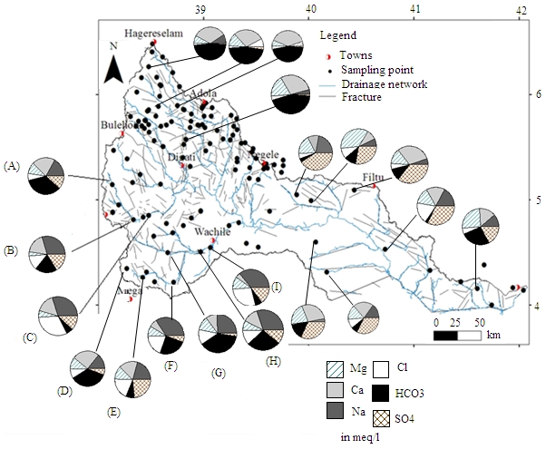
Figure 56 Chemical characteristics along selected dry riverbeds: A-C, G-I, and D-E
Based on groundwater chemical evolution models (Kebede et al. 2005; Demlie et al. 2007), this signifies the effect of chemical evolution along the stream beds and chemical character of groundwater at sites C, I, and E, is at its later stage of geochemical evolution. Along the flow lines, A–B–C, G–H–I and D–E, calcite precipitation removes Ca²⁺ and HCO₃⁻ from groundwater and, hence, other ions enriched in the groundwater. Moreover, dissolution of salts other than halite adds SO₄²⁻ and other ions into the groundwater and result in high EC in CV samples. White salts mainly consists of sulfates are commonly observed in alluvial deposits along the dry riverbeds in Wachile and surrounding areas (Kebede, 2013).
Tritium amount at site C, 1.56 TU, and I, 1.76 TU, is at amount comparable to the local rainfall, indicating modern groundwater recharge and fast groundwater circulation, at least, along these two lines.
However, tritium amount is exceptionally low at site E (Fig. 56), indicating the relatively old water. Subsequently, variations in the composition of groundwater along the line D-E (Fig. 56) can be explained by chemical evolution associated with long groundwater residence time (than long flow system given the short distance between site D and E). The long groundwater residence time and, hence, the low tritium value at site E are likely associated with the high clay content and the low hydraulic conductivity of the formation of this particular site that leads the groundwater to stay long and allow decay of tritium. Belete et al. (2000) reported that in this part of the study area Quaternary sediments which is as thick as 50 m and composed of dominantly clay associated with marl and mudstone fills the valley bottom. According to the MoWIE (2007), the sediments in the area constitutes up to 59 % clay. Generally, high clay proportion lowers hydraulic conductivity (Heath, 1983). Besides, low well yield, 0.7 l/s at site E and 0.5 l/s at site D, even lower, 0.1 l/s, in the surrounding areas (Belete et al., 2000) supports the low hydraulic conductivity in the area. However, further downstream at site F, continuity of geochemical evolution was not observed (Fig. 56) due to structural discontinuity that results local variations in the groundwater flow system.
Earlier, it is pointed out that in semiarid parts of the river basin recharge occurs from flush floods following a high-intensity local rainfall. Large number of groundwater samples collected from the region, which include selected samples in CIII, CIV, and CV, are plotted on the right side below the LMWL (1A samples, Fig. 52), indicating the importance of evaporation losses prior, during, or after recharge processes along the dry riverbeds and at few locations in the sedimentary terrain. However, samples collected from near hill-foot in the south and southeast and from an elevated area in the southwest and south-centre are plotted on or near the LMWL (1B samples, Fig. 52), pinpointing the insignificance of evaporation losses before, during or after recharge. Variation in the intensity of evaporation between 1A and 1B groundwater can be explained by variation in the length of time that the floodwater is exposed to the evaporation regime. In the elevated area and near the hill-foot, temperature is relatively low and the floodwater stays on the ground surface for a short period of time before the recharge takes place. As a result, isotopic composition of the recharge water or of the groundwater (1B) is not or less influenced by evaporation. However, further downstream toward south and southeast temperature increases along with fall in elevation (Fig. 52) and the floodwater exposes to evaporation regime for the longer time period. Consequently, this enriches isotopic composition in the recharge water and groundwater of the area (1A) more than in 1B samples.
Plot of 2A groundwater samples (the samples collected from the northern highland area and includes selected samples in CI and CII) around the mean isotopic composition of the local rainfall within the constricted range on or near the LMWL (Fig. 52) suggests that infiltration of the rainwater is significantly rapid before evaporation takes place, a fairly invariable isotopic composition, and most likely the well-mixed system. The exceptional plot of the two groundwater samples on the right side below the LMWL (2B samples, Fig. 52) indicates the influence of evaporation on the isotopic composition. These samples were collected from the wells located in the vicinity of marshy ground. The shallow groundwater in the marshy area, which is plausibly subjected to direct evaporation, is likely influenced isotopic composition of groundwater at the sampling sites.
In general, converging evidences from litho-structural, hydrochemical, isotopic, and river discharge data analysis indicated the dominance of local recharge and discontinuous flow systems in most parts of the study basin. No signature of regional groundwater flow is observed as in other large river basins of Ethiopia, e.g. Blue Nile (Kebede et al., 2005) and rift valley lakes basin (Kebede et al., 2007). In implication, due to structural and lithological factors the traditional regional groundwater flow model of Tόth (1963) appears not applicable in Dawa river basin at least at the investigation level of this work. Locally, groundwater flow direction (Annex A13) conforms to dominant orientation of the fracture lines (Fig. 9) and from hilly area toward the adjacent valley bottoms.
Therefore, the increase in mean EC or TDS values and in other water quality parameters from CI through CV (Fig. 40) are likely related to the difference in the local hydrogeological, physiographic, and climatic factors rather than chemical evolution associated to regional groundwater flow. As explained earlier, in the northern highland, volcanic and basement terrain is dominantly characterized by fractured aquifer system, rugged topography, and humid to sub-humid climatic condition. On the other hand, southern part of the basement terrain is characterized by relatively flat topography, semi-arid climatic conditions, and water movement through the alluvial sediments. By implication, there is high contact area and contact time between rock and water, and substantial amount of dissolvable salts in the aquifer matrix of southern basement terrain than the northern highland region. Subsequently, groundwater samples collected from southern parts of the basement terrain (CIII and CV) are characterized by relatively high mean EC or TDS than that of groundwater in the northern highland region (CI and CII). In CIV, the high EC is likely associated with evaporate, such as gypsum, dissolution. In the various studies elsewhere (Back, 1966; Demlie et al., 2007), the general increase in TDS or EC was explained by regional groundwater flow system. However, this study illustrates increase in EC or TDS alone might not always display regional flow system.

Conclusion and recommendation

Conclusion
The Dawa river basin in southern Ethiopia is drained by Dawa river and marked by complex geology that basement complex is laterally emplaced between the northwestern volcanic rock and southeastern sedimentary sequences. Previously, little is known about hydrogeology of the river basin. The main objective of this study is to characterize hydrological and hydrogeological behavior of the river basin by giving emphasis to understand groundwater recharge, flow systems, and factors that control groundwater chemistry. The study is based on converging evidences from the analysis of litho-structure, hydrogeology, river discharge, hydrochemistry, and isotope data. The major conclusions made from this study are the following.
- Based on the analysis of well hydraulic, geological, and structural data three major aquifers are identified in the basin: (i) dominantly semi-confined multilayer basaltic aquifer in the volcanic terrain in the north (ii) unconfined discrete basement aquifer in the basement terrain in the middle part of the basin and (iii) extensive limestone aquifer in the sedimentary terrain in the southeast.
The layered basaltic aquifer is defined by the repeated occurrence of fracture and joints, lava beds, and/or vesicles inter-bedded with the thin semi-pervious units. It is the most transmissive and productive aquifer in the basin marked with the mean transmissivity of 40 m²/d and the mean well yield of 5.8 lit/sec. The presence of inter-bed semi-pervious units at various depths in the basaltic succession builds the semi-confined aquifer system. Moreover, the basaltic aquifer is placed at higher elevation overlying the basement rocks and discharges the water it contains in the form of springs into the adjacent valleys.
Water well inventory indicated that in the basement terrain groundwater occurs along the fracture lines. Moreover, combined analysis of lineament, well log, SWL, and depth to first-water-strike revealed that in the basement terrain the aquifer is localized and unconfined and groundwater occurs in the fractured layer below the loose sediments. Well yield of the basement aquifer is moderate, 2.3 lit/sec in average, and the mean transmissivity is 36.6 m²/day. Mean yield is 3.1 and 1.9 l/sec in the northern highland and southern lowland parts of the basement terrain, respectively. The variation between the well yields of the two regions is likely associated with lithostructural and climatic factors. Structural discontinuity results in the discrete aquifer system of the basement aquifer in the most parts of the basement terrain.
In the sedimentary terrain, depth of groundwater occurrence increases towards southeast. East of 40.5°E longitude thick impermeable units cover the fractured limestone and put this extensive potential aquifer beyond the depth affordable for drilling for community water supply. The impermeable units also act as a vertical flow barrier inhibiting recharge from the local rainfall.
- River discharge analysis indicated that Awata and Mormora sub-basins generate large quantities of runoff in a year due to large amount of the rainfall that the sub-basins receive. However, the extensive semiarid region in the south and southeast contributes low runoff to the river flow, relative to humid region in the north, likely due to the low rainfall amount which less likely able to generate runoff. EC data and river discharge analysis revealed that the dry period river flow dominantly originates from the groundwater reservoir in the volcanic terrain. Further, the response of the river discharge to the local rainfall is rapid, indicating high vulnerability of the surface water resources to climatic variability. These highlight the need for appropriate management of groundwater reservoir in the volcanic terrain to ensure the sustainability of the dry period river flow.
- Groundwater chemistry varies significantly across the study area, suggesting the effect of various factors on the groundwater chemistry. Graphical plots and statistical analysis indicated that water-rock interaction is the dominant process in the study area. Silicate hydrolysis is the dominant process in the volcanic and in the most parts of the basement terrain. Besides, sulfide oxidation and sulfate dissolution has an effect on the groundwater chemistry, respectively, in the sulfide rich ophiolitic belt and along the dry riverbeds in the semiarid region. In the sedimentary terrain gypsum dissolution is the dominant process.
In the Dawa river basin, nitrate concentration varies from BDL to 433 mg/l NO₃. High nitrate concentration occurs mainly in the semiarid parts of the basin. The origin of high nitrate in the groundwater is related to fertilizer application, animal wastes or both. In the semi-arid parts of the basement terrain high correlation between K⁺ and NO₃⁻ confirms the effect of agricultural fertilizer (KNO₃) on the water chemistry. In the sedimentary terrain significant correlation between SO₄²⁻ and K⁺ as well likely supports the possible impact of fertilizer (K₂SO₄) application on the water quality. This observations highlight vulnerability of groundwater resources in most parts of the river basin to pollution sources related to the human activity and the need of appropriate groundwater management practices along with development interventions.
On the other hand, Cl⁻/Br⁻ ratio of the brackish groundwater is low, mostly less than 400, and this reveals halite dissolution has a little role in the salinity build up in these water. Sulfate dissolution are the reasons for high EC groundwater along the dry riverbeds in semiarid regions of the study area.
- Using the base flow separation method the basin-scale recharge of 174, 200, and 42 mm/y is estimated for the Awata, Mormora, and Digati sub-basin, respectively. The basin-scale recharge based on the river flow data measured at Melkaguba is 26 mm/y. Comparable recharge rate is also estimated for the Awata, Mormora, and Digati sub-basin using RCD method. Applying CMB approach, the point recharge rate greater than 188 mm/y is determined for the volcanic terrain, while humid highland parts of the basement terrain and semiarid region in the south and southeast is marked with recharge rate in the range of 55–100 and 0.78–10 mm/y, respectively. The recharge estimate from the methods based on the river discharge analysis and the CMB approach is comparable to each other where data overlaps and the result is consistent with the previous work, at least in the semiarid region, where data is available.
The high recharge rate in the headwater region in the north is most likely related to the extensive, porous, and permeable volcanic coverage and the high rainfall, while toward south the decrease in the recharge rate is likely associated with the semiarid climatic condition which limits fraction of the rainfall that available for the groundwater recharge.
- In the most parts of the study area groundwater recharge occurs from modern local rainfall. In the northern humid highland recharge is direct and occurs prior to evaporation. In the semiarid region in the south, southwest, and southeast recharge also occurs from the modern local rainfall. However, isotopic data analysis reveals that it is only the high-intensity rainfall which able to generate flush floods and induces indirect recharge in the depressions and along the dry stream channels. In elevated semiarid area in the southwest and near hill-foot in the south-central region, recharge occurs prior to evaporation, while toward southeast and at far distance downstream of hilly area the influence of evaporation prior to or after recharge is significant.
- Litho-structural analysis indicated that the three major aquifers of the study area do not have strong lateral hydraulic connection. This is due to the fact that the basaltic aquifer loses water at high elevation into the adjacent river system in the form of springs. Even, if it happens that the basaltic aquifer loses the water into the adjacent or underlying fractured basement aquifer, fractures discontinuity do not favors the occurrence of regional groundwater flow systems. Hydrochemical, stable isotope, and tritium data confirms the dominance of local or discontinuous groundwater flow systems in the most parts of the study area. In general, the crystalline basement rocks act as a regional groundwater flow barrier inhibiting the regional groundwater flow from the highland volcanic aquifers in the north toward the fractured aquifer in the semiarid parts of the basement terrain in the south and toward the extensive limestone aquifers in the southeast.
Converging evidences from different techniques indicate that due to structural and lithologic factors the traditional regional groundwater flow model which is common in large river basins of Ethiopia does not hold true in the Dawa river basin. In the upper part of the basin the flow is dominantly topographic-driven. In the middle part structure plays a vital role. Hence, the existence of Precambrian basement complex in the middle makes the flow system discontinuous. Hence, both groundwater flow and hydrochemical signatures display extreme variability. This makes the Dawa river basin in a number of ways unique. More solid conclusion can be made from detailed tracer, litho-structural, geophysical, and hydrogeological investigation accounting temporal variation of groundwater dynamics. The results of this study have significant implication on groundwater development and management activities of the river basin.

Recommendations
The basin studied is remote, geologically complex, and mostly inaccessible. The work has been done under data scarce conditions. Based on the results of this study the following has been recommended:
- Since in the Dawa river basin groundwater flow system is dominantly of local in nature, any groundwater development and management practices shall takes place at scale of watershed than mega-watershed that comprise more than one watershed.
- In semi-arid region, investigation for groundwater of less salinity shall focus near the hill-foot than areas far downstream along dry river beds.
- Since the dominantly unconfined basement aquifer in the semi-arid region is vulnerable to pollution from near surface contamination sources appropriate groundwater management practices shall be emplaced along with development interventions.
- By giving emphasis to the semiarid regions, installation of additional meteorological stations and systematic rainfall sampling for the determination of chloride is recommended to refine recharge estimation made using CMB. Furthermore, Systematic base flow measurement and measurement of total river discharge with consideration of adequate spatial and temporal coverage is required for better characterization of surface-groundwater interaction, storage characteristics of the aquifers of different terrain or of the lithologic units, and source-aquifer of the river flow. Better understanding can be obtained if discharge data is coupled with time-series isotopic and hydrochemical data. Therefore, monitoring of water quality and isotopic composition of both the river water and the surrounding aquifer is recommended for future.

References
Abdelsalam, M.G., Stern, R.J., 1996. Sutures and shear zones in Arabian-Nubian shield. Journal of African Earth Sciences 23(3):289-310.
Aboubaker, M., Jalludin, M., Razack, M., 2012. Hydrochemistry of a complex volcano-sedimentary aquifer using major ions and environmental isotopes data: Dalha basalts aquifer, southwest of Republic of Djibouti. Environmental Earth Sciences. DOI 10.1007/s12665-013-2398-8.
Aboyeji, O.S., Mogaji, K.A., Oyinloye, R.O., 2012. Structural interpretation of remotely sensed data sets its hydrogeological implication over Ile-Ife and environs. Ozean Journal of Applied Sciences 5(1):43-54.
Adams, S., Titusa, R., Pietersen, K., Tredoux, G., Harris, C., 2001. Hydrochemical characteristics of aquifers near Sutherland in the Western Karoo, South Africa. Journal of Hydrology 2001(241): 81-93.
Alemayehu, T., 2006. Groundwater occurrence in Ethiopia. Addis Ababa University Press, Addis Ababa. pp 230.
Allison, G.B., Brown, R.M., Fritz, P., 1979. Estimation of the isotopic composition of lake evaporate, Journal of Hydrology 1979(42):109-127.
Appelo, C.A.J. and Postma, D., 2005. Groundwater geochemistry, groundawater and pollution. A.A. Balkema, Leiden, The Netherlands. pp 634.
Assefa, G., 1988. Potential hydrocarbon-generating rock units within the Phanerozoic sequence of the Ogaden basin, Ethiopia: a preliminary assessment using the LOPATIN model. Journal of Petroleum Geology 11(4):461-472.
Awoke, H, Hailu, F., 2007. Geology of Yabelo sheet (NC 37-14). Memoir 16. GSE, Addis Ababa, Ethiopia.
Back, W., 1966. Hydrochemical facies and groundwater flow patterns in northern part of Atlantic Coastal Plain. United States Geological Survey professional paper 498-A.
Batayneh, A., Zumlot, T., 2012. Multivariate statistical approach to geochemical methods in water quality factor identification: application to the shallow aquifer system of Yarmouk Basin of North Jourdan. Research Journal of Environmental and Earth Sciences 4(7):756-768.
Bear, J., Verruijt, A., 1987. Modeling groundwater flow and pollution. Reidel Publishing Company, Dordrecht, the Netherlands. pp 414.
Belcher, W.R., Elliott, P.E., Geldon, A.L., 2001. Hydraulic-property estimates for use with a transient ground-water flow model of the Death Valley Regional Ground-Water Flow System, Nevada and California. (United States Geological Survey) USGS Water-Resources Investigations Report 01-4210. USGS, Nevada.
Belete, Y., Abaire, B., Asfaw, B., Tigabe, M., Shiferaw, D., Belachew, M., Adege, N., Mulachew, A., Abdela, M., 2000. Hydrogeological, geophysical and engineering geological investigation of Yabelo sheet (NB 37 – 14). GSE, Addis Ababa, Ethiopia.
Belkhiri, L., Boudoukha, A., Mouni, L., Baouz, T., 2010. Application of multivariate statistical methods and inverse geochemical modeling for characterization of groundwater — a case study: Ain Azel plain (Algeria). Geoderma 159:390-399.
Beltrandi, M.D., Pyre, A., 1972. Geological evolution of South West Somalia, in ASGA-AAGS, Symbosium of sedimentary basins of Africa: Montreal, Canada.
Bevans, H.E., 1986. Estimating stream-aquifer interactions in coal areas of eastern Kansas by using streamflow records. In Subitzky, Seymour (ed.), Selected papers in the hydrologic sciences. Water-Supply Paper 2290 (51-64). U.S. Geological Survey.
Bhawan, J.V., 1999. Hydrogeological problems in hard rock region (A state of art report). SR-5/98-99. National institute of hydrology, Roorkee, India.
Bisson, R.A. and Lehr, J.H., 2004. Modern groundwater exploration: discovering new water resources in consolidated rocks using innovative hydrogeologic concepts, exploration, drilling, aquifer testing, and management methods. John Wiley and Sons, Inc, New Jersey.
Biswas, A., Nath, B., Bhattacharya, P., Halder, D., Kundu, A.K., Mandal, U., Mukherjee, A., Chatterjee, D., Morth, C., Jacks, G., 2012. Hydrogeochemical contrast between brown and grey sand aquifers in shallow depth of Bengal basin: Consequences for sustainable drinking water supply Science of the total environment 431:402-412.
Bossellini, A., 1989. The continental margins of Somalia: their structural evolution and sequence stratigraphy. Memorie di Scienze Geologische, Padova 41: 373–458.
Bouchaou, L., Michelot, J.L., Qurtobi, M., Zine, N., Gaye, C.B., Aggarwal, P.K., Marah, H., Zerouali, A., Taleb, H., Vengosh, A. 2009. Origin and residence time of groundwater in the Tadla basin (Morocco) using multiple isotopic and geochemical tools. Jr. Hydrology vol. 379, pp. 323-338.
Brutsaert, W. and Lopez, J.P., 1998. Basin-scale geohydrologic drought flow features of riparian aquifers in the southern Great Plains. Water resources research 34(2): 233-240.
Bugliosi, E.F., 1999. The Midwestern Basins and Arches regional aquifer system in parts of Indiana, Ohio, Michigan, and Illinois. U.S. Geological Survey Professional Paper 1423-A.
Chater, A.M., 1971. The geology of the Megado area of southern Ethiopia. PhD dissertation, University of Leeds.
Chebotarev, I. I., 1955. Metamorphism of natural waters in the crust of weathering. Geochim 8: 22-28.
Chen, W., Lee, C.H., 2003. Estimating groundwater recharge from streamflow records." J. Environmental geology 44: 257-265.
Cherinet, 1993. Hydrogeology of Ethiopia and Water Resources Development. GSE, Addis Ababa, Ethiopia, unpublished Report.
Cho, J. C., Cho, H. B., Kim, S. J., 2000. Heavy contamination of a subsurface aquifer and a stream by livestock wastewater in a stock farming area, Wonju, Korea. Environmental Pollution 109(1):137–146. doi:10.1016/S0269-7491(99)00230-4.
Craig, H., 1961. Isotopic variations in the meteoric waters. Science 133(3465):1702-3.
Custodio, E., 2003. Groundwater in volcanic hards rocks. In: Krasny J, Sharp JM (ed) Groundwater in fractured rocks: Selected papers from the Groundwater in Fractured Rocks, Volume 9. Taylor and Francis, London, pp 95-108.
Dafny, E., Burg, A., Gvirtzman, H., 2006. Deduction of groundwater flow regime in a basaltic aquifer using geochemical and isotopic data: The Golan Heights, Israel case study. Journal of Hydrology 330:506-524.
Dalton, M.G. and Upchurch, S.B., 1978. Interpretation of hydrochemical facies by factor analysis. Groundwater 16(4):228-233.
Daniel, C.C., 1996. Ground-water recharge to the regolith-fractured crystalline rock aquifer system, Orange County, North Carolina. . Water-Resources Investigations Report 96-4220, U.S. Geological Survey: 59p.
Danskin, W.R., 1998. Evaluation of the hydrologic system and selected water-management alternatives in the Owens, Valley, California. U.S. Geological Survey Water supply Paper 2370-H.
Datta, P.S., Tyagi, S.K., 1996. Major ion chemistry of groundwater in Delhi area: chemical weathering process and groundwater regime. Journal of the Geological Society of India 47: 179-188.
Davidson, A., 1983. Reconnaissance geology and geochemistry of parts of Ilubabor, Kefa, Gamo Gofa, and Sidamo, Ethiopia. The Omo river project. Ethiopian Institute of Geological Survey, Addis Ababa, Bull. No. 2, pp. 1-129.
Davis, S.D., Whittemore, D.O., Fabryka-Martin, J., 1998. Uses of Chloride/Bromide ratios in studies of potable water. Groundwater. 36(2):338-350.
Demlie, Wohnlich, S., Wisotzky, F., Gizaw, B., 2007. Groundwater recharge, flow, and hydrogeochemical evolution in a complex volcanic aquifer system, central Ethiopia. Hydrogeology Journal 15:1169-1181.
de Vries, J. and Simmers, I. 2002. Groundwater recharge: an overview of processes and challenges. Hydrogeology Journal (2002) 10:5–17. DOI 10.1007/s10040-001-0171-7.
Deyassa, D., Kebede, K., Ayenew, T., Kidane, T., 2014. Crystalline basement aquifers of Ethiopia: Their genesis, classification, and aquifer properties. Journal of African Earth Sciences 100(2014):191-202.
Domenico, P.A., Schwartz, F.W., 1998. Physical and Chemical Hydrologeology (2nd ed.). John Wiley and Sons, Inc, New York, pp506.
Ebinger, C.J., Yemane, T., Genzebu, W., Aronson, J. L., Walter, R. C. 1993. Late Eocene recent volcanism and faulting in the southern main Ethiopian Rift. Journal of Geological Society of London 150, 99-108.
Elisante, E, Muzuka, A.N.N., 2015. Occurrence of nitrate in Tazanian groundwater aquifers: a review. Applied Water Science, DOI 10.1007/s13201-015-0269-z.
Fetter, C.W., 2004. Applied Hydrogeology. Prenticel-Hall.
Freeze, R.A., Cherry, J.A., 1979. Groundwater. Prentice-Hall Inc., New Jersy.
Furlong, B.V., Riley, M.S., Herbert, A.W., Ingram, J.A., Mackay, R., Tellam, J.H., 2011. Using regional groundwater flow models for prediction of regional well water quality distributions. Journal of hydrology 398(1-2):1-16.
Gamachu, D., 1977. Aspects of climate and water budget in Ethiopia. Addis Ababa University press, Addis Ababa.
Gat, J.R., 2010. Isotope hydrology: a study of the water cycle: Series on environmental science and management. Vol. 6, Imperial college press, London.
Geleta, S., 1998. Biostratigraphy, depositional environment, Basin evolution and hydrocarbon potential of the late Jurassic succession, Ogaden basin Ethiopia. PhD Dissertation. Unversity of Tubengen.
Ghebreab, W. (1992). The geological evolution of the Adola Precambrian greenstone belt, southern Ethiopia. Journal of African Earth Sciences (and the Middle East), 14(4), 457–469. doi:10.1016/0899-5362(92)90078-Q.
Gilboy, C.F., 1970. The geology of the Gariboro region, southern Ethiopia. PhD Thesis, University Leeds.
Greitzer, Y., 1970. Stratigraphy, hydrogeology and Jurassic Ammonites of Harar and Dire Dawa area, Ethiopia, PhD thesis, Hebre Univ., Israel.
Güler, C., Thyne, G.D., McCray, J.E., Turner, A.K., 2002. Evaluation of graphical and multivariate statistical methods for classification of water chemistry data. Hydrogeology Journal 10:455-475.
Guiraud R., Bosworth, W., Thierry, J., Delplanque, A., 2005. Phanerozoic geological evolution of Northern and Central Africa: An overview. African Earth Sciences 43(1-3):83-143.
Habtezgi, G. 1989. Facies,depositional Environment, Diagenesis and Hydrocarbon Potential of the Jurassic Hamanilei formation (Carbonate-evaporate rocks) in Ogaden basin, Southeast Ethiopia. Unpublished M.Sc. Thesis University Reading, UK.
Haile, E., 2005. Groundwater chemistry and recharge rate in crystalline rocks: case study from the Eritrean highland. TRITA-LWR.LIC 2031.
Halford, K.J., Mayer, G.C., 2000. Problems associated with estimating ground water discharge and recharge from streamdischarge records. Ground Water, 38(3): 331-342.
Hamrla, M., 1977. The Adola gold field, Ethiopia: geology and genetic hypothesis. Geologija Letnik, 20, 247–282. http://www.dlib.si/?URN=URN:NBN:SI:DOC-YHUQZCE8. Accessed 02 June 2016.
Hassen, N., Yemane, T., Genzebe, W., 1991. Geology of Agrermariam sheet. GSE, Addis Ababa, Ethiopia.
Heath, R.C., 1983. Basic groundwater hydrology. USGS water supply paper 220, pp86.
Hem, J.D., 1985. Study and interpretation of the chemical characteristics of natural water (3rd ed.), U.S Geological Survey Water Supply Paper 2254:1- 263.
Herczeg, A. L., Leaney, F.W. (2010) Review: Environmental tracers in arid-zone hydrology. Hydrogeology Journal. DOI 10.1007/s10040-010-0652-7.
Herman, J.S., White, W.B., 1985. Dissolution Kinetics of dolomite: effects of lithology and fluid flow velocity. Geochim. Cosmochim. Acta 49:2017-2026.
Hiscock, K.M., 2005. Hydrogeology: principles and practice, Blackwell, Malden, USA.
Holtschlag, D.J., 1997. A generalized estimate of ground-water recharge rates in the Lower Peninsula of Michigan Water-Supply Paper 2437, U.S. Geological Survey: 37 p.
Huang, Y., Kung, W.J., Lee, C.H., 2011. Estimating aquifer transmissivity in a basin based on stream hydrograph records using an analytical approach. Environ Earth Sci 63: 461-468.
Hunegnaw A, Sage, L., Gonnard, R., 1998. Hydrocarbon potential of the intracratonic Ogaden Basin, Southeast Ethiopia. Journal of petroleum geology 21(4):40-425.
Hussen, B. 2009. Geology of Wachile area. GSE, Addis Ababa, Ethiopia.
IAEA/WMO, 2015. Global Network of Isotopes in Precipitation. The GNIP Database. Accessible at: http://www.iaea.org/water.
Jackson, T.J., 2002. Remote sensing of soil moisture: implication for groundwater recharge. Hydrogeology Journal (2002)10:40-51. DOI 10.1007/s10040-001-0168-2.
Jalali, M., 2006. Chemical characteristics of groundwater in parts of mountainous region, Alvand, Hamadan, Iran. Environmental Geology 51:433-446.
Jalali, M., 2010. Groundwater geochemistry in the Alisadr, Hamadan, western Iran. Environmental monitoring and assessment 166:359-369.
Kazmin, V., 1972. Geological Map of Ethiopia (Explanatory note to geological map of Ethiopia 1:2,000,000). GSE, Addis Ababa, Ethiopia.
Kazmin, V., 1975. Explanatory Note to the Geology of Ethiopia. GSE, Bull. no. 2, Addis Ababa, Ethiopia.
Kazmin, V., Shiferaw A.,, Balcha, T., 1978. The Ethiopian basement: Stratigraphy and possible manner of evolution. Geol. Rundschau, band 67. Pp531 – 546. Stutgart, Germany.
Kazmin, V., 1979. Stratigraphy and correlation of volcanic rocks in Ethiopia. GSE, Unpubiished. Note no. 106, Addis Ababa, Ethiopia.
Kebede S, Travi Y, Alemayehu T, Ayenew T (2005) Groundwater recharge, circulation and geochemical evolution in the source region of the Blue Nile River, Ethiopia. Applied Geochemistry 20 (2005):1658-1676.
Kebede, S., Travi, Y., Asrat, A., Alemayehu, T., Ayenew, T., Tessema, Z., 2007. Groundwater origin and flow along selected transects in Ethiopian rift volcanic aquifers. Hydrogeology Journal. DOI 10.1007/s10040-007-0210-0.
Kebede, S., 2013. Groundwater in Ethiopia: features, numbers, and opportunities. Springer, Berlin.
Keene, W.C., Pszenny, A.A.P., Galloway, J.N., Hawley, M.E., 1986. Sea-salt corrections and interpretation of constituent ratios in marine precipitation. Journal of Geophysical Research:Atmospheres 91:6647–6658.
Kiflu, A., Bacha, S., 2011. Hydrogeological mapping of Wachile map sheet (NB 37-15): parts of the extreme southern Ethiopian lowlands. GSE, Addis Ababa, Ethiopia.
Kim, K., Rajmohan, N., Kim, H.J., Kim, S.H., Hwang, G.S., Yun, S.T., Gu, B., Cho, M.J., Lee, S.H., 2005. Evaluation of geochemical processes affecting groundwater chemistry based on mass balance approach: a case study in Namwon, Korea. Geochemical Journal 39:357-369.
Kozyrev, V., Kebede G., Safanov, Y, Woldemicheal, B., Gurbanovich, G., Tekele, T., Kiatukov, M., Kuzunetsov, J., Tuliankin, U., Arijapov, A., 1985. Regional geological and exploration work for Gold and other minerals in the Adola Gold fields. Ethiopian mineral resources development corporation, Unpublished Report, v. II, Addis Ababa, Ethiopia.
Krasny, J., 1997. Transmissivity and permeability distribution in hard rock environment: a regional approach. Proceedings of Rabat Symposium S2. IAHS. Publ. No. 241.
Kröner, A., Stern, R.J., 2004. Pan-African Orogeny. Encyclopedia of geology 1:1-12.
Kruseman, G.P., de Ridder, N.A., 2000. Analysis and evaluation of pumping test data. International institute for land reclamation and improvement, Wageningen, The Netherlands.
Kusky, T.M., Abdelsalam, M., Tucker, R.D., Stern, R.J., 2003. Evolution of East African and related orogens, and the assembly of Gondwana. Precambrian research 123(2-4):85-85. DOI 10.1016/S0301-9268(03)00062-7.
Leenhouts, J.M., Bassett, R. L., Maddock III, T., 1998. Utilization of intrinsic boron isotopes as co-migrating tracers of identifying potential nitrate contamination sources. Groundwater 36(2):240–250. doi:10.1111/j.1745-6584.1998.tb01089.x.
Leibundgnt, C., Maloszewski, P., Kulls, C., 2009. Tracers in hydrology. John Wiley and Sons Ltd, Atrium.
Li, P., Qian, H., Wu, J., Zhang, Y., Zhang, H., 2013. Major ion chemistry of shallow groundwater in the Dongsheng Coalfield, Ordos Basin, China. Mine water environment 32:195-206.
Lu, Y., Tang, C., Chen, J., Chen, J., 2015. Groundwater recharge and hydrogeochemical evolution in Leizhou Peninsula, China. Journal of Chemistry volume 2015, Article ID 427579. http://dx.doi.org/10.1155/2015/427579.
Lyne, V., Hollick, M., 1979. Stochastic time variable rainfall-runoff modeling. I.E. Aust. Natl. Conf. Publ. 79/10. Inst. of Eng. Aust. Pp. 89-93.
Martin, G. N., 1973. Characterization of simple exponential base flow recessions. Journal of Hydrology 12(1): 5762.
Mau, D., Winter, T.C., 1997. Estimating groundwater recharge from streamflow hydrographs for a small mountain watershed in temperate humid climate, New Hampshire, USA. Groundwater 35(2): 291-304.
Maxey, G.B., 1964. Hydrostratigrahic unts. Journal of Hydrology 2:124-129.
McMahon, T.A., 1979. Hydrological characteristics of arid zones. Proceedings of the Canberra Symposium, IAHS-AISH Publ. no. 128.
Mendoza, G.F., Steenhuis, T.S., Walter, M.T., Parlange, J.Y., 2003. Estimating basin-wide hydraulic parameters of a semi-arid mountainous watershed by recession-flow analysis. J. of hydrology 279:57-69.
Migaszewski, Z.M., Galuszka, A., Paslawski, P., Starnawska, E., 2007. An influence of pyrite oxidation on generation of acidic pit water: a case study, Podwisniowka quarry, holy cross mountains (South-central Poland). Polish Journal of Environmental studies 16(3):407-421.
Mohr, P.A., 1962. The geology of Ethiopia. University College of Addis Ababa Press. Ethiopia. pp 268.
Mohr, P., Zanettin, B., 1988. The Ethiopian Flood Basalt Province. In: Continental Flood Basalts, Academic Publishers, Kluwer, pp63-110.
Möller, P., Rosenthal, E., Inbar, N., Magri, F., 2016. Hydrochemical considerations for identifying water from basaltic aquifers: The Israeli experience. Journal of Hydrology:Regional Studies 5(2016):33-47. http://creativecommons.org/licenses/by-nc-nd/4.0/
Moral, F., Cruz-Sanjulian, J,J., Olías, M., 2008. Geochemical evolution of groundwater in the carbonate aquifers of Sierra de Segura (Betic Cordillera, Southern Spain). Journal of Hydrology (2008) 360:281-296.
MoWIE, 2007. Genale-Dawa River Basin Integrated Resources Development Master Plan. Minstry of Water Resources, Irrigation, and Energy. Addis Ababa, Ethiopia.
Mueller, D.K., Hamilton, P.A., Helsel, D.R., Hitt, K.J., Ruddy, B.C., 1995. Nutrients in groundwater and surface water of the United States: an Analysis of data through 1992. Water- resources investigation report 95-4031. US Geological Survey, Denver, Colorado
Murphy, R., Graszkiewicz, Z., Hill, P., Neal, B., Nathan, R., Ladson, T., 2009. Australian rainfall and runoff: base flow for catchment simulation. A. R. r. n. P7/S1/004, Institution of Engineers, Australia.: 121.
Nathan, R.J., McMahon, T.A., 1990. Evaluation of automated techniques for base flow and recession analysis. Water Resources Research 26(7): 1,465-1,473.
Nelms, D. L., Harlow, G. E., Hayes, D.C., 1997. Base flow Characteristics of Streams in the Valley and Ridge, the Blue Ridge, and the Piedmont Physiographic Provinces of Virginia. Water-Supply Paper: 2457, United States Geological Survey.
Nkotagu, H., 1996. Application of environmental isotopes to groundwater recharge studies in a semi-arid fractured crystalline basement area of Dodoma, Tanzania. Journal of African Earth Sciences. Vol. 22. No. 4. pp. 443-457.
Omosuyi, G.O., Oyemola. I.O., 2012. An assessement of hydrogeologic characteristics of Mamikemo’s hard rock of terrain using geophysical techniques. International Journal of water resources and Environmental Engineering. Vol. 4(5), pp. 120-133.
Ophori, D.U., Toth, J., 1989. Patterns of groundwater chemistry, Ross Creek Basin, Alberta, Canada. Groundwater 27(1):20-26.
Paillet, F.L., Reese R.S. 2000. Integrating borehole logs and aquifer tests in aquifer characterization. Groundwater 38, no. 5: 713-725.
Panno, S. V., Kelly, W. R., Martinsek, A. T., Hackley, K. C., 2006. Estimating background and threshold nitrate concentrations using probability graphs. Groundwater 44(5):697–709. doi:10.1111/j.1745-6584.2006.00240.x.
Payne, B.R., 1988. The status of isotope hydrology today. Hydrology 100(1-3):207-237. Doi:10.10/0022-1694(88)90186-2.
Piper, A.M., 1944. A graphic procedure in the geochemical interpretation of water analysis. Trans. Amer. Geophys. Union 25:914-923.
Postma, D., Boesen, C., Kristiansen, H., Larsen, F., 1991. Nitrate reduction in an unconfined sandy aquifer: water chemistry, reduction processes, and geochemical modeling. Water Resources Research 27(8):2027–2045. doi:10.1029/91WR00989.
Purcell, G.P., 1981. Phanerozoic sedimentary history and petroleum potential. In: Senbeto Chewaka; Plate Tectonics and Metallogenesis; some guide lines to Ethiopian Mineral DepoSits. E.LG.S, Addis Ababa, Ethiopia.
Rajmohan, N., Elango L., 2004. Identification and evolution of hydrogeochemical processes in the groundwater environment in an area of the Palar and Cheyyar River Basins, Southern India. Journal of Environmental earth sciences 46:47-61.
Risser, D.W., Gburek, W.J., Folmar, G. J., 2005. Comparison of methods for estimating ground-water recharge and base flow at a small watershed underlain by fractured bedrock in the eastern United States. Scientific Investigations Report 2005-5038, USGS: p31.
Rorabaugh, M.I., 1964. Estimating changes in bank storage and ground-water contribution to stream flow. Int Assoc Sci Hydrol Publ 63: 432-441.
Ruirui, Z., Hongxing, Z., Changming, L., 2010. Estmiation of groundwater residence time and recession rate in watershed of the Loess Plateau. Journal of Geographical Sciences 20(2):273–282.
Rutledge, A.T., Daniel, C.C., 1994. Testing an automated method to estimate ground-water recharge from stream flow records. Ground Water 32(2):180-189.
Rutledge, A.T., Mesko, T.O., 1996. Estimated hydrologic characteristics of shallow aquifer systems in the Valley and Ridge, the Blue Ridge, and the Piedmont Physiographic Provinces based on the analysis of streamflow recession and baseflow: . Professional Paper 1422-B, U.S. Geopolitical Survey 58p.
Rutledge, A.T., 1998. Computer programs for describing the recession of ground-Water discharge and for estimating mean groundWater recharge and discharge from streamflow records—update. Water resources investigations report 98-4148, US Geological Survey, Reston, Virginia.
Scanlon, B.R., Healy, R.W., Cook, P.G., 2002. Choosing appropriate techniques for quantifying groundwater recharge. Hydrogeology Journal (2002) 10: 18-39.
Singhal, B.S.S., 2008. Nature of hard rock aquifers: hydrogeological uncertinities and ambiguities. In: Ahmed S, Jayakumar R, Salih A (ed) Groundwater dynamics in hard rocks: sustainable management and optimal monitoring network design. Capital publishing company, New Delhi, pp20-39.
Sonkamble, S., Sahya, A., Mondal, N.C., Harikumar, P., 2012. Appraisal and evolution of hydrochemical processes from proximity basalt and granite areas of Deccan Volcanic province (DVP) in India. Journal of Hydrology 438-439:181-193.
Stumm W, Morgan JJ (1996) Aquatic chemistry. Wiley-Interscience, New York.
Subramani, T., Rajmohan, N., Elango, L., 2010. Groundwater geochemistry and identification of hydrogeochemical processes in a hard rock region, Southern India. Journal of Environmental Monitoring and Assessment. DOI 10.1007/s10661-009-0781-4.
Szilagyi, J., Parlange, M. B., Albertson, J. D., 1998. Recession flow analysis for aquifer parameter determination. Water Resources research 34:1851-1858.
Szilagyi, J., Harvey, F.E., Ayers, J.F., 2003. Regional estimation of base recharge to ground water using water balance and a base-flow index. Ground Water, 41(4): 504-513.
Tallaksen, L.M.. 1995. A review of base flow recession analysis. Journal of Hydrology 165(1995):349–370.
Tefera, M., Chernet, T., Haro W, 1996. Geological map of Ethiopia (1:2,000,000). 2nd edition. GSE, Addis Ababa, Ethiopia.
Thimonier, A., Schmitt, M., Waldner, P., Schleppi, P., 2008. Seasonality of the Na/Cl ratio in precipitation and implications of canopy leaching in validating chemical analyses of through fall Samples. Atmospheric Environment 42(40):9106–9117.
Todd, D.K. and Mays, L.W., 2004. Groundwater hydrology. John and Wiely Sons, inc, Hoboken.
Tóth, J., 1963. A theoretical analysis of groundwater flow in small drainage basins. Journal of Geophysical Research 68:298-315.
Toth, J., 1984. The role of regional gravity flow in the chemical and thermal evolution of groundwater. First Canadian/American conference on Hydroggeology, Banff, Alberta. Memoir No. 8.
UNESC, 1984. Groundwater in hard rocks. UNESCO, studies and report in hydrology 33. pp228.
van Tonder, G.J., Bean, J. 2003. Challenges in estimating groundwater Recharge. In: Xu, Y., Beekman, H.E., 2003. Groundwater recharges estimation in southern Africa. UNESCO IHP Series No. 64. UNESCO International Hydrological Programme (IHP), Paris. pp207.
Walker, G.R., Zhang, L., Ellis, T.W., Hatto, T.J., Petheram, C., 2002. Estimating impacts of changed land use on recharge: review of modeling and other approaches appropriate for management of dry land salinity. Hydrogeology Journal (2002) 10:68-90. DOI 10.1007/s10040-001-0181-5.
Warden, A.J., Horke, A.D., 1984: The Geological Evolution of NE-Branch of the Mozambique Belt (Kenya, Somalia, Ethiopia), Mitteilungen der Oesterreichischen Geologischen Gesellschaft 77, 161-184.
Whitehead, R.L., 1992. Geohydrologic framework of the Snake River Plain regional aquifer system, Idaho and eastern Oregon. USGS Professional Paper 1408-B, U.S Geological Survey.
WHO, 2008. Guidelines for drinking-water quality—volume 1: recommendations (3rd ed). World Health Organization (WHO), Geneva.http://www.who.int/water_sanitation_ health/dwq/GDW8rev1and2.pdf?ua=1. Accessed on 03 June 2016.
Wittenberg, H., 1994. Nonlinear analysis of flow recession curves. IAHS Publ. 221:61–67.
Wittenberg, H., 1999. Base flow recession and recharge as nonlinear storage processes. J. Hydrological processes 13: 715-726.
Woldehaimanot, B. and Behrmann, J.H., 1995. A study of metabasite and metagranite chemistry in the Adola region (south Ethiopia): implications for the evolution of the East African Orogeny. Journal of African Earth Sciences 21(3) 459-416.
Worku, H, 1996. Geodynamic development of the Adola Belt (southern Ethiopia) in the Neoproterozoic and its control on gold mineralization. PhD Dissertation, Berlin Technical University.
Worku, T. and Austin, T.R., 1991. The Karoo sediments (the late palaeozoic to Early Jurassic) of the Ogaden basin, Ethiopia. Sedimentary geology 76:7-21.
Worku, H. and Schandelmeier, H., 1996. Tectonic evolution of the Neoproterozoic Adola Belt of southern Ethiopia: evidence for Wilson Cycle process and implications for oblique plate collision. Precambrian Research 77:179-210.
Worku, H., Yifa, K., 1992. The tectonic evolution of the Precambrian metamorphic rocks of the Adola Belt (Southern Ethiopia). Journal of African Earth Sciences 14(1):37-55.
Wu, J., Li, P., Qian, H., Duan, Z., Zhang, X., 2014. Using correlation and multivariate statistical analysis to identify hydrogeochemical processes affecting the major ion chemistry of waters: a case study in Laoheba phosphorite mine in Sichuan, China. Arabian Journal of Geosciences 7:3973-3982.
Wu, J., Li, P., Qian, H., 2015. Hydrochemical characterization of drinking ggroundwater with special reference to fluoride in an arid area of China and the control of aquifer leakage on its concentrations. Environmental Earth Sciences. DOI 10.1007/s12665-015-4018-2.
Xu, Y., Beekman, H.E., 2003. Groundwater recharge estimation in southern Africa. UNESCO IHP Series No. 64. UNESCO International Hydrological Programme (IHP), Paris. pp 207.
Yibas, B., 2000. The Precambrian geology, tectonic evolution and controls of Gold mineralization in Southern Ethiopia. PhD thesis (unpubl.) Univ. Witwatersand, Johannesburg, South Africa, pp448.
Yibas, B, Reimold, W.U., Armstrong, R., Koeberl, C., Anhaeusser, C.R., Phillips, D., 2002. The tectonostratigraphy, granitoid geochronology and geological evolution of the Precambrian of southern Ethiopia. Journal of African Earth Sciences 34:57-84.
Yihunie, T., and Tesfaye, M., 1998. Geological map of Negele sheet 1:250,000. GSE, Addis Ababa.
Yoo, K., Kim, BS., Kim, MS., Lee, JC., Jeong, J., 2009. Dissolution of Magnesium from Serpentine mineral in sulfuric acid solution. Materials Transactions 50(5):1225-1230.
Zanettin, B. and Justin-Visentin, E., 1974. The Volcanic Succession In Central Ethiopia, The Volcanics Of The Rift And Ethiopian Rift Margins. Mem. First Geol. Miner. Univ. Padova P73 31:1-19.
Zanettin B. and Piccirillo E.M., 1978. Volcanic Succession, Tectonics And Magmatology In Central Ethiopian Atti Mem Accad. Patavina Sci. Lett Arti 90:5-19.
Zekarias, T., Tilahun K, Tafa Y, 2011. Hydrogeology of Dolo map sheet (NB38-13). GSE, Addis Ababa, Ethiopia.
Zewdie, G., Nahusenay, D., 2011. Hydrogeological and hydrochemical mapping of Sede map sheet (NB 37-16). GSE, Addis Ababa.
Zewdie, G., and Sima, J., 2011. Hydrogeological and hydrochemical maps of Negele sheet (NB 37-11). GSE, Addis Ababa, Ethiopia.

Annexes
A 1 Abstracts of published articles
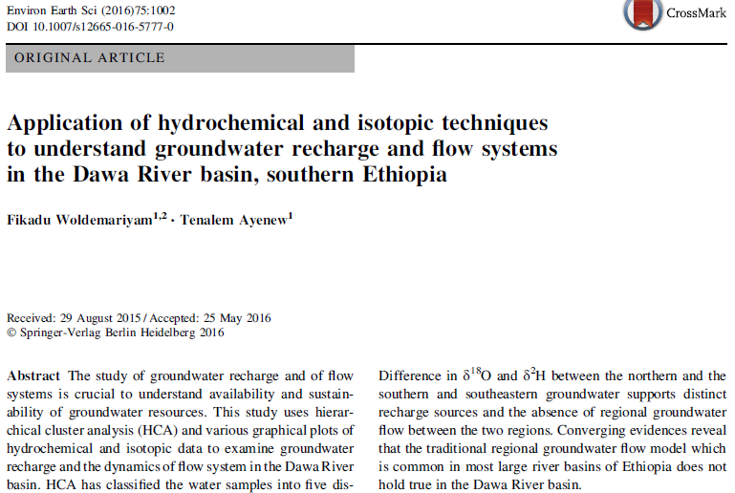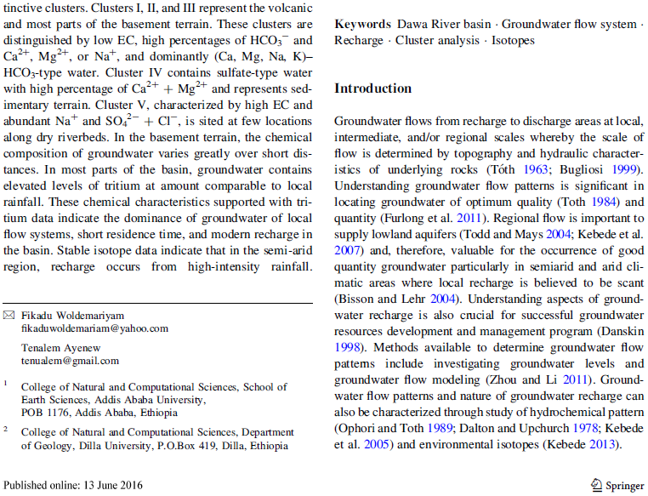
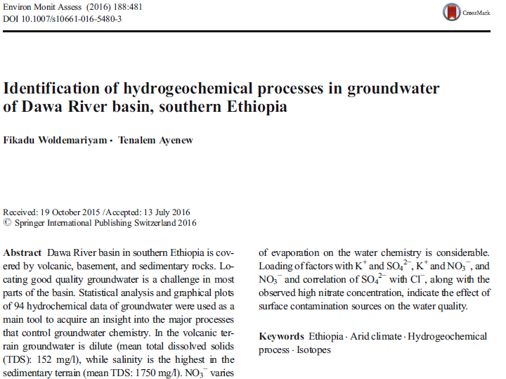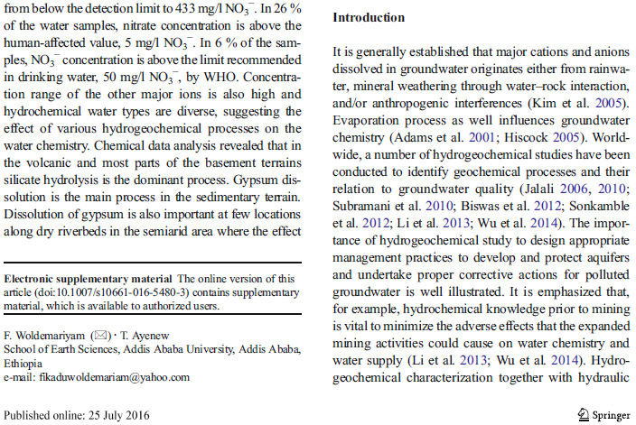

A 2 Mean monthly rainfall data of the study area
Station code | Station | X | Y |  |  |  |  |  |  |  |  |  |  |  |  | Mean annual rainfall
 |  |  |  | Jan | Feb | Mar | Apr | May | Jun | Jul | Aug | Sep | Oct | Nov | Dec | Mean annual rainfall
0 | Adola Rede | 498470 | 649332 | 23.8 | 22.1 | 90.1 | 228.7 | 219.4 | 48.0 | 33.3 | 35.4 | 83.5 | 197.0 | 76.9 | 24.5 | 1083
1 | Bore | 458192 | 703322 | 23.3 | 30.9 | 82.6 | 174.4 | 279.9 | 208.9 | 122.0 | 180.5 | 202.1 | 185.7 | 88.3 | 32.4 | 1610
2 | Hagerselam | 446727 | 720179 | 53.2 | 63.2 | 76.1 | 157.0 | 159.8 | 119.4 | 119.1 | 177.1 | 137.0 | 151.0 | 59.0 | 28.4 | 1300
3 | Bule Hora | 415081 | 622916 | 12.9 | 23.7 | 78.9 | 177.5 | 209.8 | 61.8 | 42.3 | 41.2 | 71.5 | 128.7 | 87.0 | 14.7 | 950
4 | Shakiso | 488382 | 637569 | 24.9 | 25.6 | 75.4 | 190.3 | 169.4 | 46.4 | 49.6 | 38.8 | 83.6 | 187.2 | 81.4 | 19.5 | 992
5 | Yirgacheffe | 410104 | 681710 | 26.0 | 33.7 | 106.1 | 195.5 | 225.5 | 106.6 | 91.2 | 138.1 | 143.7 | 211.2 | 87.6 | 43.1 | 1408
6 | Bule | 439761 | 694493 | 38.3 | 17.8 | 66.3 | 149.9 | 134.4 | 140.1 | 160.1 | 165.3 | 131.5 | 104.5 | 70.5 | 30.8 | 1209
7 | Gedeb | 415728 | 661257 | 20.9 | 21.6 | 51.4 | 112.7 | 130.0 | 73.1 | 60.9 | 74.7 | 82.1 | 114.3 | 58.9 | 22.3 | 823
8 | Finchaw | 411638 | 598363 | 19.6 | 26.1 | 58.0 | 179.6 | 141.9 | 41.2 | 20.8 | 26.9 | 48.4 | 118.0 | 86.6 | 23.0 | 790
9 | Filtu | 684587 | 564799 | 6.5 | 8.5 | 47.2 | 126.1 | 72.0 | 7.7 | 0.8 | 0.4 | 12.6 | 55.5 | 33.2 | 20.6 | 391
10 | Mega | 425443 | 445987 | 20.2 | 57.3 | 75.4 | 119.7 | 82.6 | 19.9 | 19.7 | 15.2 | 12.0 | 88.8 | 54.8 | 35.2 | 601
11 | Moyale | 505657 | 392088 | 18.0 | 17.6 | 59.4 | 159.8 | 88.3 | 15.4 | 8.3 | 7.7 | 16.4 | 96.6 | 81.6 | 25.1 | 594
12 | Nagele | 563791 | 589483 | 10.5 | 22.3 | 62.0 | 198.9 | 140.6 | 9.9 | 6.5 | 4.8 | 36.4 | 158.2 | 53.5 | 12.7 | 716
13 | Wachile | 506129 | 501927 | 34.7 | 6.0 | 44.6 | 211.8 | 69.8 | 4.5 | 8.8 | 0.2 | 40.3 | 63.4 | 108.8 | 25.2 | 618
14 | Wadera | 534868 | 638758 | 15.3 | 23.2 | 81.2 | 191.8 | 209.7 | 20.9 | 18.0 | 20.1 | 85.3 | 186.5 | 76.1 | 20.0 | 948
15 | Yabelo | 398541 | 541007 | 22.8 | 25.0 | 73.3 | 148.3 | 92.2 | 13.2 | 8.8 | 8.9 | 32.8 | 104.0 | 57.4 | 26.3 | 613
16 | Dolo Ado | 847227 | 465424 | 0.6 | 0.6 | 15.4 | 94.6 | 60.3 | 0.5 | 1.7 | 0.4 | 1.2 | 35.5 | 16.0 | 12.8 | 240
17 | Sede | 742784 | 436509 | 3.2 | 0.0 | 23.0 | 91.4 | 50.0 | 1.8 | 1.0 | 0.0 | 0.0 | 60.3 | 20.7 | 1.9 | 253
18 | Arero | 471451 | 523066 | 6.1 | 7.9 | 50.3 | 172.5 | 119.4 | 28.4 | 12.9 | 5.6 | 25.6 | 112.4 | 84.1 | 42.4 | 668
19 | Yirbamouda | 467373 | 688357 | 23.3 | 30.7 | 66.7 | 154.1 | 199.0 | 165.3 | 128.1 | 121.9 | 143.2 | 145.9 | 46.9 | 25.2 | 1250
20 | Zenbaba wuha | 518520 | 651300 | 9.1 | 19.1 | 45.9 | 164.2 | 145.8 | 45.1 | 17.6 | 23.4 | 73.4 | 104.6 | 52.4 | 24.8 | 725

A 3 Mean monthly discharge (m³/s) of Awata River
Year | Jan | Feb | Mar | Apr | May | Jun | Jul | Aug | Sep | Oct | Nov | Dec
1986 | 0.95 | 0.78 | 0.67 | 7.75 | 32.78 | 42.11 | 17.21 | 14.10 | 43.68 | 21.76 | 6.00 | 3.04
1987 | 1.59 | 1.17 | 2.99 | 6.28 | 40.69 | 38.24 | 31.29 | 19.50 | 20.38 | 42.08 | 25.13 | 6.59
1988 | 3.57 | 1.45 | 1.17 | 3.82 | 17.48 | 17.61 | 29.42 | 31.06 | 20.54 | 45.19 | 11.60 | 3.85
1989 | 2.62 | 1.30 | 1.39 | 6.29 | 10.86 | 15.47 | 16.26 | 22.98 | 41.65 | 64.61 | 18.42 | 12.21
1990 | 16.34 | 15.57 | 22.47 | 39.88 | 28.67 | 39.11 | 22.52 | 23.02 | 24.17 | 22.71 | 15.63 | 8.54
1992 | 1.66 | 3.00 | 0.39 | 2.50 | 10.46 | 25.64 | 44.80 | 20.44 | 31.22 | 72.08 | 19.55 | 7.67
1993 | 4.81 | 6.41 | 2.47 | 2.18 | 38.42 | 42.33 | 13.66 | 16.81 | 16.05 | 28.93 | 29.00 | 15.62
1994 | 1.27 | 0.81 | 0.82 | 3.55 | 37.74 | 46.73 | 54.02 | 36.43 | 23.52 | 26.52 | 8.16 | 4.28
1995 | 1.52 | 1.45 | 2.45 | 11.36 | 21.15 | 21.70 | 23.84 | 19.24 | 36.02 | 31.43 | 16.75 | 5.39
1996 | 2.29 | 0.75 | 2.46 | 8.29 | 20.93 | 34.19 | 16.70 | 27.73 | 42.06 | 20.78 | 11.30 | 5.70
1997 | 3.17 | 1.07 | 0.57 | 9.16 | 6.75 | 7.50 | 11.34 | 11.61 | 5.43 | 21.41 | 46.82 | 14.06
1998 | 10.36 | 8.30 | 4.78 | 9.36 | 17.94 | 18.71 | 11.77 | 16.62 | 16.33 | 48.76 | 17.98 | 4.82
1999 | 4.08 | 4.34 | 3.29 | 6.68 | 12.06 | 11.42 | 10.30 | 28.06 | 19.35 | 55.60 | 15.27 | 3.64
2000 | 7.10 | 0.64 | 0.60 | 0.60 | 3.54 | 11.94 | 14.97 | 22.10 | 20.52 | 55.18 | 31.36 | 6.08
2001 | 2.57 | 1.15 | 1.08 | 5.03 | 23.11 | 21.65 | 17.08 | 15.95 | 23.91 | 47.09 | 18.71 | 5.95
2002 | 3.97 | 1.03 | 1.99 | 4.10 | 17.21 | 13.91 | 17.37 | 19.78 | 9.68 | 25.23 | 9.31 | 6.43
2003 | 4.06 | 1.17 | 0.60 | 3.93 | 19.84 | 27.65 | 15.46 | 34.30 | 19.83 | 11.54 | 4.55 | 2.68
2004 | 3.19 | 2.88 | 0.38 | 5.00 | 27.17 | 24.95 | 10.02 | 20.86 | 25.05 | 23.86 | 29.36 | 8.10
2005 | 3.44 | 2.07 | 3.33 | 3.18 | 71.76 | 32.39 | 14.29 | 18.17 | 36.18 | 47.88 | 32.59 | 6.08
2006 | 2.66 | 2.12 | 2.34 | 14.45 | 10.71 | 25.35 | 15.38 | 12.41 | 19.27 | 45.04 | 22.46 | 10.42
2007 | 6.41 | 3.47 | 1.21 | 4.31 | 13.76 | 51.57 | 14.65 | 28.79 | 36.79 | 40.28 | 10.20 | 4.09
A 4 Mean monthly discharge (m³/s) of Mormora River
Year | Jan | Feb | Mar | Apr | May | Jun | Jul | Aug | Sep | Oct | Nov | Dec
1982 |  |  |  | 4.28 | 20.93 | 39.52 | 20.18 | 12.35 | 17.15 | 28.80 | 19.33 | 8.89
1983 | 3.90 | 3.07 | 1.21 | 3.65 | 18.60 | 24.81 | 19.51 | 13.28 | 23.99 | 60.38 | 29.01 | 8.67
1984 | 3.79 | 2.04 | 1.62 | 1.94 | 3.17 | 3.61 | 3.34 | 8.03 | 20.21 | 20.06 | 5.02 | 2.34
1985 | 1.32 | 0.96 | 1.19 | 7.83 | 14.45 | 21.55 | 16.08 | 11.00 | 10.00 | 20.35 | 7.12 | 3.12
1986 | 1.84 | 1.33 | 1.13 | 3.28 | 16.46 | 26.27 | 9.99 | 6.06 | 15.23 | 20.76 | 5.38 | 2.81
1987 | 1.45 | 0.90 | 2.11 | 2.91 | 32.67 | 25.84 | 14.53 | 8.89 | 12.12 | 38.48 | 28.51 | 8.64
1988 | 4.77 | 2.20 | 1.02 | 2.19 | 17.20 | 11.05 | 24.25 | 22.04 | 17.26 | 33.17 | 9.24 | 3.89
1989 | 3.69 | 2.24 | 1.40 | 3.98 | 7.49 | 11.41 | 12.00 | 14.22 | 31.98 | 61.06 | 14.30 | 7.58
1990 | 4.27 | 5.70 | 5.86 | 16.25 | 12.90 | 16.70 | 12.31 | 12.93 | 13.06 | 21.56 | 14.56 | 7.26
1991 | 3.17 | 1.86 | 1.32 | 2.29 | 3.28 | 9.21 | 9.01 | 11.42 | 16.13 | 11.08 | 7.73 | 3.30
1992 | 0.68 | 1.29 | 0.49 | 2.97 | 8.30 | 26.58 | 20.66 | 11.79 | 14.36 | 46.67 | 14.32 | 4.96
1993 | 0.35 | 1.93 | 0.50 | 17.96 |  |  |  |  | 7.76 | 24.77 | 11.71 | 2.77
1994 | 0.71 | 0.38 | 1.37 | 9.05 | 37.64 | 20.77 | 21.85 | 21.09 | 11.15 | 10.43 | 5.44 | 2.54
1995 | 1.22 | 0.97 | 1.78 | 8.30 | 19.01 | 14.56 | 18.28 | 13.79 | 26.14 | 34.71 | 20.21 | 3.70
1996 | 3.50 | 1.63 | 2.63 | 7.07 | 29.08 | 34.52 | 14.88 | 14.52 | 33.21 | 24.89 | 16.06 | 7.36
1997 | 2.65 | 0.65 | 0.13 | 4.76 | 6.90 | 5.88 | 8.27 | 7.86 | 5.06 | 21.88 | 43.05 | 20.05
1998 | 14.20 | 9.12 | 4.73 | 2.44 | 16.97 | 18.14 | 12.69 | 17.01 | 16.80 | 44.90 | 22.16 | 6.07
1999 | 3.54 | 2.12 | 4.09 | 4.32 | 8.40 | 7.83 | 11.02 | 17.01 | 13.51 | 35.30 | 16.22 | 5.63
2000 | 2.33 | 0.96 | 7.21 | 7.03 | 21.07 | 20.96 | 12.71 | 22.88 | 20.49 |  |  | 12.17
2001 |  | 6.84 | 8.75 | 7.03 | 21.07 | 20.96 | 12.24 | 18.58 | 24.08 | 45.37 | 32.46 | 12.17
2002 | 6.27 | 3.73 | 4.65 | 7.66 | 20.29 | 17.15 | 14.70 | 15.47 | 12.46 | 31.25 | 19.36 | 10.83
2003 | 8.10 | 4.53 | 3.70 | 7.98 | 31.44 | 21.00 | 16.05 | 18.13 | 29.84 | 23.68 | 9.39 | 7.99
2004 | 12.39 |  |  |  |  |  | 16.99 | 17.52 | 24.69 | 42.79 | 26.23 | 16.61

A 5 Mean monthly discharge (m³/s) of Digati River
Year | Jan | Feb | Mar | Apr | May | Jun | Jul | Aug | Sep | Oct | Nov | Dec
1998 |  |  |  |  |  |  |  |  |  |  |  | 3.35
1999 | 1.14 | 0.42 | 0.98 | 1.48 | 2.38 | 1.72 | 1.47 | 1.62 | 1.38 | 2.16 | 2.85 | 1.08
2000 | 0.28 |  |  |  | 16.29 | 3.29 | 2.38 | 2.14 | 1.26 | 4.25 | 7.19 | 2.72
2001 | 1.47 | 0.32 | 0.15 | 3.72 | 13.02 | 8.05 | 5.31 | 5.64 | 8.35 | 15.90 | 21.32 | 6.15
2002 | 3.71 | 2.21 | 2.25 | 3.23 | 4.12 | 4.01 | 5.06 | 6.97 | 4.23 | 3.81 | 5.34 | 1.93
2003 | 1.49 | 0.96 | 0.42 | 1.75 | 9.44 | 5.37 | 5.03 | 4.71 | 5.18 | 3.95 | 2.54 | 2.57
2004 | 1.22 | 1.53 | 0.42 | 2.96 | 5.41 | 4.94 | 3.12 | 3.18 | 1.83 | 5.87 | 9.31 | 7.68
2005 | 3.02 | 2.21 | 2.39 | 5.00 | 34.75 |  |  |  |  | 13.61 | 21.11 | 5.50
2006 | 2.58 | 1.82 | 2.65 | 5.70 | 7.34 | 5.39 | 3.28 | 5.51 |  | 9.84 | 13.76 | 8.03
2007 | 2.96 | 1.76 | 1.04 | 7.78 | 7.66 | 12.86 | 8.64 | 7.63

A 6 Mean monthly discharge (m3/s) of main Dawa River
 | Jan | Feb | Mar | Apr | May | Jun | Jul | Aug | Sep | Oct | Nov | Dec
1989 | 7.61 | 10.79 | 9.19 | 25.87 | 36.63 | 31.14 | 30.59 | 35.84 | 56.41 | 121.91 | 61.44 | 25.89
1990 | 17.26 | 10.87 | 20.65 | 55.37 | 41.61 | 45.07 | 37.74 | 34.58 | 35.87 | 40.65 | 29.94 | 18.74
1991 |  |  |  | 36.06 | 31.68 |  |  | 26.77 | 38.48 | 26.77 | 24.38 | 19.96
1992 | 8.66 | 6.16 | 2.82 | 20.11 | 24.61 | 17.05 | 23.09
1993 |  |  |  |  |  |  |  | 65.53 | 50.92 | 38.42 | 32.02 | 13.72
1994 | 7.40 | 11.86 | 6.90 | 9.14 | 42.42 | 64.09 | 57.97 | 62.31 | 42.05 | 34.98 | 24.73 | 10.53
1995 | 6.09 | 6.06 | 8.60 | 26.13 | 55.99 | 32.41 | 50.93 | 38.89 | 57.01 | 85.92 | 58.61 | 20.24
1996 | 6.59 | 8.00 | 11.49 | 19.60 | 99.60 | 122.17 | 58.09 | 48.80 | 40.36 | 53.11 | 42.40 | 20.68
1997 | 10.86 | 6.25 | 4.73 | 36.82 | 35.87 | 14.57 | 27.11 | 19.26 | 12.83 | 48.41 | 133.78 | 65.03
1998 | 40.43 | 39.87 | 20.88 | 21.22 | 41.61 | 41.33 | 37.24 | 40.44 | 42.95 | 52.73 | 77.78 | 22.06
1999 | 10.15 | 11.43 | 12.70 | 11.09 | 33.78 | 24.66 | 17.82 | 39.60 | 34.31 | 51.82 | 47.09 | 3.92
2000 | 0.21 | 0.12 | 0.16 | 2.43 | 40.10 | 13.72 | 12.48 | 13.62 | 12.67 | 58.36 | 27.45 | 13.62
2001 |  |  |  | 5.14 | 19.61 | 14.41 | 15.10 | 15.33 | 15.71 | 36.97 | 29.93 | 6.24
2002 | 1.11 | 0.40 | 2.12 | 16.10 | 46.61 | 13.94 | 9.85 | 14.07 | 11.27 | 22.78 | 11.17 | 8.49
2003 | 4.91 | 0.67 | 0.16 | 38.87 | 40.61 | 18.53 | 11.17 | 14.20 | 23.00 | 9.16 | 3.76 | 4.20
2004 | 0.55 | 1.20 | 0.10 | 9.16 | 20.73 | 17.05 | 6.18 | 7.71 | 15.26 | 20.19 | 29.91 | 8.40
2005 | 1.44 | 1.16 | 1.34 | 8.56 | 111.09 | 42.94 | 16.68 | 14.53 | 21.98 | 21.10 | 26.70 | 7.18
2006 | 2.27 | 0.78 | 2.10 | 28.23 | 14.03 | 15.66 | 9.01 | 20.08 | 16.22 | 36.73 | 38.54 | 13.86
2007 | 5.89 | 1.73 | 0.29 | 15.87 | 13.71 | 38.02 | 15.06 | 19.79 | 30.46 | 52.60 | 13.96 | 2.36

A 7 Inventory of well yield, SWL, Depth to First Water Strike (DFWS), estimated Transmissivity (T), Drawdown (DD), Specific storage (S), and Specific capacity (S_{c}) – Volcanic terrain
No | ID | Locality | X | Y | Depth | SWL | DFWS | Q | T | DD | S | Sc
155 | BH | Ageremariam | 38.24 | 5.634 | 76 | 39
156 | BH | Ageremariam | 38.239 | 5.631 | 56 | 38.2 |  | 4
157 | BH | Badessa | 38.494 | 5.688 | 146 | 24 | 56 | 5
158 | BH | Badessa Malge | 38.596 | 6.078 | 54.6 | 7
159 | BH | Bala | 38.58 | 6.048 | 55.2 | 18
160 | BH | Banko michicha | 38.415 | 5.825 | 86 | 7 | 16 | 15
161 | BH | Bilida Kojoa | 38.468 | 5.846 | 88 | 10 | 26 | 10
21 | BH | Bore#1 | 38.613 | 6.361 | 84 | 6.2 | 55 | 8* | 70 | 6.2 | 2.34E-03 | 1.29
162 | BH | Bore#2 | 38.61 | 6.36 | 92.4 | 7.52 | 57 | 3 | 3.92 | 31.38 | 5.72E-03 | 0.09
163 | BH | Bore#3 | 38.622 | 6.322 | 92.4 | 3.75 |  | 8 | 11.8 | 29.54 | 1.72E-03 | 0.27
164 | BH | Bulehora | 38.221 | 5.623 | 38.3 | 4.5 |  | 1.4
165 | BH | Chemeri_Kercha | 38.294 | 5.664 | 155 | 53.8 |  | 3.8
166 | BH | Chorso Golja | 38.329 | 6.038 | 50 | 15 |  | 3
27 | BH | Danaba#2 | 38.51 | 6.41 | 74 | 33 |  | 6.4 | 73 | 10.82 | 2.34E-04 | 0.59
167 | BH | Dande Bansa | 38.59 | 6.1 | 54.6 | 10
168 | BH | Dande Borowa | 38.57 | 6.11 | 41 | 7.5
28 | BH | Darikidame | 38.547 | 5.89 | 105 | 42 |  | 10
29 | BH | Darsa Sake | 38.546 | 5.797 | 75 | 5 | 27 | 10 | 130 | 4.53 | 3.76E-03 | 1.55
169 | BH | Dhak bor | 38.47 | 6.08 | 116 | 9 | 20 | 6
170 | BH | Diko Dulati | 38.597 | 6.072 | 50
171 | BH | Fisseha Genet | 38.22 | 6.16 | 86 | 30.86 |  | 1.8
43 | BH | Gadio guratu | 38.56 | 6.17 | 59 | 5 | 26
172 | BH | Gadio Siko | 38.64 | 6.17 | 50.6 | 26
173 | BH | Gedeb | 38.249 | 5.912 | 73 |  |  | 1.4
174 | BH | Gerba | 38.204 | 5.788 | 88.5 | 29 |  | 2.9
175 | BH | Gossa | 38.7 | 6.28 | 135 | 56.5 |  | 8 |  | 12.94 |  | 0.62
109 | BH | Guracho Jaldo | 38.452 | 5.749 | 86 | 5 | 60 | 10
45 | BH | Hagereselam | 38.52 | 6.48 | 80 | 36.6 |  | 5.5
176 | BH | Hagereselam | 38.52 | 6.48 | 150 | 100
46 | BH | Hangadhi | 38.752 | 5.899 | 50 | 5
49 | BH | Haro Borena | 38.41 | 6.16 | 89.7 | 19 | 60 | 6.6 | 94.7 | 4.82 | 4.21E-03 | 1.37
50 | BH | Hartume Lama | 38.359 | 5.703 | 107 | 51.7 |  | 2.5 | 7.52 | 27.93 | 3.46E-03 | 0.1
177 | BH | Kilenso | 38.299 | 5.488 | 100.5 | 15.9 |  | 0.9
178 | BH | Layo Ejersa | 38.596 | 6.091 | 50 | 6
179 | BH | Meleka | 38.843 | 6.026 | 39 |  |  | 4.6
180 | BH | Midhi for a | 38.595 | 6.095 | 52.2 | 13 | 23
58 | BH | Sonkole Bame | 38.594 | 6.086 | 54.6 | 5
181 | BH | Wachu | 38.58 | 6.041 | 50.6 | 28 | 34
9 | BH | Yabitu Koba | 38.585 | 5.985 | 130.5 | 36.1 |  | 8 | 18.1 | 18.68 | 6.63E-03 | 0.43
10 | BH | Yirbamoda | 38.71 | 6.21 | 28 | 20 |  | 3.3
115 | DW | Guracho Jaldo | 38.44 | 5.76 | 12 | 5
182 | DW | Yirba muda | 38.73 | 6.41 | 16 | 14
* Pumping rate during pumping test is 5.5 l/s
A 8 Lithologic log related data from basement terrain (static water level (SWL in m), Depth to first water strike (DFWS in m), well yield (Q in lit/s), tramsmissivity (T in m2/day), drawdown (DD in m), Specific yield (Sy), specific capacity (Sc), Depth to massive bed rock (DMBR in m), Top loose materials (Lma in m), thickness of top loose material (TLMa in m)
S.No | ST | Site | X | Y | Depth | SWL | DFWS | Q | T | DD | S_{y} | Sc | DMBR | Lma | TLMa
183 | BH | Adadi Bura | 38.66 | 5.54 | 45 |  | 8 | 0.5 |  |  |  |  | 18 | Sand | 8
12 | BH | Alona | 38.7 | 5.75 | 126 | 0.6 |  | 3 | 30.7 | 7.79 | 1.12E-03 | 0.90 | 64 | Clay | 9
64 | BH | Amiko | 39.41 | 4.59 | 22.6 | 22.5 |  | 0.3
184 | BH | Anferara | 38.91 | 5.93 | 85 |  |  |  |  |  |  |  | 48 | Clay | 5
13 | BH | Badakessa | 38.88 | 5.82 | 116 | 15.9 |  | 0.75 | 0.39 | 74.3 | 7.49E-04 | 0.01
185 | BH | Bake | 38.21 | 4.98 | 26 |  |  | 1.14
124 | BH | Balambal | 39.32 | 5.36 | 92.4 | 16.6 |  | 6.8 | 11.8 | 20.45 | 2.07E-03 | 0.13
186 | BH | Balesa Burka | 38.67 | 5.55 | 48 |  | 26 |  |  |  |  |  | 30 | Silt and sand | 10
16 | BH | Baya Gundi | 38.617 | 5.512 | 68 |  |  | 1.5 | 0.625 | 107 | 1.65E-03 | 0.01
18 | BH | Bitata | 39.48 | 5.49 | 48 |  | 22 | 0.9 |  |  |  |  | 30 | silt | 6
22 | BH | Bubuka | 38.96 | 5.71 | 42 | 15 | 23.2 | 2.3 |  |  |  |  |  | Clay | 9
187 | BH | Bubuka | 38.96 | 5.71 | 23.2 | 11
107 | BH | BuriKaro | 38.84 | 5.43 | 144 |  |  | 0.8
188 | BH | Burka Degaga | 38.69 | 4.21 | 52 |  | 26 |  |  |  |  |  | 36 | Clay | 2
189 | BH | Chabiti | 38.66 | 5.44 | 50 |  |  | 0.9
23 | BH | Cheme | 38.4 | 5.24 | 72 | 2.3 |  | 4.5 | 110 | 3.9 | 2.20E-04 | 1.15 | 65 | alluvial | 17
25 | BH | Dambala Saden | 38.43 | 4.83 | 75 | 15 |  | 1.8
110 | BH | Dida Yabelo | 38.22 | 4.84 | 52 | 23 |  | 1.2
190 | BH | Didimitu | 38.06 | 5.44 | 48 | 6.1 |  | 8 |  |  |  |  |  | alluvial | 48
191 | BH | Didola | 38.96 | 5.71 | 100 | 18.6 |  | 0.78 | 3.37 | 18.3 | 9.36E-03 | 0.40 | 95 | Clay and silty sand | 18
83 | BH | Dubkuk 3 | 38.28 | 4.38 | 65 | 19.4
192 | BH | Dubluk | 38.28 | 4.37 | 100 | 4.6 |  | 1 |  |  |  |  |  | alluvial | 21
193 | BH | Dubulk 4 | 38.28 | 4.38 | 35 | 20
33 | BH | Dureti | 38.81 | 4.76 | 49 | 5.9 |  | 1.25 | 3.2 | 33.75 | 1.69E-02 | 0.04 | 46 | Clay | 6
35 | BH | Ela Dima | 38.6 | 5.7 | 100 | 7 |  | 12.5
194 | BH | Ela Korcha | 38.65 | 5.43 | 47 |  | 12 | 2.5 |  |  |  |  | 27 | Silt | 2
195 | BH | Elgof#2 | 39.06 | 3.86 | 60 | 31.8 | 48 | 5.81 | 168 | 2.29 | 9.27E-03 | 2.53 |  | Sand | 48

A8 (cont.)
L | ST | Locality | X | Y | Depth | SWL | DFWS | Q | T | DD | S_{y} | Sc | DMBR | Lma | TLma
37 | BH | Figa Bike | 39.19 | 5.58 | 120 | 8 |  | 10 | 14.42 | 32 | 1.89E-02 | 0.31 | 70 | Clay and sand | 10
196 | BH | Finchawa | 38.28 | 5.29 | 76 | 4.5
197 | BH | Finchawa | 38.29 | 5.36 | 70.5 | 16.8
39 | BH | Finchawa town | 38.28 | 5.39 | 60 | 3.4 |  | 2.5 | 9.9 | 11.09 | 2.90E-04 | 0.41 | 51 | sand and boulder | 21
40 | BH | Funana Birressa | 38.71 | 4.68 | 87 | 21 |  | 3.5
42 | BH | Gada | 38.48 | 4.85 | 120 | 3 |  | 2.1
198 | BH | Galedambi |  |  |  |  |  | 0.83 | 0.189 | 72 | 1.36E-03 | 0.01
199 | BH | Galo Bokola | 38.67 | 5.49 | 46 |  |  | 1.5
77 | BH | Gayu | 38.53 | 4.22 | 50 | 25 |  | 1
200 | BH | Hadha gora | 38.72 | 5.4 | 48 |  | 2 | 6 |  |  |  |  |  | Silt | 2
201 | BH | Harakelo | 39.39 | 5.55 | 53 | 29.6 |  | 0.8 |  |  |  |  | 2 |  | 0
202 | BH | Harekelo | 39.38 | 5.55 | 91 | 34
203 | BH | Harekelo | 39.39 | 5.55 | 45 | 27
204 | BH | Haro Gari | 38.95 | 5.37 | 100 | 21.4 |  | 1.5 | 3.05 | 19.11 | 7.22E-03 | 0.24 | 81 | Clay and sand | 9
205 | BH | Haro Xixita | 38.55 | 5.54 | 51 |  | 26 | 0.5 |  |  |  |  | 42 | Clay and sand | 6
1 | BH | Hema Kisho | 38.14 | 5.47 | 88 | 19.4 |  | 2.5 | 6.08 | 24.45 | 1.47E-03 | 0.10
206 | BH | Kadale | 38.17 | 5.04 | 59 | 32.8
207 | BH | Kadale | 38.24 | 4.85 | 49 | 29.9 |  | 0.2
2 | BH | Kalkaltu | 38.33 | 5.62 | 100 | 25 |  | 4.7 |  |  |  |  |  |  | 0
208 | BH | Kibremengist | 38.98 | 5.88 | 80 | 24.5 |  | 4.7
209 | BH | Kibremengist | 38.99 | 5.88 | 57 | 7.7 |  | 2
210 | BH | Kibremengist | 38.99 | 5.89 | 43 | 21
211 | BH | Kibremengist | 38.99 | 5.89 | 50 | 29
212 | BH | Korba | 38.943 | 5.713 |  |  |  | 1.3
213 | BH | Korke#2 |  |  | 51.15 |  | 37 |  |  |  |  |  |  | Clay | 10
214 | BH | Laga Bursano | 38.57 | 5.5 | 49 |  | 10 | 2.5 |  |  |  |  | 30 | Silt | 6
215 | BH | Laga Garbi |  |  | 51.15 |  | 15 |  |  |  |  |  | 25 | Clay | 10
216 | BH | Melka Baya | 38.47 | 5.4 | 55.1 |  |  | 1.5

A8 (cont.)
L | ST | Locality | X | Y | Depth | SWL | DFWS | Q | T | DD | S_{y} | Sc | DMBR | Lma | TLma
217 | BH | Melka Baya_2 | 38.46 | 5.53 | 50 |  |  | 1.5
218 | BH | Metagefersa | 38.808 | 4.754 | 55 |  | 16 | 1 |  |  |  |  | 41 | Clay and sand | 11
219 | BH | Metagefersa 3 | 38.81 | 4.75 | 55.2 | 1.5
220 | BH | Mucho | 39.41 | 5.66 | 50 |  | 42 | 3 |  |  |  |  |  | clay | 2
4 | BH | Mugayo | 39.44 | 5.21 | 47 | 6.6 |  |  |  |  |  |  |  | Clay | 16
221 | BH | Mugayo | 39.44 | 5.3 | 51 |  |  |  |  |  |  |  | 27 | Clay | 11
125 | BH | Nurahumba | 39.41 | 5.47 | 48 |  | 18 | 2.5 |  |  |  |  |  | silt
222 | BH | Oda | 38.357 | 5.282 |  |  |  | 0.9
223 | BH | Orbati | 38.42 | 4.98 | 64.3 | 50.6 |  | 0.4
76 | BH | Qa gofa | 38.4 | 4.61 | 68 | 24 |  | 0.7
15 | BH | Qawa | 38.53 | 4.65 | 85 |  |  | 0.8 |  |  |  |  |  |  | 0
224 | BH | Raro Adadi#2 | 38.33 | 5.59 | 53
108 | BH | Rippessa | 39.01 | 5.69 | 72 | 22.5 |  | 1.8 |  |  |  |  |  | Sand | 15
47 | BH | Siminto#2 | 39.611 | 5.301 |  |  |  | 1.3
225 | BH | South Dawa | 39.9 | 4.3 | 24 | 21 |  |  |  |  |  |  | 38 | Sand | 8
226 | BH | South Dawa | 40.04 | 4.16 | 110 | 51 |  |  |  |  |  |  | 17 | Clay | 7
227 | BH | Surupa | 38.31 | 5.14 | 40 | 7.8 | 12 | 0.3 |  |  |  |  | 46 | Sand | 8
5 | BH | Udet | 39.24 | 4.76 | 46.6 | 3 |  | 1.5 |  |  |  |  | 38 | clay | 8
96 | BH | Wachile | 39.07 | 4.55 | 47 | 14
6 | BH | Wachile 2 | 39.06 | 4.55 | 29.6 | 21 |  | 1.5 |  |  |  |  |  | silt | 8
87 | BH | Wacho Dima | 38.81 | 5.4 | 36 | 10 |  | 1.7
61 | BH | Webe 1 | 38.66 | 4.5 | 50 | 26.1 |  | 0.8 |  |  |  |  | 22 | Clay and gravel | 17
8 | BH | Welesu | 38.97 | 4.51 | 51 | 20.6 | 20.1 | 3.7 | 130.2 | 1.59 | 4.35E-02 | 2.01
7 | BH | Wolena | 38.88 | 5.69 | 33 | 5.5 |  | 2 |  |  |  |  | 66 | sand and boulder | 66
63 | BH | Yabelo | 38.33 | 4.81 | 56.7 | 33.2 |  | 0.1
99 | BH | Yabelo town | 38.14 | 4.89 | 67 | 44.9 | 48 | 6.5 | 57.3 | 6.86 | 1.05E-03 | 0.73
228 | BH | Yabelo-Ageremaria | 38.2 | 5 | 58 | 10

A8 (Cont.)
L | ST | Locality | X | Y | Depth | SWL
229 | DW | Adadi | 39.41 | 5.31 | 13 | 3.3
230 | Dw | Alloye | 39.6 | 4.69 | 3.5 | 3
231 | DW | Arda Bururi | 39.84 | 5.41 | 8 | 6.02
232 | DW | Arero | 38.87 | 4.75 | 3 | 2
233 | DW | Arero | 38.73 | 4.77 | 4 | 2
234 | DW | Arero | 38.9 | 4.85 | 5 | 4.5
235 | DW | Arero | 38.9 | 4.9 | 7 | 1
236 | DW | Arero | 38.6 | 4.99 | 11.5 | 9.2
237 | DW | Bitata | 39.47 | 5.49 | 4 | 1.5
19 | Dw | Bobala | 38.88 | 4.43 | 12 | 10
238 | DW | Bokola | 39.33 | 5.54 | 5.2 | 3.1
239 | DW | Bulbul | 39.47 | 5.04 | 1.3 | 1
240 | DW | Buradhera | 39.53 | 5.24 | 9 | 5
241 | DW | Buradhera | 39.55 | 5.21 | 15 | 9.38
242 | DW | Dilalesa | 39.36 | 5.73 | 3.5 | 2.5
243 | DW | Dolcha | 39.32 | 5.67 | 8.5 | 5.4
244 | DW | Dubluk_Yabelo | 38.36 | 4.48 | 5 | 3.5
245 | Dw | Ela Dima | 38.59 | 5.7 | 7 | 5
117 | Dw | Fuldawa | 38.65 | 4.78 | 2 | 1.9
116 | Dw | Gale | 39.65 | 5.71 | 4 | 1
114 | DW | Galesa Dibisa | 38.44 | 5.68 | 12 | 3
246 | DW | Gobicha | 39.57 | 5.33 | 8.3 | 4
247 | DW | Hangadhi | 38.75 | 5.9 | 5 | 1
248 | Dw | Hardot | 39.44 | 5.3 | 11.3 | 5
79 | Dw | Kala'e | 39.52 | 4.55 | 7 | 7
249 | DW | Lami | 39.27 | 4.86 | 7 | 4.8
88 | DW | Luchole | 39.33 | 4.79 | 6.3
55 | Dw | Madar | 38.97 | 4.89 | 4 | 2
119 | DW | Madar#2 | 38.97 | 4.89 | 3 | 1.5
250 | DW | Mede | 39.4 | 5.41 | 8.1 | 5.1
251 | DW | Mega-Yabelo | 38.27 | 4.15 | 17 | 15
252 | Dw | Melicha | 38.64 | 4.78 | 12 | 8
253 | DW | Melka Guba | 39.31 | 4.88 | 7 | 5
254 | DW | Meresa | 39.58 | 5.29 | 11.3 | 6
255 | DW | Mugayo | 39.43 | 5.22 | 8 | 3.8
256 | DW | Ramat Guda | 38.81 | 4.3 | 6 | 5
257 | Dw | Udet | 39.25 | 4.77 | 5 | 2
258 | DW | Udet | 39.21 | 4.74 | 9
259 | DW | Wachile | 39.1 | 4.53 | 7 | 6.1
260 | DW | Wofe | 39.6 | 5.34 | 11 | 4.1
121 | Dw | Wolabou | 38.81 | 5.86 | 8
261 | DW | Yabelo-Arero Road | 38.63 | 4.75 | 9 | 7

A 9 Inventory of well depth (m), yield (l/s) and SWL (m) from sedimentary terrain
No | ID | Locality | X | Y | Elevation | Depth | SWL | Q
233 | DW | Arero | 38.86 | 4.77 | 1427 | 8 | 6
262 | BH | Ayinel | 41.085 | 4.771 | 734 | 216 | 210 | 0.42
66 | DW | Biyoole | 41.6 | 4.16 | 354 | 4.5 | 2.5
263 | DW | Biyoole | 39.55 | 5.22 | 369 | 9 | 5
264 | DW | Bokol Mayo | 41.4 | 4.43 | 455 | 3 | 1.5
70 | BH | Chilanko | 41.15 | 4.172 | 1045 | 24 | 21 | 1.47
75 | BH | Chilanko | 40.021 | 4.172 | 1045 | 105 | 50 | 3.3
38 | BH | Debano | 39.667 | 5.332 | 1573 | 140 | 55
265 | DW | Dipi | 41.8 | 4.22 | 226 | 7.6 | 5
266 | DW | Dolo Odo | 42.05 | 4.18 | 180 | 5.6 | 3
267 | DW | Dolo Odo | 42.04 | 4.17 | 188 | 12 | 10.6
268 | DW | Dolo_near Dawa | 42.07 | 4.17 | 178 | 4 | 3
269 | DW | Dytuli | 41.61 | 4.02 | 246 | 19 | 15.2
36 | BH | Elyapo | 40.066 | 4.602 | 1136 | 53
270 | BH | Filtu | 40.658 | 5.112 | 1250 | 367
41 | BH | Funnan Giri | 40.021 | 4.99 | 1235 | 192 | 72 | 2.5
271 | DW | Geled | 41.57 | 4.01 | 256 | 8 | 5
272 | DW | Golome | 41.96 | 4.3 | 194 | 11.3 | 7.5
273 | BH | Higili | 40.123 | 5.184 | 1154 | 148 | 72
274 | BH | Higole | 40.13 | 5.185 | 1145 | 162 |  | 0.5
275 | BH | Jilanko | 40.173 | 4.315 | 1078 | 130 |  | 3
276 | DW | Kole | 41.81 | 4.43 | 205 | 4.9 | 4.6
51 | BH | Korati | 39.885 | 5.048 | 1441 | 100 | 64 | 2
86 | Dw | Kulayi | 40.7 | 4.52 | 351 | 7 | 6.5
277 | BH | Kurabul | 40.37 | 5.314 | 958 | 268 | 74
278 | BH | Negele AP | 39.703 | 5.297 | 1530 | 168 | 59.3 | 1.4
279 | BH | Negele Army base | 39.6 | 5.333 | 1610 | 116 | 74 | 0.83
280 | BH | Negele Army base | 39.6 | 5.333 | 1610 | 95 |  | 1.1
281 | BH | Negele Army base | 39.6 | 5.333 | 1610 | 130.15 | 53.5 | 1.5
282 | BH | Negele Army base | 39.566 | 5.349 | 1460 | 43 | 2.5 | 1.88
283 | DW | Niman | 41.58 | 3.97 | 233 | 6 | 4
284 | BH | Quale | 41.08 | 5.238 | 675 | 319 | 64
285 | Dw | Quaribal | 42.07 | 4.17 | 178 | 6 | 8
89 | DW | Sede1 | 41.45 | 4.23 | 408 | 17 | 16
286 | DW | Shambel | 41.85 | 4.29 | 191 | 9.2 | 7.2
47 | BH | Siminto | 39.631 | 5.216 | 1519 | 72 | 15.25
287 | BH | Siminto#1 | 39.61 | 5.302 | 1433 | 60 | 25.5 | 1
288 | BH | Siminto#2 | 39.611 | 5.301 | 1463 | 50.5 | 16.5 | 1.3
91 | BH | Siru | 40.435 | 5.092 | 1174 | 248 | 189 | 4.4
289 | BH | Siru | 40.308 | 5.187 | 1173 | 200
290 | BH | Warsale | 39.962 | 5.103 | 1450 | 257 | 87
291 | DW | Wshaqibal | 41.07 | 4.38 | 699 | 10 | 7

A 10 Values of Transmissivity based on pump test (T_PT) and empirical formula of Driscoll (1986) based on specific capacity (T_Em)
No | Locality | X | Y | Depth | SWL | T_PT | T_Em | % Differece
21 | Bore#1 | 38.613 | 6.361 | 84 | 6.2 | 70.00 | 116.09 | 0.25
162 | Bore#2 | 38.61 | 6.36 | 92.4 | 7.52 | 3.92 | 8.60 | 0.37
163 | Bore#3 | 38.622 | 6.322 | 92.4 | 3.75 | 11.80 | 24.37 | 0.35
27 | Danaba#2 | 38.51 | 6.41 | 74 | 33 | 73.00 | 53.22 | -0.16
29 | Darsa Sake | 38.546 | 5.797 | 75 | 5 | 130.00 | 198.61 | 0.21
49 | Haro Borena | 38.41 | 6.16 | 89.7 | 19 | 94.70 | 123.19 | 0.13
50 | Hartume Lama | 38.359 | 5.703 | 107 | 51.7 | 7.52 | 8.05 | 0.03
9 | Yabitu Koba | 38.585 | 5.985 | 130.5 | 36.1 | 18.10 | 18.61 | 0.01
12 | Alona | 38.7 | 5.75 | 126 | 0.6 | 30.70 | 34.64 | 0.06
13 | Badakessa | 38.88 | 5.82 | 116 | 15.9 | 0.39 | 0.61 | 0.22
124 | Balambal | 39.32 | 5.36 | 92.4 | 16.6 | 11.80 | 12.12 | 0.01
16 | Baya Gundi | 38.617 | 5.512 | 120 |  | 0.63 | 1.26 | 0.34
23 | Cheme | 38.4 | 5.24 | 72 | 2.3 | 110.00 | 103.80 | -0.03
191 | Didola | 38.96 | 5.71 | 100 | 18.6 | 3.37 | 3.83 | 0.06
33 | Dureti | 38.81 | 4.76 | 49 | 5.9 | 3.20 | 3.33 | 0.02
195 | Elgof#2 | 39.06 | 3.86 | 60 | 31.8 | 168.00 | 228.00 | 0.15
37 | Figa Bike | 39.19 | 5.58 | 120 | 8 | 14.42 | 28.12 | 0.32
39 | Finchawa town | 38.28 | 5.39 | 60 | 3.4 | 9.90 | 20.28 | 0.34
204 | Haro Gari | 38.95 | 5.37 | 100 | 21.4 | 2.91 | 7.06 | 0.42
1 | Hema Kisho | 38.14 | 5.47 | 88 | 19.4 | 6.08 | 9.19 | 0.20
8 | Welesu | 38.97 | 4.51 | 51 | 20.6 | 130.20 | 209.34 | 0.23
99 | Yabelo town | 38.14 | 4.89 | 67 | 44.9 | 57.30 | 85.24 | 0.20
 |  |  |  |  |  | Mean of errors |  | 0.17

A 11 Inventory of spring discharge (B = crystalline basement; V = volcanic)
L | Site | Scheme type | X | Y | Elev. | Q (l/sec) | Spring type | Terrain
130 | Deritu | SP | 38.1 | 4.74 | 1550 | 1 | Depression; multiple | B
131 | Genaro | SP | 38.02 | 4.9 | 1813 | 0.5 | Depression; single | B
132 | Gerbi | SP | 38.1 | 4.91 | 1822 | 0.3 | Contact; single | B
133 | Bekeka | SP | 38.11 | 4.84 | 1755 | 0.1 | Depression; multiple | B
134 | Sankura | SP | 38.53 | 4.96 | 1520 | 1 | Depression; Multiple | B
135 | Benti | SP | 39.31 | 5.78 | 1791 | 0.5 | Contact; Multiple | B
101 | Galesa Soke | SP | 38.48 | 5.64 | 1454 | 0.05 | depression | B
103 | Miotu | SP | 38.48 | 5.86 | 1912 | 0.5 | contact | B
80 | Kenticha | SP | 39.02 | 5.46 | 1587 | 1 | Depression | B
136 | Sokoricha | SP | 38.61 | 5.73 | 2042 | 1.5 | Depression | B
137 | Arero | SP | 38.83 | 4.74 | 1631 | 0.3 | Fracture | B
138 | Benssa | SP | 38.75 | 6.07 | 2246 | 3 | Depression; Multiple | V
100 | Elafarda#1 | SP | 38.38 | 5.75 | 2110 | 1.5 | Contact; Single | V
139 | Elafarda#2 | SP | 38.37 | 5.75 | 2139 | 1 | Contact | V
53 | Layo Kuni | SP | 38.42 | 5.71 | 2014 | 1.5 | Contact | V
140 | Goromie | SP | 38.44 | 5.72 | 2046 | 2 | Depression | V
102 | Egu Abayi | SP | 38.48 | 5.72 | 1982 | 0.2 | Depression | V
104 | Bulala | SP | 38.47 | 5.85 | 2037 | 3 | Depression | V
105 | Hangadhi | SP | 38.75 | 5.9 | 2157 | 0.7 | Depression | V
141 | lemi Kercha | SP | 38.39 | 5.78 | 2198 | 1 | depression | V
142 | Sukechiga | SP | 38.36 | 5.84 | 2184 | 1 | Depression | V
143 | Qarcha town | SP | 38.42 | 5.77 | 2031 | 0.8 | Contact | V
144 | Bankobaya | SP | 38.37 | 5.88 | 2013 | 1.5 | Depression | V
145 | Bankogudub | SP | 38.39 | 5.8 | 1998 | 0.9 | Contact | V
146 | Badessa | SP | 38.5 | 5.69 | 1987 | 0.5 | Distributed | V
147 | Banko | SP | 38.41 | 5.83 | 1976 | 1 | Contact | V
148 | Sukechiga | SP | 38.36 | 5.84 | 1970 | 0.3 | Distributed | V
149 | Bilida Bukisa | SP | 38.48 | 5.82 | 1962 | 0.8 | Depression | V
150 | Guracho | SP | 38.49 | 5.75 | 1957 | 1 | Depression | V
151 | Aruse Darsa | SP | 38.52 | 5.76 | 1940 | 0.6 | Contact | V
152 | Laga Baso | SP | 38.61 | 5.67 | 2221 | 1 | Depression | V
153 | Suke | SP | 38.63 | 5.98 | 2198 | 1.2 | Contact | V
154 | Yabitu | SP | 38.55 | 6.01 | 2337 | 0.2 | Contact | V

A 12 Typical S-shape Time-Drawdown curve (Data for (a) and (b) corresponds to well 90 and 91, respectively, on Fig. 3.1 above)
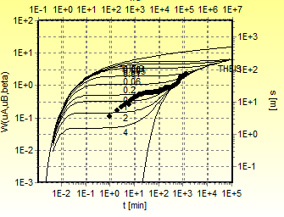(a)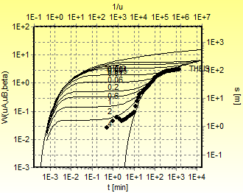 (b)

A 13 Potentiometeric surface and general groundwater flow direction
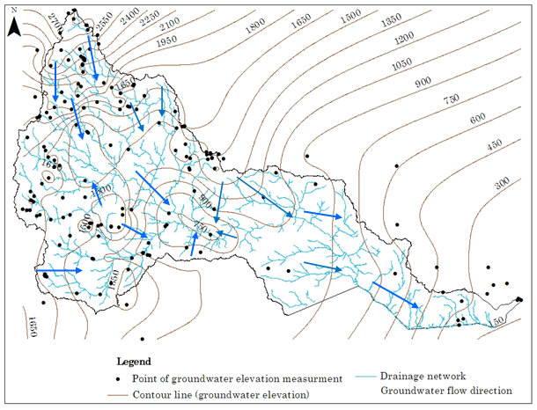

A 14 Chemical data (unit: major ions, mg/l; Tem, °c; L = sample label; T = scheme type; C = HCA class; BH = Borehole; DW = dug well; SP = spring; RF = rainfall; RV = river water)
C | Locality | L | Te | Cl | T | X | Y | Elev. | pH | Temp. | TDS | EC | Ca²⁺ | Mg²⁺ | Na⁺ | K⁺ | HCO₃⁻ | Cl⁻ | SO₄²⁻ | NO₃⁻ | Remark
II | HemaKisho | 1 | B | Hu | BH | 38.14 | 5.47 | 1767 | 6.8 | 22 | 446 | 666 | 72.2 | 13.3 | 63 | 3.8 | 263.9 | 48.4 | 108.6 | BDL
II | Kalaltu | 2 | B | Hu | BH | 38.32 | 5.17 | 1901 | 7.5 | 21.5 | 682 | 887 | 131.9 | 25 | 22 | 4.5 | 175.7 | 22.8 | 296 | BDL
II | Kukuba | 3 | B | SA | BH | 38.13 | 5.14 | 1553 | 7.3 | 23.6 | 428 | 654 | 63.1 | 17.8 | 58 | 4.1 | 317.2 | 32.3 | 82.3 | BDL
IV | Mugayo | 4 | B | SA | BH | 39.43 | 5.21 | 1244 | 6.9 | 25.8 | 1750 | 2690 | 285 | 50 | 220 | 6.8 | 476 | 174.9 | 625 | 3.2
V | Udet | 5 | B | SA | BH | 39.24 | 4.76 | 842 | 7 | 27.1 | 5349 | 8184 | 82 | 143 | 1562 | 20 | 1110 | 1572 | 1119 | 9
V | Wachile | 6 | B | SA | BH | 39.06 | 4.55 | 1040 | 7.6 | 26.7 | 5917 | 9864 | 112 | 173 | 1069 | 110 | 498 | 1269 | 917.2 | 433
I | Welena | 7 | B | Hu | BH | 38.87 | 5.69 | 1730 | 6.4 | 21 | 262 | 401 | 49.4 | 13.2 | 34 | 2.1 | 182.4 | 28.2 | 80.9 | 5.9
III | Wolensu | 8 | B | SA | BH | 38.94 | 4.51 | 1112 | 7.8 | 27.1 | 1766 | 2943 | 150 | 58 | 420 | 39 | 1002 | 249 | 323 | 26.6
I | Yabitukoba | 9 | V | Hu | BH | 38.58 | 5.99 | 2310 | 6.7 | 21 | 140 | 218 | 28 | 7.2 | 8.8 | 3.9 | 137 | 3.6 | 6.1 | 1.2
I | Yirbamouda | 10 | V | Hu | BH | 38.71 | 6.21 | 2548 | 7 | 20.4 | 80 | 108 | 11.8 | 4.6 | 8 | 1.5 | 62 | 3 | 6.1 | 0.1
I | Adola | 11 | B | Hu | BH | 38.98 | 5.88 | 1675 | 7.2 | 22.3 | 82 | 134 | 13.2 | 2 | 10 | 2 | 72 | 2 | 2.4 | 0.9
II | Alona | 12 | B | Hu | BH | 38.7 | 5.75 | 1764 | 7.1 | 20.5 | 360 | 610 | 84 | 15.4 | 22.5 | 5.5 | 300.1 | 20.9 | 53.2 | 0.7
II | Badakessa | 13 | B | Hu | BH | 38.88 | 5.82 | 1657 | 5.5 | 20.1 | 520 | 763 | 75.2 | 21.1 | 57 | 5.1 | 170.8 | 42.5 | 217.9 | 0.9
I | Bambuawuha | 14 | V | Hu | BH | 38.77 | 6.08 | 2277 | 6.5 | 21.4 | 26 | 42 | 4.2 | 1 | 2 | 1.8 | 21.5 | 1 | 0.9 | BDL
III | Qawa | 15 | B | SA | BH | 38.52 | 4.66 | 1424 | 6.5 | 26.4 | 468 | 779 | 36.9 | 17.5 | 110 | 9 | 482.1 | 12 | 6 | 0.9
II | BayaGundi | 16 | B | SA | BH | 38.62 | 5.51 | 1277 | 7.1 | 21.5 | 304 | 536 | 54.7 | 20.5 | 17 | 6.9 | 222.9 | 17.3 | 59.3 | 1.2
II | BentiKorbo | 17 | B | Hu | BH | 38.88 | 5.75 | 1837 | 6.1 | 21.4 | 542 | 753 | 106 | 25 | 42 | 12 | 246 | 17 | 203.5 | 0.3
II | Bitata | 18 | B | SA | BH | 39.47 | 5.49 | 1476 | 6.6 | 25 | 550 | 780 | 32 | 15 | 82 | 26 | 120 | 143 | 20 | 4
II | Bobala | 19 | B | SA | BH | 38.89 | 4.83 | 1574 | 6.6 | 22.1 | 498 | 862 | 120 | 19 | 38 | 1.5 | 200 | 120 | 105 | 3
III | Bokola | 20 | B | SA | BH | 39.26 | 5.57 | 1526 | 6.5 | 24.6 | 821 | 1211.3 | 242 | 24 | 60 | 5 | 672 | 8 | 188 | 3
I | Bore | 21 | V | Hu | BH | 38.61 | 6.36 | 2745 | 6.9 | 19 | 101 | 155 | 17.2 | 3.2 | 5 | 1.4 | 74.9 | 2.4 | 1 | 2.4
I | Bubuka | 22 | B | Hu | BH | 38.96 | 5.71 | 1684 | 7.4 | 22.9 | 240 | 365 | 57.6 | 6.2 | 17.5 | 4.9 | 178.5 | 7.7 | 53.2 | 1.2
II | Cheme | 23 | B | SA | BH | 38.39 | 5.25 | 1414 | 6.6 | 26 | 406 | 676 | 93 | 13 | 17 | 1 | 325 | 16.4 | 10.9 | 1
I | Dama town | 24 | V | Hu | BH | 38.48 | 6.27 | 2797 | 6.7 | 18.4 | 92 | 153 | 23 | 3.3 | 7.4 | 1.7 | 101.4 | 2.1 | 1.3 | 1.2
III | Dambala Saden | 25 | B | SA | BH | 38.42 | 4.84 | 1434 | 6.3 | 26.8 | 813 | 1355 | 95 | 40 | 110 | 27.5 | 752 | 29 | 31.5 | 2
III | Sabaguduba | 26 | B | Hu | BH | 38.84 | 5.58 | 1471 | 6.9 | 24.1 | 676 | 986 | 140 | 52 | 23 | 4.9 | 644.7 | 28.2 | 12.9 | 2.2
I | Danaba | 27 | V | Hu | BH | 38.51 | 6.41 | 2702 | 7 | 17.4 | 74 | 122 | 22 | 2.3 | 10.7 | 1.8 | 95 | 1.8 | 0.2 | 1.8
I | DariKidame | 28 | V | Hu | BH | 38.57 | 5.89 | 2117 | 6.8 | 20 | 170 | 261 | 33.6 | 8.6 | 18.5 | 1.9 | 170.8 | 5.5 | 0.1 | 0.2
I | DarsaSake | 29 | V | Hu | BH | 38.55 | 5.8 | 2117 | 6.8 | 21 | 172 | 262 | 32 | 12 | 9.8 | 2.1 | 175.7 | 5.5 | 0.1 | 0.3
II | Dawa Dimitu | 30 | B | Hu | BH | 38.53 | 5.57 | 1309 | 6.7 | 23.3 | 287 | 480 | 60.8 | 6.1 | 30 | 2.1 | 275 | 23 | 3 | 0.4
III | Dikale | 31 | B | SA | BH | 38.33 | 4.81 | 1465 | 6.7 | 24.4 | 1339 | 2230 | 160.3 | 19.5 | 300 | 38 | 533.3 | 199.9 | 340 | 1
I | Dimitu | 32 | V | Hu | BH | 38.37 | 6.02 | 2493 | 6.6 | 19.2 | 180 | 281 | 42 | 6.6 | 9.8 | 3 | 170.8 | 5.7 | 9 | 0.4
II | Dureti | 33 | B | SA | BH | 38.81 | 4.76 | 1611 | 6.8 | 24.3 | 664 | 1094 | 96.6 | 29.7 | 96 | 6.2 | 294.6 | 186.2 | 19.8 | 2
III | Sabbaboru | 34 | B | Hu | BH | 39.13 | 5.66 | 1737 | 6.9 | 24.7 | 526 | 805 | 88 | 38 | 27 | 13 | 490 | 30 | 5.6 | 0.4
II | Eladima | 35 | B | Hu | BH | 38.6 | 5.7 | 1350 | 6.4 | 21.5 | 588 | 981 | 118.6 | 13.6 | 56 | 2.2 | 195.4 | 160 | 51.9 | 1
III | Elayapo | 36 | M | SA | BH | 40.07 | 4.6 | 1136 | 6.4 | 27.4 | 1578 | 2630 | 398 | 179 | 49 | 9 | 652 | 20 | 1085 | 4.4
V | Figa Bike | 37 | B | SA | BH | 39.19 | 5.58 | 1343 | 6.7 | 26 | 6474 | 9970 | 1002 | 183.9 | 989 | 15 | 560 | 1901 | 1853 | 0.7
III | Debano | 38 | M | SA | BH | 39.67 | 5.33 | 1539 | 7.6 | 21.7 | 428 | 713 | 62 | 54 | 31 | 13 | 492 | 12 | 48 | 1.3

A14 (cont.)
C | Locality | L | Terrain | Climat | T | X | Y | Elev. | pH | Temp. | TDS | EC | Ca²⁺ | Mg²⁺ | Na⁺ | K⁺ | HCO₃⁻ | Cl⁻ | SO₄²⁻ | NO₃⁻ | Remark
II | Finchawatown | 39 | B | SA | BH | 38.27 | 5.39 | 1611 | 6.9 | 24.9 | 300 | 501 | 72 | 7.4 | 32 | 6.2 | 262 | 23 | 21 | 0.5
III | Funan Biressa | 40 | B | SA | BH | 38.7 | 4.69 | 1305 | 7.1 | 26.9 | 2371 | 3952 | 330 | 39 | 223 | 35 | 1120 | 55 | 370 | 3
IV | Funan Giri | 41 | M | SA | BH | 40.02 | 4.99 | 1279 | 7.2 | 27.1 | 1400 | 2100 | 75 | 180 | 70 | 5 | 280 | 144 | 558 | 3.8
V | Gada | 42 | B | SA | BH | 38.48 | 4.85 | 1426 | 6.8 | 26.1 | 3340 | 5570 | 392.8 | 82.7 | 860 | 75 | 425 | 1399.6 | 714.5 | 0.7
I | Gadioguratu | 43 | V | Hu | BH | 38.55 | 6.17 | 2474 | 6.5 | 22 | 60 | 94 | 16 | 1.4 | 2 | 0.7 | 58.6 | 1.8 | BDL | 0.9
IV | Godo | 44 | M | SA | BH | 39.76 | 5.33 | 1582 | 7 | 24.7 | 922 | 1536 | 395 | 138 | 45 | 14 | 450 | 98 | 1031 | 0.1
I | Hagereselam | 45 | V | Hu | BH | 38.52 | 6.49 | 2756 | 7.2 | 17.1 | 110 | 180 | 18.5 | 6.1 | 13.5 | 3.1 | 110 | 3 | BDL | 1.2 | ***
I | Hangadhi | 46 | V | Hu | BH | 38.75 | 5.89 | 2175 | 6.1 | 18.3 | 111 | 185 | 33 | 3 | 5 | 2 | 120 | 5 | 2 | 0.5
III | Siminto | 47 | B | SA | BH | 39.61 | 5.3 | 1433 | 7.2 | 23.7 | 655 | 1100 | 155 | 8.4 | 41.6 | 4.4 | 573 | 32 | 5.6 | 0.5
IV | Hardot | 48 | B | SA | BH | 39.44 | 5.31 | 1327 | 6.9 | 24.7 | 1282 | 1961 | 102 | 99.4 | 185 | 6 | 901 | 196 | 79 | 0.4
I | Haroborena | 49 | V | Hu | BH | 38.41 | 6.16 | 2617 | 6.8 | 18.5 | 60 | 97 | 10.6 | 2.3 | 5.9 | 2.7 | 55.6 | 5.5 | 0.2 | 2.1
I | Hartumelaman | 50 | V | Hu | BH | 38.36 | 5.7 | 2008 | 6.7 | 23.4 | 188 | 269 | 40 | 5 | 24 | 1.9 | 220 | 6.3 | 1.2 | 0.7
IV | Korati | 51 | M | SA | BH | 39.88 | 5.05 | 1453 | 7.7 | 29 | 1048 | 1748 | 224.5 | 222 | 523 | 18 | 225 | 183 | 2039 | 3.1
II | Korcha | 52 | B | Hu | DW | 38.59 | 5.51 | 1686 | 6.2 | 20.5 | 526 | 879 | 147.5 | 14.6 | 26 | 6.5 | 176.4 | 104 | 160.5 | 3
I | Layokuni | 53 | V | Hu | SP | 38.41 | 5.71 | 2024 | 6.7 | 19.5 | 200 | 302 | 44 | 7.2 | 7.7 | 4.2 | 148.8 | 18.2 | 18.3 | 0.6
I | Lemieriba | 54 | V | Hu | BH | 38.31 | 5.8 | 2300 | 6.4 | 20.1 | 72 | 103 | 12.8 | 2 | 4.3 | 0.3 | 45 | 1.8 | 7 | 1.2
II | Madar | 55 | B | SA | DW | 38.97 | 4.89 | 1156 | 6.4 | 25.6 | 595 | 660 | 45 | 21.5 | 60 | 8 | 302 | 25 | 25 | 3
II | Sirba | 56 | B | Hu | BH | 39.36 | 5.54 | 1594 | 6.3 | 24.6 | 762 | 1272 | 138 | 35 | 78 | 6 | 409 | 82 | 168 | 0.4
II | Sirebuke | 57 | B | Hu | BH | 39.06 | 5.53 | 1757 | 7 | 22.3 | 253 | 400 | 43 | 15 | 26 | 6 | 250 | 16 | 1 | 0.9
I | Sonkole | 58 | V | Hu | BH | 38.59 | 6.09 | 2360 | 7.1 | 20.5 | 130 | 215 | 28.8 | 6.7 | 5.9 | 2.5 | 130 | 5.5 | 0.9 | 0.4
V | Tekari | 59 | B | SA | BH | 39.52 | 5.2 | 1195 | 6.7 | 24.9 | 4654 | 7819 | 433 | 289 | 852 | 13 | 620 | 752.3 | 2540 | 0.4
II | Titita | 60 | B | Hu | DW | 39.32 | 5.4 | 1429 | 7.2 | 23.8 | 376 | 576 | 80 | 13 | 15 | 9 | 290 | 25 | 17 | 1.8 | *
III | Webe | 61 | B | SA | BH | 38.66 | 4.5 | 1247 | 7.4 | 27.4 | 894 | 1368 | 49 | 35 | 148 | 38 | 587 | 111 | 29 | 0.3
II | Woofe | 62 | B | SA | DW | 39.6 | 5.34 | 1526 | 6.7 | 24 | 1019 | 1559 | 168 | 27 | 64 | 0.7 | 238 | 156 | 208 | 84 | *
II | Yabelo | 63 | B | SA | BH | 38.14 | 4.88 | 1610 | 6.8 | 26 | 720 | 1120 | 76 | 25 | 63 | 4 | 205 | 99 | 106 | 36
III | Amiko | 64 | B | SA | DW | 39.41 | 4.59 | 943 | 8 | 27 | 1081 | 1330 | 80 | 41 | 141 | 14 | 495 | 147 | 33 | 27.5
II | Orone | 65 | B | Hu | BH | 39.01 | 5.8 | 1667 | 6.9 | 22.5 | 278 | 426 | 49 | 21 | 14 | 2 | 264 | 18 | 11 | 0.4 | *
II | Biyole | 66 | M | SA | DW | 41.6 | 4.16 | 360 | 7.5 | 28.5 | 629 | 960 | 54 | 57 | 48 | 6 | 294 | 35 | 154 | 69
IV | Bulequily | 67 | M | SA | BH | 39.76 | 5.38 | 1554 | 7.1 | 26 | 1296 | 1983 | 229 | 128 | 29 | 11 | 332 | 16 | 862 | 2.2 | *
I | Chelosegida | 68 | B | Hu | BH | 39.32 | 5.77 | 1785 | 6.5 | 21.8 | 236 | 361 | 34 | 8 | 30 | 2 | 176 | 13 | 18 | 12
IV | Mersa | 69 | B | SA | BH | 39.57 | 5.3 | 1459 | 6.8 | 24.5 | 1464 | 2240 | 223 | 62 | 154 | 2 | 628 | 371 | 98 | 71
IV | Chilanko | 70 | M | SA | BH | 40.17 | 4.33 | 1074 | 7.5 | 27 | 2988 | 4040 | 355 | 150 | 287 | 26 | 340 | 279 | 1295 | 7.5
IV | Chilanko | 71 | M | SA | DW | 41.15 | 4.33 | 986 | 6.7 | 27.5 | 1200 | 1543 | 144 | 150 | 93 | 3 | 450 | 132 | 612 | 160
III | Das | 72 | B | SA | BH | 38.72 | 4.22 | 1293 | 6.5 | 28 | 1009 | 1544 | 38 | 28 | 212 | 22 | 405 | 186 | 73 | 26
III | Dolcha | 73 | B | Hu | BH | 39.32 | 5.67 | 1507 | 7 | 24 | 873 | 1336 | 62 | 38 | 190 | 2 | 553 | 172 | 70 | 0.4
IV | ElaHadhessa | 74 | B | SA | DW | 39.63 | 4.89 | 1092 | 7.6 | 26.4 | 1736 | 2560 | 94 | 124 | 241 | 4 | 606 | 443 | 99 | 34.6
II | Gadda | 75 | B | SA | BH | 39.3 | 5.29 | 1380 | 6.5 | 25.9 | 298 | 456 | 41 | 26 | 23 | 1 | 293 | 9 | 1 | 2.2
IV | Qa Gofa | 76 | B | SA | BH | 38.42 | 4.26 | 1423 | 7 | 26.3 | 3172 | 4853 | 340 | 140 | 470 | 36 | 468 | 677 | 1113 | 2.1
* Zewdie and Nahusenay, 2011; ** Zewdie and Sima, 2011; and ***MoWIE, 2007

A14 (cont.)
C | Locality | L | Terrain | Clima | T | X | Y | Elev. | pH | Temp. | TDS | EC | Ca²⁺ | Mg²⁺ | Na⁺ | K⁺ | HCO₃⁻ | Cl⁻ | SO₄²⁻ | NO₃⁻ | Remark
III | Gayu | 77 | B | SA | BH | 38.54 | 4.22 | 1353 | 6.9 | 27.6 | 935 | 1431 | 56 | 32 | 156 | 18 | 403 | 145 | 49 | 3.2
II | Harekelo1 | 78 | B | SA | BH | 39.4 | 5.55 | 1637 | 6.7 | 22.5 | 358 | 547 | 54 | 16 | 36 | 6 | 332 | 16 | 6 | 0.4 | *
III | Kala'e | 79 | B | SA | DW | 39.52 | 4.55 | 969 | 7.8 | 27 | 1131 | 1417 | 97 | 49 | 126 | 7 | 571 | 112 | 63 | 7.1
II | Kenticha | 80 | B | Hu | SP | 39.02 | 5.47 | 1587 | 7.8 | 25 | 418 | 640 | 9 | 82 | 6 | 0.5 | 455 | 6 | 2 | 0.4 | *
II | Kiltabala | 81 | B | Hu | DW | 38.87 | 5.32 | 1443 | 6.8 | 24.5 | 451 | 690 | 32 | 20 | 93 | 1 | 360 | 27 | 14 | 17.7 | *
I | Kiltumura | 82 | B | Hu | BH | 39.02 | 5.92 | 1737 | 6.2 | 22.5 | 175 | 267 | 23 | 7 | 20 | 1 | 110 | 25 | 17 | 0.4
III | Dubulk | 83 | B | SA | BH | 38.28 | 4.37 | 1472 | 7.1 | 25 | 776 | 1187 | 100 | 26 | 64 | 17 | 430 | 61 | 53 | 22
I | Kobasorsa | 84 | B | Hu | BH | 39 | 5.9 | 1711 | 6.4 | 22 | 246 | 376 | 23 | 9 | 40 | 1 | 45 | 15 | 111 | 11 | *
IV | Anole | 85 | B | SA | BH | 38.46 | 4.32 | 1384 | 7.7 | 26 | 2172 | 3323 | 145 | 100 | 410 | 44 | 315 | 643 | 500 | 14
V | Kulayii | 86 | M | SA | DW | 40.73 | 4.53 | 351 | 7.8 | 28.1 | 3019 | 4647 | 524 | 278 | 640 | 19 | 231 | 1041 | 2508 | 4 | **
I | lega garbi | 87 | B | Hu | DW | 38.94 | 5.71 | 1693 | 6.4 | 23 | 200 | 306 | 49.6 | 3.8 | 1.9 | 3.8 | 152 | 4.5 | 24.9 | 0.3
IV | Luchole | 88 | B | SA | DW | 39.34 | 4.79 | 766 | 7.2 | 27 | 1145 | 1895 | 184 | 44 | 87 | 10 | 234 | 418 | 77 | 1.8
V | Sede1 | 89 | M | SA | DW | 41.45 | 4.22 | 408 | 7.2 | 28.4 | 4421 | 6631 | 311 | 264 | 865 | 5 | 375 | 1485 | 1212 | 113 | **
IV | Sede2 | 90 | M | SA | DW | 41.67 | 4.38 | 261 | 7.2 | 28.3 | 2301 | 3451 | 239 | 154 | 314 | 12 | 339 | 701 | 717 | 2 | **
IV | Siru | 91 | M | SA | BH | 40.43 | 5.1 | 1157 | 6.8 | 26.9 | 1523 | 2330 | 359 | 96 | 72 | 5 | 384 | 104 | 1007 | 5.3 | *
IV | Siseke | 92 | B | Hu | BH | 39.28 | 5.62 | 1460 | 6.6 | 23 | 1136 | 1738 | 128 | 80 | 161 | 1 | 338 | 191 | 484 | 1.8 | *
II | Sokora1 | 93 | B | Hu | BH | 39.26 | 5.81 | 1657 | 6.8 | 22.8 | 567 | 868 | 56 | 62 | 35 | 3 | 376 | 70 | 85 | 9 | *
II | Sokora2 | 94 | B | Hu | BH | 39.29 | 5.7 | 1430 | 6.8 | 24 | 635 | 971 | 75 | 45 | 79 | 4 | 336 | 86 | 127 | 9
 | Dolo Ado | 94E |  |  | RV | 42.02 | 4.17 | 175 | 7.76 |  | 160 |  | 33.6 | 2.55 | 12.5 | 3.2 | 95.6 | 15.9 | 13.6 | 2 | ***
 | Dhakiti | 94F |  |  | RV | 39.23 | 5.66 | 1362 | 7.1 | 25.2 | 45 |  | 7 | 2 | 4 | 2 | 40 | 3 | 5 | 0.4 | *
 | Tiro | 97 | B | Hu | BH | 39.07 | 5.79 | 1667 | 6.7 | 22.3 | 641 | 1069
 | Fulo | 98 | M | SA | BH | 39.74 | 5.26 | 1534 |  |  | 696.7 | 1159
 | Yabelo2 | 99 | B | SA | BH | 38.14 | 4.88 | 1626 |  |  | 708 | 1177
 | Elafarda | 100 | V | Hu | SP | 38.38 | 5.75 | 2110 | 5.8 | 17.8 | 132.2 | 224
 | Galesa | 101 | B | Hu | SP | 38.48 | 5.65 | 1454 | 6.3 | 21.7 | 170 | 316.6
 | Egu Abayi | 102 | V | Hu | SP | 38.48 | 5.72 | 1982 | 5.7 | 21.4 | 66.0 | 110.1
 | Miotu | 103 | V | Hu | SP | 38.48 | 5.86 | 1912 | 5.8 | 19.1 | 892 | 1487
 | Bulala | 104 | V | Hu | SP | 38.48 | 5.85 | 2037 | 6.9 | 18 | 218 | 363
 | Hangadhi | 105 | V | Hu | SP | 38.75 | 5.89 | 2157 |  | 18.8 | 66.0 | 111
 | Buriejerrsa | 106 | B | Hu | BH | 38.8 | 5.4 | 1458 |  | 26 | 523 | 921
* Zewdie and Nahusenay, 2011; ** Zewdie and Sima, 2011; and ***MoWIE, 2007

A14 (cont.)
C | Locality | L | Terrain | Clima | T | X | Y | Elev. | pH | Temp. | TDS | EC
 | Burikaro | 107 | B | Hu | BH | 38.87 | 5.32 | 1576 |  | 23.8 | 365 | 608.5
 | Rippessa | 108 | B | Hu | BH | 39.01 | 5.69 | 1660 | 4.5 | 24.5 | 360 | 605.4
 | Guracho | 109 | V | Hu | BH | 38.45 | 5.75 | 1999 | 6.3 | 28.7 | 93 | 145
 | DidaYabelo | 110 | B | SA | BH | 38.19 | 4.95 | 1516 | 6.2 | 25.2 | 1514 | 2520
 | Melka Soda | 111 | B | Hu | BH | 38.62 | 5.54 | 1266 |  | 24.2 | 555 | 923
 | Wolabou | 113 | B | Hu | BH | 38.81 | 5.61 | 1808 | 5 | 19.5 | 495 | 824.6
 | Galesa Dibisa | 114 | V | Hu | DW | 38.44 | 5.68 | 2015 | 6.2 | 21.8 | 291 | 487
 | Guracho | 115 | V | Hu | DW | 38.44 | 5.76 | 2029 | 5.9 | 22.7 | 84 | 139.8
 | Gale | 116 | B | Hu | DW | 38.65 | 5.71 | 1544 | 6.4 | 20.5 | 268 | 450
 | Fuldawa | 117 | B | SA | DW | 38.65 | 4.78 | 1531 | 6.8 | 24.1 | 127 | 208
 | Madar2 | 119 | B | SA | DW | 38.96 | 4.89 | 1155 | 5.7 | 26.6 | 2870 | 4780
 | Haya Dima | 120 | B | Hu | DW | 38.81 | 5.53 | 1499 |  | 23.3 | 219 | 364.3
 | Wolabou | 121 | B | Hu | DW | 38.82 | 5.86 | 1789 | 5.1 |  | 200 | 302
 | Balambal | 124 | B | SA | BH | 39.32 | 5.36 | 1412 | 6.9 | 26 | 238 | 397
 | Nurahumba | 125 | B | SA | BH | 39.46 | 5.45 | 1440 |  | 26.4 | 798 | 1332
 | Boke | 126 | B | Hu | BH | 39.08 | 5.88 | 1776 | 6.8 | 20.5 | 227 | 377
 | Kersamale | 127 | B | SA | BH | 39.50 | 5.40 | 1503 | 6.6 | 24.9 | 268 | 448
 | Budane | 112 | B | Hu | BH | 38.99 | 5.72 | 1655 | 5.3 | 23.4 | 713 | 1187
 | Dawa floodplain (Dolo) | 128 | M | SA | DW | 42.04 | 4.25 | 178 | 7.7 |  | 172.6 | 287.8

A 14 (cont.)
Locality | L | Clima | T | X | Y | Elev. | pH | TDS | EC | Ca²⁺ | Mg²⁺ | Na⁺ | K⁺ | HCO₃⁻ | Cl⁻ | SO₄²⁻ | NO₃⁻ | Remark
Solamo | 94D | Hu | RF | 38.59 | 6.09 | 2411 | 6.5 | 16.8 | 17.9 | 3.9 | 0.2 | 0.4 | 0.65 | 13.5 | 0.8 | 0.8 | 0.7
Solamo | 94D1 | Hu | RF | 38.59 | 6.09 | 2411 |  | 14.7 | 24.5 |  |  |  |  |  | 2.84
Solamo | 94D2 | Hu | RF | 38.59 | 6.09 | 2411 |  | 10.7 | 17.9 |  |  |  |  |  | 0.5
Bulehora | 94E | Hu | RF | 38.229 | 5.631 | 1861 |  | 12.6 | 20.2 |  |  |  |  |  | 1.87
Bulehora | 94 E1 | Hu | RF | 38.229 | 5.631 | 1861 |  | 16.0 | 26.8 |  |  |  |  |  | 1.27
Dama | 94F | Hu | RF | 38.48 | 6.27 | 2797 |  | 10.9 | 18.0 |  |  |  |  |  | 1.76
Yabelo | 94A | SA | RF | 38.14 | 4.88 | 1740 | 5.5 | 12.0 | 18.3 | 1.8 | 1.1 | 0.3 | 0.1 | 10.25 | 0.90 | 0.3 | 0.7
Mega | 94B | SA | RF | 38.31 | 4.07 | 1245 | 5.6 | 14.1 | 20.5 | 2.8 | 0.6 | 0.3 | 0.2 | 9.8 | 0.90 | 0.2 | 0.1
Mega | 94B1 | SA | RF | 38.31 | 4.07 | 1266 |  | 12.3 | 20.5 |  |  |  |  |  | 3.27
Negele | 94C | SA | RF | 39.70 | 5.29 | 1530 | 7.1 | 31.8 | 17.3 | 8 | 0.3 | 0.5 | 0.6 | 29 | 0.90 | 2 | 0.4
Negele | 94C1 | SA | RF | 39.70 | 5.29 | 1530 |  | 10.3 | 17.3 |  |  |  |  |  | 2.96
Dolo | 94G | SA | RF | 42.02 | 4.17 | 178 |  | 10.9 | 6.6 |  |  |  |  |  | 0.93

A 15 δ¹⁸O and δ²H, tritium data for groundwater (C = HCA class; L = sample label; Unit: stable isotope, ‰; Tritium, TU; BH = Borehole; SP = spring; DW = hand-dug well; T = scheme type)
C | Locality | L | T | X | Y | Elev. | Temp. | TDS | δ2H | δ18O | Tritium | Data
IV | Mugayo | 4 | BH | 39.43 | 5.21 | 1244 | 25.8 | 1750 | -3.95 | -2.85 | 1.93
V | Udet | 5 | BH | 39.24 | 4.76 | 842 | 27.1 | 5349 |  |  | 2.16
V | Wachile | 6 | BH | 39.06 | 4.55 | 1040 | 26.7 | 5917 | -8.4 | -1.74 | 2.62
III | Wolensu | 8 | BH | 38.94 | 4.51 | 1112 | 27.1 | 1766 | -14.15 | -2.7 | 1.72
I | Yabitukoba | 9 | BH | 38.58 | 5.99 | 2310 | 21 | 140 | -4.13 | -3.03
II | Badakessa | 13 | BH | 38.88 | 5.82 | 1657 | 20.1 | 520 | -2.13 | -2.88
III | Qawa | 15 | BH | 38.52 | 4.66 | 1424 | 26.4 | 468 | -20.01 | -4.51 | 2.37
II | BayaGundi | 16 | BH | 38.62 | 5.51 | 1277 | 21.5 | 304 | -2.78 | -2.52
II | Bobala | 19 | BH | 38.89 | 4.83 | 1574 | 22.1 | 498 | -24 | -3.94
I | Bubuka | 22 | BH | 38.96 | 5.71 | 1684 | 22.9 | 240 | -2.13 | -1.96
II | Cheme | 23 | BH | 38.39 | 5.25 | 1414 | 26 | 406 | -12.95 | -3.29
I | Dama town | 24 | BH | 38.48 | 6.27 | 2797 | 18.4 | 92 | -2.76 | -3.41 | 2.58
III | Dambala Saden | 25 | BH | 38.42 | 4.84 | 1434 | 26.8 | 813 | -14.38 | -3.93
I | DariKidame | 28 | BH | 38.57 | 5.89 | 2117 | 20 | 170 | -5.57 | -3.07
I | DarsaSake | 29 | BH | 38.55 | 5.8 | 2117 | 21 | 172 | -0.55 | -2.78
II | Dawa Dimitu | 30 | BH | 38.53 | 5.57 | 1309 | 23.3 | 287 | -1.97 | -2.17
III | Dikale | 31 | BH | 38.33 | 4.81 | 1465 | 24.4 | 1339 | -12.47 | -3.31
I | Dimitu | 32 | BH | 38.37 | 6.02 | 2493 | 19.2 | 180 | -3.99 | -1.82
II | Dureti | 33 | BH | 38.81 | 4.76 | 1611 | 24.3 | 664 | -11.41 | -3.28
II | Eladima | 35 | BH | 38.6 | 5.7 | 1350 | 21.5 | 588 | -0.97 | -2.17
III | Elayapo | 36 | BH | 40.07 | 4.6 | 1136 | 27.4 | 1578 | -13.98 | -3.79 | 3.18
II | Finchawatown | 39 | BH | 38.27 | 5.39 | 1611 | 24.9 | 300 | -8.63 | -2.97 | 1.45
III | Funan Biressa | 40 | BH | 38.7 | 4.69 | 1305 | 26.9 | 2371 | -20.27 | -4.69
IV | Funan Giri | 41 | BH | 40.02 | 4.99 | 1279 | 27.1 | 1400 | -5.6 | -1.02 | 2.32
V | Gada | 42 | BH | 38.48 | 4.85 | 1426 | 26.1 | 3340 | -14.75 | -3.11 | 1.56
I | Gadioguratu | 43 | BH | 38.55 | 6.17 | 2474 | 22 | 60 |  |  | 2.28
IV | Godo | 44 | BH | 39.76 | 5.33 | 1582 | 24.7 | 922 | -9.43 | -1.01 | 2.1
I | Hangadhi | 46 | BH | 38.75 | 5.89 | 2175 | 18.3 | 111 | -3.77 | -3.04
IV | Hardot | 48 | BH | 39.44 | 5.31 | 1327 | 24.7 | 1282 | -12.74 | -2.14
I | Haroborena | 49 | BH | 38.41 | 6.16 | 2617 | 18.5 | 60 | -4.53 | -3.34
IV | Korati | 51 | BH | 38.59 | 5.15 | 1453 | 29 | 1048 | -10.48 | -3.66 | 2.87
I | Lemieriba | 54 | BH | 38.31 | 5.8 | 2300 | 20.1 | 72 | -5.35 | -2.9
II | Sirba | 56 | BH | 39.36 | 5.54 | 1594 | 24.6 | 762 | -15.09 | -3.15
I | Sonkole | 58 | BH | 38.59 | 6.09 | 2360 | 20.5 | 130 | -3.91 | -1.82 | 2.32
V | Tekari | 59 | BH | 39.52 | 5.2 | 1195 | 24.9 | 4654 | -0.96 | -2.65
II | Yabelo | 63 | BH | 38.14 | 4.88 | 1610 | 26 | 720 | -13.43 | -3.52
IV | Chilanko | 70 | BH | 40.17 | 4.33 | 1074 | 27 | 2988 |  |  | 3.05
IV | Qa Gofa | 76 | BH | 38.42 | 4.26 | 1423 | 26.3 | 3172 | -14.7 | -2.11 | 0
III | Gayu | 77 | BH | 38.54 | 4.22 | 1353 | 27.6 | 935 | -13.1 | -2.75 | 0.4
 | WachileA | 96 | BH | 39.07 | 4.57 | 1038 |  |  | -11.27 | -2.2
 | Tiro | 97 | BH | 39.07 | 5.79 | 1667 | 22.3 | 641 | -9.6 | -2.76
 | Fulo | 98 | BH | 39.74 | 5.26 | 1534 |  | 696.7 | -7.09 | -2.65
 | Yabelo2 | 99 | BH | 38.14 | 4.88 | 1626 |  | 708 | -14.9 | -4.1
 | Buriejerrsa | 106 | BH | 38.8 | 5.4 | 1458 | 26 | 1180 | -8.3 | -2.69 | 2.48
 | Balambal | 124 | BH | 39.32 | 5.36 | 1412 | 26 | 1514 | -16.9 | -3.1 | 2.3
 | Nurahumba | 125 | BH | 39.46 | 5.45 | 1440 | 26.4 | 2870 | -9.74 | -2.65 | 2.56
 | Boke | 126 | BH | 39.08 | 5.88 | 1776 | 20.5 |  | -9.99 | -2.66
 | Kersamale | 127 | BH | 39.5 | 5.4 | 1503 | 24.9 |  | -10.71 | -2.34
 | Buri karo | 107 | BH | 38.87 | 5.32 | 1576 |  |  | -6.49 | -2.92
 | Rippesa | 108 | BH | 39.02 | 5.69 | 1660 |  |  | -10.84 | -2.98
 | Guracho | 109 | BH | 38.45 | 5.75 | 1996 |  |  | -3.19 | -2.89
 | Dida Yabelo | 110 | BH | 38.19 | 4.95 | 1516 |  |  | -13.88 | -3.07
 | Melkasoda | 111 | BH | 38.62 | 5.51 | 1266 |  |  | -2.78 | -2.51
 | Budane | 112 | BH | 38.99 | 5.72 | 1655 |  |  | -7.55 | -3.11
 | Wolabo | 113 | BH | 38.81 | 5.86 | 1808 |  |  | -4.23 | -2.69
 | Dariwamana | 130 | BH | 38.57 | 5.87 | 2127 |  |  | -5.87 | -3.01
II | Korcha | 52 | DW | 38.59 | 5.51 | 1686 | 20.5 | 526 | -4.7 | -1.3
II | Madar | 55 | DW | 38.97 | 4.89 | 1156 | 25.6 | 595 | -12.81 | -4.04
 | Dolo | 95 | DW | 41.94 | 4.17 | 188 |  |  | 2.43 | -0.06 | 2.24

A15 (cont.)
 | Locality | L | T | X | Y | Elev. | Temp | TDS | δ2H | δ18O | Tritium
 | Dawa river bank (Dolo) | 128 | DW | 42.04 | 4.15 | 178 |  |  | 10.95 | -0.14
 | Dawa river bank (Siftu) | 129 | DW | 41.74 | 3.99 | 189 |  |  | 5.23 | -0.97
 | Galesa Dibisa | 114 | DW | 38.44 | 5.68 | 2015 |  |  | -6.63 | -3.16
 | Guracho | 115 | DW | 38.44 | 5.76 | 2029 |  |  | -3.71 | -3.35
 | Gale | 116 | DW | 38.65 | 5.71 | 1544 |  |  | -3.39 | -2.45
 | Fuldawa | 117 | DW | 38.65 | 4.77 | 1531 |  |  | -13.44 | -4.2
 | Bobala | 118 | DW | 38.88 | 4.23 | 1576 |  |  | -24.21 | -3.71
 | Hayadima | 120 | DW | 38.81 | 5.53 | 1499 |  |  | -3.36 | -1.1
 | Madar2 | 119 | DW | 38.97 | 4.89 | 1156 |  |  | -20.29 | -3.71
 | Wolabo | 121 | DW | 38.82 | 5.86 | 1789 |  |  | -4.76 | -3.17
I | Layokuni | 53 | SP | 38.41 | 5.71 | 2024 | 19.5 | 200 | -8.09 | -3.24 | 2.37
II | Kenticha | 80 | SP | 39.02 | 5.47 | 1587 | 25 | 418 | -8.51 | -2.86 | 2.31
 | Elafarda | 100 | SP | 38.38 | 5.75 | 2110 | 17.8 | 132.2 | -5.87 | -3.01
 | Galesa | 101 | SP | 38.48 | 5.65 | 1454 | 21.7 | 170 | -2.44 | -2.42
 | Egu Abayi | 102 | SP | 38.48 | 5.72 | 1982 | 21.4 | 66 | -2.8 | -3.31
 | Miotu | 103 | SP | 38.48 | 5.86 | 1912 | 19.1 | 892 | -2.88 | -2.99
 | Hangadhi | 105 | SP | 38.75 | 5.89 | 2157 | 18.8 | 66 | -3.78 | -2.94

A 16 δ¹⁸O and δ²H, tritium data for surface water (L = Sample label; Unit: stable isotope, ‰; Tritium, TU; RV = River water; T = Scheme type)
C | Locality | L | T | X | Y | Elevation | Temp(°c) | EC | δ²H | δ¹⁸O | Tritium | Remark
 | Digati nr Kercha | 1RV | RV | 38.82 | 5.63 | 1871 | 20.5 | 255 | 3.04 | -1.53
 | Kojo’a nr Eladima | 2RV | RV | 38.62 | 5.7 | 1517 | 21.4 | 245 | 4.57 | -1.93
 | Dawa nr Melkaguba | 3RV | RV | 39.32 | 4.87 | 798 | 29.6 | 333 | 16.33 | 1.75
 | Awata nr Shakisso | 4RV | RV | 38.93 | 5.9 | 1643 | 21.8 | 239 | 11.41 | 0.24
 | Dawa nr Dolo Ado | 5RV | RV | 42.04 | 4.15 | 174 |  | 462.5 | 25.31 | 2.22 | 2
 | Digati nr Digati town | 6RV | RV | 38.79 | 5.33 | 1149 | 24.8 | 575 | 5.15 | -1.17

A 17 Tritium data of rainwater (L = Sample label; Unit: Tritium in TU; RF = Rain water)
Locality | L | T | X | Y | Elevation | Tritium
Hagere selam | 130 | RF | 38.52 | 6.48 | 2820 | 3.2
Yabelo | 131 | RF | 38.14 | 4.88 | 1778 | 2.1
Negelle | 132 | RF | 39.56 | 5.35 | 1544 | 2.3
Melka Soda | 136 | RF | 38.62 | 5.51 | 1266 | 1.2
Solamo | 137 | RF | 38.59 | 6.09 | 2411 | 1.6
Bilida Kojoa | 144 | RF | 38.51 | 5.08 | 1964 | 2.3
Kibremengsit | 145 | RF | 38.99 | 5.88 | 1737 | 2.6
Moyale | 146 | RF | 39.08 | 3.51 | 1090 | 1.5

A 18 Stable isotopes data of rainfall of the southern Ethiopia
L | Locality | Year of sampling | X | Y | Elevation | δ²H | δ¹⁸O | Region | Remark
1 | Hagereselam | 1999 | 38.51 | 6.48 | 2820 | 12.8 | -0.78 | Hu
2 | Hagereselam | 1999 | 38.51 | 6.48 | 2820 | -7.2 | -3.21 | Hu
3 | Hagereselam | 1999 | 38.51 | 6.48 | 2820 | -3.7 | -2.57 | Hu
4 | Hagereselam | 2000 | 38.51 | 6.48 | 2820 | -1.4 | -1.73 | Hu
5 | Hagereselam | 2000 | 38.51 | 6.48 | 2820 | 0.2 | -1.91 | Hu
6 | Hagereselam | 2000 | 38.51 | 6.48 | 2820 | -23.6 | -4.47 | Hu
7 | Hagereselam | 2000 | 38.51 | 6.48 | 2820 | 9.5 | -0.55 | Hu
8 | Hagereselam | 1999 | 38.51 | 6.48 | 2820 | 7 | -1.26 | Hu
9 | Hagereselam | 1999 | 38.51 | 6.48 | 2820 | -5.8 | -3.17 | Hu
10 | Hagereselam | 2000 | 38.51 | 6.48 | 2820 | -0.1 | -1.78 | Hu
11 | Hagereselam | 2000 | 38.51 | 6.48 | 2820 | -9.6 | -2.89 | Hu
12 | Hagereselam | 2000 | 38.51 | 6.48 | 2820 | -0.1 | -1.74 | Hu
13 | Hagereselam | 2000 | 38.51 | 6.48 | 2820 | -14.1 | -3.51 | Hu
14 | Hagereselam | 2000 | 38.51 | 6.48 | 2820 | 8.6 | -1 | Hu
15 | Hagereselam | 2014 | 38.54 | 6.475 | 2817 | 9.4 | -0.86 | Hu
16 | Yabelo | 1995 | 38.08 | 4.88 | 1778 | 17.1 | 0.56 | SA
17 | Yabelo | 1995 | 38.08 | 4.88 | 1778 | 5.5 | 1 | SA
18 | Nagelle | 1995 | 39.58 | 5.32 | 1544 | -10.6 | -4.16 | SA
19 | Nagelle | 1995 | 39.58 | 5.32 | 1544 | 1.4 | -1.57 | SA
20 | Nagelle | 1995 | 39.58 | 5.32 | 1544 | -13.6 | -3.82 | SA
21 | Nagelle | 1995 | 39.58 | 5.32 | 1544 | 3.65 | -2.83 | SA
22 | Yabelo | 2014 | 38.08 | 4.88 | 1778 | 8.42 | -1.11 | SA
23 | Hidilola | 1995 | 38.575 | 3.74 | 1352 | -10.6 | -3.36 | SA
24 | Hidilola | 1995 | 38.575 | 3.74 | 1352 | -10 | -3.18 | SA
25 | Hidilola | 1995 | 38.575 | 3.74 | 1352 | -6.2 | -2.42 | SA
26 | Mega | 1995 | 38.32 | 4.06 | 1254 | -7.5 | -3.19 | SA
27 | Mega | 1995 | 38.32 | 4.06 | 1254 | 1.6 | -1.88 | SA
28 | Mega | 1995 | 38.32 | 4.06 | 1254 | -9 | -2.86 | SA
29 | Mega | 1995 | 38.32 | 4.06 | 1254 | -37.2 | -6.2 | SA
30 | Moyale | 1995 | 39.08 | 3.51 | 1090 | -17.8 | -4.22 | SA
31 | Moyale | 1995 | 39.08 | 3.51 | 1090 | 27.7 | 3.94 | SA
32 | Moyale | 1995 | 39.08 | 3.51 | 1090 | 31.8 | 3.82 | SA
33 | Moyale | 1995 | 39.08 | 3.51 | 1090 | 5.7 | -1.04 | SA
34 | K.mengist | 2014 | 38.988 | 5.886 | 1737 | 16.82 | 0.12 | Hu | *
35 | Dama | 2014 | 38.479 | 6.268 | 2797 | -15.04 | -4.45 | Hu | *
36 | Bule Hora | 2014 | 38.229 | 5.631 | 1861 | 16.71 | -0.93 | Hu | *
37 | Dolo | 2014 | 41.994 | 4.163 | 188 | -7 | -3.14 | SA | *
38 | Negele | 2014 | 39.56 | 5.35 | 1544 | -12.65 | -1.27 | SA | *
39 | Mega | 2014 | 38.317 | 4.058 | 1254 | -10.68 | -2.6 | SA | *
40 | Melka Soda | 2014 | 38.62 | 5.508 | 1266 | -8.3 | -2.66 | SA | *
41 | Solamo | 2014 | 38.587 | 6.096 | 2411 | -2.13 | -2.88 | Hu | *
42 | Darme | 2014 | 38.875 | 5.49 | 1340 | -7.86 | -3.05 | SA | *
43 | Shakisso | 2014 | 38.893 | 5.76 | 1728 | -1.54 | -3.49 | Hu | *
44 | Bule Hora | 2014 | 38.229 | 5.631 | 1861 | -42.14 | -5.92 | Hu | *
45 | Ilalacha | 2014 | 38.479 | 6.24 | 2874 | -19.87 | -4.32 | Hu | *
46 | Bore | 2014 | 38.621 | 6.358 | 2730 | -38.46 | -6.75 | Hu | *
47 | Hidilola | 1995 | 38.58 | 3.74 | 1352 | 14 | 0.32 | SA | *
48 | Yabelo | 1995 | 38.08 | 4.88 | 1778 | 7.2 | -1.91 | SA | *
* indicates pimary data (data without asterisk is from GNIP data base of IAEA (IAEA, 2015); SA semiarid; Hu humid highland

A 19 Calculated point recharge using CMB (L = label on the map; GW_G = Groundwater chloride; RF = Rainfall; RF_Cl = Rainfall chloride; Cl Chloride; sdev standard deviation
L | Site name | X | Y | Climate | GW_Cl | RF (mm/y) | RF_Cl | Recharge | Cl_Sdev | Recharge_Sdev
42 | Gada | 38.48 | 4.85 | SA | 1399.6 | 668 | 1.64 | 0.8 | 1.14 | 0.00
37 | Figa Bike | 39.19 | 5.58 | SA | 1901 | 948 | 1.64 | 0.8 | 1.14 | 0.00
76 | Qa Gofa | 38.42 | 4.26 | SA | 677 | 601 | 1.64 | 1.5 | 1.14 | 0.00
59 | Tekari | 39.52 | 5.2 | SA | 752.3 | 716 | 1.64 | 1.6 | 1.14 | 0.00
70 | Chilanko | 40.17 | 4.33 | SA | 279 | 391 | 1.64 | 2.3 | 1.14 | 0.01
31 | Dikale | 38.33 | 4.81 | SA | 199.9 | 613 | 1.64 | 5.0 | 1.14 | 0.02
33 | Dureti | 38.81 | 4.76 | SA | 186.2 | 668 | 1.64 | 5.9 | 1.14 | 0.02
48 | Hardot | 39.44 | 5.31 | SA | 196 | 716 | 1.64 | 6.0 | 1.14 | 0.02
91 | Siru | 40.43 | 5.1 | SA | 104 | 391 | 1.64 | 6.2 | 1.14 | 0.04
51 | Korati | 38.59 | 5.15 | SA | 183 | 716 | 1.64 | 6.4 | 1.14 | 0.02
4 | Mugayo | 39.43 | 5.21 | SA | 174.9 | 716 | 1.64 | 6.7 | 1.14 | 0.02
92 | Siseke | 39.28 | 5.62 | Hu | 191 | 948 | 1.46 | 7.2 | 0.91 | 0.02
73 | Dolcha | 39.32 | 5.67 | Hu | 172 | 948 | 1.46 | 8.0 | 0.91 | 0.02
41 | Funan Giri | 40.02 | 4.99 | SA | 144 | 716 | 1.64 | 8.2 | 1.14 | 0.04
18 | Bitata | 39.477 | 5.489 | SA | 143 | 716 | 1.64 | 8.2 | 1.14 | 0.04
35 | Eladima | 38.6 | 5.7 | Hu | 160 | 992 | 1.46 | 9.1 | 0.91 | 0.03
19 | Bobala | 38.89 | 4.83 | SA | 120 | 668 | 1.64 | 9.1 | 1.14 | 0.05
61 | Webe | 38.66 | 4.5 | SA | 111 | 668 | 1.64 | 9.9 | 1.14 | 0.06
44 | Godo | 39.76 | 5.33 | SA | 98 | 716 | 1.64 | 12.0 | 1.14 | 0.08
56 | Sirba | 39.36 | 5.54 | Hu | 82 | 948 | 1.46 | 16.9 | 0.91 | 0.11
1 | HemaKisho | 38.14 | 5.47 | Hu | 48.4 | 790 | 1.46 | 23.8 | 0.91 | 0.25
36 | Elayapo | 40.07 | 4.6 | SA | 20 | 391 | 1.64 | 32.1 | 1.14 | 1.00
13 | Badakessa | 38.883 | 5.817 | Hu | 42.5 | 992 | 1.46 | 34.1 | 0.91 | 0.42
3 | Kukuba | 38.13 | 5.14 | SA | 32.3 | 702 | 1.64 | 35.6 | 1.14 | 0.64
25 | Dambala Saden | 38.42 | 4.84 | SA | 29 | 641 | 1.64 | 36.2 | 1.14 | 0.78
34 | Sabbaboru | 39.13 | 5.66 | Hu | 30 | 948 | 1.46 | 46.1 | 0.91 | 0.79
26 | Sabaguduba | 38.84 | 5.58 | Hu | 28.2 | 992 | 1.46 | 51.4 | 0.91 | 0.94
39 | Finchawatown | 38.27 | 5.39 | SA | 23 | 790 | 1.64 | 56.3 | 1.14 | 1.53
2 | Kalaltu | 38.14 | 5.17 | SA | 22.8 | 790 | 1.64 | 56.8 | 1.14 | 1.44
30 | Dawa Dimitu | 38.53 | 5.57 | Hu | 23 | 950 | 1.46 | 60.3 | 0.91 | 1.36
82 | Kiltumura | 39.02 | 5.92 | Hu | 25 | 1083 | 1.46 | 63.2 | 0.91 | 1.31
12 | Alona | 38.697 | 5.748 | Hu | 20.9 | 992 | 1.46 | 69.3 | 0.91 | 1.71
23 | Cheme | 38.4 | 5.242 | SA | 16.4 | 790 | 1.64 | 79.0 | 1.14 | 3.02
17 | BentiKorbo | 38.88 | 5.75 | Hu | 17 | 992 | 1.46 | 85.2 | 0.91 | 2.59
65 | Orone | 39.01 | 5.8 | Hu | 18 | 1083 | 1.46 | 87.8 | 0.91 | 2.52
57 | Sirebuke | 39.06 | 5.53 | Hu | 16 | 992 | 1.46 | 90.5 | 0.91 | 2.93
15 | Qawa | 38.52 | 4.66 | SA | 12 | 668 | 1.64 | 91.3 | 1.14 | 4.76
16 | BayaGundi | 38.617 | 5.512 | SA | 17.3 | 992 | 1.64 | 94.0 | 1.14 | 3.14
38 | Debano | 39.67 | 5.33 | SA | 12 | 716 | 1.64 | 97.9 | 1.14 | 5.10
22 | Bubuka | 38.956 | 5.709 | Hu | 7.7 | 992 | 1.46 | 188.1 | 0.91 | 12.61
20 | Bokola | 39.26 | 5.57 | SA | 8 | 948 | 1.64 | 194.3 | 1.14 | 15.20
32 | Dimitu | 38.37 | 6.02 | Hu | 5.7 | 823 | 1.46 | 210.8 | 0.91 | 20.82
50 | Hartumelaman | 38.36 | 5.7 | Hu | 6.3 | 950 | 1.46 | 220.2 | 0.91 | 19.60
28 | DariKidame | 38.57 | 5.89 | Hu | 5.5 | 907 | 1.46 | 240.8 | 0.91 | 24.74
29 | DarsaSake | 38.55 | 5.8 | Hu | 5.5 | 992 | 1.46 | 263.3 | 0.91 | 27.05
46 | Hangadhi | 38.75 | 5.89 | Hu | 5 | 992 | 1.46 | 289.7 | 0.91 | 29.98
49 | Haroborena | 38.41 | 6.16 | Hu | 5.5 | 1209 | 1.46 | 320.9 | 0.91 | 32.98
87 | lega garbi | 38.94 | 5.71 | Hu | 4.5 | 992 | 1.46 | 321.8 | 0.91 | 36.68
58 | Sonkole | 38.59 | 6.09 | Hu | 5.5 | 1250 | 1.46 | 331.8 | 0.91 | 34.08
9 | Yabitukoba | 38.58 | 5.99 | Hu | 3.6 | 1250 | 1.46 | 506.9 | 0.91 | 78.13
10 | Yirbamouda | 38.71 | 6.21 | Hu | 3.2 | 1250 | 1.46 | 570.3 | 0.91 | 99.36
45 | Hagereselam | 38.52 | 6.49 | Hu | 3 | 1300 | 1.46 | 632.7 | 0.91 | 119.09
11 | Adola | 38.98 | 5.88 | Hu | 2 | 1083 | 1.46 | 790.6 | 0.91 | 204.48
24 | Dama town | 38.48 | 6.27 | Hu | 2.1 | 1209 | 1.46 | 840.5 | 0.91 | 222.43
21 | Bore | 38.613 | 6.361 | Hu | 2.4 | 1610 | 1.46 | 979.4 | 0.91 | 230.84
43 | Gadioguratu | 38.55 | 6.17 | Hu | 1.8 | 1210 | 1.46 | 981.4 | 0.91 | 302.52
27 | Danaba | 38.51 | 6.41 | Hu | 1.8 | 1300 | 1.46 | 1054.4 | 0.91 | 325.02

A 20 Cl⁻/Br⁻ ratio for some of the samples in the study area
Label on map | Site name | Type | X | Y | EC | Cl- | Br- | Cl-/Br- | Remark
9 | DarsaSake | BH | 38.550 | 5.800 | 262.0 | 5.5 | 0.14 | 39.00
6 | Wachile | BH | 39.070 | 4.550 | 9864.0 | 1269.0 | 1.33 | 954.14
5 | Udet | BH | 39.240 | 4.760 | 8184.0 | 1572.0 | 1.66 | 946.99
56 | Sirba | BH | 39.360 | 5.240 | 1271.8 | 82.00 | 0.23 | 356.52
42 | Gada | BH | 38.480 | 4.850 | 5570.0 | 1399.6 | 3.93 | 356.12
40 | Funan Biressa | BH | 38.700 | 4.690 | 3952.0 | 55.0 | 0.2 | 275.00
24 | Dama town | BH | 38.480 | 6.270 | 153.0 | 2.10 | 0.01 | 212.00
49 | Haroborena | BH | 38.410 | 6.160 | 97.0 | 5.50 | 0.03 | 182.00
31 | Dikale | BH | 38.330 | 4.810 | 2230.0 | 199.9 | 1.101 | 181.60
44 | Godo | BH | 39.760 | 5.330 | 1536.0 | 98.0 | 0.54 | 181.48 | *
4 | Mugayo | BH | 39.430 | 5.210 | 2690.0 | 174.9 | 1.01 | 173.21
59 | Tekari | BH | 39.520 | 5.200 | 7819.0 | 752.3 | 4.83 | 155.76
36 | Elayapo | BH | 40.070 | 4.600 | 2630.0 | 20.0 | 0.15 | 133.33 | *
9 | Yabitukoba | BH | 38.580 | 5.990 | 218.0 | 3.60 | 0.03 | 121.33
41 | Funan Giri | BH | 40.020 | 4.990 | 2100.0 | 144.0 | 1.19 | 121.01 | *
48 | Hardot | BH | 39.440 | 5.310 | 1961.0 | 196.0 | 2.12 | 92.45
58 | Sonkole | BH | 38.590 | 6.090 | 215.0 | 5.50 | 0.06 | 91.00
16 | BayaGundi | BH | 38.620 | 5.510 | 536.0 | 17.30 | 0.275 | 62.87
51 | Korati | BH | 39.88 | 5.050 | 1748 | 183.0 | 3.27 | 59.96 | *

