

Ethiopian Institute of Architecture, Building Construction and City Development /EiABC/

TIME AND DISTANCE OF COMMUTING TO AND FROM BOLE LEMI-I INDUSTRIAL PARK

Presented In Partial Fulfillment of the Requirement for the Degree of Master of Urban Planning

HEAVEN GEBREYOHANNES KIDANE

Addis Ababa University
Addis Ababa, Ethiopia
June, 2019

This thesis is submitted to the Ethiopian Institute of Architecture, Building Construction and City Development (EiABC) and the School of Graduate Studies of Addis Ababa University in fulfillment of all requirements for the Degree of Masters in Urban Planning.

Title of Thesis: Time and distance of commuting to and from Bole Lemi-I Industrial Park
By: Heaven Gebreyohannes
Date: June, 2019
Approved by Board of Examiners:

Mintesnot Woldeamanuel (PhD)
Advisor | Signature | Date

External Examiner | Signature | Date

Internal Examiner | Signature | Date

Chair Person | Signature | Date

Declaration
I, the undersigned, declare that this thesis is my own and original work and has not been presented for a degree in any other university, and that all sources of material used for the thesis have been duly acknowledged, following the scientific guidelines of the Institute.

Student name: Heaven Gebreyohannes
Signature:

Confirmation
The thesis can be submitted for examination with my approval as the Institute`s advisor.

Advisor`s Name: Mintesnot Woldeamanuel (PhD)
Signature:

Acknowledgement
Finalizing this thesis has truly been a challenge, but along this road of tests there have been plenty of rewards as well. Studying urban planning I did not expect to end up in pass-through experiences that would change my life and have dimensional view towards planning, but so I did. Multidisciplinary research means learning many new things, but in the end, I am convinced that this has enriched the thesis.
I would like to start by thanking Almighty God for his guidance, protection, divine provision and brightened direction of my personal and academic journey.
Next I wish to extend my deepest gratitude to my advisor, Professor Mintesnot Woldeamanuel for his moral support, intellectual guidance and critical insights along the road. Thank you for accepting to work with my idea even on preliminary point and for believing in my abilities and for giving me freedom and means to develop the thesis along the way.
I would like to express my deepest appreciation to Dr. Tibebu Assefa for all fruitful ideas and support throughout my thesis work.
My thanks also goes to Dr. Tadesse Kassa Woldetsadik, associate professor of law at Addis Ababa University who just came in to this project at the right point and guided me along the way on broader methodological issues and empirical sources of data.
All employees I had the opportunity to interact at the Bole Lemi Industrial Park, thank you so much; this work wouldn’t have been what it is without your support and ceaseless cooperation in providing crucial data that has become the empirical basis of my work. My special thanks also go to Ms. Engedu Tsegaye and Ms. Desta Gulteneh for your supportive advice throughout my time of stay at the Bole Lemi Industrial Park. For all drivers at BLIP-I, for those who participated in the FDG group discussions and case study participant and to my 396 respondents, without your inputs and positive cooperation, this final work wouldn’t have been a realty; thank you so much.
I am also deeply grateful to my friends for their valuable suggestions and helpful comments on each chapter of my works. And to my dearest friend Mekedes, for giving me the best advice supportive advise and for being there when I needed you.
Finally a big thanks to my whole family members, without you I would not have existed and you have always been a great support in life. You gave me a great childhood and you keep giving love. You all are the world’s greatest people in my life. You raise me to become a better person. You have always been there showing me nothing but love and you taught me about the world. I love you all.

Abstract
In different parts of the Ethiopia, industrial park workers are required to commute long distance to and from workplaces. Commuting is daily routine between home and work. More specifically, Focusing on the experience of workers commuting to and from Bole Lemi Industrial Park, the study argues that due to longer commuting time occasioned because of poor coordination between industrial sector development and transportation planning in Addis Ababa, serious health related impacts have occurred on employees. The research applied quantitative and qualitative data collected from primary data source and secondary data source. And software’s like Ms Word, Ms Excel, SPSS and GIS has helped into interpreting the raw data into useful information. The study found that Bole Lemi-I Industrial Park workers commute from all-over Addis Ababa and special Oromiya zones. Also relative to worker commuters around the Park those who travel form distance to and from work are exposed to higher level of health, economic and social impact in comparison to those who commute shorter distance. It also concluded that long distance commuting is directly linked to behavioral change, which in turn impacts the level of satisfaction of employees and their individual productivity. The key actors for design and implementation of integrated city planning and industrial development continue in their failure to work together. The resultant effects are self evident; it is not simply about the commuting paradox, it as well creates negative mark on future development and sustainability of industrial parks in Addis Ababa. For all this reasons in the longer term, the city should implement a mechanism that foresees all these matters at a planning level – before any implementation kicks off.
Key words: commuting, transportation and industrialization

List of Figures
Figure1: Bole Lemi Industrial Park-One location map 26
Figure 2: Distance between home and work assessment on 396 workers in BLIP-I 32
Figure 3: Map of traveling Distance from and to workplace assessment on 396 workers 33
Figure 4: Bus route of workers assessment on 396 respondents at BLIP-I 34
Figure 5: Trip distribution of workers assessment of 396 respondents at BLIP-I 35
Figure 6: Assessment of commuting hours of 396 respondents at BLIP-I 36
Figure 7: Commuting vs. traveling hour differentiated by level of satisfaction assessment on 396 BLIP-I 2019 workers 37
Figure 8: Exposition to commuting related illness assessment on 396 workers at BLIP-I 42
Figure 9: Exposition to commuting related illness assessment based on traveling distance difference on 396 workers at BLIP-I 43
Figure 10: Experience of behavioral change as a result of commuting assessment on 396 workers at BLIP-I 44
Figure 11: Commuting Vs. workers experience of behavioral change that is related to commuting assessment on 396 BLIP-I 2019 workers 45
Figure 12: Time workers spent with families during the week assessment on 396 workers in BLIP-I 46
Figure 13: Commuting Vs. the time workers spent with their families’ assessment on 396 BLIP-I 2019 workers 47
Figure 14: Satisfaction level of workers assessment on 396 respondents in BLIP-I 48
Figure 15: Commuting vs. Satisfaction level of workers assessment on 396 BLIP-I 2019 workers 49

List of Table
Table 1: Main and substations of bus route of workers assessment of commuting hours on 396 respondents at BLIP-I (source: own computation) 34

Acronyms
AACRA | Addis Ababa City Road Authority
BLIP-I | Bole Lemi Industrial Park I
BMI | Body mass index
CAD | Computer Aided Design
CSA | Central Statics Agency
DFT | Department for Transport
FDG | Focal group discussion
FGD | Focus Group Discussion
GIS | Geographic Information System
IP | Industrial Park
IPDC | Industrial Park Development Corporation
SPSS | Statistical Package For Social Science
ZLD | Zero Liquid Discharge

Contents

Acknowledgement iii
Abstract v
List of figure vi
Acronyms viii
CHAPTER ONE: INTRODUCTION 1
1.1 Problem statement 3
1.2 Research objectives 5
1.3 Research questions 5
1.4 Scope 6
1.5 Significance 6
1.6 Limitation of the research 6
1.7 Organization of the study 7
CHAPTER TWO: LITERATURE REVIEW 8
2.1 The evolution of commute through time 8
2.1 Commuting 14
2.1 Industrialization and commuting in Ethiopia 20
CHAPTER THREE: MATERIAL AND METHOD 25
3.1 Location and topography 25
3.2 Methodology 26
3.3 Sources of data 27
3.4 Scales of Measurement 28
3.5 Sampling procedure 28
3.6 Data collecting techniques 30
3.7 Data analysis and interpretation tools 31
3.8 Presentation techniques 31
CHAPTER FOUR: ANALYSIS 32
4.1 Mode of transportation 32
4.2 Distance between workers’ home and workplace 32
4.3 Bus route of BLIP-I workers 33
4.4 Trip distribution of BLIP workers 35
4.5 Length of commuting hour 35
CHAPTER FIVE: RESULT 38
5.1 Impact of distance from and to workplace 38
5.2 BLIP-I worker commuters bus route 39
CHAPTER SIX 51
DISCUSSION 51
CHAPTER SEVEN:CONCLUSION, FINDING AND RECOMMENDATION 56
7.1 Conclusion 56
7.2 Recommendation 63
8. REFERENCE 65
9. EMPIRICAL SOURCES 69
10. APPENDIXES 71

CHAPTER ONE

INTRODUCTION
Industrialization is transformative processes for wealth generation. And create economic growth and job opportunity that draw people to cities. Industrialization leads to development of large scale production factories like industrial parks that consequently brings change in society and plays key role in enhancing the economy, promoting technology learning, upgrading and innovation and also generating stable and decent employment.
Ethiopia has benefited from industrialization and at the same time affected by it for a number of reasons. One of the main factors is unplanned or uncoordinated spatial clustering of land use. The transportation planning and system is not coping with the rapid expansion of industrial park clusters across the country, particularly in Addis Ababa. This brought unintended drawbacks in many aspects –and especially in relation to transportation system and commute hours from and to workplaces. Today, the disconnection between industrialization process and transportation planning and implementation is one of the most important features and pressing challenges.
One of the main problems related to industrialization pattern that is alienated from urban transportation planning are not entirely unprecedented. Often, industrial development patterns elsewhere in other parts of the world engender notable impacts on residents’ transport mode choice, travel time, travel length and travel frequency. Several studies in fact show that city size and spatial clustering are important determinants of commuting: large cities without clear clusters of businesses and other facilities have longer average commuting times and distances (Lara Engelfriet and Eric Koomen, 2017; Cervero and Barrett, 1989). This is typically the case in many cities which develop without seriously considering master plan set up and expand industrial hubs without adequate synchronization with transportation system. This in turn affects commuting from home to work, which today has become an important part of everyday life.
It is evident today that, the individual experiences and national features are entirely different across cities and jurisdictions. This generally being affected by a number of variables and factors such as industrial location, city plans and modes of transportation availed to communities and systems put in place by governments and private sector players. Overall, commuting time has been increasing over the years across many jurisdictions; for instance, daily commuting times increased in Germany by eight minutes between 1991 and 2001, by three minutes in the Netherlands between 1975 and 2000, and by twelve minutes in the United States between 1975 and 1994 (Gimenezn et al., 2014). In the most extreme scenario, there are some workers who will be required to fly in and out from France and Belgium and even further afield every day (Jeff Durham, 2018). The story is even worse in Ethiopia where many people are forced to commute for longer than an hour.
Depending on the degree of traveling length, longer commuting pattern may produce serious social, health, personal relations and economic problems. This may not be noticed right away, for, in most circumstances, people tend to focus on immediate material gains procured for professional occupations or engagement in work streams on which their livelihood, benefits, carrier development, status etc. depend. To this may also be added other factors which make relocation to residential quarters closer to workplaces impossible or extremely difficult due to environmental unsuitability for workers and unlikely scenario where the private industrial sector builds home for every worker.
As a result, the negative impacts of traveling longer distances between home and work remain and continue to manifest in different forms including stress-related health issues, affected personal relationships, actual efficiency of performance at work, low blood pressure, musculoskeletal disorders, increased anger and resentment at work, absenteeism, lateness, and inability to concentrate, increased risk of heart attacks, flu and depression. On a global scale, the effects of commuting are also too basic to see, grossly contributing to air pollution, global warming and traffic congestion (Jeff Durham, 2018). While there is no question that this challenge will continue for some time in the future, it also depressing to note that the most important intervention in bringing about solutions or in lessening the effects also lies in careful city planning to which little attention is given so far.
Very often, it has been the case in many jurisdictions, and this is becoming more evident in Ethiopia as well, that city administrators and planners mainly focus on developing industries and industrial clusters with the motto of decreasing the number of unemployment - without at the same time considering the effects of the interplay between spatial location of commuters and commuting as a potentially key problem. This naturally leads to the implementation of poor plans that in effect increase congestion, escalate travel times and result in the short and long term effects on the health, wellbeing and efficiency of workers.
Hence, understanding the contexts and depth of the problems and finding solutions becomes an imperative undertaking; this is especially so in the context of large industrial park clusters in Addis Ababa where there is a clear disconnect between residential quarters and industrial hubs which continue to create complex problems in relation to availability of transportation, travel hours and associated efficiency and health related challenges.

Problem statement
The general problems that arise from poor integration of industrialization development process with transportation planning are not particularly unique in Ethiopia. Naturally, a compatible design of industrial park developments in a manner that also responds to key requirements of workers’ livelihood would be an ideal scenario which may be achieved by proper planning of the industrial parks themselves, by controlling of commuting hour through the provision of alternatives, and most importantly, by exploring opportunities for land use planning of the area surrounding industrial park clusters. But a complex set of reasons – mainly involving poor planning in relation to Addis Ababa City master plans, inadequately explored options in introducing new perspective in industrialization that also integrates transportation, and the relatively new experience in industrial cluster developments which very often focus on the development of hubs alone – meant that new challenges are on the rise in the Ethiopian context. This is particularly evident in relation to experiences in the Bole Lemi industrial park clusters on the outskirts of Addis Ababa which have been operational for some years now. A quick observation shows that there are more than 10,000 workers in the Boli Lemi industrial park facilities which may well be subjected to long hour and distance of commuting that may lead to psychological problems, physiological diseases, and economical problems occurring as result of uncoordinated system of transportation and industrial development. This impacts the life of workers as individuals but also raises very critical questions in terms of whether the industrialization agenda is fully achieving the goals that are planned to be achieved through the construction of industrial parks.
While it is generally evident that the implementation of the government’s economic development program in the form of the construction of industrial parks in Addis Ababa has brought about several unintended consequences, beyond general impression and at least in relation to commuting time and distance, the experience in the Bole Lemi parks needs to be thoroughly understood. The effects traveling distance of workers to and from workplace; the bus routes of employee’s service on wellbeing of individual worker commuters must be examined to understand the full scale of their impacts on urban livelihood of workers employed in such parks. The focus will be on how longer commuting hour’s affects workers socially, professionally and individually. This is particularly important not only because of the challenges associated with the development of the BLIP-I, but also it have direct impact on poor individual citizens that are asset to the city development.

Research objectives
Main objectives
To understand how far workers commute to their work place and vice versa.
Specific objectives
The specific objectives of the study are:-
- To explore the gap between workers traveling distance and home of residence
- To explore the different impacts and factors that route of bus service have on BLIP-I worker commuters as well as on the development the Park.
- To understand the way commuting infuse the physical and economical aspect of BLIP-I worker commuters.

Research questions
Main Question:
How far industrial workers commute to and from their workplace?
Specific Questions:
- To understand traveling distance and time of BLIP-I workers between their workplace to home of residence?
- How is transportation scheme organized in the Park, and to what extent is it effective when assessed on the basis of various variables?
- What are the negative effects of longer commuting hours which employees at BLIP-I encounter in physical wellbeing and economical aspect?

Scope
The study is domain within the Addis Ababa city - focusing on the experiences and functioning of transportation system planning and implementation at the Bole Lemi one Industrial Park. Thematically, associated issues mainly involving traveling distance and time of workers Bole Lemi one Industrial Park; impact on workers; land use compatibility with industrial developments and the responsible organizations in terms of making land use compatible and comfortable for users are explored.

Significance
The research is particularly significant as it shows multifaceted issues and to explain, in greater length, the problems around the nexus between industrialization and transportation. By analyzing the traveling distance and time of workers to and from workplace, it shows the correlation with wellbeing of individual worker commuters.
The research will also have significance as an academic input as it offers a means for building knowledge and increase public awareness on the issues discussed. It can be used as reference on issues regarding commuting related challenges of employees resulting from poor synchronization of industrial development and transportation schemes.

Limitation of the research
It is not denial that any research papers from its initiation to completion perhaps encounter a limitation. Besides, there are some of the limitations that face in the preparation of this research thesis are the time allotted is really too short and limited data sources of the commuting process of Bole Lemi-I Industrial Park workers of Addis Ababa.

Organization of the study
This thesis is organized under seven chapters. The introductory part in Chapter 1 presents on background, purpose of the study, statement of the problem, objectives of the study, research questions, scope, significance and limitations of the study. While Chapter 2 on literature review presents summary of secondary data on industrialization and transportation plan, the effect on commuting, and impacts of longer commuting on workers’ health, commuting and industrialization through time in case of Ethiopia and other part of the world. After the literature Chapter 3 of the study deals with situation analysis of the area, mainly focusing on location and addresses matters related to research methodology; it mainly focuses on the research design, sample size determination, primary and secondary data collection methods used in the research. Analysis on quantitative and quantitative data analysis and presentation; this is mainly focuses on commuting in relation to mode of transportation, traveling hour and distance was take place on Chapter 4. Result was discussed in chapter 5: show how the traveling distance and hour is correlated with exposure to disease, behavioral change experiences and overall time workers spend with families. Chapter 6 discussion; it mainly focuses on issues that offer answerers to the research questions designed in the thesis. It analytically examines workers’ various issues regarding commuting that have been discussed under chapter four in relation to transportation and industrialization. Chapter 7 conclusion and recommendation was discussed.

CHAPTER TWO

LITERATURE REVIEW
The literature review incorporates discourse on the evolution of commute through time and commuting related issues. Besides, it tries to present an overview of common problems caused as a result of commuting and city developments.

The evolution of commute through time
Joe Hannon on his article review the evolution of commute through time he stated that, commuting is a universal part of the modern human condition. (Joe, 2019) he also believes that commuting is one of the most time-consuming parts of our daily lives. The article is murmur on commuting process starting from industrial revolution period until now.
- The industrial revolution and commuting
In the beginning, commuting time was long or non-existent or there was no commute. Before the Industrial Revolution, most people lived and worked in the countryside. Travel was rarely attempted; it was expensive and often unnecessary for inhabitants of rural society. The current definition of commuting routinely traveling a considerable distance between home and work didn’t quite exist until the 19th century. Farming gave way to new forms of energy and production, demand for labor in urban areas exploded. Immigrants and natives gather to cities for more reliable work, causing housing supply to tighten and living standards to sink into unhealthy territory. By the mid-1800s, the slums in industrial areas were so full that working families began to move outwards, with more citizens colonizing the borders of cities.
In New York City, for example, the shelter that wealthy New Yorkers required made traveling to their workplace merchants and bankers occasionally walked two-plus miles (approx. 40 blocks, or 40 minutes) from Midtown to Wall Street. Then in 1814, the Fulton Ferry Company gave birth to America’s first commuter suburb: Brooklyn Heights. The Heights grew in popularity due to its fresh air and proximity to Manhattan; it took a typical commuter an hour to go from work to home. By 1860, Fulton’s Ferries carried a hundred thousand workers across the East River each day.
Ferryboat boat service transformed the commute of the mid-19th century for major metros that included rivers and waterways. But on the mainland, transit innovation lagged walking remained the most common form of commuting in cities. Commuters were segmented by income: the poor had minimal commutes because they couldn’t afford it, while the affluent spent money on ferries.
- Mid-1800s: Omnibus and horse power
As the 19th century developed commuting time was recalled medium and uncomfortable, residents wanted an alternative to the irritating commute by foot, and their wish was granted in 1828 received the first omnibus. Think of it as the first ever carpool: a large, horse-drawn wheeled carriage carrying up to 40 passengers at a time. But omnibuses were overcrowded, slow and uncomfortable as they wheeled along roughly paved and uneven streets.
To combat the friction of coach wheels on dirt and stone, some cities built iron tracks in streets for horse cars, marking a first foray into on-demand rail-based transit. Horse cars allowed for a faster and more comfortable ride, traveling at an average of 6-8 mph compared to the omnibus 2-5 mph. They were also the first mode of transit to appeal to commuters on a mass scale, regardless of income a typical trip cost riders 5 cents. Horse cars and the rails upon which they traveled encouraged the redefining of city commuting and served as the foundation for electric streetcars to come.
Although rails were an improvement, the top speed of any horse-drawn transit method was limited. From the perspective of commute time, the benefit of their incremental speed over walking was counterbalanced by traffic and increasing commute distances that resulted from urban sprawl.
- Late 1800s: streetcars and railways
By the late 1800s, average commuting time is medium and comfortable the street had evolved from a place of recreation to a venue for mobility. Yet neither steam nor horsepower was sustainable for urban transit; both caused pollution, were expensive to maintain, and didn’t carry a sufficient density of commuters. Cities needed a form of mass transit to make commuting efficient.
In 1867, a number of enterprising companies in New York City launched elevated railroads above urban neighborhoods, laying the groundwork for the first form of rapid transit.
The benefits of elevated rail were clear: vehicles could go faster, avoid traffic and in doing so travel in less than half the time of a horse drawn streetcar. But elevated rails turned out to be a substitute solution, producing negative effects loud noise from night trains and falling coal- ash that affected communities near transit routes.
Envisioning a better rail solution, engineer and Thomas Edison used a new form of energy to pioneer the world’s first electric streetcar in 1888. Instead of heavy locomotives hauling the dead weight of train cars, each streetcar was powered by multiple unit control, allowing for greater speed and acceleration (up to 15 mph).
The effect on public transportation and urban design was enormous. The downtown commercial city layout we’re familiar with today was facilitated by streetcars. By making it easy to quickly go from one part of a city to another, streetcars not only proved mass transit could be sustainable, but provided the blueprint for eventual subways a form of commuting that would make living away from downtown more feasible than ever.
- Early 1900s: subways a new energy frontier
In the early 1900s the average commuting can be categorized under short to medium and exciting. The first electrified underground railways were built in London in the 1890s, but the trains were slow, averaging just 13 miles per hour. It wasn’t until Boston’s initial three-station route launched in 1897 that the US caught up to Britain.
Soon after Boston’s launch, other cities followed suit in subway development. Inter Borough Rapid Transit Company service began connecting the Bronx to Manhattan in 1904, with express cars surpassing 40 miles per hour six times faster than the city’s electric streetcars.
Electric underground trains proved to be a windfall for commuters around the country. Unconstrained by the natural limits of previous trains, subways traveled well beyond major cities and helped stimulate wide-scale suburbanization in the early 20th century. Commuters were trading proximity for space a trend that would climax with the automobile.
- Mid-1900s - Present: automobiles and highways
The mid-1900s commuting become long and auto reliant. The era of the automobile began in the early 20th century. Ford’s Model represented a shift away from mass transit: by 1920, eight million Americans owned a vehicle. Commuters fell in love with the automobile for its sense of empowerment and individual freedom qualities absent from riding a train or bus. For commuters who didn’t own a car, jitneys cruised city streets like cabs do today, giving workers the flexibility to be dropped off at a specific location.
By the mid-20th century, America had become an automobile nation. In 1956, the interstate highway program sanctioned the government to cover 90% of urban highway costs, allowing for the development of over 46,000 miles of wide, multi-lane expressways. The highways promised to eliminate traffic congestion and increase fluidity from suburb to city but rush-hour stalls persisted for commuters in many parts of the country.
Gradually, engineers and urban planners became aware of the problem of stimulate demand with highways: more lanes equal more traffic. It’s counterintuitive, but the problem still outbreaks car commuters’ today a study conducted by the Transportation Research Record found that for every one percent increase in highway capacity, traffic increases 0.29 to 1.1 percent in the long term (5 years).
Traffic worsened through the ‘70s, the government began encouraging alternatives to highway commuting. Public funding took form in other modes of transportation including rapid transit, and light rail transit, each of which eased industrial traffic congestion in cities.
Our generation of commuting is characterized by autonomy, but this freedom arrives at the cost of speed. Traffic in industrial areas is notoriously bad causing average commute times to be much higher for drivers than public transit users.
- The future of commute time
For starters, we can expect data to continue playing a role in commuting efficiency, whether in the form of mass market GPS tools or routing innovations pioneered by ride-hailing companies like Uber and Lyft. Precise, real-time knowledge of travel conditions allows people to coordinate how they commute and choose the quickest available option.
We can also expect a reduction in car ownership in the coming decades. The vast majority of commuters still drive to work today, but growing concerns surrounding speed, safety, and environmental sustainability have created opportunities for alternatives like ride-sharing. Some cities have facilitated this change by passing legislation that reduces parking requirements in transit-rich areas, creating a virtuous cycle of reduced auto dependency.
Lastly, the changing nature of work will play a nature in our commute. The growing viability of remote work provides an opportunity for forward thinking companies to create distributed micro campuses, where teams can enjoy local collaboration and stay connected to the broader organization without commuting to a central hub.
- Commute today
Commute time today is the result of several decades of technology and infrastructure improvements. For the modern commuter, metro areas offer a host of options that give travelers more choice than ever. The question of “what’s the quickest way to work” has evolved into “how do I want to get to work.”
Despite these improvements, there has been a clear push and pull in experience of commuting: though transit has constantly improved in speed and comfort, density subjects us to traffic and distance that bring our commute times back to equilibrium.
Ultimately, reimagining the way we get to work will involve reshaping our relationship to work and living. Beyond self-driving cars and bullet trains, the forces of urbanization and change in the nature of work will compel us to rethink how we manage road space, address questions about transport equity, and develop new approaches to public-private collaboration.

Commuting
Commuting is traveling distance between home and work or work and home. Commuting is usually a consequence of spatial split between place of residence and place of work and can be regarded as alternative to migration; likewise, migration can be seen as alternative to commuting (Sandow, 2011). In Sweden, commuting is often defined as the travel between home and workplace if it crosses a municipal border (Sandow, 2011).
- The Commuting Workforce
The term commute ‘has become the shorthand for the daily journey between home and work. According to askoxford.com it derives from commutation ticket, the US term for a season ticket (because the daily fare is commuted to a single payment). Thus the term emphasizes the routine and repeated nature of this journey (initially associated with public transport but now also with the car). As a feature of modern (industrialized) society, commuting has played its part in developing and frustrating the world in which we live. Motorization and the substantial growth in the use of the private car in the last half a century have given people the freedom to live further from where they work, taking greater advantage of suburban and rural living. Many of our cities and towns are now choked to a greater or lesser extent by the daily exodus from homes to offices and back. Commentators point to the irony of the “rush hour” ‘as a label linked to commuting. The average worker in Britain spends 139 hours per year commuting – the equivalent of 19 standard working days. While the average distance and time taken for journeys to work has been steadily increasing, the average number of journeys has been decreasing at a similar rate. The aggregate picture inevitably masks an array of underlying trends. Statistical evidence on trends in commuting travel behavior finds that one in 25 commuters now travel to work in excess of 100 km/s (both ways) and one in ten commuters now spend over two hours per day travelling to and from work. An estimated 90% of the workforce in the UK commute to work, with the vast majority of these taking a ‘non-active’ mode of transport; according to data from the Office for National Statistics, in 2011, 15.3 million people commuted to work by driving and a further 1.4 million as a passenger in a car or van. A sizeable percentage of the commuting workforce also uses public transport to get to work; in 2011, 1.9 million commuted by bus or coach, and a further 2.4 million commuted by either train or light rail, compared with 2.8 million who walk to work and roughly 760,000 who cycle. There are also notable regional variations; in London, for example, in 2011, just fewer than 50% of workers commuted using public transport, a figure considerably higher than other parts of the UK. Conversely, in the South West, a mere 6.3% commuted using public transport. Commuters in London also tend to spend a much higher proportion of their day travelling to work; in 2013, workers in London spent on average 79 minutes commuting each day. This amounts to just over 6 and a half hours, compared with an average weekly commute of 6 hours 18 mines in New York, 5 hours 25 mines in Chicago and 4 hours 38 mines in Los Angeles. The regions with the second longest commutes are the South East and East of England at a considerably lower 60 minutes per day. In recent years, we have also seen increased discussion of the so-called ‘extreme commuter’ - individuals willing to travel more than 90 minutes each way to get to work, with indications that this may be a growing trend; a survey in 2008 found that more than 1 in 20 workers were ‘extreme commuters’, rising to almost one in ten by 2013. Lengthy commutes are disproportionately associated with work in London, with employees being priced out of the city and immediate commuter belt, and workers across the UK often having to look to London for career progression opportunities. (Shirley, 2016)
A potential corollary of this is the various trends in objective health measures seen in commuters. Shirley found that commuting can lead to physiological effects, such as an increased pulse rate and higher systolic blood pressure. Similarly, other studies have demonstrated a connection between commuting and a higher BMI. Sugiyama et al for example, who studied car commuting in Australia found that for male commuters, spending more than 1 hour each day travelling by car was significantly associated with higher BMI and higher waist circumference than those who spend less than 15 minutes travelling by car. Although Commuting has good and bad sides; it is potentially a useful form of ‘quasi’ labor mobility – letting people get to jobs far from where they live. It acts as a half-way house between immobility and migration. On the other hand, those travelling to work get in each other’s way. Traffic jams and crowded trains are now common place. As commuting times and congestion externalities rise through the years, this area of British economic life may attract policy-makers’ attention in the future.
- Impacts of commuting
Travel is a derived activity and not a proper activity that individuals wish to undertake for its sake (Banister, 2008). Different researches had shown that commuting has not only negative but also positive impacts.
Commuting distance is nowadays promoted in political strategies to promote improved regional development and financial benefits. The commute between rural residential locations and urban workplaces is seen as a striking form of urban-rural integration (Partridge, 2010). Active physical commuting has been found to significantly increase physical activity and improve physical fitness; it also improves health outcomes. This includes reducing all-cause mortality and cardiovascular risk, particularly among women (Kitchen, 2011).
In many cases, cyclists and pedestrians have been found to achieve greater than 80% of recommended daily physical activity levels through active commuting alone(Kitchen, 2011). Achieving growth in the proportion of active commuters will therefore require very substantial and sustained investment in public transport as well as walking and cycling infrastructure; the potential benefits of this investment are likely to outweigh the costs. Research in New Zealand indicate that achieving growth in proportion of people who cycle to work that are significant enough to meet health goals requires sustained investment into the transformation of local and arterial roads using best practice bicycle friendly interventions (Hamer and Chida, 2008).
And yet, many mass transport or related long distance commuters face a number of health related problems. In 2011 the IBM Commuter Pain Index found that 71% of Perth commuters have experienced travel stress; 28% of Perth drivers believe that traffic has negatively affected their health and 26% believe that traffic has negatively affected their performance at work or school (IBM, 2011). It is known that the long-term activation of the stress-response system can disrupt almost all human body processes. This puts people at an increased risk of numerous health problems, from anxiety and depression to heart disease, sleep problems and weight gain (Mayo Clinic, 2014).
The other biggest potential impact of long distance commutes appears to be weight gain. For example, a study in Adelaide examined weight gain by more than 800 participants over a period of five years, considering the time people spent commuting by car, their work status, and leisure time physical activity. The study identified significant increases in weight across commuting categories which was more pronounced for people with long car commutes. It found that non-car commuters gained 1.26kg over the study period; occasional car commuters gained 1.53 kg; while daily car commuters gained 2.18kg (Sugiyama, Ding and Owen, 2013).
Similarly, a 2012 study examining the travel behavior of 4,297 people in Texas found that as people’s commutes get longer, their physical activity and cardiovascular fitness drops, while their low blood pressure, body weight and waist circumference rises(Hoehner, 2012).
Mental wellbeing is also one health related problem that can be caused by longer commuting. Roxby find that feelings of happiness, life satisfaction and sense of worth all decrease with every successive minute of travel to work (Roxby, 2014). This is what constitutes personal wellbeing and, in general, the longer the commute, the more it shrinks. According to the study, lengthy commutes of between an hour and an hour and half long have the most negative effect on personal wellbeing (Roxby, 2014). These findings are further verified by conclusions of a 2010 survey which found that 40% of employees who spend more than 90 minutes getting home from work experienced worry for much of the previous day. That number falls to 28% for those with commutes of 10 minutes or less.
- Commuting and urban form
Urban form has diverse impacts on travel distance and mode. Compact development patterns, featured by relatively high population density; mixed land use and easily accessible facilities, are beneficial for walking, cycling and public transportation. Their direct advantages are reduced travel demand and shortened travel distance and time (Cervero and Kockelman, 1997).
Banister stated that factors in the link between population density and travel patterns, e.g., increased accessibility of contacts and activities for local residents, reduced average spatial distances between destinations of various services, and distance to public transport facilities (Banister, 2005). Banister found that population density and mixed land use both relate with traffic mode choices, even excluding non-urban form factors for both commuting and shopping trips (Banister, 2005). Lee pointed out that destination, distance; density and route are key factors in travel mode choice for urban residents (Lee, 2011). The key point is that mode of transport and commuting hour is dependent on urban form; there are two major urban forms: polycentric and mono-centric urban form and commuting.
Polycentric urban structures bring about shorter commutes, more public transit use, and lower transport CO2 emissions (Alpkokin, 2005). Gordon stated the collocation hypothesis, which refers to firms and households periodically readjusting spatially to achieve balanced average commuting distances and durations (Gordon, 1991). Their study results were based on 20 of the largest metropolitan areas in the United States from 1980 to 1985 and suggested that polycentric or dispersed metropolitan structures are especially favorable to short commutes.
On the other hand, Vandersmissen found that in the Québec metropolitan area from 1977 to 1996, the shift from a mono centric structure to a dispersed city form was responsible for increasing commuting times (Vandersmissen, 2003). However, some scholars argue that polycentric urban structure is more beneficial than mono-centric (Burgalassi and Luzzati, 2015). Generally, though, there is no clear indication in terms of which type of urban form causes negative problems associated with commuting; the problems appear to be more related to policies and strategies adopted by decision makers on the whole transportation system and how prudently such system is managed in practice.
- Commuting and distance
As discussed above, the relationship between transportation and urban land use is one of the crucial aspects in urban sustainability research (Aditjandra, 2003). Some studies have shown that urban sprawl, referring to the rapid expansion of metropolitan areas to rural areas, with low-density development strategy at the urban fringe usually means more driving demand, longer commuting distance, increased vehicle emissions and related social costs (Frumkin, 2002; Jabareen, 2006).
Although trips to and from work (“commute” trips) comprise only about 15 percent of trips, they have elevated importance because they are associated with longest distances and durations, and because they tend to take place during peak travel periods in places of high demand so that they contribute disproportionately to traffic congestion (Santos et al., 2011). A 2006 Californian study examined correlations between distances travelled by vehicle, population density, commute time, and county indicators of obesity and physical inactivity. Supplementing the conclusions above, it found that obesity and physical inactivity were significantly related, as were obesity and vehicle miles travelled (Lopez-Zetina, 2006).
The proximity of jobs and people to one another influences several important outcomes. For local governments that derive a portion of their revenues from the area’s commercial and industrial tax base, proximity to jobs can influence local fiscal health and the quality of public services as well. (Philip: Carol and Robert, 2005). Most important for the purpose of this analysis, proximity to jobs can affect the employment outcomes of residents. People who live closer to jobs are more likely to work (Immergeluck, 2002). Proximity to workplace proves particularly important to certain kinds of workers and residents. For instance, the duration of joblessness among female and older workers tends to be more sensitive to job accessibility than it is for other kinds of workers (Immergeluck, 2002).

Industrialization and commuting in Ethiopia
Despite recent rapid growth, structural transformation of the economy remains the research able to find out that Ethiopia’s challenged by commuting process and through synchronizing Arkebe, 2019; Fasile, 2007; Ethiopian trade journal, 1989 the research able to understand the process of commuting in different eras starting from the twentieth century until now.
- Industrialization in 20th century Ethiopia
The twentieth century manufacturing industry in Ethiopia’s was mainly focused on consumer market and was guided by an import-substitution industrialization strategy. Despite recent policies that have possibly produced more results, manufacturing continues to play an important role in employment creation, output, exports, and in building technological capability, and it is still far from being an engine for growth and economic transformation. The population number was not huge at the time so employees engaged in working activity when they assigned by the emperor. Commuting was take-place by foot and domestic animals. However number of foreign experts in road construction and other areas come to Ethiopia with the request of the emperor Menilik II. (Arkebe, 2019; Fasil, 2007; Ethiopian trade journal, 1989)
- Industrialization in the Imperial era (1930–74)
The among many major events that facilitate industrialization at that time the construction of Ethio-Djibouti Railway (1897–1917) influencing the pattern of Ethiopia’s international trade, the agglomeration of industries, and the growth of new urban centers along the rail corridor was the one. Between 1941-1946 Yemeni men who called Shaykh Ahmad Salih alZahiri import labor force to Ethiopia and to Addis Ababa, monopolized the business of cargo loading and offloading cargo for a long period. The employees working under him and Shaykh Ahmad Salih alZahiri himself stayed in the neighborhood called Sengatera area as it was close to the main railway station where they work. (Arkebe, 2019; Fasil, 2007; Ethiopian trade journal, 1989)
Mussolini’s invasion of Ethiopia (1936–41), the Second World War, and post-war recovery industries were oriented toward the consumer market, dominated by foreign investors, and concentrated in the three cities of Addis Ababa, Asmara, and Dire Dawa. In 1951, there were 5,765 employees in the manufacturing sector.
Between 1962 and 1969, cotton’s share in employment and output reached 40 percent and 33 percent respectively, with numbers employed doubling from 10,100 to 21,610. Textile production stimulated backward linkages to cotton production, but its effects on forward linkages (such as stimulating the apparel industry) were weak. In the Awash valley, about 27,000 permanent workers and 60,000 seasonal workers were deployed in cotton plantations (Arkebe, 2019; Fasil, 2007; Ethiopian trade journal, 1989).the workers come from different background however stay near by the factory until their contract is over.
Mainly the Imperial era commuting is influenced by automobiles, public transport (Anbassa bus) and rail way most workers commute by foot and domestic animals. And because of high job opportunity at the time workers are not that much forced to travel long distance unless they want too.
- Ethiopian industrialization in Derg era (1975–91)
Manufacturing capability was stimulated all firms were nationalized in 1975 and public enterprises were established that operated under a centrally planned quota system independent of the rules of the market economy. (Arkebe, 2019; Fasil, 2007; Ethiopian trade journal, 1989)Sectors such as food and beverages, textiles, leather, cement, and the chemical industry continued as priorities. The food and beverages sectors were relatively competitive, while chemical plants and the defense industry were supported by outdated technology sourced from foreign suppliers (Arkebe, 2019; Fasil, 2007; Ethiopian trade journal, 1989).
Ethio-Ertia Port can be mentioned among many factories there are also developments of infrastructure in road, bridge as well as airport in Asmera; which include Barka district; Sahle district; Karn district workers and planes landing space wore their in those districts. Derg era also create a system to eliminate unemployment and prostitution developing new factories like Addie Ababa and other cotton factories also engage youth in teaching and agricultural production.
- Ethiopian industrialization from the 1990s-until now
In 1994, the government adopted the Agricultural Development-Led Industrialization strategy, to which it adhered for more than two decades. (Arkebe, 2019; Fasil, 2007; Ethiopian trade journal, 1989). The industrial development strategy adopted in 2003 emphasized export-led industrialization, and focused on labor-intensive industries, the development of infrastructure to support rapid economic growth, and the development of small enterprises for massive job creation and poverty reduction (Arkebe, 2019; Fasil, 2007; Ethiopian trade journal, 1989). And the transportation is accelerated in number options. However this unexpected industrialization process not being collaborated with the transportation system and rapid growth of population force large number of labor force to commute extra long distance.
- Standard for industrial park site selection in Ethiopia
In the broader context of the discussions on the correlation between urbanization, industrialization and transport planning, the relevant part of a report document produced by IPDC (IPDC Report, 2017) stated that in order to allocate land for the purpose of industrial park development, it takes a number of measures including on ‘zoning/land use’ and ‘proximity to urban area/region. This entails that the current and projected zoning and land use should be compatible with the use of the site for industrial park; if local regulations do not currently permit industrial facilities, it could involve a lengthy process to obtain a change in zoning or a conditional use permit. This speaks a great deal about the possible change of master plan projections to accommodate industrial park development projects which may not be synchronized with already drawn up urban development and transportation plans. Again, the document considers proximity to urban area/region as one factor; but it only considers this by stating that industrial parks, with fewer effects located in close proximity to residential zones, have to be built using buffers to minimize the adverse visual and other impacts of the activity.
The document did not indicate standard distance threshold to measure proximity from cities. For this reason, planners illustrate their analysis by comparing with other country’s experience. For example, in Thailand, an industrial park site shall be placed within a range of 800m to 5km distance away from urban areas or city centers. This thinking seems to have influenced the location decisions of many of the new industrial parks built in Ethiopia so far. This has been confirmed with the current practice of IPDC in constructing the Mekelle, Kombolcha, Hawassa, DebreBirhan, Jemma and Arerti industrial parks, all of which are situated not far from their city centers, i.e., within 5km radius. On the other hand, the Dire Dawa industrial park site is located on the outskirts of the city at a distance of 14.4km from the city center of Dire Dawa. Each of the decisions will have impacts both in the context of the nexus with urban planning and implementation and commuting times that will be experienced by employees in the future.

CHAPTER THREE

MATERIAL AND METHOD
Many countries of the world adopt Industrial Park Development (IPD) as a policy instrument for accelerating industrial development. Ethiopia also recently started to implement IPD as a policy instrument for its industrialization.
The industrial parks projects distribute in different part of the country Hawassa Industrial Park, Mekelle Industrial Park, Kombolcha Industrial Park, Dire Dawa Industrial Park Eco Industrial Park, Arerti Industrial Park, Debre-Berhan Industrial Park, Kilinto Industrial Park, Adama Industrial Park and Bole Lemi Industrial Park (I and II).

Location and topography
Industrial Park Development, 2017 document stated that Bole Lemi Industrial Park-I was founded in the South Eastern Part of Addis Ababa, 4 km away from Goro square (Figure1). It has twenty sheds which covers about 6600 m2. The total area coverage is 349 hectares. There are major Eligible Manufacturing Sectors in every industrial parks of the country and for Bole Lemi industrial park is working on Apparel & Textile; Leather and Leather products. (Industrial Park Development, 2017)
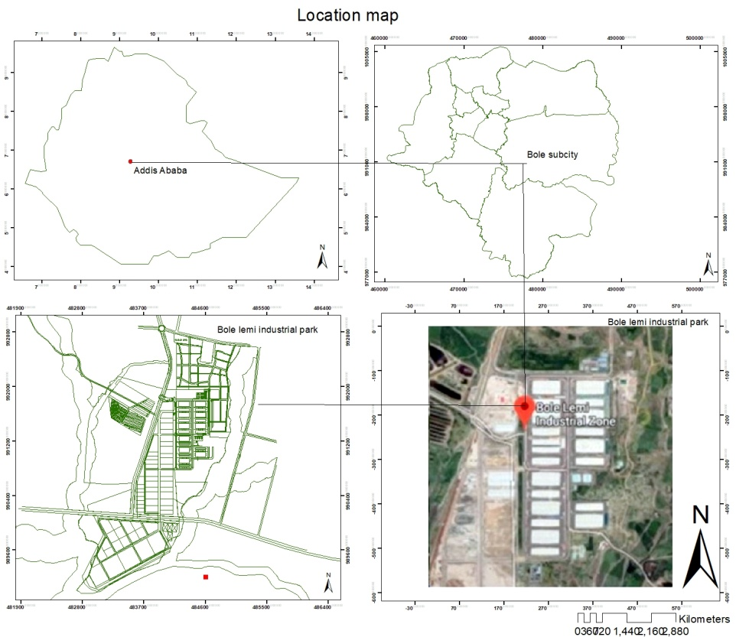
Figure1: Bole Lemi Industrial Park-One location map (source: own computation)

Methodology
Research methodology not only implies the use of various research methods, but also the logic behind the selection of the methods, the rationale of the study undertaken, the means through which the problem is identified, as well as the way data is collected and analyzed (Kothari, 2004). This chapter discusses the research method employed in the study, the research design, instruments used for data collection, the sampling technique and procedures for data analyses.
In gathering pertinent data the study employed qualitative and quantitative methods. Qualitative research method helps in exposing the impact of in-collaborative transportation and industrialization process on individuals as well as on the development of the city. Through reflection and opinions provided from worker commutes in BLIP-I directly impacted by the problem and various administrative agencies who have a stake in the implementation of industrial park programs (including the IPDC, the Addis Ababa City Road Authority, City Government of Addis Ababa Land Development and Management Bureau), and most importantly, how their fragmented decision making systems continue to affect the lives of workers at the BLIP-I and the development of the city in general.
And the quantitative research method also enables the research to generate statistical proofs from existing knowledge, by developing relationships and proposed outcomes on the impact of distance, traveling hour, and workers level of satisfaction, illness and behavioral change. In spatial analysis the research able to put together the analytical data’s on workers commuting distance with the existing transportation network of the city to show visual image of the disconnection between industrial development pattern and distance of commuting and its impact on commuters.

Sources of data
In pursuing a qualitative research method, the study has extensively used both primary and secondary data.
Primary data was used to collect data from experts and from government officials through conducting interviews with the City Government of Addis Ababa Land Development and Management Bureau (land management section, Land use preparation collaboration director directorate, Plan commotion, Plan preparation expert); IPDC (land use management and master planning unit); BLIP-I (Design and Planning division); A.A City Road Authority (Road Construction and Management Design Revision and Implementation Follow-Up Directorate unit) and FGD and questionnaire survey with BLIP-I workers.
Secondary data gathered from books, journals, reports, magazines produced by public media and internet sources on the industrial park development, in-comprehensive transportation development, commuting in relation to industrialization and commuting impact on employees’ welfare.
Key secondary resources including the Addis Ababa city woreda master plan; Addis Ababa city existing road network are also looked upon extensively.
Incidentally, it also worth mentioning that before starting the actual data collection, the research has undertaken a preliminary survey or site visit in February, 2019. And Pilot survey has been conducted on ten respondents that have different background and academic statues. The pretests or pilot studies allow us to identify potential problems and make necessary modifications.

Scales of Measurement
Ratio: the compare and contrast the effect of commuting on workers who live around the company, workers located within short distance from the company and workers those who commute from long distance.

Sampling procedure
The method of non-probability sampling applied in this study was a combination of purposive sampling and convenience sampling. There are total of 113,559 workers in BLIP-I, And out of 113,599 workers only 18,765 of them employed under shoe and construction enterprise companies within BLIP-I. The rest of 94,794 workers are from different garment and textile enterprise companies. For this reason the research mainly focuses on the 94,794 workers since the experience of commuting will not be affected by the type of job they were into and because mostly they commute from similar locations. To select respondents from administrative offices and governmental offices the research uses convenience sampling. These selected respondents directly related to the development process of the IP in the city. And at least two workers wore participated from one organization even if they might have similar response it helps the research to be reassured on the output result. Even if the research used purposive sampling method all the necessary institution administrators and individual workers wore included.
In order to determine the sample size for the 94,794 workers in BLIP-I, the research plan to specify the precision of the estimation desired and then to determine the sample size necessary to ensure it. Hence the research devised a mathematical formula, and as such putting in place a frequently used technique of determining ‘n’. In determination of sample size through the approach based on precision rate and confidence level, the research used Yamane’s formula (1967:886) which provides a simplified procedure to calculate sample sizes. This formula was used to calculate the sample sizes in 95% confidence level and P = .05
$$n= \frac{N}{1+ N (e) 2 }$$
Where n is the sample size, N is the population size, and e is the level of precision.
$$n= \frac{N}{1+ N (e) 2 }$$
$$n= \frac{94,794}{1 }+{94,794 }^{(0.05)2}$$
$$n= \frac{94,794}{1 }+236.985$$
$$n= \frac{94,794}{237.985}$$
$$n= 399$$
Additional 101 respondents were also included to eliminate any problem that may occur in the process of surveying. The sample size of 500 respondents was initially determined on the basis of the criterion of redundancy and taking into account considerations of gender representation. The sampling technique applied to identify the 500 respondent’s at BLIP-I was based on a probability (random) sampling. With this data gathering technique, each industrial park worker has an equal probability of being selected from the total targeted unit, ensuring that the sample will be representative of the population. The technique ensures a fairly equal representation of variables for the study.

Data collecting techniques
Questionnaires and focus group discussions (FGD) were employed as the key data collection techniques for extracting information on various issues of interest in this investigation.
- Physical observation method
Own direct observation is used through taking voice recording, video capturing and photograph used of the study site aid with field notes.
- Survey
Both direct approach questions were used with the aid of Structured Surveys (Every respondent had 24 hours to fill the questionnaires and return them back).
- Focus Group Discussion (FGD)
Focal group discussion was carry out with BLIP-I worker commuters with Sendafa and Debre Zayte crews. Invitations were handed to 20 workers commuters from Sendafa, of which 6 six representative workers take part in FGD. The workers have different responsible position in BLIP-I however they commute from one similar shed. The FGD takes place in Sendafa on May 11, Sunday. Selection of the date, time as well as location is based on the interest of participants and the FDG with Debre Zayte crew take place the transportation service while workers are traveling to their home. And seven worker commuters wore willing to take part in FGD. The group practice is help to identify and clarify shared knowledge among workers that would otherwise be difficult to obtain with a series of individual interviews.

Data analysis and interpretation tools
To simplify the data analysis, the row data was encoded into Excel and SPSS for processing the workers’ in the industrial park. GIS map was also formulated in order to show the traveling pattern of BLIP-I workers and the impact of incomprehensive urban planning pattern on workers.

Presentation techniques
The data gained from primary and secondary sources was analyzed using qualitative and quantitative approach supported by maps, tables and graphs.

CHAPTER FOUR

ANALYSIS

Mode of transportation
Mode of transportation is one of determinant factor of commuting frequency, effectiveness and length. Of 396 respondents, hundred percent of the workers use transportation provided by enterprises within BLIP-I. The BLIP-I enterprises provide transportation services by themselves for free through contract entered into with private transporters. This being the case, investors have always complained that the costs offered by private transport service providers are too high; there has always been difficulty between service providers and enterprises to reach consensus. An expert at IPDC admitted that the transportation system at BLIP-I is challenged by lack of organization and efficiency and is characterized by failure to implement industrial park guidelines. Little regulation of the transportation system in the park, coupled with the fact that its standards and efficiency are consistently challenged, has been recipe for aggravating low employee morale to continue to work in such settings.

Distance between workers’ home and workplace

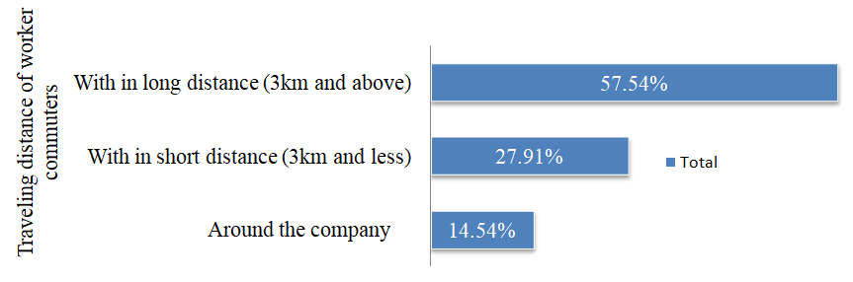
Figure 2: Distance between home and work assessment on 396 workers in BLIP-I (source: own computation)
Out of 369 BLIP-I workers 57.54% of them commute from long distance ( figure 2) and from 65 to 1430 workers commute from and to the Park from one district per-day.
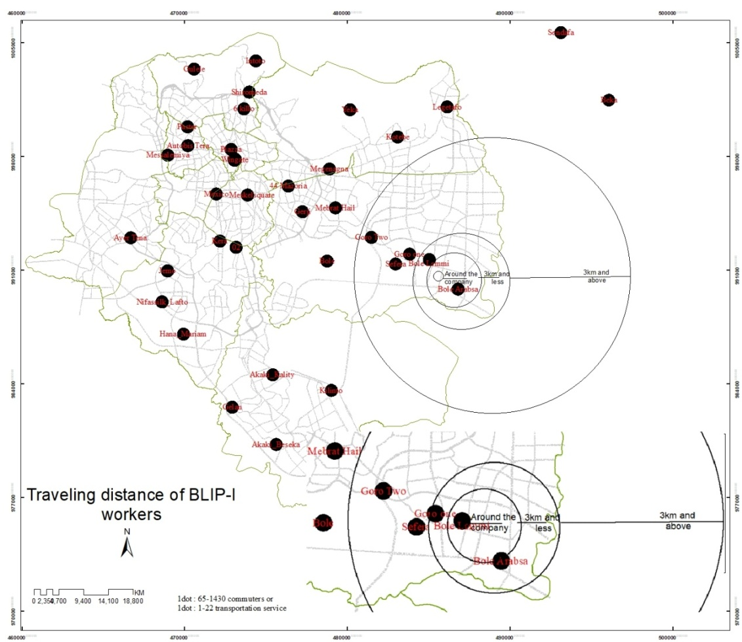
Figure 3: Map of traveling Distance from and to workplace assessment on 396 workers in BLIP-I (source: own computation) (refer the appendix for more clarity)

Bus route of BLIP-I workers
The main targeted long distance bus routes are Entoto, Gerji, Jemo, Kilinto, Gelan, Akaki-Beseka, Tulu Dimtu, Dukem, Sefera, Yeka, Lege-tafo, Sendafa, Goro I and Beka. Workers those who travel to these main stations will have to travel with all worker commuters live within short distance and around the company (Table 1 and Figure 4).

Table 1: Main and substations of bus route of workers assessment of commuting hours on 396 respondents at BLIP-I (source: own computation)
Main Destinations | Sub station
Ayertena | Mexico | Meskel-square | 44-Mazoria | Megenagna | Mebrat Hail | Goro I | Goro Two | Sefera
Autobis Tera | Messalemiya | Piazza | Wingate | Meskel-square | 44-Mazoria | Megenagna | Mebrat Hail | Goro I
Beka | Sendafa | Legetafo | Kotebe | Hyate | Bole-Lemi
Debre-Zeit | Dukem | Tulu Dimtu | Akaki-Beseka | Kilinto | Akaki-Kality | Saris | Bole | Megenagna
Gelan | Akaki-Kality | Megenagna | Mebrat Hail | Goro I | Goro Two | Sefera
Gulele | Piazza | Wingate | Meskel-square | 44-Mazoria | Megenagna | Mebrat Hail | Goro I | Goro Two
Hana-Mariam | Nifas Silk Lafto | Jemo | Mexico | Meskel-square | 44-Mazoria | Megenagna | Mebrat Hail | Goro I
Intoto | 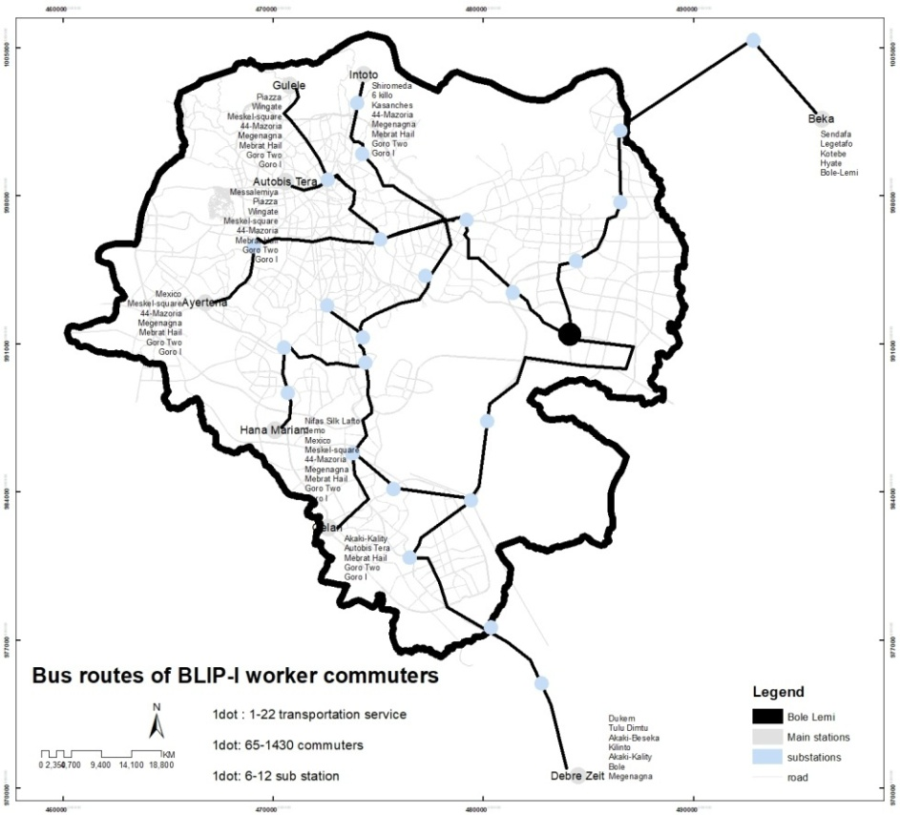  Shiromeda | 6 killo | Kasanches | Megenagna | Mebrat Hail | Goro I | Goro Two | Sefera

Figure 4: Bus route of workers assessment of commuting hours on 396 respondents at BLIP-I (source: own computation) (refer the appendix for more clarity)

Trip distribution of BLIP workers
Industrial park workers are required to commute long distance to and from workplaces. It also concluded that long distance commuting is directly linked to behavioral change, which in turn impacts the level of satisfaction of employees and their individual productivity.
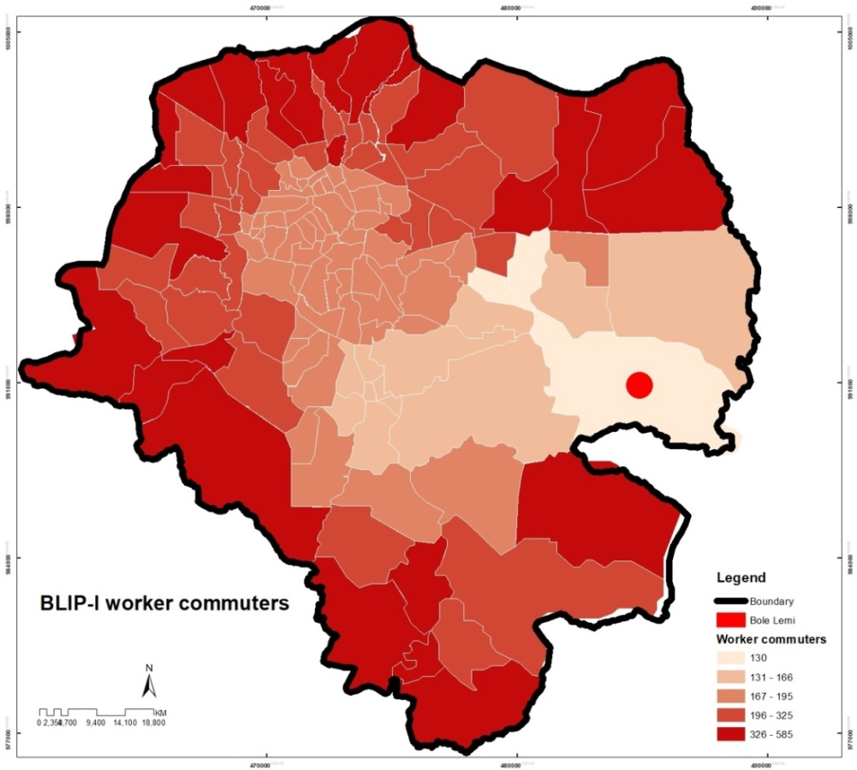
Figure 5: Trip distribution of commuting hours of 396 respondents at BLIP-I (source: own computation) (refer the appendix for more clarity)

Length of commuting hour
Length of workers’ commuting hour can be differentiated based on their destination and path of the transportation service they took. Most of employees work for 12 hours, including overtime, and spend about 2 hours commuting, they will only have fewer more hours to cater for own needs including taking care of children, family members, preparing food, and attending to personal hygiene. Therefore, employees will on the average be left with only 4-6 hours for sleeping.
The conclusion is that traveling long distance not only impacts the amount of sleeping hours of workers; it also generates many challenges related to physical and psychological problems. and Urban design manual February, 2008 indicate that to crate attractive routes for pedestrians the walking distance should be limited to 5minutes to 10minutes. However, BLIP-I, it was found that 78.54% of the workers spend between 30 minutes and 4 hours commuting every working day of the week (Figure 6). Most such workers will therefore be unable to be active and start work immediately after they arrive; in fact, they are often depressed or lack motivation to operate in full swing. This has dire consequences on employee retention, employee wellbeing and even on the factories themselves whose existence are strictly connected to time or how much each individual employee produces.
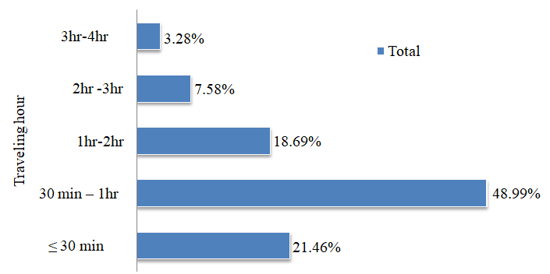
Figure 6: Assessment of commuting hours of 396 respondents at BLIP-I (source: own computation)
The basis finding was that long traveling hour decreases the amount of time workers spend on doing their personal and company works, which in turn impacts the level of production in terms of quantity and social times with family and society. (Figure 7)

Figure 7: Commuting vs. traveling hour differentiated by level of satisfaction assessment on 396 BLIP-I 2019 workers (source: own computation)
The overall analysis indicate that traveling time, distance and long distance traveling bus routes influence the wellbeing of employees and that create interrelated psychological and social problems on individual employee.

CHAPTER FIVE

RESULT
The analysis on chapter four demonstrate that most of BLIP-I workers commute from longer distance due to problems related to transportation service and proximity of their residence to the location of the Park. The traveling distance and time have its own impact on workers physical wellbeing and which could cause other inter-related problems that affect individual worker and challenge functionality of IPDC.

Impact of distance from and to workplace
The BLIP-I workers commute from all over the city of Addis Ababa, and some from the surrounding areas. Gulele, Entoto, Shiromeda, 6 killo, Paster, Autobis Tera, Messalemiya, Piazza, Wingate, Mexico, Meskelsquare, 44 Mazoria, Gerji, Mebrat Hail, Megenagna, 02, Kera, Ayer Tena, Jemo, Nifassilk-Lafto, Hana-Mariam, Akaki-Kality, Kilinto, Gelan, Akaki-Beseka, Tulu Dimtu, Dukem, DebreZeit, Bole Arabsa, Goro Two, Bole, Kotebe, Sefera, Yeka, Legetafo, Sendafa, Goro I and Beka are the main stationed places that workers commute from(Figure 3). The analysis shows that of the 396 respondents, more than half of them (57.54%) commute to BLIP-I traveling more than 3km. Only 14.54% of the workers commute from locations around the company (Figure 2). FGD participants from Sendafa mentioned that long distance commuting create a problem on their social relation quality time with families, relatives, friends and neighbors. These problems that are related to individual workers life could make workers not to be effective in their job, have depression, stress, back pain and muscular disorder number of behavioral changes and heavy physical impacts that could affect the production level of the enterprises.

BLIP-I worker commuters bus route
Long-distance commuting is widely applied and has social, political and economic consequences on the employees and their families, companies and communities. Bus routes of BLIP-I are one of the reasons for workers to travel longer distance than they supposed to (Figure 4). Daily BLIP-I worker commutes share similar mode of transportation. Even if the mode sharing process help workers to eliminate traveling financial cost and decreases transportation budget enterprises within the IP. The interviews with BLIP-I personnel driving mass transportation buses disclosed that often the cars they drive encounter technical problems owing to old age (Abenet, Esubalew, Negus and Sentayew, 2019). This is a very important variable in the context of longer commuting hours spent by employees.
The respondents revealed that on not few occasions, buses had broken down and accidents occurred - forcing them to linger for longer hours in the middle of commutes with no one taking responsibility for such incidences. One respondent retorted: “companies should take responsibility and stop underestimating the negative effect of such frequent incidences” (Ayle, 2019). Another respondent said “I have been working in one of the companies in the Park for one and half year and there was never a day gone by without we encountering some form of technical problem with the buses affecting our transportation time or crowding the roads for many hours” (Aster, 2019). This is not to mention that in all cases of technical breakdown and extended commuting hours, employees had to continue traveling home using own transportation and money, often arriving in late hours and exposing them to dangers. Given that huge amount of money is spent on fixing technical issues of buses used, this is obviously unsustainable, which, again, brings us to the imperatives of strategizing to bonding transportation and land use plans with industrialization and the development of industrial parks as a solution.
But when it comes to traffic congestion, the allocation of industrial park sites and the transportation service system comes to in question.
The BLIP-I workers working time ends at pick hours of the city – hence contributing additional problem to the congestion that has already been created. Managing pick hour traffic congestion problem is the responsibility of Addis Ababa City Road Authority and Addis Ababa City Land Management Office. But informal consultations with officers in such offices revealed that they have no control over the number or type of vehicles used by the industrial park - nor for assigning special paths for such vehicles. This is primarily the responsibility of the industrial park enterprises (Yelekal Tezena, Zebeyeder Yefru, 2019). On the other hand, the FGD session with employees indicated that they are forced to travel in long pathways when there are short-cuts that could have been used to reduce commuter times (Abebech Abdi, AyleMegarsa, Beza Dechassa, Taganu Dame, Tigist Fikadu, ZenebuMalase, 2019). However, this is unfeasible simply because the company transports massive amount of workers to different destinations which entails that short cuts would not always be practical.
The other issue which is related to urbanization, and specifically to the incompatibility of land uses for transportation and placement of industries is the immediate effect thereof in relation to wide disconnects created between industries and residential areas. Because of such incompatibilities featured in Master Plan design (influencing subsequent city developments), a massive amount of work force is compelled to travel longer distances. The research found that this is principally caused by the design of urban plan structure which is often inflexible and does not accommodate new trends and changes in city development quite easily. Such approach, forcing all planning and stakeholder sectors to work collaboratively, would offer a solution not just to individual workers, but also contribute a great deal to the efficient use of limited resources and to the development of the country.
- Trip distribution of BLIP workers
The effect is excess commuting of industrial workforce which results from uncoordinated spatial arrangement of residential and large scale industrial workplace locations in Addis Ababa. From the point of view of enterprises operating in BLIP-I, the impact also has a financial dimension. It was disclosed that on the average, the companies at BLIP-I engage about 200 buses daily each with a capacity of carrying 60-70 employees; the companies spend a daily average of Birr 800,000 just to cater for gas expenses and between 40-50,000 Birr for renting mass transport buses (Amanuel, 2019).
The research revealed that long commute hours engendered by the disconnect between urban special form and industrial locations provide strong reasons for workers to leave their jobs very often, engage in frequent absenteeism or appear at work stations fatigued by long travels which in turn reflects on their productivity. (Figure 4 & Figure 5)This is particularly concerning given that the enterprises in the Park spend millions of Birr arranging transportation schemes and training employees to make them fit for industrial work processes. It is evident that such a huge investment the companies now put on fixing transportation related problems could have been diverted to the development of different sectors required in the country. Needless also to state that such problems could have been lessened by conceptually approaching industrial parks as special areas where industries, businesses, residential quarters, and social amenity infrastructures are clustered in the same vicinity and by inculcating such approaches in master planning and implementation.
- Commuting and health related challenges
It was found during the study that many employees at BLIP-I area affected by stroke (16.41%), low blood pressure (11.87%), back pain (26.52%), musculoskeletal disorder (20.71%), sleep disturbance (12.63%), continuous flu (6.82 %), heart failure (0.76 %), and headache (1.77%). In the FGD sessions, the employees disclosed that they are literally exposed to all commuting associated diseases which continue to create impact on their personal life. (Figure 8)
The respondents admitted that such sicknesses are not adequately treated by physicians at the Park, and hence, they are forced to seek private medical services using won money. This explains why many would eventually decide to quit jobs. As finding alternative jobs is not easy, this transforms them in to dependents; this in turn impacts them psychologically. This demonstrates the crucial link between commuting and health related problems which can be traced to gaps and inconsistencies in industrial planning and urbanization programs.
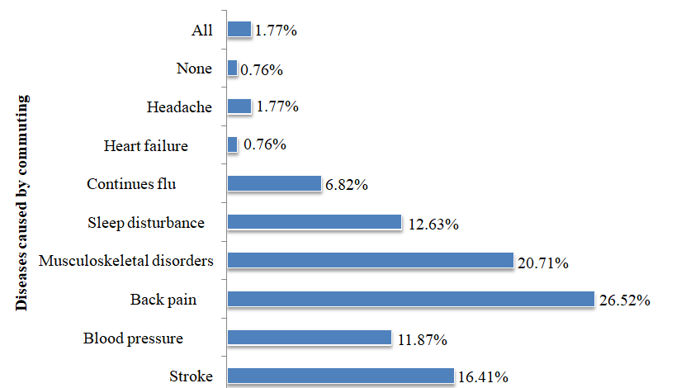

Figure 8: Exposition to commuting related illness assessment on 396 workers at BLIP-I (source: own
computation)
As shown in the previous discussions, most employees have been affected by diseases related to commuting. Workers who commuted short distance (3km and less) and long distance (3km and above) are affected by different levels of stroke, low blood pressure, back pain, musculoskeletal disorders, sleep disturbance, continues flu, heart failure, headache; evidently, long distance employees have high probability of being affected by commuting related diseases than those who travel shorter. About 85.71% of long distance commuters responded they have experienced most of the diseases listed in the graph below. Of the respondents, those who stated that they have never been affected illness represent only 33.33% of worker commuters travelling long distance. (Figure 9)

Figure 9: Exposition to commuting related illness assessment based on traveling distance difference on 396 workers at BLIP-I (source: own computation)
- Commuting and behavioral change
Although a higher percentage of workers said that they never had encountered problem related to behavioral challenge, in realty, this may not be the case. At the Park, interviews with health officers revealed that employees are often affected by lack of concentration, increasing anger, depression, lack of interest to be punctual at work and even being absent - not infrequently after they start working at BLIP-I. Strict working protocols at BLIP-I also meant workers are not allowed to show infractions like being late or absent; otherwise the penalties are stringent. Such behavioral changes may seem simple but could change over time and lead to other serious health problems on individuals and hence impact their lives and finances. (Figure 10)
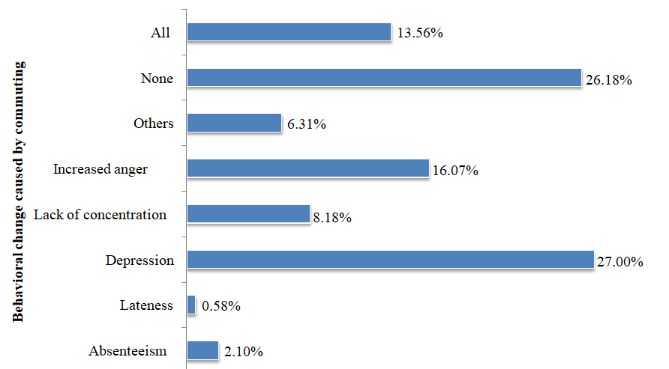
Figure 10: Experience of behavioral change as a result of commuting assessment on 396 workers at BLIP-I (source: own computation)
Higher percentage of short distance worker commuters stated in informal discussions and FDG that they are not facing any behavioral challenge. Even if 26.18% of workers gave their response by saying ‘none’ according to the data analysis 93.10% workers who commute from long distance give their feedback by stating they have experienced “all” kind of behavioral change. It may not able to conclude that all workers with various traveling distance have experience of behavioral change like Absenteeism, Depression, Lack of concentration, increasing anger, others. But this behavioral changes affect mostly long distance commuters relative to workers who commute from around the BLIP-I and within short distance from the BLIP-I. except workers located within short distance highly affected by Lateness relative to workers commute from long distance and around the BLIP-I. This may probably occur when employees try to use private or public mode of transportation unless otherwise it would not occur. Experiencing any of this behavioral changes affect the ability and functionality of workers to do their job properly, causing problem with their family member or peoples they know beside their work place. This effects not only a problem for workers personal life but also the stability of the IPDC since it would not able to function without this workers. A study conducted on 24,861 American workers individuals employed full-time in 2012 also indicate that longer commutes are associated with behavioral patterns which over time may contribute to obesity and other poor health outcomes. According to IPDC document 2017 currently BLIP-I have 113,559workers. Having thousands of workers affected by behavioral change that could lead to serious health problem need immediate attention from the IPDC, the Addis Ababa City Land Administration Office and Addis Ababa Roads Authority the IPDC. (Figure 11)

Figure 11: Commuting Vs. workers experience of behavioral change that is related to commuting assessment on 396 BLIP-I 2019 workers (source: own computation)
- Family time
Working as laborer is stressful as it is; but its impacts such as stress and depression could have been lessened if employees are afforded enough time to spend on social functions. Socialization has psychotherapy effects and may be a possible solution well adapted to our community. However, most employees at the park earn very little and hence have to work longer hours and days – which in turn meant that they spend lesser time with family members, relatives, neighbors and friends. Most respondents disclosed that they spare no greater than one hour each day with their family, including on Saturdays; they spend their Sunday (the only break they have) sleeping and cleaning. All these problems force them to basically isolate themselves from society and hence get little opportunity to derive the best of social therapy. (Figure 12)
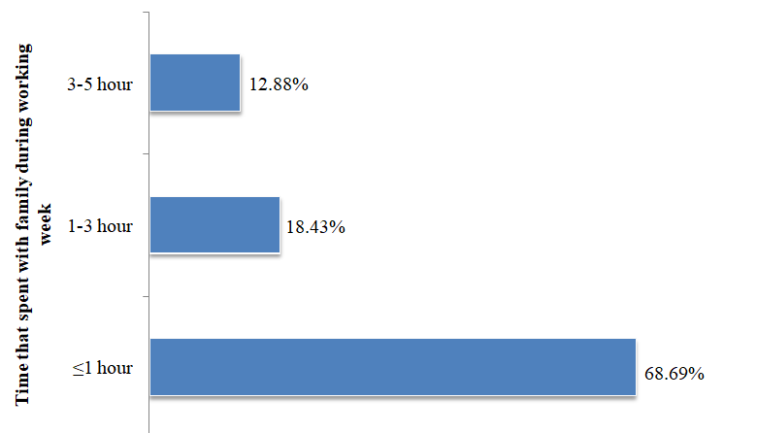
Figure 12: Time workers spent with families during the week assessment on 396 workers in BLIP-I (source: Own computation)
- Commuting and time spent with family
From the data below we can understand that 21.97% of them BLIP-I workers commute from long distance (3km and above). In addition to that workers in BLIP-I for long distance commuters 61.76%of them spent ≤1hr with their family member and only 13.73% of workers spent 3-5hour their time with their family but most of found within 3km and less distance. Long distance commuters may loss the social communication with their family, having no quality time for themselves and for their families. Except the problem will not stop at this level and could create divorce, impact on children psychological mind and could create un-satisfaction on the workers life. Generally commuting in this case can show not only impact on the individual worker but family members, the production level of the IP sector as well. (Figure 13)

Figure 13: Commuting Vs. the time workers spent with their families’ assessment on 396 BLIP-I 2019 workers (source: own computation)
- Satisfaction level of workers
Being satisfied with is very crucial requirement for any worker to continue to commute and work. Unfortunately, during the survey conducted on 396 respondents of BLIP-I, 44.12% described that they felt less satisfied with their job. On the other hand, 44.99% of the respondents revealed that they were not satisfied at all. Only 6.57% of the employees said they are satisfied with their job, and still only 0.25% of them very satisfied (Figure 14).
This reading implies that a very high number of employees, 93.18%, remain not satisfied with their job; they continue to work without passion and commitment simply because they have no much option, and they are mostly responsible to support families. This, again coupled with long commuting hours they spend on a daily basis without sufficient remuneration, offers stronger incentive for them to quit jobs very often and consider the job only as a transitional arrangement.
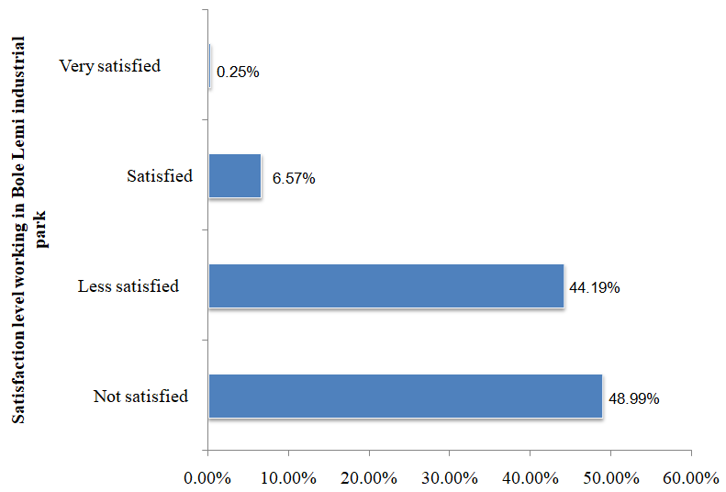

Figure 14: Satisfaction level of workers assessment on 396 respondents in BLIP-I (source: own computation)
An analysis was also conducted correlating commuting with employees’ level of satisfaction. The result indicated that only workers commuting shorter distance or from around the Park showed relative levels of satisfaction. However, significant majority of respondents who stated that they are less satisfied or are not satisfied at all include commuters travelling long distance.
Generally, it can be submitted that distance of commuting is proportional to level of satisfaction. The analysis in Figure 15 indicated that 45.2% of workers who commute longer distance are or less satisfied with their job.

Figure 15: Commuting vs. Satisfaction level of workers assessment on 396 BLIP-I 2019 workers (source: own computation)
The output result of the quantitative data indicate that workers of BLIP-I affected by issues related to physiological and physical health problems, social negligence and economically. Though it may seem these problems narrow and only affect the life of individuals but eventually it leads massive worker commuters to resign from their job. And this problem of workers living their job could affect per capital income of enterprise companies within BLIP-I. Additionally, if this enterprise companies stability in question the stability of BLIP-I as well as will in question. Furthermore all this problems come down to how our urban planning system functions integrating the industrial land use provision with the existing situation of transportation and housing. And make everyone to ask who should take the responsibility for unmanaged urban growth that may seem to elevate the development of the city but could down fall anytime unexpectedly. And the research conducted interviewees with administrative that are more related to the urban planning, industrialization development process to rich to the point that could give solution.

CHAPTER SIX

DISCUSSION
This chapter will link the key findings of the primary research and relate the findings back to previous literature. The chapter will close with the limitations of the study and possible practical implications.
Restatement of the Research Questions
The research question and the objectives established had a sole purpose to explore the wonders of commuting and to explore the effects the activity may have had upon employees’ wellbeing; In parallel to have understanding on traveling distance, time of workers and bus routes of BLIP-I worker commuters transportation service.
Objective 1: To explore the gap between workers traveling distance and home of residence
All of respondents use transportation provided by enterprises within BLIP-I without a charge. The average commuting distance was difficult to work out, but it was found that employees commute through the four main directions of Addis Ababa, including the surrounding areas of the Oromiya Special Zone. It was found that workers at BLIP-I take between 30 minutes and 4 hours to travel to and from workplaces. however, The study conducted in England stated workers who commute more than 90 minutes each way to get to work called ‘extreme commuter’. (Shirley, 2016) and study in Australia shows that workers who spent more than one hour more likely affected by higher BMI and higher waist circumference than those who spend less than 15 minutes travelling by car. On commuting, traveling hour and level of satisfaction, it was found that longer commuting hour is directly correlated to distance, while being inversely proportional to workers’ level of satisfaction.
Objective 2: To explore the different impacts and factors that rout of bus service have on BLIP-I worker commuters as well as on the development the Park.
The amount of time workers spend on the road can also be linked to a number of problems like choice of mode of transport, technical problem of vehicles and mainly traffic congestion. In their daily commutes, BLIP-I workers encounter all these problems except choices of mode as they share similar modes of transportation. The interviews with BLIP-I personnel driving mass transportation buses disclosed that often the cars they drive encounter technical problems owing to old age (Abenet,Esubalew, Negus and Sentayew, 2019). This is a very important variable in the context of longer commuting hours spent by employees. The respondents revealed that on not few occasions, buses had broken down and accidents occurred - forcing them to linger for longer hours in the middle of commutes with no one taking responsibility for such incidences. One respondent retorted: “companies should take responsibility and stop underestimating the negative effect of such frequent incidences” (Ayle Megarsa, 2019). Another respondent said “I have been working in one of the companies in the Park for one and half year - and there was never a day gone by without we encountering some form of technical problem with the buses affecting our transportation time or crowding the roads for many hours” (Aster, 2019). This is not to mention that in all cases of technical breakdown and extended commuting hours, employees had to continue traveling home using own transportation and money, often arriving in late hours and exposing them to dangers. Given that huge amount of money is spent on fixing technical issues of buses used, this is obviously unsustainable, which, again, brings us to the imperatives of strategizing to bonding urban form and land use plans with industrialization and the development of industrial parks as a solution.
But when it comes to traffic congestion, the whole of the urban form, allocation of industrial park sites and the transportation service system comes to in question.
The BLIP-I workers working time ends at pick hours of the city – hence contributing additional problem to the congestion that has already been created. Managing pick hour traffic congestion problem is the responsibility of Addis Ababa City Road Authority and Addis Ababa City Land Management Office. But informal consultations with officers in such offices revealed that they have no control over the number or type of vehicles used by the industrial park - nor for assigning special paths for such vehicles. On the other hand, the FGD session with employees indicated that they are forced to travel in long pathways when there are short-cuts that could have been used to reduce commuter times. However, this is unfeasible simply because the company transports massive amount of workers to different destinations which entails that short cuts would not always be practical.
The research revealed that long commute hours engendered by the disconnect between urban special form and industrial locations provide strong reasons for workers to leave their jobs very often, engage in frequent absenteeism or appear at work stations fatigued by long travels – which in turn reflects on their productivity. This is particularly concerning given that the enterprises in the Park spend millions of Birr arranging transportation schemes and training employees to make them fit for industrial work processes. Study shows that Individual time and monetary costs and individual consequences such as distortion of work-life balance, some health issues ,increased stress and increased traffic congestions should also be considered (Lyons & Chatterjee, 2008; IBM Corporation, 2009).
Objective 3: To understand the way commuting infuse the physical and economical aspect of BLIP-I worker commuters.
the result of inappropriate urban planning and coordination between City Master Planning, IPDC’s conception and operationalization of parks, government agencies’ oversight, have had notable effects on congestion, travel times and short and long term effects on the health, wellbeing and efficiency of workers at BLIP-I.
This experience of traveling long distance impacts the amount of sleeping hours of workers, and furthermore generates several challenges related to physical and psychological problems. Most workers travelling longer hours are unable to be active and start work immediately after they arrive; in fact, they are depressed or lack motivation to operate in full swing. This has dire consequences on employee retention, employees’ wellbeing and even on the factories themselves whose existence is strictly connected to time or each individual employee’s productivity.
On the crucial correlation between commuting and health related challenges, the study found that many employees at BLIP-I are affected by stroke, low blood pressure, back pain, musculoskeletal disorder, sleep disturbance, continuous flu, heart failure, and headache. From the FGD sessions, it was also evident that most employees are convinced that their current health state is directly related to long commuting. Besides, it was submitted that many sicknesses are not adequately treated by physicians at the Park, and hence, employees are now and then forced to seek private medical attention using own money. This explains one of the main reasons why, eventually, several employees decide to quit jobs. This demonstrates the crucial link between commuting and health related problems which can be traced to gaps and inconsistencies in industrial planning and transportation system.
In relation to the correlation between commuting and behavioral changes, the study found that employees are significantly affected by lack of concentration, increasing anger, depression, lack of interest to be punctual at work and even being absent. Such behavioral changes may appear to be simple but they could change over time and lead to other serious health problems on individuals and hence impact their lives and finances. This influence the output energy of workers they enforce on their job, social life and increase the expense on health.
The study concluded employees are forced to spare no greater than one hour each day with family, including on Saturdays; they spend their Sunday (the only break they have) sleeping and cleaning. All these problems urge them to social isolation, divorce and low levels of satisfaction.
The study also concluded that a very high number of employees at the BLIP-I remain not wholly satisfied with their job; they continue to work without passion and commitment simply because they have no option, and because they are mostly responsible to support families. This, coupled with long commuting hours they spend on a daily basis without sufficient remuneration, offered stronger incentive for them to quit jobs very often and consider the job only as a transitional arrangement. Active physical commuting has been found to significantly increase physical activity and improve physical fitness; it also improves health outcomes. This includes reducing all-cause mortality and cardiovascular risk, particularly among women (Kitchen, 2011). Research in New Zealand indicate that achieving growth in proportion of people who cycle to work that are significant enough to meet health goals requires sustained investment into the transformation of local and arterial roads using best practice bicycle friendly interventions (Hamer and Chida, 2008).
And yet, many mass transport or related long distance commuters face a number of health related problems. In 2011 the IBM Commuter Pain Index found that 71% of Perth commuters have experienced travel stress; 28% of Perth drivers believe that traffic has negatively affected their health and 26% believe that traffic has negatively affected their performance at work or school (IBM, 2011).for this reason providing workers providing workers with eco-friendly transportation materials or designing the industrial park within walking distance interval could eliminate or lessen the problems related to commuting.

CHAPTER SEVEN

CONCLUSION AND RECOMMENDATION

Findings
Urbanization and industrialization are two transformative processes for the creation of national wealth; industrialization leads to urbanization by creating economic growth and job opportunity that draws large number of people to cities. In a booming continent like Africa with a very high pace of urbanization, major economic transformation is expected to happen with interdependence between industrialization, urbanization and transportation. Ethiopia, and particularly Addis Ababa, is one of the many African cities that follow the road of rapid urbanization and industrialization which lead to large scale production factories like industrial parks that consequently brings change in society and plays key role in enhancing the economy, promoting technology learning, upgrading and innovation and also generating stable and decent employment. In this context, urbanization becomes key in future spatial development involving industrial clusters and transportation planning.
Ethiopia has benefited from industrialization and at the same time affected by it for a number of reasons. Unplanned or uncoordinated spatial clustering of land use and transportation planning has not only featured large in the current planning and practice, the rapid expansion of industrial park clusters across the country has also introduced new layers of challenges that were not anticipated and subsequently captured by policy and implementing agencies.
This brought unintended drawbacks in many aspects – and especially in relation to urban transportation and commute hours form and to workplaces. Although this challenge is not wholly unique to Ethiopia, the industrialization pattern has been alienated from urban transportation planning. Poorly designed or uncoordinated industrial and urban development pattern continue to engender notable impacts on workers’ transport mode choice, travel time, travel length and travel frequency in Addis Ababa, and especially employees at the BLIP-I.
The study, which mainly focused on the disconnect between industrialization, urbanization and transportation related planning systems of Addis Ababa and how this affects commuting infrastructure and time of employees, concluded that overall, commuting time has been increasing over the years. It also found that this development, which the analyses showed is the result of inappropriate urban planning and coordination between City Master Planning, IPDC’s conception and operationalisation of parks, government agencies’ oversight, have had notable effects on congestion, travel times and short and long term effects on the health, wellbeing and efficiency of workers at BLIP-I.
Using statistical data relating to BLIP-I workers and involving several demographic and non-demographic variables, the research argued in spite of the commonly held narrative that BLIP-I creates employment opportunities to thousands of Ethiopians, employee retention still remains one of the most pressing challenges for the Park’s enterprises; and this has been explained by reference to crucial gaps related to urban development and transportation planning - which in turn impacted employees’ commute hours, commitment to work and their wellbeing.
Of the 396 respondents, all of them use transportation provided by enterprises within BLIP-I without a charge. The average commuting distance was difficult to work out, but it was found that employees commute through the four main directions of Addis Ababa, including the surrounding areas of the Oromiya Special Zone. The length of workers’ commuting hour was differentiated based on employees’ destination and path of the transportation service they took. It was found that workers at BLIP-I take between 30 minutes and 4 hours to travel to and from workplaces.
This experience of traveling long distance impacts the amount of sleeping hours of workers, and furthermore generates several challenges related to physical and psychological problems. Most workers travelling longer hours are unable to be active and start work immediately after they arrive; in fact, they are depressed or lack motivation to operate in full swing. This has dire consequences on employee retention, employees’ wellbeing and even on the factories themselves whose existence is strictly connected to time or each individual employee’s productivity.
On the crucial correlation between commuting and health related challenges, the study found that many employees at BLIP-I are affected by stroke, low blood pressure, back pain, musculoskeletal disorder, sleep disturbance, continuous flu, heart failure, and headache. From the FGD sessions, it was also evident that most employees are convinced that their current health state is directly related to long commuting. Besides, it was submitted that many sicknesses are not adequately treated by physicians at the Park, and hence, employees are now and then forced to seek private medical attention using own money. This explains one of the main reasons why, eventually, several employees decide to quit jobs. This demonstrates the crucial link between commuting and health related problems which can be traced to gaps and inconsistencies in industrial planning and urbanization programs.
In relation to the correlation between commuting and behavioral changes, the study found that employees are significantly affected by lack of concentration, increasing anger, depression, lack of interest to be punctual at work and even being absent. Such behavioral changes may appear to be simple but they could change over time and lead to other serious health problems on individuals and hence impact their lives and finances.
Most employees at the Park earn very little and hence have to work longer hours and days – which in turn meant that they spend lesser and lesser time with family members, relatives, neighbors and friends. The study concluded employees are forced to spare no greater than one hour each day with family, including on Saturdays; they spend their Sunday (the only break they have) sleeping and cleaning. All these problems urge them to social isolation, divorce and low levels of satisfaction.
The study also concluded that a very high number of employees at the BLIP-I remain not wholly satisfied with their job; they continue to work without passion and commitment simply because they have no option, and because they are mostly responsible to support families. This, coupled with long commuting hours they spend on a daily basis without sufficient remuneration, offered stronger incentive for them to quit jobs very often and consider the job only as a transitional arrangement.
The assessment that was based on sex variable showed that while generally commuting related problems exacerbate the inclination of employees to leave jobs, certain category of employees are more disposed to leave than others mainly, if not exclusively, because of commuting distances. This adds-up to the national problem on youth unemployment and further poses challenges as the government will not be generating revenues which would have been the case if full utilization of work force was feasible.
In relation to level of education, most factory jobs would hardly require formal education, and hence many people will be attracted to the opportunity of being employed by travelling longer distances. Yet, on the flip side, it was found that employees need to have some level of communication capability which develops with formal education for them to effectively discharge their functions. Effective communication with employers was identified as important challenge.
In relation to the length of working time at BLIP-I which is generally limited to 8-12 hours, it was concluded that longer working hours to which employees are subjected (including overtime), coupled with the fact that many of them also have to commute longer distances every day, negatively affects employee productivity, retention and enterprise incomes.
The study identified that considering the arduous nature of factory works, acknowledgment of workers’ job is very crucial instrument to boost employees’ morale. Yet, the study found that the culture of acknowledging workers’ efforts and commitment is troublesomely minimal both from societal and companies’ point of view. Enterprises could have engaged in different activities that enhance employee self-esteem, which, in realty, are missing.
The study’s analyses of double and triple variables also revealed very interesting findings. For instance, the study’s approach which combined commuting distance and gender found that a more women commute long distance relative to that of men; this consequently increased chance of their exposure to sexual violence and theft relative to men, and further more led to greater weight gain than men.
On the other hand, the analyses on the correlation between commuting, marriage and level of satisfaction indicated that even though there is higher proportion of unmarried workers at the Park, most long distance commuters are those who are married. However comparing to unmarried workers, the satisfaction of married worker commuters has been found to be low.
On the correlation between commuting, family size and level of satisfaction, the research concluded that workers with large family size commute shorter distance. However, such commuters also demonstrated lower levels of satisfaction compared to those with small family members.
On commuting, traveling hour and level of satisfaction, it was found that longer commuting hour is directly correlated to distance, while being inversely proportional to workers’ level of satisfaction.
Finally, the study traced all these serious problems and challenges to lack of foresight and meaningful collaboration between key institutional stakeholders, namely, the Addis Ababa City Administration, Addis Ababa Land Administration Office, the Industrial Parks Development Corporation and the Addis Ababa City Roads Authority in relation to synchronized development of industrial parks and associated infrastructure - including roads and transportation systems.

Conclusion
Commuting have impact on BLIP-I workers social, economic and professional life. It is considered one of the worst things to do in a day. A study by (Krueger, Kahneman, Schkade, Schwarz, & Stone, 2009), puts commuting among the most disliked activities, according to the study, even working itself is not as bad as going to work.
BLIP-I worker commuters are all trapped with their commuting status. There are no better options for them to improve their commute or completely get rid of it. BLIP-I workers have been challenged by longer commuting distance than they suppose to, spend longer hour on the road and take unnecessary traveling routes every day. Through analyzing 396 people the research able to understand that not only workers lose their time but also commuting create impact on their life in way their health, economic and social statues could be affected. Problems that are resulted from commuting not only impact individual worker commuter but also the industrial development process of the city.

Recommendation
The following interventions are highly recommended given that long commute hours engendered by the high level of disconnect between urban spatial form and industrial locations continue to provide strong reasons for workers to leave jobs very often engage in frequent absenteeism and appear at work stations fatigued by long travels. Since this also reflects on their productivity and companies in the Park are also compelled to spend millions of Birr arranging for transportation schemes, nothing short of drastic measures focusing on inter-agency coordination, road infrastructure, affordable housing building schemes will alleviate the problems currently faced.
- Walking distance standard needs to be a guiding principle for positioning workers residence next to the industries.
- During planning stage, the proximity of workers residence to their work place needs to be considered.
- Construction of affordable or low-cost housing schemes adjacent to the Industrial Park.
- Determining technical and organizational matters which would ensure safety and effectiveness of the bust transportation system.
- Initiatives to designate dedicated lanes for city dwellers could also be considered as potential intervention points based on further study.
- Implementation of new road infrastructure connecting the BLIP cluster on the outskirt of Addis Ababa with major labor sourcing locations.
- The City should develop protocols that link the various government agencies in mandatory participation and cooperation.
- The government should adopt an approach that considers the integration of urbanization, industrialization and transportation planning quite seriously.
- In the longer term, the City should implement a mechanism that foresees all these matters at a planning level – before any implementation kicks off.

REFERENCE
- Aditjandra, P.T., (2003). The impact of urban development patterns on travel behavior: Lessons learned from a British metropolitan region using macro-analysis and micro-analysis in addressing the sustainability agenda. Res. Transp. Bus. Manage. 2013, 69–80.
- Alpkokin, P., Hayashi, Y., Black, J., and Gercek, H. (2005). “Polycentric employment growth and impacts on urban commuting patterns: Case study of Istanbul.
- Banister, D., (2005), Unsustainable Transport: City Transport in the New Century; Taylor & Francis: Abingdon, UK, 2005; pp. 102–106.
- Banister, D. (2008). The sustainable mobility paradigm. Transport Policy, 15(2), 73-80. http://doi.org/10.1016/j.tranpol.2007.10.005
- Brandt, Hsieh and Zhu. (2008). Accounting for China’s Growth.”1-59
- Barrett G. (1996). “The transport dimension. The Compact City: A Sustainable Urban. ” (London,1996)
- Bosworth and Collins. (2008). “Accounting for growth: Comparing China and India.”1-34
- Burgalassi, D., and Luzzati, T. (2015). “Urban spatial structure and environmental emissions: A survey of the literature and some empirical evidence for Italian NUTS 3 regions.” 134–148.
- Caselli, Francesco. (2005). “Accounting for Cross-Country Income Differences.” In Handbook of Economic
- Cervero and Barrett. (1989). “Urban development patterns have notable impacts on resident’s transport mode choice, travel time, travel length and travel frequency.”
- Cervero, R. and Kockelman, K. (1997). “Travel demand and the 3ds: Density, diversity, and design.” 199–219.
- CSA(2017).Central statistics agency, “population census report”, 2007
- Dempsey, N. (2008). Quality of the built environment in urban neighbor hoods. Planning, Practice & Research, 23(2), 249-264.
- DOP (department of planning and infrastructure). “The Housing we’d choose a study for Perth and Peel.” (http://www.planning.wa.gov.au)
- DfT (2005).Department for Transport, “Focus on Personal Travel” 2005 Edition.
- Evenson, R. E., & Gollin, D. (2003). Assessing the impact of the Green Revolution, 1960 to 2000. Science, 300(5620), 758-762.
- Earl R Babbie (2004). “The Practice Of Social Research, ” 10th edition, Belmont, CA :Thomson/Waadsworth
- FDRE (2015). “Federal Negarit Gazette of the Federal Democratic Republic Of Ethiopia.” 2015 Proclamation No. 886/20I5 article 23
- Frumkin, H. (2002). “Urban sprawl and public health.” Public Health Rep. 2002, 117, 201.
- Gimenez-Nadal, J.I., Molina, J.A., (2016). Commuting time and household responsibilities: evidence using propensity score matching. J. Reg. Sci. 56 (2), 332–359.
- Giuliano, G., Narayan, D.(2003): Another look at travel patterns and urban form: the US and Great Britain. Urban Stud. 40(11), 2295–2312 (2003)
- Gordon, P., Richardson, H. W., and Jun, M. J. (1991). “The commuting paradox evidence from the top twenty.” J. Am. Planning. Assoc., 416–420.
- Jabareen, Y.R., (2006). “Sustainable urban forms their typologies, models, and concepts.” J. Plan. Educ. Res. 2006, 38–52.
- Hamer, M., & Chida, Y. (2008). Active commuting and cardiovascular risk: a meta-analytic review. Preventive medicine, 46(1), 9-13.
- Hoehner C. (2012). “Commuting Distance, Cardio respiratory Fitness, and MetaBolecRisk.”American Journal of Preventative Medicine, 2012 June
- Hyeyoung Cho. (2011). “Industrial Park Development Strategy and Management Practices.” Ministry of Knowledge Economy, Republic of Korea, Korea Industrial Complex Corporation, 2011.
- IBM (2011). “Commuter Pain Survey Announcement.” Major Findings Document for all Australian Cities, www.ibm.com
- Immergluck (2002). “Job Proximity and the Urban Employment Problem.” Housing Policy Debate 13, no. 4.
- IPDC(2017).Industrial Park Development, Ethiopian investment commission and IPDC, Addis Ababa, Ethiopia, Dec 2017
- Jeff Durham (2018): “Effects of Long Commutes to work.” 3 Sep 2018
- Kim, Yong-Ung. (1999). “Regional Development Policy.” Bobmunsa. 1999
- Kitchen P et al, (2011). “Walking to work in Canada: health benefits, socio-economic characteristics and urban-regional variations.” BMC Public Health 2011, 11:212, (http://www.biomedcentral.com/1471-2458/11/212)
- Kopardekar H.D (1986). “Social aspects of urban development.” Popular Prakashan, Bombay.
- Kothari, C.R. (2004). “Research Methodology Methods and Techniques.”2nd Edition, 204–215.
- Krueger, A. B., Kahneman, D., Schkade, D., Schwarz, N., & Stone, A. A. (2009). National Time Accounting: The Currency of Life. In Measuring the Subjective Well-Being of Nations: National Accounts of Time Use and Well Being (Vol. I, Pp. 1–84).
- Lara Engelfriet and Eric Koomen. (2017). “The impact of urban form on commuting in large Chinese cities.” 22 February
- Lopez-Zetina (2006). “The link between obesity and the built environment. Evidence from an ecological analysis of obesity and vehicle miles of travel in California, ”
- McMillan and Rodrik D. (2011). “Globalization, structural change and economic growth.”1-27
- Marcus Arreguin. “On The Road Again.” Claremore Industrial Park Commuting
- Mayo Clinic, 2014, “Management Stress.”( http://www.mayoclinic.org/healthy-living/stress-management/in-depth/stress/art-20046037 )
- Making it magazine.net (2017). “Undeniable relationship between urbanization and industrialization.” 20december
- ONS (2006). “Social Trends No. 36 2006 edition. Office for National Statistics.
- Partridge (2010). “Rural-to-urban commuting: three degrees of integration Growth and Change.” 303–335.
- Peach G. (1968); “Urbanization in India.” Urbanization and its problems; Bosil Blackwell, Oxford.
- Philip Kloha, Carol S. Weissert, and Robert Kleine. (2005). “Developing and Testing a Composite Model to Predict Local Fiscal Distress,” Public Administration Review 65, no. 3 (2005)
- Roxby P. (2014) “How does commuting affect wellbeing?” (http://www.bbc.co.uk/news/health-26190236)Office of National Statistics, 2014, Commuting and Personal, April 2014
- Rukmana D. (2014). “The Megacity of Jakarta: Problems, Challenges and Planning Efforts.” Indonesia’s Urban Studies.
- Sandow, E. (2011). “On the road; social aspects of commuting long distances to work.” Department of social and economic geography.
- Santos, A., N. McGuckin, H.Y. Nakamoto, D. Gray, and S. Liss (2011). Summary of Travel Trends: 2009 National Household Travel Survey, US Department of Transportation, Federal Highway
- Shirley Cramer, August 2016. “Health in a Hurry: The impact of rush hour commuting on our health and wellbeing.” Royal Society for Public Health,www.rsph.org.uk
- SuaraPembaruan, (2011). “Slums in Jakarta: Where Needs of the Poor Mismatch the Needs of the City.” Jakarta Globe.
- Sugiyama T, Ding D, Owen N, 2013, “Commuting By Car. Weight Gain among Physically Active Adults,” American Journal of Preventative Medicine. Feb 2013, Vol. 44, Issue 2:169-173
- UN (2014). “Defining a global urban development agenda,” Susan Parnell, University of Cape Town, South Arica
- Vandersmissen, M.-H., Villeneuve, P., and Thériault, M. (2003). “Analyzing changes in urban form and commuting time.” 446–463.
- Yamane, Taro. 1967. “Statistics, An Introductory Analysis”, 2nd Ed., New York: Harper and Row. Administration, Washington, DC, 82 pp.
- Yang, L., Wang, Y. Q., Han, S. S., and Liu, Y. Y. (2017). “Urban transport carbon dioxide (CO2) emissions by commuters in rapidly developing cities: The comparative study of Beijing and Xi’an in China.”
- Yi, Kei-Mu, and Jing Zhang. (2011). “Structural Change in an Open Economy.” Federal Reserve Bank of
- Yin, (1984). “Case Study Research: Design and Methods.” Sage Publications, Beverly Hills, California.
- Yoo, Young Whee, (1998). “Industrial Park in Korea,” Korea Research Institute of Human Settlements.
- White, M. J. (1988). Location Choice and Commuting Behavior in Cities with Decentralized Employment. Journal of Urban Economics, 24(2), 129–152.

EMPIRICAL SOURCES
- Abebech Abdi (2019), FGD with BLIP-I worker commuters from Sendafa, Finishing supervisor in BLIP, March 24, 2019
- Abenet (2019), Personal communication with Abenet, Driver in BLIP, March 27, 2019
- Amanuel Tamene (2019), Personal communication with Amanuel Tamene, Human resource in enterprise company within BLIP-I, March 25, 2019
- Arkebe Oqubay (2019): “Industrial Policy and Late Industrialization in Ethiopia.” The Oxford Handbook of the Ethiopian Economy, a volume edited by Chris Cramer, Fantu Cheru, and Arkebe Oqubay, to published by Oxford University Press in 2019.
- Ashenafi (2019), Personal communication with Ashenafi, Human resource in enterprise company within BLIP-I, March 25, 2019
- Aster (2019), Personal communication with Aster, tailor within one of the enterprises in BLIP, March 15, 2019
- Awetash (2019), Personal communication with Awetash, tailor within one of the enterprises in BLIP, March 13, 2019
- AyleMegarsa (2019), FGD with BLIP-I worker commuters from Sendafa, Finishing supervisor in BLIP, March 24, 2019
- Bereket Belay (2019), Personal communication with Bereket Belay, Plan preparation expert inCity Government of Addis Ababa Land Development and Management Bureau, March 24, 2019
- Beza Dechassa (2019), FGD with BLIP-I worker commuters from Sendafa, Tailor in BLIP, March 24, 2019
- Delil Mehadi (2019), Personal communication with Delil Mehadi, Road construction and design head officer Authority second head officer in Addis Ababa City Road Authority, March 21, 2019
- Delta Gluten (2019), Personal communication with Delta Gluten, Human resource in IPDC, April 18, 2019
- Engedu Tsegaye (2019), Personal communication with Engedu Tsegaye, Human resource in IPDC, April 18, 2019
- Esubalew (2019), Personal communication with Esubalew, Driver in BLIP, March 28, 2019
- Ethiopian trade journal (1989): “African Chamber Of Commerce Symposium”, JULY1, 1989
- Fasil Giorghis and Denis Gerard (2007): “The City And Its Architectural Heritage, Addis Ababa 1886-1941, La Ville And Son Patrimone Architectural”
- Gobena (2019), Personal communication with Gobena, plan commissionaire in City Government of Addis Ababa Land Development and Management Bureau, March 27, 2019
- Henok Darsema (2019), Personal communication with Henok Darsema, Plan preparation expert commissionaire in City Government of Addis Ababa Land Development and Management Bureau, March 24, 2019
- Henok Tekalign (2019), Personal communication with Henok Tekalign, Construction expert in BLIP, April 4, 2019
- Joe Hannon (2019): “The evolution of commute”, 2019.
- Lealem (2019), Personal communication with Ato Lealem, Planning expert in Industrial parks master plan and land development office in BLIP, March12
- Lee, B.S. and McDonald, J.F. (2011): “Determinants of commuting time and distance for Seoul residents: the impact of family status on the commuting of women”, Urban Studies, 40(7), 1283-1302.
- Matiyas (2019), Personal communication with Ato Matiyas, Planning expert in Industrial parks master plan and land development office in BLIP, March10
- Negus (2019), Personal communication with Negus, Driver in BLIP, March 24, 2019
- Nigest (2019), Personal communication with Nigest, supervisor in BLIP-I, March 14, 2019
- Reshide, Engineer (2019), Personal communication with Engineer Reshide, Road construction and design head officer Authority second head officer in Addis Ababa City Road Authority, March 21, 2019
- Sentayew (2019), Personal communication with Sentayew, Driver in BLIP, March 28, 2019
- Negu (2019), Personal communication with Negu, Driverin BLIP, April 2, 2019
- Tigist Fikadu (2019), FGD with BLIP-I worker commuters from Sendafa, Finishing supervisor in BLIP, March 24, 2019
- Webalem Desta (2019), Personal communication with Webalem, IPDC director in BLIP, March 13, 2019
- Yelekal Tezena (2019), Personal communication with Yelekal Tezena, Plan preparation expert in City Government of Addis Ababa Land Development and Management Bureau, Land use preparation collaboration director directorate, March 26, 2019
- Zebeyeder Yefru (2019), Personal communication with Zebeyeder Yefru, Land management head officer in City Government of Addis Ababa Land Development and Management Bureau, Land use preparation collaboration director directorate, March 28, 2019
- Zenebu Malase (2019), FGD with BLIP-I worker commuters from Sendafa, Finishing supervisor in BLIP, March 24, 2019

APPENDIXES
Appendix 1
Section I: general information of the Bole Lemi Industrial Park II workers.
Give your responses by using symbol (√) on that have the right answer
Location of residence ______________
- Sex: Female Male
- Marriage statues: Single Married Divorce Widowed
- Number of your family members: ≤ 2 3-5 6-12 ≥ 13
- Age: 18-24 25-34 35-44 45-54 55-64 65 or over
- Education level completed
Not educated Primary education (1-8 grade) Secondary education (9-10)
Preparatory education (11-12) TVET University/College diploma
University/College degree (Bsc, AA) Masters and PHD
- What is your responsibility in the company?
- What mode of transportation do you use often to get to Bole Lemi-I industrial park?
Company service Bus Train Taxi Bajaj Privet car others
- How long did it take for you to come to work?
≤ 30 min 30 min – 1hr 1hr-2hr 2hr -3hr 3hr-4hr ≥4hour
- How much time do you spend on working within a day?
≤ 8hr 8hr – 10hr 10hr -12hr 12hr-14hr 14hr -16 hour ≥16 hour
- For how long have you been working in this company?
≤ 6 months 6month -1year 2-3year 3-4years 4years and above
- Have you experienced any sort of illness while working here?
Stroke Blood pressure Back pain musculoskeletal disorders
Sleep disturbance Continues flu Heart failure Headache
Others _________ None All
- Have you experienced any behavioral change while working at the industrial park?
Absenteeism Lateness Depression Lack of concentration
Increased anger Others__ None All
- How far is your home from your work place?
Within the company around the company
With in short distance (3km and less) with in long distance (3km and above)
- Any kind of rewards that you get from working here?
None some (napkins, soaps, tempos)
Lot (promotion, money, etc) others _____
- How much time per day you spend in your home with family during working week?
≤1 hour 1-3 hour 3-5 hour ≥ 5 hour
- How do you classify your satisfaction level working in Bole Lemi-I industrial park?
Not satisfied less satisfied Satisfied Very satisfied

If your choice for q16 is less satisfied or not satisfied, what is reason behind for you to stay in the Bole Lemi-I industrial park?
Payment Having no option Family head Other_____
- In the process of traveling from your home to work place and from your work place to home what kind of transportation problems have you been facing?
Lack of transportation Stack on traffic light having no option Old transportation service traveling length not having one way transportation service Other_____
- What do you suggest to be improved in transportation and access to Bole Lemi-I Industrial Park II?
Section II: Only for mangers and administrative stuffs
- Do you observe any changes in the behavior of workers through time? Explain?
- What is the reason behind the industrial parks placement to be far from workers home?
- Do you think the government achieves its goals from industrial park development?
Appendix-2
To Bole Lemi-I IPDC institute,
Interview, Section I: general information of Bole Lemi-I IPDC institute.
- What your position of work in the institute?
- How do you see the compatibility of industrial park allocation with transportation?
- How do you define the problem that caused on industrial park workers because of incompatibility of transportation and placement of industrial parks?
- Do you think the main objective of industrial park as it is stated on proclamation 885/2015 contributing towards the development of the countries technological and industrial infrastructure is fulfilled?
- What are the main procedures that are planned to be followed by the government to achieve these goals?
- What kind of measures do you think should be placed to reduce the problem?
Appendix-3

To Addis Ababa City Transportation Authority,
Interview, Section II: general information of IPDC institute development in related to Addis Ababa road network development.
- What your position of work in the institute?
- How do you explain the importance of industrial park for the development of the city?
- How do you see the compatibility of industrial park allocation with transportation system provision? In regarding the problem of proximity distance that is created between Bole Lei-I industrial park and workers residential area.
- What kind of mitigation systems has been used by Addis Ababa transportation institute to mange increasing of traveling length that resulted from incomprehensive planning?
- Who do you believe is responsible for this kind of problem?
- In your perspective what kind of measures do you think should be placed to reduce the problem?
Appendix-4

To City Government of Addis Ababa Land Development and Management Bureau,
Interview, Section III: general information of IP development in related to Addis Ababa land administration and management.

- What your position of work in the institute?
- How do define industrial park? And their contribution for the development of the city?
- What are the major priories to select site for BLIP-I industrial sites?
- How do you see the compatibility of industrial park allocation with surrounding residential sites and transportation service? In regarding the problem of proximity distance that are affecting the working force in BLIP-I?
- To what extent is this compatible with the overall reading of the Addis Ababa City master planning, and to the extent that there is incompatibility, how are issues related to the integration of industrialization and urbanization specifically addressed?
- What are the main challenges that make urban planning to be incomprehensive one another?
- Who do you believe is responsible for this kind planning problems caused by incomprehensiveness of planning?
- In your perspective what kind of measures do you think should be placed to reduce the problem?
Contacted respondents from governmental offices Contacted BLIP-I workers

Industrial park development cooperation |  |  |  | Webalem Desta | Labor Worker
Ato Lealem | Planning expert in Industrial parks master plan and land development office |  |  | Aster | Labor Worker
Ato Matiyas | Planning expert in Industrial parks master plan and land development office |  |  | Awetash | Labor Worker
Bole Lemi Industrial Park-I |  |  |  | Nigest | Labor Worker
Solomon Sema Negu | IPDC director in BLIP |  |  | Abenet | Driver
Henok Tekalign |  | Construction expert in BLIP |  | Aweke | Driver
Desta Gulteneh | Human resource in IPDC |  |  | Aychew | Driver
Engedu Tsegaye | Human resource in IPDC |  |  | Biruk | Driver
Amanuel Tamene |  | Human resource in enterprise company |  | Esubalew | Driver
Ashenafi | Human resource in enterprise company |  |  | Biruk | Driver
Addis Ababa City Road Authority |  |  |  | Negus | Driver
Delil Mehadi | Road construction and design head officer |  |  | Sentayew | Driver
Engineer Reshide | Road construction and design head officer
City Government of Addis Ababa Land Development and Management Bureau
Bereket Belay |  | Plan preparation expert
Henok Darsema | Plan preparation expert
Gobena | Plan commotion
Yelekal Tezena | Land use preparation collaboration director directorate
Zebeyeder Yefru | Land management office
Appendex-6
- Checklist Questioner FGD
  - How does the gap between your home and place of work impact you?
  - How do you explain the relationship you have with your families after you start working in BLIP-I?
  - What is the reaction of your families towards the work you do?
  - Have you experienced any behavioral change while working at the industrial park?
  - Have you experienced any sort of illness while working here?
  - Who do you believe should take the responsibility for any problems resulted because of commuting?
  - What do you suggest to amend this problem?

FGD Divisions

Crew-1Deber Zayte Crew-2Sendafa

Because refusal of commuters their name was not reviled(seven commuters take part in FDG) |  | Abebech Abdi
 |  | Alemseged Yefru
 |  | Ayle Megarsa
 |  | Beza Dechassa
 |  | Digits Facade
 |  | Zenebu Malase

Appendex-7
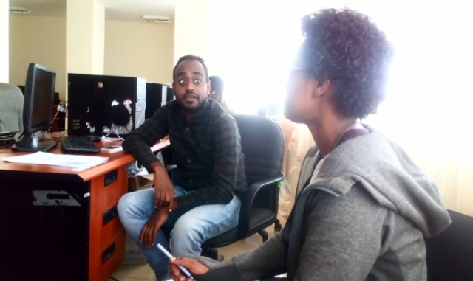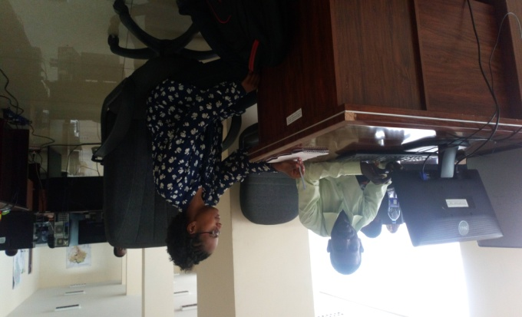
Interview with the expert

FGD with commuter’s from and to Sendafa March 23
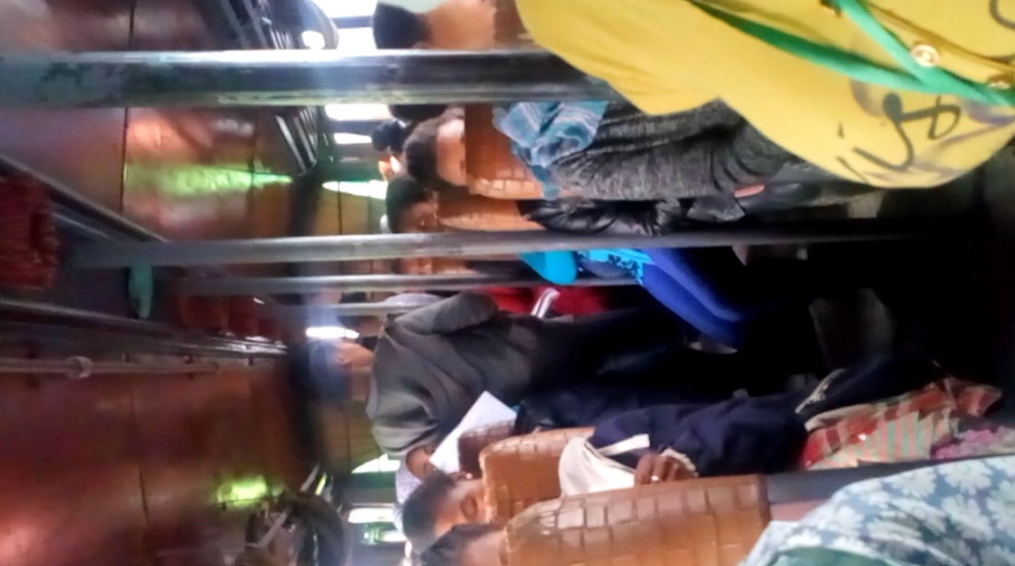
FGD with commuter’s from and to Deber Zayte May 11
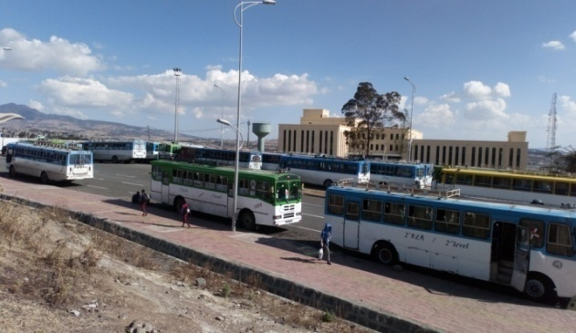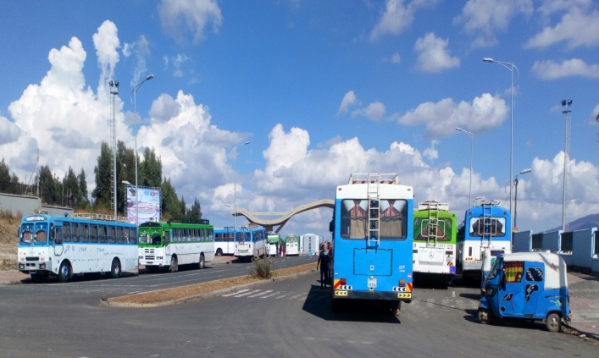
BLIP-I commuter’s mode of transportation

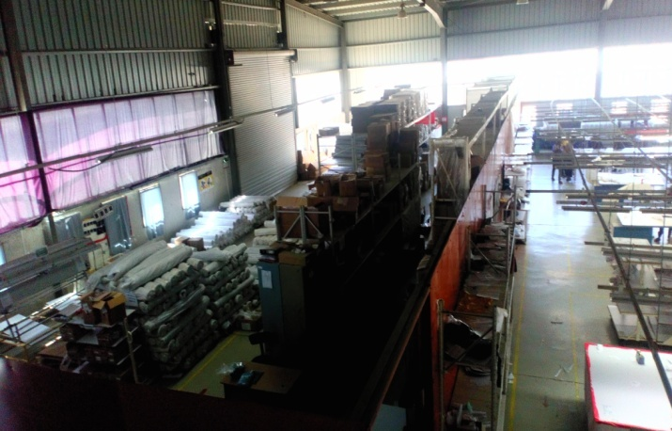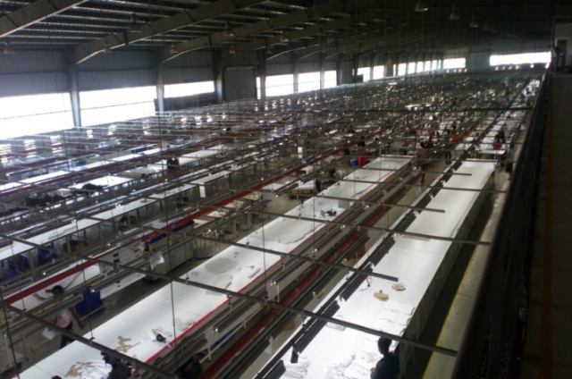
BLIP-I commuter’s work station
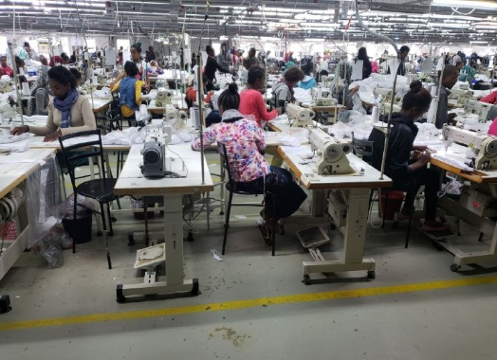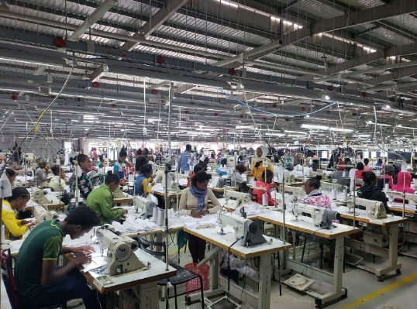
BLIP-I tailors workers
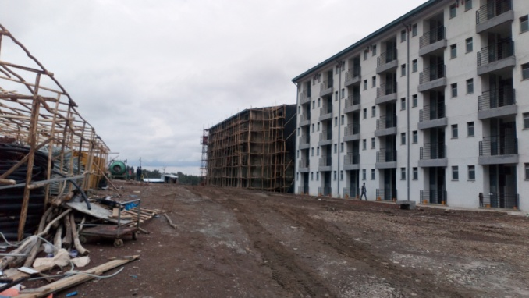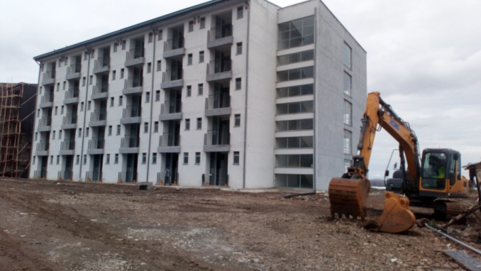
BLIP-I dormitory houses construction workers
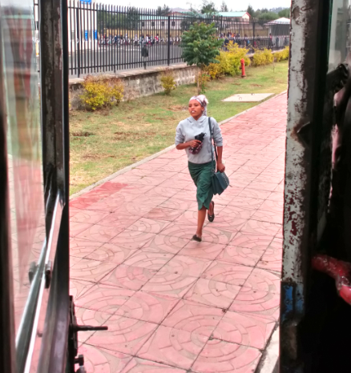
Commuter on the case history observation (evidence of medical report) and worker running towards transportation service
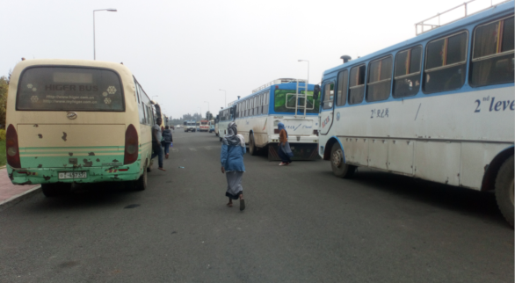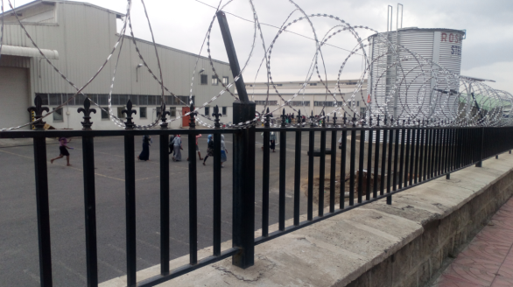
Commuters running towards transportation service
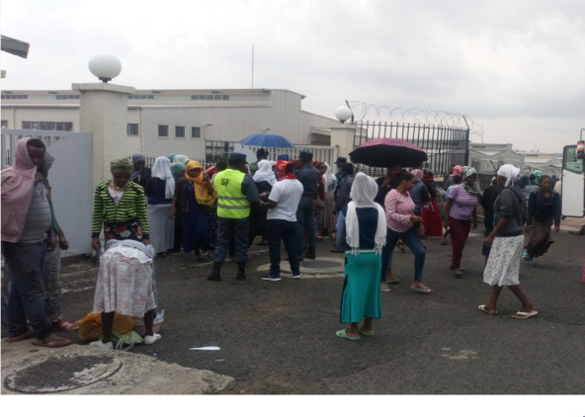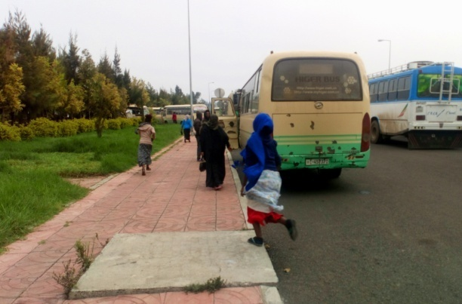
Commuters running towards transportation service
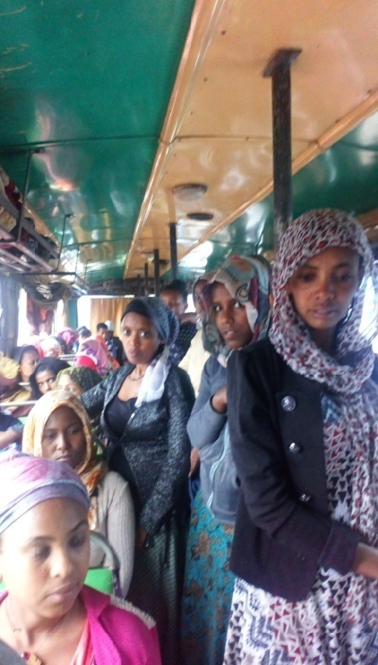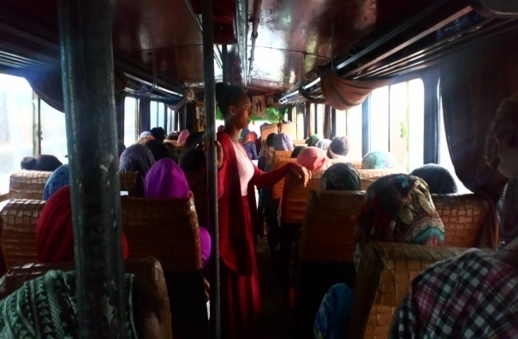
Crowded transportation service
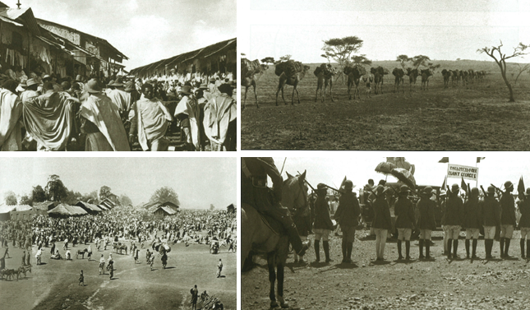
Industrialization in 20th century Ethiopia (source: Fasil, 2007)
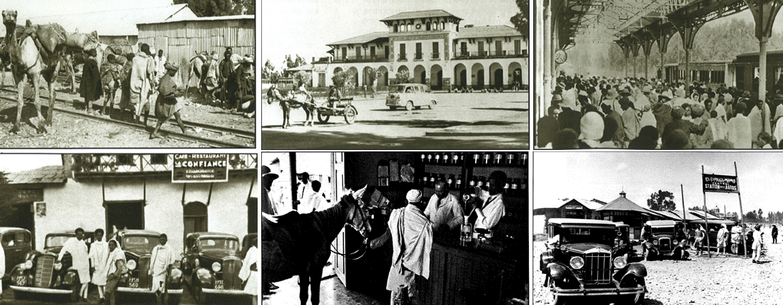
Industrialization in the Imperial era (1930–74) (source: Fasil, 2007)
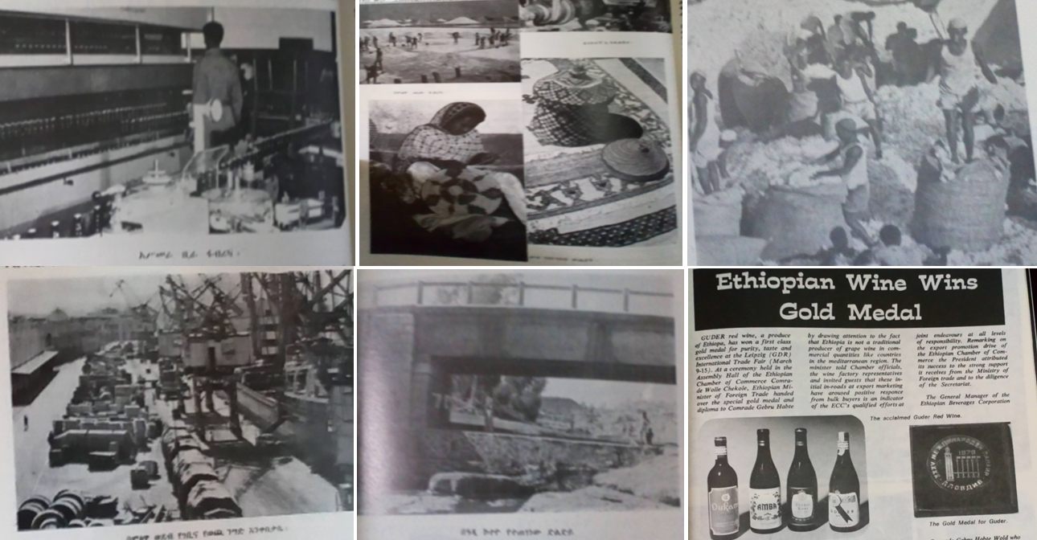
Industrial development in the period of Derg era (source: Fasil, 2007)

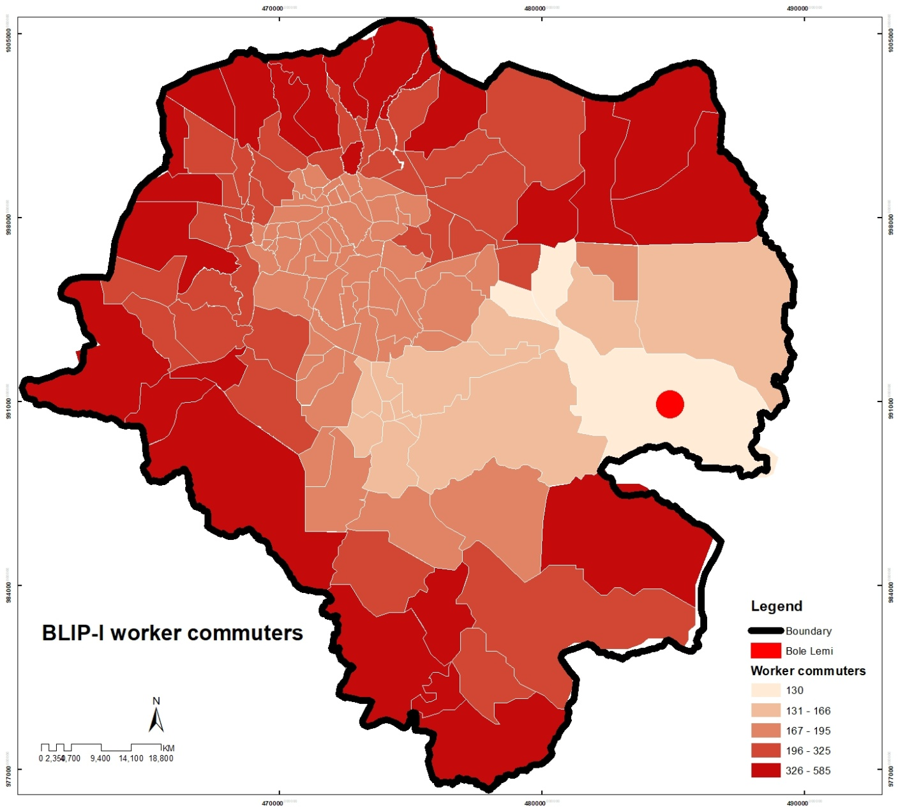
Map of traveling Distance from and to workplace assessment on 396 workers in BLIP-I (source: own computation)
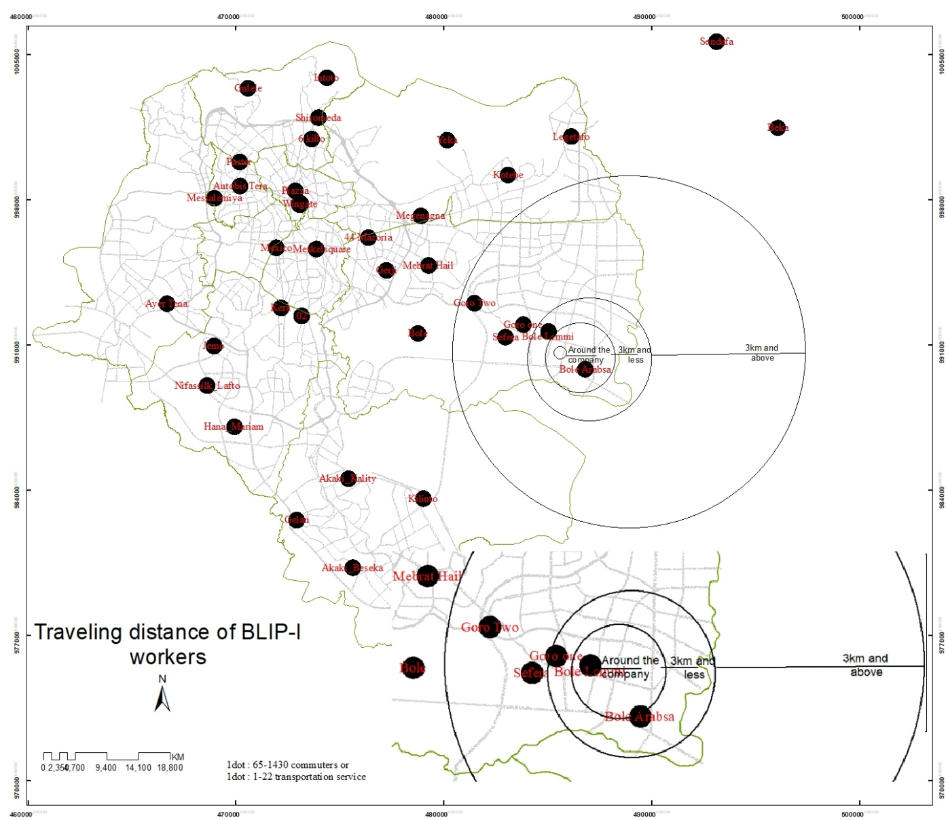

Bus route of workers assessment of commuting hours on 396 respondents at BLIP-I (source: own computation)

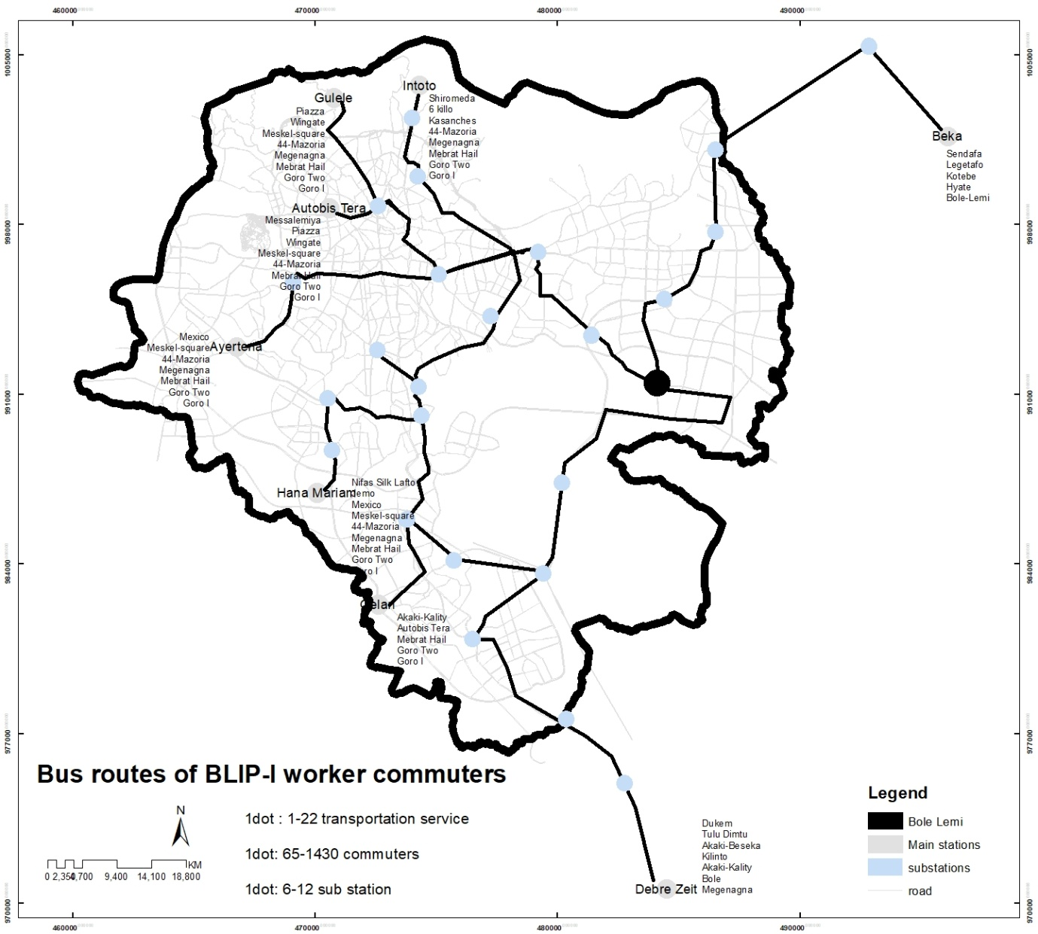
+
Trip distribution of commuting hours of 396 respondents at BLIP-I (source: own computation)

