ADDIS ABABA UNIVERSITY
COLLEGE OF NATURAL AND COMPUTATIONAL SCIENCES
School of Graduate Studies


Title: Studies on the effect of floriculture industry on honey bee productivity around Sebeta Awas Woreda of Oromia Regional state, Awash Melka District.

By; Demissie Bekele Dida
Department of zoological sciences
General Biology MSc. Program
Advisor; Emana Getu. (PhD)
Professor of Entomology
A thesis submitted to the School of Graduate studies of Addis Ababa University in partial fulfillment of the requirement for the Degree of Master of Science in Biology
Addis Ababa, Ethiopia;
August 2019
Addis Ababa University College of Natural and Computational Sciences
School of Graduate Studies

Studies on the effect of floriculture industry on honey bee productivity around Sebeta Awas Woreda of Oromia Regional state, Awash Melka District.

By; Demissie Bekele Dida (GSK 102407)
Department of Zoological science
General Biology MSc program
Advisor; Emana Getu (PhD)
Professor of Entomology

A thesis submitted to school of graduate studies of Addis Ababa University in partial fulfillment of the requirement for the degree of Master of Science in biology

Addis Ababa, Ethiopia
August 2019
Declaration
I declare that this thesis is my original work and that all sources of data and material used for this thesis has been duly acknowledged. I solely declare that this thesis is not submitted to any other situation to anywhere for award of any academic degree or diploma certificates.
Name Demissie Bekele
Date of submitted------------
Signature -------------------

Addis Ababa University
School of Graduate Studies
This is to certify that the thesis prepared by Demissie Bekele entitled: Studies on the impact of floriculture industry on honey bee productivity around Sebeta Awas Woreda of Oromia Regional state, Awash Melka District and submitted in fulfillment of the requirements for the degree of masters in biology complies with respect to originality and quality.
Signed by examining committee:
Advisor: Prof. Emana Getu Signature____________ Date ________________
Examiner: Dr. Habte Takie Signature _____________ Date_______________

Table of Contents page
Acknowledgment i
List of Tables ii
Lists of Plates iii
List of Figures iv
List of Acronyms/ Abbreviation v
ABSTRACT vi
1. INTRODUCTION 1
1.2 OBJECTIVE 4
1.2.1 General objective 4
1.2.2 Specific objectives 4
2. LITERATURE REVIEW 5
2.1 World Floriculture Industry 5
2.2 Floriculture in Africa 7
2.3 Ethiopian Floriculture Industry 8
2.4 Floriculture Industry and Its Effect on Honey Bee Productivity 10
2.5 Biology of Honey Bee 13
2.6 Bee Honey Production and Plant Pollination 14
2.7 Pesticides and their effect on Honey bees 15
2.8 Environmental Impact of Floriculture 16
2.9 Honey Contamination with pesticide 16
2.10 Health effect of Neonicotinoid 19
2.11 Health Effect of Pesticide Contaminated Honey 21
2.11.1 Honey Quality 22
3. METERIALS AND METHODS 23
3.1 Study area 23
3.2 Sources and Methods of Data Collection 23
3.2.1 Sources of Data 23
3.2.2 Data collection Method 24
3.2.3 Sampling Technique 24
3.3 Analysis and Interpretations of Data 26
4 RESULTS AND DISCUSSION 27
4.1 RESULTS 27
4.1.1 Percentage of farmers used to culture honey bee in case of Sebeta Awas……......27
4.1.2 Honey harvesting season 29
4.1.3 Average honey products harvested at single harvesting period 30
4.1.4 Average honey products harvested annually per a hive. 31
4.1.6 Relationship between bee loss and pesticide application in flower industry……...35
4.1.7 Change in honey production through the time 37
4.1.8 Productive rate of bee colony per a year. 39
4.1.9 Pesticide Chemical used in floriculture industries 40
4.2 DISCUSSION 44
5 CONCLUSION AND RECOMMENDATION 47
5.1 Conclusion 47
5.2 RECOMMENDATIONS. 48
6 Reference 49
7 Appendex ………………………………...………………………………………………….53

Acknowledgment
First of all, I would like to thank the almighty God for liberty salvation of my soul in all dimensions. I am very much grateful to my advisor prof. Emana Getu for proper follow up, constructive and stimulating advice and friendly treatment at every stage during my reduction and preparation of this paper. I am also grateful to the cooperation and assistance from the farm workers at Eney- Ethio Rose and Awash Melka agriculture office during the study period. I would also like to express my gratitude to the Ministry of Education and School of Graduate Studies of Addis Ababa University for providing me with financial support, and the program unit of Biology in particular for facilitating my work. Lastly, I would like to appreciate my lovely family for their endless encouragement and support during the entire period.

List of Tables page
Table 1. Represent responses of farmers on honey bee keeping 27
Table 2. The percentage of traditional and modern hive respondents use to keep honeybee. 28
Table 3. Honey harvest per a traditional hive at one harvesting time in kilogram. 31
Table 4. Data showing the annual honey harvest of four kebeles in past ten years. 34
Table 5 Relationship between flower factory and bee keeping 36
Table 6. Response from respondent on the status of bee products. 37
Table 7. Represent data of the factor causing decrease of honey bee productivity. 38

Lists of Plates page
Plate 1 Collected honey samples of the study area taken from (alemayew kebede, 2011). 18
Plate 2 Picture showing spraying of pesticide chemicals in jimjima rose, october. 2019 20
Plate 3 Different types of hive customized to culture honey bee. Photo may 11, 2019. 28
Plate 4. Honey bee keeper harvesting honey photo on may 12, 2011 30
Plate 5 Pictures of pesticide chemical taken from eney ethio rose factory on may 2019 41
Plate 6 Pictures showing pesticide application, photo may 21,2019. 42
Plate 7 Sampling of lufenuron and acetamiprid chemicals and its application on may 5, 2019 43

List of Figures page
Figure 1. The rate of respond on honey harvesting season 29
Figure 2. Representing the annual honey product of modern hive 32
Figure 3. Annual honey product from traditional hive in kg 33
Figure 4. Honey harvesting rate per a year 40

List of Acronyms/ Abbreviation
AIPH Agricultural Institute and Pesticide Hazard
AP Apiculture
CCD Colony Collapse Disorder
DDT Dichlorodiphenyltrichloroethane
EER Eney -Ethio Rose
EHPEA Ethiopian Horticulture Producer Exporters Association
GDP Growth Domestic Product
NN Neonicotinoids
WHO World Health Organization

ABSTRACT
Ethiopia is one of the countries harboring many industrial and agricultural institutes like floriculture industry that work on production of flower in high level. Flower farms used to spray Neonicotinoids pesticide chemical to protect insect pests. Honey bees are highly sensitive to neonicotinomide chemical which is carcinogenic chemical that sprayed in floriculture industries. The research investigation conducted to study on the impact of floriculture on honey bee productivity. It assessed the status and average risk of floriculture industry on honey production and bee managements by determining the annual production of honey through time. Descriptive research method was used to describe the impact of floriculture industry on quality and quantities products of honey and honey bee health and reproduction. Acetamiprid and Lufenuron are the Neonicotinoid pesticides that were used to control insect pest including honey bee. About 53.54% of local farmers participating in this research keep honey bee. From the 8 respondents having modern hive, the maximum productivity was 10kg per year from one hive and at a minimum some of the respondent harvested only 4kg per year. The research resulted of the total respondent about 30% harvest honey once per a year from traditional hives and 4% from modern hives while only 8% of them harvest twice from traditional hives and 26% from modern hives. Similarly none of the respondents harvest three times per a year from traditional hives as 6% of the total sample respondent harvest their honey three times from modern hives. Chemical pesticide sprayed in floriculture was commonly neonicotinomide which includes poisonous family acetamiprid, Lufenuron, clothianidin, imidacloprin, of which acetamiprid, Lufenuron and imidacloprin were widely used insecticide and they cause high toxicity to insect than mammals. Impact of this class of insecticide on pollinating insect such as honey bee and native bees were a concern of work. It is recommended to spray pesticide pre or/ after flower bloom or other wise use bee less toxic and alternative method of pests control to take care of honey bee.

Keywords; honey bee, floriculture, neonicotinomide, pesticide, honey, bee keeper, hives, productivity

- Introduction

Honey bees are dependent on flowering plants because plants provide bee with food in the form of nectar and pollen. The types of flowering plants on which bee foraged determine the productivity and quality of the honey produced by bee. Nectar and pollen are primary reward to insect pollinators in general and to honey bee in particular. As honey bees require large quantities of nectar and pollen at a particular time, they utilize particular species of plants in limited period of time.

During flowering period, there is considerable movement of honey bees between plants of the same species. Not all plant species are however equally good for beekeeping. Some supply both nectar and pollens abundantly when in the bloom and other still provide nectar or pollens for their brood bearing (Ankra, 2012). Ideally a good beekeeping area is the one in which nectar and pollen plants grow abundantly and with a relatively long blooming season. Such areas are however not always available or easy to find. Beekeepers must know the time and duration of blooming season and the types of flowering plants around their environment. However, the natural flora of Ethiopia favors bee keeping, the productivity of bee and bee diversity in Ethiopia dramatically lowering down through time.
Ethiopia is endowed with various climatic conditions, topography and a wide range of elevation favoring the presence of diversity of natural vegetation that include forest, bushes, herbs, weeds, and undergrowth. The flowering plants in Ethiopia are estimated to be 6 and 7 thousand species (Edessa Negera, 2002). The presence of these huge flowering plants make the country a home for diversity of honey bee colonies and still beekeeping has been a widely spreading. Lorenz (2009) define bee diversities of Ethiopia estimated to be 10 million bee colonies, out of which farmers are keeping about 7 millions in traditional and modern hives that the remaining exist in a forest and service.
Ethiopia is one of the countries harboring many industrial and agricultural institutes like floriculture industry that work on production of flower in high level. (Adebabay Kebede et al., 2008) reported floriculture development in Ethiopia blooming in recent years, it started for commercial purpose. The Dirge regime had established Horticulture development corporations where government was responsible both for regulation and production even for marketing of horticultural products including flowers, (Ethiopian Horticultural Strategy, 2007). The periodical development and improvement of pest management through application of diversified chemicals has causing alarming effect on our natural resource. Uncontrolled application of pesticides causes contamination of environment, animal species, and plant nectars. These chemical pesticide that mostly applicable in floriculture industry are acaricide, amitraz, celazole, bromopropylate, coumaprosflumethrin, tautfluvalinate luniferon, acetamiprid and other family of neonics chemicals ( Korta, et al., 2002).
In floriculture industries these hazardous chemicals are sprayed to prevent insect pests, and other biological agents. Risk from synergistic mixtures of pesticides, the pesticides that pose the greatest danger to insects whether by exposure to sprayed droplets or dusts, oral ingestion of contaminated food and water or contact with chemical used for floricultures in green house as (Kelly . et al., 2005) research result analysis prescribes, recent data from Ethiopian Agricultural Research Institute showed that 18 of the 96 insecticides and nematicides and 19 of the 105 fungicides imported by the flower farms were not on the MPS-code list (the list of pesticides registered in Ethiopia) and Due to the growth of the floriculture industries, environmental concerns are indeed growing and environmentalists are raising many concerns in relation to the use of too much pesticide and chemical fertilizers, disposal of waste materials; the protection of water bodies is of great concern in Ethiopia.
Pesticide chemicals are applied to the flowery factory in one of the three methods, as direct spray, seed soaking or as soil fertilizer. The direct application of pesticide cause direct contact with honey bee and other pollinating insect and animals, and is causative agent for bee death, infertility, illness and loss of productivity. These chemicals has been causing negative impact on beekeeping and honey production by affecting and altering the biological process of honey bee and even by reducing bee quality and organic nature of honey and honey products like waxes, venom and honey comb. In Ethiopia since 1970th, when the floriculture industry introduced to Ethiopia, there was high expansion of floriculture industries in a high production of massive land site and this is true to Sebeta Awas since 1995, as well as application of highly poisoning pesticide chemicals. Previously Sebeta Awas was well known by excellent site for bee keeping and honey production in traditional hive hanged in wild and around farmer’s garden. Today the annual and per hive average honey yield per colony was relatively low

  - OBJECTIVE
    - General objective
- To study the effect of floriculture industry on productivity of Honey Bee around Sebeta Awas Woreda of Oromia regional state; Awash Melka District.

    - Specific objectives
- To assess the status of honey productivity.
- To identify the annual honey production in floriculture areas.
- To investigate the negative impact of flower factor to beekeeping.
- To determine diversity of honey production among different Kebeles of Sebeta Awas, around floriculture site.

- LITERATURE REVIEW
  - World Floriculture Industry
People all over the world realize that flowers enhance the quality of life and influence human feelings more than words or other gifts. Chala Kinati et al., (2012) Globalization, cultural exchanges, and celebrations enhancing fraternity such as New Year, Valentine's Day, Memorial Day, Mothers' Day, Fathers' Day, Christmas, and weddings have induced people globally to use flowers as a means of sharing their feelings. Above all, these celebrations have acquired one-to-one pairing with flowers in some cases such as roses to Valentine's Day and carnations to Mother's Day and Increased use of flowers and ornamental plants makes marketing of flowers a lucrative business
The majority of cut flowers are produced in countries with dedicated infrastructure having facilities for airlifting to major distribution centers. The AIPH report estimates a global area of 360,000 hectares dedicated to world flower and plant production involving USD 60 billion in value terms and 100,000 companies. In 2001, the UN International Trade Centre estimated the global area of 200,000 hectares dedicated to cut flowers commanding value of USD 27 billion. In terms of total area of production, Asia and the Pacific cover nearly 60 percent of the total world area. The key markets for flower are Western Europe, North America and Japan. The EU is the world's leading importer of flowers. The other largest importers are Germany, the USA, the England, France, Netherlands and Switzerland accounting for nearly 80 percent of global imports (Hamrick, 2004)
According to the report of (Hamrick, 2004), the Netherland is the world's largest producer of cut flowers and foliage valued at USD 3.6 billion, followed by Germany and Italy. In addition, The Netherlands plays a major role in setting the global standard for daily prices through its computerized clock auction system and acts as the logistical distribution center for Europe. South American countries Colombia and Ecuador as well as Israel, are the major producers of carnations and roses. An increasing investment has also been witnessed in Kenya and other African countries. The share of the developing countries in the total trade has consistently been around 20 percent during the last five years. There has been a growth in the number of producing countries particularly among the developing nations in Asia, Africa and Latin America. In the African continent, Kenya leads cut flower exports, expanding annually at 10 to 15 percent per year, followed by Zimbabwe that Flowers are becoming the driving force in the growth of Kenyan agricultural exports (comprising 75 percent of flower export by weight) from Kenya was up by 19 percent in 2003 to the Netherlands auction market and increased the competition. Existing farms are being expanded and newer ones are being created in countries such as Tanzania, Uganda, Ethiopia, Malawi, Zambia, and Namibia.
According to Chala Kinati et al., (2012) report, some countries are both producer as well as consumers. In Israel, Africa and South and Central American countries, cut flowers have been a product produced mainly for export with no thought of a potential domestic market. On the other hand, in Asia, whereas cut flowers were initially produced for export, the market potential has rapidly changed to include opportunities for supplying to the local market as well. This unique development is on account of the rapid strengthening of economies in the region, high population densities, and the changing consumer’s perception towards importance of flowers in their lifestyle (Jinanus Dinka and Tariku Kumsa, 2016). If we take the case of Ethiopia, it is only recently that the mere concept of flowers as a gift emerged. Notwithstanding, Ethiopia has attracted several foreign investors in recent years, for exporting cut flowers mainly to European markets.
  - Floriculture in Africa
Africans floriculture industry is one of the continent’s most profitable industries, that Kenya is the biggest exporter of flower from the continent followed by Ethiopia and South Africa. In Kenya, the floriculture industry generates $1 million annually (Jinanus Dinka and Tariku Kumsa, 2016). In South Africa agriculture remains one of the back bone industry of the country by contributing high national GDP (growth domestic product) and its floriculture industry is rapidly growing. Kenya has taken step to stop and prevent growth of floriculture industries because of the deranage of many lakes like Naivasha because of the five flower industries instituted around the lakes. Gudeta Degynatu (2012), reports that and Ethiopia has to blame floriculture industry through time to time although the initial reputation of the industry diminish after some opposition party parliament members and some press releases of an information that the industry has a negative impact on social and environmental aspect quoting as a reference Kenyans flower industry.
The insecticide chemical sprayed in these industries is potentially carcinogenic and insect poisoning inorganic chemicals that kills toxifies and poisons insects like honey bees. mismanagement and uncontrolled application of pesticide chemical reduces the insect pollinators and honey bee by toxifying the flower nectars, and even it cause the honey to be toxic when these chemicals are introduced to honey while bee honey production. The organic nature of honey should be kept and protected according to world food and health organization standards. Honey bees are highly attracted to colored flowers nectar for pollination and sacking of these nectars and most floriculture culture industries cultivates rose and proteas flower in Africa (Kumar, 2010).
Rose; rose is one of the mostly exported flower from Kenya. It is used as the indicator of love price.
Proteas; South Africa is leading exporter of proteas cut flowers. Since 92% of the species are in the cape floristic region, these flowers are mainly found in the Western Cape. The proteas is also the national flower of South Africa. Most African states are well known in production of cut-flower and exporting their products. Kenya, Uganda South Africa and suddenness are some of the productive country of floriculture.
  - Ethiopian floriculture industry
In recent decades, the global demand for cut flowers has grown considerably. This growth in market demands and its diversification value has attracted increasing numbers of developing countries to the global fresh flower trade (Fatuma Abdulfeta, 2007). European cut flower growers (especially Netherlands) have been looking to other continuities for more affordable conditions as experienced other East African countries like Kenya, Tanzania and Uganda (Adebabay Kebede ,et al 2008).Though floriculture development in Ethiopia blooming in recent years, it started for commercial purpose in 1980/81 which is now twenty six years ago). The first fresh cut flowers production was commenced in 1981 /82. The Dirge regime had established Horticulture development corporations where government was responsible both for regulation and production even for marketing of horticultural products including flowers. During that time the production and export of cut flowers in Ethiopia was not established with well-planned and aiming of profit seeking but foreign exchange earnings (Getu Mulugeta, 2009).
As a result of this, the industry was one of the highly subsidized sub-sectors during the Dirge regime (Fatuma Abdulfeta, 2007). Floriculture was started to show modest increase in 1990s by 2-3 % from the agricultural output of the country. In 2001 it contributed $ 4.7 million to the country’s foreign currency earnings. But it was not as such significant enough to say it was important sector to develop the country’s economy that, in five years the total export earnings increased at least five times that figure (Ethiopian Horticultural Strategy, 2007).
Because of the Government of Ethiopia gave more attention for favorable investment condition and a more enabling atmosphere for private sector development the floriculture sector started to grow fast in the last few years. The first private floriculture producer started around 1997, a second in 1999. From 2001 onwards, other growers started coming in and according to Trade and Industry floriculture industries under production reached 65 in the year 2006, (Frank and Cruz, 2001).
According to Adebabay Kebede et al., (2008), flowers are luxurious products with high social value and rarely used for food. The demand for these luxurious products has increased in the international market in recent years and most developing nations which have geographic advantage take it as a solution to achieve rapid economic growth. Ethiopia, like many other developing countries, is attempting to diversify its export base with a view to gaining new sources of income and foreign exchange and thus reducing its exposure to price volatility that typify international markets (Ethiopian Horticultural Strategy, 2007). Besides, the country is benefiting from this development through creating employment opportunity for unemployed citizens. Ethiopia is known for its tremendous variation of agro-climatic conditions and biodiversity which favored the existence of diversified honeybee flora and huge number of honeybee colonies (Nuru Adgaba, 2007). It has the largest bee population in Africa with over 10 million bee colonies, out of which about 5 to 7.5 million are estimated to be hived while the remaining exist in the wild This makes Ethiopia a leading in Africa and ninth in the world in honey production, respectively.
By Nuru Adgaba, (2007) reported In the last five years, the floriculture industry in Ethiopia has become fast growing export business and as a result of due attention given by the government to this sector and the unparalleled advantages that Ethiopia has in this sector compared to any other products, a substantial number of investors have started investing in the country. According to Ethiopian Horticulture Producers Exporters Association Pamphlet (2007), investors are attracted by an improved investment code, a five year tax holiday, duty-free import of machinery, and easy access to bank loans and land acquisition. In addition to the above incentives the favorable agro-ecological condition of the country, the abundant cheap and easily trained labor, proximity to EU and Middle East markets encourages so many foreign and local investor to invest in Ethiopia, particularly the areas of investment so called Finfinnee special of Oromia region like Sebeta Awas, Holeta or Welmera, Bishoftu and other rural areas (Frank and Cruz, 2001).
  - Floriculture industry and its effect on honey bee productivity
Apiculture is a promising off-farm enterprise, which directly and indirectly contributes to smallholder’s income in particular and nation’s economy in general. It has significant role in generating and diversifying the income of subsistence Ethiopian smallholder farmers mainly the small land holders and landless. Ethiopia is known for its tremendous variation of agro-climatic conditions and biodiversity which favored the existence of diversified honeybee flora and huge number of honeybee colonies (Nuru Adgaba, 2007).
In Sebeta Awas Woreda, there are numerous floriculture sectors which are investing on the flower-cut export and other agricultural investments like; tomato, potato and onions along the basin of Awash River. Most of the Floriculture farms are largely confined around the vicinity of Addis Ababa. Most floriculture farms are located in West Shewa particularly located in Holeta, Sebeta and Addis Alem while the rest are more or less evenly distributed in the Rift Valley and the Awash River Basin systems (Laws, 2006). These sectors are established basically for the demand of water access from annually flowing Awash River. The reports of (Addisu Mergia, 2007) indicates that Sebeta Awas Woreda has two floriculture settled districts as Tefki and Awash Melka Kunture floriculture center, and this area are previously well known by production of honey by using traditional beekeeping strategies. Farmer’s beekeeping has been transformed from traditional perspective to modernized hive harvesting.
Debrezeit is one of the center agro-industrial institutes where numerous floriculture industries land on, around Addis Ababa. Reports have been heard that floriculture effluent application can significantly affect the soil chemical properties of vertisols at Debrezeit. It can also change the Soil PH, Organic Carbon and total Nitrogen contents, exchangeable bases and micronutrients concentrations. As a result, the neutral soil of Debrezeit was been changed to saline soil. This soil degradation in Debrezeit also affects the crops that are grown in that area likes wheat. Therefore, waste water management and treatment are necessary to reduce the impact of effluents on soil quality. The effects of pesticide contamination on crops, water and environment directly and indirectly affects the biological and productivities of honey bees. Most honey bee has been seen killed in the green house of the flower culturing rooms (Mariana, 2010).
Holeta has a longstanding beekeeping practices that has been an integral part of other agricultural activities, where more than one million households keep honeybees (Nuru Adgaba, 2007). Beekeeping subsector is dominantly for small-scale farmers and is contributing significantly to the increment off-farm income and toward poverty reduction in rural areas and explained as Honey is considered as cash crop and only about 10% of the honey produced in the country is consumed by the beekeeping households. But the application of pesticide chemical to the floriculture industry has been affecting this apiculture directly or indirectly and causes the loss of unamend able bee products. It need to test the soil prior to planting and managing the soil pH, essential humus (containing carbon to sustain useful soil microorganisms), salinity and variable nutrient and Tracing element requirements of plants (Getu Mulugeta, 2009).
Pesticides (which include herbicides, insecticides, fungicides and more) can contaminate organisms, soil, water, turf, and other vegetation. It is estimated that less than 0.1 percent of the applied pesticide reaches the target pest, leaving 99.9 percent as a pollutant in the environment, including the soil, air, and water, or on nearby vegetation. The adverse effect of pesticide use includes degrading water and soil quality, effect on non-targeted lives like soil organisms, aquatic life, human beings, insects, cattle and air pollution and increase of pesticide resistance by targeted pests. Water Pesticides can move from the site of application via drift, volatilization, leaking, and runoff.

  - Biology of Honey Bee
Honey Bee (Apis spp) are social animals those live and work cooperatively that a small hive contain average of 20,000 bees and these are grouped in to three categories ,Queen, Drone and Worker and this in normally for the sake of division of jobs. Workers exceed drones by numbers and only one Queen will exist in one bee colony. Queen normally function to lay egg and hatch it and is the reproductive group of bee. In addition to laying egg, Queen also control and regulates a colony by its especial chemical secretion called queen substance. Queen developed from fertilized egg that selectively nourished on special food called royal jelly (Mariana, 2010).
Drones are a male honey bee that developed from unfertilized egg laid by queen and are purposively used to mate with queen once his life time. Drones has no more function rather than mating and are not successively collect nectar as worker. Thus he either dies or escapes from the colony after mating queen. Flowers which are evolved to attract honey bees are optimized their flowers to increase the chance of bee visit (Carola and Diana, 2009).
Workers are a massive group of bees functioning to collect nectar, cleaning hive, caring for young and queen, secreting waxes and form comb. Worker bees are developed from fertilized egg but not nourished special food royal jelly. The bee unwittingly carries pollen from flowers to flowers thus pollinating the plants and permitting them to reproduce. This flowering plant both attracts and rewards an insect like honey bee. The flowers are differently colored and attract bees and reward with nectar and pollen Nectar is sweet liquid composed of mostly sucrose. The bee collects this liquids in their crop and the digestive enzyme most importantly invertase is added. By the time return to hive much of the sucrose is converted to glucose and fructose in the hive the bees empties its crop in to a comb cell or the nectar is transferred to other bee worker who takes it to honey comb for evaporation to make honey. Pollen is a dusted all over the bee as they visit flowers and the bees legs are designed to comb this pollen from their body and catch it in a tuft of bristle on third pairs of legs (Carola and Diana, 2009).
Honey bees body covered by special structure called exoskeleton as that of all other insects which is the common feature of class insect. Exoskeleton is integument structure of insects that used not only as protective covering over the body but also serve as attachment surface of muscle and water light barrier against desiccation and sensory interface with environment (Kumar, 2010).
  - Bee Honey Production and Plant Pollination
Honey bee provides essential ecological services in both the natural environment and in human dominated habitat. (Carola and Diana, 2009) reported that over 5200 bees were collected from grass land plots with different levels of the urbanization ,that they are sucking on the floristic plants the most important factor affecting bee abundance particularly for ground nesting bees, was grazing regime. Honey bees are the valuable resource around the world (Marina, 2010). Honey bees are very important for world food productivities and healthy productivities of crop and floriculture is perceived when health of honey bee is kept. In Ethiopia bees are highly vulnerable to the pesticide sprayed in floriculture industries because of the seasonal perambulate for the sake of pollination where there is flower odor attraction (Nuru Adgaba, 2007).
In winter seasons there is no more flowering plants mostly around low lands and plateau areas, but there is high cultivation of flower in such areas that honey bees are migrating to wards that areas. As the pesticides are applicable, these massive flows of pollinator insects are tremendously killed by pesticides (Kumar, 2010). The newly published research explains that, in Ethiopia, there were generally two honey harvesting seasons: the major one that lasts from October to November and the secondary one from April to June. However, in addition to these major harvesting periods, there are many small harvesting periods which depend on the type of flowering plants and rainfall patterns in different agro-ecologies which experienced beekeepers and local people easily associate the harvesting season with the botanical origin of honey in their locality.
  - Pesticides and their effect on Honey bees
Pesticide is used in worldwide to control pest and in most instant their administration is uncontrolled and applied without approved protocol. The usage of pesticide is to protect floriculture and increase the industrial productivity, but uncontrolled application may cause the contamination of environment, animal species and plant nectars (Getu Mulugeta, 2009). These chemical pesticide that mostly applicable in floriculture industry are acaricide, amitraz, celazole, bromopropylate, coumaprosflumethrin, tautfluvalinate and neonics chemicals (Korta et al., 2002).
In floriculture industries these hazardous chemicals are sprayed to prevent insect pest, and any biological agent and have high Risk from synergistic mixtures of pesticides used for floricultures in the green house (Kelly et al., 2005) research result analysis prescribes 18 of the 96 insecticides and nematicides and 19 of the 105 fungicides imported by the flower farms were not on the MPS-code list (the list of pesticides registered in Ethiopia). Due to the growth of the floriculture industry, environmental concerns are indeed growing and environmentalists are raising many concerns in relation to the use of too much pesticide and chemical fertilizers, disposal of waste materials; the protection of water bodies is of great concern in Ethiopia.
  - Environmental impact of floriculture
Environmental impact of floriculture Activities With the expansion of the floriculture industry, t is a growing concern as to its adverse effect on the national environment (Getu Mulugeta, 2009. Gudeta Degynatu et al. (2012), Explained that this section highlights the kinds of environmental risks use of fertilizers, pesticides, and safe disposal of wastes - involved, the extent of the threat and the activities undertaken by other nations to combat the risk. Fertilizers as Some environmentalists are of the opinion that the environment is unique and irreplaceable, and therefore no price can or should be assigned to it.
The argument may be criticized because if taken literally it would make daily living impossible as, (Fatuma Abdulfeta, 2007) described and it prohibit any development activities. The viable course of action thus seems to be minimizing the adverse impact of floriculture on the environment. Much criticism has been forwarded against chemical fertilizers. Yet, in the absence of realistic alternatives to chemical fertilizers and pesticides in agriculture, the insistence to their use continues.
  - Honey Contamination with pesticide
Honey can be contaminated from environment and from the bee keeping practice. Bogdanove reported that the nectar for honey production in India is polluted and contaminated by organochlride and as well as Dichloro Diphenyl trichloroethane (DDT) and the organ phosphorus and carbamates pesticide (Anju, 1997).
Contamination of agricultural area with pesticide and antibiotic leads to bees picking up these contaminants as they go to work pollinating flowers. These chemicals are then brought back with them into the hive and subsequently transferred into the honey that ends up on the shelves at the store and eventually on the plate. Antibiotic residues have quite a long half life time and as such will often made it all the way in to our body having direct toxic effect (Anju, 1997).
Mulugeta Getu (2009) report, honey from tropical Apies species show wider variations in composition. In Ethiopia, where more than 400 plant species are already identified as major honey plants and (Lorenz, 2009) reported it is expected to have very diversified honey types and An investigation conducted in Biochemical laboratory of the Ethiopian Authority of Standardization to characterize honey samples from all over the country indicated that about 63% of 542 honey samples had moisture content < 21%, those from highly humid areas having higher moisture content and those from low humid regions with lower moisture content. The Earlier reported that honey samples collected from the whole country had moisture content ranging between 15.25% and 30.45%, and honeys harvested from traditional hives being higher by 1.5–3% than those harvested from modern ones.
More than 95% and 80% of the samples were in the range of standards of total reducing sugar and acidity, respectively. The mineral (ash) content was relatively lower than the standards of many countries. According to (Mulugeta Getu, 2009) explanation Around 63% of the samples had Health Monitory Fund value below 40mg/kg and About 72% of the samples meet the diastase activity standards set by European Union and WHO. The diastase (amylase) activity of honey has relevance of indicating overheating, as it is heat sensitive. However, recently complaints are coming from Ethiopian honey exporters that the majority of their collections have diastase far below than the standards even for fresh and unprocessed honeys.

Honey Consumption
Honey can be consumed in different forms over the worlds in reference of the consumers culture, believe and custom (Gebregziaber Gebremedhin et al., 2013). These can be two major forms
- Raw honey consumption; people use to take flesh honey directly applying it to their nutrient, drinking or eat the raw honey without processing in industries. The most difficulty with raw honey is that it is an entirely natural product that is to say there are many factor out of our control that contributes to the production of honey. Bees will produce honey simply by following their natural instincts and as such the control is very much in their hand we can’t force them to go to only a particular flower. The recent research indicates that the raw honey contain very toxic and hazardous chemicals (Alemayew Kebede, 2011).
- Processed honey consumption; Many developed country used to feed industrially processed honey
.
Plate 1. Collected honey samples of the study area with simple label taken from (Alemayew Kebede, 2011).
Bee products, such as honey, are widely consumed as food and medicine and their contamination may carry serious health hazards. Honey and other bee products are polluted by pesticides, heavy metals, bacteria and radioactive materials. Pesticide residues cause genetic mutations and cellular degradation and presence of antibiotics might increase resistant human or animal's pathogens. Many cases of infant botulisms have been attributed to contaminated honey. Honey may be very toxic when produced from certain plants. Environmental contaminants include pesticides, heavy metals, bacteria, and radioactive materials. In addition to the public health problems, the presence of pesticides in bee products decreases its quality (Anju, 1997). It was found that the contamination of honey and other bee products with varroacides is more than ones originating from the environment.
Therefore, in conditions where granulation is unavoidable it is better to process the honey in to creamed form. Mulugeta Getu (2009), explained the rapid crystallization can be achieved by seeding cool liquid honey with 5% to 15% of a starter of finely granulated honey obtained in a previously controlled process and a study conducted to prepare finely and uniformly granulated table honey of three widely produced honey types Schiffleria abyssinica, Guizoti ascabra and Croton macrostacheys indicated that all the honey samples treated with 5%, 10%, 15% starter nuclei by weight and kept in the temperatures between 140C and 160C showed rapid crystallization.
  - Health effect of Neonicotinoid
Bees’ exposure to chemical pesticide causes many health problems to insects particularly bees by distracting the exoskeleton systems and kill bees. It also affects the biological phenomenon of bee such as reproduction, digestive track and neurological system. Adebabay Kebede et al., (2008) defined the percentage contamination of honey with pesticide of about 75% is Neonicotinoid pesticide. This fractional contamination of pesticide highly affects the insects’ biology. Neonicotinoid is potentially neurological chemical poisons, that it affects the nervous system of bee and other insect and (Alemayew Kebede , 2011) reported the application of pesticide in agricultural area affects one quarter of honey bee colony and hence honey production in Silti zone. Not only this, the chemical also alters the insect’s reproductive system by reducing sperm and egg reproduction and later on it causes bee infertility.
According to (Mercola, 2008) discuss on sample of honey collected over the world, majority of the sample were found to be contaminated with Neonicotinoid including acetamiprid, clothianidin, imidacloprin and thiacloprin. Once these chemicals contaminates the nectars and honey bee suck this chemical, then the chemical is normally systemic which affect bee immune system, allowing them to be fall prey to secondary natural bee infection such as parasite, mite and fungi. The ultimate effects of the contaminant chemicals cause the reduction of bee species both in wild and in the bee keeping institutes. The report from Holeta apiculture institute proclaimed that since the two past decades, about five species of bee diversities are going to bees destructed in wild.
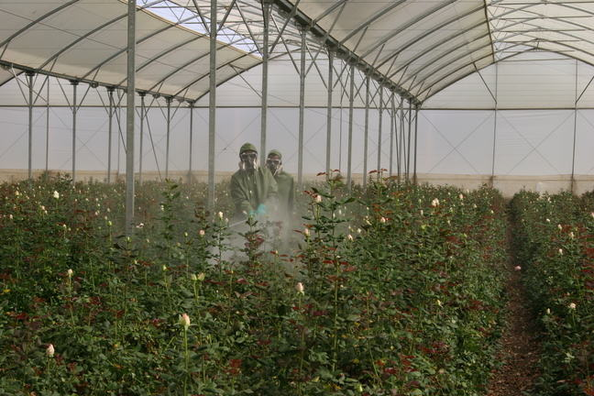 Plate 2. Picture showing spraying of pesticide chemicals in Jimjima rose, October. 2019

The effect of pesticide on non-target organisms is also immense. It has been reported that about ten million non-target organisms including thousands of domestic animals are poisoned each year throughout the world (Mulugeta Getu, 2009). Pesticide use has an adverse effect on the pollination process as honey and wild bees are vital for pollination of about one-third of fruits, vegetables, and other crops worldwide. Wild birds and mammals are also hurt by the application of pesticides. The ethical issue that arises at this juncture is the extent to which it is justifiable to destroy thousands of species for the purpose of killing the harmful few. In Air pollution many pesticides can volatilize and they can evaporate from the soil and foliage, moves away from the area of application, and contaminate the environment (Frank and Cruz, 2001). As much as 80-90 percent of applied pesticides can be volatilized within a few days of application.
  - Health Effect of Pesticide Contaminated Honey
Systemic introduction of pesticides into nectar and pollen may have direct consequences for honey bee health and ultimately lead to pesticide contamination of honey-containing food. The effects of pesticides on human health are harmful based on the toxicity of the chemical and the length and magnitude of exposure. Children’s are more susceptible and sensitive to pesticide due to their small size and underdevelopment. These chemical has ability to bio-accumulate, bio-magnify and bio-concentrate in the body over the time. Effect of exposure to pesticide can range from mild skin irritation to birth defect, tumors genetic change, blood and nerve disorder, endocrine disruption and come up to death (Dennis et al., 2007).

    - Quality Honey
Some people believe that good quality honey essential constituent that serves as nutrients for the consumer. Alemayew Kebede (2011) reported, the world honey quality investigating agency proclaimed that he good quality honey has five qualification standards. These are water content, honey color, pollen constituent, inverted sugar and hydroxyl furfural.
Water Content; some people believe that good quality honey essential has a low water content as honey is likely to ferment and lose its freshness if its content which can be measured using a gadget called refract meter is greater than 19%. Honey is hydroscopic which means that it early absorbs moisture from the air. Thus in areas with a very high humidity it can be difficult to produce honey relatively low water content. Raw honey moisture content is as low as 14%. 20% water content is not recommended.
Hydroxymethyl Furfural; HMF is a break down product of fructose (one of the main sugar in honey) formed slowly during storage and very quickly when honey is heated.
Inverted Sugar; High level of HMF greater than 100mg/kg can also be an indicator of adulteration with inverted sugar.
Honey Color; honey is a color graded in to light, amber and dark categories which do not really have any bearing on quality. Some of the most distinct really and strongly flavored honey varieties such as basswood are very light, white, mild and pleasant honey such as tulip popper can be quite.
Pollen; for many consumers good quality honey is expected to be visually free of defected-clean and clear. honey which has good pollen content appears cloudy and the presence of many other contamination such as particles of wax, bees, splinter of wood and dust certainly does makes it look un appetizing for anyone to buy and consume (Alemayew Kebede, 2011).

- METERIALS AND METHODS
  - Study area
The study was conducted in Sebeta Awas Woreda of Oromia; nearby Finfinnee special zone at 08.70⁰- 0.872⁰N and 38.60⁰-38.62⁰E of Addis Ababa at 48km. The study area was well known by crop production like cereals, and horticulture. The woody tree plants highly dominating the area. Sebeta Awas was a home for many floriculture sites namely Awash Melka Kunture Floriculture Site, Awash Jimjima Floriculture, Tefki Floriculture, Sykan Dima Floriculture and Awash Melka Bello floriculture sites and others. Awash Melka is the small town located nearby Awash River at the border of Kersa Malema and Sebeta Awas woreda and Awash Melka was the center of marketing for four surrounding kebeles namely Buro Finca, Koye, Wenber Godeti and Oda Gudda. The site was well known as the site of early human civilization and historical site so called Awash Melka Kunture historical sites. In Sebeta Awas there are 36 rural kebeles, four administrative and two non-administrative small towns. The four administrative towns are; Awash Melka, Kelecha Gudda, Tefki and Lekule Geja. This research has purposively implemented on Awash Melka district.
  - Sources and Methods of Data Collection
    - Sources of Data
Data were collected by observing floriculture pesticide application method and the status of honey bee colony and honey productivity per house holding society. Survey was conducted using semi structured questionnaire with open-ended and closed-ended questionnaires. The questions were prepared to collect information such as: age, sex, and job of the respondents, hive preference, beekeeping and/or management practices, placement and types of hives, annual honey production, major bee floras, honey yield and major constraints of bee keeping and effect of flower industry to beekeeping and management. Data were collected from interview of sample from society on the level of honey production per annual, seasonal and periodical and documented file of annual reports of agricultural office on status of beekeepers and honey production and discussions with representatives of the district and Kebele office of Agriculture and Rural Development Agents. Floriculture factory site managers and workers of the factories were also invited to participate in the study by responding to the questionnaire.
    - Data collection Method
Before the actual implementation of scientific investigation, discussion was made with Head of Sebeta Awas, Awash Melka district livestock resource, development and health officer to select sites and sample respondents. Based on the information obtained, four kebeles were purposively selected with the criteria of having flower industry, large number of participants in beekeeping, beekeepers' experience and potential area for beekeeping and these kebeles peasant bee keepers were identified. In order to conduct a survey, a purposive and stratified random sampling technique were implemented to select 50 beekeepers, 2 floriculture industrial site, with the total of 9 flower factory worker respondents to collect the required information.
    - Sampling technique
The sampling technique used in this study was both probability and non-probability sampling techniques as there are different types of probability and non-probability sampling techniques. But for this study the researcher preferred to use purposive sampling and group random samplings. The respondents were grouped in three categories. These categories were members of industry worker, local bee keepers and Kebele agricultural officers.
Group-1. Members of industry workers were grouped to collect data related with the management and control method of the pests, application and management of pesticides, management of environmental. These groups were stratified and randomly selected and sampled from the whole industry members and interviewed and data collection method done over. The factory manager purposively identified and included in interview. The factory has a readymade greenhouse rooms each room with 200metres x 50metres size holding three greenhouse workers. The rooms were grouped in to 8 and each group has 8 rooms that the sample respondents were randomly peaked up from each group. Thus the investigator took 8 samples out of 192 greenhouse room servants and one sample purposely selected from factory manager, thus in total of 9 respondents are sampled for interview.
Group-2. Kebele agricultural officers are grouped under group two samples. Sebeta Awas woreda has four administrative town namely Tefki, Awash Melka, Kelecha Gudda and Lekule Geja and 36 rural kebeles. Each town settled center to many rural kebeles. Thus from the four town Awash Melka was purposely selected with its surrounding four rural kebeles namely Buro finca, Oda gudda, Wenber godeti and Koye and agricultural office of each kebeles are targeted to collect data and information related with annually honey production and apiculture.
Group-3. Local Kebele farmers were the third but essential group of these research findings. These groups were used to keep honey bee and purposively selected and elder farmers those has been used to keep honey bee and certainly keep honey bees through their past years were identified. The 50 samples were purposively selected from the four rural Kebele of Awash Melka district farmers by distributing questioners.
  - Analysis and Interpretations of Data
Data were analyzed and interpreted by qualitative (descriptive) method and quantitative such percentage, frequency, tabulation and ratio method using Microsoft office excel 2010 software. Calculation of percentage and frequency of counts were used to arrive at general picture for generation of conclusion and used as tool for analysis data. Open ended questioner including interview and observation were analyzed using qualitative method.

- RESULTS AND DISCUSSION
  - RESULTS

Percentage of farmers used to culture honey bee in case of Sebeta Awas; Awash Melka districts
The Table1 below showed represents the percentage of local farmers participating and investing on bee keeping and those have bee hive. The question papers were distributed for 130 local farmers and 50 of them responded as they have honey bee and this accounts 38.46 % of the total respondent participating in the study and more percent of the participant do not used to keep honey bee. The 61.53 % of local farmer participants have no honey bee.
Table 1. Represent Responses of farmers on honey bee keeping
Item | Response | No of respondents | Percentage
Do you have honey bee | Yes | 50 | 38.46
Do you have honey bee | No | 80 | 61.54
Do you have honey bee | Total | 130 | 100
As Table 2 below shows most of the Sebeta Awas woreda bee keepers used to keep honey bee in traditional hive, which is not modernized and exposed to different harmful environmental and ecological factors. As Beyene Tamiru and David (2007), reported on their research estimated that around one million farmers were actively involved in honey production throughout Ethiopia using the traditional, intermediates and modern hive. The above table explains that 84% of local farmers used to keep bees by traditional hive strategies and only 16%of these respondents practiced to modernize their hiving methods.

Table 2. The percentage of Traditional and Modern hive respondents use to keep honeybee.

Item | Types of hives | No. of respondent | Percentage
Which types hive do you have | Traditional | 42 | 84
Which types hive do you have | modern | 8 | 16
Which types hive do you have | Total | 50 | 100
They used to hang their hive in wild, around their garden and near to flowering plant or forest. Eney Ethio rose and Jimjima flower factory established basically nearby Awash Melka river closest to reserved forest of Awash Melka Kunture historical site where most small household bee keeper hang their traditional hives. Honey bee foraging in this forest easily exposed to pesticide attack once there were periodical spray of pesticide. The researcher considered of 24 hanged bee hive tangibly seen 16 were empty placed there for more than a year.
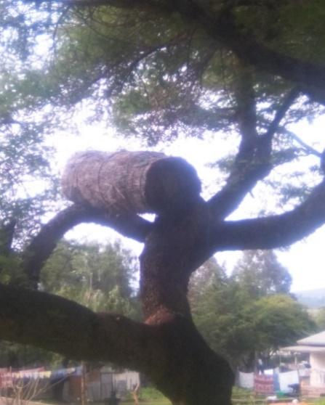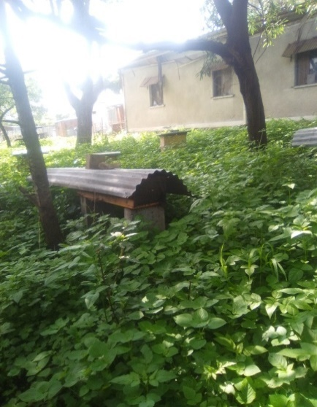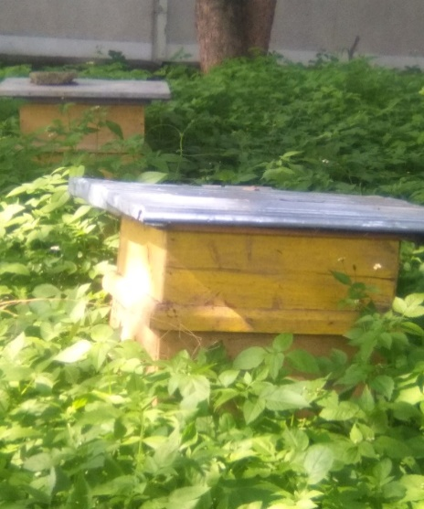
Plate 3. Different types of hive customized to culture honey bee. Photo May 11, 2019.

    - Honey harvesting season
Researcher gathered data from the local farmers and respondents to identify the seasonal productivities of honey bee and related with the periodic application of pesticide to the floriculture factories. Data gained from the floriculture manager describes that there is no periodic and seasonal determination of spraying pesticide inspire of the health standards of their flower culture. There are natural and materials indicator of flower health standards whether it infected by insect pests, fungi pest or other problems. Thus they are responsible to apply pesticide at the time they see any change on their flowers.
Figure 1 below showed that from the respondents provided question on what season honey production was most successive and yielded high, most of them responded that honey was highly harvested in autumn season than the other yearly seasons. 48% of the respondents collect their honey during autumn season while 2% of the respondents do not collect honey at autumn season. When compare this with summer season only 2% of the respondents collect honey from their hive during summer season

Figure 1. The rate of respond on honey harvesting season
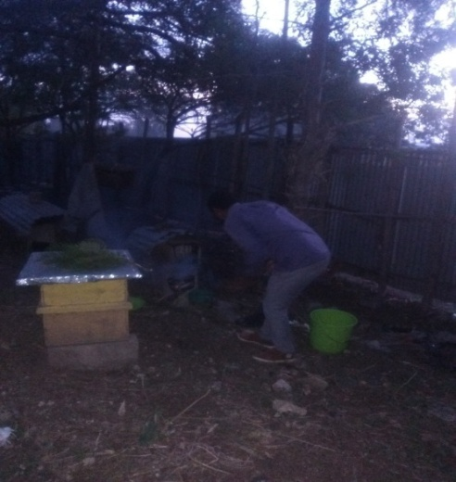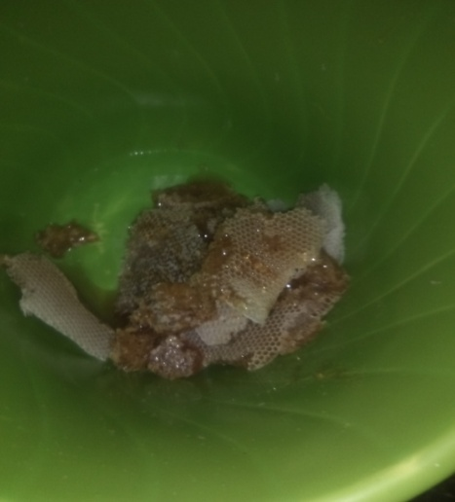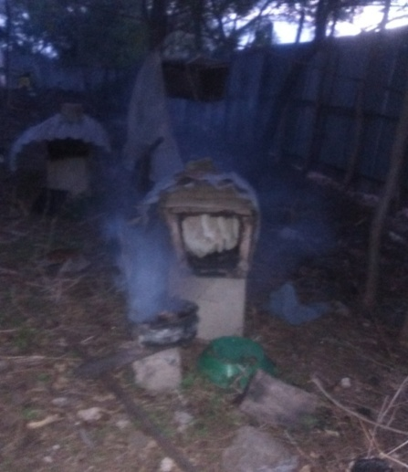
Plate 4. Honey Bee keeper harvesting honey Photo on May 12, 2011
And 48% of the respondents do not get any yield from their bee colonies during summer. In the rest two season; spring and winter there are a moderate honey production and these accounts 42% and 36% respondents collecting good honey yields.
On the other hand the amount of honey and quality of honey harvested from different bee colony and different bee hive determined by the species diversity of bee colony and the nature of hive. Most farmers still used to culture their bees in traditional hive and few and those supported by Kebele agricultural expert and supervisors were practicing to use modern hives. Nevertheless of the diversity of bee and hive, the quantity of honey production becomes reduced every year in Sebeta Awas woreda.
    - Average honey products harvested at single harvesting period
The average honey product of bee colony from respondent at every harvesting period and the values statistical description indicates the average honey product per a hive with single harvesting time was ranges between 2.58 kg to 3.04kg and this values highly contradict the report of (Tekleberhan Tsega and Welay Kiros , 2017) and (Chala Kinati et al., 2013) that the average honey product from hive per single harvesting period ranges between 22 ± 4.56 kilogram of honey per year from frame hives and 16.2 ± 4.12 kilogram of honey from transitional hives were harvested, which was calculated as about 10kg honey within a very single harvesting time.
It can be clear in table 3 below, of 42 respondents having traditional hives, the total mean of honey product gained per a traditional hive at one period accounts 2.28kg and the maximum value weighs7.00kg while the minimum weighs 0.7kg honey per single harvesting time
Table 3. Honey harvest per a traditional hive at one harvesting time in kilogram.

 | No respondent | Range | Minimum product | Maximum product | Mean |  | Std. Deviation | Variance
Honey product per hives | 42 | 6.30 | .70 | 7.00 | 2.8131 | .22824 | 1.47917 | 2.188

    - Average honey products harvested annually per a hive.
As explained in Figure 2 below the annual honey product of the modern hive seem to be very low, although a scientifically implemented and investigated proved hiving and bee management was practiced. These figure prints out that from the 8 respondent having modern hive, the maximum productivity is 20kg per a year from one hive and at a minimum some of the respondent harvests only 10kg per a years. The average honey annual harvest from modern hive do no more exceeds 14.25kg per years. This is too low when compared with the annual honey produced in wonchi bee keeper association which weighs 30kg honey per a modern hive (Taye Beyene, 2014) explained the amount of honey yield per hive was improved because the association is giving different input supply such as modern bee hive with accessories and technical support such as training and advice to the farmers.
The Wenber godeti agricultural manager explained during the interview, even though the average honey yield per hive of the members of honey bee keepers improved, the amount of honey yield is very low compared to the potential of the area, due to different factors including high cost of improved bee technologies such as modern bee hives, problems of pests and predators and application of agrochemicals.
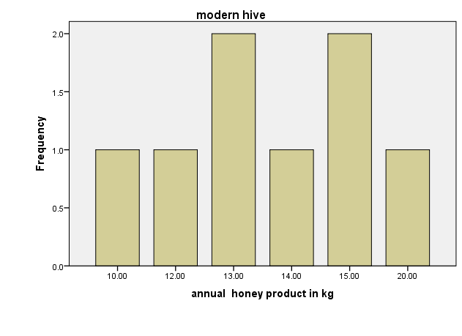
Figure 2. Representing the annual honey product of modern hive
Figure 3 below indicates the maximum honey produced from traditional hive per a year accounts 14 kg and out of 42 respondents 9 of them harvests only 8kg while the minimum product harvested per year weighs 4kg.
Traditional hive
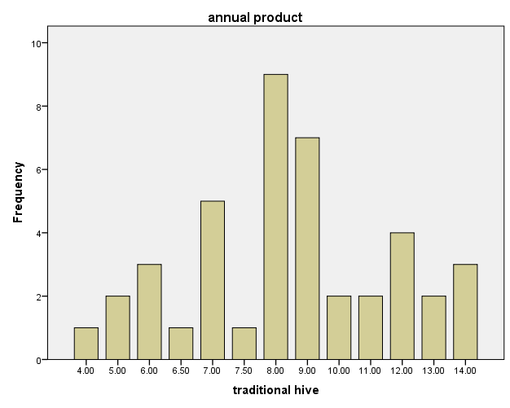 Annual honey product in kg
Figure 3. Annual honey product from traditional hive in kg
When compared annual honey product of modern hive with annual honey product from traditional hive, it seem to be slightly different that the maximum honey product from modern hive per a years is 20kg while the maximum annual honey product from traditional hive a weighs 14kg. This little bit difference determines that the potential of bee honey production is too low even whatever the bee management is so sophisticated or not. Taye Beyene (2014) explains that the environmental factors like agronomical pesticide chemical application like in flowery factories and horticulture dramatically decrease honey bee productivity by causing massive loss of bee colony, reduction in bee reproduction and bee disease like neurogenic cancer.
The gathered data from the four kebeles of Awash Melka district agricultural expert office shows that the average annual honey production reduced by 5% every years. The data record of the two kebeles; Balchi Jimjima and Wenber godeti, in past ten years described as follows.
As the Table 4 below indicates Wenber godeti and Koye have continues data record indicating the amount of honey collected each year from the Kebele bee keepers. As analyzed data describes in the table above the average mean honey collected in Wenber godeti was 61.909kg and this describes the average honey harvested in ten past years was too low. When comparing with Koye there was too high honey collection than in Wenber godeti. In Koye the average annual honey production accounts 184.272 kg and this exceeds by three times than what produced in Wenber godeti. For the two rest kebeles namely Buro Finca and Oda Gudda, there was no full and enough recorded data describing the annual honey production.
Table 4. Data showing the annual honey harvest of four kebeles in past ten years.
years | Wenber Godeti(kg) | Koye(kg) | Buro Finca(kg) | Oda Gudda(kg)
2000 | 82 | 240 | - | -
2001 | 78 | 180 | - | -
2002 | 67 | 230 | - | -
2003 | 77 | 210 | - | -
2004 | 66 | 219 | - | -
2005 | 76 | 190 | - | -
2006 | 70 | 200 | - | 100
2007 | 55 | 190 | 60 | -
2008 | 50 | 70 | 120 | -
2009 | - | 142 | 80 | -
2010 | 60 | 150 | 70 | -
Source; The annual honey product from agricultural management officers (2000 -2010)
The Kebele administrative explained as the data was fired and damaged because of conflict in past two years. The scientific determination of the difference among the two kebeles investigated by the researcher explained that Wenber godeti was a site for Eney Ethio rose factory and this indicates the closeness and existence of this factor has negative impact on honey production of this Kebele. The evidence gathered from the Kebele native people defines their honey production become lower since flower industry planed here at 1997. Additionally the local population has going to lose their bee colonies since the establishment of the factory. Researcher interviewed local farmers on what challenge meet them during bee keeping and they explained that bee colonies were lost because of mass death and queen less particularly during winter season. Graph 1.1 shows few peoples collect honey product from their hive and there more or less related with the loss of bee colony and inability of bee to overcome the external factors.
    - Relationship between bee loss and pesticide application in flower industry
Table 5 below indicated data summarized from the respondent and flower factory manager presented in table 1.4. Explain the application of pesticide to flower factory has negative impact on bee keeping that the bee loss is high as the pesticide spraying is also high. The scientific close observations of the impact of pesticide chemical called acetamiprid cause immediate death on honey bee, Adebabay (Adebabay Kebede et al., 2008). As (Kumar, 2010) explained in his research, the insecticide chemical sprayed in these industries are potentially carcinogenic and insect poisoning inorganic chemicals that kills, toxifies and poisons insects like honey bees.
Table 5 Relationship between flower factory and bee keeping
Seasons of a year | Flower factory |  | Bee keeping
Seasons of a year | Insect visiting flowers | Requirement for pesticide Application | Honey production | Bee colony loss
summer | low | low | low | Low
autumn | low | low | high | Low
winter | high | high | low | High
spring | high | high | moderate | High

Factors for bee lose indicated by the research finding related with the environmental contamination and pollution with pesticide sprayed in flower factories. Dennis et al., (2007) suggests that 40.8% of bee lost was causative of contagious pesticide to environment, thus it exceed the ratio of bee lost because of colony collapse disorder (CCD).
    - Change in honey production through the time
Table 6 below indicated most of the interviewed farmers in the study area (96%) responded that honey yield is decreasing over the years due to shortage of bee forage agrochemical spray, pests and predators and lack of improved bee hives. This report agrees with the report of (Taye Beyene, 2014) and (Tessega Belay, 2009) indicated that honey bee products production was in a decreasing trend due to shortage of bee forage, problem of agrochemical, pests and predators and poor management in wonchi bee keeping association of Oromia region and Bure district of Amhara region.
Table 6. Response from respondent on the status of bee products..
Item | Response | Types of change | No. of respondent | Percentage
Do the yield changed through the time | Yes | increased | 2 | 4
Do the yield changed through the time | Yes | Decreased | 48 | 96
Do the yield changed through the time | total |  | 50 | 100
The integrate interview with local farmers losing their honey bee defined that most of the farmers of Awash Melka district lose their bee colony one to two decade past years which prescribe since the implementation of Eney- Ethio rose and Jimjima floriculture industry at 1995 and 1997 respectively. The data gained from Koye agricultural office explains, Kebele had a three model bee keeper farmers those were rewarded by woreda agricultural bureaus, five years past but now a day none of them have bee hive and they lost their bee because of different environmental factors. The rescued farmers’ explained as they lost their bee colony by massive death in their hive. These is agreed with the research reported by Frank and Cruz, (2016) that pesticide cause colony sub lethal risk in three scenarios as risk of bee exposure to spray when placed to downwind drifted by areal or ground- rig application
In Table 7 below 74% of respondent thinks floriculture industry has negative impact on honey production, while 26 % of the respondent thinks there is no negative impact of the industry on bee production. Most of the respondents result indicates environmental chemical pollution is the leading factor causing honey bee lost and bee productivity loss. From the total 50 respondent asked 24 of them reasoned that pesticide chemicals were the cause for the loss of honey production. These accounts about 48% of the respondents and the rest percentages relate it with natural environmental factor like weather change, drought and desertification.
Table 7 Represent data of the factor causing decrease of honey bee productivity.
Item | Response | No. of respondent | percentage
What do you think will be the reason for the change in honey bee productivity through a years? (7) | Environmental chemical pollution | 24 | 48
 | Drought and desertification | 5 | 10
 | Weather change | 16 | 32
 | Absence of flowering plant | 3 | 6
 | Lose of bee diversity | 2 | 4
 | total | 50 | 100
Do you think flowery culture industry has negative impact of honey production? (8) | yes | 37 | 74
 | No | 13 | 26
 | Total | 50 | 100
Is there flowery culture industry around your homeland? (10) | Yes | 47 | 73
Is there flowery culture industry around your homeland? (10) | No | 3 | 27
Is there flowery culture industry around your homeland? (10) | Total | 50 | 100
For the question raised from the researcher whether the floriculture has negative impact on bee production and productivity on local bee keeper or not, the respondents explained as floriculture exerting definitely high effect on bee culturing by causing environmental pollution in spraying pesticide chemicals particularly during winter season when there is scarcity of blooming plant that the bee obligated to visit and collect nectar from any source.
Eney Ethio Rose manager explained in interview that their flower need pesticide treatment more in winter season when there is high heat than in rainy and cold season. In winter season, he explained there is high fungal, insect pest and other microbial infection to their flower product. Thus the application of pesticide and fungicide exceed more in winter season than in summer and autumn. Buro Finca agricultural expert and supervisor interviewed and explained honey bee colony infection and death is high in winter season than in other three seasons.
Of 50 respondents exposed for questioner, 73 % bee keepers were settled around floriculture industry because of the accessibility of plant flora at the basin of Awash River that is occasionally managed as historical site of human fossil. This site responder explained, used as a site where most industrialists seek to invest on particularly for irrigational system. For the Moment of study, the two floriculture industry settled at the basin of Awash river and all the remnant of industry flow down to the river
    - Productive rate of bee colony per a year.
As shown in Figure 4 below more than 30% of the respondent’s harvested honey once a year from traditional hive and 4% and 6% for respondent harvest once per a year from modern and transitional hive respectively. In addition, respondents having modern hives 26% and transitional 12% also harvest honey twice a year, even though the hive technology is improved and (8%)of respondent harvest honey twice from the traditional hive. About 6% of the respondents having modern hive were able to harvest three time a year, which is slightly higher than noted for transitional hive 4% and much higher than the traditional hive 0% and It agreed with what proposed by (Tekleberhan Gebremedhin and Welay Kiros , 2017).

Figure 4. Honey harvesting rate per a year
The evidence from Sebeta town and Sebeta Awas woreda water quality management explained Awash River is frequently polluted with pesticide chemical and polluted west water drains to the river.
    - Pesticide Chemical used in floriculture industries
Eney- Ethio rose and Jimjima floriculture industries currently produce several flower species, including roses like golden rose, wild rose and modern garden rose, gypsophila, and chrysanthemum. Data gathered from the two floriculture factory namely Eney-Ethio rose and Jimjima floriculture factor indicates that luniferon and acetamiprid were the type of pesticide sprayed to control insect pests.
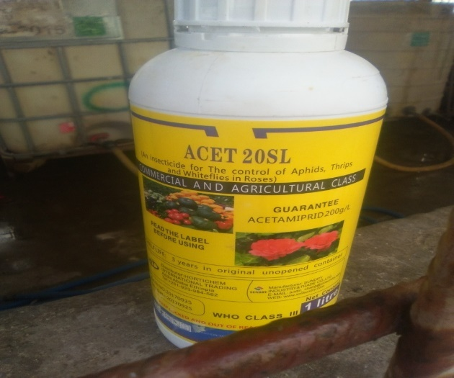
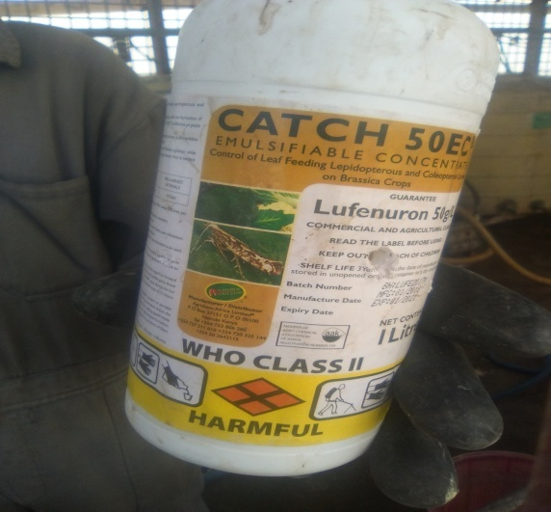
Plate 5 Pictures of pesticide chemical taken from eney Ethio rose factory On May 2019
Although these chemicals were effective to control and eradicates insect pests, the investigators hasn’t gate data showing the care and responsibility taken for protection of essential insects like honey bees. This agree with the report of (Mesay Adunga, 2017) that only less amount of the applied pesticide reaches the target pest and high percent of the pesticide rest on non-targeted living being and these cause health impact on life. The chemicals cause health effect to honey bee in similar way of harmful insects. The adverse effect of pesticide use includes degrading soil and water quality, the effect on non-targeted lives like human beings, cattle, insects, soil organisms, aquatic life etc. air pollution, and an increase of pesticide resistance by targeted pests.
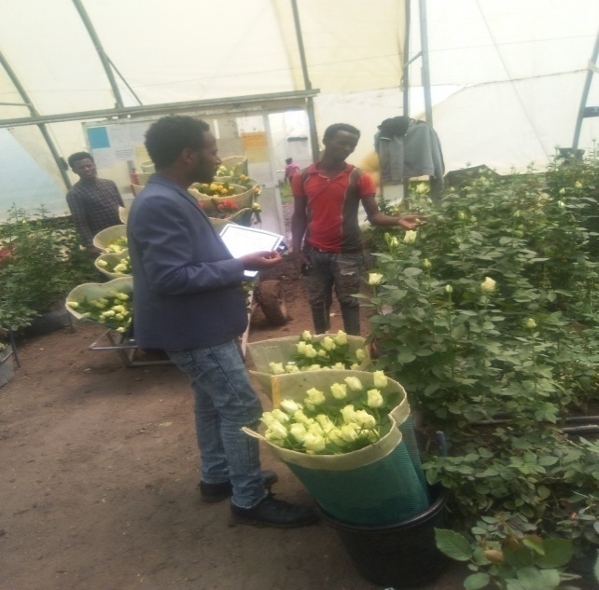
Plate 6 Pictures showing pesticide application, Photo May 21,2019.
Lufenuron and acetamiprid were the group of very poisonous chemical pesticide that causes cancer and infertility to insects. Neonicotinoid is chemical contaminates the nectars and honey bee suck this chemical, then the chemical is normally systemic which affect bee immune system, allowing them to be fall to prey and farther explain majority of the sample of honey were found to be contaminated with Neonicotinoid including acetamiprid, clothianidin, imidacloprin and thiacloprin. American society of entomology (2015) research gets shows that out of 26 pesticides applied in pesticide control only seven were less killer of honey bees. Among these chemicals acetamiprid was the Neonicotinoid pesticide that is used to kill insects including honey bee (Frank and Cruz, 2016).
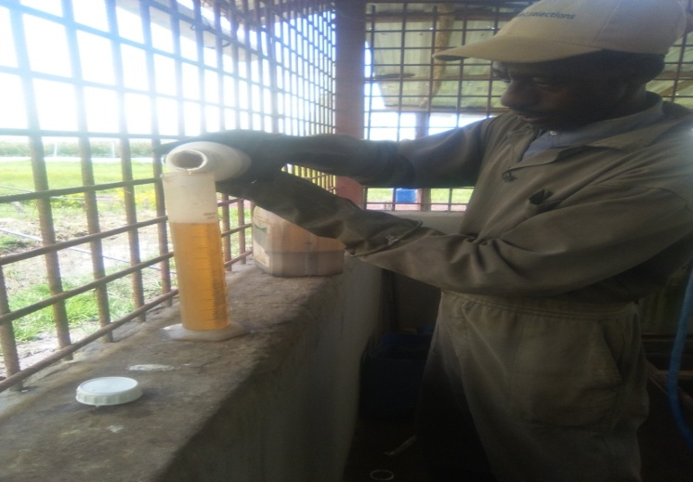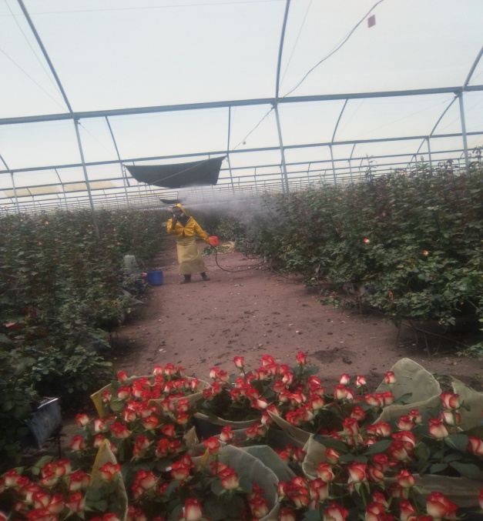
Plate 7 Pictures showing the sampling of Lufenuron and acetamiprid chemicals and its application on May 5, 2019
Lufenuron is anti-chitin synthesis chemical applied to control insect pest by preventing the development and synthesis of exoskeleton in the process of reproduction as Margaret. et al., (2016) reported in his research and these chemical pesticides sprayed in floriculture were commonly called neonicotinomide which includes poisonous family acetamiprid, Lufenuron, clothianidin, imidacloprin, of which acetamiprid, Lufenuron and imidacloprin were widely used insecticide and they cause high toxicity to insect than mammals. Impact of this class of insecticide on pollinating insect such as honey bees was a cause for concern. Because they were systemic chemicals absorbed in to the plant Neonicotinoids can be present in pollen and nectar making them toxic to pollinators that feed them.

  - DISCUSSION
Eney Ethio rose and Jimjima floriculture factory used to apply neonicotinomide family pesticide which is poisonous to honey bee and other insects which are environmentally beneficial. These chemicals are carcinogenic, neurologically hazard and intra systemic poison which cause insects infertile, diseased and nerve damage and even death in massive (Taye Beyene, 2014).
The interview with industry greenhouse servant on the periodical chemical treatment of flower explained there were two favorable period of spraying for effective treatment, which were the time interval between three hour to five hour (3:00 -5:00) during morning time and otherwise from seven hour to eleven hour during afternoon (7:00 – 11:00). These scientifically analyzed as the favorable period of pollinating insect to forage and visit flowers because of the attraction of flower odor when bloom opens at sunrise. These agreed with the statement explained that honey bee forages nectars and pollen from mid-morning to mid-afternoon on calm sunny days when the temperature is above 70⁰F (Margaret et al., 2016). These exposes honey bee to the risk of pesticide effect sprayed to floriculture and cause death.
The death and decrease in bee colony strength consequently cause loss in honey and loss of plant product because of loss of pollinator. The nectar contaminated by pesticide chemicals so called nionicotinomides infects and poisons bee, which result in poisoning of bee product so called honey. The quality of honey determined by its organic nature as described by (Frank and Cruz 2001) as honey bee collect poisonous nectar and the bee product is poisoned with inorganic pesticide, then the honey quality will be losses. Lufenuron and acetamiprid used in the eney and Jimjima floriculture is neonicotinomide family that highly poisons honey bee which is agreed with (Mesay Adunga, 2019)
Contamination of natural environment with pesticide chemicals results in loss of honey bee colony particularly in Sebeta Awas, Awash Melka district, where farmers using traditional hive in wild than the modern hives, these cause reduction of bee products. As indicated in table (1) above, out of 130 local farmers selected, only 50 have been used to culture honey bee and of these 42 of them used to keep their honey bee in tradition al hive. These accounts 84% of the total farmers sampled used to keep honey bee in traditional hive.
The annual honey production in Sebeta Awas Woreda, Awash Melka district became reduced every year and particularly in the two kebeles namely Koye and Wenber Godeti seen in table (4) harvests honey bee by an average of 184.2kg and 61.90kg per a year. This diversity of the honey products implies the closeness of the apiculture to floriculture has great effect on honey production. In these kebeles, the annual honey products per a hive account 14.25kg per a modern hive and 7.79kg per a traditional hive in averages. These reduced to a range of 2.58kg to 3.04 kg of honey per a single harvesting period per a hive, which is highly contradicting with (Tekleberhan Gebremedhin and Welay Kiros, 2017), that the average honey product from hive per single harvesting period ranges between 22 ± 4.56 kilogram of honey per year from frame hives and 16.2 ± 4.12 kilogram.
The decrease in honey product and quality directly related with the spraying of pesticide chemicals in floriculture industry. As indicated in graph (1) above the honey production season of honey bee was autumn and spring while there is natural flowering plants and these contradict with summer and winter season when there is high blooming in floriculture but high pesticide spraying and is a time of less honey production, Table (5). It is clearly indicated in Table (6) that 96% of local Kebele bee keepers have been lost their honey product because of pesticide application impact of floriculture and Table (7)shows 48% of the respondent reasoned pesticide environmental contamination was the factor to loss bee and bee products in Sebeta Awas woreda. Among the respondent of the research 74% of them were settled nearest to Eney Ethio rose and Jimjima floriculture industry and they were undermined by the industrial impact for more than 17 years.

- CONCLUSION AND RECOMMENDATION
  - Conclusion
In Ethiopia, the economic advantage of the floriculture industry has overshadowed social and environmental sacrifices of the sector. There are different perceptions with regard to the socio-economic and environmental impacts of the sector in the country. Some government officials believed that the environmental and the social effect of the sector are very insignificant and should not be considered. Other environmental and social concerned bodies believed that the country is scarifying much more than the government expected. However, environmental concerns are growing because; floriculture requires intensive use of chemical fertilizers and pesticides, the country honey production and bee diversity dramatically lowering down through the years.
The Chemical pesticide sprayed in floriculture is commonly called neonicotinomide which includes poisonous family acetamiprid, Lufenuron, clothianidin, imidacloprin, of which acetamiprid, Lufenuron and imidacloprin are widely used insecticide and they cause high toxicity to insect than mammals. Impact of this class of insecticide on pollinating insect such as native honey bees is a cause for concern, because they are systemic chemicals absorbed in to insect body as Neonicotinoids can be present in pollen and nectar making them toxic to pollinators that feed them. Ethiopian bee keeping and management still need to give high level of consideration in scientific investigation. Half percent of farmers and small house holder economically relayed on the raring and culturing livestock, bee keeping and crop production.

  - RECOMMENDATIONS.
- It is recommended to apply pesticide only pre flower blooming or after flower petal fallen off when flower are less attractive too bees, that it reduce the risk to bees coming in contact with pesticide.
- The country should implement the rules and Policies of environmental protection and evaluation to assist nature and natural well-being respective to floriculture investment and pesticide application.
- Floriculture industry should use alternative method of pest control that is environmental friendly.
- It is recommended to spray pesticide that is less toxic to bees, if it was for ornamental plants that are in bloom.
- It is recommended spraying pesticide after sunset or before sunrise since honey bee mostly visits and forage flowers after sunrise.
- Awareness creation intensive training and discussion should be organized among the district beekeepers and floriculture industry to avoid application of pesticide when honey bees are highly foraging in green house.

- Reference
Addisu Mergia (2007). Abundance and Diversity of top Soil Earthworms in Relation to Chemical use in Golden Rose Agro farm, Tefki Area, Ethiopia Pp34.
Adebabay Kebede, Kerealem Ejigu, Tesema Aynalem and Ababa Jembarie (2008). Assessment of the status of Beekeeping in the Amhara Region, Ethiopia. Amhara regional agricultural research institute, Behar Dar 1: 32-35.
Alemayew Kebede (2011). Honey Bee Production Practices and Honey Quality in Silti Wereda. Ethiopia. M.Sc thesis, Haramaya.
Anju R., Beena K., Gahlawat S., Sihag R. and Kathpal T. (1997). Multi residue analysis of market honey samples for pesticidal contamination. Pesticide Research Journal. 9(2):226–230.
Ankra B. G. A. (2012). Honey Bee “Sickle cell leg ulcers in Ghana, “East African Medical Journal 69(7): 366–369.
Ashley P. and Taylor W. (2016). Drone exposed to Neonicotinoids have fewer viable sperm and slow reduced longevity. http:// www.insect.com. Assessed 27 Jun 2019
Beyene Tamiru and Davide P. (2007). Ensuring small scale producers in Ethiopia to achieve sustainable and fair access to honey markets. Paper Prepared for International Development Enterprises (IDE) and Ethiopian Society for Appropriate Technology (ESAT).
Carola A. K. and Diana M. (2009). Environmental factors affecting bee diversity in urban and remote grassland plots in boulder of Colorado. Journal of insect conservation 13(6):655-665.
Chala Kinati, Taye Tamiru and Tadele Tamiru (2012). Opportunities and challenges of honey production in Gomma District of Ethiopia. International Conference on Bridge Scales and Epistemologies, Alexandria. Journal of agricultural extension and rural development 4(4): 85-91.
Dennis V., Jerry H. and Robiyn M. (2007). A Survey of Honey Bee Colony Losses in the U.S .A. Journal of insect conservation (3) 12.
Diane C. (2013). Honey Bee Health and Population Losses in Managed Bee Colonies. May 2013
Edessa Negera (2002). Survey on honey bee production system in West Shoa Zone (unpublished). Holeta Bee Research Center (HBRC), Ethiopia P.15
Ethiopian Horticultural Strategy (2007). Development of Strategy for Export oriented Horticulture in Ethiopia: Draft paper, February 2007.
Ethiopian Horticulture Exporter Association pamphlet (2007). http://www. Aiga forum. com. assessed 15 July 2019
Fatuma Abdulfeta (2007). Social and Environmental Implication of Floriculture. A Stake Holder’s Perception Analysis at Holeta Area, Welmera Woreda Oromia Region. AAU unpublished.
Frank B. and Cruz E. (2001): Flower for Justice, Implementing the International Code of Conduct, Friedrch Ebert Stinting. Pp. 72
Gebregziaber Gebremedhin, Gebrehiwot Tadesse and Estay Kebede (2013). Physio-chemical characteristic of honey obtained from traditional and modern hive production system in Tigray region, northern Ethiopia. Momona Ethiopian journal of sceince 5(1):115-128
Getu Mulugeta (2009). Mizan Law Rev: Ethiopian Floriculture and its Impact on the Environment. 3(2) [Online] Available: http:// www. Ajolinfo/index /Php/mlr/article/view File/ 54011/ 42554. Assessed 21 October 2018
Gudeta Degynatu (2012). Socio-economic and Environmental Impact of Floriculture Industry in Ethiopia. Unpublished thesis. Haramaya university.
Hamrick D. (2004). Can Dutch roses survive", Floriculture International trade, 4: 232-245
Jinanus Dinka and Tamiru Kumsa (2016). Factor Affecting Honey Production in Ambo District, West Shewa Zone. Oromia Regional State, Ethiopia. ; International Journey of Economics and Business Management. 12:170-182
Kelly S., Heaton K., and Hoogewerff J. (2005). Tracing the geographical origin of food: the application of multi-element and multi-isotope analysis. Trends in Food Science and Technology 16(12): 555–567.
Korta E., Bakkali A., Berrueta L. A., Gallo B., and Vicente F. (2002). Study of an accelerated solvent extraction procedure for the determination of acaricide residues in honey by high-performance liquid chromatography-diode array detector. Journal of Food Protection, 65(1):161–166.
Kumar H. (2010). Effect of Honey Bee Pollination on Productivity and Quality of strawberry. Journal of agricultural science. 32 (20): 87-90.
Laws N. (2006): "Ethiopia: the next production hot spot-floriculture", Flora Culture International, available at: http://www.honeybee.pest. Art. com. Assessed 11 march 2019.
Lorenz E. (2009). Potential health effects of pesticides. Agricultural Communications and Marketing, 1: 1–8.
Margaret J., Couvillon F., Ridden P., Christopher A., Katherine A. F., Shaun K. L. Esme L. T., Francis L. 2016. Honey bee foraging distance depends on month and forage type. Apidologic springer Verlag 46(1): 61-70
Mariana I. (2017). Biological Farming by Using Integrated Crop Management. Kenya, UK. Dudtech.Com. Bulgarian Organic Nuts and Honey. Best Quality and Service. http:// www. Bulgarian Nuts. Com. Assessed 23 October 2018
Marina D. (2010). Managed Honey Bee Population in Europe and the United States and the factors that may affect them. Journal of invertebrate pathology 103: 80-95
Melaku Girma, Shifa Ballo, Azage Tegegne, Negatu Alemayehu and Lulseged Belayhun (2008). Approaches, methods and process for innovative Apiculture Development: Experiences from Adaá Liben woreda Oromia Regional State, Ethiopia. International Livestock Research Institute 8:1-38
Mesay Adunga (2017). Review on Environmental Effects of Ethiopian Floriculture Industry.AsianResearch Journal of Agriculture 4(2):1-13.;Article no.ARJA.31884
Mulugeta Getu (2009). Ethiopian Floriculture and Its Impact on the Environment; regulation, supervision and compliance, mizan law review 3(2):240
Mutungi E. (1998). Factor Affecting Honey Bee Production in South East Kenya Range lands. A Case Study of Kibwuzi Division, Makueni District. 43pp
Nuru Adgaba (2007). Atlas of Pollen Grains of Major Honey Flora of Ethiopia. Holeta Bee Research Center. Holeta, Ethiopia.
Sefinew Alamu, Gizachew Gemechu, Assmalu Bezabeh and Malede Berhan (2013). Prevalence and associated risk factor of bee lice in Holeta and its surrounding. Ethiopia, Journal of veterinary science and technology 5:312-345
Taye Beyene (2014). Assessment of the performance of wonchi beekeepers’ association: a case of wonchi district, south west shoa zone of Oromia, Ethiopia. 2: 2
Tekleberhan Tsega and Welay Kiros (2017). Honey-bee production practices and hives technology preferences in Jimma and Illubabor Zone of Oromia Regional State, Ethiopia. Acts on agriculture and environment 9:31-36.
Tessega Belay (2009). Honey Production and Marketing Systems, Constraints and Opportunities in Bure district of Amhara region, Ethiopia M.Sc. Thesis, Bahir Dar University.

Appendix
1 Questionnaire used to gather data
Questioners for respondents
- Do you have honey bee? Yes No
- How money hive do you have? -------------Traditional Modern
- What average honey bee colony do each hive contain?------------ Traditional Modern
- What is the average honey products harvested annually? ----------- Traditional Modern
- How many gram of honey product collected from one hive at a single harvesting time in average? ------------------
Traditional Modern
- The average gram of honey from one hive per a year? ------- Traditional Modern
- What is the optimum harvesting season? summer autumn spring winter
- Do the yield changed through the time?
Yes No Increase Decreased
- What do you think will be the reason for this change?
- Is there flowery culture industry around your homeland? Yes No when it planted --------------
- Do you think flowery culture industry has negative impact of honey production? Yes No
- What is the reproductive rate of bee colony per a year? Once Twice Three times Above
- What honey product you mostly use? Honey comp Fresh honey Other

Odeeffannoo dhuunfaa
  - umri----------- sala--------------
  - Sad. Barnotaa-------------
  - Gahee hojii .; hojjataa dhaabbii ---------------- hojjataa guyyaa -----------
hogganaa --------------
waardiyaa -----------------
kan biraa ---------------
  - Waggaa meeqaf as hojjattan --------------
Gaaffilee qorannichaa
- Horsiisa kanniisaaf dammaa qabdu---------
- Gaagura meeqa qabdu --------------- kan ammayyaa ------------------- kan aadaa--------------
- Tokkon tokkoo gaagurichaa tilmaamatti kanniisa meeqa qabachuu danda’a? kan ammayyaa------------ kan aadaa -----------------------------
- Gaagura tokko keessaa waggaatti damma si’a meeqa oomishama?
Kan ammayyaa ------------------ kan aadaa--------------------
- Gaagurri tokko tilmaaman al tokkotti damma graama meeqa baha? Kan ammayyaa ---------------- kan aadaa -------------.
- Gaagurri tokko waggaatti tilmaaman damma grama meeqa baha? Kan ammayyaa ---------------- kan aadaa-----------------
- Dammi waqtii kam baayyinan oomishamaa? 1) waqti gannaa-------,2) waqtii birraa------- 3) bonaa-------- 4) waqtii arfaasaa------
- Oomishni dammaa keessan waggaa waggaan yommuu ilaaltan dabalaamo irrachaa dhufe? A) Dabalaa -----------------B) hir’achaa----------------
- Sababni isin keessan hoo maal fa’a ta’uu danda’a ?---------------------------------------------------------------------------------------------------------------------------------------------------------------------------------------------------------------------------------------------------------------------
- Oomishinni abaaboo naannoo keessan jiraa? eeyyen-------------- lakkii-------------
- Industiriin oomisha abaaboo oomisha dammaf kanniisaa irratti miidhaa fida jettanii yaaddu? Eeyyen-------------- lakki------------
- Gurmuun kanniisaa gaagura tokko keessa jiru waggatti si’a meeqa dhala?
Kan ammayyaa------------ kan aadaa-------------------
- Baayyinni kannisota (jiisaa) haaraa dhalatanii tilmamatti meeqa ta’u?-------------
- Bu’a horiisa kanniisaa baayyinan fayyadamtan isa kami? Dammaa walalaa ---------- gagaa --------------- gurguraan -------------
- Jidduu galeessatti damma kilo grama tokko hammamiitti gurgurattu ---------------waggattii-------------
- Gaagura keessan keessatti kanniisni du’anii argaman jiru? Eyyen------- maltu ajjeese isinitti fakkaata--------------- lakki-------------
- Haala gara fuula duratti oomisha dammaaf kannisaa irratti yaadni isin qabdan yoo jiraate-----------------------------------------------------------------------------------------------------------

Appendix 2 Plates collected during observation
  - Study area
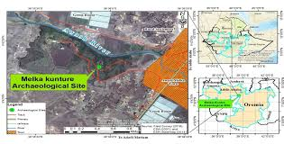
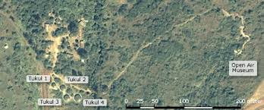
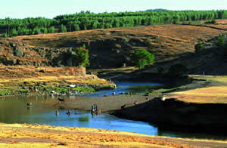
  - Interview with greenhouse servant
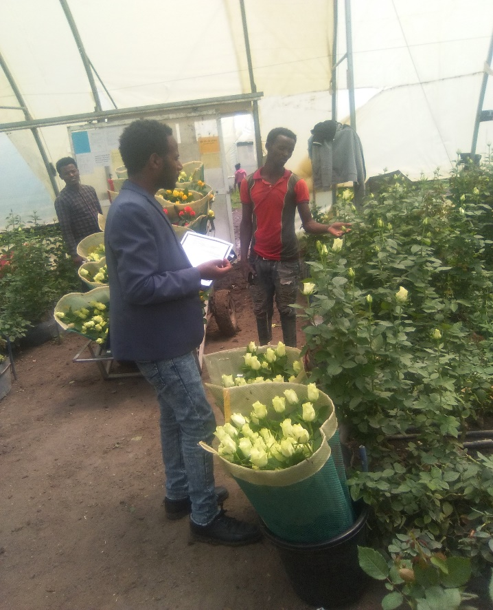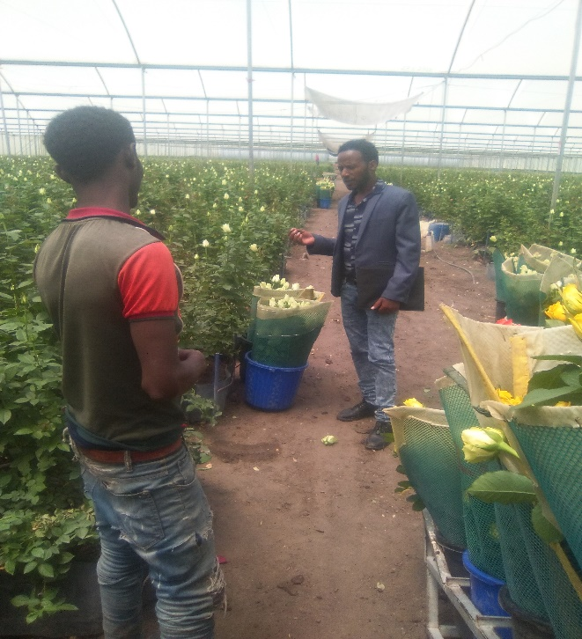

  - Stratifying the floriculture site
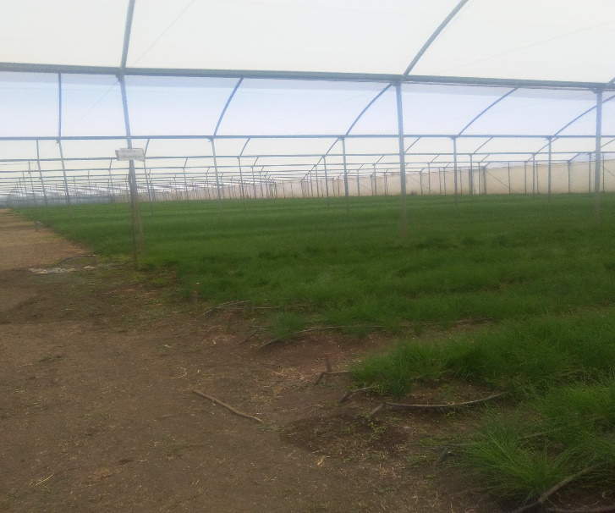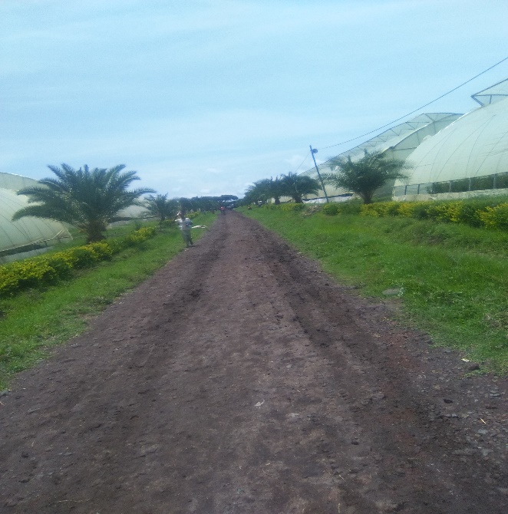
  - Interview with floriculture manager
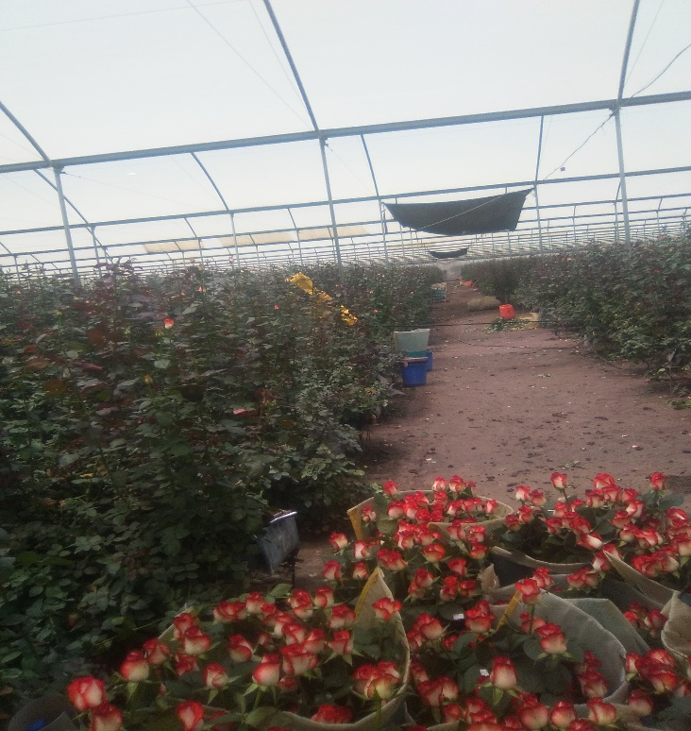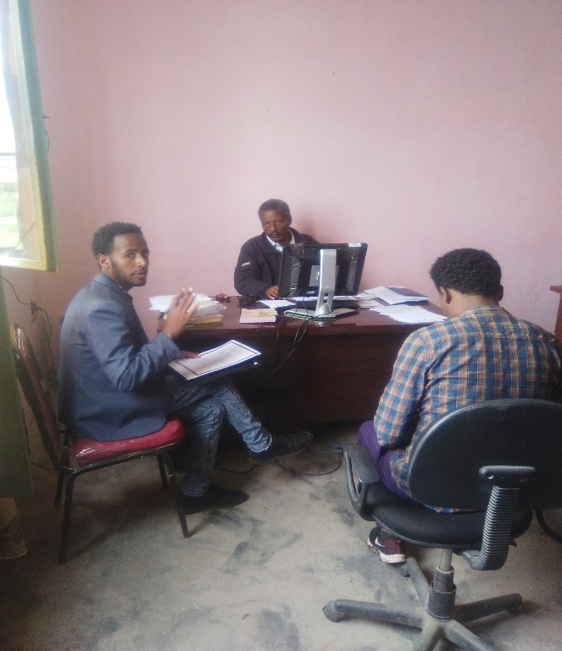
  - Plates of pesticides used in floriculture industry
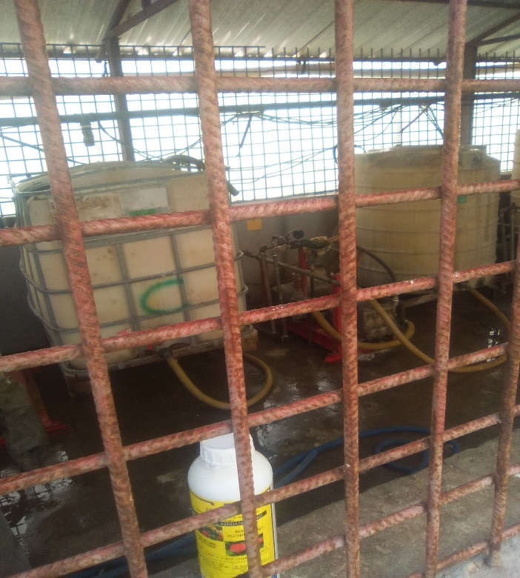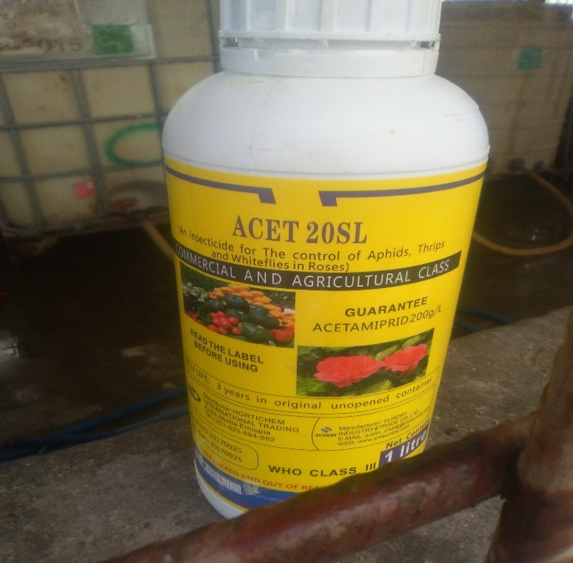

  - Spraying pesticide in green house
