ADDIS ABABA UNIVERSITY SCHOOL OF GRADUATE STUDIES


ACTIVITY PATTERN, FEEDING ECOLOGY AND POPULATION SURVEY OF DE BRAZZA’S MONKEY (CERCOPITHECUS NEGLECTUS) IN BILO NOPA WOREDA, ILU ABA BOR ZONE, OROMIA REGIONAL STATE, SOUTH WESTERN ETHIOPIA.

A Thesis Submitted to the Department of Biology in Partial Fulfillment of the Requirements for the Degree of Master of Science in Biology Addis Ababa University Zoological Sciences Addis Ababa, Ethiopia.

DIRIBA CHEWAKA

ADVISOR: HABTE JEBESSA (PhD)

August, 2018

ADDIS ABABA, ETHIOPIA

Activity Pattern, Feeding Ecology and Population Survey of De Brazza’s Monkey (Cercopithecus neglectus) in Bilo Nopa Woreda, Ilu Aba Bor Zone, Oromia Regional State, South Western Ethiopia.

Diriba Chewaka

A Thesis Submitted to Department of Biology School of Graduate studies Addis Ababa University in Partial Fulfillment of the Requirements for the Degree of Master of Science in Biology.

Addis Ababa University
School of Graduate studies

This is to certify that the thesis prepared by Diriba Chewaka entitled: Activity Pattern, Feeding Ecology and Population Survey of De Brazza’s monkey in Bilo Nopa Woreda, Ilu Aba Bor Zone, Oromia Regional State, Southwestern Ethiopia and submitted in partial fulfillment of the requirements for the degree of master of science in Biology complies with regulation of the university and meets the accepted standards with respect to originality and quality.

Signed by the examining committee:
Advisor____________________________ Signature ______Date__________

Examiner__________________________ Signature _______Date__________

Acknowledgement

First and for most I would like to express deepest gratitude to my advisor Dr. Habte Jebessa Debella who gave me constructive and very important criticism and comments on my work to complete this research paper. He shared much of his precise time in advising, guiding and supporting me.
I would also like to thank the Ministry of Education for providing my research fund. My special thanks go to Addis Ababa University and Zoological Sciences Department for its diverse helps during my master program and my gratitude also goes to Bilo Nopa Woreda Agricultural and Natural Resource Office.
Finally, I would like to thank all my friends who helped me by sharing ideas which are important for my study and providing me materials whenever necessary.

Table of content
Contents Page
Acknowledgement i
Table of content ii
List of tables v
List of figures vi
List of appendix vii
Abstract viii
CHAPTER ONE 1
1. Introduction 1
1.1. Background of the study 1
1.2. Objectives 3
1.2.1. General objective: 3
1.2.2. Specific objectives: 3
CHAPTER TWO 4
2. Review of related literature 4
2.1. Name and Taxonomy 4
2.2. Description of De Brazza’s Monkey 4
2.3. Reproduction 5
2.4. Behavior 6
2.4.1. Diet and Feeding Behavior 6
2.4.2. Social Behavior and Grouping 8
2.5. Ecology 9
2.6. Habitat Requirements and Preferences 9
2.7. Distribution 10
2.8. Natural Predators 11
2.9. De Brazza’s as a pest 11
2.10. Conservation Status 11
CHAPTER THREE 13
3. MATERIAL AND METHODOLGY 13
3.1. Materials 13
3.1.1. Description of the Study Area 13
3.1.2. Geographical feature 17
3.1.3. Soil 17
3.1.4. Climate 17
3.1.5. Flora 17
3.1.6. Fauna 18
3.1.7. Agriculture 18
3.2. Methodology 19
3.2.1. Preliminary Surveys 19
3.2.2. Habitat Use 19
3.2.3. Population status of De Brazza’s monkeys 19
3.2.4. Activity Pattern 20
3.2.5. Feeding Ecology 21
3.2.6. Data analysis 21
CHAPTER FOUR 22
4. RESULT AND DISCUSSION 22
4.1. Results 22
4.1.1. Habitat use 22
4.1.2. Population status of De Brazza’s monkeys 22
4.1.3. Group Composition 23
4.1.4. Activity pattern 23
4.1.5. Feeding ecology 24
4.1.6. Threat of De Brazza’s Monkeys 26
4.2. Discussion 27
UNIT FIVE 31
5. CONCLUSION AND RECOMMENDATION 31
5.1. Conclusion 31
5.2. Recommendations 32
References 33

List of tables
Table 1 Plant Species used by de Brazza’s monkeys in the forest. 7
Table 2 Food items eaten by De Brazza’s monkeys in percent 8
Table 3 population and elevation of De Brazza’s monkeys 22
Table 4 Age-Sex composition of troops of de Brazza’s in Bilo Nopa Forests 23
Table 5 Seasonal activity budget for de Brazza’s monkey in the study area 24
Table 6 Percentage feeding time to feed different food items by De Brazza’s monkeys 24
Table 7 List of plants, food and percentage in plant diet of de barazza’s in study area. 25
Table 8 Percent of time spent by De Brazza’s monkeys feeding on at different seasons……………26

List of figures

Figure 1 De Brazza’s monkey (Cercopithecus neglectus). 5
Figure 2 The red color shows the map of distribution of De Brazza's monkey in Africa 10
Figure 3 Tree dominated forest 13
Figure 4 Scattered tree forests 14
Figure 5 Coffee forest 14
Figure 6 Farmland 15
Figure 7 Map of the Study Area Bilo Nopa woreda 16
Figure 8 Overall activity time budgets for De Brazza’s monkeys in the study area. 23
Figure 9 Clearing Forest for expansion of farmland 27

List of appendix
Photos of De Brazza’s monkeys in Bilo Nopa Forest during the study period……………………..38

Abstract
The present study was conducted on the population status and behavior of De Brazzas monkeys in the Bilo Nopa Woreda, Ilu Aba Bor Zone, Oromia Regional State, South-Western Ethiopia, from October 2017 to May 2018. The objectives of this study were to assess the population survey, determine activity pattern, examine feeding ecology and of de Brazza’s in Bilo Nopa woreda. Materials used during the study period included digital camera, geographic positioning system (GPS), and note books. Activity pattern, feeding ecology and population survey were studied for 5 minutes with 15 minutes interval scan sampling. The result was a total of 25 de Brazza's monkeys in 3 groups and 1 solitary; including 16 adults, 4 youngsters and 5 infants. The overall activity time budgets of the De Brazza’s monkeys were given in figure 8. De Brazza’s monkeys in spent 47.91% of their time in feeding, 19.97% moving and 20.65% resting, 3.51% of its time playing, 2.33% aggression, 5.13% grooming and 0.5% sexual activities. Individuals in average spent more time in feeding (48.97%) during the wet season than during the dry season (48.64%). They spent more time moving (19.84%) and resting (20.74%) during the wet season than during the dry season (16.94%) and (21.37%), respectively. They spent more time in social activities such as playing (33.61%) and aggression (2.4%) during the dry season than during the wet season, where they spent (2.74%) playing and (1.66%) aggression. More time was also spent on other activities such as grooming (6.78%) during dry than during wet season (5.67%) and sexual activity (0.37) during the wet season than during dry season sexual activity (0.36%). De Brazza’s monkeys depended most on fruits, which accounting for 76.95% of the overall diet (n= 1332 feeding records), young leaves (13.13%) made the second largest parts of their diet. Other important food items consumed were matured leaves (3.34%), seeds and gums (2.43%) and blossoms were (1.25%). Of the 21 plant species that contributed for the overall diets of de Brazza’s, based on total percentage contribution of plant food items, Ficus species were the most consumed species. All individuals in spent more time feeding on fruit during the dry season (80.32%) than during the wet season (77.37%). Deforestation by the local people for coffee plantation, agricultural expansion, trapping, over grazing and commercial purposes could impose threat to the de Brazza’s monkey populations in the future. Therefore, it is recommended that management action should be taken to conserve the most important food resources such as Ficss species and S. guineense plant trees and further investigation should be conducted to determine the sustainable and beneficial level to integrate the local people in the conservation of wildlife.
Key words: de Brazza’s monkeys, Population, behavior, diet, threat

CHAPTER ONE

1. Introduction

1.1. Background of the study

De Brazza's monkey (Cercopithecus neglectus) is one of the most unusual species in the group of Old World monkeys commonly known as guenons (Nowak, 1991; MacDonald, 1993).

De Brazza monkeys (Cercopithecus neglectus) live in Eastern and Central Africa, in parts of Gabon, Cameroon, the Central African Republic, Zaire, Ethiopia, northern Angola, in the basin of the Congo River, the southern part of Ethiopia, the valley of White Nile, and parts of Uganda and Kenya (Decker 1995, Napier and Napier 1967). Its range was found to extend northwards to southwest Ethiopia by Brown and Urban in 1969 (Wahome, 1993).

Mostly, they inhabit riverine and swamp forests but they have been also observed in mountain forests (Oswald and Lockard 1980). De Brazza monkeys have been described as arboreal quadrupeds (Napier and Napier 1967), which reportedly also spend much of their time on the ground (Oswald and Lockard 1980). Their daily range is the shortest among all guenons about 500m (Butynski 2002, Wahome et al. 1993).

Populations of De Brazza’s monkeys are least concern because of forest fragmentation and devastation and because of hunting for their meat (in Kenya: Brennan 1985). De Brazza monkeys were reported to be living in monogamous family groups (Gautier-Hion and Gautier 1978) but other observations suggest that they are living in polygynous family groups (Rowell 1988, Wahome et al. 1993). Females are philopatric and establish a dominance hierarchy within a troop (Nowak
1991).

Behavior always has a cause and may be interaction of external stimuli and internal drive like the central nervous system and hormone (Eilbl-Eibesfeldt, 1970). Social behavior and organization may be influenced by different ecological pressures especially diet and predation (Kerbs & Davies, 1986).
The characteristic of forest monkey groups differ according to many variables which reflect responses to and exploitation of the environment and improves an individual fitness as in securing food, getting mate, escaping from predators, exchanging of information and experience. The cohesiveness and coordination of animals society are often their most striking features and forest monkeys each individual is constantly responsiveness to the movement, gestures, calls of others (Manning, 1980) certain interaction have evolved which besides having utilization function also serve to strengthen the bond between members of group.
Mutual grooming or greetings are individual activities although they performed simultaneously. They also serve to synchronize mood in group or strengthen group cohesion (Rudnai, 1970).

Body weight is between 4-9 kg with males being significantly bigger and heavier than females (Nowak 1991). Gestation period is 160 – 180 days and normally a single young is born (Nowak 1991).
De Brazza’s monkeys are mammals that typically live in relatively small groups of about six individuals. They are sometimes observed in larger groups of 16-35 individuals, and solitary males are often sighted (King, 2008; Mugambi et al. 1997). Groups often comprise one resident male, at least three adult females and some juveniles (Muriuki, 1989).

Food of these guenons comprises mainly of fruits, seeds and leaves, and also of arthropods, gum, roots, worms, lizards, etc. (Butynski, 2002, Nowak 1991). They are diurnal, active mainly in the early morning and late in the afternoon or evening (Nowak, 1991).

Their potential predators are lions (Panthera leo), leopards (Panthera pardus), cheetahs (Acinonyx jubatus), caracals (Caracal caracal), servals (Leptailurus serval), three jackal species (Canis sp.), wild domestic dogs, eagles (Polemaetus bellicosus) and eagle-owls (Bubo lacteus) (Rowell, 1988).

1.2. Objectives

1.2.1. General objective:

- The general objective of the present study was to provide information on population status, activity pattern, feeding ecology and conservation status De Brazza’s monkeys.

1.2.2. Specific objectives:

- To assess the population status of De Brazza’s monkey in Bilo Nopa woreda

- To determine the activity pattern of De Brazza monkey in Bilo Nopa woreda

- To examine the feeding ecology of De Brazza’s monkeys in Bilo Nopa woreda

- To examine the conservation status of De Brazza’s monkey in Bilo Nopa woreda

CHAPTER TWO

2. Review of related literature

2.1. Name and Taxonomy

This monkey was named for Pierre Savorgnan De Brazza, an Italian explorer originally named Pietro Savorgnan di Brazza. He lived from 1852 to 1905 and founded a city that is named for him: Brazzaville, the capital of the Republic of the Congo.

Kingdom: Animalia, Phylum: Chordate, Class: Mammalian, Order: Primate, Family: Cercopthecidae, genus: Cercopithecus and Species: neglectus. Common names: De Brazza’s Monkey, De Brazza’s Guenon, De Brazza’s Monkey, Swamp Monkey (local). The species found in the Cercopithecus genus are usually referred to as Guenons. Guenons are thought to be in the active stages of speciation (Gautier-Hion et al. 1988). The group is regularly reviewed and there is some disagreement on the taxonomy, which has in the past 30 years been described as containing one, two, four and five genera (Glenn and Cords, 2002).

2.2. Description of De Brazza’s Monkey

The de Brazza’s monkey is an “Old World Monkeys” or Guenon (Nowak, 1991). De Brazza’s monkeys are mostly covered with grizzle grey fur with black extremities and tail. They have a distinct white stripe across their thigh and rump, a white muzzle and long white beard. A conspicuous orange crown is displayed above the eyes. Markings on males are more prominent than those on females.

Its most unmistakable feature is its white beard and muzzle; highlighted by a chestnut brown patch even the young are born with a beard (Kingdon 1971; Olubayo, et al 1998). The coat is pale blue-grey in color, accented with a thin white strip running down along the hind leg, with a pure white rump.
The newly born have a brown coat with an indistinct white chin. They do not acquire the distinctive white beard or chestnut brow patch until they are 13-15 months. On average the male weighs 7 Kg (15 pounds) and the female reaching only up to 4.5Kg (10 pounds) (Kingdon 1971, Gautier-Hion and Gautier 1978, Norwak 1991). Male head to body length is 47.5 to 52 cm and the tail length is 57.5-77.5 cm. Female head and body length is 39-54cm and the tail length 46-56cm and the tail length are longer than the combined head-body length.

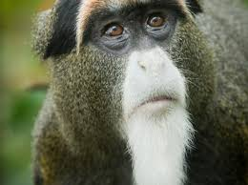
Figure 1 De Brazza’s monkey (Cercopithecus neglectus) (source: Oregon zoo, 2013).

2.3. Reproduction
Males become sexually mature at four years of age but do not generally breed until six to eight years. Females mature at three years but breed at four to five years (Brennan 1989, Harvey 1985).

Reproductive patterns of De Brazza’s monkeys are unknown in the wild. However, in captivity first pregnancy occurs at three and half years, earlier than in most Cercopithecus which is four years on average. Males typically compete to control access to group of females (Nowak, 1999).

Females generally give birth to single offspring, although twins rarely occur. Their gestation period lasts between 177 and 187 days with an inter-birth interval of 12 months (Brennan 1989). Females give birth to only one offspring per year. When born, young weigh 260g and are weaned after approximately 395 days by which time they weigh 1.6kg (de Magalhaes and Costa, 2009). Young are born with fur and with their eyes open. Newborns are able to cling to their mother’s fur and are completely dependent on the mother for the provision of food, grooming and protection. Females tend to stay with the mother once independent, but leave once they become sexually mature. Lifespan in the wild is up to 22 years and in captivity up to 30 years.

2.4. Behavior
De Brazza's monkeys forage in the early morning and evening; they hand-gather fruit, buds, young leaves, flowers and catch lizards. They are arboreal, dwelling in the tree canopy, and prefer dense vegetation near rivers. They live in lowland and sub-montane tropical moist forest, swamp forest, semi-deciduous forest and Acacia forest. These monkeys are territorial and live in small groups. Daughters may stay with mothers their entire lives. Males leave when they are sexually mature.

Unlike other species of primates, De Brazza rarely use group calls, and social alarm calls are absent (Mate et al, 1995). The species is characterized by concealment in the face of predators, large individual distances within troops, (Gautier-Hion and Gautier, 1978), relatively small group sizes and avoidance of polyspecific associations (Gautier-Hion and Gautier 1978, Wahome et al. 1993). Not only are they the only species of guenon that does not respond to alarm calls of other monkey species, but also actively avoid contact with other animals. Humans, other primates, African eagles and leopards are predators. In the rare encounters that do occur, they utilize predatory behavior of silence and concealment (McGraw 1994). De Brazza's monkeys freeze as a defense mechanism. When fully frightened, males will shake branches and bark to divert attention from the group (Gautier- Hion, 1988). As a result the male may even attack the predator in defense of the troop. These monkeys are territorial and live in small groups. Daughters may stay with mothers their entire lives. Males leave when they are sexually mature.

2.4.1. Diet and Feeding Behavior
De brazza’s monkeys are mainly frugivorous, however; a substantial proportion of their diet comes from leaves and invertebrates such as ants, termites and resting moths (Whome et al. 1993). De brazza’s monkeys also are known to eat mushrooms and lizards. There is a potential of for this species to feed on agricultural fruits and vegetables. The species is an agricultural pest in Kenya, where it is noted for raiding crops of maize and potatoes (Mugambi et al. 1997).

At least 47 plant species are used by de Brazza’s monkeys. Among these plant species 10 are commonly used plant species (Table 1).

Plant Species | Growth form | Item | Percent (%)
Ficus thoningii | Tree | Fruit, leaves, gum | 17.7
Celtis durandii | Tree | Fruit, leaves | 12.2
Manilkara butugi | Tree | Fruit | 11.0
Chaetacme aristata | Shrub | Fruit, leaves | 6.6
Neotonia wigiuii | Herb | Leaves | 5.4
Issoglossa laxa | Herb | Leaves | 4.2
Prunus africana | Tree | Fruit, leaves | 3.7
Celtis africana | Tree | Leaves | 3.1
Ipomoea wightii | Herb | Leaves | 3.1
Blighia unijugata | Tree | Leaves, buds | 2.5
Teclea nobilis | Tree | Leaves, blossoms | 2.0
Dovyalis macrocalyx | Shrub | Leaves, fruit | 1.8
Cassipourea ruwenzorensis | Tree | Leaves, fruit, blossoms | 1.7
Lantana camara | Shrub | Fruit blossoms | 1.7
Parvonia urens | Herb | Leaves | 1.4
Strychnos usambarensis | Tree | Leaves, buds, fruit | 1.4
Trichilia emetica | Tree | Leaves | 1.4
Ficus varrucocarpa | Tree | Fruit | 1.3
Albizia grandibracteata | Tree | Fruit | 1.1
Acacia sp. | Tree | Blossoms, pods | 1.1
Olea welwitschii | Tree | Leaves, seeds | 1.1
Markhamia platycalyx | Tree | Leaves, blossoms, pods | 1.0
Neoboutonia macrocalyx | Tree | Blossoms | 0.9
"Chirieso" (Luhya) | Shrub | Leaves, blossoms | 0.8
Funtumia latifolla | Tree | Leaves, gum | 0.8
Cucumis hirsutus | Vine | Fruit | 0.7
Ficus capensis | Tree | Fruit leaves | 0.6
Oblanceolatum | Tree | Leaves, buds | 0.5
Afrozersalia cerasifera | Tree | Leaves, fruit | 0.5
Diospyros abyssinica | Tree | Leaves, buds | 0.5
Aulacocalyx diervllleoides | Bush | Blossoms | 0.4
Caesalpinia decapetala | Herb | Blossoms, pods | 0.4
Sapium ellipticum | Tree | Leaves | 0.4
Aningeria altissima | Tree | Leaves | 0.4
Orchid | Leaves | leaves | 0.4
Trema guinense | Tree | Fruit | 0.3
Rinorea brachypetala | Tree | Leaves, buds | 0.3
Ficus mallatocarpa | Tree | Fruit | 0.2
Ficus dawei | Tree | Fruit | 0.2
Dombeya sp. | Shrub | Blossoms | 0.2
Hibiscus sp. | Shrub | Blossoms | 0.2
Psidium guajava | Bush | Fruit | 0.2
Ritchiea albertsii | Tree | Leaves, fruit | 0.1
Myrsine africana | Tree | Fruit, leaves | 0.1
Fagaropsis angolensis | Tree | Leaves | 0.1
Achyranthus aspera | Herb | Leaves | 0.1
Antiaris toxicaria | Tree | Leaves | 0.1
Croton megalocarpus | Tree | Leaves, blossoms | 0.1
Unidentified |  |  | 2.2

Table 1 Plant Species used by de Brazza’s monkeys in the forest (Souce: Brennan, 1985).

The percentage of fruits eaten by De Brazza’s monkeys is 44.7%, young leaves 19.5%, old leaves 12.6%, invertebrates 10.2%, blossoms 5.5%, buds 2.5%, fungi 1.8%, seeds 1.2%, gums 1.1% and others 0.9% (Table 2).

Item | Percentage diet (%)
Fruit | 44.7
Young leaves | 19.5
Old leaves | 12.6
Invertebrates | 10.2
Blossoms | 5.5
Buds | 2.5
Fungi | 1.8
Seeds | 1.2
Gums | 1.1
Others | 0.9
Total | 100

Table 2 Food items eaten by De Brazza’s monkeys in percent (Source: Brennan, 1985)

2.4.2. Social Behavior and Grouping

De brazza’s monkeys are diurnal mammals that typically live in small group of six individuals. Larger groups of 16-35 individuals may be observed and solitary males are often sighted (King, 2008: Maisels et al. 2007; Mugambi et al. 1997). Lone males of the species are often sighted outside the territories of local troops (Muriuk, 1989). Observation of captive Cercopithecus neglectus show that social structure is based on small groups to avoid confrontation (Oswald and Lockard, 1980).

De Brazza’s Monkey is considerably less conspicuous than other Guenons. The species rarely uses group calls and generally avoids living in multi-species troops (Gautier-Hion and Gautier, 1978), although they have been sighted in the company of Red-tailed Monkeys (Cercopithecus ascanius schmidti) and Black and White Colobus monkeys (Decker, 1995).

2.5. Ecology

De Brazza’s monkeys are mainly arboreal. De Brazza’s monkey is considerably more inconspicuous than most other guenons, rarely using group calls and generally avoiding living in polyspecific troops (Gautier-Hion and Gautier 1978) and at least in Gabon, north Congo, the Bateke Plateau and central Cameroon living in small family parties (Maisels et al. 2007); however, it can be found in groups of as many as 35 individuals. Though they are good swimmers, De Brazza’s monkeys are arboreal, spending 70% of their time in the understory and 20% on the ground (Gautier-Hion, 1988). They live in forests along the banks of streams and rivers, at the mid or lower canopy layers of the forest. They are diurnal, spending the majority of their time at the lower canopy or on the forest floor feeding. They are omnivores, primarily feeding on fruits and seeds, leaves, arthropods, flowers and mushrooms (Staaden, 1996). Once a food source has been located, they will visit the source repeatedly, resulting in not even a half-eaten fruit being left behind (Rowell, 1996). Occasionally they will also eat small mammals and birds (Lee, 1988). Predators are avoided by concealment, large inter-individual distances within troops, relatively small group sizes, and avoidance of polyspecific associations (Gautier-Hion and Gautier 1978, Wahome 1989).

2.6. Habitat Requirements and Preferences

The natural distribution of the species is closely linked to tropical riverine forests and swamps in central Africa, with areas of flooded forest being heavily utilised by the species (Wahome et al. 1993; King, 2008). De Brazza’s Monkeys are generally restricted to dense swamp, bamboo and dry mountain forests associated with streams, rivers and dense vegetation, and occur from lowland areas to sub-montane forests at an elevation of up to 2100m (Institute of Primate Research Kenya, 2008).
Cecopithecus neglectus are occasionally found in dense vegetation away from water. However groups found in such areas may have a water source within one day’s travel (Decker, 1995). This suggests that they may be attracted to the dense vegetation that is often present near watercourses rather than the water itself.

2.7. Distribution
In Africa the De Brazza’s monkey inhabits Equatorial African forests from Guinea to Ethiopia. It is largely riparian and much of it remains unknown. It is fairly common in its core range within the Riparian and swampy forest in the Congo Basin from South East Cameroon, Equatorial Guinea, Angola, and in extreme Eastern and Western Uganda and Western Kenya (Brennan, 1984; Decker, 1985.

The species is not only restricted to swampy forests throughout its range; it has a tolerance for altitude ranging up to 2100m and is found in closed forests, in bamboo and along the water courses of dry montane forest (Kingdon, 1974). The estimated of De Brazza’s monkey range is approximately 173,000km²

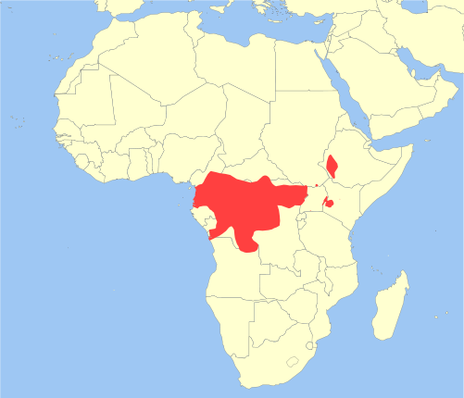
Figure 2 The red color shows the map of distribution of De Brazza's monkey (Cercopithecus neglectus) in Africa (Source: Struhsaker et al. 2008)

2.8. Natural Predators

In their natural African habitat, species that prey on De Brazza’s Monkeys include Rock Pythons, Crown Eagles (Stephanoetus coronatus), Leopards (Panthera pardus), Golden cats (Felis aurata), other primates and humans (Wahome et al. 1993; King, 2008).

2.9. De Brazza’s as a pest

Although De Brazza’s monkey has not established feral populations outside its natural range, the species is noted as an agricultural pest. De Brazza’s Monkeys are notorious crop raiders in Kenya and commonly raid crops of maize. Raiding is particularly problematic in areas of high deforestation, where natural food sources are depleted. Local villagers may chase and kill De Brazza’s Monkeys to prevent them from crop raiding. Villagers may also provide alternative food sources such as potatoes for the species to feed on in place of maize, or may clear nearby forest patches to remove suitable habitat (Karere, 1995, cited in Mugambi et al. 1997).

2.10. Conservation Status

The De Brazza’ monkey was assessed by the International Union for the Conservation of Nature
(IUCN) in 2008 and is listed as ‘least concern’ on the IUCN Red List (Struhsaker et al. 2008)
Although one of the most widespread of African forest monkeys, the de Brazza’s Monkey is not found in abundance throughout its range and limited information is available regarding the general population status of this species. This could be due to a lack of surveys undertaken (Decker, 1995) or difficulties associated with detecting the species (King, 2008).

Particularly within Kenya, the species was considered to be threatened with extinction and subject to considerable pressure through deforestation, hunting for a food source and for crop protection. As a result of these pressures, the De Brazza’s Monkey has been identified as facing reproductive isolation (Brennan, 1985). The Kenyan population remains threatened, despite a new population of approximately 300 individuals being discovered in 2007 (Mugambi et al. 1997; Mwenja, 2007).

De Brazza monkey in Kenya, Uganda and Ethiopia are endangered due to rapid habitat lose (Kingdon, 1997). The most critical factor endangering primate populations is habitat destruction (Mittermeir and Cheney 1987, Oates 1996). Low fertility rate and high infant mortality makes it difficult for De Brazza to respond to strong anthropogenic forces (Brennan, 1989). Approximately 23% of females and 20% of males die before reaching one year of age (Staaden 1996). However, the species status in Kenya and in the Eastern most range is less than 1 percent of the continent population, which is far worse than in the Congo Basin where these general listings are largely derived from. While large populations of De Brazza are found in Central Africa (Gautier-Hion and Gautier 1978), the population in Kenya is low and under immense anthropogenic pressure (Brennan 1985, Brennan, 1984, Decker 1985). The America Zoo and Aquarium Association (AZA) currently sponsors 84 Species Survival Plan (SSPs), programs that manage captive populations of endangered and threatened animals. One SSP however, was awarded to a list that is not listed the De Brazza monkey. Unlike many programs whose immediate goal is to prevent extinction, the De Brazza program proactively works to prevent future drastic down-to-the-wire conservation. Respectable primatologists in Kenya among them Booth (1962), L. Leakey (1969), Brennan (1984), Tsingalia (1987), Wahome (1989) and Karere (1995) have in the past warned that the species faces local extinction due to the rapid habitat loss and population decline, unless urgent conservation measures are taken to save the few remaining and protect their dwindling habitats. The threats are as a result of human population increase and advances in modern technology putting a lot of pressure on the land to meet rising demand for arable land for agricultural production, settlement and infrastructure development.

CHAPTER THREE

3. MATERIAL AND METHODOLGY

3.1. Materials
Materials used during the study period include digital camera, geographic positioning system (GPS), and note books.

3.1.1. Description of the Study Area
The study was conducted in Bilo Nopa woreda, Ilu Aba Bor zone, Oromia regional state, in south western Ethiopia. This woreda has 15 rural and 1 urban kebeles. Among these kebeles, the study was conducted and totally 25 De Brazza’s monkeys were counted in 3 kebeles. Namely: Karo Mariam, Kitabir and Dizi. There are four main forests in Bilo Nopa Forest: these are found in three Kebeles Yebelo Forest in Dizi kebele to Southern, Lega Ferenji and Haro Forest in Kitabir kebele to Eastern and Kollo Mora Forest in Karo Mariam kebele to the western region of the woreda town. In the woreda there were four types of habitats. These were tree dominated forest (Figure 3), scattered tree forest (Figure 4), coffee forest (Figure 5) and farmland (Figure 6).
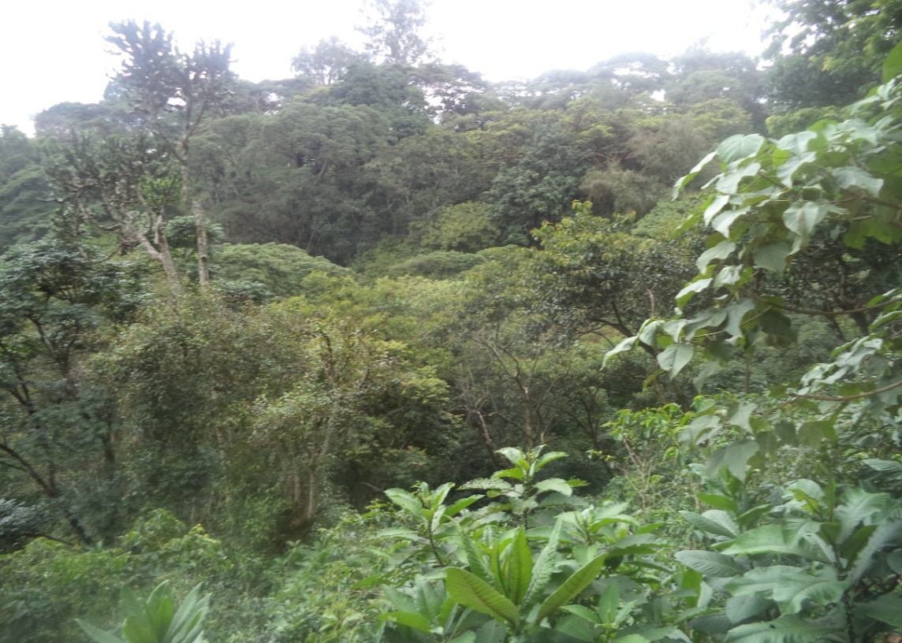
Figure 3 Tree dominated forest (Photo by: Diriba Chewaka, 2018)

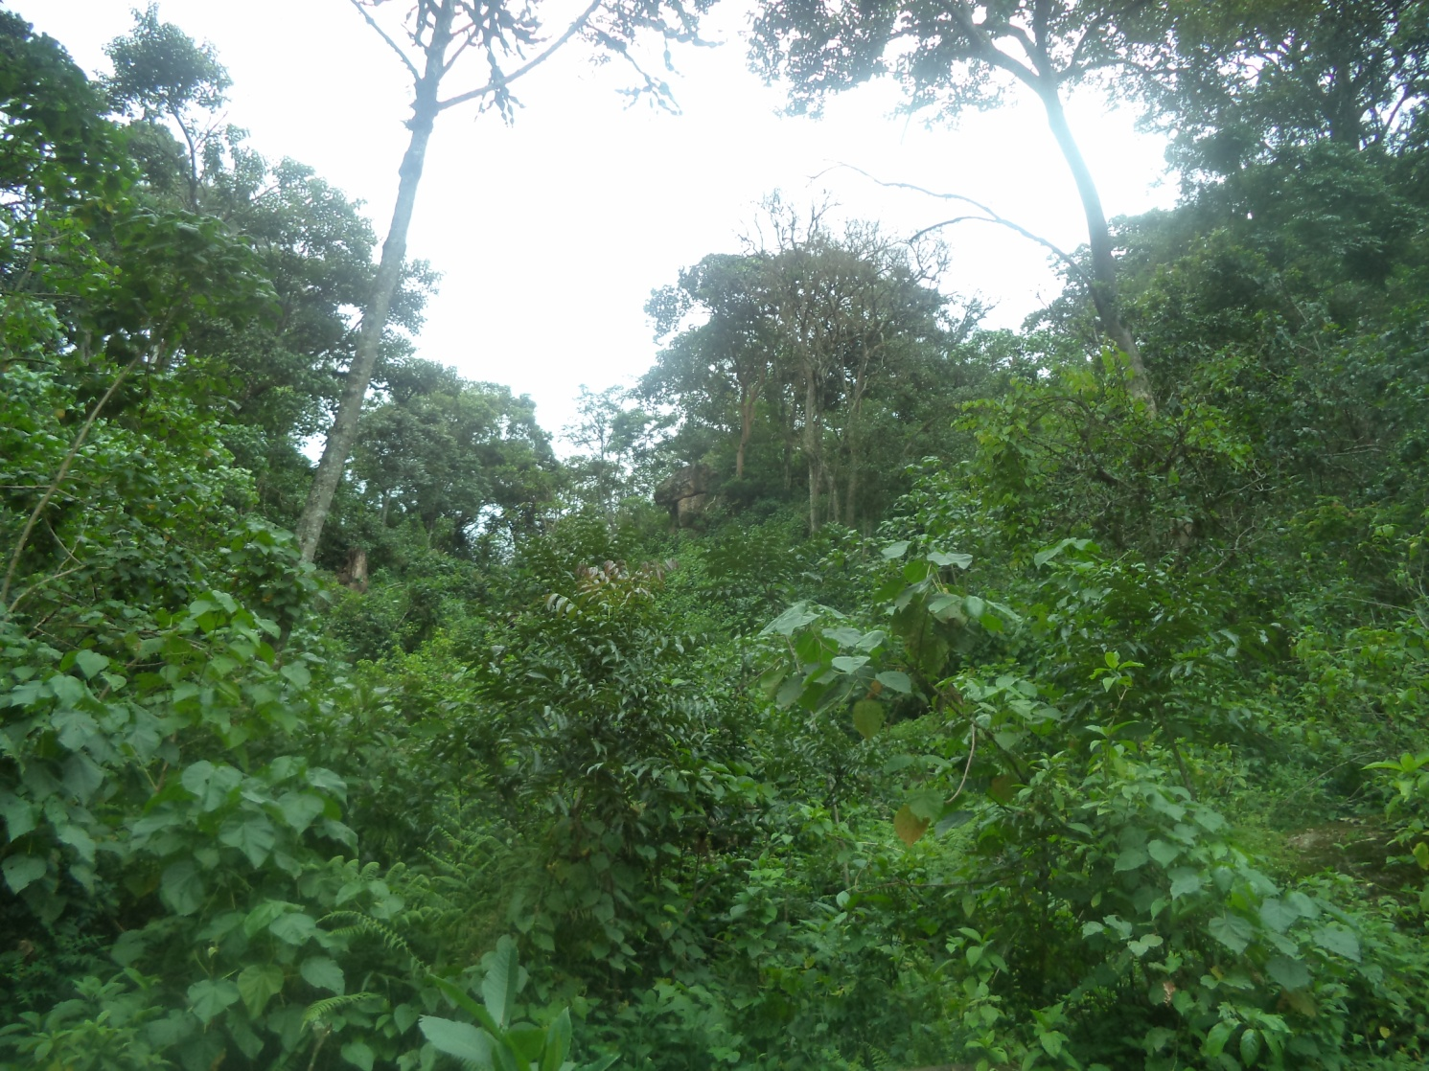
Figure 4 Scattered tree forests (Photo by: Diriba Chewaka, 2018)

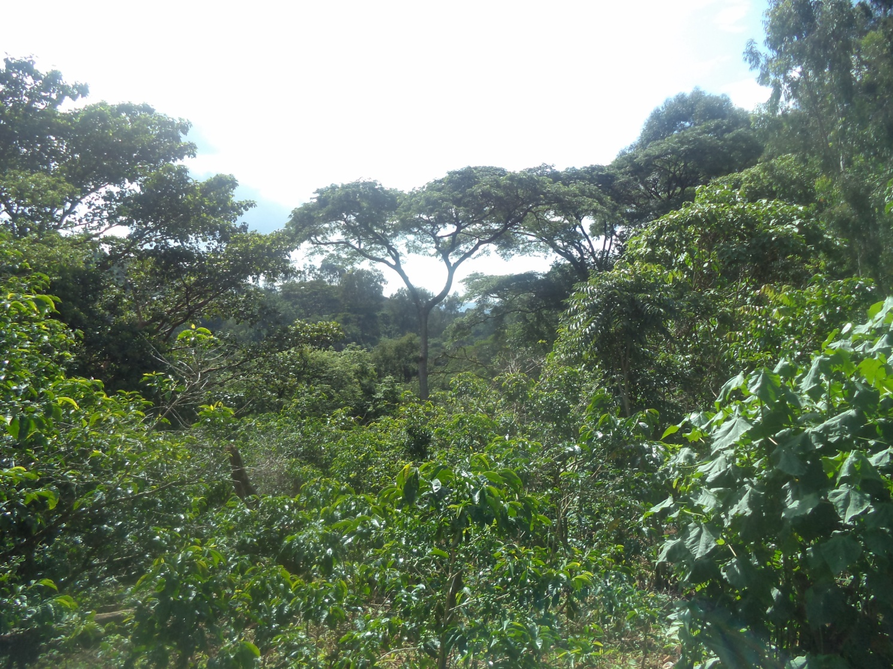
Figure 5 Coffee forest (Photo by: Diriba Chewaka, 2018)
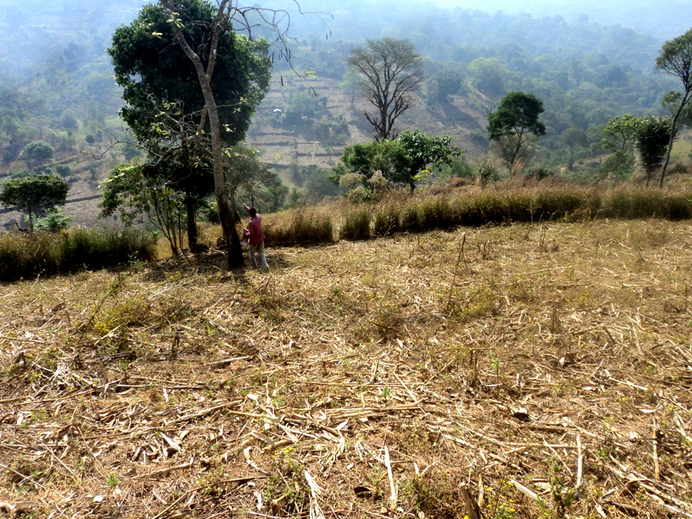
Figure 6 Farmland (Photo by: Diriba Chewaka, 2018)

The study area is located in latitude 8° 24' 36.26" - 8° 25' 7.43" N, longitude35° 36' 39.12" - 35° 37̍'13.84" E and altitude of 1259 - 1728m above sea level. Bilo Nopa woreda is 618km away from the capital Addis Ababa to the South-Western of the country. It is one of the 14 of Ilu Aba Bor zone Woredas and 18km away from zone town, Mettu to the North. The woreda is encircled by Mettu woreda in South, Darimu woreda in West, Hurumu and Dorani woreda in east and Alge-Sachi woreda in North. The woreda is also bordered by Sor River in south and Geba River in the north. Total area of the Wereda is 37,009 km², out of these 46.7% is for agricultural purpose, 41.80% is covered by forests and shrubs, 2.8% is for grazing and 8.7 for homestead purpose.

The woreda’s population is composed of both rural and urban dwellers. Most of the woreda is rural and depend on agriculture. Few urban dwellers are merchants and civil servants in governmental organization. Figure shows map of the rural kebeles of the woreda and urban center of the woreda.

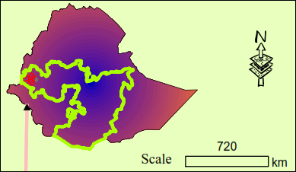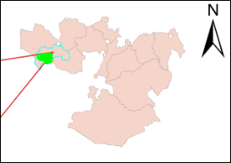

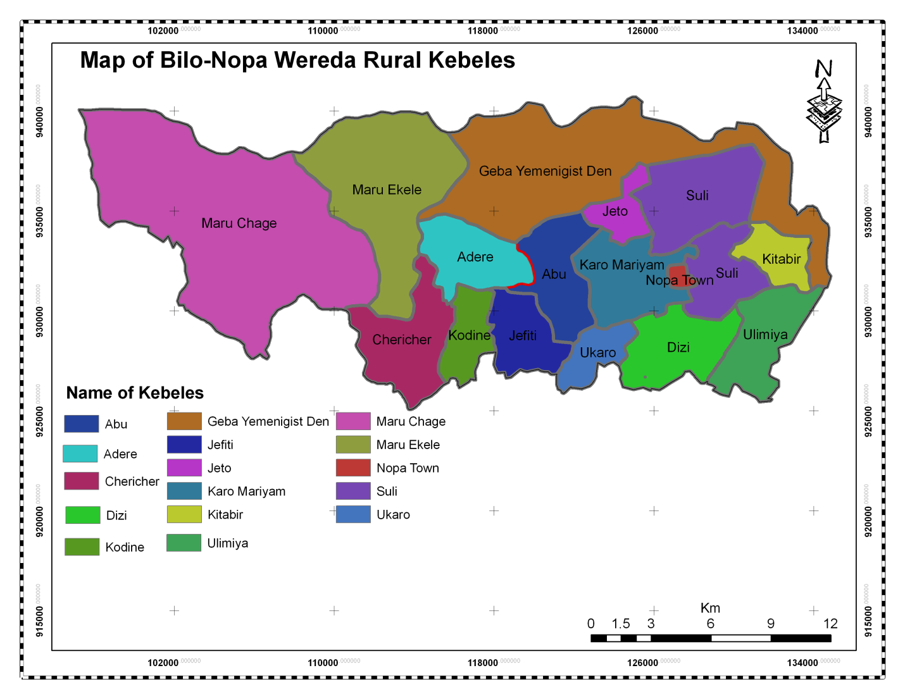

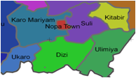

Figure 7 Map of the Study Area Bilo Nopa woreda (Source: WRLAEPO, 2010)

3.1.2. Geographical feature
The geography of the woreda is characterized by Very high ups and downs, a few plateaus, low lands and hills. Physical landscape of the woreda is characterized by irregular landscape separated by large perennial and temporary rivers. There are ridges, gorges, valleys, hills and very limited plain areas on the ridges and plateaus of the woreda. The woreda’s rivers drain to Sor and Geba rivers. Geba and Sor rivers are the major river and totally located in the Baro Drainage Basin.

3.1.3. Soil
Most of the district Surface is covered by sandstones which can be seen easily on the surface of the land everywhere.

3.1.4. Climate
The climatic condition of the woreda is estimated that 7.5% of district sub tropical (woina Dega) and 92.5% tropical (Kola).The average temperature of the woreda is 20.5°C and experienced the average rainfall of 1000 - 1290mm.

3.1.5. Flora
According to some historical records’ Bilo Nopa’ woreda was covered with dense and very thick forest a century ago. It is also believed that the coffee forest existed during the same period of time (Tamiru Tolosa, 2003).The woreda is covered by Varieties of natural Vegetation such as woodlands, savannah, grasslands, bush and shrubs etc and currently 14,359 hectare of the land of the woreda is covered by forest. Among total land of the woreda 41.80 % is covered by forest.
Majority of the forest is protected by the community for the purpose of coffee production. The current study tries to describe the vegetation of the study area are: Pittosporum viridiflorum, Brucea antidysenterica, Teclea nobilis, Clausena anisata, Pouteria adolfi-friederici, Maesa lanceolata Forssk, Syzygium guineense, Ficus sur Forssk, Ekebergia capensis, Croton macrostachyus, Vernonia amygdalina, Phoenix reclinata, Cordia africana, Coffee arabica, Vernonia auriculifera. The farmers that live near the forest area make threats to the forest and wild animals living there. The main agricultural productions are coffee, maize, sorghum, banana, orange and mango. In addition, the forest is the source of timber, fire wood and construction materials for local people.

3.1.6. Fauna
Reports from Bilo Nopa woreda Agriculture and Rural Development Office reveals that there are wild animals found in the study area. These include: lion(Panthera leo), leopard(Panthera pandus), Hyena(Crocuta crocuta), African buffaloes(Syncerus caffer), bushbuck(Tragelaphusscriptus), common Baboon(Papio cynocephalus), De Brazzaz’s Monkey(Cercopithecus neglectus), Warthog (Phacochoerusafricanus), Bush pig(Potamochoeruslarvatus), Python(Python sebae), porcupine (Hystrixcristata), colobus monkey(Colobus guereza), common duiker(Sylvicapragrimmia), grivet monkey(Cercopithecus aethops), serval cat(Leptaailurus serval), various birds and insects are among others and domestic animals includes cattle, sheep, goats, donkeys, mules, and poultries, dogs and cats are the major ones.

3.1.7. Agriculture
The major economic activity taking places in the woreda are agriculture. Food crops mainly grown in the woreda are cereals like maize, wheat, barley sorghum, millet and oil seeds include Niger seed, linseed, rapeseed and sesame. It is also very known by producing from cash crops coffee and horticultures like mangoes, orange and banana. There are no plains or plateaus rather there are rugged topography (ups and downs) which are not favorable for agriculture. But the woreda is very favorable for coffee production. The climatic weather condition also favors high temperature for agricultural products like coffee, maize and sorghum. Cereals that are grown in the woreda include maize, teff, wheat, barley, millet and oil seeds include nug, linseed, rapeseed and sesame. The woreda is also very known by producing coffee as a main source income for many farmers and horticultures like mangoes, orange and banana.

3.2. Methodology

3.2.1. Preliminary Surveys
The present study was conducted during October 2017 - May 2018. A preliminary survey was conducted for a week in September 2017 to identify the study sites and study groups. Suitable study sites were identified and habitat types were also assessed. Three different de Brazza’s monkey troops at three separate sites were selected for the study of their population status, activity pattern, diet and conservation status of de Brazza’s monkeys.

3.2.2. Habitat Use
The habitat use of De Brazza’s monkeys in Bilo Nopa was assessed during scan sampling on the selected study groups. This was undertaken every 15 minutes as the group moved from one point to another in their habitats (Vié et al., 2001). The difference in time they stayed in a particular habitat indicated the use of one habitat over the other. Habitat use was analyzed by calculating the proportion of the number of group scans the groups spend in different habitats. The analysis of habitat use was determined from the expected number of group sightings in each habitat type based on the proportion of each habitat that was actually used.

3.2.3. Population status of de Brazza’s monkeys
Censuses were conducted morning from 8:00 to 10:00 hours and afternoon from 16:00 to 18:00 hours. Individuals and troops of de Brazza’s monkeys observed were counted. When a de Brazza’s troop was located, the group size as well as the age and sex of troop members were identified and recorded. The identification of sex and age categories was carried out using a combination of beard and tail shape, pelage shading and nipple coloration and shape. Individuals were classified as adult male, adult female, young and infant according to characteristics described by Wahome (1989).
All the data gathered during the study period were recorded on data sheet and analyzed using percentage and tables.

3.2.4. Activity Pattern
The instantaneous scan sampling method was used to collect behavioral data on multiple group members (Altmann, 1974). Activity and dietary data were collected from each of the three study troops for 5 consecutive days per month covering both the dry (January, February and March) seasons and wet (October, November, December, April and May) (Fashing, 2001a).

During activity scan sampling, the activities of monkeys were recorded for 5 minutes at 15 minute intervals during 07:00-17:30 hours (Fashing, 2001a; Wong and Sicotte, 2007). The activity recorded for each visible individual was the first activity that lasted for 5 seconds. Data were collected for the first 1-5 visible adults, young and ignoring infants at the time of each scan. The group was scanned each time from left to right to avoid possible biases towards eye-catching activities like grooming, fighting or mating (Fashing, 2001a). The identity of the scanned individual was recorded and assigned to one of the following age or sex classes: adult male, adult female, young and infants. An individual scanned was recorded as performing one of the following behavioral records on the standardized data sheet: feeding, moving, resting, playing, aggression, grooming, sexual activity and others (Fashing, 2001a). The behavioral activities were recorded when the monkeys perform defined activities belonging to the one of the behavioral activities. Feeding was recorded when monkeys manipulated, masticated, or ingested a particular food item. Moving was recorded when monkeys changed spatial position, including walking, jumping, or running. Resting was recorded when monkeys were inactive, either sitting or lying down. Playing included chasing, hitting, and other vigorous activities involving exaggerated movements and gestures by a monkey interacting with others in a nonaggressive manner. Aggression was recorded when a monkey chased, bit, grabbed, displaced, threatened another monkey, or vocalized in an aggressive context. Grooming was recorded when a monkey used its hands to explore or to clean its body or the body of another monkey. Sexual activities was recorded when an individual engaged in copulatory behaviors. Others was recorded when a monkey performed activities such as vocalization.
Activity time budget was calculated by dividing the proportion of the number of behavioral records for each activity category by the total number of activity records each day. Then it was summed within each month to construct monthly proportions of time budgets. The grand mean proportion of the monthly budgets provides the overall wet and dry season time budgets, as well as the overall time budgets during the entire study period (Di Fiore and Rodman, 2001).

3.2.5. Feeding Ecology
During the activity scan sampling described above, if the monkey was observed feeding, the type of food item it consumed was recorded as young leaves, mature leaves, flowers, fruits, seeds and gums. The type of species consumed was also recorded (Fashing, 2001b; Fairgrieve and Muhumuza, 2003; Di Fiore, 2004).
Diet composition was evaluated by calculating the proportion of different food items and species consumed by the monkeys. The daily food items and type of species consumed by the groups was summed within each month to construct monthly proportion of food items and food types consumed. The monthly proportion of each food item was also calculated as the total number of monthly individual scans for each food item divided by the total number of individual scans for all food item individual scans spent for the groups. The relative proportion of plant species used as food for de Brazza’s monkeys was calculated from the monthly percentage contribution of different species (Fashing, 2001b; Di Fiore, 2004).

3.2.6. Data analysis
Data were analyzed using percentage, tables, graph, figure and textual description. Chi-square test was used to compare between groups and between seasons.

CHAPTER FOUR

4. RESULT AND DISCUSSION

4.1. Results

4.1.1. Habitat use
Among the total of 2800 scan samples 70.47% of behavioral scans were obtained in the tree dominated forest (Figure 3), 10.53% were in the scattered tree forests (Figure 4), 15.85% in coffee forest (Figure 5) and 3.17% in farmland (Figure 6).

4.1.2. Population status of de Brazza’s monkeys
The de Brazza’s monkeys counted were totally 25 in 3 troops or groups and 1 solitary adult male were counted during the study. Lega Ferenji group was coded as Group A, Yebelo group was coded as Group B and Kolla Mora group was coded as Group C. These included 16 adult De Brazza, 4 youngsters and 5 infants. De Brazza's are hard to find and to follow because they are quiet and concealment animals. De Brazza's monkeys were known to be present in the forest. The group sizes varied from 1-11 monkeys and 1 solitary adult male in Bilo Nopa Forest; smaller group was counted in Kollo Mora Forest. One solitary male was seen in Haro Coffee Forest. (Table 3)

Forests | Altitude (m) | Total population | Percent (%)
Yebelo | 1664 | 11 | 44
Lega Ferenji | 1676 | 8 | 32
Kollo Mora | 1259 | 5 | 20
Haro | 1728 | 1 | 4
Total |  | 25 | 100
Table 3 population and elevation of De Brazza’s monkeys
Due to the distance from the de Brazza’s monkeys, the sex of young and infants were difficult to identity. These were found in three separated area distributed all over the forest. Generalizing the information gathered on this study from field observations (Appendix 1).

4.1.3. Group Composition

Majority of the De Brazza’s monkeys were adults (16), and a considerable number were youngsters (4) and infants (5) (Table 4).
Forests | Adult males | Adult females | Total adults | Youngsters | Infants | Total | (%)
Yebelo | 1 | 5 | 6 | 2 | 3 | 11 | 44%
Lega Ferenji | 1 | 4 | 5 | 2 | 1 | 8 | 32%
Kollo Mora | 1 | 3 | 4 | 0 | 1 | 5 | 20%
Haro | 1 | 0 | 1 | 0 | 0 | 1 | 4%
Total | 4 | 12 | 16 | 4 | 5 | 25 | 100%

Table 4 Age-Sex composition of troops of de Brazza’s in Bilo Nopa Forests

4.1.4. Activity pattern
The overall activity time budgets of the De Brazza’s monkeys were given in figure 8. De Brazza’s monkeys in spent 47.91% of their time in feeding, 19.97% moving and 20.65% resting, 3.51% of its time playing, 2.33% aggression, 5.13% grooming and 0.5% sexual activities (Figure 8).

Figure 8 Overall activity time budgets for De Brazza’s monkeys in the study area.

Individuals in average spent more time in feeding (48.97%) during the wet season than during the dry season (48.64%). They spent more time moving (19.84%) and resting (20.74%) during the wet season than during the dry season (16.94%) and (21.37%), respectively. They spent more time in social activities such as playing (33.61%) and aggression (2.4%) during the dry season than during the wet season, where they spent (2.74%) playing and (1.66%) aggression. More time was also spent on other activities such as grooming (6.78%) during dry than during wet season (5.67%) and sexual activity (0.37) during the wet season than during dry season sexual activity (0.36%) (Table 5).
Activities in percent (%)
Seasons | Feeding | Moving | Resting | Play | Aggression | Grooming | Sexual activity
Wet | 48.97 | 19.84 | 20.74 | 2.74 | 1.66 | 5.67 | 0.37
Dry | 48.64 | 16.94 | 21.37 | 3.61 | 2.4 | 6.78 | 0.36

Table 5 Seasonal activity budget for de Brazza’s monkey in the study area

4.1.5. Feeding ecology
De Brazza’s monkeys depended most on fruits, which accounting for 76.95% of the overall diet (n= 1332 feeding records), young leaves (13.13%) made the second largest parts of their diet. Other important food items consumed were matured leaves (3.34%), seeds and gums (2.43%) and blossoms were (1.25%) (Table 6).
Food item | Time percent in (%)
Fruits | 76.95
Seeds | 2.9
Young leaves | 13.13
Matured leaves | 3.34
Blossoms | 1.25
Gums | 2.43
Total | 100

Table 6 Percentage contribution of feeding time to feed upon different food items by De Brazza’s monkeys

Of the 21 plant species that contributed for the overall diets of de Brazza’s, based on total percentage contribution of plant food items, Ficus sur was the most consumed species accounting for (26.88%) and Ficus thonigii (17.27%), Ficus vasta (15.62%), Syzygium guineense (7.66%), Psidium guajava (6.61%), Dovyalis caffra (4.2%), Prunus Africana (3.08%), Ipomoea wightii (2.63%), Landolphia buchananii (2.7%), Rubus apetalus, (1.43%) Strychnos usambarensis (1.43%), Albizia grandibracteata (1.13%), Acacia spp. (1.13%), Funtumia latifolla (0.83%), Coffee arabica (0.68%), Zehneria scabra (0.38%), Cucumis hirsutus (0.38), Zea mays (0.23%), Caesalpinia decapetala (0.38), and Clematis hirsute (0.38%) (Table 7).

Scientific name | Local name | Plant parts eaten | Percentage (%)
Ficus Sur | Fig tree | Fruit | 26.88
Ficus vasta | Fig plant | Fruit | 15.62
Ficus thonigii | Strangler fig | Fruit, young leaves, gum | 17.27
Trichilia emetica | Natal mahogany | Young leaves, fruit | 5.33
Syzygium guineense | Water berry | Young leaves, matured leaves, seeds | 7.66
Coffee Arabica | Coffee | Fruits | 0.68
Zea mays | Maize | Fruits | 0.23
Prunus Africana | African cherry | Young leaves, fruits | 3.08
Ipomoea wightii | Convolvulus | Young leaves, matured leaves | 2.63
Landolphia buchananii | Apricot vine | Young leaves, matured leaves, fruits | 2.7
Rubus apetalus | Blackberry | Young leaves, blossoms, fruits | 1.43
Strychnos usambarensis | Blue bitter-berry | Young leaves, fruits | 1.43
Albizia grandibracteata | Albizia | Fruits, gums | 1.13
Acacia spp. | Acacia | Blossoms, pods | 1.13
Funtumia latifolla | Rubber tree | Young leaves, gums | 0.83
Dovyalis caffra | Kei apple | Fruits | 4.2
Zehneria scabra | Wild cucumber | Young leaves | 0.38
Cucumis hirsutus | Horned melon | Fruits | 0.38
Parvonia urens | Stinging pavonia | Leaves | 0.23
Caesalpinia decapetala | Cat’s claw | Blossoms, pods | 0.23
Psidium guajava | Guava | Fruits | 6.61

Table 7 List of plants, food items eaten and percentage in plant diets of de barazza’s in study area.

All individuals in spent more time feeding on fruit during the dry season (80.32%) than during the wet season (77.37%). (Table 8) They spent more time feeding on young leaves (15.18%) and blossoms (0.66%) during the dry season than during the wet season feeding on young leaves (12.19%) and blossoms (0.72%). During the wet season, they spent more time consuming seeds (1.86%), matured leaves (6.29%) and gums (1.56%) than during dry season feeding on seeds (2.47%), matured leaves (0.66%) and gums (0.71%).

Food items | Seasons
 | Dry season | Wet season
Fruits | 80.2 | 78.57
Young leaves | 15.84 | 12.05
Matured leaves | 0.99 | 4.91
Seeds | 1.49 | 1.79
Gums | 0.5 | 2.23
Blossoms | 0.99 | 0.45
Total | 100 | 100

Table 8 Percent of time spent by the three groups of De Brazza’s monkeys feeding on different food items at different seasons.

4.1.6. Threat of de Brazza’s Monkeys

The plant species happen to be some of the most preferred by de Brazza's monkeys; hence the conflict. The forest and the vegetation are often burnt, either by the honey collectors, timber production, charcoal, deforestation, expansion of farmland or more distant areas are also affected by honey harvesting often leading to forest fires (Figure 9). I found persecution of the de Brazza's monkeys by the local people: using by dog, traditional snares method called ‘Bendo’ to keep them from maize was observed. Habitat destruction especially for coffee plantations was among the threats in the area. As a result the natural forests are being currently disturbed habitats for de Brazza's monkeys.

De Brazza’s Monkeys were crop raiders rarely and raid crops of maize. Predation by dogs and trapping of them by traditional method called ‘Bendo’ to protect them from maize during the study. (Figure 9)

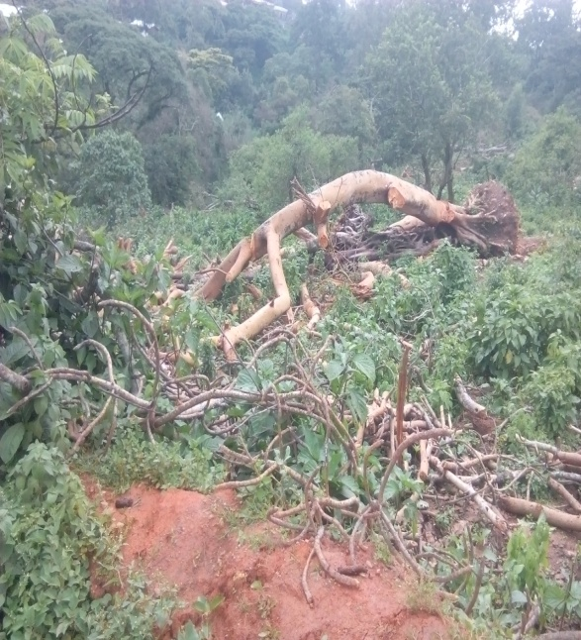
Figure 9 Clearing Forest for expansion of farmland

4.2. Discussion
The de Brazza’s monkeys are quiet in nature, large inter-individual distances within groups (Gautier-Hion and Gauttier, 19780), relatively small group sizes, and, unlike other primates, rare use of group calls, and lack of alarm calls (Mate, et al), explain why so little is known about it there. The area is also remote and has a history of insecurity that has made it difficult for biologists to work there. According to Kingdon (1974), Brennan (1984) and Wahome (1989), de Brazza's monkeys keep close to water ranging not farther than 200m away. All the de Brazza's monkeys seen in the Bilo Nopa Forest were found around water in thi study.
The species is present in Bilo Nopa woreda but absent in eastern and Northern forests in Ethiopia, because of the forests had significant differences in their floristic communities and lacking de Brazza's monkeys' most preferred plant species.Other species exploited by de Brazza's monkeys in Kisere (Wahome, 1989) and also found in Bilo Nopa Forests include Ficus species and Trichilia emetica.

Kingdom (1971, 1997) put the highest elevation of the de Brazza's monkeys at 2,100 m, but this was not the case for one solitary adult male which I found at 1728m at Haro Coffee Forest. 96% of the population was concentrated between the elevations of 1259m to 11676m above sea level. The remaining 4% occurred at 1728 m above sea level.
De Brazza’s monkeys of all groups entirely occupied tree dominated forests while foraging. Members of all groups were also spent more of the time in the tree dominated forest habitat type. De Brazza’s monkeys exhibited a tendency to spend more time in mature forest habitats, which may be linked to both fruit resource availability. Hence their primary tendency to use tree dominated forests in this study was correlated with the availability of these resources especially potential fruiting trees in the forest than in other habitat types.
The result of the present study also revealed that de Brazza’s monkey spent more time in feeding than moving and resting. In most cases, the activity time budget has direct correlation with the availability of specific resources and dietary diversity. De Brazza’s monkeys showed high movement pattern to encounter fruit when there is fruit scarcity. Dry season is the time for most fruiting plants to bear fruits. This variation might suggest that the availability of fruits during the dry season allowed them to take more time when foraging as it is their primary choice. The presence of adequate resource would reduce the time spent for searching it. The probable reason could be the presence of very few fruiting trees in their range. The time spent for resting also showed little variation between the groups and seasons. The time budget for social activities, especially for playing, aggression and grooming took greater time during the dry season. This might be related to the sunlight that can induce them to perform social activities via playing and grooming.
Forest dwelling guenons exhibit a diverse dietary preference such as fruits, leaves, flowers, vertebrates and invertebrates to varying degrees. However, they are distinguished from leaf-eating monkeys (Colobinae) by morphological adaptations to frugivorous diets (e.g. low and rounded molar cusps, simple stomach and pouches in their cheeks for storing food) (Fleagle, 1999). Fruits constituted majority (24.5% - 91%) of the diet of guenons (Jaffe and Isbell, 2007). The feeding ecology of de Brazza’s monkey also showed a similar pattern. They consume fruits as primary choice when present.

Despite being highly frugivorous, the geunons also feed on leaves, seeds and animals (Jaffe and Isbell, 2007), which are otherwise less desirable foods in the absence of fruit (Brugiere et al., 2002).
Proper understanding on habitat use and ranging patterns help to realize various aspects of animal behavior and ecology, including feeding strategies, physiological and morphological specialization and social systems (Boinski, 1987). For arboreal frugivorous primates, the daily movement distances and the frequency in the use of habitats are influenced by the food abundance and distribution (Bennett, 1986; Boinski, 1987; O’Brien and Kinnaird, 1997; Keplin, 2001). However, many primates maintain relatively consistent ranging patterns throughout the year. The consistency in ranging patterns is accomplished in most cases by a foraging pattern that facilitates resource monitoring (Olupot et al., 1997), diet shift or both (Pollock, 1977). Their territorial nature and a combination of diet shift and resource monitoring allowed maintaining consistent ranging patterns. During wet season, there was low fruit availability in the forest and as a result, they spent more time feeding on young and matured leaves. Some Cercopithecus species showed more widely ranging during periods of fruit scarcity to encounter a greater diversity of resources (Keplin, 2001). However, De Brazza’s travelled longer distances during the dry season when excess fruit was available than fruit scarcity period during the wet season. During this time, the distantly dispersed Ficus sur plants contain much fruit than other plants. They cover more than half of the fruit bearing plants and they took longer day range distance than fruit scarce time. They even travelled to a new range in which they never visited before fruits ripened.

Each de Brazza's troop in Yebelo, Lega Ferenji and Kollo Mora Coffee Forest, except the Haro Coffee Forest which had only one adult male , all had 1adult male, 3 or more adult females, and a number of youngsters, and infants, living consistently together. This agrees with other observations of large groups in East Africa (Brown and Urban, 1970, Kingdon, 1971; Brennan, 1985), but it contrasts with reports by Gautier-Hion and Gautier (1978) of groups containing only a single pair of adults in Gabon. In captivity, groups of one male and two or three females remained stable and bred successfully (Rowell and Richards, 1979; Oswald and Lockhard, 1980).
Comparison of population densities is difficult because de Brazza's monkeys have a localized and specific habitat. Densities of de Brazza's monkeys within their home ranges in Bilo Nopa Forest were much higher than those in Gabon, reported by Gautier-Hion and Gautier, who also only considered appropriate habitat.

While Gautier-Hion and Gautier (1978) used telemetered adult males to track habitat use, however; I used direct observation; my results are similar in many ways: de Brazza's monkeys in Gabon and Kenya moved about the same distance daily and spent half their time below 10 m in areas of dense undergrowth. But the Bilo Nopa Forest de Brazza's had a clear diurnal pattern of activity, with feeding allocated more time in the morning and late afternoon and resting more time in the middle of the day, while this pattern was absent in Makokou (Gautier-Hion and Gautier, 1978).

UNIT FIVE

5. CONCLUSION AND RECOMMENDATION

5.1. Conclusion
De Brazza’s monkeys were observed in the study area. De Brazza’s monkeys entirely occupied tree dominated forests but were only rarely seen in farmlands while foraging.
De Brazza’s monkeys spend much of their activity time budget for feeding and moving than socializing, moving and resting that may be interlinked with the diet of the species. De Brazza’s monkeys consumed a total of 21 plant species throughout the study period. They spent most of their time feeding on fruits.

In most cases, the activity time budget has direct correlation with the availability of specific resources and dietary diversity. De brazza’s monkeys showed high movement pattern to encounter fruit when there is fruit scarcity.

Dry season is the time for most fruiting plants to bear fruits. This variation might suggest that the availability of fruits during the dry season allowed them to take more time when foraging as it is their primary choice. The presence of ample resource would reduce the time spent for searching it.
All groups spent most of their time constantly feeding fruit most. The next were young leaves, matured leaves, seeds, blossoms and gums respectively during the study period. The time spent for resting also showed little variation between the groups and seasons. The time budget for social activities, especially for playing, aggression and grooming took greater time during the dry season. The feeding ecology of de Brazza’s monkey also showed a similar pattern. They consume fruits as primary choice when present. Fruit is the most nutritionally rewarding component of the diet of the primates (Lawes, 1991; Richard, 1985). Habitat loss through deforestation is the primary threat for primates (Chapman et al., 2006). As forest size and quality decrease, reduction of food sources for forest-dwelling primates and local extinction might result (Lee and Hauser, 1998). In order to conserve these species and prevent future decline, conservation practice involving local people is a must (Wallis, 2009).

Bilo Nopa Forest was severely threatened by coffee plantation, agricultural land expansion and commercial timber production. Grazing has a significant impact in the area in accelerating habitat degradation and competition with wildlife. In addition, firewood collection from the forest also leads to disturbance of wildlife. Illegal tree cutting is also observed in addition to charcoal production activities. If appropriate measures are not taken, it will pose a threat to the de Brazza’s monkeys and other mammals in the area in the future.

5.2. Recommendations

The population of de Brazza’s monkeys in the Bilo Nopa forest was high. The results of the present study have several conservation and management implications for the species and their habitat. Therefore, the survival of the species depends heavily on planning and implementing on the conservation and management of the tree forest habitats. The conservation of forest will ensure the existence of de Brazza’s monkeys in the future. To determine the status of the species and to develop long-term conservation and management strategies, the distribution and population size of the whole de Brazza’s monkey population in the Bilo Nopa should be examined. Deforestation by the local people for coffee plantation, agricultural expansion, trapping wildlife, illegal killing, over grazing and commercial purposes could impose threat to the de Brazza’s monkey populations in the future. If this current trend continues, the population of de brazza’s monkeys could be affected in the future. Therefore, it is recommended that management action should be taken to conserve the most important food resources such as Ficus species and S. guineense plant trees. In addition, further investigation should be conducted to determine the sustainable and beneficial level to integrate the local people in the conservation of the species and wildlife.

References
Altmann, J. (1974). Observational study of behaviour: sampling methods. Behaviour 49: 227-267.
Bennett, E. L. (1986). Environmental correlates of ranging behavior in the banded langur, Presbytis
melalophos. Fol. Primatol. 47: 26-38.
Boinski, S. (1987). Habitat use by squirrel monkeys (Saimiri oerstedi) in Costa Rica. Fol. Primatol.
49: 151-167.
Booth, C. (1962).Some Observations of Cercopithecus Monkeys. New York. Acad. sc. 102: 477-487.
Brennan, E.J. and Else, J.G. (1984) Can Kenya’s De Brazza Monkeys Survive? Swara
magazine Vol. 7:3. May-June pp. 12-14.
Brennan, E.J. (1985). De Brazza’s Monkeys (Cercopithecus neglectus) in Kenya: Census,
Distribution and Conservation, American Journal of Primatology, 8:271-277.
Brennan, E.J (1989).Demographics of Captive De Brazza’s Guenons. Zoo Biology 8:37-47.
Brown, L.H. & E.K. Urban. (1969). De Brazza's monkey Cercopithecus neglectus Schlegel in the
forests of south-west Ethiopia. E. Afr. Wildl. J. 7: 174-175.
Brugiere, D., Gautier, J.P., Moungazi, A. and Gautier-Hion, A. (2002). Primate diet and biomass in
relation to vegetation composition and fruiting phenology in a rainforest in Gabon. Int. J.
Primatol. 23: 999-1024.
Butynski, T.M. (2002): The Guenons: overview of Diversity and Taxonomy. The Guenons:Diversity
and Adaptation in African Monkeys, edited by Glenn and Cords, Plenum Publishers, New York.
Chapman, C.A., Chapman, L.J, Cords, M., Gathua. J.M., Gautier-Hion, A., Lambert, J.E., Rode, K.,
Tutin, C.E.G. and White, L.J.T. (2002). Variation in the diets of Cercopithecus species:
Differences within forests, among forests, and across species. In: The Guenons: Diversity
and Adaptation in African Monkeys, pp 325–350. (Glenn, M.E. and Cords, M. eds.).
Kluwer Academic Publishers, NewYork.
Cords, M. (1987). Mixed-species Association of Cercopithecus Monkeys in the Kakamega Forest,
Kenya. University of California Press, Berkeley.
Decker, J.S. (1995): Survey of deBrazza’s Monkey (Cercopithecus neglectus schlegeli) in The Tororo
District of Eastern Uganda and Trans-Nzoia and West Pokot Districts of Western Kenya, Journal
of East African Natural History 84: 25-34.
De Magalhaes, J. P. and Costa, J. (2009). A database of vertebrate longevity records and their
relation to other life-history traits. Journal of Evolutionary Biology (22)(8):1770-1774.

Di Fiore, A. and Rodman, P.S. (2001). Time allocation patterns of lowland woolly monkeys
(Lagothrix lagotricha poeppigii) in a Neotropical Terra Firma Forest. Int. J. Primatol.
22: 449- 480.
Di Fiore, A. (2004). Diet and feeding ecology of woolly monkeys in a western Amazonian rain
forest. Int. J. Primatol. 25: 767-801.
Eilble-eibesfeldt, 1970. Ethology, The biology of behavior. Holt, Rinehart and Winstone.
Fairgrieve, C. and Muhumuza, G. (2003). Feeding ecology and dietary differences between blue
monkey (Cercopithecus mitis stuhlmanni Matschie) groups in logged and unlogged forest,
Budongo Forest Reserve, Uganda. Afr. J. Ecol. 41:141-149.
Fashing, P.J. (2001a). Activity and ranging patterns of guerezas in the Kakamega Forest: intergroup
variation and implications for intragroup feeding competition. Int. J. Primatol. 22: 549-577.
Fleagle, J.G. (1999). Primates Adaptation and Evolution, 2nd edn. Academic Press, San Diago.
Gautier –Hion, A. and Gautier, J.P (1978) De Brazza; Une strategies Originale. Z. tierpsychol,
46:86-104.
Gautier-Gion, A. and J.P. Gautier 1985. Sexual dimorphism, Social Units and ecology among forest guenons. Francis Ltd.
Gautier-Hion, A. (1988).Primates Radiation-Evolution Biology of the Africa Guenon.
Cambridge University Press New York.
Glenn, M. and Cords, M. (2002). The Guenons: Diversity and Adaption in African Monkeys.
Kluwer Achademic/Plenum Publishers, New York.
Harvey, P.H. and T.H. Clutton-Brocks. (1985). Life History Variation In Primates. Evolution 39:
559-581.
Jaffe, K.E. and Isbell, L.A. (2007). The guenons: polyspecific associations in socio-ecological
prospective. In: Primates in Prospective, pp 277-299. Campbell, C.J., Fuentes, A., Mackinnon,
K.C., Bearder, S.K. and Stumpf, R.M. eds.). Oxford University Press, New York.
Kaplin, B.A. (2001). Ranging behavior of two species of guenons (Cercopithecus lhoesti and C. mitis
doggetti) in the Nyungwe Forest Reserve, Rwanda. Int. J. Primatol. 22: 521-548.
Karere, G. M. (2000) Some Ecological Studies of de Brazza’s Monkey, Cercopithecus neglectus, and
it’s habitat prior to translocation. Master’s Thesis University of Nairobi, Kenya. Viewed
online at<http://www.researchkenya.org/?ID=9186&search=Habitats>.
Kingdon, 1. (1971). East African Mammals, an Atlas of Evolution in Africa, Vol. 1,
Academic Press, London, pp. 253-261.

Kingdon J, Butynski TM (2008) Chlorocebus aethiops. The IUCN red list of threatened species.
Version 2014.3. Available online at: www.iucnredlist.org (Accessed on 03 February 2015)
Krebs J.R. and N.B. Davies, 1986. Behavioral ecology, an evolutionary approach. Blackwell Scientic publications London.
Lawes, M.J. (1991) Diet of the Samango monkey (Cercopithecus mitis erythrarchus) in the Cape
Vidal dune Forest, South Africa. J. Zool. Lond. 224: 149-173.
Leaky L. S. 1969. Animals of East Africa. National Geographic society. Washington D.C.
Lee, P.C. and Hauser, M.D. (1998). Long-term consequence of changes in territory quality on
feeding and reproductive strategies of vervet monkeys. J. Anim. Ecol. 67: 347-358.
Lee, P.C., Thornback, J. and Bennett, E.L. (1988). The Threatened Primates of Africa: The IUCN
Red Data Book. IUCN Gland, Switzerland and Cambridge, U.K.
Macdonald, D. (1993). The Encyclopaedia of Mammals. Facts on file, New York.
Maisels F, Bout N, Inkamba-Inkulu C, Pearson L, Aczel P, Ambahe R, Ambassa E, Fotso R (2007)
New Northwestern and Southwestern Range Limits of De Brazza’s Monkey, Mbam et Djerem
National Park, Cameroon, and Bateke Plateau, Gabon and Congo. Primate Conservation 22.
Maning, 1980. An introduction to primate behavior. Edward Arnoid Ltd.

Mate, C.C., Montserrat, M.E. (1995). Preliminary observations on the ecology of forest
Cercopithecidae in the Lokofe-ikomaloki Region (Ikela, Zaire). Folia Primatol 64:196-200.
McGraw, S. (1994). Census, Habitat preference, and polyspecific associations of six
monkeys in the Lomako Forest, Zaire. American Journal of Primatology 34:295-307.
Mittermeier, R.A., Wallis, J., Rylands, A.B., Ganzhorn, J.U., Oates, J.F., Williamson, E.A., Palacios,
E., Heymann, E.W., Kierulff, M.C.M., Long Yongcheng, Supriatna, J, Roos, C., Walker,
S., Corte´s-Ortiz, L. and Schwitzer C. (2009). Primates in Peril: The world’s 25 most
endangered primates 2008–2010. Report, IUCN/SSC Primate Specialist Group (PSG),
International Primatological Society (IPS), and Conservation International (CI), Arlington.
Mugambi, K. G., Butynski, T. M., Suleman, M. A., and Ottichilo, W. (1997). The Vanishing De
Brazza‟s Monkey (Cercopithecus neglectus) in Kenya. International Journal of Primatology
(18)(6): 9951004.
Muriuki, J.W. & M.H. Tsingalia. (1990). A new population of de Brazza's monkey in Kenya. Oryx
24: 157-162.
Mwenja, I. (2007). National Rapid Survey on the Status and Distribution of De Brazza
Monkeys in Kenya. East Africa Wildlife Society.

Napier, J.R.& Napier, P.H. (1967): Handbook of Living Primates. Academic Press,London.
Napier, J.R. and P.H. Napier, 1970. Old world monkeys. Academic press Inc. New York pp. 323- 337, 367.
Nowak, R.M. (1991).Walker’s mammals of the world, 5th edition, Vol. I. Johns Hopkins
University Press, Baltimore.
Nowak, R. 1999. Walker’s mammals of the world, six edition. The Johns Hopkins University press, Baltimore and London. Pp. 573-375.
Oates, J.F. (1996). Status, Survey and Conservation Action Plan: African Primates. IUCN/SSC
Primate Specialist Group, IUCN, Gland.
O’Brien, T. G. and Kinnaird, M. F. (1997). Behavior, diet, and movements of the Sulawesi Crested
Black Macaque (Macaca nigra). Int. J. Primatol. 18: 321-351. Olupot, W., Chapman, C. A.,
Waser, P. M. and Isabirye-Basuta, G. (1997). Mangabey (Cercocebs albigena) ranging
patterns in relation to fruit availability and the risk of parasite infection in Kibale National
Park, Uganda. Am. J. Primatol. 43: 65-78.
Olubayo, R.O. and Taiti, S.W. (1998). Conservation status of De Brazza monkey in Kenya. East
Africa Wildlife Society.
Olupot, W., Chapman, C. A., Waser, P. M. and Isabirye-Basuta, G. (1997). Mangabey
(Cercocebs albigena) ranging patterns in relation to fruit availability and the risk of parasite
infection in Kibale National Park, Uganda. Am. J. Primatol. 43: 65-78.
Oswald, M. and Lockard, J.S. (1980): Ethogram of the De Brazza’s Guenon (Cercopithecus neglectus) in captivity, Applied Animal Ethology 6(1980): 285-296
Pollock, J. I. (1977). The ecology and sociology of feeding in Indri indri. In: Primate Ecology:
Studies of Feeding and Ranging Behaviour in Lemurs, Monkeys and Apes, pp 38–71. (Clutton-
Brock, T. H., ed.). Academic Press, London.
Rechard, A.F. (1985). Primates in Nature. W.H. Freeman and Co., New York.
Rowell, T.E. 1988. Beyond the one male group behavior 104:189-201.
Rudnai, J.A. 1970. Social behavior and feeding of the lion Neuman in Nairobi National Park. Msc thesis University of East Africa.
Staaden, S. (1996). North American Regional Studbook for De Brazza monkey,
Cercopithecus neglectus, First Edition. North Carolina zoological Park.
Strier, K.B. (2003). Primate Behavioural Ecology, 2nd edn. Allyn and Bacon, San Francisco.
Struthsaker, T.T. (2008). Census Method for Estimating Primates’ Densities. In: primate
population ecology, National Academic Press, Washington D.C.
Tsingalia, H.M. 1987. Animals and regeneration of African rainforest unpublished PHD dissertation, University of California, Berkeley.

Vié, J., Richard-Hansen, C. and Fournier-Chambrillon, C. (2001). Abundance, use of space and
activity pattern of white faced sakis (Pithecia pithecia) in French Guiana. Am. J. Primatol. 55:
203-221.
Wallis, J. and Lonsdorf, V. E. (2009). Summary of recommendations for primate conservation
education programs. Am. J. Primatol. 71: 1-4.
Wahome, J.M. (1989). The Ecology of The De Brazza’s Monkey (Cercopithecus neglectus,
Schlegel) in Kisere Forest Reserve. MSc. Thesis, University of Nairobi Kenya.
Wahome, J.M. 1993. The De Brazza's monkey: A species under siege in Kenya. Swara 16:33-34.
Wahome, J.M., Rowell, T. E., & Tsingalia, H. M. (1993). The natural history of de Brazza’s monkey
in Kenya. International Journal of Primatology, 14, 445-446.
Wong, S.N.P. and Sicotte, P. (2007). Activity budget and ranging patterns of Colobus vellerosus in
forest fragments in central Ghana. Folia Primatol. 78: 245-254.

Appendix 1: Photos of de Brazza’s monkeys that were photographed in Bilo Nopa Forest during the study period

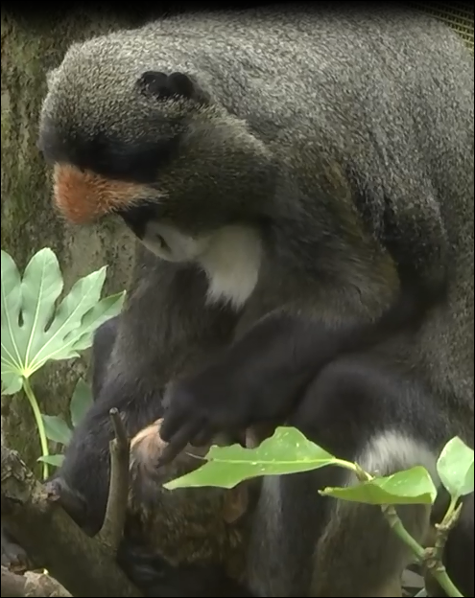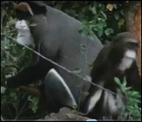
Male adult de Brazza’s monkey Female adult de Brazza’s monkey with its young

De Brazza’s monkeys in Bilo Nopa Forest during the study period (Pictured by: Diriba Chewaka, 2018)

Declaration

I, Diriba Chewaka confirm that the work presented in this thesis is my own. Where information has been derived from other sources, I confirm that this has been indicated in the thesis. The material contained in this thesis has not previously been submitted for a degree at Addis Ababa University or any other university and all the sources of materials used for thesis are acknowledged.

Name Diriba Chewaka Besha

Signature_____________
Date: August 2018
Place: Addis Ababa University

This thesis has been submitted for examination with my approval as an academic advisor.

Advisor; Habte Jebessa Debella (PhD)
Signature __________________
Date_______________________

