ADDIS ABABA UNIVERSTIY
SCHOOL OF GRADUATE STUDIES
DEPARTMENT OF MICROBIAL, CELLULAR AND MOLECULAR BIOLOGY



STUDIES ON BIOLOGICAL AND MECHANICAL MANAGEMENT OF COFFEE BERRY BORER [HYPOTHENEMUS HAMPEI (FERRARI)] USING BEAUVERIA BASSIANA AND BAITING TRAP ON COFFEE (COFFEA ARABICA L.)
BY
YONAS CHEKOL BELAY

SUPERVISOR
TESFAYE ALEMU (PHD)

JULY, 2017
ADDIS ABABA, ETHIOPIA

ACKNOWLEDGEMENTS

I would like to express my sincere appreciation to my supervisor, Dr. Tesfaye Alemu for his guidance, tireless input, patience and understanding during my PhD study and thesis writing. He was a mentor and role model to me. It is my pleasure to thank Dr. Kemal Ali, facilitating my access to Ambo plant and soil protection laboratory and providing reading materials relevant to my work.

I would like to express my sincere gratitude to Dr. Fassil Assefa for his unreserved support on writing of this dissertation by correcting and rewriting some parts of this paper in order to make it well structured and conceptually comprehensive. He also opened the great opportunity of linking our biocontrol products into fields and floriculture companies that could bring a paradigm shift of these isolates practical application. I also thanked him for his friendly approach and allowing me to be part of the”the healthy seedlings production project” for the feature endeavor.

I also thank Prof. Dr. Johannes Hallmann from Julius Kühn-Institut of Federal Research Centre, Münster, Germany for providing me with laboratory and office space at his institution, financial support, laboratory facilities and reagents for molecular work. Prof. Dr. Johannes Hallmann allowed me to do extra work on testing the pathogenicity of some Beauveria isolates against pathogenic nematodes. He and his family invited me to their home where I enjoyed the warm hospitality.

I would like to express my deepest gratitude to all staff members of Julius Kühn Institute of Federal Research Centre, Münster, for their unreserved support and cooperation during my study at Münster. I have also a special memory for the summer time trip that I had with them. My special thanks go to Mr. Falko Lange and
Mrs Agnes Windt for their support and guidance during my laboratory work.

My deepest gratitude also goes out to Dr. Beira Hailu for his unreserved support and facilitating my journey to Germany. He was dedicated on doing my molecular work through guiding and supporting laboratory and molecular data analysis. Besides, these entire he also made my days very interesting in Germany and sharing life experience. It is also my pleasure to say thank you for Dr. Degefe Tibebe and Mr. Betre Tadese and Abd ALmenem I. Hawamda for the enjoyable time we had during summer time. I would like to thank my old friends Dr. Dereje Beyene and Dr. Adey Feleke for their support on molecular analysis.

I am very much grateful to Ambo Plant Protection Research Center for allowing me to work in the laboratory to isolate Entomopathogenic fungi and Endophytic test in the green house. Tepi Green Coffee Plantation, P. L. C., Limmu Coffee Plantation and Mr. Daniel Mulatu and Mr. Mulatu Meno (Mizan-Aman) allowed me to use their coffee farms to conduct CBB trapping and provided me with technical support. My gratitude also goes to all individuals involved in this research work directly or indirectly especially during field work and green house experiment at Ambo plant and soil protection center.

I am grateful for the support of Addis Ababa University and Mizan-Tepi University. Particularly, I would like to appreciate the department of Microbial, Cellular and Molecular Biology, Addis Ababa University because the department fully financed this research. At the last stage of the study, Mizan-Tepi University also financed my research work besides my full salary sponsorship.

I wish to appreciate my lovely family without whose support it would have been difficult to complete this work. Special, thanks to my parents for their patience and understanding and to my wife Aynalem Metaferia and my beloved Sons Nahom Yonas (Baby) and Leul Yonas (Abiti) for their encouragement during my study. I last but not the list thank I would like to say thank you Afomia Samson and Efrata Samson for sharing my burden by supporting my kids on guiding and helping them doing their home work and preparing them for exam. I thank all my friends and relatives for their support during my study.

ABSTRACT

The entomopathogenic fungus (Beauveria bassiana) is a cosmopolitan pathogen of different insect hosts. It is used as a natural enemy to control insect pests in agricultural systems. Coffee production in Ethiopia is damaged by the coffee pest, coffee berry borer (CBB) [Hypothenemus hampei Ferrari (Coleopteran, Scolytidae). The control measure attempt or attention given to this potentially dangerous pest is almost none/very few compared with its economic importance. In the present study, soil samples were collected from three coffee growing areas in Jimma zone, Ethiopia. For each soil sample ten Galleria larvae were used as bait for trapping entomopathogenic fungus Beauveria bassiana. The total number of Galleria larvae positive for Beauveria spp. from the different soil samples were 159 (53%) out of 300 Galleria larvae tested, in which 26.7%, 18.7% and 7.7% were from Beletechaka, Geruke and Choche farms, respectively. The three localities significantly varied in the rapped B. bassiana isolated at (P < 0.05).The amplification of the ITS region of Beauveria spp. isolates produced single fragments of about 560 bp for all tested. Further, eight randomly selected and sequenced isolates revealed 98-100% sequence similarity and shared an overall intra-sequence similarity value of 99% among our isolates. The ML analysis of the ITS region of B. bassiana formed a highly supported clade together with other isolates retrieved from GenBank. The highest evolutionary divergence estimate between sequences of Ethiopian isolates was 1%. The molecular analysis hence supported species identification based on cultural and morphological traits and confirmed the isolates as B. bassiana. Thirteen B. bassiana isolates were selected and screened for the biocontrol agent against coffee berry borer. Four parameters (percentage of spore germination, insect mortality (%), and average survival time (LT₅₀), and spore production on the dead insect) were used for screening. Only three isolates scored > 93% spore germination, all isolates showed 100% mortality, six isolates showed shorter time of LT₅₀ mortality approximately ≤ 84 hrs (3.5) days and four isolates produced more than 1x10⁷ average mean spore production per beetle. Isolates varied in their ability to produce spores (F = 25.525, df = 12, P = 0.000) and for the spores to germinate (df = 12, F = 2.734, P = 0.016). Three isolates B7A, G2A and C3C merited for conidial mass production on sorghum using diphasic liquid-solid fermentation. The maximum value of mean spore concentration g⁻¹ of spore, weight of harvested spore kg⁻¹of substrate, spore production kg⁻¹ of substrate and the average mean spore germination potential (%) by the 3 isolates were 4.80 x10¹⁰ , 8.26 ± 0.42, 4.01x10¹¹ ± 2.00 x 10¹¹ and 89.33 ± 5.01, respectively. There was a significant difference among these three isolates on spore concentration and spore production (df = 2, F= 8.208, P = 0.019) and (df = 2, F = 10.174, P = 0.012). The minimum moisture content attained within 10 days ranged between 11.09 ± 2.39 - 12.86 ± 3.75. Coffee seedlings endophytic colonization of the 13 inoculated Beauveria isolates with 1 x 10⁸ spore/ml at 60 and 120 days of post inoculation endophytic recovery evaluation time showed progressive results from 54 (7.69%) to 90 (12.82%), from 29 (4.13%) to 51 (7.26%) and from 9 (1.28%) to 14 (1.99%) from the roots, stems and leaves, respectively. From the total of 702 inoculated subsamples, 92 (13.11%) showed endophytic recovery at 60 days and 155 (22.08%) at 120. There was no significant variation in the colonization frequency of Beauveria isolates on the coffee seedlings .The endophytic establishment of Beauveria isolates did not affect the growth of the coffee seedlings. For the control of CBB as IPM component, a total of 32 red colour baiting traps were prepared and lured with Ethanol: Methanol (E:M) mixture (1:1, 1:2 and 1:3) with releasing rate of 509.9 ± 0.06, 577.3 ± 0.02 and 580.3 ± 0.02 in mg day⁻¹, respectively. Traps were attached to wood stakes branch in a randomized complete block design (RCBD), 12m within the raw, 15m between blocks and 1.20 m from the ground. The efficiency of the attractant (E:M) mixtures at Tepi-Baya II, Limu-Goma II () and Mizan-Aman showed no significant difference, but all were significantly (P < 0.001) different from the control. The percentage of captured CBB with E:M, (1:1, 1:2 and 1:3) at Tepi-Baya II were 427 (93%), 413 (98.6%) and 416 (95.2%) at Limu-Goma II, 97 (89%), 115 (100%) and 90 (93.8%) and at Mizan-Aman; 139 (86.7%), 122 (97.6%) and 98 (94.2%), respectively. The Non Coffee Berry Borer (NCBB) showed preferable attraction by 1:1 and 1:3 than 1:2 E:M mixture across the localities. None of the controls captured the NCBB beetles at any of the localities. The total number of NCBB captured from Tepi-Baya II, Limu-Goma II and Mizan-Aman were 1,329, 320 and 388, respectively and the trapped beetles at Tepi-Baya II were4.2 times greater in number than those captured at Limu-Goma II and 3.4 times greater than at Mizan-Aman. The outcome this research work indicated that CBB population should be checked before the pest brings a devastating effect by the application of mechanical trapping and biopesticides in combination.

Key words/phrases: Baiting trap, Beauveria bassiana isolates, Bioassay, Coffee berry borer, Core sampling, Endophytes, Ethanol: Methanol mixtures, Galleria baiting, Hypothenemus hampei, ITS1-ITS2, Mass production, PCR, Semiochemical

TABLE OF CONTENTS

ACKNOWLEDGEMENTS i
ABSTRACT iv
List of Figures xiv
List of Tables xv
Appendix xvii
Abbreviation and Acronyms xxi
Abbreviation xxi
Acronyms xxii
CHAPTER ONE 1
1. INTRODUCTION 1
1.1 Statement of the Problem 8
1.2. Research objectives 9
1.2.1 General objective 9
1.2.2. Specific objectives 10
CHAPTER TWO 11
1. LITERATURE REVIEW 11
1.1. Biology and Ecology of Coffee Berry Borer 11
1.2. Beauveria bassiana as a biopesticide agent against CBB 16
1.3. Endophytic colonization of Beauveria bassiana 24
1.4. Mass trapping to control CBB using baiting trap 28
1.5. Integrated Pest Management (IPM) for the Control of Coffee Berry Borer (H. hampei) in Ethiopia 32
CHAPTER THREE 36
Isolation, characterization and molecular identification of entomopathogenic fungus, B. bassiana (Ascomycetes: Hypocreales) from soil 36
Abstract 37
1. Introduction 38
Hypothesis 40
2. Objectives of the study 41
2.1. General Objectives 41
2.2. Specific Objectives 41
3. Material and Methods 42
3.1. Soil sample collection 42
3. 2 Galleria mellonella rearing and baiting 43
3. 3 Inoculation and isolation 44
3.4. Cultural and morphological characterization 45
3.5. Molecular analysis 45
3.5. 1. DNA extraction and purification 45
3. 5. 2. PCR amplification 46
3.5. 3. Sequencing 47
3. 5. 4. Sequence alignment 47
3. 5. 5. Phylogenetic analysis 48
4. Results 51
5. Discussion 59
6. Conclusion 63
7. Recommendation 64
CHAPTERF OUR 65
Bioassay and Pilot Mass Production of Entomopathogenic Fungi, Beauveria bassiana for the Control of Coffee Berry Borer (Hypothenemus hampei), Ferrari 65
Abstract 66
1. Introduction 67
Hypothesis 73
2. Objectives 74
2.1 General objective 74
2.1.1. Specific objectives 74
3. Materials and Methods 75
3.1. Determination of spore germination potential of Beauveria bassiana isolates 75
3. 2. Bioassay of Beauveria bassiana against coffee berry borer 76
3. 3. Quantifying Beauveria bassiana spore production on coffee berry borer 77
3.4. Preparation of liquid state fermentation 78
3.5. Spore mass production on solid substrate 79
3.6. Spore drying and moisture content assessment 80
3.7. Harvesting Beauveria bassiana spores 81
3.8. Determination of spore concentration 81
3.9. Determining viability of spore 82
4. Results 83
5. Discussion 89
6. Conclusion 101
7. Recommendation 103
CHAPTER FIVE 104
Endophytic Establishment Test of Entomopathogenic Fungus, Beauveria bassiana into Coffee Seedlings (Coffee arabica) for Feature Biocontrol Potential against Coffee Berry Borer (Hypothenemus hampei) 104
Abstract 105
1.Introduction 106
Hypothesis 109
2. Objectives 110
2.1. Specific objectives 110
3. Materials and methods 111
3.1. Preparation of planting cage 111
3.2. Germination of Coffee seeds 111
3.3. Soil sterilization and pot preparation 112
3.4. Preparation of spore suspension 112
3.5. Determination of spore germination 113
3.6. Inoculation of the seedlings 114
3.7. Postinoculation endophytic establishment evaluation 114
4. Results 118
5. Discussion 123
6. Conclusions 132
7. Recommendation 132
CHAPTER SIX 133
Survey of coffee berry borer Hypothenemus hampei Ferrari (Coleoptera, Scolytidae) at Tepi, Mizan-Aman and Limu-Jima zone and evaluation of local baiting trap for mass trapping of the pest 133
Abstract 134
1. Introduction 135
Hypothesis 136
2. Objectives 137
2.1. General objective 137
2.2. Specific objective 137
3. Materials and methods 138
3.1. Study areas and coffee berry borer trapping 138
3.2. Trap preparation 140
3.3. Determination of lure releasing rate 141
3.4. Installation of Trap 142
3.5. Data collection of CBB 143
4. Result 144
5. Discussion 153
6. Conclusion 160
7. Recommendation 161
REFERENCES 162
9. APPENDIX 192
Declaration 206

List of Figures

Figure 1:- Map of different localities of Jimma zone where soil samples were collected 61
Figure 2:- PCR products amplified using ITS primers (ITS 1and ITS 4) from representative specimens of Beauveria bassiana (A-H) isolates from Ethiopia. M: 1000 bp ladder. 71
Figure 3:- Alignment of ITS of five selected Beauveria isolates.. 76
Figure 4:- Maximum Likelihood analysis of the ITS region of Ethiopia isolates and other related sequences from the GenBank. 77
Figure 5:- Mycelia and spore grown on the cadavers of coffee berry borer inoculated with Beauveria bassiana spores: different parts of the borer body is shown with spore 1x10⁷spore ml-1 102
Figure 6:- The amount of moisture loss during air drying of the conidia and sorghum substrate (200g) per each sample. The amount of the moisture loss were calculated using SPSS 20 and bars represent confidence intervals for means (P = 0.05). 103
Figure 7:- Mean soil temperature (A), cage temperature (B) and RH (C) of the cage were calculated using SPSS 20 and bar represents standard error at 95% CI. 137
Figure 8:- Endophytic CFU growth of Beauveria isolates from tissue of roots (A), stem (B), leaf (C), D and E represents control and plated last rinsed sterile distilled water, respectively. 137
Figure 9:- Map showing sites selected for of coffee berry borer, (Hypothenemus hampei) survey 159

List of Tables

Table 1:-Geographical location of soil samples collected sites in Jimma zones, Ethiopia 62
Table 2:- Beauveria bassiana isolates from Ethiopia used for molecular analysis in this study 68
Table 3:- GenBank accession numbers for reference sequences used for phylogenetic analysis 69
Table 4:- Mean ± SE and percentage of Entomopathogenic fungi (EPF) B. bassianaspp isolated from soil samples from different localities 70
Table 5:- Sequence similarity (%) of ITS region of Beauveria isolates from Ethiopia and selected fungal isolates 73
Table 6:- Nucleotide composition (%) of ITS region of Beauveria isolates 74
Table 7:- Spore germination (%), mortality (%), average lethal time in hours (LT₅₀), spore production per CBB and scoring of bioassay test after dipping the insect into spore suspension of Beauveria isolates at 1 x10⁷ ml⁻¹. 101
Table 8:- The weight of culture after 10 days air drying, oven drying and percentage of moisture attained. 104
Table 9:- The spore concentration, spore powder (g), spore production and spore germination (%) of entomopathogenic fungi, Beauveria bassiana per kg of sorghum substrates. 105
Table 10:- Colonization Frequency (CF %) of Beauveria isolates that exhibits positive postinoculation endophytic establishment of the inoculated Beauveria isolates spore suspension on root radicles of the coffee seedlings after two and four months. 138
Table 11:- Geographical location, altitudes and description of coffee berry borer (Hypothenemus hampei) surveying sites of Ethiopia 164
Table 12:- Mean ± Sd mg day-1 Semiochemical release rates of lure (E:M) mixture and mean ranges of releasing rate of different E:M concentration measured in mg day-1 with in 24hrs for 7 days. 165
Table 13:- Number of captured CBB with different E:M mixture per trap per day at Teppi-Baya II for ten days (January 22-30). 166
Table 14:- Number of captured CBB with different E:M mixture per trapper day at Limu-Goma II for ten days (March 17-25) 167
Table 15:- Number of captured CBB with different E: M mixture per trap per day at Mizan-Aman for five different days (November 17-25). 168
Table 16:- Number of adult coffee berry borers captured per trap per day in local traps containing three different ratios of ethanol: methanol (E:M) for ten days 169
Table 17:- Baiting trap efficiency of the different E:M mixture to attract CBB per local trap per day from the three localities. 171
Table 18:- Percentage of captured Non Coffee Berry Borer (NCBB) and CBB collected from different localities of coffee producing area within 10 days using different concentrations of E:M. 171
Table 19:-Total captured beetles, (NCBB) and CBB from different localities of coffee producing area within ten days per trap per day using baiting local trap with different E:M mixture. 172

Appendices

Appendix:-1. Rearing of Galleria mellonella, adult male and female kept in the flask that contained folded paper to deposit eggs on the crevices 214
Appendix:-2. Rearing of Galleria mellonella, paper attached with eggs kept in the flask that contained food (wheat bran, honey and glycerol) for hatched larvae. 214
Appendix:-3. Heat treated Galleria larvae L4 ready for baiting trap of entomopathogenic fungi 215
Appendix:-4. Baited Galleria larvae with entomopathogenic fungi and kept on sterile Whatman filter paper 215
Appendix:-5. Matured Mycelia growth of Beauveria bassiana and spore production on the cadavers of Galleria larvae 216
Appendix:-6. Sporulated Beauveria bassiana on cadavers of Galleria larvae 216
Appendix:-7. Microscopic structure of Beauveria bassiana stained with Lactophenol cotton blue (100x oil emulsion), branched hyphae, conidiophores and globose conidia. 217
Appendix:-8. Sequenced ITS region of rDNA that includes (ITS1, 5.8S and ITS4) and amplified using ITS primers (ITS I and ITS 4) 217
Appendix:-9. Mass production of Entomopathogenic fungi, Beauveria isolates using diphasic fermentation. A= Blastospore in the liquid phase of fermentation, B= Inoculated sorghum substrate with liquid culture, C= Incubated inoculated substrate in the growth chamber, D= Complete mycelia coverage of the substrate and E= Air dried spore with sorghum substrate. 218
Appendix:-10. Harvested powder spore of the 3 isolates using manual method from sorghum substrate after 20 days 218
Appendix:-11. The two cages prepared for growth of inoculated seedlings 219
Appendix:-12. Processed and pre-germinate Coffea arabica var. seeds obtained from Tepi Green Coffee Plantation Agro Industry Plc 219
Appendix:-13. One month old Germinated Coffea arabica var. seedlings root radicles ready for inoculation 219
Appendix:-14. Sporulated pure culture of B. bassiana isolates ready for suspension making 220
Appendix:-15. Germinated coffee seedlings inoculated with B. bassiana isolates suspension with 1 x 10⁸ spore/ml 220
Appendix:-16. Planted coffee seedlings inoculated with Beauveria isolates spore suspension with 1 x10⁸ spore/ml and labeled with the corresponding treatments (A) and a grown coffee arabica var. seedlings after one month (B). 220
Appendix:-17 Cage temperature, R^{H} and Soil temperature measurements using thermo-hygrometer and Ditem reader. 221
Appendix: - 18. Measuring the height of coffee seedling from base up to the tips of the meristem 221
Appendix:-19. General procedure for postinoculation isolation of the B. bassiana, A; Randomly selected coffee plants, B; uprooted coffee plants and dislodged soil, C; washed coffee seedlings with detergents, D; surface sterilized cut plant tissue (NaClO, Sodium hypochlorite, Etha., 70% of ethanol and DW, distilled water), E, F and G represents plated tissue of roots, stems and leaves respectively. 222
Appendix:-20. Mean % ± SD of Spore germination test of isolates B. bassiana with in 24 and 48 hours Spore germination test were done in three replicates per each isolate. The mean ± (SD) percentage of spore germination of each isolates were calculated and determined using SPSS version 20. 223
Appendix:- 21. Mean ± SE height (mm) of Coffee arabica var. seedlings measured at two months and four months 223
Appendix:-22. Locally made baiting CBB trap with semichemicals at the center 224
Appendix:-23. Locally made labeled CBB Baiting trap at the field 224
Appendix:-24. Hanged lured CBB trap 1.2 m the ground 225
Appendix:-25. Collection of trapped from using collection vials 225
Appendix:-26. Coffee berry borer captured and collected in the Vials 226
Appendix:-27. Female adult CBB magnified (16x pxl) 226
Appendix:-28. Coffee plantation area of Tepi-Baya II cultivated with other vegetations. 227

Abbreviation and Acronyms

ANOVA Analysis of Variance
BLAST Basic Local Alignment Search Tool
CFU Colony Forming Unit
CRD Completely Randomized Design
DNA Deoxyribose Nucleic Acid
dNTP deoxyribose Nucleotide Tri-phosphate
EARO Ethiopian Agriculture Research Organization
EDTA Ethylenediaminetetra acetic acid
EPA Environmental Protection Agency
FDRE Federal Democratic Republic of Ethiopia
HCl Hydrochloric Acid
ICM Integrated Crop Management
IPM Integrated Pest Management
ITS Internal Transcribed Spencer
LSD Least Significant Difference
LT₅₀ Lethal Time 50
MEGA5 Molecular Evolutionary Genetics Analysis version 5
ICIPE International Centre for Insect Physiology and Ecology
NBE National Bank of Ethiopia
NCBI National Center for Biotechnology Information
NNI Nearest-Neighbor-Interchange
PCR Polymerase Chain Reaction
PDA Potato Dextrose Agar
PVC Polyvinyl Chloride
RH Relative humidity
SDAY Sabouraud Dextrose Yeast Agar
SNNP Southern Nation and Nationality and Peoples
USD United State Dollar
US-EPA United States – Environmental Protection Agency
UV Ultra Violet
AMRH Average Mean Relative Humidity
AMST Average Mean Soil Temperature
AMTC Average Mean Temperature of the Cages
CBB Coffee Berry Borer
CF Colonization Frequency
ICO International Coffee Organization
ML Maximum Likelihood
MLad Moisture Loss with air drying
MLod Moisture Loss with oven drying

CHAPTER ONE

1. INTRODUCTION

Coffee is a non-alcoholic stimulant beverage crop. It belongs to the family Rubiaceae and the genus Coffea, which is widely distributed throughout the tropical region. The coffee plant has been introduced to many tropical areas of the world, especially in Central and South America. Ethiopia is considered to be the source of germplasm for several economically important cultivated crops around the world, of which Coffea arabica L., is native to Ethiopia (Anthony et al., 2001).

Coffee is the most economically and socially important crop in Ethiopia. It is highly preferred for trade and also a commodity that contributes to livelihood in the country. Coffee ranks among the world’s most valuable agricultural commodities and Arabica coffee accounts for two-thirds of the world coffee market (Labouisse et al., 2008).Coffee production is a very important sector for Ethiopian economy and generates foreign currency. It is Ethiopia’s number one source of export revenue generating about 25-30% of the country’s total export earnings (Gebre Engida et al., 2017). According to , in 2011/12, Ethiopia was the fifth largest coffee producer after Brazil, Vietnam Indonesia, Colombia and the seventh largest coffee exporter in the world. It is clearly indicated that in 2005 the country earned about 335 million USD or 41% of the foreign exchange (Samuel Gebreselassie and Ludi, 2007) from coffee. Within the recent years, 2008/9, 2009/10, 2010/11, 2011/12 and 2012/13 Ethiopia earned 344, 575, 878, 818 and 694 million USD respectively from coffee (Gebre Engida et al., 2017). From the last two consecutive years the foreign income showed a reduction of 60-184 million USD, which is a very significant amount. Smallholder producers are responsible for about 95% of production, while state-owned plantations account for 4.4% and private investor plantations account for 0.6% Eshetu Agegnehu et al. (2015).{Agegnehu, 2015 #7;Eshetu Agegnehu, 2015 #7}{Agegnehu, 2015 #7}{Agegnehu, 2015 #7}{Agegnehu, 2015 #7;Agegnehu, 2015 #7} Aerts et al. (2011) also confirmed that 70% of coffee is produced as garden coffee by smal{Agegnehu, 2015 #7}l farmers, 25% is collected in forest and semi-forest coffee systems, and merely 5% is plantation coffee. Ethiopian coffee production is predominantly characterized by traditional farm management system (Gebre Engida et al., 2017).

The coffee production is also important in terms of food security providing income for a large number of households. Samuel Gebreselassie and Ludi (2007) estimated that between 7.5 and 8 million households depend on coffee for a considerable share of their income and provide jobs for many more people in coffee-related activities such as coffee processing, transporting or marketing and it is estimated that around 15 million of the country’s population is dependent on coffee production and market based income for their livelihoods.

One of the major constraints to coffee production throughout the world is the damage caused by the coffee berry borer (CBB), Hypothenemus hampei (Ferrari) (Coleoptera: Scolytidae).The beetle is found in central, eastern African countries (Le Pelley, 1968) and causes high losses and damages to coffee beans throughout every coffee-producing region. Davidson (1968) reported the first incidence of CBB in Ethiopia, which is before 50 years. Later on, its occurrence was reported from various parts of the country (Million Abebe, 1987). According to Esayas Mendesil et al. (2004) the mean percentage of infestation level at Tepi was recorded as 60%, which is by far greater than the economic threshold level of 3% or 5% (Souza and Reis, 1997).This might affect the coffee quality for export market and the prices could also greatly reduce when the beans exhibit H. hampei damage. The reduction of the coffee export income (Wassu Mohammed and Mohammedsani Amin, 2015) might be related to the damage caused by the pest which lowers the quality of bean.

Further, climate change aggravates the impact of this beetle on the coffee production sector. There is increasing evidence that rising temperatures (climate change) in coffee landscapes is increasingly becoming a serious issue facing Ethiopia’s coffee production. Research conducted by the International Centre of Insect Physiology and Ecology (ICIPE) based in Kenya, identified that the average minimum temperature required for the beetles' reproduction was about 68⁰F, and for every 1.8ºF increase in temperature, the CBB became 8.5 % more infectious (Jaramillo et al., 2009) Temperature increase already has begun to introduce additional insect pest on coffee farms. According to Jaramillo et al. (2009) a 32 year climatic data from Jimma (Ethiopia) revealed that before 1984 it was too cold for H. hampei to complete even one generation per year, but thereafter, because of rising temperatures they acquire, 1–2 generations cycle per year. The research on climatic model forecasted that a 1–2ºC increase could lead to an increased number of generations, dispersion and damage by the CBB; whereas a rise in temperature of 2⁰C and above could lead to shifts in altitudinal and latitudinal distribution of the pest (Jaramillo et al., 2011).

Coffee berry borer is a direct pest because it causes direct damage to the coffee bean. They attack green, ripe and dry fruits or berries usually making a hole on its apical portion. The hole is located at the center or ring of the berry’s ostiole and the emission of sawdust can be observed through this hole. Its attack reduces the yield and affects the bean quality (Benavides et al., 2012). Characteristic damage includes the rotting of developing beans caused by saprophytic microorganisms that enter through the hole. This results in the drop in the number of young berries and the loss of bean weight.

International marketing policies do not allow coffee for exportation that has more than 1.5% damage caused by insects (Benavides et al., 2012). When the level of infestation reaches a threshold of 3% or 5% of damaged berries, chemical control is recommended (Souza and Reis, 1997). Benavides et al. (2012) also recommended that the infestation levels should not exceed 2% in field conditions during the critical period which is described as the moment when the coffee berries are most susceptible to the insects attack such as 120 days after flowering.

Beside bean damage, the beetle recently has been reported to serve as a vector for Aspergillus ochraceus that produce Ochratoxin A, a potent toxin that sometimes contaminates green coffee beans, roasted coffee, and coffee brews, including instant coffee. The beetle also spreads coffee berry disease caused by Colletotrichum kahawae ((Vega-Gálvez et al., 2009). Thus, the price of coffee is severely reduced if the levels of infestation with H. hampei are greater (Duque and Baker, 2003).

Coffee borer can be controlled by insecticide when it is applied before the female penetrates in to the endosperm. Endosulfan is generally regarded as causing the highest mortality (Brun et al., 1989) yet it is banned from usage. However, continuous and indiscriminate use of synthetic pesticides induces the development of resistant strains, leave toxic residues on food and environment. To overcome such problems, biopesticides are the potential candidates to make agricultural products safe and cost effective.

Insects are susceptible to a variety of diseases caused by fungal pathogens. As a result, these fungal pathogens are currently the subject of a considerable research effort aimed at developing the most effective biological control agent. There has been interest in using pathogens to control insects and some are currently used with success (Vega et al., 2009).Over the past century there are many attempts to exploit entomopathogenic fungi such as Verticillium lecanii, Aschersonia aleyrodis, Beauveria bassiana, Nomuraea rileyi, Metarhizium anisopliae and some species of Entomophthorales for pest control.

Entomopathogenic fungi are unique in their ability to infect via the insect cuticle and various products of B. bassiana have been developed for use against a wide variety of pests in forest, field, and greenhouse environments. There is considerable interest in the development of this fungus for the control of insect pests including CBB (Ludwig and Oetting, 2002). Several isolates of B. bassiana have been formulated and registered as commercial products against a wide range of insect pests (Feng et al., 1994). The fungus is considered a natural controller of the pest because it is found infecting the insect in all the countries where CBB is found (Benavides et al., 2012) B. bassiana has been approved by US-EPA for use as an insect pest biological control agent and is available from various commercial companies world-wide (Goettel et al., 2011).

Cultural methods such as picking left-over and fallen cherries are principally the recommended control measures of CBB (Esayas Mendesil et al., 2004). These methods are inadequate and cumbersome for growers to apply. Trap that is baited with semiochemicals is currently the recognized tool for CBB detection and mass-trapping. The major advantage of using traps is rapid detection of the CBB, even when the insect density is low during either adult emergence or the movement of adults into the field from neighboring farms (Pereira et al., 2012). The initial CBB captures can be used as an early-warning tool for growers, to initiate the monitoring before the number of pests reaches the action threshold, 5% (Wall, 1989). Some recent studies have focused on the development of attractant-baited traps to sample the CBB (Dufour and Frérot, 2008; Gómez et al., 1995). Silva et al. (2006) trapped the insect pest lured with E:M mixtures (1:1, 1:2 and 1:3) with a 2 mm hole on the vial dispenser to capture CBB and caught considerable number of beetles. However, controlling of the CBB either using entomopathogenic fungus (Beauveria bassiana) or trapping method are not yet applied in Ethiopia.

Different studies conducted so far regarding the occurrence of CBB in Ethiopia were based on inspection of the coffee cherry collected from the different parts of coffee plant and fallen cherries (Abebe, 1987; Crowe and Gebremedhin, 1984; Esayas Mendesil et al., 2004). Survey conducted in some coffee growing areas showed mean percentage infestation of 13.3% to 61% on dry leftover coffee berries (FUAD, 2010). This suggested that a comprehensive assessment of CBB and loss posed by this pest in Ethiopia should be further investigated. Documented research works on CBB in Ethiopia are limited. Management of the damages caused by CBB is also neglected compared to the contribution of coffee product to the country’s economy. Survey and trapping of the female adult CBB using baiting trap or any other control measures against CBB in all coffee growing area of the country are lacking.

Therefore, this research work aimed at identifying entomopathogenic fungi, Beauveria bassiana isolates from Ethiopian soils, that are potent pathogens to the adult CBB, Hypothenemus hampei (Ferrari) (Coleoptera: Scolytidae) through bioassay test on CBB. This study also aimed at bioassay test and mass multiplication of conidia of the B. bassiana against CBB and to test its endophytic colonization in the coffee seedlings to immunize the coffee plant against CBB. This research work further developed and evaluated a baiting trap for mass trapping of female adult CBB from coffee farms. The output of this work contributes to control of the CBB and reducing the pest population below economic threshold level.

1.1 Statement of the Problem

In Ethiopia coffee represents the major source of revenue for foreign exchange and income source for households of a large number of families. Nevertheless, the industry is facing a great challenge caused by the coffee pest, coffee berry borer (Hypothenemus hampei. The control measure attempt or attention given to this potentially dangerous pest is almost none/very few compared with its economical importance. It is very difficult to control the pest using conventional chemical method due to the cryptic nature of the insects’ lifecycle in the coffee bean, resistance development of the pests over the chemical insecticides and the effect of chemical on environment and human health. Some research work done in Ethiopia on CBB gave some information on the presence and distribution of the insect in the country but made no reference to control measure (Esayas Mendesil et al., 2004). Therefore, the aim of this study was to find possible control of CBB. The components of the control strategies in this study included, conidia mass production of Beauveria bassiana, testing bioassay on the CBB as a biological control agent, evaluating the endophytic establishment of the B. bassiana in the coffee seedlings and assessing the efficacy of baiting trap with different concentration of Ethanol: Methanol

1.2. Research objectives

1.2.1 General objective

Screening and identification of entomopathogenic fungi B. bassiana, assessing pathogenicity test, conidia mass production as a biopesticides, testing endophytic establishment of the isolates to control the pest and survey of coffee berry borer, using locally made baiting traps.

1.2.2. Specific objectives

To recover B. bassiana from soil samples and characterize the isolates using molecular methods

To determine the spore germination potential and screening the potent virulence of the B. bassiana isolates against the CBB

To quantify the spore production of the B. bassiana isolates on the CBB cadavers

To quantify the spore production of the B. bassiana isolates on the CBB cadavers and on sorghum substrate.

To evaluate the endophytic establishment of inoculated B. bassiana isolates into coffee seedlings

To evaluate the efficacy of root inoculation method for the establishment of B. bassiana isolates into coffee seedlings as endophytes.

To design and evaluate baiting trap with different concentration of E:M mixture and determine attracting of female coffee berry borer to determine the efficacy of the on the CBB.

CHAPTER TWO

1. LITERATURE REVIEW

1.1. Biology and Ecology of Coffee Berry Borer

One of the major constraints to coffee production throughout the world is the damage caused by the coffee berry borer (CBB), Hypothenemus hampei (Ferrari) (Coleoptera: Scolytidae). This small beetle is endemic to Central Africa and can now be found in every coffee-producing region (Le Pelley, 1968). According to Davidson (1968) the original host of H. hampei was Coffea canephora and the pest was absent from Ethiopia. Apart from a few reports of characteristically damaged berries by CBB from the southwest of the country there was no H. hampei in Ethiopia until the first report by (Damon, 2000). The borer was found at all altitudes from below 1000 m to over 1900 m in the major coffee-growing areas in the south and south-west of the country but relatively higher infestation at lower altitudes (Damon, 2000). The beetle is characterized by reproductive behavior that ensures a high degree of inbreeding.

The female beetle enters the coffee berry and bore a tunnel inside the coffee bean and lays eggs at a rate of 2-3 per day up to 20 days (Damon, 2000). The larvae damage the coffee bean reduces yields, lowers the quality of the seed and result in the abscission of the berry. The average number of offspring produced per female is 74 and the total life cycle takes 27.5 days (24.5ºC) (Benavides et al., 2012) and 28 to 34 days at (22°C) (Damon, 2000) and eight generations time in a year (Baker et al., 1992). Damon (2000) also reported nine generations time in a year from Ivory Coast, with a complete life cycle every 30 days. The sexual ratio was estimated to be 1:10 males to females (Benavides et al., 2012).

The insect spend most of its life cycle inside coffee berries, making this cryptic insect quite difficult to control both by chemical and non-chemical strategies. The males live for 20-87 days and females for an average of 157 days (Agegnehu et al., 2015) and 81 days without food (Damon, 2000). The wing muscles of the female degenerate when egg laying commences and they no longer colonize other berries (López-Guillén et al., 2011). In some cases the female may leave the berry when all the seed tissue is consumed or deteriorated and lay eggs in another berry or when progeny begin to emerge (Rehner et al., 2006).

Due to the extended oviposition period of the female, all life stages of H. hampei can be found in the berry at the same time. Up to 150 adults may be found in a single berry during the dry season as reproduction continues until the resources are totally exhausted (Damon, 2000). Significant numbers of larvae and pupae were found in dissected coffee berries collected from the Ivory Coast (Damon and Valle, 2002) and in Ethiopia (Esayas Mendesil et al., 2004). Damon (2000) found in Colombia, that only 62% of female H. hampei leaving berries are fertilized, which is in contrast to other studies (Silva et al., 2012), reporting that a significant proportion of H. hampei mate outside the berry in which they develop. This implies that matting of the beetles can be inside and outside the berry.
Dissemination of the pest is generally considered to take place by long and short distance flight, passive transport (animals, vehicles, humans, wind, etc.) and the coffee trade (Silva et al., 2012). In Ecuador, H. hampei was spread at a rate of 30–60 km per year (Silva et al., 2012). H. hampei fly very little, but a small proportion can travel long distances in search of new berries, often aided by air currents (Buteler, 2007). Flight may be induced by the first rains, the depletion of food resources within the berry (overcrowding, water logging, rotting, etc.), search for a mate or search for a berry suitable for oviposition (Agegnehu et al., 2015). Although rain is one of the factors that induces flying in the females, H. hampei have not been observed to fly when it is raining and usually fly during mid-to late-afternoon (Agegnehu et al., 2015).

Infestation first occurs on berries attached to the coffee plant and reproduction continues in berries that subsequently fall to the ground that provide humidity 12.5% (C. canephora) or 13.5% (C. arabica) (Chapman et al., 2009). Infestation, survival and reproduction of H. hampei increased better in humid and shady conditions. Mathieu et al. (1997) reported that higher H. hampei infestation levels in medium shade than in full sun or heavy shade and the pest attacked both shaded and full-sun plantations equally. In contrast (Mariño et al., 2016) found no relationship between shade and infestation levels. The pest and its offspring are protected from humidity fluctuations inside the maturing berry. Ambient humidity can become critical during the interharvest period when coffee berries become black and dry. Conversely, excessive humidity during the post-harvest period may cause accelerated rotting of coffee berries on the ground, reducing the food supply (Damon, 2000).
Fallen berries on the ground can be decomposed by bacteria, fungi and nematodes which may promote migration of the beetle. The destruction of fallen coffee berries by bacteria and fungi make an important contribution towards the reduction of available food for the reproduction of the pest (Klein Koch, 1988). Hypothenemus hampei feeds on the endosperm of the seed of the coffee berry penetrating through exocarp, mesocarp and endocarp (Mariño Cárdenas and Bayman, 2015). The lesions caused by the activity of the scolytids create an entry site for secondary infection by bacteria and fungi. Two species of bacteria, Erwinia stewartii and E. salicis have been implicated as the agents responsible for wet rot in the mesocarp of immature berries superficially damaged by H. hampei (Mariño Cárdenas and Bayman, 2015). During early developmental stage larvae feed on frass; this may be a way of acquiring the symbiotic fungi often associated with scolytids beetles (Waterhouse and Norris, 1989). The Attacked beans always have a distinct blue-green colour indication of fungal association with H. hampei. Rojas et al. (1999) found Fusarium solani on surface of the beetle suggesting that the fungus is associated with H. hampei. This fungus is common and widespread and has been reported as symbiotically associated with other Scolytidae such as Xyleborus ferrugineus (Hulcr et al., 2007).

Hypothenemus hampei infestations tend to accumulate in aggregations or foci within trees and from there may extend to various coffee trees close together (Dufour and Frérot, 2008). Raffa et al. (2005) considered the aggregation behavior of bark beetles for a mass attack mediated by pheromones to overcome the response to vigorous host plant defenses. In scolytids such as H. hampei however, this type of attack does not occur, but the tendency to aggregate continues with the formation of foci of infestation. At higher infestation levels distribution of the scolytids changed from aggregation to a more even distribution (Vega et al., 2011).The penetration of green berries may be a temporary deterrent to further boring activities in the vicinity and therefore act against the tendency to aggregate (Fernandes et al., 2015).

Environmental factors may affect the activities of the beetle and the degree of infestation. In the dry season the female H. hampei remain semi-inactive in old berries waiting for the first rains which stimulate females to emerge and search for new berries in which to begin the next cycle (Wegbe et al., 2003). The rain itself is not the trigger but the coffee berries become waterlogged and uninhabitable (Fernandes et al., 2015). An extended dry season can reduce H. hampei infestations due to the sensitivity of the scolytid to humidity levels (Agegnehu et al., 2015). The pest is inactive below 15°C and very close to the lower temperature range of the coffee plant growth at 16°C (Sponagel, 1994). This implies that both the host and the pest are critically affected almost the same lower boundary temperature.

The mated females emerge to fly and look for a new berry and host by responding to volatiles emitted by the coffee berry during its development and visual orientation to the red berries (Bustillo et al., 1998b).Experiments by Cruz-López et al. (2016) suggest that adult female H. hampei showed a significant preference for red over green berries. Fernandes et al. (2015) found that emerging H. hampei did not show preference for green berries with an endosperm adequate for oviposition. However, Mathieu et al. (2001) concluded that female H. hampei were equally attracted towards green and red berries as long as the berry has adequate room for oviposition. Caffeine may not play an important role in the attraction of H. hampei to its host plant as caffeine is not a volatile substance, but ethanol and methanol-based solvents were the important components of the attraction (GutiÉrrez-MartÍnez and Ondarza, 1996).

Hypothenemus hampei is not specific to coffee plants but various families of plants can provide appropriate conditions for reproduction of the pest. The elimination of these alternative hosts may support carry-over populations of the pest on the coffee plants. There are many reports of feeding, with occasional reproduction, in plants of the Fabaceae family. Some of these plants fix nitrogen and serve the double purpose of improving soil fertility as well as acting as a lure for H. hampei (Messing, 2012). This could contribute towards a reduction of infestation by H. hampei.

1.2. Beauveria bassiana as a biopesticide agent against CBB

Beauveria bassiana is a cosmopolitan, soil-borne entomopathogenic fungus used for the biological control of agricultural insect pests in modern agriculture. The fungus is pathogenic to many insects, including the coffee berry borer (Ludwig and Oetting, 2002). The fungus commonly described as the white muscardine fungus, because of its white powdery appearance (Kumar et al., 1999). Beauveria bassiana is usually characterized by densely grown colony on the exoskeleton of insect cadavers. The conidiogenous cells are usually clustered, colorless, with a globose base and a denticulate apical extension (Lacey, 1997). Conidia are 2-6 µm in diameter and are borne out of zigzag phialides or apical extensions (rachis) (Fernandez, 2001; Lacey, 1997).

The conidia of B. bassiana have rodlets that prevent them from desiccation and aid in the attachment to the host by hydrophobic property of the rodlets and the insect cuticle. The time required for successful attachment to the host is about 5 minutes (Jarrold et al., 2007). Some substances such as detergents, solvents and high molecular weight proteins are known to neutralize the hydrophobicity of the conidia and reduce binding to insect cuticle (Jarrold et al., 2007). Successful infection depends on the percentage of spore germination, virulent of the fungus and host specificity (Samson et al., 2013).Other factors influencing host susceptibility to fungal infections are the age and stage of the insect at the time of infection and host nutrition (Cherry et al., 1999) and exposure to chemical insecticides (Furlong and Groden, 2001).

For successful infection viability and spore germination are the critical factors for pathogenicity of the fungal biocontrol agents. Germination of conidia depends largely on environmental conditions including temperature, light and relative humidity. Especially relative humidity and temperature are the most important. Most fungal entomopathogens require relative humidity above 97% for germination (Fatu et al., 2015). For entomopathogenic fungal species, a relative humidity above 90% is needed for conidial germination. Conidia of B. bassiana germinate at a range of temperatures between 8º and 35ºC, with an optimum between 25º and 30ºC (Hallsworth and Magan, 1999). Many entomopathogenic fungi conidia will survive in the environment until they contact a nutritional source that will trigger germination. Beauveria bassiana germination depends on sources of carbon such as glucose, glucosamine, chitin, starch, and nitrogen is also necessary for hyphal growth (Rogers, 2012).The survival of conidia decreases with increased doses of UV lights. Conidial viability decreased markedly with increasing UV exposure and germination ranged between 10 and 50% after 24 hours (Cagan and Svercel, 2002). (Cagan and Svercel, 2002) investigated that when B. bassiana was exposed to UV for 4 hours, toxin production was higher probably due to some cell mutation.

Entomopathogenic fungi infect their host via conidia which produce hyphae that grow directly through insect integument. In the case of B. bassiana, the most common route of infection is through the cuticle (Jarrold et al., 2007) and through the spiracles and the tracheal system (Noda et al., 2010). The fungus produces several classes of cuticle degrading enzymes such as proteases, chitinases and lipases upon germination (Leckie, 2008). Enzymes such as proteases, lipases and chitinases are detected on germ tubes (Charnley and Leger, 1991). The lack of production of these enzymes in some strains of B. bassiana may delay the infection process in certain insect species (Bidochka et al., 2002).Infection of the conidia through the integument depends primarily on the nature of the cuticle, its thickness, sclerotization, and the presence of antifungal and nutritional substances (Dias et al., 2008). Hyphae penetrate the cuticle through a series of mechanical and enzymatic processes (Shahid et al., 2012). The insect cuticular layer is distorted by the penetrating hyphal pressure and increasing surface area for enzymatic reaction (Rogers et al., 2016).

Proteases are considered the major cuticular degrading enzyme and their activity appears to precede the action of chitinases (Shahid et al., 2012). Lipases and proteases could aid growth of B. bassiana by solubilizing tissue such as fat body or any host tissue that is fatty or proteinaceous (Bidochka et al., 2002).After penetration of the cuticle the fungus reaches the haemocoele, hyphal structure, which are single or multicelled structures that lack a formal cell wall but do contain a thin, fibrillar layer on the plasma membrane (some forms are often referred to as ‘blastospores’). Before the fungus can proliferate in the haemocoele, it must often overcome the insect’s defense response, and the production of toxins by the fungus can debilitate the efficacy of the defense response mounted by the insect.

The insect may respond to fungal infection using humoral (phenoloxidase, lectins and/or host defense proteins and peptides) and/or cellular (phagocytosis and/or encapsulation) mechanisms (Bidochka et al., 2002). However, hyphal bodies of some species (e.g. Nomuraea rileyi) do not appear to be phagocytosed by haemocytes, either because they lack specific surface residues and therefore are not recognized by humoral lectins (opsonization) or because they mimic surface epitopes on insect haemocytes (Pendland and Boucias, 1998). Insect death may result from a combination of actions, including depletion of nutrients, physical obstruction or invasion of organs and toxicosis (Butt, 2002). Beauveria bassiana produces a number of toxic compounds, including beauvericin, bassianolide and oosporein (Vey et al., 2001). Perhaps the best-studied toxins produced by entomopathogenic Hyphomycetes are the destruxins produced by M. anisopliae. Several of these are known to induce titanic paralysis (Zimmermann, 2007), while others can be immunosuppressive (Burmester, 2002).

The insect death marks the end of the parasitic phase. The fungus then continues to grow saprotrophically in all insect tissues (Lecuona et al., 1996).The life-cycle is completed when the fungus sporulated over the insect cadaver. According to Araujo and Hughes (2014) the great majority of species present a well-developed parasitic phase that infects the host’s body and killing them. Furthermore, after killing the insect, they also able to colonize the cadaver saprophytically, keeping the hyphae growing even after the host’s death and them growing fruit bodies (Butt, 2002).Under adequate conditions, high relative moisture in particular, the fungus breaks the insect cuticle producing aerial spores. The sporulated fungi on the insect cadaver dispersed the spore by the wind, rain or by other arthropods. The fungus may produce resistant spores within the dead insect that allow long survival periods under adverse conditions (Butt, 2002).

Antibiosis production by the pathogenic fungus in the dying insect inhibits the growth of saprotrophic microorganisms on the insect. These are in general the potential competitors of the entomopathogenic fungus. After total colonization the insect cadaver is transformed into a mummy, which serves as a fungus reservoir to withstand adverse climatic conditions (Lecuona et al., 1996). The growths of conidia on the cadavers as epizootics in field populations of insects are an important natural regulation of insect pests. An epizootic is the result of a complex interaction among the host, the pathogen and the environmental factors. These factors are responsible for the initiation and continuance of epizootics in the ecosystem.

The desire to decrease reliance upon chemical pesticides in favor of more eco-friendly and organic production compatible methods need to implement and investigate biological control strategies on the CBB. The entomopathogenic fungus, B. bassiana is examined as a biological agent to control the coffee berry borer. After the fungus is inoculated into the ecosystem they can serve as natural inoculum. To achieve this Benavides et al. (2012) stated that enough spore should be produced to spray in the coffee field for at least three years. This will allowed the coffee berry borer to be exposed to the fungus causing infections on its population. Bustillo Pardey (2006) has indicated that in Colombian this fungus is the natural controller of the H. hampei in the coffee ecosystem. Furthermore, there are no reports known cause diseases on H. hampei by either bacteria or viruses (Benavides et al., 2012).

The B. bassiana has shown high mortality on the coffee berry borer in different countries such as India, Colombia, Brazil, America (Haraprasad et al., 2001). High coffee berry borer mortality caused by the fungus B .bassiana has reported on Indian coffee plantations (Haraprasad et al., 2001) and Mexico (De La Rosa et al., 2000). According to Benavides et al. (2012) today, the fungus is considered as natural controller of the pest because it is found infecting the insect in all the countries that are infected with coffee berry borer. Moreover, various products of B. bassiana had developed for use against a wide variety of pests in forest, field and greenhouse environments. There is considerable interest in the development of this fungus for the control of insect pests including coffee berry borer because it is considered as a potential biopesticides (Ludwig and Oetting, 2002).

Commercial formulations are utilized in Australia, South America, Europe, Russia and North America, as well as several African and Asian countries but very limited as compared with the demand of each country (Goettel et al., 2011). Mass production of spores from B. bassiana isolate can be achieved using different methodologies, with low input and simple technologies (Gouli et al., 2005). The fungus is relatively easy to mass-produce on inexpensive natural substrates and the mycoinsecticide industries have the potential to contribute significantly to the local economy. Several isolates of B. bassiana were formulated and registered as commercial products against a wide range of insect pests (Feng et al., 1994). However, strains that yield high spore production, high pathogenicity and adequate shelf life remain a challenge for mass production and field application.

Development of simple and reliable production system follows the basic multiplication procedures of submerged liquid fermentation for the production of blastospores (Pham et al., 2009) or solid state fermentation (Yadav et al., 2013) for the production of conidia. However, the most viable mass production technologies include making use of a diphasic strategy in which the fungal inoculum is produced in liquid culture, which is further utilized for inoculating the solid substrate(s) for conidia production (Latifian et al., 2014).
Identification of the fungal species is paramount importance prior to use for biopesticide application. Identification of Beauveria species based on morphological characteristics has always been problematic, due to large heterogenicity of spherical conidia (Safavi, 2010). The number of molecular techniques has been developed to assist these limitations in identification of Beauveria species (Enkerli and Widmer, 2010).

PCR-based method revealed that B. bassiana contains a wider genetic diversity (Moino et al., 1998). This method provides sequences from specific targets in the DNA for comparison between isolates across studies. For entomopathogenic fungi, attempts were made to sequence the ITS region using general fungal primer sets, ITS1, ITS2, ITS4 (Glare, 2004). Primer sets that amplify selected regions in the genomes of Beauveria have now been developed and used as useful tools for characterization of isolates (Bidochka et al., 2002).

Ethiopia has ecologically diverse flora and fauna of different altitudes. The diversity of these flora and fauna is associated with microbial diversity. Despite this fact and cosmopolitan nature of entomopathogenic fungi, only little is known on the diversity of Beauveria isolates. Only few indigenous Beauveria and Metarhizium isolates have been retrieved in Ethiopia from insect cadavers, collected mainly in locust (Senshaw, 1998), tsetse flies breeding areas (Mamuye, 1999),termite cadavers and termite mound material (Haimanot, 2002). Beside isolation, these entomopathogenic fungi were used as biological control agents against different pests based on direct application of spore suspension on target pests. Mamuye, (1999) worked on Glossina morsitans, Seneshaw, (1998) and Seneshaw et al. (2003) on desert locust, Schistocerca gregaria, Shiberu et al. (2013) on onion Thrips, Thrips tabaci L. and Haimanot Abebe (2002) on Macrotermes subhyalinus (Isoptera: Termitidae).

There is little if any work on the effect of Beauveria bassiana to control CBB Hypothenemus hampei (Ferrari) (Coleoptera: Curculionidae) and very few research works have attempted to evaluate the molecular diversity of the Beauveria spp. isolates in Ethiopia.US-EPA approved B. bassiana for use as a biological control agent against insect pests and is available from various commercial companies worldwide (Goettel et al., 2011). However this product is not used in Ethiopia.

1.3. Endophytic colonization of Beauveria bassiana

Endophytes are microorganisms that live within plant tissues without causing symptoms of disease. They are important components of plant microbiomes and have an impact on the fitness of plants by not only direct growth promotion but also by suppressing plant pathogens and consequently applied in disease management in modern agricultural systems (Gimenez et al., 2007). They also interact with and overlap in function with other core microbial groups that colonize plant tissue such as mycorrhizal fungi, pathogens, epiphytes and saprophytes (Vega et al., 2008). Fungal endophytes alter the content of several important nutrients in tissues and can play an important role in plant defense (Gimenez et al., 2007; Rodriguez et al., 2009; Yuan et al., 2010). Entomopathogenic endophytes attack and suppress the growth of insect pests (Bing and Lewis, 1993). Evidence for endophyte-stimulated Induced Systemic Resistance (ISR) has been documented in many host species (Gimenez et al., 2007).

Biological control of crop pests using endophytes is receiving research attention in recent years (Vega et al., 2008). Beauveria bassiana not only colonizes the insect body but also can establish in plant tissue system as an endophyte (Quesada-Moraga et al., 2009). Although first recognized as an insect pathogen, B. bassiana can exist endophytically in many wild and cultivated plant species (Vega et al., 2008) and this relation can give a degree of bio-protection to the hosts (Posada and Vega, 2005a). More is known about the role of B. bassiana as an insect pathogen than as an endophyte in plants, but more interests have built up to research on this subject. The goal is to introduce B. bassiana as a fungal endophyte; this would ideally result in the establishment of a systemic biocontrol agent inside the plant, such a technique could become a very valuable pest management strategy.

Endophytic B. bassiana and host plant interactions play an important role for the potential establishment of the entomopathogens in the plants. Successful colonization may depend on a specific character of the cultivars used and may be enhanced when soil conditions provide an ‘enemy-free space’ (Vidal and Jaber, 2015). The penetration and growth of B bassiana into plant tissues were observed and detected using light and scanning electron microscopy) for the first time in detail by (Wagner and Lewis, 2000). Fungal infection processes of insects constitute adhesion and germination of conidia, and appressorium differentiation which are closely linked to fungi static and nutritional compounds found in the insect cuticle (Wagner and Lewis, 2000). In contrast to this, infection in plants start with conidia forming germ tubes, which gradually elongate into hyphae and enter the plants via either natural openings or directly with the aid of enzymes and mechanical pressure through the epidermal cell walls (Vidal and Jaber, 2015).

Plants in general, can serve as hosts to a large and diverse group of endophytic organisms including bacteria, fungi, and algae (Hurek and Reinhold-Hurek, 2003). Fungal endophytes are one of the important groups that are found across diverse habitats in the majority of plant species (Vega et al., 2008). They can reside in root, stem, leaf or multiple tissues (Yuan et al., 2010) and exhibit a wide range of functional diversity and life histories (Rodriguez et al., 2009). In vitro inoculated B. bassiana into different plants with different methods showed systemic establishment in the plant parts. Different authors inoculated with the diverse groups of plant species with B. bassiana confirmed the establishment of the inoculated isolates in the plant system. For instance, in cocoa (Posada and Vega, 2005a), coffee (Posada et al., 2007), (Akello et al., 2008), date palm (Gómez-Vidal et al., 2006), sorghum (Tadele Tefera and Vidal, 2009), opium poppy (Quesada-Moraga et al., 2006), cotton, pumpkin and wheat (Gurulingappa et al., 2010), pine trees (Reay et al., 2010), jute (Biswas et al., 2013), common bean (Parsa et al., 2016) and artichoke (Guesmi-Jouini et al., 2014).Species and cultivar of the host plants, species and strain of endophytes, concentration of the inoculum, age and growing conditions of the host plants are considered as the major factors which influence the establishment of the artificial introduce Beauveria isolates (Parsa et al., 2013; Tadele Tefera and Vidal, 2009).

Beauveria bassiana colonizes the plant through the epidermal tissue. Conidial suspensions applied to roots, leaves, petioles and seeds have resulted in successful colonization in multiple plant hosts (Posada and Vega, 2005a). One innovative researched area recently being explored against the coffee berry borer, involved fungal endophytes in coffee plants (Quesada-Moraga et al., 2006; Vega et al., 2008).

Most of these biocontrol measures are based on exogenous application of B. Bassiana as spray formulations (Shah and Pell, 2003). Intentional inoculation has been achieved with various methods, but the highest infection rates were observed using a seed coating of conidia prior to germination (Quesada-Moraga et al., 2006). This is likely due to the easy infection of young tender seedling tissues that lack well developed cuticles and the fact that germinating seedlings may not have developed environmentally or developmentally induced resistance mechanisms. Since it is a soil inhabiting fungus, seedling infection by B. bassiana may occur in nature (Brownbridge et al., 2012). Inoculation with B. bassiana inoculums offers a novel organic and environmentally friendly method of reducing pest pressure and increases the levels of natural products in economically important crops.

1.4. Mass trapping to control CBB using baiting trap

The coffee berry borer, Hypothenemus hampei (Coleoptera: Curculionidae: Scolytinae) is a key coffee pest of worldwide. Sampling and infection inspection of CBB is usually labor-intensive, costly, and ineffective (Fernandes et al., 2015). Development of less costly and effective infection inspection and sampling method based on attractant-baited traps for capturing adult female CBB allowing the sustainable management of this pest species. Alcohol baiting traps have been used to monitor the seasonal flight activity of CBB in Central and South America (Aristizábal-Salazar et al., 2015). The lure is typically enclosed in a semi-permeable plastic membrane that allows release of alcohols at an optimal rate of 186 mg/day (Borbon et al., 2002). The effectiveness of traps could be optimized by color, the mixture of alcohols (ethanol: methanol) and placement of the trap on coffee plant (0.5–1.5 m high). Other biotic and abiotic factors that affect the trapping of the CBB during inspection should not be neglected. (Borbon et al., 2002) demonstrated that trap efficiency is influenced by weather conditions and pest infestation levels. Baiting trap also used to estimate periods of CBB dispersal. In Brazil, highest CBB activity was observed during the postharvest period (August to February), with peaks during October and November (Pereira et al., 2012). In the central coffee region of Colombia, highest flight activity was observed January to March (Aristizábal-Salazar et al., 2015).

Mass trapping of CBB is currently considered to be a control method of coffee berry borer (CBB), H. hampei Ferrari. Attraction of the CBB towards the trap by volatile attractants and mimicking the color of the trap with natural ripe coffee cherry (red) is effective mass trapping. Mathieu et al. (2001)has demonstrated that vision and/or olfaction play a role in the CBB’s preference for ripe (red) versus immature (green) berries. Aristizábal-Salazar et al. (2015) captured 6120 CBB per trap/week in farms with high infestation (17%–28% of berries) indicated the effectiveness of the trap to reduce pest pressure.

The baiting trap is a method that exploits the sensitivity of insect pest by different stimuli; physical, chemical and mechanical (Uemura-Lima et al., 2010). Certain chemicals, Kairomones are released by the coffee fruits which attract the borer and cause it to detect and find its food source and reproduction site. Some of these Kairomones are used in the borer trap as artificial attractant. A commonly used volatile chemicals substance already known as a kairomone which attracts the borer is ethanol (Moeck, 1970), methanol (Byers, 1992) and combination of them (Uemura-Lima et al., 2010).

Several authors have researched on the attractive properties of the volatile compounds from coffee berries for the CBB (Giordanengo et al., 1993) and showed these volatile compounds (Kairomones) released by berries attracted CBB females and (Mathieu et al., 1998) identified 45 volatile compounds emitted by fresh Coffee arabica and Coffea canephora var. Robusta berries at different degrees of ripeness. The chemical composition of berry effluvia changed during berry ripening (Dufour and Frérot, 2008).

Attraction and capture of CBB have previously been carried out to investigate the efficacy of chemical attractants. A mixture of ethanol and methanol was found to be attractive in field trapping (Dufour and Frérot, 2008) and high proportions of those alcohols were identified in berry effluvia (Dufour and Frérot, 2008). Ethanol and Methanol are currently the best known attractants for trapping CBB, yet berry may attract the CBB better than the two alcohols (Ortiz et al., 2004). There may also be synergistic effects because of the presence of other components in berry effluvia.

This strategy is based on understanding the behavior of colonizing females, especially during the post-harvest period, when they leave residual fruits to search for new host fruits suitable for the development of a new generation. The idea of using CBB olfaction to develop mass trapping strategies has been considered by several authors. Dufour and Frérot (2008) have succeeded in catching large quantities of CBB, and reducing damage, using home-made traps baited with a mixture of coffee berry extracts, ethanol and methylene chloride. Borbón et al. (2002) have obtained capture results with different multiple funnel traps but these models were not found to be practical for use in coffee plantations because of their design.

Mass trapping is a technique aimed at eliminating the different effect of colonizing females surviving and developing in dry berries left in the field (Dufour et al., 1999). Such residual berries serve as absolute CBB reservoirs and are difficult to eliminate them by labour-intensive picking over a long period. Thus, with a good attractant, efficient traps and an adequate technique, it can be expected that the effect of colonizing females can be drastically reduced, especially in the absence of natural attractive berries that might compete with synthetic attractants. Mathieu et al. (2001) stated that it is the residual berries where the colonizing mated females and leaving the berries where they were born to look for a new berry for oviposition.

The traps that are baited with semiochemicals are the recognized tools for pest detection and mass-trapping. The major advantage of using traps is rapid detection of the CBB, even when the insect density is low during either adult emergence or the movement of adults into the field from neighboring farms (Pereira et al., 2012). The initial CBB captures can be used as an early-warning tool for farmers, to initiate the monitoring before the number of pests reaches the action threshold (Wall, 1989). When the level of infestation reaches an action threshold 3% or 5% damaged berries, chemical control is recommended depending on whether the market price is high or low, respectively (Souza and Reis, 1997).

Post-harvest period, when CBB populations are preparing to leave residual fruits to seek new food sources is relatively the time to trap more CBB per trap. Using the trap it was possible to catch large numbers of CBB. Dufour and Frérot (2008) have observed on one farm7 million caught females, with an average of 76, 000 per trap in 20 days. The infestation level fell visibly when compared to the control plots, with a reduction of 84.6% in one plot and in the second year, the greatest reduction reached 87.1%. The plots with trapping also displayed higher green coffee yields than the control plots, with a weight gain varying from 2.9% to 16.3% (Dufour and Frérot, 2008).
Davidson (1968) has reported that the first incidence of coffee berry borer in Ethiopia and later on, its occurrence was reported from various parts of the country (Crowe and Gebremedhin, 1984; Million Abebe, 1987) Survey conducted in some coffee growing areas showed mean percentage infestation of 13.3% to 61% on dry leftover coffee berries (Mendesil et al., 2004). This suggested that a comprehensive assessment of CBB and loss posed by this pest in Ethiopia should be further investigated.

1.5. Integrated Pest Management (IPM) for the Control of Coffee Berry Borer (H. hampei) in Ethiopia

Sustainable agriculture could be achieved not only through proper agricultural practices but also through continuous research and development of new technologies, particularly agricultural biotechnology, which is probably a very important investment to achieve greater competitiveness in the world market. Biological control of insect pests is considered to be an alternative to chemical use in modern agriculture systems. Controlling of insect pests including CBB could be more effective, sustainable and environmentally accepted if the control strategies are in IPM strategies.

Sampling and monitoring using baiting traps, application of B. bassiana as biopesticides, cultural practice and release of parasitoids against CBB could be practically applied for the control of CBB in Ethiopia. An important aspect of an IPM program for CBB is determining the location and infestations levels of the pest. Different strategies should bring together as IPM components to control the coffee berry borer. Benavides et al. (2012) stated that cultural practices, crop agronomical management, the protection of beneficial fauna, and the introduction of exotic natural enemies and entomopathogens are important components of IPM for CBB. These strategies should be covered by the concept of Integrated Pest Management (IPM) (Benavides et al., 2012). The IPM focuses in a series of principles and concepts on pest control which are integrated and in a theoretical way they are proposed to establish an ecological guideline in the solution of a pest problem. So the IPM is flexible, dynamic and always susceptible of improvement, even though its comprehension and adoption by the farmers may be difficult. In the case of H. hampei the IPM program is defined as: the use of a series of control measures (cultural, biological and chemical) to reduce and control coffee berry borer populations to level at which the pest damage should not bring economical damage.

The control measures used must be compatible and should not cause deleterious effects to the farmers living in the coffee zone, nor to the fauna, and do not contaminate the coffee ecosystem (Bustillo et al., 1998a). This concept is now extended to the Integrated Crop Management (ICM), which includes besides all the above mentioned tools, all the agronomical practices which are not directly pointed to the borer control, but if they are implemented can contribute indirectly to reduce borer populations (Aristizábal et al., 2012).

The implementation of an IPM program for the control of the CBB in Ethiopia should begin with surveying and infection inspection of the CBB. This research work and other former studies (Esayas Mendesil et al., 2004) also confirmed that the pest is emerging and causing the damage. Comparing the time of the first report 50 years before (1968) and considering the reproduction potential of the pest currently the pest population could be near/at/above the action threshold.

The damage caused by coffee berry borer creates the necessity to take efficient control measures, in the right moment when the insect threats the coffee crop. Therefore, an important requirement in an IPM program is to measure the insect population in the field and correlate this population with the final damage to the crop. In the case of H. hampei, the sampling consists on taking from a hectare (sampling universe), 30 trees randomly (sample size), selecting a productive branch containing 30 to 100 coffee berries (sampling unit) and then counting total number of berries in the branch and total number of berries infested by the coffee berry borer (Benavides et al., 2012). The infestation level is the result of dividing the total number of infested berries over the total counted coffee berries (Decazy, 1989). The sampling should be done in a monthly basis in each coffee plot to follow up the borer populations and deciding control measures timely (Bustillo et al., 1998b). The infestation levels cannot exceed 2% in field conditions during the critical period which is described as the moment when the coffee berries are most susceptible to the insects attack such as 120 days after flowering (Benavides et al., 2012).

The basis of the IPM to control H. hampei is cultural control (Benavides et al., 2012). It has been demonstrated that in coffee plantations after harvest, 10% of the coffee berry production remain on the trees and in the ground (Aristizábal et al., 2016). If this population of berries is infested with the CBB, then the insect can continue its reproduction. Cultural control consists then on timely harvesting the coffee berries before they drop onto the ground. If needed, coffee berries should be handpicked from the ground (Aristizábal et al., 2011). The over mature berries and especially the dry ones, when infested by coffee berry borer are the reservoir for borer populations that will infest the next coffee berry production. The dispersal of coffee berry borer adults should be avoided (Gil et al., 2015), since 64 to 75% of the total population of coffee berry borer individuals are taken to the processing area during harvest time (Moreno et al., 2001) and then fly back to the field (Bustillo, 2000).

The information regarding the status and the control measure against CBB in all coffee producing area of the country are not yet implemented. Therefore, this research was planned to contribute and fill in the gap of knowledge of controlling CBB with biological control approach using entomopathogenic fungus, Beauveria bassiana as a biopesticides and mass trapping of the female CBB. To this end, entomopathogenic fungi were isolated, characterized and molecular identification of the isolates done. Bioassay test and pilot mass production of the isolates for field application and endophytic establishment of the isolates into the coffee plant for the future biological control potential as endophytes was conducted. Baiting traps were also designed and surveying of the CBB using different Ethanol: Methanol mixtures (1:1, 1:2 and 1:3) to attract the beetles.

CHAPTER THREE

Isolation, characterization and molecular identification of entomopathogenic fungus, B. bassiana (Ascomycetes: Hypocreales) from soil

Abstract

The entomopathogenic fungus Beauveria bassiana is a cosmopolitan pathogen of different insect hosts. It is used as a natural enemy to control insect pests in agricultural commodities. In the presented study, soil samples were collected from coffee farms in three localities in Ethiopia. For each soil sample ten Galleria larvae were used as bait for trapping entomopathogenic fungi. The total number of Beauveria spp. isolates trapped from the different soil samples were 159(53%) out of 300 Gallaria larvae tested, in which 80(26.7%), 56(18.7%) and 23(07.7%) were from Belete chaka, Geruke and Choche farm, respectively. The three localities were significantly varied at (df = 2, F = 34.28 and P = 0.00) in the trapped B. bassiana isolated. The amplification of the ITS region of Beauveria spp. produced single fragments of about 560 bp for all tested isolates. Further, eight randomly selected and sequenced isolates revealed 98-100% sequence similarity and shared an overall intra-sequence similarity value of 99% among the indigenous isolates. The ML analysis of the ITS region of B. bassiana formed a highly supported clade together with other isolates retrieved from GenBank. The highest evolutionary divergence estimate between sequences of Ethiopian isolates was 1%. The molecular analysis hence supported species identification based on cultural and morphological traits and confirmed the isolates as B. bassiana.

Key words/phrases:-Coffee, Ethiopia, Galleria baiting, ITS, B. bassiana, molecular detection.

1. Introduction

Ethiopia is believed to be the country of origin of arabica coffee (Coffea arabica) that supplies organic coffee beans to the world. In Ethiopia, coffee represents the major source of revenue for foreign exchange. Nevertheless, the industry is facing a great challenge by the coffee pest, coffee berry borer (Hypothenemus hampei Ferrari) that causes direct damage to the beans. Yield losses of 30–35% with 100% perforated berries at harvest time were reported (Vega et al., 2009). Moreover, it was reported that H. hampei serves as a vector for Aspergillus ochraceus (Vega et al., 2009) that produces Ochratoxin A, contaminating green coffee beans, roasted coffee, and coffee brews, including instant coffee.

For control of H. hampei insecticides such as endosulfan were considered to be effective if applied when the female is in the entry tunnel just before penetrating the endosperm (Brun et al., 1989). However, continuous and indiscriminate use of synthetic pesticides has led to the development of resistant strains, the presence of toxic residues in beans and environmental problems. Consequently, there is a high demand for effective and environmentally friendly methods with which H. hampei could be managed. One alternative to control this insect pest is seen in microbial agents with high specificity and efficiency in reducing its ability to cause injury to coffee beans. Hence, the entomopathogenic fungi Beauveria bassiana is seen as a promising candidate for insect control due to its high pathogenicity (Vega et al., 2009). This fungus colonizes the insect body but also establishes endophytically in the plant tissue (Biswas et al., 2013). Therefore, there is considerable interest in the development of this fungus for the control of H. hampei an alternative to insecticide treatment (Ludwig and Oetting, 2002).

Several isolates of B. bassiana have been formulated and registered as commercial products against a wide range of insect pests elsewhere (Latifian et al., 2013). In this regard, accurate identification of the fungal species is of paramount importance for its use as a biopesticide. Identification of Beauveria spp. based on morphological characteristics has always been problematic, due to large heterogenicity of the spherical conidia (Glare and Inwood, 1998). Therefore, molecular techniques have been developed and used to assist these limitations in the identification (De Muro et al., 2005).

DNA PCR based method has revealed that B. bassiana contains a wider genetic diversity (De Muro et al., 2005). This method provides little phylogenetic information that the characters cannot be used to compare data between studies (Rehner and Buckley, 2003). However, sequences from specific targets in the DNA provide tools for explicit comparison between isolates across studies. For entomopathogenic fungi, attempts were made to sequence the ITS region using general fungal primer sets (De Muro et al., 2005). Sequencing of ITS regions has been used effectively to detect and differentiate entomopathogenic fungi (Bidochka et al., 2002).

Ethiopia is rich in flora and fauna comprising different agro-ecologies. Despite this fact and considering the cosmopolitan nature of entomopathogenic fungi, only little is known about the diversity of Beauveria spp. in Ethiopia. So far, only few indigenous Beauveria and Metarhizium isolates have been detected in Ethiopia from insect cadavers, collected mainly from locust (Senshaw, 1998), tsetse flies breeding areas (Mamuye, 1999) as well as termite cadavers and termite mound material (Haimanot, 2002). Therefore, the objective of this study was to collect ecologically adapted B. bassiana isolates from soil samples from three coffee growing areas in the southwest part of Ethiopia by the baiting trap method and molecularly characterize those isolates as a source for future control of the CBB.

Hypothesis
- Entomopathogenic fungi, B. bassiana isolated from soils collected from different coffee producing areas in Ethiopia are phylogeneticaly different using r-DNA ITS analysis.

2. Objectives of the study

2.1 General Objectives

Isolation and molecular characterization of entomopathogenic fungi, Beauveria isolates from soil samples

2.2 Specific Objectives

- To isolate B. bassiana from soil sample using baiting method.
- To rear Galleria mellonella for trapping of B. bassiana
- To identify B. bassiana isolates using microscopic, cultural and molecular methods

3. Material and Methods

3.1. Soil sample collection

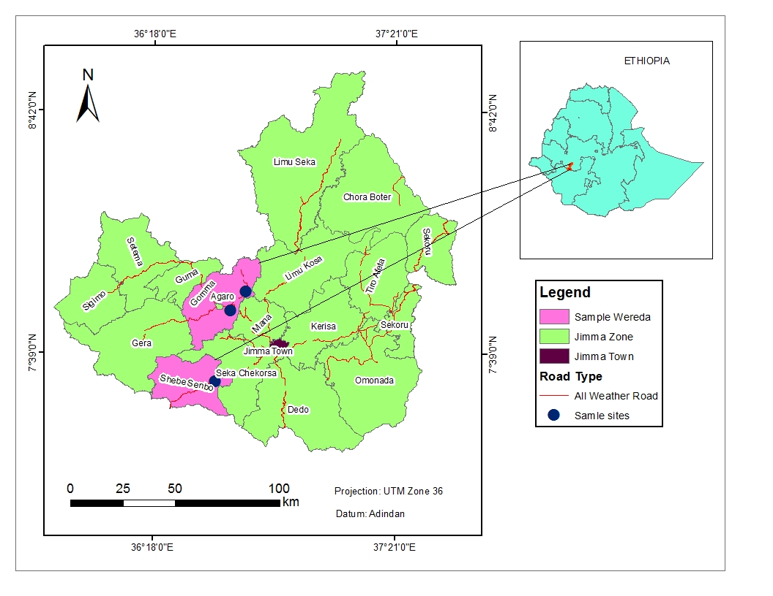
Soil samples were collected from three different localities (Table 1 and Fig. 1) using core sampling technique described by (Tuininga et al., 2009). At each of the three localities, ten soil samples were collected from 5 places by digging (15 cm diameter, 10-15 cm depth), 5 m apart in a transect. From each five sampling places, about 1.5 kg of soil was placed together (pooled) and mixed. From the mixed soil, 1 kg was kept in sterile plastic bag and moisturized as per required with sterile water to make sure that the only source of the microbes are from the soil and avoid any antagonist effect and packed. In the Mycology lab, Addis Ababa University, the aggregated soils were mechanically crushed, and sieved using 20 mm aperture sieve.
Figure 1:- Map of different localities of Jimma zone where soil samples were collected

Table 1:-Geographical location of soil samples collected sites in Jimma zones, Ethiopia

Site | Location | Description
Belete Chaka | N7°31'53", E36°33'46" | Natural forest
Choche | N7°55'20", E36°4'42" | Cultivated land
Geruke | N7°50'23", E36°37'53" | Open grazing land

From each locality 10 soil samples were collected using core sampling method

3. 2 Galleria mellonella rearing and baiting

At Ambo plant protection agricultural research institute Galleria mellonella was reared according to the method described by (Meyling, 2007). Male and female adult were kept in 500 ml flasks with a lid. Strip folded paper was placed in the flask to facilitate mating and egg laying (Appendix 1). Each folded paper with the eggs attached was carefully transferred into a container with a mixture of sterile wheat bran, glycerol and honey as food source for hatching larvae and kept in an incubator at 35ºC (Appendix 2). When larval growth reached about 2.5 cm in length within 4-5 weeks after hatching, larvae were used for baiting. The baiting process was done following the method described by (Meyling and Eilenberg, 2006). Larvae were heat treated in warm water to prevent extensive webbing in the baiting test soil. Therefore, a 1000 ml beaker filled with 500 ml of sterile water was placed in a water bath at 56ºC. Larvae from the rearing containers were collected in a box and at once poured into the beaker with 56°C warm water for 10 seconds. The beaker was emptied through a sterile sieve of 20 mm aperture and then the larvae were cooled by immersing in sterile cold water for 30 seconds and placed on dry sterile tissue paper in the dark for 3-5 h until they have recovered from the treatment (Appendix 3).

3. 3 Inoculation and isolation

About 1kg sieved soil was placed on surface disinfected tray and moisturized with sterile water, then filled into 1.5 liter of glass container with screw capped leaving some space on the top to inoculate Galleria larvae. For each sample, ten glass containers were used and 10 larvae were inoculated per container. Sterile soil was used as control. Containers were incubated at 25 ± 5ºC in the dark. Dead larvae were removed every 3 days intervals from the glass containers. The moisture level of inoculated soil was maintained by gentle moistening with sterile water after inspecting the dead larvae on tray. The dead larvae were surface sterilized in 0.5% sodium hypochlorite for 3 min, rinsed in sterile distilled water for 2 min, immersed in 70% ethanol for 2 min and finally rinsed three times in sterile distilled water. After surface sterilization the cadavers were placed on a sterile plate that contained sterile Whatman filter paper No. 1 moistened with sterile water and incubated at 25 ± 5ºC in the dark (Appendix 4). When the Beauveria spp. sporulated on the cadaver they were subcultured on PDA and pure cultures were preserved on 3% glycerol PDA slant at refrigeration temperature.

3.4. Cultural and morphological characterization

The infected larvae that showed adequate fungal growth and produced spores on the dead larvae of Galleria, cadavers(Appendix 5) were transferred using sterile scrapper to 0.01% chloramphenicol Sabouraud Dextrose Yeast Agar (SDAY) and incubated at 25 ± 5º C. The isolates were characterized based on their colony growth character, conidial and spore features grown on each insect cadaver. On the basis of surface texture, either whitish pigmentation when young or yellowish when sporulating was used as criteria for culture characteristics in the identification (Appendix 6). Microscopic examinations were carried out with Lacto-phenol cotton blue and myco-taxonomic keys of (Samson, 1981) for identification based on conidial characteristics including position of spore, septation of hyphae, shape, conidiophores, colour of colonies (Appendix 7). Beauveria isolates were preserved on PDA slant that contained 30% glycerol and incubated at 4ºC in refrigerator for further activities.

3.5. Molecular analysis

3.5. 1 DNA extraction and purification

Preserved pure cultures of Beauveria spp. were transported to the Julius Kühn-Institut, Münster, Germany for molecular characterization. From the preserved slant the fungal spores were grown on potato dextrose agar (PDA). After 20 days using sterile spatula the spores were inoculated into 50 ml of potato dextrose broth in 100ml of flask and allowed to grow at 26.5ºC in temperature regulated room for four days on a shaker at 300 rpm.
The grown mycelium was then harvested by filtering through a sterile Whatman No. 1 filter paper and allowed to dry for 5 min in a microbiological safety hood. One gram of mycelium was weighed into 2 ml sterile Eppendorf tube and then incubated in a freezer at -80ºC for 20 min. About 80 mg of 212 µm size sterile glass bids were added to the mycelium and mixed with the mycelium by thoroughly stirring with a sterile spatula within, 100 µl of DNA extraction buffer (Tris-HCl, 1M; EDTA, 0.5 mM pH 8.0; KCl, 25 mM and SDS, 0.5%) was added. The mixture was vortexed for 5 min and centrifuged at 13,000 rpm for 1 min. The supernatant was transferred to a new Eppendorf tube in to which 3 µl of proteinase K was added. The mixture was then incubated at 64ºC for 1 hr followed by 96ºC for 15 min. The mixture was then centrifuged at 13,000 g for 1 min and the supernatant transferred to a new Eppendorf tube. 300 µl of cold isopropanol was added, mixed and centrifuged at 13,000 g for 20 min at 4ºC. The supernatant were carefully discarded and the pellet washed with 40 µl of 70% ethanol and air-dried at 37ºC for 15 min. Finally, the DNA was resuspended in 50 µl of nuclease free water and stored at -20ºC.

3. 5. 2 PCR amplification

The rDNA regions targeted for PCR cloning were ITS1, 5.8S gene and ITS4. Primers ITS1 (5’-TCCGTAGGTGAACCTGCGG-3’) and ITS4 (5’ TCCTCCGCTTATTGATATGC-3’) were used to amplify the target regions (White et al., 1990). The PCR amplification reaction was conducted in a total volume of 25 µl. The mixture contained 13.5 µl of water, 2.5 µl buffer, 3.0 µL of dNTP, 1 µl of each primer, 1µl Taq polymerase, and 3.0 µl genomic DNA. PCR thermocycler settings were 4 min initial denature at 94ºC followed by 35 cycles of 30 sec denaturation at 94ºC, 30 second annealing at 58ºC and 1 min at 72ºC for extension. The PCR product was assayed by electrophoresis in 1.5 % agarose gel run with TBE buffer at 100 mV and stained with 0.0001% Ethidium bromide. The gel was photographed under UV light.

3.5. 3.Sequencing

The amplified PCR product was sequenced. Prior to sequencing, the amplicon was purified using the Wizard® SV Gel and PCR Clean-Up System according to the manufacturer’s instruction. For sequencing, 5 µl of the PCR products and 5 µl of 10 pmole/µl of the forward primer were mixed. Eight isolate were randomly selected and sequenced in one direction. Sequencing was performed at the Macro gene sequencing Facility Service (Amsterdam, The Netherlands). Nucleotide sequences were deposited in GenBank nucleotide sequence databases.

3. 5. 4. Sequence alignment

All raw sequence chromatograms obtained in this study were edited in Chromas Lite version 2.1 (Sagong et al., 2012) to exclude incorrect base calls before multiple alignment was performed. Consensus quality sequences were subjected to BLAST engine (Altschul et al., 1990) for sequence similarity search in GenBank, NCBI database. All the new sequences and sequences from the GenBank were then aligned using the default parameters of ClustalX version 2.1 (Larkin et al., 2007).

3. 5. 5. Phylogenetic analysis

Newly obtained sequences of rDNA-ITS gene plus related published sequences from GenBank were used to reconstruct the phylogenetic trees. Cordyceps militaris (KM197165) from Taiwan was chosen as out group taxa. Pair wise distance between our isolates and B. bassiana sequences in GenBank from China (KU158450), Kenya (AJ560666), India (KU363833), Switzerland (KT583186), Turkey (KP862983), Thailand (EU573330), and Portugal (LT220530) together with other fungal species from Greece (L. lecanii, EF513006), Portugal (B. pseudobassiana, LT220534), and Thailand (B. brongniarti, EU573325) were analyzed using MEGA5 (Tamura et al., 2011). The phylogenetic analysis was carried out with Maximum Likelihood (ML). ML analysis was performed using heuristics searches with Nearest-Neighbor-Interchange (NNI) branch swapping filter. Gaps and missing data were also considered in the Tamura-Nie Model. The support for each branch was estimated using the bootstrap (bs) method with heuristics search and 1500 replicates in MEGA5 analysis (Tamura et al., 2011).

Table 2:- Beauveria bassiana isolates from Ethiopia used for molecular analysis in this study
Locality | Isolate code | Accession number
Belete Chaka | B5B | KR337495
Belete Chaka | B7E | KR337496
Belete Chaka | B2J | KR337494
Belete Chaka | B6F | KR337499
Belete Chaka | B7A | KR337493
Geruke | G5I | KR337500
Choche | C3C | KR337498
Choche | C1C | KR337497

Table 3:- GenBank accession numbers for reference sequences used for phylogenetic analysis
Species | Accession Nr | Origin of country | Reference
Beauveria bassiana | AJ560677 | United Kingdom | Aquino de Muro et al., 2003
Beauveria bassiana | KR014380 | Italy | Gnavi and Varese, 2015
Beauveria bassiana | KP862996 | Turkey | Keskin et al., 2015
Beauveria bassiana | KF971688 | Morocco | Imoulan et al., 2013
Beauveria bassiana | KC004059 | Brazil | Formentini et al.,2012
Isaria farinose | KM035983 | China | Wang and Wu, 2014
Beauveria bassiana | KC461111 | Mexico | Perez-Gonzalez et al., 2012
Beauveria bassiana | JX406519 | China | Tang et al., 2012
Beauveria bassiana | EU573326 | Thailand | Aung et al., 2008
Beauveria bassiana | KC461112 | Mexico | Perez-Gonzalez et al., 2012
Beauveria asiatica | HQ880785 | USA | Rehner et al., 2011
Lecanicillium lecanii | EF513006 | Greece | Kouvelis et al., 2008
Beauveria brongniartii | JX110381 | South Africa | Goble et al., 2012
Beauveria brongniartii | EU573312 | Thailand | Aung et al., 2008
Beauveria pseudobassiana | KC355185 | Mexico | Perez-Gonzalez et al.,2012
Beauveria bassiana | HQ380852 | Switzerland | Schulz et al.,2010
Cordyceps militari | AJ243774 | China | Zhao et al.,1999
Beauveria bassiana | GU189515 | Mexico | Rosas-G. and Villegas-M., 2009
Beauveria bassiana | KC688689 | Spain | Morales-Rodriguez,et al., 2013
Beauveria bassiana | GQ354257 | Canada | Johny et al., 2012
Beauveria bassiana | JX110368 | South Africa | Goble et al., 2012
Beauveria bassiana | JX110390 | South Africa | Goble et al, 2012
Beauveria bassiana | HQ380843 | Switzerland | Schulz et al., 2010
Beauveria bassiana | GU373819 | Denmark | Meyling,et al., 2009
Beauveria bassiana | HQ380849 | Switzerland | Schulz et al., 2010
Beauveria bassiana | KJ489077 | Slovakia | Medo et al.,2014
Beauveria bassiana | KC004064 | Brazil | Formentini,etal.,2012
Beauveria bassiana | KF500409 | Argentina | Russo, et al.,2013 2013
Beauveria brongniarti | GU373818 | Denmark | Meyling, et al., 2009
Beauveria brongniarti | JX110373 | South Africa | Goble et al., 2012
Beauveria brongniarti | KJ489070 | Slovakia | Medo et al. 2014

4. Results

The total number of B. bassiana trapped from the different soil samples were 159 (53%) out of 300 Gallaria larvae tested, in which 80 26.7%), 56 (18.7%) and 23 (07.7%) were from Beletechaka, Geruke and Choche farms, respectively. The mean ± SE of B. bassiana isolated from each locality were significantly different (Table 4).

Cultural and morphological characteristics of B. bassiana were confirmed by their densely and yellowish-white cottony colony on the exoskeleton of insect cadavers and a dense white colony that turns to yellowish white (creamy) when sporulation was also observed on the SDAY media. From the microscopic features the conidiogenous cells were observed as clustered, colorless, with a globose base and a denticulate apical extension (Lacey, 1997). Conidia were borne out of zigzag phialides or apical extensions (Boucias et al., 1998).

Table 4:- Mean ± SE and percentage of B. bassiana spp isolated from soil samples collected from different localities in Jimma zone, southwestern Ethiopia during
Localities |  | Occurrence (%) | Mean ± SE
Beletechaka |  | 80 | 8.0 ± 0.61^{c}
Choche |  | 23 | 2.3 ± 0.21^{b}
Geruke |  | 56 | 5.6 ± 0.54ª
Ten soil samples were collected per localities and ten Galleria larvae were used for trapping of B. bassiana. Values with different letter are significantly different at P < 0.05 by Tukey HSDª multiple tests.
The PCR amplification of the ITS region of the 36 isolates produced single fragments of about 560 bp long. All tested isolates gave the same fragment size (Fig. 2). Eight isolates were randomly selected and sequenced. A BLAST search at NCBI confirmed the species identity of the Ethiopian isolates. Each isolate revealed 98-100% sequence similarity with one or more previously published isolates of B. bassiana (Table5). Moreover, both sequence and phylogenetic analysis confirmed that the Ethiopian isolates represent the species B. bassiana.

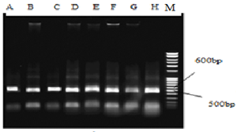
Figure 2:- PCR products amplified using ITS primers (ITS 1and ITS 4) from representative specimens of Beauveria bassiana (A-H) isolates from Ethiopia. M: 1000 bp ladder.

The final ITS sequence alignment contained 513 positions with 34 parsimony informative sites. Within the Ethiopian isolates, there were three groups based on AT richness: (4) 42 %, (3) 43%; and (1) 45% (Table 6). The Ethiopian isolates shared an overall intra-sequence similarity value of at least 99%. The sequence similarity among all isolates of sequences aligned in the sequence analyzed was 97-100% and 91% without group of Cordyceps militaris (Table 5). For comparison, sequence similarity with other Beauveria species ranged between 4% for B. brongniarti.

Table 5:- Sequence similarity (%) of ITS region of Beauveria isolates from Ethiopia and selected fungal isolates

 |  | Fungal isolates
 |  | 1 | 2 | 3 | 4 | 5 | 6 | 7 | 8 | 9 | 10 | 11 | 12 | 13 | 14 | 15 | 16 | 17 | 18 | 19
1 | LT220530 Beauveria bassiana | -
2 | EU573330 Beauveria bassiana | 100 | -
3 | KU363833 Beauveria bassiana | 100 | 100 | -
4 | C3C (KR337498) | 100 | 100 | 100 | -
5 | B2J (KR337494) | 99 | 100 | 100 | 99 | -
6 | C1C (KR337497) | 99 | 100 | 100 | 99 | 100 | -
7 | B5B (KR337495) | 99 | 100 | 100 | 99 | 100 | 100 | -
8 | B6F (KR337499) | 100 | 100 | 100 | 99 | 100 | 100 | 100 | -
9 | B7A (KR337496) | 100 | 100 | 100 | 99 | 100 | 100 | 100 | 100 | -
10 | B7E (KR337500) | 100 | 100 | 100 | 99 | 100 | 100 | 100 | 100 | 100 | -
11 | G5I (KR337493) | 100 | 100 | 100 | 99 | 100 | 100 | 100 | 100 | 100 | 100 | -
12 | KU158450 Beauveria bassiana | 100 | 100 | 100 | 99 | 100 | 100 | 100 | 100 | 100 | 100 | 100 | -
13 | AJ560666 Beauveria bassiana | 100 | 100 | 100 | 99 | 100 | 100 | 100 | 100 | 100 | 100 | 100 | 100 | -
14 | KP862983 Beauveria bassiana | 100 | 100 | 100 | 100 | 100 | 100 | 100 | 100 | 100 | 100 | 100 | 100 | 100 | -
15 | KT583186 Beauveria bassiana | 100 | 100 | 100 | 100 | 100 | 100 | 100 | 100 | 100 | 100 | 100 | 100 | 100 | 100 | -
16 | EF513006 Lecanicillium lecanii | 96 | 96 | 96 | 97 | 96 | 96 | 96 | 96 | 96 | 96 | 96 | 96 | 96 | 96 | 96 | -
17 | LT220534 Beauveria pseudobassiana | 96 | 96 | 96 | 96 | 95 | 95 | 95 | 96 | 96 | 96 | 96 | 96 | 96 | 96 | 96 | 98 | -
18 | EU573325 Beauveria brongniartii | 96 | 96 | 96 | 97 | 96 | 96 | 96 | 96 | 96 | 96 | 96 | 96 | 96 | 96 | 96 | 98 | 98 | -
19 | KM197165 Cordyceps militaris | 91 | 91 | 91 | 91 | 91 | 91 | 91 | 91 | 91 | 91 | 91 | 91 | 91 | 91 | 91 | 90 | 90 | 90 | -

The ITS sequence alignment was compared between three Ethiopian isolates, one isolate from each locality (C1C, B5B and G5I) and other two isolates from GeneBank (KF500409; Argentina) and (JX110373; South Africa) (Fig.3). Overall, the alignment consists of five sequences with 496 bp in length (after trimming to equal length). A total of 24 variable positions were found among sequences of those five isolates. The variability is described as 9 transitions (6 G ↔A; 3 C↔T); 11 transversions (3 A↔C, 2 G↔T, 1 A↔T and 5 G↔C) and four indels ↔AATA. The highest nucleotide variation (19 nucleotides) was between the isolates from (JX110373) South Africa followed by (KF500409) Argentina (16 nucleotides) and the Ethiopian isolates B2J and C1C. These two Ethiopian isolates did not vary in nucleotide position to each other. The Ethiopian isolate G5I showed less nucleotide variation with isolate from Argentina (5 nucleotide) compared to the Ethiopian isolate that varied in 16 nucleotide positions (Fig. 3).

Table 6:- Nucleotide composition (%) of ITS region of Beauveria isolates
Beauveria isolates * | ITS region
Beauveria isolates * | T | C | A | G | AT | GC
B. bassiana /EU573326/ | 19 | 31 | 24 | 26 | 43 | 57
B2J | 19 | 30 | 24 | 26 | 43 | 57
C1C | 20 | 30 | 24 | 26 | 45 | 55
B5B | 19 | 32 | 23 | 26 | 42 | 58
G5I | 19 | 32 | 23 | 26 | 42 | 58
B7A | 19 | 32 | 23 | 26 | 43 | 57
B7E | 19 | 32 | 23 | 26 | 42 | 58
B6F | 18 | 32 | 24 | 26 | 42 | 58
B. bassiana /KC461111/ | 20 | 31 | 24 | 25 | 44 | 56
I. farinosa /KM035983/ | 19 | 31 | 24 | 26 | 44 | 56
L. lecanii /EF513006/ | 20 | 32 | 24 | 24 | 44 | 56
B. brongniarti /EU573312/ | 20 | 30 | 25 | 25 | 44 | 56
C3C | 18 | 31 | 24 | 26 | 43 | 57
B. bassiana /HQ380849/ | 18 | 31 | 24 | 26 | 43 | 57
*Isolates retrieved from GenBank are indicated by the corresponding accession number in parenthesis
In the ML analysis of the ITS region of Beauveria, the isolates formed a highly supported clade together with other isolates retrieved from the GenBank. The highest evolutionary divergence estimate of between sequences of Ethiopian isolates was only 1% (Fig. 4), with an overall distance of 0.0136. On the other hand the sequence variability among those isolates retrieved from the GenBank ranged from 1-2% with an overall distance of 0.0067. Therefore, the sequence disparity observed between the Ethiopian isolates can be within the acceptable range. However, given these isolates were collected from different habitats, the level of heterogeneity observed between isolates could be considered within the acceptable range. ML analysis placed all isolates on a strongly supported clade separated from other Beauveria species.

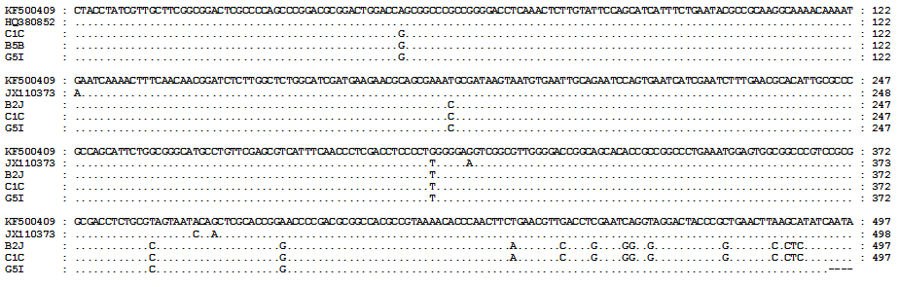
Figure 3:- Alignment of ITS of five selected Beauveria isolates. Isolates B2J, C1C and G5I are from Ethiopia. KF500409andJX110373 are from GeneBank originally from Argentina and South Africa, respectively. Sequences were trimmed to equal length manually in GeneDoc software. Identical nucleotide positions are indicated with ‘.’ Indels are indicated with ‘-’.
Figure 4:- Maximum Likelihood analysis of the ITS region of Ethiopia isolates and other related sequences from the GenBank. Sequences are given with their corresponding accession number. The analysis was performed using 1000 bootstrap replicates. Corresponding bootstrap support more than 50% are given for each appropriate clade. Whereas sequences for Ethiopian isolates are given by codes in blue color (B5B, B7E, B2J, B6F, B7A, G5I, C3C and C1C). Cordyceps militaris has been used as an out group taxa.

5. Discussion

The trapping frequency of B. bassiana isolation varied among localities Beletechaka being the highest trapped 80% followed by Geruke which is 56% as compared to Choche that was only 23% (Table 4). The number of trapped Beauveria isolate from these localities was relatively high. This might be due to the core soil sampling method and number of larvae used (10) per treatment. Using the same soil sampling method from five pooled soil samples (Quesada-Moraga et al., 2007) reported that of the 244 soil samples, 104 yielded B. bassiana (42.6 %) and 53 samples (21.7%) harbored both species (B. bassiana and M. anisopliae). On the contrary from single soil sampling method Sun et al. (2008) reported that (20.4%) B. bassiana and 24 (3%) M. anisopliae were isolated from 171 soil samples. The difference in isolation frequency of B. bassiana could be due to the fact that soil samples pooled by core sampling increase the chance of mixing fungal propagules of different species in the soil sample and exposed Galleria larvae than using single soil sample. Using more number of trapping larvae (10) would also increase the chance of infection than using small number (3) per treatment (Sun et al., 2008).

The low baiting of B. bassiana from Choche could be due to the intensive agricultural practice in this region. The farmed soil is routinely exposed to plant protection agents including fungicides and insecticides. Fungicides used by the farmers for fungal disease control could have directly affected B. bassiana in the soil while applications of insecticides could have reduced their natural host. In this regard, Vänninen et al. (2000) highlighted the fact that B. bassiana requires frequent serial passage through insect hosts to survive. Scarcity of host insects in heavily cultivated and insecticide treated areas subsequently will put B. bassiana at a disadvantage in those soils. Similarly, Gc (2006) and Vänninen et al. (2000) confirmed that B. bassiana requires host insects for survival and long-term persistence in the soil.

The higher frequency of B. bassiana isolation from Belete chaka could be related to an intact forest ecosystem with a high diversity of plants and insect hosts with the latter serving as the host for B. bassiana. Studies from tropical and temperate forests of Mexico and worldwide Sánchez-Peña et al. (2011) confirmed the natural forest areas harbor a diverse spectrum of entomopathogenic fungi. The third location Geruke is characterized by natural vegetation serving as grazing area for cattle, sheep and goats. Their fecal matter harbors a diverse spectrum of insects providing natural hosts for entomopathogenic fungi including B. bassiana. Overall, those results confirm the importance of natural habitats as reservoirs for natural enemies as potential biological control agents.

Traditionally, the identification of entomopathogenic fungi relies on fungal isolation and a highly skilled expert in fungal identification. In comparison, modern DNA based molecular diagnostics are fast, independent of fungal culturing and often more accurate. Therefore, the feasibility of using the ITS region for the detection and identification of Beauveria spp. was evaluated. The amplification of the ITS region produced a fragment size of approximately 560 bp which is in agreement with that report by (De Muro et al., 2005). Similar, Carneiro et al. (2008) reported a fragment length of 570 bp from the ITS-rDNA region for 24 B. bassiana isolates. Hence, the size of the PCR product already allows discriminating B. bassiana from other species. The low level of sequence variation is commonly detected within ITS regions (De Muro et al., 2005). Thus the mere use of the PCR fragment size is not conclusive for correct species identification.

The ITS primers utilized in this study amplified a fragment with approximately 560 bp for all fungal isolates. Analysis at nucleotide level provided more informative and the ITS sequences from all isolates suggested that the isolates examined could have a common genetic basis with low variation at conserved regions. There was only 1% sequence disparity among the Ethiopian isolates of B. bassiana. Sequence disparity was also reported by Carneiro et al. (2008) who found four variations in nucleotide positions out of 571 nucleotides between B. bassiana isolates. In the present study, the eight randomly sequenced isolates of B. bassiana were collected from different habitats within a relatively close geographical origin. Therefore, the level of sequence disparity observed between those Ethiopian isolates is considered realistic and supports the hypothesis that the overall sequence variability within Beauveria isolates ranges between 1-4%.

The ML analysis of the DNA-ITS region formed a highly supported clade together with other isolates retrieved from GenBank. When compared the study of these isolates with other GenBank nucleotide sequences of different species of the Hyphomycetes groups such as Beauveria brongniartii, Lecanicillium lecani, and Beauveria pseudobassiana and Cordyceps militaris showed differences from the sequence of the ITS region and made it possible to discriminate the studied isolates according to their genetic profiles with these isolates B. bassiana.
The clustering of the B. bassiana isolates from Ethiopia showed the closest relationship with different isolates of B. bassiana from other regions. Except for isolate C3C, all Ethiopian isolates appeared between isolates from Kenya (AJ560666) and China (KU158436). The analyses of these isolates indicated intraspecific variation amongst Ethiopian isolates. Isolate C3C showed fairly distant relation to the rest of the Ethiopian isolates but closely related to Portuguese isolate (LT220530) isolated from Vineyard soils. However Carneiro et al. (2008) obtained B. bassiana that clustered based on the origin of the isolates. All the B. bassiana isolates are genetically similar and quite distant from the out group fungal isolate Cordyceps militaris.

6. Conclusion

Soil samples collected from different localities, Beletechaka, Geruke and Choke are good source of entomopathogenic fungi, B. bassiana germplasm. Soil core sampling methods is more advantageous than single soil sampling for increasing the chance of contacting fungal spore for infection from different sites. Exposing more number of Galleria larvae (10) than using small number (3) per treatment as it reduce the chance of trapping of the fungi. Isolation of B. bassiana from the soil using Galleria larvae trapping method is simple but it needs additional continuous management of rearing of the insect.

From this study intact environments are richer in entomopathogenic diversity than farm lands. B. bassiana trapping was more from soil samples of Belete chaka (natural forest) and Geruke (open gazing land), which are relatively undisturbed area. Utilization of different fungicides and pesticides chemicals as agricultural input reduces the abundance of the entomopathogenic fungi.

Species identification of B. bassiana using molecular diagnostics is reliable which can be effectively used in parallel with classical identification methods based on morphology and culture characteristics.

7. Recommendation

Natural forests and grazing grasslands are biodiversity reservoirs of B. bassiana compared to farm lands. Conservation of these resources is therefore important.
- Additional screening B. bassiana isolates are also required from other localities to exploit diversity of the isolates
- Core sampling and using large number of Galleria larvae are reliable methods on trapping large number of B. bassiana isolates.

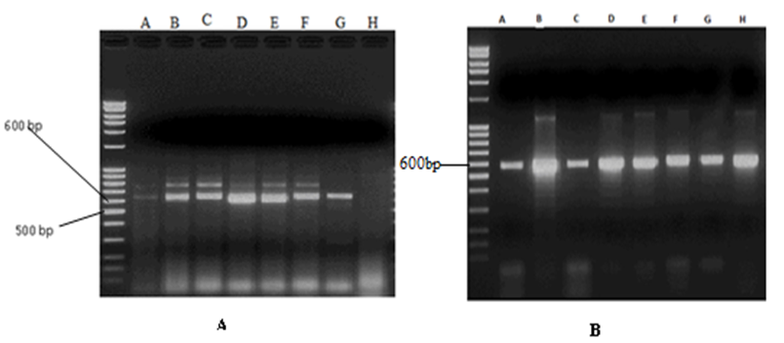
CHAPTERF OUR

Bioassay and Pilot Mass Production of Entomopathogenic Fungi, Beauveria bassiana for the Control of Coffee Berry Borer (Hypothenemus hampei, Ferrari)

Abstract

Thirteen Beauveria bassiana isolates were selected and screened for their biocontrol effects against coffee berry borer. Four parameters (percentage of spore germination, insect mortality (100%), average survival time (LT₅₀), and spore production on CBB cadaver) were used for screening criteria. 0nly 3 isolates scored > 93% spore germination, all isolates showed 100% mortality, six isolates showed shorter time of LT₅₀ mortality approximately ≤ 84 hrs (3.5) days and4 isolates produced more than 1x10⁷ average mean spore per CBB. There were significant differences on spore germination due to isolates at (df = 12, F = 2.734 and P = 0.016) and spore production at (F = 25.525, df = 12, P = 0.000).Three isolates B7A, G2A and C3C merited for conidial mass production cultured on sorghum using diphasic liquid-solid fermentation. The maximum mean spore concentration g⁻¹ of spore, weight of harvested spore kg⁻¹of substrate, spore production kg⁻¹of substrate and the percentage of average mean spore germination potential during conidia mass production using the 3 isolates were4.80 x10¹⁰ ± 2.66 x10¹⁰, 8.48 ± 0.71,4.01x10¹¹ ± 2.00 x 10^{11A}and 89.33 ± 5.01 respectively. There was a significance difference by the isolates on spore concentration and spore production by the

isolates at (df = 2, F= 8.208 and P = 0.019) and (df = 2, F = 10.174 and P = 0.012) respectively. The minimum moisture content attained within 10 days was ranged from 11.09 ± 2.39 - 12.86 ± 3.75.

Key words/phrases:- Bioassay, Coffee berry borer, Mass production, Moisture content, Mortality, LT₅₀, Spore production

1. Introduction

Sustainable agriculture could be achieved not only through proper agricultural practices. Continuous research and development of new technologies; particularly agricultural biotechnology is very important input to achieve greater competitiveness in the world market. Knowledge and continuous research is the key to assess the potential of biotechnology to increase agricultural productivity and to contribute for sustainability of agricultural systems. It is estimated that one third of global agricultural production including coffee is annually destroyed by over 20,000 species of field and storage pests valued billion dollars (Attathom, 2004; Posada and Vega, 2005b).

Many African coffee producer countries depend almost entirely on foreign exchange earnings from coffee exports. Majority of their population draw their livelihood from coffee cultivation, processing and marketing establishments. Major coffee producer countries in order of importance are Ethiopia, Uganda, Ivory Coast, Kenya, Tanzania, Cameroon, Madagascar, Burundi and Democratic Republic of Congo, Benin, Angola, Central African Republic, Congo (Brazzaville), Gabon, Togo, Equatorial Guinea, Ghana, Guinea, Liberia, Nigeria and Sierra Leone produce smaller quantities (Kucel et al., 2009)

Among the major factors limiting increased coffee production worldwide are losses due to pests (disease, insects, nematodes and weeds), both indigenous and exotic. Insect pests are the most serious and the most numerous, with over 900 species having been recorded (Mitchell, 1988) Antestia bug (Antestiopsis intricate, A. facetoids), coffee blotch miner, (Leucoptera caffeinia) coffee berry borer (Hypothenemus hampei), coffee thrips (Diarthrothrips coffeae), green scale (Coccusal pinus) and coffee cushion scale, (Stictococcus formicarius), are potentially important insect pests in Ethiopia (Abebe, 1987).

The majority of African coffee producer countries rank the CBB, Hypothenemus hampei as the single most important constraint of production. Some countries such as Uganda, Cameroon, D.R. Congo and Kenya reported increases in berry borer damage levels over the years (Kucel et al., 2009). Cameroon, D.R. Congo, Central African Republic and Ivory Coast consider their CBB profile as getting worse or much worse. In Kenya, infestation levels of 80% during the peak season with similar magnitude of crop losses with reduction in quality of the remaining yield have been reported (Mugo et al., 1997). Severe infestation may result in up to 80% of berries being attacked in Uganda and Ivory Coast and 96% in Congo and Tanzania (Waterhouse and Norris, 1987). In Uganda, CBB is a serious pest of Robusta, and may also be important on Arabica at low altitudes (Mukiibi, 2001).

The majority coffee farmers in Africa are small holders with farm sizes hardly exceeding 2 hectares. Uganda for instance, nearly all the Robusta and most of the Arabica is grown by local cultivators in small individual plots, with average farm size of 0.36 hectares for Robusta and 0.23 for Arabica (Kucel et al., 2009).
.
The trend is also the same in Ethiopia, 70% of the coffee is produced as garden coffee by small farmers, 25% is collected in forest and semi-forest coffee systems and merely 5% is plantation coffee (Abebe Yadessa et al., 2008). Smallholder producers are responsible for about 95 percent of production, while state-owned plantations account for 4.4%and private investor plantations 0.6% (Petit, 2007). The CBB is remained as problem for many coffee producer farmers in African countries. In some countries the situation is getting worse (80%-85%) and the control measures are generally ineffective (Kucel et al., 2009) and yet not given a deserving attention like in Ethiopia.

The CBB, Hypothenemus hampei (Ferrari), is the most serious insect pest of coffee worldwide causing severe economic damage in every region where commercial coffee is grown. Synthetic, broad-spectrum insecticide is a satisfactory for immediate and the possible solution for pest control. Chemical control of CBB is discouraged in Uganda by policy that promotes production of specialty coffee, but is widely applied in plantation coffee in Kenya and some other African countries (Kucel et al., 2009). Chemical spray against coffee berry borer has limited effectiveness due to the cryptic nature of pest (Vijayalakshmi et al., 2013). Therefore, it must be applied before the beetle enters into the hardened bean (Mugo et al., 2011). Several insecticides have been recommended for the management of borer. Application of insecticides causes development resistant type of coffee berry borer (Brun et al., 1989). The resistant type of H. hampei to endosulfan is reported initially in New Caledonia (Brun et al., 1989). The resistance type was later confirmed through molecular studies and found that it was depends on the Rdl gene (Gingerich et al., 1996). This resistance gen also described in Colombia (Navarro et al., 2010).

Besides to resistance development, excessive use of chemical insecticides is a threat to human and animal health, natural ecosystem and environment. Societal concerns over chemical pesticide use have resulted in the development of new biologically based insect pest management strategies that are ecologically sound, reliable, environmentally friendly and economical feasible.

Entomopathogenic fungus, Beauveria bassiana is pathogenic to many insects, including the CBB (Fernando et al., 2009). Once, if the fungus is inoculated into the ecosystem they can serve as natural inoculum. In order to get these levels, enough spore should be produced to spray the coffee area for at least three years (Benavides et al., 2012). Bustillo Pardey (2006) has observed that in the coffee ecosystem of Colombia, this fungus is a natural controller of the H. hampei. Furthermore, there are no known diseases of H. hampei caused by either bacteria or viruses other than B. bassiana (Benavides et al., 2012). B. bassiana has been shown high mortality in the ecosystem as a natural inoculum where the CBB is present in different countries (Haraprasad et al., 2001). High CBB mortality caused by the B. bassiana has been reported in Indian coffee plantations (Haraprasad et al., 2001) and Mexico (De La Rosa et al., 2000) as well.

Beauveria bassiana are unique in their ability to infect via the insect cuticle and various products of B. bassiana have been developed for use against a wide variety of pests in forest, field, and greenhouse environments. There is considerable interest in the development of this fungus as biopesticides in Ethiopia for the control of insect pests in the floricultures including CBB (Ludwig and Oetting, 2002).

Commercial formulations of B. bassiana are utilized in Australia, South America, Europe, Russia and North America, as well as several African and Asian countries but in small quantities compared with the demand of biopesticides by producers (Goettel et al., 2011). Mass production of B. bassiana spores can be achieved using different methodologies, with low input and simple technologies (Gouli et al., 2005). The fungus is relatively easy to mass-produce on inexpensive natural substrates in systems that are highly appropriate for myco-insecticide industries that have the potential to contribute significantly to the local economy. However, strains that keep yield high spore production, high pathogenicity and adequate shelf life simultaneously remain a challenge for mass production and field application (Gouli et al., 2005)

Production of B. bassiana spores can be achieved using different methodologies, which can be classified as either low input or industrial technologies (Feng et al., 1994). Both solid and liquid fermentation systems are used for the mass production of biocontrol agents (Pham et al., 2010). Solid state fermentation (SSF) allows several types of fungi to produce hardly and healthy conidia (Pham et al., 2009). Development of simple and reliable production system follows the basic multiplication procedures of submerged liquid fermentation for the production of blastospores, which are short lived, and hydrophilic (Rombach, 1989) for start culture of solid state fermentation.

The most viable mass production technologies include making use of a diphasic strategy in which the fungal inoculum is produced in liquid culture, which is further utilized for inoculating the solid substrate(s) for conidia production (Burges and Hussey, 1981). The present study was undertaken to evaluate the grain, sorghum, for mass production of conidia for biocontrol of CBB. Therefore, to this end pathogenicity test of the Beauveria isolates against the coffee berry borer, CBB and pilot mass conidia production of these biocontrol agents against the insect pest were the main objective of this work. This study includes screening of virulent Beauveria isolates based on bioassay test on CBB and also to produce mass multiplication of conidia using diphasic fermentation.

Hypothesis
- Isolates of B. bassiana have different virulent potential against CBB and spore production using diphasic fermentation on sorghum substrate.

2. Objectives

2.1 General objectives

- To determine the virulence potential of B. bassiana on coffee berry borer
- To evaluate the conidial mass production of B. bassiana using diphasic fermentation on sorghum substrate.

2.1.1. Specific objectives

To determine the spore germination potential of B. bassiana isolates

To determine potential virulence of the isolates from bioassay test on the CBB

To determine the amount of spore production by the isolates on the cadavers and substrate

To determine viability of spores after mass production on the substrate

3. Material and Methods

3.1. Determination of spore germination potential of Beauveria bassiana isolates

Spore germination test usually done before bioassay tests (Kreutz et al., 2004) and carried out within 24 hours of incubation as was also done by (Bateman et al., 1995). A one month old Beauveria isolates were subculture from Potato Dextrose Agar (PDA) slant onto Sabouraud Dextrose Yeast Agar (SDAY) plate and incubated at 25 ± 5ºC until sporulated. The sporulated fungus was scrapped using sterile spatula into a test tube. The spore concentration was adjusted to1x10⁷ spore/ml from the stock suspension using haemocytometer.

The conidial viability was assessed according to Ali (Alizadeh et al., 2007). Consequently, 1ml of the final conidial suspension 1x10⁷ spore/ml of Beauveria isolates was inoculated into sterile mixture of 9ml of 1% water agar and 0.05% yeast extract. Then the suspension was vortexes and incubated at 25±5ºC for 24 hours. After incubation, 1ml of the spore culture was placed into haemocytometer and approximately 200 germinated and non-germinated conidia were counted to estimate percentage of germination under light microscope. Each count was done in triplicates to calculate the mean % of spore germination. Viability of the spores was confirmed and conidium was considered as germinated when a visible germ tube longer than half the diameter of the spore was observed (Vega et al., 2008). Percentage of germination was calculated using the following formula:
% of spore germinated = Number of spore germinated x 100
Total spore count

3. 2. Bioassay of Beauveria bassiana against coffee berry borer

The adult female CBB were identified according to Booth et al. (1990) using stereomicroscope. The beetles with approx. 1.7 mm size were selected as female CBB. The color of the young beetle when observed using stereomicroscope their abdomen appears a blackish-brown, with a lighter brown pronotum and darken to black at maturity. The shape of the elytral setae, which in H. hampei are longer and cylindrical whereas in the 'false borer' (H. obscurus or H. seriatus), they are shorter and more conical with dentate tips.

The identified female CBB were surface sterilized with 0.5% sodium hypochlorite solution and gently shaken for two minutes. Afterwards, they were rinsed three times in sterile distilled water and again sterilized with 70% ethanol for two minutes and rinsed with sterile distilled water three times and dried in a container lined with sterile towels paper to remove surface micro-flora. Surface sterilized CBB then separated into small groups to be assigned to the treatments, ten CBB were kept into a sterile plate in triplicate per treatment.

Ten CBB per treatment were dipped into 100 ml sterile beaker from the plate using sterile paintbrush that contained 10 ml of Beauveria isolates spore suspension with 1x10⁷ spore ml⁻¹ (Posada and Vega, 2005b). For control 0.1% Triton X-100 without spore were used. The spore suspension and the insects were gently shaken for two minutes while dipped in their respective treatments. The suspension with CBB was emptied into sterile 60mm plate gently. Using a sterile paintbrush the inoculated insects placed into sterile plate containing two pieces of sterile Whatman No.1 filter paper moistened with sterile distilled water. Five inoculated insects were kept per plate with reasonably separated one insect from the other in space. The experiment was conducted as a completely randomized design, with each isolate treatment replicated 3 times. Sterile distilled water was added to the filter paper to moisturize as needed. All treatments were incubated in the dark at 25 + 2º C in a growth chamber. Insects’ mortalities were assessed within 24hrs intervals. Mortality of the insects was checked based on stiffness of the cadavers and mycelia observed under microscope. Dead cadavers manifesting the mycelia growth on the surface were kept separately in the 5cm sterile plates containing sterile Whatman No.1 filter paper moistened with sterile distilled water until the fungi sporulated. Median of lethal time (LT₅₀) of each isolates was calculated using probit analysis.

3. 3 Quantifying Beauveria bassiana spore production on coffee berry borer

Spore production was determined by randomly selecting 3 beetles within each treatment for which there was spore production. Each beetle was immersed with in 5 ml of sterile distilled water with 0.1% Triton X-100 and gently shaken for one minute and then diluted to 10 ml (Posada and Vega, 2005). From a diluted spore suspension 1ml was counted in triplicate per each sample using a haemocytometer. The data were analyzed using a one-way analysis of variance (ANOVA, SPSS, 20). Statistical significance was checked at P < 0.05 and was considered significant.

Using a scoring system for the selection of potential biocontrol agent scoring system of a “+” was applied. Isolates that fulfilled the minimum values for each parameter of; insect mortality potential 100%; fungal spore germination > 85%; median of lethal time (LT₅₀) ≤ 84 hrs (3.5 days) and spore production ≥ 1x10⁷ spores per insect (Posada and Vega, 2005b). Thus ranked as, the higher the number of “+” signs, the better the isolate with four “+” being optimal; three “+” being good; two “+” average; and below two “+” not satisfactory.

3.4. Preparation of liquid state fermentation

Three isolates of Beauveria, B7A, C3C and G2A were selected based on the defined parameters for conidial mass production. One month old sporulated cultures of the selected isolates on PDA were inoculated into a sterilized 250ml of Sabouraud Dextrose Broth (SDB) in 500ml of flat bottom round flask. The inoculated cultures were kept on orbital shaker for a couple of weeks for the growth of blastospores to inoculate sorghum substrate for mass production (Appendix9-A).

3.5. Spore mass production on solid substrate

Mass production of Beauveria conidia on solid substrate was done according to (Gouli et al., 2005). One kg of sorghum was washed and dried into direct sun light. The dried sorghum substrate then mixed with water in the autoclaveable bags. The mixture then cooked in a water bath at 100⁰C to boil for 2 hrs. The bags with the cooked sorghum substrate was autoclaved at 121" C for 1 h. Mass production of each isolates were done induplicate; 2 kg of substrate per isolates.

The bags containing the grain were sterilized at the previous day and remaining in the autoclave overnight to ensure their sterility is maintained. The autoclaved substrates were inoculated with Beauveria blastospores inside a laminar flow hood. During inoculation the mouth of the bags were inserted into a cylindrical autoclaveable PVC pipe and the mouth of the bags pulled out through the PVC pipe reasonably and wrapped on PVC pipe in such away to keep the mouth open. The mouth of the bags were covered with the sterile cheese cloth, tissue paper and aluminum foil cover from inside to outside, respectively and held in place with a rubber band round the PVC pipe opening (Appendix9-B). The inoculated bags were kept inside a growth chamber (Appendix9-C) at 25.5ºC. Open shelves were used to allow air to circulate freely around the bags, preventing localized heating of the substrate as the fungus grows. The inoculated substrate was distributed evenly inside the bag as a thin layer as possible to maximize the surface area for gas exchange, evenly distribution of substrate and promote fungal growth. Three to four days after inoculation, the substrate was gently mixed without opening the bags. The mixing process was repeated 1-2 more times, 3-4 days apart. After one week of inoculation aluminum cover were removed for the better supply of oxygen for fungal mycelia growth and sporulation. Within 15 days the fungal mycelia were completely covered the substrate and sporulated within 20 days (Appendix9-D).

3.6. Spore drying and moisture content assessment

After 20 days the fungal biomass plus the substrate were transferred from the bags on to the trays which were wrapped with sterile news paper (Appendix 9-D). Two trays were generally used for each bag so that the substrate can be spread thin, to enhance hyphal maturation, sporulation and eventual drying.

Simultaneously when the cultures exposed to open tray from each treatments 200g of subsample culture (sorghum plus conidia) were taken at random places in duplicates for moisture content assessment (four subsamples per treatment). To dry the sample cultures they were kept in a chamber with an average temperature of 12 ± 4⁰C and an average relative humidity of 22 ± 6% for air dry. The moisture content of the culture and sorghum during air drying process were assessed in 24hrs intervals for ten days until the moisture content was stable. In order to monitor the efficiency of air drying, same amount of subsamples were taken from each treatment to oven drying for 24 hours at 105⁰C (Rao et al., 2006).

Percentage of the final moisture content of the harvested spore was calculated using the following formula.

% of moisture = MLod – MLad x 100
MLod
Where: - MLod= Moisture Loss with oven drying
MLad= Moisture Loss with air drying

3.7. Harvesting Beauveria bassiana spores

Harvesting was done manually for 20 minutes in a separate room. Any large clumps were first broken apart and the entire contents were gently mashed and then shaken. Spore powder separation from the dried substrate was done by placing the dried culture into a fine mesh bag size (25 x 50 cm), through a 35-mesh sieve (279 μm pore size) which was held inside a plastic bag (35 x 60 cm or larger) (Gouli et al., 2005). After that, aerial conidia were harvested by manually shaking the fungus colonized substrate. The separated conidia from the grains passed through the mesh was weighed and kept in to plastic bag (Appendix 10).

3.8. Determination of spore concentration

After 10 days of air drying 1gm of harvested spore was transferred into 10 ml sterilized distilled water containing 0.1% of triton-X-100 solution in 100 ml conical flasks then shaken to mix for 10 min. The suspension was filtered through double layered muslin cloth. Counting of spores was made after the serial dilution of the suspension using haemocytometer for determining the number of spores (concentration) per gm.

3.9. Determining viability of spore

After spore powder were harvested the viability of the spore was assessed by sampling a 1gmof the conidia and suspended in a small volume of 0.01% triton-X-100 and filtered through sterile cheese cloth and then adjusting the spore concentration to 1x10⁷ spore/ml. Spore viability was determined as indicated in the method under section 3.1 above.

4. Result

The mean spore germination (%) of 13 Beauveria isolates before bioassay was ranged from 76.33 ± 9.88- 95.75 ± 1.77 and 9 (69.23%) isolates showed > 85% of spore germination at 24 hours. Three isolates, B7A, C3C and G2A scored even better spore germination potential (> 93%) (Table 1). There was significant differences in Beauveria isolates spore germination (%) due to isolates at (DF = 12, F = 2.734 and P = 0.016).

Mortality of coffee berry borers dipped into spore suspensions of 1x10⁷ ml⁻¹ showed high mortality with 13 of the isolates reaching 100% mortality within 5 days even though there was discrepancies on number the mortality of the coffee berry borers at different hours (days) intervals. Two (15.38%) isolates (B7A and C3C) showed LT₅₀ mortality less than 72 hrs (3 days), 3(23.08%) isolates (B9D, G2A and G3H) cause mortality within less than 84 hrs (3.5 days), 4 (30.77%) isolates (B1D, B2J, B5B andB7E) less than 96 hrs (4 days) and 2 (15.38%) isolates (C1C and G5I) showed between 96 and 120 hrs (4 and 5.2 days). Generally 5 (38.46%) isolates B7A, B9D, C3C, G2A and G3H) showed LT₅₀ mortality approximately ≤ 3.5 days. There was no mortality observed in the controls within 5 days and LT₅₀ was 125.4hrs (5.23 days) (Table 7).

Table 7:- Spore germination (%), mortality (%), average lethal time in hours (LT₅₀), spore production per CBB and scoring of bioassay test after dipping the insect into spore suspension of Beauveria isolates at 1 x10⁷ ml⁻¹.
Isolates | Germination (%) | Mortality100%; | LT₅₀(hrs) | Spore per CBB | Scoring
Isolates | A | B | C | E | F
B1D | 82.17 ± 7.59^{ab} | 100.00 ± 0.00 | 87.94 | 3.3 x 10⁶± 1.1 x 10^{6 a, b} | -+-.-
B2J | 88.50 ± 4.77^{ab} | 100.00 ± 0.00 | 89.18 | 2.9 x 10⁷± 2.3 x 10^{7 b} | ++-+
B5B | 85.33 ± 7.59^{ab} | 100.00 ± 0.00 | 93.32 | 1.5 x 10⁷± 1.7 x 10^{7 a, b} | ++-+
B6F | 76.33 ±9.88ª | 100.00 ± 0.00 | 96.17 | 4.3 x 10⁶± 2.0 x 10^{6 a, b} | -+--
B7A | 93.83 ± 1.04^{b} | 100.00 ± 0.00 | 66.68 | 8.3 x 10⁷± 1.3 x 10^{7 c} | ++++
B7E | 77.83 ± 9.70^{ab} | 100.00 ± 0.00 | 94.57 | 5.0 x 10⁵± 2.6 x 10^{5 a} | -+--
B9D | 88.17 ± 4.75^{ab} | 100.00 ± 0.00 | 83.77 | 2.7 x 10⁶± 9.9 x 10^{5 a, b} | +++-
C1C | 83.17 ± 5.01^{ab} | 100.00 ± 0.00 | 103.24 | 6.5 x 10⁶± 8.0 x10^{5 a, b} | ----
C3C | 95.75 ± 1.77^{b} | 100.00 ± 0.00 | 67.44 | 6.5 x 10⁷± 2.1 x10^{6 c} | ++++
C5I | 89.00 ± 6.38^{ab} | 100.00 ± 0.00 | 85.26 | 5.5 x 10⁶± 6.6 x10^{5 a, b} | ++--
G2A | 94.83 ± 0.58^{b} | 100.00 ± 0.00 | 78.30 | 6.7 x 10⁶± 3.8 x10^{6 a, b} | +++-
G3H | 86.67 ± 2.84^{ab} | 100.00 ± 0.00 | 80.58 | 3.4 x 10⁶± 3.3 x10^{6 a, b} | +++-
G5I | 87.00 ± 5.63^{ab} | 100.00 ± 0.00 | 125.40 | 5.5 x 10⁵± 3.3 x 10^{5 a} | ++--

Each treatment was replicated 3 times and ten CBB were subjected per each treatment. Mean ± SD, percentage of germination, mortality (%) and spore per CBB were calculated with SPSS 20. Different letters showed significant differences of spore germination test using ANOVA post hoc LSD Tukey’s test at P < 0.05.Lethal Time 50 (LT₅₀)was determined using probit analysis. Scoring of each parameter was given based on; a “+” score was based on minimum values for each parameter as follows: mortality: 100 %; germination: > 85%; LT₅₀ ≤ 84hrs (3.5 days) and spore production: ≥ 1x10⁷ spores insect⁻¹. The better the isolate, the higher the “+” score, with 4“+” being optimal, 3“+” good, 2“+” average and below 2“+”, below average.
From the average mean spore production 4 (30.77%) isolates B2J, B5B, B7A and C3C produced more than 1x10⁷ spores per beetle (Table 7). Seven (53.85%) isolates (B1D, B6F, B9D, C1C, C5I, G2A and G3H produced between 1x10⁶ and 1x10⁷ spores per beetle and two isolates, B7E and G5I produced between 1 x 10⁵ and 1x10⁶ spores per beetle. There were significant differences in spore production on coffee berry borer cadavers at (F = 25.525, df = 12, P = 0.000) (Table 7).

Scoring of each parameter tested for screening potential Beauveria isolates that fulfill the minimum requirements were scored as “+’ sign. Two isolates which qualify the minimum values for each parameter with 4“+”were B7A and C3C while 5 isolates (B2J, B5B, B9D,G2A and G3H) scored 3+ and the rest 6 isolates scored 2“+” and below (Table 7).

Figure 5:- Mycelia and spore grown on the cadavers of coffee berry borer inoculated with Beauveria bassiana spores: different parts of the borer body is shown with spore 1x10⁷spore ml-1
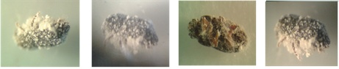
The above pictures illustrated mycelia growth and spore production on surface of CBB cadaver within 7-10 days after treatment.

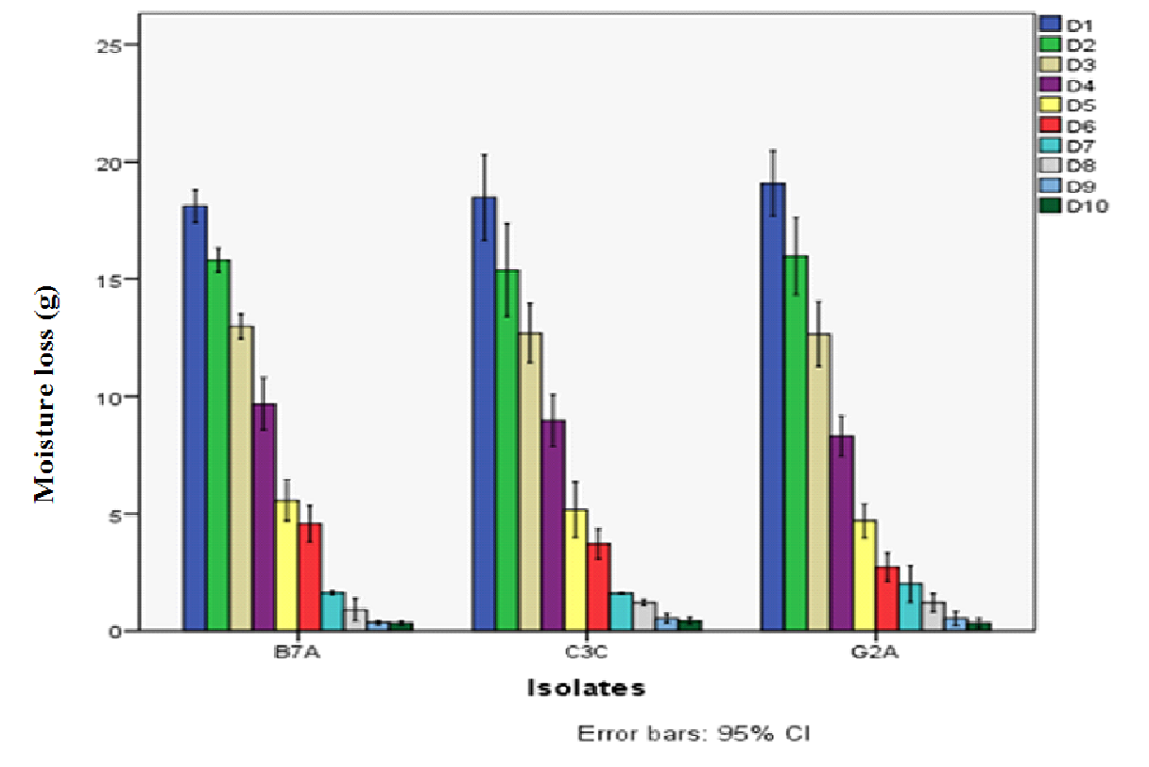
Figure 6:- The amount of moisture loss during air drying of the conidia and sorghum substrate (200g) per each sample. The amount of the moisture loss were calculated using SPSS 20 and bars represent confidence intervals for means (P = 0.05).

The moisture content fell rapidly during the first 4 days of assessment when the substrate exposed from the bag onto the tray and afterwards the moisture loss was relatively small and remained steady at around 10th days (Fig.6). All the cultures of the three isolates showed almost the same pattern of moisture loss.

Table 8:- The weight of culture after 10 days air drying, oven drying and percentage of moisture attained.
Isolates | Air drying | Oven drying | % of moisture
B7A | 143.87 ± 0.98 | 136.85 ±1.59 | 11.09 ± 2.39
C3C | 145.13 ± 2.78 | 137.16 ±1.22 | 12.62 ± 5.66
G2A | 145.14 ± 2.65 | 137.05 ±1.15 | 12.86 ± 3.75

From each treatment 200gof four subsamples were taken for assessment. Air and oven drying moisture loss from each were recorded with in 24 hrs (1 day) interval for ten days. The mean ± SD were calculated using SPSS 20.

The mean weight of air dried and oven dried of the three culture (B7A, C3C and G2A) were (143.87 ± 0.98, 145.13 ± 2.78 and 145.14 ± 2.65) and (136.85 ±1.59, 137.16 ±1.22 and 137.05 ±1.15) respectively, while the mean percentage of moisture content of the three isolates B7A, C3C and G2A were 11.09 ± 2.39, 12.62 ± 5.66 and 12.86 ± 3.75 respectively (Table 8).

After 10 days of air drying the average mean spore concentration per gram of harvested spore and the weight of powder spore per 1kg of sorghum substrate were (4.80 x10¹⁰, 4.07 x10⁹ and 3.33 x10⁹) and (8.48 ± 0.71, 7.32 ± 0.56 and 8.26 ± 0.42)by the isolates of B7A, C3C and G2A respectively. The spore production and the average mean spore germination potential (%) of the harvested spore from B7A, C3C and G2A were (4.01x10¹¹ ± 2.00 x 10¹¹, 3.06 x10¹⁰ ± 1.90 x 10¹⁰ and 2.71x10¹⁰ ± 1.45 x 10⁹) and (89.33 ± 5.01, 86.50 ± 6.61 and 88.50 ± 3.77) respectively (Table 9).

Table 9:- The spore concentration, spore powder (g), spore production and spore germination (%) of entomopathogenic fungi, Beauveria bassiana per kg of sorghum substrates.
Isolates | Spore Concentration | Spore powder | Spore Production | Germination (%)
A | B | C | D | E
B7A | 4.80 x10¹⁰ ± 2.66 x10¹⁰B | 8.48 ± 0.71^{A} | 4.01x10¹¹ ± 2.00 x 10^{11A} | 89.33 ± 5.01^{A}
C3C | 4.07 x10⁹ ± 2.24 x10⁹A | 7.32 ± 0.56^{A} | 3.06 x10¹⁰ ± 1.90 x 10^{10B} | 86.50 ± 6.61^{A}
G2A | 3.33 x10⁹ ±1.85 x10⁹A | 8.26 ± 0.42^{A} | 2.71x10¹⁰ ± 1.45 x 10^{9B} | 88.50 ± 3.77^{A}

The spore concentration, spore powder, spore production and germination potential of B7A, C3C and G2A Beauveria isolate after 10 days of drying. A = Isolates, B = The mean concentration of spores per ml in one gram of harvested spore; C = The mean powder spore harvested per kg of sorghum and D = B x C; spores produced / kg sorghum. Each trial replicate 3 times and average mean ± SD were calculated using SPSS 20. Different letters indicates the significance difference at LSD of Tukey’s P < 0.05.

There was a significant difference on spore concentration per gram (df = 2, F= 8.208 and P = 0.019) and spore production (df = 2, F = 10.174 and P = 0.012) by isolate B7A from the other two isolates. However, there was no difference on amount of harvested spore powder (df = 2, F = 3.548, P = 0.096) and spore germination (%) potential (df = 2, F = 0.230, P = 0.801) among the isolates.

5. Discussion

The mean percentage of germination by the 13 Beauveria isolates before bioassay ranged from 76.33 ± 9.88to95.75 ± 1.77 and among them 9 (69.23%) isolates showed more than 85% germination at 24 hours. Posada and Vega (2005b) obtained 0-95% spore germination from fifty Beauveria isolates at 24 hrs. Unlike his result, none of these isolates showed 0% of germination rather 76.33% was the lowest. The isolates in this study showed better germination potential and are therefore good candidates as biocontrol agent.

All of the thirteen isolates showed 100% mortality on CBB pathogenicity test, even 4 (30.77%) isolates that scored < 85% of germination also caused 100% mortality. This implies that some virulent spores may germinate after 24 hours. Posada and Vega (2005b) reported that isolates exhibiting no germination within 24 hrs still caused 100% mortality. However, the delay of spores to germinate is not a good quality because the spore may be damaged by environmental factor such as temperature, UV and low humidity which are the potential cause for loss of spore viability. In such cases, special physical protection means should be implemented. For such spores, under shade coffee plantation, like most of coffee grows in Ethiopia, may be advantageous as the shade will protect the spores from direct light, UV and low humidity. Shade with high humidity conditions favors the growth and survival of B. bassiana (Staver et al., 2001). Most of these isolates 9 (69.23%) showed > 85% spores germination were within 24hrs implies that they are less likely affected by potentially adverse conditions that might reduce their viability in the field application other than the shade.

The germination value is a parameter that needs to be considered for spore viability. Isolates should keep their potential of germination under different circumstances such as after conidial mass production and field application. The average mean spore germination potential (%) of the isolates, B7A, C3C and G2A after mass production and harvesting process from the substrate were 89.33 ± 5.01, 86.50 ± 6.61 and 88.50 ± 3.77 respectively. Isolates, B7A, C3C and G2A which were best in spore germination during bioassay screening showed reduction of germination potential on average by 6.69% after mass production but still they showed more than 88.11% of average germination after mass production.

The germination potential and pathogenicity of the spores are the two most important quality control parameters in rapid mortality of coffee berry borer. To assess pathogenicity potential of the isolates dipping method was preferred than spraying when conducting bioassay on coffee berry borer with entomopathogenic fungal. The first reason was the uniform spore concentrations and thus pathogenicity can be easily compared across isolates and the second one was dipping provides a massive spore concentration to the insect and results in faster mortality than spraying (Posada and Vega, 2005b). Dipping method also has a chance of contacting every insect’s body uniformly. Marín et al. (2000) have shown that coffee berry borer mortality caused by B. bassiana is just over three days using the dipping method. Spraying and exposing the insects to the droplet deposit can take more than 10 days for mortality (Gandarilla-Pacheco et al., 2013). Even though, dipping methodology does not mimic field application methods it is a valuable tool for assessing what strains should be studied in more detail when screening of fungal strains.

The mortality of coffee berry borers dipped into 1x10⁷ spore ml⁻¹ showed high mortality with 13 of the isolates reaching 100% mortality even though there were some discrepancies on number the mortality of the coffee berry borers at different hours (days) intervals (Table 7). Posada and Vega (2005b) have also obtained high coffee berry borer mortality with 47 of the fungal isolates reaching 100% mortality, two isolates causing 97.5% mortality and one causing 67.5% mortality with 1x10⁷ spores suspensions ml⁻¹.

The average survival time (LT₅₀)of the 13 isolates 2 isolates showed < 72 hrs (3 days), 3 isolates 72 - 84 hrs (3-3.5 days), 5 isolates 84 - 96 hrs (3.5 - 4 days) and 3isolates showed between 96 - 120 hrs (4 - 5.2 days). With the same method of treatment Posada and Vega (2005) using fifty isolates obtained 3.2 - 9.6 days of average survival time (LT₅₀). From the over all of this bioassay experiment 4 isolates (G3H, B7A, C3C and G2A) caused 100% mortality within ≤ 80.58 hrs (3.3 days). Thirty one isolates caused 100% coffee berry borer mortality within 3.2 and 4.0 days, while 17 isolates took between 4 - 6 days; two isolates took longer than 6 days to kill the insects (Posada and Vega, 2005). There was no mortality in the controls due to fungal growth. The average survival time for the controls was 129.5 hrs (5.39) days.

Amount of spore production is also the other parameter for selection of the isolates. The highest average mean spore production per beetle was observed by isolates of B2J, B5B, B7A and C3C and produce more than 1x10⁷ spore/beetle (Table 7). These isolates produce spore above the minimum requirement of spore production (>1 x 10⁷) which is the baseline concentration used to evaluate B. bassiana against coffee berry borers at the National Coffee Research Center (Cenicafé) in Colombia (Marín et al., 2000).Thus, production of conidia on the cadaver could provide a fresh source of fungal inoculum directly in the coffee agro-ecosystem if the sprayed spores colonize the beetle. (Posada and Vega, 2005b) proposed and estimate from two B. bassiana isolates applied on coffee berry borer treatment that produce 1x10⁷spores per beetle per plant and 5000 plants per hectare would contribute (2 beetles x 5000 plants/hector x10⁷ spore/beetle = 1x10¹¹) spores per ha, which can be equal to what is applied in a commercial application (Marín et al., 2000). Four Beauveria isolates that produce more than 1x10⁷ spore per beetle from this experiment could be a potential source of coffee ecosystem inoculum and can persist their life cycle especially these coffee that grow under the shade. Fungal entomopathogen isolates that provide a fast kill and produce a high number of spores in the insect cadaver can play an important role in causing natural epizootics, thus reducing coffee berry borer populations and leading to a more sustainable agricultural system.

Screening and scoring system of the potential B. bassiana isolates were based the criteria sated in the bioassays test that showed from 0 - 4 “+” sign. For scoring system a “+” was assigned when the isolate fulfilled minimum values (according to this context) for each of the parameter. Among the 13 isolates evaluated based on the parameters only 2 isolates (B7A and C3C) scored 4 “+” and 5 isolates (B5B, B2J, B9D, G2A and G3H) scored 3 “+”as a good potential biocontrol agents. Thus, the criteria that were selected can be used to narrow down the number of strains to be assessed bioassay studies. However, by incorporating isolate G2A, only three isolates, B7A, C3C and G2A were selected for the next biopesticide conidial mass production. Isolate G2A showed best spore germination potential (94.83 ± 0.58) % and less LT_{50,} (78.30 hrs or 3.25 days) than the rest isolates (B5B, B2J and B9D) that showed better spore production/beetle than G2A.

Insect mortality and average survival time presents only a partial view of pathogenicity and does not provide adequate information to select the best fungal isolates (Posada and Vega 2005). In this present study a method to evaluate candidate fungal entomopathogens was based on four parameters: spore germination (%), insect mortality (%), lethal time LT₅₀, and spore production per insect. This information provides a better picture to determine which fungal isolates should be considered for subsequent mass production, formulation and possible commercialization. In this study attempts were carried out to develop a screening method that can be applied in future studies aimed at assessing the potential use of fungal entomopathogens in insect pest management strategies, IPM.

Mass production of spore from 1kg of sorghum substrate at 20 days showed significantly higher spore production using liquid-solid phase fermentation. The average mean spore concentration of B7A, C3C and G2A Beauveria isolates were 4.80 x10¹⁰, 4.07 x10⁹ and 3.33 x10⁹spore ml⁻¹ respectively. Isolate B7A showed statistically significant difference in spore count ml⁻¹ from other isolates. Latifian et al. (2013) obtained (6.24 x10⁴ spores/ml) on rice and (4.34 x10⁴ spores/ml) from 150g sorghum seeds. Interestingly Banik et al. (2017) obtained 8.3 x 10⁹ more spores g⁻¹ with rice water and using the new technique of polyurethane foams medium in first 10 days. Santa et al. (2005) using agricultural potatoes, coffee husks and sugar-cane bagasse obtained even more maximum production(1.07 x 10¹⁰spores g⁻¹) at the 10th day of fermentation. (Sahayaraj and Namasivayam, 2008) also using a variety of agro-industrial residue from 100g of substrate obtained spores count (x10⁸) from Rice 11.24,Wheat 11.76, Sorghum 10.24, Pearl millet 9.78, Raghi 10.72 and Maize 9.44.From this study spore concentration obtained from isolate B7A was relatively higher spore concentration while C3C and G2A isolates produce less than (Santa et al., 2005) and (Banik et al., 2017) but higher than (Sahayaraj and Namasivayam, 2008) and (Latifian et al., 2013) spore g⁻¹ that use different or same substrates. In the case of isolate B7A the spore concentration per gm of the substrate was relatively higher (4.80 x 10¹⁰) as compared to other isolates and also showed statistically significance difference at (p < 0.05, P = 0.019).

The success of microbial control of insect pests depends not only on the isolation, characterization and pathogenicity, but also on the successful mass production of the microbial agents in the laboratory. Large-scale availability of the biocontrol agent is a primary requirement in the biocontrol program. For a successful integrated pest management program, the agents like the entomopathogenic fungi should be amenable to easy and cheap mass multiplication. Several naturally available substrates were tested for mass multiplication of B. bassiana.
The weight of spore powder harvested (g) per 1kg of the substrate of each isolates ofB7A,C3C and G2A were 8.48 ± 0.71, 7.32 ±0.57 and 8.26 ± 0.42 respectively and did not show statistically significant different at P < 0.05, P = 0.096). Sahayaraj and Namasivayam (2008) from 100g of agricultural products obtained the spore powder (g) from Rice 0.11, Wheat 0.19, Sorghum 0.41, Pearl millet 0.47, Raghi 0.64 and Maize 0.56. The biomass products obtained from this research showed relatively more comparing with Sahayaraj and Namasivayam (2008) with different or same substrate.

Spore separation from the substrate was done using manual shaking method to harvest the spore and this method could be stronger than the mechanical method allowing some sorghum bran will mix and pass through the sieve mesh thereby adding the weight to the spore powder. (Posada and Vega, 2005b) compared mechanical and manual method of spore harvesting and they found out that the spore concentration was highly variable for harvest methods and for isolates. The spore concentration was higher for the mechanical method and this result was the opposite for the spore powder weight obtained using the manual method. The advantage of mechanical method over the manual method is that the same frequency will be generated during the time of cultures being sieved, while in the manual method the rhythm of shaking changed more often because the operator became tired.

Both mechanical and manual harvesting methodologies had low efficiency to extract the spores from the grains and this resulted in low spore productivity and requires looking for better methods of B. bassiana mass production and spore harvesting if the fungus is going to be used as a myco-insecticide (Jaronski, 2013) . If industrial production of entomopathogenic fungal spores as a myco-insecticide it is necessary to adapt or change production methods to increase spore production and harvest with greater efficiency (Ye et al., 2006). In the case of B. bassiana products based on gains, it will be necessary to improve the extraction method to remove the spores that are retained from the substrate. Posada-Flórez (2008) have produced spore based on rice substrate using manual and mechanical extraction method the rice retained which were twice the spores produced.

The spore production per kg sorghum substrate were significantly higher from B7A, C3C and G2Aand produced 4.01x10¹¹ ± 2.00 x 10¹¹, 3.06 x10¹⁰ ± 1.90 x 10¹⁰ and 2.71x10¹⁰ ± 1.45 x 10⁹ spore/kg respectively. Abraham et al. (2003) also harvested significantly higher spore production of B. bassiana in chopped carrots (2.08 x 10¹⁰ spores/100 g), tapioca (1.74 x 10¹⁰ spores/100 g) and potato (1.67 x 10¹⁰ spores/100 g) compared to PDA medium (1.45 x 10¹⁰ spores/100 ml).Tincilley et al. (2003) using 6% molasses obtained (1.53 x 10¹⁰ spores/100 ml), 4% (1.25 x 10¹⁰ spores/100 ml) and 5% (1.25 x 10¹⁰ ml) and 3% (1.08 x 10¹⁰ spores/100 ml). Spore production by B7A isolates showed almost similar amount with (Abraham et al., 2003) but higher than (Sahayaraj and Namasivayam, 2008) and others isolates C3C andG2A. They produce almost same amounts comparable with that of (Sahayaraj and Namasivayam, 2008) even using same substrate (sorghum).

Moisture loss is a result of the metabolic activity of the fungus, transpiration and diffusion while the cultures are developing. Metabolic and added water moisture in the production process should be very low and be acceptable level. To assess the moisture content of the Beauveria isolates culture and sorghum each treatment were dried for ten days until the moisture content was stable (Fig. 5). When the culture and sorghum exposed from mass producing bag on to open air tray the moisture content was fell rapidly during the first four days and then after the moisture loss was relatively small and remained steady at around 10th day (Fig.5). The corresponding dry weights at each day attended were inversely proportional to the moisture loss in the first four days and the weight reduction became very small and finally remains stable at the 10 day. The mean percentages of moisture content of these cultures were ranged from 11.09 ± 2.39 - 12.86 ± 3.75. The mount of moisture content that was achieved at 10 days as compared to (Posada-Flórez, 2008) was relatively high.

The lowest moisture content achieved from harvested spore powder was around 10% for the 15 days harvesting period (Posada-Flórez, 2008) and this moisture content, obtained under controlled conditions of air drying. It was still considered as too high to store the spores and to preserve their viability. The moisture content of the spore would have been preferable to be 5% (Bateman et al., 1995). This means the percentage moisture content that was achieved from the culture and sorghum during air drying process was not satisfactory (Table 8). Prolonged period of time exposing the spore for drying will affect the spore viability (Gouli et al., 2005). Attaining both the minimum accepted moisture content and viability of the spore may be the challenge of mass production and commercialization of biopesticide producers especially for small scale producers that do not use technologies for this purpose.
One way to decrease the moisture content would be to keep the spore mix with a desiccant such as silica gel which would help to achieve the objective of spore storage with low moisture content (Moore and Caudwell, 1997). The use of silica gel to maintain the spore moisture at a low level would not pose a technical problem even for larger scale production. Moisture content can influence the weight of the spores harvested. The duration of the drying process depends on the ambient temperature and humidity, air circulation and ventilation. Drying of the fungal spore too rapidly or slowly can be harmful to conidia, so it is critical to determine viability after drying is complete. If the conidia are exposed to open air for a long period of time to attain the lowest acceptable level of moisture content they lose their viability and will die. If they are stored with high moisture content they will germinate and die. Therefore, the two main challenges of biopesticide mass production are attending the lowest acceptable moisture content and keeping viability of the spore.

Selection of favorable time for application of Beauveria bassiana can be best and mostly effective when female H. hampei are just starting to penetrate the berries. Usually effective control coincides with the beginning of the rainy season and later during harvesting when the pest migrate to new berries. The effect of B. bassiana on the target pest may be on different ways, insects infected with an entomopathogenic fungus may alter their behavior during mating and oviposition (Goettel et al., 2011) decreasing their progeny. In the case of coffee berry borer, the infection can cause physiological damage to insects in such a way that they cannot mate inside berries, or eggs do not develop after mating (Roy et al., 2006). Fungal infection can also induce aberrant behavior that can decrease the fitness of the insect. These behaviors include male copulating more with infected females, or infected females not copulating, which are behaviors previously reported in other species of insects (Roy et al., 2006).

The low prices being paid to coffee growers and unstable market price in Ethiopia have contributes a reduction of attention of coffee pest management inputs FAO (2014). Moreover, lack of the knowledge of the control strategy of this devastating coffee pest will aggravate the damage of the coffee production. According to Staver et al. (2001) any investment in fungal entomopathogen production in coffee producing countries aimed at the coffee berry borer should be based on use of a strain with the highest potential for causing high mortality and for being recycled in coffee fields. If the coffee is growing under shade like most coffee production in Ethiopia, have high humidity conditions favorable for B. bassiana.

In the field Beauveria bassiana exclusively attacks adult H. hampei and infection can be detected by a blob of white, cotton-wool like mycelium, growing away from the body of the insect, appearing at the entrance of the tunnel (perforation) bored into the coffee berry Damon (2000). Beauveria bassiana is a broad host range insect pathogen that has been approved by EPA (United States Environmental Protection Agency), for use as an insect pest biological control agent and is available from various commercial companies world-wide Goettel et al. (2011). Today, the fungus is considered a natural controller of the pest because it is found infecting the insect in all the coffee producing where coffee berry borer has arrived and reported. Countries were used chemical pesticides but problems such as resistant to chemical insecticides and environmental issues forced to ban these chemicals from use. Therefore, it is advisable to initiate the utilization of Beauveria bassiana as biopesticides which is environmentally friendly pest management method in Ethiopia to control or maintain the coffee berry borer under the economic injury level.

6. Conclusion

Screening, evaluation and mass production of entomopathogenic fungi, Beauveria bassiana for of biopesticides against coffee berry borer are very critical steps. The pathogenicity potential of thirteen of these isolates were checked with their spore germination potential, pathogenicity, 100% mortality, average survival time (LT₅₀) and spore production of each isolates on insects cadaver were the criteria and seven isolates scored the minimum requirements and they were considered as the potential biocontrol agents. Especially, two isolates B7A and C3C scoring and fulfilling all the 4 criteria were selected as the better isolates for biocontrol agents. This information provides a better picture to determine which isolates should be considered for subsequent mass production, formulation and possible commercialization. The use of high quality standards for spores increases the likelihood of success when applied in the field. The shorter mean mortality time and high germination potential of the isolates selected for mass production caused rapid mortality observed.

The spore concentration per gram, powder spore harvested and spore produced per kg of the sorghum substrate were considerable amount for future utilization of the isolates as a biopesticides. Three of the Beauveria isolates were good at spore production using the sorghum substrate. However, the moisture content that was achieved after culture and substrate was air dried was not satisfactory as compared to the recommended moisture content to store and keeping the viability the spore.

Although the total spore production of these isolates were higher the spores with the highest weight may be due to high moisture content, this did not mean that they have high spore concentrations. The significant high amount of spore production may also be due to the presence of sorghum bran of the substrate. These substances will block the nozzles of application equipment during application. These characteristics need to be evaluated if fungal production is to be scaled up to avoid application problems in the field situations.

7. Recommendation

- Assess the population status of coffee berry borer at different coffee producing area to plan control measure nationally.
- Additional researches are required to find a better virulent isolates of short LT₅₀
- Desiccant such as silica gel are required to meet the standards of moisture content of mass produced conidia
- Formulation of the conidia with different inert materials should be assessed to improve the shelf life and maintain viability.
- Environmental impact of these isolates before usage of the fungi as biopesticides need be assessed

CHAPTER FIVE

Endophytic Establishment Test of Entomopathogenic Fungus, Beauveria bassiana into Coffee Seedlings (Coffee arabica) for Feature Biocontrol Potential against Coffee Berry Borer (Hypothenemus hampei)

Abstract

Beauveria bassiana is endophytic fungi that could establish in the plant system develop endophytes-stimulated Induced Systemic Resistance (ISR) against insect pests. In this work artificially inoculated B. bassiana into the coffee seedlings system could established as endophytes. One month old cultures were scraped and suspended into 10 ml sterile 0.1% Triton-X 100 and filtered through sterile cheesecloth and adjusted a final concentration to 1x10⁸ conidia/ml using hemocytometer. Colonization of leaves, stems, and roots of coffee seedlings by Beauveria isolates inoculated with 1x10⁸ spore/ml was assessed within 60 and 120 days after application of the isolates as biocontrol agent. From the inoculated seedlings702 segments of subsample (roots, stems and leaves) were assessed. The colony forming unit (CFU) recovered from the roots, stem and leaves showed progressive results from 54 (7.69%) to 90 (12.82%), from 29 (4.13%) to 51 (7.26%) and from 9 (1.28%) to 14 (1.99%) respectively at two and four months of post inoculation times. From the total inoculated and screened 702 subsamples, 92 (13.11%) showed endophytic recovery at two months and 155 (22.08%) at four months. A significant variation was not detected in the colonization frequency of Beauveria isolates in the coffee seedlings, at P < 0.05. Endophytic colonization by Beauveria isolates had no adverse effects on the growth of the coffee seedlings and it is evident that Beauveria isolates are able to colonize coffee seedling plant tissues as asymptomatic endophytes.

Key words/phrases: - Endophytes, B. bassiana, coffee seedlings, coffee berry borer, postinoculation recovery, colonization frequency
Spacing

Introduction

Biological control of insect pests is considered to be a complement to chemical use in modern agriculture systems. The major constraints to crop production throughout the world are the pre-and post-harvest loss due to infestation by different types of pests (Le Pelley, 1968). Biological control of crop pests using endophytes is receiving research attention in recent years (Vega et al., 2008). These endophytes are microorganisms that live within plant tissues without causing symptoms of disease. They are important components of plant microbiomes and have an impact on the fitness of plants by not only direct growth promotion, but also by suppressing plant pathogens and consequently applied in disease management in modern agricultural systems (Gimenez et al., 2007).They also interact with and overlap in function with, other core microbial groups that colonize plant tissues, e.g., mycorrhizal fungi, pathogens, epiphytes, and saprotrophs (Vega et al., 2008)

Plants, in general, can serve as hosts to a large and diverse group of endophytic organisms including bacteria, fungi, and algae (Hurek and Reinhold-Hurek, 2003). Fungal endophytes are one of the important groups that are found across diverse habitats in the majority of plant species (Vega et al., 2008). They can reside in root, stem, leaf or multiple tissues (Yuan et al., 2009) and exhibit a wide range of functional diversity and life histories (Rodriguez et al., 2009). Fungal endophytes alter the content of several important nutrients in tissues and can play an important role in plant defense (Gimenez et al., 2007; Rodriguez et al., 2009; Yuan et al., 2009). Entomopathogens are one of the endophytes that attack and suppress the growth of insect pests (Wagner and Lewis, 2000). Evidence for endophyte-stimulated Induced Systemic Resistance (ISR) has been documented in many host species (Gimenez et al., 2007; Vega et al., 2008).

Endophytic establishment of Beauveria bassiana is affected by the combined influence of environments, biotic and abiotic factors affect the colonization and ecology of endophytes in the host plant (Tan and Zou, 2001). Host ranges can be broad or specific and infection frequencies can be as high as 90-100% especially in high stress environments (Rodriguez et al., 2009).

Endophytic B. bassiana and host plant interactions play an important role for the potential establishment of the entomopathogens in the plants; successful colonization may depend on a specific character of the cultivars used and may be enhanced when soil conditions provide an ‘enemy-free space’ (Vidal and Jaber, 2015). Species and cultivar of the host plants, species and strain of endophytes, concentration of the inoculum, age and growing conditions of the host plants are considered as the major factors which influence the establishment of the artificial introduction of endophytes (Parsa et al., 2013; Tadele Tefera and Vidal, 2009). The penetration and growth of an entomopathogenic fungi, B bassiana into plant tissues were observed and detected using light and scanning electron microscopy within young and adult date palm (Phoenix dactylifera) by (Wagner and Lewis, 2000) for the first time in detail.

Conidia form germ tubes, which gradually elongate into hyphae, enter the plants via either natural openings or directly with the aid of enzymes and mechanical pressure through the epidermal cell walls (Vidal and Jaber, 2015). Beauveria bassiana colonizes the plant through the epidermal tissue. Conidial suspensions applied to roots, leaves, petioles and seeds have resulted in successful colonization in multiple plant hosts (Posada and Vega, 2005b). One innovative research area recently being explored against the coffee berry borer, involved fungal endophytes in coffee plants (Posada and Vega, 2006; Vega et al., 2008). The goal was to introduce B. bassiana as a fungal endophyte; this would ideally result in the establishment of a systemic biocontrol agent inside the plant, such a technique could become a very valuable pest management strategy.

Most of these biocontrol measures are based on exogenous application of B. Bassiana as spray formulations (Shah and Pell, 2003).Intentional inoculation has been achieved with various methods, but the highest infection rates were observed using a seed coating of conidia prior to germination (Quesada-Moraga et al., 2006). This is likely due to the easy infection of young tender seedling tissues that lack well developed cuticles and the fact that germinating seedlings may not have developed environmentally or developmentally induced resistance mechanisms. Since it is a soil inhabiting fungus, seedling infection by B. bassiana may occur in nature (Quesada-Moraga et al., 2006).Inoculation with B. bassiana inoculum offers a novel organic and environmentally friendly method of reducing pest pressure and increases the levels of natural products in economically important crops.

Once the isolates established as endophytes they could appear as epiphytes and sporulated to be a potential source of inoculum for the ecosystem and insect pests including coffee berry borer, CBB than applying the spore suspension. Colonization, proliferation and establishment of Beauveria isolates as an endophytic within a host plant are the prerequisites for providing durable resistance through such an approach. Therefore, endophytic establishment of an entomopathogens within the coffee plant system is expected to be more advantageous than external application of bio-agents because of continued presence and assured expression of the entomopathogen throughout the coffee developmental stages.

Hypothesis

- Inoculation of entomopathogenic fungi, Beauveria bassiana spore suspension on to the coffee root radical to establish as endophytes in the coffee seedlings

2. Objectives

The main objective of this research work was to evaluate the endophytic establishment of Beauveria isolates into coffee seedlings towards the control of coffee berry borer.

Specific objectives

- To evaluate the endophytic establishment of inoculated entomopathogenic fungi, Beauveria isolates into coffee seedlings.
- To establish the effect of endophytic establishment of B. bassiana on growth of the seedlings.

3. Materials and methods

3.1. Preparation of planting cage

Two rectangular wire framed cages were made for keeping the coffee seedlings in isolated condition. Each cage had the volume of 1.5 m³ (with the dimension of 1m height, 1m width and 1.5m length) and wrapped with cheese cloth. An opening with zip (1m height and 0.5m length) was made for checking the seedlings during the experimental treatment and data collection (Appendix 11). Each cage was placed on rectangular wooden frame with the height of ca. 40 cm above the ground. The two cages were kept in a wire net that is covered by transparent synthetic plastic; hard enough to withstand external environmental pressure and to create greenhouse condition and each cage accommodate 126 pots.

3.2. Germination of Coffee seeds

One kg of coffee arabica processed and pre-germinated seeds were brought from Teppi Green Coffee Plantation Agro Industry Plc to Ambo plant and soil protection laboratory. The seeds were screened and selected based on their uniformity size, intact of the seed coat, color and absence of any spot on seed coat surface using hand lens (Appendix12). The selected seeds were surface sterilized by using methods of (Posada et al., 2007).Seeds were washed with detergent and then surface sterilized by submerging them in 5% sodium hypochlorite for 2 min, finally submersion in 95% ethanol for 2 min, each steps were followed by rinsing with sterile distilled water three times. Surface sterilized seeds then kept in Petri dishes (100 x 15 mm) that contained sterile filter paper and moistened cotton with sterile water then sealed with parafilm and kept in growth chamber at 26±5ºC for germination. After thirty days the germinated seeds were selected based on the size of the root radicles ca.1.5 cm for inoculation with spore suspension of Beauveria isolates (Appendix13).

3.3. Soil sterilization and pot preparation

The mixture of soil (sand, soil and compost with the proportion of 1: 2 : 1 respectively) was placed on the rectangular tray and kept into sterilizing chamber. The soil was sterilized with tyndallization at 60⁰C for 24 hours two times within one day interval. A total of 252 small pots were surface sterilized by immersing in to 2% of sodium hypochlorite for 24 hrs and 70% of ethanol (Bhatti and Yawar, 2010) and filled with 350gm sterilized soil. Approx. 1g of soil samples were taken from 10 pots randomly and suspended into 10ml of distilled water and the P^{H} was measured using a PH meter and the soil in the pots were watered with sterile water within 3 days intervals.

3.4. Preparation of spore suspension

Sub-cultured was prepared on PDA from one month old preserved Beauveria isolates on 30% glycerol PDA slant and used as source of inoculum. The sporulated cultures on PDA (Appendix 14) were scraped and suspended into 10 ml sterile 0.1% Triton-X 100 and filtered through sterile cheesecloth to remove the hyphae and scraped media then adjusted a final concentration of 1x10⁸ conidia/ml using haemocytometer. The final concentration of the spore was adjusted using the following formula.

C1V1= C2V2
Where; C1= Stock concentration, V1= Stock volume, C2= the required concentration of spore (1x10⁸ spore/ml) and V2= The final volume
Final volume = Stock concentration x stock volume
1 x 10⁸ spore/ml

3.5. Determination of spore germination

To assess conidial viability the method of Alizadeh et al. (2007) was used. Consequently, 1ml of the final conidial suspension 1x10⁸ spore/ml of B. bassiana was inoculated into sterile mixture of 9ml of 1% water agar and 0.05% yeast extract. Then the suspension was vortexed and incubated at 25±5⁰C for 24 hours. After incubation, 1ml of the culture was placed into haemocytometer and approximately 200 germinated and non-germinated conidia were counted to estimate percentage of germination under light microscope. Each count was done in triplicates to calculate the mean % germination of spore. Viability of the spores was confirmed by (Vega et al., 2008) and the conidium was considered as germinated when a visible germ tube longer than half the diameter was measured.
% of spore germinated = Number of spore germinated x 100
Total spore count

3.6. Inoculation of the seedlings

The germinated seedlings were inspected under stereomicroscope for any fungal growth on their surface before inoculation. For each treatment six seedlings were used in triplicates and placed on a sterile Petri dish. According to (Posada and Vega, 2006) individual germinated seedling was inoculated with, 100 µL of a 1x10⁸Beauveria isolates spore suspension on the main radical and allowed to dry in the laminar flow hood(Appendix15). Seedling inoculated with suspension medium, triton-X-100without fungal spore was included as a control. The inoculated seedlings were then transferred into pots containing sterile soil mixture and planted carefully without folding the roots using sterile spatula and forceps (Appendix16). After planting the seedlings were watered with sterile water within 2 days intervals. The soil temperature, cage temperature and relative humidity of the cage were measured at 8am, 12am, 3pm and 12pm for four months (Appendix17).

3.7 Postinoculation endophytic establishment evaluation

Postinoculation endophytic establishment evaluation of Beauveria isolates were carried out in a completely randomized design (CRD) with a factorial arrangement. The factors were the isolates (13 isolates and the control), two times of evaluation (two months and four months postinoculation), and three types of tissues sampled (leaves, stems, and roots). Thus, at each evaluation time, 756 subsamples of tissues were plated, based on the combination of 13 treatments with isolates and one control, three plants per treatment and three plant parts per each plant (leaves, stems and roots) and 6 subsamples (from each plant parts) plated on each Petri dish. Before processing each plant height was measured from the base to the apical meristem and their height was recorded (Appendix18). Then, the plants uprooted carefully and washed gently in slowly running tap water and detergent in the laboratory and kept on surface sterilized a 120mm plastic plate in the microbiological safety cabinet for 1hr to remove surface water.

Modification of the method developed by (Arnold et al., 2001) was applied during sampling of plant tissue for plating. From each plant three leaves, three pieces of stem and three pieces of root were taken. Leaves were randomly selected from the middle section of the seedling, i.e. no leaves were selected from the apical area or from the basal area. Similarly, three parts of the stem were sampled, i.e. from the end of soil surface to towards young part of the plant and then divided in to three equal parts (4-6 mm).As for roots, the tap root was sampled by dividing it into three parts, but the root tips were not sampled. From each plant three pieces leaves, three pieces of stem and three pieces of root were taken and surface sterilized in a 0.5 % sodium hypochlorite suspension for 2 min and rinsed three times in sterile distilled water then immersed into 70 % ethanol for 2 min and then finally rinsed three times in sterile distilled water and dried on sterile towel paper. Parts of tissues, two ends of edge, which were damaged through surface sterilization process were cut and removed. Each piece of plant tissue was cut using sterile razor blade in cross section in order to make six from each plant parts. At all sampling times, the control was processed first (Appendix19).

Six pieces roots stem and leaves were placed on 60mm diameter Petri dishes containing SDYA to which a 0.1% stock antibiotic solution was added and incubated at 25 ± 5⁰C. The antibiotic stock consisted of 0.02 g of each of three antibiotics (tetracycline, streptomycin, and penicillin)dissolved in 10 ml sterile distilled water, followed by filter sterilization through a 0.2-µm filter (Nalgene Disposable Filterware, Nalge Nunc International Rochester, NY); from this, 1 ml was added to each liter of medium. The last rinsing water after processing each treatment of a given plant part were plated by taking a 100 μl sample and plated on SDAY media and incubate for 20 days at 25⁰C to assess whether sterilization process was successful or not in eliminating epiphytic microorganisms (Vega et al., 2008).

Plates were inspected every 2-3 days for 20 days and record Beauveria fungal growth on the plate was sub-cultured on individual plates containing SDAY plus three antibiotics prepared aforementioned above for subsequent identification. The grown fungi with plant section exhibiting presence of Beauveria isolates endophytes excised and transferred to the plates containing fresh PDA and supplemented with the antibiotics (tetracycline, streptomycin and penicillin) prepared. Growth of Beauveria isolates from plant sections were recorded as a pure culture. The data were calculated using the formula of (Fisher and Petrini, 1987) to obtained the evaluation of endophytic establishment and expressed as colonization frequency.
Colonization Frequency (CF) = 100 ×The number of segments colonized by a single endophyte
Total number of segments inoculated

Cultural characteristics of endophytic Beauveria isolates were identified by white dense mycelia and became cream to pale yellow at the edge. Microscopic examinations of the endophytes were carried out with Lactophenol cotton blue. Myco-taxonomic keys (Samson, 1981) were used for the identification of the fungus to determine whether the fungal structures are Beauveria isolates or not. Conidial characteristics, position of spore, septation of hyphae, shape, conidiophores were identified using microscope stained with Lactophenol cotton blue.

The Spore germination, growth of seedlings and postinoculation recovery of endophytic B. bassiana were analyzed using SPSS 20 one way of ANOVA. Significant differences of endophytic recovery of the means and standard error were determined with the Tukey HSD multiple tests.

4. Results

The average mean soil temperature (AMST) in the pots were ranged from 22-24ºC, the average mean cage temperature (AMCT) ranged from 24- 30º C and average mean relative humidity (AMRH) of the two cages also ranged from 65- 69º C within the four months of post inoculation assessments. The results of AMST, AMCT and AMRH parameters showed a relative reduction at the fourth month than the other three months (Fig. 7).

Cultural and morphological characteristics of B. bassiana were confirmed by their densely and yellowish-white cottony colony on the plate and a dense white colony that turns to yellowish white when sporulated. From the microscopic features the conidiogenous cells were observed as clustered, colorless, with a globose base and a denticulate apical extension and conidia borne out of zigzag phialides or apical extensions (rachis) (Appendix 7).

Thirteen Beauveria isolates were selected for endophytic colonization test in coffee seedlings. The mean ± SD (%) of the Beauveria isolates spore germination for endophytic test were more than 96.00 % ±1.2at 24 hrs and 97.50 % ± 0.00 at 48 hrs (Appendix20). The inoculated Beauveria isolates did not affect the normal growth of the seedlings and they were healthy in the physical state at two months and at four months of postinoculation recovery test and even some inoculated seedlings showed a better growth in height as compared to the control (Appendix 21).
Almost all coffee seedlings inoculated with Beauveria isolates spore suspension of 1x10⁸ spore/ml showed positive results. The final water used to rinse tissues after surface sterilization yielded no microorganisms in both evaluations time (Fig. 8).Thus, any subsequent endophytic fungal colony (CFU) growth had to originate from internal tissues (Fig. 7;A, from roots; B, from stem; C, from leaf; D, represents control and E, plated last rinsed sterile distilled water).

From the 702 inoculated sub-sampled tissues (roots, stems and leaves) at two month of postinoculation recovery the colonization frequency were totally 92 (13.11%) positive, which comprised 54 (7.69%)from roots, stems 29 (4.13%) and leaves 9 (1.28%). Postinoculation colonization frequency of the Beauveria isolates at four months of recovery totally yielded 155 (22.08%), i.e. 90 (12.82%) from the roots, 51 (7.26%) from the stems and 14 (1.99%) from the leaves (Table 10). From the percentage of colonization frequency4isolates recovered ≥ 33.33%, 3 isolates 22.22% and 1 isolate 16.67% from the root, stem and leaves at two months of postinoculation reisolation. At four months 10 isolates recovered ≥ 38.89%, 6 isolates 27.78% and 6 isolates > 10 % showed positive endophytic recovery frequency from the root, stem and leaves respectively (Table 10).Seven isolates at two months and 6 isolates at four months of postinoculation did not recover from the leaves. From the total colonization frequency of the tissue 3isolates showed >20.37% at two months of postinoculation recovery while 4 and 5 isolates showed >20.37% >25.93% at four months respectively (Table 10).

Postinoculation evaluation of endophytic recovery out of 39 inoculated plants showed 26(66.67%), 13(33.33%) and 7(17.95%) positive from the root, stem and leaf respectively at two months of postinoculation evaluation. From the 39 inoculated plants with isolates 29(74.36%), 22(56.41%) and 7(17.95%) were positive for endophytic test from the roots, stem and leaves at four months postinoculation recovery.

The recovery some isolates from inoculated coffee seedlings increased from 33 ± 0.11 to 44 ± 0.12 with isolate B2J, 39 ± 0.12 to 44 ± 0.12with isolate B7E, 22 ± 0.10 to 44 ± 0.12 with isolate B9D,33 ± 0.11 to 44 ± 0.12 with isolate C3C, 11 ± 0.08 to 22 ± 0.10 with isolateG2A and 22 ± 0.10 to 39 ± 0.12with isolateG3H from the root at two months to four months respectively. The inoculated isolates recovered from the stem increased from 11 ± 0.08 to 28 ± 0.11 with isolate B2J, 17 ± 0.09 to 28 ± 0.11 with isolate B7E, 22 ± 0.10 to17 ± 0.09 with isolate B9D, 22 ± 0.10 to 33 ± 0.11 with isolate C3C, 11 ± 0.08 to 17 ± 0.09 with isolate G2A and 00 ± 0.00 to 17 ± 0.09 with isolate G3H at two months to four months of postinoculation, respectively.

Isolates recovery from the leaves also increased from 06 ± 0.06 to 11± 0.08 with isolate B2J, 06 ± 0.06 to11 ± 0.08 with isolate B7E, 17 ± 0.09 to 11 ± 0.08 with isolate B9D, 06 ± 0.06 to 11 ± 0.08 with isolate C3C, 06 ± 0.06 to 00 ± 0.00 with isolate G2A and 11 ± 0.08 to 06 ± 0.06 with isolate G3H from two months to four months of postinoculation recovery. None of the control was positive for endophytic recovery at two and four months of postinoculation assessments.
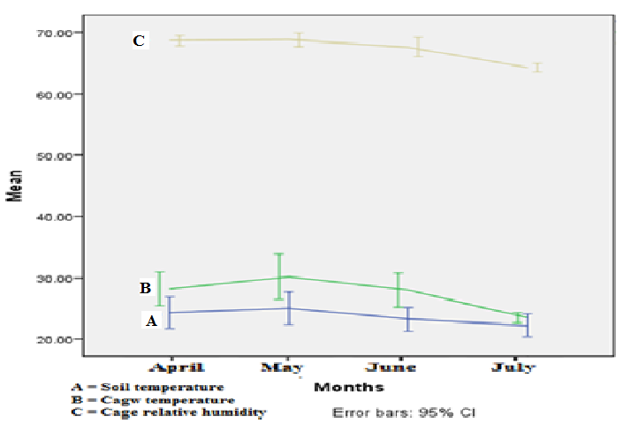
Figure 7:- Mean soil temperature (A), cage temperature (B) and RH (C) of the cage were calculated using SPSS 20 and bar represents standard error at 95% CI.
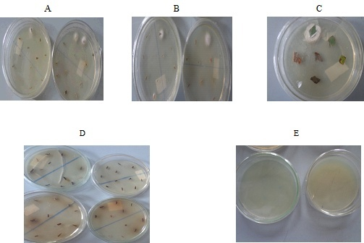
Figure 8:- Endophytic CFU growth of Beauveria isolates from tissue of roots (A), stem (B), leaf (C), D and E represents control and plated last rinsed sterile distilled water, respectively.
Table 10:- Colonization Frequency (CF %) of Beauveria isolates that exhibits positive postinoculation endophytic establishment of the inoculated Beauveria isolates spore suspension on root radicles of the coffee seedlings after two and four months.
Colonization Frequency ( CF %) of postinoculation evaluation
Two months |  |  |  |  |  |  |  |  | Four months
Isolates | Roots |  | Stem |  | Leaves |  | Total |  |  | Root |  | Stem |  | Leaf |  | Total
Isolates | + | CF% | + | CF% | + | CF% | + | CF% | + | CF% | + | CF% | + | CF% | + | CF%
B1D | - | - | - | - | - | - | - | - | 3 | 16.67 | 2 | 11.11 | - | - | 5 | 9.26
B2J | 6 | 33.33 | 2 | 11.11 | 1 | 5.56 | 9 | 16.7 | 8 | 44.44 | 5 | 27.78 | 2 | 11.11 | 15 | 27.78
B5B | 3 | 16.67 | 3 | 16.67 | - | - | 6 | 11.1 | 7 | 38.89 | 5 | 27.78 | 2 | 11.11 | 14 | 25.93
B6F | 5 | 27.78 | 1 | 5.56 | - | - | 6 | 11.1 | 7 | 38.89 | 3 | 16.67 | - | - | 10 | 18.52
B7A | 6 | 33.33 | 4 | 22.22 | - | - | 10 | 18.5 | 9 | 50 | 6 | 33.33 | 3 | 16.67 | 18 | 33.33
B7E | 7 | 38.89 | 3 | 16.67 | 1 | 5.56 | 11 | 20.4 | 8 | 44.44 | 5 | 27.78 | 2 | 11.11 | 15 | 27.78
B9D | 4 | 22.22 | 4 | 22.22 | 3 | 16.67 | 11 | 20.4 | 8 | 44.44 | 3 | 16.67 | 2 | 11.11 | 13 | 24.07
C1C | 5 | 27.78 | 3 | 16.67 | - | - | 8 | 14.8 | 8 | 44.44 | 3 | 16.67 | - | - | 11 | 20.37
C3C | 6 | 33.33 | 4 | 22.22 | 1 | 5.56 | 11 | 20.4 | 8 | 44.44 | 6 | 33.33 | 2 | 11.11 | 16 | 29.63
C5I | 2 | 11.11 | 2 | 11.11 | 1 | 5.56 | 5 | 9.26 | 4 | 22.22 | 3 | 16.67 | - | - | 7 | 12.96
G2A | 4 | 22.22 | - | - | 2 | 11.11 | 6 | 11.1 | 7 | 38.89 | 3 | 16.67 | 1 | 5.56 | 11 | 20.37
G3H | 4 | 22.22 | 3 | 16.67 | - | - | 7 | 13 | 6 | 33.33 | 5 | 27.78 | - | - | 11 | 20.37
G5I | 2 | 11.11 | - | - | - | - | 2 | 3.7 | 7 | 38.89 | 2 | 11.11 | - | - | 9 | 16.67
Total | 54 | 7.69 | 29 | 4.13 | 9 | 1.28 | 92 | 13.1 | 90 | 12.82 | 51 | 7.26 | 14 | 1.99 | 155 | 22.08

NB: -Three plants per treatment were assessed and plant parts, leaves (6), stems (6) and roots (6) per plant tissue parts were plated. Per treatment fifty four tissue, eighteen tissue per plant were plated to assess endophytic establishment of Beauveria isolates and calculated the percentage of Colonization Frequency (CF %).

5. Discussion

The average mean soil and the cage temperature of coffee seedlings in the experimental setup were 22-24⁰ C and 24-30⁰ C, respectively (Fig.7). The optimum mean annual temperature for arabica coffee is 18-21ºC (DaMatta and Ramalho, 2006). DaMatta et al. (2007) reported that above 23⁰C development and ripening of fruits are accelerated, often leading to loss of quality. The average mean soil and cage temperature that attained in this work did not affect the growth of the seedlings and the endophytic establishment of the inoculated isolates. Melke and Fetene (2014) stated that continuous exposure of Coffee arabica to the temperatures as high as 30ºC resulted not only to depressed growth but also in abnormalities such as yellowing of leaves and growth of tumors at the base of the stem. The average mean relative humidity of the cages was within the range of 65- 69⁰ C within four months of experimental setup and this did not affect the plant growth.

Absence of any detrimental symptoms on the coffee seedlings indicates that they are not affected by serving as a niche for Beauveria isolates. Both the treated and non treated coffee seedlings showed no differences in growth. The growth of the inoculated coffee seedlings did not affected by the endophytic colonization of the Beauveria isolates and the growth (mm) ranged from (45.93 ± 0.18 to 55.60 ± 3.64) and (83.9 ± 2.28 to 101.13±5.53) at two months and four months of postinoculation recovery test sampling. The growth of seedling from control ranged from 47.83 ± 0.85 and 80.90 ± 2.07 at two months and four months of sampling (Appendix21). Depieri et al. (2005) confirmed that inoculated B. bassiana did not result in the development of root disease. (Tadele Tefera and Vidal, 2009) have also showed that B. bassiana isolates are well adapted to a wide range of conditions including endophytic in plants and pathogenic to insects.

Some experimental coffee seedling showed relatively better growth compared with the control and this might be due to the endophytes in the system. (Gimenez et al., 2007) reported that plant gains various symbiosis-induced competitive advantages such as improved resource availability and use efficiency, increased growth and biomass production, enhanced regulation of metabolism and gene expression, and improved defense against herbivores and pathogens, which increase overall fitness.

The mechanism of colonization and endophytic establishment of the Beauveria isolates into the root system has critical steps. The conidia should first attach to the root surface, geminate, penetrate and colonize the epidermal tissue of the root radicles. The mechanism of penetration is different from that of insect cuticle penetration. During infection of the insects breach of the cuticle, related to a distortion in surrounding cell wall structures, allows passage rather than formation of appressoria at the penetration site (Quesada-Moraga et al., 2006). Colonization pattern of Beauveria bassiana that begins with conidia germination and germ tube formation; the germ tube can penetrate the epidermis immediately or propagate into a surface mycelium as an epiphyte prior to penetration (Posada and Vega, 2006; Quesada-Moraga et al., 2006; Wagner and Lewis, 2000). Penetration of the plant tissue in the initial stages of colonization seem to primarily involve inter-and intracellular regions of parenchyma tissues with appressorial formation at the surface of cells prior to entry.
The endophytic establishments of inoculated Beauveria isolates were confirmed by the CFU of fungal growth from the plant tissue on the plate. At two and four months of postinoculation recovery of Beauveria isolates from the inoculated coffee seedlings parts indicates that the inoculated isolates could established as endophytes in the coffee plant system. From the sum of data the better postinoculation recovery was observed at four months (22.08%) than at two months (13.11%) from all tissues. Increasing of endophytic recovery with function of time implies that the inoculated isolates will take some time to adapt the internal system and established in the plant tissue. Even some Beauveria isolates may not be appeared as CFU on the plates. This implies that they may need longer period or hindered by other per-established endophytic flora or may not produce conidia and fail to grow on the media. Failing of producing CFU on the plates by the endophytic established Beauveria isolates does not exactly mean they are not established in the plant system. Wagner and Lewis (2000) observed that B. bassiana hyphal growth in the xylem elements using light and electron microscopy; conidia were never detected in their examinations on culture.

The percentage of endophytic recovery (CFU) of the isolates out of 39 inoculated coffee seedlings increased from 26(66.67%) to 29(74.36%) from the root, 13(33.33%) to 22(56.41%) from the stem two and four months of postinoculation recovery. Likewise (Posada and Vega, 2005a) obtained the results by all endophytic plated plant parts exhibited a sharp increase from the first sampling period to the second and isolates recovered 100% in all tissues. The recovery frequency of the isolates from tissue samples also increased from the first to the second data collection. From the summary postinoculation recovery frequency 92 (13.11%) at two months and 155 (22.08%) at four months showed positive Beauveria isolates out of 702 inoculated sub-sampled tissues. Posada et al. (2007) also obtained 25% at 30 days and 50% at 60 days of postinoculation of the coffee seedlings.

The recovery of isolates from the root were increased from 54 (7.69%) to 90 (12.82%). (Posada and Vega, 2005a) confirmed that the endophytic recovery from the roots sub-sampled cocoa plant parts was increased from 4.26 ± 4.2% to 81.3 6 ± 7.3% by the isolate CS16-1 and14.6 6 ± 9.7% to 52.1 6 ± 13.5% by isolate IC- 5486 at1month and 2 months respectively.

The recovery of the isolates from all stem tissues was increased from 29 (4.13%) to 51 (7.26%) at two months and four months of postinoculation recovery. In line with this Posada and Vega (2005b) from each sub-sampled stem tissue of cocoa plant parts endophytic recovery was increased from 56.36 ± 10.9% to 68.86 ± 11.5% by the isolate CS16-1 and27.1 6 ± 8.9% to 56.36 ± 10.9% by isolate IC- 5486 at1month and 2 months respectively. The recovery isolates from the total inoculated leaves increased from 9 (1.28%) to 14 (1.99%) at two month and four months of postinoculation isolation. (Posada and Vega, 2005a) also obtained the recovered endophytic isolates from sub-sampled cocoa plant parts increased from 4.26 ± 2.7% to 37.56 ± 7.6% by the isolate CS16-1 and from 6.3 6 ± 4.4% to 52.1 6 ± 14.6% by isolate IC- 5486 from the leaves at 1 month and 2 months respectively.

Once the entomopathogenic fungus established as endophytic in the plant system they can bring an adverse effect on the target pest. Bing and Lewis (1991) reported that the performance of eggs, larvae or adults of herbivorous insects is inconsistent and Lepidopteran larvae (Ostrinia nubilalis or Sesamiacalamistis) exhibit reduced tunneling in corn and sorghum plants inoculated by Beauveria bassiana isolates. However, mycosis was not observed (or not reported) in those studies, indicating an indirect effect of the fungal colonization of plant tissues on larval performance. In banana inoculated with a Beauveria bassiana isolate, banana root borer larvae exhibited a higher mortality, and both eggs and adults showed mycosis (Akello et al., 2008). Inoculation of opium poppy with endophytic Beauveria bassiana reduced larval abundance of the gall wasp Iraella luteipes up to 73%, although without any mycosis (Quesada-Moraga et al., 2009).

Larvae of the leaf mining fly, Liriomyza huidobrensis suffered significantly when developing on Beauveria bassiana endophyte-inoculated faba or common bean plants, resulting in less pupation; moreover, emergence of adults from pupae developing on inoculated plants was reduced. However, mycosis was never observed in more than 6000 cadavers recovered from inoculated faba plants (Quesada-Moraga et al., 2009). Gurulingappa et al. (2011) able to established both L. lecanii and Beauveria bassiana in cotton, wheat, bean, tomato, corn and pumpkin plants and conclude that presence of entomopathogens as endophytes can influence growth and fecundity of insect herbivores, suggesting a possible role for endophytic entomopathogens in the regulation of insect populations.

In the current study, another important finding was inoculated Beauveria was isolated from the plants part at locations distant from the point of inoculation. Recovery of Beauveria inoculum from stem and leaf at location distant from the point of inoculation, root radicles was observed. Posada et al. (2007) inoculated by injection in the stem with Beauveria isolates, the fungus was subsequently recovered from the stem and roots of the plant. Similarly plant inoculated via stem injection, the fungus was recovered from the roots (Akello et al., 2007). Therefore, the recovery of inoculated Beauveria from the distant of inoculation site of the plant indicates that these fungi move through plant system and colonize a new plant parts.

The degree of recovery of the inoculated isolates can be affected by both the method and site of inoculation. (Posada and Vega, 2005a) using injected plants, sprayed on leaves and drenching methods of inoculation obtained 7(58.3%), 3(25%) and 1(8.3 %) respectively at two months of postinoculation recovery out of 12 plants. Regardless of the different inoculation methods that had been employed to introduce Beauveria bassiana into the plant system, different researches reported that Beauveria bassiana could be used as a fungal endophyte to induce plant resistance against some insect pests. Established Beauveria isolates into the plant system were confirmed by different authors; (Jones, 1994) in potatoes after foliar spray applications; (Akello et al., 2008) in maize plants after stem injections; or (Bing and Lewis, 1993) after granular applications to the whorl; (Wagner and Lewis, 2000) in maize leaves after applying a 20ml conidia suspension to the abaxial side of leaves; (Ownley et al., 2008) in tomatoes after coating seeds with a B. bassiana conidia; (Quesada-Moraga et al., 2006) in opium poppies after spraying leaves or coating seeds with B. bassiana spore suspensions; (Posada and Vega, 2005b) in cocoa and (Posada and Vega, 2006) in coffee seedlings after placing spore suspensions on the radicle.

(Posada et al., 2007) observed only one of four B. bassiana isolates was recovered from sprayed coffee leaves. They also have suggested that the leaf is a poor route of entry for the fungus to colonize the coffee plant. The low recovery of B. bassiana from leaves could be due to specific cuticular components on the leaf and the lack of stomata on the adaxial side. It is possible that the main components on the leaf cuticle, waxes and cutin (Martin, 1964), might have a detrimental effect on B. bassiana conidium germination. The highest recovery of B. bassiana was from the stems of plants injected with conidia suspensions (Posada et al., 2007). This method of inoculation circumvents the physical barrier of the plant cuticle. A similar method has been successfully used in grasses, where fungal endophyte mycelium is inserted between the shoot and root sections (Johnson-Cicalese et al., 2000) or at the junction of the coleoptile and mesocotyl (Latchs and Christensen, 1985).

Planting conidia-treated seeds in vermiculite and sterile soil, rather than in non-sterile soil improved endophytic colonization of B. bassiana (Tadele Tefera and Vidal, 2009). Autoclaving the soil might have eliminated microorganisms that otherwise would have competed with or antagonized B. bassiana. From this work the recovery of B. bassiana from different parts of coffee plant indicated that root inoculation method could work to introduce and colonize the coffee plant tissue. The result also showed that Beauveria isolates can move throughout internal plant tissues from the coffee roots, site of inoculation to the stems and leaves.

Ownley et al. (2008) confirmed that well colonized plants, hyphae in xylem vessels facilitate systemic translocation throughout the plant; B. bassiana has been isolated from root, leaf, stem, and cotyledon tissues distant from the site of inoculation as much as one year later. In some cases, B. bassiana emerged on the surface of distant tissues, existed as an epiphyte, and sporulated. According to (Posada and Vega, 2006) the inoculated B. bassiana endophyte becomes an epiphyte points to the possibility that the fungus might sporulated from the plant surface once it has been translocated through internal tissues, thus serving as a constant source of fungal inoculum in the coffee agro-ecosystem. The endophytic fungus through time and conducive internal and external factors will favor appearing of the endophytic to epiphytic growth, sporulating and become source of inoculums.

Beauveria bassiana is the main biocontrol agent against coffee berry borer and could be applies in different methods on the target insect. B. bassiana could be entered and achieved as endophytes through wounds caused by the coffee berry borer (Posada et al., 2007). From result of this study the recovered Beauveria isolates after postinoculation may be considered as less effective in colonization of the plant tissue. This may be due to other rapidly growing endophytic fungi Penicillium and Fusarium, which were frequently isolated as endophytes (Posada et al., 2007). The use of molecular detection techniques, for future endophyte studies, should be employed in a more precise estimate of B. bassiana establishment as an endophyte. Using molecular techniques it is possible to reduce time, labor, and supplies required with the current method, which involved 756 culturing of subsamples (702 treatments and 54 controls) at each evaluation time. Application of molecular detection technique for B. bassiana will also reduce problems faced when classical isolation on Petri dishes is used, which results in the suppression of other endophytic fungi that might underestimate the presence of B. bassiana.

This research study demonstrates that Beauveria isolates can be established as an endophyte in coffee seedling through inoculation of spore suspension onto the root radicles. Almost all Beauveria isolates can established and colonize the different parts of the coffee plants starting from the inoculation site roots to the stems and leaves. Endophytic establishment of Beauveria bassiana in the plant system indicate the feature potential of the isolates as a biocontrol potential against insect pest in general and CBB in particular.

6. Conclusions

The ability of Beauveria isolates to occupy and enter into plant tissue niches as endophytes provide unique opportunities for biological control of insect pests. Especially in the control of coffee berry borer their role is paramount. The results of this study confirmed that inoculated Beauveria isolates can rapidly colonize and established as endophytes in the coffee plant tissues from the site of inoculation to the other parts. The establishment of these fungi as endophytic biological control may overcome some of the challenges faced by the application of the spore suspension which are adversely affected by direct sunlight and less relative humidity. These endophytic established fungi may also appear as epiphytic growth and could be a potential inoculum of the ecosystem, which provides opportunities to suppress the coffee berry borer population and reduce damage to the coffee products.

7. Recommendation

Present investigation suggested that there is need of more research to understand endophytic Beauveria fungi activity especially associated with coffee plant. Although much has been accomplished in the commercial development of Beauveria and as fungal entomopathogens in plant production, more work is needed to understand the roles of these fungi as epiphytes and endophytes involved in suppression of coffee berry borer. Future studies should focus on the ecology of these fungi, with other endophytic fungi and bacteria and their antagonism against pathogenic and nonpathogenic microorganisms.

CHAPTER SIX

Survey of coffee berry borer Hypothenemus hampei Ferrari (Coleoptera, Scolytidae) at Tepi, Mizan-Aman and Limu-Jima zone and evaluation of local baiting trap for mass trapping of the pest

Abstract

A total of 32 red colour local baiting trap was prepared and lured with Ethanol: Methanol (E:M) mixture (1:1, 1:2 and 1:3) with releasing rate of 509.9 ± 0.06, 577.3 ± 0.02 and 580.3 ± 0.02 in mg day⁻¹, respectively. Traps were attached to wood stakes branch in a completely randomized block design (CRBD), 12m within the raw, 15m between blocks and 1.20 m from the ground for 10 days and the trapped CBB were collected within one day intervals. The efficiency of the attractant (E:M) mixtures at Tepi-Baya II, Jimma Zone (Limu-Goma II) and Mizan-Aman showed no significant difference, but all were statistically significantly different from the control (P < 0.001). The percentage of captured Coffee Berry Borer (CBB) with E:M, (1:1, 1:2 and 1:3) were at Tepi-Baya II, 427 (93%), 413 (98.6%) and 416 (95.2%) at Limu-Goma II, 97 (89%), 115 (100%) and 90 (93.8%) and at Mizan-Aman; 139 (86.7%), 122 (97.6%) and 98 (94.2%), respectively. The Non Coffee Berry Borer (NCBB) attracted more by 1:1 and 1:3 than 1:2 E:M mixture across the localities. None of the controls captured the NCBB beetles at any of the localities. The total captured from Tepi-Baya II, Limu-Goma II and Mizan-Aman was 1,329, 320 and 388, respectively. The total captured from Tepi-Baya II was 4.2 times that captured at Limu-Goma II and 3.4 times that at Mizan-Aman.

Keywords/phrases: Hypothenemus hampei, semiochemical, baiting trap and Ethanol: Methanol mixture

1. Introduction

Coffee is vital to the economy of Ethiopia, providing a major source of foreign exchange earnings and, as a cash crop, supporting the livelihoods of millions of people involved in cultivation, processing, marketing, and export industry. This cash crop occupies the first place among the export crops in Ethiopia. It is mainly cultivated in Western, Southern, Northern and Eastern parts of Ethiopia. One of the major challenges to coffee production across the world is the damage caused by the coffee berry borer (CBB), Hypothenemus hampei (Ferrari) (Coleoptera: Curculionidae). These small beetles are found in Central and Eastern African countries (Le Pelley, 1968). They cause severe losses and damages to coffee and beans in all coffee producing areas in Ethiopia. Adult females bore a hole in the coffee berry and lay their eggs in internal galleries, with larvae feeding on the coffee bean. The feeding of an insect on coffee beans damages the beans and reduces the yields, lowers the quality of the seed, and can result in abscission of the berry. The female to male ratio of the insect in the berry is in the order of 10:1. Once the insects moult into adults inside the berry, mating occurs between the siblings. As a result, the emerging females are inseminated and are ready to search for a berry in which they start oviposition ((Vega et al., 2009). Thus, its life cycle takes place inside coffee berries, making this cryptic insect quite difficult to control by applying chemical as well as non-chemical strategies.

CBB is regarded the most prevalent and important insect pest of coffee in Ethiopia posing a major challenge to the coffee production. Much effort has been made by Esayas Mendesil et al. (2004) to address the challenge posed by the insect pest in Ethiopia and recommended control measures have principally relied on cultural methods such as picking left-over and fallen cherries. These methods are on their own inadequate and cumbersome for farmers/producers to apply. Silva et al. (2006) trapped the insect pest using Ethanol (E), Methanol (M) with a 2 mm hole in the vial dispenser to capture CBB lured with E:M mixtures (1:1, 1:2, 1:3) and caught considerable number of CBB. Our study was designed to prepare a coffee berry borer trap from local materials and lured with Ethanol: Methanol (E:M) to use as a baiting trap to capture and reduce the population of female CBB and report on the results.

This study has initiated in order to undertake the preparation of locally made baiting trap using local materials for capturing, assessing and mass trapping of CBB using different mixture of E:M as a control measure from different localities of coffee producing areas of Ethiopia.

Hypothesis

- Coffee berry borer, Hypothenemus hampei, are attracted by traps lured with the mixture of different proportion of Ethanol – Methanol (E;M).
- Coffee berry borer, Hypothenemus hampei show preference towards the traps baited with different mixture of (1:1, 1:2 and 1:3) of E:M.

2. Objectives

2. 1 General objective

- To evaluate the efficacy of locally designed baiting trap for surveying CBB in different localities of coffee producing areas in Ethiopia.

2.2. Specific objective

- To design and prepare local baiting trap from local materials for capturing and surveying of the female coffee berry borer.
- To determine the releasing rate of the Ethanol: Methanol (E:M) mixture at different ratio ( E:M, 1:1, 1:2 and 1:3).
- Survey and assess the coffee berry borer (CBB) at different study sites, (Teppi, Limu and Mizan-Aman).
- To determine the efficiency of the different concentration of E: M on attracting the CBB.

3. Materials and methods

3.1 Study areas and coffee berry borer trapping

Coffee berry borer were caught and assessed in three different localities known for coffee production in south west Ethiopia (Fig. 1). The localities were Tepi coffee plantation area at “Baya II” (7º10'36"N, 35º24'50" E and 1,206 m.a.s.l.) on (20-30)-I-2013, Jimma zone, (Limu Goma II) (7º 57'47"N, 36º41'9"Eand 1,409 m.a.s.l.) on (15-25)-III-2014 and Mizan-Aman (7º 00'10" N, 35º34'56" E and1325 m.a.s.l.) on (15-25)-XI-2015 (Table 11). The ecological and environmental conditions of these three localities are favorable for coffee production but different on climatic and weather conditions. Due to these conditions, the flowering, fruiting and maturation of coffee production at these localities occur at different times. The harvesting of ripped red cherries at Tepi-Baya II, Mizan-Aman and Limu-Goma II areas is taking place from late August to late October, late September to late November and from late October to late December, respectively. The data was collected at Tepi-Baya II during a winter season with moderate rain, while at Mizan-Aman data was collected during a spring season with an unexpected intense rain fall making coffee harvesting and drying process very difficult. The weather condition at Jimma zone Limu-Goma II was extremely dry condition.

The type of coffee variety from the three coffee plantation areas is almost the common variety comprising varieties of 7440, Catmir, F59, Gesha and 7454. These varieties are all susceptible to insect pests including to the CBB that infects the coffee beans of different coffee types (Romero and Cortina, 2005). Capturing of CBB at Tepi-Baya II was carried out from 20-30-I-2013 after the end of the coffee harvesting season when the coffee plants were at the flowering stage. By that time, the future colonizing CBB females would survive in the unpicked left over residual and fallen fruits (Esayas Mendesil et al., 2004). The coffee plants were about 1.6 m - 2m high, unless otherwise stated. At Limu-Goma II, the capturing was carried out from 15-25-III-2014. It was a dry condition and the coffee plants were at vegetative stage (no flower and cherry fruit) and their height was ca1.6-2m, unless otherwise stated. Dry unpicked and fallen coffee cherries were common but the farm was in good sanitation compared with the farms in the other two localities. At Mizan-Aman, trapping was carried out from 15-25-XI-2015 in the farms of volunteer farmer at a harvesting time and the coffee plants were 1.5 - 2m high unless otherwise stated. The coffee plants were planted 2 m apart in rows and 1.5 m apart within the row at Tepi-Baya II and Limu-Goma II, but at Mizan-Aman some were plants in the row and other in random. At mizan the coffee farm also produces other plants such as yam, maize and vegetables for house hold consumption.

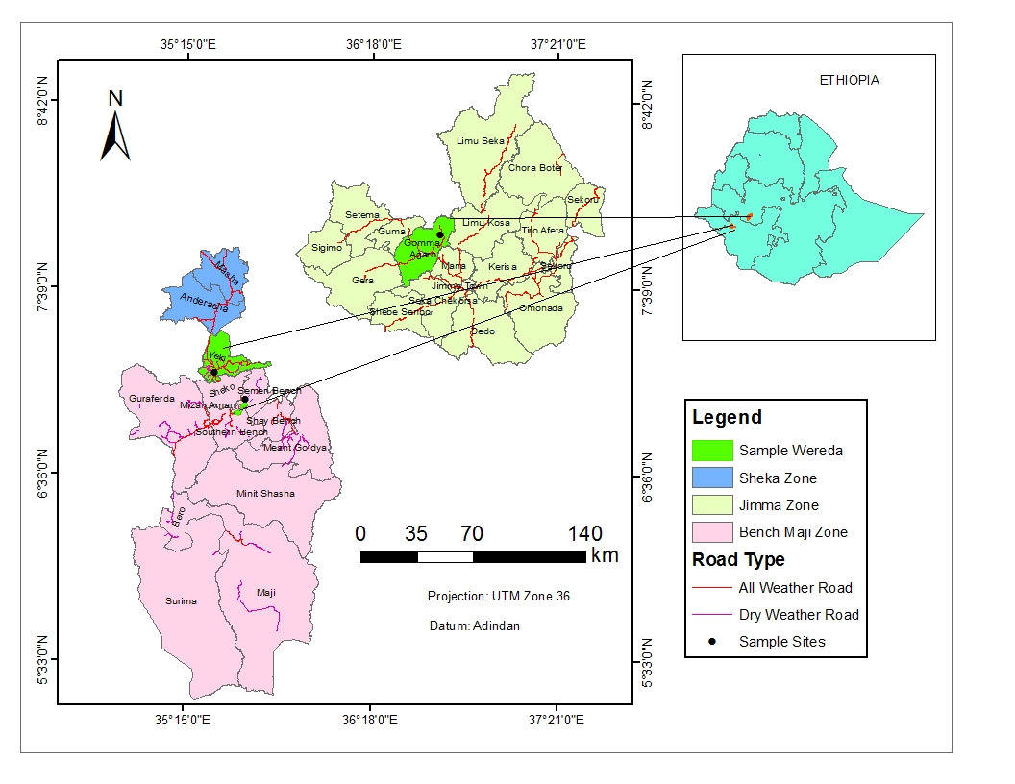
Figure 9:- Map showing sites selected for of coffee berry borer, (Hypothenemus hampei) survey

3.2. Trap preparation

Traps were prepared and assembled using metal sheet, plastic funnel and cylindrical screw cupped container. The metal sheet was sketched, designed, assembled and painted with red color except for the plastic container. The trap was designed to mimic the evolutionary adaptation of the CBB insect's biology that is attracted by coffee color and the volatile aroma of coffee cherry (Mathieu et al., 1997; Mendesil et al., 2009). The color and powerful attractant of the different concentrations of Ethanol Methanol (E:M) to the CBB was used according to (Silva et al., 2006). Mathieu et al. (1997) and Mendesil et al. (2009) have demonstrated that vision and/or olfaction play a role in the CBB’s preference for ripe (red) versus immature (green) berries. Each piece of the designed parts of the trap was assembled to make a completed CBB trap as shown on and a total of 32 local baiting traps were prepared and a flexible wire was attached on the top of the trap for hanging it on coffee tree.

3.3. Determination of lure releasing rate

The releasing rates of the semiochemicals were determined in the laboratory before field application. Transparent 10 ml plastic vials closed by a screw cap were used as dispensers perforated with 2mm diameters hole at the center of the screw cap on top (Silva et al., 2006). The reference mixture used in all the trials consisted of 99% ethanol and 100% methanol commercially available and the two alcohols were used undiluted in accordance with the methodology proposed by (Mathieu et al., 1997). From each Ethanol : Methanol, E : M (1:1, 1:2 and 1:3) mixture 10 ml were injected into labeled vials in five replicates and the releasing rate of each mixture were recorded within 24 hours intervals for seven days. The Mean ± SD of semiochemicals releasing rate were calculated using SPSS 20.

The amount of releasing rate was within the accepted range to attract adult CBB (Silva et al., 2006) and (Mathieu et al., 1997). Each E : M mixture (lure) releasing rate was calculated based on the difference between the initial weight (mg) (vial plus the mixture) minus the weight of vial dispenser (vial plus the mixture) (mg) after releasing of its content within 24 hours intervals and their mean ± SD releasing rate was considered as releasing rate of each mixture mg/day units (Table 12).

3.4. Installation of Trap

Placing of traps in the coffee plantation area was carried out in a completely randomized block design (CRBD) with a factorial arrangement. The factors were the lure E:M mixtures (1:1, 1:2 and 1:3), the control and the two plots A and B were randomly selected from the coffee farm. From each study localities a total of 32 traps were placed for capturing of CBB which comprised 24 semiochemicals (E: M) baiting trap and eight controls. The traps installation at each study site was 12m within the raw and 15m between the blocks (Silva et al., 2006).

Based on this placing distance, CRBD arrangement four in rows and four in blocks (16 traps) were used and 1,620 m² areas were covered from each plot and a total of 3,240 m² (0.324 hectare) from each locality. This ensured that the effect of the lure was approximately the same within the range (Messing, 2012). The vial that contained the semiochemicals (E: M) mixture was kept at the center in upright position to make sure that the releasing of the lure not blocked by barer. Each trap was attached to wood stakes branch so that the holes (dispenser) were located around 1.20 m from the ground (Silva et al., 2006). The color combination of the trap was red except for the semiochemical dispenser, the funnel and the container. The female CBB entering the trap automatically fell into the container where they were drowned and collected in the sterile vial. Trapped CBB was collected within one day intervals from the first day of trapping for ten days.

3.5. Data collection of CBB

After the traps were placed in the coffee plantation in the CRBD design the captured CBB were collected within 24 hours intervals for 10 days. From each trap caught beetles were collected in different sterile vials. Other Hypothenemus beetles, non-target insects (NCBB) were also found in the trap and were sorted out and inspected using hand lens (10x) to differentiate them from the non-CBB Hypothenemus beetles (Messing, 2012). The CBB identified in each vials were counted and pooled into the rectangular transparent box and kept at room temperature until transported to the laboratory. In the laboratory each beetle was also further inspected and examined individually under a dissecting microscope.

According to Booth et al. (1990) the adult female CBB were identified using stereomicroscope and illustrative colored diagram according to (Johnson et al., 2016) guideline to identify the female CBB. Based on the guideline the color of the young beetle when observed using stereomicroscope their abdomen appears a blackish-brown and darken to black at maturity, with a lighter brown pronotum, the size approx. ca. 1.7 mm considered as female. The shape of the elytral setae, which in H. hampei are longer and cylindrical whereas in the 'false borer' (H. obscurus or H. seriatus), they are shorter and more conical with dentate tips.

4. Result

Each coffee producing sites were planted with C. arabica with different coffee varieties of 7440, Catmir, F59, Gesha and 7454 grown under shade canopies (except Limu). Annual agricultural upkeep was ensured with moderate management, characterized by moderate coffee tree pruning, shade regulation. During data collection there was no any control or protection measure carried out targeting on CBB pest in any of coffee production localities.

Table 11:- Geographical location, altitudes and description of coffee berry borer (Hypothenemus hampei) surveying sites of Ethiopia
Sites | Date data collection | Long/Lat location | Alt | Description
Tepi- biy-II | Jan. 20 - Jan 30/2013 | 7⁰ 10'36"N, 35⁰24'50"E | 1206 | Flowering stage
Limu-Goma- II | Mar. 15 -25/2014 | 7⁰57'47"N, 36⁰41'9"E | 1409 | Dried condition
Mizan-Aman | Nov. 15 - 25/ 2015 | 7⁰00'10" N, 35⁰34'56"E | 1325 | Harvesting, rain

The releasing rate of semiochemicals were determined in the laboratory and all of the E:M mix volatility resulted in reduction of the initial weight. The calculated weight loss was directly proportional to the released rate of the each semiochemicals, E:M.The weight loss in Mean ± SD mg day⁻¹ from each of E:M mix was calculated and resulted in 509.9 ± 0.06, 577.3 ± 0.02 and580.3 ± 0.02 from E:M, 1:1, 1:2 and 1:3 mix, respectively (Table 12).

Table 12:- Mean ± Sd mg day-1 Semiochemical release rates of lure (E:M) mixture and mean ranges of releasing rate of different E:M concentration measured in mg day-1 with in 24hrs for 7 days.
E:M | Mean range mg day⁻¹ | Mean ± SD mg day⁻¹
1:1 | 430.50 - 593.10 | 509.9 ± 0.06
1:2 | 559.06 - 587.66 | 577.3 ± 0.02
1:3 | 570.98 - 591.52 | 580.3 ± 0.02
Five replicates of E:M mix released for 7 days and mean ± Sd and the range were calculated using SPSS 20.

The mean number of captured CBB from Tepi-Baya II using different mixture of E:M on different days of data collection is shown in Table 13. Starting from 22-26-I-2013, the mean number of CBB captured was relatively higher (ca.11 - 16 CBB/trap/day) and irrespective of the E:M mixture differences, the capture per trap per day showed relatively reduction in the last two days (Table 6-3). The mean capture of CBB from Tepi-Baya II on each days of data collection and attraction of 1:1 and 1:2 E:M mix showed no statistically significant difference in their efficiency in attracting of CBB. However, there was a statistically significance difference in the mean number of CBB captured per day per trap at E:M mixture of 1:3 (Table 13). The level of significance for each collected CBB with each bating traps was checked at P < 0.001 (df = 4, f = 4.923 and p = 0.003 for 1:1; df = 4, f = 2.860, p = 0.038 for 1:2 and df = 4, f = 9.785, p = 0.000 for 1:3).

Table 13:- Number of captured CBB with different E:M mixture per trap per day at Teppi-Baya II for ten days (January 22-30).
Date | 1:1 | 1:2 | 1:3 | Control
22 | 11.88 ± 5.30a | 14.25 ± 7.67a | 16.13 ± 4.76b | 0.00 ± 0.00a
24 | 12.00 ± 3.59a | 11.38 ± 2.62a | 11.00 ± 2.62ab | 0.38 ± 0.74a
26 | 14.50 ± 5.04a | 9.75 ± 2.92a | 9.75 ± 4.83ab | 0.63 ± 0.92a
28 | 7.38 ± 2.50a | 9.38 ± 4.57a | 9.75 ± 2.49ab | 0.50 ± 0.76a
30 | 7.63 ± 2.13a | 6.88 ± 2.95a | 5.38 ± 1.19a | 0.38 ± 0.52a
Each treatment was replicated 8 times and the mean of captured CBB were calculated using SPSS 20. Similar letters on the column indicates their significance difference with one way of ANOVA at Tukey HSD P < 0.001 n= 8.

Trapping of CBB from Jimma zone Limu-Goma II coffee plantation using baiting trap of E:M mixture resulted in relatively less number of captures (Table 14). The mean number of CBB captured across all days using the three different E:M mixtures was almost the same and there was no statistically significant difference in capturing of CBB per day per trap using the different E:M mixtures and the control at P < 0.001,df = 4, f = 2.643, p = 0.050 for 1:1;df = 4,f = 0.466p = 0.233 for 1:2 and df = 4, f = 0.842, p = 0.508 for 1:3.

Table 14:- Number of captured CBB with different E:M mixture per trapper day at Limu-Goma II for ten days (March 17-25)
Date | 1:1 | 1:2 | 1:3 | Control
17 | 3.38 ± 1.06a | 3.63 ± 1.30a | 2.25 ± 1.28a | 0.00 ± 0.00a
19 | 3.00 ± 1.20a | 2.00 ± 0.76a | 2.88 ± 1.55a | 0.00 ± 0.00a
21 | 1.88 ± 1.55a | 2.88 ± 2.30a | 2.00 ± 1.31a | 0.00 ± 0.00a
23 | 2.13 ± 0.99a | 3.13 ± 0.99a | 1.75 ± 1.16a | 0.00 ± 0.00a
25 | 1.75 ± 1.39a | 2.75 ± 1.04a | 2.38 ± 1.19a | 0.00 ± 0.00a

Each treatment was replicated 8 times and the mean of captured CBB were calculated using SPSS 20. Similar letters on the column indicates their significance difference with one way of ANOVA at Tukey HSD P < 0.001 n= 8.

The mean capture of CBB from Mizan-Aman using baiting trap was observed with different E:M mixtures (Table 15). The number of beetles captured with different E:M mixture on different days was small and similar. On statistical analysis at P < 0.001,df = 4, f = 1.103 p = 0.371 for 1:1; df = 4, f = 0.164 p = 0.955 for 1:2 and df = 4, f = 0.564 p = 0.690 for 1:3 E:M mixture, the mean capture was not significant with different E:M mixtures, both among the E:M mixtures and with the control.

Table 15:- Number of captured CBB with different E: M mixture per trap per day at Mizan-Aman for five different days (November 17-25).
Date | 1:1 | 1:2 | 1:3 | Control
17 | 4.00 ± 1.20a | 3.25 ± 1.39a | 2.38 ± 1.19a | 0.00 ± 0.00a
19 | 3.63 ± 1.06a | 3.00 ± 1.31a | 2.88 ± 1.25a | 0.00 ± 0.00a
21 | 3.25 ± 1.04a | 2.75 ± 1.39a | 2.13 ± 0.83a | 0.00 ± 0.00a
23 | 3.00 ± 0.76a | 3.25 ± 1.98a | 2.25 ± 0.89a | 0.00 ± 0.00a
25 | 3.25 ± 1.16a | 3.00 ± 1.07a | 2.63 ± 1.41a | 0.13 ± 0.35a

Each treatment was replicated 8 times and the mean number captured CBB were calculated using SPSS 20. Similar letters on the column indicates their significance difference with one way of ANOVA at Tukey HSD P < 0.001 n= 8.

The overall number of adult coffee berry borers captured per trap per day with baiting traps on the three coffee farms for ten days were computed. The mean number of CBB captured at Tepi-Baya II showed relatively more number per trap per day as compared with Mizan-Aman and Limu-Baya II farm (Table 13). The minimum and maximum mean CBB numbers captured per trap per day at Tepi-Baya II were 5.06 ± 3.41 and 10.56 ± 8.09 respectively. There was a statistically significant difference in the number of CBB captured at Tepi-Baya II form that captures at the other localities (Limu-Goma and Mizan-Aman) throughout the capturing days, but there was no significant difference in the mean number of CBB captured at the three localities: Limu-Goma II and Mizan-Aman at P < 0.001, df = 4, f = 4.195 p = 0.003 at Tepi-Baya II; df = 4, f = 0.840 p = 0.502 at Limu-Goma II and df = 4, f = 0.286,p = 0.887 at Mizan-Aman.

Table 16:- Number of adult coffee berry borers captured per trap per day in local traps containing three different ratios of ethanol: methanol (E:M) for ten days
Localities | 1st | 2nd | 3rd | 4th | 5th
Tepi-Baya II | 10.56 ± 8.09b | 8.69 ± 5.48b | 8.66 ± 6.26b | 6.75 ± 4.68b | 5.06 ± 3.41b
Limu-Goma II | 2.31 ± 1.77a | 1.97 ± 1.58a | 1.69 ± 1.80a | 1.75 ± 1.44a | 1.72 ± 1.46a
Mizan-Aman | 2.41 ± 1.85a | 2.38 ± 1.74a | 2.03 ± 1.56a | 2.13 ± 1.70a | 2.25 ± 1.63a

Each trap replicated eight times and the data were collected for 10 days with in one day intervals. The mean ± SD were calculated using SPSS 20 one way of ANOVA. Different letters indicates the significance difference at Tukey HSD at P < 0.001. 1st, 2nd, 3rd, 4th and 5th refers the consecutive date at which data collection took in one day interval.

The attraction potential of the different E:M mixture (1:1, 1:2 and 1:3) at the three different localities and the corresponding number of CBB captured per trap per day are shown in (Table 14). The three different E:M mixtures at the Tepi-Baya II and Limu-Goma II had no significant difference in their potential for attraction of CBB into the trap but significant difference from the control (Table 14). The attraction potential of the E:M mixture lured with 1:3 showed significant difference comparing with 1:1 and 1:2 at Mizan-Aman per trap per day at p < 0.001.

The number and percentage of CBB and the NCBB beetles collected from Tepi-Baya II, Limu-Goma II and Mizan-Aman using baiting local trap with different E:M mixtures are indicated on (Table 15). The number of NCBB captured at Tepi-Baya II using 1:1, 1:2 and 1:3 mixture of E:M were 31, 6 and 21 respectively but more than 410 CBB were captured by all the E:M mix and also showed the higher proportion (Table 15). The number and the percentage of CBB captured at Limu-Goma II using 1:1, 1:2 and 1:3 E: M mixture were 97 (89%), 115 (100%) and 90 (93.8%), respectively. The number of NCBB captured at Mizan-Aman showed relatively higher number, 21 (15.3%) lured with 1:1 E:M mixture than the other E:M mixture, but the captured CBB were relatively more than NCBB, 139 (86.7%), 122 (97.6%) and 98 (94.2%) with E:M mixture of 1:1, 1:2 and 1:3 respectively. From the overall collected Scolytidae beetles the highest proportions of percentage were CBB from all localities. The percentage of NCBB captured from Limu-Goma II and Mizan-Aman localities were relatively higher as compared with Tepi-Baya II. The NCBB showed preferably attracted by 1:1 and 1:3 than 1:2 E:M mixture across the localities. None of the control captured the NCBB beetles at any of the localities (Table 16).

Table 17:- Baiting trap efficiency of the different E:M mixture to attract CBB per local trap per day from the three localities.
E:M | Tepi-Baya2 | Limu-Goma | Mizan-Aman
1:1 | 10.68 ± 4.65b | 2.43 ± 1.36b | 3.43 ± 1.06c
1:2 | 10.33 ± 4.97b | 2.88 ± 1.42b | 3.05 ± 1.40bc
1:3 | 10.40 ± 4.80b | 2.25 ± 1.30b | 2.45 ± 1.11b
Control | 0.38 ± 0.67a | 0.00 ± 0.00a | 0.03 ± 0.16a

Each trap replicated eight times and the data were collected for 10 days with in one day intervals. The mean ± Sd were calculated using SPSS 20 one was of ANOVA. Different letters indicates the significance difference at Tukey HSD at P < 0.001, n = 40.

Table 18:- Percentage of captured Non Coffee Berry Borer (NCBB) and CBB collected from different localities of coffee producing area within 10 days using different concentrations of E:M.
E:M | Tepi-Baya 2 |  |  |  | Limu-Goma 2 |  |  |  | Mizan – Aman
 | NCBB | % | CBB | % | NCBB | % | CBB | % | NCBB | % | CBB | %
1:1 | 31 | 6.77 | 427 | 93.2 | 12 | 11.01 | 97 | 89 | 21 | 15.33 | 137 | 86.71
1:2 | 6 | 1.43 | 413 | 98.6 | - | - | 115 | 100 | 3 | 2.46 | 122 | 97.6
1:3 | 21 | 4.81 | 416 | 95.2 | 6 | 6.25 | 90 | 93.8 | 6 | 6.12 | 98 | 94.23
Control | - | - | 15 | 100 | - | - | - | - | - | - | 1 | 100

The percentage was calculated after screening of CBB from the NCBB beetles from each E:M mixture trap. Each NCBB were screed from CBB using dissecting microscope.

The total number of beetles captured from Tepi-Baya II coffee plantation were 458, 419 and 437 beetles using 1:1, 1:2 and 1:3 E:M mixture of bating trap, respectively. The three mixture of baiting trap at Limu-Goma II, Mizan-Aman and Tepi-Baya II captured relatively the same number of beetles. However, the total captured beetles from Tepi-Baya II (1,329 beetles) showed relatively higher number of beetles than Limu-Goma II (320 beetles) and Mizan-Aman (388 beetles). The total number of beetles captured from Tepi-Baya II was 4.2 times the number of bettles captured at Limu-Goma II and 3.4 times that captured at Mizan-Aman (Table 19).

Table 19:-Total captured beetles, (NCBB) and CBB from different localities of coffee producing area within ten days per trap per day using baiting local trap with different E:M mixture.
Beetles captured
E:M ratio | Tepi-Baya II | Limu-Goma II | Mizan-Aman
1:01 | 458 | 109 | 158
1:02 | 419 | 115 | 125
1:03 | 437 | 96 | 104
Control | 15 | - | 1
Total | 1329 | 320 | 388
Per each localities the eight traps were used and the collection were within 10 days

5. Discussion

The coffee berry borer (Hypothenemus hampei) is considered the most important insect pest and the greatest economic threat to coffee industry (Soto-Pinto et al., 2002). Davidson (1968) reported the first incidence of coffee berry borer in Ethiopia. Survey conducted in some coffee growing areas showed mean percentage infestation of 13.3% to 61% on dry leftover coffee berries (Gemechu et al., 2016). This indicates that the pest is also predominant in coffee growing plantations of organic coffee farmers. None of the organizations or farmers applied any measures towards the control of CBB despite the fact that there are reports on CBB infestation in the region.

The present study indicated that the infestation level of CBB is high in the study area of coffee plantation (Tepi Baya site, Mizan Aman and Limu Jima zone). Mass trapping of this beetle is considered to be a good practice strategy to suppress the population and reduce its impact. The releasing rate of the three E:M mixture (1:1,1: 2 and 1:3) that was used at the three localities were potentially effective in attracting the CBB into the traps. The releasing rate (mg day⁻¹) of the three E:M mixture 1:1, 1:2 and 1:3 were 509.9 ± 0.06, 577.3 ± 0.02 and 580.3 ± 0.02, respectively. (Silva et al., 2006) to captured the CBB lured with E : M (1:1) releasing range of 342, 400, 428 and 710 mg day⁻¹ were used and caught similar numbers of insects irrespective the releasing rate. Mathieu et al. (1997) applied the three doses tested (0.5, 1.5, and 20 g/day) lured with 1:2 and 1:3 E:M and the traps with lowest emissions (500mg/day) showed the best captured. From this result it is possible to suggest that the attraction potential of these E:M mixture releasing rate in mg day⁻¹ did not affect capture of the female CBB in the three localities and also it is clearly observed the live female CBB was successfully captured for the first time using locally prepared baiting traps in Ethiopia. The current results also showed that using different E:M mixture did not affect the mean number of captured CBB at different localities.

Mendesil et al. (2009) observed the effectiveness of the E:M mixture in attracting CBB using the trapping study. Silva et al. (2006) used Ethanol (E), Methanol (M) with a 2 mm hole in the vial dispenser to capture CBB lured with E : M mixtures (1:1, 1:2 and 1:3) and they caught similar and higher number of insects than the control. Similarly, Mathieu et al. (1997) demonstrated that both ratios 1:1 and 1:3 (as well as a 1:2 ratio) perform equally well in CBB field captures.

The attraction and the capturing efficiency of each baiting E: M concentration (1:1, 1:2 and 1:3) did not show significance difference from each locality. Similarly results were obtained by de (Silva et al., 2006) traps lured with E: M mixtures (1:1, 1:2 and 1:3) caught similar and higher number of insects than the control. Recently, Messing (2012)using baiting traps containing 1:3 ratio of ethanol: methanol mean (± SE) the captured female CBB was not significantly different from caught in traps containing a 1:1 ratio of ethanol: methanol. However, the capture of CBB using baiting methods of E:M by different researchers was not consistence and controversial. In Brazil (Silva et al., 2006) found nominally higher CBB captures in traps using a 1:2 or 1:3 rather than a 1:1 ratio of E: M while in El Salvador, studies showed marginally higher catches with the 1:1 ratio. Richard et al. (2010) used traps with a 1:3 ratio significantly outperformed traps with a 1:1 ratio in Bolivia. Commercial CBB lures sold in the United States use a 1:3 ethanol: methanol ratio (AgBio, Westminster, CO, USA) (Messing, 2012). Mendesil et al. (2009) and (Mathieu et al., 1997) have also showed a decreasing capture of CBB with the increase of release rate of 1:3 E:M mixtures, while others presented an opposite effect (Borbon et al., 2002). Red traps captured more CBB than white traps under semi natural conditions (Mathieu et al., 1997) but the opposite occurred in another field study (Borbon et al., 2002).

Despite their long and widespread use of baiting E:M lure traps, there are considerable discrepancies in various researches about optimal capture of CBB. It is probable that the conditions under which coffee is grown (climate, spacing, shade, cultivar, plant age, wind direction, speed etc,) may affect trapping efficiency (Silva et al., 2006). This can induce some discrepancy in results involving capture of CBB in response to semiochemicals, which may interact with other factors.

During the time of data collection in the three localities were not peak season to capture large number of CBB. Capturing of the CBB at Tepi-baya II and Limu-Goma II took place three months after harvesting time and time of capturing did not coincide with the time of trapping large number of CBB and Mizan-Aman was unexpectedly intense rain to capture the beetle. The mean (± SD) of CBB trapped from each localities (Tepi –Baya II, Limu –Goma II and Mizan-Aman) using locally prepared baiting trap should not be considered as low number. The mean number of female CBB captured using E:M 1:1, 1:2 and 1:3 mixture from Tepi-Bay II were 10.68, 10.33 and 10.40 respectively after three months of harvesting time.

Higher number of CBB capture could be at the season when the long dry condition followed by rain especially immediately after the rains and when the relative humidity and temperature had increased (Pereira et al., 2012). (Mathieu et al., 1997) also noted that the highest seasonal trap captures at the time when coffee fruit on the trees declines rapidly. During the off-season (i.e. following the harvest and before the next year’s crop is sufficiently developed for infestation) low but persistent numbers of CBB captured (some tens per trap per day) indicate a reservoir of adult beetles surviving in coffee berries dropped to the ground, in dried berries remaining on the trees, and in nearby off-farm sources.

Even though mean (± SD) of the captured CBB per trap/day was small number from each localities of the total number of capture per trap within five days were considerable number (Table 19). When considering the reproduction potential of each trapped female lays an average of 50 eggs, the number of CBB females would be approximately 66,450 (1,329 x 50), 16,000 (320 x 50) and 19,400 (388 x 50) from Tepi-Baya II, Jima zone Limu Goma II and Mizan-Ama respectively and assuming the sex ratio of CBB to be 10 females to each male and eight generation time per year (Baker et al., 1994). However, this number would be lower considering the natural mortality factors in the environment (Baker et al., 1994). The highest mean percent of infestation was recorded at Tepi 60% and most of the damaged berries obtained showed high degree of damage by CBB (> 50% damage) (Esayas Mendesil et al., 2004)

Based on placement distance (12m in a row and 15m in the block) and CRBD arrangement 4 in rows and 4 traps in blocks it was possible to estimate the area coverage. From each study plots and localities a total of 1620 m² and 3240 m² (0.324 hectare) areas were covered respectively. From this it is possible to predict that the total number of CBB captured from each localities of Tepi-Baya II, Limu-Goma II and Mizan-Aman were 1,329, 320 and 388 per 0.324 hectare of coffee plantation. This implies that very large number of CBB/trap/day will be captured if more baiting traps were used per hectare. The experience from Columbia showed as many as 3 million beetles per acre were caught in coffee berries that were not removed before pruning (Dufour et al., 1999). The altitudinal coverage of the study rangedfrom1206 - 1409 m.a.s.l. which was within the range of altitudes coverage of (Esayas Mendesil et al., 2004) study that ranged from 1200–1770 m.a.s.l.

All Hypothenemus hampei as well as other non-targeted insects, NCBB scolytids found in the traps were collected and counted at each day of data collection. The discrimination process was not difficult for us as compared with the total numbers of capture but it seems to be a lengthy, tedious, and difficult task when very large numbers are caught. The sum total of NCBB Hypothenemus beetles trapped at different E:M concentration from different localities were relatively lower numbers as compared with the true CBB trapped (Table 19).

The relative attraction of E:M lure to NCBB showed higher in 1:1 at Tepi-Baya II31 (6.77%), followed by Mizan-Aman 21 (15.3%) and 12 (11%) at Jimma zone Limu-Goma II, coffee plantation area. The trapped number of NCBB lured with 1:3 resulted in lowered at Jima zone Limu-Goma II and Miazan-Aman and even more low using 1:2 E:M from the three localities (Table 18). Messing (2012) captured roughly equivalent numbers of non-target insects with 1:3 and 1:1 ratios of ethanol: methanol, predominantly invasive tropical nut borers, (Hypothenemus obscurus and black twig borers, (Xylosandrus compactus).

Some of coffee plants in the study area were under the shade and some are surrounded by some native rainforest such as Tepi-Baya II and Miazan-Aman. Some scolytids might have migrated from the trees, shrubs, and Eucalyptus comprising the forest, to the coffee plantation areas. The relative higher number capture of NCBB at Tepi-Baya II and Miazan-Aman with baiting methods could be due to the reservoirs of tree that shade the coffee or from the surrounding trees or shrubs that could harbor the beetles. (Pereira et al., 2012) suggested that some scolytids might have migrated from the trees, pines, and Eucalyptus comprising the forest, to the coffee areas. These NCBB beetle should not be neglected even though they are low in numbers.

From this research work it is possible to conclude that there are limited knowledge and awareness by farmers and some agricultural development workers about the distribution and the damage that will be imposed by CBB on coffee industry. The female CBB was captured using this trap from the different coffee producing area in different environmental conditions and seasons. This implies that this trap can be used in different localities for mass trapping of the female CBB as a tool to reduce the level populations of CBB and could be part of an Integrated Pest Management (IPM) as a control strategy. Therefore, application of this trap for mass trapping of the CBB could be used to reduce the population of the borer and the possible damage posed by the pest integrating with other biological control methods. The mean (±SD) of the CBB captured from these different localities could be an alarm to check the economic injury level (EIL), the economic threshold or action threshold at different coffee producing localities for designing management aspects.

6. Conclusion

This study confirms that there is limited knowledge and awareness by farmers and some agricultural development workers on the distribution and the damage imposed by CBB on coffee industry. The female CBB was captured from the different coffee producing areas, which have different environmental conditions and seasons, using traps. This implies that this trap can be used in different localities for mass trapping of the female CBB as a tool to reduce the level of CBB populations and could be part of a promising a control strategy. Therefore, application of this trap for mass trapping of the CBB could be used as a control strategy by integrating with other biological control methods.

The number of CBB captured from these different localities could be an alarm to check the economic injury level (EIL), the economic threshold or action threshold at different coffee producing localities for designing management aspects.

7. Recommendation

The trap method can also be used with other cultural and biological control methods to reduce the insect pests’ impact on production loss and quality of the coffee related to some fungi that produce fungal toxins such as Ochratoxin A associated with the beetle. Almost in all study localities the CBB are captured, then studies should conduct to determine the economic injury level of the CBB for the implementation of the action of the control measures. Further field investigations should be carried out to establish trap density need per hectare to reduce the pest below the control threshold. Government, institutes, organization, policy makers and others that could concern about coffee production should give attention for this vital industry before the insect pest bring unexpected damage and pose enormous economic challenge.

REFERENCES

Abebe Yadessa, Burkhardt, J., Denich, M., Tadesse Woldemariam and Goldbach, H. (2008). Influence of Soil Properties on Cup Quality of Wild Arabica Coffee in Coffee Forest Ecosystem of S.W. Ethiopia. 22nd International Conference on Coffee Science (ASIC). Campinas, Brazil, Pp. 14-19.
Abraham, T., Easwaramoorthy, S. and Santhalakshmi, G. (2003). Mass production of Beauveria bassiana isolated from sugarcane root borer, Emmalocera depresella Swinhoe. Sugar Tech. 5: 225-229.
Aerts, R., Kitessa Hundera, Gezahegn Berecha, Gijbels, P., Baeten, M., Van Mechelen, M., Hermy, M., Muys, B. and Honnay, O. (2011). Semi-forest coffee cultivation and the conservation of Ethiopian Afromontane rainforest fragments. For. Ecol. Manage. 261: 1034-1041.
Agegnehu, E., Thakur, A. and Mulualem, T. (2015). Potential Impact of Climate Change on Dynamics of Coffee Berry Borer (Hypothenemus hampi Ferrari) in Ethiopia. Open Acc. Libr. J. 2: 1.
Akello, J., Dubois, T., Coyne, D. and Kyamanywa, S. (2008). Endophytic Beauveria bassiana in banana (Musa spp.) reduces banana weevil (Cosmopolites sordidus) fitness and damage. Crop Protect. 27: 1437-1441.
Akello, J., Dubois, T., Gold, C. S., Coyne, D., Nakavuma, J. and Paparu, P. (2007). Beauveria bassiana (Balsamo) Vuillemin as an endophyte in tissue culture banana (Musa spp.). J. Invertebr. Pathol. 96: 34-42.
Alizadeh, A., Samih, M. A., Khezri, M. and Riseh, R. S. (2007). Compatibility of Beauveria bassiana (Bals.) Vuill. with several pesticides. Int. J. Agric. Biol. 9: 31-34.
Altschul, S. F., Gish, W., Miller, W., Myers, E. W. and Lipman, D. J. (1990). Basic local alignment search tool. J. Mol. Biol. 215: 403-410.
Anthony, F., Bertrand, B., Quiros, O., Wilches, A., Lashermes, P., Berthaud, J. and Charrier, A. (2001). Genetic diversity of wild coffee (Coffea arabica L.) using molecular markers. Euphyt. 118: 53-65.
Araujo, J. P. and Hughes, D. P. (2014). Diversity of entomopathogens Fungi: Which groups conquered the insect body? bioRxiv: P. 003756.
Aristizábal, L. F., Bustillo, A. E. and Arthurs, S. P. (2016). Integrated pest management of coffee berry borer: strategies from Latin America that could be useful for coffee farmers in Hawaii. Insects 7: 6.
Aristizábal, L. F., Jiménez, M., Bustillo, A. E. and Arthurs, S. P. (2011). Monitoring cultural practices for coffee berry borer Hypothenemus hampei (Coleoptera: Curculionidae: Scolytinae) management in a small coffee farm in Colombia. Fla. Entomol. 94: 685-687.
Aristizábal, L. F., Lara, O. and Arthurs, S. P. (2012). Implementing an integrated pest management program for coffee berry borer in a specialty coffee plantation in Colombia. J. Integ. Pest Manag. 3: 1-5.
Aristizábal-Salazar, R. E., Calvo-Torres, L. F., Valencia-Arango, L. A., Montoya-Cañon, M., Barbosa-Gantiva, O. and Hincapié-Baena, V. (2015). Equilibrio Ácido-Base: el mejor enfoque clínico. Revista Colombiana de Anestesiología 43: 219-224.
Arnold, A. E., Maynard, Z. and Gilbert, G. S. (2001). Fungal endophytes in dicotyledonous neotropical trees: patterns of abundance and diversity. Mycol. Res. 105: 1502-1507.
Attathom, T. (2004). Biotechnology for insect pest control. J. Inter. Coop. Agri. Devel. 4: 73-84.
Baker, P. S., Rivas, A., Balbuena, R., Ley, C. and Barrera, J. (1994). Abiotic mortality factors of the coffee berry borer (Hypothenemus hampei). Entomol. Exp. Appl. 71: 201-209.
Baker, P., Barrera, J. and Rivas, A. (1992). Life-history studies of the coffee berry borer (Hypothenemus hampei, Scolytidae) on coffee trees in southern Mexico. J. Appl. Ecol. (29)3: 656-662.
Banik, A., Ganguly, S., Mukhopadhyay, B. B. and Mukhopadhyay, S. K. (2017). A new report on rapid, cheap and easily extractable mass spore production of Beauveria bassiana using recyclable polyurethane foams as support medium. J.Micro. and Biotech. Res. 4: 1-6.
Bateman, R., Lomer, C. and Lomer, C. (1995). Formulation and application of mycopathogens for locust and grasshopper control. LUBILOSA Technical Bulletin 4: 67.
Benavides, P., Góngora, C. and Bustillo, A. (2012). IPM program to control coffee berry borer Hypothenemus hampei, with emphasis on highly pathogenic mixed strains of Beauveria bassiana, to overcome insecticide resistance in Colombia. pp. 511–540. In Perveen F. (ed.), Insecticides-advances in integrated pest management. InTech Europe, Croatia.
Bhatti, T. M. and Yawar, W. (2010). Bacterial solubilization of phosphorus from phosphate rock containing sulfur-mud. Hydrometa. 103: 54-59.
Bidochka, M. J., Menzies, F. V. and Kamp, A. M. (2002). Genetic groups of the insect-pathogenic fungus Beauveria bassiana are associated with habitat and thermal growth preferences. Arch. Microbiol. 178: 531-537.
Bing, L. A. and Lewis, L. C. (1991). Suppression of Ostrinia nubilalis (Hübner)(Lepidoptera: Pyralidae) by endophytic Beauveria bassiana (Balsamo) Vuillemin. Environ. Entomol. 20: 1207-1211.
Bing, L. A. and Lewis, L. C. (1993). Occurrence of the entomopathogen Beauveria bassiana (Balsamo) Vuillemin in different tillage regimes and in Zea mays L. and virulence towards Ostrinia nubilalis (Hübner). Agric. Ecosyst. Environ. 45: 147-156.
Biswas, C., Dey, P., Satpathy, S., Satya, P. and Mahapatra, B. (2013). Endophytic colonization of white jute (Corchorus capsularis) plants by different Beauveria bassiana strains for managing stem weevil (Apion corchori). Phytopara. 41: 17-21.
Booth, R., Cox, M. L. and Madge, R. (1990). IIE guides to insects of importance to man. 3. Coleoptera. CAB International. pp.384, Queen's Gate, London.
Borbon, A., Locoge, N., Veillerot, M., Galloo, J. and Guillermo, R. (2002). Characterisation of NMHCs in a French urban atmosphere: overview of the main sources. Sci. Total Environ. 292: 177-191.
Borbón, M., Mora, A., Oehlschlager, A. and González, L. (2002). Hypothenemus hampei (Ferrari) (Coleoptera: Scolytidae), traps, attractants and repellents for the control of coffee tree fruit borer. Informe ICAFE, San José, Costa Rica. P.18.
Boucias, D. G., Farmerie, W. G. and Pendland, J. C. (1998). Cloning and sequencing of cDNA of the insecticidal toxin hirsutellin A. J. Invertebr. Pathol. 72: 258-261.
Brownbridge, M., Reay, S. D., Nelson, T. L. and Glare, T. R. (2012). Persistence of Beauveria bassiana (Ascomycota: Hypocreales) as an endophyte following inoculation of radiata pine seed and seedlings. Biol. Control 61: 194-200.
Brun, L.O., Marcillaud, C., Gaudichon, V. and Suckling, D. (1989). Endosulfan resistance in Hypothenemus hampei (Coleoptera: Scolytidae) in New Caledonia. J. Econ. Entomol. 82: 1311-1316.
Burges, A. and Hussey, N. (1981). Microbial Control of Insect Pests and Mite, Academic Press, London. Pp. 161-167.
Burmester, T. (2002). Origin and evolution of arthropod hemocyanins and related proteins. J. of Compa.Physio. B: Biochem., Syste. and Environ. Physio. 172: 95-107.
Bustillo Pardey, A. E. (2006). A review of the coffee berry borer, Hypothenemus hampei (Coleoptera: Curculionidae: Scolytinae), in Colombia. Revista Colombiana de Entomo. 32: 101-116.
Bustillo, A. (2000). The role of biological control in an integrated coffee berry borer management in Colombia. In: Coffee Biotech.and Quality, Springer, Pp. 229-237.
Bustillo, J. M., Howe, R. T. and Muller, R. S. (1998a). Surface micromachining for microelectromechanical systems. Proceedings of the IEEE 86: 1552-1574.
Bustillo, P., Cárdenas, A., Villalba, R., Benavides, D., Orozco, P. and J Posada, F. (1998b). Integrated management of the coffee borer Hypothenemus hampei (Ferrari) in Colombia. Federación Nacional de Cafeteros de Colombia, Chinchiná (Colombia) Centro Nacional de Investigaciones de Café Pedro Uribe Mejía, Chinchiná (Colombia). p134.
Buteler, M. (2007). Integrated management of the wheat stem sawfly by exploiting semiochemicals to enhance trap crops. ProQuest Dissertations Publishing. PhD dissertation. Montana State University.
Butt, T. M. (2002). Use of entomogenous fungi for the control of insect pests. In: Agricultural Applications, Springer, pp. 111-134.
Byers, J. A. (1992). Attraction of bark beetles, Tomicus piniperda, Hylurgops palliatus, andTrypodendron domesticum and other insects to short-chain alcohols and monoterpenes. J. Chem. Ecol. 18: 2385-2402.
Cagan, L. and Svercel, M. (2002). The influence of ultraviolet light on pathogenicity of entomopathogenic fungus Beauveria bassiana (Balsamo) vuillemin to the European corn borer, Ostrinia nubilalis HBN.(Lepidoptera: Crambidae). J Cent Eur Agric 2:3–4.
Carneiro, A. A., Gomes, E. A., Guimarães, C. T., Fernandes, F. T., Carneiro, N. P. and Cruz, I. (2008). Molecular characterization and pathogenicity of isolates of Beauveria spp. to fall armyworm. Pesquisa Agropecuária Brasileira 43: 513-520.

Chapman, E. G., Jaramillo, J., Vega, F. E. and Harwood, J. D. (2009). Biological control of coffee berry borer: the role of DNA-based gut-content analysis in assessment of predation. Proceedings of the 3rd International Symposium on Biological Control of Arthropods, pp. 475-484.
Charnley, A. and Leger, R. S. (1991). The role of cuticle-degrading enzymes in fungal pathogenesis in insects. In: The fungal spore and disease initiation in plants and animals, Springer, Pp. 267-286.
Cherry, A., Lomer, C., Djegui, D. and Schulthess, F. (1999). Pathogen incidence and their potential as microbial control agents in IPM of maize stem borers in West Africa. BioControl 44: 301-327.
Crowe, T. and Gebremedhin, T. (1984). Coffee pests in Ethiopia. Their biology and control. Institute of Agricultural Research , Addis Abeba, Ethiopia. Pp.44
Cruz-López, L., Díaz-Díaz, B. and Rojas, J. C. (2016). Coffee volatiles induced after mechanical injury and beetle herbivory attract the coffee berry borer and two of its parasitoids. Arthropod-Plant Interactions 10: 151-159.
DaMatta, F. M. and Ramalho, J. D. C. (2006). Impacts of drought and temperature stress on coffee physiology and production: a review. Brazilian Journal of Plant Physiology 18: 55-81.
DaMatta, F. M., Ronchi, C. P., Maestri, M. and Barros, R. S. (2007). Ecophysiology of coffee growth and production. Brazilian journal of plant physiology 19: 485-510.
Damon, A. (2000). A review of the biology and control of the coffee berry borer, Hypothenemus hampei (Coleoptera: Scolytidae). Bull. Entomol. Res. 90: 453-465.
Damon, A. and Valle, J. (2002). Comparison of two release techniques for the use of Cephalonomia stephanoderis (Hymenoptera: Bethylidae), to control the coffee berry borer Hypothenemus hampei (Coleoptera: Scolytidae) in Soconusco, southeastern Mexico. Biol. Control 24: 117-127.
Davidson, A. (1968). Research in Agricultural Entomology in Ethiopia. Institute of Agricultural Research, Addis Ababa.
De La Rosa, W., Alatorre, R., Barrera, J. and Toriello, C. (2000). Effect of Beauveria bassiana and Metarhizium anisopliae (Deuteromycetes) upon the coffee berry borer (Coleoptera: Scolytidae) under field conditions. J. Econ. Entomol. 93: 1409-1414.
De Muro, M. A., Elliott, S., Moore, D., Parker, B. L., Skinner, M., Reid, W. and El Bouhssini, M. (2005). Molecular characterisation of Beauveria bassiana isolates obtained from overwintering sites of Sunn Pests (Eurygaster and Aelia species). Mycol. Res. 109: 294-306.
Decazy, B., Ochoa, H. and Lotodé, R., (1989). Spatial distribution indices and sampling method of coffee borer populations, Hypothenemus hampei Ferr. Coffee, Cocoa, Tea, 33(1): 27-41.
Depieri, R. A., Martinez, S. S. and Menezes Jr, A. O. (2005). Compatibility of the fungus Beauveria bassiana (Bals.) Vuill.(Deuteromycetes) with extracts of neem seeds and leaves and the emulsible oil. Neotrop. Entomol. 34: 601-606.
Dias, B., Neves, P., Furlaneto-Maia, L. and Furlaneto, M. (2008). Cuticle-degrading proteases produced by the entomopathogenic fungus Beauveria bassiana in the presence ofcoffee berry borer cuticle. Braz. J. Microbiol. 39: 301-306.
Dufour, B. P. and Frérot, B. (2008). Optimization of coffee berry borer, Hypothenemus hampei Ferrari (Col., Scolytidae), mass trapping with an attractant mixture. J. Appl. Entomol. 132: 591-600.
Dufour, B., Gonzalez, M. and Frérot, B. (1999). Mass trapping of coffee berry borer Hypothenemus hampei Ferr.(Col., Scolytidae) under field conditions: first results. Dix-huitième Colloque Scientifique International sur le Café, Helsinki, Finland, Pp. 480-491.
Duque, H. and Baker, P. (2003). Case studies in CBB economics. Devouring Profit. The socio economics of coffee berry borer IPM. The Commodities Press-CABI-CENICAFE (ed.). Chinchiná, Colombia: Pp.51-63.
Enkerli, J. and Widmer, F. (2010). Molecular ecology of fungal entomopathogens: molecular genetic tools and their applications in population and fate studies. BioControl 55: 17-37.
Esayas Mendesil, Bekele Jembere and Emiru Seyoum (2004). Population dynamics and distribution of the coffee berry borer, Hypothenemus hampei (Ferrari)(Coleoptera: Scolytidae) on Coffea arabica L. in southwestern Ethiopia. SINET: Ethiopian Journal of Science 27: 127-134.
Eshetu Agegnehu, Thakur, A. and Tewodros Mulualem (2015). Potential Impact of Climate Change on Dynamics of Coffee Berry Borer (Hypothenemus hampi Ferrari) in Ethiopia. Open Access Library J. 2: 1.

Fatu, A.C., Dinu, M.M. and Andrei, A.M. (2015). Influence of different temperatures and relative humidifies on in vitro germination of three entomopathogenic fungal strains of Beauveria brongniartii. Scientific Bulletin. Series F. Biotechnologies 19: 48-51.
Feng, M., Poprawski, T. and Khachatourians, G. G. (1994). Production, formulation and application of the entomopathogenic fungus Beauveria bassiana for insect control: current status. Biocontrol Sci. Technol. 4: 3-34.
Fernandes, F., Picanço, M., Fernandes, M., Dângelo, R., Souza, F. and Guedes, R. (2015). A new and highly effective sampling plan using attractant-baited traps for the coffee berry borer (Hypothenemus hampei). J. Pest Sci. 88(2): 289-299.
Fernandez, S. (2001). Study of conidia production and transmission of Beauverza bassiana(balsamo) vuill. in Colorado potato beetle (leptinotarsa decemlineata). Electronic Theses and Dissertations.p348.
Fisher, P. and Petrini, O. (1987). Location of fungal endophytes in tissues of Suaeda fruticosa: a preliminary study. Transactions of the British Mycological Society 89: 246-249.
Furlong, M. and Groden, E. (2001). Evaluation of synergistic interactions between the Colorado potato beetle (Coleoptera: Chrysomelidae) pathogen Beauveria bassiana and the insecticides, imidacloprid, and cyromazine. J. Econ. Entomol. 94: 344-356.

Gandarilla-Pacheco, F. L., Galán-Wong, L. J., López-Arroyo, J., Rodríguez-Guerra, R. and Quintero-Zapata, I. (2013). Optimization of Pathogenicity Tests for Selection of Native Isolates of Entomopathogenic Fungi Isolated from Citrusgrowing Areas of México on Adults of Diaphorina citri Kuwayama (Hemiptera: Liviidae). Fla. Entomol. 96: 187-195.
Gc, Y. D. (2006). White grubs (Coleoptera: Scarabaeidae) associated with Nepalese agriculture and their control with the indigenous entomopathogenic fungus Metarhizium anisopliae (Metsch.) Sorokin, PhD Thesis, University of Basel.
Gebre Engida, Tegegn Bosena and Zemedu Lemma (2017). Analysis of Coffee Market Chain: The Case of Gewata District, Kaffa Zone, Southwest Ethiopia, Doctoral dissertation, Haramaya University.
Gemechu, F., Maryo, M. and Benti, G. (2016). The prevalence and impact of coffee arthropod pests in the gedeo indigenous agro forestry systems, Southern Ethiopia. Int. J. of Biodiversity and Conservation, 8(10): pp.233-243.
Gil, Z. N., Benavides, P., Souza, O. D., Acevedo, F. E., & Lima, E. (2015). Molecular markers as a method to evaluate the movement of Hypothenemus hampei (Ferrari). J. of Insect Scie. 15(1): 72.
Gimenez, C., Cabrera, R., Reina, M. and Gonzalez-Coloma, A. (2007). Fungal endophytes and their role in plant protection. Curr. Org. Chem. 11: 707-720.
Gingerich, D. P., Borsa, P., Suckling, D. M. and Brun, L.-O. (1996). Inbreeding in the coffee berry borer, Hypothenemus hampei (Coleoptera: Scolytidae) estimated from endosulfan resistance phenotype frequencies. Bull. Entomol. Res. 86: 667-674.
Giordanengo, P., Brun, L. O. and Frerot, B. (1993). Evidence for allelochemical attraction of the coffee berry borer, Hypothenemus hampei, by coffee berries. J. Chem. Ecol. 19: 763-769.
Glare, T. (2004). Molecular characterization in the entomopathogenic fungal genus Beauveria. Laimburg Journal 1: 286-298.
Glare, T. R. and Inwood, A. J. (1998). Morphological and genetic characterisation of Beauveria spp. from New Zealand. Mycol. Res. 102: 250-256.
Goettel, M., Eilenberg, J. and Glare, T. (2011). Entomopathogenic fungi and their role in regulation of insect populations, 2004-2009. In: Insect Control, Academic Press, Pp. 387-431.
Gómez, J., Barrera, J. and Alauzet, C. (1995). Can the coffee berry borer (Hypothenemus hampei) reproduce by parthenogenesis? Entomol. Exp. Appl. 77: 351-354.
Gómez-Vidal, S., Lopez-Llorca, L., Jansson, H.-B. and Salinas, J. (2006). Endophytic colonization of date palm (Phoenix dactylifera L.) leaves by entomopathogenic fungi. Micron 37: 624-632.
Gouli, V., Gouli, S., Brownbridge, M., Skinner, M. and Parker, B. (2005). Manual for Mass Production of Entomopathogenic fungi in developing countries with particular reference to Beauveria bassiana and Metarhizium anisopaliae. University of Vermont, Entomology Research Laboratory, UK.
Guesmi-Jouini, J., Garrido-Jurado, I., López-Díaz, C., Halima-Kamel, M. B. and Quesada-Moraga, E. (2014). Establishment of fungal entomopathogens Beauveria bassiana and Bionectria ochroleuca (Ascomycota: Hypocreales) as endophytes on artichoke Cynara scolymus. J. Invertebr. Pathol. 119: 1-4.
Gurulingappa, P., McGee, P. A. and Sword, G. (2011). Endophytic Lecanicillium lecanii and Beauveria bassiana reduce the survival and fecundity of Aphis gossypii following contact with conidia and secondary metabolites. Crop Protect. 30: 349-353.
Gurulingappa, P., Sword, G. A., Murdoch, G. and McGee, P. A. (2010). Colonization of crop plants by fungal entomopathogens and their effects on two insect pests when in planta. Biol. Control 55: 34-41.
GutiÉrrez-MartÍnez, A. and Ondarza, R. N. (1996). Kairomone effect of extracts from Coffea canephora over Hypothenemus hampei (Coleoptera: Scolytidae). Environ. Entomol. 25: 96-100.
Haimanot Abebe (2002). Potential of entomopathogenic fungi for the control of Macrotermes subhyalinus (Isoptera: Termitidae). PhD Thesis. Universität Hannover. Pp.161
Haimanot Abebe, Christian, B. and Jurgen, L. (2002). Potential of entomopathogenic fungi for the control of Macrotermes subhyalinus (Isoptera: Termitidae). Ph.D Dissertation. Hannover.
Hallsworth, J. E. and Magan, N. (1999). Water and temperature relations of growth of the entomogenous fungi Beauveria bassiana, Metarhizium anisopliae, and Paecilomyces farinosus. J. Invertebr. Pathol. 74: 261-266.
Haraprasad, N., Niranjana, S., Prakash, H., Shetty, H. S. and Wahab, S. (2001). Beauveria bassiana-a potential mycopesticide for the efficient control of coffee berry borer, Hypothenemus hampei (Ferrari) in India. Biocontrol Sci. Technol. 11: 251-260.
Hulcr, J., Kolarik, M. and Kirkendall, L. R. (2007). A new record of fungus-beetle symbiosis in Scolytodes bark beetles (Scolytinae, Curculionidae, Coleoptera). SYMBIOSIS-REHOVOT- 43: 151.
Hurek, T. and Reinhold-Hurek, B. (2003). Azoarcus sp. strain BH72 as a model for nitrogen-fixing grass endophytes. J. Biotechnol. 106: 169-178.
International Coffee Organization (2012). Monthly Coffee Market Report. Monthly report: p.1-10.
Jaramillo, J., Chabi-Olaye, A., Kamonjo, C., Jaramillo, A., Vega, F. E., Poehling, H.-M. and Borgemeister, C. (2009). Thermal tolerance of the coffee berry borer Hypothenemus hampei: predictions of climate change impact on a tropical insect pest. PLoS One 4: e6487.
Jaramillo, J., Muchugu, E., Vega, F. E., Davis, A., Borgemeister, C. and Chabi-Olaye, A. (2011). Some like it hot: the influence and implications of climate change on coffee berry borer (Hypothenemus hampei) and coffee production in East Africa. PLoS One 6: e24528.
Jaronski, S. (2013). Mass production of entomopathogenic fungi—state of the art. Mass production of beneficial organisms: invertebrates and entomopathogens. Academic, San Diego: Pp.357-413.
Jarrold, S. L., Moore, D., Potter, U. and Charnley, A. K. (2007). The contribution of surface waxes to pre-penetration growth of an entomopathogenic fungus on host cuticle. Mycol. Res. 111: 240-249.

Johnson, A. J., Kendra, P. E., Skelton, J. and Hulcr, J. (2016). Species diversity, phenology, and temporal flight patterns of Hypothenemus pygmy borers (Coleoptera: Curculionidae: Scolytinae) in South Florida. Environ. Entomol. 45: 627-632.
Johnson-Cicalese, J., Secks, M., Lam, C., Meyer, W., Murphy, J. and Belanger, F. (2000). Cross species inoculation of Chewings and strong creeping red fescues with fungal endophytes. Crop Sci. 40: 1485-1489.
Jones, K. D. (1994). Aspects of the biology and biological control of the European corn borer in North Carolina. PhD thesis. North Carolina State University.
Klein-Koch, C., Espinoza, O., Tandazo, A., Cisneros, P. and Delgado, D.(1988). Natural factors of regulation and biological control of the coffee borer (Hypothenemus hampei Ferr.). Plant Health 3: 5-30.
Kreutz, J., Vaupel, O. and Zimmermann, G. (2004). Efficacy of Beauveria bassiana (Bals.) Vuill. against the spruce bark beetle, Ips typographus L., in the laboratory under various conditions. J. Appl. Entomol. 128: 384-389.
Kucel, P., Kangire, A. and Egonyu, J. (2009). Status and current research strategies for management of the coffee berry borer (Hypothenemus hampei Ferrari) in Africa. ICO Seminar on the Coffee Berry Borer. Available at: http://www.ico.org.
Kumar, V., Singh, G., Babu, A., Ahsan, M. and Datta, R. (1999). Germination, penetration, and invasion of Beauveria bassiana on silkworm, Bombyx mori, causing white muscardine. Ital. J. Zool. 66: 39-43.
Labouisse, J.-P., Bellachew, B., Kotecha, S. and Bertrand, B. (2008). Current status of coffee (Coffea arabica L.) genetic resources in Ethiopia: implications for conservation. Genet. Resour. Crop Evol. 55: 1079.
Lacey, L. A. (1997). Manual of techniques in insect pathology. Pp. 1-15. Academic Press.
Larkin, M. A., Blackshields, G., Brown, N., Chenna, R., McGettigan, P. A., McWilliam, H., Valentin, F., Wallace, I. M., Wilm, A. and Lopez, R. (2007). Clustal W and Clustal X version 2.0. Bioinformatics 23: 2947-2948.
Latchs, G. and Christensen, M. (1985). Artificial infection of grasses with endophytes. Ann. Appl. Biol. 107: 17-24.
Latifian, M., Rad, B. and Amani, M. (2014). Mass production of entomopathogenic fungi Metarhizium anisopliae by using agricultural products based on liquid-solid diphasic method for date palm pest control. International Journal of Farming and Allied Sciences 3: 368-372.
Latifian, M., Rad, B., Amani, M. and Rahkhodaei, E. (2013). Mass production of entomopathogenic fungi Beauveria bassiana (Balsamo) by using agricultural products based on liquid-solid diphasic method for date palm pest control. International Journal of Agriculture and Crop Sciences 5: 2337.
Le Pelley, R. H. (1968). Pests of coffee. Longmans, Green and Co. London. Pp. 590

Leckie, B. M. (2008). Plant improvement for insect resistance: Testing of the candidate organism Beauveria bassiana, transgenic tobacco expressing protease inhibitors, and rapid screen of insect resistance genes in an agroinfiltration transient expression system. PhD dissertation, University of Tennessee.
Lecuona, R., Tigano, M. and Diaz, B. (1996). Characterization and pathogenicity of Beauveria bassiana against Diatraea saccharalis (F.)(Lepidoptera: Pyralidae) in Argentina. Anais da Sociedade entomológica do Brasil 25: 299-307.
López-Guillén, G., Carrasco, J. V., Cruz-López, L., Barrera, J. F., Malo, E. A. and Rojas, J. C. (2011). Morphology and structural changes in flight muscles of Hypothenemus hampei (Coleoptera: Curculionidae) females. Environ. Entomol. 40: 441-448.
Ludwig, S. W. and Oetting, R. D. (2002). Efficacy of Beauveria bassiana plus insect attractants for enhanced control of Frankliniella occidentalis (Thysanoptera: Thripidae). Fla. Entomol. 85: 270-272.
Mamuye, H. (1999). Pathogenicity of Ethiopian isolates of entomopathogenic fungi against Glossina morsitans morsitans, MSc. Thesis, Addis Ababa University School of Graduate Studies, Addis Ababa, Ethiopia.
Marín, M., Posada, F., González, G. and Bustillo, P. (2000). Biological quality of Beauveria bassiana formulations used for control of the coffee berry borer. Revista Colombiana de Entomologia 26: 17-23.
Mariño Cárdenas, Y. A. and Bayman, P. C. (2015). Reproduction, sex ratio and bacterial communities of the coffee berry borer Hypothenemus hampei F (Coleoptera: Curculionidae). PhD dissertaton. University of Puerto Rico.
Mariño, Y. A., Pérez, M.-E., Gallardo, F., Trifilio, M., Cruz, M. and Bayman, P. (2016). Sun vs. shade affects infestation, total population and sex ratio of the coffee berry borer (Hypothenemus hampei) in Puerto Rico. Agric. Ecosyst. Environ. 222: 258-266.
Martin, J. (1964). Role of cuticle in the defense against plant disease. Annu. Rev. Phytopathol. 2: 81-100.
Mathieu, F., Brun, L.-O., Marchillaud, C. and Frérot, B. (1997). Trapping of the coffee berry borer Hypothenemus hampei Ferr.(Col., Scolytidae) within a mesh‐enclosed environment: interaction of olfactory and visual stimuli. J. Appl. Entomol. 121: 181-186.
Mathieu, F., Gaudichon, V., Brun, L. O. and Frérot, B. (2001). Effect of physiological status on olfactory and visual responses of female Hypothenemus hampei during host plant colonization. Physiol. Entomol. 26: 189-193.
Mathieu, F., Malosse, C. and Frérot, B. (1998). Identification of the volatile components released by fresh coffee berries at different stages of ripeness. J. Agric. Food Chem. 46: 1106-1110.
Melke, A. and Fetene, M. (2014). Eco-physiological basis of drought stress in coffee (Coffea arabica, L.) in Ethiopia. Theoretical and Experimental Plant Physiology 26: 225-239.
Mendesil, E., Bruce, T. J., Woodcock, C. M., Caulfield, J. C., Seyoum, E. and Pickett, J. A. (2009). Semiochemicals used in host location by the coffee berry borer, Hypothenemus hampei. J. Chem. Ecol. 35: 944-950.
Mendesil, E., Jembere, B. and Seyoum, E. (2004). Population dynamics and distribution of the coffee berry borer, Hypothenemus hampei (Ferrari)(Coleoptera: Scolytidae) on Coffea arabica L. in southwestern Ethiopia. SINET: Ethiopian Journal of Science 27: 127-134.
Messing, R. H. (2012). The coffee berry borer (Hypothenemus hampei) invades Hawaii: Preliminary investigations on trap response and alternate hosts. Insects 3: 640-652.
Meyling, N. V. (2007). Methods for isolation of entomopathogenic fungi from the soil environment-laboratory manual. University of Copenhagen. Pp.18.
Meyling, N. V. and Eilenberg, J. (2006). Occurrence and distribution of soil borne entomopathogenic fungi within a single organic agroecosystem. Agric. Ecosyst. Environ. 113: 336-341.
Million Abebe (1987). Insect pests of coffee with special emphasis on antestia, Antestiopsis intricata, in Ethiopa. Int. J. Trop. Insect Sci. 8: 977-980.
Mitchell, H. (1988). Cultivation and harvesting of the arabica coffee tree. Coffee, Agronomy 4: 43-90.
Moeck, H. A. (1970). Ethanol as the primary attractant for the ambrosia beetle Trypodendron lineatum (Coleoptera: Scolytidae). The Canadian Entomologist 102: 985-995.
Mohammed, W. and Amin, M., (2015). Effect Of Harvesting And Postharvest Processing Methods On The Quality Of A Hararghe Coffee (Coffea Arabica L.) Genotype In Mechara, Eastern Ethiopia. Doctoral dissertation, Haramaya University.
Moino, A., Alves, S. and Pereira, R. (1998). Efficacy of Beauveria bassiana (Balsamo) Vuillemin isolates for control of stored‐grain pests. J. Appl. Entomol. 122: 301-305.
Moore, D. and Caudwell, R. (1997). Formulation of entomopathogens for the control of grasshoppers and locusts. The Memoirs of the Entomological Society of Canada 129: 49-67.
Moreno, D., Bustillo, A., Benavides, P. and Montoya, E. (2001). Escape and mortalidad of Hypothenemus hampei in the procesos of recolección and beneficiary of coffee in Colombia. Cenicafe´(52): 111–116.
Mugo, H., El-Banhawy, E., Irungu, L., Ndegwa, P. and Mburu, D. (2011). Resistance of predacious mite, euseius kenyae (acari: phytoseiidae) to chlorpyrifos (dursban®) in kenyan coffee farms. Journal of Agri.Sci. and Tech. 13(1).
Mugo, H., Omondi, G. and Ndugo, S. (1997). Biological control of coffee insect pests in Kenya. Nairobi: ASIC. Paris (France), P. 646-652 .
Mukiibi, M. (2001). Agriculture in Uganda vol. I General information, Uganda Fountain Publishers. P.486.
Navarro, L., Gongora, C. and Benavides, P. (2010). Single nucleotide polymorphism detection at the Hypothenemus hampeiRdl gene by allele-specific PCR amplification with T m-shift primers. Pestic. Biochem. Physiol. 97: 204-208.
Noda, T., Ono, M., Iimure, K. and Araki, T. (2010). Characterization of a germination-accelerating factor from the silkworm (Bombyx mori Linnaeus) of entomopathogenic fungus Nomuraea rileyi (Farlow) Samson. Biosci. Biotechnol. Biochem. 74: 1226-1230.
Ortiz, A., Ortiz, A., Vega, F. E. and Posada, F. (2004). Volatile composition of coffee berries at different stages of ripeness and their possible attraction to the coffee berry borer Hypothenemus hampei (Coleoptera: Curculionidae). J. Agric. Food Chem. 52: 5914-5918.
Ownley, B. H., Griffin, M. R., Klingeman, W. E., Gwinn, K. D., Moulton, J. K. and Pereira, R. M. (2008). Beauveria bassiana: endophytic colonization and plant disease control. J. Invertebr. Pathol. 98: 267-270.
Parsa, S., García-Lemos, A. M., Castillo, K., Ortiz, V., López-Lavalle, L. A. B., Braun, J. and Vega, F. E. (2016). Fungal endophytes in germinated seeds of the common bean, Phaseolus vulgaris. Fungal Biol. 120: 783-790.
Parsa, S., Ortiz, V. and Vega, F. E. (2013). Establishing fungal entomopathogens as endophytes: towards endophytic biological control. Journal of visualized experiments: JoVE.(74).
Pendland, J. C. and Boucias, D. G. (1998). Characterization of monoclonal antibodies against cell wall epitopes of the insect pathogenic fungus, Nomuraea rileyi: differential binding to fungal surfaces and cross-reactivity with host hemocytes and basement membrane components. Eur. J. Cell Biol. 75: 118-127.
Pereira, A. E., Vilela, E. F., Tinoco, R. S., de Lima, J. O. G., Fantine, A. K., Morais, E. G. and França, C. F. (2012). Correlation between numbers captured and infestation levels of the coffee berry-borer, Hypothenemus hampei: a preliminary basis for an action threshold using baited traps. Int. J. Pest Manage. 58: 183-190.
Petit, N. (2007). Ethiopia's coffee sector: A bitter or better future? Journal of Agrarian Change 7: 225-263.
Pham, T. A., Kim, J. J. and Kim, K. (2010). Optimization of solid-state fermentation for improved conidia production of Beauveria bassiana as a mycoinsecticide. Mycobiology 38: 137-143.
Pham, T. A., Kim, J. J., Kim, S. G. and Kim, K. (2009). Production of blastospore of entomopathogenic Beauveria bassiana in a submerged batch culture. Mycobiology 37: 218-224.
Posada, F. and Vega, F. E. (2005a). Establishment of the fungal entomopathogen Beauveria bassiana (Ascomycota: Hypocreales) as an endophyte in cocoa seedlings (Theobroma cacao). Mycologia 97: 1195-1200.
Posada, F. and Vega, F. E. (2006). Inoculation and colonization of coffee seedlings (Coffea arabica L.) with the fungal entomopathogen Beauveria bassiana (Ascomycota: Hypocreales). Mycoscience 47: 284-289.
Posada, F. J. and Vega, F. E. (2005b). A new method to evaluate the biocontrol potential of single spore isolates of fungal entomopathogens. Journal of Insect Science 5(1):37.
Posada, F., Aime, M. C., Peterson, S. W., Rehner, S. A. and Vega, F. E. (2007). Inoculation of coffee plants with the fungal entomopathogen Beauveria bassiana (Ascomycota: Hypocreales). Mycol. Res. 111: 748-757.
Posada-Flórez, F. J. (2008). Production of Beauveria bassiana fungal spores on rice to control the coffee berry borer, Hypothenemus hampei, in Colombia. Journal of insect science 8: 41.

Quesada-Moraga, E., Landa, B., Muñoz-Ledesma, J., Jiménez-Diáz, R. and Santiago-Alvarez, C. (2006). Endophytic colonisation of opium poppy, Papaver somniferum, by an entomopathogenic Beauveria bassiana strain. Mycopathologia 161: 323-329.
Quesada-Moraga, E., Munoz-Ledesma, F. and Santiago-Alvarez, C. (2009). Systemic protection of Papaver somniferum L. against Iraella luteipes (Hymenoptera: Cynipidae) by an endophytic strain of Beauveria bassiana (Ascomycota: Hypocreales). Environ. Entomol. 38: 723-730.
Quesada-Moraga, E., Navas-Cortés, J. A., Maranhao, E. A., Ortiz-Urquiza, A. and Santiago-Álvarez, C. (2007). Factors affecting the occurrence and distribution of entomopathogenic fungi in natural and cultivated soils. Mycol. Res. 111: 947-966.
Raffa, K. F., Aukema, B. H., Erbilgin, N., Klepzig, K. D. and Wallin, K. F. (2005). Interactions among conifer terpenoids and bark beetles across multiple levels of scale: an attempt to understand links between population patterns and physiological processes. Recent advances in phytochemistry 39: 79-118.
Rao, N., Hanson, J., Dulloo, M., Ghosh, K., Nowell, D. and Larinde, M. (2006). Manual of seed handling in genebanks. Handbooks for Genebanks No. 8. Bioversity International, Rome, Italy.
Reay, S., Brownbridge, M., Gicquel, B., Cummings, N. and Nelson, T. (2010). Isolation and characterization of endophytic Beauveria spp.(Ascomycota: Hypocreales) from Pinusradiata in New Zealand forests. Biol. Control 54: 52-60.
Rehner, S. A., Posada, F., Buckley, E. P., Infante, F., Castillo, A. and Vega, F. E. (2006). Phylogenetic origins of African and Neotropical Beauveria bassiana sl pathogens of the coffee berry borer, Hypothenemus hampei. J. Invertebr. Pathol. 93: 11-21.
Rehner, S. and Buckley, E. (2003). Isolation and characterization of microsatellite loci from the entomopathogenic fungus Beauveria bassiana (Ascomycota: Hypocreales). Mol. Ecol. Resour. 3: 409-411.
Richard, A., Luis, B. J., Carlos, A. J. and Manuel, L.-M. (2010). Crafting traps with attractant alcoholics an alternative for monitoring and control of borer coffee, Hypothenemus hampei (Ferrari 1867). Journal of the Selva Andina Research Society 1: 2-12.
Rodriguez, R., White Jr, J., Arnold, A. and Redman, a. R. a. (2009). Fungal endophytes: diversity and functional roles. New Phytol. 182: 314-330.
Rogers, M. A. (2012). Efficacy of biopesticides for organic management of cucumber beetles. PhD dissertation, University of Tennessee.
Rogers, M. A., Ownley, B. H., Avery, P. B. and Wszelaki, A. L. (2016). Toxicity and efficacy of novel biopesticides for organic management of cucumber beetles on Galia muskmelons. Organic Agriculture: Pp1-13.
Rojas, M. G., Morales-Ramos, J. A. and Harrington, T. C. (1999). Association between Hypothenemus hampei (Coleoptera: Scolytidae) and Fusarium solani (Moniliales: Tuberculariaceae). Ann. Entomol. Soc. Am. 92: 98-100.
Rombach, M. (1989). Production of Beauveria bassiana [Deuteromycotina. Hyphomycetes] sympoduloconidia in submerged culture. BioControl 34: 45-52.
Romero, J. V. and Cortina, H. A. (2005). Evaluación de germoplasma de café por antixenosis a Hypothenemus hampei Ferrari en condiciones controladas. Cenicafé. 55(4): 341-346
Roy, H., Steinkraus, D., Eilenberg, J., Hajek, A. and Pell, J. (2006). Bizarre interactions and endgames: entomopathogenic fungi and their arthropod hosts. Annu. Rev. Entomol. 51: 331-357.
Safavi, S. (2010). Isolation, identification and pathogenicity assessment of a new isolate of entomopathogenic fungus, Beauveria bassiana in IRAN. J. of plant prot. Res. 50: 158.
Sagong, B., Park, H.-J., Lee, K.-Y. and Kim, U.-K. (2012). Identification and functional characterization of novel compound heterozygotic mutations in the TECTA gene. Gene 492: 239-243.
Sahayaraj, K. and Namasivayam, S. K. R. (2008). Mass production of entomopathogenic fungi using agricultural products and by products. Afri. J. Biotech. 7.
Samson, R. (1981). Identification: entomopathogenic deuteromycetes. Microbial control of pests and plant diseases. Pp.1970-1980.
Samson, R. A., Evans, H. C. and Latgé, J. P. (2013). Atlas of entomopathogenic fungi. Springer Science and Business Media.
Samuel Gebreselassie and Ludi, E. (2007). Agricultural commercialisation in coffee growing areas of Ethiopia. Eth. J. of Econ. 16: 87-116.
Sánchez-Peña, S. R., Lara, J. S.-J. and Medina, R. F. (2011). Occurrence of entomopathogenic fungi from agricultural and natural ecosystems in Saltillo, Mexico, and their virulence towards thrips and whiteflies. J. of Ins. Sci. 11: 1.
Santa, H. S. D., Santa, O. R. D., Brand, D., Vandenberghe, L. P. d. S. and Soccol, C. R. (2005). Spore production of Beauveria bassiana from agro-industrial residues. Brazilian Archives of Biology and Technology 48: 51-60.
Seneshaw, A. (1998). Evaluation of Ethiopian isolates of entomopathogenous fungi as potential biological control agent of the desert locust, Schistocerca gregaria, MSc Thesis, Addis Ababa University School of Graduates Studies, Addis Ababa, Ethiopia.
Seneshaw, A., Seyum, E. D. (2003). Evaluation of Ethiopian isolates of Entoopathogenic fungi as potential biological control agents of the desert locust (Schistocerca gregaria) pest management. pp. 1-73: Addis Ababa University College of Natural Sciences.
Shah, P. and Pell, J. (2003). Entomopathogenic fungi as biological control agents. Appl. Micro.. Biotech. 61: 413-423.
Shahid, A. A., Rao, Q. A., Bakhsh, A. and Husnain, T. (2012). Entomopathogenic fungi as biological controllers: new insights into their virulence and pathogenicity. Arch. Biol. Sci. 64: 21-42.
Shiberu, T., Negeri, M., Selvaraj, T., (2013) Evaluation of Some Botanicals and Entomopathogenic Fungi for the Control of Onion Thrips (Thrips tabaci L.) in West Showa, Ethiopia. J Plant Pathol Microb.4:161.
Silva, F. C. d., Ventura, M. U. and Morales, L. (2006). Capture of Hypothenemus hampei Ferrari (Coleoptera, Scolytidae) in response to trap characteristics. Scientia Agricola 63: 567-571.
Silva, W. D., Mascarin, G. M., Romagnoli, E. M. and Bento, J. M. S. (2012). Mating behavior of the coffee berry borer, Hypothenemus hampei (Ferrari)(Coleoptera: Curculionidae: Scolytinae). J. Insect Behav. 25: 408-417.
Soto-Pinto, L., Perfecto, I. and Caballero-Nieto, J. (2002). Shade over coffee: its effects on berry borer, leaf rust and spontaneous herbs in Chiapas, Mexico. Agrofo. Sys. 55: 37-45.
Souza, J. and Reis, P. (1997). Coffee-borer: History, recognition, biology, losses, monitoring and control. Belo Horizonte, EPAMIG, 40p. Boletim técnico 50.
Sponagel, K. W. (1994). The Hypothenemus hampei coffee borer in robust coffee plantations in the Ecuadorian Amazon. Wissenschaftlicher, Fachverlag, Giessen, Germany. Pp.208.
Staver, C., Guharay, F., Monterroso, D. and Muschler, R. G. (2001). Designing pest-suppressive multistrata perennial crop systems: shade-grown coffee in Central America. Agroforestry Systems 53: 151-170.
Sun, B.-D., Yu, H.-y., Chen, A. J. and Liu, X.-Z. (2008). Insect-associated fungi in soils of field crops and orchards. Crop Protect. 27: 1421-1426.
Tadele Tefera and Vidal, S. (2009). Effect of inoculation method and plant growth medium on endophytic colonization of sorghum by the entomopathogenic fungus Beauveria bassiana. BioControl 54: 663-669.
Tamura, K., Peterson, D., Peterson, N., Stecher, G., Nei, M. and Kumar, S. (2011). MEGA5: molecular evolutionary genetics analysis using maximum likelihood, evolutionary distance, and maximum parsimony methods. Mol. Biol. Evol. 28: 2731-2739.
Tan, R. X. and Zou, W. X. (2001). Endophytes: a rich source of functional metabolites. Nat. Prod. Rep. 18: 448-459.
Tuininga, A. R., Miller, J. L., Morath, S. U., Daniels, T. J., Falco, R. C., Marchese, M., Sahabi, S., Rosa, D. and Stafford III, K. C. (2009). Isolation of entomopathogenic fungi from soils and Ixodes scapularis (Acari: Ixodidae) ticks: prevalence and methods. J. Med. Entomol. 46: 557-565.
Uemura-Lima, D. H., Ventura, M. U., Mikami, A. Y., Da Silva, F. C. and Morales, L. (2010). Responses of coffee berry borer, Hypothenemus hampei (Ferrari)(Coleoptera: Scolytidae), to vertical distribution of methanol: ethanol traps. Neotrop. Entomol. 39: 930-933.
Vänninen, I., Tyni-Juslin, J. and Hokkanen, H. (2000). Persistence of augmented Metarhiziumanisopliae and Beauveria bassiana in Finnishagricultural soils. BioControl 45: 201-222.
Vega, F. E., Infante, F., Castillo, A. and Jaramillo, J. (2009). The coffee berry borer, Hypothenemus hampei (Ferrari)(Coleoptera: Curculionidae): a short review, with recent findings and future research directions. Terres. Arthro. Rev. 2: 129-147.
Vega, F. E., Kramer, M. and Jaramillo, J. (2011). Increasing coffee berry borer (Coleoptera: Curculionidae: Scolytinae) female density in artificial diet decreases fecundity. J. Econ. Entomol. 104: 87-93.
Vega, F. E., Posada, F., Aime, M. C., Pava-Ripoll, M., Infante, F. and Rehner, S. A. (2008). Entomopathogenic fungal endophytes. Biol. Control 46: 72-82.

Vega-Gálvez, A., Di Scala, K., Rodríguez, K., Lemus-Mondaca, R., Miranda, M., López, J. and Perez-Won, M. (2009). Effect of air-drying temperature on physico-chemical properties, antioxidant capacity, colour and total phenolic content of red pepper (Capsicum annuum, L. var. Hungarian). Food Chem. 117: 647-653.
Vey, A., Hoagland, R. E. and Butt, T. M. (2001). 12 Toxic Metabolites of Fungal Biocontrol Agents. Fungi as biocontrol agents: P. 311.
Vidal, S. and Jaber, L. R. (2015). Entomopathogenic fungi as endophytes: plant-endophyte-herbivore interactions and prospects for use in biological control. Curr. Sci. 109: 46-54.
Vijayalakshmi, C., Tintumol, K. and Saibu, U. (2013). Coffee berry borer, Hypothenemus hampei (Ferrari): A review. International Journal of Innovative Research and Development 2(12).
Wagner, B. L. and Lewis, L. C. (2000). Colonization of corn, Zea mays, by the entomopathogenic fungus Beauveria bassiana. Appl. Environ. Microbiol. 66: 3468-3473.
Wall, C. (1989). Monitoring and spray timing. Insect Pheromones in Plant Protection, John Wiley and Sons, London: Pp.39-66.
Waterhouse, D. F. and Norris, K. R. (1987). Biological control: Pacific prospects. Melbourne (Inkata Press): VIII + 454 S
Waterhouse, D. F., and K. R. Norris. (1989). Hypothenemus hampei, coffee berry borer. Biological Control Pacific Prospects. Supplement 1. Australian Centre for International Agricultural Research (ACIAR), pp. 56–75.
Wegbe, K., Cilas, C., Decazy, B., Alauzet, C. and Dufour, B. (2003). Estimation of production losses caused by the coffee berry borer (Coleoptera: Scolytidae) and calculation of an economic damage threshold in Togolese coffee plots. J. Econ. Entomol. 96: 1473-1478.
Yadav, S., Tandan, N. and Kumar, K., (2013). Mass production of entomopathogens Beauveria bassiana and Metarhizhium anisopliae using rice as a substrate by diphasic liquid-solid fermentation technique. Int. J. Adv. Biol. Res, 3: pp.331-35.
Ye, S., Ying, S., Chen, C. and Feng, M. (2006). New solid-state fermentation chamber for bulk production of aerial conidia of fungal biocontrol agents on rice. Biotechnol. Lett. 28: 799-804.
Yuan, Z.l., Chen, Y.C. and Yang, Y. (2009). Diverse non-mycorrhizal fungal endophytes inhabiting an epiphytic, medicinal orchid (Dendrobium nobile): estimation and characterization. World Journal of Microbiology and Biotechnology 25: 295.
Yuan, Z.l., Zhang, C.l. and Lin, F.C. (2010). Role of diverse non-systemic fungal endophytes in plant performance and response to stress: progress and approaches. J. Plant Growth Regul. 29: 116-126.
Zimmermann, G. (2007). Review on safety of the entomopathogenic fungus Metarhizium anisopliae. Biocontrol Sci. Technol. 17: 879-920.

9. APPENDIX

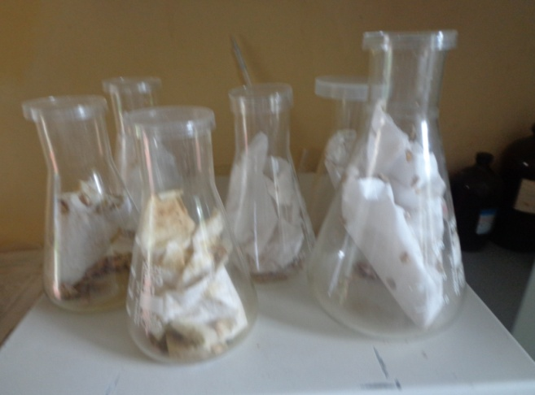

Appendix:-1. Rearing of Galleria mellonella, adult male and female kept in the flask that contained folded paper to deposit eggs on the crevices
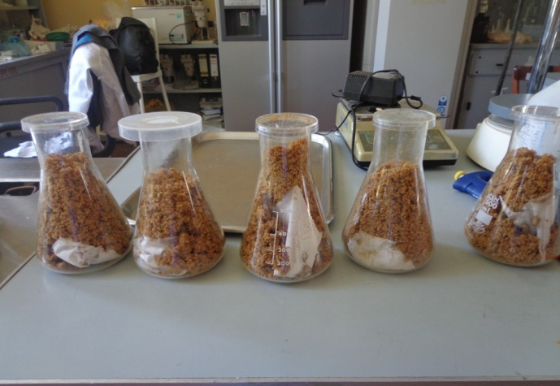

Appendix:-2. Rearing of Galleria mellonella, paper attached with eggs kept in the flask that contained food (wheat bran, honey and glycerol) for hatched larvae.

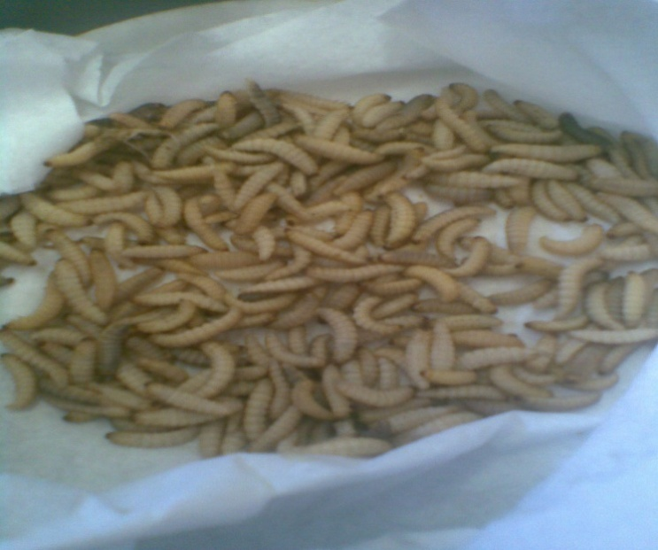

Appendix:-3. Heat treated Galleria larvae L4 ready for baiting trap of entomopathogenic fungi
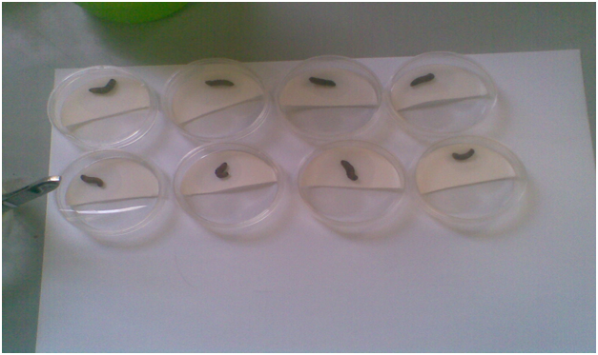

Appendix:-4. Baited Galleria larvae with entomopathogenic fungi and kept on sterile Whatman filter paper

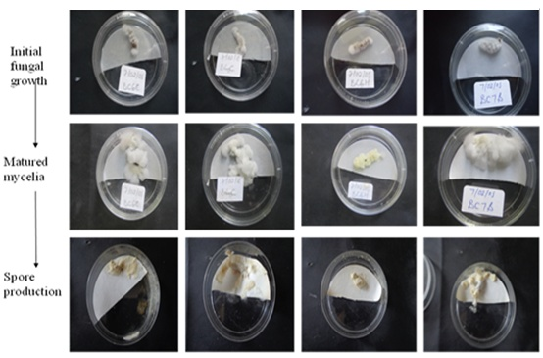
Appendix:-5. Matured Mycelia growth of Beauveria bassiana and spore production on the cadavers of Galleria larvae

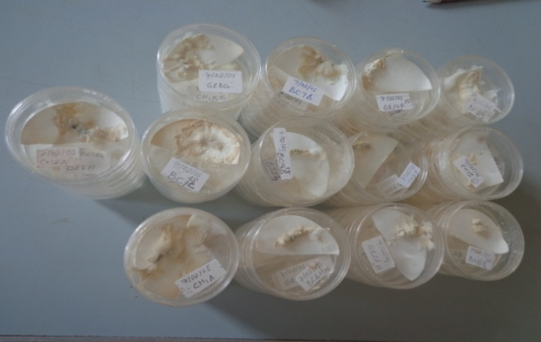

Appendix:-6. Sporulated Beauveria bassiana on cadavers of Galleria larvae

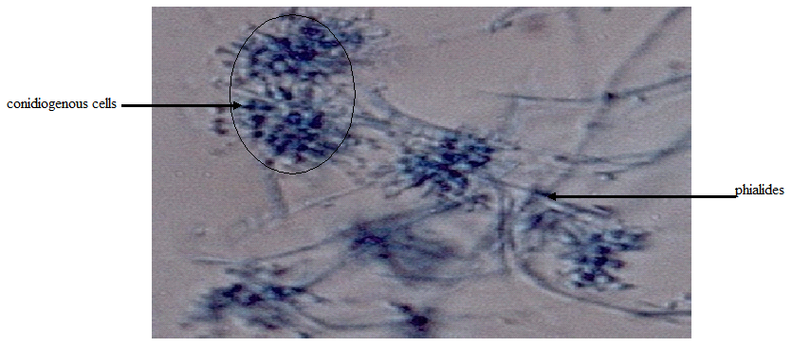

Appendix:-7. Microscopic structure of Beauveria bassiana stained with Lactophenol cotton blue (100x oil emulsion), branched hyphae, conidiophores and globose conidia.

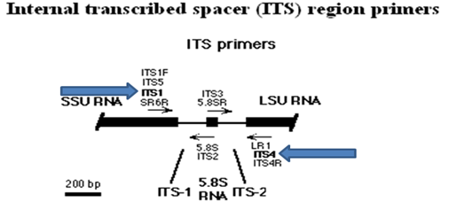

Appendix:-8. Sequenced ITS region of rDNA that includes (ITS1, 5.8S and ITS4) and amplified using ITS primers (ITS I and ITS 4)

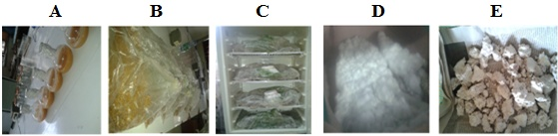

Appendix:-9. Mass production of Entomopathogenic fungi, Beauveria isolates using diphasic fermentation. A= Blastospore in the liquid phase of fermentation, B= Inoculated sorghum substrate with liquid culture, C= Incubated inoculated substrate in the growth chamber, D= Complete mycelia coverage of the substrate and E= Air dried spore with sorghum substrate.

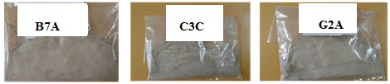

Appendix:-10. Harvested powder spore of the 3 isolates using manual method from sorghum substrate after 20 days

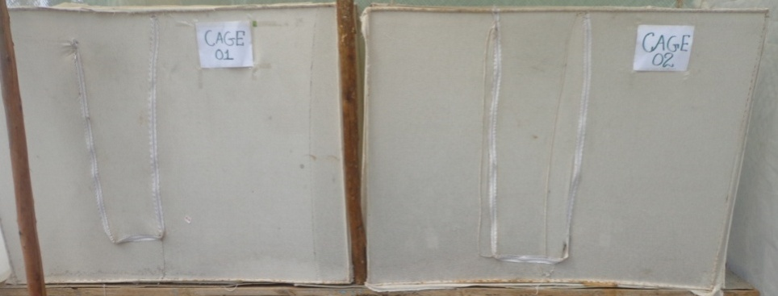

Appendix:-11. The two cages prepared for growth of inoculated seedlings
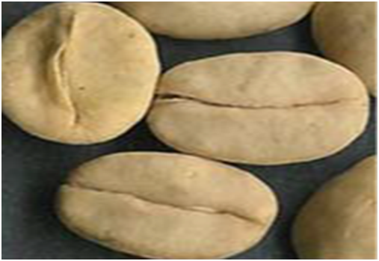

Appendix:-12. Processed and pre-germinate Coffea arabica var. seeds obtained from Tepi Green Coffee Plantation Agro Industry Plc

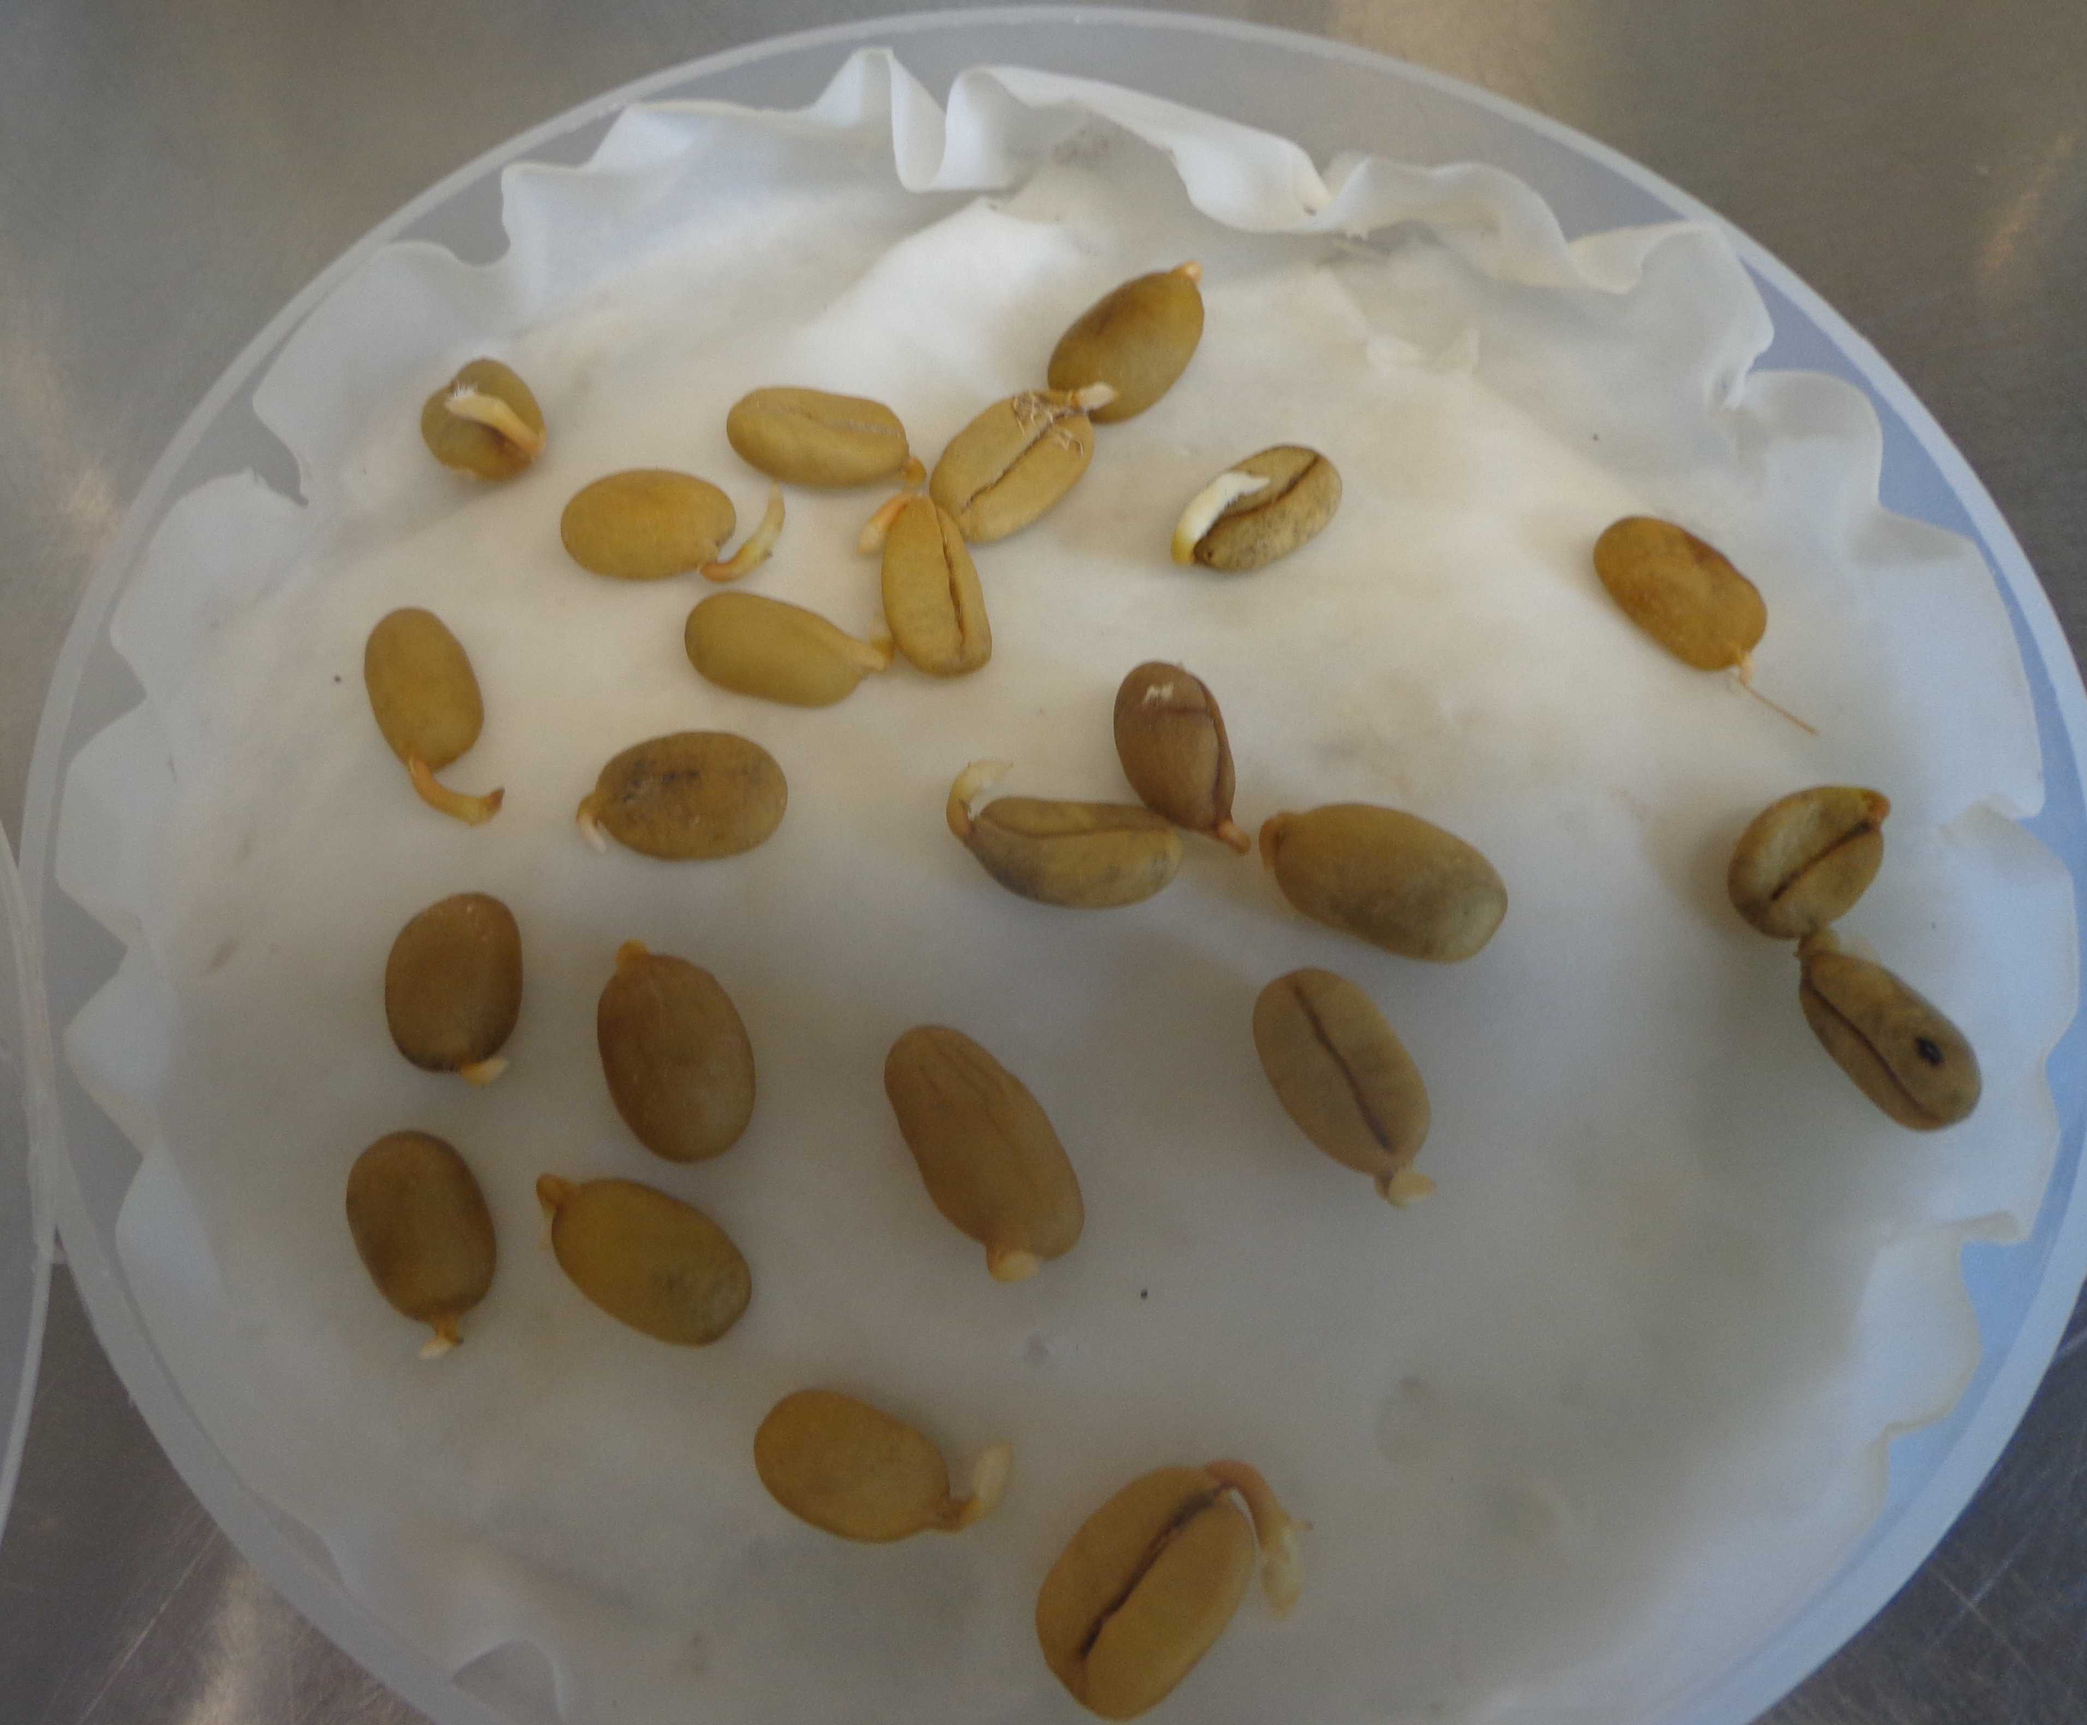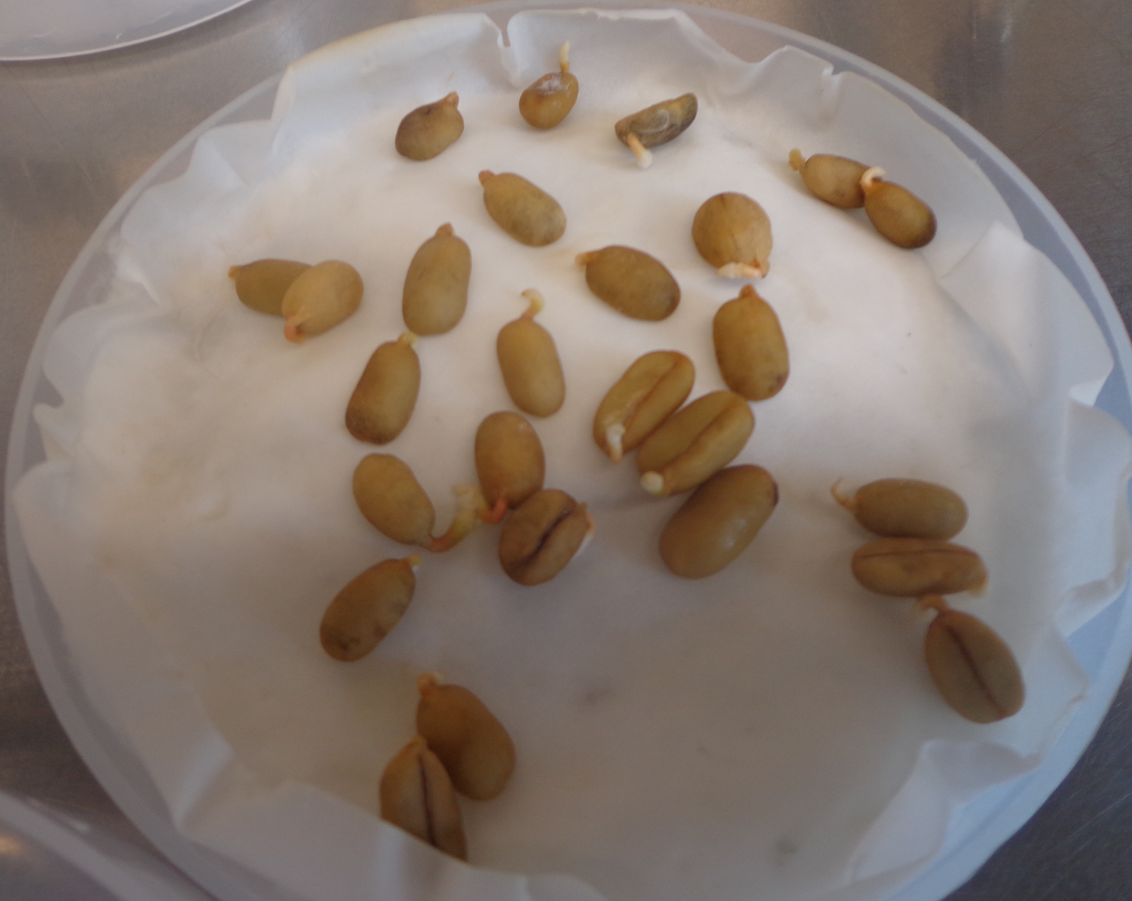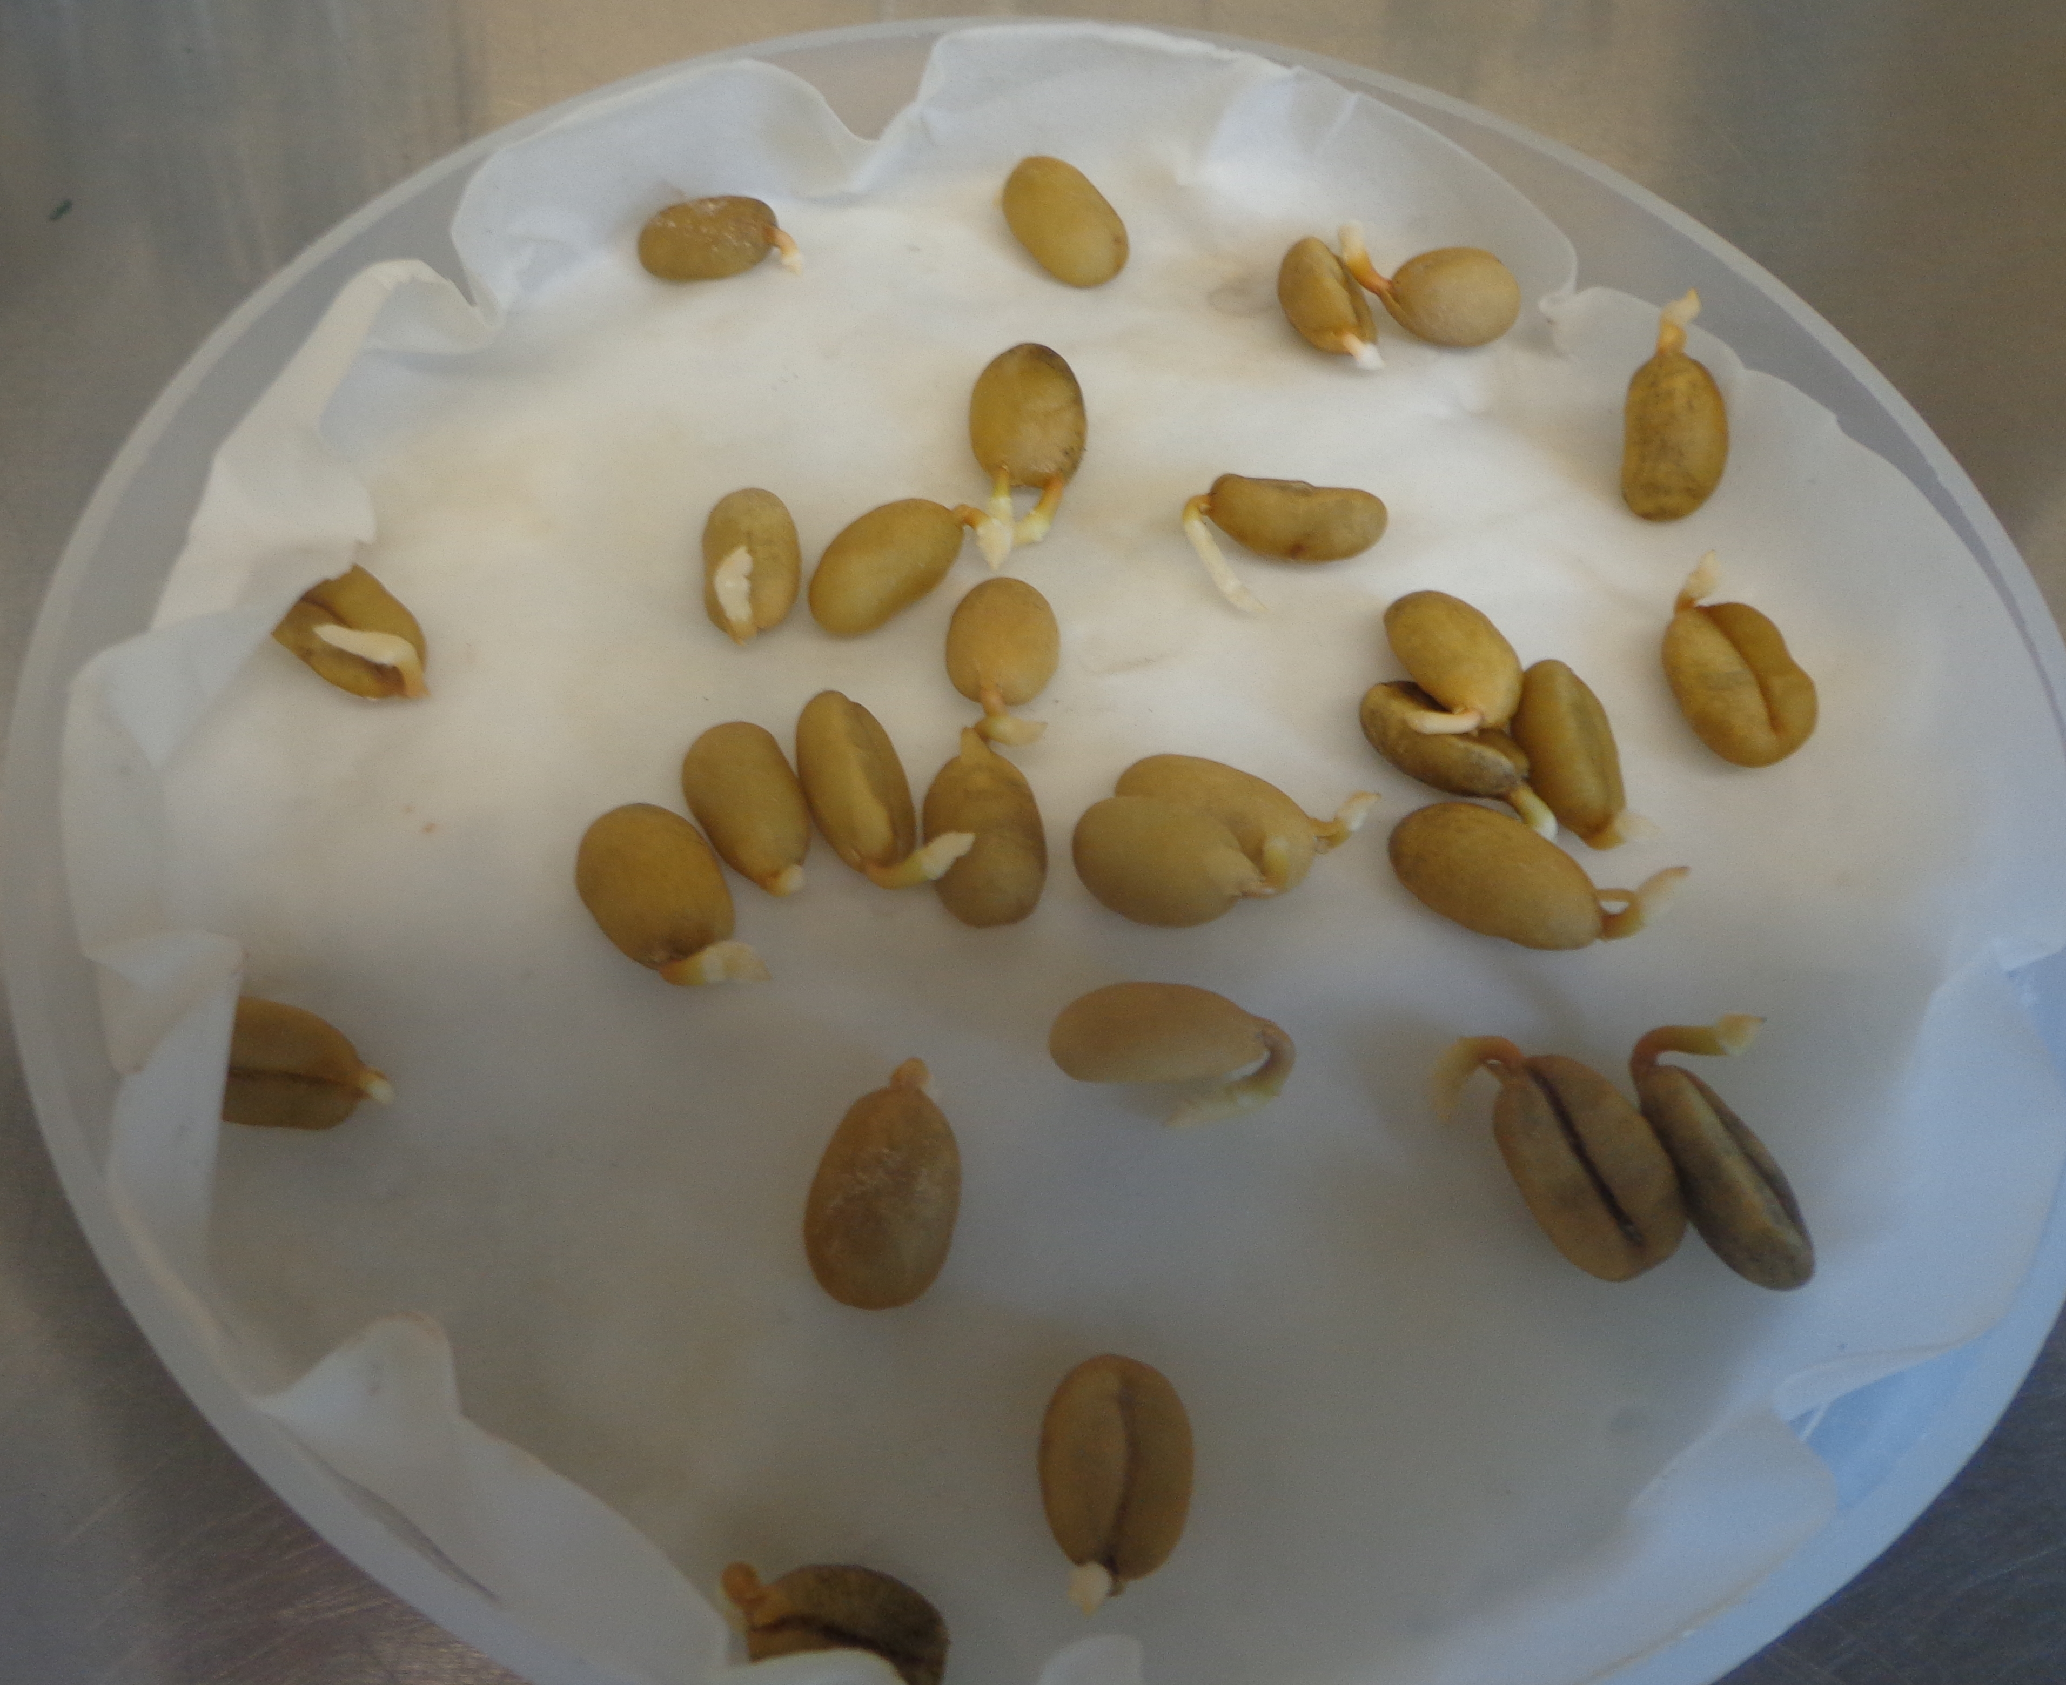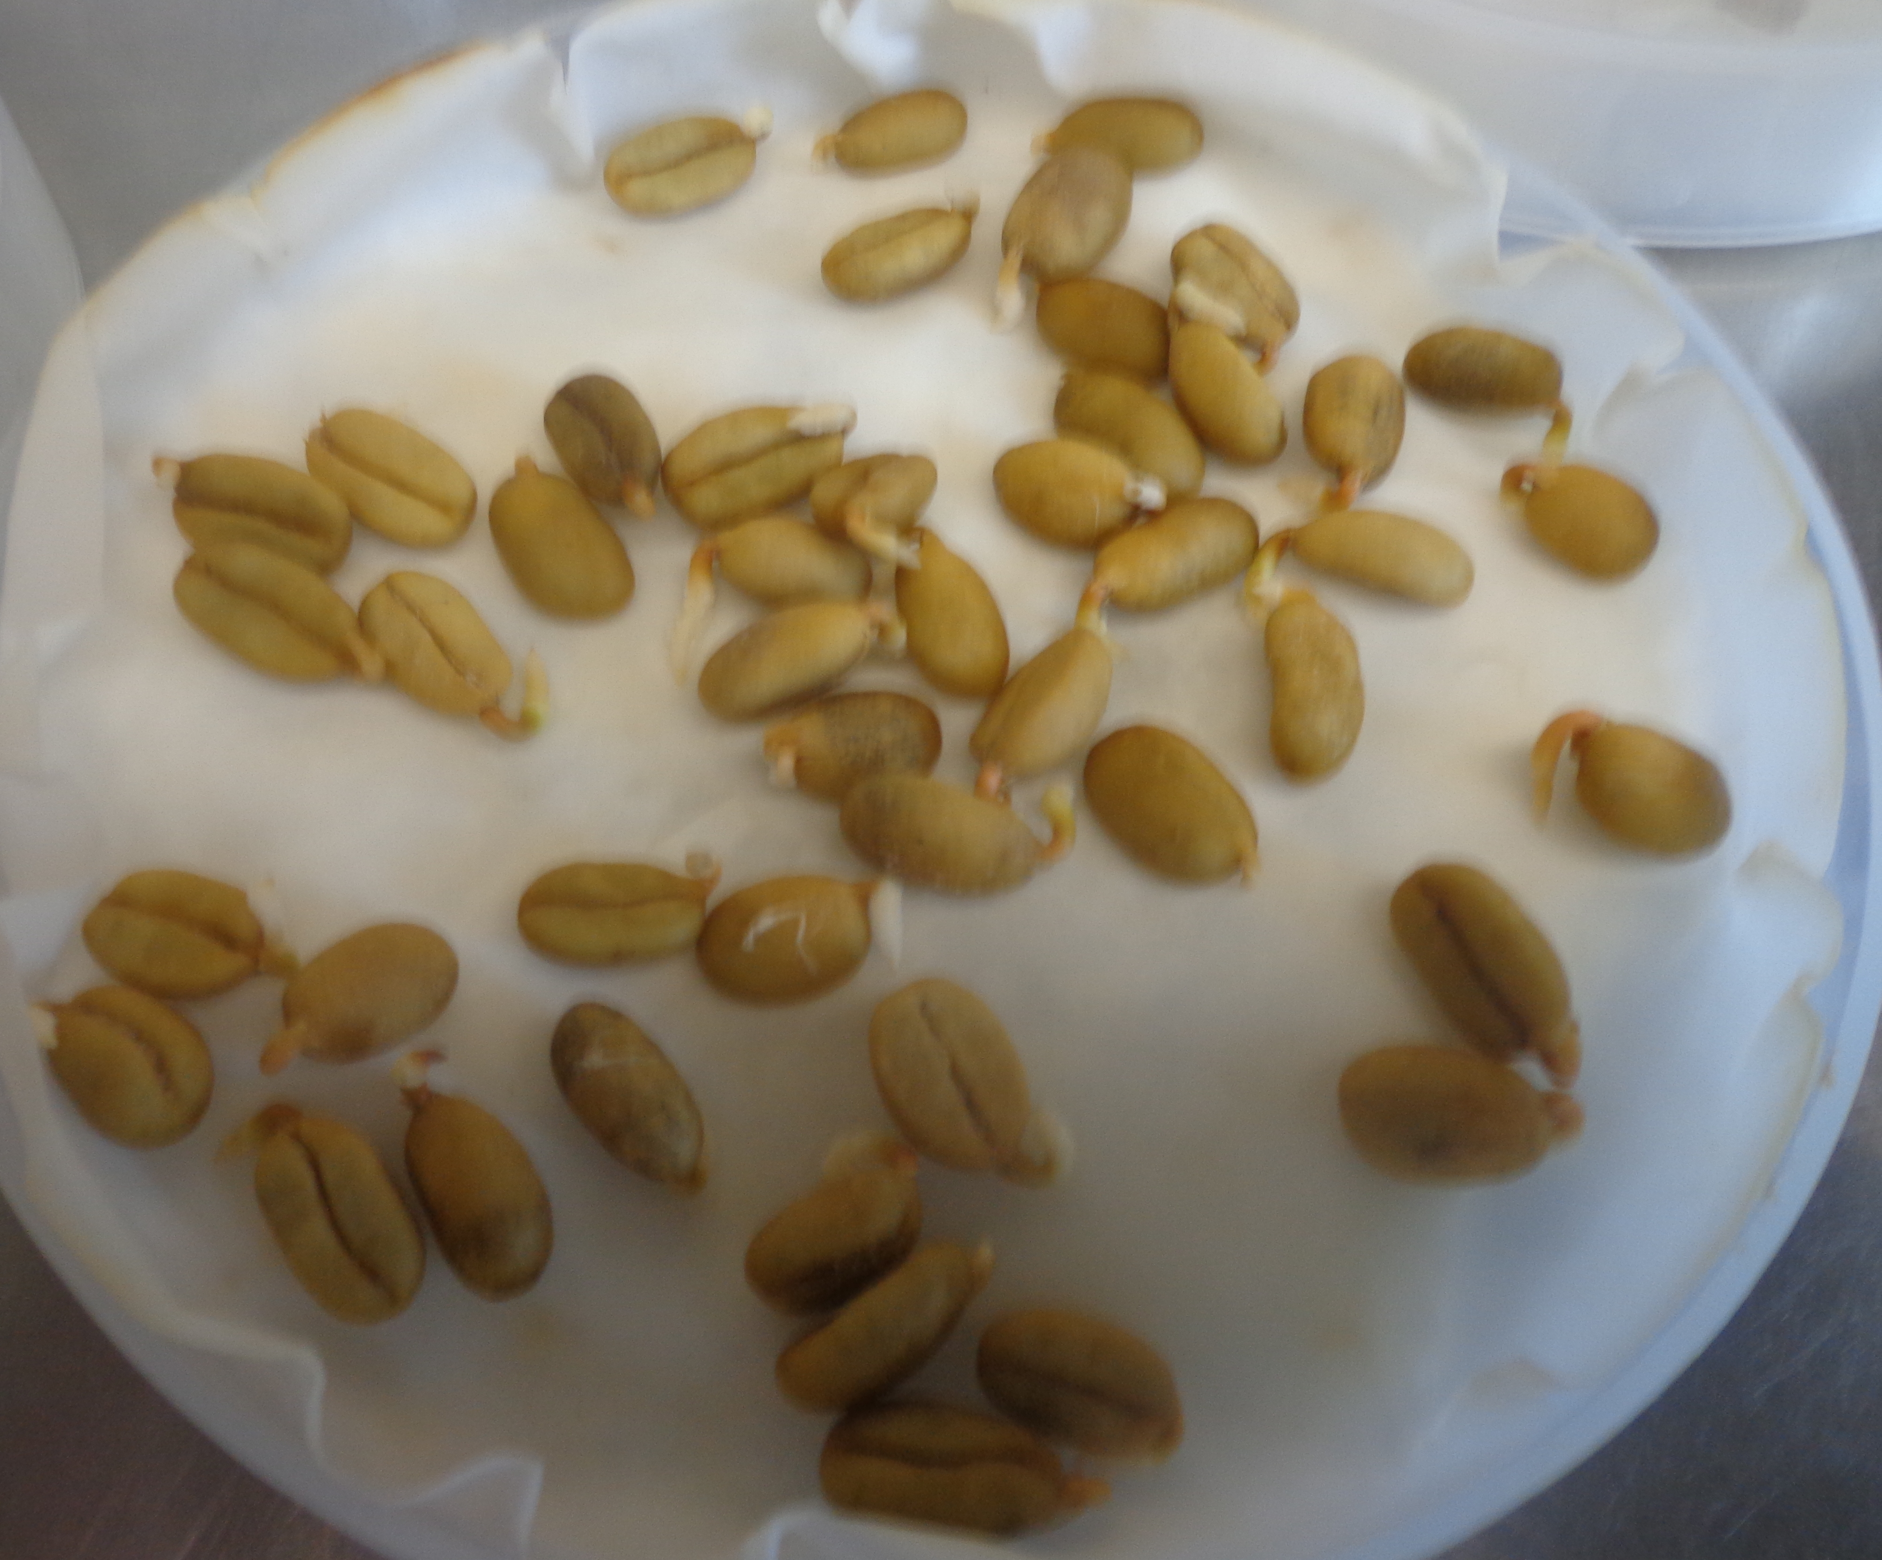

Fig 1:- pre-germinated coffee seeds

Appendix:-13. One month old Germinated Coffea arabica var. seedlings root radicles ready for inoculation
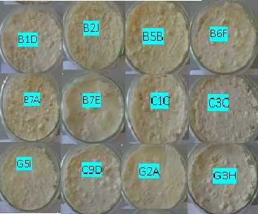
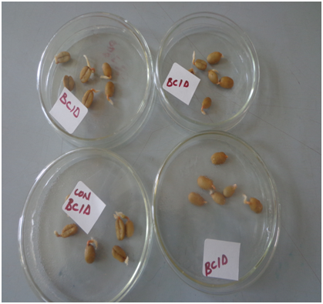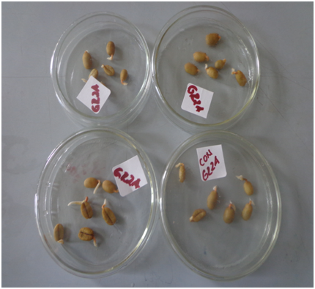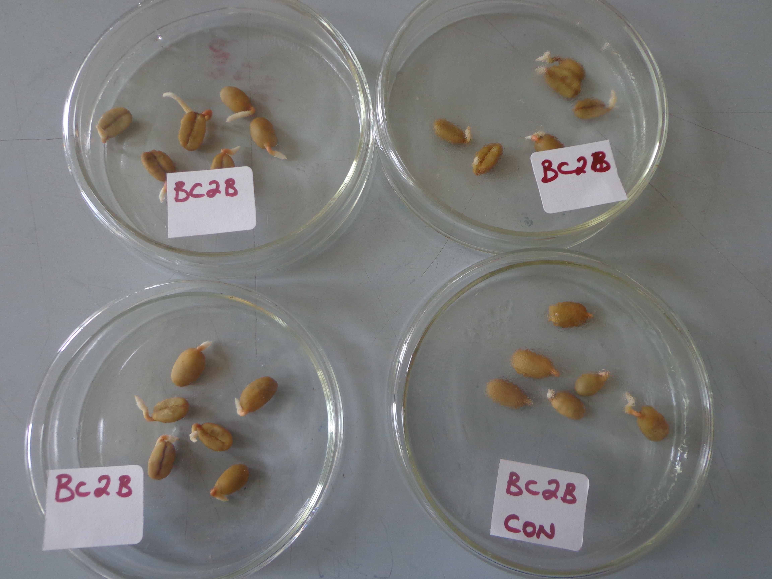Appendix:-14. Sporulated pure culture of B. bassiana isolates ready for suspension making

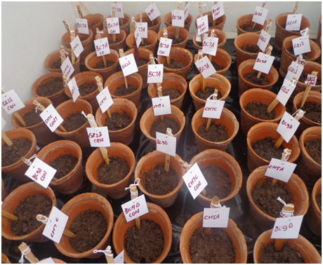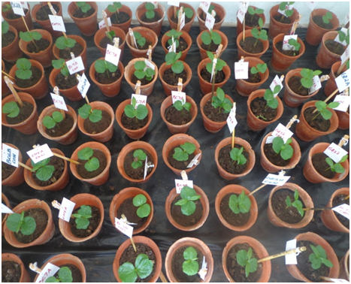Appendix:-15. Germinated coffee seedlings inoculated with B. bassiana isolates suspension with 1 x 10⁸ spore/ml
A
B

Appendix:-16. Planted coffee seedlings inoculated with Beauveria isolates spore suspension with 1 x10⁸ spore/ml and labeled with the corresponding treatments (A) and a grown coffee arabica var. seedlings after one month (B).
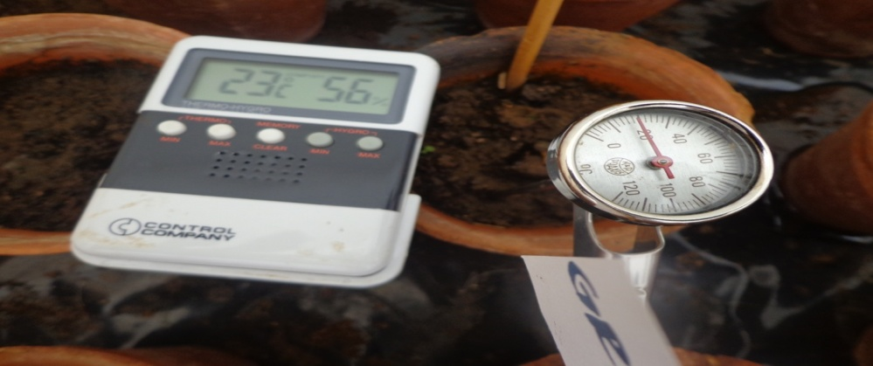

Appendix:-17 Cage temperature, R^{H} and Soil temperature measurements using thermo-hygrometer and Ditem reader.

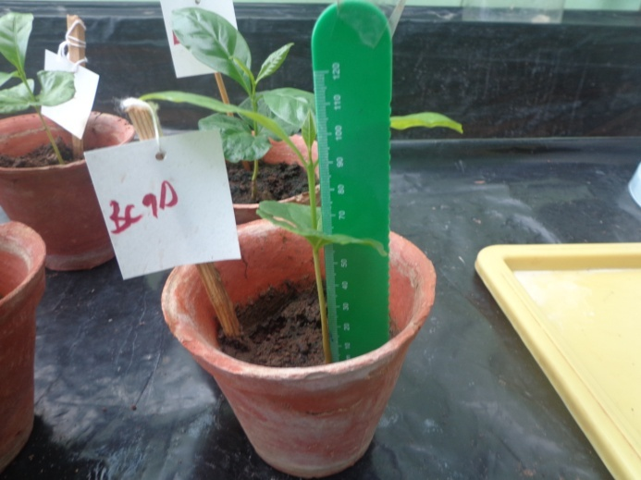

Appendix: - 18. Measuring the height of coffee seedling from base up to the tips of the meristem

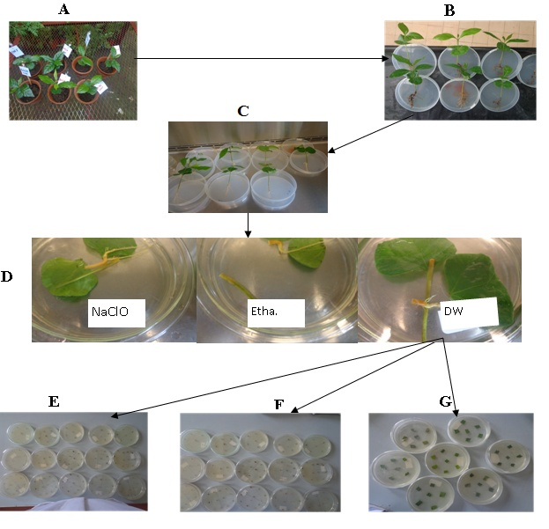
Appendix:-19. General procedure for postinoculation isolation of the B. bassiana, A; Randomly selected coffee plants, B; uprooted coffee plants and dislodged soil, C; washed coffee seedlings with detergents, D; surface sterilized cut plant tissue (NaClO, Sodium hypochlorite, Etha., 70% of ethanol and DW, distilled water), E, F and G represents plated tissue of roots, stems and leaves respectively.

Appendix:-20. Mean % ± SD of Spore germination test of isolates B. bassiana with in 24 and 48 hours Spore germination test were done in three replicates per each isolate. The mean ± (SD) percentage of spore germination of each isolates were calculated and determined using SPSS version 20.
Isolates | B1D | B2J | B5B | B6F | B7A | B7E | B9D | C1C | C3C | C5I | G2A | G3H | G5I
4hrs | 98.17± 0.73 | 96.17±  1.01 | 97.7±  0.3 | 98.3±  0.7 | 96.0±  1.2 | 96.17±  1.74 | 96.67±  0.44 | 97.00±  1.44 | 97.17±  1.17 | 96.33±  0.6 | 98.00±  0.87 | 98.00±  0.29 | 97.00±  0.5
48hrs | 99.17±  0.17 | 98.17±  0.88 | 98.3±  0.30 | 99.3±  0.70 | 98.0±  0.60 | 99.00±  0.00 | 98.33±  0.17 | 97.83±  1.30 | 98.00±  0.76 | 97.50±  0.00 | 98.50±  0.58 | 98.67±  0.44 | 98.00±  0.00

Appendix:- 21. Mean ± SE height (mm) of Coffee arabica var. seedlings measured at two months and four months

Months | B1D | B2J | B5B | B6F | B7A | B7E | B9D | C1C | C3C | C5I | G2A | G3H | G5I | Con
 | 46.70± | 51.10± | 47.77± | 48.87± | 45.93± | 46.43± | 55.60± | 48.10± | 46.53± | 46.10± | 52.17± | 47.13± | 46.90± | 47.83±
Two | 0.57 | 2.33 | 0.56 | 0.82 | 0.18 | 0.43 | 3.64 | 1.99 | 0.5 | 0.75 | 3.09 | 0.82 | 0.26 | 0.85
 | 89.4± | 83.9± | 93.8± | 94.2± | 84.43± | 87.57± | 94.10± | 93.87± | 93.67± | 92.47± | 101.13± | 94.47± | 96.73± | 80.90±
Four | 1.63 | 2.28 | 1.56 | 1.44 | 3.11 | 0.96 | 1.53 | 0.70 | 0.93 | 1.88 | 5.53 | 0.96 | 1.01 | 2.07

Three replicates of coffee seedlings pretreatment were selected randomly and the height of each plant was measured in mm. The mean ± (SE) of each measured height were calculated using SPSS version 20.

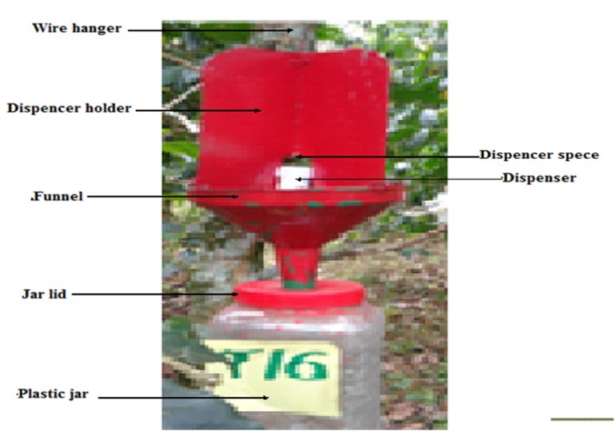

Appendix:-22. Locally made baiting CBB trap with semichemicals at the center
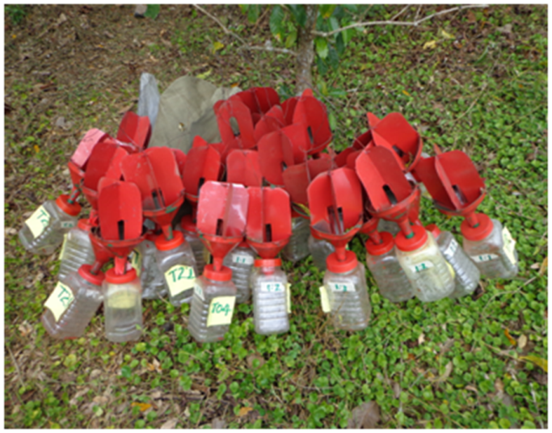

Appendix:-23. Locally made labeled CBB Baiting trap at the field

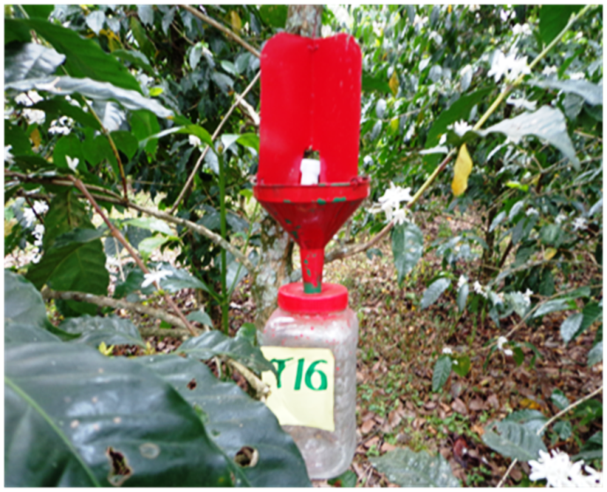

Appendix:-24. Hanged lured CBB trap 1.2 m the ground

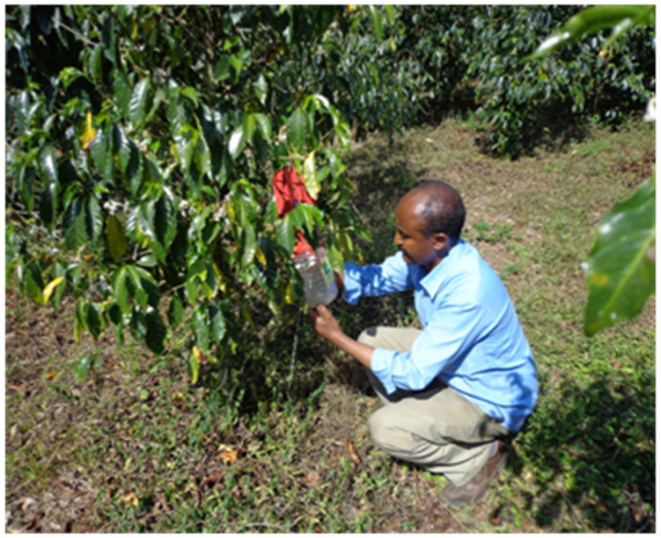

Appendix:-25. Collection of trapped from using collection vials

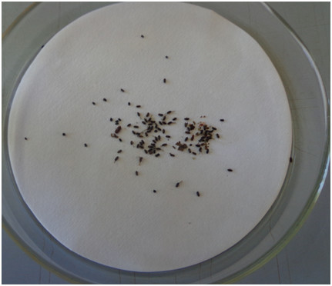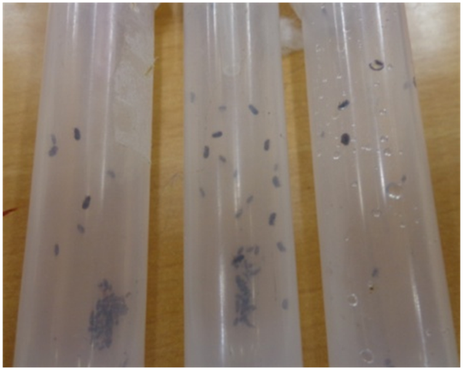

Appendix:-26. Coffee berry borer captured and collected in the Vials

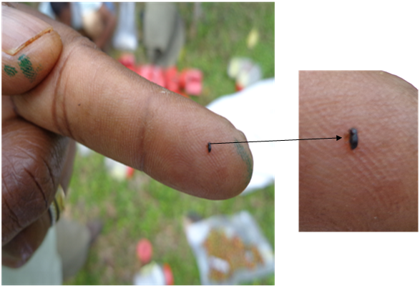

Appendix:-27. Female adult CBB magnified (16x pxl)

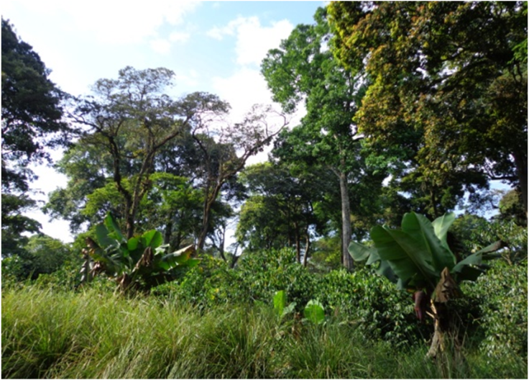

Appendix:-28. Coffee plantation area of Tepi-Baya II cultivated with other vegetations.

Declaration

I, the undersigned here honestly declare that this PhD dissertation is my own original work and has not been submitted to any were by me or another body to universities, academic institution, research organization or other related research affiliated organization to fulfill a similar purpose. All materials used for the thesis has been dully acknowledged.

PhD candidate
Yonas Chekol Signature__________ Date _________
Supervisors
1. Dr. Tesfaye Alemu (PhD) Signature __________Date ________

