

ADDIS ABABA UNIVERSITY
ETHIOPIAN INSTITUTE OF ARCHITECTURE,
BUILDING CONSTRUCTION AND CITY DEVELOPMENT
SCHOOL OF GRADUATE STUDIES

DOCUMENTATION AND CONSERVATION STRATEGIES
FOR DAGA ESTIFANOS MONASTERY CHURCH, LAKE TANA

By:
Tsegaye Kassa Woldetsadik

Advisor:
Ato Tadesse Girmay

A Thesis Submitted to the School of Graduate Studies, Addis Ababa University in Partial Fulfillment of the Requirement for the Degree of Master of Science Conservation of Urban and Architectural Heritage.

June, 2018
Addis Ababa

ADDIS ABABA UNIVERSITY
ETHIOPIAN INSTITUTE OF ARCHITECTURE,
BUILDING CONSTRUCTION AND CITY DEVELOPMENT
SCHOOL OF GRADUATE STUDIES
This is to certify that the thesis prepared by Tsegaye Kassa, entitled “Documentation and Conservation Strategies for Daga Estifanos Monastery Church, Lake Tana”, and submitted in partial fulfillment of the requirements for the Degree of Master of Science in Conservation of Urban and Architectural Heritage compiles in accordance of the regulations of the University and meets the accepted standards with respect to originality and quality.

Author: Tsegaye Kassa
Signature: ……………………
Date: ………………………….
Advisor: Ato Tadesse Girmay

Approved by the Examining Committee:
- Advisor
------------------------- Signature ___________ Date________
- External Examiner
------------------------- Signature ___________ Date________
- Internal Examiner
--------------------------------- Signature ___________ Date________
- Chair Person
-------------------------- Signature ___________ Date________

Declaration
I hereby declare that the dissertation entitled “Documentation and Conservation Strategies for Daga Estifanos Monastery Church, Lake Tana” has been carried out under the supervision of Ato Tadesse Girmay, EiABC (Addis Ababa University), during the year 2017/2018 as part of the fulfillment of the Degree of Master of Science program in Conservation of Urban and Architectural Heritage. I further declare that this work has not been submitted to any other University or Institution for the award of any degree.
Tsegaye Kassa
Signature _____________________________________
Date: March 2018
Addis Ababa, Ethiopia

Confirmation
The thesis can be submitted for examination with my approval as an institute’s advisor;
Advisor:
Ato Tadesse Girmay Signature ___________ Date________

Acknowledgment
First, I would like to thank my advisor, instructor and most of all my friend At Tadesse Girmay for his insightful and consistent advises during the whole time while I conducted this research. Second, I would like to forward my gratitude to all the academic staff and graduating students of the Conservation of Urban and Architectural Heritage Chair, at EiABC, A.A.U. for their warm friendship and acquaintance. My warm thanks also goes to my friends Ato Fikreselassie Abey and Ato Yoseph Kahsay, and Ato Girmachew Beyene who provided me with all the necessary support and motivation whenever necessary. In addition, I would like to Finally, last but not least, I would like to deliver my deepest gratitude and admiration to my wife and life partner w/o Hana Nigussie and my brother Tadesse Kassa (Dr.) with his family for giving me their unwavering support and inspiration which greatly enabled me to pursue and accomplish my study on time.

Tsegaye Kassa
Addis Ababa,
July, 2018

Table of Content
Annexes x
List of Acronyms xi
Abstract xii
Chapter One 1
1. Introduction 1
1.1. Background of the Study 4
1.2. The Study Area: Natural and Cultural Setting 4
1.2.1. Natural Setting: Geographic Description of Daga Estifanos Monastery 4
1.2.2. Topography and Climate of Daga Island and Surrounding Environment 6
1.2.3. Cultural Setting 7
A. Historical Background 7
B. Architectural Context 7
C. Demography 9
D. Economic Features 9
1.3. Statement of the Problem 9
1.4. Research Questions 13
1.5.Objectives of the Study 13
1.5.1. General Objective 13
1.5.2. Specific Objectives 13
1.6. Significance of the Study 14
1.7. Scope of the Study 14
1.8. Limitation of the Study 15
1.9. Research Methodology 15
1.9.1. Sampling and Sampling Strategies 15
1.9.2. Site selection 16
1.9.3. Research Tools 16
1.9.4. Sources of Data 16
A. Primary Data Sources 16
B. Secondary Data Sources 16
1.9.5. Data Acquisition Techniques 17
A. In depth Interview 17
B. Personal Observation 17
C. Measurement 18
D. Photography 18
1.9.6. Data Analysis Techniques 18
Chapter Two 19
2. Literature Review 19
2.1. General Concepts of Heritage and Cultural Heritages 19
2.2. Historic Building Documentation and Conservation: Definitions and Concepts 21
2.3. Significances of Historic Building Heritages 22
2.3.1. Historic Significances/ Context 23
2.3.2. Architectural Significance/ Context 24
2.4. Factors Deteriorating Historic Building Heritages 25
2.5. Principles and Approaches on Heritage Conservation: Trends on Historic Buildings 26
2.5.1. The History of Conservation/ Restoration 26
2.5.2. The Principles of Conservation/ Restoration 28
2.5.3. The Theories and Concepts of Conservation/ Restoration 30
2.5.4. Definitions and trends 33
2.5.5. Modern aspects of heritage and conservation 34
A. Universal value 34
B. Authenticity 35
C. Integrity 35
2.6. A History of Architectural Developments in Ethiopia 36
2.6.1. Historical Periods 37
A. Pre-Axumite Architectural Period 37
B. Axumite Architectural Period 38
C. Medieval and Zagwe Architectural Period 39
D. Gondarian Architectural Period 41
E. Modern and Post-Modern Architectural Period: Addis Ababa and Its Architecture 44

Chapter Three 47
3. Data Documentation, Presentation and Analysis 47
3.1. The Geographic Description and Location of the Monastery Church 47
3.2. A History of Daga Estifanos Monastery Church 49
3.3. Description of Daga Estifanos Monastery Church: Physical Aspects 56
3.3.1. Architectural Data for Daga Estefanos Monastery Church 56
A. Form of the Building 56
B. Flooring 58
C. Walls 60
D. Windows and Doors 60
E. Roofing 62
3.3.2. Documentation: Current Conditions of the Church - Pathological Study 65
3.3.3. Description of the Exterior Part of the Church 70
A. Floor Plan 70
B. The Southern Façade 71
C. The Eastern Façade 72
D. The Northern Façade 73
E. The Western Façade 74
3.4. Description of the Rooms 75
A. Bete-Mekdes (Sanctuary/Holy of Holies) 76
B. Kidist (Surrounding Ambulatory) 77
C. Kine-Mahlet (Outer Ambulatory) 78
3.5. Technology: Architecture and Raw Materials 79
3.6. Construction Materials 82
3.7. Associated Findings: Historically Significant Cultural Heritages and Artefacts 83
Chapter Four 89
4. Discussion and Data Implications 89
4.1. Implication of the Geographical Location: Cultural Routes 89
4.2. Site Selection Implication 89
4.3. Implication of the Structures of the Monastery Church 89
4.4. Technology: Architectural Implication and Construction Materials 90
4.5. Significances of the Monastery Church: Cultural Heritage and Tourism Values 90
4.5.1. Historic Values 90
4.5.2. Economic Values: Tourism potential of the Monastery Church 91
4.5.3. Architectural, Aesthetic and Educational Values 92
4.6. Conservation and Management Status of the Monastery Church 93
4.6.1. Current Physical State of the Building 93
4.6.2. Heritage Management Status of the Monastery Church 94
A. Development of Conservation Plan 94
B. Conservation Proposal 95
C. Proposed Building Solutions 96
Chapter Five 102
5. Conclusion and Recommendation 102
5.1. Conclusions 102
5.2. Recommendations 103
References 105
1. Books and Publications 105
2. Websites 106

Table of Figures
Figure 1. Relative location of Lake Tana and Bahir Dar City 1
Figure 2. The Historic Route of Ethiopia. 2
Figure 3. Lake Tana and the islands of Dek and Daga 2
Figure 4. The Location of Daga and relative to Dek Island 3
Figure 5. The location of Bahir Dar city relative to Dek and Daga Islands 3
Figure 6. Daga Island and its Natural 5
Figure 7. Fruits and vegetables on Daga Island 5
Figure 8. The access port on the East of Dag Island 5
Figure 9. The climate of Bahir Dar and surrounding environment 6
Figure 10. The shape of Daga Estifanos Church resembles Noah’s Ark 8
Figure 11. Population character of Amhara Region and Bahir Dar City 9
Figure 12. Yeha Temple 38
Figure 13. Ta’akha Maryam Palace 39
Figure 14. Dingur Palace 39
Figure 15. Arial View and Plan of Bete Ghiorgis Church 40
Figure 16. The Guzara Palace 42
Figure 17. Palace of Fassiladas 43
Figure 18. The Greek Moussie Minas Residence 45
Figure 19. Verandah of Alfred Ilg’s Residence 45
Figure 20. Verandah of Addis Ababa Tukul 45
Figure 21. National Bank of Ethiopia, Henri Chommet 46
Figure 22. Daga Island and the Monastery of St. Estifanos Church 47
Figure 23. The main port of Daga Island 48
Figure 24. Traditional Paint of Abune Hirute Amlak 50
Figure 25. Two stone slabs used as boats 51
Figure 26. Lake Tana Located In Amhara Regional State 52
Figure 27. Daga Island Located in the Vicinity of Dek Island 52
Figure 28. Eastern Plateau landed first by Abune Hirute-Amlak 53
Figure 29. South-Western view with its visible Gulilat 53
Figure 30. The Plan and Cross-section views by Sandro Angelini, 1969 G.C. 55
Figure 31.View towards the roof with three Gulilat or Seqela 56
Figure 32. North-Eastern view with roof and iron mesh 57
Figure 33. View towards the Southern Verandah 58
Figure 34.View Towards Northern Verandah 58
Figure 35. Stairs on Eastern Façade made from Concrete 59
Figure 36. Vertical wooden posts inside the rooms 59
Figure 37. The floor of interior rooms 59
Figure 38. Stone masonry Walls plastered with Mud 60
Figure 39. Windows and Doors Made from Wooden lumbers 61
Figure 40. Roofing Structural Support Techniques 62
Figure 41. Triangular Supportive Wedges 63
Figure 42. Roofing Load Transfer Wooden Posts 64
Figure 43. CIS Roofing and the Three Gulilat (Seqela) 64
Figure 44. Termite Damages on Wooden Posts & Beams 66
Figure 45. Termite Damage on Window and Door Panels 66
Figure 46. Termite Damage on Interior Timber Panels 67
Figure 47. Termite Damage on Timber Roof Panels 67
Figure 48. Wall Cracks 67
Figure 49. Dislocation of Roof Structure 68
Figure 50. Improper Paints on Wall and Wooden Panels 68
Figure 51. Improper Wall Conservation Works 69
Figure 52. Iron Mesh Covers to Protect Birds and Insects 69
Figure 53. Floor Plan 70
Figure 54. South Side Elevation 71
Figure 55. East Side Elevation 72
Figure 56. North Side Elevation 73
Figure 57. West Side Elevation 74
Figure 58. Bete-Mekdes Floor Plan 76
Figure 59. Kidist Floor Plan 77
Figure 60. Kine-Mahlet Floor Plan 78
Figure 61. Door 1 & 2 Detail Drawings 79
Figure 62. Door 3 up to 8 Detail Drawings 80
Figure 63. Window 1 & 2 Detail Drawings 81
Figure 64. Section Drawing 82
Figure 65. Two-storied Museum and Storage 83
Figure 66. Stone Slabs Used as Boats 84
Figure 67. Religious Manuscripts 84
Figure 68. Religious Books and Artefacts 85
Figure 69. Atse Dawit’s Golden Crown 85
Figure 70. Atse Zer’a Yaekob’s Golden Crown 86
Figure 71. A Royal Chair with Three Legs 86
Figure 72. Skeletal Remains of Atse Fassiladas 87
Figure 73. Skeletal Remains of Atse Suseniyos 87
Figure 74. Limestone walls 96
Figure 75. Thatch roofing 96
Figure 76. Bamboo Verandah Cover 97
Figure 77. Tid and Zigba Wooden Posts and beams 97
Figure 78. Tid and Zigba Timber for Doors 98
Figure 79. Tid and Zigba Timber Panels for Doors 99
Figure 80. Tid and Zigba Timber Frames for Windows 100
Figure 81. Tid and Zigba Wooden Structural Frames for Roof Support 101

Annexes
Annex I ……………………………………………………… Ground Floor Plan of Daga Estifanos Church
Annex II ………………………………………………. Northern Side Elevation of Daga Estifanos Church
Annex III ……………………………………………… Southern Side Elevation of Daga Estifanos Church
Annex IV ………………………………………………... Eastern Side Elevation of Daga Estifanos Church
Annex V ……………………………………………….. Western Side Elevation of Daga Estifanos Church
Annex VI …………………………………………………………….. Roof Plan of Daga Estifanos Church

List of Acronyms
ARCTO: Amhara Region Culture and Tourism Office
ARCCH: Authority for Research and Conservation of Cultural Heritage
AMMA: Amhara Mass Media Agency
CSA: Central Statistics Agency of Ethiopia
EPLUAA: Environmental Protection and Land Use and Administration Authority of Amhara
GPS: Global Positioning System
ICCROM: The International Centre for the Study of the Preservation and Restoration of Cultural Property
ICOMOS: International Council on Monuments and Sites
IES: Institute of Ethiopian Studies
UN: United Nations
UNEP: United Nations Environment Program
UNESCO: United Nations Educational, Scientific and Cultural Organization
WB: World Bank
WBIDA: World Bank-International Development Association
WHC: World Heritage Council
WMF: World Monument Fund

Abstract
The significance of historic buildings for the development and value of nations is paramount. These significances manifest in different forms and ways. Hence, this paper investigates the primary roles, in addition to their intended purposes and functions, are their contribution to display nations’ pasts, their indication of the continuity of change in a country’s character, and their ability to mark periods of climax and decadence of civilizations due to various factors. In addition, it analyses importance of historic buildings as are vehicles for the understanding and critical analysis of current generations about their place in history. In doing so, it highlights the benefits of heritage buildings to contemporary societies regarding their impact on the continuous and inevitable transformation of a nation and its civilization. Moreover, the study assesses the role of historic building in terms income generation through tourism, in addition to architectural values/ significance acquired through research and education.
Hence, this research is intended to assess and discuss the current status of Daga Estifanos Monastery Church, by documenting its historic and architectural context, and proposing possible conservation strategy. To this end, the study utilized both qualitative and quantitative research methods and incorporated four specific objectives. The research also investigated and utilized previously available researches and conservation activities on this heritage building, together with associated historic structures and artefacts. Hence, the study employed both primary data (interviews, measurements and personal observations) and secondary data from previous works and related literatures. The research included investigation regarding the presence of policy alternatives or deficiencies of existing guidelines, in addition to assessing the degree of understanding and engagements by various responsible institutions and stakeholders regarding the conservation of architectural heritages at regional and national levels.
Finally, the research formulated concluding remarks that led to devising appropriately crafted technical conservation approaches for the heritage building, in addition to proposing possible future policy recommendations that can help safeguard its future prospects.

Chapter One

Introduction
Bahir Dar is a relatively younger city as compared with many cities in Ethiopia, such as Addis Ababa, Gondar, Debre Birhan, etc., to mention a few, which are endowed with a number of historic buildings with either regional, national and/ or world heritage status. Individual monuments, landmarks, buildings, sites and urban spaces, street patterns and coherent ensembles convey cities’ pasts, continuity of change through time, periods of ascent and decadence of urban fabrics due to circumstances such as economic boom, wars/ conflicts, natural hazards etc. However, such historic heritage buildings and sites of Bahir Dar city and surrounding areas have not been given proper attention and care by mechanisms of methodically selected and approved scientific approaches of conservation (EPLUAA, 2007).
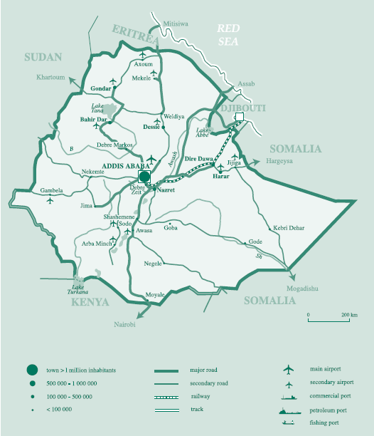

Figure 1. Relative location of Lake Tana and Bahir Dar City

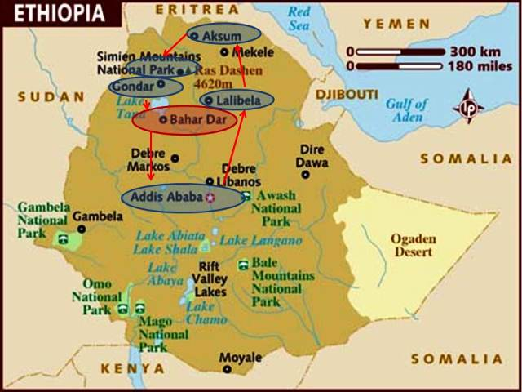
Figure 2. The Historic Route of Ethiopia.

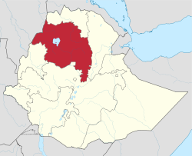
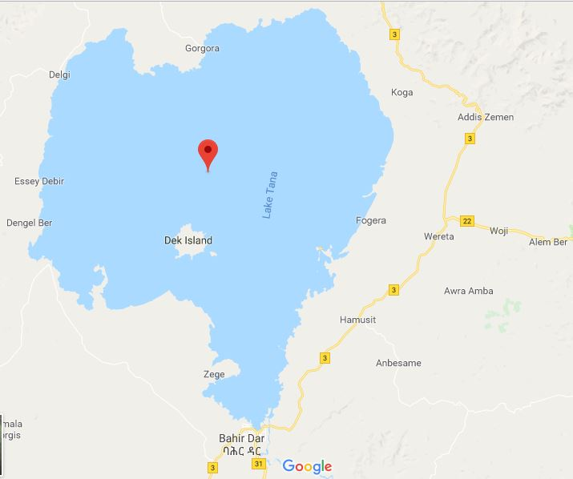
The church and monastery of Daga Estifanos is located on the small island of Daga which is situated to the north of Bahir Dar City, at a distance of forty-four kilometers (44km). The monastery and its church are open to visitors throughout all days of the week. It is accessible only through boats which transport tourists and the permanent residents of the island, in addition to bringing all the necessary amenities and goods. The voyage to the shores of the island usually take around three hours with motor boats that often drive with an average speed of 16km/hr (EPLUAA, 2007).

Figure 3. Lake Tana and the islands of Dek and Daga
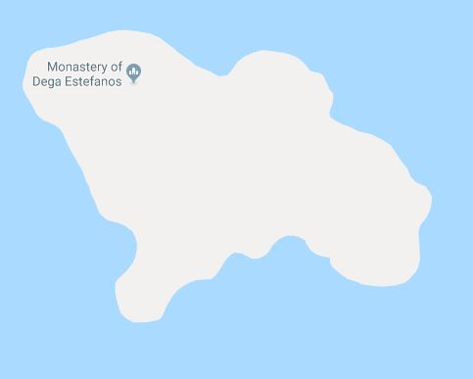
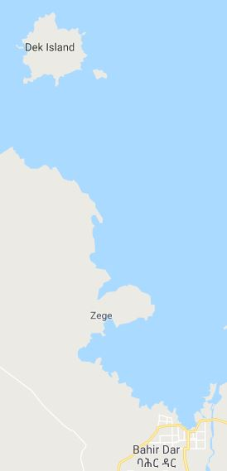
The island of Daga is covered with lush evergreen forest consisting of trees that are predominantly indigenous to Ethiopia. Different types of birds and small wild animals such as apes and monkeys are common features in and around the island. In addition, fishes of diverse typologies are abundant in the surrounding lake water, which attract fishing men with traditional boats called locally as ‘Tanqua’. The island, in addition to the main church building, a nearby museum, other subordinate rooms, is comprised of an old port. This port was built at the beginning of the 1940s, during the reign of Emperor Haileselassie I, with his support and direction (AMMA, 2005).

Figure 4. The Location of Daga and relative to Dek Island

Figure 5. The location of Bahir Dar city relative to Dek and Daga Islands

Background of the Study
Lake Tana, with its natural surroundings, is one of the most pleasant spots in Ethiopia. The lake has a generally organic configuration which resembles the shape of the heart. With an average diameter of seventy kilometers (70km) and a maximum depth of fourteen meters (14m), it is bounded by vast plains and distant mountain ranges. The lake and its surrounding environment has a particularly attractive and diverse vegetation cover, which range from thick wood trees to patches of papyri and wide areas of coffee plantations (EPLUAA, 2007).
The cultural mosaic and diversity coupled with the ethnographic milieu of the population neighbouring Lake Tana is one of its points of interest and appreciation to visitors. Many races with their different ancestral traditions, huts, work tools, the papyrus boats, and other elements of cultural expressions are all parts of valid touristic interests and research areas.
The presence of monasteries (about twenty) on most of the islands has been historically the driving factor that resulted in the focus of this lake for tourists and various scholars for many years. However, these monasteries and churches, which flourished mainly during the period of the Gondar Emperors, are currently in a state of rapid and progressive decay (AMMA, 2005).

The Study Area: Natural and Cultural Setting

Natural Setting: Geographic Description of Daga Estifanos Monastery
The Island of Daga is geographically located at a distance of 44km to the north of Bahir Dar City. The island ha the shape of a cross when viewed from an airplane, in which its land mass longitudinally stretches from east to west. The main church building is located on the highest hills of the western part of the island. The island is relatively located at the center of the lake. The eastern half of the land mass is characterized as a Streep of land which is stretched in a linear fashion (AMMA, 2005).
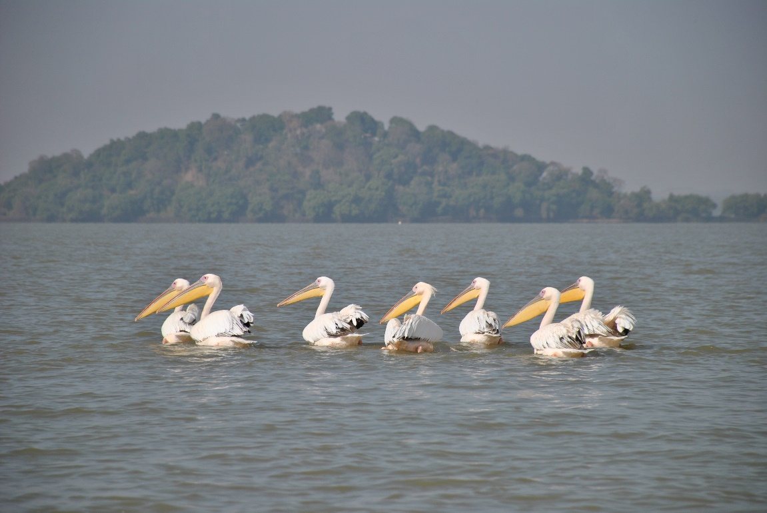

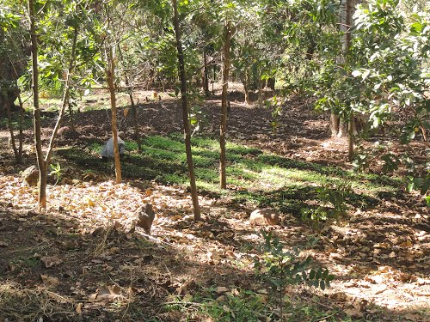
Figure 6. Daga Island and its Natural
Greenery and Forest

Figure 7. Fruits and vegetables on Daga Island

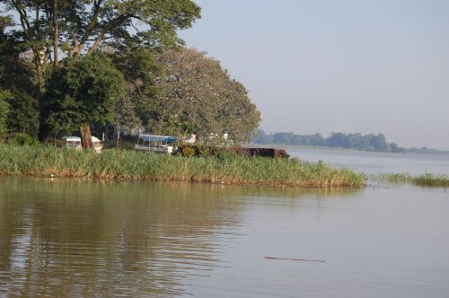
Figure 8. The access port on the East of Dag Island

The north-south orientation of the land creates the cross-shaped formation of the island. The following churches and monasteries are some of the monuments located in and around Lake Tana that are historically and architecturally more significant, and thereby depending on the level of physical deterioration and damage they endure, require immediate intervention with restoration:
- Daga Estifanos on the Island of Daga
- Kibran Gabriel on the Island of Kibran
- Ura Kidanemihret on Zeghie Peninsula
- Narga Selassie on Island of Narga
- Arsema Mariam on Dek Island in the center of the lake; (AMMA, 2005)

Topography and Climate of Daga Island and Surrounding Environment
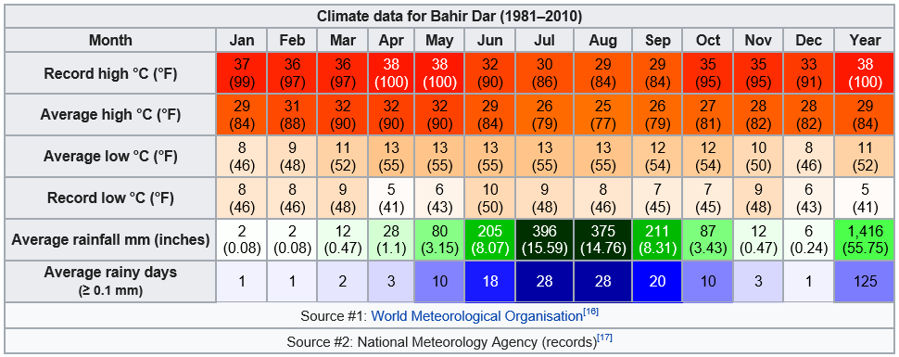
The Lake Tana Region is a UNESCO Biosphere Reserve since 2015 G.C. the topography of Daga Island is characterized by a mountainous land that also consists pockets of flat vegetation areas. It has the lowest point on the eastern portion of the island with the port and the highest point on its western portion which is the position of the church building. In addition, Bahir Dar city and the surrounding environment has a borderline tropical savanna climate, very close to a subtropical highland climate. Afternoon temperatures are very warm to hot year-round, and morning temperatures cool; however, the diurnal range is much larger in the largely cloudless dry season (AMMA, 2005).

Figure 9. The climate of Bahir Dar and surrounding environment

Cultural Setting

Historical Background
The monastery of Daga Estifanos is believed to have been founded around 1268 E.C. by a monk named Abune (Father) Hirute-Amlak. He is thought to have arrived from Haiq Estifanos monastery, a historically significant religious institution situated on an island in the middle of Lake Haiq, located in the province of Wollo. According to the deeply held legend by the church and its faithful, Abune Hirute-Amlak was ordered and guided by God through vision to bring the thabot, which is the replica of the Ark of the Covenant, of Haiq Estifanos monastery to Daga Island at Lake Tana. The monastery is endowed with a large number of religious and traditional artefacts. One of these artefacts are two stones that are located half way through the path from the shore to the main church. These stones are shaped as a pair of stone carvings which form the shape of a boat when joined together, which are believed to have been used by the founder of the monastery to arrive at the island (AMMA, 2005).

Architectural Context
The main church building of Daga Estifanos monastery has rectangular shape. The roof of this building has three raised volumes that are in Amharic termed as “Gulilat” which will contain the crosses of the church. The rectangular shape of the church and its deliberate placement at the highest level of the island are believed to symbolize Noah’s Ark. The interior space of the church has three major compartments, referred to as Kine-Mahlet, Kidist and Mekdes, which are basic and common to all Ethiopian Orthodox church configurations. Hence these three interior spaces of the church are also considered to be synonymous to the three interior parts of Noah’s Ark. Additionally, the three spaces are believed by the church scholars and fathers to represent the existence and manifestations of God as both one and three entities (AMMA, 2005).

Figure 10. The shape of Daga Estifanos Church resembles Noah’s Ark

During the earliest periods of the history of Ethiopian Orthodox church construction, it was customary to make them rectangular in shape. However, circular shaped church buildings have become predominant in recent and near past history of the church. Hence, the shape of Daga Estifanos church is representative of the original and pioneer configurations of church architecture. In addition to its intended function as a church, the main building of Daga Estifanos church also serves as a mausoleum for the founder of the monastery which is found buried underneath the main building (AMMA, 2005).

Demography
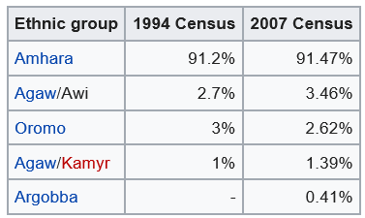
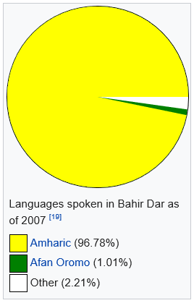
According to the First Draft Results of the Population and Housing Census (2015), the total population of Bahir Dar City and Amhara Region is 221,991 and 17,221,976 respectively. The island and its surrounding church and monastery is inhabited by monks, priests and religious students, totaling about 150 in number (CSA, 2015).

Figure 11. Population character of Amhara Region and Bahir Dar City

Economic Features
The major economic activities practiced on the island of Daga resemble those which are common in many rural areas of Ethiopia. These include small scale agriculture and animal husbandry. Additionally, the island residents also practice small scale commercial fishing, producing fishing nets and different religious artefacts. In addition to tourists, mainland residents and those living on the nearby Dek Island are the main customers (AMMA, 2005).

Statement of the Problem
Ethiopia in general and Amhara region in particular is endowed with considerable number of heritage buildings, monuments and sites. The nation is in fact renowned for its distinctive historic buildings including churches, mosques, monasteries, and fortress many of which date back to millennia. These buildings are essential part of the cultural heritage of Ethiopia's people and are impressive for tourists. In recent times it is common to hear the average citizen, experts and different stakeholder discus and mention the level of threat and danger our various cultural heritages face and the need to preserve and conserve them in order to transfer them for future generations. In general these threats and dangers are caused by the combination of both man-made activities and natural/ environmental calamities.
The dangers that are facing many of our cultural heritages are often exacerbated by the lack of appropriate funds and skilled man power, in the fields of conservation of urban and architectural heritages, required to conduct proper research and maintenance endeavors. This in turn has resulted in the deterioration and decay of various iconic/ important cultural heritages of the nation in general and those present inside the islands of Lake Tana. Hence, as time goes by, it has become urgent to device different schemes and strategies, both at local/ regional levels, national levels and that at the international level, to rescue and preserve our heritages.
When we observe the physical situations, socio-cultural settings and architectural contexts of Daga Estifanos Monastery Church, it is simple to notice its significance as a cultural heritage. However, we can also easily notice it manifests significant levels of decay and dangers in terms the above-mentioned problem scenarios. Hence, despite its historic and architectural significances, very few or no detailed researches and studies have been conducted in order to unravel and understand its history and previous current physical integrity. As a result there has never been previous attempts to devise and formulate any form of proper comprehensive heritage management plan for the building.
According to the information gathered from Culture and Tourism Bureau of Amhara National Regional State, previously there have been fragmented documentation and conservation works performed by various stakeholders from responsible regional and national organizations. However, there was lack of coordination and depth since they were not comprehensive and consistent research works than patches of activities at different times depending on the urgency of problems that faced the building (ARCTO, 2010).
The lack of comprehensive heritage management strategy for Daga Estifanos Monastery Church has clearly been evident due to the absence of any forms of documentation and inventory works that in turn resulted in the absence of any forms of data on the building. Additionally, the absence of appropriately conducted documentation is self-evident in the absence of any knowledge in correlation to its architectural style and characteristics. As a result, there is little or no possibility of analyzing and understanding the historic integrity and the physical authenticity of the building structure due to previously performed conservation and preservation efforts.
Nowadays, many nations of the world in general and Ethiopia in particular have put the documentation, conservation and preservation of their cultural heritages, whether with those that are internationally renowned or those which have national or regional significances. In fact, the notion of conserving and preserving cultural heritages has become synonymous and integral part of their sustainable economic development strategies. However, the lack of detail scholarly description and research about the history, significance and current status of Daga Estifanos has created major drawback in achieving the above objectives and goals.
One of the major sources of concern that can easily be recognized by any visitor to the monastery is the threat that is posed and the damages that have already been induced by environmental agents such as moisture, intense solar radiation and prevailing wind gusts that that have impacted the physical attributes of the building. Damages and decay such as discoloration, cracks, and fungal growth that are visible on the building are some of the defects resulting from the environmental adversaries mentioned above.
The risks associated with these defects, coupled with the lack of any documentation and inventory work previously conducted on the monastery and church, can have a lasting damage on the structural and architectural integrity and authenticity of the edifice, which in the long run might ultimately include collapse. Currently there are no studies that investigate and demonstrate whether or not Daga Estifanos Monastery and Church building has resemblances to other religious buildings in terms of architectural styles and construction techniques. There is no documented research work that compares the similarities and differences based on the various attributes of the building in relation to other buildings of ancient or present periods or similar or differing functions, either nationally or internationally. As a consequence, at this particular moment it is difficult to organize or categorize the building to any of the architectural prototypes common in the country.
In conclusion, it is my firm believe and understanding that now is the right to study and analyze this cultural heritage site by way of conducting inventory and documentation for the purpose of crafting a scheme of conservation strategy so as to assist responsible stakeholders devise a comprehensive heritage management plan (CHMP) and sustainable tourism development in the near future. By accomplishing this it is possible to inform and bring focus to the national government in general and the regional and local stakeholders in particular. Doing so will translate to taking actions in order to preserve and protect the architectural edifice from any potential decay thereby being able to transfer the artefact to the future generation. Therefore, it is my intention to conduct this research in order to investigate the historical context, the architectural & structural significance and the socio-economic context of the building and its surrounding environment in addition to investigating its current conservation status.

Research Questions
This research is intended to formulate possible answers to the following core questions:
- What is the historic significance, architectural design contexts in terms of characteristics and styles, and its similarities and differences with other structures in Ethiopia or abroad?
- What is the current state or physical condition of Daga Estifanos Monastery Church with regards to the possible agents causing and aggravating the deterioration of the heritage? What appropriate conservation activities need to be taken to salvage the monastery?
- What are the possible economic and socio-cultural potentials and future prospects of the monastery?

Objectives of the Study

General Objective
The general objective of this study is concentrated on an assessment of the conservation status of Daga Estifanos Monastery Church related to its historical and architectural significance in order to come up with possible remedies and mitigations, as well as to suggest directions for heritage management plan of the church.

Specific Objectives
This research is planned to accomplish the following specific objectives:
- To describe the historical and socio-economic factors that inspired the realization of Daga Estifanos Church by the people of the period;
- To fully document the current physical state and to identify the causes of deterioration of the Church;
- To investigate the tourism role of the building, and the challenges and opportunities of the establishment of new developmental projects in the area;

Significance of the Study
The first and foremost significance of this research rested on the introduction and further promotion of Daga Estifanos Monastery Church to the general public, other researchers, governmental and non-governmental organizations. The study also desired to act as an assistance for various institutions and responsible stakeholders to formulate appropriate policies and equip them with informed knowledge necessary in their decision making processes. In addition, it intended to be useful in crafting a well-thought out documentation and conservation proposal material, which will serve as archival resource and baseline documentation for future conservation measures.
Finally, this document is desired to help provide students of architecture and professionals with insights and knowledge regarding the architectural style and characteristics of the building. Moreover, it will be a springboard for other scholars and researchers interested in conducting similar studies on the many ancient churches and monasteries found in and around the islands of Lake Tana and the surrounding areas.

Scope of the Study
This research is confined to the main monastery church building and associated buildings and artefacts that are significant in terms of architecture and history. Hence, it required conducting inventory and documentation work of all the significant structures and artefacts so as to understand its status and propose conservation strategies in such a way to assist in crafting proper heritage management schemes for the monastery.

Limitation of the Study
The following are some of the limitations that are faced while undergoing the research:
      - Lack of adequate reference materials;
      - Lack of previously conducted research works on the monastery;
      - Difficulty in frequently accessing the church;
      - Scarcity of adequate finance, and
      - Distance of the site and availability of amenities.

Research Methodology
In order to achieve the objectives of the study both quantitative and qualitative research methods were employed to gather both primary and secondary data. As a result, the research relied on data obtained from field observation, interview, photography, sketching, measurement and information gatherings from governmental and non-governmental bodies such as the Authority for Research and Conservation of Cultural Heritages, Amhara National Regional State Culture and Tourism Bureau, different NGO, universities and various Tour and Travel agencies.

Sampling and Sampling Strategies
The sampling was undertaken within local residents in the study area. Four informants were selected for interview based on the availability of willing individuals out of all requested for the purpose. Two of the interviewees were local residents on the island leading their monastic life while two were professionals from working at the Amhara Region Culture and Tourism office who are currently participating on similar study on the same church. The selection was made based on both availability, willingness and relevance to the research. Informal talks and discussions were also conducted with relevant academics at Bahir Dar University to achieve the objective of the study that intends to document the monastery at large.

Site selection
The main reasons for the selection of the site are:
- Lack of similar study about this heritage site and other similar places.
- Relative degree of urgency for intervention due to the level of damage the monastery is facing and the need to formulate appropriate conservation remedies that will help salvage it.

Research Tools
Digital camera, tape measure, tape recorder-to conduct interview and collect physical data of the building are employed during onsite investigation.

Sources of Data
Both primary and secondary sources such as interviews, personal observation and physical measurements and relevant books, articles, and publications, respectively, are utilized. This is made possible during pre-field and on site investigation.

Primary Data Sources
Primary data from the site were collected by conducting frequent personal observation sessions, measuring the physical dimensions of the building to prepare descriptive drawings, photographing the main building together with its surrounding, and interviewing selected local people.

Secondary Data Sources
The main sources of secondary data included both published and un-published sources with topics and notes related to the area of research. These included books, official documents, reports, magazines, newspapers and also publication of Amara Culture and Tourism Bureau, NGOs and other institutions working in the area, to mention a few.

Data Acquisition Techniques
During the execution of this research, the following data acquisition methods are preferably engaged:

In depth Interview
Conducting interview, which took lion’s share, was determined to be necessary to carry out this study. Based on this, selected local residents nearby the site were interviewed. As part of the interview, after the informants were introduced with the objective of the research, oral interview questions were presented to the informants and data was collected. They were asked about the historical aspects of the building, the current condition of the building, their attitude to the building, factors aggravating its deterioration, etc. The selection of the informants was dependent on their willingness, age, knowledge, and duration of their stay in the study area. These interviews were composed of unstructured questions that helped to generate data on challenges, awareness, contributions and future prospects of the historic buildings.

Personal Observation
In conducting this study, personal observation provided critical information by applying my educational and work experiences as one means of generating primary data. In doing so, it was intended to engage the use of cameras and other similar gadgets so as to strengthen and reinforce the qualitative information obtained by interviews and questionnaires. Accordingly, with the help of critical observation on the Monastery church, every part of the structure was investigated clearly and separately.

Measurement
In this day and age of technological and scientific advancement, measurement with various appropriate gadgets and tools has become vital aspect of conducting architectural documentation of buildings. Hence, this research engaged the use of measurement in collecting physical descriptions such as length, width, coordinates and volume of the heritage in focus.

Photography
Photography is believed to have valuable contribution in documentation and reproduction of real objects by providing meaning and interpretation about a certain object. In light of this notion, this research utilized digital camera in taking important pictures of the monastery building and its environment.

Data Analysis Techniques
The primary and secondary data gathered and collected are analyzed using various methods such as descriptive and non-descriptive methods of analysis in terms of existing physical status, architectural functions, level of authenticity and integrity and other similar architectural parameters and descriptions. Both of the above methods aided the researcher in describing and presenting the findings in the form of drawings, images, maps format.
The drawings produced by different software, photographs and rough sketches, data collected through observation, interview, review of different literatures and documents were analyzed and interpreted. Generally, current physical status, architectural styles, functions or purposes, conservation status of the structure and its significance, and other associated studies were interpreted.

Chapter Two

Literature Review

General Concepts of Heritage and Cultural Heritages
Different authors try to define the concept of heritage in various ways. In general it includes explaining both what heritage means and what should be considered for an item to be considered as a heritage. Heritage is a word with many meanings most relating to its general interpretation "which is inherited from the past” the term <heritage>has been used in relation to the natural world, referring to mountains and rivers, buildings and monuments, arts and social customs and tradition.
In the oxford English dictionary (2005) and Cambridge international dictionary (1995), Heritage, as derived from inheritance, and is defined as that which has been or may be inherited’, such as traditions, languages or historical buildings, which still exists from the past which have a historical importance.
According to the Ethiopia proclamation of 209/2000: “Heritage means anything tangible or intangible which is the product of creativity and labor of man in pre- historical and history times, that describes and witness to the evolution of nature, and which has major value in its scientific, historical, cultural, artistic and handicraft content, a human work or a place that gives evidence of human activity or a place that has spiritual or cultural meaning, and that has been determined to be of historical value to the province, a community, or an aboriginal people”.
The Proclamation also indicates that: “WHEREAS, Cultural Heritage constitutes the imprints of a people's age-old way of life, labour and creativity; WHEREAS, Cultural Heritage constitutes an indispensable source of information for the purpose of study and research regarding the origin and evolution of man and other forms of life and thereby for the better understanding of nature and environment. WHEREAS, Cultural Heritage makes a major and universal contribution to the development of science and regarding the whole gamut of human knowledge generally; WHEREAS, Ethiopia, a country of nations, nationalities and peoples with history and culture of their own, has through the course of its long history acquire numerous cultural heritage including those which have been registered in the World Cultural Heritage List; WHEREAS, Cultural Heritage plays a major role in enabling the next generation to acquire profound and extensive awareness about its culture and history, which is the expression of its identity, and hence the protection and preservation of cultural heritage has been made the responsibility of each citizen, the society and the state; WHEREAS, it has become necessary to devise ways and means for the full protection and preservation of cultural heritage and to ensure that the research of Cultural Heritage at all stages is carried out in a way consonant with the national interest and the rights of the people” (Federal Negarit Gazeta, of the Federal Democratic Republic of Ethiopia, 2000).
In addition, as per the definition provided by the World Bank, cultural heritages include movable or immovable objects, sites, structures, groups of structures, and natural feature and landscapes that have archeological, paleontological, historical architectural, religious, aesthetic, or other cultural significance. The World Bank also recognizes that “physical cultural resources are important as sources of valuable scientific and historical information, as assets for economic and social development, and as integral parts of a people’s cultural identity and practices” (World Bank, Cultural Heritage in Environmental Assessment Sourcebook Update, 1994).
Moreover, UNESCO broadly defines heritage as the memory of nation, including its events, which have been historically affected by economic, social, cultural, spatial and constructional condition and shall consider the following: `monuments, architectural works, works of an archaeological nature, inscriptions, cave dwellings and combination of the features, which are of outstanding universal value from the point of view of history, art or science, groups of buildings, groups of separate of connected buildings which, because of their architecture, their homogeneity or their place in the landscape (Definition of Cultural Heritage, Selected by J. Jokilehto, Originally for ICCROM, 1990, Revised for CIF: 15 January 2005).

Historic Building Documentation and Conservation: Definitions and Concepts
The most essential and usually neglected investigation document employed in the preservation of historic structures is referred to as the Historic Structures Report (HSR). Historic structures are considered to be highly complex artifacts that require skilled care and upkeep. This is because they are subjected to a wide array of environmental conditions (both natural and man-made impacts). The materials from which these structures are constructed vary considerably in their physical properties and thereby their abilities to withstand the various conditions and functional demands to which they are subjected (Historic Structures Report, David Arbogast, 2010).
According to Arbogast (2010), the compilation of a complete HSR can be time-consuming and costly, and due emphasis is required in creating a report that is clear, thorough and comprehensive so as to make it useful in protecting and preserving historic assets. Hence the preparation of a well-written HSR provides the necessary data or documentation vital not only for significant intervention in a historic structure, but for the ongoing curatorial care and management of it as well. The working knowledge necessary to care properly for historic structures requires the expertise of specialists in many disciplines. Architectural historians, architectural conservators, construction engineer, fabric analysts, and site investigators are a few of the numerous investigators who typically contribute to the creation of a HSR (Arbogast, 2010).
The main purpose of documentation of historic heritage structures is to provide architects, engineers, scholars, preservationists, and interested members of the public with comprehensive information on the historical, architectural, technological, or cultural significance of a building, site, structure, object or landscape, and to serve as a permanent record of the growth and development of the nation’s built environment. Hence the preparation of well documented and elaborated HSR will serve as a planning document before any major intervention in the fabric of a specific building is undertaken. In other words, HSRs are typically prepared with a view toward restoration of a specific structure. The conservator responsible for the restoration of a historic heritage structure should ensure that all relevant data have been acquired so that fact-based decisions will be made. This in turn will help to avoid costly and irreversible mistakes that have happened frequently in the past (Arbogast, 2010).
Documentation is conducted through the preparation properly measured drawings, the collection of large-format and other types of photographs, and the compilation of written data that highlight the historic significance and urban and architectural contexts of a building, site, structure, object, or landscape (Arbogast, 2010).

Significances of Historic Building Heritages
The historic built environment is frequently the only tangible evidence of history, and historic structures can open new doors to understanding the past. They can be significant for their characteristics and features as well as for their association with people and events. As artifacts, they can provide insights into past cultures and activities, events, and people. If a structure is significant – for its history, design, sentiment, or some other criterion – some means of preservation can usually be found. Continued use is the most common and best form of preservation, ideal for structures that have not lost their functional useful ness. Other historic structures have been adapted to new uses or turned into museums (Jokilehto, 2005).
In a 2010 document commissioned by World Bank, a major problem with preserving historic structures is their size. The vast majority of historic structures, being too large to move, must be preserved in place. Choosing the most appropriate treatment for a building requires careful decision-making about a building’s historical significance, as well as taking into account a number of other considerations. A building’s historic significance is the formal narrative for the building’s relative importance in history. This narrative provides answers to the following core questions:
- From an architecture perspective, is the building a nationally significant resource—a rare survivor or the work of a master architect or craftsman?
- From a historical perspective, did an important event take place in it?
- Buildings that contribute to the significance of a historic district but are not individually listed in the National Register more frequently undergo Rehabilitation for a compatible new use.

Historic Significances/ Context
One of the steps in researching the history of a building is conducted through what is commonly termed as “Basic Research”. This type of research refers to uncovering of all that can be known about the building one is studying. This includes information regarding owners, occupants, designers, builders and their history (and the history of the time) as it relates to the structure at hand. In doing so it is vital to not spend a lot of time documenting the lives of these individuals – only as related to the structure (Arbogast, 2010).
Additionally, David Arbogast (2010) also emphasized that the major sources of information while conducting basic research of a historic building requires conducting “Standard Research” which include original sources (titles, sale documents, architectural plans and drawings, old maps, photographs, journals or diaries), oral histories (interviews with residents of the building or neighborhood) and secondary sources (newspaper and magazine articles, books, other reference materials: encyclopedias, atlases, dissertations, earlier documentation, old post cards).

In conclusion historical information is gathered, analyzed and interpreted to fulfill our understanding of a historic heritage building concerning its:
- Physical history, and
- Historical context

Architectural Significance/ Context
According to David Lettelier (2007), the architectural significance of a heritage building in light of its historic values refers to the physical attributes of the historic structure. These attributes are researched by:
- Describing of the building and its style, materials, and distinguishing features.
- Conducting an inventory to determine the extent, age, and condition of the building fabric.
- Documenting the quality and quantity of materials that comprise the building.
The most important tools that are often employed in reading a building to identify its architectural elements and style are:
- Site visit
- Photographs
- Architectural plans and drawings
- Books on local and regional architecture
  - Identification of common building features and materials
  - Recognition of different styles used to assemble the materials and create the features
In conclusion architectural information is gathered, analyzed and interpreted to fulfill our understanding of a historic heritage building concerning its:
- General form– architectural character, condition of fabric
- Exterior shapes – front, rear, left and right elevations
- Interior description
- Site – general setting and orientation, historic landscape design, outbuildings
The major sources of information in gathering architectural information of a historic heritage building include drawings, photographs, interviews, bibliography: primary and unpublished sources, secondary and published sources, likely sources not yet investigated, supplemental material (Recording, Documentation, and Information Management for the Conservation of Heritage Places, Robin Letellier, 2007).

Factors Deteriorating Historic Building Heritages
It is generally believed that our cultural heritages are not eternal. Hence, one of the essentials of conducting the documentation and preparation of HSR for historic heritage buildings is to understand and recognize the types and causes of decay on them. This in turn helps conservators recognize and classify the main threats facing cultural heritages in general, and the form of decay affecting architectural monuments in isolated sites urban centers. Conservators will conduct site visits to underline, whenever possible, the aspects of deterioration and conservation of heritage monuments. Decay and deterioration of buildings are irreversible processes that we can delay but not avoid. All materials comprising our cultural heritage, whether monuments or objects, are deteriorating as a result of physical, chemical and/ or biological changes that occur over time (Jokilehto, 2005).
The way a monument deteriorates depends on the material it is made of and on the conditions it is kept in. Granite and porphyry, for example, are hard and extremely durable rocks. Sandstone, on the contrary, is relatively fragile and subject to wind and water erosion. The degree and extent of deterioration and the speed at which decay affects heritage buildings is greatly dependent on whether it is built out of porous, earthen, stone, brick, concrete/ mortars, wood, or and/ or steel building materials. In addition it will be influenced by the type of architectural surfaces/ finishes employed on them – renders, plasters and/ or paints. As a general rule, deterioration is slower if the environmental conditions are stable, even if they are not ideal (Jokilehto, 2005).
Heritage has been seriously threatened over the last hundred years not only by natural causes of decay, but also by social and economic changes such as urban development, increasing tourism and ethnic/ religious conflicts. The threats that endanger our cultural heritages may be of natural and/ or human origin. They jeopardize buildings, monuments, historical and archaeological sites as well as objects and works of art exhibited in museums. Some of the examples include: climate, pollution, earthquakes, floods, volcanic eruptions, wars, vandalism, light, humidity, moisture, rising damp, animals, neglect and/ or abandon, lack of adequate legislation, clandestine diggers, and urban development (Arbogast, 2010).

Principles and Approaches on Heritage Conservation: Trends on Historic Buildings

The History of Conservation/ Restoration
The modern concept of restoration, fruit of a long historical process, was shaped in the eighteenth century with the development of Western historical thought and as a result of tension between the rationalism of the Enlightenment and pre-Romantic and Romantic sentiment. Later it was further defined in the debates of the nineteenth and twentieth centuries. It is from the initial dualism, where classical antiquity and the barbarian world of invasions confronted each other that this concept slowly emerged (ICCROM and the Conservation of Cultural Heritage, Jukka Jokilehto, 2011).
The first decisive step towards a specifically European form of relation to the past occurred in Italy, when Renaissance humanism recognized in antiquity both a historic epoch of the past and an ideal model that could inspire contemporary culture and open it to future creative developments in all fields. A new form of relation to the world was then born uniting the objectifying distance and the creative present. It found its spatial correspondence in the elaboration by architects, painters and sculptors of the unified perspective construction of the visible world, now perceived as nature, correlative object to the humanistic subject (Jokilehto, 1999).
The epochs of Europe are characterized by successive historical trends: the dualism of Byzantium and the Holy Roman Empire of the Germanic nation; the Greek world and the Latin Roman–Gothic world; humanism, Renaissance and baroque matured in Italy; Protestantism and Counter-Reformation; the French rationalism of the Enlightenment and Germanic Romanticism. Even the nineteenth century nationalism finds its place in this scheme as it reflects the historicist turning in on itself, which emerged from the European Romanticism of the nineteenth century or belatedly in the twentieth century. Moreover, one can see how this nineteenth-century conception, being identity-related and closed, obscures comprehension of the continuous osmosis that preceded it throughout Europe, and results easily in denying the existence of a European culture, which it cannot conceive of except through its own involute scheme (Letellier, 2007).
This evolution is traced by Jukka Jokilehto in a clear manner through the progressive emergence of the various components of the modern conception of restoration, which appears as a specifically European phenomenon. All the more so since the genesis of these factors is carefully placed in the general cultural context of the sensitivity and thinking that feeds them. The relation to the past is always an integral dimension of the form of being of the present, and restoration, dealing materially with the object, always exteriorizes this relationship in a manifest and indisputable manner, even in its least conscious aspects. The nineteenth and twentieth centuries see the European restoration panorama, like that of culture, open itself progressively to diverse sectors originally neglected by classical tradition: first to the Romanesque and Gothic Middle Ages, perceived especially in the national perspective, then, gradually, to the baroque world, and finally to the non- European cultures. In the second half of the twentieth century, interest spreads rapidly to historical ensembles, to vernacular or popular production, and eventually to territory where history and nature rejoin, the landscape acquiring a historical dimension (A History of Architectural Conservation, Jukka Jokilehto, 1999).
This extension of the domain of restoration and conservation is accompanied by a deepening of the critical concepts inherited from the classical tradition and the opening of a dialogue with other cultures. These trends constitute today the heart of current debate in that historical thought, Western criticism and the concept of authenticity that it implies find themselves confronted with various traditional situations reminiscent of those in the Western world before the Renaissance. But on the other hand, the various cultures of the non-European world find themselves invited to find their ways to cope with the requirements of safeguarding historic authenticity, which appears to be essential to any modern conception of restoration (Jokilehto, 1999).

The Principles of Conservation/ Restoration
The use of the term Conservation refers to the whole subject of the care and treatment of valuable artefacts, both movable and immovable, but within the discipline conservation has a meaning which is distinct from that of restoration. Conservation used in this specialized sense has two aspects: first, the control of the environment to minimize the decay of artefacts and materials; and, second, and their treatment to arrest decay and to stabilize them where possible against further deterioration. Restoration is the continuation of the latter process, when conservation treatment is thought to be insufficient, to the extent of reinstating an object, without falsification, to a condition in which it can be exhibited (Letellier, 2007).
In the field of conservation conflicts of values on aesthetic, historical, or technical grounds are often inevitable. Rival attitudes and methods inevitably arise in a subject which is still developing and at the core of these differences there is often a deficiency of technical knowledge. In most of these matters ethical principles are the subject of much discussion, and generalizations cannot easily cover (say) buildings, furniture, easel paintings and waterlogged wooden objects.
A rigid, universally agreed principle is that all treatment should be adequately documented. There is also general agreement that structural and decorative falsification should be avoided. In addition there are three other principles which, unless there are overriding objections, it is generally agreed should be followed (Jokilehto, 1999).
The first is the principle of the reversibility of processes, which states that a treatment should normally be such that the artefact can, if desired, be returned to its pre-treatment condition even after a long lapse of time. This principle is impossible to apply in some cases, for example where the survival of an artefact may depend upon an irreversible process. The second, intrinsic to the whole subject, is that as far as possible decayed parts of an artefact should be conserved and not replaced. The third is that the consequences of the ageing of the original materials (for example ‘patina’) should not normally be disguised or removed. This includes a secondary proviso that later accretions should not be retained under the false guise of natural patina. With the existence of IIC, ICOM, ICOMOS and ICCROM, the principles and practice of conservation have become as internationalized as the problems (Letellier, 2007).

The Theories and Concepts of Conservation/ Restoration
To a great degree, the twentieth century is built on the inheritance of the previous century, but it also has a particular identity of its own. Some of the main currents of the nineteenth century, especially Romanticism and Historicism, are concluded, while at the same time, there are developments in art history by Alois Riegl, Erwin Panofsky, Rudolf Wittkower, Giulio Carlo Argan and others, which give a new, critical basis for a more global approach. Other currents include the scientific, technical and industrial developments, new forms of economic, social and political life, improved communication, mobility and international collaboration. Closely linked with these, the conservation movement has evolved from the romantic preservation of ancient monuments and works of art into a broad discipline recognized by government authorities and supported by international organizations (Jokilehto, 1999).
- Alois Riegl (1857–1905)
To summarize the resulting values, Riegl divides them in two main groups:
  - Memorial values: age value, historical value, and intended memorial value; and
  - Present-day values: use value, art value, newness value and relative art value
- Georg Dehio
He was one who reacted to these aspects of Riegl’s theory in a speech at Strasbourg University in 1905. He agreed with the description of the general development, and gave credit to nineteenth-century historicism and its historical spirit for having established the real basis for conservation. Where Dehio disagreed with Riegl was in the aims of conservation; apart from the aesthetic–scientific approach one now needed an inner motivation for the cult of monuments. We do not conserve a monument because we consider it beautiful, but because it is a part of our national existence. To protect monuments does not mean to look for pleasure, but to practice piety. Aesthetic and even art-historical judgments vary; here lie unchanging distinguishing features for value (Letellier, 2007).
- Adolf Loos (1870–1933)
The concept of aiming at the conservation of the whole field of cultural heritage was shared also by others such as Adolf Loos, one of the promoters of the modern movement in architecture, in his article of 1907. According to this concept, heritage was conceived as extending from monuments to historic areas, and from significant natural features to whole landscapes, and it became the foundation for the conservation policy of the Austrian administration (Jokilehto, 1999).
- Gustavo Giovannoni (1873–1947)
He drew attention to the significance of ‘minor architecture’ in providing continuity to the urban fabric in a historic city, and this was to become an important theme in his activities as a planner of Rome. Through his teaching and writings Giovannoni consolidated the modern Italian conservation principles, emphasizing the critical, scientific approach, and thus providing a basis for ‘restauro scientifico’ (‘scientific restoration’). This policy was applied not only to ‘monuments’, but also to historic buildings in general, and even initiated a new approach to historic urban areas.
Giovannoni identified four types of restoration:
  - Restoration by consolidation;
  - Restoration by recomposition (anastylosis);
  - Restoration by liberation; and
  - Restoration by completion or renovation.

- Guglielmo De Angelis d’Ossat (1907–92)
The future Director General of Antiquities and Fine Arts, and founder of the school for the study and restoration of historic buildings, at the University of Rome, who became one of the principal partners in the development of international training courses at ICCROM. In the instructions, special emphasis was laid on administrative aspects, regular maintenance and timely repairs, a methodical and immediate conservation of archaeological sites and finds, the necessity of conservation in situ, and the conservation and respect of urban areas having historic and artistic values. Furthermore, it was proposed to forbid categorically building ‘in historic styles’ even in areas that had no specific monumental or landscape interest. In the following year, 1939, Italy received a new law on the conservation of ‘objects of historic and artistic interest’, as well as another law for the protection of sites of natural beauty (Letellier, 2007).
- Roberto Pane (1897–1987)
He was an expert of UNESCO, and long associated with Croce. He was also interested in sociology, historic towns and the environment. Pane laid the main emphasis on the aesthetic demands of restoration, though not in the form of stylistic restoration. He disagreed with a ‘ripristino’ (rebuilding) on the basis of analogy, and insisted on a specific and secure basis following the principles of Giovannoni. In principle, he saw it as legitimate to conserve all elements of historic or artistic character whatever period they belonged to, but there was also a need for a critical choice of what to conserve, considering that each monument was unique as a work of art. Restoration should, therefore, help to free hidden aesthetic qualities from insignificant obstructing additions. Here, to be a critic was not enough, and in every restoration there was always a moment when the solution could only be found through a creative act. In such a moment, the restorer could only have confidence in himself, and not look for guidance from the ghost of the first architect (Jokilehto, 1999).
- Renato Bonelli
Born in 1911, professor of history of architecture at the University of Rome, who defined restoration as ‘a critical process, and then a creative act, the one as an intrinsic premise of the other’.28 He saw the possible approaches towards a historic monument to be either a respect for its existing condition as a document full of human richness from the past, or a responsible initiative to modify the present form of the monument in order to enhance its value, to ‘possess it fully’, and to purify it from later stratifications so as to reach its ‘real form’ (vera forma). The aim was to restore the monument to a ‘unity of line’ (unità di linea) in the most complete form with an ‘artistic function’ that it had accomplished (Letellier, 2007).
- Cesare Brandi (1906–1988)
An active writer and art-critic, Brandi lectured on the history, theory and practice of restoration, as well as being professor of art history at the universities of Palermo and Rome. From 1948 he carried out several missions abroad for UNESCO (Jokilehto, 1999).

Definitions and trends
Modern conservation is principally characterized by the fundamental change of values in contemporary society, a paradigm based on relativity and the new concept of historicity. Therefore, identification of historic objects and structures as cultural heritage has led to different objectives than was the case with ‘traditional’ repair. As a matter of fact, as has been seen above, Riegl was the first to provide a clear analysis of the values that distinguish traditional and modern approaches, i.e., the distinction between a monument in the sense of being intentionally built as a memorial to carry a message, and a historic monument being subsequently recognized as historical, and associated with specific values (Jokilehto, 1999).
The traditional aim of repair of a memorial was to keep its message intact; the modern notion of historic monument, instead, qualified by Riegl with age value, reflected the new concept of historicity and the values in relation to a specific culture. Modern values associated with cultural resources can thus not be presented within a coherent hierarchy as was the case in ‘pre-modern’ society where creative action was referred to ideal or universal models guiding human action and artistic productivity (Jokilehto, 1999).

Modern aspects of heritage and conservation

Universal value
In the modern context, there is a need to reflect on the change in the meaning of ‘universal’. The traditional idea to refer universal to ‘divine’ models or ideas that were to be imitated (mimesis) in order to reach the closest possible resemblance was relevant not only to all human products but also to nature, human beings themselves and society. With the gradual change of values during and since Romanticism, the question of universally valid models was not relevant any more. Nevertheless, the issue of universal value continues being proclaimed even in modern society; it is at the basis of international collaboration, and the justification for the World Heritage Convention of UNESCO. Modern society, having recognized the specificity of heritage resources in relation to their cultural and physical context and the essence of authenticity in creative diversity, has given a new focus for the issue of universal significance (Basic Texts of the 1972 World Heritage Convention, UNESCO, 2005).

Authenticity
The Nara Document on Authenticity (1994) declared that our ability to understand heritage values depends on the degree to which the relevant information sources may be understood as credible or truthful, and therefore authentic. In the Middle Ages authenticity was related to legal authentication of texts; gradually it was also extended to the authentication of objects, such as relics of saints. The word ‘authentic’ refers to the Greek authentikòs (autòs, myself, the same) and the Latin auctor (an originator, authority), and thus to original as opposed to copy, real as opposed to pretended, genuine as opposed to counterfeit (UNESCO, 2005).
Comparing ‘authentic’ with ‘identical’ is to compare the specific with the general. Being authentic refers to acting autonomously, having authority, being original, unique, sincere, true, or genuine. Being ‘identical’ refers to what is representative of a class with the same properties, e.g., an identical reproduction, replica, copy, reconstruction. In relation to the creative process and time, the authenticity of a work of art is a measure of truthfulness of the internal unity of the creative process and the physical realization of the work, and the effects of its passage through historic time (UNESCO, 2005).

Integrity
In its general definition, ‘integrity’ refers to undivided or unbroken state, material wholeness, completeness, or entirety. This is reflected in article 8 of the Venice Charter, recommending that ‘items of sculpture, painting or decoration which form an integral part of a monument may only be removed from it if this is the sole means of ensuring their preservation’.
However, in the United States it has also been used to qualify the significance of heritage resources particularly recognized in seven aspects of integrity: location, design, setting, materials, workmanship, feeling and association.3 In the nomination process of natural heritage to the World Heritage List, such sites are examined for their integrity in reference to different notions, such as structural integrity within an ecosystem, functional integrity and visual integrity.4 While cultural heritage has been tested for its authenticity, the question of integrity in relation especially to historic cities or cultural landscapes has also been discussed (UNESCO, 2005).
The intrinsic problem of the concept of integrity is its reference to ‘material wholeness’, which may stress the trend to reintegration, stylistic restoration, or reconstruction. Nevertheless, referring the concept to heritage sites, one could propose it as a tool for the identification of elements that make up an ‘organic’ whole, such as the complexity formed of the fabric and infrastructures of a historic settlement, and the mutual relationship of such elements within the whole and the setting. This would have particular importance for the conservation planning and management of such areas; it could help to define the significance of single historic structures within the overall context, and justify even minor elements that only have meaning in relation to the whole (UNESCO, 2005).

A History of Architectural Developments in Ethiopia
Art & Architecture, considered as components of the living history of human societies, are subject to social, political, or cultural influences. They reflect the society and thereby communicate the values of that society. The architecture of a nation, a certain society, or a community has so many stories to tell about them. It’s our personality and our culture which is reflected in the structure/ shelter we build (Ethiopia: three millennia of legend and history, The UNESCO Courier, 2008), (Ethiopians and the Houses They Live in, Ethiopian Tourism Commission, 1981).

Historical Periods

Pre-Axumite Architectural Period
The tradition and practice of building and architecture has a long history in Ethiopia. Similar to other ancient civilizations of the world, there has been established urban and rural settlements in Ethiopia since antiquity. These settlements of humans included both traditional communities with simple huts and cave dwellings and more advanced and organized urban areas with government structures. The first well-documented historical urban settlements in Ethiopia occurred during the time commonly referred to as the Pre-Axumite period. This period, which started around the 9thc B.C., is well exemplified by the construction of the Almaqah Temple at Wukro and the Grand Temple of Yeha (የቋሚ ቅርሶች ጥበቃና እንክብካቤ ግንዛቤ መፍጠሪያ ማንዋል ፡ የአብክመ ባህልና ቱሪዝም ቢሮ ፡ ግዛቸው መንግሥቱ ፡ 2008 ዓ.ም).
The Grand Temple of Yeha, believed to have been built at the beginning of the first century B.C. is located in Tigray. The building has a rectangular shape with stone masonry walls, a building style that became common practice in parts of Northern Ethiopia up to the first millennium A.D. The Pre-Axumite building styles, architectural characteristics and construction techniques were utilized during the subsequent Axumite period. In fact, the continuity of styles and techniques is manifested well into the Medieval Christian periods and the latter Gondarian era of Ethiopia. This phenomenon is one of the important indications of spatial and temporal continuity in the architectural history of ancient Ethiopia (ግዛቸው መንግሥቱ ፡ 2008 ዓ.ም).
Yeha Temple is supposed to be the oldest well-preserved building in Ethiopia (built more than 2500 years ago, in Sabian times). It is considered to be marker of the country’s earliest high civilization. The building has exterior dimensions of 18.66 x 15.02 meters (ca. 285 sq. meters) and height 12 meters. The walls are characterized with dry wall construction, using well-dressed limestone blocks. Regular rectangular blocks of up to 3 m length were used to construct the wall, without the use of any mortar. The only apparent exterior openings in the high walls of the original structure were the two windows at the front of the building, and the grand entrance centered just below the windows on the same wall. The wall, whose total thickness is about 60 cm, is not just a single structure but there are two walls interconnected to each other by smaller blocks of stone which serve as anchor (Local History in Ethiopia, Bernhard Lindahl, 2005), (Ethiopian Architecture, EiABC, 2011), (The Historic Route, Sandro Angelini, 1971).

Figure 12. Yeha Temple

Axumite Architectural Period
The powerful kingdom of Axum rose approximately between 100 - 1000 A.D. According to historical chronology of the nation, it was the Axumites who established the first civilization of historic Ethiopia. The geographical location of Axum provided advantages for its inception and establishment. Some of the factors included: the land was well suited for agriculture, its proximity to the red sea was ideal for trade, and it has access to the Indian Ocean and to the outside world. Geologically, different categories of stone for the construction of buildings and monuments was abundant. Religion also played important factor. King Ezana converted to Christianity and his court followed the religion as a state religion in early 4th century A.D (EiABC, 2011).
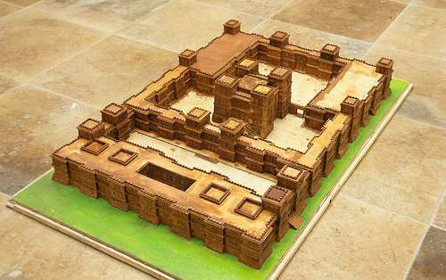
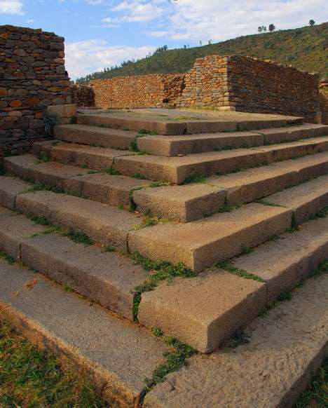

Figure 13. Ta’akha Maryam Palace
Figure 14. Dingur Palace
Hence, Axum became a great commercial civilization comparable with other great ancient world civilizations such as Egypt, Persia, Arabia, Romans, Byzantines, Ceylon and India. Axum was protected by the mountains of north Tigray, which resulted in a relatively longer and prosperous time with less warfare and invasion by adversaries. Axumite architectural period can be broadly categorized as Pre-Christian and Christian architectural periods. These two periods are characterized with such architectural features and elements as capitals, arches monkey-head wall structures and ceilings, which were also commonly used in the subsequent medieval churches in Tigray and the rock hewn churches of Lalibela (EiABC, 2011).

Medieval and Zagwe Architectural Period
The medieval churches and monasteries of northern Ethiopia, in conjunction with the rock-hewn churches of Lalibela, constitute the architectural period of Ethiopia between the 11th and 16th century. This was a time in which Christianity was becoming a dominant religion in Ethiopia and in Western Europe. While the great Romanesque and Gothic cathedrals were the dominant features in Europe, monastic churches in mountainous areas and monolithic churches in and around Lalibela were common features in Ethiopia (Angelini, 1971).

Figure 15. Arial View and Plan of Bete Ghiorgis Church
During the medieval times, both Political and Religious influences played vital roles in establishing the architecture of this period. Almost all the early churches with built-up walls were destroyed, except the likes of the famous Debre Damo Monastery. Hence, in the 12th c. the center of Ethiopian political power was moved southwards to the province of Lasta, where a new ruling dynasty, the Zagwe established its capital at Roha, later renamed as Lalibela (Angelini, 1971).
Regional factors also influenced this period of Ethiopian history. In fact, most of the medieval churches are built in areas surrounded by rugged mountains and on top of an inaccessible mountain tops. Some of the possible explanation for the emergence of medieval Rock- Hewn churches include: Protection against wars, environmental factors like rain, the need for seclusion from the rest of the world, and the desire to achieve permanence (Angelini, 1971).

The medieval period buildings are categorized into the following three major typologies:
- Built up Cave churches
- Rock - hewn cave churches
- Rock - hewn monolithic churches
In both the Zagwe and whole medieval period buildings, the earliest architectural traditions of Ethiopia - architectural elements of built up structures of the pre-Christian and Christian Axum- such as capitals, arches, domes, wall structure like monkey headed wall, and ceilings were imitated again on the structure of rock hewn churches of Lalibela. Additionally, they consist of elements such as full arches, bracket capitals, and domes, with the only major difference that the ones in Lalibela are rock-hewn-monolithic building, while stone and mortar were largely employed for churches in Tigray with some exceptions such as Michael-Amba Church (EiABC, 2011).

Gondarian Architectural Period
The isolation of Christian Ethiopia due to the expansion and then encirclement by Islam region lasted about one thousand years. The war between Mohamed Gragn and Ethiopian highlanders between 1527 and 1543 resulted in the destruction of much of the Christian medieval architectural heritage in Ethiopia. While the Ottomans were helping the Muslims the Portuguese were assisting Christian Ethiopia during the war. Until the 16th century, the Solomonic Emperors of Ethiopia usually had no fixed capital. One exception to this rule was Debre Birhan, founded by Zara Yaqob in 1456. Before Fassiladas came to power Emfraz, Ayba, Gorgora and Dankaz flourished as seats of government for a short time (EiABC, 2011).
It is generally understood that both Foreign and local contributions influenced the rise and development of Gondarian architecture. The major foreign contributors were Jesuit missionaries. The Jesuit father Pedro Paez supervised the construction of the cathedral and castle in Gorgora for Emperor Suseniyos in 1621. The Jesuit fathers brought a number of Indians as craftsmen and assistants to help them realize their projects. After the war with Gragn the Portuguese soldiers had been assisting the king in the construction of the Imperial Compound. They introduced some new methods by working themselves and also through Indians. They thought and trained the locals the arts of burning lime, preparing good mortar, and constructing true masonry arches. Beginning from Gorgora, Gomange, Guzara etc., and other former cities of the royals, from site to site, the royal residences follow the same general architectural pattern: quadrangular castles in stone and mortar, with adjacent cisterns to maintain a permanent water supply, surrounded by roughly circular walled compounds surmounted by cylindrical towers with egg-shaped domes. Design is often non-symmetrical in Gondarian Architecture (Angelini, 1971).
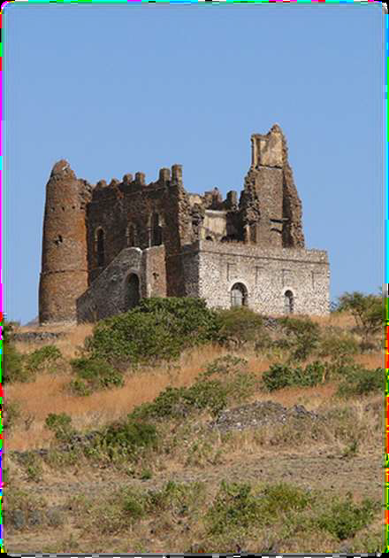

Figure 16. The Guzara Palace

Arches in Gondarian architecture are semicircular or sometimes lower. They often stand out visually as different and more easily cut kind of stone, Wine red instead of black stone or light plaster as for the walls. Battlements of the Gondar castles serve as symbols of grandeur for the imperial court. They are considered to be much more local in character. The spatial architecture of Gondar was traditionally divided into several neighborhoods or quarters: Addis Alem, where the Muslim inhabitants dwelled; Kayla Meda, where the adherents of Beta Israel lived; Abun Bet, centered on the residence of the Abuna, or nominal head of the Ethiopian church; and Qagn Bet, home to the nobility (Angelini, 1971).

Figure 17. Palace of Fassiladas

In conclusion, the architectural style of Gondarian period has its own clearly defined characteristics. One of the features that identify Gondar-styles is that it has its own clearly identifiable architectural styles. Both ecclesiastical and secular aspects of architectural styles were part of the buildings of the then period. Contrary to the rock-hewn churches of Lalibela and Tigray, Gondarian buildings were built up structures. During Gondarian period, there were various raw materials used to build Gondarian structures. Some of these materials were stone, lime mortar and wood-used for roofing, flooring, and balconies (EiABC, 2011).

Modern and Post-Modern Architectural Period: Addis Ababa and Its Architecture
The history of modern Ethiopian architecture has its roots on two moments: Pre-Addis Ababa period and the period that started after the designation of Addis Ababa as the capital city of the nation and onwards. The pre-Addis Ababa period comprises of the years when Mekelle, Ankober and Entoto chronologically became the seats of government for some times. Generally, there are little to none influences of architectural styles and characteristics upon the later periods. The birth of Addis Ababa that started at the beginning of the 20th century was that of a multi-centered settlement with a structure composed of older areas named Ghebbi (the then Menelik Monastery Church), Arada with its open air market, St. George Church and later the Train Station as the main landmarks. The hot spring of Filwoha at the foot of the imperial Monastery Church was also one other important driver for the designation of Addis Ababa to be the seat of the king as his capital (EiABC, 2011).
Architectural periods of Addis Ababa’s history is categorized into four periods:
- First period, between 1889-1935, known as Addis Ababa style;
- Second period, between 1936-1941, referred to as Italian rationalism;
- Third period, 1942- up to late 1960s, known as modern formalist style;
- Fourth period which refers to the contemporary period of the city.
The Addis Ababa Style has its origin with Arabic influence that was the strongest in the beginning through craftsmen who often came from Eden, Yemen. Migrant Indian craftsmen who brought their traditional native Mughal design to effect in Ethiopia included Hajji Kawas (Indian master builder) who built the Raguel church, Gabriel church and Monastery Church inside the old Ghebbi. The architectural Characteristics of this period has features such as fanciful roof shapes, with thatch and corrugated iron sheets roofing material, green painted balconies and roofs, and verandahs and balconies, borrowed from India, are richly decorated, mostly with wooden ornaments and sometimes with flat metal sheets (EiABC, 2011).

Figure 18. The Greek Moussie Minas Residence
Figure 19. Verandah of Alfred Ilg’s Residence

Figure 20. Verandah of Addis Ababa Tukul

The Italian Rationalism period manifests architectural characteristics of the Italian occupation period. It has architectural features such as plain, smooth and almost undecorated surfaces, with straight lines appearing as dominant elements while circular and semicircular lines are allowed but free curves are often avoided. Smooth plaster and paint are commonly employed rather than with textured natural materials. Buildings constructed with the styles of this period have certain horizontals or verticals or frames emphasized by projecting strongly but with a plain form. Exterior walls have colors ranging from light yellow and beige through warm shades to dark red and brown (EiABC, 2011).

Figure 21. National Bank of Ethiopia, Henri Chommet

The Modern Formalist Style occurred between the 1950s and 1960s. During the period Ethiopia was considered as champion of the African unity for it initiated the establishment of Organization of African Unity (OAU). This in turn resulted in a construction boom of Addis Ababa. This phenomenon was assisted with the advent of new technology such as pile foundations, vibrated concrete, factory finished surface materials, using cranes and the likes. All the buildings of this time show the styles of the individual architects rather than the styles of their countries. Multistory buildings were abundantly introduced by the arrival of well-educated European architects and engineers. Characterized with being big, grey, functional and monotonous most of the buildings of this period were designed by different foreigners. The leading architects and firms of the time includes H. Chomette - Swiss-French, Z. Enav and M. Tedros - Israeli and Ethiopian, G. Hentz – German, Z. Kovachevic and I. Straus – Yugoslav, A. Mezzedimi – Italian, Norconsult – Norwegian, P.E.A. – Italian and Techno export story – Bulgarian (EiABC, 2011).

Chapter Three

Data Documentation, Presentation and Analysis

The Geographic Description and Location of the Monastery Church
Daga Estefanos Monastery Church is a historic church that is located in the Amhara Regional State, Bahir Dar Zuria Wereda, at Daga Island which is one of the northern clusters of islands inside Lake Tana. The Island of Daga is situated at a distance of 47 km to the north of the regional capital, Bahir Dar City, which takes three and a half hours drive with boats. The island is situated at an altitude of 1886 meters above sea level. The lush greenery cover of the island consists of larger land mass and size in comparison to other monasteries inside the lake. The Island of Daga is considered to have the shape of the Ark of Noah, while resembling a traditional Ethiopian embroidery called “Mesobe-Werk” when viewed from a distance (Amhara Mass Media Agency /AMMA/, The History of Daga Estifanos Monastery Church, 2005).
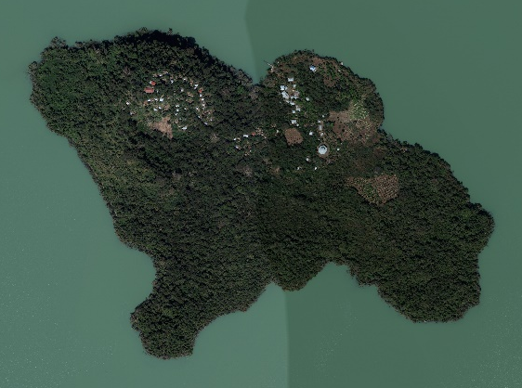

Figure 22. Daga Island and the Monastery of St. Estifanos Church
The church officials have managed to provide the island with a newly built port. This effort was realized in collaboration with the regional tourism bureau, the regional finance and economic bureau and other responsible stakeholders in terms of finance and planning activities. Although the residents of the monastery are monks who follow strict laws and norms of everyday life activities, the following factors have influenced the building of the port and other necessary infrastructures:
- Due to the significance of the monastery church as a center of history, religion and civilization, it attracts a number of both national and international tourists;
- The monks at the monastery have to travel to other places so as to fulfill their duty in teaching and spreading religious knowledge; and
- The residents of the monastery are involved in the production of religious artefacts and crafts that are sold to tourists and other communities so as to enable them purchase basic needs (AMMA, 2005).
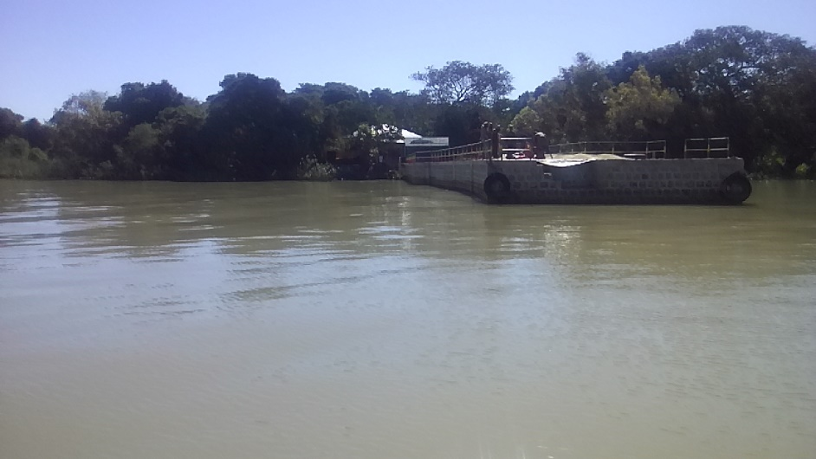

Figure 23. The main port of Daga Island

The History of Daga Estifanos Monastery Church
During the reign of Abraha & Atsbaha at Axum around the 4th century A.D., there was a monk named Abune Selama who was preaching and spreading the Gospel and baptizing local residents in the name of Chris. According to legend and historic narratives of the church, Abune Selama is believed to have arrived at Daga Island for similar missionary purposes mentioned above. During his stay there he is thought to have experienced the vision of St. Mary that influenced him decide to build a church in commemoration and bearing her name. The legend also states that he spent a total of three years spreading Christianity among the local and surrounding communities (ግዛቸው መንግሥቱ ፡ 2008 ዓ.ም).
Currently, there is ruin of an ancient structure located about 100 meters to the west of St. Estefanos church that is considered to be the remains of St. Mary church. In addition, there are beliefs deeply held by current residents & church elders that, the Leviathans (a member of the ancient tribes of Israel) were residing on the island permanently serving as priest since ancient periods. The church of St. Mary is believed to have lasted until the middle of the 13th century.
The absence of written or oral records regarding the architectural features of St. Mary church (its shape, form, walls, flooring, roofing, windows, doors, materials of construction, styles of religious paintings, decorations, ornamentations, etc.) has been one major obstacle to conduct research on it. There are claims by the monks residing on the island and other religious elders that there had been renovation efforts on the church throughout its history. These efforts were intended to amend various defects caused by different agents. However, they lack either oral or written records to corroborate the claims (AMMA, 2005).
According to the well-established oral and written historical records obtained from the church, a monk named Abune Hirute Amlak was one of The Seven Saints of Ethiopian Orthodox Church referred to as The Seven Stars. The Seven Stars (Saints) are believed to have voyaged across Lake Tana in the 12th century, miraculously travelling either on foot or using mere stone slabs as boats. The Saints are considered to be responsible to the establishment of historically iconic monasteries and churches located on most of the islands of Lake Tana. Additionally, they are thought to have travelled to other neighbouring terrestrial places with a caravan of lions carrying their religious books and manuscripts (Mezgebe Kidusan, 2009, pages 248-249).


Figure 24. Traditional Paint of Abune Hirute Amlak

Abune Hirute Amlak was born in the former province of Wollo, in a locality called Merto, according to his church biography. However, some religious elders residing on the island claim his birth place to have been in the former province of Showa. In addition, this monk is also believed to be the cousin of Atse Yikuno Amlak. Abune Hirute Amlak, together with Abune Teklehaimanot of Debre Libanos, were attended their religious school under the mentorship of the prominent religious scholar named Aba Iyesus Moa. The two students then went on to begin their monasticism at a historically significant monastery called Haiq Estefanos that is located on an island of Lake Haiq in Wollo (Mezgebe Kidusan, 2009, pages 248-249).
After the conclusion of their religious study at Haiq Estefanos Monastery, the king assigned Abune Teklehaimanot to become the Head Priest (Liqe Kahn) of all the churches in Ethiopia. Similarly he designated Abune Hirute Amlak as head of treasury (Aqabe Se’at). However, the latter decided to abandon his prestige and official position to restart his monastic life once again. According to church legends, with the guidance and aid of an angel, he took the Ark of the Covenant (Thabot) of Haiq Estefanos Church with him and arrived at the shores of Lake Tana. After some days of rest he then decided miraculously to use two stone slabs as a boat (traditionally called Tanqua) and his crosses as rafts to travel across the lake (AMMA, 2005).
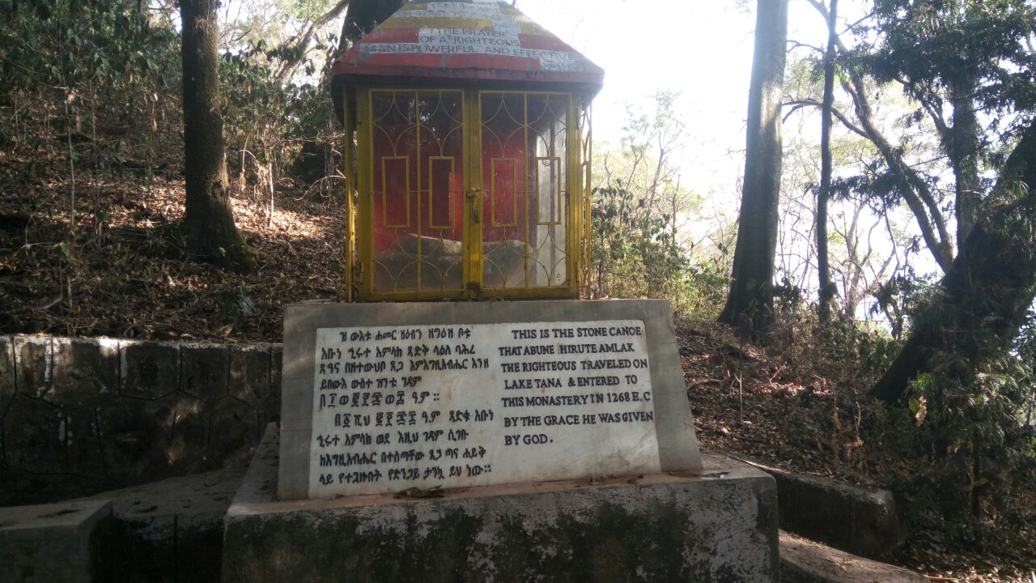

Figure 25. Two stone slabs used as boats located at Me’erafe Tsadkan

Eventually, his journey led him to arrive at the shores of Daga Island where he decided to take some rest. This same spot on the shore, as indicated in the picture below, is still named ‘Aqabe ‘Se’at in commemoration of Abune Hirute Amlak. While travelling from the shore through the hinterland to the highest mountain peak on the island, he is believed to have rested at about the middle of the whole distance. As a result the same resting spot is still known as The Holy Resting Place (Me’erafe Tsadkan) whereby the same stone slabs used by him as travelling boats are placed (Mezgebe Kidusan, 2009, pages 248-249).

Figure 26. Lake Tana Located In Amhara Regional State

Figure 27. Daga Island Located in the Vicinity of Dek Island

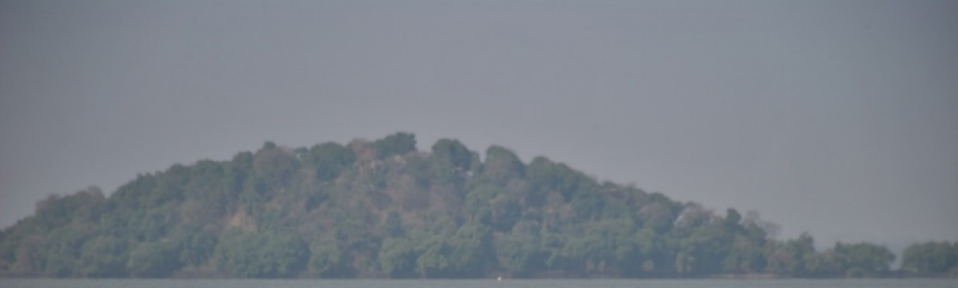
First Landing Site

Figure 28. Eastern Plateau landed first by Abune Hirute-Amlak
After some moments of his early periods on the island he is thought to have chosen the highest mountain peak as the holiest site for the consecration of Daga Estefanos Monastery Church building. In the inception of the building character he has chosen the style of construction locally known as “Seqela” or “Miqurab”. The building was configured with particular emphasis on the overall shape / form of the building resembling Noah’s Ark. However, throughout its long history, both oral and written records indicate that the building has sustained rebuilding and renovation activities by local residents. Even though there is no exact information on the number, extent and type of renovations and the individuals involved, this efforts have happened at various moments in its history as remedies to structural defects that occurred due to different reasons. Hence, there is a general consensus regarding the building that the original construction materials and design motifs have been lost and replaced to great extents (AMMA, 2005).
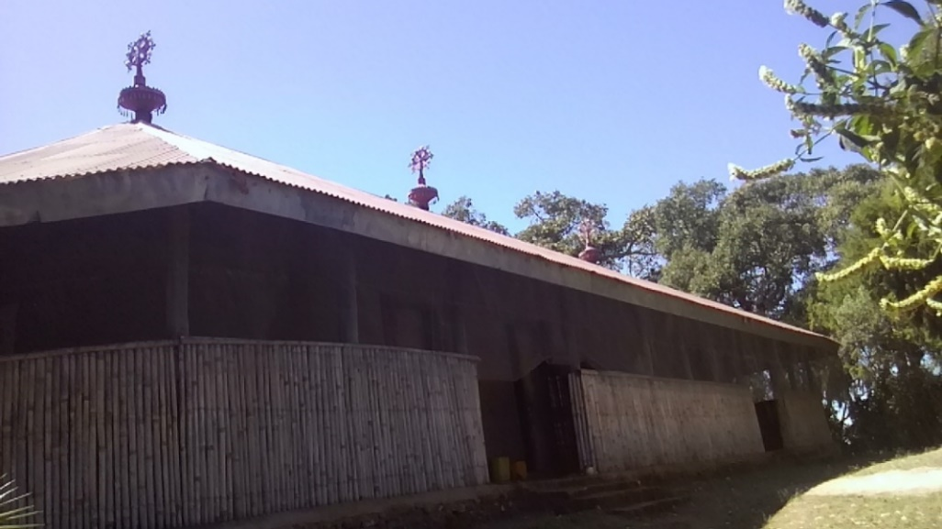

Figure 29. South-Western view with its visible Gulilat

The officially accepted historical records state that Daga Estefanos Monastery Church was established in 1268 E.C. during the reign of King Atse Yikuno Amlak. The same records also indicate the concept of shaping the building morphology similar to Noah’s Ark was meant to symbolize the survival of human race during the great Noah’s flood to the redemption and repentance of him through the teachings of the Holy Bible. In the 17th cent., during the reign of King Atse Fassiladas, the building was renovated with limestone masonry (Nora Gimb) with its original shape and form kept intact. In fact there are evidences in the forms of oral stories, Brana writings and physical ruins that explain this major restoration effort (ግዛቸው መንግሥቱ ፡ 2008 ዓ.ም).
Accordingly, one of these oral records obtained from living monks today states Atse Adyam Seged (the grandson of Atse Fassiladas and the son of Atse Yohannes/ Tsadiku) had a visit to the monastery during his reign. While staying at the island he was inspired by the achievements of his grandfather in his renovation endeavor to the church that led him order the construction of Debre Birhan Selassie Church at Gondar city using similar materials and design concepts. After some time Daga Estefanos church building renovated by Atse Fassiladas suffered from a fire incident that destroyed it to great extent (AMMA, 2005).
The monastery of St. Estefanos Church at the Island of Daga was one of the thirteen monasteries and churches located in and around Lake Tana designated for a study that was envisaged by UNESCO. The study was then conducted by a team of experts and researchers led by a prominent Italian conservator named Sandro Angelini. This study was commissioned by UNESCO in 1969 G.C. as part of research and documentation of architectural heritage sites and historic monuments along the historic route of Ethiopia.
The research was published in 1971 G.C. as a book titled: “Ethiopia: The Historic Route”:- A Work Plan for the Development the Sites and Monuments. The book included the floor plan of the church with a section view of its cross-section from east to west. A comparison of the floor plans for current existing situation of the building with the one produced by the UNESCO team provides similar features with the exception of slight dislocation of the six exterior doors (AMMA, 2005).

Figure 30. The Plan and Cross-section views by Sandro Angelini, 1969 G.C.

The document published by UNESCO in 1985 G.C. titled: “Master plan for the Preservation and Presentation of Cultural Heritages” included the study of Daga Estefanos Monastery Church between the pages 65-66. In this publication the study about the church emphasized the fact that the church at Daga has resemblances with the building at Tana Cherkos Monastery Church. The similarities reside in the characteristic features such as the Seqela and Miqurab. The same study also stated the walls of the building were reconstructed in 1880 by the local people out of stone masonry with mud used as mortar. Hence, the study concluded this renovation effort similar to those that happened at various moments in its history and performed by unskilled manpower resulted in the loss of huge aspects of its originality in terms of design intent, materials and architectural characters (ግዛቸው መንግሥቱ ፡ 2008 ዓ.ም).

Description of Daga Estifanos Monastery Church: Physical Aspects

Architectural Data for Daga Estefanos Monastery Church

Form of the Building
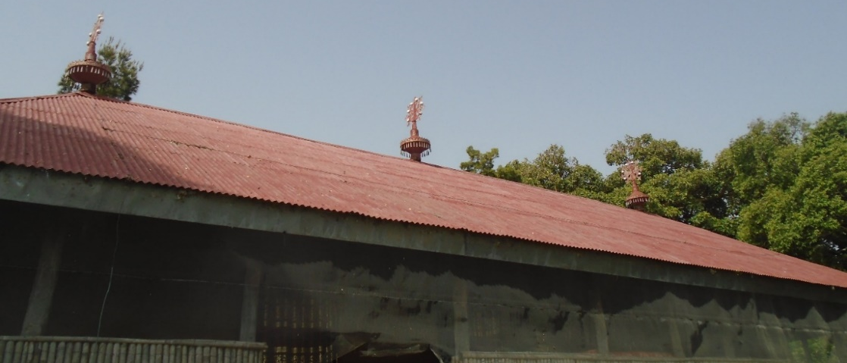
From the beginning of its inception and realization, the form of the church was conceptualized in the shape of what is locally termed as Seqela or Gulilat.

Figure 31.View towards the roof with three Gulilat or Seqela
The current building was reconstructed in 1978 E.C. with all its authentic forms and characteristics kept intact. The building is rectangular in shape with circular shapes at the corners of the eastern wall. The external length of the walls running east to west measure 23.84 meters, while the walls running north to south measure 10.89 meters.
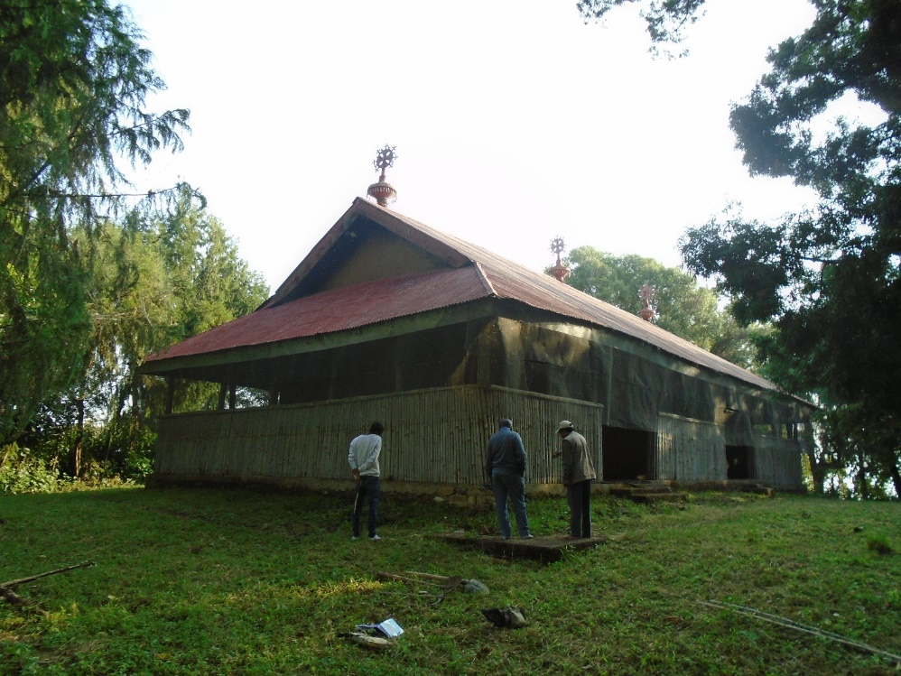

Figure 32. North-Eastern view with roof and iron mesh

The overall spatial configuration of the building follows the standard norms of Ethiopian Orthodox Church containing the three basic interior spaces termed as “Kine-Mahlet”, “Kidist”, and “Bete-Mekdes”. The building also consists of an exterior verandah on all of its four sides measuring an average width of 2.02 meters.
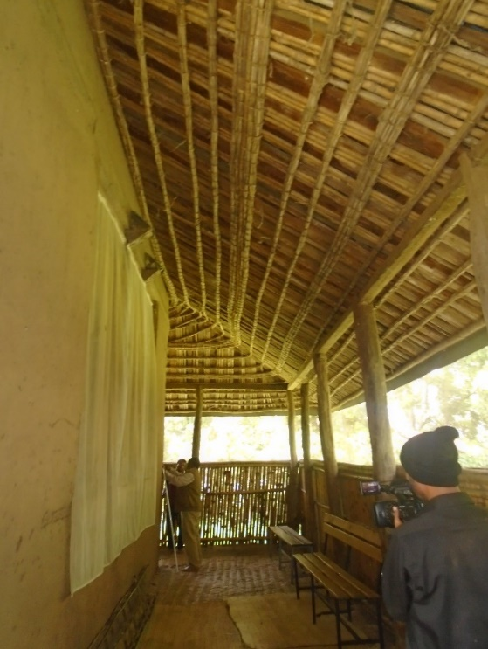
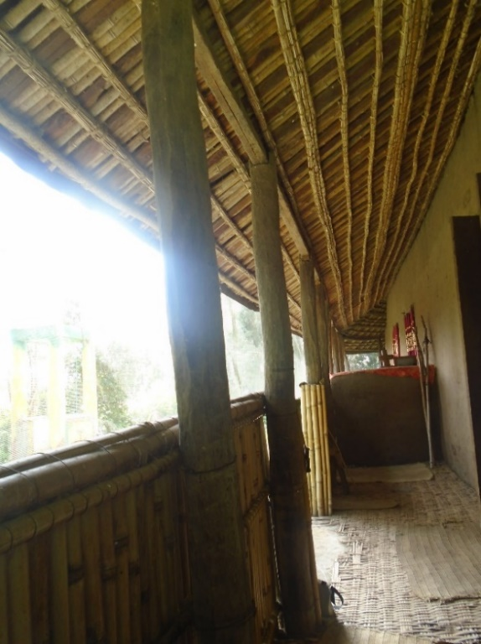

Figure 33. View towards the Southern Verandah
Figure 34.View Towards Northern Verandah
The verandah is colonnaded with thirty wooden posts carved out of solid woods that are hinged at the top to two diagonally flanking wooden supports carrying the roof structure. Additionally, it has exterior short walls covered with bamboo that are running along the vertical wooden posts. These posts are square shaped columns that are made out of “Tid” and “Wanza” trees which have an average height of 3.30 meters and a width of 30 cm.

Flooring
The original flooring materials of Daga Estefanos Monastery Church building was made out of limestone (‘Nora’). However, its current floor is cement screed that is covered with bamboo and carpet materials (’Sigaja’ and ‘Selen’). The covers are applied with the intention of protecting occupants’ feet freezing from cold surface of the cement.
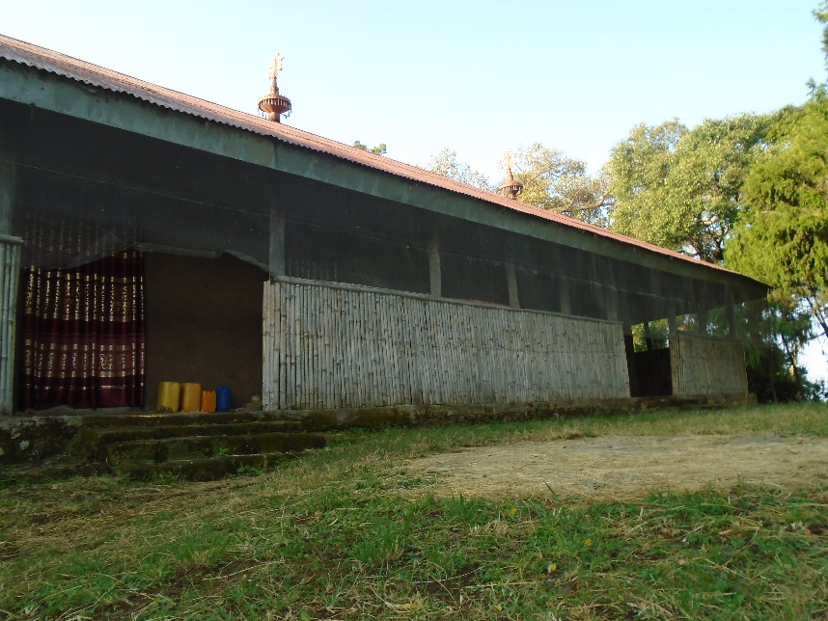
Figure 35. Stairs on Eastern Façade made from Concrete

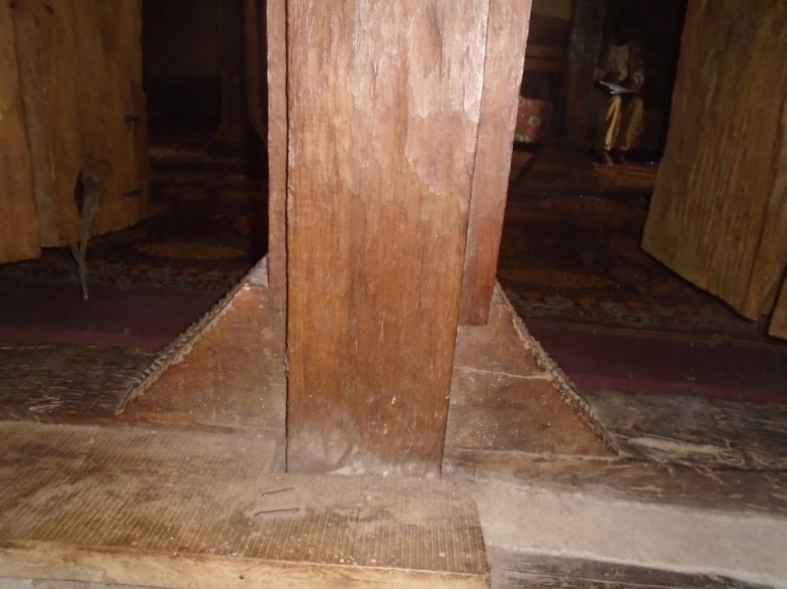

Figure 36. Vertical wooden posts inside the rooms

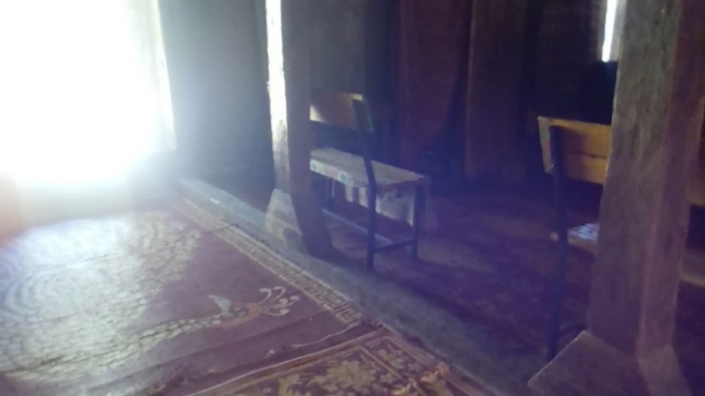

Figure 37. The floor of interior rooms

Walls
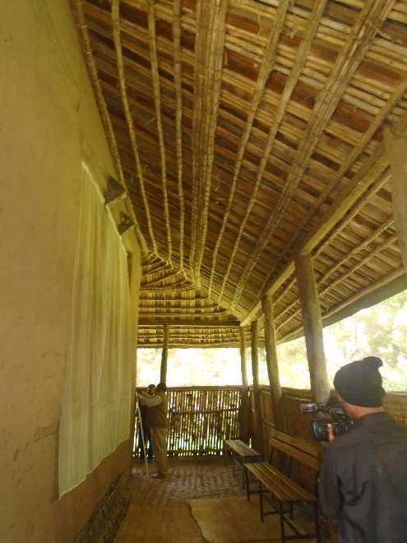
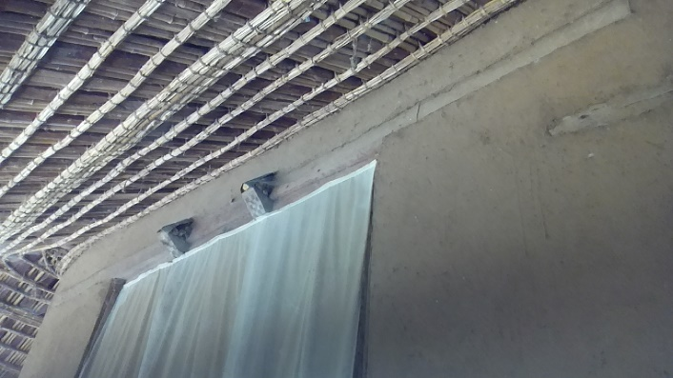
The original walls of the church building were constructed with stone masonry bonded with mud used as a mortar. However, recently the walls have been renovated and reconstructed using mud applied as a remedy to wall cracks that threatened its structural integrity. The mud was pasted to fully cover the walls thereby hindering the sight of the stone walls underneath. During this renovation the size of its walls were reduced with the north and south walls of the building measuring an average external length of 19.19 meters while the east and west walls measure 7 meters long externally. All the four walls measure an average height of 4.45 meters and width of 73 cm.

Figure 38. Stone masonry Walls plastered with Mud

Windows and Doors
The church building has a total of eight doors which consist of two openings parts. These doors are made out of ‘Warka’ tree for the main panels and ‘Tid’ tree for its frames. The placement and arrangement of the doors is as follows:
- Two doors with two openings leading to the “Kine-Mahlet” are placed on its north and south parts;
- Three doors with two openings leading to “Kidist” are placed on its north, south and west parts. The western door has gold plating;
- “Bete Mekdes” has three doors placed on its north, south and west parts which have two openings. The left part of the western door has lesser length than its right part.
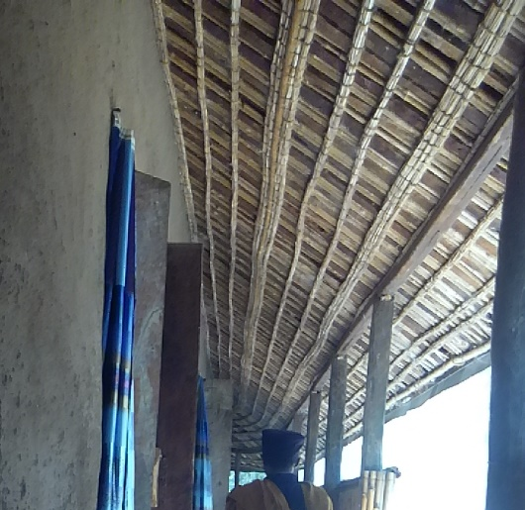
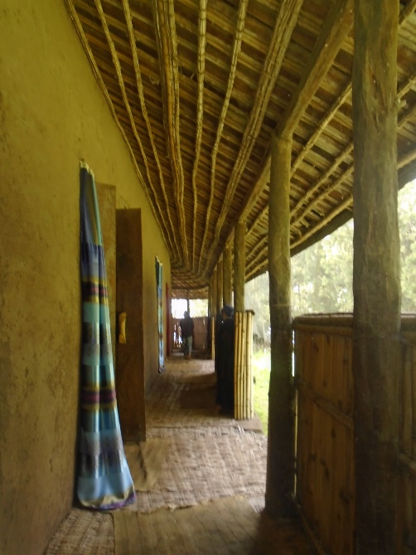
All the individual openings of the eight doors mentioned above have significant width that had forced its builders use two lumbers for each part. The lumber panels are attached to each other and the corner frames by the use of iron nails that are traditionally prepared by the local people. The techniques applied here can be considered as an indigenous knowledge that had grown out of a necessity at the moment.

Figure 39. Windows and Doors Made from Wooden lumbers
In addition, the building contains two windows each of which has two openings. One of the windows is located on the eastern wall of “Bete Mekdes” and measures 1.60 meters in height and 3.05 meters in width. The second window is located on the western wall of “Kine-Mahlet” and measures 3.52 meters in height and 2.40 meters in width. Both of the windows have main lumber panels made from ‘Warka’ tree while their frames are made from ‘Wanza’ tree.

Roofing
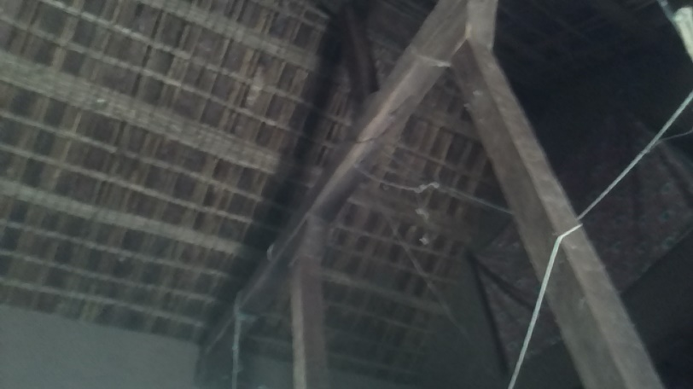
The roof of the building is framed with three major rows of wooden posts arranged from north to south. Each one of the three posts is positioned on top of the three major rooms of the church (Kine-Mahlet, Kidist and Bete-Mekdes). The two posts are spaced at a distance of 5.69 meters from the central post. Additionally, there are two wooden vertical posts in each of the above three major rooms which are part of the overall structural elements of the building helping in supporting the roof and transferring its load to the ground. The two posts located in each of the three rooms are spaced 1.75 meters from each other. Hence, the building comprises of a total of six interior columns with rectangular shapes that enabled them to fit well into the structural wooden grade beam placed on the ground.
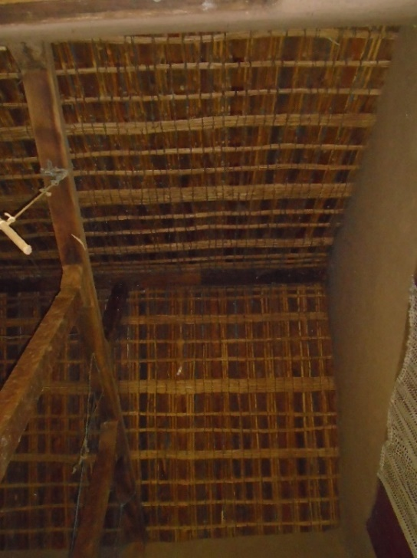
Figure 40. Roofing Structural Support Techniques

Triangularly shaped wooden wedges are placed between the floor and the four sides of the posts acting as structural connectives. These wedges are hinged between the vertical columns and the floor by the help of locally produced iron nails using traditional knowledge. The top ends of the eight internal posts also support the two major top tie roof beams running from north to south of the building. The two beams are rectangular shape and made out of ‘Wanza’ tree. Similarly, triangular wooden wedges connect the two top tie beams with the eight vertical posts using similar iron nails mentioned above. Hence, the load of the roof structure is systematically transferred through consecutively arranged horizontal beams and vertical posts to the ground.
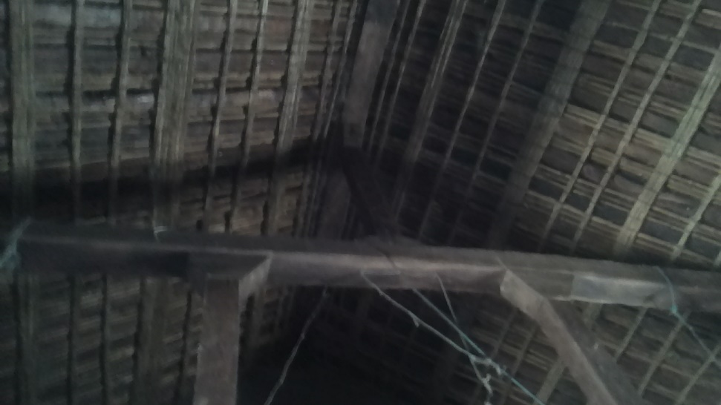

Figure 41. Triangular Supportive Wedges

A single column with shorter heights then rested at about the middle of the top of each of the two top tie beams thereby providing support to the main wooden trusses of the roof that run between east and west of the building. All of the diagonally running roof trusses made from ‘Tid’ tree and roof purlins prepared from ‘Tid’ and bamboo trees rested on the top of the top tie beams. Ropes prepared from animal hides and skin are used to tie together the elements of the roof structures with each other. The roof of the building was covered with thatch prior to 1992 E.C. when it was replaced with corrugated iron sheets.
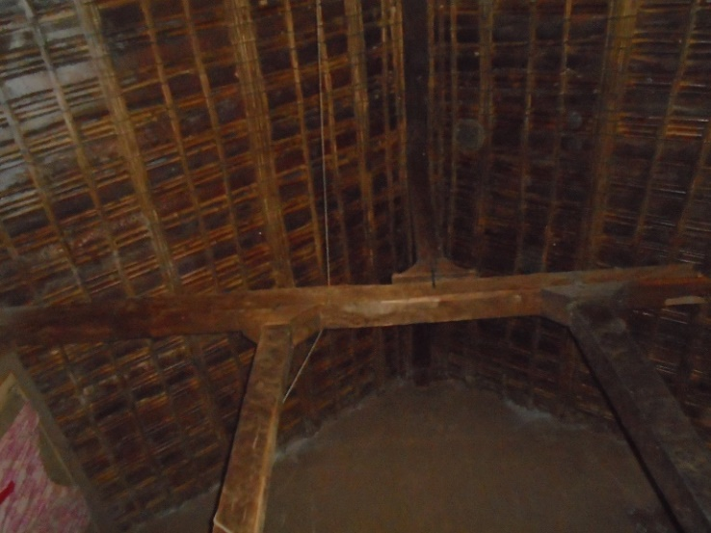

Figure 42. Roofing Load Transfer Wooden Posts

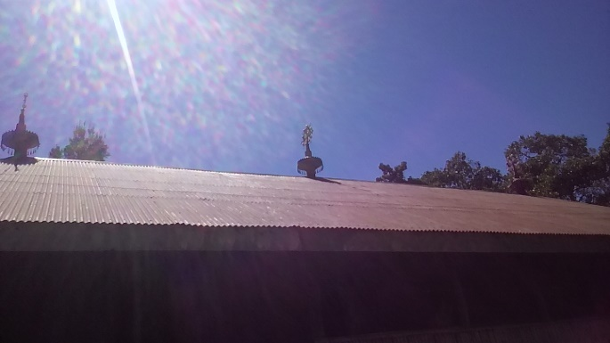
In 1992 E.C. additional roofing structure that was prepared from eucalyptus tree truss and purlin and connected with modern iron nails was put over the old structure. In addition, three metallic crosses locally known as ‘Gulilat’ were placed on top of the CIS roofing that were arranged on the east west direction. The eastern cross is placed at a distance of 7.57 meters away from the middle cross while the western cross is separated 9.05 meters from it.
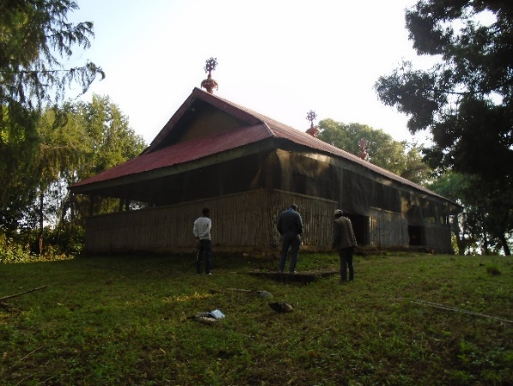
Figure 43. CIS Roofing and the Three Gulilat (Seqela)

Documentation: Current Conditions of the Church - Pathological Study
The most crucial degrading factors responsible in the structural and physical decay of the church building are considered to be age, fire (at various moments in its history), environmental agents and human beings. According to oral records obtained from local religious elders and monks on the island, there had been random and frequent renovation efforts at different moments in its long history. However, almost all of the previous restoration efforts were conducted without properly skilled experts (AMMA, 2005).
In addition, these activities were often randomly initiated and performed lacking prior planning, research and methodological approaches with appropriately prepared implementation strategies. Hence, these haphazardly intended and executed restorations by local residents have through time resulted in the gradual loss of original architectural character and identity of the building. Currently, the existing building to the great extent manifests renovation activities that happened in 1970 E.C. These efforts included such changes as:
- The wall of ‘Bete Mekdes’ was reconstructed with stone masonry using mud as mortar. This change also included an increment in the height of the building;
- The walls of ‘Kidist’ and ‘Kine-Mahlet’ were reconstructed with stone masonry bonded with mud;
- The roof structure was rebuilt materials prepared from ‘Tid’ tree and bamboo that were tied using animal hide and skin ropes and covered with CIS roofs hinged with modern nails (ግዛቸው መንግሥቱ ፡ 2008 ዓ.ም).

Currently, the major types of damages sustained by the building, their primary causes and the extent of decay that can be observed include:
- The external and internal vertical wooden posts and the load bearing roof beams have sustained damages caused by termites. For example, as indicated in the picture below, the top tie beams supporting the roof had been damaged by termites that resulted in the structural failure of the roof;
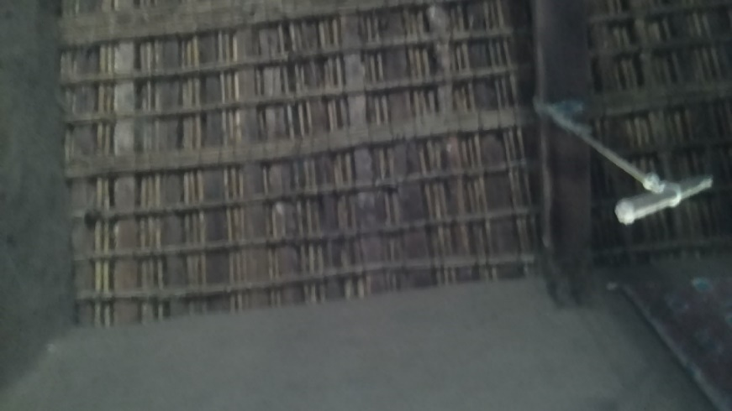

Figure 44. Termite Damages on Wooden Posts & Beams

- Window and door panels with their frames have sustained damages caused by termite;
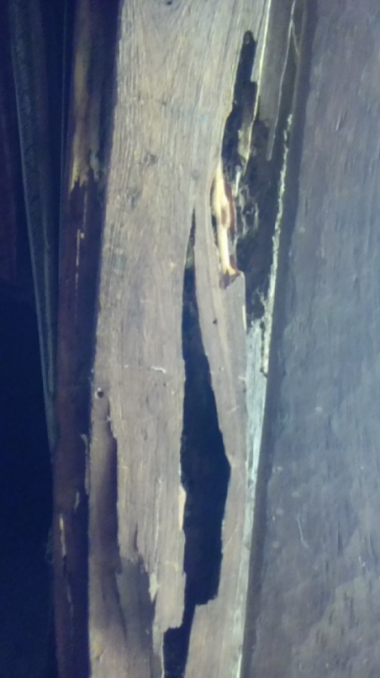

Figure 45. Termite Damage on Window and Door Panels

- Timber panels located at the corner of the wall of ‘Bete Mekdes’ has been damaged by termites;
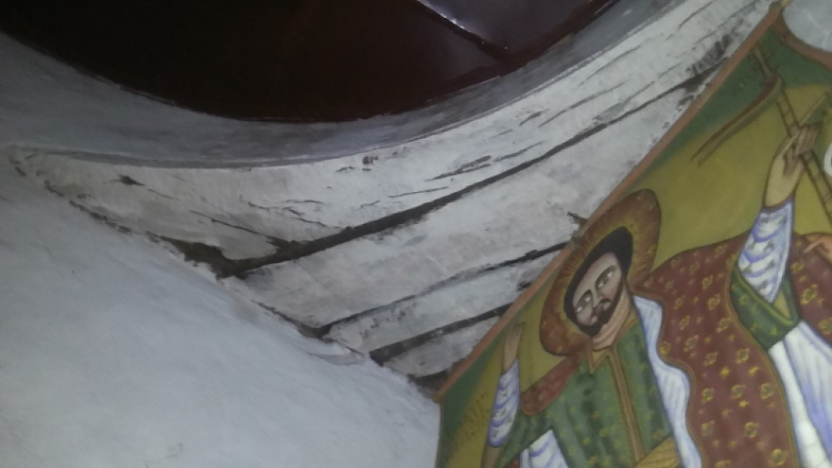

Figure 46. Termite Damage on Interior Timber Panels


Figure 47. Termite Damage on Timber Roof Panels

- A horizontal wooden beam inserted as part of the masonry wall of ‘Kine-Mahlet’ has been damaged by termites. This in turn has resulted in a crack on the same wall;
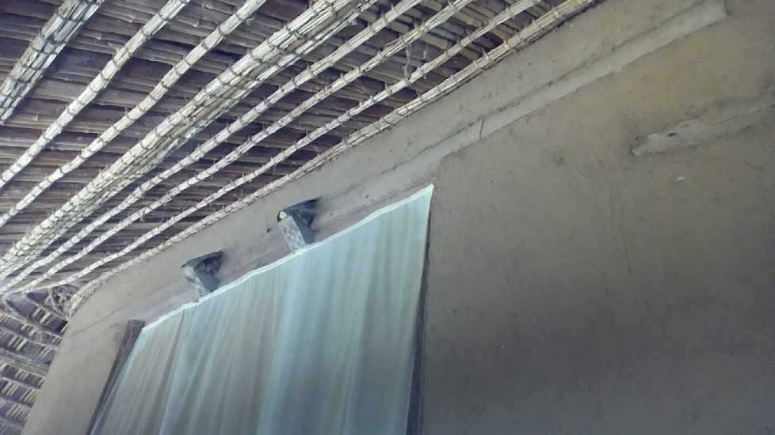

Figure 48. Wall Cracks

- In general, the damages sustained on the doors, windows, columns and beams, walls and parts of the roof have resulted in the dislocation of the overall roof structure;
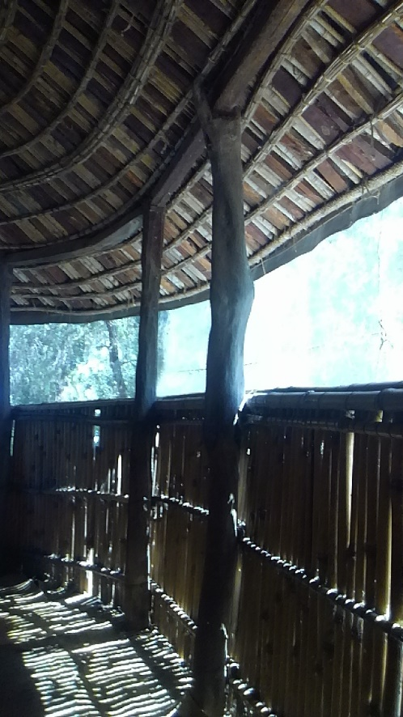

Figure 49. Dislocation of Roof Structure

- Some portions of the building that were made out of timber have been painted in order to protect them from termites and other environmental factors. However, these actions have greatly contributed to the loss of originality of these wooden elements in character;
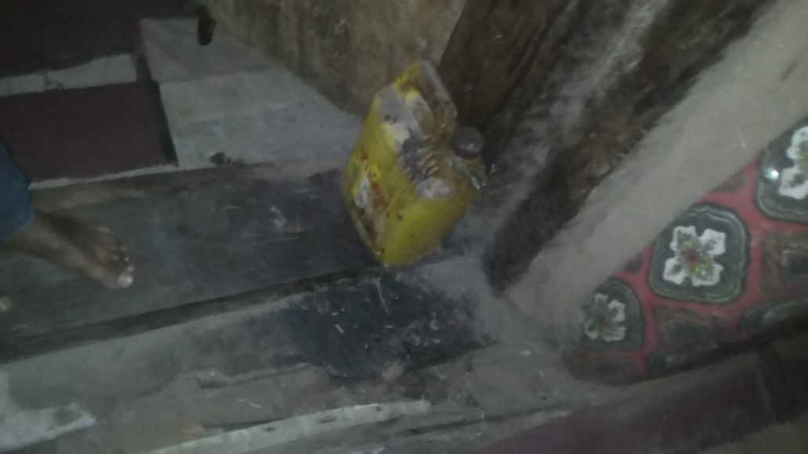

Figure 50. Improper Paints on Wall and Wooden Panels

- The application of mud to correct wall cracks as infill elements has damaged the originality in terms of character and aesthetic values;


Figure 51. Improper Wall Conservation Works
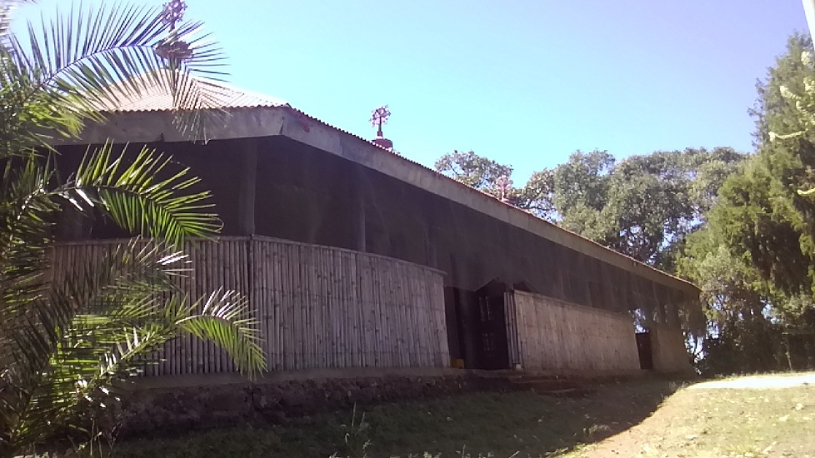
- There are damages sustained on the building due to excretions and other dirt caused by bats, birds, rodents and other animals. Hence, the local people have applied external iron mesh on the ceiling level of the roof around the whole verandah so as to hinder access to this animals. This, however, has affected the building by reducing its authenticity thereby diminishing its aesthetic value;

Figure 52. Iron Mesh Covers to Protect Birds and Insects

- The application of cement screed in order to prevent the damages caused by termites has degraded character of the original floor made from limestone (Nora).

Description of the Exterior Part of the Church

Floor Plan
The building has a single story. The floor plan has a rectangular shape with circular chamfers at the corners of the western wall.
The functional layout of the floor plan is comprised of three rooms namely Kine-Mahlet, Kidist and Bete-Mekdes, which are traditionally the basic components of all Ethiopian Orthodox Christian Churches.
The above three rooms are chronologically arranged in the traditionally accepted norms and standards of church building constructions of Ethiopia. The floor plan also contains two windows and seven doors.
The internal rooms are entirely encircled by a verandah which is composed of thirty wooden posts carved out of solid woods that are hinged at the top to two diagonally flanking wooden supports carrying the roof structure. The verandah is covered with low walls at two meters of height and made out of bamboo with two entrances on each north and south sides.

Figure 53. Floor Plan

The Southern Façade
The Southern façade of the building a length of around 24 meters between the two ends of the verandah and 19 meters between the eastern and western walls of the main building.
This façade is comprised of a limestone wall of the main building with the height of three meters and seventy-two centimeters from the ground to the ceiling level. The verandah is composed of a bamboo made low wall enclosure with a height of two meters and twelve colonnades made from solid wooden posts.
In addition, this façade of the building contains the iron mesh cover that hangs from the ceiling level to the bamboo low walls and running all along its full length.
It also contains two entrances with a width of two meters and eighty-five centimeters that lead to the verandah, and three doors of variable widths that lead to each of the three rooms of the church.

Figure 54. South Side Elevation

The Eastern Façade

Figure 55. East Side Elevation
The Eastern façade of the building a length of around 10 meters 90 centimeters between the two ends of the verandah and 7 meters between the eastern and western walls of the main building.
This façade is comprised of a limestone wall of the main building with the height of three meters and seventy-two centimeters from the ground to the ceiling level. The verandah is composed of a bamboo made low wall enclosure with a height of two meters and six colonnades made from solid wooden posts.
In addition, this façade of the building contains the iron mesh cover that hangs from the ceiling level to the bamboo low walls and running all along its full length. This side of the building also consists of one of the two windows of the church with height of 240 centimeters and a width of about 352 centimeters.

The Northern Façade
The Northern façade of the building a length of around 24 meters between the two ends of the verandah and 19 meters between the eastern and western walls of the main building.
This façade is comprised of a limestone wall of the main building with the height of three meters and seventy-two centimeters from the ground to the ceiling level. The verandah is composed of a bamboo made low wall enclosure with a height of two meters and twelve colonnades made from solid wooden posts.
In addition, this façade of the building contains the iron mesh cover that hangs from the ceiling level to the bamboo low walls and running all along its full length.
It also contains two entrances with a width of 294 centimeters each that lead to the verandah, and three doors of variable widths that lead to each of the three rooms of the church.

Figure 56. North Side Elevation

The Western Façade

Figure 57. West Side Elevation
The Western façade of the building a length of around 10 meters 90 centimeters between the two ends of the verandah and 7 meters between the eastern and western walls of the main building. This façade is characterized by its circular chamfers at the two corners of the main building as well as the inscribing verandah adjacent to it.
This façade is comprised of a limestone wall of the main building with the height of three meters and seventy-two centimeters from the ground to the ceiling level. The verandah is composed of a bamboo made low wall enclosure with a height of two meters and six colonnades made from solid wooden posts.
In addition, this façade of the building contains the iron mesh cover that hangs from the ceiling level to the bamboo low walls and running all along its full length. This side of the building also consists of one of the two windows of the church with height of 168 centimeters and a width of about 305 centimeters.

Description of the Rooms
The word Church (ቤተ-ክርስቲያን) has two meanings. One of these means a community of the faithful who are baptized believing in Christ, (Fetha-Negest Art. 1; Mt. 18:17; Acts 20:28). As people of God in the times of the Old Testament were called House of Israel (Bete Israel); so are God’s people in the New Testament times called Church. This means Christians; the community of Christians. The second meaning denotes the building in which believers congregate to offer worship to God. The Ark of Noah, the Tent of Abraham, the Tabernacle and the Temple of Solomon had been examples of churches where offerings and worship to God were made. During the times of the New Testament, Our Lord and Savior Jesus Christ, who is the Head and foundation of the Church established the Church with his own blood. The church as laid down by the church Fathers in “Tselote-Hymanot” (Creed) is known as the One, Holy, Universal and Apostolic” (Mezgebe Kidusan, 2009).
According to the rites and tradition of the Ethiopian Orthodox Tewahido Church, the construction of a church follows a particular pattern, though the mode could vary. The pattern has three partitions namely Kine-Mahlet, Kidist and Bete-Mekdes. The Church is: the abode of God, a place of teaching, prayers and worship (Mt. 21:13; Jn. 2:7, Ps. 68:9), a place for the forgiveness of sin and intercession, a place where the Gospel is preached, the Holy Communion is administered and Baptism is conducted, the final resting place of Christians, a place where spiritual service is conducted for all irrespective of age, race and gender. The attributes which make the Church different from all other structures are: Bishops consecrate it, it is anointed with Myron, the place where the Ark of the Covenant is kept, and the sacraments of the Church are conducted there. (ግዛቸው መንግሥቱ ፡ 2008 ዓ.ም).

Bete-Mekdes (Sanctuary/Holy of Holies)
This is the place where Liturgy is conducted and a revered area where the altar of the Ark of the Covenant is kept. Only ordained men are allowed to enter here. However, the Bete-Mekdes of this church is differently placed to the left /in the western flank/ of the building. According to the rites of the Ethiopian Orthodox Tewahido Church the “Mekdes” has three main doors: (ግዛቸው መንግሥቱ ፡ 2008 ዓ.ም).
- West: - Glory to God is recited and the Holy Communion is given here.
- North: - the faithful men attend liturgy here and the priests perform horology.
- South: - the faithful women attend liturgy and pray here.

The room designated as Bete-Mekdes in the inner most room which is also called the holy of holiest. It covers an area of around 32.2 square meters. This room is located on the western portion of the building. It is bounded by masonry wall on its four sides with three doors on the north, east and south walls and a window on the western wall.

Figure 58. Bete-Mekdes Floor Plan

Kidist (Surrounding Ambulatory)
In the traditional spatial arrangement the Kidist is the central part of the Church and is also the place where the faithful receive the Holy Communion. It is also referred to as the inner ambulatory, surrounding the Mekdes, which is often named also called the Kidist which is used by communicants at mass. However, the Kidist of Daga Estefanos Church is place in the middle of the building. (Mezgebe Kidusan, 2009).

The room designated as Kidist is located as the second inner most room which is also called the Kidiste Kidusan. It covers an area of around 29 square meters. This room is located in the middle portion of the building. It is bounded by masonry wall on its four sides with three doors on the north, west and south walls and a window on the eastern wall.

Figure 59. Kidist Floor Plan

Kine-Mahlet (Outer Ambulatory)
Generally this is the place where choir men present worship and chant songs of praise to God. Hence, it is the space where ordinary people, as members of the congregation attend religious ceremonies. It is also referred to as the outer ambulatory, surrounding the Kidist, this part of the church is accessible to anyone. However, the Kine-Mahlet of this church is differently placed to the right /in the eastern flank/ of the building. (Mezgebe Kidusan, 2009).

The room designated as Kine-Mahlet is located at the outer most area of the building which is commonly referred to as the peoples’ place. It covers an area of around 28.75 square meters. This room is located on the eastern flank of the building. It is bounded by masonry wall on its four sides with two doors on the north and south walls and a window on the eastern wall.

Figure 60. Kine-Mahlet Floor Plan

Technology: Architecture and Raw Materials

The technique used in building the windows and doors manifest locally developed methods with indigenous character.

Figure 61. Door 1 & 2 Detail Drawings

Figure 62. Door 3 up to 8 Detail Drawings
Limestone for walls, wood for vertical and horizontal structures, timber for roof support, and thatch for roof and traditional mats for flooring are the original building materials used for the construction of the church. In addition, locally developed techniques were used as joining and tying of different elements of the building with each other.

Limestone for walls, wood for vertical and horizontal structures, timber for roof support, and thatch for roof and traditional mats for flooring are the original building materials used for the construction of the church. In addition, locally developed techniques were used as joining and tying of different elements of the building with each other.

Figure 63. Window 1 & 2 Detail Drawings

Construction Materials

The main construction materials utilized to construct the church building include limestone, corrugated iron sheet, Tid and Zigba tree, eucalyptus tree, traditional bamboo, RC concrete, and hard core.
The original building construction included locally developed construction techniques such as metallic nails made out of iron and triangular wedges made from wooden panel. Both this entities assisted in providing structural stability of the whole building as joining elements.
The building also manifested a structural support mechanism that relied on vertically erected wooden posts and horizontal wooden beams that relayed the load of the building to the ground.

Figure 64. Section Drawing

Associated Findings: Historically Significant Cultural Heritages and Artefacts
Daga Estefanos Monastery Church is endowed with significant amount of religious artefacts and skeletal remains of ancient kings and prominent religious figures of the nation. As a result, the monastery has become one of the most important tourist destinations in Ethiopia. In addition, it has become an important magnet for scholars and academicians interested in conducting research works on cultural heritages with religious and historic significances. The following list includes some of these historic cultural heritage items located within the monastery:
- A two-storied museum and storage building constructed during the reign of Atse Fassiladas from limestone;
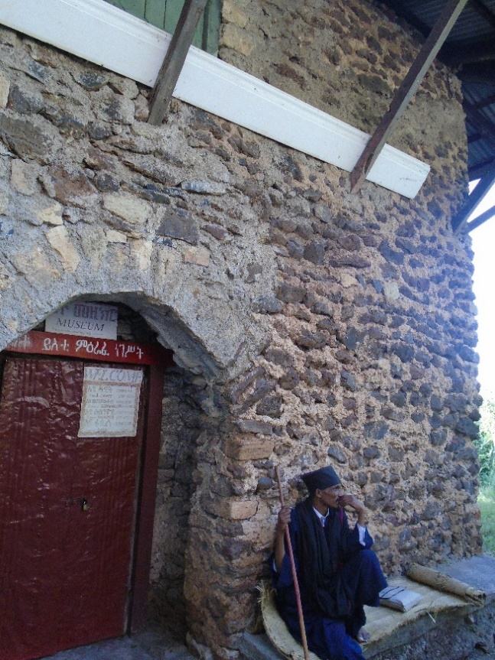
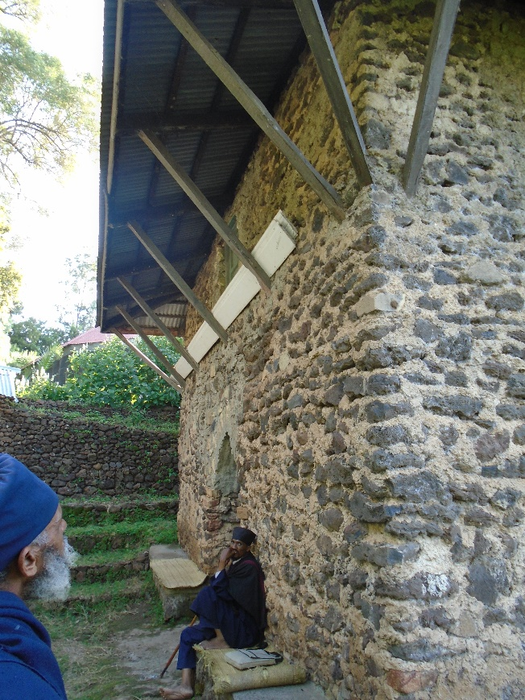

Figure 65. Two-storied Museum and Storage

- The two stone slabs used as a boat by Abune Hirute Amlak to travel across Lake Tana to the island;
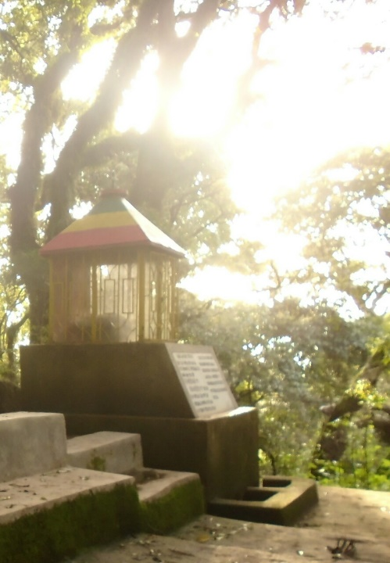
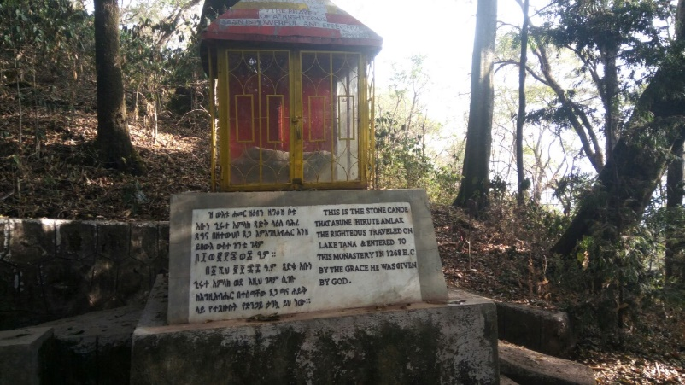

Figure 66. Stone Slabs Used as Boats

- Ancient religious manuscripts written on Branna that are uniquely found only in the monastery which include: Kelemnitos, Ghiorgis Wolde Amid, Ritu’e Haimanot, Gedle Sema’etat (one year), Te’amire Maryam (one year), a Holy Bible with painting illustrations (known in ancient periods as Wongel Ze’Werk), the Five Books of Moses, Gibre Himan, etc.
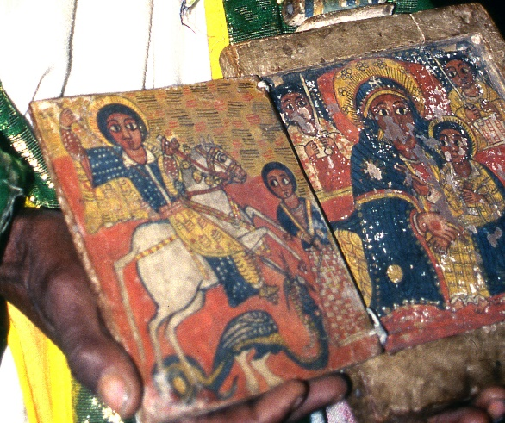
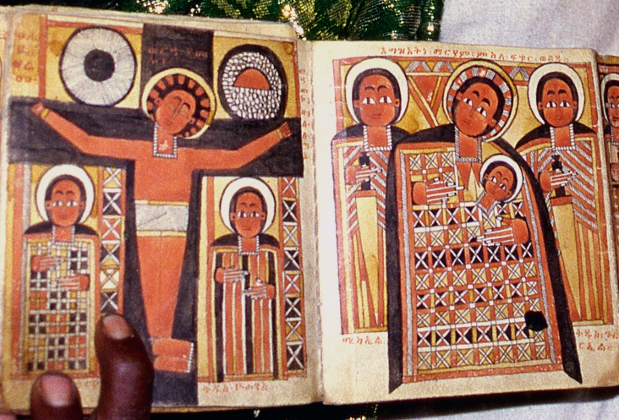

Figure 67. Religious Manuscripts


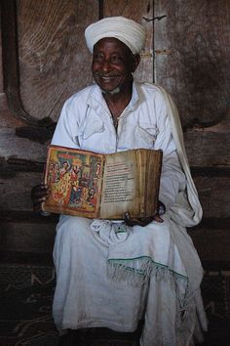

Figure 68. Religious Books and Artefacts

- Various artefacts presented to the monastery by different kings which include:-
- Atse Dawit:- a cross made out of bronze (that can be opened and closed), his personal cross carved out of a wooden block believed to be Jesus’ dying cross and embroiled with ivory, his golden crown and a drum known locally as Negarit;
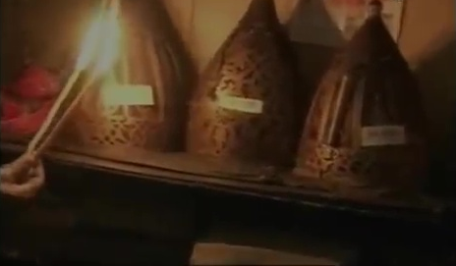

Figure 69. Atse Dawit’s Golden Crown

- Atse Zer’a Yaekob:- golden cross, paint of St. Mary brought from Jerusalem, his personal cross, his personal sword containing writings with Greek and Ge’ez languages and embroiled with diamond decorations, his golden crown used in his crowning ceremony and Negarit made out of bronze;
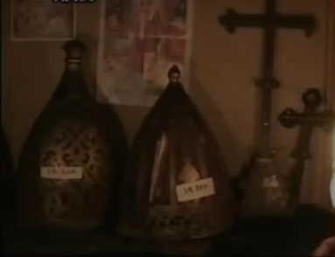

Figure 70. Atse Zer’a Yaekob’s Golden Crown

- Atse Fassiladas:- mountable bed with gold plates, a royal chair with three legs, golden crown and coat (Kaba), horn trumpet and bronze Negarit.
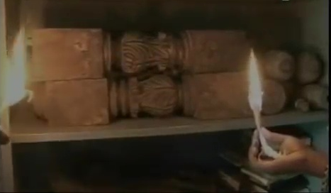
Figure 71. A Royal Chair with Three Legs

- Skeletal remains for kinks, popes and other holy fathers of the church that include fully formed skeleton remains of the four kings (Atse Dawit, Atse Zer’a Yaekob, Atse Suseniyos and Atse Fassiladas), in addition to the remains of other unidentified kings; the skeleton remains of Abune Salama (the 3rd);
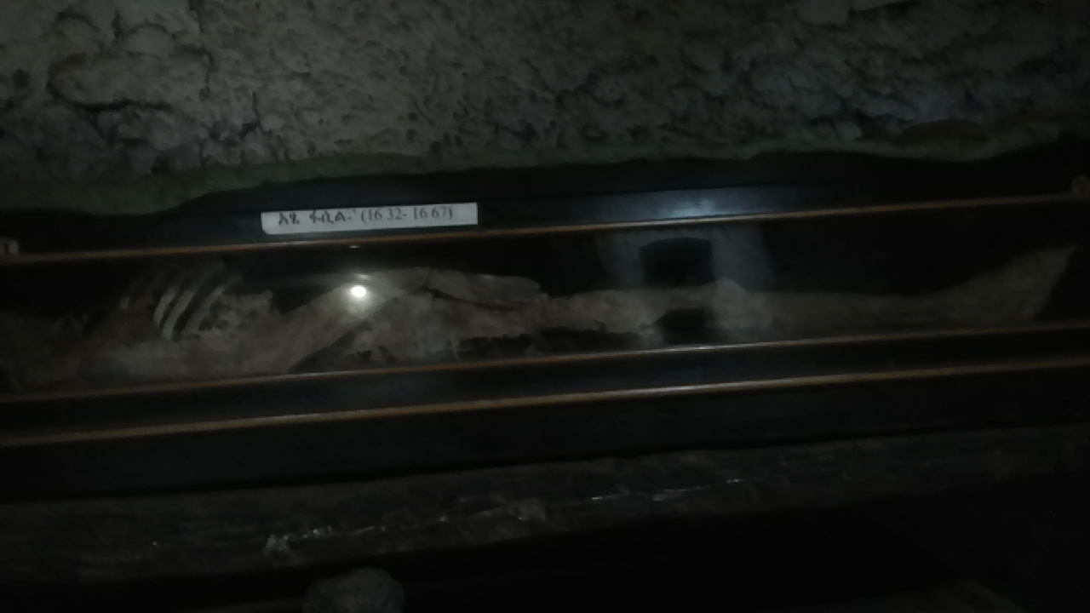

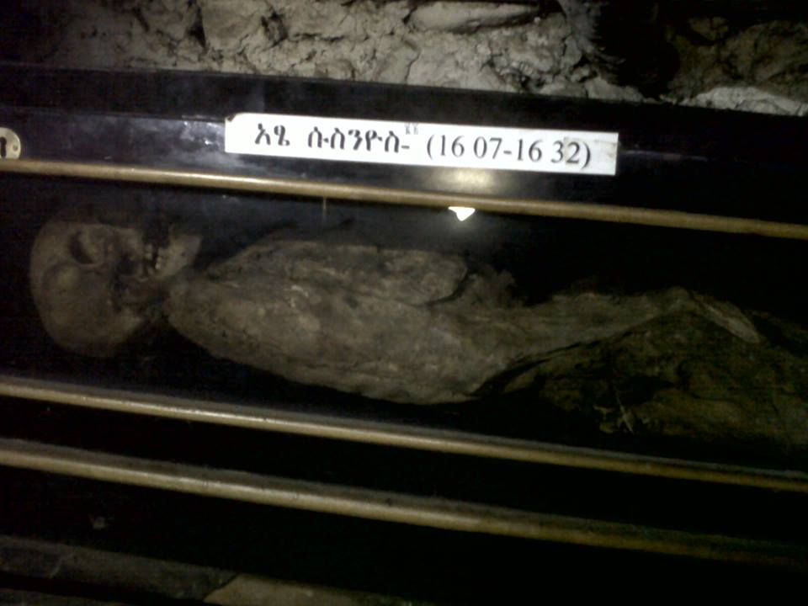
Figure 72. Skeletal Remains of Atse Fassiladas

Figure 73. Skeletal Remains of Atse Suseniyos

- Five religious ceremonies that are regularly held in commemoration of holy popes and other religious fathers, considered as major components of intangible heritage items, including:
- Nehase 8 remembering the passing date of Abune Hirute Amlak;
- Meskerem 15 remembering the martyrdom of St. Estefanos;
- Tikimt 17 remembering the sainthood date of St. Estefanos;
- Tir 1 in commemoration of the passing date of St. Estefanos;
- Pagume 3 in commemoration of the passing date of Atse Zer’a Yaekob;
In all of the above five religious ceremonies, all the festivities and activities commonly practiced by the Ethiopian Orthodox Churches throughout the nation are performed. The only exception to this norm is the absence of the coming out of the replica of the Ark of the Covenant (Tabot).

Chapter Four

Discussion of Existing Data

Geographical Location: Cultural Routes
Daga Estifanos Monastery Church is located on Daga Island which in turn is located at Lake Tana. Hence, it is geographically positioned at the crossroads of what is commonly referred to as the Historic Routes of Ethiopia. This route is one of the most important cultural and historical destinations for tourism and research. It is geographically situated in the northern provinces of Tigray and Amhara regions of Ethiopia.

Site Selection
According to the ICOMOS Charter document ratified in 2008 at the 16th General Assembly of the organization held in Quebec, Canada, cultural routes are defined as any route of communication, be it land, water, or some other type, which is physically delimited and is also characterized by having its own specific dynamic and historic functionality to serve a specific and well determined purpose. The charter document also specifies that the most defining elements of cultural routes are: context, cross-cultural significance as a whole, dynamic character, and setting.

Historic Structures of the Monastery Church
It is generally believed that structures of architectural heritage, by their very nature and history (material and assembly), present a number of challenges in diagnosis and restoration. According to the 2003 ICOMOS charter document on structures, ratified at the General Assembly of the organization held in Victoria Falls, Zimbabwe, remedial measures and controls of structural decay of heritage buildings should focus on addressing root causes rather than symptoms, with due emphasis on preventive maintenance.

Technology: Historic Architectural Characters and Construction Materials
In October 1999 G.C., ICOMOS held its 12th General Assembly in Mexico City, Mexico to device, craft and then ratify a document charter concerning the principles for the preservation of historic timber and wood structures. This charter laid out and emphasized the conditions for the preservation or restoration of wood and timber structures and their components in such a way that they should be carefully documented before any intervention. Hence, a thorough and accurate diagnosis of the condition and causes of decay and structural failure of the timber/ wood structure should precede any intervention.
In addition, according to the charter document any proposed intervention should for preference:
- Follow traditional means
- Be reversible, if technically possible; or
- At least not prejudice or impede future preservation work whenever this may become necessary; and
- Not hinder the possibility of latter access to evidence incorporated in the structure.

Significances of the Monastery Church: Cultural Heritage and Tourism Values

Historic Values
According to the 1964 ICOMOS International Charter on Monuments and Sites, which was held to ratify and adopt it in Venice, Italy, during its 2nd General Assembly, historic architectural monuments embrace messages of generations of people from the past that still remain to the present day as living witnesses of their age old traditions.
Article 1 of the same document also defines the concept of a historic monument as an entity that embraces not only the single architectural work but also the urban or rural setting in which is found the evidence of a particular civilization, a significant development or a historic event. In addition, Article 2 of the charter document states that the conservation and restoration of architectural monuments must have recourse to all the sciences and techniques which can contribute to the study and safeguarding of the architectural heritage.

Economic Values: Tourism potential of the Monastery Church
In 1999, during the 12th Regular General Assembly of ICOMOS that was held in Mexico City, Mexico, the organization discussed on, adopted and ratified the charter document that addressed the crucial issues related to the management of tourism at places of heritage significance. Hence, the document is referred to as The International Cultural Tourism Charter since its proclamation.
During the formulation and adoption of the charter the main focus resided on the fact that the primary objective of managing tourism at heritage places is to communicate its significance need for its conservation to its host community and to visitors. In addition, the document strongly stressed the fact that reasonable and well managed physical, intellectual and/ or emotive access to heritage and cultural development is both a right and a privilege. This understanding in turn is considered vital for it brings with it a duty of respect for heritage values, interest and equity of the present-day host community, indigenous custodians or owners of historic property and for the landscapes and cultures from which that heritage evolved.
Daga is the other principal magnetism and most visited monastery though it is far from Bahir Dar. It is located 40 kilo meters far from Bahir Dar city. This monastery is built on a steep hilltop and needs to climb up walking through a winding path. The current building of the church was built in 1880s after it was burnt down by fire but the early paintings have survived from destruction of burning. The church and monastery was founded by Abune Hirsute Amlak in 1275 and it was dedicated to St. Stephen. As of history of St. Abune Hirute-Amlak, he brought the Tabot from Haiq Estifanos and the saint has prayed here for 60 years without eating and sleeping with help of the God.
The treasure house found here is different from other monasteries in that it hosts piles of brightly colored ceremonial cloaks and mummified coffins containing remains of the five former Ethiopian Emperors who ruled the country from the early 14th c until late 17th c; that include, Emperor Dawit, Emperor Zere-Yaekob, Emperor Susenyos, Yekuno-Amlak and Emperor Fasil. The church is also the burial place for the founder, Hirute Amlak and King Ze Dingle. The museum also displays three crowns of Emperor Fasiladas, Zere-Yaekob and Dawit and more other collections. It is open only for men.

Architectural, Aesthetic and Educational Values
In general, the repair and / or replacement of historic structures for the purpose of preservation interventions should be executed with due respect to relevant historical and aesthetical values, and where it is an appropriate response to the need to replace decayed or damaged members or their parts, or to the requirements of restoration.
One of the issues discussed at the 12th General Assembly in Mexico clearly emphasized that new members or parts of members for repair or replacements should be made from the same materials for masonry structures and the same species of wood from historic timber and/ or wood structures. The other critical component of this charter document also discussed and ratified the issue of built vernacular heritages. This portion of the document focused on the fact that throughout the world vernacular heritage occupies a central place in the affection and pride of all peoples. In addition, it stated that built vernacular heritage is important for it is the fundamental expression of the culture of a community, of its relationship with its territory and, at the same time, the expression of the world’s cultural diversity.

Conservation and Management Status of the Monastery Church
The Burra Charter is a set of principles that have been adopted to create a nationally accepted standard for heritage conservation practice in Australia. The Australia ICOMOS Charter for the Conservation of Places of Cultural Significance, known as the Burra Charter, was first adopted at Burra in 1979.

Current Physical State of the Building
As discussed in the previous chapters, the building heritage is found currently in a dire situation in terms of physical wellness.
- Natural Causes of Deterioration
The most critical natural causes of deterioration of Daga Estifanos church building include termites, moisture, rodents & birds, and insects. The impact of termites on the structural failures of wooden posts and beams acting as major structural components of the building has the most devastating effect on it.
- Anthropogenic Problems
Since the church is part of the monastery that houses about fifty monks who are permanently residing on the island, there is continuous human presence in and around it with respect to religious duties and activities. Hence, there are various aspects of damages and decay that result due to impacts of human movements, candle lighting, incense burning, and other activities.

Heritage Management Status of the Monastery Church

Development of Conservation Plan
The preparation of Conservation Management Strategy (CMS) is vital for the well-being and upkeep of any cultural heritage entity all over the world. According to the definitions provided during the adoption of the Burra Charter in 199 G.C., a Conservation Management Strategy (CMS) is a practical guide to the maintenance of a heritage place. Amongst other things, it contains a Building Condition Assessment Report, conservation management schedule and maintenance schedule. (Conservation Management Plans: A Guide Managing Heritage Places, Heritage Council of Victoria, 2010) Heritage Council of Victoria
Hence, the conservation management strategy for Daga Estifanos Monastery Church should be prepared in such a way that it will fulfill towards achieving the following objectives:
- Facilitate understanding and appreciation of the monastery as a historically significant cultural heritage;
- Communicate the meaning of cultural heritage in relation to the context of the monastery to a range of audience;
- Safeguard both the tangible and intangible components of this particular heritage site;
- Respect the authenticity of the cultural heritage;
- Contribute to the sustainable conservation schemes of the cultural heritage;
- Encourage inclusiveness in the interpretation and safeguarding of the cultural heritage site; and
- Develop technical and professional guidelines for the interpretation and presentation of this heritage site, including technologies, research and training.

Conservation Proposal
The Conservation Management Strategy (CMS) document that should be prepared for Daga Estifanos Monastery Church has to be compiled in such a way that it comprises the following major sections:
- Introduction: which provides purpose of the Conservation Management Strategy, description of the place, the Statement of Significance, a location plan, current heritage listings of the place, acknowledgements of people and funding as appropriate;
- Background information about the place;
- Graded Zones and Elements of Significance; Primary significance, Secondary significance, Intrusive (detracts from or has an adverse effect on the significance of the place);
- Recommended Conservation Works Schedule;
- Recommended Maintenance Works Schedule;

Proposed Building Solutions

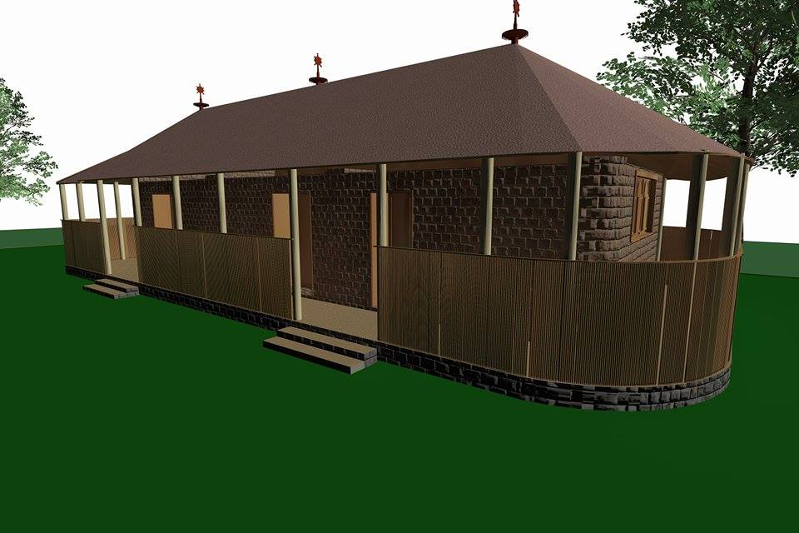

Figure 74. Limestone walls

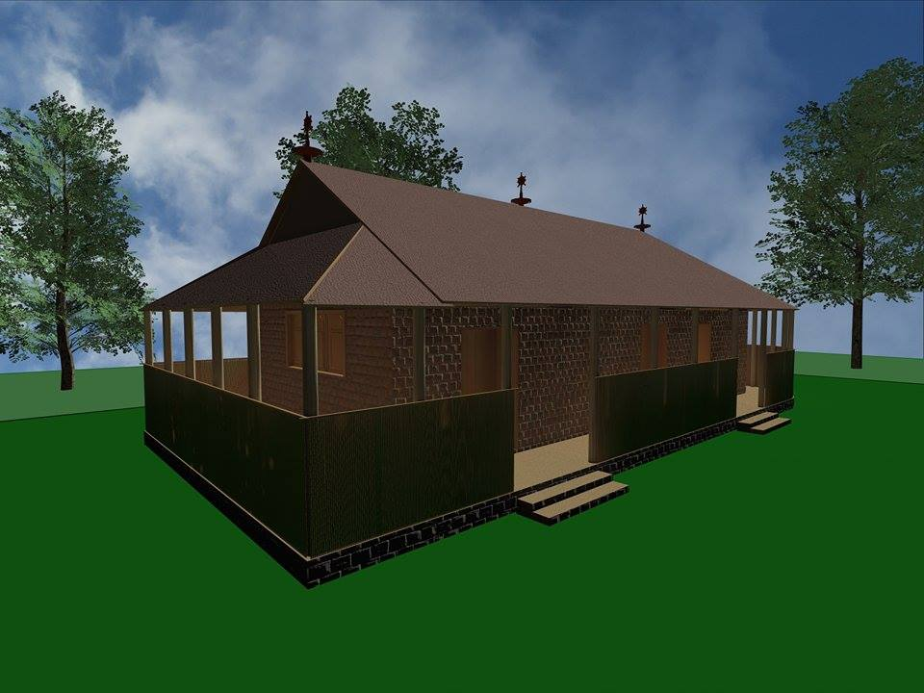

Figure 75. Thatch roofing

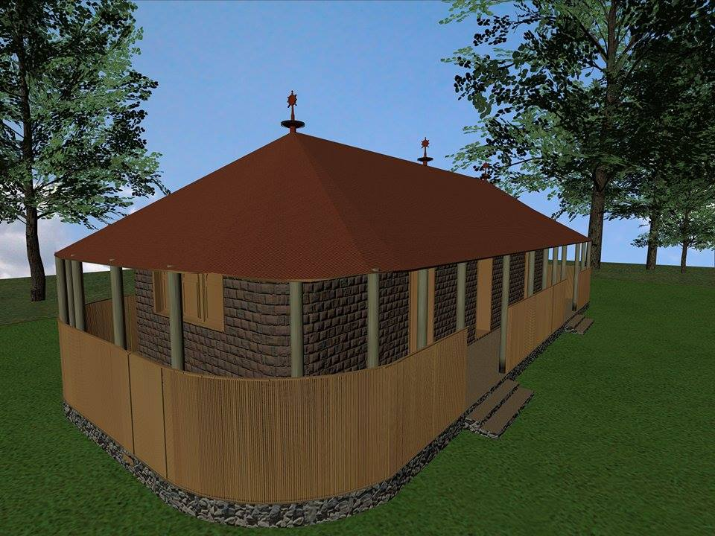

Figure 76. Bamboo Verandah Cover

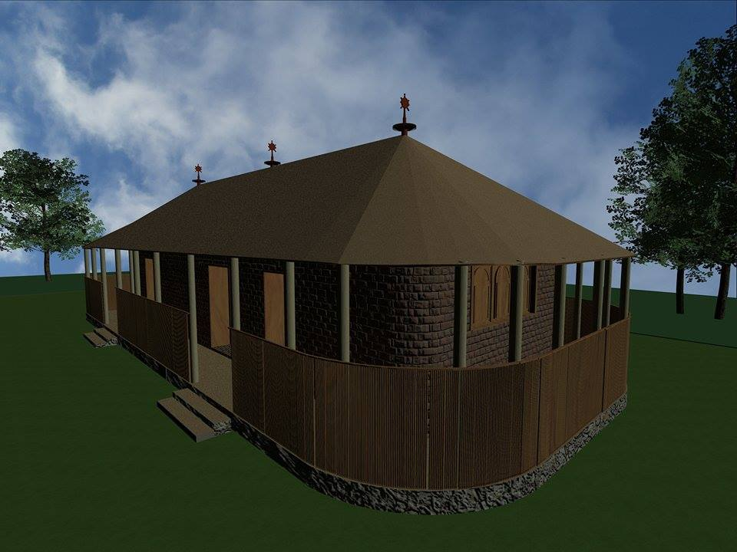

Figure 77. Tid and Zigba Wooden Posts and beams

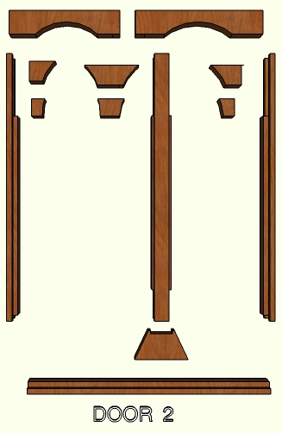
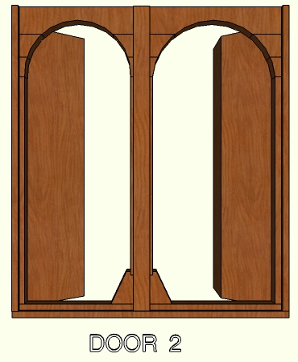
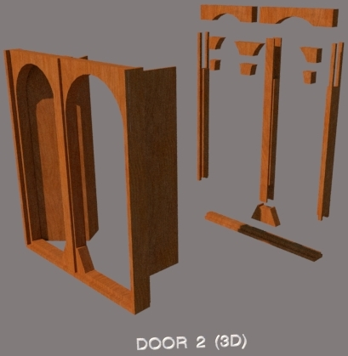

Figure 78. Tid and Zigba Timber for Doors


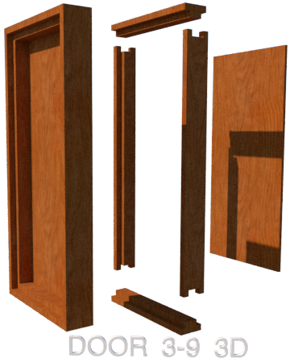



Figure 79. Tid and Zigba Timber Panels for Doors

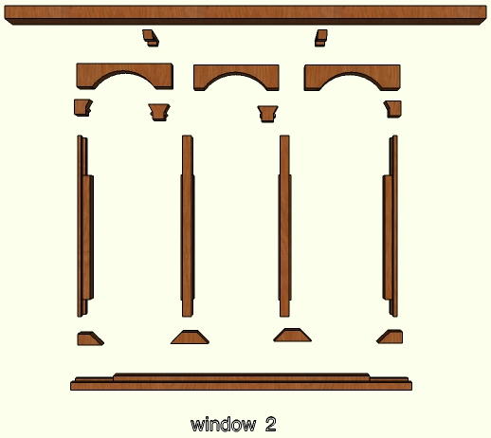
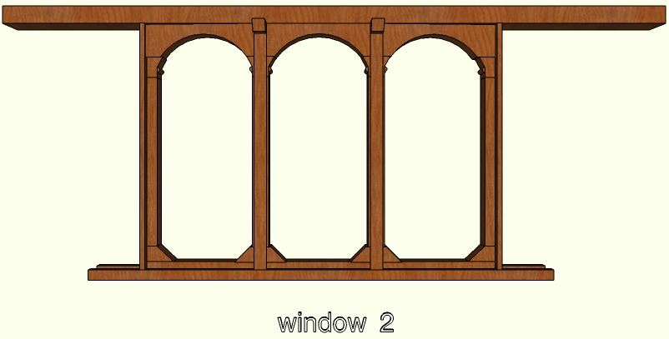
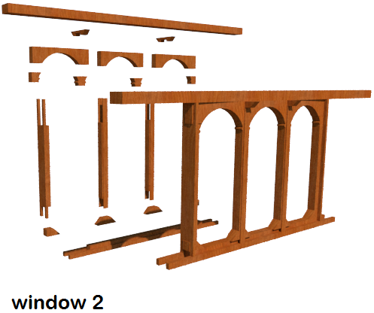

Figure 80. Tid and Zigba Timber Frames for Windows

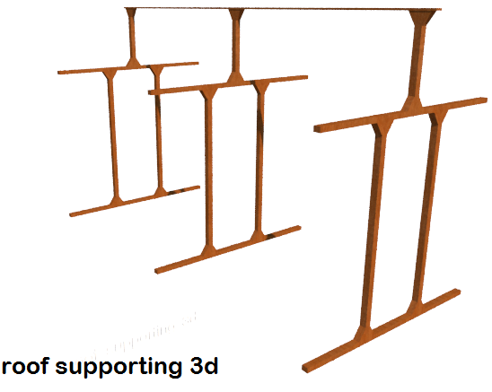

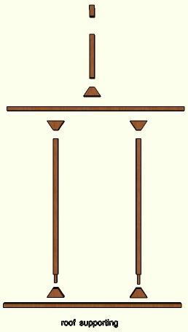

Figure 81. Tid and Zigba Wooden Structural Frames for Roof Support

Chapter Five

Conclusion and Recommendation
The researcher of this study work utilized firsthand information based on personal observations during three visits to the site and secondary data gathered from various relevant sources. The primary data collection involved conducting all the necessary physical measurement, photographing and interview with monks and other relevant stakeholders. Additionally it involved the observation and documentation of major defects sustained the building thereby its physical integrity. Hence, the data collection, analysis and interpretation of the whole research work are summed up to formulate the following conclusions and recommendations below.

Conclusions
The researcher of this study work has arrived on the following concluding remarks regarding the documentation and conservation approach for the church building of Daga Estifanos Monastery:
- The researcher has observed and concluded that the frames and panels of doors and windows of the building, the structural posts in and outside of the building, the load bearing beams, old wooden beams and posts deliberately left embedded within the walls as integral parts of the building, and most of the roof over Bete Mekdes are severely damaged by termites. This in turn has jeopardized the overall structural integrity of the building thereby endangering the safety and security of both human beings (religious fathers, researchers and tourists) and religious manuscripts and artefacts.
- The church building has undergone frequent renovation measures of varying degrees throughout its history. However, the renovation activity of 1978 E.C. by the local community has had an overhauling effect, including the intentional reduction in size of the building volume as a result of adequate financial resources. Hence, since then it had become difficult to comfortably accommodate church goers and religious attendees during congregations and annual festivities.
- In all of the discussions and conversations between the researcher and church officials including monks who are permanent residents on the island, it has become clear that there is a great desire and goodwill to allow another major renovation work.

Recommendations
In conclusion the researcher of this study with strong emphasis forwards the following recommendations as a major intervention effort so as to salvage the heritage building in order to ensure its survival and eventual transfer to the next generation:
  - Hence, the general consensus reached by the researcher, church scholars, priest, monks and other responsible stakeholders is to conduct a rebuilding activity the church building. Hence, the researcher recommends to restore the building to its glorious status during the reign of King Fassiladas during which he is historically believed to have authorized and personally supervised its restoration. This includes rebuilding the church with limestone walls, thatched roof, using Tid tree and ‘Tikur Enchet’ (hard wood) for structural posts and beams, and floor material made out of a mat locally handcrafted from the leaves “zenbaba’ tree.
  - Considering the level of urgency in terms of the degree of deterioration and decay the building is sustaining, and hence the high level of threat to the safety and security of church goers and artefacts, the researcher highly recommends the preparation of a comprehensive heritage conservation plan (CHCP) for the church and the monastery as a whole.
  - Taking into consideration the desire and full willingness from church officials to allow and cooperate with a comprehensive restoration work on the church, the researcher recommends for the formation of a task force consisting of all the relevant stakeholders to come up with an appropriate conservation plan for the church building. The team will be tasked to craft a plan to look for possible sources of finance to raise the large amount of money required to execute the work. In addition, the task force will be mandated to come up with a plan to form a group of conservation experts, local artisans and craftsmen necessary to succeed in such types of restoration endeavors. The possible members of this task force may include: financial donors, church community members, monks, individuals working in governmental and non-governmental organizations, university academic members, etc.

References

Books and Publications
- Environmental Protection and Land Use and Administration Authority of Amhara, EPLUAA
- Amhara Mass Media Agency /AMMA/, The History of Daga Estifanos Monastery Church, 2005
- Amhara Region Culture and Tourism office, 2010 Report
- Roselyne N. Okech, 2010, Tourism Development in Africa: Focus on Poverty Alleviation, the Journal of Tourism and Peace Research University of Newfoundland, Canada
- Central Statistics Agency
- First Draft Results of the Population and Housing Census, 2015
- Authority for Research and Conservation of Cultural Heritages
- Oxford Advance dictionary, 2005 oxford Advanced learner’s dictionary of current English (7th edition oxford university press)
- Bernard M. Feilden and Jukka Jokilehto, 1993, management’s guidelines for world cultural heritage sites, published in Italy by international center for the study of preservation and the restoration of cultural property
- Cambridge international dictionary of English, 1995, Cambridge international dictionary published by the press syndicate of the University of Cambridge
- Federal Negarit Gazeta, of the Federal Democratic Republic of Ethiopia, 2000
- World Bank, Cultural Heritage in Environmental Assessment Sourcebook Update, 1994
- Definition of Cultural Heritage, Selected by J. Jokilehto, Originally for ICCROM, 1990, Revised for CIF: 15 January 2005
- Historic Structures Report, David Arbogast, 2010
- Recording, Documentation, and Information Management for the Conservation of Heritage Places, Robin Letellier, 2007
- ICCROM and the Conservation of Cultural Heritage, Jukka Jokilehto, 2011
- A History of Architectural Conservation, Jukka Jokilehto, 1999
- Basic Texts of the 1972 World Heritage Convention, UNESCO, 2005
- Ethiopia: three millennia of legend and history, The UNESCO Courier
- Ethiopians and the Houses They Live in, Ethiopian Tourism Commission, 1981
- የቋሚ ቅርሶች ጥበቃና እንክብካቤ ግንዛቤ መፍጠሪያ ማንዋል ፡ የአብክመ ባህልና ቱሪዝም ቢሮ ፡ ግዛቸው መንግሥቱ ፡ 2008 ዓ.ም
- Local History in Ethiopia, Bernhard Lindahl, 2005
- Ethiopian Architecture, EiABC, 2011
- The Historic Route, Sandro Angelini, 1971
- Mezgebe Kidusan, 2009

Websites
- http://www.wikipedia.org /en
- http://www.whc.org
- http://www.youtube .com

