
Climate Change Trends, Projections and Vulnerability Integration
to Enhance Urban Resilience Planning: The case of Addis Ababa City

Nahimi Feyissa

A Dissertation Submitted to the Office of Graduate Program of the Ethiopian Institute of Architecture, Building Construction and City Development (EiABC), Addis Ababa University

Presented in Fulfillment of the Requirements for the Degree of Doctor of Philosophy (Environmental Planning)

Addis Ababa University
Addis Ababa, Ethiopia
February, 2019
Ethiopian Institute of Architecture, Building Construction and City Development (EiABC), Addis Ababa University Office of Graduate Program.
This is to certify that the dissertation prepared by Nahimi Feyissa, entitled: Climate Change Trends, Projections and Vulnerability Integration to Enhance Urban Resilience Planning: The case of Addis Ababa City and submitted in fulfillment of the requirements of the Degree of Doctor of Philosophy (Environmental Planning) compiles with the regulations of the University and meets the accepted standards with respect to originality and quality.

Approved by examining board:
Name Signature Date Dr. Gete Zeleke (Advisor) ______________ __________
Dr.Ephrem Gebremariam (Advisor) _____________ _ __________
Professor Woldeamlak Bewket (Advisor) _______________ __________ ___________________ (Examiner) _______________ __________ _____________________ (Examiner) _______________ __________
_______________________ (Chairman) _______________ __________
Dr. Fisseha Wegayehu (Graduate Programme Director) ________ __________

Abstract
Climate Change Trends, Projections and Vulnerability Integration to Enhance Urban Resilience Planning: The case of Addis Ababa City
Nahimi Feyissa
Environmental Planning PhD Programme, EiABC, Addis Ababa University
February, 2019

Impacts of climate change continue to knock on the doors of different societies including urban dwellers. The effect is more severe in towns of developing world like Addis Ababa where level of mitigation and adaptation measures are low and detailed climate change information is lacking. Many of existing studies give no consideration to the future climatic conditions, spatial quantification and mapping of vulnerability hotspots and integration of these all together for enhanced resilience planning. They mainly focused on basic environmental plans, where most of them fail implementation due to low level of law enforcements and unavailability of up to dated cadastral information system. Taking these points into considerations, this study focuses on analyzing climate change trends, downscaling projected results from general circulation models, analyzing land surface temperature changes, quantifying and mapping climate change vulnerability at sub-city level to recommend better environmental planning options which could be implemented to minimize severe climate change risks at Addis Ababa city. To achieve these, various methodological approaches were applied in a sequential order. Using Statistical Downscaling Model (SDSM), downscaled daily maximum temperature, minimum temperature, and precipitation in 30 years intervals from the second generation of the Earth System Model (CanESM2) and Coupled Global Climate Model (CGCM3) under two Representative Concentration Pathways (RCP) Scenarios (RCP4.5 and RCP8.5) and two Special Report Emission Scenarios (SRES), A1B and A2, were generated to examine future changes and their extremes. Two representative meteorological stations were selected for model calibration and validation in the SDSM. With this, ten core temperature and precipitation indices were selected to assess temperature changes and precipitation extremes. Spatio-temporal Land Surface Temperature (LST) characteristics were analyzed using four Landsat satellite image series with ten years interval from 1986 to 2017. Sub-city level Climate change vulnerability analyses were undertaken by integrating the Sullivan and Meigh’s Model of composite climate change vulnerability index and the IPCC’s approach of vulnerability assessment which comprises exposure, sensitivity and adaptive capacity. Fifteen subcomponents of vulnerability indicators were identified in ten sub-cities, and their values were normalized to a number which ranges between 0 and 1, with unequal weighting system, indicating as the values increased to 1, vulnerability to climate change increases. The results were mapped using ArcGIS 10.2 package. In-depth empirical field work including a survey of 399 households in four sub-cities and key informant interviews were conducted and analyzed using descriptive statistics and Chi-squared tests were used to summarize the findings in SPSS. Finally climate change resilience plans were proposed for a sustainable environmental protection and to reduce the vulnerability that could be induced by climate change. The results showed that maximum temperature, minimum temperature and mean temperature was increasing in the last 60 years. The second thirty years mean temperature average, was higher than the first thirty years average by 1.1 ºC within 1957-2016. The trend in precipitation shows only insignificant rise wihin the last six decades. The projected maximum temperature, increases were in the range of 0.9ºC (RCP4.5) in 2020 to 2.1ºC (CGCM3A2) in 2080 at Addis Ababa Observatory. The minimum temperature is projected to increase by 0.3ºC (RCP4.5) in 2020 and 1.0 ^{º}C in 2080 (CGCM3A1B). While the changes in maximum temperature are lower at Entoto station compared to Addis Ababa Observatory, the highest minimum temperature change is projected at Addis Ababa Observatory, which ranges from 0.25ºC in the 2020s to 1.04ºC in 2080 according to the CGCM3 model. Except for the coldest nights (TNn), the mean temperature and other temperature indices will continue to increase to the end of this century. The highest precipitation change is projected by CGCM3A2 and CanESM2 RCP8.5 at an increase of about 11.8% and 16.62% by 2080. The highest total precipitation increase is 29% (RCP4.5) in winter and 20.9% (RCP8.5) in summer by 2080. The rise in temperature will exacerbate the urban heat highland effects in warm seasons and an increase in precipitation is expected along with a possible risk of flooding due to a low level of infrastructure development and a high rate of urbanization. It is also found that land surface temperature was highly influenced by land cover types. The highest LST was found in built-up areas and barren lands. 49% and 47% of the study area had an LST range of 23°C - 27°C in 1986 and 1995 respectively. However, in 2007 and 2017, 41% and 59% of the study area had LST range of 27°C - 31°C respectively. The ten sub-cities in Addis Ababa were found in different levels of vulnerability to climate change with the highest exposure and sensitivity in Addis Ketema, Arada, and Lideta while the adaptive capacity was highest in Gulelle, Bole, and Arada sub-cities. The overall climate change vulnerability was highest in Arada, Addis Ketema and Kirkos. The result also found that 69.2% and 60.2% of the respondents perceived that temperature and precipitation increased within the last one to three decades respectively. Flash flood during high precipitation is common along the main roads in Kirkos, while river flooding is a major problem in summer for the residents living along the sides of Akaki River where the cost of damage is high sometimes to the loss of all property and life too. The study recommended city level and landscape level resilience plans within Addis Ababa and the surrounding mountainous landscapes.

Keywords: Climate Change; General Circulation Models; Statistical Downscaling Model, Resilience Plans, Urban Heat Island, Vulnerability Index

Acknowledgements

Praise to God, without His blessings this thesis work would not have been completed successfully.
Let me extend my deepest gratitude to my advisors Dr. Gete Zeleke, Dr.Ephrem Gebremariam and Professor Woldeamlak Bewket for having accepted my thesis supervision, and then for their enthusiasm, support and thoughtful comments and follow ups from the start to the end of my study. Their patience, guidance and courage helped me to complete this work.
I am also grateful to Professor Prof. Dr. Juergen P. Kropp and Dr. Diego Rybski for their supervision, support, detailed comments on my article, hospitality and care during my research visit at Potsdam Institute for Climate Impact Research, PIK, where I met many climate change professionals and scientific community.
I am very grateful to those who have given me advice on specific aspects of this research in particularly Professor Hailu Worku, Dr. Kumilachew Yeshitela and Dr. Aramde Fetene during my PhD Study at EiABC. I am also grateful for Mr. Gifawosen Desisa, Zerihun Amdemariam, and Addis Ababa City Administration Land Holding Registration and Information Agency, GIS staffs, who gave me tremendous support during my study.
I would also like to thank the German Academic Exchange Service (DAAD) for
providing an in-country scholarship for my PhD study at Addis Ababa University. I would also like to thank Potsdam Institute for Climate Impact Research for allowing me a six-month research visit in Potsdam, Germany. I am also grateful for Bauhaus University, Weimar, and Goethe University, Frankfurt, for the training opportunity they gave me in a summer school programme, which were highly related with my research interest, where I applied many of them to strengthen my thesis.
I would like to thank various national and international organizations for offering me different types of data free of charge.
I also thank my family who has supported me through my academic trajectory to achieve my goals. Big thank goes to my mother, Buki, and Sisay for their always support, help and encouragement. My thanks equally go to my brothers and sisters and for my extended family, Abeba and Laekemariam and all family, for their endless help and support during my PhD study. I am thankful for Giftisho, who added a new hope, enthusiasm and philosophy to my life.
I wish to acknowledge my colleagues at EiABC, for their participation help and advice. I am also thankful for my spiritual fathers, brothers and sisters at WDB, Orthodox Tewahido Church spiritual association, for their love and encouragement, who always remembers me on their praying.
Last but not the least I would like to thank all those who put a drop of contribution in any ways for the successful completion of my study.

Declaration
I, Nahimi Feyissa Dechassa, hereby declare that this thesis entitled: Climate Change Trends, Projections and Vulnerability Integration to Enhance Urban Resilience Planning: The Case of Addis Ababa City” which I submit for the degree of Doctor of Philosophy in Environmental Planning at The Ethiopian Institute of Architecture, Building Construction and City Development (EiABC), Addis Ababa University, is my own original work and it has not been presented in other universities, colleges or institutes for a degree or other purpose. All sources of the materials used have been duly acknowledged.

Name: Nahimi Feyissa
Signature ……………………………Date…….……………………

Dedication
To my mother Buki Tadesse Urgawa

Publications from the Monograph
- Downscaling of Future Temperature and Precipitation Extremes in Addis Ababa under Climate Change. Climate, 6, 58. https://doi.org/10.3390/cli6030058
- GIS based quantification and mapping of climate change vulnerability hotspots in Addis Ababa. Geoenviron Disasters, 5, 14. https://doi.org/10.1186/s40677-018-0106-4
- Mapping of landscape structure and forest cover change detection in the mountain chains around Addis Ababa: The case of Wechecha Mountain, Ethiopia. Rem. Sens.Appl. Society and Environment, 11: 254-264.
https://doi.org/10.1016/j.rsase.2018.07.008
Submitted
- Comparison of the Characteristics of urban Thermal Landscape of High Rise Buildings Versus old Roofed Low Rise Houses in a High Elevated Tropical Cities: the Case of Addis Ababa
- Residents Perceptions on climate change and Extreme events induced Vulnerability in the last 30 years: the case of Addis Ababa

Table of Contents
Declaration ix
Publications from the Monograph xi
List of Figures xvii
List of Tables xx
List of Acronyms and Abbreviations xxii
1. Introduction 1
1.1. Background 1
1.2. Statement of the problem 5
1.3. Objectives 9
1.4. Research Questions 10
1.5. Scope of the Research 12
1.6. Significance 12
1.7. Outline of the study 13
2. Review of Related Literature 14
2.1. Overview of Climate Change: Concepts and Perceptions 14
2.2.1. Urban Heat Islands and Climate Change 19
2.2.2. Climate Change and Flood Hazard in Urban Areas 20
2.4. Climate Change in Ethiopia 24
2.4.1. Trends and Projections of Temperature and Preciptation in Ethiopia 24
2.4.2. Climate Change and Vulnerability of Urban Areas in Ethiopia 27
2.5. General Circulation Climate Models to Understand Climate Change 28
2.5.1. Climate Change Scenarios 29
2.5.2. GCM Downscaling 33
2.6. Integration of Remote Sensing and GIS in Climate Change Analyses 37
2.7. Vulnerability and Resilience in the Context of Climate Change 39
2.7.1. Vulnerability Mapping 42
2.7.2. Considering Perception of the Society in Resilience Planning 42
2.8. Climate Change Adaptation Planning and Practices in Addis Ababa 43
3. Materials and Methods 46
3.1. Description of the Study Area 46
3.1.1. Location 46
3.1.2. Climatic Characteristics of Addis Ababa 47
3.1.3. Soil 51
3.1.4. Geology 52
3.1.5. Population and Human Livelihood 53
3.2. Data Sources 54
3.2.1. Observed Climate Data 54
3.2.2. GCM Climate Data 55
3.2.3. Satellite Imgaes 58
3.2.4. Vulnerability Layers 59
3.3. Methods of Data Analysis 60
3.3.1. Trend Analysis and Downscaling 60
3.3.2. Land Cover Change Analysis and LST Extraction 69
3.3.3. Climate Change Vulnerability Assessment 74
3.3.4. Perceptions and Attitudes 80
3.3.5. Resilience Planning 85
3.4. Methodological Framework 91
4. Results 93
4.1. Trends in Observed and Downscaled Temperature, Precipitation and Extremes 93
4.1.1. Trends in Observed Temperature and Preciptation Data 93
4.1.2. Performance of the SDSM Model Validation and Calibration Result 97
4.1.3. Future Temperature and Precipitation Change Scenarios 101
4.2. Characteristics of Land Cover change and LST 107
4.2.1. Land Cover Changes 107
4.2.2. Land Surface Temperature 109
4.2.3. Shifts in Area Coverage of LST 112
4.2.4. Relationship between land cover and land surface temperature 114
4.2.5. Elevation versus LST 115
4.2.6. Comparison of LST within Housing Characteristics 117
4.3. Climate Change Vulnerability, Quantification and Mapping 123
4.3.1. Exposure Component 123
4.3.2. Sensitivity Component 129
4.3.3. Adaptive Capacity Component 132
4.4. Residents Attitude and Perception 137
4.4.1. Demographic and Socio Economic characteristics of the Respondents 137
4.4.2. Perception on Temperature and Precipitation Trend 139
4.4.3. Perception on the Impacts of Climate Change 140
4.4.4. Perception on Impacts of Temperature Changes 141
4.4.5. Assessment on the Impacts of High Precipitation 142
4.4.6. Perception on the Adaptation Activities 143
4.4.7. Perception and Attitudes on Adaptation to Temperature Changes 144
4.4.8. Perception and Attitudes on Adaptation for Flood Controlling 145
5. Discussions 147
5.1. Discussion on Trends and Downscaling 147
5.2. Land Surface temperatuchure pattern and their implications 150
5.3. Quantified and Mapped Climate Change Vulnerability 152
5.4. Implication of Residents Attitude and Perceptions 156
6. Planning for Climate Resilient City of Addis Ababa 160
6.1. Introduction 160
6.2. Resilience Planning Recommendations 163
6.2.1. General Recommendations 163
6.2.2. Adaptation Planning for Extreme Heat and Precipitation 168
6.3. Landscape Level Planning Approach 177
6.3.1. Surrounding Mountain Chains Planning 177
6.3.2. Controlling Water Relesed from Dam 182
6.3.3. Industry Park Planning 183
7. Conclusion and Recommendations 184
7.1. Main Concluding Remarks of Each Topic 185
7.1.1. Trends in Climatic Elements and Future Conditions 185
7.1.2. LST and Land Use Land Cover Change 187
7.1.3. Climate Change Vulnerability 189
7.1.4. Perceptions of the Residents, Currently Practiced Methods 190
7.2. Recommendations 191
7.2.1. Modern and up-to- date Cadastral Development 192
7.2.2. Enforcing the Existing Rules to be Implemented 193
7.2.3. Consideration Climate Change Concepts in Structural Plan Preparation 193
References 195
Annex 229

List of Figures
Figure 2.1: Adjusted annual temperature anomalies (1880 - 2000) 16
Figure 2.2: Projected mean temperature and precipitation change in Ethiopia 27
Figure 2.3: RCP and SRES comparison 33
Figure 2.4: Graphical representation of the climate resilience framework 41
Figure 3.1: Study area map 46
Figure 3.2: Annual average maximum temperature 1986-2006. 47
Figure 3.3: Annual average minimum temperature 1986-2016 48
Figure 3.4: Annual precipitation in Addis Ababa (1986-2016) 49
Figure 3.5: Annual average (right) and monthly average (left) wind speed 50
Figure 3.6: Annual average 1983-2005 RH %( left) and monthly (right) RH% 50
Figure 3.7: Soil map of Addis Ababa 51
Figure 3.8: Geology map of Addis Ababa 52
Figure 3.9: SDSM Version 4.2 climate scenario generation 63
Figure 3.10: Study Area and selected sites where interviews held 81
Figure 3.11: Discussions with different experts 89
Figure 3.12: Discussions with Residents 89
Figure 3.13: Methodological Flow Chart 92
Figure 4.1: Maximum, minimum and mean temperature 94
Figure 4.2: Maximum (above) and minimum (below) temperature anomalies 95
Figure 4.3: Rainfall (1953-2013) 96
Figure 4.4: Preciptation Anomalies 96
Figure 4.5:Quantile–quantile (Q–Q) plots of observed versus modeled maximum temperature (°C) at Addis Ababa (upper) and Entoto (bottom) stations. 99
Figure 4.6: Quantile–quantile plots of observed versus modeled minimum temperature (°C) at Addis Ababa (upper) and Entoto (bottom) stations during the validation period 100
Figure 4.7: Observed and modeled precipitation at Addis Ababa (upper) and Entoto (bottom) stations during the validation period. 101
Figure 4.8: Changes in selected temperature extreme indices. 104
Figure 4.9: Selected precipitation indices in percentages 106
Figure 4.10: Land covers classes of the study area 108
Figure 4.11: Land surface temperature of Addis Ababa at different time 110
Figure 4.12: LST area share of Temperature distribution 112
Figure 4.13: Urban Thermal Environment Index 113
Figure 4.14: Mean NDVI per sub-city 114
Figure 4.15: LST per land Covers at 2300m elevation. 115
Figure 4.16: Relationship between Land Surface Temperature and Elevation 116
Figure 4.17: Low rise Buildings in Addis Ketema Worea 02 117
Figure 4.18: Houses of in Addis Ketema Woreda 02 119
Figure 4.19: Bole Woreda 03 Collected points overlaid on Google Earth Image 120
Figure 4.20: Bole Subcity, Edna Mall Area 122
Figure 4.21: Normalized air temperature and LST change in °C 126
Figure 4.22: Layers weighted for flood risk 127
Figure 4.23: Frequency of flood Risk in Addis Ababa (2010-2015) 129
Figure 4.24: Sensitivity Layers 131
Figure 4.25: Adaptive capacity layers (distance and road) 135
Figure 4.26: Adaptive Capacity Map 136
Figure 4.27: Range of cost of damage of flooding per household 143
Figure 5.1: Frequency of flood by months (2010-2015) 154
Figure 6.1: Registered number of vehicles in Ethiopia 166
Figure 6.2: Vegetation along the street around Kazanchis 169
Figure 6.3: Suggested parks to have even distribution. 171
Figure 6.4: Vertical Gardens and Tree climbers 172
Figure 6.5: Stream orders 173
Figure 6.6: Landscape and mountain chains around Addis Ababa 178
Figure 6.7: Akaki River Flooding, August 22, 2018, Addis Ababa 182

List of Tables
Table 2-1: Impacts of climate change in urban areas 18
Table 2-2: Summary of major urban land use in Ethiopian major towns 24
Table 2-3: Comparison of SRES and RCP Emission Scenarios 32
Table 2-4: The summary of the Strengths and Weakness of Downscaling Methods 36
Table 3-1: Meteorological stations information 55
Table 3-2: Characteristics of Landsat images and Observed Weather Records 59
Table 3-3: Selected Indicators of Exposure, Sensitivity and Adaptive Capacity 60
Table 3-4: Selected predictor variables from the General Circulation Models 65
Table 3-5: Definition of extreme temperature and precipitation indices. 66
Table 3-6: Description of land covers classes 70
Table 3-7: Major Components of CVI (Based on Sullivan and Meigh, 2005) 77
Table 3-8: Frequency of Flood Record in Addis Ababa (2002-2007) 81
Table 3-9: Specific places where the interviews took place 83
Table 3-10: Concerned stakeholders which take part in the discussions 88
Table 4-1: Result of model calibration and validation 98
Table 4-2: Downscaled temperature (°C) and precipitation (%) scenarios (changes) 103
Table 4-3: Summary of land cover classes in km² 108
Table 4-4: Trends in minimum, maximum and mean LST 111
Table 4-5: LST characteristics at selected places in Addis Ketema, Woreda 02 and 08 118
Table 4-6: LST characteristics at selected places in Bole and Kirkos Sub-cities 121
Table 4-7: Comparison of Minimum, Maximum and Mean LST in °C from two categories 123
Table 4-8: Exposure Layers 125
Table 4-9: Sensitivity Layers 130
Table 4-10: Socio economic and demographic data. 132
Table 4-11: Adaptive Capacity: Access, distance and density Data. 134
Table 4-12: Weights of Adaptive capacity layers 135
Table 4-13: Normalized Exposure, Sensitivity and Adaptive Capacity layers 137
Table 4-14: Socio demographic characteristics of the study area. 138
Table 4-15: Perception on temperature and precipitation changes 140
Table 4-16: Perception on the impacts of temperature change 142
Table 4-17: Awareness on temperature adaptation 144
Table 4-18: Perception on flooding 146
Table 5-1: Comparison of the result with other studies in Ethiopia 148
Table 5-2: Comparison of perceptions on climate change with other parts of Ethiopia 158
Table 6-1: Summary of Plan Recommendations in 10 sub-citiesof Addis Ababa 175
Table 6-2: Selected class and landscape level spatial metrics 180

List of Acronyms and Abbreviations
AACFEPRS: Addis Ababa City Fire & Emergency Prevention & Rescue Authority
AHP: Analytic Hierarchy Process
CLUVA: Climate Change Vulnerability Assessment in Africa
AOGCMs: Atmospheric and Ocean General Circulation Models
CanESM2: Second Generation of Earth System Model
CDD: Consecutive dry days
CGCM3: Third Version Coupled Global Climate Model
CMIP5: Coupled Model Intercomparison Project 5
CSA: Central Statistical Agency
CVI: Climate Change Vulnerability Index
DEM: Digital Elevation Model
DN: Digital Number
ENSO: El Niño/Southern Oscillation
ETM: Enhanced Thematic Mapper
ETCCDI: Expert Team on Climate Change Detection Indices
FAO: Food and Agriculture Organization
GCM: General Circulation Models
GDP: Gross Domestic Product
GHG: Greenhouse Gas
GPS: Global Positioning System
GIS: Geographical Information System
IPCC: Intergovernmental panel on Climate Change
ICRISAT: International Crops Research Institute for the Semi-Arid Tropics
ILITO: Integrated Land Information and Technology Office
IR: Infrared Radiation
LST: Land Surface Temperature
LULC: Land Use Land Cover
MoUDH: Ministry of Urban Development and Housing
NAPA: National Adaptation Plan of Action
NASA: National Aeronautical Space Administration
NCEP: National Center for Environmental Prediction
NCAR: National Center for Atmospheric Research
NDVI: Normalized Difference Vegetation Index
NMSA: National Meteorological Service Agency
NOAA: National Oceanic and Atmospheric Administration
RCP: Representative Concentration Pathways
RH: Relative Humidity
SRES: Special Report on Emissions Scenarios
SDSM: Statistical Downscaling Model
TACC: Territorial Approach for Climatic Change
TM: Thematic Mapper
UNDP: United Nations Development Programme
UNFCCC: United Nations Framework Convention on Climate Change
UHI: Urban Heat Island
USGS: United States Geological Survey
UTEI: Urban Thermal Environment Index
WB: Worl Bank

Introduction

Background
Climate change can be defined as a trend in one or more climatic variables characterized by a fairly smooth continuous increase or decrease of the average value during the period of record (IPCC, 2001). It is occurred due to natural internal processes or external forcing such as modulations of the solar cycles, volcanic eruptions, and persistent anthropogenic changes in the composition of the atmosphere or in land use (IPCC, 2014). Climate change has become one of the most challenging global environmental issues facing humanity. While it is a profound global issue, in all of its manifestations and components, climate change, mainly, global warming is a deeply local issue as well (Lankao, 2008). Scientific evidence confirms that climate change is already taking place and that most of the warming observed during the past 50 years is due to human activities. Anthropogenic greenhouse gas emissions have increased from 27 to 49GtCO₂ eq/year (+80%) between 1970 and 2010; GHG, emission during the last decade of these periods were the highest in human history. In Africa, GHG emissions have risen by 70% over the last decade (IPCC, 2001; IPCC, 2014).
The recent fifth Assessment Report of the Intergovernmental Panel on Climate Change indicated that each of the last three decades has been successively warmer at the Earth’s surface than any preceding decade since 1850. The globally averaged combined land and ocean surface temperature data as calculated by a linear trend show a warming of 0.85 (0.65 to 1.06) °C over the period 1880 to 2012. With the rise in temperature, global humidity, precipitation and evaporation also increased during the past half century mainly on the world’s ocean surfaces (Brutsaert, 2017).
Regarding precipitation change, the value varies geographically. The global trend analysis of 1900-2005, indicates precipitation increased significantly in Eastern parts of North and South America, Northern Europe, Northern and Central Asia, where as precipitation decreased in Sahel, Mediterranean, Southern Africa and parts of Southern Asia (IPCC, 2007). IPCC, also reported, the increases in the number of heavy precipitation events. A significant increasing trend in the global oceanic precipitation is identified in both the reconstruction and models (Ren, 2013). Both observations and models show generally increasing trends in extreme precipitation since 1901 with largest changes in deep tropics, although annual-maximum daily precipitation has increased faster in the observations than in most of the CMIP5 models (Kea et al., 2016). Many studies indicate rise of preciptation in Eastern Africa, (UNFCC, 2007).
The long rains season of East Africa has recently experienced a series of devastating droughts, whereas the majority of climate models predict increasing rainfall for the coming decades. This has been termed the East African climate paradox and has implications for developing viable adaptation policies ( Rowell, Booth, 205). Global warming would lead to change in the wind speed at global and regional levels, but at the latter a different trend in future wind may be seen than the one expected from globalized mo-dels (Kulkarni et al., 2013). The projections of wind speed under climate change in the future will not have similar patterns in the world. In some places, studies predict the rise of wind speed under climate change (Liu et al., 2014) while others predict decline in wind speed (Najac et al., 2011, Bogardi and Matyasovzky, 1996).
The impact of climate change on the world is continously increasing. Rapidly expanding urban settlements in the developing world are and will continue to face severe climatic risks in light of climate change. Rapid growth of urban population creates huge demand for food, shelter, services, infrastructure, better lifestyle and income, which these all intensive use of resources creates the depletion of natural environment at the source, and increases the greenhouse gas emissions in the city. Urban populations will increasingly be forced to cope with increased incidents of flooding, air and water pollution, heat stress and vector-borne diseases (IPCC, 2001; IPCC, 2007; Tylera and Moench, 2012). Urban areas will be faced with increases in the frequency and intensity of heavy rain, storms, droughts, heat-waves and other extreme weather events (Runhaar et al., 2012; Lankao, 2008). Changes in mean temperature, precipitation levels and sea level will lead to impacts on energy demand, reduction of the draining capacity of sewage systems and long-term increases in vulnerabilities of cities (Lankao, 2008).
In Africa also, though the size and growth is not as big as other continents, the effect of urban heat island is also started to be identified as a problem in cities like Ouagadougou (Robine et al., 2008; Bai et al., 2014; CLUVA, 2013). Cities in developing countries are at particular risk due to their high density populations, a lack of adequate drainage channels, a concentration of solid and liquid waste, expansive informal settlements and urban expansion onto risky sites (Satterthwaite et a.l, 2007). Specifically, urban areas, which are highlighted as the center and source for high rate of pollution due to emissions from industries and vehicles are increasing to be hit by vector borne and air borne diseases (Tylera and Moench, 2012).
In addition to trend analyses, general circulation models, future impact and vulnerability resulted from climate change could be predicted as well. Various projections available in predicting the future climate change situations everywhere in the world based on the models developed under different climate scenarios that already have confirmed changes as will be expected in main climatic elements. For example, as the projections of IPCC, mid-range (A1B) emission scenario, the mean annual temperature will increase in the range of 0.9 ºC - 1.1 ºC by 2030, in the range of 1.7 ºC - 2.1 ºC by 2050 and in the range of 2.7 ºC - 3.4 ºC by 2080 over Ethiopia compared to the 1961-1990 (Ministry of Water Resource and National Meteorological Service Agency, 2007). Understanding the real impacts of climate change vulnerability, international organizations and scientific communities are preparing how places on the earth are resilient for climate, by developing vulnerability assessment and resilience building guidelines (World Bank, 2012).
Vulnerability, resilience, and adaptive capacity are the main central concepts for the analyses and understanding of the impacts of climate change, because together they provide a framework that links biophysical climate sensitivity to social and economic factors that mitigate or amplify the consequences of environmental changes. Low resilience systems are intrinsically vulnerable to stress and shock, so in this sense increasing resilience reduces vulnerability (Folke, 2006). Urban Resilience is defined as the capability to prepare for, respond to, and recover from significant multi-hazard threats with minimum damage to public safety and health, the economy, and security of a given urban area (Coaffe, 2010). A resilient city is one that is prepared for existing and future climate impacts, thereby limiting their magnitude and severity. Once an impact occurs, a resilient city is able to respond quickly and effectively, in an equitable and efficient way (Voogta and Okeb, 2002). Resilience planning should involve stakeholder groups in a collaborative way and should be based on detailed region-specific vulnerability analysis to capture vulnerability in its varied.
In Ethiopia, the impact of climate change is studied largely at country level in different sectors mainly emphasizing on the impacts of agricultural productivity and water sectors. These studies reveal that climate change and variability severely affect economic conditions livelihoods and agricultural production and food security, water resources and health (Gebregziabher et al., 2016; Legesse et al., 2016; Tafesse et al., 2016; Melese, 2016; Abebe and Kebede, 2017; Amare and Simane, 2017). Few studies conducted on climate change impacts in Ethiopia indicate the climate change affects the day to day life styles of urban dwellers. Studies by Billi et al., 2015, at Dire Dawa and Addis Ababa (CLUVA, 2011; Cochrane and Costolanski, 2013; Birhanu et al., 2016) indicate cities in Ethipia are vulnerable to climate change and hence, require considerable and applicable resilience plans. In general, in a big city like Addis Ababa, integrating all the concepts of climate change and preparing considerable resilience plan to reduce the effect of future climate change is highly important.

Statement of the problem
It is well accepted that climate change will have a far more detrimental effect on developing countries compared to developed countries; this is mainly because the capacity to respond to such changes is the lowest in developing countries (reference). Moreover, it seems clear that vulnerability to climate change is closely related to poverty, as the poor are least able to respond to climatic stimuli (Srivastava, 2015). An urban land‐surface model that has been included in the HadAM3 Global Climate Model shows that regions of high population growth coincide with regions of high urban heat island potential, most notably in the Middle East, the Indian sub‐continent, and East Africa (McCarthy et al., 2010). Urban centers of different sizes – especially cities – play a crucial role in the climate change arena. Urban areas concentrate populations, economic activities and built environments, thus increasing their risk from floods, heat waves, and other climate and weather hazards that climate change is expected to aggravate the urban centers that will be more at risk are those where these events are already widespread. However, with the expected increase in frequency and intensity of those extremes, risks for these already threatened areas will increase more (Lankao, 2008).
The case is also true for Africa, as the continent is viewed as the most vulnerable region to climate variability and change. Regionally in East Africa studies indicate that in countries like Burundi, Kenya, Sudan and Tanzania people are hit high by the impacts of climate change (Hassaan et al., 2017; Mwangi and Muthua, 2015; Shemsanga et al., 2010). In Ethiopia, within the last decades, high temperature values were recorded in different parts of the country. Various General Circulation Models (GCMs) results also tell as the future change climatic elements will be high. For instance, the average future change for the whole of Ethiopia for three 30-year periods with A2 emissions shows warming in all four seasons in all regions, with annual warming in Ethiopia by the 2020s of 1.2 ºC with a range of 0.7–2.3 ºC, 2050s by 2.2 ºC, range 1.4–2.9 °C (Conway and Schipper, 2011). So far some studies predict long-term future climate change situations that could prevail up to the end of this century in Ethiopia (McSweeney, 2010).
In Addis Ababa, due to rapid expansion of population growth and urban expansion, Environmental problems are increasing from time to time, even though the damage of the effect is not profoundly quantified and precisely identified. Climate change, flooding, transportation, erosion, heat waves, solid and hazardous waste management, water supply and others are among the major environmental problems related to the city (Birhanu et al., 2016; Arsiso et al., 2017; Worku, 2011; CLUVA 2011). Due to its topographic natures, Addis Ababa could be more vulnerable to extreme climatic events as several small streams originating in the mountains neighboring the city cross the downtown of Addis Ababa. Torrential rains are common during the rainy season, cause sudden rise in the flow of these streams, which bring about flood damages to settlements along their banks. Flooding in urban settlements, especially in Addis Ababa, annually causes damages to property along streams coming down from the nearby hills. In most cases such damages occur on illegal settlement at the banks of the streams (CLUVA, 2010). Even though the signals of climate change is already happening in the city, detailed analyses, mainly, the fine resolution downscaled climate data in Ethiopia, and for Addis Ababa in particular is not widely available.
Another case study work for short term and medium term climate projections have been done by Ward and Lasage 2009, using ECHAM5 and HADCM3 models for Ethiopia and Northern Kenya, include one point from Addis Ababa. The assessment is however more regional with coarse resolution about 18.3km by 18.3 km. Moreover the study only used two models which show numerous differences in mean annual precipitation, especially, changes in the monthly rainfall regime. Differences on precipitation results, projected from different models, for instance of HADCM3 and ECHAM5, assure us to use additional model ensembles. In order to be sure and more reliable multi model ensembles means are believed to be better reliable in climate projections (Semenova and Staratonovitch, 2010). Therefore as literatures suggest at least of four to five models is needed to obtain robust precipitation change estimates (Giorgi and Coppola, 2010).
LST increment problem in Addis Ababa, by now is researchable field, which involved many scholars to investigate on the issue in detail (Teferi and Abraha, 2017; Feyissa et al., 2014; Abebe and Megento, 2016). Inorder to have successful adaptation mechanism against increasing LST problem, historical trends within the past decades should be identified quantified and mapped. Due to its, physical and socio economic characteristics, sub-citiesin Addis Ababa do not have similar vulnerability to climate change,for instance due to their differences in adaptive capacities of sub-cities, location based characteristics and changes in climatic parameters. Therefore this should be well addressed for intervention mechanisms and the degree of influence for each factor should be identified.
Public awareness and knowledge on climate change constitute essential background to deal with climate change and related problems (Al Buloshi and Ramadan, 2015). Different types of knowledge were found to have different impacts on people's concern about climate change, their willingness to change behaviors, and their acceptance of policies about climate change. Specifically, causal knowledge significantly increased concern about climate change and willingness to support climate‐friendly policies (Shi et al., 2015). Awareness and attitude of the residents, their perception on the trends of climatic elements, the experience in climate change adaptation at their localities, should also be well assessed as the main integral part of successful climate change resilience plan. In this regard, the available studies lack to tell the full image of the societies’ understanding about climate change in Addis Ababa. Revision and scrutinization of the previously available environmental planning documents should also be well addressed as it plays a crucial role in proposing optional resilient plan development.

Objectives
The main objective of the research is to integrate an overall understanding of the existing and future climate change characteristics and vulnerability analysis to enhance urban resilience planning, at Addis Ababa city. The research aims to achieve the following specific objectives:
- To analyze trends and downscale the future maximum temperature, minimum temperature, and precipitation, as well as the statistics of extreme events from GCMs under different climate change scenarios.
- To examine the trends and spatio-temporal variation of land surface temperature and its reponse to land cover change in different elevation categories.
- To assess, quantify and map climate change vulnerability in Addis Ababa based on climate change vulnerability index.
- To investigate how residents of Addis Ababa perceive changes in temperature and precipitation, impacts and state of adaptation activities.
- To develop a resilience plan which help to minimize the impact of climate change and enhance better adaptation mechanisms within and around the city.

Research Questions
Objective 1: Statistical Downscaling
- Question 1: What is magnitude and rates of change for maximum temperature, minimum temperature and Preciptation elements in Addis Ababa for the last 60 years?
- Question 2: Do maximum temperature, minimum temperature and precipitation values increase or decrease in Addis Ababa to the end of this century?
- Question 3: What are the characteristics of extreme indices of temperature and precipitation under changing climate?
Objective 2: LST
- Question 1: What was the land cover characteristics and urbanization trend in Addis Ababa within the last 40 years?
- Question 2: How the distribution land surface temperature was influenced by land cover changes in Addis Ababa?
- Question 3: What are the characteristics of LST in the high rise building areas with appropriate urban planning and in areas of old roofed, low rise buildings in Addis Ababa?
Objective 3: Vulnerability
- Question 1: What is the state of the city’s environment, with emphasis on aspects relating to climate change vulnerabilities and which indicators have to be identified to prepare climate change vulnerability map?
- Question 2: How these vulnerability indicators are quantified and mapped by integration in IPCC’S and Sullivan and Meigh`s climate change vulnerability index model in the context of Addis Ababa?
- Question 3: Which part of the city is the most vulnerable to climate change and needs intervention priority for adaptation?
Objective 4: Perception Assessment
- Question 1: What is the attitude and perception of the residents in Addis Ababa in understanding climate change situation within the last three decades?
- Question 2: What were the actual climate change impacts, the residents identified in their locality?
- Question 3: What were the main adaptations activities practiced to by the residents to control the impact of climate change?
Objective 5: Resilience Planning
- Question 1: Do the existing environmental plans considered the future climate change situation of the city?
- Question 2: What are the general recommendations for resilience planning within and around Addis Ababa to reduce the severe impact of climate change?
- Question 3: What are the easy approaches to implement the recommended climate change resilience plan into practice?

Scope of the Research
The analyses of climate change vulnerability and the geographical coverage for this study is limited to Addis Ababa city Administration. i.e. the study follows the political boundary of Addis Ababa city. Though political boundary consideration for climate change analyses is not preferable, as the influence of climate change is mainly controlled by spatial factors, it helps for the analyses of socio economic data within a political administration boundary. In the resilience planning part, however, the landscape level approach which considers the mountain chains around Addis Ababa is included. This is essential because, for effective adaptation strategies, consideration of the neighboring environmental change is important and is not as easy as putting a political boundary for climate change impacts. The study mainly focuses on what climatic trends looks like in Addis Ababa, and analyses of future projection characteristics and urges on the concepts of integrating these changes into urban environmental planning. In Addition it assesses on the ways how climate change vulnerability could be mapped, in order to make help policy makers and the residents how climate change affects urban dwellers over a long period of time and how the city will be among the world’s climate resilient in the future provided that the recommended climate change mitigation and adaptation measures are implemented.

Significance
In any environmental planning related activities, consideration of information of climatic elements and change is very essential. The compiled climate change analyses data, the downscaled projected data have invaluable contribution in scientific studies. The results from this study could be used as a comparison for the results obtained from other model ensembles, as well as for comparison studies in of climate change in tropical cities with other cities which have similar socio economic characteristics. The data also used for many planning institutions mainly in urban drainage design sectors and in urban planning and architectural designs for the future. The downscaled results under different scenarios could be considered in environmental policy formulations. The LST distribution result also helps to know the general UHI characteristics of Addis in the last decades and to develop better urban environmental plans. The vulnerability analyses, also helps to strengthen mitigation and adaptation activities and prioritize sub-citiesfor intervention based on their degree of vulnerability. The model results, the maps and graphs obtained from the study can be used as the planning support and the solution to the reduction of climate change vulnerability and how we have to prepare for it.

Outline of the study
This thesis is divided into seven chapters. In chapter 2, literature reviews on climate change vulnerability and resilience planning is presented. Chapter 3 contains study area description and data source and methodology to achieve each objective. In chapter 4, the results of all objectives are presented and in chapter 5 their description is separately presented. In chapter 6 resilience planning options are presented in detail. Finally, conclusions and recommendations are given in Chapter 7.

Review of Related Literature

Overview of Climate Change: Concepts and Perceptions
Now a days climate change is one of the leading global agenda for the world community and government. According to IPCC, 2014, climate change refers to a change in the state of the climate that can be identified by changes in the mean and/or the variability of its properties and that persists for an extended period, typically decades or longer. United Nations Framework Convention on Climate Change (UNFCCC) by its part defines climate change as a change of climate which is attributed directly or indirectly to human activity that alters the composition of the global atmosphere and which is in addition to natural climate variability observed over comparable time periods (UNFCC, 1992). From the 1970s onwards, understandings of climatic change began to relate with a wide range of human activities, mainly with energy use to food production which had a great potential to alter the physical functioning of an interconnected global system. In the early decades of the twenty-first century, climate change has become an idea that offers new imaginaries, a new language and new institutions through which the complexities, interdependencies and dilemmas of human life are acted out (Hulme, 2017).
Since the First World Climate Conference, which held in 1979 and identified climate change as an urgent world problem various conventions, strategies and researches were conducted on climate change. The existence and the impacts of climate change is widely presented by various scientific community and individuals in the world. There is an increasing trend of the people and scientific community who believe, climate change is a real phenomena. with a focus on human-caused or anthropogenic global warming study which examined nearly 12,000 peer-reviewed papers in the climate science literature analysis found that 97% of the papers that stated a position on the reality of human-caused global warming said that global warming is happening and human-caused (Cook et al., 2013). There is new and stronger evidence that most of the warming observed over the last 50 years is attributable to human activities, in particular emissions of the greenhouse gases.
Scientists know that recent climate change is largely caused by human activities from an understanding of basic physics, comparing observations with models, and fingerprinting the detailed patterns of climate change caused by different human and natural influences. All major climate changes, including natural ones, are disruptive. Past climate changes led to extinction of many species, population migrations, and pronounced changes in the land surface and ocean circulation. The speed of the current climate change is faster than most of the past events, making it more difficult for human societies and the natural world to adapt (The royal socity and national academy of sciences, 2014).
Understanding the relative contributions of individual countries to global climate change for different time periods is essential for mitigation strategies that seek to hold nations accountable for their historical emissions. Developing countries are the most vulnerable to climate change impacts because they have fewer resources to adapt: socially, technologically and financially. Model based studies from 1850 to 2005 indicate that developed countries contribute approximately 53%–61%, and developing countries approximately 39%–47%, to the increase in global air temperature, upper oceanic warming, sea-ice reduction in the NH, and permafrost degradation. Although uncertainties remain in the climate model and the external forcings used, GHG emissions in developed countries are the major contributor to the observed climate system changes in the 20th century (Wei 206). Climate change is an emerging threat to global public health. It is also highly inequitable, as the greatest risks are to the poorest populations, who have contributed least to greenhouse gas (GHG) emissions. The rapid economic development and the concurrent urbanization of poorer countries mean that developing-country cities will be both vulnerable to health hazards from climate change and, simultaneously, an increasing contributor to the problem.
As mentioned above climate change has emerged as one of the defining issues of the early 21st century. The Goddard Institute for Space Studies finds that global surface temperatures in the past decade are 0.8 °C higher than the start of the 20th century, with two thirds of this warming having occurred since 1975(NASA, 2010). The data from different research centers (Figure 2. 1) also reveals that the world temperature is increasing. Seventeen of the 18 warmest years in the 136-year record all have occurred since 2001, with the exception of 1998. The year 2016 ranks as the warmest on record.
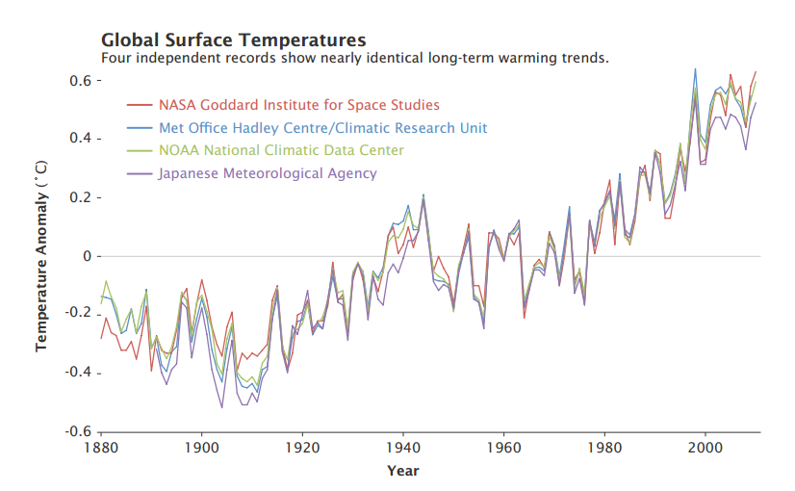
Figure 2.1: Adjusted annual temperature anomalies (1880 - 2000)
Source: NASA Earth Observatory/Robert Simmon, from (https://eoimages.gsfc.nasa.gov/images/imagerecords/48000/48574/adjusted_annual_temperature_anomalies.pdf)
Scientists have reached a consensus that the global annual average temperature is likely to be 2 °C above pre-industrial levels by 2050, and a 2 °C warmer world will experience more intense rainfall and more frequent and more intense droughts, floods, heat waves, and other extreme weather events (IPCC, 2007; IPCC, 2014; Abbasnia et al., 2016). The year 2017 demonstrates up-to-date evidence for climate change as it was the warmest year on record for the global ocean (Cheng and Zhu, 2018). It is well accepted that climate change will have a far more detrimental effect on developing countries compared to developed countries, mainly because the capacity to respond to such changes is lower in developing countries.
  - Climate Change Impacts in Urban Areas
Urbanization is estimated to result in 6 billion urban dwellers by 2050. Cities will be exposed to climate change from greenhouse gas induced radiative forcing, and localized effects from urbanization such as the urban heat island. Climate change may influence most of the urban environment including health and urban biodiversity (Reacher et al., 2004). According to IPCC (2007a) increases in the frequency and severity of floods and droughts as well as declines in water qualities stored in glaciers and snow cover are also expected. The rapid economic development and the concurrent urbanization of poorer countries mean that developing-country cities will be both vulnerable to health hazards from climate change and, simultaneously, an increasing contributor to the problem (Campbell-Lendrum and Corvalan, 2007).
Urban residents are exposed to higher heat stress risk than rural residents due to the Urban Heat Island, i.e urban areas being warmer than surrounding rural areas. Urbanization reduces green space, increases impervious surfaces, and alters albedo and geometry compared to rural surfaces (Oke, 1982). The geographic focus of climate research mainly the impact of climate change on cities focus on Europe, North America and China, and there has been little research in regions most vulnerable to climate change, such as Africa and South America. Future research should aim to incorporate urban growth into climate change simulations, and focus on regions that will be most affected by heat stress (Chapman, 2017). Summary of climate change impacts in urban areas is presented in Table 2.1.
Table 2-1: Impacts of climate change in urban areas
Climate Phenomena | Major Projected Impacts
Warmer and more frequent hot days and night | Increased demand for cooling. Declining air quality in cities. Increased disruption to transport due to overheating of engines.
Warm spells/heat waves | Reduction in quality of life for people in warm areas without air conditioning. Impacts on elderly, very young, the sick and poor.
Heavy precipitation events | Disruption of settlements, Commerce, transport and societies due to flooding. Pressure on infrastructure, potentials for use of rain in hydro power generation.
Cities affected by drought | Water shortages for households, industries and services. Reduced hydro power generation potentials. Potentials for population migration
High sea rise | Costs of coastal protection versus costs of land- use relocation. Decreased freshwater availability due for movement of population and infrastructure.
Source: from Ifeanyi and Ayadiulo, 2012, based on IPCC (2007a)
The two main important topics related with climate change in urban area are urban heat island and urban flooding.

Urban Heat Islands and Climate Change
Surface and atmospheric conditions of the urban and rural area do not have similar thermal characteristics. Urban centers are warmer than the surrounding non-urbanized areas. This condition is called urban heat island (IPCC, 2007; IPCC, 2014) and was studied for the first time in London in 1833 (Howard, 1833). The Urban Heat Island air temperature differences between the urban environment and its surrounding rural areas. The heat island structure may extend from the ground to the top of the roofs and canopy levels above the ground. The Urban Heat Island effect is a major which are expected to increase with the rapid growth of urban populations and projected future climate change (Abutaleb et al., 2015). Different factors are available which affect land surface temperature in urban areas: changes of albedo due to increased surface areas of asphalt and concrete, decreased water content of soil due to enhanced evapo-transpiration, changes of radiative flux due to more buildings and streets, and increases of anthropogenic urban heat emission (Xiao et al., 2007).
Anthropogenic activities associated with urbanization and industrialization were the most important driving force in land cover changes and UHI formation, as expected (Xie and Zhou, 2015). UHIs may be identified by measuring surface or air temperatures. Rise in surface temperature influences air temperature to increase. For instance, the highest temperature of the given place will be regulated in green areas due to vegetations which contribute to cooler air temperatures (Feyissa et al., 2014). Dense built-up areas and impervious surfaces and transportation fields on the other hand typically lead to warmer air temperatures because of the air mixes within the atmosphere, though, the relationship between surface and air temperatures is not constant (Adeline et al, 2014). Compared to rural areas urban centers will be exposed to climate change and variability due to high anthropogenic activities and localized effects from urbanization. Climate change projections for East Africa point to a warming trend, particularly in the inland subtropics. Frequent occurrence of extreme heat events increasing aridity and changes in rainfall with a particularly pronounced decline in southern Africa and an increase in East Africa (Coumou et al., 2016).
LST is a good indication and identification for UHI (Kumar et al., 2012; Feyissa et al., 2014; Feizizadeh, 2013). Traditional methods for deriving impervious surface are highly dependent on personal experience and often cannot be accurate (Zhang et al., 2008). Urban overheating produced by UHI has a dangerous impact on citizens’ health conditions and indoor-outdoor comfort perception and therefore, it affects their quality of life and economy (Akbari, 2015). The UHI effect is suspected of warming urban areas 3.5–4.5°C more than surrounding rural areas and is expected to increase by approximately 1°C per decade (Voogt, 2002). The built environment, including buildings and roadways that absorb sunlight and re-radiate heat, combined with less vegetative cover to provide shade and hold cooling moisture, all contribute to cities being warmer and susceptible to dangerous heat events (Corburn, 2009)

Climate Change and Flood Hazard in Urban Areas
One of the main impacts of climate change in urban area is flooding. In recent years, extreme events of weather have become more frequent due to climate warming, and pluvial flooding disasters in inland cities induced by extreme precipitation have shown an increasing trend (Pradhan-Salike and Pokharel, 2017). Future climate change conditions with present urbanization will increase pluvial ﬂooding. Fluvial (River Flood) or riverine flooding, occurs when excessive rainfall over an extended period of time causes a river to exceed its capacity. A pluvial, or surface water flood, is caused when heavy rainfall creates a flood event independent of an overflowing water body. The magnitudes of urban flood volumes are found to increase nonlinearly with changes in precipitation intensity. On average, the projected flood volume under RCP 2.6 is 13 % less than that under RCP 8.5, demonstrating the benefits of global-scale climate change mitigation efforts in reducing local urban flood volumes. Comparison of reduced flood volumes between climate change mitigation and local adaptation (by improving drainage channel systems) scenarios suggests that local adaptation is more effective than climate change mitigation in reducing future flood volumes (Zhou et al., 2018).
East Africa is at higher risk of flooding and concurrent health impacts and infrastructure damages (Serdeczny, 2017). A number of studies find that a number of ﬂood-related disasters in Africa show an increasing trend over the past half century. Wetting of the Horn of Africa is also reflected in projected extreme precipitation events based upon the full CMIP5 model ensemble (Sillmann et al., 2013). The high emission scenario projects an increase in the total amount of annual precipitation on days with at least 1 mm of precipitation (total wet-day precipitation) in tropical eastern Africa by 5–75 %, with the highest increase in the Horn of Africa, although the latter represents a strong relative change over a very dry area (Sillmann et al., 2013). In contrast to global models, regional climate models project no change, or even a drying for East Africa, especially during the long rains (Laprise et al., 2013). Consistently, one regional climate model study projects an increase in the number of dry days over East Africa (Serdeczny, 2017).
Due to undulating and slopy topography, poor solid and liquid waste management and absence of sustainable storm water management, Addis Ababa is faced with surface flooding during rainy seasons. Several small streams originating in the mountain range at the foot of which the city lies traverse metropolitan Addis Ababa. Torrential rains, common during the rainy season, cause sudden rise in the flow of these streams, which bring about flood damages to settlements along their banks. Flooding in Addis Ababa annually causes damages to property along streams coming down from the nearby hills. In most cases such damages occur on illegal settlement at the banks of the streams (CLUVA, 2012)
  - Urban Land Use Land Cover and Climate Change
Urban land use land cover has a direct relationship with urban heat island and urban flooding. Land cover can be defined as the biophysical state of the earth’s surface and immediate subsurface, including biota, soil, topography, surface water and groundwater, and human structures (Turner et al., 1995). In other words, it describes both natural and human-made coverings of the earth’s surface. Land use can be defined as the human use of the land. Land use involves both the manner in which the biophysical attributes of the land are manipulated and the purpose for which the land is used (Turner et al., 1995). The relationship between land use and land cover is not always direct and obvious (Weng, 2010). A single class of land cover may support multiple uses, whereas a single land use may involve the maintenance of several distinct land covers (Weng, 2010).
An important human influence on atmospheric temperature trends is extensive land use/land cover change and its climate forcing. Studies using both modeled and observed data have documented these impacts. Land cover of certain area has a great influence on temperature conditions. Many studies on urban thermal environment indicate that settlement and impervious surfaces are highly expanded at the expense of green areas, and open spaces (Mutiibwan et al., 2014; Boysen et al., 2014). Land use changes also exacerbate effects on hydrology (Tsarouchi and Buytaert, 2018). Urban landscapes are typically a complex combination of buildings, roads, industries, commercial centers, parking lots, sidewalks, gardens, cemeteries, soil, water, and so on. Each of the urban component surfaces possess unique biophysical properties and relates to their surrounding environment to create the spatial complexity of urban ecologic systems and landscape patterns (Weng, 2010). In Ethiopia, many researches indicate urban land use there is significant increment in built up areas and decrease in green areas and open spaces. Table 2.2 presents the summarized examples of land cover changes in Ethiopian major towns.

Table 2-2: Summary of major urban land use in Ethiopian major towns
City | General conclusion on land cover change | Reference
Addis Ababa | Built up area increased, vegetation cover decreased | Abebe and Megento, 2016
Adama | Built up area increased, vegetation cover decreased 1984 to 2015 | Sinha et al., 2016
Mekele | Built up area highly increased, Bareland decreased between 1985-2010 | Tahir et al., 2016
Bahirdar | Built up area increased, vegetation cover decreased( 30 %) and 1973–2015 | Gashu and Gebre-Egziabher, 2018
Dire Dawa | Built up area increased, vegetation cover decreased 1985 - 2015 | Taffa et al., 2013
Hawassa | Built up area increased, vegetation cover decreased(14%) in 1973–2015 | Gashu and Gebre-Egziabher, 2018
Source: Author’s own construction based on different literatures
As indicated the land use land cover has a high relation with climate change, for instance increase in temperature, and the flooding is a series current problems in Ethiopian towns.

Climate Change in Ethiopia

Trends and Projections of Temperature and Preciptation in Ethiopia
Regionally in East Africa, studies indicate that in countries like Burundi, Kenya, Sudan, and Tanzania people are badly hit by the impacts of climate change in the recent decades (Hassaan, 2017; Mwangi and Mutua, 2015). In Ethiopia in the last few decades, high temperature values were recorded in different parts of the country. Research conducted in Ethiopia reveals that there has been a warming trend in the annual minimum temperature over the past 55 years (1951-2006). In the indicated period, the temperature has been increasing by about 0.37 °C every ten years. The country has also experienced both dry and wet years over the same period and annual rainfall shows that it remained more or less constant when averaged over the whole country (NAPA, 2007). Warming is expected to continue in Ethiopia, for all seasons, in all regions, and even if emissions decrease. The multi-model average shows warming in all four seasons in all
regions, with annual warming in Ethiopia by the 2020s of 1.2 °C with a range of 0.7–2.3 °C (2050s 2.2°C, range 1.4–2.9°C) (Conway et al., 2011).
The considerable projected warming in East Africa, with the highest temperature rises expected with higher emissions. Under a business as usual scenario with no policy changes to reduce global emissions, the average warming across all models shows temperature increases of approximately 4°C by the end of the century. Some individual models show temperature increases approaching and exceeding 6°C. Under ambitious global greenhouse gas emission reductions (RCP2.6) temperatures are expected to increase by approximately 1°C by the end of the century; however, even under this ambitious scenario increases in mean annual temperature above current conditions still approach 2°C for some models. (Reference) When considering ranges of projected changes it is important to note that the average does not imply a greater likelihood of occurrence. For Ethiopia, even the projected temperature change under the most ambitious emissions scenarios will have significant impacts for agriculture, extreme events (Murphy and Tembo, 2014). The various General Circulation Model (GCM) results also suggest that future climatic change climatic elements will be significant. So far, some studies have predicted long-term future climate change situations that could prevail up until the end of this century in Ethiopia (McSweeney et al., 2010).
Ethiopia is particularly vulnerable to global climate change, given its massive reliance on agriculture. 85% of Ethiopians live in rural areas and most rely on subsistence farming for survival. The main climate hazards in Ethiopia are associated with rainfall variability including amount, timing, intensity and associated floods and droughts. Increased precipitation trends are projected from early this century. Future projections of rainfall are more complex to disentangle. Research indicates a future positive shift in rainfall for most models with increases in both average rainfall and intensity simulated for most of East Africa, including Ethiopia. Increases in rainfall extreme are likely to translate into rising flood risks for the region and rising of the temperature spread of diseases like mosquitoes to the highland areas (Weldegebriel and Gustavsson, 2017).
Historical climate analysis for Ethiopia indicates that mean annual temperature has increased by 1.3°C between 1960 and 2006, an average rate of 0.28°C per decade and the increase in temperature in Ethiopia has been most rapid in June, August, and September at a rate of 0.32°C per decade (McSweeney et al., 2008). Mean annual temperature is projected to increase by 1.1 to 3.1°C in the 2060s, and 1.5 to 5.1°C in the 2090s (Figure 2.2). Under a single emissions scenario, the projected changes from different models span a range of up to 2.1°C (McSweeney et al., 2010). Rainfall is historically highly variable and there is no clear trend in the amount of rainfall over time (McSweeney et al., 2008; Ministry of Water Resource and National Meteorological Service Agency, 2007). Climate models show different projections of annual rainfall over Ethiopia, with some models projecting more rain, others less, but with a tendency for for slightly wetter conditions (Conway et al., 2011).
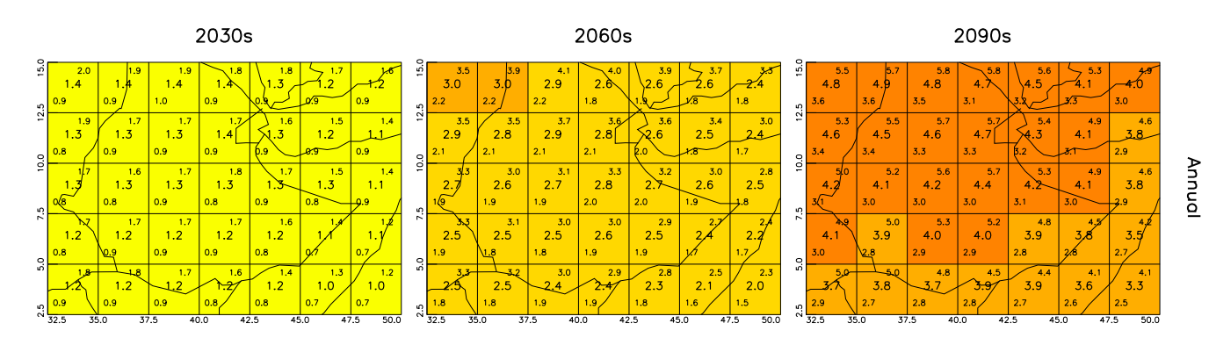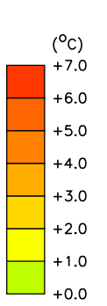
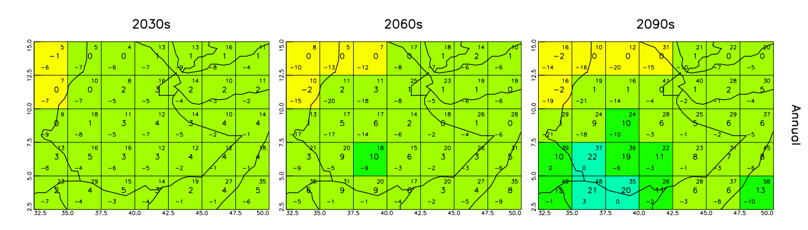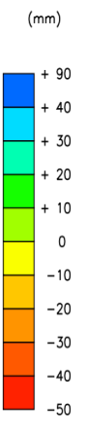

Figure 2.2: Projected mean temperature and precipitation change in Ethiopia
Under the SRES A2 scenario, all values are anomalies relative to the mean climate of 1970-1999, adopted from McSweeney et al., 2010)

Climate Change and Vulnerability of Urban Areas in Ethiopia
Urban Population accounts 20% in Ethiopia. Even though Ethiopia is a rural country, the urbanization rate is the fastest in eastern Africa and in 2017 its growth rate was 5.6%. However due to the economy of the country is highly dependent on agriculture, and agricultural sectors practiced in all over the country, the impact of climate change was not widely mentioned on urban areas and are only of the recent research interest. The assessments that are undertaken in major Ethiopian towns indicate that the temperature has increased and continue to increase in the future, while precipitation change has no clear trend. For instance, the temperature trends indicates increment in major towns like, Mekelle, Bahirdar, Gondar, Adama, Dire Dawa, Gode Jigjiga, Batu, Arbamich and others (Beyene, 2016; Mulgeta et al., 2017) and fluctuations in annual rainfall trends (Abebe, 2016). In general in Ethiopia, historical data indicate that precipitation is increasingly erratic, with marked seasonal deficits when compared to long term past averages heavy rainfall events appear to be increasingly frequent, with changes in rainfall patterns, including decreased reliability and less predictability, temperatures are increasing and the number of extreme events is likely increasing (Chemonics International, 2015). Climate related impacts are highly reported in urban centers in Ethiopia, like flash flooding during extreme rain fall.

General Circulation Climate Models to Understand Climate Change
In the available, meteorological records, it is easy to know the trends in the past by computing statistically. However it is more worthy to know the future climatic condition and prepared for adaptation measures. In this case, climate general circulation models will be a vital tool of analysis. A GCM is a numerical model of the general circulation of a planetary atmosphere or ocean, taking into account thermodynamic terms for various energy sources (radiation, latent heat) as well as the laws for momentum and mass conservation (Pauleit et al., 2005). Future scenarios of greenhouse gases are used as input to these models to explore how differing global concentrations of greenhouse gases are likely to affect important climatic variables such as temperature and precipitation. These models operate at large scales and are usually downscaled to a higher resolution so that their outputs can be used as inputs to impact models to explore how changes in climate might impact on specific sectors (Murphy and Tembo, 2014).
General circulation models (GCMs) are essential tools for climate studies and mainly help to understand the climatic conditions of the past and future (Hashmi, 2009). There is considerable confidence that Atmosphere-Ocean General Circulation Models (AOGCMs) provide credible quantitative estimates of future climate change, particularly at continental and larger scales. Confidence in these estimates is higher for some climate variables, like temperature than precipitation (IPCC, 2007).
Over several decades of development, models have consistently provided a robust and unambiguous picture of significant climate warming in response to increasing greenhouse gases. Accordng to IPCC, source of confidence in models comes from the fact that model fundamentals are based on established physical laws, such as conservation of mass, energy and momentum, along with a wealth of observations. A second source of confidence comes from the ability of models to simulate important aspects of the current climate. A third source of confidence comes from the ability of models to reproduce features of past climates and climate changes (IPCC, 2007).

Climate Change Scenarios
Climate change scenarios are plausible representations of the future climate and are consistent with assumptions about future emissions of greenhouse gases and other pollutants (Kattsov et al., 2005). Scenarios form a crucial element in climate change research. They allow researchers to explore the long-term consequences of decisions today, while taking into account the inertia in both the socio-economic and physical system. Scenarios also form an integrating element among the different research disciplines of those studying climate changes, such as economists, technology experts, climate researchers, atmospheric chemists and geologists (van Vuuren et al., 2011). They are based on today’s understanding of the effects of increased atmospheric concentrations of these gases on the global climate. While formulating climate change scenarios assumptions on future trends in population, economy, technology, energy demand, and agriculture (land use) on emission of greenhouse gases over long time scales were used (IPCC, 2007).
Since the 1999s the intergovernmental panel for climate change (IPCC, 1990, 1995, 2001, 2007 and 2013) releases different climate change related assessment reports. These reports have forced policy makers to take action on the climate change that threatens the earth. The first well organized climate scenario was the SRES Scenario. The SRES (Special Report on Emissions Scenarios) scenarios were those used by the IPCC until the fourth Assessment report, and these four narratives (A1, A2, B1, and B2) cover different demographic and technological futures, that is, a fossil-fuel intensive future (A1F1 scenario) versus a predominantly non-fossil-fuel future (A1T).
A1 Scenario: Globalized human wealth, intensive (market forces). This family is described as the world will record a very rapid economic growth with efficient technology use and global population that peaks in middle century and declines afterwards. The A1 scenario family develops into three groups that describe alternative directions of technological change in the energy system. The three A1 groups are distinguished by their technological emphasis: Fossil intensive (A1FI), Non - fossil energy sources (A1T), or Balance across all sources (A1B).
A2 Scenario: Regionalized human wealth, intensive (clash of civilizations).
The storyline and scenario describes a very heterogeneous world with a self-reliance and preservation of local identities.
B1 Scenario: Globalization, sustainability and equity globalized and extensive (sustainable development). It has similar trends of global population increment with A1 storylines. The scenario is characterized by rapid changes in economic structures towards a service and information economy and resource-efficient technologies.
B2 Scenario: Regionalization, sustainability and equity regional, extensive (mixed green bag).
This scenario family describes the world emphasizes on local solutions to economic, social, and environmental sustainability, global population increases at a rate lower than A2 storylines with intermediate levels of economic development.
Meanwhile, based on the new evidence of climate change from different independent scientific analyses, from observations of the climate system, paleo climate archives, theoretical studies of climate processes and simulations using climate models, the IPCC has released a new assessment report. As a result, the Working Group I of the IPCC’s releases its Fifth Assessment Report (AR5) outlined and has projected the climate change that could be occurred on the globe during the twenty first century (IPCC, 2014).
For the Fifth Assessment report of the IPCC, new scenarios, the Representative Concentration Pathways (RCPs) were developed. Each pathway represents a set of internally consistent socioeconomic assumptions that result in four levels of radiative forcing. It supersedes Special Report on Emissions Scenarios (SRES) projections. So far, four RCP scenarios were defined and each assumes a different level of radiative forcing by the year 2100: 2.6, 4.5, 6 and 8.5 W/m2. The equivalence of these four scenarios is summarized in Table 2.3. RCPs describe a wide range of potential issues concerning climate change like greenhouse gases, air pollutants, emissions and land use. RCPs have broken new grounds in several ways. They include some of the highest and lowest scenarios of greenhouse gases that have been recently examined by the climate research community (IPCC, 2013). Table 2.3 presents comparison of SRES and RCP Scenarios
Table 2-3: Comparison of SRES and RCP Emission Scenarios
New Scenario | Scenario Characteristics | Comparison to old scenario | Description of emissions
RCP2.6 | An extremely low scenario that reflects aggressive GHG reduction and sequestration efforts | No analogue in previous scenarios | “Very Low”
RCP4.5 | A low scenario in which GHG emissions stabilize by mid-century and fall sharply thereafter | Very close to B1 by 2100, but higher emissions at midcentury | “Low”
RCP6 | A medium scenario in which GHG increase until stabilizing in the final decades of the 21st century | Similar to A1B by 2100, but closer to B1 at mid-century | “Medium”
RCP8.5 | A high scenario that assumes continued increases in GHG until the end of the 21st century | Nearly identical to A1FI(B) | "High”
Source: Adopted from Climate Impact Group, College of the Environment, University of Washington.
Many of the previous studies conducted in Ethiopia used SRES scenarios.The current researches after the release of RCP uses the RCP Scenarios. It is therefore, essential to indicate the relationship between the two scenarios as indicated in Figure 2.3.
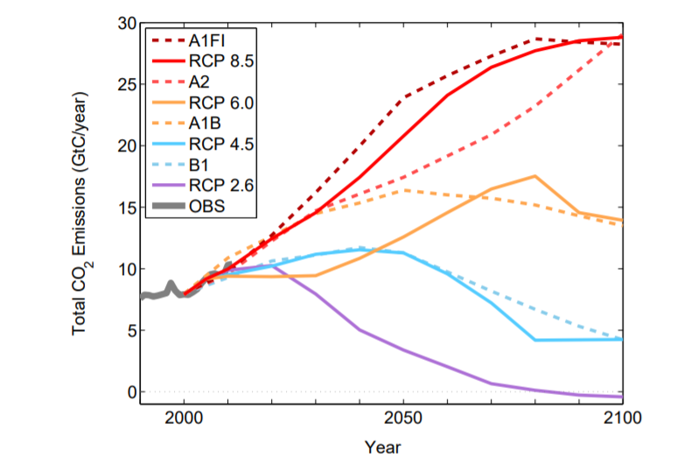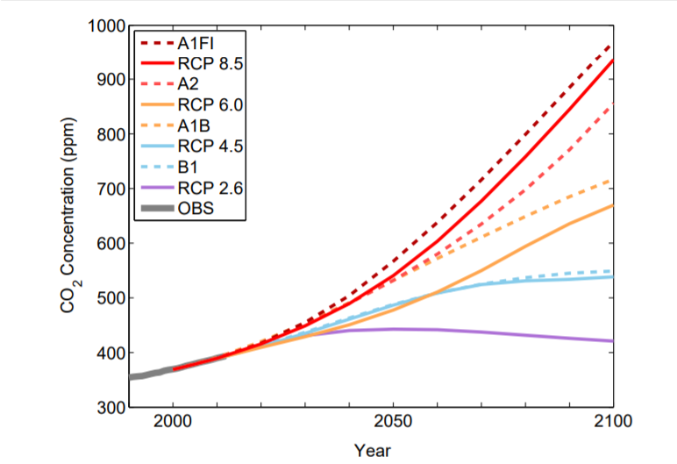
Figure 2.3: RCP and SRES comparison
Source: Climate Impacts Group, 2013, based on data from Le Quéré et al. 2015; IPCC 2007 and IPCC 2013)

GCM Downscaling
Downscaling is the process of translating the climate information from the GCMs from their native coarse resolution to a much finer resolution (Patte et al., 2014). Downscaling process is an agent that establishes relationship between climate variables on a local scale (predicted) and large-scale atmospheric variables (predictors) (Wilby and Dawson, 2013). In order to identify the impacts and characteristics in local scale it is common to use the downscaled results from GCMs, as it is used by various researchers to access the impacts of long term climate change at a city level (Molavi et al., 2011). One of the most important parts of downscaling is its ability to identify and analyze extreme events (Domínguez et al., 2013). It is a method for obtaining high-resolution climate or climate change information. There are two broad categories of downscaling: dynamic (which simulates physical processes at fine scales) and statistical (which transforms coarse-scale climate projections to a finer scale based on observed relationships between the climate at the two spatial resolutions) (Christensen et al., 2007).

Statistical Downscaling
Statistical downscaling is a computer-wise cheap method for the description of seasonal climate variability at regional and local scale, i.e. local meteorological variables that are not adequately described in climatic projections of GCM's. Statistical downscaling is based on statistical relationships linking regional climate variables (predictands) to large-scale atmospheric variables (predictors). Such links are determined during an observational period, tested with independent data outside this period, and used for computing future climate projections (Pizzigalliet al., 2012). The main advantage of Statistical Downscaling is that it provides local-scale information, which is very useful in climate change impact assessment studies (Giorgi et al., 2001). On the downside, the main disadvantage of this approach is that it requires long historical meteorological weather station data to construct an appropriate link with large-scale variables. The main assumption of SD is that the empirical relationship between larger and small scales is temporally stationary (Hay and Clark, 2003).

Dynamical Downscaling
Dynamical downscaling, nesting a fine scale climate model in a coarse scale model, produces spatially complete fields of climate variables, thus preserving some spatial correlation as well as physically plausible relationships between variables (Maurer and Hidalgo, 2008). The Regional Climate Model uses the GCM to define time-varying atmospheric boundary conditions around a finite domain, within which the physical dynamics of the atmosphere are modelled using horizontal grid spacing of 20–50 km. The main limitation of RCMs is that they are as computationally demanding as GCMs (placing constraints on the feasible domain size, number of experiments and duration of simulations).

Downscaling Drawbacks
Whatever downscaling procedure is chosen there are always some drawbacks and it is not possible to expect that one type of downscaling will be better than all others. It may be that some of the downscaling methods are more suitable for a location than others. All downscaling methods have a set of assumptions and at times and places it is not easy to conform such assumptions to the existing local reality. It is, therefore, advised that prior to the application of any methodology and especially the use of software one should know the restrictive assumptions and interpret the final results accordingly (Sen, 2010). Both dynamic and statistical approaches have advantages and disadvantages because; they need assumptions that cannot be verified in a climate change context (Giorgi et al., 2001). The summary of the weakness and strengths of the methods are presented in Table 2.4.

Table 2-4: The summary of the Strengths and Weakness of Downscaling Methods
 | Statistical downscaling | Dynamical Downscaling
Strengh | - Station–scale climate information from GCM–scale output  - Cheap, computationally undemanding and readily transferable  - Ensembles of climate scenarios permit risk/ uncertainty analyses  - Applicable to ‘exotic’ predictands | - 10–50 km resolution climate  information from GCM–scale output  - Respond in physically consistent ways  to different external forcings  - Resolve atmospheric processes  - Consistency with GCM
Weakness | - Dependent on the realism of GCM boundary forcing  - Choice of domain size and location affects results  - Requires high quality data for model calibration  - Predictor–predictand relationships are often non–stationar  - Choice of predictor variables affects results  - Choice of empirical transfer scheme affects results  - Low–frequency climate variability problematic  - Always applied off-line, therefore, results do not feedback into the host GCM | - Dependent on the realism of GCM boundary forcing  - Choice of domain size and location affects results  - Requires significant computing  resources  - Ensembles of climate scenarios seldom produced  - Initial boundary conditions affect results  - Choice of cloud/ convection scheme affects results  • Not readily transferred to new regions or domains  • Typically applied off-line, therefore results do not always feedback into the host GCM

Source: Adopted from Wilby et al., 2002.
Statistical Downscaling is among the widely used techniques in Ethiopia to detect climate change impacts mainly in the agricultural and hydrological applications. Some of these applications include statistical downscaling for daily temperature and rainfall in South Wollo (Solomon et al., 2013), the study of future changes in climate parameters in Amhara Regional State (Ayalew et al., 2012), future climate studies in northwestern Ethiopia for assessing the hydrological response of the Gilgel Abay River to climate change in the Lake Tana Basin (Dile et al., 2013), and the climate change impact on the Geba Catchment in Northern Ethiopia (Samuale et al., 2014). However, applications of statistical downscaling of general circulation models for the largest cities in Ethiopia have not been undertaken. It is important to use the downscaled results of GCMs to assess future projections and to identify adaptation measures, as recently explored in some large East and North African cities (Rukundo, 2016; Sayad et al., 2016). Only a few studies are available for Addis Ababa, which differ in method and temporal scale from this study (Ward and Lasage, 2009; CLUVA 2011).

Integration of Remote Sensing and GIS in Climate Change Analyses
In addition to the climate models, GIS and remote sensing applications play a key role in visualization, summarizing and obtaining the information on climate change. Mainly the satellite application of thermal remote sensing is always important to monitor the land surface temperature. Satellite remote sensing provides an independent source of observations to validate climate models and climate theories. Satellite remote sensing has provided major advances in understanding the climate system and its changes, by quantifying processes and spatio-temporal states of the atmosphere, land and oceans (Yang et al., 2013). Satellite data are frequently used with climate models to simulate the dynamics of the climate system and to improve climate projections. Satellite data also contribute significantly to the improvement of meteorological reanalysis products that are widely used for climate change research, for example, the National Center for Environmental Prediction (NCEP) reanalysis (Ghent et al., 2010).
Remote Sensing and GIS are vital tools in the present monitoring of frequent measurements of the Earth over decades with significantly high spatial resolution. A variety of satellite sensors (microwave and visible radiometers, scatterometers, SAR, gravity sensors, altimeters, etc.) are used for tracking the melting of sea ice and continental ice over the Polar Regions and Greenland. Remote sensing technology often has been applied to map land use or land cover instead of materials. Each type of land cover may possess unique surface properties (material), but mapping land covers and materials has different requirements (Weng, 2010). Infrared remote sensing makes use of infrared sensors to detect infrared radiation emitted from the Earth's surface. The middle-wave infrared and long-wave infrared are within the thermal infrared region. These radiations are emitted from warm objects such as the Earth's surface. They are used in satellite remote sensing for measurements of the earth's land and sea surface temperature (Abdulrahman, 2010). In general, thermal remote sensing is regarded as an efficient technology which provides a synoptic and uniform means of studying UHI effects on a regional scale. In the absence of a dense network of land-based meteorological stations, the spatiotemporal distribution of LSTs from thermal remote sensing imagery can be used as information to support UHI management and, potentially, countermeasures (Feizizadeh, 2013).
GIS techniques are used to monitor large scale natural climate oscillations such as El Niño and the influence of atmospheric teleconnections (Mali, 2016). GIS is also a key tool in data integration, presenting scenario and adaptation planning mainly in climate related disasters like urban flooding, urban heat island, storm surge, ice melting and others, but indicating a point specific (Matouq et al., 2014). It is also a key to assess the impact of climate change on agricultural production, on hydrology and others (Yumbya et al., 2014). GIS provides flexible environment to map and handle information in urban areas as urban areas are composed of a variety of materials, including different types of artificial materials (e.g., concrete, asphalt, metal, plastic, glasses etc.), soils, rocks, minerals, and green and non photosynthetic vegetation.

Vulnerability and Resilience in the Context of Climate Change
Climate change is not a single concept by itself and rather it enclosed various concepts within it. In most cases, vulnerability, resilience, and adaptive capacity are the central concepts for the analyses and understanding of the impacts of climate change, because, together they provide a framework that links biophysical climate sensitivity to social and economic factors that mitigate or amplify the consequences of environmental changes. Vulnerability assessment and resilience is mainly analyzed with the topics like sustainability, hazards and climate change impacts (Malone, 2009). Low resilience systems are intrinsically vulnerable to stress and shock, so in this sense increasing resilience reduces vulnerability (Folke et al., 2002). Vulnerability to a climatic stressor is essentially a composite of exposure, a degree of sensitivity to the stressor, and the ability of the exposed system to cope with the stressor. Vulnerability is mostly considered to be a local phenomenon that is investigated by local-scale studies in which the specific societal (and physical) situation can be taken into account much better than in a global-scale study (Doll, 2009).
Terms such as “climate resilient”, “climate-proofing”, and “resilient city” are frequently used to emphasize the idea that cities, urban systems and urban communities need to be able to quickly recover from climate-related shocks and stressors. As result, a resilient city is characterized by its capacity to withstand or absorb the impact of a stressor through resistance or adaptation, which enable it to maintain certain basic functions and structures during an extreme event, and bounce back or recover from an event (Twigg, 2009).
Rafael et al., 2015, classified urban resilience study into four categories based on different literatures. These are:
- Urban ecological resilience: Based on traditional notions of ecosystems resilience, defines urban resilience as the “ability of a city or urban system to absorb disturbance while retaining identity, structure and key processes”
- Urban hazards (stressors) and disaster risk reduction: Emphasis is placed on enhancing the capacity of cities, infrastructure systems, and urban populations to quickly and effectively recover from both natural and anthropogenic stressors.
- Resilience of urban and regional economies: This literature studies the evolution of urban and regional economic and industrial systems, through the use of the ideas and terminology from ecological resilience theory, emphasizing that climate change is one of many types of stressors that urban and regional economies face.
- Promotion of resilience through urban governance and institutions: This literature focuses on how different types of institutional mechanisms (financial instruments, insurance policies, regulatory proceedings, program formulation, and development of community participation and stakeholder involvement) affect the resilience of local environments and how resilience thinking can influence the development of governance measures to promote adaptation to climate change.
The concept of resilience has been applied in urban areas in the recent research, and appears to be related to one of the components of vulnerability, the same that is called adaptive capacity (or coping capacity, coping, and capacity of response). However it is unclear if resilience includes adaptive capacity, or is an element of the latter, although the conceptual links between these concepts are well defined.
The relationship between vulnerability and resilience is presented in Figure 2.4.
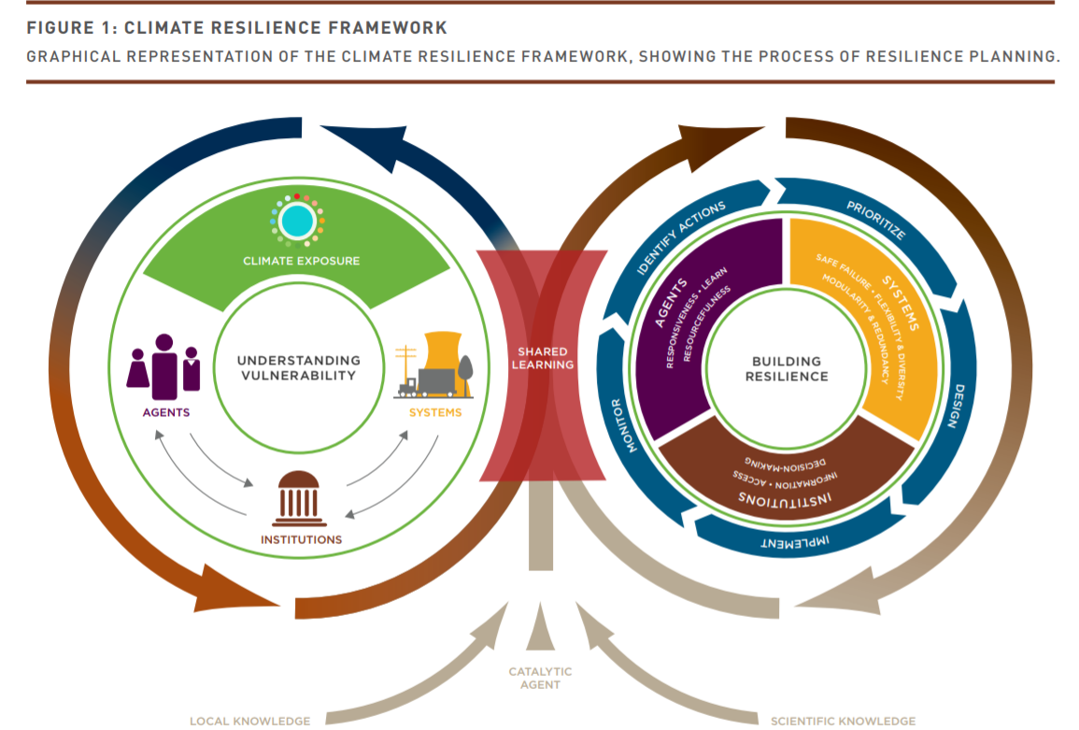
Figure 2.4: Graphical representation of the climate resilience framework
Source: Rafael et al., 2015.

Vulnerability Mapping
Mapping vulnerability hotspots of climate change in urban areas underpin climate change adaptation and mitigation policies and strategies in the contemporary world. It helps to figure out which places and people are the most vulnerable, as well as the degree of vulnerability and possible adaptation options (Gebreegziabher et al., 2016). Due to the potential of maps in depicting vulnerability hot spots is high, as it has strong visual elements and can easily be interpreted than text, its usage is increasing in different research groups and organizations (de Sherbinin, 2014). More specifically, vulnerability mapping helps to set three policy measures. First, it is used to specify long-term targets for the mitigation of climate change; second, to identify vulnerable places and people and to prioritize resource allocation for adaptation and to put adaptation measures (Fussel and Klein, 2006). In climate change literature, two components of vulnerability are identified: internal and external dimensions (Gebreegziabher et al., 2016). The internal dimension refers to frailty, insecurity, and capacity to anticipate, cope with, resist and recover from adverse effects of shocks. The external dimension involves exposure to risks and shocks.

Considering Perception of the Society in Resilience Planning
An understanding of residents’ perception and attitude on climate change and its related vulnerability is essential to provide strategies for resilience planning and implement mitigation options successfully. As the impacts of climate change are already being felt and are expected to increase in intensity over time, effective governmental actions and adaptation mechanisms will be critical in making the city a livable place. This is because the vulnerabilities within the urban environment currently have the greatest impact upon the poor; a problem that experts and city residents anticipate will increase (Cochrane and Costolanski, 2013). Perceptions of climate change may affect how people respond and adapt to multiple impacts i.e. it is the perceived changes that are likely to motivate for adaptive actions (Bewket and Alemu, 2011). The degree of awareness and perception of the residents on climate change is essential to implement the adaptation plans imposed by government in appropriate manner and helps to integrate the community in the planning process which makes the whole climate change mitigation plans to be successful. People’s perception of climate change was significantly related to the age of the head of the household, wealth, knowledge of climate change, social capital and agro-ecological settings (Deresa, 2009). It is important to know despite the facts happening and checked by scientists in physical science through various models, the perceptions and attitudes of people, their feelings, the impacts they noticed, and the general perceptions and awareness on climate change and the mechanisms to adopt it.

Climate Change Adaptation Planning and Practices in Addis Ababa
The Federal Democratic Republic of Ethiopia has put in place policies, strategies and programmes that enhance the adaptive capacity and reduce the vulnerability of the country to climate variability and in 2012 the Climate Resilient Green Economy (CRGE) initiative was launched to protect the country from the adverse effects of climate change and to build a green economy that will help realize its ambition of reaching middle income country status before 2025. Though the adaptation measures are employed at different levels of the country, at the city level, it is mainly expressed on the structural plan preparations. From this perspective, it is understood from the trend of the environmental plans of the city, how emphasis is given to combat climate change overtime.
So far conducted 10 master plans and except for the last two master plans, the main focus of the master previous master plans was on land use, not specifically on environmental change. The master plan developed in 2002 to cover the years 2003-2010, did not explicitly address climate change, it did address a number of issues of relevance to create resilience to climate change as it focused on making Addis Ababa a livable and safe city mainly on housing issues (CLUVA, 2012). Many of the intentions in the master plan were never implemented. Most of the plans have failed to guide development in accordance with the intended goals. All of which were comprehensive and future oriented rather than being relevant to solving the existing problem. Most of these plans were professional oriented and based on foreign planners’ experience and values, without giving due attention to the city’s actual situations, and consequently they have less relevance (Mahiteme, 2007).
The less adaptation practices to climate change in Addis Ababa emanates from poor urban land management in Addis Ababa (Abebe, 2016). The problem in Addis Ababa that makes the master plans and other structural plans not to be implemented is improper land management and unavailability of modern cadastral system. Cadastre is referred to as a parcel based land information system (Mahiteme, 2007). The currently introduced master plan considered the urban planning, preparation and implementation strategy allocated 30% of the land for roads and infrastructure, 30% for green areas and shared public use and 40% for building construction in their urban land management plan (MoUDH, 2015).
The establishment of the Gullele Botanical, a newly established conservation initiative located at the northwestern tip of the Addis Ababa, covering an area of 1000 Garden (GBG) could be taken as a good measure, for climate change adaptation. The establishment of climate change and offices are offices could also be taken as adaptation practices against climate change. For instance, the establishment of Addis Ababa Rivers and riversides development and climate change project office indicates the city administration starts to feel the impact of climate change. Environment related proclamations, directives and standards are available, thought as stated above, they always fails implementation.

Materials and Methods

Description of the Study Area

Location
Addis Ababa is found between 8º50’ N to 9º50’ N and 38º38’ E to 38º54’ E. The city is located in the central highlands of Ethiopia covering an areal extent of about 527 km² with an average elevation of 2600m above mean sea level (asl). The elevation ranges from the highest peak at Mount Entoto which is 3041m to 2051 mean above sea level at the lower part of Akaki plain. The topography is undulating and form plateau in the northern, western and southwestern parts of the city. Bole, Akaki, and south western part of the city is characterized by gentle morphology and flat land areas. The urban area is endowed with three major rivers: Kebena, Little Akaki and Big Akaki rivers and numerous small streams. The study area is presented in Figure 3.1.
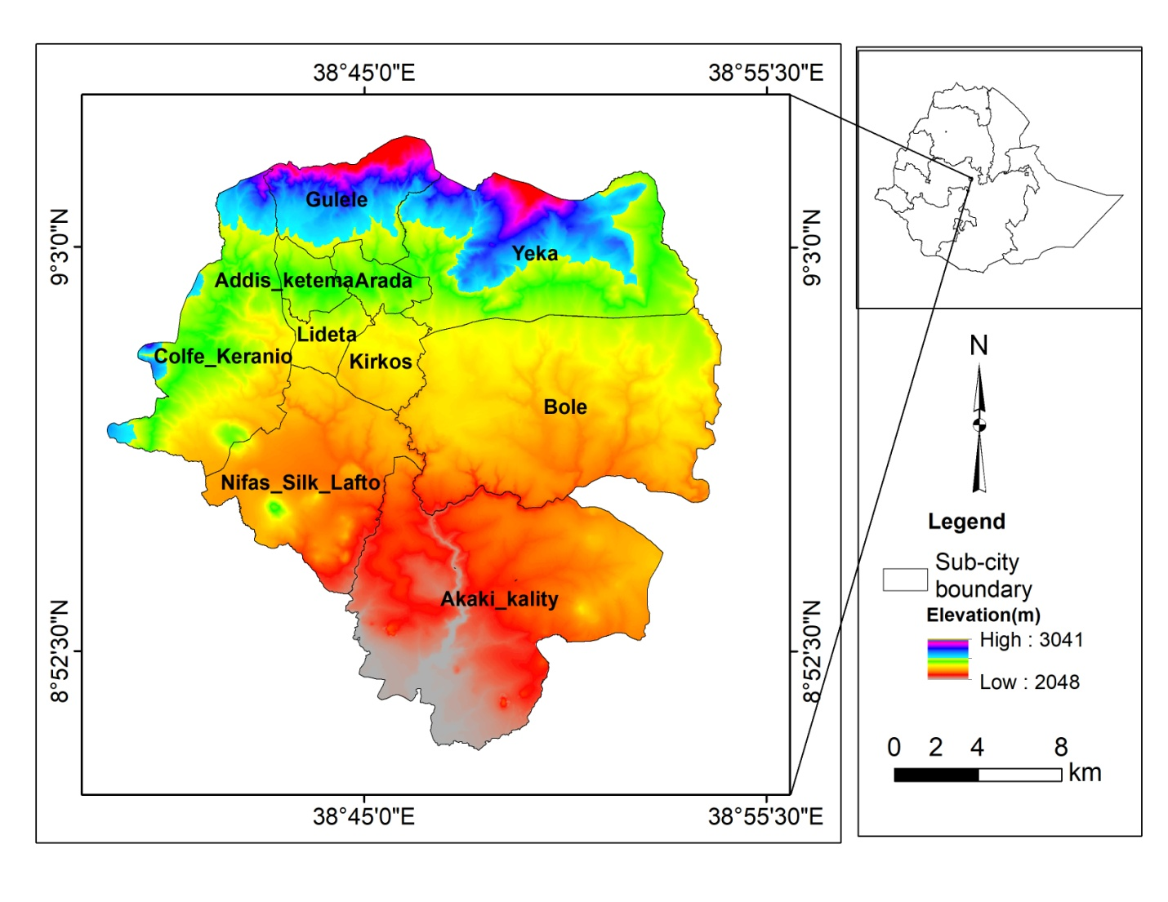
Figure 3.1: Study area map

Climatic Characteristics of Addis Ababa

Temperature
An average maximum temperature for Addis Ababa stations, was 18.12°C, 23.54°C, 23.54°C, and 26.4°C respectively at Entoto, Bole Addis Ababa obs. and Akaki in 1986-2016. February, March, April and May are the hottest months with a monthly maximum temperature record above 27.5 °C. The overall maximum monthly average temperature is lower in July, and August with less than 20 °C. Maximum temperature records from four meteorological stations found in Addis Ababa is presented in Figure 3.2.

Figure 3.2: Annual average maximum temperature 1986-2006.
Source: NMSA, constructed by the Author
Similarly, monthly average minimum temperature in 1986-2016 at Entoto, Bole Addis obs. and Akaki was 8.6°C, 9.9°C, 10.8°C, 13.9°C. The overall average minimum temperature of Addis Ababa resulted from these stations was 10.8°C. The monthly average minimum temperature is presented in Figure 3.3 below.

Figure 3.3: Annual average minimum temperature 1986-2016
Source: NMSA, constructed by the Author

Precipitation
Average precipitation in 1986-2016 was 1254.7mm at Entoto, 1018.7mm at Bole, 1208.2mm at Addis obs.(Tikur Anbesa), 979.2 mm at Akaki and 1226.3mm at Kotebe stations and the averaged annual total rainfall general was 1125.7 mm within 1986-2016(Fig. 3.4). The wet season is from June to mid-September. The highest precipitation is recorded in July and August. At Addis obs.on average a rainfall of 252 mm to 272 mm will be recorded in these months. The highest numbers of rainy days are in July and August.

Figure 3.4: Annual precipitation in Addis Ababa (1986-2016)
Source: NMSA, constructed by the Author

Wind Speed
There is a limited record of wind speed for Addis Ababa. The record on wind speed shows a decreasing trend in Addis Ababa. The highest average wind speed value is in February and March (0.8m/s) and the lowest wind speed is in August (0.3m/s). The average annual wind speed value for Addis Ababa is 0.6m/s. The wind speed starts to decline from 1985 to 1996 continuously. Increased by 0.1m /s in 1996 and 1997, again it starts to fall. Wind speed plays a significant role for temperature modification in carrying hot urban center air and distributing to the cooler areas of suburban. The urban built environment, especially the tall buildings have a role in wind speed value reduction. Average wind speed Characteristics at Addis obs is presented in variation is given Figure 3.5

Figure 3.5: Annual average (right) and monthly average (left) wind speed
Source: NMSA, constructed by the Author

Relative Humidity
Another important climate element is the relative humidity. The average RH in 1983-2013 was 57.59% in Addis Ababa obs. The highest RH value is in August and July (76.08% and 75.44% respectively) and December is the lowest RH (48%). There is insignificant variation of RH as described in the Figure.3.6.

Figure 3.6: Annual average 1983-2005 RH %( left) and monthly (right) RH%
Source: NMSA, constructed by the Author

Soil
As quoted by Gizachew, Ministry of Water and Energy in 2004, classified the soil of Addis Ababa in to seven major types namely Calcic Xerosols, Chromic Luvisols, Chromic Vertisols, Eutric Nitisols, Leptosols, Ortic Solonchaks and Pellic Vertisols (Gizachew, 2011). The dominant soil of the region is Pellic Vertisol (277.23km²) which is found in the southern and north east part of the city. Eutric Nitisol (111.55km²) is the second most dominant soil found in the central and North West part of the region. Calcic Xerosols (39.79km²) is the third most dominant type of soil found in the northern part of the city. Chromic Vertisols are the forth dominant soil of the region covering an area of about 34km² and found in the central part of the city center. The rest soil types are found in the northern part of the center covering smaller areas. FAO classified the soil types in Addis Ababa into six main groups as indicated in Figure 3.7.
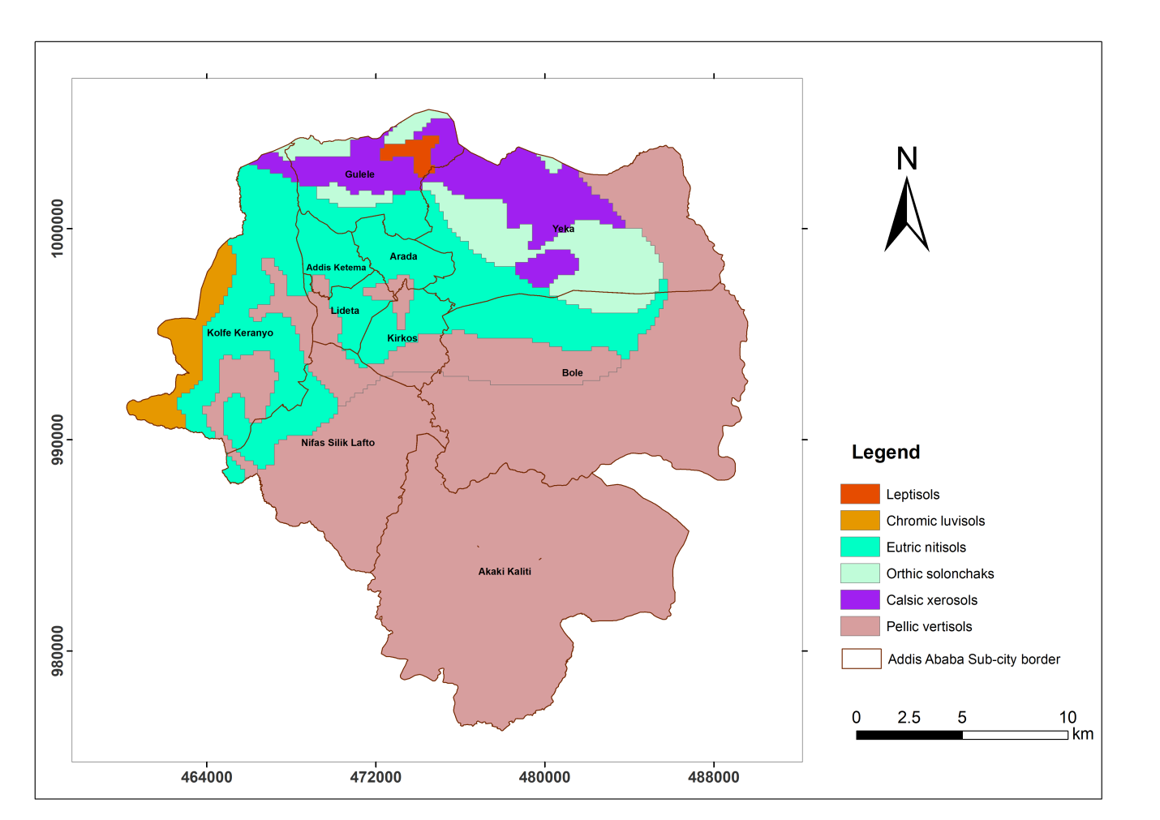
Figure 3.7: Soil map of Addis Ababa
Source: FAO Classification

Geology
Addis Ababa is located in the western margin of the Main Ethiopian rift and consists of different volcanic rocks that range from basic to acidic composition. The vicinity of the city is surrounded by trachyte and rhyolite hills and mountains. In the northern part, the Entoto mountain chains are composed of rhyolite and trachyte which are called the Entoto silicic of the Addis Ababa area. They are associated with the Alaji formation and rest on older basalts. Volcanism initiating the Alaji cycle occurred in late Oligocene - early Miocene times. The basalts are outcropping in the central part of Addis Ababa and to the south and north of the Entoto hills some small patches of basalts are capping the Entoto silicic. The Miocene-Pleistocene volcanic succession in the Addis Ababa area suggested by Haileselassie Girmay and Getaneh Assefa and cited by Tamiru et.al., 2003 from bottom to top is: Alaji Basalts, Entoto Silicics, Addis Ababa Basalts, Nazareth Group, And Bofa Basalts as described on Fig 3.8.
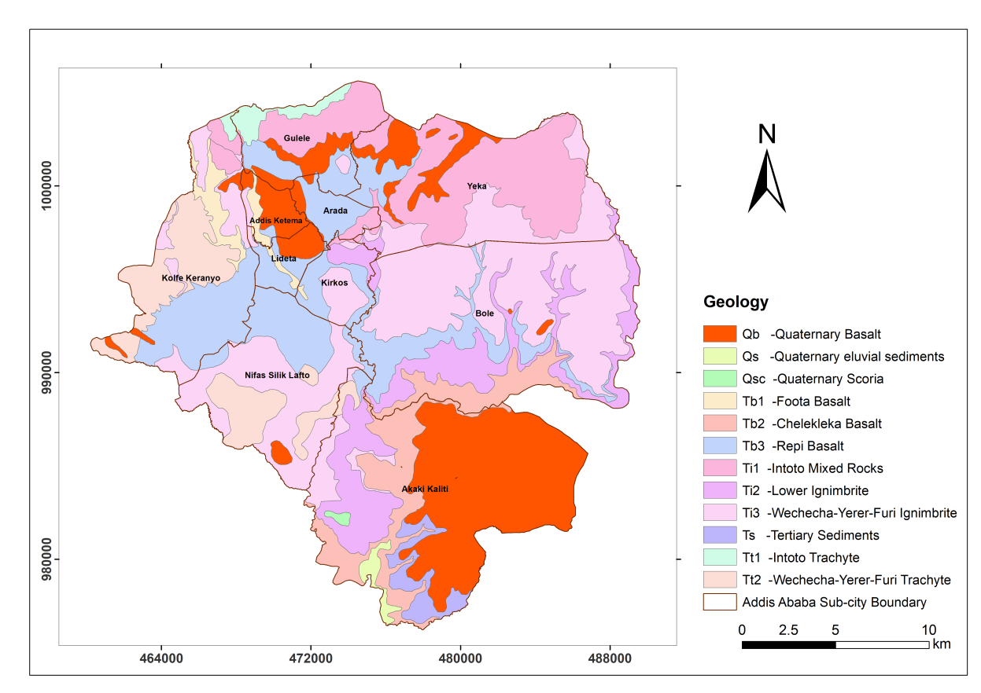
Figure 3.8: Geology map of Addis Ababa
Source: Data from Geological Survey of Ethiopia, 2007, prepared by Addis Ababa Integrated Land Information, Center, March, 2015

Population and Human Livelihood
Addis Ababa is the capital and the largest city of Ethiopia, with a total projected population of 3.44 million people in 2017(Ethiopian Central Statistical Authority, 2013) and the administration of the city is divided into ten sub-cities. The city is also the capital of Oromia regional state, the seat for African Union and other many international organizations. The administration of Addis Ababa is divided into ten sub-cities. These sub-cities are Addis Ketema, Akaki Kality, Arada, Bole, Gulelle, Kikos, Kolfe Keraniyo, Lideta, Nifas Silk Lafto and Yeka. Each sub-city is divided into “Woredas”, which are the smallest administrative units of the city. The population density varies from sub-city to sub-city. The highest density in Addis Ketema sub-city (37,215p/sk.km) to the sparse density in Akaki-Kality sub-city (1,832p/sk.km). All the sub-cities in the downtown have high population density compared to sub-citiesfound in peripheral areas. Addis Ababa is home to 25% of the urban population in Ethiopia and is one of the fastest growing cities in Africa. The city is a major growth corridor for the countries vision to become a middle income by 2025. The city alone contributes approximately 50% towards the national Gross Domestic Product, highlighting its strategic role within the overall economic development of the country (World Bank, 2015).
Despite the efforts of the federal government and the city administration to diversify the economic base of the capital, the service sector remains dominant while the pace of manufacturing growth has remained slow though improving (UN Habitat, 2017). According to f Finance and Economic Developmnet Bureau of the city, Gross Domestic Product (GDP) estimates, the city’s economic activity is dominated by the services sector, which contributes to about 77% of the city’s economy, followed by the industrial sector whose share in the economy is about 22%. Agriculture contributes to less than 1% of the city’s output (World Bank, 2010). Fast rate of urban expansion and built up area are rapidly increasing in Addis Ababa (Woldegerima et al., 2016), which were largely attributed to population pressure on the land, a rapidly growing infrastructure and poor land use planning (Teferi and Abraha, 2017).

Data Sources

Observed Climate Data
The distribution of meteorological stations in Addis Ababa is few, and most of the stations are recently established. Two of the oldest meteorological stations are Addis Obs. and Bole which record all parameters of the climatic elements. They are synoptical stations and found in the city center. The records in these two stations are nearly similar, and the distance between the two stations is not long. The other station with temperature and Preciptation record since 1988 is Entoto. This station is found at the boundary of Addis Ababa, at high elevated area. Akaki and Kotebe stations do not have long periods record. Therefore, Addis Ababa Obs and Entoto stations are used both in the trend analysis and model calibration and validation because these two stations have complete, long time data and are represented from homogenous locational characteristics. Addis Ababa obs. station represents the urban center (downtown), while Entoto station represents the suburban (peripheral area).
The daily observed maximum temperature, minimum temperature and precipitation data from National Meteorological Service Agency of Ethiopia were used for model calibration and validation in SDSM. Data from 1971–1985 were used for model calibration and from 1986–2000 for model validation at Addis Ababa Observatory. At Entoto station data from 1989–1998 were used for model calibration and 1999–2005 for model validation. The difference in the baseline year is based on the availability of the baseline data in the study area. Some missed records were interpolated and filled during the analysis. The general characteristics of meteorological stations in Addis Ababa is presented in Table 3.1
Table 3-1: Meteorological stations information
Station Name | Location  (Latitude) | Location  (Longitude) | Elevation(m)
Addis Ababa Obs. | 9.01891 | 38.7475 | 2386
Bole | 8.98108 | 38.7987 | 2354
Entoto | 9.08367 | 38.7213 | 2903
Kotebe | 9.05917 | 38.8392 | 2755
Akaki | 8.8698 | 38.7862 | 2057

Source: NMSA, compiled by the author

GCM Climate Data
All the predictor data have been obtained from a Canadian climate data and scenarios website (http://climate-scenarios.canada.ca). These models are selected because; they are tested for other parts of East Africa including Ethiopia. The predictors within these models are also prepared as an input for SDSM; in the appropriate format. The model data are also freely available.
The general circulation models used in the analyses were:
- Third Version Coupled Global Climate Model (CGCM3): This is the third version of the Canadian Coupled Global Climate Model (CGCM3.1) and is a widely used model for statistical downscaling input. Details of the model are described by McFarlane et al. 2005. Additional information can also be obtained from (http://www.ec.gc.ca/ccmac-cccma/default.asp?lang=En&n=89039701-1. The CGCM3 has a resolution of 3.75° latitude and 3.75° longitude.
- Second Generation of Earth System Model (CanESM2): Developed at the Canadian Centre for Climate Modelling and Analysis (CCCma), this model consists of the physical coupled atmosphere–ocean model CanCM4 coupled to a terrestrial carbon model (CTEM) and an ocean carbon model (Merryfield, 2013). CanESM2 provided CCCma’s long-term climate simulations for Phase 5 of the Coupled Model Inter-comparison Project, which in turn informed the Fifth Assessment Report (AR5) of the Intergovernmental Panel on Climate Change. The CanESM2 model has a resolution of 2.79° latitude and 2.81° longitude.
The predictands were maximum temperature, minimum temperature and precipitation. Wind speed was not considered to be downscaled in this study. Most of the studies conducted on the impacts of climate change on wind speed are undertaken in the countries, which are highly dependent on wind energy because the wind energy sector is highly susceptible to climate change (Schaeffer et al., 2012). Similarly, due to the wind energy is not well utilized in Ethiopia; the study didn’t considered wind downscaling. The other reason also related with limited wind data for model calibration and validation in Addis Ababa. Unless enough historical period data is obtained, the projected result could lead to wrong results
These models were used both for the Special Report on Emissions Scenarios and the Representative Concentration Pathway (RCP) Scenarios. A1B, which mainly assumes balanced energy source for the future, and A2, which assumes regionalized human wealth and describes a very heterogeneous world were selected. These scenarios were selected, though the considered parameters are global, the trends in developing country, including Ethiopia, have similarity with these assumptions. Considering the SRES Scenarios, is important for comparison, because many of the previous works were undertaken using SRES Scnearios. The RCP Scenarios considered in this study were RCP4.5 and RCP 8.5. Low emmission scenarios were not included, because most of the assumptions in the scenario are not the characteristics of developing countries. RCPs describe a wide range of potential issues concerning climate change like greenhouse gases, air pollutants, emissions, and landuse. RCPs have broken new grounds in several ways. They include some of the highest and lowest scenarios of greenhouse gases that have been recently examined by the climate research community.
The results from these models were compared with the National Centers for Environmental Prediction (NCEP) Data for the historical baseline period. (NCEP Data is a reanalysed data designed to provide homogenized (gridded) records of atmospheric fields, to support climate research by assimilating data from multiple sources with modeled short-range forecasts (Kalnay et al., 1996). The coherence, accessibility, and completeness of the NCEP dataset make it attractive for climate studies on topics ranging from climate variability and synoptic climatological analyses to comparative analyses of GCM performance (Schoof et al., 2003). NCEP data was used to compare the results obtained from the models during the historical simulation period. NCEP has a resolution of 2.5° latitude and 2.5° longitude.

Satellite Imgaes

The extraction of land cover and LST depends on four times Landsat image series. All images with similar properties which are taken in the month of January have been selected. With this month, the study area has clear sky with no cloud. In order to select the Landsat images, the observed weather conditions of maximum temperature, minimum temperature and, precipitation and wind speed data has been considered at the date of image acquisition. Due to their affordability, moderate resolution, and historical archival availability, four times satellite images are nearly with ten years interval 1986, 1995, 2007 and 2017 are extracted from Landsat scene with path 168 and row 54. Thematic Mapper (TM) thermal infrared data have a 120m resolution and the Landsat 7 Enhanced Thematic Mapper Plus (ETM+) thermal infrared data has a resolution of 60m. Landsat 8 acquires thermal infrared data at 100m pixel-resolution. All other bands have a 30m spatial resolution. All Landsat images were accessed free of charge from U.S. Geological Survey (USGS) Center for Earth Resources Observation and Science (EROS) (via http://glovis.usgs.gov/).
Digital Elevation Model (DEM) with 30m spatial resolution is derived from 2010 air photo of Addis Ababa. All the images have been resampled to 30m raster using nearest neighbor method in ArcGIS. Four times NDVI has also derived from similar Landsat images. Details of the data characteristics used for the study have been presented in Table 3.2.
Table 3-2: Characteristics of Landsat images and Observed Weather Records
Landsat  Satellite | Acquired  Date | Cloud Cover (%) | Observed Maximum  Temp. | Observed Minimum Temp. | Precip. | Wind  Speed
TM | 21 January ,1986 | 0 | 24.8 | 6.2 | 0 | 0.8
TM | 14 January 1995 | 0 | 25.7 | 5.8 | 0 | 0.6
ETM+ | 07 January 2007 | 0 | 25.3 | 5.5 | 0 | NA
Landsat 8 | 02 January 2017 | 0 | 24 | 5 | 0 | NA

Vulnerability Layers

Considering the basic indicators of climate change vulnerability with minor modifications in Sullivan and Meigh Model, 2005, the methodology followed is integrating IPCC’s definition of vulnerability, in three sub layers of exposure, sensitivity and adaptive capacity. Every component is made up of sub-components. Based on these components, the 15 selected indicators presented on Table 3.3 were identified and analyzed for Addis Ababa.

Table 3-3: Selected Indicators of Exposure, Sensitivity and Adaptive Capacity
Component | Indicators | Relation-ship | Layers in Sullivan Definition | Data  Source
Exposure  Layers | Mean air temperature change(°C) | + | Geospatial | National Meteorological Agency
Exposure  Layers | Change in LST (°C) | + | Geospatial | Extracted from Landsat
Exposure  Layers | Flood Risk Area( km²) | + | Geospatial | From different layers
Sensitivity  Layers | Mud(wood) house(%) | + | Capacity | CSA
Sensitivity  Layers | Population density (p/km²) | + | Environment | CSA
Sensitivity  Layers | Vegetation cover (km²) | - | Environment | From 2017 Landsat
Adaptive capacity  Layers | Unemployment rate (%) | + | Capacity | CSA
Adaptive capacity  Layers | Literacy rate (%) | - | Capacity | CSA
Adaptive capacity  Layers | Under five mortality rate (%) | + | Capacity | CSA
Adaptive capacity  Layers | Activity Rate (%) | - | Capacity | CSA
Adaptive capacity  Layers | Distance from emergency centers(km) | + | Capacity | AACFEPRS
Adaptive capacity  Layers | Road distance(km) | + | Access | Addis Ababa Road Authority
Adaptive capacity  Layers | Access to tap water (%) | - | Access | CSA
Adaptive capacity  Layers | Access to toilets (%) | - | Access | CSA
Adaptive capacity  Layers | Distance from all type of health centers(km) | + | Access | ILITO

Methods of Data Analysis

Trend Analysis and Downscaling

Observed Temperature and Preciptation Analysis Method
The methods used to assess changes in temperature and preciptation were based on the criterias identified by IPCC in 2001 to analyse changes in climatic elements. These are:
- Magnitude of change: The magnitude of change is the size of the change. In many literatures, the magnitude of change is essential to study climate change. The change in mean temperature is a significant variable, which serves as a modulus of change against which to compare climate sensitivities and impacts.
- Rate of Change: The speed of change is very important. For example, a 2ºC temperature rise over a decade would have a more profound impact than the same temperature rise over a century. Rates of change that exceed the ability of ecosystems to adapt or migrate could be especially damaging.
- Thresholds: It is possible that there are key threshold levels below which there are only minor impacts, and above which impacts become more severe.
Based on these change analysis elements, the oldest meteorological station, Addis Ababa Obs. was selected. The station has more than 60 years records of climatic data, so it is selected for comparison by segmenting the result into two parts by 30 years. Other station, with different location, Entoto, was also used for some analysis.

Statistical Downscaling Methods
As a number of studies indicate that the SDSM yields reliable estimates of extreme temperatures, seasonal precipitation totals, and areal and inter-site precipitation behavior (Abbasnia et al., 2016; Wilby and Dawson 2013; Samuale et al., 2014; Wilby et al., 2002), this study used SDSM method. The SDSM calculates statistical relationships based on multiple linear regression techniques between large-scale (the predictors) and local climate variables (the predictand) (Coulibaly and Dibike, 2005). As stated on the literature part of this study, statistical downscaling has many advantages over dynamical downscaling. Statistical DownScaling Model (SDSM) facilitates the rapid develop-ment of multiple, low-cost, single-site scenarios of daily surface weather variables under current and future regional climate forcing (Wilby et al 2001).
The SDSM is a combination of regression and stochastic weather generator method (Wilby and Wigley, 1997). The SDSM software manages tasks like data quality control and transformation, screening variables, model calibration, frequency analyses, statistical analysis, scenario generation, and graphing of climate data. All the data are processed using the SDSM software. The mathematical details of this model are provided in the study by Wilby et al., 2007.
As the values are normally distributed, transformation was not undertaken on temperature results in the software (Dile et al., 2013). However, for the daily rainfall, the fourth root transformation was used as the data were skewed and as its model was conditional. Transforming created a more normal distribution in the precipitation data.
The SDSM model contains two separate sub-models to determine the occurrence and amount of conditional meteorological variables (or discrete variables), such as precipitation, and the amount of unconditional variables (or continuous variables), such as temperature or evaporation. Therefore, the SDSM can be classified as a conditional weather generator in which regression equations are used to estimate the parameters of daily precipitation occurrence and amount separately, making it slightly more sophisticated than a straightforward regression model. The SDSM yields reliable estimates of extreme temperatures, seasonal precipitation totals, and areal and inter-site precipitation behavior. This freely available software enables the production of climate change time series at sites for which there are sufficient daily data for model calibration, as well as archived General Circulation Model (GCM) output to generate scenarios for the 21st century. The SDSM can also be used as a stochastic weather generator or to fill in gaps in meteorological data (Wilby and Dawson, 2013). Details of the the structure of SDSM is given in Figure 3.9
Screen Variables
Model Output
Select predictors
Station and NCEP Data

Calibrate Model
Transform Variables
Select Predictand
Quality Control
Station Data
Scatter Plot
(Un)Conditional Process?
Set model structure
NCEP Data

Weather Generator
Scenario Generator
NCEP Prediction

Downscale Predictand
GCM Prediction

Figure 3.9: SDSM Version 4.2 climate scenario generation
Source: Adapted from (Wilby et al., 2007)
Defining the predictand, station data analysis, predictor selection, model calibrartion and validation are the main processes in the model. Finally the historical period data will be generated from each model and compared with NCEP data, and finally, scenario generation will take place from GCM data for the future.

Selection of Predictors
Selecting a predictor is an important step in the downscaling process. It is an iterative procedure consisting of a rough screening of the possible settings and predictors, which is repeated until an objective function is optimized (Wilby and Harris 2006). The variables with the highest correlation are selected using the screen variable tool in the SDSM. First, all the predictors from historical records are correlated with the past observed maximum temperature, minimum temperature, and precipitation in the past. Then the predictors with the highest correlation are selected. The selected number of predictors varies from three to five. The correlation statistics and p-values are used to explain the strength of the relationship between the predictor and predictand. The highest correlation values represent a higher degree of association and smaller p-values describe a better chance for an association between variables. The most appropriate sets of predictor variables are selected on the basis of partial correlation and percentage of explained variance (E) analysis among the predictand and the individual predictors. In order to have better prediction results, all the correlations with a p-value less than 0.05 were selected. The default bias correction factor in the SDSM is 1 for temperature. The ‘Bias Correction’ parameter compensates for any tendency in the downscaling model to over- or under-inflate the variance of the conditional process. The selected variables, screened for precipitation and temperature at Entoto station and Addis Ababa Observatory, are given in Table 3.4.

Table 3-4: Selected predictor variables from the General Circulation Models
Predictors | Code | Addis Ababa Station |  |  | Entoto Station
Predictors | Code | Max. Temp | Min.  Temp | Precip. | Max. Temp | Min.  Temp | Precip.
Surface zonal velocity | p_u | ✓ |  |  |  |  | ✓
500 hPa airflow strength | p5_f |  |  | ✓ | ✓
500 hpa geopotential height | p500 | ✓ | ✓ |  | ✓
Surface meridional velocity | P_v | ✓ |  |  | ✓
500 hPa zonal velocity | p8_v |  | ✓ |  |  | ✓ | ✓
Surface specific humidity | shum |  |  | ✓ |  |  | ✓
Mean temperature at 2 m | temp | ✓ | ✓
500 hPa zonal velocity | p5_u |  |  |  | ✓
Surface vorticity | p_z | ✓ |  |  | ✓
850 hpa divergence | p8zh |  |  |  |  |  | ✓
850 hPa airflow strength | p8_f |  |  | ✓
850 hpa zonal velocity | p8_u |  |  |  |  | ✓
850 hPa meridional velocity | p8_v |  |  |  |  |  | ✓
850 hpa vorticity | p8_z. |  | ✓ |  | ✓ | ✓
500 hPa divergence | p5zh |  | ✓ |  |  | ✓
Surface wind direction | p_th: |  |  | ✓
Surface airflow strength | p_f |  |  | ✓

Extreme Event Indices Selection
One of the main concerns while assessing extreme climate events is properly defining extreme indices for climate variables (temperature and precipitation). Different studies have defined varying indices according to their study regions’ climates. While these indices may have similar names, their definitions may vary. Recently, the Expert Team on Climate Change Detection Indices (ETCCDI) has developed a core set of 27 indices to analyze the wide range of extreme climate changes. For this study, four temperature indices and six precipitation indices out of the 27 ETCCDI’ recommendations were selected. In addition to the definitions given by the ETCCD for the extreme events, an additional definition given by Donat et al., 2013 was used. Extreme events such as heat waves and heavy rains result in severe climate-related damage and hence emphasis is given to analyzing the changes in extreme events under a changing climate. The temperature and precipitation indices used in this study are summarized in Table 3.5.
Table 3-5: Definition of extreme temperature and precipitation indices.
Temperature Indices
Code | Description | Indices definition | Units
TXx | Hottest days | Maximum values of daily maximum temperature | °C
TNx | Hottest nights | Maximum values daily minimum temperature | °C
TXn | Coldest days | Minimum values of daily maximum temperature | °C
TNn | Coldest nights | Minimum values of daily minimum temperature | °C
Precipitation Indices
Rx1day | Max 1-day precip. | Monthly maximum 1-day precip. | mm
Rx5day | Max 5-day precip. | Monthly maximum consecutive 5-day precip. | mm
99%le | Extremely wet days | Annual total precip. from days >99th percentile | mm
PRCPTOT | Total wet day precip. | Annual total precip. from days ≥1 mm | mm
CDD | Consecutive dry days | Maximum number of consecutive days  when precip <1 mm | days
CWD | Consecutive wet days | Maximum number of consecutive days  when precip ≥1 mm | days

Model Calibration and Validation
To calibrate the SDSM, regression models for every month of the year are constructed with the relationship between predictand and selected predictors. The first 15 years (1971-1985) of the observed data and reanalysis (predictors) datasets are used for calibration, and the last 15 (1986-2000) years of observed data for validation of the prediction. The period 1989–1998 was used for model calibration and 1999–2003 for model validation for Entoto station. Though 5 meteorological stations’ data were collected, only these two stations were used for model validation and calibration, due to these two stations have full daily data and their location could represent the the down town (Addis Obs.) and the peripheral city boundary(Entoto). Daily maximum temperature, minimum temperature and precipitation data was used.
When calibrating a model the coefficient of determination (R²) and Standard Error (SE) factors are considered. The calibration algorithm reports the percentage of explained variance and standard error for each regression model type (monthly, seasonal, or annual averages). These data should inform assessments of the significance of climate changes projected by the statistical downscaling.

Quantile Mapping and Delta Statistics (not clear)
Quantile Mapping (QM) is an emerging downscaling approach that is utilized to remove bias from observed and simulated rainfall using cumulative distribution functions. It estimates quantiles for both datasets, then forms a transfer function by interpolation between corresponding quantile values. The number of quantiles is a free parameter. A quantile–quantile plot is a basic graphical approach for checking normality by comparing sample quantiles against population quantiles. Thus, quantile–quantile downscaling consists of a probability plot of model outputs against observed values, with both corresponding to the same probability (Deque et al 1994) or using empirical distribution functions (Amadou et al., 2009). It assumes that, although the two time series are independent, they describe the same variable at approximately the same location and, therefore, must have unique probability density functions (PDFs).
The delta method is a simple, yet widely used method (Schoof et al., 2003) to create scenario time series from GCM output. The method uses the delta method of the SDSM for future projections and changes in extreme indices. The standard approach for the delta method is that the GCM-simulated difference for each calendar month (absolute difference for temperature and relative difference for precipitation) between a future period and the baseline period is determined and then this is superimposed on the historical daily temperature and precipitation series (Choi et al, 2009).
In the SDSM, a change in precipitation is obtained by:
$∆n the \frac{(v2020s-vbase)×100}{vbase}$. | (1)
The same is true for changes in 2050 and 2080.
For the absolute value calculation (temperature in this case)
$$∆2020=v2020-vbase$$ | (2)
The value at 2050 and 2080 is also obtained by the same formula explained in Equation (2).
Vbase is the mean of all ensembles (or a specific ensemble if selected) for each statistic for the baseline period. Likewise, V2020s is the mean of all ensembles (or a specific ensemble) for each statistic for period A, and so on for V2050s and V2080s (Wilby et al, 2007).

Land Cover Change Analysis and LST Extraction

Land Cover Classification Methods
All the necessary analysis in image processing i.e. image downloading, layer stacking, image enhancements, image sub setting has been undertaken prior to classification using ERDAS IMAGINE and ArcGIS Softwares. Landsat 7 ETM+ of 2007 data which contain gaps due to the Landsat 7 scan line corrector (SLC) error require gap filling prior to classification, has been filled Landsat gap fill tools (Chen et al., 2012, Weiss et al., 2014). Supervised classification has been used to classify the land cover, by overlaying the ground truth points collected by hand held Garmin Global Positioning System (GPS). Five major land cover classes have been identified i.e. forest (vegetation), builtup area, agricultural land, open land (grasses land) and bare grounds. Land covers the biophysical state of the earth’s surface and immediate subsurface, including biota, soil, topography, surface water and groundwater, and human structures which descries both natural and human-made coverings of the earth’s surface whereas Land use is the human use of the land (Turner et al., 1995). A single class of land cover may support multiple uses, whereas a single land use may involve the maintenance of several distinct land covers (Weng, 2010). Therefore, within each land cover class, it is assumed that there are various land uses, which may have an impact on land surface temperature distribution. These classifications take as a base a USGS land use classification system developed by Anderson, et al in 1976. Short description of the land classes are given in Table 3.6

Table 3-6: Description of land covers classes
Land Cover Types | Description
Built up area | Residential, mixed use, commercial, industrial areas, villages, small road networks.
Forest | Natural vegetation, trees, garden, parks, botanic gardens
Agriculture | All agricultural lands, cereal crop lands
Open land | Open spaces, grasslands, stadium fields, airport fields
Bare ground | Road networks, bare soils, excavation sites, and transportation

GPS points and Google Earth
40 sample points were collected from representative places. 20 GPS points from places which represented high rise buildings were collected from Bole subcity, Woreda 03, around Edna Mall, and from Kirkos Sub-city Woreda 8, from specific place name called Kazanchis. These two selected areas are known by their high rise buildings, international hotels as well as good urban planning conditions. Another 20 points were selected from Addis Ketema Sub-city, representing low rise houses, old aged, low rise houses with old roofs and low green infrastructure availability. These areas were selected from Woreda 02 and Woreda 08. The selection is mainly helps to answer whether the LST distribution in Addis Ababa is the result of dense, high rise building or, might have be other factors. Due to its better spatial resolution, a Google Earth image gives a clear view of the characteristics of the selected places for comparison.

Calculation of Land Surface Temperature (LST) from Landsat Satellite Image
At satellite temperature can be determined for thermal data in a two-step process (Markham and Barker, 1987). These processes are converting the pixel values of digital numbers to at sensor spectral radiance and to effective at-satellite temperature. The digital number (DN) of thermal infrared band is converted into spectral radiance using the equation supplied by the Landsat user’s hand book (NASA, 2004). All the formulas are summarized in ArcGIS TIRS Tool developed by Walawander et al., 2012. The spectral radiance, Lw, of each digital number (DN) value is calculated using Equation (3 and 4).The tool converts pixel values digital numbers of Landsat thermal band to at sensor spectral radiance (units in W m −2 sr −1 μm −1) using appropriate conversion coefficients (gain and bias) according to equation 4 and then transform Ls to at-sensor brightness temperature (Ts) applying inverted planck`s law and specific calibration constants (K1 and K2) as given in equation (5)
Lλ=gain.DN+Bias……………………………………………………….. (3)
This can be expressed as given in equation
$Lh=\frac{((LMAXan be exp}{(QCALMAX be expres}*\left(QCALLMAX be \right)+LMINQ$….………. (4)
Where
QCAL = Radiance in DN units (Calibrated and scaled)
LMINw = Spectral radiance at QCAL = 0
LMAXw = Spectral radiance at QCAL = QCALMAX
QCALMAX = Range of rescaled radiance in DN
LW = Spectral radiance
QCAL, LMINW, LMAXW and QCALMAX are obtained directly from the header information for each of the satellite scenes for each LANDSAT vehicle mission (Landsat Handbook 7, retrieved from http://glovis.USGS.gov)
$Ts=\frac{K2}{ln2(\frac{K1}{Ls}+1)}$………………………………………………..…………. (5)
Where
Ts = Effective at-satellite temperature in Kelvin, K
K2 = Calibration constant 2 in K
K1 = Calibration constant 1 in W.m⁻².sr⁻¹. µm ⁻¹
Ls = Spectral radiance in W.m⁻².sr⁻¹. µm ⁻¹
K2 and K1 are obtained directly from the header file for each Landsat vehicle mission.
K2 and K1 are obtained directly from the header file for each Landsat vehicle mission.

The most recently launched Landsat 8 has different algorithm change from the previous Landsat Series to convert Digital number to radiance as follow (USGS, 2016):
Digital Numbers to ToA(Top of Atmosphere) radiance values
L_{λ} = (M_{L *} Q_{cal}) + A………………………………………………..……… (6)
Where:
L_{λ} = ToA spectral radiance
M_{L} = Band-specific multiplicative rescaling factor
A_{L} = Band-specific additive rescaling factor
Q_{cal} = Quantized and calibrated standard product pixel values (DN).
Where R NIR and Rred are the spectral reflectances in the TM and ETM+ red and near-infrared
bands. In addition TIRS tool developed by Walawender et al., 2012 was used in ArcGIS.

Urban Thermal Environment Index and Normalized Difference Vegetation Index
Direct comparison is impossible for urban surface thermal landscape of multiple times due to seasonality and the inter-annual variability of the atmospheric conditions (Han qiu and Ben-qing, 2004). Therefore all the images have to be normalized, as shown as equation 7. This helps to reduce the influence of using images from different temporal dates.
$U i =\frac{T s i - T min}{T max - T min}$……………………….……………….(7)
Ui is the Land Surface Temperature of pixel i on the Thermal Infrared image obtained after normalization, which also referred as the urban thermal environment index (UTEI); Tsi is the initial Land Surface Temperature in degrees Kelvin of pixel i obtained from the Landsat satellite images; Tmin is the minimum LST, and Tmax is the maximum LST on the whole retrieved image. To reduce the influence of abnormal values on the Urban Heat Island intensity, Tmin, Tmax and Tmean are statistically computed ( Xiong, 2012).
According to the UTEI values (0 ⩽ U_{i} ⩽ 1), UTEI distribution is classified into five zones: the very low LST zone (0 ⩽ U_{i} < 0.2), the low LST zone (0.2 ⩽ U_{i} < 0.4), the moderate LST zone (0.4 ⩽ U_{i} < 0.6), the high LST zone (0.6 ⩽ U_{i} < 0.8), and the very high LST zone (0.8 ⩽ U_{i} ⩽ 1).
Derivation of the Normalized Deference Vegetation Index(NDVI)
Normalized vegetation Index image shows the density of vegetation in the study area.

NDVI = (NIR - R) / (NIR + R)……………………………………………………... (8)
Where NDVI is Normalized Vegetation Index, NIR is near infrared, and R is Red Bands. For Landsat 8 data the standard algorithm for NDVI is NIR (band 5) is from 0.85 µm -0.88µm and Red band is band 4(Ganie and Nusrath, 2016). This NDVI equation produces values in the range of -1 to 1, where positive values indicate vegetated areas and negative values signify non-vegetated surface features such as water, barren soils and clouds

Climate Change Vulnerability Assessment
Various vulnerability assessment methods are available for urban areas. For instance, the Climate change and Urban Vulnerability in Africa (CLUVA) used the vulnerability assessment for Addis Ababa, following the works of Moser et al. 2010, which divides vulnerability into four categories, namely, asset, institution, attitude and physical.
According to the IPCC’s definition, vulnerability to climate change and variability is represented by three elements: exposure, sensitivity, and adaptive capacity. Exposure can be interpreted as the direct danger (i.e., the stressor), and the nature and extent of changes to a region’s climate variables (e.g., temperature, precipitation, extreme weather events). Sensitivity describes the human–environmental conditions that can worsen the hazard, ameliorate the hazard, or trigger an impact. Adaptive capacity represents the potential to implement adaptation measures that help avert potential impacts. Adaptive capacity is considered “a function of wealth, technology, education, information, skills, and infrastructure, access to resources, and stability and management capabilities (Adger et al., 2005).
Therefore, analyzing vulnerability must involve identifying not only the threat but also the “resilience,” or the potential responsiveness of the system and its ability to exploit opportunities and resist or recover from the negative effects of a changing environment. The first two components together represent the potential impact and adaptive capacity is the extent to which these impacts can be averted. Thus vulnerability is a potential impact (I) minus adaptive capacity (AC). This leads to the following mathematical equation for vulnerability (International Crops Research Institute for the Semi-Arid Tropics, 2009)
V= I-AC……….………….………….……….………….………….…………..… (9)
This study uses equation 9 above, and differentiates the indicators into three categories as exposure, sensitivity and adaptive capacity.

Climate Change Vulnerability Index
Quantitative assessment of impact (vulnerability) is usually done by constructing a vulnerability index. This index is based on several sets of indicators that result in the vulnerability of a region. It produces a single number, which can be used to compare different regions (International Crops Research Institute for the Semi-Arid Tropics, 2009).

Various indices have been developed to construct and map climate change vulnerability. This study uses indicator approach by integrating Climate change Vulnerability Index (CVI) model developed by Sullivan and Meigh to construct climate change vulnerability index. This index is used as a checkup in indicator approach, whereas the weight is assigned in ArcGIS analyses.
The layers used to construct CVI, were selected based on the the methodology of Water Poverty Index developed by Sullivan and Meigh (2005) as specified in equation 10. However, some modifications were made on the indicators, based on the actual context of the study area.
$CVI=\frac{w_{r}R+w_{a}A+w_{c}C+w_{u}U+w_{e}E+w_{g}G}{w_{r}+w_{a+}w_{c}+w_{u+}w_{e}+w_{g}}$…………………………….. (10)
R(Resources), A(Access), U(Use), C(Capacity), E(Environment), G(Geospatial), and
w_{r}, w_{a}, w_{u}, w_{c}, w_{e}, w_{g} – the weights of indicators.
The main components and subcomponents of vulnerability index developed by Sullivan and Meigh is presented in Table 3.7.

Table 3-7: Major Components of CVI (Based on Sullivan and Meigh, 2005)
CVI Component | Sub Indicators
Resource | Total water resource
Access | Clean water
Access | Sanitation
Capacity | Education level of a population
Capacity | under five mortality rate
Capacity | Income
Capacity | People live in informal housing
Capacity | Access to a place of safety in the event of flooding
Capacity | Existence of disaster warning system
Use | Domestic water use
Use | Industrial water use
Use | Agricultural water use
Environment | Water stress
Environment | Water management
Environment | Population density
Environment | Loss of habitat
Geospatial | Deforestation
Geospatial | Flood
Geospatial | Infrastructure
Geospatial | Thermal Heat Index
Geospatial | Land conversion from natural vegetation

Normalization of the Indexes
Normalization of the indicators will undertake to ensure the comparability of the indicators. . This was carried out using the methodology developed for the calculation of the Human Development Index (UNDP, 2006) using equation 11. Then all the indicators assigned with values range from 0 to 1.
$$X_{ij}=\frac{ X_{ij}-Min⁡(X_{ij })}{Max \left(X_{ij}\right)-Min(X_{ij})}……………………………………… in.……(11)$$
Where X is the separated value in the distribution, Min $($X_{ij}$)$ is the minimum value in the distribution and Max (X_{ij}) is the maximum value of the mean of the distribution i is the sub-city and j is number of indicators. The value of the normalized equation falls between 0 and 1. Where, 1 being the highest value and 0 with being the least vulnerable area for the indicators with positive relationship with climate changes vulnerability. Unless if the indicators are assumed to be negative relationship with vulnerability, the above formula will be changed to the following as described in equation 12.
$$X_{ij}=\frac{ Max \{X_{ij}\}jX_{ij}}{Max \left(X_{ij}\right)-Min(X_{ij})}……………………………………………ic(12)$$

Once the normalized scores have been completed for entire selected indicators the simple average construct vulnerability index by adding all normalized scores
$VI=\frac{\sum_{j}{x_{ij}+\sum_{j}{y_{ij}}}}{K}.............................................. for entire$(13)
Where VI is vulnerability index, i represent the sub-city and j represents indicator and K is the total number of indicators.
The value of the districts (i) is sub-cities and j (indicators) is replaced with normalized CVI results in this study.

Assigning Weights to Indicators
The basic challenge in constructing indices is the lack of standard ways of assigning weight to each indicator. The two most common weighting methods used to combine indicators are equal and unequal weighting schemes (Gebregziabhre et al. 2016). The present study uses an unequal method of Iyengar and Sudarshan’s, 1982 to give weight to all indicators. The choice of the weights in this manner would ensure that large variation in any one of the indicators would not unduly dominate the contribution of the rest of the indicators and distort the overall ranking(Iyengar and Sudarshan, 1982)
In Iyengar and Sudarshan’s method, the weights are assumed to vary inversely as the variance over the regions in the respective indicators of vulnerability.
That is, the weight w_{j} is determined by equation 14.
$W_{j}=C/{\sqrt{{Var}_{i }(X_{ij })}}$………………………………………………………………… (14)
Where C is a normalizing constant: (Equation (16)
$$\left[C=\right]{\left[\sum_{j=1}^{j=k}{1/{\sqrt{{Var}_{i }(x_{ij})}}}\right]}^{-1}………………………………………… constan.(15)$$
The overall sub-city index, Yi, also varies from zero (0) to one (1), with 1 indicating maximum vulnerability and 0 indicating no vulnerability at all. The higher the normalized sub-city index, the more the level of vulnerability. The composite indicator for climate change vulnerability factors (exposure, sensitivity and resilience) for the ith sub-city was obtained as:
$\sum{W_{i }Y_{ij}}$…………………………………………………………………$(16)$
Where: Yi is the composite indicator of ith sub-city; W_{j} is the weight for each indicator lies between 0 and 1; $\sum{W_{j=}}1$ and Y_{ij} is the normalized scores of indicators.

Zonal Statistics:
The Zonal Statistics tool of ArcGIS was widely used in this study to assign values obtained from raster images to the sub-cities. A mean value of each indicator was computed for every zone (sub-city). The average of the values in each zone is assigned to all output cells in the same zone. Zonal statistics tool is used in classifying and relating land surface in land use change in various studies (Youneszadeh et al., 2015; Rahman 2016; Sierra-Soler, 2015). Based on the calculations, the land surface temperature changes with time and the elevation, their statistics and spatial correlations has been utilized. The application of GIS to analyze climate
change vulnerability has grown highly in the last decade (Woodruff et al., 2017).

Perceptions and Attitudes

Survey Site Selection
The site selection has a multi stage process. First, the areas are identified based on the purposive sampling. Using purposive sampling, from the ten sub-cities, four sub-cities were selected based on their landscape structure, housing type, location, green area coverage, availability of rivers, and flood record history. Addis Ketema, Bole and Kirkos sub-cities have woredas (districts) with high rise buildings and also with old settlement, have good indications to assess perceptions on temperature changes. The flood record history for each sub-city is obtained from AAFEPRA (Table 3.8). Based on these factors and the experience of the researcher four sub-cities were selected. These Addis Ketema, Kikos, Bole, and Akaki Kality sub cities.
Table 3-8: Frequency of Flood Record in Addis Ababa (2002-2007)
Subcity | 2002 | 2003 | 2004 | 2005 | 2006 | 2007 | Causes
A/Ketema | 2 | 1 |  |  |  |  | Heavy rain
Kolfe | 1 |  |  |  | 1 |  | Heavy rain
Akaki | 1(high( | 2(1high) | 1(High) |  | 1 | 1(River) | Heavy rain
Gulellee | 2(high) | 1(high) |  | 2 |  |  | Heavy rain
Kirkos | 1 |  | 1(High) | 2 | 3(1High) | 2 | Heavy rain
Nefassilk | 2 |  |  |  |  |  | Heavy rain
Arada |  |  | 2(High) |  |  |  | Heavy rain
Yeka |  | 2(1high) |  | 1 |  |  | Heavy rain
Bole |  | 1 | 2(high) | 1 | 3(1high) |  | Heavy rain
Lideta |  |  |  | 1 |  | 1 | Heavy rain

Selected survey sites, where questionnaires collected from, is presented Figure 3.10 below
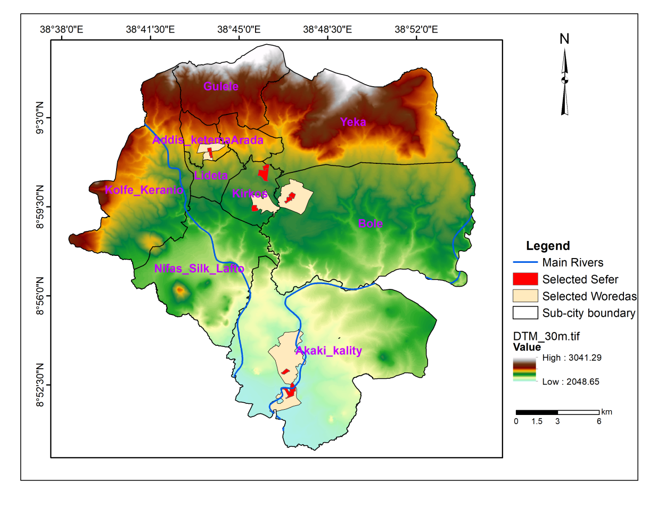
Figure 3.10: Study Area and selected sites where interviews held

Field Survey
The data used as base to draw the sample size is the 2007 Population and Housing Census of Ethiopia. Based on the data there were 662,728 in general and 235,764 households in selected sub-cities. The methodology to determine the sample size is based on the Yamane (1967)’s simplified formula to calculate sample sizes. Hence the sample size is determined by the equation 17 (at 95% confidence level and P = 5%).
$n=\frac{N}{1+N(e^{2})}$……………………………………………………………$(17)$
Where n is the sample size, N is the population size, and e is the level of precision.
Based on these formula 399 household samples were obtained. Rather than directly distributing these 399 households equally to four sub cities, purposive sampling technique also used in order to have accurate information to meet the intended objective of the research. This is because, for instance, the impacts of the extreme rainfall which creates flooding is not similar for the houses found along the river banks and other(even the distance of 50 meter difference from the stream creates huge difference on the property damage of the residents). Similarly, the distribution of places which could give a good indication for temperature change (mainly impacts by high rise buildings and old roofed houses) are found in different parts. Considering these observed situations on the ground, appropriate sefers (neighborhoods) were selected. Based on a proclamation to provide for registration of urban landholding number 818/2014 of Addis Ababa, sefer is the smallest administration unit with household units not more than 200. Table 3.9 presents the places where the survey was held.

Table 3-9: Specific places where the interviews took place
 | Subcity | Woreda | Number of Selected households | Specofic locality(sefer) names*
1 | Addis Ketema | Woreda 02 and woreda 08 | 113 | Chilalo Terara, Wancha Gebreyes, Sebategna
2 | Bole | Woreda 03 | 80 | Tele and Edna Mall Area
3 | Kirkos | Woreda 02 and woreda 02 | 120 | Kazanchis, ECA Area, Global
4 | Akaki Kality | Woreda o8 and woreda 03 | 80 | Melka Shedi Bireta Biret
 | Total |  | 393

Key Informant Interviews
The key informants were selected during the questionnaire filling process based on the information they give on the questionnaire, the informants who live for a long period of time in the area, good understanding of the changes in environment and those whom suffered more from impacts of climate change were selected and approached for further discussions. The key informant interviews held aiming at obtaining a deep attitude and perception on the, actual events, their risk and the long time experience they used to overcome the problem and to understand the general perceptional image of the community in detail. The approach also helps to identify the unique and major events might they faced in the places they live. The total of 12 key informant interviews were selected in each cases from for ages based on their live and educational backgrounds.

Type of Questionnaire
Close ended and some open ended questionnaires are prepared and given to the data collectors which are experts in the field. The questionnaire is developed in Amharic language, which is a prominent language for interview. The data were collected between January 2018 and February 2018. Respondents with 18 years of age and above were simply selected on the basis that they live within the area and the perceptions they feel at different age. The final questionnaire was used to collect information on socio-demographic characteristics of the residents, and their knowledge and perception of climate change, flooding, and climate change adaptation mechanisms. Collecting information on gender, age, and educational level of household head were included because they play an important role in shaping household perception (Deresa et al., 2009; Kabir, 2009). Data collectors were first informed of the aim of the interview, and some scientific terms in the questionnaire to explain to the respondents during the interview.
The questionnaire was designed to focus on three main topics: the general socio economic and demographic characteristics of the residents, the perceptions on temperature and precipitation changes and the vulnerability and adaptation activities being undertaken or proposed to be undertaken in the future to combat the impact of climate change. Data were tabulated and managed in an Excel spreadsheet. SPSS (Statistical Package for the Social Science) version 20.0 was used for data analysis. Chi-square distribution and p values were applied to display the number and percentage of household respondents for each question (variable). Tests were used to determine whether two variables are independent of, or related to, each other using the test of independence of variables. Most of the data were designed to reflect a 95% confidence level to ensure statistical significance.

Resilience Planning
The approach to propose a plan for continuous protection of environment and to reduce the vulnerability induced by climate change in Addis Ababa is based on various levels of analyses. The following are the major methods to address the planning gaps and why the problems are exacerbated and how it will be improved in the future

Using the findings from the previous objectives

On the previous objectives, key and important information have been identified, which used as an input for resilience planning recommendations. The results of the previous objectives starting from the GCMs downscaling to vulnerability mapping and perception assessment have been considered.

From identified Gaps in Review of available documents

Various governmental and nongovernmental as well as researches related documents with Environmental planning of Addis Ababa have been assessed. Reviewing these available documents is to enquire the degree at which the issue of climate change is addressed in the document and to understand the methods were used by these documents. However, the aim of this research is not to propose a new urban plan or a master plan, rather, it tries to see the undisclosed plans, filling the gaps, implementations and the new options for climate change resilience plans within the available planning environment in Addis Ababa. These data are broadly classified into two types. These are methodological reviews and reviews of available documents of climate change in Ethiopia. .

Methodological Reviews
- World Bank Method to urban resilience planning
World Bank identifies four components of urban resilience for urban climate related hazards. These are social, infrastructural, economic and institutional (WB, 2012).
- Social Resilience refers to the demographic profile of a community including by sex, age, ethnicity, disability, socio-economic status and other key groupings, as well as a community’s social capital. Social capital, although it is difficult to quantify, refers to a sense of community, the ability of groups of citizens to adapt, and a sense of attachment to a place.
- Infrastructural Resilience refers to the vulnerability of built structures including property, buildings and transportation systems. It also refers to sheltering capacity, health care facilities, the vulnerability of buildings to hazards, critical infrastructure, and the availability of roads for evacuations and post-disaster supply lines. Infra- structural resilience also refers to a community’s capacity for response and recovery.
- Economic Resilience: refers to a measure of a community’s economic diversity as well as to the overall employment, number of businesses, and their ability to function following a disaster.
- Institutional Resilience: refers to the governmental and non-governmental systems that administer a community.
- Resilience community documents: Resilience Community, 2005 also provided four interconnected research theme for prioritizing urban research. These are:
- Metabolic flows: production, supply and consumption chains
- Governance networks: Institutional structures and organizations.
- Social dynamics: Demographics, human capital and inequity
- Built Environment: Ecosystem services in urban landscapes (Resilience Alliance 2007).

Review of Data Regarding Climate Change in Ethiopia and Addis Ababa
Many climate related documents which address the issue of environmental change in Ethiopia, specifically Addis Ababa were identified. Some of them are very general and not use for decision. Therefore, only selected documents have been chosen for consideration. These are:
- Ethiopia’s Climate-Resilient Green Economy Green economy strategy
- Manual for the Preparation and Implementation of Basic Plans (Structure Plans) of Small Towns of Ethiopia
- Ethiopia National Urban Green Infrastructure Standard-
- Climate Change National Adaptation Programme of Action (NAPA) of Ethiopia
- Central Statistical Authority Population Projection Documents
- Unlocking the Power of Ethiopia’s Cities a
- Enhancing Urban Resilience, Addis Ababa, Ethiopia (World Bank, 2015)
- Addis Ababa 2013-2023 Structural Plan Document
- Catchments and Vegetation Management study for Addis Ababa Rivers and Riverside Development plan project(Mekuria et al., 2017) World

Discussions with the professionals in the field
The urban planning and green area planning is a multidisciplinary planning which involves the many stake holders. When these planning recommendations are conducted the following discussions have been held with the experts in the field from different institutions (Table 3.10).
Table 3-10: Concerned stakeholders which take part in the discussions
Number | Offices held discussions with | Number of Experts | Background of the experts
 | Immovable properly registration | 5 | GIS, Civil Engineering, Geography
 | Urban Planning institute | 2 | Urban Planning
 | Addis Ababa Environment office | 1 | Environmental Science
 | Addis Ababa City fire and Disaster controlling agency | 1 | Disaster risk mgt
 | Addis Ababa university Planning (EiABC) | 3 | Architecture, Urban Planning
 | Addis Ababa transport agency | 2 | Transport Management
 | Addis Ababa city Land information system | 3 | GIS
 | Addis Ababa Rivers and Riverside Development and Climate change project | 2
 | Private Real Estate Companies | 2 | Urban Planning, Water Engineering

The experts include the architects, urban planners, geographers, GIS experts, economists, and environmentalist background both from the government and from the experts involved in real states. The following discussions had been held with the government bodies (Figure 3.11)
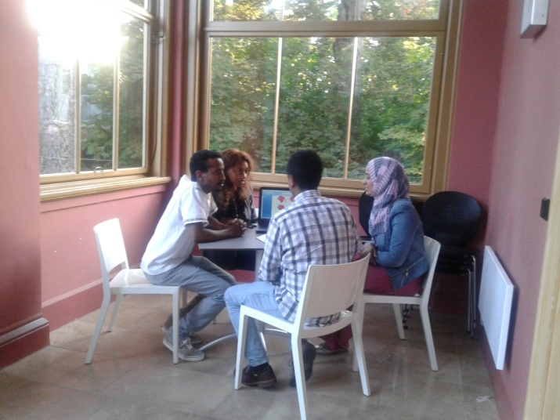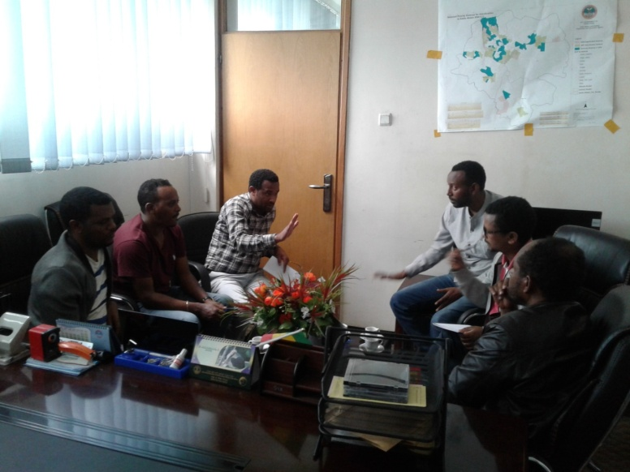
Figure 3.11: Discussions with different experts

Discussion with the Residents
Questionnaires were conducted in selected woredas, where high climate change vulnerability is witnessed by tangible impacts. During a questionnaire, people who met specific problems, experience losses from climate change were approached and open discussions were held with them (Fig 3.12). The discussion held with the key informant’s added additional information in understanding the depth of the problem. The vulnerability, the undertaken measures, and their need from the concerned body to be undertaken were the main focus of the discussion for the residents.
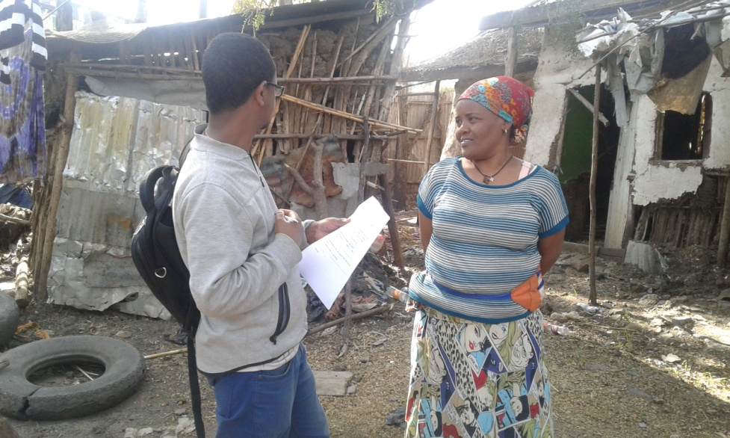
Figure 3.12: Discussions with Residents

Patch-corridor-matrix ecological model
In order to understand the land cover change undertaking in the surrounding mountains, the patch-corridor-matrix ecological model was used. This was mainly applied on mount Wochecha as a case study, among the mountain chains found around Addis Ababa, which have a great influence on the climate of Addis Ababa. Once the land cover types are identified from satellite images, the analyses of landscape structures followed. The landscape structure has been analyzed using the landscape indices. The landscape indices are generated using patch analyst version 2.2 extension tool in ArcGIS which is also an extension for Fragstats software. The generated landscape indices has been divided into three groups (McGarigal etal., 2002):
Patch-level metrics: which are measures of individual patches and
their spatial character or context,
Class-level metrics: which are measures of one patch type (class) existing in the landscape and can either be derived by averaging or calculated separately, so that they reflect an aggregate property of the patches in a particular cover type,
Landscape-level metrics: measures extending over the whole of a landscape and are similarly derived by averaging or calculated using all the patches in all classes.
With regard to landscape analyses the following analyses were undertaken using patch analyst extension
Landscape patch analysis: Landscape patch, as the base of landscape pattern, can be described by the number of landscape patterns, the quantity of each pattern, the area of each pattern, the average area of patch, the coefficient of area variation for patch, standard difference of area, max patch index and so on. These characters can reflect the status of landscape pattern.
Patch shape index analysis: The shape index of patch is generally the proportion of the width of a patch to the area of the patch.
Fragmentation analysis: Fragmentation of landscape is the process
that the landscape changes from simple to complex due to the natural and artificial factors. There are many indices to describe fragmentation. In this paper, average area, fractal dimension, departure and density of patches were used to analyze the fragmentation of the landscape in study area. Generally speaking, for a patch, the larger the degree of human activity, the simpler the geometry shape of the patch, leading to more linear boundary, the lower the fractal dimension of the patch and vise versa.
Landscape pattern analysis: The Shannon's diversity and evenness index were used to analyze landscape pattern.
The main advantage of patch – corridor - matrix model is a functional aspect - it is mostly focused on relations between elements. On the other hand, map of geocomplexes give the spatial dispersion of most components not only land cover. Both are applied in planning from local to regional (Cieszewska, 2000)

Methodological Framework

The process starts with observed meteorological data analysis. The observed data used to generate a trend in climatic elements of the past, in one hand and for model calibration and validation in SDSM in the other hand. The change result also serve as an exposure layer in vulnerability analysis. The GCM data analysis ends with scenario generation and for resilience planning recommendation. The second part is satellite image analysis, which helps to generate the land cover map and LST. The LST map also serves as one input in flood risk map preparation and also serves as an input in exposure layer. The final vulnerability analyses contain exposure, sensitivity and adaptive capacity layers. The CVI is also generated from these layers. Survey on perception and attitude was also considered when resilience planning is prepared. Possible adaptation plans will take places. The general methodological flow chart is presented in Figure 3.14.
Vulnerability Analysis
CVI
Sensitivity
Adaptive Capacity
Survey on Climate Change Perception and Attitude
Climate Change Resilience Planning
Exposure
LST Map
Land Cover Analyses
Satellite Image
Flood Risk Map
Trends
Analyses
Observed
Data
Calibration

SDSM
Historical Data Generation
Scenario Generation
GCM Data
Validation

Figure 3.13: Methodological Flow Chart

Results

Trends in Observed and Downscaled Temperature, Precipitation and Extremes

Trends in Observed Temperature and Preciptation Data
The computed rate and magnitude of change in temperature within the last 60 years, segmenting into two period’s average, both maximum and minimum temperature, shows increment. The average maximum temperature for the period 1957-1986 was 22.41ºC, however, the average maximum temperature for the periods of 1987-2016 was increased to 23.56 ºC exceeded the first 30 years average by by 1.1ºC. Segmenting the record of 60 years into 20 years, the shift of average maximum temperature per two decade 1957-1976 is 22.28 ºC, 1977-1996 is 22.9 ºC, and 1997 to 2016 is 23.78 ºC. The rate of change in 1957-1976 and 1977-1996 was 0.62 ºC while the rate of change in 1977-1996 and 1997-2016 was 0.88 ºC for maximum temperature. This indicates the temperature is increasing per decade. Average maximum temperature for Addis Ababa Obs. for the period 1957-2916 was 22.99 ºC. The highest maximum temperature is recorded within the last 60 years is in 2015, which was 24.3 ºC. All of the ten warmest maximum temperature records were observed after 1997.
The average minimum temperature of 1957 to 1986 was 9.83 ºC and average minimum temperature of 1987-2016 was 10.94 ºC. It was increased by 1.1ºC, within the two period’s average. The average minimum temperature within 20 years was 9.3 ºC for 1957-1976, 10.78 ºC for 1977–1996 and 1997-2016 was 11 ºC. The highest minimum temperature was registered in 2002, about 11.8 ºC. The lowest minimum temperature recorded so far within 60 years was in 1957, about 7.97 ºC. The highest value of minimum temperature was recorded in 2002 (11.87 ºC). The average minimum temperature of Addis Ababa in 1957- 2016 is 10.38ºC. The mean temperature at Addis Obs. from 1957-2016 was 16.68 ºC. The average maximum temperature and average minimum temperature of 1957- 2016 is given Figure 4.1.

Figure 4.1: Maximum, minimum and mean temperature
Source: NMSA, constructed by the Author
It is easy to understand the changes when the values are expressed in terms of anomalies. Anomalies are the difference between the mean value and the recorded result of the year). In view of this the highest value of the anomaly is recorded for the year with high maximum and minimum temperature. The negative values in the anomaly indicates the temperature value of the year is below the mean of 60 years in this study and the positive values indicate the recorded result of the year is above mean value of 60 years (10.38 ºC mean value for minimum temperature and 22.99 ºC mean value for maximum temperature for the last 60 years). The minimum and maximum temperature anomalies indicate that both values are rising. The temperature anomalies are given in Figure 4.2 for both maximum and minimum temperature for the last 60 years, for Addis Ababa

Figure 4.2: Maximum (above) and minimum (below) temperature anomalies
Source: NMSA, constructed by the Author
The average annual total rain fall for Addis Ababa Obs.from 1957-1986 was 1179.5 mm while the average mean value of 1987-2016 was 12056 mm, exceeding the firt 30years avegare by 27.3 mm. The rain fall didn’t show a rise or decrement but within each decade it is in insignificant rise (Figure 4.3).

Figure 4.3: Rainfall (1953-2013)
Source: NMSA, constructed by the Author
Of the last 60 years, fifteen top periods with the highest rainfall records are identified. Accordingly, 7 of the years with the highest record of rainfall were within the first 30 years and the others were observed after 1993. The highest precipitation is recorded in July and August. On average a rain fall of 252 mm to 272 mm will be recorded in these months. The highest numbers of rainy days are in July and August. The precipitation anomalies are given in Figure 4.4

Figure 4.4: Preciptation Anomalies

Performance of the SDSM Model Validation and Calibration Result
Prior to future scenario construction the results of the observed data of maximum temperature, minimum temperature and precipitation are correlated with the modeled data during the calibration and validation periods using the coefficients of determination and standard errors. The calibration period for Addis Ababa station is 1971–1985 and for Entoto station it is 1989–1998. The coefficient of determination for Addis Ababa Observatory is 0.63(NCEP and CanESM2) and 0.4(CGCM3) for maximum temperature and 0.68(NCEP) and 0.66(CanESM2 and CGCM3) for minimum temperature during the calibration period for both CanESM2 and CGCM3 models. The correlation coefficient of determination for precipitation is 0.09, 0.011, and 0.010 in the NCEP, CanESM2, and CGCM3A2 models, respectively, for Addis Ababa station. In the unconditional process the calibration and validation period’s coefficient of determination (R²) and standard error are similar. The R² for precipitation at Addis Ababa station is higher than in the validation period.
The R² for precipitation is the lowest due to it being a conditional process and having a less regular distribution than the temperature distribution. Unconditional models assume a direct link between the regional-scale predictors and the local predictand. For example, local wind speeds may be a function of gridded airflow indices such as the zonal or meridional velocity components. Conditional models, such as for daily precipitation amounts, depend on an intermediate variable such as the probability of wet-day occurrence (36). The R² and standard error of the calibration and validation period are summarized in Table 4.1.

Table 4-1: Result of model calibration and validation
Addis Ababa obs. Calibration Period (1971–1985) |  |  |  |  |  |  |  |  | Addis Ababa obs. Validation Period (1986–2000)
Model |  | Maximum Temp. |  |  | Minimum  Temp. |  | Precipitation |  | Maximum Temp. |  |  |  | Minimum  Temp. |  |  | Precipitation
 |  | R² |  | SE | R² | SE | R² | SE | R² | SE |  |  | R² | SE |  | R² |  | SE
NCEP |  | 0.63 |  | 1.34 | 0.68 | 1.21 | 0.09 | 9.02 | 0.58 | 1.45 |  |  | 0.63 | 1.12 |  | 0.02 |  | 9.55
CanESM2 |  | 0.63 |  | 1.36 | 0.66 | 1.18 | 0.01 | 9.00 | 0.57 | 1.46 |  |  | 0.65 | 1.17 |  | 0.01 |  | 9.50
CGCM3 |  | 0.64 |  | 1.34 | 0.66 | 1.17 | 0.01 | 9.00 | 0.58 | 1.44 |  |  | 0.64 | 1.17 |  | 0.06 |  | 9.58
Entoto Station Calibration Period (1989–1998) |  |  |  |  |  |  |  |  | Entoto Station Validation Period (1999–2003)
NCEP | 0.58 |  | 1.32 |  | 0.65 | 1.10 | 0.031 | 9.30 | 0.60 |  | 1.4 | 0.40 |  |  | 1.00 | 0.01 | 8.20
CanESM2 | 0.62 |  | 1.35 |  | 0.64 | 0.09 | 0.04 | 9.30 | 0.63 |  | 1.36 | 0.41 |  |  | 0.97 | 0.04 | 8.20
CGCM3 | 0.61 |  | 1.36 |  | 0.65 | 1.10 | 0.03 | 9.37 | 0.62 |  | 1.38 | 0.43 |  |  | 1.00 | 0.04 | 8.22

R²: Coefficient of determination; SE: Standard Error. Autoregressive terms are added on all R² and SE values in SDSM.
The performance of the model is tested by constructing the plots for the observed and modeled data during the calibration period. The validation period for Addis Ababa station is 1986–2000 and the validation period for Entoto station is 1999–2005. As observed from the graphs, the observed maximum temperature values and the graphs are well simulated with pattern characteristics both at Addis Ababa and Entoto stations. Except for the CGCM3 at Addis Ababa station, all the models overestimate the minimum temperature for values below 8 °C and above 11 °C. Details of the models of the quantile plots are shown in Figure 4.5
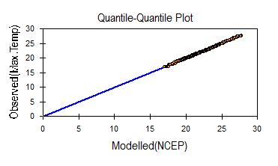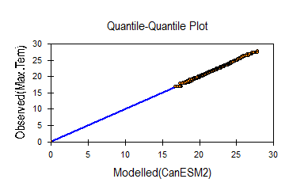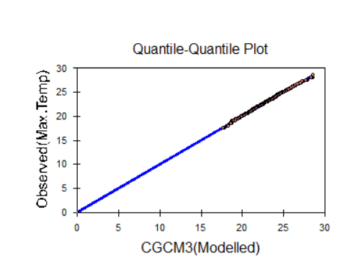
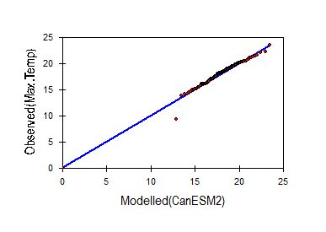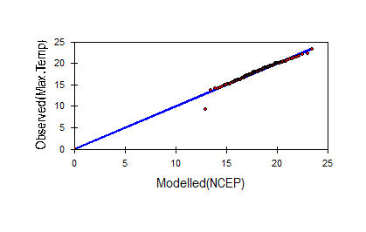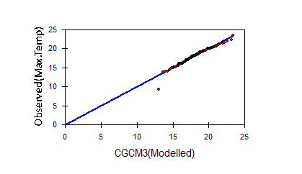
Figure 4.5:Quantile–quantile (Q–Q) plots of observed versus modeled maximum temperature (°C) at Addis Ababa (upper) and Entoto (bottom) stations.
The plot has a normally distributed population. The modeled maximum temperatures are exactly the same as the observed temperatures, shown as fitted lines for the Q–Q plots (except for records for values less than 12 °C that overestimate the maximum temperature at Entoto station). The Q–Q plot for minimum temperature is normally distributed at Addis Ababa station. At Entoto station, however, all models overestimate the highest and lowest values. The Q–Q plot fits between 6 °C and 10 °C. The Q–Q plots of minimum temperature at Addis Ababa and Entoto stations are given in Figure 4.6.
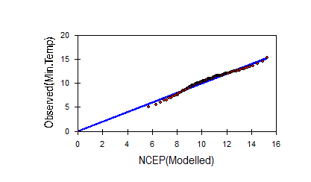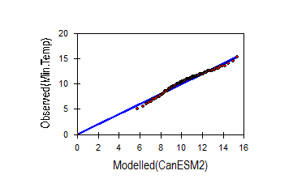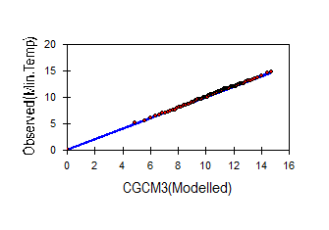
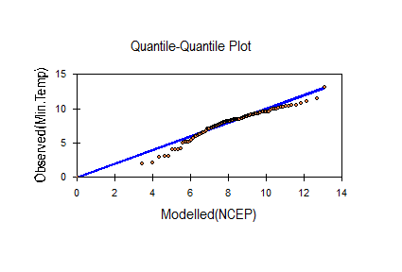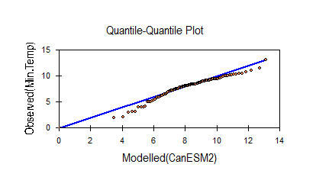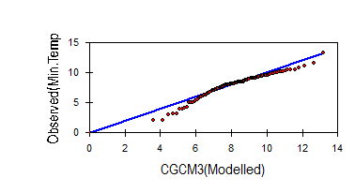
Figure 4.6: Quantile–quantile plots of observed versus modeled minimum temperature (°C) at Addis Ababa (upper) and Entoto (bottom) stations during the validation period

Similarly, simulated daily precipitation is modeled against the observed precipitation.
The Q–Q plots of daily precipitation of the validation period are given in Figure 4.7.

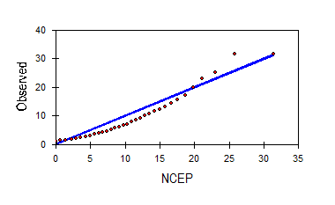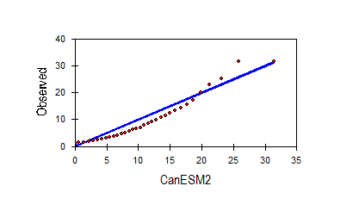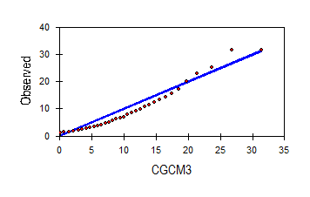
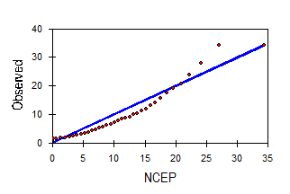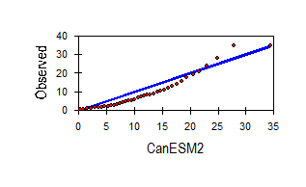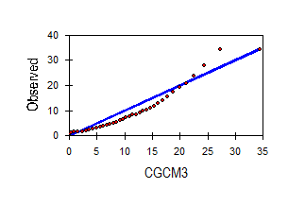
Figure 4.7: Observed and modeled precipitation at Addis Ababa (upper) and Entoto (bottom) stations during the validation period.

Future Temperature and Precipitation Change Scenarios

Temperature
Future temperature predictions from all downscaled models under different scenarios show that both maximum and minimum temperature increase in magnitude and intensity in Addis Ababa up to the end of this century. According to the models, the change ranges from 0.03 °C for the minimum temperature at Entoto in 2020 to 2.1 °C by 2080 using the CGCM3A2 projections and considering RCP4.5 in the worst case scenario for maximum temperature. All models project increases of the maximum temperatures from 0.03 °C–0.21 °C using the CGCM3A2 and RCP4.5 models in 2020. In 2050, the maximum temperature increases by 1 °C in the CGCM3A2 scenario. In all scenarios the projected maximum temperature in 2020 is the highest at Entoto station. The minimum temperature is also projected to increase by 1.03 °C in 2080 under the A1B scenario at Entoto station. The minimum temperature change at Addis Ababa station is the lowest in 2020. The minimum temperature at Entoto station increases more than the maximum temperature in the 2020s. In 2050 the minimum temperature ranges from 0.29 °C (RCP4.5) to 0.32 °C (RCP8.5) at Addis Ababa station. In 2080, the CGCM3A2 model projects an increase of 0.6 °C for the minimum temperature at Entoto station and 0.75 °C under the RCP8.5 model at Addis Ababa station. It is observed that the rate of change for the minimum temperature at a higher altitude is much higher than the rate of change at a lower altitude at Addis Ababa. However, the change in maximum temperature is higher in the downtown than in the peripheral areas (Entoto).
The results from all models under multiple scenarios indicate that precipitation will continue increasing until the end of this century. In the CanESM2 model under the RCP8.5 scenario and the CGCM3A2model, the precipitation is projected to increase by 16.6% compared to the baseline period. Though the changes in the precipitation value by 2020 are not significant, as concluded from the results of future scenarios, the prediction of precipitation will continue to increase in 2050 and 2080. In 2050, under the worst-case scenario, precipitation will increase by 8.7% compared to the baseline period. In 2080, the highest projection is 16.6% (RCP8.5), followed by the CGCMA2 scenario, which is 11.7% at Addis Ababa station. At Entoto station, the rate of change in 2080 is projected to be 2.58%, 8%, 7.8%, and 11.8% under the RCP4.5, RCP8.5, CGCM3A1B, and CGCM3A2 scenarios, respectively. The summaries of maximum and minimum temperature predictions from three models for the six scenarios are presented in Table 4.2.
Table 4-2: Downscaled temperature (°C) and precipitation (%) scenarios (changes)
Station | Predictands | Year |  | CanESM2 |  |  |  | CGCM3
Station | Predictands |  |  | RCP4.5 |  | RCP8.5 |  | A1B |  | A2
Addis Ababa obs.  (Baseline period  1971–2000) | Maximum  Temperature | 2020s  2050s  2080s |  |  | 0.09  0.41  0.52 | 0.06  0.61  1.20 |  | 0.09  0.77  1.31 |  | 0.12  1.00  2.06
Addis Ababa obs.  (Baseline period  1971–2000) | Minimum  Temperature | 2020s  2050s  2080s |  |  | 0.02  0.239  0.30 | 0.02  0.39  0. 70 |  | 0. 36  0.18  0.28 |  | 0.07  0.14  0.27
Addis Ababa obs.  (Baseline period  1971–2000) | Precipitation  (% Difference) | 2020s  2050s  2080s |  |  | 1.28  3.82  7.49 | 1.30  6.20  16.6 |  | 1.08  4.02  7.40 |  | 2.30  8.70  11.7
Entoto  (Baseline period 1989–2003) | Maximum  Temperature | 2020s  2050s  2080s |  |  | 0.09  0.22  0.28 | 0.09  0.41  0.71 |  | 0.17  0.57  0.84 |  | 0.21  0.56  1.01
Entoto  (Baseline period 1989–2003) | Minimum  Temperature | 2020s  2050s  2080s |  |  | 0.03  0.07  0.10 | 0.03  0.09  0.14 |  | 0.25  0.69  1.04 | 0.20  0.57  0.99
Entoto  (Baseline period 1989–2003) | Precipitation  (% Difference) | 2020s  2050s  2080s | 1.10  2.57  2.58 |  |  | 0.60  4.80  8.00 | 1.24  2.80  7.80 |  | 1.36  2.70  11.8

Changes in Temperature Extreme Indices
The results of the extreme events analyses are important for this study. Temperature indices are studied based on their changes within each season. In all the seasons, the maximum value of the maximum temperature (TXx) is projected to increase in 2080 with the highest projection reaching 3.20 °C (A2). Except for the RCP8.5 scenario, the CGCM3A2 scenario in 2020 and CanESM2 RCP8.5 scenario in 2050 all the maximum value of the minimum temperatures (TNx) will increase to a non-significant degree (Figure 4.8).
TXx (°C | TNx (°C)
TXn (°C) TNn (°C)
Figure 4.8: Changes in selected temperature extreme indices.
In winter and spring the TNx value decreases, while in summer and autumn the TNx value is projected to increase The year-round prediction has a positive value. Regarding the minimum values of the minimum temperature (TNn), half of the scenarios indicate that TNn decreases. In 2050 and in 2080 all the CanESM2 scenarios project that the TNn value decreases. Details of the temperature indices based on the seasonal changes in 2020, 2050, and 2080 are given in Figure 4.8.

Future Changes in Precipitation Extreme Indices
The precipitation indices show different changes in intensity and amount, indicating incremental changes in the precipitation amount. Except for the RCP8.5 scenarios in 2020, CGCM3 in 2050, and A2 in 2080, all the models predict Rx1 increases. The highest value is 7.22% in 2050. However, specifically for autumn, the prediction falls to −11.3%. Similarly, the Rx5day is expected to increase in 2050 for most of the models. The highest Rx5day predictions are 21% (RCP4.5) and 17.6% (RCP8.5) in winter 2020 and 2080, respectively. Regarding the total precipitation index (PTOT), the highest is in 2080 at 17.96% (RCP8.5). The greatest change is in the winters of the 2080s, for which a value of 29.30% (RCP4.5) is predicted, and in summer a value of 20.9% (RCP8.9) and 19.13% (CGCM3A2). Consecutive wet days are expected to increase by 27.3% (RCP8.5) in 2050, and the highest value for this is in summer 2080 at 28% (RCP8.5). Consecutive dry days are projected to decrease from 2020–2080 in all models, with ranges from −0.6% in 2020 to −19.8% in 2080. Details of the precipitation indices are presented in Figure 4.9.
Rx1day | 99%le
PRCPTOT | Rx5day
CDD | CWD
Figure 4.9: Selected precipitation indices in percentages

Characteristics of Land Cover change and LST

Land Cover Changes
The land cover analysis starts with the oldest, 1986, period. During this time, the largest part of Addis Ababa is covered by agricultural lands. The southern and western parts of Addis Ababa were the main agricultural fields of the time. These places have a gentle slope, and are favorable for agriculture compared to the northern mountainous parts which has steep slope and covered by forests. In 1986, the built-up areas are mainly found in the Central and North Western parts of Addis Ababa. In 1995, the situation was also similar with the previous period, except during this time the dominant land cover is built-up area. The built-up area is increasing to the southern and western direction of the city. Significant change has not happened to the forests that confined to the Northern and North Western part of the city. However, during this time, the open and agricultural lands were diminished from their previous coverage. The bare ground also increased.
In 2007, the forest land was deteriorated considerably. The period when built-up areas are increased by nearly one third, is when peak changes in the cities land cover change has happened (Figure 4.10). In 2017, the rate of changes to forest has decreased compared to the previous decades due to the implementation of the confined forests and controlling measures the government has put in place. However, in all directions of the city, the built-up area increases in the expense of open and agricultural lands, to the boundaries of the town. Due to the expansion of road networks, highways, railways and other transportation routes, the coverage of bare ground increases in 2017 with the highest rate.

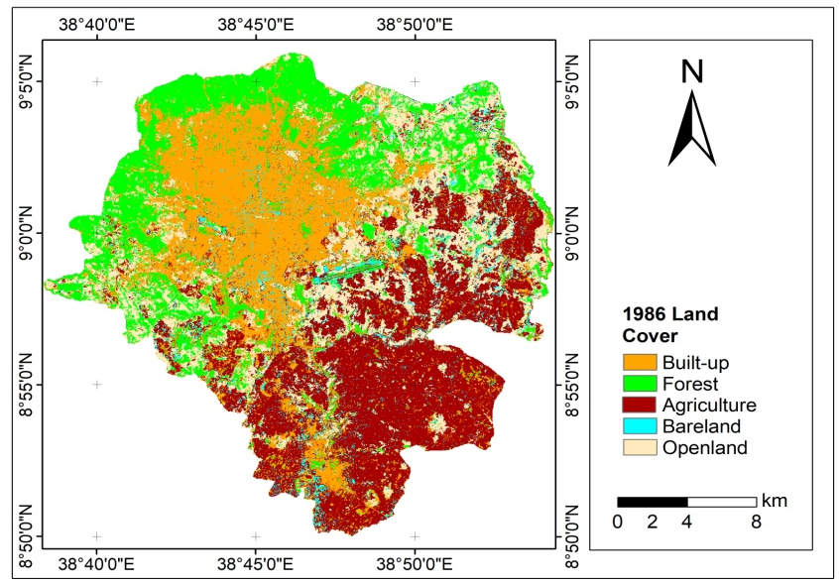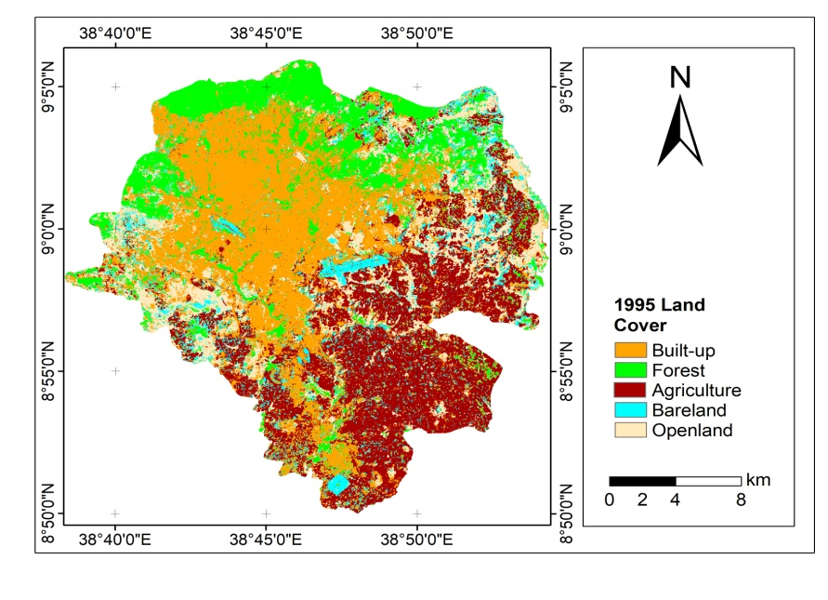
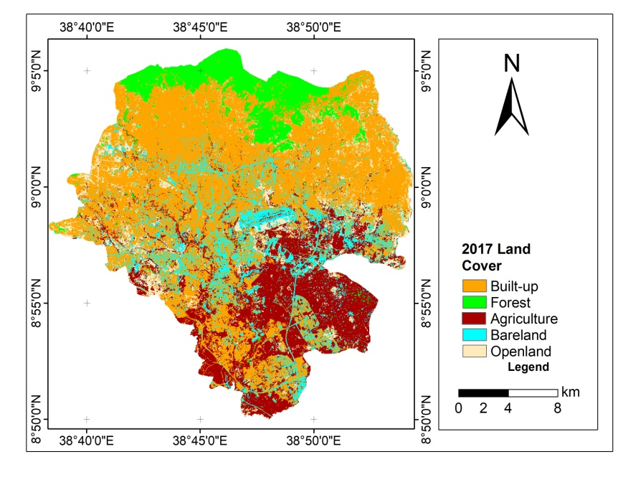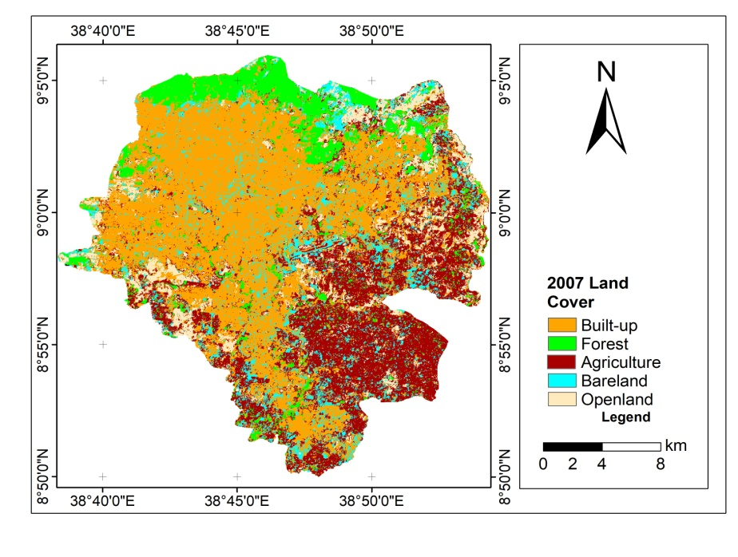
Figure 4.10: Land covers classes of the study area
The coverage of each land cover type is given in Table.4.3.
Table 4-3: Summary of land cover classes in km²
 | 1986 | 1995 | 2007 | 2017
Built up area | 146.3 | 179.75 | 239.14 | 264.73
Agriculture | 152.99 | 137.77 | 129.92 | 103.42
Open land | 91.72 | 78.86 | 46.52 | 41.66
Forest | 102.66 | 79.85 | 51.75 | 49.11
Bare ground | 27.80 | 45.38 | 54.17 | 70.3
Many other studies also show similar changes in these land cover classes. For example, Change analysis of higher level urban morphology Types between 2006 and 2011 revealed that surface cover types of built structure type I (generally well planned and high rise buildings), non-eucalyptus trees, dark bare-ground, light bare-ground and vegetable farm showed positive change whereas built structure type II (informal, generally unplanned, and non-high rise buildings), eucalyptus trees, shrub/bush vegetation, grassland and field crop cover showed negative change(Woldegerima, 2016). The four times land cover class is given in Figure 4.10.

Land Surface Temperature
In 1986, the temperature distribution was largely determined by the topographic characteristics of the area, and the effect of land cover change was not identified clearly. The land surface temperature for that year was largely depending on the topography of Addis Ababa. As a result, the temperature continuously fell from North to South direction. The hottest pixels were found in low altitude areas and to some extent in built up areas. The temperature value ranges from 12°C to 38°C for January 1986, in 1995 also, the land surface temperature distribution, still the temperature is determined by topographic factors. The highest temperature > 25°C is found in low elevation, and the lowest land surface temperature is recorded for highland forests. Built up areas have a land surface temperature record of 20- 27°C, whereas the areas forest covered high elevation areas confined to the top of the Mount Entoto has the lowest temperature.
In 2007 and 2017 the highest land surface temperature is not only registered in low elevated places, but also in areas of high elevation covered by built up. Lideta, Addis Ketema, Arada and Kirkos sub cities, which area found in middle elevation, experiences highest land surface temperature, due to their housing and population density. In 2017, the value of land surface temperature is mainly determined by type of land cover, as easily identified from the LST distribution map. In 2017 except for the areas confined over the mountain of Entoto, and some open spaces and protected large green areas all parts of the town is covered by building. As a result of this highest land surface temperature is also recorded in high elevated areas with an elevation more than 2500m where built up is a dominant land cover type and vegetation cover is insignificant. Figure 4.11 depicts the LST distribution with ten years interval.
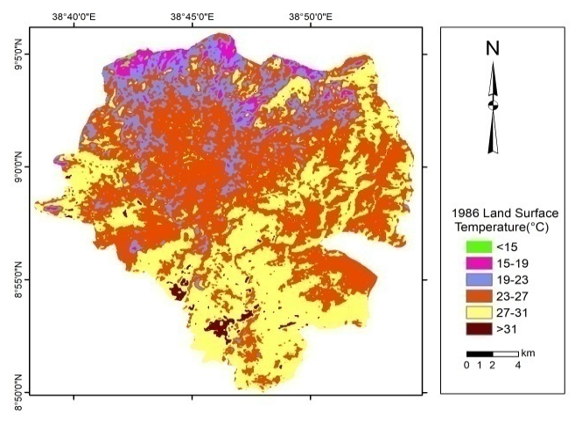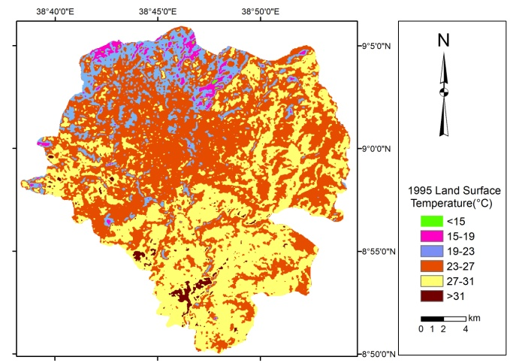
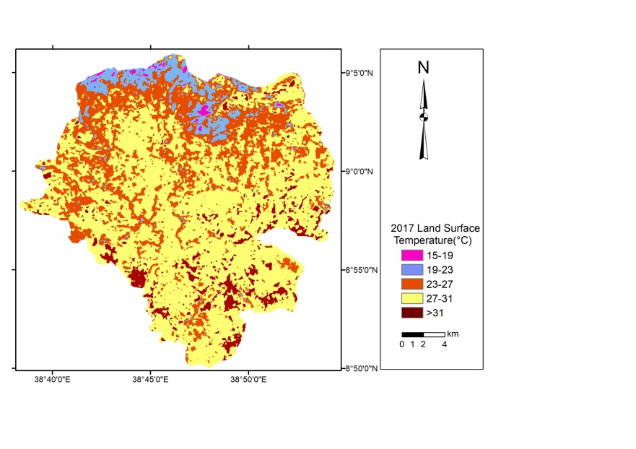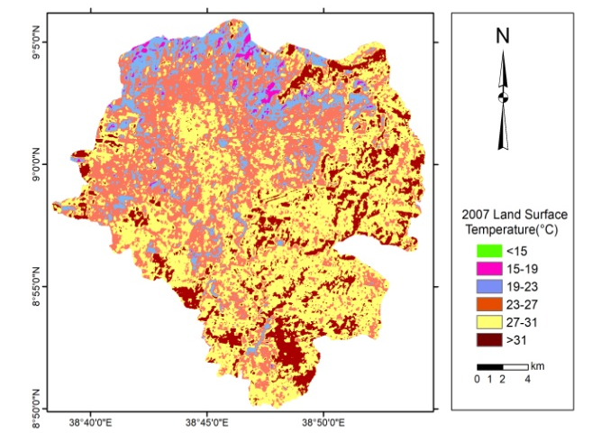
Figure 4.11: Land surface temperature of Addis Ababa at different time
Gulellee, Yeka and Kolfe Keraniyo have the lowest LST due to, high vegetation cover in these two sub-citiesand they are found in high elevation. Akaki and Nefas Silk Lafto, though they are sparsely populated and the density of the house is not high as the sub-citiesfound in the downtown, have the highest LST due to their lowest elevation. Addis Ketema, Kirkos, Lideta and Arada sub-cities which are found in high elevation, have highest LST because of high built ups. In general the land surface temperature in all sub-cities is increasing from 1986 to 2017 both in extreme values and mean values. A highest extreme LST value is in Akaki Kality sub-city. It is 36.97°C, 35.39°C, 39.69°C, and 35.06°C in 1986, 1995, 2007 and 2017 respectively. The lowest LST is in Gulelle. It is about 12.9°C in 1986 and 1995, 14.5°C, and 16.3°C in 2007 and 2017 respectively. Table 4.4 presents the minimum, maximum and mean land surface temperature of Addis Ababa in each subs cities, which generated by zonal statistics.
Table 4-4: Trends in minimum, maximum and mean LST

 | 1986 |  |  | 1995 |  |  | 2007 |  |  | 2017
 | Min | Max | Mean | Min | Max | Mean | Min | Max | Mean | Min | Max | Mean
Yeka | 13.0 | 31.8 | 25.1 | 12.5 | 32.6 | 24.6 | 15.1 | 37.4 | 26.2 | 15.9 | 36.5 | 25.9
Nifas_Silk_  Lafto | 15.3 | 33.8 | 26.6 | 17.6 | 34.2 | 26.3 | 12.3 | 35.6 | 27.6 | 21.4 | 36.3 | 28.0
Lideta | 19.0 | 29.7 | 25.2 | 20.8 | 28.1 | 24.7 | 19.9 | 33.3 | 27.1 | 23.3 | 32.1 | 27.9
Kolfe_Keraniyo | 14.4 | 34.6 | 25.3 | 13.4 | 32.6 | 25.2 | 15.6 | 37.9 | 25.9 | 16.9 | 33.7 | 26.7
Kirkos | 19.4 | 28.9 | 25.3 | 19.0 | 28.1 | 24.7 | 18.8 | 33.3 | 27.0 | 21.9 | 32.1 | 27.7
Gullele | 13.0 | 31.0 | 22.4 | 13.0 | 29.7 | 21.9 | 14.5 | 38.8 | 23.7 | 16.3 | 30.6 | 24.0
Bole | 17.6 | 32.6 | 26.7 | 17.6 | 32.6 | 26.4 | 12.3 | 37.0 | 28.9 | 15.1 | 34.1 | 28.4
Arada | 19.0 | 28.9 | 24.5 | 19.0 | 28.1 | 24.5 | 19.3 | 31.8 | 26.4 | 21.8 | 32.1 | 27.7
Akaki_kality | 13.9 | 37.0 | 27.9 | 13.9 | 35.4 | 27.9 | 12.8 | 39.7 | 29.1 | 17.9 | 35.1 | 29.2
Addis_ketema | 19.4 | 29.3 | 24.2 | 16.7 | 27.7 | 24.1 | 18.3 | 32.3 | 26.7 | 22.5 | 31.9 | 27.6

Shifts in Area Coverage of LST
It is important to consider, not only the extreme values or mean values, but also the area of each pixels from time to time. Because this also reduces the biases may arise from the general judgment based only on extreme values. The area covered by highest records of land surface temperature is increasing from a decade to decade. The majority of the places have 23°C to 27°C in 1986 and 1995, with 259 km² and 252km² respectively. However in 2007 and 2017 the highest area coverage was for land surface temperature between 27°C to 31°C which is 221km² in 2007 and 313km² in 2017. The class of temperature range below 15°C is not available in 2007 and 2017. The area covered by a land surface temperature of 21°C1-24°C is diminished from 60km² to 30 km² which, diminished by half between 2007 and 2017. Details of the area coverage with changes are given in the Figure 4.12

Figure 4.12: LST area share of Temperature distribution
Another important analysis is the land surface temperature distribution per subcity level.
Due to its time difference and seasonal difference, most of the time it is difficult to compare the direct LST value of different periods. Therefore, all the four times LST is converted to urban thermal environment index (UTEI). The index values between 0 which indicates the lowest LST and 1, the highest LST. In 1986 and in 1995, half of the northern part has the lowest UTEI whereas in 2007 and more in 2017, the indexes with the highest value is also found in any direction of the city, which indicates the highest temperature also expands due to the land cover changes. The urban thermal environment deteriorates with increasing frequency of extreme heat events in cities (Yue et al., 2017). Four times Urban Thermal Environment Index of Addis Ababa is given in Figure 4.13.
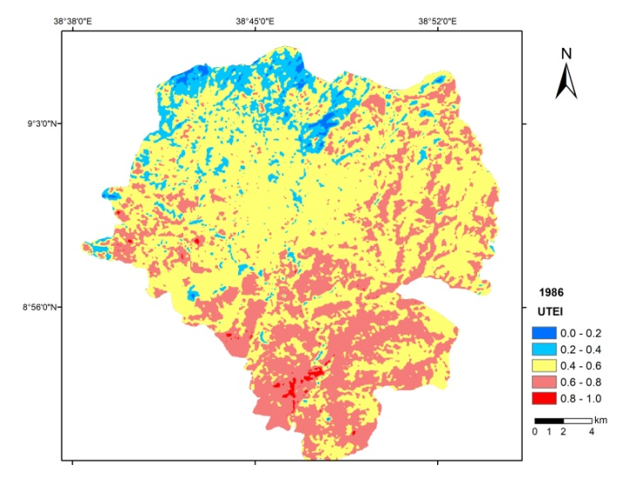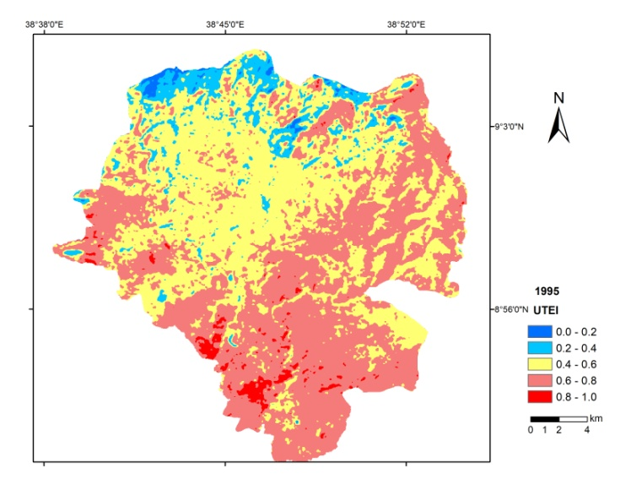
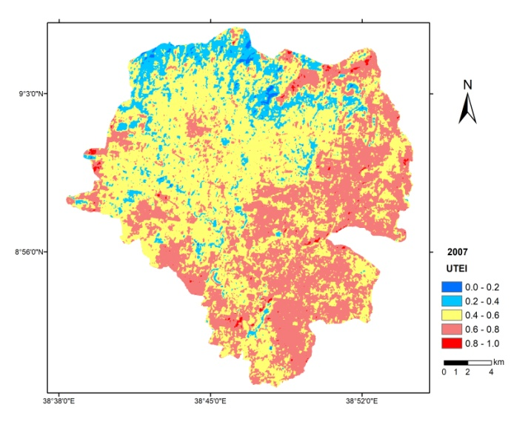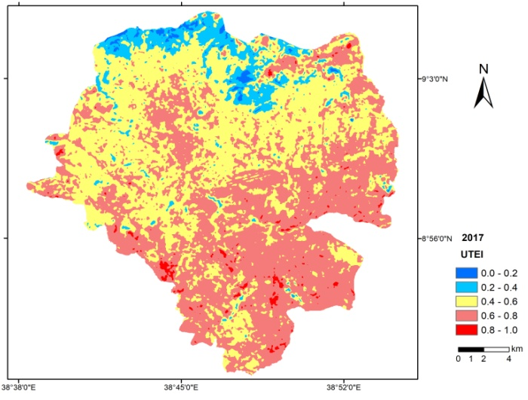
Figure 4.13: Urban Thermal Environment Index
Regarding the NDVI analysis the result Gulelle and Yeka sub-cities has the highest NDVI values due to these areas have more forest cover than other sub-cities. The Gulelle, botanic garden, which covers the highest point in Addis, is found in Gulellee sub-city, in the northern part of the city. Addis Ketema, Kirkos and Lideta have the lowest NDVI, because the land cover is highly built up areas and green places are found dispersedly in fragmented ways, like in small parks and recreational areas. We can easily understand that the forests have the great contribution in controlling the land surface temperature studies. Details of the NDVI value per sub-city are given in Figure 4.14.

Figure 4.14: Mean NDVI per sub-city

Relationship between land cover and land surface temperature
Moreover, the land surface at similar elevation (2300m) but with different land cover highly varies. On average the LST distribution of the given land cover classes vary highly and in an increasing rate from time to time. The forest cover has the lowest LST (21-24°C) while the urban built-up area and barren land (26-30.54°C) have the highest LST at specific elevation. Tree planting is one of the most cost-effective means of mitigating urban heat islands. Air temperature differences of approximately 2 to 4°C have been observed across urban areas having variable tree cover, with approximately 1°C of temperature difference being associated with 10% canopy cover difference. The indirect cooling effect of evapotranspiration is greater than the direct effect of shading. As the number of trees in an area increase, relative contribution of evapotranspiration to overall cooling goes up, mitigating the urban heat effect. Trees cool city heat islands by 10°C to 20°C (Alliance for Community Trees in 2011). The LST per different land cover is given in Figure 4.15.

Figure 4.15: LST per land Covers at 2300m elevation.

Elevation versus LST
It is obvious that an elevation does not change and it is constant any time. It is also clear that with the rise of elevation, temperature decreases. Addis Ababa is found in high elevated area that ranges from 2000 to 3000m above sea level. Itis noted that there is an elevation difference of 1000m between the highest and lowest points of the city. From the trends of the LST, the highest temperature is coming to the highland area smoothly. For example, 21°C record is on 2650m in 1986, while it is on 2750m in 2017, indicating nearly within 100m elevation rise, same temperature record is found within 30 years. The R² of LST with elevation in 1986 is -0.95 and -0.90, in 2017. This also indicates that though the elevation is constant, and the R² value is expected to be similar, it negatively increases which indicates the LST temperature distribution in relation to elevation is also affected by other factors, which could be land cover change in this case. R² between elevation and LST falls to which indicates the role of elevation is still high, but decreasing due to other land cover factors. The relationship between LST and elevation is given in Figure 4.16.

Figure 4.16: Relationship between Land Surface Temperature and Elevation

Comparison of LST within Housing Characteristics
It is important to differentiate the thermal characteristics of urban surfaces in Addis Ababa because; the general configuration and pattern of buildings are highly varied. Parts of the city has modern, high rise, quality houses and standard street trees like in Bole sub-city, while others majority of the places have low standard quality houses, old roofed materials and the green area planning rules are not preserved. In order to understand the effect of building type and planning on urban heat island distribution, we have divided the city in to two broad groups; these are high rise building areas, and the low rise building areas. 20 GPS points were selected from each selected places for comparison weather the urban heat island has similar characteristics in these places which are morphologically different, within one city.
- LST Characteristics in Low Rise old Roofed Buildings
20 points were selected from downtown, all from Addis Ketema Sub-city, Woreda 02 and Woreda 09(Figure 4.17).
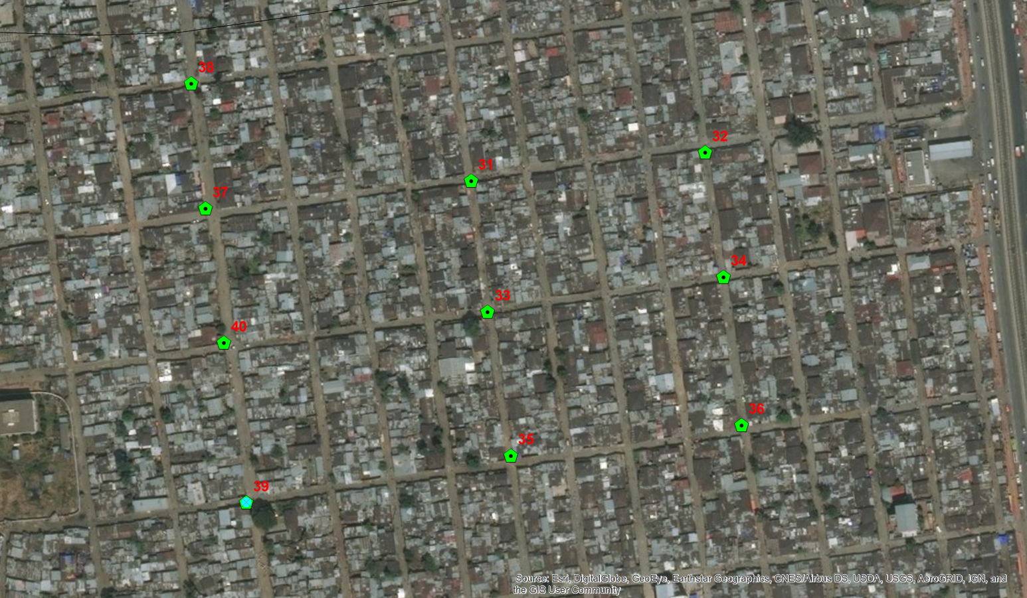
Figure 4.17: Low rise Buildings in Addis Ketema Worea 02

These Woredas have unique characteristics because of their building type, age and unavailability of urban green areas. Table 4.5 indicates the LST recorded in four times series of Landsat images.
Table 4-5: LST characteristics at selected places in Addis Ketema, Woreda 02 and 08
Woreda | Points | Elevation(m) | Land Surface Temperature in °C
Woreda | Points | Elevation(m) | T1 | T2 | T3 | T4
Woreda 08 | 21 | 2453 | 25.53 | 23.82 | 24.49 | 25.17
Woreda 08 | 22 | 2457 | 23.38 | 24.68 | 27.48 | 28.57
Woreda 08 | 23 | 2460 | 23.82 | 24.68 | 26.99 | 28.64
Woreda 08 | 24 | 2449 | 25.96 | 25.53 | 29.44 | 27.63
Woreda 08 | 25 | 2458 | 23.82 | 24.68 | 26.49 | 28.43
Woreda 08 | 26 | 2448 | 25.53 | 25.53 | 29.44 | 27.15
Woreda 08 | 27 | 2455 | 23.38 | 24.68 | 26.49 | 28.54
Woreda 08 | 28 | 2449 | 24.68 | 25.53 | 28.46 | 28.61
Woreda 08 | 29 | 2453 | 23.38 | 24.68 | 27.48 | 28.49
Woreda 08 | 30 | 2454 | 25.53 | 25.96 | 28.95 | 28.47
Woreda 02 | 31 | 2442 | 25.96 | 25.96 | 29.44 | 27.94
Woreda 02 | 32 | 2446 | 21.63 | 23.38 | 27.48 | 28.72
Woreda 02 | 33 | 2440 | 21.19 | 24.25 | 27.97 | 28.53
Woreda 02 | 34 | 2443 | 21.63 | 22.95 | 27.48 | 28.69
Woreda 02 | 35 | 2437 | 20.75 | 23.82 | 28.46 | 28.79
Woreda 02 | 36 | 2439 | 21.19 | 23.38 | 27.48 | 28.35
Woreda 02 | 37 | 2432 | 21.19 | 24.25 | 28.95 | 29.11
Woreda 02 | 38 | 2432 | 22.07 | 23.38 | 27.48 | 28.31
Woreda 02 | 39 | 2427 | 22.51 | 23.82 | 27.48 | 27.69
Woreda 02 | 40 | 2430 | 22.95 | 24.25 | 26.99 | 28.05
Note: T1, T2, T3, T4 LST in °C in 1986, 1995, 2007 and 2017 respectively.
As shown in Figure 4.17, the selected GPS points are overlaid by recent Google Earth image, to confirm the land cover types identified from Landsat Satellite image analyses. Similar characteristics of urban landscape and building types are available in these woredas (districts). In these areas, though the elevation of each point is more than 2425m above sea level, due to the urban surface characteristics, and more heat is trapped by these old roofs, the land surface temperature record was high.
In these areas, the houses are very close to each other, the roofs are old, improper urban planning and no street trees are found as shown in Figure 4.18.
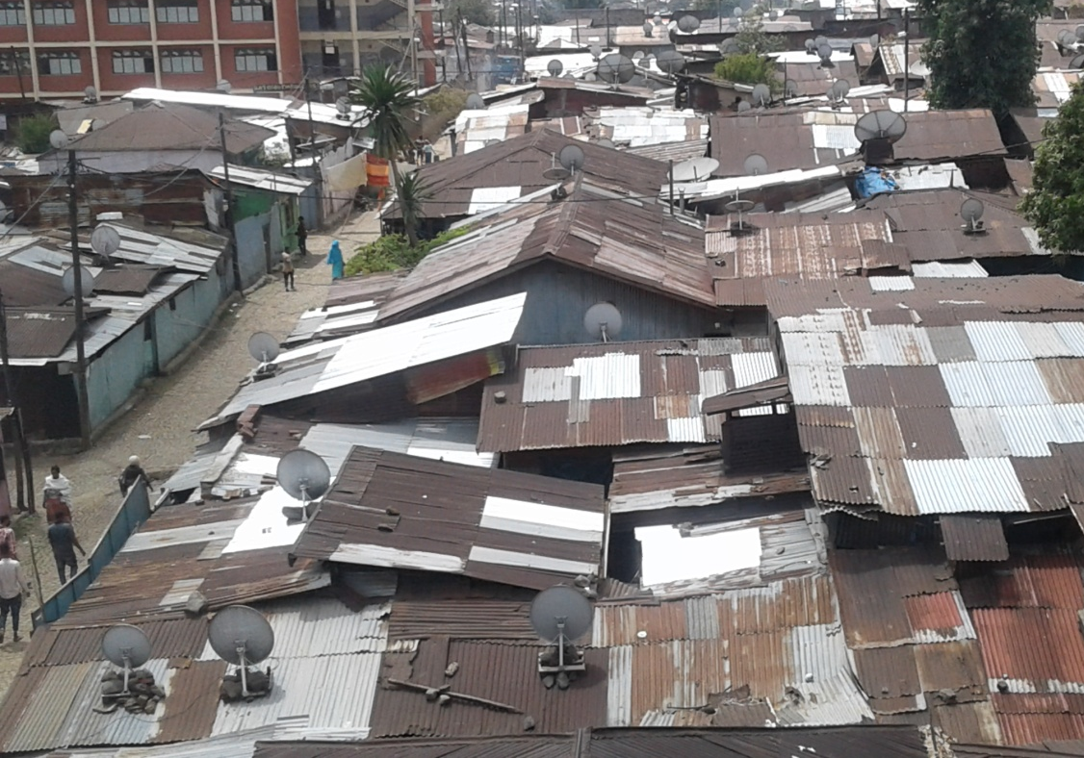
Figure 4.18: Houses of in Addis Ketema Woreda 02
(Source: Photographs taken by the author in December 2017)

- LST Characteristics in a High Rise Buildings
High rise building areas selected for the analyses is found in Bole Sub-city Woreda 03 and Kirkos Sub-city Woreda 08. The specific name for Bole Woreda 03 area at which these analyses were conducted is Edna mall area. In this area, many high rise, modern buildings are found. The streets are well planned and have street trees along the road. The other place is in Kirkos Woreda 08 specifically known as Kazanchis where the African Economic Commission and many other international hotels and high rise builds are found. Collected GPS points overlaid on Google Earth of Bole Edna Mall area is given in Figure 4.19.
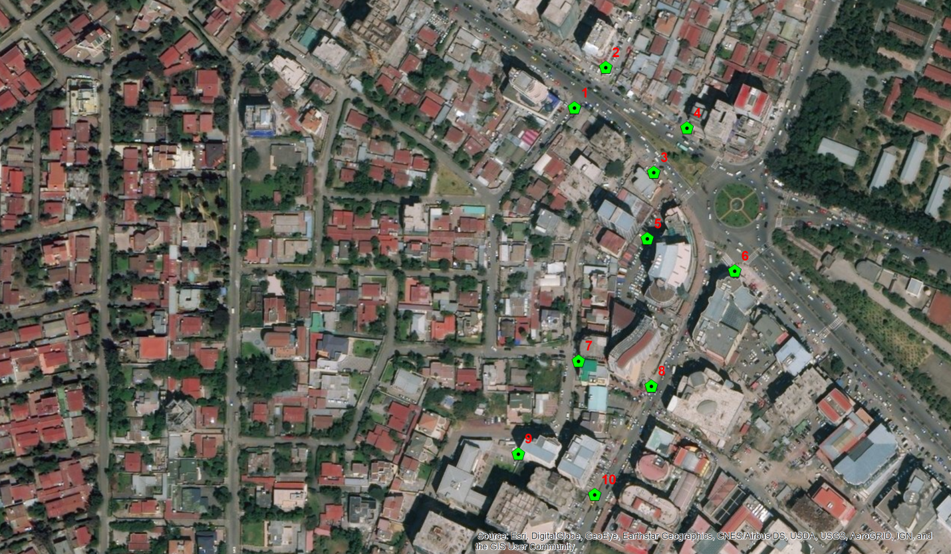
Figure 4.19: Bole Woreda 03 Collected points overlaid on Google Earth Image
The reading of each point in Degree centigrade is given in Table 4.6.

Table 4-6: LST characteristics at selected places in Bole and Kirkos Sub-cities
Sub-city | Specific place name | Pt. | Elevation(m) | Land Surface Temperature
 |  |  |  | T1 | T2 | T3 | T4
Bole | Woreda 03 | 1 | 2347
Bole | Woreda 03 | 2 | 2347 | 23.82 | 24.25 | 27.48 | 27.02
Bole | Woreda 03 | 3 | 2347 | 24.25 | 23.82 | 27.97 | 26.47
Bole | Woreda 03 | 4 | 2348 | 23.82 | 24.25 | 27.97 | 26.23
Bole | Woreda 03 | 5 | 2345 | 23.82 | 23.82 | 28.46 | 26.49
Bole | Woreda 03 | 6 | 2345 | 23.82 | 24.68 | 27.48 | 26.04
Bole | Woreda 03 | 7 | 2342 | 26.38 | 25.11 | 27.97 | 26.00
Bole | Woreda 03 | 8 | 2343 | 24.25 | 25.11 | 25.50 | 25.38
Bole | Woreda 03 | 9 | 2338 | 25.53 | 25.53 | 26.49 | 25.03
Bole | Woreda 03 | 10 | 2339 | 25.96 | 24.25 | 26.00 | 25.11
Kirkos | Kazanachis | 11 | 2377 | 25.96 | 25.11 | 25.00 | 24.77
Kirkos | Kazanchis | 12 | 2374 | 23.38 | 22.95 | 23.99 | 24.35
Kirkos | Kazanchis | 13 | 2371 | 23.82 | 23.82 | 26.99 | 25.76
Kirkos | Kazanchis | 14 | 2379 | 25.96 | 25.53 | 29.44 | 27.35
Kirkos | Kazanchis | 15 | 2367 | 25.53 | 25.96 | 26.99 | 26.50
Kirkos | Kazanchis | 16 | 2365 | 25.53 | 25.96 | 25.50 | 25.59
Kirkos | Kazanchis | 17 | 2365 | 24.25 | 25.53 | 29.44 | 23.73
Kirkos | Kazanchis | 18 | 2368 | 24.25 | 25.11 | 28.46 | 24.17
Kirkos | Kazanchis | 19 | 2373 | 24.68 | 25.53 | 23.48 | 24.85
Kirkos | Kazanchis | 20 | 2374 | 25.53 | 25.11 | 29.44 | 26.35

Note: T1, T2, T3, T4 LST in °C in 1986, 1995, 2007 and 2017 respectively
The building type in these areas, specifically, the points at which the GPS readings are taken for comparison have tall buildings, planed streets and good quality houses. A part of the selected area is presented on Figure 4.20.
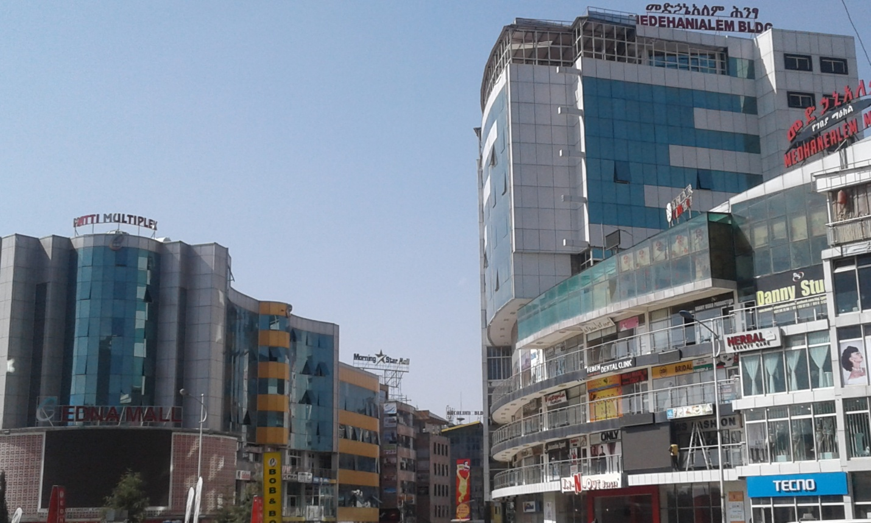
Figure 4.20: Bole Subcity, Edna Mall Area
(Source: Photographs taken by the author in December 2017)
Using ArcGIS for zonal statistics tool, the average LST value for each pixel from the whole Woreda in the selected study area is calculated. The result indicates that places with low rise building, old asbestos roofs and narrow streets have high LST value and the rate of change of the LST per decade was also high compared to the places with high rise and properly planned places. The comparison of the LST is given in Table 4.7.

Table 4-7: Comparison of Minimum, Maximum and Mean LST in °C from two categories
Year | Woreda | Mean Elevation(m) | Minimum Temp | Maximum  Temp | Mean  Temp | Building Type
1986 | Bole 03 | 2334 | 21.19 | 28.06 | 24.56 | High rise
1986 | Kirkos 08 | 2362 | 21.19 | 27.22 | 24.57 | High rise
1986 | Addis 02 | 2417 | 19.4 | 25.53 | 22.15 | Low rise
1986 | Addis 08 | 2444 | 21.19 | 27.64 | 24.84 | Low rise
1995 | Bole 03 | 2334 | 19.41 | 27.64 | 24.17 | High rise
1995 | Kirkos 08 | 2362 | 20.75 | 26.80 | 24.22 | High rise
1995 | Addis 02 | 2417 | 22.51 | 25.53 | 23.72 | Low rise
1995 | Addis 08 | 2444 | 23.38 | 27.64 | 25.44 | Low rise
2007 | Bole 03 | 2334 | 18.81 | 31.36 | 26.83 | High rise
2007 | Kikos 08 | 2362 | 19.34 | 30.88 | 26.36 | High rise
2007 | Addis 02 | 2417 | 24.99 | 29.43 | 27.57 | Low rise
2007 | Addis 08 | 2444 | 22.96 | 32.31 | 28.36 | Low rise
2017 | Bole 03 | 2334 | 22.80 | 30.94 | 27.07 | High rise
2017 | Kikos 08 | 2362 | 23.07 | 30.35 | 26.82 | High rise
2017 | Addis 02 | 2417 | 27.68 | 29.25 | 28.32 | Low rise
2017 | Addis 08 | 2444 | 24.34 | 29.14 | 28.08 | Low rise

Climate Change Vulnerability, Quantification and Mapping

Exposure Component
Based on the climate vulnerability assessment procedure two major exposure layers were identified. These were temperature changes and flood risk layers. These layers are widely used in climate change exposure analyses.
A) Temperature Layers
Under temperature change layers two sub-layers have been prepared. One is air temperature change layer, which obtained from direct measurement of meteorological stations and the other is the Land surface temperature change layer, which were derived from consecutive Landsat satellite images. Regarding the air temperature, three stations have been selected of five stations found in Addis Ababa based on the data availability and geographical variability. These were Entoto, Addis Ababa, and Bole observatories. The record at Entoto starts from 1989 onwards. Therefore the mean temperature record from 1989 to 2016 was divided into two parts for all the three stations. These are from (1989-2002) and from (2004 – 2016).
The mean values of each station have been calculated and the first 14 years average was subtracted from the first mean value. Based on this, the temperature values were obtained, mapped and reclassified. The last final result was normalized. According to this, changes in mean temperature were 0.47°C, 0.24°C and 0.20°C at Entoto, Addis Ababa observatory, and Bole respectively. The normalized scores were reclassified into five groups equally distributed with 0.2 normalized values range as presented in Figure 4.17. Based on the Iyengar and Sudarshan’s method of equation 8, the attached weights are (0.3), (0.3) and (0.4) respectively for Land Surface Temperature Change, air temperature change, and flood risk. The assumption was that the places with the highest temperature change are more vulnerable to climate change. Identified exposure layers are presented in Table 4.8

Table 4-8: Exposure Layers

 | LST (°C) 1986 | LST (°C) 2017 |  |  | Air Temperature (°C)
 | Mean | Mean | Difference | Nor. | Mean  Temp (°C)* | Mean Temp  (°C)** | Mean Difference | Nor.
Arada | 24.5 | 27.7 | 3.2 | 0.92 | 16.64 | 16.91 | 0.27 | 0.22
Addis Ketema | 24.2 | 27.6 | 3.4 | 1.00 | 16.18 | 16.48 | 0.30 | 0.39
Lideta | 25.2 | 27.9 | 2.7 | 0.73 | 17.05 | 17.30 | 0.25 | 0.11
Kirkos | 25.3 | 27.7 | 2.4 | 0.62 | 17.06 | 17.30 | 0.24 | 0.06
Nifas Silk | 26.6 | 28.0 | 1.4 | 0.23 | 16.65 | 16.90 | 0.25 | 0.11
Akaki-Kality | 27.9 | 29.2 | 1.3 | 0.19 | 16.67 | 16.91 | 0.24 | 0.06
Bole | 26.7 | 28.4 | 1.7 | 0.35 | 16.82 | 17.05 | 0.23 | 0.00
Yeka | 25.1 | 25.9 | 0.8 | 0.00 | 16.09 | 16.38 | 0.29 | 0.32
Gulelle | 22.4 | 24.0 | 1.6 | 0.31 | 14.04 | 14.45 | 0.41 | 1.00
Kolfe | 25.3 | 26.7 | 1.4 | 0.23 | 15.92 | 16.23 | 0.31 | 0.44
*Averaged mean air temperature record from (1989-2002) interpolated from Entoto, Addis Ababa, and Bole observatories, and derived for each sub-city using Zonal Statistics
** Averaged mean air temperature record from (2003-2016) interpolated from Entoto, Addis Ababa, and Bole observatories, and derived for each sub-city using Zonal Statistics
(Source: Based on data from Landsat and National Meteorological Service, constructed by author)
The mean difference of LST ranges from 3.4°C at Addis Ketema to 0.8°C at Yeka sub-city. The difference between the 1986 and 2017 has been normalized. Both results from air and land surface temperature change indicates that high rate of change is found in the northern and northwestern parts of Addis Ababa while the low elevated parts of Addis Ababa, which are sparsely populated have low rate and magnitude of change in temperature(Figure 4.21).
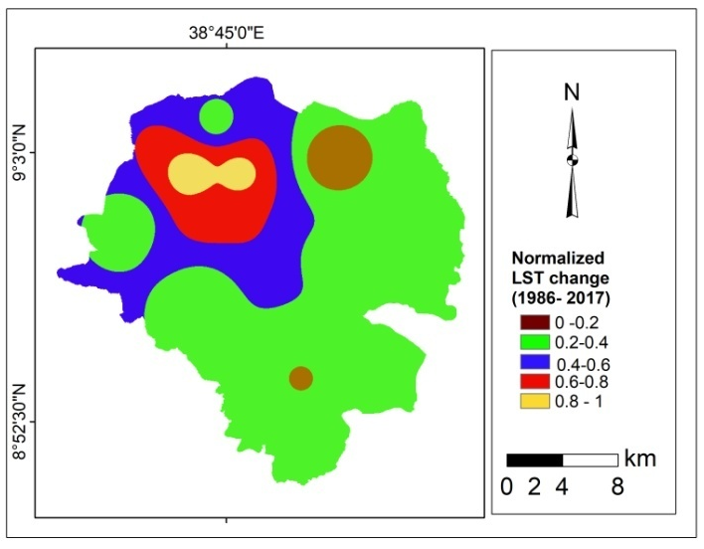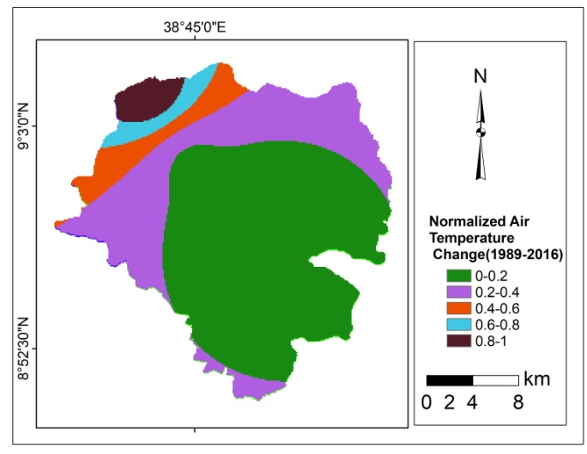
Figure 4.21: Normalized air temperature and LST change in °C
B) Flood Risk Layers
The flood risk is not directly obtained as a single layer as explained in temperature case. Instead of considering a precipitation as a direct exposure layer in an urban area, it is better to integrate it with the flood risk layers. In order to get flood risk layers, four sub-layers has been weighted using multi-criteria evaluation. These four sub-layers are a) 2017 land cover layers: The land cover layer has five land cover classes, namely built-up area; bare ground, open land, vegetation cover and agricultural land. b) Slope layers: the slope is divided into five classes 0-2%, 2-8%, 8-15%, 15-30% and greater than 31%. The slope layer is classified based on FAO, the highest slope value with fewer floods and the least with high probability to be hit by flooding. c) Drainage density layers: The drainage data is extracted from 30m Digital Elevation Model (DEM of Addis Ababa). Up to six stream orders have been considered for the analyses. The drainage classes are 0-0.5km/km², 0.5-1km/km²,1-1.5km²,1.5-2km² and >2km/km². Drainage density has a positive relationship with flooding. d) The soil layers: The six soil types identified by as surveyed by Ministry of Water and Energy in 2004 were used. Soils with high permeability are assigned lesser weights in flood risk mapping. Based on these the highest value is assigned for Vertisol and the least value is assigned for Leptisol. In general 30%, 25%, 30%, and 15% weight factor is assigned for land cover, slope, drainage density, and soil type respectively to get flood risk map of Addis Ababa. Flood layers are presented in Figure 4.22
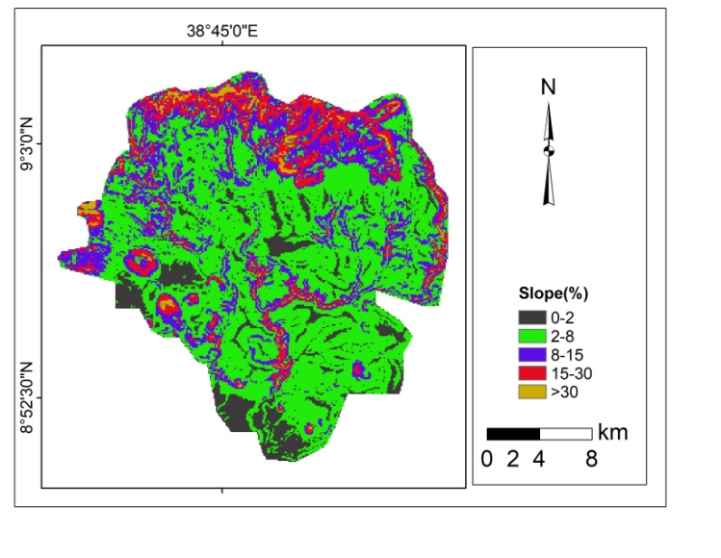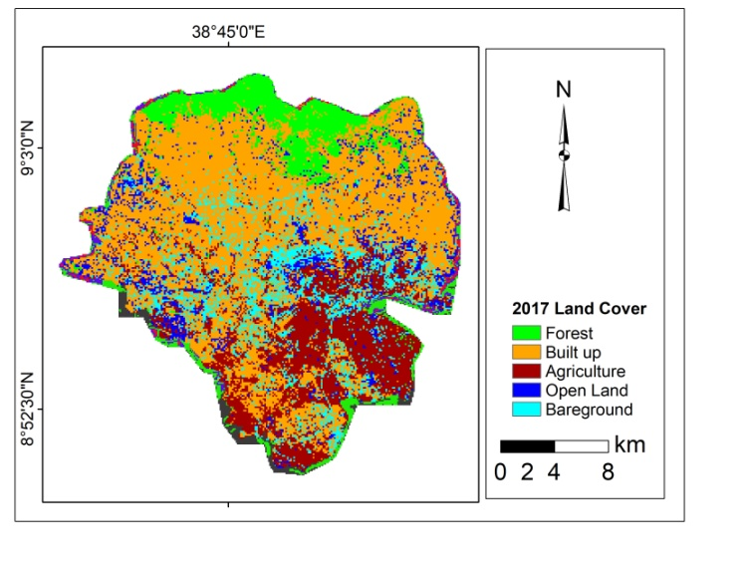
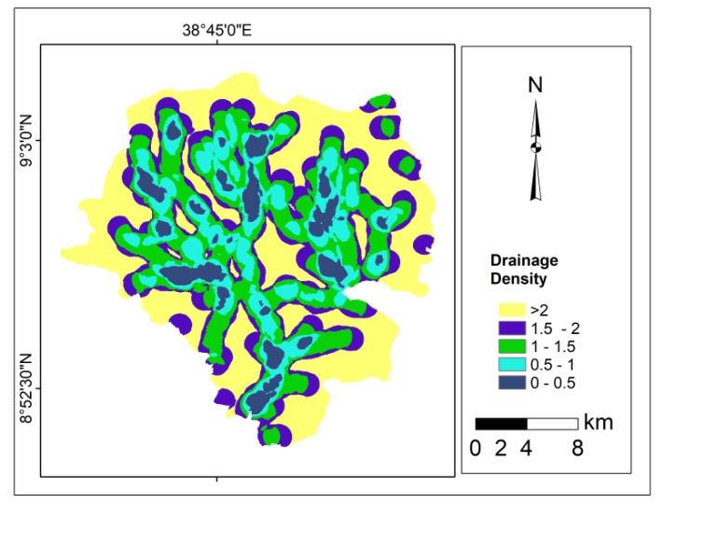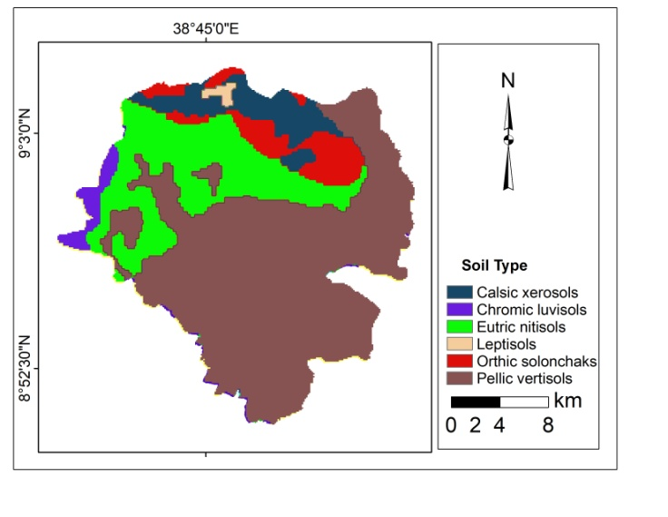
Figure 4.22: Layers weighted for flood risk
The final flood risk map was divided into five layers, from low to very high flood risk categories. The area coverage percentage of very high risk and the high-risk were summed together to categorize the sub-cities. Based on the criteria, the sub-cities fall under risk areas were Arada, Lideta, Addis Ketma, Kirkos and Akaki, which have large parts of their land fall under flood risk. The flood risk map showed that areas with highest population density and lowest elevation as well as high drainage density have a highly exposed to climate change. The upper parts of the city which is covered by forest had low flood risk while the places along the drainage basins and high-density areas had highest flood risk. The food risk map is presented in a systematic manner from high risk to very low risk as depicted in Figure 4.23 The same approach is used for flood risk mapping by various authors (Olatona 2017,Ouma and Tateishi 2014). General exposure index indicates that the highest exposure were in Addis Ketema(0.72), Arada(0.66) and Lideta(0.5). Moderate exposure were in Kirkos(0.45), and Gulelle(0.49). Others sub-cities have low exposure index value. The least exposure was in Bole(0.135).
The flood risk map(Figure 4.23) prepared from the composite layers of drainage density, soil, population density and slope at the exposure layer of this analysis was well integrated with the actual data recorded on flood history. The flood history has been collected from the Addis Ababa fire and emergency preparedness office from 2010 – 2016. The GPS points where flood history is recorded in the past eight years has been taken and overlaid.The result indicated that very high, high, medium, low and very low risk areas cover 20 km², 215 km², 212², 47 km² and 19 km² respectively.
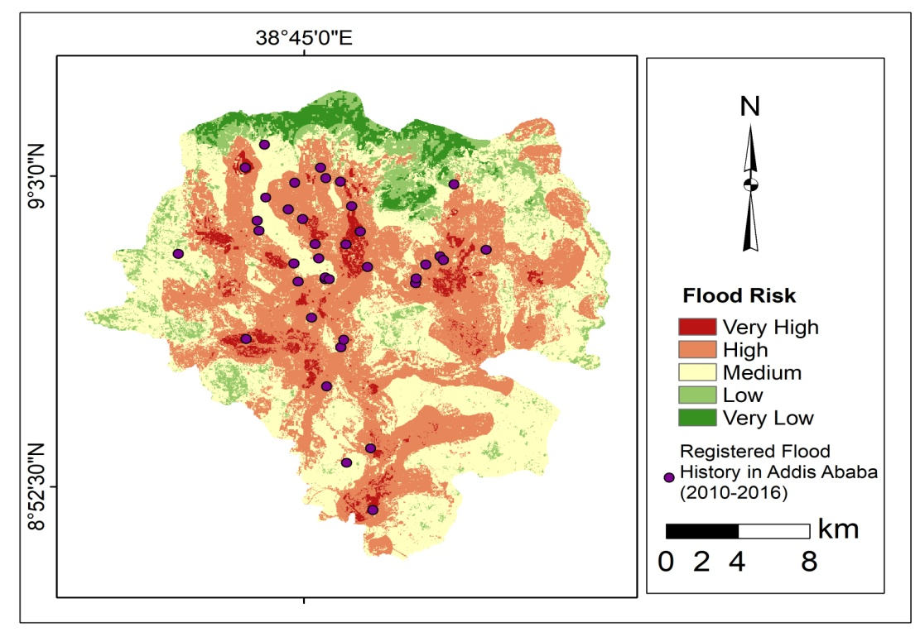
Figure 4.23: Frequency of flood Risk in Addis Ababa (2010-2015)
(Source: Data from Addis Ababa City Fire and Emergency Service, author own construction)

Sensitivity Component
Three layers have been identified for sensitivity component based on the criteria set by different authors and literature. These were the population density, the house type, and the vegetation cover (Figure 4.20). Similar indicators have been used for sensitivity analyses (Gebreegziabher et al 2016, Zurovec et al., 2017). High population density was at Addis Ketema (37,215/km²) and sparsely populated at Akaki-Kality (1,832) in 2017 as projected by Central Statistical Authority (Federal Democratic Republic of Ethiopia Central Statistical Agency, 2013). Regarding the house types, the housing and population census have put different house types which include corrugated iron sheets, concrete/cement, thatch, wood and mud, bamboo, plastic, asbestos, and others. For the analyses, only house types constructed of mud and wood have been selected. Most parts of Addis Ababa had the houses constructed from mud and wood. Arada, Addis Ketema, Kirkos are the sub-cities with the majority of their houses are constructed by mud and wood. A well-planned sub-city like in Bole sub-city, the main house construction type is concrete. It is assumed that houses constructed by mud are highly sensitive to climate change and cannot resist change-induced impacts like heavy rainfall than concrete building houses. The third subcomponent of sensitivity layer is forest cover layer. It is extracted from 2017 Landsat image. The population density, the area of places covered by forest and the house type share per sub-city is presented in Table 4.9
Table 4-9: Sensitivity Layers
Sub-city | Population Density  (2017 projected) |  | Forest Area(sq.km) |  | Houses Constructed by Wood and Mud
 | Pop density | Norma-  lized | (Km² ) | Normalized  (-ve relation) | Percent | Normalized
Arada | 28,206 | 0.75 | 0.08 | 1.00 | 81.2 | 0.77
Addis Ketema | 37,215 | 1.00 | 0.07 | 1.00 | 88.4 | 1.00
Lideta | 27,483 | 0.72 | 0.02 | 1.00 | 84.3 | 0.87
Kirkos | 18,996 | 0.49 | 0.04 | 1.00 | 76.5 | 0.62
Nifas Silk | 6,812 | 0.14 | 0.22 | 0.99 | 66.5 | 0.31
Akaki-Kality | 1,832 | 0.00 | 0.42 | 0.99 | 80.7 | 0.76
Bole | 3,283 | 0.04 | 0.41 | 0.99 | 56.7 | 0.00
Yeka | 5,292 | 0.10 | 27.35 | 0.00 | 82.7 | 0.82
Gulelle | 10,751 | 0.25 | 15.63 | 0.43 | 87.5 | 0.97
Kolfe | 8,479 | 0.19 | 4.43 | 0.84 | 76.3 | 0.62

The land cover analyses indicates that Yeka and Gulelle sub-citieshad a high area of forest cover while Addis Ketema, Arada, Kirkos, and Lideta have a small proportion of vegetation covers. Places covered by forests are less sensitive to climate change. Based on these three layers one final layer is obtained. Accordingly highly sensitive, moderately sensitive and less sensitive areas have been identified. The sensitivity is low in sparsely populated areas, in open spaces and for buildings constructed by a standard material.
The attached weights for each the three sensitivity layers were 0.32, 0.32 and 0.35 respectively for population density, forest coverage and houses constructed by mud and wood (Figure 4.24).
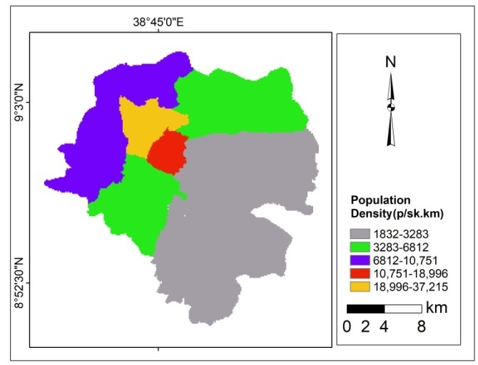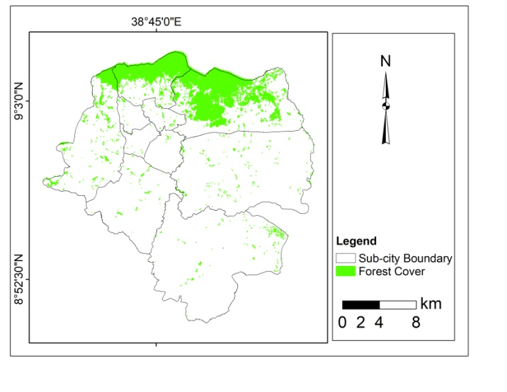
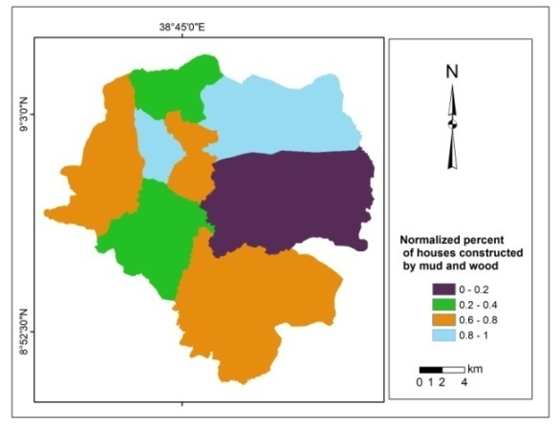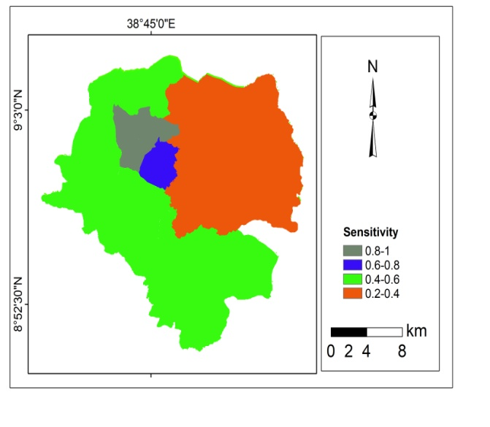

Figure 4.24: Sensitivity Layers
Based on the weights, the highest sensitivity was in Addis ketema, Arada and Lideta,with very high sensitivity index greater than 0.8, high sensitivity index is in Kirkos (0.69), the medium sensitivity is in Nefassilk Lafto,Kolfe,Akaki-Kality,and Gulelle with sensitivity index from 0.4 to 0.6. Yeka and Bole had a lowest sensitivity index (0.2 - 0.4).

Adaptive Capacity Component
Nine adaptive capacity layers have been identified. These adaptive capacity layers were categorized into three sub-layers. These are socio-economic and demographic layers, access layers, and density and distance layers. a) The socio-economic layer consists of the unemployment rate, activity rate, literacy rate and under-five mortality rates. The data were used based on the 2007 Ethiopian housing and population census’s definition. The percentage of socio-economic and demographic layers is presented in Table 4.10
Table 4-10: Socio economic and demographic data.
Sub-city | Literacy Rate  (%) | Norm. | Under five mortality Rate  (%) | Nor. | Unemployment Rate  (%) | Norm. | Activity Rate  (%) | Norm.
Arada | 89.3 | 0 | 0.05 | 0.33 | 24.2 | 0.68 | 63.8 | 0.73
A/Ketema | 84 | 0.77 | 0.03 | 0.11 | 27.2 | 1 | 62.8 | 0.95
Lideta | 86 | 0.48 | 0.04 | 0.16 | 26.2 | 0.89 | 63.4 | 0.82
Kirkos | 88.8 | 0.07 | 0.03 | 0.06 | 21.2 | 0.37 | 64.1 | 0.66
Nifas silk | 85.4 | 0.57 | 0.02 | 0.01 | 21.0 | 0.35 | 63.1 | 0.89
A/Klity | 82.4 | 1 | 0.05 | 0.31 | 20.3 | 0.27 | 60.5 | 1.48
Bole | 84.1 | 0.75 | 0.02 | 0 | 17.7 | 0 | 67 | 0.00
Yeka | 86 | 0.48 | 0.1 | 1 | 23.4 | 0.6 | 62.6 | 1.00
Gulelle | 85 | 0.62 | 0.05 | 0.42 | 20.8 | 0.33 | 62.6 | 1.00
Kolfe | 83.7 | 0.81 | 0.04 | 0.27 | 23.5 | 0.61 | 63.3 | 0.84
**Norm indicates normalized value.
b) Access to Social Services
There are many access data that has to be considered for climate change vulnerability. However, in order to avoid bias, only two data sets, which are fully available and complete for all sub-citieswere considered to analyze access. These are a percentage of access to water (only access to water provided by tap both in their house or compound whether it is shared or private) and percentage of access to toilets for sanitation layer.
c) Distance and Density Data: The two layers of distance (distance from the health center and distance from emergency controlling center (ECC) have been analyzed. The health centers include both private and government health centers, all types of clinics and all types of hospitals. The distance from emergency controlling centers data indicates that the average distance of each place in the sub-city from the Addis Ababa fire and emergency controlling center. The road density layer data was obtained by adding all types of road lengths and dividing it to the area of the sub-city. The types of roads considered in these analyses are asphalt, large stone, gravel, earth, and cobble stone. The distance and density layers are presented in Figure 4.25. Details of the adaptive capacity data with their normalized value per sub-cities are given in Table 4.11

Table 4-11: Adaptive Capacity: Access, distance and density Data.
 | Access Data |  |  |  | Distance Data
 | To safe drinking_water |  | To sanitation |  | From health centers |  | From ECC |  | Asphalt road distance***
Sub-city | (%) tap** | Nor | (%) of toilet | Nor |  | Nor |  | Nor |  | Nor
Arada | 68.53 | 0.40 | 90.66 | 0.00 | 0.64 | 0.26 | 1.38 | 0.04 | 0.04 | 0.00
A/Ketema | 55.61 | 1.00 | 87.29 | 0.27 | 0.26 | 0.04 | 1.18 | 0.00 | 0.04 | 0.00
Lideta | 65.91 | 0.52 | 87.75 | 0.23 | 0.89 | 0.41 | 2.29 | 0.24 | 0.08 | 0.02
Kirkos | 73.19 | 0.18 | 90.31 | 0.03 | 0.25 | 0.03 | 2.04 | 0.18 | 0.04 | 0.00
Nifas silk | 77.00 | 0.00 | 86.12 | 0.37 | 0.76 | 0.33 | 3.80 | 0.56 | 0.58 | 0.25
A/Kality | 65.33 | 0.55 | 78.25 | 1.00 | 2.10 | 1.00 | 4.67 | 0.74 | 2.23 | 1.00
Bole | 72.03 | 0.23 | 83.38 | 0.59 | 0.19 | 0.00 | 5.90 | 1.00 | 1.18 | 0.52
Yeka | 71.65 | 0.25 | 84.97 | 0.46 | 2.06 | 1.09 | 5.70 | 0.96 | 0.85 | 0.37
Gulelle | 73.11 | 0.18 | 84.74 | 0.48 | 0.25 | 0.03 | 4.00 | 0.60 | 0.31 | 0.12
Kolfe | 68.64 | 0.39 | 84.98 | 0.46 | 2.10 | 1.00 | 3.10 | 0.41 | 0.44 | 0.18

**% of tape inside the house, in compound private and tap in compound shared
ECC: Emergency Controlling Center ***Eucledean distance of asphalt Road

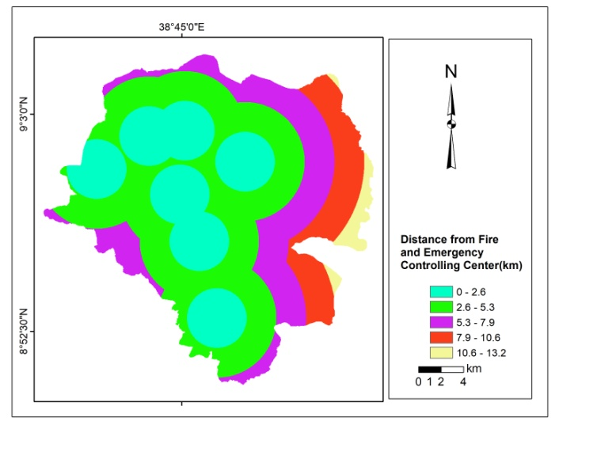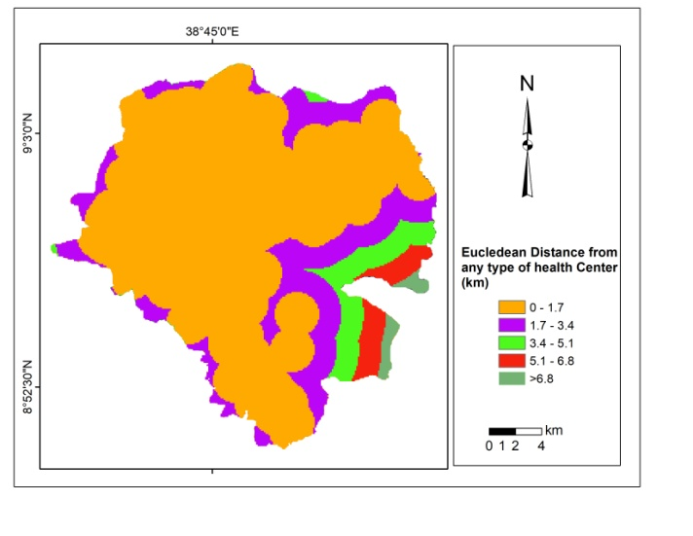
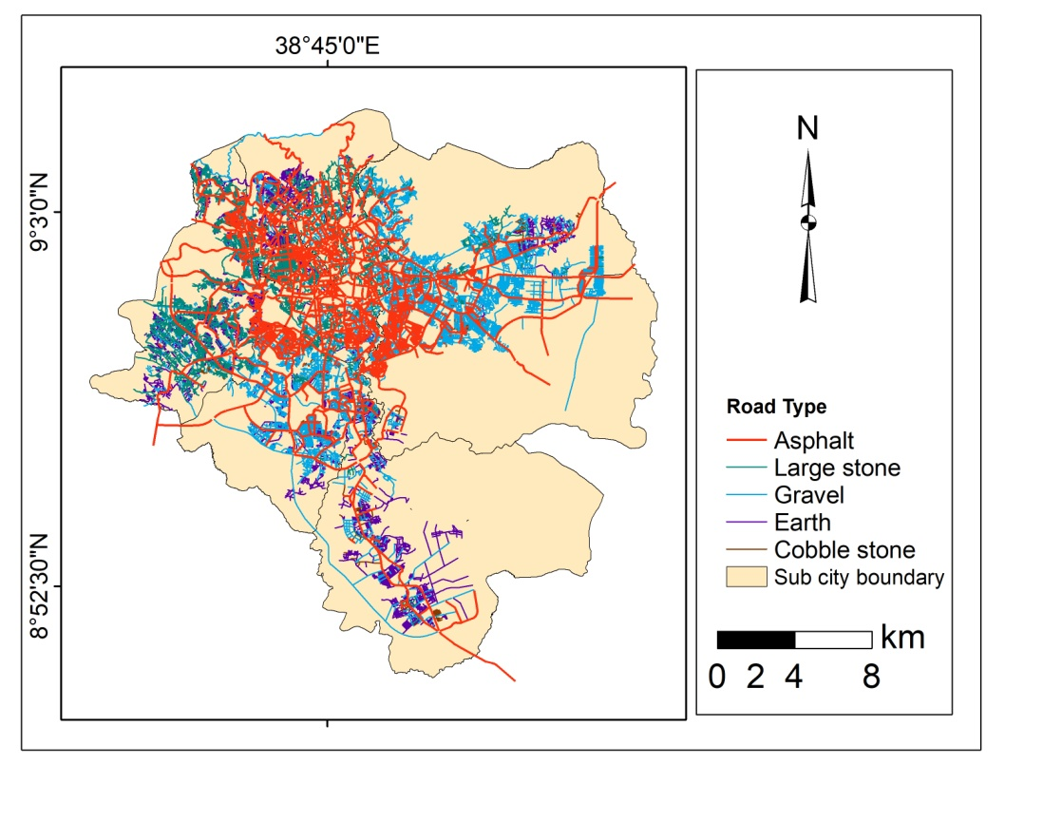
Figure 4.25: Adaptive capacity layers (distance and road)

Finally as depicted on Table 4.12, the weights has been assigned to the indicators
Table 4-12: Weights of Adaptive capacity layers
Indicators | 1 | 2 | 3 | 4 | 5 | 6 | 7 | 8 | 9
Weight | 0.11 | 0.12 | 0.11 | 0.14 | 0.13 | 0.12 | 0.10 | 0.08 | 0.09
Total |  |  |  |  |  |  |  |  |  | 1
Table Legend: Literacy Rate(1),Under five Mortality Rate(2),Unemployment Rate(3),Activity Rate(4), Access to tap(5), Access to toilets(6), Distance from emergency(7), Distance from health centers(8), Road Density(9),
Based on the assigned weight and indicators value, Bole, Kirkos, Arada, Lideta and Nifas Silk Sub-cities have high adaptive capacity, while, Gulelle and Arada sub-cities have medium adaptive capacity. Akaki Kality, Kolfe Keraniyo and Yeka have low adaptive capacity. The adaptive capacity map of Addis Ababa is presented on Figure 4.26.
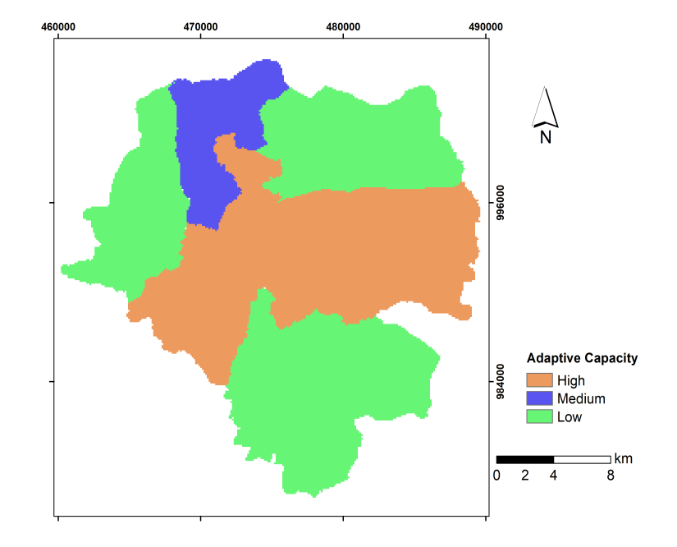
Figure 4.26: Adaptive Capacity Map
The final vulnerability index, determined by composite indicators of exposure, sensitivity and adaptive capacity indicates that Arada, Addis Ketema and Kirkos have high CVI, and are more vulnerable to climate change than other subcities. Lideta, Akaki, Nifas Silk Lafto and Gulelle sub-cities have medium CVI while Bole, Yeka and Kolfe Keranio subcities have low CVI. All indicators CVI per Subcity is summerized in Table 4.13.

Table 4-13: Normalized Exposure, Sensitivity and Adaptive Capacity layers
 | Exposure |  |  | Sensitivity |  |  | Adaptive Capacity
 | 1 | 2 | 3 | 4 | 5 | 6 | 7 | 8 | 9 | 10 | 11 | 12 | 13 | 14 | 15
Arada | 0.92 | 1.00 | 0.22 | 0.75 | 1.00 | 0.77 | 0.40 | 0.00 | 0.24 | 0.49 | 0.04 | 0.00 | 0.00 | 0.33 | 0.68
Addis .K | 1.00 | 0.87 | 0.39 | 1.00 | 1.00 | 1.00 | 1.00 | 0.27 | 0.04 | 0.65 | 0.00 | 0.00 | 0.77 | 0.11 | 1.00
Lideta | 0.73 | 0.80 | 0.11 | 0.72 | 1.00 | 0.87 | 0.52 | 0.23 | 0.37 | 0.55 | 0.24 | 0.02 | 0.48 | 0.16 | 0.89
Kirkos | 0.62 | 0.82 | 0.06 | 0.49 | 1.00 | 0.62 | 0.18 | 0.03 | 0.03 | 0.45 | 0.18 | 0.00 | 0.07 | 0.06 | 0.37
Nifas .S | 0.23 | 0.18 | 0.11 | 0.14 | 0.99 | 0.31 | 0.00 | 0.37 | 0.30 | 0.60 | 0.56 | 0.25 | 0.57 | 0.01 | 0.35
Akaki_K | 0.19 | 0.53 | 0.06 | 0.00 | 0.99 | 0.76 | 0.55 | 1.00 | 1.00 | 1.00 | 0.74 | 1.00 | 1.00 | 0.31 | 0.27
Bole | 0.35 | 0.10 | 0.00 | 0.04 | 0.99 | 0.00 | 0.23 | 0.59 | 0.00 | 0.00 | 1.00 | 0.52 | 0.75 | 0.00 | 0.00
Yeka | 0.00 | 0.13 | 0.32 | 0.10 | 0.00 | 0.82 | 0.25 | 0.46 | 0.98 | 0.68 | 0.96 | 0.37 | 0.48 | 1.00 | 0.60
Gulelle | 0.31 | 0.00 | 1.00 | 0.25 | 0.43 | 0.97 | 0.18 | 0.48 | 0.03 | 0.68 | 0.60 | 0.12 | 0.62 | 0.42 | 0.33
Kolfe | 0.23 | 0.10 | 0.44 | 0.19 | 0.84 | 0.62 | 0.39 | 0.46 | 1.00 | 0.57 | 0.41 | 0.18 | 0.81 | 0.27 | 0.61
SDV | 0.34 | 0.39 | 0.30 | 0.35 | 0.34 | 0.31 | 0.28 | 0.29 | 0.43 | 0.25 | 0.36 | 0.32 | 0.32 | 0.29 | 0.30
C | 0.02 | 0.02 | 0.02 | 0.02 | 0.02 | 0.02 | 0.02 | 0.02 | 0.02 | 0.02 | 0.02 | 0.02 | 0.02 | 0.02 | 0.02
Weight | 0.06 | 0.05 | 0.07 | 0.06 | 0.06 | 0.07 | 0.08 | 0.07 | 0.05 | 0.08 | 0.06 | 0.07 | 0.07 | 0.07 | 0.07

Table Legend: LST change (1), Flood Risk (2), Air Temperature change (3), Population density(4), Forest cover(5), Mud house(6), Access to water(7), Access to sanitation(8), Distance from Health Center, (9), Activity Rate(10), Distance from ECC(11), Asphalt Road Distance(12), Literacy Rate(13), Under Five Mortality Rate(14), Unemployment Rate(15) , SDV is standard deviation, C is constant.

Residents Attitude and Perception

Demographic and Socio Economic characteristics of the Respondents
Age, sex, education level, number of years they lived in the study area, income and house types were among the socio demographic characteristics selected for the analyses. 52.4% of the respondents were male and 47.6% of the respondents were female. A detail of the socio demographic characteristics of the area is summarized in Table 4.14.
Table 4-14: Socio demographic characteristics of the study area.
 |  | Selected Sub cities
Background data | Descriptions | Bole | Kirkos | A/Ketema | Akaki | X² Value | P-value
Sex | Male | 36 | 64 | 69 | 40 | 3.47 | 0.325
Sex | Female | 44 | 56 | 50 | 40 | 3.47 | 0.325
Age Group | 18-35 | 0 | 6 | 8 | 1 | 22.54 | 0.007
Age Group | 35-49 | 44 | 65 | 52 | 29 | 22.54 | 0.007
Age Group | 50-64 | 24 | 36 | 41 | 27 | 22.54 | 0.007
Age Group | >64 | 12 | 13 | 18 | 23 | 22.54 | 0.007
Level of Education | Primary | 12 | 46 | 22 | 24 | 38.36 | 0.000
Level of Education | Secondary | 36 | 46 | 59 | 34 | 38.36 | 0.000
Level of Education | Tertiary | 30 | 19 | 24 | 10 | 38.36 | 0.000
Level of Education | Illiterate | 2 | 9 | 14 | 12 | 38.36 | 0.000
Years lived in the area | 5-10 | 8 | 16 | 2 | 0 | 46.17 | 0.000
Years lived in the area | 10-20 | 26 | 34 | 26 | 10 | 46.17 | 0.000
Years lived in the area | 20-30 | 14 | 31 | 38 | 16 | 46.17 | 0.000
Years lived in the area | >30 | 32 | 39 | 53 | 54 | 46.17 | 0.000
House type | Mud | 30 | 92 | 73 | 67 | 75.4 | 0.000
House type | Stone | 28 | 9 | 28 | 1 | 75.4 | 0.000
House type | Hollow concrete | 22 | 12 | 18 | 10 | 75.4 | 0.000
House type | Bricks | 0 | 2 | 0 | 1 | 75.4 | 0.000
House type | Other | 0 | 5 | 0 | 1 | 75.4 | 0.000
Income | <100 | 2 | 40 | 37 | 59 | 163.7 | 0.000
Income | 100-200 | 30 | 40 | 26 | 8 | 163.7 | 0.000
Income | 200-300 | 20 | 30 | 50 | 13 | 163.7 | 0.000
Income | 300-400 | 24 | 8 | 2 | 0 | 163.7 | 0.000
Income | 400-500 | 4 | 2 | 0 | 0 | 163.7 | 0.000
Income | >500 | 0 | 0 | 4 | 0 | 163.7 | 0.000

The age ranges from 18-65. The majority of the respondents live in the study area for more than 30 years (44.6%). 43.9% of the respondents attended their secondary education. The tertiary level of education rate is high in Bole while it is low in Akaki Kality sub-city. The income of the respondents is also highly varied. Majority of the respondents have a daily income less than 100 Ethiopian birr (34.6%). Only 1% of the respondents have a daily income more than 500 birr per day. The main economic activity of the respondents is trade activity.

Perception on Temperature and Precipitation Trend
The surveyed respondents had different attitude and perception on the changes of precipitation and temperature of Addis Ababa. 69.2% of the respondent’s perceived as temperature was increasing. Only 10.8 % responded as the temperature was decreasing. Residents in Bole and Addis Ketema sub-cities perceived there is high temperature increment while the lowest perception is in Akaki Kality (52.2%). Survey respondents were also asked to report their overall perceptions on precipitation trends. Regarding the precipitation 60.2% of the respondents said the precipitation is increasing, 20.1% as decreasing and 19% as no change. The summary of perception on temperature and precipitation is given in Table 4.15.

Table 4-15: Perception on temperature and precipitation changes
Changes | Perception |  | Places |  |  | Total | X² test | P value
Changes | Perception | Addis Ketema | Kirkos | Bole | Akaki | Total | X² test
Temperature trends | Increasing | 88 | 84 | 62 | 42 | 276 | 51.38 | 0.000
Temperature trends | Increasing | 73.9% | 70.0% | 77.5% | 52.5% | 69.2% | 51.38 | 0.000
Temperature trends | Decreasing | 1 | 13 | 4 | 25 | 43 | 51.38 | 0.000
Temperature trends | Decreasing | 0.8% | 10.8% | 5.0% | 31.2% | 10.8% | 51.38 | 0.000
Temperature trends | No change | 30 | 23 | 14 | 13 | 80 | 51.38 | 0.000
Temperature trends | No change | 25.2% | 19.2% | 17.5% | 16.2% | 20.1% | 51.38 | 0.000
Precipitation trends | Increasing | 65 | 67 | 58 | 50 | 240 | 36.45 | 0.000
Precipitation trends | Increasing | 54.6% | 55.8% | 72.5% | 62.5% | 60.2% | 36.45 | 0.000
Precipitation trends | Decreasing | 15 | 25 | 14 | 26 | 80 | 36.45 | 0.000
Precipitation trends | Decreasing | 12.6% | 20.8% | 17.5% | 32.5% | 20.1% | 36.45 | 0.000
Precipitation trends | No change | 39 | 28 | 8 | 4 | 79 | 36.45 | 0.000
Precipitation trends | No change | 32.8% | 23.3% | 10.0% | 5.0% | 19.8% | 36.45 | 0.000
Total | Total Respondant | 119 | 120 | 80 | 80 | 393
Total | Total percentage | 100.0% | 100.0% | 100.0% | 100.0% | 100.0%

Perception on the Impacts of Climate Change
Rise in temperature, extreme rainfall, heat waves and others are a long been reported as environmental problems in Addis Ababa (Birhanu et al., 2016; CLUVA, 2011). This part is therefore focused on how peoples perceive changes temperature and precipitation and its impact on their day to day activity. The damage caused by climate change has an adverse affect on infrastructure and communities and thus on sustainable development. Different climate related impacts were also reported in Addis Ababa, mainly flooding as indicated on Addis Ababa Fire and Emergency Prevention and Rescue Agency. The perception of the impacts is presented into two parts.

Perception on Impacts of Temperature Changes
The impact of the rise in temperature is clearly perceived by majority of the survey respondents. The respondents in old roofed, crowded areas and high rise building areas mainly share the perception that indicates the temperature is rising. They perceived that the construction of high rise building and its reflective materials, less vegetation cover, emission from vehicles, emission from factories as the main reason for the rise of temperature. The majority of the respondents(65.7%) said the rise of the temperature than a normal condition have an impact and only 34.3% of the surveyed respondents responded as the rise in temperature has no impact. Being inactive at work place, accidental fire, skin irritations, are the major impacts they identified. They perceived also when the temperature lowers (falls) than normal situation, as it has is no impact (71.4%). Only 28.6% responded at lower temperature impacts, for instance, death of animals and respiratory diseases happened. The summary of the perception on the impacts when temperature rise or fall is presented in Table 4.16 below.

Table 4-16: Perception on the impacts of temperature change
 |  | Sub cities |  |  |  | Total | X² test | P value
 |  | Addis Ketema | Kirkos | Bole | Akaki | Total | X² test | P value
Impact when temperature rises | yes | 77 | 83 | 46 | 56 | 262 | 3.73 | 0.292
Impact when temperature rises | yes | 64.7% | 69.2% | 57.5% | 70.0% | 65.7% | 3.73 | 0.292
Impact when temperature rises | No | 42 | 37 | 34 | 24 | 137 | 3.73 | 0.292
Impact when temperature rises | No | 35.3% | 30.8% | 42.5% | 30.0% | 34.3% | 3.73 | 0.292
Impact when temprature decrase | Yes | 29 | 47 | 19 | 19 | 114 | 9.453 | 0.024
Impact when temprature decrase | Yes | 24.4% | 39.2% | 23.8% | 23.8% | 28.6% | 9.453 | 0.024
Impact when temprature decrase | No | 90 | 73 | 61 | 61 | 285 | 9.453 | 0.024
Impact when temprature decrase | No | 75.6% | 60.8% | 76.2% | 76.2% | 71.4% | 9.453 | 0.024
Total |  | 113 | 119 | 80 | 80 | 399 | 9.453 | 0.024
 |  | 100.0% | 100.0% | 100.0% | 100.0% | 100.0%

Assessment on the Impacts of High Precipitation
The impact of high precipitation is more identifiable than temperature. During extreme rainfall, high flooding problem will be common. The frequent flooding is common in summer mainly for people living along the river banks. Other type of flooding is flash flooding which overflows on some streets. Akaki River is among the rivers where frequently over floods the residents at its lower courses during the summer time. The flooding by Akaki River will be serious when the release of water from Legedadi Dami meets with peak rainy season. The personal survey of the impact was took in two sub-citieswhere series flooding problems was reported. The respondents told that the damage is huge in terms of property loss. Mainly the respondents who live along Akaki, specifically in Melka Shedi area responded that, they faced a time where their house is fully over flooded by the Akaki River and lost all their properties. The major flood damage estimation in Birr was 10,000 to 20,000 in Akaki while the highest share is from 5000 to 10000 in Kirkos-Woreda 02. The Kirkos area has less damage than Akaki, due to the power of the flood is not as high as Akaki. The no cost of damage (20%)is responded by the residents in Kirkos than at least a minimum cost will occur in Akaki Kality. Figure 4.27 summarizes the damage in terms of Ethiopian birr.

Figure 4.27: Range of cost of damage of flooding per household

Perception on the Adaptation Activities
It is understandable that if the threats from climate change are managed properly, associated risks that may jeopardize the achievement of sustainable development goals can be reduced. However the management of climate changes could not be successful in a traditional planning process and it should include the attitudes of the community, their tendency and understanding on adaptation measures.

Perception and Attitudes on Adaptation to Temperature Changes
In this part, the questionnaires are prepared to know the level of the awareness the residents have, the previous adaptation mechanism and the mechanism they perceived as better. Accordingly, 75% of the residents concerned about climate change. Similarly they responded that 62.2% of them had a medium awareness on global warming. 56.4% of the respondents responded that, in their compound no tree is found(Table 4.17).
Table 4-17: Awareness on temperature adaptation
 |  | Places |  |  |  | Total
 |  | Addis Ketema | Kirkos | Bole | Akaki | Total | X² | P-Value
Concern about global warming | yes | 99 | 85 | 72 | 47 | 303 | 112.6 | 0.000
Concern about global warming | yes | 83.2% | 70.8% | 90.0% | 58.8% | 75.9% | 112.6 | 0.000
Concern about global warming | No | 20 | 35 | 8 | 33 | 96 | 112.6 | 0.000
Concern about global warming | No | 16.8% | 29.2% | 10.0% | 41.2% | 24.1% | 112.6 | 0.000
Is tree available in your compound | yes | 47 | 51 | 30 | 46 | 174 | 26.73 | 0.00
Is tree available in your compound | yes | 39.5% | 42.5% | 37.5% | 57.5% | 43.6% | 26.73 | 0.00
Is tree available in your compound | No | 72 | 69 | 50 | 34 | 225 | 26.73 | 0.00
Is tree available in your compound | No | 60.5% | 57.5% | 62.5% | 42.5% | 56.4% | 26.73 | 0.00
Awarness about global warming | yes | 22 | 14 | 25 | 7 | 68 | 33.33 | 0.00
Awarness about global warming | yes | 18.5% | 11.7% | 31.2% | 8.8% | 17.0% | 33.33 | 0.00
Awarness about global warming | Medium | 83 | 72 | 46 | 47 | 248 | 33.33 | 0.00
Awarness about global warming | Medium | 69.7% | 60.0% | 57.5% | 58.8% | 62.2% | 33.33 | 0.00
Awarness about global warming | No | 14 | 34 | 9 | 26 | 83 | 33.33 | 0.00
Awarness about global warming | No | 11.8% | 28.3% | 11.2% | 32.5% | 20.8% | 33.33 | 0.00
Total |  | 113 | 119 | 80 | 80 | 399
 |  | 100.0% | 100.0% | 100.0% | 100.0% | 100.0%

Perception and Attitudes on Adaptation for Flood Controlling
Flooding is one of the incidences frequently reported in Addis Ababa. The magnitude of a disaster of flooding depends on social, economic and physical context based on the locally practiced adaptation activity of a particular community. A climate-resilient community is one that can anticipate, efficiently respond to and rapidly recover from a climate-related shock. In this part when the flooding damage occurred, which responsible body first come to the place and helps the community. They responded Addis Ababa Fire and Disaster controlling agency and Police are the major government bodies that arrived first for rescue. 13.3% of them responded that no government organization visits them at the time of flood hazards. The use of warning system is also low. For instance 71.4% do not use early warning system.
The adaptation measures identified by the community to control flooding were not advanced and the majority of them (51.7%) responded they do not have any appropriate controlling method 75.8% of them need any other methods to be undertaken by the government. Controlling sand bag, modifying building structure, concrete blockage, using big trees are the major practices undertaken to control flooding. The summary of adaptation activities is given in Table 4.18

Table 4-18: Perception on flooding
 |  | Places |  | Total | X² | P value
 |  | Kirkos | Akaki | Total | X² | P value
Responsible body to control flood | Fire and Disaster Controlling | 7 | 27 | 34 | 10.7 | 0.13
Responsible body to control flood | Fire and Disaster Controlling | 17.5% | 33.8% | 28.3% | 10.7 | 0.13
Responsible body to control flood | Police | 16 | 33 | 49 | 10.7 | 0.13
Responsible body to control flood | Police | 40.0% | 41.2% | 40.8% | 10.7 | 0.13
Responsible body to control flood | Neighbors | 4 | 12 | 16 | 10.7 | 0.13
Responsible body to control flood | Neighbors | 10.0% | 15.0% | 13.3% | 10.7 | 0.13
Responsible body to control flood | No one | 13 | 8 | 21 | 10.7 | 0.13
Responsible body to control flood | No one | 32.5% | 10.0% | 17.5% | 10.7 | 0.13
Is current adaptation methods are appropriate enough | Agree | 2 | 0 | 2 | 4.565 | 0.102
Is current adaptation methods are appropriate enough | Agree | 5.0% | 0.0% | 1.7% | 4.565 | 0.102
Is current adaptation methods are appropriate enough | Ambivalent | 24 | 45 | 69 | 4.565 | 0.102
Is current adaptation methods are appropriate enough | Ambivalent | 60.0% | 56.2% | 57.5% | 4.565 | 0.102
Is current adaptation methods are appropriate enough | Disagree | 14 | 35 | 49 | 4.565 | 0.102
Is current adaptation methods are appropriate enough | Disagree | 35.0% | 43.8% | 40.8% | 4.565 | 0.102
Type of early warning system | Meteorology | 3 | 6 | 9 | 1.28 | 0.685
Type of early warning system | Meteorology | 7.5% | 7.6% | 7.6% | 1.28 | 0.685
Type of early warning system | Cloud situation | 1 | 6 | 7 | 1.28 | 0.685
Type of early warning system | Cloud situation | 2.5% | 7.6% | 5.9% | 1.28 | 0.685
Type of early warning system | warning by govt body | 1 | 2 | 3 | 1.28 | 0.685
Type of early warning system | warning by govt body | 2.5% | 2.5% | 2.5% | 1.28 | 0.685
Type of early warning system | other | 5 | 10 | 15 | 1.28 | 0.685
Type of early warning system | other | 12.5% | 12.7% | 12.6% | 1.28 | 0.685
Type of early warning system | Not available | 30 | 55 | 85 | 1.28 | 0.685
Type of early warning system | Not available | 75.0% | 69.6% | 71.4% | 1.28 | 0.685
Previously available flood controlling methods | Blocking by Sand bag | 2 | 25 | 27 | 28.669 | 0.000
Previously available flood controlling methods | Blocking by Sand bag | 5.0% | 31.2% | 22.5% | 28.669 | 0.000
Previously available flood controlling methods | Tall Building | 4 | 3 | 7 | 28.669 | 0.000
Previously available flood controlling methods | Tall Building | 10.0% | 3.8% | 5.8% | 28.669 | 0.000
Previously available flood controlling methods | Big Tubes | 5 | 0 | 5 | 28.669 | 0.000
Previously available flood controlling methods | Big Tubes | 12.5% | 0.0% | 4.2% | 28.669 | 0.000
Previously available flood controlling methods | Stone/concrete blockage | 4 | 6 | 10 | 28.669 | 0.000
Previously available flood controlling methods | Stone/concrete blockage | 10.0% | 7.5% | 8.3% | 28.669 | 0.000
Previously available flood controlling methods | Others | 7 | 2 | 9 | 28.669 | 0.000
Previously available flood controlling methods | Others | 17.5% | 2.5% | 7.5% | 28.669 | 0.000
Previously available flood controlling methods | Not available controlling method | 18 | 44 | 62 | 28.669 | 0.000
Previously available flood controlling methods | Not available controlling method | 45.0% | 55.0% | 51.7% | 28.669 | 0.000
Recommendation by the community | Pump | 4 | 0 | 4 | 8.289 | 0.016
Recommendation by the community | Pump | 10.0% | 0.0% | 3.3% | 8.289 | 0.016
Recommendation by the community | Controlling Dam | 8 | 17 | 25 | 8.289 | 0.016
Recommendation by the community | Controlling Dam | 20.0% | 21.2% | 20.8% | 8.289 | 0.016
Recommendation by the community | Other | 28 | 63 | 91 | 8.289 | 0.016
Recommendation by the community | Other | 70.0% | 78.8% | 75.8% | 8.289 | 0.016
Total |  | 40 | 80 | 120
 |  | 100% | 100% | 100%

Discussions

Discussion on Trends and Downscaling
This study investigated trends and changes in maximum temperature, minimum temperature, precipitation, and their extremes in Addis Ababa, from the observed data and through downscaling from selected general circulation models. The considered changes were analyzed from 1960’s to the end of the 21st century, mainly based on Addis Ababa Obs.and Entoto stations. The aim of the downscaling was to predict site-specific future temperature and precipitation extreme changes, in order to assess possible future risks from climate change. The results indicated that temperature increased and precipitation also insignificantly rising in the past six decades, and future temperature, precipitation as well as its extremes is expected to increase in the city, with the highest rate occurring in the 2080s. The trends, changes, highest moderate and extreme changes in both climatic elements and extreme events have been identified. For all three future periods and under all scenarios, almost all intensity extreme indices showed incremental. It could be concluded that more warming is expected towards the end of this century. The preciptation will also continue to increase.
It should not be surprising that this study’s findings are in line with many downscaling works undertaken in Ethiopia, particularly on temperature results, though the previous studies were not conducted on an urban scale. Model projections of climate in Ethiopia show warming in all four seasons across the country but a wide range of rainfall patterns, with no clear direction of change. Table 5.1 describes the summary of many downscaling studies in Ethiopia, using statistical models.

Table 5-1: Comparison of the result with other studies in Ethiopia
Model | Study Area | Temperature | Precipitation | References
ECHAM 5 and HADCM3 | Across Ethiopia and Kenya | Clear trends at all locations towards warmer conditions in the future. | ECHAM5 shows a trend towards wetter conditions over most parts. | (Ward and Lasage, 2009)
HadCM3 A2a and B2a and CanESM2 (RCP2.6, 4.5 and 8.5) | Upper Blue Nile River Basin | Maximum temperature rise by 0.4 °C to 2.9 °C and minimum temperature rise by 0.3 °C to 1.6 °C. | Relative changes in mean annual precipitation ranges from 2.1–43.8%. | (Mekonnen and Disse, 2018)
HadCM3 A2 and B2 | Lake Hawasa | Maximum temperature increase by 1.6–1.8 °C and minimum temperature by 1.54–1.7 °C in 2050. | Trends in precip. do not show statistically meaningful trends | (Gebrie, and Abate, 2012)
CGCM3.1 and REMO | Baro-Akobo Basin | Maximum temperature rises by 1.3 °C (REMO A1B and B1) and 2.55 °C (CGCM3.1). | 24% (REMO) and 23% (CGCM3.1) rise in 2050. | (Kebede et al., 2013)
HadCM3 A2a | Northwestern Ethiopia | The increase in mean max. and min. temp.(1.55–6.07 °C and from 0.11–2.81 °C), respectively, in the 2080s. | Decrease in precip and number of rainy days in 2080s. | (Ayalew et al., 2012)
HadCM3-A2 | Upper Blue Nile Basin | The minimum and maximum temp. increase by 3.6 °C and 2.4 °C, respectively, towards the end of the 21st century. | Dry season rainfall amounts are likely to increase and wet season rainfall to decrease. | (Worqlul et al., 2018)
Source: Compiled by the author
From the results obtained from this study and other general studies in Ethiopia, it should be noted that increases in temperature and rainfall amount is real. Despite climate change being a major global issue today, in Addis Ababa it does not given a considerable attention. All current government plans are focused on supplying the ordinary needs of residents; the climate issue seems to be mostly neglected. The city is busily supplying basic infrastructural and social demands because of high population growth, which of course plays a pivotal role in modifying the local climate of the city. Within this framework, the awareness of future downscaled climatic data for environmental planning is generally limited.
However, considering future changes and prioritizing their incorporation into plans for the city is inevitable for several reasons. First, there is an elevation difference of 1000 m within the city. Due to this, all places not might be affected equally by climate change, and hence prioritization for an intervention mechanism is important. Second, there is a high rate of population growth. Studies reveal that the projected population of Addis Ababa city, with a high population growth rate (3.3%), will be about 7 million by the year 2039, which would exacerbate water problems in the city (Arsiso, 2017). Thirdly, there is a high rate of urbanization. Urban heat islands could exacerbate the climate problem as the studies indicate the downtown areas are getting hot, and the land surface temperature is increasing over time. The urban areas are expanding at the expense of forests and agricultural land (Teferi and Abraha, 2017; Feyissa et al., 2014; Abebe and Megento, 2016).

Land Surface temperatuchure pattern and their implications
In order to understand the land surface temperature pattern, trend and charactristics, the term Urban Thermal Landscape was used as one kind of landscape to indicate the pattern and variation of urban surface temperature, which is assumed as the presentation of local surface heating process upon urban landscape (Xue, 2014). The general analyses presented in this part have similar definition for general urban heat characteristics, except focused not in identifying the urban heat island characteristics and its trends, but also intra-comparison of the urban thermal landscapes within the same town.
With the rapid growth of population, Addis Ababa’s built up area is developed with greater proportion resulting into changes in existing landscape, agricultural land and forest lands. The shrinking of vegetation cover continously worsens the thermal condition of the city, which contributes its part in increasing air temperature to rise. In the land cover change analyses perspective, this study is in line with previous studies undertaken, which indicates the increment of settlement and decreases in other land cover types mainly green areas and agricultural lands in different times (Woldegerima et al., 2016, Zewdie et al., 2017). Addis Ababa is referred to as the forest city, and now the ‘forest city’ definition explaining Addis Ababa of the past, works no more, due to detoriration of it’s forest cover (Abebe and Megento, 2016).
It also well in line with the studies undertaken on urban heat island in the city (Abebe and Megento 2016, Feyissa et al., 2014). Currently, the vegetations are confined only to the protected areas mainly on Entoto and Yeka mountains in the North, and small fragmented parks in other parts of the city. The housing replaces agriculture open land and forests, with impervious surfaces which are impermeable and dry. Moreover, it takes the highest role in increasing the air temperature of the city. For instance, all of the ten warmest years are recorded in maximum temperature after in the recent decades since 1997. The 30 years average maximum temperature in 1984-2013 was increased by 1.14 °C compared to the previous 30 years average maximum temperature. This also plays a pivotal role in microclimate modification of the city, and contributes to the climate change, in a longer period. It has also social, economic, and environmental impacts and forces the residents to adopt new mechanism, which needs additional cost for adaptation mechanism and to change lifestyle than previously adopted. It also worsens heat-related diseases.
Even though the Urban Heat Island is real in Addis Ababa, it was not devastating so far, due to two main reasons. The first reason is due to its topographic factors. The elevation of the city ranges between 2000 and 3000m above sea level and the second is during the Northern summer, the cloud cover is high, and the summer temperature is minimal in Addis Ababa. However, if the current condition continues without any intervention, the UHI will be a challenge for the city in the coming decades specially, in warmest months.
One of the main finding in this paper, of course, which differs from many other studies is that the LST in Addis Ababa has unique characteristics. We have found the lowest LST in a high rise buildings and high LST in low rise buildings. Though this is not common in many studies, in Addis Ababa, in a high rising building areas, it is might be happened due to the shadows of the building, elevation reasons or due to the good green area proportion. But in low rise buildings, the highest LST was observed due to roof types, and unavailability of green places and other problems related to planning. Selected places in Bole and Kirkos have lower LST than places selected as a case study, in Addis Ketema Sub-city.
We could understand from this that planning plays a key role to regulate urban heat island. This enables the places to have good air circulation, though the high rise buildings are found. The Urban Heat Island effect can be mitigated by conceptualizing the urban planning and strategy for urban development. This mainly includes green infrastructure development, and improving the housing conditions. Most part of Addis has the oldest and dark roofs which absorb high temperature. Using reflective roofs is the most cost effective way to mitigate the urban heat island (California Climate Action Team, 2013).

Quantified and Mapped Climate Change Vulnerability
Climate change impact is not measured only by the exposure and sensitivity’s strength; rather, it is a matter of adaptive capacity. The exposure layers selected for vulnerability analyses in Addis Ababa was lower, but the sensitivity was high and adaptive capacity activities were low. These altogether makes Addis Ababa to be vulnerable city to climate change. The distribution of exposure layers which contains physical factors was different. For instance the air and LST temperature changes to the central and northern part of the city is high, indicating the higher of the sensitivity and the lower value of adaptive capacity in that parts. Addis Ketema and Arada sub cities, which contained the oldest buildings within them, have old roofed houses, limited green area coverage’s and poorly managed streets with no street trees. These all makes the exposure to climate change in this part to be high.
In contrast to this, the sub-cities with high rise building, but with more planned parcels of land like in Bole and most parts of Yeka had lower-temperature change. Another important and influential exposure indicator which has high factor in Addis Ababa was flooding. Floods, the most prevalent of natural risks, are anticipated to happen more strictly and regularly in the future because of climate change (Nasiri and Shahmohammadi, 2013). Flood as exposure layer plays a key role in Addis Ababa, mainly in the southern and south eastern parts of the city due to the gentle slope characteristics of the relief in these parts. The past record on flooding in Addis Ababa indicates, it was increasing from time to time. There is a wide evidence that the flooding in Addis will be continue to increase to the end of this century due to climate change(CLUVA, 2011; Ward and Lasage 2009; McSweeney et al., 2010) and poor urban storm water management in Addis Ababa. The exposure layer of climate change vulnerability identified in these analyses indicates the flood is common in poor infrastructure areas, low quality housed but dense population along streams. Flooding is common in Kirkos, parts of Bole and Akaki, at a time of heavy rain . The topographic nature of the southern and south western are gentle, and the heavy rain drops from mountains flow to the southern direction, makes the Akaki-Kality area to be more vulnerable to flooding.
Climate change vulnerability activities and the vulnerability to flooding is more aggravated due to a poor drainage system, rapid housing development along river banks and using inappropriate construction material(Birhanu et al., 2016, Belete, 2011 ). The estimated cost of damage in Addis Ababa was 373,640 million birr, 1.3 million birr and 1.3 million birr in 2010, 2011 and 2012 respectively. Many of the costs of the recent flood damage, was not estimated. Majority of the damages were occurred in the months of August and September as well as in July (Fig 5.1). The stated Akaki-Kality and Kirkos were the highest affected by flooding in Addis Ababa, due to their plain elevation and over-crowded of old houses. Bole and Gullelle sub-cities had also high flood damage, while Addis Ketema, Yeka and Lideta are the moderately affected. Nefas silk Lafto, Arada and Kolfe Keraniyo sub-cities were the least affected sub cities.

Figure 5.1: Frequency of flood by months (2010-2015)
The higher sensitivity of the sub-cities to climate change emanated from higher density, low quality of constructed houses and low level of infrastructure development. These areas are mainly found in the central parts of the city, which have a high population density mainly in Addis Ketema, Lideta and Arada sub cities. In sensitivity values, variations were being observed among sub cities. Well planned, places with a good proportion of green area coverage and places with good construction materials were less sensitive to climate change impacts.
The predominant use of mud and wood for the construction of house walls and floors calls for frequent repairs, which tend to be expensive in the long run. The households that have the highest use of these materials are in Akaki-Kality and Addis Ketema where the highest need for repairs was also apparent. In addition, dust from the mud and earth used for the floors and walls leads to increased susceptibility of the dwellers to respiratory diseases, especially among children (UN Habitat, 2003). This is the reason why sub-city like Bole is less sensitive than Addis Ketema and Arada. Households in slum areas usually occupy non-durable dwelling units that expose them to high morbidity and mortality risks (UN Habitat, 2003). Exposure and sensitivity are almost inseparable properties of a system (or community) and are dependent on the interaction between the characteristics of the system and on the attributes of the climate stimulus. The exposure and sensitivity of a system to an environmental related risk reflect the general conditions and characteristics of the system (Smit and Wandel, 2006). The highest proportion of green area coverage in Yeka (15.63km²) and Gulelle (15.63km²) in line with their geographical position within the city makes them to have lowest sensitivity to climate change. In addition due to historical reasons, the development of botanic gardens in this area, the rehabilitation of forest is high.
The low level of socio-economic, demographic and access to facilities in Addis Ababa made the adaptive capacity, to be low. Literacy rate and under five mortality rate as well as the higher unemployment rate also indicated the low level of the community’s adaptation capacity to climate change. The low level of access layers, to social services like toilets and tap water were also the lowest. Another important layer in adaptive capacity, which has a greatest influence on the adaptive capacity layer, is the distance from the disaster controlling center. Most parts, mainly the peripheral sub-citieshad the highest distance from disaster controlling center. The infrastructural development, used at the time of early warning and hazard was also an important factor; which makes the adaptive capacity to be lower. The sub-cities which have low adaptive capacities are well vulnerable to climate change. Due to rapid urbanization and population increase, low-income communities are forced to settle in flood-prone areas additionally the poor drainage systems of the city also intensify the risk of flooding as well. Lacks of adaptation to climate change have increased vulnerability (Cochrane and Costolanski, 2013). It is based on the adaptive capacity, whether any type of climate-related impact occur, it is based on its adaptive capacity whether it was a resilient or not.

Implication of Residents Attitude and Perceptions
The survey respondents were selected from the areas where assumed to have high vulnerability to climate change impacts than others, in terms of temperature change and precipitation impacts. The study tries to diversify the samples which could be representative for Addis Ababa’s resident’s perception and attitude. Their responses are assumed to represent the reflection of the general perception of the society in the city. The survey respondents were people with different education level, age groups, income, house types and others. The sampling areas have also some unique characteristics. For instance in Kirkos around Kazanchis, and in Bole, there are high rise buildings. The houses statuses are better in Bole and Kazanchis than houses surveyed in Addis Ketema and Akaki-Kality. The Addis Ketema area is an urban center, but crowded, old roofed houses with less vegetation cover. It is among the oldest neighbourhood houses in Addis Ababa.
The majority of the respondents have a clear perception on changes in temperature and precipitation. Majority of the households experienced hotter days, high rainfall, which is similar with modern predictions of the past and the present in Addis Ababa. Their perception is in line with many scientific analyses held in Addis Ababa, which indicates the temperature and rain fall is increasing from time to time(Ward and Lasage 2009; McSweeney, 2010). The respondents have also percieved the effect of changes in perception is minimal. No acute problem is responded except some simple diseases like skin irritation and effects on working habits. Due to elevation the impact of Addis Ababa in temperature was not easily identifiable.
Their perception on precipitation trend was also high; however the percentage of residents who perceive the precipitation rise was not as high as perception on temperature. They perceive this due to frequent flooding. As high level to low level flooding is reported in Addis Ababa. They have already experienced catastrophic flood disasters and also predicted more flood disasters in the future due to climate change and low adaptation practices. The perception of the respondents in Addis Ababa is in line with the other studies undertaken in different parts of Ethiopia, in temperature changes though it is different in precipitation changes perception and attitude as indicated in Table 5.2.
The perception of the residents on urban flooding was also high. It is obvious that flooding could be the signals of climate change impact as understood from various researches. The significant increase in urban flooding for the past two decades is evident due to the rapid urbanization and climate change impacts in Addis Ababa (Birhanu et al., 2016). However, what makes flooding problems series is not only the extreme rainfall, but also the discharge of water from Legedadi Dam to Akaki River, mainly in the middle of the summer, when the dam overflows by water. The key informant groupalso indicated mainly in Akaki, sometimes unexpected flood damage will happen that lasts to the loss of their property as a whole. For instance Belainesh Dhaba, 35, who lives in Akaki Woreda 3 said “It was in the middle of the night that we heard the sound outside. People are shouting here and there. When we went outside, soon we recognized the Akaki River flooding reaches to the walls of our houses and the water from the flood starts to enter. We have no time to evacuate our property. We all run from the house. All our property is then taken by the flood. Parts of the house, as you see falls. This happened at the beginning of the month of September 2017.”
Table 5-2: Comparison of perceptions on climate change with other parts of Ethiopia
Regions | Study area | Perception on temperature | Perception on precipitation | References
Perception in rural areas | Western Oromia | Perceived increase in temperatures, | Perceived decrease in rainfall | Daba, 2017
Perception in rural areas | Abay and Baro Akobo | Perceived 82 % increase | Perceived as 96% decrease d | Bewket and Alemu, 2011
Perception in rural areas | Central Rift valley | Perceived 68.5 % increase | Perceived as 85% decreased | Belay et al., 2017
Perception in rural areas | Borana | Perceived 66 % increase | Perceived as 94 % decreased | Debela et al.,2015
Perception in urban areas | Shashemene | Perceived 82 % i 74% - 77% increase | 71% agreed flood as a series problem | Bambrick et al.,2015
Perception in urban areas | Mekele | 98.6 increased | 81.5% reduction in rainfall | Moges, 2016
Perception in urban areas | Gondar | (85.9) increasing heat wave | 47.7% perceived rainfall variability | Gebrehiwot, 2014
Source: Compiled by the author
The adaptation activity by the residents to control climate change is minimal. This is due to the attitudes they have towards the impact of the climate change. It could also be be related with many factors such as the enforcement by government body, lack of awareness, unavailability of land, income level and others. No modern techniques and technologies were available to inform community members about early warning system for instance, during extreme flooding. The habit of the people to follow the meteorological information was also minimal. The findings also reveal that the adaptation activity among the sub-citieswas different. For instance, the adaptation mechanism to control flooding occur along the main roads in Kirkos is different from the methods to control river floods in Akaki Kality.

Planning for Climate Resilient City of Addis Ababa

Introduction
Once the citie’s vulnerability to climate change is identified and well addressed, it is always important to recommend the mechanisms and environmental planning solutions that help to have a climate resilient city of Addis Ababa in the future. However the concept of resilience is very broad and its scope needs to be narrowed based on the specific characteristics of the cities. The emerging application of resilience science to urban vulnerability reflects a general shift from vulnerability to response-capacity building in recent climate change studies, with some attempts to explore vulnerability and resilience as two overlapping inherent properties of urban people and places(Few and Tran, 2010).
The resilience planning is mainly contains two fundamental concepts, i.e., adaptation and mitigation. Mitigation and adaptation are the two primary instruments of the international climate convention to minimize negative impacts of climate change on humans and ecosystems (Duguma et al., 2014). Climate change adaptation is the process of preparing for, and adjusting proactively to unavoidable impacts of climate change (both negative impacts as well as potential opportunities). Because cities are dynamic systems that face unique climate impacts, their adaptation must be location specific and tailored to local circumstances (World Bank, 2011), while mitigation is an intervention to reduce the emissions sources or enhance the sinks of greenhouse gases(IPCC, 2001). Both adaptation and mitigation are equally important to address climate change. Adaptation primarily aims at moderating the adverse effects of unavoided climate change through a wide range of actions that are targeted at the vulnerable system (Fussel and Klein, 2006).
Addressing the resilience of cities is more than identifying and acting on specific climate change impacts. When a specific city is being considered, the level and forms of resilience are often related to specific local factors, services, and institutions. Here, resilience is not only the ability to recover from the impact but also the ability to avoid or minimize the need to recover and the capacity to withstand unexpected or unpredicted changes (UNISDR, 2011).
Hence the concept of resilience planning should be different from the ordinary urban planning, i.e unlike the ordinary urban plans which involve the group of higher level experts and practiced a defined scope, but in this case it needs more to consider the involvement of various institutions and concepts, to really solve climate related problems. An important aspect of resilience is the functioning of institutions to make this possible and the necessary knowledge base (da Silva et al., 2012). The emerging literature on the resilience of cities to climate change also highlights the need to focus on resource availabilities and sinks beyond the urban boundaries. Not also the institutions but also the city adaptation planning needs many experts from field as it to consider the climate resilient city.
All these solutions call city planners, architects or policy makers to adapt a city planning face to the global warming. The single fact that urban heat island effect would be increased because of the global warming and possible negative consequences on people would happen, should lead actors to think cities differently by proposing adaptive strategies. This suggests a reframing of the traditional role of climate on a building in the architectural field to be reversed and look at the role of the building on local climate. The resilience to climate change will then be possible with an adaptive design, but with an adaptive consciences as well (Tromeur et al., 2012).
Resilience will be prepared by developing scenarios. Cited by Choy el at 2012, O’Brien stated Scenario planning as an instructive for a decision context that involves a particular question or problem that demands action now but will play out in an uncertain future. Scenario planning can be used to develop a science based decision making framework in the face of high uncertainty and low controllability (Peterson et al., 2003). It involves the systematic exploration and description of the range of ways in which uncertainties could be played out and their impact on the focal question. Each scenario involves the consideration of likely trends; uncertainties; and possible shocks and surprises (Choy et al., 2012).
Resilience to extreme weather for urban dwellers is strongly influenced by factors already mentioned—the quality of buildings, the effectiveness of land use planning, and the quality and coverage of key infrastructure and services. Resilience to climate change is influenced by many factors including early warning systems, public response, and by the proportion of households with savings and insurance and able to afford safe, healthy homes. High and middle income cities are more resilient to climate change. Where provision for adequate housing, infrastructure, and services is most lacking, the capacity of individuals, households, and community organizations to anticipate, cope, and recover from the direct and indirect losses and impact of disasters (of which climate-related events are a subset) becomes increasingly important (Revi et al., 2014).
Low resilience systems are vulnerable to climate related risks, so in this sense increasing resilience reduces vulnerability (Folke, 2006). Similarly, scholars in the area defined urban resilience as the capability to prepare for, respond to, and recover from significant multi-hazard threats with minimum damage to public safety and health, the economy, and security of a given urban area (Coaffe, 2010). The situation of the future climate change that we will face is almost trouble and anxiety unless urgent mitigation measures are taken (IPCC, 2013).
It has been recalled from the previous works and also as attested by this study in previous objectives, Addis Ababa is a victim of climate change as other cities do in the world. The residents are now started to aware about changes undertaken in climatic elements. However, due to improper management of the land use planning in specific, and implementing the available urban plan is a challenge, mainly, in relation to green areas, the activities to curb climate change is not to a desired level. Due to the current situation and future conditions will be exacerbated, it is essential to recommend a resilience plan to have a climate smart city for now and for the future. This part is therefore, based on the identified problems and existing situations, addresses the environmental planning options which helps to adapt and mitigate climate change impacts problems in Addis Ababa.

Resilience Planning Recommendations

General Recommendations

Implementing and enforcing urban planning laws for public open green spaces
In Ethiopian context, urban green spaces are
• Parks and gardens (recreational, botanical and zoological), amenity green open spaces or other green open spaces (e.g. natural and semi-natural land, urban forests, wetlands and grasslands), for the exclusive use of pedestrians and cyclists and accessible to the public, except green
streetscape, roundabouts and medians;
• School and kindergarten grounds, accessible to the public;
• Cemeteries, accessible to the public, but in a restricted way since they provide only limited recreational activities;
• Outdoor sport fields and facilities, accessible to the public;
• Private compounds, agricultural areas, private gardens, accessible to the public.
The laws, regulations, standards regarding urban green space in Ethiopia which could be applicable at city level, are awesome, but fail implementation. The Urban Planning preparation and Implementation Strategy, (2014) guides to allocate 30% of the land for roads and infrastructure, 30% for green areas and shared public use and 40% for building construction in their urban land management plan. However the actual fact, for example, based on the 2017 land cover analyses in Addis Ababa, the settlement alone accounts 50% of the Addis Ababa’s land cover. This indicates the settlements are grown at the expense of urban green areas. In Addis Ababa, prior to preparing new type of plan for climate change, it is better to enforce the previous plans to be implemented. The previous structural plans, for instance, the (2002-2010) had set major land use principles that had to be strictly adhered to like. These were, Promotion of intensive uses of land and space, urban rural harmony, decentralization of urban activities, promotion of mixed/compatible land use, integration of different components along activity spine/mass transport lines and increased foresight and practicality of plan. These principles are adapted by the current structural plan as well.
Without implementing available, ordinary urban plan, specific plans for climate change adaptation will not be successful. In the revision of the available documents of urban planning, it is not, the problem of the plan preparation at basic level; rather, plan implementation is a serious challenge. Many parts of the green areas plan found on the plan are the settlement areas in actual sense.
In general the Ethiopia National Urban Green Infrastructure standard prepared which sets the basic minimum standard requirements for Urban Green Infrastructure (UGI) development and management to create ecologically well-functioning, aesthetically pleasing, and socially beneficial green landscape environments in cities and provide suitable, sufficient and ecologically viable green and open spaces for recreational, social, economic and environmental needs of the community, design urban spaces with modified and enhanced microclimate for improved living, working and leisure activities, improve air quality in cities is not well implemented in Addis Ababa.

Enforcing air Pollution Regulations and Planning for clear air
Even though there are limited information on air pollution studies in Addis Ababa, air pollution level in Addis Ababa is presumed to be high due to the prevalence of old vehicles and substandard road infrastructures. Overall, there is limited information on gaseous pollutants which is mainly focused on ambient CO level (Gebre et al., 2010). However due to the increasing number of vehicles and, pollutant industries in and around Addis Ababa, planning for clean air is inevitable. The majorities of the vehicles in Addis Ababa are old and consume high petroleum amount. The registered number of vehicles increased continously in Ethiopia, having expected, the majorities of these vehicles’ destination is Addis Ababa, than any other city (Figure 6.1).

Figure 6.1: Registered number of vehicles in Ethiopia
Source: Federal Transport Office
Similarly the industries that release high emissions should be given considerable attention in enforcing the regulation to air pollution. This is because the temperature is increasing from time to time; the contribution of smoke from industries is also high.

Improving the Integrity among Institutions
Climate change adaptation by its nature, in general does not need the collaboration of environmental institutions like environmental protection authority office, urban planning office, Beautification, Park, and Cementer Development Agency, and other environmental institutions alone. Rather it also highly needs the collaboration of non-environmental offices in one way or the other. It is impossible to list, the institution, whichout a role in climate change adaptation planning. Not implementing environmental laws could sometimes not taken as a wrong deed, and this makes many people not to respect environmental laws in Addis Ababa. For instance, people build houses within a river buffers, or green areas by clearing trees, which is not allowed by law. These people, once established, even by law it is difficult to force them to leave the area. For developmental purposes also, though it is done for the benefits the people, taking parts from urban green spaces, cutting trees, and fragmenting biodiversity resources, is common. To control this and other similar problems, other institutions should also collaborate well. Financial institutions, security and legal institutions, social institutions should collaborate to implement any environmental laws within the city. The general relationship, should not be able within environmental offices, rather should be high within environmental and other sectors.

Rising Awareness and Attitudes
As indicated on the vulnerability assessment, an understanding of residents’ perception and attitude on climate change and its related vulnerability is essential to provide strategies for resilience planning and implement mitigation options successfully. The awareness of the people on the impact of climate change, for instance, on flooding event is higher, but still needs to create awareness on the general changing situations, its impact and how it is interconnected. The general survey conducted in Addis Ababa indicated the people have medium awareness on climate change and, not highly conscious about the climate change. This in turn, helps not to implement climate change adaptation plan successfully and reduces their participation in the planning process.

Adaptation Planning for Extreme Heat and Precipitation

Adaptation plan for urban heat Island
It is witnessed from the previous studies and literatures; Addis Ababa already has an increasing temperature problem, mainly in the overcrowded settlements of central parts of the city. The LST trend over the past four decades indicates that the surface is getting warmer. The following environmental plans are recommended to adapt urban heat problems in Addis Ababa.
- Vegetating the streets
A literature lists many benefits of street trees to reduce urban heat island and climate change. Mainly like cooling gas tanks on car parks, which lower evaporative emissions of volatile organic compounds reduction of urban noise; increase property values; decrease stress and aggressive behavior (Enete, 2012). Despite the great benefit of street vegetations, many of the streets in Addis are remained unvegetative. Places with planned street trees like in Bole woreda 03 and woreda 05 have regulated temperature, despite available high rise buildings in the area. Similarly, places where urban renewal is undertaking like in Kazanchis, the streets are well vegetated (Figure 6.2). The street vegetation has used to compensate the green areas covered by settlement. However main streets around Megenagna-Bole, Piazza-Mexico, Piazza-Asco, Piazza-Kolfe, Piassa-Addisu Gebeya, Piazza-Megenagna, and Arat Kilo among others, where huge amount of vehicles pass through do not have street trees. If these streets are vegetated well, they will be used as a buffer between the roads and the buildings.
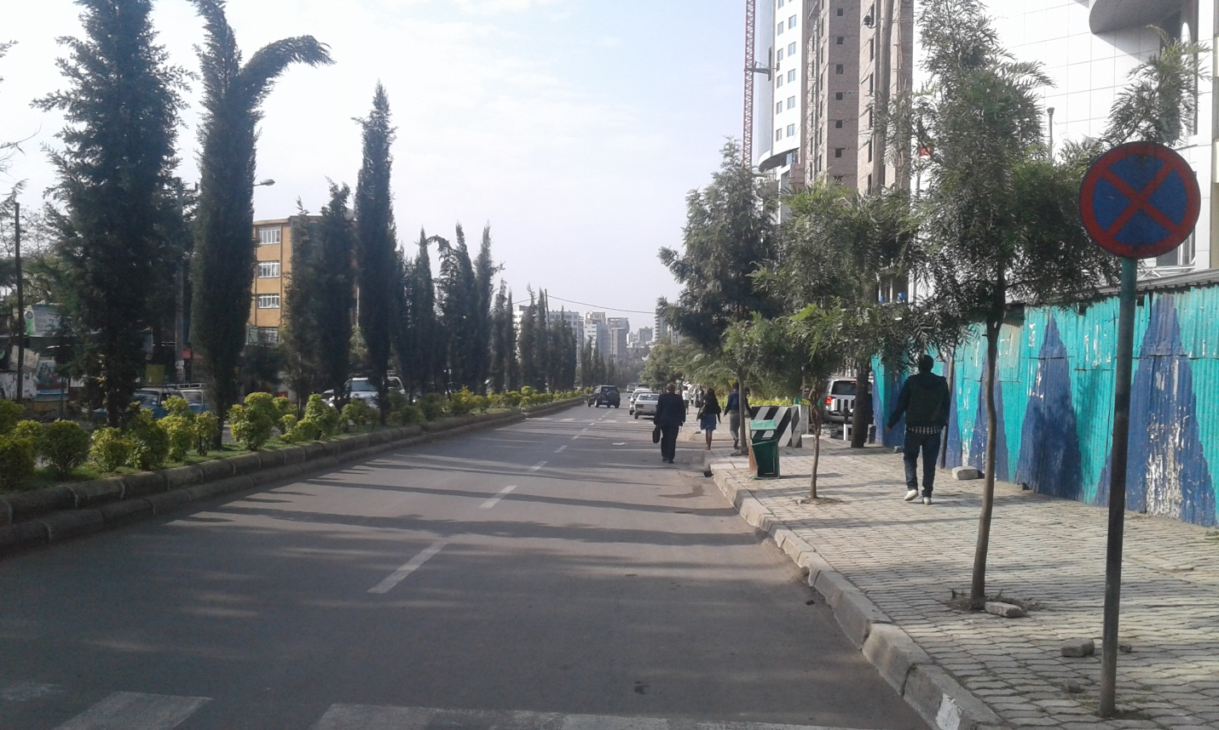
Figure 6.2: Vegetation along the street around Kazanchis
Source: Photo taken by the author
Many of the streets found in the old settlements with old roofs areas do not have street vegetation and they are too narrow.
- Planning for evenly distributed Parks
Based on the National Urban Planning preparation and Implementation Strategy (2014) Ethiopia, Public green open spaces shall be evenly distributed within the city to keep the distances people have to travel to a green open space low. However, parks in Addis Ababa are unevenly distributed. Parks have great role in temperature regulation. Feyissa et al 2014 studied on the efficiency of the parks in Addis Ababa, Addis in mitigating urban heat island, and concludes the benefits and concludes cooling effect is mainly determined by species group, canopy cover, size and shape of parks. Nonetheless, the presence of planned public green areas is limited in terms of its availability and distribution. The World Health Organization (WHO) standard is 9 m² per person and that of Africa 7 m² per person. At present, there are well over 18 functional recreational parks in Addis Ababa with total area coverage of 113.7 ha, which puts the current per capita available green space of Addis Ababa at less than 1 m² per person and as one of the lowest by international standards (Lia et al., 2017). Therefore mainly the southern and western part of Addis has to have additional parks, as suggested on Figure 6.3. This helps to have evenly distributed parks at Addis Ababa.
In the currentmaster plan (2013-2023) a total of 2730 ha recreational parks in Addis Ababa at the city, sub-city and Woreda levels. Several neighborhood level parks to be located within 300m radius are also proposed. Moreover, an estimated 90 ha of neighborhood parks will be developed. This results in a total accessible green area of 5700 m2. If 40% of this total area is developed in 10 years, the per capita accessible green area becomes 5.2 m². Development of all accessible green area in 25 years would results in a green share of 8.9 m² per person (Lia et al., 2017)
The proposal on the new master plan divides the park into four levels, i.e city park (>10ha) subcity park (1-10ha) and woreda park (0.3-1ha) and neigbourhood park (<0.3ha). Though the places are already identified on the structural plan (2013-2023), based on the rule which states public green open spaces shall be evenly distributed within the city to keep the distances people have to travel to a green open space low, the following identified places could be used an optional park development area. These points were suggested from multicriteria analyses of GIS, which overlaued various datasets. The current land covers at the proposed sites are open land, agriculture and some are built up areas.
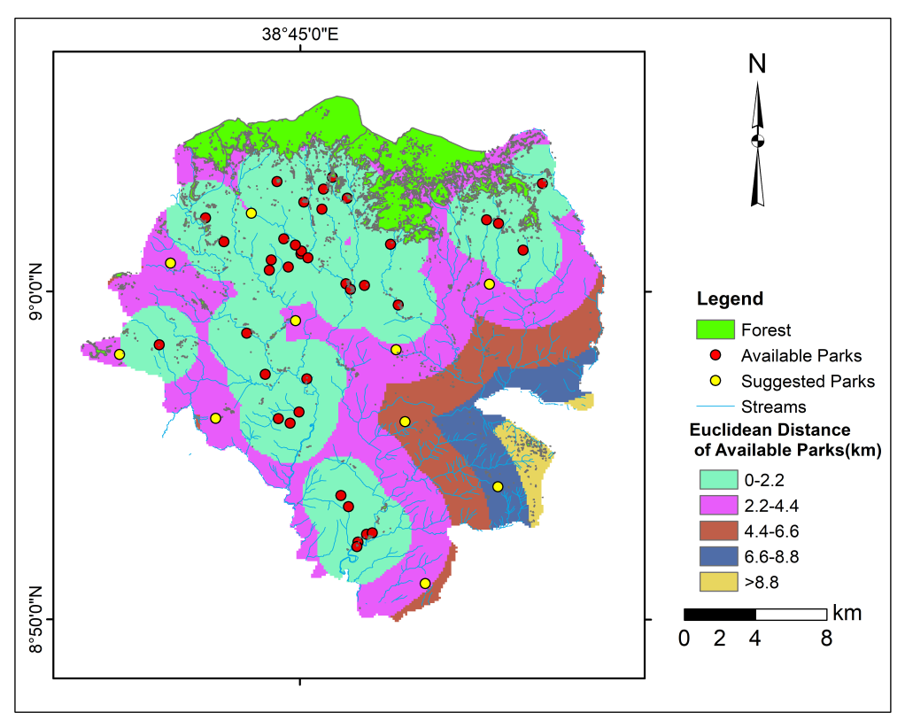
Figure 6.3: Suggested parks to have even distribution.
- Green Roofs, Vertical and Façade Gardening
It has been proven that green roofs could mitigate urban heat islands significantly by removing heat from the air through evapotranspiration and reducing heat absorb, which brings about a decrease of the temperature of roof surface and surrounding air(Shishegar, 2014). Though vertical greening systems mainly climbing trees have been used for many years, they are becoming more important and growing rapidly because the benefit they to control urban heat island. This success inspired many designers, engineers, and architects to introduce living walls in their new building projects. (Pérez-Urrestarazu et al, 2016). Mainly climbing plants could be planted and and used, despite the economic condition of the residents (Figure 6.4). Many studies tested the use of climbing plants in reduction of temperature. For instance, the ivy layers reduced exterior surface temperatures by an average of 0.7°C, and reduced heat flux through the opaque walls by 10 %(Susorova et al, 2014).
Vertical greening can provide a cooling potential on the building surface, which is very important during summer periods in hot climates. The cooling effect of green facades has also an impact on the inner climate in the building by preventing warming up the façade (Sheweka and Mohamed, 2012). Due to the housing problem in Addis Ababa, people usually do not leave free spaces for vegetation greening. In the absence of free spaces, mainly in small compounds, or even with no compounds, this could be easily implemented.
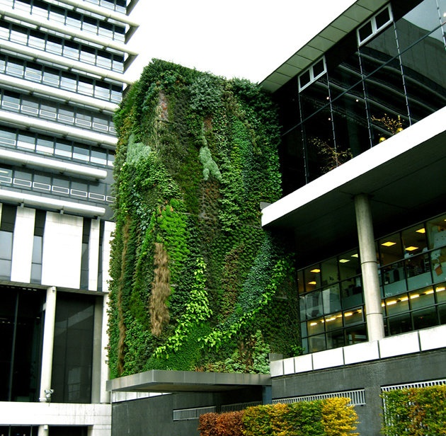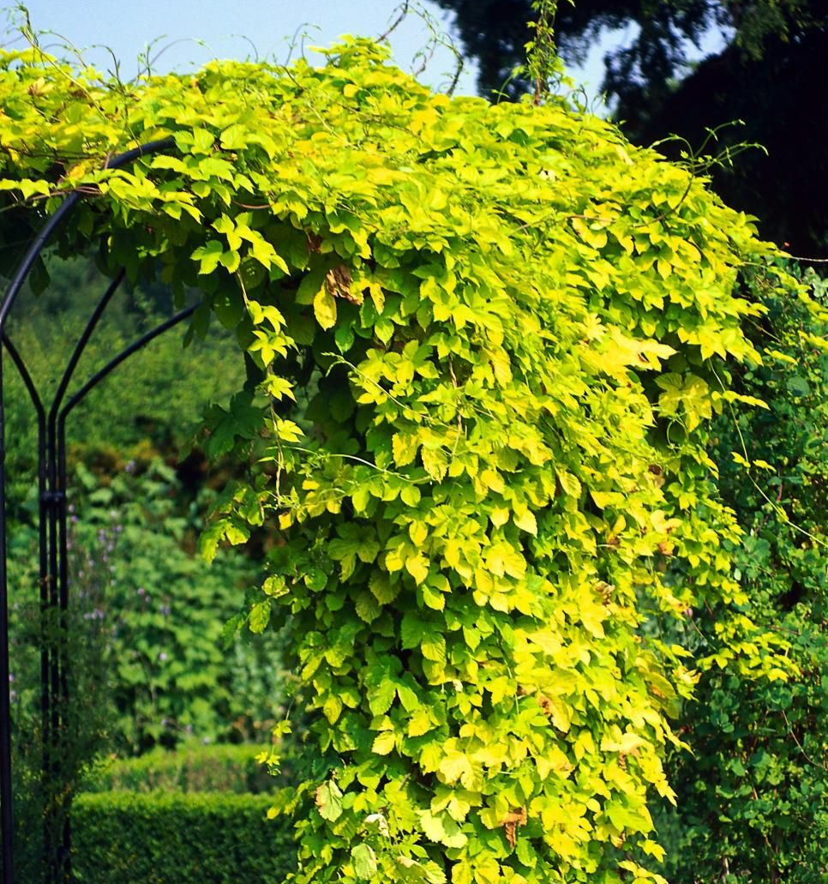
Figure 6.4: Vertical Gardens and Tree climbers
(Photo source: Patrick Blanc - Vertical garden, Hotel Department Hauts de Seine, Paris, from lovely homes4all.com)

Planning to Control Extreme Flooding
- Vegetating streams
Due to its topographic characters, Addis Ababa is endowed with rivers and smaller streams. These streams mainly flow from the Northern to Southern direction or from western to south eastern direction. They have enormous environmental benefits. However, they are highly polluted and filled with plastic materials, due to the encroachment of people highly to the rivers. As a result, the streams, which by nature their banks were covered by the trees are now bounded with individual houses.
Until currently, due consideration was not given in river banks management. In the 2013-2023 structural plan 50m wide buffer along river courses were proposed to be rehabilitated. The current measure undertaken by Addis Ababa city administration to protect these rivers is establishing a project office, which controls the development of the streams. Though that is a good start, vegetating the river side and keeping the buffer as the standard is highly essential to control flooding and regulate climate. Even though the streams are not buffered and vegetated, at least if the stream orders from (1 to 3) are vegetated it could be a best mechanism to control river flooding (Figure 6.5).
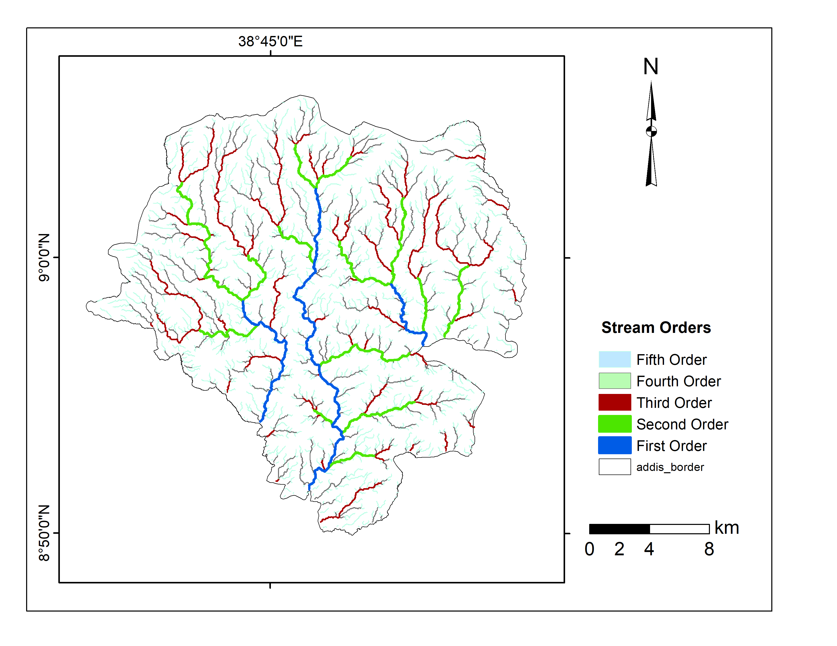
Figure 6.5: Stream orders
- Improving storm water management
Storm water runoff has become a significant problem in Addis Ababa (Mezgebe, 2009). Urban water management is main problem in Addis Ababa, in general and storm water management in particular. The storm water management is found at low level due to the poor infrastructure, standard of the drainages. In the urban standard of Ethiopia, even if it stated on the regulation, before new buildings are occupied, it shall be proved that surface water drainage works have been implemented in accordance with a detailed site plan, including an assessment of potential disposing of surface water by means of a sustainable drainage system. However, many buildings are not keeping this rule. This, at a time of extreme rain overflows to the streets and brings many damages. In general, as suggested by Worku, 2017, An Integrated Urban Water Management strategy that covers the entire urban water cycle, including diversification of water sources, protection and conservation of water, sustainable exploitation, distribution, and consumption and wastewater management, water recycling, nutrient reuse, and safe wastewater disposal, should be implemented as soon as practicable.

Summary of Adaption Activities in Addis Ababa
Though Addis Ababa is a big city with one central administration, and treated as one landscape, due to its various topographic and socio economic characteristics, the adaptation activities may vary. It is recalled that the climate change vulnerability assessment is prepared per sub cities. From the analyses, it is understood that cities are found under different vulnerability levels, and the green infrastructure within the city highly varies. In this case it is well recommended to have distributed adaptation actions to control the impacts of climate change, mainly urban heat island and flooding which are the main threats for the city. The summary of the adaptation is divided into two categories. These are the simple activities which could be implemented with short periods, small capital and small group of people or by house hold level and the second one is an advanced adaptation planning, which needs the integration of various stake holders, which needs huge capital and implemented within a long period of time. The adaptation mechanisms are summarized in Table 6.1 below per sub cities.
Table 6-1: Summary of Plan Recommendations in 10 sub-citiesof Addis Ababa

Sub-city | Urban Heat(Extreme temperature) |  | Flooding
Sub-city | Simple  (Short term) Plans | Advanced  (Long term)  Plans | Simple  (Short term) Plans | Advanced  Plans
Arada | - Street vegetation  - Rooftop gardening  - Vertical Greening | - Urban renewal  - Parks  - Awareness creation  - Enforcing LDP |  | - Relocating people from risky sites mainly along river banks
Addis Ketema | - Street tree  - Rooftop gardening  - Vertical greening | - Awareness creation  - Forcing to implement the LDP |  | - Storm water management
Lideta | - Rooftop gardening  - Vertical greening | - Enforcing LDP |  | - Storm water management
Kirkos | - Rooftop gardening  - Street Trees  - Increase shade around your home | - Awareness creation  - Enforcing LDP |  | - Separate rainwater from sewer system
Nifassilk | - Rooftop gardening  - Street Trees  - Vertical Greening | - Urban renewal  - Enforcing LDP |  | - River Buffer Greening
Akaki-Kality | - Reflective buildings  - Increase shade around your home  - Light-coloured concrete and white roofs | - Green park | - Developing Good early warning system | - Upper catchment development  - River Buffer Bank Greening  - Relocation of people from risk areas
Bole | - Reflective Buildings  - Increase shade around your home | - Constructing Parks  - Street trees | - Early warning
Yeka | - Keeping the current available vegetation from forest cleares  - Reflective buildings | - Awareness creation
Gulelle | - Keeping the current forest  - Controlling the expansion of settlement into forest sites | - Street trees
Kolfe-Keraniyo | - Street vegetation  - Controlling urban sprawl | - Street trees

Landscape Level Planning Approach
Landscape level approach includes the adaptation planning activity not only in Addis Ababa, but also on the surrounding landscape broadly. Climate change problems could not be avoided by activities undertaken by only one city or institution. By its nature climate change impact crosses border and not limited by political boundary. It also needs collaboration with various regional, national and international institutions. It is important to enhance the environmental planning integration between Addis Ababa and the surrounding. The emphasis should be given to the following landscapes.

Surrounding Mountain Chains Planning
Mountains have a profound influence on not only their local climate and immediate vicinity, but sometimes in areas a thousand or more miles away. This is due to the fact that mountains, putting up into an otherwise orderly flow of winds around the globe, cause these winds to be lifted up, over and around the peaks and ridges. Addis Ababa is surrounded by four mountains from every direction (Fig 6.6). Planning on these mountains is essential to have regulated climate in Addis Ababa. Land cover changes and any activity have a direct relationship with climate of Addis. Under this one detail survey with high vegetation cover was assessed. The four mountains around Addis Ababa are:
- Northern Direction: Entoto, well maintained, good conservation activity. Urban sprawl and encroachment problem is common in the area. For instance the areas between Addis and Sululta are highly occupied by informal settlement by clearing existing green area.
- Eastern Direction: The Erer Mountain contains forests, and relatively in good condition, due to the Akaki Catchment conservation.
- Southern Direction: The Furi Mountain, though cover small places it has great contribution to regulate climate of Addis from southern direction. Illegal settlement is a big treat around the mountain.
- Western/South Western: One of the main important things to focus and to see the reflection is the case of mount Wochecha, where remnants of forests are found. The place is highly dynamic, and need essential consideration. The forest cover clearing is a common problem.
These mountains are covered by forests and play a pivotal role in climate regulation of Addis Ababa city. As the city is surrounded by high mountains, the topography is undulating and form plateau in the northern, western and southwestern parts of the city. Bole and south western part of the city is characterized by gentle morphology and flat land areas.
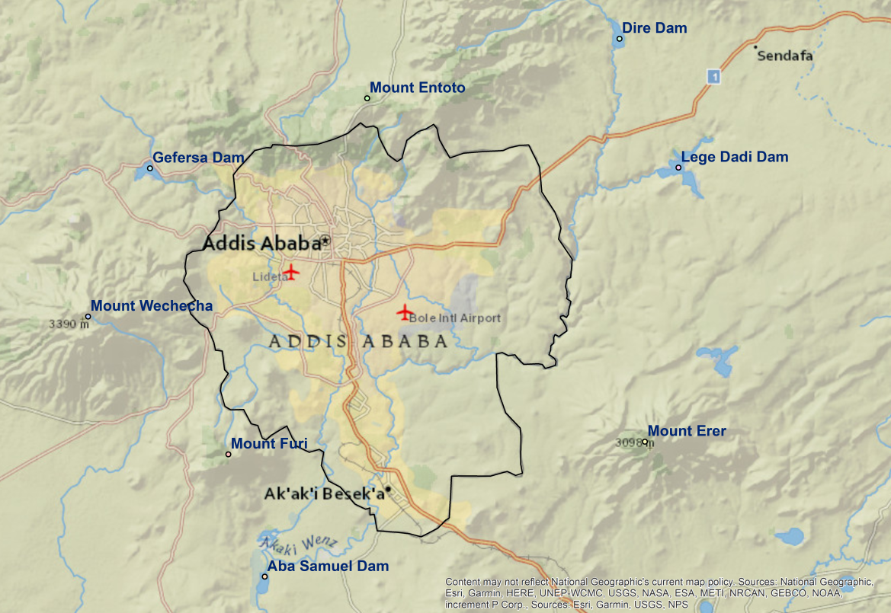
Figure 6.6: Landscape and mountain chains around Addis Ababa
These mountains have a great role in regulating climate of the city. Unless important measures are not taken to control the forest deterioration in the nearby mountains, the adaptation activity in the city alone couldn’t be a solution to mitigate climate change impacts. In order understand the contemporary problem and land cover dynamics being undertaken in Addis Ababa, land use land cover and forest loss trend on Mount Wochecha, a mountain found in the south western part of the city was analyzed. The land cover changes and forest loss in this mountain could be a reflection for other parts of the mountain chains.
Mount Wechecha, which has a great contribution in the regulation of modifying micro climate of the city and the surrounding environ, not only due to its elevation but also due to its dense forest cover. Monitoring land cover changes in a mountain ecosystem help to understand and pinpoint the strategy to be followed for the conservation of ecosystems found on the neighbouring mountains, which also have a great influence on regulating the climate of the city. Five Landsat satellite images were used to derive land cover of Mount Wechecha from 1973 to 2013. Landscape structures and matrixes have been analyzed and mapped based on the patch-corridormatrix ecological model. The results have shown that the patch analyst result is proportional to the land cover classes derived from the satellite image. The landscape structure indices of the number of patches are decreasing in all years, except for water and settlement. The forest patches are dissolved into agricultural lands.
The mean core area of the forest that increases indicates that the forest coverage is limited to certain places. The Mean Core Area of agricultural land decreased in the last decade due to the agricultural land being interrupted by other economic activities, which leads to landscape modifications. Shannon's evenness and diversity index was zero. The overall result indicates that the forest, which play a great role in climate regulation and open land coverages are decreasing at a faster rate (30% and 24.5% in 1973–14% and 2.4%. in 2013 respectively), while settlement is highly increasing (from 1.3% to 26.25% same period). Summary of each landscape indices are presented in Table 6.2
Table 6-2: Selected class and landscape level spatial metrics
Year | Class | MCA | TCA | TCAI | CAD | MSI | MPFD | AWM-PFD | TE | ED | MPS | NUMP | CA
1973 | Forest | 11.1 | 3986.2 | 53.0 | 1.4 | 1.4 | 1.1 | 1.2 | 110443 | 44.2 | 10.9 | 687 | 7519
1973 | Agriculture | 5.0 | 4046.6 | 37.1 | 3.2 | 1.5 | 1.1 | 1.3 | 209931 | 84.1 | 16.8 | 647 | 10903
1973 | Water | 25.1 | 50.4 | 60.3 | 0.0 | 2.4 | 1.1 | 1.1 | 8778. | 0.4 | 83.5 | 1 | 83.5
1973 | Settlement | 0.0 | 0.0 | 0.0 | 0.0 | 1.1 | 1.0 | 1.0 | 196080 | 7.9 | 0.5 | 630 | 327.8
1973 | Open Land | 1.6 | 936.0 | 15.3 | 2.4 | 1.4 | 1.1 | 1.2 | 192568 | 77.1 | 3.7 | 1647 | 6135
1984 | Forest | 16.8 | 4091.4 | 59.9 | 1.0 | 1.4 | 1.1 | 1.2 | 811920 | 32.4 | 12.8 | 532 | 6827.2
1984 | Agriculture | 41.2 | 9658.0 | 67.7 | 0.9 | 1.3 | 1.0 | 1.3 | 114780 | 45.9 | 75.5 | 189 | 14273
1984 | Water | 50.0 | 50.0 | 59.4 | 0.0 | 2.5 | 1.1 | 1.1 | 9000 | 0.4 | 84.2 | 1 | 84.2
1984 | Settlement | 0.7 | 22.3 | 1.5 | 0.1 | 1.2 | 1.0 | 1.1 | 740160 | 29.6 | 0.9 | 1654 | 14273
1984 | Open Land | 2.9 | 501.1 | 21.9 | 0.7 | 1.3 | 1.0 | 1.2 | 610440 | 24.4 | 3.5 | 651 | 2289.2
1993 | Forest | 21.8 | 3771.4 | 83.7 | 0.7 | 1.4 | 1.1 | 1.2 | 400380 | 16.0 | 13.1 | 344 | 4504.7
1993 | Agriculture | 26.0 | 12380 | 77.0 | 1.9 | 1.3 | 1.0 | 1.4 | 188088 | 75.3 | 24.6 | 651 | 16069
1993 | Water | 67.9 | 67.9 | 79.4 | 0.0 | 2.3 | 1.1 | 1.1 | 8460 | 0.3 | 85.5 | 1 | 85.6
1993 | Settlement | 1.1 | 650.6 | 31.8 | 2.4 | 1.4 | 1.1 | 1.2 | 874920 | 35.0 | 1.9 | 1102 | 2044.
1993 | Open Land | 2.7 | 1028.6 | 45.4 | 1.5 | 1.3 | 1.0 | 1.3 | 784140 | 31.4 | 1.6 | 1401 | 2267
2003 | Forest | 51.7 | 3001.0 | 77.7 | 0.2 | 1.3 | 1.0 | 1.1 | 282834 | 11.3 | 14.1 | 273 | 3858
2003 | Agriculture | 48.7 | 11817 | 69.7 | 1.0 | 1.3 | 1.0 | 1.3 | 133003 | 53.2 | 83.4 | 203 | 16944
2003 | Water | 59.7 | 59.8 | 63.9 | 0.0 | 1.7 | 1.1 | 1.1 | 9120 | 0.4 | 46.7 | 2 | 93.6
2003 | Settlement | 1.9 | 459.7 | 15.1 | 1.0 | 1.3 | 1.0 | 1.2 | 104595 | 41.8 | 2.2 | 1385 | 3047
2003 | Open Land | 4.9 | 325.8 | 31.6 | 0.3 | 1.3 | 1.0 | 1.2 | 253650 | 10.1 | 4.0 | 261 | 1030
2013 | Forest | 84.9 | 2972.8 | 81.8 | 0.1 | 1.2 | 1.0 | 1.1 | 204480 | 8.2 | 19.9 | 182 | 3633
 | Agriculture | 11.4 | 7084.8 | 50.3 | 2.5 | 1.3 | 1.0 | 1.4 | 194652 | 77.8 | 35.5 | 396 | 1407
 | Water | 75.2 | 75.2 | 61.7 | 0.0 | 1.5 | 1.1 | 1.1 | 11880 | 0.5 | 40.6 | 3 | 122.0
 | Settlement | 2.9 | 1596.6 | 24.5 | 2.2 | 1.4 | 1.1 | 1.3 | 162936 | 65.2 | 6.6 | 987 | 6531.1
 | Open Land | 1.9 | 88.6 | 14.6 | 0.2 | 1.2 | 1.0 | 1.1 | 202200 | 8.1 | 2.0 | 300 | 605.5
Table Legend: MCA(Mean Core Area), TCA(Total Class Area), TCAI(Total Core Area Index), CAD(Core Area Density), MSI(Mean Shape Index), MPFD(Mean Patch Fractal Dimesnsion), AWMPFD(Area Weighted Mean Patch Fractal Dimension), TE(Total Edge), ED(Edge Density), MPS(Mean Patch Size), Nump (Number of Patches), CA(Class Area).
Despite Mount Wechecha being partly the source of water for Gefersa Reservoir, and plays a key role in regulating the climate of the surrounding area, and the highest elevated place found near capital Addis Ababa, most parts of the mountain are devoid of trees except
protected sites of Menagesha-Suba and Egdu state forests. One of the main ecological importances of forests found on Mount Wechecha is climate regulation for Addis Ababa, and the surrounding towns. The capital city is bordered by mountain chains from all directions. The land transformation on these mountains has its influence on the climate of the city. Recently, even though, there is no severe lack of policies and strategies or laws and regulations, people are forced to implement it due to economic problems.
The implementation fails, mainly due to low level of economic development in the community. Even people cut trees despite their awareness even if they know the laws, and the ecological benefits of the trees. On Mount Wechecha, people have based their livelihoods on agriculture, animal herding, and use of forest resources (timber, fuel wood, fodder). The main economic activity that takes place on the mountain is agriculture. However in addition to agriculture, specifically in previous times, the mountain trees were cleared for economic purposes. The local people used to cut the trees and bring them to the town. However since the forests are cleared and others are protected, recently, people started to plant eucalyptus tree and sell the products to earn money.
The land cover change and forest loss on mount Wochecha is a clear reflection of environmental degradation on other surrounding mountains. Hence, the priority has to be given to protecting the sorruonding mountains mainly loss of mountain forests in order to have favourable climate conditions in the city. Without controlling the landscape level activities, the climate change mitigation planning within the city boundary alone could not be a solution for climate change. Inter regional collaboration and regional environmental plan is recommended.

Controlling Water Relesed from Dam
Four dams are found around Addis Ababa. These are Dire, Legedadi, Gefersa and Aba Samuel Dams. The major problem of the flooding in Addis Ababa, mainly in the lower catchments is not only created from the streams within the city but also it is highly associated with the water released from a dam. The main treat in this case is water released from Legedadi Dam. During the peak rainy seasons, the water released from Legedadi Dam abruptly, and this creates over flooding of Great Akaki, in Akaki Kality subcity, mainly in woreda 08 and 03 frequently and brings much damage to the properties of the residents (Fig 6.7). Hence enough warning system should be established and other controlling mechanism has to be implemented by the government.
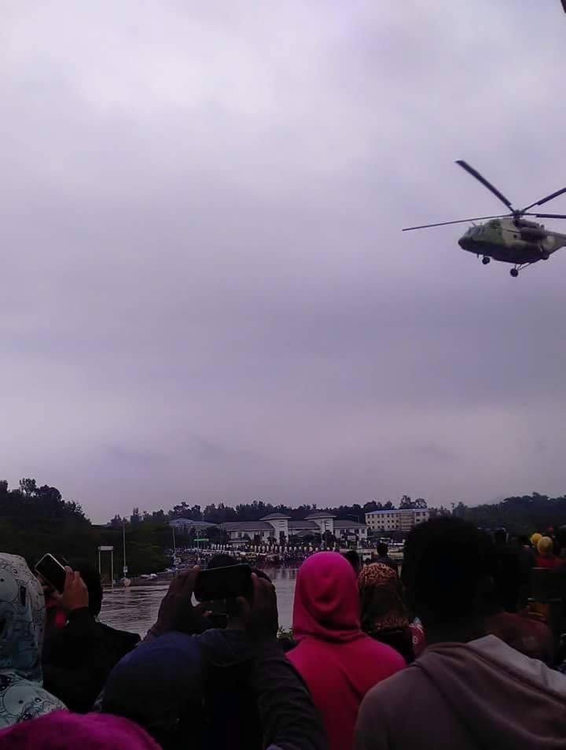
Figure 6.7: Akaki River Flooding, August 22, 2018, Addis Ababa
Photo (Fana Broadcasiting Corporate)

Industry Park Planning
Industry parks are not evenly distributed in Ethiopia. Majority of the industry parks are established around Addis Ababa. Investors, due to many reasons prefer to locate around Addis Ababa for their industry. This have a negative impact on the climate of Addis, mainly if the industries could not control the smoke they release to the air and the sorrounding environ. Environmental problems are already reported due to these industrial parks. There are huge industries parking around Addis Ababa in the road from Addis-Bishoftu, From Addis-Ambo, From Addis-Sebeta directions. Appropriate site selection for industrial parks and distribution is highly important to have a regulated climate in Addis Ababa.

Conclusion and Recommendations
The overall aim of this research was to create additional understanding on climate change at local scale, its impacts andvulnerability and the ways of impacts are reduced by adaptation and mitigation activititties, which could be generally termed as resilience planning. Planning for climate smart city, which could better withstand climate change related catastrophies, would be an inevitable part of environmental planning because, the future climatic conditions are likely to be worse than the current. Inorder to achieve this, various assessments that includes, analyses of climate models, downscaling to the point level, the pattern and trend of urban heat islands which modify micro climate of the city, climate change vulnerability assessments per subcities in order to have intervention priorities and mechanisms, the degree of awareness and attitude of the residents towards climate change, and the best recommendations have been integrated and discussed in detail. The analyses was also supported by uptodated literature reviews, under each sub-topic the results were compared with other regional and international environmental change studies, inorder to keep the standard and quality for the study. There is much concern about the vulnerability based on the IPCC’s definition and applicable recommendations on adaptation activities. The overall existing situation and documents, the actual plans on the ground were considered and the possible planning recommendations have been set. The summary and conclusion for each topic is presented below.

Main Concluding Remarks of Each Topic
Being a city with high population growth, high rate of urbanization and economic activity, Addis Ababas climate characteristics is dynamic and changing overtime. These changes made a concern on climate change of the city to be high and unavoidable. Based on the findings from each objective, the main concluding remark is presented below in four themes. These are i) the previous climatic trends and the modeling indications, ii) the urban heat island and current urbanization activity, iii) the vulnerability and iv) the perception of the society.

Trends in Climatic Elements and Future Conditions
Supported by extensive works of literatures, meterological observation data analyses shows that, the overall trends in climatic elements in Addis Ababa mainly temperature condition is continuously increasing. The precipitation in the past has no clear trend. Regarding the modeling result, the study attempted to analyze historic climate change trends and extremes, and constructs future temperature and precipitation scenarios up to the end of this century, in 30-year intervals, based on daily predictor data from two stations in Addis Ababa city. The analyses also consider future extreme events by analyzing four temperature indices and six precipitation indices that could prevail in Addis Ababa city based on the definitions set by the ETCCD to study climate change extremes. Two GCMs have been statistically downscaled under four scenarios (two SRES and two RCP). The predictors of the model were screened and selected based on the R² and p-values. The study found a good correlation between the modeled and observed results during the validation period. It also compares the results of the modeled data against the observed values for the base periods of 1971–2000 for Addis Ababa station and 1989–2005 for Entoto station.
All the models perform well in predicting the mean values during the validation period. Their good performance is displayed in quantile–quantile plots. Future scenarios predict that both the maximum and minimum temperature will increase up to the end of the century. All the models predict the change will be highest after 2020. The changes in climatic elements up to 2020 are not significant. However, in 2050, and 2080, the predictions are higher. The changes in maximum temperature reach around 2.06 °C (CGCM3A2) in the worst-case scenarios in 2080. Similarly, the increase in the minimum temperature reaches around 1.03 °C in 2080 (CGCM3A1B). Except for the coldest nights (TNn), the mean temperature and other temperature indices are projected to increase up to the end of the century. Precipitation will also increase by around 11.8% (CGCM3A2) or 16.6.2% (CanESM2 RCP8.5) by 2080. All the models also predict an increase in precipitation. The changes in precipitation are seasonally varied. The total precipitation increases by 29% (RCP4.5) in winter and 20.9% (RCP8.5) in summer by 2080 in the worst-case scenarios. Maximum one-day and five-day precipitation will also significantly increase in winter and summer in 2080. All the indices of precipitation will additionally increase to the end of the century compared to the baseline period, except for consecutive dry days (CDD).
Although there is a seasonal difference in the amount and change in extreme events, there is good agreement among the models under different scenarios regarding the increase of precipitation and temperature. All the values of the models indicate similar projections; however, the magnitude of the prediction varies from one model to another. Except for the minimum temperature at Addis Ababa Observatory in the SRES scenarios of the CGCM3A2 model, temperature values are highly overestimated (even more than in RCP8.5) at both Entoto and Addis Ababa stations. Regarding precipitation, in 2020 and 2050 the precipitation value is overestimated by the SRES in CGCM3A2; however, after 2050, the RCP8.5 projects higher value for precipitation than SRES, except at Entoto station. The analysis also shows that there is no significant negative trend in temperature and precipitation despite the variability in amounts. Generally, the city will experience an increase in temperature, which will gradually modify the existing temperature conditions, resulting from high urban activity and climate change.
As a result, the effect of elevation differences, which ranges by 1000 m, will be less in every direction of the city. The city has been affected by flood-induced damage due to the low level of infrastructure development and the poor quality of housing. Moreover, with the expected rise of precipitation due to global climate change, the city will continue to experience flooding vulnerability. Hence, it is recommended that city planning integrates the findings of this research to develop better adaptation mechanisms. Further studies also need to be undertaken by adding various model ensembles in order to avoid prediction inconsistency

LST and Land Use Land Cover Change
Surface skin temperature (LST) is a good indication to study the urban heat island coverage and variation. The response of the land surface temperature to land cover change and topographic influence is analyzed. The analyses depend on four times Landsat satellite images, on which land surface temperature is extracted. The study accesses the spatio temporal variation of LST in Addis Ababa since 1986. In addition to the direct values of LST extracted from satellite images, the analyses from NDVI and UTEI indexes which supports the LST characteristics and distribution in Addis Ababa is also used. The landsurface temperature which is esacerbated by urban heat island is also increasing in the past four decades. The fast urbanization is responsible for the occurance of high urban heat island for instance the built up area is increased by this which is by far witnessed by others in the previous studies. All the indices and the results indicate that the land surface temperature of the city is continously increasing. The areas with highest land surface temperature also increase. The highest temperature areas, which was only found in the Southern and South Western parts of Addis Ababa in 1986 and 1995, due to its low lying elevation, starts to shift to the central and Northern parts in 2007 and 2017, indicating the potential effect of the land cover change on the LST of Addis Ababa. The high activity in urbanization which mainly focuses on house construction with little attention to green infrastructure development makes the LST overtime. The role of the topographic influence diminishes, as the role of land cover change getting high.
Significant, and actual effect of urban heat, which indicates the magnitude of change like deaths, could happen at this time, though, the potential effects of urban heat is still there and has an impact on the social, economic and environmental conditions. The LST change is high but its hazard is not well captured for now, due to the elevation of Addis Ababa. However, it creates a great challenge in the future, as the role of elevation gradually diminishes. If the condition continues without any intervention mechanism, it changes, for instance, on life style of the residents, also which was known than adopted. It could be also be concluded that the urban thermal characteristics is the highly influenced by the housing material type mainly roof types and the planning activity, rather than the height of the buildings.

Climate Change Vulnerability
In this part, climate change vulnerability is quantified, mapped and categorized by layer of exposure, sensitivity and adaptive capacity. 15 layers of vulnerability indicators were considered with bio physical, social and economic layers at sub-city level in Addis Ababa. The selections of the indicators are based on the literature used to identify and map climate change vulnerability layers. Though it follows the IPCC`S climate change vulnerability definition, the selection of the indicators was based on the Sullivan and Meigh’s model which initially developed to prepare climate change vulnerability indices.
Vulnerability to climate change is recognized as a state generated not just by climate change but by multiple processes and stressors. The stresses are more expressed by the low level development of adaptive capacity activities in Addis Ababa. Changes in adaptive capacity which mainly contained the socio economic analyses were rapidly changed, imposing greatest effect on the impact of climate change vulnerability. Studies also suggest that the changes in the social causes of vulnerability often happen much more rapidly than many environmental changes (Khajuria Ravindranath, 2012). The overall arrangement of the vulnerability in Addis Ababa is determined by insufficient environmental management capacity. Highest vulnerability is due to extreme precipitation events, which mainly affects densely populated areas with low level of infrastructure development and low quality houses. Increases in temperature (both air and LST), as a result of urbanization activity and low land use management, will also continue to be a key concern for Addis Ababa’s vulnerability to climate change in the future. A change in these two climatic elements plays a key role in determining the intensity and frequency of climate change vulnerability.
Well implemented planning activity was confirmed to play a pivotal role in reducing impacts exerted by climate change; the exposure and sensitivity to climate change were confirmed to be high in densely populated areas with poor housing conditions, temperature change was confirmed to be high in sub-citiesfound in the northern and north western parts; the flooding risk was confirmed to be high in the areas of low slope and high population density; and the highest vulnerability at a sub-citieswith lower adaptation capacities. The integrated Sullivan and Meigh`s Climate change vulnerability Index and the IPCC’s definition of climate change vulnerability is well integrated in indicating and prioritizing vulnerable hot spots to climate change at sub-city level.

Perceptions of the Residents, Currently Practiced Methods
Understanding of local people’s perception on environmental conditions is crucial to design and implement appropriate adaptation strategies to climate change and variability. Awareness and attitude is the ingtegral part of any climate resilience plannings and the main planning part to be integrated. In this part, resident’s perception of climate change and its impacts as well as the adaptation practices in Addis Ababa was assessed. A total of 399 households from four sub-cities were surveyed with structured questionnaire. In addition additional qualitative information was generated from key informant interviews and authors observations. The period considered for analyses were the past one to three decades. The results of the study showed that the respondents were perceived the rise in temperature and precipitation. However there is limited public understanding of the urban impacts of climate change. Though the respondents perceive well the changes in climatic elements mainly temperature and precipitation, their perception on the overall impact is minimum. The current adaptation approaches are not enough to provide a long-term solution to the fast changing climate, because the community has limited knowledge of adaptation strategies, resources, and limited support from the government. Adaptation to climate change requires local knowledge, local competence and local capacity within local governments. It needs households and community organizations with the knowledge and capacity to act. However the adaptation practices both by community and the government is minimal

Recommendations
Climate change Resilience planning for a big city is not a single concept, as it contains various ideas within it, and needs a collaboration of different stakeholders. The integration of the concerned institutions is very important to solve climate change problems, at city level. The impacts of climate change, which are so far identified in Addis Ababa, are not remained as a problem because of the degree of their damage, but due to low level of adaptation planning. When we said adaptation planning problem, it is not only about unavailability of environmental plans, but, lack of its implementation. Regarding to the institutions also, of course there are a plenty of environmental related offices in Addis Ababa. However, there is a weak relationship between them. The available, environmental plans, enclosed within the master plan to the local development plan are well prepared. The major problem again is the lack of their implementation at all levels. These remain as a challenge in any planning process of Addis Ababa. Many things are happening against the plan. The green areas which have a crucial importance to combat urban climate change are not found on the ground as on the plan.
In general, the climate change problem is real, and the adaptation mechanism should be improved, mainly implementation. The climate change mitigation planning could be started from simple methods to the complicated ones. As recommended on the resilience planning part of this study, some climate change adaptation mechanism could be implemented, by individuals, for instance, at their individual garden. The second and complicated is the long term plan, which needs a huge investment, space, collaboration, and policy as well as law enforcements. The recommendations listed in this study above, will also help to have a better climate change resilient city, as they are tested in some other exemplary cities. There need to be an organized awareness creation problem on the impacts and new adaptation measures using mass media and different information channels. Further studies have to be undertaken by identifying additional indicators and recent data for better understanding and effective control of climate change vulnerability in Addis Ababa. Inorder to implement, the available and recommended planning solutions to climate change, it is recommended to fulfill another prior works that could be a must for effective climate change mitigation and adaptation plans. These are cadastre development, rule enforcement and integration of climate change resilience planning in structural plans.

Modern and up-to- date Cadastral Development
The problem in Addis Ababa which makes the structural plans and other plans not to be implemented is the low land management or unavailability of fully developed modern cadastre system. The rules are proclaimed in the absence of fully developed cadastre system. Cadastre is referred to as a parcel based land information system. The land registration on the plan and the ground is varying. Land management in Addis Ababa is characterized by lack of coordination, lack of proper legal frameworks, lack of specific targets, monitoring and evaluation mechanisms and lack of stakeholder involvement, excluding stakeholders with legitimate interests in the city development from the process. The only recent attempt to make the land ownership registration digital, which covers all parts the city with high resolution orthophoto (taken in 2010) might help to reduce the challenge in this regard. Cadastre plays a crucial role in the urban land management.

Enforcing the Existing Rules to be Implemented
It has been recalled from varios documents that implementation failure has also been a problem for the envrironmental related rules and plans in the past for Addis Ababa. Various environmental rules including proclamations, directions, standards and manuals are available, but most of them are not implemented. It is impossible to plan for new and complicated environmental plans without implementing the previously prepared plans. Most of the plans have failed to guide development in accordance with the intended goals. Rules by the the urban planning, preparation and implementation strategy allocated 30% of the land for roads and infrastructure, 30% for green areas and shared public use and 40% for building construction in their urban land management plan (MoUDH, 2015) should be implemented.

Consideration Climate Change Concepts in Structural Plan Preparation
Addis Ababa is so far conducted 10 master plans since the establishment, which most of them are undertaken by foreigners. Except for the last two master plans, the main focus of the master plans was on land use, not specifically on climate change. The master plan developed in 2002 to cover the years 2003-2010, did not explicitly address climate change, it did address a number of issues of relevance to create resilience to climate change as it focused on making Addis Ababa a livable and safe city. Topics of relevance for climate change adaptation were for example environment focusing on protecting and rehabilitating the green structure of the city, the provision of sanitation services to a larger proportion of the citizens and improved waste management. A further topic of relevance was housing focussing on provision of formal housing opportunities to counter the negative effects of informal settlements, rehabilitation of settlements to improve living conditions, and resettlement of people living in undesirable informal settlements. Under the heading of land use, the master plan focused on the development of Addis Ababa to become more compact and to allow for small scale agriculture at the urban fringe (CLUVA, 2012).
Though currently proposed master plan (2013-2023) prepared following the urban planning, preparation and implementation strategy allocated 30% of the land for roads and infrastructure, 30% for green areas and shared public use and 40% for building construction in their urban land management plan, it did not give gave a special attention to future climate change. It is just used the available elements that are normally used to prepare environmental plan, but it did not consider any changes or made scenarios of climate change. However, the integtration of, for instance changes in the climate elements like precipitation, drainage conditions should be incorporated. Considering these changes better plans could be prepared.

References
Abbasnia, M., Toros, H. (2016). Future changes in maximum temperature using the statistical downscaling model (SDSM) at selected stations of Iran. Model. Earth Syst. Environ., 2, 1–7. https://doi.org/10.1007/s40808-016-0112-
Abdulrahman, K. (2010). Remote Sensing. Republic of Iraq Ministry of Higher Education and Scientific Research University of Technology.
Abebe, E., and Kebede, A. (2017). Assessment of Climate Change Impacts on the Water Resources of Megech River Catchment, Abbay Basin, Ethiopia. Open Journal of Modern Hydrology, 07(2). 10.4236/ojmh.2017.72008.
Abebe, G. (2017). Long-term climate data description in Ethiopia. Data in Brief, 14, 371-392. https://doi.org/10.1016/j.dib.2017.07.052
Abebe, M., (2016). Remote Sensing and Geographic Information System Based Suitability Analysis of Urban Green Space Development in Addis Ababa: A case Study of Bole Sub-city. MSc Thesis submitted to Addis Ababa University Addis Ababa, Ethiopia.
Abebe, M. and Megento, T. (2016). The City of Addis Ababa from ‘Forest City’ to
‘Urban Heat Island’: Assessment of Urban Green Space Dynamic. Journal of Urban and Environmental Engineering, 10(2), 254-262.
https://doi.org:10.4090/juee.2016.v10n2.254262.
Abutaleb, K., Ngie, A., Darwish, A., Ahmed, M., Arafat, S., Ahmed, F. (2015). Assessment of Urban Heat Island Using Remotely Sensed Imagery over Greater Cairo, Egypt. Advances in Remote Sensing, 4, 35-47. http://dx.doi.org/10.4236/ars.2015.41004
Adeaga, O. (2009). Planning and Warning Tools for Flood Disaster Management in Lagos Mega City. Fifth Urban Research Symposium
Adeline, N., Abutaleb, K., Ahmed, F., Darwish, A., Ahmed, M. (2014). Assessment of urban heat island using satellite remotely sensed imagery: a review. South African Geographical Journal, 96(2), 198-214. http://dx.doi.org/10.1080/03736245.2014.924864
Adger, NW. Arnell, E.L., Tompkins (2005). Successful adaptation to climate change across scales. Global Environ. Change, 15(2), 75-86.
http://dx.doi.org/10.1016/j.gloenvcha.2004.12.005
Akbari, H., Cartalis, C., Kolokotsa, D., Musciod, A., Piselloe, A., Rossie, F., Santamouris, M., Synnefa, A., Wong, N., Zinzig, M. (2015). Local Climate Change and Urban Heat Island Mitigation Techniques – The State of the Art. Journal of Civil Engineering and Management. http://dx.doi.org/10.3846/13923730.2015.1111934
Alliance for community trees. (2011). Benefits of Trees and Urban Forests: A Research List. http://www.actrees.org/files/Research/benefits_of_trees.pdf
Al Buloshi, AS., Ramadan, E. (2015) Climate Change Awareness and Perception amongst the Inhabitants of Muscat Governorate, Oman. American Journal of Climate Change, 2015, 4, 330-336
Amadou, A., Gado, D.A., Seidou, O., Seidou, S.I., Ketvara, S. (2015). Changes to flow regime on the Niger River at Koulikoro under a changing climate. Hydr. Sci. J. 60, 1709–1723, http://dx.doi.org/10.1080/02626667.2014.916407
Amare, A., Simane, B. (2017). Determinants of smallholder farmers’ decision to adopt adaptation options to climate change and variability in the Muger Sub basin of the Upper Blue Nile basin of Ethiopia. Agric and Food Secur 6(64).
http://dx.doi.org/10.1186/s40066-017-0144-2
Anderson, JR., Hardy, E.E, John, T., Roach, J.T., Richard, E., Witmer, RE. (1976) . A land use and land cover classification for use with remote sensor data, U.S. Geological Survey Professional Paper 964, Washington, U.S. Government Printing Office.
Arsiso, B.K, Tsidu, G.M., Stoffberg, G.H., Tadesse, T. (2017). Climate change and population growth impacts on surface water supply and demand of Addis Ababa, Ethiopia. Clim. Risk Manag., 18, 21–33. http://dx.doi.org/:10.1016/j.crm.2017.08.004
Ayalew, D., Tesfaye, K., Mamo, G., Yitaferu, B., Bayu, W. (2012). Outlook of future climate in Northwestern Ethiopia. Agri. Sci., 3, 608–624, http://dx.doi.org/10.4236/as.2012.34074
Bambrick, H., Moncada, S., and Briguglio, M. (2015). Climate change and health vulnerability in informal urban settlements in the Ethiopian Rift Valley. Environ. Res. Lett. 10 http://dx.doi.org/10.1088/1748-9326/10/5/054014
Belay, A., Recha, J., Woldeamanuel, T., and Morton, J. (2017). Smallholder farmers’ adaptation to climate change and determinants of their adaptation decisions in the Central Rift Valley of Ethiopia. Agri and Food Sec., 6, 24. http://dx.doi.org/10.1186/s40066-017-0100-1
Belete, DH. (2011). Road and urban storm water drainage network integration in Addis Ababa: Addis Ketema Sub-city Journal of Engineering and Technology Research. 3(7):217-225. http://www.academicjournals.org/article/article1380190860_Belete.pdf
Bewket, W., Alemu, D. (2011). Farmers perception of climate change and its agricultural impacts in the Abay and Baro Akobo River Basins, Ethiopia. Ethiopian journal of development research, 33, 1.
Beyene, A. (2016). Precipitation and Temperature Trend Analysis in Mekelle city, Northern Ethiopia, the Case of Illala Meteorological Station. J Earth Sci Clim Change, 7:1 http://dx.doi.org/10.4172/2157-7617.1000324
Billi, P., Alemu, Y., Ciampalini, R. (2015). Increased frequency of flash floods in Dire Dawa,
Ethiopia: Change in rainfall intensity or human impact? Natural Hazards.
76, 2, 1373–1394. http://dx.doi.org/10.1007/s11069-014-1554-0
Birhanu, D., Kima, H., Jang, C., Park, P. (2016). Flood Risk and Vulnerability of Addis Ababa City Due to Climate Change and Urbanization. Procedia Engineering, 154:696 – 702. http://dx.doi.org/10.1016/j.proeng.2016.07.571
Bogardi I, Matyasovszky I. (1996). Estimating daily wind speed under climate change. Solar Energy 57(3): 239–248.
Boysen, LR. Brovkin, V., Arora, VK., Cadule, de Noblet-Ducoudré, PN., Katon, E., Pongratz, J., Gayler, V. (2014). Global and regional effects of land-use change on climate in 21st century simulations with interactive carbon cycle. Earth Syst. Dynam., 5, 309–319. www.earth-syst-dynam.net/5/309/2014/ http://dx.doi.org/10.5194/esd-5-309-2014.
Brutsaert, W. (2017). Global land surface evaporation trend during the past half century. Advances in Water Resources, 106, 3-5. https://doi.org/10.1016/j.advwatres.2016.08.014
California Climate Action Team. (2013). Preparing California for Extreme Heat Guidance and Recommendations. http://www.climatechange.ca.gov/climate_action_team/reports/Preparing_California_for_Extreme_Heat.pdf
Campbell-Lendrum, D., and Corvalán, C. (2007). Climate Change and Developing-Country Cities: Implications for Environmental Health and Equity. J. Urban Health. 84(Suppl 1): 109– http://dx.doi.org/10.1007/s11524-007-9170-x117.
Chapman, S., Watson, J.E.M., Salazar, A. et al. (2017). The impact of urbanization and climate change on urban temperatures: a systematic review. Landscape Ecol, 32: 1921. https://doi.org/10.1007/s10980-017-0561-4
Chemonics International. (2015). Climate Variability and Change in Ethiopia Summary of findings. Prepared for United States Agency for International Development Climate Change Adaptation Thought Leadership and Assessments (ATLAS). https://www.usaid.gov/sites/default/files/documents/1866/12.22.15%20-%20ClimateVariabilityChange_Ethiopia_Dec2015%20%281%29.pdf
Cheng, L.J., Zhu, J. (2018). 2017 was the warmest year on record for the global ocean. Adv. Atmos. Sci., 34, 261–263, https://doi.org/10.1007/s00376-018-8011-z.
Chen, X., Su, Y., Li, D., Huang, G., Chen, W., Chen, S. (2012). Study on the cooling effects of urban parks on surrounding environments using Landsat TM data: A case study in Guangzhou, southern China. International Journal of Remote Sensing, 33:5889–5914. http://dx.doi.org/10.1080/01431161.2012.676743
Choi, G., Collins D., Ren G., Trewin, B., Baldi, M., Fukuda, Y., Afzaal, M., Pianmana, T., Gomboluudev, P., Huong, P.T.T., et al. (2009). Changes in means and extreme events of temperature and precipitation in the Asia-Pacific network region, 1955–2007. Int. J. Clim., 29, 1906–1925.
Choy, D., Serrao-Neumann, S., Crick, F., Schuch, G., Sanò, M., Staden, R., Sahin,O., Harman,B., Baum,S. (2012). Scenario Planning for Climate Change Adaptation. Griffith University. ISBN: 9781921760815
Christensen, J.H., Hewitson, B., Busuioc, A., Chen, A., Gao, X., Held, I., Jones, R., Kolli, R.K., Kwon, W.-T., Laprise, R., Magaña Rueda, V., Mearns, L., Menéndez, C.G., Räisänen, J., Rinke, A., Sarr, A., and Whetton, P. (2007). Regional Climate Projections. In: Climate Change 2007: The Physical Science Basis. Contribution of Working Group I to the Fourth Assessment Report of the Intergovernmental Panel on Climate Change. Solomon, S., Qin, D., Manning, M., Chen, Z., Marquis, M., Averyt, K.B., Tignor, M., and H.L. Miller (eds.). Cambridge University Press, Cambridge, United Kingdom and New York, NY, USA.
Cieszewska, A., (2000). Comparative landscape structure studies for land use planning: Przedborski landscape park case study. In: Landscape Ecology. Theory and Applications for Practical Purposes. Polish Association for Landscape Ecology, Pułtusk School of Humanities, pp. 54–68.
Climate Change and Urban Vulnerability in Africa. (2013). Green Infrastructure. An essential foundation for sustainable urban futures in Africa. http://www.cluva.eu/deliverables/CLUVA_D2.10.pdf
Climate Change and Urban Vulnerability in Africa. (2012). Climate change and vulnerability of African cities, Research briefs. Deliverable reference number and title: D 5.2 Report on climate related hazards in the selected cities.
Climate Change and Urban Vulnerability in Africa. (2011). Assessing Vulnerability of Urban Systems, Populations and Goods in Relation to Natural and Man-Made Disasters in Africa. http://www.cluva.eu/CLUVA_publications/CLUVA_Climate-change-and-vulnerability-of-Africancities-Research-briefs.pdf (accessed on 15 March 2016).
Climate change and Urban Vulnerability in Africa. (2010). Assessing vulnerability of urban systems, populations and goods in relation to natural and man-made disasters in Africa
Climate Impacts Group University of Washington. (2013). Climate Change Impacts and Adaptation in Washington State: Technical Summaries for Decision Makers. http://cses.washington.edu/db/pdf/snoveretalsok816lowres.pdf
Climate Impact Group. NY. College of the Environment, University of Washington. http://cses.washington.edu/db/pdf/snoveretalsok2013sec3.pdf
Coaffe, J. (2010). Protecting vulnerable cities: the UK’s resilience response to defending everyday urban infrastructure International Affairs. Blackwell Publishing Ltd. The Royal Institute of International Affairs.
Cochrane, L., Costolanski, P. (2013). Climate change vulnerability and adaptability in an urban context: A case study of Addis Ababa, Ethiopia. International Journal of Sociology and Anthropology.5(6):192-204, https://doi.org/10.5897/IJSA2013.0459
Conway, D., Schipper, L.E.F. (2011). Adaptation to climate change in Ethiopia: opportunities identified from Ethiopia, Global Environmental Change 21(1): 227-237. https://doi.org/10.1016/j.gloenvcha.2010.07.013
Corburn, J. (2009). Cities, Climate Change and Urban Heat Island Mitigation: Localising Global Environmental Science. Urban Stud, 46, 413. http://usj.sagepub.com/cgi/content/abstract/46/2/413
Coulibaly, P., Dibike, Y.B. (2005). Downscaling precipitation and temperature with temporal neural networks. Am. Meteorol. Soc., 6, 483–496, doi:10.1175/JHM409.1.
Coumou, D., Robinson, A., Hare, B., Schaeffer, M. (2016). Climate change impacts in Sub-Saharan Africa: from physical changes to their social repercussions. Regional Environmental Change, 17(6), 1585–1600. http://dx.doi.org/10.1007/s10113-015-0910-2. https://landsat.usgs.gov/sites/default/files/documents/L5TM_postcal.pdf
da Silva, J., Sam, Kernaghan , S., Luque, A. (2012). A systems approach to meeting the challenges of urban climate change. Volume 4, 2012 - Issue 2
https://doi.org/10.1080/19463138.2012.718279
Daba, M. (2018). Assessing Local Community Perceptions on Climate Change and
Variability and its Effects on Crop Production in Selected Districts of
Western Oromia, Ethiopia. Journal of climatology and weather forecasting.6,1. https://doi.org/10.4172/2332-2594.1000216
De Sherbinin, A. (2014). Climate change hotspots mapping: what have we learned? Climatic Change. (123(1): 23–37. https://doi.org/10.1007/s10584-013-0900-7
Debela, N., Mohammed, C., Bridle,K., Corkrey, R., and McNeil, D. (2015). Perception of climate change and its impact by smallholders in pastoral/agropastoral systems of Borana, South Ethiopia. Springer plus. https://doi.org/10.1186/s40064-015-1012-9
Deresa, TT, Hassan, RM., Ringler, C., Alemu, T., Yesuf, M. (2009). Determinants of farmers’ choice of adaptation methods to climate change in the Nile Basin of Ethiopia. Glob Environ Chang 19:248–255.
Deque, M., Dreveton, C., Braun, A., Cariolle, D. (1994). The ARPEGE/IFS atmosphere model: A contribution to the French community climate modelling. Clim. Dyn., 10, 249–266.
Dile, Y.T., Berndtsson, R., Setegn, S.G. (2013). Hydrological response to climate change for Gilgel Abay river, in the Lake Tana basin—Upper Blue Nile basin of Ethiopia. PLoS ONE, 8, e79296. https://doi.org/10.1371/journal.pone.0079296
Doll, P. (2009). Vulnerability to the impact of climate change on renewable groundwater resources: a global-scale assessment. Environ. Res. Lett.4 (1). https://doi.org/10.1088/1748-9326/4/3/035006
Domínguez, M., Romera, R., Sánchez, E., Fita, L., Fernández, J., Jiménez-Guerrero, P., Montávez, J., David, W., Cabos, W.D., Liguori, G. et al. (2013). Present climate precipitation and temperature extremes over Spain from a set of high resolution RCMs. Clim. Res. 58, 149–164, https://doi.org/ 10.3354/cr01186.
Donat, M.G., Alexander, L.V., Yang, H., Durre, I., Vose, R., Dunn, R.J.H., Willett, K.M., Aguilar, E., Brunet, M., Caesar, J., et al. (2013). Updated analyses of temperature and precipitation extreme indices since the beginning of the twentieth century: The HadEX2 dataset. J. Geophys. Res. Atmos., 118, 1–16, doi:10.1002/jgrd.50150
Duguma, L.A., Minang, P.A., van Noordwijk, M. (2014). Environmental Management, 54: 420. https://doi.org/10.1007/s00267-014-0331-x
Ethiopia’s New Climate Economy Partnership. (2015). Unlocking the Power of Ethiopia’s Cities.
Federal Democratic Republic of Ethiopia Central Statistical Agency. (2013). Population Projection of Ethiopia for all Regions at Wereda Level from 2014 – 2017
Federal Democratic Republic of Ethiopia. (2011). Ethiopia’s Climate Resilient Green Economy Green economy strategy.
Feizizadeh, B., Blaschke, T., Nazmfar, H., Akbari, E. and H. R. Kohbanani, H. (2013). Monitoring land surface temperature relationship to land use/ land cover from satellite imagery in Maraqeh County, Iran. Journal of Environmental planning management
Feyissa, G., Dons, K., Meilby, H. (2014). Efficiency of parks in mitigating urban heat island effect: An example from Addis Ababa. Landscape and urban planning, 123, 87-95. https://doi.org/10.1016/j.landurbplan.2013.12.008
Few, R., Tran, PG. (2010). Climatic hazards, health risk and response in Vietnam: case studies on social dimensions of vulnerability. Global Environmental Change, 20(3): 529–538.
Finance and Economic Development Bureau. Population Affairs Coordination Sub process. (2009). Addis Ababa population images.
Folke, C. (2006). Resilience: The emergence of a perspective for social-ecological systems analysis. Global Environmental Change, 16(3), 253–267.
Folke, C., Carpenter, S., Elmqvist, T., Gunderson, L., Holling, C. S., Walker, B. (2002). Resilience and Sustainable Development: Building Adaptive Capacity in a World of Transformations. A Journal of the Human Environment 31(5):437-440.
https://doi.org/10.1579/0044-7447-31.5.437
Fussel, H.M., Klein, R. J.T. (2006). Climate Change Vulnerability Assessments. Climatic Change. 75: 301–329. https://doi.org/10.1007/s10584-006-0329-3
Ganie, M., Nusrath, A. (2016). Determining the Vegetation Indices (NDVI) from Landsat 8 Satellite Data. International Journal of Advanced Research, 4(8), 1459-1463. https://doi.org/10.21474/IJAR01/1348
Gashu, K., Gebre-Egziabher, T. (2018). Spatiotemporal trends of urban land use/land cover and green infrastructure change in two Ethiopian cities: Bahir Dar and Hawassa Kassahun. Environ Syst Res 7:8. https://doi.org/10.1186/s40068-018-0111-3
Geberehiwot, H., (2014). Climate Change Perception and Adaptation Practices of Gondar
City Administration Office Workers, Ethiopia. Journal of Environment and Earth Science ISSN 2224-3216 (Paper) ISSN 2225-0948 (Online) 4, 13.
Gebre, G., Feleke, Z., and Demissie, S. (2010). Mass Concentrations and Elemental Composition of Urban Atmospheric Aerosols in Addis Ababa, Ethiopia. Bull. Chem. Soc. Ethiop. 2010, 24(3), 361-373. ISSN 1011-3924.
Gebregziabher, Z, Mekonnen, A., Deribe, R, Boka, J.,Abera, S. (2016). Mapping Vulnerability to Climate Change of the Farming Sector in the Nile Basin of Ethiopia. A Micro-level Perspective. Environment for Development.
Gebrie, W.G., Abate, B. (2012). Trend of lake evaporation considering climate change, the case of Lake Hawasa, Ethiopia. Int. J. Sci. Res., 3, 2319–7064
Ghent, D., Kaduk, J., Remedios, J. & Balzter, H. (2010). Data assimilation into land surface models: The implications for climate feedbacks. Int. J. Remote Sens. 32, 617–632
Giorgi F, Coppola, E. (2010). Does the model regional bias affect the projected regional climate change? An analysis of global model projections. Climatic Change, 100:787–795. https://doi.org/10.1007/s10584-010-9864-z.
Giorgi, F., B., Hewitson, J., Christensen, M., Hulme, H., Von Storch, P., Whetton, R., Jones, L., Mearns, C., Fu. (2001). Regional Climate Information: Evaluation and Projections (Chapter 10). In Climate Change 2001: The Scientific Basis, Contribution of Working 32 Group I to the Third Assessment Report of the IPCC [Houghton, J. T., Y. Ding, D. J. Griggs, M. Noguer, P. J. van der Linden, X. Dai, K. Maskell, and C. A. Johnson (eds.)]. Cambridge U. Press: Cambridge, pp. 739-768. http://www.efdinitiative.org/sites/default/files/publications/efd-dp-16-19_0.pdf
Gizachew Kabite. (2011). GIS and remote sensing based solid waste landfill site selection: A case of Addis Ababa city. Un published MSc thesis submitted to Addis Ababa college of natural sciences school of earth and planetary science department of earth sciences
Han-qiu, X., Ben-qing, C. (2004). Han Remote sensing of the urban heat island and its changes in Xiamen City of SE China. Journal of Environmental Sciences, 16(2):276-81.
Hashmi, M.Z., Shamseldin, A.Y., Melville, B.W. (2009). Statistical downscaling of precipitation: state-of-the-art and application of bayesian multi-model approach for uncertainty assessment. Hydrol. Earth Syst. Sci., 6, 6535–6572.
Hassaan, M.A., Abdrabo, MA., Masabarakiza, P. (2017). GIS-Based Model for Mapping Malaria Risk under Climate Change Case Study: Burundi. Journal of Geoscience and Environment Protection, 5: 102-117. https://doi.org/10.4236/gep.2017.511008
Hay, LE., Clark, MP. (2003). Use of statistically and dynamically downscaled atmospheric model output for hydrologic simulations in three mountainous basins in the western United States J. Hydrol., 282 (1–4) (2003), pp. 56-75, 10.1016/s0022-1694(03)00252-x
Howard, L. (1833). The climate of London: deduced from meteorological observations, vol 1
Ifeanyi, E., Ayadiulo, R.U. (2012). Urbanization and the Challenge of Climate Change in Nigeria Cities: A Review. IOSR.
Intergovernmental Panel on Climate Change. Climate Change. (2014). Impacts, Adaptation, and Vulnerability WGII. AR5 Summary for Policymakers. 2014.
Intergovernmental Panel on Climate Change. (2014) Annex II: Glossary [Mach, K.J., S. Planton and C. von Stechow (eds.)]. In: Climate Change 2014: Synthesis Report. Contribution of Working Groups I, II and III to the Fifth Assessment Report of the Intergovernmental Panel on Climate Change [Core Writing Team, R.K. Pachauri and L.A. Meyer (eds.)]. IPCC, Geneva, Switzerland, pp. 117-130.
Intergovernmental Panel on Climate Change. (2013). Climate Change 2013: The
Physical Science Basis. Contribution of Working Group I to the Fifth Assessment
Report of the Inter govern-mental Panel on Climate Change (Stocker, T.F., D. Qin, G.- K. Plattner, M. Tignor, S.K. Allen, J. Boschung, A. Nauels, Y. Xia, V. Bex and P.M. Midgley (eds.)). Cambridge University Press, Cambridge, United Kingdom and New York, NY, USA, 1535.
Intergovernmental Panel on Climate Change. (2007). Summary for Policy Makers. Fact Sheet Climate Change in Africa—What Is at Stake? Excerpts from IPCC Reports, the Convention, & BAP Compiled by AMCEN Secretariat. Available online: https://www.ipcc.ch/pdf/assessment-report/ar4/wg2/ar4_wg2_full_report.pdf.
Intergovernmental Panel on Climate Change. (2007) .Climate Change: Working Group I: The Physical Science Basis. Observations: Surface and Atmospheric Climate Change
Intergovernmental Panel on Climate Change. (2001). Climate Change. online: http://www.ipcc.ch/report/ar5/wg2
International Crops Research Institute for the Semi-Arid Tropics. (2009). Quantitative Assessment of Vulnerability to Climate Change. URL:Http://Www.Icrisat.Org/What-We-Do/Impi/Training-Cc/October-2-3-2009/VulnerabilityAnalysis-Manual.Pdf
Iyengar, N.S., Sudarshan, P. (1982). A Method of Classifying Regions from Multivariate Data. Economic and political weekly, 17: 2048-2052. http://www.epw.in/journal/1982/51/special-articles/method-classifying-regions-multivariate-data.html
Kabir, MI., Rahman, MB., Smith, W,, Lusha, MA,, Milton, AH. (2016). Climate change and health in Bangladesh: a baseline cross-sectional survey. Glob Health Action. pmid: 27049012, PubMed Central PMCID: PMCPMC4821870
Kalnay, E., Kanamitsu, M., Kistler, R., Collins, W., Deaven, D., Gandin, L., Iredell, M., Saha, S., White, G., Woollen. J., et al. (1996). The NCEP/NCAR 40-year reanalysis project. Bull. Am. Meteorol. Soc., 77, 437–471
Kattsov, V.M. et al. (2005). Future Climate Change: Modelling and Scenarios for the Arctic. In: Arctic Climate Impact Assessment (Eds: Symon, C., Arris, L. & Heal, B.), pp. 99‐ 150. Cambridge: Cambridge University Press.
Kea, K., Dymond,R., Campbell,W. (2016). An Analysis of Patterns and Trends in United States Stormwater Utility Systems.Journal of the American Water resourceAssociation. 52(6):1-22. https://doi.org/10.1111/1752-1688.12462
Kebede, A., Diekkruger, P., Moges, S.A. (2013). An assessment of temperature and precipitation change projections using a regional and a global climate model for the Baro-Akobo Basin, Nile Basin, Ethiopia. J. Earth Sci. Clim. Change, 4, 133, doi:10.4172/2157-7617.1000133.
Khajuria, A., Ravindranath, NH. (2012). Climate Change Vulnerability Assessment: Approaches DPSIR Framework and Vulnerability Index. J Earth Sci Climat Change, 3(1). https://doi.org/10.4172/2157-7617.1000109
Kulkarni, S., Deo, M., Ghosh, S. (2013). Impact of Climate Change on Local Wind Conditions. Proceedings of Hydro 2013 International.
Kumar, SK., Bhaskar, PU., Padmakumar, K. (2012). Estimation of Land Surface Temperature to Study Urban Heat Island Effect using Landsat ETM+ Image. International Journal of Engineering Science and Technology (IJES, 4(2), 771-778.
Lankao, P. (2008). Urban Areas and Climate Change: Review of Current Issues and Trends. Urban Areas and Climate Change: Review of Current Issues and Trends. Issues Paper for the 2011 Global Report on Human Settlements
Laprise, R., Hernández-Díaz, L,, Tete, K,, Sushama, L., Šeparović ,L,, Martynov, A,, Winger, K., Valin, M. (2013). Climate projections over CORDEX Africa domain using the fifth-generation Canadian Regional Climate Model (CRCM5). Clim Dyn. https://doi.org/10.1007/s00382-012-1651-2
Legesse, SA. Rao, P., Rao, N. (2016). Statistical Downscaling Of Daily Temperature and Rainfall Data from Global Circulation Models: In South Wollo Zone, North Central Ethiopia. National Monthly Refereed Journal of Res. in Science & Tech 2(7).
Le Quéré, C., Moriarty, R., Andrew, R. M., Peters, G. P., Ciais, P., Friedlingstein, P., Jones, S. D., Sitch, S., Tans, P., Arneth, A., Boden, T. A., Bopp, L., Bozec, Y., Canadell, J. G., Chini, L. P., Chevallier, F., Cosca, C. E., Harris, I., Hoppema, M., Houghton, R. A., House, J. I., Jain, A. K., Johannessen, T., Kato, E., Keeling, R. F., Kitidis, V., Klein Goldewijk, K., Koven, C., Landa, C. S., Landschützer, P., Lenton, A., Lima, I. D., Marland, G., Mathis, J. T., Metzl, N., Nojiri, Y., Olsen, A., Ono, T., Peng, S., Peters, W., Pfeil, B., Poulter, B., Raupach, M. R., Regnier, P., Rödenbeck, C., Saito, S., Salisbury, J. E., Schuster, U., Schwinger, J., Séférian, R., Segschneider, J., Steinhoff, T., Stocker, B. D., Sutton, A. J., Takahashi, T., Tilbrook, B., van der Werf, G. R., Viovy, N., Wang, Y.-P., Wanninkhof, R., Wiltshire, A., and Zeng, N.(2015). Global carbon budget 2014, Earth Syst. Sci. Data, 7, 47–85, https://doi.org/10.5194/essd-7-47-2015,
Lia et al. (2017). Summary Report of Addis Ababa Structural Plan.
Mahiteme, Y. (2007). Carrying the Burden of Long-term Ineffective Urban Planning’ An Overview of Addis Ababa’s Successive Master Plans and their Implications on the Growth of the City Working papers on population and land use change in central Ethiopia, nr. 7 Acta Geographica-Trondheim Serie A, Nr. 16 Series A, No. 16 Avhandlinger og rapporter/Theses and reports.
Mali, S., Bhable, S., Kayte, J., Sangramsing Kayte, S. (2016). Oceanography and Climate Change Using Remote Sensing And Gis. International Journal of Remote Sensing & Geoscience (IJRSG). Volume 5, Issue 1.
Malone, E. (2009). Vulnerability and Resilience in the Face of Climate Change: Current Research and Needs for Population Information. Pacific Northwest Division Richland,Washington. http://www.globalchange.umd.edu/data/publications/Resilience_and_Climate_Change.pdf
Matouq, M., Al-Bilbisi, H., El-Hasan,T., Eslamian, S. (2013). GIS Applications in a Changing Climate. In book: Handbook of Engineering Hydrology (Modeling, Climate Change and Variability) Edition: 1 Chapter: 15 Publisher: CRC Press. https://doi.org/: 10.1201/b16683-16.
Maurer, E. P., Hidalgo, H. G. (2008). Utility of daily vs. monthly large-scale climate data: an inter comparison of two statistical downscaling methods. Hydrol. Earth Syst. Sci., 12, 551–563. https://doi.org/10.5194/hess-12-551-2008, 2008
McCarthy, M., Best, M.,Betts, R. (2010). Climate change in cities due to global warming and urban effects.Geophysical Research Letters, 37(9). https://doi.org/10.1029/2010GL042845
McGarigal, K., Cushman, S.A., Neel, M.C., Ene, E., (2002). FRAGSTATS: Spatial Pattern Analysis Program for Categorical Maps. Computer software program produced by the authors at the University of Massachusetts.
McSweeney, C., New, M., Lizcano, G. (2010). UNDP Climate Change Country Profiles: Ethiopia. https://digital.library.unt.edu/ark:/67531/metadc226682/
Mekonnen, D.F., Disse, M.(2018). Analyzing the future climate change of Upper Blue Nile River basin using statistical downscaling techniques. Hydrol. Earth Syst. Sci., 22, 2391–2408, doi:10.5194/hess-22-2391-2018.
Mekuria Argaw, Dessie Nadew, Ensermu Kelbessa, Kimilachew Yeshitela, Mekonen Biru,Alemu Beyene, Mesfin Sahle, Teshome Soromessa, Ahmed Hussein,Dejene Tsegaye, Walelign Dessalegn and Debela Biru. (2017). Catchments and Vegetation Management study for Addis Ababa Rivers and Riverside Development plan project, center for Environmental Science, Addis Ababa University, Addis Ababa.
Melese, S. (2016). Effect of Climate Change on Water Resources. Journal of Water Resources and Ocean Science.5(1). https://doi.org/10.11648/j.wros.20160501.12
Mezgebe, B. (2009). Sustainable Stormwater Management: Applying Green Infrastructure Principles in Addis Ababa. (Electronic Thesis or Dissertation). Retrieved from https://etd.ohiolink.edu/
Ministry of Water Resource and National Meteorological Service Agency of Ethiopia. (2007). Climate Change National Adaptation Programme of Action (NAPA) of Addis Ababa.
Ministry of Urban Development and Housing. (2015). Ethiopia National Urban Green Infrastructure Standard.
Ministry of Urban Development and Construction. (2010). Manual for the Preparation and Implementation of Basic Plans (Structure Plans) of Small Towns of Ethiopia.
Moges, H.(2016). People’s Awareness and Perception Level on the Risks of Climate Change and Constraints of Their Adaptation Strategies in Mekelle City, Tigray Regional State, Ethiopia. Civil and Environmental Research www.iiste.org ISSN 2224-5790 (Paper) ISSN 2225-0514.
Molavi, S., Muttil, N., Tran, D. (2011). Urban flood modelling and climate change: A Melbourne area case study. MODSIM 2011, 19th International Congress on Modelling and Simulation, Perth, Australia, 3608 – 3614
Moser, C., Norton, Stein, A., Georgieva, S. (2010). Pro-Poor Adaptation to Climate Change in Urban Centers: Case Studies of Vulnerability and Resilience in Kenya and Nicaragua. Social Development Department Report 54947-GLB. Washington: World Bank.
Moser, SC, Ekstromc, JA. (2010). A framework to diagnose barriers to climate change adaptation. PNAS Early Edition.
Mulugeta, M., Tolossaa, D., Abebe, G. (2017). Description of long-term climate data in Eastern and Southeastern Ethiopia. Data in Brief. 12, 26-36. https://doi.org/10.1016/j.dib.2017.03.025
Mutiibwa, D., Kilic, A., Irmak, S. (2014). The Effect of Land Cover/Land Use Changes on the Regional Climate of the USA High Plains. Climate 2014, 2, 153-167, https://doi.org/10.3390/cli2030153
Murphy, C., Tembo, M. (2014). Observed and projected climate change in the Philippines, Honduras, Kenya, Malawi and Ethiopia Report prepared for Trócaire. https://www.climatelearningplatform.org/sites/default/files/resources/trocaire-climate-change-report-2014.pdf
Mwangi, KM., Mutua, F. (2015). Modeling Kenya’s Vulnerability to Climate Change – A Multifactor Approach. International Journal of Science and Research (IJSR) ISSN (Online): 2319-7064 http://www.ijsr.net/archive/v4i6/SUB155079.pdf
Najac, J., Lac, C., Terray, L. (2011). Impact of climate change on surface winds in France using a statistical-dynamical downscaling method with mesoscale modeling. Int. J. Climatol. 31: 415–430.
National Aeronautics and Space Administration Goddard Institute for Space Studies. (2017). Global Temperature https://climate.nasa.gov/vital-signs/global-temperature/
National Aeronautics and Space Administration. (2004). Landsat 7 Science Data Users Handbook. https://landsat.gsfc.nasa.gov/wpcontent/uploads/2016/08/Landsat7_Handbook.pdf
Nasiri, H., Shahmohammadi-Kalalagh, S. (2013). Flood vulnerability index as a knowledge base for flood risk assessment in urban area. J Journal of Novel Applied Science 2: 269–272.
Oke, T.R. (1982). The energetic basis of the urban heat island. Quart. J. Roy. Meteor. Soc., 108, 1–24.
Olatona. (2017). Mapping of Flood Risk Zones in Ala River Basin Akure, Nigeria . American journal of applied sciences and engineering. http://thescipub.com/abstract/10.3844/ofsp.11774
Ouma, Y., Tateishi, R. (2014). Urban Flood Vulnerability and Risk Mapping Using Integrated Multi-Parametric AHP and GIS: Methodological Overview and Case Study Assessment . Water journal. http://dx.doi.org/10.3390/w6061515
Patte, D. (2014). Climate Trends and Projections—A Guide to Information and References.
Pauleit, S., Coly, A., Fohlmeister, S., Gasparini, P., Jørgensen, G., Kabisch, S., Kombe, W. Lindley, S., Simonis, I., Yeshitela, K. (2015). Urban Vulnerability and Climate Change in Africa: A Multidisciplinary Approach. https://doi.org/ 10.1007/978-3-319-03982-4, ISBN: 978-3-319-03984-8
Pérez-Urrestarazu, L., Fernández-Cañero,R., Franco-Salas, A., Egea,G. (2016). Vertical Greening Systems and Sustainable Cities, Journal of Urban Technology. http://dx.doi.org/10.1080/10630732.2015.1073900
Peterson, G.D., Cumming, G.S., Carpenter, S.R. (2003). Scenario Planning: a tool for conservation in an uncertain world”. Conservation Biology, 17(2), 358-366.
Pizzigalli, C., Palatella, L., Zampieri, M., Lionello, P., Miglietta, M, Paradisi, P. (2012). Dynamical and statistical downscaling of precipitation and temperature in a Mediterranean area. Italian Journal of Agronomy 2012, volume 7:e2
Pradhan-Salike, P., Pokharel, JR. (2017). Impact of Urbanization and Climate Change on Urban Flooding: A case of the Kathmandu Valley. Journal of natural resource and Development.7, 55-56. http://dx.doi.org/10.5027/jnrd.v7i0.07
Rafael, S., Martins, H., Borrego, C., and Lopes, M. (2015). Urban vulnerability and resilience to climate change CESAM & Department of Environment and Planning, University of Aveiro, Portugal. www.witpress.com, ISSN 1743-3541 (on-line) WIT Transactions on Ecology and The Environment, 198, http://dx.doi.org/10.2495/AIR150331
Rahmana, M. (2016). Land Use and Land Cover Changes and Urban Sprawl in Riyadh, Saudi Arabia: An Analysis Using Multi-Temporal Landsat Data and Shannon's Entropy Index. The International Archives of the Photogrammetry, Remote Sensing and Spatial Information Sciences, XLI-B8, 1017-1021. https://doi.org/10.5194/isprs-archives-XLI-B8-1017-2016
Reacher, M., Mckenzie, K. Lane, C. (2004). Health Impacts of Flooding in Lewes: A comparison of reported gastrointestinal and other illness and mental health in flooded and non flooded households. Commun Dis Oublic Health. 7:56-63.
Resilience Allinace. (2007). Urban Resilience. A Resilience Alliance Initiative for Transitioning Urban Systems towards Sustainable Futures.
Ren, L., Arkin, P., Smith, T., Shen, S. (2013). Global precipitation trends in 1900–2005 from a reconstruction and coupled model simulations. Journal of Geophysical Research: Atmospheres, 118, 1679–1689. https://doi.org/10.1002/jgrd.50212, 2013
Revi, A., D.E. Satterthwaite, F. Aragón-Durand, J. Corfee-Morlot, R.B.R. Kiunsi, M. Pelling, D.C. Roberts, and W. Solecki, (2014): Urban areas. In: Climate Change 2014: Impacts, Adaptation, and Vulnerability. Part A: Global and Sectoral Aspects. Contribution of Working Group II to the Fifth Assessment Report of the Intergovernmental Panel on Climate Change (Field, C.B., V.R. Barros, D.J. Dokken, K.J. Mach, M.D. Mastrandrea, T.E. Bilir, M. Chatterjee, K.L. Ebi, Y.O. Estrada, R.C. Genova, B. Girma, E.S. Kissel, A.N. Levy, S. MacCracken, P.R. Mastrandrea, and L.L.White (eds.)). Cambridge University Press, Cambridge, United Kingdom and New York, NY, USA, 535-612.
Rowell, D., Booth, B. (2015). Reconciling Past and Future Rainfall Trends over East Africa. Journal of Climate, 28. https://doi.org/10.1175/JCLI-D-15-0140.1
Royal Society (2014). A Short Guide to Climate Science.
Rukundo, E., Doğan, A. (2016). Assessment of climate and land use change projections and their impacts on flooding. Pol. J. Env. Stud., 25, 2541–2551, doi:10.15244/pjoes/63781
Runhaar, H., Mees, H., Wardekker, A., van der Sluijs,J., Driessen,P. (2012). Adaptation to climate change-related risks in Dutch urban areas: stimuli and barriers. Reg Environ Change (2012) 12:777–790 DOI 10.1007/s10113-012-0292-7
Samuale, T., Raj, A., Girmay G. (2014). Assessment of climate change impact on the hydrology of Geba catchment, Northern Ethiopia. Amer. J. Envi. Eng., 4, 25–31, http://dx.doi.org/10.5923/j.ajee.20140402.02
Satterthwaite, D et al. (2007). Adapting to climate change in urban areas: the possibilities and constraints in low and middle income nations. Human Settlements Working Paper Series Climate Change and Cities No. 1. IIED, LondonSchmidt-Thomé, P. 2006. Integration of natural hazards, risk and climate change into spatial planning practices. To be presented with the permission of the Faculty of Science of the University of Helsinki, for public criticism in the Auditorium D 101 of Physicum, Kumpula.
Schaeffer, R., Szklo, A Lucena, A., Borba, B Nogueira, L., Fleming, F., Troccoli, A., Harrison,M., Boulahya,M. (2012). Energy sector vulnerability to climate change: A review. Energy, 38, 1-12.
Schoof, J.T., Pryor, S.C. (2003). Evaluation of the NCEP/NCAR reanalysis in terms of synoptic scale phenomena: A case study from the Midwestern USA. Int. J Clim. 23, 1725–1741. http://dx.doi.org/10.1002/joc.969.
Semenov, MA, Stratonovitch, P. (2010). Use of multi-model ensembles from global climate models for assessment of climate change impacts. Clim Res. Vol. 41: 1–14, 2010. doi: 10.3354/cr00836
Sen, Z. (2010). Critical Assessment of Downscaling Procedures in Climate Change
Impact Models. Int. J. of Ocean and Climate Systems.1 (2).
Serdeczny, O., Adams, S., Baarsch, F. et al. (2017). Climate change impacts in Sub-Saharan Africa: from physical changes to their social repercussions. Reg Environ Change. 17: 1585. https://doi.org/10.1007/s10113-015-0910-2
Shemsanga, C., Omambia, A.N., Gu, Y. (2010). The cost of climate change in Tanzania: Impacts and adaptations. Journal of American Science, 6(3): 182–196. http://www.jofamericanscience.org/journals/am-sci/am0603/24_2189_climate_am0603_182_196.pdf
Sheweka, S., Mohamed, N. (2012). Green Facades as a New Sustainable Approach Towards Climate Change. Energy Procedia 18 (2012) 507 – 520. https://doi.org/10.1016/j.egypro.2012.05.062
Shi, J., Visschers , V., Siegrist. M, (2015). Public Perception of Climate Change: The Importance of Knowledge and Cultural Worldviews. Risk Analyses, 35, Issue12, 2183-2201. https://doi.org/10.1111/risa.12406
Shishegar, N. (2014). Impact of Green Areas on Mitigating Urban Heat Island Effect: A Review International Journal of Environmental Sustainability, 9, 1, 119-130
Sinha, P., Verma, N., Ayele, E. (2016). Urban Built-up Area Extraction and Change Detection of Adama Municipal Area using Time-Series Landsat Images International Journal of Advanced Remote Sensing and GIS, 5(8), 1886-1895: https://doi.org/10.23953/cloud.ijarsg.67
Sierra-Soler, A., Adamowsk, J., Qi., Z., Saadat, H., Pingale, S. (2015). High Accuracy Land Use Land Cover (LULC) Maps for Detecting Agricultural Drought Effects in Rainfed Agro-Ecosystems in Central Mexico. Journal of Water and Land Development and Environmental Engineering in Agriculture, 26(Vii–Ix), 19–35. https://doi.org/10.1515/jwld-2015-0014
Sillmann, J., V. Kharin, X. Zhang, F. Zwiers, and D. Bronaugh. (2013). Climate extremes indices in the CMIP5 multimodel ensemble: Part 1. Model evaluation in the present climate, J. Geophys. Res. Atmospheres, 118, 1716–1733. https://doi.org/10.1002/jgrd.50203
Sinha, P., Verma, NK., Ayele,E. (2016). Urban Built-up Area Extraction and Change Detection of Adama Municipal Area using Time-Series Landsat Images.International journal of advanced sciences. https://doi.org/10.23953/cloud.ijarsg.67)
Solomon, A., Rao, P., Rao, M.N. (2013). Statistical downscaling of daily temperature and rainfall data from global circulation models: In South Wollo zone, North Central Ethiopia. J. Res. Sci Tech., 2, 27–39.
Srivastava, A. (2015). Report on the Patterns of Disaster Risk Reduction Actions at Local Level. Vulnerability to climate change & variability: an investigation into macro & micro level assessments – A case study of agriculture sector in Himachal Pradesh, India.
http://www.unisdr.org/campaign/resilientcities/assets/documents/privatepages/VULNERABILITY%20TO%20CLIMATE%20CHANGE%20&%20VARIABILITY.pdf
Sullivan, C., Meigh, J. (2005). Targeting attention on local vulnerabilities using an integrated index approach: The example of the climate vulnerability index. Water Science and Technology, 51(5): 69-78. http://www.iwaponline.com/wst/05105/wst051050069.html.
Susorova, I., Azimi, P., Stephens, B. (2014). The effects of climbing vegetation on the local microclimate, thermal performance, and air infiltration of four building facade orientations. Building and Environment 76. DOI: 10.1016/j.buildenv.2014.03.011
Tadesse, D. (2006). Reflections on the Situation Of Urban Cadastre In Ethiopia”. Africa Local Government Action Forum (ALGAF) 2006 Phase Vi.
Tafesse, A., Ayele, G., Ketema, M., Geta, E. (2016). Food Security and Vulnerability to Climate Change in Eastern Ethiopia. Economics. 5(6): 81-88. http://dx.doi.org/10.11648/j.eco.20160506.11
Taffa, .C, Mekonen, T., Mulugeta, M., Tesfaye, B. (2017). Data on Spatiotemporal Urban Sprawl of Dire Dawa City, Eastern Ethiopia, Data in Brief, 12, 341-345. http://dx.doi.org/10.1016/j.dib.2017.04.008
Tahir, M., Imam, E., Hussain, T. (2013). Evaluation of land use/land cover changes in Mekelle City, Ethiopia using Remote Sensing and GIS Computational Ecology and Software, 2013, 3(1): 9-16
Tamiru Alemayehu, Tenalem Ayenew, Dagnachew Legesse, Yirga Tadesse, Solomon Waltenigus, Nuri Mohammed. (2003). Groundwater vulnerability mapping of the Addis Ababa water supply aquifers, Scientific Report.
Teferi, E., Abraha, H. (2017). Urban heat island effect of Addis Ababa City: Implications of urban green spaces for climate change adaptation. In Climate Change Adaptation in Africa, Climate Change Management, Filho, W.L., Belay, S., Kalangu, J., Menas, W., Munishi, P., Musiyiwa, K., (Eds.), Springer: New York, NY, USA. http://dx.doi.org/:10.1007/978-3-319-49520-0_33.
Tesfaye, M. (2016). Remote Sensing and Geographic Information System Based
Suitability Analysis of Urban Green Space Development in Addis Ababa: A case Study of Bole Sub-city, Addis Ababa University.
Tromeur, E., Menard,R., Bailly, J.B, and Soulie, C. (2012). Urban vulnerability and resilience within the context of climate change. Nat. Hazards Earth Syst. Sci., 12, 1811–1821, 2012 https://doi.org/:10.5194/nhess-12-1811-2012
Tsarouchi, G., Buytaert, W.(2018). Land-use change may exacerbate climate change impacts on water resources in the Ganges basin. Hydrol. Earth Syst. Sci., 22, 1411–1435, 2018 https://doi.org/10.5194/hess-22-1411-2018.
Turner, B. L., II., Skole, D., Sanderson, S., et al. (1995). Land-Use and Land-Cover Change: Science and Research Plan. Stockhdm and Geneva. International Geosphere-Bioshere Program and the Human Dimensions of Global Environmental Change
Program (IGBP Report No. 35 and HDP Report No. 7). Geneva: International
Geosphere-Bioshere Program.
Twigg, J. (2009). Characteristics of a Disaster-Resilient Community: A Guidance Note. DFID Disaster Risk Reduction Interagency Coordination Group.
United Nations Development Programme. (2006). Human development Report 2006. Beyond scarcity: Power, poverty and the global water crisis. http://hdr.undp.org/sites/default/files/reports/267/hdr06-complete.pdf
United Nations Framework Convention on Climate Change. (2007). Climate Change: Impacts, Vulnerabilities and Adaptation in Developing Countries. https://unfccc.int/resource/docs/publications/impacts.pdf
United Nations Framework Convention on Climate Change. (2006). Handbook. Bonn, Germany: Climate Change Secretariat.
United Nations Framework Convention on Climate Change. (1992).
United Nations Human Settlements Programme. 2017. The State of Addis Ababa 2017. The Addis Ababa We Want
United Nations Habitat. (2003). Urban Inequities Report. Addis Ababa, cities and citizens series.
United Nations International Strategy for Disaster Reduction. (2011). Global Assessment Report on Disaster Risk Reduction
United States Geological Survey. (2016). LANDSAT 8 (L8) Data Users Handbook.
https://landsat.usgs.gov/sites/default/files/documents/Landsat8DataUsersHandbook.pdf
Urban Resilience framework from Resilience Alliance Project prospectus. (2007). Research Prospectus. A Resilience Alliance Initiative for Transitioning Urban Systems towards Sustainable Future.
van Vuuren, D.P., Edmonds, J.A., Kainuma, M., Riahi, K., Weyant,J. (2011). A special issue on the RCPs. Climatic Change, 109: 1. https://doi.org/10.1007/s10584-011-0157-y
Voogta, J., Okeb, T. (2002). Thermal remote sensing of urban climates.
Voogt, J. A. (2002). Urban heat island. In T. Munn (Series Editor) & I. Douglas (Vol. Ed.) Encyclopedia of global environmental change: Vol 3. Causes and consequences of global environmental change (pp. 660‐666). Chichester, UK, John Wiley & Sons.
Walawender, J., Hajto, M., Iwaniuk, P. (2012). A new ArcGIS toolset for automated mapping of land surface temperature with the use of LANDSAT satellite data. Proc. IEEE International Geoscience and Remote Sensing Symposium (IGARSS), 22-27 July 2012, Munich, Germany, 4371-4374. https://doi.org/10.1109/IGARSS.2012.6350405.
Ward, P., Lasage, R. (2009). Downscaled climate change data from the HADCM3 and ECHAM5 models on precipitation and temperature for Ethiopia and Kenya. Institute for Environmental Studies, Vrije Universiteit. Netherlands.
Wei, T., Dong, W., Yan, Q, Chou,J., Yang,H., Tian,D (2016). Developed and developing world contributions to climate system change based on carbon dioxide, methane and nitrous oxide emissions. Adv. Atmos. Sci. (2016) 33: 632. https://doi.org/10.1007/s00376-015-5141-4
Weldegebriel, NW., Gustavsson, H. (2017). Climate Change Adaptation and Mitigation Strategies Vis-À-Vis the Agriculture and Water Sectors in Ethiopia - Case Review/Study of the EPCC Project. Environ Pollut Climate Change 1: 125. https://doi.org/10.4172/2573-458X.1000125
Weng, Q. (2010). Remote Sensing and GIS Integration. Theories, Methods, and Applications. The McGraw-Hill Companies, Inc.
Wilby, R.L., Dawson, C.W. (2013). The statistical downscaling model (SDSM): Insights from one decade of application. Int. J. Clim., 33, 1707–1719, doi:10.1002/joc.3544.
Wily, R.L., Dawson, C.W. (2007). SDSM 4.2 — A decision support tool for the assessment of regional climate change impacts. User Manual. https://sdsm.org.uk/software.html.
Wilby, R L., Dawson, C W., Barrow, E M. (2002). SDSM - a decision support tool for the assessment of regional climate change impacts. Environmental Modelling and Software 17, 2, p. 147 – 159.
Wilby, R.L., Harris, I. (2006). A framework for assessing uncertainties in climate change impacts: Low-flow scenarios for the River Thames, UK. Water Res., 42, W02419, https://doi.org/10.1029/2005WR004065.
Wilby, R. L., Wigley, T. M. L. (1997). Downscaling general circulation model output: a review
of methods and limitations. Progress in Physical Geography 21, 530–548
World Bank. Enhancing Urban Resilience. Addis Ababa, Ethiopia. (2015). Available online: https://www.gfdrr.org/sites/default/files/publication/Addis_Ababa_Resilient_cities_program.pdf
World Bank. (2012). The International Bank for Reconstruction and Development. Tools for Building Urban Resilience: Integrating Risk Information into Investment Decisions. Pilot Cities Report – Jakarta and Can Tho.
World Bank Group. (2011). Guide to Climate Change Adaptation in Cities. World Bank, Washington, DC. https://openknowledge.worldbank.org/handle/10986/27396 License: CC BY 3.0 IGO.
World Bank. (2010). Addis Ababa City Public Expenditure Review.
Woldegerima, T., Yeshitela, K., Lindley, S. (2016). Characterizing the urban environment through urban morphology types (UMTs) mapping and land surface cover analysis: the case of Addis Ababa, Ethiopia. Urban Ecosystem, 19, 2.
http://dx.doi.org/10.1007/s11252-016-0590-9
Woodruff, S., Vitro, K., Ben Dor, T. (2017). GIS and Coastal Vulnerability to Climate Change. University of North Carolina at Chapel Hill, Chapel Hill, NC, United States. 236-257. https://doi.org/10.1016/B978-0-12-409548-9.09655-X
Worku, H. (2017). Rethinking urban water management in Addis Ababa in the face of climate change: An urgent need to transform from traditional to sustainable system. Environmental Qulaity Management, 27(1), 103-119. https://doi.org/10.1002/tqem.21512
Worku, H. (2011). Low Carbon and Climate Change Resilient Local Development Strategy. Territorial Approach for Climatic Change (TACC) Strategy of Addis Ababa City. Draft final report to United Nations Development Program.
Worqlul, A.W., Taddele, Y.D., Ayana, E.A., Jeong, J., Adem, A.A., Gerik, T. (2018). Impact of climate change on stream flow hydrology in headwater catchments of the Upper Blue Nile Basin, Ethiopia. Water, 10, 120, doi:10.3390/w10020120.
Xiao, R. B., Z. Y. Ouyang, H. Zheng, W. F. Li, E. W. Schienke, and X. K. Wang. (2007). Spatial pattern of impervious surfaces and their impacts on land surface temperature in Beijing, China,” Journal of Environmental Sciences, 19(2): 250-256
Xie, Q., Zhou, Z. (2015). Impact of urbanization on urban heat island effect based on tm imagery in Wuhn China. Environmental Engineering and Management Journal, 14(3), 647-655. http://omicron.ch.tuiasi.ro/EEMJ/
Xiong, Y., Huang, S., Chen, F., Ye, H., Wang, C., Zhu, C. (2012). The Impacts of Rapid Urbanization on the Thermal Environment: A Remote Sensing Study of Guangzhou, South China. Remote Sens. 2012, 4, 2033-2056. https://doi.org/10.3390/rs4072033
Xue, Y., Fung, T., Tsou, J. (2014). Urban thermal landscape characterization and analysis. IOP Conference Series: Earth and Environmental Science, 17, conference 1
Yamane, T. (1967). Statistics, an Introductory Analysis, 2nd Ed., New York.
Yang, J., Gong, P., Fu, R., Zhang, M., Chen, J., Liang, S., et al. (2013). The role of satellite remote sensing in climate change studies. Nat. Clim. Change 3, 875–883. https://doi.org/10.1038/nclimate1908
Younes zadeh, S., Amiri N, P. Pilesjo, P. (2015). The Effect of Land Use Change on Land Surface Temperature in the Netherlands. The International Archives of the Photogrammetry, Remote Sensing and Spatial Information Sciences, XL-1/W5, 745-748.
Yue, Y., Zhan, Q., Wang, j., Xiao.Y. (2017). Optimizing the urban thermal Environment at Local Scale: A Case Study in Wuhan, China. International. Journal of sustainable Development planning, 12(8), 1312 – 1325. http://doi.org/10.2495/SDP-V12-N8-1312-1325
Yumbya, Y., Vaate, MD., Kiambi, D., Kebebew., Rao,K.P.(2014). Geographic Information Systems for Assessment of Climate Change Effects on Teff in Ethiopia. African Crop Science Journal, 22, Issue Supplement s4, 847 – 858.
Zewdie, M., Worku, H., Bantider, A. (2018). Temporal Dynamics of the Driving Factors of Urban Landscape Change of Addis Ababa during the Past Three Decades. Environmental Management. 61: 132. https://doi.org/10.1007/s00267-017-0953-x
Zhang, Z., Ji, M., Shu, J., Deng, Z., Wu, Y. (2008). Surface Urban Heat Island in Shanghai, China: Examining the Relationship between Land Surface Temperature and Impervious Surface Fractions Derived from Landsat ETM+ Imagery. International Archives of Photogrammetry, Remote Sensing and Spatial Information Science, 37, 601–606.
Zhou, Q., Leng, G., Huan, M. (2018). Impacts of future climate change on urban flood volumes in Hohhot in northern China: benefits of climate change mitigation and adaptations. Hydrol. Earth Syst. Sci., 22, 305–316, 2018
Zurovec, HG., Cadro, S., Sitaula, BK. (2017). Quantitative Assessment of Vulnerability to Climate Change in Rural Municipalities of Bosnia and Herzegovina. Sustainability, 9(7): 1208. https://doi.org/10.3390/su9071208

Annex
Questionnaire
Part I: General Information
1. Sex_____________Sub- city_________Woreda_____________________
2. Age: 18-35 [ ] 36-49 [ ] 50-64[ ] Over 64 [ ]
3. What is your highest level of education? Primary [ ] secondary [ ] tertiary [ ] Illiterate[ ]
4. Type of housing: Mud[ ] stone [ ] Bricks [ ] Timber[ ] other [ ]
Specify ---------------------------------------------------------------------------------------------
5. Roofing: Grass [ ] iron sheet [ ] tiles [ ] Plastic [ ]
6. What is the nature of the floor of your residential house?
Concrete [ ] Wood [ ] Earthen [ ] nothing [ ] other [ ] (specify) --------------------------
7. Occupation: Government [ ] Private [ ] NGO [ ] self [ ] retired [ ] no job [ ] other……….
8. For how long have you lived here?
Less than Five years [ ] 5-10- years [ ] 10-20 years 20-30[ ] More than 30 Years [ ]
Trade [ ] specify where and what you trade -------------------------------------------
Urban agriculture [ ] specify which crops ----------------------------------------------
9. Daily Income in Birr
Less than 50[ ] 50-100[ ] 100-200[ ] 200-300 [ ] 300-400[ ] 400-500[ ] >500[ ]
Part II: Questions Related With temperature changes and Its Impacts
- Changes in temperatures in the last decade or more
Increased [ ] Decreased [ ] Fluctuated [ ]
- What is your perception on the reasons why temperature increased (decrease)?
----------------------------------------------------------------------------------------------------------------------------------------------------------------------------------------------------------------------------------------------------------------
- Impacts when temperature increases
Impact [ ] No Impact [ ] Type of Impact [………………………………..]
- Impact when temperature decreases
Impact [ ] No Impact [ ] Type of Impacts [………………..……..….… ..]
- Impact on your work or day to day activity
No impact [ ] affect [ ] Type of Impact [……….……….….……….... ]
- Is at least one tree found in your compound?
Yes [ ] No [ ] No compound [ ]
- What are the adaptation activities being undertaken to control rise of temperature in your locality?
Tree planting [ ] street planting [ ] other [……………………………..]
- Are you concerned about the rise of temperature in Addis Ababa
Yes [ ] No [ ]
- Do you have awareness about global warming?
Yes [ ] Medium awareness [ ] No[ ]
Part III: Questions Related With Precipitation changes
- Notices change in rainfall pattern
Increased [ ] Decreased [ ] High intensity with short time [ ] lasts long when rain [ ]
- Have you ever been affected by flooding? yes [ ] N o [ ]
- If your response for question number 2 is Yes, how often you face flood hazard?
Every year [ ] only once in …….year [ ] two times in a year [ ] Other [ ]
- Impact of flooding you have faced
Loss of family member [ ] Yes [ ] No[ ]
Number of death [ ]
Property Loss: Yes [ ] No [ ]
Type and Number of property………………………………………………………
Estimated property loss in Ethiopian Birr ………………………………………….
- Any disease related with flooding Yes[ ] No[ ]
Type of disease………………………………………………………..………….
- Any early warning system for flooding
Meteorology [ ] Flow of river [ ] Cloud situation [ ] Other[ ] No[ ]
- What type of practiced flood controlling methods?
……………………………………………………..……………………………
- Which government bodies first arrive for help at time of flood disaster?
Police [ ] Fire controlling Agency [ ] military [ ] other [ ]
- Do you think the previously practiced flood controlling method was successful?
Yes [ ] No [ ]
- What do you think the best mitigation or adaptation mechanism to control flood in your area? --------------------------------------------------------------------------------------------------------------------------------------------------------------------------
Thank You

