ADDIS ABABA UNIVERSITY
Germination physiology, seedling survival and growth performances of Dodonaea viscosa Jacq subsp. angustifolia (L.f) Benth: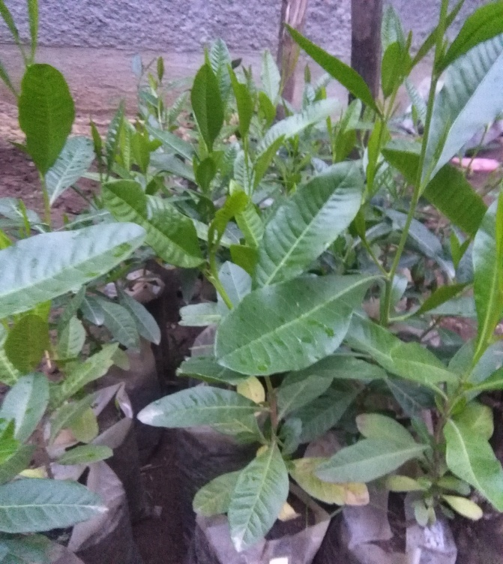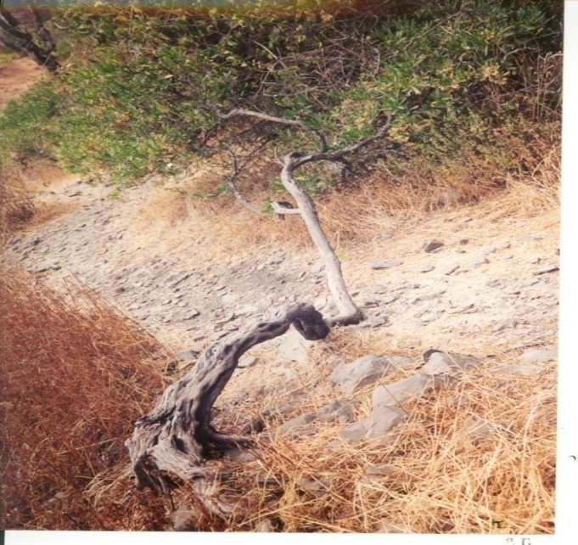
BY
Kassahun Alebachew Dessie

Addis Ababa University, Department of Zoological Sciences
Addis Ababa, Ethiopia
September, 2018
Addis Ababa University

Germination physiology, seedling survival and growth performances of Dodonaea viscosa Jacq subsp. angustifolia (L.f) Benth:
By
Kassahun Alebachew Dessie

A Thesis Submitted to Department of Zoological Sciences in partial fulfillment of the Requirements for the Degree of Master of Science in Biology
Addis Ababa University
Addis Ababa, Ethiopia
September, 2018
Right-hand-side cover picture: Courtesy of Prof. Legesse Negash

ADDIS ABABA UNIVERSITY
GRADUATE PROGRAMMES

DECLARATION
This is to certify that the thesis prepared by Kassahun Alebachew Dessie, entitled Germination physiology, seedling survival and growth performances of Dodonaea viscosa Jacq subsp. angustifolia (L.f) Benth:, submitted in partial fulfillment of the requirements for the degree of Master of Science in Biology complies with the regulation of the university and meets the accepted standards with respect to originality and quality.
NAMES AND SIGNATURES OF THE EXAMINING BOARD
Name signature Date
1. ________________________(Advisor) ______________ ___________
2. ________________________ (Examiner) _______________ ____________
3. ________________________ (Examiner) _______________ ____________
4. ________________________ (Chairman) _______________ ____________

Thesis Title:-Germination physiology, seedling survival and growth performances of Dodonaea Jacq subsp. angustifolia (L.f) Benth:
Candidate’s name:-Kassahun Alebachew Dessie
Addis Ababa University, 2018

ABSTRACT
The present study was undertaken to address two major challenges in Dodonaea viscosa Jacq subsp. angustifolia (L.f) Benth, namely to break seed coat dormancy and to assess the potential of early survival and growth performances of seedlings in soils sampled from degraded landscapes. D. viscosa subsp. angustifolia is an ecologically and medicinally very significant indigenous shrub or small tree, which belongs to the family Sapindaceae. It is a multi-seeder, evergreen, drought resistance, fast growing and pioneer plant that can grow in poor soils. However, to use the plant in restoration programs its complete, rapid and uniform germination is limited by species’ seed coat dormancy. The present study attempted to break seed dormancy through mechanical scarification, treatment with 98% sulphuric acid for 1, 3, 5, 10, 20 and 30 minutes, also hot water treatments at 70, 80, 90 and 95°C for 5, 10, 20, 30 and 40 minutes for each of the specified temperatures employed with a view to breaking seed dormancy of the species. Non-scarified seeds were used as a control. To determine the extent of early seedling survival and growth performances, a total of 120 seedlings of D. viscosa subsp. angustifolia were grown in soils sampled from degraded landscapes. The experiment was conducted under nursery bed conditions, and the results were compared with those obtained from plants grown in soils mixed with 50% compost. The study found that all scarification treatments improved mean germination percentage and rate. Mechanical scarification and acid treatments for 10, 20, and 30 minutes significantly increased (p ≤ 0.05) mean germination percentage over the control. Seeds treated in hot water at 70°C for 40 minutes, at 80° C for 30 and 40 minutes, at 90°C for 20 and 30 minutes, and at 95°C for 10 and 20 minutes, significantly increased (p ≤ 0.05) mean germination percentage as compared to the control. Except for mean root dry weight, other observed growth parameters were significantly higher (p ≤ 0.05) for seedlings grown in media mixed with compost. From these results, it is concluded that mechanical scarification, hot water and sulphuric acid treatments are all suitable pretreatments for maximizing germination percentage and germination rate in D. viscosa subsp. angustifolia. The shrub’s potential to survive and grow in soils sampled from degraded landscapes indicates that this important plant can be used for the restoration of degraded landscapes.
KEYWORDS/PHRASES: Degraded landscape, Ecological restoration, Pioneer plant, Root collar diameter, Sapindaceae, Seed coat dormancy, Seed dormancy breakage

ACKNOWLEDGEMENTS
First and foremost, I would like to express my heartfelt gratitude to my advisor Professor Legesse Negash for his incredible guidance, encouragement, time devotion, and generous help throughout my study.
I would like to forward my grateful thanks to the Amhara Region Educational Bureau for sponsoring me to pursue my study, Mertule Mariam agricultural college and Aberhawoatsibha general secondary and preparatory school for allowing me to use laboratory facilities and chemicals, Debre Markos soil laboratory center for analyses of soil parameters.
I am indebted to thank Ato Ketema Mersha for his continuous support, and comment during my study, Ato Sewunet Guadie for supporting me in seed acid treatments, Ato Liknaw Melesse and Ato Alemu Bisenebit for their brotherly support in computer skills, Ato Assefa Alebachew, Ato Zewdu Demissie, and Ato Melkamu Yigrem for supporting me in seed and soil collections.
I also express my lovingly acknowledge to my wife W/ro Areged Mulualem for her support to keep me to go through any difficulties, to my mother W/ro Tsehaynesh Dessie who has sacrificed her today for my future, for my children Biruktawit and Yonatan who are my strength and inspirations.
Finally, I thank the almighty God and St. Virgin Mary for their kindness and untold endowment.

TABLE OF CONTENTS
DECLARATION ii
ABSTRACT iii
ACKNOWLEDGEMENTS iv
LIST OF FIGURES viii
LIST OF TABLES ix
LIST OF APPENDICES x
LIST OF ACRONYMS xi
1 INTRODUCTION 1
1.1 Background of the study 1
1.2 Statement of the problem 2
2 OBJECTIVES OF THE STUDY 4
2.1 General objective 4
2.2 Specific objectives 4
3 LITERATURE REVIEW 5
3.1 Dodonaea viscosa Jack subsp. angustifolia (L.f) Benth: 5
3.1.1 Taxonomy and morphological features 5
3.1.2 Ecological and geographical distribution 6
3.1.3 Ecological, medicinal and economical importance 7
3.1.3.1 Ecological importance 7
3.1.3.2 Medicinal importance 9
3.1.3.3 Economical importance 10
3.2. The seed 11
3.2.1 The seed and its role 11
3.2.2 Dormancy in seeds 12
3.2.2.1 Seed coat dormancy 13
3.2.2.2 Seed coat dormancy breakage 14
3.3 Seed germination 15
3.3.1 The germination process 15
3.3.2 The conditions for seed germination 16
3.3.2.1 Temperature 16
3.3.2.2 Water 17
3.3.2.3 Oxygen 17
3.3.2.4 Light 17
3.4 Soil 18
3.4.1 Soil physical and chemical properties 18
3.4.1.1 Soil texture, structure and bulk density 18
3.4.1.2 Soil pH 18
3.4.1.3 Soil organic matter 19
3.4.1.4 Soil nitrogen and phosphorus 19
3.4.2 Soil from degraded landscapes 20
3.5 Compost 20
3.7 Seedling growth and measurement techniques 21
4 MATERIALS AND METHODS 22
4.1 Description of the study area 22
4.2 Seed collection 23
4.3 Seed pretreatments 23
4.4 Seed germination studies 24
4.5 Soil collection and preparation 24
4.6 Soil sample analyses 25
4.7 Nursery experiments 25
4.8 Germination parameters and statistical analysis 27
5 RESULTS 28
5.1 Seed germination 28
5.1.1 Mechanical scarification 28
5.1.2 Sulphuric acid treatments 29
5.1.3 Hot water treatments 31
5.1.4 Germination under open nursery bed conditions 33
5.2 Soil analyses results 33
5.3 Early Growth performances 35
6 DISCUSSIONS 40
6.1 Seed germination 40
6.2 Seedlings’ survival 42
6.3 Early growth performances 42
7 CONCLUSIONS AND RECOMMENDATIONS 44
7.1 Conclusions 44
7.2 Recommendations 45
REFERENCES 46
APPENDICES 57

LIST OF FIGURES
Figure 1: Native ranges of D. viscosa subsp. angustifolia 7
Figure 2: Diagram showing D. viscosa subsp. angustifolia grown in highly degraded landscape (A) and D. viscosa subsp. angustifolia grown in bare ground as a pioneer plant (B) 8
Figure 3: Diagram showing D. viscosa subsp. angustifolia grown as an ornamental hedge plant 9
Figure 4: Map of the study area. 22
Figure 5: Mean germination percentage (MGP) of D. viscosa subsp. angustifolia seeds as a function of time on mechanically scarified and non scarified seeds 28
Figure 6: Mean germination time (MGT) of mechanically scarified and non scarified D. viscosa subsp. angustifolia seeds. 29
Figure 7: Mean germination percentage (MGP) of D. viscosa subsp. angustifolia seeds as a function of time on sulphuric acid treatment 30
Figure 8: Mean germination time (MGT) of D. viscosa subsp. angustifolia seeds as a function of time on sulphuric acid treatments 31
Figure 9: Emergence of D. viscosa subsp. angustifolia seedlings whose seeds were sown in plastic sleeves containing soils sampled from degraded landscapes (A), and soil sampled from degraded landscapes mixed with 50% compost (B) 33
Figure 10: Measurement of height increments by using mm-ruler 35
Figure 11: Mean height increment (in cm) of D. viscosa subsp. angustifolia seedlings grown in plastic sleeves filled with soils from degraded landscapes with (SSDLWC) and without (SSDL) 50% compost. 36
Figure 12: Mean leaf numbers of D. viscosa subsp. angustifolia seedlings grown in plastic sleeves filled with soil from degraded landscapes with (SSDLWC) and without (SSDL) 50% compost. 37
Figure 13: Mean branch numbers of D. viscosa subsp. angustifolia seedlings grown in plastic sleeves filled with soil from degraded landscape with (SSDLWC) and without (SSDL) 50% compost. 38
Figure 14: Mean leaf area (A), Mean root collar diameter (B), Mean root dry weight (C), Mean shoot dry weight (D) of D. viscosa subsp. angustifolia seedlings grown in plastic sleeves filled with soil from degraded landscapes with (SSDLWC) and without 50% compost (SSDL). 39

LIST OF TABLES
Table 1: Mean germination percentage (MGP) of D. viscosa subsp. angustifolia seeds on different hot water treatments. 32
Table 2: Mean germination time (MGT) of D. viscosa subsp. angustifolia seeds on different hot water treatments. 32
Table 3: Physical and chemical analyses results of soils sampled from degraded landscapes (SSDL) and Soil sampled from degraded landscapes mixed with equal proportion of compost (SSDLWC); 1 Kg of soil were analyzed for each soil groups. 34
Table 4: Standardized ranges and rates for soil properties (Organic carbon, Av. P, total N, exchangeable K⁺, exchangeable Na⁺ and pH) 35

LIST OF APPENDICES

Appendix 1: Seeding habit(A), seed collection (B), collected mature pods containing fully developed seeds (C), Seed before sowing(D) of D. viscosa subsp. angustifolia …………57
Appendix 2 Sulphuric acid seed treatment (A), mechanical scarification (B), germination pattern (C) of D. viscosa subsp. angustifolia……………………………………………………...58
Appendix 3: Successive stages of germination in D. viscosa var. angustifolia (A) radicle emergence (B) elongation of radicle (C) arise of cotyledon from the ground (epigeal germination) (D) seedling after 1 month…………………………………………………..58
Appendix 4: Number of germinants in different treatments…………………………………….59
Appendix 5: Degraded landscape area where degraded soil sample for the study taken (A), soil sampled from degraded landscape (B) and soil sampled from degraded landscape mixed with equal proportion of compost (C)……………………………………………………..60
Appendix 6: Seedlings of D.viscosa subsp. angustifolia grown in soil from degraded landscape with compost (A) and without compost (B) after 5 months under open nursery bed conditions………………………………………………………………………………...60
Appendix 7: Seedling height in cm of seedlings measured at the time of experiment………….61
Appendix 8: Numbers of leaves in sampled seedlings that were counted monthly during the time of experiment…………………………………………………………………………….62
Appendix 9: Numbers of branches in sampled seedlings that were counted monthly during the time of experiment…………………………………………………………………….…63
Appendix: 10 Leaf area, shoot and root, dry weights of seedlings of D. viscosa subsp. angustifolia measured after 5 months grown in soils sampled from degraded land with and without 50% compost under nursery bed conditions……………………………………...64
Appendix 11: Statistical analyses of germination percentage, germination time and early growth parameters using ANOVA single factor…………………………………………………65

LIST OF ACRONYMS

CRD Completely randomized design
MGP Mean germination percentage
MGT Mean germination time
RCD Root collar diameter
SOM Soil organic matter
SSDL Soil sampled from degraded landscapes
SSDLWC Soil sampled from degraded landscapes with 50% compost

1 INTRODUCTION

1.1 Background of the study
Ethiopia is a country endowed with high biodiversity, distinctive ecosystems and natural resources (Gete Zeleke et al., 2006). The country is also one of the most important centers of biodiversity (Vavilove, 1997). However, Ethiopia is experiencing high levels of deforestation, natural resource degradation and loss of biodiversity at alarming rate (Demel Teketay et al., 2010; Hurni et al., 2010). The country has lost 98% of its forested regions in the last 50 years (Parry, 2003). The main direct drivers of deforestation are small-scale agricultural expansion, fuel wood consumption, cut down too many trees without putting effective replanting programs in place as well as timber poles for construction (Moir et al., 2007, FDRE, 2011; Temesgen Gashaw et al., 2013).
Deforestation is a devastating crisis that characterizes the contemporary Ethiopia (Legesse Negash, 2004). As a result of deforestation, Ethiopia’s forests and woodlands have been declining both in size and species richness. Forest depletion had caused and continues to cause land and water resources degradation, loss of biodiversity, massive soil erosion, unusual flooding, wood famine particularly shortage of industrial wood, and potentially desertiﬁcation (Legesse Negash, 2002; Zerihun Woldu et al., 2002). This in turn makes an increasing number of Ethiopians vulnerable to climate change effects such as drought and floods.
In Ethiopia land degradation has been recognized as one of the most serious environmental problem that leads to soil nutrient depletion and decline in agricultural productivity. Estimates suggest that 45% of the total Ethiopian land mass has been affected by soil erosion, with an estimated 50% of the area in the Ethiopian highlands facing intense degradation (CGIAR, 2015). These challenges can be confronted only if efforts are made, on the one hand to maintain the remaining forests and on the other hand to restore deforested and degraded areas. Forest restoration has been a prominent topic in the agenda of many international forums over the last decade from climate, biodiversity, desertification and sustainable development perspectives (Lamb, 2014). It is among the prominent means to overcome the prevailing environmental degradation. Rapid productions of seedlings in nurseries and high survival rate after planting is important to reverse the current degradation of natural forests, woodlands and shrublands. Biological restoration with native trees (Legesse Negash and Berhanu Kagnew, 2013) and plantation are the first important steps in restoration, rehabilitation or reclamation of degraded land (Coxhead and Ygard, 2008). Plantation of plants those are adapted to the stressful conditions of degraded landscapes combat and reverse degradation process by stabilizing soils through their root system, hence reducing water and wind erosion. These plants also improve soil nutrient status and soil organic matter by enhancing litter production, decomposition rates, fine root turn over, as well as through the moderation of soil pH and maintenance of nutrient cycling in soils (UNCCD, 2004).
Suitable forest plantations established on degraded sites that are long devoid of a native tree cover also act as successional catalysts, facilitating the recolonization of native flora through their influence on understory microclimate and soil fertility, suppression of dominant grasses and provision of habitats for seed dispersing animals (Parrotta 1995; Betru Nedessa, 2003). In Ethiopia, even if afforestation and conservation programs have been made in the last three decades, success to date has been limited (Badege, 2001) due to various reasons. Few of the very important reasons were the use of seeds/seedlings of poor seed source/origin and the existence of poor species/site matching approach. In selecting species for successful environmental rehabilitation, it is often best to choose the ones that are already growing in the area, since these are well adapted to the local conditions and friendly to the environment. If the choice lies between two species of comparable growth and [biological] quality, one of which is native and the other exotic, the native species is to be preferred (Evans, 1992). With this view, the interest in using indigenous species for afforestation needs to be increased.

1.2 Statement of the problem
The sustainable productivity of ecosystems depends to a large extent by having rich and healthy indigenous forests. Indigenous forests are critical in providing clean water, fresh air, fertile soil, food, fiber, fuel, and plant-based medicines (Legesse Negash, 1995). Much of Ethiopia’s highlands, watersheds, and woodlands were once covered with a variety of indigenous trees (Legesse Negash, 1995, 2002). However, indigenous trees and shrubs are being depleted at an alarming rate due to unwise utilization of the available vegetation resources coupled with insufficient knowledge and little consideration to their propagation (Legesse Negash, 1990 and 1995). It is believed that there should be an urgent need to reverse the loss and degradation of plants by restoring degraded landscapes with plantation and/ or regeneration of native species (Legesse Negash, 1990). Knowledge on germination physiology, establishment potential, seedling survival and growth performances of the species has its own contribution for conservation purposes and crucial for successful regeneration and recruitment of plant species in forestry nurseries as well as for direct planting in arid and semiarid regions (Vanclay, 1994). Furthermore, important questions, including which species are better adapted to specific sites need to be answered (Negash Mamo and Mebrate Mihretu, 2005). Some observations indicate that D. viscosa subsp. angustifolia is fast growing, drought tolerant and capable to grow on degraded land (Demel Teketay, 1991; Azene Bekele, et al., 1993). Consequently, it has been suggested that the species is useful for restoring degraded landscapes (Tesfaye Bekele, 2000). It is also medicinal plant upon which Ethiopia’s rural communities depend (Kaleab Asres et al., 2006; Haile Yineger et al., 2008; Ermias Lulekal et al., 2014). However, there is insufficient knowledge on its germination physiology, seedling survival and early growth performances of seedlings grown in soils sampled from degraded landscapes.
In the present study, attempts were made to investigate the effects of different pretreatment procedures on seed germination of D. viscosa subsp. angustifolia and the potential of seedling survival and early growth performances in soils sampled from degraded landscapes.

2 OBJECTIVES OF THE STUDY

2.1 General objective
The general objective of the present study was to assess germination responses of D. viscosa subsp. angustifolia seeds to different pretreatment procedures, as well as the potential of seedling survival and growth performances in soils sampled from degraded landscapes.

2.2 Specific objectives
The specific objectives of the study were to:
- Determine germination responses of D. viscosa subsp. angustifolia seeds to various pretreatments;
- Develop effective pretreatment procedures that stimulate seed germination processes in D. viscosa subsp. angustifolia;
- Determine and compare seed germinations of D. viscosa subsp. angustifolia in soils from degraded landscapes with or without 50% compost;
- Determine and compare seedling survival of D. viscosa subsp. angustifolia in soils from degraded landscapes with or without 50% compost; and
- Determine and compare early growth performances (height, leaf number, number of branches, leaf area, root collar diameter, shoot dry weight, and root dry weight) of D. viscosa var. angustifolia seedlings grown in soils from degraded landscapes with or without 50% compost.

3 LITERATURE REVIEW

3.1 Dodonaea viscosa Jack subsp. angustifolia (L.f) Benth:

3.1.1 Taxonomy and morphological features
D. viscosa subsp. angustifolia is grouped under division-Angiospermae (flowering plant), class-Dicotyledonae, order-Sapindales and family-Sapindaceae (soap berry family) (Rajamanickam, et al., 2010). It named Dodonaea after the Flemish physician and botanist Rembert Dodoens. The specific epithet viscosa means sticky, referring to the young growing tips which contain surface flavonoids that gives them a shiny appearance (Chah, 2006). In English it is known as a common name sand olive, and hop bush (Roger and Jones, 2017). In Ethiopia it is locally known as Kitkita in Amharic, Etacha/Tedecha in Afan oromo, Itancha in Sidamigna, Den/Hayramat in Somaligna, Gerege in Wolaytgna, Kerara in Agewgna, Hidesa in Borenagna (Azene Bekele, 2007), Taheses in Tigrigna (Kebrom Tekle et al., 1997).
D. viscosa subsp. angustifolia is a fast growing, perennial and evergreen small tree or shrub, commonly 2-8 m high (Demel Teketay, 1991; Azene Bekele et al, 1993). Young growth is covered with a sticky secretion which hardens with age. As a result, all parts are glabrous and resinous when young.
Leaves are simple, petiolate, with narrowly attenuate lamina, sticky leathery, and secretes gummy exudate on both the surfaces and thus always appearing shiny. Their varnished appearances have a resinous coating that is a protection against water loss, and this allows the plants to be exceptionally drought tolerant. The leaf tip is pointed, usually spoon shaped. The long narrow leaves are shiny light green above and paler green below. D. viscosa subsp. angustifolia is without thorns and buttresses (Demel Teketay, 1991; Azene Bekele et al., 1993). Bark is dark grey coloured, finely fissured and peeling. It is many branched. Branchlets are rusty red in colour and exudates resin. Flowers are very small, yellowish green, borne on long and slender flower stalks (Walsh and Entwisle, 1996). Inflorescence is terminal or axillary and densely flowered, clusters of yellow fruits with papery wings. Flowers bloom between the months of August and November (Haftom Kebede and Samuel Gebrechirstos, 2016). Flowers are greenish yellow, with sepals, but not true petals. The flowers are usually dioecious (Vollesen, 1989). It is among the species with increased pollen quantities (Bonnefille and Hamilton, 1986). Pollination is mainly by wind. The most outstanding part of this plant is the pendent dry fruit (Jansen, 1981). Fruit is two to three winged papery capsules (Walsh and Entwisle, 1996). Fruits are circular in outline and yellowish. Dispersal of the broad-winged fruits is enhanced by wind. Floating on the water is also another option. It produces large numbers of small seeds (100 seeds per g), and the seeds are dormant (Demel Teketay 1991, Azene Bekele et al., 1993). Seeds are black and lens like in shape. Each chamber of the fruit contains one to two seeds.

3.1.2 Ecological and geographical distribution
D. viscosa subsp. angustifolia abundantly grow in tropics and subtropics (Friis, 1992). It grows in a variety of habitats from arid, semi-arid to high rainfall regions and is also frost hardy (Harris, 2012). It is native to Ethiopia, Kenya, Tanzania, South Africa, Mozambique, Madagascar, Oman, Australia and New Zealand (Orwa et al., 2009). It is cultivated in Ghana, Nigeria and Cameroon. It is one of Ethiopian indigenous small tree or shrub (Kebrom Tekle et al., 1997; Tesfaye Bekele, 2000) widely distributed within and below the Afromontane zone (Friis, 1992). The plant mostly grows at edge of upland forest, upland bushland and grassland (Vollesen, 1989). It grows at the altitudes between 800 and 2650 m a. s. l. and in areas with a rainfall range of 500-1500 mm/year (Friis, 1992). It grows in a variety of habitats and rapidly colonizes open areas of recently cleared forests, invades overgrazed bushlands and fallow lands and is usually found in rocky and stony sites. It can withstand fires to an amazing degree (Hedberg and Edwards, 1989), so the plant regenerates rapidly after fire (Fichtl and Admasu, 1994). It grows in full sun and also frost hardy. It can tolerate soil acidity or alkaline, drought, soil salt. The species is mostly favor east facing slope (Rani et al., 2009). It can tolerate part shade.
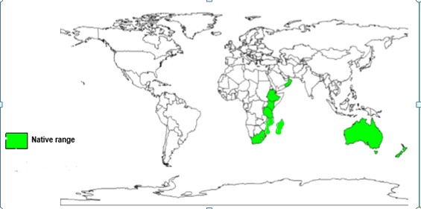
Figure 1: Native ranges of D. viscosa subsp. angustifolia (image taken from Orwa et al., 2009). The figure shows the species is native to Ethiopia, Kenya, Tanzania, South Africa, Mozambique, Madagascar, Oman, Australia and New Zealand.

3.1.3 Ecological, medicinal and economical importance

3.1.3.1 Ecological importance
Considering the use of D. viscosa subsp. angustifolia in conservation the fibrous spreading, excellent soil binder root system, rapid growth, and spreading canopy make it an effective soil stabilizer which is particularly useful in controlling soil erosion. It could be used to reclaim land, and is also good for sand binding (Azene Bekele et al., 1993). It is drought tolerant and has the ability to withstand dry desert, heat and wildfires. D. viscosa subsp. angustifolia is a species with Crassulacean acid metabolism (Chauvet, 2016) thus minimizing water loss under arid conditions. It requires very little water once established. It takes well in any kind of soil and can grow well on poor soils and rocky sites (Rajamanickam et al., 2010). It favors areas that receive full sun but somewhat shade tolerant. It is also very wind hardy and useful as an in-field windbreak system (Duvauchelle, 2004). It is a promising pioneer species in forest rehabilitation with a goal to facilitate natural successional processes (Friis, 1992; Kebrom Tekle et al., 1997; Tesfaye Bekele, 2000). Natural succession is a key factor in the restoration process (MacMahon, 1997). Direct facilitation may be by increasing availability of a key resource, improving substrate conditions, or ameliorating some unfavourable environmental characteristics. Indirect facilitation may be by introduction of beneficial organisms (e.g. seed dispersers, pollinators, mycorrhizae or soil microbes) or protection from herbivores (Schleicher et al., 2011). D. viscosa subsp. angustifolia can establish itself on degraded land, once the disturbance has ceased. Its ability to colonise barren areas suggests that it could be used at early stages of restoration of natural forest (Tesfaye Bekele, 2000). According to Pohjonen 1989 succession of bushy vegetation of pioneer species like D. viscosa subsp. angustifolia and Acacia abyssinica may lead to mature Afromontane forests. D. viscosa subsp. angustifolia colonizes forest margins, roadsides, overgrazed bush lands and areas cleared of forest vegetation (Fichtl and Admasu, 1994). The species is not browsed and therefore easy to establish. D. viscosa subsp. angustifolia is resistant to salinity, and pollution. It can be used for remediation of polluted lands.
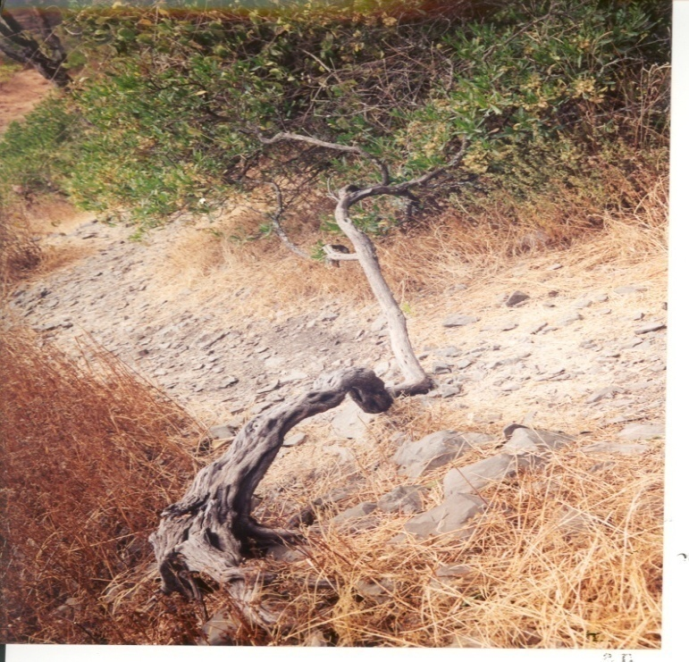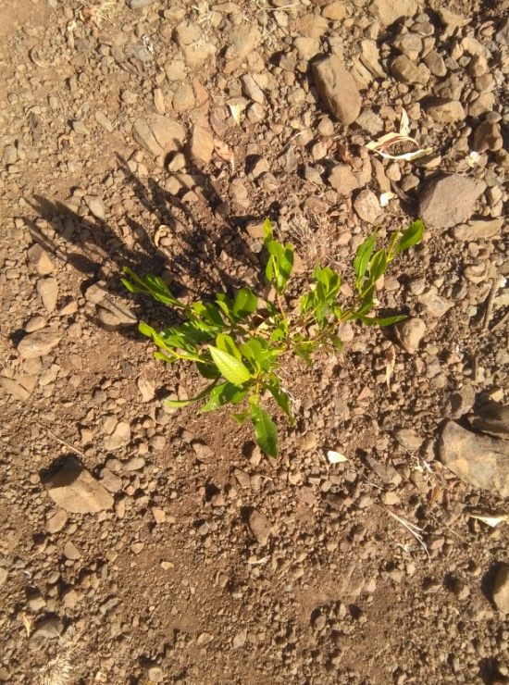
A B
Figure 2: Diagram showing D. viscosa subsp. angustifolia grown in highly degraded landscape (photo from Prof. Legesse Negash) (A) and D. viscosa subsp. angustifolia grown in bare ground as a pioneer plant (B)

Ecologically the dense bushy hedges which it may form are ideal bird nesting sites and the flowers attract butterflies. In landscape it is also used as an ornamental hedge plant (Azene Bekele et al., 1993; Roger and Jones, 2017). Its successful use as a hedge is due to the dense habit and for its shiny foliage. It tolerates regular pruning very well if a uniform hedge is desired. It is an aesthetically pleasing plant. It has lush green foliage that makes it pleasing to the eye. It can also be grown in fence rows as a living fence.
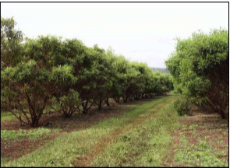
Figure 3: Diagram showing D. viscosa subsp. angustifolia grown as an ornamental hedge plant (Photo from David Duvauchelle, 2004)

3.1.3.2 Medicinal importance
D. viscosa subsp. angustifolia has a wide range of valuable medicinal properties. The leaves are sold in local markets for medicinal purposes in South Africa (Van Wyk et al. 1997). It used as anti-inflammatory such as anti arthritis and anti dermatitis (Rajamanickam et al., 2010), analgesic activity (Amabeoku et al., 2001; Duvauchelle, 2004). Leaves are powdered and sprinkle on the wound as wound healing agents (Jansen, 1981; Duvauchelle, 2004; Alemayehu kefalew, 2015), to treat rashes (Duvauchelle, 2004). The infusion of leaves (Duvauchelle, 2004; Rajamanickam et al., 2010; Roger and Jones, 2017) or oil prepared from roots (Roger and Jones, 2017) is used to treat rheumatism. It is used to treat various gastro-intestinal disorders. Decoction of the leaves or bark is drunk to treat sudden diarrhea (Duvauchelle, 2004; Ermias Lulekal et al., 2014), remedy for constipation (Duvauchelle, 2004; Ermias Lulekal et al., 2014), colic (Duvauchelle, 2004), infusion of leaves to treat stomach ulcers, hemorrhoids (Ermias Lulekal et al., 2014; Rajamanickam et al., 2010), Bloat (Ermias Lulekal et al., 2014), as a cure for sore throats (Jansen, 1981; Ermias Lulekal et al., 2014), skin lesion, scabies, ringworm (Ermias Lulekal et al., 2014), allergies (Haile Yineger et al.,2008). The species has antipyretic (Amabeoku et al., 2001; Jansen, 1981), antiretroviral (Kaleab Asres et al., 2006) and anti malarial (Simonsen et al., 2001) activities. The infusions of leaves are used to treat skin infections, gout, snake bites, bone fracture (Rajamanickam et al., 2010). The species is known to have distinct anti diabetic properties (Muthukumran et al., 2001), anesthetic and smooth muscle relaxant, anti-ulcer and anti-microbial activities. The leaves are chewed without swallowing to alleviate toothache (Roger and Jones, 2017; Duvauchelle, 2004). The juice from heated leaves is rubbed on nipples of breastfeeding women to stimulate lactation in mothers, to treat sore eyes, bitter leaf decoction is taken as a treatment for venereal diseases (Duvauchelle, 2004). It has several classes of secondary metabolites which are responsible for antibacterial activity. Root infusions used to treat colds (Teffo et al., 2009), to treat jaundice, and taeniasis (Ragunathan and Solomon, 2009). The plant also has anti cancer (Solomon et al., 2017), anti pneumonia and anti tuberculosis (Watt and Breyer-Brand Wijk, 1981) activity. The species is also used for botanical pesticide applications (Ghosh and Ulaganathan, 2004).

3.1.3.3 Economical importance
The wood is extremely hard and used in Ethiopia as a fuel wood and for construction materials (Al-Asmari et al., 2013). Its wood ignites easily. However, the usually small dimensions more or less restrict its use to firewood. It also makes an excellent charcoal, as fencing material and also for making hut roofs in rural areas (Tesfaye Bekele, 2000). The wood (hard, durable and termite resistant) used for making house timbers, weapons (Duvauchelle, 2004), tool handles, walking sticks, agricultural tools, digging sticks (Medeiros et al., 1998). The fruits ‘hops’ can be fed to cattle. Flowers are ideal bee forage (Orwa et al., 2009).

3.2. The seed
Plant propagation is key to human development and biodiversity conservation. In propagation of higher plants, the seed is an effective and inexpensive means of propagation. The degree of successful plant establishment is largely determined by the physiological and biochemical status of its seed (Legesse Negash, 1992; 2002). Consequently, the seed occupies a strategic position in the life cycles of higher plants (Bewley and Black, 1994).
Seeds have complex structure that consists of three major components, the embryo; new plant in miniature that will become the vegetative plant, the endosperm; structure that provides nourishment for the developing embryo and/or seedling until it establishes itself as a self-sufficient, autotrophic organism, and the testa (seed coat); surrounding the embryo and endosperm or cotyledon (Mayer and Poljakoff-Mayber, 1989). When seeds are formed, most plants store a food reserve with the seed as starch, proteins, or oils.

3.2.1 The seed and its role
Seeds have the following roles
1. Major Segregation and recombination of the genetic material: plants propagated by seed, involves genetic recombination through sexual reproduction that ensures genetic diversity. The rearrangement of genes leads to the production of individuals that are different from their parents (Piotto and Di Noi, 2003). As a result, the progeny of plants grown from seed tend to exhibit a relatively high amount of genetic variation. So plants produced from seed are related, but not identical, to the parent plant (Bewley and Black, 1994). The genetic diversity makes possible the survival and the natural evolution of species in continually changing environmental conditions.
2. Dispersal mechanism (Mayer and Poljakoff-Mayber, 1989).
3. Multiplication mechanism: New plant generation starts with a seed (Bentsink et al., 2007). Seeds are important starting materials for propagation of many vital tree species (Mog‟omba, 2007).
4. Survival mechanism (e.g. seed banks): seeds contain a fully developed embryo that can survive the period between seed maturation and germination (Bentsink et al., 2007).

3.2.2 Dormancy in seeds
A dormant seed is a viable seed that is unable to germinate in a specified period of time even if all the necessary environmental conditions for germination are satisfied (Legesse Negash, 1995; Baskin and Baskin, 2004). Thus lack of germination is due to a seed rather than environmental problems. This phenomenon has the following main functions for the plant;
1. Increase the likelihood of seedling growth and survival by matching germination with optimal conditions (Black et al, 2006). It has great adaptive importance to plants in ensuring that seedling emergence occurs at the most advantageous time and place (Bewley and Black, 1994). The ability of seeds to germinate readily when conditions are suitable for successful growth and the ability to avoid germination at inappropriate times are essential to the survival of a species. It controls the distribution of germination in space (e.g., habitat selection) and time (e.g., in response to seasonal temperature changes). In highly seasonal climates, a critical role of seed dormancy regulation mechanisms is in determining the timing of germination (Schu¨tz, 2000). Seeds will germinate at different times over a period of days, weeks, months, or even years, ensuring that some offspring will be exposed to favorable environmental conditions for survival. It is also used to create a seed bank. A seed bank includes the seeds that are shed from the plant that do not germinate for years due to dormancy. A seed bank ensures that not all seeds of a species germinate in a single year. This is insurance against seedlings being exposed to catastrophic conditions like frosts, drought and herbivore pressure that kill the entire next generation of a species (Eira and Caldas, 2000,). D. viscosa subsp. angustifolia is known to possess persistent soil seed banks and retain their viability for at least four years in the forest soil (Demel Teketay and Granström, 1997). It also allows seedlings to grow during favorable years even if the mother plants failed to flower and make seeds. Thus, seed germination under favorable conditions results in seedling production over many years, providing numerous opportunities for survival.
2. Provides additional time for seed dispersal over greater geographic distances by introducing a temporal delay in the germination processes.
However, seed dormancy is often considered as a problem by practicing foresters, since in the absence of appropriate pretreatments seeds possessing inbuilt dormancy mechanisms often germinate irregularly, extending from several months to several years (Legesse Negash, 1995).
There are five classes of dormancy depending on seed dormancy classification scheme of Baskin and Baskin (2004): physiological dormancy-imposed due to the presence of inhibitors, especially abscisic acid, as well as the absence of growth promoters, such as gibberellic acid; morphological dormancy-due to underdeveloped embryo, thus embryo needs time to grow within the seed after maturity before it can germinate; morphophysiological dormancy-combination of physiological and morphological dormancy; physical dormancy-water impermeability of seed or fruit coat caused by a layer(s) of macrosclereid cells; and combinational dormancy-physical dormancy plus physiological dormancy.

3.2.2.1 Seed coat dormancy
Prevention of water uptake, mechanical constraint, interference with gaseous exchange, inhibitor retention and production of chemical inhibitors are five possible mechanisms that cause the strong inhibitory effect of the seed coat on seed germination (Bewley and Black, 1994; Taiz and Zeiger, 2002). Ecologically hard seed coat is significant to rapidly decolonize burnt areas after fire, and withstand ingestion by animals and birds (Rolston, 1978). The Sapindaceae is one of angiosperm families known to contain taxa with seed dormancy caused by a water impermeable seed coat (Baskin et al., 2000). Seeds of the genus Dodonaea are impermeable (Cook et al. 2008). Although D. viscosa subsp. angustifolia is known as a good seeder, its germination limited by the presence of high physical dormancy due to water impermeable seed coat (Demel Teketay, 1991, 1996). Coat-imposed dormancy due to prevention of water uptake has been also reported to be present in some indigenous tree species of Acacia abyssinica Hochst ex Benth and Faidherbia albida (Del.) A. Chev (Legesse Negash, 1995). Impermeability is due to the presence of one or more palisade layers. Impermeable palisade layers are composed of macrosclereid cells that have thick lignified walls, in the seed coat or in the innermost layer of the fruit wall (endocarp) (Esau, 1964). Impermeability of macrosclereids to water is due to the presence of water repellent substances like cutin, lignin, quinines, suberin and wax (Rolston, 1978). In some cases, the seed coat may be too rigid for the radicle to penetrate (mechanical constraint). The hard seed coats of Olea europaea subsp. cuspidata and Podocarpus falcatus (Thumb.) Mirb. has been reported to hinder the germinating embryo from breaking through (Legesse Negash, 1992, 1993, 1995). Several layers of tissue surrounding the embryo might limit the capacity for gaseous exchange, consequently inhibition of respiration and germination (Bewley and Black, 1985). The inhibitory action of such tissues surrounding the embryo is much reduced simply by scratching or puncturing them (Bewley and Black, 1985; Legesse Negash, 1995). The seed coat may prevent the escape of inhibitors from the seed or seed coats and pericarps may contain relatively high concentrations of growth inhibitors, including abscisic acid that can suppress germination of the embryo.

3.2.2.2 Seed coat dormancy breakage
Germination of seeds in a particular situation and season is determined by the interaction between the dormancy releasing factors, such as temperature, light and moisture. The conditions necessary to allow seeds to break dormancy and germinate can be highly variable among species, within a species, or among seed sources of the same species (Bewley and Black, 1994). Rupture of the seed coat improves germination in many hard-seeded species with impermeable seed coats (Rolston, 1978; Bewley and Black, 1994). The embryos of seeds with impermeable seed coat will germinate readily in the presence of water and oxygen once the seed coat and other surrounding tissues have been either removed or damaged. In nature, this is brought about by several factors including exposure to high temperature (Demel Teketay, 1994), temperature fluctuations (Baskin and Baskin, 2000), ingestion and, thus, acid scarification in the digestive tract of various animals (Gardner et al., 1993), action of soil acids (Bewley and Black 1994), scarification by being rubbed against rocks or other hard objects (Gutterman, 1993), attack by soil micro-organisms like fungi (Sanchez-Coronado et al., 2011), weathering on the soil surface for several months (Burrows, 1995), exposure to heat shock during wildfires (Hodgkinson, 1991). In D. viscosa subsp. angustifolia species wide temperature fluctuations and animals, which browse on twigs, pods and seeds, may stimulate germination (Demel Teketay, 1996). Artificially, coat imposed dormancy can be overcome through treatments that weaken or rupture the integument, allowing water absorption and the onset of germination (Mayer and Poljakoff-Mayber, 1989). Mechanical scarification, acid scarification, immersion seeds in boiling water, seed coat cracking, and removing chemical inhibitors through leaching by water can be used to overcome coat imposed dormancy (Legesse Negash, 1995, 2002; Hartmann and Kester, 1975). Seed scarification is a method that is used to break seed dormancy by cutting or softening the hard wall of a seed. It helps to improve germination percentage, rate, and evenness by allowing entrance of water and oxygen into seeds having seed coat dormancy (Schelin et al., 2004).

3.3 Seed germination
Seed germination is defined as protrusion of the radicle from the seed coat (Baskin and Baskin, 2014). Seed Germination is the most critical life-cycle transition in the development of plants. This is because, time of emergence from the protective seed coat is crucial for survival and reproductive success by determining the efficient use of the nutrients and water resources available to plants (Nelson et al., 2009).

3.3.1 The germination process
The time between seed imbibition and radicle emergence is the period of germination in the strict sense (Bewley and Black, 1994). Sequences of events that occur during germination of most seeds are categorized into three stages by many authors (Hartmann and Kester, 1975). The first stage involves uptake of water by the dry seed (imbibition), as a result of which the seed swells, general metabolism of seed activated, components of protein synthesizing system of cells become active, and respiration increased. The second stage of germination involves digestion and translocation. Water uptake and respiration now continue at a steady state. This phase of development is characterized by relatively little change in seed water content until it is terminated by the initiation of embryo growth (Bray, 1995). The existing cell systems have been activated and the protein-synthesizing system is functioning to produce various new enzymes, structural materials, regulator compounds, etc to carry on the cell functions and synthesize new materials (Bray, 1995). The ability of an imbibing seed to initiate germination can be considered as a critical regulatory step in plant development (Johnson, 2000). Enzymes appear and begin to digest reserve substances (fats, proteins, carbohydrates) in the storage tissues (cotyledons, endosperm, perisperm, or megagametophyte) to simpler chemical compounds to be translocated to the growing points of the embryonic axis to be used for growth and the production of new plant parts (Bewley and Black, 1985). The third stage of germination consists of cell division in the separate growing points of embryo axis followed by the expansion of the seedling structures such as elongation of radicle.

3.3.2 The conditions for seed germination
Germination in seeds is a complex process that is controlled by several biological (species, seed viability, seed dormancy, seed size, seed mass) and environmental (moisture availability, a supply of oxygen, temperature, light intensity and duration) factors (Bewley and Black, 1994; Raven et al. 2005; Nelson et al., 2009). Seed germination in plants differs among different plant species and among different genera. Various plants require different variables for successful seed germination. Investigation of the germination physiology of seeds of several indigenous tree species of Ethiopia has shown that a certain level of maturity must be reached for the successful germination of the seeds to produce the required amount of seedlings for mass propagation of forest trees (Legesse Negash, 1995). According to Hartmann et al. (1997) three conditions are required for germination to be initiated:
(1) The seed must be viable; for successful seed propagation, the availability of viable seeds is of paramount importance. Seed viability is defined as the ability of a seed to be alive, elicit germination and field performance under suitable environmental conditions.
(2) Dormancy of the seed must be overcome
(3) The seed must be subjected to the appropriate environmental conditions: available water, proper temperature regimes, a supply of oxygen, and sometimes light.

3.3.2.1 Temperature
Like other physiological processes seed germination is temperature dependent. Temperature affects seed germination in several ways (Probert, 1992). According to Bewley and Black (1994), the effects of temperature on germination are complex, since they affect each individual reactions and phases of the process in different ways and are also related to the biochemical processes that regulate the entire metabolic process. Seeds from different species and even seeds from the same plant germinate over a wide range of temperatures. Seeds often have a temperature range within which they will germinate, and they will not do so above or below this range. Optimal temperature for germination varies between species (Demel Teketay, 1996). Extremely high temperatures are recognized as a potentially harmful factor, subjecting the seeds of many plant species to stress during the germination process. On the other hand, low temperatures reduce metabolic rates to the extent that essential pathways for the onset of germination can no longer function and can change the cell membrane from the liquid-crystalline to the crystalline state (Hendricks and Taylorson, 1976).

3.3.2.2 Water
Mature seeds, in their resting state are extremely dry and relatively inactive metabolically. In absence of sufficient amount of water, cells are unable to maintain turgor so that their growth is checked. Cells also do not have sufficient amount of soluble respirable food as the reserve food stored in cotyledons or endosperm is in insoluble form and is not available to these cells. To resume cellular metabolism and growth, seeds need to take-in significant amounts of water. The uptake of water by seeds leads to the swelling and the breaking of the seed coat (Bentsink, et al., 2007). When the seed imbibes water, hydrolytic enzymes are activated which break down stored food resources into metabolically useful chemicals (Raven et al., 2005). So water is essential for enzyme activation, breakdown, translocation, and use of reserve storage material (Hadas, 2004).

3.3.2.3 Oxygen
Oxygen is an atmospheric gas that is also found in soil pore spaces. It is required in seed germination of most species for metabolism (Siegel and Rosen, 1962). Oxygen is used in aerobic respiration, which is the main source of energy for the germinating embryo (Raven et al., 2005). If a seed is buried too deeply within the soil or the soil is water logged, the seed can be oxygen starved and unable to germinate. Impermeable seed coats that prevent oxygen from entering into seeds may also restrict aerobic respiration in embryo cells.

3.3.2.4 Light
Most seeds are not affected by light or darkness, but some seeds, including species found in forest settings, will not germinate until an opening in the canopy allows sufficient light for growth of the seedling (Raven et al., 2005). In light requiring species, Sisymbrium officinale and Arabidopsis, light plays an important role in the biosynthesis of gibberellic acid and also increase the sensitivity of seeds to gibberellic acid (Baskin and Baskin, 1998). These species germinate in darkness when exogenous gibberellic acid was applied.

3.4 Soil
Soil is the medium for plant growth. It offers support to plants and acts as a reservoir of water and nutrients. For satisfactory plant growth, it is essential that the soil provides a favourable physical environment for root development, and sufficiently provide the plant's needs for water, nutrients and anchorage. Its physical, chemical and biological properties determine the degree of workability, suitability to specific plant varieties, as well as productivity.

3.4.1 Soil physical and chemical properties

3.4.1.1 Soil texture, structure and bulk density
Soil texture depends upon the percentage of clay, silt and sand particles in the soil. It determines many other physical properties such as inﬁltration rate and some chemical properties such as cation exchange capacity. Clay has typical higher organic matter content, lower hydraulic conductivity, lower bulk density and higher water holding capacity than sandy soils (Brady, 1990).
Soil structure is arrangement of soil solids and voids. It should be suitable for the germination of the seeds and the growth of the roots, and must have characteristics that enhance the storage and supply of water, nutrients, gases and heat to the plant. It influences water infiltration and retention, erosion, crusting, nutrient recycling, root infiltration and crop yield.
The bulk density is a key physical property of soil material which varies with the nature of the soil particles and contents of organic matter of the soils. It is highly dependent on changes in topography, plant cover, swelling and water content of soils (Sumnar, 2000). The low bulk density of soils indicates that ease for agricultural practice and good plant growth. Most plant roots have problems to penetrate compacted soils.

3.4.1.2 Soil pH
Some of the soil fertility features affected by soil pH include:
Availability of mineral elements to plants in the soil (Thompson and Troeh, 1978): At low pH, there is the risk of deﬁciency of base nutrients (Ca, Mg, and K) due to their low content. It decreased the solubility of Mo and P compounds, thus decreasing their availability. It increases Al concentration (usually at pH less than 5.5) leading to Al toxicity effects (Landon, 1996). But, the concentration of plant nutrients like Fe and Mn can be high enough at low pH. At high pH the solubility of many metals and trace elements decreases, including essential nutrients for plants such as Fe, Mn, Cu or Zn. Deﬁciency of Fe, known as iron chlorosis, is frequent in basic soils (typically in calcareous ones).
Biological properties: extreme pH values decrease microbial activity in soils (Mengel and Kirkby, 1982). This affects many soil processes like soil organic matter decomposition, nitriﬁcation, and biological nitrogen ﬁxation.
Physical properties: low Ca concentration in acidic soils is usually related to an increased dispersion of colloids, if Al is not present at high concentration. Thus, acidic soils can have poor soil physical properties, including poor structural stability or low permeability.

3.4.1.3 Soil organic matter
Soil organic matter is a key factor affecting biological activity in soils. It is the carbon source for many organisms, including soil microbiota. Not only the amount, but also the type of organic compounds in the soil determines its biological activity. The most important function of organic matter is to supply the binding and buffer capacity of the soil and contributes to limit diffusion of contaminated water through the soil (Mira, 2007). Soil organic carbon (SOC) is one of the most important components of soil organic matter. SOC is indispensable for ecosystem functioning, has a major influence on soil structure, water holding capacity, cation exchange capacity (CEC) and soils’ ability to form complexes with metal ions and nutrients for storage (Milne et al., 2007). It contains large amounts of plant nutrients, slow release nutrient storehouse, supplies energy for soil microorganisms, and contains compounds with growth stimulating effects on plants.

3.4.1.4 Soil nitrogen and phosphorous
Nitrogen and phosphorous are critical determinants of plant growth and productivity. Nitrogen is a major constituent of several of the most important plant substances. For example, nitrogen compounds comprise 40% to 50% of the dry matter of protoplasm, and it is a constituent of amino acids (Swan, 1971). It is also an essential constituent of chlorophyll (Roy et al., 2006). The amount and timing of N application can alter plant morphology, nutrient availability, and net photosynthesis (Zhao et al., 2008). Phosphorus is also considered as a vital nutrient for plant growth (Hinsinger, 2001). The element is essential for cell division, reproduction, and plant metabolism. Moreover, its role is related to the acquisition, storage, and use of energy (López et al., 2003).

3.4.2 Soil from degraded landscapes
Land degradation includes all process that diminishes the capacity of land resources to perform essential functions and services in ecosystems as a result of adverse soil fertility decline (Hurni et al., 2010). According to WMO, (2005) soil fertility decline refers to
(a) Reduction in soil organic matter status, leading to decline in soil biological activity (reduction biomass, decline in land biodiversity)
(b) Degradation in soil physical properties (structure, aeration, water holding capacity) caused by reduced organic matter.
(c) Adverse changes in soil nutrient status, including reduction in availability of the major nutrients (N, P, K), initiation of micronutrient deficiencies and development of nutrient imbalances; and
(D) Build up of toxicities (by heavy metals, xenobiotics, and acidification through incorrect use of fertilizers).
Degraded land is characterized by: loss of top soil and anchorage for plant roots, loss of soil nutrients, breaking of critical nutrient cycles and reduced water holding capacity of the soil (Mulugeta Lemenih and Demel Teketay, 2004). Loss of SOM often depends on degradation processes like wind and water erosion, floods and landslides (Dawson and Smith, 2007). About 85% of the causes of land degradation worldwide are due to soil erosion by wind and water. Hence soil and land degradation are often used interchangeably. Degradation of soil has a direct impact on water and soil quality, influences food chains, climate change and hinders biosphere functioning (Tóth et al., 2007).

3.5 Compost
Compost is defined as stable aerobically decomposed organic matter which is the result of managed decomposition process. Composting process is dependent on micro-organisms (Tilahun Amade, 2003). During decomposition process, aerobic micro-organisms break down and transform organic material in to a range of increasingly complex organic substances (Bastida et al., 2010). Composting organisms require proper mixture of water, oxygen, carbon, and nitrogen to work effectively. To accelerate the decomposition process factors like water, oxygen, carbon, and nitrogen should be carefully monitored (Misra et al., 2003). In composting process carbon used for microbial oxidation, nitrogen for growth and reproduction of more organisms, oxygen for oxidizing the carbon, water in the right amounts to maintain activity of microbes without causing anaerobic conditions. In forest and horticulture nurseries, use of mature compost is preferred to other growing media, because it is light, has high cation exchange capacity and nutrients, extended nutrient release, improving the structure of the soil, high water holding capacity (Diver and Greer, 2001). Compost can provide both macro and micro nutrients, but it could be unwise to expect that it fulfills the plant demand for all basic nutrients. Most types of composts contain very small quantities of some nutrients like potassium and zinc to cover the full demand of plants.

3.7 Seedling growth and measurement techniques
Growth in plants is defined as an irreversible increase in volume. The largest component of plant growth is cell expansion driven by turgor pressure. During this process, cells increase in volume and become highly vacuolated (Taiz and Zeiger, 2002).
Seedling growth is affected by conditions like humidity, CO₂, temperature, light, water, mineral nutrients, and other organisms that are either beneficial or harmful (Jaenicke, 1999).
Growth can be measured in terms of change in fresh weight: that is, the weight of the living tissue over a particular period of time. However, the fresh weight of plants growing in the soil fluctuates in response to changes in the water status, so the criterion may be a poor indicator of actual growth. Thus, measurements of dry weight are often more appropriate than the fresh weight (Taiz and Zeiger, 2002)

4 MATERIALS AND METHODS

4.1 Description of the study area
The present study was carried out in North Western Ethiopia, Amhara Regional State, East Gojjam Zone, Enebsie Sar Midir Woreda, Mertule-Mariam town, located at 10° 52ꞌ North latitude and 38° 17ꞌ East longitudes. The Woreda is bordered by River Abay on the North and East (Figure 4).
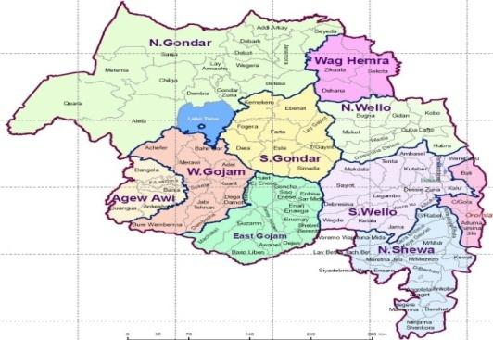
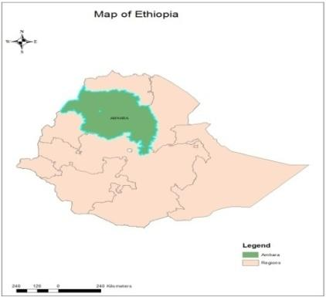
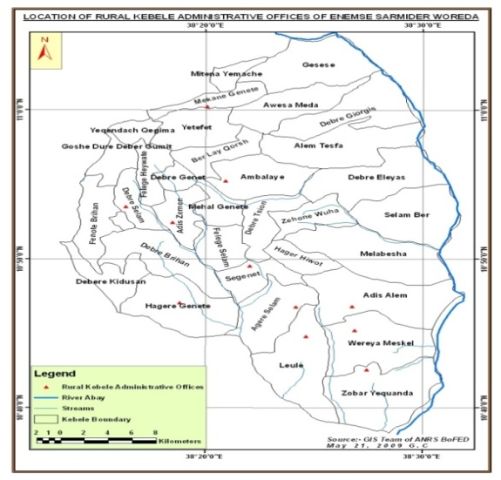
Figure 4: Map of the study area. The map indicates the specific location where the study has been conducted in Amhara Regional State, East Gojjam Zone, Enebsie Sar Midir Woreda, Mertule-Mariam town
The altitude of the study area is 2610 m a. s. l. The area receives an average annual rain fall of 1053 mm, ranging from 941 to 1203 mm with mono-modal rain fall pattern. The rainfall ranges from the periods June to September (Woreda Agricultural Office, 2012). There is also a chance of getting little shower rain from March to May. The temperature range of the Woreda is 9.5 to 27.5°C (Agri-service Ethiopia, 2011)

4.2 Seed collection
Mature pods containing fully developed seeds of D. viscosa subsp. angustifolia were collected from East Gojjam Zone, Enebsie Sar Midir Woreda, Zihonwuha Kebele (altitude, 1971.7 m a. s. l; mean annual rainfall, 980 mm; and mean annual temperature, 23.1°C). The area is 26 km away from the Woreda town of Mertule Mariam. The area was selected depending on accessibility of the plant. Seeds of the species were collected on December 17, 2017. Maturity of seeds was assessed by the shrubs’ dried and whitish capsules. The collected pods were allowed to dry for one week under subdued sunlight in open conditions, and seeds were extracted by breaking the dried pods into pieces and separating the seeds from the broken pods. The clean seeds were then stored at room temperature until used for the experiment.

4.3 Seed pretreatments
In this study, the strategy employed was to stimulate germination by breaking dormancy of D. viscosa subsp. angustifolia seeds using different pretreatment approaches. Accordingly, three seed pretreatment procedures that aimed at seed coat modification were used. These were: (1) Mechanical scarification; (2) Soaking seeds in concentrated (98%) sulphuric acid. (3) Soaking seeds in hot water. The control was to use untreated seeds. Before the application of treatments, ‘empty seeds’ were removed by immersing the population of freshly extracted seeds in a bucket of water where the normal seeds sunk while ‘empty seeds’ floated. Seeds were thoroughly mixed and experiments were conducted on sample seeds drawn from the entire pool of seeds. For experiments on mechanical scarification treatment, seeds were individually scarified by sand paper. Great care was taken to avoid embryo damage during scarification. For the sulphuric acid treatment, seeds were placed in a 300 ml heat-resistant, non-corrosive glass beaker and concentrated sulphuric acid (98%) was poured slowly on the side of the beaker so that all the seeds were covered with the acid. The seeds in the beaker were left for the assigned times (i.e., for 1, 3, 5, 10, 20 and 30 minutes) in concentrated sulphuric acid and were stirred with a glass rod to expose all sides of the seeds for the acid to act on the seed coat. At the end of the treatment time, the acid was drained off into another beaker, and the seeds were thoroughly washed and rinsed with distilled water several times so as to remove all acid from the seeds. For hot water treatment, seeds were poured in a 300 ml heat resistant glass beaker half-filled with hot water which was maintained at initial temperatures of 70, 80, 90 and 95°C, and maintained at room temperature (20°C) for 5, 10, 20, 30 and 40 minutes for each of the specified temperatures.

4.4 Seed germination studies
Germination studies were conducted in the laboratory of Mertule-Mariam Agricultural College. Germination was monitored for mechanically scariﬁed, acid treated, hot water treated and non-treated (control) seeds of D viscosa subsp. angustifolia. The experimental design consisted of a completely randomized design (CRD) with five replicates for each treatment and 50 seeds in each replicate. Seeds were arranged (roughly equidistant from one another) in 9 cm diameter Petri dishes which were overlaid with layers of filter paper. The labeled Petri dishes were arranged randomly. Seeds in each Petri dish received an initial 5 ml of water and were moisturized by the addition of 3 ml distilled water as the water got depleted through imbibition. This was continued up to the end of the experiment. To avoid fungal contamination, filter papers were changed every 4 days. To facilitate future counts, germinated seeds (2 mm radicle length) were transferred to other Petri dishes after recording. The numbers of germinated seeds were counted daily for 4 weeks. According to Baskin and Baskin (2001), germination study period should extend to 3 ─ 4 weeks if germination percentage increased at the end of 2 weeks. The mean temperature of the room was 20 ± 1.6°C.

4.5 Soil collection and preparation
Soil samples were collected from degraded landscapes hence the study was undertaken to assess the potential of early survival and growth performance of seedlings in soils from degraded landscapes. It was collected from a locality called Zihonwuha, which is 26 km away from Mertule-Mariam. The site was selected based on its status as a degraded site (hence degraded soil) and also considering the presence of D. viscosa subsp. angustifolia in the area after several reconnaissance trips. Soil degradation status of the landscapes was determined by using visible attributes like evidence of erosion in the form of rills, exposure of subsoil, and poor plant growth. From each of the 20 sub-plots of the selected area, five smaller areas of 25 cm × 25 cm were delineated. Soil samples from a depth of 25 cm were then dug from these smaller areas. Equal volumes of soil from each hole were taken and these were mixed, and allowed to dry. Compost was prepared in a pit of 2 m wide, 1 m high and 18 m long from mixtures of ash, cow dung, crop residue, and leaf litter of Datura stramonium, Sesbania sesban and Cordia africana. The piles were turned weekly up to the maturation phase in order to maintain adequate O₂ levels. Enough water was added to keep the moisture content of the composting materials. Crop residues of wheat were used as compost cover materials to keep the pile warm.

4.6 Soil sample analyses
Soil organic carbon, soil pH, soil texture (silt, sand and clay particles), total N, available P, exchangeable K⁺, and exchangeable Na⁺ were analyzed in the Soil Laboratory of East Gojjam Zone Soil Research Center (Debre Markos). For each soil sampled from degraded landscapes and soil sampled from degraded landscapes mixed with compost in equal proportions 1kg of well mixed and dried composite sample was used for analyses. For the determination of soil pH 1:2.5 soil water suspensions was used. Silt, sand and clay percentages were analyzed through hydrometer. The clay (<0.002 mm), silt (0.002-0.05 mm) and sand (0.05-2 mm) fraction of the soil samples were determined and the texture triangle was used to classify soil texture (Soil Survey Staff, 1998). Percentage organic carbon was determined following Black and Walkely method; total nitrogen by Kjeldahl method; exchangeable Na⁺ and K⁺ by NH₄AC flame photometer, available phosphorus by spectrophotometer.

4.7 Nursery experiments
To determine germination, seedling survival and early growth performances of D viscosa subsp. angustifolia in soils sampled from degraded landscapes, the experiment was conducted under nursery bed conditions. The study was conducted from January 4 to June 3, 2018 in a nursery at Mertule-Mariam. The soil samples collected from degraded landscapes were mixed with compost in equal proportions so as to compare potential improvements in plant growth performances. One kg of soil was filled in each of the 120 plastic sleeves (diameter, 20 cm; depth, of 25 cm; 60 plastic sleeves for each of the two soil groups). The filled plastic sleeves were labeled as D₁ up to D₆₀ for soils sampled from degraded landscapes; C₁ up to C₆₀ for soils sampled from degraded landscapes and mixed with compost in equal proportions. Plastic sleeves were arranged randomly in a nursery bed. Soils were lightly watered with a fine moist spray. ten holes that were deep enough to accommodate the seed made in each plastic sleeve at roughly equidistant. One healthy looking, and relatively big size seed was sown in each hole (10 seeds in each plastic sleeve). Each plastic sleeve was supplied with 100 ml of water. Watering was done twice a day in the mornings and afternoons for a month, and once a day from a month up to harvest. To conserve moisture, the plastic sleeves were covered with dried grass stalks. After 3 weeks dried grass stalks were removed and lifted up by using wooden frames of each 50 cm long. Seed germination was followed daily and was recorded starting from the first day of germination. Counting of germinants was followed until no more seeds germinated. After germination counts accomplished (45 days after sowing) one healthy looking juvenile seedling was retained in each of the plastic sleeve while all the others were removed. The mean temperatures of the nursery bed during the investigation were 23 ± 2.8°C.
To compare early growth performances of seedlings, height increment, leaf number, number of branches, leaf area, RCD, shoot dry weight, and root dry weight were measured from 40 randomly selected seedlings from each of the soil treatments. Measurement of height increments, number of leaves, and numbers of branches were started in the 2nd month after sowing. These were carried out every month up to the 5th month. Leaf area, RCD, shoot dry weight and root dry weight of seedlings were measured at the end of the 5-month experiment.
Number of wilted or dead seedlings from each of the two treatments was counted and recorded every day up to the end of the experiment, and survival percentage was calculated from these counts.
Seedlings height was measured from the base to the highest point of the plant using mm ruler. To calculate the leaf area, three matured and healthy-looking leaves were selected from the middle region of each sampled seedling. Maps of sampled seedling leaves were traced on mm graph paper which had uniform distribution with area (Bhattand and Chanda, 2003). Root collar diameter of each sampled seedling was measured in mm at the junction where the stem joined the root. For biomass determination the roots of seedlings were soaked in water for about 20 minutes, and carefully washed as described by Kirchmann (1988). Shoots and roots of the fresh seedlings were carefully separated by cutting these with dissecting knife. Dry matter data were recorded after drying the shoots and roots in an oven maintained 70°C for 48 hours until constant dry weight was attained for three days consecutive measurements. The dried shoot and root of each seedling were measured by electronic balance.

4.8 Germination parameters and statistical analyses
The germination responses of seeds were expressed in terms of mean germination percentage and mean germination time. Germination percentage was calculated according to the following formula:
Germination Percentage = ($\frac{n}{N}$) x 100, where: n=total number of germinated seeds;
N=total number of seeds in the sample.
Mean germination time (MGT) was determined according to Labouriau and Agudo (1987) using the following equation:
MGT $=$ $\frac{∑niti}{ n}$, where: n_{i}= percentage of seeds germinated between two consecutive counts;
t_{i}= time taken(in days) since germination experiment started;
n= total numbers of seeds germinated.
Data on mean germination percentages, mean germination times, seedling survival and early growth performances of D viscosa subsp. angustifolia were analyzed by ANOVA single factor using SPSS software version 20 and Microsoft excel 2007. Significant differences between treatments were considered at the p ≤ 0.05 level of significant difference.

5 RESULTS

5.1 Seed germination
The results of the present study showed that germination of D. viscosa subsp. angustifolia seeds were improved by employing seed pre-treatments as compared to the control (non-scarified seeds). There were variations in number of germinated seeds between treatments. Pretreatments increased mean germination percentage, but reduced mean germination time of D. viscosa subsp. angustifolia over the control.

5.1.1 Mechanical scarification
Seed germination in mechanically scarified seeds was started in the 2nd day and ended in the 13th day after sowing. But in non scarified seeds it was started in the 10th day and continued up to the 26th day (Figure 5). Mean germination percentage of mechanically scarified seeds was increased to 82.4% as compared to the control (41.6%). There was significant difference (p ≤ 0.05) in mean germination percentage of mechanical scarified seeds over the control.

Figure 5: Mean germination percentage (MGP) of D. viscosa subsp. angustifolia seeds as a function of time on mechanically scarified and non scarified seeds.
With regard to mean germination time of mechanically scarified seeds, it was reduced to 6.8 days as compared to the control (19.3 days) (Figure 6). There was also significant difference (p ≤ 0.05) in mean germination time between mechanically scarified seeds and the control.

Figure 6: Mean germination time (MGT) of mechanically scarified and non scarified D. viscosa subsp. angustifolia seeds. Vertical bars indicate ± SE

5.1.2 Sulphuric acid treatments

All tested acid treatments enhanced mean germination percentages of seeds compared to the control (Figure 7). Mean germination percentages of acid treated seeds were 65.2%, 70.8%, 74%, 86%, 93.2% and 83.2% in seeds treated for 1, 3, 5, 10, 20 and 30 minutes respectively. Mean germination percentage was increased as soaking periods increased. But, it showed considerable reduction beyond 20 minutes soaking periods. Seeds treated for 1, 3, and 5 minutes showed no significant differences (p ≤ 0.05) in mean germination percentage over the control, but there were significant differences (p ≤ 0.05) in mean germination percentage of seeds treated for 10, 20 and 30 minutes over the control.

Figure 7: Mean germination percentage (MGP) of D. viscosa subsp. angustifolia seeds as a function of time on sulphuric acid treatment. At1, At3, At5, At10, At20 and At30 indicates acid treated seeds for 1, 3, 5, 10, 20 and 30 minutes respectively

Mean germination time was also affected by acid treatments. As shown in Figure 8, germination time was reduced as soaking periods increased. Mean germination times of acid treated seeds were 15.2, 13, 11.3, 10.5, 9.6, and 6.8 days in seeds treated for 1, 3, 5, 10, 20 and 30 minutes respectively. There were no significant differences (p ≤ 0.05) in mean germination time of acid treated seeds as compared to the control except for seeds treated for 20 and 30 minutes.

Figure 8: Mean germination time (MGT) of D. viscosa subsp. angustifolia seeds on sulphuric acid treatments. Vertical bars indicate ± SE. NS indicate non-scarified seeds. At1, At3, At5, At10, At20 and At30 indicates acid treated seeds for 1, 3, 5, 10, 20 and 30 minutes respectively

5.1.3 Hot water treatments
All hot water treatments enhanced mean germination percentage. It was observed that the maximum percentage of seed germination (85.2%) was found in seeds that were soaked in hot water at 95°C for 20 minutes, where as soaking in hot water at 70°C for 5 minutes showed the minimum (53.6%) germination percentage (Table 1). The results showed that mean germination percentage of seeds were increased with increasing water temperature and soaking periods, but germination started to reduce as seeds were soaked for more than 20 minutes at 90°C and 95°C (Table 1). There were significant differences (p ≤ 0.05) in mean germination percentage between hot water treated seeds and the control for seeds treated at 70°C for 40 minutes, at 80°C for 30 and 40 minutes, at 90°C for 20 and 30 minutes, at 95°C for 10 and 20 minutes as compared to the control.
Table 1: Mean germination percentages (MGP) of D. viscosa subsp. angustifolia seeds on different hot water treatments.
Soaking temperatures(°C) | Soaking periods (in minutes)
Soaking temperatures(°C) | 5 | 10 | 20 | 30 | 40
70 | 53.6 | 56 | 65.2 | 70 | 79.2
80 | 58 | 62.8 | 70 | 76 | 82
90 | 62.8 | 72 | 84 | 80.4 | 78.4
95 | 65.2 | 76.8 | 85.2 | 78.8 | 76.4

Hot water treatments also reduced mean germination time as compared to the control (Table 2). Lowest germination time was found in hot water treatment at 95°C for 40 minutes (9.28 days). In the contrary, the highest (17.43 days) mean germination time was observed in hot water treatment at 70°C for 5 minutes. Except seeds treated at 90°C for 40 minutes, at 95°C for 30 and 40 minutes there were no significant differences (p ≤ 0.05) in mean germination time between hot water treated seeds and the control. Mean germination time was reduced as soaking period and temperature of hot water got higher as shown in Table 2.

Table 2: Mean germination time (MGT) in days of D. viscosa subsp. angustifolia seeds on different hot water treatments.
Soaking temperatures(°C) | Soaking periods (in minutes)
Soaking temperatures(°C) | 5 | 10 | 20 | 30 | 40
70 | 17.43 | 15.66 | 15.35 | 14.79 | 14.78
80 | 17.24 | 16.3 | 14.57 | 13.88 | 12.66
90 | 13.45 | 13.42 | 13.38 | 11.38 | 10.13
95 | 13.23 | 13.27 | 11.97 | 9.97 | 9.28

5.1.4 Germination under open nursery bed conditions
Seed germination of D. viscosa subsp. angustifolia under open nursery bed conditions showed that seeds had higher germination percentage (52.83%) in soils sampled from degraded landscapes than in soils sampled from degraded landscapes mixed with 50% compost (49.17%), but there were no significant difference (P ≤ 0.05) in mean germination percentage between seeds sown in the two soil groups.
Seed germination was first started on 9th day and completed on 38th day after sowing in soils sampled from degraded landscapes mixed with equal proportion of compost. In case of soils sampled from degraded landscapes it was started on 12th day and completed 45th after sowing. Extended germination time was observed in soils sampled from degraded landscapes.
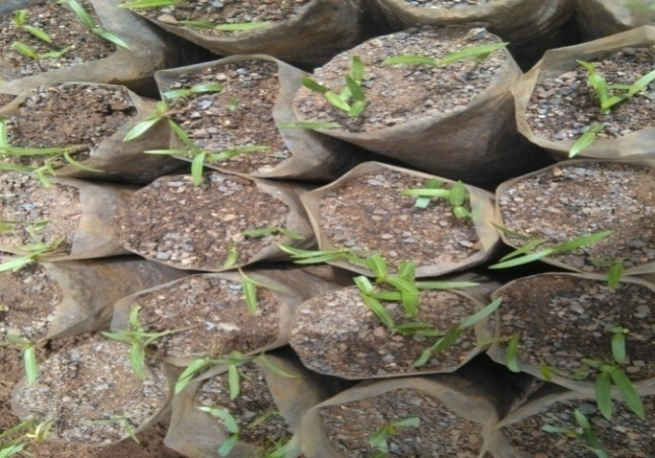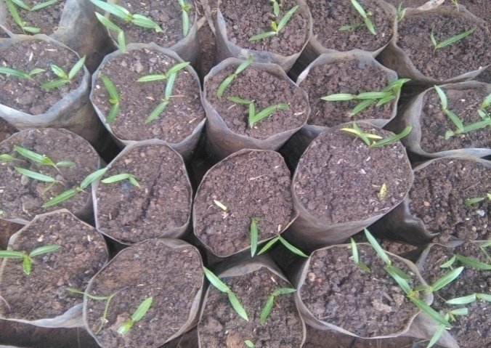
A B
Figure 9: Emergence of D. viscosa subsp. angustifolia seedlings whose seeds were sown in plastic sleeves (diameter 20 cm; depth 25 cm) containing soils sampled from degraded landscapes (A), and soil sampled from degraded landscapes mixed with 50% compost (B).

5.2 Soil analyses results
Soil physical and chemical analyses results shows that soil sampled from degraded landscapes was low in organic carbon (1.6%), low in available phosphorous (6 ppm), low total nitrogen (0.117%), high K^{+.}(1.1 cmol/kg) and high Na⁺ (0.76 cmol/kg) (Table 3) in reference to the standard (Table 4). It also has soil textural class of sandy clay loam (46% sand, 26% silt, 28% clay) with pH of 6.52 (slightly acidic).
Soils sampled from degraded landscapes mixed with equal proportion of compost used for the study has medium organic carbon (3.54%), very high available phosphorous (23 ppm), high total nitrogen (0.3%), very high K⁺ (10.61 cmol/kg) and very high Na⁺ (1.95 cmol/kg) in reference to the standard. It has soil textural class of clay (23% sand, 26% silt, 41% clay) and pH of 6.65 (neutral).
These results showed that amounts of total C, available P, total N, exchangeable K⁺ and Na⁺ in soils from degraded landscapes mixed with equal proportion of compost were 2, 4, 2.5, 9.5 and 2.5 times greater than that of soil sampled from degraded landscapes in respective orders.

Table 3: Physical and chemical analyses results of soils sampled from degraded landscapes (SSDL) and soil sampled from degraded landscapes mixed with equal proportion of compost (SSDLWC); 1 kg of soil were analyzed for each soil groups.
Soil groups | Organic C (%) | Av. P (ppm) | Total N (%) | pH | Exchangeable bases |  | Soil texture (%)
 |  |  |  |  | K⁺  cmol/kg | Na⁺ cmol/kg | clay | Silt | sand | Textural  class
SSDL | 1.60 | 6 | 0.117 | 6.52 | 1.10 | 0.76 | 28 | 26 | 46 | Sandy clay loam
SSDLWC | 3.54 | 23 | 0.3 | 6.65 | 10.61 | 1.95 | 41 | 26 | 33 | Clay

Table 4: Standardized ranges and rates for soil properties (Organic carbon, available P, total N, exchangeable K⁺, exchangeable Na⁺ and pH)
Soil property |  |  | Very low | Low | Medium | High | Very high
Organic carbon (%) |  |  | < 1 | 1 – 2 | 2 – 4.2 | 4.2 - 6 | > 6
Av. P (ppm) |  |  | < 5 | 5 - 10 | 10 - 15 | 15- 20 | >20
Total Nitrogen (%) |  |  | <0.05 | 0.05-0.125 | 0.125 - 0.225 | 0.225 - 0.3 | > 0.300
K⁺ (cmol/kg) |  |  | <0.1 | 0.1-0.3 | 0.3-0.6 | 0.6-1.2 | >1.2
Na⁺(cmol/kg) |  |  | <0.1 | 0.1-0.3 | 0.3-0.7 | 0.7-2.0 | >2
pH | Very  strongly acidic | Strongly acidic | Moderately acidic | Slightly acid | Neutral | Moderately alkaline | Strongly alkaline
pH | < 4.5 | 4.5 - 5.2 | 5.3 - 5.9 | 6.0 - 6.6 | 6.7 - 7.3 | 7.4 - 8.0 | >8.0
Source: Frank, (1990)

5.3 Early growth performances
The study results showed that seedlings grown in the two soil sample groups had insignificant differences (p ≤ 0.05) in mean shoot heights and mean numbers of branches in the first measurements. There were also insignificant differences (p ≤ 0.05) in mean numbers of leaves in first and second measurements.
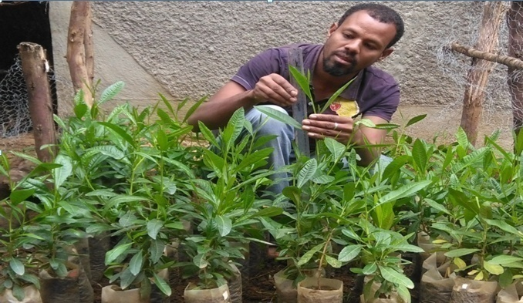
Figure 10: Measurement of height increments by using mm-ruler in soils sampled from degraded landscapes with and without 50% compost under open nursery conditions. 120 replicate of plastic sleeves each with one healthy plant.
The leaves of seedlings grown in soils sampled from degraded landscapes mixed with equal proportion of compost were dark green in colour, but leaves of seedlings grown in soils sampled from degraded landscapes were light green in colour and showed chlorosis at the lower parts of the plant (Figure 10).
The result of height measurements showed that mean shoot height (in cm) of seedlings grown in soils from degraded landscapes were 5.15, 12.83, 18.85, and 26.58 in the 1st, 2nd, 3rd and 4th measurements respectively. On the other hand, mean shoot height (in cm) of seedlings grown in soils from degraded landscapes mixed with 50% compost were 5.49, 14.45, 23.36, and 36.55 in the 1st, 2nd, 3rd and 4th measurements respectively (Figure 11). There were significant differences (p ≤ 0.05) in mean height between seedlings grown in the two soil samples except in the first measurements.

Figure 11: Mean height increment (in cm) of D. viscosa subsp. angustifolia seedlings grown in plastic sleeves filled with soils from degraded landscapes with (SSDLWC) and without (SSDL) 50% compost.

The results of leaf number counts showed that mean number of leaves for seedlings grown in soils from degraded landscapes were 6.03, 10.93, 19.68, and 30.25 in the 1st, 2nd, 3rd and 4th counts respectively. On the other hand mean number of leaves for seedlings grown in soil from degraded landscapes mixed with 50% compost were 6.48, 12.13, 30.4, and 47.8 in the 1st, 2nd, 3rd and 4th counts respectively (Figure 12). There were significant differences (p ≤ 0.05) in number of leaves between seedlings grown in the two soil samples except in the first and second measurements.

Figure 12: Mean leaf numbers of D. viscosa subsp. angustifolia seedlings grown in plastic sleeves filled with soil from degraded landscapes with SSDLWC and without (SSDL) 50% compost.
The result of branch number counts showed that mean number of branches for seedlings grown in soils from degraded landscapes were 0.43, 1.38, 2.38 and 4.03 in the 1st, 2nd, 3rd and 4th counts respectively. On the other hand mean number of branches for seedlings grown in soils from degraded landscapes mixed with 50% compost were 0.93, 2.58, 5.45 and 8.98 in the 1st, 2nd, 3rd and 4th counts respectively (Figure 13). There were significant differences (p ≤ 0.05) in number of branches between seedlings grown in the two soil sample groups except in the first measurement.

Figure 13: Mean branch numbers of D. viscosa subsp. angustifolia seedlings grown in plastic sleeves filled with soil from degraded landscape with SSDLWC and without (SSDL) 50% compost.

In both soil samples all seedlings survived up to the period of harvest. So there was no significant difference in survival percentage between seedlings grown in the two soil sample groups. Mean leaf area (mm²), mean root collar diameter (cm), mean root dry weight (g) and mean shoot dry weight (g) of seedlings grown in soils from degraded landscapes were 236, 2.24, 2.86, and 7.52 in respective order. But 247.05, 3.46, 2 and 12.52 for seedlings grown in soil from degraded landscapes mixed with 50% compost (Figures 14 A, B, C, D and appendix 10). Mean leaf area, mean root collar diameter and mean shoot dry weight of seedlings grown in soil from degraded landscape mixed with 50% compost were significantly higher (p ≤ 0.05) than seedlings grown in soil sampled from degraded landscapes. But root dry weight was significantly higher (p ≤ 0.05) in seedlings grown in soil from degraded landscapes as compared to seedlings grown in soils sampled from degraded landscapes mixed with equal proportion of compost.

A B

C D
Figure 14: Mean leaf area (A), Mean root collar diameter (B), Mean root dry weight (C), Mean shoot dry weight (D) of D. viscosa subsp. angustifolia seedlings grown in plastic sleeves filled with soil from degraded landscapes with SSDLWC and without 50% compost (SSDL).

6 DISCUSSIONS

6.1 Seed germinations
Hard seed coats have been evolved to withstand unfavorable conditions like severe drought, mechanical damage, intense heat from sunlight, and dispersing animals. Germination in seeds having hard seed coat requires rupture of the seed coat and subsequent absorption of water by the seed (Baskin and Baskin, 1998; Silvertown, 1999). D. viscosa subsp. angustifolia has high physical seed dormancy due to water impermeable seed coat (Demel Teketay, 1991, 1996). As a consequence, treatments are required to enhance permeability of seed coat to water. In the present study mechanical scarification, acid scarification and immersion seeds in hot water were methods used to improve germination.
Mechanical scarification of D. viscosa subsp. angustifolia seeds increased mean germination percentage, but reduced mean germination time. This is due to the disruption of the barrier for the uptake of water and oxygen. It also permits radicle emergence by weakening coat structures (Bewley and Black, 1985, 1994; Baskin and Baskin, 1998). But in mechanical scarification there may risk of seed damage and increased fungal attack (Legesse Negash, 1995). At the end of the germination study non germinated seeds in the present study were observed imbibed (swell up). There was also fungal growth even if the filter papers were changed every two days. So germination failure of the remaining seeds in the present study may be due to damage of the seed during mechanical scarification and/or interference of normal germination process by fungal or bacterial attacks.
Concentrated sulphuric acid pretreatments also increased mean germination percentage, but decreased mean germination time. The mechanism of possible seed germination influenced by sulphuric acid is due to its capability in disintegration of the seed coat as well as the micropylar plug that leads to increase in imbibition and subsequent germination of seeds (Baskin and Baskin, 1998). In the present study lower mean germination percentages in seeds pretreated for 1, 3, and 5 minutes as compared to seeds treated for 20 minutes may be due to inefficient time for the disintegration of the seed coat (Baskin and Baskin, 1998). Decrease in mean germination percentage when seeds were immersed in acid for more than 20 minutes, suggests that embryo may get damaged on contact with concentrated sulphuric acid for a prolonged period (Legesse Negash, 1995). Mean germination time results indicated that the more time of soaking the faster the rate of germination; however, prolonged immersion may be injurious to the seeds as a result of the corrosive action of the acid that may rupture vital parts of the embryo and subsequent fungal and/or bacterial attacks (Legesse Negash, 1995).
Hot water treatment softens the palisade layer and separates it from the underlying mesophyll, creates cracks in seed coats at non-localized areas, splits macrosclereids in the palisade layer from each other and/or removes the chalazal plug; thereby enhance the rate of imbibition and diffusion of oxygen into the embryo (Agboola and Adedire, 1998; Baskin and Baskin, 1998; Sabongari, 2001). However, its effect is not universal and the exposure time which resulted in the highest germination varied from species to species, probably depending on the thickness of the seed coat. Hot water treatments have been reported to enhance germination of several species with hard seed coat (Legesse Negash, 1995; Demel Teketay, 1996; Tigabu and Odén, 2001). This agrees with the positive responses observed in the present study for seeds of D. viscosa subsp. angustifolia. Mean germination percentage and rate was increased as soaking periods and soaking temperatures increased, but mean germination percentage was decreased when seeds immersed in hot water (at 90°C and 95°C) for more than 20 minutes. These may due to damage of the embryo on contact with hot water for prolonged periods (Demel Teketay, 1996).
These results showed that D. viscosa subsp. angustifolia seeds require a proper seed pre-sowing treatments for better germination of seeds. The importance of seed treatment for the species was similarly reported by earlier studies of Demel Teketay (1996) and Baskin and Baskin (2004).
Seed germinations of D. viscosa subsp. angustifolia under nursery bed conditions started and completed at different time durations even within the same soil groups. This may be due to the mechanism developed by the species to avoid hazardous conditions that are inhospitable for the establishment of seedlings (Legesse Negash, 1995, 2010). Relatively lower mean seed germination percentage in soil sampled from degraded landscapes mixed with 50% compost might be due to the organic matter effects by either creating water logged conditions in the containers and thereby reducing the oxygen supply or releasing deleterious acids that damage the seed viability (Fenner and Thompson, 2005).

6.2 Seedlings’ survival
Mortality or survival rate of seedlings affect long term achievement of plantation (Negash Mamo and Mebrate Mihretu, 2005). Morphological and physiological conditions of the species, care taken (watering, protection from being browsed or fencing, addition of compost) are some of the reasons that contribute for high seedling survival percentage (Evans, 1972). Factors such as the size of polythene pots, soil, moisture, temperature and pests also have effect on survival of seedlings (Negash Mamo and Mebrate Mihretu, 2005). Insignificant significant difference (p ≤ 0.05) survival percentage of seedlings’ grown in the two soil groups under nursery bed conditions indicated that the species has higher survival potential in soils from degraded landscapes. High survival percentage of D. viscosa subsp. angustifolia seedlings in these soil types may due to its morphological and physiological adaptabilities like resinous coating (Chah, 2006) and Crassulacean acid metabolism (Chauvet, 2016) that minimize water loss.

6.3 Early growth performances
Nutrient supply is one of the most important factors that affect the growth and productivity of plants (Tilman, 1988). The acquisition of nutrients in soils, the use of absorbed nutrients and the loss of nutrients (length of the time period that nutrients can be used) are the three important components of plant functioning that determine the relation between nutrient supply and long-term success of a plant (Pugnaire and Valladares, 1999).
In the present study insignificant differences (p ≤ 0.05) in height and mean numbers of branches in the 1st measurement and also in numbers of leaves in 1st and 2nd counts between seedlings grown in the two soil groups agree with the idea that appropriate moisture and sufficient air are more important for growth performances of plants at the early growth stages than the nutrient levels (Elberse et al., 2003).
Soils that provide a favourable physical environment for root development and anchorage, as well as sufficiently provide water and nutrients are needed for healthy seedling growth (Moir et al., 2007). As soil analyses results showed soil sampled from degraded landscapes were low in total organic carbon, total nitrogen, and available phosphorus. It was expected that mixing 50% compost with soil sampled from degraded landscapes would enrich the growing media. So, higher early growth performances (in terms of mean shoot height, mean number of leaves, mean number of branches, mean leaf area, mean root collar diameter, and mean shoot dry weight) of seedlings grown in soils sampled from degraded landscapes mixed with 50 % compost than without compost may be due to differences in nutrient content of soils. In this study significantly lower mean root collar diameter of seedlings grown in soils from degraded landscapes agree with the idea that the roots of nutrient-poor sites have smaller root diameters leading to an increased root length per unit root weight (Elberse and Berendse, 1993; Fitter, 1997; Pugnaire and Valladares 1999).
In low fertile soils, much of the photosynthates produced by the seedling are being allocated to the growth and development of the root system in search for water and nutrients, while in soils with higher fertility, seedlings expend less energy on root growth and most of the photosynthates produced are directed to shoot growth (Kraske and Fernandez 1990). Tilman, (1988) also suggested that increased allocation to root biomass would be one of the most important adaptations of plants to nutrient-poor soils. So higher mean root dry weight of D. viscosa subsp. angustifolia seedlings grown in soils from degraded landscapes without compost than mixed with 50% compost may be linked to poor fertility of the soil. This result is also in agreement with the ideas of Agren and Franklin (2003) which suggests that, when nutrient availability increases, plant allocates less biomass to their roots.
Capacity to grow on poor soils is the primary quality of plants to be used in soil fertility improvement/restoration (Young, 1997). Madejon et al. (2006) also indicated that the revegetation of eroded ecosystems must be carried out with plants selected on the basis of their ability to survive, regenerate or reproduce under severe conditions, drought resistance, and fast growing plants that can grow in nutrient deficient soils. Survival and growth potential of D. viscosa subsp. angustifolia seedlings in soils sampled from degraded landscapes indicates the usefulness of the species for ecological restoration.

7 CONCLUSIONS AND RECOMMENDATIONS

7.1 Conclusions
The present study revealed that D. viscosa subsp. angustifolia produces large number of seeds, thus its propagation could be achieved by means of seed propagation. The present study clearly demonstrated that dormancy in seeds of D. viscosa subsp. angustifolia was associated with the seed coat, since employed seed pretreatments (mechanical scarification, soaking in hot water and immersion in sulphuric acid) that improved germination were those that can affect the seed coat.
Seed pretreatments that improved the percentage and rate of germination could be an advantage to produce even aged and uniform seedlings in nursery for plantation purposes. To overcome seed coat dormancy in D. viscosa subsp. angustifolia soaking seeds at 95°C hot water for 20 minutes, immersion in concentrated (98%) sulphuric acid for 20 minutes, and mechanical scarification were effective. But, knowledge of the most effective and lowest cost pre-sowing treatment can be used to increase seedling viability and enhance field establishment for greater production. Even though sulfuric acid was successful, in improving germination, difficulty in obtaining the acid, possibility of accidents during handling, and the proper disposal of the generated wastes may restrict its usage. Mechanical scarification is also tedious, needs more man power and also needs great care to avoid damage of embryo. So soaking seeds at 95°C hot water for 20 minutes is easy and cost effective method for large scale scarification in D. viscosa subsp. angustifolia. These results will assist plant nurseries to reduce the time and labor needed to overcome seed dormancy.
The present study also showed that variation in soil physical and chemical properties are directly related to germination, and early growth performances of D. viscosa subsp. angustifolia. Despite the low total carbon, low total nitrogen and low phosphorus of soils sampled from degraded landscapes seedlings of D. viscosa subsp. angustifolia survived and grow in these soils until harvest time (5 months). Early survival and growth in the nursery can be taken as an indicator of the species potential to grow when planted in a field. So these results indicate the potentials of this drought-tolerant, fast-growing plant species for restoration of degraded landscapes.

7.2 Recommendations
To overcome seed coat dormancy in D. viscosa subsp. angustifolia, soaking seeds at 95°C hot water for 20 minutes, immersion in concentrated (98%) sulphuric acid for 20 minutes, and mechanical scarification are recommended.
Rehabilitation of deforested and highly degraded areas with indigenous tree species like D. viscosa subsp. angustifolia that are better adapted to the climate and soil of the country is advisable for quick and sustainable production from forest plantation. These also protect our environment from ecological crisis.
Furthermore, germination and early growth performance of other indigenous plant species that are used for restoring degraded landscapes needed to be studied in the future.

REFERENCES
Agboola, D.A. and Adedire, M.O. (1998). Response of treated dormant seeds of three species to germination promoters. Nigerian Journal of Botany, 11: 103-109
Agri-service Ethiopia (2011). Base line survey analysis report, unpublished. Enabsie sarmidir Woreda. Integrated Food Security Program (IFSP), Addis Ababa, Ethiopia. Pp 8-16
Agren, G.I. and Franklin, O. (2003). Root: Shoot Ratios, optimization and nitrogen productivity. Ann. Bot. 92: 795-800
Al-Asmari, A.K., Al Otaibi, K.E., Al-Omani, S., Athar, M.T. (2013). An Updated Phyto-pharmacological Review on Medicinal Plant of Saudi Arabia. American Journal of Research Communication, 1(12): 519–531
Alemayehu Kefalew (2015). Ethnobotany of medicinal plants in Ada’a District, East Shewa Zone of Oromia Regional State, Ethiopia. Journal of Ethnobiology and Ethnomedicine, 11:25
Amabeoku, G., Eagles, P., Scott, G., and Mayeng, I. (2001). Analgesic and antipyretic effect of Dodonaea angustifolia and Salvia africalutea. Journal of Ethnopharmacol, 75: 115-126.
Azene Bekele, Birnie, A. and Tengnäs, B. (1993). Useful trees and shrubs for Ethiopia. Regional Soil Conservation Unit (RSCU), SIDA. Nairobi. 747 pp.
Azene Bekele (2007). Useful Trees and Shrubs for Ethiopia: Identification, Propagation and Management for 17 Agroclimatic Zones. Nairobi: RELMA in ICRAF Project, 552 pp.
Badege, B. (2001). Deforestation and land degradation in the Ethiopian highlands. Journal of Environment and Earth Science, 4(9): 7-26. www.iiste.org ISSN 2224-3216. Accessed on 17/03/2018
Baskin, C.C. and Baskin, J.M. (1998). Seeds: Ecology, biogeography, and evolution of seed dormancy and germination. Academic Press, San Diego, California, USA.
Baskin, C.C., Baskin, J.M. and Li, X. (2000). Taxonomy, anatomy and evolution of physical dormancy in seeds. Plant Species Biology 15, 139–152.
Baskin, C. C. and Baskin, J. M. (2001). Seeds: ecology, biogeography, and evolution of dormancy and germination. http://bit.ly/gtc_ref_8c
Baskin, C.C., Baskin, J.M. (2004). Classification system for seed dormancy. Seed Science Research. 14:1-16. http://dx.doi.org/10.1079/SSR2003150.
Baskin, C.C. and Baskin, J.M. (2014). Variation in Seed Dormancy and Germination within and between Individuals and Populations of a Species. Seeds: Ecology, Biogeography, and, Evolution of Dormancy and Germination. Burlington: Elsevier Science. pp. Pages 5–35. ISBN 9780124166837.
Bastida, F., Hernandez, T., Garcia, C. (2010). Soil degradation and rehabilitation: Microorganisms and functionality. Springer, Heidelberg, Dordrecht, London, New York.
Bentsink, L., Soppe, W. and Koornneef, M. (2007). Genetic aspects of seed dormancy: In Seed development, dormancy, and germination, pp, 72-106, (Bradford, K. and Nonogaki, H. eds.), Blackwell Publishing Ltd, USA.
Betru Nedessa. (2003). Proceedings of the Natural Resources Management Conference, Soil and Water Conservation Program in the Amhara National Regional State, Impact on Food Security. Bahir Dar, Ethiopia.
Bewley, J.D. and Black, M. (1985). Seeds: Physiology of Development and Germination. Plenum Press, New York and London, 366 pp.
Bewley, J.D. and Black, M. (1994). Seeds: Physiology of development and germination. 2nd ed. Plenum press, New York, 445.Pp.
Bonnefille, R. and Hamilton, A. (1986). Quaternary and late tertiary history of Ethiopian vegetation. Symbolae Botaniceae Uppsala, 26(2): 48-63.
Brady, N. and Weil, R. (1990). The nature and properties of soils, 12thed, Prentice-Hall, Sydney.
Burrows, C.J. (1995). Germination behavior of the seeds of six New Zealand woody plant species. New Zealand Journal of Botany 33, 365–377.
CGIAR (Consultative group on International Agriculture Research). (2015). Sustainable approaches to degraded land in Ethiopia. https://wle.cgiar.org/project/n6. Accessed on 03/01/2018
Chah. (2006). Census of Australian plants. http://chah.gov.au/chah/apc/. Accessed on 02/09/2017
Chauvet, M. (2016). Dodonaea viscosa (PROSEA)-plant use. https://uses.plantnet-project.org. Accessed on 07/01/2018
Cook, A., Turner, S. R., Baskin, J. M., Baskin, C. C., Steadman, K. J. and Dixon, K. W. (2008). Occurrence of Physical Dormancy in Seeds of Australian Sapindaceae: A Survey of 14 Species in Nine Genera. Annals of Botany 101: 1349–1362
Coxhead, I., and ygard, R. (2008). Land Degradation. Submitted for Copenhagen Consensus Comments. University of Wisconsin-Madison and Norwegian University of Life Sciences.
Dawson, J.C., Smith, P. (2007). Carbon losses from soil and its consequences for land-use management. Science of the total environment, 382, 165-191.
Demel Teketay (1991). Problems associated with raising trees from seeds: The Ethiopian experience. In Lieth, H. and Lohmann, M. (eds). Restoration of Tropical Forest Ecosystem. pp. 91-100. Kluwer Academic Publishers. Dordrecht, The Netherlands. 269 pp.
Demel Teketay (1994). Germination ecology of two endemic multipurpose species of Erythrina from Ethiopia. Forest Ecology and Management 65: 8187.
Demel Teketay (1996). Seed ecology and regeneration in dry Afromontane forests of Ethiopia. Ph.D. dissertation, Swedish University of Agricultural Sciences. Umeå, Sweden. 175 pp.
Demel Teketay and Granström, A. (1997). Germination ecology of forest species from the highlands of Ethiopia. Journal of Tropical Ecology 14: 793-803.
Demel Teketay, Mulugeta Lemenih, Tesfaye Bekele, Yonas Yemshaw, Sisay Feleke, Wubalem Tadesse, Yitebetu Moges, Tesfaye Hunde, Demeke Nigussie (2010). Forest Resources and Challenges of Sustainable Forest Management and Conservation in Ethiopia. Earthscan, UK.
Diver, S. and Greer, L. (2001). Sustainable Small – scale Nursery Production: Horticulture Systems Guide. Website: http://www.attra.org/Nursery/nurs Cont Prod.htm
Duvauchelle, D. (2004). Plant fact sheet for hop bush (Dodonaea viscosa (L.) Jacq. http://www.nrcs.usda.gov, Accessed on 01/12/2017
Eira, M.T., Caldas, L. S. (2000). Seed dormancy and germination as concurrent processes. Rev. Bras. Fisiol. Veg 12:85–104.
Elberse, W.Th. and F. Berendse, 1993. A comparative study of the growth and morphology of eight grass species from habitats with different nutrient availabilities. Functional Ecology 7: 223–229.
Elberse, I. A., Turin, J. H., Wackers, F. L., Van Damme, J. M. and Tienderen, P. H. (2003). The relation between relative growth rate and susceptibility to aphids in wild barley under different nutrient levels. Oecologia 137: 564-571.
Ermias Lulekal, Rondevaldova, J., Bernaskova, E., Cepkova, J., Zemede Asfaw, Ensermu Kelbessa, Kokoska, L., and Van Damme1,P. (2014). Antimicrobial activity of traditional medicinal plants from Ankober District, North Shewa Zone, Amhara Region, Ethiopia Journal of Ethno biology and Ethno medicine. 10(21) Pp 7
Esua, K. (1964). Anatomy of seed plants, Willey, New York.
Evans, G. (1972). The Quantitive Analysis of Plant Growth. Berrkeley, University of California, 632 pp.
Evans, J. (1992). Plantation Forestry in the Tropics. Clarendon Press, Oxford, 403 pp.
Federal Democratic Republic of Ethiopia (2011). Ethiopia’s Climate-Resilient Green Economy Strategy. Addis Ababa, Ethiopia.
Fenner, M. and Thompson, K. (2005). The Ecology of Seeds. Cambridge University Press, U.K. Seed Ecology. Chapman and Hall, London and New York. Pp 262
Fichtl, R. and Admassu Adi (1994). Honeybee Flora of Ethiopia. Margraf/Verlag, Germany, 510 Pp
Fitter, A.H. (1997). Nutrient acquisition. In: M.J. Crawley, ed. Plant Ecology, second edition. Blackwell Scientific Publications, Oxford, pp. 51–72.
Frank, B. (1990). Adapted from agricultural compendium; FAO and Booker (MTS)
Friis, I. (1992). Forests and forest trees of North-east tropical Africa. Kew Bull. Add. Ser. 15: 1-396.
Gardner, C. J., McIvor, J. G. and Jansen, A. (1993). Passage of legume and grass seed through the digestive tract of cattle and their survival in faeces. Journal of Applied Ecology 30: 63-74.
Gete Zeleke, Menale, K., Pender, J. and Mahmud, Y. (2006). Stakeholder Analysis for Sustainable Land Management (SLM) in Ethiopia: Assessment of Opportunities, Strategic Constraints, Information Needs, and Knowledge Gaps. Environmental Economics Policy Forum for Ethiopia (EEPFE). Pp 4-91.
Ghosh, M. and Ulaganathan, K. (2004). Dodonaea angustifolia. A potential biopesticide against Helicover paarmigera. Current Science, 86: 26-28.
Gutterman, Y. (1993). Seed Germination in Desert Plants. Spring-Verlag, Berlin.
Hadas, A. (2004). Seed bed preparation the soil physical and environment of germinating seeds: In Handbook of seed physiology: applications to agriculture, pp 3-49
Haftom Kebede and Samuel Gebrechirstos (2016). Floral establishment of major honey plants in Tahtay Qoraro, North western zone of Tigray, Ethiopia Bulletin of Environment, Pharmacology and Life Sciences 5 (12) pp 52
Haile Yineger, Ensermu Kelbessa, Tamirat Bekele, Ermias Lulekal (2008). Plants used in traditional management of human ailments at Bale Mountains National Park, Southeastern Ethiopia. Journal of Medicinal Plants Research 2: 132–53.
Harris, S.K. (2012). Desert national botanical garden, South Africa National Biodiversity Institute
Hartmann, H.T. and Kester, D.F. (1975). Plant Propagation, Principles and Practices. Prentice - Hall, Englewood Cliffs, New Jersey, pp. 1-180.
Hartmann, H.T. and Kester, D.F. (1983). Plant Propagation: principles and Practices. Prentice-Hall International, London. 747 pp.
Hartmann, H.T., Kester, D.E., Davis, F.T. and Geneva, R.L. (2004). Plant Propagation: Principles and Practices. 6th edn. Prentice Hall of India Press, New Delhi, 770 pp
Hedberg, I. and Edwards, S. (1989). Flora of Ethiopia. Addis Ababa Univ., Addis Ababa. , Ethiopia and Uppsala University, Uppsala, Sweden, 659 pp.
Hendricks, S. B. and Taylorson, R. B. (1976). Variation in germination and amino acid leakage of seeds with temperature related to membrane phase change. Plant Physiology 58:7-11.
Hinsinger P. (2001). Bioavailability of soil inorganic P in the rhizosphere as affected by root-induced chemical changes: a review. Plant and Soil. 237(2):173–195.
Hodgkinson, K.C. (1991) Shrub recruitment response to intensity and season of ﬁre in a semi-arid woodland. Journal of Applied Ecology 28, 60–70.
Hurni, H., Amare Bantider, Ludi, E.,and Portner, B. (2010). Land degradation and sustainable land management in the highlands of Ethiopia. Georaphica Bernensia. 5:187-201.
Jaenicke, H. (1999). Good Tree Nursery Practices: Practical Guidelines for Research Nurseries. Majestic Printing Works Nairobi, Kenya, 91 Pp
Jansen, P. C. M. (1981). Spices, Condiments and Medicinal plants in Ethiopia. Pudoc, Wageningen, the Netherlands. 277 pp.
Kaleab Asres, Bucar, F and Gbbons, S. (2006). Radical scavenging compounds from Ethiopian medicinal plants. Journal of Ethnopharmacol, 24: 23-35.
Kebrom Tekle, Backéus, I., Skoglund, J. and Zerihun Woldu (1997). Vegetation on hill slopes in southern Wello, Ethiopia: Degradation and regeneration. Journal of Botany 17: 483-493.
Kirchmann, H. (1988). Shoot and root growth and nitrogen uptake by six green manure legumes. Acta Agricultural sciences. 38:25-31.
Kraske, C.R. and Fernandez, I.J. (1990). Conifer seedling growth responses to soil type and selected nitrogen availability indices. Soil Science Society of American Journal 54, 246 – 251.
Lamb, D. (2014) Large-Scale Forest Restoration; Earthscan-Routledge: London, UK, Pearman, In Anthropology University of Kent, Canterbury, pp. 40.
Legesse Negash (1990). Ethiopia's Indigenous Forest Species and the Pervasive Effects of Deforestation. SINET News Letter. Vol. 14. No. 2.
Legesse Negash (1992). In vitro methods for the rapid germination of seeds of Podocarpus falcatus (Thunb.) Mirb. SINET: Ethiopian Journal of Sciences. 15(2): 85-97.
Legesse Negash (1993). Investigations on the germination behavior of wild olive seeds and the nursery establishment of germinates. SINET: Ethiopian Journal of Sciences. 16(2): 71-81.
Legesse Negash (1995). Indigenous Trees of Ethiopia: Biology, Uses and Propagation Techniques. Printed by the SLU Reprocentralen, Umeå, Sweden, ISBN 91-7191-105- 7 Pp. 285.
Legesse Negash (2002). Review of research advances in some selected African trees with special reference to Ethiopia. Review article. Ethiopian Journal of Sciences. 1: 81-126.
Legesse Negash (2004). The tortuous path ahead: Facing the grim reality of Ethiopia’s contemporary environmental challenges. “Consultation Paper No. 7” published by the FSS (Forum for Social Studies), Addis Ababa, Ethiopia.
Legesse Negash (2010). A selection of Ethiopian’s Indigenous Trees Biology, Uses and Propagation Techniques, Addis Ababa University press, Addis Ababa, Ethiopia, pp.386.
Legesse Negash and Berhanu Kagnew (2013). Mechanisms for the successful biological restoration of the threatened African pencil cedar (Juniperus procera Hochst. Ex. Endl., Cupressaceae) in a degraded landscape. Forest Ecology and Management 310:476-482.
Li, S., Shi, T., Kong, F., Ma, Q., Mao, Y. and Yin, T. (2013). Methods for breaking the dormancy of eastern red bud (Cercis canadensis) seeds. Seed Science and Technology. 41:27-35.
López-Bucio, J., Cruz-Ramírez, A., Herrera-Estella, L. (2003). The role of nutrient availability in regulating root architecture. Current Opinion in Plant Biology. 6(3):280–287.
MacMahon, J.A. (1997). Principles of Conservation Biology. Second edition. Sinauer Associates, Inc. Publishers, Sunderland, Massachusetts, USA, pp. 479-511.
Madejon, E., Mora, A.P., Felipe, E., Burgos, P. and Cabrera, F. (2006). Soil amendments reduce trace element solubility in a contaminated soil and allow re-growth of natural vegetation. Environ. Pollut. 139: 40-52
Martín, I. and Guerrero, M. (2014). Seed Science and Technology, Effect of sulphuric acid scarification on seed accessions of cluster clover (Trifolium glomeratum) stored in a genebank. 42:293-299.
Mayer, A. M. and Poljakoff-Mayber, A. (1989). The germination of seeds. 4th ed. Pergamon, New York.
McDonald, M B. (1994). Seed lot potential: viability, vigour and field performance. Seed Science and Technology 22: 421-425.
Medeiros, A. C., Davenport,C.F., Chimera,C.G. (1998). Ethnobotany of a Hawaiian Dryland Forest. Cooperative National Park Resources Studies Unit, University of Hawaiʻi at Mānoa. Pp 14-16.
Mengiste, B., Makonnen, E., Urga, K. (2012). In vivo Antimalarial Activity of Dodonaea angustifolia Seed Extracts against Plasmodium berghei in Mice Model. MEJS (Mekelle Univ. Ethiopia), 4 (1):47-63.
Mengel, K. and Kirkby, E.A. (1982). Principles of plant nutrition. International potash institute. Bern/ Switzerland.
Misra, R. V., Roy, R. N. and Hiraoka, H. (2003). On-farm composting methods. FAO Land and Water Discussion Paper No. 2. Italy, Rome, 51p.
Moir, K., Vandenbosch, T. and Scull-Carvalho, S. (2007). Practical tips for healthy tree nurseries and home gardens, Jacaranda. Designs. Growing trees and Gardens for life, Ltd, Nairobi, Kenya pp.85. ISBN 9966-956-54-9.
Mog‟omba, S. A., Dutoit, E. S. and Akinnifesi, F. K. (2007). Germination Characteristics of Tree Seeds: Spotlight on Southern African. Tree Species. Tree and Forestry Science and Biotechnology, South Africa, Pp. 1 - 8.
Mulugeta Lemenih and Demel Teketay (2004). Restoration of native forest flora in the degraded highlands of Ethiopia. SINET: Ethiop. J. Sci. 27 (1): 75-90.
Muthukumran, P., Begumand, V.H., Kalaiarasan, P. (2011). Anti-diabetic activity of Dodonaea viscosa (L) leaf extracts. International Journal of Pharmacological Technology Research, 3:‏ 136−139.
Negash Mamo and Mebrate Mihretu (2005). Provenance effect on early survival and growth performance of juniperus procera at jibli, Awi zone. Ethiopian journal of natural resource 7(2) pp 203-217.
Nelson, D. C., Riseborough, J., Flematti, G. R., Stevens, J., Ghisalberti, E. L., Dixon, K. W. and Smith, S. M. (2009). Karrikins Discovered in Smoke Trigger Arabidopsis Seed Germination by a Mechanism Requiring Gibberellic Acid Synthesis and Light. Plant Physiology 149:863–873.
Orwa, C., Mutua, A., Kindt, R., Jamnadass. R., Anthony, S. (2009). Agroforestree Database:a tree reference and selection guide. http://www.worldagroforestry.org/sites/treedbs/treedatabases.asp. Accessed on 19/3/2018
Parrotta, J.A. (1995). Influence of over story composition on understory colonisation by native species in plantations on a degraded tropical site. Journal of Vegtation Science 6: 627-636.
Parry, J. (2003). Tree choppers become tree planters, Appropriate Technology, 30(4), 38-39. ABI 538367341)
Piotto, B. and Di Noi, A. (2003). Seed propagation of Mediterranean trees and shrubs. Agency for the protection of the environment and for technical services Via Vitaliano Brancati, 48 - 144 Roma, Italy.
Pohjonen, V. (1989). Establishment of fuel wood plantations in Ethiopia. Silva carelica 14: 1-388.
Probert, R.J. (1992). The role of temperature in germination ecophysiology. The Ecology of Regeneration in Plant Communities. CAB International, Wallingford. pp. 285-325.
Pugnaire, F. and Valladares, F. (1999). Functional plant ecology. 2nd ed pp 259-279.
Ragunathan, M. and Solomon, M. (2009). The study of spiritual remedies in orthodox rural churches and traditional medicinal practice in Gondar Zuria district, Northwestern Ethiopia Vol 1,| Issue 3 pp 181. Phcog.Net | www.phcogj.com.
Rajamanickam, V., Rajasekaran, A., Anandarajagopal, K., Sridharan, D., Selvakumar, K., Stephen Rathinaraj, B. (2010). Anti-diarrheal activity of Dodonaea viscosa root extracts. International Journal of Pharmacy and Bio Sciences, (1): 182-185.
Rani, M. S., Pippalla, R. S., Krishna, M. (2009). Dodonaea viscosa linn. an overview. Asian Journal of Pharmaceutical Research and Health Care 1, 97112.
Raven, Peter, H., Ray, F., Evert, Susan, E., Eichhorn. (2005). Biology of Plants, 7th Edition. New York: W.H. Freeman and Company Publishers. pp. 504–508.
Roger and Jones (2017). Australian National Botanical Gardens (ANBG). Lothian Publishing Company Pty Ltd, Melbourne, Australia.
Rolston, M. p. (1978). Water impermeable seed dormancy. The botanical review 44(3):365-396
Roy, R.N.; Finck, A.; Blair, G.J.; Tandon, H.L.S. (2006). Plant nutrition for food security: a guide for integrated nutrient management (PDF). Rome: Food and Agriculture Organization of the United Nations. pp.25–42. ISBN 92-5-105490-8. Retrieved 20 February 2018.
Sabongari, S. (2001). Coat imposed germination and seedling establishment of selected dormancy in Acacia farnesiana seeds, Addision-Wesley Usmanu Danfodiyo University, Sokoto, Nigeria. Pub. Co. Inc. U.S.A, pp: 501-540.
Schelin, M., Tigabu, M., Eriksson, I, Sawadogo,L. and Odén, P.C. (2004). Predispersal seed predation in Acacia macrostachya, its impact on seed viability, and germination responses to scarification and dry heat treatments. New Forests. 27: 251-267.
Schleicher, J., Meyer, K.M., Wiegand, K., Schurr, F.M., Ward, D. (2011). Disentangling facilitation and seed dispersal from environmental heterogeneity as mechanisms generating associations between savanna plants. Journal of Vegetation Science 22: 1038–1048.
Schu¨tz, W. (2000). Ecology of seed dormancy and germination in sedges. Perspectives in Plant Ecology, Evolution and Systematics. 3: 67– 89
Siegel, S. M., Rosen, L. A. (1962). Effects of Reduced Oxygen Tension on Germination and Seedling Growth. 15 (3): 437–444.
Silvertown, J. (1999). Seed ecology, dormancy, and germination: a modern synthesis Am. J. Bot., 86(6), 903-905.
Simonsen, H., Braendegaard, J., Ulla, N., Smitt, W., Nyman, U., Palpu, U and Joshi, J. (2001). Invitro screening of Indian medicinal plants for antiplasmodial activities. Journal of Ethnopharmacol.,74:195-204.
Soil Survey Staff, (1998). Soil survey laboratory methods manual: Soil survey investigation report no .42 version 10, Washington D.C. 273pp.
Solomon, T., Esubalew, Anteneh Belete, Ermias Lulekal, Tesfaye Gabriel, Ephrem Engidawork, Kaleab Asres (2017). Review of Ethnobotanical and Ethnopharmacological Evidences of some Ethiopian Medicinal Plants traditionally used for the Treatment of Cancer. Ethiopian Journal of Health Development.31(3)
Sumnar, M.E. (2000). Hand book of soil science. CRC press, United States of America. 14pp.
Swan, H.S.D. (1971). Relationships between nutrient supply, growth and nutrient concentrations in the foliage of white and red spruce. Res. Inst. Can., Woodlands. Pp 34. 27.
Taiz, L. and Zeiger, E. (2002). Plant Physiology. 3rd ed Sinauer Associates, Inc. Publishers, Sunderland, Massachusetts, ISBN: 0878938230, 690 Pp.
Teffo, L. S., Aderogba, M. A., Eloff, J. N. (2010). Antibacterial and antioxidant activities of four kaempferol methyl ethers isolated from Dodonaea viscosa Jacq. subsb. angustifolia leaf extracts. South African Journal of Botany, 76(1): 25-29.
Tekalign, D., Yalemtsehay Mekonnen, Animut, A. (2010). In vivo Antimalarial Activities of Clerodendrum myricoides, Dodonaea angustifolia and Aloe debrana against Plasmodium berghei. Ethiopian Journal of Health Development. 24 (1): 25-29.
Temesgen Gashaw; Amare Bantider and Hagos G/Silassie (2014) Land Degradation in Ethiopia: Causes, Impacts and Rehabilitation Techniques. Journal of Environmental and Earth Sciences. 4, 98–104.
Tesfaye Bekele (2000). Plant Population Dynamics of Dodonaea angustifolia and Olea europaea ssp. cuspidata in Dry Afromontane Forests of Ethiopia. Acta Universitatis Upsaliensis. Comprehensive Summaries of Uppsala Dissertations from the Faculty of Science and Technology 559. 47 pp. Uppsala. ISBN 91-554-4781-3
Thompson, K. and Troeh, F.R. (1978). Soil and soil fertility. Fourth edition. Tata McGraw-Hill Publishing company, Ltd., New Delhi.
Tigabu, M. and Odén, P.C. (2001). Effect of scariﬁcation, gibberellic acid and temperature on seed germination of two multipurpose Albizia species from Ethiopia. Seed Science and Technology. 29, 11–20.
Tilahun Amade. (2003). Opportunity and Challenges in Reversing Land Degradation the Regional Experience. Addis Ababa:
Tilman, D., (1988). Plant Strategies and the Dynamics and Structure of Plant Communities. Princeton University Press, Princeton.
Tóth, G., Stolbovoy, V., Montanarella, L. (2007). Soil Quality and Sustainability Evaluation. An
integrated approach to support soil-related policies of the European Union. EUR 22721 EN.
40pp. Office for Official Publications of the European Communities, Luxembourg. ISBN 978-92
79-05250-7.
UNCCD (2004). Forests: Climate Change, Biodiversity and Land Degradation. Joint Liaison Group of the Rio Conventions, Germany. pp3-6.
Vanclay, J. (1994). Modeling Forest Growth and Yield. Biddles Lted, UK, 312 pp.
Van Wyk, B.E., Van Oudtshoorn, B. and Gericke, N. (1997). Medicinal plants of South Africa. Briza Publications, Pretoria, South Africa. 304 pp.
Vavilove, I. (1997). Five Continents. Academy of Science, USSR, 198 pp.
Vollesen, K. (1989). Flora of Ethiopia, Addis Ababa and Asmara, Ethiopia; Uppsala, Sweden. V. 3, pp. 491-492.
Walsh, N.G. and Entwisle, T.J. (1996), Flora of Victoria, Inkata Press, Melbourne, VIC, Volume 3.
Watt, J.M. and Breyer-Brand wijk, M.G. (1981). Medicinal and Poisonous Plants of Southern and Eastern Africa, E. and S. Livingstone Ltd., Edinburgh, London, 2nd Ed., 931–932 pp.
Woreda Agricultural Office (2012). Agricultural constraint of Enebsie Sar midir Woreda, unpublished. Mertulemariam, East Gojjam Zone, Ethiopia.
WMO (World Meteorological Organization) (2005). Climate and land degradation. http://www.wmo.int/web/wcp/agm/agmp. Accessed on 23/02/2018
Zerihun Woldu, Dragan, M., Feoli, E. and Fernetti, M. (2002). Reducing soil erosion in Northern Ethiopia, Adawa zone, through application of a Spatial Decision Support System (SDSS).Ethiop. J. Biol. Sci. 1: 1-12
Young, A. (1997). Agroforestery for soil management, Effect of trees on soils. CAB International. Pp 23
Zhao, D., Kane, M., Borders, B., Harrison, M. (2008). Pine growth response to different site- preparation methods with or without post-plant herbaceous weed control on North Florida’s Lower Coastal Plain. Forest Ecology and Management. 255(7):2512–2523.

APPENDICES
Appendix 1: Seeding habit (A), seed collection (B), collected mature pods containing fully developed seeds (C) and seeds of D. viscosa subsp. angustifolia before sowing (D)
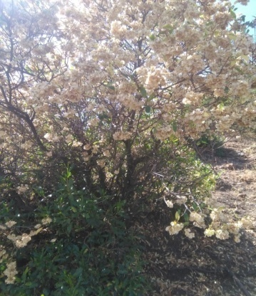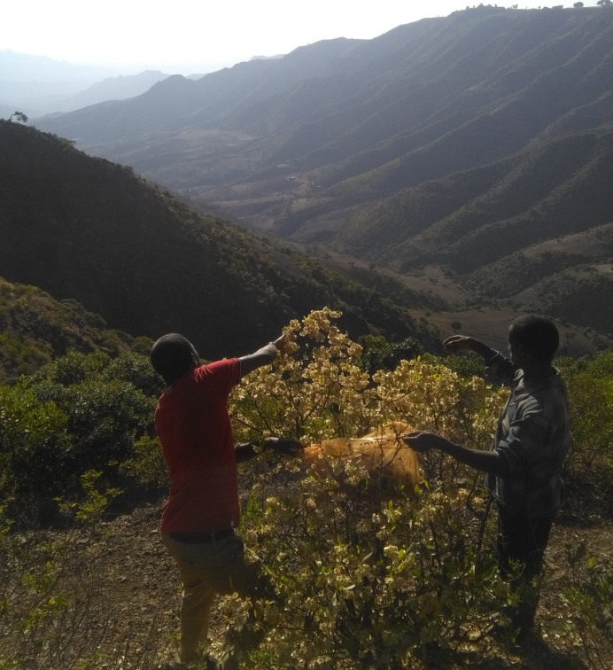
A B

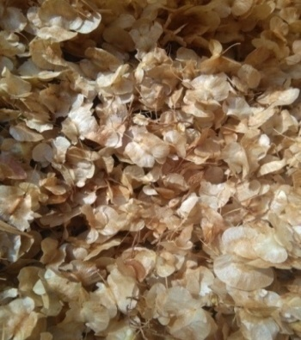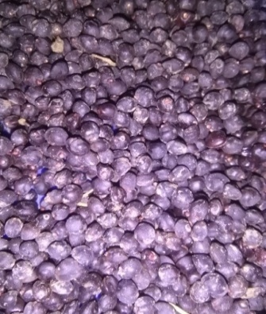
C D
Appendix 2: Sulphuric acid seed treatment (A), Mechanical scarification using sandpaper (B), Germination pattern subjected to different treatments.(C) of D. viscosa subsp. angustifolia seeds.
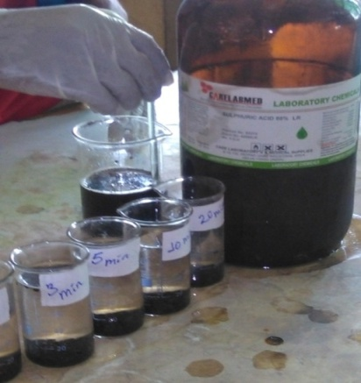
A B

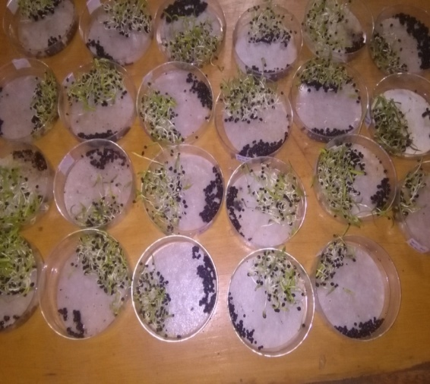
C

Appendix 3: Successive stages of germination in D. viscosa subsp. angustifolia (A) radicle emergence (B) elongation of radicle (C) arise of cotyledon from the ground (epigeal germination) (D) seedling after 1 month
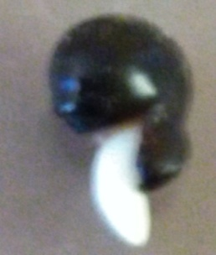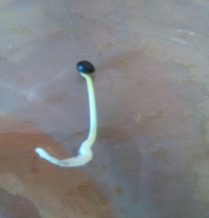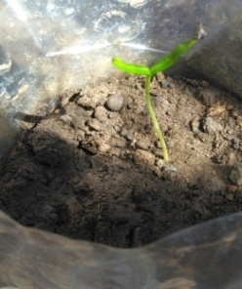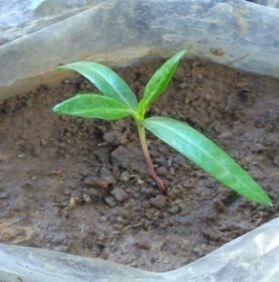
A B C D
Appendix 4: Daily numbers of germinants in different treatments
Days | Numbers of germinants
Days | T₁ | T₂ | T₃ | T₄ | T₅ | T₆ | T₇ | T₈ | T₉ | T  ₁₀ | T  ₁₁ | T  ₁₂ | T  ₁₃ | T  ₁₄ | T  ₁₅ | T  ₁₆ | T  ₁₇ | T  ₁₈ | T  ₁₉ | T  ₂₀ | T  ₂₁ | T  ₂₂ | T  ₂₃ | T  ₂₄ | T  ₂₅ | T  ₂₆ | T  ₂₇ | T  ₂₈
1 | 0 | 0 | 0 | 0 | 0 | 0 | 0 | 0 | 0 | 0 | 0 | 0 | 0 | 0 | 0 | 0 | 0 | 0 | 0 | 0 | 0 | 0 | 0 | 0 | 0 | 0 | 0 | 0
2 | 0 | 12 | 0 | 0 | 0 | 0 | 0 | 0 | 0 | 0 | 0 | 0 | 0 | 0 | 0 | 0 | 0 | 0 | 0 | 0 | 0 | 0 | 0 | 0 | 0 | 0 | 0 | 0
3 | 0 | 21 | 0 | 0 | 0 | 0 | 0 | 12 | 0 | 0 | 0 | 0 | 0 | 0 | 0 | 0 | 0 | 0 | 0 | 0 | 0 | 0 | 0 | 0 | 0 | 0 | 0 | 0
4 | 0 | 22 | 0 | 0 | 0 | 0 | 0 | 15 | 0 | 0 | 0 | 0 | 0 | 0 | 0 | 0 | 0 | 0 | 0 | 0 | 0 | 0 | 0 | 0 | 0 | 0 | 0 | 0
5 | 0 | 24 | 0 | 0 | 0 | 5 | 9 | 27 | 0 | 0 | 0 | 0 | 0 | 0 | 0 | 0 | 0 | 0 | 0 | 0 | 0 | 0 | 13 | 0 | 0 | 0 | 0 | 6
6 | 0 | 20 | 0 | 3 | 5 | 13 | 20 | 31 | 0 | 0 | 0 | 0 | 0 | 0 | 0 | 0 | 8 | 4 | 0 | 0 | 0 | 5 | 10 | 0 | 0 | 13 | 14 | 15
7 | 0 | 18 | 0 | 2 | 7 | 19 | 27 | 29 | 0 | 0 | 0 | 0 | 0 | 0 | 0 | 0 | 12 | 9 | 7 | 3 | 9 | 20 | 17 | 9 | 12 | 16 | 20 | 19
8 | 0 | 26 | 4 | 11 | 17 | 28 | 34 | 32 | 0 | 0 | 0 | 7 | 5 | 5 | 4 | 6 | 10 | 17 | 9 | 8 | 11 | 24 | 23 | 10 | 11 | 18 | 22 | 20
9 | 0 | 19 | 6 | 15 | 22 | 21 | 23 | 23 | 0 | 0 | 3 | 8 | 7 | 2 | 7 | 8 | 11 | 23 | 10 | 20 | 14 | 18 | 21 | 10 | 14 | 20 | 21 | 23
10 | 2 | 15 | 9 | 16 | 21 | 25 | 31 | 19 | 4 | 5 | 9 | 7 | 11 | 4 | 5 | 12 | 22 | 20 | 18 | 17 | 17 | 21 | 20 | 14 | 18 | 19 | 19 | 21
11 | 4 | 12 | 12 | 21 | 28 | 27 | 27 | 12 | 3 | 9 | 8 | 13 | 15 | 3 | 8 | 19 | 13 | 21 | 13 | 21 | 16 | 22 | 21 | 16 | 21 | 16 | 18 | 20
12 | 4 | 10 | 13 | 19 | 26 | 22 | 23 | 8 | 2 | 3 | 12 | 17 | 21 | 6 | 11 | 15 | 14 | 12 | 10 | 8 | 14 | 19 | 18 | 14 | 11 | 14 | 17 | 26
13 | 5 | 7 | 17 | 22 | 20 | 17 | 20 | 0 | 9 | 7 | 16 | 17 | 18 | 7 | 13 | 16 | 18 | 15 | 10 | 11 | 16 | 17 | 13 | 16 | 15 | 12 | 16 | 16
14 | 6 | 0 | 14 | 18 | 16 | 13 | 16 | 0 | 9 | 18 | 20 | 16 | 20 | 9 | 11 | 18 | 9 | 12 | 5 | 9 | 17 | 14 | 18 | 17 | 13 | 19 | 10 | 12
15 | 9 | 0 | 13 | 16 | 10 | 11 | 3 | 0 | 11 | 13 | 19 | 18 | 19 | 10 | 13 | 17 | 11 | 14 | 11 | 10 | 14 | 13 | 6 | 14 | 16 | 15 | 11 | 13
16 | 11 | 0 | 19 | 11 | 3 | 8 | 0 | 0 | 16 | 17 | 17 | 12 | 18 | 12 | 10 | 14 | 15 | 13 | 10 | 12 | 15 | 9 | 9 | 11 | 13 | 16 | 9 | 0
17 | 8 | 0 | 14 | 6 | 5 | 5 | 0 | 0 | 17 | 16 | 14 | 16 | 16 | 14 | 12 | 13 | 13 | 15 | 12 | 9 | 13 | 12 | 6 | 8 | 15 | 8 | 9 | 0
18 | 12 | 0 | 10 | 10 | 3 | 1 | 0 | 0 | 15 | 11 | 15 | 10 | 11 | 11 | 11 | 11 | 10 | 14 | 18 | 14 | 17 | 4 | 1 | 9 | 13 | 11 | 8 | 0
19 | 10 | 0 | 7 | 3 | 2 | 0 | 0 | 0 | 13 | 8 | 12 | 11 | 10 | 13 | 13 | 5 | 6 | 11 | 6 | 17 | 13 | 3 | 0 | 4 | 10 | 6 | 3 | 0
20 | 12 | 0 | 6 | 3 | 0 | 0 | 0 | 0 | 10 | 6 | 9 | 9 | 10 | 15 | 9 | 4 | 7 | 3 | 6 | 9 | 12 | 0 | 0 | 3 | 2 | 7 | 1 | 0
21 | 2 | 0 | 7 | 1 | 0 | 0 | 0 | 0 | 7 | 9 | 4 | 6 | 8 | 11 | 7 | 3 | 5 | 2 | 7 | 5 | 12 | 0 | 0 | 4 | 3 | 3 | 0 | 0
22 | 2 | 0 | 5 | 0 | 0 | 0 | 0 | 0 | 6 | 5 | 2 | 5 | 5 | 8 | 6 | 2 | 4 | 0 | 3 | 2 | 0 | 0 | 0 | 1 | 4 | 0 | 0 | 0
23 | 5 | 0 | 5 | 0 | 0 | 0 | 0 | 0 | 4 | 3 | 1 | 2 | 3 | 7 | 5 | 4 | 2 | 0 | 1 | 3 | 0 | 0 | 0 | 2 | 1 | 0 | 0 | 0
24 | 6 | 0 | 2 | 0 | 0 | 0 | 0 | 0 | 5 | 6 | 2 | 0 | 1 | 3 | 6 | 4 | 0 | 0 | 1 | 1 | 0 | 0 | 0 | 1 | 0 | 0 | 0 | 0
25 | 5 | 0 | 0 | 0 | 0 | 0 | 0 | 0 | 2 | 0 | 0 | 1 | 0 | 4 | 2 | 2 | 0 | 0 | 0 | 1 | 0 | 0 | 0 | 0 | 0 | 0 | 0 | 0
26 | 1 | 0 | 0 | 0 | 0 | 0 | 0 | 0 | 0 | 4 | 0 | 0 | 0 | 1 | 3 | 2 | 0 | 0 | 0 | 0 | 0 | 0 | 0 | 0 | 0 | 0 | 0 | 0
27 | 0 | 0 | 0 | 0 | 0 | 0 | 0 | 0 | 1 | 0 | 0 | 0 | 0 | 0 | 1 | 0 | 0 | 0 | 0 | 0 | 0 | 0 | 0 | 0 | 0 | 0 | 0 | 0
28 | 0 | 0 | 0 | 0 | 0 | 0 | 0 | 0 | 0 | 0 | 0 | 0 | 0 | 0 | 0 | 0 | 0 | 0 | 0 | 0 | 0 | 0 | 0 | 0 | 0 | 0 | 0 | 0

T₁ – non scarified, T₂ –mechanical scarified, T_{3,} , T_{4,} T_{5,} T_{6,} T_{7,} T₈–Sulphuric acid treated for 1, 3, 5, 10, 20,.and 30 minutes respectively, T_{9,} T_{10,} T_{11,} T₁₂ ,T₁₃-Hot water treated at 70°C for 5, 10, 20, 30 and 40 minutes respectively, T_{14,} T_{15,} T_{16,} T_{17,} T₁₈-Hot water treated at 80°C for 5, 10, 20, 30 and 40 minutes respectively, T_{19,} T_{20,} T_{21,} T_{22,} T₂₃-Hot water treated at 90°C for 5, 10, 20, 30 and 40 minutes respectively, T_{24,} T_{25,} T₂₆ ,T₂₇, T₂₈--Hot water treated at 95°C for 5, 10, 20, 30 and 40 minutes respectively.
Appendix 5: Degraded landscape area where degraded soil sample for the study taken (A), soil sampled from degraded landscape (B) and soil sampled from degraded landscape mixed with equal proportion of compost (C)
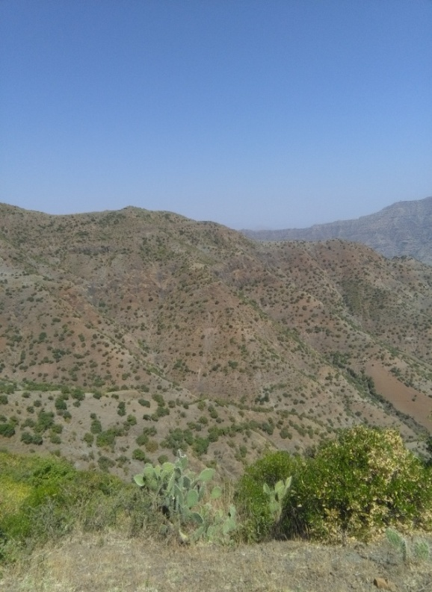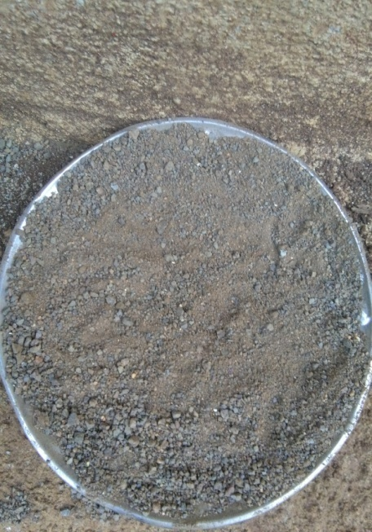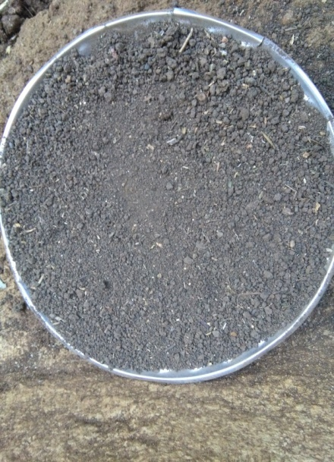
A B C

Appendix 6: 5 months aged seedlings of D. viscosa subsp. angustifolia grown in soils from degraded landscapes mixed with 50% compost (A) and without compost (B) under open nursery bed conditions.
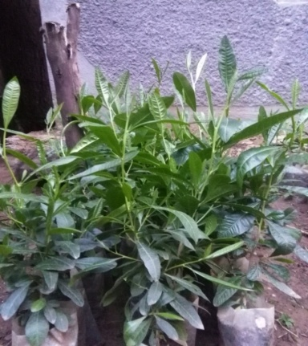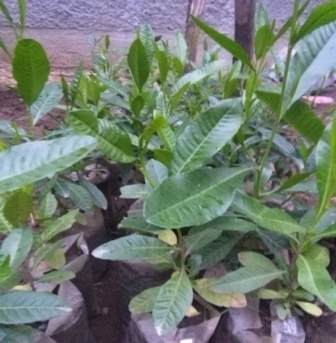
A B
Appendix 7: Height in cm of sampled seedlings that were measured monthly during the time of experiment
Seedling  code | With compost |  |  |  | In soil from degraded landscape
Seedling  code | Days |  |  |  | Seedling  code | Days
Seedling  code | 60th | 90th | 120th | 150th | Seedling  code | 60th | 90th | 120th | 150th
C₁ | 5.4 | 12.1 | 23.4 | 34.5 | D₁ | 5.2 | 12 | 18.3 | 27
C₃ | 6 | 15.3 | 22 | 36 | D₃ | 5 | 9.8 | 23.1 | 31.4
C₄ | 5.1 | 13.8 | 21 | 30 | D₄ | 6 | 11 | 20 | 26
C₅ | 5 | 11.3 | 13.6 | 28.4 | D₅ | 5.3 | 15.4 | 24 | 33.6
C₇ | 5.6 | 12.5 | 23 | 33.3 | D₇ | 5.1 | 12.4 | 17 | 23
C₈ | 4.9 | 10.9 | 18.6 | 35.7 | D₈ | 5.2 | 13 | 16.5 | 29.4
C₉ | 5 | 12 | 20.9 | 35 | D₉ | 4.9 | 9 | 15 | 22.5
C₁₁ | 5.3 | 10.4 | 17 | 32.6 | D₁₁ | 5.1 | 10 | 28.2 | 36.8
C₁₂ | 5.7 | 14 | 19.9 | 29 | D₁₂ | 5 | 14.7 | 18.1 | 28.4
C₁₃ | 6.2 | 17.8 | 26 | 40.2 | D₁₃ | 5.4 | 15.5 | 23 | 34.8
C₁₅ | 6.1 | 17.4 | 29.7 | 42.6 | D₁₅ | 5.3 | 15.9 | 19.8 | 26.5
C₁₆ | 5.9 | 16 | 27.5 | 40 | D₁₆ | 5 | 10.3 | 17 | 21
C₁₉ | 5 | 11.5 | 20 | 34 | D₁₉ | 4.9 | 12.5 | 18.7 | 35.7
C₂₀ | 4.9 | 11.2 | 27.3 | 41.4 | D₂₀ | 5.4 | 16.2 | 21 | 27.4
C₂₁ | 5.2 | 12 | 28 | 39.2 | D₂₁ | 4.8 | 11.2 | 16 | 23
C₂₂ | 5.4 | 13.3 | 24 | 41.2 | D₂₂ | 5.2 | 15.5 | 19 | 27
C₂₄ | 4.8 | 9.4 | 18.5 | 37.3 | D₂₄ | 5.3 | 16 | 20.1 | 23.1
C₂₆ | 5 | 10.5 | 19 | 39 | D₂₆ | 4.8 | 12 | 17 | 22
C₂₇ | 5.5 | 15 | 25.4 | 41 | D₂₇ | 5.2 | 10.3 | 17 | 26.5
C₂₉ | 6.3 | 17 | 26.3 | 41.2 | D₂₉ | 5.3 | 11 | 16 | 23
C₃₀ | 5.4 | 11.7 | 28 | 38.9 | D₃₀ | 5.1 | 10.8 | 16.5 | 27.6
C₃₂ | 5.8 | 14 | 23 | 33.8 | D₃₂ | 5.6 | 16 | 18 | 23.1
C₃₃ | 5.1 | 16 | 21 | 40 | D₃₃ | 5 | 9.6 | 13 | 22
C₃₅ | 5.2 | 16.1 | 20.9 | 39 | D₃₅ | 5.2 | 13.8 | 17.2 | 26
C₃₆ | 5 | 12.7 | 22 | 38.4 | D₃₆ | 5.2 | 14 | 21.3 | 30.1
C₃₈ | 5.6 | 16.3 | 29.4 | 42 | D₃₈ | 5.4 | 15.5 | 22 | 29.8
C₄₀ | 5.5 | 14 | 28 | 37 | D₄₀ | 5 | 12 | 18 | 20.5
C₄₂ | 6.2 | 19 | 24 | 36.5 | D₄₂ | 5.1 | 14 | 17.1 | 26.9
C₄₄ | 5 | 12.4 | 21.7 | 34 | D₄₄ | 5.3 | 11 | 25.5 | 34.6
C₄₅ | 6.5 | 20.2 | 31.6 | 45.2 | D₄₅ | 5.2 | 15.2 | 24 | 32.4
C₄₇ | 6.1 | 20.1 | 26 | 33.1 | D₄₇ | 5.4 | 16 | 21 | 33.5
C₄₈ | 5.6 | 15.6 | 23 | 31.2 | D₄₈ | 4.7 | 11.4 | 17 | 23.2
C₅₂ | 6.4 | 18.4 | 29 | 47.8 | D₅₂ | 4.9 | 11.6 | 22.9 | 31.2
C₅₃ | 5.1 | 13 | 25.5 | 34 | D₅₃ | 5 | 10 | 13 | 19
C₅₅ | 5.2 | 14 | 20.2 | 30.8 | D₅₅ | 5.4 | 16 | 18.6 | 23.1
C₅₆ | 6 | 17.5 | 29 | 48 | D₅₆ | 4.9 | 13 | 19.3 | 27
C₅₇ | 4.9 | 12 | 16 | 24.1 | D₅₇ | 5 | 14.1 | 15 | 20.5
C₅₈ | 5.9 | 19.6 | 21 | 27.2 | D₅₈ | 5.4 | 16 | 20.2 | 23.9
C₅₉ | 5.6 | 18 | 24 | 39 | D₅₉ | 5 | 10 | 14.3 | 20
C₆₀ | 5.1 | 13.9 | 19.8 | 30.2 | D₆₀ | 4.8 | 9.5 | 15.4 | 20.5
Appendix 8: Numbers of leaves in sampled seedlings that were counted monthly during the time of experiment.
Seedling  code | With compost |  |  |  | In soil from degraded landscape
Seedling  code | Days |  |  |  | Seedling  code | Days
Seedling  code | 60th | 90th | 120th | 150th | Seedling  code | 60th | 90th | 120th | 150th
C₁ | 8 | 16 | 36 | 58 | D₁ | 7 | 13 | 19 | 25
C₃ | 5 | 10 | 29 | 42 | D₃ | 6 | 11 | 20 | 31
C₄ | 6 | 10 | 30 | 52 | D₄ | 5 | 8 | 17 | 33
C₅ | 5 | 11 | 26 | 48 | D₅ | 7 | 14 | 21 | 29
C₇ | 9 | 17 | 45 | 56 | D₇ | 6 | 11 | 16 | 23
C₈ | 6 | 10 | 29 | 44 | D₈ | 5 | 10 | 13 | 19
C₉ | 7 | 11 | 32 | 56 | D₉ | 6 | 9 | 16 | 28
C₁₁ | 5 | 9 | 32 | 42 | D₁₁ | 7 | 8 | 15 | 23
C₁₂ | 7 | 13 | 31 | 43 | D₁₂ | 7 | 13 | 20 | 32
C₁₃ | 8 | 14 | 40 | 64 | D₁₃ | 8 | 12 | 19 | 33
C₁₅ | 7 | 14 | 37 | 54 | D₁₅ | 7 | 14 | 22 | 34
C₁₆ | 5 | 9 | 29 | 42 | D₁₆ | 5 | 10 | 19 | 29
C₁₉ | 7 | 12 | 25 | 52 | D₁₉ | 6 | 11 | 18 | 30
C₂₀ | 6 | 11 | 22 | 39 | D₂₀ | 7 | 14 | 23 | 36
C₂₁ | 8 | 14 | 32 | 53 | D₂₁ | 5 | 11 | 21 | 33
C₂₂ | 7 | 12 | 29 | 41 | D₂₂ | 6 | 12 | 20 | 31
C₂₄ | 5 | 8 | 27 | 38 | D₂₄ | 4 | 9 | 15 | 20
C₂₆ | 5 | 11 | 24 | 39 | D₂₆ | 6 | 10 | 19 | 31
C₂₇ | 6 | 11 | 28 | 41 | D₂₇ | 5 | 11 | 24 | 30
C₂₉ | 7 | 13 | 29 | 46 | D₂₉ | 6 | 9 | 18 | 32
C₃₀ | 9 | 15 | 35 | 62 | D₃₀ | 8 | 13 | 27 | 39
C₃₂ | 8 | 14 | 39 | 62 | D₃₂ | 5 | 9 | 20 | 33
C₃₃ | 5 | 10 | 25 | 41 | D₃₃ | 6 | 12 | 20 | 32
C₃₅ | 6 | 13 | 21 | 29 | D₃₅ | 7 | 13 | 19 | 30
C₃₆ | 6 | 9 | 25 | 34 | D₃₆ | 6 | 12 | 18 | 30
C₃₈ | 5 | 13 | 30 | 42 | D₃₈ | 8 | 13 | 21 | 35
C₄₀ | 6 | 12 | 25 | 39 | D₄₀ | 5 | 8 | 22 | 31
C₄₂ | 8 | 14 | 32 | 54 | D₄₂ | 5 | 10 | 17 | 33
C₄₄ | 7 | 9 | 29 | 48 | D₄₄ | 6 | 10 | 16 | 21
C₄₅ | 8 | 15 | 31 | 45 | D₄₅ | 8 | 15 | 25 | 36
C₄₇ | 7 | 13 | 33 | 51 | D₄₇ | 8 | 16 | 29 | 40
C₄₈ | 8 | 16 | 36 | 54 | D₄₈ | 5 | 8 | 13 | 21
C₅₂ | 9 | 15 | 38 | 63 | D₅₂ | 6 | 10 | 16 | 28
C₅₃ | 5 | 13 | 28 | 51 | D₅₃ | 5 | 9 | 14 | 29
C₅₅ | 4 | 11 | 27 | 38 | D₅₅ | 7 | 12 | 24 | 35
C₅₆ | 6 | 14 | 35 | 57 | D₅₆ | 5 | 9 | 21 | 30
C₅₇ | 5 | 11 | 29 | 40 | D₅₇ | 5 | 10 | 25 | 33
C₅₈ | 5 | 7 | 26 | 46 | D₅₈ | 6 | 9 | 23 | 31
C₅₉ | 8 | 13 | 31 | 53 | D₅₉ | 5 | 11 | 22 | 30
C₆₀ | 5 | 12 | 29 | 53 | D₆₀ | 4 | 8 | 20 | 31
Appendix 9: Numbers of branches in sampled seedlings that were counted monthly during the time of experiment.
seedling code | With compost |  |  |  | In soil from degraded land
seedling code | days |  |  |  | Seedling  code | days
seedling code | 60th | 90th | 120th | 150th | Seedling  code | 60th | 90th | 120th | 150th
C₁ | 1 | 3 | 6 | 10 | D₁ | 0 | 1 | 1 | 3
C₃ | 0 | 0 | 3 | 8 | D₃ | 0 | 0 | 3 | 6
C₄ | 0 | 2 | 4 | 9 | D₄ | 0 | 0 | 2 | 4
C₅ | 0 | 1 | 3 | 6 | D₅ | 1 | 3 | 4 | 6
C₇ | 1 | 3 | 6 | 12 | D₇ | 1 | 3 | 5 | 7
C₈ | 0 | 0 | 2 | 6 | D₈ | 0 | 0 | 2 | 4
C₉ | 1 | 3 | 6 | 10 | D₉ | 0 | 1 | 3 | 4
C₁₁ | 0 | 0 | 4 | 9 | D₁₁ | 0 | 0 | 1 | 2
C₁₂ | 2 | 4 | 5 | 8 | D₁₂ | 1 | 2 | 3 | 5
C₁₃ | 2 | 5 | 8 | 13 | D₁₃ | 0 | 2 | 2 | 3
C₁₅ | 1 | 2 | 5 | 6 | D₁₅ | 1 | 2 | 3 | 5
C₁₆ | 0 | 2 | 4 | 7 | D₁₆ | 0 | 1 | 2 | 4
C₁₉ | 2 | 4 | 6 | 9 | D₁₉ | 1 | 3 | 5 | 6
C₂₀ | 1 | 2 | 7 | 11 | D₂₀ | 1 | 4 | 5 | 7
C₂₁ | 1 | 3 | 6 | 11 | D₂₁ | 0 | 1 | 3 | 5
C₂₂ | 1 | 3 | 4 | 8 | D₂₂ | 0 | 1 | 1 | 2
C₂₄ | 0 | 0 | 5 | 7 | D₂₄ | 0 | 0 | 0 | 1
C₂₆ | 0 | 2 | 3 | 6 | D₂₆ | 0 | 1 | 2 | 4
C₂₇ | 1 | 2 | 5 | 8 | D₂₇ | 1 | 2 | 2 | 3
C₂₉ | 1 | 3 | 6 | 9 | D₂₉ | 0 | 1 | 2 | 4
C₃₀ | 1 | 2 | 8 | 12 | D₃₀ | 1 | 2 | 4 | 6
C₃₂ | 2 | 5 | 9 | 13 | D₃₂ | 1 | 2 | 2 | 3
C₃₃ | 1 | 3 | 5 | 7 | D₃₃ | 0 | 1 | 2 | 4
C₃₅ | 1 | 4 | 4 | 5 | D₃₅ | 0 | 0 | 0 | 1
C₃₆ | 2 | 2 | 6 | 10 | D₃₆ | 0 | 1 | 1 | 1
C₃₈ | 1 | 4 | 6 | 9 | D₃₈ | 1 | 3 | 5 | 7
C₄₀ | 1 | 3 | 4 | 6 | D₄₀ | 1 | 2 | 3 | 5
C₄₂ | 2 | 4 | 8 | 13 | D₄₂ | 0 | 1 | 2 | 4
C₄₄ | 0 | 1 | 6 | 9 | D₄₄ | 0 | 0 | 0 | 1
C₄₅ | 2 | 6 | 8 | 11 | D₄₅ | 1 | 3 | 4 | 6
C₄₇ | 0 | 2 | 7 | 9 | D₄₇ | 2 | 4 | 5 | 8
C₄₈ | 1 | 2 | 5 | 8 | D₄₈ | 0 | 0 | 0 | 1
C₅₂ | 2 | 5 | 9 | 13 | D₅₂ | 0 | 0 | 0 | 1
C₅₃ | 2 | 4 | 7 | 10 | D₅₃ | 0 | 0 | 2 | 4
C₅₅ | 0 | 0 | 5 | 8 | D₅₅ | 1 | 3 | 4 | 6
C₅₆ | 1 | 3 | 6 | 12 | D₅₆ | 1 | 2 | 5 | 8
C₅₇ | 0 | 2 | 3 | 5 | D₅₇ | 1 | 3 | 4 | 5
C₅₈ | 0 | 1 | 3 | 6 | D₅₈ | 0 | 0 | 0 | 1
C₅₉ | 2 | 4 | 7 | 11 | D₅₉ | 0 | 0 | 1 | 3
C₆₀ | 1 | 2 | 4 | 9 | D₆₀ | 0 | 0 | 0 | 1
Appendix 10: Leaf area, shoot dry weight and root dry weight of seedlings of D. viscosa subsp. angustifolia in the two soil samples (measured after 5 months)
seedling code | with compost |  |  |  | In soil from degraded land
seedling code | Leaf area (mm ²) | RCD  (cm) | RDW  (g) | SDW  (g) | seedling code | Leaf area (mm²) | RCD  (cm) | RDW  (g) | SDW  (g)
C₁ | 249 | 3.2 | 1.7 | 11.9 | D₁ | 234 | 2.1 | 3.2 | 9.2
C₃ | 251 | 3.7 | 1.9 | 13 | D₃ | 236 | 2.3 | 2.4 | 11
C₄ | 259 | 3.1 | 2 | 12.4 | D₄ | 232 | 2.1 | 2.1 | 8.7
C₅ | 243 | 2.9 | 1.5 | 11.2 | D₅ | 237 | 2.3 | 2.6 | 5
C₇ | 246 | 3.2 | 1.6 | 9.7 | D₇ | 228 | 1.9 | 3.5 | 7.2
C₈ | 253 | 3.8 | 1.8 | 12.1 | D₈ | 238 | 2.2 | 3.2 | 8.6
C₉ | 252 | 3.6 | 1.9 | 13.3 | D₉ | 234 | 2.2 | 3.8 | 4.5
C₁₁ | 247 | 3 | 1.7 | 11 | D₁₁ | 243 | 2.4 | 2 | 9.4
C₁₂ | 242 | 3.1 | 1.5 | 12.1 | D₁₂ | 240 | 2.3 | 2.6 | 11.2
C₁₃ | 251 | 2.9 | 2.8 | 10.5 | D₁₃ | 236 | 2.7 | 2.4 | 12
C₁₅ | 253 | 4.1 | 2.2 | 11.6 | D₁₅ | 241 | 2.1 | 3.5 | 3.9
C₁₆ | 241 | 3.4 | 2 | 13.8 | D₁₆ | 231 | 2.3 | 4.4 | 7.3
C₁₉ | 250 | 3.2 | 1.8 | 10 | D₁₉ | 243 | 2.5 | 2.7 | 10
C₂₀ | 252 | 4.2 | 2.5 | 11 | D₂₀ | 233 | 2.1 | 2.4 | 9.6
C₂₁ | 240 | 3.5 | 2.1 | 12 | D₂₁ | 235 | 2.6 | 3.8 | 4.5
C₂₂ | 249 | 3.9 | 2.9 | 11.2 | D₂₂ | 237 | 2.1 | 3.5 | 8
C₂₄ | 246 | 3.4 | 1.7 | 12.1 | D₂₄ | 235 | 1.9 | 3.9 | 5.1
C₂₆ | 248 | 3.1 | 1.9 | 11 | D₂₆ | 237 | 2.4 | 3.4 | 7.5
C₂₇ | 242 | 3.8 | 2.1 | 13 | D₂₇ | 240 | 2.3 | 2.8 | 8.9
C₂₉ | 244 | 3.3 | 2.4 | 13 | D₂₉ | 235 | 2.1 | 2.4 | 5.7
C₃₀ | 249 | 3.8 | 2.3 | 12.6 | D₃₀ | 243 | 2.2 | 3 | 9.3
C₃₂ | 247 | 3.9 | 1.7 | 14 | D₃₂ | 231 | 1.9 | 1.9 | 5.2
C₃₃ | 245 | 3.6 | 2.3 | 12.8 | D₃₃ | 237 | 2.5 | 2.8 | 6.6
C₃₅ | 251 | 4 | 1.8 | 11.9 | D₃₅ | 234 | 2.3 | 2.6 | 7
C₃₆ | 246 | 3.7 | 1.9 | 12 | D₃₆ | 236 | 2 | 3 | 10.1
C₃₈ | 244 | 4.1 | 2.5 | 13 | D₃₈ | 238 | 1.9 | 2.6 | 9
C₄₀ | 246 | 3.4 | 1.8 | 11.1 | D₄₀ | 231 | 2.6 | 3.1 | 6.9
C₄₂ | 250 | 3.3 | 1.7 | 12 | D₄₂ | 241 | 2.1 | 2.4 | 7.6
C₄₄ | 247 | 3.1 | 2 | 14.9 | D₄₄ | 238 | 2.3 | 2.7 | 11.9
C₄₅ | 243 | 4.3 | 2.9 | 13 | D₄₅ | 245 | 2.1 | 1.9 | 11
C₄₇ | 249 | 3 | 1.7 | 14 | D₄₇ | 233 | 2.2 | 2 | 8.7
C₄₈ | 246 | 2.9 | 1.7 | 13 | D₄₈ | 237 | 2.1 | 3.6 | 5.2
C₅₂ | 241 | 3.3 | 2.9 | 11.4 | D₅₂ | 233 | 2.4 | 3.7 | 4.1
C₅₃ | 248 | 3.6 | 1.5 | 24 | D₅₃ | 235 | 2.3 | 2.4 | 6
C₅₅ | 245 | 2.9 | 1.6 | 14 | D₅₅ | 234 | 2 | 2.1 | 4.8
C₅₆ | 242 | 4.1 | 2.8 | 12.3 | D₅₆ | 238 | 2.7 | 2.5 | 6.3
C₅₇ | 246 | 2.9 | 1.4 | 13.7 | D₅₇ | 232 | 2.1 | 2 | 8
C₅₈ | 244 | 3.1 | 1.6 | 12.1 | D₅₈ | 237 | 2.2 | 3.7 | 5.3
C₅₉ | 252 | 3.7 | 1.8 | 11.4 | D₅₉ | 231 | 2.5 | 3 | 6.1
C₆₀ | 243 | 3.2 | 1.5 | 11.9 | D₆₀ | 231 | 2.3 | 2.7 | 4.7
RCD -Root collar diameter, RDW-Root dry weight, SDW- Shoot dry weight
Appendix 11: Statistical analysis of germination percentages, germination times and early growth parameters using ANOVA single factor

ANOVA: Single Factor summaries showing germination percentages of treatments as compared to the control.

Groups | Count |  |  | Sum |  | Average |  | Variance
Non scarified | 28 |  |  | 39.6 |  | 1.414286 |  | 2.347196
Mechanical scarified | 28 |  |  | 83.8 |  | 2.992857 |  | 14.4518
Source of Variation | SS |  |  | df |  | MS |  | F |  | P-value |  | F crit
Between Groups | 34.88643 |  |  | 1 |  | 34.88643 |  | 4.153395 |  | 0.046462 |  | 4.019541
Within Groups | 453.5729 |  |  | 54 |  | 8.399497
Total | 488.4593 |  |  | 55
Groups |  | Count |  |  | Sum | Average | Variance
Non scarified |  |  | 28 |  | 39.6 | 1.414286 | 2.347196
Acid treated for 20 minutes |  | 28 |  |  | 93.2 | 3.328571 | 22.75619
Source of Variation |  | SS |  |  | df | MS | F |  | P-value |  | F crit
Between Groups |  | 51.30286 |  |  | 1 | 51.30286 | 4.087326 |  | 0.048173 |  | 4.019541
Within Groups |  | 677.7914 |  |  | 54 | 12.55169
Total |  | 729.0943 |  |  | 55

Groups | Count | Sum | Average | Variance
Non scarified | 28 | 39.6 | 1.414286 | 2.347196
At 70°C for 40 min | 28 | 79.2 | 2.828571 | 9.160635
Source of Variation | SS | df | MS | F | P-value | F crit
Between Groups | 28.00286 | 1 | 28.00286 | 4.866748 | 0.031654 | 4.019541
Within Groups | 310.7114 | 54 | 5.753915
Total | 338.7143 | 55

Groups | Count | Sum | Average | Variance
Non scarified | 28 | 39.6 | 1.414286 | 2.347196
At 80°C for 30 min | 28 | 76 | 2.714286 | 6.747937
Source of Variation | SS | df | MS | F | P-value | F crit
Between Groups | 23.66 | 1 | 23.66 | 5.202783 | 0.026521 | 4.019541
Within Groups | 245.5686 | 54 | 4.547566
Total | 269.2286 | 55

Groups | Count | Sum | Average | Variance
Non scarified | 28 | 39.6 | 1.414286 | 2.347196
At 80°C for 40 min | 28 | 82 | 2.928571 | 10.0036
Source of Variation | SS | df | MS | F | P-value | F crit
Between Groups | 32.10286 | 1 | 32.10286 | 5.198509 | 0.02658 | 4.019541
Within Groups | 333.4714 | 54 | 6.175397
Total | 365.5743 | 55

Groups | Count | Sum | Average | Variance
Non scarified | 28 | 39.6 | 1.414286 | 2.347196
At 90°C for 20 min | 28 | 87.6 | 3.128571 | 9.387302
Source of Variation | SS | df | MS | F | P-value | F crit
Between Groups | 41.14286 | 1 | 41.14286 | 7.012291 | 0.01059 | 4.019541
Within Groups | 316.8314 | 54 | 5.867249
Total | 357.9743 | 55
Groups | Count | Sum | Average | Variance
Non scarified | 28 | 39.6 | 1.414286 | 2.347196
At 90°C for 30 min | 28 | 80.4 | 2.871429 | 12.27915
Source of Variation | SS | df | MS | F | P-value | F crit
Between Groups | 29.72571 | 1 | 29.72571 | 4.06468 | 0.048775 | 4.019541
Within Groups | 394.9114 | 54 | 7.313175
Total | 424.6371 | 55
Groups | Count | Sum | Average | Variance
Non scarified | 28 | 39.6 | 1.414286 | 2.347196
At 95°C for 20 min | 28 | 83.2 | 2.971429 | 9.024339
Source of Variation | SS | df | MS | F | P-value | F crit
Between Groups | 33.94571 | 1 | 33.94571 | 5.970296 | 0.017848 | 4.019541
Within Groups | 307.0314 | 54 | 5.685767
Total | 340.9771 | 55

Groups | Count | Sum | Average | Variance
Non scarified | 28 | 39.6 | 1.466667 | 2.357692
At 95°C for 30 min | 28 | 75.6 | 2.8 | 10.36308
Source of Variation | SS | df | MS | F | P-value | F crit
Between Groups | 24 | 1 | 24 | 3.773357 | 0.057499 | 4.026631
Within Groups | 330.74 | 52 | 6.360385
Total | 354.74 | 53

ANOVA: Single Factor summaries showing in Germination times of treatments over the control.
Groups | Count | Sum | Average | Variance
Non scarified | 28 | 19.33 | 0.690357 | 0.551339
Mechanical scarified | 28 | 6.861 | 0.245036 | 0.105379
Source of Variation | SS | df | MS | F | P-value | F crit
Between Groups | 2.776356 | 1 | 2.776356 | 8.455242 | 0.005272 | 4.019541
Within Groups | 17.7314 | 54 | 0.328359
Total | 20.50775 | 55

Groups | Count | Sum | Average | Variance
Non scarified | 28 | 19.33 | 0.690357 | 0.551339
Acid treated for 20 min | 28 | 9.62 | 0.343571 | 0.251646
Source of Variation | SS | df | MS | F | P-value | F crit
Between Groups | 1.683645 | 1 | 1.683645 | 4.193465 | 0.045457 | 4.019541
Within Groups | 21.6806 | 54 | 0.401493
Total | 23.36424 | 55

Groups | Count | Sum | Average | Variance
Non scarified | 28 | 19.33 | 0.690357 | 0.551339
Acid treated for 30 min | 28 | 6.83 | 0.243929 | 0.146054
Source of Variation | SS | df | MS | F | P-value | F crit
Between Groups | 2.790179 | 1 | 2.790179 | 8.001736 | 0.006545 | 4.019541
Within Groups | 18.82962 | 54 | 0.348697
Total | 21.6198 | 55

Groups | Count | Sum | Average | Variance
Non scarified | 28 | 19.33 | 0.690357 | 0.551339
At 90°C for 40 min | 28 | 10.13 | 0.361786 | 0.195934
Source of Variation | SS | df | MS | F | P-value | F crit
Between Groups | 1.511429 | 1 | 1.511429 | 4.045186 | 0.0493 | 4.019541
Within Groups | 20.17636 | 54 | 0.373636
Total | 21.68779 | 55

Groups | Count | Sum | Average | Variance
Non scarified | 28 | 19.33 | 0.690357 | 0.551339
At 95°C for 30 min | 28 | 9.97 | 0.356071 | 0.171262
Source of Variation | SS | df | MS | F | P-value | F crit
Between Groups | 1.564457 | 1 | 1.564457 | 4.330073 | 0.042202 | 4.019541
Within Groups | 19.51022 | 54 | 0.3613
Total | 21.07468 | 55

Groups | Count | Sum | Average | Variance
Non scarified | 28 | 19.33 | 0.690357 | 0.551339
At 95°C for 40 min | 28 | 9.28 | 0.331429 | 0.260279
Source of Variation | SS | df | MS | F | P-value | F crit
Between Groups | 1.803616 | 1 | 1.803616 | 4.444493 | 0.03967 | 4.019541
Within Groups | 21.9137 | 54 | 0.405809
Total | 23.71731 | 55
ANOVA: Single Factor summaries showing early growth differences of treatments as compared to the control
Height(cm) ANOVA: Single Factor summary
Groups | Count | Sum | Average | Variance
with compost | 40 | 1461.8 | 36.545 | 29.25
Without compost | 40 | 1063 | 26.575 | 23.77
Source of Variation | SS | df | MS | F | P-value | F crit
Between Groups | 1988.018 | 1 | 1988.018 | 74.99 | 4.93E-13 | 3.963471921
Within Groups | 2067.714 | 78 | 26.50915
Total | 4055.732 | 79

Leaf number ANOVA: Single Factor summary
Groups | Count | Sum | Average | Variance
with compost | 40 | 1912 | 47.8 | 72.47179
Without compost | 40 | 1210 | 30.25 | 23.21795
Source of Variation | SS | df | MS | F | P-value | F crit
Between Groups | 6160.05 | 1 | 6160.05 | 128.7505 | 3.49E-18 | 3.963472
Within Groups | 3731.9 | 78 | 47.84487
Total | 9891.95 | 79

Branch number ANOVA Single factor summery
Groups | Count | Sum | Average | Variance
with compost | 40 | 359 | 8.975 | 5.512
Without compost | 40 | 161 | 4.025 | 4.435
Source of Variation | SS | df | MS | F | P-value | F crit
Between Groups | 490.05 | 1 | 490.05 | 98.53 | 1.75E-15 | 3.963471921
Within Groups | 387.95 | 78 | 4.973718
Total | 878 | 79

Leaf area (mm²) ANOVA: Single Factor summary
Groups | Count | Sum | Average | Variance
with compost | 40 | 10328.6 | 258.215 | 218.3859
Without compost | 40 | 9588.6 | 239.715 | 42.55259
Source of Variation | SS | df | MS | F | P-value | F crit
Between Groups | 6845 | 1 | 6845 | 52.46447 | 2.7E-10 | 3.963472
Within Groups | 10176.6 | 78 | 130.4693
Total | 17021.6 | 79

ANOVA single factor summary for root dry weight
Groups | Count | Sum | Average | Variance
3.2 | 39 | 128.7 | 3.3 | 0.057
2.1 | 39 | 87.5 | 2.24359 | 0.046
Source of Variation | SS | df | MS | F | P-value | F crit
Between Groups | 21.76205 | 1 | 21.76205 | 422.4 | 9.11E-33 | 3.96675966
Within Groups | 3.915897 | 76 | 0.051525
Total | 25.67795 | 77

ANOVA: single factor summary for shoot dry weight
Groups | Count | Sum | Average | Variance
with compost | 40 | 662 | 16.55 | 12.16
Without compost | 40 | 301.1 | 7.5275 | 5.366
Source of Variation | SS | df | MS | F | P-value | F crit
Between Groups | 1628.11 | 1 | 1628.11 | 185.8 | 2.45E-22 | 3.963471921
Within Groups | 683.4198 | 78 | 8.761792
Total | 2311.53 | 79

