Planning for Core areas of Wildlife Conservation at Gambella National Park Using Habitat Classification and Habitat Mapping

Gatluak Gatkoth Rolkier
A Dissertation Submitted to
Office of Graduate Program of Ethiopian Institute of Architecture, Building Construction and City Development (EiABC), Addis Ababa University in Fulfillment of the Requirements for Degree of Doctor of Philosophy (Environmental Planning)
Addis Ababa University
Addis Ababa, Ethiopia
June, 2017

Addis Ababa University,School of Graduate Studies,Ethiopian Institute of Architecture, Building Construction and City Development (EiABC)
Approved by examining board:
Name Signature Date
Dr Kumelachew Yeshitala (Advisor) ______________ ____________
Prof.Zerihun Woldu (Examiner) ______________ _____________
Dr Zelalem Tefera (Examiner) _______________ _____________
Prof. Dark Donath (Chairman) _______________ ______________

ABSTRACT
Planning for Core areas of Wildlife Conservation at Gambella National Park Using Habitat Classification and Habitat Mapping
Gatluak Gatkoth Rolkier
Addis Ababa University, 2017
Gambella National Park has a diverse set of habitat types, which Ethiopia shares with neighboring South Sudan and the Park is considered as one of the top wildlife areas of Ethiopia. The objectives of this research were to determine vegetation types, identify habitat types on recent satellite imageries, determine the abundance,distribution and density of studied wild animal species and study migration patterns of some selected wild animal species and their habitat use. The method used for vegetation data collection and studied wild animal species were transects lines, The data for studied wild animal migrations were collected by using satellite collars.PC-ORD software was used for analyzed vegetation data. Rapid Eye image 5m resolution 2012 was used to classify the habitats map of Gambella National Park. ArcGIS version 10.1 was used for analyzing animal distributions,density and study wild animals’ migration patterns and their habitats used. The cluster analysis classified,the Gambella National Park into 6 vegetation communities and the relative abundance and relative frequency was used for naming vegetation communitiy types. However, the satellite image had classified the Gambella National Park into 5 major habitat types.In general, the abundance and distribution of studied wild animal species to be the higher in dry season than wet season. The abundance and distribution of White eared kob were observed in all habitat types of Park. However, the abundance and distributions of Nile lechwe, Buffalo, Shoe bill stork, Tiang and elephant were observed in the wetlands of the Park.The majority of White eared kob and African elephant are seasonal migratory between Gambella National Park and South Sudan. The relevance of habitat types for successful migration of elephant was woodland in wet seasons and wooded grassland in dry seasons. The core area of wildlife conservation and Four other zones of the Park had been proposed.
Key words: Gambella National Park, Habitats type, Habitat map Abundance, Vegetation community, Species, South Sudan, Patterns of migration and observations.

ACKNOWLEDGMENTS
I would like to sincerely express my thanks and gratitude to both major and co-supervisors. Without their technical support, this research could not be very fruitful; Dr Kumilachew Yeshitela for his professional advises specially for vegetation communities. Prof.Dr.Ruediger Prasse for his technical advises specially, for studied wild animal migration. I would like to thank Professor Meinsser and his students, Mrs Anja Stoetz and Mr Matthias fessen of Applied Science Department of Berlin University for their technical support on image classification of habitat type of Gambella National Park. I am grateful to Dr. Ephrem G/Mariam for his kindness that let his relative or friends to provided me accommodation for two weeks in city of Berlin, when I was classified RapidEye image for my study area.
I would like to thank Dr Ahmed Amdihun and Kassahun Abera for their GIS technical support during my data analysis.
I would like to thank the staffs of Ethiopian Wildlife Conservation Authority (EWCA) for their unreserved support throughout my study and in particularly, I am grateful to Ato Rezenom Almaw, Dr Kifle Aragaw, Ato Ewunetu Bilata, Ato Dawud Mume, Ato Kahsay Grebretensae, Late Cherie Enawugaw, Ato Kumara Wakjira, Ato lakew Berhanu, Ato Arega Mekonen, Dr Ludwig Siege and Dr Fanuel Kebede. I would also like to thank individuals W/r Embet executive secretary of director general of EWCA and W/r Mahder executive secretary of GIZ of EWCA for their printing support of my seminars papers and Pablo Schapira conservation manager of African Park network for his printing support of second draft of my dissertation.
Specaial thanks goes to Gambella National Park staffs in particular Ato Ochan Both,Abebe Fendiso, Henok Tamiru,Teshome Tura,Gambella Lual,Chuol Riek and Top Gach for thier assistant during the data collection.
I would also like to thank my Colleagues and friends in Environmental Planning at EiABC for their contribution of successful of my thesis in particular Dr Aramde Fetene, Ato Grimaye Abebe, Dr Sisay Siefu and Ato Sileshi Azagew
My deepest admiration and respect goes to my wife Nyeboth yangkier, Sons Tesloch and Kim Gatluak for their persistent encouragement throughout my study.
The financial support for this research was provided by the Addis Ababa University, Ethiopian Wildlife Conservation Authority and Gambella People Regional state. I would like to thank Gambella National Park Conservation patrtner specially Horn of Africa Regional Environment Centre and Network and African Park network for financing the collaring of studied wild animal and the Ethiopian Wildlife Conservation Authority for support and allow me to use GPS tracking of African elephant, Nile lechwe and White eared kob.

TABLE OF CONTENTS
LIST OF FIGURES----------------------------------------------------------------------------XIII
LIST OF PHOTOGRAPHS-----------------------------------------------------------------XVII
LIST OF TABLES--------------------------------------------------------------------------XVIII
LIST OF ACRONYMS------------------------------------------------------------------------XIX
1. INTRODUCTION------------------------------------------------------------------------------1
  - Background--------------------------------------------------------------------------------------2
    - Habitat Classification and Mapping------------------------------------------------------2
    - Wild animal migration----------------------------------------------------------------------4
    - Vegetation types-----------------------------------------------------------------------------5
  - Definition of Terms-----------------------------------------------------------------------------6
  - Problem Statement------------------------------------------------------------------------------6
  - Objectives----------------------------------------------------------------------------------------8
1.4.1 General objective-----------------------------------------------------------------------------8
1.4.2. Specific objectives----------------------------------------------------------------------------8
1.5.Research questions-------------------------------------------------------------------------------9
2. MATERIALS AND METHODS--------------------------------------------------------------9

2.1. Study Area---------------------------------------------------------------------------------------9

2.1.1. Geographical location------------------------------------------------------------------------9
2.1.2. Climate----------------------------------------------------------------------------------------10
2.1.3. Topography----------------------------------------------------------------------------------11
2.1.4. Vegetation------------------------------------------------------------------------------------12
2.1.5. Wildlife---------------------------------------------------------------------------------------12
2.1.6. Population and Economic activities------------------------------------------------------15
3. METHODS OF DATA COLLECTION AND ANALYSES---------------------------16
3.1.Data Collection---------------------------------------------------------------------------------16
3.1.1.Vegetation data-------------------------------------------------------------------------------16
3.1.2.Data Collection of wild animal species--------------------------------------------------17
3.1.2.1.The abundance,distribution and density of stuied wild animal species-------------17
3.2. Data Analysis----------------------------------------------------------------------------------19
3.2.1.Vegetation data analysis--------------------------------------------------------------------19
3.2.2. Diversity data analysis----------------------------------------------------------------------20
3.3. Digital elevation model processing---------------------------------------------------------21

3.4. Habitat types identified from satellite image --------------------------------------------22
3.5.Data analysis for wild animal species-------------------------------------------------------23
3.6. The studied of migratory wild animal species and habitat types they use during migration?--------------------------------------------------------------------------------------------24 3.7..Method of developing a plan for core wildlife conservation area-----------------------25
4.RESULTS---------------------------------------------------------------------------------------26
4.1.1.. Cluster Classification of plant species of Gambella National Park------------------26
4.1.2.Naming of Vegetation communities by Indicator species of study plant of Gambella National Park----------------------------------------------------------------------------------------29
4.1.2.1.Combretum collinum-Terminalia brownii Community------------------------------37
4.1.2.2. Hyparrhenia rufa-Oryza longistaminata community--------------------------------38
4.1.2.3.. Cyperus castaneus-Perpyrnuo cypress Community---------------------------------39
4.1.2.4. Ziziphus mucronata-Acacia senegal-Hyparrhenia rufa community---------------40
4.1.2.5. Acacia nilotica-Acacia bussei Community-------------------------------------------41
4.1.2.6. Balanites aegyptiaca-Acacia nilotica Community-----------------------------------42
4.2.Species composition and diversity-----------------------------------------------------------43
4.3. Monte Carlo Permutation test of significance of observed maximum indicator value-----------------------------------------------------------------------------------------------------------44
4.4. Digital elevation model and its relationship with vegetation communities------------50
4.5. Habitat types of Gambella National Park--------------------------------------------------52
4.5.1.Physiognomic strucure of habitat types--------------------------------------------------54
4.5.1.1.Woodland-----------------------------------------------------------------------------------54
4.5.1.2.Wooded grassland-------------------------------------------------------------------------55
4.5.1.3. Savanna grassland------------------------------------------------------------------------56
4.5.1.4.Open grassland-----------------------------------------------------------------------------57
4.5.1.5.Wetland-------------------------------------------------------------------------------------58
4.6.Abundance of studied wild animal species in Gambella National Park----------------59
4.6.1. Dry season abundance of studied wild animal species---------------------------------59
4.6.2.Wet season abundance of studied wild animal species---------------------------------61
4.7.Distribution of studied wild anima species in Gambella National Park----------------63
4.7.1.Dry season distribution of studied wild animal species---------------------------------63
4.7.2.Dry season density of studied wild animal species in Gambella National Park-----66
4.7.2.1.Dry season density of White-eared kob-------------------------------------------------66
4.7.2.2.Dry season density of Buffalo and Elephant-------------------------------------------67
4.7.2.3.Dry season density of five selected wild animal species-----------------------------68
4.7.3. Wet season distribution of studied wild animal species in Gambella National Park----------------------------------------------------------------------------------------------------------69
4.7.3.1. Wet season density of studied wild animal species in Gambella National Park--71
4.8. Diversity of some selected wild animal species in Gambella National Park----------72
4.9.1. Distributions and seasonal patterns of migration of studied wild animals-----------73
4.9.1.1. Wet season patterns of migration of White-eared kob-------------------------------73
4.9.1.2. Dry season patterns migration of White eared kob-----------------------------------75
4.9.2. Distribution of African elephant----------------------------------------------------------76
4.9.2.1. Wet season patterns of migration of African elephant-------------------------------78
4.9.2.2.Dry season patterns of migration of African elephant--------------------------------79
4.9.3.1. Wet season movement patterns of Nile lechwe---------------------------------------80
4.9.3.2. Dry season movement patterns of Nile lechwe---------------------------------------81
4.10. Habitat types used by studied wild animals during thier migration------------------82
4.10.1. The most relevance habitat types used by the studied wild animals----------------83
4.10.1.1. The most relevance habitat types used by White eared kob during their migration---------------------------------------------------------------------------------------------83
4.10.1.2. The most relevance habitat types used by African elephant during their migration---------------------------------------------------------------------------------------------84
4.10.1.3. The most relevance habitat types used by Nile lechwe during its movement---85
4.10.2. The relevance of habitat types for successful migration between seasons---------86
4.10.2.1. The relevance of habitat types for successful migration of White eared kob----86
4.10.2.2. The relevance of habitat types for successful migration of elephant between seasons-----------------------------------------------------------------------------------------------87
4.10.2.3. The relevance of habitat types for successful migration of Nile lechwe between seasons-----------------------------------------------------------------------------------------------88
4.11. The home ranges of African elephant and Nile lechwe in Gambella National park----------------------------------------------------------------------------------------------------------89
4.11.1. African elephant's home range---------------------------------------------------------89
4.11.2. Nile lechwe's home range---------------------------------------------------------------90
5. DISCUSSIONS----------------------------------------------------------------------------------91
5.1 Cluster classification and Indicator species of study plant in Gambella National Park----------------------------------------------------------------------------------------------------------91
5.2.Monte Carlo Permutation test of significance of observed maximum indicator valu-------------------------------------------------------------------------------------------------------------93
5.3.Digital elevation model and its relationship with vegetation communities-------------93
5.4. Habitat types of Gambella National Park--------------------------------------------------94
5.5. Abundance of studied wild animal species in Gambella National Park----------------95
5.6. Distribution of studied wild animal species in Gambella National Park---------------96
5.7. Density of studied wild animal species in Gambella National Park-------------------101
5.8. Diversity of some selected wild animal species in Gambella National Park---------101
5.9. Distributions and seasonal patterns of migration of studied wild animals-----------102
5.10. The home ranges' of African elephant and Nile lechwe-------------------------------104
6. PLANNING FOR CORE AREA OF WILDLIFE CONSERVATION------------105
6.1. Core area of wildlife conservation---------------------------------------------------------106
6.2. Visitors use Zone-----------------------------------------------------------------------------106
6.3. Low use zone---------------------------------------------------------------------------------107
6.4. Migration corridor---------------------------------------------------------------------------107
6.5. Buffer zone------------------------------------------------------------------------------------107
7.CONCLUSION--------------------------------------------------------------------------------108 8.RECOMMENDATION----------------------------------------------------------------------109 REFERENCES-----------------------------------------------------------------------------------111

LIST OF FIGURES
Figure 1: Location of Gambella National Park within Gambella Regional State----------10
Figure 2: Relationship between precipitation and temperature-------------------------------11
Figure 3: Survey transect lines for studied wild animal species of Gambella National Park---------------------------------------------------------------------------------------------------19
Figure 4: Rapid Eye image 5m Resolution 2012 for classification of habitat types of Gambella National Park----------------------------------------------------------------------------23
Figure 5: Satellite Deployment site in Gambella National Park and South of Gambella Region------------------------------------------------------------------------------------------------25
Figure 6: Dendrogram of cluster analysis results of species abundance data of studied plant species of Gambella National Park--------------------------------------------------------28
Figure 7: Relationship between vegetation communities and elevetion ------------------52
Figure 8: Habitat types of Gambella National Park -------------------------------------------53
Figure 9: Dry season abundance of studied wild animal species of Gambella National Park---------------------------------------------------------------------------------------------------60
Figure 10: Dry season abundance of studied wild animal species per habitat type of the Park---------------------------------------------------------------------------------------------------61
Figure11: Wet season abundance of studied wild animal species of Gambella National Park---------------------------------------------------------------------------------------------------62
Figure12: Wet season abundance of studied wild animal species per habitat type of the Park---------------------------------------------------------------------------------------------------63
Figure 13: Dry season distribution of studied wild animal species--------------------------66
Figure 14: Dry season density of White-eared kob in Gambella National Park------------67
Figure 15: Dry season densities of Buffalo and Elephant-------------------------------------68
Figure 16: Dry season densities of selected five studied wild animal species--------------69
Figure 17: Wet season distributions of studied wild animal species in Gambella National Park---------------------------------------------------------------------------------------------------71
Figure 18: Wet season densities of studied wild animal species in Gambella National Park---------------------------------------------------------------------------------------------------72
Figure 19: Diversity of some selected wild animal species of Gambella National Park-73
Figure 20: Wet season migration Patterns of White-eared kob between Gambella and South Sudan-----------------------------------------------------------------------------------------74
Figure 21: Dry season migration patterns of White-eared kob between Gambella and South Sudan-----------------------------------------------------------------------------------------75
Figure 22: Distributions of African Elephant within Ethiopia and South Sudan-----------76
Figure 23: The time the elephant spent in Ethiopia and South Sudan-----------------------77
Figure 24: Distance tracked in kilometer elephant travel per month------------------------78
Figure 25: Wet season migration patterns of African elephant between Ethiopia and South Sudan-----------------------------------------------------------------------------------------79
Figure 26:Dry season migration patterns of African elephant between Gambella National Park and South Sudan------------------------------------------------------------------------------80
Figure 27: Wet season patterns of migration of Nile lechwe in Gambella National Park------------------------------------------------------------------------------------------------------------81
Figure 28: Dry season patterns of migration of Nile lechwe in Gambella National Park-82
Figure 29: Habitat types the studied wild animal use during their migration--------------83
Figure 30: The most relevant habitat types used by the White-eared kob during its migration---------------------------------------------------------------------------------------------84
Figure 31: The most relevant habitat types used by African elephant during its migration----------------------------------------------------------------------------------------------------------85
Figure 32: The most relevant habitat types used by Nile lechwe during its migration----------------------------------------------------------------------------------------------------------------86
Figure 33: The relevant of habitat types for the successful migration of White-eared kob between seasons-------------------------------------------------------------------------------------87
Figure 34: the relevant of habitat types for successful migration of elephant between seasons-----------------------------------------------------------------------------------------------88
Figure 35: The relevant habitat types for successful migration of Nile lechwe between seasons-----------------------------------------------------------------------------------------------89
Figure 36: Elephant home range in Gambella National park --------------------------------90
Figure 37: Home range of Nile lechwe in Gambella National Park-------------------------91
Figure 38: Habitat classification of Gambella National Park by 1999 satellite image----95
Figure 39: five proposed conservation zones of Gambella National Park----------------108

LIST OF PHOTOGRAPHS
Photo 1: Combretum collinum-Terminalia laxiflora community----------------------------38
Photo 2: Hyparrhenia rufa-Oryza longistaminata community-------------------------------39
Photo 3: Cyperus castaneus-Perpyrnuo cypress community---------------------------------40
Photo 4: Ziziphus mucronata-Acacia senegal-Hyparrhenia rufa community--------------41
Photo 5: Acacia nilotica-Acacia bussei community-------------------------------------------42
Photo 6: Balanites aegyptiaca-Acacia nilotica community-----------------------------------43
Photo 7: Structure of woodland in Gambella National Park----------------------------------55
Photo 8: Structure of wooded grassland in Gambella National Park------------------------56
Photo 9: Structure of savanna grassland in Gambella National Park------------------------57
Photo 10: Structure of open grassland in Gambella National Park--------------------------58
Photo 11:Structure of wetland in Gambella National Park------------------------------------59

LIST OF TABLES
Table 1: Indicator values (% of perfect indication based on combining values for relative abundance and relative frequency)---------------------------------------------------------------31
Table 2: Monte Carlo Permutation test of significance of observed maximum indicator value (IV) for each species based on 1000 randomization---------------------------------46
Table 3: The area covered by each habitat type------------------------------------------------54
Table 4: Distribution of White-eared kob per habitat type------------------------------------64
Annex Table 1: Identified plant species of Gambella National Park-----------------------121
Annex Table 2: Genera’s name of studied plant species of Gambella National Park----126
Annex Table 3: Familys’ name of studied plant species of Gambella National Park----127
Annex Table 4: Diversity of studied plant species of Gambella National Park-----------128
Annex Table 5:Diversity of studied plant species per habitat types------------------------131
Annex Table 6: Dry season wild animal coordinates-----------------------------------------133
Annex Table 7: Multi-Response Permutation Procedures----------------------------------134

LIST OF ACRONYMS
APN African Park Network
CSA Central Statistical Authority
CSG Conservation Strategy of Gambella
EWCA Ethiopian Wildlife Conservation Authority
EWNHS Ethiopian Wildlife and Natural History Society
FDREMOA Federal Democratic Republic of Ethiopia, Ministry of Agriculture
GC Giraffe Conservation Foundation
GNPM Gambella National Park Management plan
GPS Global Positioned System
HoAREC Horn of Africa Regional Environment Centre and Networks
Km² Kilometre square
IUCN International Union for Conservation of Nature and Natural Resources
M.a.s.l Meter abov sea level

INTRODUCTION

Gambella National Park was established in 1973 and has a diverse set of habitat types, which Ethiopia shares with neighboring South Sudan. Vast collections of plains game are found in the Park and perhaps that can be considered as one of the top wildlife areas of Ethiopia. The major vegetation types that are observed in the park are woodland, wooded grassland, grassland and wetlands. Since the 1980s, there have been large scale habitats changed in Gambella National Park mostly due to human pressure. These pressures came from establishment of state farm in Abobo with the area of 3,000ha of land, situated in the eastern part of Gambella National Park and the Construction of Alewero dam for large scale commercial agriculture. At present, both large scale agricultural investments ( e.g. like Karaturi, Rushi and Saudi Star) and small scale agricultural investments from different local investors reduced the Park area from 5,061km² to 4,575km². It is assumed that these anthropogenic impacts have affected wildlife and their habitats.
The development of management plan of the Gambella National Park is hindered by lack of information on habitat types within the park. Although there have been few studies focusing on the vegetation of Gambella region as a whole (Tesfaye Awas et al, 2001, Puldeng et al, 2012), identification and mapping of the habitat types and distribution of wildlife within the national park has never been attempted. This is particularly important for planning sustainable wild life management. Mapping of wildlife habitat could be used
as a tool in wildlife management, a guide for wildlife viewing and as a gauge for the loss of critical wildlife habitats (Sarell et al, 2003).
The main reason for classifying and mapping the habitats of Gambella National Park was to have better understanding on the location of vegetation community types at local level and habitats types’ at large level. This could allow better understanding of the important habitat types for key conservation species in which the Park was established for. This research expected to fulfill a knowledge gap on the information of vegetation communities and habitat types for Gambella National Park.
  - Background
1.1.1. Habitat Classification and Mapping
The habitat description and classification system devised by Elton and Miller (1954) was done by structural approach. The approach was originally proposed as a rapid method of habitat classification for zoologists and subsequently has been used for more general surveys of ecosystems and habitat classifications for rural planning purpose and as part of techniques for ecological evaluation. The main assumption of the technique was that structural complexity in the vegetation is represented by the degree of layering or stratification present within the vegetation composition and can be equated with habitat diversity, which would in turn encourage animal and to a lesser extent plant species diversity to be classified into habitat type. In this approach three major habitat classification systems (terrestrial habitat system, aquatic and aquatic-terrestrial transition in the Methuen of the United Kingdom) were original, recognized (Elton, 1966).
Habitat mapping is typically undertaken by resource agencies to serve different purposes including: assessment of habitat change due to natural or human impacts, monitoring and protecting important habitats, design and location of marine reserves or aquaculture projects and species distributions and stock assessment (Lenton and Del Val, 2000). The ability to map spatial distribution and changes in distribution of wildlife is of considerable importance for wildlife conservation and management. Information collected with a GPS receiver would be combined with other geographic data using GIS technology for habitat mapping of key fauna species (Lenton and Del Val, 2000). The characteristics of spatial analysis and spatial display of GIS not only provides efficient way of data handling, storage, and analyzing, more importantly, it also enables mapping of wildlife distribution (Kafley, 2008).
Habitat destruction is widely accepted as the leading cause of wildlife extinction in recent decades (Myers et al., 2000; Pimm and Raven, 2000; Hoekstra et al., 2005, Krauss et al., 2010). In many cases, the absence of adequate survey data to monitor wildlife populations and distributions prevents timely management and conservation decisions that could ultimately save a species or population. This is especially true with rare and endangered species in developing countries including Ethiopia where wildlife managers have limited resources and information to formulate effective conservation strategies. Given the urgency with many at-risk species, wildlife managers are increasingly looking for new approaches to assess a population’s range and distribution, identify critical habitats, and guide conservation priorities (Menon et al., 2002; Thorbjarnarson et al., 2006). For example, the Lynx habitat classification system in the Doug Sutherland of United State of America, (LHMP, 2006) had indicated advantages to separate those areas within a landscape that are potentially usable by lynx (called “the lynx habitat matrix”) from those that are generally avoided (called “open areas”). The lynx habitat matrix is further divided into four categories by type of use. Within the matrix, currently forested habitats (Forage, Travel, and Denning Habitat) are separated from areas which have the potential to become lynx habitat in the future (Temporary Non-lynx Areas). Additional lynx habitat components travel routes, travel corridors, and densities are also recognized.
1.1.2. Wild animal migration
Wild animal migration is the seasonal and round-trip movement of animals between discrete areas (Berger et al. 2004). It is a behavior common to a diversity of taxa (Dingle 1996). A few wild animal migrations are well known for instance the seasonal movements by 1.3 million wildebeest (Connochaetes taurinus) in the Serengeti-Mara Ecosystem of Tanzania and Kenya (Thirgood et al, 2004).
Several aspects of the migration of the white-eared kob are also known. Marjan (2014) reviewed available literature and carried out aerial surveys, and estimated a population size of 792,782; he also tracked two collared individuals, recording a migration of >895 km.
The Ethiopian Wildlife Conservation Authority Task Force, which comprises seven organizations (EWCA, Forum for Environment, Horn of Africa Regional Environmental Network Centre, Frankfort Zoological Society, Culture and Tourism Bureau of the Southern Region, African Park and Gambella National Park), produced a report which described the Gambella National Park as unique and little known wilderness area with the assumption of White-eared kob as second largest mammal migration in Africa (Gambella aerial survey, 2010)
    - Vegetation types
The present vegetation of Ethiopia is physiognomically divided into nine major types. These include: 1) Desert and Semi-desert scrubland; 2); Lowland (Semi-) every green forest; 3) Acacia-Commiphora small leaved, deciduous woodland;4) Combretum-Terminalia broad leaved deciduous woodland and savanna; 5) Everygreen scrub; 6) Moist evergreen montane forest/Afromontane rainforest;7) Dry evergreen and montane forest and grassland; 8) Afro-Alpine and subalpine zone and 9) Riparian/riverine swamp vegetation (Friis and Sebsebe Demissew, 2001). The riverine and riparian forest and Combretum-Terminalia broad leaved deciduous woodland and savanna in western Ethiopian were named by white (1983) as Ethiopian undifferentiated woodlands.
Based on the floristic study made on the part of this woodland vegetation that occurs in Gambella Regional State in southwestern Ethiopia, five plant communities were recognized (Tesfaye Awas et al, 2001).
These are: Commelina zambesica-Hygrophila auariculta, Purpureo sericeum-Pennisetum thumbergii, Loudetia arundinacea-Hyparrhenia pilgeriana, Combretum adenogonium-Anogeissus leiocarpa and Tamarindus indica-Anogonium community types. The vegetation community types of Gambella National Park were not studied and therefore, there is gap of information in this particular area.

1.2. Definition of Terms
Habitat: is locality in which a plant or animal naturally lives. It also refers to the environment in which a single species lives. However, for the purpose of habitat classification and mapping, it is usual to expand the concept to refer to habitat as the place where multiple species occur together under similar environmental conditions, such that a habitat can be distinguished from surrounding habitats on the basis, both for its species composition and its physical environmental characteristics (Connor et al, 2004).
Habitat Classification: is classification of wildlife habitats based on the type of vegetation, landscape, wild animal use as well as particular attributes of vegetation to animal species. It is also defined as structured system of habitat type often arranged in hierarchy, when the types are clearly defined and occur again in different geographical places (Davies et al, 2004).
Habitat Mapping: is the plotting of the distribution and extent of habitat to create maps with complete coverage of distinct mapped boundaries and separating adjacent habitat from other habitat (Connor et al, 2004). Habitat mapping is also representing the potential importance of the land and its features to specific wildlife species through a species-habitat model. The model is used to generate a habitat map by assigning ratings to different habitat types, based on the needs of the species for particular life basics (RIC, 1999).
1.3. Problem Statement
Several aspects of habitat classifications are known (Elton and Miller 1954) classified the habitat systems of Methuen of United Kingdom by structural approach. They classified habitat systems into terrestrial habitat system, aquatic and aquatic-terrestrial transition but this study classified the habitat types of Gambella National Park by using satellite image.
White (1983) classified the vegetation types of western Ethiopia into riverine and riparian forest, Combretum-Terminalia broad leaved deciduous woodlands and savanna.One of the most amazing places of vegetation but least studied is that of Gambella National Park. Tesfaye Awas et al (2001) identified five plant communities in Gambella region, out of which only Combretum adenogonium-Anogeissus leiocarpa and Tamarindus indica-Anogeissus leiocarpa community types were recognized from the National park.
The Gambella National Park management plan (GNPM, 2004) had described the status of 8 species of mammals and 4 species of birds while listed other species in the appendix and proposed boundary modifications, optimal protection and conservation of wildlife of the park; however, nothing has been done in terms of identifying the core area for wildlife conservation of the National Park. All these documents did not address the planning for core areas in the park for wildlife conservation.
The white-eared kob migration between Gambella National Park and Boma National Park of South Sudan is the second largest mammal migration in Africa next to wildebeest migration between Serengeti National Park in Tanzania and Masai-Mara Game Reserve in Kenya (Gambella aerial survey, 2010). Since, the migration was simply assumed by a report of aerial survey, further scientific investigation on animal migration by using satellite collars was conducted. In addition, other migratory wild animal species whose identity and route have never been studied were also included in the studied.
The absence of information for habitat classifications and habitat maps of Gambella National Park has resulted in problems to identify the abundance, distribution, diversity and density of wild animal species as well as to plan for the core wildlife conservation areas of the Park.
Therefore, habitat classifications and habitat maps are used as tools to indicate the preference of habitat types for the studied wild animal species of the park and also used as important element to show the distribution of key wild animal species and planning for Park’s core conservation areas.
1.4. Objectives

1.4.1 General Objective
The general objective of this study is to identify core areas for wildlife conservation using habitat classifications and habitat mapping and plan for core wildlife conservation areas of Gambella National Park.

1.4.2. Specific objectives
The specific objectives of this research are:
- To determine the vegetation types in the Gambella National Park
- To identify the habitat types on the recent satellite imageries and develop a habitat map of Gambella National Park.
- . To determine the abundance, distribution and density of wild animal species
- To study the migration pattern of some selected wild animal species and their habitat use

- To develop a plan for the core wildlife conservation area of the park

1.5. Research questions
- How many vegetation types could be identified from Gambella National Park?
- Which habitat types can be identified from satellite image?
- What does the abundance, distribution and density of wild animal species looks like?
- Which of the selected wild animal species are migratory and what habitat types are they using during their migration?
2. MATERIALS AND METHODS

2.1. Study Area

2.1.1. Geographical location
Gambella National Park is located in the lowland plain of the Gambella People’s National Regional State of Ethiopia. According to Monico et al (2015), the park is situated between 32⁰59’and 35⁰23’longitude and 6⁰17’ and 8⁰ 42’ latitude.(Figure, 1).It is situated between eight administrative districts namely Jikawo, Lare, Wantawo in the north, Akobo in the west, Itang and Abobo in the east, Gog and Jor in the south. It was established in 1973, with newly, area of 4,575 km².

Figure 1: Location of Gambella National Park within Gambella Regional State

2.1.2. Climate
As part of Gambella region, Gambella National Park is characterized by unimodal rainfall brought by tropical monsoon blowing from South Atlantic and Indian oceans. It is also characterized by heavy rainfall during the wet season (May to October) and very little precipitation during the dry season (November to April). The maximum mean monthly rainfall around the park is about 1198mm recorded in may,July and August (Figure, 2). Its minimum monthly rainfall of 5 and 6 mm were recorded in Febuary and January respectively, (Figure, 2). The mean daily minimum temperature was 19.4⁰c but the highest mean daily maximum temperature is 28.6ºC and has been recorded in January,Febuary and March while however, the mean monthly temperature varies significantly (CSG, 2000).
Figure 2: Relationship between Precipitation and Temperature. Source: Gambella Meterological station (2007-2016)

2.1.3. Topography
The region in general comprises contrasting topographic features with altitude varying from 394 m.a.s.l in western lowland areas to 2300m a.s.l. in the eastern highlands. The land mass of the region is extensive flat plain surrounded by chains of mountains, which form the drainage system in the North and South eastern part of the region. The park is located in the flat plain with altitude ranging from 300-500 m.a.s.l (Selkhozpomexport, 1989).

2.1.4. Vegetation
The region is Sudanian and the Guineo-Congolian centre of endemism (White, 1983). Sudanian vegetation type occurring on the slope down to the Gambella plain and extending toward the Sudan border which is termed as Ethiopian undifferentiated woodland (White, 1983). The predominant natural vegetation in the Park is woodland, which is bisected by riverine forest. The dry peripheral semi-deciduous Guineo-Congolian forests cover the eastern margin of the Park, while the upland catchments are covered by transitional rain forest (Selkhozpomexport, 1989). Friis et al. (2010) who studied the potential vegetation of Ethiopia had also described the vegetation type of Gambella region included the park as Combretum-Terminalia woodland in the east and wooded grassland and grassland in the west.
2.1.5. Wildlife
The Park has a high diversity of wildlife resources with 69 species of mammals, 327 species of birds, 7 species of reptiles, 493 species of plants and 92 species of fish (Hillman, 1993, Selkhozpomexport, 1989 and EWNHS, 1996). Wild animals such as White-eared kob (Kobus kob), Nile lechwe (Kobus megaceros), African elephant (Loxodonta africana), Buffalo (Syncerus caffer), Lion (Panthera leo), Leopard (Panthera pardus), Roan antelope (Hippotragus equinus), Giraffe (Giraffacamelopardalis reticulate), Lelwel hartebeest (Alcelaphus bucelaphus) and Tiang (damaliscus lunatus) are important species of the park. Some species such as Nile lechwe (Kobus megaceros) and White eared kob (Kobus kob) are regionally endemic. Rare bird species such as Shoe-billed stork (Balaeniceps rex), Black-winged pratincole (Glareola nordmanni) and Basra reed warbler (Acrocephalus griseldis) are unique features of the avian fauna of the Park. Among these species,the eight study wild animal species are discribed below:
White eared kob is described as medium-sized antelope with a muscular, deep, rounded body and neck and robust limbs. The males have thick, lyrate horns, and coloring is dark brown. Habituates savanna country, restricted distribution and migrates seasonally between S. Sudan and Gambella. Live in congregation with strong attachments to both grazing grounds and watering points. Its status indicates as widely distributed and are not endangered (Kingdom, 1997).
Nile lechwe is a robust swamp antelope with longish hair. The hooves are exceptionally elongated. Males have double-curved, lyrate horns (50-87 cm long). The underside, tail, back of the neck and upper shoulder are creamy white, as are the muzzle and surround of the eyes (Kingdom, 1997). Entirely restricted to a very limited area in the wetlands of southern Sudan, and along the flood plains of Gambella (Akobo and Baro Rivers). More resident in the area, in contrast to the much larger but strictly transient herds of White-eared kob. Total population amount to only a few hundred individuals and listed as Threatened (Kingdom, 1997).
African elephant is largest living land mammal with males of the species weighing up to 6, 000 kg and standing 3.3 m at the shoulder, with a trunk weighing 140 kg. Humans have coveted their two elongated incisors composed of ivory for hundreds of thousands of years. Found in Gambella Region, restricted in small pockets of open savanna grasslands and woodlands, where human habitation is absent and list as endangered species (Corbet et al, 1980).
Buffalo is large ox with thick bossed horns and tasseled ears. The coat is short, often sparse. Coat is paler in colour with less massive horns compared to the cape and forest buffaloes (Kingdom, 1997). Largely dominating in the wetlands of Gambella National Park and it is not endangered.
Roan antelope is tall, powerful antelope with a thick neck, robust muzzle, long, drop-tipped ears, and massive, arched horns (50-100 cm in males). The hooves are large with pungent inter-digital glands. The coat is very coarse, becoming shaggy on the throat; hairs on the upright mane are dark tipped (Kingdom, 1997). The species generally thinly distributed and very uncommon in Ethiopia. In Gambella mainly seen in the broadleaved woodlands, and savanna woodlands. It prefers habitat mosaics where there are clumps of trees or woodland margins in which shade and resting places can easily be found. It also has shown a substantial contraction in its range and number throughout Ethiopia. In Gambella, the species faces serious of depletion of stocks by over-hunting
Giraffe is a tall, browsing animal whose long muscular tongue has been modified to serve as a plucking organ. Its horns begin as cartilaginous buds in the skin of the forehead, eventually become bony and fuse to the skull below.Its long neck, tall shoulders and sloping hindquarters. Female Giraffes are both shorter and more lightly built than males, and feed from a narrower stratum. It is widely distributed throughout the drier savannas of Africa. Giraffes prefer areas, where rainfall, soils, wind, fire or flooding favor scattered low and medium-height woody growth and its status is listed as vunerable (IUCN, 1998). In Gambella, it is commonly in Balanites-Acacia woodlands between Akobo and Gilo rivers.
Tiang is a large compact antelope with a deep chest,prominently ridged shoulders rather a short neck and a long face. The tail is narrow and fringed and its horns vary from one region to another in its curve. However, all have backward-curving stems forward or inward curving tips.The body colour varies from yellowish bleached brown to red or even purplish brown. Its status is widely distributed in Africa and not endangered (Kingdom, 1997).In Gambella National Park,it is found in Alewero swamp and its surrounding area.
Shoe billed stork is easy to identify by its huge boat or shoe-shaped bill, and a tiny ‘top-knot’ crest. Size is about 152cm. Plumage is entirely blue-gray in adult; the immature is similar but slightly browner. Produces a chatter with is bill, in the same manner as a Marabou Stork and its status is listed threatened species (IUCN, 1994). In Gambella National Park,it is found in Alewero swamp.

2.1.6. Human population and Economic activities
The population census conducted in 2007 revealed that there are over 18 ethnic groups, and about 306,916 people living in Gambella Region (CSA, 2007). The major indigenous nationalities in Gambella are of Nilotic origin and include: Nuer (46.65%), Anuak (21.17%), Majang (4%) and the minority populations of the Komo and Opuo. They are characteristically dark, tall and proud majestic bearing.
The livelihood of the Nuers is mainly agropastoralism while the other nationalities including the Anauk practice subsistence farming using slush and burn method and using simple agricultural implements. Both the Nuer and the Anauk also supplement their livelihoods with fishing and hunting.

3. METHODS OF DATA COLLECTION AND ANALYSIS
3.1. Data collection
3.1.1 Vegetation data
The method employed for vegetation data collection was systematic sampling. This sampling was done on line transects which were laid down across east to west and north to south depending on habitat information (anthropogenic disturbance, physiognomy, etc), which was designed based on identified areas with high environmental variability. This technique was used because it is simple for ecological surveys and good for sampling a very large area relatively quickly.
The first transect was established based on vegetation physiognomy and by avoiding sites of severe human impact,e.g fire. The remaining transects were put in place systematically at specific intervals of 5 km. In th woodland and wooded grassland areas, sample plots of 40mx40m were laid out at intervals of 500 m along the transect for recording tree and shrub species. For recording herbaceous and grass species, four, 2mx2m sample plots were laid out at the corners of the bigger plot.Moreover,the average of subplots were taken. In grassland, savanna and wetland areas, sample plots of 2mx2m were laid at intervals of 500m apart for recording herbaceous and grass species. Accordingly, a total 450 sample plots, woodland (292 plots), wooded grassland (98 plots), grassland (35 plots), savanna (11 plots) and wetland (14 plots) were sampled. Due inconvenient for these much sample plots for analysis,the screnning was done bases on species area curve and similarity of the species and therefore, sample plots with most similar species were excluded from the analysis.
Consequently, 80 sample plots, woodland (26 plots), wooded grassland (20 plots), grassland (12 plots), savanna (8 plots) and wetland (14 plots) were taken for final analysis.
In each sample plot the GPS point, altitude and species list, which included the habits, were recorded. Every plant species was recorded with its estimated percent cover abundance using the scale of Braun Blanquet 1932 as modified by Westhoff and Vander Maarel (1978), where 1= 1-2 individuals, covering <5% of the sampled area; 2=3-10 individuals covering <5% of sampled area;4= abundance individuals, covering <5% of the sampled area;5= plant cover ranging from 5 to 12%; 6 = plant cover from 12 to 25%;7=plant cover from 25 to 50%; 8 = plant cover from 50 to75% and 9 = plant cover from 75 to 100%.
Common plant species were identified in the field and for unidentified 10 species herbarium specimens were taken and identified in the National Herbarium of Ethiopia by comparing them with already identified plant species and referring to the “Flora of Ethiopia and Eritrea” Vol.1 Hederg et al, 2009, Vol.:2.1 Edwards et al, 2000,Vol.:2.2 Edwards et al,1995, Vol :3 Hederg et al, 1989,Vol 4 :1 Hedberg et al,2003, Vol:5 Hedberg et al, 2006,Vol:6 Edwards et al, 1997,Vol:7 Hedberg et al,1995 and Vol:8 Hedberg et al, 2009
3.1.2 Data Collection for Wild animal species
.3.1.2.1.The abundance, distribution and density of studied wild animal species
The total area of the Park was divided up into transects, known as sample units. A selection of these transects was based on the seasonal and natural variation of the study area. The direct count along the transect lines was used for recording abundance,distribution and density of studied wild animal species.The distance count was not used because it is either overestimate when individuals species are recorded in single group or underestimate when a few individuals species are observed and recorded as group
.In this study, two seasons survey programs were conducted (Figure, 3). The first survey was conducted in the dry season (February-May 2014) This survey had a total of 32 transect lines (26 transects with length of 8 km and 6 transects with length of 5 km) with interval of 5km. This survey covered large parts of National Park. The second survey was conducted at the wet season of the year (June-January 2014). This survey had a total of 11 transect lines with length of 5km with various interval (noth 5km,east 7km,southeast 8 and 5km). It covered the smallest parts of the National Park.
Five men in a queue were involved in each survey. The front man used a compass to lead the team in a straight line along the transects and the second man measured the bearing of track of animals, two men were positioned at the middle and one was observed on the right side of the transect while the other observing on the left side of transects and the rear man used GPS receiver and kept recordings of information of observed wild animals species.
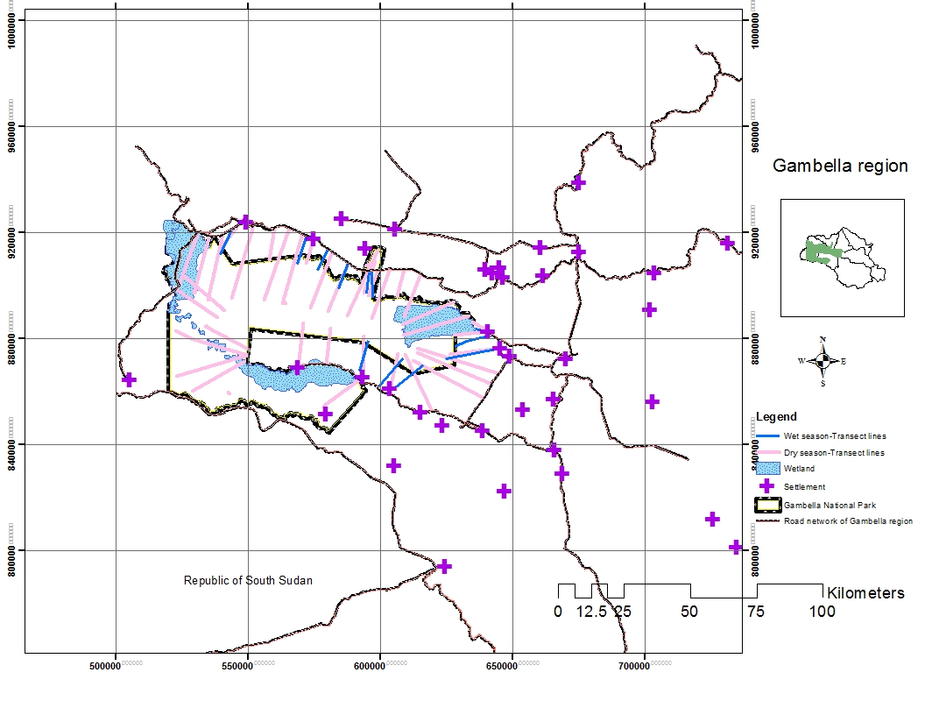Figure 3: Survey transect lines for studied wild animal species of Gambella National Park
3.2 Data Analysis
3.2.1 Vegtation data analysis
The data collected were used to generate a plot-vs.-species matrix (using the percentage cover/abundance values of each species. Cluster analysis using resemblance index and ward's method of hierarchical grouping was performed to identify community groups (McCune and Mefford, 1999).Resemblance index was used because,it refers to similarity or disimilarity between samples in term of species composition.Sample plots that share same species with same abundance indicate the highest similarity and the lowest disimilarity and therefore,they become one group.Statistical validity of the identified groups was evaluated using multresponse permutation procedure (MRPP) and T-Statisics (Biondini et al, 1995,Miek and Berry, 2001,McCune and Grace, 2002). Both cluster analysis and MRPP were performed using PC-ORD software (McCune and Mefford, 1999). The groups were designated as community types and named by most significant indicator species in the group (Grace et al, 2000)
In this study, the indicator species analysis method proposed by Dufre'n and Legendre (1997) was used to identify indicator species.The indicator species are the most characteristic species of each group and present in the majority of the plots belonging to that group (Dufre'n and Legendre,(1997).
3.2.2. Diversity data analysis
The species diversity was analysezed by Shannon and Simpson diversity indices.The Shannon diversity index (H) is index that is commonly used to characterize species diversity in a community (Pielou, 1977). It takes into accounts both abundance and evenness of the species present. The proportion of species i relative to the total number of species (p_{i}) is calculated, and then multiplied by the natural logarithm of this proportion (lnp_{i}). The resulting product is summed across species, and multiplied by -1:
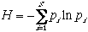
H = Shannons' diversity index
where p_{i} is the proportion of characters belonging to the ith type of letter in the string of interest
lnp_{i=} natural logarithm of this proportion
Simpson diversity index was also used. With this index, 0 represents infinite diversity and 1, no diversity. That is, the bigger the value of D, the lower the diversity (Simpson, 1949). This is neither intuitive nor logical, so to get over this problem, D is often subtracted from 1 .It is described below as follow:
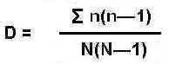
D=Simpsons'diversity index, n=the total number of organism of a particular species.
N = the total number of organisms of all species.
3.3. Digital elevation model processing
Digital Elevation Model (DEM) with a spatial resolution of 30m was extracted from Shuttle Radar Topography Mission (SRTM) and downloaded from United State Geogological Survey (USGS). Using ArcGIS and ERDAS softwares, spatial analysis capability was used to generate DEM based on elevation values and then classified in to ten categories. All contourlines peak points, depressions and streams were digitzed in Arcview GIS.The Arcview shapefiles of the contour lines,peak points were converted to Arc coverage files of same map projection.The DEM was prepared from the coverage files using TOPOGRID, a DEM building module built in Arc/INFo GIS program which is based on the procedure developed by Hutchinson (1989). Different data layers were generated from the DEM using surface analysis module in the Arcview GIS software.These include elevation,slope angle,aspect angle.
The Arcview extension called SINMAP (Pack et al, 1998) was used to drive slope stability and wetness indices.The aspect angle was converted into continuous variables of northness and eastness by using cosine and sine transformations, respectively.Transformation converted the aspect angle in continuous data ranging between values -1 and 1. Finally, the terrain data used as environmental factors or explantatory were elevation range.

3.4. Habitat types identified from satellite image
Rapid Eye satellite imagery (5m resolution) data acquired in 2012 covering all of the Gambella National Park and its surrounding areas was permitted from applied science department of Berlin University. It was first classified by unsupervised classification. The sensor type used in acquiring this imagery for unsupervised classification was multi-spectral push broom imager and captured five spectral bands (blue (440 – 510nm), green(520 – 590nm), red (600 – 700nm), Red-Edge (690-730nm) and near-infrared bands (760 –850nm). ERDAS Imagine 2012 software was used in the pre-processing, pixel-based classification, and post processing of the RapidEye satellite imagery covering the study area. For the pixel-based classification, the satellite imagery was classified by pixel-based spectral angle mapper (SAM) classifier. The signature file was generated and this involves the training of classes. Areas of Interest (AOI) was created and used to train the land cover classes (water body ,bare-soil and vegetation) for every class, random samples were taken across the National Park based on pixel spectra.
The SAM Algorithm which is supervised classification approach was then applied. The supervised classification was mainly the ground truthing or GPS points.The SAM algorithm was based on the assumption that a single pixel of remote sensing images represents one certain ground cover material, which was uniquely assigned to only one ground cover class. This algorithm was based on the measurement of the spectral similarity between two spectra. The spectral similarity was obtained by considering each spectrum as a vector in q -dimensional space, where q is the number of bands.In this process woodland,woodedgrassland,waterbody, grassland and savanna were represented by red,orange, blue green and sahara sand respectively, (Figure, 4).
Figure 4: Rapid Eye image 5m Resolution 2012 for classification of habitat types.
3.5. Data analysis for wild animal species
The recorded information of studied wild animal species both for dry and wet seasons in excel files were added into ArcGIS desktop as shape files. These shape files were overlaid on the habitat maps. The geoprocessing and Kernel density tool were further used to analysis the distribution and density of each recorded wild animals species and presented on habitat maps. The Microsoft office excels was used to present the results of both seasonals abundance of studied wild animal species in the Park.
3.6. The studied migratory wild animal species and the habitat types they use during migration.
This study was designed based on satellite collars for collection of animal tracking data that help to understand how individuals or selected wild animal populations move within the Gambella National Park and migrate across the international boundary to South Sudan. This information is being used to understand the home range, habitats use, distribtion and seasonal patterns of migration of studied wild animals. Therefore, in April 2013, a systematic aerial survey was conducted by Ethiopian Wildlife Conservation Authority (EWCA) and Horn of Africa Regional Environment Centre and Network (HoAREC) team to obtain information on the presence of distributions of each wild animal species programmed to be collared. After the information with help of GPS technology was available, the satellite collars deployment was conducted. A total samples of 51 satellite collars: (43 White-eared kob, 4 Nile lechwe and 4 Elephants) were systematically, fitted on these three species at different sites of Gambella National Park and South of Gambella region (Figure, 5).
The GPS data were downloaded in the EWCA official website. The researcher was allowed by the Ethiopian wildlife Conservation Authority to have the password for each animal species. The ideas were to investigate migration of White-eared kob which was assumed to be existing migratory species and examined the other species such as Nile lechwe and African elephant, which was one of objectives for researcher study among others. The movement of sampled animal species was monitored through GIS technology using daily and monthly GPS points as unit of analysis. ArcGIS version 10.1 was used for analyzing and mapping the monthly animal tracking and it was also used to analysis the home ranges.The home range was calcultated by Kernel density tool from geo-processing and arcGIS tool box.
Figure 5: Satellite deployment site in Gambella National Park and South of Gambella Region

3.7. Method of developing a plan for core wildlife conservation area
The planning criteria were:
- Diversity and preference habitat types of studied wild animal species
- Abundance and distribution of studied wild animal species per habitat type
- Migration route for studied migratory species
Base on these criteria, the Park area was divided into five zones: The areas with the highest diversity and preference habitat types of studied wild animal and regional endangered species was delineated and digitized as core conservation area. The areas with more distribution and abundance of studied wild animal in the park but less divers than the core area was delineated and digitized as visitor use zone. The area with the least abundance, distribution and diversity of wild animal species in the Park was delineated and digitized as the Low use zone. The areas which indicated the migration routes for migratory species was delineated and digitized as migration corridors. The areas between the National Park and development activities such as agricultural investment and human settlements was delineated and digitized as buffer zone (Atte moilanen, 2012).
4. RESULTS
4.1.1. Cluster Classification of plant species of Gambella National Park
Six vegetation groups were identified using cluster analysis in combination with multiresponse permutation procedure (MRPP) and the cutoff for this classification was 50% (Figure, 6).
From 80 sample plots, 4 plots (Plot 5, Plot 6, plot 9 and plot 30) were considered as outliers and thus were excluded from the cluster analysis.
The T-value statistic for six groups was -1.28 (P<0.001) which indicated the significant different at p-value, while the statistic chance-corrected within group agreement was 0.1.The T statistic is based on Pearson type III distribution (Annex Table, 7).The P-value associated with T is determined by numerical integration of type III distribution.The A statistic is descriptor within a group homogeneity falls between 0 and 1 (Annex Table, 7). When the items are identical, A=1. Therefore, A statistic is equal to 1 when all items are identical within groups while the delta equal to 0. A = 0 when heterogeneity within groups equals expectation by chance.

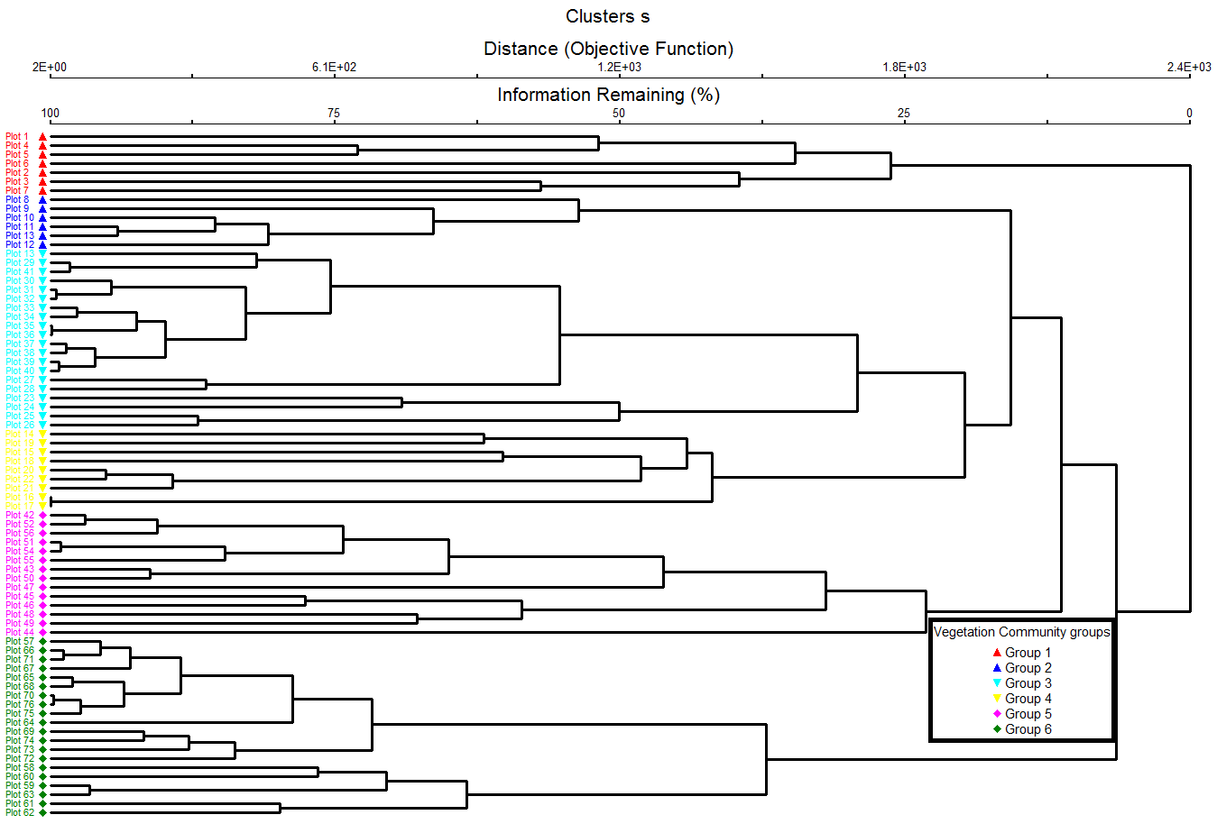Figure 6: Dendrogram of cluster analysis results of species abundance data of the studied plant species of Gambella National Park.Plots forming same cluster have similar symbols.

4.1.2.Naming of Vegetation communities by Indicator species of study plant of Gambella National Park
The 6 vegetation communities were named base on indicator values indicated by precent prefect indication value (combining relative abundance and relative frequency) (Table, 1).The species in bold for each group is one with the maximum indicator values for combining relative abundance and relative frequency.
The maximum indicator for group 1 species were observed for Combretum collinum (49%);Combretum molle (47%);Terminalia brownii(40%) and Terminalia laxiflora (32%).This goup had formed the vegetation community known as Combretum collinum-Terminalia brownii community.The maximum indicator values for group 2 species were observed for .Hyparrhenia rufa (26%),Oryza barthii (23%) and Oryza longistaminata (25%).This group formed Hyparrhenia rufa-Oryza longistaminata community (Table, 1), while Cyprerus castaneus (48%) and Perpyrnuo cypress (40%) were species in group 3 with maximum indicator values.These species formed Cyprerus castaneus-Perpyrnuo cypress community.
The maximum indicator values for group 4 species were observed for Ziziphus mucronata (33%),Acacia senegal (32%),Acacia polyacantha (22%), Acacia nilotica (20%) and Hyparrhenia rufa (22%).These species formed Ziziphus mucronata-Acacia- senegal-Hyparrhenia rufa community.The group 5 was named as Acacia nilotica- Acacia bussei community because the maximum indicator values were observed in the Acacia nilotica (30%) and Acacia bussei (25%) The maximum indicator values for group 6 were observed in the Balanites aegyptiaca (32%),Acacia nilotica (22%) and Acacia asak (21%). These species formed vegetation community known as Balanites aegyptiaca -Acacia nilotica community.Detailed of each vegetation community association are described in the next section.

Table:1 Indicator values (% of perfect indication based on combining values for relative abundance and relative frequency)________________________________________
Group
Sequence: 1 2 3 4 5 6
Identifier: 1 5 6 8 7 9
Number of items: 30 11 11 8 8 8
Species MaxGrp_____________________________________________
Abelmoschus ficulneus 3 0 0 2 0 0 0
Acacia asak 6 0 1 0 0 19 21
Acacia brevispica 6 0 0 0 3 7 9
Acacia bussei 5 0 0 0 18 25 19
Acacia nilotica 5 6 9 3 20 30 22
Acacia oerfota 5 6 13 6 11 19 14
Acacia polyacantha 4 7 12 5 22 12 15
Acacia senegal 4 6 9 5 32 5 8
Acacia sieberiana 5 0 0 0 0 6 5
Acacia tortilis 6 0 0 0 0 0 6
Adansonia digitata 1 2 0 0 0 0 0
Allophylus macrobotrys 5 0 0 0 0 1 0
Amaranthus spinosus 3 0 0 2 1 0 0
Annona senegalensis 1 1 0 0 0 0 0
Balanites aegyptiaca 6 0 2 3 0 0 32

Indicator values (% of perfect indication based on combining values for relative abundance and relative frequency)_____________________________________
Group
Sequence: 1 2 3 4 5 6
Identifier: 1 5 6 8 7 9
Number of items: 30 11 11 8 8 8
Species MaxGrp___________________________________________
Borassus aethiopum 6 0 0 0 0 0 1
Boswellia rivea 5 0 0 0 0 1 0
Cadaba farinose 2 0 7 0 0 0 0
Calotropis procera 2 1 2 0 0 1 0
Capparis tomentosa 1 2 0 0 0 0 0
Ceiba pentrandra 1 1 0 0 0 0 0
Celtis toka 1 1 0 0 0 0 0
Cissus populnea 1 2 0 0 1 0 0
Clerodendrum captitatum 2 0 1 0 0 0 0
Combretum aculeatum 1 11 2 0 0 0 0
Combretum collinum 1 49 0 7 9 4 0
Combretum molle 1 47 1 0 0 0 0
Commiphora africana 6 0 0 0 0 1 2
Cordia africana 1 1 0 0 0 0 0
Cyperus castaneus 3 0 0 48 0 0 0
Dichrostachys cinerea 5 0 0 0 0 3 0
Diospyros mespiliformis 4 8 0 1 14 8 3

Indicator values (% of perfect indication based on combining values for relative abundance and relative frequency)_______________________________________
Group
Sequence: 1 2 3 4 5 6
Identifier: 1 5 6 8 7 9
Number of items: 30 11 11 8 8 8
Species MaxGrp________________________________________
Echinochloa rotundiflora 2 1 2 0 0 0 0
Entada africana 4 0 0 0 1 0 0
Eragrostis tremula 4 0 0 7 14 0 0
Euphorbia candelabrum 5 0 0 0 0 4 0
Ficus elastic 1 3 0 0 0 0 0
Ficus sur 1 1 0 0 0 0 0
Ficus sycomorus 1 1 0 0 0 0 0
Ficus vasta 1 4 0 0 0 0 0
Flueggea virosa 6 0 0 0 0 0 1
Gardenia ternifolia 1 2 0 0 0 0 0
Grewia bicolor 1 1 0 0 0 0 0
Grewia mollis 1 2 0 0 0 0 0
Grewia tenax 1 1 0 0 0 0 0
Grewia villosa 1 4 0 0 0 0 0
Harrisonia abyssinica 1 2 0 0 0 0 0
Hyparrhenia rufa 2 0 26 0 22 0 0
Hypgrophila auriculata 2 0 3 0 0 0 0

Indicator values (% of perfect indication based on combining values for relative abundance and relative frequency)_______________________________________
Group
Sequence: 1 2 3 4 5 6
Identifier: 1 5 6 8 7 9
Number of items: 30 11 11 8 8 8
Species MaxGrp______________________________________
Hyperthila dissolute 3 0 0 3 0 0 0
Hyperthila auriaulata 3 2 0 3 0 0 0
Ipomoea aquatica 3 0 0 3 0 0 0
Kigelia africana 1 2 0 0 0 0 0
Lannea fruticosa 1 1 0 0 0 0 0
Lawsonia inermis 5 0 0 0 0 4 0
Ledebouria kirkii 1 4 0 0 0 0 0
Lonchocarpus laxiflrus 1 4 0 0 0 0 0
Loudetia arundinacea 2 0 1 0 0 0 0
Maytenus senegalensis 5 0 0 0 0 1 0
Nymhaea nouchalii 3 0 0 2 0 0 0
Oryza barthii 2 0 23 0 1 0 0
Oryza longistaminata 2 0 25 0 0 0 0
Perpyrnuo cypress 3 2 8 40 0 0 0
Persicaria senegalensis 3 0 0 2 0 0 0
Phyllanthus boehimii 2 0 1 0 0 0 0
Pilostigma thonningii 3 0 0 5 0 0 0

Indicator values (% of perfect indication based on combining values for relative abundance and relative frequency)____________________________________
Group
Sequence: 1 2 3 4 5 6
Identifier: 1 5 6 8 7 9
Number of items: 30 11 11 8 8 8
Species MaxGrp_____________________________________
Portulaca oleracea 2 1 2 0 0 0 0
Pterocarpus lucens 1 4 0 0 0 0 0
Pyrenacantha kaurabassana 3 0 0 3 0 0 0
Richiea albersii 5 0 0 0 0 2 0
Ricinus communis 1 3 0 0 1 0 0
Saba florida 1 3 0 0 0 0 0
Sacciolepis africana 2 0 1 0 0 0 0
Salvadora persica 2 0 1 0 0 0 0
Sarcocephalus latifolius 4 0 0 0 2 0 0
Sclerocarya birrea 1 4 0 0 0 0 0
Securidaca longepedunculata 1 4 0 0 0 0 0
Sorghum arundinaceum 3 0 0 3 1 0 0
Sorghum purpureo-sericeum 3 0 0 3 0 0 0
Sphenoeclea zeylanica 2 0 2 0 1 0 0
Steganotaenia araliacea 2 0 1 0 0 0 0

Indicator values (% of perfect indication based on combining values for relative bundance and relative frequency)______________________________________
Group
Sequence: 1 2 3 4 5 6
Identifier: 1 5 6 8 7 9
Number of items: 30 11 11 8 8 8
Species MaxGrp_________________________________________
Sterculia africana 1 6 0 0 0 0 0
Tamarindus indica 6 0 5 5 0 0 6
Terminalia brownii 1 40 0 0 0 0 0
Terminalia laxiflora 1 32 0 0 0 0 0
Terminalia macroptera 1 4 0 0 0 0 0
Terminalia schimperiana 1 4 0 0 0 0 0
Typha latifolia 1 6 0 3 0 0 0
Vanguria apiculata 3 0 0 2 0 0 0
Vitellaria paradoxa 1 2 0 0 0 0 0
Ximenia americana 1 4 0 0 0 0 0
Ziziphus abyssinica 1 1 0 0 0 0 0
Ziziphus mauritiana 3 0 0 6 0 0 0
Ziziphus mucronata 4 6 3 6 33 0 0
Ziziphus spina-christ 1 2 0 0 0 0 0
Ziziphus pubescene 1 2 0 0 0 0 0

4.1.2.1. Combretum collinum-Terminalia browwii community
This vegetation community consists of Combretum collinum, Combretum molle, Terminalia brownii and Terminalia laxiflora. Therefore, the dominant species in the vegetation community were Combretum and Terminalia species respectively, (Photo, 1). Other species found in association within this vegetation community were Combretum aculeatum,Ficus elastic, Ficus sur, Ficus sycomorus, Ficus vasta, Kigelia africana, Pterocarpus lucens,Ricnus communis, Securidaca longepedunculata, Sclerocarya birrea, Sterculia africana, Terminalia macroptera, Ledebouria kirkii, Lonchocarpus laxiflora, Terminalia schimperiana, Ximenia americana, Typha latifolia, Capparis tomentosa, Cissus populnea, Harrisonia abyssinica, Ziziphus abyssinica, Ziziphus spina-christ, Ziziphus pubescen, Lannea fruticose, Cordia africana, Ceiba pentrandra, Celtis toka, Gardenia ternifolia, Grewia bicolor, Grewia mollis, Grewia tenax, Grewia villosa, Saba florida and Vitellaria paradoxa.

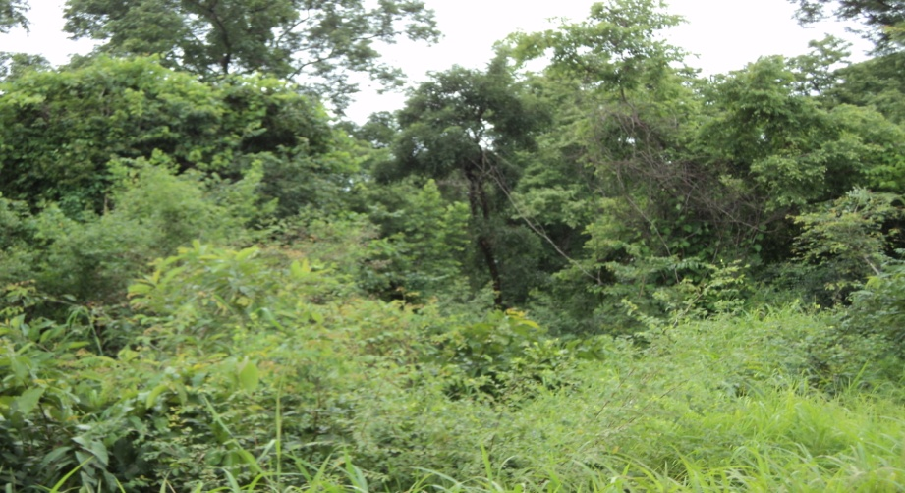
Photo 1: Combretum collinum-Terminalia laxiflora community.
4.1.2.2. Hyparrhenia rufa-Oryza longistaminata community
This vegetation community was dominated by Hyparrhenia rufa, Oryza longistaminata and Oryza barthii. Other species found in association with this vegetation community were: Echinochloa rotundi, Hypgrophila auriculatam, Sacciolepis africana, Calotropis procera,Clerodendrum captitatum,Perpyrnuo cypress,Portulaca oleracea, Loudetia arundinacea, Phyllanthus boehimii,Sphenoeclea zeylanica, Combretum aculeatum, Combretum mollis,cadaba farinose, Salvadora persica,Balanites aegyptiaca,Acacia asak,Acacia nilotica,Acacia oerfota,Acacia senegal Acacia polyacantha,Tamarindus indica and Ziziphus mucronata (Photo, 2).
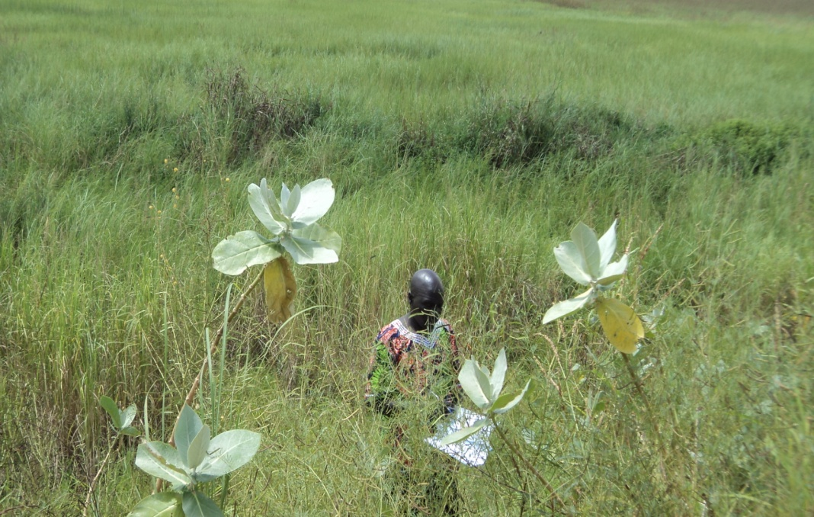
Photo 2: Hyparrhenia rufa-Oryza longistaminata community
4.1.2.3. Cyperus castaneus-Perpyrnuo cypress community
This vegetation community was dominated by Cyperus castaneus and Perpyrnuo cypress.Other minority species found in association with this vegetation community were: Abelmoschus ficulneus,Amaranthus spinosus,Eragrostis tremula,Hyperthila dissolute,Hyperthila auriaulata,Typha latifolia, Nymhaea nouchalii, Ipomoea aquatica, Pyrenacantha kaurabassana, Ziziphus mauritiana,Ziziphus mucronata,Pilostigma thonningii, Sorghum arundinaceum, Sorghum purpureo-sericeum,Acacia oerfolta,Acacia nilotica,Acacia polyacantha, Persicaria senegalensis,Balanites aegyptiaca,Tamarindus indica, Combretum collinum,Diospyros mespiliformis and Vanguria apiculata.
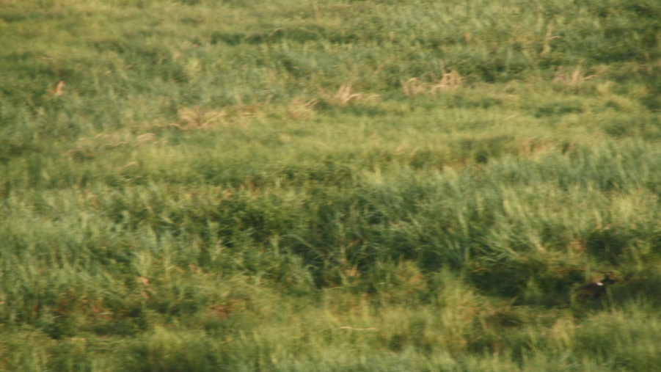
Photo 3: Cyperus castaneus-Perpyrnuo cypress community
4.1.2.4. Ziziphus mucronata-Acacia senegal-Hyparrenia rufa community
The dominant species in this vegetation community were: Ziziphus mucronata, Acacia senegal, Acacia polyacantha, Acacia nolitica and Hyparrenia rufa Other species found in association with vegetation community were:Abelmoschus ficulneus, Ricinus communis, Acacia asak,Acacia brevispica,cacia bussei, Acacia oerfota, Sorghum arundinaceum, Sphenoeclea zeylanica, Oryza barthii, Cissus populnea, Amaranthus spinosus,Eragrostis tremula, Diospyros mespiliformis,Entada africana, Sarcocephalus latifolius and combretum collinum.
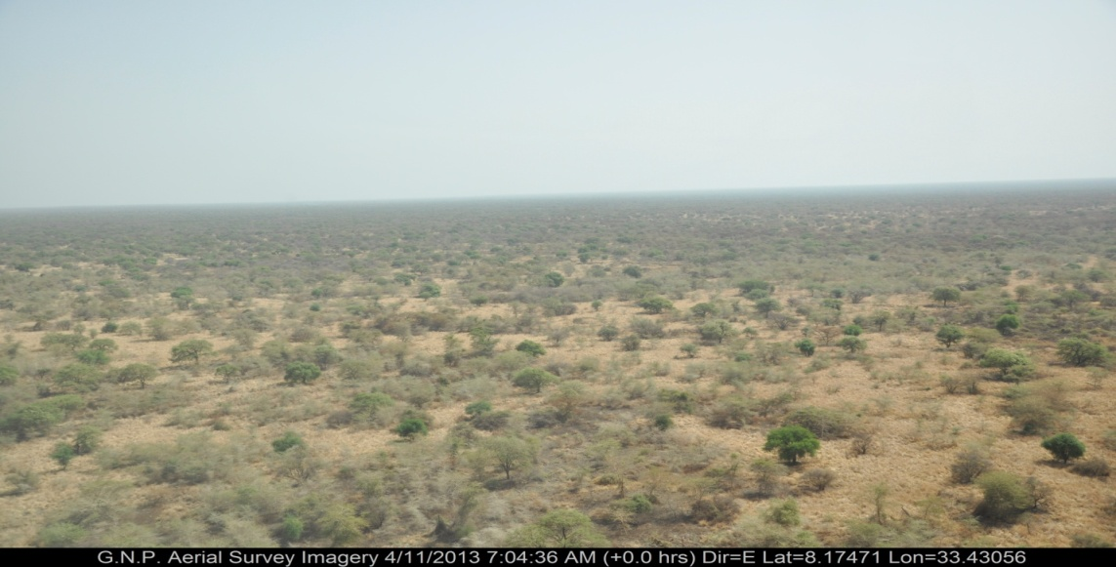
Photo 4: Ziziphus mucronata-Acacia senegal-Hyparrenia rufa community
4.1.2.5. Acacia nilotica-Acacia bussei community
The dominant species in this vegetation community were Acacia nolitica and Acacia bussei. Other species found in association with this vegetation community were: Boswellia rivea, Acacia senegal, Acacia asak,Acacia oerfota, Acacia polyacantha, Acacia brevispica, Acacia sieberiana, Commiphora africana, Combretum collinum, Diospyros mespiliformis, Allophylus macrobotrys, Dichrostachys cinerea, Lawsonia inermis, Richiea albersii and Euphorbia candelabrum
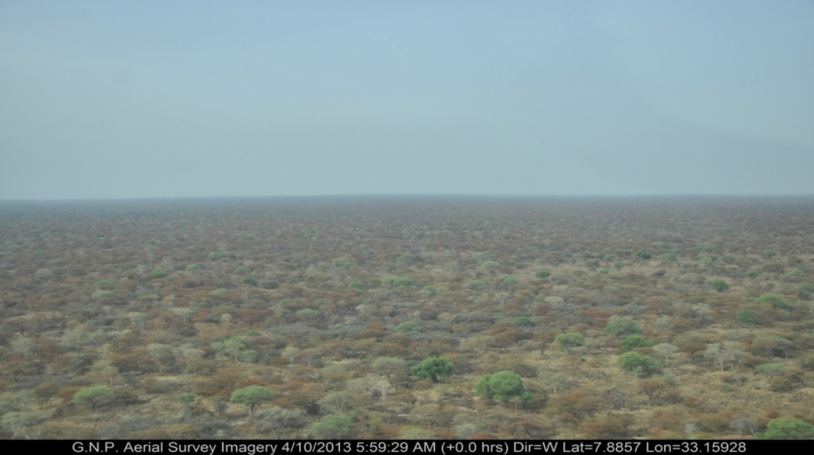
Photo 5: Acacia nilotica-Acacia bussei community
4.1.2.6. Balanites aegyptiaca-Acacia nilotica community
The Balanites aegyptiaca, Acacia nilotica and Acacia asak were the dominant species in this vegetation community.The minority species found in association with this vegetation community were: Acacia senegal, Acacia polyacantha,Acacia bussei, Acacia oerfota, Acacia brevispica,Acacia tortilis,Acacia sieberiana, Maytenus senegalensis, Commiphora africana,Diospyros mespiliformis, Borassus aethiopum, Tamarindus indica and Flueggea virosa (Photo, 6).
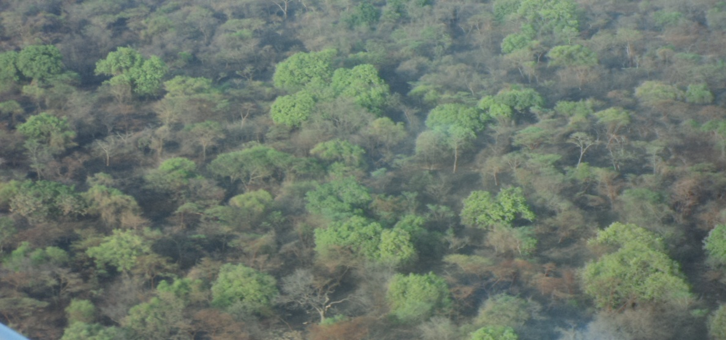
Photo 6: Balanites aegyptiaca-Acacia nilotica community
4.2. Species composition and Diversity
A total of 102 plant species; Tree (37 species); Shrub (35 species); Herbaceous (17 species); Grass (10 species);Climber (2 species) and Indigeneous palm (1 species) were recorded from Gambella National Park (Annex Table, 1).They belong to 73 genera (Annex Table, 2) and 47 family (Annex Table, 3). The diverse genera were Acacia (10 species), followed by Ziziphus (5 species) and Combretum,Grewia,Ficus and Terminalia which were represented by 4 species each.
Other genera such as Capparis,Commiphora,Hyperthila,Oryza and Sorghum were represented by 2 species each.The remaining genera were represented by single species (Annex Table, 2). The diverse families were Fabaceae ( 17 species) and Poaceae (11 species). They were followed by Combretaceae and Rhamnaceae,which were represented by 7 and 5 species respectively.However,families of Capparidaceae,Moraceae and Tiliaceae were represented by 4 species each.They were followed by Burseraceae,Euphorbiaceae and Rubiaceae which were represented by 3 species each.Remaining families were represented by 2 and 1 species (Annex Table, 3).When compared the species diversity in habitat types,woodland had the highest species diversity with 48 species, 21 species shared with other habitat types followed by woodedgrassland and grassland which had composed 21 species each (Annex Table, 5) But with exception of 2 species from the woodedgrassland,all members of thier species are shared with other habitat types.
Wetland and savannah grassland had low species diversity as compared with woodland,woodedgrassland and grassland respectively.All species found in the wetlands and savannah were shared with other habitat types (Annex Table, 5).The average species richness was 4.8 whereas the average species diversity by shannon diversity index was 1.52 however,the average species diversity using simpson's diversity index was 0.77(Annex Table, 4).
4.3. Monte Carlo Permutation test of significance of observed maximum indicator value (IV).
The Monte Carlo analysis is used as test in which the p-value is based on the proportion of randomized trials with indicator value equal to or exceeding the observed indicator value.In Table 2 Species in bold are indicator species with indicator values greater than twenty (IV>20) or less than zero point one at p-value (P<0.1).Using both indicator species with indicator value (IV>20) and its sigificant at p-value (P<0.1).
The indicator species with indicator values greater than twenty (IV>20) in group 1 were Combretum collinum, Combretum molle, Terminalia brownii and Terminalia laxiflora.These species had shown significant difference at p-value less than zero point one (P<0.1) (Table, 2). Indicator species with indicator values greater than twenty(IV>20) in group 2 were Hyparrhenia rufa, Oryza barthii and Oryza longistaminata however, only Hyparrhenia rufa had a significant difference at p-value less than zero point one (P<0.1) (Table, 2). Cyperus castaneus and Perpyrnuo cypress were species in group 3 with indicator values greater than twenty (IV>20). but,only Cyperus castaneus had a significant difference at p-value less than zero point one (P<0.1).
The species in group 4 with indicator values greater than twenty (IV>20) were Acacia senegal,Acacia polyacantha,Acacia nilotica and Ziziphus mucronata,with exception of Ziziphus mucronata all Acacia species in this group had shown a significant difference at p-value less than zero point one (P<0.1).Acacia nilotica and Acacia bussei were species in group 5 with indicator values greater than twenty (IV>20). However, Acacia nilotica had a significant difference at p-value less than zero point one (P<0.1) while species with indicator values greater than twenty (IV>20) in group 6 were Balanites aegyptiaca,Acacia nilotica and Acacia asak. Balanites aegyptiaca and Acacia nilotica were species in this group which had indicated a significant difference at p-value less than zero point one (P<0.1) (Table, 2).

Table: 2 Monte Carlo Permutation test of significance of observed maximum
indicator value (IV) for each species based on 1000 randomization______________
Species Maxgrp IV IV from randomized groups
Mean Standard deviation P______
Terminalia brownii 1' 50.0 9.2 10.91 0.001*
Terminalia laxiflora 1' 37.6 14.8 11.14 0.058*
Combretum collinum 1' 48.8 10.4 11.29 0.010*
Combretum molle 1' 47.3 14.6 10.95 0.007*
Sterculia africana 1' 6.0 15.1 10.76 0.874
Ledebouria kirkii 1' 4.2 14.0 11.05 0.935
Lonchocarpus laxiflrus 1' 4.2 13.8 10.91 0.939
Terminalia macroptera 1' 4.2 14.0 11.04 0.939
Terminalia schimperiana 1' 4.2 14.1 11.16 0.936
Ximenia americana 1' 4.2 13.9 10.91 0.937
Pterocarpus lucens 1' 4.2 14.0 11.06 0.936
Ricinus communis 1' 4.2 14.1 11.17 0.932
Sclerocarya birrea 1' 4.2 14.0 11.08 0.933
Securidaca longepedunculata 1' 4.2 13.9 10.96 0.941
Combretum aculeatum 1' 4.0 13.5 11.16 0.960
Annona senegalensis 1' 4.2 14.0 11.16 0.960
Ficus vasta 1' 3.7 13.5 11.08 0.997
Grewia villosa 1' 6.5 15.5 11.31 0.827
Adansonia digitata 1' 1.7 10.1 11.98 1
Capparis tomentosa 1' 2.5 11.6 11.89 1
Cissus populnea 1' 2.0 10.1 11.04 1
Ficus elastic 1' 2.7 12.1 11.23 1
Monte Carlo Permutation test of significance of observed maximum
indicator value (IV) for each species based on 1000 randomization____________
Species Maxgrp IV IV from randomized groups
Mean Standard deviation P____
Ficus sur 1' 1.0 6.9 10.34 1
Ficus sycomorus 1' 1.2 7.9 10.49 1
Harrisonia abyssinica 1' 1.7 9.6 11.57 1
Kigelia africana 1' 2.0 10.5 11.11 1
Lannea fruticosa 1' 1.2 7.9 10.41 1
Typha latifolia 1' 2.7 11.9 11.24 1
Ziziphus abyssinica 1' 1.2 7.9 10.93 1
Ziziphus pubescene 1' 2.0 9.9 11.14 1
Ziziphus spina-christ 1' 2.0 9.8 11.06 1
Ceiba pentrandra 1' 0.7 5.2 9.32 1
Cordia africana 1' 1.7 10.1 11.87 1
Gardenia ternifolia 1' 1.7 10.1 11.87 1
Celtis toka 1' 1.0 6.9 10.40 1
Grewia bicolor 1' 1.5 9.3 11.94 1
Grewia mollis 1' 1.7 10.0 11.84 1
Grewia tenax 1' 1.5 9.1 11.67 1
Vitellaria paradoxa 1' 1.0 6.9 10.40 1
Saba Florida 1' 1.0. 7.0 10.57 1
Hyparrhenia rufa 2' 37.7 14.9 11.15 0.059*
Oryza barthii 2' 20.0 11.0 11.77 0.169
Oryza longistaminata 2' 20.9 16.6 9.45 0.207
Monte Carlo Permutation test of significance of observed maximum
indicator value (IV) for each species based on 1000 randomization____________
Species Maxgrp IV IV from randomized groups
Mean Standard deviation P____
Cadaba farinose 2' 9.4 7.9 10.88 0.313
Calotropis procera 2' 1.0 7.2 10.99 1
Echinochloa rotundiflora 2' 3.2 12.7 11.30 1
Clerodendrum captitatum 2' 1.5 8.5 10.87 1
Loudetia arundinacea 2' 1.5 8.6 10.91 1
Salvadora persica 2' 1.7 10.0 11.81 1
Phyllanthus boehimii 2' 1.2 7.9 10.92 1
Portulaca oleracea 2' 2.7 11.7 11.11 1
Steganotaenia araliacea 2' 1.5 9.3 11.57 1
Hypgrophila auriculata 2' 3.0 12.0 11.29 1
Sphenoeclea zeylanica 2' 1.7 9.4 10.79 1
Sacciolepis africana 2' 3.2 12.9 11.07 1
Cyperus castaneus 3' 47.6 14.0 10.94 0.003*
Perpyrnuo cypress 3' 20.3 16.5 10.94 0.299
Pilostigma thonningii 3' 4.7 14.4 11.10 0.945
Sorghum arundinaceum 3' 3.2 12.8 11.40 1
Nymhaea nouchalii 3' 2.5 11.3 10.92 1
Pyrenacantha kaurabassana 3' 3.0 12.0 11.16 1
Persicaria senegalensis 3' 2.0 10.0 10.95 1
Ipomoea aquatica 3' 2.7 11.9 11.21 1
Hyperthila dissolute 3' 3.2 12.6 11.22 1
Amaranthus spinosus 3' 3.0 12.1 11.16 1

Monte Carlo Permutation test of significance of observed maximum
indicator value (IV) for each species based on 1000 randomization______________
Species Maxgrp IV IV from randomized groups
Mean Standard deviation P____
Vanguria apiculata 3' 2.7 11.24 11.16 1
Abelmoschus ficulneus 3' 1.7 10.1 11.83 1
Sorghum purpureo-sericeum 3' 2..0 10.1 10.96 1
Acacia senegal 4' 37.7 14.9 11.15 0.059*
Acacia nilotic 4' 33.0 15.4 12.29 0.096*
Ziziphus mucronata 4' 23.0 17.0 9.57 0.169
Acacia polyacantha 4' 23.0 9.6 3.01 0.005*
Hyparrhenia rufa 4' 37.7 14.9 11.15 0.059*
Sarcocephalus latifolius 4' 4.2 13.9 11.05 0.951
Entada africana 4' 2.5 11.5 11.12 1
Diospyros mespiliformis 4' 1.7 10.0 11.78 1
Eragrostis tremula 4' 2.0 10.1 11.04 1
Acacia nilotica 5' 33.0 15.4 12.29 0.096*
Acacia bussei 5' 21.0 16.4 10.89 0.269
Acacia oerfota 5' 18.5 17.3 3.21 0.337
Acacia sieberiana 5' 1.6 8.5 10.93 1
Dichrostachys cinerea 5' 3.2 12.6 11.29 1
Allophylus macrobotrys 5' 3.0 12.1 11.31 1
Lawsonia inermis 5' 1.5 9.0 11.92 1
Boswellia rivea 5' 1.7 10.1 11.83 1

Monte Carlo Permutation test of significance of observed maximum
indicator value (IV) for each species based on 1000 randomization____________
Species Maxgrp IV IV from randomized groups
Mean Standard deviation P____
Maytenus senegalensis 5' 1.5 9.0 11.61 1
Euphorbia candelabrum 5' 2.4 11.5 11.86 1
Richiea albersii 5' 1.5 8.9 11.83 1
Balanites aegyptiaca 6' 23.8 17.1 3.73 0.046*
Acacia nilotica 6' 33.0 15.4 12.29 0.096*
Acacia asak 6' 20.0 16.5 10.87 0.302
Acacia brevispica 6' 4.2 14.0 11.16 0.960
Commiphora africana 6' 4.2 14.1 11.14 0.969
Acacia tortilis 6' 1.5 8.4 10.92 1
Borassus aethiopum 6' 1.5 8.4 10.92 1
Flueggea virosa 6' 1.5 8.5 10.87 1
Tamarindus indica 6' 3.2 12.6 11.29 1
MaxGrp= Maximum Group, *= species with significant at P-value,Species in bold are the indicator species with IV>20 or P<0.1
4.4. Digital elevation model and its relationship with vegetation communities.
Gambella National Park is characterized by flat plains, low relief and wetlands.The digital elevation model indicated the highest elevation ranged from 428-439m.a.s l.This highest points is situated in the eastern part of the Park.The lowest elevation was ranged from 392-405m.a.s l.This is located in the western part of the National Park.The elevation ranging between the highest and the lowest points are situated in the west,central and south of the National Park (Figure, 7).
The relationship between elevation and vegetation communities was based on growth form.The samples of vegetation communities such as Combretum collinum-Terminalia brownii which was mainly trees growth form was found in the highest elevation range from 421-425 m.a.s.l (Figure, 7). However, Cyperus castaneus-Perpyrnuo cypress community which comprise the grass species was found at various elevation level 410-412 m.a.s.l. as its lowest elevation, 412-415 m.a.s.l as its middle elevation and 421-425 m.a.s.l as its highest elevation.This vegetation community was situated in three wetlands of the National park. Hyparrhenia rufa-Oryza longistaminata community which comprise herbaceous and grass species were found in the elevation from 405-415 m.a.s.l (Figure, 7). The Ziziphus mucronata-Acacia senegal-Hyparrhenia rufa which was combination of growth form of woody,herbaceous and grass form of vegetation, was found with in elevation range from 407-418 m.a.s.l.However,two trees growth form of commuities such as Acacia nilotica-Acacia bussei and Balanites aegyptiaca-Acacia nilotica communities were located at elevation ranges from 407-415 and 405-415 m.a.s.l.
Figure 7: Relationship between studied vegetation communities and Elevation.
4.5. Habitat types of Gambella National Park
. The Rapid Eye image classified the Gambella National Park into five major habitat types which included woodland, wooded grassland, savanna, grassland and wetlands (Figure, 8). Other minor habitat types classified on the map were temporary burned, water body and rivers.
The woodland has comprise three vegetation community types.These were Combretum collinum-Terminalia brownii, Acacia nilotica-Acacia bussei and Balanites aegyptiaca-Acacia nilotica communities while Ziziphus mucronata-Acacia senegal-Hyparrhenia rufa community was found in this wooded grassland habitat of the Park. Hyparrhenia rufa-Oryza longistaminata and Cyperus castaneus-Perpyrnuo cypress community was found in open grassland and wetland respectively.

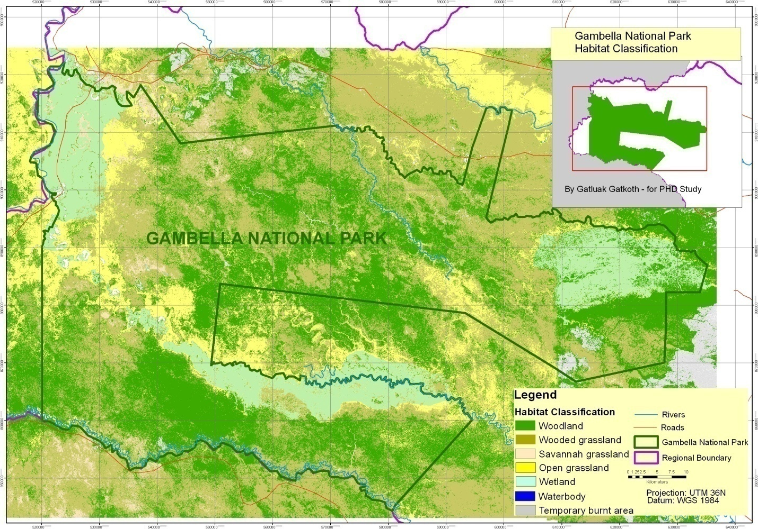Figure 8: Habitat types of Gambella National Park
. The classification of habitats for Gambella National Park had also shown that woodland in Gambella National Park cover an area of 1,716.50 square kilometers (37.92%) of the land cover of the Park followed by wooded grassland which had an area cover of 1,650.04 square kilometer (36.45%) of the land cover of the Park (Table, 3). The wetland had also relative large share of the area of the Park, 645.99 square kilometer (14.27%) of the area cover as compare with grassland and savannah which comprise 8.74% and 1.52% of the land cover respectively.

Table 3: The area covered by each habitat type
No | Habitat Classification | Area in Km² | Percentage
1 | Grassland | 395.50 | 8.74
2 | Savannah | 68.63 | 1.52
5 | Wet land | 645.99 | 14.27
4 | Wooded grassland | 1650.04 | 36.45
3 | Woodland | 1716.50 | 37.92
6 | Others:
6.1 | Settlements/Roads | 0.16 | 0.00
6.2 | Temporary burned | 23.15 | 0.50
6.3 | Water body | 27.15 | 0.60
 | Total | 4,527.12 | 100

4.5.1.Physiognomic strucure of habitat types
4.5.1.1.Woodland
Woodland is a habitat where trees are the dominant plant form. The individual tree canopies generally overlap and interlink, often forming a more or less continuous canopy which shades the ground (Photo, 7). Depending on the amount of light reaching the ground through the tree canopy, there is a great variety of other plants.The more different kinds of plants there are, the greater the animal diversity is in the woodland. It vary greatly depending on the dominant tree species making up the wood, as well as on the spacing between individual trees. Tree spacing is determined naturally as a result of competition between individual tree seedlings for necessities such as space, light, nutrients and water.
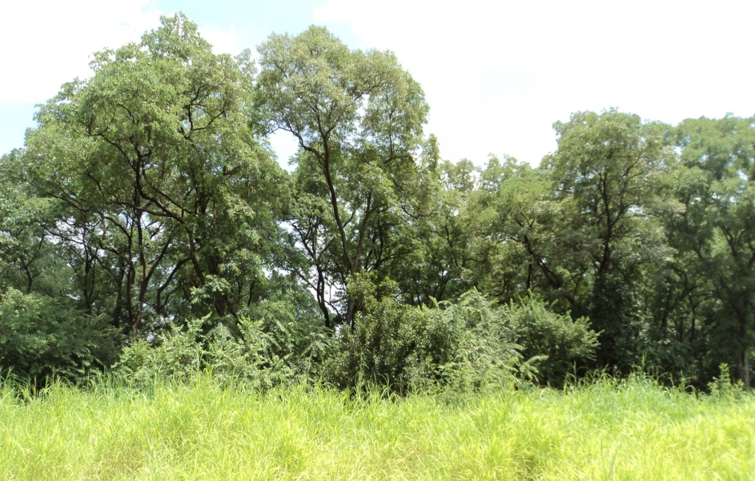
Photo 7: Structure of woodland in Gambella National Park
4.5.1.2.Wooded grassland
Wooded grasslands are lands covered with grasses and other herbs with woody plants (trees [≥ 7 m tall], bushes [3 - 7 m], dwarf trees, palm trees or shrubs [≤ 2 m]) covering between 10 and 40 percent of the ground. Woody plants nearly always occur scattered (Photo, 8).

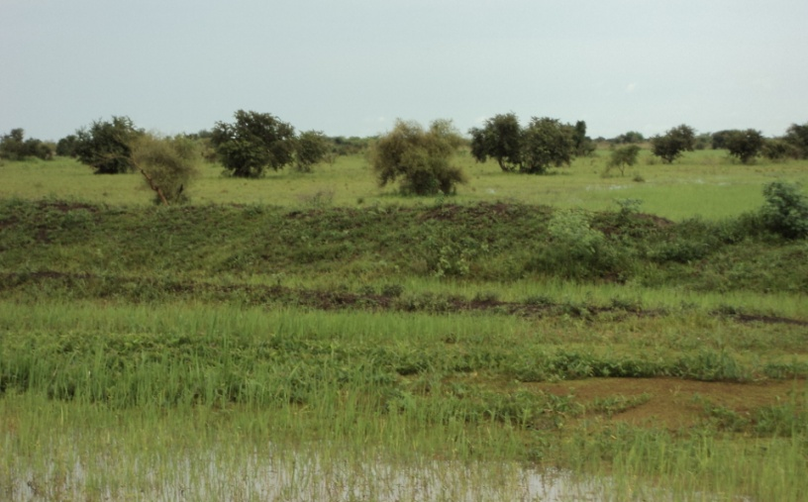
Photo 8: Structure of wooded grassland in Gambella National Park
4.5.1.3. Savanna grassland
Savanna is grassland with scattered individual trees (Photo, 9). The predominant vegetation consists of grasses and forbs (small broad-leaved plants that grow with grasses). Some deciduous trees and shrubs are scattered across the open landscape. Frequent fires and large grazing mammals are the responsible of this landscape because they kill seedlings, thus keeping the density of trees and shrubs low. These factors play a vital role in the savanna's biodiversity. Savanna is dependent to have both dry and rainy season.

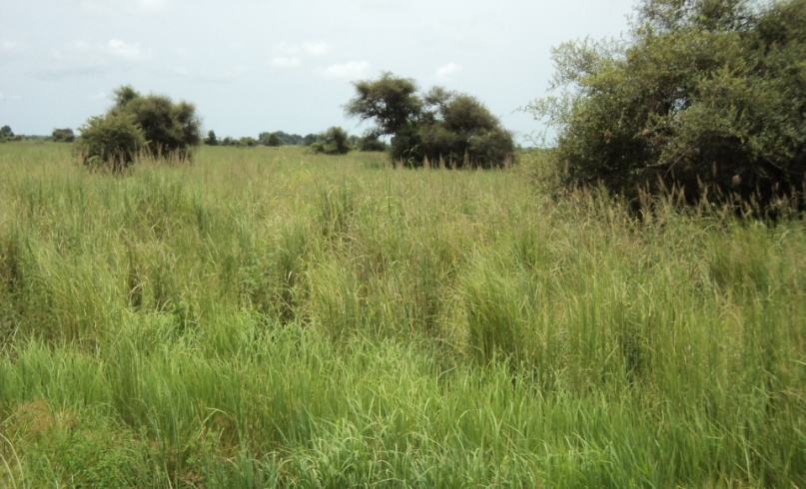
Photo 9: Structure of savanna grassland in Gambella National Park
4.5.1.4.Open grassland
Open Grasslands are areas where the vegetation is dominated by grasses and other herbaceous or non-woody plants (Photo, 10). Its description is same as that of savannas but in this case the landscape is more open, without the presence of a few scattered individual trees.

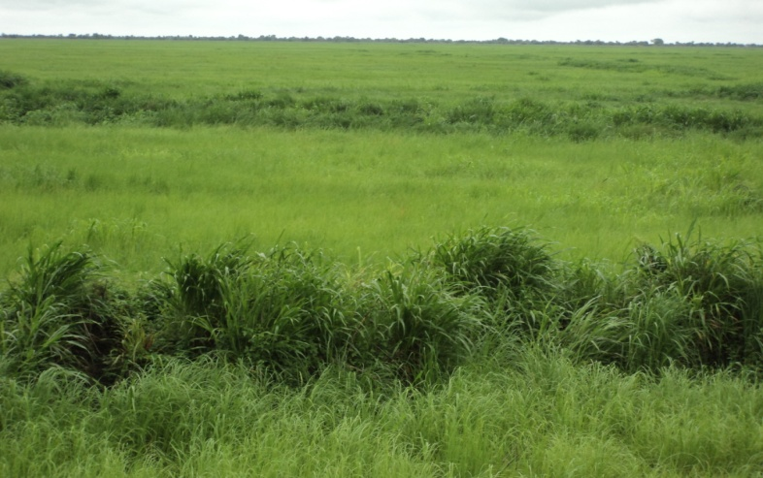
Photo 10: Structure of open grassland in Gambella National Park
4.5.1.5.Wetland
A wetland is a land area that is situated with water, either permanently or seasonally, such that it takes on the characteristics of a distinct ecoystem (Photo, 11). The primary factor that distinguishes wetlands from other land forms or water bodies is the characteristic vegetation of aquatic plant, adapted to the unique hydric soil.It plays a number of roles in the environment, principally water purification, flood control, carbon sink and shoreline stability. It also considered the most biological divers of all ecosystems, serving as home to a wide range of plant and animal life.
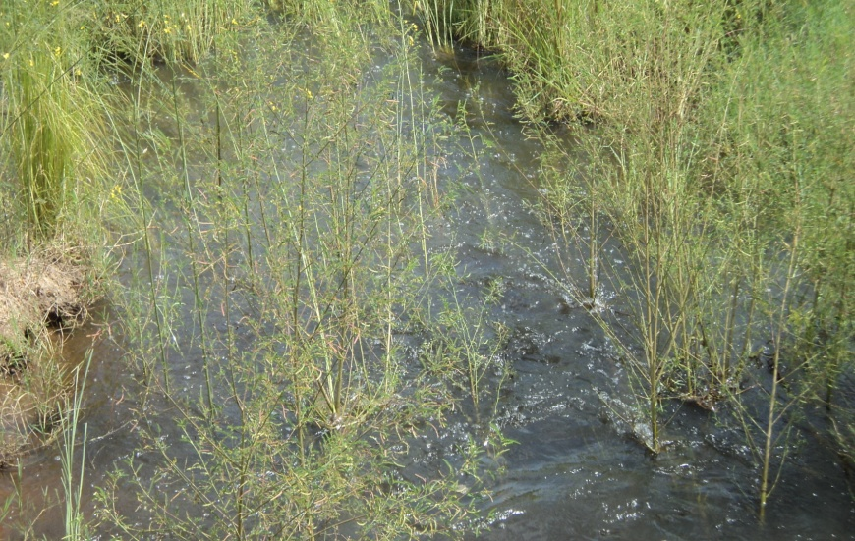
Photo 11:Structure of wetland in Gambella National Park
4.6. Abundance of studied wild animal species in Gambella National Park
4.6.1. Dry season abundance of studied wild animal species
The dry season results of this study had shown that, the highest abundance of studied wild animal species of Gambella National Park was White-eared kob (Kobus Kob) with observation 5,442 individuals followed by Buffalo (Syncerus caffer), African elephant (Loxodonta africana) and Nile lechwe (Kobus megaceros), which had observation of 430, 348 and 228 individuals respectively, (Figure, 9). Other species such as Tiang (Damaliscus lunatus), Giraffe (Giraffacamelopardalis reticulate), Roan antelope (Hippotragus equinus), and Shoe bill stork (Balaeniceps rex) had observation of 69, 26, 25 and 12 individuals respectively. Among the studied mammal species in the Park, Roan antelope and Giraffe had a lower abundance in the Park. However, the shoe bill stork had the lowest abundance of all studied wild animal species of the Park.

When compared the abundance of studied wild animal species per habitat type, the White-eared kob population was the most abundance of all terrestrial habitat types. The highest abundance of White-eared kob in the terrestrial habitat types was observed in open grassland (1,695 individuals). The wooded grassland, woodland and savannah grassland had abundance of 1,226, 1,193 and 1,065 individuals of White-eared kob respectively, (Figure, 10). The Giraffe, Roan antelope and 36 Tiang were observed in woodland and wooded grassland respectively. The remaining studied wild animal species were observed in wetland of the Park however, 15 African elephants were observed in woodland habitat type.

4.6.2. Wet season abundance of studied wild animal species
The wet season results of this study had shown that the highest abundance of studied wild animal species of Gambella National Park was White-eared kob with overall observation 1,851 individuals. Buffalo and Nile lechwe had observations of 135 and 70 individuals respectively, (Figure, 11). Among the studied mammal species in the Park, Tiang and Roan antelope had a lower and the lowest abundance in the Park with observations of 35 and 16 individuals respectively. The shoe bill stork had the lowest abundance of all studied wild animal species of the Park with observation of 5 individuals.

When comparing the abundance of studied wild animal species per habitat type, the White-eared kob population had the most abundance in all major terrestrial habitat types. The highest abundance of White-eared kob in the terrestrial habitat types was observed in wooded grassland followed by open grassland (Figure, 12).The remaining studied wild animal species were also observed in wooded grassland and none of them was observed in woodland.

4.7.Distributions of studied wild animal species in Gambella National Park
4.7.1.Dry season distributions of studied wild animal species
The results of dry season had indicated groups’ distributions of White-eared kob (Kobus Kob) across all locations. The largest groups of White-eared kob (1001-3292) were observed at northern part of the Park followed by the groups of 700-1000 individuals, which were observed at north of southern wetland. Smaller groups which had 400-401 were observed in the central and southwestern part of the Park respectively. The smallest groups (1-50) were observed in the south of the National Park (Figure, 13).
In general the White eared kob was almost evenly distributed in all habitat types of the Park. However, the largest number of White-eared kob was observed in open grassland (1,695 individuals) followed by wooded grassland (1,226 individuals), woodland (1,193 individuals) and savannah grassland (1,065 individuals). The 265 individuals of White eared kob were observed in wetlands of the Park (Table, 4).
Table 4: Dry season distribution of White-eared kob per habitat type.
Distribution of White eared kob per habitat type during dry season
No | Habitat type | No of individuals
1 | Woodland | 1,193
2 | Wooded grassland | 1,226
3 | Savannah grassland | 1,065
4 | Open grassland | 1,695
5 | Wetland | 265

The results had indicated the distributions of Nile lechwe(Kobus megaceros) both for its groups and its habitat. The largest group of Nile lechwe had 51-178 individuals.A small group had 8-50 individuals (Figure, 13). All its groups’ sizes were observed in wetland habitat in general and eastern wetland in particular. The population of Nile lechwe in Gambella National Park was found to be limited to eastern wetland of the Park.
Buffalo (Syncerus caffer) were distributed in wetlands of Gambella National Park (Figure, 13).However, the largest groups’ concentration of Buffalo was observed at eastern wetland (201-230 individuals). Its group distributions of 100-200 individuals were observed in both southern and western wetlands (Figure, 13).Therefore, eastern wetland was the most relevant habitat type for Buffalo in dry season in Gambella National Park.
African elephants (Loxodonta africana) were observed in different habitat types. However, the largest group distributions was observed at course of wetland. This group had composed of 11-333 individuals. The smallest group of 5 individuals was observed in woodland habitat of the Park. Other group distributions of 6-10 individuals was also observed in woodland but outside the National Park (Figure, 13). The dry season distribution of African elephant was restricted to the western part of Gambella National Park.
The population distributions of Giraffe (Giraffacamelopardalis reticulate) had 26 individuals observed in two separated groups but close to each other. Its small group had 11 individuals where as its large group had 15 individuals (Figure, 13). All its groups were observed in the woodedgrassland, southwest of Gambella National Park.
Roan antelope (Hippotragus equinus) distribution was found in south of southern wetland. Its distributions were observed in two separated groups. A large group had 6-20 individuals observed in woodland. The main reason may probably be due to their presence under shade at noon time. A small group had 5 individuals observed in open grassland south east of southern wetland (Figure, 13).
Tiang (Damaliscus lunatus) distribution was observed at the east of Gambella National Park, south eastern wetland. The largest group had 34-36 individuals observed in wooded grassland. A small group with 33 individuals was observed in eastern wetland (Figure, 13).
The distribution of Shoe bill stork (Balaeniceps rex) in Gambella National Park was observed in the eastern wetland with two separate groups. A large group of 5-8 individuals was observed in the central part of eastern wetland. A small group with 4 individuals was observed in the eastern part of eastern wetland (Figure, 13).

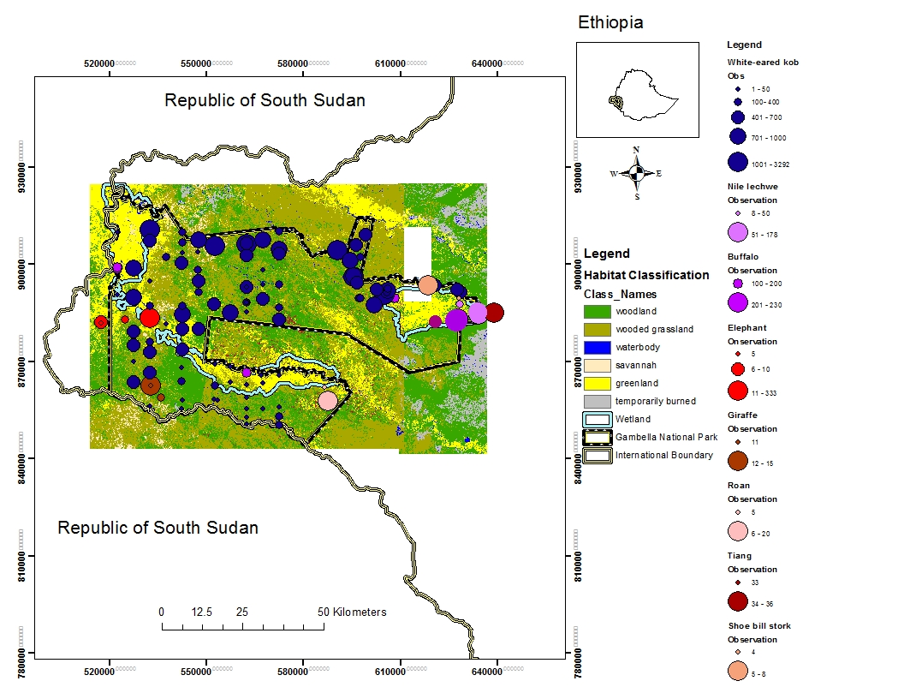Figure 13:Dry season distribution of studied wild animal species
4.7.2.Dry season density of studied wild animal species in Gambella National Park
4.7.2.1.Dry season density of White-eared kob
The highest density of White-eared kob kob (Kobus Kob) was 115-151kobs per square kilometer and the lowest density was 6-42 kobs per square kilometer..The highest density was observed in the north eastern part of the Park whereas the lowest density was observed in the south central part of the National Park (Figure, 14).
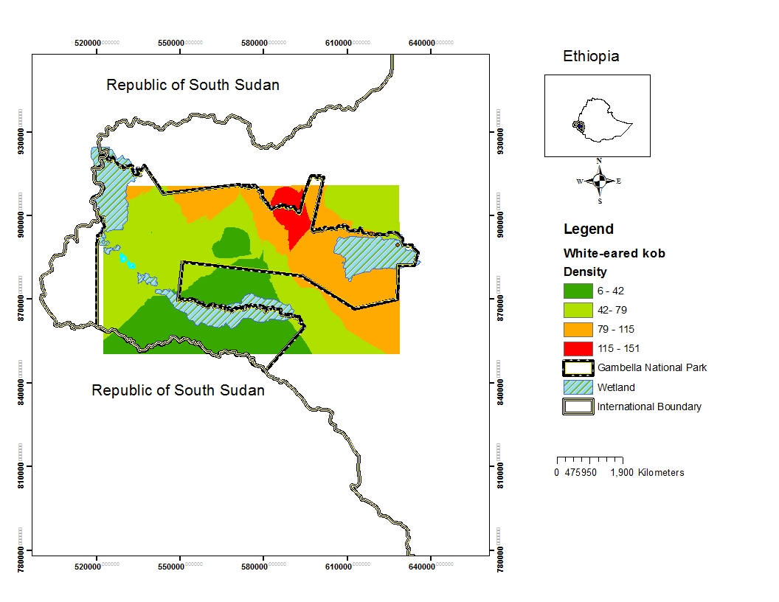Figure 14: Dry season density of White-eared kob in Gambella National park
4.7.2.2.Dry season densities of Buffalo and Elephant
The density of Buffalo in dry season was observed in the wetlands of the Park however, its highest density of 8-9 Boffalo per square kilometer was observed in the north of eastern wetland of the Park followed by the density of 7-8 Buffalo per square kilometer.The lowest density of 7 Buffalo per square kilometer was observed at south central part of the Park (Figure, 15).
The density of 30-226 elephant per square kilometer was observed at the bank of wetland (Figure, 15).
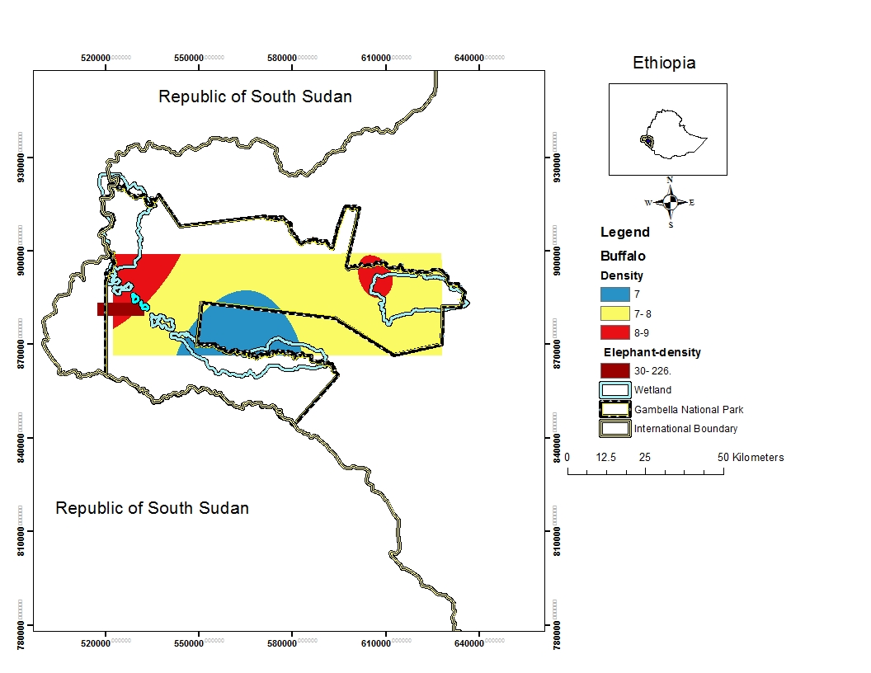Figure 15: Dry season densities of Buffalo and Elephant
4.7.2.3.Dry season densities of selected five studied wild animal species
The density of Giraffe was observed in southwest of Gambella National Park.Its density was 1 Giraffe per square kilometer and was observed at the western part of the National Park (Figure, 16). Roan antelope in Gambella National Park had a density of 3 Roan per square kilometer.However,Nile lechwe has a density of 9 Lechwe per square kilometer.observed at the eastern part of the National Park.
The highest density of Tiang was 4 Tiang per square kilometer and its lowest density was 2 Tiang per square kilometer but Shoe bill stork had a density of 2 per square kilomeneter (Figure, 16).Thier densities were observed in the eastern wetland of Gambella National Park.
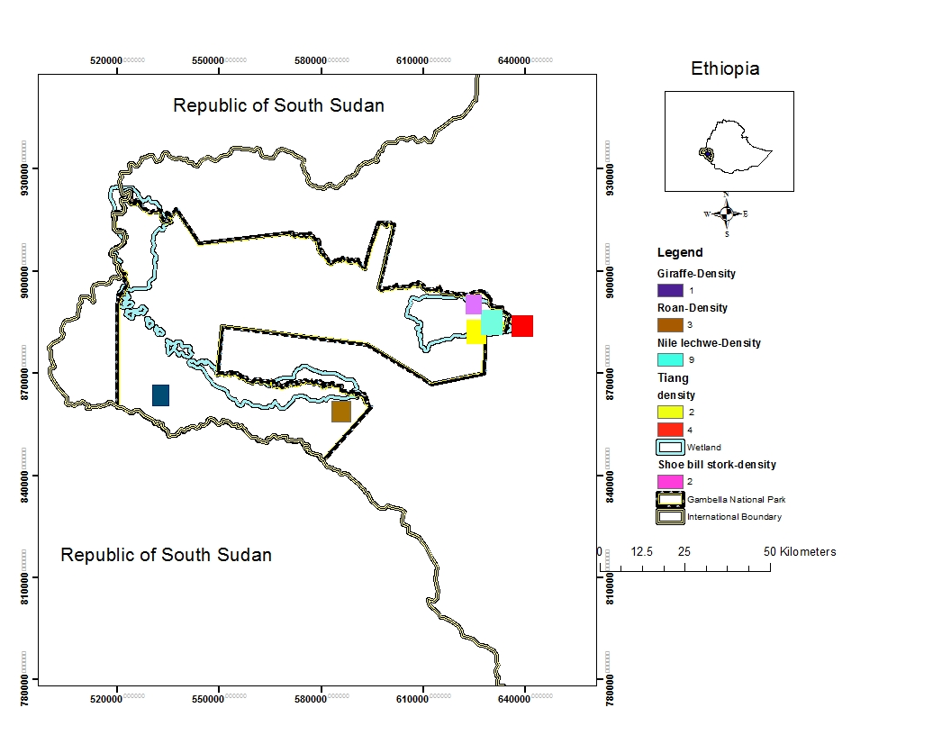Figure 16: Dry season density of selected five studied wild animal species
4.7.3. Wet season distribution of studied wild animal species in Gambella National Park.
The wet season distribution of White-eared kob (Kobus kob) in Gambella National Park was accompanied by the habitat types of the Park and its distributions were categorized by groups size. The largest group of 801-1000 individuals were observed in wooded grassland in the northern part of the park.The groups of 52-800 and 7-51 individuals were observed both in wooded grassland in the north and grassland in the south. However, its distributions found in south were observed outside of the National Park (Figure, 17).
The group distributions of Nile lechwe (Kobus megaceros) were observed in the eastern wetland of the Park (Figure, 17). The largest group had 21-50 individuals where as the smallest group had 5-20 individuals. All its groups’ sizes were observed in the eastern wetland of the Park.
The distributions of Buffalos (Syncerus caffer) in Gambella National Park were observed in groups. The largest group had 53-63 individuals followed by a group with 21-52 individuals. The smallest group had 20 individuals (Figure, 17). All its groups’ sizes were observed in wooded grassland in the northern part of the Park.
. The largest group distribution of Tiang(Damaliscus lunatus) had 11-25 individuals. The smallest group had 6-10 individuals. All its groups’ distributions were observed in wooded grassland, southeast of the National Park (Figure, 17).
The distributions of Roan antelope (Hippotragus equinus) in wet season were observed in two separated groups. A large group had 7-10 individuals; where as a small group had 6 individuals (Figure, 17). All its groups were observed in wooded grassland, south of eastern wetland.
The wet season distributions of Shoe bill stork (Balaeniceps rex) in Gambella National Park was observed in the woodland with two separate groups. A large group of 4 individual was observed in north of eastern wetland. A small group with 1 individuals was also observed in the north eastern wetland but outside the National Park (Figure, 17).
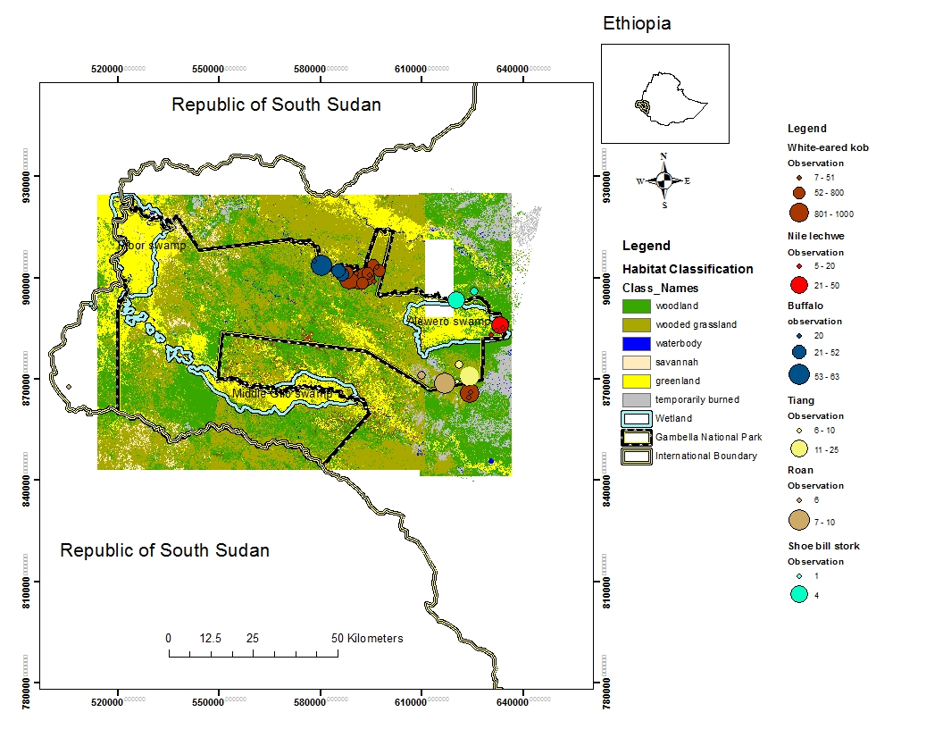
Figure 17: Wet season distribution of studied wild animal species in Gambella National Park
4.7.3.1.Wet season density of studied wild animal species of Gambella National Park
The White-eared kob in wet season had the highest density of 63-67 per square kilometer but had the lowest density of 56-60 per square kilometer observed in east-central part and south east of the National Park (Figure, 18).
The density of Nile lechwe in wet season was 29 per square kilometer whereas the density of Shoe bill stork was 30 per square kilometer (Figure, 18).
The density of Buffalo in wet season was 59 per square kilometer and its density was observed in the north of the National Park.However, densities of Tiang and Roan antelope were 19 and 17 per square kilometer respectively (Figure, 18). Thier densities were observed in the south east of the National Park.
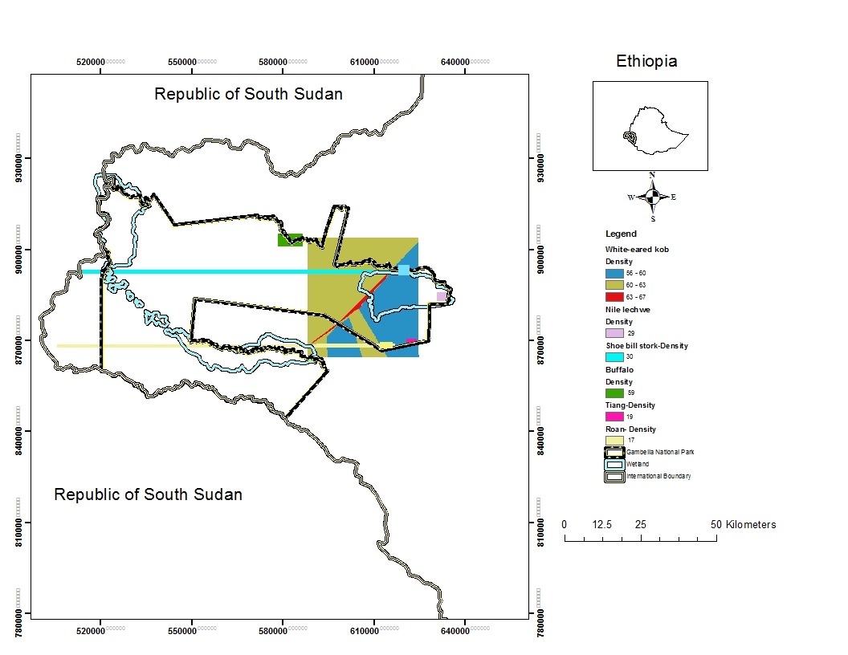Figure 18:wet seasn densities of studied wild animal specis in Gambella National Park
4.8. Diversity of some selected wild animal species in Gambella National Park.
The diversity of some selected wild animal species was observed in the east, west and south west of Gambella National Park. The wild animal such as Buffalo, Tiang, Nile lechwe and Shoe bill stork were observed in Alewero swamp (Figure, 19). This Alewero swamp is considered to be sensitive habitat of the Park. The wild animal species which included African elephant, Giraffe, Roan antelope and few Buffalo were observed in the west and south of the Gambella National Park.
Figure 19: Diversity of some selected wild animal species in Gambella National Park
4.9. Distributions and seasonal patterns of migration of studied wild animals
4.9.1.1. Wet season patterns of migration of White-eared kob
The satellite collars result had shown distributions and seasonal migration patterns of White-eared kob. The patterns of migration indicated that, the majority of white-eared kobs migrate to Republic of South Sudan. All the major wet season patterns observations were located in South Sudan (Figure, 20). May, June, July, August, September, October and November were the wet season of the year in Gambella region which represented the migration patterns of White-eared kob on the map. The start of migration was observed in May across west and south west of Gambella National Park of Ethiopia and north east of Boma National Park of South Sudan. However, the presence of some migration patterns for its residents’ population was also observed at Gambella National Park. There was no resident population of White-eared kob observed in south of Gambella region (Figure, 20). Three White-eared kob migration corridors were observed. One each was observed in the north west and south west of Gambella National Park. The other was observed in South of Gambella region (Figure, 20). August, September and October were the months the northwestern and southern migration trips match together.
Figure 20: Wet season migration patterns of White-eared kob between Gambella and South Sudan

4.9.1.2. Dry season patterns migration of White-eared kob
The dry season migration patterns had indicated that White-eared kob migration started to come back in November to Gambella National park. It was observed that its migration patterns were moved across border between South Sudan and Ethiopia in December and January where they begin to reach the Gambella National Park and South of Gambella region (Figure, 21). The April migration patterns had shown the presence of majority of White-eared kob inside the Gambella National Park and South of Gambella region.
Figure 21: Dry season migration patterns of White-eared kob between Gambella and South Sudan

4.9.2. Distribution of African elephant
Figure 22 shows the distribution of African Elephant within Ethiopia and South Sudan. The red and the greenish color represented the presence of African elephant in the territory of South Sudan and Ethiopia respectively. The migration pattern on the map shows that, African elephant spent much more time in South Sudan than Ethiopia. Its migration patterns were not observed at the centeral part of South Sudan (Figure, 22). However, its patterns of migration were also observed along the countries’ border.
Figure 22: Distribution of African Elephant within Ethiopia and South Sudan
When comparing individuals groups of African elephant, all groups spent much more time in South Sudan than Ethiopia (Figure, 28). A group three (G3) spent 47% and 35% in South Sudan and Ethiopia respectively (Figure, 23). It had also shown that, groups one, two and four (G1, G2 and G4) spent their regular time almost together either in the individual country or in both countries (Figure, 23). The African elephant moved in two separated groups. The G3 was moving alone while the other three groups were almost moving together.

Figure 23: The time the elephant spent in Ethiopia and South Sudan
G1, G2, G3 and G4=group of elephant based on GPS collars
The maximum distance, the elephant traveled was 350km.This was observed for G4 in May. The non distance of 0 km tracked by African elephant was observed for G3 in December,January, February and April (Figure, 24). The distance African elephant traveled varied between groups and months. The group two (G2) had traveled maximum distance of 325km and 340km in January and May respectively, while group three (G3) had travel maximum distance of 340km in June.The variation of elephant distance tracked travelled was observed between G3 and the other groups(G1,G2 and G4).

Figure 24: Elephant travel distance per month
4.9.2.1. Wet season patterns of migration of African elephant
The results of satellites collar on four African elephants had confirmed that, African elephant is one of the seasonal migratory species of Gambella National Park.Its wet season patterns of migration were concentrated along the border of Gambella and South Sudan, which was marked by the Akobo basin. Its patterns of migration in May and June were observed in south of Gambella National Park at the border of South Sudan and South of Gambella region (Figure, 25). In July, August and September Its migration patterns were observed from south to west of Gambella National Park (Figure, 25). In October and November, Its migration patterns were observed back to South Sudan. This result indicated that, elephants’ migration patterns had followed the same path. Based on these results two main elephant corridor has been recognized. The first one at the south of Gambella National Park and the other at the southwest of Gambella region
Figure 25: Wet season migration patterns of African elephant between Ethiopia and South Sudan
4.9.2.2. Dry season patterns of migration of African elephant
The results of dry season patterns of migration had shown that, elephants’ migration patterns were observed in December in South Sudan. However, in January and February its patterns of migration were observed across the border into the south of Gambella National Park (Figure, 26). In March, its patterns of migration were observed moving to west of Gambella National Park. Though, African elephant is one of the seasonal migratory species in Gambella National Park, which migrate along the border between Gambella and South Sudan. The concentration of its patterns of migration in wet season were observed in the west of Gambella region outside the Gambella National Park.
Figure 26: Dry season migration patterns of African elephant between Gambella National Park and South Sudan
4.9.3.1. Wet season patterns of movement of Nile lechwe
The wet season patterns of migration had indicated that, Nile lechwe is non migratory species of Gambella National Park. Its local movement patterns for wet season were observed at the east of Gambella National Park. When compared its movement patterns based on analysis for each month of the year, its movement patterns were observed in the extremely east in May but in June and July the movement patterns were observed from east toward northeast of the park. However, in August, September, October and November its patterns of movement were observed toward south central part of the Park (Figure, 27). The Nile lechwe population was only found in small area of the eastern part of the Park.
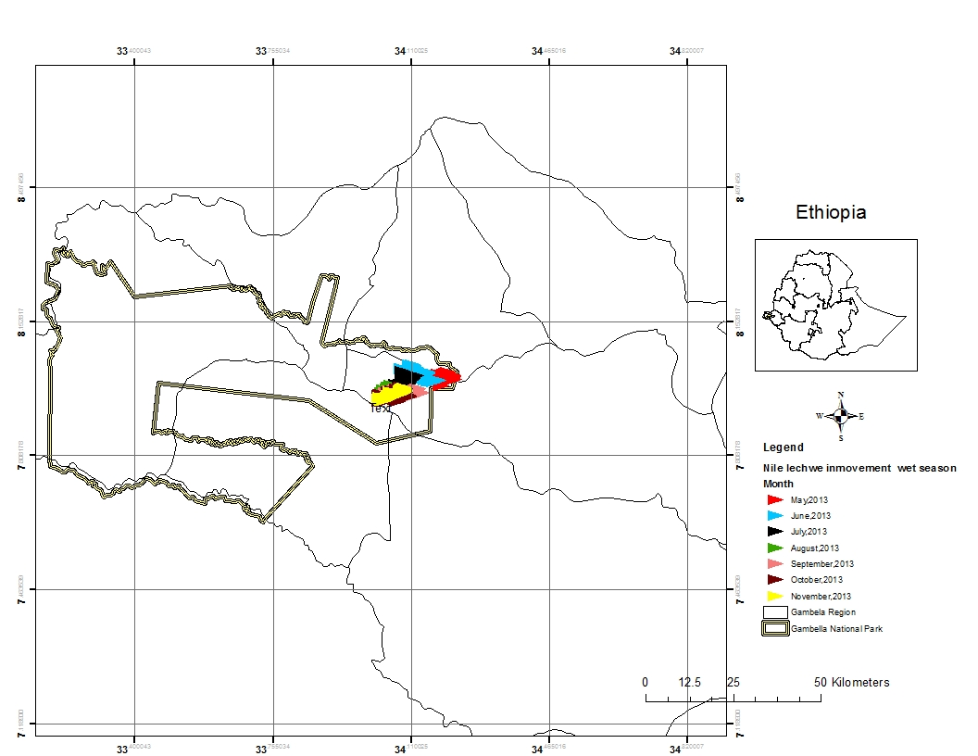
Figure 27: Wet season patterns of movement of Nile lechwe in Gambella National Park
Gambella National Park
4.9.3.2. Dry season patterns of movement of Nile lechwe
The dry season patterns movement of Nile lechwe in December, January and February were observed in Alewero swamp, east of the National Park (Figure, 28). In March its patterns of movement were observed in south of Alewero swamp. Based on both seasons’ results, the population of Nile lechwe in Gambella National Park was found in area of 49 square kilometer.

Figure 28: Dry season patterns of movement of Nile lechwe in Gambella National Park
4.10. Habitat types studied wild animals use during thier migrations
The information gathered for vegetation communities at local scale of the Park were used for classified the Rapid Eye satellite image at large scale of Gambella National Park. Similary vegetation communities at local level were classified in the habitats map as one major habitat type. Therefore, the result of habitats map had indicated that, the Gambella National Park has a five major habitat types which were used by the studied wild animal species. These habitat types were woodland, wooded grassland, savannah, grassland and wetlands (Figure, 29). Other minor habitat classifications crossed by the migratory wild animal species were temporary burned, open water body and rivers. All of the major habitat types have significant values for migratory species, because each studied wild animal, migrates across the particular habitat types and then pass to the others.
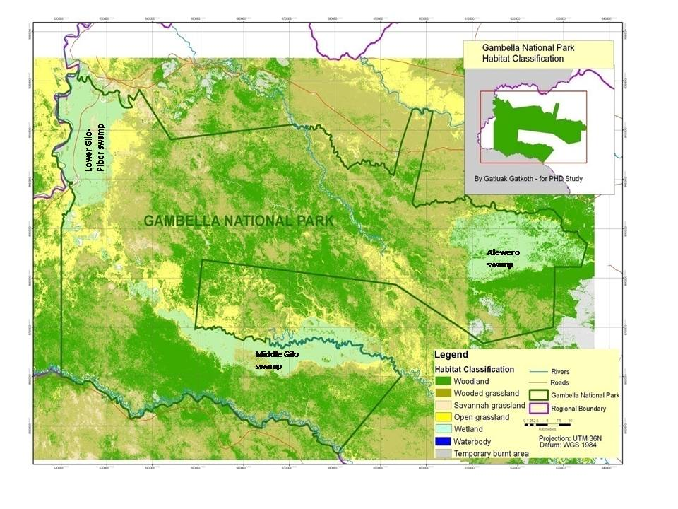 Figure 29: Habitat types the studied wild animal use during their migrations
4.10.1. The most relevance habitat types used by the studied wild animals
4.10.1.1. The most relevance habitat types used by White-eared kob during its migration
The patterns of migrations of the White-eared kob were observed across all major habitat types of the Park however, the most relevance habitat types used during its migration were wooded grassland and woodland. These habitats had 35% and 30% of its patterns of migration. The open grassland, wetland, and savannah grassland were represented by the frequency of its patterns of migration of 12%, 11% and 10% respectively, (Figure, 30) but the temporary burned area was represented by 1% of its patterns of migration.
Figure 30: The most relevance habitat types used by the White eared k ob during its migration
4.10.1.2. The most relevance habitat types used by African elephant during its migration
The patterns of migration of African elephant were measured by frequencies of satellite collar located at each habitat types. It was observed that 50% for frequency of its patterns of migration were situated in wooded grassland however, 23% and 20% for frequencies of its patterns of migration were located in woodland and open grassland respectively (Figure, 31). The wetland and savannah grassland were represented by the frequencies of 5% and 2% for its patterns of migration. Therefore, the most relevance habitat type used by African elephant during its migration was wooded grassland.
Figure 31: The most relevance habitat types used by African elephant during its migration
4.10.1.3. The most relevance habitat types used by Nile lechwe during its movement
The results had indicated that, the patterns of movement of Nile lechwe had frequency 96% observed in Alewero swamp whereas 4% its patterns of movement was observed in woodland (Figure, 32). Therefore, the most relevance habitat types used by Nile lechwe during its movement was Alewero swamp situated in the eastern part of the Park.
Figure 32: The most relevance habitat types used by Nile lechwe during their migration
4.10.2. The relevance of habitat types for successful migration between seasons
4.10.2.1. The relevance of habitat types for successful migration of White-eared kob
The highest frequencies of patterns of migration for the White-eared kob in wet season were observed in woodland (45%) and wooded grassland (37%) however, the highest frequencies of its patterns of migration in dry season were 45% and 18%, observed in wooded grassland and wetland respectively, (Figure, 33). Open grassland, savannah grassland and woodland in dry season were represented by 15%, 13% and 8% of its frequencies of the patterns of migration whereas in wet season, the savannah grassland was represented by frequency 8% of its patterns of migration while wetland and open grassland were represented by frequency 5% each.
Figure 33: The relevance of habitat types for the successful migration of White-eared between seasons
4.10.2.2. The relevance of habitat types for successful migration of elephant between seasons
The highest frequencies of patterns of migration for African elephant in wet season were observed in woodland 50% and wooded grassland 40% however, the highest frequencies of its patterns of migration in dry season were 40%, 30% and 15% observed in wooded grassland, woodland and open grassland respectively, (Figure, 34). Savannah grassland and wetland in dry season were represented by 10% and 5% of its frequencies of patterns of migration whereas in wet season, the open grassland and wetland were represented by frequencies 9% and 1% respectively.
Figure 34: The relevance of habitat types for successful migration of elephant between between seasons
4.10.2.3. The relevance of habitat types for successful movement of Nile lechwe between seasons
The highest frequencies of 97% and 95% of patterns of movement for Nile lechwe were observed in dry and wet seasons at the Alewero swamp respectively. However, the lowest frequency of 5% and 3% of its patterns of movement for both wet and dry seasons were observed in woodland (Figure, 35).
Figure 35: The relevance habitat types for successful migration of Nile lechwe between seasons
4.11. The home ranges of African elephant and Nile lechwe in Gambella National park
4.11.1. African elephant's home range
The home range analysis had shown that, elephant home range was concentrated along border between Gambella National Park and South Sudan. The highest elephant’s home range 50% was observed in the west and south of Gambella National Park (Figure, 36). The later was observed at the corridor between Boma National Park of South Sudan and Gambella National Park of Ethiopia. Its highest home range has also determined to be its core conservation area. It was also observed that, elephants spend 40% of its time along west to southern border of Gambella National Park and South Sudan and 5% of its home range was observed as corridor (Figure, 36).
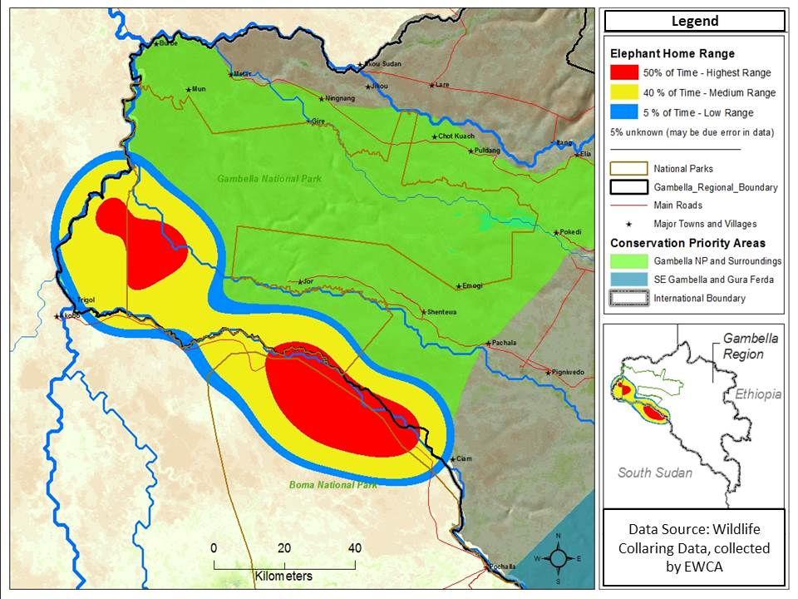
Figure 36: Elephant home range in Gambella National park and South Sudan
4.11.2. Nile lechwe's home range
The results of home range analysis had indicated that Nile lechwe has limited home range. It is confined to Alewero swamp in east of Gambella National Park. Its home range was estimated to be 49km². The highest Nile lechwe home range 75% was observed in the middle and east of the Alewero swamp (Figure, 37). It was also observed that Nile lechwe spent 15% and 10% of its time in the middle and east of Alewero swamp respectively.
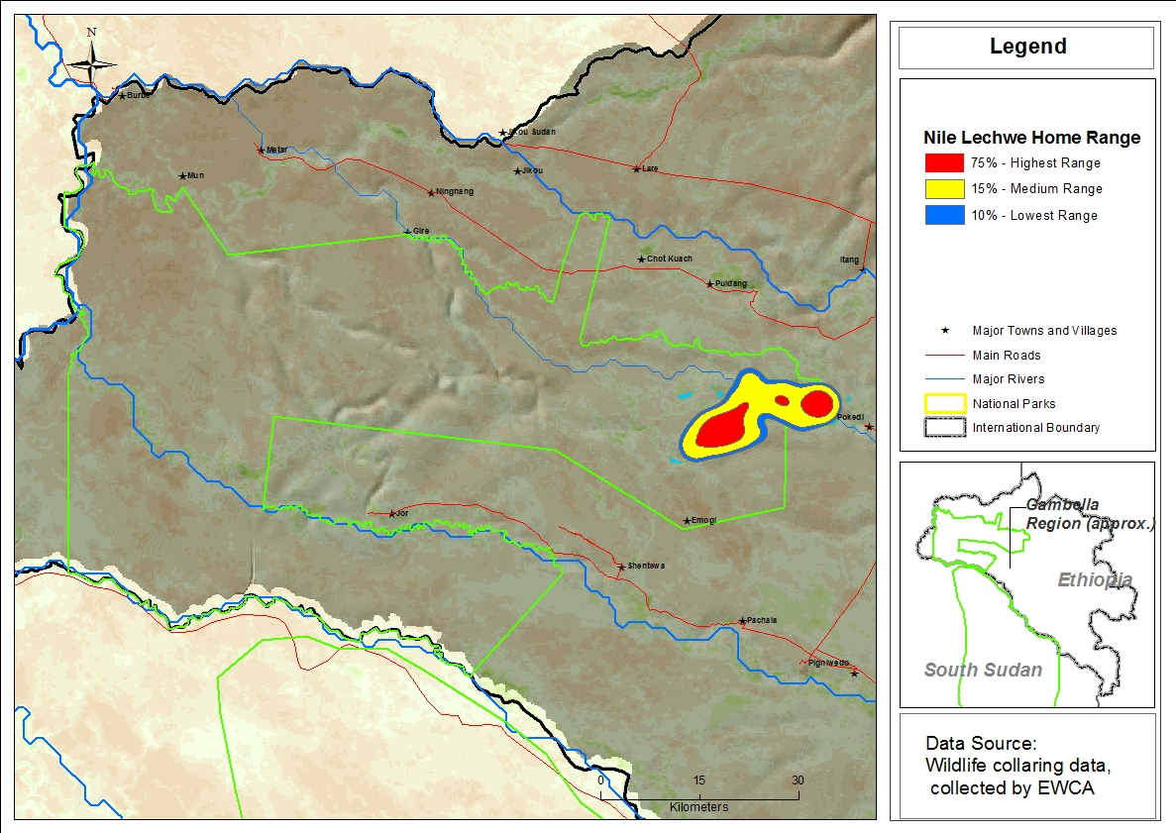
Figure 37: Home range of Nile lechwe in Gambella National Park
5. DISCUSSIONS
5.1.Cluster classification and Indicator species of studied plant of Gambella National Park
The cluster analysis had classified vegetation communities of Gambella National Park into 6 major types (Figure, 6). These vegetation communities play important role in conservation and management of studied wild animal species of the Park. For instance, Cyperus castaneus-Perpyrnuo cypress community was found in wetlands of the Park.The eastern wetland was used as main habitat for Nile lechwe and Shoe bill stork. Therefore, this vegetation community used to be pasture for Nile lechwe while it was observed as important habitat for Shoe bill stork.
Acacia nilotica-Acacia bussei, Balanites aegyptiaca-Acacia nilotica and Hyparrhenia rufa-Oryza longistaminata communities have mutual implication on conservation and management of African elephant of the Park. These vegetation communities’ uses as habitat. African elephant has positive influence on modification of these vegetation communities. All major vegetation communities were important habitats for White-eared kob.These vegetation communities were included in the major habitat types except savannah grassland.The main reason may be because sampled species in this habitat may have similarity with other habitat types.Other reason may be it included 4 plots which were excluded from final analysis due thier outliers.
These results are in disagreement with previous studied, the study made by (Friis et al. 2010), which was based on broader vegetation types and had suggested that, the dominant plant communities of the Gambella region included the park as only Combretum-Terminalia woodland in the east and wooded grassland in the west. Gambella National Park dry season aerial survey had indicated that, Acacia community (Acacia seyal and Acacia nilotica) as dominant plant community in the Park (Gambella aerial survey, 2013). White (1983) also studied broader vegetation type of western Ethiopia and had suggested that, the vegetation of western Gambella region, which included current Gambella National Park as Ethiopian undifferentiated woodland, Tesfaye Awas (1997) studied of Ecology and Ethnobotany of non-cultivated food plants and wild relatives of cultivated crops in Gambella region had classified plant communities into five vegetation community types and only Combretum adenogonium-Anogeissus leiocarpa and Tamarindus indica-Anogeissus leiocarpa community types were recognized from the park.
5.2.Monte Carlo Permutation test of significance of observed maximum indicator value (IV).
Indicator species analysis had indicated that Combretum collinum, Combretum molle,Terminalia brownii, Terminalia laxiflora, Hyparrhenia rufa, Cyperus castaneus, Acacia senegal, Acacia nilotica,Acacia polyacantha and Balanites aegyptiaca were species with maximum indicator values and shown significant difference at p-value (P<0.1) (Table, 2). These species may be due to thier presence in a favourable environmental condition in thier respective sites.The species with maximum indicator values but with no significant difference at p-value (P<0.1) were Oryza barthii,Oryza longistaminata, Perpyrnuo cypress, Ziziphus mucronata, Acacia asak and Acacia bussei. The reason why these species had shown no significant difference at site level may be due to presence of same environmental factors such as soil mositure with associated species in their respective sites.
5.3.Digital elevation model and its relationship with vegetation communities
The altitude of Gambella National Park was ranging from 392 to 439m.a.s.l (Figure, 7).This altitude has an influence on the vegetation communities.Combretum collinum-Terminalia brownii community which was mainly trees form was found at the highest altitude (421-425 m.a.s.l).The reason may be due to lack of flooding in those locations. The grass form community such as Hyparrhenia rufa-Oryza longistaminata was situated at the lowest altitude.This may be due to prsence of flooding which allow only the shallow root plant species to exist. However,Cyperus cataneus-Perpyrnuo cypress which was grass form but considered to be wetland community was found both at the highest and the lowest altitudes.The reason may be due to presence of wetlands in both altitudes.
Ziziphus mucronata-Acacia senegal-Hyparrhenia rufa community were found between the lowest and the highest altitude (Figure, 7). The presence of this community in the middle altitudes may be due to presence of optimum flooding moreover,Acacia nilotic-Acacia bussei and Balanites aegyptiaca-Acacia nilotica communities were also found between the lowest and the highest altitude.This may be due to presence of thier shallow roots that may allow them to grow in altitudes range of 407-415 and 405-415 m.a.s.l.
5.4. Habitat types of Gambella National Park
When compared the habitat types of Gambella National Park by recent Rapid Eye image, 2012 and the land sat satellite image of 1999, there was too much difference between the major habitat types. The habitat types by recent Rapid Eye image 2012, was dominated by woodland and wooded grassland (Figure, 8), where as the habitat types by satellite image of 1999, was dominated by grassland followed by wetlands (Figure, 38).There was no savanna grassland for habitat types by satellite image of 1999 FDREMOA (2004),but it was presence in the classification for Rapid Eye image 2012.Reason for difference in habitats types between the two satellites images may be due to the lack of ground truthing data used as supervised classification for satellite image of 1999,because this satellite classified the habitat types at country level and it was based on objective for general Ethiopian woody biomass assessment. The ground truthing data collected for the vegetation survey of this research was used as supervised classifications for recent Rapid Eye image which was used to classify the habitats together with other detailed components such settlement, roads, temporary burned and water body.
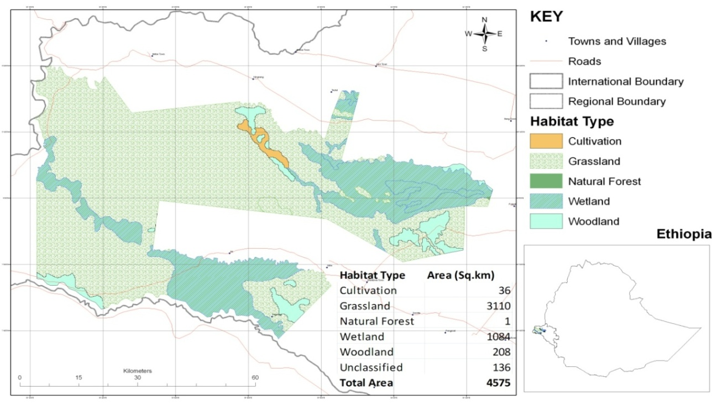
Figure 38: Habitat types of Gambella National Park by1999 landsat satellite image

5.5. Abundance of studied wild animal species in Gambella National Park
In dry season, the highest abundance of individuals’ wild animal species in Gambella National Park was White-eared kob followed by Buffalo, African elephant and Nile lechwe (Figure, 9). Other species such as Tiang, Giraffe, Roan antelope, and Shoe bill stork had abundance of less than hundred individuals.
The main reason for the highest abundance of White-eared kob may be due to presence of its highest number of individuals in the Park. Other reason may be due to its seasonal nature of migration where major numbers of its individuals were found at dry season in Gambella National Park and its surrounding areas.
In wet season, the highest abundance of individuals’ wild animal species in the Park was also White-eared kob, Buffalo and Nile lechwe respectively (Figure, 11). The reason may be due to the presence of the highest resident population of White-eared kob. These results are in agreement with Gambella aerial survey Report (2013), which had suggested that, the total number of White-eared kob was estimated to be over 1000,000, of which around 250,000 individuals were believed to be resident in Gambella National Park.
When compared the abundance of all studied wild animal species in the Park, the highest abundance of individuals were observed in dry season than wet season. This may be due to inaccessibility to the Park in wet season than dry season in survey time. other reason may be due to migration of some species to Republic of South Sudan at wet season of year.
5.6. Distribution of studied wild animal species in Gambella National Park
In dry season, the largest group distributions of White-eared kob was observed at northern part of the Park whereas the smallest group distribution was observed in south of the National Park and its surrounding areas (Figure, 13). The presence of the largest group distribution in the north of the Park may be due to presence of Baro river in the north of National Park where the White-eared kob had got the easiest access to water in dry season of the year. Other reason may probably be due to presence of other available resources such as pasture that are major feed for them. When compared its distributions per habitat types of the Park, the largest number of White-eared kobs were observed in open grassland, wooded grassland, woodland, savannah grassland and wetland respectively (Table, 4).
In wet season, the largest groups distributions of White-eared kob were also observed in wooded grassland at the northern part of the Park (Figure, 17) while the smallest groups of its distributions were observed in open grassland at southeastern part but outside the National Park. This wet season population distributions were believed to be the resident population of White-eared kob in Gambella National Park.
When compared the groups’ distributions of White-eared kobs per habitat types in both dry and wet seasons, its group’s distributions in wet season were observed only in wooded grassland and open grassland whereas in dry season, its groups distributions were observed in open grassland, wooded grassland, woodland, savannah grassland and wetlands (Figures, 10 &12).
The reason that made open grasslands and wooded grasslands appropriate for the largest number of White-eared kob may be due to presence of grass and foder species which might be major feed for them. These results are in partial agreement with study made by (East, 1999), which suggested that typical habitat of White-eared kobs are included riverine open bush, woodland, open woodland and floodplains of major rivers.
The dry season results had indicated that the Nile lechwe population distribution was confined to eastern wetland situtated at the eastern part of Gambella National Park whereas in wet season, its population distribution was observed in the periphery of the eastern swamp of Park (Figure, 17). Its population size was estimated to be over 180 individuals in the Park. These results are in agreement with previous studied made by Watson et al (1977) and Mefit-Babtie (1983) which suggested that a total population of Nile lechwe in Sudan was 30-40,000 individuals, nearly all in the Nile Sudd area with 900 individuals in the Marchar Marshes and also suggested that it was confined to the Sudan apart from a very small population just across the border in Gambella, Southwestern Ethiopia.
In dry season, the Buffalo population was distributed in the wetlands of Gambella National Park. However, the higher population distribution was observed in eastern wetland than south and westen wetlands (Figure, 13). The main reason for the higher population distribution to be observed in wetlands may be due to presence of availability of pasture in those swamps. In wet season, Buffalo population was shift to wooded grassland located in the northern part of the Park (Figure, 17). The shifting from wetlands to wooded grassland may probably be due to presence of heavy flooding in the wetlands of the park. These results are in partial agreement with studied made by East (1999), which had suggested that, African Buffalo inhabit wide range of habitat types, including semi-arid bush land, Acacia woodland, Miombo Brachystega woodland,montane grassland, forest, coastal savannas and moist lowland rainforest.
In dry season, the distribution of African elephant population was observed in the wetlands and woodland of the Park. However, the largest group distribution was observed at western swamp (Figure, 13). The main reason for the presence of the largest group of Elephant at this swamp may be due to searching for drinking water in that swamp.
The research survey of African elephant was conducted only in dry season, this is because inaccessibility to its habitats in wet season. The population of African elephant obtained from this research survey was 348 individuals but the Gambella aerial survey results had suggested that the African elephant population to be 550 individuals number (Gambella Aerial survey, 2015).
Poaching for Ivory was major threat for the population of Elephant in Gambella National Park and in January 2016, 7 Elephant were killed in western part of the Park.
In dry season, the distribution of Giraffe population was found in woodland, west of Gambella National Park. This study indicated that, the population of Giraffe to be 26 individuals in the Park (Figure, 13). Although, this study was not conducted in wet season due to inaccessibility to its habitats in this season, these results are in parial agreement with report of Gambella aerial surveys (2015),which suggested that the Giraffe population was found in west of Gambella National Park. However, the Gambella aerial survey report 2015 revealed that the Giraffe population had increased by 68 individuals (Gambella aerial survey, 2015). The Giraffe in Gambella was considered to be among the remnant population in Ethiopia..
In 1998, the total number of Giraffe in Africa was estimated by IUCN at greater than 140,000 individuals (East, 1999) the best estimated by the Giraffe Conservation Foundation (GCF) have the Africa-wide population at less than 80,000 individuals which encompassing all the sub species (Fennessy, 2007).
In dry season, the population of Roan antelope was distributed in woodland and open grassland, south of southern wetland located in south of Gambella National Park whereas in wet season, its population was distributed in wooded grassland, south of eastern wetland situated in the eastern part of the park (Figure, 17). The reason for shifting its population from south to the east of the Park may be due to flooding at the wet season of the year.
In dry season, the population of Tiang was distributed in wooded grassland and wetland, east of eastern wetland at the east of the National Park while in wet season; its population was distributed only in wooded grassland, south east of the National Park (Figure, 17). The main reason for the presence of Tiang population in those particular habitats may be due to presence of Cyperus castaneus in wetland and Hyparrhenia rufa in wooded grassland, which were observed at survey time as major feed for them.
In dry season, the population of Shoe bill stork was distributed in wetland of eastern part of the Park, with observations of 12 individuals (Figure, 13). In wet season, its population was distributed in woodland, northeast of the National Park with observation of 5 individuals (Figure, 17). The reason for the absence of the Shoe bill stork in wetland may be due to presence of heavy flooding in wetland.
These results are in agreement with previous studied made by (Muir and King 2012),which suggested that, the Shoebill Stork lives only in the wetlands and marshy areas of Africa, including the countries of South Sudan, Zambia, Rwanda, and Tanzania. The total population size was estimated by Guillet (1978) to be not more than 14,900, based on research mainly carried out in (South) Sudan. In a desk study review for assessing water bird population estimates in Africa, Dodman (2002) estimated to be from 5,000 - 8,000 birds.
Significant threat to the population of Shoebills stork was oil exploration and extraction, especially in the Sudd in South Sudan, where significant developments have taken place, along with the searched of access canals, which impact the hydrology of the swamps and agricultural developments also threaten important Shoebill areas, notably at Gambella in western Ethiopia (Dodman, 2013).
5.7.Density of studied wild animal species in Gambella National Park
In general the densities of Buffalo, Nile lechwe,Roan antelope,Tiang and Shoe bill stork were higher in wet season than dry season (Figures, 15,16&18). This may be due to flooding in the wet season where the studied wild animal species occupied and concentrated in smaller areas than dry season. However, density of White-eared kob was higher in dry season than wet season (.Figures, 14 & 18). The main reason may be due to its seasonal nature of migration where only few individuals remain as residents population in Gambella National Park.
In dry season, the highest density of White-eared kob was 115-151 kob/ km² and the lowest density was 6-42 kob/km² whereas in wet season, the highest density of White eared kob was 63-67 Kob/km² and its lowest density was 56-60 Kob/ km² observed in northern corridor of Gambella National Park. These results are in disagreement with studied made by Frexyll (1987) in South Sudan, which suggested that, the dry season White-eared kob (Kobus Kob) density in a single group around meadows and watercourse reaches between 500-1000kob/km² and can reach high densities when well protected in areas of favorable habitat.
5.8. Diversity of some selected wild animal species in Gambella National Park
The diversity of studied wild animal species in Gambella National Park, without White-eared kob was higher in the Alewero wetlands than wetlands of middle Gilo and Lower Gilo-Pibor (Figure, 19). Because, the Alewero wetland comprise wild animal species such as Buffalo, Tiang, Nile lechwe and Shoe bill stork. The wild animal species that include African elephant, Giraffe, Roan antelope and few groups of Buffalo were observed in the west and south of the Gambella National Park. This diversity of studied wild animal species was taken as base foundation for core wildlife conservation area planning.
5.9.Distributions and seasonal patterns of migration of studied wild animals
White-eared kob and African elephant are seasonal migratory species between Gambella National Park and South Sudan. During the wet season they move to South Sudan and in dry season, they move back to Gambella National Park and its surrounding areas. However, resident population of White-eared kob was confirmed in Gambella National Park (Figure, 20). The main reason that causes these animals migration may be due to nature of landscape, which presented favorable and hardship condition at different season of the year. There was no significant difference observed between the wet and dry seasons for the patterns of migrations of African elephant this is because it moves follow the same path (Figures, 25 & 26). Vast areas of Gambella National Park and South of Gambella region are covered by flood at wet season whereas the Jonglie region of South Sudan is upper land areas which use to have scarce of resources for White-eared kob and African elephant at dry season of the year.
This study is in agreement with study made by Marjan (2014), which stated that, White-eared kob apparently migrated acyclic pattern in the plains below the Boma plateau, between the River Nile in South Sudan and Alewero “(Duma”) wetland in Gambella Region of Ethiopia and Fryxell (1985), studied the population dynamics of White-eared kob and followed them through most of their migration through aerial survey reconnaissance flights and estimated a population to be 800,000-1000,000 individuals.
The population of Nile lechwe is resident of Gambella National Park in general and Alewero wetland in particular.
Gambella National Park has a five major habitat types which were used by studied wild animal species, during their migration. The relevance of habitat types for successful migration of White-eared kob varies between dry and wet seasons. In wet season, the relevance habitat types for its successful migration were found to be woodland and wooded grassland but in dry season, the relevance habitat types for its successful migration were found to be wooded grassland and wetlands (Figure, 21). The main reason for difference in the seasonal relevance of habitat types for its successful migration may be due to presence of flooding in the wet season where they use their journey through woodland and wooded grassland, which were located in upper ground than other habitat types. The other reason may be probably due to searching for water and pastures in wetlands and wooded grassland at dry season of the year. The wooded grassland was observed as shared and used for migration in both seasons by White-eared kob as the relevance habitat type. This may be due to the presence of some important grass and fodder species that were used as the major feed for them.
This research is in agreement with studied made by Marjan (2014), which suggested that, the vegetation of the migrations ecosystem of White-eared kob in the eastern part of Boma National Park is covered with woodland dominated by Combretum species, while the middle-western flat flood plains are covered with open grassland dominated by Hyperhenia rufa, Sporobolus, Pennisetum and Echinoloa species.
The wooded grassland was most relevance habitat type used by African elephants during its migration but its relevance habitat types used for its successful migration was woodland in wet season and wooded grassland in dry season (Figure, 25&26). The size of its home range was 84km². This size may be influenced by seasonal change, availability of feed supply and human settlements. The presence of home range in this location could also be encouraged by presence of belt of Acacia nilotica-Acacia bussei community and Balanites aegyptiaca-Acaccia nilotica community. However, the studied made by Blanc (2008) had suggested that, the African elephant was very widespread in its range, and tends to move between a variety of habitats which includes dense forest, open and closed savanna, grassland and, at considerably lower densities, in the arid deserts of Namibia and Mali.
5.10.The home ranges of African elephant and Nile lechwe
The African elephant’s home range was observed in the west and south of Gambella National Park. The main reason may be due to presence of few human settlements in those areas. However, its higher home range was fragmented into two areas, one was situated in the west and the other was located in the south (Figure, 36). The reason could be due to presence of some human settlement between west and south which were considered to be its main home range.
African elephants’ home ranges currently occur in 37 countries in sub-Saharan Africa Blanc et al. 2008). They are known to have become nationally extinct in Burundi in the 1970s, in Gambia in 1913, in Mauritania in the 1980s, and in Swaziland in 1920.
Nile lechwe has limited home range in Gambella National Park (Figure, 37). Its home range in Gambella National Park was too small located in Alewero swamp. The main reason for presence of Nile lechwe in Alewero swamp may be due to presence of Cyperus castaneus and Perpyrnuo cypress in this swamp which may be the major feed for them.Its home range was also fragmented into two areas.This is because of seasonal changes.In wet season they concentrate in the east of swamp whereas in dry season they spent much more time in the centre of the swamp.
6. PLANNING FOR CORE AREAS OF WILDLIFE CONSERVATION
Zonation is a framework for conservation prioritization and large-scale spatial conservation planning (Atte moilanen, 2012). It identifies areas, or landscapes, that are important for retaining habitat quality and connectivity simultaneously for multiple species (or any other biodiversity features), thus providing a quantitative method for enhancing persistence of biodiversity in the long term. Zonation can do traditional reserve selection or site selection as well, but this is only a subset of analyses allowed by conservation prioritization. Typical analyses allowed by Zonation include (i) identification of near-optimal connected reserve networks, (ii) expansion of existing reserve networks, (iii) evaluation of existing or protected reserve networks, (iv) identification of ecologically low-value areas for economic use and (v) prioritization which can be used for many purposes including targeting of incentive funds
6.1. Core area of wildlife conservation
This is an area with sensitive habitat type in the Park, consisting mainly wetlands of Alewero, middle Gilo and some part of lower Gilo-Pibor swamps. The Alewero swamp and its surrounding areas was found to be the habitat of Nile lechwe, Shoe bill stork, Tiang and Buffalo where as the middle Gilo and lower Gilo-Pibor swamps are found to be habitats of African elephant, Giraffe, Roan antelope and White-eared kob. Therefore, these habitats have the highest diversity of wild animal species in the Park. This zone covered an area of 1821km², comprising 32.04% of the Park area (Figure, 39). The management objective of this area should be at protection and conservation of nature so that the resources remain undisturbed for survival of the wild animal in general and regional endangered species in particular. Recreation and economic activities in this area should not be allowed.
6.2. Visitor use Zone
This zone serves as dry season refugee areas for large number of White-eared kob. It also represented more abundance and distribution of studied wild animal species next to the core wildlife conservation areas of the Park. The management of this zone must be concerned to provide the visitors with an optimum view of nature. The impact of infrastructures development must be kept to the minimum and natural aspect should be maintained. However, traditional uses of resources such as medicine plant, fruit and use of some indigenous plant species as religious function may be allowed provide that they do not hinder the objective of conservation. In other words, traditional extraction of resources use may be permitted based on sustainable basis. It covers a total area of about 1,921km² and consist 33.80% of the Park area (Figure, 39).
6.3. Low use zone
This is part of the Park where some human impact is expected. The recreation and administrative objective is proposed to be exceeding the protection of nature however, the impact of infrastructures development must be kept to the minimum. It is located in the southeast and north west of Gambella National Park. It had total area of 167km² and consist 2.94% of the Park area (Figure, 39).
6.4. Migration corridor
This zone is linkage routes of African elephant and White-eared kob between the Gambella National Park and South Sudan. It is situated south of the Gambella National Park and covers an area of 222km² comprise 3.91% of the Park area (Figure, 39). The transboundary agreement and joint management cooperation of this zone is proposed to be agreed by Ethiopian Wildlife Conservation Authority and South Sudan Wildlife Services.
6.5. Buffer zone
This area serves as buffer between the conservation and development activities such as human settlement and agricultural investment. It is situated 3km outside the Park boundary. The management of this zone is proposed to aim at reducing the conflict of land use or encroachment pressure from surrounding communities and it must be based on the binding agreement to be made between the Park office and local administrators together with local communities. This zone covers an area of 1552km² and comprises 27.31% of the Park area (Figure, 39).
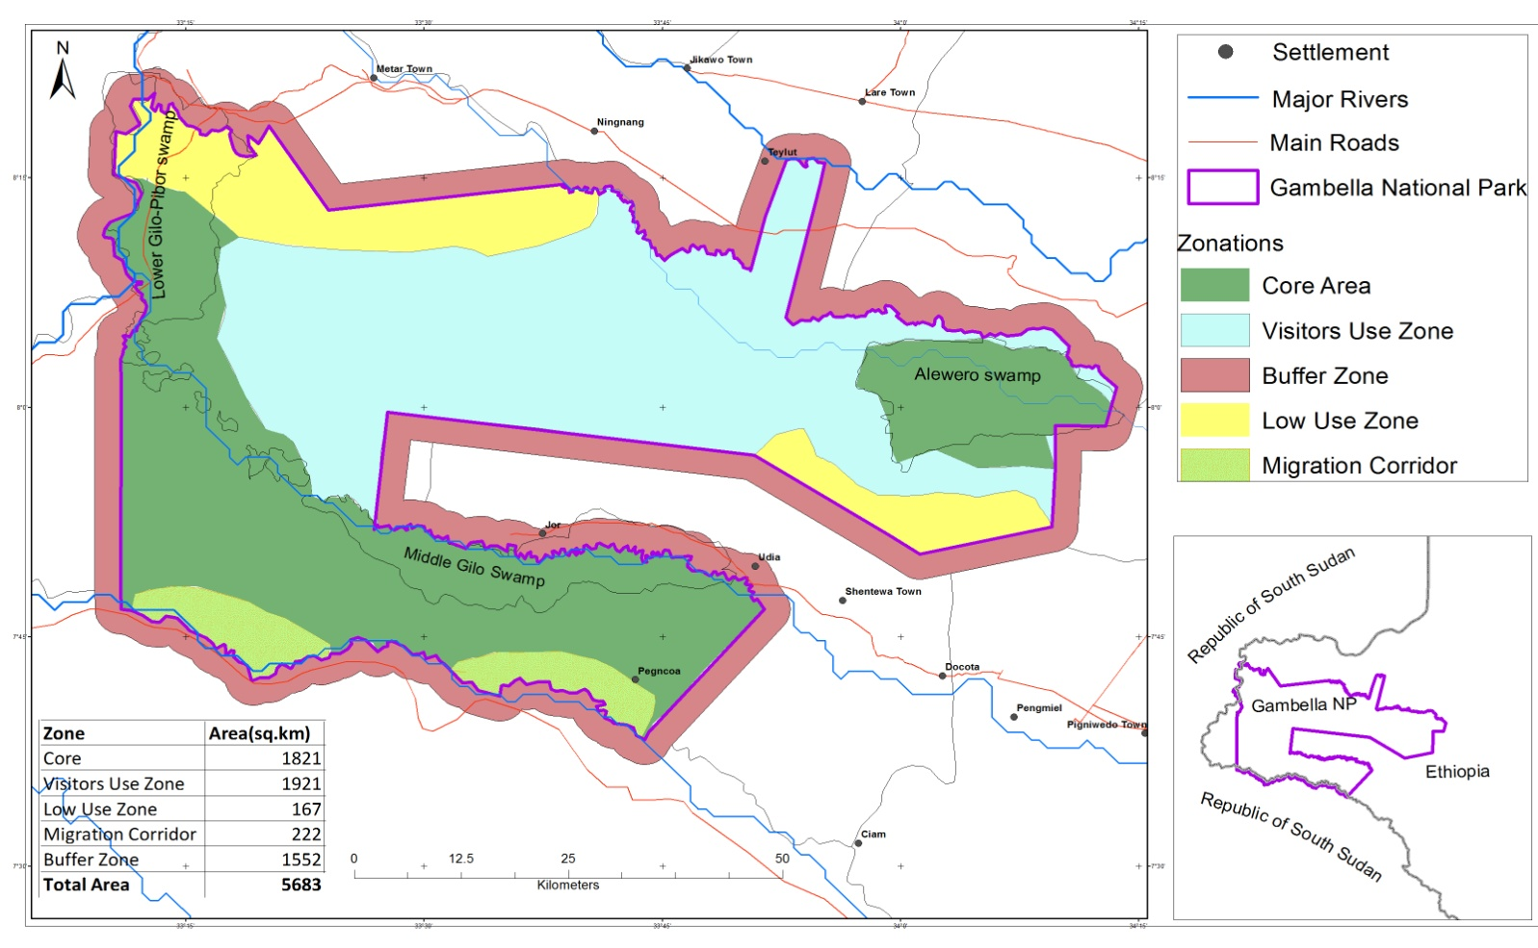
Figure 39: Five proposed conservation zones of Gambella National Park
7. CONCLUSION
It can be concluded that,cluster analysis classified the vegetation community of Gambella National Park into 6 groups. However, at large scale level of the Park,the Gambella National Park was classified into 5 major habitat types.The relative abundance and relative frequency for plant species of Gambella National Park was the best mechanism for naming the vegetation communities of the Park. It can also be concluded that, abundance and distribution of White-eared kob were observed in all habitat types of Gambella National Park. However, the abundance and distributions of Nile lechwe, Buffalo, Shoe bill stork, Tiang and elephant were observed in the wetland habitats of the Park. The abundance and distribution of Giraffe and few African elephant were observed in woodland but the abundance and distributions of Roan antelope and few Tiang were observed in wooded grasslands. In general the densities of the studied wild animal species were higher in wet season than dry season with exception of White-eared kob, which had higher density in dry season than wet season. White-eared kob and African elephant are seasonal migratory species between Gambella National Park and South Sudan. However, resident population of White-eared kob was confirmed in Gambella National Park and Nile lechwe is not migratory and had limited home range in Gambella National Park. The relvance habitat types for successful migration of White-eared kob in wet season was woodland and wooded grassland respectively.However,the relvance habitat types for successful migration of African elephant was woodland in wet season and wooded grassland in dry season. The core wildlife conservation and four other zones for Gambella National Park have been proposed.
8. RECOMMENDATION
- As the wetlands of the Park were proposed to be the core wildlife conservation area of the park, the regional government and Gambella National Park office should work together to have watershed management at upper catchment of the major rivers, which are source of wetlands.
- The African elephant and White-eared kob are seasonal migratory species between Gambella National Park and South Sudan, therefore, joint conservation and transboundary agreement is needed between the two countries (Ethiopia and South Sudan).
- Since Giraffe population was small and considered to be among the remant population in Ethiopia,Therefore, effort by all stakeholders is needed to protect and conserve this remaining population for the country
- The distribution of some animal species such as Giraffe, Buffalo and Roan antelope were observed close to the border of Gambella National Park and South Sudan therefore, the investigation of their migration through collaring is required.
- Ethiopian Wildlife Conservation Authority should implement the proposed zonation of Gambella National park.
- As this study was focus mainly on the distributions of wild animal species per their habitats use, further research is needed on the population dynamic.
- As the climate of Gambella region indicates the longer wet period than dry period,the recommend period for the visitors who want see the wild animals is late January to April.

REFERENCES
Atte moilanen, L.2012.Spatial Conservation planning framework and software zonation version 3.1,User manual. Biodiversity Conservation Informatics’ Group, Department of Biosciences, University of Helsinki, Finland
Berger, J.2004. The last mile: how to sustain long-distance migration in mammals. Conservation Biology 18:320–331
Biondini M.E. Bonham C.E. and Redente E.F.1985. Secondary Successional patterns in a sagebrush (ifalic).Community as they relate to soil disturbance and soil biological activity.Vegetatio 60:25-36.
Blanc, J. 2008. Loxodonta africana. The IUCN Red List of Threatened Species 2008: T12392A3339343.
Connor, D. W., J. H. Allen, N. Golding, K. L. Howell, L. M. Lieberknecht, K. O. Northen, J. B. Reker. 2004. Marine Habitat Classification for Britain and Ireland Version 04.05. http://eunis.eea.europa.eu/habitats-factsheet.jsp?idHabitat=441
Corbet,G.B. and Hill,J.E. 1980.A world List of Mammalian Species.British Museum (Natural History) and Comell University Press.
CSA- Central Statistical Authority 2008.The 2007 Population and Housing Census of Ethiopia: Result for Gambella region. Federal democratic Republic of Ethiopia, Office of Population and housing commission, Central Statistical Authority, Addis Ababa, Ethiopia.
CSG- the conservation strategy of Gambella CSG, 2000. Volume I the resources base. The Gambella peoples’ National Regional state. Bureau of planning and Economic Development unpublished report.
Davies, C.E, Moss, D & Hill, M.O, 2004. EUNIS Habitat Classification Revised 2004.Report to the European Topic Centre on Nature Protection and Biodiversity. European Environment Agency.
Dingle, H.1996. Migration: The Biology of Life on the Move. Oxford (United Kingdom), Oxford University Press.
Dodman, T. 2002. Waterbird Population Estimates in Africa. Wetlands International, Dakar. Unpublished consultation draft.
Dodman, T. 2013. International Single Species Action Plan for the Conservation of the Shoebill Balaeniceps rex. AEWA Technical Series No. 51. Bonn, Germany.
Dufre'ne M. and Legendre P.1997.Species assemblage and indicator species:the need for a flexible asymmetrical approach.Ecol.Monogr.67:345-366.
East, R.1999.African Antelope Database 1999.IUCN Gland, Switzerland and Cambridge UK.Cs 2001
Edwards,S. and Mesfin Tadess. 1995. Flora of Ethiopia and Eritirea, Vol 2,Part 2, Canellaceae to Euphorbiaceae. The National Herbarium, Addis Ababa university,Addis Abeba, Asmara and Uppsala.
Edwards, S., Sebsebe Demissew and Hedberg, I.1997.Flora of Ethiopia and Eritirea, Volume 6, Hydrocharitaceae to Arecaceae.The National Herbarium, Addis Ababa University,Addis Ababa and Uppsala.
Edwards,S.,Mesfin Tadess, Sebsebe Demissew and Hedberg,I. 2000. Flora of Ethiopia and Eritirea, Vol 2,Part 1, Magnoliaceae to Flacourtiaceae. The National Herbarium, Addis Ababa university,Addis Abeba, Asmara and Uppsala.
Elton, C. S. and Miller, R. S. 1954. The ecological survey of animal communities with a practical system of classifying habitats by structural chacters.Journal of Ecology 42,460-96.
Elton, C.S.1966. The pattern of animal communities. London: Methuen; New York: John Wiley and Sons.432.PP.
EWCA-EthiopianWildlife Conservation Authority 2010. Gambella Aerial survey Report of wildlife, Livestock and Human activities in Gambella Region, Gambella, Ethiopia
EWCA-EthiopianWildlife Conservation Authority 2013.Gamella Aerial survey Report of wildlife, Livestock and Human activities in Gambella Region, Ethiopia.
EWCA-EthiopianWildlife Conservation Authority 2013. Report for Systematic Survey of Gambella National Park. Gambella, Ethiopia.
EWCA-EthiopianWildlife Conservation Authority 2015. Gambella Aerial survey unpublished Report of wildlife, Livestock and Human activities in Gambella Region, Gambella, Ethiopia
EWNHS-Ethiopian Wildlife Conservation and Natural History Society, 1996. Important Bird Areas of Ethiopia: A First Inventory. EWNHS, Addis Ababa, Ethiopia. 300 pp
FDREMOA-Federal Democratic of Ethiopia, Ministry of Agriculture.2004.Ethiopian Energy II Project. Woody Biomass Inventory Project and Strategic Planning, Addis Ababa, Ethiopia
Fennessy, J. 2007. Development of the Giraffe Database and species status report. Giraffa 1(2): 2-6.
Friis,Ib. and Sebsebe Demissew .2001.Vegetation maps of Ethiopia and Eritrea:A Review of existing maps and the need for a new map for the flora of Ethiopia and Eritrea.Biol.SKr 54:399-438.
Friis, Ib., Sebsebe Demissew and Paulo, V. 2010.Atlas of the Potential vegetation of Ethiopia. The Royal Danish A academy of Science and letter.
Fryxell, J.M. 1987. Lek breeding and territorial aggression in White-eared kob, Vol 75,PP 211-220.Department of Zoology,University of British Columbia.
Fryxell,J.M.1985.Recource Limitation and Population Ecology of the White eared kob. A PhD Thesis, University of British Columbia, Canada.
GNPM, P. 2004. Gambella National Park Management Plan Phase III.Unpubished document, Gambella People’s National Regional State Bureau of Agriculture, SKAPE Consult, July, 2004.Addis Ababa.
Grace, J.B., Allain L. and Allen.C.2000.Vegetation association in a rate community type-coastal tall grass Prairie.Plant Ecol 147:105:105-115.
Guillet, A. 1978. Distribution and conservation of the shoebill (Balaeniceps rex) in the Southern Sudan.Biol. Conserv. 13: 39-49.

Hedberg, I. and Edwards, S. 1989.Flora of Ethiopia and Eritirea, Vol 3, Pittosporaceae to Araliaceae. The National Herbarium, Addis Ababa university,Addis Abeba, Asmara and Uppsala.
Hedberg, I. and Edwards, S.1995. Flora of Ethiopia and Eritirea,Vol 7, Poaceae (Gramineae).The National Herbarium, Addis Ababa University,Addis Ababa and Uppsala.
Hedberg, I.,Friis,Ib and Pearson, E. 2001. Flora of Ethiopia and Eritirea, Vol 1, Lycopodiaceae to Pinaceae.The National Herbarium, Addis Ababa university,Addis Abeba.
Hedberg, I., Friis, Ib. and Pearson, E.2009. General part and index, Vol 8. The National Herbarium, Addis Ababa University,Addis Ababa and Uppsala.
Hedberg, I., Ensermu, Kelbessa, Edwards,S., Sebsebe Demissew and Pearson, E.2006.Flora of Ethiopia and Eritirea, Vol 5, Gentianaceae to Lamiaceae.The National Herbarium Addis Ababa University,Addis Ababa and Uppsala.
Hedberg, I.,Edwards,S. and Sileshi Nemomissa.2003. Flora of Ethiopia and Eritirea, Vol 4, Part 1. Apiaceae to Dipsacaceae.The National Herbarium Addis Ababa University,Addis Ababa and Uppsala.
Hillman, C. 1993. Ethiopia: Compendium of Wildlife Conservation Information.VolI. Ethiopian Wildlife Conservation Organization, Addis Ababa, Ethiopia
Hoekstra, J., Boucher T., Ricketts T. and Roberts C. 2005. Confronting a biome crisis: global disparities of habitat loss and protection. Ecology Letters 8: 23–29.
Hutchinson, M.F. 1989.A new procedure for gridding elevation and stream line data with automatic removal of Spurious pits.J.Hdro.106:211-232.
IUCN. 1994. IUCN Red List categories.IUCN Species survival commission.IUCN Gland Switzerland and Combridge, U.K.
IUCN.1998. IUCN Red List categories: Version 3-1,IUCN Species Survival commission.IUCN,Gland, Switzerland and Combridge, U.K.
Kafley, H. 2008. Habitat Evaluation and Suitability Modelling of Rhinoceros unicornis in Chitwan National Park, Nepal: A Geospatial Approach. Institute of International Education World Wildlife Fund ITTO. p. 53
Kingdom,J. 1997. The Kingdom Field Guide to African Mammals.Academic Press,San Diego, California, Xviii + 464 PP ISBN 0-2.
Krauss, J, Bommarco R, Guardiola M, Heikkinen R, Helm A, Kuussarri M, Lindborg R, Ockinger E, Partel M, Pino J, Poyry J, Raatikainen K, Sang A, Stefanescu C,Teder T, Zobel M Steffan–Dewenter, I .2010. Habitat fragmentation causes immediate and time–delayed biodiversity loss at different trophic levels. Ecology Letters, 13(5): 597–605.
Krebs, C. J. 1999. Ecological methodology, 2nd edition. Addison-Wesley, Menlo Park, CA.
Lenton, S. M., J. E. Fa, and Del Val. J. P. 2000. A simple non-parametric GIS model for predicting species distribution: endemic birds in Bioko Island, West Africa. Biodiversity and Conservation 9 (7): 869-885.
LHMP-Lynx Habitat Management Plan for DNR-Managed Lands.2006.Washington State Department of Natural Resources Doug Sutherland-Commissioner of Public lands Management: A Social Science Perspective. In Nelson, J.G., and Serafin. R, eds., National Parks and Protected Areas: Keystones to Conservation and Sustainable Development. Proceedings,
Mapping European Seabed Habitat (MESH).2007.Http://WWW.Searchmesh.net
Marjan, Malik, D.Mr. 2014. Movement and Conservation of the Migratory White eared kob(Kobus kob leucotis) in South Sudan. Doctoral Dissertation,2004 Current page 248,University of Massachusettis,Amherst.
Marti´nez, M. L., P´rez-Maqueo, O., Va´zquez, G., Castillo-Campos, G., Garci´a Franco, J., Mehltreter, K., Equihueo, M., and Landgrave, R. 2009. Effects of Land Use Change on Biodiversity and Ecosystem Services in Topical Montane Cloud Forests of Mexico. Forest Ecology and Management, 258:1863.
McCune, B. and Grace, J.B.2002.Analysis of ecological communities Mjm software Design.Gleneden Beach.
McCune,B.and Mefford MJ.1999.PC-ORD.Multivariate analysis of ecological data version 4.0.MjM software Design, Gleneden Beach.
Mefit-Babtie,SRL.1983.Development Studies in the Jonglei Canal area,Final Report, Volume 5-Wildlife Studies.Mefit-Babtie,SRL,Glasgow,Rome,Khartoum and Executive Organ of the National Council for Development of the Jonglei Canal Area,Khartoum,194 pp.
Menon, S., Pontius R., Rose J., Khan M. and Bawa K, 2002. Identifying conservation–priority areas in the tropics: a land–use change modeling approach. Conservation Biology 15(2): 501–512.
Mieke,P.W.and Berry, K.J.2001.Permutation methods:adistance function approach.Springer series in statistics,Springer-Verlag.New york.
Monico,M. and Schapira,P.2015.Aerial Survey, Gambella National Park and Surrounding Areas. Dry season April 2015.Technical Report IGAD/BMP, Unpblished
Mueller-Dombois, D. and Ellenberg, H.1994.Aim and Methods of Vegetation Ecology. Wiley, New York.
Muir, A. and King, C.E. 2012. Management and husbandry guidelines for Shoebills Balaeniceps rex in captivity. International Zoo Yearbook 47: 181–189.
Myers N., Mittermeier R., Mittermeier C., da Fonseca G. and Kent J, 2000. Biodiversity hotspots for conservation priorities. Nature 403:853–858.
Pack, R.T.Tarboton D.G. and Goodwin C.N.1998.Terrain Stability Mapping with SINMAP:technical description and users guid forversion1.0.Report number 4114-0.Terratech Consulting Ltd, Salmon Arm,Canada.
Pielou, E.C. 1977. Mathematical Ecology, New York, Wiley. (A basic text on quantitative analysis in Ecology, containing two chapters on the analysis of ecological diversity)
Pimm S., and Raven P, 2000. Biodiversity: Extinction by numbers. Nature 403: 843–845.
Puldeng, P. G., Debela Hunde, D. F. and Chala, W. 2012. Benefits gained from Woodland resource uses: The Cases of Lare District, Gambella Regional State of Ethiopia. Ethiopia. J. Appl. Sci. Technol. Vol. 3 (2): 53 - 60.
Resources Inventory Committee (RIC). 1999. British Columbia wildlife habitat rating standards, Version 2.0. Min. of Environ, Lands and Parks, Resource Inventory Branch. Victoria, BC.
Sarell, M., Haney, A. and Tolkamp, C. 2003. Sensitive ecosystems inventory: Central Okanagan, 2001-2001. Volume 3 Wildlife habitat mapping.
Selkhozpromexpor.1989.Baro-Akobo Basin Master plan Study of Water and Land Resources of Gambella Basin. Final Report. Draft Volume IX. USSR. Moscow.
Simpson, E.H. 1949. Measurement of diversity in ecological communities, Nature, 163, 688.
Tamrat Bekele. 1993. Vegetation ecology of remnant afromontane forests on the Central plateau of Shewa, Ethiopia. Acta Phytogeographica Suecica, 79: 1−59
Tesfaye Awas, Sebsebe, Demissew and Tamarat Bekele. 2001. An ecological study of the vegetation of Gambella Region, South western Ethiopia. SINET Ethiop.J. of Sci., 24(2): 213-228
Tesfaye Awas. 1997. A Study on the Ecology and Ethnobotany of Non-cultivated Food Plants and Wild Relatives of cultivated Crops in Gambella, South-western Ethiopia, M. Sc. Thesis, School of Graduate Studies, Addis Ababa University, Addis Ababa.
Thirgood, S., Mosser A., Tham S. and Hopcraft, G .2004. Can parks protect migratory ungulates? The case of the Serengeti wildebeest. Anim Conserv 7:113–120
Thorbjarnarson J,, Mazzotti F., Sanderson E., Buitrago, F. and Lazcano M et al., 2006. Regional habitat conservation priorities for the American crocodile. Biological Conservation 128 (1): 25–36.
Wason, R.M., Tipper, C.I.,Rizk,F.,Beckett,J.J. and Jolly,F.1977.Sudan National livestock Census and Resources inventory. Volume 31.Results of an Aerial Census of Resources in Sudan Veterinary Research Adminstration,Minstry of Agriculture, Food and Natural Resources,Khartoum.34 pp.
Westhoff, V. and van der Maarel, E. 1978. The Braun-Blaquet approach. In: Whittaker, R.H. (Ed.), Classification of plant communities. Junk Publishers. The Hague, pp.287-399.
White, F. 1983. The Vegetation of Africa. A descriptive memoir to accompany the UNESCO/AETFAT/UNSO vegetation map of Africa. Natural Resources Research 20. UNESCO, Paris.
Yisehak Doku, Afewerk Bekele, & Balakrishnnan, M. 2006. Human Impact on the Plain Zebra (Equus quagga) Population in NechSar plains, NechSar National Park, Ethiopia. International Journal of Ecology and Environmental Science 32:137-142.

Annex Table 1: Identified plant species of Gambella National Park.
No | Scientific name | Family name | Common name/Local name |  |  | Habit
No | Scientific name | Family name | Anuak | English | Nuer | Habit
1 | Abelmoschus ficulneus (L.) Wight&Arn. | Malvaceae | Walwagno |  | Baroa | Herb
2 | Acacia asak | Fabaceae | Uchino | Wait-a-bit thorn | Chuadok | Shrub
3 | Acacia brevispica | Fabaceae | - | Wait-a-bit thorn | Theep | Shrub
4 | Acacia bussei | Fabaceae | - | - | Theep | Shrub
5 | Acacia nilotica | Fabaceae | Alor | Egyptian thorn | Luor | Tree
6 | Acacia oerfota | Fabaceae | Akiru | Egyptian thorn | Kiir | Shrub
7 | Acacia polyacantha | Fabaceae | Tip | Falcon’s-claw | Koar | Tree
8 | Acacia senegal | Fabaceae | Uchino | Three-thorn Acacia | Nguer | Tree
9 | Acacia seyal | Fabaceae | Alalo | White whistling thorn | Koar | Tree
10 | Acacia sieberiana | Fabaceae | Tip | - | Theep | Tree
11 | Acacia tortilis | Fabaceae | Tip | Umbrella thorn | Theep | Tree
12 | Adansonia digitata | Bombaceae | Gaynene | Baobab | Gay nene | Tree
13 | Albizia malacophylla | Fabaceae |  | Peacock flower | Rier | Tree
14 | Allophylus macrobotrys Gilg | Sapindaceae | Athow | - | Pour | Shrub
15 | Amaranthus spinosus L. | Amaranthaceae | Amugnaedor |  | Duwong | Herb
16 | Annona senegalensis | Annonaceae | Geyo | Wild custard apple | - | Shrub
17 | Balanites aegyptiaca | Balanitaceae | Tow | Desert date | Sow | Tree
18 | Borassus aethiopum | Arecaeae | Udua | African fan palm | Noor | Palm
19 | Boswellia rivea | Burseraceae |  | Black incense | kiir | Shrub
20 | Cadaba farinose Forssk | Capparidaceae | Anaedo | - | Net | Shrub
21 | Calotropis procera | Ascepisdaceae | Abuwo | Apple of Sodom | Paak | Shrub
22 | Capparis erthrocarpose | Capparidaceae | Omono | - | Koot | Tree
23 | Capparis tomentosa | Capparidaceae | Omono |  | Koot | Climber
24 | Ceiba pentrandra | Bombaceae |  | Kapok Tree | Laasi | Shrub
25 | Celtis toka | Ulmaceae | Laero | - | Rieek | Tree
26 | Clerodendrum captitatum (Willd.) | Verbenaceae | Ajaegna |  | Matuchang | Herb
27 | Cissus populnea Guill.&Perr | Vitaceae | Ajaegno |  | Loonhguar | Herb
28 | Combretum aculeatum | Combretaceae | Kegno | - | Gok | Tree
29 | Combretum collinum | Combretaceae | Duno | Variable combretum | Gok | Tree
30 | Combretum molle | Combretaceae | Kegno | Vevet-leaved | Gok | Tree
31 | Commiphora africana | Burseraceae | - | Commiphora | Kuoch | Shrub
32 | Commiphora habessinica | Burseraceae | - | - | Kuoch | Shrub
33 | Cordia africana | Boraginaceae | Urogu | Large leave cordia | Rooki | Tree
34 | Dichrostachys cinerea | Fabaceae | Akiru | - | Kiir | Shrub
35 | Cyperus castaneus Willd. | Cyperaceae |  |  | Paath | Herb
36 | Diospyros mespiliformis | Ebenaceae | Adiu | African ebony | Mochol | Tree
37 | Echinochloa rotundiflora Clayton | Poaceae | Terro | - | Toat | Grass
38 | Entada africana Guill.&Perr | Fabaceae | Chilwidy | - | Rier | Tree
39 | Eragrostis tremula HocHSt.Ex Steud | Poaceae | Juwi Awaero | - | Buok | Grass
40 | Euphorbia candelabrum | Euphorbiaceae | - | Candelabra euphorbia | Bool | Tree
41 | Ficus elastic | Moraceae | Olam | Common fig | Ngoop | Tree
42 | Ficus sur | Moraceae | Olam | Indian rubber tree | Ngoop | Tree
43 | Ficus sycomorus | Moraceae | Olam | Cape fig | Ngoop | Tree
44 | Ficus vasta Forssk | Moraceae | Olam | Farob’s tree | Ngoop | Tree
45 | Flueggea virosa | Euphorbiaceae | Akano | Snowberry tree | Waak | Shrub
46 | Gardenia ternifolia | Rubiaceae | Dowung | Large leaved Transvaal | Gaar | Shrub
47 | Grewia bicolor | Tiliaceae | Pabo | - | Keem | Shrub
48 | Grewia mollis A.Juss. | Tiliaceae | Pabo |  | Keem | Shrub
49 | Grewia tenax (Forssk.) Flori. | Tiliaceae |  |  | Pour | Shrub
50 | Grewia villosa | Tiliaceae | Pabo | - | Keem | Shrub
51 | Harrisonia abyssinica olive. | Simaroubaceae | Piabo |  | Kuom | Shrub
52 | Hypgrophila auriculata (Schumach.) Heine | Acanthaceae | Utiwaello |  | Siyal | Herb
53 | Hyparrhenia rufa (Nees.) Stapf | Poaceae | Acheill | - | Luom | Grass
54 | Hyperthila auriaulata (Schumach.) Heins | Acanthaceae |  | - | Siyal | Herb
55 | Hyperthila dissolute (Steud.) Clayton | Poaceae | Till | - | Siyal | Grass
56 | Ipomoea aquatica | Convolvulaceae | Ajuwaella | - | Tach | Herb
57 | Kigelia africana | Bignoniaceae | Jaa | Sausage tree | Lueal | Tree
58 | Lannea fruticosa | Anacardiaceae | Qualidi | - | Riir | Tree
59 | Lawsonia inermis | Lythraceae | - | Henna | - | Shrub
60 | Ledebouria kirkii (Bake.) Stedje.& Thulin. | Hyacinathceae | Apitu |  | Botolot | Herb
61 | Lonchocarpus laxiflrus | Fabaceae | Olwaeto | - | Nyoor | Tree
62 | Loudetia arundinacea Hochst.ex A.Rich | Poaceae | Akarach |  | Dupir | Grass
63 | Maytenus senegalensis | Celastraceae | Ulaemo | Confetti tree | Nyoor | Shrub
64 | Nymhaea nouchalii | Nymhaeceae | Kiyho | - | Kaehe | Herb
65 | Oryza barthii | Poaceae | Alumo | - | Poon | Grass
66 | Oryza longistaminata | Poaceae | Alumo | - | Poon | Grass
67 | Perpyrnuo cypress | Poaceae | - | - | Paath | Herb
68 | Persicaria senegalensis (Meisn.) Sojak | Polygonaceae | Aboyo | - | Paath | Herb
69 | Phyllanthus boehimii Pax. | Awik |  |  | Butot | Herb
70 | Pilostigma thonningii | Fabaceae | Upet | Monkey breed | Ngoany | Shrub
71 | Portulaca oleracea L. | Portulacaeae | Adilagae |  | Wur | Herb
72 | Pterocarpus lucens Guill&Perr | Fabaceae | - | - | Lare | Tree
73 | Pyrenacantha kaurabassana Baill. | Icacinaeae | Appel |  | Lew | Herb
74 | Ricinus communis | Euphorbiaceae | Uliru | Castor-oil plant | Nyuom | Shrub
75 | Richiea albersii gilg | Capparidaceae |  |  | Kechi | Shrub
76 | Saba Florida (Benth.) Bullock | Apocynaceae | Cohomo | - | Koot | Climber
77 | Sacciolepis africana | Poaceae | - | - | Buor | Grass
78 | Salvadora persica | Salvadoraceae | - | Toothbrush tree | Gegi | Shrub
79 | Sarcocephalus latifolius | Rubiaceae | Mogno | - | Miyar | Shrub
80 | Sclerocarya birrea | Anacardiaceae | Tibo | - | Kameel | Tree
81 | Securidaca longepedunculata | Polygalaceae | Urao | Violet tree | Leele | Shrub
82 | Sorghum arundinaceum (Desv.) Stapf | Poaceae | Baro | - | Kaye | Grass
83 | Sorghum purpureo-sericeum Hochst. | Poaceae | Baro |  | Kaye | Grass
84 | Sphenoeclea zeylanica | Plantaginaeage | - | - | Belriaka | Herb
85 | Steganotaenia araliacea | Apiaceae | Urao | Violet tree/Carrot tree | Leele | Tree
86 | Sterculia africana | Sterculiaceae | Orimo | - | Tariir | Tree
87 | Strycho innocua | Loganiaceae | Adiquala | - | Thock | Shrub
88 | Tamarindus indica | Fabaceae | Chuwa | Tamarind | Qad | Tree
89 | Terminalia brownii | Combretaceae | Reed | Brown’myrobalan | Mes | Tree
90 | Terminalia laxiflora | Combretaceae | Reed | - | Mes | Tree
91 | Terminalia macroptera Gull.&Perr. | Combretaceae | Pok |  | Pook | Tree
92 | Terminalia schimperiana Hochst. | Combretaceae | Pok |  | Pook | Tree
93 | Typha latifolia | Typhaceae | - | - | Paath | Herb
94 | Vanguria apiculata K.Schem | Rubiaceae | Aruwano | - | Kuech | Tree
95 | Vitellaria paradoxa | Sapotaceae | Wedo | - | Pook | Tree
96 | Vitex doniana | Verbenaceae | Juwaello | Black plum | Jithchar | Tree
97 | Ximenia americana L | Olaceae | Ulaemo | - | Wulaeng | Shrub
98 | Ziziphus abyssinica.ex A.Rich. | Rhamnaceae |  |  | Kuoch | Shrub
99 | Ziziphus mauritiana | Rhamnaceae | - | - | Gabi | Shrub
100 | Ziziphus pubescene | Rhamnaceae | Laro | - | Bow | Shrub
101 | Ziziphus spina-christ | Rhamnaceae | Lang | - | Bow | Shrub
102 | Ziziphus mucronata | Rhamnaceae | Lang | - | Bow | Shrub

Annex Table 2: Genera’s name of studied plant species of Gambella National Park
No | Name of Genera | Frequency | No | Name of Genera | Frequency | No | Name of Genera | Frequency
1 | Abelmoschus | 1 | 26 | Eragrostis | 1 | 51 | Pterocarpus | 1
2 | Acacia | 10 | 27 | Euphorbia | 1 | 52 | Pyrenacantha | 1
3 | Adansonia | 1 | 28 | Ficus | 4 | 53 | Richiea | 1
4 | Albizia | 1 | 29 | Flueggea | 1 | 54 | Ricinus | 1
5 | Allophylus | 1 | 30 | Gardenia | 1 | 55 | Saba | 1
6 | Amaranthus | 1 | 31 | Grewia | 4 | 56 | Sacciolepis | 1
7 | Annona | 1 | 32 | Harrisonia | 1 | 57 | Salvadora | 1
8 | Balanites | 1 | 33 | Hyparrhenia | 1 | 58 | Sarcocephalus | 1
9 | Borassus | 1 | 34 | Hyperthila | 2 | 59 | Sclerocarya | 1
10 | Boswellia | 1 | 35 | Hypgrophila | 1 | 60 | Securidaca | 1
11 | Cadaba | 1 | 36 | Ipomoea | 1 | 61 | Sorghum | 2
12 | Calotropis | 1 | 37 | Kigelia | 1 | 62 | Sphenoeclea | 1
13 | Capparis | 2 | 38 | Lannea | 1 | 63 | Steganotaenia | 1
14 | Ceiba | 1 | 39 | Lawsonia | 1 | 64 | Sterculia | 1
15 | Celtis | 1 | 40 | Ledebouria | 1 | 65 | Strycho | 1
16 | Cissus | 1 | 41 | Lonchocarpus | 1 | 66 | Tamarindus | 1
17 | Clerodendrum | 1 | 42 | Loudetia | 1 | 67 | Terminalia | 4
18 | Combretum | 3 | 43 | Maytenus | 1 | 68 | Typha | 1
19 | Commiphora | 2 | 44 | Nymhaea | 1 | 69 | Vanguria | 1
20 | Cordia | 1 | 45 | Oryza | 2 | 70 | Vitellaria | 1
21 | Cyperus | 1 | 46 | Perpyrnuo | 1 | 71 | Vitex | 1
22 | Dichrostachys | 1 | 47 | Persicaria | 1 | 72 | Ximenia | 1
23 | Diospyros | 1 | 48 | Phyllanthus | 1 | 73 | Ziziphus | 5
24 | Echinochloa | 1 | 49 | Pilostigma | 1
25 | Entada | 1 | 50 | Portulaca | 1

No | Name of Family | Frequency | No | Name of Family | Frequency
1 | Acanthaceae | 2 | 26 | Lythraceae | 1
2 | Amaranthaceae | 1 | 27 | Malvaceae | 1
3 | Anacardiaceae | 2 | 28 | Moraceae | 4
4 | Annonaceae | 1 | 29 | Nymhaeceae | 1
5 | Apiaceae | 1 | 30 | Olaceae | 1
6 | Apocynaceae | 1 | 31 | Plantaginaeage | 1
7 | Arecaeae | 1 | 32 | Poaceae | 11
8 | Ascepisdaceae | 1 | 33 | Polygalaceae | 1
9 | Balanitaceae | 1 | 34 | Polygonaceae | 1
10 | Bignoniaceae | 1 | 35 | Portulacaeae | 1
11 | Bombaceae | 1 | 36 | Rhamnaceae | 5
12 | Bombaceae | 1 | 37 | Rubiaceae | 3
13 | Boraginaceae | 1 | 38 | Salvadoraceae | 1
14 | Burseraceae | 3 | 39 | Sapindaceae | 1
15 | Capparidaceae | 4 | 40 | Sapotaceae | 1
16 | Celastraceae | 1 | 41 | Simaroubaceae | 1
17 | Combretaceae | 7 | 42 | Sterculiaceae | 1
18 | Convolvulaceae | 1 | 43 | Tiliaceae | 4
19 | Cyperaceae | 1 | 44 | Typhaceae | 1
20 | Ebenaceae | 1 | 45 | Ulmaceae | 1
21 | Euphorbiaceae | 3 | 46 | Verbenaceae | 2
22 | Fabaceae | 17 | 47 | Vitaceae | 1
23 | Hyacinathceae | 1
24 | Icacinaeae | 1
25 | Loganiaceae | 1
Annex Table 3: Familys’ name of studied plant species of Gambella National Park

Annex Table:4 Diversity of plant species of Gambella National Park
Plots' number | Mean | Stand.Dev | Number of  Species | S | E | H | D`
Plot 1 | 0.098 | 0.299 | 10.0000 | 10 | 1.000 | 2.303 | 0.9000
Plot 2 | 0.059 | 0.236 | 6.0000 | 6 | 1.000 | 1.792 | 0.8333
Plot 3 | 0.049 | 0.217 | 5.0000 | 5 | 1.000 | 1.609 | 0.8000
Plot 4 | 0.088 | 0.285 | 9.0000 | 9 | 1.000 | 2.197 | 0.8889
Plot 5 | 0.078 | 0.270 | 8.0000 | 8 | 1.000 | 2.079 | 0.8750
Plot 6 | 0.118 | 0.324 | 12.0000 | 12 | 1.000 | 2.485 | 0.9167
Plot 7 | 0.078 | 0.270 | 8.0000 | 8 | 1.000 | 2.079 | 0.8750
Plot 8 | 0.137 | 0.346 | 14.0000 | 14 | 1.000 | 2.639 | 0.9286
Plot 9 | 0.078 | 0.270 | 8.0000 | 8 | 1.000 | 2.079 | 0.8750
Plot 10 | 0.059 | 0.236 | 6.0000 | 6 | 1.000 | 1.792 | 0.8333
Plot 11 | 0.088 | 0.285 | 9.0000 | 9 | 1.000 | 2.197 | 0.8889
Plot 12 | 0.069 | 0.254 | 7.0000 | 7 | 1.000 | 1.946 | 0.8571
Plot 13 | 0.049 | 0.217 | 5.0000 | 5 | 1.000 | 1.609 | 0.8000
Plot 14 | 0.059 | 0.236 | 6.0000 | 6 | 1.000 | 1.792 | 0.8333
Plot 15 | 0.039 | 0.195 | 4.0000 | 4 | 1.000 | 1.386 | 0.7500
Plot 16 | 0.049 | 0.217 | 5.0000 | 5 | 1.000 | 1.609 | 0.8000
Plot 17 | 0.029 | 0.170 | 3.0000 | 3 | 1.000 | 1.099 | 0.6667
Plot 18 | 0.049 | 0.217 | 5.0000 | 5 | 1.000 | 1.609 | 0.8000
Plot 19 | 0.039 | 0.195 | 4.0000 | 4 | 1.000 | 1.386 | 0.7500
Plot 20 | 0.039 | 0.195 | 4.0000 | 4 | 1.000 | 1.386 | 0.7500
Plot 21 | 0.039 | 0.195 | 4.0000 | 4 | 1.000 | 1.386 | 0.7500
Plot 22 | 0.039 | 0.195 | 4.0000 | 4 | 1.000 | 1.386 | 0.7500
Plot 23 | 0.049 | 0.217 | 5.0000 | 5 | 1.000 | 1.609 | 0.8000
Plot 24 | 0.049 | 0.217 | 5.0000 | 5 | 1.000 | 1.609 | 0.8000
Plot 25 | 0.039 | 0.195 | 4.0000 | 4 | 1.000 | 1.386 | 0.7500
Plot 26 | 0.039 | 0.195 | 4.0000 | 4 | 1.000 | 1.386 | 0.7500
Plot 27 | 0.049 | 0.217 | 5.0000 | 5 | 1.000 | 1.609 | 0.8000
Plot 28 | 0.039 | 0.195 | 4.0000 | 4 | 1.000 | 1.386 | 0.7500
Plot 29 | 0.039 | 0.195 | 4.0000 | 4 | 1.000 | 1.386 | 0.7500
Plot 30 | 0.049 | 0.217 | 5.0000 | 5 | 1.000 | 1.609 | 0.8000
Plot 31 | 0.039 | 0.195 | 4.0000 | 4 | 1.000 | 1.386 | 0.7500
Plot 32 | 0.039 | 0.195 | 4.0000 | 4 | 1.000 | 1.386 | 0.7500
Plot 33 | 0.039 | 0.195 | 4.0000 | 4 | 1.000 | 1.386 | 0.7500
Plot 34 | 0.039 | 0.195 | 4.0000 | 4 | 1.000 | 1.386 | 0.7500
Plot 35 | 0.039 | 0.195 | 4.0000 | 4 | 1.000 | 1.386 | 0.7500
Plot 36 | 0.039 | 0.195 | 4.0000 | 4 | 1.000 | 1.386 | 0.7500
Plot 37 | 0.039 | 0.195 | 4.0000 | 4 | 1.000 | 1.386 | 0.7500
Plot 38 | 0.039 | 0.195 | 4.0000 | 4 | 1.000 | 1.386 | 0.7500
Plot 39 | 0.029 | 0.170 | 3.0000 | 3 | 1.000 | 1.099 | 0.6667
Plot 40 | 0.049 | 0.217 | 5.0000 | 5 | 1.000 | 1.609 | 0.8000
Plots' number | Mean | Stand.Dev | Number  of species | S | E | H | D`
Plot 41 | 0.049 | 0.217 | 5.0000 | 5 | 1.000 | 1.609 | 0.8000
Plot 42 | 0.039 | 0.195 | 4.0000 | 4 | 1.000 | 1.386 | 0.7500
Plot 43 | 0.039 | 0.195 | 4.0000 | 4 | 1.000 | 1.386 | 0.7500
Plot 44 | 0.039 | 0.195 | 4.0000 | 4 | 1.000 | 1.386 | 0.7500
Plot 45 | 0.039 | 0.195 | 4.0000 | 4 | 1.000 | 1.386 | 0.7500
Plot 46 | 0.039 | 0.195 | 4.0000 | 4 | 1.000 | 1.386 | 0.7500
Plot 47 | 0.029 | 0.170 | 3.0000 | 3 | 1.000 | 1.099 | 0.6667
Plot 48 | 0.039 | 0.195 | 4.0000 | 4 | 1.000 | 1.386 | 0.7500
Plot 49 | 0.049 | 0.217 | 5.0000 | 5 | 1.000 | 1.609 | 0.8000
Plot 50 | 0.039 | 0.195 | 4.0000 | 4 | 1.000 | 1.386 | 0.7500
Plot 51 | 0.039 | 0.195 | 4.0000 | 4 | 1.000 | 1.386 | 0.7500
Plot 52 | 0.039 | 0.195 | 4.0000 | 4 | 1.000 | 1.386 | 0.7500
Plot 53 | 0.039 | 0.195 | 4.0000 | 4 | 1.000 | 1.386 | 0.7500
Plot 54 | 0.029 | 0.170 | 3.0000 | 3 | 1.000 | 1.099 | 0.6667
Plot 55 | 0.039 | 0.195 | 4.0000 | 4 | 1.000 | 1.386 | 0.7500
Plot 56 | 0.029 | 0.170 | 3.0000 | 3 | 1.000 | 1.099 | 0.6667
Plot 57 | 0.039 | 0.195 | 4.0000 | 4 | 1.000 | 1.386 | 0.7500
Plot 58 | 0.039 | 0.195 | 4.0000 | 4 | 1.000 | 1.386 | 0.7500
Plot 59 | 0.049 | 0.217 | 5.0000 | 5 | 1.000 | 1.609 | 0.8000
Plot 60 | 0.029 | 0.170 | 3.0000 | 3 | 1.000 | 1.099 | 0.6667
Plot 61 | 0.029 | 0.170 | 3.0000 | 3 | 1.000 | 1.099 | 0.6667
Plot 62 | 0.049 | 0.217 | 5.0000 | 5 | 1.000 | 1.609 | 0.8000
Plot 63 | 0.059 | 0.236 | 6.0000 | 6 | 1.000 | 1.792 | 0.8333
Plot 64 | 0.059 | 0.236 | 6.0000 | 6 | 1.000 | 1.792 | 0.8333
Plot 65 | 0.039 | 0.195 | 4.0000 | 4 | 1.000 | 1.386 | 0.7500
Plot 66 | 0.049 | 0.217 | 5.0000 | 5 | 1.000 | 1.609 | 0.8000
Plot 67 | 0.049 | 0.217 | 5.0000 | 5 | 1.000 | 1.609 | 0.8000
Plot 68 | 0.029 | 0.170 | 3.0000 | 3 | 1.000 | 1.099 | 0.6667
Plot 69 | 0.029 | 0.170 | 3.0000 | 3 | 1.000 | 1.099 | 0.6667
Plot 70 | 0.039 | 0.195 | 4.0000 | 4 | 1.000 | 1.386 | 0.7500
Plot 71 | 0.029 | 0.170 | 3.0000 | 2 | 1.000 | 1.099 | 0.6667
Plot 72 | 0.029 | 0.170 | 3.0000 | 3 | 1.000 | 1.099 | 0.6667
Plot 73 | 0.039 | 0.195 | 4.0000 | 4 | 1.000 | 1.386 | 0.7500
Plot 74 | 0.049 | 0.217 | 5.0000 | 5 | 1.000 | 1.609 | 0.8000
Plot 75 | 0.039 | 0.195 | 4.0000 | 4 | 1.000 | 1.386 | 0.7500
Plot 76 | 0.049 | 0.217 | 5.0000 | 5 | 1.000 | 1.609 | 0.8000
Averages | 0.4743E-01 | 0.2099 | 4.838 | 4.8 | 1.000 | 1.518 | 0.7707

S = Richness = number of non-zero elements in row E = Evenness = H / ln (Richness)
H = Diversity = - sum (Pi*ln(Pi)) = Shannon`s diversity index
D = Simpson`s diversity index for infinite population = 1 - sum (Pi*Pi)
where Pi = importance probability in element i (element i relativized by row total)

Annex 5: Diversity of plant species per habitat types
No | Scientific name | Woodland  ( Plots 26) | Wooded grassland  (Plots20) | Savannah  (Plots 8) |  | Grassland  (Plots 12 | Wetland  (14 plots)
1 | Abelmoschus ficulneus | XX | XX | XX
2 | Acacia asak | XX | XX |  |  | XX
3 | Acacia brevispica | XX | XX |  |  |  | XX
4 | Acacia bussei | XX | XX | XX
5 | Acacia nilotica | XX | XX | XX |  | XX | XX
6 | Acacia oerfota | XX | XX | XX |  | XX | XX
7 | Acacia polyacantha | X | XX | XX |  | XX | XX
8 | Acacia senegal | XX | XX | XX |  | XX
9 | Acacia seyal | XX | XX
10 | Acacia sieberiana | X
11 | Acacia tortilis | X
12 | Adansonia digitata | X
13 | Albizia malacophylla | X
14 | Allophylus macrobotrys | X
15 | Amaranthus spinosus |  | XX |  |  |  | XX
16 | Annona senegalensis | X
17 | Balanites aegyptiaca | XX |  | XX |  | XX | XX
18 | Borassus aethiopum | X
19 | Boswellia rivea | XX
20 | Cadaba farinose |  | XX |  |  | XX
21 | Calotropis procera |  | XX |  |  | XX
22 | Capparis erthrocarpose | XX | XX
23 | Capparis tomentosa | XX
24 | Ceiba pentrandra | XX
25 | Celtis toka | XX
26 | Clerodendrum captitatum |  |  | XX |  | XX
27 | Cissus populnea | XX | XX
28 | Combretum aculeatum | XX |  |  |  | XX
61 | Lonchocarpus laxiflrus | X
62 | Loudetia arundinacea | XX |  |  |  | XX
63 | Maytenus senegalensis | X
64 | Nymhaea nouchalii |  |  | XX |  |  | XX
65 | Oryza barthii |  | XX | XX |  | XX
66 | Oryza longistaminata |  |  |  |  | XX
67 | Perpyrnuo cypress |  |  | XX |  | XX | XX
68 | Persicaria senegalensis |  |  |  |  |  | XX
69 | Phyllanthus boehimii |  |  |  |  | XX
70 | Pilostigma thonningii |  |  |  |  |  | X
71 | Portulaca oleracea |  |  |  |  | XX
72 | Pterocarpus lucens | XX
No | Scientific Name | Woodland  ( Plots 26) | Wooded grassland (Plots20) |  | Savannah  (Plots 8) | Grassland  (Plots 12 | Wetland  (14 plots)
73 | Pyrenacantha kaurabassana |  |  |  |  |  | X
74 | Ricinus communis |  | X
75 | Richiea albersii gilg | X
76 | Saba Florida | X
77 | Sacciolepis africana |  |  |  | XX | XX
78 | Salvadora persica | X
79 | Sarcocephalus latifolius |  |  |  | XX
80 | Sclerocarya birrea | X
81 | Securidaca longepedunculata | X
82 | Sorghum arundinaceum |  | XX |  |  | XX
83 | Sorghum purpureo-sericeum |  |  |  |  |  | X
84 | Sphenoeclea zeylanica |  | X |  |  | XX
85 | Steganotaenia araliacea | X
86 | Sterculia africana | X
87 | Strycho innocua | XX | XX
88 | Tamarindus indica | XX |  |  |  | XX
89 | Terminalia brownie | X
90 | Terminalia laxiflora | X
91 | Terminalia macroptera | X
92 | Terminalia schimperiana | X
93 | Typha latifolia | XX | XX |  |  |  | XX
94 | Vanguria apiculata |  |  |  |  |  | X
95 | Vitellaria paradoxa | X
96 | Vitex doniana | X
97 | Ximenia americana | X
98 | Ziziphus abyssinica. | X
99 | Ziziphus mauritiana |  |  |  |  |  | X
100 | Ziziphus pubescene | X
101 | Ziziphus spina-christ | X
102 | Ziziphus mucronata | XX | XX |  |  | XX | XX
XX=common species shared by two or more habitat types, X =species found in particular habitat types,

Annex Table 6: Dry season wild animal coordinates.
Species | Latitude | Longititude | Species | Latitude | Longititude | Species | Latitude | Longitude
Buffalo | 7.98771 | 34.15968 | Roan antelope | 7.798225 | 33.78511 | White eared kob | 8.208279 | 33.613383
Buffalo | 7.98666 | 34.1563 | Roan antelope | 7.7595 | 33.7981 | White eared kob | 8.198228 | 33.567548
Buffalo | 7.98608 | 34.1542 | Shoe bill stork | 7.99824 | 34.15699 | White eared kob | 8.200072 | 33.567536
Buffalo | 8.04533 | 33.98131 | Shoe bill stork | 7.99844 | 34.21299 | White eared kob | 8.166546 | 33.567513
Buffalo | 8.12817 | 33.20437 | Tiang | 7.98508 | 34.1504 | White eared kob | 8.077221 | 33.566901
Buffalo | 8.13271 | 33.20445 | Tiang | 8.00889 | 34.27289 | White eared kob | 8.03352 | 33.567572
Buffalo | 7.83812 | 33.56685 | Tiang | 8.00822 | 34.27072 | White eared kob | 8.008812 | 33.566835
Elephant | 7.953998 | 33.24917 | Tiang | 7.50877 | 34.49661 | White eared kob | 8.192902 | 33.477137
Elephant | 7.979373 | 33.15885 | White eared kob | 8.04624 | 33.884821 | White eared kob | 8.208757 | 33.430949
Elephant | 7.977261 | 33.15885 | White eared kob | 8.045689 | 33.879796 | White eared kob | 8.174709 | 33.385746
Elephant | 7.99162 | 33.29493 | White eared kob | 8.231847 | 33.65822 | White eared kob | 8.144048 | 33.3595
Giraffe | 7.801931 |  | White eared kob | 8.171847 | 33.658054 | White eared kob | 8.202875 | 33.385477
  33.29774
Giraffe | 7.80168 | 33.29816 | White eared kob | 8.133302 | 33.657766 | White eared kob | 8.230963 | 33.386091
Nile lechwe | 7.99954 | 34.22035 | White eared kob | 8.083516 | 33.656686 | White eared kob | 8.161656 | 33.340494
Nile lechwe | 7.99844 | 34.21299 | White eared kob | 7.987239 | 33.658493 | White eared kob | 8.1263373 | 33.430242
Nile lechwe | 7.9974 | 34.2056 | White eared kob | 8.042863 | 33.612729 | White eared kob | 8.024794 | 33.386254
Nile lechwe | 7.99912 | 34.2176 | White eared kob | 8.125677 | 33.613091 | White eared kob | 8.000263 | 33.386054
Nile lechwe | 7.99789 | 34.20929 | White eared kob | 8.08385 | 33.612404 | White eared kob | 8.030609 | 33.476123

Annex Table 7: Multi-Response Permutation Procedures
Group | Average  Distance | T-stastics for all groups | Observed delta of all groups | Expected delta | Variance of delta | Skewness of delta
1 | 0.56015326 | -1.28 | 0.46 | 0.50 | 0.91E-03 | -0.36
2 | 0.71570882
3 | 0.71570882
4 | 0.20574713
5 | 0.29731800
6 | 0.45517242

Chance-corrected within-group agreement, A = 0.07734179
A = 1 - (observed delta/expected delta)
Amax = 1 when all items are identical within groups (delta=0)
A statistic is descriptor within a group homogeneity falls between 0 and 1
A = 0 when heterogeneity within groups equals expectation by chance
A < 0 with more heterogeneity within groups than expected by chance
Probability of a smaller or equal delta, p = 0.00143541
Skewness of delta=Peason type II distribution

Declaration
This thesis is my original work and that all sources of the materials used for this thesis have been duly acknowledges.

Name____________________________________Signature_______________________

