
ADDIS ABABA UNIVERCITY
[EiABC]

The Graduate School
Housing and Sustainable Development

The process of regularizing informal settlements and the issue of affordability in relation to the process
The case of “Shed Sefer” woreda 10, Yeka sub city, Addis Ababa city

MASTER’S THESIS
This thesis is submitted to the Ethiopian Institute of Architecture, Building construction and City development [EiABC] and to School of Graduate Studies of Addis Ababa University for partial fulfilment of all requirements of Master of science in Housing and Sustainable Development.

By
Philmon Gebeyehu

Academic Advisor
Elias Yitbarek (PhD, Assist. Professor)

April 2019
Addis Ababa
Declaration
I declare that, this thesis prepared for the partial fulfilment of the requirements for the degree of Masters of Science in Housing and Sustainable Development entitled “The process of regularizing informal settlements and the issue of affordability in relation to the process; the case of Shed Sefer” is my original research work prepared independently by my own effort with the close advice and guidance of my adviser. I also declare that this thesis has not been presented in any university and all sources that I have used or quoted have been indicated and acknowledged by means of complete references.
Philmon Gebeyehu Mamo
Signature _________________
Date _____________________

Certification
Here with I state that Philmon Gebeyehu has carried out this research work on the topic entitled "Process of regularizing Informal settlements and the issue of affordability in relation to the process: the case of “Shed Sefer” woreda 10, Yeka sub city, Addis Ababa city" under my supervision and it is sufficient for submission for the award of MSc Degree in Housing and Sustainable Development.

Elias Yitbarek Alemayehu (PhD)
Signature _______________
Date ____________________

This thesis is submitted to the Ethiopian Institute of Architecture, Building Construction and City Development (EiABC) and to the School of Graduate Studies of Addis Ababa University (AAU) for Partial fulfilment of all requirements of Master of Science in Housing and Sustainable Development.

Title of Thesis: The process of regularizing informal settlements and affordability; the case of Shed Sefer, Yeka sub city, Addis Ababa

Author: Philmon Gebeyehu Mamo
Date: April, 2019
Approved by the Examining Board:
________________________ | ________________________ | ________________________
Advisor | Signature | Date
________________________ | ________________________ | ________________________
Internal Examiner | Signature | Date
________________________ | ________________________ | ________________________
External Examiner | Signature | Date
________________________ | ________________________ | ________________________
Chair Person | Signature | Date

Acknowledgement
I give thanks unto the doer of good things unto us, The Merciful God, The Father of our Lord and our Saviour Jesus Christ: for He hath covered us, succoured us, He hath kept us and brought us nigh and received us unto Himself, and undertaken our defence, and strengthened us and brought us unto this hour.
I am thankful for all the experiences I had to encounter in all my life and specifically in this study. I would also like to thank Dr Elias Yitbarek for his invaluable support and help truthfully and humbly, being patient with us through the whole paper work. My thanks go to my wife Serkalem and my family for their help and advises. Last but not least, my gratitude goes to the officials of woreda 10 and the residents of shed sefer for their cooperation in providing me with the necessary information.

Contents
Acknowledgement iv
Contents v
LIST OF TABLES viii
LIST OF FIGURES viii
ABSTRACT 1
1. INTRODUCTION 2
1.1. Problem Statement 3
1.2. Research questions 5
1.3. Research Objective 5
1.4. Significance of the research 6
1.5. Scope 6
1.6. Organization of the study 7
2. METHODOLOGY 9
2.1. Introduction 9
2.2. Method selection 10
2.3. Selection of study area 11
2.4. Source of data and techniques 12
3. LITRATURE REVIEW 14
3.1. Introduction 14
3.2. Background 14
3.3. Characteristics of informal settlements 15
3.4. Causes for the development of Informal Settlements 16
3.5. The issue of affordability 19
3.6. Actions taken through time 20
3.7. Regularization 22
3.7.1. Regularization process in Tanzania 24
3.7.2. Regularization in Peru 26
3.7.3. Regularization in Brazil 27
4. CONTEXTUAL STUDY 29
4.1. Introduction 29
4.2. Background 29
4.2.1. Monarchical feudal system (before 1974) 29
4.2.2. Derg regime (1974-1991) 30
4.2.3. Under the EPRDF regime 1991 up-to date 31
4.3. Informal Settlements 33
4.4. Housing finance and affordability in Ethiopia 35
4.5. Regularization 36
5. CASE STUDY 38
5.1. Introduction 38
5.2. Case 1- W/ro Letemikael Gebreslasie 42
5.2.1. Location 42
5.2.2. Life story-1 44
5.2.3. Housing finance Affordability 45
5.2.4. Transformation of the compound 47
5.3. Case 2- Ato Daniel Alemu 48
5.3.1. Location 48
5.3.2. Life story-2 49
5.3.3. Housing finance Affordability 50
5.3.4. Transformation of the compound 51
5.4. Case 2- W/ro Etenesh 52
5.4.1. Location 52
5.4.2. Life story-3 53
5.4.3. Housing finance and Affordability 54
5.4.4. Transformation of the compound 55
6. DATA PRESENTATION AND ANALYSIS 56
6.1. Introduction 56
6.2. Household profile of respondents 57
6.3. Process of regularization in “Shed Sefer” 59
6.3.1. Common problems that delayed the process 61
6.3.2. The land lease payment procedure 62
6.4. The regularization process and affordability 65
6.4.1. Source of income of resident 65
6.4.2. Income difference 66
6.4.3. Affordability 67
7. FINDINGS AND RECOMMENDATION 69
7.1. Summary of findings 69
7.1.1. Process 69
7.1.2. Process delay 69
7.1.3. The increase of land value 70
7.1.4. Affordability 70
7.2. Recommendation 71
REFERENCES 73
APPENDICES 75
Appendix I: Questionnaire for Residents 75
Appendix II: Raw data collected from site 80

LIST OF TABLES
Table ‎1-1 organization of the study 8
Table ‎2-1 data source and technique 13
Table ‎3-1Titles Granted Annually in Peru, 1996–2006 26
Table ‎3-2 Regularization and Titling Results in Brazil, 2009 28
Table ‎5-3 registered and adjudicated informal lands (until February 2018) 39
Table ‎6-1 respondents’ participation based on age and sex 58
Table ‎6-2 family size, frequency and percentage 58
Table ‎6-3 distribution based on educational status 59
Table ‎6-4 distribution based on marital status 59
Table ‎6-5 residents common frequent of income 65
Table ‎6-6 residents income based on interviewee and based on researcher's estimation 66
Table ‎6-7 how many got their deed and how many did not? 67
Table ‎6-8 Reason for not getting the land deed 67
Table ‎6-9 land price based on time of purchase 68

LIST OF FIGURES
Figure ‎2-1 Research flow chart 9
Figure ‎2-2 sed sefer location 11
Figure ‎4-1Population living in slums in Ethiopia (% of urban population) 34
Figure ‎6-1 location map of interviewed residents 56
Figure ‎6-2 parcel-based forma- informal lands range 57
Figure ‎6-3 flow chart of the land adjudication process 60
ABBREVIATIONS AND LOCAL TERMS

AACRA | Addis Ababa construction of road Authority
AAHDPO | Addis Ababa Housing Development Project Office
AALDMAO | Addis Ababa Land development and management administration office
AAU | Addis Ababa University
AUHF | African union for housing finance
CBB | Construction and Business Bank
CBE | Commercial Bank of Ethiopia
CSA | Central Statistical Agency
EC | Ethiopian Calendar
EiABC | Ethiopian Institute of Architecture, Building Construction and City Development
ETB | Ethiopian Birr
IHDP | Integrated Housing Development Project
MUDHC | Ministry of Urban Development and Housing
Qetena | An area below Woreda
USD | United States Dollar
Woreda | District, below sub-city

ABSTRACT
This thesis studies the process of regularization of informal settlements in the city of Addis Ababa. The study also looks into the issue of affordability in relation to the regularization process.
The case study method was used to conduct the study. In order to get a wider information, interviews were done from 20 households, selected government officials, brokers and a review of government and municipal documents to generate empirical data. In addition to that secondary data; maps, satellite images, pictures and documents were examined. Review of different literatures concerning the regularization and related subjects were undertaken to give a better understanding on the case. Both the international and contextual conditions were included in this study. Selected cases, with different situations, were studied to illustrate the condition on the ground. The data collected from the study area has information on how the regularization process was conducted and how effective it was.
The study found that the process took longer than it should have because of the low awareness on how the regularization works. Another finding was that, those who inherit their land and those who got larger lands find it difficult to afford the land price. To tackle these impediments, the government had used different methods, but still it was difficult for some of the residents.
The study recommends that, the government should let citizens participate in all the decisions made before implementing for a better outcome.

Key words: informal settlements, regularization and affordability

INTRODUCTION
Addis Ababa, as it is the capita of the country, is the largest city and the center of urban economy in Ethiopia. The city was founded by Empress Taitu, wife of Atse /king/ Minilik II, in the 1980s. since its emergence the city has undergone through different stages of development. These developments have their own characteristics with different reasons for their development. (Kurtz, April 3, 2009)
The extreme concentration of jobs, education and opportunities turned Addis Ababa into the major migration magnet of the whole nation. According to 2011 census the city has 3,272,086 inhabitants (CSA, 2012). Accommodating the current population with the limited infrastructure is a great challenge among others. In addition to that informal settlements are one of the challenges facing the city as well.
In the last three decades, there has been a clear recognition of the importance of urban land management in helping alleviate poverty in the city. Access to land and security of tenure have been identified as two strategic prerequisites for the provision of adequate shelter and for the development of sustainable human settlements affecting both urban and rural areas.
The proliferation of informal settlements in many cities of the developing world reflects increasing differences in the distribution of wealth and resources. Ensuring equitable access to land has always been a daunting task for many governments even though the majority of the obstacles hindering access to land by the urban poor are almost obvious.
Early reactions to urban informality were characterized by hostility (the demolition and relocation of slums in urban areas). Upon the realization that this approach is too expensive and that it was impossible to overcome the situation in such a way, there has been a shift of policies that seek to deal with urban informality. In terms of policy making, the goal has shifted “…from hostility to acceptance, restriction to tolerance, restraining to enabling…”. (R. Perera and N. Amin, 1996)
There is now a general consensus that capturing “the benefits of harnessing the efficiencies of urban informality” can result in a level of economic efficiency irresistible to entrepreneurial city governments. Governments are increasingly encouraged to embrace, promote, and accommodate informal activities in their urban environments. (R. Perera and N. Amin, 1996)
It is in this broad and complex socio-legal context of land governance that land regularization should be discussed. While stressing the need for preventive policies, it is crucial to also recognize the need for the appropriate treatment of existing consolidated settlements involving millions of people.
This research is aimed at studying the process of regularizing informal settlements in the city of Addis Ababa, one of the strategies undertaken by the government to eradicate the housing shortage. The first proclamation concerning regularization was introduced in 2000 (Lirebo, 2006). The implementation of this proclamation had different results. These outputs were assessed and analysed by Daniel Lirebo in 2006. Since then the strategy has undergone through different improvements. However, less attention was given to the study of how this regularization strategy was implemented. In addition to that, the issue of affordability in relation to the informal settlements is also discussed.

Problem Statement
The city of Addis Ababa has been expanding horizontally in all directions since its establishment. This expansion was never controlled as should be, mainly since the city is considered to be the ‘capital’ of Africa. Slums in the inner city, squatters in the periphery and plastic houses in the streets of Addis Ababa are common situations that anyone can identify easily. Though these annoying images of the city have different reasons for their existence, government’s inability to cope up with the increasing migration and demand for housing is on the top list.
A distinguishing feature of the urban growth in developing countries, including Ethiopian, has been the growth of informal settlements. The UNCHS (1996 p. 292) estimated that between 20% and 80% of urban growth in developing countries is “informal”. This figure is 80% for Addis Ababa City (Alemayehu, 2008).
Addis Ababa is a big city, where informal sub division and settlement expansion is predominantly practiced in the legally acknowledged lots in the inner parts and in the periphery of the city, where most of the areas are occupied by farmers or used to be forests. The peripheral areas are easy to attack since they are out of "sight" from the government. These situations are not problems by themselves, rather, the researcher thinks, that they are the outcome of different reasons. To mention some; Migration, corruption, poor urban planning, low income tradition and others.
The government has been providing strategies to meet the housing demand of the city in particular and the country as a whole. Providing condominium projects, renewal of slums in the inner city and providing better opportunities for private real estate companies are to mention some. However, these and other approaches were unable to meet the need. As Kurtz mentioned, “The fast growth of Addis Ababa makes every long-term planning immediately outdated and therefore needs more flexible tools and strategies” (Kurtz, April 3, 2009).
Since the first regularization proclamation made by the AACA, Regulation No.1/2000, the city administration has been giving land deeds for the city residents in different stages (Lirebo, 2006). This was supposed to slow down the proliferation of informal settlements in the city. However, the opposite was witnessed in the following years. The peripheral zones were invaded, including the forests, and the farmers started to sell their farm land in fear of losing their land to the government without any or with very low compensations. Not only was the government unable to control this outburst of informal settlements, considering their scale it was impossible to ignore them or label them as illegal. In order not prevent further such problems, the land lease policy had to go in parallel with the regularization scheme.
The study is focused on the process of regularizing informal settlements and its relation to affordability. Different studies have been done on the case of informal settlements concerning their physical and their social characteristics. In addition to this, there are researches on transformation of the informal settlements through time, (Kurtz, April 3, 2009) and assessment of the implementation of regulation No.1/92 (by Daniel Lirebo). This shows that, the issue of regularizing informal settlements has not been given much attention. However, this is not just the issue that has been avoided, but also the issue of affordability of the settlers to regularize their land, be it inherited or bought from farmers. Hence this study deals with these two issues, regularizing process and affordability issue.

Research questions
- How is the process of regularizing informal settlements in “Shed Sefer”, Addis Ababa undertaken?
- Who are the actors involved in the process?
- How do these actors interact in the process of regularizing informal settlements?
- What are the required documents in the process?
- How affordable was the regularization process for the residents?
- What is the Cost of acquiring informal land?
- What is the Cost of construction (formally and informally)?
- What is the Cost of regularizing process?
- How were the inhabitants able to afford these costs?

Research Objective
The main objective of this research project is to:
- Understand the process of regularization of informal settlements and to
- Understand the issue of affordability in relation to the regularisation of informal settlements
The specific objective of the research is to:
- Study the actors involved in the regularization process.
- Study the interaction of these actors in the process of regularizing informal settlements
- Document the process of regularization of informal settlements.
- Analyse the issue of affordability in relation with the process.

Significance of the research
The first regulation, Regulation No.1/92, concerning regularization was drafted by the AACA in 2000 (Lirebo, 2006). Since the concept of regularizing informal settlements is relatively new, there is no record of organized way of the process. Hence, this has created confusions over the people which resulted in the spread of corruption and the dissatisfaction of the people. The problem also extends to the deception of the buyers by the brokers in wasting extra money and henceforth may lead to disagreement with the sellers. In other cases, the buyers are not aware of whether the land (property) they are buying is eligible for regularization. This also had led to confusion, dispute and conflicts.
This research is significant in recording/documenting the process of regularizing informal settlements in the city to eradicate these and other related problems. In addition to this it will unveil how affordable this process is for the people who live in these settlements. The vastness of the problem is evident as many of the residents of the city are living in the worst condition and the demand for housing is increasing due to population increase. It is time for the consideration of multiple options to tackle the existing and the coming problems. Hence, this research will provide relevant information for municipal planners, policy makers and urban managers at different level in considering areas of intervention to divert the negative impact of the informal settlement.

Scope
Spatial
Spatially the research focuses on squatter settlements found only in Addis Ababa. The researcher’s focus is on informal settlements found in the outskirts of Yeka Sub City, woreda 10, Shed Sefer. Data will be collected from the selected areas. A large portion of informal settlements found in this sub city, are formalized, even though most of them are still on the process because of different reasons (this is during the research period).
Thematic
The scope of the study is limited to the investigation informal settlements in Addis Ababa in terms of process of regularization and the issue of affordability in relation with process. Reviewing of supportive literatures is also part of the paper on how these settlements are being handled and considered by the government (and other countries as well). The study is limited to answering the research questions posed.

Organization of the study
The study is divided in to seven chapters. In the first chapter introduction to the study, the research questions, objective significance and scope are covered. The second chapter is about the methods and methodologies used to undertake the study. In this chapter, case selection criteria and source of data & techniques are discussed. Chapter three describes the theoretical framework with review of literatures concerning regularization of informal settlement and affordability. In chapter four the situational analysis of informal settlement and the process of regularization based on contextual study is discoursed. In the sixth chapter, Data Presentation, the data collected are presented and analysed. These includes tables, maps and descriptions of the information gathered. Finally, the finding is described in chapter seven along with the conclusion, summary, recommendations based on the findings’ implication to the study.

Table ‎1-1 organization of the study
Chapters | Topic | Content
1 | Introduction | Introduction with the study
2 | Methods | How the study is done?
3 | Literature review | What are the theories about the subject?
5 | Contextual study | How is the subject in Ethiopia?
4 | Case studies | What are the facts on the ground?
6 | Data Analysis | Assessment of the data gathered.
7 | Findings | What are the findings?

METHODOLOGY

Introduction
The method or procedure section is really the heart of any research. One must decide exactly how he/she is going to achieve the stated objectives: i.e., what new data is need in order to shed light on the stated problem and how is the data going to be collected and processed. (Yin, 2012)
In this section the methods and methodologies used to undertake the study of the ‘process of regularization and its relation to affordability’ are discussed. In addition to that, the description of the site, selected for the study is also included in this section. The sources of data to do the study and the techniques used to undertake the gathering of data are discussed in this chapter too.
Figure ‎2-1 Research flow chart
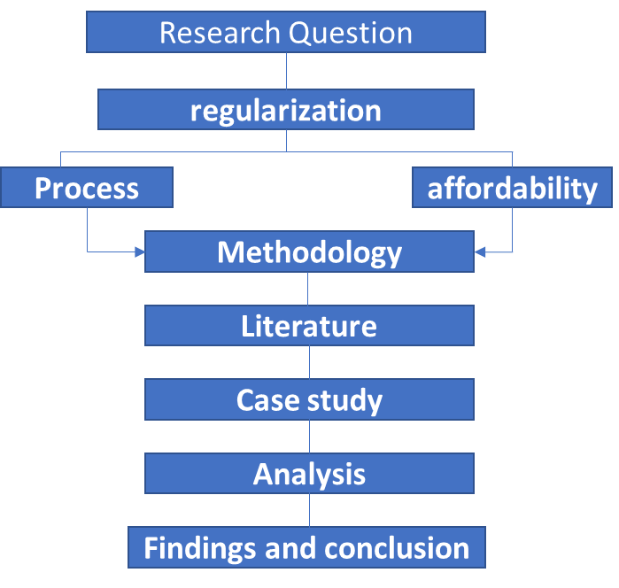

Method selection
In order to understand the real situation of informal settlements, one need to know the day to day life of the residents of these settlements. To study the process of regularization and its relation with affordability requires a close observation from all perspectives. This may include understanding their source and frequency of finance, employment situations, expenditures and priorities. This is because the process of regularization and affordability is related to different aspects of life. For example, it starts with one of the main human needs, which is shelter. It goes on to transportation, income, family size, ambitions, abilities and so on.
This study focuses on how the process of regularizing informal settlements is in this area and its relation with affordability as well. Depending on the nature of the settlement and the situation of the residents (land holders), the outcome varies as much. This is because the lives and priorities of societies defer as match as their location.
The method of case study in investigating a situational analysis is of great help for researchers. The reason is that, case study method illustrates the qualitative as well as the quantitative information in a very vivid way. It has also the quality to go further in-depth to find the truest sources for the required conclusion (Yin, 2012). YIN defines the case study research method as “an empirical inquiry that investigates a contemporary phenomenon within its real-life context; when the boundaries between phenomenon and context are not clearly evident; and in which multiple sources of evidence are used” (Yin, 1984).
Therefore, in order to understand the issue as clear as possible it was necessary for the researcher to take a close look at sample cases. This means a case study method was selected to do the research.

Selection of study area
Site selection plays an important role in the achievement of the desired objective stated. This is because it provides the necessary data to amplify the existential situation. One can’t select a site which has no relation with the stated problem, for the outcome will be invalid. Hence it is important to check the relation between the plausible site and the stated problem/ objective for a reasonable/ logical outcome.
The area selected to be studied is located in Shed Sefer, Woreda 10, Yeka sub city. Around 50% of this area was a ranch up to the year of 2001 and used to be owned by the Bedhadha family (according to Google earth and local residents’ interview). 2.3 ha of the farm land was taken by the government for construction of shed (temporary shelter for Micro and Small-scale Enterprise) in 2005. This is the reason why the area is known as “shed sefer”.
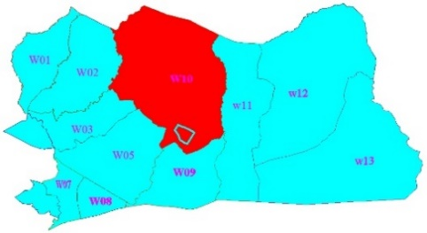
The regularization of informal settlements has been conducted in many areas of the city. The sub-cities (Bole, Yeka, Gulele, Kolfe, Akaki, Nifas-Silk) are on the periphery and exposed to squatting than the rest three sub-cities (Arada, Kirkos, Addis Ketema and Lideta). One of the first settlement in Yeka sub-city to have started the process regularization was “shed sefer” in woreda 10. In addition to that the area was one of the Qetenas/districts, in Woreda 10, which had the highest number of informal settlements, 311 to be exact. The proximity of location, to where the researcher has lived, and the accessibility of data made the researcher select the area as a case. In this regard “shed sefer” found in Yeka sub-city Woreda 10 was selected.
Figure ‎2-2 sed sefer location
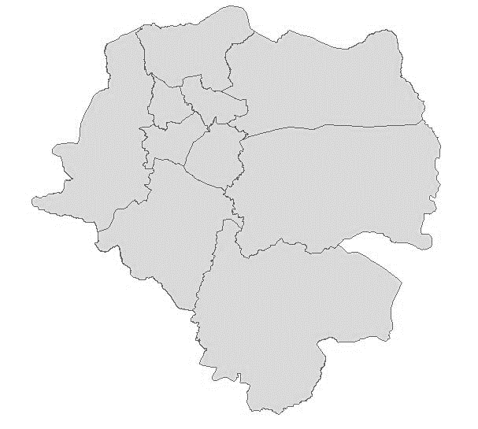
Yeka Sub city

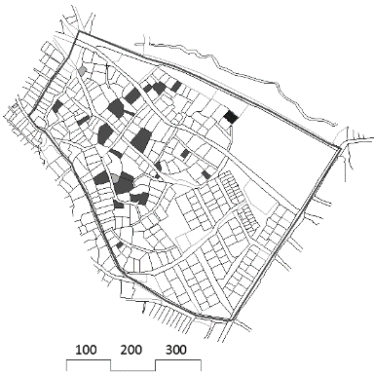

Shed Sefer
Addis Ababa

Source of data and techniques
The techniques used to gather the data depend on the type of information that is necessary for the study. In addition, it also depends on the source of data from which the information is to be collected. In this study both primary and secondary data were collected.
Primary data:
These data include the interviews conducted with the household/residents, the government officials of the woreda and the Qetena, the brokers in the study area and key informants. These primary data help in identifying the real situation of the case and the interactions between the actors involved in the process, which is one of the objectives of the study.
The other part of this category is the collection of data from observation, map reading and taking pictures of the settlements. The transformation of the settlement and compound layouts were studied in comparison with the current regulations, by-laws, and background of the area.
Selected cases were studied to collect in depth and more informative data which provided important input for the research. These cases were selected each with different condition that could represent (though this is not the purpose of the study) some the ongoing process of the regularization program.
Secondary data:
In studding the issue, the researcher used maps from the governmental institutions and from satellite images taken in different time. These documents are used as secondary data for the thorough analysis of the study. The analysis of published & unpublished and archival study, concerning the study area, were used as well.

Table ‎2-1 data source and technique
R.Q | Data | Method | Source of Data
Process of regularization
Who are the actors involved in the process? | -people involved in the process.  -roles of these actors.  -how they influence the process | -interview  -observation | -land owners  -Government officials  -Brokers  -Qetena rep.
How do these actors interact in the process of regularizing informal settlements? | -How do they find each other  -interaction  - | -Interview  -observation | -land owners  -officials  -Brokers  -Qetena rep.
What are the required documents in the process? | -documents (maps, agreements….)  -forms  -receipts | -interview  -observation  -maps & document study | -Government officials  -land owners  -literature
How is the issue of affordability
What is the Cost of acquiring informal land? | -land price  -means of payment  -ways of payment | -interview  -observation | -Government officials  -land owners  -Brokers
What is the Cost of construction (formally and informally)? | -transformation  -cost for construction  -cost for permit | -interview  -observation | -land owners
What is the Cost of regularizing process? | -cost for lease  -cost for documents | -interview  -observation | -government officials  -land owners
How were the inhabitants able to afford these costs? | -source of income (informal formal)  -income/ financial transformation | -interview | -Government officials  -land owners

LITRATURE REVIEW

Introduction
In this chapter the issue of informal settlement and programs of regularizing these settlements, based on different literatures, is discussed. The history, factors leading to the formation and proliferation of informal settlements, perceptions on informal settlement and the actions taken to rectify the different problems perceived in these informal settlements are discussed. The characteristics of common informal settlements are also included in this section. In addition to that, the issue that has a significant influence in the housing crises and the spread of informal settlement, which is the issue of affordability is discussed. Literature focussing on regularization of these informal settlements are included as well.

Background
The definition of squatter/ informal settlement varies from country to country. For example, in Australia, squatter settlement refers to occupying large tracts of land for housing construction. In England, squatter/ informal settlements refer to occupying an empty house in a city. Vacant buildings and state-ran enterprises that are occupied by squatters termed as squatter settlement in Germany (Wikipedia, 2018). As can be observed from the above definitions, countries define the term squatter/ informal settlement on their own context. This indicates that there is no one and concise definition to the term squatter settlement. However, the definition of UNCHS has got a wider acceptance. UNCHS (1996) defines squatter/ informal settlement as: -
“Informal settlements are units of irregular, low-cost dwellings, usually on lands belonging to third parties, and most often located in the periphery of the cities. These dwellings are often assembled in a patchwork fashion from pieces of plywood, corrugated metal, sheets of plastic, and any other material that will provide cover. Residences are almost always built without a license. They pose a fine hazard and are remarkable by their near total absence of numbered streets, sanitation networks, electricity, telephone etc.”
Informal settlements have been in existence for a long time. It started as far back in history; chronologies have left evidences in graphic description of such areas as in ancient Roma, medieval Cairo and Ottoman Istanbul. The largest scale of developing countries, nowadays have large areas of informal settlements in their urban centres. One-tenth of houses in urban areas of LDCs are informal settlement. Almost all major cities in Asia, Africa and South America have vast informal settlements on the outskirts (UN-HABITAT, 2011). Informal settlements have been the “problem” of many African and Latin American countries, mainly in their cities. These settlements have different characteristics based on their context and formation. One thing they have in common is that, they show there is a great shortage of housing and land supply in those countries and their cities.

Characteristics of informal settlements
There are essentially three major defining characteristics that help us understand squatter settlement. These are: the physical, the social and legal, with the reasons behind them being interrelated. These characteristics may differ based on the locations of the settlements. However, the common issues are witnessed in these settlements, though the degree of the problems differs in each of them. Below is the description of the characters visible in these settlements.
Physical characteristics: - informal settlements, due to their inherent “non-legal” status, have no or below the “adequate” or minimum levels of services and infrastructure. These services include both network and social infrastructure; like water supply, sanitation, electricity, road and drainage, schools, health centre, market place etc. (World Bank, 2002). The settlements lack these infrastructures due to the policies of land management of governments exercised in the respective cities/countries. The residents can’t make any modifications with the consent of the official bodies. For this reason, the residents had to provide the necessary services and infrastructure for their daily activities informally and in discreet.
Social characteristics: - Most households that reside in infformal settlements belong to the lower income group. They either are working as wage labourers or in various informal enterprises. On an average, most earn wages at or near the minimum wage level. Informal settlers are predominately migrants, either rural-urban or urban-urban (ibid, 2002). However, residents in many informal settlements represent a wide range of socioeconomic categories, especially in high-value established urban locations where many residents are considered more middle-class. Moreover, many poor people live in formal settlements (Fernandes, 2011).
Legal characteristics: -The key characteristic that delineates an informal settlement from other settlements is its lack of tenure security of the land parcel on which they have built their houses. These could be on a vacant government or public land, or marginal land parcels like railways setbacks or undesirable marshy land (Shido, 1990). Informal development, therefore, usually involves the existence of one or more intrinsic forms of illegality, through violations of private, public, or communal land ownership rights; urban, environmental, or building regulations and standards; registration requirements; and taxation provisions (Fernandes, 2011).

Causes for the development of Informal Settlements
The factors responsible for the emergence of informal settlements and the shapes they took are wide. The main factors for the emergence and proliferation of informal settlements in the urban areas are; the inability of governments to create equal and efficient land allocation, the inability of low-income groups of the urban dwellers to afford for the acquisition of land & participate in the formal housing programs and the prolonged bureaucratic way of acquiring land legally. Of these, the issue of affordability is of great influential one (UN-HABITAT, 2011).
Low income: Poverty is one of the most important factors that aggravate the expansion of informal settlements. Poverty and underlying global and national micro and macro-economic factors, especially wealth distribution and job creation, play a central role in determining the range of informal settlements. Combined with the unequal spatial distribution of urban infrastructure by the public authorities, the overall process of land and housing delivery through the formal market is characterized by prices that are high relative to incomes, and these high prices carry over to informal developments.
The inability of the poor to acquire land either through the private or public programs in the formal procedures is the basic reason for the informal settlements. Hence, illegal subdivision and the proliferation of unauthorized settlements are the common phenomena in the urban areas of the third world that accommodates over 20 to 50 percent of the urban population in its large cities.
N. AERUS (2001) strengthen this argument by saying that the poor section of the society employ informality as the coping strategy of securing houses when they lack alternative for decent houses. According to N. AERUS (2001) there is high coincidence between poverty and informal/ illegal settlement. Poor people would have no alterative than informally sheltering themselves, as they are denied to the formal access to housing.
Shortage of Social Housing: Informal settlement development is also affected by the nature and scope of government housing policies. Insufficient social housing production is aggravated by the inadequate conditions of existing housing projects. Moreover, the credentials required by many lending agencies to approve mortgage applicants have excluded most poor people from access to loans to even many public housing programs.
The former socialist countries were the dominant nations in providing social housing. In these countries, the government was responsible in providing houses and related facilities for the citizens. The projects were handled by the governmental agencies starting from conception to the delivery to the qualified ones including the funding. However, the production of social housing in many countries has declined for reasons associated with management and finance. After independence, most colonized countries focused in constructing and handing over of houses to the people. But this strategy did not work since the target groups were not the ones getting these houses, rather, the middle and high-income groups were (CDM Smith Inc., 2013).
Formal Market Outcomes: “The formal housing finance mechanism consists of a sophisticated system of mortgage finance, title companies, real estate brokers, developers, and others for the purchase or rent a complete housing unit. However, private developers traditionally have no interest in meeting the needs of the urban poor in most cities, especially in the absence of significant public subsidies, thus making room for informal land development opportunities” (Fernandes, 2011). This has resulted in the creation of huge gaps between the housing supply and demand. The inability of the formal market in talking the housing problem made the situation worsen. The people who were in desperate need of shelter had to look somewhere as an instant solution.
The outcomes of the formal market had benefited the high-income (and small range of the middle income) groups only. However, the formal market has also affected the informal land development and transactions as well. The prices for land, property, and rents has risen, and services such as water supply became more expensive. Also, informal land development processes often involve highly profitable informal market operations (Fernandes, 2011).
Unrealistic Planning: “The urban planning tradition in major LDC cities has reinforced informal processes, together with the lack of systematic public investment and service provision in the areas where most of the urban poor live.” (Fernandes, 2011) The resulting lack of serviced land then has the effect of creating more informality. A recurrent criticism of urban planning highlights its poor integration of land, housing, environment, transportation, taxation, and budgetary policies. With few exceptions, local administrations have failed to promote a more inclusive urban order. Both existing planning laws and the approval (especially by local administrations) of elitist urban planning regulations based on unrealistic technical standards often fail to take into account the socioeconomic realities determining the conditions of access to land and housing.
According to (Hardoy and Satterth Waite 1995) cited in (Tilahun 2002), the norms and codes of urban planning in developing countries are simulated from the developed countries. Most of the governments of developing countries have hardly made significant efforts in changing the situation. Hence, the urban planning tools i.e. plot development guidelines, zoning and planning are all obstacles, making land allocation and administration difficult. This in turn inflicts insufficient land supply and increases in land prices that did not coincide with the growing urban population.
Regulations such as minimum lot sizes, excessive development and construction restrictions, and prohibition of services, commerce, and small businesses in residential areas have had a fundamental role in making land and property prices high. Only recently has research started to quantify how urban and environmental regulations have been translated into land prices and impacted the dynamics of urban land markets (Monkkonen, 2012).
Problems of Urban Management: Informal settlements also emerge from the exclusionary nature of the regulatory framework governing land development, as well as the bureaucratic nature of land and urban management systems that are arbitrary and fail to involve effective popular participation. The imposition of strict obligations, the requirement of inflexible guarantees, and the lack of one-stop-shops to help potential developers or residents all contribute to high transaction costs. However, it remains difficult to quantify the extent to which bureaucratic costs are imbedded in land and property prices (Fernandes, 2011).
The cost and time needed to register land also discourages many people from obtaining legal security of tenure through that process. In Peru, for example, transactions in titled settlements are recorded for only one-fourth of sales, indicating that any others simply ignore the process. However, registration is the sole factor that constitutes legal ownership in any Latin American national legal systems.

The issue of affordability
People need places to live, places that provide shelter and places that provide a sense of “home,” and how to meet those needs in a time of economic crisis is one of the most pressing issues facing almost every nation today. With distressing statistics about rising cost burdens, increasing foreclosure rates, rising unemployment, falling wages, and widespread homelessness, building affordable housing will remain one of our most pressing social and economic policy problems for years to come.
The issue of affordability, although it still lacks precise and consistent definition, has achieved international attention. It typically encompasses not only social housing and low-income housing, but also financially assisted housing for middle-income households that find it difficult to purchase houses in the private speculative market (Jota Samper, Catalina Ortiz, Javier Soto, 2014). In fact, in recent years, the term ‘affordable housing’ has been used as an alternative term for ‘public’, ‘social’ or ‘low cost’ housing.
The term “Affordability” can be defined as the ability to pay with the choice/willingness to do so (Tibaijuka, 2009). Affordability expresses the challenge each household faces in balancing the cost of its actual or potential housing, on the one hand, and its non-housing expenditures, on the other, within the constraints of its income. (UN-HABITAT, 2011). This issue has great influence in the choices of housing every household had to make in order to live their lives. The low- and middle-income groups in the cites, since they are excluded from the formal housing provisions, prefer to find housing options (shelter) either through informal way in the inner city or informal settlements in the outskirt areas of cities. Consequently, there is a significant number of informal settlements living in the cities.
The issue of affordable housing is directly related to the options of housing policy and finance provided by governments of nations. In any situation, housing finance consists of the organized mobilization of savings, credit and subsidies, or any combination of these (UN-HABITAT, 2011). In developing countries both formal and informal institutions involve in providing finance for housing. Roughly 70% of the world’s population in developing countries access shelter through “progressive housing.” This is because the sophisticated systems of housing finance provisions like; mortgage finance, title companies, real estate brokers and developers are inaccessible by the low and most middle-income groups in the developing countries (Ferguson, 2008).
Therefore, to conclude the review housing affordability is the challenge each household faces in balancing the cost of its actual or potential housing, on the one hand, and its non-housing expenditures, on the other, within the constraints of its income.

Actions taken through time
As mentioned above, characteristics of informal settlements are the main visible issues that distinct the settlements from others. The people who chose these settlements have their own reasons. The main cause for this is the issue of affordability. The urban poor have resulted to living in the Informal Settlements where they build their houses with their own hands with no title or official permission and depend on informal economy (Hall and Pfeiffer, 2000). The unofficial occupation makes them lack support from authorities for the provision of basic social services and infrastructure.
Informal settlements are seen as a problem in most cities, mainly in the LDC (less developed countries) cities. These “problems” were handled in three ways through different period of time (though may not be chronological in Ethiopian context). Eviction, upgrading and regularization were the main measures taken to handle the situations. The urban poor have been unable to comply with existing planning standards, regulations and administrative systems of land management. The immediate response to this by the government was /and still is in some places/ eviction. later on, the upgrading approach was conducted. However, “The upgrading approaches often include predetermined principles and objectives” to be met (Alemayehu, 2008). The latest approach taken in response of the spread of informal settlement is regularization. This approach is intertwined with the people’s lives and the administration of land. These approaches are discussed below.
Eviction; In the very beginning, government’s reaction was to evict and destroy the settlements because of the inherent problems the cities were facing. Laws drafted by governments and the high-income people supported evictions. The dwellings being on private and public land and others on physically unsuitable areas, helped to enforce the laws. Eviction, however, has not succeeded as Informal Settlements have continued to increase in number and size from country to country and have ended up housing the majority of the urban dwellers. Besides, the urban poor have through time consolidated their resources and tried on their own to improve their dwellings (World Bank, 1996). Though evictions still occur in a number of countries, other alternatives had to be sought.
Upgrading; Informal settlers have accessed land through different procedures and build their houses on their own. These dwellings, with the help of ‘self-help groups’ and NGOS, have acquired some basic services. The issue of “what to provide in an upgrading project so as to improve the living condition of the residents and to give the settlements a legal outfit” became the main question. There are those services, however, that individuals cannot afford to do on their own outside the formal government set up (Davidson F & Payne GK , 1983). These include expensive undertakings like building roads, schools, legal tenure and planning among other things. These are the ones that the World Bank aims to meet in housing projects.
Site and services; these are meant to provide the low-income groups with serviced plots that have tenure security, which they should develop on their own with their own resources or “soft” loans from governments. Comparatively, this approach had more popular support than the previous ones. However, the location of the sites, on the other hand, was discouraging for it means having them on the city peripheries far from job locations. The standards of expected development were still beyond the means of the poor and they end up not with the target group but with ‘government employees’ and those with regular incomes. Alongside site and services, the World Bank further noticed the advantages of having on site improvement by availing those basic services that Informal Settlements lack. This new shift is referred to as upgrading and often is carried out at the same time with sites and service schemes when World Bank is the sponsor of the project.

Regularization
The factors for the proliferation of informal settlements are wide as mentioned above. The issue of affordability being the main factor, there are different factors that contribute for the immense increase of these settlements. Different approaches were tried to overcome the spread of these settlements by urban administrations in the past two decades (Lirebo, 2006). The previous actions taken to eradicate these spreads were not able to meet their intended goals, which was controlling informal land holding and providing better living condition for the inhabitants. Instead, the opposite was witnessed (Fernandes, 2011)and (Gondo, 2011). One of the main reasons for this is that, the popular participation in the decision-making process was not considered in the drafting of these policies. In developing countries, the urban poor and low-income households have been unable to comply with existing planning standards, regulations and administrative systems. This situation directly leads to the formation and proliferation of informal settlements.
Many scholars do not agree with the demolishing of informal settlements. In Amis & Lioyd (1990) view the best way to mitigate informal settlement is through regularization. They further substantiate their argument in that the process of regularization of informal settlement pattern ultimately brings low-income urban poor to better security and owner of urban housing.
The Merriam-Webster dictionary defines Regularization as; The act of changing a situation or system so that it follows laws, policies or rules, or is based on reason (Merriam-Webster, 1999). There are three important elements to policies: their contents, the process of formulation and the methods of implementation (Monkkonen, 2012). Regularization policies also deal with complex socioeconomic and urban-environmental realities and involve multiple aspects of land, registration, financial, urban, and environmental laws. They seek to ensure that residents of consolidated informal settlements are not evicted or relocated, but can remain on the land they have occupied with access to better living conditions. Moreover, to some extent regularization policies promote social justice and compensate for historical inequalities.
The main goal of Regularization is to increase the access of low-income households and the poor to adequate, safe and secure shelter. The concept of 'adequate shelter' adopted by projects of regularization schemes is the same as that in “The Habitat Agenda” (UNCHS, 1997:35), which is more than simply “a roof over one’s head”.
Regularizing informal settlements means first of all providing security of tenure. This is an essential step. Changing the shape of the plots to suit road network and to build houses. Households should not be evicted by an administrative or court decision for the sole reason that they are not the owner of the land/house they are occupying, or that they have not entered into a formal agreement with the owner, or do not comply with planning and building laws and regulations (Alain Durand-Lasserve, 2002). The main purpose is making regular by integrating with the previously planned settlements.

Regularization process in Tanzania
Before colonial invasion, land rights were governed by customary rules and land holding was influenced by patterns of settlements in Tanzania. Land was owned communally and individually. During the colonial era, the written title deed was granted to foreigners in urban centres and to estates and plantations. However, the majority of citizens were limited to customary tenure under a system of informal law. Thus, under statute law the economically dominant classes in urban and rural areas came to dominate large-scale properties while the majorities, under customary law, were restricted to ownership of small-scale landed property (Tenga, 2011).
After the independence in 1961, the new government accepted the legal framework which had been erected by the colonial government. Further, in the late 1960s’ after the 1967 the Arusha declaration, all land in Tanzania was nationalized, followed by the forced resettlement of hundreds of thousands of peasants and pastoralists in new villages and as such agriculture production was to take the route of “Transformation” and “Improvement” (Wanjala, S., 2002)
The government was forced to abandon its land policy strategies erected after the independence, which were socialist-oriented to save the economy of the country and be able to receive financial assistance from capitalist-oriented organizations. Tanzanian government introduced the National Agricultural Policy in 1983, in which private ownership of land was emphasized (Tenga, 2011).
However, with the high growth of population and an increased trend of rural-urban migration, economy of the nation continues to decrease. The majority of migrants grabbed and occupied valuable plots of land irregularly at the impulse of The National Agricultural Policy of 1983. These irregularly/informally occupied plots of land posed an imminent danger to the economy of the nation. It became a wakeup call to Tanzania government of the inevitable need to giving legal recognition to informal settlements, and also giving land its value (United Republic of Tanzaniya , 2008).
Tanzania Government, formed a commission to inquire into land matters and to prepare a report on necessary improvements. Based on the report the government came to realize that, the main pillars of land allocation and planning policy is security of land tenure for all its residents. With that view, the commission recommended a total new approach to urban planning; that, planning should follow registration of land rights rather than precede it (United Republic of Tanzaniya , 2008).
Regularization in Tanzania took a form of community initiative what has been termed as self-regulation (Kombe W.J & K Volker, 2006). This is mainly attributed to the resource constraints on the part of the government which is traditionally seen as the enabler in such activities. The Government decided to allow people living in informal settlements to regularize their plots on their own initiative and resources while the Government plays a facilitative role.
A Commissioner was appointed by The Minister, to do an inquiry and explain to the residents of the area; the nature, purpose and procedure to be followed in the declaration and implementation of the regularization scheme. The criteria to be satisfied includes:
- that the area should be used substantially for habitation,
- that substantial number of persons living in the area appears to have no apparent lawful title to their use and occupation of land
- that the residents must have lived there for substantial period of time and
- that despite lack of security of tenure people appear to be investing in their houses and businesses and attempting to improve the area through their own initiatives
When an area is declared an area for regularization, the residents and their leaders will have to convene a meeting to discuss their idea of a layout plan of the settlement and planners will thereafter translate it into conceptual plan. If the residents are in agreement with the conceptual plan, they will sign an agreement confirming the acceptance of the mapped boundaries. The map will be submitted to the Municipal council for approval. Meanwhile the residents will have to organize themselves to mobilize resources for the cadastral survey and take necessary steps towards land regularization, and as noted earlier, the Government will play a facilitative role (Sara A. K & Kyessi A.G, 2008).

Regularization in Peru
The dominant approach to land regularization internationally and in Latin America for the last two decades has focused on legalizing tenure of individual plots as a self-contained program. This has been the focus of Peru’s regularization policy. Since 1996, Peru is a leading practitioner in the implementation of regularization. This titling program has been financed with national, international, and World Bank funding. For this reason, nearly 1.6 million freehold titles were distributed in Peru between 1996 and 2006.
Table ‎3-1Titles Granted Annually in Peru, 1996–2006
Year | # Total Registered Titles
1996 | 33,742
1997 | 129,392
1998 | 149,574
1999 | 322,053
2000 | 419,846
2001 | 115,599
2002 | 123,827
2003 | 70,401
2004 | 65,598
2005 | 71,300
2006 | 68,468
1996–2006 | 1,596,801
Source; Calderon (2007).
The formalization process in Peru, has involved three stages:
- The gathering of information on land and on existing obstacles to formalization of settlements,
- Identification, demarcation, and registration of plots and buildings and
- Identification of entitled occupiers.

Large-scale titling programs in Peru have increased tenure security within informal settlements—a major accomplishment. They have also increased the value of the properties of the affected residents at relatively low cost. However, those programs have also created many problems that could be solved by implementing more sustainable processes. Instead of discussing settlements, neighbourhoods, and communities, formal titling focuses on individual units, property rights, and free market transactions regardless of the social context and consequences. Titling is implemented without mention of social safety nets and welfare, or cooperatives and public goods. A line of legal criticism notes that the focus on individual rights fails to take into account social property relations and other forms of collective, customary, restricted, and temporary rights that may benefit society (Arruñada,2009) (Riofrio 2008).

Regularization in Brazil
It is not sufficient to “legalize the illegal” without provoking changes in the legal-urban system that led to the illegality in the first place—especially in the name of fighting poverty. Land Titling provides legal security of tenure to the residents, a necessary step, but it is not sufficient to promote socio-spatial integration and may undermine the permanence of the legalized communities. The socio-spatially integrated approach to regularization tries to ensure individual tenure security while maintaining communities in their original locations in order to ensure that the main beneficiaries will indeed be the urban poor. This approach requires a broader set of strategies and measures, ranging from promoting urban and environmental sustainability to strengthening local communities and empowering women.
Motivating this integrated approach meant, to the Brazilian government, the social right to adequate housing, promoted by the UN Housing Rights Programme (UNHRP). These includes; the right of all to live in dignified conditions and to participate fairly in the opportunities and benefits created by urban development. The question is how to achieve both tenure security and socio-spatially integrated regularization.
According to Larangeira, Brazilian municipalities have been far more successful in upgrading informal settlements than in legalizing them, although the majority of the upgrading programs did not lead to titling. The internationally acclaimed Favela-Bairro program in Rio de Janeiro resulted in only 2,333 titles in a universe of more than 50,000 families, but only 145 actually completed the registration process (Larangeira, 2002). One reason for this low titling rate is that occupants have to work through a complex bureaucracy on their own to complete the process.
Table ‎3-2 Regularization and Titling Results in Brazil, 2009
 | Regularization Initiated | Titles Issued | Titles Completed
Number | 2 1,706,573 | 369,715 | 136,974
Percent | 100% | 21.7% | 8.0%
Source: SNPU/Mcidades (n.d.).
Over the years even as some regularization policies have become more technically sophisticated, more environmentally sensitive, and more participatory, they continue to benefit a small number of people mainly because of their high financial costs. However, the particular problem has been the failure to scale up interventions (Rojas 2010). Most existing regularization policies have addressed only a small number of informal settlements. Porto Alegre’s regularization program, for example, is limited in scale, but is among the most comprehensive because it integrates socioeconomic, financial, and urban-environmental sustainability through physical upgrading; introduces legalization; and provides socioeconomic and cultural programs aimed at generating income and jobs (Smolka and Damasio 2005).

CONTEXTUAL STUDY

Introduction
In this chapter, the study focuses on the situational analysis of land management, housing and related issues in Ethiopia, specifically in the city of Addis Ababa. This section also discusses the issue of land management history, informal settlements and regularizations in the city.

Background
The land delivery system in Ethiopia has gone through different land tenurial systems. Such tenurial shifts are a reflection of the land policy and landholding tenure systems of the country under different governance regimes. Notable examples include the free land holding system (pre-1975), public controlled permit system (1975-1992) and public lease hold system (1993 up to date). In addition to these, there are customary and informal land holding systems, which are commonly known in Ethiopia and other developing countries. (Alemayehu, 2008)

Monarchical feudal system (before 1974)
During the Monarchical feudal regime, political and economic power of Ethiopia had been under the monopoly of the nobilities for centuries. This includes, land ownership (both rural and urban) and other properties. At this time, extensive areas of urban land and numerous houses were vested in the hands of individual lords, aristocrats, loyal families and high government officials. However, some intellectuals and few emerging owners of capital managed to buy some plots of urban lands. According to a survey carried out in 1961, on the one hand, out of the 212 square kilometres area of Addis Ababa, 1768 proprietors each with more than one hectare owned 58% of the land. On the other hand, 24,590 inhabitants occupied 7.4% of the total area of the urban land, each possessing an average plot size of 150-meter square (Workneh, 1995). All unused land, including the rural land, was presumed to be the property of the monarch.
During the imperial regime, the majority of urban dwellers were residing in rental houses that had little or no adequate facilities. There were concentration of land and housing in the hands of the minority. These houses had little or no adequate facilities and were rental houses for the majority of urban dwellers to reside in. 55% of the houses in the city were rental houses, which forced the poor section of the society to live in a perpetuate congestions and overcrowding (Tesfaye, 2007; 34, citing Gulte,1989).
The pre-revolutionary land tenure system deterred the development of squatter settlements. This was due to the power of the property owners was so strong as to discourage illegal occupation of land by anyone. What it encouraged, though, was sustained production of unauthorized housing by the property owners themselves. The notorious discrepancy between the total number of annual municipal building permits and actual housing and extensions, in pre- revolutionary Addis Ababa, reflected the fact that most property owners boosted rental incomes through increased supply of unauthorized dwellings. Moreover, it was common practice among tenants to share their rented spaces with needy individuals or households based on various informal living arrangements (UN_HABITAT, 2007).

Derg regime (1974-1991)
When the military had controlled power over the government of Ethiopia, the regime issued a proclamation that nationalized all rural land, to address the main cause for the 1974 revolution (UN_HABITAT, 2007). In July 1975, through the Proclamation No. 47 known as “Government Ownership of Lands and ‘Extra’” all urban land and rental dwellings were nationalized (Alemayehu, 2008). In addition to that, the proclamation, No.31/1975 was issued for the nationalization rural land. These proclamations prohibited private ownership of land, transfer of land by sale, lease, mortgage, succession or donation. These proclamations nationalized all urban high-rise apartment, office buildings and extra houses without direct compensation (Tesfaye, 2007).
The significant effects of such radical measure were witnessed on the regressive reduction of the monthly rent on the houses that were nationalized. Accordingly, between 15% and 50% on the amount of rent that used to be paid to the landlords were reduced by the government for the renters (Alemayehu, 2008) and (UN_HABITAT, 2007). Following the nationalization, the role of private firms in the development of residential houses was totally neglected. This in turn has highly intensified the problem of housing in the city.
Indeed, under the Derg rule, all cities in Ethiopia, including Addis Ababa, went through acute housing shortages and ever-deteriorating housing conditions. Toward the end of that period, the junta realized the damage its policies and proclamations had visited on Ethiopia’s economy in general, and the urban housing sector in particular. The policies which were implicit in proclamation No. 47/1975, despite their concern for equity, created serious bottlenecks in the housing sector, and largest share of the housing need remained unattended. The housing policy document issued by the government Proclamation. No 92/1986, and the associated regulations were responses of sever problems faced with regard to housing. The most notable move in that regard probably was the housing policy laid out in 1986, the major objectives of which were as follows (UN_HABITAT, 2007):
- standardize building codes;
- research housing design and building materials;
- encourage community involvement in housing production;
- more effective use of the existing housing stock, by allowing co-dwelling and regulating the purchase and sale of houses.

Under the EPRDF regime 1991 up-to date
In 1991, when the EPRDF took power (by force) from the Derg regime, the country’s condition was worse due to the decades of protracted, lingering civil war and many misguided social and economic policies that characterized the Derg’s 17 years of “heavy-handed rule” (UN_HABITAT, 2007).
The EPRDF made immediate decision after coming to power, which was, the establishment of federal system of governance, with nine, mainly ethnic-based, national regional States. The Addis Ababa and Dire Dawa city administrations remained self-governing cities. The subsequent federal and regional constitutions entrenched self-rule for the people at all government levels. However, the concept of local authority remains largely underdeveloped in Ethiopia, as the national government sets policies, strategies and broad financial parameters for regional governments (UN_HABITAT, 2007). The constitution has empowered the federal government to issue laws for the utilization and conservation of land and other natural resources. Parallel to that, Regional Governments are empowered to administer land and other natural resources in accordance with the federal laws (FDRE, 1995).
After the down fall of the Derg, in 1991, for the first times, Ethiopia has introduced a lease system as a mode of urban land administration through the proclamation No.80/1993. The urban land lease holding proclamation was enacted before the constitution was adopted. Hence, this proclamation did not emanate from the constitution.
The objectives of the proclamation, as indicated in its preamble, were as follows:
- To create equitable distribution of land,
- To control the growth of city centres,
- To increase urban revenue to finance urban infrastructure,
- To expedite construction of urban houses
- To alleviate the existing shortage,
- To provide land utilization value [market value of urban land] which was not in existence,
- To ensure transparency in land transfer and avoid land speculation,
- To promote the economic development of urban centres through involvement of investors, and
- To ensure tenure security by providing land rights of longer durations.”
This proclamation did not define “land lease”, instead, it classified urban land into three categories, namely, those allotted before the issuance of the proclamation for the construction of dwelling houses, lands allotted before the issuance of the proclamation to be utilized for purposes other than dwelling houses, and lands to be allotted for any purposes after the issuance of the proclamation. Even though proclamation No. 80/1993 mandates cities and towns in Ethiopia to use the proceeds of lease transactions to finance various types of services including infrastructure, in reality, the revenues from such transactions have remained unimpressive.
The main objectives of revised land lease proclamation, No.272/2002 were two; to collect in come from land lease in order to assure faire share from urban land wealth, and transform the permit system in to a lease system. This lease proclamation defines lease under article 2(1) which was not included in the proclamation, No.80/1993. It defined ‘lease’ as ―lease-hold system in which use right of urban land is transferred or held contractually”.
Unlike the previous lease law, proclamation, No.272/2002 allowed free transfer of lease right with the full advantages of the enhanced value of the lease land. However, this proclamation required the lessee to pay back the difference to the government that an enhanced land value gained by the leaseholder during transfer of the lease right. Another modification made in this proclamation was that, Proclamation No .80/1993 did not mention about clearance of illegal possessors of urban land which was indicated in this proclamation, Article 16(2).
The main objectives of the recent and active land lease Proclamation No.721/2011 is as follows:
- To provide an appropriate urban land administration which is efficient and responsive to the continuous and increasing urban land resources demand, created due to the rapid economic growth registered across all economic sectors and regions in the country
- To ensure the prevalence of good governance which is a foundational institutional requisite for the development of an efficient, effective, equitable and well-functioning land and landed property market, the sustenance of a robust free market economy and for building transparent and accountable land administration system that ensures the rights and obligations of the lessor and the lessee.

Informal Settlements
Informal Settlements are the result of various reasons. They have a historical aspect dating from the monarchical period. The locals were allowed in for the services they could offer and were housed in certain localities with no free means of acquiring land. With independence, the flow of locals to the cities was and has been too large for services planned for a small number of people.
Besides the above, rural poverty and opportunity differences have contributed to mass movements from rural to urban areas. There are also other factors like influx of refugees, which are common in Africa and some Asian countries, natural calamities associated mainly with weather and economies that do not seem to improve (Hall and Pfeiffer, 2000). The expansion of informal settlements has expanded in the current regime than ever before. According to (Alemayehu, 2008) “it is estimated that 80% of the population of Addis Ababa is living in slums”.
However, this number has been decreasing due to the interventions made by the government to eradicate the problem. According to WORLD BANK report, there has being a decline of informal settlements by more than 20% until 2014 (WORLD BANK, 2016). One of the main reasons for this was the introduction of IHD program as an approach for the provision of housing in the city of Addis Ababa in particular, and the country in general.
Figure ‎4-1Population living in slums in Ethiopia (% of urban population)

Source: (WORLD BANK, 2016)

The upgrading programs and the IHDP (integrated housing development programs) drafted by the government, with the help of international organizations had contributed in the reduction of slum dwellers in Ethiopia (WORLD BANK, 2016).

Housing finance and affordability in Ethiopia
In Ethiopia, like in all developing countries, both formal and informal institutions are involved in providing finance for housing. The formal housing provisions (real-estate, IHDP and alike) are not successful in housing the 20% of the urban resident (Lirebo, 2006). For this reason, the informal ways of acquiring land for housing was and still is the only way for most of the urban residents.
Mortgage; Construction and Business Bank S.C. (CBB) was a wholly government-owned public enterprise and successor of the Housing and Savings Bank (HSB) which was formed in 1975 through the merging of two financial institutions namely, Imperial Savings and Home Ownership Association (ISHOA), and Savings and Mortgage Corporation of Ethiopia (SMCE)which were nationalized at the on-set of the socialist era of Ethiopia. The Bank was involved in providing mortgage finance. However, a decision was made to merge the bank with the Commercial Bank of Ethiopia in December 22, 2015. The decision was made because the two banks are engaged in similar activities (source; Fana Broadcasting Corporate). And in April 4, 2016 the CBB banks reopened their doors as branches of the Commercial Bank of Ethiopia CBE.
This institution was to provide one of the formal ways for housing finance in Ethiopia. If this had continued, significant changes might have been visible in the challenge of housing shortages witnessed in the city. The merging of these two banks blocked the possible options to provide homes for the city residents.
Real Estate; Apart from the mortgage finance mechanism by the Construction and Business Bank, which did not last for long, there are more than 200 real-estate providing housing projects in the city. However, only the high-income groups were able to afford these housing options provided by these Real Estate companies. These is because the standards and the qualities were unreachable by the low and middle-income groups.
For this reason, these low- and middle-income groups, been excluded from the formal provision of housing scheme, had only two choices. These are; wait for the government to provide a housing scheme targeted for them (like the IHDP) or look for land/housing in the outskirt informally on their own. Evidently these situations occurred parallel to each other. The IHDP program was introduced in the city hopping it will eradicate the housing shortage. However, the problem has worsened because of migration, and population growth. Hence, the low- and middle-income residents of the city went on looking for the housing options that suites them.

Regularization
Land regularization scheme have great impact on contemporary evolution of land planning & management and also the fundamental changes of the land laws. It ensures legal recognition of land acquired informally, promote security of land tenure and expected to reduce the level of poverty to individual land holders and nation at large. On the other hand, it is employed as a methodological approach to illustrate the end of land monopoly to individuals, who are in position to obtain land through legal channels, as opposed to majority of disadvantaged population.
The importance of land regularization in overcoming the problem of insecurity of tenure in urban centres is highly reflected by the number of people living in informal settlements. In an estimate, almost 3 billion people, half of the world population now lives in cities. Based on World Bank Organization, more than 70% of the population live in slums in the case of Ethiopia (UN-HABITAT, 2011).
The proclamation, No.721/2011 allowed the regularization of land, held without the authorization of the appropriate body, through registration and lease system. These possessions must be found acceptable in accordance with urban plans and parcelling standard. According to this proclamation, article 6 sub-article 5, the registration was supposed to take place within the succeeding four years from the year this proclamation was put to action. It has been more than eight years since the proclamation was put to action. However, the registration of “old possession” lands and the informally held ones are not all registered.
The urban land lease holding Proclamation No.721/2011, gave permission for the formalizing of informal settlements under specific requirements and principles. Among the requirements are planning and parcelling standard. This was the base for the issuance of the proclamation, No. 818/2014, its basic objective being the registering of Urban land holding. In addition to that, the Proclamation No.721/2011 has put the following objectives at its preamble:
- To give security for the possession right of citizens and there by accelerate economic, social and environmental development of cities;
- To minimize disputes raised related to land and immovable property;
- To put in place legal framework which is up-to-date, efficient, compatible;
- To implement legal cadastre principles such as registration of possession, getting the consent of the possessor during transaction, making registration of possession open to public.
This was as an extension to the previous land lease proclamation’s objective, which was to register the urban land and include it to the lease system. The proclamation, No. 818/2014 is the latest land law in act at the current time.

CASE STUDY

Introduction
In order to have a better of the situation, the researcher made a case study to illustrate the process. The study was conducted in Yeka Sub-City, one of the ten Sub-Cities of Addis Ababa, where the larger share of informal settlements is located (Figure ‎5-1). Yeka Sub-City is on the North-eastern part of Addis Ababa. The Sub-City has an area of 8598 Ha (85.98 km²) and is dominated by peripheral zones having more farm lands and forest. It is sparsely populated, with the density of 4475.57 per SQ.KM, compared to other parts of the city, Yeka is the third less densely populated sub city. According to the July 2011, Population and Housing Census, 384,810 inhabitants are living in the sub city (CSA, 2012). According to the study undertaken by the Office for Revision of the Addis Ababa Master Plan (ORAAMP, 2001), and from the different reports of the municipality of Addis Ababa, the sub-city is part of the city where illegal sub division is predominantly practiced.
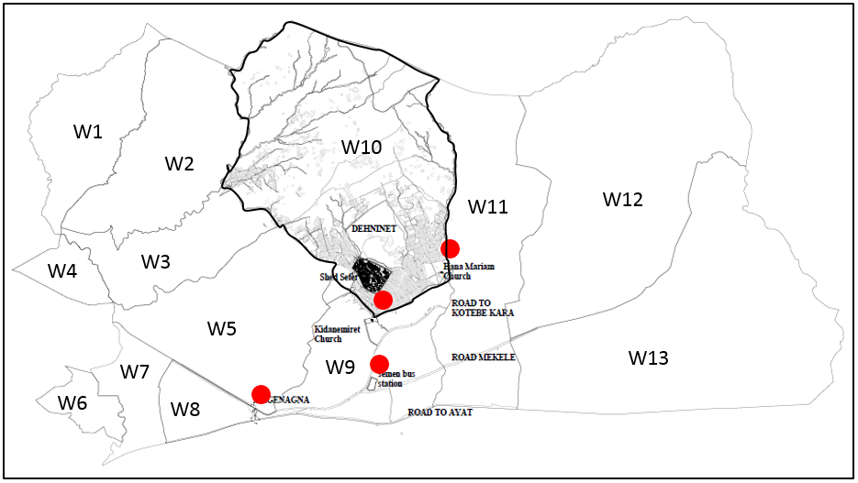
Figure ‎5-1 study area location map (source Nortec map)

According to the information from the Yeka Sub City Administration Land Development and Management Office, there are 13 woredas in the sub city (Table ‎5-1). In every part of the sub city there are informal settlements, though they differ in scale and type. In 2017 the government demanded the registration of informal settlements so that they could be regularized. The least number of informal settlements registered was in woreda 6, which is 26 (Table ‎5-2). This number was very small compared to what was planned to be registered, which is 81. The reason will be discussed in the next chapter. However, none were granted the land deed by the administration office. The higher number of informal settlements registered is in woreda 13, which is 5406. This is because the woreda is 1439 Ha and is located more to the peripheral part of the city. Because of this, there was more informal subdivision of land in this woreda (Wereda 15) than in others. This number of informal settlements was very high compared to what was planned to be registered, which was only 1808 (299%).
Table ‎5-3 registered and adjudicated informal lands (until February 2018)
WOREDA (DISTRICT) | REGISTRAION |  |  | SEND TO PARCELLING DESK | DOES NOT EXIST IN LINE MAP |  |  | PLAN OPPOSITION |  |  | PRINTED
WOREDA (DISTRICT) | PLANNED | REGISTERED | SEND TO S/CITY
 |  |  |  |  | IN PARCELING | IN INFFORMAL | TOTAL | IN PARCELING | IN INFFORMAL | TOTAL | PRINTED
1 | 415 | 226 | 205 | 193 |  |  | 35 |  |  | 86 | 23
2 | 745 | 425 | 338 | 126 |  |  | 51 |  |  | 133 | 63
3 | 88 | 28 | 39 | 21 |  |  | 2 |  |  | 12 | 3
4 | 84 | 28 | 10 | 6 |  |  | 0 |  |  | 2 | 4
5 | 349 | 733 | 717 | 343 |  |  | 76 |  |  | 334 | 112
6 | 81 | 26 | 13 | 9 |  |  | 2 |  |  | 10 | 0
7 | 261 | 26 | 31 | 23 |  |  | 4 |  |  | 10 | 4
8 | 169 | 31 | 31 | 31 |  |  | 2 |  |  | 8 | 7
9 | 914 | 821 | 793 | 780 |  |  | 99 |  |  | 178 | 307
10 | 2197 | 4472 | 2810 | 1042 |  |  | 484 |  |  | 1022 | 477
11 | 409 | 1498 | 1535 | 1314 |  |  | 130 |  |  | 526 | 382
12 | 1276 | 4872 | 3383 | 2692 |  |  | 381 |  |  | 138 | 1691
13 | 1808 | 5406 | 3793 | 2976 |  | 701 | 724 |  |  | 379 | 1427
TOTAL | 8796 | 18589 | 13698 | 9556 |  |  | 1990 |  |  | 2838 | 4500

Source; Yeka Sub City Administration Land Development and Management Office
Shed sefer, which the researcher has selected to study, is located in woreda 10. This woreda has two parts (the northern and the southern part). The northern part is covered with forest. For this reason, this part of the woreda is designated as a forest in the new master plan, though there are many settlers in this area (Figure ‎5-2). In January 2016 there was a conference in the woreda with the higher officials and the people who settled in the northern part (forest) concerning their dislocation to other parts. However, this conference was not “successful” in convincing the residents to leave their places. This conference was done after some of the settlers got the basic infrastructure like; water line, power line and after most had gathered money (with the help of the woreda officials) for the construction of cobble stone roads to their respective areas. Some of these roads were already completed. According to the interviews the researcher made with the residents, these and other reasons made the residents refuse to agree with the land management officials demands. Despite all this, the new master plan indicates this area as special park (EA-17 ልዩ መናፈሻ አረንጓዴ) and as multi-functional forest (EA-11 ዘርፈ-ብዙ መናፈሻ አረንጓዴ). (Figure ‎5-2)
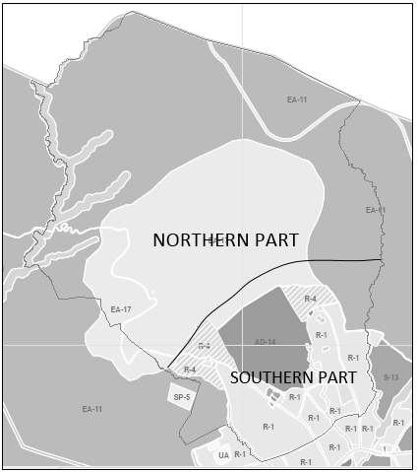
Figure ‎5-2 Yeka sub city, Woreda 10 land use
Most of the southern part of the Woreda used to be a farm before 2001 and used to belong to farmers who reside in the northern part (Figure ‎5-2) & (Figure ‎5-3). There were few settlements/ residents living in this area at this time. After 2001, the year where the first regulation for the regularization of informal settlements was drafted (Lirebo, 2006), the settlers started to sell the land informally to buyers with the help of brokers. In addition to this there were who came to the area and start occupying without the consent of the government officials (Figure ‎5-3).
In woreda 10 the informal settlements registered to adjudicate their land were 4472 residents (Table ‎5-4). This number was more than two-fold of what was planned to be undertaken by the woreda. The office had predetermined to handle only 2197 residents, although the reason behind this prediction is not clear. From the registered 4472 residents only 477 were eligible to get their land deed. The rest were disqualified because they did not fulfil the requirements put by the bureau.
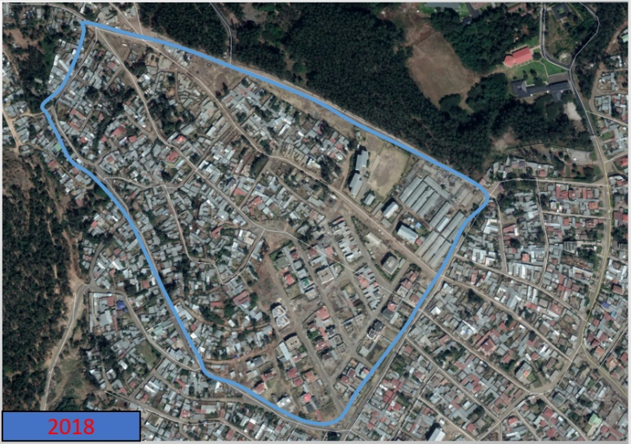
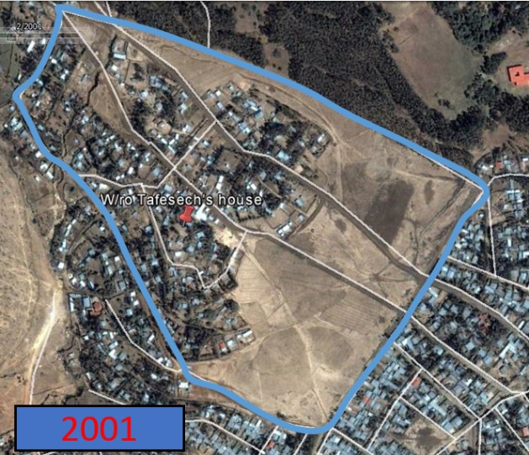
Shed sefer is one of the 14 Qetenas found in Woreda 10. It has an area of 24 ha and has about 574 household. This number is, however, without the tenants that live in this area. According to the Woreda 10 administration, 56% of the residents were informal settlers. From these around 10% are farmers who have been living there for more than 30 years. These farmers inherited these lands from their parents. The rest are relatively “new comers” to the site (Figure ‎5-3). These relatively “new comers” bought lands from the farmers with very low price (until 2003) and were able to formalize their lands. Some of these lands specially those found in the southern part of the study area were legalized before 2014 (2007E.C).
Figure ‎5-3 shed sefer settlement transformation

Case 1- W/ro Letemikael Gebreslasie

Location
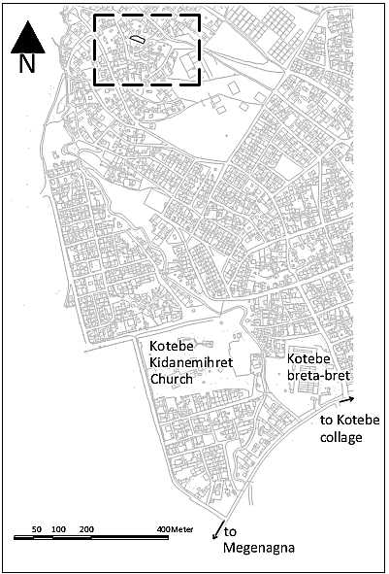
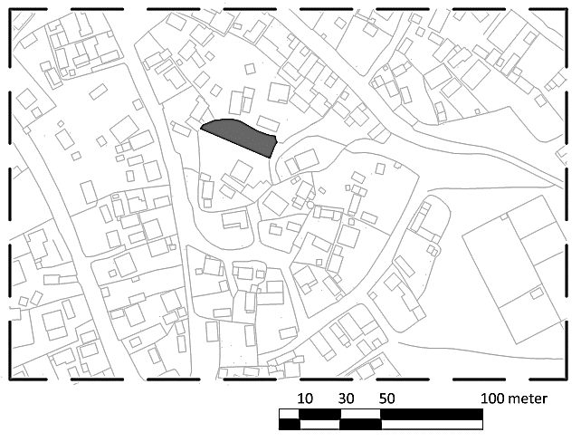
b
a

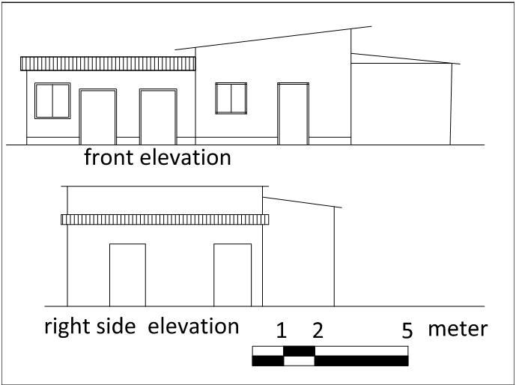
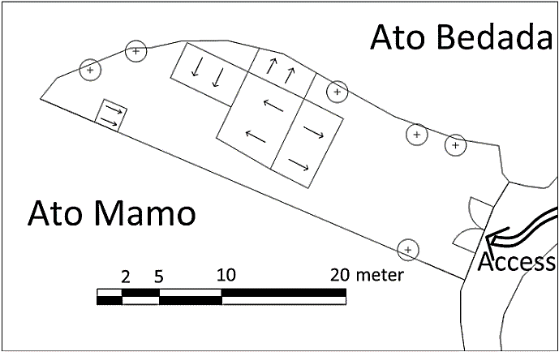
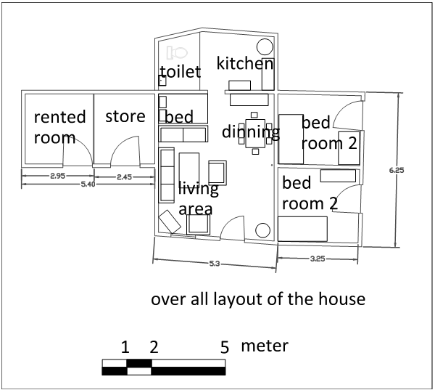
Figure ‎5-4 location map (a &b), site map (c), building layout (d) and elevations of the house (e)
d
e
c
W/ro Letemikael’s settlement is located in Woreda 10, Yeka sub-city, Addis Ababa, Ethiopia. The area had a specific local name which is Anqorcha (አንቆርጫ) Gebere Mahber (Now it has a new name which is Shed-Sefer ሸድ ሰፈር). This name was given to this area because a temporary shelter was constructed for the purpose Micro and Small-scale Enterprises in this area in 2000.
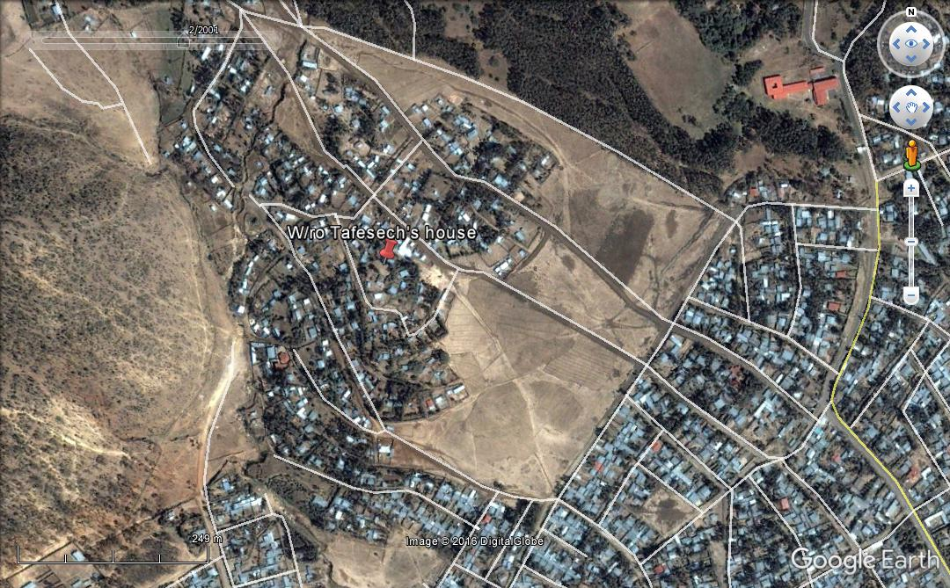
These areas used to be the residential and farm land of the farmers with single-storey chika (mud houses) houses for living as well as for their cattle’s. Starting from 2000, these farmers started to sell pieces of land (Figure ‎5-5), from their own compounds and from their farm lands as well which was around the area, to different people until 2012. In the past one and half decades, the area was changed tremendously in terms of density of residents (Figure ‎5-3).
Figure ‎5-5 shed sefer in 2001

Life story-1

W/ro Letemikael came to Addis Ababa in 2009 with her four children. She has been living in Asmara since she was 15 years old (now she is about 60 years old). Life has been difficult since she came to Addis Ababa because she had no one to rely on except her second child who works in Riyadh, Saudi Arabia. Her third son (who came to Addis Ababa 5 years earlier) used to live alone in a single private backyard house. When he was informed that she is coming he had to change, since it is not enough for him, his four brothers and his mom.
Figure ‎5-5 w/r Letemikael
After arriving in Addis Ababa w/ro Letemikael got in to this two-room, private backyard house around ‘Hayahulet’ which her son rented. At first, she was able to pay for the rent ,600 ETB per month, and feed her children, by renting a small shop in the area. Later on, however, the owner raised the rent because of the number of the family members and asked her to reduce the number of the guests that come to the house. She said, “I cried the whole day when she told me to bake injera once in two weeks. Or else I have to use fire wood for that” She decided to moveout and look for a house that she can afford.
It was on this time that she heard that there are ‘Chereka bet’ in Kotebe where the rent is good enough for her. However, even though she was able to afford the rent no one was able to rent her a house when they learned that she has six children (one was her brother’s son who came to live with them from Adwa by then). For about three years the family has to move in and move out (five different Chereka bet houses) from one place to another (Figure ‎5-6). Even though it was on the same area, Kotebe, and specially for the children that they don’t have to transfer from one school to another, it was difficult for the family as a whole to have a sense of belonginess and sense of place. “Until recent years” w/ro Letemikael said, “we never had Edir, Equb, Mahber or even father of confession for that matter, we were just working for our survival and thinking where our next “home” would be.”
At this time w/ro Letemikael ’s second daughter came to Addis Ababa. Hence, she had to rent a more decent house, for the house she was in was not enough for all and had no separate facilities like kitchen and toilet. The family then had to move for a three-room rent, private backyard rental with separate kitchen and toilet, with 1500 ETB per month (Figure ‎5-6). Here they only stayed for six months. This was because her daughter had decided to return again after four months of her stay in the house deciding that the family need to have a house no matter what.
With the help of a ‘delala’ (an informal realtor) they were able to find a piece of land in shed sefer. The farmer who sold them the land owned an inherited 900 m² of land. An area of 300m² was sold to w/ro Letemikael with 160,000 ETB. The land had two (2x3 m each) chika (mud) houses and about 25 eucalyptus trees (Figure ‎5-8). The land had no legal tenure, hence no services like water and electricity. The contract was done between the two insisting that, w/ro Letemikael will pay only 130,000 ETB at the time of purchase and after the land is legalized, she would pay the rest, 30,000 ETB. The family is happy that they don’t have to move again and could settle in one place without warry. Now that the land is legalized, the family is got services like; water telephone and electricity. The lease price offered by the government was too high for the family to pay. “We are still living in a daily basis, we don’t have such money. I am happy that I am here but the government was going to take the land if I hadn’t paid the 10% of the total lease price which was around 48 thousand.” The social life had already started for the family. The children have got friends, which was difficult for them before because of the moving, and the family is engaged in Edir and Mahber.

Housing finance Affordability
Since her arrival to Addis Ababa, w/r Letemikael has changed 4 houses in just two (2) years. This made life worse for the family. The rent was increasing dramatically as they change dwelling every time. Because the family was not able to catch-up with this “race”, it had to look for more affordable options that meet their capability. This situation lasted for five years with worsening outcomes.
W/ro Letemikael’s main source of income was the small shop she had when she got into the fifth house. Before that her daughter supported the family in addition to the small support, she got from her third son who was working in an advertising company.
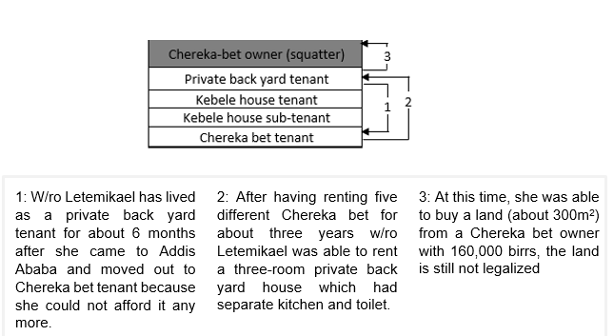
Figure ‎5-6 housing ladder
According to w/ro Letemikael, after she bought the land, the compound has gone through three transformations. Except the first one, the late two were done without the consent of the local authority (kebele). The cost for the construction of the houses was covered by the income from the small shop and with the materials, eucalyptus and mud found from the compound.
b
a
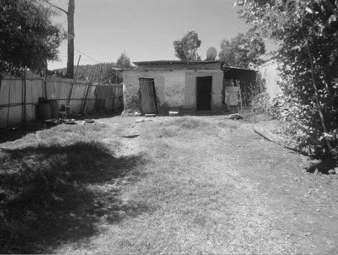
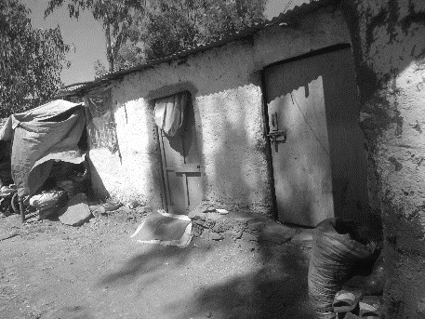
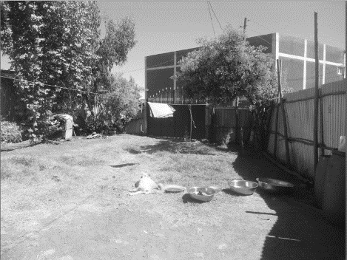
c

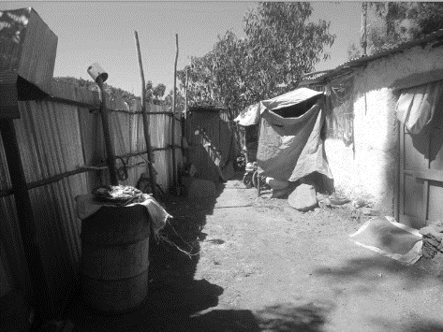
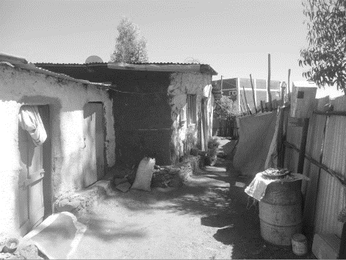
e
d
Figure ‎5-7 Arial views of the compound. Front yard (a), store and rented house (b), first two rooms (c), toilet and backyard (e).

Transformation of the compound
The compound has gone through different stages of transformation. These transformations were done without the consent of the government officials (kebele), except the house constructed in 2012 (Figure ‎5-7) and (Figure ‎5-8). This was because, the area was informal and the residents had no official deeds to do so. The house constructed in 2012 were done with the consent of the government officials. Documents permitting the residents to construct, modify and renew are given if their situation is proven “critical” (like toilet, fences and roof).
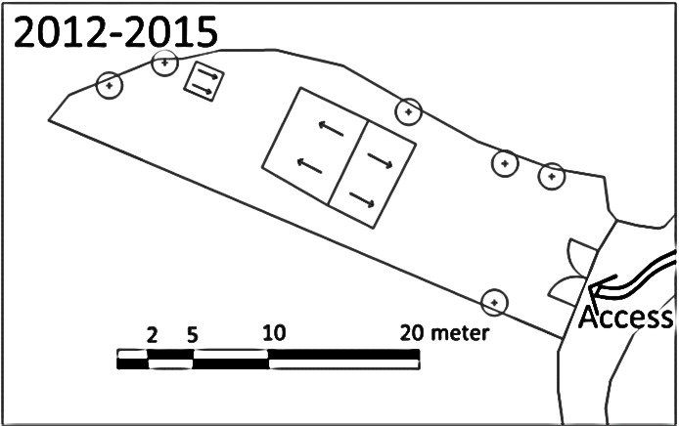
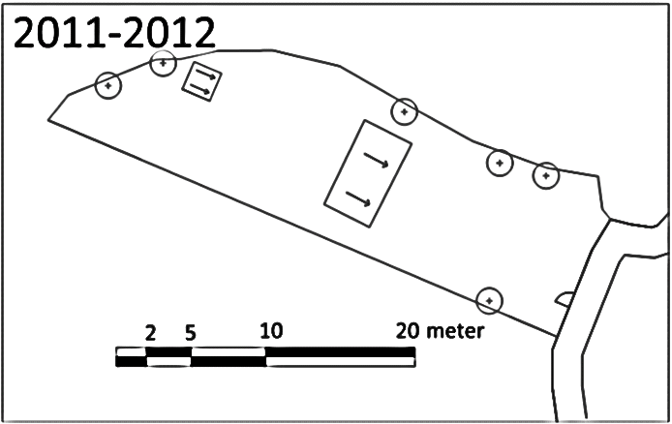
b
a

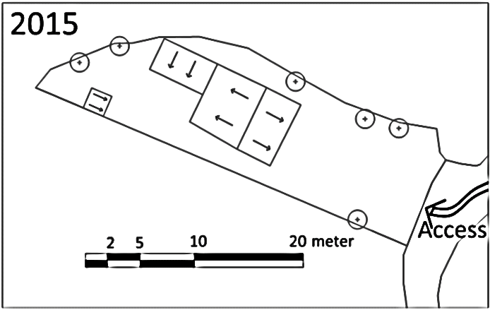
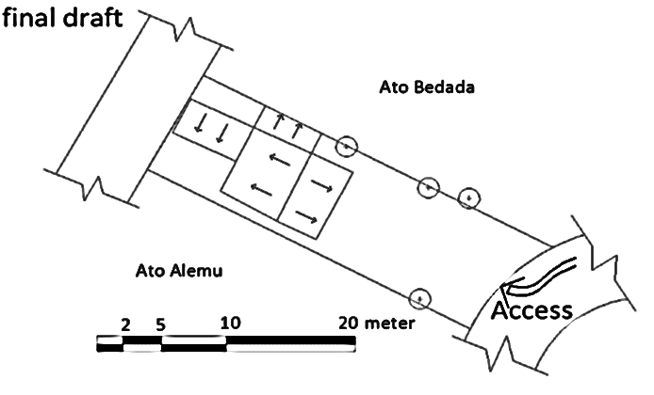
d
c

Figure ‎5-8 the transformation of the compound from the time of purchase through now.

Case 2- Ato Daniel Alemu

Location
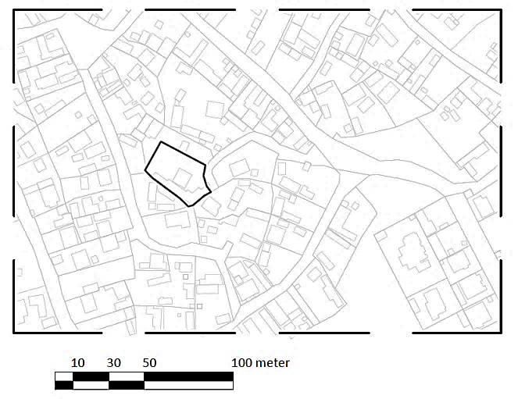
b
a

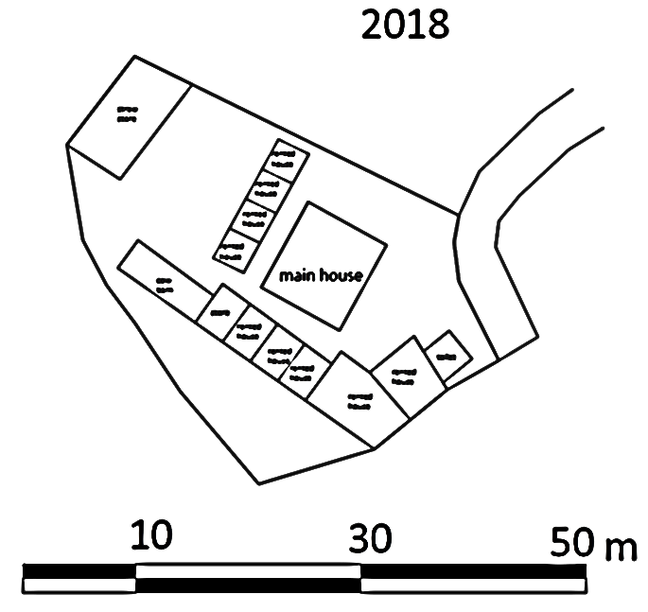
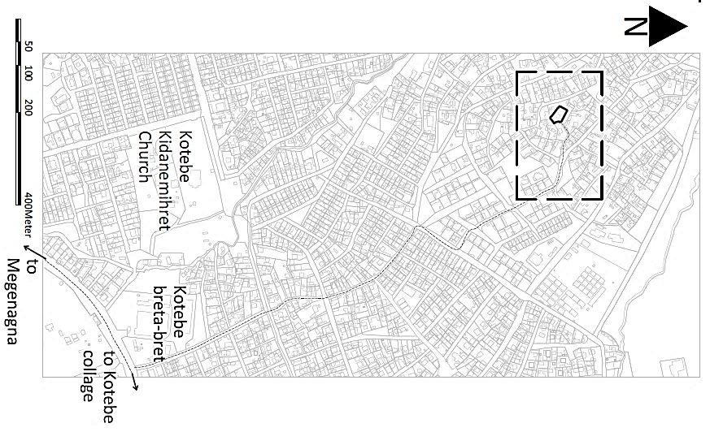
Figure ‎5-9 location map (a &b), site map (c), building layout (d)
c

Life story-2
Ato Daniel was born in Addis Ababa, shed sefer (the same place he is living at present) in 1970 from his father Ato Alemu Shume and his mother w/ro Yetnayet. After he got married, he left the house and start living separated from his parents for the first time. After his father died and left the land to him, he started to live in this same land assuring his legal inheritance in the court 1993. The land he inherited was almost 1400 m² with one big main house at the centre of the plot and a barn for the cattle which he inherited from his father as well (Figure ‎5-10).
Since 1993, the time he inherited the land from his father, Ato Daniel has being living in the compound with his wife and two children. The girl is the older one and is a 4th year student at Dire-Dawa University and younger one is a boy, he is 9th grade student (this is at the time of the study).
Ato Daniel constructed rooms for rent at different times to increase his income. In addition to that he also bought new cows which produce more milk, by selling the old ones he got from his father and selling pieces of land. This was his main income in addition to the rental rooms. Since that time, he sold four pieces of land at different times. This also helped him to construct more rooms for rent. However, he hasn’t modified the house he was living in since he got in the area only that he modified the room for his cattle to accommodate more cows.
When the regularization process had begun, Ato Daniel registered like everyone else to adjudicate his land. The concept of registering his own land as lease and also paying for it was improper in his point of view and others like him who inherited their land from their ancestors. "It doesn’t seem right" said Ato Daniel, "that the land we have being living in and our forefathers have been living in, would be sold to us by the government". However, there was nothing he could do and he decided to follow up the process and deal with the situation. Since the land was large, 1400 m², the amount he had to pay was extreme, in his point of view. More than 1 million was expected of him to pay for the whole land lease. He was devastated by this prerequisite and decided to terminate the regularization process.
The other situation that made him frustrated and went on quitting the process was that, he went to the office several time and was asked to give bribe from three officers. "One clerk even asked me to pay 10,000 ETB (ten thousand), promising he would reduce the amount I must pay for the lease price" said Ato Daniel. He refused to pay and returned losing his hopes on getting his land deed. The land is therefore, not legalised until the time of the study. Ato Daniel is one of the residents who haven't got their land deed.

Housing finance Affordability
Ato Daniel inherited 1400 m² of land from his father. In addition to that he also got 3 cows (domestic) which were giving 15-20 litter of milk per day. This was good source of income for the family. In addition to that, he had constructed rooms for rent (currently there are 9 rooms for rent, 4 rooms with 1000 ETB, 3 with 800 ETB and 2 with 500 ETB) (Figure ‎5-10). When he decided to buy more cows (hybrid), he sold the old ones he got from his father and he sold a piece of land (200 m² of land Northwest to the main house). Using the money, he bought 5 cows which could give each 10-15 litters of milk per day. This was good source of income and the family was saving good enough.

Transformation of the compound
When Ato Daniel got the plot from his father, there was no structure but the main house and a barn for the cattle’s. The compound has gone through different transformation since then. The following were the major transformation made at different times.
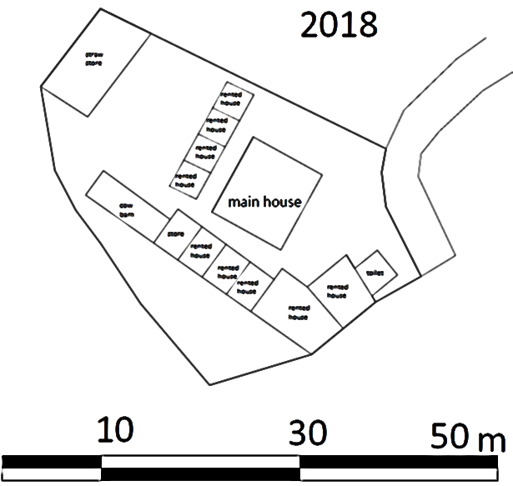
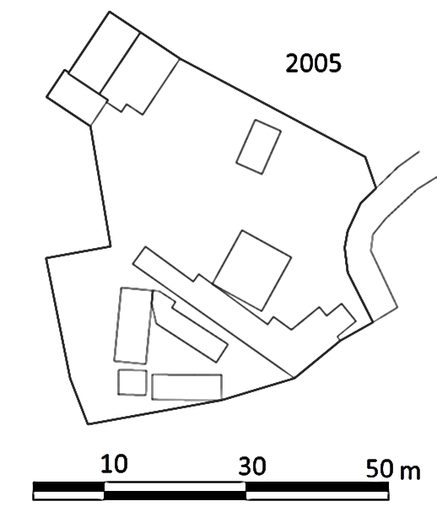
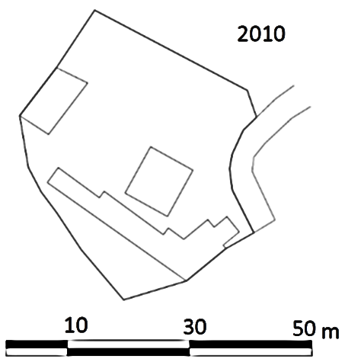
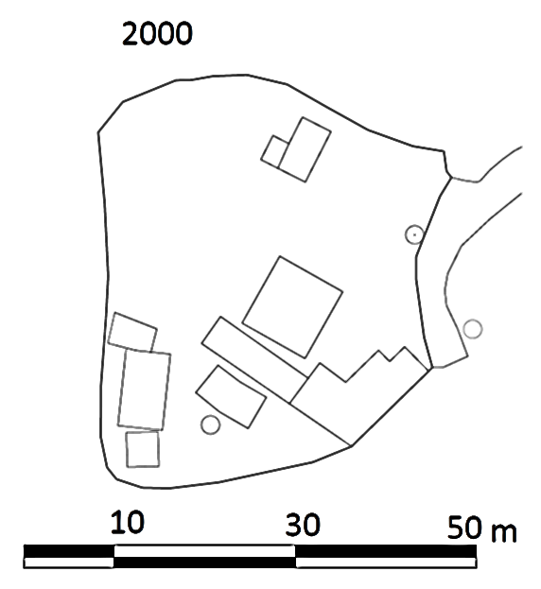
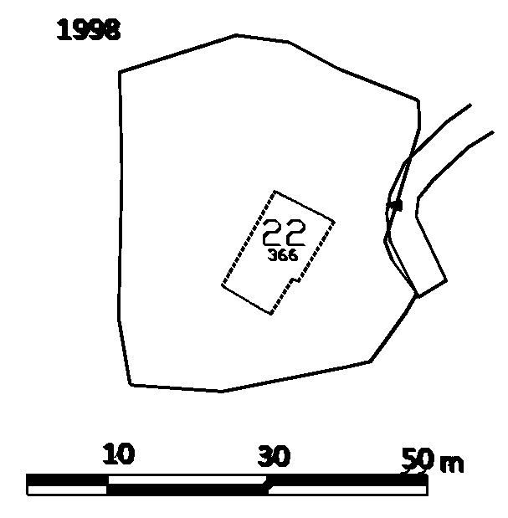
e
d
c
b
a
Figure ‎5-10 transformation of the compound in about 20 years

Case 2- W/ro Etenesh

Location
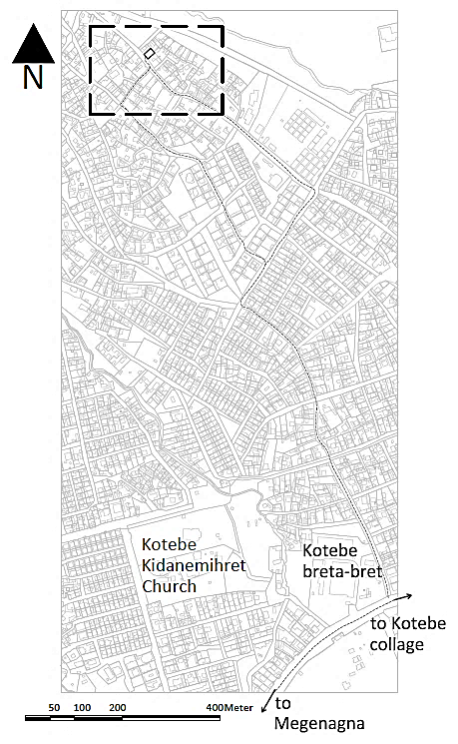
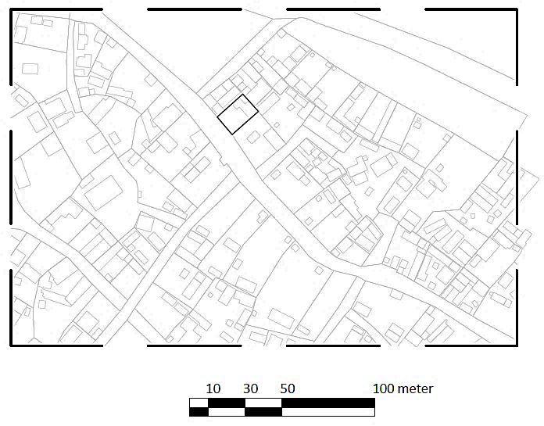
b
a

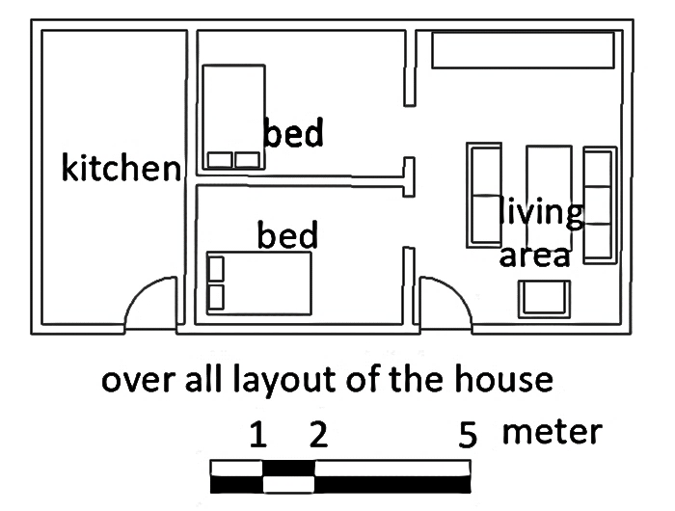
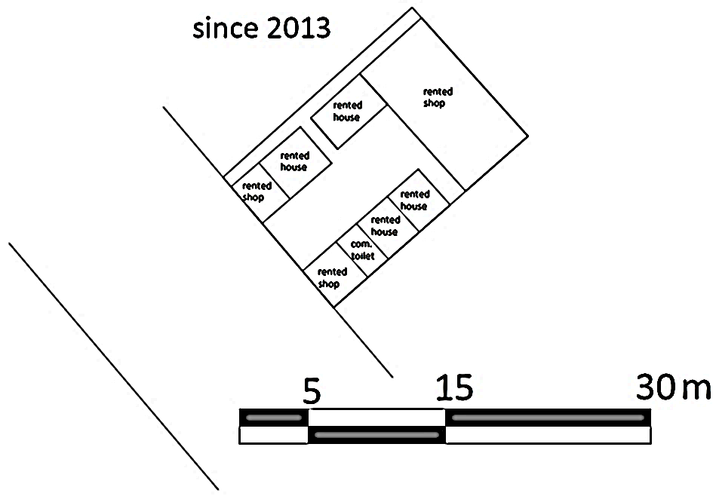
Figure ‎5-11 location map (a &b), site map (c), building layout (d)
d
c

Life story-3
W/ro Etenesh was born in Gojam. Before she came to Addis Ababa in 1992, she got married and move to Gondor with her husband. After their 7 years stay in Gondor, they moved again to Addis Ababa in the hope of a better life. The family had one child, Tilahun, during their journey to Addis Ababa. This choice, coming to Addis Ababa, was made in search of better job and better lifestyle. The house they were living in while they were in Gondor was only one room. They barely could pay the rent. The only income they get was from Ato Tesfaye, the husband, who was the only one working during that time. However, his payment was not enough for the family to lead a middling life.
The hope that dragged the family to come and live to the city was, a relative living in Addis Ababa gave a job offer to Ato Tesfaye in a construction site, for Ato Tesfaye works as a mason. This was a great opportunity for the “small” family to start afresh. They came to the city in 1992.
They first got in to a small, one room house, near the area they are living now. The room was constructed with mud and timber, that it is was cheap and fitting with their income was good enough for them. Through time, Ato Tesfaye’s income started to go up and hence they moved to a better room. It was during this time that they heard about lands being sold from farmers in the same area. Though it was not cheap, for the income they had, they decided to buy one, for the same relative who helped them move to Addis Ababa offered to help them to do so. They agreed to take money from him and return it in due appropriate time.
They found this land with the help of “delala” (informal realtor) who led them to a farmer who happen to sell a piece of land from his own compound. The price, the farmer offered was 4000 ETB for 200 m² (this was in 1999) which was unacceptable by the family. This was too much for the small family which had a second child coming on the way. After a long bargaining, they finally came to an agreement with a price of 3000 ETB. At the time of purchase the land had no official document except the sketch map (line map) and power line bills. The land had only one room on the purchased land constructed with mud and wood only for the purpose of selling the land(Figure ‎5-10).
The profession of Ato Tesfaye, a good mason, had helped in raising some more rooms for the family to live-in at first, and some more for rent in the past twelve years. This was the main income source for the family in addition to the ‘wage’ payment of Ato Tesfaye. This helped also for the repayment of the money they borrowed to buy the land form the “good relative”, according to W/ro Etenesh. When the regularization process was put to action, it was easier for the family to make the necessary payment for they have started saving from the rental income. Paying all the lease price which was 24,304.00 ETB, they got their land deed from the administration.

Housing finance and Affordability
The main income, W/ro Etenesh’s family had before they got in to this plot was, the one, they get from Ato Tesfaye’s payment. This was barely enough for their daily life to lead. The situation has changed since they got the land in 1999. They had no rental expenses hence they had to put the money they used to put to rent for the construction of more houses. By the time they had erected rooms for rent they were able to save more money for both their basic needs as well as their housing needs.
Another reason that made the family able to afford the lease price was that the area of their land to be legalised was reduced from 218 m² to 112 m². In the first stage, where only 75 m² was considered to be multiplied with 217 ETB and the rest with the highest auction price (3662.96 ETB), W/ro Etenesh’s family had to pay 151,804.52 ETB (one hundred fifty-one thousand eight hundred four ETB and fifty-two cents). However, in the second stage, where only 150 m² was considered to be multiplied with 217 ETB and the rest with the highest auction price (3662.96 ETB), W/ro Etenesh’s family had to pay 24,304.00 ETB (twenty-four thousand three hundred four ETB).
This was a good opportunity concerning the payment they had to do, even though they had to lose almost half of the land they used to own. However, this lose was acceptable by W/ro Etenesh’s family for there were neighbouring families who happen to have being denied “their” land-deed by the government. Henceforth, the family where thankful that they got their land and had to pay the amount they could afford. Paying all the whole amount of the lease price the family is now one of the recently legalized land owners in the area.

Transformation of the compound
By saving their rental expenses they had been paying before, they were able to construct six rooms for rental purpose, in addition to the renovation of their house. The rooms were constructed at different times progressively and using mud and wood. This construction was done without the consent of the government officials. Currently, there are five rooms and two shops (for rent only).
The latest Addis Ababa’s master plan is to change the plot size and shape, though it had not been implemented yet. A 20-meter-wide sub-arterial road is to pass in front of the plot reducing 98 m² from the total land. This situation definitely had frustrated the family and they made complaints together with other affected families. However, there was no positive response from the planning bureau. However, there was no alterations made because of their complaints.
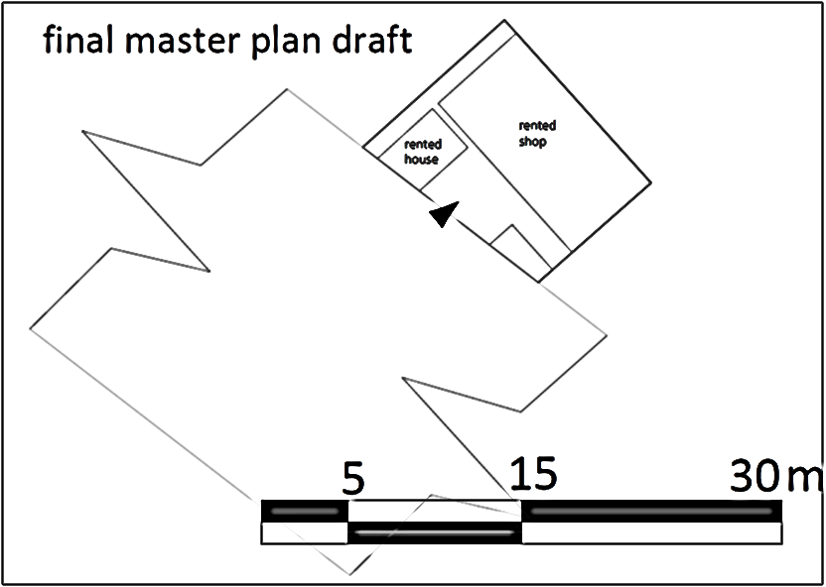
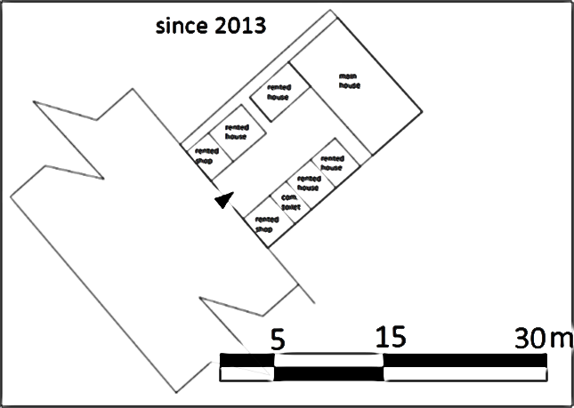
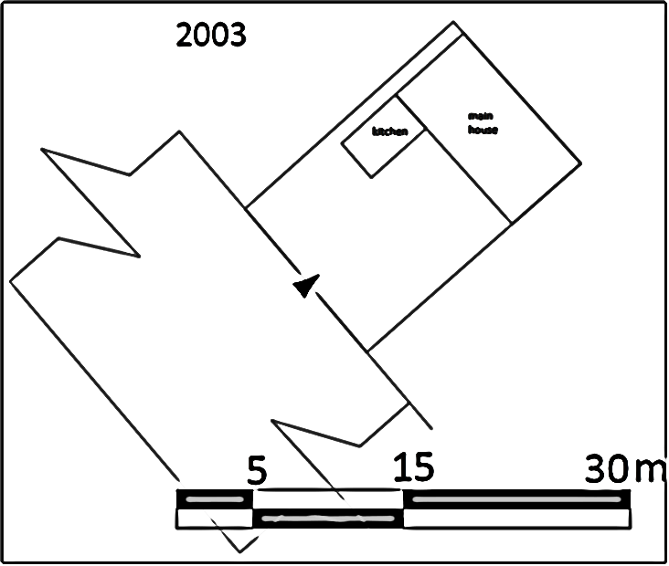
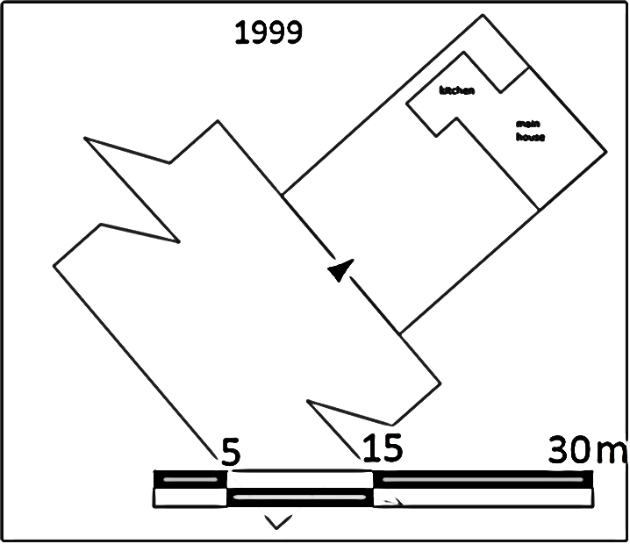
Figure ‎5-12 transformation of the compound in 20 years

DATA PRESENTATION AND ANALYSIS

Introduction
This study is concerned with the process of regularization and the issue of affordability in relation to the process. In order to understand these issues, a background of the issue and the case of ‘Shed Sefer’ were investigated. In this chapter the data collected from these investigations are to be presented and analysed. These includes the maps, pictures, observations and interviews. These data will be presented, analysed and interpreted below.
The data was collected from 20 households which resided in the Shed Sefer area in different times. These interviewed residents comprise of different background. From these, six of them inherited their land and the rest bought from land owners. Since most of the informal settlements are located in the “northern” part of the study area, all the interviewees are located in this area.
1 | Letemichael G/Silasie
2 | Daniel Alemu
3 | Etenesh Bayleyegn
4 | Belachew Teshome
5 | Shume Dinko
6 | Zelalem Teshome
7 | Abera Tadele
8 | Teshome Bedada
9 | Habte Demelash
10 | Betsega tadele
11 | Abate
12 | Hailu
13 | Tigist Hailu
14 | Ato Getachew
15 | Ato Million
16 | Kedir Alem
17 | Ato Akalu Abebe
18 | Ato H/Mariam
19 | Yohanes
20 | Habte
 | legend
 | Inherited
 | bought
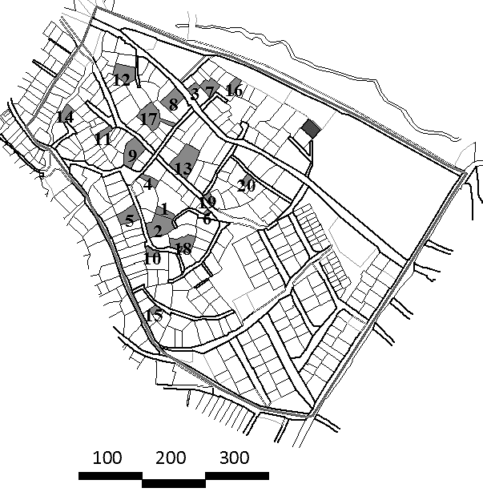
Figure ‎6-1 location map of interviewed residents

Household profile of respondents
In the study area, according to the administration of woreda 10, there are 1210 households (including tenants). From these only 574 households are the owners. Of these settlers 311 (56%) were informal settlers (Figure 6-2). These informal settlers have different background in relation to where they came from. There are those who got the land from their forefathers and those who bought pieces of land from these successors and remained informal until 2014. The remaining 44% were legalized before 2014. These legalized settlements are mostly located in the southern part of the study area. This is because, these areas used to be farm fields of farmers who resided on the northern part of the study area. These fields (farm lands) were then sold to individuals (by the farmers who owns them) with relatively very cheap price. The farmers say, they had to do this before the government took their lands with less or no compensations at all. The individuals who bought the lands registered their own plots separately and got their deeds before 2014. For this reason, as shown in the map below, the study area can be divided into two parts based on the formal-informality pendulum of the settlements. The parcels in the southern part are of 100% legalized ones. Going up to the upper part, the northern part, the percentage of formality decreases as the informality percentage increases.
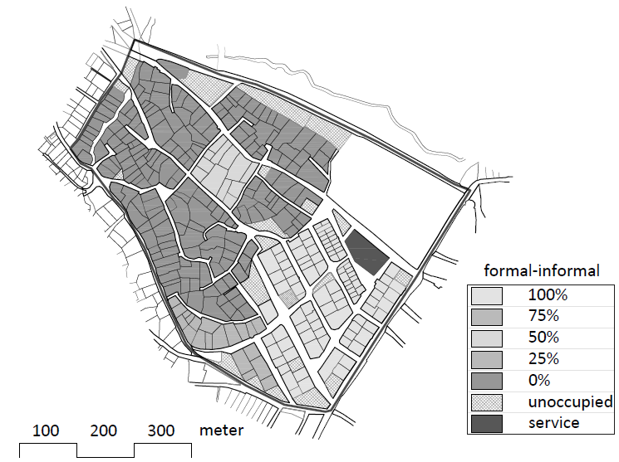
Figure ‎6-2 parcel-based forma- informal lands range
The table below (Table ‎6-1) shows that the respondents’ participation in the interview based on age and sex. Based on this, it shows that, the age group participated in the interview were of on the range between 20 to 65. This is in favour of the researcher in providing a variety of information according to the respondents. Out of the 20 interviewed residents 9 of them were above the age of 50. This by itself has positive input in providing information of the history of the site.
Table ‎6-1 respondents’ participation based on age and sex
 | male | female | total
House hold size | 48 | 52 | 100
 | Age | Frequency | %
Age of respondents | 20-30 | 3 | 15
Age of respondents | 31-40 | 5 | 25
Age of respondents | 41-50 | 3 | 15
Age of respondents | 51 -65 | 9 | 45
 | total | 20 | 100
Sex of respondents | Sex | Frequency | %
Sex of respondents | male | 10 | 50
Sex of respondents | female | 10 | 50
 | total | 20 | 100

The family size of the Shed Sefer interviewed residents range from 1-7. The family size with 6 members is the most frequent one (30%), followed by 5 and 4 respectively (based on the interview). (Table ‎6-2)
Table ‎6-2 family size, frequency and percentage
family size | frequency | %
1 | 1 | 5%
3 | 2 | 10%
4 | 4 | 20%
5 | 4 | 20%
6 | 6 | 30%
7 | 3 | 15%

Table ‎6-3 distribution based on educational status
 | Male | Female | Total | Percentage
Illiterate | 1 | 4 | 5 | 5.1
Elementary | 17 | 17 | 34 | 34.3
High School | 16 | 16 | 32 | 32.3
10+1,2,3 | 2 | 3 | 5 | 5.1
University | 2 | 3 | 5 | 5.1
Degree and Above | 7 | 4 | 11 | 11.1
Total | 51 | 48 | 99 | 100.0

Table ‎6-4 distribution based on marital status
 | male | female | total | percentage
married | 21 | 17 | 38 | 38%
single | 30 | 29 | 59 | 60%
widowed | 0 | 2 | 2 | 2%

Process of regularization in “Shed Sefer”
The regularization program of the informal settlements in the study started officially in march 2014. According to the proclamation no. 818/2014 (2006 E.C) proclaimed in March 2014, the government issued for the registration of urban land holding. This was introduced to regularize the informal settlements which were not included in the lease policy of the urban land administration.
Figure ‎6-3 flow chart of the land adjudication process
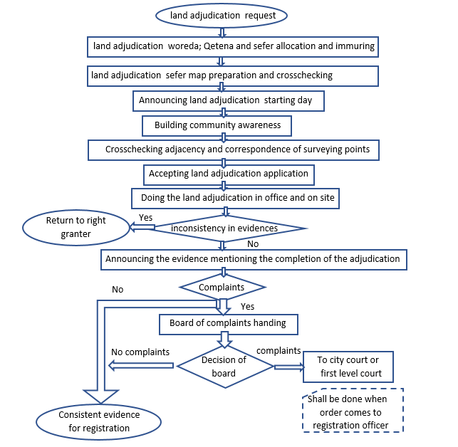
Source; urban land holding adjudication and registration standard no. 05/2014 (05/2007EC)
Based on the above procedure, the regularization process was started in September 2014 (2007 E.C) in “shed sefer” area. This area was the first to register its informal residents. At this stage, 311 informal settlers who reside in this area were registered. The Qetena/district representatives of “shed sefer” were selected in order to undertake the regularization program of this area. From the 311 residents, all except the 11 were eligible for the regularization of their land according to the Woreda 10 criteria. These 11 households were not eligible because of either; their plot was not visible in the Nortec Map, the plot size is below minimum standard plot size to be allocated, mismatches of name spellings in different documentations or boundary disputes. These reasons are to be explained further below. Aside from these the rest were “able” to regularize their land. Even though the 300 fulfilled the legal conditions to the eligibility of regularization, there are still some of the land owners, 35% of the interviewed residents for instance, who did not go through the whole regularization process. Especially those who inherited the land from their ancestors refused to pay the lease price required by the government to undertake the regularization.

Common problems that delayed the process
The process took longer time for many of the residents in the study area, according to the interviews made with the residents. Although it has to do with different issues, the issue of affordability took a wider influence. This issue will be discussed in this section, but before that, to mention some of the common problems that delayed the process are as follows.
- Nomenclatures: what is meant by this is that, there are different documents that the residents have to bring to the woreda for the authentication of the property. Article 14 sub-article 2 states that “Where there is inconsistency between the evidences mentioned under sub-article (1) of this Article the matter shall be referred to the appropriate organ empowered to permit land use right”. These documents include the electric bills, water-line bills, telephone-line bills (if there are any), agreements showing how they got the land (be it inheritance or purchase from farmers) and personal identification documents. When cross-checking these documents, the ‘adjudication officer’ should also check the names if they match to avoid fraud. Hence, if the name spelling of the residents doesn’t match, they are not able to proceed to the next step.
- Nortec map: the next step is to check if the layout of their property is in alliance with or if the property dose really exists in the Nortec map of 1996 (1988 E.C). what is included in the layout, be it a house a tree or reference point is checked in this stage. However, there were landholding right requesters who brought a lay-out without any indicating/ reference points shown in the 1996 Nortec map and calming to have a house in their plot even before that time.
- Opposition: in the first stage the residents revolted opposing the ‘lease price’ provided by the government. As previously mentioned, the government set the lease price to be in two parts (this issue is further explained below). These are; those who reside in the area before 1996, and those who did between 1996 and 2005. This classification was made to distinguish the illegal squatters from the legal ones, though it might not have been successful. These and the amount of land lease payment benchmark were the main issues for the resident’s opposition during the process.
- Below standard plot size: the government set the “minimum plot area” to be regularized in the area. The minimum plot area eligible for regularization is 55m² (fifty-five m²) and those residents who “own” lands below this standard are denied to get the legal land deed. This is one of the obstacles for the residents to regularize their land.
All or at least one of the above situations made the process to be delayed. According to the Woreda 10 regularization process representative officer, these obstacles were handled in a careful way in order to avoid disputes. The problems that could be solved by the Woreda were handled by the Woreda. These included the Nortec map problems. The rest were sent to the respective bureaus to be resolved.

The land lease payment procedure
In 2014, when the process of regularization was started, the government put prerequisites for the process to carry-on. Besides the authentication of documents and the eligibility of the land to be regularized for the process, the residents had to pay for the land lease price set by the government. This price was set in two parts, based on the time the residents settle in the area they are to regularize.
- The residents which settle in the area before 1996 and which have documents (sketch maps, power bills, water bills and certificate from the woreda) of the land, are referred to as “old possession “nebar yizota” (ነባር ይዞታ). These residents were one category on the land lease payment procedure.
- The residents which settles (mostly purchase) in the area between the years 1996-2005 are referred to as parcelling (ሽንሻኖ).
- The ones who came and hold informal lands after the year 2005 were not eligible for requesting land adjudication. The only option they get is to wait for land auction provided buy the government or by land from previously legalized owners.
Payment of the land lease price was set based on the above conditions. At first the government set the procedures as follows.
- The residents with “old possession” (ነባር ይዞታ) would have to pay the “lease benchmark price” which is 217 ETB per square meter for the 150m². For the rest of the land they occupy they would have to pay based on the recent land purchase per square meter from the government in that same area, which is 3662.96 ETB in the case of Shed Sefer.
- The occupants who settle after 1996 and before 2005 would have to pay the “lease benchmark price” which is 217 ETB per square meter for the 75m². For the rest of the land they occupy they would have to pay based on the recent land purchase per square meter from the government in that same area, which is 3662.96 ETB in the case of Shed Sefer.
These payments were very expensive for the residents and they had to oppose them by refusing to pay. All the residents did not pay, even though they all wanted to get their land deed. These opposition were beyond the Woreda’s ability to answer, hence, officials from the sub city came and held a two-days meeting with the residents in January, 2017. The residents demanded on the reduction of the lease price set by the government, for it was too much for them to bear. However, their request was impossible for the officials to adjust and came up with another way of reducing the total payment.
The modified way of the procedure follows the same lease prices set by the government. Also, the distinction between the residents with “old possession” and with parcelling (ሽንሻኖ) was left as it was. The modification was made on the area to be multiplied by the lease benchmark price and maximum auction price in the area.
Based on this, those with “old possession” would have 500 m² of their land to be multiplied by the “lease benchmark price” which was 217 ETB and the rest of the land they occupy would be multiplied by the maximum auction price in the area (3662.96 ETB). In the same way those who settle after 1996 and before 2005 would have 150 m² of land to be multiplied by the “lease benchmark price”, which was 217 ETB and the rest of the land the occupy would be multiplied by the maximum auction price in the area (3662.96 ETB).
This procedure reduced the payment that the residents had to pay by almost 50%. But still, residents with lower income and those who occupy large areas of land were unable to pay since the total amount they had to pay was higher than they could afford. However, residents with the capacity to pay and those with less land areas (specially less than 150 m²) started the process, since the total amount was less compared to the previous once. This division made the process continue and those who couldn’t pay were forced either to pay or stop the process and continue living informally, like Ato Daniel (case-2 in this research).

The regularization process and affordability
In this study, 13 out of the 20 interviewed residents had got their land deed, out of which 2 are the ones who inherited their land, while 4 of them did not get their land deed. This was after the government made modification on the land lease price of the regularization process. Before that, none of the residents, registered to regularize their lands, were willing to pay the required payment, for it was more than they can bear. Hence, the government made a dramatic modification on the payment procedure, which reduced the price by almost 50% for most of the residents.

Source of income of resident
As mentioned in the previous articles, there are more tenants than there are plot owners in the study area. This is a great source of income for the land owners. 19 out of the 20 interviewed residents has spare rooms for renting. Though most of these rooms for renting are below standard and made of mud and wood, they are cheap relative to the rent payment in the city and they are those that can be afforded by the low-income groups. This is common in the study area and the whole woreda 10 as well. Some of them even have shops for rent, with monthly rent higher than rooms for households’ residence. 10 out of the 20 interviewed residents have shops for rent in their plots. Out of these 10 residents which have shops for rent, 3 of them run the shops by themselves. This is also another way of getting income for the residents.
Table ‎6-5 residents common frequent of income
Source of income
Shopkeeper/rent | 10 | 50%
Chauffeur | 1 | 5%
Cattle farm | 3 | 15%
Renting houses | 19 | 95%
Retired | 1 | 5%
Construction | 2 | 10%
House wife | 3 | 15%

The above table shows the range of sources of income, the residents have to lead their lives. 15% of the interviewed residents have livestock (sheep for sale and cows for milk) that they keep in addition to other income sources (rooms for rent and shops). This has helped the family in saving money for the family.

Income difference
The income of the residents was difficult to identify this is because, the residents interviewed were not willing to state their exact income. This is a common problem that researchers face during research, especially in Ethiopia. To rectify the situation two methods where used. One is the estimation of their income based on the expenditure that the interviewees claimed to have. The problem with this was that the residents exaggerate the amount of expenditures they have and lowers down the income that they say they get. This situation is a hinderance by itself.
Table ‎6-6 residents income based on interviewee and based on researcher's estimation
 | Income | Frequency
EXPENSE | 0-5000 | 4
EXPENSE | 5001-10000 | 13
EXPENSE | above 10000 | 3
INCOME (BASED ON INTERVIEWEE | 0-5000 | 6
INCOME (BASED ON INTERVIEWEE | 5001-10000 | 12
INCOME (BASED ON INTERVIEWEE | above 10000 | 2
INCOME (BASED ON ESTIMATION) | 0-5000 | 0
INCOME (BASED ON ESTIMATION) | 5001-10000 | 2
INCOME (BASED ON ESTIMATION) | 10001-20000 | 12
INCOME (BASED ON ESTIMATION) | 20001-30000 | 3
INCOME (BASED ON ESTIMATION) | above 30000 | 3
The next method the researcher used is, to evaluate the sources of income and estimate the average income they could get from each source. For instance, as mentioned in the case study, Ato Daniel claimed to have 7000 ETB of income per month in the interview. However, based on the second method of the researcher, Ato Daniel has three cattle and sell more than 25 litters of milk per day. This is more than 20 thousand per month. In addition to that Ato Daniel has 10 rooms renting ranging from 500-1000 ETB per month. Considering the same conditions for each interviewee in the study, the possible income of the residents is estimated and presented in the above table (Table ‎6-4).

Affordability
From the interviewed residents, only 65% were able to complete the process and got their land deed during the study time. The rest 35% were unable to follow up the whole process even-if they wanted to. From these 35%, who haven’t got their land deed, 86% of them were unable to afford the lease payment set for them by the government and the rest was because the plot area is below standard. The tables below (table 6-5 and table 6-6) shows the resident who got their land deed and those who did not (based on the interview).
Table ‎6-7 how many got their deed and how many did not?
 | Process of Regularization program
 | got the deed | haven't got the deed | total
inherited | 2 | 4 | 6
bought | 11 | 3 | 14
total | 13 | 7 | 20
% | 65% | 35% | 100%

Table ‎6-8 Reason for not getting the land deed
 | Reason for not getting the land deed
 | standard | affordability | total
inherited | 0 | 5 | 5
bought | 1 | 1 | 2
total | 1 | 6 | 7
% | 14% | 86% | 100%
The following table (Table ‎6-7) shows that the land price has changed dramatically in the past 20 years. The change ranges (based on the interviews) from 3.49 ETB per one metre square to 1612.90 ETB per one metre square in just 19 years. The highest price jump was made in the years between 2010 and 2013. This was due to the government policies and proclamations made during and just before these years concerning urban land.
Table ‎6-9 land price based on time of purchase
YEAR OF PURCHASE | AREA | AREA (MODIFIED) | % SUBTRACTED | PRICE (purchased from land owners) | PRICE PER M²
1994 | 716 | 692.2 | 3% | 2500 | 3.49
1999 | 219 | 110.9 | 49% | 3000 | 13.70
2000 | 777 | 498.4 | 36% | 12000 | 15.44
2002 | 274 | 274 | 0% | 25000 | 91.24
2006 | 260 | 244.7 | 6% | 75000 | 288.46
2007 | 371 | 336 | 9% | 80000 | 215.63
2010 | 320 | 320 | 0% | 150000 | 468.75
2011 | 300 | 261 | 13% | 160000 | 533.33
2012 | 199 | 186 | 7% | 130000 | 653.27
2013 | 62 | 45.9 | 26% | 100000 | 1612.90
2013 | 137 | 133.2 | 3% | 120000 | 875.91
2013 | 177 | 133 | 25% | 150000 | 847.46
2014 | 545 | 545 | 0% | 500000 | 917.43
2017 | 270 | 253.9 | 6% | 250000 | 925.93

FINDINGS AND RECOMMENDATION

Summary of findings
As mentioned in the first chapter of this study under the objective subtitle, the aim of the research was to understand the process of regularization of informal settlements and the issue of affordability in relation to the regularisation. In order to achieve this understanding of the situation, first hand data was collected from actors involved in the whole process, which are; government officials, brokers and the residents. These data were then presented and analysed in the sixth chapter.
Based on the data, the researcher was able to identify different outcomes from the process of regularization. These findings include process delay and the reason behind it; the increase in the value of land after the regularization had been introduced and the issue of affordability. These findings will be discussed below.

Process
The regularization approach was more focused in providing land deeds and is concerned to the promotion of property right only. Unlike the Tanzanian approach, which was focused on the community initiatives, it did not address the community’s way of life. This has resulted in notable disputes between the residents which were in-line to regularize their land.

Process delay
The study finds that the process took more than 4 years. In addition to that, there are also residents who still haven’t got their land deed. In this research, the main reasons for this delay was identified from the data collected. The first reason was, the residents were unable to afford the land lease price set by the government and they were unwilling to pay (especially those who inherit the land). This had led to for the consideration of the land lease price by the government. This consideration resulted in the reduction of the price up to more than 50% of the previously estimated payment. After this, some of the residents started to pay and got their land deed.
The other case that led to the delay of the process was, the eligibility issues. These issues include; minimum plot area standards, misspellings of the documentation referring the plot area and alliance with the 1996 (1988 E.C) Nortec map. In the woreda only 11 residents were returned out of the 311 registered informal settlers.
The third point that led to the delay of the process was the issue of corruption. These and other bureaucratic issues related to the regularization process were the reason for the delay of the process. Based on the study made in the selected area only 65% (13 out of 20) of the interviewed residents were able to go through the whole process and got their land deed.

The increase of land value
Those who finished their regularization process and got their land deed, are able to start construction with their preferred design (with in the standard set for the respective area). This was a good opportunity for the residents to modify the old ones that were used for rental purpose and construct new buildings for them to live in and also for rent as well. The new rooms are constructed with concert and hollow concrete blocks (HCB). Hence, the rent price is better for the owners compared to the previous one, which means more income.
Because of the regularisation process, the infrastructures in the area has been improved (more families get access to water line, power line and roads). This has also increased the land price in the area by two-hundred-fold. This was a good opportunity for those who wanted to sell their land because of affordability issue. However, this is a negative outcome for the people who wanted to rent as well as wanted to buy a house/ land in that area.
This has helped 2 of the interviewed to pay their lease payment. They had sold piece of land from the property to fully cover for the land price and construct a more suitable home.

Affordability
One of the main issues raised in this study was the issue of affordability in relation with the regularization process. It is mentioned in the data presentation that, 35% of the interviewed were unable to pay the land lease payment set by the government. The rest had gone through the whole process and got their deeds, but at great sacrifice. For instance, from those who got their land deed 2 of them had to sell piece of land from their plot (this is done informally) to pay their land lease payment. This shows that the land lease price was not set based on the income of the of the residents.
There is also the issue that the residents’ resistance, especially the ones who inherited their plots, to pay land lease price. Their reason is that, it is unfair to pay for the land they and their ancestors have been living for long time. The other reason is that, the idea the residents have about the urban land lease proclamation. One of the main points impossible for them to accept was, the idea that they had to leave their land or pay again for it when the leasing year is over. In addition to that most of the residents who inherited lands have large plots which in-turn made the land lease price go up farther where it is impossible for them to pay.

Recommendation
Based on the study done and the data presented & analysed, the following recommendation, to be an input for the latter regularization process, are presented below by the researcher;
The land lease price must be set based on, even though the actual income is difficult to identify, the income of the residents. Unless the price is in parallel with the resident’s income, the residents would be unable to finish the payment. If they do not pay, they would not get their land deed, and consequently no construction (formally). Therefor the government should consider the ones who are to pay in setting the land lease price (the lease benchmark price and the maximum auction price in the area).
Government should involve his citizens in the drafting of policies and let them participate in the decision-making process instead of just informing the already decided options. Before implementing the regularization process, or any other proclamation for that matter, the government should do awareness-building about the proclamation. By doing so, citizens would be ready to cooperate with the officials and this way the process will have less obstacles. In addition to that, the trust of citizens over the government would also increase.
The case of the residents with “old possession” was considered in the process of regularization in shed sefer. However, the total amount they should have to pay was beyond their capability, for the lands they own was relatively large. For this reason, the consideration for these residents must be careful and seen separately from the ones without the old possession.
The parcelling system did not consider the existing roads during the making of the latest master plan of the city. There are those who lost their plots, because the new roads “designed” pass through their plot and leaving nothing or below standard minimum lot size to be regularized. Though this is a case that concern the municipality, when the plans were made the residents should have participated in the plan preparation. It has made more damage for some residents, leaving them with less or no land at all.

REFERENCES
Abramo, P., 2009. Favela e mercado informal: A nova porta de entrada dos pobres nas cidades brasileiras. 1st ed. Porto Alegre: IPPUR.
Alemayehu, E. Y., 2008. Revisiting «Slums», Revealing Responses. Trondheim: NTNU-trykk.
BERHANE, D., OCTOBER, 2015. SQUATTER SETTLEMENT AND ITS IMPACT ON URBAN AMENITIES OF TILILI TOWN, AWI ZONE ETHIOPIA. ADDIS ABABA: ADDIS ABABA UNIVERSITY.
Betancur, J. J., 2007. APPROACHES TO THE REGULARIZATION OF INFORMAL SETTLEMENTS: THE CASE OF PRIMED IN MEDELLIN, COLOMBIA. Global Urban Development, November, III(1), p. 15.
CDM Smith Inc., 2013. India: Promoting Inclusive Urban Development in Indian Cities, India: Technical Assistance 7148-IND.
CSA, 2012. Inter-Censual Population Survey Report, Addis Ababa: CSA.
Davidson F & Payne GK , 1983. The Urban projects manual. Liverpool: Liverpool University Press.
Dowall, David, 2007. Brazil’s urban land and housing markets: How well are they working? In Land policies and their outcomes. Cambridge: Lincoln Institute of Land Policy.
FDRE, 1995. Constitution. Addis Ababa: Federal Negarit Gazzete.
Ferguson, B., 2008. A Value Chain Framework for Affordable Housing in Emerging Countries. Global Urban Development.
Fernandes, E., 2011. Regularization of Informal Settlements in Latin America, Cambridge: Lincoln Institute of Land Policy.
Gondo, T., 2011. Housing Informality in Expanding Ethiopian Cities: Moving beyond the ‘New Normal’ Syndrome. s.l.:REAL CORP.
IBGE (Instituto Brasileiro de Geografia e Estatística), 2000. Demographic Census 2000. [Online]
Available at: http://www.ibge.gov.br/english/
Jota Samper, Catalina Ortiz, Javier Soto, 2014. RETHINKING INFORMALIT; strategies of urban space co-production. Colombia: MIT School of Architecture and Planning.
Kamete, A. Y., 2001. The quest for affordable urban housing: A study of approaches and results in Harare, Zimbabwe. Development Southern Africa, V18(1), p. 34.
Kombe W.J & K Volker, 2006. Governance of Informal Urbanization in Tanzania. Dar-es-salaam: Mkukina Nyota .
Kumar, A. & Pushplata, 2013. Vernacular practices: as a basis for formulating building regulations. International Journal of Sustainable Built Environment, p. 189.
Kurtz, T., April 3, 2009. Kotebe hana mariam, Berlin: TU Berlin.
Lirebo, D., 2006. An Assessment of the Development, Addis Ababa: Unpublished .
Merriam-Webster, D., 1999. 10th ed. Springfield: MA: Merriem Webster Incorporated.
Ministry of Urban Development,Housing and Construction, 2015 . Vision and Mission. 6 October.
Monkkonen, P., 2012. The Demand for Land Regularisation:Theory and Evidence from Tijuana,Mexico. Urban Studies, 49(2), p. 271–288.
ORAAMP, 2001. Structure Plan: Housing component, , Addis Ababa: ORAAMP.
R. Perera and N. Amin, 1996. Accommodating the Informal Sector: A Strategy for Urban. Journal of Environmental Management, p. 12.
Sara A. K & Kyessi A.G, 2008. Regularization and formalization of informal settlements in Tanzania: Opportunities and Challenges A case of Dar-es-salaam city. s.l.:s.n.
Shido, G., 1990. Housing policies in developing countries. Great Britain: Biddies.
Smolka Martim O, Adriana de A. Larangeira., 2008. Informality and poverty in Latin American urban policies. In: E. Fernandes, ed. The new global frontier: Urbanization, Poverty and environment in the 21st century. London: IIED/UNFPA and Earthscan.
Tenga, R., 2011. “Processing a land policy: The case of Tanzania Mainland”. [Online]
Available at: http//:www.whoseland.com/papers
[Accessed 2 January 2019].
Tibaijuka, A. K., 2009. Building Prosperity. London: Earthscan.
Turner, J. F., 1991. HOUSING BY PEOPLE; Towards autonomy in building. New York: International Publications.
UN_HABITAT, 2007. Situation analysis of informal settlement in Ethiopia. Nairobi: United Nations Human Settlements Programme.
UN-HABITAT, 2009. Slum Upgrading Facility, Nairobi : United Nations Human Settlements Programme.
UN-HABITAT, 2011. Housing the Poor in African Cities. Nairobi, Kenya: UN-HABITAT.
United Republic of Tanzaniya , 2008. The Presidential Commission of Inquiry into Land Matters: Land policy and Land Tenure Structure, United States : nordiska Afrikainstitutet.
Workneh, A., 1995. Urban Land in Transition: Policy, Problems and Prospects:The case of Addis Ababa.. Nazareth, Ethiopia: s.n.
WORLD BANK, 2016. World Bank Open Data. [Online]
Available at: https://data.worldbank.org/indicator/EN.POP.SLUM.UR.ZS?
[Accessed 1 March 2018].
Yin, R. K., 1984. Case Study Research: Design and Methods. California: Sage publisher.
Yin, R. K., 2012. Application of Case study research. California: Sage publisher.

APPENDICES

Appendix I: Questionnaire for Residents
Name of Interviewer: Philmon Gebeyehu ቀን / /2010__
የተጠያቂዉ ስም (በፈቃደኝነት): ______________________________
Profile
House hold profile
የቤት ቁጥር _____ የይዘታ ዓይነት ፡ የመንግስት የገል ሌላ _______
ቤት ባለቤት ስም __________________
ለምን ያህል ጊዜ በአከባቢው ኖረዋል ____________________ የቤተሰብ ብዛት _________ ወንድ _________ ሴት _________
የቤ/ሰብ ወርሀዊ ወጪ __________ለምግብ _________ ለቤት ኪራይ _________ Utilities_________
ለት/ቤት _________ ለትራንስፖርት ________
የቤ/ሰብ ወርሀዊ ገቢ ____________________
Background
ወደዚህ አከባቢ ከመምጣትዎ በፊት የት አከባቢ ይኖሩ ነበር?
______________________________________________________________________________________________________________________________________________________________________________________________________________
ወደዚህ አከባባ ለመምጣትዎ ምክንያት ምንድነው? _____________________________________________________________________________________________________________________________________________________________________________________________________________________________________________________________________________________________________________________

የቤተሰብ አባላት ስም ዝርዝር (በእርስዎ ስር የሚተዳደሩ ሁሉ ያካትታል)
ተ. ቁ | ስም | ከአባውራ/እማወራ ያለው ዝምድና | ፆታ | አድሜ | የጋብቻ ሁኔታ | አካል ጉዳተኝነት | ገቢ | ስራ (ቋሚ / በትርፍ ጊዜ) | ልዩ ችሎታ | የስራ ቦታ | ወደ ስራ ቦታ ለመኄድ ሚጠቀሙት ትራንስፖርት
1
2
3
4
5
6
7
8

መሰረተ ልማት
የሃይል ምንጭ:
ምግብ ማብሰያ: ኤሌክትሪክ [] ጀነሬተር [ ] ከሰል[ ] ነጭ ጋዝ [ ] ማገዶ [ ] ሌላ ______________________________
መብራት: ኤሌክትሪክ [ ] ጀነሬተር [ ] ነጭ ጋዝ [ ] ሻማ [ ] ሌላ _____________________________________________
የመጠጥ ዉሃ : የግል [ ] የጋራ [ ] የህዝብ (ቦኖ) [ ] ምንጭ [ ] ወንዝ [ ] ሌላ ______________________________
ለማጠቢያ የሚሆን ዉሃ : የግል [ ] የጋራ [ ] የህዝብ (ቦኖ) [ ] ምንጭ [ ] ወንዝ [ ] ሌላ ___________________________________
ደረቅ ቆሻሻ፡ ቤት ለቤት [ ] የግል [ ] ገንዳ [ ] ሌላ ____________________________________
የቆሻሻ ዉሃ አወጋገድ: መንገድ ላይ [ ] ትቦ ላይ [ ] ጉድጓድ ዉሰጥ ሌላ ___________________________________
አገልገሎት | አገልገሎቱ የሚገኝበት ቦታ | ወደ ቦታው ለመሄድ ሚጠቀሙት ትራንስፖረት | በውር ስንቴ ይሄደሉ | ምልክታ

በአከባቢያችሁ የሚገኙት ማህበራዊ አገልገሎቶች

ማህበራዊ ትስስር
ባከባቢዎ ከሚካሄዱት ማህበራዊ አንቅስቃሴዎች ቤትኛው ይሳተፋሉ?
እድር [ ] እቁብ [ ] ማህበር[ ] ሌሎች _________________________________
ባከባቢዎ በሚካሄዱት ማህበራዊ አንቅስቃሴዎች የተቀላቀሉት መቼ ነዉ? የማህበራዊ ኑሮ ትስስሩ መሰረትስ ምንደነው?
______________________________________________________________________________________________________________________________________________________________________________
ከቤተሰብዎ በአከባቢው ሃላፊነት ያልው ሰው አለ? አዎ [ ] የለም[ ] መልስዎ አዎ ከሆን በምን ላይ?
_______________________________________________________________________________________________________________________________________________________________________________
በሰፍር ዉስጥ በሚደረጉትን የልማት እንቅስቃሴዎች ዉስጥ ይሳተፋሉ? አዎ [ ] አልሳተፍም [ ] መልስዎ አዎ ከሆን በምን መልኩ? ____________________________________________________________________________________________________________________________________________________________________
በሰፈር ዉስጥ የሚደረጉትን ማሀበራዊና ኢኮኖሚያዊ አንቅስቃሴዎች ምን ይመስላሉ?
________________________________________________________________________________________________________________________________________________________
________________________________________________________________________________________________________________________________________________________
________________________________________________________________________________________________________________________________________________________
አከባቢያዊ እና አረንጓዴ ስፍራ
በግቢያችሁ ዉስጥ ምን ዓይነት ዛፎች አሉ?
___________________________________________________________________________________________________
የዛፎቹ አገልግሎት ምንደነው? (ለምሳሌ እንደ አጥር፡ ልብስ ማስጫ፡ ጥላ ወዘተ….)
___________________________________________________________________________________________________
ሰፊ ቦታ ቢኖር አትክልቶች እና ዛፎች የመትከል ፍላጎት አለዎት? አዎ [ ] የለኝም [ ] :: መልስዎ አዎ ከሆነ፣ በምን መልኩ? የለኝ ከሆነ፣ ለምን?___________________________________________________________________________________________________________________________________________________________
________________________________________________________________________________________________________________________________________________________
በአከባቢዎ ብክለትን ሊያመጠ የሚችሉ ነገሮች አሉ? ካሉ ምነ ምን ናቸው? መንስኤውስ ምንድነው?
________________________________________________________________________________________________________________________________________________________
________________________________________________________________________________________________________________________________________________________
ለአከባቢ ጥበቃ በምን መልኩ ይሳተፋሉ? (አከባቢ ለማጽዳት በአከባቢው የተለየ ልማድ ካለ ይጠቀስ)
________________________________________________________________________________________________________________________________________________________
________________________________________________________________________________________________________________________________________________________
Economic situation
ስራዎ ምንድነዉ?
___________________________________________________________________________________________________
የስራው ዓየነት? ቋሚ [ ] ቋሚ ያለሆነ [ ] የመንግስት [ ] የግል [ ] ሙሉ ቀን [ ] በትርፍ ጊዜ [ ]
ሌላ የገቢ ሚንጭ ካለ? ___________________________________________________________________________________________________
Regularization program
ሰነድ ያልነበራቸዉን ይዞታዎች ህጋዊ ወደማደረግ ባለው ሂደት ያሎት አመለካከት (አስተያየት)?
________________________________________________________________________________________________________________________________________________________________________________________________________________________________________________________________________________________________________________________________________________
አሁን ካሉበት የኢከኮኖሚ ደረጃ አንጻር ሰነድ ያልነበራቸዉን ይዞታዎች ህጋዊ ወደማደረግ የሚደረገዉ ሄደት አንዴት ያዩታል?
________________________________________________________________________________________________________________________________________________________________________________________________________________________________________________________________________________________________________________________________________________
አሁን ያሉበት ሰፈር ከሌሎች ሰፈሮች ያለዉ ልዩነት እና አንድነት ያበራሩ፡፡ (ከማህበራዊ, ከኢኮኖሚያዊ, ከመሰረተልማት እና ከቦታው አንጻር)
________________________________________________________________________________________________________________________________________________________________________________________________________________________________________________________________________________________________________________________________________________
እዚህ ሰፈር መቆየትን ይመርጣሉ? አዎ [ ] የለም [ ]
ለምን?____________________________________________________________________________________________________________________________________________________
_______________________________________________________________________________________________________________________________________________
ቦታዉን ያገኙት እንዴት ነው?
ውርስ [ ] ከገበሬ (ከበለ ይዞታ) የተገዛ [ ]
ዋጋዉ. _____________________ ካሬ._________________
ሌላ______________________
ቦታዉን ከያዙት ጀምሮ የገነቡት/ ያሰተካከለት ካለ? (ነባር ቤቶች ማደስ, አጥር ማጠር፣ አዲስ ቤት ማደስ…………)
______________________________________________________________________________________________________________________________________________________________________________________________________________________________________________________________________________________________
ከላይ የተጠቀሱት ማሰተካከያዎች ለመጨረስ ምን ያህል ጊዜና ወጪ ፈጀብዎ?
________________________________________________________________________________________________________________________________________________________________________________________________________________________________________________________________________________________________________________________________________________
ተሳትፎ
መንግስት ሰነድ ያልነበራቸዉን ይዞታዎች ህጋዊ ወደማደረግ የሚደረገዉ ሂደት የሰሙት መቼ ነበር?____________________________________________________
መረጃዉን ያገኙት እንዴት ነበር? ________________________________________________________________________________________________________________
መረጃዉን ያገኙት ከማን ነበር? _______________________________________________________________________________________________________________
መረጃዉ የደረስዎት መች ነበር? ________________________________________________________________________________________________________________
መረጃዉ የደረስዎት የት ነበር? __________________________________________________________________________________________________________________
ስለዚህ ጉዳይ የደረስዎት መረጃዉ ምን ይመስል ነበር? (ባጭሩ ያበራሩ)
________________________________________________________________________________________________________________________________________________________________________________________________________________________________________________________________________________________________________________________________________________
መንግስት ሰነድ ያልነበራቸዉን ይዞታዎች ህጋዊ ወደማደረግ የሚደረገዉ ሂደት ላይ አስተያየት ለመስጠት አድሉ አግኝተዉ ነበር?
አዎ [ ] አላገኘሁም [ ]
መልስዎ አዎ ከሆነ በምን መልኩ? የሰጡት አስተያየት ተፍጻሚነት አግኝቷል?
________________________________________________________________________________________________________________________________________________________________________________________________________________________________________________________________________________________________________________________________________________
Process of Regularization program
ይዞታዉን ያግኙት መች ነዉ? (ገዝተዉት ከሆነ የገዙበት ጊዜ/ ዉርስ ከሆነ የተረከቡበት ጊዜ) _________________________________________
ይዞታዉን ህጋዊ ለማደረግ ሂደቱን መች ጀመሩ?__________________________________________________________________________________________
በአሁኑ ሰዐት ይዞታዉን ህጋዊ ለማደረግ ሂደቱ በምን ደረጃ ላይ ይገኛል?
________________________________________________________________________________________________________________________________________________________________________
ይዞታዉን ህጋዊ ለማደረግ ሂደቱን ይህን ያህል ጊዜ የፈጀበት ምክንያት ምንድነው ይላሉ?
________________________________________________________________________________________________________________________________________________________________________________________________________________________________________________________________________________________________________________________________________________
ይዞታዉን ህጋዊ ለማደረግ ወደ መንግስት መስራቤት ምን ያህል ጊዜ ተመላለሱ?
________________________________________________________________________________________________________________________________________________________________________________________________________________________________________________________________________________________________________________________________________________
በመንግስት መስራቤት ሰራተኞች የነበረዉን አቀባበል እንደት ይገልጹታል?
________________________________________________________________________________________________________________________________________________________________________________________________________________________________________________________________________________________________________________________________________________________________________________________________________________________________________________________________________________________________________________________
ይዞታዉን ህጋዊ ለማደረግ ሂደቱ ምን ያህል ወጪ ፈጀብዎ? (ለፎቶ ኮፒ፡ ለማህተም ……… ወዘተ)
________________________________________________________________________________________________________________________________________________________________________________________________________________________________________________________________________________________________________________________________________________________________________________________________________________________________________________________________________________________________________________________
ይዞታዉን ህጋዊ ለማደረግ የነበረዉን ሂደት በቅደም ተከተል ያበራሩ?
________________________________________________________________________________________________________________________________________________________________________________________________________________________________________________________________________________________________________________________________________________________________________________________________________________________________________________________________________________________________________________________
ያለዎትን አስተያየተ ይግለጹ
________________________________________________________________________________________________________________________________________________________________________________________________________________________________________________________________________________________________________________________________________________________________________________________________________________________________________________________________________________________________________________________

Appendix II: Raw data collected from site
Forms to be filled for the
