ADDIS ABABA UNIVERSITY
SCHOOL OF GRAGUATE STUDIES
COLLEGE OF NATURAL AND COMPUTATIONAL SCIENCE
DEPARTEMENT OF ZOOLOGICAL SCIENCE

Assessment on the Ethnobotanical Importance of Bamboo Tree among the Berta People of Assosa zone, Assosa woreda, Benishangul Gumuz, Ethiopia
Tarike Teshome Gelleta

A Thesis Submitted to the Department of Zoological Science Presented in Partial Fulfilment of the Requirements for the Degree of Master of Science (Biology)

August 2019
Addis Ababa, Ethiopia

STATEMENT OF AUTHER
First I declare that this thesis is my legitimate work and all sources of material used for this thesis have been properly acknowledged. This thesis has been submitted in partial fulfilment of the requirement for the degree of MSc in Biology at Addis Ababa University.

Name :---------------------------------------------------------------- Signature :-------------
Place: Addis Ababa University.
Date of submission :-------------------------------------------------

APPROVAL SHEET
ADDIS ABABA UNIVERSITY
SCHOOL OF GRADUATE STUDIES

This is to certify that the thesis prepared by Tarike Teshome entitled ‘Assessing the Ethno botanical importance among Berta people of Assosa zone, Assosa woreda, Beneshangul Gumuz, Ethiopia’’ and submitted in partial fulfilment of the requirements for the degree of Master of Science (Biology) complies with the regulation of the University and meets the accepted standards with respect tooriginality and quality.

Signed by the Examining Committee:

Examiner________________________Signature________________Date___/___/____

Examiner________________________Signature________________Date___/___/____

Advisor _________________________ Signature _______________Date___/___/____

Department Head _________________ Signature _______________Date___/___/____

Table of Contents
Tables Pages
LIST OF TABLES iii
LIST OF FIGURES iv
ACKNOWLEDGEMENTS iv
List of acronyms /Abbreviations/ vi
Abstract vii
CHAPTER ONE 1
1. Introduction 1
1.1 Statement of the Problem 3
1.1. Objective of the Study 4
1.3.1 General objective 4
1.3.2 Specific Objectives 4
1.4 Research Questions 4
1.5 Significance of the Study 5
1.6 Scope of the Study 5
1.7 Organization of the Paper 5
1.8 Ethical consideration 5
CHAPTER TWO 6
2. Literature Review 6
2.1. General Description of Bamboo 6
2.2. Taxonomies of Bamboo in Ethiopia 8
2.3. Distribution of Bamboo in Ethiopia 9
2.4Ethnobotanical Uses of Bamboo 10
2.4.1 Uses as medicine 11
2.4.2 Uses as food 13
2.4.3. Uses as Income Generation 14
2.4.4. For Making Traditional Materials 15
2.4.5. Bamboo for Charcoal Making 15
2.4.6. The Socio-cultural Value of Bamboo 16
2.4. Ecological Uses 16
2.4.1. Bamboo for erosion control 16
2.4.2. Holding Soil 17
2.4.3. Preventing landslides 17
2.4.4. Bamboo for land rehabilitation 17
2.5. Current Management of Bamboo Resource 18
2.6. Conservation of bamboo 19
2.7. Management guidelines for Ethiopian lowland bamboo 20
CHAPTER THREE 21
3 MATERIALS AND METHODS 21
3.1 Description of the Study Area 21
3.1.1 Geographical Location 21
3.1.2 Climate 22
3.1.3 Vegetation 22
3.1.4 Population 23
3.1.5. Socio-economic Activity 23
3.2. Methods 23
3.2.1. Study Site Selection 23
3.2.2. Key informant and Focus Group Discussion 24
3.2.3 Selection of Informants 24
3.2.4 Sampling Method 24
3.2.5. Data Sources 25
3.2.6 Ethnobotanical data collection and Instruments 25
3.2.7. Methods of Data Analysis 25
CHAPTER FOUR 27
4. RESULTS 27
4.1. Demographic Characteristics 27
4.2. The ethnobotanical importance of bamboo among the Berta people 29
4.3. Bamboo as a source of income 40
4.4. Bamboo productivity over years 41
4.5. Ecological Importance of Bamboo 42
5. Discussion, Conclusion and Recommendation 44
5.1. Discussions 44
5.1.1. Ethnobotanical Importance of Bamboo 44
5.1.2. Bamboo as a Source of Income 45
5.1.4. Status of bamboo 47
5.2. Conclusions 47
5.3. Recommendations 49
REFERENCES 50

LIST OF TABLES
Tables Pages
Table1. Demographic characteristics of the informants -------------- --------------------27
Table2. Ethno botanical importance of bamboo-------------------------------- -------------29
Table3: Bamboo as medicine---------------------------------------------------------------------35
Table4: Traditional use of bamboo among Berta people------------------------------------37
Table5. Bamboo as a source of income --------------------------------------- -----------------38
Table6: Comparison of sex with bamboo incame-------------------------------------------39
Table7. Bamboo productivity--------------------------------------------- -----------------------40

LIST OF FIGURES
Figures Pages
Figure1. Geographical location of the study area ---------------------- -----------------22
Figure2. The age distribution of Household----------------------------- ------------------27
Figure3. Bamboo-made houses-------------------------------------------- -----------------30
Figure4. Bamboo-made shelter and toilet ---------------------------------- --------------30
Figure5. Fence and tree guard made from bamboo----------------------- --------------31
Figure6. Bamboo-made beehive---------------------------------------------- --------------31
Figure7. Bamboo-made household items------------------------------- ------------------32
Figure8. Food From bamboo’Qontsu’ ----------------------------------- -----------------34
Figure 9.Bamboo used as fodder --------------------------------------- --------------------34
Figure10.Musical instrument (Bolo/Zumbara made from bamboo) -----------------------35
Figure11.Bamboo as Medicine -----------------------------------------------------------------36
Figure12. Bamboo as sources of income ----------------------------- ----------------------38
Figure13: Bamboo productivity----------------------------------------- ----------------------40
Figure14:Oxytenanthera abyssinica---------------------------------- ----------------------42

ACKNOWLEDGEMENTS
First of all I would like to thank the almighty God for helping me in all my life. I am also very grateful to express my deepest gratitude to my advisor Dr.Tamirat Bekele for his consistent advice, comments and follow up right from the beginning to now.. In addition, my thanks go to Addis Ababa University (AAU) for its financial support of the thesis. My thanks also go to enumerators Sherif Mohammed, Abduselam Musitefa, Musa Ali, Oumer Alhasen and Abduselam Harun who was collected data from some kebeles.
I would like to thanks peoples of Assosa woreda for their response to information on Ethno botanical use of bamboo, Assosa woreda Communication Bureau, Meteorology Agency ,Bamboo Star Agro_ forestry plc., kebele chairman’s for their selection of informant and at last to Assosa woreda Agricultural office for their provision of data .
Moreover, I would like to thank my family and my colleagues Mr Addisu Daka, Nebiyu Samuel and Tesfaye Wolde for their support and advice and also I would like to thank Kulule Tamiru for her support to handle all my three babies,Yanet Yohanis, Amen Yohanis and Nafilet Yohanis during my work.
Finally, I would like to thank all my friends, staff members,and all who supported me to complete my study.

List of acronyms /Abbreviations/
BPG: Bamboo phylogeny group.
BGRS: Beneshangul Gumuz Regional State
Cms: Centimetre’s.
DAs: Developmental Agent.
EABP: East Africa Bamboo Project.
FA0: Food and Agricultural Organization.
FGD: Focus Group Discussion.
GPWG: Grass Phylogeny Working Group.
HH: Head of Household.
ICFRE: Indian Council of Forestry Research and Education.
INBAR: The International Network for Bamboo and Rattan.
KI: Key Informant.
kms kilometre’s
MOA: Ministry Of Agriculture
MEFCC: Ministry of Environment, Forest and climatic change .
NTFP: Non –timber forest Products.
WBO: World Bamboo Organization.

ASSESSING ETHNO BOTANICAL IMPORTANCE OF BAMBOO TREE AMONG BERTA PEOPLE OF ASSOSA WEREDA,ASSOSA ZONE BENISHANGUL GUMUZ REGINS.
TARIKE TESHOME
ADDIS ABEBA UNIVERSITY S 2019

Abstract
Bamboo is one of the world’s most important non-timber forest products (NTFPs) and managed bamboo harvesting and marketing has been advocated for poverty alleviation in many regions. Beneshangul Gumuz is one of bamboo cultivating region in Ethiopia and since there is lack of information about ethno botanical importance of bamboo, the main reason for this study wasto focuson howthe bamboo plants have been or used or, managed, and perceived by Berta people in Assosa zone, Assosa woreda .The main objective of this study was to assess the ethno botanical importance of bamboo tree among Berta people of Assosa Sworeda of Beneshangul Gumuz Regional State, Ethiopia. Fifteen kebeles and 150 sample households (HHs) were selected purposively. This research is a descriptive type with qualitative and quantitative research methods. The research used both primary and secondary data sources. Primary data sources were obtained through questionnaires that were distributed to the selected samples- those people who have been living in the study area for more than 20 years and semi-structured interview and focus group discussion were also employed. The source of secondary data includes materials like books, journals and sources from the internet. To determine the sample, the researchers used the purposive sampling and also proportional sampling was used toselect number of samples from the fifteen kebele. The findings of the study showed that bamboo has a great ethnobotanical importance for the Berta people which include: - house construction, fencing, food, fodder, medicine, household items and musical instruments. Unlike other bamboo growing areas bamboo in the studied kebeles of Assosa woreda is not a source of income. Bamboo is decreasing in the study area because of termites’ damage, clearing for agriculture, fire hazards, and damage by animals. Majority of the respondents know the ecological importance of bamboo and most of them conserve it using traditional method. The study forwarded the following recommendations; bamboo should be protected from interference, create awareness for the local community to conserve and manage bamboo scientifically, decrease the risk of bamboo fire, introduce technology to process bamboo into other products, protect and conserve bamboo to make it source of income by creating a market for the farmers, establishing bamboo processing industries introduce ‘Qontsu’ as a food to other communities, and conducting adequate research on the ethnobotanical importance of bamboo.
Keyword: Bamboo, Ethnobotany, Importance, Qontsu.

CHAPTER ONE
- Introduction
  - Background of the Study
Ethno-is a popular prefix these day, because it is a short way of saying ‘that’ is the way other peopleat the world. Ethnobotany is that parts of the ethnoecology which concern plant. The basic definition is –the study of how people interact with all aspects of the natural environment, including plant and animals, land form, forest type and soil among many other things (Martin, 1995).
Ethnobotany is defined as the study of plant, people and their interaction with environment. It emphasizes specifically the study of the knowledge on plant and how they are used, managed, and perceived by different peoples. Indigenous people have lived close to the natural environment depending on its product for their needs as sources of food, medicine, construction, manufacture (Martin, 1995).Traditional society throughout the world possess a with the natural world which remains fundamental to their physical, spiritual and social wellbeing (Cotton, 1996).
The ethnobotanical uses of bamboo differ from region to region. It has been an integral part of Indian’s cultural, social and economic tradition. Due to their strength, straightness, lightness combined with an extraordinary hardness range of size, abundance, a short period in which they attain maturity, make them suitable for a variety of uses. Bamboo has varieties of use like building material, scaffolding, handicraft, agricultural implements, musical instruments, weapons, food, fodder, fuel and solves so many environmental problems (Sharma2008).

Throughout the history of time, the production of food, energy, feed, and other environmental
goods has largely depended on both agricultural and natural resources. In many developing
countries today, an increasing population, changing diets, and urbanization place immense pressure on these resources (Swinnen, 2013).
Woody bamboos, or the “tree grasses,” are a cultural and ecological feature of many countries of Asia, America, and Africa, where bamboos can provide environmental,
social, and economic benefits. Bamboo is a multipurpose plant it can substitute
for timber in many respects due to its lignified culms, and because of its fast growth,
intricate rhizome system, and sustainability, it has become a plant with conservation value, able to mitigate phenomena that result from global climate change(Clark et al. 2015)
As reported by Maxim et al. (2005) and FAO (2007), bamboo is an extremely diverse plant which easily adapts to different climatic and soil conditions. It is an extremely versatile strong renewable and environment friendly plant species. It grows on marginal and degraded lands elevated grounds along field bounds and river banks. In bamboo based agroforestry system other woody and non-woody plant species are intercropped as cash crops. In this system bamboo also generates the medium term income while cash crops can generate income in the short term (Maxim et al. 2005) and FAO (2007). Bamboo provides more than 1500 uses e.g. from food, construction material, housing and bridges to household articles and use in agriculture, fisheries, transportation and in village industry (Rao, 2004; Nath, et al., 2009). This makes bamboo one of the non-timber forest products which contribute to the livelihood of millions of the rural people in many countries.
When we consider the availability of bamboo in Africa, it possesses about 43 species on over 1.5 million ha of land; 40 of these species are primarily distributed in Madagascar while the remaining three species are found in mainland Africa (Ensermu Kelbesa, et. al., 2000). African bamboo region has only three genera- Oreobambos, Oxytenanthera, and Arundinaria. The low land bamboo O.abyssinica in Ethiopia covers100.000 ha (INBAR, 1995).
Many rural Ethiopian households depend on non-timber forestry products (NTFP), through their provision of goods and services, as a significant part of their livelihood (Melaku,2006). However, there has been an annual acute shortage of forestry products due to an expected increase in the demand for lumber and other wood products (Mekonnen ,et al., 2014). This occurrence has brought bamboo into the spotlight as a possible replacement for wood for a variety of usages and purposes. Bamboo is identified as having great potential for poverty reduction, environmental enhancement, and sustainable economic development. Bamboo has increasingly replaced wood for industrial usages throughout the last few decades, thereby lessening the pressure for forest clearings (Adnew and Statz, 2007).
There are two types of bamboo in Ethiopia: highland and lowland bamboo. Highland bamboo accounts for around 15 per cent of bamboo coverage and is mostly cultivated on a smallholder’s own land, whereas lowland bamboo grows in natural groves and forests in the southern parts of Ethiopia.

Thus the main focus of this research is to assess the ethno botanical importance of lowland bamboo to rural households in Benishangul-Gumuz Regional State Assosa Zone Assosa Woreda.

  - Statement of the Problem
Bamboo is the vernacular term for perennial, giant woody evergreen plants in the grass family Poaceae (syn. Gramineae); subfamily Bambusoideae (Yeasmin,et al., 2015). The sub family Bambusoideae has about 75 genera with overs 1250 species (Soderstrom and Ellis, 1986). It is estimated that about 21 million hectares of the earth surface is covered by bamboo forests. They are widely distributed in the tropical to temperate zones, from sea level to alpine elevation (Vanita et al., 2015).
Despite the abundant quantities, bamboo has traditionally been treated as an undervalued resource in Ethiopia in comparison to other forest resources (Adnew and Statz, 2007). In contrast, bamboo is a highly valued resource in many Asian countries and has been transformed into more than 1500 products worldwide (Embaye, 2000).
According to Ethiopian Ministry of Agriculture Bamboo Cultivation Manual Guideline, reduction of production capacity and yields as well as quality deterioration results from poor utilization system and unmanaged exploitation of the resource (MOA, 2013), which results into many culms/hectare but culms’ diameter and height are becoming thin and short (INBAR, 2011). Additionally, some of the small micro-enterprises are suffering from shortage of getting good quality and quantity of bamboo culms in Addis Ababa, Ethiopia; whereas a large numbers of bamboo culms are deteriorating in the bamboo forest (MoA, 2013).
Besides this, the bamboo resource in Ethiopia is utilized far below its potential due to lack of knowledge on its management and utilization (Embaye, 2000) such as lack of technology for its utilization and lack of information on the propagation methods. The resource has also been neglected for many years and even was not included in any forest development endeavours carried out in the country (Andargachew, 2008; Ensermu et al., 2000).
According to Plotkin (2006), ethnbotany is the study of the interaction between plants and people, with a particular emphasis on traditional tribal cultures. Therefore by considering the status of bamboo in my surrounding area and since there are no studies conducted on the ethno botanical importance of bamboo in Benishangul Gumuz Reginoal State, which is one. Of the bamboo cultivation areas in Ethiopia, and since there is lack of information about Ethno botanical importance of bamboo, this study was conducted with the objective of generating and to document information about the ethno botanical importance of bamboo among Berta people in Benishangul Gumuz Reginoal State Assosa Zone, Assosa woreda.

  - Objective of the Study

1.3.1 General objective
The general objective of this research is to assess the ethnobotanical importance of bamboo tree among the Berta People of Assosa woreda.

Specific Objectives
1. To assess the ethnobotanical importance of bamboo tree among Berta people of Assosa Woreda.
2. To identify the cultural value of bamboo tree in the study area.
3. To investigate bamboo as a food and the medicinal value of bamboo tree in the study area.
4. To assess the socio-economic importance of bamboo tree in the study area.
5. To evaluate the overall situation of bamboo tree and the challenges that the indigenous people face regarding bamboo.

1.4 Research Questions
1. What is the ethnobotanical significance of bamboo tree among Berta people of Assosa Woreda?
2. What are the cultural values of bamboo tree of the study area?
3. What are medicinal values of bamboo and use of bamboo as a food?
4. What is the socio-economic importance of bamboo tree among the people of the study area?
5. What is the overall situation of bamboo tree in the area and the challenges that the indigenous people face regarding bamboo.

1.5 Significance of the Study
The significance of this study lies in its ability to show the ethnobotanical importance, socio-economic benefit including cultural (traditional), and nutritional value of bamboo tree and to show the overall situation of bamboo tree in Assosa Woreda. The recommendations of this study will provide valuable information to the concerned bodies for improved management and utilization of bamboo trees. Moreover, the study will strengthen the relationship between the people of the study area and the environment.

Scope of the Study
This research will concentrate on the ethnobotanical importance of bamboo tree; identify the challenges facing the distribution of bamboo tree and also the socio-economic importance of bamboo tree in Assosa Woreda of Beneshangul-Gumuz Regional State

1.7 Organization of the Paper
This study was organized in five chapters, chapter one is about the problems and its approach, background of the problem, statement of the problem, objective of the study, significance of the study, scope of the study. Chapter two is about the review of related literature. The study design and methodology used was stated and described in chapter three. Chapter four is about data analysis and interpretation. The last chapter (chapter five) contains, summary of findings, conclusions, and recommendations.

Ethical consideration
During data collection, the researcher followed good ethical bases. This means, before data collection, the respondents who were asked to respond for the questions (both in the interview and written questionnaire) were volunteers and were above the age of 18. The respondents who agreed to respond were asked to fill the questionnaire for and respond to questions to the interview. Care was given to the respondents’ response and data was collected in secret and in ethical manner. Moreover the final output of this research will not be the cause for any negative intentions rather than solving the problems.

CHAPTER TWO
- Literature Review
  - General Description of Bamboo
Bamboos comprise the subfamily Bambusoideae, one of 12 subfamilies currently recognized within the grass family (Poaceae). Unlike the other grasses, bamboos are the only major lineage within the family to adapt to and diversify within the forest habitat (Judziewicz et al. 1999; Grass Phylogeny Working Group [GPWG]2001; Bamboo Phylogeny Group [BPG] 2012). Molecular sequence data strongly support the bamboos as a distinct lineage, as does the presence of well-developed, asymmetrically strongly invigilated arm cells in the leaf mesophyll as seen in cross-section (GPWG 2001; Kelchner et al. 2013). Bamboos also generally exhibit relatively broad, pseudo etiolate leaf blades, with fusoid cells flanking the vascular bundles [but fusoid cells are often lacking in sun plants, March and Clark (2011)].Bamboos include ca. 1,482 described species classified in approximately 119 genera, which in turn are grouped into three tribes: Arundinarieae (known as the 2 L.G. Clark et al. temperate woody bamboos, even though some occur in the tropics at high elevations; ca. 546 species), Bambuseae (known as the tropical woody bamboos, even though some occur outside of the tropics; 812 species), and Olyreae (herbaceous bamboos, 124 species) (BPG 2012).

Bamboo is naturally distributed in the tropical and subtropical belt between approximately 46° north and 47° south latitudes, and is commonly found in Africa, Asia and Central and South America. Some species may also grow successfully inmild temperate zones in Europe and North America (Muller & Rebelo, 2011).According to (Kigomo, 2007b) bamboo shoots and culms grow from the dense root rhizome system. There are two main categories of rhizomes: monopodial and sympodial. Monopodial rhizomes grow horizontally, often at a surprisingly faster rate, and thus their given nickname ‘runners’. The rhizome buds develop either upward, generating a culm, or horizontally, with a new tract of the rhizome net. Monopodia bamboos generate an open clump with culms distant from each other and can be invasive. They are usually found in temperate regions and include the genera Phyllostachys and Pleioblastus. Sympodial rhizomes are short and thick, and the culms above ground are close together in a compact clump, which expands evenly around its circumference (Kigomo, 2007b; Lobovikov et al., 2005). Yushania alpina belongs tothe Yushania genus of bamboo which belongs to the Poceae family a woody bamboo, of the Bambusea tribe and the Bambusodea supertribe. The species of Yushaniabamboo are evergreen, spreading and less throng; they are found in Asia regions with in the Himalayan and Taiwanese mountain ranges as well as the subtropics of Africa a thigh altitude.

The cultural significance of bamboo in Asia has led to the extensive application of bamboo in enhancing the economic and ecological wellbeing of resource-dependent communities in Asia (Ongugo et al., 2012).This has also been supported by systematic studies of the potential of bamboo’s previous and current uses, and the social, cultural and political perspectives of these resources, which have been invaluable in promoting development through innovative and sustainable uses of bamboo and rattan in Asia. Organizations such as The International Network for Bamboo and Rattan (INBAR) are dedicated to improving the social, economic, and environmental benefits of bamboo and rattan, which has resulted in comprehensive research of bamboos resulting to advances of bamboo and rattan in Asia (Lobovikov et al., 2005). INBAR has facilitated and coordinated research (including action-research) on biodiversity and genetic conservation, production systems, processing and utilisation and socioeconomics and policy, while promoting capacity building at the national level. A number of rural development programs are being implemented in Asia. INBAR has also been instrumental in promoting technology transfer and information exchange between networks partners (World Bamboo Organisation, 2012).INBAR connects a global network of partners from the government, private, and not for profit sectors in over 50 countries to define and implement a global agenda for sustainable development through bamboo and rattan. Through their research, there is evidence that replication in Latin America and Africa of the success stories of usage of bamboo from South and South-East Asia is yet to be assessed despite the immense interest from the private sector, non- governmental organizations and government institutions, in using bamboo to fuel rural development in the region. According to Lobovikov et al., 2005 it is evident that the dearth of information on the bamboo sector has been the main constraint to the development of systematic and sustainable development programs. Thus, there is need for further research to find the cause and solutions to make bamboo economically and ecologically viable in Africa.

  - Taxonomies of Bamboo in Ethiopia

There are two indigenous bamboo species in Ethiopia, namely Oxytenanthera abyssinica (lowland bamboo) and Arundinaria alpina (highland bamboo). Besides, some bamboo species are introduced in the country since recently. Oxytenanthera abyssinica has different synonyms (Phillips, 1995): Bambusa abyssinica A. Rich. (1850)-Type Ethiopia, Oxytenanthera borzii Mattei (1909), Houzeaubambus brozii (Mattei (1910)-Type-Eritrea, Bambusa schimperana stead. ap. Murno. Common name and vernacular names of the species include English: savanna bamboo, bamboo, plains bamboo; French: Bambou; Italian: bambu.

In Ethiopialocal names include Amharic: shimel; Sodo gurage: betre; Tigre: arkay; Wolayta: tamia, sankara.A. alpina has other new names (Synonyms): Yushania alpina, Sinarundinaria alpina (K.Schum.) C.S.Chao & Renvoize. There is inconsistency in naming this species by isolated botanists working in different parts of the world; because of such problems, the old name Arundinaria alpina is still maintained by flora books in Ethiopia and by the National Herbarium of the country. The vernacular names of A. alpina include English: African alpinebamboo/mountain bamboo/highland bamboo; French: Babou Creux; Kiswahili: Mianzi/Mwanzi.

In Ethiopia local names include Agew: Anini; Amharic:Kerkeha; Gamu: Kias; Kefigna: Shineto/Shinato; Oromigna: Lemmen, Shimela;Wolayita: Shenbek’wa; Konso, Kembata, Sodo Gurage and Sidamo: lema;efa: werye/shikaro/Shinato; Nuwer: lewu.
Besides the two indigenous species, there are about 23 different bamboo species, from seven genera, introduced since 2008. The genera of the species include Bambusa (six species), Dendrocalamus (seven species), Guadua (two species), Gigantochloa (three species), Phyllostachys, Schizostachyum and Thyrsostachys. The first entries were by the Ministry of Agriculture/the then East Africa Bamboo Project and the European Union-Energy Project/INBAR. The species are under evaluation in many agro-ecologies by the Ethiopian Environment and Forest Research Institute. Among the species Dendrocalamus hamiltonii, Bambusa vulgaris var. green, Dendrocalamus asper and Dendrocalamus membranaceus showed best adaptability and growth performance under field conditions. The second entries were introduced by Morel Agro-industries LTD. These species are under multiplication at Holetta, Addis Ababa.
  - Distribution of Bamboo in Ethiopia
A study made 15 years ago (LUSO, 1997) estimated bamboo cover of the country to be about one million, however, afterwards many changes were observed. In some regions and agricultural landscapes, bamboo stands that were not included in the previous inventory are observed; on the other hand, associated with bamboo flowering and many anthropogenic factors, bamboo stands have been observed shrinking down. The current forest cover of the country, including bamboo, is under inventory, by the newly established Ministry, Ministry of Environment, Forest and Climate Change (MEFCC) in collaboration with the Food and Agriculture Organization of the United States (FAO). The coverage of lowland bamboo is estimated to be 1,000,000 hectares (Woldemichael Kelecha, 1980), while the highland bamboo is estimated to be 300,000 hectares (LUSO CONSULT, 1997). This means that 86% of the African bamboo resource is found in Ethiopia.

In Ethiopia, lowland bamboo is confined to the western side of the central highlands in Moist and Wet Kolla agro climatic zones. The species is found in savanna woodlands, often forming extensive stands (Phillips, 1995).
Through discussion made with regional experts and by consulting reports, many districts found in different zones of different regions are identified for their lowland bamboo potential:(1) Benishangul Gumuz region: Assosa zone (Bambassi, Assosa and Homosha districts); Metekel zone (Mankush, Mandura, Guba, Pawe, and Dibatedistricts); Kemash zone (Kemashdistrict); Mao-Komo especialdistrict;(2) Oromiya region: Gimbi, Guten, Kelkon, Leka; (3) Amhara region: Awi zone (Jawi, Guangua, Ankeshaand Zigem districts); East Gojjam zone (Debre Elias and Baso-Libendistricts); West Gojjam zone (Bure,Womberima, and Dembecha districts); North Gondar zone (Metema, Quara,Alefa, Tach-Armach’ho, Tsegede and Adiarkay districts); (4) Tigrai region: Mierabawi Tigray zone (Tselemti, Welkait, Tahtay Adiabo, Asgede Simbala, Tsegede, Kafta Humera); (5) Gambela Region: in many areas.

In African countries such as Sudan, Kenya and Tanzania O. abyssinica has been planted by local farmers, but in Ethiopia this species is growing asnatural forest, except in research plots and some starts in the Benishangul Gumuz region. A. alpina is found in different places in Ethiopia: It covers a large areabetween Bale Mountain, Bonga and Metu in south west part of Ethiopia and up to Dangla in the North. (1)Amhara region: South Gondar zone (East and West Estie, Farta, Lay Gaiint); Awi zone (Banja, Fagita, Ankasha-Guagusa, Guagusa-Shikudad); East Gojjam zone (Sinan, Bibugn, Machakel); West Gojjam zone (Sekela, Dega Damot); North Shoa zone (Tarmaber); South Wollo zone (Debre-Sina);(2) Oromiya region: West Arsi zone (Koffale and Arsi-Negele), Bale zone (Goba), West Shoa zone (Dire Inchini and Shenen); Jimma zone (Dedo,Seka-Chekorsa, Mana, Kersa, Agaro, Gera, Gera-Lola); (3) South Nations, Nationalities and Peoples region: Sidama zone (Hula, Arbegona, Bensa);Gedeo zone (Bule, Yirga Chefe, Kochore); Gamo-Gofa zone (Chencha,Arbaminch zuria, Bonke, Kamba, Boreda, Kucha, Mirab Abaya, Deramalo, Dita, Geze-Gofa); Guraghe zone (Cheha, Gummer, Geta, Enemore, Endegagn); Hadya zone (Misha, Anlemo, Duna); Kembata zone (Angecha, Doyo Gena); South Omo (North Ari); Kefa zone (Gawata, Decha, Adiyo,Gesha); Dawro zone (Tercha, Esera), Segen Hizboch (Amaro), Wolayta zone(Sodo Zuria). Sheka zone (Masha, Anderacha, Debub Bech; Mizan TeferiKulish, Wushwush-Bonga, Bonga-Ameya).

2.4Ethnobotanical Uses of Bamboo
According to Connie and Steven (2005) described ethnobotany as the study of how people of a particular culture and region make use of indigenous plants, and how they classify, identify and relate to them.
The ethnobotanical uses of bamboo differ from region to region. Due to their strength, straightness, lightness combined with an extraordinary hardness range of size, abundance, a short period in which they attain maturity, make them suitable for a variety of uses.
Bamboos are fastest growing woody plants in all over the world. Bamboo can grow three times faster than eucalyptus and release 35 per cent more oxygen than other forest plants. One bamboo can hold 6 m2 of soil. One hectare of bamboo forest can absorb 12 t ofCO2 from the air and store 1000 t of water. Therefore, bamboo provides a great benefit to the natural environment and also solves so many environmental problems (Diwakar et al. 2017).According to Kurz (1876),no plant is known in the tropical zone which could supply to man as so many technical advantages of the bamboo. The strength of the bamboo culms, their straightness, smoothness, lightness combined with hardness and greater or less hollowness, the facility and regularity with which they can be split; the different size, various length and thickness of the joints make them suitable for numerous purpose to serve which other material would require much labour and preparation.
When it comes to Ethiopia, although bamboo is not an integral part of the economy, it plays a very important role socially, economically and ecologically in areas where it occurs naturally and where it is planted. Both the highland and lowland bamboos are such a versatile type of resources that they can be used in many ways. Their paramount importance and multifaceted use in different parts of the country are reported. Bamboo culms in Agew-Awi Zone of the Amhara Region are used as construction material for housing, fences, and beehives in the villages. More importantly, a market for bamboo culms and bamboo products has developed in the past years. Many of the landless men buy bamboo from farmers and engage in producing mats, and furniture e.g. chairs, sofas, and baskets that they produce and sell along the roadside. For these households bamboo is the major source of income (LUSO CONSULT, 1997).The major use of bamboo in Kafa-Shaka Zone in the Southern Nations, Nationalities and Peoples Region for construction of houses, especially the structure of the roofs. Because of the freely grazing cattle, bamboo is used for making fences in order to protect crops. Bamboo is the principal raw material for making beehives that are hanged in the particular trees for honey production. Other uses of bamboo are the production of household utensils like cups, local pipes, jugs and Jerry cans to carry water (LUSO CONSULT, 1997).Bamboo is the main material for the construction of houses, animal sheds, fences, fuel and beehives in Asossa Zone in Benshangul-Gumuz Region. For the Jeblawi people in the Zone, the shoots of bamboo are very important for their nutrition. Bamboo provides most of the fodder for the livestock in the area (LUSO CONSULT, 1997).

2.4.1 Uses as medicine
From the ancient and using the traditional knowledge, pharmaceutical preparations of bamboo shoots like bamboo salt, bamboo vinegar, bamboo extracts are using to control diabetes and keep the cholesterol level within normal limit (Singhal et al., 2013). Bamboos and bamboos extract has been utilized in Korea for traditional treatment to relieve hypertension, sweating and paralysis. It has been established that bamboo extract have antioxidant activities and anti-inflammatory effects (Hu et al, 2000, Jung et al., 2005). Bambusa arundinacea is highly reputed ayurvedic medicinal plant. Various parts of this plant such as leaf, root, shoot and seed possess anti-inflammatory, antiulcer, anti-diabetic, anti-oxidant, anthelmintic and astringent activity. Various phyto-pharmacological evaluations have been reported for the important potential of the Bambusa arundinacea (Rathad et al, 2011). The root (burnt root) is applied to ringworm, bleeding gums and arthritis. Bark is used for skin eruptions. Leaf has a property of antileprotic and anticoagulation activities that can be used in haemoptysis (Khare, 2007).
Seeds are acrid, laxative, said to be beneficial in strangury and urinary discharges (Chopra et al 1958). The combination of herbal product (methanol extract of Bambusa arundinacea) with modern medicine (NSAIAs) will produce the best anti-inflammatory drug and will be useful for long-term treatment of chronic inflammatory conditions like rheumatoid arthritis with peptic ulcer (Muniappan and Sundaraj, 2003). Bambusa arundinacea seed has shown statistically significant anti-diabetic activity as like the standard glibenclamide (Macharla et al., 2011). Furthermore, bamboo-derived pyrolyzates have been proposed to have antimicrobial and antifungal activities (Fujimura, 2005) and to protect neurons from oxidative stress (Akao et al. 2004). Bamboo extract pyrolyzates may have anti-apoptotic effects and can be useful as a supplement for ischemic injury treatment (Hong et al, 2015). The tender shoots of Bambusa bambos are reported to enhance appetite and help in digestion. Buds of Bambusa bamboo are reported to have estrogenic activity. Extract of the bud has shown antifertility activity in rats (Sethi et al. 1989) and very soft shoots of this species are used for birth control (Tewari, 1992) in north Lakhimpur, Assam, India. It is also reported that bamboo shoots have cancer prevention properties and effective in decreasing blood pressure, cholesterol and increasing appetite (Science Tech Mag, 2015). Bambusa bambose L. leaves extract possess broad spectrum antibacterial properties and can be used for the most common bacterial diseases. These promissory extracts open the possibility of new clinically effective antibacterial compounds (Durgesh and Wasnik, 2014). Modern research has revealed that bamboo shoots have a number of health benefits such as: improving appetite and digestion, weight loss, curing cardiovascular diseases, antioxidant activities and anti-inflammatory effects (Lu et al. 2005).
The different parts of this plant contain silica, cholin, betain, cynogenetic glycosides, albuminoids, oxalic acid, reducing sugar, resins, waxes, benzoic acid, arginine, cysteine, histidine, niacin, riboflavin, thiamine, protein, gluteline, lysine, methionine, proteolytic enzyme, nuclease, urease (Rathod,et al .,2011). The silicious substance found inside the bud joint and it is white camphor like crystalline in appearance, slightly sticky to the tongue and sweet in taste (Vaidya, 1982 and Watt, 1972). Moreover, shoot has active constituents those are oxalic acid, reducing sugar, resins, waxes, HCN, benzoic acid (Ghosh and Chopra 1938). Seed contain arginine, cysteine, histidine, isoleucine, leucine, lysine, methionine, phenylamine, threonine, valine, tyrosine, niacin, riboflavin and thiamine. Similarly, leaves mainly contain protein, gluteline, lysine, methionine, betain, cholin, proteolytic enzyme, nuclease, urease (Chatterjee and Pakrashi, 2001). It has been noted that the bamboo plant has unusually high levels of acetylcholine (which acts as a neurotransmitter in animals andhumans; its role in plants is as yet unknown), especially in some portions of the plant (e.g., upper part of the bamboo shoot) (itmonline.org, 2015). Occurrence of taxiphyllin, a cyanogenic glycoside in raw shoots, and it have harmful effect on human health calls for the demand to innovate processing ways using scientific input to eliminate the toxic compound without disturbing the nutrient reserve (Singhal et al, 2013).

    - Uses as food
A bamboo shoot is the new gentle growth of the stem apex into a young culm consisting of compressed internodes sheltered by a number of leathery sheaths. The shoots are usually harvested when they attain the height of 15-16 cm. After eliminating the fibrous sheaths the inner tender portion or meat has been thoroughly washed in water and then cut into pieces. The pieces are usually eaten as vegetable components in curry or soup by mixing with fish or meat and also as pickle. Shoots of both running (monopodia) and clump forming (symposia) bamboos are utilized as food. In Northern China and Japan, the monopodia bamboo species such as phyllostachys edulis, p. mitis, and p. pubescentare most common and prepared delicious bamboo shoot (McClure, 1996). However, plantation of bamboo should
Be encouraged and promoted due to their high value, productivity, uniformity of crop, choice of species linked to people and industrial need. It is estimated that bamboo plants constitutes about 13% of the total forest area of the India. About 50% of bamboo produced in North Eastern region and West Bengal of India. It is also estimated that India has the second largest bamboo reserves in the world after China (Panda, 2011). Various palatable species and interesting food products (fermented shoots, pickle, etc.) and guidelines of bamboo shoots (bamboo beer, bamboo cookies) are consumed all over the world. Different species of bamboo shoots have varieties of nutritional composition. Bamboo shoot used as food in traditional ways by the tribal community the in deferent countries. Bamboo shoots are used as a good source of dietary fibre, low in fat and calories for human being (Bal, 2012). Bamboo shoots contain high protein but less fat, moderate dietary fibre, having essential amino acids, selenium, potassium, a potent antioxidant and minerals for healthy heart. Besides all the versatile uses of bamboo, people has been using shoots of this plant as one of his food items since prehistoric days when they were ignorant about vegetable growing. Young shoots of several species of bamboo are used as important vegetable in the daily meals in China, Japan, Taiwan and Thailand. These young bamboo shoots have been considered as gourmet items in the western world where these are available only as imported canned products (McClure, 1996). They can be stir-fried alone or mixed with other vegetables with or without meat and with very little oil. Bamboo juice is also used in recipes. To get some delicious effect, it needs to extract moisture from the roots, particularly those that are a little sweet (flavorandfortune.com, 2015). Soft drink, bamboo wine also prepared from bamboo shoot (cgiar.org, 2015). Moreover, nutritional value of bamboo shoots is different between species and within the same species based on local conditions. Generally the nutritional values are more or less similar. Nutritional value for bamboo shoots, cooked, boiled, with salt bamboo shoots is rich and they contains about 18 amino acids (fao.org, 2015) and it also contains 96% moisture (nutritiondata.com, 2015)

2.4.3. Uses as Income Generation
Bamboo and its related industries provide income; food and housing to over 2.2 billionpeople worldwide (Cherla, 2008). Large proportion of the people in the world depend economically on bamboo and international trade in bamboo amounts to about U$$2.5 millian (Anonymous, 2005). About 300 companies are engaged around the world in production of various bamboo based products (Xuhe, 2003). FAO (2005) report reveals the investment return for a new bamboo plantation is 3-5 years thereby signifying that it is a critical element of an economy. In comparison with other forms of natural resources, investment in bamboo ishighly profitable.

There are about 43.2 million mandays of employment is generated annually by bamboo sector in India (Bakshi, 2010). Demand of bamboo is estimated to 26.6 million tons/year, whereas supply is of 13.7 million tons/year (Anonymous, 2003). Agroforestry is a dynamic, ecologically based natural resources management system that, thought the integration of trees in farms and in the agriculture landscape, diversifies and sustains production for increased social, economic, and environmental benefits for land users at all levels (Leaky, 1999). . Recent trial at IFP with some silvicultural measures have shown enhanced yield of edible

Bamboo shoot and duration of shoot production period in some native and introduced bamboo species under Chota Nagpur climatic condition (Das, 2013). More than 100 bamboo species are used commercially and have potential to provide excellent means of income generation in primary and secondary processing with little capital investment (Wang et al. 1996). They are important for biomass production and play an increasing role in local and world economies (Bystriakova et al. 2003)

2.4.4. For Making Traditional Materials
Bamboo is a major construction material in many countries particularly in rural areas. It can be used for construction of almost all parts of houses, including posts, roofs, walls, floors, beams trusses and hand fences and also it is used to produce mats, baskets, tools, handles, hats, traditional toys, musical instruments and furniture (FAO, 2007). For instance high land bamboo is used for build bamboo houses for residence and shade, construct frames of doors and windows construct, fences, make beehives and furniture (Ensermu Kelbesa, et al., 2000; EABP, 2009; INBAR, 2011).

High land bamboo culms in Awi Zone Amhara Region are used traditionally for construction of house, fences and beehives in the villages (Ensermu et al., 2000). Manyof the landless men buy bamboo from farmers and engage in producing mat chairs, sofas and baskets that they produce and sell by the roadside and for these households bamboo is the major source of income (Ensermu et al., 2000; UNIDO, 2007; EABP, 2009). It also provides fodder for the livestock in the area of Awi (Yeshambel et al., 2011).

2.4.5. Bamboo for Charcoal Making
The calorific value of bamboo charcoal is almost half that of oil of the same weight and the absorption capacity of excess moisture is six times that of wood charcoal of the same weight (FAO, 2007). Bamboo charcoal is traditionally used as a substitute for wood charcoal. According to FAO (2005) bamboo charcoal is produced from small sized and old tops and roots of bamboo which are not fit for making other bamboo products and residues from bamboo processing industry. Because of special porous microstructure of bamboo, bamboo charcoal has a very strong absorption capacity (Zehui et al. 2007), and it is six times that of wood charcoal of the antipollution purposes (Hunter, 2003). It can also be used for absorbing unpleasant odours; as a deodorant in refrigerators bathrooms and pools; for refining wines of high grade and edible oil; for purifying water due to its micro–porous structure it can also be used to treat drinking water in eliminating organic impurities and offensive smell; for purifying air and to absorb harmful chemicals such as phosphorous dioxide, carbon monoxide and hydrogen sulphide released to the atmosphere (EABP, 2007). As reported by INBAR (2003), bamboo charcoal contains many microelements like calcium, magnesium, aluminium and calcium etc. In Asia it is known as “Black Diamond”. Bamboo charcoal products are well received in Japan, Korea and Taiwan (Suneel, 2008).

2.4.6. The Socio-cultural Value of Bamboo
Bamboo is a special plant known for its strength, straightness, lightness, etc. Combined with the extraordinary hardness, range of size abundance, short period in which they attain maturity, make them suitable for a variety of purposes and uses (Nath et al., 2009).In ancient African countries like Ethiopia, bamboo has been an integral element to religious ceremonies, art, music and daily life. It is the paper the brush and the inspiration of poems and paintings. Bamboo pens, brushes and musical instrument were invented and have been in use since 300 years ago (EABP, 2009). The first paper was produced from bamboo in China in the ninth century. Bamboo culture is an essential part of human history and civilization especially in Asia (FAO, 2007).The North eastern region of India has a climate favouring bamboo outgrowth and bamboo is interwoven with the life of the people in this part of the region with certain meanings and cultural connotations. Bamboo is used extensively in making different items as required for domestic purposes, food, hunting, as items in life cycle rituals etc. Syiemleih (1995) in his work mentioned that the believers of Seng Khasi religion have a peculiar belief of hanging a bamboo basket fastened by strings and portions of sacrificial animals kept above the corpse which was supposed to serve as a food to the departed soul. The use of bamboo trunks to carry water from the mountains to the fields (Rizui and Roy, 2006)
  - Ecological Uses
The increasing rate of tropical deforestation makes the search for alternative natural resources important. The characteristics of bamboo make it a perfect solution for the environmental and social consequences of tropical deforestation. Its biological characteristics make it perfect tool for solving many environmental problems.
    - Bamboo for erosion control
In addition to many industrial construction uses, bamboo also is valuable for controlling soil erosion. It grows well on steep hillsides, road embankments, gullies or on banks of ponds and streams. In Hakone –yana mountain of Japan, the bamboo community of Sasa and Indocalamus distributed in the high mountainous area, 1000m above the sea level, resulting a little water and soil loss. The Brazilian introduced bambusa blumeana and Phyllostachis pubescens for controlling soil erosion, preventing nutrient loss and improving soil structure (Fu et al. 2000). The valuable features of bamboo for controlling soil erosion are its extensive fibrous root system, connected rhizome system, the leafy mulch it may produce on the soil surface, its comparatively dense foliage which protects against beating rains, and its habit of producing new culms from underground culms from underground rhizomes which allows harvesting without disturbing the soil (Zhou et al. 1985).
    - Holding Soil
Bamboo can form a closely woven mat of roots and rhizomes underground, which are effective in holding soil (Zhou et al. 1985). The extensive underground root and rhizome system has a significant capacity to bind the top soil (Anonymous, 1997). It is reported that the Guada bamboo in Colombia has been the one that prevented millions of tons of mountain soil from reaching the ocean bottom (Ibid). Bamboo is so effective in binding soil on steep slope that that Malaysia has started planted bamboos on hillsides to block mud and stones sliding on to roads (Judziewocz et al. 1999)
    - Preventing landslides
Puerto Rican researchers experimented with several plant species found bamboo to be one of the most effective in controlling landslides. The Department of Interior has used planting of bamboo with considerable success to maintain fills and steep road embankments. The bamboo generally used to this purpose is the common species Bambusa vulgaris (White and Cheldens, 1945; Anonymous. 1997).
    - Bamboo for land rehabilitation
The globe store of arable land and grazing lands is under increasing pressure from varied causes, including overuse of fertilizers and pesticides, salinization, acidification, or alkalinisation, nutrition depletion, etc. (Oldeman et al. 1990). According to a UNEP report (1992), at least one-quarter of the degradation of agricultural lands is human induced (agriculture practices, overgrazing, deforestation, etc.). Bamboo is healer of lands wounded through human enterprise. The ability to grow in a wide variety of soils, from marginal to semi-arid, makes bamboo perfect; it also serves to conserve soil and manage water flows. Bamboo is also prolific generator of biomass, ideal for regenerating soil. The plant is thus well-positioned to be used as an instrument for land repair and maintenance. Is Bamboo is not only an ideal economic investment that can be utilized in many day.
  - Current Management of Bamboo Resource
In Ethiopia there are both natural and planted stands of bamboo, and can be treated separately.
Natural Stands Inventory: According to the natural bamboo stand inventory result of LUSO CONSULT (1997), there is 130,000 hectares of highland and more that 480,000 hectares of lowland bamboo in the country. One hectare of the highland bamboo forest has an average of 5869 culms whereas that of a lowland bamboo has an average of 8124 living culms and 4185 dead culms. The average biomass of the culms of the highland bamboo amounts to 51.3 tons/hectare whereas that of the lowland amounts to 70.3 tons/ha. The mean annual increment of oven dry culms is 8.6 tons/hectare for highland bamboo and 10.1tons/hectare for lowland bamboo (LUSO CONSULT, 1997) flowering: Flowering, seeding and dying back in highland bamboo (A. alpina) occurs gregariously in Kenya (Kigomo, 1988). For the lowland and highland bamboo in Ethiopia the flowering age is not precisely reported. Sporadic flowering for lowland bamboo is estimated to occur after 7 years of sgrowing (Woldemichael, 1980). So far the highland bamboo is more endangered by its mass flowering. When flowering occurs, always a bigger part of the more homogenous bamboo stand will be concerned (LUSO CONSULT, 1997). Mass flowering has been observed in Jibat area during this investigation where an estimated 75% of the bamboo populations have died out. Cutting Intensity, Cutting Cycle and Regeneration: Clear cutting depresses the rate of recovery of bamboo after cutting (Wimbush, 1945 cited in Kigomo, 1988).Information on rate of recruitment of culms and rate of recovery of a clump to full-size should be able to provide useful guidelines for cutting intervals. Cutting cycles will be governed by the recovery period. Recovery after fire will be larger since new shoots after fire are much smaller in diameter and shorter than those shoots appearing before fire (Phillips, 1995).The effect of fire on the rate of recovery of culms to full size therefore seem similar to the effect of clear-cutting (Kigomo, 1988).
In Ethiopia, it is remarkable that a high proportion of dead biomass characterises the highland bamboo stands. Nearly all the culms reach their full age, and after the end of the life cycle the dead culms remain in bamboo stands, start to rot, and finally collapse (LUSO CONSULT, 1997). This may be attributed to a prolonged cutting cycle and low cutting intensity. Almost the entire lowland bamboo area examined in Asossa is annually burned sometimes even more than once per year. The frequent fire has resulted in thin leave litter and left the area with young shoots. However, the occurrence of fires in the highland areas was not observed (LUSO CONSULT, 1997).
Cultivation: As a result of lack of serious interest in bamboo, East African foresters and farmers have been slow in promoting cultivation of indigenous bamboo and where necessary introducing new ones. In Tanzania and Uganda, some attempts were however made in 1940s (Kigomo, 1988).In Ethiopia there is a planting experience of the highland bamboo by individual farmers and rural communities. But there is no information concerning the planting experience of the lowland bamboo. The areas of Hagereselam, Chencha, Hosaina, Shenen-Inchini and Injibara are typical sites for individual farmer bamboo use. With the exception of Hosaina and especially Injibara (also Shenen-Inchini in Jibat, personal observation) where one can observe bamboo plots planted by farmers, bamboo stands occurring in the other sites seem to be remnants of natural bamboo (LUSO CONSULT, 1997).
  - Conservation of bamboo
Conservation of bamboos assumes great importance on account of their irregular flowering and seeding nature. The strategy for conservation of rare and threatened bamboo species can be broadly classified in two ways : (1) in-situ conservation : involves prevention measures against the exploitation of edible shoots, culm extraction of rare species, fencing of area in seeding year, restriction on clear felling and declaration of bamboo sanctuary for lesser known species. This method helps in preserving of inter-specific and intra-specific genetic variability. Therefore, areas rich in species diversity need to be marked for taking conservation measures of economically important, rare and vulnerable species (2) ex-situ conservation: this involves seed banks, clone banks, bamboo gardens and cryopreservation. Several botanical gardens and arboreta in the tropics are maintaining rich collection of bamboos for botanical conservation and study. Fine collections of bamboos exist at Royal Botanic Garden, Paradeniya (Sri Lanka), Botanic Garden, Bogor (Indonosia), Peching Botanic Garden, Hopei (China), Botanic Garden of Tokyo (Japan), Bangladesh Forest Research Institute, Chittagong and a number of botanic gardens in India. The Forest Research Institute, Dehradun has the good collection of over 32 species. Similarly, the establishment of a bambusetum at State Forest Research Institute, Itanagar (Van Vigyan Kendra, Chessa, and Arunachal Pradesh) has given the leading role in bamboo research with a collection of over 50 species. Indian Botanic Garden, Calcutta; Tropical Botanic Garden, Trivandrum and Kerala Forest Research Institute, Peechi are maintaining good exotic and indigenous collections. A large collection of about 60 species of bamboos has been established at Regional Plant Resource Centre, Bhubaneswar. Dr. Y.S. Parmar University of Horticulture and Forestry, Solan and its Regional Research Stations, have been able to introduce over 30 species in bambusetum. In addition to this there are many institutes and organizations including the state forest departments in India viz., constituent institutes and centres of Indian Council of Forestry Research and Education (ICFRE), Dehradun; research wings of the different States and some universities like Tripura University, Agartala which are maintaining inter and intra species collection of bamboos as per the regional priority so that they can conserve the resources and promote their use in that region. The intra-species cohorts of bamboos raised from the seeds of clumps which have flowered at different periods by maintaining a proper record will serve as useful gene pool for planting those areas which will flower gregariously in the days to come (Thiru, 2018).

  - Management guidelines for Ethiopian lowland bamboo
The following management guidelines can be followed to obtain high productivity with the desired culm quality out of the previously unmanaged lowland bamboo stands:1. Loosen the soil at the periphery of clumps and mound the soil around the clumps to a height of 10 cm. Additional soil can also be obtained by bringing soil or composted material from outside;2. Apply X-shaped and Horse-shoe harvesting design while harvesting;3. Protect the forest from livestock and human interference;4. After the forest is rehabilitated, probably within 3 to 4 years, a rational harvesting intensity that maintains sustainable yield and productivity of the stand should be in place. Harvesting 75% of mature culms i.e. culms of age three and more is found to be optimum intensity for plantation stands;5. Retaining old culms that are meant to stabilize productivity should be limited to a small fraction (25 percent of the existing mature culms);6. One to two year old culms are required to maintain productivity for bamboo stands hence must not be harvested while older culms could be harvested in a certain ratio; 7. No clump should be clear felled except after flowering and when seeding has been completed;8. Culms should be cut as low as possible leaving one internode above ground (Yigardu et al. 2016).

CHAPTER THREE

3 MATERIALS AND METHODS

3.1 Description of the Study Area

3.1.1 Geographical Location
This research work was conducted in Assosa Zone; Assosa Woreda of Benishangul Gumuz Regional State(BGRS). BGRS is one of the nine Federal states of Ethiopia located in the western parts of the country.The regional state has three zones, namely, Assosa zone, Metekelzone and Kamash zone; one city administration (Assosa town administration) and one special woreda named Mao Komo. The five indigenous people of the region (ethnic group) are: Gumuz, Berta, Shinasha, Mao and komo. The capital city of BGRS is Assosa which is located at distance of 687kmfrom Addis Ababa.
The region has international boundary with Sudan and South Sudan in the west and is located bordered by the Amhara region in the North and Northeast and Oromia in the Southeast. The region has a total area of approximately 50,380km with altitude ranging from 580-2,731 meters above sea level (m.a.s.l.) (CSA 2007).
The absolute location of Assosa woreda is 10⁰32'14.2'' to 10⁰34'40'' N; 037⁰ 45' 30.7'' to 037⁰ 46'06.2''W. Assosa woreda has 74 kebeles. Enzi is one of the mountains in Assosa Zone -Assosa Woreda. Assosa zone, is bordered by Kormuk and Komesha in the north, Menge in the northeast, Oda Buldigilu in the east, Bambasi in the southeast, Mao-Komo special woreda in the south and by Sudan in the west. In a study conducted by BGRSFEDO, 2014 the topographic features of Asosa Woreda showed large variation across the gradient. At the upper slopes and valley areas the slope rises up to 70% while in between are from level to gently sloping sites of 5 to 15 %.
Majority of the Assosa woreda is inhabited by indigenous Berta people and hence these areas were selected for the study to assess the ethno botanical importance of bamboo tree.
Figure1: Map of Ethiopia showing study area. Source (Assosa Woreda
office of Agriculture).

3.1.2 Climate
The study area comprises two major climatic zones namely both semi desert and desert highlands (80%) and mid highland (20%).The altitude ranges from 1,850 to 2870 m a.s.l. The mean annual rainfall of the area is between 2,200 and 2,400 mm. The rainfall distribution pattern varies from season to season and it starts in May and extends to the end of October. The mean annual temperature varies between the maximum of 39⁰c and minimum of 23⁰c(BGRSFEDO, 2014).

3.1.3 Vegetation
Assosa woreda, accompanied forest strips (dominated by Syzygiumguineense), and on its extensive gravel fields Tamarix sp. settles easily. In the area between the escarpments, on well-drained positions with light soils, extensive lowland bamboo stands (Oxytenanthera) occur. They often cover many square kilometres and are usually sharply delimited from the savanna forests and tree-penetrated high grasslands. Such bamboo forests accompany the entire western edge of Ethiopian highlands and also penetrate into the larger westbound valleys. A more humid, only partially deciduous forest extends into deeper gorges near the highlands, dominated by Milletiaferruginea, different Ficus species, Podocarpus, Dracaena and Tecleanobilis including also false banana. Individual trunks reach a height of 30 meters; the understory is usually quite dense and composed of moisture-loving shade plants that cannot grow in the open savannah (Kuls, 1962).

3.1.4 Population
Based on figures from the Central Statistical Agency in 2009, the woreda has an estimated total population of 108,693, of men 54,564 are men and 54,129 are women; almost all of the population are rural dwellers with an estimated area of 1,991.41 square kilometres. The population density is 51.6 people per square kilometre which is greater than the Zone average of 19.95.

3.1.5. Socio-economic Activity
In the district mixed farming, comprising crop production and livestock husbandry are the predominant farming system. Potato, Oat, ‘Teff’, wheat and that of perennial crops are, scoffee, lemon, sweet orange, mango and avocado are food crops produced in the study area. The major livestock in the area include cattle, equine, poultry and sheep but the productivity of livestock is low principally due to shortage of livestock feed resources and lack of improved breeds (BGRSFEDO, 2014).

3.2. Methods

3.2.1. Study Site Selection
The study was conducted in 15 kebeles of Assosa woreda from September 2018 to June 2019.The rationale for the choice of Assosa Woreda for the study was based on its widespread cultivation of lowland bamboo and the different uses it gives and accessibility of the bamboos. In addition, there are a number of people engaged in using bamboo in the locality. The woreda has a total of 74 kebeles of which 15 kebeles were identified for the study with the help of natural resources development experts at woreda level, the local authorities and kebele agricultural sector. These kebeles were selected purposively based on the distribution of bamboo and the distance from woreda town. There are kebeles which do not have bamboo and those kebeles which have high distribution of bamboo tree are selected for the study. The distance of these selected kebeles from Assosa town ranges between 4km and 20 kms (Appendix VI).

    - Key informant and Focus Group Discussion
In this study, key informants (KIs) were involved to supplements and confirm information obtained from the household questionnaire. KIs are defined as person who is knowledgeable about lowland bamboo and who lived at least for continues 20 years. The KIs were selected based on their traditional knowledge of bamboo by the suggestion given from local authorities. From each of the 15 kebeles three key informants were selected making a total 45KIs(Appendix VII).

Focus group discussion was conducted by grouping the 15 kebeles in three categories. From each of the three categories discussion was made with 12 to 17 people who include 5 kebele chairman, 5community elders,2local bamboo processors, 2Development Agents (DAs) from the kebels and 3 from women’s .Total 51 Focus Group Discussion(FGD) were selected for discussion(Appendix III).

3.2.3 Selection of Informants
Five to eighteen informants were purposively selected from each of the 15kebeles based on their ethnobotanical and traditional knowledge of bamboo. The informant included 141 male and 9 females. Accordingly, 150 households were selected from the fifteen kebeles. To get the desirable information, the informants who participated in this study were matured and elders who have been living in the study areas for some years and selected based on the suggestion given from local communities and local authorities or kebele managers. Of the total sample household 141 male headed and 9 female headed were involved in the study.

    - Sampling Method
There are 5907 households in the fifteen kebeles. To determine the number of households to be selected from each Kebeles proportional sampling method was used and this result the number of households to be taken from each kebele to be in the ranges between five and eighteen. To select the 150 informants from the fifteen kebeles purposive sampling method was employed (Appendix VI).
- To determine number of household from each kebele proportional sampling; - n/N.(Koul, 1996).

3.2.5.Data Sources
Data that is necessary for the study was collected from both primary and secondary sources. But the main source was primary data in order to get first-hand information which was collected from elders of the selected Kebeles. As a source, secondary data was assessed through desk reviewing to gather information that is relevant to the study and pertinent information on ethno botanical importance of bamboo in Assosa woreda.

Ethnobotanical data collection and Instruments
To collect the appropriate data on the ethnobotanical importance of bamboo, primarily questionnaires were used which were distributed to 150 head of households residing in the studied kebeles. The questionnaires were initially prepared in English language and later on translated into Amharic. After setting the questionnaire, a formal pre-test was carried out on 20 households (15 male and 5 female) to check respondents reaction to the questions, to make sure that the questions are relevant and easily understood by the interview and also to estimate the time it requires for completion. After the pre-test the questionnaire was re modified to create ease of communication with the selected respondents.
Because of political problem around Assosa weroda and the distance from the town it was difficult to collected data from some of the kebeles for the researcher. Five data collector who speak” Rutana” is one of the language spoken in Berta people and Amharic were selected and a one day training was provided to five data collectors to enable them understand the question and also to provide them the skill on how to approach individual households during the data collection. The data collectors were supervised by the researcher during data collection. The questionnaire addresses two major issues. The first part deals with demographic attributes and the second is information related to Ethno botanical importance of bamboo tree which assess perception on bamboo and its use in the community, status of bamboo, ecological importance, socio-economic and how to conserve. The study was also supported by personal (researcher) observation and taking relevant pictures.

3.2.7. Methods of Data Analysis
For the collected quantitative and qualitative data various analysing techniques were used. The quantitative data collected from household was analysed using descriptive statistics. The results were presented using tables and figures. The qualitative data collected from the key informant’s interview and focus group discussion were narrated and summarized and used to substantiate the collected data. Both diverging and converging issues on particular issues were identified and used for analysis in line with the research objectives.

CHAPTER FOUR

4. RESULTS

4.1. Demographic Characteristics
The demographic characteristics of the studied households are summarized in table 1 and figure 2 below. Accordingly, the sex distribution of the HHs selected for the study shows that from the total of 150 HHs taken for the study, 141(94%) of them were males whereas the rest 9(6%) were house headed by women. This indicates that the majority of the HHs taken for the study is headed by males.
The data for the age of the HHs heads shows that most 63(42%) are within the age range of 51 and 60 years and those between ages between 41 and 50 constitute 38.66% of the total respondents and the rest 29(19.33%) are above 60 years of age. Concerning the marital status of the head of HHs majority of them 141(94%) are married and 7(4.66%) are widowed and the rest 2(1.33%) are divorced.
Regarding how long the HH heads lived in the study area, 60(40%) of them had been living in the area for more than forty years, and 54(36%) of them had been living in the area from 31-40 years and the rest 36(24%) have living in the area from 21 -30 years. As indicated in table1, the educational level of the HH heads shows that 51(34%) of them know how to read and write 44(29.33%) have attended elementary school (grade 1-8), 40(26.66%) of them are illiterate, 11(7.33%) have attended secondary education (9-12), 3(2%) and 1(0.66%) hold diploma and first degree respectively.
The data on the occupation of the HH heads shows that majority137 (91.33%) of them are engaged in agricultural activities, 11(7.33%) of them are civil servants and the rest 2(1.33%) are involved in other activities. In terms of the size of the HHs, majority of them 96(64%) HHs have the size between 6 and 10 family members these households constitute 59.33% of the total HHs , 36.66% of the HHs have family members, those household size between 1 and 5 person constitute 20.66% and the rest 23(15.33%) have more than 10 family members.

Table 1: Household characteristics of respondents (N=150)
HH characteristics | Parameter | Frequency | Percent (100%)
Sex of HHs | Male | 141 | 94
Sex of HHs | Female | 9 | 6
Age of HHs | 41-50 | 58 | 38.66
Age of HHs | 51-60 | 63 | 42
Age of HHs | Above 60 years | 29 | 19.33
Marital status | Married | 141 | 94
Marital status | Divorced | 2 | 1.33
Marital status | Windowed | 7 | 4.66
For how long have you lived here? | 21-30 years | 36 | 24
For how long have you lived here? | 31-40 years | 54 | 36
For how long have you lived here? | Above 40 years | 60 | 40
Education | Illiterate | 40 | 26.66
Education | Read and write only | 51 | 34
Education | Elementary (grade 1-8) | 44 | 29.33
Education | Secondary (9-12) | 11 | 7.33
Education | Diploma | 3 | 2
Education | BA/BSC | 1 | 0.66
Occupation | Farmer | 137 | 91.33
Occupation | Civil servant | 11 | 7.33
Occupation | Other | 2 | 1.33
Household size | 1 -5 | 31 | 20.66
Household size | 6-10 | 96 | 64
Household size | Above 10 | 23 | 15.33

Figure 2: The age distribution of the Household.

4.2. The ethnobotanical importance of bamboo among the Berta people
Data obtained regarding ethno botanical importance of bamboo in the study area showed that all (100%) of the HH heads responded that bamboo is used highly for: making a ladder(‘laho’), making chair and table, making bed( ‘Adaza’), making beehive, making basket(to carry different items, for trash bin “,Ashet“) making door and window, construction of house, making fence, making tree guard, making agricultural implements, boundary marker, walking stick, making handle for axe, for making a mat, making handle for spade, loading materials, a container, storing grain, making broom, fodder, musical instrument, fuel wood, making beehive, making “giraf” , making “asherenbe” used to make pourage, for making farm materials ( kenber and mofer) and flag post.
The other ethnobotanical uses raised in the study were responded in the following manner. The response on making snare from bamboo shows that its importance 141(94%) of the informants rated it as highly important, 6(4%) rated as medium and 3(2%) rated it as low. In the study area the majority of the informants 133(88.66%) rated the medicinal value of bamboo as high while11 (7.33%) and 6(4%) rated the medicinal value of bamboo as medium and low, respectively. The informants’ response on the importance of bamboo for construction of bridges showed that 129(86%) rated its importance for construction of bridges as highly used, 13(8.66%) of them rated the importance as medium and the rest 8(5.33%) rated its importance as low. Regarding the response on the importance of bamboo in making boat, only 2(1.33%) of the informants rated bamboo for making boats as medium but the rest of the informants rated its importance as low. However, bamboo is not preferred species for making charcoal at all of the study localities, all (150) of the respondents showed that bamboo is not utilized for charcoal making.
House construction: As showed in table 2 majority of the HH live in bamboo- made traditional houses in the study area. The houses made for humans are of two types. Those house which are made with bamboo with corrugated metal sheet roofing and those that are made from bamboo with grass roofing. The house of the Berta people is entirely constructed from bamboo products except for the roofing which is thatch grass. The roof, the tying material called “tuf”,the floor, the wall, the window, the door and decoration material are all bamboo products. The house shown in the left-hand side in figure 3 has been standing there for nearly 80 years showing that bamboo- made houses last longer.

Table2. Responses on ethnobotanical importance of bamboo to Berta people (n=150)
No | Items | Response
No | Items | Highly | Medium | Low
1 | For construction of house | 150 | --- | ---
2 | For making door and window | 150 | --- | ---
3 | For construction of bridges | 129 | 13 | 8
4 | Making fence | 150 | --- | ---
5 | To make tree guard | 150 | --- | ---
6 | To make a ladder | 150 | --- | ---
7 | For making chair and table | 150 | --- | ---
8 | For making bed | 150 | --- | ---
9 | To make boat | --- | 2 | 148
10 | For making beehive | 150 | --- | ---
11 | For making agricultural implements | 150 | --- | ---
12 | Boundary marker | 150 | --- | ---
13 | Flag post | 150 | --- | ---
14 | To make basket | 150 | --- | ---
15 | Charcoal making | --- | --- | 150
16 | For making snare | 141 | 6 | 3
17 | For walking stick | 150 | --- | ---
18 | Handle for axe | 150 | --- | ---
19 | For making a mat | 150 | --- | ---
20 | To make handle for spade | 150 | --- | ---
21 | For loading materials | 150 | --- | ---
22 | Used as a container | 150 | --- | ---
23 | Uses as food | 150 | --- | ---
24 | For storing grain | 150 | --- | ---
25 | For making broom | 150 | --- | ---
26 | Uses as fodder | 150 | --- | ---
27 | Musical instrument | 150 | --- | ---
28 | Uses as fuel wood | 150 | --- | ---
29 | For medicine | 133 | 6 | 11

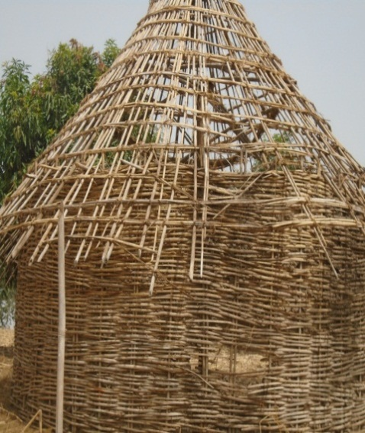
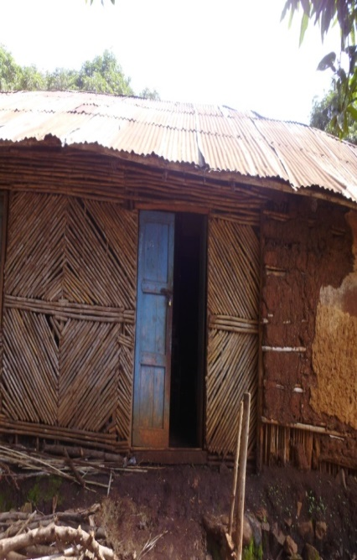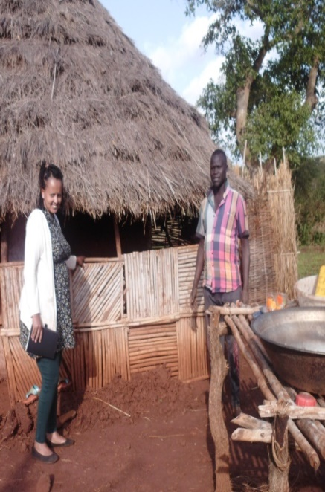
Figure 3: Types of houses (hut) constructed from bamboo in Agusha Kebele (Photo courtesy by Tarike Teshome, 2019)
In all of the study areas bamboo is also used to make shelter for goats, sheep, cattle, dog donkey and also to make a toilet. In making the shelter for goats the bamboo stand is made in a square or rectangle shape and the floor of the shelter, which is also made up of a bamboo, is kept above the ground and its walls are also made of a bamboo. The bamboo is also used to make a toilet among the Berta people. The bamboo is used in this respect as a floor, a door or a wall. In addition to this bamboo is used to make shelter for hens. In Berta people they use bamboo to make the house known as “kelewa” for guests.
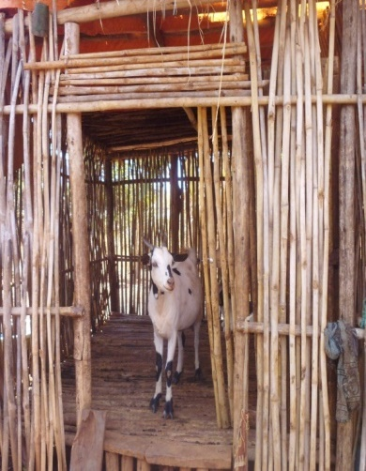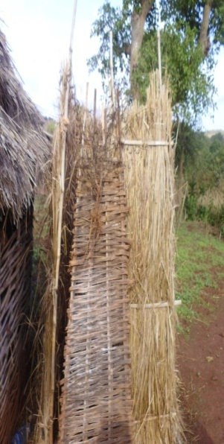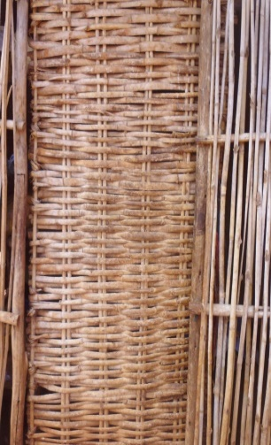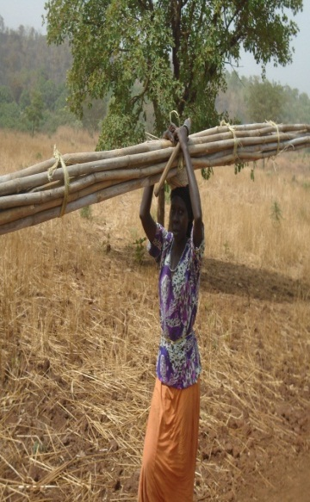
Figure 4: Shelter for goats and a toilet constructed from bamboo in Abramo Kebele(Photo courtsey by Tarike Teshome, 2019)
Fences: the other major ethno botanical importance of bamboo in the study area is to make fences and tree guard. In all the kebeles observed in the study, fences and tree guards are made from bamboo. Fences are made to separate ones compound from others and a tree guard is made to protect the tree and flowers from damage by animals and humans. Berta people also use bamboo for fencing field crops and also as a barn to shelter their livestock. To make a fence or a tree guard, the culm of the bamboo is splitted in to two or three and is interwoven with posts which are also made of bamboo.
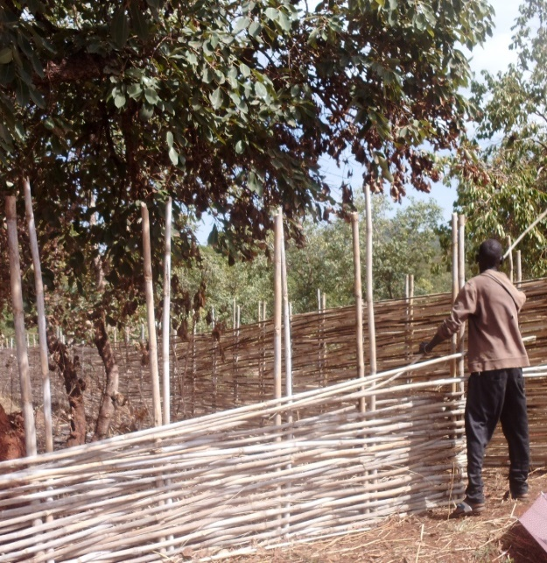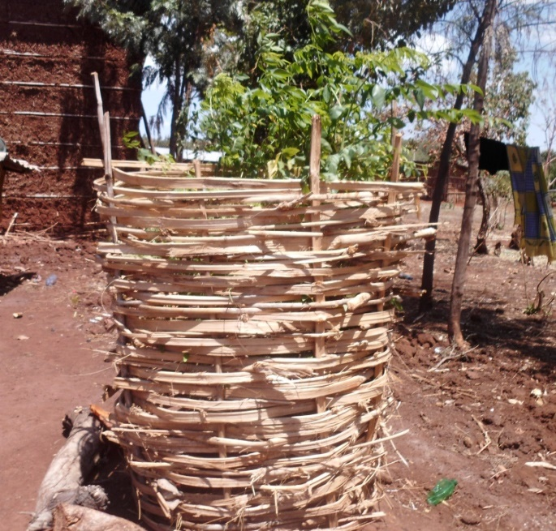
Figure 5: Bamboo used to make fence and tree guardin Enzi Shederia kebele (Photo courtesy by Tarike Teshome, 2019)

Bamboo for making beehive: the other traditional use of bamboo is to make a beehive among the Berta people of Assosa woreda. To make the beehive the bamboo culm is splinted and then it is made in a cylindrical shape by interweaving the bamboo and the outer part is covered with grass.

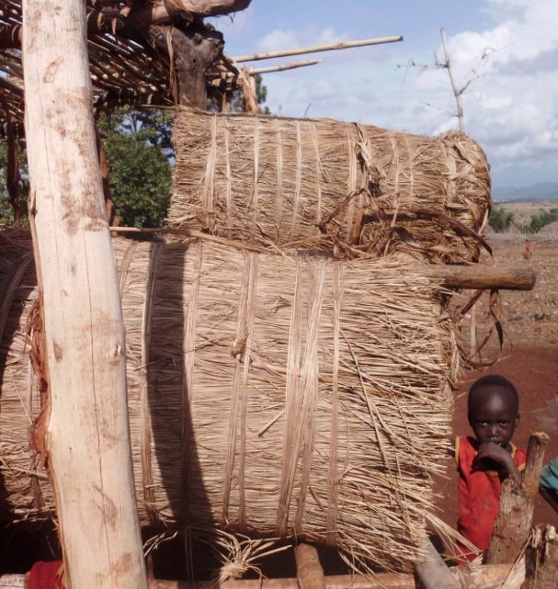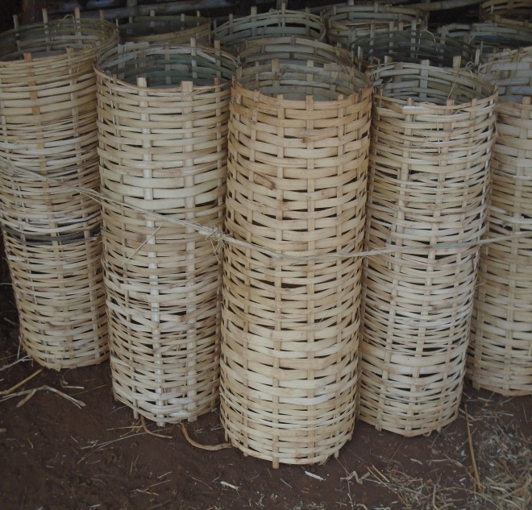
Figure 6: Bamboo-made beehives Baro kebele. (Photo courtesy by Tarike Teshome, 2019)
Household items: Berta people of Assosa woreda are highly interrelated to bamboo. We can say bamboo is their life since all of their day to day activities are based on bamboo. Almost all of the household’s items are made up of bamboo. They have their own indigenous knowledge to make different types of bamboo products. Some of these include; tables, chairs, basket.
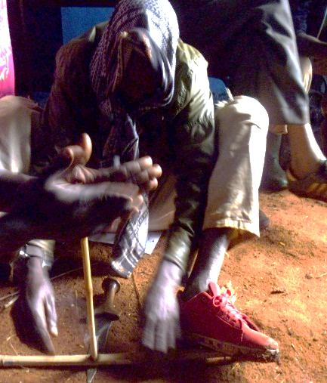
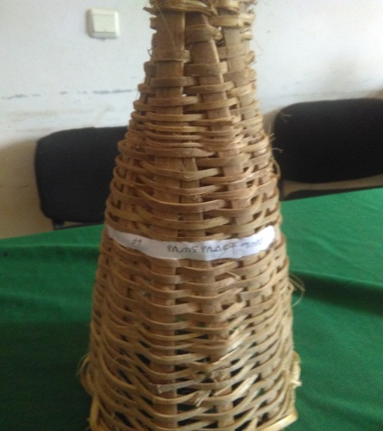
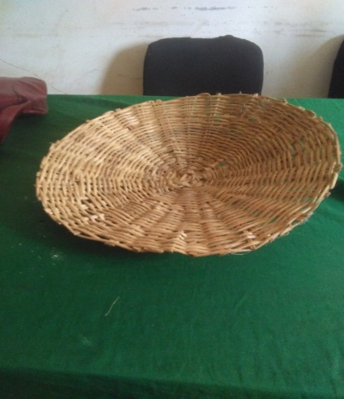
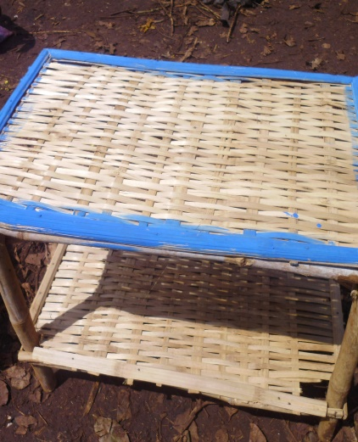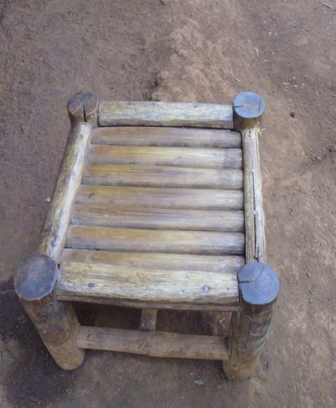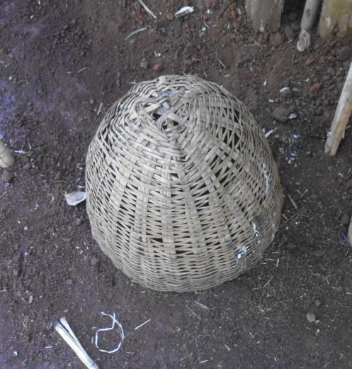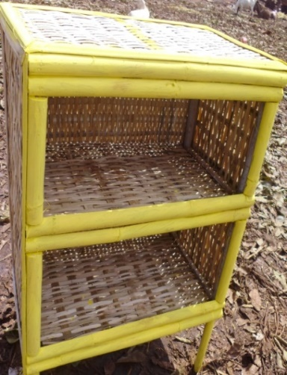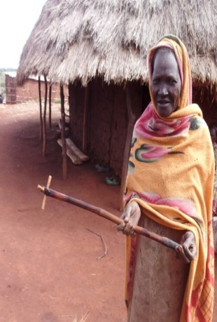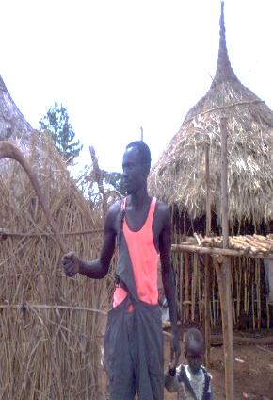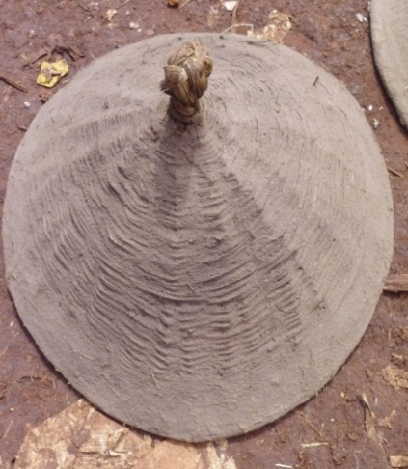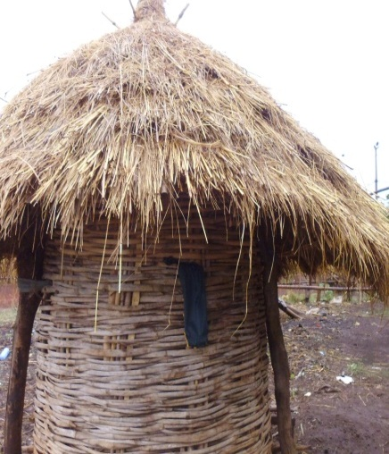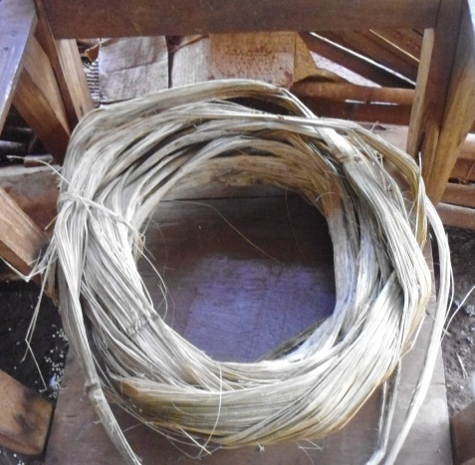
shelf
tuf
Table
basket
Chair
Grain storage
akunbalo
a
Albango
Adadafat

Fire creation
tatsa
sefed

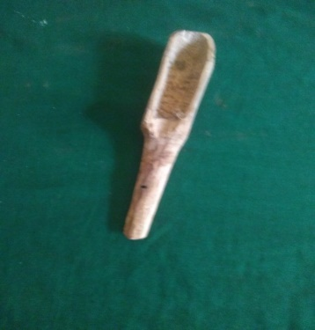
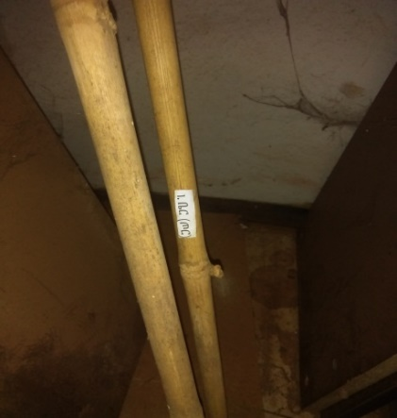
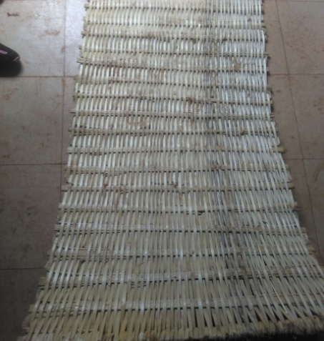
spoon
ber
aderhadi
Figure 7: Household items made from bamboo (photos courtsey by Tarlike Teshome, 2019)
Clarifications for the above pictures
- “Albango”/Benign: - used for protection and for cultural dancing.
- “Adadafat: - a sick used for steer “kenkes”.”Kenkes” is a delicious cultural food in Berta people.
- “Akimbo”:-used for making “injera.
- “Fesho/Tuff”:- is made from bamboo aged 1year (in early stage).
- “Sefed: - used to separate grains.
- “Tatsa: - to separate local drinking called “Borde” and dough.
- Mat;-used for flooring, to have “solat” in Berta people.
- “Ber” or Tor in Amharic; - used for protection during war.
Bamboo as a food: Food from bamboo is very familiar among the Berta people of Assosa woreda which is locally known as ‘Qontsu’. Qontsu (in ‘Rutana’ - one of the languages spoken by the Berta people) is prepared from a young culm (shoot of bamboo)consisting of compressed internodes sheltered by a number of leathery sheaths which is about 15 or 16 cms cut from the base of the plant (Fig 8). The fibrous sheath is eliminated, and the inner portion is grinded using a grinding stone (Fig 8). Then it is boiled in water for some time and a leaf known as “Agenbel” is added together with ‘Agaro”. ‘’Agaro’’ is an ash of bamboo and it makes cooking faster. It also reduces belly abdomen. The water is latter poured, and further cooked with onion, red pepper, oil and salt. Qontsu is then used as a sauce (‘wat’) and eaten with ‘Injera’ or porridge. The younger bamboo shoots are also used to make ‘algurasa’, local bread or ‘kita’ particularly in times when there is no good crop harvest. Foods made from bamboo plant are known in giving physical strength and preventing constipation.
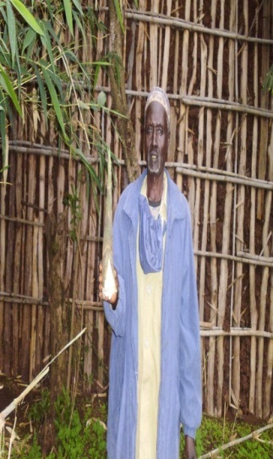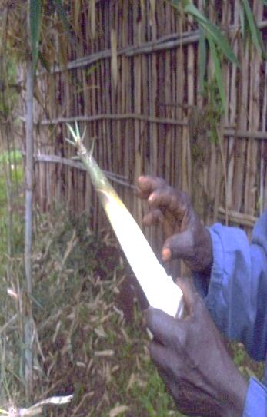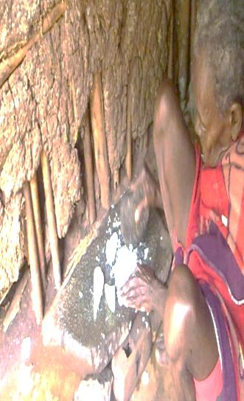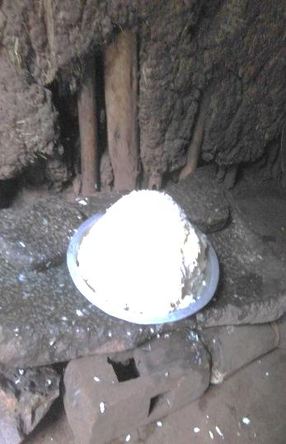
a b c d
Figure 8: ‘’Qonsu’’ food preparation from bamboo in Gambela Kebele. (Photo courtsey by Tarike Teshome, 2019)
Uses as fodder: In all of the studied kebeles the leaf of a bamboo tree is used as a fodder for different animals like donkeys, goats and cattle.
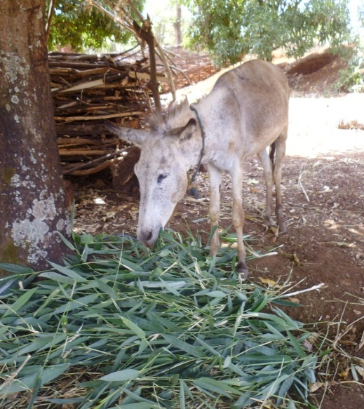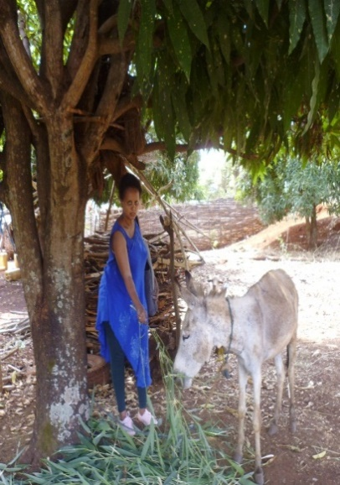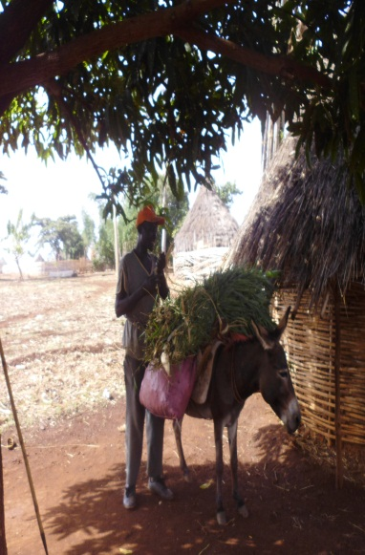
Figure 9: Bamboo leaf uses as a fodderin Enzishederia kebele. (Photo courtesy by Tarike Teshome, 2019)
Musical instrument: one of the most popular and traditional musical instruments of the Berta people is ‘Bolo’ which is made from bamboo. The other famous Berta traditional musical instrument is ‘Zumbara’ which is also made from bamboo and calabash (Fig 10). Bamboo is also used to make handle of ‘Kirar’. Zumbara” is very famous cultural instrument of berta people, which is used during cultural day, wedding, flag days and other festivals.

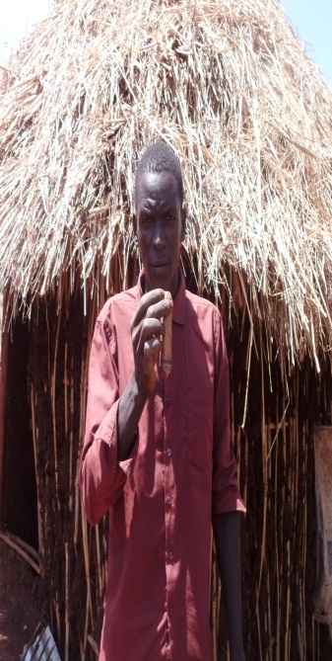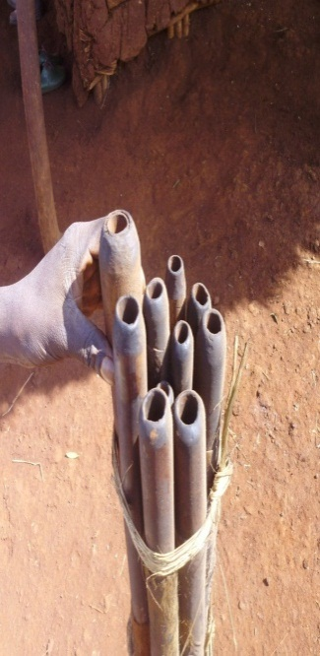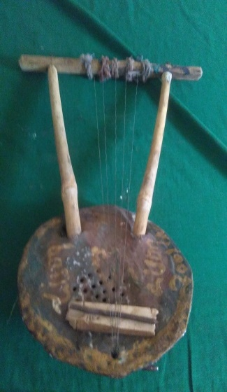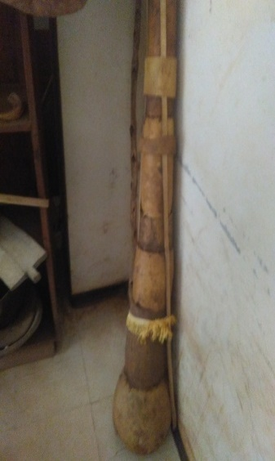
a b c d
Figure 10: ‘Musical instruments (Bolo’ “zumbara” and “kirar)” made of bamboo in Enzi Shederia Kebele. (Photo courtesy by Tarike Teshome, 2019)
A and b; - are” bolo” musical instrument, C; -“kirar” and D is Zumbara.
Bamboo as a medicine: One of the most traditional uses of bamboo among the Berta people is its medicinal value. The study indicated that the hair-like feature on the culm and leaf of a bamboo is used to quickly heal wounds. Others medicinal benefits of bamboo among the Berta people include preventing constipation, a cure for gastritis, to heal abdominal pain and cure from ‘Mich’. Mich according to the local people is diseases that occur suddenly and luck modern treatments. (Table3and Fig.11).
Table 3: Bamboo as Medicine

 |  | Frequency | Valid Percent | Cumulative Percent
Valid | High | 133 | 88.7 | 88.7
Valid | Medium | 6 | 4.0 | 92.7
Valid | Low | 11 | 7.3 | 100.0
Valid | Total | 150 | 100.0

Figure 11:Berta people used Bamboo as medicine to cure some disease
In addition to the aforementioned ethno botanical importance of bamboo, there are also many uses among the Berta people. This include: handle for hoe (Pali, Taba, Dogn,), handle for a broom(Quqa), for stretching a snar(A’ende), tooth brush(Aguwe, Jindu), ‘Albango’ is a stick which is used for protection and traditional dancing, for ceiling, for decoration, for frame, to make spear (‘Gorsh’) handle of a javelin, ‘Tatsa’(used to filter borde and dough), Borde is cultural drinking of Berta people, and to make different types of spoon.
Result from the key informant interview showed that their strength, straightness, smoothness, lightness and flexibility helps to spit into different size and used to produce different traditional products. Some of the traditional bamboo product commonly used in Berta people is listed with their local name function as showed below in Table 4.

Table4:Traditional Bamboo product Commonly by Berta people.
 | Items | Local name | Used for
1. | Ladder | Laho | For climbing
2. | Chair | Ederhadhi
3. | Bed | Adaza
4. | Basket | Ashet | For carrying fruit,vegetable
5. | Mat | Aderhadhi | For ‘ solat’
6. | Food | Qontsu
7. | Stick for poridge | Asherenbe | For poridge
8. | Stick for making ocra | Adedhefat | For stirring kenkes
9. | Rope | Tuff | For making House ,fence
10. | Musical Instrument | Zumbara/Bolo/ | Musical instrument
11. | Fence | Abenger | Separate compounds
12. | Walking stick | Hodiya/Begni/ | For walking
13. | Hunting stick | Gejemo | For hunting
14. | To make spear | Gorish/Beri/
15. | Stretcher/kareza/ | Atsame | To carry dead people
16. | Handle for hoa | Pali,Taba,Dagni | For agriculture
17. | Filtering coffee | Alifa
18. | Stick to support flower | shila | To support flower
19. | Handle for broom | Quqa
20. | Shelves | Tatsi | Used to material
21. | House for guest | Kelewa | For guests
22. | Stick for dancing | Alibango | For cultural dancing
23. | Filter dough and Borde | Tatsa | To filter cultural drink “Borde”
24. | Stretching snare | Aend
25. | Toothbrush | Aguwe,jindu
25. | Climber | Akontsetse/taba/ | To climb something
26. | Chical | shila
27. | Snare | Ahende
28. | For stretching rope of kirar | Agagnibaragni | For musical instrument
29. | Ox tail handle | Adenhatsi | For agricultural purpose
30 | store | Afentsekelu | To store any material
3.1 | Highland Bamboo | Gagoo
32. | Tree guard |  | Protection of seedling from cattle
33. | Grain store |  | For keeping food store

4.3. Bamboo as a source of income
In the studied kebeles as depicted in table 5 and Figure 12 most of the informants 98(65.33%) do not use bamboo as a source of income. Out of the 52(34.6%) informants who use bamboo for income generation, 47(90.37%) of them generate income by selling bamboo culm, 3(5.77%) of them generate income by selling bamboo seedling and the rest 2(3.85%) generate income by selling bamboo products.
Table5. Bamboo as a source of income
Item | No | %
Selling culm | 47 | 90.38
Selling seedling | 3 | 5.77
selling bamboo products | 2 | 3.85
Total | 52 | 100

Figure 12: The share of different parts of bamboo as sources of income.
According to household responses with regard to income obtained from selling bamboo was higher for female headed household compared to male headed household (Table 6).

Table 6: Female benefit more than men in selling Bamboo.
Income from selling * sex Cross tabulation
 |  | sex |  | Total | Per cent
 |  | male | female | Total | Per cent
Income from selling | Culm | 41 | 6 | 47 | 90.38
Income from selling | Seedling | 3 | 0 | 3 | 5.77
Income from selling | bamboo products | 2 | 0 | 2 | 3.85
Total |  | 46 | 6 | 52 | 100

4.4. Bamboo productivity over years
The current study revealed that the majority 87(58%) of the respondents reported that the productivity of bamboo is declining which they mainly attributed to damage by termites, fire hazards, open grazing causing destruction by livestock and land clearing by people for agricultural purpose. The Berta people also believe that there is a natural destruction of bamboo forest caused by what they call ‘Shingile’. Shingle according to them is happening every ten year. It is also mentioned that Shingle is overlapping with the time of bamboo flowering which took place in the range of seven to ten years. After flowering the bamboo shed seeds and the plant disappears which might be the end of the lifecycle of one generation of bamboo tree. Some of the informants 59(39.33%) reported that there is an increasing of bamboo productivity in their respective kebeles and the rest 4(2.66%) replied that the productivity of bamboo is the same over years. The reason suggested for productivity improvement of bamboo in some of the kebeles is attributed to the intervention made by government in raising bamboo seedlings through mainly cutting and distributing the seedlings to local people. However, they believe that the amount of seedling raised by the government is not adequate. Some of the respondents also described that bamboo seedlings are raised from seeds (Table 7 and Fig.13).

Table 7: Bamboo productivity
Item | No | %
Increasing | 59 | 39.33
The same | 4 | 2.66
Decreasing | 87 | 58
Total | 150 | 100

Figure 13:Bamboo productivity.

4.5. Ecological Importance of Bamboo
Bamboo in Berta language is known as ‘Gagoo” and or Honkole’, and ‘’shimel” in Amharic. The bamboo that is found in Assosa woreda is a lowland bamboo and its scientific name is Oxytenanthera abyssinica and this species of bamboo is grown naturally as indigenous plant in the studied area.
Focused group discussion showed that Berta people are aware of the ecological importance Bamboo which is related to conserving the environment, stabilizing the temperature, reducing desertification and that it is a house for wild life. They also understand that bamboo plantations improve soil fertility as a result of falling of leaves and plant parts that decomposes and improve nutritional status of the soil. They described that the soil fertility improvement of the soil in that when bamboo trees are cleared and allocated for crop cultivation significant yield improvements are observed. They also mentioned that bamboo plantation plays significant role in reducing soil erosion which is mainly attributed to the fibrous roots of the plant which hold the soil tight together. Besides, the natural propagation of the plant through production of numerous suckers is also additional factor for reduction of soil erosion. In bamboo forests the soils are rarely bare.
FGD also indicated that currently efforts are underway by the government to conserve bamboo plantation through protection as well as propagation. These is mainly observed in kebeles like Agusha, Afasizim, Abrahamo , Enzi shederia and Gambela where seedlings is distributed by the government and plantation is conducted. In these kebeles miss utilization of the planted bamboo tree is prohibited by the regional government.
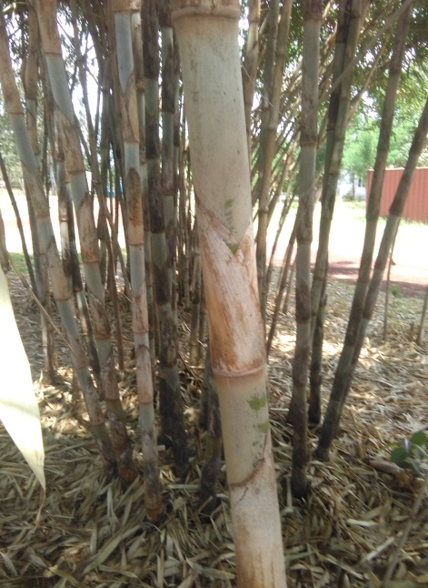
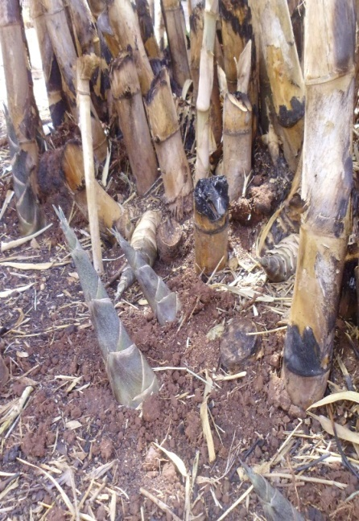
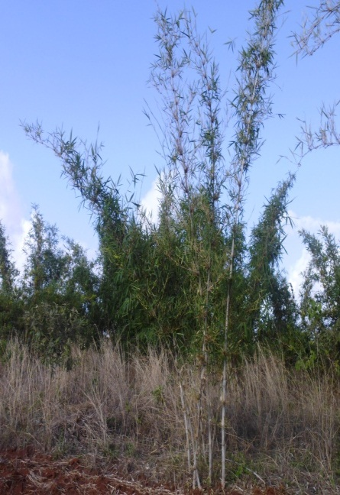
a b c
Figure 14: low land bamboo (Oxytenanthera abyssinica)(a) youngshoot (b) and bamboo culm (C)(Photos courtsey by Tarike Teshome, 2019).

CHAPRE FIVE

5. Discussion, Conclusion and Recommendation

5.1. Discussions
This research is intended to assess the ethnobotanical importance of bamboo, to identify the cultural value of bamboo, to investigate bamboo as a source of food and medicinal value of bamboo, to assess the socio-economic importance and to evaluate the current situation and challenges that the Berta people face regarding bamboo, accordingly, the following discussion is made.

5.1.1. Ethnobotanical Importance of Bamboo
The study on the ethnobotanical importance of bamboo for the Berta people is conducted in Assosa woreda. The study revealed 100% of the respondents have close relationship with bamboo and its uses. Bamboo in these areas contributes for construction of houses for humans and cattle, toilets construction, bridges; fences, tree guards, ladders, and beehives as shown in table 2. LUSO (1997) as reported in Ensarmu Kelbesa and Tamirat Bekele (2000) described that bamboo is the main material for the construction of houses, animal sheds, fences, fuel and beehives in Asossa Zone in Benshangul-Gumuz Region. For the Jeblawi people in the Zone, the shoots of bamboo are very important for their nutrition. Bamboo provides most of the fodder for the livestock in the area (LUSO CONSULT, 1997).
Almost all household items in the Berta peoples’ are made of bamboo which include table, chairs, baskets, cupboards, and grain stores. In line with this Lalhraitluanga (2009), reported that household items like different types of baskets, bamboo spoon, leaching funnel, sieve, winnowing ray and mortar are made from bamboo. The other traditional importance of bamboo is for making of musical instrument called the ‘Bolo/Zumbara’. Lalhraitluanga(2009) also reported that Mizo people are producing musical instruments like Perhkhuang, Rawchhem, Phenglaung (flute); Tingtang(guitar) and Tawtawrawt(trumpet) from bamboo. A study by Seyoum et al, (2018) in Kokosa woreda of south west Ethiopia, also confirmed that majority of the rural communities live in bamboo made traditional houses which is also in line with this study. ITTO (2002) estimated that globally, one billion people live in bamboo houses. Bamboo housing in Costa Rica, other Latin American countries, and Ethiopia is a good example (Seyoum et al. 2018).
Berta people who live in the studied area use bamboo as a source of food. One of the main food type prepared from Bamboo is called ‘Qontsu’ in ‘Rutana’ which is prepared from younger shoots. According to INBAR (1995) reported Bamboo shoot are now widely recognized as a health food .It can be eaten both fresh, and canned or as other forms of convenient food. China has over 100 species which produce edible shoots.
A report by Alam (2008) indicated that young shoots of several species of bamboo are used as important vegetable in the daily meals in China, Japan., Taiwan and Thailand. These young bamboo shoots have been considered as gourmet items. Alam also stated that in the western world food items prepared from bamboo are available only as imported canned products (Alam, 2008). Bamboo shoots are used as a good source of dietary fibre, low in fat and calories for human being (Bal, 2012). Bamboo shoots contain high protein but less fat, moderate dietary fibre, having essential amino acids, selenium, potassium, a potent antioxidant and minerals for healthy heart.
The study results also showed that the medicinal value of the bamboo plant which is familiar with the Berta people in preventing constipation, curing gastritis, healing abdominal pain, healing wounds quickly. Also a report by Chopra and others suggested that different parts of bamboo are uses as a medicine. The root (burnt root) is applied to ringworm, bleeding gums and arthritis. Bark is used for skin eruptions. Leaf has a property of antileprotic and anticoagulation activities that can be used in haemoptysis. Seeds are acrid, laxative, said to be beneficial in strangury and urinary discharges (Chopra et al, 1958).Bamboos and bamboos extract has been utilized in Korea for traditional treatment to relieve hypertension, sweating and paralysis. It has been established that bamboo extract have antioxidant activities and anti-inflammatory effects (Hu et al, 2000, Jung et al., 2005).Furthermore, bamboo-derived pyrolyzates have been proposed to have antimicrobial and antifungal activities (Fujimura, 2005) and to protect neurons from oxidative stress (Akao et al. 2004).

5.1.2. Bamboo as a Source of Income
Table3shows 65.33 per cent of the respondents who do not use bamboo as a source of incomewhich implies that bamboo in the study area has more of ethnobotanical importance than a source of income. But only 52% of the respondents use bamboo as a source of income and the largest portion of these respondents who use bamboo as a source of income depend on selling bamboo culms. In contrast to the finding of this research Cherla (2008) reported that bamboo and its related industries provide income; food and housing to over 2.2billionpeople worldwide. Bamboo agribusiness has worldwide opportunities. In contrast with Xuhe, (2003) Bamboo products currently have very huge demand. It can be utilized at all levels of industrial activity from small craft based industries to modern highly integrated plants. The global demand for bamboo is increasing. Smith and Marsh in (2005) reported the global market for bamboo products is approximately USD 7 billion which is expected to triple by the year 2017. The worldwide demand for bamboo products rises by double. In its market value was estimated its present size of USD10 billion to over 20 billion by 2015.About 300 companies are engaged around the world in production of various bamboo based products (Xuhe, 2003).
5.1.3 Ecological importance of Bamboo
Focused group discussion showed that Berta people are aware of the ecological importance Bamboo which is related to conserving the environment, stabilizing the temperature, reducing desertification that it is a house for wild life and improve soil fertility as a result of falling of leaves and plant parts that decomposes and improve nutritional status of the soil. They described that the soil fertility improvement of the soil in that when bamboo trees are cleared and allocated for crop cultivation significant yield improvements are observed.
They also mentioned that bamboo plantation plays significant role in reducing soil erosion which is mainly attributed to the fibrous roots of the plant which hold the soil tight together. Besides, the natural propagation of the plant through production of numerous suckers is also additional factor for reduction of soil erosion. In bamboo forests the soils are rarely bare. Also as reported by Pimentelet al. (1995)Soil erosion is a major environmental threat to the sustainability and productive capacity of agriculture. It is a worldwide problem approaching disaster proportions in many countries. It is estimated that the world's arable land is lost at a rate of more than 10 million hm 2 per year. Seventy-five billion metric tons of soil is removed from the land each year, causing up to US$400 billion in damage worldwide. One analysis of globe soil erosion estimates that, depending on the region, topsoil is currently being lost 16 to 300 times faster than it can be replaced. Soil is eroded by wind, water, and gravity aided and hurried by tillage and poor soil management(Barrow, 1991).

5.1.4. Status of bamboo
This study identified that bamboo productivity is decreasing, and this is attributed to different factors including damage by termites, fire hazards, animals damage, clearing for agricultural purposes, a disease locally known as ‘Shengel’ if it nears about 35 years it dries and die, deforestation by the local community, improper cutting before it matures. In line with Yigaredu Mulatu, etal. (2016). The species flowers gregariously at long time intervals, every 30-35 years. The most recent gregarious flowering is observed in the north western part of Ethiopia mainly in the Benishangul Gumuz region, where almost all natural forest has been regenerating using vegetative means. Mass flowering occurred starting from 2010 in Ambesa Chaka, lion's forest in Amharic, the famous bamboo growing area which spreads over 7,500 ha of land in Bambasi district, of the region. It started about seven years after flowering occurred in other areas, namely Guba and Mankush districts of the region. By 2010, mass flowering thereby mass death has reached over 85% of the estimated total 400,000 ha bamboo in the region.

5.2. Conclusions
From the findings and discussions on the ethnobotanical the following conclusions are derived;
- Bamboo in the study area has so many traditional and cultural uses in Assosa woreda and in the entire world. Some of the traditional uses are largely used for construction of houses, fences, tree guards and ladders. In the study area many household items are made from bamboo which includes bed, chair, table and baskets shelve, walking stick, stick for porridge, stick for steering okra, stretcher (kareza), hunting stick, handle for hoe, material for filtering coffee, stick for supporting flower, handle of broom, toothbrush, grain store, stretching snare and baskets.
- As emphasized in the study Bamboo have cultural values to make the famous traditional musical instrument of the Berta called ‘Bolo or Zumbara’ and is a good source of food for the Berta people of Assosa wereda.
- In the studied area Bamboo is not the major source of income .When compare to other sources of income, the income volume was found to be insignificant compared to the potential of area under the study because of the traditional way of harvesting and processing. Hence lot should be done to increase the benefit from the potential of bamboo to improve the live hood income.
- The Berta people also prepare a medicine from bamboo to cure gastritis, and to prevent constipation Bamboo in the studied areas is declining due fire hazards, termite damage, and damage by animals, clearing of bamboo forest for agricultural purposes. They also understand that bamboo plantations improve soil fertility as a result of falling of leaves and plant parts that decomposes and improve nutritional status of the soil. They described that the soil fertility improvement of the soil in that when bamboo trees are cleared and allocated for crop cultivation significant yield improvements are observed. They also mentioned that bamboo plantation plays significant role in reducing soil erosion which is mainly attributed to the fibrous roots of the plant which hold the soil tight together. Besides, the natural propagation of the plant through production of numerous suckers is also additional factor for reduction of soil erosion. In bamboo forests the soils are rarely bare.

5.3. Recommendations
Based on the findings of the study and the final conclusions of the result, the following
recommendations are forwarded:
- The Federal government and regional government should be manage and protect current remnants of the natural bamboo forest for sustainable utilization of the forest.
- Government and non- government organization should create awareness for the local community on improved propagation, harvesting, processing and utilization methods.
- The woreda agricultural office with the local community must be decrease the risk of bamboo destruction caused by fire hazards.
- The regional agricultural office establishes regional research to conduct research on the ethnobotanical importance of bamboo, productivity improvement as well as diseases and termites that are currently contributing to bamboo destruction.
- Government and non- government should give Special attention to make bamboo as a source of income by creating market for the local farmers.
- Government need to support the establishment of bamboo processing industries in bamboo producing areas.
- Communication office and regional government should be identified and if found suitable there is a need to promote the nutritional and medicinal value of the bamboo foods like ‘Qontsu’ to other similar areas of the country where bamboo is grown.
- Introduction of new knowledge and knowledge products that enhance innovative methods of bamboo productivity enhancement as well as utilization of the products is very crucial.
- Government shall support capacity building of the local people to enhance productivity of bamboo as well as improving the knowledge and skill of the traditional hand crafts.

REFERENCES
Adnew, B. & J. Statz. (2007). Bamboo Market Study in Ethiopia. Technical report prepared for UNIDO (United Nations Industrial Development Organization). Addis Ababa, Ethiopia.
Akao Y., Seki N., Nakagawa Y., Yi H., Matsumoto K.,Ito Y., Ito K., Funaoka M., Maruyama W., Naoi M. and Nozawa Y.A.,(2004) highly bioactive lignophenol derivative From bamboo lignin exhibits a potent activity to suppressapoptosis induced by oxidative stress in humanneuroblastoma SH-SY5Y cells, Bioorganic and
Medicinal Chemistry, 12, 4791–4801Alam M.K., Recent Flowering of Muli Bamboo (Melocanna baccifera) in Chittagong Hill Tracts and Rat Infestation: Eco-environmental Aspects, USAID.
Andargatchew, A. (2008). Value Chain Analysis for Bamboo Originating from Shedem Keble, Assossa Zone. MBA. Faculty of Business and Economics, School of Graduate /Studies, Addis Ababa University. Unpublished. Addis Ababa, Ethiopia.
Anonymous. (1997), Healing degraded land. INBAR magazine.5 (3):40-45.
Bal.M.L.,Singhal p., satya.,Naik S .N.and Kar A,(2012).Ba mboo shoot preservation for Enhancing its Business potential and local Economy: A review),Critical review in Food science and nutrition52(9),804-814.
Bakshi, M.(2010).Sustainable production of bamboo for rural and tribal communities via farmer-friendly technologies, 173-180. In: Multipurpose forestry. Proc. Managing and Enhancing Ecosystem Services and Production Function of Forests, Woodlands and Trees Outside Forests (S.S. Negi and Dinesh Kumar eds.). FRI, Dehradun, 268 p.
Bamboo Phylogeny Group [BPG] (2012) An updated tribal and subtribal classification of the bamboos (Poaceae: Bambusoideae). In: Gielis J, Potters G (eds) Proceedings of the 9th world bamboo congress, Antwerp, Belgium, 10–12 Apr 2012, pp 3–27.
BGRSFEDO, (2014)(Beneshangul Gumuz Regional State finance and economic development office raw data).
BWADO.(2012). Socio- economic characteristics of Banjia districts 40p.
Bystriakova, N., kapos,V., Lysenko I. and Stapleton C.M.A.: Distribution and conservation status of forest bamboo biodiversity in Asia-Pacific Region. Biodiversity and conservation, 114(10): 1833-1841 (2003).
Chatterjee, A. and Pakrashi S.C., The Treatise on IndianMedicinal plants, National Institute of Science communication, New Delhi, 6, 50-51(2001)
Chopra R.N., Chopra I.C., Handa K.L. and Kapur L.D.(1958).Indigenous Drugs of India, U.N. Dhur and Sons Pvt. Ltd.,Calcutta. pp. 289, 665.
Cotton,C.M.(1996).Ethno botany, Principle and Applications.John Wiley and sons Ltd.
Connie, V. and R.K. Steven.(2005). An introduction to ethnobotany. An African Ethnobotany. Bulletin No. 2.
CSA (2009).Federal Democratic Republic of Ethiopia (FDRE) Central Statistical Agency (CSA), Addis Ababa.
Das, R.: Studies on edible bamboo shoot production as influenced by various cultural practices and clump management in some selected species of Jharkhand. Ph.D. Thesis, FRI University, ICFRE, submitted October, (2013).
Diwakar Prasad Nirala, Nirbhay Ambasta and Phallo Kumari (2017) . A Review on Uses of Bamboo Including Ethno-Botanical Importance Int. J. Pure App. Biosci.5 (5): 515-523.
Durgesh D. and Wasnik P.M. Tumane., Antibacterial Activity of Bambusa bambose L. against Multiple Drug Resistant (MDR) Bacteria Isolated from Clinical Specimen, Int. J. Pharm. Sci. Rev. Res., 25(1), 215-218 (2014)
EABP ,(2009). Containing master data of budget billing plan any body, october05 ,2009
EABP.(2007).Bamboo the millennium of grass of Ethiopia.EABP, accessed on
November 12 2011 from http://eabpnews.Wordpress.com.
Embaye K. (2000).The indigenous Bamboo Forest of Ethiopia: an overview .AMBo:J.Human
Environ. 29(8):518-521.
Ensermu. K, Tamrat, B.,Alemayehu, G. and Gebremedhin, H. (2000). The socioeconomic case study of the bamboo sector in Ethiopia: an analysis of the production -to- consumption system, Addis Ababa, Ethiopia, p10-11.
FAO. (2005). Global Forest Resources. Country report on bamboo resources (final draft), Addis Ababa, Ethiopia.
FAO.( 2007). World bamboo resources. A thematic study prepared in the framework of the global forest resources assessment (2005). Rome, Italy, Rome, 73 p
Fue Maoyi, Xiao Jianghua, Lou Yiping.( 2000). Cultivation and utilization on bamboo. Beijing:China Forestry Publishing House.
Fujimura M., Ideguchi M., Minami Y., Watanabe K. andTadera K., Amino acid sequence and antimicrobialactivity of chitin-binding peptides, Pp-AMP 1 and PpAMP 2, from Japanese bamboo shoots (Phyllostachyspubescens), Bioscience, Biotechnology and Biochemistry,69, 642–645 (2005)
Gebremariam, A.H., M. Bekele & A. Ridgewell.(2009). Small and Medium Forest Enterprises in Ethiopia. IIED Small and Medium Forest Enterprise Series No. 26.
FARM-Africa and International Institute for Environment and Development, London, U.K. http://pubs.iied.org/ pdfs/13553IIED.pdf
Ghosh N.N., Ghosh S. and Chopra R.N., Chemical and pharmacological examination of the young sprouts of Bambusa arundinacea, Arch Pharm Berl, 276- 351(1938)
Grass Phylogeny Working Group [GPWG] (2001) Phylogeny and subfamilial classification of the grasses (Poaceae). Ann Missouri Bot Gard 88:373–457
Grass Phylogeny Working Group [GPWG] II (2012) New grass phylogeny resolves deep evolutionary relationships and discovers C4 origins. New Phytol 193:304–312
Hong E.J., Jung E.M., Lee G.S., Kim J.Y., Na K.J., ParkM.J., Kang H.Y., Choi K.C., Seong Y.H., Choi I.G. andJeung E.B., Protective effects of the pyrolyzates derivedfrom bamboo against neuronal damage and hematoaggregation, J. Ethno-pharmacology, 128, 594-599 (2010)
http://www.fao.org/docrep/field/003/AC265E/ of page(l)AC265E00.htm#top (economic appraisal), (2015)
http://www.flavorandfortune.com/, (2015)
http://www.ipgri.cgiar.org/publications/HTMLPublicatio ns/572/ch10.htm#Top (Bamboo resource), (2015)
http://www.itmonline.org/(bamboo as medicine), (2015)
http://www.nutritiondata.com/(nutrition data), (2015)
http://www.nutritiondata.com/(nutrition data), (2015)
http://www.technopreneur.net/ScienceTechMag/may07/Bamboo_processin g.pdf, (2015)
Hu C., Zhang Y. and Kitts D.D., Evaluation of antioxidant and pro-oxidant activities of bamboohyllostachys nigra var, henonis leaf extract in vitro, J.Agril. Food Chem., 48, 3170–3176 (2000)
Hunter, 1.R. (2003). Bamboo resources, uses and trade the future? Journal of bamboo, 2(4); p 319-326
INBAR (2012) Bamboo as Sustainable Biomass Energy: A Suitable Alternative for
Firewood and Charcoal Production in Africa http://www.inbar.int.
INBAR.(2011).The value chain development and sustainability of bamboo housing in Ethiopia. Beijing, china, 129 p.
INBAR.( 2003). INBAR’s new efforts to assist development in eastern African countries. Proceeding of international workshop on bamboo industrial utilization, October (2003), Beijing, china.
INBAR. (1995).Biodiversity And Genetic Conservation. Bali, Indonesia.
Judziewicz EJ, Clark LG, London ˜o X, Stern MJ (1999) American bamboos. Smithsonian Institution, Washington, DC, p 392
Judziewicz, E. Clark, L.G. Londono, X., et al. (1999). American Bamboos. Washington: Smithsonian Institute Press.
Jung H.J., Nam J.H., Choi J., Lee K.T. and Park H.J.,Anti-inflammatory effects of chiisanoside andchiisanogenin obtained from the leaves of Acanthopanax chiisanensis in the carrageenan-and Freund’s completeadjuvant-induced rats, J. Ethno pharmacology, 97, 359-367 (2005)
Kelchner SA, Bamboo Phylogeny Group (2013) Higher level phylogenetic relationships within the bamboos (Poaceae: Bambusoideae) based on five plastid markers. Mol Phylogenet Evol 67:404–413
Khare C.P., Indian Medicinal Plants, An Illustrated Dictionary, Springer publication, New Delhi, India, 90(2007)
Kigomo, B. N. (2007b). Guidelines for growing bamboo. Nairobi: Kenya Forestry
Research Institute.
Kigomo, B. N. (1988). Distribution, cultivation and research status of Bamboo in Eastern Africa.
Koul,L(1996).Methodology of Educational Research.(2nd ed).Delhi: vikas publishing House Pvt.Ltd.
Kuls, W. (1962).Land, Economy and Settlement of the Gumuz in the west Godjam (Ethiopia). 8(1):45-46
Kurz, S.: Bamboo and its uses. Indian Forester.1: 219-269 (1876).
Connie, V. & R.K. Steven.( 2005). An introduction to ethnobotany. An African Ethnobotany. Bulletin No. 2.
L.G. Clark, X. London ˜o, and E. Ruiz-Sanchez.(2015) Bamboo Taxonomy and Habitat.Springer International Publishing Switzerland (2015).
Lalhraitluanga, H. (2009). Traditional Uses, Economical Importance and Ecological Services of Meloccana baccifera Roxb. in Mizoram, India . The Asian and Australasian Journal of Plant Science and Biotechnology .
Lobovikov, M., Paudel, S., Piazza, M., Ren, H., & Wu, J. (2005).World Bamboo
Resources: A thematic study prepared in the framework of the Global Forest
Resources Assessment (2005). Rome: Food and Agriculture organization of the
United.
Lu B.Y., Wu X., Tie X., Zhang Y. and Zhang Y., Toxicology and safety of antioxidant of bamboo leaves, Part I: acute and sub chronic toxicity studies on antioxidant of bamboo leaves, Food Chem. Toxicol., 43(5), 783-792 (2005)
LUSO (1997). Study on sustainable Bamboo Management. GTZ. Addis Ababa,
Ethiopia.
LUSO CONSULT,.(1997). Study sustainable Bamboo Management:
Second Interim Report.
Macharla S.P., Goli V., Gowrishankar N.L., Dinakaran S.K., Dasarapu S. and Malothu N., Anti-diabetic activityof Bambusa arundinaceae seed extracts on alloxaninduced diabetic rats, International Journal of Pharmaceutical Research and Development, 3(5), (2011)
March R, Clark LG (2011) Sun-shade variation in bamboo (Poaceae: Bambusoideae) leaves. Telopea 13:93–104
Martin, G.J. (1995). Ethnobotany: A method Manual. Chapmanand Hall, London.
Maxim et al, (2005) will add to own fire bodies and market apparatus for sale across Canada pierce dealer network. APPLYTON, WIS.
McClure F.A., Bamboos: A fresh perspective, Harvard University press Cambridge, Mass,USA,347(1996).
Mekonnen, Z.; Worku, A.; Yohannes, T.; Alebachew, M.; Teketay, D.; Kassa, H. Bamboo Resources in Ethiopia: Their Value Chain and Contribution to Livelihoods. Ethnobototany. Res. Appl.(2014), 12, 511–524. [CrossRef]
Melaku Tadesse,(2006). Bamboo the millennium grass of Ethiopia: insuring in a new prosperity through a million bamboo homesteads: Eastern Africa Bamboo Project
Ministry of Agriculture Natural Resources Management Directorate (MOA)(2013).Training Manual for Bamboo Stand Management and Utilization, Addis Ababa, Ethiopia.
Muller, I., & Rebelo, C. (2011).Bamboo Worldwide:The Current Market & Future
Potential. Chicago: Ecoplanet Bamboo.
Muniappan M. and Sundararaj T., Anti-inflammatory andantiulcer activities of Bambusa arundinacea, J. Ethnopharmacology, 88, 161–167 (2003)
Nath , S., Das , R., Chandra, R. and sinha, A. (2009). Bamboo based agroforestry for
marginal lands with reference to productivity, market trend and economy:
presented in the symposium ICFRE on 21st march, (2009), lalgutwa, Ranchi
Jharkhand, p 7-23
Oldeman, L.R. 1990. World map of the status of human-induced soil degradation. Wageningen, Netherlands: International Soil Reference and Information Centre.
Ongugo, P., Langat, D., & Musalia, W. (2012).Ecological and Socio- economic
study on Bamboo farming in the Western Mt. Kenya Region.Nariobi: KEFRINMK.
Panda H.,Bamboo plantation and utilization .Hand book,publisher:Adia Pacific Business pressInc,(2011).
Phillips, S. (1995). Flora of Ethiopia and Eritrea, Poacea (Gramineae) (Vol. 7).The
National Herbarium, Addis Ababa, Ethiopia.
Phillips, S. (1995). Poaceae (Gramineae). In: Edwards, S. and Hedberg, I.
(eds.), Flora of Ethiopia and Eritrea, Volume 7, Addis Ababa, Ethiopia and
Uppsala, Sweden.
Plotkin, M.J. (2006). Ethnobotany.Microsoft Encarta, Microsoft, Redmond, Washington.
Rao, I.V.R.( 2004). Bamboo and their role in ecosystem rehabilitation .international
network for.bamboo and rattan, Beijing, china, p1011-1017
Rathod Jaimik D, Pathak Nimish L, Patel Ritesh G,Jivani N.P. and Bhatt Nayna M., Phyto-pharmacologicalProperties of Bambusa arundinacea as a PotentialMedicinal Tree: An Overview, J. AppliedPharmaceutical Sci., 01(10), 27-31 (2011)
Rizui SHM. , Roy (,2006), shibani the Nagas-New Delhi: B.R. publishing corporation
Sethi N., Nath D. and Singh R.K., Teratological evaluation of some commonly used indigenous antifertility plants in rats, International Journal of Crude Drug Research, 27(2), 118-120 (1989)
Seyoum G., Lemma T. and Yigardu M. (2018). Indigenous knowledge on highland bamboo (Yushania alpina) management and utilization practices in Kokosa
Woreda, South East Ethiopia. Vol. 13(11), p. 119.
Sharma T. P. and Borthakur, S.K.: Ethnobotanical obsevations on Bamboo among the Adi tribe in Arunachal Pradesh. Indian J. Trad. Knowl, 7: 594-597 (2008).
Singhal P, Lalit Mohan Bal, Santosh Satya P., Sudhakarand Naik S.N., Bamboo Shoots: A Novel Source of Nutrition and Medicine, 53(5), 517-534 (2013)
Soderstrom, T.R. and Ellis, E.V.( 1986).The position of bamboo genera and allies in a system of grass classification. In : Grass Systematics and evolution. (Eds.) Soderstrom T.R., Hitu, K.W., Campabell, C.S., Barkworth, N.E .Smithsonian Institute Press, Washington, D.C. pp. 225-238.
Suneel, p.(2008). new generation value added products of bamboo. In : choudhary M.L and shri K.S. (eds). Proceeding of 3rd international conference on improvement of bamboo productivity abd marketing for sustainable livelihood, 15th-17th april,
2008, new delhi, India.
Swinnen, J.; Riera, O.The Global Bio-Economy.Agric. Econ.(2013), 44 (Suppl. 1), 1–5. [CrossRef]
Syiamhlieh.J. (1995), the Funeral Rites and practices in the Khasi mainland. An
Anthropological study phD thesis unpublished shilling. NEHU.
Tewari D.N., A Monograph on Bamboo, International Book Distributors, Dehra Dun, India, 498 (1992).
Thiru Selvan,( 2018). Bamboo Resources, Their Status, Conservation and Strategies for Improvement. Department of Forestry and Biodiversity, Tripura University, Suryamaninagar, Agartala-799022. Tripura
UNEP. 1992. The world environment 1972-1992-two decades of challenge. London: Chapman and Hall.
UNIDO, (2007). Bamboo marketing for the eastern Africa bamboo project Kenya and Ethiopia p 95
Vaidya B., Some Controversial Drugs in Indian Medicine, Chaukhambha Orientalia, Varanasi, 203-207(1982)
Vanita M, Thakur MK, Mishra RP (2015). Dasturella Rust of Bamboo in India.
Wang, H., Varma, R.V. and Xu, T.: Insect Pests of Bamboos in Asia- An Illustrated Manual. International Network for Bamboo and Rattan (INBAR), 200 p. (1996).
Watt G.A., Dictionary of the Economic Products ofIndia, reprinted edition, volume-I, Periodical Expert, Delhi, 383-391 (1972)
White, D.G and Childens, N.F. 1945. Bamboo for erosion control. J.American Society of agronomy,37:839-847
Wimbush, S. H. (1945). The African alpine bamboo. Empire Forestry Journal.33-39.
Woldemichael Kelecha. 1980. The Bamboo Potential of Ethiopia, Addis Ababa.
World Bamboo Organization.(2012). The 9th World Bamboo Congress Proceedings
9th World Bamboo Resources Proceedings 10th - 15th April (p. 22).
Massachusetts: World Bamboo Organization.
Xuhe, C.: Promotion of bamboo for poverty alleviation and economic development. J. Bamboo and Rattan, 2(4): 345-350 (2003).
Yeasmin L, Ali MN, Gantait S, Chakraborty S (2015). Bamboo: An overview on its genetic diversity and characterization. Biotechnol. 3(5):1-11.
Yeshambel, M., mengistu, U. and getachew, A. (2011). Role of indigenous bamboo
species (yushainia alpine and oxytenanthera abyssinica) as ruminate feed in north
western. Livestock research for rural development 23(9)
Yigardu Mulatu, Asabeneh Alemayehu and Zebene Tadesse. 2016. Biology and Management of Indigenous Bamboo Species of Ethiopia. Ethiopian Environment and Forest Research Institute (EEFRI)
Zehui, J., Benhua, F. and xuhe, C. (ED).( 2007). Bamboo and rattan in the world. China forestry publishing house, p 2-255
Zhou Jianyi, Hu Chaozong, Yang Iiampo.( 1985). Investigation of Rhizomes of shoot-oriented high yield bamboo forest. Journal of bamboo research,
Appendices
Appendix I: QUESTIONNAIRE
ADDIS ABABA UNIVERSITY
DEPARTEMENT OF ZOOLOGICAL SCIENCE
This questionnaire is designed to gather data on the ethno botanical importance of bamboo tree in Assosa woreda, Benishangul Gumuz Regional State. Your response is strictly confidential and respondents’ views in this questionnaire shall not be used for any other purpose rather than the advancement of this study. Therefore, your genuine responses contribute a lot to the accuracy of this research’s findings and to further investigate the ethno botanical importance of bamboo in Assosa woreda.
- This questionnaire has two parts.
- The first part is background information of farmers which includes details of personal information.
- The second part involves questions related to ethno botanical importance of bamboo tree in Assosa woreda.
General Instructions:
- Please put ( √ ) mark in appropriate places
- Write in the spaces provided where appropriate

Thank you in advance!!!

- Personal Information
- Sex Male Female

- Age 41-50 51-60 Above 60 years

- For how many years you have been living here?

21 -30 31-40 Above 40 years

- Educational background :

Illiterate Read and write 1-8 9-12

Diploma BA/BSC MA/MSC
- Occupation:
Farmer Civil servant Business

Other ------------------------------------------------------------------------
- Marital status : Married Single Widowed Divorced

- Household size :

1 – 5 6– 10 10 +

- Information related to ethno botanical importance of bamboo

- Do people in your kebele use bamboo for cultural purposes?

Yes No

- If your answer for question number 9 is yes, please rate its importance.
No | Items | Response
No | Items | Highly | Medium | Low
1 | For construction of house
2 | For making door and window
3 | For construction of bridges
4 | Making fence
5 | To make tree guard
6 | To make a ladder
7 | For making chair and table
8 | For making bed
9 | To make boat
10 | For making beehive
11 | For making agricultural implements
12 | Boundary marker
13 | Flag post
14 | To make basket
15 | Charcoal making
16 | For making snare
17 | For walking stick
18 | Handle for axe
19 | For making a mat
20 | To make handle for spade
21 | For loading materials
22 | Used as a container
23 | Uses as food
24 | For storing grain
25 | For making broom
26 | Uses as fodder
27 | Musical instrument
28 | Uses as fuel wood
29 | For medicine

30- Do you know other traditional uses of bamboo in your locality?
Yes No
31. If your answer for question number 31 is yes, please mention it/them --------------------------------------------------------------------------------------------------------------------------------------------------------------------------------------------------------------------------------------------------------------------------------------------------------------------------------------------------------------------------------------------------------------------------------------------------------------------
32. Do use bamboo as a source of income?
Yes No
33. If your answer for question number 33 is yes, in what way do you generate income?
---------------------------------------------------------------------------------------------------------------------------------------------------------------------------------------------------------------------------------------------------------------------------------------------------------------------------------------------------------------------------------------------------------------------------------------------
34. What is/are the local name/s of bamboo in your kebele?
-----------------------------------------------------------------------------------------------------------
35. What is the status of bamboo production in your locality?
Increasing The same Decreasing
36. If your answer for question number 35 is decreasing, what is/are the reason/s for this -------------------------------------------------------------------------------------------------------------------------------------------------------------------------------------------------------------------------------------------------------------------------------------------------------------------------------------------------------------------------------------------------------------------------------------------------------------------------------------------------------------------------------------------------------
37. Do you think that bamboo has ecological importance?
Yes No

38. If your answer for question number 37 is yes, how is it useful in your locality?
---------------------------------------------------------------------------------------------------------------------------------------------------------------------------------------------------------------------------------------------------------------------------------------------------------------------------------------

39. Do you have any involvement in the conservation of bamboo?
Yes No

40. How do you conserve bamboo in your locality?
--------------------------------------------------------------------------------------------------------------- ------------------------------------------------------------------------------------------------------------------------------------------------------------------------------------------------------------------------------------------------------------------------------------------------------------------------------------------------------------------------------------------------------------------------------------------
41. What is/are your suggestion/s to promote the ethno botanical uses of bamboo?
------------------------------------------------------------------------------------------------------------------------------------------------------------------------------------------------------------------------------------------------------------------------------------------------------------------------------------------------------------------------------------------------------------------------------------------------------------------------------------------------------------------------------------------------------------------------------------------------------------------------------------------------------------------------------

Thank you for your corporation.

Appendix II
Check list of semi – structured interview and discussion used in collecting ethno botanical data
Name --------------------------------------sex-------------age-----------------------serial no ------
Marital status -----------------------occupation -----------------------------------------------------
Religion ----------------------------------Ethnicity-------------------------------------------------
Kebele/code----------------------------------------------------------------------------------------------
For how long have you lived in the area -------------------------------------------------------------?
Educational status -----------------------------Date ---------------------------------------------------
1. What is the local name of bamboo --------------------------------------------------------?
2. What are some of the uses of bamboo tree in your locality?
3. Do you know that we can get human food from bamboo?
3.1. What is the local name of the food?
3.2. Which part of the bamboo is used for food?
3.3. How is the food prepared?
4. Do you know that we can get animal food from bamboo?
4.1. Which part of the bamboo is used for food?
5. Do you know that we can get medicine from bamboo?
5.1. Which part of the bamboo is used for medicine?
5.2. How is the medicine prepared?
5.3. What type of diseases does it cure?
6. Do you know that bamboo is used for making musical instrument?
6.1. What is the name of the musical instrument that is made from bamboo?
6.2. Which part of the bamboo is used for making musical instrument?
7. What is the status of bamboo in your locality?
8. How do you see the current utilization of bamboo in the area?
9. What are the threatening factors for bamboo in the study area?
10. Does bamboo have any ecological significance for the environment?
11. Are there any efforts made on the management and conservation of bamboo in your idea?
12. Is there any commercial industry that uses bamboo as raw material in the area?
13. What is/are your suggestion/s concerning ethno botanical importance of bamboo?

Thank you for your cooperation!!!

Appendix III: Checklist for Focus Group discussion
Development Agent
- Is farmer preferred of bamboo from other tree?
- Foe what purpose farmer use bamboo?
- Do farmer use bamboo as medicine?
- How farmers traditionally conserve bamboo?
- Is there any effort made on the management and conservation of bamboo in your area?
- Is there any cultivated bamboo tree in you locality?
- Is there in industries that use bamboo as raw material in your are
Local Bamboo processors
- What types of bamboo product did you produce?
- Where did you get raw material to produce bamboo product?
- Availability of market?
- Current price of bamboo culm?
- Does the price increase or decrease?
- Cultural and traditional use of bamboo?
- How about abundance of the tree?
- How do you see the current utilization of bamboo in the area?
- Do have other income rather than selling bamboo products
Community elders
- How many bamboo culms sell per day?
- Are females participating in selling bamboo?
- Does bamboo have ecological significance for environment?
- Do you use for cultural benefit?
- Do you use for recreational value and as sources of food?
- Do you use as medicine?
- List other use of bamboo in your locality?
- Did you use bamboo as income generating or for household?

Appendix IV:
ቅጥያ 1 መጠይቅ
የባይሎጂ ዲፓርትመንት
ይህ መጠይቅ በቤንሻንጉል ጉምዝ በአሶሳ ወራ የሽመል ስነ-ህይወታዊ ጠቀሜታ ለማጥናት የተዘጋጀ ነው፡፡ ቃለ መጠይቁ ሚስጥርን የሚጠብቅና ለታለመለት በስተቀር ለሌላ ስራ አይውልም፡፡ ስለሆነም የእርስዎ በቅንነት ለሚጠየቁት ጥያቄ ተገቢውን ምላሽ ለመስጠት መረጃውን ተአማኝነት እና ለጥናቱ ውጤታማነት ከፍተኛ አስቴዋጽኦነ ያደርጋል፡፡
መጠይቁ ሁለት ክፍሎች አሉት፡- የመጀመሪያው መነሻ ሀሳብ የግለሰብ ሁኔታ በቀበሌ ነዋሪነቱን የሚጠየቅ ሲሆን ሁለተኛው ምዕራፍ ደግሞ በአሶሳ ወረዳ የሽመል ስነ-ህይወት ጠቀሜታ ላይ ተኮረ ነው፡፡
ጠቅላላ መመሪያ፡-
- በተገቢው ቦታ ላይ ምልክት ያድርጉ፡፡
- በተሰጠው ክፍት ቦታ ላይ መልሱን ይጻፉ፡፡
- በመረጃ ሰብሳቢዎችአማካኝ ጥናት የሚሞላ የመረጃ ሰብሳቢው ስም
የግል መረጃ
- ፆታ ወንድ ሴ
- እድሜ 41-50 ከ60 በላይ
- ለምን ያህል ጊዜ እዚህ ቀበሌ ኖረዋል?
21-30 31-40 ከ40 ዓመት በላይ

- የትምህርት ደረጃ
ያልተማረ ማንበብና መጻፍ 1-8
- የስራ ሁኔታ ገበሬ የመንግስት ሠራተኛ ነጋዴ ሌሎች
- የጋብቻ ሁኔታ ያገባ ያላገባ የሞተበት የፈታ
- የቤተሰብ ብዛት 1-5 6-10 10⁺
ከሽመል ጥቅም ጋር ተያያዥነት ያላቸው ጥያቄዎች
- በቀበሌ ውስጥ ሰዎች ሽመልን ለባህላዊ ነገሮች ይጠቀማል
አዎ አይደለም
- ለጥያቄ ቁጥር 8 መልሶ አዎ ከሆነ ደረጃ ይስጡ፡-
ተ.ቁ. | ዓይነት | መልስ
ተ.ቁ. | ዓይነት | ከፍተኛ | መካከለኛ |  | ዝቅተኛ
1.. | ለቤት መስሪያነት
2. | ለመስኮትና ለበር መስሪያነት
3. | ለድልድይ መስራት
4. | ለአጥር
5. | ለአትክልት መከላከያ
6. | ለመሰላል
7. | ለወንበርና ጠረቤዛ
8. | ለአልጋ
9. | ለጀልባ
10. | ለቀፎ
11. | ለግብርና መሳሪያ እጀታ
12. | ድንበረ
13. | ለሰንደቅ ዓላማ መስቀያ
14. | ለቅርጫት
15. | ለከሰል
16. | ወጥመድ
17. | ለምርኩዝ
18. | ለመጥረቢያ እጀታ
19. | ለወለል ምንጣፍ
20. | አካፋ
21. | እቃ መመደረደሪያ9መሸከምያ)
22. | ማጠራቀሚያ
23. | ለምግብነት
24. | ለእህል ማጠራቀሚያ
25 | መጥረጊያ
26 | ለእንስሳት መኖ
27. | ለባህላዊ ሙዚቃ መሳሪያ
28. | ለማገዶ
29. | ለመዳኒትነት

30. በአካባቢው ሌላ የሽመልጥቅም ያውቃሉ
አዎ አያውቅም
31. ለተ.ቁ. 30 ጥያቄ መልስ አዎ ከሆነ ከዚህ በታች ይዘርዝሩ
____________________________________________________________________________________________________________________________________________________________________________________________________________________________________________________________________
32. ሽመልን እንደ ገቢ ምንጭ ይጠቀማሉ
አዎ አይደለም
33. ለተ.ቁ. 32 ጥያቄ መልስ አዎ ከሆነ ከዚህ በታች ይዘርዝሩ
____________________________________________________________________________________________________________________________________________________________________________________________________________________________________________________________________
34. በአካባቢው ሽመል ምን ይባላል?
35. በአካባቢው የሽመ ል ምርት እንዴት ነው ?
ጨምሯል ተመሳሳይ ነው ቀንሷል
36. ለተ.ቁ. ጥያቄ 35. ቀንሷል ከሆነ ለምን?
____________________________________________________________________________________________________________________________________________________________________________________________________________________________________________________________
37. ሽመል ለአካባቢው የሚሰጠው ሌሎች ጥቅም አለ?
አዎ የለም
38. ለተ.ቁ 37 ጥያቄ አዎ ከሆነ፣ ለምን ለምን ይጠቀሙታል?
____________________________________________________________________________________________________________________________________________________________________________________________________________________________________________________________________
39. በአካባቢዎት ሽመልን ከመጠበቅ አንጻር ድርሻ አለዎት?
አዎ የለም
40. ለተ/ቁ. 39. አዎ ከሆነ እንዴት ይሰብቃሉ?
____________________________________________________________________________________________________________________________________________________________________________________________________________________________________________________________
41. በአካባቢው ሽመል የሚሰጠውን ጥቅም ለማስፋፋት ያለዎት አስተያየት
____________________________________________________________________________________________________________________________________________________________________________________________________________________________________________________________

Appendix V:-
ቅጥያ 2፡ስነ-ህይወታዊመረጃንለመሰብሰብየተዘጋጀየቃልመጠይቅ፡-
ስም----------------------------------ጾታ---------------ዕድሜ------------መለያቁጥር-----------------
የጋብቻሁኔታ-------------------------ስራ----------------ሀይማኖት--------------------------
ብሄር----------------------ቀበሌ---------የቆይታጊዜ--------------------------ቀን-----------
1. በአካባቢዉየሸመልመጠሪያምንይባላለል?
2. በአካባቢዉሸመልየሚሰጠዉጥቅምዘርዝር?
3. ሸመልለምግብነትእንደሚዉልያዉቃሉ?
3.1 ምግቡበአካባቢዉምንተብሎይጠራል?
3.2 የትኛዉየሸመልክፍልለምግብነትይዉላል?
3.3 ምግቡእንዴትይዘጋጃል?
4. ከሸመልየእንስሳትመኖይዘጋጃልን?
4.1. የትኛዉየሸመልክፍልለመኖይዘጋጃል?
5. ሸመልንለመዳኒትነትይጠቀማሉ?
5.1 የትኛዉየሸመልክፍልለመድሃኒትነትይጠቅማል?
6.ሸመልለሙዚቃመሳሪያይዉላልን?
6.1ከሸመልየሚዘጋጀዉየሙዚቃመሳሪያምንይባላል?
6.2. የትኛዉየሸመልክፍልለሙዚቃመሳሪያይዉላል?
7.በዚህወቅትየሸመልክምችትበአካባቢዉያለዉ
8በአሁኑጊዜያለዉየሸመልአጠቃቀምምንይመስላል?
9.በአካባቢዉሸመልንየሚጎዱነገሮችካሉይዘርዝሩ?
10.ሸመልለአካባቢዉየሚሰጠዉጥቅምካለየጥቀሱ?
11.መንግስትሸመልንለመጠበቅየሚያደርገዉድጋፍካለየጥቀሱ?
12.በአካባቢዉሸመልንየሚጠቀምፋብሪካአለ?
13. በአካባቢዉየሸመልንጥቅምአስመልክቶአስተያየትካለዎትይጥቀሱ?

Appendix VI
Selected kebeles from Assosa Woreda

No | Name of Kebels | Number of Households | Number of HHs taken
1 | Abramo | 457 | 11
2 | Afasizm | 291 | 7
3 | Agole | 201 | 5
4 | Agusha | 540 | 14
5 | Ansha | 506 | 13
6 | Baro | 709 | 18
7 | Bashabuda | 384 | 10
8 | Enzi Shederiya | 120 | 3
9 | Gambela | 684 | 17
10 | Kushmegeni | 221 | 6
11 | Kushmengel | 332 | 8
12 | Nebar komoshiga | 417 | 11
13 | Rubalageda | 249 | 6
14 | Tsentsealu | 179 | 5
15 | Tsetse | 617 | 16
 | Total | 5907 | 150

Appendix VII
Names of respondents from the selected kebeles for interview
No | Name | Sex | Age | Kebele
1 | Mussa Oumer | M | 56 | Enzi Shederia
2 | Sumeya Ahmed | F | 61 | Enzi Shederia
3 | Hawa Nasir | F | 45 | Enzi Shederia
4 | Abdulwahid Ateyib | M | 36 | Enzi Shederia
5 | Mustefa Yishak | M | 50 | Nebar Komoshiga
6 | Meka Babekir | F | 42 | Nebar Komoshiga
7 | Zeyneb Mohammed | F | 38 | Rubalageda
8 | Nadiya Ahmed | F | 53 | Rubalageda
9 | Awatif Defala | M | 48 | kushmegani
10 | Mohammed Babakir | M | 70 | kushmegani
11 | Momina Mohammed | F | 30 | Bashabuda
12 | Halifa Mohammed Ali Hojele | M | 70 | Enzishederia
13 | Arabiya Tinakuf | F | 65 | Abrehamo
14 | Ateyib Abdella | M | 49 | Abrehamo
15 | Awod Jimma | M | 45 | Agole
16 | Oumer Alhassen | M | 37 | Agole
17 | Alewuya Mohammed | F | 45 | Afasizim
18 | Asiya Rejime | F | 60 | Afasizim
19 | Endris Mohammed | M | 38 | Baro
20 | Albeshir Ahmed | M | 54 | Baro
21 | Sofiya Yasin | F | 46 | Baro
22 | Beshir Dawud | M | 49 | Tsetse
23 | Mohammed Babi | M | 35 | Tsetse
24 | Oumer Asadik | M | 46 | Tsetse
25 | Abdulahi Hamid | M | 64 | kushmengel
26 | Abdella Bor | M | 29 | kushmengel
27 | Abdulahi Jelaledin | M | 66 | kushmegani
28 | Elias Bored | M | 45 | Tsetsehalu
29 | Oumer Babakir | M | 42 | Tsetsehalu
30 | Albehid Abeni | M | 70 | Agusha
31 | Ibrahim Bored | M | 50 | Agusha
32 | Arbab Yasin | M | 57 | Agusha
33 | Mensur Merdo | M | 65 | Gambela
34 | Asedik Halifa | M | 36 | Gambela
35 | Arshedi Kelifa | M | 32 | Gambela
36 | Alhasen Hamis | M | 50 | Agusha
37 | Nehima Ali | F | 50 | Agusha
38 | Asha Terfa | F | 55 | Bashabuda
39 | Arumiya Mohammed | F | 60 | Bashabuda
40 | Arbab Abdulahi | M | 60 | Anisha
41 | Filel Hadis | M | 65 | Gambela
42 | Jemal Oumer | M | 50 | 02 kebele
43 | Alhasen Abdurehim Hojele | M | 73 | 02 kebele

