
Addis Ababa University
School of Earth Sciences
College of Natural Sciences
Integrated Geophysical and Geotechnical Investigations for Building Foundation at kotebe Metropolitan University North East of Addis Ababa, Ethiopia
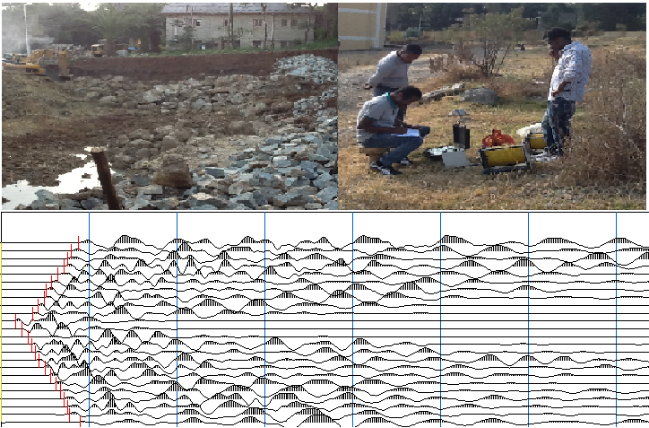
By: Shewangizaw Ayidefer
Advisor: Prof. Tigistu Haile
April 2019

A THESIS PRESENTED TO THE PROGRAM OF GRADUATE STUDIES ADDIS ABABA UNIVERSITY
IN PARTIAL FULFILLMENT OF THE REQUIREMENTS FOR THE DEGREE MASTER OF SCIENCE IN APPLIED GEOPHYSICS ADDIS ABABA, ETHIOPIA
Integrated Geophysical and Geotechnical Investigations for Building Foundation at Kotebe Metropolitan University, North East of Addis Ababa, Ethiopia
By: Shewangizaw Ayidefer Gulilat
School of Earth sciences
Approved by the Examining Board:
Dr. Balemwal Atnafu ___________ _________
Chairman, School of Earth Sciences Signature Date
Prof. Tigistu Haile _____________ ___________
Advisor Signature Date
Dr. Genet Tamiru _____________ ___________
Co- Advisor Signature Date
______________ ___________
Internal Examiner Signature Date
______________ ___________
External Examiner Signature Date
DECEMBER 2018
Declaration
I hereby declare that the work which is being presented in this thesis entitled “Integrated Geophysical and Geotechnical Investigations for Building Foundation at kotebe Metropolitan University North East of Addis Ababa, Ethiopia” is original work of my own, has not been presented for a degree or diploma in any other university and that all source of the material used for the thesis have been duly acknowledged.

Shewangizaw Ayidefer __________ ____________
(Candidate) signature Date
This is to certify that the above declaration made by the candidate is correct to the best of my knowledge.

Dr. Tigistu Haile ___________ ____________
(Advisor) signature Date

ABSTRACT
This study was carried out within the premises of Kotebe Metropolitan University which is located north east of Addis Ababa with the objective to assess the suitability of the foundation condition for the new building is erected within the campus. To achieve this proposed objective systematic methodology was followed includes an integrated approach where both geophysical and geotechnical investigations were carried out. For geophysical investigations Electrical Resistivity Imaging (ERI) and seismic refraction methods were employed.
The collected data were interpreted using qualitative and quantitative methods of analyzing by integrating with borehole log data available from nearby areas. The results have revealed that the subsurface geology consisted of three distinct units whose geological interpretations correspond to a topsoil, weathered rock unit and bedrock which shows distinctive physical properties i.e. (resistivity and velocity). The topsoil is composed of reddish brown, medium stiff, moderately plastic silty clay soil. The second layer is a completely decomposed, weathered and fractured weak unit. The bottom stratum mapped in the survey, considered to be the bed rock in the area is a high resistivity, high seismic velocity unit which could be the response of basaltic layer. The geoelectrical section across the study area shows smooth characteristics of the bedrock morphology. From the combination of electrical resistivity imaging and the seismic refraction survey interpretations and from borehole log data this bed rock unit extends, from 7.5 to 21.5m. There are signatures of fractures and weathering within the bedrock, as deduced from reduced velocity within the bedrock unit which can affect the building foundations in some area of the site. From these assessments, the study area falls within a good to fair engineering property.

AKNOWLEDGEMENT
I should begin with thanking my advisor Prof. Tigistu Haile, whose intellectual advice, guidance and regular discussions were very valuable and inspiring in the process of the proposal writing, on field work, research undertaking and thesis writing. He gave me all what I have to get from him and I would also like to thank my co divisor Dr. Genet for her especial devoted advice.
I am indebted to Addis Ababa water and sewerage authority, Ethiopian geological survey and Ethiopian Water Works Design and Supervision Enterprise (WWDSE) allowing valuable data and information during my research work. And I would also like to thank all Addis Ababa University Earth Science Department instructors and secretary office members for their contributions in providing of reliable knowledge and information during learning of geophysics.
I am thankful to my colleagues; Getachew B., Tariku D., Belete G, for supporting and cooperation during primary data collection that leads to achieve my research work properly. I should also mention Daniel’s help in supplying and supporting me with important software and other relevant materials. I am grateful to Alemayehu Mengesha (Alex) for his special encouragement; Alex I have no words to thank you for all what you did for me. Without them this work would never have come into existence. You gave me the strength to mount it.
Finally, I wish to thank all Kotebe Metropolitan University staff members. Especially, Dr. Getinet, I have no words to thank you for all what you did for me, be blessed brow.
At last, but not least, my thank goes to the Almighty God who helped me above all I have mentioned earlier.

Table of Contents page
Abstract ……………………………………………………………………………………………i
Acknowledgement………………………………………………………………………………...ii
CHAPTER ONE
- INTRODUCTION………………………………………………………………………1
  - Background …………………………………………………………………………..1
  - Statement of the problem ……………………………………………………………3
  - Objective of the study ………………………………………………………………..3
    - General objectives …………………………………………………………….3
    - Specific objectives ……………………………………………………………4
  - Description of the study area ………………………………………………………..4
    - Location, physiographic and accessibility ……………………………………4
    - Climate ………………………………………………………………………..5
    - Drainage pattern ………………………………………………………………6
  - Outcomes of the study…………………………………………………………….…6
  - Limitation of the study …………………………………………………………….…7
  - Methodology …………………………………………………………………………7
    - Desk study …………………………………………………………………….8
    - Fieldwork ……………………………………………………………………..8
    - Data analysis and presentation ……………………………………………..…9
  - Previous works ……………………………………………………………………….9
  - Layout of the thesis …………………………………………………………………10
CHAPTER TWO
- OVERVIEW OF THE GEOLOGIGAL, HYDROLOGICAL AND
SEISMIC SETTINGS OF THE STUDY AREA………………………………………..11
  - Regional Geology settings ……………………………………………………….…11
    - The stratigraphic sequence…………………………………………………...11
  - Tectonic setting……………………………………………………………………...14
  - Site geology………………………………………………………………………....15
    - Soil…………………………………………………………………………...15
  - Hydrological setting ………………………………………………………….……..15
  - Seismic setting ……………………………………………………………………...16
CHAPTER THREE
- THEORETICAL BACKGROUND METHODS OF INVESTIGATION ……………20
  - Direct Current Resistivity Method…………………………………………………...20
    - Introduction…………………………………………………………………..20
  - The electrical resistivity method…………………………………………………….21
    - Principle of Resistivity method………………………………………………21
    - Electrical properties of Earth materials ……………………………………...31
    - Types of resistivity surveys………………………………………………….33
      - Electrical resistivity profiling…………………………………………...33
      - Electrical resistivity Imaging/ Tomography/ERT……………………….33
    - Soil corrosivity ………………………………………………………………34
    - Limitation of electrical resistivity methods………………………………….34
  - The Seismic Method ………………………………………………………………..35
    - Overview of Seismic waves and velocity …………………………………...35
    - Seismic refraction Method…………………………………………………...35
    - Basic principles of Refraction………………………………………………..37
    - Geometry of Refraction waves………………………………………………39
    - Geophysical inversion………………………………………………………..42
    - The Time-term method………………………………………………………42
    - The Reciprocal time method…………………………………………………43
    - The Topographic Method……………………………………………………43
CHAPTER FOUR
- DATA ACQUISITON , PROCESSING AND PRESENTATION……………………..44
  - Introduction…………………………………………………………………….……44
  - Electrical Resistivity Imaging (ERI)………………………………………………...44
    - Field procedure and data acquisition of ERI ………………………………..45
    - Processing and presentation of ERI data…………………………………….48
  - Seismic refraction Method…………………………………………………………..49
    - Field procedures and presentation of seismic data…………………………..50
    - Data processing and presentation of Seismic data…………………………………...51
CHAPTER FIVE
- RESULT, DISCUSSION AND INTERPRETATION………………………………….54
  - Interpretation of resistivity imaging data …………………………………………....54
    - Introduction…………………………………………………………………..54
  - Interpretation of seismic refraction data…………………………………………….62
    - Introduction…………………………………………………………………..62
  - Combined interpretation of 2D ERI models and seismic Refraction data…………..69
CHAPTER SIX
- CONCLUSITION AND RECOMENDATIONS………………………………………..75
  - Conclusions………………………………………………………………………….75
  - Recommendations…………………………………………………………………...76
REFERENCES ………………………………………………………………………….78
LIST OF APPENDICES
ANNEX -A...........................................................................................................................i
ANNEX -B……………………………………………………………………………….vi
ANNEX- C………………………………………………………………………………vii

List of Figures
Figure 1.1: Location Map of the study area …………………………………...………………….4
Figure 1.2: Drainage map of Addis Ababa ….................................................................................5
Figure 1.3: General Methodology followed in the thesis work…………………………………...9
Figure 2.1: Geological map of Addis Ababa …………………………………...……………….12
Figure 2.2: Photo taken from the site; where the soil section showing dark to light brown, medium stiff silty clay and reddish to yellow soils are exhibited. …………...……………….…16
Figure 2.3: A) Seismic hazard map of Ethiopia...…......................................................................18
B) Seismicity of the region with the seismic source zones………………………......18
Figure 3.1: Current distribution for a point source……………………...………………………23
Figure 3.2: potential due to two current electrodes ………………………...……………………25
Figure 3.3: Current distribution for various electrode separations ………...……………………26
Figure 3.4: Two potential and two current electrodes……………...……………………………26
Figure 3.5: Wenner array…………………….......………………………………………………29
Figure 3.6: Schlumberger array ……………..……………………………………………….….30
Figure 3.7: ERT Wenner-Schlumberger configuration ………………………………………....31
Figure 3.8: Schematic plan for EPR…………………………………………………………......33
Figure 3.9: Ray path diagram showing the respective paths for direct, reflected, and refracted rays………………………………………………………………………………………….....…37
Figure 3.10: A two- layer horizontal stratified substratum…………………...………………….39
Figure 3.11: Travel-Time graph for two layer surface………………………………………......41
Figure 4.1: Showing connection for resistivity method……………………………………….....45
Figure 4.2: Location and distribution map of the ERT profiles and Seismic spread surveys, Kotebe Metropolitan University building site ………..…………………………………...…….46
Figure 4.3: ERT data acquisition by PASI Resistivity meter unit (showing the P-100 Energizer, cable reels and layout), Kotebe Metropolitan University building site…………....…48
Figure 4.4: Example of measured, calculated and inverse 2D model resistivity section for Profile-1, Kotebe Metropolitan University building site ………………………………………..49
Figure 4.5: layout of seismic refraction surveying……………………………………………....50
Figure 4.6: Seismic cables, trigger cable, geophones, and hammer with plate and DOLANG data logger respectively ..............................................................................................................50
Figure 4.7: Seismic data acquisition by DOLANG data logger unit and other seismic instruments ………………………………………………………………………………….…...51
Figure 4.8: Picked first breaks for Profile-1 with 1000Hz frequency, Kotebe Metropolitan University building site ..................………………….…………………………………………..52
Figure 4.9: Flow chart for seismic refraction data processing and analysis in SeisImager/2D software ….....................................................................................................................................53
Figure 5.1: 2D inverse resistivity model section along Profile-1, Kotebe Metroplitan University building site……………………………………………………..……………………55
Figure5.2: Inverse 2D resistivity model for Profile-2, Kotebe Metropolitan University building site……………………………………………………………………………………………...57
Figure 5.3: Inverse 2D resistivity model for Profile-3, Kotebe Metropolitan University building site………………………………………………………………………………………………..58
Figure 5.4: Inverse 2D resistivity model for Profile-4, Kotebe Metropolitan University building site………………………………………………………………………………………………..60
Figure 5.5: Inverse 2D resistivity model for Profile-5, Kotebe Metropolitan University building site …………………………………..………………………….………………………61
Figure 5.6: Time-term inversion for Profile-1, Kotebe Metropolitan University building site………………………………………………………………………………………………..63
Figure 5.7: 2D Seismic tomography velocity models for proftle-1, Kotebe Metropolitan University building site ………………………………………………………………………….64
Figure 5.8: Time-term inversion for proftle-2, Kotebe Metropolitan University building site ……………………………………………………………………………………………………65
Figure 5.9: 2D seismic tomography velocity models for proftle-2, Kotebe Metropolitan University building site .......................................................................…………………………. 65
Figure 5.10: Time-term inversion for spread-3, Kotebe Metropolitan University building site...66
Figure 5.11: 2D seismic tomography velocity models for spread-3, Kotebe Metropolitan University building site…………………………………………………………………………. 66
Figure 5.12: Time-term inversion for spread-4, Kotebe Metropolitan University building site………………………………………………………………………………………………. 67
Figure 5.13: 2D seismic tomography velocity models for spread-4, Kotebe Metropolitan University building site……………………………………………………………………….… 67
Figure 5.14: Time-term inversion for spread-5, Kotebe Metropolitan University building site …....................................................................................................................................................64
Figure 5.15: 2D seismic tomography velocity models for spread-5, Kotebe Metropolitan University building site…………………………………………………………...…………….. 69
Figure 5.16: Electrical resistivity imaging versus tomographic inversion along Profile-1, Kotebe Metropolitan University building site ……………………….……………………….………….70
Figure 5.17: Electrical resistivity imaging versus tomographic inversion along profile-2, Kotebe Metropolitan University building site …………………..…………………….…………………71
Figure 5.18: Electrical resistivity imaging versus tomographic inversion along Profile-3, Kotebe Metropolitan University building site ………………………………….……….……………….72
Figure 5.19: Electrical resistivity imaging versus tomographic inversion along Profile- 4, Kotebe Metropolitan University building site…………………………………………………...……… 73
Figure 5.20: Electrical resistivity imaging versus tomographic inversion along Profile-5, Kotebe Metropolitan University building site……………………...……………………….……………74

List of Tables
Table 1.1: Annual temperature and precipitation of Addis Ababa city…………………………..6
Table 2.1: Major earthquakes that occurred previously in Addis Ababa ……………………….17
Table 2.2: Ethiopian seismic zone and their equivalent bed rock acceleration…………………18
Table 3.1: Resistivity valve of common earth materials ………………….……………………..32
Table 3.2: British Standard Classification of soil corrosivity…………………………………...34
Table 3.3: Seismic velocity for common materials …………………………………………….36
Table 4.1: 2D profiling data sheet………………………………………………………………..47

CHAPTER ONE
1. INTRODUCTION
  - Background
Every building consists of two basic components: the superstructures and the sub structures or foundations. The superstructure is usually that part of the building which is above ground and which serves the purpose of its intended use. The sub structure or foundations, on the other hand, is the lower portion of the building, usually located below ground level, which transmits the load of the superstructure to the sub soil. A foundation is therefore the part of the structure which is in direct contact with the ground to which the loads are transmitted. The soil which is located immediately below the base of the foundation is called the sub soil or foundation soil (Sirles, 2006).
Now a days, many people are building a lot of buildings on the surface of the Earth, but, most of the building owners are not undertaking a professional ground survey and investigation of the building site before they start to work. If a building foundation is made on soft or filled-in soil, the whole building may fail in the event of an Earthquake regardless of the advanced investigation techniques employed.
There are several techniques that can be employed to study the suitability of a site for a desired infrastructure. The most commonly used techniques involve geotechnical investigations, where by pitting or coring can be used to study the subsurface characteristics. Geotechnical investigations can give information on the physical properties of soils underlying a site to evaluate soil conditions that may affect the safety, cost effectiveness and design of a proposed structure. If the building foundation studies are not carried out properly, it may affect the performance of the structure. However, as these are spot measurements a much simpler and cost effective technique to characterize a building site, small or large, is to use geophysical methods.
Geophysical methods have much importance in supplementing geotechnical investigations in that they provide continuous coverage of a site. It is applicable to investigate, detect and determine soil properties, inhomogeneity of the subsurface, cavities, ancient relics and generally any underlying structures or bodies that have different physical properties from their geological surroundings (Sirles, 2006).
Several geophysical investigation techniques can be employed for building site characterization; the most commonly used being electrical resistivity, seismic refraction and magnetic surveys. In the past, electrical resistivity method was the most widely used geophysical prospecting methods in ground water and underground resource exploration. But now a days the electrical resistivity method is highly advanced and widely used for civil engineering and environmental application as well. Because of the new development in electrical surveying technique associated with development in electronic switching, i.e. the use of electrical resistivity tomography; which gives the 2-D geoelectrical resistivity section of the subsurface geology of the site. Electrical resistivity tomography provides a relatively low cost, noninvasive and rapid means of generating spatial models of physical properties of the subsurface (Sirles, 2006)
The 2D electrical resistivity imaging is the most effective methods that can provide a detailed picture of the underground conditions without digging. Proper use of resistivity imaging surveys can provide significant cost saving over other exploratory methods.
Seismic methods can be used in engineering projects to determine directly the velocity of propagation of seismic waves of soil and rock bodies. The velocities are characteristic for different soils and for stiffness or relative density of a given soil (Terzaghi et al., 1996). Contrasts of P- or S-wave velocities can be interpreted as internal boundaries between soft and hard soils or rocks and can be clearly visible with modern seismic processing techniques such as refraction tomography or Multichannel Analysis of Surface Waves (MASW) depending on the geologic settings of the selected site. These internal boundaries of seismic velocities can be associated with other mechanical properties such as shear strength and bearing capacity and can be implemented for preliminary structural design and construction methods for different engineering structures such as roads, tunnels and buildings.
The magnetic methods of prospecting on the other hand, gives information on the presence or absence of subsurface structures, weak zones and discontinuities which are essential parameters in foundation studies.

  - Statement of the problem
Buildings should be designed to support certain loads without deforming excessively. The agent for deformation may be earthquake forces, wind, bad design, faulty construction, foundation failure, extraordinary loads, unexpected failure modes and the effects of different dynamic loads. Of all these possible causes, foundation failures occur mostly by failure to conduct proper geotechnical investigation of a building site.
Sufficient information should be collected about the properties of soils and rocks, geological structures and hydro geological nature of the site. Currently, in Addis Ababa most building foundations are conducted without proper geophysical and geotechnical investigations. Moreover, inadequate planning and undermining the need of conducting detail investigations employing appropriate techniques cause structural problems that result in damage of buildings with visible fracture and crack on the walls, sinking and total collapse that finally lead to loss of lives and properties.
Therefore, proper surface geophysical and geotechnical investigations will be conducted and provide actual foundation conditions so that resolve the above listed problems by producing better extrapolations of the whole area below the selected surface of the Earth and that is why the researcher is motivated to conduct integrated geophysical and geotechnical methods for better understanding of the subsurface properties of Earth layers as foundation material in the selected site.
Furthermore, those investigations can provide information to the concerned body of the building site and future buildings will be constructed accordingly and safely.

  - Objective of the study
    - General objectives
The main aim of this research work is to conduct integrated geophysical and direct geotechnical investigations to image the subsurface geology and to characterize the soils and rocks in terms of their engineering geological properties and their suitability for building foundations at the selected site.
    - Specific objectives
- To map the subsurface resistivity stratification of the site from which the subsurface geology could be deduced.
- To determine depth to the shallow ground water table (if it exists)
- To detect lateral changes and local anomalous geological conditions, lithological contacts and structures of the site and their influence on engineering structures.
- To characterize the soils and rocks of the site in terms of their engineering geological properties and their influence.

  - Description of the study area
    - Location, physiographic and accessibility
Kotebe Metropolitan University is located in the central Ethiopian highlands at the Western edge of the Main Ethiopian Rift. The site is situated on the northern side of Addis Ababa within Yeka sub city at the edge of an area locally known as ‘Asmera Menged’ around Kotebe as shown in Figure 1.1. It is bounded by geographical UTM coordinates of 482,042 to 482,742m East and 998,922 to 999,322m North.

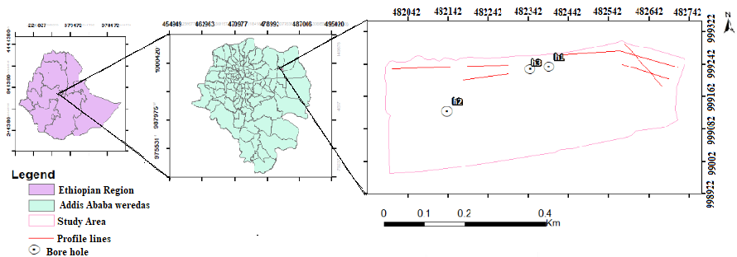

Figure 1.1: Location of the study area.

Specifically, the study area is located within the premise of the Kotebe Metroplitan University where extensions and a number of new infrastructures are being built to accommodate new Faculty and programs. The building site, lies on the eastern edge of the compound on a gently sloping topography with small sized erosion gullies crossing it (Figure 1.2). It is currently being utilized for farming. The site is as well covered by recent deposited sediment of varying thickness.
    - Climate
The climate of Addis Ababa is categorized as warm with an average annual temperature of 16.3 °C and a temperatures variation of 3.2 °C annually (Available at https:- //en. Climate data.org/location/532/) based on (Cwb koppen and Geiger, 2006) classification system.

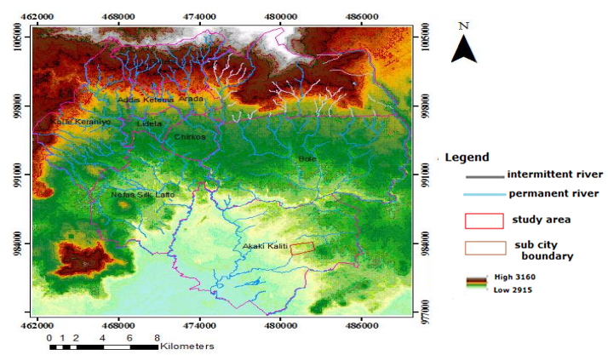
Figure 1.2: Drainage map of Addis Ababa.
The dry season extends from October to May, while from June to September it is wet, with intermittent rainfall in the rest of the months as shown (Table 1.1). The summer seasons are much rainier than the winter. The average precipitation in the city is 1143mm. The difference in precipitation between the driest month and the wettest month is estimated nearly 255mm.
Table 1.1: Annual temperature and precipitations of Addis Ababa city
Particulars | Jan | Feb | Mar. | April | May | June | July | Aug | Sep | Oct | Nov | Dec
Average temperatures (ºC) | 15.4 | 16.6 | 17.9 | 17.9 | 18 | 17 | 15.9 | 15.8 | 16.2 | 15.7 | 14.8 | 14.9
Minimum temperature (ºC) | 7.4 | 8.7 | 10.5 | 11.1 | 10.8 | 10.6 | 11.1 | 11 | 10.7 | 8.7 | 6.7 | 7
Maximum temperature (ºC) | 23.5 | 24.5 | 25.4 | 24.8 | 25.2 | 23.4 | 20.7 | 20.7 | 21.7 | 22.7 | 23 | 22.9
Precipitation (mm) | 17 | 39 | 66 | 86 | 84 | 118 | 256 | 263 | 161 | 34 | 8 | 11

    - Drainage pattern
The geomorphic feature of Addis Ababa city declines from NE towards SW and it has 2015 and 3050 m minimum and maximum elevation above mean sea level (amsl) respectively. It is surrounded by Furi Mountain from the southwest, Entoto Mountain Ridge from the north and Wechecha Mountain from west. The drainage of Addis Ababa shows dendritic pattern and it consists of intermittent and permanent rivers (Figure 1.2). Regionally, it is found within the Upper Awash Basin of the Akaki River catchment. In the northern border of the site, a number of small streams run from NE to SW. The topography of the specific studied site is nearly inclined towards the southeast. The maximum and minimum elevations reach 2143 and 2149m above mean sea level (amsl) respectively.
  - Outcomes of the study
The results of this research will help to understand the conditions of the Kotebe Metropolitan University site with regard to its suitability for building foundation. This means, civil engineers may find key inputs to develop engineering designs and also mitigation plans for anticipated problems that might happen anytime in the future. Moreover, the result of this research provides valuable input as background material for geophysicist researchers, city planners and other decision makers, which may require relevant geophysical and geotechnical information.

  - Limitation of the study
Maximum effort was made to effectively carry out this thesis work through the allocated time and financial resources. Well planned and proper field survey was conducted in different seasons to acquire reliable geological information about the vertical and horizontal stratification of the study site. However, some situations rendered the field survey difficult if not impossible. Some of the major limitations encountered are stated as follows:
- Problem of galvanic contact- i.e. the presence of relatively thick baked concrete (leftover from earlier construction work) which have significant effect on the electrical resistivity while the current flow deep in to the ground and thereby limits the depth of investigation.
- As the study area is located nearby the main asphalt road and new residential houses construction site, there was noise from traffic flows, construction machineries, animals and human beings. Generally, these situations have made the field work tedious, time consuming for particularly the seismic refraction survey.
- Absence of well documented lithological log data within this specific site has made difficult a refined detailed geophysical data interpretation.

  - Methodology
To achieve the research objectives stated in section 1.3 systematic methodology was followed within in the given time and resource. Accordingly, both secondary and primary data have been used. In this research integrated geophysical and geotechnical methods, namely electrical resistivity and seismic refraction surveying in addition to some geotechnical data were implemented along selected profile lines in order to portrait the near surface Earth features beneath the target site. The geological and geophysical data have been prepared and modeled using AutoCAD, ArcGIS, WinResist, IPI2WIN, RES2D-INV, PROSYS II data management system, SeisImager/2D and Surfer software.
This thesis work was conducted in three stages classified as: desk study, field work, and post field data processing, presentation, interpretation and analyses. More description about each stage is given below.

    - Desk study
The activities done before starting the real fieldwork involved collection of secondary data related to the study from different sources, i.e. Addis Ababa Water and Sewerage Authority (AAWSA), Ethiopian Geological Survey (EGS) and Ethiopian Water Works Design and Supervision Enterprise (WWDSE), internet and others.
The whole methodology followed during this desk study stage can be summarized as follows:
- Collection of geological, hydrogeological and geotechnical- including borehole- data from government organizations and the Internet.
- Review of both published and unpublished previous works related to the subject matter.
- Preliminary site visit and preparation of field survey design.
- Checking the functionality of survey instruments and other ancillaries.

    - Fieldwork
Collection of primary data has been the main purpose of this stage and therefore, relevant geophysical, to some extent geological, data representing the research area its immediate surroundings were acquired during this stage.
Works progressed in this stage are listed as follows:
- Collection of 2D electrical imaging data along five profiling lines using Wenner-Schlumberger configuration with inter electrode spacing of 5m using PASI resistivity meter and associated accessories.
- By utilizing 48 channels Dolang Seismograph, refraction seismic data was collected along five profiles using 24 channels. For all spreads the spacing between each successive geophones (receivers) were maintained to be 5m.
    - Data analysis and presentation
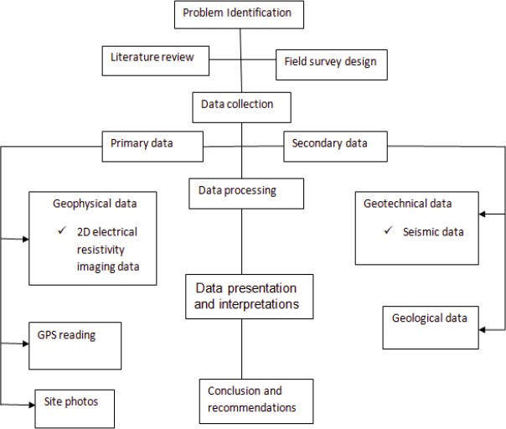
The geophysical field data, i.e. electrical resistivity and seismic refraction data were filtered and converted to appropriate formats, which then were processed using different types of geophysical software, including ArcGIS, WinResist, IPI2WIN, RES2DINV, PROSYS II, SeisImager/2D, AutoCAD and Surfer. Geophysical depth profiles were prepared and correlated with borehole data. Then maps and profile sections were interpreted to represent the corresponding geological information which leads to the discussion and conclusion about the result of the study.

Figure 1.3: General methodology followed during the thesis work.

  - Previous works
Previously, different geophysical and geotechnical, geological, hydrogeological, pollution and other related research studies have been done over the selected study area. The main purpose of those studies were mostly concerned with hydrogeological works, to plan and design water supply for the city of Addis Ababa and surroundings, especially in Akaki, Lege Dadi, Sululta, etc.
Numerous works have been done by different scholars. From amongst those, the relevant works include:
- The Construction Design Share Company (2011) - has conducted direct geotechnical investigations to study the engineering properties soils and rocks of the Addis Ababa Science and Technology University. The methods incorporated in this study were drilling of boreholes, standard penetration test and collections of undisturbed soil sampling.
- Tigistu Haile and Alemayehu Ayele (2014, and the references therein)- has conducted electrical resistivity tomography and magnetic surveys applied for building site characterization at Gubre, Wolkite University site, Western Ethiopia. In this study, a combination of surface geophysical investigation techniques (2D electrical resistivity imaging, vertical electrical sounding (VES) and magnetic surveying) is used to characterize a building site and determine its suitability for building foundations.
- Hailemariam Siyum (2011 and the references therein)- conducted investigation for building Foundation at Addis Ababa Science and Technology University, Akaki, Addis Ababa, Ethiopia,
- Addis Ababa University and Addis Ababa Water and Sewerage Authority (2003)-conducted a comprehensive study on ground water vulnerability mapping of the Addis Ababa area.
- Tilahun Mamo (2005) - site specific ground motion simulation and seismic response analysis at the proposed bridge sites within the city of Addis Ababa, Ethiopia.
- Messele Haile (2004) - Seismic Micro Zonation for the City of Addis Ababa by Using Micro tremors.

  - Layout of the thesis
This thesis is organized in to six chapters. The first chapter is general introduction of the study. The second chapter is concerned with previous works that includes geology, hydrogeology and seismicity of the study area and its surrounding. Chapter three covers the theoretical background methods of investigation. Chapter four describes the complete data acquisition, processing and presentation. Chapter five covers Results and interpretation. The last chapter; chapter six contains conclusions and recommendations of the overall research work.
CHAPTER TWO
2. OVERVIEW OF THE GEOLOGICAL, HYDRO GEOLOGICAL AND SEISMIC SETTINGS OF THE STUDY AREA
  - Regional Geological Setting
The landmass of Ethiopia is covered by three major geological terrains. These are Proterozoic crystalline basement rocks, Late Paleozoic-Mesozoic sedimentary rocks and Cenozoic volcanic rocks. Among those, the Cenozoic volcanic rocks and quaternary sediments cover the majority of the country’s landmass (Solomon Gerra, 2002).

Assiged Getahun (2007) mapped the geology of Addis Ababa and classified the volcanic rocks into Entoto trachyte, Entoto mixed rocks, Foot basalt, Cheleka basalt, Repi basalt (trachyte basalt and basalt), lower ignimbrite, Wechecha-Furi-Yerer trachyte and trachyte basalt, Wechecha-Furi-Yerer ignimbrite, Quaternary olivine basalt, Quaternary scoria, Tertiary sediments and Lake sediments. While conducting the engineering geological mapping of Addis Ababa area, Kebede Tsehayu and Tadessse Hailemariam (1990) have delineated trachyte and rhyolite, ignimbrite tuff, trachyte basalt and basalt of different age. A representative geological map of Addis Ababa and its surroundings is given in Figure 2.1 (OWWDSE, 2008).

    - The stratigraphic sequence
Haileselassie Girmay and Getaneh Assefa (1989) have presented the stratigraphic sequence of Addis Ababa and its surrounding. According to them, its stratigraphy mainly consists of Miocene-Pleistocene volcanic successions. From oldest to youngest the Alaji rhyolites and basalts, Entoto silicic, Addis Ababa basalts, Nazareth group and Bofa basalts constitute the lithostratigraphic succession of Addis Ababa.

- Alaji Basalt
The outcrop of this volcanic rock is exposed in the Entoto Mountain from the end of Oligocene until middle Miocene (Zanettin and Justin, 1974). This series is represented by Alaji rhyolites and Alaji Basalts and underlain by tuffs and ignimbrites. These basalts, with grey and glassy welded tuff intercalation, show highly variable texture that ranges from highly pophyric to aphyric. Its distribution extends from the crest of Entoto ridge (bordering the northern parts of Addis Ababa) towards the north (Haileselassie Girmay and Getaneh Assefa, 1989).

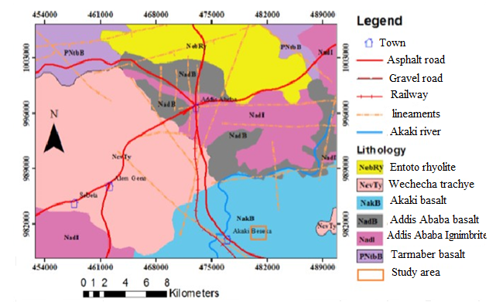

Figure 2.1: Geological map of Addis Ababa (WWDSE, 2008).

II. Entoto Silicic
The Entoto Silicic volcanic are uncomfortably overlain by Addis Ababa basalt on the foothill of Entoto and underlain by Alaji basalt. These units are composed of early Miocene rhyolite and trachyte with minor amount of welded tuff and obsidian. Silicic volcanic unit could denote localized terminal episodes to massive Oligocene fissure basalt activity in the Addis Ababa region (Morton et al., 1979). The thickness of the flow becomes maximum on the top of Entoto ridge and thin at the eastern part of Addis Ababa (Haile Selassie Girmay and Getaneh Assefa, 1989).

III. Addis Ababa Basalt
It is underlain by the Entoto silicic and overlain by Lower welded Tuff of the Nazareth group. The maximum thickness exceeding 130 meters and the outcrop was exposed at ketchene stream. Olivine porphyritic basalts outcrop in the central part of the town that includes Mercato, Teklehaymanote and Sidist Kilo. The distribution of plagioclase porphyritic basalt is almost the same as that of the Olivine porphyritic basalt. It outcrops in an area, which includes Sidist Kilo, General Winget School and French Embassy. The Lower Welded Tuff overlies both types of basalt nearby the Building College, the Kolfe Police School, the Kokobe Tseba School and YecaMariam Church (Haile Selassie Girmay and Getaneh Assefa, 1989).

IV. Nazaret Group
The lithological units’ identified in this group are Lower Welded Tuff, Aphanitic basalt and Upper Welded Tuff. They are underlain by Addis Ababa basalt and overlain by Bofa basalts .These welded tuff outcrops as small discontinuous body at Filwoha, western parts of Addis Ababa and Sululta areas. It is glassy with abundant frame and has columnar joints. It is overlain by the Aphanitic basalt and underlain by the olivine and plagioclase porphyritic basalt. Aphanitic Basalt covers the southern part of the town, especially the areas of Bole International Airport and Lideta Airfield.

The rock shows vertical curved columnar jointing together with sub-horizontal sheet jointing. The basalt is overlain by pumeacoues pyroclastic falls and the pyroclastic falls. It consists of labradorite, augite, rarely olivine and magnetite. The crystals of plagioclase show marked flow alignments. Upper Welded Tuff outcrops all over the southern part of the town; including Bole, Nefas Silk and Railway station; nevertheless it is also present in the central and northern parts of the town. It is gray colored, vertically and horizontally jointed and composed of sandine, orthoclase, quartz, and pumice and unidentified volcanic fragments. The welded tuff is underlain by Aphanitic basalts and overlain by young olivine basalts.

V. Bofa Basalts
These basalts comprised of olivine porphyritic basalt, scoria, and vesicular basalt and trachyte basalt lava flows. They extend in to the south from Akaki River and have a thickness of about 10 meters (Anteneh Girma, 1994). They appear to have a maximum thickness of 20-40m over the Akaki well field, and get thinner, even absent in other places.

VI. Alluvial and Residual Deposits
These deposits consisted of quaternary to recent alluvial and residual deposits. Those deposits are mainly found in some localities along small and Big Akaki Rivers, especially south and southwest of the capital city. A thick alluvial deposit occurs in the area between Akaki town and Abba Samuel Lake. Some deposits occur along the Kebena River, north-west of Bole area. Soils, which are developed in-situ by the decomposition of rocks, are located in the central, southeast, northeast, and Gullele and Kolfe areas. The thickness of these deposits varies between 5 and 50m.

  - Tectonic setting
Addis Ababa’s geology is the result of the intersection of two major tectonic lineaments and Cenozoic to Quaternary volcanism. The two tectonic features are the Yerer-Tullu Welele Volcanic Lineament (YTVL) and the western margin of the Main Ethiopian Rift (MER). The YTVL is an East-West running fault and volcanic zone. The intersection between YTVL and MER created the Addis Ababa embankment, where the rift becomes wider and the step faults defining the rift are subdued (Abebe Bekele, 1998). The Addis Ababa area is highly tectonized and complex due to its location with proximity to the margin of the Main Ethiopian Rift (Assegid Getahun, 2007). Accordingly, the main diastrophic structures encountered are lineaments and faults, whereas the non-diastrophic structures are bedding and volcanic layering.
Different geomorphic features align mostly in NE-SW direction, which is parallel to the rift structures or rift margin (Figure 1.2). Most of the faults mainly trend in NE-SW direction. These faults, which cut the entire section, are mainly normal faults. Joints and fractures are observed in rocks. The sizes of these structures vary from few centimeters to several meters in length (Assegid Getahun, 2007).

  - Site geology
From surface exposure and borehole log data the study area consists of exposure of reddish brown, medium stiff moderately plastic silty clay soil and light gray to yellowish completely decomposed fractured weak unit.

    - Soil
The occurrence and distribution of soils within a specific locality is controlled by topography, geology and climate. Soils in the study area could be the result of physical, chemical and biological decomposition of the surroundings volcanic rocks. The nature of soils is an important parameter in the development of civil engineering structures which directly poses social, environmental and economic impacts. Their effect is more pronounced for shallow foundation structures due to their proximity to surface. From visual observation, nearby borehole and ongoing construction sites, the top layer is represented by fractured weak trachyte with reddish brown color (Figure 2.2).

  - Hydrological setting
The occurrence, movement and storage of groundwater at particular place depend upon the surrounding geological setup, climatic conditions and surface morphology. In this case, porosity and permeability of the volcanic rocks and recent sediments distributed within this specific area determine the hydrogeological characteristics. The possible mechanism for rocks to acquire porosity and permeability is associated with the formation primary porosity and post-rock formation processes, such as weathering and fracturing.
The rock mass is fractured, reddish brown, light gray colored, and slightly weathered on the surface as observed in an abandoned quarry. So the target area is accessible through all weathered gravel road from the main asphalt south east direction. The expected aquifer type in such geological condition is mainly volcanic aquifer. The groundwater in the study area related with the nature of the surrounding lithology, structure and topographic features.

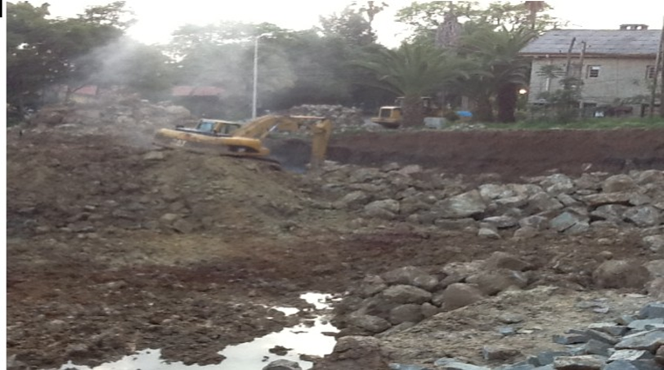
Figure 2.2: Photo taken from the site; where the soil section showing dark to light brown, medium stiff silty clay and reddish to yellow soils are exhibited.

  - Seismic setting
The Main Ethiopian Rift System and the Afar Depression are parts of the great East African Rift System, where numerous seismic activities take place indicating tectonically dynamic nature of this region. As such the study area is located at the western margin of the main Ethiopian Rift seismic activity should be considered.
According to the report compiled by World Bank Group (2015), Addis Ababa is urbanizing and growing at a rapid pace. However, the city faces potential shocks and stresses that could hinder it from achieving its development goals. These include urban flooding, Earthquakes and rapid urbanization. The city lays in the seismically active region it could experience moderate seismic risk (Messele Haile, 2012). It is located only 75-100 kilometers away from the western margin of the Main Ethiopian Rift Valley, which is a hotbed of tremors and active volcanoes.
In addition to Addis Ababa, some major cities in Ethiopia are very near to the major fault lines, like the Wonji fault, Nazret fault, Addis-Ambo-Ghedo fault, and Filowha fault lines along which numerous Earthquakes of varying magnitude have been registered in the past (Samuel Kindie, 2002).
The presence of the Filwoha hot springs at the heart of Addis Ababa city itself is a good example of nature’s reminder that the city lies on fault zone that slowly builds strains. It is the release of these strains accumulated over the years that cause the phenomenon of earthquake (Samuel Kindie, 2002).
In a century of its existence Addis Ababa has witnessed a number of Earthquakes. Some of the recorded occurrences are listed in Table 2.1.

Table 2.1: previously occurred Earthquakes in Addis Ababa (Laikemariam Asfaw, 1985 as cited in Messele Haile, 2012)
Year | Earthquake  magnitude | Epicenter distance  From Addis Ababa | Location
1906 | 6.8 | 100km | South of Addis Ababa
1961 | 6.6. | 200km | Karakore
July 1997 | 4.0 | 22km | Southwest  Of Addis Ababa
1997 and 1984 | Small | Far but felt in high rise  Building | -

Based on the Ethiopian Building Code Standard (1995), from seismic zone and ground acceleration data, the country is divided in to five seismic zones, namely Zone 0, 1, 2, 3 and 4, or no damaging zone (0 zones), less damaging zones (zone 1 and 2) and zones of major damaging (zone 3 and 4) (Table 2.2). Accordingly, the study area lies under zone 2, where a moderate seismic risk is expected. The seismic zonation shown in Figure 2.3 is related to bed rock acceleration (BRA) and the study area fall under Zone 2.

Table 2.2: Ethiopian seismic zone and their equivalent bed rock acceleration.

Zone | 4 | 3 | 2 | 1
Bed rock acceleration(_{o}) | 0.1 | 0.07 | 0.05 | 0.03

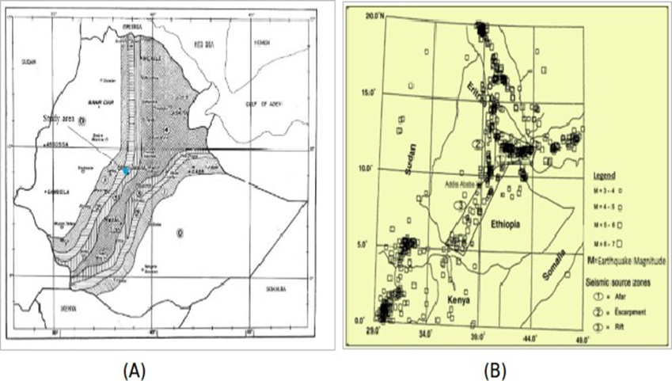
Figure 2.3: A) Seismic hazard map of Ethiopia (Ethiopian Building Code Standards, 1995)
B) Seismicity of the region with the seismic source zones (Tilahun Mammo, 2005)

Based on the seismicity and the knowledge of the geology and tectonics, the region can also be broadly divided into three seismic source zones (Tilahun Mammo, 2005). These are: the Afar Depression, Escarpment and Ethiopian Rift System seismic source zones which are very near to the study area. The location of the earthquake is not uniformly distributed throughout the region, but it is clustering along the Main Ethiopian Rift system. Generally, the existence of a number of hot springs and the proximity of the city to the Central Main Ethiopian Rift are clear indications of the dynamic nature of the region, and therefore, attention should be given for the development of proper designs and constructions of civil engineering infrastructures in the city.

CHAPTER THREE
3. THEORETICAL BACKGROUND METHODS OF INVESTIGATION
  - Direct Current Resistivity Method
    - Introduction

Electrical resistivity methods of geophysical prospecting are well established and the most important method for groundwater investigations. It is also the one that has been widely used because of the theoretical, operational and interpretational ease. The advantages of electrical methods include control over depth of investigation, portability of the equipment, availability of wide range of simple and elegant interpretation techniques, and the related software etc.

Direct current (D.C.) resistivity (electrical resistivity) techniques measure Earth resistivity by driving a direct current signal into the ground and measuring the resulting potentials (voltages) created in the Earth. From the data obtained, the electrical properties of the Earth (the geo electric section) can be derived. In turn, from those electrical properties we can infer the geological characteristics of the Earth.

In geophysical and geotechnical literature, the terms "electrical resistivity" and "D.C. resistivity" are used synonymously. Several geological parameters which affect Earth resistivity (and its reciprocal, conductivity) include clay content, soil or formation porosity and degree of water saturation.
The theory and practice of electrical method for groundwater investigations is well documented by Bhattacharya and Patra (1968) and Parasinis (1973). The interpretation of resistivity data and its application to groundwater studies has been given in detail by Zohdy (1976).
D.C resistivity techniques may be used in the profiling mode (Wenner surveys) to map lateral changes and identify near vertical features or they may be used in the sounding mode (Schlumberger array) to determine depths to geoelectric horizons (depth to water table). Both profiling and vertical electrical sounding (VES) has been successfully applied to various geological formations by (Flathe, 1955; Ogilvy, 1967; Ogilvy et al., 1980; Zohdy et al., 1974). Common applications of the D.C resistivity method include delineation of aggregate deposits for quarry operations, estimating depth to water table and bedrock or to other geoelectric boundaries, mapping and/or detecting other geologic features (Sahebrao Sonkamble, 2014).

  - The electrical resistivity method
    - Principle of Resistivity method

In electrical resistivity method a direct or low frequency alternating current is introduced into the ground by means of two current electrodes connected to the terminals of a portable source of electromotive force (emf). The resulting potential distribution on the ground, mapped by means of two non-polarizable electrodes (potential electrodes) is capable of yielding information about the distribution of electrical resistivity below the surface.
The method is efficient when good electrical contact with the ground is secured. Thus, it is not effective in regions with non-conducting surface formations like dry desert rocks, frozen ground, etc.
The electric current in a short thin, linear conductor of uniform cross-section, is given by Ohm’s law:
(3.1)
where, I is the current in ampere (A), ∆V is the potential difference in volts (v) between the ends of the conductor and R is the resistance of the conductor in ohms (Ω). The minus sign expresses the fact that the current flow is from high to low potential (opposite to the increase of potential gradient). Since resistance is directly proportional to the length ’l’ in meters (m) of the conductor and inversely proportional to the cross-sectional area A in square meter (m2),
(3.2)
where, the constant of proportionality ρ is the resistivity in ohmmeters (Ω-m) of the material of the conductor. The distinction between resistance and resistivity is that resistance is an opposition that a particular path of an electric current offers to the flow of the current whereas resistivity is one of the physical properties of a conductor that determines its electric resistance. Substituting equation (3.2) in equation (3.1) for R and rearranging gives
(3.3)
The left-hand side of equation (3.3) is the current density J (current per unit area of cross-section in (A/m²), while − on the right hand side is the electric field E in v/m in the direction of the current density vector.
Hence,
(3.4)
Since resistivity ρ is the inverse of conductivity σ in Siemens per meter (s/m) or mho, equation can alternatively be written as
(3.5)
When the length "l" in equation (3.3) tends to zero and if one considers the linear conductor as a homogeneous and isotropic continuous medium, then, either of equations (3.4) or (3.5) expresses Ohm’s law for such a medium.
The electrical resistivity method is based on Ohm’s law, which in more generalized form, states that the electric field strength at a point, in an electrically isotropic material, is directly proportional to the current density passing that point.

Current flow in a homogeneous, isotropic Earth
An electrically isotropic medium is the one for which the resistivity ρ, is a scalar function of the point of observation and the current density J, is in the same direction as the electric field vector, E. In an anisotropic medium, J has a directive property and, in general, is not in the direction of E. This calls for some modification in Ohm’s law as:
(3.6)

Point current source
The resistivity method consists of measuring potential P₁ when current is applied at a point source "A". The return current electrode can be placed at a very great distance and assume material of uniform resistivity ρ. Because air has infinite resistivity, no current flows upward. Thus, current flows radially outward through the Earth equally in all directions so as to define a hemispherical surface (Fig.3.1). Since current distribution is equal everywhere on this surface, which is at a distance "r" from the current electrode "A", the potential also is equal. These surfaces are known as equipotential surfaces.
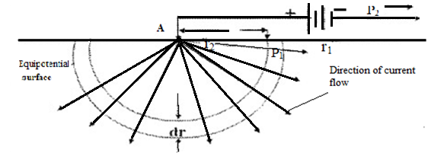
Figure 3.1: Current distribution for a point source
By defining a very thin shell of thickness ‘dr’ and developing equation (3.7), one can define the potential difference across the shell to be
(3.7)
The potential at a point far away by convention is arbitrarily defined to be equal to zero. The most direct way to determine "V" is to integrate equation (3.7) over its distance r₁ to the current electrode to infinity,
(3.8)
Equation (3.8) determines the potential at P₁. This equation is the fundamental equation in electrical resistivity prospecting discussions and it is possible to use it to develop more practical relationships as will be seen in the following sections. The information, which can be obtained from equation (3.8) by assuming a constant resistivity and current, is that it enables to map the potential at any point in section view of Figure (3.1). If adequate number of points were plotted one can draw lines through those points possessing the same potential. This defines the equipotential surfaces. Therefore, the direction of current flow can be determined, because current must be perpendicular to these equipotential surfaces.

Two current electrodes
In a homogeneous isotropic Earth with two current electrodes the current must flow from the positive current electrode (the source) to the negative current electrode (the sink). The derivation for the case when the current electrodes and the potential point lie in the same plane as shown in Figure (3.2) is that the potential at point P₁ is determined by using equation (3.8). The effect of the source at A (+) and the sink at B (-) are both considered, and therefore,
(3.9)

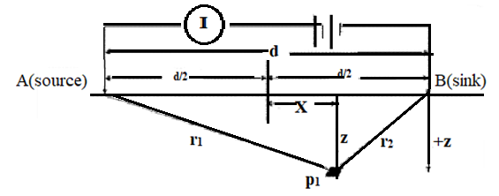
Figure 3.2: Potential due to two current electrodes.
Expressing r₁ and r₂ of x-z coordinate system shown in Fig. (3.2), equation (3.9) can be written as:
(3.10)
The above equation is used for a computer contouring package of the distribution equipotential surfaces. The current flow lines are perpendicular to the equipotential lines, but the manner in which current is distributed is not known.
The mathematical analysis to determine the current distribution is fairly complicated, but results in a simple equation that provides current distribution as a fraction of the total current. Along a vertical plane midway between two current electrodes Figure (3.2), the fraction of the total current ‘I_{f}’ penetrating to depth "z" for an electrode separation "dr" is given by:
(3.11)
Current distribution for various electrode separations can be investigated using eqn. (3.11). Therefore, for a homogeneous isotropic subsurface, the greater the electrode separation the greater the depth to which a given percentage of current penetrates.
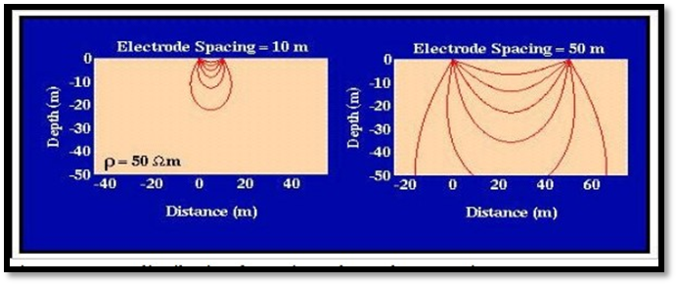
Figure 3.3: Current distribution for various electrode separations.

Two potential electrodes
In electrical resistivity surveying, the potential difference between two points is measured. Figure (3.4) illustrates two potential electrodes M and N that are located on the surface as are the current electrodes. Using equation (3.9), derived to determine the potential at a point due to a source and sink, the potential difference can be obtained by determining the potential at one point electrode M and subtracting from it the potential at N.
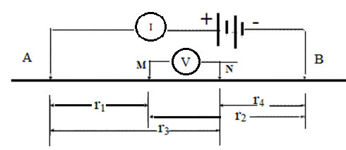
Figure 3.4: Two potential and two current electrodes.
Using equation (3.9)
(3.12)
and,
(3.13)
Therefore, the potential difference ∆V equals

(3.14)
or,
(3.15)
In electrical resistivity method, a known current is entered into the ground, potential difference is measured and resistivity can be determined. Because resistivity is unknown quantity, one can solve for the resistivity ρ from equation (3.15) and obtain
(3.16)

Apparent resistivity
Before discussing the various electrode spreads, it is necessary to consider what is actually measured by any array of current and potential electrodes.
From equation (3.15)
(3.17)
where,
3.18)
K is the geometric factor which depends on the electrode disposition.

Over homogeneous isotropic ground the resistivity will be constant for any current electrode arrangement. For non-homogeneous ground, however, as the electrode spacing is varied or the spacing remains fixed while the whole array is moved then the ratio will in general change. This results in a different value of ρ for each measurement. Thus, the value of resistivity is intimately related to the arrangement of electrodes. This measured quantity is known as apparent resistivity ρ_{a}. Although it is diagnostic, to some extent, to the actual resistivity of a zone in the vicinity of the electrode array, the apparent resistivity is definitely not an average value and only in the case of homogeneous ground it is equal to the actual resistivity.

Common electrode configurations
In actual practice a number of conventional surface configurations are used for the current and potential electrodes. In many arrangements, both sets of electrodes are laid out along a line. The current electrodes are generally placed on the outside of the potential electrodes (symmetrical). The most widely used configurations will be described in the paragraphs that follow. For convenience V will denote the measured potential while the potential difference is denoted by ∆V.

- Wenner array
One common electrode arrangement for resistivity measurement is the Wenner array (configuration) illustrated in Figure (3.5). Here each potential electrode is separated from the adjacent current electrode by a distance ’a’, which is one-third the separation of the current electrodes. For this arrangement, setting r₁ = r₄ = a and r₂ = r₃ = 2a in eqn. (3.16), the apparent resistivity becomes
(3.19)

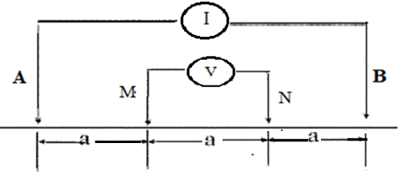

Figure 3.5: The Wenner array.

- Schlumberger array
In the Schlumberger configuration, the operator expands the electrode spacing by increasing the distance between current electrodes, typically on a logarithmic scale during the course of measurements. The potential electrode spacing is assumed to be infinitesimal, and the observed values of potential can be adjusted accordingly. The Schlumberger electrode arrangement is illustrated in Fig. (3.5). the apparent resistivity at the center of a Schlumberger array, r₁ = r₄ = (s−a) and r2 = r₃ = (s + a) in eqn. (3.16), yields
(3.20)
where, "s" is half of the current electrode separation (i.e. .AB/2). The Wenner arrangement is a special case of the Schlumberger array, in which s = 3a/2.

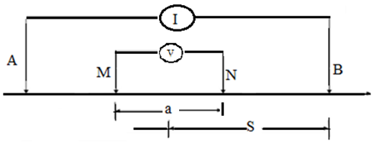
Figure 3.6: Schlumberger array.

- Wenner-Schlumberger array
This is a new hybrid between the Wenner and Schlumberger arrays (Pazdirek and Blaha, 1996) arising out of relatively recent work with electrical imaging surveys.
The classical Schlumberger array is one of the most commonly used array for resistivity sounding surveys. One can use a modified form of this array so that it can be used on a system with the electrodes arranged with a constant spacing. Note that the "n" factor for this array is the ratio of the distance between the C₁-P₁ (or P₂-C₂) electrodes to the spacing between the P₁-P₂ potential pair. The sensitivity pattern for the Schlumberger array is slightly different from the Wenner array with a slight vertical curvature below the center of the array, and slightly lower sensitivity values in the regions between the C₁ and P₁ (and also C₂ and P₂) electrodes.
There is a slightly greater concentration of high sensitivity values below the P₁-P₂ electrodes. This means that this array is moderately sensitive to both horizontal and vertical structures. The median depth of investigation for this array is about 10 percent larger than that of the Wenner array for the same distance between the outer (C₁ and C₂) electrodes.
The Wenner Schlumberger array has a slightly better horizontal coverage compared with the Wenner array. For the Wenner array each deeper data level has 3 data points less than the previous data level, while for the Wenner Schlumberger array there is a loss of 2 data points with each deeper data level. The horizontal data coverage is slightly wider than the Wenner array.

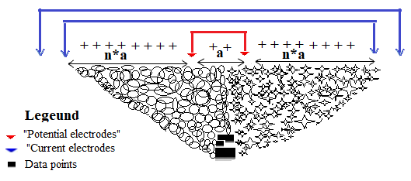
Figure 3.7: ERT Wenner-Schlumberger array configuration.

    - Electrical properties of Earth materials
Electrical prospecting involves the detection of surface effects produced by electric current flow in the ground. There is a much greater variety of techniques available than in the other prospecting methods, where one makes use of a single field of force or anomalous property gravitation, magnetism, elasticity, radioactivity.
Using electrical methods one may measure potentials, currents, and electromagnetic fields that occur naturally or are introduced artificially in the Earth. Furthermore, the measurements can be made in a variety of ways to determine a variety of results. Basically, however, it is the enormous variation in electrical conductivity found in different rocks and minerals that makes these techniques possible.
Materials that differ geologically may also differ electrically and such differences are distinguished by an electrical resistivity survey. Properties that affect the resistivity of a soil or rock include porosity, permeability, water content, composition (clay mineral and metal content), salinity of the pore water, and grain size distribution.
Sedimentary rocks, which are usually more porous and have higher water content, normally have lower resistivity values compared to igneous and metamorphic rocks. The resistivity values range from 10 to about 10000 Ωm.
Unconsolidated sediments generally have even lower resistivity values than sedimentary rocks, with values ranging from about 10 to less than 1000 Ωm.
Different class of rocks and soils may have similar range of resistivity values (see Table 3.1). This is because the resistivity of a specific rock or soil material dependent on the porosity (assuming all the pores are saturated) as well as the clay content. Clayey soil normally has a lower resistivity value than sandy soil. Clays and a few other minerals, notably magnetite, hematite may be found in sufficient concentration to contribute measurably to the conductivity of the soil or rock. Soil conductivity is a function of grain size, with finer grains producing higher values and coarse grains resulting in lower values.
A typical resistivity survey has low resistivity for the soil layers with underlying bedrock producing higher resistivity. Usually, this will be the case, but the particular conditions of a site may change the resistivity relationships (Bernard, 2003).

Table 3.1: Resistivity valve of common earth materials (Loke, 2001)
Common earth materials | Resistivity (Ω.m)
Slate | 6×102-4×107
Marble | 102-2.5×108
Quartzite | 102-2×108
Granite | 5×103-106
Basalt | 103-106
Sandstone | 8-4×103
Shale | 20-2×103
Limestone | 50-4×102
Clay | 1-100
Alluvium | 10-800
Groundwater(fresh) | 10-100
Sea water | 0.2

    - Types of resistivity surveys
There are two basic types of resistivity investigations: Profiling and depth sounding investigation. A combination of both has also been possible through the development in electronic switching that has resulted in improved data acquisition and interpretation.
Moreover, the earlier techniques although still widely used were considered very labor intensive and the development of the multi-electrode surveys has been able to reduce this aspect of the survey (Karim, 2014).

      - Electrical resistivity profiling
The resistivity profiling is a technique to locate lateral variations in resistivity at a constant depth. Here the electrode configuration remains the same for the entire area and it is moved as a whole along a traverse, generally normal to the strike of the rock formations, or set at regular interval distances. This resistivity profiling procedure is especially useful to locate and map vertical contacts like dykes, faults, fissures and segregated mineralization zones (Loke, 2001). The procedure is called lateral inhomogeneity hunting.
Interpretation of resistivity profiling data is usually qualitative in nature.

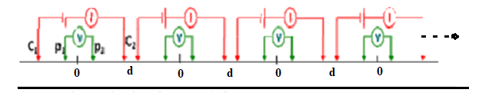
Figure 3.8: Schematic plan for EPR (after Loke, 2001).

      - Electrical resistivity Imaging/ Tomography/ERT
One of the new developments in recent years is the use of 2D electrical tomography surveys to map areas with moderately complex geology. Such surveys are usually carried out using a large number of electrodes, in this study 24 electrodes were and a constant spacing between adjacent electrodes was used.
To convert the resistivity picture into a geological picture, some knowledge of typical resistivity values for different types of subsurface materials and the geology of the area surveyed is important. The resulting measurements were combined with the available geological and geotechnical reports of the study area and were used to assess the structure of the near surface geology.
After the acquisition of the geophysical data interpretation of the resistivity results were carried out using soft wares. The apparent resistivity distribution of the subsurface structure is then inverted using that software to estimate the true resistivity structure. The inverted data produce the 2D resistivity distribution map, which can then be used for extracting information about the contact between sediments and bedrock.
    - Soil corrosivity
One of the best and most reliable parameters indicating soil corrosivity is the electrical resistivity of the soil at the relevant location and depth. High corrosivity would occur in area of lowest resistivity values where there is high moisture content (Table 3.1).

Table 3.2: British Standard Classification of soil corrosivity (BS, 1973)
Soil resistivity () | Corrosive
Up to 10 | Severely corrosive
10-100 | Moderately corrosive
Above 100 | Slightly corrosive

    - Limitation of electrical resistivity methods
Electrical boundaries separating layers of different resistivity coincide with layers of different lithologic composition. This may result in the electrical stratigraphy varying from the gross geologic stratigraphy (Ruffell and McKinley, 2005).
Earth resistivity measurement has been made using an array of grounded electrodes (Wenner, Schlumberger, etc.) with which to inject current into the ground and to measure the potential difference.
The use of grounded electrodes can sometimes give problems in areas of high surface resistivity because in such situation obtaining useful levels of current flow in the ground could be difficult.

  - The Seismic Method
    - Overview of Seismic waves and velocity
The building foundations that may be subjected to seismic force should be designed so as to maintain structural safety equivalent to or exceeding that of the upper structure. It is important to conduct an investigation according to the state of the site with respect to possible ground deformation such as liquefaction and landslide.
Proper analysis and design of foundations under seismic loading involves a broad variety of factors related with seismology, earthquake geotechnical engineering, geology and applied mechanics. Thus, topics on seismic soil site effects, techniques to define dynamic properties, soil structure interaction phenomena, foundation stability, code requirements and instrumentation of soil foundation systems are studied. Amongst the important parameters in rock hardness and suitability for foundation is the property of seismic velocity within it. There is recognition that this property can be used as a diagnostic tool. This parameter is found to exhibit large variation as shown in Table 3.2.
    - Seismic refraction Method
The seismic refraction technique is based on the refraction of seismic energy at the interfaces between subsurface/geological layers of different velocity. The seismic refraction method uses very similar equipment to seismic reflection, typically utilizing geophones in an array, and a seismic source (shot).

Table 3.3: Seismic velocity for common Earth materials (Keary et al.; 2002).

Earth materials | V_{p} (km/s)
Sand (dry) | 0.2-1.0
Sand (water saturated) | 1.5-2.0
Clay | 1.0-2.5
Glacial till (water saturated) | 1.5-2.5
Permafrost | 3.5-4.0
Sandstone | 2.0-6.0
Quartzite | 5.5-6.0
Limestone | 2.0-6.0
Chalk | 2.0-2.5
Dolomite | 2.5-6.5
Salt | 4.5-5.0
Anhydrite | 4.5-6.5
Gypsum | 2.0-3.5
Granite | 5.5-6.0
Gabbro | 6.5-7.0
Ultramafic rocks | 7.5-8.5
Serpentinite | 5.5-6.5
Pure water | 1.4-1.5
Petroliam | 1.3-1.4
Ice | 3.4

Some of the seismic energy travels along the surface in the form of a direct wave. However, when a seismic wave encounters an interface between two different soil and rock layers a portion of the energy is reflected and the remainder will propagate through the layer boundary at a refracted angle (Figure 3.9).
At a critical angle of incidence (Figure 3.9), the wave is critically refracted and will travel parallel to the interface at the speed of the underlying layer. Energy from this critically refracted wave returns to the surface in the form of a head wave, which may arrive at the more distant geophones before the direct wave.

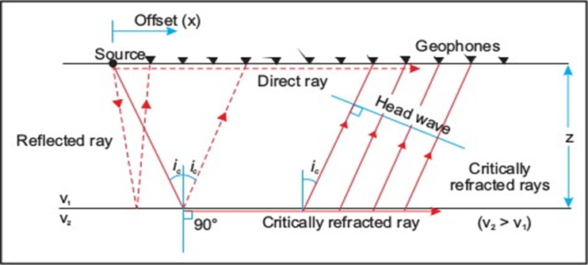
Figure 3.9: Ray path diagram showing the respective paths for direct, reflected, and refracted rays.
By picking the time of the first arrival of seismic energy at each geophone, a plot of travel-time against distance along the survey line can be generated. The gradients of the lines in this type of plot are related to the seismic velocity of the subsurface layers.
Instruments distributed along the surface detect ground motion caused by these returning waves and hence measure the arrival times of the waves at different ranges from the source. These travel times may be converted into depth values and, hence, the distribution of subsurface geological interfaces may be systematically mapped. In this study, the focus is refracted seismic waves solely and taking other waves as a noise.

    - Basic Principles of Refraction
Refraction seismology is applied to a very wide range of scientific and technical problems, from engineering site investigation surveys to large scale experiments designed to study the structure of entire crust or lithosphere.
Two major categories of seismic waves are known: body waves and surface wave:
Body waves: these waves propagate through the Earth’s interior. Especially in refraction surveying, the body waves are used as the source of information used to image the Earth’s interior. Body waves propagate away from the source in all directions. If the speed at which body waves propagate through the Earth’s interior is constant, then at any time, these waves form a sphere around the source. This wave can be further subdivided into two classes of waves: P and S waves.
P-waves are also called primary waves, because they propagate through the medium faster than other wave types. In such waves, the particles constituting the medium are displaced in the same direction that the wave propagates, in this case, the radial direction. Thus, material is being extended and compressed as these waves propagate through the medium.
S-waves it sometimes called secondary waves; because they propagate through the medium slower than P waves. In these waves, particles constituting the medium are displaced in a direction that is perpendicular to the direction that the wave is propagating. In most exploration seismic surveys we use P waves as their primary source of information.
Surface waves: are waves that propagate along the Earth’s surface.
Their amplitude at the surface of the Earth can be very large, but this amplitude decays exponentially with depth. Surface waves propagate at speeds that are slower than S waves, are less efficiently generated by buried sources, and have amplitudes that decay with distance from the source more slowly than is observed for body waves. Like body waves, there are two classes of surface waves, Love and Rayleigh waves that are distinguished by the type of particle motion they impose on the medium. For homogeneous and isotropic medium P and S waves are calculated mathematically as follows.
and,
where µ and k are collectively called elastic parameters of a material through the wave passes and ρ is density of a material.

    - Geometry of Refraction waves
Refraction survey gives rise to first arrival signals whose time are picked up from a seismogram and plotted as travel time curves (Igboekwe and Ohaegbuchu, 2011). The interpretation of the seismic signal is therefore set to determine the interface depths and layer velocities.
Here we consider a two layer horizontal stratified substratum as shown in the Figure 3.10. where; “X” is the offset distance from the energy source to the geophone. Z₁ is the thickness of the first layer, V₁ is the signal velocity in the first layer and V₂ is the signal velocity in the second layer. The path of the energy signal is defined as SABG; we consider the wave SA which hits the layer boundary at the critical angle θc.

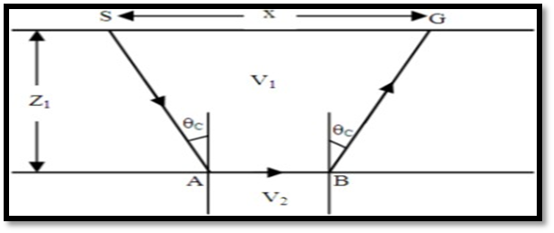
Figure 3.10: A two layer horizontal stratified substratum.

The total travel time for the refraction signal to travel from the source "S" to the geophone "G" is expressed as equation (3.21):
(3.21)
This can also be expressed as Equation (3.22):
(3.22)
SA= BG which is equals to:
(3.23)
and,
(3.24)
Now, by inserting the above equation (eq.3.24 and eq.3.23) in to equation 3.22, we get eq.3.27: (3.25)
(3.26)
This can be re-arranged to give:
(3.27)
According to Snell’s law,
(3.28)
While the relations/identity;
(3.29)
One can, therefore, express equation 3.27 as equation 3.31;
(3.30)
(3.31)
Equation 3.31 represents the time taken by the wave to travel to the bedrock and back to the geophone. The time distance curve produces two segments with different slopes as shown in Fig.3.11.
This travel time curve is used to determine the velocities of the two layers. The slope of the first part gives 1/v₁ and the slope of the second part gives 1/v₂. The inverse of slopes gives us the velocities of the subsurface (Igboekwe and Ohaegbuchu, 2011). The critical distance (Xc) is the point on the surface at which the direct wave and the head wave arrived simultaneously. Before the critical distance, the direct waves arrive first while beyond the critical distance, the head wave arrives first. According to Figure 3.11, t₁ is the intercept of the second segment of the straight line graph.
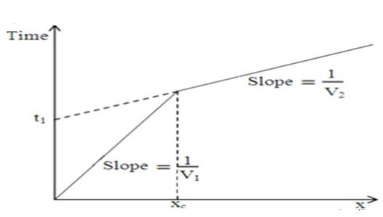
Figure 3.11: Travel-Time graph for two layer surface.

With all the necessary information obtained from the plot, the depth of the first layer is obtained to be Equation 3.32:
(3.32)
(3.33)
For the general depth calculation for any number of layers using intercept time as:
(3.34)

    - Geophysical inversion

Seismic inversion aims to reconstruct a quantitative model of the Earth subsurface, by solving an inverse problem based on seismic measurements.
According to Veeken and Da Silva (2004), inversion can be defined as a technique solving for a spatial distribution of parameters which could have produced an observed set of measurements. Inversion is capable of handling different kinds of geophysical data such as seismic, potential field, borehole data etc. For every specific case of inversion the assumption is made that a specific physical law holds. For the case of seismic inversion, this law is the wave equation or one of its numerous approximations. Thus, algorithms based on this physical law enable us to invert the measured data for the subsurface characteristics, which gave rise to these observations in the first place.
In this study, modeling of the velocity of near surface layers was made by using SeisImager/2D seismic refraction inversion software. Within this software package three different inversion techniques are designed. These inversion techniques are discussed in next subsections.

    - The Time-term method
A time-term method is a simple travel time inversion for seismic refraction crustal studies. Although this method is based on simple travel time calculation, it is robust in determining a basement velocity under the complicated surface structure.
This technique is a linear Least-Squares approach to determining the best discrete layer solution to the data.

    - The Reciprocal time method
Here the interpreter interacts with the software to a much greater degree, providing much more input. The reciprocal method should be used when the desired result needs to be as detailed as possible. It needs more data because of its use of "delay times", which require a refracted arrival from each direction. Ideally, data is acquired such that a delay time can be computed beneath each geophone. The depth is then computed from the delay time and the velocity.

    - The Topographic Method
Seismic tomography uses seismic records to create 2D and 3D images of subsurface anomalies by solving large inverse problems such that generate models consistent with observed data. Various methods are used to resolve anomalies in the crust and lithosphere, shallow mantle, whole mantle, and core based on the availability of data and types of seismic waves that penetrate the region at a suitable wavelength for feature resolution. The accuracy of the model is limited by availability and accuracy of seismic data, wave type utilized, and assumptions made in the model.
It involves the creation of an initial velocity model, and iteratively tracing rays through the model, comparing the calculated travel times to the measured travel times, modifying the model, and repeating the process until the difference between calculated and measured times is minimized. The math is quite complex. It needs better understanding of upper level calculus and linear algebra. Finding the minimum travel time between source and receiver for each pair is the main goal of this technique. This is accomplished by solving for "l" (ray path) and "s" (inverse velocity or slowness). Since we know neither, the problem is under constrained, and we must us an iterative, least-squares approach.

CHAPTER FOUR
4. DATA ACQUSITION, PROCESSING AND PRESENTATION
  - Introduction

This study was done by collecting reliable geophysical data in the field and geotechnical data from different organizations, like the Ethiopian Construction Design and Supervision Works Corporation and Addis Ababa Water and Sewerage Authority (AAWSA) to achieve the objectives of the research work. The data were acquired and analyzed to get the relevant information for the subsurface foundation condition of the proposed building site. Data collection, processing and interpretation during the present study are discussed in detail here under.

  - Electrical Resistivity Imaging (ERI)
Electrical Resistivity Imaging (ERI) techniques are employed to investigate both the vertical and lateral heterogeneity of near surface features underlying the study area. In the geoelectrical method a controlled current (I) is injected into the ground by two steel electrodes and the potential drop (ΔV) is acquired by two others. The apparent resistivity (ρ_{a}) is determined as:
where ‘K’ is a geometric factor defined by the electrode configurations on the surface.
The locations of study area boundary, geophone position, relative distance between surveyed points , shot points and stations were recorded interims of Easting, Northing and elevations using the Garmin GPS map 62 receiver, which provides readings with an accuracy of ±3m.
The various instrumentation and accessories employed in a typical electrical resistivity surveying work are shown in Figure 4.1.

    - Field producer and data acquisition of ERI
During the geoelectrical survey, the instruments employed for the survey were the PASI-16 GL electrical resistivity unit with P-100 Energizer, cable on reels for both the current and potential, steel electrodes, hammer, meter tape and also handheld GPS was used to record the location of the data point.

For each measurement the stainless steel metal stakes were inserted into the soil approximately 1 foot deep to ascertain good galvanic contact. The resistivity cable was then laid out and each electrode on the cable was connected to each metal stake. Once the line was laid out, the cables were connected to the instrumentation. P-100 Energizer power supply was used to provide the 16GL unit with additional backup power.

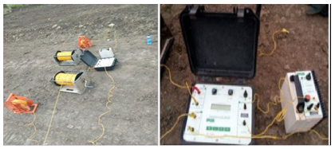
Figure 4.1: Showing connection for resistivity method.

Before collecting data, tests are run on the instrument and cable to ensure each electrode was properly connected to each stake and the instrument is running properly. Contact resistance tests were conducted to ensure the circuits were complete. Electrodes with contact resistance greater than 2,000 ohms fail the test and that particular stake needs to be pushed deeper in the soil to help create a better contact with the soil. In general, the lower contact resistance indicates better contact with subsurface material and increases signal strength, which improves better data quality and accuracy. During the surveys, no extra fluids were required at the sites, to obtain good electrode contact.
Data were collected by Electrical Resistivity Imaging technique using the Wenner-Schlumberger array and the survey was carried out along five transects/ profile lines with inter electrode spacing (AB/2) of 5m. The orientation and extent of those lines are shown in the post map of Figure 4.2.

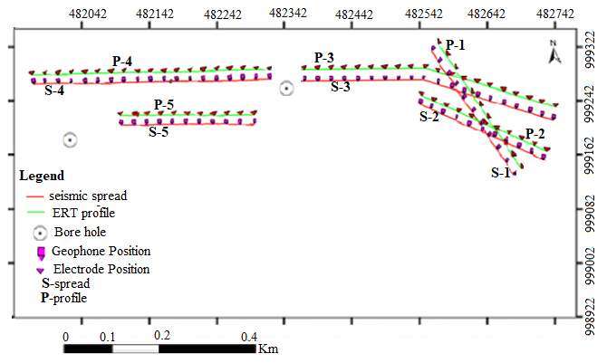
Fig. 4.2 Location and distribution map of the ERT profiles and Seismic spread surveys.

The primary 2D electrical resistivity raw data acquired in the field were carefully written on the data sheet prepared for this purpose and then the recorded raw data are inserted into Microsoft excel to calculate resistivity and apparent resistivity in Ohm-m.

. The data collection scheme for the Wenner-Schlumberger array employed is as given in Table 4.1.

Table 4.1: 2D profiling data sheet

Line No: ___________ Date: ____________
Area: _______________________ Locality: ___________________
Station Spacing = 20 m |  |  |  |  |  |  |  | R (Ohm-m)
Int. electrode spacing = 5m |  |  | Location (UTM, m): Easting_______ Northing_____  Elev.________
n |  |  |  | Plotting Pt (PP) |  |  |  | 2.5 |  | 22.5 |  | 42.5 | 62.5 | 82.5 |  | 102.5 |  | 122.5 |  | 142.5 |  | 162.5
 | C₁ |  | P₁ | P₂ |  | C₂
1 | -5 |  | 0 | 5 |  | 10
2 | -10 |  | 0 | 45 |  | 15
3 | -15 |  | 0 | 5 |  | 20
4 | -20 |  | 0 | 5 |  | 25
5 | -25 |  | 0 | 5 |  | 30
6 | -30 |  | 0 | 5 |  | 35
7 | -35 |  | 0 | 5 |  | 40
8 | -40 |  | 0 | 5 |  | 45
9 | -45 |  | 0 | 5 |  | 50
10 | -50 |  | 0 | 5 |  | 55
 | 182.5 | 202.5 |  |  | 222.5 |  | 242.5 |  | 262.5 |  | 282.5 |  | 302.5 |  | 322.5 |  | 342.5 |  | 362.5 |  | 382.5 |  | 402.5 | 422.5
1
2
3
4
5
6
7
8
9
10

Since the work is being conducted in a closed area, it was not possible to leisurely choose the line orientations as would be required in normal survey work. Hence, the orientations of the profile lines were taken in the direction (i.e. the three profile line were along SW to NE and the remaining two profile lines (NW to SE) as the survey area would dictate. An illustration of the field crew working in a field condition is depicted in Figure 4.3.

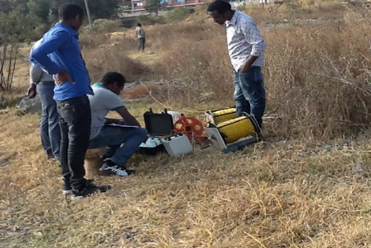
Figure 4.3: ERT data acquisition by PASI Resistivity meter unit (showing the P-100 Energizer, cable reels and layout).

    - Processing and presentation of the ERI data
In this work, the apparent resistivity data were inverted by the RES2DINV software (Loke, 2001) to obtain a subsurface image of the electrical resistivity pattern. The 2D inversion routine applies a Gauss-Newton least squares method (Loke and Barker, 1996), based on the finite difference model of the subsurface, and automatically adjusted in an iterative process.
The data points are saved in the form of "*.dat" which is the file ready for processing in RES2D inversion software. Each data set are first automatically filtered and manually examined and culled as well for removal of erroneous and outlier data. Following this, data of each profile line was processed separately for the inversion result. As a sample of the inversion process, data for Profile-1 which is made on a 140m length line showing the measured apparent resistivity, the calculated and the inversion 2D model resistivity section are shown in Figure 4.4.

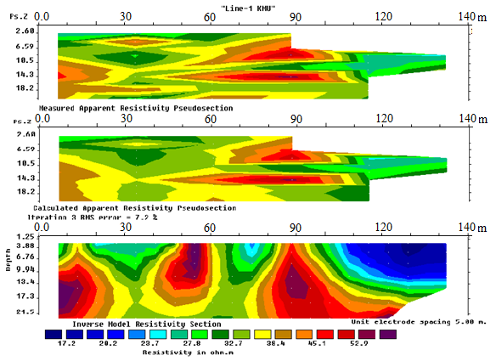
Figure 4.4: Example of measured, calculated and inverse 2D model resistivity section for Profile-1, Kotebe Metropolitan University building site.
With the help of the 2D inversion software program, iterations have been applied three to five times to yield valid inversion result with RMS error of 11.1 percent. This was taken as acceptable since not much improvement was observed with more iteration.

  - Seismic refraction Method
In a seismic refraction survey, pulses of low frequency seismic energy are emitted by a seismic source such as a hammer-plate, weight drop or buffalo gun. The type of source is dependent on local ground conditions, required depth penetration and in most instances, like in our case, on the availability of the source type. Explosives are best for deeper applications but are constrained by environmental and safety regulations.
The seismic waves thus generated propagate downward through the ground until they are reflected or refracted off subsurface layers. Refracted waves are detected by arrays of 24 or 48 geophones spaced at regular intervals of 1-10 meters, depending on the desired depth of penetration of the survey. Sources are positioned at each end of the geophone array to produce forward and reverse wave arrivals along the array. Additional sources may be used at intermediate or off-line positions for full coverage at all geophone positions.

    - Field Procedures and presentation of seismic data
In this study, seismic refraction survey was conducted by 24 channels DOLANG Seismograph along five profile lines having different lengths. For each profile line, a geophone spacing of 5m was used. In order to generate elastic waves, an artificial seismic source (10 kg sledge hammer as an impact source and strike plate) was utilized. The strike plate was hit by the sledge hammer repeatedly to enhance the elastic energy and improve the signal to noise ratio in a systematic way. The strike plate, sledge hammer, DOLANG seismograph, lap top computer and geophones were connected by a means of seismic and trigger cables. Location of each successive geophones and shot points in terms of easting, northing and elevation were taken with help of Garmin GPS map 62. Figures 4.5 and 4.6 show the data acquisition scheme and the accessories normally utilized in a typical seismic refraction work, while Figure 4.6 shows the exertion required to generate the seismic energy using sledge hammer source.
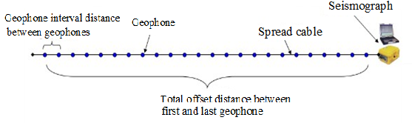
Figure 4.5: layout of seismic refraction surveying

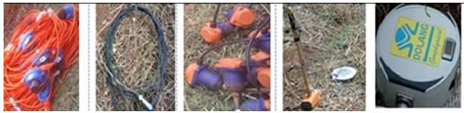
Figure 4.6: Seismic cables, trigger cable, geophones, and hammer with plate and DOLANG data logger respectively.

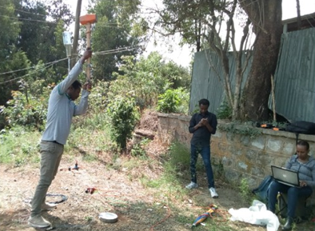
Figure 4.7: Seismic data acquisition by DOLANG data logger unit and other seismic instruments.

    - Data processing and presentation of Seismic data
The geophone output data as time traces which are compiled and processed by the seismograph. The basic components of a seismic trace are the direct wave, the reflected wave and the critically refracted wave. Wave refraction occurs at interfaces in the ground where the seismic velocity of the lower layer is greater than the velocity of the overlying layer. This condition normally applies in near surface site investigations where soil or fill overlies bedrock.
At geophones position close to the seismic source, the first seismic wave arrivals are direct waves. However, beyond a critical distance from the source, the first arrivals change to refracted waves due to the faster relative velocity of the refracted waves. Interpretation procedures involve the accurate measurement of first arrivals from the time traces recorded at each geophone position. The seismic trace obtained for survey on Profile-1 for a forward near offset shot point is as shown in Figure 4.8. It is clear from the plot that remarkably good quality seismic traces are acquired with the instrumentation, source and field setup employed.

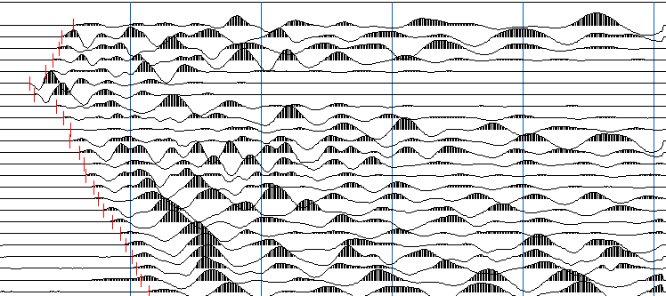
Figure 4.8: Picked first breaks for Profile-1 with 1000Hz frequency, Kotebe Metropolitan University building site.

Interpretation techniques are applied to the first arrival times to calculate the seismic velocities of the layers and the depths of individual refracting interfaces using the SeisImager. Figure 4.9 shows the flow diagram of the processing steps employed in the software. The interfaces are correlated with real physical boundaries in the ground, such as the soil-bedrock interface and other lithological boundaries, to produce a model of the subsurface ground structure. The final interpretation is presented in a format that is easily understood by engineers.
The main objective is to measure the time of the "first break", that is, the time when a given geophone first moves in response to a seismic energy source. Simply stated, since time and relative distances of sources and geophones are known, the velocity of the subsurface can be calculated.

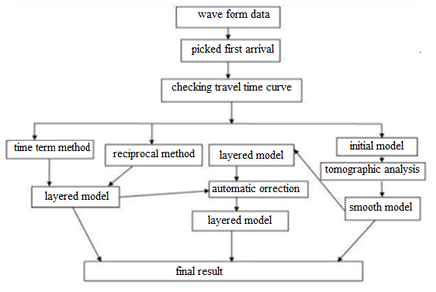
Figure 4.9: Flow chart for seismic refraction data processing and analysis in SeisImager/2D software

CHAPTER FIVE
5. RESULT, DISCUSSION AND INTERPRETATION
  - Interpretation of resistivity imaging data
    - Introduction
For this study, a combination of geophysical and geotechnical investigations have been carried out on the Kotebe Metropolitan University construction site to investigate its suitability for the proposed building foundation. Data collected from the study site and secondary geological data from boreholes are integrated to conduct reliable interpretation and obtain clear picture about the foundation conditions of this specific site.

The 2D electrical imaging and seismic refraction survey results are presented in the form of 2D plan maps. Interpretation and analyses of the 2D electrical imaging and compression wave velocity models are made integrated with the available lithological borehole log data from the site and thereby attempt has been made to minimize possible data interpretation ambiguities.

In the present work, electrical imaging surveys were carried out along five profile lines. Three profile lines were oriented along SW to NE nearly north south and the remaining two profile lines were NW to SE. The minimum profile length was 115 meters and the maximum was 290 meters with inter-electrode spacing of 5 meter. With this spacing and with the 24-electrode set up and depth of investigation acquired is 21.5m. All the profiles are plotted on site plan on the location map of the study area shown in Figure 1.1.
For this study information from borehole drilled to a maximum depth of 10m are used (boreholes logs are annexed in Appendix C). This provides to reveal the vertical as well as lateral geological section of the study site well. Since the 2D resistivity imaging survey is a preferable and effective survey tool to map subsurface features both laterally and vertically at the same time (Loke, 2001), the results of this survey are presented in form of 2D resistivity model sections and are discussed in the sections below.

Profile-1
The total length of this profile is 140m and the 2D inverse model resistivity section obtained from the data is shown in Figure 5.1. The measured and calculated apparent resistivity sections illustrated in Figure 4.3 are not displayed as they are not required in the result interpretation work. The 2D model shown (Figure 5.1) is correlated with distinct lithological features observed from nearby borehole log data (Appendix C, borehole 1). Accordingly, the top section is the response of reddish brown clay soil and the partly medium stiff moderately plastic silty clay soil distributed up to about 4m. Below this layer there is light gray to yellowish completely decomposed, fractured weak unit correlable to the borehole log data to about 10m. Note that, the fact that the layer that can be considered as the bed rock unit in the area is a highly fractured unit is shown by the relatively low resistivity response.

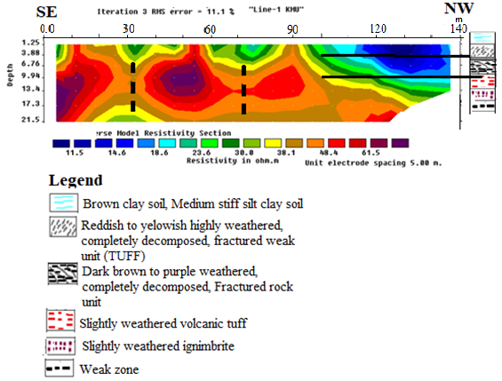

Figure 5.1: 2D inverse resistivity model section along Profile-1, Kotebe Metroplitan University building site.
The inversion result shows RMS errors of 11.1% after 5 iterations. The model actually describes the depth to along profile wise variation of low to high resistivity zones (11.5 - 61.5 Ωm). This variation in resistivity response could have resulted from variations in lithology, degree of weathering as well as variation in moisture content. A topsoil of relatively varying resistivity is observed in the upper part of the profile. The overall thickness of this top layer is not the same over the entire profile. However; there is variation in resistivity at about 4m depth which could be attributed to the response of the change in lithology. This second layer which is having a relatively higher resistivity extending along the profile (from 10-20m and from 28-42m) and with different thickness, could probably be the response of the weathered and fractured bedrock horizon is mapped below this top soil layer. This layer thickness extends about 15m.
Correlating the 2D resistivity imaging with the nearby lithological log data, it becomes evident that the top low resistivity zone (18.6 − 44.4 Ωm) approximately extending to about 4m represents the cumulative effect of the top reddish brown clay soil, and partly medium stiff moderately plastic silty clay soil. The thickness of this section shows a significant increment towards SE direction, but at the begging of the profile, i.e. between around 20m to 70m very thin layer with low resistivity seems ups and downs structure and increases its thickness with decrease in resistivity from about.
The second layer from the depth 4m to about 17m and along-profile length from 10m to 28m is high resistivity and the same response is repeated from along-profile length 28m to 42m having resistivity value of 48.4 Ωm to 61.5 Ωm and are attributed to the highly weathered volcanic rock. The resistivity of the bottom part that changes from 48.4 Ωm to 30 Ωm is associated with the occurrence of relatively competent volcanic unit that can be considered as the bedrock in the area.
Three distinct areas of the low resistivity responses extending to depth are mapped on the profile. They are interpreted as highly fractured basaltic rocks due to high weathering activity with high moisture content. A near vertical weak zone is interpreted to exist at about 20 m from the beginning of the profile that should be considered during foundation design. These are essential results from Profile-1 from the point of view of the survey objectives.

Profile-2
Resistivity imaging Profile-2 has a total length of about 225m and is oriented in a SE-NW direction. On the profile (Figure 5.2), three distinct geoelectrical layers were identified and correlated with the available geological information and borehole data (Appendix C, borehole 1). The top layer indicates a low resistivity layer whose resistivity varies from 5 Ωm to 20 Ωm and it corresponds to the reddish brown clay soil (clay and silty clay material). The thickness of this layer shows a significant increment from NW to SE direction along the profile. This layer is significantly thick in the NW part. The greater thickness of soil at this zone could be due to the high degree of weathering.

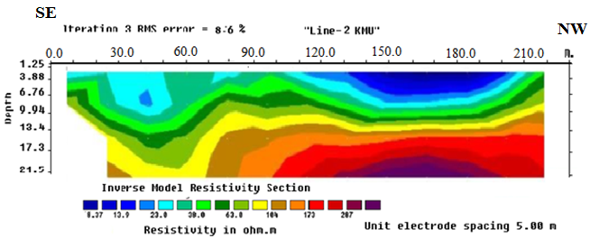
Figure 5.2: Inverse 2D resistivity model for Profile-2, Kotebe Metropolitan University building site.

It is further seen from the 2D inverse resistivity model section (Figure 5.2) that the section exhibits a relatively smooth resistivity transition from top to bottom; with the bottom layer showing a high resistivity response suitable for foundation work but a found at depths in excess of 10 m especially on the north western side of the line. This potentially bed rock unit is found at larger depth on the south eastern side of the line.

Profile-3
This traverse is also oriented in nearly North-West to South-East direction and runs almost parallel to the other three profiles (Profiles-1, 2 and 4). It is spaced about 50m from Profile-2 and has a total length of about 125m. The inversions of data give RMS error of 6.6 percent after 3 iterations and the resulting 2D section is given in Figure 5.3.

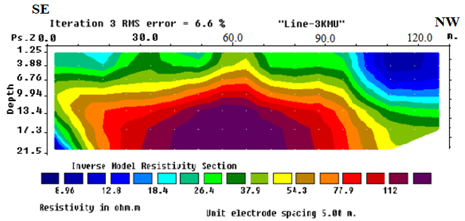
Figure 5.3: Inverse 2D resistivity model for Profile-3, Kotebe Metropolitan University building site.

The inversion results of Profile-3 are depth wise variation of low to high resistivity zones with resistivity ranges from 8.96 Ωm to 112 Ωm over the model section.
The variation in resistivity response could have resulted either from variation in moisture content of the top dry soil or from variations in lithology. The overall thickness of this top layer is not the same over the entire profile. Along the profile from 95 to 125m with depth 9.4m the resistivity is very low.
This low resistivity horizon extending from 0 to 95m and have nearly the same thickness, probably resulting from higher moisture content or water saturation, is mapped below this top soil layer.
The profile has different resistivity stratification and is interpreted separately. The top thin resistivity sections are observed in both sides of geoelectric sections. At the central portion of the profile relatively high resistivity and the second layer is exposed on the surface. This dry nature of top soil extends to about 3.88m of depth and the resistivity value ranges from 18.4 to 37.9 Ωm.
In the third resistivity variation zone, resistivity relatively increases (54.3-112Ωm) and it has been interpreted as high variation in resistivity with depth and this represents the weathered and fractured bedrock horizons. This transition zone underlies relatively fresh bedrocks and its depth extends about 13.4m. The bottom stratum mapped with this survey is slightly weathered/relatively fresh bedrocks and extends for about 21.5m depth.
The correlation depicts relatively low resistivity zone of topsoil matches with the reddish brown clayey soil. The low resistivity zone of layer two correlate yellowish gray silty soils and the transition zone of different weathering bedrocks correspond to grayish weathered ignimbrite and slightly weathered volcanic tuff. The bottom stratum of slightly weathered/relatively fresh bedrocks corresponds to fresh/slightly weathered ignimbrite of the site well. Also the low resistivity response of the layer is due to the presence of local pockets of groundwater. This layer is highly saturated, especially along weak zones, than any other layers. Relative to the other layer it is very thick and extends for about 21.5m in depth around the central part of the profile.

Profile-4
This is the fourth profile along which imaging data have been collected. The profile was chosen to run parallel to the fifth profile and its length is about 290m. The profile was intended to map the presence of structures oriented in the North-West to south-East direction. The survey line was denoted as Profile-4 and its inverse model is shown in Figure 5.4.

Analogous to the second line in this profile three distinct geoelectrical layers were identified and correlated with the available geological information and borehole data (Appendix C, borehole 2). The top layer indicates potentially low resistivity layer that varies from to 1.27Ωm to 18.3Ωm and it corresponds to dark brown soil (clay and silt clay materials). The thickness of this layers show a significant increment from NW to SE direction along the profile. This layer is significantly thick in the NW part. The greater thickness of soil at this zone could be due to the high degree of weathering.

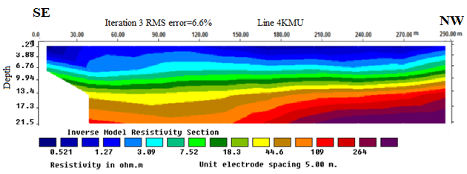

Figure 5.4: Inverse 2D resistivity model for Profile-4, Kotebe Metropolitan University building site.
Underlying the clay soil layer relatively intermediate resistivity variation varies from 18.3Ωm to 44.6Ωm is delineated. This layer attributed to highly to moderately weathered basalt. Its morphology is almost uniform and horizontal throughout the profile. The true resistivity of the third layer ranges from 44.6Ωm to 150Ωm which is related to the occurrence of comparatively strong formation than the overlaying layers. Its thickness is almost unique along the profile.

Profile-5
The 2D resistivity data acquired employing the same configuration with the above 4 profiles with inter electrode spacing of 5m and were processed using the Res2Dinv software. The total length of this profile is 115m and the result is shown in Figure 5.5.
As presented in the 2D model, at least, three prominent sections can be identified which can be correlated with distinct lithological features observed from nearby bore hole log data. Accordingly, the top reddish brown soil (clay) and partly the silty clay layers distributed up to about 7m. From about 7 m to a maximum of nearly 21.5m depth the resistivity of the underlying formations increases gradually from 67.6 to 180Ωm between the profile length 40 to 90m, which clearly indicate that the strength of the underlying formations considerably improve vertically. Along the profile extending from 0-25m; relatively the same resistivity variations depth wise.

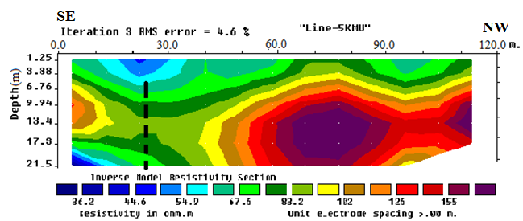
Figure 5.5: Inverse 2D resistivity model for Profile-5, Kotebe Metropolitan University Building site.

Correlating the 2D model with the nearby lithological log data, it becomes evident that the top low resistivity zone (50-85Ωm) represents the cumulative effect of the top dark-brown soil composed of, clay and silty and completely decomposed and fractured volcanic rock. The thickness of this section shows a significant reduction from the center towards both sides; especially the left side. But, at the center of the profile, i.e., between stations around 40 and 90m, the layer has high resistivity value and seems bulged upward and its thickness decreases downwards on both sides. The low resistivity region between about 10 to 40 m with resistivity value less than 100 Ωm is possibly the response of a highly weathered and fractured zone extending to depth that should be considered during building design.
Intermediate parts of this section are characterized by relatively enhanced resistivity values ranging from 36.2 Ωm to 100 Ωm. It is attributed to the highly weathered and volcanic bed, whose thickness is smaller at the central part of the profile and shows undulation with the station interval 40-90m. The resistivity of the bottom part changes from 85 Ωm to 180 Ωm is associated with the occurrence of relatively competent volcanic bedrock extending from 25m towards the right along profile.

  - Interpretation of seismic refraction data
    - Introduction
To identify the thickness of the overburden materials and depth to more competent hard formations through determination of compressional wave velocity (Vp), five seismic refraction lines have been surveyed. These transect more or less correspond to the five electrical imaging lines and are designed as such so that joint interpretations can be achieved.
The collected data were processed using the software programs PickWin95 and Plotrefa from the SeisImager software package. After determining the first break arrival time of wave using the PickWin95 software, and further processing of the picked travel time curves with the help of Plotrefa software. First arrival times were picked up using the auto-pick option of the system for all records and few adjustments were made automatically. This was performed for each of the shot points along the spreads. Then, the first arrival data were imported into Plotrefa, and a plot of time versus distance () was generated. Plotrefa automatically checks reciprocal times for multiple shot locations. These programs allow cross-sectional areas of the subsurface beneath each spread to be plotted. Thus modeling the bedrock interface using a time-term inversion method was employed. Then later were inverted and velocity models are generated. Two layer models were employed to represent the bedrock, vesicular basalt and a thin top soil layer. Layers are assigned by identifying crossover points, which occur where the slope of 1 changes. The change in slope between the top soil and bedrock is distinct. After the layer assignment, a time-term inversion model can be done, then using this result as an initial model tomographic inversion is applied. Velocity is calculated and the model depth is inferred. Velocity models for each spreads were generated using different first arrival picks in order to gain an understanding of model sensitivity. The model produced using the above software packages were interpreted according to the area geology and the parameters determined from the model.
In this seismic survey all 5 profile lines are used 24 channel seismic refraction spread with 5m geophone spacing.

Velocity model for Spread-1
This spread is 115m long and runs in a NW-SE direction. Time-term inversion method was used to generate the 2D subsurface model. The velocity model represents seismic velocities between 0.4km/s and 2.14km/s. The top most layer shows low P-wave velocity that vary between 0.38-0.7km/s and is about 5m thick with slight difference in thickness along the spread. The low velocity indicates that the top layer is essentially composed of soil deposits. The bottom layer, which is marked by comparatively high P-wave velocity that varies from 2.0 to 2.5km/s and, from the lithological borehole log data in the study area, this layer is probably the response of the weathered and fractured vesicular basalt which seems a little bit deeper symmetrically at both peripheries and slightly thicker at the center of the profile. This layer is located at a depth of about 10-13m along the profile.

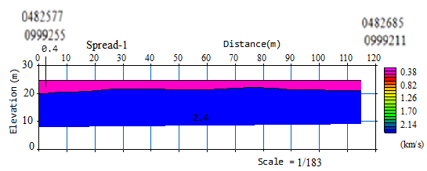
Figure 5.6: Time-term inversion for Profile-1, Kotebe Metropolitan University building site.

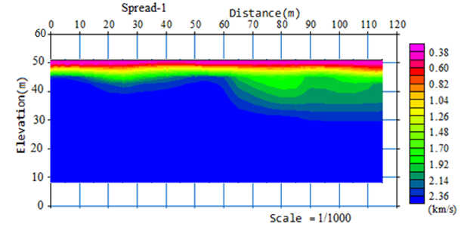
Figure 5.7: 2D seismic tomography velocity models for proftle-1, Kotebe Metropolitan University building site.

Velocity model for Spread-2
The seismic refraction of this spread lie with parallel to that of spread one laying in NW to SE direction. This Profile has total profile length of 225m length. The velocity model displayed in Figure below shows two contrasting lithological features which are discussed in the above sections. The top layer shows low p-wave velocity consists of soil deposits, clay, silt and sand with 0.3 -0.5km/s velocity and about 6m thickness ranges to the right from 80 to 225m along the profile line and very thin layer to the left side. The lower horizon is mapped by 1.2-1.6km/s velocity range associated with the response of completely decomposed rock, slightly weathered and highly fractured vesicular basalt. The depth of this layer is approximately 10m towards the right and thin at the left ends of the velocity model.

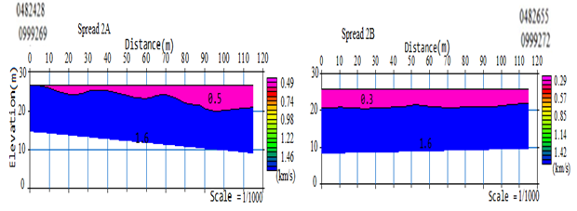
Figure 5.8: Time-term inversion for proftle-2, Kotebe Metropolitan University building site.

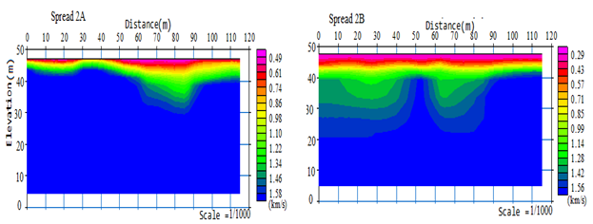

Figure 5.9: 2D seismic tomography velocity models for proftle-2, Kotebe Metropolitan University building site.

Velocity model for Spread-3
This Profile has 125m length and the velocity model displayed in the figure shows two contrasting lithological features which are almost similar to the first profile. The top first Layer in the velocity model essentially shows low-velocity material which is dark to light brown, medium stiff silty clay soil, reddish to yellowish highly weathered, completely decomposed and fractured weak until with 0.3- 0.91km/s velocity and about 6m thickness. The velocity of the second Layer with p-wave velocity of 1.43 -2.7km/s velocity range associated with the response of dark brown to purple weathered, locally fractured down hole rock unit. The depth for this layer extends up to about 10m.

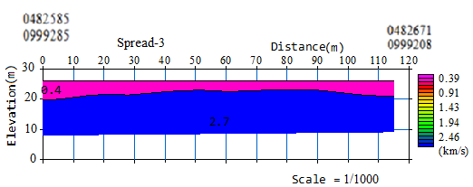
Figure 5.10: Time-term inversion for spread-3, Kotebe Metropolitan University building site.

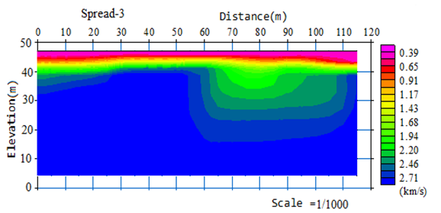

Figure 5.11: 2D seismic tomography velocity models for spread-3, Kotebe Metropolitan University building site.
Velocity model for Spread-4

The seismic refraction of profile four is laying in NW to SE direction. As shown in velocity model the thickness of the first top layer is about 5m thick and dead at the right side with seismic velocity of 0.4- 0.71km/s. Information from the lithologic log and the velocity value this layer is more likely made up of top soils of clay, silt, and sand. The second layer with p-wave velocity value from 1.02- 1.8km/s is corresponding to weathered and highly fractured vesicular basalt. It is found at a depth up to about 8-10m.

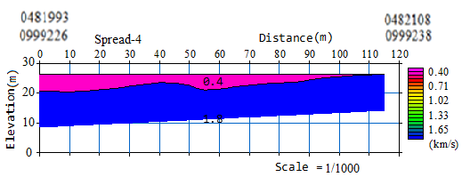
Figure 5.12: Time-term inversion for spread-4, Kotebe Metropolitan University building site.

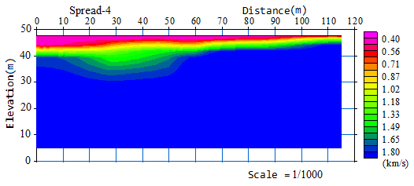
Figure 5.13: 2D seismic tomography velocity models for spread-4, Kotebe Metropolitan University building site.

Velocity model for Spread-5
This spread is parallel to profile four of the resistivity imaging survey which lies along NW-SE direction. The seismic velocity model of this spread is shown below. The top Layer of the velocity model for this spread is about 5m thick with average P-wave velocity of 0.4km/s. Layer 2 has average velocities of 2.7km/s. The first layer of this spread has relatively low velocity as compared to second layer in the survey area. This low p-wave velocity indicates the top layer is composed of clay, silt and sand deposits. From the lithological log in the study area the second layer is probably weathered and highly fractured basalt with p-wave velocity varies 1.97-2.7km/s.

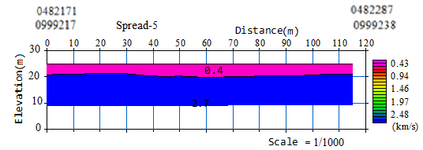
Figure 5.14: Time-term inversion for spread-5, Kotebe Metropolitan University building site.

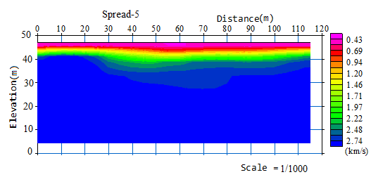
Figure 5.15: 2D seismic tomography velocity models for spread-5, Kotebe Metropolitan University building site.

  - Combined interpretation of 2D ERI models and seismic refraction data
After detailed examination and comparison of 2D electrical resistivity imaging and seismic refraction data and also by taking into account the borehole log data from the study area; the following combined interpretations are done. The following sections present the combined interpretations of the results of the different methods employed for each profile.

Profile-1
From the combined interpretation of the 2D electrical imaging and seismic refraction sections conveniently presented in Figure 5.16, the following deductions are made: a low resistivity horizon represents the top layer that extends to depths of about 5m; this layer is represented by an average velocity of 0.4km/s and thickness of about 5m on the seismic refraction 2D section. The second layer on the other hand shows high resistivity and corresponds to a relatively competent formation whose velocity is with quite high average elastic wave velocity of 2.4km/s and a depth range of 10-13m. In comparison, it is seen that, the 2D electrical resistivity model section has better outlined the subsurface undulations as well as lateral variations in lithology or degree of weathering and fracturing of the rocks because of its higher resolution.
Upon close examination of the two model sections, one can conclude that the resistivity and refraction survey give almost similar result but not quite uniform, while the depth and the overall trend of the layers from the both methods are quite similar.

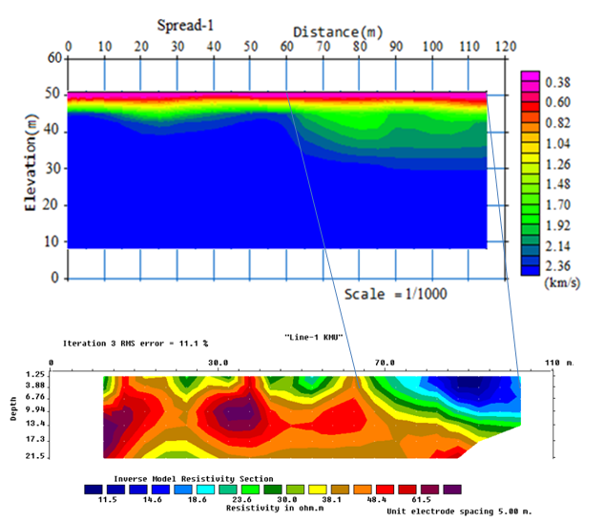
Figure 5.16: Electrical resistivity imaging versus tomographic inversion along profile-1, Kotebe Metropolitan University building site.

Profile-2
Figure 5.17 reveals the correlation between the 2D electrical resistivity imaging and the seismic refraction profiling survey results and demonstrates almost identical trends about the subsurface characteristics. Accordingly, both sections confirm that the resistivity is increasing with depth and which corresponds to increase in the competence of the formation with depth. The inverted 2D resistivity model and tomographic inversion have similar trend of variation. This profile is characterized by almost a horizontal layering of the underlying Earth materials that can be clearly depicted from the sections whose determinant parameters (resistivity and seismic velocity) increase with depth. Besides, both sections show that the thickness of the low resistivity layer increases southeast wards, whereas on the northeastern side the high resistive body significantly rises to the subsurface occurs at a relatively near to the surface.

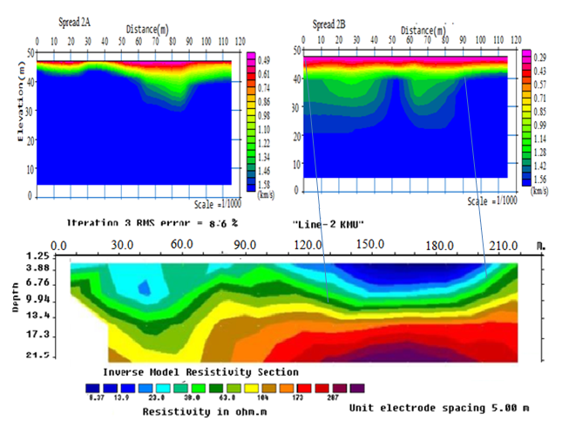
Figure 5.17: Electrical resistivity imaging versus tomographic inversion along profile-2, Kotebe Metropolitan University building site.

Profile-3
The inverted 2D resistivity model and seismic refraction survey sections are as shown in Figure 5.18. Both survey methodologies have similar trend of variation observed which is characterized by almost a horizontal layering of the underlying Earth materials with increase in wave velocity as well as resistivity with depth. Besides, in both sections, the thickness of the high resistivity layer increases at the central part of the profile, whereas on either sides the low resistivity region occurs at a relatively shallower depth. The variation is clearly observed in 2D electrical resistivity imaging section rather than seismic refraction one showing again the higher resolving power of the 2D electrical imaging technique.

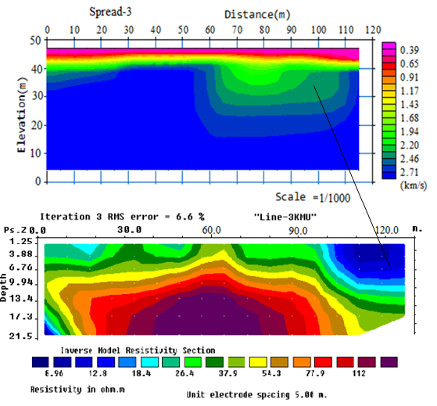
Figure 5.18: Electrical resistivity imaging versus tomographic inversion along profile-3, Kotebe Metropolitan University building site.

Profile-4
In this spread both methods have done along the same profile with similar trend of resistivity and velocity variation. It is characterized by almost a horizontal layering of the underlying Earth materials. Both sections show that the thickness of the low resistivity layer increases northwest wards and high resistivity increases in opposite direction. Here the thickness of the layer is approximately the same and high resistivity and velocity vale corresponding to weathered and highly decomposed and fractured vesicular basalt.

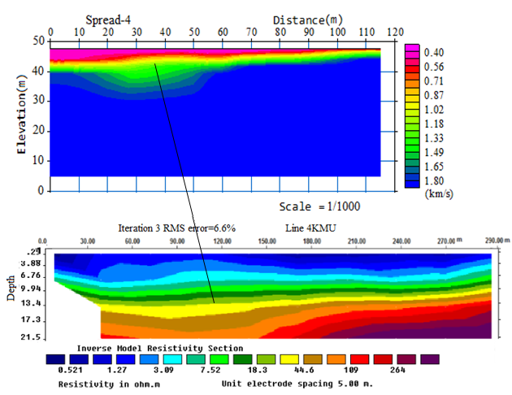
Figure 5.19: Electrical resistivity imaging versus tomographic inversion along profile- 4, Kotebe Metropolitan University building site.

Profile-5
The resistivity in the study area shows a series of high resistivity and velocity zones, which can be related to highly decomposed, local fracture and weathering. For example, Profile 1 and 3 shows a high resistivity zone. On the other hand profile-2 and 4 shows relatively low resistivity and velocity zones, such an anomaly can be caused by water saturated fracture or weathering and have been observed and can probably be used to trace the weak zone in the study area. By comparing the two we can easily distinguish the overburden from the bedrock.
Depth to bedrock estimated in both methods show considerable difference this may come due to the resolution difference in vertical depth. Both methods have also their own limitations, the resolution of the resistivity method decreases exponentially with depth and the image becomes increasingly fuzzier with depth. Refraction seismic has a limitation to see very thin layer and low velocity zone at depth.
This profile is parallel to profile 4 and the first layer of average depth 7m and has high resistivity and velocity variation from the depth 7m to bottom.

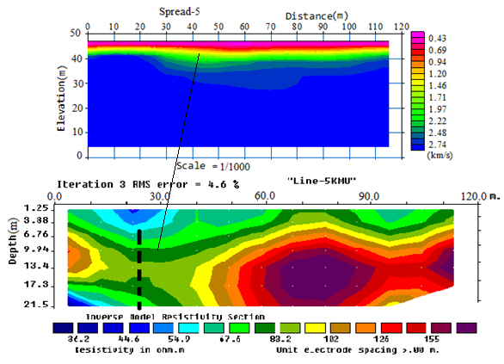
Figure 5.20: Electrical resistivity imaging versus tomographic inversion along profile-5, Kotebe Metropolitan University building site.
CHAPTER SIX
6. CONCLUSIONS AND RECOMMENDATIONS
This study involves the use of electrical resistivity imaging and seismic refraction methods which were carried out for investigation of building foundation at Kotebe Metropolitan University; North East of Addis Ababa, Ethiopia. By incorporating the available geological borehole log data and integrating the results from the different techniques, valuable conclusions and recommendations are drawn.
  - Conclusions
Based on the integration of the surveying results of collected data and available lithological log data the following conclusions are made:
- From the 2D inverse model resistivity and seismic wave velocity sections of the 5 surveyed profiles, the resistivity responses and wave velocities show significant variations laterally as well as vertically possibly due to changes in the degrees of soil compaction, moisture content and composition.
- From the combination of 2D electrical resistivity imaging and seismic refraction velocity models two distinct anomalous features are identified that are associated with different lithological units. The upper most layers, characterized by low resistivity (0.521- 44.6Ωm) and low P-wave velocities (0.3- 0.4km/s) are associated with the resonse of the upper reddish brown soil, composed of moderately plastic, medium stiff, clay and silty clay materials. The thickness of this layer varies from 5 to 7.5m. The relatively extensive resistivity and P-wave velocity variations are due to heterogeneous nature of these top soils in terms of their moisture content, composition, degree of weathering and compactions. The second layer recognized to be a slightly to moderately decomposed, weathered and fractured rock unit is characterized by 104-287Ωm resistivity and 1.6- 2.7 km/s P-wave velocity range. The lower resistivity range (<287Ωm) associated with this bed shows its strongly weathered nature with possible content of significant amount of fluid. This bed is assumed to acquire suitable geotechnical characteristics to bear loads from heavy civil engineering structures. The bottom depth to the surface of this competent formation ranges from about 7.5m in the NW end and SE part to 21.5m near to the end part of the study area.
- As the apparent resistivity map shows that the NW part of the study area retains relatively low resistivity except Proftle-3 that may exhibit poor bearing capacity for the building site. However, most of electrical resistivity imaging and seismic refraction sections indicated that the study area shows highly resistive formation which may provide better bearing capacity for the building foundation.
- As observed from the sections, the northeastern portions of the study area may provide better bearing capacity for building foundation than the southwestern side. Moreover, it is also concluded that the strata with low resistivity, potentially high moisture content or fluid saturation, may pose corrosive potential that may severely affect the strength of the building foundation. Thus, while designing the footing for planned buildings proper care must be taken to protect it from the possible corrosive effect within strata of low resistivity.
- As the geophysical signatures shows, there are no unexpected anomaly differences that might be signs of major structural discontinuities.

  - Recommendations
Hereunder recommendations are given based on the geophysical surveying results, discussions, critical examination of the resistivity and seismic wave velocity model sections obtained for the subsurface characteristics of the study area.
- The upper part of the site is mainly consisted of reddish brown soil, moderately plastic, medium stiff, clay and silty clay materials which are not competent enough to bear loads from heavy engineering structures. Thus, erecting high-rise structures over such relatively weak formation require proper engineering measures during the design and construction stages. Therefore, in addition to other protective measures, compaction, stabilization, removing and backfilling by another well graded material can be implemented as supplementary remedial steps.
- To avoid percolation of surface runoff to soil and thereby protect the base of the structures from cracking and settlement, proper drainage should be constructed to maintain the moisture content in the underlying materials.
- Corresponding to the top section some part of the second layer (decomposed rock) also show low resistivity hence at places where this formation is thick it possibly affect the structure and due attention must be given.
- The study area is near to the Main Ethiopian Rift (MER) system and furthermore; the studied area is characterized by weak foundation materials which amplify and aggravate Earthquake effects, the likely impacts of seismic activity should be considered carefully during designing and construction of high- rise buildings.
- Relatively we observed from the maps that the northeastern portions of the study area may provide better bearing capacity for building foundation than the southwestern hence development of high rise buildings is preferable in that part of the site.
- The rocks of the subsurface, for the most part, show low to intermediate resistivity as well as low to intermediate values of seismic velocity values (weathered and fractured rocks), this shows that the rocks are amenable to excavation and are rip able.
- Since this study covered only some part of the university construction site; additional investigations must be conducted at places where the University compound will be expanded so as to confirm the safety and sustainability of the buildings to be constructed in the future.

References
- Alastair and Jennifer McKinley (2005) Forensic geoscience: applications of geology, geomorphology and geophysics to criminal investigations. Earth- Science Reviews, 69 (3-4): 235–247.
- Alemayehu Tamiru, Ayenew Tenalem, Legesse Dagnachew, Tadesse Yirga, Waltenigus Solomon, and Mohammed Nuri (2005). Groundwater vulnerability mapping of the Addis Ababa water supply aquifers. Scientific Report, Addis Ababa University, Addis Ababa.
- Anteneh Girma (1994). Hydrogeology of akaki area. Addis Ababa University, Addis Ababa, Ethiopia. Unpublished Master Thesis.
- Dahlin, T. (1996). 2-D Resistivity Surveying for Environmental and Engineering Applications. First Break 14 (7), 275-283.
- Ernesto A, Piero Bruni, and Mario Sagri (2015). Geology of Ethiopia: a review and geomorphological perspectives. In Landscapes and Landforms of Ethiopia, pp 33–64.
- Hilemariam Syuim (2011). Integrated Geophysical and Direct Geotechnical Investigation for Addis Ababa Science and Technology University Building Foundation site, Akaki, Addis Ababa, Ethiopia. Unpublished Master‟s Thesis, Addis Ababa University, Ethiopia, 100 pp.
- Hussein, H. Karim, Mahmoud R., A. Qaissy, and Nadia A Aziz (2014). 2d and 3d resistivity imaging for soil site investigation. Engineering and Technology Journal, 32 (Part Engineering): 249–272.
- J. P Cull (1985). Self-potential and current channeling. Geophysical prospecting, 33(3):460–467.
- Kearney, P. Brooks, M. and Hill, I. (2002). An Introduction to Geophysical Exploration, 3rd ed., Blackwell Science Ltd. UK, 160 pp.
- KebedeTsehayu and Tadesse Hailemariam (1990). Engineering Geological Mapping of Addis Ababa, Unpublished technical report, Ethiopian Geological Survey, Addis Ababa, Ethiopia, 84 pp.
- Lulseged Ayalew, H. Yamagishi, and G. Reik (2004). Ground cracks in Ethiopian rift valley: facts and uncertainties. Engineering Geology, 75(3-4):309–324.
- M. Boccaletti, M. Bonini, R. Mazzuoli, Bekele Abebe, L. Piccardi, and L. Tortorici (1998). Quaternary oblique extensional tectonics in the Ethiopian rift (horn of Africa). Tectonophysics, 287(1-4):97–116.
- Mesele Haile (2004) . Seismic micro zonation for the city of Addis Ababa by using micro tremors. In 13 WCEE: 13th World Conference on Earthquake Engineering.
- MU. Igboekwe and HE. Ohaegbuchu (2011). Investigation into the weathering layer using up-hole method of seismic refraction. Journal of Geology and Mining Research, 3(3):73–86.
- M. Raphael, D. Cardoso, F. Fernando N. Marcuzzo, and J. Ramalho, Barros (2014). Climatic classification of koppen-geiger for the state of goias and the federal district. REVISTA ACTA GEOGRAFICA, 8(16):40–55.
- O. Pazdirek and V. Blaha (1996). Examples of resistivity imaging using me-100 resistivity field acquisition system. In 58th EAGE Conference and Exhibition.
- PAUL, L. Williams, Don, R. Mabey, Adel, AR. Zohdy, H, Ackermann, Donald, B Hoover, Kenneth, L. Pierce, and S. Oriel (1976). Geology and geophysics of the southern raft river valley geothermal area, idaho, usa. In Proc. 2nd United Nations Symp. Dev. Use geotherm. Resour, pages 1273–1282.
- P. Veeken, D. Silva, and M (2004). Seismic inversion methods and some of their constraints. First break, 22(6):47–70.
- P. Mohr (1983). Perspectives on the Ethiopian volcanic province. Bulletin volcanologique, 46(1):23–43.
- Sahebrao, Sonkamble (2014). Electrical resistivity and hydrochemical indicators distinguishing chemical characteristics of subsurface pollution at cuddalore coast, tamil nadu. Journal of the Geological Society of India, 83(5):535–548.
- Seifu Kebede (2013). Groundwater occurrence in regions and basins. In Groundwater in Ethiopia, pages 15–121.
- Soupois, P., Georgakopoulos, P., Papadopoulos, N., Saltas, V., Andreadakis, A., Vallianatos, F., Sarris, A. and Makris, J.P. (2007). Use of engineering geophysics to investigate a site for a building foundation. Journal of Geophysics and Engineering 4(1): 94–103.
- Tigistu Haile and Alemayehu Ayele (2014). Electrical resistivity tomography and magnetic surveys: applications for building site characterization at gubre, Wolkite University site, western Ethiopia. SINET: Ethiopian Journal of Science, 37(1):13–30.
- Tilahun Mammo (2005). Site-speciftc ground motion simulation and seismic response analysis at the proposed bridge sites within the city of Addis Ababa, Ethiopia. Engineering geology, 79(3-4):127–150.

ANNEX A
Interpreted seismic refraction using SeisImager/2D software
First Arrival time
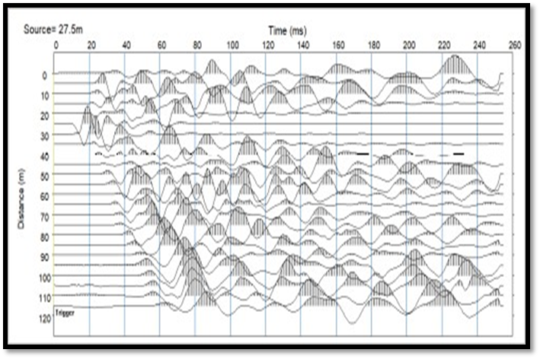
Linear velocity line
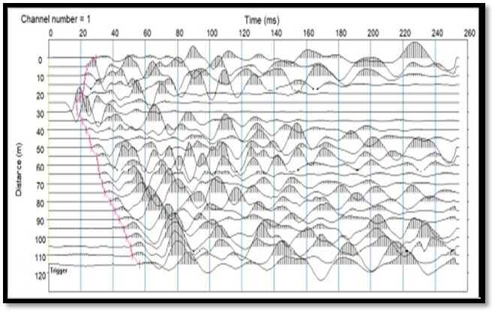
Picked first break (red vertical lines) at the second shot
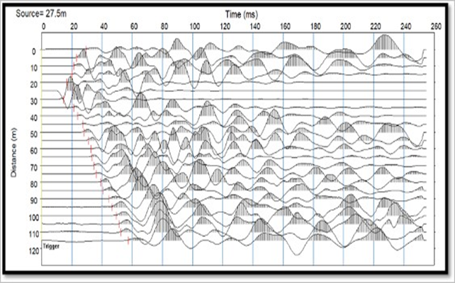
Layer assignment
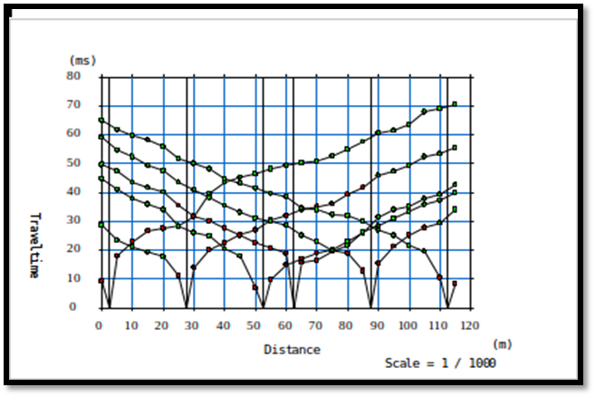

Time-term velocity mode
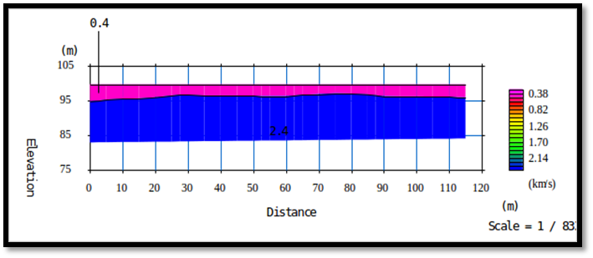
Travel time curve
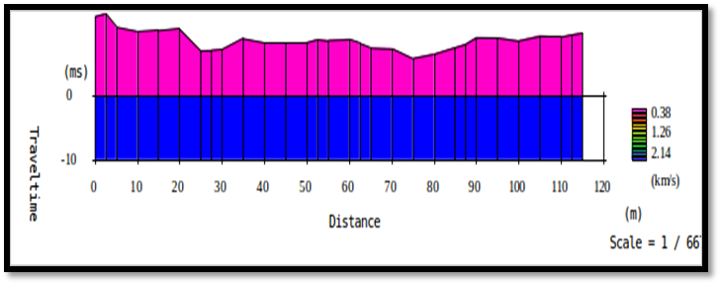

Layer cake inversion
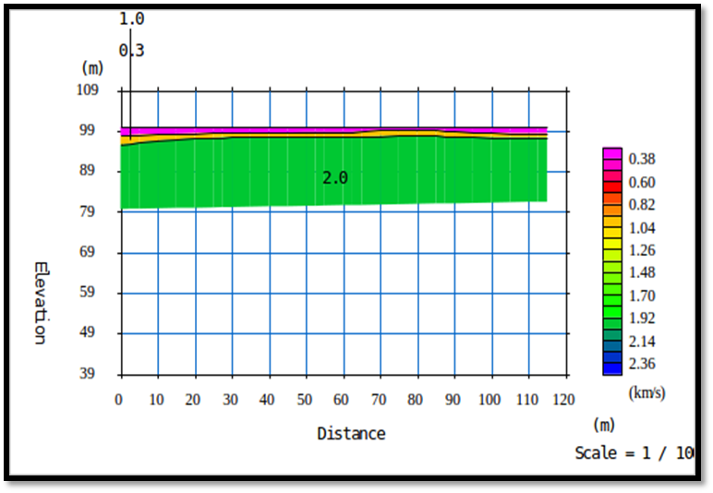
Tomographic inversion
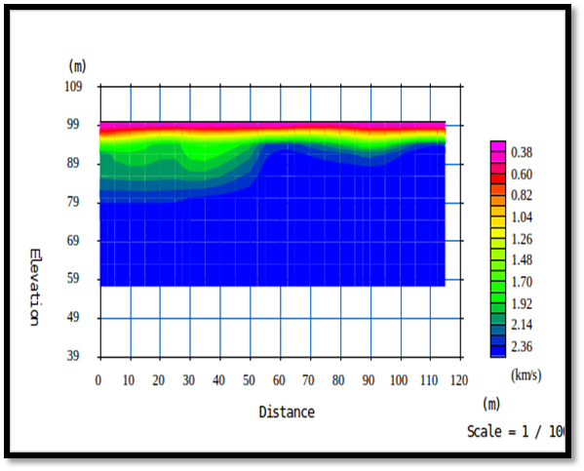
Ray path pattern
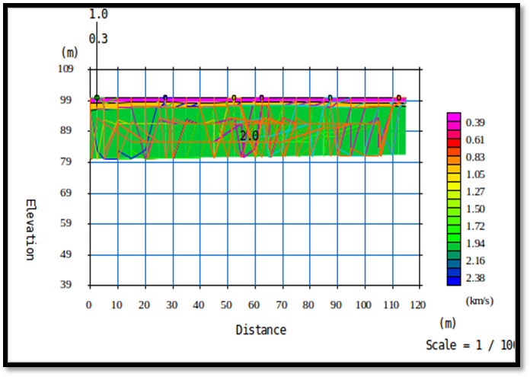
Initial tomography
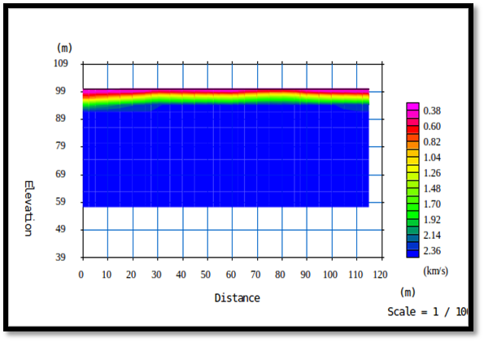
ANNEX B
Measured, calculated and inverse 2D resistivity model
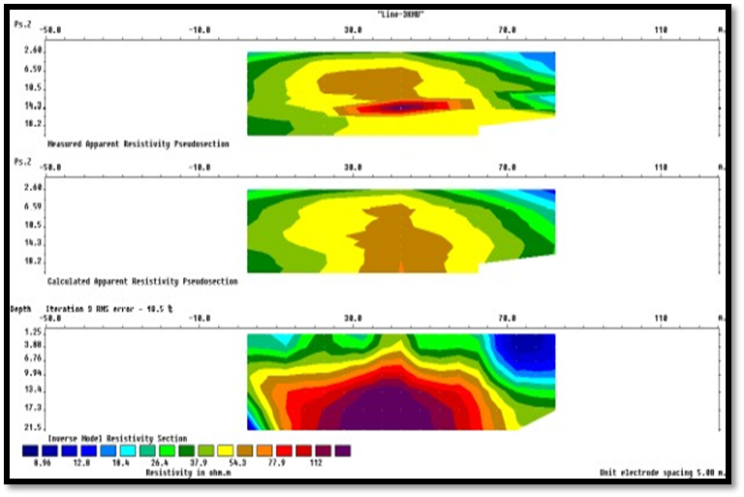
Inverse 2D resistivity model for interpretation
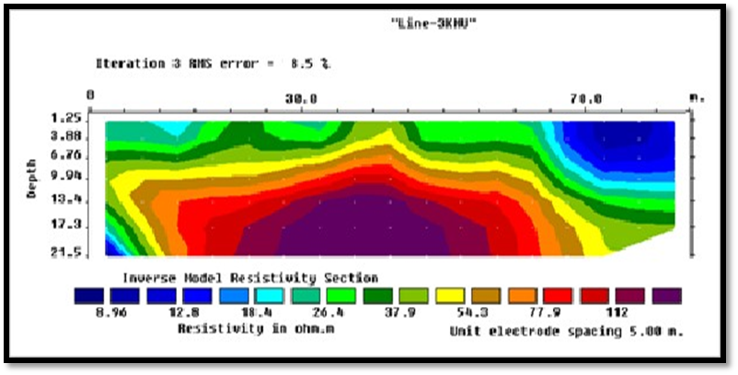

ANNEX C
Geological borehole log data of the study area
Borehole log data-1
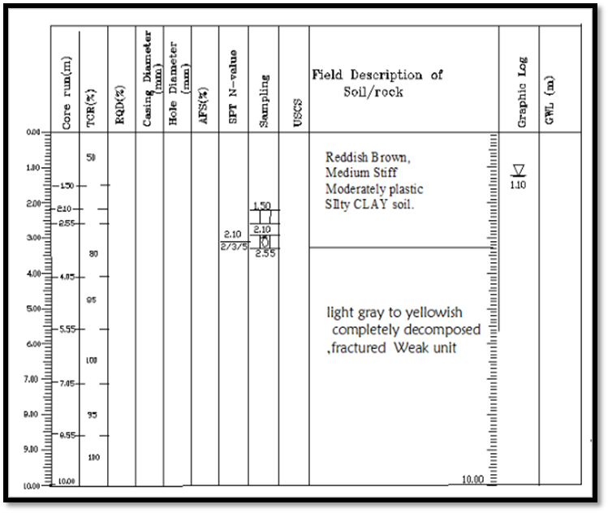

Borehole log data-2
