

Addis Ababa University
Faculty of Informatics
Department of Computer Science

M-Learning for Distance Education

A PROJECT SUBMITTED TO
THE SCHOOL OF GRADUATE STUDIES OF THE ADDIS ABABA UNIVERSITY
IN PARTIAL FULFILLMENT FOR THE DEGREE OF MASTERS OF SCIENCE
IN COMPUTER SCIENCE

By

Ephraim Tilahun

Advisor:

Dida Midekso (PhD)

June 2010, Addis Ababa

Addis Ababa University
Faculty of Informatics
Department of Computer Science

M-Learning for Distance Education

DESIGN AND IMPLEMENTATION OF
MOBILE LEARNING WEB APPLICATION FOR
ETHIOPIAN DISTANCE EDUCATION

By

Ephraim Tilahun

ADVISOR
Dida Midekso (PhD)

APPROVED BY
EXAMINING BOARD:
1. Dr. Dida Midekso, Advisor _________________________
2. _______________________ _________________________
3. _______________________ _________________________

June 2010, Addis Ababa

Acknowledgments

Foremost, I would like to express my sincere gratitude to my Lord. God’s heavenly guidance helped me in all the time of my life including in this project. This work is not any different to that. So the first thanks goes to God.
During my post graduate study, I have been accompanied and supported by many people. It is a pleasure that I have now the opportunity to express my gratitude to all of them.
I would like to express my deep and sincere gratitude to my advisor, Dr Dida Midekso. His wide knowledge and his logical way of thinking have been of great value for me. His understanding, encouraging and personal guidance have provided a good basis for the present work.
During this work I have collaborated with many colleagues for whom I have great regard, and I wish to extend my warmest thanks to all those who have helped me with my work in the registrar office, in the distance education coordinator office and in the student admission office at Alpha University College.
I owe my loving thanks to my sister, Selamawit Tilahun. Without her encouragement, understanding and financial help, it would have been impossible for me to finish this work. My special gratitude is due to my mother, Ehete Solomon for her loving support.
I warmly thank Teklay Gebregzabhere, for his valuable advice and friendly help. His extensive discussions around my work and interesting explorations in operations have been very helpful for this project. My sincere thanks are due to Beza Mamo, Msc. for his detailed review, constructive criticism and excellent advice during the preparation of this project document. And lastly, I’d like to thank Zekarias Tilahun, INSA, for his corporation by lending his laptop.
Addis Ababa, June 2010
Ephraim Tilahun

Table of Contents
Acknowledgment IV
LIST OF fIGURES vi
lIST OF TABLES vii
aBBREVIATION vii
ABSTRACT viii
1. Introduction 1
1.1 Background 1
1.1.1 Conventional Education 1
1.1.2 Distance Education 1
1.1.3 Electronics Revolution 2
1.2 Statement of the Problem 4
1.3 Objective 5
1.3.1 General Objective 5
1.3.2 Specific Objective 5
1.4 Significance of the Project 5
1.5 Scope of the Project 5
1.6 Methodologies and Techniques 6
1.6.1 Data Collection Methods and Techniques 6
1.6.2 Development Tools 6
1.7 Document Organization 7
2. Literature Review 8
2.1 Introduction 8
2.2 Mobile Technology 8
2.2.1 Mobile Network 8
2.2.2 Features of Mobile Phone 9
2.2.3 Mobile Software 9
2.2.4 Mobile Internet 9
2.2.5 Mobile Learning 9
2.3 Mobile Learning History 10
2.4 Related works 11
2.4.1 NKI Distance Education and Online Education 11
2.4.2 From E-learning to M-learning by Ericsson 11
2.4.3 MOBIlearn 12
2.4.4 M-Learning in Rural Africa 12
3. System Analysis 14
3.1 Introduction 14
3.2 Background 14
3.2.1 Overview of the Application 14
3.3 Proposed system 14
3.3.1 Overview 14
3.3.2 Functional Requirements 15
3.3.3 Nonfunctional Requirements 16
3.3.4 System Models 17
3.3.5 Use Case Model 17
3.3.6 Object model 25
3.3.7 Data dictionary 26
3.3.8 Class Diagram 28
3.3.9 Dynamic Models 29
4. System Design 31
4.1 Introduction 31
4.2 Goals and Trade-offs 31
4.2.1 Design goals 31
4.2.2 Trade-offs 31
4.3 System Decomposition 32
4.3.1 Layers & Partitions 33
4.3.2 System Topology 34
4.4 Hardware/Software Allocation 35
4.5 Data Management 37
4.6 Software Control Implementation 38
5. Implementation 39
5.1 Overview 39
5.2 Tools and Technologies Utilized for Implementation 39
5.3 M-learning for Distance Education System (MLFDE) 40
5.3.1 Registrar Service Interface 40
5.3.2 Student Service Interface 45
6. Conclusion and Future Work 50
6.1 Conclusion 50
6.2 Future Work 51
References 52
Glossary 53

List of Figures

Figure 3.1: | Use case diagram………………………………………………………. | 18
Figure 3.2: | Class diagram………………………………………………………….. | 28
Figure 3.3: | Sequence diagram for registration for courses………………………… | 29
Figure 3.4: | State diagram for actor student………………………………………… | 30
Figure 4.1: | The Architecture of the system ……………………………………...… | 33
Figure 4.2: | Logical view…………………………………………………………… | 34
Figure 4.3: | Deployment diagram for MLFDE system……………………………... | 36
Figure 4.4: | Relationships between the table………………………………………. | 37
Figure 5.1: | MLFDE Home Page ………………………………………………….. | 40
Figure 5.2: | Registrar Service Home Page ………………………………………….. | 41
Figure 5.3: | Student Information Page …………………………………………….. | 42
Figure 5.4: | Course Information Page ……………………………………………… | 43
Figure 5.5: | Course Offering Page ………………………………………………….. | 44
Figure 5.6: | MLFDE System Mobile Home page ………………………...………… | 45
Figure 5.7: | MLFDE Student Login Page ……………………………..…………… | 46
Figure 5.8: | MLFDE Student Service Home Page ………………………………… | 47
Figure 5.9: | Post Preview Pages ……………………………………………………. | 48
Figure 5.10: | Course Registration …………………………………………………….. | 49

List of Tables

Table 3.1: | Entity, boundary and control classes……………………………...……… | 25
Table 3.2: | Description of Entity classes……………………………………………… | 26
Table 3.3: | Description of Boundary classes………………………………………..… | 27
Table 3.4: | Description of Control classes……………………………………………. | 27
Table 4.1: | Access control table………………………………………………………. | 38

Abbreviations and Acronyms

- MLFDE | Mobile Learning for Distance Education
- AUC | Alpha University College
- LAN | Local Area Network
- WLAN | Wireless Local Area Network
- RAM | Random Access Memory
- PDA | Personal Digital Assistance
- SMS | Short Message Service
- WAP | Wireless Application Protocol
- GPRS | General packet radio service
- PDT | Portal Data Terminal
- MMS | Multimedia Messaging Service
- AMPS | Advanced Mobile Phone System
- D-AMPS | Digital - AMPS
- CDMA | Code Division Multiple Access
- GSM | Global System for Mobile
- UMTS | Universal Mobile Telecommunications System
- BREW | Binary Runtime Environment for Wireless
- SDK | Software development kit
- PARC | Palo Alto Research Centre
- CCNA | Cisco Certified Network Associate
- MCSE | Microsoft Certified Systems Engineer
- ETC | Ethiopian Telecommunications Corporation
- ISP | Internet Service Provider

Abstract

This project is about design and implementation of web based mobile learning (M-learning) in Ethiopia. There are basically three types of learning methods: conventional learning, distance learning and electronics learning. Electronics learning can be divided into two: E-learning and M-learning. This project focussed primary on M-learning.
In this project work, we have developed a web based application that makes use of the availability of mobile phones. The system enables distance education learners to register for courses, add/drop courses, preview any information released by the institutions and download learning materials using their mobile devices. The system is web based and it needs the internet connection that is provided by local ISP provider like ETC.
The project is implemented by visual studio 2005 and we use visual C#.net web tools. The database is developed by Microsoft SQL Server 2000. The system has been tested with different kinds of aspects and the test result shows successful implementation of the mobile web application. We use Windows Mobile Professional 6 mobile to test the prototype and the positive results shows that this web based mobile application can run in all kinds of mobile devices which have any internet browsers and in addition on any pocket PC.

Key words: M-learning, E-learning, D-learning, Mobile device

Introduction

Background
Education and training is the process by which the wisdom, knowledge and skills of one generation are passed on to the next. This education process has been going on since time immemorial. It is the central process in the conservation and development of human culture. It began at the dawn of time and has continued to today. Eventually society developed schools for itself as the privileged places where the education process takes place.
Later, in the 12th century, universities were added to schools as additional places where the education process would occur. To these were added, more recently, training centres for the teaching and learning of skills that are needed for the functioning of society [15].
Today there are two forms of education and training: conventional education and distance education [15]. Distance education can comprise: distance learning (d-learning), electronic learning (e-learning) and mobile learning (m-learning).

Conventional Education
Conventional education is also known as face-to-face education or ILT (instructor led training). Conventional education has three fundamental characteristics:
- The teacher and the learning group are assembled at a fixed time in a fixed place for the purposes of learning
- The learner forms part of the learning group
- Interpersonal communication is the means by which the process of education and training takes place.
Today throughout the world, society provides itself with schools, colleges and universities to which students travel for the purposes of learning. The characteristic of the school is the bringing together of students with teachers at the same time and the same place in classes, in laboratories, and in recreation centres for the purposes of schooling.

Distance Education
The wondrous developments of technology during the Industrial Revolution brought about, for the first time in history, the possibility of distance education. These developments were particularly important in transport and communication.

The first distance educators appear with the following unique behaviour:
- Separated the teacher and the learner;
- Separated the learner from the learning group; and
- Used a form of communication mediated by technology.
These systems attempted to replace interpersonal communication, and the inter subjectivity between the teacher and the taught, which is the essence of the educational transaction, by a personal form of communication mediated by technology. In Ethiopia, distance education has been introduced since 1980s and currently there are many institutions providing distance educations in different level, elementary up to higher education [20].
Distance learning brought great benefits to society. It freed up learners so that they could study at any time and in any place and in structures suited to their employment and family commitments.

Electronics Revolution
The next development in distance education is attributed to what may be called an electronics revolution of the 1980s. The wonderful developments in technology associated with this revolution made it possible for the first time in history to teach (electronically) face-to-face at a distance and to teach (electronically) groups at a distance.
The telecommunications industry underwent swift and complex changes in the 1980s, which constitute an electronics revolution. These changes can be attributed to three factors:
- An urge to deregulate;
- Speeding up of chips; and
- Introduction of broadband technologies.
The development of broadband technology is of vital importance for distance training, because one needs extensive bandwidth for pictures, audio, video and virtual realities. Broadband technology provides high speed of communications as rates of more than 2 Mbits per second over a public switched network. Interactive multimedia, image processing, data and video are all large consumers of bandwidth. The electronics revolution of the 1980s led to group-based distance training and opened the way to the net and the web.

E- Learning
E-learning is electronic learning. It means the provision of education and training electronically, on the Internet and the WWW [2].
World Wide Web is the most successful educational tool to have appeared in a long time [15]. It combines and integrates text, audio and video with interaction amongst participants. It can be used on a global scale and is platform independent. While largely an asynchronous medium, it can also be used for synchronous events. It is not surprising therefore, that trainers, lecturers, distance education providers and teaching institutions at all levels are increasingly using the World Wide Web as a medium for course provision.

Mobile learning
ITU Corporate Annual Report 2009 announced that there are 4,600,000,000 mobile telephones in the world by 2009. The world population is just over 6 billions [21]. That shows mobile technology is coming common in most societies.
With the successful development of Bluetooth, WAP (Wireless Application Protocol), GPRS (General Packet Radio System) and UMTS (Universal Mobile Telecommunications System), the technological structures for wireless telephony and wireless computing are now firmly in place.
All over Europe today wireless technologies and applications are replacing wired ones: e-Commerce is moving to m-Commerce; m-Business is replacing e-Business; [16]. According to [1], mobile learning is defined as:
“Any sort of learning that happens when the learner is not at a fixed, predetermined location, or learning that happens when the learner takes advantage of the learning opportunities offered by mobile technologies”.
M-learning is convenient in the sense that it is accessible virtually from anywhere, which provides access to all the different learning materials available. It also provides collaborative learning approach; sharing is almost instantaneous among everyone using the same content, which leads to the reception of instant feedback and tips. M-learning also brings strong portability by replacing books and notes with small RAMs, filled with tailored learning contents. In addition, this kind of learning is engaging and fun. Therefore, it is simple to utilize mobile learning for a more effective and entertaining experience [2].

Statement of the Problem
Currently, almost all of distance education institutions in Ethiopia use the traditional way of learning activities. The existing distance learning activities are being done manually. Such learning activities include the following drawbacks:
- Accessing of learning materials is not possible anytime, anywhere. When students need to have access to a potentially huge library of training and they need to communicate with main or branch office so that they acquire the materials and they get the resources through postal mail that takes several days.
- Overall cost is the single most influential factor in distance learning. Costs associated with salaries of dispatcher, expense of postal service, printing, photo copy and binding learning materials are directly quantifiable.
- Usually lessons will be available at each branch office at regular fixed time so that students who want to learn at their own pace could not get the resource before that regular time. So they need to depend on someone else’s progress.
- Students need to wait longer time to see their grades because grade reports are sent to students via postal mail. Sometimes, it may be necessary for students to go to the branches to get their grades for next course registration.
- Consistent delivery of student learning materials is not always possible in the existing distance learning system due to missing of postal envelop in the delivery.

Objective

General Objective
The general objective of this project work is to develop an application that provides distance education through mobile device.

Specific Objective
The specific objectives include:
- Conduct a review of M-learning and mobile technologies that provide the state of art of the application;
- Develop appropriate algorithm and techniques in relation to the M-learning.
- Select appropriate middleware architecture for better integration and configuration of hardware (PDA or other handheld devices) with the application thought to be developed;
- Develop a prototype for M-learning application; and
- Test the prototype.

Significance of the Project
The significance of distance education through mobile is as follows:
- It is important to bring new technology into the application domain (distance education);
- It will be more light weight device compared to books, PCs, etc.;
- Mobile learning could be utilized as part of a learning approach which uses different types of activities (or a blended learning approach);
- Mobile learning supports the learning process rather than being integral to it; and
- Mobile learning can be used as a motivation to re-engage disaffected youth. Youth are interested for new technologies.

Scope of the Project
The proposed m-learning for distance education system will have the following features:
- Learners can read posts such as registration date, exam schedule or tutorial date information that are posted by the institution;
- Students can select next available courses and submit their registration through the system to the registrar;
- Students can download their learning materials such as e-books, modules and references that are available for their respective courses registered; and
- Students can see their current grades and their cumulative results.
Due to lack of Mobile banking system and limited local Internet connection, this project is unable to:
- Handle online tuition fee that facilitates students to pay their tuition fee though mobile phone money transfer;
- Download reference materials that are huge in capacity and occupied more memory by which some mobile devices unable to hold; and
- Provides voice service by which students communicate with their instructor or advice for the purpose of academic consultation.

Methodologies and Techniques

Data Collection Methods and Techniques
In order to attain the general and specific objectives of this project, a number of methods will be applied. Study the different manual distance education mechanisms which are available in Ethiopia through questionnaire and/or interview and literature review for better understanding of the problem domain. The detail activities done are the following:
- Carry out literature review that focuses on reviewing the basic learning theories along with that of the related works;
- Collect and review secondary data from selected distance education institution for the purpose of requirement determination; and
- Conduct an interview with selected individuals about the desirable system they need to have in relation to the proposed mobile learning system.

Development Tools
Microsoft Project is used to prepare system analysis phase. For design phase, we choose rational rose UML tool because this tool has fully object-oriented feature that helps for the preparation of system design.
For the development, the system needs to have front and back end. Since the mobile learning system is a web based system, we chose Visual Studio 2005 that provided web page editor for the front end using visual C#.NET code. Because it has a feature of creating graphical user interface and it is easy to develop dynamic web pages [5].
For the back end, since it is the main part of the system, we chose Microsoft SQL 2000 Server which is compatible with visual studio 2005 [4].

Document Organization
The remaining part of this documentation is organized in such a way that the next chapter deals with literature review and related work. The literature review part gives a summarized report on the state of art in mobile computing in relation to our project, and related work discusses some selected m-learning applications.
The focus of chapter three is on system analysis that provides functionalities and system models of the proposed system. Chapter four discusses the proposed design and architecture that we proposed in order to develop M-learning for distance education system. Chapter Five explains the implementation and evaluation issues of the system.
The last chapter concludes the paper by giving recommendation and future work in the aspect of our project work.

Literature Review

Introduction
Advances in computer technologies, intelligent user interfaces, context modeling applications and recent developments in the field of wireless communications, including Wi-Fi, Bluetooth, multi-hop wireless LAN and the global wireless technologies such as GPS, GSM, GPRS, 3G and satellite systems have created a wide array of new possibilities for today’s society [3]. When these technologies started to be used in conjunction with mobile computers a new learning paradigm, mobile learning, emerged [1].

Mobile Technology
There are estimated to be 1.5 billion mobile phones in the world today [12]. This is more than three times the number of personal computers (PCs), and today’s most sophisticated phones have the processing power of a mid-1990s PC. These facts, and the range of computer-like functionality offered by top-of-the-range devices, are leading some observers to speculate that many people in the not so distant future will start to see the mobile phone as an alternative to a PC [13, 14]. Clearly, neither view is likely to be completely objective, but the fact that the debate is happening is an indication of how powerful and sophisticated mobile devices are becoming.

Mobile Network
Mobile phones and their network vary very significantly from provider to provider and country to country. However the basic communication method of all of them is through the electromagnetic microwaves with a cell base station. The cellular companies have large antennas, which are usually mounted over towers, buildings and poles. The cell phones have low-power transceivers that transmit voice and data to the nearest sites usually within the 5 to 8 miles (8 to 13 kilometres away) [7].
The dialogue between the mobile phone handset and the cell phone site is a stream of the digital data, which includes the digitized audio. This technology depends on the same system as of mobile phone operator. Some mobile phone technologies have adopted the AMPS for the analog communication and D-AMPS, CDMA2000, and GPRS for the digital communication [7].
There are different mobile communication methods, such as SMS, WAP, WLAN, WIFI, GPRS, Bluetooth, Infrared and I-Phone etc. Mobile phones are different from the cordless telephones because they only operate within the specific range. Many types of the mobile computers have been introduced including the Laptop computer, Subnotebook, Portable data terminal (PDT), Personal digital assistance (PDA), Tablet personal computer and smart phone [7].

Features of Mobile Phone
Mobile phones have features beyond sending text messages and making the short or long distance voice calls, the other features including internet browsing, mp3 playback music, email, personal organizer, built in cameras, MMS, SMS, call registries, built in games, voice mails, downloading, video call, Bluetooth, infrared and they also serve as the wireless modem for a PC. Mobile technology has both negative and positive impact on every day’s life [7, 9].

Mobile Software
Windows mobile, Palm OS and Symbian OS supports typical application binaries as found on the personal computers. Windows mobile also supports portable executable format which is associated with the .NET Framework. Both Windows Mobile and Palm OS provide free SDK and integrated development environment for the developers. BREW is another format which gives complete control of the handset and access to all its functions. Java (J2ME, Java ME) runs atop a virtual machine, which allows reasonable functionalities. Because of the extra security and compatibility, it is quite simple to write, distribute and execute the mobile Java applications [7].

Mobile Internet
According to the many sources, one of the major factors of the usage of mobile internet is its speed. Mobile internet has faster connection. Due to this fact, many users tend to use mobile internet. The introduction of the 3G cards has a competitive high speed. All the current service providers are trying to increase their bandwidth to get more customers. The numbers of mobile phones that are cable of surfing the net have been increasing rapidly. One of the greatest problems when browsing the net on the cell phones is the small size of the screen. Because of the many developers are developing the websites that can easily be seen on the cell phones [7].

Mobile Learning
M-learning is the follow up of E-learning and which originates from distance learning. M-learning is the delivery of education to the students who are not having fixed location or who prefer to use mobile phone technology for learning. The rapid growth in the mobile and communication sector make it possible to develop new forms of education. M-learning means delivery of education by means of the mobile phone devices, PDAs and audio players [2].
Mobile learning is characterized solely by its ability to incorporate transportable devices used in the learning process which in turn offer a number of incentives. Whilst undoubtedly, technology plays a central role in modern society, and its use in teaching or training is unavoidable, even mobile technologies/devices can have their shortcomings [8, 10].

Mobile Learning History
Although the current interest in ‘e-learning’ and ‘m-learning’ is a relatively recent phenomenon, especially supported by developments in the Internet since the WWW was created in 1992, in fact the history of learning with technology goes back much further.
During pre 1970s, arguably the first instance of mobile learning goes back as far as 1901 when Linguaphone released a series of language lessons on wax cylinders. This was followed up in later years as technology improved, to cover compact cassette tapes, eight track tape, and CDs.
Between 1970s and 1980s Alan Kay and colleagues in the Learning Research Group at Xerox Palo Alto Research Center [PARC] propose the Dynabook as a book-sized computer to run dynamic simulations for learning. Their interim Dynabooks are the first networked workstations [2].
In 1990s, Universities in Europe and Asia developed and evaluated mobile learning for students. Palm Corporation offered grants to universities and companies who created and tested the use of Mobile Learning on the PalmOS platform. Knowledgility created the first mobile learning modules for CCNA, A+ and MCSE certification using the core tools [2].
In 2000, the European Commission funded the major multi-national MOBIlearn and M-Learning projects. Companies were formed that specialized in three core areas of mobile learning [2]:
- Authoring and publishing;
- Delivery and Tracking; and
- Content Development.

Related works

NKI Distance Education and Online Education
The NKI Group is a non-profit foundation in education found in Norway and Dublin [19]. It is in continuous operations since 1987 giving online distance learning. NKI Distance Education/NKI Internet College integrated research/educational development/technological development. It has 4500 students in 34 countries and gives 380 courses in 60 study programmes.
Students’ and tutor’s use mobile technology to:
- Download and synchronize learning content;
- Study the course materials;
- Make notes;
- Write assignments;
- Access discussion Forum to read;
- Access discussion Forum to submit contributions;
- Send an receive e-mail to fellow students;
- Submit assignments by e-mail including attachments; and
- Receive assignments corrected and commented on by the tutor.
The project “M-learning for PDAs: Enhancing the Flexibility of Distance Education – Experiences with a Learning Environment for Mobile Distance Learners” was implemented in 2001 [19].

From E-learning to M-learning by Ericsson
This was a groundbreaking European Commission project which defined ‘mobile learning’ as the provision of education and training on personal digital assistants (PDAs), smart phones and mobile phones, thus eliminating wired computers and laptops from the field [16]. The project started from the acknowledgment that e-learning is the state of the art for distance education today, but asks what the next dimension is. It sets out to produce a series of courses for PDAs, smart phones and mobile phones.
What is important about this project is that it solved all the problems confronting the provision of mobile learning courses on PDAs. It took the standard 5.7 cm x 7.6 cm screen of a PDA and, by using Microsoft Reader software, designed a comfortable and successful learning environment for student study.

It took a 1000 A4 page course comprising course materials and background reading and loaded it on a PDA. It offered courses for paid enrolment, for credit as a normal part of the institution’’ provision. Students were surveyed and expressed satisfaction and no problems with mobile learning as a form of study. The problems of providing mobile learning on PDAs were all solved. The project also showed that the problems of providing mobile learning on smart phones and mobile phones were not yet solved [16].

MOBIlearn
The MOBIlearn project, is coordinated by Giunti Ricerca in Italy and co-funded by the European Commission and with supporting actions by NSF in the USA and DEST in Australia. The MOBIlearn project involves 24 partners from the European Community, Israel, Switzerland, USA and Australia. The project provides structures for mobile learning and courseware for students on MBAs, for medical updates and for museum visitors.
This is a very large project with many of Europe’s leading universities, including the Open University of the United Kingdom as partners in addition to important industry providers like Nokia.
The courseware is focused on three groups of students:
- Students on MBA courses who require summaries, examination preparations, additional information and focused studies;
- Students in the health care professions who require updates and specialized information; and
- Visitors to museums and art galleries who will receive detail information on exhibits on their mobile phones.
This project again has a focus of mobile learning on phones [17].

M-Learning in Rural Africa
At the University of Pretoria, two projects have been launched using personal digital assistants (PDAs). In the first project, an M-learning project in the Faculty of Health Sciences, PDAs were used in clinical assessment sessions of medical students. Performance was assessed and automated results and feedback provided.
Research is being done on the impact of PDA use on assessment quality; the impact of PDA use on student performance; and the impact on efficiency and effectiveness (impact on administrative load, time, paper work, human errors, calculation errors, record keeping, duplication, costs, etc). As the project is still in progress, no official results are available yet.
In the second project, an M-learning project in the Faculty of Engineering, Built Environment and Information Technology, students in a fourth year course have been issued with PDAs to use within a pilot wireless e-learning environment. PDAs are used for queries, content delivery, interactive distributed simulations, notices, database access, collaboration, etc. In this project research is being done on Human Language Technologies (HLT). As the project is still in progress, no official results are available yet. These projects are focused only on providing mobile learning on phones as the students do not have PDAs.
The University of Pretoria started using mobile phone support during 2002 in three paper-based distance education programmes because more than 99% of the “rural students” had mobile phones [18].

System Analysis

Introduction
The purpose of this chapter is to identify requirements to contribute to the identification and definition of model user scenarios and, following the analysis of these requirements, to identify their implications for the system model. The work here presented was based on the analysis of secondary data provided by different distance education institutions. The content of this chapter is the result of that process, with contributions to the overall system design.

Background

Overview of the Application
Mobile learning, or M-learning, has been defined as a learning approach that takes place via wireless devices such as mobile phones, personal digital assistants (PDAs), or laptop computers. [1].
M-learning is convenient in the sense that it is accessible virtually from anywhere, which provides access to all the different learning materials available. It also provides collaborative learning approach; sharing is almost instantaneous among everyone using the same content, which leads to the reception of instant feedback and tips. M-Learning also brings strong portability by replacing books and notes with small RAMs, filled with tailored learning contents. In addition, this kind of learning is engaging and fun. Therefore, it is simple to utilize mobile learning for a more effective and entertaining experience [2].

Proposed system

Overview
The MLFDE system will be designed to provide a registration system which is intended to register students that can not come to the college for registration. The proposed system also provides a mechanism to maintain Add and Drop courses cases and enables them to download necessary learning materials. In addition to this, the system can ease the burden of registrar office staff by performing many tasks which are done manually in the current system.

Functional Requirements
The functional requirements of the MLFDE system are:
- Preview Posts: This functionality of the system enables students to read any post related to them that can be about registration, tutorial class information, final exam schedule and any academic news.
- Registration: This functionality of the system enables students to register for courses online by selecting courses which are available for specific year, semester and department.
- Add/Drop Course: In case of add and drop course, the system provides students list of courses that they can drop or add for next semester.
- Generate Report: This functionality generates different kinds of report that are necessary for different purposes according to the request of the registrar such as report of registered students etc.
- Enter Students: This functionality enables the user to register new student to the system. Recorded students will have access to the system to continue further learning processes.
- Enter Courses: This functionality enables to register course to the system so that registration will be facilitated. The new courses detail information will be recorded.
- Enter Current Semester Courses: In order to facilitate students’ registration for the current semester, the system enables the responsible person to select current semester courses for each department.
- Upload Materials: Every course has its own learning materials such as reference book, modulus, text books and handouts. With this functionality, students will be provided all necessary materials for those courses they registered for.
- Download Materials: Student’s learning materials are available on the server; this functionality enables students to download their learning materials into their mobile phone.
- Change Password: For the purpose of security, the system provides possibilities of changing password for the users.

Nonfunctional Requirements

User Interface and Human Factors
This system will be used by two main groups of people: first an authorized representative of the college, registrar office staff member, can use it. Second, it can be used by the students. The web application has to be simple and attractive to motive the students. Since most of the new students might not have enough knowledge to access web site applications through their mobile, we will prepare user guide/help to demonstrate every steps of the system in order to make it easy to use and learn.

Hardware and Software Consideration
The proposed system will permanently reside on the server i.e. the Web Server that will host the pages. Whenever a client (in our case the student, the registrar, Webmaster or any visitor) browses the site; some part of the systems will be transported to the client machine. Therefore, what is needed on the client machine is only the Web browser. The system also uses external systems like the Mail Server and Backup Web Server.

Security Issues
Security is one of the primary concerns for any institution or any individual using computers. Security must therefore consider external environment of the system, and protect it from:
  - Unauthorized access
  - Accidental introduction of inconsistency
User authentication methods are used in protecting special sections of the site documents meant to be accessed only by individuals with the proper clearance as determined by an appropriate set of identification credentials. The security provisions can be achieved by requiring that:
  - User identity is established through passwords;
  - Passwords must be kept secret
    - Frequent change of passwords by the holder
    - Use of a “non-guessable” passwords (not in dictionary or username)
Therefore, all access-control decisions boil down to who is allowed to do what.

System Models
Information should be thoroughly analyzed to get a clear understanding of them. Therefore, we analyzed the requirements gathered from relevant parties and decided to categorize the users who use this system into registrar and student. All users have their own usernames and passwords to access the system and they have the ability to change their passwords. They will be given separate entry levels to access the system.
MLFDE system model has two actors: Registrar and Student. Registrar is the staff officer at the AR Office who is responsible for course registration. They have the authority on deciding duration time, entering required details and finalizing registrations. Student category contains everyone who has registered for a diploma/degree program in the institute. They are allowed to view available courses, their grades, and complete registration and add/drop forms.

Use Case Model
It is a detail description of the use-case view of the software architecture of MLFDE. It describes the set of scenarios and/or use cases that represent some significant, central functionality in the system. The MLFDE use cases are:
- Login
- Change Password
- Verify Registration
- Enter Students
- Enter Courses
- Generate report
- Post Information
- Offer Courses
- Upload Materials
- Register for courses
- Add/Drop courses
- Download Materials
- Preview Posts
These use cases are initiated by the student or the registrar actors.

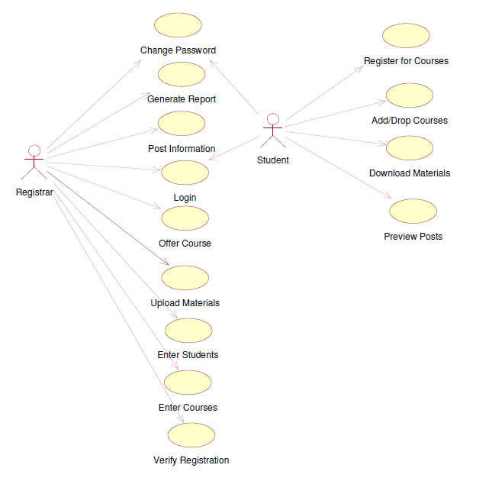
Figure 3.1: Use case diagram

Description of Use cases
- Name of use case: Login
  - Entry condition: The user should be authorized.
  - Flow of events:
- The user initiates the system to log in.
- The system prompts the user to enter user name and password.
- The user enters user name and password and submits.
- The system checks the user name and password. If the user does not exist in the system, [alternative A].
- The system displays the first page of the system.
  - Alternative A:
- The system informs the user that he/she is not eligible, and the system gives the user an option to try again or cancel action.
  - Exit condition: The user logs in into the system.
- Name of use case: Change Password
  - Entry condition: The user must login to the system.
  - Flow of events:
- The user presses the “Change Password” button.
- The system displays the “Change password” page.
- The system prompts the user to enter old password and new password.
- The registrar submits the form after it fills them.
- The system checks the user name and validates the new password.
- If the user name not found or the password is not valid, [Alternative A].
- The system verifies the password and save it.
  - Alternative A:
- The system informs the error and displays the form again to enter valid data or cancels the operation.
  - Exit condition: The new password is set.
- Name of use case: Verify Registration
  - Entry condition: The user should be authorized to activate registration so he/she should login to the system.
  - Flow of events:
- The user opens the registration page.
- The user enters the students ID to search.
- The system displays the page with information of the student registration.
- The user verifies or rejects the student’s registration.
- The system displays confirmation message whether accepting or rejection of the student registration.
  - Exit condition: The registration is verified or rejected.

- Name of use case: Enter Students
  - Entry condition: The registered student should be admitted to the institution as student and the user should login to the system.
  - Flow of events:
- The user initiates the system to register the new student.
- The system displays student registration page.
- The user fills all the necessary information about the student.
- The user submits the page.
- The system checks the validation and correctness of filled form.
- If the form is not filled correctly, [alternative A].
- The system confirms the registration of the new student.
  - Alternative A:
- The system redisplays the page and orders the user to fill valid information.
  - Exit condition: The new student name will be registered into student database.
- Name of use case: Enter Courses
  - Entry condition: There should be new course and the user should login.
  - Flow of events:
- The user initiates the system to register the new course.
- The system displays course registration page.
- The user fills all the necessary information about the course.
- The user submits the page.
- The system checks the validation and correctness of filled form.
- If the form is not filled correctly, [alternative A].
- The system confirms the registration of the new course.
  - Alternative A:
- The system redisplays the form and orders the user to fill valid information.
  - Exit condition: The new course will be recorded into course database.
- Name of use case: Generate Report
  - Entry condition: The user should login to the system.
  - Flow of events:
- The user presses the “Generate report” button.
- The system displays the “Generate report” page and prompt the user to select the report type that he/she want to generate.
- The user selects the report type and requests the system to generate report.
- The system displays reports according to the user choice.
  - Exit condition: The report will be displayed to be viewing or printing.
- Name of use case: Post Information
  - Entry condition: The user should be authorized and login to the system
  - Flow of events:
- The user initiates the system to post.
- The system displays post page.
- The user writes required news, notice or any information into the page.
- The user submits the page.
- The system checks the validation and correctness of filled form.
- If the form is not filled correctly, [alternative A].
- The system confirms the post.
  - Alternative A:
- The system redisplays the form and orders the user to fill valid information.
  - Exit condition: The post will be available on the website.
- Name of use case: Offer Courses
  - Entry condition: The user should login to the system.
  - Flow of events:
- The user presses the “Enter Current Semester Courses” button.
- The system displays the “Enter Current Semester Courses” page.
- The user chooses department, year and semester that he/she wants to add courses for current semester.
- The system displays all available courses for that specific department.
- The user selects courses that are assigned to the department and submit it.
- The system validates each course that is submitted to the department.
- If any repeat course found or compatibility occurred, [Alternative A].
- The system displays confirmation message.
  - Alternative A
- The system confirms the user that the course is already added to the list or rejects the course automatically from the list and redisplays the list.
  - Exit condition: The courses offered to each department will be available for registration.
- Name of use case: Upload Materials
  - Entry condition: The user should login to the system and courses have resources.
  - Flow of events:
- The user presses the “Upload Materials” button
- The system prompts the user to select the course.
- The system displays dialog box to select the materials that will be loaded into the server.
- The user selects the file and submits the dialog box.
- The system starts uploading the materials into the server.
- If error occurred, [Alternative A].
- The system confirms the successful uploading of the file.
  - Alternative A
- The system confirms the user that error occurred while uploading the file and informs to reload it or do it other time.
  - Exit condition: The course resources will be uploaded into the server and ready to be downloaded.
- Name of use case: Register for Courses
  - Entry condition: The user should be student and login to the system.
  - Flow of events:
- The user presses the “Register for Course” button.
- The system checks the possibility of registration.
- If the registration has been stopped or already registered, [Alternative A].
- The system displays the registration page and list of courses that the student can register for the current semester.
- The user submits the courses that are available for current semester.
- The system displays confirmation about student’s registration.
  - Alternative A
- The system informs the user that the registration time has already finished or informs he/she is already registered and returns the page into home page.
  - Exit condition: The user will be registered for the specific courses.

- Name of use case: Add/Drop Courses
  - Entry condition: The user should login and should have registered for courses.
  - Flow of events:
- The user presses the “Add/Drop Courses” button.
- The system checks the possibility of add/drop courses.
- If add/drop has been stopped, [Alternative A].
- The system displays list of courses that he/she registered for in the current semester and that can be added in current semester.
- The user selects courses he\she wants to drop or select new courses to add and submit the form.
- The system confirms the add/drop courses has been saved.
  - Alternative A
- The system informs the student that adding or dropping courses time has already finished and returns the page into home page.
  - Exit condition: The user adds or drops courses into/from list of registered.
- Name of use case: Download Materials
  - Entry condition: The user should login and have current course registration.
  - Flow of events:
- The user presses the “Download Materials” button.
- The system displays all courses that the student registered.
- The user select the course that he/she want download its materials.
- The system displays list of all available learning materials that are prepared for respective course.
- The user chooses materials that he/she wants to download.
- The system starts to download the file into the user mobile phone.
- If any error found and can not to continue loading, [Alternative A].
- The system displays confirmation message when it finish loading.
  - Alternative A
- The system informs the student that downloading the materials failed currently and reminds the student to try again later.
  - Exit condition: The learning material will be downloaded into user mobile device
.
- Name of use case: Preview Posts
  - Entry condition: The user should be student and should login to the system.
  - Flow of events:
- The student presses the “Preview Notice” button
- The system displays title of notices that is posted by the college.
- The user select the notice title that he/she want to read.
- The system displays the notice at which the user selects its title.
- The student read posts that can be any news about exam schedule, tutorial class information or registration news.
  - Exit condition: The notice will be displayed.

Object model
This section presents a list of the fundamental objects of MLFDE system that must be modeled within the system to satisfy its requirements. The purpose is to provide an alternative, “structural” view on the requirements stated above and how they might be satisfied in the system.
Table 3.1: Entity, boundary and control classes
Entity Class
Student
Registrar
Course
Department
Posts
Learning_Materials
Boundary Classes
Registration_Form
Add/Drop_Form
Offer_Course_Form
Accept/Rej_Reg_Form
Post_Preview_Form
Post_Form
Download_Form
Upload_Form
Report_Form
Control Class
Registration_Control
Add/Drop_Control
Post_Control
Download_Control
Report_Control

Data dictionary
MLFDE system has different types of entities, boundaries and controls. Table 4 describes detail information about each class.
Table 3.2: Description of Entity classes
Entity Classes
Class | Description
Student | Someone who is registered to take courses at the College. This actor has attributes that are needed by the registration system (for example, name, address, phone, id Number, major, and department).  Has methods such as register for courses, download materials, view posts and add/drop courses.
Registrar | Someone who is responsible for the maintenance of the registration System.  Has attributes Full Name, id number, position and address.  Has methods such as verify registration, add/drop, post notices, enter students and courses.
Course | Course is an entity at which students registered to take it for the purpose of academic knowledge. Course has attributes such as course code, title, credit hours, references and prerequisite.  And has operations like get course and get prerequisite.
Department | Each student is enrolled in one department. Department has attributes like department number, department name and location.
Posts | Post is a written announcement or statement of information, displayed on the college official website for the purpose of informing all students. Posts’ attributes are date, subject and id.
LearningMaterials | Learning materials are all available educational materials such as reference books, modules, text books that are provided to aid students in their study. Learning materials have attributes like code, title, authors.

Table 3.3: Description of Boundary classes
Boundary Classes
Classes | Description
Registration_Form | Form which provides the capability for a student to select registration options.
Add/Drop_Form | Form which provides the capability for a student to modify a course registration by adding extra courses or deduct courses registered for.
Offer_Course_Form | Form which provides the capability for a registrar to selects courses to launch for each department into year and semester.
Post_Preview_Form | Form which provides the capability for a student to view any notice, schedule, advertisement posted by the institute.
Post_Form | Form which provides the capability for a registrar to post notice, news, advertisements that should be known by students.
Download_Form | Form which provides the capability for a student to download any learning materials into his/her mobile.
Upload_Form | Form which provides the registrar to upload learning materials into the web server to make them available for students.
Report_Form | Form which provides the capability for a registrar to generate any type of report that is important fro further action.

Table 3.4: Description of Control classes
Control Classes
Class | Description
Registration_Control | This class knows the business rules associated with the management of registration and it is responsibility for enables students to register courses.
Add/Drop_Control | It is a control class to handle all tasks that related with adding and dropping course registration.
Post_Control | Class that control posting of news, notice, schedule or advertisements.
Download_Control | A control to handle downloading and uploading of learning materials for students and registrar.
Report_Control | This class is responsible for generating different kinds of report that is initiated by registrar.

Class Diagram
The most basic objects in the M-learning for distance education system are student, registrar, course, department, posts and learning materials. Figures 3.2 describe classes, including their associations, attributes and operations.
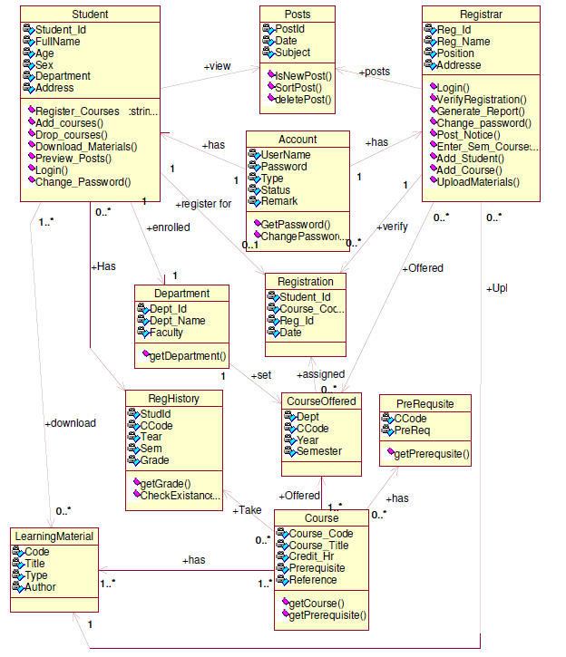
Figure 3.2: Class diagram

Dynamic Models

Sequence diagram
Sequence diagrams in MLFDE system are used to formalize the behavior of the system and to visualize the communication among the objects. They are useful for identifying additional objects that participate in the use cases. We call objects involved in a use case participating objects. A sequence diagram shown in Figure 3.3 is one of selected sequence diagram which represents the interactions that take place in register for course use case.
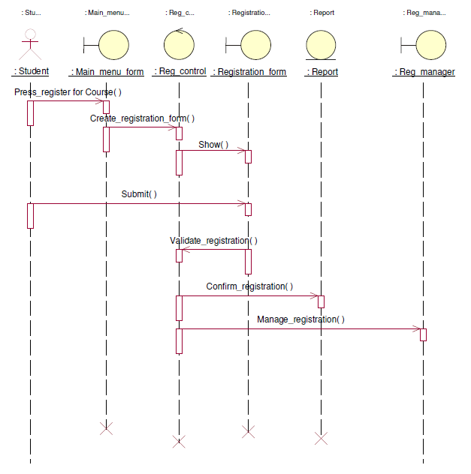
Figure 3.3: Sequence diagram for registration for courses

State Diagram
State diagrams describe the behavior of an individual object in MLFDE system as a number of states and transitions between these states. A state represents a particular set of values for each object. Given a state, a transition represents a future state the object can move to and the conditions associated with the change of state. Figure 3.4 is a state diagram for the Student.
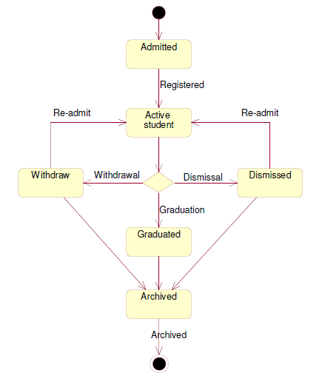
Figure 3.4: State diagram for actor student

System Design

Introduction
In this chapter we discuss the architectural design of MLFDE system, the main components and their interactions. We will first discuss goals and tradeoffs, then the main components of MLFDE alongside the subcomponents and resources needed for each module/component.

Goals and Trade-offs

Design goals
- Usability: The system should be easily usable. It has to use clear interface and interactive features. It will have easily browse-able pages, which are consistent. An online user guide on how to use the system shall also be included to make it easy for new students who use the system for the first time.
- Response time: The system should be fast enough to display each page when a user browses. It should not take too much time to check validity when a student wants to logs in for registering, adding, and dropping courses through their mobile device. It should also be fast when the registrar logs in for administration purposes.
- Security: The detail information of each student should be secured. Each student should have his/her own user id and password by which he/she can access the system. If any student logs in the system for any purpose; only his/her information is displayed. But an authorized person (such as the registrar) has the right to see all information of all students using his/her own user id and password.

Trade-offs
  - Usability vs. Response time: Making MLFDE system web pages useable by using images/pictures may affect the response/download time of each page. However, by using less picture and image files, we will minimize downloading and response time.
  - Security vs. Response time: Checking User Id and Password before a student enters to a personalized page creates response time problem/overhead. And hence we give security preference over response time. Because the information of each student should be safe and protected from being accessed by another person.

System Decomposition
The M-learning for distance education (MLFDE) system has got four main subsystems:
- Registration Subsystem: - This subsystem is responsible to provide access for students to register for courses and perform add/drop course cases through their mobile and service provided by ISP.
- Loading Files Subsystem: - This subsystem is intended to serve the students of the College by providing accesses to download necessary learning materials into their mobile phones. In addition, it provides access for instructor to upload learning materials for students.
- Posting Subsystem: - This is a sub system which can be accessed by the registrar office. Through this subsystem, the registrar performs tasks like: posting notice, news or any advertisement that should available for all students. This subsystem also includes preview posts, view grade results.
- Administration Subsystem: - It is responsible for handling user accounts. The management includes creation of new account, removing the existing accounts and modification of accounts.

Layers & Partitions
MLFDE system is decomposed into four subsystem using layers and partitions. Student service interface is accessed through mobile device and registrar service interface is accessed through personal computers. Figure 4.1 shows the relationships between the interfaces and decomposed subsystems.
Client
Registrar Service Interface
Student Service Interface

Database
Internet
Server
Registration Subsystem
Loading Files Subsystem
Posting Subsystem
Administration Subsystem

Figure 4.1: The Architecture of the system.

System Topology
The logical view of the MLFDE system is comprised of the 3 main packages: User Interface, Business Services, and Business Objects.
The User Interface Package contains classes for each of the forms that the actors use to communicate with the system. Boundary classes exist to support login, registration for courses, add and drop, downloading of learning materials, maintaining of student information, selecting courses, maintaining student information and viewing report.
The Business Services Package contains control classes for interfacing with the MLFDE system, controlling student registration, and managing posting notice and downloading learning materials.
The Business Objects Package includes entity classes for the college artifacts (i.e. course offering, learning materials, posts) and boundary classes for the interface with other systems. Figure 4.2 shows the logical view of the system.
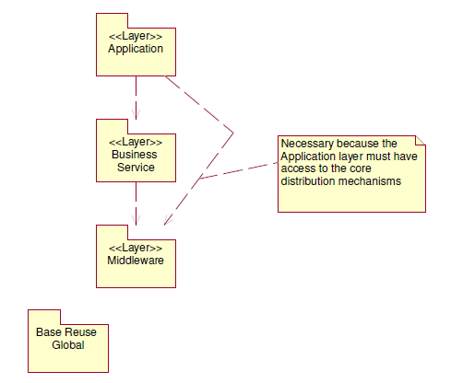
Figure 4.2: Logical view
- Application layer: This application layer has all the boundary classes that represent the application screens that the user sees. This layer depends upon the Process Objects layer; that straddles the separation of the client from mid-tier.
- Business Services layer: The Business Services process layer has all the controller classes that represent the use case managers that drive the application behavior. This layer represents the client-to-mid-tier border. The Business Services layer depends upon the Process Objects layer; that straddles the separation of the client from mid-tier.
- Middleware layer: The Middleware layer supports access to Relational DBMS..
- Base Reuse: The Base Reuse package includes classes to support list functions and patterns.

Hardware/Software Allocation
The proposed system will permanently reside on the server i.e. the Web Server that will host the pages. Whenever a client (in our case the student, registrar) browses the site; some part of the systems will be transported to the client machine. Therefore, what is needed on the client machine is only the Web browser.
The following are the machines that will be involved in the MLFDE system operation:
- Web Server: It is the server where the institution’s official Web site resides. Since MLFDE system is part of the institution’s official web site it will also reside on the Web Server for a better performance.
- Client Machine: The client machine is the mobile phone or digital computer from which the student or the registrar accesses the MLFDE system. This client machine can be anywhere in the world where Internet access and mobile connection are available.
- Backup Web Server: This server that will contain all the recent copies of the Web Server.
Figure 4.3 below shows the deployment diagram of M-learning for distance education (MLFDE) mobile web application.

Web Browsers
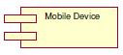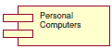
Web Server
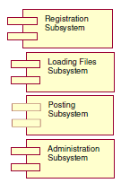

Database Server
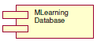

Figure 4.3: Deployment diagram for MLFDE system.

Data Management
We are using relational database to store the information of the students since it is assumed that the institution has many students and the system should provide fast service. Figure 4.4 shows the tables of the MLFDE system database and it also shows the relationship between them.
In addition to this, the server database has high scalability feature in terms of data size, working area, and number of users. So its extensibility is reliable. To make the access of the database fast, all the applications of the system have their own interface with the database.
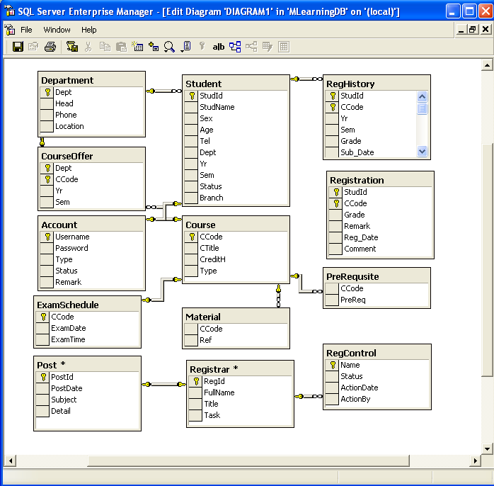
Figure 4.4: Relationships between the Tables.

Software Control Implementation
The MLFDE system has for main subsystem and each subsystem has its own functionalities that are accessed by student and registrar. Table 4.1 shows which functionality can be accessed by which user.
Table 4.1: Access control table
Subsystems  Actors | Registration Subsystem | Loading Files Subsystem | Posting  Subsystem | Administration Subsystem
Student | RegisterCourse ( )  Add/DropCourse ( ) | downloadFiles ( ) | PreviewPost ( ) | ChangePassword ( )
Registrar | Accept/Rej_Reg ( )  GenerateReport ( )  EnterCourse ( )  EnterStudent ( ) | UploadFiles ( ) | PostNotice ( ) | ChangePassword ( )  CreateNewuser ( )  ModifyAccount ( )

Implementation
The previous chapter presented the detail of the proposed M-learning for distance education architecture. This chapter discusses the prototype implementation of the system by stating the objectives of the prototype, tools and technologies used, the prototypical setup, the implementation details and evaluation results.

Overview
The prototype implementation developed in this project is principally aimed at providing proof of mobile learning can replace the distance education that is currently going on in Ethiopia. To achieve this principal goal, we made experiment in one of distance education institutions in Ethiopia, Alfa University College.

Tools and Technologies Utilized for Implementation
Several tools and technologies were utilized for the purpose of developing the prototype implementation. The following is list of the programming, communication, database management and operating environment used in the prototype implementation.
- Windows Embedded CE 6.0 Operating System (OS) for CLDC (Connected Limited Device Configuration) of the MIDP (Mobile Information Device Profile) is used for developing the mobile device edition of the prototype.
- Visual Studio 2005 version 2.0.50727, with the language visual C# and ASP.Net server is used for developing the desktop machine edition of the prototype.
- Microsoft SQL Server 2000 database server version 8.0 is used for persistent data management on the m-learning server.
- Windows Mobile 6 SDK version 1.43(1004) is used for emulating the mobile device edition and the desktop edition of the prototype application.
- Microsoft ActiveSync version 4.5.0(Build 5096) is used for bridging and connecting the mobile device edition with the desktop edition of the prototype application.
- Microsoft Windows 7 operating system is used for the m-learning server.
- IEEE 802.11 wireless LAN (Wi-Fi) is used as a communication infrastructure between the mobile device and the context refinement server.

M-learning for Distance Education System (MLFDE)
The implementation of the system consists of the development of a number of web-forms, database entries and store procedures. Every web-form includes one or more data-tables to transact relevant data. According to the relationship between the web-forms, data-tables are created. As mentioned in chapter five of this document the interfaces are categorized into two main interface components: Student interface and Registrar interface. This section describes the two parts.

Registrar Service Interface
When the system is being activated by the registrar, the home page of the system is displayed as shown in figure 5.1. Figure 5.2-5.5 show selected snap shoot of the system.
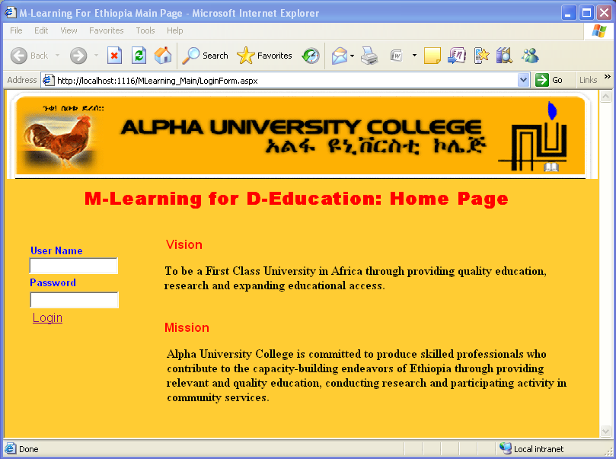
Figure 5.1: MLFDE Home Page

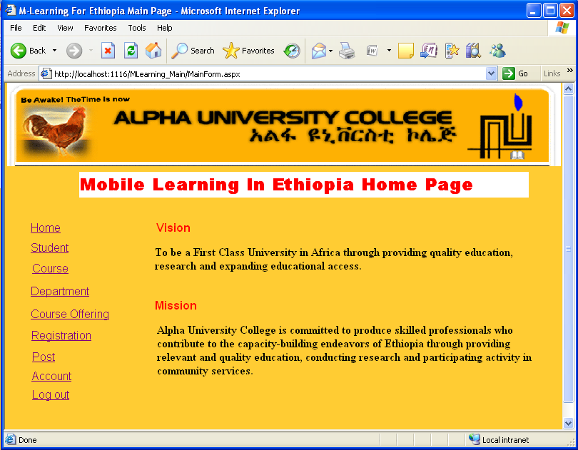
Figure 5.2: Registrar Service Home Page

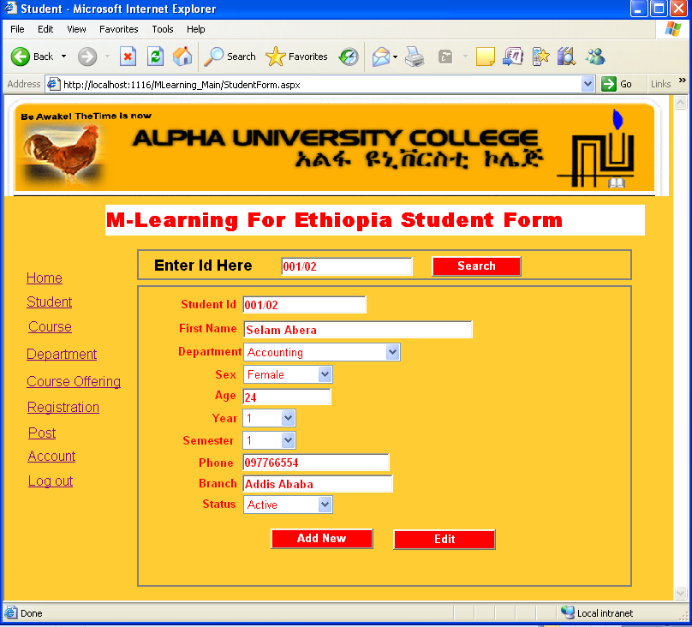
Figure 5.3: Student Information Page

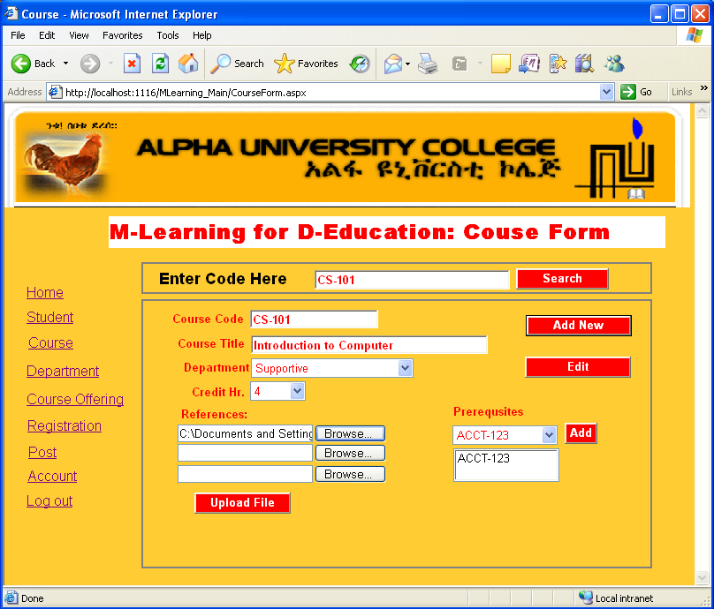
Figure 5.4: Course Information Page

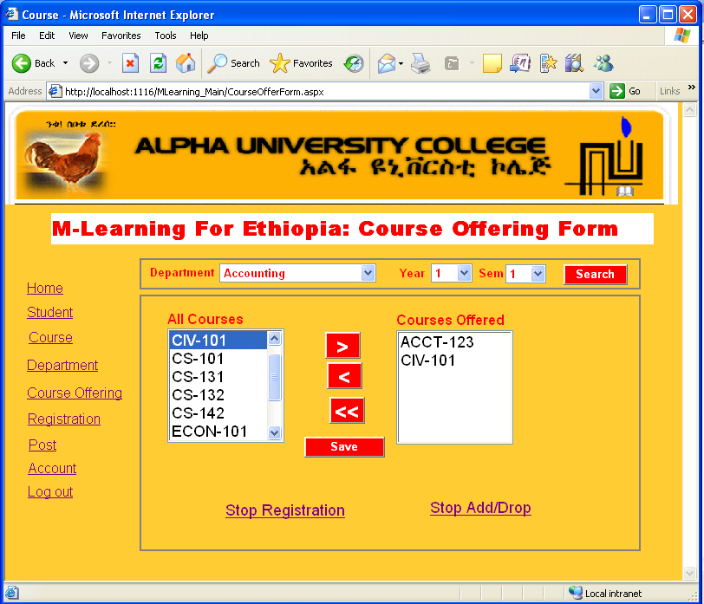
Figure 5.5: Course Offering Page

Student Service Interface
Since students access the services of MLFDE system through their mobile devices, all interfaces of student user are mobile web applications. When students request the official web page of the system web site, the following home page, Figure 5.6, will be displayed on their mobile device. Figure 5.7- 5.10 show some selected snap shoots.
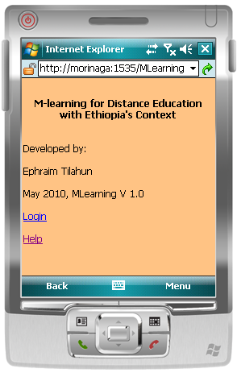

Figure 5.6: MLFDE System Mobile Home Page

The user needs to be a student of the institution and should have authorized user to enter to the M-learning for distance education system. When the user click login link, the next mobile web page will be displayed to prompt the user to enter user name and password. The user username is the student official student id. The login page is shown in Figure 5.7.
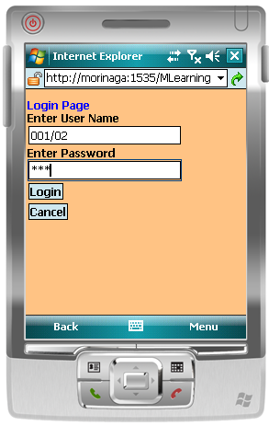

Figure 5.7: MLFDE Student Login Page

After authentication of the user, the student service main page will be displayed with list of sub menus. The interface is shown in Figure 5.8. The sub menus are preview post, register for course, view registration, add/drop course, download materials and change password.
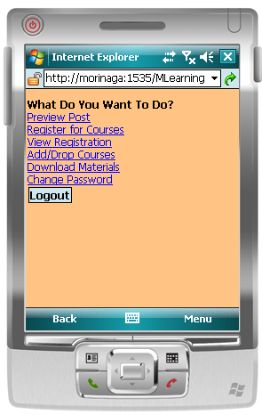
Figure 5.8: MLFDE Student Service Home Page

If the user clicks preview post sub menu, titles of all posts will be displayed in other page as shown in figure 5.9(a). The user can read the titles and click on that he/she wants to read more. Figure 5.9(b) shows the detail of selected title.
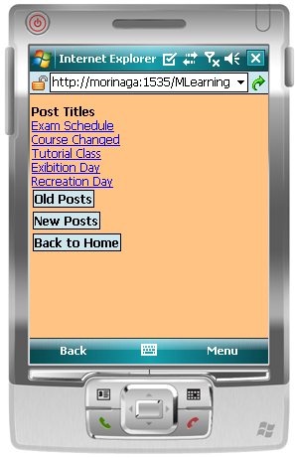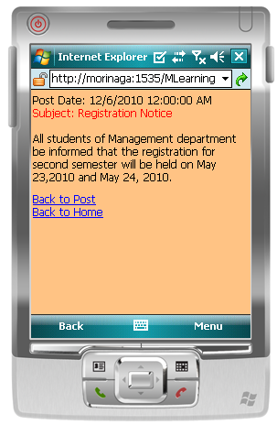
(a ) (b )
Figure 5.9: Post Preview Pages

When the user wants to register for courses, he/she clicks the register for courses link and the registration page will be displayed. As shown in Figure 5.10(a), available courses for student will be displayed according to his department, year and semester. The student needs to submit the button to register for the courses. The page that is shown in Figure 5.10(b) shows student registration status. It can be no registration, suspended registration or verified registration.
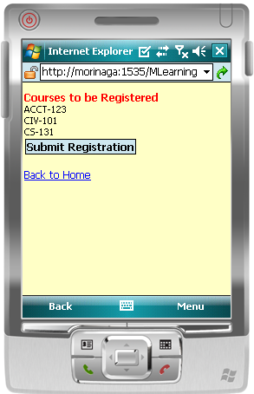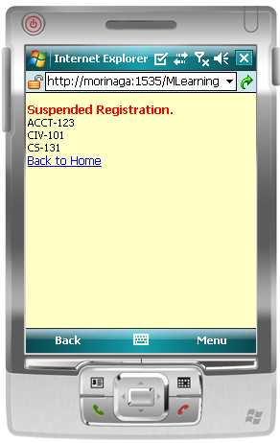
        - (b)
Figure 5.10: Course Registration

Conclusion and Future Work

Conclusion
Business and leisure have long benefited from the use of mobile devices, such as mobile phones, but research in the use of mobile phones in learning is recent. The aim of this project is to explore the on-going technique of distance education on the possible effects of using mobile phones to support learning, especially as a way of creating access for the disadvantaged people. In developing countries like Ethiopia, people do not have convenient environment to continue their education in fixed space and time. Distance education is one way to remedy this problem but it has many drawbacks to meet needs of the learners. E-learning is one possible way, but it needs much investment for PC which is the main resource of e-learning.
It is often emphasized that the main advantage of e-learning is independence of both location and time. However, in traditional e-learning the minimum requirement is still a personal computer (PC)—consequently an absolute independence in location is not provided. These independencies are still not fulfilled with the use of notebooks because a real independency in location depends on the rapid advancement and affordability of the necessary technology. This problem could be solved by using highly mobile and available devices such as mobile phones. Since the majority of students at both secondary schools and universities have a mobile phone at hand most of the time, mobile learning (m-learning) could be an important instrument for assisting learning in the future.
In this project work, we have developed a system that makes use of the availability of mobile phones. The Mobile Learning for Distance Education system is a web-based application for mobile phones. The MLFDE was developed by using Microsoft visual studio Edition (Visual C#) and runs on a broad variety of mobile phones. The system tested in Windows Mobile Professionals 6 mobile and the evaluation shows the successful implementation of the mobile web application and then the application of M-learning. The mobile web application can run on any mobile device which has internet browser. In addition, since the application is web based, it needs internet connection that is provided by local ISP.

Future Work
This work can be considered as gate opener on mobile assisted education for this country. The area is still open for research and it is a topic of discussion world wide. The question of whether there should be new type of pedagogy for mobile based learning is not yet answered. The other issue on the area can be having an agent based system. Questions of such type can be taken as indicator for the gap in the area. Future research work on the area could come up with solutions for the above questions and related ones.
Trends in mobile technologies suggest that they have the potential to impact positively on learning in general and higher education in particular. In the near future, it is expected that learning will move more and more outside the classroom and lectures halls into the learner’s environment both real and virtual mediated by mobile devices. For this to happen:
- The usability of mobile devices for educational purposes will need to improve ;
- Relevant and usable theories of mobile learning will need to be developed;
- Innovative learning design and delivery methods suited for “learning anywhere and at anytime” will need to be promoted; and
- Educational institutions would have to adopt policies which support integration of mobile and handheld devices into the formal learning environment

References
[1]. | Guidelines for learning/teaching/tutoring in a mobile environment, MOBIlearn. October 2003. http://www.mobilearn.org/download/results/guidelines.pdf. Retrieved February 8, 2010.
[2]. | http://en.wikipedia.org/w/index.php, Retrieved February 8, 2010.
[3]. | H.-W. Gellersen, A. Schmidit and M. Beigl, “Adding Some Smartness to Devices and Everyday Things”, Proceedings of the Third IEEE Workshop on Mobile Computing Systems and Applications December 2000
[4]. | http://databases.about.com/od/sqlserver/a/sqlserver2k.htm, Retrieved February 10, 2010.
[5]. | http://msdn.microsoft.com/en-us/vstudio/default.aspx, Retrieved February 10, 2010.
[6]. | http://www.functionx.com/sqlserver/, Retrieved February 10, 2010.
[7]. | http://www.networktutorials.info/index.html, Retrieved February 10, 2010.
[8]. | http://wiki.media-culture.org.au/index.php/M-Learning_-_Disadvantages_of_M-Learning_Technology, Retrieved February 10, 2010.
[9]. | http://mist.ist.psu.edu/ff2004/wireless.html, Retrieved February 10, 2010.
[10]. | “M-Learning-Opportunities for Introducing Cognitive Apprenticeships into Trade-based Apprenticeship Training” Paper presented to the 14th National VET Research Conference, Wodonga Institute of TAFE, Christchurch.
[11]. | Bruegge B. and Dutoit A. Object-Oriented Software Engineering, Conquering Complex and Changing System, Pearson Education, 2002.
[12]. | What Can You Learn from a Cell Phone? – Almost Anything. At www.marcprensky.com/writing/  Prensky-What_Can_You_Learn_From_a_Cell_Phone-FINAL.pdf, accessed 29 November 2004.
[13]. | The next frontiers: way cool phones. Newsweek, 7 June 2004.
[14]. | A technology update and m-learning project summary, Jill Attewell Technology Enhanced Learning Research Centre. www.LSDA.org.uk, accessed 12 March 2010.
[15] | Mobile Learning: The next generation of learning by Desmond Keegan, http://learning.ericsson.net/mlearning2/files/workpackage5/book.doc, accessed April 23, 2010.
[16] | Ericsson Education Dublin: http://learning.ericsson.net/mlearning2/project_one/index.html, accessed April 23, 2010.
[17] | Giunti Ricerca, Genoa: www.mobilearn.org, accessed April 23, 2010.
[18] | University of Pretoria: http://www.up.ac.za, accessed April 23, 2010.
[19] | M-learning: The Cutting Edge: Ericsson Education, Dublin 22 November 2002, http://home.nettskolen.nki.no/~torstein/ , April 23, 2010.
[20] | Alpha University College: http://www.alphauniversitycollege.edu.et, accessed May 28, 2010.
[21] | ITU Corporate Annual Report 2009: http://www.itu.int/dms_pub/itu-s/opb/conf/S-CONF-AREP-2008-E06-PDF-E.pdf

Glossary
Definitions
- Mobile | Cell phone, a portable telephone through a cellular radio network that uses as means of communication [3].
- SMS | Text Messaging Service: a service that allows short text messages to be sent, e.g. between cellular phones and pagers.
- WAP | Communication standard for handheld digital devices: a standard protocol for the transmission of electronic data between handheld narrowband devices such as cellular phones and pagers and other sources of digital information such as the Internet.
- Wi-Fi | A trademark, a certification trademark assuring the interoperability of wireless local area network products.
- GPRS | Wireless system providing Internet access: a system that provides immediate and continuous access to the Internet from wireless devices such as cell phones. Full form general packet radio service.
- Bluetooth | Trademark, a trademark for a wireless technology that enables devices such as portable computers, cell phones, and portable handheld devices to connect to each other and to the Internet.
- Infrared | Portion of invisible spectrum: the portion of the invisible electromagnetic spectrum consisting of radiation with wavelengths in the range 750 nm to 1 mm, between light and radio waves.
- Wax cylinder | One of the earliest formats for making sound recordings invented by Thomas Edison in the late 1880s and used until the early 20th.

Declaration
I, the undersigned, declare that this project is my original work and has not been presented for degree in any other university, and that all sources of materials used for the project have been acknowledged.
Declared By:
Name: Ephraim Tilahun
Signature: _________________
Date: _________________
Confirmed By Advisor:
Name: Dr. Dida Midekso
Signature: _________________
Date: _________________
Place and date of submission:
Addis Ababa University, June 2010

