

THE SOCIAL AND ECONOMIC IMPACTS OF PUBLIC TRANSPORTATION ON ADJACENT COMMUNITIES: THE CASE OF EAST-WEST ROUTE OF THE ADDIS ABABA LIGHT RAIL TRANSIT

BY
GEBEYEW TADESSE DEYAS

JUNE, 2019
ADDIS ABABA, ETHIOPIA

The Social and Economic Impacts of Public Transportation on Adjacent Communities: The Case of East-West Route of the Addis Ababa LRT
A thesis submitted to the school of graduate studies of the Addis Ababa University, Ethiopian Institute of Architecture, Building Construction and City Development (EiABC), in partial fulfilment for master’s degree in Urban Planning.

By
GEBEYEW TADESSE DEYAS

Advisor: Professor Mintesnot G. Woldeamanuel (PhD)

Ethiopian Institute of Architecture, Building Construction and City Development
Addis Ababa University
June, 2019
Addis Ababa, Ethiopia

ADDIS ABABA UNIVERSITY
ETHIOPIAN INSTITUTE OF ARCHITECTURE, BUILDING CONSTRUCTION AND CITY DEVELOPMENT (EiABC)
This thesis is submitted to Ethiopian Institute of Architecture, Building Construction and City Development (EiABC), Addis Ababa University in partial fulfillment of the requirements for the degree of Masters of Science in Urban Planning.
Title of Thesis: The Social and Economic Impacts of Public Transportation on Adjacent Communities: The Case of East-West Route of the Addis Ababa LRT

Author: Gebeyew Tadesse
ID NO: GSR/1675/10
Date: June, 2019

Approved by boards of examiners
Advisor Signature Date
Professor Mintesnot G. Woldeamanuel (PhD)

Internal Examiner Signature Date
Dipl-Ing. Berhanu Woldetensae (PhD)

External Examiner Signature Date
Kassa Moges (PhD)

DECLARATION
I the undersigned, hereby declare that this thesis is my original work and to the best of my knowledge and belief this thesis contains no material previously published by any other person except where proper citation and due acknowledgement has been made. I do further affirm that this thesis has not been presented or being submitted as part of the requirements of any other academic degree or publication in any language.

Addis Ababa
June, 2019

Author: Gebeyew Tadesse Deyas
Id No: GSR/1675/10

Signature

CERTIFICATION
I the undersigned certify that the thesis titled: The Social and Economic Impacts of Public Transportation on Adjacent Communities: The Case of East-West Route of the Addis Ababa LRT which is submitted to the school of graduate studies of Addis Ababa University to award a degree of Masters of Science in Urban Planning is the original work of Gebeyew Tadesse.

Program of Urban and Regional Planning, Ethiopian Institute of Architecture, Building Construction and City Development (EiABC), Addis Ababa University

Advisor’s Name: Professor Mintesnot G. Woldeamanuel (PhD)

Signature:

Date:

ABSTRACT
The Addis Ababa Light Rail Transit system is the first modern mass transit system for Ethiopia as well as for Sub Saharan Africa. Although, the Addis Ababa LRT lines/ stations thought to bring either positive or negative or both social-economic impacts on the adjacent communities, after it has been launched there was/were no research done focusing on the socio-economic impacts the LRT on the adjacent community. Therefore, the purpose of this study was to assess the socio-economic impacts of the light rail transit line/stations on the community.
To conduct the research, about six LRT stations along the East-West LRT line from Coca-Cola to Ayat were selected by bypassing 3 LRT stations to embrace the Coca-Cola LRT station which is service dominate area, Megenagna the active commercial area and Ayat the residential dominate area since the study focus on the adjacent residential, commercial and social services. Then, random data collection methods were used to collect the data from the community around each LRT stations. Questionnaire surveys, interview and observations methods were used to collect data. There were 720 respondents for the questionnaires and 20 people for an interview to consolidate the quantitative data. Then, the descriptive statistics and spatial analysis methods were administered for data analysis. Using the above approaches, the social and economic impact of the LRT on community in residential, commercial and social service were analyzed.
As the result of this, the social and economic impact of the LRT on adjacent community in residential, commercial and social service were analyzed separately using the social and economic impact indicators of the LRT. The community living in the residential areas uses the LRT the most for their trip purpose than the rest of the other adjacent land uses, while followed by the community in the social service, and the least percentage of the adjacent community were those in social services. The LRT has brought both positive and negative socio-economic impacts on the adjacent communities having varied frequency of responses from family to family as well as from station to station. The positive impacts of the LRT for the adjacent community were the transport cost reduction, travel time reduction, increasing volume of retailers around the LRT stations, increasing the volume of the renters in the communities, means of transportations for the community and etc. In contrast to this, the negative impacts of the LRT were segregation of the adjacent communities around the LRT, reduction of the customers from some business activities, long walking distance to access the opposite side of the LRT, inconvenience of the stations for elders and those in need, problems of turning around the car when driving and etc. Eventually the mitigation methods of the negative effects of the LRT on community has been recommended as: the socio-economic impact of the light rail transit on the existing community should be studied in detail before the implementation; the light rail transit should be built underground or on the existing level of the public street to reduce the socio-economic disturbance of the adjacent community; the LRT station distances and facilities should be considered the elders and those in need and the spacing between the distance of the pedestrian cross should be also considered to minimize the negative impact of the LRT on social interaction of the adjacent communities living in the opposite side of the LRT.
Keywords: Light, Rail Transit (LRT), Socio-economic impact, Adjacent community.

ACKNOWLEDGMENT
I do not have the right word to appreciate GOD, because GOD is always with me in each and every progress I’m making. Simply GOD is my everything!
First and for most I would like to forward my deepest and sincere gratitude to my advisor Professor, Mintesnot Woldeamanuel. This work would not have been possible if it was not for his unreserved and constructive guidance ever since we met for the first time. I myself have not even read my own paper line by line as much as he did. I would also like to appreciate his friendly and respectful approach.

I do not have enough words to express my heartily gratitude to the chairperson of the Urban and Regional Planning, Dipl-Ing. Berhanu Woldetensae. I personally believe that I would not complete this study without his invaluable encouragements and strong commitment in running the program. I would not be the man I’m today without the support of my family, Tigist Tadesse and Berhanu Geneti. I would like to thank Wollega University for sponsoring me the academic finance from the beginning to the end.

My sincere gratitude also goes to all of my data collectors and informants who were willing to respond to the questionnaires and interviews those living in the surrounding of the selected LRT station from Ayat to Torhailoch area. I would also want to thank the government officials from Addis Ababa planning commission and Addis Ababa land development and management office for their cooperation. I also want to acknowledge and thank my friends for their encouragement, appreciation and understanding.

TABLE OF CONTENTS
ABSTRACT v
ACKNOWLEDGMENT vi
TABLE OF CONTENTS vii
LIST OF FIGURES x
LIST OF MAPS xiii
LIST OF TABLES xiv
ACRONYMS xv
GLOSSARY xv
CHAPTER ONE: INTRODUCTION 1
1.1. Introduction 1
1.2. Background of the study 1
1.3. Statements of the problem 3
1.4. The research objectives 4
1.5. Research questions 4
1.6. Significance of the study 5
1.7. Scope of the study 5
1.8. Limitations of the study 6
1.9. Organization of the paper 7
CHAPTER TWO: LITERATURE REVIEW 9
2.1 Introduction 9
2.1. Terminologies 10
2.2. The Impacts of Light Rail Transit on Employment Opportunity 11
2.3. The Impacts of Light Rail Transit on adjacent Land use and Property value. 13
2.4. The impacts of Light Rail Transit on Business activities 15
2.5. Complementary Policies for Light Rail Transit Implementation 16
2.6. The Addis Ababa Transport Policy 17
2.7. The Gaps in Literature Reviews 18
2.8. Conclusion of Literature review 19
CHAPTER THREE: METHODOLOGY 20
3.1. Introduction 20
3.2. Research design 20
3.3. Research process 21
3.4. Data collection tools 22
3.5. Indicators of the social and economic conditions related to the LRT 23
3.6. Population 25
3.6.1. Sampling frame 25
3.6.2. Sampling technique 26
3.6.3. Sample Size 26
3.6. Data Analysis Methods 28
CHAPTER FOUR: THE DESCRIPTION OF THE STUDY AREA 29
4.1. Introduction 29
4.2. The development of the Addis Ababa Light Rail Transit 30
CHAPTER FIVE: RESULTS AND DISCUSSIONS 32
5.1. Introduction 32
5.2. The response rate of the samples 34
5.3. The socio-economic background of the respondents 34
5.4. RESULTS/FINDINGS 37
5.4.1. The relationship of income level and LRT use of the adjacent residents 37
5.4.2. Identifying the social and economic impacts indicators of the LRT on adjacent residential community 38
5.4.3. The impact of LRT stations on the adjacent volume of the renters in residential community 68
5.4.4. The subjective impact of LRT on the adjacent residential community 70
5.4.4.1. The impact of LRT line/ station on livelihood activities 70
5.4.4.2. The LRT station/line impact on adjacent community social interaction 101
5.4.5. Identifying the social and economic impacts indicators of the LRT on adjacent commercial community 106
5.4.5.4. The economic impacts the LRT on commercial community 111
5.4.6. The impact of the LRT stations on the volume of the adjacent retailers 115
5.4.7. Identifying the social and economic impacts indicators of the LRT on the adjacent community in the social service 119
5.5. DISCUSSIONS 129
CHAPTER SIX: CONCLUSION AND RECOMMENDATION 135
6.1. CONCLUSION 135
6.2. RECOMMENDATION 139
References 142

LIST OF FIGURES
Figure 1: The organization of the thesis 8
Figure 2: The relationship between transport infrastructure and urban development. 9
Figure 3: The research process 22
Figure 4: The percentage of the adjacent residential community using LRT 39
Figure 5: The percentage of LRT users in the adjacent stations on East-West LRT line 40
Figure 6: The percentage of the family members using the LRT in each family members 42
Figure 7: The LRT Users by sex in six LRT stations 44
Figure 8: The LRT users in residential community by educational level. 45
Figure 9: The percentage of the community using the LRT for visiting relatives trip purpose at each station. 47
Figure 10: The aggregate percentage of the community using LRT for visiting relatives trip purpose. 48
Figure 11: The percentage of the community using LRT for recreation trip purpose at each station. 49
Figure 12: The percentage of the community using LRT for recreation trip purpose. 50
Figure 13: The percentage of the adjacent community using LRT for school trip purpose at each station. 51
Figure 14: The percentage of the community using LRT for school trip purpose. 52
Figure 15: The percentage of the adjacent community using LRT for work trip purpose at each station. 54
Figure 16: The percentage of the community using LRT for work trip purpose. 55
Figure 17: The impact of the LRT on transportation cost of the residents around the Coca cola LRT station. 57
Figure 18: The impact of the LRT on transportation cost of the residents around the Legahare LRT station. 58
Figure 19: The impact of the LRT on transportation cost of the residents around the St. Uriel LRT station. 59
Figure 20: The impact of the LRT on transportation cost of the residents around the Megenagna LRT station. 60
Figure 21: The impact of the LRT on transportation cost of the residents around the Civil Service LRT station. 61
Figure 22: The impact of the LRT on transportation cost of the residents around the Ayat LRT station. 62
Figure 23: The impacts of LRT on travel time of the adjacent community. 64
Figure 24: The impacts of LRT on trip length of the community living around each station. 65
Figure 25: The impact of the Addis Ababa LRT on trip length of the community. 66
Figure 26: The percentage of the community using LRT for shopping trip purpose at each station. 68
Figure 27: The percentage of the adjacent community using LRT for shopping trip purpose. 68
Figure 28: The change of the number of renters after the LRT at each LRT stations. 69
Figure 29: The impact of LRT on number of renters. 70
Figure 30: The relationship between the station distance and the community feelings about the impact of LRT on their livelihood activity around the Coca-Cola LRT station. 73
Figure 31: The shifting of business activity as the result of Addis Ababa LRT. 74
Figure 32: The negative impact of the LRT line on the adjacent community around Meshualekea. 77
Figure 33: The relationship between the station distance and the community feelings about the impact of LRT on their livelihood activity around the Legahare LRT station. 79
Figure 34: The relationship between the station distance and the community feelings about the impact of LRT on their livelihood activity around the St. Uriel LRT station. 84
Figure 35: The relationship between the station distance and the community feelings about the impact of LRT on their livelihood activity around the Megenagna LRT station. 88
Figure 36: The relationship between the station distance and the community feelings about the impact of LRT on their livelihood activity around the Civil Service LRT station. 92
Figure 37: The walking distance to cross the LRT line around Civil Service University 93
Figure 38: The relationship between the station distance and the community feelings about the impact of LRT on their livelihood activity around the Ayat LRT station. 97
Figure 39: The impact of LRT line/station on livelihood activity of the residents at each LRT station. 100
Figure 40: The livelihood impact of LRT line/stations on the adjacent community. 101
Figure 41: The impact of the LRT on social interaction of the adjacent communities. 102
Figure 42: The impact of the LRT on social interaction of the adjacent communities. 103
Figure 43: The impact of LRT lines/stations on adjacent community at different LRT station. 104
Figure 44: The impact of LRT stations on adjacent community at different LRT station. 105
Figure 45: The percentage of LRT users within commercial activity at each station. 107
Figure 46: The percentage of the LRT users within commercial community. 108
Figure 47: The percentage of the LRT users by er within commercial community. 109
Figure 48: The percentage of the LRT users with age group. 110
Figure 49: The percentage of LRT users within different types of commercial activities. 111
Figure 50: The impacts of the LRT on attracting the customers and employees in business activities at each station. 112
Figure 51: The impacts of the LRT on attracting the customers and employees in business activities. 113
Figure 52: The impact of LRT on travel time. 115
Figure 53: The change of the number of the retailers around each LRT stations. 117
Figure 54: The change of the number of the retailers around LRT stations. 118
Figure 55: The numbers of workers in service area using the LRT as the means of transport. 120
Figure 56: The percentage of the LRT users with age group. 121
Figure 57: The percentage of the LRT users within service adjacent to the LRT stations/ lines. 123
Figure 58: The percentage of the LRT users by sex. 124
Figure 59: The educational status of the workers in service area. 125
Figure 60: The impact of LRT on the number of customers and employees at each station. 127
Figure 61: The impact of LRT on the number of customers and employees. 127
Figure 62: The impact of LRT on travel time. 129

LIST OF MAPS
Map 1: The map of the selected six LRT station on the East-West LRT line 31
Map 2: The map to show the distance of respondents from the Coca-Cola LRT station 72
Map 3: The livelihood impact map of the LRT line/station around Coca-Cola LRT station. 75
Map 4: The map to show the distance of respondents from the Legahare LRT station. 78
Map 5: The livelihood impact map of the LRT line/station around Legahare LRT station. 80
Map 6: The map to show the distance of respondents from the St. Uriel LRT station. 83
Map 7: The livelihood impact map of the LRT line/station around St. Uriel LRT station. 85
Map 8: The map to show the distance of respondents from the Megenagna LRT station. 87
Map 9: The livelihood impact map of the LRT line/station around Megenagna LRT station. 89
Map 10: The map to show the distance of respondents from the Civil Service LRT station. 91
Map 11: The livelihood impact map of the LRT line/station around Civil Service LRT station. 94
Map 12: The map to show the distance of respondents from the Ayat LRT station. 96
Map 13: The livelihood impact map of the LRT line/station around Ayat LRT station 98

LIST OF TABLES
Table 1: The sample size conducted by questionnaire data collection method. 27
Table 2: The table of the age and sex of the respondents 34
Table 3: The table of the family size of the respondents 36
Table 4: The table of the education level of the respondents 36
Table 5: The comparation of the transport cost before and after the Addis Ababa LRT. 63
Table 6: The comparatives of the transport cost before and after the LRT. 114
Table 7: The impact of LRT on transport cost of the workers in social service. 128

ACRONYMS
AALRT: Addis Ababa Light Rail Transit
BART: Bay Area Rapid Transit
ERC: Ethiopian Railway Corporation
GDP: Gross Domestic Product
LRT: light rail transit
MARTA: Metropolitan Atlanta Rapid Transit Authority
US$: United States Dollar
US: United State
VKT: Vehicle Kilometers Travel
VMT: Vehicle Mile Travel

GLOSSARY
Birr: Ethiopian Currency
Khat: Green plant consumed as a recreational drug in Ethiopia
Tibs-Eshet: Fried maize

CHAPTER ONE: INTRODUCTION

Introduction
Although an old-fashioned mode developed at the end of the 19th century, we have seen that electric trams have made an impressive comeback in many cities around the world. One has to remember that at the turn of the 20th century electric trams were the most important transport mode in urban areas throughout the world (Hass-Klau et al., 2004). Now a days in many cities, rail urban projects, light rail systems appear as the optimal solution in getting a sustainable mobility for the growing urban population, because they provide a modern image of the city among other benefits: fast, regular, safe and comfortable services, with medium-high capacity.

According to UITP (2015) the Light Rail Transit (LRT) and tramway systems are in operation in 388 cities around the world including the Addis Ababa LRT. The majority of which in Europe (206) and Eurasia (93), followed by Asia (41) and North America (36). Africa and South America are starting to consider LRT as alternative solution, complementary to other public transportation. Even though, the Addis Ababa light rail transit project required large investments in order to be implemented, mainly in infrastructure construction and maintenance costs, it is required to develop an ex-post assessment considering economic and social impact on the adjacent community in order to find the real benefit provided by these projects and to justify these large investments.

Background of the study
From the previous study around the world, the Light rail transit (LRT) in and around cities affect the adjacent communities both in positive and negative ways. The positive impacts of the LRT will be means of transportation, raising of the land and property value, employment creation, travel time reduction, transportation cost reduction, increasing the level of income, spurring the adjacent business activities. The negative impacts of the light rail transit on the adjacent community are sound pollution, crime rate increase and nuisance effects on the surrounding communities (Bowes & Ihlanfeldt, 2001).
The implementation of light rail transit (LRT) also has the potential to influence urban growth and revitalize cities. It can help strengthen development in existing neighborhoods, rejuvenate declining areas and also attract new clusters of development around station sites (Cervero, 1984). Simply put, the development and land use potential of light rail is recognized to be moderately high but only where there are pro-development policy environments and other complementary forces in place before the rail line is constructed (ibid.). To initiate the urban development, the introduction of complementary policies will be needed to influence the urban growth and land use changes (Handy, 2005). But the Addis Ababa light rail transit was extended in the city without the interventions of some complementary policies that support the urban development.
The Addis Ababa light rail transit (LRT) extends East-West direction covering 17.4 kilometres (10.8 mi), this line stretches from Ayat to Torhailoch passing through Megenagna, Meskel Square, Legehare and Mexico Square and North-South line extending 16.9 kilometers (10.5 mi) in length passing from Menelik II square through Mercato, Lideta, Legehare, Meskel square, Gotera, and Kaliti. (ERC, 2009). But the study only focuses on the East-West line having six LRT stations namely: Coca-Cola station, Legahare station, St. Uriel station, Megenagna station, Civil Service and Ayat station. Starting with a support of literatures relevant to the topic, the influence of LRT over its adjacent is described through the relationships between light rail transit and indicators of socio-economic conditions by focusing on the residentials, commercials and services adjacent to the Addis Ababa light rail transit. Although, the Addis Ababa LRT has increased the loading capacity of passengers, its socio-economic impacts on adjacent communities has not been studied yet. So, this study attempts to analyze the detailed social and economic impacts of the Addis Ababa light rail transit on the adjacent communities.

Statements of the problem
Addis Ababa is the capital of Africa and the hub of the Ethiopian economy; this is why the city municipality has implemented the mass transit LRT to fulfill the transportation demand of the city population. The Addis Ababa LRT was financed and constructed by the Chinese’s government as a loan to Ethiopia government, this loan is going to be paid back in the coming fifteen years with its interest rate. The cost to build the Addis Ababa Light Rail Transit was 475million dollar, with construction taking three years (ERC, 2009). But after the Addis Ababa Light rail transit launched in 2015, there has not been research done focusing on the socio-economic impacts the LRT on the adjacent community.

Even though, the Addis Ababa LRT was planned to improve the social and economic condition of the community in the city, still it has a negative impact on some of the adjacent community in terms of their socio-economic activities (Satterthwaite, 2007). The impacts of the LRT on adjacent economic activities perhaps because of the disintegration of the adjacent community living on both side of the LRT line. In addition, the LRT structure makes a barrier to the pedestrians to access the economic activity on the adjacent of the opposite direction of the LRT. Therefore, this study is needed to identify the positive and negative effects of the Addis Ababa light rail transit on the existing adjacent communities. In this case, the relocation of the community as the result of the demolished during the construction of the LRT line can be taken as negative impact while job creation around the LRT station taken as positive impact. However, there was no research done on socio-economic impacts of the LRT on the adjacent community after it was launched. Therefore, this study emphasizes on social and economic effects of the Addis Ababa light rail transit on the existing adjacent communities from Ayat to Torhailoch.

The research objectives
1.3.1 General Objective
The main objective was assessing the social and economic impacts of the Addis Ababa light rail transit on the adjacent communities on the East-West Route of the Addis Ababa LRT from Ayat to Torhailoch LRT station.
1.3.2. Specific objectives
- To identify the social and economic impacts indicators of the LRT on adjacent residential, social services and commercial areas by using social and economic indicators;
- To assess the impact of the LRT stations on the change of the volume of the renters on East-West LRT line from Ayat to Torhailoch LRT station;
- To study the subjective impact of the LRT on the adjacent residential community;
- To compare and contrast the volume of the retailers around the LRT station before and after the LRT line/stations;

Research questions
To achieve the above-mentioned research objectives, there were some research questions to be answered using the questions form of the specific research objectives as follows:
- What are the indictors of the social and economic to measures the impacts of the AALRT on adjacent residential, social service and commercial areas?
- What is the change of the volume of the renters around the residential community as the result of the LRT around the LRT stations?
- What are the subjective impacts of the LRT on the adjacent residential community;
- Which LRT stations affected the volume of the retailers in terms of job creations?

Significance of the study
Addis Ababa is the capital of Africa and the hub of the Ethiopian economy; therefore, the city municipal has implemented mass transit, LRT to fulfill the transportation demand of the city population. The light rail transit was expected to bring positive social and economic changes on the city population; therefore, it is very important to assess and observe its impacts by assessing the social and economic indicators.
This study will help to understand the impacts of Addis Ababa light rail transit on socio-economic conditions of the adjacent communities. It will be intended to pave the way for the relevant bodies to take in to considerations the problems recognized by the study and helps to mitigate the challenges of the LRT for the future LRT project in our country. Therefore, from the outcomes of the study, the recommendations for different responsible bodies like engineering and managerial bodies and other stakeholders relevant to the LRT projects.

Scope of the study
The study emphasis on single LRT line of the two Addis Ababa LRT routes and this was the East-West line extends 17.4 kilometres (10.8 mi), stretching from Ayat to Torhailoch, and passing through Megenagna, Meskel Square, Legehare and Mexico Square. This route has 22 LRT stations, but to assess the socio-economic impacts of Addis Ababa LRT on the adjacent community, six stations was selected by taking 1km radius (the walking distance) from the station to include some important areas for the study like the dominant residential area around Ayat LRT station, the dominant commercial area around Megenagna LRT station and the social service dominate area around the Coca-Cola LRT station. The selected six LRT stations are: Coca cola station, Legahare station, St. Uriel station, Megenagna station, Civil Service station, Ayat station. The data have been collected from the residentials, commercials as well as service areas of the adjacent light rail transit line.

Limitations of the study
This research mainly employed random sampling considering the volume of the respondents within the selected LRT station to conduct representative sampling within the randomly selected parcels. The parcels of the respondents were selected randomly from the adjacent base map of the parcels in the adjacent. Since the base maps of the Addis Ababa was outdated, there were no parcels on the ground during data collection because of demolish/land use change, so this has been edited on the satellite image map by substituting the previous selected sample for data collection and this took more time than the intended time to collect data. Getting the secondary data were also very challenging which retarded the schedule of the study. As some respondents suggested that the impact of the LRT around Megenagna was controversial since the area was active before the LRT station as the result of high accessibility of the area because of minibus taxi station. For this reason, the Megenagna LRT station by itself needs further study to see the socio-economic impact of the LRT on the adjacent community. Some of the respondents did not understand the questionnaire questions even in local language and they need support from the data collectors and explaining the questions or asking them in the form of interview questions might affect the results to some extent. The shortage of time affected the time of the study since there were 4 courses in first semester of the second year in masters of urban planning and this could affect the quality of the study negatively. But in others master programs, there are few courses in first semester of the second years. This load of courses in the first semester might affect the quality of the study.

Organization of the paper
This research paper was organized in to five chapters. The first chapter holds that the introductory; the second chapter deals with review of literature relevant to the research; the third chapter was methodology; the fourth chapter discuss about background; the fifth chapter was about results and discussions; the six chapter was about the conclusion and recommendation. The figure below shows the organization of the thesis.

Chapter one:
Introduction
Research background
-Researcher’s interest

Research problems Researcher’s objectives

Chapter two:
Literature review
Research objectives
Main concepts

Chapter three:
Methodology
Research questions
Research questions

Chapter four:
Background of the study area
Secondary data
Written documents

Chapter five:
Results and Discussions
Questionnaires, interviews and observations, secondary data,
Research findings,
Interpretation of results with respect to literature review

Research findings,
Interpretation of results with respect to literature review

Chapter six:
Conclusions and recommendations
The methods, problem of the statement,
The result of the study, the negative and positive impacts
of the LRT
General conclusions and recommendations
Theoretical conclusions and recommendations
7

Source: The researcher, 2019
Figure1: The organization of the thesis
Figure 1: The organization of the thesis

CHAPTER TWO: LITERATURE REVIEW

2.1 Introduction
Globally the earliest international study of the urban impact of rail public transport was the BritishGerman comparison Can Rail save the City? by Hall and Hass-Klau (1985). This project focused specifically on the impact of light rail, underground and suburban rail on the economic vitality of city centres in 15 cities (8 German and 7 British). In addition, in previous years different sources have shown the relationships between the public transport and land uses in different countries (Babalik, 2000). Almost all of the authors suggested that there is strong relationship between transport infrastructures, land use changes and urban developments. The figure below shows the relationship between transport infrastructure and its impacts on the urban development.
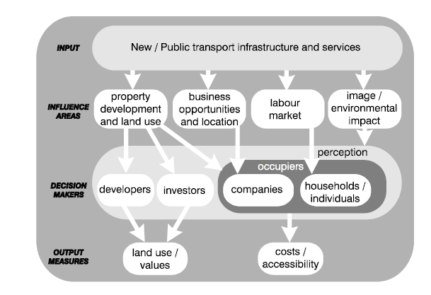

Sources: Mike Wrigley and Peter Wyatt, 2011
Figure 2: The relationship between transport infrastructure and urban development.
Babalik (2000) summarised attainment of land-use and urban development objectives in 8 urban rail systems, 4 American, 1 Canadian, and 3 British. She concluded that the Vancouver Skytrain and San Diego Trolley provided the clearest evidence of success in 3 dimensions:
(a) stimulation of development in the city centre;
(b) stimulation of development in declining areas;
(c) change in the pattern of urban development.

Terminologies
According to the research by European Conference of Ministers of Transport (2001), the term light rail transit was defined as railway for the transport of passengers that often uses electrically powered rail-borne cars operating singly or in short trains on fixed duo-rail lines. Stations/stops of light rail transit generally have a distance between them of less than 1200 meters. In comparison to metros, light rail is more lightly constructed, is designed for lower traffic volumes and usually travels at lower speeds. Moreover, the research report by the Federal Transit Administration (1999) in America defined light rail as a system of electrically propelled passenger vehicles with steel wheels that are propelled along a track constructed with steel rails. When extending light rail transit throughout cities or in any geographical area it may bring either positive or negative impacts on the communities especially those living in the adjacent to light rail transits.
Community refers to the structure of relationships through which localized population provides its daily requirements (Hawley, 2009). Again, Orlando defined community as a collection of people who share a common territory and meet their basic physical and social needs through daily interaction with one another (Orlando, 1986). In addition, three authors named as Copp, Clark and Pitman gave the definition of community as a body of people living in the same locality; a sense of identity and belonging shared among people living in the same locality; the set of social relations found in a particular bounded area (Copp, Clark & Pitman, 1990). So, adjacent community is defined as the communities very close to or near something. In case of the adjacent communities to light rail transit it to mean the communities living in 1km radius from the LRT stations/ lines.

The Impacts of Light Rail Transit on Employment Opportunity
According to the conducted research by American Public Transportation Association (2011), the aim of public transportation was maximizing job creations for every transportation dollar spent. These includes: selecting modes of transportation that generate the most jobs; incentivizing projects that locate jobs in underserved communities; and vigorously enforcing requirements for equal opportunity programs and grants targeting disadvantaged business enterprises. Transportation investments make good economic sense. In addition, the American Public Transportation Association estimated that about 36,000 jobs are created or supported for every $1 billion invested in public transportation; and every $1 invested in public transportation generates almost $4 in economic benefits in 2011. Although, the American Public Transportation Association proved the advantage of public transportation in generating job opportunities, there are conflicting opinions on whether expenditures on public transport projects produce more jobs than its’ expenses. So, the Addis Ababa LRT is one of public transportation that needs assessing to understand whether it is creating more employment opportunity than before the project was implemented. The big picture, however, shows that public transportation projects have greater potential to foster equal employment opportunity across racial and socioeconomic lines (The Leadership Conference Education Fund, 2011).
The previous empirical studies on the impacts of rail stops on adjacent areas in terms of property values, population and employment, have shown that the extent of impacts depend crucially on increasing in ridership (Baum-Snow & Kahn 2005; Brown et al 2013; Kahn 2007) and (Bollinger & Ihlanfeldt, 1997). Therefore, increasing the ridership at stations will attract private developers around light-rail transit stations, giving people easier access to businesses, residential housing units and other facilities, then this private development will create jobs.
According to Berry and Stern, if rail stations attract additional riders to the neighborhood, either residents who move to the area or commuters who work nearby the station will effectively increase the buyer density in the neighborhood, and should lead to an increase in the number of retail establishments and employees (Berry, 1967 & Stern, 1972). In case of San Diego new restaurant and office developments were seen around the San-Ysidro station, a new commercial zone was developed close to the Chula-Vista-Palomar station and office buildings were built next to the National City-24th Street station employing approximately 600 workers (Crampton, 2003).
Although urban development has been reported around many implemented LRT lines, a report from the Transit Cooperative Research Program (TCRP) of 1995 concluded that rail transit may not actually create new growth but simply redistribute growth that would have otherwise taken place elsewhere without the transit investment (Handy, 2005). However, LRT systems consistently influence and direct where and what kind of growth will take place (Cervero, 1984). Directly or indirectly light rail transit can affect the peoples’ socio-economic activities and alter their livelihood activities. In congested cities during peak hours, taking rail transit can reduce the travelling time; increases the trip length to move throughout the cities and work at different places in the cities. The whole advantages mentioned above will create additional job opportunity for the people. In addition, the reduced transportation costs allow households to spend more on housing and, in turn, bid up the rents or prices of homes located in areas with low commuting costs; this creates the land value/density gradient. But, opening of new public transport or transport stations do not always create positive impacts on employment. Light rail transit has also negative impacts on employment opportunities of the previous active areas. According to Schuetz study public transport has negative impact on employment creation. He concludes that new stations have negative impact on employment in Los Angeles and Sacramento MSAs new stations (Schuetz, 2014).

The Impacts of Light Rail Transit on adjacent Land use and Property value.
The rationale for an investment in light rail transit is to induce land use change in areas with unrealized developmental potential attributed to lack of accessibility (Cohen-Blankshtain & Feitelson, 2011). Furthermore, some study argues that once a light rail line is constructed, the accessibility benefits of the new transit facility will affect land use by increasing land rents and promoting higher density development, which, in turn, can alter travel patterns and mode choices over time within the urban system (TCRP, 2004). In their study Cervero and Duncan suggested that high value land parcels in turn, will produce additional property taxes for the municipality helping to pay for the capital and operating costs of the system (Cervero & Duncan, 2002). Of course, we can see the land use changes in most of the cities as the results of the LRT implementation in all over the world, but in case of the Addis Ababa we could not observe much of the land use changes followed by the LRT implementation, but there are some activity changes on its adjacent. Reducing transportation cost of public transportation for residents as the results of the LRT introduction increases land values in commuter zones, spur higher density development and higher-value uses (TCRP, 2004).
This encourage land use changes in the commuter zones from agricultural to residential land uses. The basis for this relationship was first developed by von Thunen in 1826. Within that framework, increases in rents and housing prices due to accessibility whether from a new rail station, bus stop, or freeway onramp are caused by subsequent decreases in commuting costs, measured in time. Many proponents of light rail argue that an investment in LRT can spur urban growth, revitalize declining areas, and promote more transit-oriented development (TOD) in a city’s downtown core, inner suburbs, and outlying areas. Cervero and Landis (1996) revealed the impacts of BART stations on land use changes and reported the result as vacant land in a ½ mile radius surrounding a station fell sharply in the first 20 years of BART’s existence from 27.6% of total area in 1965 to just 4.2% of area in 1990. The positive impacts of Metro rail station on property value was studied by Garrett (2004) and found an average home values between 1,400 and 2,300 feet increased $139.92 for every 10 feet closer they are to a MetroLink station, up to 2,300 feet. This translates into a 31.25-32.72 percent increase in property value when averaging across the 4 models. Moreover, evidence shown by Weinberger (2001). Ms. Weinberger analyzed commercial property values near Bay Area Rapid Transit (BART) rail stations in Santa Clara County, California to test for any potential impacts on property values. Her study used a dataset of negotiated lease transactions for commercial office space that spanned sixteen years (1984-2000). This time period covered five years prior to BART’s opening, as well as the following ten years to test for impacts on property values and she found that properties that lay within one-half mile of a light rail station commanded a higher lease rate than other properties within the county.
But, the growing bodies of scholarly research challenges the generative land use effects of rapid transit, arguing that rail transit, at least on its own, is insufficient for generating new urban economic or population growth (Babalik-Sutcliffe, 2002; Black, 1993; Cervero & Landis, 1997; Cervero & Seskin, 1995). In some studies, LRT has also negative impacts on adjacent property values because of its negative effects like nuisance and crime (Landis et al.,1995; Benjamin & Sirmans, 1996; Workman & Brod, 1997; Sedway, 1999). Thus, some urban areas benefit from a public transit project while others will not. Similar to the aforementioned above, we can see the negative impacts of the Addis Ababa light rail transit project on some adjacent properties. This is because the physical structure of the Addis Ababa LRT has created barriers on adjacent communities by protecting the pedestrian access. This aspect has some consequences on land and property value adjacent to the light rail transit.

The impacts of Light Rail Transit on Business activities
Business and commercial interests benefit from increased access to employees and customers due to accessible transit nodes. The transport project investment cause major changes on the business performance through supplier effect, consumer and labor market. These icons affect the business firm day to day activity or revenue which is ultimately affects the profitability. In addition, the cost advantage and convenience of the transportation will have direct and indirect impact on the profitability (Fisher & Harrington, 1996). Therefore, whether rail stations result in an increase in the quantity (or quality) of surrounding retail will depend on the number of transit users at that location. Moreover, an increase in retail establishments near a newly built train stop could represent either a net increase in retail activity through new store creation or redistribution from other, less accessible sites, as stores relocate closer to the rail station. In their study of the Atlanta MARTA (Metropolitan Atlanta Rapid Transit Authority), Bowles and Ihlanfeldt (Journal of Urban Economics, 2001) found positive economic impacts resulting from light rail station proximity. Their study analyzed the economic development impacts of the MARTA by examining the system’s impact on property values, changes in the local crime rate, and increases in the number of local retail businesses.
The presence of retail services in a neighborhood, such as grocery stores, pharmacies and restaurants, has important quality of life implications for residents, for instance whether they can purchase healthy food choices at reasonable prices (Hayes, 2000). Therefore, the extent to which rail investments improve the quantity or quality of retail services in surrounding neighborhoods is potentially a valuable social benefit that might serve to justify public expenditures. This is particularly true for rail investments in low-income and minority neighborhoods, which tend to have fewer retail and household service establishments, and where those that do exist offer inferior quality goods at higher prices (Schuetz, 2001). Moreover, because, low-income households are typically less likely to own automobiles, they may face greater barriers to reaching commercial centers outside their immediate neighborhoods. Berry and Stern consolidated the importance of the rail stations as the stations create and encourage business activities surrounding the LRT stations and increase the buyer density in the neighborhood; and this leads to an increase in the number of retail establishments and employees (Berry, 1967; Stern, 1972).

Complementary Policies for Light Rail Transit Implementation
Transport planning approaches in the 1950s and the 1960s were ruled by investments in the development and expansion of roads and motorways, and are responsible to some extent for the current level of the car use. In contrast to these approaches, since the 1970s some local and central governments world-wide have been searching for measures to limit the car use and promote public transport as an alternative. Hence, national policy documents, guidelines and urban policy initiatives in recent years, especially in North American and the majority of the West European countries, have all emphasised the need to provide a good public transport system (Hall & Hass-Klau, 1985; Simpson, 1987, 1988; Banister, 1994; Banister & Lichfield, 1995; Paaswell, 1995; Bernick & Cervero, 1997; Hass-Klau et al., 2000). It was built into these policy documents that new public transport systems were to be planned in order to provide effective solutions for urban problems, particularly for car traffic, environmental and urban growth problems. Complementary policies and forces influence the ability of rapid transit to generate urban development and land use changes and include: existing regional development trends and forces, federal/regional/local government land use policies, the availability of land and the physical characteristics of the area (Handy, 2005). Many of these policies are also conducive to, or will stem from, Transit Oriented Development (TOD) and Smart Growth principles. Simply put, the development and land use potential of light rail is recognized to be moderately high but only where there are pro-development policy environments and other complementary forces in place before the rail line is constructed (Cervero, 1984). If rapid transit is to be used as an effective policy instrument then its implementation should be based on urban development objectives which are compatible with rapid transit and are themselves accepted policy (U.S. DoT, 1977). The Planning Policy Guidance Note on Transport (PPG13) by the Department of Environment and Department of Transport of UK, for example, emphasised the opportunities public transport offered in implementing locational policies, and stated that rail stations or light rail stops should be the preferred locations for travel-intensive development, because: Rail services with their fixed infrastructure can provide the greatest certainty for developers and can provide a focus for regeneration and comprehensive redevelopment. Likewise, to the above literatures, the Addis Ababa LRT alone will not stimulate the development of the city unless some complementary development policies are associated with the LRT.

The Addis Ababa Transport Policy
The Addis Ababa Transport policy was prepared based on different proclamations, regulations and directives issued by the Federal Government and the City Administration which renders difficult for harmonized and coordinated actions (The Addis Ababa Transport Policy, 2011). The followings are the purposes of the Addis Ababa Transport Policy; those are: Enabling the transport services of the city assist the national effort to reduce poverty and accelerated development programs; Realizing infrastructure and transport service based on development in the city; Integrating the city’s land-use and transport plan; Providing the efficient, coordinated and improved transport services. The literatures reviewed from different sources related to public transport and transport policies including the Addis Ababa Transport policy and other countries experiences shows that the implementation of light rail transit alone cannot stimulate the desired urban development and land use changes (Cervero, 1984). That means simply installing a light rail line will not be enough to spur development on its own. The Addis Ababa LRT should have prepared complementary policies with LRT project to promote the expected development, especially the adjacent community surrounding the LRT lines/ stations.

The Gaps in Literature Reviews
The Addis Ababa Light Rail Transit is the first implemented LRT system in sub-Saharan Africa in 2015. For this reason, there were no research related to the socio-economic impacts of the LRT both in Ethiopia and in Sub-Saharan Africa. Therefore, this study will fill the gaps subjective to the socio-economic impacts of the LRT on adjacent communities. The other gap was, globally most of the studies focus on specific land uses/ activity areas, i.e. only commercial, only residential or only retail activities adjacent to light rail lines/ stations. Most of the authors in the past have studied the impacts of LRT on adjacent residential property prices (Kyeongsu Kim & Michael Lahr, 2013; Iacono & Levinson 2011; Hess & Almeida 2007) and few authors studied the price impacts of LRT on rental offices (Bina, Warburg & Kockelman, 2006; Cao & Hough, 2008). Some authors focus on the impacts of LRT on job opportunities (Blumenberg & Manville, 2004; Rast, 2004; Sen et al., 1999; Kawabata, 2002; Ong & Houston, 2002; Bania et al., 2008; Cervero, Sandoval, & Landis, 2002; Sanchez, 1999; Sanchez et al., 2004) while others only studied the impacts of LRT on adjacent firm’s profit (Parsons Brinckerhoff & Quade Douglas, 1998; Raper & Ihlandfeldt, 1993), however, this study do not focus only on single land uses/ activity areas but uses the whole socio-economic indicators collected from the respondents in residential, commercial and service area adjacent to the light rail transit lines/ stations. Again most of the method used in previous literatures were hedonic price modelling which study economic impacts of public transport in terms of property prices and it is widely method used in urban studies (Adair et al., 1996; Carroll et al., 1996; Long et al., 2007; Marco, 2008; Rosiers et al., 2011; Cervero, 2004; Mohammad et al., 2013; Armstrong & Rodriguez, 2006; Hess & Almeida, 2007) but this study uses descriptive statistics and spatial analysis method for data analysis.

Conclusion of Literature review
The Addis Ababa Light Rail Transit is an interesting example of a sustainable urban development initiative in Ethiopia (Yee, 2008). Nevertheless, the AALRT project has the socio-economic impact on the community both in negative and positive ways. The negative impacts on adjacent property values are nuisance and crime (Landis et al.,1995; Benjamin & Sirmans, 1996; Workman & Brod, 1997; Sedway, 1999) while the positive impact of LRT on urban economic or population growth was studied previously (Babalik-Sutcliffe, 2002; Black, 1993; Cervero & Landis, 1997; Cervero & Seskin, 1995). According to Nyarirangewe and Mbara (2007), transport infrastructure is a crucial to the economic and social development of cities. For this reason, it can affect the socio-economic activities of the cities (Satterthwaite, 2007). So, the social and economic impacts of the AALRT studied on the adjacent communities has been used the social and economic indicators of the LRT impact.

CHAPTER THREE: METHODOLOGY

Introduction
The research instrument used to collect data were questionnaire survey, interview, observation and secondary data. The questionnaire survey helps to present the social and economic impacts of the Addis Ababa light rail stations on adjacent community, while the interview questions were used to illustrate the impacts of Addis Ababa light rail stations on commercial and service areas. Two types of sampling techniques/methods were used in the study; these were: non-random and random sampling techniques. Non-random (purposive) sampling was used to include the Ayat, the residential dominant area, the Megenagna, the business dominant area and the Coca-Cola the service dominate area, because the study focus on the three different adjacent land uses (residential, commercial and social service).
Then random sampling techniques/ method was used collect the data from the community within residential, commercial and social service adjacent to each of the LRT stations and this helps to collect unbiased data. The distance of the location of the respondents from LRT were measured using GIS to study the impact of the LRT station/line distance on the community in terms of both the social and economic activities. When undertaking the data collection both the primary and secondary data were gathered and after the data collection, they were analyzed by using descriptive statistics and spatial analysis approaches.

Research design
The first stage was reviewing of relevant literature related to assess the socio-economic impacts of light rail transit station on adjacent community and indicators were used to analysis the social and economic related impacts of the LRT. The second process was the development of criteria to select the sample size and area. Therefore, before going to the site, the non-random sampling (purposive sampling method) was used to reveal the impacts of LRT on the adjacent the community from Torhailoch to Ayat area. The researcher has used both quantitative and qualitative method (mixed approach) to get information from the respondents at 6 sampled stations/stops from Ayat to Torhailoch LRT line. Then the data were collected from the community within 1km radius from the station using the random sampling technique was used collected the data from the community within residential, commercial and social service adjacent to each of the LRT stations and this helps to collect unbiased data. The third stage was the development of the questionnaires and interviews as well as observation approaches for data collection. The fourth stage was data collection from the relevant areas and bodies.
The questionnaires comprised of open-ended and closed-ended questions. questionnaire method was used to collect data from the adjacent community and a hand delivered method was preferred in order to minimize a low response rate. The interview method focused on socio-economic activities of the adjacent LRT line was gathered from the community in participating on commercial activity in the adjacent area of the LRT station/line. Observation was helpful to collect data related to observing the volume of pedestrians crossing the LRT station. The data were organized and analyzed using descriptive statistics and spatial analysis. The data were presented in tables, graphs, pie charts, maps and narration of qualitative data.

Research process
The research design formulated to conduct the socio-economic impacts of the Light rail transit on the adjacent communities from Ayat to Torhailoch LRT station gone through the following process. First the problems were defined based on issue under study within the study area. Then written materials related to the defined problem was reviewed using secondary data and primary data were collected using questionnaires, interviews and observations. Some analysis methods were chosen from the reviewed literatures. Therefore, the primary and secondary data was analyzed using the selected data analysis method. After the analysis, the positive and negative socio-economic impacts of the AALRT on adjacent community was shown. So, the positive impacts were encouraged and the negative impacts need some recommendations and further researches.
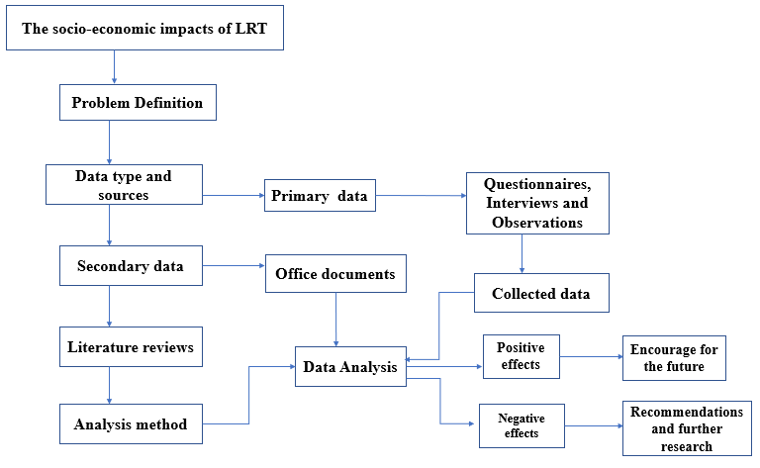
Source: By the researcher, 2019
Figure 3: The research process

Data collection tools
The primary and secondary data were used as instrument to collect data from the selected area. The primary data were the questionnaires and interview as well as observation of physical things which is helpful for the study. The secondary data were the written materials relevant to the study.
    - Primary sources of data
- Questionnaires: helps to gather relevant social and economic impact of the LRT from the community in the residential, commercial and the service adjacent to the LRT station/line.
- Interviews: for some of the community who cannot read and busy to fill the questionnaire questions the interview technique was used to collect the data. Again, the interview from the elders/those spent above five years around the LRT station were used as primary data.
- Observation: This is a kind of physical things which support about the impact of the LRT on the adjacent community. This can be the volume of the retailers in the surrounding the LRT station, the physical structure of the LRT that is creating barrier on the adjacent community and etc.
    - Secondary sources of data
1. Secondary Source of Data: Secondary data were compiled by the researcher from different literatures for his own use. The sources of secondary data were personal document such as thesis, dissertation and public document. Public documents such as books, physical mapping, records, and census reports of survey by private and public institution and various information’s published in newspapers and journal articles regarding the social and economic impact of the LRT on the community.

Indicators of the social and economic conditions related to the LRT
Indicator can then be converted into variables. Indicators were used to show whether or not the objectives have been achieved.
- The social and economic indicators of the LRT
Retailers number/volume: when light rail transit line is opened in some areas or cities, it may affect the business activities including retail activities in the adjacent areas. Therefore, the advantage of the access might change the volume of the retailers.
Employee and customers in business activity: The access to some public transport like light rail transit might affect positively or negatively the numbers of the customers or employees in some business activities or service areas.
Renters number/volume: The introduction of new mass transportation mode has an impact on change of the number of the renters in the surrounding LRT stations.
- The economic indicators of the LRT
Trip distance and Travel time: This is measured by the time taken to travel between two locations. This can be considered as economic and social indicators, because there is strong relationship between travel time and operating costs, as well as social interactions. When your travel time is saved it has value in productive business activities and encourage recreation trip or visit trip.
Transport cost: The more the cheap cost of transport with lesser travel time, the more trip distance travelled by people. This has huge impact on people social and economic activities.
Economic related trip purpose: the residential community in the adjacent area were asked about the LRT use for economic related trip purpose, i.e. work and shopping trip purpose and their frequency of responses can be used to assess economic impact of the LRT on the adjacent community.
- The Social indicators of the LRT
Social interaction: The LRT is subsidized by government and this public transportation system is introduced to reduce the transportation cost, traveling time as well as increase the trip length and this can increase tendency of the adjacent community for some trip purposes.
Social related trip purpose: the community in the adjacent residential area were asked about the LRT use for social related trip purpose like for recreation, visiting relatives, and school trip purpose and their response rate helped to measure the social impact of the LRT on the adjacent community.

Population

Sampling frame
The sample size of the selected population will be calculated using the following formula.
n= Z²*P(1-P)/e²
1+( Z²*P(1-P)/Ne²)
where n = the sample size
N = the population size
e = margin of error with 95% confidence interval and the true mean to be within margin of error of 0.5 and the sample size from the population size of the adjacent community living in 1km radius from the LRT station/line from Ayat to Torhailoch was not collected. But the maximum sample size used for the population size equal to or above 100,000 was used to calculate the sample size. So according to this about 384 sample size could be used for this study, but to undertake the detail study, about 720 sample size has been used which was more than double of the sample size as calculated from the population. since the most of the community found within 1km radius from the LRT station were the residents, about 60% of 720 respondents were focused on residential area accounting 432 of the respondents in residential community. From the community around the LRT stations those in commercial and service area were minor when compared with the residents in the 1km radius from the LRT stations. For this reason, 30% of 720 from the community in adjacent commercial and 10% of the community in social service was used to consolidate about the study of the impact of the LRT on the adjacent community.

Sampling technique
To conduct the research about six LRT stations along the East-West LRT line. Non-random (purposive) sampling was used to include the Ayat, the residential dominant area, the Megenagna, the business dominant area and the Coca-Cola the service dominate area, because the study focus on the three different adjacent land uses (residential, commercial and social service). Then random data collection methods were used to collect the data from the community by distributing 72 questionnaires for residential, 36 questionnaires for commercial and 12 questionnaires for workers in social services in each LRT station. This data distribution considers the volume of the respondents in the area and tried to collect the representative data. To see the proximity impacts of the LRT on the adjacent communities, the location distance of the respondents was categorized as below 300meters, 301-500meters, 501-700meters and from 701-1000meters. The selected six LRT stations are: Coca cola station, Legahare station, St. Uriel station, Megenagna station, Civil Service station, Ayat station. and the length between the consecutive selected LRT station is 1-mile (1600 meters).

Sample Size
For questionnaire questions about 720 respondents were surveyed from the residential, commercial and social services in the adjacent of the East-West LRT line. About 432 respondents in residential community were responded to the questionnaires, while 216 respondents were in commercial and 72 respondents in social service were administered for the study. In addition to this about 18 elders, three in each LRT stations and two workers in Addis Ababa land management office were used for an interview question.

Table 1: The sample size conducted by questionnaire data collection method.
LRT Focus Area | The sample size for the adjacent communities |  |  | Subtotal in each station
LRT Focus Area | Residential | Commercial | Service | Subtotal in each station
Coca cola station | 72 | 36 | 12 | 120
Legahare station | 72 | 36 | 12 | 120
St. Uriel station | 72 | 36 | 12 | 120
Megenagna station | 72 | 36 | 12 | 120
Civil Service station | 72 | 36 | 12 | 120
Ayat station | 72 | 36 | 12 | 120
Total sample size | 432 | 216 | 72 | 720
Source: By the researcher, 2019
Moreover, about three elders/those spent more than five years around the LRT station per LRT station with total of 18 elders in the total LRT stations were interviewed to witness the change on volume of retailers around the LRT stations before and after the Addis Ababa LRT in each selected station. Again, two government officials from the Addis Ababa land development and management office were interviewed about the land policy changes as the result of new infrastructure.

Data Analysis Methods
    - Descriptive Statistics Analysis
The softwares used to analyze the collected are: GIS, AutoCAD, MS Word, Excel and SPSS for analysis parts and Mendeley to write references. The analysis of the whole study is interpreted and interpreted by both qualitative and quantitative data analysis approaches. Accordingly, the qualitative data collected by an interview and observation methods from the respective relevant body was analyzed in descriptive statistics analysis (the analyzed volume of the retailers around the LRT stations could be an example); whereas the data that obtain via questionnaire is interpreted and analyzed in a quantitative manner as a result the organized (analyzed) data is presented in the form of tabulations, diagrams, maps, text and graphs.
    - Spatial Analysis
The Auto-CAD file of the parcel adjacent to the Addis Ababa LRT within 1km radius is collected from the Addis Ababa planning commission and relevant sub-cities. The satellite imagery showing the spatial coverage of the LRT stations and the whole study area is downloaded from the Google Earth. This is overlaid with Auto-CAD files. The Auto-CAD file is used for georeferencing the satellite imagery and the satellite imageries are used to update CAD files using GIS (ArcGIS10.6) software. Within 1 km radius from the LRT stations there are four distance categories (less than 300m, 301-500m, 501-700m and 701-1000m) to see the socio-economic impacts of the LRT on adjacent communities in relation to the distance from the LRT lines/ stations. So, using the overlaid satellite imagery and Auto-CAD file in ArcGIS software the differences of the response of the respondents relative to the distance from the stations are measured. Finally, the impacts of the LRT lines/ stations on the adjacent community is assessed.

CHAPTER FOUR: THE DESCRIPTION OF THE STUDY AREA

4.1. Introduction
Addis Ababa is a fast-growing African city with growth rate of 3.8% per annum. According to the 2007 census total population of the city was 2,7389,551 and the forecasted data by UN-habitat in 2016 indicates 4.6 million (UN-habitat, 2017). The total area of the city covers 540 square kilometers. The rising of population in the city from time to time has increased the demand for infrastructure including transportation system. Transportation system includes transportation modes and one of the modes is public transport. Currently, there are four major public transport services in Addis Ababa; those are LRT, Minibus taxis, Mid-buses (Higers and Isuzus) and Public buses (Anbessa and Sheger buses) and those public transportations couldn’t cope with the public demand for transportation, especially during peak hours.

Study by Ahmed et al (2008) revealed that an efficient transportation system plays an important role in shaping the daily lives of citizens. The provision of competent and efficient transportation system is of paramount importance for the cities especially in the modern era of globalization and information age where cities are the centers of urbanization and propellers of national and global economies (Fantahun T.,2012). Therefore, urban transportation is a critical concern for the development of a country around the world. However, most of the existing public transports in Addis Ababa were characterized by chaotic, unreliable, unsafe, unaffordable and inefficient for a fast-expanding city; therefore the Addis Ababa City Government has introduced the Light Rail Transit system, which is the first modern mass transit system not only in Ethiopia but also in Sub Saharan Africa (CNN, 2015; Jemere, 2014; The Economist, 2015).

4.2. The development of the Addis Ababa Light Rail Transit
The AA-LRT infrastructure development took three years with a total investment cost of $475 million and the project was inaugurated on September 21, 2015. The project was launched by the Ministry of Transportation in 2008 and received 85 percent of its funding from a loan by the Export-Import Bank of China. The AA-LRT consists of two routes/ lines: The North-South and the East-West route. North-South lines extends 16.9 kilometers (10.5 mi) in length passing through Menelik II square, Mercato, Lideta, Legehar, Meskel square, Gotera, and Kaliti while the East-West lines extends 17.35 kilometres (10.8 mi) and this line stretches from Ayat to Torhailoch passing through Megenagna, Meskel, Legehar and Mexico Square. The LRT covers a total length of 34.25 km and has 39 stations (ERC, 2009). The study is to conduct the socio-economic impacts of Addis Ababa LRT on the adjacent communities. So, from the two LRT route, the study only focuses on six LRT stations of the East-West line for an assessment. The LRT station names are: Coca cola, Legahare, St. Uriel, Megenagna, Civil Service University and Ayat LRT station.
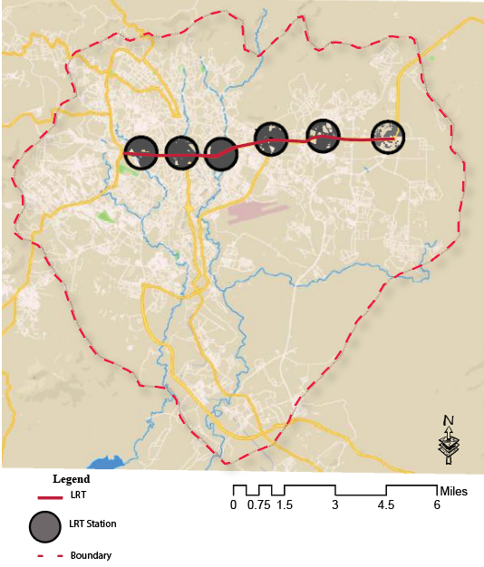
Source: The researcher, 2019
Map 1: The map of the selected six LRT station on the East-West LRT line

CHAPTER FIVE: RESULTS AND DISCUSSIONS

5.1. Introduction
The extension of the new infrastructure in the city can affect the livelihood of the community living in the adjacent of the intended project both in positive and negative ways. Therefore, the Addis Ababa LRT lines/ stations thought to bring either positive or negative or both impacts on the adjacent communities in terms of the social and economic conditions. Obviously, the LRT has brought huge positive impacts in solving the problem of the transportation for the residents of the Addis Ababa city population. The Addis Ababa LRT has numerous advantages for some areas of the adjacent communities in terms of spurring their economic activities as well as for the transportation means. However, the Addis Ababa light rail transit line has divided the adjacent areas in to two districts in some parts of the city. This segregation of the adjacent areas can affect the community in terms of breaking their social interaction and retarded the adjacent business activity. The East-West LRT line, which is stretched from Ayat to Torhailoch area is one of the two LRT routes extended in the city.

At some area the East-West LRT has closed the previous pedestrian cross that was being used to access the opposite side of the road before the LRT. As an example, the LRT line has closed the previous pedestrian cross to access the business activity found in front of EiABC (Ethiopian Institute of Architecture, Building Construction and City Development) and Ethiopian Civil Service University to access the other side of the LRT. The commercial community that had been participated on student-oriented business activity changed their business activity to pedestrian oriented business activity. So, it is very challenging to access the opposite side of the LRT throughout the city where LRT lines is extended. In contrary, some areas were being affected by the Addis Ababa LRT in a positive way like that of the Ayat LRT station that brought the number of the retailers around the station. Again, the construction of the LRT has demolished the properties of the communities in the adjacent area. Specially, the construction of the power supply station for the LRT has relocated the adjacent communities. Although, the government tried to choose the government land and open spaces while constructing the power supplies, still they are some properties demolished for the sake of the LRT power supply constructions. As the result of this, the Light rail project extended in the city from Ayat to Torhailoch residential area has affected some groups of the communities in a negative way. As told by the residents living around the LRT power supply stations from Ayat to Torhailoch, only for the construction of the power supply stations more than 70 households has been displaced from their previous living places. These means at Meri 2 households, Civil Service 15 households, St. Uriel about 36 households and in Lideta 9 households were dislocated from their original places.

In addition to this there were also affected and dispositioned groups during the widening of the roads that runs on both side of the LRT. Afterall, leaving their original place can affect the livelihood of the communities directly or indirectly. As informants noted during an interview, the ownership of the demolished properties was considered for the payment of the compensation and there were unfair payments of compensation for the demolished properties. About 432 respondents in residential community were responded to the questionnaires, while 216 respondents were in commercial and 72 respondents in social service were administered for the study. In addition to this about 18 elders, 3 in each LRT stations and 2 workers in Addis Ababa land management office were used for an interview question.

5.2. The response rate of the samples
To increase the response rate of the sampled residential community, the mixed questionnaire and interview data collection instruments used but for those who showed the uninterest about answering to the questionnaire the replacement by the nearby residential parcel was used. Since the random sampled residential community was 72 parcel units around each of the selected LRT station, the inconvenient participants were replaced by those who has interest to reply to the questionnaire. The above mentioned has increased the response rate in residential community to 100% (432 of the respondents returned to the questionnaire). Again, the interested participant/respondents in commercial and service area were interviewed in the data collected about 100% of the response rate was found. That means 216 samples from the adjacent commercial and 72 samples from the adjacent social service were collected. Generally, the data collection method was based on the random selection and quota technique for uninterested minor groups the substitution method was used.

The socio-economic background of the respondents
    - Sex and Age
Table 2: The table of the age and sex of the respondents
Characteristics | Community in residential adjacent to LRT
Characteristics | Male |  | Female |  | Total
Age groups | Frequency | Percent | Frequency | Percent | Frequency | Percent
Less than 14 years | 25 | 5.8% | 26 | 6.0% | 51 | 11.8%
15-24 years | 77 | 17.8% | 49 | 11.3% | 126 | 29.1%
25-54 years | 107 | 24.8% | 78 | 18.1% | 185 | 42.9%
55-64 years | 30 | 6.9% | 12 | 2.7% | 42 | 9.6%
65 and above | 19 | 4.4% | 9 | 2.1% | 28 | 6.5%
Sub-total | 258 | 59.7% | 174 | 40.3% | 432 | 100%
Age groups | Community in commercial area adjacent to LRT
Less than 14 years | 6 | 2.7% | 7 | 3.2% | 13 | 5.9%
15-24 years | 53 | 24.5% | 66 | 30.6% | 119 | 55.1%
25-54 years | 49 | 22.7% | 28 | 13.0% | 77 | 35.7%
55-64 years | 4 | 1.9% | 2 | 0.9% | 6 | 2.8%
65 and above | 1 | 0.5% | 0 | 0% | 1 | 0.5%
Sub-total | 103 | 52.3% | 113 | 47.7% | 216 | 100%
Age groups | Community in social service adjacent to LRT
Less than 14 years | 1 | 1.4% | 4 | 5.6% | 5 | 7%
15-24 years | 14 | 19.4% | 19 | 26.4% | 33 | 45.8%
25-54 years | 21 | 29.2% | 11 | 15.3% | 32 | 44.5%
55-64 years | 1 | 1.4% | 0 | 0% | 1 | 1.4%
65 and above years | 1 | 1.4% | 0 | 0% | 1 | 1.4%
Sub-total | 38 | 52.8% | 34 | 47.2% | 72 | 100%
Source: The researcher, 2019

    - Family size of the adjacent residential community
Table 3: The table of the family size of the respondents
Family size | Frequency | Percent
one person | 73 | 16.9%
two persons | 75 | 17.4%
three persons | 68 | 15.7%
four persons | 63 | 14.6%
five persons | 66 | 15.3%
above 5 persons | 87 | 20.1%
Total | 432 | 100.0%
Source: The researcher, 2019
    - Education level of the adjacent community
Table 4: The table of the education level of the respondents
Education level | Community in residential adjacent to LRT |  | Community in commercial adjacent to LRT |  | Community in social service adjacent to LRT
Education level | Frequency | Percent | Frequency | Percent | Frequency | Percent
Illitrate | 35 | 8.1% | 13 | 6.0% | - | -
Primary school (1-8) | 67 | 15.5% | 46 | 21.3% | 12 | 16.7%
Secondary school (9-10) | 64 | 14.8% | 60 | 27.8% | 7 | 9.7%
Preparatory school (11-12) | 53 | 12.3% | 29 | 13.4% | 7 | 9.7%
TVET | 32 | 7.4% | 19 | 8.8% | 2 | 2.8%
Diploma | 74 | 17.1% | 24 | 11.1% | 12 | 16.7%
Degree | 92 | 21.3% | 24 | 11.1% | 30 | 41.7%
Masters/PhD | 15 | 3.5% | 1 | 0.5% | 2 | 2.8%
Sub-total | 432 | 100.0% | 216 | 100.0% | 72 | 100.0%
Source: The researcher, 2019
    - Income status of the respondents
There are the disparities in income level of the Addis Ababa residents and the income level also are vary between the sub-cities of the city. The income level of the residents in Bole sub-city is high relative to those in old city centers like Kirkos and Addis Ketema sub-city (UN habitat, 2003). Therefore, the community in Coca-Cola and Legahare LRT station area were characterized by lower income households when compared to Bole sub-city. As the result of this the residents in Bole sub-city (the Civil Service and Ayat) were the higher income than the rest of the city center like the Kirkos and Addis Ketema (Coca-Cola and Legahare LRT station) area.

RESULTS/FINDINGS

The relationship of income level and LRT use of the adjacent residents
This study depicts that the practice of public transportation usage has strong relationship with the income level of the households and family sizes. When there is a large family size with low income there is a tendency to use public transportation within the family than those of small family size with high income. The income level of the community in the adjacent of the LRT were not collected and used for this study, but observation of the residential environment like ownership of the building, the structure and age of the building, the number of the private cars were used to extrapolate the income level of the community and used to compare the income level of the community around each LRT stations. So, the community living in the old city center of the Addis Ababa found on East-West line of the AALRT were like to be low income relative to new developing areas. On the contrary, the low-income community with large family size that the AALRT line pass through were those situated around Coca-Cola and Legahare LRT stations. The small family size with high income were those surrounding Megenagna, Civil Service and Ayat LRT stations compared to the rest of the area under studied as extrapolated from their transportation cost.

Identifying the social and economic impacts indicators of the LRT on adjacent residential community
The social-related issues considered in the study are: the social structure of the LRT users in residential communities, the impact of LRT on social interaction of the adjacent community and the impact of LRT on social related trips. And the economic impacts of the LRT can be assessed using: economic related trips, the impact of LRT on travel time and distance, the livelihood impact of the LRT and impact LRT on transport cost of adjacent community were considered.
      - The LRT user in the adjacent residential community
The Addis Ababa LRT was thought to improve the socio-economy of the city population especially the community living in the adjacent to the light rail transit line/station. Moreover, the LRT was also intended to reduce the transportation problems of the Addis Ababa city. The collected data from the adjacent community surrounding of the LRT lines/stations from Ayat to Torhailoch area shows that about 78% (338 of 432 respondents) of the communities were using the LRT as an alternative means of transportation while about 22% (94 of 432 respondents) of the city population did not use the LRT as the means transport. The figure below represents the percentage of the adjacent community using the Addis Ababa light rail transit.
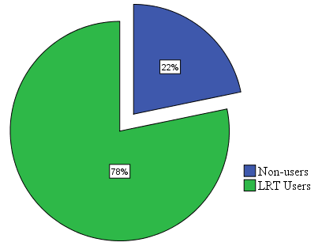

Source: The researcher, 2019
Figure 4: The percentage of the adjacent residential community using LRT

LRT users around each LRT stations

Thus, the results of the study show that the LRT users as an alternative transport was high in residential communities surrounding Coca-Cola LRT stations. In Coca-Cola LRT station about 11.1% of the respondents were not using the LRT for any trip purpose while about 89.9% of the respondents in residential area were using the AALRT. The reason behind the results perhaps the community living around this area were low-income; hence they chose the cheap price, and most of them do not have their own private cars when compared to the other assessed adjacent area of the LRT stations.
So, they use the LRT for work, school, shopping, visit, recreation and others trip purposes. The next adjacent community using the LRT for transport were the residents around Legahare and St. Uriel LRT stations. About 86.1% of the community surrounding Legahare LRT stations and 83.6% of the community living in the surrounding of Megenagna LRT station were using the LRT for transport respectively in descending order. But there is less use of LRT the residents around St. Uriel, Civil Service and Ayat LRT station relative to the above stations; because of most of the residents were high income and uses their private car for transportations. The family size of the residents around those stations area is also low relative to the residents around Coca-cola, Legahare and Megenagna LRT stations. The percentage of the community that did not use the LRT for transport in Ayat, Civil Service and St. Uriel were 31.9%, 27.8% and 19.4% respectively. The figure below shows the percentage of the residents using the LRT.

Source: The researcher, 2019
Figure 5: The percentage of LRT users in the adjacent stations on East-West LRT line

      - The family size and the number of LRT users with the family members
The numbers of the family size within residential community in the adjacent of the East-West LRT line vary from station to station. In that case, the numbers of the LRT users within family numbers depends on the size of the family. As the results of this, the family size around the Coca-Cola LRT station were large relative to the residents living around the other stations on the LRT line. Hence, the major percentage of the family size having above 5 persons in the family goes to the Coca-Cola LRT area covering 31.9% of the residents, followed by Legahare LRT station covering 23.6% of the residents, the third majority is 20.8% of the residents surrounding the Megenagna LRT station. The minimum percentage of the family size having above 5 persons in the family was those living around Civil Service LRT station. Therefore, when undertaking the research, the number of the family size using the LRT go along with the number of the existing family size. That means the more the family size, the more tendency to use the LRT.
While assessing the numbers of the LRT users within family in the surrounding of the LRT station on the East-West line, the family having one-person user within their family members was highest around Ayat LRT station accounting 45.8% of the respondents. Two person users within family members was high around Civil Service and Legahare LRT station, covering 38.9% of the surrounding residents. The highest percentage of the family having three persons user within their family members was around Coca-Cola LRT station sharing 18.1% of the respondents. Both of the highest percentage of the LRT users with five persons and above in their family members were found around the same station, the Coca-Cola LRT station covering 5.6% and 2.8% respectively.

Source: The researcher, 2019
Figure 6: The percentage of the family members using the LRT in each family members

      - The LRT users according to age group
The LRT users were categorized by their age groups. So, the age groups from 25-54 years were the dominant users of the LRT taking 43.8% and the next highest age groups using the LRT were those from 15-24 years accounted to 30.5% of the respondents. The third largest percentage of age group were those within 0-14 years covering 11.2% of the respondents. The least groups of the LRT users were the elders 65 and above years covering 5.6% of the respondents. As can be seen from the above the practice of the LRT user was very low for elders 65 and above years old and this might be as the result of those groups might make fewer trip than the rests of the age groups; moreover, the LRT infrastructures at some LRT stations are inconvenient to use by those age groups.

Source: Own computation from CSA, 2019
Figure5: The percent of the age groups using LRT from Ayat to Torhailoch LRT station.
      - The LRT users according to Sex
When the LRT users are categorized by sex, the male respondents use the AALRT than female respondents at 5 LRT stations other than the Civil Service LRT station, where 41.6% of the users were females and 30.5% were males. This reason behind the female dominance around the Civil Service was, perhaps most of the males prefer driving than using the public transportation like females, while females uses alternative mode of transportation like private cars, minibus taxis, public buses and the light rail transit. The figure below shows the percentage of the LRT Users by sex in each LRT stations
Source: The researcher, 2019
Figure 7: The LRT Users by sex in six LRT stations
When the LRT users were categorized according to their educational status, the persons with diploma have great experience in using the AALRT accounting 17.8% of the respondents. The second groups of persons using the LRT for their trip purpose were those with secondary school (9-10) accounted to 17.5% of the respondents and the third highest percentage of the LRT users were those with primary school education level taking 12% of the respondents. The analyzed data shows that most of the persons with diploma, high school and primary school education levels travel by LRT to their work places and schools respectively. The lowest percentage of educational levels that uses the LRT were Masters/PhD holders which covers 2.4% of the respondents. In fact, from the interviewed Masters/PhD holders, most of them uses either their own car or the government car or public services other than the LRT. The figure below shows the LRT users in residential community by their educational level.
Source: The researcher, 2019
Figure 8: The LRT users in residential community by educational level.

      - The impact of the LRT on social related trip purposes
The community of the Addis Ababa uses the Addis Ababa light rail transit for different trip purpose both for economic or social related issues. As the result of this, the numbers of the community using the LRT for social trip purpose from Ayat to Torhailoch LRT station were calculated by using the collected data. The social related trip purposes were: visit, school and recreation trip purpose. Thus, each of the mentioned social concerned trip purpose within the study area were analyzed and discussed below.
- The LRT for visit trip purpose
The visit trip purpose within the residential area of the adjacent community was studied and categorized by the percentage of persons using the LRT for visit purpose. The visit trip purpose includes visiting the relatives, friends and others. So, the largest percentage that single person using LRT for visit trip purpose within family members were 47.2% of the respondents living in the surrounding of Civil Service LRT station. This is because around this area the land use is dominated by residential with small family size when compared to those living around the other LRT stations like the Coca-Cola and Legahare. Beside to the above station, the largest number of two-persons using LRT for visit purpose within family member were 13.9% of the respondents around Ayat LRT station. Again, the highest percentage of the three persons using the LRT for visit trip purpose within family members was around Ayat LRT station covering 12.5% of the respondents. The percentage of four persons using the LRT for visit trip purpose within family members was highest around Coca-Cola and St. Uriel LRT station sharing 4.2 percent in both station areas.
The five person users of the LRT within family members was great around Coca-Cola LRT station accounting 1.4 percent. There were also more than five people that uses the LRT for visit trip purpose around Legahare and Ayat LRT station covering 1.4% in both stations. As can be mentioned above, there is a positive correlation between the number of the LRT users and the family sizes. This is to say that when there are large family around the LRT station, there might be higher numbers of LRT users for visit trip purpose. Moreover, around Civil Service and Ayat there were small family size. Hence, the one-person LRT user within family members for visit trip purpose was highest around these two LRT stations since both of the area have small family size with better interest and income for visit trip than the residents living around the rest of the LRT stations.

Source: The researcher, 2019
Figure 9: The percentage of the community using the LRT for visiting relatives trip purpose at each station.

The aggregate study about the use of the LRT for visit trip purpose shows that within 47.7% of the respondents at least one of the family members were using the LRT for visit trip purpose while within 52.3% households none of the family members were using the LRT for visit trip purpose.
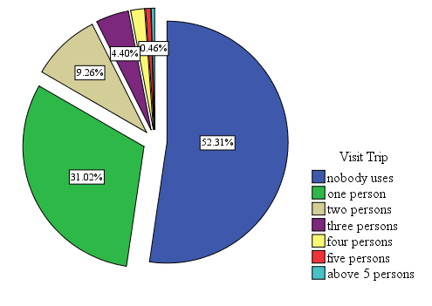

Source: The researcher, 2019
Figure 10: The aggregate percentage of the community using LRT for visiting relatives trip purpose.

- The LRT for recreation trip purpose
Another social related trip purpose was recreational trip purpose. Thus, the residents surrounding the LRT stations were asked whether they had used the LRT for recreational trip purpose. So, the one person users of the LRT for recreational trip purpose within family members was maximum at Ayat LRT station taking 23.6%, followed by community surrounding Coca-Cola LRT station covering 15.3% of the respondents. The highest percentage of the two-persons using LRT for recreation trip purpose within the family members was around Megenagna LRT station taking 12.5% of the residents in selected area. The three-person users of the LRT for recreation trip was highest around the Coca-Cola LRT station sharing 6.9% of the studied community around the station. The four-persons within family members using the LRT for recreation trip purpose was highest around the Coca-Cola and Legahare LRT stations covering 2.8% in both stations. By the same token above about the relationship between family size and the numbers of the LRT users for visit trip purpose within family members, there also strong relation between the family size and the numbers of the LRT users for recreation trip purpose within family members. To elaborate this, most probably when there is large family size living around the LRT station, there is the probability of high numbers of LRT users for some trip purposes including recreational trip purposes. For instance, most of the Ayat residents have small family size and they use LRT for recreational trip purpose other than any other trip purpose since they use private cars for their trip purposes. As the result of this especially during Saturday and Sunday about quarter (23.6%) of the Ayat residents uses the LRT for recreation trip purpose.

Source: The researcher, 2019
Figure 11: The percentage of the community using LRT for recreation trip purpose at each station.
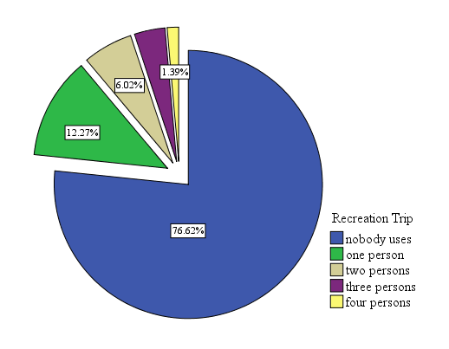
The cumulative results of the LRT users for recreation trip purpose from Ayat to Torhailoch LRT station reveals that about 76.6% of the community do not use the Addis Ababa light rain transit for recreational trip purpose while only 23.4% of the community were using the LRT for recreational trip purpose and the numbers of the users vary from station to station as described in the above.

Source: The researcher, 2019
Figure 12: The percentage of the community using LRT for recreation trip purpose.

- The LRT for school trip purpose
The third social issue to assess the social impact of the LRT on adjacent community was school trip purpose. Thus, the results about the percentage of the residents using the LRT for school purpose have been analyzed and the highest percentage of one person using LRT for school trip purpose within family members was found around Legahare LRT station accounting 41.7% of the respondents. The second majority was around St. Uriel station covering 37.8% of the respondents and the least percentage of one person users of the LRT for school trip within family members was around Ayat LRT station which accounted to 15.3% of the respondents. The maximum percentage of the two persons using the LRT found around Megenagna LRT taking 8.3% of the respondents followed by those living around St. Uriel and Coca-Cola LRT station sharing 6.9% of the respondents in both stations. The three persons using the LRT for school trip purpose was highest around Legahare LRT station covering 2.8% of the respondents within the selected station. As shown in the above, there is strong association between the number of the LRT users and the family size, income as well as the location distance of the school from the residential houses. This means when the location of the public school is close to the residential area like the Coca-Cola station and if the residents are low income, there might be no need of travel for school trip purpose other than few students that attend the private schools. Again, we can see less percentage of the LRT users within family members around Ayat LRT station because most of the students use other mode of transportation for school trip purpose.
Source: The researcher, 2019
Figure 13: The percentage of the adjacent community using LRT for school trip purpose at each station.

The combined result about the use of LRT for school trip purpose from Ayat to Torhailoch LRT station shown in the figure above tells that about 65.5% of the community did not use the LRT for school trip purpose. But 34.5% of the community uses the LRT for school trip purpose having varied percentage at different LRT stations.

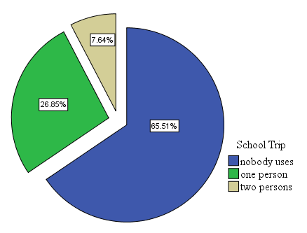

Source: The researcher, 2019
Figure 14: The percentage of the community using LRT for school trip purpose.

      - The economic related impacts of the LRT on adjacent residential areas
The economic impacts of the light rail transit on adjacent community were studied by using the collected data from the adjacent residential communities on the East-West line of the LRT from Ayat to Torhailoch station. Thus, while conducting the study, the indicators of the economic impact related to the LRT were used for the analysis. The economic indicators of the LRT on the adjacent residential community were work and shopping trip purpose, change of transport cost, change on travel time, change on trip distance and the general impacts of the livelihood activities.
- The LRT for work trip purpose
One of the economic indicators of the LRT for the community was work trip. Therefore, the figure below shows the number of the LRT users that uses the LRT for work trip purpose. The highest percentage of one person users of the LRT for work trip purpose within family members was around Coca-Cola LRT station covers 55 percent of the respondents, besides of this, the highest percentage of the two person users of the LRT within family members was around Coca-Cola LRT station accounting 19.4% of the respondents. Again, three person users of the LRT for work trip purpose within family members was maximum around Coca-Cola LRT station accounting 9.7% of the total respondents. The four-persons using the LRT for work trip purpose was maximum around St. Uriel LRT station having 4.2% of the respondents in both stations. There were also five person users of the LRT for their work trip purpose having 1.3 percent of the respondents around the Coca-Cola LRT station. The figure below shows the percentage of the LRT users within family members that uses the LRT for work trip purpose.

Source: The researcher, 2019
Figure 15: The percentage of the adjacent community using LRT for work trip purpose at each station.

Even though, the majority of the respondents covering 62.5% of the residents uses the LRT for work trip purpose, about 37.5% of the community do not use the LRT for work trip purpose. As shown above, the practice of using the LRT for work trip purpose within adjacent community vary from station to station depending the family size and economic level of the adjacent residential community. As an example, the community surrounding the Coca-Cola LRT staion have more experience of the LRT use for work trip purpose; while the community surrounding Ayat and Civil Service area have less practice of the LRT use to their work places as the result of most of the residents around these stations use other mode of transportation like private car, minibus taxis and other public transportations. The figure below shows the use of the LRT for work trip purpose within residential area the under studied.
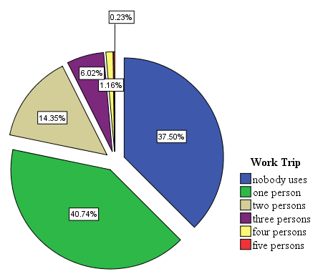

Source: The researcher, 2019
Figure 16: The percentage of the community using LRT for work trip purpose.

- The impact of LRT on transport cost
The other indicator of economic impact of the LRT on adjacent residential community can be the the LRT impact on the transportation cost. The government subsidize the public transportations to reduce the transportation problems and reduce environmental pollution as well as to bring affordable transport cost to help the low-income group of the society. As the results of this the fare of the public transport mode like buses and LRT thought to give services at cheap prices than the rests of transportation mode. Hence the AALRT is believed to reduce the transportation cost for the users. For this reason, the transport cost before the LRT operated is compared with the transport cost after the LRT. Therefore, the transportation cost of the community living adjacent to the LRT station from Ayat to Torhailoch LRT station before and after the LRT has been assessed separately.
- Coca-Cola LRT station:
The analysis of the impacts of the LRT on transportation cost of the residents around Coca-Cola LRT line/station shows that, the community spending less than 50birr per week before the LRT were 37.5% and increased to 63.3% after the LRT. Those spend from 51-100birr per week before the LRT was 30.6% and reduced to 22.2% after the LRT. The transportation cost spent from 101-150birr per week before the LRT was 25% and reduced to 9.7% after using LRT. Again, those spend from 151-200birr per week before the LRT was 4.2% and reduced to 1.4% after the LRT. The transport cost spent above 200birr per week before the LRT was 2.8% and this minimized to 1.4% after the LRT. As can be seen from the above results, there is significant change on transport cost of the users of the LRT, especially those of the residential communities living adjacent to the AALRT. Generally speaking, the LRT has saved transport cost for the users. Hence the saved cost can be spent on something else and this can affect the economic conditions of the adjacent communities in a positive way. The figure below shows the impact of the LRT on transport cost of the adjacent residential community around Coca-Cola LRT station.

Source: The researcher, 2019
Figure 17: The impact of the LRT on transportation cost of the residents around the Coca cola LRT station.
- Legahare LRT station:
The transportation cost of the community living adjacent to Legahare LRT line/station was also analyzed. In the same fashion of the transportation cost of the community living in the surrounding Coca-Cola LRT station, the transport cost of the community living around the Legahare LRT station was also studied and the results shows the reduction of the transport cost after the LRT. The percentage of the community spending less than 50birr per week has been increased after the LRT from 34.7% to 86.1% while the rests of the transport expense categorized under the study has been reduced after using the LRT. These means those spend between 51-100birr per week before the LRT were 41.7% and reduced to 8.3% per week after the LRT and those devote 101-150birr per week before the LRT were 8.3% and now reduced to 1.4% per week. Again, the transport cost from 151-200birr per week before the LRT was 12.5% and reduced to 1.4% after the LRT. But those spend above 200bir per week before the LRT was 2.8% and kept constant after the LRT. This might as the result of the economic improvements taken place within the residential communities. That means the more transportation cost spent, the more economic activities that the people are involved in. The figure below shows the impact of the LRT on transport cost of the adjacent residential community around Legahare LRT station.

Source: The researcher, 2019
Figure 18: The impact of the LRT on transportation cost of the residents around the Legahare LRT station.
- St. Uriel LRT station:
The impact of the LRT on transport cost of the residential community surrounding the St. Uriel LRT station has been analyzed after collecting the concerning data from the adjacent communities. So, the community spending less than 50birr per week before the LRT was 30.6% and this has been increased to 79.2% after the LRT. The rests of the transport cost category after the LRT were reduced. For example, the percentage of the community that spent from 51-100birr per week before the LRT was 43.1% and reduced to 11.1% after the LRT. Those spend from 101-150birr per week before the LRT was 9.7% and now reduced to 4.2% after the LRT. About 9.7% of the community were spending from 151-200birr per week before the LRT and now reduced to 4.2% after the LRT. The 6.9% of the surrounding St. Uriel LRT were spending above 200birr before the LRT and this also reduced to 1.4% after the LRT. In this case the overall impacts of the LRT on transportation cost of the adjacent residential community around the St. Uriel LRT line/station reduced after they had started using the LRT for transport. The figure below shows the impact of the LRT on transport cost of the adjacent residential community around St. Uriel LRT station.

Source: The researcher, 2019
Figure 19: The impact of the LRT on transportation cost of the residents around the St. Uriel LRT station.
- Megenagna LRT station:
Similarly, the impact of the LRT on transportation cost of the adjacent community living around the Megenagna LRT station was weighed. Thus, the community spending less than 50birr per week before the LRT was 31.9% and this increased to 70.8% as well as those spend from 51-100birr per week before the LRT was 33.3% and reduced to 18.1% after the LRT. Again, the groups that spend from 101-150birr per week before the LRT was 20.8% reduced to 4.2% after the LRT. Furthermore, about 9.7% of the Megenagna LRT station adjacent residential community spent from 151-200birr per week before the LRT reduced to 5.6% after the LRT. About 4.2% of the community spent above 200birr per week before the LRT reduced to 1.4% after using LRT. The results shown above revealed the significant change on transport cost of the residential community adjacent to the Megenagna LRT line/station. The figure below shows the impact of the LRT on transport cost of the adjacent residential community around Megenagna LRT station.

Source: The researcher, 2019
Figure 20: The impact of the LRT on transportation cost of the residents around the Megenagna LRT station.

- Civil Service LRT station:
Similar to the other LRT station under studied, the impact of the LRT on transportation cost of the residential community around Civil Service LRT station was studied. Hence, about 26.4% of the community around Civil Service LRT station spent less than 50birr per week before the LRT and increased to 55.6% after the light rail transit launched. And those spent 51-100birr per week before the LRT was 43.1% and reduced to 30.6% after the LRT. Moreover, the transport cost from 101-150birr per week before the LRT was 18.1% and reduced to 8.3% after the LRT. Also, those spent from 151-200birr per week before the LRT was 5.6% and reduced to 2.8% after the LRT. Similarly, those used up above 200birr per week for transport before the LRT was 6.9% and reduced to 1.4% after the LRT. So, by using the above results as an illustration, there is significant change on transport cost of the residential community adjacent to the Civil Service LRT line/station and this might bring some positive economic impacts on the residential communities. The figure below shows the impact of the LRT on transport cost of the adjacent residential community around Civil Service LRT station.

Source: The researcher, 2019
Figure 21: The impact of the LRT on transportation cost of the residents around the Civil Service LRT station.
- Ayat LRT station:
The Ayat LRT station was one of the six selected LRT station on the East-West LRT line. For this reason, the change of the transport cost of the LRT on the adjacent community was studied on the residential community around Ayat LRT station. Therefore, the community spending less than 50birr per week before the LRT were 34.7% and increased to 48.6% after they used the Addis Ababa light rail transit. Those spend from 101-150birr per week before the LRT was 19.4% and reduced to 15.3% after the LRT. About 11.1% of the adjacent community spent from 151-200birr per week before the LRT reduced to 4.2% after the LRT. Surprisingly, the percentage of the community spent above 200birr per week before the LRT was increased after the LRT from 18.1 percent to 19.4 percent. Relatively there was less significant change on the transport cost of the residential community living around the Ayat LRT station when compared to the rest of the LRT station from Ayat to Torhailoch LRT station. The figure below shows the impact of the LRT on transport cost of the adjacent residential community around Ayat LRT station.

Source: The researcher, 2019
Figure 22: The impact of the LRT on transportation cost of the residents around the Ayat LRT station.

The aggregate result of the LRT line impact on transport cost
By comparing the transport cost spent by the adjacent community before and after the LRT on the East-West LRT line from Ayat to Torhailoch LRT station, we can see huge gap between the cost of the transport spent by the community. The figure below is an illustration of the gaps between the transport cost before and after the Addis Ababa light rail transit. The table below shows the difference between the transportation cost spent by the community living around the LRT stations from Ayat to Torhailoch LRT stations.
Table 5: The comparation of the transport cost before and after the Addis Ababa LRT.
Category of transport cost | The transport cost before the LRT in percentage | The transport cost after the LRT in percentage
Less than 50birr | 32.6% | 67.6%
51-100birr | 34.7% | 17.1%
101-150birr | 16.9% | 7.2%
151-200birr | 8.8% | 3.2%
Above 200birr | 6.9% | 4.9%
Source: The researcher, 2019
- The impact of LRT on travel time
The impacts of the LRT on travel time of the adjacent communities from Ayat to Torhailoch LRT station has been studied. In this case for about 63% of the total respondents (80.7% of the LRT users) of the residential communities around the LRT stations, the LRT has reduced the travel time than other mode of transportation. But still 15% of the respondents (19.3% of the LRT users) answered no change about the impact of LRT on the travel time. About 22% of the respondents do not use the LRT and responded I do not know answer. The travel time can affect the economic conditions of the communities, the less the time to arrive at a place means, the less time spent on travelling and the more time to carry out different jobs instead of travelling time. The figure below shows the impact of the LRT on travel time of the adjacent residential community.
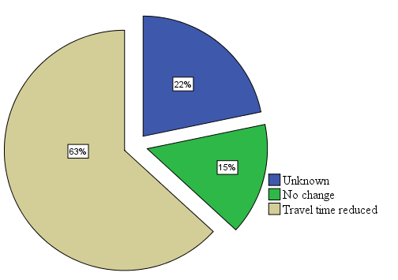
Source: The researcher, 2019
Figure 23: The impacts of LRT on travel time of the adjacent community.

- The impact of LRT on trip length
The other impact of the Addis Ababa light rail transit was the change of the trip length of the users. This economic indicator helps to know the LRT impact on length of the trip that the people travelled after the LRT compared to the distance they could travelled before LRT. This has significant impact on economic conditions of the adjacent communities, because if people travelled a lot, they would access better and convenient places for their economic activities. That means they can move throughout the city and work at different places. So, this could affect their economic activities and income levels.

Source: The researcher, 2019
Figure 24: The impacts of LRT on trip length of the community living around each station.

The above figure depicts feelings of the respondents about the impact of the AALRT on trip length. In this case, the impacts of the LRT on trip length of the adjacent residential communities was assessed as for about 48.6% of the community around the Coca-Cola LRT station, the LRT has increased their trip length, similarly it has increased the trip length for about 40.3% the residential community living around the Legahare LRT station. The lowest percentage of the response responded positive about the trip length was those around Ayat LRT station covering 25% of the respondents. This is because of most of the time the residents living around Ayat LRT station do not use the LRT for their trip purposes when compared to the community living around the LRT stations in the city centers, i.e. Legahare and Coca-Cola LRT station areas.
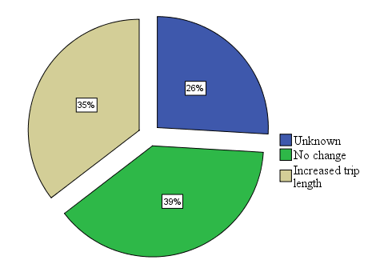
Source: The researcher, 2019
Figure 25: The impact of the Addis Ababa LRT on trip length of the community.

The figure above shows that for about 35.4% of the community under the study, the LRT has increased their trip length, this means about one-third of the community living in the adjacent to the AALRT has improved ether social or economic conditions of the community by travelling more distance than the distance they used to travel before the LRT. Nevertheless about 38.7% of the respondents did not feel any change on the trip length while using the LRT. But about 25.9% of the respondent do not know the trip length change brought with LRT use.
- The LRT for Shopping trip purpose
Since one of the indicators of the economic impact of the LRT was shopping trip purpose, the percentage of the adjacent community using the LRT for shopping trip purpose was studied using the data collected. The shopping trip purpose has strong relationship with the family size and economic status of the adjacent residential community surrounding the LRT stations. As the results of this, from the whole LRT station one person using the LRT for shopping trip purpose within family members is high around Coca-Cola LRT station covering 40.3% of the respondents. Then again, the two persons using the LRT within family members was maximum around Coca-Cola LRT station accounting 12.5% of the respondents. The dominant of the three persons using the LRT for shopping trip purpose within the family members was highest around Coca-Cola, Legahare and Megenagna LRT stations. The four persons using the LRT within the family members for shopping trip purpose was maximum around Coca-Cola LRT station covering 2.8% of the respondents. The five persons within the family members that uses the LRT for shopping trip purpose was maximum around St. Uriel LRT station 2.8% of the respondents. Similar to the impacts of the LRT for social issue related trip purposes, the impacts of the LRT on economic trip purpose depend on the socio-economic characteristics of the LRT adjacent residential communities. The socio-economic characteristics can be income level, family sizes, education levels and etc. The figure below shows the percentage of the LRT users for shopping trip purpose.

Source: The researcher, 2019
Figure 26: The percentage of the community using LRT for shopping trip purpose at each station.

The cumulative results revealed that about 66.2% of the community do not use the LRT for shopping trip purpose while about 33.8% of the adjacent communities uses the LRT for shopping trip purpose. The figure below shows the percentage of the percentage of persons using the LRT for shopping trip on East-West LRT line from Ayat to Torhailoch LRT station.
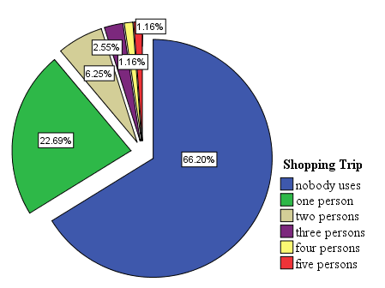

Source: The researcher, 2019
Figure 27: The percentage of the adjacent community using LRT for shopping trip purpose.

The impact of LRT stations on the adjacent volume of the renters in residential community
The house rent has both social and economic impact on the adjacent community. But in this case, we focus on social impact of the renter volume that increase adjacent density of the population. The LRT stations bring some changes on the number of the adjacent populations. After the Addis Ababa LRT had been in operation the number of the population around the selected LRT stations from Ayat to Torhailoch LRT was increased to some extent. About 23.7% of the resident’s response shows that after the AALRT around Megenagna LRT station, the numbers of the renters have been increased. This effect was followed by the Coca-Cola LRT station, sharing 22.8% of the resident’s response tells us as the LRT has increased the number of the renters. The minimum numbers of the renters increased was 10.5% around the St. Uriel LRT station. The change on the numbers of the renters was very low around the St. Uriel LRT station compared to the other LRT station studied because of two reasons as mentioned by qualitative questions: first, in the residential parcels there were fewer or no rental rooms in the residents parcel and the second reason was the previous renters did not leave their rental home/rooms hence there were no extra rental rooms. But the study did not consider the natural growth within the study area.

Source: The researcher, 2019
Figure 28: The change of the number of renters after the LRT at each LRT stations.
The figure below shows the total change of the number of the renters around the LRT stations after the Addis Ababa LRT has been built. About 16% of the residents responded that after the Addis Ababa LRT the numbers of the renters have increased in their parcels. This implies the AALRT has brought some density changes on the adjacent communities. In another way, when the numbers of renters increased, it might bring some positive economic changes on the adjacent residential communities, especially for the home owners.

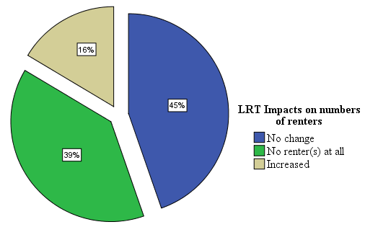

Source: The researcher, 2019
Figure 29: The impact of LRT on number of renters.

The subjective impact of LRT on the adjacent residential community

The impact of LRT line/ station on livelihood activities
Definitions suggested by Chambers and Conway (1991) as the livelihoods are formed within social, economic and political contexts. It’s about making a living, supporting a family, or job opportunity all describe a livelihood. As these contexts change, they create new livelihood obstacles or opportunities. For this reason, the adjacent community on the adjacent of the LRT line from Ayat to Torhailoch station were asked about the cumulative impact of the LRT on their livelihood. The livelihood impacts were responded in reference to the positive or negative impacts or the cumulative impact that matter the most. The livelihood might impacts might be in referencing of the positive effect of the LRT line/station like employment opportunity, Rental price increase as a rentee, activating economic activity, means of transportation and others as well as in consideration of the negative effect of the LRT line/station like long distance walk from LRT station, rental price increased as a renter, problem of accessing the opposite side, sound pollution (vibration) and others. So, the community responded this impact in reference to which impact matter the most after the LRT and mentioned their responses in terms of I do not know, negative, no change, both and positive answers. There is some relationship between the distance of the LRT lines/ stations and the feelings of the adjacent residential communities about the LRT on their livelihood activities. The community living around the LRT stations from Ayat to Torhailoch LRT stations have different feelings relative to the distance from the LRT lines/ stations. There were four walking distance categorized in the study; these are: less than 300meters, 301-500meters, 501-700meters and 701-1000meters. Each of the LRT stations were studied in relation to the livelihood impact of the LRT in the below.
- Coca-Cola LRT station:
As the results of this the community living within 300meters around Coca-Cola LRT station feel more negative impacts of the LRT on their livelihoods accounting 60% of the respondents. The map 3 below indicates the location distance of the respondents from the Coca-Cola LRT station. The LRT line/station distance from the residential community has been measured using ArcGIS 10.6.

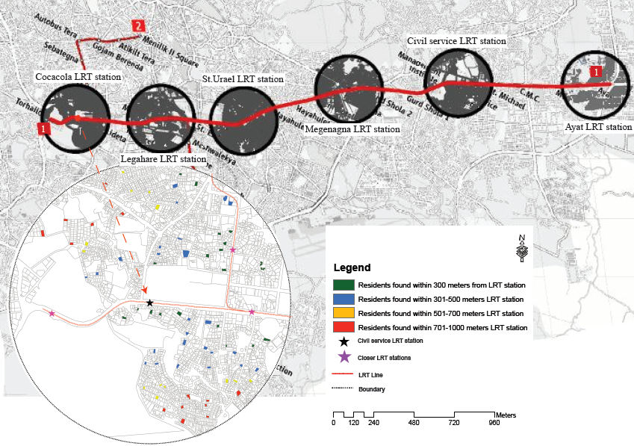

72
Source: The researcher, 2019
Map 2: The map to show the distance of respondents from the Coca-Cola LRT station

The residential area located in the distant of 701-1000meters from the LRT feel more positive impact of the LRT on their livelihood activities than the rests of the community found within other distances from the LRT station but the negative feeling was dropped from 60% to 7.1% of the respondents. So, 7.1% was the lowest negative percentage of the community living within the categorized distances from the LRT station. As has been note from the above results, the community living within 300meters from the LRT line/station were very discomforted community about the LRT line/station on their livelihood while those living in 700-100meters distance from the LRT line/station have more positive feelings and fewer negative feelings towards the impact of the LRT line/station on livelihood activities. The figure below shows the impact of the LRT on livelihood activity around the Coca-Cola LRT station.

Source: The researcher, 2019
Figure 30: The relationship between the station distance and the community feelings about the impact of LRT on their livelihood activity around the Coca-Cola LRT station.

The figure 31 below indicates the livelihood impact of the LRT line/station on the adjacent residential communities around the Coca-Cola LRT station.
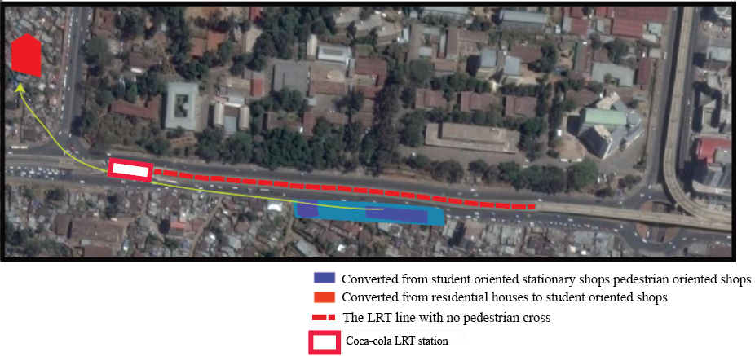
Currently the in front of EiABC has changed the business activity type of the community from the previous activity (student oriented), before the Addis Ababa LRT to pedestrian oriented after the Addis Ababa LRT. This kind of business activity changes are observable throughout the city where LRT lines is extended. In contrary, some other areas were affected in a positive way after the Addis Ababa LRT stations.
Source: The researcher, 2019
Figure 31: The shifting of business activity as the result of Addis Ababa LRT.
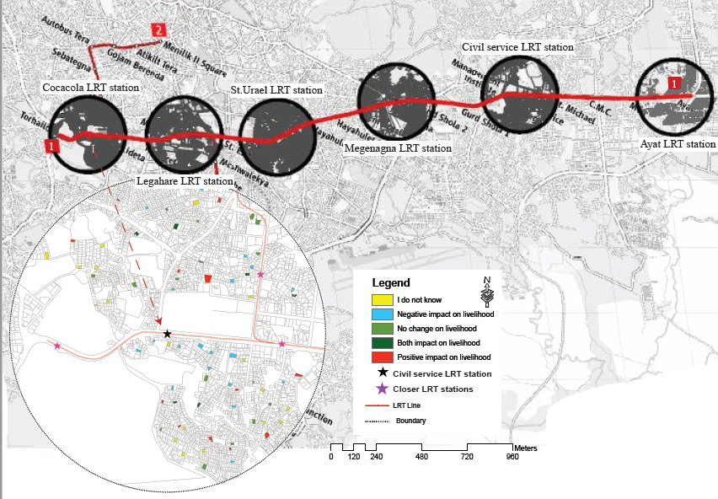

75
Source: The researcher, 2019
Map 3: The livelihood impact map of the LRT line/station around Coca-Cola LRT station.

- Legahare LRT station:
The 1km radius from the selected Legahare LRT station touches the adjacent residential communities from two directions. This was the community around the East-West LRT line and those found around North-South LRT line. So, the impacts of the LRT line/ station on the adjacent community can be studied in terms of both LRT line/station effects. As the result of this, the adjacent residents feel the impacts of the closer LRT line/station on his/her livelihood activity than the distant LRT line/station. Therefore, the community living in the distance of 501-700meters from the LRT line felt the negative impacts of the LRT station than the rest of the residents living in others categorized walking distances. In this case, the community living within 300 meters from the LRT station about 33.3% of the total residents feel negative impact of the LRT line/ station on their livelihood activities. The negative impacts of the LRT on community living within 300meters distance from station comes the second covering 23.8% of the total respondents. In contrary, the highest positive feelings about the impact of LRT on livelihood activity was found within the distance of 301-500meters from the LRT line/ station covering 11.5% the respondents. The community living in distance of 701-1000meters do not replied either the positive or negative impacts of the LRT on their livelihood activity. This means since they are living in the far distance from the LRT line/station, they do not feel any impact on their livelihood activities. As the result of this, the figure 32 below shows the location of the respondents from the LRT station around the Legahare LRT station.

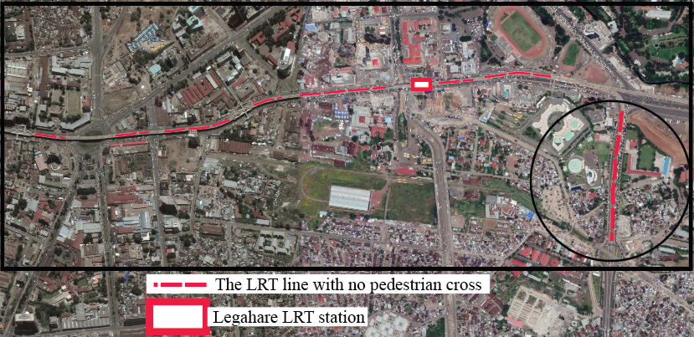
Around the Legahare LRT line/station, the LRT line that goes from Piassa to Kality was the longest LRT line that affected the adjacent community negatively by segregating the surrounding community living in the opposite side of the LRT line/station as responded by the residents. The figure below shows the pedestrian cross distance affecting the livelihood of the adjacent communities in negative ways.
Source: The researcher, 2019
Figure 32: The negative impact of the LRT line on the adjacent community around Meshualekea.

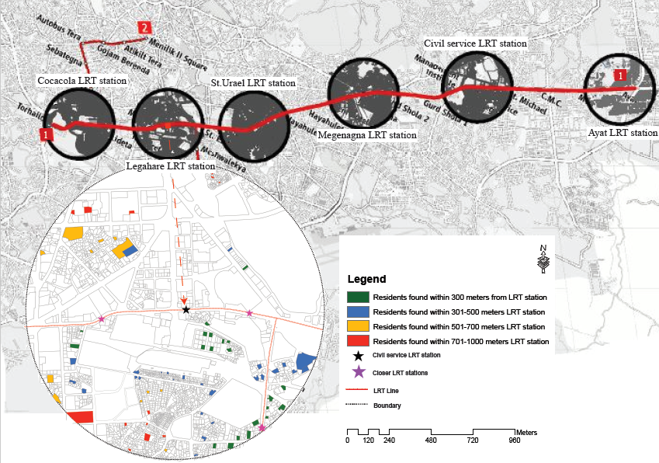

Map 4: The map to show the distance of respondents from the Legahare LRT station.
Source: The researcher, 2019

Source: The researcher, 2019
Figure 33: The relationship between the station distance and the community feelings about the impact of LRT on their livelihood activity around the Legahare LRT station.

The map 6 below designates the responses of the livelihood impact of the LRT on the adjacent residential communities around the Legahare LRT station studied by collecting the community feelings about the impacts of the LRT on their livelihood activities.
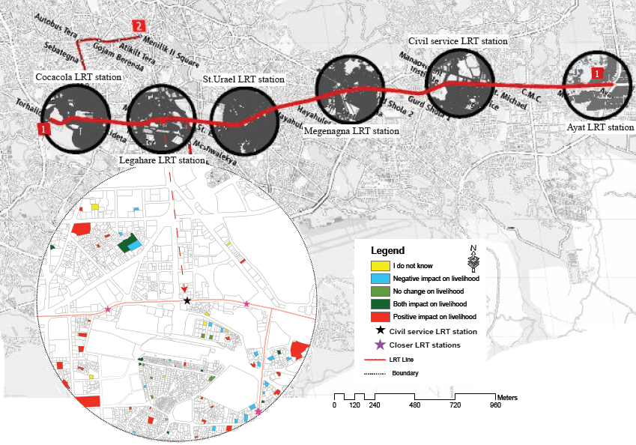
80
Map 5: The livelihood impact map of the LRT line/station around Legahare LRT station.
Source: The researcher, 2019

Relative to the other stations, the community living close to the LRT line/station feel negative about the impact of the LRT on their livelihood activities. In order to consolidate the quantitative data, the qualitative data collected from the community living within 300 meters from the Legahare stations describe the reason why they responded feel negative about the LRT line/station on their livelihood. As the result of this, one of my key informants living in the very adjacent of Legahare station/line forwarded his complaint stating his feelings about the LRT projects as:
Look my son, for anything you are going to use it, I do not care, but I can tell you my feelings, I am a man who pass through different journeys of life. I absolutely know that for a one thing to be achieved another thing usually gets sacrificed. But when you look at the conditions we live in now, they are worse than they used to be before the LRT. A development is not sustainable development if governments cannot give equity for the affected group of people like us. Most of the time I use minibus taxis for transportation thus, when I need to go to my relatives’ home in Saris, I have to walk more than 300 meters to cross the LRT but before the LRT there was a pedestrian cross that do not consume time to access this road to get the minibus taxis on opposite side of the LRT. And he continued I know a guy living next to my home who used to provide foods for garage workers found on the opposite side of the road before the LRT but now he ceased providing the food for his customers because of this physical barrier created by the LRT. He added, bear in mind my son, you will be one of the responsible men in the future for this kind of projects, so when you take over the office please consider the negatively affected community before its implementation. Whether you believe it or not most of our neighbors are blaming about the LRT on our livelihood activity.

- St. Uriel LRT station:
The results about the impacts of the LRT on livelihood activities of the adjacent community around the St. Uriel LRT station shows that about 53.8% of the respondents living within 300meters form the LRT station felt that the LRT has negative impacts on the livelihood activity of the adjacent community. Whereas about 36.8% of the residents living within 301-500meters distance from the LRT station responded about the negative impacts of the LRT on their livelihood. The highest positive feelings of the LRT on livelihood activity of the residential community around the St. Uriel LRT was 23.5% of the respondents representing those living within 501-700meters distance from the station. The least percentage concerning the positive feeling about the LRT station/line on livelihood activity was 7.7% of the respondents living within 300 meters distant from the LRT station.
The map 6 below shows the location distance of the respondents from the LRT station/line distance around the St. Uriel station.

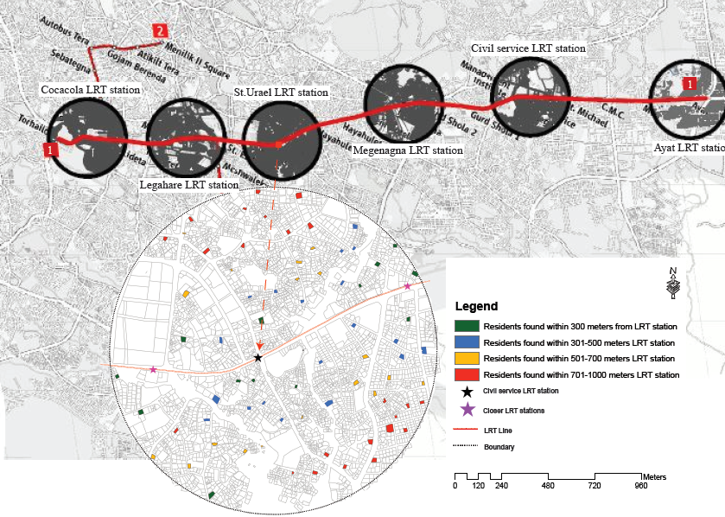
83
Map 6: The map to show the distance of respondents from the St. Uriel LRT station.
Source: The researcher, 2019

Source: The researcher, 2019
Figure 34: The relationship between the station distance and the community feelings about the impact of LRT on their livelihood activity around the St. Uriel LRT station.

The map 7 below indicates the livelihood impact of the LRT on the adjacent residential communities around the St. Uriel LRT station.

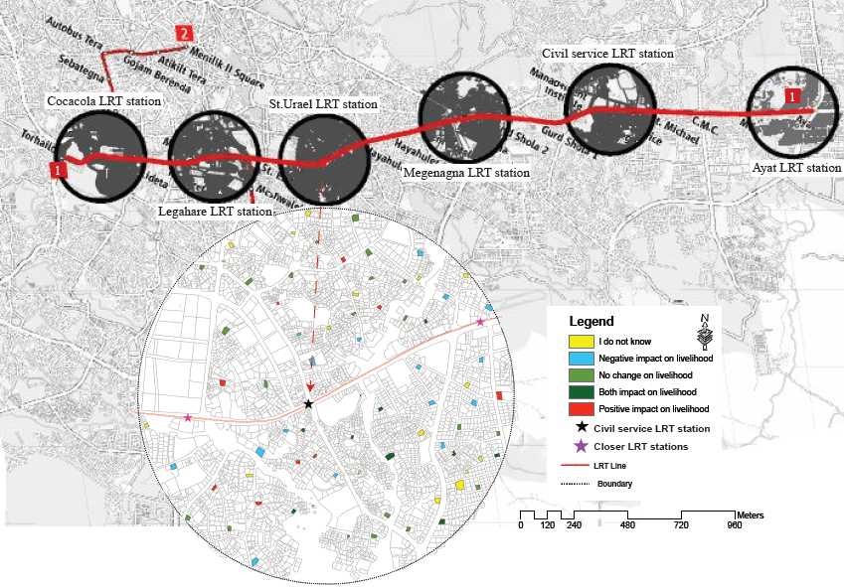
85
Map 7: The livelihood impact map of the LRT line/station around St. Uriel LRT station.
Source: The researcher, 2019

- Megenagna LRT station:
The data collected from the residents living around Megenagna LRT station show that about 55% of the community living within 300meters were feeling positive impacts of the LRT line/ station on their livelihood activity. This is the result of the LRT station coupled with the existing minibus taxi station brought mass number of passengers to the area and this could stimulate the economic activities for the residential community in addition to the rental value increment in the area. Again about 44% of the community living within 301-500meters away from the LRT station have positive feelings about the LRT line/ station on their livelihood activity. This also because of the LRT has spurred some economic activities as the result of the increased pedestrian density in the area. The majority of the respondents covering 36% of the community living within 301-500meters from Megenagna LRT station were feeling negative about the impacts of the LRT on their livelihood activities. The qualitative data collected from the respondent tells us the reason behind the negative feelings of the residential community. They complain about the physical barrier brought by the LRT that limited the access of the opposite side of the LRT. They mentioned the negative impact of the LRT as it has affected the economic and social conditions of the area. As aforementioned above, the location of the respondents from the LRT station was measured and mapped as shown in the map 8 below.

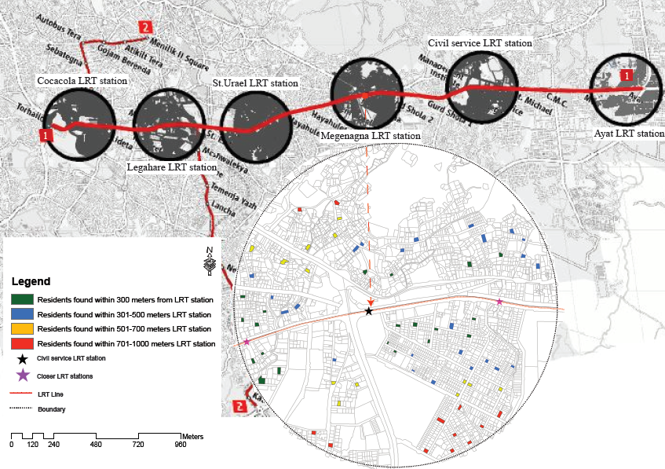
87
Source: The researcher, 2019
Map 8: The map to show the distance of respondents from the Megenagna LRT station.

Source: The researcher, 2019
Figure 35: The relationship between the station distance and the community feelings about the impact of LRT on their livelihood activity around the Megenagna LRT station.

Around Megenagna LRT station the impact of the LRT station/line distance on the residential community was conducted around the Megenagna LRT station area. The map 9 below indicates the feeling of the residents towards the livelihood activity.

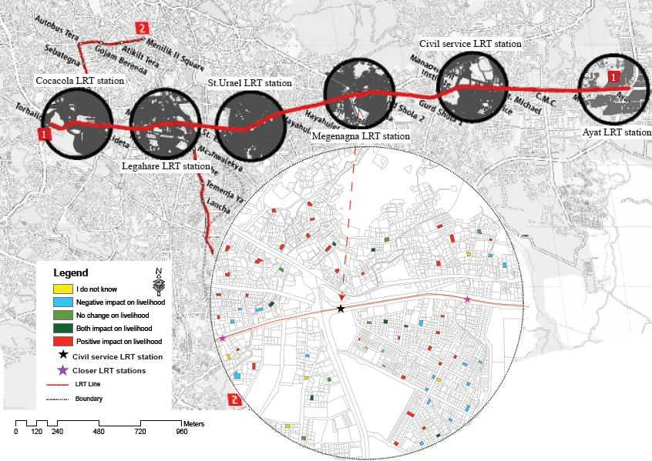
89
Source: The researcher, 2019
Map 9: The livelihood impact map of the LRT line/station around Megenagna LRT station.

- Civil Service LRT station:
Moreover, the community living in the surrounding of the Civil Service LRT station were asked about the impacts of the LRT on their livelihood activity. In this case, the highest percentage the residential community having positive feelings about the LRT impact were those found within 701-1000meters distant away from the LRT station and they cover 52% of the respondents. In addition to this about 35.3% of the community living within 301-500meters from the LRT stations feel positive impacts of the LRT on their livelihood activities. The least percentage of the positive impacts of the LRT by the residents was 9.1% which was responded by the community living within distance of 300meters from the LRT station. Conversely to this, the highest percentage of the community feeling the negative impacts of the LRT on their livelihood was about 41.2% of the respondents living within 301-500meters, followed by the community living within 300meters away from the station taking 36.4% of the respondents and the least percentage of the negative feeling about the impact of the LRT on livelihood condition of the community were collected from the distance of 501-700meters from the station sharing 15.8% of the respondents. Therefore, the map 10 below tells the LRT station/line location distance of the respondents from the Civil Service LRT station.

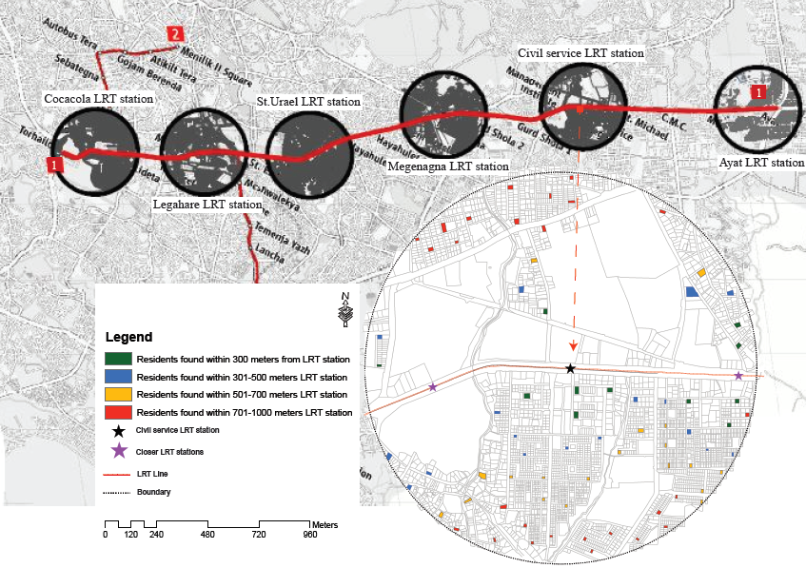
91
Source: The researcher, 2019

Map 10: The map to show the distance of respondents from the Civil Service LRT station.

Source: The researcher, 2019
Figure 36: The relationship between the station distance and the community feelings about the impact of LRT on their livelihood activity around the Civil Service LRT station.

The residential community living in the surrounding of the Civil Service LRT station were affected by the long distance of the LRT line that closed the previous pedestrian cross. The distance between two consecutive LRT station was 400 meters in this area. Those far away from the LRT stations have to walk at least 400 meters in order to access the opposite side of the LRT line. This was the major complaint of the residential community in the surrounding of the Civil Service LRT station/line. The figure below shows the pedestrian cross situated on LRT station affecting the livelihood of the adjacent communities in negative ways.
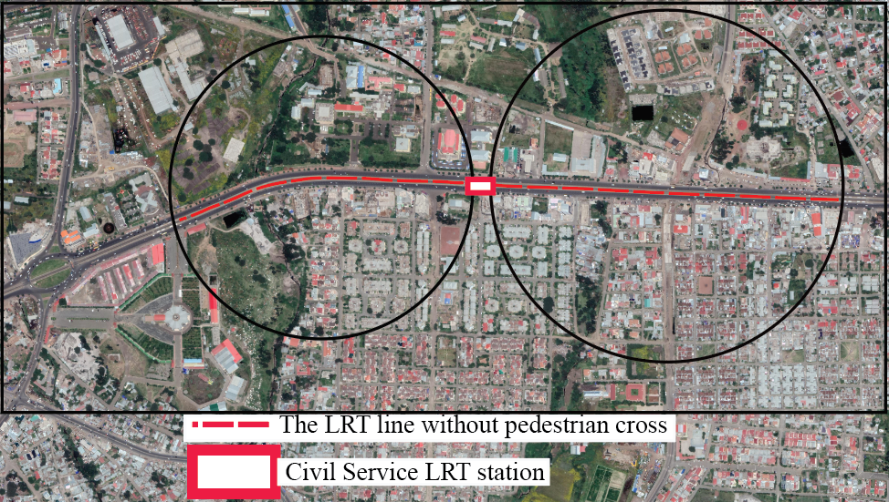
Source: The researcher, 2019
Figure 37: The walking distance to cross the LRT line around Civil Service University

In the same manner, after the assessment about the impact of the LRT station/line distance on adjacent residential community around the Civil Service LRT station has been undertaken, the feelings of the community relative to the distance from the LRT station was assessed. The map 11 below illustrates the livelihood impact of the LRT on the adjacent residential communities around the Civil Service LRT station.

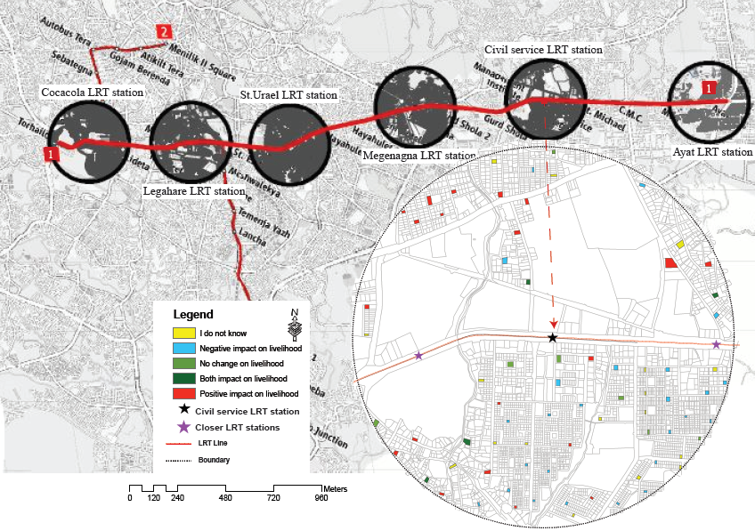
94
Map 11: The livelihood impact map of the LRT line/station around Civil Service LRT station.
Source: The researcher, 2019

- Ayat LRT station:
Similar to the above LRT stations, the residents living around the Ayat LRT station were asked about the impacts of the LRT line/ station on their livelihood activity and responded. Therefore, the majority of the negative feelings were collected from the residents living within 301-500meters from the LRT station sharing 23.1% of the respondents. Their complaint was mentioned by qualitative data. Most of the residents replied as the LRT station far away from the residents, they have to walk long distance to access the LRT station. In addition, they added, there are some problems along the LRT line like the physical barrier of the LRT line that limited the pedestrian cross and it takes time to turn around the car when driving. In like manner, about 12.5% of the community living within 300meters away from the LRT station were feeling negative about the impacts of the LRT line/ station on their livelihoods. The least percentage of the negative impacts of the LRT on livelihood activity was 2.6% of respondents replied by the residents living within 701-1000meters away from the station. However, there were also positive feelings about the impacts of the LRT on adjacent residential community sharing 36.8% of the residents living within 701-1000meters from the LRT station and this was the dominant respondents of the positive feelings about the impacts of the LRT. The lowest percentage concerning the positive impacts of the LRT on livelihood condition of the community were collected from the community living within 501-700meters radius of the LRT station covering 7.7% of the respondents. The location distance of the residential community from the LRT station around the Ayat LRT station has been indicated with the help of the map as shown below.

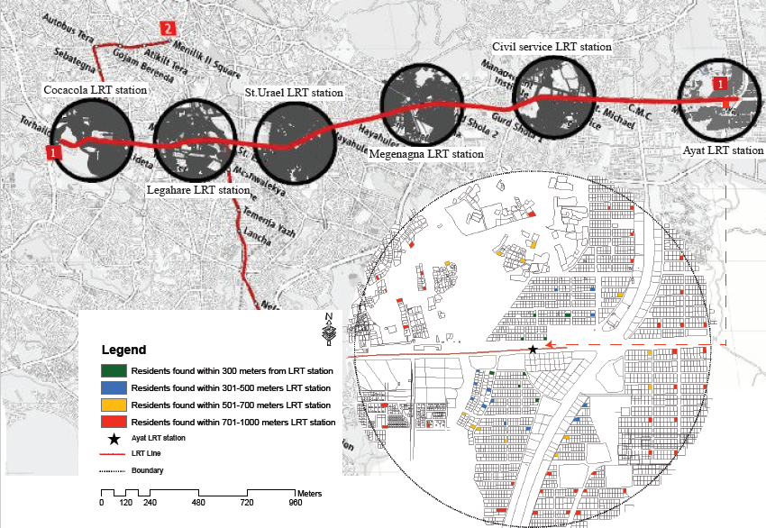
96
Source: The researcher, 2019

Map 12: The map to show the distance of respondents from the Ayat LRT station.

Source: The researcher, 2019
Figure 38: The relationship between the station distance and the community feelings about the impact of LRT on their livelihood activity around the Ayat LRT station.

By using the similar assessment methods used for the above LRT station, the impact of the LRT on livelihood activity is studied on Ayat LRT station area. So, the map below that depicts the livelihood impact of the LRT on the adjacent residential communities around the Ayat LRT station.

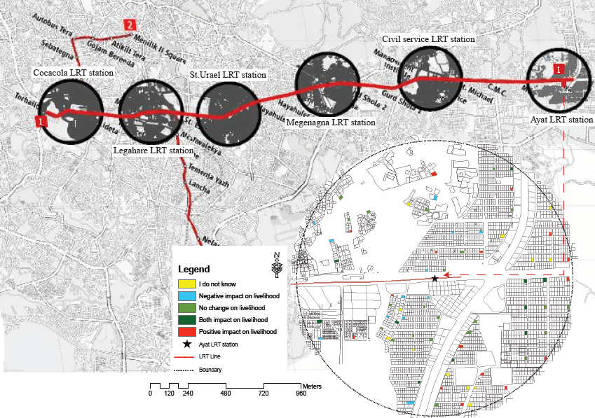
98
Source: The researcher, 2019
Map 13: The livelihood impact map of the LRT line/station around Ayat LRT station
.
In addition to the quantitative data analyzed above, the qualitative data were collected from the residents living around the Ayat and Megenagna LRT station. Although, most of the residents did not tell about the negative impact of the LRT on their livelihood activity, few of respondents complain about the problem of accessing the opposite side of the LRT, especially when driving. When compared to other LRT station areas, these were odd responses about the negative impacts of the LRT on livelihood activity around those LRT stations. One of my key informants living around the Ayat LRT line/station complaint the negative impacts of the LRT line as follows:
Other than for recreation purpose seldomly on Sunday, most of the time I do not use the LRT for my trip purpose and also the LRT stretched around Ayat area did not affected my livelihood activity; but this kind of transportation is very important and promising to solve the transportation problems in our city. However, when I and my friends discuss about the negative impact of the LRT, during driving it takes me much time to turn around my car and this increased my trip length unwillingly. Rather than the thing I mentioned above, for me the LRT has more advantage than negative impacts.
The aggregate results of the East-West LRT line/ station impact on the livelihood:
The aggregate impacts of the LRT stations on livelihood condition of the adjacent community from Ayat to Torhailoch LRT station were studied and the results of the analyzed data shows that different LRT station and distances from the LRT station has huge impact on the feelings of the residential community. As an example, around Megenagna LRT station about 45.1% of the residents feel the positive impacts of the LRT on their livelihood activities, nevertheless this impact is not only because of the LRT station, but the existence of the minibus taxi station in the area. In contrast to the above only about 5.3% of the respondents around Legahare LRT station were feeling the positive impacts of the LRT on their living conditions. The majority of the residential community around Legahare LRT station responded that the LRT line/station has no change on their previous livelihood activity taking 22.1% of the total respondents as well as some part of them replied as the LRT line/station has both impacts covering 22.9% of the total respondents rather than feeling only positive impacts which shares 5.3% of the total respondents. The residents around Civil Service LRT were the leading complainers about the impacts of the negative impacts of the LRT on their livelihood activity covering 31.3% of the respondents followed by the residents around the St. Uriel LRT station which covers 28.1% of the respondents. The lowest percentage of the complainers were the residents around the Ayat LRT station accounting 11.5% of the respondents. The figure below shows the impact of LRT line/station on livelihood activity of the residents at each LRT station.
102

Source: The researcher, 2019
Figure 39: The impact of LRT line/station on livelihood activity of the residents at each LRT station.
As can be seen on figure below, the adjacent community responded to the impact of the LRT on their livelihood activity from Ayat to Torhailoch LRT stations was analyzed. So, majority of the community responded negative impact of the LRT on their livelihood activity covering 23.2% of the respondents, this followed by those responded positive impact of the LRT accounting 22.2% of the respondents while 11.1% of the respondents felt both positive and negative impacts of the LRT on their livelihood conditions. But 21% of the respondents do not feel neither positive nor negative impacts of the LRT on their livelihood activity. In addition, about 22.2% of the residents do not even know the relationship between the light rail transit and livelihood activity.

Source: The researcher, 2019
Figure 40: The livelihood impact of LRT line/stations on the adjacent community.

The LRT station/line impact on adjacent community social interaction
The Addis Ababa LRT has been created physical barriers on the community living in the opposite side of the LRT line. That means it affected the social and economic conditions of the adjacent community in negative ways. As an example, the community living in the surrounding of the Coca-Cola LRT line feel negative about the impact of the LRT line/station on their social interaction covering 19.3% of the respondents. About 16.1% of the respondents living around Civil Service LRT station also responded that it has affected their social interaction negatively. Around Megenagna and Ayat LRT station, relatively there is more positive feelings in comparative to the negative impacts of the LRT line/station accounting 16.4% and 11.1% correspondingly.

Source: The researcher, 2019
Figure 41: The impact of the LRT on social interaction of the adjacent communities.

The cumulative of the impact of the LRT on adjacent social interaction of the adjacent community from Ayat to Torhailoch LRT station was assessed and the results were depicted under the figure below as: 23% of the community responded as negative and about 21% of the community responded as negative impacts, while 6% and 27% of the residential community responded as both impacts and no change on their social interaction respectively.
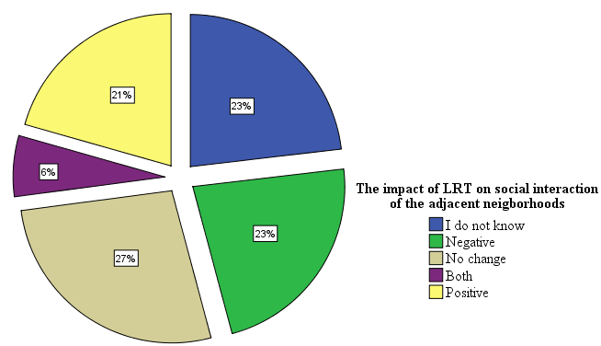
Source: The researcher, 2019
Figure 42: The impact of the LRT on social interaction of the adjacent communities.

The positive and negative side of the LRT on the adjacent residential community
From 720 respondents about the impacts of the LRT line/station on residential community surrounding the LRT stations from Ayat to Torhailoch area, about 114 respondents wrote about the positive and about 82 respondents wrote the negative effect of the LRT on their livelihood activities. By categorizing the qualitative data collected from the community the aggregate of the positive and negative impact of the LRT on the adjacent communities is described below.
- The positive side of the LRT on the adjacent community:
Therefore, about 114 of the community responded to the positive side of the LRT. In the light of this 80% of the respondents replied the positive side of the LRT as the means of transportation, 9.3% as the employment opportunity, 5% as the rental price increase because of proximity to the LRT line/ station, again 5% as the LRT stimulate the economic activity and 2% as other positive impacts of the LRT. Most of respondents that responded others do not use the LRT but they were the supporters of the LRT technology. Their qualitative descriptions include: being happy because of the LRT introduced in to the city, the environmental advantage of the LRT, being happy because of the LRT reduced the transport problems in the city and etc. The figure below shows the identified positive side of the LRT on the adjacent community described by qualitative data.

Source: The researcher, 2019
Figure 43: The impact of LRT lines/stations on adjacent community at different LRT station.

- The negative side of the LRT on the adjacent community:
The qualitative data also used to demonstrate the negative side of the LRT by collecting the response from 82 respondents. The majority of the negative side of the LRT goes to the problems of accessing the opposite side of the community covering 33% of the respondents while, 29.3% of the community were complaining the long distance walking that they walk from their home to the LRT stations, the third highest percentage related to the negative side of the LRT was the rental price increased as the result of the LRT accounting 24.4% of the respondents. The least percentage of the negative side of the LRT responded by the communities was sound pollution sharing 2.4% of the respondents. The varied negative answers were categorized under the other sharing 10.7% of the respondents. Those include the physical structure of the LRT that create discomfort for the respondents, the long distance it takes to turn around cars, social interaction reduction with the community living in the opposite side of the LRT and etc. The figure below shows the identified negative side of the LRT on the adjacent community.

Source: The researcher, 2019
Figure 44: The impact of LRT stations on adjacent community at different LRT station.

Identifying the social and economic impacts indicators of the LRT on adjacent commercial community
The impact of the LRT on social conditions of the adjacent commercial community were studied by collecting the relevant data from the adjacent commercial community living around the LRT stations from Ayat to Torhailoch area. The social indicators about the impact of the LRT on the adjacent commercial community were: the number of the commercial communities using the LRT, the type of the commercial activity using the LRT, social structures of the LRT users within business activity. The economic indicators about the impact of the LRT on the adjacent commercial community were: the change of the numbers of the employees within business activities, the change of the numbers of the customers within business activities, impact on transportation cost, the LRT station impacts on the number of the retailers, the LRT impact on travel time.
      - The LRT users in the adjacent commercial community
The employees or the owners of the business activities adjacent to the LRT line from Ayat to Torhailoch LRT station were asked whether they use the LRT to their work places. From the total respondents the majority of the LRT users were found around Civil Service LRT station accounting 72% of the respondents uses the LRT to their work. The lowest percentage of the LRT users were the respondents around Megenagna LRT station covering 50% of the total respondents surrounding the station.

Source: The researcher, 2019
Figure 45: The percentage of LRT users within commercial activity at each station.

The aggregate results of the LRT users for commercial areas shows that about 65% of the adjacent community working in business activities uses the LRT to their work place. That means only 35% of the respondents do not use the LRT to travel to their work place.
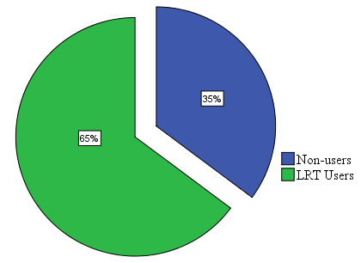

Source: The researcher, 2019
Figure 46: The percentage of the LRT users within commercial community.

      - The LRT users by sex in adjacent the commercial community
The use of the LRT by workers in commercial area adjacent to the LRT was also categorized by sex as discussed below. As the figure below shows, about 33.8% of the male respondents uses the LRT to their work place while about 18.5% of the males do not use the LRT for transportation to their work places. When we see the share of the females, about 31% of the females uses the LRT to work place while 16.7% of them do not use the LRT for work trip when going to their business activity areas.

Source: The researcher, 2019
Figure 47: The percentage of the LRT users by er within commercial community.

      - The LRT users by age within the commercial community
The impact of the LRT on social issue was also described by the age of the LRT users. The majority of the LRT users were found within 25-54 years old accounting 56.3% respondents and the second highest percentage were the age group from 15-24 years which accounted about 38.9% of the respondents. The minimum percentage represents those within 55-64 age groups covering 1.4% of the respondents. There were no age group that uses the LRT above the 65 years old, but most of the age groups between 55-64 years were either owners of the business activity or the guard of the commercial buildings. The age of the LRT users in commercial areas around LRT stations were identified in the following figure.

Source: Own computation from CSA, 2019
Figure 48: The percentage of the LRT users with age group.

The category of the LRT users according to the type of the business activity:
The numbers of the LRT users were also categorized according to the type of the business activity that they are working in. So, from the LRT users those working in shops (shop keepers) were the majority of the LRT users covering about 44% of the respondents. The second majority of the commercial community using the LRT were those working in restaurant covering 13% of the respondents. The others type of business activities were also assessed in the study covering 13% the respondents. The category of other type of business activity were not identified in the multiple choose as the results of the existence of minor business activities on the adjacent of the LRT line. The other type of business activity includes: pharmacy, shoeshine boys, traditional coffee sellers, chat sellers and etc. The minimum percentage was collected from the commercial activity from those working in guest house covering only 2% of the respondents. The figure below shows the percentage of the persons interviewed within different commercial activities.

Source: The researcher, 2019
Figure 49: The percentage of LRT users within different types of commercial activities.

The economic impacts the LRT on commercial community
- The impact the LRT on the employees and customers in business activity
The other impact brought with the introduction of the AALRT on economic issues of the adjacent business area were: the change of the numbers of the employees and customers within the business activity area. For this reason, there are some business activity areas around the LRT stations from Ayat to Torhailoch area that has increased, decreased as well as showed no change concerning the number of the employees or customers after the LRT.
The analysis of the impact of the LRT on numbers of employees and customers within business activity shows that around Megenagna LRT station, about 22.2% of the responses tells that the LRT has increased both the number of employees and customers within business activities. This increment was very less around Civil Service LRT station covering 4.2% of the respondents. The LRT has brought huge change on the numbers of the commercial area around Legahare LRT station. In this case the LRT has increased only the numbers of the customers for about 25% of the commercial activities around this station. The LRT also decreased the number of employees and customers in some business activity areas. There are some areas affected in negative ways when observing the impact of the LRT on the number of the customers and employees. As an example, the business area around Coca-Cola LRT station were the highest negatively affected areas accounting 5.6% respondents in terms of decreasing both the number of the customers and employees in the business activity. This might be happened because the LRT line has created some barrier to access the business activities in the opposite side of the LRT line.

Source: The researcher, 2019
Figure 50: The impacts of the LRT on attracting the customers and employees in business activities at each station.

The results of the cumulative impact of the LRT line on the number of the customers and employees discussed below. As the result of this, about 23% of the respondents within business activity areas replied that the LRT has increased both the number of the customers and employees. And about 24% of the commercial activities responded that the LRT has increased only the number of customers within the business activity areas. While 6% of the respondents replied that the LRT has decreased both the number of the customers and employees. The figure below shows the impacts of the LRT on number of customers and employees in business activities.

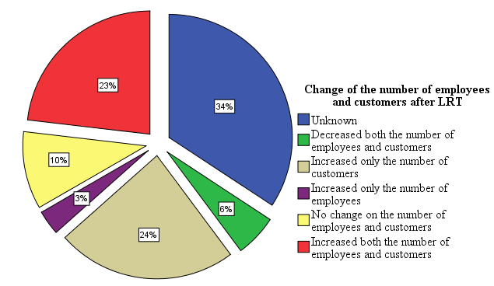
Source: The researcher, 2019
Figure 51: The impacts of the LRT on attracting the customers and employees in business activities.

- The impact of LRT on transport cost of the commercial community:
The LRT has also affected the cost of the transportation on the employees or workers on the adjacent community of the LRT line. The impact of the LRT on transportation cost can be estimated through comparing the cost of the transportation before and after the LRT. The table below shows the difference between the transportation cost spent by the employees/workers in business activities in the adjacent of the LRT lines/ stations from Ayat to Torhailoch. The table below shows the comparative cost of transport spent by the adjacent commercial community before and after the AALRT.
Table 6: The comparatives of the transport cost before and after the LRT.

Category of transport cost | The transport cost before the LRT in percentage | The transport cost after the LRT in percentage
Less than 50birr | 46% | 50%
51-100birr | 33% | 10%
101-150birr | 11% | 5%
151-200birr | 3% | 0%
Above 200birr | 7% | 0%
Source: The researcher, 2019

- The impact of LRT on travel time of the commercial community:
The commercial communities adjacent to the LRT line/stations were asked about the change of the travel time after using the AALRT for transport. So, about 52% of the respondents witnessed the travel time reduction after the LRT; nevertheless about 11% of the respondents still complaining about the LRT in terms of the travel time; they added the reasons behind this as the power on the LRT line went-off while travelling for this reason the LRT stop working. In additions, sometimes there are unknown problems that stop the operation of the LRT. This is why some groups of the adjacent commercial community responded no change on the travel time after the LRT. Directly or indirectly the travel time has an impact on the economic activity of the commercial community. When the travel takes large time to arrive at the business area, there is less time spent on working. When the travel time is reduced there is a tendency to be involved in different economic activities. The figure below shows responses of the community concerning the LRT impact on travel time.

Source: The researcher, 2019
Figure 52: The impact of LRT on travel time.

The impact of the LRT stations on the volume of the adjacent retailers
Around adjacent of some LRT stations, the number of retailers increased after the stations were built. Most of the time the retailers use the advantage of the concentration of the population to activate their business activity. One of the population concentration area can be the transportation stations. So, to understand the change on the number of the retailers around the LRT stations, the elders/ those lived more than five years in the area were interviewed. The results of the interviews show that the LRT has brought some changes on the numbers of the retailers in the surrounding of the LRT stations from Ayat to Torhailoch area. However, the change in number of the retailers vary from station to station. For instance, the number of retailers around Ayat LRT station before the LRT were 2 retailers (shoeshine boy and banana seller) and now there are about 29 retailers (eight shoeshine boys, ten fruit and vegetable sellers, five traditional coffee sellers on the pedestrian and six fried maize sellers) surrounding the station.
Around the Civil Service LRT station there are some changes on the number of the retailers. Although, there are negative changes on the number of the shoeshine boys around Civil Service LRT station that reduced from 13 to 11 after the LRT line constructed, there a radical change on the number of the other retailers participated on other type of retailing activities. There were 8 retailers added in to the area after the LRT. These were Tibs-Eshet (fried maize) sellers increased from none to five after the LRT, there were also three retailers added to the area that sells goods around the LRT station. In case of the Megenagna LRT station, the elders in the surroundings were asked about the impact of the LRT on the number of the retailers in the area and three of the elders answered similar/related responded as the change on the number of the retailers could not be because of the LRT station, perhaps as the result of the existence of minibus taxi station. When this explained in another word, since the formation of the minibus taxi station, the passengers have been increased in mass around the Megenagna and perhaps the major reason to attract the number of the retailers to this area. Similar to the above station, there are some changes on the number of the retailers around the LRT stations on the LRT line from Ayat to Torhailoch area. As the result of this, after the LRT the number of the retailers were increased from 4 to 7, 3 to 15 and 2 to 8 around St. Uriel, Legahare and Coca-Cola LRT stations respectively. One of my key informants, the elder of the Megenagna area mentioned the factors behind the change of the number of the retailers around the Megenagna LRT station as follows:
I have been lived this area for more than 20 years. Nowadays, the number of the retailers around this area is increasing from time to time following the minibus taxi station. As the name of the area indicates, Megenagna is the Amharic word to say ‘the place to meet each other’. As the result of this, always the retailers follow the concentration of the people to sell their commodities in mass. Lately the number of populations in the city is increasing and this also increased the mass of the people in this area. People travel to different direction of the city from this minibus taxi station. The number of the people are high from 8am-9am in the morning and 4pm-8pm in the evening. As the result of the reasons mentioned in the above, I do not think the increment of the retailers around the LRT station was the result of the introduction of the Addis Ababa LRT.

The figure below manipulates the impact of the LRT on the number of the retailers.

Source: The researcher, 2019
Figure 53: The change of the number of the retailers around each LRT stations.

The aggregate data of the number of the retailers found around the LRT stations before and after the LRT was studied. Generally speaking, the number of the retailers have been increased by triple fold after the LRT from 24 to 72 persons in cumulative of the three six LRT stations. Those retailers were involved in different business activity by using the advantage of the LRT stations to stimulate their business activity. The figure below shows the cumulative impact of the LRT on the number of the retailers from Ayat to Torhailoch LRT station as derived from the above graph.

Source: The researcher, 2019
Figure 54: The change of the number of the retailers around LRT stations.

The number of retailers around Ayat LRT station is highly increasing from time to time with the increasing of the development the Ayat area. Especially the numbers of the retailers adjacent to the LRT station have been increased from two before the LRT to twenty-three after the LRT. For this case the resident of an area studying abroad and doing his PhD research on tourism was randomly asked about the change of the number of the retailers adjacent to Ayat LRT station and his responses were stated as following:
The whole development you are seeing around were not here before the LRT, not only the number of the retailers. Frankly speaking after the Addis Ababa LRT was starched in to this area the numbers of those retailers are surprisingly increased around the station. if you have asked me about the retailer numbers in the adjacent of the LRT station before the operation of the LRT, there was only one guy selling banana on pedestrian road and one shoeshine boy. But I cannot deny that there were some retailers around Ayat roundabout before the LRT which is some meters away from here. Those developments you see in this area are after the Addis Ababa LRT. And he continued, to observe the change of the number of the retailers around the LRT station, now you can count and compare it with the number of the retailers before the LRT as I mentioned above.
Then I thanked the respondent and started counting the numbers of the retailers by categorizing them to different business activities like shoeshine, vegetable and fruit sellers, fried maize sellers and the others good sellers.

Identifying the social and economic impacts indicators of the LRT on the adjacent community in the social service
      - The social impact of the LRT on adjacent social services
The social indicators about the impact of the LRT on the adjacent community working in social service were: the number of the employees using the LRT, the LRT users within in different social services, the age and sex of the LRT users within social services.

      - The LRT users within adjacent social services
Even though, some of the service areas, especially the government services were providing the public service buses for their workers, still some of the employees working within the service were using the LRT for work trip. The number of the workers using the LRT as the alternative means of transportation were about 74% of the workers for their work places/areas, while 26% do not use the LRT for work trip.
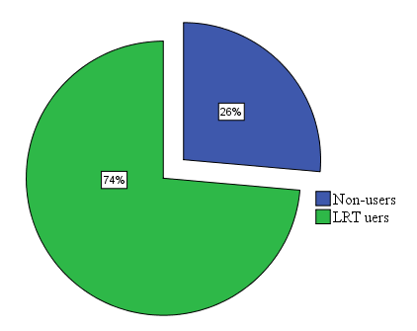
Source: The researcher, 2019
Figure 55: The numbers of workers in service area using the LRT as the means of transport.
      - The LRT users by age in adjacent social service
The LRT users in social issue was also described by the age groups. The majority of the LRT users were found within 25-54 years old accounting 79.2% respondents and the second highest percentage were the age group from 15-24 years which accounted about 18.1% of the respondents. The minimum percentage was those between 55-64 and 65 and above years age groups covering 1.4% of the respondents. The age of the LRT users in social service around LRT stations were identified in the following figure.

Source: Own computation from CSA, 2019
Figure 56: The percentage of the LRT users with age group.
After the employees in different social services were responded to the interview questions, some qualitative questions were asked to consolidate quantitative data. So, most of the workers in different social services use the LRT as an alternative mode of transportation than as regular customer. One of the key informants, PhD holder working in Civil Service University responded to the reasons why some of the government workers do not like using the LRT and described his perception as follows:
I tried to use the LRT as alternative mode of transport as soon as the LRT was launched but I ceased after I faced the problem of travelling long distance that increased my trip time to work. When I need to take the LRT, I have to travel from my home from Paulo Hospital to Piassa by minibus taxi. As you know from Piassa I cannot take LRT to Civil Service University. Then I have to take the LRT which goes to Kality, then I should get-off the LRT at stadium LRT station to wait for the LRT that come from Torhailoch. So, those all mentioned above has spent much time while increasing the travel time. For this reason, now I do not use the LRT, instead I take a minibus taxi while spending less time than the LRT.
      - The category of the LRT users according to the type of the services
When the LRT users were divided according to the service types, the respondents working in educational institutions were the majority of groups using the LRT for their work trip covering 29.2% of respondents. The next majority of the respondents using the LRT for work trip were those working in unidentified services labeled as others. The type of other services includes youth centers, construction offices, water resource management and etc. The interview collected from the others shares 20.8% of the respondents. The minimum share of the workers being interviewed were the police officers accounting 4.2% of the total respondents. This was because most of the time the police officers do not pay when they are on duty. But sometimes when they dressed the civil clothes even if they are going to the office, they are required to pay the fare of the LRT.

Source: The researcher, 2019
Figure 57: The percentage of the LRT users within service adjacent to the LRT stations/ lines.

      - The LRT users within social service according to sex
The LRT users by sex of the workers in service area adjacent to the LRT was studied as shown in the figure below. As the figure illustrates, about 45.8.8% of males uses the LRT for work, while 6.9% of the males do not use the LRT to their work places. When we see the share of the female about 27.8% of the females uses the LRT while 19.4% of them do not use the LRT to their work places. As can be seen from the above result, males were more experienced than females in using the LRT for work trip purpose from Ayat to Torhailoch LRT station.

Source: The researcher, 2019
Figure 58: The percentage of the LRT users by sex.

      - The LRT users within adjacent social service according to education levels
The educational level of the workers in the service area were collected and analyzed. So, the educational status of the majority of the respondents were the secondary school covering 27.8% of the respondents. This followed by the primary school sharing 21.3% of the total respondents. The third percentage was those having preparatory school education level which take 13.4% of the respondents. Furthermore about 11.1% of the interviewees had Diploma certificate and 11.1% were Degree holders. The minimum percentage takes 0.5% representing Masters/PhD holders. Nonetheless, about 6% of the respondents were still illiterate. Most of the employees with illiterate education level were working as guard in the service areas.
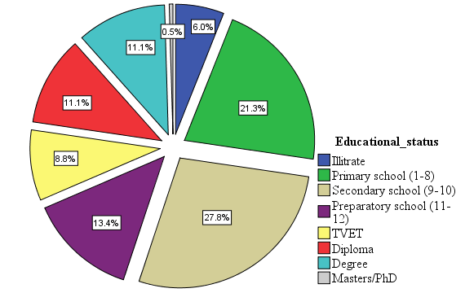
Source: The researcher, 2019
Figure 59: The educational status of the workers in service area.

      - The economic impact of the LRT on the community working in adjacent social services
The economic indicators of the impact of the LRT on the community working in adjacent social services were: the change of the numbers of the employees within social services, the change of the numbers of the customers within social services, the impact of LRT on transportation cost, the LRT impact on travel time
      - The number of the customers and employees within social services
In terms of the impact of the LRT on number of the customers and employees, in the same fashion it had affected the adjacent commercial communities, also brought some changes on the adjacent social services. Therefore, the maximum changes on both the number of the employees and customers has been seen around the St. Uriel station accounting 4.2% of the respondents, and the minimum change was around Megenagna and Ayat LRT station covering 1.4 percent. The impact of the LRT on the number of the customers was highest around Legahare and St. Uriel stations covering 2.8% of the respondents at both LRT station. Around Coca-Cola LRT station the majority of the respondents answered no change about the impact of the LRT on the numbers of the employees and customers which take 6.9% of the interviewee responds. Again, about 5.6% of the respondents result shows that there was no change on their service area around Legahare LRT station. The lowest percentage of the feeling of no change impact of the LRT on the service area were around Ayat and St. Uriel LRT station covering 1.4% of the respondents. As replied by qualitative data, the employees working around this service area uses the public bus in majority and the rests of them use the minibus taxi and other mode of transportations than the LRT because of the LRT stations were far from their living home and when they tried to travel by LRT to their work place, it took them larger time than travelling by other means of transportation mode. The figure below shows the impact of the LRT stations on the number of employees and customers within different types of social services.

Source: The researcher, 2019
Figure 60: The impact of LRT on the number of customers and employees at each station.

By the same token in above, the impact of the LRT on number of customers and employees in commercial community above, the cumulative result of the community working in social service adjacent to the LRT line interviewed about the change of their customers and employees after the AALRT were revealed as about 10% of the respondents told that the LRT has changed only the number of customers as well as 10% of the service area responded that the LRT has positive impact on both the number of customers and employees. About 21% of the respondent replied that the LRT did not bring any change on both the numbers of the customers and employees. The rest of the workers covering 60% of the respondents replied I do know answers about the impacts of the LRT on the numbers of the customers and employees.
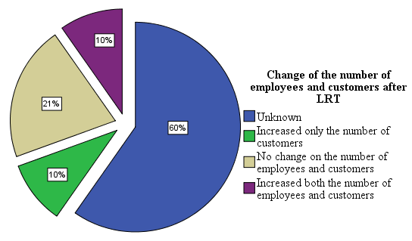
Source: The researcher, 2019
Figure 61: The impact of LRT on the number of customers and employees.

- The economic impact of the LRT on transport cost
The LRT has also affected the cost of the transportation on the employees working in social services adjacent to the LRT. The cost of the transport before and after the LRT was compared to see the change of the transport cost on the employees. The table below shows the difference between the transportation cost spent by the employees working in the social service adjacent to the LRT line/stations.
Table 7: The impact of LRT on transport cost of the workers in social service.
Category of transport cost | The transport cost before the LRT in percentage | The transport cost after the LRT in percentage
Less than 50birr | 50% | 76%
51-100birr | 31% | 19%
101-150birr | 11% | 3%
151-200birr | 3% | 1%
Above 200birr | 6% | 0%
Source: The researcher, 2019
- The impact of the LRT on travel time of the workers in social services
The workers in the service area adjacent to the LRT station/ line from Ayat to Torhailoch LRT station were asked about the change of the travel time effect after the AALRT. So, about 53% of the respondents replied that the travel time was reduced after they had started using the LRT for their work trip purpose. However, about 23% of the respondents still complain about the travel time change after brought with the LRT; while supporting their answers with the qualitative data, the reason why there is no change on the travel time were: the distance of the workers home from the LRT stations was far. So, to access the LRT they had to travel by other mode of transportation. This process took time even more than the time it takes them to travel before the LRT. And also, when the power went-off on the LRT line, the LRT had to stop working and also because of unknown reasons, the LRT sometimes does not operate.
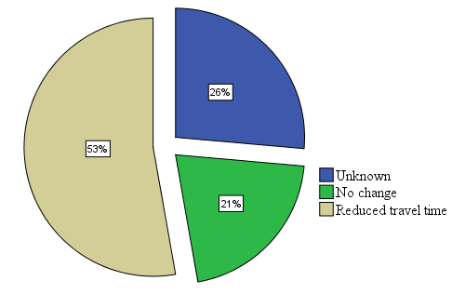
Source: The researcher, 2019
Figure 62: The impact of LRT on travel time.

DISCUSSIONS
The result of the impact of the Addis Ababa light rail transit on transport cost of the adjacent residential, commercial and service community was shown in the result section of the above. In this case, the cost of transportation spent by the adjacent community before and after the LRT on the East-West LRT line from Ayat to Torhailoch LRT station was observed. In all LRT station areas, the transportation costs of the adjacent community were reduced after the LRT. As an example, the transport costs of the residential community after the LRT was studied within the community around the Coca-Cola LRT station and compared with the time before the LRT. So, those spent from 51-100birr before the LRT was 34.7 percent and now reduced to 17.1 percent. In the same fashion those spent 101-150birr reduced from 16.9 percent to 7.2 percent, 151-200birr reduced from 8.8 percent to 3.2 percent and those spent above 200birr reduced from 6.9 to 4.9 percent. The impact of the transit ridership on fare were studied by some researchers. The summary of the research studied by two researchers shows that the overall average elasticity of transit ridership with respect to fares was -0.4, meaning that each 1.0% fare increased would reduce ridership by 0.4%, although this varies depending on various geographic, demographic and service factors (Hensher & King, 1998). As can be seen from the previous studies from other countries and the Addis Ababa case, most of the time people would prefer the cheap transportation cost with the same or better speed than the rest of the other transportation modes; while higher transportation cost without speed might reduce the customers from using the transportation mode.
The results concerning the impact of the LRT on travel time of the community in the residential, commercial and service area adjacent to LRT station/line were revealed in the result section above. So, about 63% of the residential, 53% of the commercial and 52% of the respondents in service area have been responded that the LRT station has reduced their travel time than before. However, for those replied no change on their travel time, sometimes as the result of the power went-off on the LRT line, while another times the LRT do not operate for unknown reasons. Hence, those reasons mentioned above could decrease the travel time of the LRT. Some literatures across the world shows the impact of public transport on travel time. According to Becker (1965) and Bruzelius (1979), time has a price and implies that passengers’ time spent on board a vehicle could be allocated to other activities and has an alternative usage that can be given a pecuniary value.
Furthermore, the study carried-out by Mohammed (2017) on sustainability of the Addis Ababa’s Light Rail Transit reveals that taking trip by LRT would cost the smallest time during peak hours when compared to other mode of transportations. When relating the travel time impact on economic conditions of adjacent communities, the less the time to arrive at a place means, the less time spent on travelling and the more time for other activities other than for travel. In addition, the reduced travel time gives extra time to travel long distances to participate on different economic activities at different locations of the cities.
The relationship between the LRT and trip length travelled by the adjacent residential communities was shown in the result section above. Thus, for about 48.6% of the community surrounding the Coca-Cola LRT station, the LRT has increased their trip length, similarly it has increased the trip length for about 40.3% the residential community living around the Legahare LRT station. The lowest percentage of the positive responses about the effect of LRT on trip length was found around Ayat LRT station covering 25% of the respondents. This is because of most of the residents living around Ayat LRT station do not use the LRT for their trip purposes when compared to the community living around the city centers, i.e. Legahare and Coca-Cola LRT station areas. The study undertaken by Vanderschuren & Hitge (2015) in South Africa shows the advantage of the public transportation over the other modes of transportation in terms of increasing trip distance and their study shows that the trip distance travelled by passengers by public transportation is higher than other modes of transportation by 27.02 km.

Eckstein (1982) found a change in the relationship between vehicle mile travel (VMT) and GDP at the national level and he mentioned the relationship as, when the VMT increased the economic condition of the people improved. The New Zealand Ministry of Transport and Statistics (2009) reported that between 1992 and 2000, Vehicle kilometers of travel (VKT) and GDP increased at a similar rate. In contrast, between 2001 and 2007, VKT increased about 12 percent, while GDP increased 22.5 percent. In congested cities, taking public transport like that of light rail transit can reduce the travel time which helps to travel different parts of the city for different trip purposes with cheap transport cost.
The cumulative impacts of the LRT on the adjacent number of the customers and employees working in commercial and social services in the adjacent to the LRT were described under the result section above. In that case, about 23% of the respondents within commercial community and 10% of the respondents working in social service adjacent to the LRT line/station replied that the LRT increased both the number of the customers and employees in the working areas, in like manner about 24% of the workers in commercial activities and 10% of workers in social services responded that the LRT has increased only the number of customers to their working areas. Form the previous studies across the world, the light rail transit has both positive and negative impacts on employment opportunities. According to Berry and Stern, if rail stations attract additional riders to the neighborhood, either residents who move to the area or commuters who work nearby the station will effectively increase the buyer density in the neighborhood, and should lead to an increase in the number of retail establishments and employees (Berry, 1967; Stern, 1972). As the result of this, the increased numbers of the customers and employees within commercial and service area can affect the social and economic conditions of the business and service area as well as the employees in positive ways.
In case of San Diego new restaurant and office developments were seen around the San-Ysidro station, a new commercial zone was developed close to the Chula-Vista-Palomar station and office buildings were built next to the National City-24th Street station employing approximately 600 workers (Crampton, 2003). Following the East-West LRT line of the Addis Ababa, the number of the retailers around the LRT stations increased as the result of the concentration of the riders around the LRT station. As the study reveals the number of the retailers have been increased by triple after the LRT from 24 to 72 retailers as shown in the result section above. In case of the Addis Ababa LRT stations/line, there were areas affected in positive and negative ways. For instance, the Ayat LRT station/line has created some job opportunities for the adjacent communities. However, the Schuetz study concludes that new stations have negative impact on employment in Los Angeles and Sacramento MSAs new stations (Schuetz, 2014). Similar to the Los Angeles and Sacramento MSAs new stations, the Coca-Cola and Civil Service LRT line/station have been affected the adjacent communities in negative ways in terms of segregating the adjacent social interaction in the opposite side of the LRT and affected the previous business activities in the areas.

The most effective system in terms of shaping urban growth is the SkyTrain. The corridor that the SkyTrain runs through became the main development axis of Vancouver with a notably denser urban form after the opening of the SkyTrain. Similar to this, there are some changes on the number of the retailers around the LRT stations on the LRT line from Ayat to Torhailoch area. As the result of this, after the LRT the number of the retailers were increased from 4 to 7, 3 to 15 and 2 to 8 around St. Uriel, Legahare and Coca-Cola LRT stations respectively. In terms of the impacts of the LRT line/station on the number of renters, about 16% of the residents responded the positive impact of the LRT in increasing the numbers of the renters in their parcels; due to this the density of the community adjacent to the LRT in some areas were increased. Development densities along the SkyTrain route have changed especially as a result of the rezoning plans of the municipalities. These increased the densities at station areas, and encouraged office and retail centres at stations. Some of the SkyTrain stations became the new town centres' as proposed in the metropolitan development plan (Babalik, 2000).
In the same manner to the above, especially the volume of retailers around Ayat LRT station is highly increasing from time to time with the increasing of the development the Ayat area after the LRT. Especially the numbers of the retailers adjacent to the LRT station have been increased from two before the LRT to twenty-three after the LRT. However, Babalik concluded that with the exception of Vancouver, any revitalizing impact on slum areas accessed by the systems was thin like to the in the front of the EiABC University that were shifted their business activity from student oriented to pedestrian oriented after the LRT. Similar to the Babalik conclusion in his study about the impacts of the public transportation on urban development, the Addis Ababa light rail transit has affected some area in negative ways by creating barriers on social and economic activities, while stimulating some areas of the previous active business activity areas in the cities.

CHAPTER SIX: CONCLUSION AND RECOMMENDATION

6.1. CONCLUSION
This study attempted to assess the socio-economic impact of the Addis Ababa light rail transit stations/line on the communities in the residential, commercial and social services on the adjacent of the LRT line from Ayat to Torhailoch LRT stations. To conduct the research about six LRT stations along the East-West LRT line, starting from Coca-Cola to Ayat were selected purposively by bypassing 3 LRT stations to embrace the community living in the adjacent to the LRT line. There were 720 respondents in sample size which includes the community in residential, commercial and social services in the adjacent of the East-West LRT line. About 432 respondents in residential community were responded to the questionnaires, while 216 respondents were in commercial and 72 respondents in social service were administered for the study. In addition to this about 18 elders, 3 in each LRT stations and 2 workers in Addis Ababa land management office were used for an interview question. Then random data collection methods were used to collect the data from the community by distributing 72 questionnaires for residential, 36 questionnaires for commercial and 12 questionnaires for workers in social services in each LRT station. The descriptive statistics and spatial analysis method were administered for data analysis. In this case, the social and economic impact of the LRT on community in residential, commercial and social service were analyzed separately. The indicator of the impact of the LRT on the adjacent social conditions were: the social structure using the LRT, the impact of LRT on adjacent density of the community (number of renters), the impact of LRT on social interaction of the adjacent community and the impact of LRT on social related trips. And the economic impacts of the LRT can be assessed using: economic related trips, the impact of LRT on travel time and distance, the livelihood impact of the LRT as well as the impact of the LRT on transport cost of the adjacent community were considered.
The percentage of the adjacent community using the LRT were identified. So, about 78% of the residential, 65% of the commercial and 74% of the employees in adjacent social services were identified as LRT users on the adjacent of the LRT line. This result shows that, the community living in each three different land use adjacent to the LRT have different practice about LRT use. Therefore, the community living in the residential areas uses the LRT the most for their trip purpose than the rest of the studied land use, while followed by the community in the social service, and the least percentage of the adjacent community that use the LRT was the community in commercial areas. As consolidated by qualitative data, the commercial community either do not travel long distances or economically enough to use other mode of transportations than those working in social services.
In terms of the impacts of the LRT line/station on the number of renters, about 16% of the residents responded the positive impact of the LRT in increasing the numbers of the renters in their parcels. Due to this the density of the community adjacent to the LRT in some areas were increased. Again, the LRT has affected the social interaction of the adjacent community from Ayat to Torhailoch LRT station. In this case, about 23% of the community complained negatively and 21% of the community praise the positive impacts of the LRT on their social interaction. The positive responses about the impact of the LRT was the results of the communities that uses the LRT for visit trip purpose to visit their friends and relatives; in contrast some of adjacent communities were affected in negative way as the result of the LRT segregated their social interaction.
The transportation cost before and after the LRT were compared in the residential, commercial and social services. For example, the community that spent above 200birr for transport within the residential reduced from 6.9% to 4.9, commercial from 7% to 0% and social services from 6% to 0% after the LRT as analyzed in the result section above. As the result of this the LRT saved the transportation costs that the community had been spending before the LRT. In addition, the travel time reduced was about 63% for the residential, 52% for the commercial and 53% for the community in social service adjacent to the LRT line/stations. The reduction of transport cost and travel time implies the economic advantage of the LRT and it would increase the trip length of the adjacent community, especially those involved in business activities.
The livelihood impact can be both the economic and social impacts of the LRT on the adjacent community. So, the community replied negative impact covers 23.2% while about 22.2% of the community replied as they were affected in positive ways because of the LRT line/stations. So, the adjacent were asked about the impact of the LRT on their livelihood activity. As the result of this, the community responses were different from station to station as well as the location distance from LRT line/station matter. For instance, from the above results we can see the relationship of the LRT station distance and the feelings about the livelihood activity. In this case, the LRT line has negatively affected the very adjacent community around the Coca-Cola and Civil Service LRT station, while it has brought more positive impact on the community around Ayat LRT station.
When relating the number of customers and employees increase after the LRT, for about 23% in commercial and 10% in social services both the number of customers and employees were increased, while the positive change responded about the number of customers in commercial and social service areas were accounted 24% and 10% respectively. About 6% respondents replied negative change on both the number of customers and employees in commercial community. The increment of the number of the employees and customers or one of them shows, the positive impact of the Addis Ababa LRT station. In contradict to this, the reduction in numbers of the employees and customers or one of them manipulates the negative impact of the LRT line/station.
The research studied by Hall and Hass-Klau (1985) was the earliest international study of the urban impact of rail public transport. The study focused more specifically the impact of rail on the economic vitality of the city center. Gardner et al. (1990) showed that LRT might also be considered as a potential catalyst for other urban development though detailed research by Hall and Hass-Klau (1985).

According to John (2007) study, the economic benefits of accessibility, expressed as proximity to a transit station. Von Thunen (1826) developed the basis relationship between accessibility and economic change. Due to this the transport station increases in rents and housing prices due to accessibility whether from a new rail station, bus stop, or freeway onramp are caused by subsequent decreases in commuting costs, measured in time. Through what is known as the compensation principle, reduced transportation costs allow households to spend more on housing and, in turn, bid up the rents or prices of homes located in areas with low commuting costs; this is precisely what creates the land value/density gradient. The study conducted by Hass-Klau et al. (2004) shows the impact of the LRT in raising the rent of offices and retailing activity in the city center and as a result of a new tram line changed the retailing character in some streets from an average type of shop to high class fashion and shoe shops. This change occurred in the city center of Strasbourg when Line B opened. In Strasbourg retailing turnover increased in the city center so much that the resulting increases in property prices and rents had a negative effect on the pattern of shops, driving the old-established shops out of the more expensive city center streets.

The other literatures review shows the impact of the LRT on rental offices as studied by many researchers (Warburg & Kockelman, 2006) reveals the increment of the rental value of the offices because of the LRT infrastructure. Most of the method used in previous literatures were hedonic price modelling which study economic impacts of public transport in terms of property prices and it is widely method used in urban studies (Adair et al., 1996; Rosiers et al., 2011; Cervero, 2004; Mohammad et al., 2013; Armstrong & Rodriguez, 2006; Hess & Almeida, 2007) but this study uses the descriptive and spatial analysis method and finally the collected data were analyzed using the selected analysis methods that lead to the results of the study.

6.2. RECOMMENDATION
As mentioned in Chapter 4, LRT is widely adopted in many cities across the world including the Addis Ababa. With this in mind it is important to learn from the experiences of the Addis Ababa light rail transit to improve the future design and implementation strategy of the LRT focusing on socio-economic impact of the infrastructure on the adjacent community. Of course, any infrastructure development in the city can affect the exiting community along the implemented project. In this study, the challenges of the new infrastructure on socio-economic conditions of the communities in residential, commercial and social service in the adjacent to the LRT were identified and some recommendations were mentioned to apply this infrastructure to the other cities across the Ethiopian cities.

- The socio-economic impact of the infrastructure on the community in the adjacent to the LRT should have been studied in detail during the feasibility study before the implementation. As the result, they were demolished properties of the communities adjacent to the East-West LRT line from Ayat to Torhailoch area. Participating the whole relevant stakeholders including those adjacent community for the project will mitigate the negative effect of the LRT on the socio-economic condition of the community.

- The Addis Ababa light rail transit should have been built underground or on the existing level of the public street to reduce the socio-economic disturbance of the adjacent community. The LRT line affected some of the adjacent communities both in positive and negative ways. The positive effect of the LRT were the reduction of the transport cost and travel time, while increasing travel distance for the users. The negative impact of the LRT line was the reduction of the previous business activities in the adjacent areas of the LRT line because of the LRT line closed the previous pedestrian cross/zebra cross. Of course, any development project has major crosscutting themes that are attributed to both beneficiary and adverse effects, as afore mentioned earlier, observed during a preliminary study and also as strengthened by the perception and reports of informants from the field research. Therefore, the construction of the LRT in Ethiopian cities in the future should consider and embrace the existing communities along the intended project.

- The LRT stations distances and facilities should have been considered the elders and those in need. As can be seen in result section above the elder were the minimum social group using the LRT. The long distance and the height of the stair of the station in some areas are inconvenient for elders, sick people and children to climb up. This also affected the previous social interaction of the adjacent community those living in the opposite side of the LRT line as well as the adjacent business activities in negative ways. As the result of this, for the future LRT projects in Ethiopian cities, the LRT stations should be designed by considering the social and economic impact by considering the distance between stations and its physical structures. Some policies that promote the development of the adjacent LRT lines/stations should be formulated before the extension of new transportation infrastructure; because any development has both negative and positive impacts, especially when it takes place in the existing urban areas

References
- Adair, A.S., Berry, J. N, & McGreal, W. S. (1996). Hedonic modeling: Housing submarkets and residential valuation. Journal of Property Research, 13, 67–83
- Adams, K., & Corrigan, J. M. (2003). Priority areas for national action: Transforming health care quality. Washington, DC: National Academy Press.
- Armstrong, R. J., & Rodriguez, D. A., (2006). An evaluation of the accessibility benefits of commuter rail in Eastern Massachusetts using spatial hedonic price functions. Transportation 33, 21-43.
- Babalik-Sutcliffe, E. (2002). Urban rail systems: Analysis of the factors behind success. Transport Reviews 22(4): 415-447.
- Bania, N., L. Leete, & C. Coulton. (2008). Job access, employment and earnings: Outcomes for welfare leavers in a US urban labour market. Urban Studies, 45(11): 2179–2202. doi:10.1177/0042098008095864.
- Banister, D., & Berechman, J. (2000). Transport Investment and Economic Development, UCL Press, London.
- Banister, D., & N, Lichfield. (1995). The Key Issues in Transport and Urban Development, in Banister, D (ed) Transport and Urban Development, E&FN Spon, UK.
- Becker, G. (1965). A theory of the allocation of time. The Economic Journal 75: 493–517.
- Benjamin, J., Guttery, R., & Sirmans, C. (2004). Mass Approisal: An Introduction to Multiple Regression Analysis for real Estate Valuation. Journal of Real estate Practice and Education, 7 (1).
- Bernick, M., & R, Cervero. (1997). Transit villages in the 2F' Century. McGraw-Hill.
- Berry, J. (1967). Economic Impacts of LRT. The Human Consequences of Urbanization. The Macmillan Press, LTD, London.
- Bina et al. (2006). Location choice vis-à-vis transportation: Apartment dwellers. Transportation Research Record 1977: 93-102.
- Black, A. (1993). The recent popularity of light rail transit in North America. Journal of Planning Education and Research 12(2): 150-159.
- Blumenberg, E. & M. Manville. (2004). Beyond the spatial mismatch: Welfare recipients and transportation policy. Journal of Planning Literature, 19(2): 182–205. doi:10.1177/0885412204269103.
- Bowes, D., & Ihlanfeldt, K. (2001). Identifying the Impacts of Rail Transit Stations on Residential Property Values. Journal of Urban Economics, 50, 1-25. doi:10.1006_juec.2001.2214
- Bruzelius N (1979) The Value of Travel Time: Theory and Measurement. London: Croom Helm.
- Cao, Xinyu, & Jill A. Hough. (2008). Hedonic value of transit accessibility: An empirical analysis in a small urban area. Journal of the Transportation Research Forum 42(3): 171-183.
- Carroll, T. M., Clauretie, T. M., & Jensen J. (1996). Living next to godliness: residential property values and churches” Journal of Real Estate Finance and Economics, 12, 319–330
- Cervero, R. (1984). Light rail transit and urban development. Journal of the American Planning Association 50: 133-147.
- Cervero, R., & Landis, J. (1996). Twenty Years of the Bay Area Rapid Transit System: Land Use & Development Impacts. Transportation Research Part A: Policy and Practice, 31 (4), 309-333. doi:10.1016/S0965-8564(96)00027-4
- Cervero, R., & J. Landis. (1997). Twenty years of the Bay Area Rapid Transit System: Land use and development impacts. Transportation Research Part A 31(4): 309-333. County, California. Presented at Transportation Research Board 80th Annual Meeting.
- Cervero, R., and S. Seskin. (1995). An evaluation of the relationships between transit and urban form. Research Results Digest. Washington, DC: Transportation Research Board.
- Cervero, R., O. Sandoval, and J. Landis. (2002). Transportation as a stimulus of welfare-to-work: Private versus public mobility. Journal of Planning Education and Research, 22(1): 50–63. doi: 10.1177/0739456X0202200105.
- Cervero, Robert & Duncan, Michael (2002). Transit’s Value-Added Effects. Transportation Research Record, 1805, 8-15.
- Chambers, R. & Conway, G.R. (1991). Sustainable Rural Livelihoods: Practical Concepts for the 21st Century, Discussion Paper 296. Brighton, UK: Institute of Development Studies.
- Cohen-Blankshtain, G., & E. Feitelson. (2011). Light rail routing: Do goals matter? Transportation 38: 343-361.
- Crampton, G. R. (2003). Economic development impacts of urban rail transport. Jyvaskyla, Finland: European Regional Science Conference.
- CSA (2018). The 2015/16 Ethiopian household consumption - expenditure survey. Results for Addis Ababa city administration.
- Crowley, D. F., Shalaby, A. S., & Zarei, H. (2009). Access walking distance, transit use, and transit-oriented development in North York City Centre, Toronto, Canada. Transportation Research Record, 2110, 96–105.
- Dale, S. (1990). Controversies in Sociology. A Canadian Introduction, Copp, Clark and Pitman: Toronto, p. 562
- Department of the Environment and Department of Transport (1994) Planning Policy Guidance: Transport. PPG13. District (BART). San Francisco, 1999.
- Eckstein, Z. (2011). Job and wage mobility with minimum wages and imperfect compliance, Journal of Applied Econometrics, Econometrics, Volume (26), 580-61.
- Fan et al. (2012). Impact of light-rail implementation on labor market accessibility: A transportation equity perspective. The Journal of Transport and Land Use, 5(3):35-38
- Fischer, Jeffrey and Joseph Harrington. (1996). Product Variety and Firm Agglomeration. RAND Journal of Economics 27(2): 281-309.
- Frank, L., Andresen, M., & Schmid, T. (2004). Obesity relationships with community design, physical activity and time spent in cars. American Journal of Preventive Medicine, 27(2), 87–89.
- Frank, L., Kavage, S., & Litman, T. (2007). Promoting public health through smart growth. Retrieved from http://www.smartgrowth.bc.ca/Default.aspx?tabid=155.
- FTA. (2009). University corridor LRT: Houston, Texas: Preliminary engineering. Washington, DC: Federal Transit Administration.
- Garrett, T. (2004). Light Rail Transit in America: Policy Issues and Prospects for Economic Development. Federal Reserve Bank of St. Louis.
- Grant, C. (2016). Socio-economic concerns of young musicians of traditional genres in Cambodia: implications for music sustainability. Ethnomusicology Forum 25: 306-325. DOI:org/10.1080/17411912.2016.1236696.
- Handy, S. (2005). Smart growth and the transportation-land use connection: What does the research tell us? International Regional Science Review 28(2): 146-167.
- Hass-Klau, C., & G. Crampton., 2002. Future of Urban Transport: Learning from Success and Weakness: Light Rail. Brighton, UK: Environment and Transport Planning.
- Hass-Klau, C., Crampton, G., Deutsch, V., & Biereth, C. (2003) Bus or Light Rail: Making the Right Choice, ETP, Brighton (second edition).
- Hawley, A. H. (1950). Human Ecology: A Theory of Community Structure. New York: Ronald Press.
- Hayes, L. R. (2000). Do the Poor Pay More? An Empirical Investigation of Price Dispersion in Food Retailing. Princeton Department of Economics, Industrial Relations Working Paper No. 446.
- Hensher, D.A., King, J. (1998). Establishing Fare Elasticity Regimes for Urban Passenger Transport: Time-Based Fares for Concession and Non-Concession Markets Segmented by Trip Length, Journal of Transportation and Statistics January.
- Hess, D. B., & T, M. Almeida. (2007). Impact of proximity to light rail rapid transit on station-area property values in Buffalo, New York. Urban Studies 44(5/6): 1041-1068.
- Iacono, M., & Levinson, D. (2013). Case Studies of Transportation Investment to Identify the Impacts on the Local and State Economy. Minnesota Department of Transportation, Research Services, Office of Planning Analysis, Research and Innovation.
- Johnson, A. (1986). An Introduction to Sociology. Human Arrangements, Harcourt Brace Jovanovich Publishers: Orlando, 1986, p. 692.
- Kawabata, M. (2002). Job access and work among autoless adults in welfare in Los Angeles. Working Paper 40, Ralph and Goldy Lewis Center for Regional Policy Studies. http://www.escholarship.org/uc/item/6bq3457v.
- Kelly-Schwartz, A. C., Stockard, J., Doyle, S., & Schlossberg, M. (2004). Is sprawl unhealthy? A multilevel analysis of the relationship of metropolitan sprawl to the health of individuals. Journal of Planning Education and Research, 24(2), 184–196.
- Kim, K., & Lahr, M. (2013). The impact of Hudson-Bergen Light Rail on residential property appreciation
- Kim, S., Ulfarrson, G., & Hennessy, J. (2006). Analysis of Light Rail Rider Travel Behavior: Impacts of Individual, Built Environment, and Crime Characteristics on Transit Access. Transportation Research Part A, 41, 511-522. DOI: 10.1016/j.tra.2006.11.001.
- Kitchen, P., Williams, A., & Chowhan, J. (2011). Walking to work in Canada: Health benefits, socioeconomic characteristics and urban-regional variations. BMC Public Health, 11, 1–11.
- Ministry of Transport (2011). The need for the policy. Transport Policy of Addis Ababa.
- Mohammed, A. (2017). Performance Assessment of Addis Ababa’s Light Rail Transit (LRT) Based on Sustainability Variables.
- Mohammad, S.I., Graham, D.J., Melo, P.C., & Anderson, R.J. (2013) A meta-analysis of the impact of rail projects on land and property values. Transportation Research Part A: Policy and Practice 50, 158-170.
- Ong, P., & D, Houston. (2002). Transit, employment andwomen on welfare. Urban Geography, 23(4): 344–364. doi:10.2747/0272-3638.23.4.344.
- Paaswell, R.E. (1995) “ISTEA; Infrastructure Investment and Land Use” in D. Banister (ed) Transport and Urban Development, London: Spon, pp. 36–58.
- Parsons Brinckerhoff. (1999). Land Use Impacts of Transportation: A Guidebook. NCHRP Report 423A. Washington, DC: National Academy Press.
- Rosiers, F., Dubé, J., & Thériault, M. (2011). Do peer effects shape property values? Journal of Property Investment and Finance, 29, 510–528
- Schuetz, J. (2015). Do rail transit stations encourage neighborhood retail activity? Urban Studies, 52, 2699–2723. doi:10.1177/0042098014549128
- Sedway Group. Regional Impact Study. Report commissioned by Bay Area Rapid Transit
- Simpson, B. (1987) Planning and public transport in Great Britain, France and West Germany, Longman Scientific & Technical, Harlow, Essex.
- Smith, V.K., C. Poulos, and H. Kim. 2002.“Treating Open Space as an Urban Amenity.” Resource and Energy Economics 24(1): 107–129.
- Stokes, R. J., MacDonald, J., & Ridgeway, G. (2008). Estimating the effects of light rail transit on health care costs. Health and Place, 14, 45–58.
- UN habitat (2003). Urban inequality report: Addis Ababa, Cities and citizens series.
- Vanderschuren, M & Hitge, G. (2015). Comparison of travel time between private car and public transport in Cape Town Journal of the South African Institution of Civil Engineering-title of article, Vol 57 No 3, 35–43.
- Von Thünen, J.H. (1826). Der Isolierte Staat. [Hall, P., editor; Wartenberg, C.M., translator 1966. The Isolated State. Pergamon Press: New York, NY.]
- Weinberger, R. (2001). Commercial Property Value and Proximity to Light Rail: A Hedonic Price Application. Dissertation Presented to the Transportation Research Board. 1-142
- Williams, M., & Wright, M. (2007). The impact of the built environment on the health of the population: A review of the literature. Simcoe Muskoka District Health Unit. Retrieved from http://www.simcoemuskokahealth.org/JFY/OurCommunity/healthyplaces/links.aspx.
- Workman, S. (1997). Measuring the Neighborhood Benefits of Rail Transit Accessibility. Transportation Research Record, 1576: 147–53.

Appendices
This questionnaire is used to collect the socio-economic data concerning the Addis Ababa LRT impact on the adjacent communities in RESIDENTIAL AREA.
Name the LRT station: ______________________Parcel No: ______________
- Sex ☐Male ☐Female
- Age (in years)? ☐ less than 14 ☐15-24 ☐25-54 ☐55-64 ☐ 65 and above
- Educational Status
☐ Illiterate ☐ Primary school (1-8) ☐ Secondary school (9-10)
☐ Preparatory school (11-12) ☐ TVET ☐ Higher Institution, Diploma
☐ Higher Institution, Degree ☐ Post Graduate (Masters/ PhD)
- How long have you been living in this neighbourhood? (in years)
☐ Below3 years ☐3-5 years ☐Above 5 years
- In what way does the Addis Ababa LRT line/station is affecting your livelihood the most?
☐Positive ☐ Negative ☐Both ☐No impact at all ☐I do not know
- What are the positive impacts of LRT on your livelihood?
☐Employment opportunity ☐More Economic activity
☐Means of transportation ☐Rental price increased as the rentee (እንደ አከራይ)
☐Others, specify ____________ ☐Mention your reasons _________________
- What are the negative impacts of LRT on your livelihood?
☐Sound pollution
☐Long walking distance from the station
☐Rental price increased as the renter (እንደ ተከራይ)
☐Reduced accessibility to destinations (shops, cafes etc)
☐Others, specify _________________ ☐Mention your reasons _________________
- If there was/ were renter(s) in your parcel, the renter(s) number(s) after the Addis Ababa LRT is/are?
☐Increased ☐Reduced ☐No change ☐ No renter(s) at all
- Do you use LRT as a means of transportation? ☐Yes ☐No
- If your answer is yes, prior to the Addis Ababa LRT, what mode of transportation have you been using in majority?
☐Taxi ☐Public bus ☐Private car ☐Walking ☐Bike ☐Bicyle Others, specify ________
11. How much did transportation cost your family per week, before the Addis Ababa LRT launched (in ETB)? __________
☐Less than 50 ☐ 51-100 ☐ 101-150 ☐ 151-200 ☐Greater than 200 birr
12. While using Addis Ababa LRT, how much does the fares cost your family per week (in ETB)?
☐Less than 50 ☐ 51-100 ☐ 101-150 ☐ 151-200 ☐Greater than 200 birr

Please fill the table below in terms of you and your family using the LRT in numbers
Nos. | Trip purpose | No. of family members | No. of family members using the LRT
13 | Work
14 | School
15 | Shopping
16 | Recreation
17 | Visiting
18 | Others
- Does the Addis Ababa LRT have increased your trip length?
☐Yes ☐No ☐I do not know
- Did the Addis Ababa LRT reduce your traveling time?
☐Yes ☐No ☐I do not know
- What is the impact of the Addis Ababa LRT on your social interaction with opposite side of the neigborhood?
☐Positive ☐Negative ☐ No change ☐ I do not know
- If you were using any public transportation before Addis Ababa LRT, your walking distance to bus/taxi stop was? (In meters)
☐Less than 300meters ☐ 101-300meters ☐ 301-600meters ☐ 601-1000meters ☐Above 1000meters
- The distance of LRT station from your home is? (In meters)
☐Less than 300meters ☐ 101-300meters ☐ 301-600meters ☐ 601-1000meters ☐Above 1000meters
- If your properties were demolished during Addis Ababa LRT construction? if so were you given a commensurate amount for the demolish? ☐Yes ☐No ☐My property did not demolish
- If your answer in the above question is yes, in what form the amount was compensated?
☐Cash ☐Property ☐Both ☐Others, specify ________

This questionnaire is used to collect the socio-economic data concerning the Addis Ababa LRT impact on the adjacent communities in COMMERCIAL AREA.
Name of the LRT station: __________________Parcel No: ____________
- Sex ☐Male ☐Female
- Age (in years)? ☐ less than 14 ☐15-24 ☐25-54 ☐55-64 ☐ 65 and above
- Educational Status
☐ Illiterate ☐ Primary school (1-8) ☐ Secondary school (9-10)
☐ Preparatory school (11-12) ☐ TVET ☐ Higher Institution, Diploma
☐ Higher Institution, Degree ☐ Post Graduate (Masters/ PhD)
- What kind of business activity is your company involved in? ☐Restaurant and hotel
☐ restaurant ☐hotel ☐ super market ☐shop ☐retail ☐grocery ☐pension/ guest house ☐Others, specify________________
- The position of the respondent in business activity: ☐Barman/Bartender ☐Cash attendant ☐Manager ☐Waitress/Waiter ☐Chefs ☐Retailer ☐Shop keeper ☐Others, specify _________________
6. Currently, do you use LRT as a means of transportation? ☐Yes ☐No
7. If your answer is yes, prior to the Addis Ababa LRT, what mode of transportation have you been using in majority?
☐Taxi ☐Public bus ☐Private car ☐Walking ☐MotorBike ☐Bicyle
Others, specify ________
8. Did the Addis Ababa LRT reduce your traveling time to your work?
☐Yes ☐No ☐I do not know
9. If you are the Addis Ababa LRT customer, how much does the fares cost you per week (in ETB)? ☐Less than 50 birr ☐51-100 birr ☐101-150 birr ☐151-200 birr ☐Greater than 200 birr
10. How much did transportation cost you per week before the Addis Ababa LRT launched (in ETB)?
☐Less than 50 birr ☐51-100 birr ☐101-150 birr ☐151-200 birr ☐Greater than 200 birr
- The ownership of the building.
☐Rental ☐Own ☐Others_________________
- For how many years has your business activity been working in this area?
☐ Less than 4 years ☐4-5 years ☐Above 5 years
- Have you been living this place before Addis Ababa LRT? If yes is the rental price increased? ☐ Yes ☐No ☐ We haven’t lived this place before the LRT
☐The place is not rental
- Does the Addis Ababa LRT increased the number of employees/ customers in your business activity?
☐Increased both workers and customers number
☐Only increased number of employees
☐Only increased number of customers
☐Neither the workers nor customers increased in number
☐We do not hire employees
☐I don’t know
15. What sort of impact does the zebra replacement by LRT stations on your business activity? ☐Positive ☐Negative ☐No change ☐I do not know
16. If your properties were demolished during Addis Ababa LRT construction? if yes were you given a commensurate amount for the demolish? ☐Yes ☐No ☐My property did not demolish
17. If your answer in the above question is yes, in what form the amount was compensated?
☐Cash ☐Property ☐Both ☐Others, specify ________
18. Have you perceived any positive or negative changes to your business after the Addis Ababa LRT?
☐ Positive changes perceived___________________________________________________
☐ Negative changes perceived__________________________________________________
☐No change
☐ I do not know

Interview question
The following table used to compare the change of the volume (numbers) of the retailers surrounding the LRT stations by asking the elders/ those lived more than five years around the station.
LRT Station Name | Volume of the retailer (in numbers)
LRT Station Name | Before the LRT (Before 5 years) | After the LRT
Coca-Cola
Legahare
St. Uriel
Megenagna
Civil Service
Ayat

This questionnaire is used to collect the socio-economic data concerning the Addis Ababa LRT impact on the adjacent communities in SOCIAL SERVICE.
Name of the LRT station: __________________Parcel No: _____________
- Sex ☐Male ☐Female
- Age (in years)? ☐ less than 14 ☐15-24 ☐25-54 ☐55-64 ☐ 65 and above
- Educational Status
☐ Illiterate ☐ Primary school (1-8) ☐ Secondary school (9-10)
☐ Preparatory school (11-12) ☐ TVET ☐ Higher Institution, Diploma
☐ Higher Institution, Degree ☐ Post Graduate (Masters/ PhD)
- The type of the social service? ☐Health service ☐School ☐Police station
☐ Religious service ☐Others, specify _________________
- The position of the respondent in social service? ☐Head ☐Employee ☐ Others_______
- Do you use the Addis Ababa LRT? ☐Yes ☐No
- If your answer is yes, prior to the Addis Ababa LRT, what mode of transportation have you been using in majority?
☐Taxi ☐Public bus ☐Private car ☐Walking ☐MotorBike ☐Bicyle Others, specify ________
- If your answer is yes to question no 6, did the Addis Ababa LRT reduce your traveling time to work?
☐Yes ☐No ☐I do not know
- If you are the Addis Ababa LRT customer, how much does the fares cost you per week (in ETB)? ☐Less than 50 birr ☐51-100 birr ☐101-150 birr ☐151-200 birr ☐Greater than 200 birr
- How much did transportation cost you per week before the Addis Ababa LRT launched (in ETB)? ☐Less than 50 birr ☐51-100 birr ☐101-150 birr ☐151-200 birr ☐Greater than 200 birr
- For how many years have you been working in this service?
☐ Less than 4 years ☐4-5 years ☐Above 5 years
- Did the Addis Ababa LRT increase the number of workers or customers in the service? ☐Increased both employees and customers number
☐Only increased number of employees
☐Only increased number of customers
☐Neither the employees nor customers increased in number
☐We do not hire workers
☐I don’t know
- Have you perceived any positive or negative changes to your institution after the Addis Ababa LRT?
☐ positive change
Mention the positive changes _______________________________________________________________________________________________________________________________________________
☐Negative change
Mention the negative changes ________________________________________________________________________________________________________________________________________________
☐No change
☐I do not know

