
ADDIS ABABA UNIVERSITY
COLLEGE OF NATURAL AND COMPUTATIONAL SCIENCES
CENTER FOR ENVIRONMENTAL SCIENCE

HEAVY METAL POLLUTION AND ITS EFFECTS ON URBAN AGRICULTURE IN CASE OF, PEACOCK AND GOFA VEGETABLE FARMING, IN ADDIS ABABA, ETHIOPIA.

ASAYECH WORKU WOYESA

A THESIS SUBMITTED TO CENTER FOR ENVIRONMENTAL SCIENCE IN PARTIAL FULFILLMENT OF THE REQUIREMENT FOR THE DEGREE OF
MASTER OF SCIENCE IN ENVIRONMENTAL SCIENCE

ADDIS ABABA UNIVERSITY
JANUARY, 2018
ADDIS ABABA, ETHIOPIA
ADDIS ABABA UNIVERSITY
COLLEGE OF NATURAL AND COMPUTATIONAL SCIENCES
CENTER FOR ENVIRONMENTAL SCIENCE
This is to certify that the thesis prepared by Asayech Worku, entitled: Heavy metal pollution and its effects on urban agriculture in case of, peacock and gofa vegetable farming, in Addis Ababa, Ethiopia and submitted in partial fulfilment of the requirements for the Degree of Master of science in Environmental Science complies with the regulations of the university and meets the accepted standards with respect to originality and quality.

Signed by the Examining Committee:
Examiner Dr Ahmed Hussen Signature Date ______________
Examiner Dr Yedilfana Tsetarge Signature Date ______________
Advisor Dr Seyoum Leta Signature Date ______________

ABSTRACT
Heavy metal pollution and its effects on urban agriculture in case of, peacock and gofa vegetable farming, in Addis Ababa, Ethiopia.
Asayech Worku Woyesa
Addis Ababa University, 2018
Rivers in urban areas including Addis Ababa has water quality problems. Domestic and industrial wastes, often discharged untreated into water bodies that causing potentially toxic element mainly heavy metal concentrations in water and Vegetables produced by irrigating river. The objective of this study was to evaluate the degree of selected heavy metals pollution in vegetables, river water, and soil sediments from peacock and Gofa vegetable farming sites. In the study vegetables; swiss chard, lettuce, potato, and cucumber, soil sediment and river water samples were collected. The extraction of heavy metals was done by standard methods (APHA). The heavy metal in all samples were analyzed by ICP-OES. The data obtained was analyzed using SPSS version 20. Turkey post hoc test was used to determine the level of significance of variations between the samples and Pearson correlation was applied to test the relationship between various parameters. pH, EC, T.N, AV. P, OC, texture of soil sediment and, BOD, COD pH, EC, T.N, & AV. P of river water were analyzed. From analyzed eleven heavy metals in river water and soil sediment samples, analysis showed that the highest concentration of Fe was observed at Kera river, and the lowest concentration of Cd in river and Cu in sediment was obtained. In the current study the eleven metals in river water and sediments samples decreased in the following order, Fe > Mn > Sn > B > Pb > Cr > As > Zn > Ni > Cu > Cd, and Fe > M n > B > Pb > Sn > As > Zn > Cr > Ni > Cd > Cu respectively. In vegetables sample the highest heavy metal concentration was found in Swiss chard 6.63 mg/kg at Gofa site and the lowest was in Potato 0.7246mg/kg at Bulbula site. As, Pb, B, Mn and Fe from river water, As, Cd and Sn from soil sediment sample, and As and Pb from vegetable sample, were more than recommended maximum limit.
Key words: Heavy metals, Kebena River, Kera River, Bulbula River, vegetables, sediments

ACKNOWLEDGEMENTS
I would like to express my deepest gratitude to my advisor, Dr. Seyoum Leta (Associate professor), My deepest gratitude also goes to Taddese Alemu (PhD) and Mr. Eshetu Lema for their dedicated advice, closer help and deepest treatments besides the ideas and suggestions they shared with me. I thank them from the bottom of my heart for all their deeds that are difficult to express in words.
My deepest gratitude also goes to my father in Christ Mr. Gilbert Bayoon who always sacrificed in all the matter and dream to see my success and well-being and for his endless effort and contribution. I am also grateful to my mother Zewditu Ambo who has sacrifice herself to see my success. Again, I want to express my gratitude to my sisters Nigatua Worku, Meselech Worku and Tarikua Worku, my Friends; Netsanet Wondimu, Elias Wolde, Saron Fekadu, Derib Wondimu, Zinash Wolde, Yordanos Kiros and all my class meets for their unreserved help, prayer and tremendous encouragement.
I extended my deepest gratitude to my research assistant both who assisted in laboratory Mr. Temesgen and Ms. Mingizem (laboratory technicians of center for environmental science) and Abraham Mulu PhD student in center for environmental science who helped me a lot during my laboratory work and in sample collection processes Mifta, Kinfe. I would like to give regard to Horti coop Ethiopia PLC, Debrezeit, and Mr. Yitbarek laboratory technicians. Special thank goes to female scholarship for their partial scholarship that enabled me to finish my studies.

CONTENTS
CHAPTER ONE 1
1. Introduction 1
1.1. Statements of the problems 4
1.2. Objectives 5
1.2.1. General objective 5
1.2.2. Specific objectives 5
CHAPTER TWO 6
2. Review of related literatures 6
2.1. Heavy metal pollution and its effects on urban agriculture 6
2.1.1. Urban agriculture 6
2.1.2. Heavy metals and their properties 8
2.1.3. The pollution effects of heavy metal 10
2.1.4. Highly toxic trace metals 12
2.1.5. Some essential heavy metals 15
2.1.6. Heavy metal pollution of river water in Addis Ababa 17
2.2. Vegetables and accumulation of heavy metal in plant 19
2.3. Irrigation and associated risks 21
2.4. Heavy metal pollution in agricultural soil 23
2.4.1. Soil sediments and heavy metal accumulation in sediments 23
CHAPTER THREE 25
3. Materials and methods 25
3.1. Description of the study area 25
3.2. Sampling and analyses 28
3.2.1.Plant (vegetable) sample collection and digestion procedures 29
3.2.2.Soil sediment sample collection and digestion procedure 30
3.2.3.River water sample collection and analysis 31
3.3. Analysis of solutions by ICP-OES with radial plasma observation 32
3.4. Analysis of soil sediment physical and chemical properties 33
3.5. Analysis of river water physicochemical and biological properties 33
3.6. Statistical analysis 35
CHAPTER FOUR 36
4. Results and discussions 36
4.1. Physiochemical and biological components of irrigated river water 37
4.2. Heavy metals concentration in sample of irrigated river water from three selected sites 39
4.2.1. The concentration of heavy metals in irrigated river water sample 40
4.1. Soil sediment physicochemical properties 45
4.1.1. metal concentration in soil sediment from three different sites 46
4.2.2. The concentration of heavy metals in soil sediment sample at selected sites 47
4.3. Heavy metal concentration in vegetables sampled from three sites 52
4.3.1. The concentration of heavy metals in selected vegetable samples at three farming sites 55
4.4. Suitability assessment 65
4.5. Correlation analysis 66
CHAPTER FIVE 71
5. Conclusions and recommendations 71
5.1. Conclusions 71
5.2. Recommendations 72
6. References 73
7. Appendix 82

LIST OF TABLES
Table. 1 Sampled Vegetables, and their local, English and Scientific names… 29
Table. 2. BOD, COD, pH, EC, Total nitrogen and Available phosphorous
of irrigated river water 39
Table. 3. Mean (±SD), ranges and maximum limit of heavy metals in irrigated river water of selected vegetable farm 40
Table. 4. pH, EC, Total nitrogen, Available phosphorous, Organic carbon
and texture of soil sediment sample 48
Table. 5. Mean (±SD), ranges and maximum limit of heavy metals in soils sediments selected sites 49
Table. 6. Mean (±SD), ranges and maximum limit of heavy metals in vegetables from peacock (kebena) vegetable farm. 56
Table. 7. Mean (±SD), ranges and maximum limit of heavy metals in vegetables from peacock (bulbula) vegetable farm. 57
Table. 8. Mean (±SD), ranges and maximum limit of heavy metals in vegetables from gofa vegetable farm. 58
Table. 9. Heavy metals surpassed maximum limit of irrigation water 69
Table. 10. Pearson correlations of trace heavy metals in river water and vegetables 70
Table. 11. Pearson correlations of trace heavy metals in river water 72
Table. 12. Pearson correlations of trace heavy metals in sediment samples
of river water. 74
LIST OF TABLES IN THE APPENDIX
Table. 13. ANOVA of heavy metals in soil sediment sample 87
Table. 14. ANOVA of heavy metals in vegetable sample from three different sites 88
Table. 15. ANOVA of heavy metals in river water sample 89

LIST OF FIGURES
Figure: 1. Map generally showing study area 28
Figure: 2. picture showing river basins in Addis Ababa 28
Figure: 3. Picture of some selected vegetables 30
Figure: 4. Picture showing soil sediment of river water 31
Figure: 5. Picture showing kera, kebena and bulbula river water 32
Figure: 6. Comparison of mean concentration of heavy metals in irrigated
river water at three sites 44
Figure: 7. Comparison of mean concentration of heavy metals in soil sediment
at three sites 52
Figure: 8. Comparison of mean concentration of heavy metals, in lettuce
sample from three selected vegetable farming. 63
Figure: 9. Comparison of mean concentration of heavy metals in potato
sample from three selected vegetable farming. 64
Figure: 10. Comparison of mean concentration of heavy metals in Swiss
chard sample from three selected vegetable farming. 64
Figure: 11. Comparison of mean concentration of heavy metals, in Cucumber
sample from three selected vegetable farming. 65
Figure: 12. Different Pictures of laboratory and field work 90

ACRONYMS AND ABBREVIATIONS
AAEPA Addis Ababa Environmental Protection Authority
ANOVA Analysis of Variance
APHA American Public Health Association
ATSDR Agency for Toxic Substances and Disease Registry
AV. P Available Phosphorous
BOD Biological Oxygen Demand
COD Chemical Oxygen Demand
dS/m deci-Siemens per meter
EPA Environmental Protection Authority
FAO Food and Agriculture Organization
ICP-OES Inductively coupled plasma optical emission spectrometry
UAO Urban Agricultural Office
USEPA United State Environmental Protection Agency
UPA Urban and peri-urban agriculture
WHO World health organization
NAS/IOM National Academy of Sciences/Institute of Medicine
NAS/NRC National Academy of Sciences/National Research Council
NTP National Toxicology Program

CHAPTER ONE

Introduction
Account must be taken of the pollution produced by residue, including dangerous waste present in different areas. Each year hundreds of millions of tons of waste are generated, much of it non-biodegradable, highly toxic and radioactive, from homes and businesses, from construction and demolition sites, from clinical, electronic and industrial sources (Francis, 2016).
Heavy metals are natural components of the earth crust and as a result they are found naturally in soils and rocks with a subsequent range of natural concentrations in soils, sediments, waters and organisms. They are defined “as elements in the periodic table having atomic numbers more than 20 or densities more than 5 g/cm³, generally without alkali and alkaline earth metals. They are often referred to as toxic elements because of their noxious effects in plants, animals and humans (Aissatou, 2016).
Among the wide range of pollutants affecting water resources heavy metals pollution is one of the major quality issues in many cities of developed and developing countries (Minbale Aschale et al., 2015). The main sources of pollution that enters urban surface water bodies are industries, municipal solid waste and oily wastes from garages and fuel stations. There are over 2,000 registered industries in Addis Ababa (65 % of all industries in the country) most of them located along the river banks (Getaneh Gebre & D. Van, 2009). Water from the rivers is being used for various purposes; irrigation, sand mining, industrial consumption, washing of materials, and bathing, cattle consumption and waste disposal. Industrial waste and chemical products utilized in cities and agricultural areas can lead to bioaccumulation in the organisms of the local population, even when levels of toxins in those places are low. Frequently no measures are taken until after people’s health has been irreversibly affected (Francis, 2016).
Rivers in Addis Ababa are polluted with heavy metals due to different industrial waste discharge in to river untreated or slightly treated (Seyum Leta et al., 2004). Now a day’s water pollution from disposal of industrial wastewater is becoming an environmental concern in Addis Ababa city and its neighborhood areas, where most (More than 40% of large and medium scale manufacturing industries are located. In current situation the available natural freshwater resources are threatened by hazard of pollution; predominantly rivers water in the city are greatly polluted due to release of untreated effluents and waste material from domestic area, and industries located around rivers. The city’s rivers are contaminated with different organic and inorganic pollutants (Hamere Yohannes and Eyasu Elias, 2017) such as different ions, heavy metals, fecal coliforms were found as the major treats weakening the water quality for different uses such as irrigation, swimming and aquatic ecosystem preservation. As a result, many rivers and streams are heavily polluted as they flew through major cities.
Most of the industries are established along the course of the little akaki river and its major tributaries. To mention some tanneries, breweries, wineries, distilleries, pharmaceutical and national alcohol liquor factories and others (Hamere Yohannes and Eyasu Elias, 2017). Most rivers along the main industry zones are excessively polluted. In these countries, where environmental enforcement laws may not be satisfactory, high concentrations of trace metals can be discharged from e-waste, thus causing widespread environmental damage to people and their immediate environment (Oladunni et al., 2013). According to Nuttal, (2011) not only liquid waste offers a challenge, but also solid waste dumped along Addis Ababa main river, near bridges and shores of small tributaries where it is washed into the river and cause pollution.
Heavy metal elements, such as lead (Pb), cadmium (Cd), arsenic (As), chromium (Cr), Nickel (Ni), Zinc (Zn), mercury (Hg), cobalt (Co), copper (Cu) etc., have toxic effects on human health. Even though, heavy metals like Fe, Cu, Zn, Ni and other trace elements are important for proper functioning of biological systems and their deficiency or excess could lead to many disorders (Pawan, 2012). Toxic metals can accumulate persistently in the body over a lifetime (Hang et al., 2016). Some heavy metals are being subject to bioaccumulation and may cause risk to human health when transferred to the food chain. Exposure to heavy metals may cause blood and bone disorders, kidney damage, decreased mental capacity, and neurological damage (Oladunni et al., 2013).
River water in Addis Ababa that pass through the commercial areas receiving untreated effluents from markets, garages, households and slaughter houses. They could therefore be charged with significant amounts of contaminants that would be taken up by the irrigated vegetable farms. About, 60% of the city’s vegetable consumption, particularly lettuce, Swiss chard, Ethiopian Kale and several root vegetables is supplied by urban farmers who irrigate their crops using polluted river water or diluted wastewater (Nuttal, 2011).
Vegetables are important edible crops and are an essential part of the human diet. They are rich in nutrients required for human health, and are an important source of carbohydrates, vitamins, minerals, and fibers. Heavy metals can be readily taken up by vegetable roots, and can be accumulated at high levels in the edible parts of vegetables. In many countries and regions, vegetables are exposed to heavy metals by various means, thus vegetable consumption can cause adverse health effects (Hang et al., 2016).
In many countries including, Addis Ababa, urban agriculture is practiced by using wastewater, surface water, and domestic water for irrigating agricultural soil. Polluted effluent water is found to be rich in organic matter, nutrients and heavy metals. That finally reach to the soil of agricultural area and leads to food chain contamination as crops and vegetables absorb them from the soil (Aklilu Asfaw et al., 2013).
Contamination of environmental media with heavy metals has attracted a great deal of global attention due to their non-biodegradable and persistent nature, which poses potential risks to the ecosystem (Wang et al., 2012). Global pollution by heavy metals has been well documented in all environmental media such as water, soils, plants, and sediments (Li and Zhang, 2010).
The present study was aimed to evaluate heavy metal concentrations of Pb, As, Cr, Cd, Ni, Sn, Zn, Cu, Mn, B, and Fe in some vegetable mainly Lettuce, Swiss chard, cucumber and potato, in river water and soil sediments from Gofa vegetable farming using Kera river part of litile akaki river and Peacock vegetable farming site using Kebena, and Bulbula river, in Addis Ababa urban agricultural areas.

1.1. Statements of the problems
In Addis Ababa river bodies are highly polluted by different pollutants from different sources mainly from industrial discharges. Although these polluted rivers are used for vegetable production in several sites. The farmers, consumers, and some government agencies in many countries are not fully aware of the potential impacts of irrigation with wastewater and river water. Even they purposely use wastewater as it provides nutrients and it is more reliable or cheaper than other water sources (Drechsel and Keraita, (2007) it is obvious wastewater or river water contain some important nutrients that provides the vegetables to grow and improve. But, this practice can severely harm human health and the environment mainly due to heavy metals pollution and other undesirable toxic materials depending on the source.
Heavy metals, once released into the environment, can remain in waterways for decades or even centuries, in concentrations that are high enough to pose a health risk. The poor living conditions of people in settlement around rivers, non-availability of treatment from urban areas and negligence of industries for treatment of effluent before release of natural water bodies are the major reason of pollution of cities rivers and other water bodies like ponds, lakes (Pawan, 2012). Communities along and on the downstream are extremely damaged and their livelihood is at risk because of consumption of vegetables that are cultivated on the polluted soil and irrigated with the polluted river water and using of polluted water for several activities.
There are several researches conducted concerning these pollution issues in Addis Ababa. They showed rivers pollution and related problems caused by vegetable cultivation by irrigating polluted river water. As a result, causing health risk to humans in and around the city. To mention some of them Fisseha Itana, (1998), Amare Hailu, (2007), Minbale Aschale et al., (2015), Ayelign Melesse, (2011) and others. In current study, I have also realized irrigation of river water for production of vegetables, practiced with in ten sub cities of Addis Ababa by using river water basin. I have done this research to evaluate the river water pollution of selected sites in Addis Ababa.

1.2. Objectives

1.2.1. General objective
To evaluate the extent of selected heavy metals pollution in selected vegetables, river water, and in sediments from Peacock vegetable farming using Kebena and Bulbula river and Gofa vegetable farming using Kera River part of Little Akaki.

1.2.2. Specific objectives
- Physicochemical and biological assessment of selected irrigation river (kebena, bulbula, and kera) at peacock and Gofa farming sites,
- Physicochemical assessment of sediments of river water,
- Assessment of heavy metal concentration in selected vegetables (lettuce, potato, swiss chard, and cucumber) from peacock and Gofa farming sites, and
- Evaluate the current situation of heavy metal pollution in rivers and assessing its suitability for irrigation.

CHAPTER TWO

Review of related literatures

2.1. Heavy metal pollution and its effects on urban agriculture

2.1.1. Urban agriculture
Urban agriculture can be defined as the growing of plants and the raising of animals for food and other uses within and around cities and towns, and related activities such as the production and delivery of inputs, processing and marketing of products. Urban agriculture includes agricultural productions such as horticulture, floriculture, forestry, fishery, poultry and livestock mainly in public open spaces within cities and fringe of cities (Deelstra and Girardet, 2004). It uses resources, products and services of the city area, and it provides the same.
Growing poverty, hunger and lack of formal employment opportunities, as well as the special opportunities provided by the city including the growing demand for food, proximity to markets and availability of cheap resources such as urban organic wastes and wastewater have stimulated the development of diverse agricultural production systems in and around cities. These systems are often specialized in perishable products, such as green leafy vegetables, milk, eggs and meat, and exploit vacant open spaces (FAO, 2007).
urban agriculture has increasingly become important in feeding the growing urban population. It has become like a building block for creating sustainable urban settlement (Kibassa, et al., 2013). In recent studies on urbanization in Africa, various researchers have documented with emphasize the practices of urban and peri urban agriculture. This is because such practices have become like a surviving strategy for urban dwellers. In Ethiopia, Addis Ababa urban agriculture involves keeping livestock, cultivation of fruit and the most important aspect, vegetable production. farming in urban and peri-urban areas plays a very important role in providing the city with fresh vegetables of highly nutritious value, and that small-scale farmers, and agricultural laborer’s in general, derive a livelihood from this activity, it is essential for the government to encourage this activity (Godswill et al., 2014).
Nevertheless, of the importance of urban agriculture, there are various challenges facing urban farmers in the city. One of these challenges is water availability. Due to poor water supply, urban farmers use water from wells and rivers for irrigation and in some cases rainfall during wet season (Kibassa, et al., 2013). Such water sources could cause contamination. In peri-urban and urban ecosystems, industrial and/or municipal wastewaters are mostly used for the irrigation of crops presumably due to its availability or scarcity of fresh water (Godswill et al., 2014). Many activities associated with urban agriculture can cause health and hygiene problems. The hazards of wastewater and solid waste used in urban and peri-urban agriculture (UPA) have been categorized into three groups: biological agents, chemical and physical hazards (Chopra et al., 2009). Biological agents include bacteria, helianthus, viruses, protozoa and micro-fauna, Chemical contamination is a potential risk associated with waste reuse, notably in municipal solid waste and wastewater, especially if it is of industrial origin. Chemical hazards include chemical agents such as heavy metals, nutrients such as nitrogenous compounds, phosphorus compounds, minerals, insecticides, pesticides, fertilizers, fungicides, herbicides and organic hazards. physical hazards include sharp objects, psychosocial discrimination, insecurity and land tenure.
Farming in the city may carry higher health risks than in rural areas because the urban air, water, soil, and waste may be more polluted and hazardous for farming. The proximity of urban farming to larger population concentrations increases the risk of spreading both communicable and non-communicable diseases. Pollution from industrial, commercial, residential, and other urban activities affects the soil, air, and water that urban farming uses. Pollution in urban areas can be caused by industrial solid and liquid waste, industrial air exhaust, inadequate waste disposal, and automobile exhaust. These pollutants may deposit heavy metals in the soil, air, or water, and on plants (Jac S et al., 2001).
When water contaminated by heavy metal is used for irrigation chances of that the concentration of such metals in the soils might be high and eventually absorbed by plants and passed in to human being. If these heavy metals are consumed by human beings, they might cause serious health effect Kibassa, et al. (2013) that will be acute or chronic in most case. Studies have shown that heavy metals are potentially toxic to crops, animals and humans when contaminated soils were used for crop production, because heavy metals are easily accumulated in vital organs to threaten crop growing and human health (Pawan and Neena, 2013).
Continuous irrigation of agricultural land with sewage and wastewater may cause heavy metal accumulation in the soil and vegetables produced. Besides, pesticides and fertilizers are known to be the main sources of heavy metal pollution in agricultural areas (Pawan and Neena, 2013). Wastewater composition is variable and contains high levels of toxic metals, therefore heavy metal contamination of agricultural soils has also become increasingly serious in sewage irrigation area. The total concentration of heavy metals in soil persist for a long time after their introduction (Adriano, 2003). Changes in their chemical forms (speciation) and bioavailability are, however, possible. Heavy metals in environment may accumulate to toxic levels without visible signs. This may occur naturally from normal geological phenomenon such as ore formation, weathering of rocks and leaching or due to increased population, urbanization, industrial activities, agricultural practices, exploration and exploitation of natural resources (Ajayi and Osibanjo, 1981).

2.1.2. Heavy metals and their properties
Heavy metals are defined as metallic elements that have a relatively high density compared to water (Odoh and Kolawole, 2011). With the assumption that heaviness and toxicity are inter-related, heavy metals also include metalloids, such as arsenic, that can induce toxicity at low level of exposure (Duffus, 2002). Heavy metals become toxic when they are not metabolized by the body and accumulate in the soft tissues. Occurring as natural constituents of the earth’s crust, heavy metals are by nature non-biodegradable and tend to be contaminants to living things in the environment (Boadu, 2014). They may enter the human body via food, water, air, or absorption through the skin in agriculture, manufacturing, pharmaceutical, industrial, or residential settings. Industrial exposure is common in adults and ingestion the most common route in children (Esi, 2012). Heavy metals are usually characterized by their toxicity and complexity of chemical behavior (Alloway, 1995).
Heavy metals are produced from a variety of natural and anthropogenic activities like mining, disposal of effluents (Amman et al., 2002) from industries, and indiscriminate use of fertilizers and pesticides in agriculture. Heavy metals can enter the human body through inhalation, ingestion and dermal contact absorption. They also accumulate in soils, plants and in aquatic biota. They are non-degradable and therefore do not decay with time. Heavy metals can be biomagnified if an organism excretes it slower than it takes in. also heavy metals bio accumulate and tend to be dangerous since they have long biological half-lives. They can therefore become dangerous to human beings and wildlife (Boadu, 2014)
Human exposure to heavy metals occurs through three primary routes, i.e. inhalation, ingestion and skin absorption. In addition to sites contaminated by human activity, natural mineral deposits containing particularly large quantities of heavy metals are present in many regions of the globe (Memon et al., 2001). The anthropogenic sources are associated mainly with industrial activities such as metal finishing, paint pigment and battery manufacturing, leather tanning, mining activities, foundries and smelters, diffuse sources e.g., piping, constituents of products, combustion by-products, traffic emissions and other human activities like urban composts and municipal waste water sludge depositions and use of pesticides and phosphate fertilizers. Also, human exposure has risen dramatically because of an exponential increase of their use in several industrial, agricultural, domestic and technological applications (Bradl, 2002).
Heavy metals are one of the contaminants present in wastewater. Heavy metals are highly toxic, and this can pose serious health risks to human beings. Types of the highly toxic heavy metals that can be found in trace amounts in wastewater are cadmium, copper, zinc, iron, lead and nickel which originate from metal plating, mining activities, smelting, battery manufacture, tanneries, petroleum refining, paint manufacture, pesticides, pigment manufacture, printing and photographic industries (Wan and Hanafiah, 2008).
Although these trace metals are necessary for the human body to perform their basic metabolic functions; however, if they are consumed in high concentrations, they would cause hazard to human health. Living organisms require trace amounts of some heavy metals, including sodium (Na), magnesium (Mg), potassium (K), calcium (Ca), chromium (Cr), manganese (Mn), iron (Fe), cobalt (Co), copper (Cu), zinc (Zn), selenium (Se) and molybdenum (Mo), but excessive levels can be detrimental to the organism. Of (Tamiru Alemayehu et at., 2011). Although zinc and copper are essential trace elements which may also serve as plant nutrients, their excessive presence in the environment can also be hazardous to man (WHO, 1984).

2.1.3. The pollution effects of heavy metal
Exposure to atmospheric pollutants produces a broad spectrum of health hazards, especially for the poor, and causes millions of premature deaths. People take sick, for example, from breathing high levels of smoke from fuels used in cooking or heating. There is also pollution that affects everyone, caused by transport, industrial fumes, substances which contribute to the acidification of soil and water, fertilizers, insecticides, fungicides, herbicides, heavy metals and agro-toxins in general (Francis, 2016). Among the inorganic contaminants of the river water, and soil heavy metals are of great concern because of their non-degradable nature and their potential to accumulate through trophic level causing a deleterious effect.
There are more than twenty heavy metals, but four are of concern to human health and the environment namely Lead (Pb), Cadmium (Cd), Mercury (Hg), and Arsenic (As), (ATSDR, 2011). They are among the ‘‘Top 20 Hazardous Substances’’ listed by the Agency for Toxic Substances and Disease Registry (ATSDR) which are of great concern to human health and the environment and They are toxic and can cause damaging effects even at very low concentrations. Mainly, the eleven elements of highest concern are arsenic, cadmium, cobalt, chromium, copper, mercury, manganese, nickel, lead, tin, and thallium Boadu, (2014) within the European community.
Heavy metals can directly influence behavior by impairing mental and neurological function, influencing neurotransmitter production and utilization, and altering numerous metabolic body processes. Systems in which toxic metal elements can induce impairment and dysfunction include the blood and cardiovascular, eliminative pathways (colon, liver, kidneys, skin), endocrine (hormonal), energy production pathways, enzymatic, gastrointestinal, immune, nervous (central and peripheral), reproductive, and urinary.
The contamination of surface water by heavy metals is a serious ecological problem as many heavy metals such as Hg, As, Pb, Sb, Ni, Sr and Cd are toxic even at low concentrations. They are non-degradable and can accumulate in the human body and causing damage to nervous system and internal organs (Minbale Aschale et al.,2015). Trace elements also occur naturally in rock forming minerals and ore minerals; hence they can reach the environment from natural processes (Akinmosin et al., 2009). The occurrence of metals in aquatic ecosystems more than natural background loads has become a problem of increasing concern.
Metals are emerging as an important class of human carcinogens. At least five transition metals arsenic, cadmium, chromium VI, beryllium, and nickel are accepted as human carcinogens in one form or another or routes of exposure (NTP, 2002). Human exposure to heavy metals occurs through three primary routes, i.e. inhalation, ingestion and skin absorption (Algirdas et al., 2011). The term “heavy metals” is sometimes used to suggest pollution and toxic effects; it implies metals of high density, but has also been used for other metals.
Heavy metals are not easily biodegradable, and it leads to their accumulation in human vital organs causing varying degrees of illness on acute and chronic exposure. Chronic heavy metal toxicity for example, has been the result of long term low level exposure to pollutants and is associated with many chronic diseases (Godswill et al., 2014).
Heavy metals might lead to very serious health effects to consumers of vegetables and other foods grown in urban areas if their concentration levels exceed the permissible limits as stipulated by the World Health Organization (WHO). Heavy metal contamination of soil and vegetable resulting from wastewater irrigation is a cause of serious concern due to the potential health impacts of consuming contaminated produce (Mmolawa et al., 2011). Toxic effects of trace heavy metals such as Cd, Pb, Hg, Cr, As, to man, other animals and organisms are well known. This category of metals is not required by man even in small amounts. Although some of the heavy metals such as Zn, Mn, Ni, and Cu act as micronutrient at lower concentrations, they become toxic at higher concentrations. Potential toxicity of trace metals results from the fact that they are transitional elements able to form stable coordinated compounds (Mmolawa et al., 2011).

2.1.4. Highly toxic trace metals
Arsenic, cadmium, lead, and mercury, and their inorganic compounds, are probably the most potentially toxic metals in the environment. They have no known nutritional or beneficial effects on human health but are universal in nature and present in air, water, and soil, so that some level of exposure is not readily preventable (Robert, 2004). Other metals of concern to EPA include aluminum, antimony, barium, beryllium, silver, strontium, and thallium. These metals have many industrial uses, which increases the probability of human exposure. Industrial activities may also convert the metallic forms of the metals to compounds that may be more soluble in various media, with a resultant increase in risk for exposure and toxicity. Because these metals have no known essential or beneficial effect, guidelines for regulatory activity might limit human exposure to the lowest level known to have a plausible adverse health effect (Robert, 2004).
The contamination of surface water by heavy metals is a serious ecological problem as many heavy metals such as Hg, As, Pb, Sb, Ni, Sr and Cd are toxic even at low concentrations. They are non-degradable and can accumulate in the human body and causing damage to nervous system and internal organs (Minbale Aschale et al., 2015). The nonessential metals, mercury (Hg), lead (Pb), cadmium (Cd), and arsenic (As) are recognized as health hazardous and all have caused major health problems because of environmental pollution (Tamiru Alemayehu et at., 2011).
Their effect on microorganisms can give rise to decrease in litter decomposition and nitrogen fixation, less efficient nutrient cycling and impair enzyme synthesis. Heavy metals persist for a long time in the environment being non-degradable and are translocated to different components affecting the biota. Through human activities the metals are distributed, concentrated and chemically modified, which may increase their toxicity. The activities however can result in higher concentrations of the metals relative to their normal background values (Boadu, 2014).
Pb is a particularly dangerous metal that has no biological role and negatively affects children in significant ways (Oladunni et al, 2013). The primary sources of this heavy metal pollution are the burning of fossil fuels, mining and smelting of metalliferous ores, metallurgical industries, municipal wastes, fertilizers, pesticides, and sewage (Alloway, 1995). Lead is number two on the ATSDR's "Top 20 List" of toxic and hazardous substances. Lead accounts for most cases of pediatric heavy metal poisoning (Esi, 2012). Lead (Pb) accumulation in the body organs may lead to poisoning or even death. The presence of lead (Pb) may also affect the gastrointestinal tract, kidneys, and the central nervous system. For instance, children exposed to lead (Pb) suffer from impaired development, lower IQ, shortened attention span, hyperactivity and mental deterioration.
The main sources of lead entering an ecosystem are atmospheric lead (primarily from automobile emissions), paint chips, used ammunition, fertilizers and pesticides and lead-acid batteries or other industrial products. The transport and concentration of lead from major emission sources, both fixed and mobile are mainly through air. Lead in the air has come from a variety of sources. Exposure to lead is cumulative over time. High concentrations of lead in the body can cause death or permanent damage to the central nervous system, the brain, and kidneys (Esi, 2012). Pb is the most significant toxin of the heavy metals. The main sources of lead contamination of the aquatic environment are the industrial discharges from smelters, paints and ceramics, through vehicular emissions, runoff from contaminated land areas, atmospheric fallout and sewage effluents. In some cases, lead is used to stabilize land pipes/plastic pipes and results in lead contamination of river water (WHO, 1995). It is an element that occurs in the environment only at very low levels and is essential in small doses, but it can be dangerous when the maximum tolerable amounts are exceeded (Boadu, 2014).
Lead, cadmium and mercury are exceptions; they are toxic even in low concentrations (Galas, 1991). Even though many plants accumulate large amounts of lead without visible changes in their appearance or yield, this may cause a series of metabolic changes in plant such as slow growth, delayed flowering and reduced in quality). In addition, this can bring Pb into the human food chain, in that way becoming a major concern for health. In current study, the high level of lead in all vegetables suggests that the wastewater (river water) used for irrigation was not good for irrigation of crops. In these cases, consuming the vegetables may pose health risk due to the high Cd and Pb concentrations (Yirgaalem Weldegebriel, 2011).
As is a metalloid element which is normally occurring in mineral bound form in the earth's crust and which can become more easily available by natural sources such as volcanic activity and weathering of minerals, and by anthropogenic activity causing emissions in the environment, such as ore smelting, burning of coal and specific uses, such as arsenic-based wood preservatives, pesticides or veterinary or human medicinal drugs. Because of naturally occurring metabolic processes in the biosphere arsenic occurs as many organic or inorganic chemical forms in food. Arsenic is classified as an established human carcinogen by the International Agency for Research on Cancer, 1987. Arsenic poisoning from naturally occurring arsenic compounds in drinking water remains a problem in many parts of the world. Residents who consumed water that had arsenic level greater than 5 μg/L for ten years or longer were more likely to report a diagnosis of skin cancer, adult onset diabetes, and cardiovascular disease than age matched residents who drank water that contained no detectable arsenic (Esi, 2012)
Cadmium is introduced into the environment from paint and pigments, and plastic stabilizers, mining and smelting operations and industrial operations, including electroplating, reprocessing cadmium scrap, and incineration of cadmium containing plastics. Cadmium (Cd) causes bone diseases (itai- itai), cardiovascular diseases, renal problems, severe pains in the joints, kidney and lung problems and anemia due to decrease of iron adsorption by intestines (Kaluli et al., 2014).
In low doses, cadmium can produce coughing, headaches, and vomiting. In larger doses, cadmium can accumulate in the liver and kidneys, and can replace calcium in bones, leading to painful bone disorders and to a renal failure. The kidney is the critical target organ in humans chronically exposed to cadmium by ingestion (EPA, 1999). Cadmium is easily absorbed and translocated to shoots of food crops and may lead to chronic Cd toxicity in human (Mumba et al., 2008). It can enrich the food chain, because of its relative high mobility in soil plant system. When the growing takes place on the same type of soil, the cadmium accumulation in different species decreases in the following order: Grains < Root <Vegetables < Leaf vegetables (Oros, 2001). According to Sandalio et al., (2001) the reduction of plant growth by Cd toxicity could be the direct consequence of the decreased uptake of nutrient elements, inhibition of various enzyme activities, and induction of oxidative stress including alterations in enzymes of the antioxidant defense system.
Boron (B) does not exist in elemental form but is combined with oxygen as borate minerals and various boron compounds such as boric acid, borax and boron oxide. Boron compounds have been used in mild antiseptics, glass manufacture, cosmetics, pharmaceuticals, boron neutron capture therapy, pesticides and agricultural fertilizers (WHO, 1998).
The toxicity of boron is manifested by generalized or alternating focal seizure disorders, irritability and gastrointestinal disturbances. The most frequently occurring symptoms are vomiting, headache, fever abdominal pain, diarrhea, nausea, lethargy and muscle cramps. Boron can also infect the stomach, liver, kidneys and brains, and can eventually lead to death. The ingestion of large amounts of boron can affect the central nervous system. Protracted ingestion may result in a clinical syndrome known as “Borism” (WHO, 1998).

2.1.5. Some essential heavy metals
There are a lot of Heavy Metals in our environment and living organisms require varying amounts of these metals such as, Iron, cobalt, copper, manganese, and zinc, etc., which are act as micronutrient at lower concentrations or small amounts (quantities) are actually necessary for good health or are nutritionally essential for a healthy life for living organisms, due to their involvement in certain physiological process (Godswill et al., 2014) some forms of them are commonly found naturally in foodstuffs, fruits and vegetables, and in commercially available multivitamin products (Esi, 2012) However, if the levels of these metals are higher than the recommended limits or elevated level, their roles change to a negative dimension and these has been found to be toxic. And they are essential for life processes in plants and microorganisms, while many other metals like Cd, Cr and Pb have no known physiological activity, but have been proved to be detrimental beyond certain limits (Yirgaalem Weldegebriel, 2011). Manganese is cited as a nutritionally essential metal evidence is limited to its role in non-human animal species. Nevertheless, manganese is regarded as essential for human nutrition because it is an activator and constituent of many enzymes present in humans (NAS/IOM, 2003). In addition, these metals are also generally regarded as nutritionally essential for humans; chromium III, and selenium, and must be recognized as such in the regulatory process (Goyer and Clarkson, 2001).
Metals like Cu, Fe, Mn, Ni and Zn are essential as micronutrients for life processes in plants and microorganisms, while many other metals like Cd, Cr and Pb have no known physiological activity, but have been proved to be detrimental beyond certain limits (Esi, 2012). Concerning humans copper (Cu) helps in the production of blood hemoglobin whiles in plants it is used in seed production, disease resistance and regulation of water (Boadu, 2014). It is also an essential micronutrient required in the growth of both plants and animals. Cu is an essential nutrient and is present in water in ionic form or in complex organo-mineral. At low concentrations Cu ions cause headache, nausea, vomiting and diarrhea and at high concentrations it causes coronary heart diseases, chronic anemia, gastrointestinal disorder and leads to liver, high blood pressures and kidney malfunctioning (USEPA, 1999). High level of copper may be due to presence of industrial, municipal and domestic wastes. High doses of copper cause anaemia, liver and kidney damage, stomach and intestinal irritation, neurological complications, hypertension and liver and kidney dysfunctions (Bhagure and Mirgane, 2010) with a range of both organic and inorganic ligands (Fergussio, 1990).
In addition, these metals such as Cu, Fe, Mn and Zn are essential as micronutrients for living organisms, they can be harmful to their physiology at higher concentrations (Minbale Aschale et al., 2015). Zinc occurs naturally in soil, but the concentrations are rising due to anthropogenic additions. Most additions are from industrial activities such as mining, coal, waste combustion and steel processing (Boadu, 2014). Zn is an essential trace element found in aquatic environments in the form of salts or organic complexes. There are several sources of elevated Zn found the water bodies including industrial discharges, sewage effluents, domestic wastes, municipal wastes, mining, as well as natural chemical weathering of geological materials (Minbale Aschale et al., 2015).
Acute and long-term exposure of Zn may lead many health disorders such as fever, vomiting, stomach cramps, diarrhea and carcinogenic. Nickel contamination can arise from various industrial activities, domestic wastes, municipal sewage, multicolored paints, electroplating, coal and oil combustion, household appliances, pigments and batteries. Though in very low concentrations traces of heavy metals are not toxic in plants and animals there are few exceptions. Boron is an essential element for plant growth. However, more than 2 mg/L in irrigation water, it is deleterious to certain plants and some plants may be affected adversely by concentrations as low as 1 mg/L (or even less in commercial green-houses) (WHO, 2003).

2.1.6. Heavy metal pollution of river water in Addis Ababa
The most important sources of pollution for rivers water in Addis Ababa are industrials and domestic pollution. All wastes dumped in other places eventually end up to rivers during run off. Thus, the rivers and water reserves of Addis Ababa, polluted by industrial and municipal solid and liquid wastes then used by downstream residents to cultivate vegetables, which are sold and consumed by peoples of the city (Hamere Yohannes and Eyasu Elias, 2017). Generally, metals enter the aquatic environment through atmospheric deposition, erosion of geological setting or due to anthropogenic activities caused by industrial effluents, domestic sewage and mining waste. They usually remain either in soluble or suspension form and finally tend to settle down to the bottom or are taken up by organisms. Then also through urban storm, water runoff, landfill, mining of coal and ore. But naturally metals get to waters by chemical weathering of minerals and soil leaching. Heavy metals occur naturally in the ecosystem with large variations in concentration (Boadu, 2014).
Generally, river water in Addis Ababa has characteristic of greenish-dark color, dark sediment and a weird strong odor which is associated to the industrial and domestic waste discharged to the river water system. Akaki river is the most polluted river system in Addis Ababa compared to the other rivers in the country water quality in almost all the assessed sites along the Akaki rivers was found to be declined and not meeting the river water quality standard (Hamere Yohannes and Eyasu Elias, 2017). These is due to different pollutants derived from different sources of pollutants both point (factories discharge, urban waste water discharges, garage wastes, hospital wastes, etc.) and non-point sources (e.g. different sewages runoff agricultural runoff. Industrial wastes are the dominant sources pollutions this is because most industries are established along the course of river these include tanneries, breweries, wineries, distilleries, pharmaceutical and national alcohol liquor factories (Fisseha Itanna, 1998).
Bulbula river is one of the rivers that flow through the inner section of the city, which receive large amount of liquid and solid wastes along their course and in Kebena river, there is also organic pollution from domestic, commercial, agricultural and institutional wastes and residential pollutant sources were the main cause of pollution for Kebena River followed by institutional and agricultural sources. Kebena river has poor quality classes though it has a better status as compared to Akaki River (Hamere Yohannes and Eyasu Elias, 2017). Heavy metals are among the most common environmental pollutants, and their elevated occurrences in waters and biota usually indicate the presence of anthropogenic sources. The main natural sources of metals in waters are chemical weathering of minerals and soil leaching, while anthropogenic sources are associated mainly with industrial and domestic effluents, surface runoff, landfill leachate, mining of coal and ore, atmospheric sources and inputs from agricultural activities in rural areas (Minbale Aschale et al., 2015). Rivers in urban areas in many developing countries have water quality problems because of domestic and industrial wastes are often discharged untreated into water bodies which leads to the increase in the level of potentially toxic element concentrations.

2.2. Vegetables and accumulation of heavy metal in plant
Globally, vegetables, either traditional or indigenous, are important components of diets and have been widely consumed and recommended (FAO/WHO, 2004). Vegetables are common diet taken by populations throughout the world, being sources of essential nutrients, antioxidants and metabolites, the consumption of fresh vegetables gives the consumer a variety of compounds that have a positive influence on human health. The phytochemicals found in fresh vegetables and fruit have anti-inflammatory, enzyme inhibiting and bioactive features capable of combating the activities of oxidants (Tendai et al., 2007)
This vegetable has lower levels of saturated fat and cholesterol and is a good source of thiamin, calcium, iron, magnesium, phosphorus, potassium, dietary fiber, folate (vitamin B9) and manganese as well. Consumption of vegetable have increased in recent years due to the awareness that vegetables contain certain nutritionally important compounds necessary for human survival and are often called protective food due to their functions of preventing disease of human body (Radulescu et at., 2013). Vitamins are essential for normal body functions, cell function regulation, growth and development. They must be obtained from the diet, as the body cannot produce them in adequate amounts. Vitamins such as A, B6, C, and K are important to the human body and can be provided by vegetables. Vitamins, minerals, and phytochemicals contained in fruits and vegetables each have antioxidant activity. Carotenoids, selenium, Vitamin C and E are all examples of antioxidants. Phytochemicals are strong antioxidants that can modify metabolic activity, aid in the detoxification of carcinogens, and even influence processes in a tumor cell. They have been investigated for their specific role in the prevention of cancers, heart disease, eye disease and other human health conditions (Tendai et al., 2007).
Accumulation of heavy metals in the body can happen only when one consumes vegetables or other food types grown in the contaminated area because plants have ability to accumulate heavy metals and pass them along the food chain (Kibassa et al., 2013).
Vegetables accumulate heavy metals in their edible and non-edible parts. Their accumulation leads to stress conditions in plant systems: by interfering with the uptake of essential nutrients (micronutrient antagonism), metabolic activities and physiological functioning of the plants (Godswill et al., 2014). The effect of heavy metals toxic influence on plants is large, a strong and fast inhibition of growth processes of the above- and underground parts, as well as the decreased activity of the photosynthetic apparatus are reported (Lin et al., 2005). Food safety issues and potential health risks make this as one of the most serious environmental concerns. Absorption and accumulation of heavy metals in vegetables and fruits are influenced by many factors, including: concentration of heavy metals in water which will be used for irrigation for vegetable production, in soil, composition and intensity of atmospheric deposition, including precipitations, phase of plant vegetation the administration of organic and mineral fertilizers with the load of heavy metals, or application of pesticides, which contain in their structure such chemical elements (Pawan and Neena, 2013). Earlier studies revealed that metal uptake by plants occur not only by soil-root transfer but also by direct transfer of contaminants from the polluted atmosphere to the aerial parts of plants (Uzu et al. 2010). Therefore, atmospheric deposition could also be another reason for elevated concentration of Pb in leafy vegetables. (Pawan and Neena, (2013) reported the report from Samarghandi et al., (2000) determined the concentrations of Pb, Ni, Cd and Cr in vegetables which were irrigated with polluted water in Hamadan city, Iran. They reported that Pb concentration in vegetables was more than the permissible limitation for human foods. The concentrations of other heavy metals were lower than permissible limitation for human foods. When the present concentrations of metals were compared with permissible limits given by FAO/WHO, (2001) lead and Arsenic levels were found to exceed the maximum permissible limits for human consumption.
Intake of vegetables is an important path of heavy metal toxicity to human being. Crops and vegetables grown in soils contaminated with heavy metals have greater accumulation of heavy metals depends upon the nature of vegetables and some of them have a greater potential to accumulate higher concentrations of heavy metals than others. Dietary intake of heavy metals through contaminated vegetables may lead to various chronic diseases. It was suggested that bio toxic effects of heavy metals depend upon the concentrations and oxidation states of heavy metals, kind of sources and mode of deposition (Duruibe et al., 2007).

2.3. Irrigation and related risks
With the rapid economic development, water shortage has become an important factor to limit people’s lives and social development. To solve the problem of water lack, from 20th century 50 years, China especially northern areas has begun to use wastewater for irrigation, it contains plant nutrients and organic matter, so this approach may be increased soil fertility. Wastewater irrigation has been driven by the need to beneficially dispose of the wastewater, effectively utilize the scarce available water resources, take advantage of the high nutrient content of wastewater, and reduce the need for commercial fertilizers (Kaluli, 2014). The nitrates, phosphates and potassium, in sewage may be useful to crops, but the resources also contain heavy metals which can be transferred to the food chain (Khan, 2010).
Irrigation have two main purposes in relation to agricultural production: It can enhance the quantity and the quality of output through preventing damage by temperature extremes, dryness or shortage of water and providing important nutrients to the soil. (David et al., 2000). Although the nutrients present in the wastewater is considered as beneficial to agriculture, yet this wastewater may also carry appreciable amounts of trace toxic metals and its long-term application on agricultural lands contributes significantly to the buildup of elevated concentration of toxic metals in irrigated soil and plants (Chopra et al., 2009)
Water sources for irrigation are usually of three kinds 1, groundwater (e.g. using wells or boreholes), 2, surface water sources on-farm, including abstractions from farm reservoirs or rivers, 3, surface water sources off-farm, where water is brought from more distant sources such as rivers and reservoirs, often via large-scale water concentration infrastructure (David et al., 2000). In many countries, including Ethiopia sewage and wastewater from industry are used for irrigating farmland. Irrigating industrial wastes through river water is mainly practiced in urban area. This practice has two purposes: it disposes of wastewater and adds nutrients and organic matter to soils However, there is concern about harmful pollutants in wastewater entering the water and soil building up of chemical pollutants in the soil (heavy metals) finally in food chain. If consumed in high concentrations, heavy metals can deplete important nutrients and lead to serious health problems (SCU, 2013).
Despite all potential risks, irrigated farming of high value crops is livelihood to many urban residents since it provides employment and income (Desta Woldetsadik et al., 2017) Environmental problems can also result from irrigation with sewage effluent which introduces heavy metals though can help alleviate water shortages (Minbale Aschale et al., 2015). Irrigation with waste water is one of the undesirable means by which heavy metals are added to agricultural farms. Generally, this is a major problem in poor densely populated developing countries where pressure on irrigation water resources is extremely great (Godswill et al., 2014). The contaminants present in the wastewater pose health risks directly to agricultural workers and indirectly to consumers of the wastewater grown product (fodder crops, greens and vegetables), as the long-term application of the wastewater may result in the accumulation of toxic compounds such as heavy metals in soil and plants.
In most cases the safety of water used in urban areas is questionable because the sources are always not reliable. There is a possibility that water from these sources might be contaminated by various pollutants, including heavy metals (Kibassa et al., 2013). in many cases vegetable farmers in Addis Ababa have complained about contaminated water used for irrigation. This implies that it is likely that irrigated water in the city is contaminated by pollutants from various sources such as manufacturing industries, domestic and agrarian-based pollutants.
Irrigation can affect the environment through: Direct impacts upon water sources both their quality and quantity, affecting ground and surface waters. Direct impacts upon soils both quality (e.g. through contamination) and quantity (through erosion). Direct impacts upon biodiversity and landscapes by displacing former habitats and creating new ones, by degrading or maintaining existing habitats, and by affecting the diversity and composition of landscapes. Secondary impacts arising from the intensification of agricultural production permitted by irrigation, such as increased fertilizer use (David et al., 2000).

2.4. Heavy metal pollution in agricultural soil
Some of the general impacts of higher concentrations of heavy metals in soils include retarded plant growth causing problems in nutrient uptake, physiological and metabolic processes. Many heavy metals are considered as serious pollutants because of their toxicity nature, persistent and non-degradable conditions in the environment (Kibassa et al., 2013). The toxic elements accumulated in organic matter in soils are taken up by growing plants (Dara, 1993). Vegetable uptake of metals is one of the major pathways which soil-metals enter food chain and is subsequently bio-accumulated to high concentrations causing serious risk to human health when plant-based food stuffs are consumed (Pawan and Neena, 2013). High heavy metal concentrations in the surface layers of soil have an adverse effect on soil organisms as well as on humans to evaluate the ecological status of surface sediments and their impact on biota and man, it is important to measure the heavy metal amounts (Algirdas et al., 2011).

2.4.1. Soil sediments and heavy metal accumulation in sediments
Sediment is a habitat and major nutrient source for aquatic organisms. sediments serve as a sink or reservoir for the metal contaminants generally it is the ultimate sink of contaminants in the aquatic system. Sediment is the loose sand, clay, silt and other soil particles that settle at the bottom of body of water (Davies and Abowei, 2009). Sediments are hosts of toxic metals and can therefore allow for the detection of heavy metals that may be either absent or in low concentration in the water column (Aderinola et al., 2009). The accumulated heavy metals in the sediments can remain present for many years. It is widely accepted that heavy metal contamination in sediment, soil, and groundwater is one of the largest threats to environmental and human health. Sediments are the principle sinks for heavy metals in aquatic environments and can result in a secondary contamination source affecting the ecosystem (Mindaugas et al., 2012).
Sediment analysis is important in evaluating qualities of total ecosystem of a body of water in addition to water sample analysis practiced for many years because it reflects the long-term quality situation independent of the current inputs (Adeyemo et al., 2008) and Monitoring of the contamination of soil and sediment with heavy metals is of interest due to their influence on ground water and surface water consequently on plants, animals and humans. The erosion of bedrock and soils leads to accumulation of sediments of past or on-going natural and anthropogenic processes and components. Data from sediments can provide information on the impact of distant human activity on the wider ecosystem (Fagbote, 2010).
Accumulation of trace heavy metals occur in sediment of river (water) body by biological and geochemical mechanisms and become toxic to sediment-dwelling organisms and fish, resulting in death, reduced growth, or in impaired reproduction and lower species diversity. The major part of heavy metal accumulates on the surface of soil and in the upper layers of bottom sediments of water basins. Heavy metals mix with the substances existing in such upper layers and change their characteristics (Algirdas et al., 2011). One of the most common methods for assessing pollution levels and quantifying metal enrichment in bottom sediments is to compare identified concentrations with a background level or with a concentration posing serious environmental risks., (Mindaugas et al., 2012).
The sediments existing as the bottom of the water column play a major role in the pollution scheme of an aquatic system by heavy metals (Forstner, 1985). They reflect the current quality of the water system and can be used in detecting the presence of contaminants that do not remain soluble after discharge into surface water. Because of complex physical, chemical and biological processes a major fraction of heavy metals (contributed naturally as well as through various anthropogenic activities) is found to be associated with bottom sediments (Pawan, 2012). Bed sediments in surface water systems thus act both as a sink and source of metals.
The degree of the heavy metal accumulation in surface sediments depends on different emission sources and the distance between them (As per data of investigations of other authors, the heavy metal amounts in soil, river and sediments depend on what human settlements and industrial objects are in the area (Algirdas et al., 2011).

CHAPTER THREE

Materials and methods

Description of the study area
Addis Ababa is the capital city of Ethiopia. The total population of the city, according to the 2007 housing and population census, is about 2,739,551 million and the total area of the city is 540 square kilometers (54,000 hectare). The city lies at the foot of the 3,000 meters high Entoto Mountains which has mean annual rainfall of 1400 mm and temperature of 16ºC (EPA, 2005). In Addis Ababa, ten sub-cities are: Addis ketema, Lideta, Cherkos, Yeka, Bole, Akaki kaliti, Nefas silk, Kolfe keranio, Gulele and Arada. There is a practice of vegetable production in each sub cities by using the river basins that found in the city. Each sub city has the following hectares of land for vegetable production 7, 120, 124, 48.5, 4, 0.5, 0.45, 8.33, 23.45, and 3 for Yeka, Akaki kality, Nefas silk, Kolfe, Gulele, Arada, Kirkos, Addis Ketema, Bole, and Lideta, respectively (Urban Agriculture offices).
Addis Ababa, the capital city has many rivers which are the tributary of main Akaki river (Teleku or great and Tinishu or Little akaki). The tributaries of the Akaki River include Kebena, Banteyiketu, Kurtume, Bulbula, LequSoramba, kotebe, Fincha rivers, and kera river and others.
Vegetables grown in Addis Ababa include: potato (Solanum tuberosum L.), swiss chard (Beta vulgaris L. var. cicla), carrot (Daucus carota L.), cabbage (Brassica oleracea L. var. capitata), Ethiopian kale (Brassica carinata A. Br.), lettuce (Lactuca sativa L. longifolia), spinach (Beta vulgaris var. cicla), cauliflower (Brassica oleracea L. var. botrytis) and red beet (Beta vulgaris L. var. vulgaris) and Cucumber (Cucumis sativus L.). Currently in Addis Ababa leafy vegetables are producing dominantly these is because unlike Rooty vegetables farmers can frequently harvest leafy vegetables in one production.
The peacock park vegetable farm is located on the east side of the road to bole international airport. A part of this farm extending from the western to eastern side of the city is irrigated with bulbula river while the farm extending from the northern to the southern side of the city is being irrigated with kebena river. Bulbula river is more heavily contaminated with heavy metals than kebena river (Fisseha Itanna, 1998).
Bulbula river is one of the rivers that flow through the inner section of the city, which receive large amount of liquid and solid wastes along their course. the streams serve as the main dumping sites for all forms of wastes from household, construction, garages, fuel station, construction wastes, hospitals, congested settlements and others (Tilahun Alemayehu, 2007).
Kebena river is a tributary of the awash river and it is relatively free from anthropogenic sources of pollutant and located within relatively protected area. Kebena river has poor quality classes though it has a better status as compared to akaki river (Hamere Yohannes and Eyasu Elias, 2017).
Gofa vegetable farm is located under nefas silk sub city. The site covers both 05 and 06 Woredas which is totally 46.075 hectar. Gofa farms is found in the southern part of the city. It lies downstream of kera area, from germen square 200 meter to the left side. It is irrigated with kera river part of little akaki river. Kera river is polluted by different wastes from industries, hospitals and domestic wastes. The major industries from which effluents enter into kera river are Addis Ababa tannery, tikur abay shoe factory, Gulele soap factory, Ethio Mareble industry and Gulele shirt factory (Fisseha Itanna, 1998).
The vegetable samples in this study were taken from the peacock vegetable farming side irrigated with both bulbula river and kebena river, and from gofa vegetable farming site irrigated with kera river.
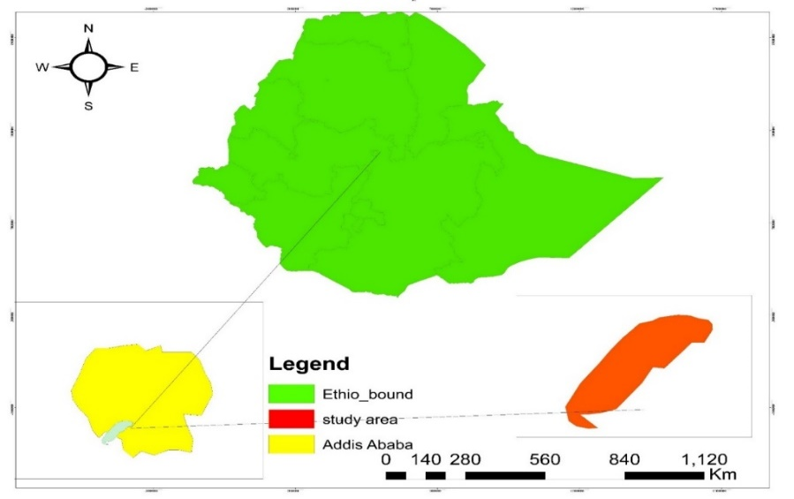
Peaco k.f

Gofa.f

ADDIS ABABA

Figure:1. Map generally showing study area
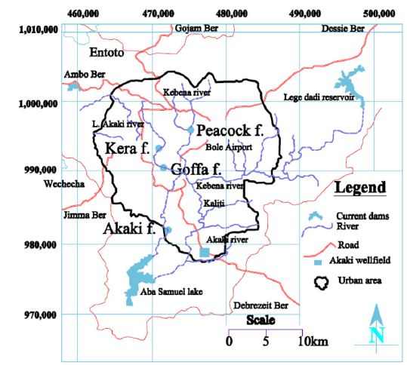
Figure:2. Picture showing river basins in Addis Ababa

Table.1. Sampled vegetables, and their local, English and Scientific names
Local name | English name | Scientific name
Kosta | Swiss chard | Beta vulgaris L. var. cicla
Selata | Lettuce | Lectuca sativa L
Dinich | Potato | Solanum tuberosum L
Zikuni | Cucumber | Cucumis sativus L.

Sampling and analyses

To meet the objectives set, samples from vegetables, soil sediment and irrigation water have been collected between April-June, 2017, and analyzed for selected heavy metals. Composite samples were taken to give a true representation of the area. Vegetable samples were taken from a total of 3 farms from Addis Ababa, from gofa vegetable farming and peacock vegetable farming of two site that are using two different river basins, one is from kebena river and the other is from bulula river. The samples represent swiss chard (Beta vulgaris L.var. cicla), lettuce (Lectuca sativa), potato (Solanum tuberosum L.), and cucumber (Cucumis sativus L.). The river water samples were collected using plastic bottles from different water sources that the farmers use for irrigation. Gofa farm utilizes water from kera river (part of little akaki river), peacock farm utilizes water from kebena and bulbula river. Soil sediments samples were collected from each sampling site for metal determination. All samples were digested According to standard procedure (APHA).

Plant (vegetable) sample collection and digestion procedures
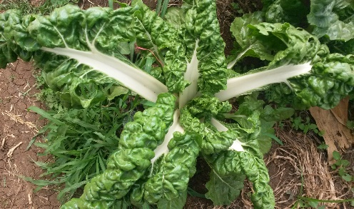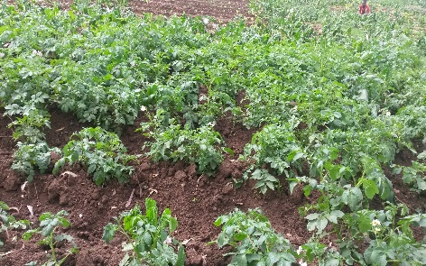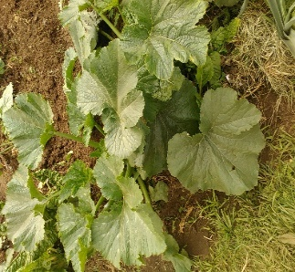
cucumber
potato
Swiss.c
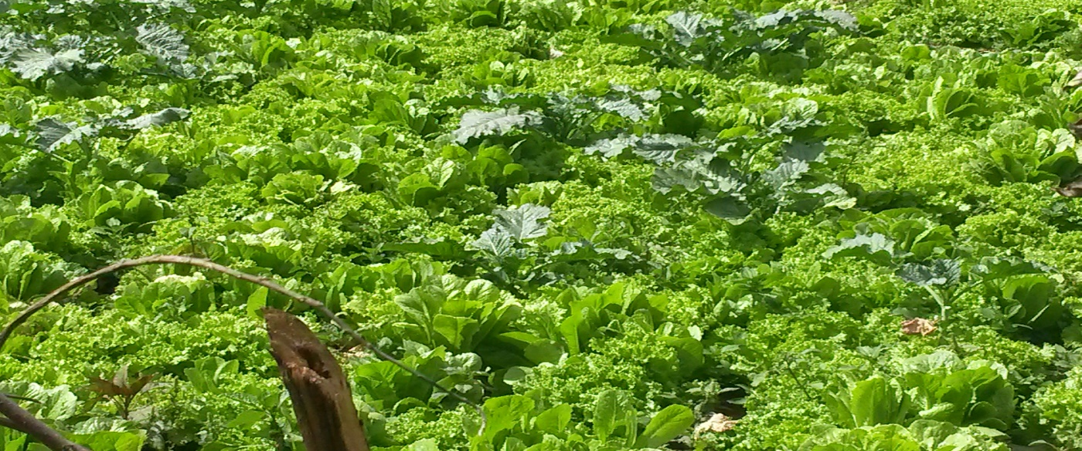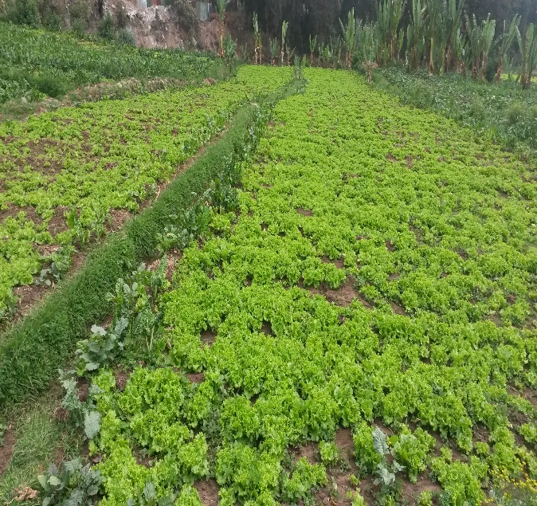
lettuce
Figure:3. Picture of selected vegetables
Leafy, vegetables were handpicked and washed by distilled water and subsequently rinsed with deionized water to eliminate all contaminants including air borne pollutants. Samples from potato and cucumber were washed and sliced thinly before drying. All samples were dried in an oven at 75ºc for leafy vegetables 24 hrs and for root vegetables 48 hrs, because root vegetables have high water content than leafy vegetable and they need more heat to dry. Moisture removal was carried out to minimize considerable thermal decomposition. The dried samples were grounded by a pestle and mortar and sieved through a mesh size of 2 mm in diameter. 1 gm powdered vegetable samples were weighed and added into 50 ml beakers to which 10 ml of concentrated 70% HNO₃ were added and digested overnight. Then after heated on hot plate at 125ºc for one hour following the addition of 2 ml of 30% H₂O₂ and 5 ml HNO₃. Repeated heating and addition of 30% H₂O₂ until the digested was clear. After cooling, the digested samples were filtered by What man filter paper, and kept in the refrigeration for some time until analysis.

Soil sediment sample collection and digestion procedure
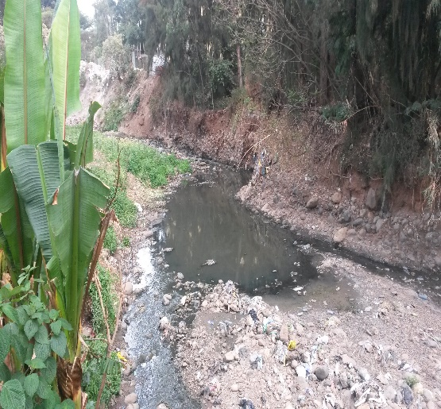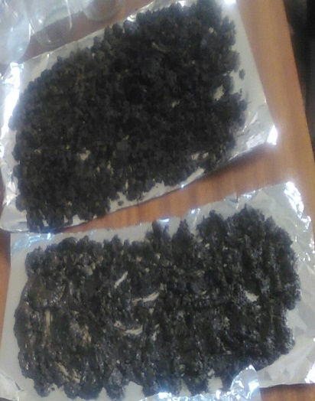
Soil Sediment
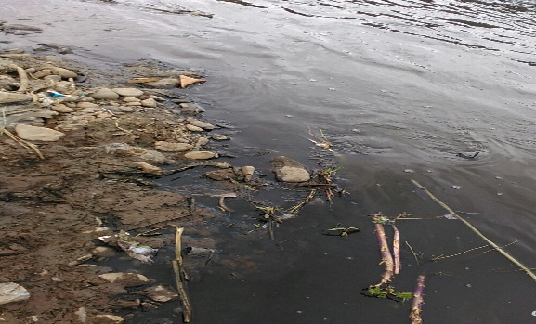
Figure:4. Picture showing soil sediment of river water
Surface sediment samples were collected with a plastic bag at each site along the river bank at a depth of 5–10 cm. Following transfer to the laboratory, all sediment samples were air-dried at room temperature for a week in a clean environment with organic debris picked from the samples. Then the samples were grounded with a mortar and pestle until all particles passed through a 2 mm sieve. 1gm of powdered soil sample was weighed into 50 ml beakers to which 10 mL of concentrated 70% HNO₃ were added and digested overnight. After heated on hot plate at 125ºc for one hour. 2 mL of 30% H₂O₂ and 5ml HNO₃ were added. Heating and addition of 30% H₂O₂ was repeated until the digested sample was clear. Then, the mixture was diluted by adding HNO₃ and deionized water to dissolve digest residue and filtered into 50 ml flask and kept in the refrigeration for some time until analysis.

River water sample collection and analysis
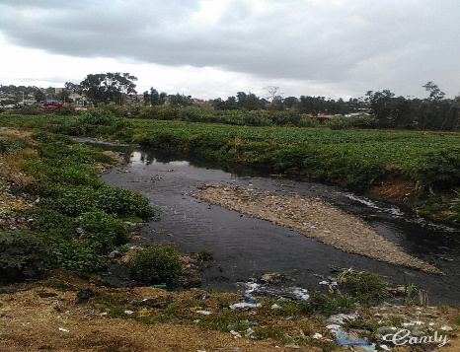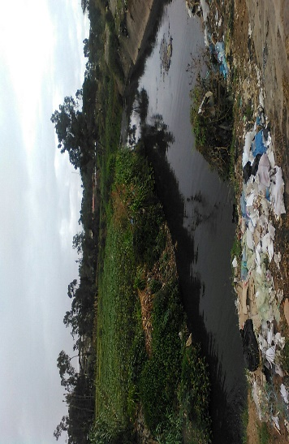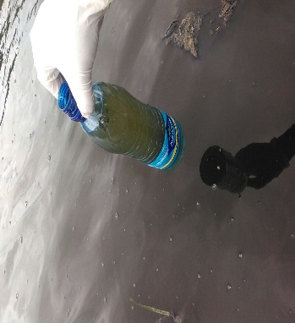
Irrigated Vegetable F

KERA R RR
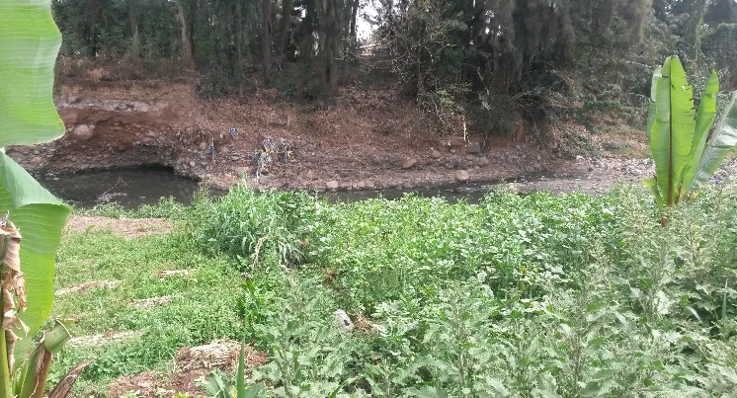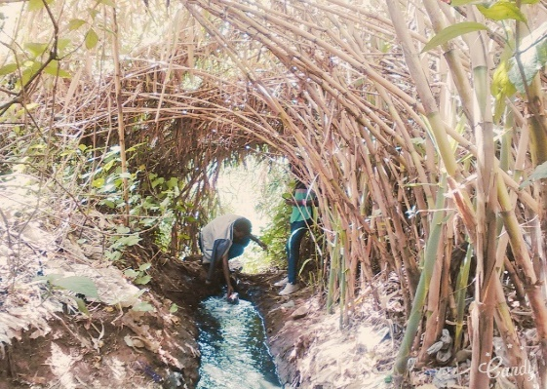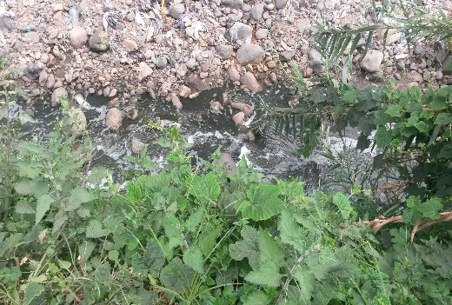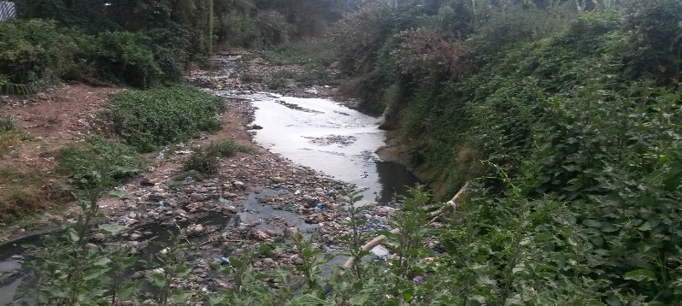
Kebena R
Bulbula R
Figure:5. Picture showing kera, kebena and bulbula river water
River water samples were collected in 500 mL plastic bottles from diversion irrigation sites from each selected study sites. Three samples from each river, kebena, bulbula, and kera were collected. The collected river water samples were brought to the laboratory and filtered using Whatman filter paper and preserved with 1 ml of 70% HNO₃. The filtered samples were stored in a refrigerator to minimize volatilization and biodegradation between sampling and analysis periods. Finally, the preserved samples of vegetable, soil sediment and river water samples were transported to the laboratory Horticoop Ethiopia (Horticultural) PLC Debrezeit. Determination of the heavy metals was achieved by Inductively coupled plasma optical emission spectroscopy (ICP-OES) (Model Spectro arcos, SPECTRO Inc, Germany).
ICP-OES is a trace-level, elemental analysis technique that uses the emission spectra of a sample to identify, and quantify the elements present. The Inductively Coupled Plasma Optical Emission Spectroscopy (ICP-OES) analysis method uses a high-frequency inductively coupled plasma as the light source, and is perfect for the element analysis of sample solutions. The ICP Emission Spectrometer has become highly regarded for its speed and accuracy.
This technique is used for multi-element analysis of aqueous samples. Quantitation is accomplished using multi-element standard solutions from which calibration curves are prepared. These instruments have a wide linear dynamic range (typically 3 to 5 orders of magnitude) that permits the analyst to measure both major and trace elements in the same solution without dilution. The technique has one major disadvantage as it yields very complex spectra with many overlapping lines, which may introduce a bias or increase the uncertainty in the final results. The following features of ICP-OES distinguish it from atomic absorption spectrophotometers used for similar purposes. Simultaneous, sequential analysis of multiple elements possible, Wide linear region of analytical curve, few chemical interference or ionization interference, making analysis of high-matrix samples possible, High sensitivity (low limit of detection for majority of elements is 10ppb or lower), High number of measurable elements - elements that are difficult to analyze in atomic absorption spectrometry such as Zn Ta, rare earth, P and B can be easily analyzed, and Stable.

Analysis of solutions by ICP-OES with radial plasma observation
All measurements were performed with Spectro arcos optical emission spectrometer optimized with small volume and 32 linear CCD detectors the wave length range between 130-770 nm simultaneously analyze, the sample is nebulized in to the argon filed plasma and the energy excitement is processed in the single spectra and the energy is expressed in intensity which is directly proportion to concentration , the concentration is calculated on the linear graph of the standard concentration and the corresponding Intensities.
All the measuring conditions, like plasma power, gas flows, torch positions and measuring time are configuring according to the standard. The calibration and standardization of the spectra method is performed but standardization is daily, and it is a quick procedure for correcting measuring intensities so that the correct concentration is obtained using the original calibration curve. The standardization factor on a regular base falls between 0.987 to 0.999 for all elements. So that the accuracy and precision of our method was the R² of the standardization and the recovery of our control sample which is the concentration limit. The samples were diluted as needed to meet range requirements of the analytical instrument.

Analysis of soil sediment physical and chemical properties
The soil pH and Ec was measured on a suspension obtained after shaking 10 g of the soil sample with 25 mL distilled water for 1hr on a magnetic shaker Rpm 150 and settled for 30min. The PH Measured by SX 711 pH/mv meter and EC by CON 2700 EC meter. Soil sediment samples was sieved with 0.5 micro meter size and used for nutrients analysis. The organic carbon organic carbon (OC) content of the soil was analyzed by the procedures of Walkley-Black potassium dichromate wet oxidation method (G. Nabulo et al., 2008). The available phosphorus by the Olsen method and measured by Jenway UK model 6705. The total Nitrogen content by the Kjeldahl method, and texture by Hydrometer method nutrient analysis were analyzed at the National Soil Research Laboratory, Ethiopian Agricultural Research Organization (Addis Ababa, Ethiopia).

Analysis of river water physicochemical and biological properties
    - BOD and COD
According to APHA standard method the BOD analysis of river water sample was started immediately after sample collected to minimize changes in bacterial concentration. BOD of river water was analyzed by Winkler Method in laboratory of center for environmental laboratory. 300 mL glass bottles stoppered wash thoroughly with a 0.2- percent non-phosphate detergent solution and rinse with deionized or distilled water. Bottles were labeled appropriately for sample identification. 100ml of river water sample added in to 200 mL of tap water followed by addition of reagents step by step. First 2mL of Manganese Sulphate (MnSO4) then 2 mL of Alkaline potassium iodide-sodium azide solution, the color became yellowish (light yellow). Then after sulphuric acid (H₂SO₄) was added to dissolve, first two chemicals combine with dissolved oxygen to form a compound which, when acid is added, releases free iodine. After shaking it very well, starch indicator was added and change the color into blue. finally, titrated by sodium thiosulphate (Na₂S₂O₃) to determine the amount of dissolved oxygen present. Followed by incubating a BOD bottle full of dilution water for 5 days at 20ºC. Exclude all light to prevent photosynthetic production of DO. Finally, after five days’ incubation the BOD₅ was calculated by using the following equation (G.C. Delzer and S.W. McKenzie, 2003). COD of river water sample from three sites was analyzed in laboratory of environmental science using APHA standard procedure and measured by Jenway UK model 6705. The following reagents were used for COD analysis of river water sample, HgSO₄ (Mercury Sulphate), H₂SO₄ (Sulphuric acid), Ag₂SO₄ (Silver Sulphate), K₂Cr₂O₇ (Potassium dichromate).
3.5.1.2. The general equation for the determination of a BOD₅ value
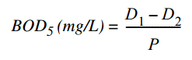
where D₁ = initial DO of the sample, or DO of sample immediately after preparation, mg/L
D₂ = final DO of the sample after 5 days, or DO of sample after incubation period, mg/L and
P = decimal volumetric fraction of sample used.
If 100 mL of sample are diluted to 300 mL, then P =100/300 = 0.33.
Notice that if no dilution was necessary, P = 1.0 and the BOD₅ is determined by D₁ - D₂.
If the BOD₅ value of a sample is less than 7 mg/L, sample dilution is not needed. A BOD₅ value greater than 7 mg/L requires sample dilution. Dilution is necessary when the amount of DO consumed by microorganisms is greater than the amount of DO available in the air-saturated BOD₅ sample.
    - pH and EC
pH and EC of river water was measured in the laboratory of center for environmental science immediately after sample was brought from sampling site by using SX 711 pH/mv meter and CON 2700 EC meter respectively. Conductivity is the capacity of water to carry an electrical current and varies both with number and types of ions in the solutions, which in turn is related to the concentration of ionized substances in the water. Most dissolved inorganic substances in water are in the ionized form and hence contribute to conductance. The available phosphorus from river water analyzed by the Olsen method and measured by Jenway UK model 6705. The total Nitrogen content analyzed by the Kjeldahl method.
The guidelines used in this text for maximum levels(ML) of heavy metals in irrigated water, soil sediment sample and vegetable samples were adopted from FAO (1985), USEPA, (2001), WHO, (2003), Ewers, U, (1991), and FAO/WHO, (2001).

Statistical analysis
The data obtained from the chemical analysis were subjected to descriptive statistical analysis (mean, range and standard deviation at 95% confident limit). All statistical analyses were performed by statistical package for social sciences (SPSS) program, version 20 and using the Microsoft excel (version 2016). Analysis of variance (ANOVA) with Turkey post hoc test was used to determine the level of significance of variations between the samples. All statistical analyses described here were conducted at 5% level of significance and declared significant at p < 0.05. Pearson correlation was applied to test the relationship between various parameters along sampling sites.

CHAPTER FOUR

Results and discussions
The results of heavy metal concentrations in the irrigated river water, soil sediments and plant samples are presented in (Table. 3, 5, 6, 7, and 8) respectively. The results clearly showed the highest concentration of heavy metal in the soil sediment samples from three sites. Heavy metal concentrations in the sediment samples were generally higher than in the overlying water. This trend was observed in all the sampling sites with low levels of metals in the river water corresponding to high levels in sediment. This was because of binding characteristics and that the heavy metals concerned were sequestered at the bottom of the river water. (Aderinola et al., 2009) also confirmed that sediments were very important host for toxic metals. They allow for the detection of heavy metals that may be either absent or in low concentration in the water column. In general, metal content in sediments is indicative of the degree of pollution of river water (Ogoyi et al., 2011).
The experimental results show that all the trace metals under analysis were observed to be absorbed by all selected vegetables in this study. Leafy vegetables accumulate much higher contents of heavy metals as compare to other vegetables because leafy vegetables are most exposed to environmental pollution because of large surface area (Fisseha Itanna et al., 2002). Difference in metal concentration in vegetables seems to indicate that different types of vegetables have different abilities to accumulate metals. Lettuce and swiss chard accumulated more heavy metal followed by cucumber. Potato was the least accumulator of analyzed metals.
Arsenic, Lead, Cadmium, Chromium, and Nickel are very toxic metals even at low concentration. The concentration of these metals in river water samples, soil sediment and, different vegetable samples were compared between farming sites (figure 6-11).
Correlation analysis was carried out for inter-metallic and other parameters association to understand the significance (p < 0.01, p < 0.05) of association among the metals and the parameters presented on (Table. 10-12)
Significance test was carried to see the obtained significant different among sampling sites and among samples. Significant differences in concentration levels of heavy metals along sampling sites was shown by ANOVA (Table 13-15) presented in appendix part.

4.1. Physiochemical and biological components of irrigated river water
The Physicochemical properties and metal concentrations of water from the three river water irrigation sources are given in (Table 2 and 3). In the current study, the pH of the irrigation water ranged from 7.06-7.38 Kebena, 7.28-7.58 Bulbula, and 6.83-7.22 Gofa (kera river), which were in the normal range for irrigation and clean water since the normal pH range river water suitability for irrigation is from 6.5 to 8.4 (FAO; STN, 1998). Water with a pH outside the normal range (6.5 – 8.4) may contain excess toxic ion(s) posing serious threat to aquatic organisms. It may also bring about nutritional imbalance if used for irrigation purposes.
These results confirm that high concentrations of the metals were registered at pH < 7 specifically at pH = 6.55 and 6.85 which is in agreement with Tamene Fente and Seyoum Leta, (2015). In the current study, high concentrations of metals were registered at pH < 7 specifically at kera river pH 6.94 (Table 2). Heavy metal concentration at kera river was higher in most case than kebena and bulbula river.
The electrical conductivity (ms) measured at 23-25°C ranged from 573.20-619.20 at Kebena, 711.40-770.90 at Bulbula, and 413.30-711.80 at Gofa (Kera). EC this parameter is playing a role as a proxy of ion content in the river. A high electrical conductivity in the study area is a signal for most disturbed river system, high ionic presence and nutrient load. At the more urbanized area of the river basin electrical conductivity is expected to be high due to effluents from different sources, mainly because of sewage leakage (Ferezer Eshetu, 2012).
The mean value of BOD and COD of river water sample in mg/L was recorded as follows from three sites. 15.8667 at Kebena, 18.333 at Bulbula, and 45 at Gofa for BOD and 118 at Kebena, 193.66 at Bulbula, and 236 at kera for COD. Most relatively unpolluted rivers has a BOD₅ that ranges from 1 to 8 mg/L. In current study the value of BOD indicates that the river water is relatively polluted because the value was more than WHO.
Total nitrogen and available phosphorous in the river water sample (from three sites) were obtained as follows, 0.10% from kebena, 0.28% from bulbula and 0.40% from kera and 20.66 mg/kg from kebena, 50 mg/kg from bulbula, and 80.33 mg/kg from gofa (kera) respectively. High concentration of nitrogen compound in the water bodies is responsible to cause many health problems. The discharge in to akaki river basin might be comes from many sources: from city sewage, defective septic tank effluents, municipal waste, industrial waste, wastes from livestock and chemical fertilizers containing nitrogen (Ferezer Eshetu, 2012).
Table.2. BOD, COD, pH, Ec, TN and Av. P concentration in irrigated river water
Water sample | BOD (mg/L) | COD (mg/L) | PH | EC (ms) | TN % | AV.P (mg/kg)
Kebena | 15.8667 | 118 | 7.21 | 600.76 | 0.10 | 20.66
Bulbula | 18.333 | 193.66 | 7.39 | 748.83 | 0.28 | 50
Gofa | 45 | 236 | 6.94 | 648.24 | 0.40 | 80.33
TN, Total nitrogen, AV. P, Available phosphorous

4.2. Heavy metals concentration in sample of irrigated river water from three selected sites
Table.3. Mean, (±SD), ranges and Maximum limit of heavy metals in irrigated river water of selected farms
Metals (mg/L) | Kebena | Bulbula | Kera | FAO (1985)  USEPA*, 2001  WHO**, 2003
As | 0.2± 0.006 | 0.25 ±0.01 | 0.33 ±0.01 | 0.1
Pb | 0.47 ±0.02 | 0.41± 0.04 | 0.54 ±0.02 | 0.065*
Cr | 0.22 ±0.02 | 0.33 ±0.02 | 0.35 ±0.03 | 0.55*
Cd | 0.001 ±0 | 0.001 ±0 | 0.001 ±0 | 0.01
Ni | 0.100 ±0 | 0.100 ±0 | 0.200 ±0 | 1.4*
Cu | 0.010 ±0 | 0.013 ±0 | 0.02 ±0.01 | 0.017*
Sn | 0.60 ±0.02 | 0.53 ±0.03 | 0.76 ±0.02 | -
B | 0.39±0.02 | 0.38±0.02 | 0.66±0.03 | 0.3**
Zn | 0.13 ±0.01 | 0.17 ±0.01 | 0.20 ±0.01 | 0.2
Mn | 2.14 ±0.01 | 1.63 ±0.02 | 2.35 ±0.01 | 2
Fe | 4.51 ±0.06 | 5.56 ±0.26 | 6.2 ±0.09 | 0.5

The irrigated river water obtained from kebena, bulbula and kera were analyzed for selected heavy metals. Heavy metal concentration for arsenic, lead, boron and iron in all case, manganese in kebena and gofa, and cupper in case of bulbula river were more than the recommended maximum limit for irrigation water by FAO (1985) and USEPA, (2001). The rest heavy metals were within safe limit.
The order of the metals concentrations in river water sample (mean ± STD) is Fe (6.2 ±0.09) > Mn (2.35 ±0.01) > Sn (0.76 ±0.02) > B (0.66±0.03) > Pb (0.54 ±0.02) > Cr (0.35 ±0.03) > As (0.33 ±0.01) > Zn (0.20 ±0.01) > Ni (0.15 ±0) > Cu (0.02 ±0) > Cd (0.001 ±0).

4.2.1. The concentration of heavy metals in irrigated river water sample
Arsenic
The mean of concentration of arsenic from river water sample was recorded as follows 0.2± 0.006 at kebena river, 0.25 ±0.01 at bulbula river, 0.33 ±0.01 at kera river. The highest concentration of arsenic was obtained from kera river followed by bulbula and kebena. In the present study arsenic concentration was more than FAO (1985) recommended limit for irrigation water, (0.1 mg/L). The concentration of arsenic in this study ranged from 0.20-0.34 mg/L, result was high compared to a study by Minbale Aschale et al., (2015). He showed that the levels of arsenic in the analyzed water samples in the range 0.5-3.05 µg /L with mean value of 1.46±0.66 µg/L. The mean concentration of arsenic in river water sample was significantly different among sampling sites P-values< 0.05.
Cadmium
Cadmium concentrations in three river water samples are generally low, no appreciable amount of cadmium was detected at all sampling sites, which is below FAO (1985) recommended limit for irrigation water, (0.01 mg/L). Cd is a toxic metal and can cause serious health problems even if ingested in small amounts. It has the tendency to accumulate in body tissues causing lung problems, kidney lesions, neurological disorders and skeletal damage (Abdul et al., 2012). In similar study by Minbale Aschale et al., (2015), Cd concentration varied between 0.03 and 0.12 µg /L and mean value was 0.06 ±0.02 µg/ L, which is much less than the current study with mean value of 0.001 mg/L. The study by kaluli et al., (2014) in Kenya showed the concentration of cadmium in wastewater was negligible, and hence also within the acceptable limits.
Chromium
The concentration of chromium from river water samples was recorded as follows, from kebena, bulbula and Kera river sample (mg/L) 0.22 ±0.02, 0.33 ±0.02 and 0.35 ±0.03 respectively. The higher concentration of Cr was obtained from bulbula river followed by kera river and the list concentration was recorded at kebena river. The concentration of chromium is less than USEPA, (2001) recommended limit for irrigation water, 0.55 mg/L in all cases, but appreciable amount of Cr was detected at all sampling sites.
Chromium concentration in the analyzed samples ranged from 0.21-0.35 mg/L. This result was greater than previously studied by Minbale Aschale et al., (2015) which was ranged from 1.25-485 µg /L with mean value 67.04±119.57 µg /L. According to the report by Fisseha, (1998) Cr, Cd, Ni, Pb and Zn were detected in kera river which is in agreement with the current study. These was because more industrial effluents from various industries enter in to kera river than kebena and bulbula rivers. The mean concentration of Cr in river water sample among sites was significantly different at P values < 0.05.
Lead
The concentration of lead from river water sample was recorded as follows from kebena, bulbula and kera river (mg/L) 0.47 ±0.02, 0.41± 0.04, and 0.54 ±0.02, respectively. The levels of lead in river water samples in all case was more than USEPA, (2001) recommended maximum limit, 0.065 mg/L. The highest concentration was obtained from kera river followed by kebena and bulbula river. The concentration of lead in present study ranged from 0.36-0.55 mg/L. This result was higher than previous study by Minbale Aschale et al., (2015), Pb value ranged from 1.15-11.35 µg/ L, with mean value of 3.13± 2.60 µg/ L. Similar Study by Amhare hailu, (2011) reported that Pb concentration in irrigation water was detected at the north part of Addis Ababa, which is typically derived from wells water that was used for irrigation.
The higher values of, As, Pb, Cd and Cr might be due to the uses of pigments/paints, fertilizers, tanneries, fossil fuels, car battery wash wastewaters and plastic materials production processing at upper course of the river (FAO et al., 1996). The mean concentration of Pb in river water sample between gofa and bulbula, kebena was significantly different at P-values < 0.05, but no significant difference was observed between kebena and bulbula. Indicating that concentration of lead in kebena and bulbula river is similar and more concentration of lead was recorded from kera indicating it pollution level
Nickel
The concentration of nickel in river water samples was recorded as follows, 0.1 ±0 at kebena and bulbula, and 0.2 ±0 at kera river. The highest concentration of nickel was obtained at kera river and equal amount Ni was obtained from kebena and bulbula. Nickel level in current study was generally below the recommended limit 1.4 mg/L by USEPA, (2001), but an appreciable amount Ni was detected at kera river. In current study concentration of Ni ranged from 0.1-0.2 mg/L from three sites was greater than a study by Minbale Aschale et al., (2015), Ni value ranged from 2.85-14 µg /L with mean value 6.66± 3.29 µg /L.

Figure:6. Comparison of mean concentration of highly toxic metals in irrigated river water samples from three sites

Boron
The concentration of boron in irrigated river water sample was recorded from kebena, bulbula and kera river 0.39±0.02, 0.38±0.02, and 0.66±0.03 mg/L respectively. Higher concentration of boron was obtained from kera river, followed by bulbula and kebena. Boron concentration was more than permissible limit 0.3 mg/L by WHO, (2003). This could be due to the discharge of industrial, domestic and municipal wastes in these sampling areas. The mean concentration of boron in river water sample among kera and bulbula, kebena was significantly different at P-values < 0.05, but no significant difference was observed between kebena and bulbula. Indicating that concentration of boron in kebena and bulbula river is similar and more concentration of boron was recorded from kera.
In similar study reported by Minbale Aschale et al., (2015), the concentration of boron in the water samples was ranged from 0.5-6135 µg/ L with a mean of 383.04± 1190.78 µg/ L. This result was less than the current study, boron concentration ranged from 0.36-0.68 mg/L with a mean of 0.4733 mg/L.
Zinc
The concertation of zinc in river water sample was recorded from kebena, bulbula and kera river 0.13 ±0.01, 0.17±0.01 and 0.20 ±0.01 mg/L respectively. Higher concentration of zinc was obtained from kera river, followed by bulbula and kebena. Zinc concentration in current study was under safe limit. The presence of the zinc may be from wastewater from industrial effluents and runoffs from the burning area. Similar study by Amhare hailu, (2011) reported Zn in irrigation water was detected at the north part of Addis Ababa, which is typically derived from wells water that was used for irrigation. The values of zinc in this study was ranged from (0.12-0.21 mg/L) with mean value 0.17mg/L. This result was greater than a study by Minbale Aschale et al., (2015). He reported the concentration of Zn ranged from 8.35-77.5 µg /L with a mean of 25.50± 16.53 µg /L. The mean concentration of Zn of river samples was significantly different among sampling sites at P-values < 0.05.

Copper
The concentration of copper in water samples of kebena, bulbula and kera river was recorded in 0.01 ±0, 0.013±0, and 0.02 ±0.01 mg/L respectively. Very low concentration of copper was obtained which was below the detection limit from. Concentration of Cu was more than USEPA, (2001), recommended limit 0.017 mg/L. The concentration of Cu in this study were ranged from (0.01-0.02 mg/L) with mean value of 0.0144 mg/L. This was higher than the study by Minbale Aschale et al., (2015). He reported that the concentration of Cu ranged from 2.1-11.55 µg/ L with the mean value of 5.61±1.89 µg /L. The mean concentration of Cu between gofa and bulbula, kebena was not significantly different, but was significantly different between kebena and bulbula at P-values < 0.05.
Iron
The concentration of iron from sampling sites was recorded as follows (mg/L) 4.51 ±0.06 at kebena, 5.56 ±0.26 at bulbula, and 6.2 ±0.09 at kera. Relatively high concentration of Fe, was obtained from the analyzed river water samples in current study. The highest concentration Fe was recorded in kera river. The mean concentration of iron was more than FAO, (1985) the recommended maximum level for irrigation 0.5mg/L. In current study Fe concentration was ranged from (4.45-6.30 mg/L) with mean value of 5.4284 mg/L. In similar study Minbale Aschale et al., (2015) reported the iron concentration ranged from 175-4800 µg/L with the mean of 1075.92±1069.54 µg /L. This result is lower than current study. The high Fe concentrations in this river water samples may be due to iron ore tailing from the metal workshops and discharge of iron loaded industrial wastes.
Manganese
The concentration of Mn from sampling sites was recorded as follows (mg/L) 2.14 ±0.01 at kebena, 1.63 ±0.02 at bulbula, and 2.35 ±0.01 at kera river. Mn concentration was more than FAO, (1985) recommended maximum limit 2 mg/L in case of kebena river and kera river. In the current study concentration of Mn ranged from 1.61-2.36 mg/L with mean value of 2.0411 mg/L. In similar study by Minbale Aschale et al., (2015) the concentration of manganese ranged from 38- 3950 µg/ L with the mean of 1540±843.53 µg/ L this result is less than current study. The highest concentration Mn was recorded in kera river. Mn in kera river (Fisseha Itanna, 1998) were surpassed the maximum recommended limits. The presence of high amounts of these metals in irrigation waters may increase their levels in soils, which in turn may boost metal uptake by plants ultimately leading to elevated concentrations in the vegetables.
Tin
The concentration of Sn from sampling sites was recorded as follows (mg/L) 0.60 ±0.02 at kebena, 0.53 ±0.03 at bulbula and 0.76 ±0.02 at kera. Highest tin concentration was recorded from kera river. The concentration of tin was more than WHO, (2003) recommended maximum limit 0.3 mg/L. The mean concentration of Mn, Fe and Sn from river water sample were significantly different among sampling sites at P-values< 0.05.

Soil sediment physicochemical properties
Soil sediment physicochemical properties for, pH, EC, T.N, AV. P, OC, Texture class were analyzed and presented in table.4. The pH in all samples was ranged between 6.91-7.41. All sampled soil sediments were slightly acidic to neutral. EC ranged from 1.06-1.39 ms, TN ranged between 0.16-0.62, AV. P ranged from 36.98-103.92, Soil OC was high, ranged between 4.88-40 which was higher than values found in soils of the Nigerian savannah, that ranged from 0.8-2.9 g /kg (Jones and Wild, 1975). The relatively high total organic carbon content in soil sample could be due to the high organic content of used lubricants that were discharged from heavy duty machines, 60 mechanic workshops in the areas (Akoto et al., 2008) as well as indiscriminate disposal of organic waste into the environment as the industrial area is crowed by residential houses with no proper waste disposal systems. The texture class of soil sediment was recorded, Sandy clay, Sandy clay loam and clay from kebena, bulbula and gofa respectively.
Several studies have shown that availability of heavy metals is pH dependent and their mobility in soil decreases with increased soil pH and vice versa (Iwegbue et al., 2006). Soil pH serves as a useful index of availability of nutrients, the potency of toxic substances presents in the soil as well as the physical properties of the soil. The high soil pH values suggest that heavy metals availability for plant uptake is low in the sample soils.
Gofa site contains higher nutrients and slightly higher organic matter than bulbula and kebena sites. This could have partially contributed to the relatively higher metal uptake by plants grown there. That site has sedimentary soils deposited because of sediments are one of the several means through which soils are enriched with heavy metals.
Table.4. pH, Ec, total nitrogen, available phosphorous, organic carbon and texture of soil sediment sample
Soil sample | pH | Ec (ms) | TN (%) | AV. P (mg/kg) | OC (%) | Sand (%) | Silt (%) | Clay (%) | Texture  class
Kebena | 7.41 | 1.06 | 0.16 | 36.98 | 4.88 | 58 | 4 | 38 | Sandy clay
Bulbula | 7.1 | 1.14 | 0.39 | 79 | 54 | 54 | 12 | 34 | Sandy clay loam
Gofa | 6.91 | 1.39 | 0.62 | 103.92 | 40 | 40 | 18 | 42 | clay
T.N, Total nitrogen, AV. P, Available phosphorous, OC, Organic carbon

Heavy metal concentration in soil sediment from three different sites
The range of the concentration (mg/kg) for As, Pb, Cr, Cd, Ni, Cu, Sn, B, Zn, Mn and Fe was 12.11-13.50, 36.42-45.02, 5.58-7.37, 2.27- 3.45, 5.18-7.84, 2.0-2.36, 16.05-18.40, 81.84-88.71, 8.47 -10.31, 107.50-206.31, and 2206.00-2316.64 respectively. The highest concentration of trace metals in general were found in sediment samples with Fe having the highest mean concentration values in the three sampling sites. The metal concentration was high in all selected sites in current study, kebena, bulbula and gofa site, even though the concentration of most of the heavy metals does not pass the recommended maximum limit. Cadmium in gofa site Arsenic, and Tin from all sites were above the maximum recommended limit which is in agreement with the study by Ewers, (1991) and Lithuanian, (2004).

Table.5. Mean (±SD), ranges and maximum limits of heavy metals in soils sediments of selected sites
Metals (mg/kg) | Kebena | Bulbula | Gofa | Ewers, (1991)  Pedias*, (1992)  Lithuanian**, (2004)
As | 12.2 ±0.12 | 12.5 ±0.03 | 13 ±0.5 | 10**
Pb | 36.61 ±0.24 | 37.7 ±0.94 | 44.9 ±0.23 | 100
Cr | 6.18 ±0.08 | 5.7 ±0.2 | 7.22±0.14 | 50
Cd | 2.5 ±0.02 | 2.4 ±0.1 | 3.4 ±0.07 | 3
Ni | 5.4 ±0.19 | 5.9 ±0.06 | 7.5 ±0.45 | 50
Cu | 2.05 ±0.04 | 2.29 ±0.08 | 2.2 ±0.04 | 100
Sn | 16.2±0.2 | 16.4 ±0.07 | 18.4 ±0.02 | 10**
B | 86.42±3.1 | 83.5±1.53 | 86.5±2.17 | -
Zn | 8.67 ±0.17 | 8.56 ±0.09 | 10.2 ±0.1 | 300
Mn | 109.5 ±3.04 | 122.5 ±3.04 | 201±5.48 | 2000
Fe | 2255 ±13.2 | 2262 ±53.5 | 2311.9 ±5.31 | 50000*

4.2.2. The concentration of heavy metals in soil sediment sample at selected sites
Arsenic
It is observed that the concentration of arsenic in soil sediment was more than 12 mg/kg. The concentration of arsenic was 12.2 ±0.12 at kebena, 12.5 ±0.03 at bulbula, and 13 ±0.5 at gofa. The highest concentration of this metal was obtained from gofa followed by bulbula and kebena. The level of arsenic from three sampling sites were more than Lithuanian, (2004) maximum limit 10mg/kg. Study by Esi, (2012) in Ghana, reported the mean concentration of arsenic in sediment sample. The result was 0.066 mg/kg compared to current study it was less. The mean concentration of arsenic between kebena and gofa were significantly different at p value <0.05, but no significant difference was seen between bulbula and kebena.

Lead
The concentration of Lead in soil sediments sample is higher compared to analyzed heavy metal in this study, except Fe and Mn. The mean concentration of lead was obtained 36.61 ±0.24 at kebena, 37.7 ±0.94 at bulbula, and 44.9 ±0.23 at gofa. The highest lead concentration was obtained from gofa site, followed by bulbula and kebena site. Esi, (2012) in Ghana has reported the concentration of lead in sediment sample 0.759 mg/kg. The result was less than current study. A study by Brigden et al., (2008) reported that the sediments from the “korle” lagoon had lead Concentration 1685 mg/kg the result was very higher than current study. Comparable study in china by Jun-min et al., (2016) reported the mean concentration of Pb in sediments sample 8.0–56.6 mg/kg. Industrial waste is the most important sources of Pb exposure. Pb element and its compounds are components of many industrial products such as batteries, cables, pigments, plumbing and ceramics, gasoline, tobacco, solder and steel products, food packaging glassware and pesticides (Tangahu et al., 2011).
The mean concentration of Pb between gofa and kebena as well as bulbula was significantly different at p value <0.05, but no significant difference was seen between bulbula and kebena.
Chromium
The mean concentration of Chromium in soil sediment sample was recorded as follows 6.18 ±0.08 at kebena, 5.7 ±0.2 at bulbula, and 7.22±0.14 at gofa. The higher concentration of Cr was recorded from gofa, followed by bulbula and kebena. A study by Brigden et al., (2008) reported that the sediments from the “korle” lagoon had Cr concentration of 34 mg/kg which is very higher than current study. Comparable study in china by Jun-minet al., (2016) reported the mean concentration of Cr in sediments sample 33.9– 161.1 mg/kg this result is also higher than current study. The mean concentration of Chromium from soil sediment sample was significantly different among sites at P-values < 0.05

Cadmium
The mean concentration of cadmium was recorded as follows 2.5 ±0.02 at kebena, 2.4 ±0.1 at bulbula, and 3.4 ±0.07 at gofa. High concentration of Cd was obtained from gofa site followed by bulbula and kebena. The concentration of Cadmium was not high in soil sediment sample of selected sites compared to other heavy metals analyzed in current study. Although the concentration of Cd was more than Ewers, (1991) maximum permissible limit 3mg/kg at gofa site. A study by Esi, (2012) in Ghana reported the concentration of Cd in sediment sample 0.178mg/kg. this result was very less compared to current study. Like study in china by Jun-minet al., (2016) reported the mean concentration of Cd in sediments sample 0.02–2.23 mg/ kg this result is also less than current study. Similar study by Pawan R and Neena M, (2013) reported that the concentration of Cd in soils irrigated with industrial wastewater exceed the maximum permissible limit of 3 mg/ kg by Ewers, (1991).
The mean concentration of Cd between gofa and kebena, as well as bulbula was significantly different at p value <0.05, but not significantly difference was observed between kebena and bulbula.
Nickel
The mean concentration of nickel in soil sediment was recorded as follows, 5.4 ±0.19 at kebena, 5.9 ±0.06 at bulbula, and 7.5 ±0.45 at gofa. The highest concentration was obtained from gofa site followed by bulbula and kebena. Comparable study in china by Jun-min et al., (2016) reported the heavy metals in sediments for Ni 17.8–112.3 mg/kg. These heavy metal level was highest compared to current study.
The mean concentration of nickel between gofa and kebena as well as bulbula was significantly different at P-values < 0.05, but not significant difference was seen between kebena and bulbula.

Figure:7. Comparison of mean concentration of toxic metals in soil sediment samples from three sites
Copper
The mean concentration of copper in soil sediment sample was recorded as follows 2.05 ±0.04 at kebena, 2.29 ±0.08 at bulbula, and 2.2 ±0.04 at gofa. The highest concentration of Cu was obtained from bulbula site, followed by gofa and kebena. Comparable study in china by Jun-min et al., (2016) reported that the heavy metals in sediments for Cu 36.7–133.1 mg/kg. this result is higher than current study. The mean concentration of copper between gofa and kebena as well as bulbula was significantly different at P-values < 0.05, but no significant difference was observed between kebena and bulbula.

Tin
The mean concentration of Sn from three sites was recorded as follows, 16.2±0.2 at kebena, 16.4 ±0.07 at bulbula, and 18.4 ±0.02 at gofa. The highest concentration was obtained from gofa followed by bulbula and kebena. The level of Tin from three sampling sites of soil sediment samples were more than Lithuanian, (2004) maximum limit 10mg/kg. The mean concentration of Sn between gofa and bulbula as well as kebena was significantly different at P-values < 0.05, but no significant difference was observed between bulbula and kebena.
Boron
The concentration of boron from three sites was obtained 86.42±3.1 at kebena, 83.5±1.53 at bulbula, and 86.5±2.17 at gofa. The mean concentration of Boron in the soil sediment was highest in gofa followed by kebena and bulbula. The mean concentration of boron from soil sediment sample was not significantly different between sites.
Zinc
The Zinc concentration from three sites were recorded as follows, 8.67 ±0.17 at kebena, 8.56 ±0.09 at bulbula, and 10.2 ±0.1 at gofa. The highest mean concentration of Zn was obtained from gofa, followed by kebena and bulbula. A study in china by Jun-min et al., (2016) reported that the heavy metals in sediments for Zn 229.7- 1079.0 mg/kg, the current result was lesser. The mean concentration of Zn was significantly different in soil sediment sample between gofa and kebena as well as bulbula at P-values < 0.05, but no significant difference was observed between kebena and bulbula.
Manganese
The mean concentration of Mn was recorded as follows, 109.5 ±3.04 at kebena, 122.5 ±3.04 at bulbula, and 201±5.48 at gofa. The highest concentration of Mn was obtained at gofa site followed by bulbula and kebena. The concentration of Manganese in soil sediment sample was the second highest next to iron in this study. Comparable study in china by Jun-min et al., (2016) reported the heavy metals in sediments for Mn 161.2– 2693.0 mg/kg. These heavy metal level is highest compared to current study. The mean concentration of Manganese among sites was significantly different at P-values< 0.05.
Iron
The mean concentration of iron was recorded as follows, 2255 ±13.2 at kebena, 2262 ±53.5 at bulbula, and 2311.9 ±5.31 at gofa. The highest concentration of Fe was obtained at gofa site. The concentration of iron was the highest in soil sediment sample compared to all analyzed heavy metal in this study. similar study in china by Jun-min et al., (2016) reported the heavy metals in sediments for Fe 10,720–28,130 mg/kg, the result was high compared to current study. The mean concentration of Fe was not significantly different among sites P-values< 0.05.
In current study the eleven metals in sediments decreased in an order of Fe > M n > B > Pb > Sn > As > Zn > Cr > Ni > Cd > Cu. This remarkable variation reflects the influence of anthropogenic activity on the spatial concentration of sedimentary metals in the river. Like current study Among the metals studied, the highest concentrations were observed for Fe, Mn, B and Pb especially Fe, which is consistent with the high background values of Fe, Mg, and Mn in soils of China (Jun-min et al., 2016).

4.3. Heavy metal concentration in vegetables sampled from three sites
Except for Lead and Arsenic all analyzed heavy metal from three vegetable farming sites do not pass the maximum limit recommended by FAO/WHO. Comparing the three contaminated sites lettuce, swiss chard .and cucumber accumulate more metals and metalloid at gofa. Lead, cadmium, chromium, and nickel in potato grown at peacock park (bulbula and kebena) and gofa site did not show any difference. When I took potato sample it was not matured enough may be this could be the reason. Alike study by Alemayehu, (2001), reported metal concentration of vegetables by farm, those grown in gofa and kera were the highest accumulators and those in Peacock the least accumulators. Vegetables from farms irrigated with the more polluted little akaki river (gofa and kera farms) were higher accumulators of metals than those irrigated with the less polluted big akaki river (peacock farm).
Leafy vegetables accumulate much higher contents of heavy metals as compare to other vegetables types analyzed in current study. Similarly, Leafy vegetables accumulate higher metal contents than others (Alexander et al., 2006). In current study leafy vegetables like Swiss chard .and lettuce were higher accumulator. Analyzed, Arsenic and Lead content of sample were above permissible level recommended by, FAO (1985), while the rest analyzed metal content was within the safe limit. Similar study by Yirgaalem Weldegebriel, (2011), from the vegetables studied metals in mg/kg of leafy vegetables, ethiopian kale (1.13) from kera was the highest and swiss chard (0.12) from Peacock was the least accumulators. The average Cd concentration (mg/kg) trend by vegetables was ethiopian kale (0.79) cauliflower leaves (0.74) cauliflower (0.56) lettuce (0.39) swiss chard (0.27) cabbage (0.18) and by farm was gofa, kera and akaki.
Table.6. Mean (±SD), ranges and maximum limit (mg/kg) of heavy metals in vegetable from peacock (kebena) vegetable farm.
Metals (mg/kg) | Lettuce | Potato | Swiss chard | Cucumber | FAO/WHO*, 2001
As | 2.34 ± 0.1 | 1.01±0.01 | 2.89±0.10 | 2.17±0.03 | 0.43*
Pb | 3.12 ±0.01 | 0.001±0 | 4±0.1 | 1.81±0.03 | 0.3*
Cr | 0.84±0.006 | 0.001±0 | 1.01±0.02 | 0.57±0.03 | 2.3*
Cd | 0.03±0.01 | 0.001±0 | 0.05±0.01 | 0.05±0.01 | 0.2*
Ni | 0.27±0.01 | 0.1±0 | 0.31±0.01 | 0.19±0.01 | 67.9
Cu | 0.17±0 | 0.001±0 | 0.31±0.01 | 0.43±0.01 | 73.3
Sn | 3.86±0.09 | 2.96±0.15 | 4.4±0.08 | 3.07±0.02 | -
B | 1.99±0.13 | 0.433±0.04 | 1.59±0.04 | 2.193±0.8 | -
Zn | 1.51±0.02 | 0.80±0.02 | 2.22±0.04 | 2.32±0.05 | 99.4
Mn | 2.97±0.15 | 0.34±0.01 | 7.16±0.09 | 1.56±0.02 | 500
Fe | 11.2±0.07 | 2.47±0.09 | 9.31±0.15 | 5.49±0.3 | 425.5

Table.7. Mean (±SD), ranges and maximum limit (mg/kg) of heavy metals in vegetables from Peacock (Bulbula) vegetable farm.
Metals (mg/kg) | Lettuce | Potato | Swiss chard | Cucumber | FAO/WHO*, 2001
As | 2.67±0.02 | 0.96±0.03 | 3.94±0.05 | 2.37±0.1 | 0.43*
Pb | 3.84±0.12 | 0.001±0 | 4.59±0.12 | 2.21±0.02 | 0.3*
Cr | 0.72±0.03 | 0.001±0 | 1.39±0.01 | 0.88±0.02 | 2.3*
Cd | 0.05±0.01 | 0.001±0 | 0.07±0.01 | 0.02±0.01 | 0.2*
Ni | 0.28±0.01 | 0.1±0 | 0.85±0.02 | 0.33±0.02 | 67.9
Cu | 0.30±0.01 | 0.001±0 | 0.41±0.01 | 0.50±0.01 | 73.3
Sn | 4.39±0.02 | 2.84±0.05 | 5.53±0.03 | 3.85±0.02 | -
B | 2.07±0.1 | 0.17±0.01 | 3.70±0.30 | 2.07±0.09 | -
Zn | 2.41±0.05 | 0.79±0.1 | 8.40±0.2 | 2.61±0.02 | 99.4
Mn | 2.51±0.02 | 0.33±0.01 | 12.06±0.57 | 1.41±0.02 | 500
Fe | 13.2±0.02 | 2.77±0.04 | 11.42±0.09 | 3.63±0.05 | 425.5

Table.8. Mean (±SD), ranges and maximum limit (mg/kg) of heavy metals in vegetables from Gofa vegetable farm.
Metals (mg/kg) | Lettuce | Potato | Swiss chard | Cucumber | FAO/WHO*, 2001
As | 2.78±0.01 | 0.84±0.04 | 3.24±0.07 | 2.48±0.1 | 0.43*
Pb | 3.87±0.12 | 0.001±0 | 4.2±0.02 | 2.5±0.05 | 0.3*
Cr | 0.64±0.10 | 0.001±0 | 1.36±0.12 | 0.80±0.01 | 2.3*
Cd | 0.05±0.01 | 0.001±0 | 0.05±0.01 | 0.02±0.01 | 0.2*
Ni | 0.50±0.04 | 0.1±0 | 1.04±0.01 | 0.31±0.01 | 67.9
Cu | 0.41±0 | 0.19±0.01 | 0.53±0.03 | 0.44±0.006 | 73.3
Sn | 4.25±0.05 | 2.95±0.07 | 5.13±0.06 | 3.92±0.02
B | 1.77±0.03 | 0.16±0.01 | 2.01±0.08 | 1.57±0.08
Zn | 2.1±0.07 | 0.74±0.05 | 8.65±0.2 | 1.57±0.08 | 99.4
Mn | 1.81±0.05 | 0.27±0.01 | 37.4±0.25 | 1.81±0.08 | 500
Fe | 13.6±0.16 | 3.21±0.17 | 9.39±0.05 | 5.33±0.03 | 425.5

4.3.1. The concentration of heavy metals in selected vegetable samples at three farming sites
Lead
Mean concentration of lead at selected vegetable farming sites, and from selected four vegetable types were recorded. At kebena for lettuce, potato, swiss chard, and cucumber, 3.12 ±0.01, 0.001±0, 4±0.1, and 1.81±0.03 respectively. At bulbula for lettuce, potato, swiss chard, and cucumber, 3.84±0.12, 0.001±0, 4.59±0.12, and 2.21±0.02 respectively. At gofa for lettuce, potato, swiss chard, and cucumber, 3.87±0.12, 0.001±0, 4.2±0.02, and 2.5±0.05 respectively. The concentration of lead except in potato was more than FAO/WHO, (2001) the maximum limit recommended 0.43mg/kg in all studied farm sites. The highest lead concentration was obtained from all selected vegetable farms by swiss chard followed by lettuce. The mean concentration of Pb among analyzed vegetable samples and between farm sites was significantly different at P-values < 0.05.
A study by Yu et al., (2006) reported that among eight species of vegetables analyzed, non-leafy vegetables are less contaminated than the leafy vegetables cultivated in same area. The situation is similar to current study; non-leafy vegetables are less contaminated than leafy vegetables. Suggesting that the accumulation effect strongly depends on the crop physical properties (Miller et al., 2004). Similar study by Ayelign Melesse, (2011) reported that the lead concentration in spinach and lettuce ranged from 0.05-0.94 mg/kg in both akaki and peacock farm sites. The result was less than current study. Total lead concentration ranged from 0.001-4.73 mg/kg with mean value of 2.51 mg/kg. In connection to this finding, some studies with other vegetable species were carried out by Singh, (2006) and Kumar et al., (2009) they reported that the lead concentrations of lettuce ranged from 2.3-5.30 mg/kg by which super passed the maximum permissible level by FAO/WHO. A study by Adekunle et al., (2009) reported that Pb in vegetables exceeded the recommended values for three cities in Nigeria. Zhuang et al., (2002) also reported higher than the maximum permissible levels of Cd and Pb concentrations in vegetables collected from six sampling sites around Dabaoshan mine located at Shaoguan city, Guangdong, southern China.
Similar study by Girmaye Benti, (2012) reported that the highest concentration of lead ranged from 1.03- 3.53 mg/kg was obtained in dry season vegetable sample. The concentration of lead in cabbage, lettuce and spinach was more than the maximum limit recommended by (FAO/WHO, 2001). This is an indication of a high potential risk of Pb exposure at both melka hida and wonji gefersa sites. As a result, they are not suitable for consumption.
Arsenic
In the analyzed vegetable samples of this study, arsenic level from three vegetable farming sites, and from selected four vegetable types were recorded. At kebena for lettuce, potato, swiss chard, and cucumber, 2.34 ± 0.1, 1.01±0.01, 2.89±0.10, and 2.17±0.03 respectively. At bulbula for lettuce, potato, swiss chard, and cucumber, 2.67±0.02, 0.96±0.03, 3.94±0.05, and 2.37±0.1 respectively. At gofa for lettuce, potato, swiss chard, and cucumber, 2.78±0.01, 0.84±0.04, 3.24±0.07, and 2.48±0.1 respectively. The highest arsenic concentration was obtained by swiss chard at all selected sampling sites, and the second-high concentration was obtained by Lettuce followed by Cucumber and Potato. The concentration of arsenic in all vegetable sample including potato, was more than FAO/WHO, (2001) maximum limit recommended 0.43 mg/kg. Similar study by Fisseha, (1998) also reported that the arsenic concentration was highest in leafy vegetables in Swiss chard.
The significant differences were observed in mean As concentrations for lettuce and swiss chard, and cucumber, but not potato among farm sites. Vegetables types from kebena, significant difference was observed among lettuce, potato and swiss chard, but not cucumber. From bulbula and gofa farming site the significant difference was seen among Lettuce, Potato, Swiss chard and Cucumber at P-values< 0.05.
Chromium
In the analyzed vegetable samples of current study, the mean concentration of chromium from vegetable farming, and from selected four vegetable types was recorded. At kebena for lettuce, potato, swiss chard, and cucumber, 0.84±0.006, 0.001±0, 1.01±0.02, and 0.57±0.03 respectively. At bulbula for lettuce, potato, swiss chard, and cucumber, 0.72±0.03, 0.001±0, 1.39±0.01, and 0.88±0.02 respectively. At gofa for lettuce, potato, swiss chard, and cucumber, 0.64±0.10, 0.001±0, 1.36±0.12, and 0.80±0.01 respectively. The significant differences were observed in mean Cr concentrations for Lettuce, swiss chard, cucumber, and potato among farm sites, and within vegetables at P-values< 0.05.
The higher concentration of chromium was obtained from swiss chard, followed by cucumber and lettuce. The list accumulator of Cr was potato. In this study the concentration of chromium in all cases were within the permissible limits recommended by (FAO/WHO, 2001).
A study by Ayelign Melesse, (2011), chromium concentration was generally within normal range in cabbage and spinach from both peacock and akaki farms. In contrast to current study, maximum permitted limit of Cr by FAO/WHO, (2001) was surpassed by lettuce grown at peacock farm site. Similar study by Girmaye Benti, (2012) reported that, chromium concentration of samples ranged from 0.29-2.72 mg/kg. The result shows, chromium level is generally within normal range almost in all vegetable samples from both farms in Melka Hida farm of Adama town. In agreement to current study, Sharma et al., (2009) reported the levels of chromium in different vegetables grown in the lands irrigated by wastewater the concentration of Cr was within the safe limits. In contrast to current study the chromium contents of lettuce at Melka Hida farm exceed maximum limit of metal concentration (Girmaye Benti, 2012). Similar results in line with Fisseha, (1998) reported that lettuce had generally the highest concentrations of Cr at peacock vegetable farm.
Cadmium
In the analyzed vegetable samples of current study, the mean concentration of cadmium from vegetable farming, and from selected four vegetable types was recorded. At kebena for lettuce, potato, swiss chard, and cucumber, 0.03±0.01, 0.001±0, 0.05±0.01, and 0.05±0.01 respectively. At bulbula for lettuce, potato, swiss chard, and cucumber, 0.05±0.01, 0.001±0, 0.07±0.01, and, 0.02±0.01 respectively. At gofa for lettuce, potato, swiss chard, and cucumber, 0.05±0.01, 0.001±0, 0.05±0.01, and 0.02±0.01 respectively.
In all the samples analyzed, its level was observed to be varying between 0.001-0.0733 mg/kg, lowest in Potato and highest in swiss chard, followed by lettuce at bulbula, gofa and kebena respectively. Cucumber from kebena accumulate more Cd than bulbula farm and gofa farm. The concentration of Cd accumulation in current study was less than permissible limit in all vegetables from both peacock (bulbula and kebena) and gofa farms by (FAO/WHO, 2001).
The significant differences were observed in mean Cd concentrations for lettuce, swiss chard, potato and cucumber among farm sites. Within the vegetables samples from kebena, and bulbula farms significant difference was observed among lettuce, potato, swiss chard .and cucumber. At gofa farms except between lettuce and Swiss chard, significant difference was observed among Lettuce, potato and Cucumber.
Similar study by (Ayelign Melesse, (2011) reported that Cd level was between 0.234 and 0.375 mg/kg, lowest in cabbage and highest in lettuce in peacock and akaki farms respectively, and concentration of Cd was more than permissible limit in all vegetables from both farms. Similarly, Fsseha, (1998) reported the high concentration of cadmium in lettuce. A study by Amhare hailu, (2011) reported that the chromium concentrations in different vegetables, lettuce contains higher Cr, Pb and Zn concentrations, whereas elevated Cd level was also exhibited by ethiopian kale. Similar study by Girmaye Benti, (2012), and earlier study by Rahlenbeck et al., (1999) reported that the heavy metal contents of vegetables from Addis Ababa market showed that lettuce contained the highest Cd accumulation and cabbage contained the least. It has been reported that cadmium is a highly mobile metal, easily absorbed by the plants through root surface and moves to wood tissue and transfers to upper parts of plants (Fisseha Itanna, 2002). Herbs absorb less metal than fast growing plants such as lettuce and spinach.
Nickel
In the analyzed vegetable samples of current study, the mean concentration of nickel from vegetable farming, and from selected four vegetable types was recorded. At kebena for lettuce, potato, swiss chard, and cucumber, 0.27±0.01, 0.1±0, 0.31±0.01, and 0.19±0.01 respectively. At bulbula for lettuce, potato, swiss chard, and cucumber, 0.28±0.01, 0.1±0, 0.85±0.02, and 0.33±0.02 respectively. At gofa for lettuce, potato, swiss chard, and cucumber, 0.50±0.04, 0.1±0, 1.04±0.01, and 0.31±0.01 respectively. The higher concentration of Ni was obtained at gofa for lettuce and swiss chard, at bulbula for cucumber. The lower concentration was obtained for potato at all site. The significant differences were observed in mean Ni concentrations for lettuce and swiss chard, potato and cucumber among farm sites, and Within the vegetables samples at P-values< 0.05.

Figure:8. Comparison of mean concentration of heavy metals, in lettuce sample from three selected vegetable farming.
Figure:9. Comparison of mean concentration of heavy metals, in potato sample from three selected vegetable farming.

Figure:10. Comparison of mean concentration of highly toxic metals, in swiss chard sample from three selected vegetable farming.

Figure:11. Comparison of mean concentration of highly toxic metals, in Cucumber sample from three selected vegetable farming.
Copper
In the analyzed vegetable samples of current study, the mean concentration of nickel from vegetable farming, and from selected four vegetable types was recorded. At kebena for lettuce, potato, swiss chard, and cucumber, 0.17±0, 0.001±0, 0.31±0.01, and 0.43±0.01 respectively. At bulbula for lettuce, potato, swiss chard, and cucumber, 0.30±0.01, 0.001±0, 0.41±0.01, and 0.50±0.01 respectively. At gofa for lettuce, potato, swiss chard, and cucumber, 0.41±0, 0.19±0.01, 0.53±0.03, and 0.44±0.006 respectively. The high concentration of Cu was recorded from gofa for lettuce and swiss chard, and from bulbula for cucumber. Potato was least accumulator of Cu in all site and vegetables.
The significant differences were observed in mean Cu concentrations for lettuce and swiss chard, potato and cucumber among farm sites, and within the vegetables samples. At gofa farms except between lettuce and, Cucumber significant differences were observed among Lettuce, potato and swiss chard at P-values< 0.05.
Tin
The Sn concentration in vegetable samples from different farms was recorded as follows. At kebena for lettuce, potato, swiss chard, and cucumber, 3.86±0.09, 2.96±0.15, 4.4±0.08, and 3.07±0.02 respectively. At bulbula for lettuce, potato, swiss chard, and cucumber, 4.39±0.02, 2.84±0.05, 5.53±0.03, and 3.85±0.02 respectively. At gofa for lettuce, potato, swiss chard, and cucumber, 4.25±0.05, 2.95±0.07, 5.13±0.06, and 3.92±0.02 respectively. The higher concentration of Sn was recorded in lettuce, Swiss chard .and Potato from bulbula and in Cucumber from gofa.
The significant differences were observed in mean Sn concentrations for lettuce, swiss chard, potato and cucumber among farm sites, and within the vegetables samples at P-values< 0. 05.
Boron
The boron concentration in vegetable samples from different farms was recorded as follows. At kebena for lettuce, potato, swiss chard, and cucumber, 1.99±0.13, 0.433±0.04, 1.59±0.04, and 2.193±0.8 respectively. At bulbula for lettuce, potato, swiss chard, and cucumber, 2.07±0.1, 0.17±0.01, 3.70±0.30, and 2.07±0.09 respectively. At gofa for lettuce, potato, swiss chard, and cucumber, 1.77±0.03, 0.16±0.01, 2.01±0.08, and 1.57±0.08 respectively.
The significant differences were observed in mean B concentrations for lettuce and swiss chard, potato and cucumber among farm sites, within the vegetables samples. At kebena, and bulbula except for lettuce and cucumber, significant differences were observed among lettuce, potato and swiss chard. and gofa farms except for lettuce and potato there were no significant difference among lettuce, swiss chard, and cucumber at P-values< 0. 05.
Zinc
Zinc concentration in vegetable sample of selected sites was recorded. At kebena for lettuce, potato, swiss chard, and cucumber, 1.51±0.02, 0.80±0.02, 2.22±0.04, and 2.32±0.05 respectively. At bulbula for lettuce, potato, swiss chard, and cucumber, 2.41±0.05, 0.79±0.1, 8.40±0.2, and 2.61±0.02 respectively. At gofa for lettuce, potato, swiss chard, and cucumber, 2.1±0.07, 0.74±0.05, 8.65±0.2, and1.57±0.08 respectively. Zinc concentration was high in lettuce and cucumber from bulbula, in potato from kebena, swiss chard from gofa. Zn level was within the permissible limit.
A study by Pawan and Neena, (2013) reported that among all the heavy metals, Zn showed maximum and Cd minimum levels in all the vegetables. Sharma and Chettri, (2005) also reported highest accumulation of Zn in spinach grown in production sites of Kathmandu valley. Similarly, Sharma et al., (2009) also found highest concentration of Zn as compared to Cu, Cd and Pb in the vegetables collected from market as well as production sites of Varanasi city, India.
The significant differences were observed in mean Zn concentrations for lettuce, swiss chard, potato and, cucumber among farm sites, and within the vegetables samples. At kebena, and gofa farms significant differences were observed among lettuce, potato, swiss chard .and cucumber, and at bulbula farm except for lettuce and cucumber significant differences were observed among Lettuce, Potato, and Swiss chard at p-values< 0. 05.
Manganese
The concentration of Mn in vegetable sample from selected vegetable farm was recorded as follows. At kebena for lettuce, potato, swiss chard, and cucumber, 2.97±0.15, 0.34±0.01, 7.16±0.09, and 1.56±0.02 respectively. At bulbula for lettuce, potato, swiss chard, and cucumber, 2.51±0.02, 0.33±0.01, 12.06±0.57, and 1.41±0.02 respectively. At gofa for lettuce, potato, swiss chard, and cucumber, 1.81±0.05, 0.27±0.01, 37.4±0.25, and 1.81±0.08 respectively. The high concentration of Mn was obtained at kebena for lettuce and potato, and at gofa cucumber.
The significant differences were observed in mean Mn concentrations for lettuce and swiss chard, potato and cucumber among farm sites, and within the vegetables samples. At kebena, and bulbula significant differences were observed among lettuce, potato, swiss chard, and cucumber, and at gofa farms except for lettuce and cucumber, significant differences among lettuce, potato, and swiss chard was seen at p-values< 0. 05.
Iron
The concentration of Fe in analyzed vegetable samples from selected vegetable farms was recorded. At kebena for lettuce, potato, swiss chard, and cucumber, 11.2±0.07, 2.47±0.09, 9.31±0.15, and 5.49±0.3 respectively. At bulbula for lettuce, potato, swiss chard, and cucumber, 13.2±0.02, 2.77±0.04, 11.42±0.09, and 3.63±0.05 respectively. At gofa for lettuce, potato, swiss chard, and cucumber, 13.6±0.16, 3.21±0.17, 9.39±0.05 and 5.33±0.03 respectively. The highest concentration of Fe was obtained by lettuce at gofa, and by swiss chard, and cucumber at bulbula. The significant differences were observed in mean Fe concentrations for lettuce and swiss chard, potato and cucumber among farm sites, and within the vegetables samples at p-values< 0. 05.

4.4. Suitability assessment
The irrigated river water obtained from kebena, bulbula and kera were analyzed for selected heavy metals. Heavy metal concentration for arsenic, lead, boron and iron in all case, manganese in kebena and gofa, and copper in case of bulbula river were more than the recommended maximum limit for irrigation water by FAO (1985) and USEPA, (2001).
Metal and metalloid concentration of kera, kebena and bulbula river water analysis show that in most case kera river was more contaminated with metals/metalloids than bulbula and kebena river. This is primarily because more industrial sources are found around kera river and effluents from those industries discharged, enter in to this river than bulbula and kebena river (Fisseha Itanna, 1998).
In current study As, Pb, B, Mn, and Fe were surpassed the recommended maximum limit in irrigation river water.
Table.9. heavy metals surpassed maximum limit of irrigation water
Heavy metals | kebena river | bulbula river | Kera river | Max. limit
Pb | yes | yes | yes | 0.065
As | yes | yes | yes | 0.1
B | yes | yes | yes | 0.3
Mn | yes | no | yes | 2
Fe | yes | yes | yes | 0.5
Yes- means more than maximum limit
No- - means not more than maximum limit

4.5. Correlation analysis
Table.10. Pearson correlations of trace heavy metals in river water and vegetables
Pearson Correlation, Sig. (2-tailed), N = 45
Correla  tions | As | Pb | Cr | Ni | Cu | Sn | B | Zn | Mn | Fe
As | 1
Pb | 0.902** | 1
Cr | 0.887** | 0.885** | 1
Ni | 0.558** | 0.599** | 0.380* | 1
Cu | 0.170 | 0.187 | 0.218 | 0.342* | 1
Sn | 0.935** | 0.803** | 0.778** | 0.596** | 0.255 | 1
B | 0.871** | 0.915** | 0.898** | 0.527** | 0.151 | 0.784** | 1
Zn | 0.725** | 0.693** | 0.573** | 0.822** | 0.451** | 0.803** | 0.686** | 1
Mn | 0.418** | 0.494** | 0.356* | 0.708** | 0.596** | 0.473** | 0.370* | 0.815** | 1
Fe | 0.662** | 0.858** | 0.667** | 0.499** | 0.018 | 0.526** | 0.689** | 0.415** | 0.309* | 1
**. Correlation is significant at the 0.01 level (2-tailed). *. Correlation is significant at the 0.05 level (2-tailed).
Table 4.8. presents correlation statistics. Correlation coefficient measures the strength of a linear relationship between any two variables on a scale of -1 (strong inverse relation) through 0 (no relation) to +1 (strong significant relation). The positive and negative correlations observed could indicate common and uncommon sources of these heavy metals and significant positive or negative correlation could indicate the effect of one factor on another.
Cu except with Ni, Zn and Mn (r= 342), (r= 451), (r= 596) it has weak insignificant positive correlation to As, Pb, Cr, Sn, B, and Fe (r= 170, 187, 218, 255, 151, and 018) respectively. Weak insignificant correlation could indicate different sources of these metals. Cu is strongly significant (p < 0.01) with Zn and Mn (r=0.451) and (r= 0.596) and it is strongly significant (P< 0.05) positively with Ni (r=0.342). This is indicating that Cu has the same source in the samples with Ni, Zn and Mn. As is strongly significantly (p < 0.01) positively correlated with Pb, Cr, Ni, Sn, B, Zn, Mn, and Fe with relation value (r=0.902, 0.887, 0.558, 0.935, 0.871, 0.725, 0.418, and 0.662) respectively.
Cr is strongly significant P< 0.05. positively correlated with Ni and Mn (r= 0.380) and (r=0.356). B is strongly significant P< 0.05. positively correlated with Mn (r=0.370). Fe is strongly significant P< 0.05. positively correlated with Mn (r=0.309). The results of correlation of heavy metals positively correlated to each other, this is because all may have common sources or may be influenced by similar factors. The common sources of such contamination could either be the farming sites irrigated polluted river water or atmospheric deposition these metals due to the vehicle pollution or the sources of soil formations.

Table.11. Pearson correlations of trace heavy metals in river water
Pearson Correlation, Sig. (2-tailed), N = 9
Corrl  ations | As | Pb | Cr | Ni | Cu | Sn | B | Zn | Mn | Fe
As | 1
Pb | 0.635 | 1
Cr | 0.423 | -0.292 | 1
Ni | -0.748* | -0.579 | 0.013 | 1
Cu | 0.151 | -0.548 | 0.784* | -0.060 | 1
Sn | 0.735* | 0.912** | -0.138 | -0.694* | -0.381 | 1
B | 0.896** | 0.816** | 0.118 | -0.700* | -0.159 | 0.927** | 1
Zn | 0.944** | 0.403 | 0.615 | -0.635 | 0.304 | 0.540 | 0.768* | 1
Mn | 0.421 | 0.879** | -0.543 | -0.557 | -0.672* | 0.893** | 0.739* | 0.199 | 1
Fe | 0.931** | 0.386 | 0.695* | -0.598 | 0.406 | 0.552 | 0.741* | 0.942** | 0.140 | 1
*Correlation is significant at the 0.05 level (2-tailed). **Correlation is significant at the 0.01 level (2-tailed).
Cr except with Cu and Fe, it has insignificant positive correlation with As, Ni, B and Zn (r=0.423, 0.013, 0.118, and 0.615) respectively and it has weak insignificant negative correlation to Pb, Sn and Mn (r= -0.292, -0.138, and -0.543) respectively. Cr is strongly significant (P < 0.05) positively correlated with Cu and Fe (r=0.784 and 0.695). This is indicating that Cr has the same source in the samples with Cu and Fe. Ni has weak significant (P < 0.05) correlation with As, Sn, and B (r= -0.748, -0.694, and -0.700), and it has insignificant correlation with Pb, Cu, Zn, Mn, and Fe (r= -0.579, -0.060, -0.635, -0.557, and -0.598) respectively. B except with Cr and Cu, it is strongly significant (P < 0.01) correlated with As, Pb, and Sn (r= 0.896, 0.816, and 0.927), respectively and it is strongly significant (P < 0.05) correlated with Zn, Mn, and Fe (r= 0.768, 0.739, and 0.741) respectively. This is indicating that B has the same source in the samples with As, Pb, Sn, Zn, Mn, and Fe. As has strong positive correlation (P < 0.01) with B, Zn, and Fe (r= 0.896, 0.944, and 0.931) respectively. This is indicating that As has the same source in the samples with B, Zn and Fe. Mn is strongly significant (P < 0.01) correlated with Pb and Sn (r= 0.879 and 0.893) it has weak significant (P < 0.05) correlation with Cu (r= -0.672). Cu except with Cr and Mn it has weak and negative correlation with other heavy metals.
Table .12. Pearson correlations of trace heavy metals in sediment samples of river water
Pearson Correlation, Sig. (2-tailed), N = 9
Correla  tions | As | Pb | Cr | Cd | Ni | Cu | Sn | B | Zn | Mn | Fe
As | 1
Pb | 0.786* | 1
Cr | 0.565 | 0.887** | 1
Cd | 0.692* | 0.968** | 0.970** | 1
Ni | 0.802** | 0.951** | 0.807** | 0.914** | 1
Cu | 0.133 | 0.103 | -0.260 | 0.091 | 0.148 | 1
Sn | -0.661 | -0.400 | -0.290 | 0.483 | -0.744* | -0.716* | 1
B | 0.070 | 0.262 | 0.510 | 0.417 | 0.218 | -0.257 | 0.203 | 1
Zn | 0.698* | 0.966** | 0.953** | 0.987** | 0.918** | -0.060 | -0.523 | 0.436 | 1
Mn | 0.797* | 0.992** | 0.885** | 0.965** | 0.973** | 0.082 | -0.679* | 0.238 | 0.964** | 1
Fe | 0.528 | 0.641 | 0.557 | 0.619 | 0.682* | -0.168 | -0.458 | 0.131 | 0.701* | 0.672* | 1
*. Correlation is significant at the 0.05 level (2-tailed), **. Correlation is significant at the 0.01 level (2-tailed).

Ni except with Cu and B it has strong positive correlation (P < 0.01) with As, Pb, Cr, Cd, Zn, and Mn (r= 0.802, 0.951, 0.807, 0.914, 0 .918 and 0.973) respectively. It is strongly correlated (P < 0.05) with Fe (r=0.682) and weakly correlated (P < 0.05) with Sn (r= -0.744). Cd has strong correlation (P < 0.01) with Pb, Cr, Zn, and Mn (r= 0.968, 0.970, 0.918, and 0.973) respectively. It has strong correlation (P < 0.05) with As (r= 0.692).
Pb has strong correlation (P < 0.01) with Cr, Zn, and Mn (r= 0.887, 0.966, and 0.992) respectively. Cu except with Sn it has insignificant correlation with Pb, Cr, Ni, and B (r= 0.133, 0.103, 0.148, and 0.082) respectively. It has negative correlation with Cr, Cd, B, Zn, and Fe (r= -0.260, -0.091, -0.257, -0.060, and -0.168). It has weak significant correlation (P < 0.05) with Sn (r= -0.716). Mn except with Cu and B it has strong correlation (P < 0.01) with Pb, Cr, Cd, Ni, and Zn (r=0.992, 0.885, 0.965, 0.973, and 0.964) respectively. It has strong correlation (P < 0.05) with As (r= 0.797), and it has weak correlation with Sn (r= -0.679).

CHAPTER FIVE

5. Conclusions and recommendations

5.1. Conclusions
An assessment of the heavy metals (As, Pb, Cr, Cd, Ni, Cu, Sn, B, Zn, Mn, and Fe) from the three selected locations in Addis Ababa industrial area was carried out. Heavy metals concentration was determined from river water, soil sediment and Vegetable samples. In all analyzed samples, the test results showed the presence of all the eleven trace heavy metals. The results clearly indicate that concentration of heavy metal was highest in the sediment samples from three sites compared to river water and vegetable sample. Cadmium in gofa site arsenic, and tin from all sites were above the maximum recommended limit. Heavy metal concentrations in the sediment samples were generally higher than in the overlying water. In general, metal content in sediments is indicative of the degree of pollution of river water.
Mean concentration of heavy metals in river water sample for arsenic, lead, boron and iron in all case, manganese in kebena and gofa, and cupper in case of bulbula river were more than the recommended maximum limit for irrigation water.
Leafy vegetables (lettuce and swiss chard) accumulate higher level of heavy metals when compared to non-leafy vegetables (potato and cucumber). This could be due to the transfer of metals from the soil, to the root and leaf. The results of current study generally reveal that kera river is more polluted by heavy metals, followed by bulbula river. The pollution level of kebena river was less. All selected rivers are not surely suitable, because toxic metals like Pb and As was recorded more than maximum limit in vegetables and river water.
In production and processing of fresh produce, quality and hygiene are the most important criteria for reducing consumer risk. Leafy vegetables are often eaten raw or with minimal processing and, if contaminated with toxic substances may lead to health hazard.

5.2. Recommendations
- There should be increased environmental sanitation education by district assemblies in communities along the bank to prevent contamination of this water resource and subsequent transmission of water-related diseases.
- Heavy metals as they tend to accumulate due to their non-biodegradable nature in the soil, water and plans. Therefore, it is recommended that: Research should be conduct regularly to determine the level of pollution of heavy metals in the environment.
- All these metals have toxic potential, but the detrimental impact becomes apparent only after decades of exposure. Monitoring of heavy metals in plant tissues is essential to prevent excessive build-up of these metals in the human food chain.
- Proper domestic and industrial waste disposal and sludge treatment plant is needed in the area; in addition, further work must be done about the current heavy metal pollution and quality of the irrigation water in the farming area.
- The study reveals that lead and Arsenic is still predominant in the study area. It is therefore recommended that further study be conducted to assess the impact of the administrative policies and the government efforts previously put in place to limit lead and arsenic pollution.

6. References
Adekunle IM, Olorundare O, Nwange C, 2009. Assessments of lead levels and daily intakes from green leafy vegetables of southwest Nigeria. Nutr Food Sci. Vol. 39, p. 413.
Aderinola O. J., Clarke E. O., Olarinmoye O. M., Kusemiju V. and Anatekhai M. A, 2009. Heavy Metals in Surface Water, Sediments, Fish and Periwinkles of Lagos, Lagoon. American-Eurasian J. Agric. & Environ. Sci. Vol. 5, pp. 609- 617
Adeyemo, O. K., Adedokun, O. A., Yusuf, R. K. and Adeleye, E. A, 2008. Seasonal changes in physicao-chemical parameters and nutrient load of river sediment in Ibadan city, Nigeria. Global NEST Journal. Vol.10, pp. 326 – 336
Ajayi, S. O. and Osibanjo, O, 1981. Water quality of some rivers in Nigerian rivers. Environ. Pollut. (Series B). Vol. 2, pp. 87 – 95
A. K. Chopra, Chakresh Pathak and G. Prasad, 2009. Scenario of heavy metal contamination in agricultural soil and its management. Journal of Applied and Natural Science. Vol.1, pp. 99-108
Akinmosin, A, Osinowo, O. O. and Oladunjoye, M. A, 2009. Radiogenic components of the Nigeria Tarsand Deposits. Earth Sci. Res. J. Vol.13, pp. 64 – 73
Aklilu Asfaw, Mengistu Sime, Fisseha Itanna, 2013. Determining the extent of contamination of vegetables affected by tannery effluents in ejersa area of east shoa, Ethiopia. I.Journal of Scientific and Research Publications. Vol. 3, pp. 2250-3153.
Akoto, O., Ephraim, J.H. &Darko, G, 2008. Heavy metal pollution in surface soils in the vicinity of abundant railway servicing workshop in Kumasi, Ghanaian. Journal of Environ. Res. Vol. 2, pp. 359–364.
Alexander, P.D., B.J. Alloway and A.M. Dourado, 2006. Genotypic variations in the accumulation of Cd, Cu, Pb and Zn exhibited by six commonly grown vegetables. Environ. Pollut. Vol. 144, pp. 736-745.
Algirdas Dumčius Dainius Paliulis, Justyna Kozlovska-Kędziora, 2011. Selection of investigation methods for heavy metal pollution on soil and sediments of water basins and river bottoms: a review. Vol. 57, pp. 30–38
Alloway, B.J, 1995. Heavy metals in soils. John Wiley and Sons. New York, USA.
Amare hailu, 2011. Metal concentration in vegetable grown in the hydrothermally affected area in Ethiopia. Journal of Geography and Geology. Vol. 3, pp. 86-89
ATSDR, 2011. Agency for Toxic Substances and Disease Registry, 4770 Buford Hwy NE Atlanta. GA p. 30341
Ayelign Melesse Wubetie, 2011. Heavy metal and microbial contamination of some vegetables irrigated using waste water on selected urban farms around Addis Ababa, Ethiopia.
Boadu Theophilus Marfo, 2014. Heavy metals contaminations of soil and water at agbogbloshie scrap market, accra.
Bradl H, 2002. Heavy Metals in the Environment: Origin, Interaction and Remediation London.
C. Radulescu, C. Stihi, I.V. Popescu, I.D. Dulama, E.D. Chelarescu, A. Chilian, 2013. Heavy metal accumulation and translocation in different parts of brassica oleracea. Rom. Journ. Phys. Vol. 58, pp. 1337–1354.
Dara S.S, 1993. Environmental Chemistry and Pollution Control. Ram Niger. New Delhi. Vol.1055, pp. 167-207.
Davies, O. A. and Abowei, J. F. N, 2009. Sediment quality of lower reaches of Okpoka Creek, Niger Delta, Nigeria. European Journal of Scientific Research. Vol. 26: pp. 437 - 442
David Baldock, IEEP Helen Caraveli, Janet Dwyer, IEEP Silke Einschütz, IEEP Jan Erik Petersen, IEEP Jose Sumpsi-Vinas, Consuelo Varela-Ortega, 2000. The environmental impacts of irrigation in the European union.
Deelstra, T. and H., Girardet, 2004. Urban Agriculture and Sustainable Cities. News from the Field. The 26th Bienale De São Paulo Hong Kong Press. Vol. 15.
Delzer and S.W. McKenzie Third Edition, 2003. Five-day biochemical oxygen demand.
D. O. Ogoyi, C.J. Mwita, E.K. Nguuand P.M. Shiundu, 2011. Determination of Heavy Metal Content in Water, Sediment and Microalgae from Lake Victoria, East Africa. Environmental Engineering Journal. Vol. 4, pp. 156-161
Duffus JH, 2002. Heavy metals-a meaningless term. Pure Appl Chem. Vol. 74: pp. 793–807.
Duruibe, J.O., Ogwuegbu M.D.C., Egwurugwu J.N, 2007. International Journal of physical Sciences. Vol. 2: pp. 112-118.
Environmental Protection Agency Cincinnati, 2003. exposure research laboratory office of research and development U.S. pp.1-36
Esi saawa dadzie, 2012. Assessment of heavy metal contamination of the densu river, weija from leachate. Ghana.
Ewers, U. 1991. Standards, guidelines, and legislative regulations concerning metals and their compounds. In: Merian E. Metals and Their Compounds in the Environment: Occurrence, Analysis and Biological Relevance. Weinheim, pp. 458-680
Fagbote Emmanuel Olubunmi, 2010. Evaluation of the Status of Heavy Metal Pollution of Sediment of Agbabu Bitumen Deposit Area, Nigeria. European Journal of Scientific Research. Vol.41, pp. 373-382
FAO, 1985. Water quality for agriculture. Irrig. Drain. Paper. Vol. 29, pp. 1–120.
FAO, C. Biney, A.T. Amuzu, D. Calamari, N. Kaba, I.L. Mbome, H. Naeve, P.B.O. Ochumba, O. Osibanjo, V. Radegonde and M.A.H. Saad, 1996. Review of pollution in the African aquatic environment, FAO Corporate Documentary Repository, Report No 22, on the ninth Steering Committee Meeting, Gaborone, Botswana.
FAO/WHO, 2001. Food additives and contaminants, Joint Codex Alimentarius Commission, FAO/WHO. Food standards Programme.
Ferezer Eshetu Tegegn, 2012. Physico-chemical pollution pattern in Akaki River basin, Addis Ababa, Ethiopia. Msc thesis Stockholm
Fisseha Itanna, 1998. Comparative study on soil pollution with toxic substances on farm lands close to old and new industrial sites in Ethiopia. Bulletin of the chemical society of Ethiopia. Vol. 12, pp. 105-112.
Fisseha Itanna, 2002. Metals in leafy vegetables grown in Addis Ababa and toxicological implications. Ethiopian Journal of Health Development. Vol.16, pp. 295-302.
Food, Jobs and Sustainable Cities FAO, 2007. Profitability and sustainability of urban and peri-urban agriculture.
Forstner, U, 1985. Chemical forms and reactivities of metals in sediments in
chemical methods for assessing bioavailable metals in sludge and soils, In: Leschber,
R., Davies, R.D. and Hermite, L.P, Elsevier, London, pp. 1-30.
Francis, 2016. Laudato si’ on care for our common home. Encyclical letter
Galas- Gorcher, H, 1991. Dietary intake of patricide residues: Cadmium, Mercury and Lead. Food add. Vol. 8, pp. 793-80.
Getaneh Gebre & Daan Van Rooijen, Ethiopia, 2009. Urban water pollution and irrigated vegetable farming in Addis Ababa, Ethiopia.
Girmaye Benti Regassa, 2012. heavy metal and microbial contaminants of some vegetables irrigated with wastewater in selected farms around Adama town, Ethiopia.
G. Nabulo, H. Oryem Origa, G. W. Nasinyama, D. Cole, 2008. Assessment of Zn, Cu, Pb and Ni contamination in wetland soils and plants in the Lake Victoria basin. Int. J. Environ. Sci. Vol. 5, pp. 65-74.
Godswill Azinwie Asongwe, Bernard P.K. Yerima and Aaron Suh Tening, 2014. Vegetable production and the livelihood of farmers in bamenda municipality, Cameroon. Vol. 3, pp. 682-700.
Hamere Yohannes and Eyasu Elias, 2017. Contamination of Rivers and Water Reservoirs in and Around Addis Ababa City and Actions to Combat It. Environ Pollute Climate Change. Vol.1, p. 116
Hang Zhou, Wen-Tao Yang, Xin Zhou, Li Liu, Jiao-Feng Gu, Wen-Lei Wang, Jia-Ling Zou, Tao Tian, Pei-Qin Peng and Bo-Han Liao, 2016. Accumulation of Haynes, R. J, 1980. A comparison of two modified kjeldahl digestion techniques for multi-element plant analysis with conventional wet and dry ashing methods. Comm. in Soil Sci. and Plant Anal. Vol. 11, pp. 459-467.
Iwegbue C. M. A., Isirimah N.O., Igwe C. and Williams E.S, 2006. Characteristic levels of heavy metal in soil profiles of automobile mechanic waste dumps in Nigeria. Environmentalist. Vol.26, pp. 123 – 128.
Jac Smit, Joe Nasr and Annu Ratta, 2001. Urban Agriculture Food, Jobs and Sustainable Cities.
Jun-min Gao & Xiu-qian Sun & Wen-chao Jiang & Yun-mei Wei & Jin-song Guo & Yuan-yuan Liu & Ke Zhang, 2016. Heavy metals in sediments, soils, and aquatic plants from a secondary anabranch of the three gorges reservoir region, China.
J. W. Kaluli, P. G. Home and C. Githuku, 2014. The heavy metal content of crops irrigated with untreated wastewater: a case study of Nairobi, Kenya JAGST. Vol. 16
Kibassa, D., Kimaro, A. A. and Shemdoe, R. S, 2013. Heavy metals concentrations in selected areas used for urban agriculture in Dar es Salaam, Tanzania. Scientific Research and Essays. Vol. 8, pp. 1296-1303.
Kumar A, I.K. Sharma, A. Sharma, S. Varshneg, and P.S. Verma, 2009. Heavy metal contamination of vegetable foodstuffs in Jaipur (India). Electronic J. Environ. Agri. Food Chem. Vol. 8, pp. 96 – 101
Lin, Ch-Ch., Chen, L-M. and Liu, Z-H, 2005. Rapid effect of copper on lignin biosynthesis in soybean roots. Plant Sci. Vol. 168, pp. 855-861.
Li SY, and Zhang QF, 2010. Risk assessment and seasonal variations of dissolved trace elements and heavy metals in the upper Han River, China. J Hazard Mater. Vol.181, pp.1051–1058
Lithuanian, 2004. Maximum allowable concentrations, mg/kg. Hygienic Norm HN 60.
Memon, A.R., Aktoprakligil, D., Ozdemir, A., and Vertill, A, 2001. Heavy metal ac-´ cumulation and detoxification mechanisms in plants. Turkish Journal of Botany. Vol.25, pp. 111–121.
Minbale Aschale, Yilma Sileshi, Mary Kelly-Quinn, Dereje Hailu, 2015. Potentially Toxic Trace Element Contamination of the Little Akaki River of Addis Ababa, Ethiopia. J. Natural Sciences. Vol. 5, pp. 2224-3186
Mindaugas Raulinaitis, Gytautas Ignatavičius, Stanislovas Sinkevičius, vytautas Oškinis, 2012. Assessment of heavy metal contamination and spatial distribution in surface and subsurface sediment layers in the northern part of Lake Babrukas. Ekologija. Vol. 58, pp. 33–43
Mmolawa, KB, Likuku AS, Gaboutloeloe GK, 2011. Assessment of heavy metal pollution in soils along major roadside areas in Botswana. Afr. J. Environ. Sci. Technol. Vol.5, pp. 186-196.
Mumba PP, BQ Chibambo, and W Kadewa, 2008. A comparison of the levels of heavy metals in cabbages irrigated with reservoir and tap water. Int. J. Environ. Res. Vol. 2, pp. 61-64.
NAS/IOM (National Academy of Sciences/Institute of Medicine), 2003. Dietary reference intakes for Vitamin A, Vitamin K, arsenic, boron, chromium, copper, iodine, iron, manganese, molybdenum, nickel, silicon, vanadium, and zinc. Food and Nutrition Board, Institute of Medicine, Washington, DC. pp. 309-7279.
NAS/NRC (National Academy of Sciences/National Research Council), 1999. Arsenic in drinking water. Washington, DC. pp. 251-257.
NTP (National Toxicology Program), 2002. 10th Report on carcinogens. U.S. Department of Health and Human Services, Public Health Service, Washington, DC.
Nuttal N, 2011. Fast pace of African urbanization affecting water supplies and
sanitation. United Nations Environment Program.
Odoh Rapheal and Kolawole Sunday Adebayo, 2011. Assessment of trace heavy metal contaminations of some selected vegetables irrigated with water from river benue within makurdi metropolis, benue state Nigeria. Adv. Appl. Sci. Res. Vol. 2, pp. 590-601
Oladunni Bola Olafisoye, Tejumade Adefioye, Otolorin Adelaja Osibote, 2013. Heavy Metals Contamination of Water, Soil, and Plants around an Electronic Waste Dumpsite. J. Environ. Stud. Vol. 22, pp. 1431-1439.
Oros, V, 2001. Heavy Metals Biomonitoring, (in Romanian), North University Baia Mare, Romania.
Pawan Kumar, 2012. ‘Bharti’ heavy metal in environment. Centre for Agro-Rural Technologies (CART) Jamaalpur Maan, Raja Ka Tajpur, Bijnore (UP)-246735, India.
Pawan Raj Shakya and Neena Malla Khwaounjoo, 2013. heavy metal contamination in green leafy vegetables collected from different market sites of kathmandu and their associated health risks.
Robert Goyer Contributors: Mari Golub, Harlal Choudhury, Michael Hughes, Elaina Kenyon, Marc Stifelman, 2004. Issue paper on the human health effects of metals.
Sandalio, L.M., Dalurzo, H.C., Gomez, M., RomeroPuertas, M.C. and Rio, L.A.D, 2001. Cadmium induced changes in the growth and oxidative metabolism of pea plants. J. Exp. Bot. Vol. 52, pp. 2115–2126.
Seyoum Leta S, Assefa F, Gumaelius L, Dalhammar G, 2004. Biological nitrogen and
organic matter removal from tannery wastewater in pilot plant operations in
Ethiopia. Appl Microbiol Biotechnol. Vol. 66, pp. 333-339.
SCU, 2013. European Commission DG Environment News Alert Service, edited, The University of the West of England, Bristol, "Science for Environment Policy"
Sharma, B. and Chettri, M.K. 2005. Monitoring of heavy metals in vegetables and soil of agricultural filds of Kathmandu Valley. Ecoprint. Vol.12, pp.1-9
Sharma, R.K., Agrawal, M. and Marshall, F.M, 2009. Heavy metals in vegetables collected from production and market sites of a tropical urban area of India. Food and Chemical Toxicology. Vol.47, pp. 583–591.
Singh, S. and M. Kumar, 2006. Heavy metal load of soil, water and vegetables in peri-urban Delhi. Environ. Monitor. Assess. Vol.120, pp. 71–79.
Smarghandi, M., Karimpoor, M. and Sadri, Gh.H, 2000. Determination of heavy metals in Irrigated vegetables with polluted water in hamadan city. Journal of Man Environment. Vol.5, pp. 24-31
Tamene Fite Duressa, Seyoum Leta, 2015. Determination of Levels of As, Cd, Cr, Hg and Pb in Soils and Some Vegetables Taken from River Mojo Water Irrigated Farmland at Koka Village, Oromia State, East Ethiopia. International Journal of Sciences: Basic and Applied Research. Vol. 21, pp .352-372
Tangahu BV, Sheikh Abdullah SR, Basri H, Idris M, Anuar N, Mukhlisin M, 2011. A review on heavy metals (As, Pb, and Hg) uptake by plants through phytoremediation. Int. J. Chem. Eng. pp. 1 -32.
Tendai Marowa-Wilkerson, Leia Weaver, Cara Hovius, J.W. Zandstra, 2007. Nutritional and Health Benefits of Fresh Vegetables.
USEPA, 1999. National Primary Drinking Water Regulation. United States Environmental Protection Agency.
USEPA, 2001. Dietary Exposure Potential Model. Office of Research and Development: National Exposure Research Laboratory.
Uzu, G., S. Sobanska, G. Sarret, M. Muñoz and C. Dumat, 2010. Foliar lead uptake by lettuce exposed to atmospheric fallouts. Environ. Sci. Technol. Vol. 44, pp. 1036-1042.
Van Rooijen DJ, Biggs TW, Smout I, Drechsel P, 2010. Urban growth,
wastewater production and use in irrigated agriculture: A comparative study
of Accra, Addis Ababa and Hyderabad. Irrigation and Drainage Systems. Vol.24, pp.
53-64.
Wan Ngah WS and Hanafiah MAKM, 2008. Removal of heavy metal ions from wastewater by chemically modifiedplant wastes as adsorbents: A review, Bioresour. Technol. Vol.99, pp. 3935–3948.
Wang YC, Qiao M, Liu YX, Zhu YG, 2012. Health risk assessment of heavy metals in soils and vegetables from wastewater irrigated area, Beijing-Tianjin city cluster, China. J Environ Sci. Vol.24, pp. 690–698
WHO, 1995. World Health Organization, Lead. Environmental Health Criteria. 165, Geneva.
WHO (World Health Organization), 1996. Trace elements in human health and nutrition. Chapter 10: Manganese. Geneva. pp. 163-167.
WHO, 1998 Guidelines for Drinking Water Quality (2nd edition) Health criteria and other supporting information, Geneva.
WHO/World Health Organization, 2003. Antimony in Drinking-water Background document for development of WHO Guidelines for Drinking-water Quality.
Xian X., plant and Soil Pollution, 1987. Vol. 113, pp. 257-264.
Yirgaalem Weldegebriel, Bhagwan Singh Chandravanshi, Taddese Wondimu, 2011. Concentration levels of metals in vegetables grown in soils irrigated with river water in Addis Ababa, Ethiopia. Ecotoxicology and Environmental Safety.Vol.77, pp. 57–63

7. Appendix
Table.13. ANOVA of Soil Sediment Sample

 |  | Sum of Squares | DF | Mean Square | F | Sig.
As | Between Groups | .977 | 2 | .488 | 5.523 | .044
 | Within Groups | .531 | 6 | .088
Pb | Between Groups | 121.866 | 2 | 60.933 | 212.063 | .000
 | Within Groups | 1.724 | 6 | .287
Cr | Between Groups | 3.672 | 2 | 1.836 | 112.499 | .000
 | Within Groups | .098 | 6 | .016
Cd | Between Groups | 1.801 | 2 | .901 | 180.136 | .000
 | Within Groups | .030 | 6 | .005
Ni | Between Groups | 7.201 | 2 | 3.601 | 43.469 | .000
 | Within Groups | .497 | 6 | .083
Cu | Between Groups | .084 | 2 | .042 | 13.195 | .006
 | Within Groups | .019 | 6 | .003
Sn | Between Groups | 8.993 | 2 | 4.497 | 397.924 | .000
 | Within Groups | .068 | 6 | .011
B | Between Groups | 17.552 | 2 | 8.776 | 1.569 | .283
 | Within Groups | 33.558 | 6 | 5.593
Zn | Between Groups | 4.822 | 2 | 2.411 | 134.029 | .000
 | Within Groups | .108 | 6 | .018
Mn | Between Groups | 14618.625 | 2 | 7309.313 | 451.661 | .000
 | Within Groups | 97.099 | 6 | 16.183
Fe | Between Groups | 5776.620 | 2 | 2888.310 | 2.830 | .136
 | Within Groups | 6122.915 | 6 | 1020.486

Table.14. ANOVA of vegetable sample from three different sites
 |  | Sum of Squares | DF | Mean Square | F | Sig.
As | Between Groups | 30.667 | 11 | 2.788 | 50.182 | .000
 | Within Groups | 1.333 | 24 | .056
Pb | Between Groups | 104.306 | 11 | 9.482 | 341.364 | .000
 | Within Groups | .667 | 24 | .028
Cr | Between Groups | 6.750 | 11 | .614 | . | .
 | Within Groups | .000 | 24 | .000
Cd | Between Groups | .000 | 11 | .000 | . | .
 | Within Groups | .000 | 24 | .000
Ni | Between Groups | 5.556 | 11 | .505 | 18.182 | .000
 | Within Groups | .667 | 24 | .028
Cu | Between Groups | 1.417 | 11 | .129 | 2.318 | .041
 | Within Groups | 1.333 | 24 | .056
Sn | Between Groups | 26.750 | 11 | 2.432 | . | .
 | Within Groups | .000 | 24 | .000
B | Between Groups | 39.639 | 11 | 3.604 | 129.727 | .000
 | Within Groups | .667 | 24 | .028
Zn | Between Groups | 237.556 | 11 | 21.596 | 259.152 | .000
Zn | Within Groups | 2.000 | 24 | .083
Mn | Between Groups | 3645.222 | 11 | 331.384 | 3976.606 | .000
 | Within Groups | 2.000 | 24 | .083
Fe | Between Groups | 556.306 | 11 | 50.573 | 455.159 | .000
 | Within Groups | 2.667 | 24 | .111
Table.15. ANOVA of river water sample
 |  | Sum of Squares | DF | Mean Square | F | Sig.
As | Between Groups | .025 | 2 | .012 | 158.286 | .000
 | Within Groups | .000 | 6 | .000
Pb | Between Groups | .027 | 2 | .013 | 17.706 | .003
 | Within Groups | .005 | 6 | .001
Cr | Between Groups | .017 | 2 | .009 | 19.600 | .002
 | Within Groups | .003 | 6 | .000
Cd | Between Groups | .000 | 2 | .000 | . | .
 | Within Groups | .000 | 6 | .000
Ni | Between Groups | .000 | 2 | .000 | . | .
 | Within Groups | .000 | 6 | .000
Cu | Between Groups | .000 | 2 | .000 | 7.000 | .027
 | Within Groups | .000 | 6 | .000
Sn | Between Groups | .082 | 2 | .041 | 94.949 | .000
 | Within Groups | .003 | 6 | .000
B | Between Groups | .151 | 2 | .076 | 133.588 | .000
 | Within Groups | .003 | 6 | .001
Zn | Between Groups | .007 | 2 | .004 | 55.500 | .000
 | Within Groups | .000 | 6 | .000
Mn | Between Groups | .814 | 2 | .407 | 1928.895 | .000
 | Within Groups | .001 | 6 | .000
Fe | Between Groups | 4.346 | 2 | 2.173 | 81.052 | .000
 | Within Groups | .161 | 6 | .027

7.1. Different Pictures of laboratory and field work
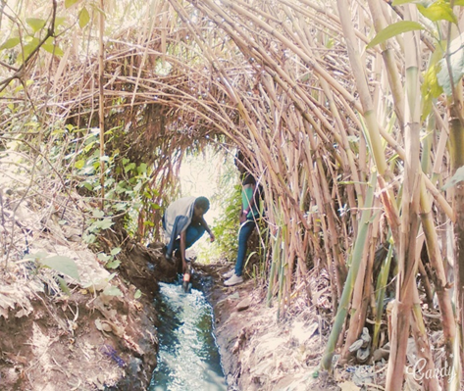
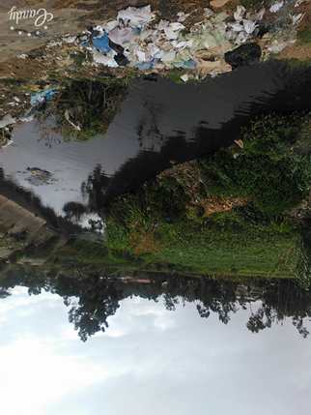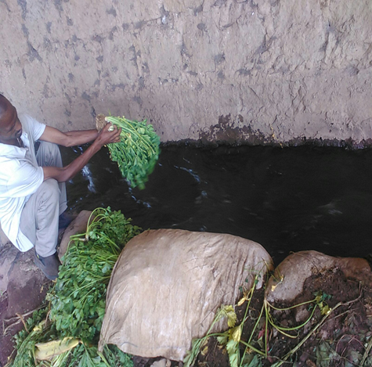
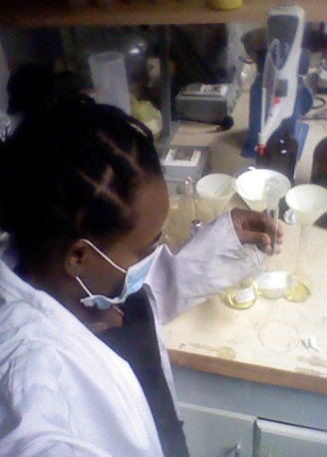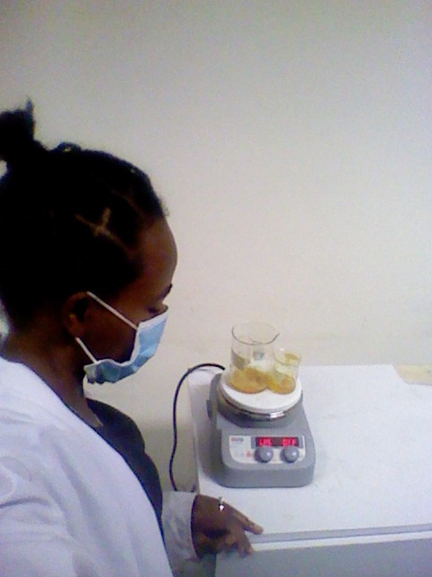
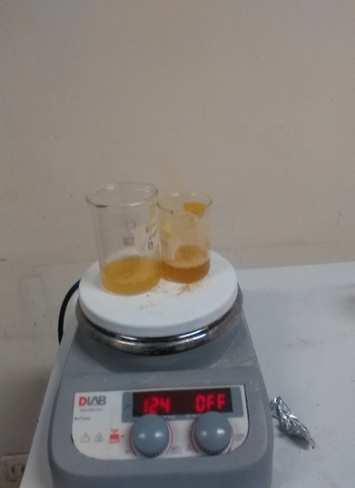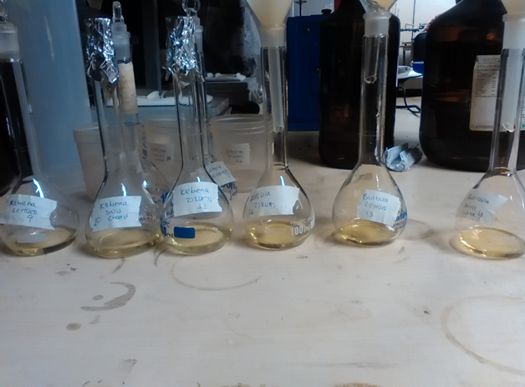
Figure:12. Different Pictures of laboratory and field work

